SUPERIOR GROUP OF COLLEGES LAHORE


Faculty of Computer Science & IT

Final Year Project
PROJECT REPORT

Online Brand Clothing Store

Project ID:[write ID here Issued by FYP Manager]

Project Team
Student Name | Student ID | Program | Contact Number | Email Address
Maha Shahid | BCSM-F15-241 | BSCS | 03249001905 | mahashahid21@gmail.com
Syed Haider Ali | BCSM-F15-128 | BSCS | 03122101996 | syedhaiderali30@gmail.com
M. Usman Sharif | BCSM-F15-123 | BSCS | 03044238231 | mani.awan767@gmail.com

Muhammad Saleem Butt
Lecturer

Project Report
[Title of Project]

Change Record
Author(s) | Version | Date | Notes | Supervisor’s Signature
 | 1.0 |  | <Original Draft>
 |  |  | <Changes Based on Feedback from Supervisor>
 |  |  | <Changes Based on Feedback From Faculty>
 |  |  | <Added Project Plan>
 |  |  | <Changes Based on Feedback from Supervisor>

APPROVAL
Project Supervisor
Comments: ___________________________________________________________________
_____________________________________________________________________________
Name:______________________________
Date:_______________________________ | Signature:__________________________

Project Manager
Comments: ___________________________________________________________________
_____________________________________________________________________________
Date:_______________________________ | Signature:__________________________

Head of the Department
Comments: ___________________________________________________________________
_____________________________________________________________________________
Date:_______________________________ | Signature:__________________________

Dedication

This document is dedicated to my respected teachers and university because without them this would be impossible for us.
I also want to dedicate this to my mother who believed in me from the first day and have faith in me that I can do this.

Acknowledgements

First and foremost, I have to thank my research supervisors, Mr Saleem Butt and Mr Ahmad Kaloon. Without their assistance and dedicated involvement in every step throughout the process, this paper would have never been accomplished.
I would like to thank you very much for your support and understanding over these past four years. And also I would like to thanks to my family.

Executive Summary
Now a day there have been a lot of technological advancement that have made the life of the people easier. As we can see that people are buying or offering different things from many different online websites while sitting at home. Similarly using these advancements our company is providing you an online brand clothing website from where we can purchase each and every kind of clothes without having any issues. We are providing you with the latest fashion trends in a cheap and easier way. Our collection design aims to inspire you because we are providing you all the kind of branded clothing facilities in a centralized hub. We deliver happiness with latest fashion trends.

In this document we have we have discussed about the problem that the people are facing now a days and also proposed solutions that how we are overcoming from them. We have also discussed about the scope of our project that what amenities we are providing. We have also shown a proper architectural design of our system that shows the major aspects. Then we have
Deliberated that on which tools we are working and how we are going to implement them on our website.

As we can see that the online shopping platform is vastly growing, as people have to waste a lot of time on surfing on different websites and have to pay a handsome amount of money on delivery charges. This creates problem for those people who likes to do online shopping and also there are no such website that provides the facilities for the people who can sold their longstanding clothes.

We have given our customers an easy and convenient way to shop from the comfort of their homes on a website that sells all of their favorite clothes from their favorite brands. So, you don’t need to go and look on each and every website of each brand. We have given you a platform that will give you amazing discounts and they deliver all your products safely at your home. We have also giving you a facility to sale your old clothes and get a good amount on them.

Table of Contents
Dedication iv
Acknowledgements v
Executive Summary vi
Table of Contents vii
List of Figures ix
List of Tables x
Chapter 1 1
Introduction 1
1.1. Background 2
1.2. Motivations and Challenges 2
1.3. Goals and Objectives 2
1.4. Literature Review/Existing Solutions 2
1.5. Gap Analysis 2
1.6. Proposed Solution 2
1.7. Project Plan 3
1.7.1. Work Breakdown Structure 3
1.7.2. Roles & Responsibility Matrix 3
1.7.3. Gantt Chart 3
1.8. Report Outline 3
Chapter 2 4
Software Requirement Specifications 4
2.1. Introduction 5
2.1.1. Purpose 5
2.1.2. Document Conventions 5
2.1.3. Intended Audience and Reading Suggestions 5
2.1.4. Product Scope 5
2.1.5. References 6
2.2. Overall Description 6
2.2.1. Product Perspective 6
2.2.2. Product Functions 6
2.2.3. User Classes and Characteristics 6
2.2.4. Operating Environment 7
2.2.5. Design and Implementation Constraints 7
2.2.6. User Documentation 7
2.2.7. Assumptions and Dependencies 7
2.3. External Interface Requirements 8
2.3.1. User Interfaces 8
2.3.2. Hardware Interfaces 8
2.3.3. Software Interfaces 8
2.3.4. Communications Interfaces 9
2.4. System Features 9
2.4.1. System Feature 1 9
2.4.1.1. Description and Priority 9
2.4.1.2. Stimulus/Response Sequences 9
2.4.1.3. Functional Requirements 9
2.4.2. System Feature 2 10
2.4.2.1. Description and Priority 10
2.4.2.2. Stimulus/Response Sequences 10
2.4.2.3. Functional Requirements 10
2.4.3. System Feature 3 (and so on) 11
2.5. Other Nonfunctional Requirements 11
2.5.1. Performance Requirements 11
2.5.2. Safety Requirements 11
2.5.3. Security Requirements 12
2.5.4. Software Quality Attributes 12
2.5.5. Business Rules 12
2.6. Other Requirements 12
Chapter 3 13
Use Case Analysis 13
3.1. Use Case Model 14
3.2. Use Case Descriptions 14
Chapter 4 15
System Design 15
4.1. Architecture Diagram 16
4.2. Domain Model 16
4.3. Entity Relationship Diagram with data dictionary 16
4.4. Class Diagram 17
4.5. Sequence / Collaboration Diagram 17
4.6. Operation contracts 17
4.7. Activity Diagram 18
4.8. State Transition Diagram 18
4.9. Component Diagram 18
4.10. Deployment Diagram 19
4.11. Data Flow diagram [only if structured approach is used - Level 0 and 1] 19
Chapter 5 20
Implementation 20
5.1. Important Flow Control/Pseudo codes 21
5.2. Components, Libraries, Web Services and stubs 21
5.3. Deployment Environment 21
5.4. Tools and Techniques 22
5.5. Best Practices / Coding Standards 22
5.6. Version Control 22
Chapter 6 23
Testing and Evaluation 23
6.1. Use Case Testing 24
6.2. Equivalence partitioning 24
6.3. Boundary value analysis 24
6.4. Data flow testing 24
6.5. Unit testing 25
6.6. Integration testing 25
6.7. Performance testing 25
6.8. Stress Testing 25
Chapter 7 26
Summary, Conclusion and Future Enhancements 26
7.1. Project Summary 27
7.2. Achievements and Improvements 27
7.3. Critical Review 27
7.4. Lessons Learnt 27
7.5. Future Enhancements/Recommendations 28
Reference and Bibliography 35
Index 37

List of Figures

1.1 Caption of first figure of first chapter 6
1.2 Caption of second figure of first chapter 7
2.1 Caption of first figure of second chapter 14
2.2 Caption of second figure of second chapter 22
2.3 Caption of third figure of second chapter 26
5.1 Caption of first figure of fifth chapter 49
5.2 Caption of second figure of fifth chapter 49

List of Tables

1.1 label of first table of first chapter 6
1.2 label of second table of first chapter 7
2.1 label of first table of second chapter 14
2.2 label of second table of second chapter 22
2.3 label of third table of second chapter 26
5.1 label of first table of fifth chapter 49
5.2 label of second table of fifth chapter 49

Chapter 1

Introduction

Chapter 1: Introduction
In today’s world fashion industry is always looking for the latest trend to absorb it and then spread it to the rest of the world. Each fashion brand aims to create a unique and characteristic visual style that fits its personality. However, there are certain characteristics that are common to most fashion company’s websites. But the main characteristic that we are entering in our website is that we are merging the entire Pakistanis top brand on a single platform that will ease you from surfing on different website.
The main objective of this fashion website is to keep the viewer in the site enough time for him or her to see the last collection of the product of all brands. Some fashion websites have interactive elements and try to transform the visit into a sensory experience for the viewer but they don’t have such big thing that our website is offering them.

Background
A fashion house that made its mark in couture is by making decent attires and supplying them in a safe and cheap way for example, often develops a ready-to-wear line for department stores and a discount line for mass-merchandisers. Our ability is to launch such kind of website that is introduced in your chosen niche market might depend on controlling and delivering your line at the appropriate price.
As our website is unique and performing much different kind of functionalities, so in Pakistan there are no such kinds of platform from which a person can avail each and everything related to clothes. Though there are such platform that are giving us some brands clothes but in a very small scale because they have their own clothes that they have bought from different brands and are trading them but in our case, we are just delivering these products to the customers in a cheap way which have not been done by anybody in Pakistan.

Motivations and Challenges

Now days there are many websites who offers different types of clothing line of different brands, yet not on a same/single platform. This creates problems for those peoples who do online shopping from different brands, as it is more expensive to buy branded clothes from different websites because every brand website causes you to pay some delivery charge. Also, these websites don’t offer special discounts for people. There are also no platforms that allow you to sale your old clothes on a handsome amount. So it’s a challenge for us to create such an interesting and amazing website through which people can happily enjoy there shopping time with amazing offers and that make our website superior from out competitors.

Goals and Objectives
- Goal:

There is different guideline objectives of web based shopping which are controlled by the end client.

- Time and Energy efficiency:

It is efficient and vitality sparing. Customer can easily login to online website while sitting at home. So by this we can state that it is time as vitality sparing.

- Accessibility:

Individuals while sitting at one place can reach to number of things with different combinations and can arrange them and would get them at their door step.

- Design
The entire layout of the website is the most important aspect which consists of themes, banners, photographs, videos if any. The layout needs to be more organized and composed. So, in our website the design will be simple that is easy to understand and is user-friendly. Because the website that we are providing is a combination of many brand clothing website so we will make the website simple and attractive.

- Marketing tools
In this competitive business world, it is of utmost importance for the business to be universal on all social media website ranging from Face book, Integral, twitter. However, this isn’t just enough your website requires various marketing tools such as
- Newsletters
- Blog integration
- SMS notification
- Live chat
- Refiral (Viral marketing tool)
- Product and packaging
Another significant factor of our website is to ensure the product quality is superior and lives up to the customers’ expectations. We will also ensure the product is delivered to customer safely by packaging the product in the right size of packages and with stamps in case of fragile materials.
- Courier Services
Lastly an efficient and hassle-free courier service is what the customers look forward to. We will deliver your product with the collaboration of top courier services that can deliver your glee with complete protection.
- Customer support
Some customers need help when completing a purchase on an online store. To overcome with that issue our website will provide you that facility. Whatever the reason that may hamper the visitor’s progress from making a purchase, most customers would want to know that support is on hand if they require it.
- Terms and conditions
A terms and conditions page are a significant feature of any website as it can guard your website, your company and in some cases your customers in terms of liability for damages or losses incurred as a result of using your ecommerce website. Our website will be providing you with that feature as well.

- Objective:

The principal target of Online Shopping Website is to give a path of purchasing online branded clothes by instantly without any then intense medium. This Project has been intended to recreate the working of a genuine online shopping Store.

- To shop while in the comfort of your own home, without stepping out of the entrance.

- Provide a platform of all major brands.

- Provide home conveyance free of cost.

Literature Review/Existing Solutions
In this section we are going to describe about the literature Review of the system

- Purchase Intention

The Customer will have these following points in there minds will purchasing any product from an online shopping system.
- Price
- Discounts
- Reviews
- Comparison
- Quality
- Time management
- Variety

- Time saving:
Time is also perceived as one of a factor that relates with intention to purchase in a shopping context. It is believed that consumers have their own perception of time, whether or not to shop from the internet.

- Perceived risk
There is certain risk that consumers will face when making online purchase. Shopping on the internet which is a new medium for consumers will be a challenge for them because shopping on the internet is relatively new and consumers have less experience with it

- Enjoyment and excitement
Excitement is defined as high level of enjoyment and stimulation that has the positive emotional state. Consumer also associate shopping with enjoyment and excitement which they would think is a fun activity to them regardless in an online or offline context. Enjoyment is defined as the extent to which online shopping is perceived to be personally enjoyable and fun
- Existing Solutions
- ePal.pk.
- Daraz.pk.
- Yayvo.com (Tcsconnect)
- Affordabledeals.com.pk

Gap Analysis
Target Item | Current state | Future State | Improvement Steps
Software Requirement Specification | Requirements of User  Interface are  Complete. | Completing the System  Requirement  Specification to start  Implementation. | We will make some  changes after testing  the software.  Change only require  when it needed.
Use case Analysis | Use case model is also complete. | Complete Use case  model and Fully  Dressed Use case to  clearly define the  path for design and  implementation | If cases not go as our  software  requirements so we  will improve or make  Some changes.
System Design | Architecture diagram  and use cases  diagram and others  are also completed. | Implementation will be started after testing of diagrams. | Design of the system will be improved and more changes are done if required.
Implementation | Working on front end and Prototype  is almost  completed | Software will be  Complete. | Improve design and  functionality with the  instance.
Documentation and Project Testing | Documentation is almost completed but new increments will be included with time. | When documentation  will be completed  implementation will  be start. | Setting up the errors and  develop the project  as per requirements.

Proposed Solution
We are giving our customers an easy and convenient way to shop from the comfort of their homes on a website that sells all of their favorite clothes from their favorite brands. So, you don’t need to go and look for each and every website of each brand. We have given you a platform that will give you amazing discounts and they will deliver all your products safely at your home.
Many of the brands add hidden charges like shipping, taxes etc., which our website will not allow and the customer has to pay only the actual amount. During all these processes, we will provide safety and privacy of your data.

Project Plan
It is a final year project and because of this we will use the Agile methodology of Software Engineering and get methodology for version Control.

Work Breakdown Structure

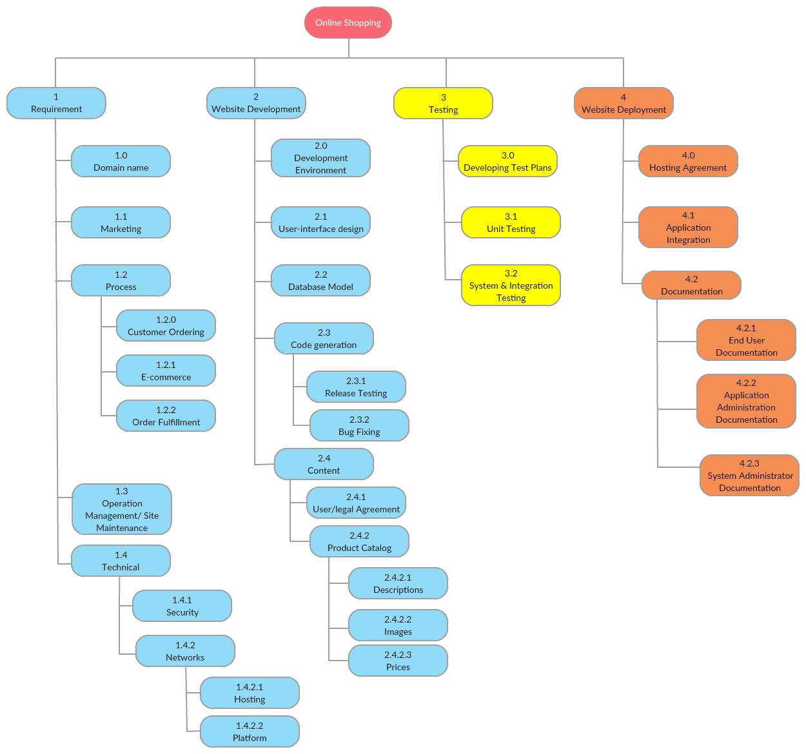

Roles & Responsibility Matrix
The purpose of roles & responsibility matrix is to identify who will do what.

WBS # | WBS Deliverable | Activity # | Activity to Complete the Deliverable | Duration  (# of Days) | Responsible Team Member(s) & Role(s)
1 | Training Session | PA-001 | Take the trainings | 40 | Maha, Haider, Usman
2 | Requirements Gathering | PA-002 | Done surveys of different brands | 15 | Maha and Haider
3 | Documentation | PA-003 | Search and Read different FYP projects | 30 | Maha, Haider and Usman
4 | UI- Design | PA-004 | Done surveys of different website | 32 | Usman and Haider
5 | Development & Testing | PA-005 | Check the systems with different process | 30 | Maha, Haider and Usman
6 | Maintenance | PA-006 | Using agile methodology increment is done | 12 | Maha, Haider and Usman

Gantt Chart

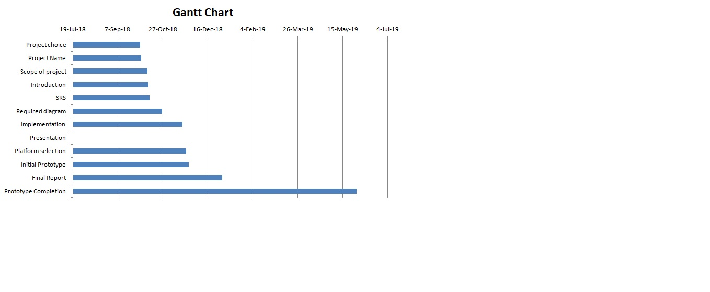

Report Outline
This report tells us about what the system is that we are trying to make.
- In Chapter 1 we have shown the goals and problems that the market is facing right now and also display the gannt chart and work break down structure.
- Chapter 2 includes all the System requirements counting all type of explanation like product scope and operational environment.
- Chapter 3 and Chapter4 is all about the diagrams that elaborate all the aspects of the online clothing system.
- Chapter 5 tells the implementation tools and techniques that we are going to use for the implementation of our website.

Chapter 2

Software Requirement Specifications

Chapter 2: Software Requirement Specifications

Introduction

One stop cloth is the online shopping website where consumer search different brand and select cloth only in one website. Shoppers can visit web stores from the comfort of their homes and shop as they sit in front of the computer. Consumers buy a variety of items from online one stop cloth. You can search through stores at the same time, comparing material quality, sizes and pricing simultaneously. Many people choose to conduct shopping online because of the convenience and not everyone chooses to purchase item some people like the idea of physically going to a store and experiences to shopping process.

Purpose

The purpose of this site is consumer directly buy the all types of clothes form the different brands in Pakistan. Consumer easily search any type of brand only in one website they don’t visits different website again and again.

Document Conventions
Standard rule of documentation has been followed in the order of standardized the work. In order to create efficient One Stop Cloth Website in the building of online shopping.

Intended Audience and Reading Suggestions
This report is for individuals like engineer, client, venture chief, database staff designer, developers, project managers, and marketing staff, users, testers, and documentation writers.
Whereas the rest of the document tells us about what are the things that we want to add in our website and how we can safely deliver our products to the customer.

Product Scope

This product has great future scope. One stop cloth is online shopping store where user easily search product and purchase sit in the front of computer and received at doorstep.
The purpose scope is to present an efficient, reliable online shopping and deliver the product safely and securely.

References
- IEEE 830-1998 standard for writing SRS document.
- I Summerville, Software Engineering, 8th edition, Addison- Wesley, 2007.
- Summerville, Software Engineering, 10th edition.

Overall Description

Product Perspective
The one stop cloth should provide the facility of online ‘buying’ and ‘cancelling’ of item.
Online transaction should take place if the item is available and the amount should taken from the customer account by using their credit number and if they cancel the item means the amount should returned to the account.

Product Functions
The website is performing the following functionalities:
Website:
- Register: First user create the account for enter into a system
- Login: User can login into a system
- Search Item: After login user can search the product what they want.
- View / Edit Profile Function: The user can update the data and can view it
- Select item Function: customer can select item from the system and then add the product into the cart.
- View item Function: User login and then view detail of item
- View Details Function: User login and then view detail of item
- View Order Function: User can view detail of item that they entered.
- Add Category Function: Allow admin to add item into cart easily.
- Edit Category Function: Allow admin to edit item category.
- Place order Function: User has ability to place order to the Available item.
- Cancel Order Function : The customer can cancel its order whenever he wants
- Edit cart Function: Allow user to edit item into cart easily.
- Add to Cart: User can order product and can also choice how many product user want user can check the all details about your product ( Size , Color , Quality , Fit type )
- Shipping Method: After add to cart user add all details Email Address , First name , Last name , password , street address , state and at the end Phone number
- Select Payment Method: User can select payment method (Online Payment , cash on delivery , bank transfer payment )
- Cost Calculation: This system calculates total cost of the item placed into the cart and provide payment module.
- Logout Function: The users can logout from the account whenever he wants.

Register detail
- Username (30 Char)
- Email (30 char)
- Password (20 char)
- Password 2 (20 char)
- User Image
- Address (25 Letters)
- User_type (30 char)
Login detail
- Email (30 char)
- Password (20 char)
Product detail
- Product_id (8digit)
- Brand_name (20 char)
- Product_title (20 char)
- Product_price (10digit)
- Product_type (char 50)
- Product_description (char 100)
- Product_image (varchar 50)
- Product_image 2 (varchar 50)
- Product_image 3 (varchar 50)
- Product_category (20 char)
Product cart
- Product_id (8digit)
- Product_size (12 char)
- Product_color ( 12 char)
- Product_quality (14 char )
- Product_price ( 30 char)
Shipping Detail
- Email_id ( 25 char)
- Name (12 char)
- Password_id (20 char)
- Street (30 char)
- City_name (10 char)
- Zip_code (8 digit)
Delete Details
- Delete Product (20 char)
Payment method
- Shipment (20 char)
- Complete (25 char)
- Credit card
- Expiry date
- Cvv code
Define the logic of processes
- Register detail
- Login detail
- Product detail
- Cart detail
- Shipping detail
- Delete Detail
- Payment detail
Database required with separate tables
users table
- User detail with primary key
product table
- Product detail with primary key (pk)
- Order detail with foreign key (fk)
order table
- Order detail with foreign key
orderproducts table
- Shipping detail with primary key
migrations table
- Delete detail with primary key and primary key
categories table
- Payment detail with primary key
- Perform sizing
- 8 megabytes hardware required
- Login table contain (30 char)
- Product table contain (15 kilobyte)
- Delete product table contain (5 kilobyte)
Determine the hardware Requirement
- One disk drive to store the backup
- Strong server or LAN cables to connect system

User Classes and Characteristics
There are 2 kind of client of this product
- Overall population
One stop cloth is one of the general website for all the classes their cost and amount accessible. Consumer can easily purchase the item and order.
- Administrator
Administrator can see the all clients who have to purchase from this website and can easily handle all situation of client who are in trouble.

Operating Environment
- Operating Environment Win 8/10
- Language are used PHP and laravel
- Database SQL Server
For user
- Internet Browser
- Internet Connection

Design and Implementation Constraints
- Client details save into a database
- The one stop cloth is running 24 hours per day.
- Users must have their rights username and password to go into online records and do activities
- User may have access from anywhere where internet has accessible.

User Documentation
User must know details of our product, how to use it and how to purchase product. User use internet to order product or need friendly environment

Assumptions and Dependencies
• It is assumed that the requirements are in its completion phase.
• It is assumed that user is used to the internet browser
• It is assumed that user is familiar with mouse and keyboard use
• It is assumed that user has decent internet connectivity.
Dependencies
• User’s levels are previously determined for all the users
• Access to the system is restricted to the user name
• Restrictions and limitations of all the levels are known by the higher level users
• Admin have access to any user’s account

External Interface Requirements

User Interfaces
GUL of Screen
- Login: User have to write the username and secret password
- Search: User enter any kind of product he is looking for and that he can order for the required product by entering the name of the item.
- Category View: User can easily find the category which he is looking for, all product show on the front screen with price.
- Add Product to Cart: User can add product into the cart which he want to order.
- Delete Product from Cart: User also delete the selecting product from the cart.
- Payment method: User select the payment method

Hardware Interfaces
- Processor
- Hard drive
- Ram
- Keyboard
- Mouse
- LCD

Software Interfaces
- Software required are the requirements which are required for creating the website and which software the project is been made up.
- Language: HTML, CSS, JAVASCRIPT, PHP, LARAVEL
- Software: Dream viewer

Communications Interfaces
Communication interface are the interfaces through which user and product are connected with each other.
- Fax
- Mobile phone
- Email
- Live call

Sender
Receiver

System Features
The features that are used in or website are also mentioned above but all the working of this is now going to explained below:

System Feature 1
Functional Requirement 1
Registration Function

Identifiers | FR-001
Title | Allows register access online
Requirement | Username, Email, Password, Address, Phone
Rational | Register to the system and provide security to personal information.
Restriction and risk | User must enter accurate information
Dependency | Pc , Connection with server
Priority | Safety ,timing

Functional Requirements
The functional Requirements of this are explained by the table here we have given a brief description of this system feature. So in this the user needs to enter all the data to register him or her selves if they want to purchase anything from our website. All the information, user enter must be valid and accurate.

System Feature 2
Functional Requirement 2
Login Function
Identifiers | FR-002
Title | Allows Login access online
Requirement | Username, password
Rational | Login to the system and provide security to personal information.
Restriction and risk | User name and password must be correct  Otherwise users can’t login .
Dependency | Pc , Connection with server
Priority | Safety ,timing

Functional Requirements
This system feature is for login and in this the user needs to enter the correct data for login. User must have an account when he tries to login. User can also use the system without registering his self.

System Feature 3
Functional Requirement 3
Search Item Function
Identifiers | FR-003
Title | Allows user to search and view items.
Requirement | None
Rational | The user can search and view the data and the profile.
Restriction and risk | The data must be entered correctly.
Dependency | Pc , Connection with server
Priority | Safety ,timing

Functional Requirements
This system feature is to allow the user to search the website according to its perspective. The user can view all the description and other details of it.

System Feature 4
Functional Requirement 4
View / Edit Profile Function
Identifiers | FR-004
Title | Allows user to edit and view profile.
Requirement | Username, password, email etc.
Rational | The user can update the data and can view it.
Restriction and risk | User name and password must be correct  While updating it
Dependency | Pc , Connection with server
Priority | Safety ,timing

Functional Requirements
This system feature is for viewing and editing the user profile. User must have an account which he tries to edit. User can also use the system without registering his self.

System Feature 5
Functional Requirement 5
Select item Function

Identifiers | FR-005
Title | Add a item to user account
Requirement | City name ,time, product type, date
Rational | User must add item in cart
Restriction and risk | The data must be entered properly
Dependency | Valid information
Priority | Item should add in user account.

Functional Requirements
In this the customer can select item from the system and then add the product into the cart. The user can select the product from any brands that are the website and then can confirm order.

System Feature 6
Functional Requirement 6
View item Function
Identifiers | FR-006
Title | Allows Login access online
Requirement | Username, password
Rational | Login to the system and provide security to personal information.
Restriction and risk | User name and password must be correct  Otherwise users can’t login .
Dependency | Pc , Connection with server
Priority | Safety ,timing

Functional Requirements
This system feature is for login and in this the user needs to enter the correct data for login. User must have an account when he tries to login. User can also use the system without registering his self.

System Feature 7
Functional Requirement 7
View Details Function
Identifiers | FR-007
Title | Allows customer to view details
Requirement | User login and then view detail of item
Rational | Login to the system and view detail
Restriction and risk | User must login to check the detail  Otherwise detail doesn’t show.
Dependency | Pc , Connection with server
Priority | Safety ,timing

Functional Requirements
This requirement is all about to view the details of the products its price , its quality and other things. The user will easily view all the details after logging.

System Feature 8
Functional Requirement 8
View Order Function
Identifiers | FR-008
Title | Access to view order on schedule
Requirement | Address, item type, date
Rational | User has ability to View order which have  Place.
Restriction and risk | User must login to view order detail.
Dependency | Valid information
Priority | View order detail

Functional Requirements
This requirement is all about to view the products its price , its quality and other things. The Product will be shown by the name of the brand from which the customer is purchasing. The user will easily view all the details after logging.

System Feature 9
Functional Requirement 9
Add Category Function
Identifiers | FR-009
Title | Allow admin to add category.
Requirement | Category id , category name.
Rational | Allow admin to add item into cart easily.
Restriction and risk | None
Dependency | None
Priority | None

Functional Requirements
This functionality defines that after login admin can add categories like clothes accessories. All of these items are entered in the cart including their quantity and prices.

System Feature 10
Functional Requirement 10
Edit Category Function
Identifiers | FR-010
Title | Allow admin to edit categories.
Requirement | Category id , category name.
Rational | Allow admin to edit item category.
Restriction and risk | None
Dependency | User must enter the category first.
Priority | None

Functional Requirements
In this the admin can easily edit the categories that he added and can change the details of it.

System Feature 11
Functional Requirement 11
Place order Function

Identifiers | FR-0011
Title | Access to place order on schedule
Requirement | City name, item type, date
Rational | User has ability to place order to the  Available item.
Restriction and risk | Current item, the available item or current  Timing must be adjusted.
Dependency | Valid information, available item is valid
Priority | Modified in order.

Functional Requirements
User has ability to place order of the available item and the

System Feature 12
Functional Requirement 12
Cancel Order Function
Identifiers | FR-012
Title | Access to Cancel order on schedule
Requirement | Order in cart
Rational | The order will be cancelled
Restriction and risk | Current item, the available item or current  Timing must be adjusted.
Dependency | Valid information, available item is valid.
Priority | Modified in order

Functional Requirements
The customer can cancel its order whenever he wants. All the data that he entered in the cart will be removed and the customer can place new order whenever he wants.

System Feature 13
Functional Requirement 13
Add to cart Function
Identifiers | FR-013
Title | Allow user to add item to cart.
Requirement | Types of item, item no , item name
Rational | Allow user to add item into cart easily.
Restriction and risk | None
Dependency | None
Priority | None

Functional Requirements
This functionality defines that after login user can add item like clothes accessories. All of these items are entered in the cart including their quantity and prices.

System Feature 14
Functional Requirement 14
Edit cart Function
Identifiers | FR-014
Title | Allow user to edti item in cart.
Requirement | Types of item, item no , item name
Rational | Allow user to edit item into cart easily.
Restriction and risk | None
Dependency | None
Priority | None

Functional Requirements
This functionality defines that after login user can add item like clothes accessories. All of these items are entered in the cart including their quantity and prices and after that the customer can easily edit the cart easily.

System Feature 15
Functional Requirement 15
Cost Calculation Function
Identifiers | FR-015
Title | Allow user to add item to cart and cost  calculations module shows.
Requirement | Types of item, item no , item name, Total  Cost
Rational | Allow user to add item into cart easily and  cost module occur in front of the user’s  Screen.
Restriction and risk | None
Dependency | None
Priority | None

Functional Requirements
This function states the total cost of the products that the customer have entered in the cart and display the out with the total amount.

System Feature 16
Functional Requirement 16
Payment Method Function

Identifiers | FR-016
Title | Allow user to select payment methods.
Requirement | Types of card, Card no ,Card password,  Card holder name, Card holder Mobile no
Rational | None
Restriction and risk | Valid card no or PIN Code
Dependency | Account balance update
Priority | Account balance update

Functional Requirements
In this system requirement the user can select the method of payment from the website after placing the order and all the data that the user entered will depend upon the payment method.

System Feature 17
Functional Requirement 17
Logout Function
Identifiers | FR-0017
Title | Allows Logout access online
Requirement | None
Rational | Logout to the system and provide security to personal information.
Restriction and risk | User must login
Dependency | Pc , Connection with server
Priority | Safety ,timing

Functional Requirements
The users can logout from the account whenever he wants. The customer cant place the order after logging our from the account. Even after logging out the user get notify about all the updates of the website.

Other Nonfunctional Requirements

Performance Requirements
- System should be available all the time for customers.
- Its server’s link should never be down
- To get best speed, should best internet to server
- System should not be slow on having load on site.

Safety Requirements
- System should have a backup database in case of any lose or damage.
- System should be well updated.
- System should have backup server all the time stand by.
- Administrator should always alert due to that no one hacked website.

Security Requirements
- Security should be fool proof
- It should have login
- It should have a password
- Account should be integrated
- Personal information of client should not be leaked out

Software Quality Attributes

- Availability
System should be available all the 24 hours so that it could not be have any difficulty booked the order.
- Reliability
System should be reliable so that client can give their personal information and booked the order.
- Correctness
System should always update the data and correct the new price whenever offer season are came.
- Probability
Client can sign in to the framework whenever.
- Quality record
Record can be managed in different way, by year, by alphabets and many more ways.

Business Rules
- Administrator has the full authorized of controlling the framework.
- User has authorization to buy request or view detail of the item.

Other Requirements
The requirements that we want to enter in the system are defined below:
- Technical: The system will have no technical issue and the information of the customer should be saved in the server with precautionary measures.
- Economic: Cost will be reasonable

- Specification: This web base Application is for Windows Users. Web Application would be free of cost.

- Legal and Ethical: This web base application would be accessible for all clients and will meet legitimate and moral principles.

Chapter 3

Use Case Analysis

Chapter 3: System Analysis
This outline is bound with changing the shopping from manual to on the web. Client can easily purchase items online after login to the webpage. Admin will add items in the database. The items are delivered to client address that he has given. Admin can see day-by-day offer and refresh the status. Both admin and client needs to login for performing their tasks.

Use Case Model

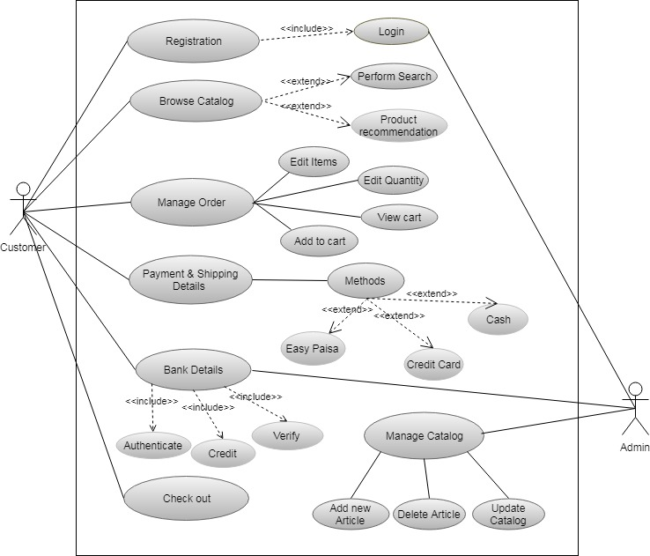

Use Case Descriptions

Use Case | Registration
Name
Purpose | To keep the details of the new user for the website.
Description | Admin will see the complete list of details of the customer.
Primary Actors | Customer
Stake Holders | Admin
Pre- Conditions | None
Post- Conditions | The customer will be registered.
Main Success Scenario | - The customer will enter all the details and get registered to buy different products and can get details about the product and delivery.  - Customer can update their profile whenever they want.
Alternative Scenarios | - If the system is down an error message will be displayed.
Assumptions | Customers know how to use the system.

Use Case | Browse Catalog
Name
Purpose | To see the different products of different clothing Brands.
Description | Customer will see the complete list of products of the different brands.
Primary Actors | Customer
Stake Holders | Admin
Pre- Conditions | Customer needs to be logged in or register.
Post- Conditions | The customer will select any kind of clothes from any kind of brand.
Main Success Scenario | - The customer can browse different kind of products after registration.  - Customer can add the products to cart while browsing.
Alternative Scenarios | - If the system is down an error message will be displayed.
Assumptions | Customers know how to use the system.

Use Case | Manage Order
Name
Purpose | To see the different products of different clothes of different clothing Brands.
Description | Customer can manage the list of products from cart.
Primary Actors | Customer
Stake Holders | Admin
Pre- Conditions | Customer needs to add items into the cart.
Post- Conditions | The customer can confirm the order.
Main Success Scenario | - The customer can add item, edit quantity, view cart and delete item.
Alternative Scenarios | - The customer will confirm the order.  - If the system is down an error message will be displayed.
Assumptions | Customers know how to use the system.

Use Case | Payment & Shipping Details
Name
Purpose | How customer wants to do the payment and give the resources of shipping.
Description | Customer will select the method for payment and give details of delivering the product.
Primary Actors | Customer
Stake Holders | Admin
Pre- Conditions | Customer needs to add items into the cart.
Post- Conditions | The product will be delivered to the customer with the method that he selected.
Main Success Scenario | - The customer has given us all the original values froe shipping.]  - The method that he selected was one of our types.
Alternative Scenarios | - The product will not be delivered to the required customer while he or she has confirmed the order.  - If the system is down an error message will be displayed.
Assumptions | Customers know how to use the system.

Use Case | Bank Details
Name
Purpose | To authenticate that the methods that customer wants to use are valid and original.
Description | The admin and bank will authenticate and verify the account.
Primary Actors | Customer & Admin
Stake Holders | Admin
Pre- Conditions | Customer has to place the order and has to complete the shopping.
Post- Conditions | Order will be placed.
Main Success Scenario | - The details of the customer are valid and original.  - The payment is successfully transferred in the bank account.
Alternative Scenarios | - The system will give an error message and the user needs to select the different method for payment.
Assumptions | Customers know how to use the system.

Use Case | Manage Catalog
Name | Manage Catalog
Purpose | To add, update or delete new category from the data.
Description | Admin can manage the list of products from cart.
Primary Actors | Admin
Stake Holders | Customer
Pre- Conditions | Admin needs to add items into the cart.
Post- Conditions | The Admin can update the category.
Main Success Scenario | - The admin can add item, edit quantity, view catalog and delete item.
Alternative Scenarios | - The admin will see the list and items.  - If the system is down an error message will be displayed.
Assumptions | Admin know how to use the system.

Use Case | Check out
Name | Check out
Purpose | Which methods customer wants to use form payment method and give shipping details.
Description | Customer can manage the list of products from cart.
Primary Actors | Customer
Stake Holders | Admin
Pre- Conditions | Customer has placed the order and has done the shopping.
Post- Conditions | None
Main Success Scenario | - The Customer will logout from their account conveniently.
Alternative Scenarios | - The customer will search for more products to place additional order.  - If the system is down an error message will be displayed.
Assumptions | Customers know how to use the system.

Chapter 4

System Design

Chapter 4: System Design

The One Stop Cloth is an online website server. The web program is the UI for the frame. The web program speaks with the server utilizing HTTP as transport convention. Web program sends messages to the server and the server react to web in and the web program display the data to the client. WIFI or Ethernet is utilized and it needs for the working of system. MySQL Database is used for the storage of the clients’ information.

Architecture Diagram

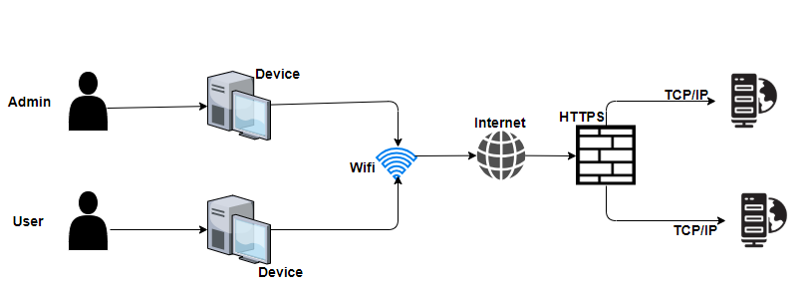

Domain Model

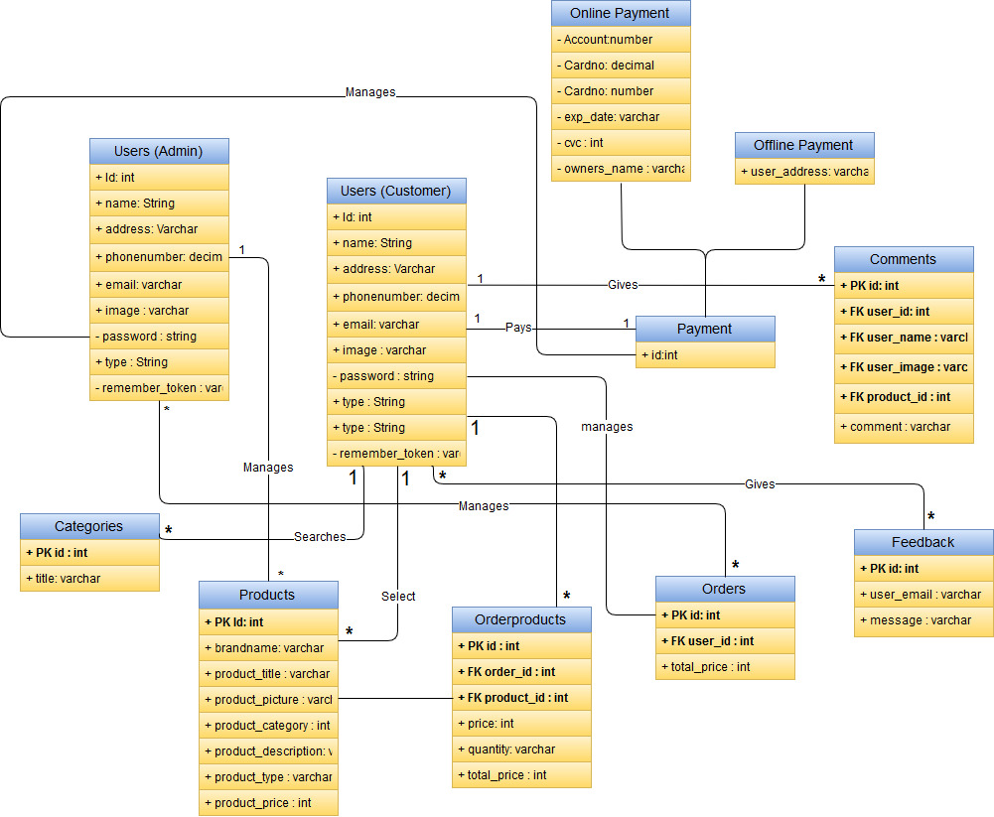

Entity Relationship Diagram with data dictionary

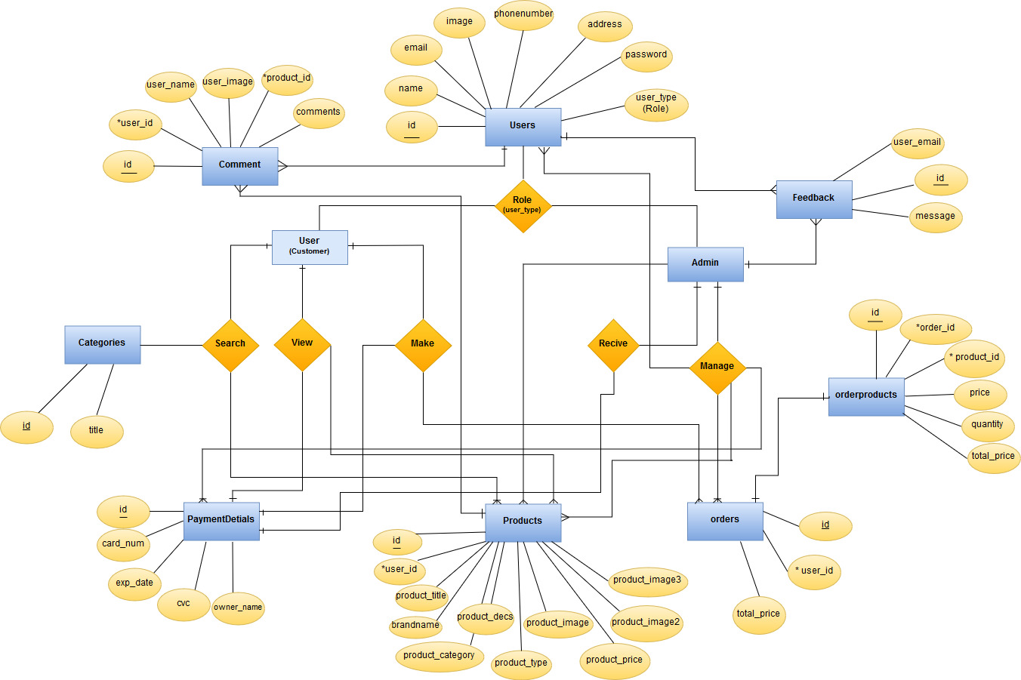

- data dictionary

Users
Field Name | Data Type | Allow Null | Constrains | Description
id | int | No | PK | Id of User
email | Varchar | No | Null | Email of User
Password | Varchar | No | Null | Password of User
name | Varchar | No | Null | Name of User
phonenumber | Int | No | Null | Phone no of User
address | Varchar | no | Null | Address of User
image | Varchar | No | Null | image of User
type | Varchar | No | Null | type no of User

Product
Field Name | Data Type | Allow Null | Constrains | Description
id | int | No | PK | Product Id
Product_title | Varchar | No | null | Title of product
brandname | varchar | No | Null | Brand Name of product
Product_description | varchar | No | Null | Description of product
Product_category | varchar | No | Null | category of product
Product_type | Varchar | No | Null | type of product
Product_price | Int | No | Null | price of product

Payment
Field Name | Data Type | Allow Null | Constrains | Description
Pay_id | Varchar | No | PK | Payment Id
Owner_name | Varchar | No | Null | Owner’s name
Exp_date | varchar | No | Null | Date of expiry
Card_no | int | No | Null | Credit card no
cvc | int | No | Null | Cvc number

Order
Field Name | Data Type | Allow Null | Constrains | Description
id | int | No | PK | Order id
user_id | int | No | Fk | ID of user
Total_price | int | No | Null | Total Amount

Orderproducts
Field Name | Data Type | Allow Null | Constrains | Description
id | int | No | PK | Order product id
order_id | int | No | Fk | ID of order
Product_id | int | No | FK | ID of product
price | int | No | Null | Status of order
quantity | Varchar | No | Null | Product id

Comments
Field Name | Data Type | Allow Null | Constrains | Description
Id | int | No | PK | Order product id
order_id | int | No | Fk | ID of order
Product_id | int | No | FK | ID of product
Price | int | No | Null | Status of order
Quantity | Varchar | No | Null | Product id

Feedback
Field Name | Data Type | Allow Null | Constrains | Description
Id | int | No | PK | feedback id
user_email | Varchar | No | Null | user email
Message | varchar | No | Null | Message

Category
Field Name | Data Type | Allow Null | Constrains | Description
Id | int | No | PK | Id of Category
Title | Varchar | No | Nul | Name of title

Class Diagram

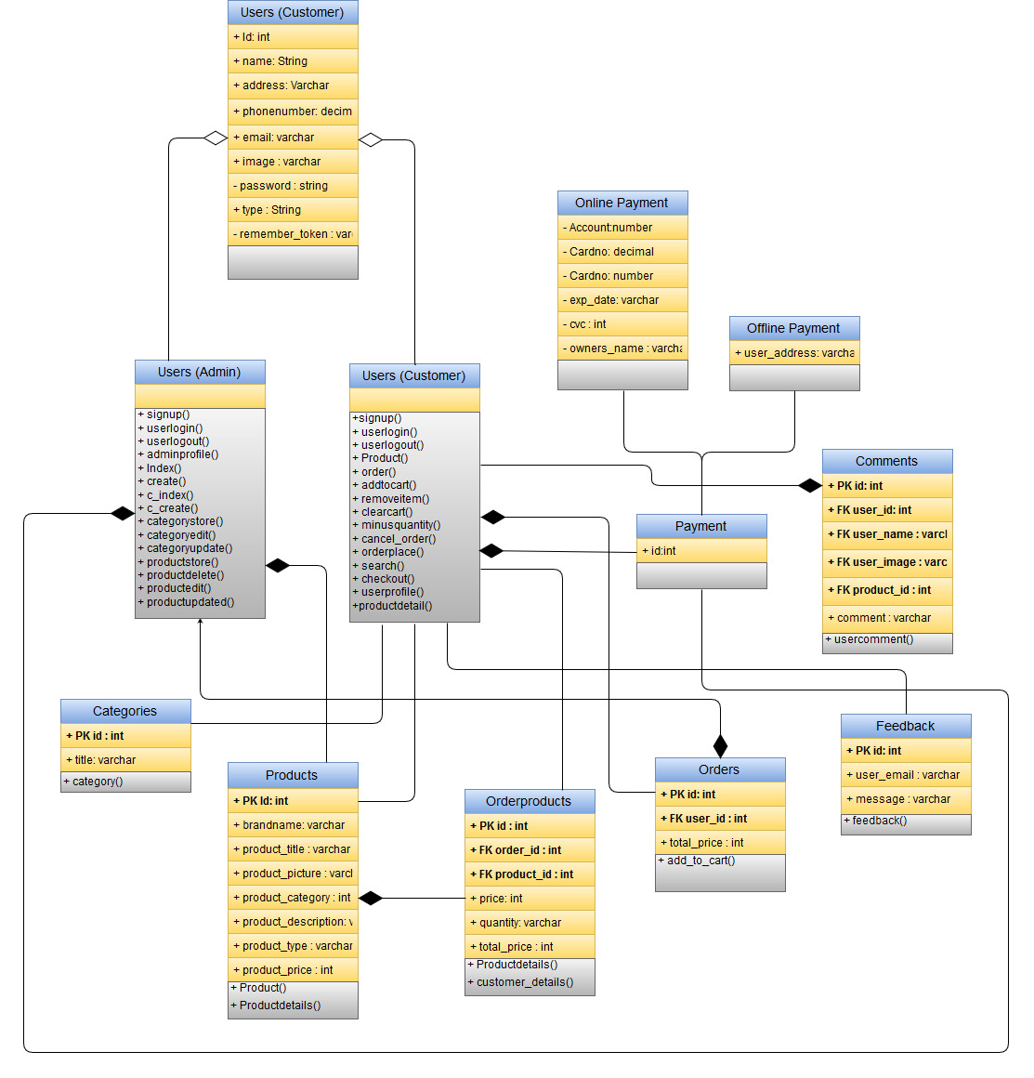

Sequence / Collaboration Diagram
- Sequence Diagram of User
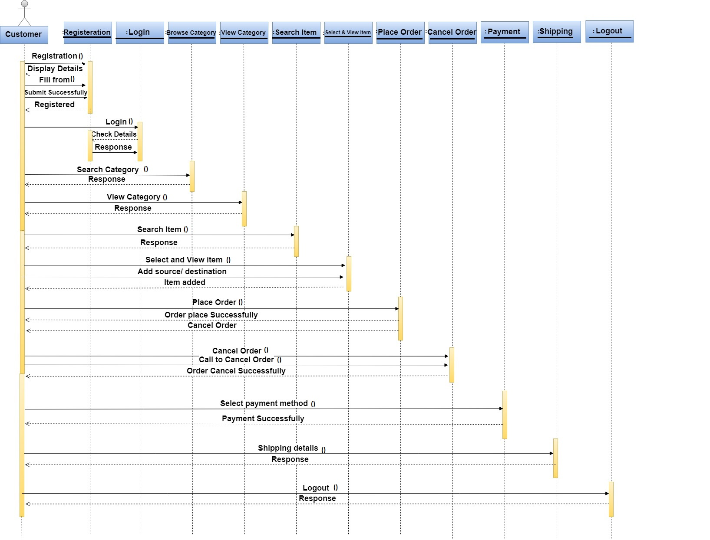

- Sequence Diagram of Admin

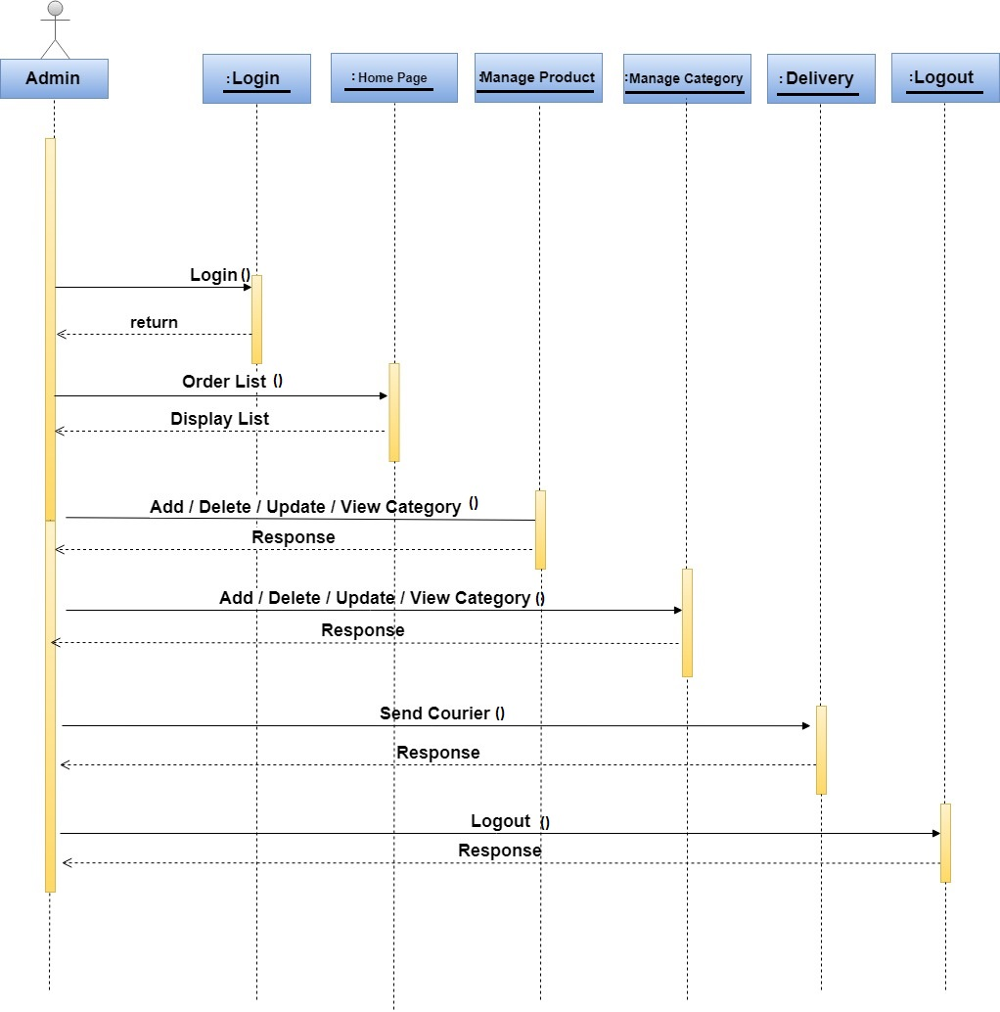

Operation contracts
4.6.1. Operation Contract#1

Name: Register.

Responsibilities: To register the new user.

Cross References: Use case: Register.

Exceptions: None.

Preconditions: Registration form will open and user must enter valid information.

Post conditions: Home Page displayed

4.6.2 Operation Contract#2

Name: Log in.

Responsibilities: A user is logged in.

Cross References: Use Case: log In.

Exceptions: invalid user name or password.

Preconditions: user should have account.

Post conditions: Successfully logged in.

4.6.3 Operation Contract#3

Name: Search Category.

Responsibilities: User must Search any category or brands.

Cross References: Use Case: Browse Category.

Exceptions: None.

Preconditions: user should have account.

Post conditions: . Browse successfully

4.6.4 Operation Contract#4

Name: Perform Search.

Responsibilities: User must Search for items.

Cross References: Use Case: Perform search.

Exceptions: None.

Preconditions: User must login.

Post conditions: Search item successfully.

4.6.5 Operation Contract#5

Name: Select item

Responsibilities: User must login and select item.

Cross References: Use Case: Select item.

Exceptions: None.

Preconditions: Must be logged in.

Post conditions: Select item successfully.

4.6.6 Operation Contract#6

Name: View detail.

Responsibilities: User must View detail of the product.

Cross References: Use Case: View Detail.

Exceptions: None.

Preconditions: User must login.

Post conditions: View detail successfully.

4.6.7 Operation Contract#7

Name: View category.

Responsibilities: User must View category of the product.

Cross References: Use Case: View category.

Exceptions: None.

Preconditions: None.

Post conditions: View detail successfully.

4.6.8 Operation Contract#8

Name: Search item

Responsibilities: User select any brand first.

Cross References: Use Case: Search item.

Exceptions: None.

Preconditions: Must be logged in.

Post conditions: Select item successfully.

4.6.9 Operation Contract#9

Name: Place order.

Responsibilities: User must Place order of the selected product.

Cross References: Use Case: Place order.

Exceptions: None.

Preconditions: User must login.

Post conditions: View place order successfully.

4.6.10 Operation Contract#10

Name: View order.

Responsibilities: User should View order, which he place.

Cross References: Use Case: View order.

Exceptions: None.

Preconditions: User must login.

Post conditions: View order successfully.

4.6.11 Operation Contract#11

Name: Cancel order.

Responsibilities: User should add item, which he place.

Cross References: Use Case: Cancel order.

Exceptions: None.

Preconditions: User must login.

Post conditions: View order successfully.

4.6.12 Operation Contract#12

Name: Add to cart.

Responsibilities: User will select the product and add it to the cart.

Cross References: Use Case: Add to cart.

Exceptions: None.

Preconditions: User must login.

Post conditions: Add to cart successfully.

4.6.13 Operation Contract#13

Name: Cancel order.

Responsibilities: User can cancel order of the product, which he placed.

Cross References: Use Case: Cancel order.

Exceptions: None.

Preconditions: User must login.

Post conditions: Cancel order successfully.

4.6.14 Operation Contract#14

Name: Cost calculation.

Responsibilities: User must select the product and cost will display.

Cross References: Use Case: Cost calculation.

Exceptions: None.

Preconditions: User must login.

Post conditions: Cost calculation successfully.

4.6.15 Operation Contract#15

Name: Payment.

Responsibilities: User must select payment method after placing the order.

Cross References: Use Case: Cancel order.

Exceptions: None.

Preconditions: User must login.

Post conditions: Cancel order successfully.

4.6.16 Operation Contract#16

Name: Shipping Details.

Responsibilities: User must select payment method after placing the order.

Cross References: Use Case: Shipping detail.

Exceptions: None.

Preconditions: User must login.

Post conditions: Cancel order successfully.

4.6.17 Operation Contract#17

Name: Log out.

Responsibilities: user is logged out.

Cross References: Use Case: Check out.

Exceptions: None.

Preconditions: should be logged in.

Post conditions: Log out successfully.

Activity Diagram

- Activity diagram of Customer

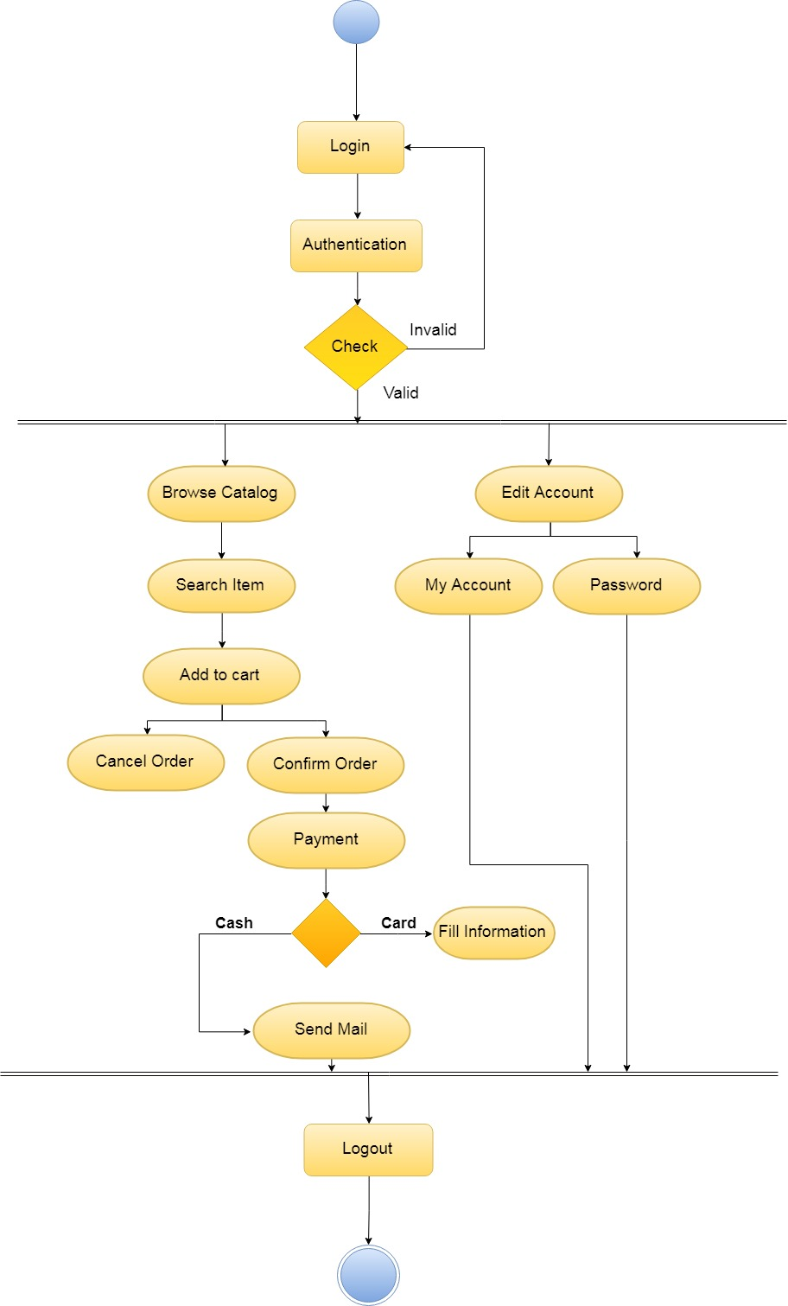

- Activity diagram of Admin

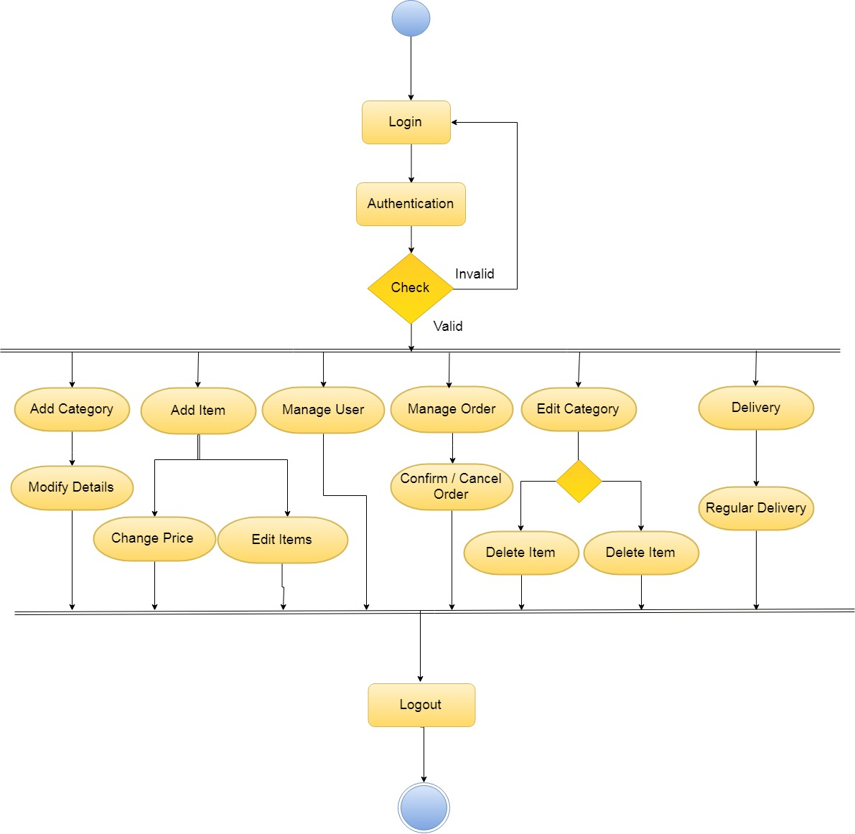

State Transition Diagram

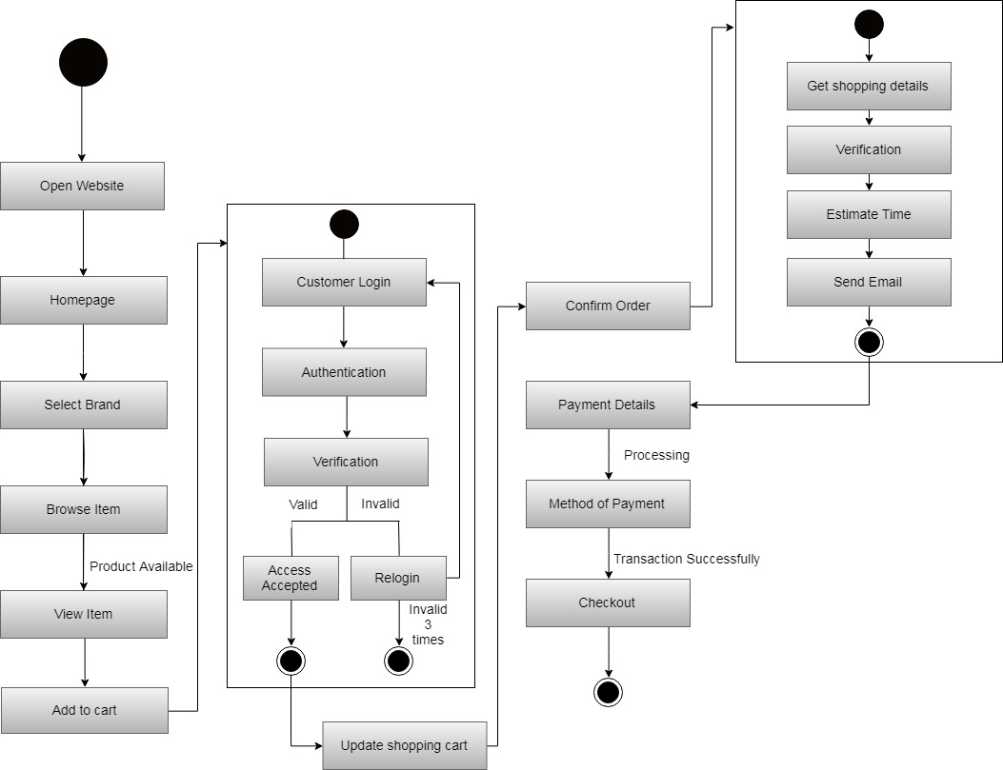

Component Diagram

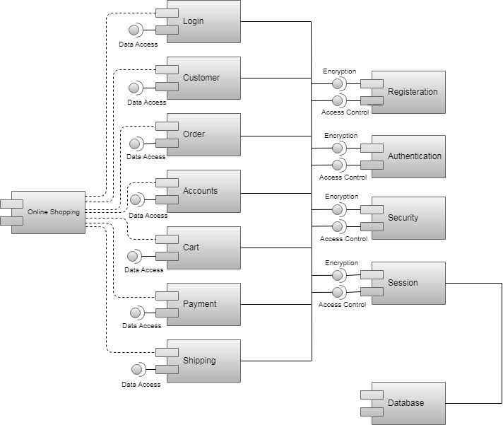

Deployment Diagram

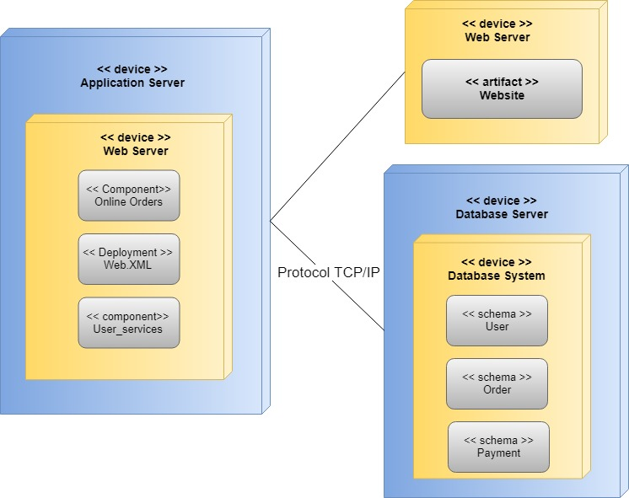

Data Flow diagram
In this we have used the object-oriented approach so that’s why this diagram is not necessary.
As the other diagrams show the working and functionalities of the system.

Chapter 5

Implementation

Chapter 5: Implementation
To make a website where customer can buy any kind of clothes of any kind of brand that are available I Pakistan on a great discounts in very difficult. To implement such kind of thing on a single platform require many things to perform and how we are going to handle them and implement them is explained in this chapter.

Important Flow Control/Pseudo codes
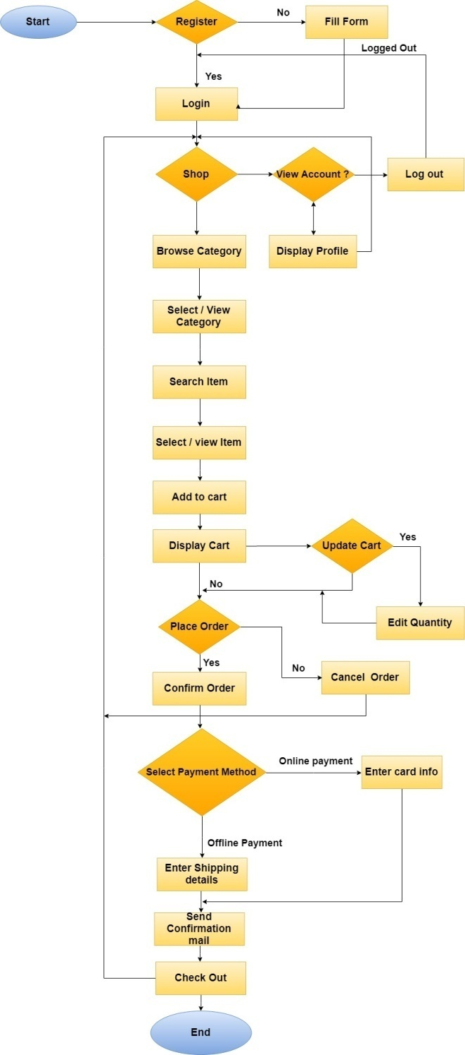

Components, Libraries, Web Services and stubs
Components:

- Properly Structured Website
One stop shop website is easy and useful to use. If a customer wants to purchase any clothes of any brands, they can easily purchase from our website. Our website has a easy configuration. All the information and arrangements of data are in a appropriate order and user can easily gets what he wants.

2. Mobile Friendly Shopping Experience
As we know that in today’s world of technology more and more people have been using mobile devices for almost everything. Our website is mobile friendly. And customer can easily access the enjoyment of our website on their smart phones.

Web Services
- 24-hr access
- Variety
- Facility to evaluate
- home-privacy

Deployment Environment
Here we need a domain on which the Gr3n system will exists and through the domain several people will access the application. And smart phone users can download either form Apple store or from Google play store through which they can easily access the service and can easily purchase online products. It required one administrator who will be in charge of the approval and other supervision duty.

Tools and Techniques
Applications and tools that would be used during this project preparation are as follows:

- Microsoft Word
Microsoft word is used for documentation purpose throughout the whole project.

- Microsoft Project
Microsoft Projects provides extensive features on project management with a prominent feature of project scheduling. Gantt charts, resource allocations. This would be used as a project management tool throughout the whole project.

- Draw.io
Draw.io is a tool for modeling different diagrams which would be addressed during Analysis and design phases of the project.

- Project Modeling
Microsoft Visio is also used for different Perspectives. Use case Diagram, Data Flow Diagram (DFD), domain model and all other OOAD analysis and Design diagrams are supported.

- Server
Server is required where whole data is stored.

Best Practices / Coding Standards
- No coding repetition
- Function and classes are always commented showing expected input and output.

Version Control
A component of software configuration management, version control, also known as revision control or source control, is the management of changes to documents, computer programs, large web sites, and other collections of information. So in this system we have used the agile software development for version control.

Chapter 6

Testing and Evaluation

Chapter 6: Testing and Evaluation
. A test strategy is methodology that describes the various steps that need to be performed during testing and the time and effort required for performing them. The following strategies are used for testing.

Use Case Testing
Test case 1 (Registration)

Test suite ID | S001
Test Case ID | C001
Actor | Unregister user
Test Case Summery | To verify that the Registration saves new user.
Related Requirement | User should be able to sign up.
Prerequisites | None
Test Procedure | - Open the Signup , Press Register button  - Fill Registration Form.  - Click Submit button.
Test Data | For username field:  Maha, maha123, maha123@gmail.com  For password field:  1234, abc12 , ABC12*
Expected | For username:  - If valid username is entered (accepted).  - If invalid username is entered, the field color should turn red (rejected).  - The form will not be post and User will be notify “Please match the format request as the password requirement is not meet.”  - The form will not be post and User will be notify “Please match the format request as the password Confirmation is not Correct.”  - When User enters a Password less then (5 digits password) then a  message must show “Your Password is Weak Please Enter the Strong  Password to secure your account”.  - The User will be created in the database, the browser will display the  Search area and client name will replace the text “guest” in the Navigation bar.
Actual Result | Test Successful.
Status | Pass
Created By | Usman Sharif
Date of Creation | 10- June-2019
Executed by | Haider Ali

Test case 2 (Login)

Test suite ID | S002
Test Case ID | C002
Actor | Register user
Test Case Summery | To verify that login button functions
Related Requirement | correctly.
Prerequisites | 1. User must be registered
Test Procedure | - 2.Open application  - 3. Enter Email and password  - 4. Click on the login button
Test Data | Login detail jack123,john  Login detail abc123@outlook.org
Expected | - If the username and password are  valid then the home page should be  Opened.  - When User enters in invalid Email  then message show “Your Email is  invalid Please Enter the correct Email,  Retry option”.  - When User enters a wrong Password  then message show “Your Password is  invalid Please Enter the correct  Password, Retry option”.
Actual Result | Login successful
Status | Test Successful.
Created By | Usman Sharif
Date of  Creation | 10- June-2019
Executed by | Maha Shahid

Test case 3 (LogOut)

Test suite ID | S003
Test Case ID | C003
Actor | Register user
Test Case Summery | To verify that Logout button is working when user click on it.
Related Requirement | Login user cans Logout.
Prerequisites | None
Test Procedure | - When the user can Log in if he want to Logout.  - Click Logout button
Test Data | For username field:  Jack, john123,abc234@outlook.org  For password field:  123123, asdasdv1232, as, ATy78&  For city:  23123, asdasdas, Chakwal, Lahore
Expected | For username:  - If valid username is entered, the field color should turn green (accepted).  - If invalid username is entered, the field color should turn red (rejected).  - The form will not be post and User will be notify “Please match the format request as the password requirement is not meet.”  - The form will not be post and User will be notify “Please match the format request as the password Confirmation is not Correct.”  - When User enters a Password less then (5 digits password) then message show “Your Password is Weak Please Enter the Strong Password to secure your account”.  - The User will be created in the database, the browser will display the search area and client name will replace the text “guest” in the navigation bar.  - When the user want to logout then click on logout button.
Actual Result | Login successful
Status | Test Successful.
Created By | Usman Sharif
Date of  Creation | 10- June-2019
Executed by | Haider Ali

Test case 4 (Select Item)

Test suite ID | S004
Test Case ID | C004
Actor | Register user
Test Case Summery | To verify Select item button is functioning correctly.
Related Requirement | User can select item and add into cart.
Prerequisites | Use must be login.
Test Procedure | - Login in  - Select Item
Test Data | Valid selected Item  Invalid selected Item
Expected | User can select Item
Actual Result | Select item is added into the cart.
Status | Test Successful.
Created By | Usman Sharif
Date of Creation | 15-May-2019
Executed by | Maha Shahid
Date of Execution | 10- June-2019

Test case 5 (View Detail)

Test suite ID | S005
Test Case ID | C005
Actor | Register user
Test Case Summery | To verify View Detail is functioning correctly.
Related Requirement | User can enter required information to view detail.
Prerequisites | Use must be login.
Test Procedure | Login in  User can enter a required information
Test Data | User can view detail of the items
Expected | User can view detail of selected item.
Actual Result | View detail of the selected item
Status | Test Successful.
Created By | Usman Sharif
Date of Creation | 15-May-2019
Executed by | Haider Ali
Date of Execution | 10- June-2019

Test case 6 (Place Order)

Test suite ID | S006
Test Case ID | C006
Actor | Register user
Test Case Summery | To verify place order button is functioning  correctly.
Related Requirement | - User must be successfully Login In.  - Information of the User must be successfully entered.  - Information of the Source must be successfully entered.
Prerequisites | User must be login.  Select the item.
Test Procedure | User must login  Select the item  Add to cart after selecting the item.
Test Data | User can place order.
Expected | User can place order after selecting the  item.
Actual Result | Place order after selecting the product.
Status | Test Successful.
Created By | Usman Sharif
Date of Creation | 15-May-2019
Executed by | Haider Ali
Date of Execution | 10- June-2019

Test case 7 (View Order)

Test suite ID | S007
Test Case ID | C007
Actor | Register user
Test Case Summery | To verify view order button is functioning correctly.
Related Requirement | - User must be successfully Login In  - Information of the User must be successfully entered  - Information of the Source must be successfully entered
Prerequisites | User can view order of selected item.
Test Procedure | - User must login  - Select the item  - Add to cart after selecting the item.  User can view order of selected item.
Test Data | User can view order.
Expected Result | User can view order after placing the order.
Actual Result | View the order detail.
Status | Test Successful.
Created By | Usman Sharif
Date of Creation | 15-May-2019
Executed by | Maha Shahid
Date of Execution | 10- June-2019

Test case 8 (Cancel Order)

Test suite ID | S008
Test Case ID | C008
Actor | Register user
Test Case Summery | To verify cancel order button is functioning correctly.
Related Requirement | - User must be successfully Login In  - Information of the User must be successfully entered  - Information of the Source must be successfully entered
Prerequisites | User can cancel order of selected item.
Test Procedure | - User must login  - Select the item  - User can cancel the order..
Test Data | User can cancel order.
Expected Result | User can cancel order after placing the order.
Actual Result | View the detail.
Status | Test Successful.
Created By | Usman Sharif
Date of Creation | 15-May-2019
Executed by | Maha Shahid
Date of Execution | 10- June-2019

Test case 9 (Add to Cart)

Test suite ID | S009
Test Case ID | C009
Actor | Register user
Test Case Summery | To verify Add to cart button is functioning correctly.
Related Requirement | - User must be successfully Login In  - Information of the User must be successfully entered  - Information of the Source must be successfully entered
Prerequisites | None
Test Procedure | - User must login  - Select the item  - Add to cart after selecting the item.
Test Data | User can add item into cart.
Expected Result | User can add item into cart.
Actual Result | Add item into the cart.
Status | Test Successful.
Created By | Usman Sharif
Date of Creation | 15-May-2019
Executed by | Haider Ali
Date of Execution | 10- June-2019

Test case 10 (Select Payment Method)

Test suite ID | S010
Test Case ID | C010
Actor | Register user
Test Case Summery | To verify payment method button is functioning correctly.
Related Requirement | - User must be successfully Login In  - Information of the User must be successfully entered  - Information of the Source must be successfully entered
Prerequisites | None
Test Procedure | - User must login  - Select the item  - After tracking the order then payment module show in front of the user and  - select payment method by hand or by credit card.
Test Data | User can add item into cart and payment method show.
Expected Result | Payment method shows in front of the user.
Actual Result | After placing the order payment method shows in front of the user.
Status | Test Successful.
Created By | Usman Sharif
Date of Creation | 15-May-2019
Executed by | Maha Shahid
Date of Execution | 10- June-2019

Test case 11 (Add Item)

Test suite ID | S011
Test Case ID | C011
Actor | Admin
Test Case Summery | To verify add item button is functioning correctly.
Related Requirement | Admin can add item like
Prerequisites | None
Test Procedure | Admin can add item like
Test Data | None
Expected | Admin can add item.
Actual Result | Item is added
Status | Test Successful.
Created By | Usman Sharif
Date of Creation | 15-May-2019
Executed by | Haider Ali
Date of Execution | 10- June-2019

Test case 12 (Delete Item)

Test suite ID | S012
Test Case ID | C012
Actor | Admin
Test Case Summery | To verify delete item button is functioning correctly.
Related Requirement | Admin can delete item like
Prerequisites | None
Test Procedure | Admin can delete item like
Test Data | None
Expected | Admin can delete item.
Actual Result | Item is delete
Status | Test Successful.
Created By | Usman Sharif
Date of Creation | 15-May-2019
Executed by | Maha Shahid
Date of Execution | 10- June-2019

Test case 13 (Update Item)

Test suite ID | S013
Test Case ID | C013
Actor | Admin
Test Case Summery | To verify Update item button is functioning correctly.
Related Requirement | Admin can Update item like
Prerequisites | None
Test Procedure | Admin can Update item like
Test Data | None
Expected | Admin can Update item.
Actual Result | Item is Update
Status | Test Successful.
Created By | Usman Sharif
Date of Creation | 15-May-2019
Executed by | Haider Ali
Date of Execution | 10- June-2019

Function Testing
The function testing is about to test the whole function and check that if the function is working properly. In this scenario we will test all the functionalities of the project an after all these testing, we have entered all the screenshots of our website which are given further below in this document. System testing involves the set of tests that ensures that the entire system performs according to specifications

Unit testing
Unit testing is a white-box testing technique. The main consideration in this test is verification of all modules of the software system. Each module is unit tested, as follows:

- Unit testing for the project User Management is tested by valid user or invalid user.

- Unit testing for the project User Account management is provided by testing Login, Logout and creating new or deleting updating existing user.

- Unit testing for the project articles details is performed by entering new information.

- Unit testing for the Project Detail of items give detail accurately.

- Unit testing for the module Add/update/delete product.

- Unit testing for the project online payments is performed by searching customer record of continuing status then entering payment information

Integration testing

Integration testing is the technique for testing the interfaces of software components. Each software components in unit tested, and all the components are integrated to perform together. The tests are conducted to ensure that the components are working properly after interfacing.

All modules are integrated by an incremental approach, and integration testing of the system is performed as follows:

- Integrate login module and test that the software is properly connected to the database.

- Integrate all modules and test by inserting updating, and deleting records.

Screen Shots
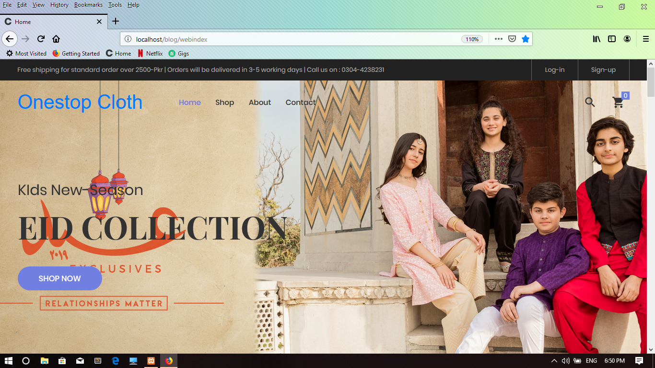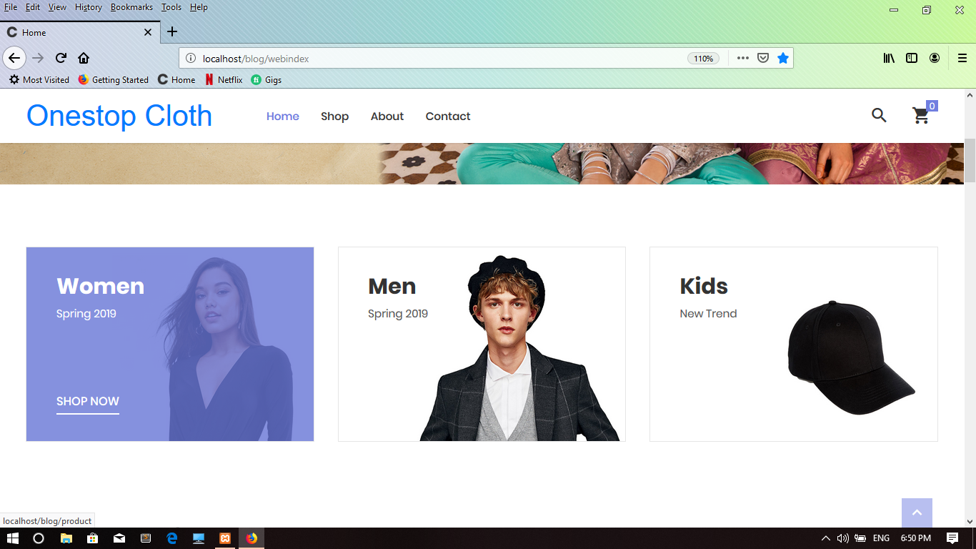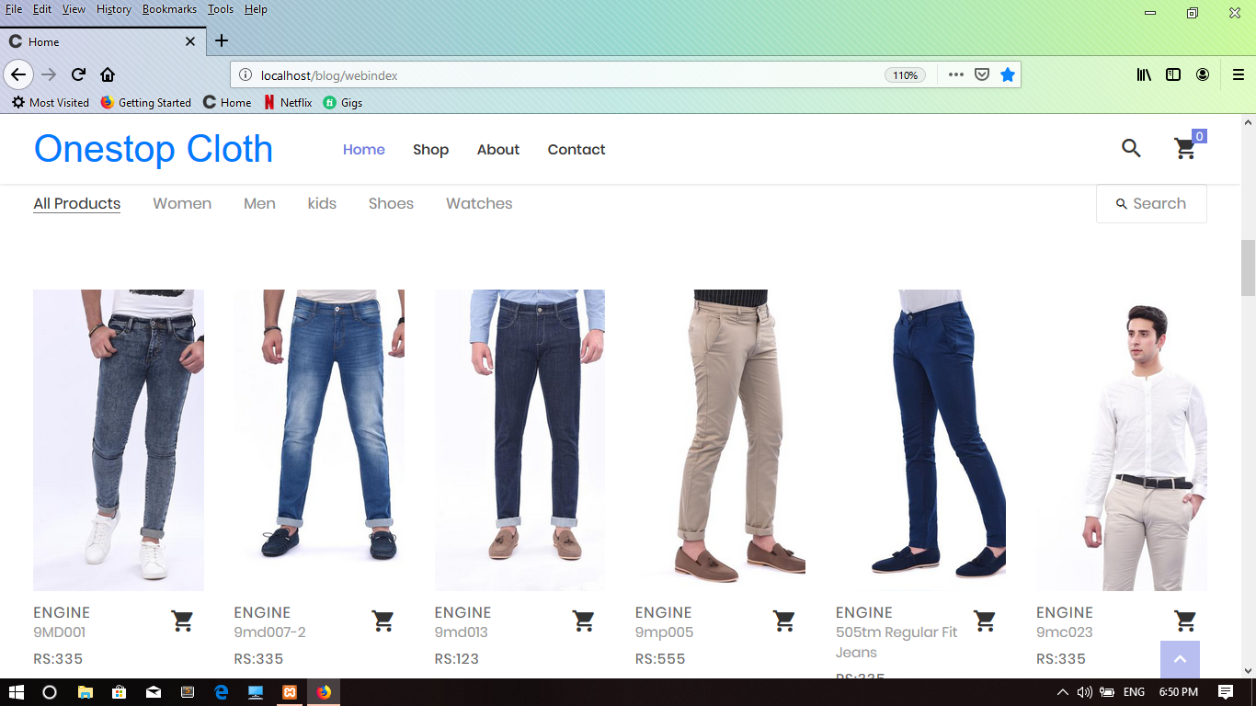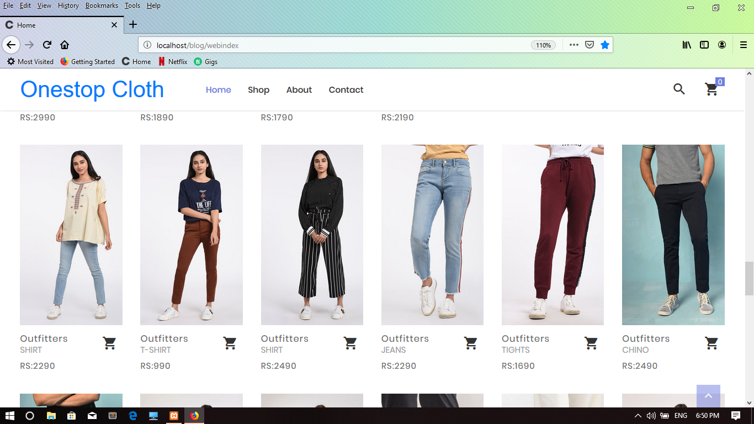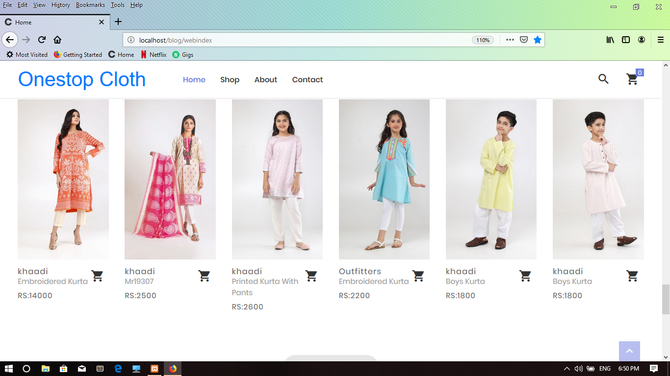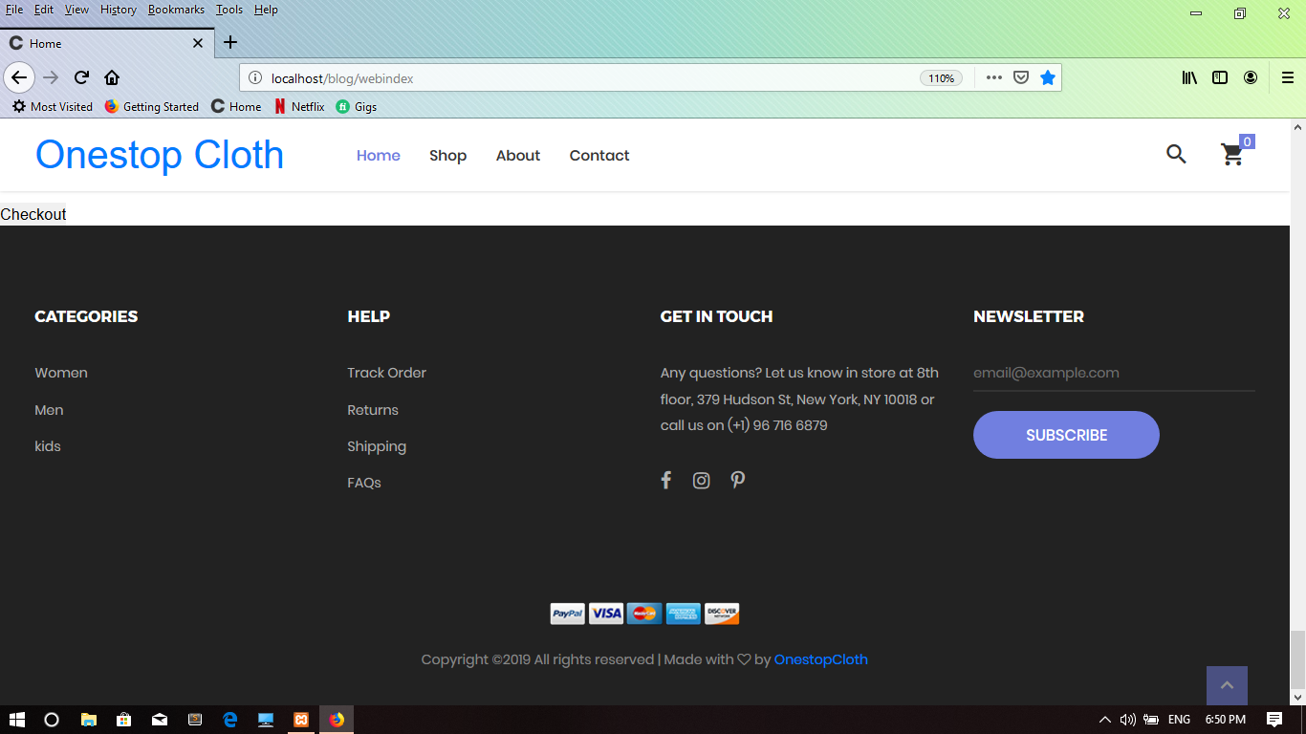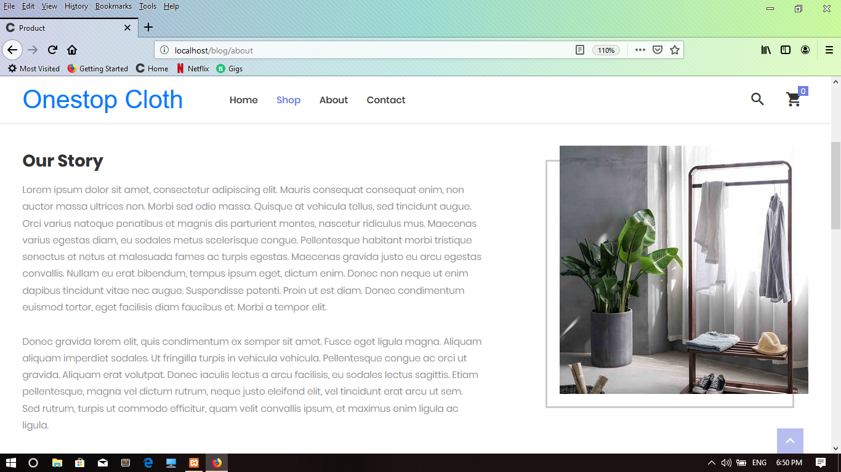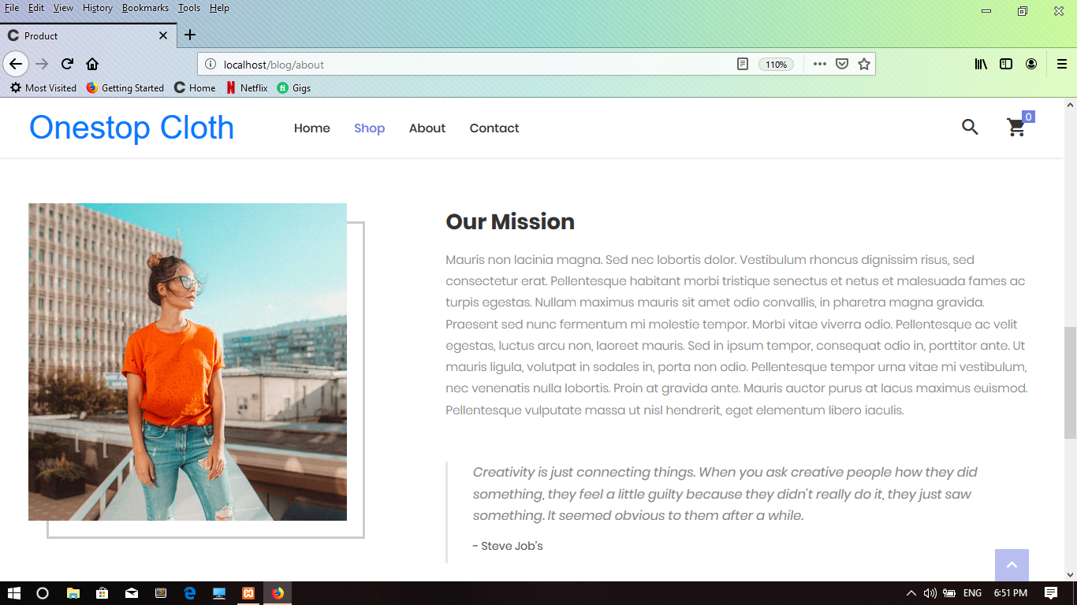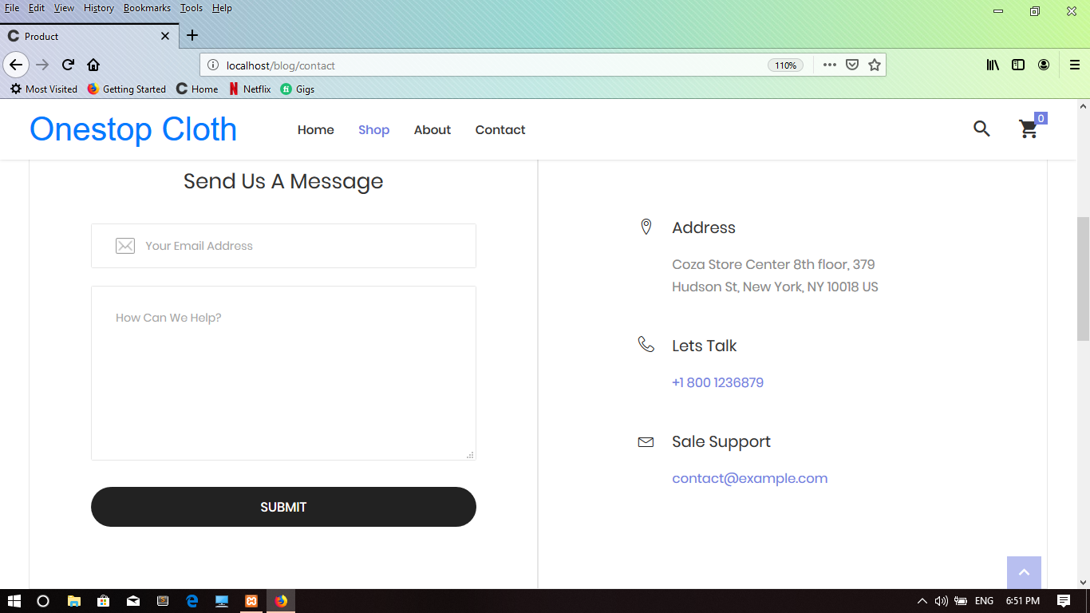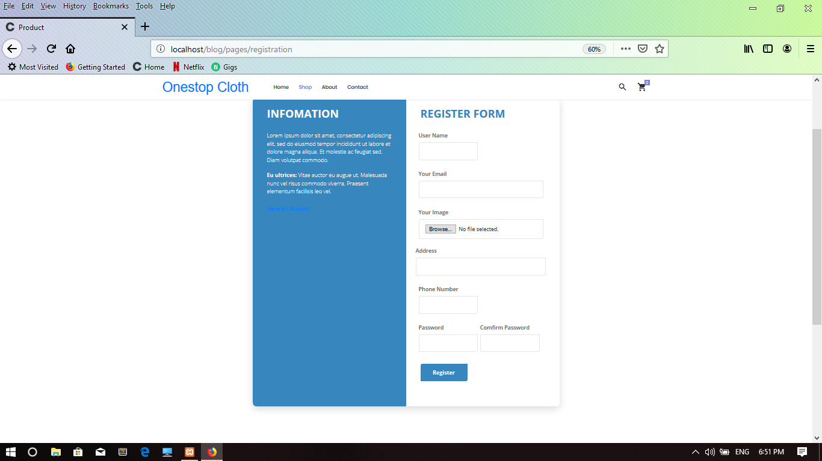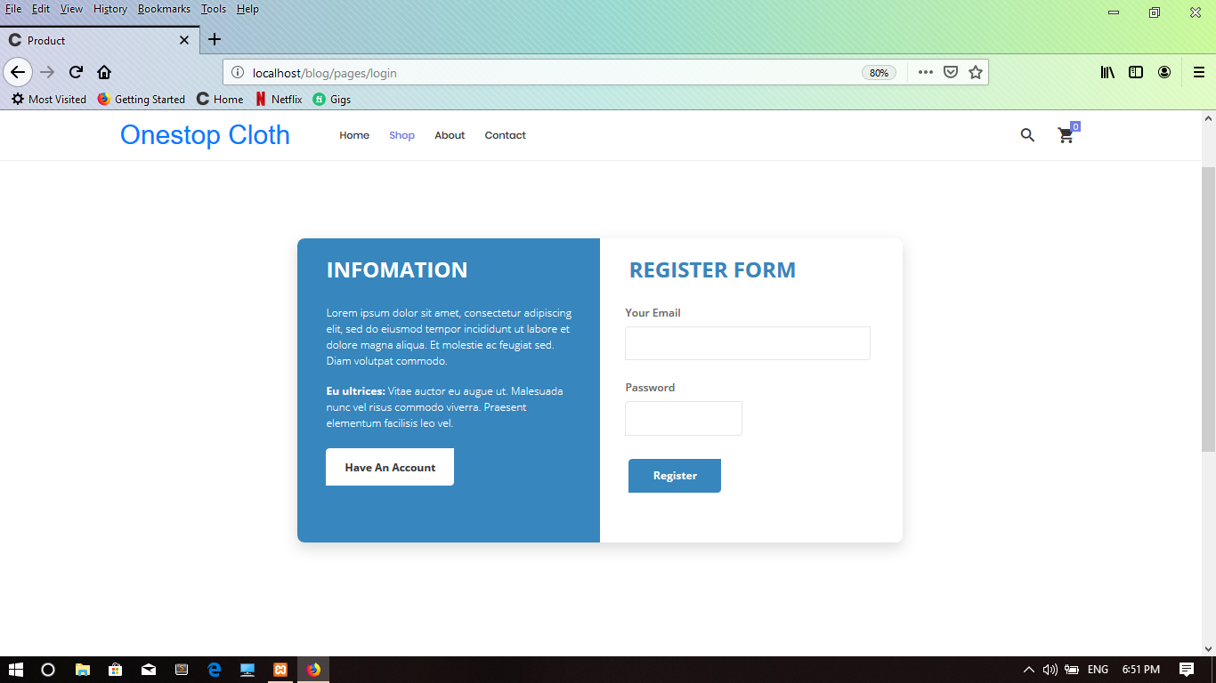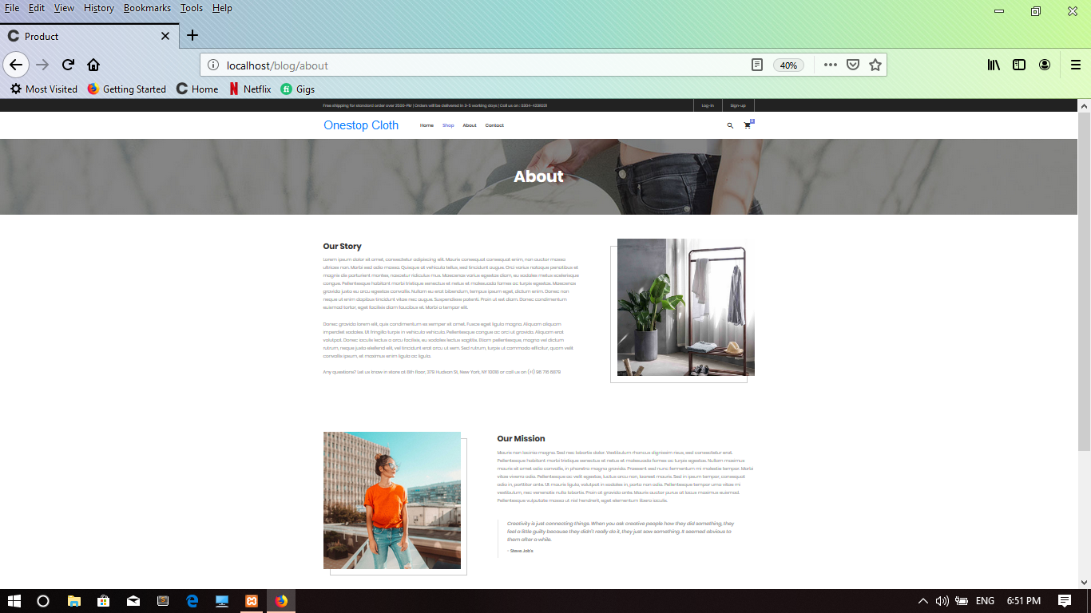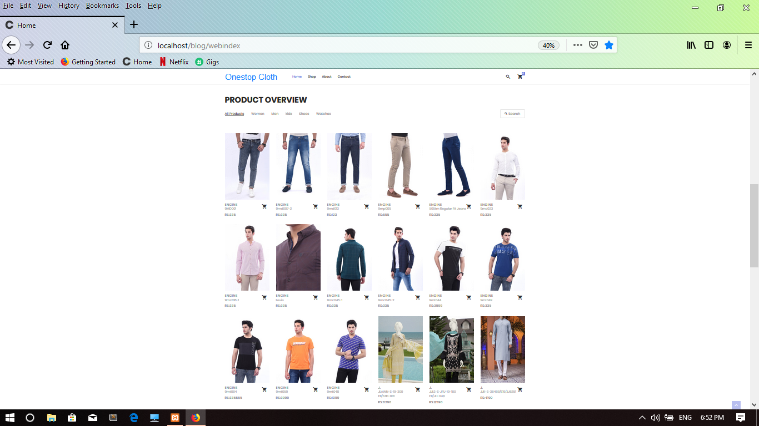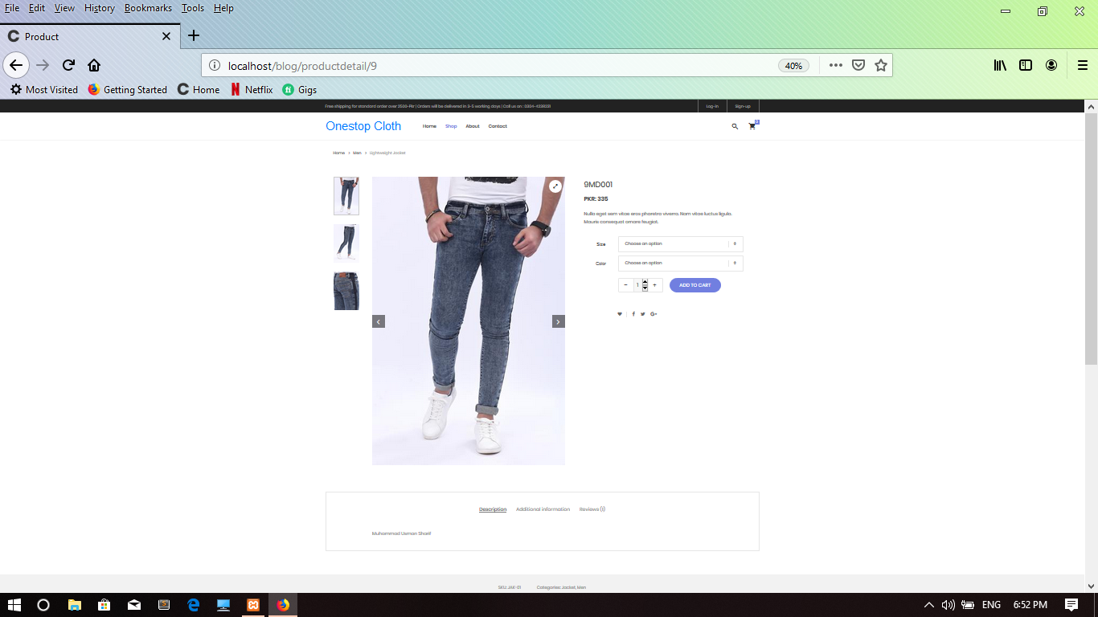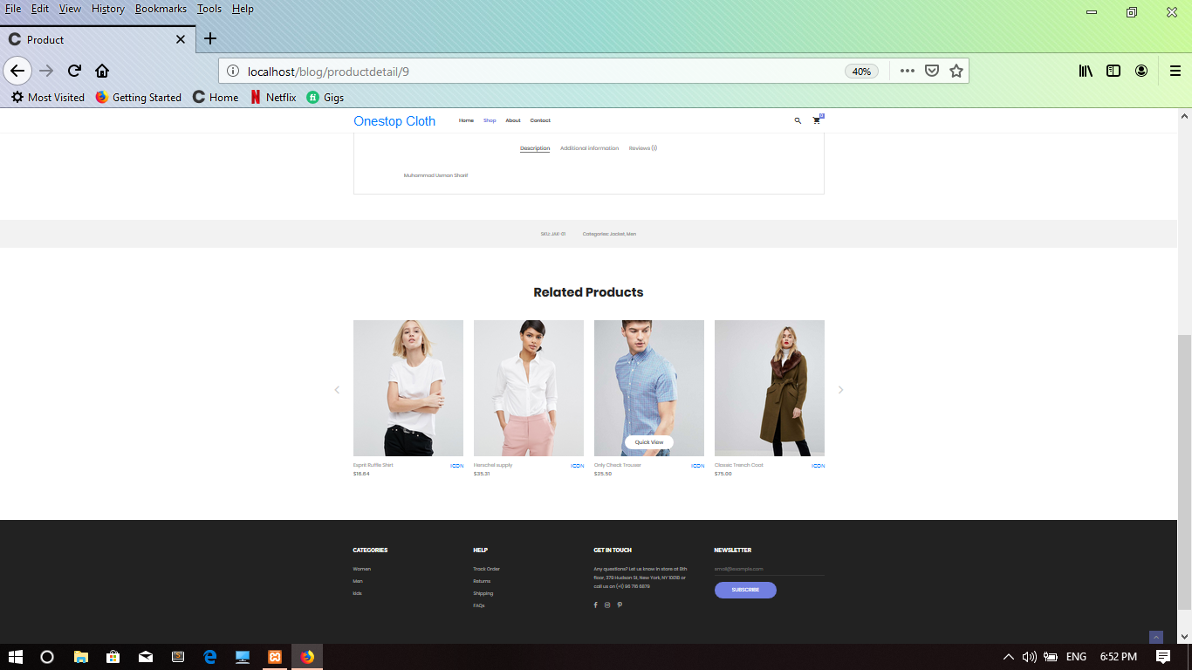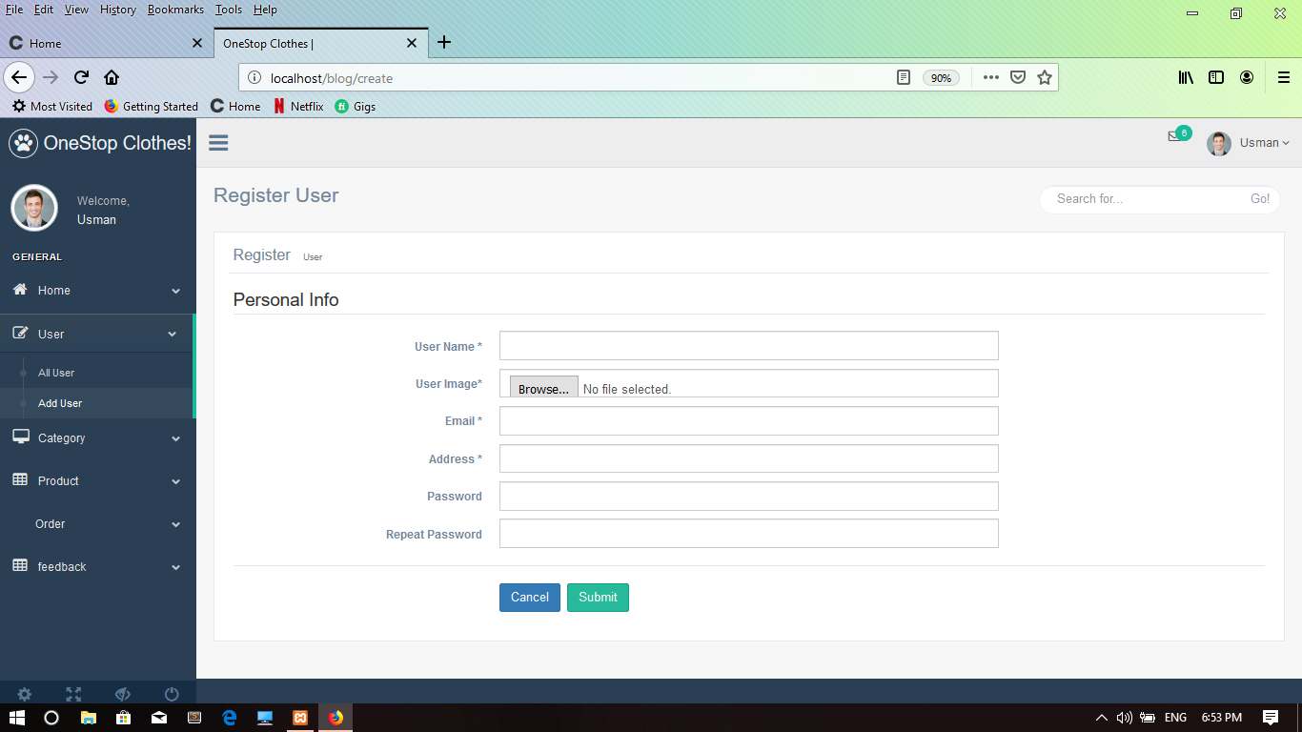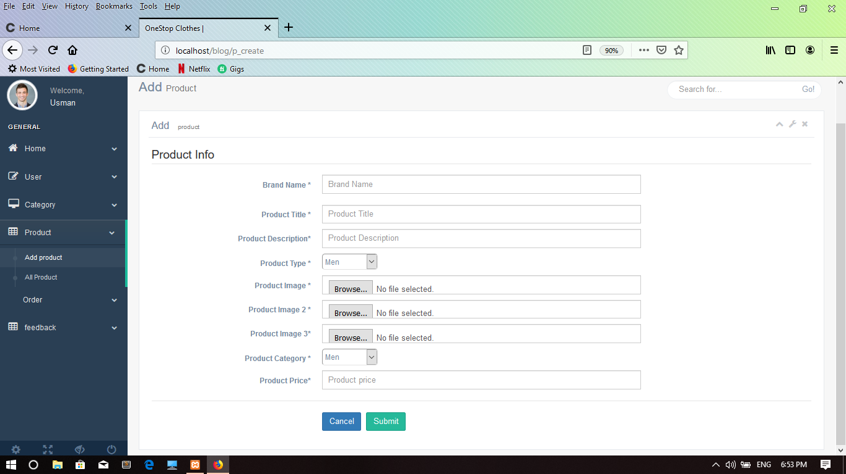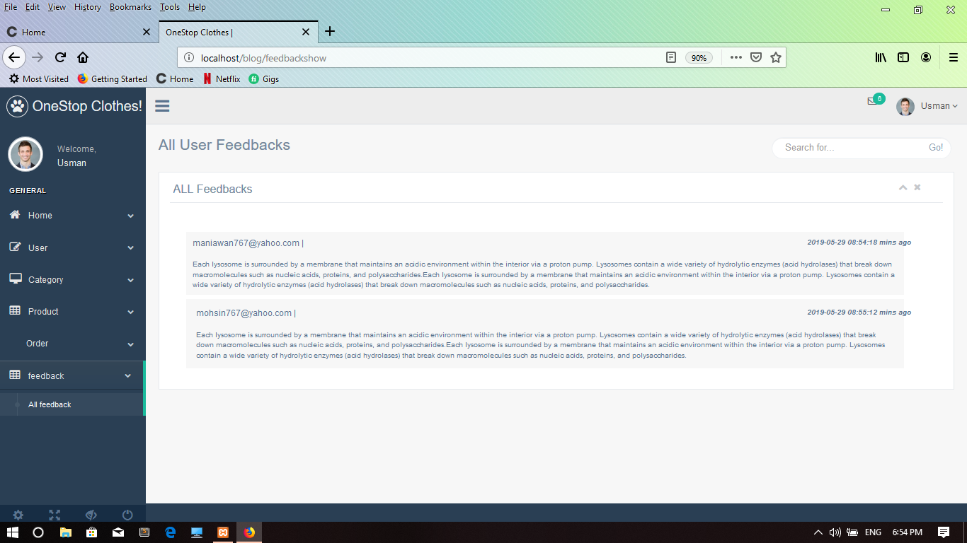

Chapter 7

Summary, Conclusion and Future Enhancements

Chapter 7: Summary, Conclusion & Future Enhancements

Project Summary

In today’s world fashion industry is always looking for the latest trend to absorb it and then spread it to the rest of the world. Each fashion brand aims to create a unique and characteristic visual style that fits its personality. However, there are certain characteristics that are common to most fashion company’s websites. But the main characteristic that we are entering in our website is that we are merging the entire Pakistanis top brand on a single platform that will ease you from surfing on different website.
We are giving our customers an easy and convenient way to shop from the comfort of their homes on a website that sells all of their favorite clothes from their favorite brands. So, you don’t need to go and look for each and every website of each brand. We have given you a platform that will give you amazing discounts and they will deliver all your products safely at your home.
Many of the brands add hidden charges like shipping, taxes etc., which our website will not allow and the customer has to pay only the actual amount. During all these processes, we will provide safety and privacy of your data.

Achievements and Improvements

One stop cloth is the online shopping website where consumer search different brand and select cloth only in one website. This product has great future scope. One stop cloth is online shopping store where user easily search product and purchase sit in the front of computer and received at doorstep
The purpose scope is to present an efficient, reliable online shopping and deliver the product safely and securely. The achievements that we have made is that we are providing all the details of different and top most Pakistani brands on a single shelter and gives our customers an ease for shopping with us.

Lessons Learnt
This project helped us in gaining valuable information and practical knowledge on several topics like designing web pages using html & css and laravel, usage of responsive templates, designing of responsive website, and management of database using mysql . The entire system is secured. Also the project helped us understanding about the development phases of a project and software development life cycle. We learned how to test different features of a project.

Future Enhancements/Recommendations
In future the project will be updated with to top most methodology and with the passage of time new advancement will be mad in it and kept in knowledge. Stay aware of patterns and advancements in online industry, watch out for the opposition and receive new innovation.

Reference and Bibliography

Reference and Bibliography

[1] M. Sher, M. Rehman, “Title of the Paper” Conference name/Journal Name, Edition, Volume, Issue, ISBN/ISSN, PP, Publisher/City-Country, Year.
M. Sher, M. Rehman, “Title of the Paper” Conference name/Journal Name, Edition, Volume, Issue, ISBN/ISSN, PP, Publisher/City-Country, Year.
[2]P. T. S. J. Joseph, 2006, E-Commerce: An Indian Perspective 4 Edition 4th Edition
[3]Shiven Dragupta, 2014, Introduction [online]. Available.

https://www.slideshare.net/shivendragupta55/trustbuilding factors-in-ecommerce industry

[3]-------, 2014, Flowchart [online]. Available.

https://code2flow.com/app

[4]-------2014, summery, [online]. Available.

https://www.bplans.com/hydroponics_farm_business_plan/executive_summary_fc.phpre

- By Ulf Eriksson 28th September 2012, Test case [online]. Available. https://reqtest.com/tutorials/how-to-develop-a-template-for-test-cases/

- ------, October 31, 2017, Sequence Diagram [online]. Available http://centreurope.info/sequence-diagram-template/sequence-diagram-template-sequence

diagram-templates-to-instantly-view-object-interactions-free/

- E draw Soft 2004-2018, Class Diagram [online]. Available https://www.edrawsoft.com/template-uml-class-diagram.php

[8] ---------, 2016 Wiring Diagram, Network Diagram [online]. Available http://collagenrestores.com/basic-network-diagram-example-image/physical-network-

diagram-quickly-create-professional-physical-4/

[9]-------, 1993 — 2018 CS Odessa, Activity Diagram, [online]. Available

http://www.conceptdraw.com/examples/activity-diagram-template [10]-----, 2018, Diagram Build Tool, [online]. Available http://www.draw.io
[4] http://www.w3schools.com/html/defualt.asp, http://www.w3schools.com/css/default.asp, http://www.w3schools.com/js/default.asp

