Korai Iron Store

Final Year Project

Session 2015-2019

A project submitted in partial fulfillment of the degree of

BS in Software Engineering


Department of Software Engineering
Faculty of Computer Science & Information Technology
The Superior College, Lahore

FALL 2019

Type (Nature of project) |  |  | [ ] Development [ ] Research [ ] R&D
Area of specialization |  |  | Web Development
FYP ID |  |  | FYP-BSSE-S19-003
Project Group Members
Sr.# | Reg. # | Student Name |  | Email ID | *Signature
(i) | Bsem-F15-067 | Usman Bilal |  | Usmanbilal66@gmail.com
(ii) | Bsem-F15-068 | Umar Bilal |  | Ughani956@gmail.com
(iii) | Bsem-F15-097 | Noman Latif |  | noumanlatif143@gmail.com

*The candidates confirm that the work submitted is their own and appropriate credit has been given where reference has been made to work of others

Plagiarism Free Certificate
This is to certify that, I am Usman Bilal S/D of Bilal Hussain, group leader of FYP under registration no __________Bsem-f15-067____________________at Software Engineering Department, The Superior College, Lahore. I declare that my FYP report is checked by my supervisor.

Date: Name of Group Leader: Usman Bilal Signature: _____________
Name of Supervisor: Sir Imran Ahmad
Designation: Junior Lecturer
Signature: ________________
HoD: Dr. Arfan Jaffar
Signature: _______________

Project Report
[Korai Iron Store]

Change Record
Author(s) | Version | Date | Notes | Supervisor’s Signature
 | 1.0 |  | <Original Draft>
 |  |  | <Changes Based on Feedback from Supervisor>
 |  |  | <Changes Based on Feedback From Faculty>
 |  |  | <Added Project Plan>
 |  |  | <Changes Based on Feedback from Supervisor>

APPROVAL
Project Supervisor
Comments: ___________________________________________________________________
_____________________________________________________________________________
Name:______________________________
Date:_______________________________ | Signature:__________________________

Project Manager
Comments: ___________________________________________________________________
_____________________________________________________________________________
Date:_______________________________ | Signature:__________________________

Head of the Department
Comments: ___________________________________________________________________
_____________________________________________________________________________
Date:_______________________________ | Signature:__________________________

Dedication

This work is dedicated to our parents, who believed us and giving a chance to get knowledge, makes better life himself, popularizes the name of his university and Pakistan also. We are also dedicating to our respected teachers and specially our supervisors, who help us to making and completing this project. We are also thanks to our chairman and all the superior team, who provides a platform to enhancing and creating our abilities and polished us for every type of situation.

Acknowledgements

Alhamdulillah, all praises to Allah Almighty, the most Merciful and the most Gracious, for the strengths and His blessings in completing this Project. Working on this project was indeed a challenging task that demanded immense efforts. But we feel proud to express our deepest sense of gratitude and appreciation to our supervisor Sir. Imran Ahmad for his kind help, advice, inspired guidance, unlimited support, sympathetic attitude and sincere personal involvement throughout the development of project. We would never have been able to reach this stage but for the prayers and great support of our families. Thanks and best wishes for all those who have made this learning experience so wonderful for us.

Executive Summary
Web based application for an Iron shop. Different types of data of different users will be maintained separately. Customers are purchasing products and have records of each transaction. Each customer should have to provide authentication to use the system. Authenticated User can check the Updated records of sale, purchase and other relevant things. The environment of the application will be user-friendly. The design is according to customer perspective and their needs. Pictures of products and their price will be upload for public users. Customers can communicate the owner in different ways. We provide help corner online.

Table of Contents
Korai Iron Store i
Final Year Project i
Session 2015-2019 i
BS in Software Engineering i
*The candidates confirm that the work submitted is their own and appropriate credit has been given where reference has been made to work of others ii
Plagiarism Free Certificate ii
Dedication v
Acknowledgements vi
Executive Summary vii
Table of Contents viii
List of Figures xii
List of Tables xiii
Chapter 1 14
Introduction 14
1.1. Background 15
1.2. Motivations and Challenges 15
1.3. Goals and Objectives 15
1.4. Literature Review/Existing Solutions 16
1.5. Gap Analysis 17
1.6. Proposed Solution 18
1.7. Project Plan 19
1.7.1. Work Breakdown Structure 19
1.7.2. Roles & Responsibility Matrix 21
1.7.3. Gantt Chart 22
1.8. Report Outline 23
Chapter 2 24
Software Requirement Specifications 24
2.1. Introduction 25
2.1.1. Purpose 25
2.1.2. Document Conventions 25
Stander rules of SRS documentation has been followed in the order of standardized the work. In order to create efficient this Website in the properties of data storing and make online order. 25
2.1.3. Intended Audience and Reading Suggestions 25
2.1.4. Product Scope 26
2.1.5. References 26
2.2. Overall Description 27
2.2.1. Product Perspective 27
2.2.2. Product Functions 27
2.2.3. User Classes and Characteristics 30
2.2.4. Operating Environment 31
2.2.5. Design and Implementation Constraints 31
2.2.6. User Documentation 32
2.2.7. Assumptions and Dependencies 32
2.3. External Interface Requirements 32
2.3.1. User Interfaces 32
Client of the site will be given the Graphical UI; there is no order line interface for any elements of the item. 32
2.3.2. Hardware Interfaces 33
2.3.3. Software Interfaces 34
2.3.4. Communications Interfaces 34
2.4. System Features 34
2.4.1. System Feature 1 36
2.4.1.1. Description and Priority 36
2.4.1.2. Stimulus/Response Sequences 36
2.4.1.3. Functional Requirements 37
2.4.2. System Feature 2 37
2.4.2.1. Description and Priority 37
2.4.2.2. Stimulus/Response Sequences 38
2.4.2.3. Functional Requirements 38
2.4.3. System Feature 3 39
2.4.3.1. Description and Priority 39
2.4.3.2. Stimulus/Response Sequences 39
2.4.3.3. Functional Requirements 40
2.4.4. System Feature 4 40
2.4.4.1. Description and Priority 40
2.4.4.2. Stimulus/Response Sequences 41
2.4.4.3. Functional Requirements 41
2.4.5. System Feature 5 42
2.4.5.1. Description and Priority 42
2.4.5.2. Stimulus/Response Sequences 42
2.4.5.3. Functional Requirements 42
2.4.6. System Feature 6 43
2.4.6.1. Description and Priority 43
2.4.6.2. Stimulus/Response Sequences 43
2.4.6.3. Functional Requirements 44
2.4.7. System Feature 7 44
2.4.7.1. Description and Priority 44
2.4.7.2. Stimulus/Response Sequences 45
2.4.7.3. Functional Requirements 45
2.4.8. System Feature 8 46
2.4.8.1. Description and Priority 46
2.4.8.2. Stimulus/Response Sequences 46
2.4.8.3. Functional Requirements 47
2.4.9. System Feature 09 47
2.4.9.1. Description and Priority 47
2.4.9.2. Stimulus/Response Sequences 48
2.4.9.3. Functional Requirements 48
2.4.10. System Feature 10 49
2.4.10.1 Description and Priority 49
2.4.10.2 Stimulus/Response Sequences 49
2.4.10.3 Functional Requirements 50
2.4.11 System Feature 11 50
2.4.11.1 Description and Priority 50
2.4.11.2 Stimulus/Response Sequences 50
2.4.11.3 Functional Requirements 51
2.4.12 System Feature 1: Registration 51
2.4.12.1 Description and Priority 51
2.4.12.2 Stimulus/Response Sequences 52
2.4.12.3 Functional Requirements 52
2.4.13 System Feature 2: Login 53
2.4.13.1 Description and Priority 53
2.4.13.2 Stimulus/Response Sequences 53
2.4.13.3 Functional Requirements 54
2.4.14 System Feature 3: Logout 54
2.4.14.1 Description and Priority 54
2.4.14.2 Stimulus/Response Sequences 55
2.4.14.3 Functional Requirements 55
2.4.15 System Feature 4: Moisture Details 55
2.4.15.2 Stimulus/Response Sequences 56
2.4.15.3 Functional Requirements 56
2.5 Other Nonfunctional Requirements 57
2.5.10 Performance Requirements 57
2.5.11 Safety Requirements 57
2.5.12 Security Requirements 57
2.5.13 Software Quality Attributes 57
2.5.14 Business Rules 58
2.6 Other Requirements 58
Chapter 3 60
Use Case Analysis 60
3.1. Use Case Model 63
3.2. Fully Dressed Use Cases 64
Chapter 4 93
System Design 93
4.1. Architecture Diagram 94
4.2. Domain Model 95
4.3. Entity Relationship Diagram with data dictionary 96
4.4. Class Diagram 97
4.5. Sequence / Collaboration Diagram 98
4.6. Operation contracts 99
4.7. Activity Diagram 106
4.8. State Transition Diagram 109
4.9. Component Diagram 110
4.10. Deployment Diagram 111
Chapter 5 112
Implementation 112
5.1. Components, Libraries, Web Services and stubs 113
5.2. Deployment Environment 114
5.3. Tools and Techniques 114
5.4. Best Practices / Coding Standards 115
5.5. Version Control 116
Chapter 6 117
Testing and Evaluation 117
Chapter 7 123
Summary and conclusion 123
Appendices 127

List of Figures

1.1 Caption of first figure of first chapter 14
1.2 Caption of first figure of second chapter 24
1.3 Caption of first figure of third chapter 60
1.4 Caption of first figure of forth chapter 93
1.5 Caption of first figure of fifth chapter 112
1.6 Caption of first figure of sixth chapter 117
1.7 Caption of first figure of seventh chapter 123

List of Tables

1.1 label of first table of first chapter 21
1.2 label of second table of first chapter 7
2.1 label of first table of second chapter 14
2.2 label of second table of second chapter 22
2.3 label of third table of second chapter 26
5.1 label of first table of fifth chapter 49
5.2 label of second table of fifth chapter 49

Chapter 1

Introduction

Chapter 1: Introduction
The owner of iron shop wants to make a web-based application. In this system, we define and explain the flow of sales and purchase with proper calculations. Almost calculations are manual and not yet have any online API. Manual Data may be lost anywhere anytime but this system will store data permanently in database. The system is also facilitating to the dealers by providing information regarding Iron price.

Background
A company works with the manual system in which they are facing more difficulties like managing the data entries, employee’s salaries and customers’ data. They wrote data of the firm on daily books and registers manually. Sometimes, the registrar missed the data entry of the products which was created issue in the form of the company’s loss. The wrong calculation is also another issue for firm. The owners of the company were in trouble to manage the problem of the firm.

Motivations and Challenges
We are providing a solution of the owner’s problems in the form of technology. That is the point which is motivated us to making and competing this project at any cost because we are changing the iron field through technology and overcome the communication gap of the customers and dealers of the iron products. This is the big challenge to educate and motivate the customers to moving on websites through computer technology but we are accepting this challenge to enhance product of cash iron by providing information and educating the customers of Pakistan.

Goals and Objectives
Goals and Objective of this project is very clear to control the problems of old system (that was to record the manual data) and facilitate to the owners of the shop. Using this software, maintain all data of the shop in database. Through this project, we provide the method to overcome the communication gap between user and Dealers and provide the all data for authenticated user on his account. Unauthorized user can also view the company’s website to get information about agriculture field.

Literature Review/Existing Solutions
There are many existing Point of sales in the market but these are all working offline. These corporations are not providing guidelines to customers. These offline systems only handle calculations for the ease of corporations and some local companies are using this type of point of sale systems which manage and save the data of the company. These all systems are basically desktop system. Many of peoples are used desktop based and maximum peoples are manually write and save the data on work books. We are also search on internet, about related websites and applications. There are many websites of iron shops but all providing information of company and business needs. In account of all these existing system, we are launching a system that is covering all the gapes in market. Our project is based on web-based Application. It has user-friendly interface. Its unique web based system because this system is not based on desktop application. It is the mixture of desktop and website-application. The system provides the facility to communicate with customers. This system is providing all information of the user on software. The user will login and see the status of the product and profile also.

Gap Analysis
The owner of shop "Korai Iron Store" wants to make web-based application. The web-application should be user-friendly, easy to use, and maintains the records of the shop. A shop works with the manual system in which they are facing more difficulties like managing the data entries, employee’s salaries and customers’ data. The owner decided to make complete software with the standard interface so that every person works according to his task on time. Basically, the problem is in the file system. It’s more difficult to manage the gap of customers, employees and how to work with other corporations for making standard relationships. They want to work according to standard business Rules. It also establishes his shop name as a brand in the market. All these problems are faced by owners of the shop and they decided to make complete software with the database. So that every person works according assign task at time and also focus on check and balance by owners and managers of shop.
Software should be user-friendly and all customer’s data (names, father names, addresses, CNIC numbers and etc.) accurately stored in the database. It should also maintain a stock of the Company and software telling about a stock which where is stand and tells record of every customer with his payment (debit and credit). All these issues will solve in this software and make reliable as much as possible. All attributes of the software will be reliable for the customer according to its desire.

Proposed Solution
- What it will solve?
- We will make a webs application for The Iron store that will act like point of sale and can save data of customer, franchise manager and Admin. At the end of each month admin and franchise manager will be able to see their statistical reports.
- It will provide platform for all users like admin, franchise manager and customers to get information about the desired product. The user can see all information which is necessary for him.
- The admin and franchise manager can check the reports of each month.
- Admin perform CRUD operation on Franchise manager and customer and the Franchise manager perform CRUD operation only on customer.

Admin

F. Manager
F. Manager
F. Manager

Customer
Customer
Customer
Customer
Customer
Customer

Project Plan
In Project Plan there are two things WBS and Gantt chart. In WBS we divide the mile stones into sub tasks to achieve the goals and objectives. Assign tasks to each team member according their work experiences. In Gantt chart we decide which tangibles things has to be deliver in which duration.

Work Breakdown Structure
Korai Iron Store
- Initialization
  - Inception
  - Problem
  - Market Analysis
  - Conclusion of Problem
  - Solution
- Planning
  - Elicitation
  - Analyze Problem
  - Design SRS
    - Documentation
    - Analyze Documents
    - Review Documents
    - feasibility Report
- Diagrams
  - Use Case
  - Domain Model
  - Sequence Diagram
  - System Sequence Diagram
  - Operational Contract
  - Activity Diagram
  - State Machine Diagram
  - Class Diagram
  - Deployment Diagram
- Implementation/Execution
  - Cover modules
  - Review Covered Modules
  - Control Changings
- Testing
  - Testing Tools
  - Testing Methods
    - Unit Testing
    - Integrate Testing
    - System Testing
    - Alpha Testing
- Deployment

Roles & Responsibility Matrix
The purpose of roles & responsibility matrix is to identify who will do what.
WBS # | WBS Deliverable | Activity # | Activity to Complete the Deliverable | Duration  (# of Days) | Responsible Team Member(s) & Role(s)
1.1 | Project proposal | 1 | Market analysis | 2 | Usman
1.2 |  | 2 | Project plan | 2 | Usman, Umar
1.3 |  | 3 | Review project plan | 1 | Full team
1.4 |  | 4 | QA plan | 2 | Noman
1.5 | Project proposal | 5 | Review QA plan | 2 | Full team
2.1,2.2 | SRS | 6 | Gather & analyze requirements | 4 | Usman
2.3,2.4,2.5 | SRS | 7 | SRS | 10 | Umar, Noman
2.6 |  | 8 | Development design | 3 | Umar
3.1-3.6 | User layout, admin layout | 9 | Design documentation | 10 | Usman
4.1-4.5 | Coding | 10 | Implementation | 30 | Full team
5.0 | Testing | 11 | Testing | 10 | Full team
6.1 | deliver | 12 | Deliver | 2 | Usman

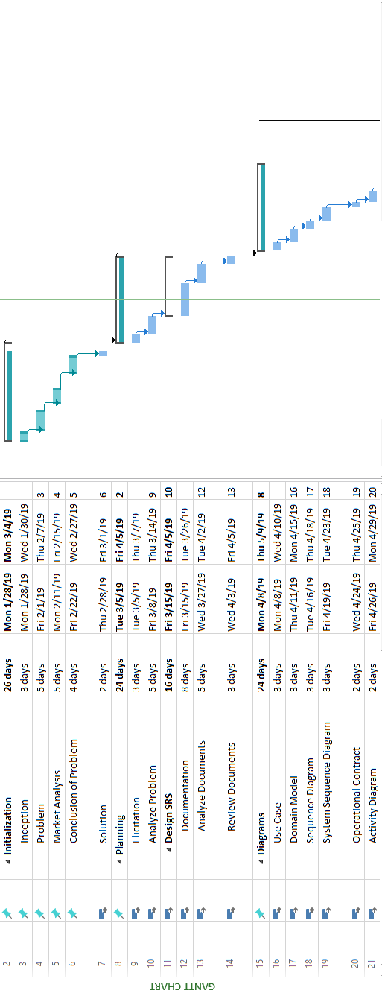Gantt Chart

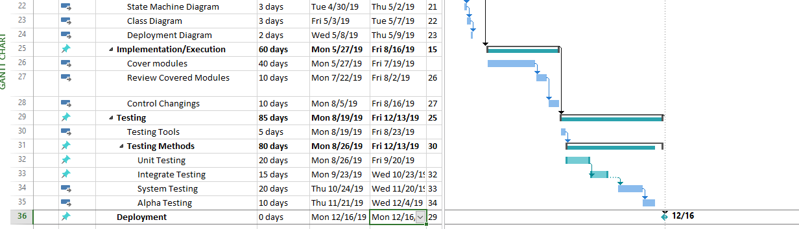

Report Outline
- Introduction
- Background
- Motivations and challenges
- Goals and Objectives
- Literature Review/ Existing Solutions
- Gap Analysis
- Proposed Solution
- Project Plan

Chapter 2

Software Requirement Specifications

Chapter 2: Software Requirement Specifications

Introduction
We wants to make a POS web-based application for the managing the data. In this system, we define and explain the flow of sales and purchase with proper calculations and Some User Authentications to communicate with the System. Already Existing Systems are Offline and some Systems are Manual. Calculations are manual and not yet have any online API for this Purpose. Manual Data may be lost anywhere anytime but this system will store data permanently in database Online. This system will provide the all POS information about iron when they login into system and purchase the product. It will provide the all transaction data on the user screen after providing authentication. The system is also facilitate to the customer by providing customer basic iron needs. Customer can check his balance status through this software at any time. The software is also providing useful information for user regarding iron. The Admin will handle all the Queries of this System regarding sales and other Update of the Organization. Through this system, company enhance his believe with his customers and identify to the customers and user that they are first priority of the Corporation.

Purpose
The actual purpose of this document is to define the functionality and purpose of our Web based Application “Korai Iron Store". All the requirements and components are also mentioned in this document. The main purpose of this SRS is to provide a complete understanding about the Web Apps.

Document Conventions

Stander rules of SRS documentation has been followed in the order of standardized the work. In order to create efficient this Website in the properties of data storing and make online order.

Intended Audience and Reading Suggestions
This SRS is for specific and individual person of this IT field. This report is for individual like:
- Engineers
- Marketing Staff
- Client
- Data base Staff Designer

Product Scope
The System Managing the Records of the organization. By Using the Previous Manual Experience Designing a Complete System for the Customers and users to help them for Selling and Purchasing the iron and they get the helpful Material for their iron and Transactions.

References
- IEEE Software Engineering Standards Committee, “IEEE Standard 830-2016, IEEE Recommended Practice for Software Requirements Specifications”, October 20, 2016.

Overall Description

Product Perspective
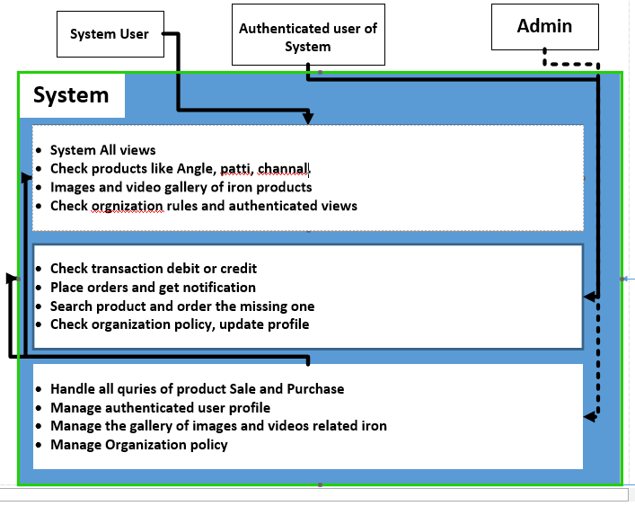Figure 2.2.1.0

Product Functions
Website:
- Register: User can register into the System
- Login: User can login into the System to check their transactions, Profile. The pre-requisite for Login into the is Registration
- Add items: After login user can add item of iron.
- View Detail: user can order products and can also check the detail of the Products and complete processing system.
- Online shopping: The system also allows the user to place order for the selected Product.
- Add to cart: This module allows the user to place order for only 1 item and add this information to the cart Cost Calculation: The system calculates total cost of the item placed in the cart and provides payment module.
- Select payment Method: User can select the payment method (By hand or by credit card or by easy paisa or jazz cash)
- Products Search/view: The system also enables the user to search for the Products and other Transaction that he had made.
- Log out: After placing the order user can logout.
Application:
- Register: User can register
- Login: User can login
- Logout: User cans logout
Decide what section is computerized, and how
- All Process will be computerized
- With the help of this chocoholic manager can print a report any time less time consuming
- A central database is required and will be installed in sever that sever is required online implementation to get the required results.
Determine detail of dataflow
- Login detail
- Email/Phone Number (30 char)
- Password (20 char)
- Registered member detail
- Full Name (30 char)
- Email (30 char)
- Phone Number (15 char)
- CNIC No. (15 char)
- Password (20 char)
- Confirm Password (20 char)
- Address (100 letters)
- Product Detail
- Product_name (12 char)
- Product_Price (12 digit)
- Product_image(50 varchar)
- Delete Detail
- Delete Product(20 char)
- Detail Product (25 char)
- Delete user (30 char)
- Payment Detail
- Shipment (20 char)
- Complete (25 char)
- Logout detail
Logout detail (20 char)
Define the logic of processes
- Login table Detail
- Page layout Detail
- Product Detail
- Payment Method Detail
- Register Detail
- Logout member table detail
Define the data store
- Login table contain (3steps)
- Page layout contain (3steps)
- Product table contain (3steps)
- Payment table contain (3steps)
- Register contain (3 steps)
- Logout member table contain (3steps)
Define Physical resources
- Sequential File
- NO-SQL
Database required with separate table
Login Page Table
- Login page with primary key (pk)
Page Layout Table
- Page layout with primary key (pk)
Product Table
- Product Detail with primary key (pk)
- Order detail (fk)
Payment Method Table
- Payment with primary key (pk)
Logout Table
- Logout table no with primary key (pk)
Perform sizing
- 5 megabyte hardware required
- Login table contain (30 char)
- Product table contain (20 kilobyte)
- Delete Product table contain (8 kilobyte)
- Doctor information and hospital detail table contain (40 byte)
- Logout member table contain (0byte)
Determine the hardware Requirement
- One disk drive to store the backup
- Printer to print a report
- Pc with desktop to view the data
- Server or LAN cables to connect systems

User Classes and Characteristics
There are 3 kinds of client of this product
Overall population
Overall population can utilize the framework to see the item, their costs and amount accessible. General client can't purchase the items.
Clients
Clients are utilizing for review and purchasing the items.
Administrator
Administrator can include, alter and erase items and give administrations to the client. Chairman can see the everyday offer.

Operating Environment
- Operating Environment Win 7/8/10 Platform
- Angular Js Framework
- Node Js Framework
- Mongo db NO SQL Server
For Users:
- Internet Browser
- Internet Connection
- The Korai Iron Store is a site in which we work every single well known program for a model we are taking Microsoft Internet Explorer, Google Chrome, Mozilla Firefox with Flash Player and JavaScript

Design and Implementation Constraints
- Client detail save into the database.
- MS SQL Server or SQL server will be utilized as SQL motor and database.
- The Korai Iron Store System is running 24 hours per day.
- Users may access from any PC that has Internet perusing abilities and an Internet association. Users must have their right usernames and passwords to go into their online records and do activities

User Documentation
- Korai Iron Store Website
- Korai Iron Store Module
- Korai Iron Store Website Facebook Page
- User can Use Google for any kind of Information Regarding iron

Assumptions and Dependencies
There are some possibilities through which by using one of them we can develop our Web Application which are:
- SQL Server can be use rather MY SQL Server
- We can also design web application using AngularJs and Master Detail crud Operation with PAS.Net Web API
- AngularJs application also design with Spring MVC(java frame work for building web application build industry standard java enterprise applications)
- NodeJS can be Used for backend Coding for this Application
- Framework can be Changed according Requirement

External Interface Requirements

User Interfaces

Client of the site will be given the Graphical UI; there is no order line interface for any elements of the item.
Table 2.1
Screen Name | Description
Login | In that case the client isn't enlisted yet; he can enter the points of interest and enlist. Which requests that the client write his username and secret key .If the client entered his username or Password Incorrect then error message occurs.
Search | The registered user of Korai Iron Store can enter the kind of Product he is looking for and after that he can scan for the required Product by entering the name of the item.
Categories view | The Product classifications see with capacity Korai Iron Store include/alter or erase classification from the rundown.
Add Product to cart | User can add product into the cart which he wants to order and also can select quantity
Delete Product from cart | After adding the product into the cart user can also delete the selected product from the cart.
Payment Method | User selects the payment method and proceeds the order.  - Through ATM  - Through easy paisa  - Through Jazz Cash
Co-Admin | Co-Admins that will handle finance, orders and etc.… and report to the admin
Admin user | Create invoice, add users, update products processing’s videos, update products gallery, delete user , change password
Report | Select, view, add, save and delete reports
Cancel the order | Customers can cancel the orders

Hardware Interfaces
Equipment prerequisites for Insurance on web will be same for both the gatherings which are takes after:
- Processor
- Ram: - 128 MB or above.
- HD: - 20 GB or above.
- Just the prescribed setup (fundamental necessities of a PC framework) no other particular equipment is required to run the product.

Software Interfaces
All the databases for the Korai Iron Store system will be configured using access 2018 – 2027. These databases include Products and user information. These can be modified by the end user. The Korai Iron Store database will include the user information and Products information. The user or products or order detail information database will contain all the detail of the user or products detail or order detail such as first name surname ID number, Gender and phone number, P_id, P_name, P_type, order_id, order_time, order_date, order_type.

Communications Interfaces
The two gatherings ought to be associated through either by LAN or WAN for the correspondence. Sender Communication channels Receiver.
Receiver
Sender

System Features
Website
Website Features
- Register: User can register into the System
- Login: User can login into the System
- Add items: After login user can add item like Angle, Patti and Channel.
- View Detail: user can order iron and can also view their details.
- Online shopping: The framework likewise enables the client to put arrange for the chose products.
- Add to cart: This module enables the client to add product into the cart.
- Cost Calculation: The system calculates total cost of the item placed in the cart and provides payment module.
- Select payment Method: User can select the payment method (By hand or by credit card)
- Log out: After placing the order user can logout.

Application Features
- Register: User can register
- Login :User can login
- Logout: User can logout
- Iron detail: User checks the detail of iron.
Technical Features:
Website
Software Requirements:
- Windows 10
- SQL 2014,2016
- Notepad++
- Xampp
- VS Code
- Node Js
Equipment Components:
- Processor – i5,i7
- Hard Disk – 5 GB
- Memory – 1GB RAM
- Graphical Tools: Photoshop CC 2015, Adobe artist CC
- Microsoft Visio
- Excel
Application
Application Features
- Product Images and videos
- Product details
- Suggestion to the customer
- Online Help
Technical Features
Application
Software Requirements: All Devices and Android

System Feature 1

Description and Priority
Every business logic required complete authentication to use the system. So, Registration is the best solution to get user authentication and also get basic info of the user. It’s now has become very important for every system to prevent from the system hacking. Its priority is high.
Table 2.4.1.1.0
Components | Ratings
Benefits | 8
Penalty | 7
Cost | 3
Risk | 3
Security | 9

Stimulus/Response Sequences
Table 2.4.1.2.0
Ser. No. | Requirements | Description
1 | Identifiers | FR-001
2 | Title | Allows Register access online
3 | Requirements | User First name, last name, CNIC, Gender, Select Field Email, Phone, Address, Password, Confirm Password,
4 | Rational | Register to the system and provide security to personal information.
5 | Restriction and Risk | Correct data must be enter during registration, otherwise user don’t register
6 | Dependency | Pc , Connection with server
7 | Priority | Safety ,timing

Functional Requirements
Register
Table 2.4.1.3.0
Actor | - Unregister User
Pre-conditions | - User must open the web  - User must open Register Page
Basic Flow | - User wants to create its account for this particular App  - User provides all required information and get registered
Alternate Flow | - User can’t use this Application as Unregister user
Post-conditions | - User must successfully registered

System Feature 2
Login Feature

Description and Priority
Login to the System is possible when the user have been provided proper information during Registration. And the Login to the System become possible when user give got authentication after checking Credentials. After that User can Use System easily.
Table 2.4.2.1.0
Components | Ratings
Benefits | 8
Penalty | 4
Cost | 3
Risk | 6
Security | 9

Stimulus/Response Sequences

Table 2.4.2.2.0
Ser. No. | Requirements | Description
1 | Identifiers | FR-002
2 | Title | Allows Login access online
3 | Requirements | User Email/Phone, Password
4 | Rational | Login to the system and use the system with recommended API’s
5 | Restriction and Risk | Correct data must be enter during Login, otherwise user don’t Login
6 | Dependency | Pc , Connection with server
7 | Priority | Safety ,timing

Functional Requirements
Login
Table 2.4.2.3.0
Actor | - register User
Pre-conditions | - User must Registered the web  - User must have account for this Application
Basic Flow | - User enter his user email/phone number and password and gets login
Alternate Flow | - User can also use this application as unregistered user
Post-conditions | - User must be successfully Log In

System Feature 3
Logout Feature

Description and Priority
Logout from the System is possible when the user have been Login to the System. After using the system user can’t leave the account without logout otherwise session will be expire after few minutes when user leave the system idle.
Table 2.4.3.1.0
Components | Ratings
Benefits | 4
Penalty | 5
Cost | 3
Risk | 7
Security | 8

Stimulus/Response Sequences

Table 2.4.3.2.0
Ser. No. | Requirements | Description
1 | Identifiers | FR-003
2 | Title | Allows Logout access online
3 | Requirements | None
4 | Rational | Logout to the system and provide security to personal information.
5 | Restriction and Risk | User must login.
6 | Dependency | Pc , Connection with server
7 | Priority | Safety ,timing

Functional Requirements
Logout
Table 2.4.3.3.0
Actor | - Register User
Pre-conditions | - User must be successfully Log In  - Information of the User must be successfully entered
Basic Flow | - User want to Log-out
Alternate Flow | - User don’t want to view the result
Post-conditions | - User must be successfully Logout

System Feature 4
Select Item Feature

Description and Priority
Select the required items that provided. In this system we have provided items which are necessary for the regular use. Items are provided with category and user can view details of the items before selection.
Table 2.4.4.1.0
Components | Ratings
Benefits | 6
Penalty | 4
Cost | 6
Risk | 3
Security | 7

Stimulus/Response Sequences

Table 2.4.4.2.0
Ser. No. | Requirements | Description
1 | Identifiers | FR-004
2 | Title | Add an item to user account
3 | Requirements | Full name, Address, CNIC, Phone, product type, Quantity, date
4 | Rational | A user must add item into cart
5 | Restriction and Risk | Balance adjust User current item
6 | Dependency | Valid information
7 | Priority | Item add in user account

Functional Requirements
Order View
Table 2.4.4.3.0
Actor | - Register User
Pre-conditions | - Login the website and then user can select item
Basic Flow | - User wants to see the product and select
Alternate Flow | - User don’t want to select the product
Post-conditions | - None

System Feature 5
Item View Feature

Description and Priority
User can check the details of the items before ordering the any item that given. Complete data will be given with perspective of the item. Whether it is all will be given in details which will help the user to choose.
Table 2.4.5.1.0
Components | Ratings
Benefits | 6
Penalty | 2
Cost | 4
Risk | 3
Security | 9

Stimulus/Response Sequences

Table 2.4.5.2.0
Ser. No. | Requirements | Description
1 | Identifiers | FR-005
2 | Title | Allows user to view detail
3 | Requirements | User login and then view detail of item
4 | Rational | Login to the system and view detail
5 | Restriction and Risk | User must login to check the detail otherwise detail don’t show.
6 | Dependency | Pc , Connection with server
7 | Priority | Safety ,timing

Functional Requirements
Item view
Table 2.4.5.3.0
Actor | - Register User
Pre-conditions | - Information of the Source must be successfully entered  - Information of the Destination must be successfully entered
Basic Flow | - User wants to see the path between Source and Destination
Alternate Flow | - User don’t want to view Detail
Post-conditions | - User must see the path between source and destination

System Feature 6
Place order Function

Description and Priority
“User has ability to place order to the available item.”

Table 2.4.6.1.0
Components | Ratings
Benefits | 8
Penalty | 7
Cost | 6
Risk | 3
Security | 9

Stimulus/Response Sequences

Table 2.4.6.2.0
Ser. No. | Requirements | Description
1 | Identifiers | FR-006
2 | Title | Access to place order on schedule
3 | Requirements | name, address, CNIC, item type, quantity date
4 | Rational | User has ability to place order to the available item
5 | Restriction and Risk | Current item, the available item or current timing must be adjusted.
6 | Dependency | Valid information, available item is valid
7 | Priority | Modified in order

Functional Requirements
Place order
Table 2.4.6.3.0
Actor | - Register User
Pre-conditions | - Information of the product must be successfully entered  - Information of the Destination must be successfully entered
Basic Flow | - User wants purchase the product and place order
Alternate Flow | - User don’t want to place order
Post-conditions | - User must see the path between source and destination

System Feature 7
View Order Form Function

Description and Priority
User can add the product into the cart and also view the order which he place. Which items has been selected can view and make decision to proceed it.

Table 2.4.7.1.0
Components | Ratings
Benefits | 8
Penalty | 4
Cost | 5
Risk | 3
Security | 9

Stimulus/Response Sequences

Table 2.4.7.2.0
Ser. No. | Requirements | Description
1 | Identifiers | FR-007
2 | Title | Access to place order on schedule
3 | Requirements | name, address, CNIC, item type, quantity date
4 | Rational | User has ability to View order which have place.
5 | Restriction and Risk | User must login to view order detail
6 | Dependency | Valid information
7 | Priority | View order detail

Functional Requirements
View Order Form

Table 2.4.7.3.0
Actor | - Register User
Pre-conditions | - Information of the product must be successfully entered  - Information of the Destination must be successfully entered
Basic Flow | - User wants to see the path between Source and Destination
Alternate Flow | - User don’t want to view the order
Post-conditions | - User must see the path between source and destination

System Feature 8
Cancel order Function

Description and Priority
User can cancel the order which he place.

Table 2.4.8.1.0
Components | Ratings
Benefits | 6
Penalty | 5
Cost | 2
Risk | 6
Security | 9

Stimulus/Response Sequences
Table 2.4.8.2.0
Ser. No. | Requirements | Description
1 | Identifiers | FR-008
2 | Title | Access to Cancel order on schedule
3 | Requirements | Order in cart
4 | Rational | User has ability to the Cancel order
5 | Restriction and Risk | Current item, the available item or current timing must be adjusted
6 | Dependency | Valid information, available item is valid
7 | Priority | Modified in order.

Functional Requirements
Cancel order Function

Table 2.4.8.3.0
Actor | - Register User
Pre-conditions | - User must successfully Login.  - Information of the User must be successfully entered  - Information of the Source must be successfully entered  - User must create the event
Basic Flow | - User Cancel order of the selected product Destination
Alternate Flow | - User don’t want to Cancel the order
Post-conditions | - Event deleted successfully

System Feature 09
` Cost Calculation Function

Description and Priority
The system calculates total cost of the item placed in the cart and provides payment module

Table 2.4.9.1.0
Components | Ratings
Benefits | 8
Penalty | 6
Cost | 5
Risk | 4
Security | 9

Stimulus/Response Sequences

Table 2.4.9.2.0
Ser. No. | Requirements | Description
1 | Identifiers | FR-010
2 | Title | Allow user to add item to cart and cost calculation module shows
3 | Requirements | Types of item, item no , item name, Total cost
4 | Rational | Allow user to add item into cart easily and cost module occur in front of the user’s screen.
5 | Restriction and Risk | None
6 | Dependency | None
7 | Priority | None

Functional Requirements
Cost Calculation

Table 2.4.9.3.0
Actor | - Register User
Pre-conditions | - Information of the Product add to cart successfully  - Information of the Cost module display successfully
Basic Flow | - User want to see the path between source and destination.
Alternate Flow | - User don’t want to view the order
Post-conditions | - User must see the path between source and destination

System Feature 10
Payment Method Function

Description and Priority
User can select the payment method. There may be 4 types of payment methods which are:
- Credit Card
- Easy paisa
- Jazz Cash
- By Hand

Table 2.4.10.1.0
Components | Ratings
Benefits | 8
Penalty | 7
Cost | 6
Risk | 3
Security | 9

Stimulus/Response Sequences

Table 2.4.10.2.0
Ser. No. | Requirements | Description
1 | Identifiers | FR-011
2 | Title | Allow user to select payment method after adding product into cart, methods like credit card or cash after deliver or by easy paisa, jazz cash or by hand.
3 | Requirements | Types of card, Card no ,Card password, Card holder name, Card holder Mobile no
4 | Rational | Allow user to select payment method.
5 | Restriction and Risk | None
6 | Dependency | Valid card no or PIN Code
7 | Priority | Account balance update

Functional Requirements
Payment Method

Table 2.4.10.3.0
Actor | - Register User
Pre-conditions | - Information of the Source must be successfully entered  - Information of the Destination must be successfully entered
Basic Flow | - User wants to see the path between source and destination.
Alternate Flow | - User don’t want to order
Post-conditions | - User must see the payment method

System Feature 11
Check the Debit and Credit Function

Description and Priority
User can check the Debit and Credit details

Stimulus/Response Sequences
Table 2.4.11.2.0
Ser. No. | Requirements | Description
1 | Identifiers | FR-012
2 | Title | User check the Debit and Credit
3 | Requirements | User must be login
4 | Rational | Allow user to select debit and credit.
5 | Restriction and Risk | None
6 | Dependency | Valid data provide
7 | Priority | User Account

Functional Requirements
Check the Debit and Credit

Table 2.4.11.3.0
Actor | - Register User
Pre-conditions | - User must be login
Basic Flow | - User wants to see the accounts details in term of debit and credit
Alternate Flow | - User don’t want to order
Post-conditions | - User must enter the correct account details

Function of Application

System Feature 1: Registration

Description and Priority
Every business logic required complete authentication to use the system. So, Registration is the best solution to get user authentication and also get basic info of the user. It’s now has become very important for every system to prevent from the system hacking. Its priority is high.
Table 2.4.12.1.0
Components | Ratings
Benefits | 8
Penalty | 7
Cost | 3
Risk | 3
Security | 9

Stimulus/Response Sequences

Table 2.4.12.2.0
Ser. No. | Requirements | Description
1 | Identifiers | FR-001
2 | Title | Allows Register access online
3 | Requirements | User First name, last name, CNIC, Gender, Select Field Email, Phone, Address, Password, Confirm Password,
4 | Rational | Register to the system and provide security to personal information.
5 | Restriction and Risk | Correct data must be enter during registration, otherwise user don’t register
6 | Dependency | Pc , Connection with server
7 | Priority | Safety ,timing

Functional Requirements

Table 2.4.12.3.0
Actor | - Unregister User
Pre-conditions | - User must open the web  - User must open Register Page
Basic Flow | - User wants to create its account for this particular App  - User provides all required information and get registered
Alternate Flow | - User can’t use this Application as Unregister user
Post-conditions | - User must successfully registered

System Feature 2: Login

Description and Priority
Login to the System is possible when the user have been provided proper information during Registration. And the Login to the System become possible when user give got authentication after checking Credentials. After that User can Use System easily.

Table 2.4.13.1.0
Components | Ratings
Benefits | 8
Penalty | 7
Cost | 3
Risk | 3
Security | 9

Stimulus/Response Sequences

Table 2.4.13.2.0
Ser. No. | Requirements | Description
1 | Identifiers | FR-002
2 | Title | Allows Login access online
3 | Requirements | User Email/Phone, Password
4 | Rational | Login to the system and use the system with recommended API’s
5 | Restriction and Risk | Correct data must be enter during Login, otherwise user don’t Login
6 | Dependency | Pc , Connection with server
7 | Priority | Safety ,timing

Functional Requirements

Table 2.4.13.3.0
Actor | - register User
Pre-conditions | - User must Registered the web  - User must have account for this Application
Basic Flow | - User enter his user email/phone number and password and gets login
Alternate Flow | - User can also use this application as unregistered user
Post-conditions | - User must be successfully Log In

System Feature 3: Logout

Description and Priority
Logout from the System is possible when the user have been Login to the System. After using the system user can’t leave the account without logout otherwise session will be expire after few minutes when user leave the system idle.

Table 2.4.14.1.0
Components | Ratings
Benefits | 8
Penalty | 7
Cost | 3
Risk | 3
Security | 9

Stimulus/Response Sequences

Table 2.4.14.2.0
Ser. No. | Requirements | Description
1 | Identifiers | FR-003
2 | Title | Allows Logout access online
3 | Requirements | None
4 | Rational | Logout to the system and provide security to personal information.
5 | Restriction and Risk | User must login.
6 | Dependency | Pc , Connection with server
7 | Priority | Safety ,timing

Functional Requirements
Table 2.4.14.3.0
Actor | - Register User
Pre-conditions | - User must be successfully Log In  - Information of the User must be successfully entered
Basic Flow | - User want to Log-out
Alternate Flow | - User don’t want to view the result
Post-conditions | - User must be successfully Logout

System Feature 4: Moisture Details
      - Description and Priority
System will provide the moisture detail to the users and keep the record of each iron in database and save it yearly.
Table 2.4.15.1.0
Components | Ratings
Benefits | 8
Penalty | 7
Cost | 3
Risk | 3
Security | 9

Stimulus/Response Sequences

Table 2.4.15.2.0
Ser. No. | Requirements | Description
1 | Identifiers | FR-004
2 | Title | Allows Logout access online
3 | Requirements | None
4 | Rational | Logout to the system and provide security to personal information.
5 | Restriction and Risk | User must login.
6 | Dependency | Pc , Connection with server
7 | Priority | Safety ,timing

Functional Requirements

Table 2.4.15.3.0
Actor | - Register User
Pre-conditions | - User must be successfully Log In  - Information of the User must be successfully entered
Basic Flow | - User want to Check moisture details
Alternate Flow | - User don’t want to view the moisture result

Other Nonfunctional Requirements

Performance Requirements
With a specific end goal to keep up a worthy speed at most extreme number of transfers permitted from a specific client will be any number of clients and can get to the framework whenever and wherever with availability of internet and required device.. Likewise associations with the servers will be founded on the criteria of properties of the client like his area, and server will work 24X 7 times.

Safety Requirements
All exchanges, logged data, refreshes, client exercises are reinforcement.

Security Requirements
Any adjustment (insert, update and delete) for the Database might be synchronized and done just by the System manager.

Software Quality Attributes
Reliability
The framework can be utilized by different clients simultaneously. Any client can get to the framework with utilizing even a low execution PC.
Availability
The framework is accessible amid 24 hours of the day.
Maintainability
The framework should give the ability to go down the Data.
Portability
Client can sign in to the framework whenever.
Robustness
The framework won't be separated effortlessly

Business Rules
There are mostly two kinds of clients utilizing the framework, for example,
- User
- Administrator
Administrator has the full authorization of controlling the framework.
User has authorization to buy request or view detail of the item.

Other Requirements
At the point undertaking the principal matter to build up is to survey the usibility of a task or item. It is essentially utilized as a measure how down to earth or gainful the advancement of a product framework will be to you (or association). This movement repeats for the duration of the life cycle. There are numerous kinds of possibilities:
- Technical
- Economic
- Specification
- Information
- Motivational
- Legal and Ethical
Technical Feasibility
Korai Iron Store site require following advances:
Server: A server will be required which will have all information of customer. It check client name and passwords of the considerable number of clients, the areas went by the clients, an occasion created by client e.g. data about some strike in the way.
Economic Feasibility
Korai Iron Store site require these fundamental to meet to work:
Cost of System:
- 1 Windows Phone (GPS booster) @ Rs.20, 000
- Internet Connection @Rs.2000/month
Advantages
- 24 hour accessible
Schedule Feasibility
We isolate the undertaking into various modules and prerequisite modules will be constructed and afterward would be coordinated to make an appropriate working application.
Specification Feasibility
This web base Application is for Windows, Mac, and Android Users. Web Application would be free of cost. Required Specifications are Windows (8, 7), Rational Rose and MS Office. Some Specifications are as take after
- Mobile telephone that help GPS
- Pentium 4 Processors
- 80 GB hard plates
- 1 GB RAM
Here enrolled are some Non Functional Requirements:
- GUI
- User amicable
- Performance
Motivational Feasibility
The thought is given by an instructor and we are engaged to defeat the thought. As this web base application appear to be extremely useful for individuals.
Legal & Ethical Feasibility
This web base application would be accessible for all clients and will meet legitimate and moral principles. As the client who will produce occasions would be a valid client with client data accessible so it is imagined that it would be a decent affair to utilize this application.

Chapter 3

Use Case Analysis

Chapter 3: System Analysis
System:
An online web-based application of local company which name is Korai Iron Store(KIS).
Statement:
An Organization KIS wants to make agricultural and business software. Software should be user-friendly, easy to use, and maintains the records of the company.
A company works with the manual system in which they are facing more difficulties like managing the data entries, employee’s salaries, and customers’ data. The company decided to make complete software with the standard interface so that every person works according to his task on time. KIS also works with other Companies in Pakistan. Basically, the problem is in the file system. It’s more difficult to manage the formers, customers, agents, employees and how to work with other companies for making standard relationships. They want to work according to standard business Rules. It also establishes his company name as a brand in the market. They wanted to establish on a national level. All these issues will solve in this software and make reliable as much as possible. All attributes of the software will be reliable for the customer according to its desire.

Risk Factors
- First priority is to manage the user’s accounts and maintain the security.
- Second is to maintain business information (like customers receipt). It can create any risk in software.
- Complete project on given time with all features which is given by the customer.
- The system should provide an alternative to produce any type of error.
- The system has to be easy for non-technical people to use

System Level Use Case Diagram
There are some actors and use cases which are used to making a diagram of the system;
Actors
- User
- Customer
- Admin
- Product Manager
- Order Manager
- Account Manager
- Marketing Manager
Use Cases
- View Products
- Register
- Forget Password
- Login
- View records
- Update Profile
- Search Product
- Purchase Product
- Update Product
- Place Order
- Manage Profile
- Order Deliver
- Payment Method
- Maintain Order
- Manage User Accounts
- Generate Receipt
- Manage Advertisement
- Maintain Transactions
- Logout

Use Case Model

Figure 3.0

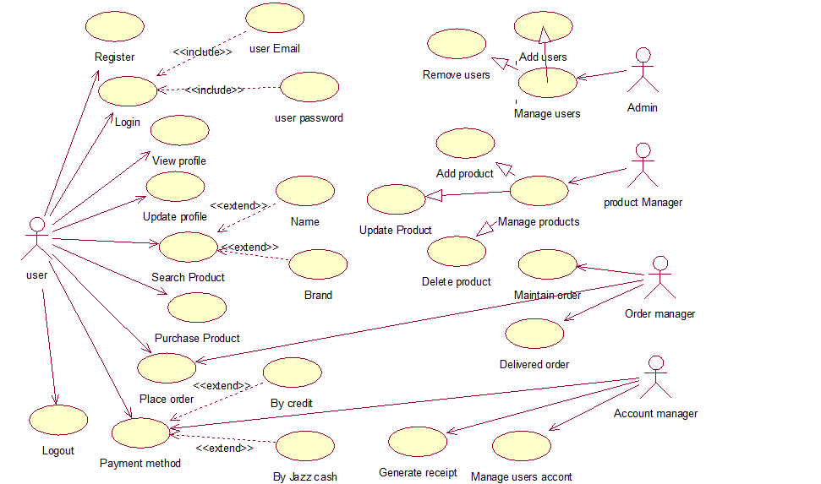

Fully Dressed Use Cases
Use Case Specification
Registration Subsystem of KIS(1.0)

Table 3.0
Number | UC-01A
Name | Registration (user side)
Summary | This Use Case describes the process by which new user signup with necessary information about him and uses the website of KIS and moves to next instruction
Priority | 5
Pre-Condition | User know about URL of this website
Post-Condition | User has login page
Primary Actor | User (Customer)
Secondary Actor (s) | Admin
Trigger | User has chosen the registered himself on webpage
Main Scenario | - The Use Case Starts when the user starts registration.  - The system displays the registration screen.  - The user enters his FNAME, LNAME, Email, Phone#, CNIC#, City, Gender (Male, Female), select Field (Customer), and Password  - The user submits this information to the System.  - The System Admin Check this Information  - After complete checking System makes account for user  - User goes to next page.  - The Use Case Ends
Alternative Scenario | - The Use Case starts when the user starts registration.  - The system displays the registration screen.  - 3- The user enters his FNAME, LNAME, Email, Phone#, CNIC#, City, Gender (Male, Female), Job (Customer, and Agent), and Password.  - If the user enters wrong information then  The system shows error “Redline” under the wrong information.  - The user submits this information to the System.  - If the System does not accept the information then  The system shows error message on screen  - If the System again show error message then  The System provides guideline to the user  - Else the system shows the message to user to re-enter all accurate information  The System Admin Check this Information.  - After complete checking, the System shows the message  Registration is Successful and  Welcome to our website  - User goes to next page.  - The Use Case Ends.
Open Issue | - The user can enter wrong information  - The user can add wrong phone number

Use case 1.0 (Registration)
Figure 3.1

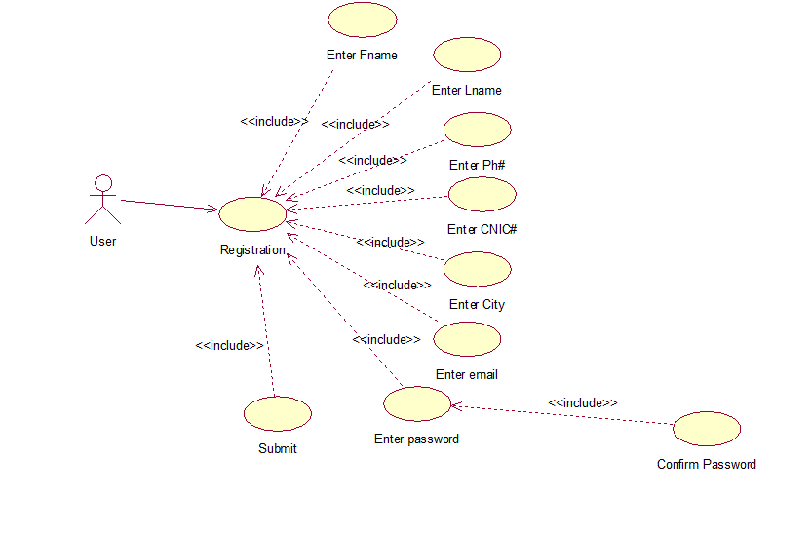

Table 3.1
Number | UC-01B
Name | Registration (company side)
Summary | This Use Case describes the process by which new user signup with necessary information about him, Admin check that information, verify and provide login access after completing the signup process and user moves to Login Page.
Priority | 5
Pre-Condition | Admin know about URL of this website
Post-Condition | Admin has login page
Primary Actor | User (Customer)
Secondary Actor (s) | Admin
Trigger | Admin manage the user webpage
Main Scenario
Alternative Scenario | - The Use Case starts when the user starts registration.  - The system displays the registration screen.  - The user enters his FNAME, LNAME, Email, Phone#, CNIC#, City, Gender (Male, Female), Job (Customer, and Agent), and Password.  - The admin verify the information  - If user enters true information  - Admin accept the information  - Else If enter incomplete information and press submit button  - Admin shows error on user screen  - “Incomplete information”  - Else If user enter wrong information  - Admin shows error message  - “Please Enter True Information”  - Admin provide identity against User accepted Information  - The user moves to login page  - The use case ends.
Open Issue | No Issue

Login Subsystem of KIS (1.0)

Table 3.2
Number | UC-02A
Name | Login (User side)
Summary | This Use Case describes the process by which user login the system through enters email/phone# and password. The admin verify the login details and provide homepage after succesive login from the user.
Priority | 5
Pre-Condition | User has registration
Post-Condition | User shows home page
Primary Actor | User (Customer)
Secondary Actor (s) | Admin
Trigger | User enter his email and password
Main Scenario | - The Use Case starts when the user opens the website.  - The System will display the login screen  - The user enters email/phone# and password.  - The system will verify the information  - The system moves user to home page.  - The Use Case Ends
Alternative Scenario | - The use case starts when the user starts website.  - The system will display the login screen.  - The user enters email/phone# and password.  - The system will verify the information  - If user enters wrong email/phone#  - The system shows error message “please enter correct email/phone# or password”  - Else if user enters wrong password  - The system shows error message “please enter correct email/phone# or password”.  - The system moves user to home page  - The use case ends.
Open Issue | - The user can enter wrong email or password.

Use case 1.0 (Login)

Figure 3.3
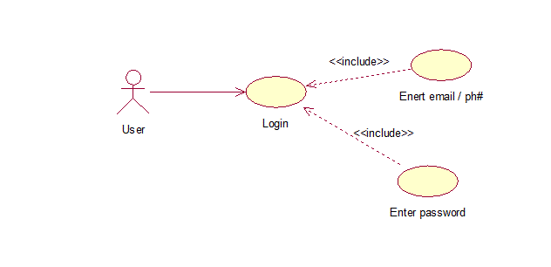

Table 3.3
Number | UC-02B
Name | Login (Company side)
Summary | This Use Case describes the process by which user login the system through enters email/phone# and password. The admin verify the login details and provide homepage after succesive login from the user.
Priority | 5
Pre-Condition | The admin registered his account first
Post-Condition | The admin manage user registration
Primary Actor | User (Customer)
Secondary Actor (s) | Admin
Trigger | The system manage the user’s account
Alternative Scenario | - . The use case starts when the user starts website.  - The system will display the login screen.  - The user enters email/phone# and password.  - The admin check the information which enter by the user  - If user enter wrong email/phone#  - The admin compare information with database  - Message prints on user screen “The email/phone or password was wrong. Please enter correct information”  - Else if user enters wrong password  - The admin compare information with database  - Message prints on user screen “The email/phone or password was wrong. Please enter correct information”  - Else  - System allows five attempts for login  - If user lost attempts  - The admin suggest to user to moves on “forget password” page  - The admin verify user login information  - If user login verification succeeded  - The system provide home page of the software  - Else the system shows message to “try again”.  - If the user verification succeeded but admin not provide Login Access  - System shows message “System resolving an error”  - The admin provide login access after verification.  - The user moves to home page  - The use case ends.
Open Issue | No issue

Use case 1.0 (Registration)
Company Side
Figure 3.4
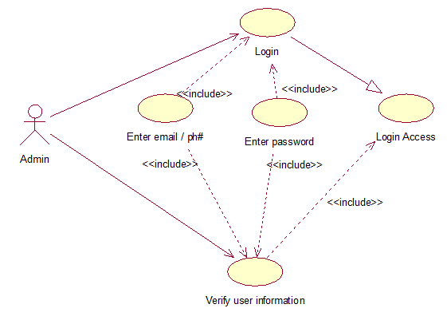
Forget Password Subsystem of KIS (1.0)

Table 3.4
Number | UC-03A
Name | Forget Password
Summary | The use case define the forget password process, when user enters wrong information continuously, the system provide access to renew password through define criteria. The user can forget own password. In this situation the system provide guidelines to user and help the user to reuse the user account. The user provides necessary information about his account and the system generate code on user’s phone.
Priority | 5
Pre-Condition | User has registration
Post-Condition | User shows home page
Primary Actor | User (Customer)
Secondary Actor (s) | Admin
Trigger | User enter his email and password
Main Scenario | - The use case starts when user comes to login page  - The user click on forget password button  - The user moves to forget password page  - The system generate code on the user email or phone number for user verification  - The user enter the received code on web-page form  - The system verify the code  - The system allows to user to create new password and confirm the password  - The system verify the new password which entered by user twice time.  - The system shows verification message on the user screen  - The user enters new password with email/phone# for login  - The use case ends.
Alternative Scenario | - The use case starts when user comes to login page  - The user click on forget password button  - The user moves to forget password page  - The system generate code on the user email or phone number for user verification  - If the system doesn’t generate code within one minute  - The system shows message on user screen “click on generate code if you don’t get code”  - The user enter the received code on website page  - The system verify the code  - If user enters wrong code  - The system doesn’t allow to user to performing another tasks  - The system print on user screen “Please enter correct code”  - Else the system moves the user on next instruction  - The system allows to user to create new password and confirm the password  - The system verify the new password which entered by user twice time.  - If user enter different passwords  - The system shows error message on screen “Please enter correct password”  - Else the system moves on next instruction  - The system shows verification message on the user screen  - The user enters new password with email/phone# for login  - The use case ends.
Open Issue | User can’t know how to enter code for renewing password.

Use case 1.0 (Forget Password)
Figure 3.5

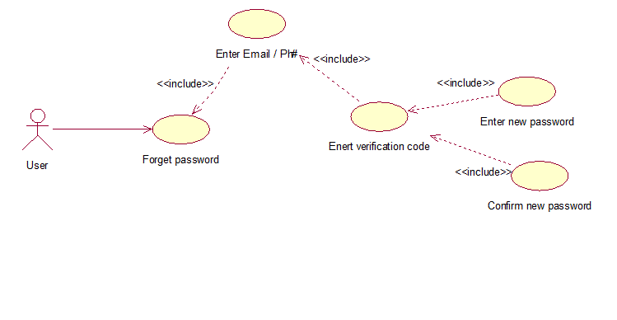

Product subsystem of KIS (1.0)
Table 3.5
Number | UC-04A
Name | Product (user side)
Summary | In this use case, user can view, search and purchase the company’s products which are given on website. User can view the rates of the product and other necessary information given by the company.
Priority | 3
Pre-Condition | User should login with his account
Post-Condition | User can order products
Primary Actor | User ( Customer)
Secondary Actor (s) | Product Manager
Trigger | User can view, select and purchase product
Main Scenario | - The use case starts when user comes to home page  - The user can view all type of necessary information about the website  - The user can search the product for purchase  - The user can select the product by clicking on “Purchase Products”  - If user click on product type  - The user view on screen three different product types ^{i)}Angle^{ii)} Patti^{iii)}Chanal  - The use case ends
Alternative Scenario
Open Issue | - User can be feel purchasing criteria difficult  - New user (purchaser) feels difficult to distinguishing about different products.

Figure 3.6
ARCHITECTURE04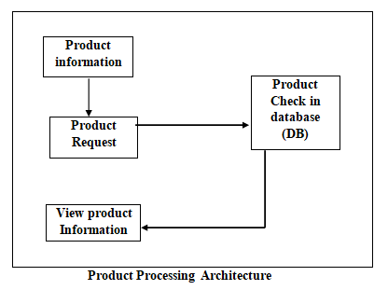

Product information
The user view the products, the user can chose, search product and purchase the product.
Product Request
The user selects function and wants to get information about it.
Check in DB
The system working on user request and search the product in system’s Database (DB)
View Product information
The system provide information (either in the form of success or failure) against the user request.
Table 3.6
Number | UC-04B
Name | Product (company side)
Summary | In this use case, user can view, search and purchase the company’s products which are given on website. User can view the rates of the product and other necessary information given by the company.  The system (Product Manager) provides all necessary information about the products and defines the criteria to purchasing. The system also facilitates to user (either old or new user) on any issue to purchasing product or any product related issue.
Priority | 3
Pre-Condition | User should login with his account
Post-Condition | User can order products
Primary Actor | User (Customer)
Secondary Actor (s) | Product Manager
Trigger | The system provide all information about the product
Main Scenario
Alternative Scenario | - The use case starts when user comes to home page  - The user can view all type of necessary information about the website  - The system (Product Manager) Provides necessary information to user  - The user can search the product for purchase  - If user entered irrelevant information in search bar  - The system shows error message “irrelevant information, please search correct products information”  - Else the system provide products related information  - The system allows to user to search and select the company’s product data  - The user can select the product by clicking on “Purchase Products”  - The system performs for loop for user to checking product related information again and again.  - For user, the system update the product’s informationevery time  - The system add new products  - The system Remove soled products  - The system Edit Product information (update Rate list etc.)  - The use case ends
Open Issue | The system can show error due to unpleasant environment

Place Order subsystem of KIS(1.0)
Table 3.7
Number | UC-05A
Name | Place Order (user side)
Summary | The use case describes the purchase order system. Through this criterion, the user can place the order for purchasing product.
Priority | 4
Pre-Condition | User should login with his account
Post-Condition | User pay bills through system define criteria
Primary Actor | User (Customer)
Secondary Actor (s) | Order Manager
Trigger | The user places the order for purchasing desire product from the website.
Main Scenario | - The use case starts when users comes to purchasing product on “Place order”  - The system defined the path by completing information  - The user complete and select the category of the product  - If user select and fills incomplete information  - The system shows error message on user screen “Please Complete the information”  - The user can define the quantity of the product manually  - The user can select predefined mechanism for defining the quantity of the product  - The system verify the user information  - The system allows to user to purchasing the product.  - The use case ends.
Alternative Scenario
Open Issue | The user can be face issue to placing order.

Use case 1.0 (Place Order)
Figure 3.8
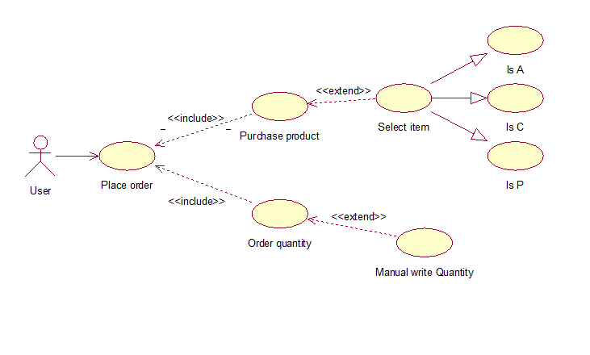

Table 3.8
Number | UC-05B
Name | Place Order (company side)
Summary | The use case describes the purchase order system. Through this criterion, the user can place the order for purchasing product.  The system manages the order procedure of the user and provides guidelines to user on any issue. The system manages the order of the user.
Priority | 4
Pre-Condition | User should login with his account
Post-Condition | User pay bills through system define criteria
Primary Actor | User (Customer)
Secondary Actor (s) | Order Manager
Trigger | The system manage the orders of the user.
Main Scenario
Alternative Scenario | - The use case starts when users comes to purchasing product on “Place order”  - The system defined the path by completing information  - The user select and complete the category of the product  - If user select and fills incomplete information  - The system shows error message on user screen “Please Complete the information”  - The user can define the quantity of the product manually  - If user doesn’t know how to define manually  - The system helps user to defining the product  - The system shows guidelines in the beginning of the define manually product  - Else the system shows error message “Please define quantity according to system instructions”  - The user can select predefined mechanism for defining the quantity of the product  - If user doesn’t select any product and enter the submit button to submitting information  - The system doesn’t allow to submit information and shows error message on user screen “Please chose the category for purchasing product”  - The system verify the user information  - If user provide wrong information the user doesn’t allow any transaction  - Else the system blocked the spam account  - The system allows to user to purchase product  - The use case ends.
Open Issue | No issue.

Payment Method subsystem of KIS (1.0)
Table 3.9
Number | UC-06A
Name | Payment Method (user side)
Summary | After placing the order the user comes to payment method and pay bills through define criteria of the company.
Priority | 5
Pre-Condition | User should login with his account
Post-Condition | User moves to home page for further transactions.
Primary Actor | User (Customer)
Secondary Actor (s) | Order Manager
Trigger | The user pays bill.
Main Scenario | - The use case starts when user purchase the product and pay bills through “Payment Method”  - The user pay the bills with different methods through ^{i)} Easy paisa ^{ii)} Banks ^{iii)} Jazz Cash  - The system check the account information  - The system verifies the account information.  - The system generate Bill Receipt on user account when the user purchase anything  - The system verify the order delivered to user or not  - The use case ends.
Alternative Scenario
Open Issue | The user can be fill wrong information for paying bills.
Use case 1.0 (Payment Method)
Figure 3.10
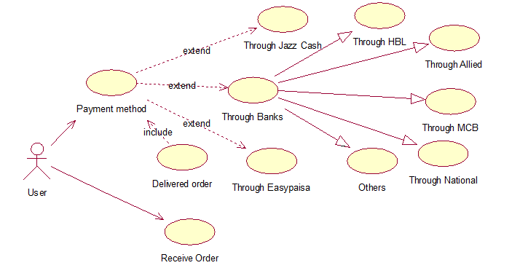
Table 3.10
Number | UC-06B
Name | Payment Method (company side)
Summary | After placing the order the user comes to payment method and pay bills through define criteria of the company.  The system manages payments of the user and generates receipt for user. The system verifies the transaction of user and update to user about all users’ transactions through communication method.
Priority | 5
Pre-Condition | User should login with his account
Post-Condition | User moves to home page for further transactions.
Primary Actor | User (Customer)
Secondary Actor (s) | Order Manager
Trigger | The system manages user’s bills.
Main Scenario
Alternative Scenario | - The use case starts when user purchase the product and pay bills through “Payment Method”  - The user pay the bills with different methods through ^{i)} Easy paisa ^{ii)} Banks ^{iii)} Jazz Cash  - If user select the “Easy paisa” account  - Easy paisa account transaction methods shows on user screen  - The user pay bill and get receipt on his account by the system  - Else the system shows message on user screen  - Please recharge your account and try again  - If user pay bill through Bank by clicking on “Bank Transaction”  - The system shows different Banks option  - ^{i)} HBL ^{ii)} MCB ^{iii)} National Bank ^{iv)} Allied Bank ^{v)} Other Banks  - The system verify the account information  - If user chose HBL  - The system moves on HBL transaction page.  - The user enter his Account Number  - The system withdraw the payment of product  - If account number is wrong  - The system Shows Error Message on user screen  - Else if account balance is limited  - The system Shows Error Message On user screen  - Else the system suggest to user to contact with company  - The system Recharge Balance from user account  - If user chose MCB  - The system moves on MCB transaction page.  - The user enter his Account Number  - The system withdraw the payment of product  - If account number is wrong  - The system Shows Error Message on user screen  - Else if account balance is limited  - The system Shows Error Message On user screen  - Else the system suggest to user to contact with company  - The system Recharge Balance from user account  - If user chose National Bank  - The system moves on National Bank transaction page.  - The user enter his Account Number  - The system withdraw the payment of product  - If account number is wrong  - The system Shows Error Message on user screen  - Else if account balance is limited  - The system Shows Error Message On user screen  - Else the system suggest to user to contact with company  - The system Recharge Balance from user account  - If user chose other banks  - The system moves on other transaction page.  - The user enter his Account Number  - The system withdraw the payment of product  - If account number is wrong  - The system Shows Error Message on user screen  - Else if account balance is limited  - The system Shows Error Message On user screen  - Else the system suggest to user to contact with company  - The system Recharge Balance from user account  - The system generate Bill Receipt on user account when the user purchase anything  - If Bill Receipt are not generate on user account  - The user contact with the company by clicking on Help Us  - The system verify the order delivered to user  - If user not get order on time  - The user contact with company.  - The system facilitate to user  - The user account is updated by the system after collecting order.  - The use case ends.
Open Issue | No issue.

Use case 1.0 (Payment Method)
Company Side
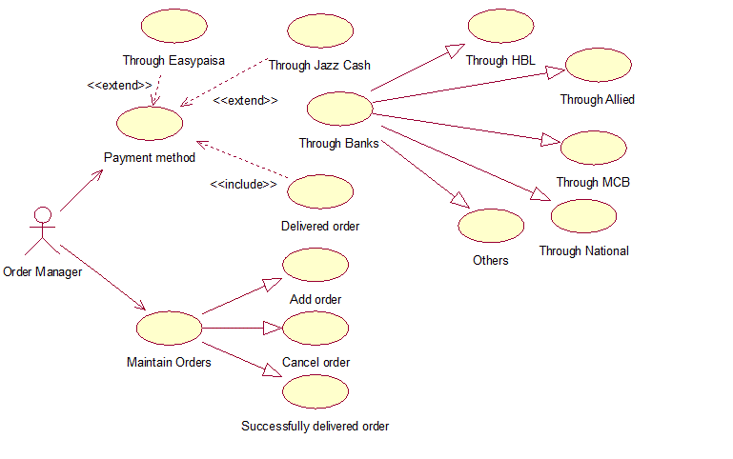

Table 3.11
Number | UC-08A
Name | logout (user side)
Summary | When the system works
Priority | 2
Pre-Condition | User should be login
ost-Condition | User should be logout
Primary Actor | User (Customer)
Secondary Actor (s) | Admin
Trigger | The system should be logout
Main Scenario
Alternative Scenario
Open Issue | No issue.

Chapter 4

System Design

Chapter 4: System Design
The online Korai Iron Store is an electronic application and utilizations server. The web program fills in as a UI for the framework. The web program speaks with the server utilizing HTTP as transport convention. Web program sends solicitations to the server and the server react to web in HTML organize, web program, at that point show the data to the client. WIFI or Ethernet is utilized and it needs a legitimate system. MySQL Database dwells on the server when client information is stored and handled.

Architecture Diagram

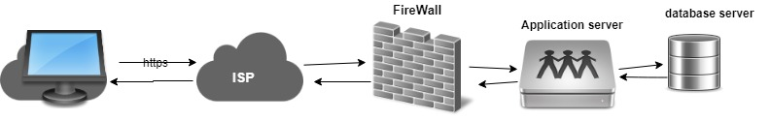

Domain Model
A domain model is a conceptual model that describes the domain problems (like object, classes etc.) of the system. It is used to sort out the real time conceptual issues of the problems through describing the model. Through this model, the software system can communicate with non-technical stakeholders. It should not refer to any technical implementation such as database or component diagrams that are being designed.
It is generally implemented on “Object Model” within a layer. The layers are used to communicate with the data and behavior of the model. In the Unified Modeling Language (UML), a class diagram is used to represent the domain model.
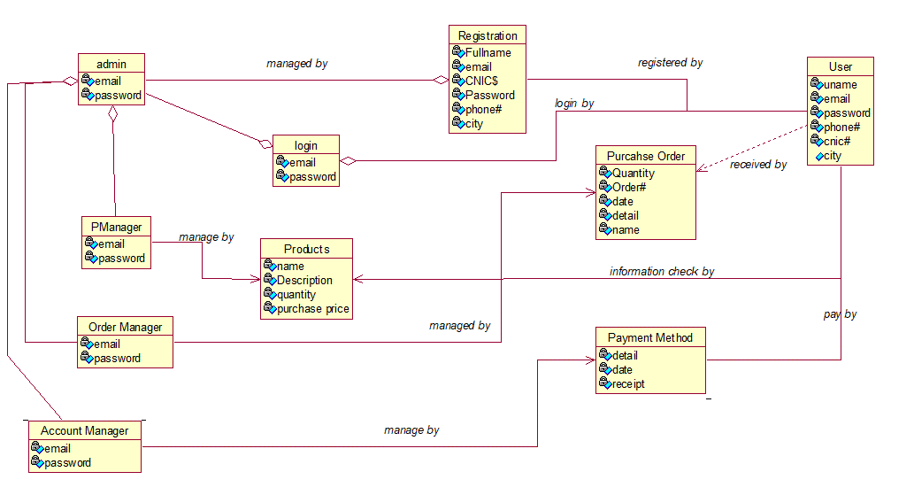

Entity Relationship Diagram with data dictionary

Class Diagram

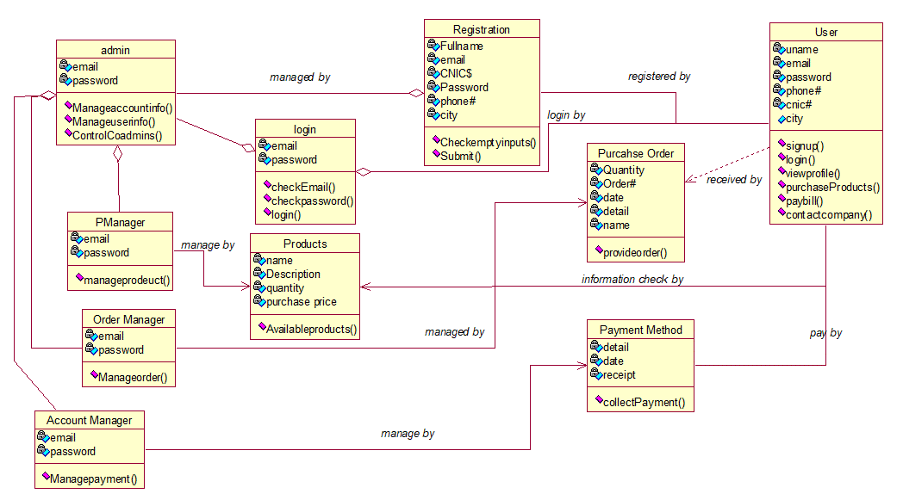

Sequence / Collaboration Diagram
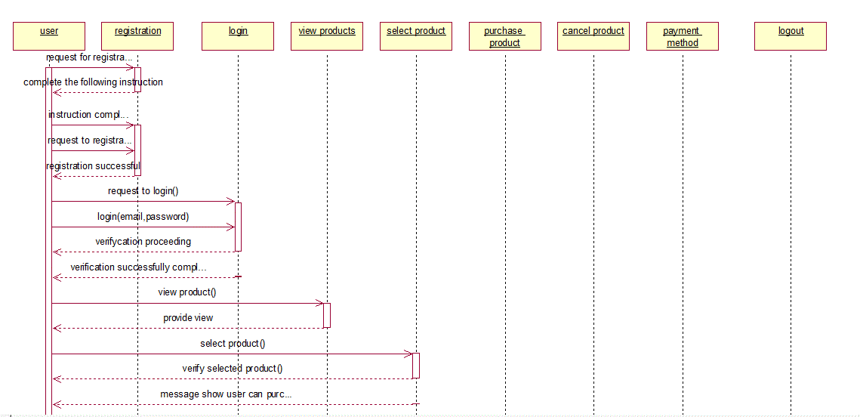

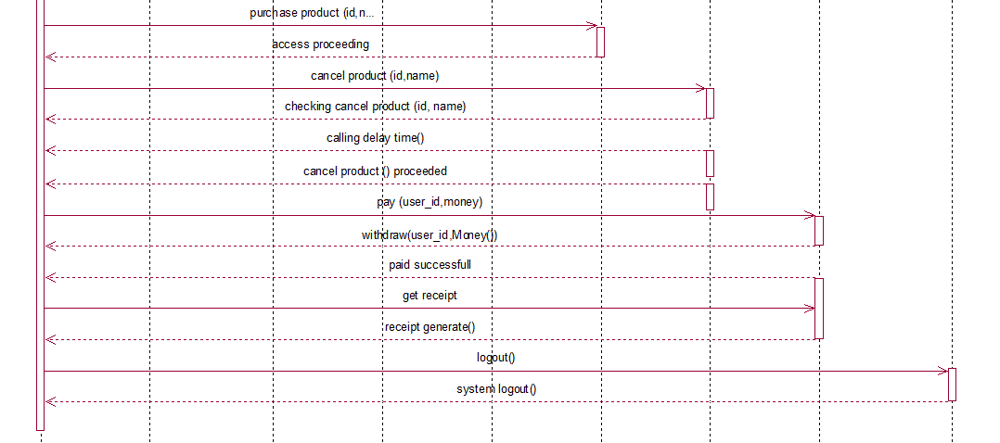

Operation contracts
- Operation contract Registration operation
Operation: | Registration (fname, lname, email…)
Responsibilities | To register the new user
Cross References | Use Case: Register  Scenario: User Registration
Exception | None
Pre-Condition | None
Post-Condition | - The user classregister user“ru” will create  - Functions will callwhich are associates with registration data  - Instance “sti”will create tostore the information in database  - Function “ci” executes tochecking user informationof “sti”  - Attributes will beupdate after “ci” complete execution of “sti”  - Function“cmp” generate account and allows to user for further procedure

- Operation contract login operation
Operation: | Login (Email or phone, Password)
Responsibilities | A user will be login
Cross References | Use Case: Login  Scenario: Login the system
Exception | Invalid user name or password
Pre-Condition | The user must have an account
Post-Condition | - The login instance “li” will create  - The user registration verification function“rf” will call to verify the user account of “li”  - The instance“c” will create which compare the login identity with user registration  - The attributes are initialize for login system  - The function“ls()” will show the result oflogin successful  - The instance “li” will destroy (when user successfully login).

- Operation contract view operation
Operation: | ViewProduct (name)
Responsibilities | None
Cross References | Use Case: view product  Scenario: The user views company’s products
Exception | None
Pre-Condition | - The user can be registered  - The user can be login the system
Post-Condition | - The View product instance “vp” will create  - The Function product view“pv” will call of “vp”(continue..)

- Operation contract search-product operation
Operation: | search(name)
Responsibilities | User search valid product information
Cross References | Use Case:Search Product  Scenario: The user can search the product
Exception | Invalid search
Pre-Condition | - User will registered  - user will login with the system
Post-Condition | - User search product instance “sp” will create  - The function show_result “sr” will be call for searching the product of “sp”  - The instance “sp” will destroy (after complete search)

- Operation contract Purchase product operation
Operation: | PurchaseProduct(ProdNo, ProdName, quantity, UserID)
Responsibilities | Purchase the product with the system’s predefined criteria
Cross References | Use Case:Purchase Product  Scenario: The use can purchase product
Exception | Invalid procedure for purchasing product
Pre-Condition | - The user should be login with the system
Post-Condition | - A classPurchase Product“pp” will create  - The class“pp” associated with class“ru” of registered user  - The function VerifyInfo() will call of class“pp”  - The attributes will initialize of VerifyInfo() (to check the user record)  - The function IsverifyInfo() will call of “pp”  - The attributes of IsverifyInfo() check the user detail (registered user or not) and shows result  - The instance Get Product “gp” will create  - The “gp” will associated with “pp”  - The IsPurchaseProd()is a function of instance “gp” is executed  - The “gp” will destroy

- Operation contract for end-purchase-product operation
Operation: | end-purchase-product ()
Responsibilities | None
Cross References | Use Case: Purchase Product  Scenario: use can purchase product
Exception | None
Pre-Condition | - user should be registered  - user should be login the system
Post-Condition | - The system check class“purchase product”pp.IsPurchaseProd() became true

- Operation contract for get-payment operation
Operation: | payment(amount: Money)
Responsibilities | The user payment card will be correct
Cross References | Use Case:Payment Method  Scenario:The user will pay money against purchasing the product
Exception | Invalid Payment Card and number
Pre-Condition | - user should be registered  - user should be login the system
Post-Condition | - Thepayment method class“pm” will be create  - pm.GetAmount() became amount  - pm associated with purchase product“pp”

- Operationdelivered order operation
Operation: | Delivered_Order()
Responsibilities | User should be receive order
Cross References | Use Case:Delivered order  Scenario:The company delivered the order
Exception | None
Pre-Condition | - The user should be login the system
Post-Condition | - The function IsOrderDelivered() is associated with payment method class  - Function calling is occur (Pm.IsOrderDelivered() becomes delivered)

- Operation Contract “Add Product” operation

Operation: | Add_Product (id, detail)
Responsibilities | The product manager is add the products
Cross References | Use Case: Maintain Product  Scenario: The product Manager Maintain the records
Exception | Irrelevant adds
Pre-Condition | - The product manager should be login with the system  - The product manager works during the office time
Post-Condition | - The class Manage product“mp” will create  - The instanceAdd Product“ap” is associated with “mp”  - The function IsproductAdd() is call in “ap”  - Function is calling Ap.IsProductAdd()becomes add  - The instance “ap” is destroyed

- Operation contract Delete_product operation
Operation: | Add_Product (id, detail)
Responsibilities | The product manager is delete the product
Cross References | Use Case: Maintain Product  Scenario: The product Manager Maintain the records
Exception | relevant adds
Pre-Condition | - The product manager should be login with the system  - The product manager works during the office time
Post-Condition | - The class Manage product“mp” will create  - The instance delete Product“dp” is associated with “mp”  - The function IsProductDelete() is call in “dp”  - The function IsProductSale() is associated with IsProductDelete()  - Function is calling dp.IsProductSale() becomes true  - Function is calling dp.IsProductDelete() becomes remove  - The instance “dp” is destroyed

- Operation contract “edit product” operation
Operation: | Add_Product (id, detail)
Responsibilities | The product manager is edit the product
Cross References | Use Case: Maintain Product  Scenario: The product Manager Maintain the records
Exception | Irrelevant adds
Pre-Condition | - The product manager should be login with the system  - The product manager works during the office time
Post-Condition | - The class Manage product“mp” will create  - The instance edit Product“ep” is associated with “mp”  - The function IsProductEdit() is call in “mp”  - The functions IsProductoldRate(), IsProductQuantity() associated with IsProductEdit()  - Function is calling dp.IsProductRate() becomes correct  - Function is calling dp.IsProductQuantity() becomes correct  - Function is calling dp.IsProductEdit() becomes updated  - The instance “ep” is destroyed

Activity Diagram

Subsystem Activities
Login
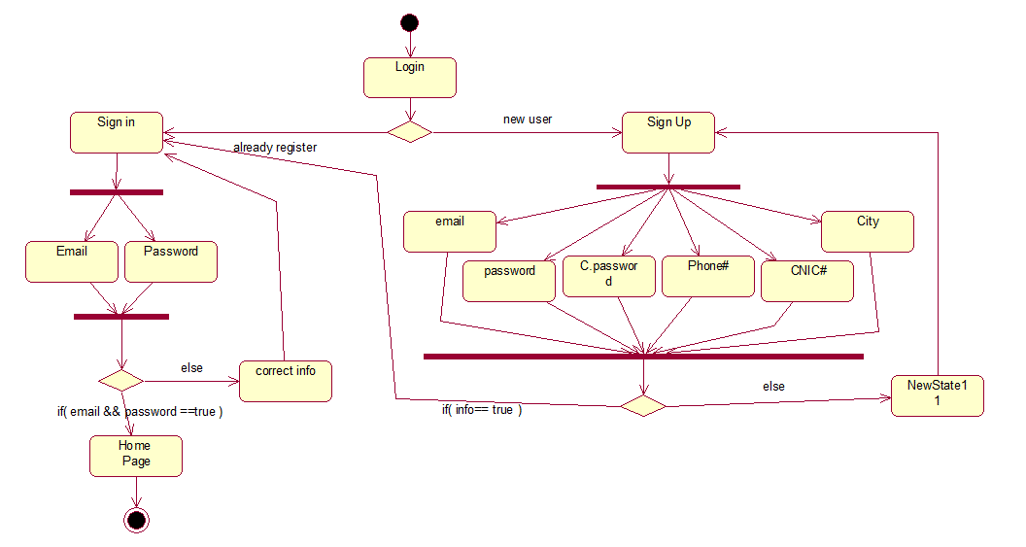

Update Profile
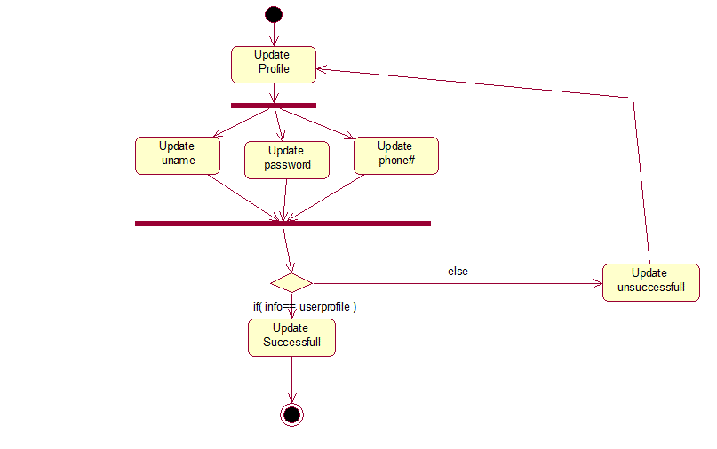

Payment Method
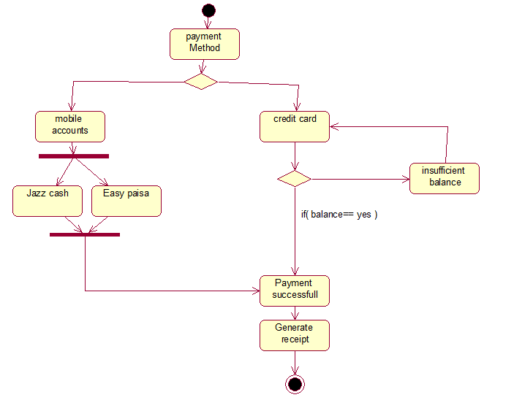

State Transition Diagram
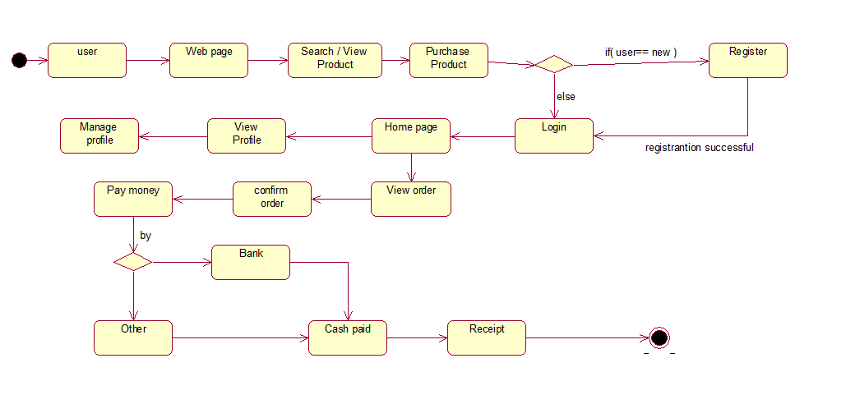

Component Diagram
A Component Diagram provides high level view of large system. The components diagram shows how to compose and interact with the system. The basic purpose is to shows structural relationship between components.
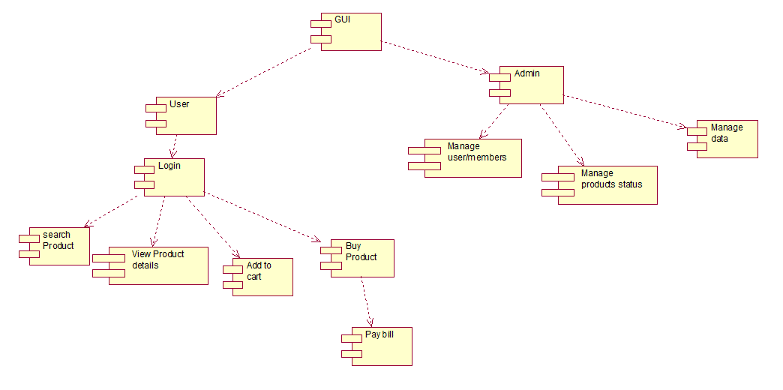

Deployment Diagram

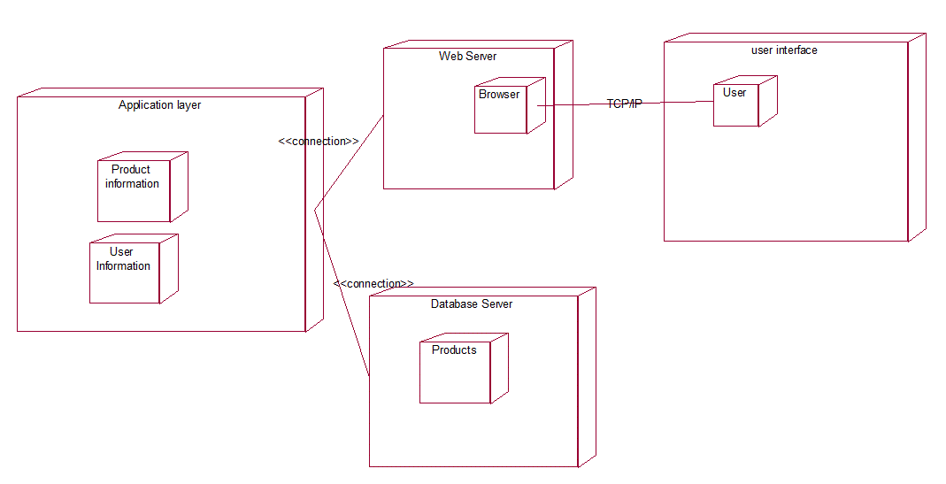

Chapter 5

Implementation

Chapter 5: Implementation
Implementation of requirements and tools and techniques and SRS on this System will be standardized. No one process can be missed due to system sequence. If one of them process is skipped, then benefits will below, priority of risk will be high and system will be unsecure completely regarding that module functionality.
Implementation of:
- SRS
- Requirements
- Tools
- Techniques
- Testing’s
- Class Diagrams
- Activity Diagrams
- Sequence
- Architecture Design

Components, Libraries, Web Services and stubs
Components:
- Properly Structured Website
Korai Iron Store’s website is easy to use. If a customer wants to purchase a product, they can easily purchase a product from our website. Our website has a simple structure, with the most important pages accessible from the main navigation menu. Korai Iron Store’s website has products, separate contact form and Transaction details.
- Mobile Friendly Shopping Experience
Today, the world of technology is evolving quickly, more and more people have been using their mobile devices to shop online. Korai Iron Store’s website is mobile friendly. This website mobile navigation is easy to use and Korai Iron Store’s having friendly environment.
Web Services
- Consumers straightforwardly purchase merchandise or administrations from a vender continuously, without a go-between benefit
- 24-hr access
- Variety
- Ability to comparison shop
- The in home-privacy

Deployment Environment
Here we need a domain on which the Korai Iron Store’s system will exists and through the domain several people will access the application. And smart phone users can download either form Apple store or from Google play store through which they can easily access the service and can easily purchase online products. It required one administrator who will be in charge of the approval and other supervision duty.

Tools and Techniques
Applications and tools that would be used during this project preparation are as follows:
PHP
Php is a general-purpose programming language originally designed for web development. It was originally created by Ramus Leadoff in 1994. PHP code may be executed with a command line interface (CLI), embedded into HTML code, or used in combination with various web template systems, web content management systems, and web frameworks. PHP code is usually processed by a PHP interpreter implemented as a module in a web server or as a Common Gateway Interface (CGI) executable. The web server outputs the results of the interpreted and executed PHP code, which may be any type of data, such as generated HTML code or binary image data. PHP can be used for many programming tasks outside of the web context, such as standalone graphical applications and robotic drone control.
Maria DB
In Maria DB, you can search by field, range query and it also supports regular expression searches. You can index any field in a document. Maria DB can run over multiple servers. The data is duplicated to keep the system up and also keep its running condition in case of hardware failure. It has an automatic load balancing configuration because of data placed in shards.
Microsoft Word
Microsoft word is the word processor and would be used for documentation purpose throughout the whole project.
Microsoft Excel
Microsoft excel is spreadsheet and would be used for data analysis throughout the Whole project. Classifier
Microsoft Project
Microsoft Projects provides extensive features on project management with a prominent feature of project scheduling. Gantt charts, resource allocations. This would be used as a project management tool throughout the whole project.

Rational Rose
Simplify and communicate complex information with data-linked diagrams that we can create in just a few clicks. Visio makes diagramming simple. Whether we want to quickly capture a flowchart that we brainstormed on a whiteboard, map an IT network, build an organizational chart, document a business process, or draw a floor plan, Visio helps you work visually.
Adobe Illustrator
A wide range of tutorials to help you quickly learn and understand the concept, workflow, tips, and tricks. Popular presets to get you started with the new documents quickly. Display and access to your recent documents
Adobe Photoshop
Adobe Photoshop CC allows users to access their Light-room photos from the Start Screen of the app. Adobe Light-room is a photo processor and image organizer. Thus, users will be able to edit their Light-room photos

Best Practices / Coding Standards
- No coding repetition
- Function and classes are always commented showing expected input and output

Version Control
Version control system are a Category of software tools that help a software team manage changes to source code over time. Version control software of every modification to the code in a special kind of database. If a mistake is made, developer can turn back the clock and compare earlier versions of the code to help fix the mistakes of the code while minimizing troubles to all team members, there are some tools for controlling code
- CircleCi
- Bit bucket
We are scaling every feature with initial versions. Like:
- System
  - Registration
    - Authentication change
    - Make alternate for pre-condition
  - Login
  - Logout
  - Forget Password
  - Make order
  - View Profile

These are some features with initial versions. After testing these versions will be upgrade and aggregate into different scales. With the passage of time these versions will become older due to many changings. So here these old versions will help us maintain our System and code.

Chapter 6

Testing and Evaluation

Chapter 6: Testing and Evaluation
Designing interactive systems with graphic user interfaces is an important step in the development of online websites. Korai Iron Store have improved in the last decade. However, it is important to understand online dealer’s needs and preferences and to take them into account. In this regard, several online iron shopping systems rely on customer preference elicitation while others suggest products based on other customers recommendations. An evaluation and testing method is utilized to obtain user feedback on how effective the system is and how easy it is to use, compared to other systems.

Use Case Testing
Verify that user is able to navigate through all the products across different categories.
Verify that all the links and banners are redirecting to correct product/ category pages and none of the links are broken.
Verify that all the text - product, category name, price and product description are clearly visible.
Verify that all the images - product and banner are clearly visible.
Verify that category pages have relevant product listed specific to the category. Verify that correct count of total products is listed on the category pages.
Search - Verify that on searching the entire product satisfying the search criteria are visible on the search result page.
Search - Verify the more relevant product for the search term is displayed on the top for a particular search term.
Search - Verify that count of products is correctly displayed on the search result page for a particular search term.
Filtering - Verify that filtering functionality correctly filters product based on the filter applied.
Filtering - Verify that filtering works correctly on category pages.

Filtering - Verify that filtering works correctly on the search result page.
Filtering - Verify that correct count of total products is displayed after a filter is applied.
Sorting - Verify that all the sort options work correctly - correctly sort the products based on the sort option chosen.

Unit testing

Using Unit testing frameworks we write unit tests quickly and easily. Most of the programming languages do not support unit testing with the inbuilt compiler. Third party open source and commercial tools can be used to make unit testing even more fun.
List of popular Unit Testing Tools for different programming languages:
Java framework – JUnit
PHP framework – PHPUnit
C++ frameworks – UnitTest
Python framework – py.test

Integration testing
We feel that Integration testing is complex and requires some development and logical skill. That’s true! Then what is the purpose of integrating this testing into our website testing strategy?
- In the real world, when website of online shopping (KIS) is developed, it is broken down into smaller modules and individual developers are assigned 1 module. The logic implemented by one

Developer is quite different than another developer, so it becomes important to check whether the logic implemented by a developer is as per the expectations and depiction the correct value in accordance with the set standards.
    - Many a time the face or the structure of data changes when it travels from one module to another. Some values are appended or removed, which causes issues in the later modules.
    - Modules also interact with some third party tools or AP Is which also need to be tested that the data accepted by that API / tool is correct and that the response generated is also as expected.
    - A very common problem in testing frequent requirement change. Many a time developer deploys the changes without unit testing it. Integration testing becomes important at that time
Here we should understand that Integration testing does not happen at the end of the cycle, rather it is conducted simultaneously with the development. So in most of the times, all the modules are not actually available to test and here is what the challenge comes to test something which does not exist!
The main function or goal of this testing is to test the interfaces between the units/ modules.

Performance Testing
The purpose of this document is to define/ explain how Performance Testing will be performed on the online shopping website (KIS) for the current and future state.
Korai Iron Store is a website. This website will be used to fulfill customer requirements.
KIS website that will have its own stores and perform online shopping process and will perform basic functionality of online shopping but will have some new features like any brand if they want to open their shop on this Website they can open but they will be strictly announced to have order delivering facilities on their own behalf. So this thing will bring easiness for customer to get their order from desired brand by nearby shop within one day. And if customer wants to order a product which belongs to other region of his city then he will wait for one week to receive hisorder by using TCS service.
It is being assumed that the Performance environment data will be a copy of the production data and the required Test data will be provided by the project team.

Stress Testing
Stress testing anything beyond a point results in serious consequences in humans, machine or program it either causes serious damages or breaks it completely.
Similarly, in this tutorial, we will learn how to stress test web applications along with its effect.
In order to avoid any permanent damage to your apps or websites when they are stressed i.e. heavily loaded, we need to find the breaking point and in turn the solution to avoid such conditions. Just think how it would be when your shopping website goes down during Christmas sale.

Enlisted below are some Examples of real cases where it is of high importance to stress test an app or website:
    - Commercial shopping apps or websites need to perform stress testing as the load becomes very high during festivals, sale or special offer period.
    - Financial apps or websites need to perform stress test as the load increases at times like when a company share goes up, a lot of people log in to their accounts to buy or sell, online shopping websites redirect ‘Net- bankers’ for payment etc.

    - Web or emailing apps need to be stress tested.
    - Social networking websites or apps, blogs etc., need to be stress tested etc.

Chapter 7

Summary and conclusion
Future Enhancement

Chapter 7: Summary, Conclusion & Future Enhancements

Project Summary
Web based application for an Iron shop. Different types of data of different users will be maintained separately. Customers are purchasing products and have records of each transaction. Each customer should have to provide authentication to use the system. Authenticated User can check the Updated records of sale, purchase and other relevant things. The environment of the application will be user-friendly. The design is according to customer perspective and their needs. Pictures of products and their price will be upload for public users. Customers can communicate the owner in different ways. We provide help corner online.

Achievement and Improvements
There’s more competition than ever online as you try to sell your goods. Customers are looking for more than just a utilitarian shopping site, they want an experience. How can you tempt them away from the big companies and over to you?

Identify your own brand’s personality
    - Proofread all your website content
    - Improve your emails
    - Have product reviews written for you
    - Be genuine
    - Check and improve your grammar
    - Use recommendation engines
    - Appeal to the buyer’s emotions
    - Use the ‘customer service tone’
    - Be enthusiastic about what you’re selling
Critical Review
In the history of management science, no topic has been the object of more academic research over such a short time than the Internet. This technology has provided a new interface linking businesses as well as individuals, and spanning many fields, from information systems to marketing, worldwide.
With the proliferation of websites (one hundred fold growth in ten years), academic and empirical research has sought to evaluate the features of e- commerce websites most likely to maximize Internet technology adoption, to attract Internet users, turn them into cyber buyers, encourage customer loyalty, improve service and ultimately increase profits. However, there has been great diversity in the research, with different skills involved

(Information technology, marketing, communication, etc.), as well as a wide range of websites being analyzed.
The Internet is a field of research that is still evolving, with businesses and customers learning together, and little is known about how to develop commercial websites to maximize profit.

Lessons Learnt
The main lesson that we have learnt during developing this project was how to give importance to time, how to work hard and how to face all problems created by other people.

Future Enhancements/Recommendations
We are looking to add some new features in future like open our own stores in all over the Pakistan instead of registering others. We are also looking to add events on this sites let suppose if someone gets 100 orders from customers then this website will be shown as trending website for cars.

Appendices

Appendix A: User Manual
In the appendix section we describe the different phases of user interface and also describe how user can use our project. Secondly we describe our promotional plan and promotional materials like broacher, banner, standee and other marketing materials. We also describe other interfaces of this project.

Appendix A: Information / Promotional Material

In the appendix section we describe the different phases of user interface and also describe how user can use our project. Secondly we describe our promotional plan and promotional materials like broacher, banner, standee and other marketing materials. We also describe other interfaces of this project.

Broacher

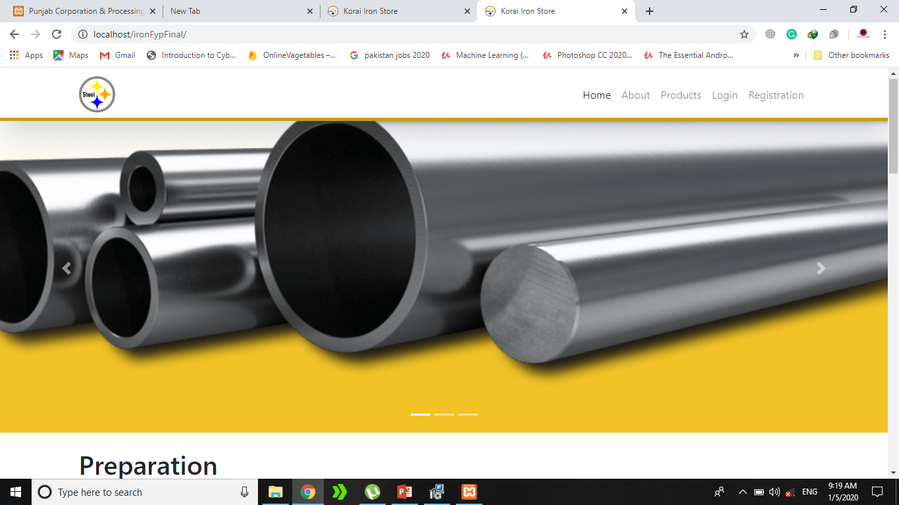
Flyer

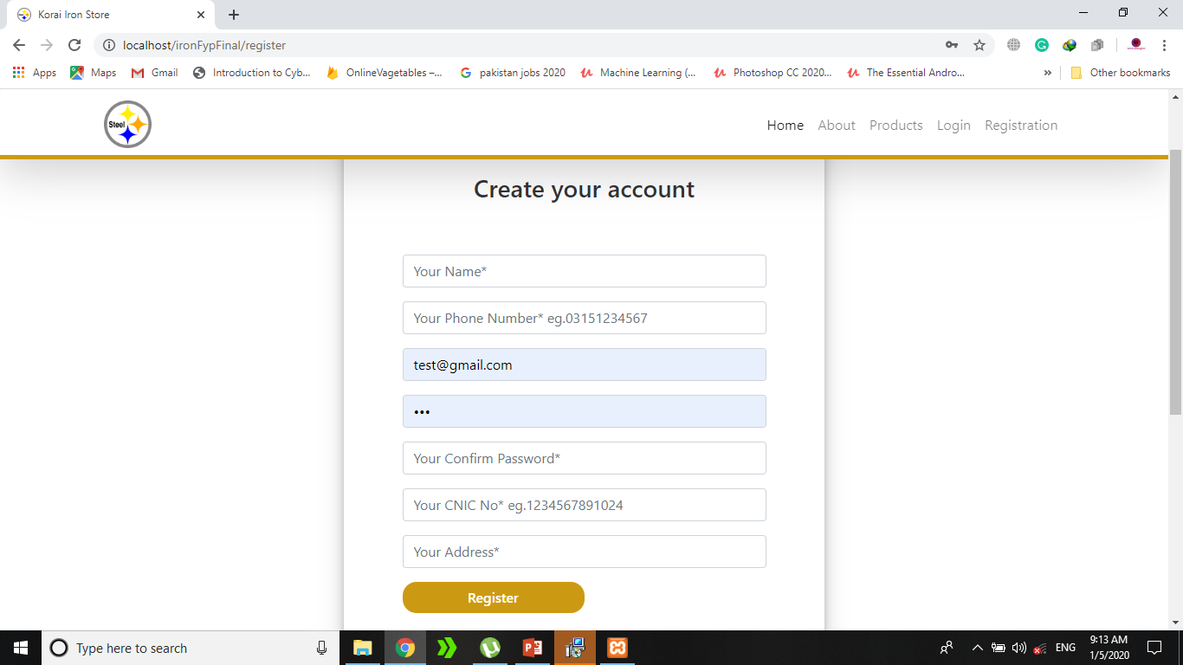

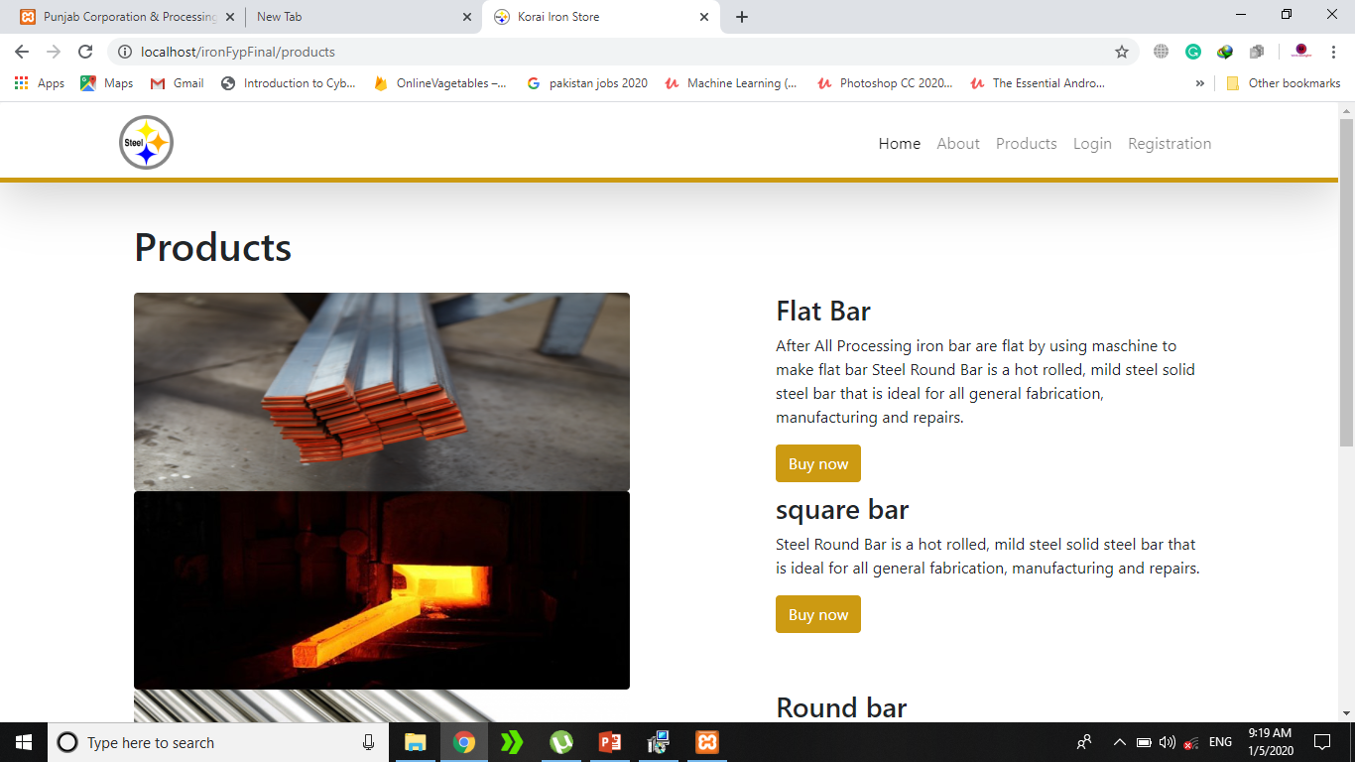

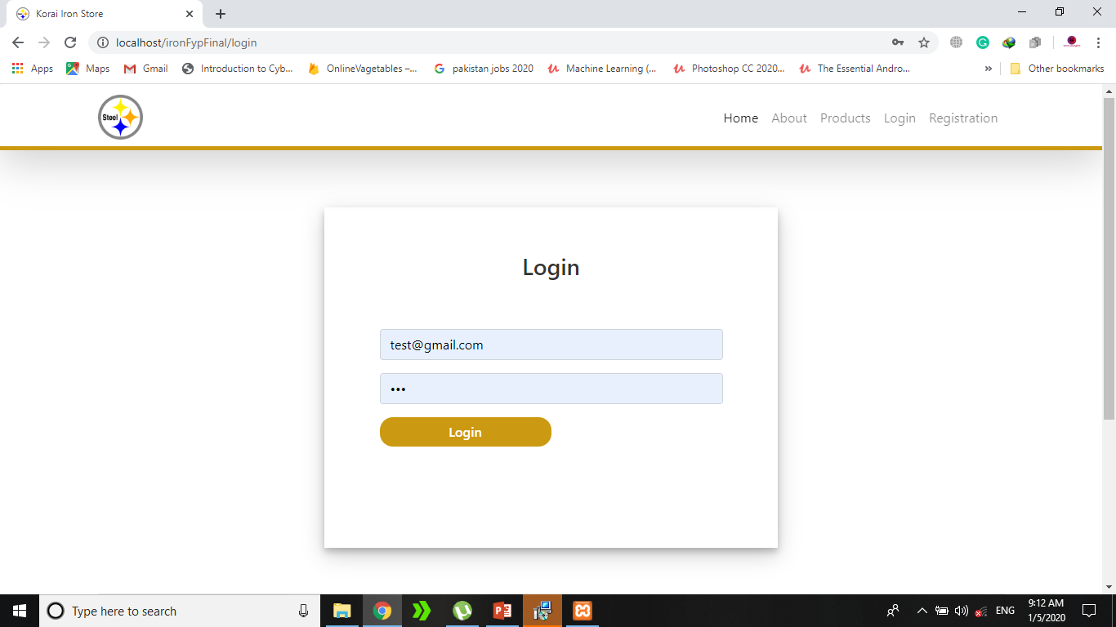

Reference and Bibliography

Reference and Bibliography

- https://Daraz.pk/
- https://notepad- plus- plus.org/download/v7.6.2.html
- https://filehippo.com/download_xampp/
- http:// stackoverflow.com
- https:// codepen.io
- https://youtube.com
- https://www.wikipedia.org/
- https://www.w3schools.com/js/
- https://www.amazon.com/
- https://www.w3schools.com/bootstrap/bootstrap_list_groups.asp

