License Plate Recognition System
Final Year Project
Session 2016-2020

A project submitted in partial fulfillment of the degree of
BS in Computer Science


Department of Computer Science
Faculty of Computer Science & Information Technology
The Superior College, Lahore
Spring 2020

Type (Nature of project) |  |  | [ ] Development [ ] Research [ ] R&D
Area of specialization
FYP ID |  |  | Group-40
Project Group Members
Sr.# | Reg. # | Student Name |  | Email ID | *Signature
(i) |  | (Project Leader)  Ali Waseem |  | Bcsm-f16-290@superior.edu.pk
(ii) |  | Muhammad Umair |  | Bcsm-f16-123@superior.edu.pk
(iii) |  | Ayesha Bashir |  | Bcsm-f16-170@superior.edu.pk
*The candidates confirm that the work submitted is their own and appropriate credit has been given where reference has been made to work of others

Plagiarism Free Certificate
This is to certify that, I Ali Waseem S/D of Muhammad Waseem, group leader of FYP under registration no __40____________________________at Computer Science Department, The Superior College, Lahore. I declare that my FYP report is checked by my supervisor.

Date: Name of Group Leader: Ali Waseem Signature: _____________
Name of Supervisor: Dr. ABC Co-Supervisor: Mr. XYZ
Designation: Lecturer Designation: Associate Professor
Signature: ________________ Signature: _________________

HoD: Dr. irfanudin
Signature: _______________

Project Report
License Plate Recognition System

Change Record
Author(s) | Version | Date | Notes | Supervisor’s Signature
 | 1.0

APPROVAL
PROJECT SUPERVISOR
Comments: ___________________________________________________________________
_____________________________________________________________________________
Name:______________________________
Date:_______________________________ | Signature:__________________________

PROJECT MANAGER
Comments: ___________________________________________________________________
_____________________________________________________________________________
Date:_______________________________ | Signature:__________________________

HEAD OF THE DEPARTMENT
Comments: ___________________________________________________________________
_____________________________________________________________________________
Date:_______________________________ | Signature:__________________________

Dedication

“This work is dedicated to our Father who always Support us in every way, and to the mother how always love her in every situation and always boost us”. We want to dedicate this to our teachers also who enlightened us with knowledge.

Acknowledgements

First and foremost, I would like to thank God for his never-ending grace, mercy, and provision during what ended up being one of the toughest times of my life, and a very thanks to our Supervisor Madam Arshia for their wonderful Collaboration. It always a pleasure to work with a lovely and engaging personality like you. It’s your expert advice and encouragement which help us to achieve our Goal.

Executive Summary
World widely there exist many systems for license plate recognition. Which do Automatic Number Plate recognition. We have considered the research paper of Bangladesh and India. This system detects vehicles which involves the detection and identification of license plate number. For this purpose, they used algorithm used in plate localization for identifying edges, a character segmentation and extraction. A character extraction and segmentation algorithm which uses the Korhonen neutral work concept to identify the position and dimension of characters is presented along with the existing Histogram and Pixels approach.

We use a more efficient algorithm and we try to implement a new add-on which can help us to extract data for raw images which difficult to recognize.

The basic aim of pre-processing stage was to improve the contrast and reduce the noise in the image.${}^{\left[1\right]}$
Another system uses image Acquisition, Character segmentation and extraction, character recognition, License plate information Storage to identify the person.${}^{[2]}$

Table of Contents
Dedication vi
Acknowledgements vi
Executive Summary vii
Table of Contents viii
List of Figures ix
List of Tables x
Chapter 1 1
Introduction 2
1.1. Background 2
1.2. Motivations and Challenges 3
1.3. Goals and Objectives 3
1.4. Literature Review/Existing Solutions 4
1.5. Gap Analysis 4
1.6. Proposed Solution 4
1.7. Project Plan 4
1.7.1. Work Breakdown Structure 4
1.7.2. Roles & Responsibility Matrix 3
1.7.3. Gantt Chart 3
1.8. Proposed Methodology 6-10
1.9. Report Outline 10

Chapter 2 11
Software Requirement Specifications 11
2.1. Introduction 11
2.1.1. Purpose 11
2.1.2. Document Conventions 11
2.1.3. Intended Audience and Reading Suggestions 11
2.1.4. Product Scope 12
2.1.5. References 12
2.2. Overall Description 12
2.2.1. Product Perspective 13
2.2.2. Product Functions 14
2.2.3. User Classes and Characteristics 15
2.2.4. Operating Environment 15
2.2.5. Design and Implementation Constraints 15
2.2.6. User Documentation 15
2.2.7. Assumptions and Dependencies 16
2.3. External Interface Requirements 16
2.3.1. User Interfaces 17
2.3.2. Hardware Interfaces 17
2.3.3. Software Interfaces 17
2.3.4. Communications Interfaces 18
2.4. System Features 18
2.4.1. Login 18
2.4.1.1. Description and Priority 18
2.4.1.2. Stimulus/Response Sequences 18
2.4.1.3. Functional Requirements 19
2.4.2. Forget Password 19
2.4.2.1. Description and Priority 19
2.4.2.2. Stimulus/Response Sequences 20
2.4.2.3. Functional Requirements 20
2.4.3. Data Collection (and so on) 21
2.5. Other Nonfunctional Requirements 29
2.5.1. Performance Requirements 29
2.5.2. Usability Requirements 29
2.5.3. Security Requirements 29
2.5.4. Reliability 29
2.5.5. Availability 29
2.5.6. Efficiency 29
2.5.7. Accuracy 29
2.5.8. Simplicity 29
2.6. Other Requirements 30
Chapter 3 35
Use Case Analysis 35
3.1. Use Case Model 36
3.2. Use Case Descriptions 43
Chapter 4 53
System Design 53
4.1. Architecture Diagram 54
4.2. Domain Model 55
4.3. Entity Relationship Diagram with data dictionary 56
4.4. Class Diagram 57
4.5. Sequence / Collaboration Diagram 58
4.6. Operation contracts 64
4.7. Activity Diagram 69
4.8. State Transition Diagram 72
4.9. Component Diagram 75
4.10. Deployment Diagram 76
4.11. Data Flow diagram [only if structured approach is used - Level 0 and 1] 77
Chapter 5 79
Implementation 20
5.1. Important Flow Control/Pseudo codes 21
5.2. Components, Libraries, Web Services and stubs 21
5.3. Deployment Environment 21
5.4. Tools and Techniques 22
5.5. Best Practices / Coding Standards 22
5.6. Version Control 22
Chapter 6 23
Testing and Evaluation 23
6.1. Use Case Testing 24
6.2. Equivalence partitioning 24
6.3. Boundary value analysis 24
6.4. Data flow testing 24
6.5. Unit testing 25
6.6. Integration testing 25
6.7. Performance testing 25
6.8. Stress Testing 25
Chapter 7 26
Summary, Conclusion and Future Enhancements 26
7.1. Project Summary 27
7.2. Achievements and Improvements 27
7.3. Critical Review 27
7.4. Lessons Learnt 27
7.5. Future Enhancements/Recommendations 28
Appendices 29
Appendix A: User Manual 30
Appendix B: Administrator Manual 31
Appendix C: Information / Promotional Material 32
Reference and Bibliography 35
Index 37

List of Figures
Chapter 1
Work Breakdown Structure………………………………………………………………………………….5
Figure1.1: Gant Chart……………… ……………………………………………………………………………………..5
Figure1.2:Methodolgy …………………………………………………………………………………………………..6
Figure1.3: Flow Diagram of Number Plate…………………………………………………………………………8
Chapter 3
Diagram 1.0
Create Account………………………………………………………………………………………………………………….36
Diagram 2.0
Login...………………………………………………………………………………………………………………………37
Diagram 2.1
Forget Password…………………………………………………………………………………………………………………37
Diagram 3.0
Verify Plate Number…………………………………………………………………………………………………………..38
Diagram 3.1
Record not Verify ……………………………………………………………………………………………………………….38
Diagram 4.0
Verify Vehicle……………………………………………………………………………………………………………………..39
Diagram 5.0
Generate Challan ……………………………………………………………………………………………………………….39
Diagram 5.1
Show Challan ……………………………………………………………………………………………………………………..40
Diagram 5.2
Store Record ………….…………………………………………………………………………………………………………..40
Diagram 5.3
User Challan Record…………………………………………………………………………………………………………….41
Diagram 5.4
Pay Challan …………..…………………………………………………………………………………………………………….41
Diagram 6.0
Logout …………………….…………………………………………………………………………………………………………..42

List of Tables

Table No 1.1………………………………………………………………………….5
- Table No 2.1 …………………………………………………………………………………12
Table No 2.2…………………………………………………………………………19
Table No 2.3…………………………………………………………………………20
Table No 2.4…………………………………………………………………………21
Table No 2.5…………………………………………………………………………23
Table No 2.6…………………………………………………………………………24
Table No 2.7…………………………………………………………………………26
Table No 2.8…………………………………………………………………………27
Table No 2.9…………………………………………………………………………28
Table No 2.10…………………………………………………………………………34

Chapter 1

Introduction

Chapter 1: Introduction
There exist many systems for license plate recognition worldwide. We have considered an already existing system that is modified by Indian. This system detected vehicles which involves the detection and identification of license plate number. For this purpose, they used three algorithms for identifying edges, a character segmentation and extraction algorithm. This system assigned a well-defined ant position and made use of weights to calculate heuristic value which will provide additional information about transition probabilities are used. A character extraction and segmentation algorithm which uses the Korhonen neutral work concept to identify the position and dimension of characters is presented along with the existing Histogram and Pixels approach.
The basic aim of pre-processing stage was to improve the contrast and reduce the noise in the image.${}^{\left[1\right]}$
Another system uses image Acquisition, Character segmentation and extraction, character recognition, License plate information Storage to identify the person.${}^{[2]}$

Background
Automatic number plate recognition is a technology that detects vehicles and number plate. ANPR is used by police around the world for law enforcement purposes, including to check either a vehicle is licensed or not. The background system of ANPR is in 1976 police scientific development branch in Britain. This technology was not widely used.

In Pakistan we find that this system is not yet introduced police has to check each vehicle by their own and manual work of challan. There is no appropriate record of data. With our System we capture the unlicensed or License plate number, people who regularly broke the rules, though we thought that there should be something that can make records of all these things and helpful for police forces so we made our system more fast and efficient.

Motivations and Challenges
Motivation: -

Over 1.2 million deaths and 50 million injuries a year are no small numbers. These are figures reported for road accidents globally in 2017, highlighting the important subject of safety on roads. A number of factors contribute to compromised road safety leading to these tragic statistics. They include speeding, poor vehicle and road condition, driving under the influence of alcohol and drugs, not wearing safety belts, unlicensed underage driving, etc.
With our System we capture the unlicensed or License plate number, people who regularly broke the rules.
Challenges: -

In this System we face a lot of Challenges, the important Challenge we want to overcome is, in Pakistan Vehicles owner use local number plates, this plates data is not easy to extract we want to overcome this Challenge.
The Second one sometimes because of the bad weather or any other Things picture taking with the camera is not enough to extract data, we assure that with the new methodology we overcome this Challenges.

Goals and Objectives
Goals: -
Our main Goal we want to achieve is to make our system more efficient and able to extract data from the local Number plats or from the raw pictures.
Objectives: -
Our Main Objective to build this system provide efficient System to government to Capture the un-licensed or drivers how broke the rules regularly. To make the roads safe for innocent people.

Literature Review/Existing Solutions
- Literature Review
- In the literature, for license plate recognition many algorithms have been designed. It has been active research for many years. It is still challenging task to recognize and identify license plate number of vehicle either it is register or not. This review will cover different related work and used different algorithms to identify LPN of different country. In [1], Mitra et.al present Automatic Number Plate Recognition system using image processing, neutral network, Dilation and Histogram based approach used to resolve the computational and mathematical complexities of ANPR. In [2] Ms. Shilpi Chauhan and Vishal Srivastava proposed efficient vehicle system to detect LPN to keep record of vehicles by using Image processing, Image binarization and Template matching. In [3] Ibrahim Türkyılmaz and Kirami Kaçan developed License Plate Recognition System by using artificial neutral network. For recognition process three stages are used Plate Region Determination, Character Segmentation and Character Recognition. Image processing used in two stages. They used 357 images and got result of 97% accuracy. In [4] P. Surekha et.al present Automatic License Plate Recognition for parking lot using Neutral Network and Image processing and got successful rate of 97% accuracy. In [5] Minghui Zhang et.al proposed JOINT LICENSE PLATE SUPER-RESOLUTION AND RECOGNITION IN ONE MULTI-TASK GAN FRAMEWORK by using deep learning-based and end-to end LPR system for unconstrained urban surveillance scenes.

- The literature review is presented in tabular form:
S.No | Author | Year | Title | Objective /Purpose | Technique | Result accuracy /outcome | Limitation
1 | Dipayan Mitra, Soumit Banerjee | 2016 | Automatic Number Plate Recognition System: A Histogram Based Approach | It is design for faster detection of LPN of  Vehicles that break traffic rules or drive car too fast.  To resolve the computational and mathematical complexities of ANPR. | Artificial neutral network  Image processing | Implement pre-defined functions in pre-processing so computational cost has been reduced.  It also detect images under different conditions. | It fails to detect number plates under changing illuminations.  Input of images that direct matches with database required.
2 | Ms. Shilpi Chauhan  and  Vishal  Srivastava | 2017 | Matlab Based Vehicle Number Plate Recognition | This efficient system is design to identify License Plate Number of vehicle for security purpose. | Image processing technology used | It recognize the image of vehicle that enters in secure areas. | Limitation of image processing & others hardware requirements.
3 | Ibrahim Türkyılmaz and Kirami Kaçan | 2017 | License Plate Recognition System  Using Artificial Neural Networks | LPRS that takes less processing time,  uses low computing power, and it recognize vehicle  under every condition | ANNs  backpropagation learning algorithm &  Image  Processing used | 357 images  97% accuracy | Advanced image processing  Techniques needed in which LPRS with a higher performance  under fewer restrictions could be developed.
4 | P. Surekha et.al | 2018 | AUTOMATIC LICENSE PLATE RECOGNITION USING IMAGE PROCESSING AND NEURAL NETWORK | The ALPR system is design to identify LP of vehicle for parking lot or toll both. | Image processing Neutral network using the feed-forward backpropagation algorithm | It was successfully achieved to detect LP for parking lot using Matlab & Raspberry PI hardware.  105 images used  97% accuracy | Deep learning is require to predict the presence of vehicle.  On a single frame the system would be able to predict multiple LPN of multiple vehicles.
5 | Minghui Zhang, Wu Liu, Huadong Ma | 2018 | JOINT LICENSE PLATE SUPER-RESOLUTION AND RECOGNITION IN  ONE MULTI-TASK GAN FRAMEWORK | It develop LPR system with deep learning and end-to end for unconstrained urban surveillance scenes. | RCNN  Generative network (GN) | The outcome is that system jointly sharpens the license plates and recognizes the  Characters in one multi-task based GAN framework.

Gap Analysis
The Current existing systems generate the challan but do not recognize the plate is registered or not or licensed or unlicensed or unable to extract data directly to image. The other systems exist in other countries to extract data directly to image but those systems extract data from government given number plates but not local number plates or not good enough to extract data from Raw images.

Proposed Solution
We proposed the number plate recognition system which captures the images of the number plates of vehicles then cut out the noise and blur from it and forward the information to the E-challan system.

Project Plan
In the following section we shall use Gantt chart to illustrate our project planning structure;

Work Breakdown Structure
The deliverables of this project are based on the continuous process. The project will be continuing with the roles and responsibilities of every group member. The process from Survey to system design takes 3 to 4 months to fully gather the requirements and reviews.
After the implementation, performance and testing will take place. Hopefully the total time for the project will be 8 to 9 months.

Roles & Responsibility Matrix
Task |  | Start Date |  | #Days Required | Responsibility
Develop broad plan |  | 4/3/07 |  | 12 | Teamwork
Present plan to council |  | 4/20/07 |  | 3 | Teamwork
Identify team |  | 4/20/07 |  | 15 | Supervisor
Train team |  | 5/20/07 |  | 30 | Supervisor
Develop detailed plan |  | 5/27/07 |  | 7 | Teamwork
Conduct preliminary research |  | 5/25/07 |  | 15 | Ayesha Bashir
Identify key practices |  | 6/7/07 |  | 10 | Teamwork
Identify benchmark partners |  | 5/25/07 |  | 20 | Teamwork
Collect public data |  | 6/10/07 |  | 15 | Muhammad Umair
Analyze public data |  | 7/1/07 |  | 15 | Teamwork
Identify current state |  | 6/15/07 |  | 10 | Teamwork
Develop benchmark questions |  | 6/15/07 |  | 7 | Teamwork
Visit benchmark partners |  | 7/15/07 |  | 7 | Teamwork
Develop new process |  | 7/28/07 |  | 40 | Ali Waseem
Present new plan to council |  | 8/31/07 |  | 3 | Teamwork

Table No 1.1

Gantt Chart
Figure 1.1

Proposed Methodology
Methodology

The model development life cycle of our project is based on Agile Scrum Methodology so that we can update it along with the passage of time. This methodology is further divided into 4 parts which are as follow:
- Planning
- Requirements Analysis
- Design
- Testing

Figure 1.2
- PLANNING: -
In the initial stage of the project we have read about 5 to 10 research papers based on License Number Plate Recognitions by using different algorithms and scenarios for getting a proper knowledge about the work already have been done. By such technique of information gathering we have find out that the system which is already implemented had some flaws or downfalls like:
- Blur image capture due to low quality camera or weather
- Images with very high noise
- Not detecting the characters from 2D license plates
- Format of the license plate is not considered at all which is issued by the Government.

- REQUIREMENT ANALYSIS: -
- Such project is required to handle with the Agile Scrum Methodology for the development cycle
- Ant Colony Optimization (ACO) algorithm for detecting the different object in the image
- Artificial Neural Network (ANN) algorithm for recognizing the patterns
- Matlab for making the simulation for evaluation
- Design: -
- For the design purpose of a system, we use Agile Scrum Methodology.
- Testing: -
- See Ch. # 6
Reason: -
However, what we are trying to do is to add a specific module in the already built by using the means of Image Processing Based on a trained AI System to cut such flaws like noisy and blur images and issues like character recognition in certain situations.

The working of the Number Plate Recognition system will be divided into two parts.
- Software Model
In this system processing software model is an important part. The software model uses image processing technology. The programs are implemented in MATLAB. The algorithm is divided into following parts:

Capture Image

Pre-Processing

Object recognition

Algorithm of object Recognition

License plate Recognition

Algorithm of License plate Recognition

Segmentation of characters

Display of Character Recognition
Characters Recognition

Display of Character Recognition
Characters Recognition

Figure 1.3 Flow diagram of Number Plate Recognition

Workflow Process: -
- Capture Image
- The system first captures an image of the number plate using a camera.
- The image stored in JPEG format.
- The image then converted to a gray scale image using MATLAB.

- Pre-Processing
- If there are affected conditions like noise, darkness, snow in this process it will be cleared by using Gray levels and Median Filtering.

- Object Recognition
- There is a lot of objects in the pictures in the image, We identify the specific Number plate
- We use Algorithms to find the specific object.

- License plate Recognition
- In this process we identify the License plate in the objects.
- For this process we use Ant colony optimization Algorithm.

- Character Segmentation
- Image extraction can be done by using segmentation methods.
- Image banalization is used

- Character Recognition
- Split each character of the number plate image.
- Then find correlation and database if both values are the same and generate value 0-9 and A-Z.
- Correlation is used to match the character.
- Convert value in string.
- Display it in the edit box and store characters in some text file.
- Character recognition compares individual characters with the character store in the database.
- If the character matches, display legal otherwise illegal.

Hardware Model
Microcontroller used for controlling complete hardware of number plate recognition systems. The algorithm used for capturing images and processing of vehicle plates. The number compares to the database and gives a signal to the microcontroller to control the hardware system. If the number plate matches with database number the vehicle will be legal otherwise illegal.

Report Outline
- The system accepts validated values and doesn't accept the invalid values.
- It generates challan reports online.
- It produces a report of license or unlicensed plate number of vehicles.
- It generates reports to pay online to users who break rules.

Chapter 2

Software Requirement Specifications

Chapter 2: Software Requirement Specifications

Introduction

Purpose

This document is all about the requirements for the LPRS for the Pakistan Government. Our purpose is to provide an efficient system to capture the unregistered or unlicensed vehicles on the road. This project will be very helpful in making things fast and reliable.

Document Conventions

LPRS | License Plate Recognition System
ACO | Ant Colony Optimization
ANN | Artificial Neural Network
DB | Data Base
KNW | Korhonen neutral network
ANPR | Automatic License Plate Number
LPN | License Plate Number
Table No 2.1

Intended Audience and Reading Suggestions
This document is only for clients not for the public. The document is planned for project managers, developers, marketing staff, users, testers and documentation writers.
Audience: - Government sector, Safe City Projects.
Sequence:
- Introduction, Motivation, Goals, Gap Analysis, Proposed Solution
- Project Plan, WBS, Roles and Responsibility Matrix, Gantt Chart
- Building Methodology

Product Scope
The scope of product is as follows:
- We will design a license plate recognition (LPR) system which will differentiate licensed and unlicensed cars.
- We will design a database for the images dataset management.
Moreover, our system will help to capture the images of the number plates and recognize that either it is registered or not and forward the collected information to the E-Challan system for further inquiry.

References
The basic aim of the pre-processing stage was to improve the contrast and reduce the noise in the image.${}^{\left[1\right]}$
Another system uses image Acquisition, Character segmentation and extraction, character recognition, License plate information Storage to identify the person.${}^{[2]}$

Overall Description

Product Perspective
Pakistan has no electronic system that detects vehicles and LPN. The existing system in India and Bangladesh have features:
- LPRS that detect vehicles.
- Identification of LPN.
- Automatic recognize license plate number using algorithm KNW.
- Existing system of E-Challan is manual in Pakistan.
- Existing system is more time consuming.
- Existing system consumes more men power because traffic police have to deal with a lot of vehicles and generate challan on paper.
- As the data is on paper so it is unable to update, delete, add or view data.
This proposed LPRS has the following features:
- This system recognizes vehicles.
- This system recognizes LPN using more efficient algorithms.
- It implements a new add-on which helps us to extract data for raw images that is difficult to recognize.
- Less time consuming.
- In case of unlicensed plate number or rules break challan will be generated online to that user or public.
- Users can pay their challan online without facing any difficulty.
- Efficient system for traffic police and government.
- Traffic violations will be reduced.
- Public will follow the traffic rules.
- Accidents will be reduced.

Product Functions

Functionalities of this LPRS are:
- Recognize license plate number.
- Detect the vehicles.
- Online generate challan.
- Public pay challan online easily.
- Extract data for raw images
- It identifies whether the plate number is license or unlicensed.
- It takes a few seconds to recognize whether the plate number is registered or not.
- Editing, adding and updating of records.
- Work speed has increased.
- Integrity of all records of challan.
- Better storage capacity.
- Updating is more easy
- Retrieval of information is easy and fast.

User Classes and Characteristics
- Government Authority
- Safe City Projects
- Traffic Police
- Motorway Police

Operating Environment
This System will be available for all android devices. Each generation of laptop will be able to run the System application also.

Design and Implementation Constraints
- The government has to contract with a company to deal with this project.
- Company has to handle this project according to the contract agreement.
- It will be the responsibility of the admin.
- The software design (maintainability) will not be the responsibility of the developer or company.
- In case of any mishap in the software the developer or company will not be responsible for that lose
- Developer or company gives a first trial of the software and after that they will not entertain their queries.

User Documentation
No manual on paper shall be delivered. The System will come with its own set of tutorials that might help users understand and work through the System firsthand. Users can pay challan online.

Assumptions and Dependencies
Assumptions:
- It is assumed that the requirements are in its completion phase.
- It is assumed that users have decent internet connectivity.
- Users have to pay challan online within the required time.
- Typical errors regarding a MatLab
Dependencies:
- Restrictions and limitations of all the levels are known by the users.
- Concepts from existing Systems.
- Access to the system is restricted to the user name.

External Interface Requirements

User Interfaces

In this section, we shall present the Visual part of computer application through which the user will interact with the software. It determines how commands are given to the computer or the program and how information is displayed on the screen.
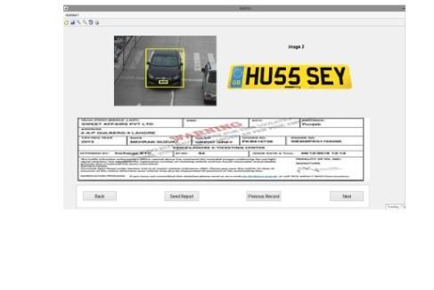
- It will be standard viewing protocols.
- It will maintain high contrasts.
- It will have high visibility to get best results.
- It will have a dark and light colored background depending on time.
- It will have light colored font increase the visibility
- Layout will be according to the display and scope of the device on which software is being used
- User interface for the application will be in the form of forms, that it will easy to read

Hardware Interfaces
- camera
- Ram
- Hard disk
- Processor
- Monitor
- Keyboard
- Mouse

Software Interfaces
Software requirements are the requirements which are required for the building of the project. At which software the project is been made up:
- Algorithm: Anaconda 3.2
- Database: SQL Server
- Browsers: All the browsers

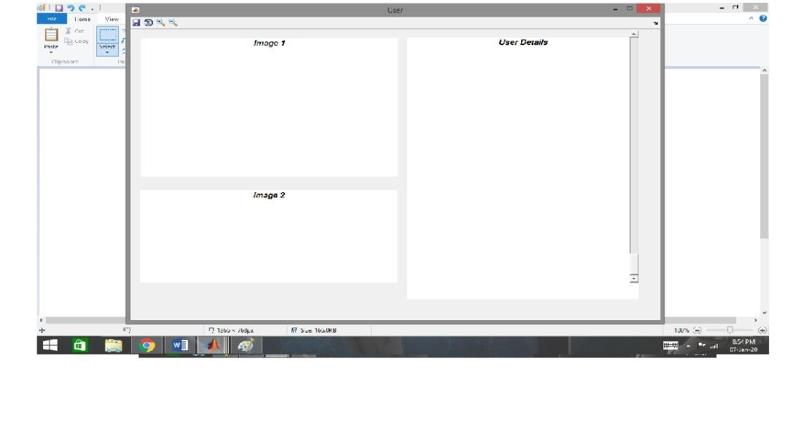

Communications Interfaces
Communication interfaces are the interfaces through which user and product stakeholders are connected.
In our System it has only a one-way communication System to use. Where the system sends a report to the Police or sends a challan to the Driver.

System Features

2.4.1 Login

Description and Priority
This should be included in the first release because the administrator needs to be able to log in so she/hi can manage the system.
Priority: High

Stimulus/Response Sequences
Stimulus: Admin want to login the account to have access to the system.
Response: system will provide login form to fill mandatory fields.

Stimulus: Admin can fill the mandatory fields of login form.
Response: System will login the admin account by recalling the database information that has been saved.
Stimulus: If the admin doesn't remember the password.
Response: System will provide a forget password field to enter a new password.

Functional Requirements
For login account  Match admin data with record  Enter the email  Enter the password  Click the login button | You can login after creating a new account.  System will check a record and match whether you are the authentic person or not.  The login form will have following fields:  - Email field  - Password field and  - Login button.  All fields are mandatory.
Table No 2.2
REQ-SF1-1: Security
REQ-SF1-2: Authentication
- To maintain security of the system and login process for authentication if the right person is using the system. Admin has to follow the login procedure in order to take access of the whole system. To maintain security of the system it is necessary to go through this login procedure.

Forget Password

Description and Priority
In case the Admin will forget the password , the admin will be able to follow the forget procedure and reset the new password.
Priority: Medium

Stimulus/Response Sequences

Stimulus: If the admin doesn't remember the password.
Response: System provides forget password.

Stimulus: Admin click the forget password.
Response: system will provide links through email.

Stimulus: Admin will go to email and check links given by the system.
Response: system will reset password provided by admin.

Stimulus: After reset password admin can login the account.
Response: system gives access to admin.

Functional Requirements
Forget Password  Sign in google account  Go to email  Check given link  Follow given procedure | In case of forget password, the system should be able to make a new password through email verification code.  Steps involve:  - Click on forget password.  - Fill the email field and click on the send button.  - Check your email and follow instructions given to you to reset your password.  - After that password will be reset and you can login the account.
Table No 2.3
REQ-SF2-1: Reset Password

Data Collection

Description and Priority
System will collect images of the plate number of vehicles that are registered or not. Records of all data will be stored in the system database. Admin will be able to update records. System has the ability to capture images in any environment.
Priority: High

Stimulus/Response Sequences
Stimulus: Camera captures the plate number.
Response: System matches that plate number with the database.
Stimulus: It will take a few seconds to capture an image.
Response: System has records of the plate number and show that plate number is in record or not.
Stimulus: Admin request to view the records of vehicles.
Response: System will show the records.

Functional Requirements

Store Record  Check plate number is register or not | The system should be able to store records of vehicles and plate numbers.  - It stores records of all vehicles that are legal or illegal.
Vehicles back Up Record  Detail of challan  Type of punishment | The system has a backup record of vehicles and owners of vehicles.  - From the backup system check details about challan.  What punishment will be given to illegal vehicle owner if it has history of challan
Table 2.4

REQ-SF3-1: Capture Image
REQ-SF3-2: Capture vehicle
- System should be able to recognize the vehicle plate number by using a digital camera. It uses an algorithm to recognize plate numbers and then keep records of vehicles. The image stored in JPG format. The image then converted into a gray scale image using MatLab.

Features Extraction

Description and Priority
The first step is the capture of images. The image is captured by electronic device. It will extract plate number whether it is registered or not and vehicles over line means that breaks the rules of the traffic. If anyone breaks the rules they have to pay a fine online. So next time they can follow rules strictly.
Priority: High

Stimulus/Response Sequences
Stimulus: Digital cameras capture the license plate number.
Response: System will keep record of that vehicle.

Stimulus: Admin request to match record.
Response: System will then match plate number from database.

Stimulus: Admin request system to check the vehicle.
Response: System will match record and display the result.

Functional Requirements
Verify Plate Number  Capture the image  Report illegal plate number  Technology | The system should be able to detect and recognize the vehicle plate number.  - The system should be able to capture the image of the number plate of vehicles using a digital camera.  - It must check the front and back number plate of the vehicle. The system should report only the illegal plate number.  - The tender/ system include image processing technology and presentation monitors for operation.
Table 2.5

REQ-SF4-1: Extracting LPN
REQ-SF4-2: Extract vehicles over line.
- Disobeying traffic signals:
- Red light
- Red thinking
- Amber flashing

Pre-Processing

Description and Priority
The required image for per-processing is taken by using a camera. In this stage dilation of image and the noise removal is done. In the pre-processing stage RGB to Gray conversion results in the loss of some details of the original image. Even noise can also corrupt the image. So, dilation is necessary to enhance the converted image and make it suitable for edge processing, by removing noise and sharpening edges. Due to pre-processing some key features of an image, like brightness, light edge, color difference may get lost. By dilation such losses can be overcome and the pre-processed image is sharpened and the brightness is increased.

Priority: High

Stimulus/Response Sequences
Stimulus: Image is taken by using electronic device like camera
Response: system records the image.
Stimulus: original image is in colored form.
Response: System will convert it into gray level.
Stimulus: light edge, noisy image create problems.
Response: System dilation will overcome this problem.

Functional Requirements
Recognize Vehicle  Read the plate number  Recognize plate number in every condition  Recognize number plate  Image processing | The system should be able identify, recognize and authenticate the vehicle.  - The system should be capable of reading and interpreting the fonts used in international plate numbers of vehicles.  - The system is able to recognize the number plate even in light conditions like in dust, at night.  The quality of number plate recognition is not affected in varying weather conditions like snow, mist and in rain.  - The tender/ system include image processing technology and presentation monitors for operation.
Table No 2.6
REQ-SF5-1: Gray levels
- It involves the conversion of image into Gray levels. Color images are converted into Gray images. It calculates the value of gray value, and obtains the gray image at the same time
REQ-SF5-2: Median Filtering.
- It will remove the noises from the image. Gray level cannot remove the noises. Media filtering is used to make images free from noise.
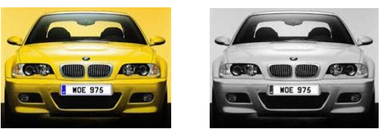
Original image taken as input Gray conversion of input image

Object Recognition

Description and Priority
There is a lot of objects in the pictures in the image, so to identify the specific Number plate
System will use Algorithm to find the specific object.
Priority: High

Stimulus/Response Sequences
Stimulus: vehicles have many objects but capture only images.
Response: System will compare the images

Stimulus: vehicle shows both images.
Response: System will check both frontend and backend of images.

Functional Requirements

Recognize image  Capture the image  Both images | The system should be able to recognize the vehicle plate number.  - The system should be able to capture the number plate using a digital camera.  - It must check the front and back number plate of vehicle.
Table No 2.7

REQ-SF6-1: Vehicle recognition
REQ-SF6-2: LPN recognition
In this process first it recognizes the vehicle and then identifies its License plate in the objects. For this process we use Ant colony optimization Algorithm.

Character Segmentation

Description and Priority
In this stage Image extraction can be done by using segmentation methods. There are numerous image segmentation methods. System will use the methods of image binarization.

Stimulus/Response Sequences
Stimulus: Image of the plate number required
Response: Extracted number plate and then split each character.

Stimulus: Match the image of the number plate.
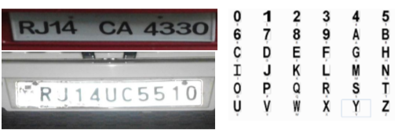
Response: Find the correlation and database match the characters if both the values are same mean it will convert the value to string and display in the edit box store the character in the text file.

Functional Requirements
Recognize image  Recognize character  Database | - System will identify the plate number  - It will extract character from plate number.  - Identify the character in database  - Match the character and display in text file
Table 2.8

REQ-SF7-1: Binarization.
- It is used to extract the character of an image in binary form. This is the best method for image extraction.

Character Recognition
In this stage it used to compare individual characters of image. it will display whether the vehicle is registered or not.

Stimulus/Response Sequences
Stimulus: Image of the plate number is required.
Response: Extracted number plate and then split each character.

Stimulus: Match the image of the number plate.
Response: Find the correlation and database match the individual characters with the character stored in the database. If both characters match then it will display whether the plate is registered or not.

Functional Requirements
Recognize image  Recognize character  Database  License or unlicensed | - System will identify the plate number  - It will extract character from plate number.  - Identify the character in database  - Match the character and display in text file  - It will match both characters and show that plate number is license or not.

Table 2.9
REQ-SF8-1: Binarization.
- It is used to extract the character of an image in binary form. This is the best method for image extraction.

Other Nonfunctional Requirements

Performance Requirements
- Its performance should be accurate
- It should bear the load of as many vehicles at a time, if admin can login to the system should not be crashed.

Usability Requirements
System will be easy to operate for users.
- They submit their challan without facing any difficult situation.
- Instruction will be mentioned online.

Security Requirements
- It’s possible to use the system after security logging predefined by admin.
- All data stores or updating lists must be in encrypted form.
- The system must be secure from hacking in case of updating the list of vehicles.

Reliability
- System should perform its function in any case:
- System detects plate numbers even in affected conditions like rain, snow, at night.

Availability
- System services should be available for all time.
    - Efficiency
- System will be capable of recognizing number plates other than Pakistan that are registered.
    - Accuracy
- System should recognize plate numbers correctly that are scanned and give 95% accuracy.
    - Simplicity
- User interface should be simple

Other Requirements
SR | Functional Requirement | Detail
FR01 | Create account | You can first create an account before login there will be a form in which input fields are given.  - The field Name contains only alphabet characters.  - The field Email contains both alphabets and numeric and symbol @ must be added when entering email.  - The field contains a minimum of eight characters for Password.  - The Confirm Password should be the same which you have filled in the field of password.  - Click on the submit button and your account will be created.  - All fields are mandatory.
FR02 | Login | You can login after creating a new account.  System will check a record and match whether you are the authentic person or not.  The login form will have following fields:  - Email field  - Password field and  - Login button.  All fields are mandatory.
FR03 | Forget Password | In case of forget password, the system should be able to make a new password through email verification code.  Steps involve:  - Click on forget password.  - Fill the email field and click on the send button.  - Check your email and follow instructions given to you to reset your password.  - After that password will be reset and you can login the account.
FR04 | Verify Plate Number | The system should be able to detect and recognize the vehicle plate number.  - The system should be able to capture the image of the number plate of vehicles using a digital camera.  - It must check the front and back number plate of the vehicle. The system should report only the illegal plate number.  - The tender/ system include image processing technology and presentation monitors for operation.
FR05 | Verify Vehicle | The system should be able identify, recognize and authenticate the vehicle.  - The system should be capable of reading and interpreting the fonts used in international plate numbers of vehicles.  - The system is able to recognize the number plate even in light conditions like in dust, at night.  The quality of number plate recognition is not affected in varying weather conditions like snow, mist and in rain.
FR06 | Generate Challan | The system should be capable of generating challan:  - The camera installed in the system scanned the plate number and generated a challan of illegal plate numbers.  - The system will send challan online to the owner of illegal vehicles.
FR07 | Back Up Record | The system has a backup record of vehicles and owners of vehicles.  - From the backup system check details about challan.  What punishment will be given to illegal vehicle owners if it has a history of challan?
FRO8 | Store Record | The system should be able to store records of vehicles and plate numbers.  - It stores records of all vehicles that are legal or illegal.
FR09 | Logout | After logging the account all functionality will be closed.  Click the logout button for logout.

Table No 2.10

Chapter 3

Use Case Analysis

Chapter 3: System Analysis
In this chapter, we will design diagrams which will fully analyze how our system tends to actually function. These diagrams are part of the software engineering process which helps users detail their project. These diagrams are basically the map of a project defining the users the flow of the proposed project

Use Case Model
1.0
Create Account

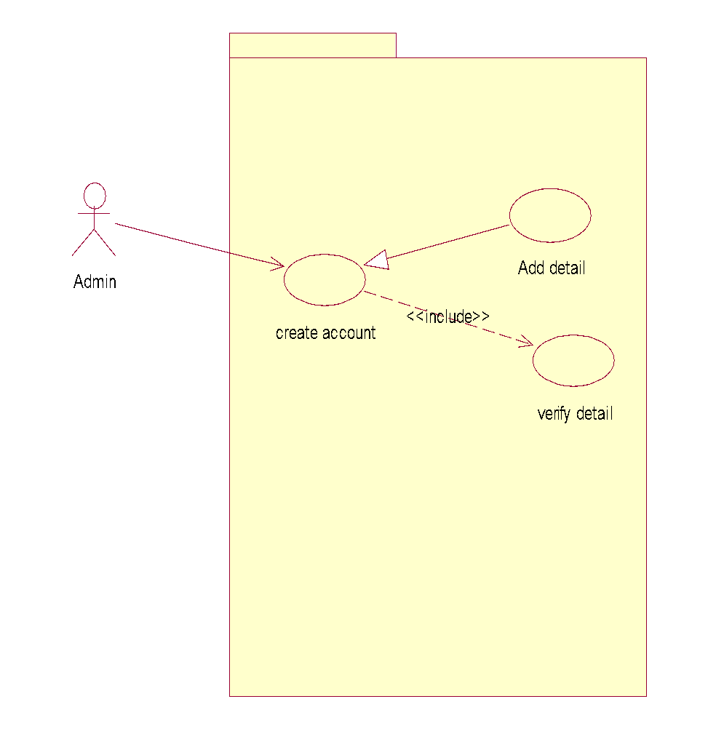

2.0
Login
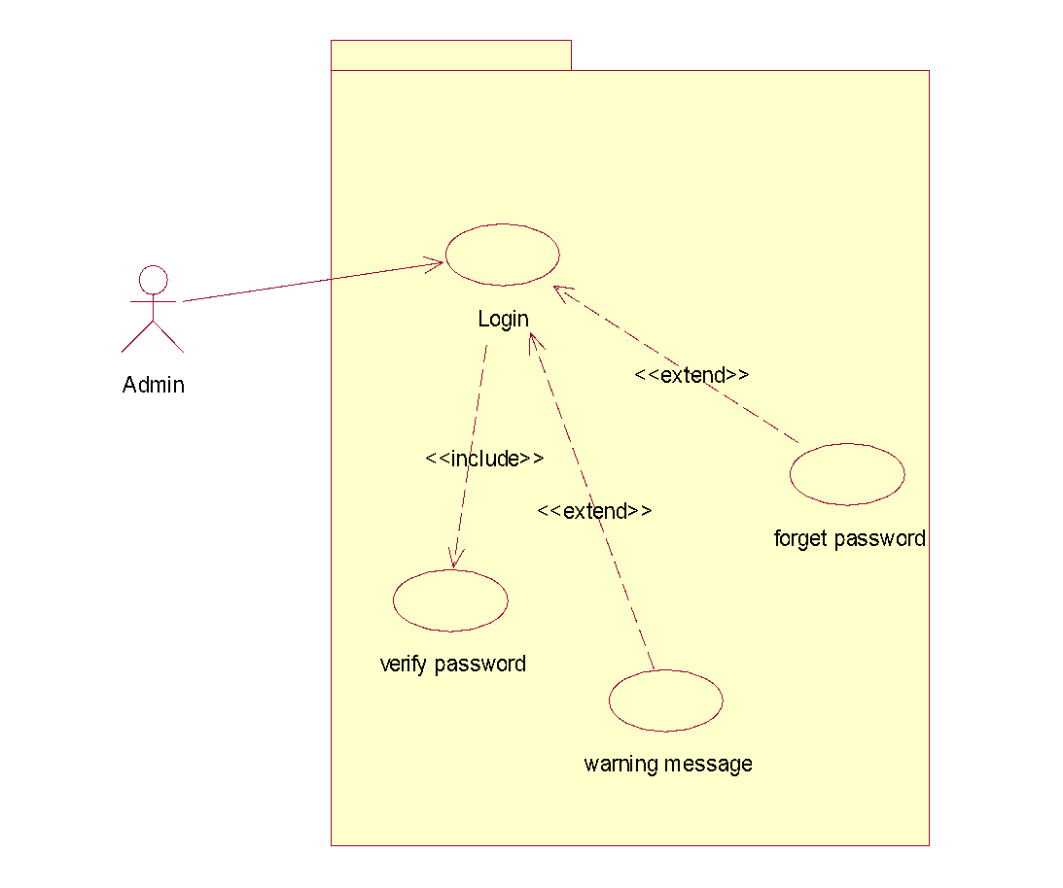
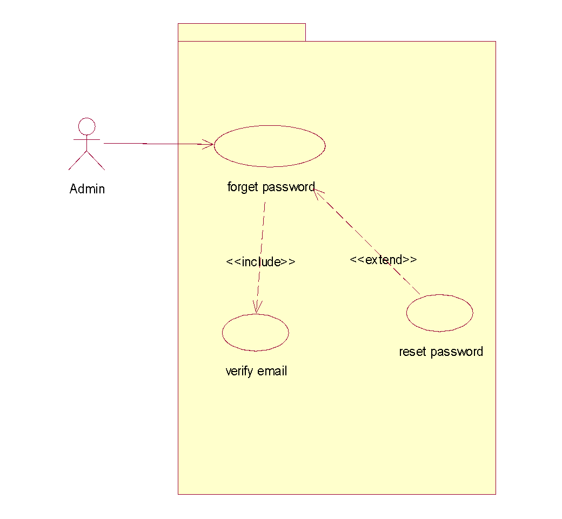
2.1
Forget Password

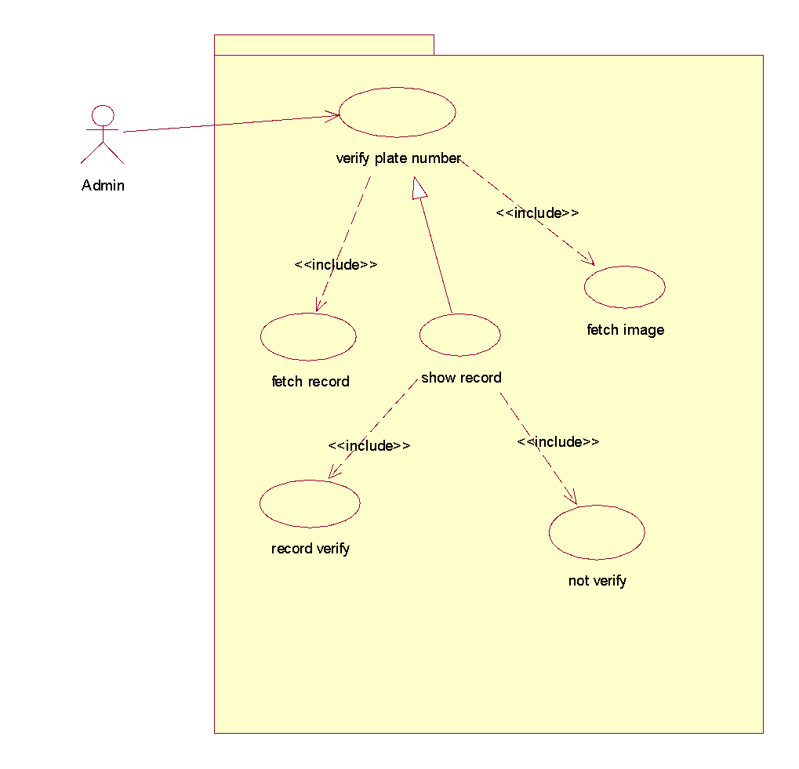
3.0
Verify plate number

3.1
Record not verify
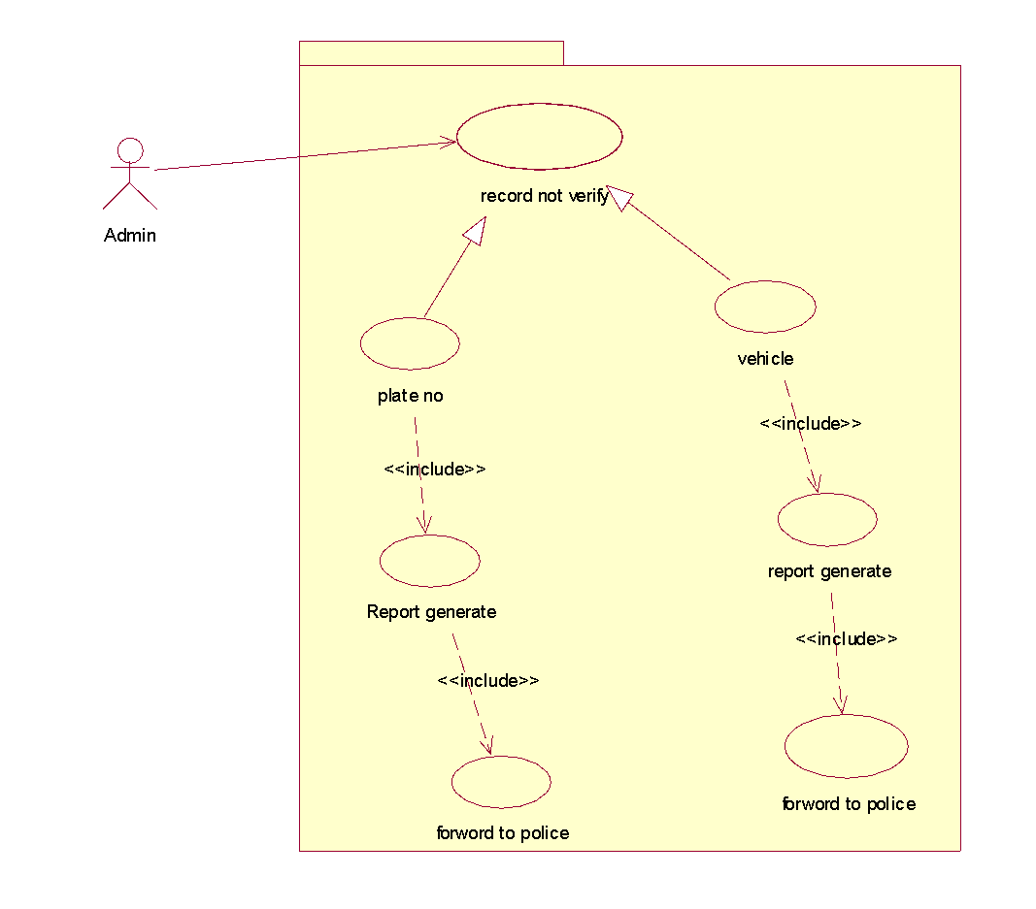

4.0
Verify vehicle
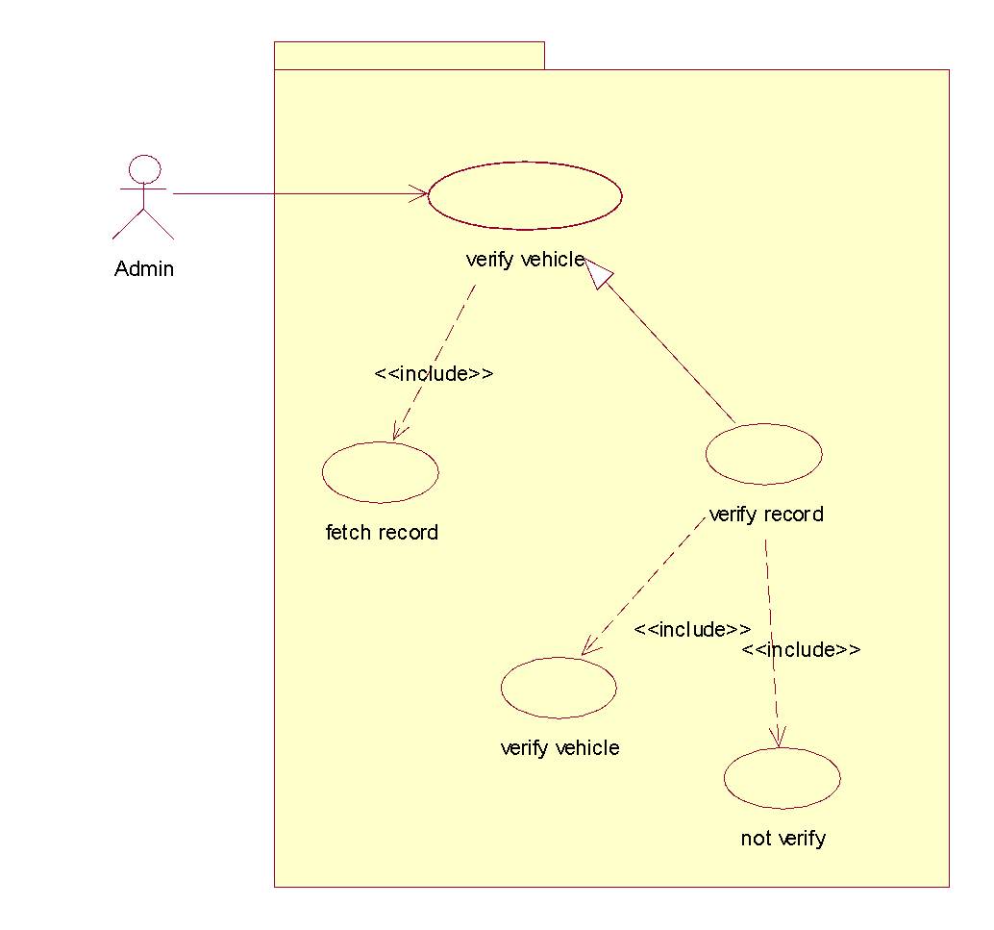
5.0
Generate Challan
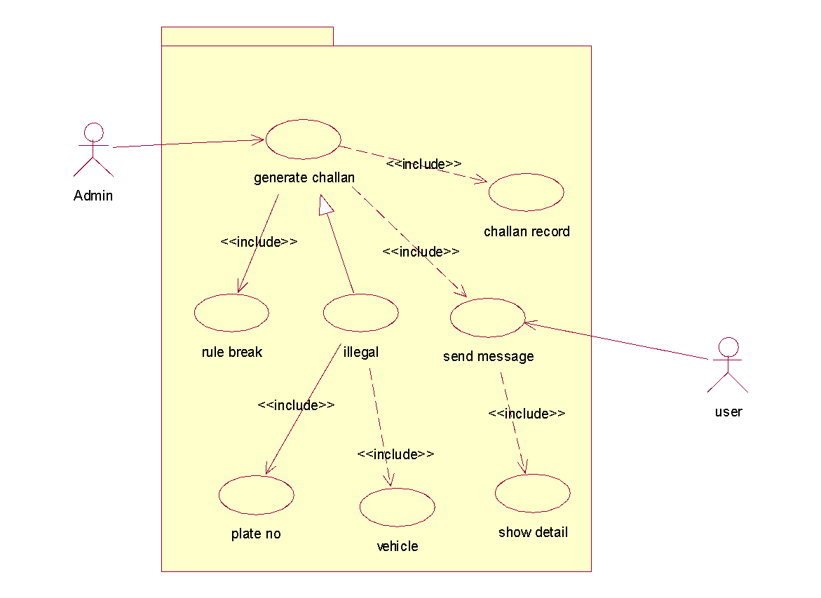
5.1
Show challan
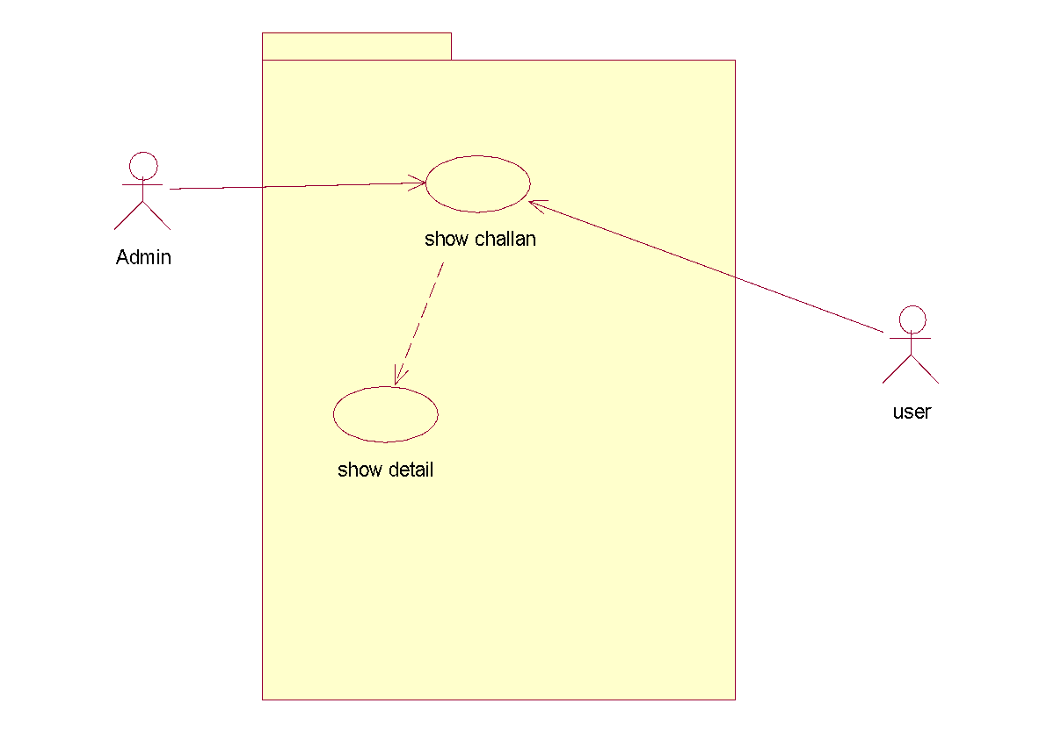
5.2
Store Record

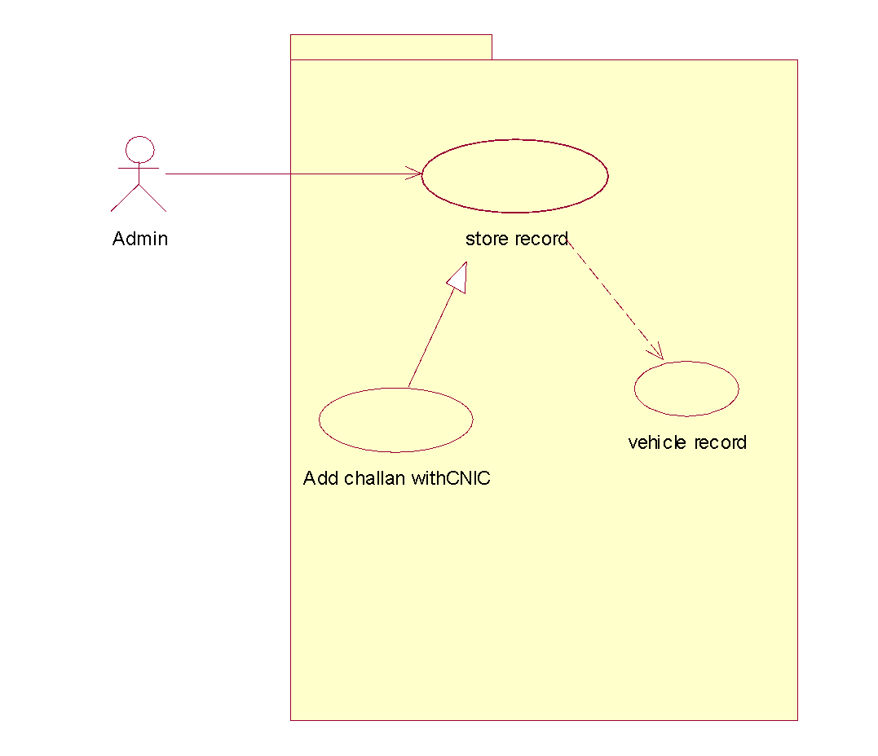

5.3
User challan record
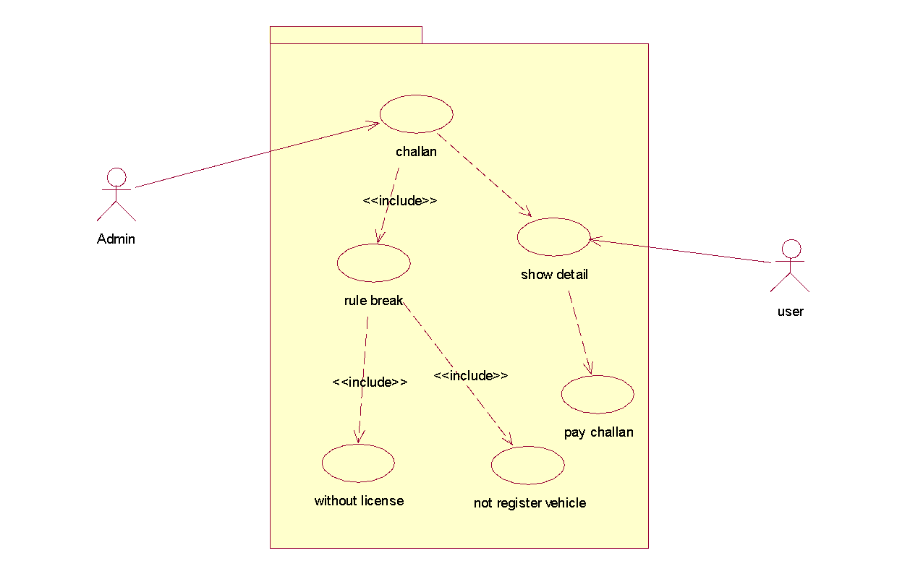
5.4
Pay Challan

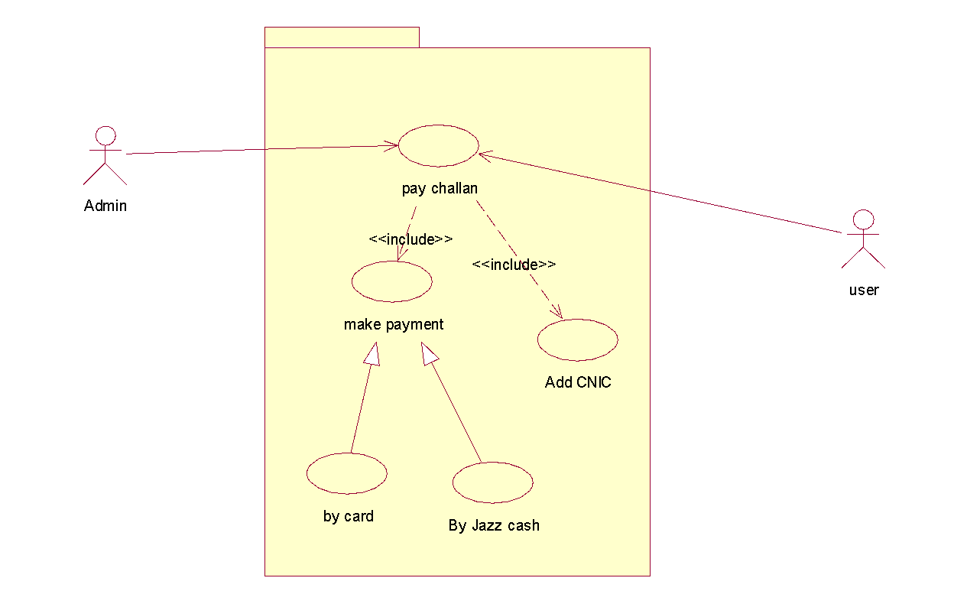
6.0
Logout

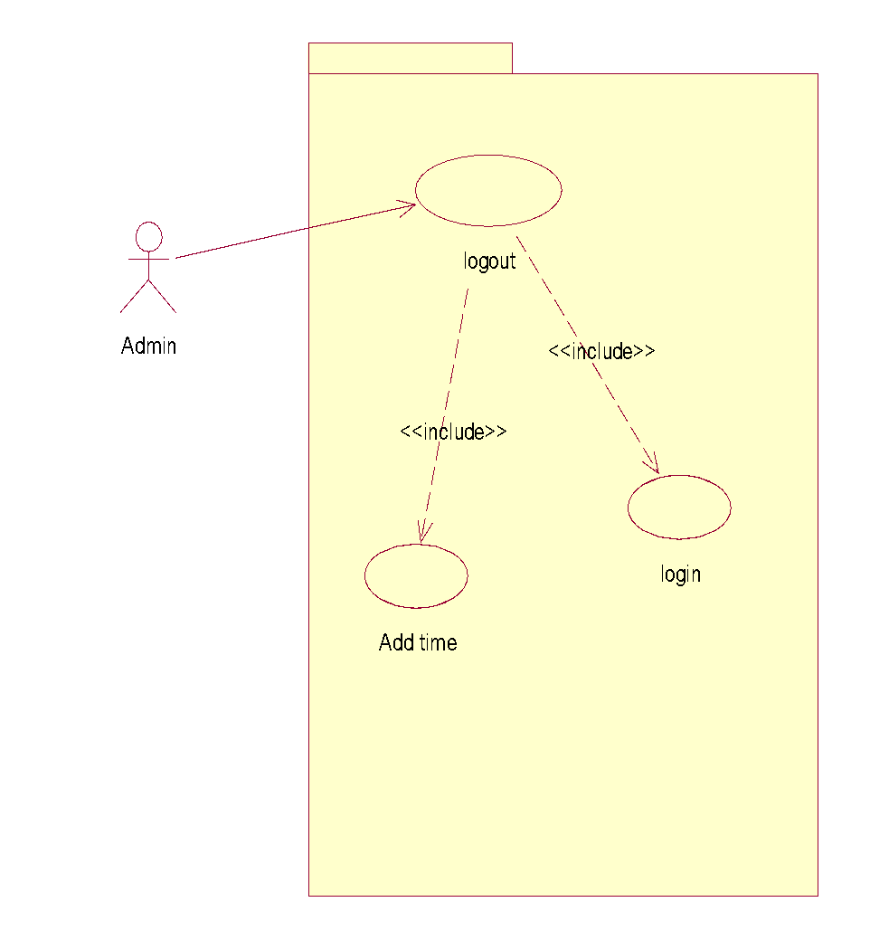

Use Case Descriptions

Fully Dressed Use Case

- Create Account: -

Brief Description
- When Admin First Log-in he has to create an Account. For this, Admin have to create an Account.
Primary Actors
- Admin.
Secondary Actors
- No Secondary Actor.
Pre-Condition
- No-Pre-condition for this use case.
Main Flow
- Admin has to create an account to log-in to the system. For this, Admin Click on Create Account Add the required details and Click on a Confirm. The request is sent to the main System for verification detail.
Post conditions
- Admin must be confirmed after adding the details.
Alternative Flow
- No Alternative Flow.

- Log-in: -

Brief Description
- For Login Admin must enter the correct Password. And Click on Log-in Button for Log-in
Primary Actors
- Admin.
Secondary Actors
- No Secondary Actor.
Pre-Condition
- Admin must have an account.
Main Flow
- For Login Admin Enter password and click on Log-in button. If the password is correct Admin log-in to System.
Post conditions
- Admin must click Log-in after adding the details.
Alternative Flow
- If the password is incorrect a warning message pops up.
- And Forget password windows pop up for an alternate solution.

2.1 Forget Password: -

Brief Description
- Admin Forget the password, in this scenario Admin has to enter email for new password.
- Admin has the option to reset password.
Primary Actors
- Admin.
Secondary Actors
- No Secondary Actor.
Pre-Condition
- Admin must enter a wrong password.
Main Flow
- Admin forget the password; Admin enter the email a notification sends to the email for the password confirmation.
- Admin also has the option of setting new passwords in email.
Post conditions
- Admin must enter the correct e-mail.
Alternative Flow
- No Alternative Flow.

- Verify Plate Number: -
Brief Description
- Image fetch data matches with the data fetches to the record. And show the record.
- Record is verified.
- Record is not verified.

Primary Actors
- Admin.
Secondary Actors
- No Secondary Actor.
Pre-Condition
- Image must be clicked by camera.
Main Flow
- Picture click through the camera sent to the system, by fetching data to the image compared to the data in records.
- The record is verified.
Post conditions
- Vehicle has to exist in the picture.
Alternative Flow
- Record is not matched.

3.1 Record not verified: -

Brief Description
- Record is not found, System generate the challan and send to the police
Primary Actors
- Admin.
Secondary Actors
- No Secondary Actor.
Pre-Condition
- Record must not be verified.
Main Flow
- Record is not found to generate the challan to the vehicle plate and send to the police.
Post conditions
- Vehicle plate number must be original.
Alternative Flow
- No Alternative Flow.

- Verify Vehicle: -

Brief Description
- Verify the vehicle plate.
- Record is found.
- Please do not modify it.
Primary Actors
- Admin.
Secondary Actors
- No Secondary Actor.
Pre-Condition
- Records must be fetched.
Main Flow
- Fetch data compared to record; data is Matched.

Post conditions
- No Post condition.
Alternative Flow
- Data is not matched.
- Generate Challan: -

Brief Description
- Rule break by the vehicle driver, Vehicle plate number is identified and sent to the user and informed by message.
- Challan is recorded in Database.
Primary Actors
- Admin, User.
Secondary Actors
- No Secondary Actor
Pre-Condition
- Rules must be broken by vehicle drivers.
Main Flow
- Rule break by the vehicle driver, Vehicle number plate is not registered or unlicensed.
- Generate Challan and send the message to the user.
- Generated challan data stored in a record.
Post conditions
- Vehicle plates must be original.

Alternative Flow
- No Alternative Flow

  - Show Challan: -

Brief Description
- Challan show to users.
Primary Actors
- Admin, User.
Secondary Actors
- No Secondary Actor.
Pre-Condition
- Challan must be issued.
Main Flow
- Challan shows to the user.
Post conditions
- No post condition.
Alternative Flow
- No Alternative Flow.

  - Store Record: -

Brief Description
- Generated challan stored to the record for further use in future.
Primary Actors
- Admin.
Secondary Actors
- No Secondary Actor.
Pre-Condition
- Challan must be generated.
Main Flow
- Record stored CNIC of the user.
- Vehicle record update.
Post conditions
- No post condition.
Alternative Flow
- No Alternative Flow.

  - User Challan Record: -

Brief Description
- Why challan generated, not registered vehicle or without license vehicle.
- Challan pay by user.
Primary Actors
- Admin, User.
Secondary Actors
- No Secondary Actor.
Pre-Condition
- Challan must be generated.
Main Flow
- Challan generated by system; users pay the challan.
- Users check why challan is generated, unlicensed vehicle or not registered vehicle.
- Challan paid.

Post conditions
- No post condition.
Alternative Flow
- No Alternative Flow.

  - Pay Challan: -

Brief Description
- Pay challan with CNIC identification, through jazz cash or by card.
Primary Actors
- Admin, User.
Secondary Actors
- No Secondary Actor.
Pre-Condition
- Challan must be generated.
Main Flow
- Users pay challan online with CNIC identification, through jazz cash or card.
- Admin pay the Challan manually.
Post conditions
- Users must have CNIC.
Alternative Flow
- No Alternative Flow.
- Log out: -

Brief Description
- Admin logout to system and time is noted.
Primary Actors
- Admin.
Secondary Actors
- No Secondary Actor.
Pre-Condition
- Admin must be logged in.
Main Flow
- Admin logging out to the System.
- Logged out time is noted.
Post conditions
- No post condition.
Alternative Flow
- No Alternative Flow.

Chapter 4

System Design

Chapter 4: System Design
In this chapter, we will design diagrams which will fully depict how our system tends to actually function. These diagrams are part of the software engineering process which helps users detail their project. These diagrams are basically the map of a project defining the flow of the proposed project.

Architecture Diagram

Domain Model

Entity Relationship Diagram with data dictionary

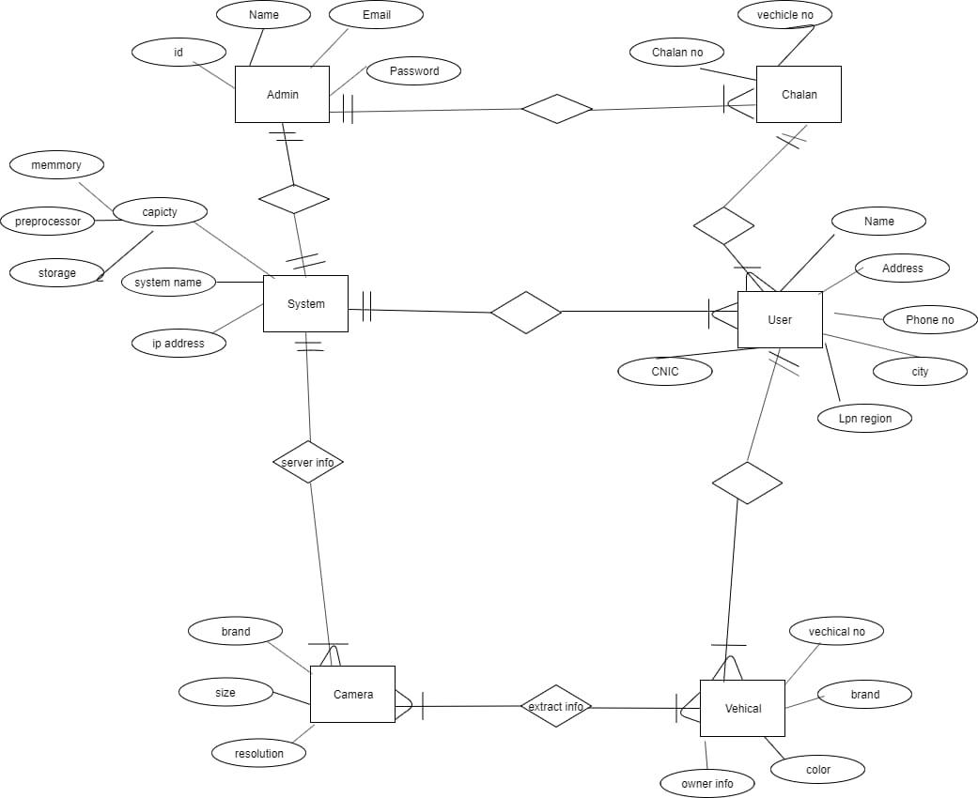

Class Diagram

Sequence / Collaboration Diagram
4.5.1 Challan Pay
4.5.2
Forget Password

4.5.3
Generate Challan

4.5.4
Log-in, Log-out, Create Account

4.5.5
Verify Number Plate

4.5.6
Verify Vehicle

Operation contracts
- Registration

Headings | Sub-Headings
Operations |  | Register( )
Cross-Reference | Use-Case | Registration
Cross-Reference | Scenario | Registration
Pre-  Conditions |  | N/A
Post-Conditions | Instantiation | An instance “A” of Account was created.  An instance “U” of users was created.
Post-Conditions | Attribute Modification | A.Id becomes ID.  A.Name becomes Name.  A.Phone becomes Phone.  A.Address becomes Address.  A.PW becomes PW  A.CNIC becomes CNIC.
Post-Conditions | Association | A was associated with Users.

  - Login

Headings | Sub-Headings
Operations |  | Login( )
Cross-Reference | Use-Case | Login
Cross-Reference | Scenario | Login
Pre-  Conditions |  | N/A
Post-Conditions | Instantiation | An instance of “A” of Account was created.  An instance “U” of users was created.  An instance “a” of Admin was created.
Post-Conditions | Attribute Modification | A.Id becomes ID.  A.PW becomes PW
Post-Conditions | Association | A was associated with Admin.  A was associated with Users.

3.0 Verify Plate Number

Headings | Sub-Headings
Operations |  | Verify Plate Number( )
Cross-Reference | Use-Case | Verify Plate Number
Cross-Reference | Scenario | Verify Plate Number
Pre-  Conditions |  | Image must be captured by camera.
Post-Conditions | Instantiation | An instance of “Cam” of cameras was created.  An instance “a” of Admin was created.  An instance “v” of Vehicle plate number has to exist in database was created.
Post-Conditions | Attribute Modification | N/A
Post-Conditions | Association | Cam was associated with Admin.  Cam was associated with vehicles.

4.0 Verify Vehicle

Headings | Sub-Headings
Operations |  | Verify Vehicle( )
Cross-Reference | Use-Case | Verify Vehicle
Cross-Reference | Scenario | Verify Vehicle
Pre-  Conditions |  | Records must be fetched.
Post-Conditions | Instantiation | An instance of “Cam” of cameras was created.  An instance “a” of Admin was created.  An instance “v” of Vehicle has to exist in the database was created.
Post-Conditions | Attribute Modification | N/A
Post-Conditions | Association | Cam was associated with Admin.  Cam was associated with vehicles.

4.0 Generate Challan

Headings | Sub-Headings
Operations |  | Generate Challan( )
Cross-Reference | Use-Case | Generate Challan
Cross-Reference | Scenario | Generate Challan
Pre-  Conditions |  | Rules break by vehicle driver.
Post-Conditions | Instantiation | An instance “s” of System was created.  An instance “a” of Admin was created.  An instance “V” of vehicle plate number must be original.
Post-Conditions | Attribute Modification | N/A
Post-Conditions | Association | S was associated with Admin.  S was associated with vehicles.

5.0 Show Challan
Headings | Sub-Headings
Operations |  | Show Challan( )
Cross-Reference | Use-Case | show Challan
Cross-Reference | Scenario | show Challan
Pre-  Conditions |  | Users should be logged into the system.  Challan should be issued.
Post-Conditions | Instantiation | An instance of “SH” of show detail was created.  An instance “u” of Users was created.  An instance of “a” of admin was created.
Post-Conditions | Attribute Modification | N/A
Post-Conditions | Association | SH was associated with users.  SH was associated with admin.

6.0 Pay Challan
Headings | Sub-Headings
Operations |  | Pay Challan( )
Cross-Reference | Use-Case | Pay Challan, Payment
Cross-Reference | Scenario | Play Challan
Pre-  Conditions |  | Users should be logged into the system.  Challan must be issued.
Post-Conditions | Instantiation | An instance “P” of Payment was created.  A was associated with Users.
Post-Conditions | Attribute Modification | N/A
Post-Conditions | Association | P was associated with users.

Activity Diagram
4.7.1

Create Account, Log-in, Log-out, Forget Password

    - Challan Pay

4.7.3 Verify Vehicle, Generate Challan

State Transition Diagram
4.8.1
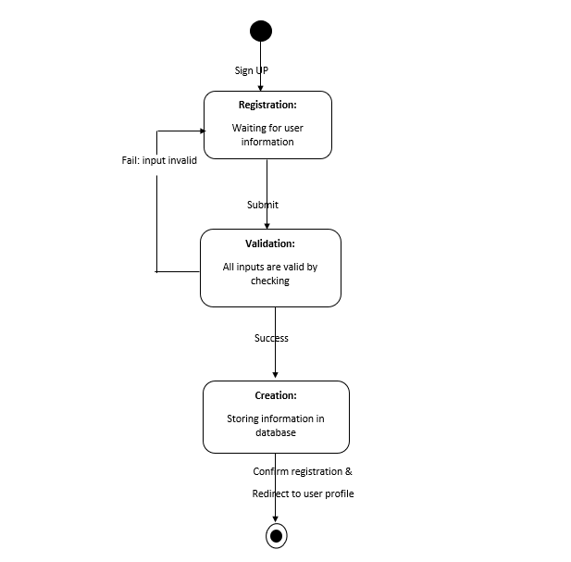

4.8.2
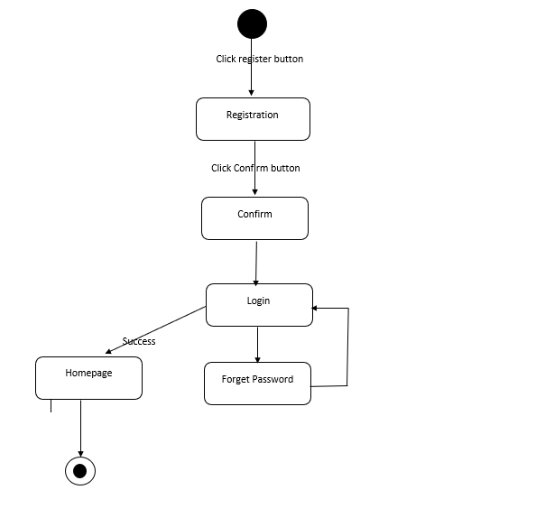

4.8.3
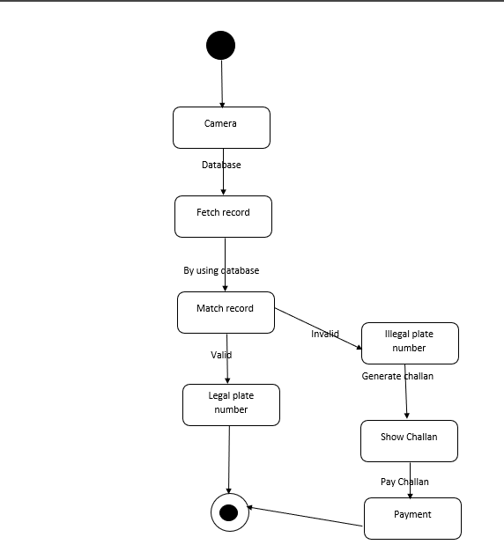

Component Diagram
4.9.1
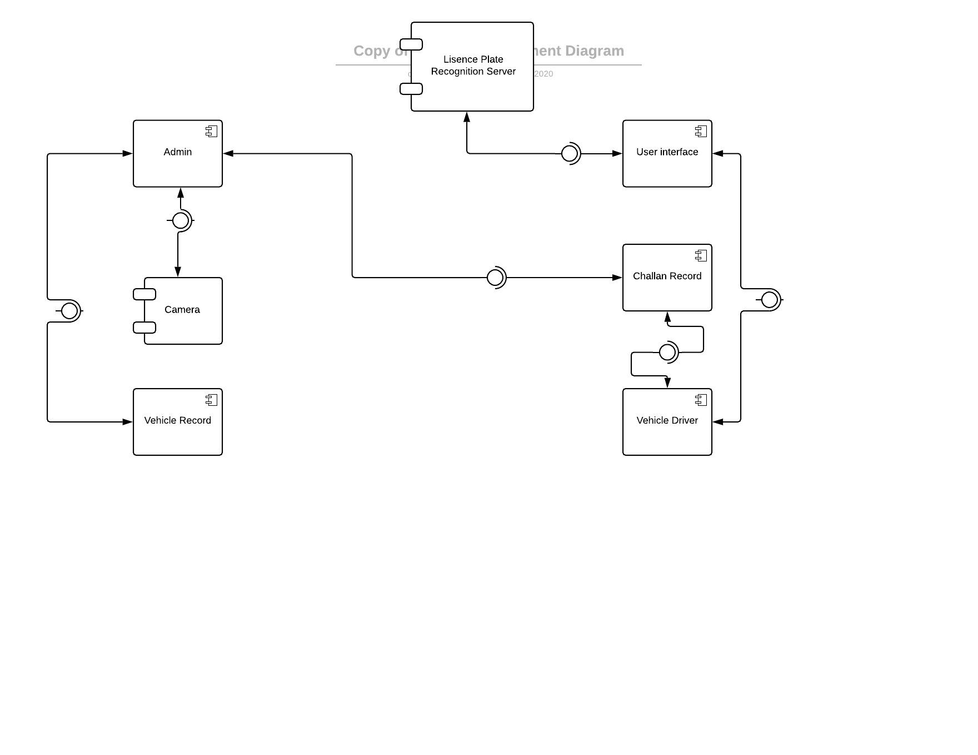

Deployment Diagram

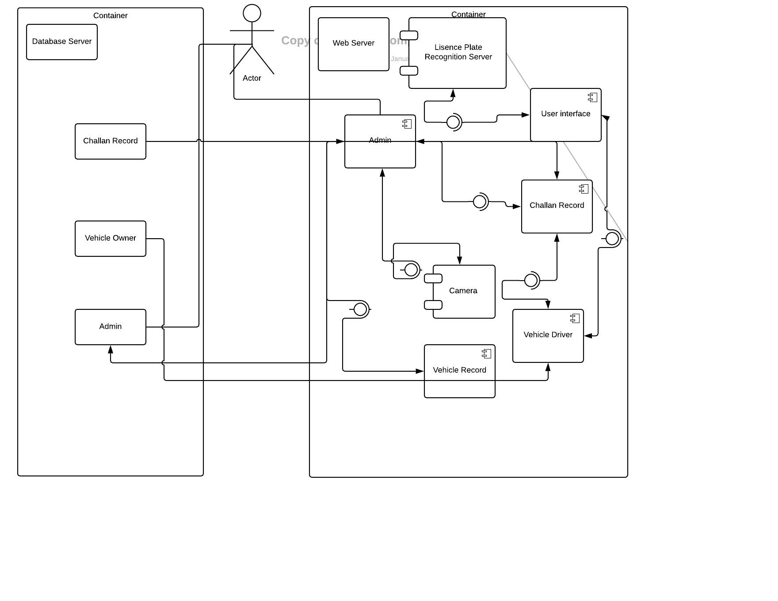

Data Flow diagram
Level 0

Level 1

Chapter 5

Implementation

Chapter 5: Implementation
There is a brief description in the section about our idea and the steps we are taking to achieve our goal. Here, we have listed out some methods to give an idea of our perspective.

Important Flow Control/Pseudo codes

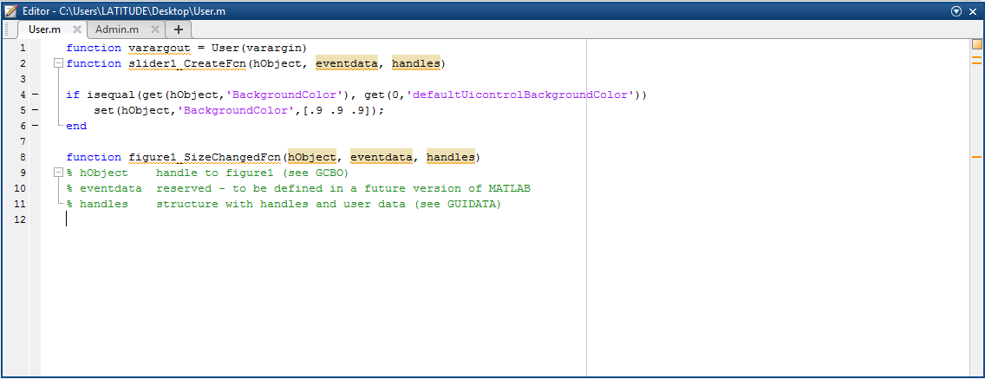
Admin panel
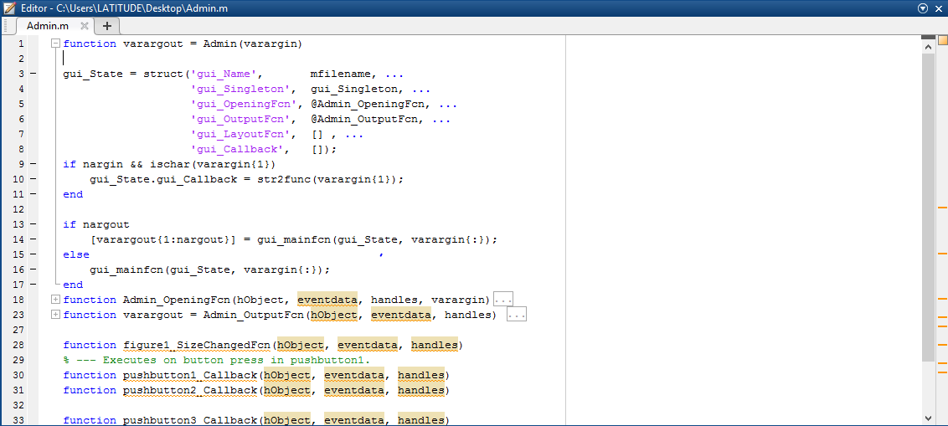

Deployment Environment
Matlab will be used for interface development. The algorithm which will work on the backend of the application will be developed in a python language by using Anaconda 3.2 Software. Database will be used for the storage of data collected by the algorithm. Different simulation techniques will be performed by Matlab for testing the algorithm with every possible perspective.

Components, Libraries, Web Services and stubs
- Simulation
- XAMPP Server
- Database
- Administration Module

Tools and Techniques
Tools
Algorithm
Anaconda 3.2
Web Application
Brackets, Visual Studio Code, Bootstrap Studio
Interface Designing Tools
Lucidchart.com, Draw.io, Matlab
Techniques
Application
Matlab, Python and Database
Web Application
HTML/CSS, Node JS, React JS, MYSQL, Bootstrap

Best Practices / Coding Standards
- Communication with stakeholders.
- No repetition of coding
- Work Breakdown structure will be followed
- Feedback will be accepted and applied.
- Each requirement will be documented.

MATLAB Code:

outputFolder = fullfile('Image');
rootFolder = fullfile(outputFolder);

categories={'reg','noreg'};

imds = imageDatastore(fullfile(rootFolder,categories),'LabelSource','foldernames');

tbl = countEachLabel(imds);
minSetCount = min(tbl{:,2});

imds = splitEachLabel(imds, minSetCount, 'randomize');
countEachLabel(imds) ;

reg = find(imds.Labels == 'reg',1);

non_reg = find(imds.Labels == 'noreg',1);

% figure;
% subplot(2,2,1);
% imshow(readimage(imds,reg));
%
% subplot(2,2,2);
% imshow(readimage(imds,non_reg));

net = resnet50();

% figure
% plot(net)
% title('Architecture of ResNet-50')
% set(gca, 'YLim', [150 170]);

net.Layers(end)

numel(net.Layers(end).ClassNames)
[trainingSet, testSet] = splitEachLabel(imds, 0.4, 'randomize');

imageSize = net.Layers(1).InputSize

augmentedTrainingSet = augmentedImageDatastore(imageSize, trainingSet, 'ColorPreprocessing', 'gray2rgb');

augmentedTestSet = augmentedImageDatastore(imageSize, testSet, 'ColorPreprocessing', 'gray2rgb');

w1 = net.Layers(2).Weights;
w1 = mat2gray(w1);

% figure
% montage(w1)
% title('First Convolutional Layer Weight')

featureLayer = 'fc1000';
trainingFeatures = activations(net, augmentedTrainingSet, featureLayer, 'MiniBatchSize', 32, 'OutputAs', 'columns');

trainingLables = trainingSet.Labels;
classifier = fitcecoc(trainingFeatures, trainingLables, 'Learner', 'Linear', 'Coding', 'onevsall', 'ObservationsIn', 'columns' );

testFeatures = activations(net, augmentedTestSet, featureLayer, 'MiniBatchSize', 32, 'OutputAs', 'columns');

predictLabels = predict(classifier, testFeatures, 'ObservationsIn','columns')

testLables = testSet.Labels;
confMat = confusionmat(testLables, predictLabels);
confMat = bsxfun(@rdivide, confMat, sum(confMat,2));

mean(diag(confMat))

newImage = imread(fullfile(‘’));

ds = augmentedImageDatastore(imageSize, newImage, 'ColorPreprocessing', 'gray2rgb');

imageFeatures = activations(net, ds, featureLayer, 'MiniBatchSize', 32, 'OutputAs', 'columns');

label = predict(classifier, imageFeatures, 'ObservationsIn','columns')

sprintf('the number plate is %s ',label)

Version Control
We are planning to launch v 1.0 of our algorithm in the upcoming months. First changes will be made according to user feedback.

Chapter 6

Testing and Evaluation

Chapter 6: Testing and Evaluation
System Name： | License Plate Recognition System
Module Code： | CR100 - Export to excel
Test requirement: | CR1 -
Pass |  | Pending
Fail |  | Number of test cases:

ID | Test Case Description | Test Case Procedure | Expected Output | Test date | Result | Note
Create Account(Submit Button)
TC1 | Type should be submit | type='submit' | Accepted | 4/6/2020 | Pass
TC1.1 | Type is post | type='post' | Not Accepted | 4/6/2020 | Fail
TC1.2 | Text must be a Character | Submit | Accepted | 4/6/2020 | Pass
TC1.3 | Check weather text in integer | Submit1 | Not Accepted | 4/6/2020 | Fail
TC1.4 | Check all data field are filled | Ayesha, Bashir, 04/1/98, ayesha@gmail.com, ashii1234 | Message appear at top Thank You for creating account. | 4/6/2020 | Pass
Check Admin Login
TC2 | Checking Admin log in | 1. Go to the system 2. Enter username & Password 3. Verify username & Password  4. Click login button | Admin successfully login |  | Pass
TC2.1 | Checking Admin log in | 1. Go to the system 2. Enter wrong username 3. Verify username & Password  4. Click login button | Message appear enter correct user name |  | Fail
TC2.2 | Checking Admin log in | 1. Go to the system 2. Enter wrong password 3. Verify username & Password 4.Forget Password 5. Click login button | Message appear enter correct password |  | Fail
Checking Forget Password
TC2.1.1 | Checking Admin log in | 1. Go to the system 2. Enter username & Password 3. Verify username & Password  4. Click login button | Admin successfully login |  | Pass
TC2.1.2 | Checking Admin log in | 1. Go to the system 2. Enter username 3. Forget Password 4. Verify username & Password  5. Click login button | Message appear verify email |  | Fail
TC2.1.3 | Checking Admin log in | 1. Go to the system 2. Enter username 3. Forget Password 4. Verify username & Password  5. Follow the procedure in which link is given in email account. 6. Click login button | Password successfully reset |  | Pass
TC2.1.4 | Checking Admin log in | 1. Go to the system 2. Enter username 3. Enter new Password 4. Verify username & Password 6. Click login button | Admin successfully login |  | Pass
Check Verify Plate Number= true
TC3.1 | Check Admin can view data | Enter command " " to fetch record. | Successfully fetch the record |  | Pass
TC3.2 | Check Admin can view data | Admin can view record by entering command | Record will show to admin Show record is verified or not to admin |  | Pass
Check Verify Plate Number= false
TC3.4 | Check Admin can view data | Enter wrong command " " to fetch record. | Enter the correct comment |  | Fail
TC3.5 | Check Admin can view data | Admin can't view record by entering wrong command | Record will not show to admin |  | Fail
Record Not Verify =true
TC3.1.1 | Admin can check the record | Enter command " " to view record. | Successfully view verified record |  | Pass
TC3.1.2 | Admin can check the record | Enter command " " to view record. | Record is not verified & Generate report |  | Pass
TC3.1.3 | Admin can check the record | Command " " to forward option | Report will be forward to police |  | Pass
Check vehicle verification=true
TC4 | Admin can view vehicle record | Enter command " " to fetch vehicle record. | Successfully fetch the vehicle record |  | Pass
TC4.1 | Admin can view vehicle record | Admin can't view record by entering wrong command | Record will show to admin Show record is verified or not to admin |  | Pass
Check vehicle verification=False
TC4.2 | Admin can view vehicle record | Enter wrong command " " to fetch record. | Enter the correct comment |  | Fail
TC4.3 | Admin can view vehicle record | Admin can't view record by entering wrong command | Record will not show to admin |  | Fail
Generate Challan=true
TC5 | Admin can generate challan | User traffic violation | challan will be generated |  | Pass
TC5.1 | Admin can generate challan | User break the traffic rules | challan will be generated |  | Pass
TC5.2 | Admin can generate challan | Illegal vehicle | challan will be generated |  | Pass
TC5.3 | Admin can generate challan | Illegal plate number | challan will be generated |  | Pass
Show Challan=true
TC 5.1.1 | Admin can view challan user can view challan | Command " " show detail Net is connected | challan will be shown |  | Pass
Show Challan=false
TC 5.1.2 | Admin can't view challan user can't view challan | Wrong Command "" show detail Net is not connected | challan will not be shown |  | Fail
Store Record-=true
TC5.2.1 | Admin can store user record | Add challan by adding user CNIC | Record will be stored |  | Pass
TC5.2.2 | Admin can store vehicle record | Add vehicle data in database | Record will be stored |  | Pass
User Challan Record=true
TC 5.3 | Admin can store user challan record | Traffic rule break | Challan will be generated |  | Pass
TC 5.3.1 | Admin can store user challan record | Without license | Challan will be generated |  | Pass
TC 5.3.2 | Admin can store user challan record | Not register vehicle | Challan will be generated |  | Pass
Pay Challan=true
TC 5.4 | Admin give instruction to user | Give message to user to pay challan | User has to pay fine |  | Pass
TC 5.4.1 | Admin store user challan | Add user CNIC By adding user CNIC to record user information | Record will be stored |  | Pass
logout=true
TC6 | Admin can logout account | Click logout option | Successfully logout |  | Pass

Chapter 7

Summary, Conclusion and Future Enhancements

Chapter 7: Summary, Conclusion & Future Enhancements

Project Summary
In our studies, we tried to add a module to detect the license number plate algorithm in the present E-Challan system to enhance the efficacy. Our module can able to detect the number plate of the vehicle that either it is eligible or not by comparing the provided image with the Government elected pattern. The system is based on RESNET-101 algorithm that consist of about 1000 layers. Each layer has its own functionality like clearing the blurriness from the image, convert the RBG image to black & white, and change the dimensions of the provided image for the evaluations etc.

Achievements and Improvements
Our module presents the identifications of the Licenses Number Plate of the vehicles. We also discovered that networks with shortcuts, such as ResNet101, have a suitable plate detection performance. ResNet101 was used in our system as a feature extractor. Systems containing networks with shortcuts as feature extractors can accurately detect partially visible objects and relatively small object like a number plate.

Lessons Learnt
Our team tried our best for the implementation of the module and had done it successfully in the given time and resources but after all the studies and experimentation there is still a room for the further improvement. We plan to focus on the images taken under extreme illumination conditions. We plan to develop suitable metrics to appropriately measure the model performance for localizing objects, speciﬁcally for our night-time data.

We will continue our research on this project so that we can modify and make it better day by day experimentation and with much greater data set with the collaboration of the E-Challan system that is based on various types of images and data

Future Enhancements/Recommendations
In our future work, we plan to improve the performance of our system by using alternative normalization methods. However there are still couple of issues for robust license plate detection, which also need to be addressed and the lack of enough data of multi-directional car license plates limits the performance of our method, which will force us to collect more data or employ some advanced techniques to synthesize data. Besides, although we focus on the multi-directional car license plate detection in this paper, the detection still aims for the subsequent recognition

Reference and Bibliography

[1] A. H. Ashtari, M. J. Nordin, and M. Fathy, “An iranian license plate recognition system based on color features,” IEEE Trans. Intell. Transp. Syst., vol. 15, no. 4, pp. 1690–1705, Aug. 2014.
[2] R. Azad, F. Davami, and B. Azad, “A novel and robust method for automatic license plate recognition system based on pattern recognition,” Adv. Comput. Sci., Int. J., vol. 2, no. 3, pp. 64–70, 2013.
[3] F. A. da Silva, A. O. Artero, M. S. V. de Paiva, and R. L. Barbosa. (2013). “ALPRS—A new approach for license plate recognition using the sift algorithm.” [Online]. Available: https://arxiv.org/abs/1303.1667
[4] He, K.; Zhang, X.; Ren, S.; Sun, J. Deep Residual Learning for Image Recognition. In Proceedings of the IEEE Conference on Computer Vision and Pattern Recognition, Las Vegas, NV, USA, 26 June–1 July 2016.
[5] D. Mitra and S. Banerjee, “Automatic number plate recognition system: a histogram based approach,” IOSR Journal of Electrical and Electronics Engineering, vol. 11, pp. 26–32, 2016.
[6] Ms. Chauhan and V.Srivastava, “Matlab Based Vehicle Number Plate
Recognition”,ISSN 0973-1873 Volume 13, Number 9 (2017), pp. 2283-2288.
[7] Ibrahim Türkyılmaz and Kirami Kaçan, “License Plate Recognition System
Using Artificial Neural Networks” ETRI Journal, Volume 39, Number 2, April 2017.
[8] P.surekha et.al ,Automatic license plate recognition using image processing and neural network ICTACT Journal on image and video processing,Vol-08,Issue-4,2018.

