THE SUPERIOR COLLEGE LAHORE


Faculty of Computer Science & IT
Department of Computer Science

Final Year Project
PROJECT REPORT (Part-2)

[MARRIAGE BUREAU]

Project ID: [FYP-BCSM-F20-041]

Project Team
Student Name | Student ID | Program | Contact Number | Email Address
(Project Leader) Rehmat Qadeer | Bcsm-f17-260 | BSCS | 03046494824 | Bcsm-F17-260@superior.edu.pk
HM Tahir | Bcsm-f17-327 | BSCS | 03084271446 | Bcsm-F17-327@superior.edu.pk
Farman Tariq | Bcsm-f17-278 | BSCS | 03024595683 | Bcsm-F17-278@superior.edu.pk
Anwar ul Haq | Bcsm-f17-252 | BSCS | 03066200677 | Bcsm-F17-252@superior.edu.pk
Abdul Wajid | Bcsm-f17-205 | BSCS | 03017292223 | Bcsm-F17-205@superior.edu.pk

[Ma’am Madiha Rasool]
([Lecturer])

[Marriage bureau]

Change Record
Author(s) | Version | Date | Notes | Supervisor’s Signature
 | 1.0 |  | <Original Draft>
 |  |  | <Changes Based on Feedback from Supervisor>
 |  |  | <Changes Based on Feedback From Faculty>
 |  |  | <Added Project Plan>
 |  |  | <Changes Based on Feedback from Supervisor>

APPROVAL
Project Supervisor
Comments: ___________________________________________________________________
_____________________________________________________________________________
Name:______________________________
Date:_______________________________ | Signature:__________________________

Project Manager
Comments: ___________________________________________________________________
_____________________________________________________________________________
Date:_______________________________ | Signature:__________________________

Head of the Department
Comments: ___________________________________________________________________
_____________________________________________________________________________
Date:_______________________________ | Signature:__________________________

Dedication

This work is dedicated to my . . . . . .

Acknowledgements

We are thankful to our instructor ma’am Madiha Rasool and also management who gave opportunity us to make this project. This project improve our searching skills also improve our analyzing of software requirements and documentation.

Executive Summary

Nowadays, most of the people those commit crimes in our society or violet local rules and regulations, about 75% of them are unhappy in their personal life. If we can rearrange a better life partner for them and make them happy in their daily life, then our society will be a place where there will be no crime left to face.
We should encourage every single man and woman around us to get married according to the individual choice that will bring permanent peace and happiness to our society. Even we should advise married couples who are not happy in their personal life, to choose a better life partner heading to bring happiness to our community.
Elite people from modern society make sophisticated rules to prevent crime. But nobody digs to find a reason where and how crime gets born in society. A romantic man or woman never commits a crime. Romance is a flavor that prevents crime to get into a human mind. A romantic mind gets busy making love only. Marriage provides a permanent platform to the romance and leads a couple to build a decent family. New-born baby increases the aromatic of romance that lasts long. So, marriage is the first platform where we can resolve most of the social crimes if it goes in the right way.

Table of Contents
Dedication iv
Acknowledgements v
Executive Summary vi
Table of Contents vii
List of Figures ix
List of Tables x
Chapter 1 1
Introduction 1
1.1. Background 2
1.2. Motivations and Challenges 2
1.3. Goals and Objectives 2
1.4. Literature Review/Existing Solutions 2
1.5. Gap Analysis 2
1.6. Proposed Solution 2
1.7. Project Plan 3
1.7.1. Work Breakdown Structure 3
1.7.2. Roles & Responsibility Matrix 3
1.7.3. Gantt Chart 3
1.8. Report Outline 3
Chapter 2 4
Software Requirement Specifications 4
2.1. Introduction 5
2.1.1. Purpose 5
2.1.2. Document Conventions 5
2.1.3. Intended Audience and Reading Suggestions 5
2.1.4. Product Scope 5
2.1.5. References 6
2.2. Overall Description 6
2.2.1. Product Perspective 6
2.2.2. Product Functions 6
2.2.3. User Classes and Characteristics 6
2.2.4. Operating Environment 7
2.2.5. Design and Implementation Constraints 7
2.2.6. User Documentation 7
2.2.7. Assumptions and Dependencies 7
2.3. External Interface Requirements 8
2.3.1. User Interfaces 8
2.3.2. Hardware Interfaces 8
2.3.3. Software Interfaces 8
2.3.4. Communications Interfaces 9
2.4. System Features 9
2.4.1. System Feature 1 9
2.4.1.1. Description and Priority 9
2.4.1.2. Stimulus/Response Sequences 9
2.4.1.3. Functional Requirements 9
2.4.2. System Feature 2 10
2.4.2.1. Description and Priority 10
2.4.2.2. Stimulus/Response Sequences 10
2.4.2.3. Functional Requirements 10
2.4.3. System Feature 3 (and so on) 11
2.5. Other Nonfunctional Requirements 11
2.5.1. Performance Requirements 11
2.5.2. Safety Requirements 11
2.5.3. Security Requirements 12
2.5.4. Software Quality Attributes 12
2.5.5. Business Rules 12
2.6. Other Requirements 12
Chapter 3 13
Use Case Analysis 13
3.1. Use Case Model 14
3.2. Fully Dressed Use Cases 14
Chapter 4 15
System Design 15
4.1. Architecture Diagram 16
4.2. Domain Model 16
4.3. Entity Relationship Diagram with data dictionary 16
4.4. Class Diagram 17
4.5. Sequence / Collaboration Diagram 17
4.6. Operation contracts 17
4.7. Activity Diagram 18
4.8. State Transition Diagram 18
4.9. Component Diagram 18
4.10. Deployment Diagram 19
4.11. Data Flow diagram [only if structured approach is used - Level 0 and 1] 19
Chapter 5 20
Implementation 20
5.1. Important Flow Control/Pseudo codes 21
5.2. Components, Libraries, Web Services and stubs 21
5.3. Deployment Environment 21
5.4. Tools and Techniques 22
5.5. Best Practices / Coding Standards 22
5.6. Version Control 22
Appendices 23
Appendix A: Information / Promotional Material 24
Reference and Bibliography 27
Index 29

List of Figures

1.1 Caption of first figure of first chapter 6
1.2 Caption of second figure of first chapter 7
2.1 Caption of first figure of second chapter 14
2.2 Caption of second figure of second chapter 22
2.3 Caption of third figure of second chapter 26
5.1 Caption of first figure of fifth chapter 49
5.2 Caption of second figure of fifth chapter 49

List of Tables

1.1 label of first table of first chapter 6
1.2 label of second table of first chapter 7
2.1 label of first table of second chapter 14
2.2 label of second table of second chapter 22
2.3 label of third table of second chapter 26
5.1 label of first table of fifth chapter 49
5.2 label of second table of fifth chapter 49

Chapter 1

Introduction

Chapter 1: Introduction
Our Team is looking to design and develop web application for marriage bureau. We should encourage every single man and woman around us to get married according to the individual choice that will bring permanent peace and happiness to our society. Even we should advise married couples who are not happy in their personal life, to choose a better life partner heading to bring happiness to our community.
Elite people from modern society make sophisticated rules to prevent crime. But nobody digs to find a reason where and how crime gets born in society. A romantic man or woman never commits a crime. Romance is a flavor that prevents crime to get into a human mind. A romantic mind gets busy making love only. Marriage provides a permanent platform to the romance and leads a couple to build a decent family. New-born baby increases the aromatic of romance that lasts long. So, marriage is the first platform where we can resolve most of the social crimes if it goes in the right way.

Background
Marriage bureau websites are popular in Pakistan and among Pakistanis settled overseas, as an alternative to the traditional marriage broker. According to the Associated Chambers of Commerce and Industry in Pakistan, the online matrimony business is expected to be a $250 Million business by 2017.
Marriage bureau sites register users, after which they are able to upload their profile onto a searchable database maintained by the website. Those users looking to find suitors search the database with customised searches that typically include nationality, age, gender, availability of photograph and often religion, geographic location and caste.

Motivations and Challenges
After studied different website related to marriage bureau we can say that there are different methodology and techniques to implement this kind of system. But, we are thinking about make a system that includes multiple option. Elite people from modern society make sophisticated rules to prevent crime. But nobody digs to find a reason where and how crime gets born in society. A romantic man or woman never commits a crime. Romance is a flavor that prevents crime to get into a human mind. A romantic mind gets busy making love only. Marriage provides a permanent platform to the romance and leads a couple to build a decent family. New-born baby increases the aromatic of romance that lasts long. So, marriage is the first platform where we can resolve most of the social crimes if it goes in the right way.

Goals and Objectives

The objective of the team of Marriage Bureau includes: Understanding, the requirements of the family of a single, divorced or widowed customer through unending support, analysis and study. Provision of satisfactory and distinguished matchmaking procedure along with the maintenance of our privacy policy. A marriage is two people on a life-long mission. Whether we notice it or not we all go into marriage with a goal or two in mind.

Literature Review/Existing Solutions
Marriage information has always been an integral part of the knowledge base in any civilized society. Usually some agencies and other de-institutionalized sources become operative in producing and transferring great variety of matrimonial information. In recent time, online matrimony portals accelerate the opportunities of providing newer matrimony services for sharing matrimonial information more comfortably and selectively, though often criticized in terms of adequacy and authenticity of such information. This paper aims to present a brief account on marriage information systems and services with reference to India, thus provide glimpses of popular matrimony sites emerged in last two decades. It evaluates the usefulness and web-metrics as well as popularity of broad-spectrum matrimony portals; those have become accessible to diverse Indian communities, and beyond the geographical boundaries. It emphasizes on proper coordination and standardization among the service portals toward developing a comprehensive information system for potential marriage-information seekers in national, regional, and local level. New policy initiatives and technological capabilities might more effective platform.

Gap Analysis
Marriage bureau is also a good platform for the people who want love marriage, but are very shy. Here, if they like any profile they feel comfortable to approach, as they know the other person is also there to find a life partner. Appearance-wise, Marriage bureau is far superior to other side. Apart from browsing and tabs-management, the profile and photos look far cleaner and better in marriage bureau. In fact, you can choose a 2-Way Match using. If you meet somebody's criteria of an ideal life partner and they meet your criteria, it is a 2-Way Match.

Proposed Solution
We have decided to create website of marriage bureau using Python, Django Rest Framework, React JS, Redux, Redux Store, JWT AUTH, etc. Marriage bureau provide a superior matchmaking experience to Pakistani all over the world. Marriage bureau has redefined the way people meet for marriage and has touched the lives of millions people all over the world and helped over millions of people find their matches. Marriage provides a permanent platform to the romance and leads a couple to build a decent family. New-born baby increases the aromatic of romance that lasts long. So, marriage is the first platform where we can resolve most of the social crimes if it goes in the right way.

Project Plan
We have decided to create website of marriage bureau using Python, Django Rest Framework. Marriage bureau is also a good platform for the people who want love marriage, but are very shy. Here, if they like any profile they feel comfortable to approach, as they know the other person is also there to find a life partner. The objective of the team of Marriage Bureau includes: Understanding, the requirements of the family of a single, divorced or widowed customer through unending support, analysis and study.

Work Breakdown Structure
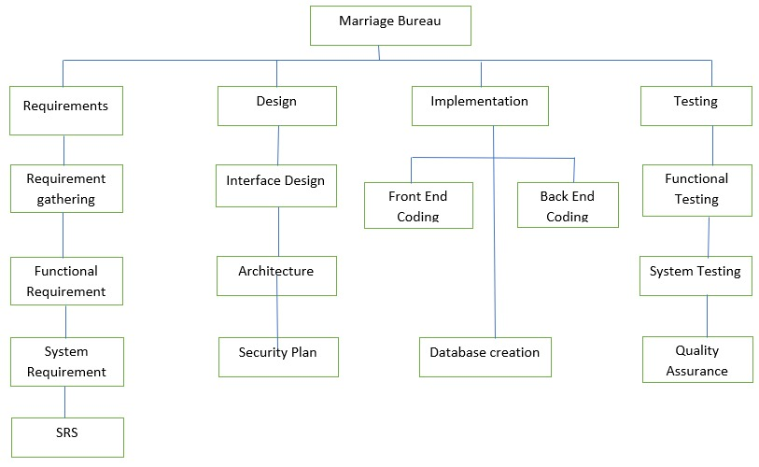

Roles & Responsibility Matrix
The purpose of roles & responsibility matrix is to identify who will do what.
WBS # | WBS Deliverable | Activity # | Activity to Complete the Deliverable | Duration  (# of Days) | Responsible Team Member(s) & Role(s)
1 | Planning | 1 |  | 10 Days | Abdul Wajid
2 | Requirement Gathering | 2 |  | 30 Days | All Members
3 | UI Design | 3 |  | 30 Days | Anwaar ul Haq+Farman Tariq
4 | Coding | 4 | On Python | 90 Days | Rehmat Qadeer+HM Tahir
5 | Testing and Implementation | 5 |  | 50 Days | All Members

Gantt Chart

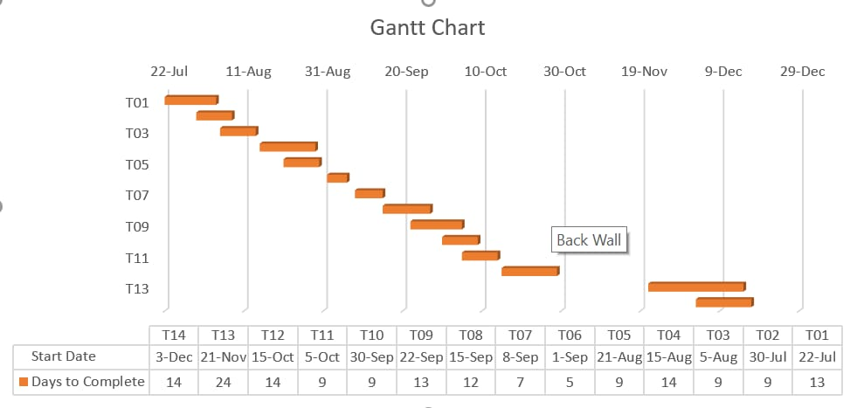

Report Outline
In this chapter we discussed about scope of the project and project background also developing the project of marriage bureau. After gap analysis we came to know about difficulties also we have some resources but they have lack of information about marriage bureau so we work on it by our self.

Chapter 2

Software Requirement Specifications

Chapter 2: Software Requirement Specifications

Introduction
In first chapter we have concerned all basic information now it’s time to specify some of them requirements because all the information that we have collected in first chapter is not specified for implementation now we will specify our purpose on that basis we will specify our needed function or non-functional requirements to implement.

Purpose
We have decided to create website of marriage bureau using Python, Django Rest Framework, React JS, Redux, Redux Store, JWT AUTH, etc. Marriage bureau sites register users, after which they are able to upload their profile onto a searchable database maintained by the website. Those users looking to find suitors search the database with customised searches that typically include nationality, age, gender, availability of photograph and often religion, geographic location and caste. Marriage bureau is also a good platform for the people who want love marriage, but are very shy. Here, if they like any profile they feel comfortable to approach, as they know the other person is also there to find a life partner.

Document Conventions
For the main selection titles
- Font will be “times new roman”
- Face will be bold
- Size:14
Sub selection titles
- Font “time’s new roman”
- Face bold
- Size : 12
Others text explanations
- Font “time’s new roman”
- Face normal
- Size 12

Intended Audience and Reading Suggestions

We are going to create website of marriage bureau using Python, Django Rest Framework, React JS, Redux, Redux Store, JWT AUTH, etc. We developed it in SRS form. Mostly this SRS is developed for project management team. In our project team there will be project manager, developer, coder, tester and documentation writer.
User customer
This intended belongs to customer and user. It is just for to make them ensure that document is correctly meeting their need.
Project Manager
Project manager also need this SRS document. It is very important for the project manager to determine the cost that will be occur during the making of this project. This is done by implementation to the SRS document. And that documents consist of all type of information that is require for planning the projects.
Project developer
When SRS is formed the next step is to name it and project developer will name this SRS document to confirm that it is what customer requires.
For the project developer it is very important.
Tester
Tester duty is very important when SRS document is formed tester will carefully read it and he will tell that the requirements are fully satisfied with the customer so that he able to test that software and handles it’s working.
Document writer
Document writer will review this document to assure that this document is well competent that is able to write the users standard. It is mandatory that document standard will meet user’s standard.
Maintenance
Engineers will used this document to understand the total functionality of the system, this information about functionality can help engineers to briefly explain the design and code of project.

Product Scope
All the requirements capture in one document by software requirements specification. The project will consist of 3 parts admin (or organizer), Staff manager and user. Admin will add particular product along with the staff manager or organizer. We are going to create website of marriage bureau using Python, Django Rest Framework, React JS, Redux, Redux Store, JWT AUTH, etc. Marriage bureau sites register users, after which they are able to upload their profile onto a searchable database maintained by the website. Those users looking to find suitors search the database with customised searches that typically include nationality, age, gender, availability of photograph and often religion, geographic location and caste.

References

Web address
www.google.com

https://www.studymode.com

https://www.answers.com

https://www.shaadi.com
https://www.goodreads.com

Overall Description

Product Perspective
To improve the power of staff manager and users used the combination of online Marriage bureau system. This system is generated to developed the interest of people for find your life partner. Marriage bureau is also a good platform for the people who want love marriage, but are very shy. Here, if they like any profile they feel comfortable to approach, as they know the other person is also there to find a life partner.

User Classes and Characteristics
Persons, administer who manage the system and company staff they all are the users of the system. All staff and (user) have little knowledge about the computers and the internet browsing so they are able to use their seat in a right way. The little problems that may arise due to some interruption in the disk or crashes in the disk, failure of power and other crashes to manage the system, this all problem is justify by the administrator of the system which have more knowledge about the internet. To install the system there must be proper user’s manual, online help, interface and guideline. And user must be educate in this way how to use the system in a right way without any problems.

Operating Environment

Software requirements
Language: Python language, Django, react js etc
Operating system window 10,
Database: MySQL
Hardware requirements 512 RAM, Pentium 5/ 40GB hard disk

Design and Implementation Constraints
All user’s information should be save in the database so it is easy for marriage bureau to accessible. All computers of company is connected with the manufacturing execution system and it is executing all the 24 hours a day. The user or any other authorized person can access data online from any person that has good ability of browsing and good speed of internet which is connected to online data server. This online system database should be suitable with combination of marriage bureau system. To login in marriage bureau website user must have a correct information of their password and user names.

Assumptions and Dependencies

Applicable users have more knowledge about website. If interface of system is provided in English then user must know the English language. And all the type of product can access the student database.

External Interface Requirements

User Interfaces
Design and layout for each form will be very good and clear and very attractive for all users so they cannot distract.
Welcome window will appear immediately when the user open this website.
User can easily enter their password and usernames in the login window.
Login message will appear when login done.
For the user there must be a relative link in all window for others window so user can go easily to other window.
There will be a help for the user in every window and Mac there must be support option window for ease of user.
There must be all collection of graphical user interface that provide good look and feel.
Graphic and font family size will be in a good manner and well organized and the color of the background should be very light in the screen layout.
Error message will be displayed in a proper way whenever users write any error statement by mistakenly.
For displaying message in each and every window there will be alert and confirm message.
By using guideline which is in the window and Mac user will be able to search and find the data from the record.
When user enter in the system there will be menu window and this window will contain all the table contents of software and user can use this window to go any desired window and Mac he want.
Menu window is displaying according to the login (user normal or admin) so it will provide a satisfied security data.
User and other authenticated person can save data in the database very easily and control the path of records of users purchases and others vendor.

System software will be understandable and very easy to understand by the normal user

Hardware Interfaces

System that are already exists data will be used for taking the data from the users and update the marriage bureau system catalogue.

Software Interfaces
We are going to create website of marriage bureau using Python, Django Rest Framework, React JS, etc. Marriage bureau sites register users, after which they are able to upload their profile onto a searchable database maintained by the website. Those users looking to find suitors search the database with customised searches that typically include nationality, age, gender, availability of photograph and often religion, geographic location and caste

Communications Interfaces
In recent times matrimony portals, social networking sites, community specific chat rooms are prevailing on the Internet. These can be treated as transmitting agent of first hand matrimonial information and gaining popularity with the increasing use of Internet in our country. Such interactive platforms offer attractive services to their registered members and facilities online searching (free or fee based) instantly and more comfortably.

System Features

System Feature 1
Login System

Description and Priority

First priority will be the welcome form as we know whenever user or any other person who has authority want to enter in the system they have to login in the system. For the logging there must be a welcome page or screen before login form which ensure to the user he wants to enter or exist.
Login form comes after the welcome form. Users and other authenticated person used this form to login in the system by entering their password and good usernames.
As we know priorities is important thing so priorities of the user always be given through his basic.
Menu form will show according to activities of the users and they can use this and users can approach all the time all reports.

Stimulus/Response Sequences

User authentication for the all registered members they should have their id and unique key in the system so they have their own choice of select for their favorite relevant material.

Functional Requirements

For making this web service for 24/7.First we have to maintain our domain or hosting package that available all time and the web files of SQ and XAMP database so that all functionalities will be available 24/7 and admin can access this web from anywhere and can add or edit any update related to the marriage bureau system also people can access so that they can do their related tasks easily like management staff can see their duties and people profile they have given to manage and people can see updated info related the Marriage bureau.
Functional Requirements:

Admin:
REQ-SF1-1 | The Admin will be able to login to system.
REQ-SF1-2 | The Admin will be able to create user login for users.
REQ-SF1-3 | The Admin will be able to give access.
REQ-SF1-4 | The Admin will be able to delete user account.
REQ-SF1-5 | The Admin will be able to edit any related info.
REQ-SF1-6 | The Admin will be able to related field.
REQ-SF1-7 | The Admin will be to change any update.
REQ-SF1-8 | The Admin will be able to add or edit user profile.
REQ-SF1-9 | The Admin will be able to add or edit new information about marriage.
REQ-SF1-10 | The Admin will be able to check output.

For Person(User):
REQ-SF1-1 | The user will be able to register himself or herself.
REQ-SF1-2 | The user will be able to view other people profile.
REQ-SF1-3 | The user will be able to view other user status.
REQ-SF1-4 | The user will be able to contact other people.
REQ-SF1-5 | The user will be able to send request to the other user.

System Feature 2
View people profile

Description and Priority

As login part is discussed so display and view part of the system is discussed in this phase so the admin, user all can access view phase of the system they can access it without going to any login system even they can people profile is available without login on the system and they can also see the about person status.

Stimulus/Response Sequences

People just have to open web browser with the normal speed of internet and search our domain to find the information related about marriage bureau so they can easily access our site and if they want to find your life partner.

Functional Requirements

For making this web service for 24/7.First we have to maintain our domain or hosting package that available all time and the web files of SQ and XAMP database so that all functionalities will be available 24/7 and admin can access this web from anywhere and can add or edit any update related to the Marriage bureau also people can access so that they can do their related tasks easily they have given to manage and people can see updated info related the MB.
Functional Requirements:

Admin:
REQ-SF1-1 | The Admin will be able to login to system.
REQ-SF1-2 | The Admin will be able to create user login for users.
REQ-SF1-3 | The Admin will be able to give access.
REQ-SF1-4 | The Admin will be able to delete user account.
REQ-SF1-5 | The Admin will be able to edit any related info.
REQ-SF1-6 | The Admin will be able to related field.
REQ-SF1-7 | The Admin will be to change any update.
REQ-SF1-8 | The Admin will be able to add or edit user profile.
REQ-SF1-9 | The Admin will be able to add or edit new information about marriage.
REQ-SF1-10 | The Admin will be able to check output.

For Person(User):
REQ-SF1-1 | The user will be able to register himself or herself.
REQ-SF1-2 | The user will be able to view other people profile.
REQ-SF1-3 | The user will be able to view other user status.
REQ-SF1-4 | The user will be able to contact other people.
REQ-SF1-5 | The user will be able to send request to the other user.

Nonfunctional Requirements

REQ-SF1-1 | The system will be available 24/7.
REQ-SF1-2 | The system will have a great database so that every attendant person’s details should be there.
REQ-SF1-3 | The system has great maintenance team that will be available 24/7.
REQ-SF1-4 | The system transaction system will be related with bank so that every person’s transaction details should be available online.
REQ-SF1-5 | This system will use an interactive Web browser to establish communication.

Performance Requirements

As performance of the system is very necessary part of the system so that people will satisfy our service and our mission for making service will be fulfill if people will satisfy with this service so this service should be available 24/7 so that every coming person can get it helpful to make it helpful we make a team that will handle it 24/7 so that if any issue will come they will be available to resolve it as soon as possible and the speed of this web service is more considered even if a person seeing a live match there is no browsing error will happen in making this service more perfect.

Safety Requirements

As the safety of the system is very necessary part of the system so that every person who comes and use our service will satisfy with us. To creating best safety we have created a database system so if anyone want to make any serious decision so first of all he or she will have to login to the system so that his or her information will be saved in the secure database system.

Security Requirements

As we know we are living in the era of information so information is a very secure part of every person so people will not search any site that is harmful for their information so the security in our service is a very big part to handle it.

Usability Requirements

A usability requirement specifies how easy the system must be to use. The usability requirements must be tangible so that we are able to verify them and trace them during the development. Synchronize human and machine actions dynamically and manage human processes with our sophisticated workflow management capabilities.

Reliability Requirements

To assess the safety of software based safety critical systems, we firstly analyzed the differences between reliability and safety, then, introduced a safety model based on three-state Markov model and some safety-related metrics. For safety critical software it is common to demand that all known faults are removed. Thus an operational test for safety critical software takes the form of a specified number of test cases (or a specified critical mission duration) that must be executed unsafe-failure-free.

Maintainability/Supportability Requirements

The degree of facility with which an equipment or system is capable of being retained in, or restored to, serviceable operation. Focuses on the core systems engineering tasks of writing, managing, and tracking requirements for reliability, maintainability, and supportability that are most likely to satisfy customers and lead to success for suppliers.

Portability Requirements

Portability is the ease with which a software system can be transferred from its current hardware or software environment to another environment. Often close relatives, neighborhood natives, colleagues, and friends reliably transfer matrimonial information to settle the marriage among their aspiring young. Although sometimes they fear to communicate such information directly, as they feel, their help might be a lifelong embarrassment to them later, if anything happens unlikely.

Efficiency Requirements

By implementing a marriage bureau, we can improve the bottom line without sacrificing quality or safety. Marriage bureau sites register users, after which they are able to upload their profile onto a searchable database maintained by the website. Those users looking to find suitors search the database with customised searches that typically include nationality, age, gender, availability of photograph and often religion, geographic location and caste.
.

Domain Requirements

As we all know today quality of the services is more important to make it long so we have also quality attributes in our service that become a reason for customer to stay on our service as long as we make it more attractive and easy to use for every one and there is more menu options then other sites. If there is anyone who is not able to read they can get idea with the related images and icons.

Chapter 3

Use Case Analysis

Chapter 3: Use Case Analysis

Use case analysis is a technique used to identify the requirements of a system (normally associated with software/process design) and the information used to both define processes used and classes (which are a collection of actors and processes) which will be used both in the use case diagram and the overall use case in the development or redesign of a software system or program.

Use Case Model

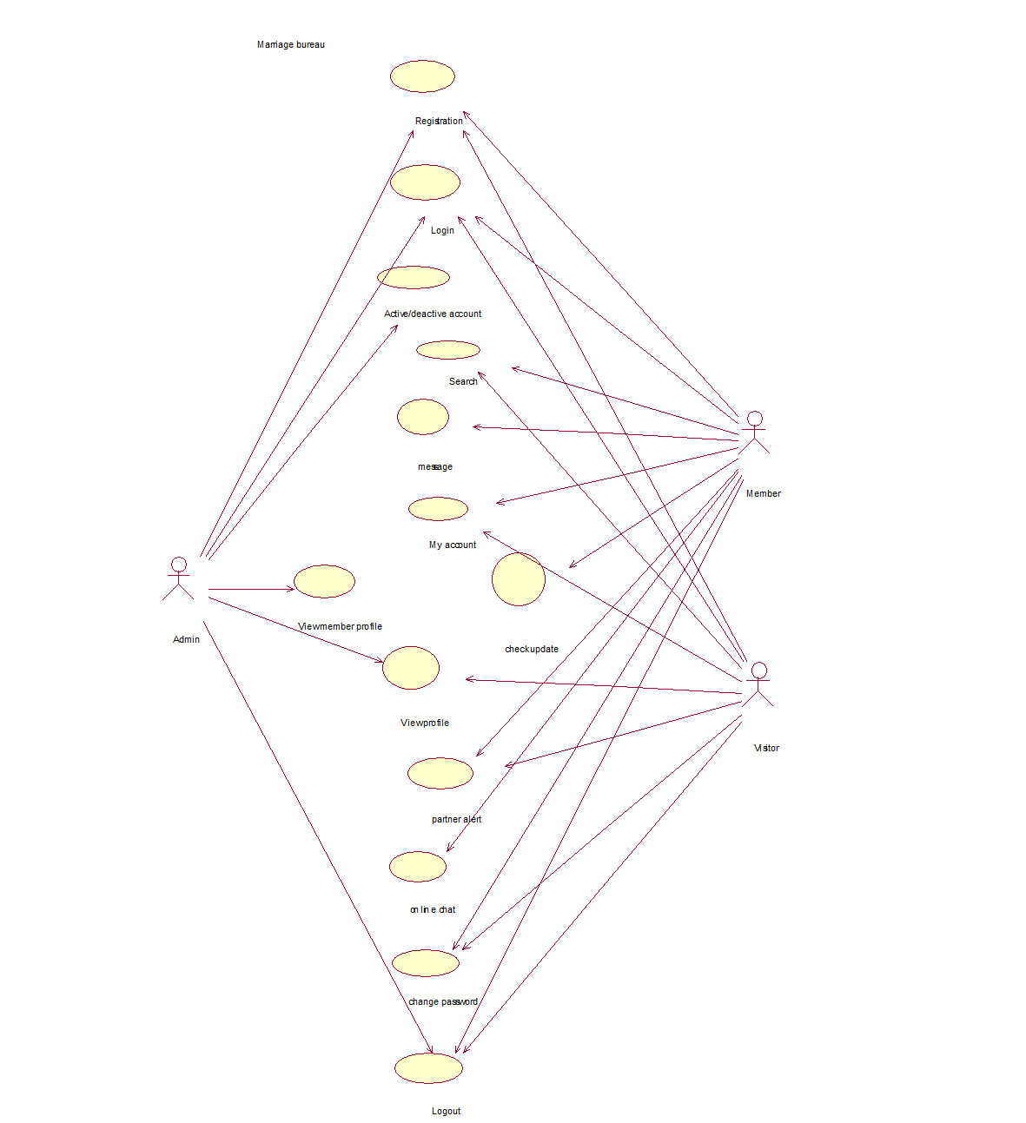

For Admin:
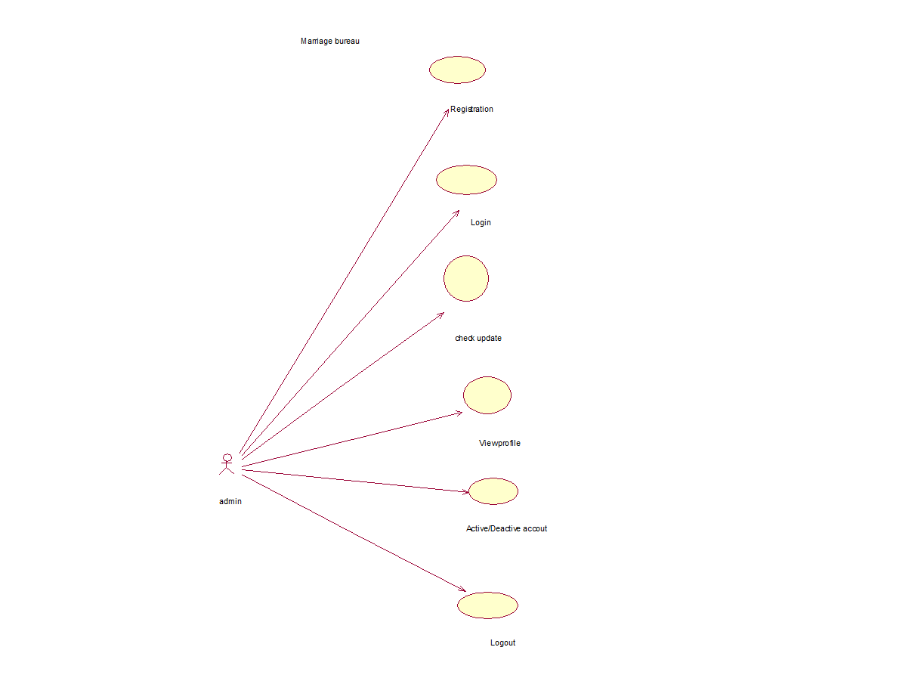

For Member:

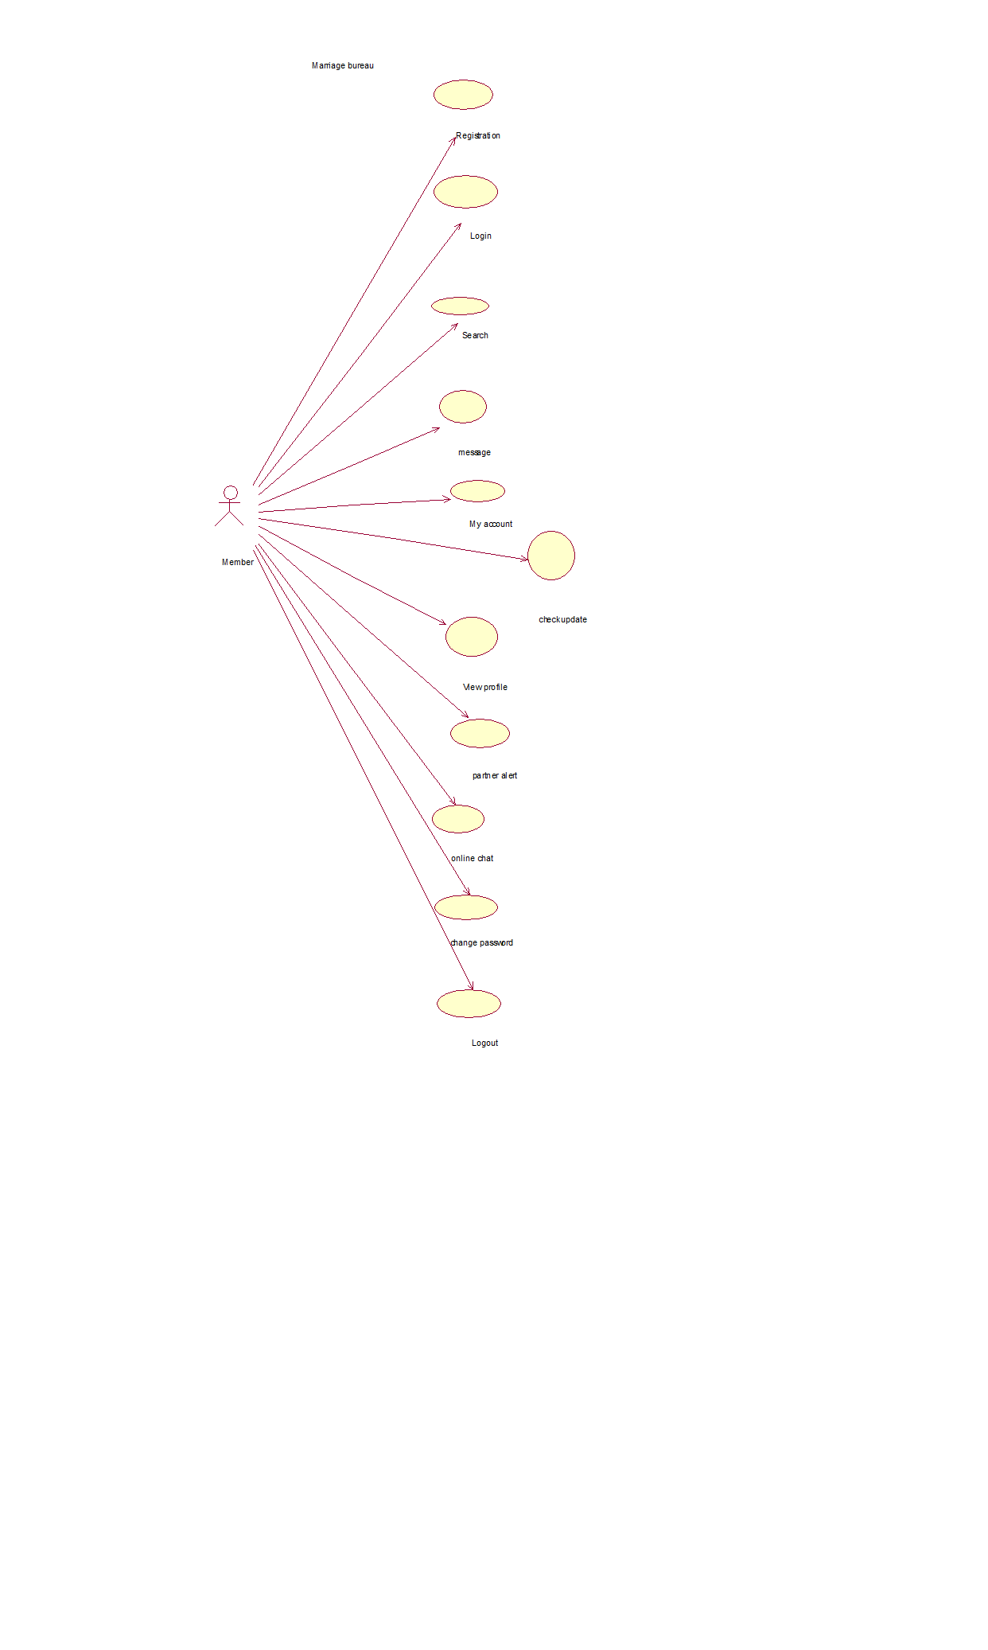

For Visitor:

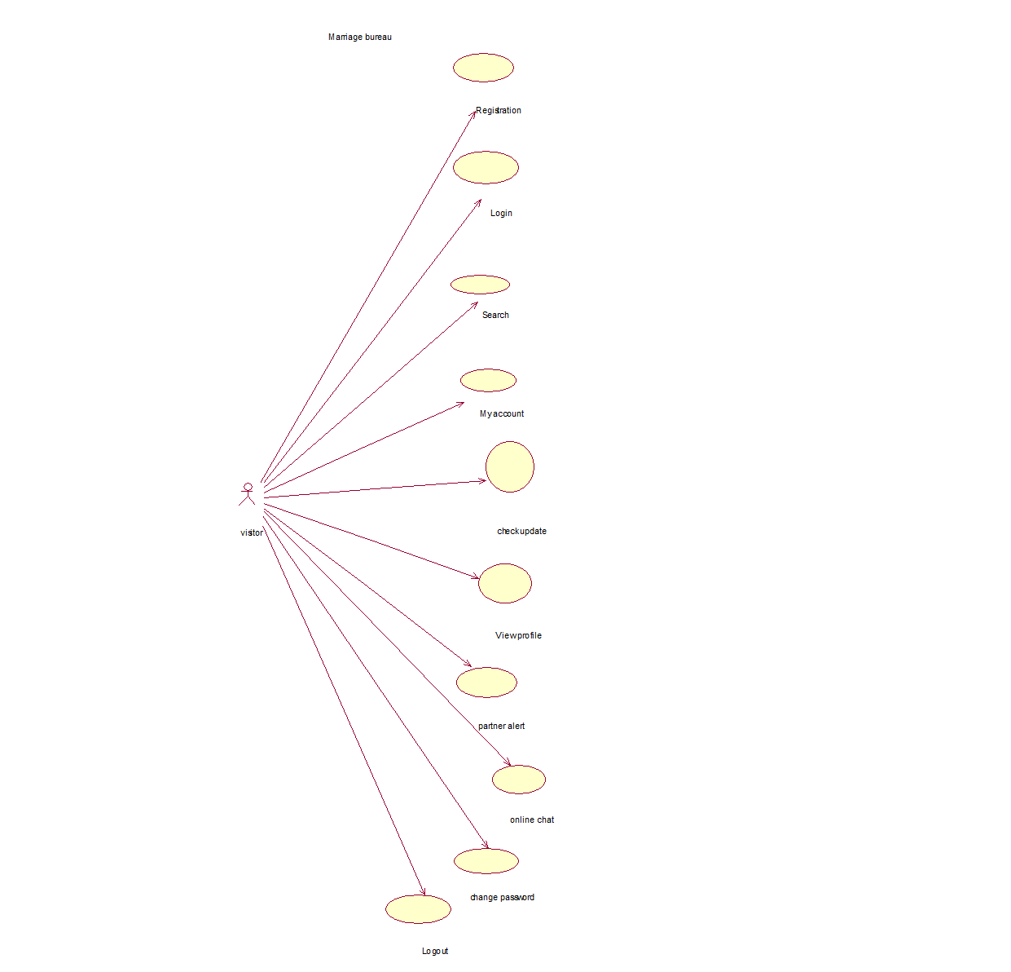

Use Cases Description
Use Case ID | 01
Use Case Name: | Login
Scope | Marriage Bureau
Level | User goal
Primary Actor | (Admin)

Stakeholder and Interest:
Admin: wants to login to Marriage bureau.
Pre-Conditions:
- The password entered is correct.
Success Guarantee:
- Admin successfully login and his record saved in database.
Main Success Scenario:
- Admin: login to Marriage bureau.
- Admin: view detail of wires type.
Extension:
- Error message will be show with reason.
- If the network connection is slow then form will be submitted but it will update later in database.
Special Requirements:
The System can support English language.

Use Case ID | 02
Use Case Name: | Create user account
Scope | Marriage bureau
Level | User goal
Primary Actor | (Admin)

Stakeholder and Interest:
Admin: can create a user account.
Pre-Conditions:
- The password entered is correct.
Success Guarantee:
- Account is created and saved in database.
Main Success Scenario:
- Admin created the user account successfully .
Extension:
- Error message will be show with reason.
- If the network connection is slow then form will be submitted but it will update later in database.
Special Requirements:
The System can support English language

Use Case ID | 03
Use Case Name: | Active/deactive account
Scope | Marriage bureau
Level | User goal
Primary Actor | (Admin)

Stakeholder and Interest:
- admin: can give access to users.
- admin: can see the users.

Pre-Conditions:
- The password entered is correct.
Success Guarantee:
User get access successfully.
Main Success Scenario:
- The admin will give access to the user and user get access successfully.

Extension:
- Error message will be show with reason.
- If the network connection is slow then form will be submitted but it will update later in database.

Special Requirements:
The System can support English language.

Use Case ID | 04
Use Case Name: | Logout
Scope | Marriage bureau
Level | User goal
Primary Actor | (Admin)

Stakeholder and Interest:
- Admin: Wants to logout.
Pre-Conditions:
- Admin must login first.
Success Guarantee:
Admin logout successfully.
Main Success Scenario:
- The admin logout successfully when he is login to MES.
Extension:
- Error message will be show with reason.
- If the network connection is slow then form will be submitted but it will update later in database.

Special Requirements:
The System can support English language.

Use Case ID | 01
Use Case Name: | Login
Scope | Marriage bureau
Level | User goal
Primary Actor | Member(User)

Stakeholder and Interest:
- User: Wants to login.
Pre-Conditions:
- The password entered is correct.
Success Guarantee:
User login Successfully.
Main Success Scenario:
- User enter the correct password and he login to Marriage bureau successfully.
Extension:
- Error message will be show with reason.
- If the network connection is slow then form will be submitted but it will update later in database.

Special Requirements:
The System can support English language.

Use Case ID | 02
Use Case Name: | Search
Scope | Marriage bureau
Level | User goal
Primary Actor | Member (User)

Stakeholder and Interest:
- User: Wants to choose search id.
Pre-Conditions:
- The password entered is correct.
Success Guarantee:
Show other member profile.
Main Success Scenario:
- User choose partner and view other member profile successfully.
Extension:
- Error message will be show with reason.
- If the network connection is slow then form will be submitted but it will update later in database.

Special Requirements:
The System can support English language.

Use Case ID | 03
Use Case Name: | messsage
Scope | Marriage bureau
Level | User goal
Primary Actor | Member (User)

Stakeholder and Interest:
- User: Wants to message
Pre-Conditions:
- The password entered is correct.
Success Guarantee:
Show message.
Main Success Scenario:
- User choose member and view message send successfully.
Extension:
- Error message will be show with reason.
- If the network connection is slow then form will be submitted but it will update later in database.

Special Requirements:
The System can support English language.

Use Case ID | 04
Use Case Name: | My account
Scope | Marriage bureau
Level | User goal
Primary Actor | Member (User)

Stakeholder and Interest:
- User: Wants to see my account.
Pre-Conditions:
- The password entered is correct.
Success Guarantee:
Account see successfully.
Main Success Scenario:
- User choose his/her account and view account successfully.
Extension:
- Error message will be show with reason.
- If the network connection is slow then form will be submitted but it will update later in database.

Special Requirements:
The System can support English language.

Use Case ID | 05
Use Case Name: | Partner alert
Scope | Marriage bureau
Level | User goal
Primary Actor | Member(User)

Stakeholder and Interest:
- User : Wants to check partner alert.
Pre-Conditions:
- The password entered is correct.
Success Guarantee:
Show output successfully.
Main Success Scenario:
- User choose to partner alert and check alert successfully.
Extension:
- Error message will be show with reason.
- If the network connection is slow then form will be submitted but it will update later in database.

Special Requirements:
The System can support English language.

Use Case ID | 06
Use Case Name: | Online chat
Scope | Marriage bureau
Level | User goal
Primary Actor | Member (User)

Stakeholder and Interest:
- User: Wants to chat online.
Pre-Conditions:
- The password entered is correct.
Success Guarantee:
Show online chat.
Main Success Scenario:
- Show the chat online to the user successfully.
.
Extension:
- Error message will be show with reason.
- If the network connection is slow then form will be submitted but it will update later in database.

Special Requirements:
The System can support English language

Use Case ID | 07
Use Case Name: | Change password
Scope | Marriage bureau
Level | User goal
Primary Actor | Member (User)

Stakeholder and Interest:
- Admin: Wants to Change password.
Pre-Conditions:
- The password entered is correct.
Success Guarantee:
Show confirmation of the password changed successfully.
Main Success Scenario:
- The user want to change password and the system show password change successfully.

Extension:
- Error message will be show with reason.
- If the network connection is slow then form will be submitted but it will update later in database.

Special Requirements:
The System can support English language.

Use Case ID | 08
Use Case Name: | Logout
Scope | Marriage bureau
Level | User goal
Primary Actor | Member (User)

Stakeholder and Interest:
- User: Wants to logout.
Pre-Conditions:
- User must login first.
Success Guarantee:
User logout successfully.
Main Success Scenario:
- The User logout successfully when he is login to MES.
Extension:
- Error message will be show with reason.
- If the network connection is slow then form will be submitted but it will update later in database.

Special Requirements:
The System can support English language.

Use Case ID | 01
Use Case Name: | Login
Scope | Marriage bureau
Level | User goal
Primary Actor | Visitor(User)

Stakeholder and Interest:
- User: Wants to login.
Pre-Conditions:
- The password entered is correct.
Success Guarantee:
User login Successfully.
Main Success Scenario:
- User enter the correct password and he login to Marriage bureau successfully.
Extension:
- Error message will be show with reason.
- If the network connection is slow then form will be submitted but it will update later in database.

Special Requirements:
The System can support English language.

Use Case ID | 02
Use Case Name: | Search
Scope | Marriage bureau
Level | User goal
Primary Actor | Visitor (User)

Stakeholder and Interest:
- User: Wants to choose search id.
Pre-Conditions:
- The password entered is correct.
Success Guarantee:
Show other member profile.
Main Success Scenario:
- User choose partner and view other member profile successfully.
Extension:
- Error message will be show with reason.
- If the network connection is slow then form will be submitted but it will update later in database.

Special Requirements:
The System can support English language.

Use Case ID | 03
Use Case Name: | Partner alert
Scope | Marriage bureau
Level | User goal
Primary Actor | Visitor(User)

Stakeholder and Interest:
- User : Wants to check partner alert.
Pre-Conditions:
- The password entered is correct.
Success Guarantee:
Show output successfully.
Main Success Scenario:
- User choose to partner alert and check alert successfully.
Extension:
- Error message will be show with reason.
- If the network connection is slow then form will be submitted but it will update later in database.

Special Requirements:
The System can support English language.

Use Case ID | 04
Use Case Name: | Online chat
Scope | Marriage bureau
Level | User goal
Primary Actor | Visitor (User)

Stakeholder and Interest:
- User: Wants to chat online.
Pre-Conditions:
- The password entered is correct.
Success Guarantee:
Show online chat.
Main Success Scenario:
- Show the chat online to the user successfully.
.
Extension:
- Error message will be show with reason.
- If the network connection is slow then form will be submitted but it will update later in database.

Special Requirements:
The System can support English language

Use Case ID | 05
Use Case Name: | Change password
Scope | Marriage bureau
Level | User goal
Primary Actor | Visitor (User)

Stakeholder and Interest:
- Admin: Wants to Change password.
Pre-Conditions:
- The password entered is correct.
Success Guarantee:
Show confirmation of the password changed successfully.
Main Success Scenario:
- The user want to change password and the system show password change successfully.

Extension:
- Error message will be show with reason.
- If the network connection is slow then form will be submitted but it will update later in database.

Special Requirements:
The System can support English language.

Use Case ID | 06
Use Case Name: | Logout
Scope | Marriage bureau
Level | User goal
Primary Actor | Visitor(User)

Stakeholder and Interest:
- User: Wants to logout.
Pre-Conditions:
- User must login first.
Success Guarantee:
User logout successfully.
Main Success Scenario:
- The User logout successfully when he is login to MES.
Extension:
- Error message will be show with reason.
- If the network connection is slow then form will be submitted but it will update later in database.

Special Requirements:
The System can support English language

Chapter 4

System Design

Chapter 4: System Design
We have decided to create website of marriage bureau using Python, Django Rest Framework, React JS, Redux, Redux Store, JWT AUTH, etc. Marriage bureau provide a superior matchmaking experience to Pakistani all over the world. Marriage bureau has redefined the way people meet for marriage and has touched the lives of millions people all over the world and helped over millions of people find their matches. Marriage provides a permanent platform to the romance and leads a couple to build a decent family. New-born baby increases the aromatic of romance that lasts long. So, marriage is the first platform where we can resolve most of the social crimes if it goes in the right way.

Architecture Diagram
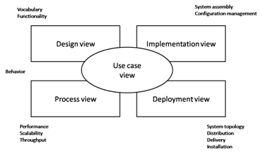

Domain Model

Entity Relationship Diagram with data dictionary

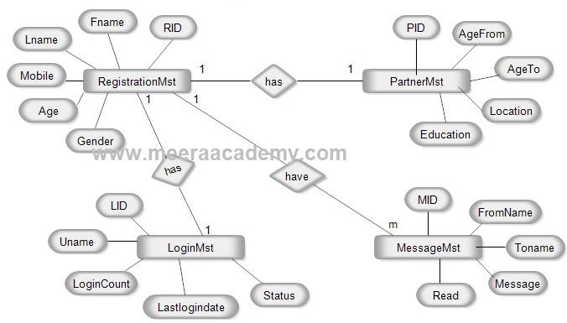

Class Diagram

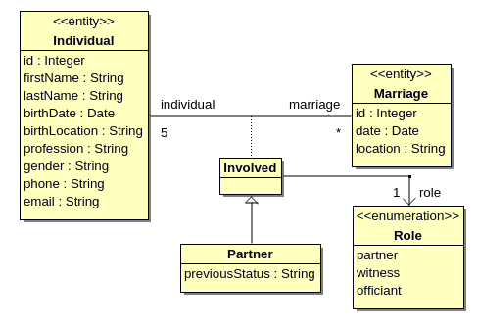

Sequence / Collaboration Diagram

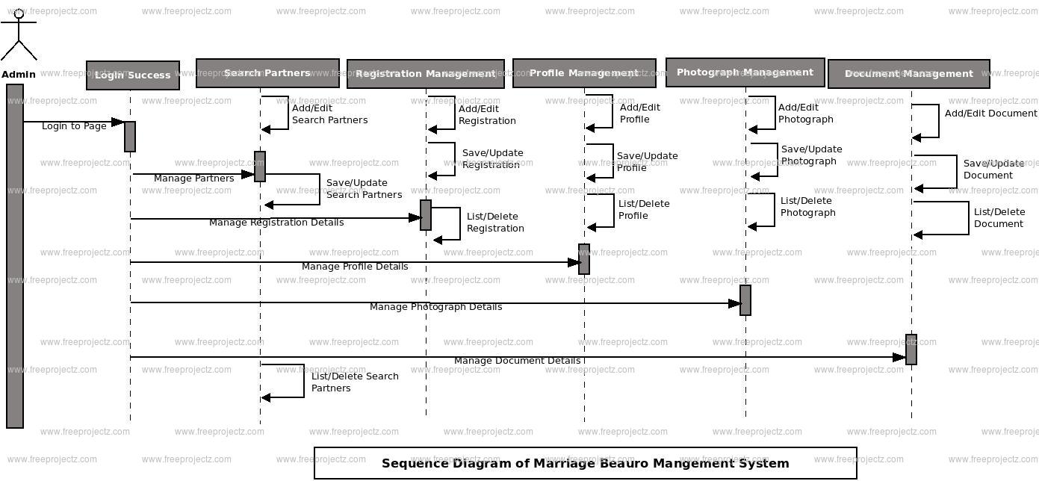

Operation contracts

Activity Diagram

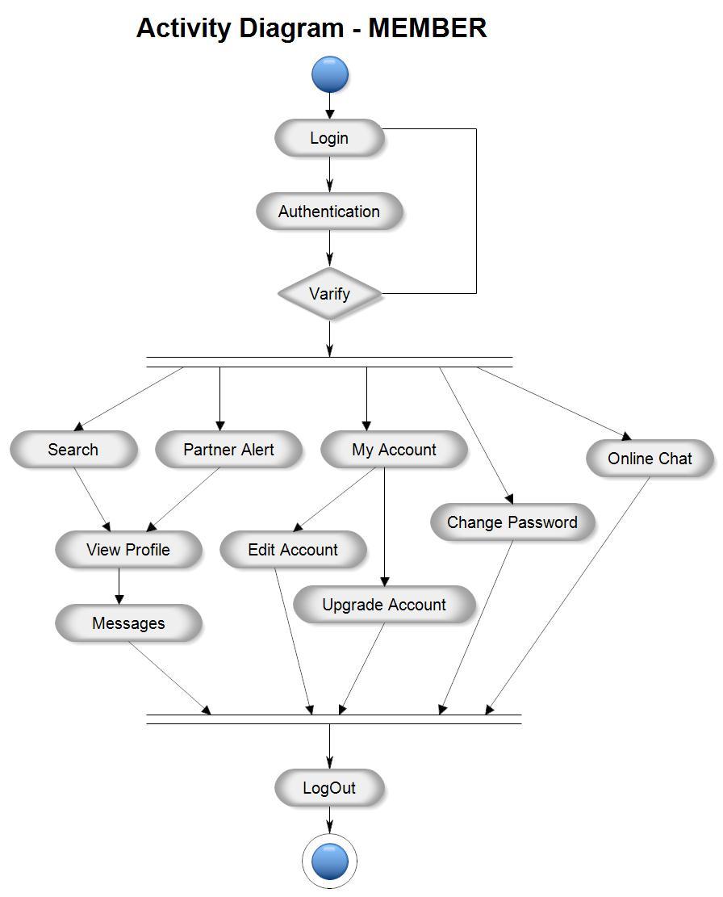

State Transition Diagram

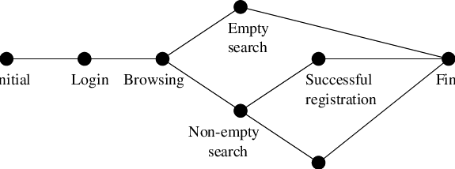

Component Diagram

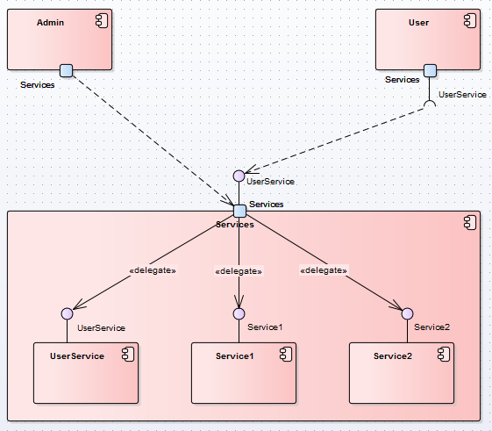

Deployment Diagram

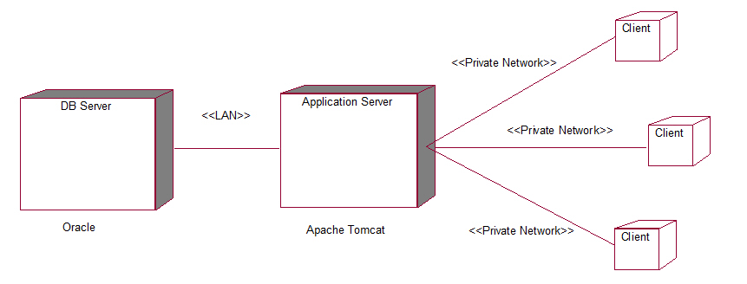

Data Flow diagram

Zero level DFD
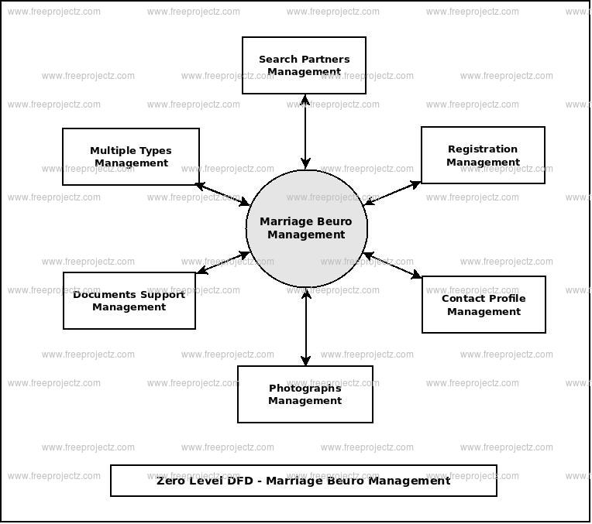

First level DFD:
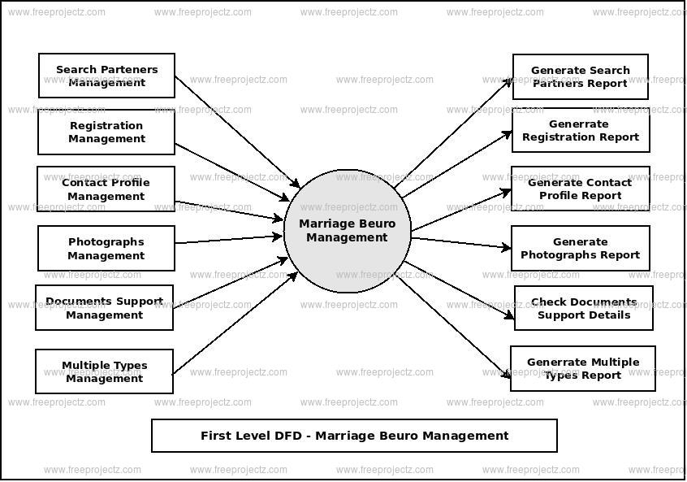

Second level DFD:

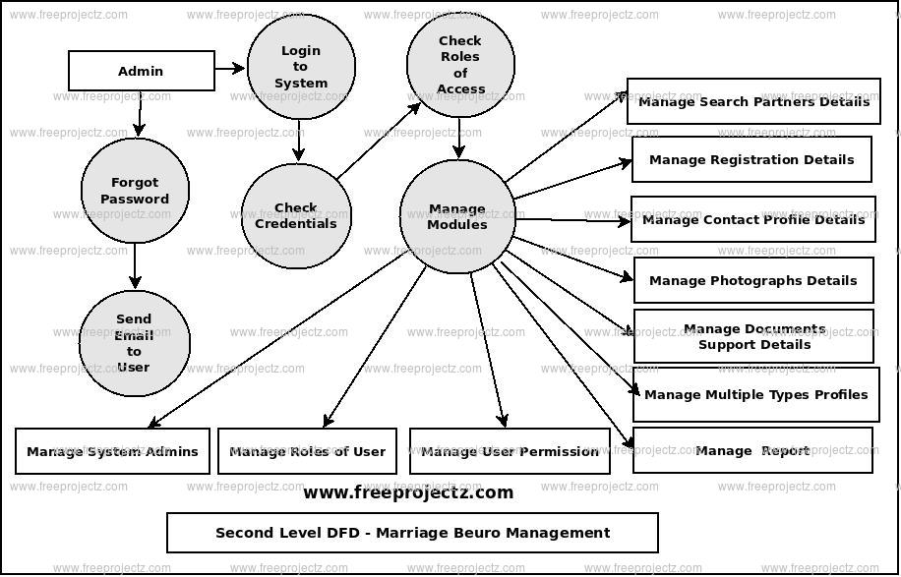

Chapter 5

Implementation

Chapter 5: Implementation

We have decided to create website of marriage bureau using Python, Django Rest Framework, React JS, Redux, Redux Store, JWT AUTH, etc. Marriage bureau provide a superior matchmaking experience to Pakistani all over the world. Marriage bureau has redefined the way people meet for marriage and has touched the lives of millions people all over the world and helped over millions of people find their matches. Marriage provides a permanent platform to the romance and leads a couple to build a decent family. New-born baby increases the aromatic of romance that lasts long. So, marriage is the first platform where we can resolve most of the social crimes if it goes in the right way.

Important Flow Control/Pseudo codes

Member
- Registration
- Login
- Search
- Message
- Online chat
- Accept request
- View profile
- Check update
- Partner Alert
- My Account
- See partner profile
- Change password
- Logout
- Member Rating
- Member Report

Admin
- Registration
- Login
- View member profile
- Active account
- Deactive account
- logout

Visitor
- Registration
- Login
- Search
- Message
- Online chat
- Accept request
- View profile
- Check update
- Partner Alert
- My Account
- See partner profile
- Change password
- Logout

Components, Libraries, Web Services and stubs

- Secure user profile
- Administration Module

Deployment Environment
The objective of the team of Marriage Bureau includes: Understanding, the requirements of the family of a single, divorced or widowed customer through unending support, analysis and study. Provision of satisfactory and distinguished matchmaking procedure along with the maintenance of our privacy policy. A marriage is two people on a life-long mission. Whether we notice it or not we all go into marriage with a goal or two in mind.

Tools and Techniques
Tools:
Language: Python, Django Rest Framework, React JS, Redux, Redux Store, JWT AUTH, Operating system window 10,
Database: MySQL
Software Designing Tools
Lucidchart.com, Rational Rose, MS Visio, MS world, MS Excel, notepad++ .

Techniques:
Python, Django Rest Framework, React JS, Redux, Redux Store, JWT AUTH,
Database: MySQL

Best Practices / Coding Standards

- Communication with stakeholders.
- No repetition of coding
- Work Breakdown structure will be followed
- Feedback will be accepted and applied.
- Each requirement will be documented.
- The website will be frequent to open and use
- The application interface will be user friendly.

Version Control

We are planning to create a web application of marriage bureau in the upcoming months. First changes will be made according to user feedback

Appendices

Appendix A: Information / Promotional Material
[Paragraph Text 12 pt, Calibri, 1.5 Line Spacing, Justified]
[Between 4 to 8 lines describe what is this appendix all about]

  - Broacher

  - Flyer

  - Standee

  - Banner

  - First Level heading [16 pt, Calibri, Bold, Left aligned]
[Paragraph Text 12 pt, Calibri, 1.5 Line Spacing, Justified]

    - Second level heading [14 pt, Calibri, Bold, Left aligned]
[Paragraph Text 12 pt, Calibri, 1.5 Line Spacing, Justified]

      - Third level heading [12 pt, Calibri, Bold, Left aligned]
[Paragraph Text 12 pt, Calibri, 1.5 Line Spacing, Justified]

Appendix [no.]: Appendix Title
[Paragraph Text 12 pt, Calibri, 1.5 Line Spacing, Justified]
[Between 4 to 8 lines describe what is this chapter all about]

  - First Level heading [16 pt, Calibri, Bold, Left aligned]
[Paragraph Text 12 pt, Calibri, 1.5 Line Spacing, Justified]

    - Second level heading [14 pt, Calibri, Bold, Left aligned]
[Paragraph Text 12 pt, Calibri, 1.5 Line Spacing, Justified]

      - Third level heading [12 pt, Calibri, Bold, Left aligned]
[Paragraph Text 12 pt, Calibri, 1.5 Line Spacing, Justified]

Reference and Bibliography

Reference and Bibliography

Shaadi.com, 2009, Available at: http://www.shaadi.com (accessed on 18th July 2009).
Simkins MA (1983). The impact of new technology on the information processing, Aslib Proceedings, (35):
SimplyMarry.com (2009). Available at: http://www.simplymarry.com (accessed on 21st August 2009).
ATBlog.com, 2008, Online matrimony market statistics (message posted by Rajiv Dingra dated March 20, 2008), Available at: http://www.watblog.com/2008/03/20/online-matrimony-marketstatistics-reveal-12-million-users (accessed on 12th October 2009)

Index

Index

[A]

[B]

[C]

