THE SUPERIOR COLLEGE LAHORE


Faculty of Computer Science & IT

Final Year Project
PROJECT REPORT (Part-2)

[Battle Arena: Ball Showdown]

Project ID:[FYP-BITM-S19-001]

Project Team

Student Name | Student ID | Program | Contact Number | Email Address
AWAIS ASIF | BITM-S16-002 | BSIT | 03324746329 | Awaisasif474@gmail.com
SAMIR ZAHEER | BITM-S16-016 | BSIT | 03035322399 | Samirzaheer05@gmail.com
NAJM-UL-HASSAN | BITM-S16-013 | BSIT | 03035102404 | hasssankhan661@gmail.com

[Gohar Mumtaz]
([Designation])
Project Report
[Title of Project]

Change Record
Author(s) | Version | Date | Notes | Supervisor’s Signature
 | 1.0 |  | <Original Draft>
 |  |  | <Changes Based on Feedback from Supervisor>
 |  |  | <Changes Based on Feedback From Faculty>
 |  |  | <Added Project Plan>
 |  |  | <Changes Based on Feedback from Supervisor>

APPROVAL
Project Supervisor
Comments: ___________________________________________________________________
_____________________________________________________________________________
Name:______________________________
Date:_______________________________ | Signature:__________________________

Project Manager
Comments: ___________________________________________________________________
_____________________________________________________________________________
Date:_______________________________ | Signature:__________________________

Head of the Department
Comments: ___________________________________________________________________
_____________________________________________________________________________
Date:_______________________________ | Signature:__________________________

Dedication

This work is dedicated to my Family members, they had played important role where I am today. They taught us by lessons and words, they all had played role for my education and career.

Acknowledgements

In performing our Project, we had to take the help and guideline of some respected teachers, who deserve our greatest gratitude. The completion of this assignment gives us much Pleasure. We would like to show our gratitude lecture Ghohar Mumtaz Superior University for giving us a good guideline for Project throughout numerous consultations. We would also like to expand our deepest gratitude to all those who have directly and indirectly guided us in writing this Project

Executive Summary
The goal of this project is to develop android platform game which will have a 2d game play with 3d animation. The project combined four core components. Learning android game development, utilizing unity (game/graphics engine), creating user control methods. The game will be developed as a universal application, meaning that it was compatible with all Android devices. The goal of this project is to develop a game for the android platform.
A detailed set of requirements and specifications was set out at the beginning of the project. One example of a requirement was that the game was to be developed in a 2D orthogonal style. All of the specified requirements were fulfilled upon the completion of the project. Writing a full set of specifications early on helped greatly in prioritizing features to implement and manage the time spent on each section of the project.All of these elements were combined to create an overall game, “battle arena ball showdown”. The objective of the game is to be a dog fight between two players with a ball, they have to protect their territory by using shields, and balls would be fired by one to another causing the damage to opponents. The stadiums will be provided to players with their own selection.This game is going to be a 2D coop-multiplayer game as well as 1 vs computer so people can enjoy it in whichever way they like. Moreover, the game is action-based game and its main aim to destroy the 5-6 or more than 6 power shields that are behind your opponent using a ball in order to win the game. There will be a 2 round match. Both the players will have the shield or weapon with which they will hit the ball in the opponent’s area in order to destroy their territory power shield, and try to damage the opponents as much as they can. There is no limitation of age. Because of its minimal interface and play style there is a very small learning curve in the game and there is no such thing in the game that will be difficult to understand by the user no matter the age.

Table of Contents
Dedication iv
Acknowledgements v
Executive Summary vi
Table of Contents vii
List of Figures ix
List of Tables x
Chapter 1 1
Introduction 1
1.1. Background 2
1.2. Motivations and Challenges 2
1.3. Goals and Objectives 2
1.4. Literature Review/Existing Solutions 2
1.5. Gap Analysis 2
1.6. Proposed Solution 2
1.7. Project Plan 3
1.7.1. Work Breakdown Structure 3
1.7.2. Roles & Responsibility Matrix 3
1.7.3. Gantt Chart 3
1.8. Report Outline 3
Chapter 2 4
Software Requirement Specifications 4
2.1. Introduction 5
2.1.1. Purpose 5
2.1.2. Document Conventions 5
2.1.3. Intended Audience and Reading Suggestions 5
2.1.4. Product Scope 5
2.1.5. References 6
2.2. Overall Description 6
2.2.1. Product Perspective 6
2.2.2. Product Functions 6
2.2.3. User Classes and Characteristics 6
2.2.4. Operating Environment 7
2.2.5. Design and Implementation Constraints 7
2.2.6. User Documentation 7
2.2.7. Assumptions and Dependencies 7
2.3. External Interface Requirements 8
2.3.1. User Interfaces 8
2.3.2. Hardware Interfaces 8
2.3.3. Software Interfaces 8
2.3.4. Communications Interfaces 9
2.4. System Features 9
2.4.1. System Feature 1 9
2.4.1.1. Description and Priority 9
2.4.1.2. Stimulus/Response Sequences 9
2.4.1.3. Functional Requirements 9
2.4.2. System Feature 2 10
2.4.2.1. Description and Priority 10
2.4.2.2. Stimulus/Response Sequences 10
2.4.2.3. Functional Requirements 10
2.4.3. System Feature 3 (and so on) 11
2.5. Other Nonfunctional Requirements 11
2.5.1. Performance Requirements 11
2.5.2. Safety Requirements 11
2.5.3. Security Requirements 12
2.5.4. Software Quality Attributes 12
2.5.5. Business Rules 12
2.6. Other Requirements 12
Chapter 3 13
Use Case Analysis 13
3.1. Use Case Model 14
3.2. Fully Dressed Use Cases 14
Chapter 4 15
System Design 15
4.1. Architecture Diagram 16
4.2. Domain Model 16
4.3. Entity Relationship Diagram with data dictionary 16
4.4. Class Diagram 17
4.5. Sequence / Collaboration Diagram 17
4.6. Operation contracts 17
4.7. Activity Diagram 18
4.8. State Transition Diagram 18
4.9. Component Diagram 18
4.10. Deployment Diagram 19
4.11. Data Flow diagram [only if structured approach is used - Level 0 and 1] 19
Chapter 5 20
Implementation 20
5.1. Important Flow Control/Pseudo codes 21
5.2. Components, Libraries, Web Services and stubs 21
5.3. Deployment Environment 21
5.4. Tools and Techniques 22
5.5. Best Practices / Coding Standards 22
5.6. Version Control 22
Appendices 23
Appendix A: Information / Promotional Material 24
Reference and Bibliography 27
Index 29

List of Figures

1.1 Caption of first figure of first chapter 6
1.2 Caption of second figure of first chapter 7
2.1 Caption of first figure of second chapter 14
2.2 Caption of second figure of second chapter 22
2.3 Caption of third figure of second chapter 26
5.1 Caption of first figure of fifth chapter 49
5.2 Caption of second figure of fifth chapter 49

List of Tables

1.1 label of first table of first chapter 6
1.2 label of second table of first chapter 7
2.1 label of first table of second chapter 14
2.2 label of second table of second chapter 22
2.3 label of third table of second chapter 26
5.1 label of first table of fifth chapter 49
5.2 label of second table of fifth chapter 49

Chapter 1

Introduction

Chapter 1: Introduction
The main objective of this game is to entertain the people and is going to be an android platform game and audience of every age is able to play the game. There is no limitation of age. Because of its minimal interface and play style there is a very small learning curve in the game and there is no such thing in the game that will be difficult to understand by the user no matter the age. This game is going to be a 3D coop-multiplayer game as well as 1 vs computer so people can enjoy it in whichever way they like. Moreover, the game is action-based game and its main aim to destroy the 5-6 or more than 6 power shields that are behind your opponent using a ball in order to win the game. There will be a 3 to 5 minute time limit of every level match. Both the players will have the shield or weapon with which they will hit the ball in the opponent’s area in order to destroy their territory power shield, and try to damage the opponents as much as they can. They would select characters by their choice, stadiums will also be selected by users or they have to unlock stadiums and characters as they would increase their levels. There will also be the special moves of both the players and will also have a boost to save their power shields. It would be fast paced game with minimal effort to learn the interface.

Background
There are many action games in market now days. Video games are becoming an increasing part of everyday life thanks to the birth of the smart phone; Casual gaming has become one of the fastest growing genres of video games in recent years, particularly on handheld devices.
A casual game is a video game aimed at a wide demographic. These are typically simple games with intuitive and addictive gameplay. Casual games do not require a large amount of time to be dedicated to them, unlike the classic style of hardcore games. Hardcore games traditionally have complex story and gameplay mechanics which take time to master. Hardcore games often make use of complicated, high-end graphics that require a high-specification device to run them effectively and they are therefore expensive to purchase. In contrast, casual games are usually much more favorably priced in order to reach a greater audience. Casual games are also spreading into the traditionally hardcore console market nine of the top thirty games sold in 2010 were casual games.
Casual games are the most heavily downloaded genre of game on android devices. The most popular and well known casual game on the android platform is Angry Birds, which recently reached a monumental milestone of 500 million downloads .

Motivations and Challenges
More than 60 percent population of Pakistan consist of youngsters and majority of them have access to mobile phone so targeting them with the model we describe above is not difficult so we decided to make Game. The main challenge is to fit our game in to the Play store, For that reason we have study the unity tool and try to learn the trends of Android mobile game market.
Next task was making such game which attracts customers and business. So we set the game story according to market trend.
The 2d animations consist of digital images which portray cartoonish characters which looks unrealistic.
- Game play of today games is complex and need time to understand the gameplay and to get us to learn the interface.
- Long going mission which really hunt the thirst to play the game and to get entertained.
- One side of view is only displayed of characters.
- Multiplayer options are very rare in 2d games.
- People don’t have time to understand the concepts of hardcore games such as "pubg".
- No characters emotions are displayed on their face.
- Mind puzzle games which is headache for most of peoples plus no sign of relief instead it puts more pressure on mind.

Goals and Objectives
The main objective of this game is to entertain the people. This type of game is currently not available in the market and we are hoping to give people something new that is not yet been seen in the world of entertainment. This is going to be an android platform game and audience of every age is able to play the game. There is no limitation of age whatsoever. Because of its minimal interface and play style there is a very small learning curve in the game and there is no such thing in the game that will be difficult to understand by the user no matter the age. Now-a-days ,3d games are consuming sufficient memory Battle Arena ball showdown would be in 3d and will consume less memory.

Gap Analysis
Since our major concern is to make the game which will attract all age group members so we decided to bring simplicity and excitement in our game. Right now, we have decided to make game according to market standards in future we will bring innovation and more business in our game. Our concern is to make the game fast and efficient so we decided to make it 2d using 3d models we try to do this by choosing right tools and techniques.

Proposed Solution
- 3d Animations will be provided which consists of vector images, which will portray real-life characters and look realistic.
- Game play would be easy and consumers will not take time to understand the interface.
- Levels would not be long as hardcore games as it would be timed about 3 to 5 minutes.
- People will have thirst to play game without getting exhausted.
- Multiplayer options will be added in our game.
- More than 30 animations is added.

Project Plan
Following are some milestone
- Planning
- Game design
- Game environment
- Programming
- Testing
- Deployment and Fixing error

Work Breakdown Structure
- Planning
- Compatible versions of Android
- Orientation of Android screen
- Development tool of game design
- Programming language
- Reports / Documentation
- Final Documentation Introduction
- Requirements Analysis
- System Design
- Implementation
- Testing & Performance Evaluation
- Conclusion & Outlook
- End User Documentation
- System
- Development Environment
- Unity Engine 2017
- Mixamo
- Presentation Layer
- User Interface
- Business Logic Layer
- C Sharp Programming Language

Roles & Responsibility Matrix
The purpose of roles & responsibility matrix is to identify who will do what.

WBS # | WBS Deliverable | Activity # | Activity to Complete the Deliverable | Duration  (# of Days) | Responsible Team Member(s) & Role(s)
1 | Planning | 1 | About project | 82 days | Najm-ul-hassan
2 | UI Designing | 2 | Game Environment | 49 days | Samir zaheer
3 | Design SDK App | 3 | Game unity | 14 days | Samir Zaheer
4 | Development phase | 4 | Game Environment | 62 days | Najm-ul-hassan
5 | Testing Phase | 5 | Game Environment Game script | 25 days | Awaisasif
6 | Deployment Phase | 6 | Game unity | 91 days | Najm-ul-hassan Awaisasif  Samir
7 | Documentation | 7 | Programming | 341 days | Samir Zaheer

Gantt Chart

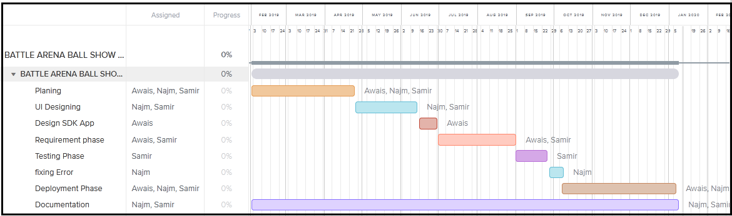

Chapter 2

Software Requirement Specifications

Chapter 2: Software Requirement Specifications

2.1.Introduction
The purpose of this documentation is to explain the software specification and requirement of game " Battle Arena: Ball Showdown "

Purpose
The purpose of the chapter is to map the needs of our game “Battle Arena: Ball Showdown”. Upon approval of this document will serve as the agreement for the development and requirements of our system. In other phase this documentation will help in modeling and implementation of the project, it will also help in the validation of our project.

Document Conventions
This document follows Calibri format and the font size is 12. Bold-faced text has been used to emphasize sections and main headings of our project and all text is justified in the documentation.

Intended Audience and Reading Suggestions
This documentation is created for the approval of the Final year project of Information Technology . The main focus is the approval panel of the Final year project and the Supervisor of project (Professer Gohar Mumtaz).This documentation will help us as a team for assessing risks, model used for development and features of the product.

Product Scope

Good script::
The game covers the fighting script like taken which is played for more than 20 years while we added some functionality of defensive and offensive at the same time and players defending their respective territory.
- Destroying object features::
Destroying feature allow us to destroy opponent territories object which is protected by opponent with the shield.

- Stadium category selection::
This allow the user to choose the Stadium how is being done and play by the user/games.
- Appearance /lifestyle and fashion::
This will allows the user to change the character daily or even from to time.
- AI features::
This Feature will Control the Movement of the Opponent Player in single player option.
- Speed::
The Winning and losing of game Depends upon the Speedy movement of the Players.To gain Advantage over their opponent players have to be fast.

- Shot Timing::
The timing of the shot helps the player to attack the other player with more power giving your opponent a hard time to reflect the ball.

- Positioning::
The positioning of character should be good in order to defend or attack. The selection of position is all where you got a good chance to both defend and attack even if you are not a hardcore player.

- Power Shot::
Player has an option to use the power shot which will speed up the ball that would be
disadvantage at the opponent side. If the power shot hits early or late it will have less
impact on opponent.

Overall Description

Product Perspective
The game does not include a story line it is a action game. The game is simple so user doesn’t have to worry about its learning, there is no limitation for playing, a person can play at any time and for many times he wants. The game play is very simple, player would not feel difficult to play battle arena ball showdown second time.

Product Functions
In this game we will divide the sections into the following categories. These sections are the most important part of the game.
- Single Player: In this mode we will have the single player option where you will play against the AI player.

- Multiplayer: In This mode we will have the 2-player mode on the single device.

- Character Selection: on screen there would be option to lock and unlock given characteristics. There will be there characteristics through which you will select one
- Stage/Ball Selection: In Stage/Ball selection player will have to select stage and ball.
- Tutorial: at this phase we will have the game tutorial that will help you to learn about the game.
- Settings: This will have settings about sounds like SFX sounds, game music.

User Classes and Characteristics
We have kept the scheme of the game easy and simple and the game play is also which is not unfamiliar. It consists of simple design in which age would not matter while playing game, the user experience is what matters for us. quality of game is up to top.There would be single and double player mode and double player mode will be on same device for example like luddo star.
- Speed::
The Winning and losing of game Depends upon the Speedy movement of the Players.To gain Advantage over their opponent players have to be fast
- Shot Timing::
The timing of the shot helps the player to attack the other player with more power giving your opponent a hard time to reflect the ball.
- Positioning::
The positioning of character should be good in order to defend or attack. The selection of position is all where you got a good chance to both defend and attack even if you are not a hardcore player.
- Power Shot::
Player has an option to use the power shot which will speed up the ball that would be disadvantage at the opponent side. If the power shot hits early or late it will have less impact on opponent.

Operating Environment
The game will be on android mobile only and it will support android 4.3 (KitKat) and above until android 8.1 (Oreo).The android 9.0 (Pie) will not support and it will be included later. The android device must support minimum 5 finger multi-touch support in order to need to play multiplayer as the game will support only single device multiplayer initially.

Design and Implementation Constraints
The major constraints in design department for the development team will be to design stadiums in such a way that people don’t get bored of the stadium after playing it 2 to 3 times but to keep people attached to the stadiums. Moreover, the unlock able items should be so much great that people play in the game in desire to unlock the items such as new characters, stages and the balls. For the consumers the main problem will be that firstly your device should be using an android operating system and secondly the device should not be.

Outdated as it must have at least android 4.3 and the device should support multi touch at least up to 5 fingers in order if you want to play game local multiplayer that will be two players on a single device only.

User Documentation
In this game we would provide a tutorial separately, which would provide how to use games characteristics and this would be very handy to learn the controls and the mechanics of the games so that the user never get confused.

Assumptions and Dependencies
The Game has two modes Single Player and doula player. Single Player mode has no problem but the problem that exists in multiplayer mode is that the user must convince another user to play and the both users must be on a single device to play the game.

Mobile phone not according to requirements and performance:

If the mobile device is not according to our requirement it will slow down the speed of Game or if mobile phone does not have the right version of the Android it will also affect the compatibility of the game.

External Interface Requirements

User Interfaces
The Interface of this game will consist of mutual sections:
The title screen will consist the game modes, Tutorial section and Settings sections.
The game modes will have sub section in which user will have to select the character to play with. After the character selection the next section will be stage and ball type after the selection of all these things the match will start.
- The Tutorial section will include the help related to the controls and gameplay mechanic.

Hardware Interfaces
The hardware interface includes the Android mobile phone on which user will play the game. For the mobile phone it must have at least 1 GB ram. The device must allow a minimum of up to 5 finger multi touch support in order for the user to play the game in multiplayer mode otherwise the game will not function properly and the user will experience lag in controlling the game characters.

Software Interfaces
The only devices that will be compatible with this game are the ones that will be using android operating system from version android 4.3(Kit Kat) to android 8.1(Oreo). This game will only be released for the android operating systems.

Communications Interfaces
As our game will be on the play store so following are our communication means.
Feedback:
As we described that our game will be on the play store so user can give us feedback/ suggestion through play store and we will also give feedback option in our game so they can give feedback to us or improvements needed to be done in game.

System Features
Following are some important features and requirements of system.

Single Player Mode:

Different mode in the Games

      - Description and Priority:

This game mode has the highest priority. This mode will allow user to play the game against computer AI opponent and after defeating the opponent you will get reward points that will enable user to unlock new stages, characters, super powers and new ball styles.
Open the game

- You will go to the character selection screen. Select your desired character from there.
- After that you will need to select the stage and also the ball design

- The match will start

Functional Requirements:

- REQ-SF1-1:Character must be selected each time

- REQ-SF1-2:The stage and the ball design selection must be done by choice or can also be selected randomly

Stimulus and Response Sequences:

- User must play the game to earn the game currency and XP level

- Characters can be unlocked on the character selection menu

- The items like new ball design and stages can also be unlocked from the item’s selection menu

System Feature 1
Different levels in the game with Time challenge

Description and Priority
There will be 3 different levels in game each with different level of difficulty and scenes. Each level will contain new set of objectives and save the home with shield.Ouraim is that protects the wall and wins. It is most important feature to engage the user in the game. The user has to save the house in the specific time so it will increase the interest if user in our product.

Stimulus/Response Sequences
- User must play the game to earn the game currency and XP level

- Characters can be unlocked on the character selection menu

- The items like new ball design and stages can also be unlocked from the item’s selection menu

Functional Requirements
REQ-SF2-1: User can play any level
REQ-SF2-2: User can pause and save game
REQ-SF2-3: Game must have the protector as game character

System Feature 3 (and so on)
User save game at any instance he wants......

Other Nonfunctional Requirements

Performance Requirements
As we are in 2020 so the minimum ram in Mobile now a days is 1 GB so performance will be not a issue for new mobiles but as game is developed by keeping in mind the middle class so some users are still using old version of mobiles. So we decided to make 2d game with 3d models in this way we can consume less hardware resources of mobiles ultimately it will increase performance of our game. Game will tolerate small human errors to increase the productivity of our game.

Safety Requirements

The game will not do any damage to personal belongings of the user. Game should not be played during driving and if someone has eyes issue he should contact doctor before playing game and or take break after some time to relax eye and mind.

Security Requirements

The game will not require any of your email address or any other details. You only have to use the name of your choice in order to save the stats for that particular user. So, the security flaws regarding your privacy and safety is not a threat at all.

Software Quality Attributes

Considering the system and the usage of mobiles now a days some of the qualities of the game are as follows:

Availability:

This game will be available for every android user.

Adaptability:

This game is made keeping in mind every age group from a child to an adult so the adaption of the game will not be difficult for anyone and it has no such graphics and scenes that will be bothering to some people.

Usability:

The mechanics of game are easy and tutorial is also given for the people so that they can learn the mechanics of the game easily and be a good player in no time

Maintainability:

The game has no server-side functions so it will have no server-side issues while if any of the bugs cause issues in the game we will try to solve the issue as quickly as possible.

Business Rules
This game has no limitations whatsoever and everyone who has access to android phones can play the game and it has no functionality that has access to some people only. It is free to play and free in game supplies.

Chapter 3

Use Case Analysis

Chapter 3: System Analysis
This chapter provides an understanding for analysis of functions and their interactions with other functions of the game, using Use Case Models. In this chapter we will know the basic flow of our application and who are the user of game.

Use Case Model
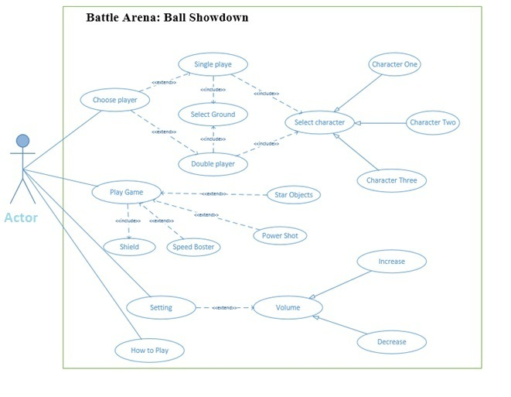

Fully Dressed Use Cases
    - Fully Dressed Use Case for Player selection
Title | Player mode selection
Primary Actors | Player
Stake Holders | Developer, Players
Pre-conditions | - The Player must possess Android Phone.  - The Player must have Apk file in device.  - The player must install the game after it is downloaded.
Post-conditions | - The game has been started by Player.
Status | Under Development
Owner | Samir Zaheer,Najm-ul-hassan,Awais Asif
Basic Flow | - The Application has been opened by the Player.  - The Game Screenappears.  - Form appears.

    - Fully Dressed Use Case for Character

Title | Character Selection
Primary Actors | Player
Stake Holders | Developer, Game Players
Pre-conditions | - The Player must select the character
Post-conditions | The screen appears to Player which includes different options which include.  - Player can click on select character  - Player can click on confirm button
Status | Under Development
Owner | Samir Zaheer,Najm-ul-hassan,Awais Asif

    - Fully Dressed Use Case for Player Options

Title | Options
Primary Actors | Player one and player two
Stake Holders | Developer, Game Players
Pre-conditions | - The Player must have select player  - The player must login in to the Game.  - The player must click the confirm button to start the game
Post-conditions | - No Post condition because there is only message to display.
Status | Under Development
Owner | Samir Zaheer,Najm-ul-hassan,Awais Asif
Basic Flow | - The Player must have to play the game

    - Fully Dressed Use Case for Player Score

Title | Player Score
Primary Actors | Player
Stake Holders | Developer, Game Players
Pre-conditions | - The player must play the game.  - The player must Enter into the Game.
Post-conditions | - No Post condition because there is only player score to display.
Status | Under Development
Owner | Samir Zaheer,Najm-ul-hassan,Awais Asif

Chapter 4

System Design

Chapter 4: System Design
This chapter defines architecture, relationship, interface of the game to satisfy the needs of user. This chapter emphasize on the game logic and modeling. Following diagrams are used to emphasize the system design

Architecture Diagram
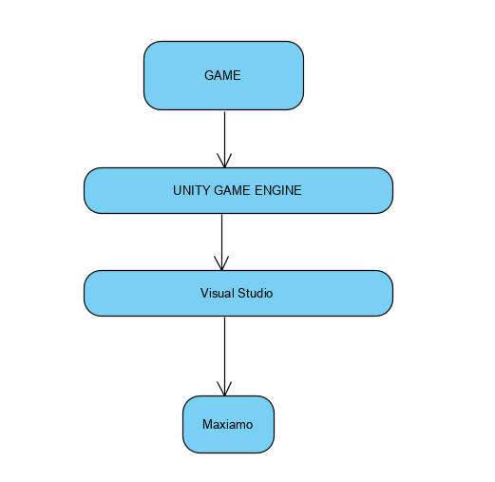

Domain Model

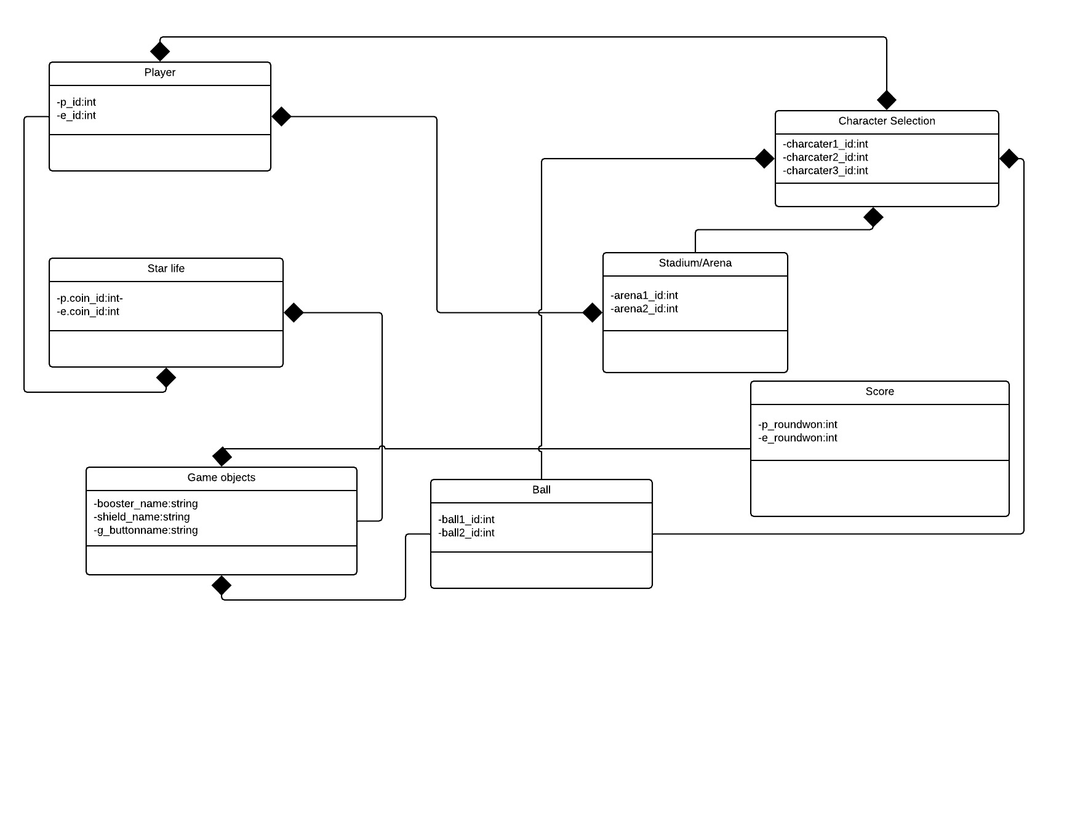

Entity Relationship Diagram with data dictionary

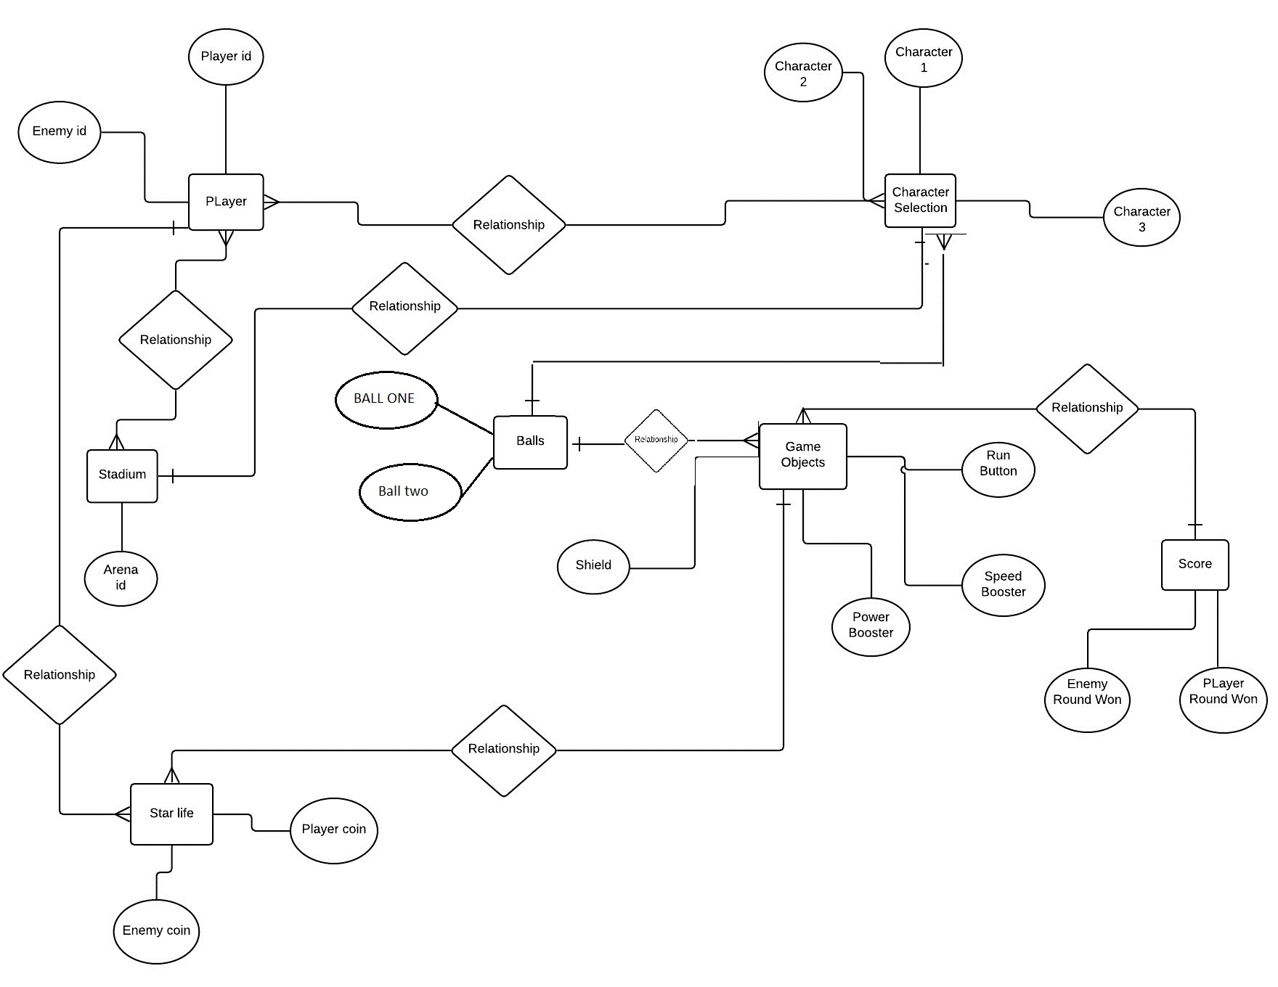

Class Diagram

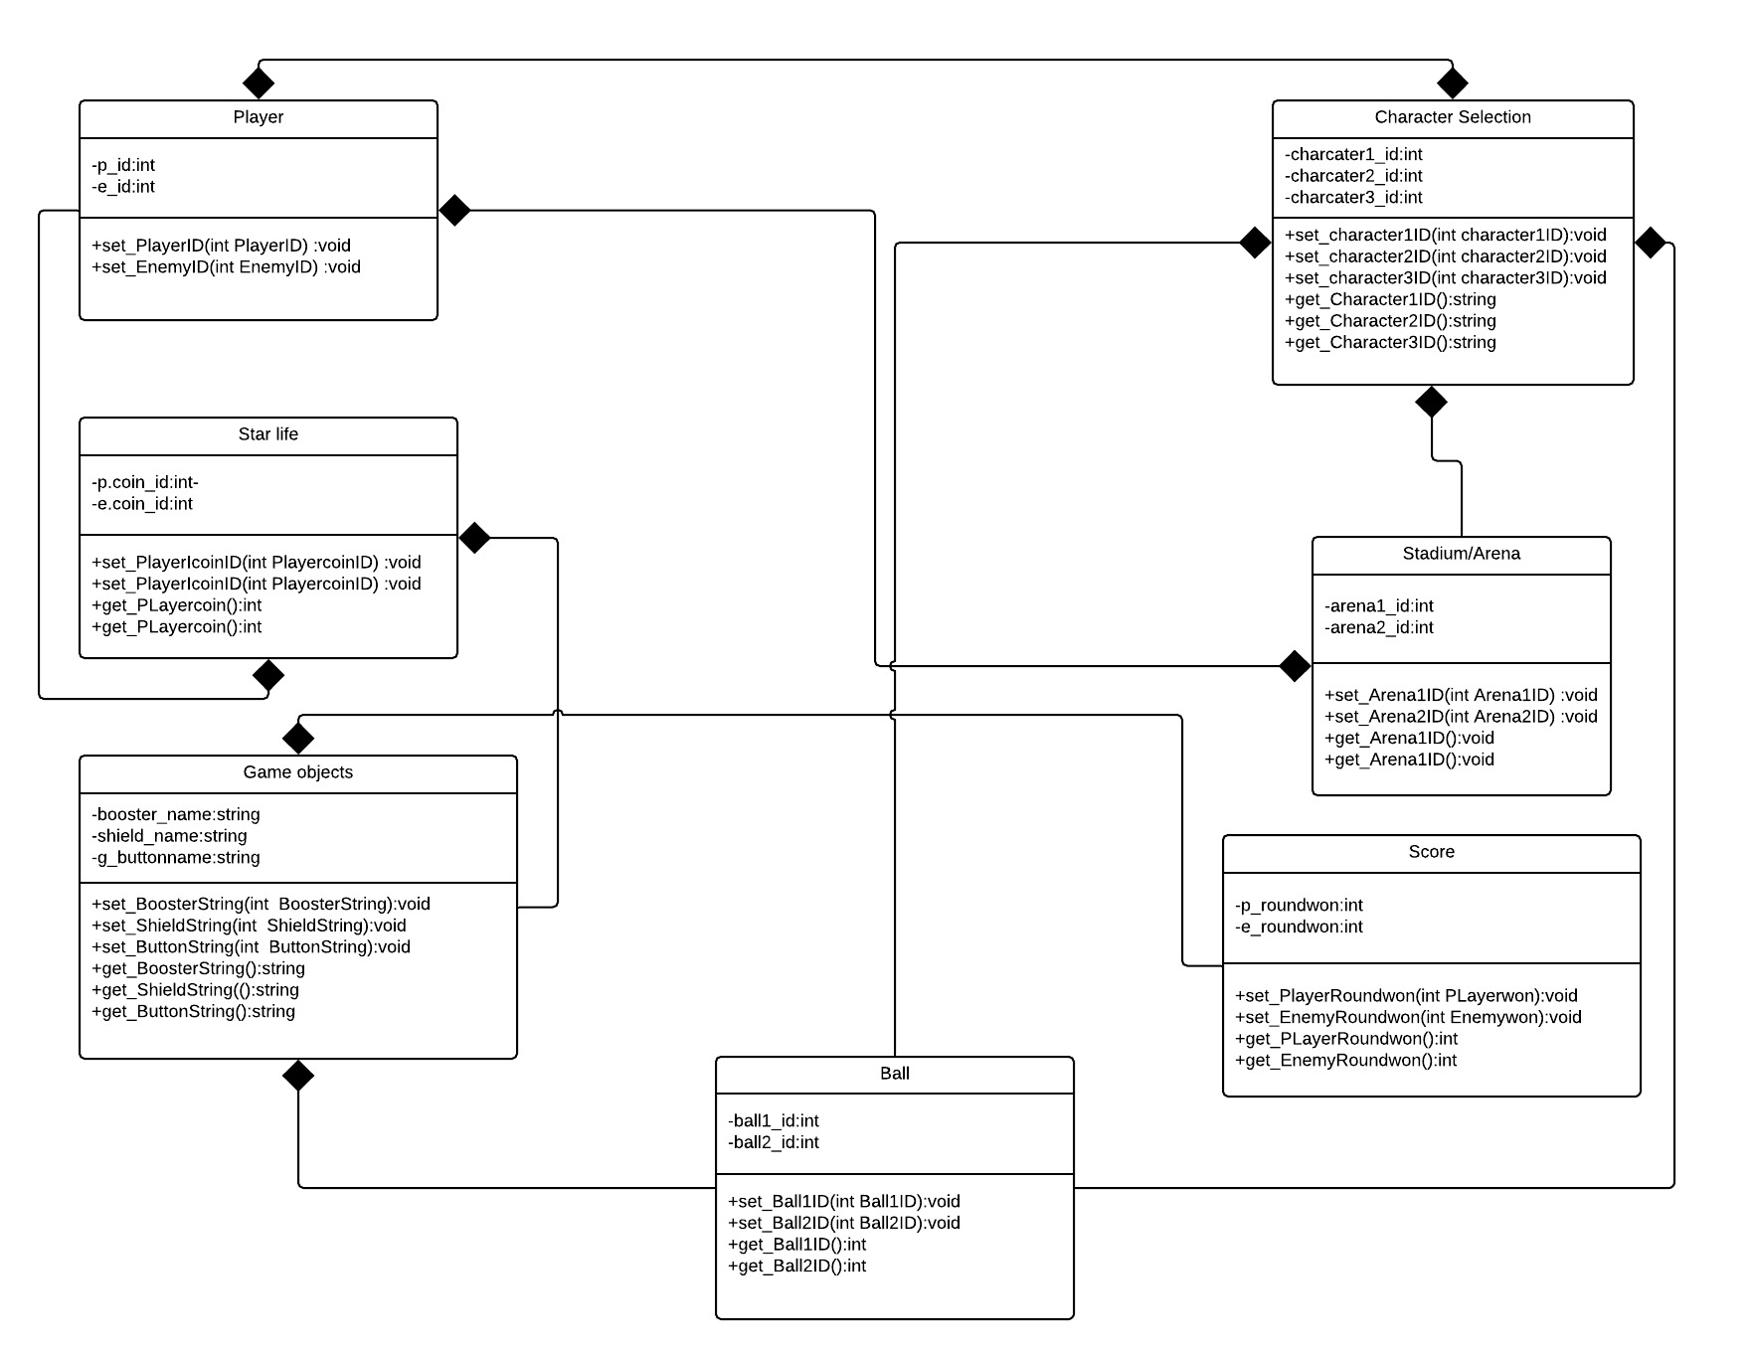

Sequence / Collaboration Diagram
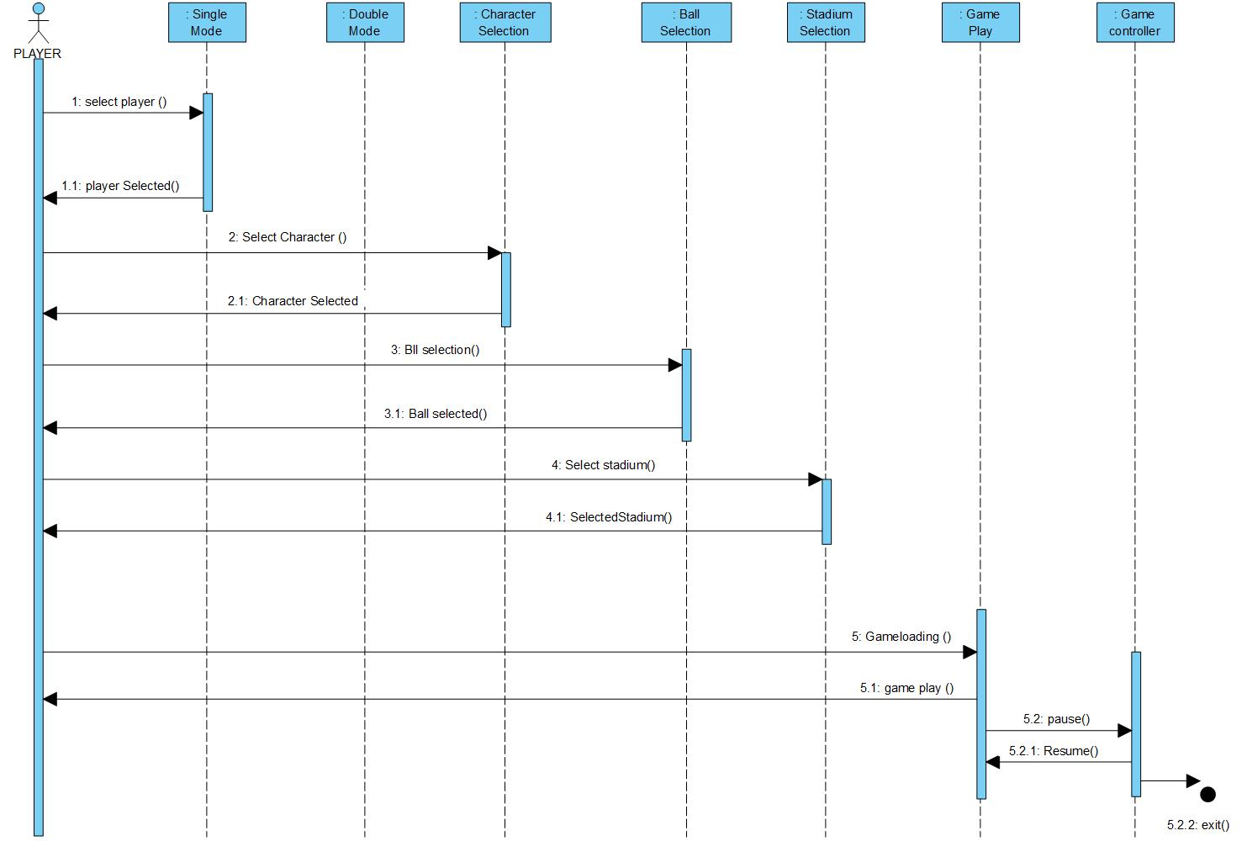

Operation contracts
The Operations Contracts are explained in a detailed manner in Chapter#3 (Fully Dressed Uses Cases). The Pre-Conditions are the same for every operation of Battle Arena: Ball Showdown, however the Post-Conditions vary to the operations. Following are the operation contracts for the major operations of the game:

Activity Diagram
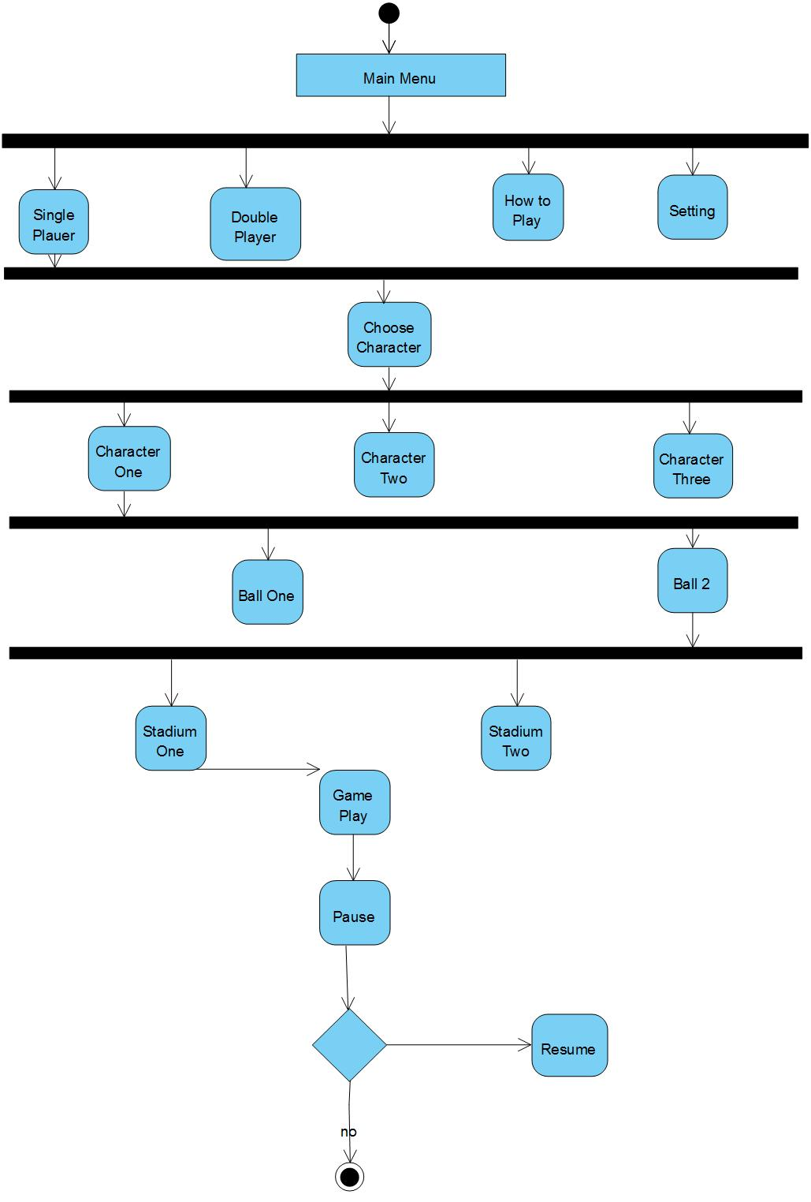

State Transition Diagram
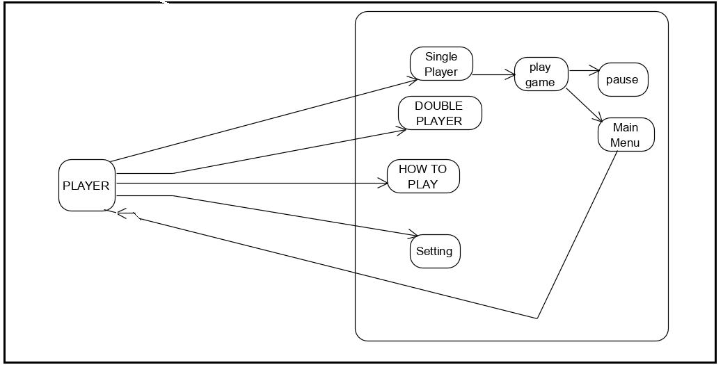

Component Diagram
- 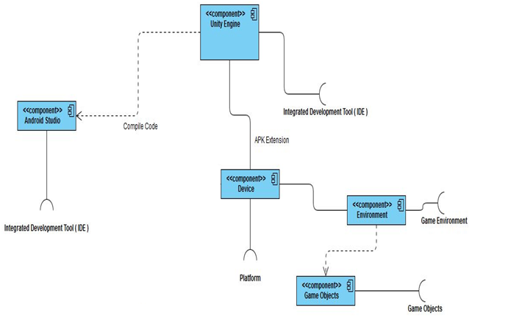

Chapter 5

Implementation

Chapter 5: Implementation
For the implementation of game logic to final product we will use unity engine with visual studio. Our project implementation consists of four phases main flow of software, tool we will use for development, environment consist of building etc and language we will use to implement the logic of the game.

Important Flow Control/Pseudo codes
Pseudo helps to understand flow of the game following is pseudo code of our game.
START

1.The game is being opened by the Player and
Main menu Game Play starts:

2.The Game Menu options appears.

2.1IF the Player clicks single player.
2.3ELSE the Player clicks Double player.
2.4ELSE the Player clicks setting.
2.4ELSE the Player clicks how to play.
That will appear the complete guides

2.4IF the Player clicks setting.
Then volume controller will be appare

2.1.single player of game is being displayed to the player.

4.The characters Selection screen appears that 1st Player s

4.1 IF Player select the characters we can lock and unlock
4.2 ELSE IF Player select the characters that is unlocked, then game Initiates.

5.The Game Initiates the game play and Player begins to play.

6.Player plays the game with Screen /Button.

7.Player completes the Level.

8.1 IF Player fails the level, ROUND LOST Message appears.
8.2 ELSE IF Player wins the then round won and we can select another ground easily.

9.Player Pauses the game.
9.1 IF player clicks the Pause button, and then clicks the Resume button then game initiates.
9.2 ELSE IF player clicks the Pause button, and then click the Menu button, then game initiates from game menu

10.Player Home the game.

10.1IF Player click “Yes”, game Exits.

END

Components, Libraries, Web Services and stubs
Following are the fundamental new level in Unity that will make us able to create Game play for this game
5.2.1 Components
Components are basic ground unit for the development of game it will helps developer to perform different task when attached to the objects.
Following are the components we will use to build game.
- Animator
- Canvas
- Sprite
- Rigid Body
- Prefab
5.2.2 Game Objects
Any object in our game is a Game Object: characters (shield ball), sound, special effects, etc.

5.2.3 Variables
We can change the properties of components by writing code or by the inspector window on the screen of unity.

5.2.4 Scenes
Everything in the game "Play to eat" is in the scene. A scene, for example, is a level in a game, though we can have multiple levels in one scene file by just moving the player/camera to different points in the scene.
There are following scenes...
-Game Menu Scene
-single player
-double player
-how to play
-setting

5.2.5 C# Scripts
C# is the language of the unity .For the implementation of logic in the game we will use C# sharp as the language and the tools for using is visual studio.

Deployment Environment
For deployment of the game we will need laptop, tools and devices where we have to deploy the game. For deployment of game on android mobile device we need game resources and permission from device.
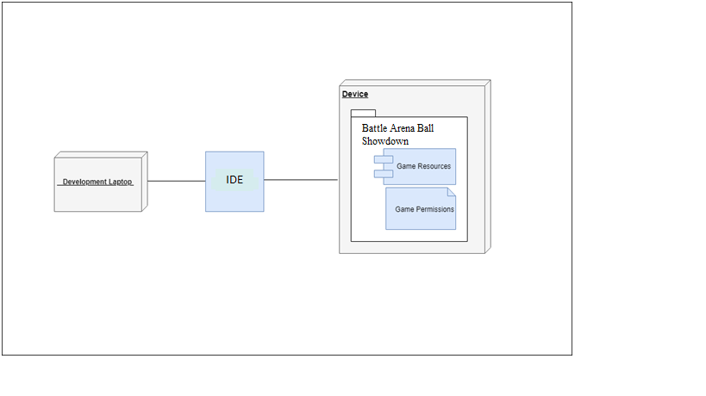

Tools and Techniques
Unity is an ultimate game development platform having capability to generate the games for Android devices, iOS devices and Windows phones.
- First, for the development of game:
-a Windows 7 laptop is required
- with Unity installed in it
- with Visual Studio installed in it
-with Adobe Photoshop installed in it (game designing)
- After the development of the game, for making the game to be able to run on Android devices (Building game for android phones and tabs):
-An android phone with latest version of Android OS installed.

Best Practices / Coding Standards
As we are using c# language for the development of game and visual studio for the coding, Following are some standard we will keep in mind while developing game.

Avoiding overloading of code
For keep development easy and understand able we will make the helper class of the file if the code exceed250 lines. If the lines of exceed in the method more the 30 than again we will consider to refactoring the code.

Comments
Good, readable code will require very few comments and that is what we will do. It will help to understand the function of code reader; sometime developer wants to make changes in the product it will become easy for the developer to make changes.

Exception Handling
We will never do a "catch exception and do nothing." If we happen to hide an exception, we will never know if the exception happened or not. So, in the case of exceptions, we will give a friendly message to the user, but log the actual error with all possible details about the error, including the time it occurred, the method and class name, etc. We will only catch the specific exception, not generic exceptions.

Version Control
As soon as our application become famous, we will launch update our app according to user requirements/need for to improve the performance of the application and also launch beta version for testing our application and getting feedback from the user for better check bugs and fix them and again launching the final versions.

Chapter 6

Testing and Evaluation

Chapter 6: Testing and Evaluation

Use Case Testing
PLAYER SELECTION
Main Success Scenario | Steps | Description
A:PLAYER | 1 | A: SELECT PLAYER
A:PLAYER | 2 | S: single player
A:PLAYER | 3 | S: Double player
A:PLAYER | 2a | Slected player  S: selected player one
A:PLAYER | 2b | Confirplayer  S: Display player after selected

Character selection
Main Success Scenario | Steps | Description
A:Actor  S:System  Extension | 1 | A: choose the character
A:Actor  S:System  Extension | 2 | A: character one
A:Actor  S:System  Extension | 3 | A: character two
A:Actor  S:System  Extension | 3 | S: character three
A:Actor  S:System  Extension | 2a | Selectionofcharacter  S: Display that character
A:Actor  S:System  Extension | 2b | Confirm  S: Display after the confirm the selection

Equivalence partitioning
After Selecting the Single Player, the Selection of Character is necessary and this is considered the Valid. The selection of the Ball and selection of the Stadium is necessary and this is considered the Valid. The selection of the stadium after selecting single Player is considered invalid.

Boundary value analysis
- Player one testing
We need to execute 2 Test Cases

Test case 1: AI opponent computer is working

Test case 2: game play is working

Note: 2nd test case is considered for negative testing

We need to execute 5 Test Cases.

Test case1: Consider the shield is working
Test case 2: Consider the speed booster is giving acceleration to player
Test case 3: Consider the power shot is giving the speed to ball
Test case 4: Consider the objects are being destroyed
Test case 5: Consider the Ai computer is working

Note: 1st and 5th Test Cases are considered for Negative Testing

- Multiplayer testing
So in this case we execute max 2 test cases:

Test case1: game play is working correctly.
Test case2: controls are working correctly.

Note: 1st Test Case is considered for Negative Testing

Data flow testing
Data flow Test case 1: AI opponent computer is working
Data flow Test case 2: game play is working

Note: 2nd test case is considered for negative testing

We need to execute 5 Data flow Test Cases.

Data flow Test case1: Consider the shield is working
Data flow Test case 2: Consider the speed booster is giving acceleration to player
Data flow Test case 3: Consider the power shot is giving the speed to ball
Data flow Test case 4: Consider the objects are being destroyed
Data flow Test case 5: Consider the Ai computer is working
Data flow Test case1: game play is working correctly.
Data flow Test case2: controls are working correctly.

Note: 1st Test Case is considered for Negative Testing

Unit testing
Unit testing of Battle Arena Ball Showdown Units
Software unit Name | Testing Method | Test Result
UI Testing | combinatorial , clean room, functionality ,compatibility, tree testing , regression | Pass
Player one gameplay | combinatorial , clean room, functionality ,compatibility, tree testing , regression | Pass
Player two gameplay | combinatorial , clean room, functionality ,compatibility, tree testing , regression | Pass
Animation | combinatorial , clean room, functionality ,compatibility, tree testing , regression | Pass
Controls | combinatorial , clean room, functionality ,compatibility, tree testing , regression | Pass

Integration testing
Integration Testing of Battle Arena Ball Showdown Units
Software unit Name | Test with Unit | Testing Method | Test Result
UI Testing | Battle Arena Ball Showdown Interface and relevant feature | Manual Testing | Pass
Player one game play | Battle Arena Ball Showdown Interface and relevant feature | Manual Testing | Pass
Player two game play | Battle Arena Ball Showdown Interface and relevant feature | Manual Testing | Pass
Animation | Battle Arena Ball Showdown Interface and relevant feature | Manual Testing | Pass
Controls | Battle Arena Ball Showdown Interface and relevant feature | Manual Testing | Pass

Performance testing
In this phase we test the different stages and these stages are consists
Single Player: In this mode we will have the single player option where you will play against the AI player.
Multiplayer: In This mode we will have the 2-player mode on the single device.

Character Selection: on screen there would be option to lock and unlock given characteristics. There will be there characteristics through which you will select one
Stage/Ball Selection: In Stage/Ball selection player will have to select stage and ball.
Tutorial: at this phase we will have the game tutorial that will help you to learn about the game.

Settings: This will have settings about sounds like SFX sounds, game music.

User Classes and Characteristics
We have kept the scheme of the game easy and simple and the game play is also which is not unfamiliar. It consists of simple design in which age would not matter while playing game, the user experience is what matters for us. quality of game is up to top.There would be single and double player mode and double player mode will be on same device for example like luddo star.
- Speed::
The Winning and losing of game Depends upon the Speedy movement of the Players.To gain Advantage over their opponent players have to be fast
- Shot Timing::
The timing of the shot helps the player to attack the other player with more power giving your opponent a hard time to reflect the ball.
- Positioning::
The positioning of character should be good in order to defend or attack. The selection of position is all where you got a good chance to both defend and attack even if you are not a hardcore player.

- Power Shot::
Player has an option to use the power shot which will speed up the ball that would be disadvantage at the opponent side. If the power shot hits early or late it will have less impact on opponent.

Stress Testing

We also verified our game our project and after that we will never face these kind of problems
- Errors
- Handling
- Deadslocks

Chapter 7

Summary, Conclusion and Future Enhancements

Chapter 7: Summary, Conclusion & Future Enhancements

Project Summary
The goal of this project is to develop android platform game which will have a 2d gameplay with 3d animation. The project combined four core components. Learning android game development, utilizing unity (game/graphics engine), creating user control methods. The game will be developed as a universal application, meaning that it was compatible with all Android devices. The goal of this project is to develop a game for the android platform.A detailed set of requirements and specifications was set out at the beginning of the project. One example of a requirement was that the game was to be developed in a 2D orthogonal style. All of the specified requirements were fulfilled upon the completion of the project. Writing a full set of specifications early on helped greatly in prioritizing features to implement and manage the time spent on each section of the project. All of these elements were combined to create an overall game, “battle arena ball showdown”. The objective of the game is to be a dog fight between two players with a ball, they have to protect their territory by using shields, and balls would be fired by one to another causing the damage to opponents. The stadiums will be provided to players with their own selection.

Achievements and Improvements
Here we have achieved 2d game play with 3d animation with a simple game play in which is provided some of the modern techniques for example speed booster and power shot, it will carry most of audience which are addicted to casual games with a modern touch and we have targeted a niche ones, hopefully it would please the user entertainment expectation. Improvement which are suggested by our user and developers would be considered first, multiplayer option will be on server in future, more stadiums will be given to play, more ball and more exceptional animations would be added, excited and modern features would be added, xp will be given in future as per user requirement, User interface would be made more appealing.

Critical Review
In order to enlarge the specifications and requirements for the improvements to be brought by the next version of the Battle Arena Ball showdown mobile game.we realized that there is no platform that is providing the Efficient and simple game that consume the less hardware resources.

Lessons Learnt
As the student of bachelor in information technology this was an uphill task for us to develop a game and we have to learn the unity engine to an extreme extent so that we can give reasonable project to our final year project milestone. We have learn animations, how to develop them and use them then further coding was difficult because we were fond of networking but with determination we have leaned this. With this project we have learned the market trend we are now very much familiars with these trends that would further help us is our professional life.

Future Enhancements/Recommendations
Improvement which are suggested by our user and developers would be considered first, multiplayer option will be on server in future, more stadiums will be given to play, more ball and more exceptional animations would be added, excited and modern features would be added, xp will be given in future as per user requirement, User interface would be made more appealing, we also want to launch this game in ios as well and many more options will be given in games which will benefit and entertain users.

Appendices

Appendix: User Manual
In this phase we will guide you complete about how to install and game play of game.
We also provide how to play button to guide you
Just as a user manual and that will teach you about game and their function

Appendix A: Player

The major sections of the game are divided into the following categories. These sections are the most important part of the game.

  - First Player
- This mode will have the single player option where you will play against the AI player
- The player can select the Stadium after the selection of the ball
- The user can continue the gameplay as player 1 he cannot edit gameplay name as he want.

    - Character Selection
This scene will consist of both locked and unlocked characters and player will select the desired character from the unlocked characters.

      - Stage/Ball Selection
- In Stage/Ball selection player will have to select stage and ball.

Appendix B: Administrator Manual
[Paragraph Text 12 pt, Calibri, 1.5 Line Spacing,Justified]
[Between 4 to 8 lines describe what is this appendix all about]

  - First Level heading [16 pt, Calibri, Bold, Left aligned]
[Paragraph Text 12 pt, Calibri, 1.5 Line Spacing, Justified]

    - Second level heading [14 pt, Calibri, Bold, Left aligned]
[Paragraph Text 12 pt, Calibri, 1.5 Line Spacing, Justified]

      - Third level heading [12 pt, Calibri, Bold, Left aligned]
[Paragraph Text 12 pt, Calibri, 1.5 Line Spacing, Justified]

Appendix C: Information / Promotional Material
[Paragraph Text 12 pt, Calibri, 1.5 Line Spacing,Justified]
[Between 4 to 8 lines describe what is this appendix all about]

  - Broacher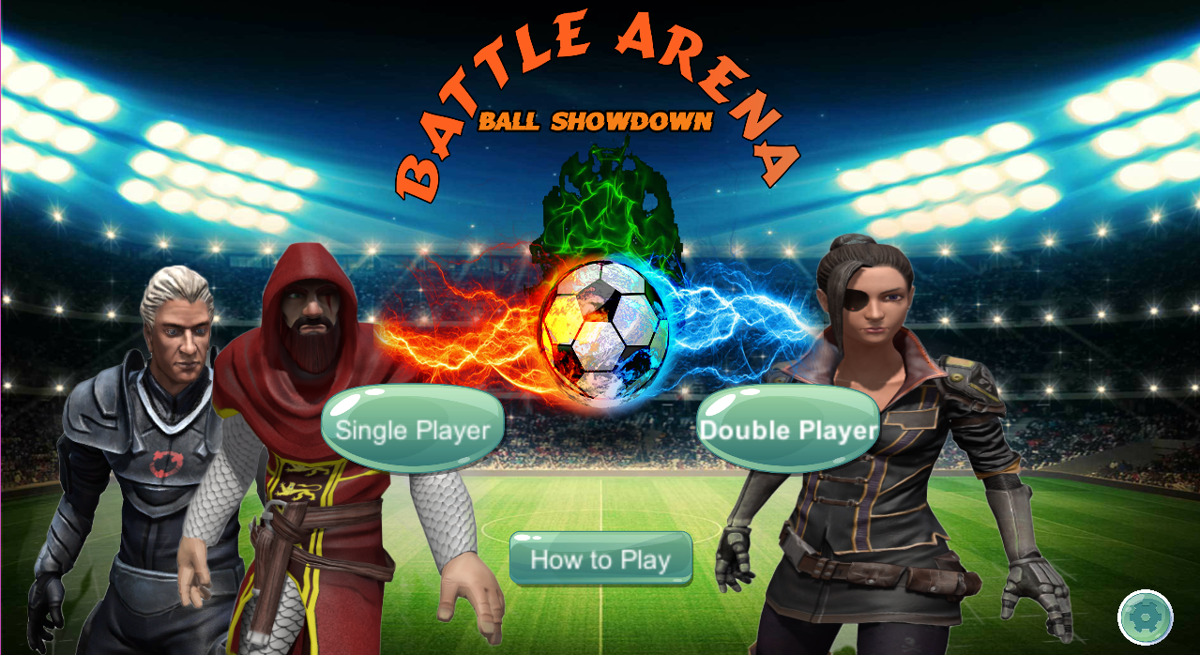

  - Flyer
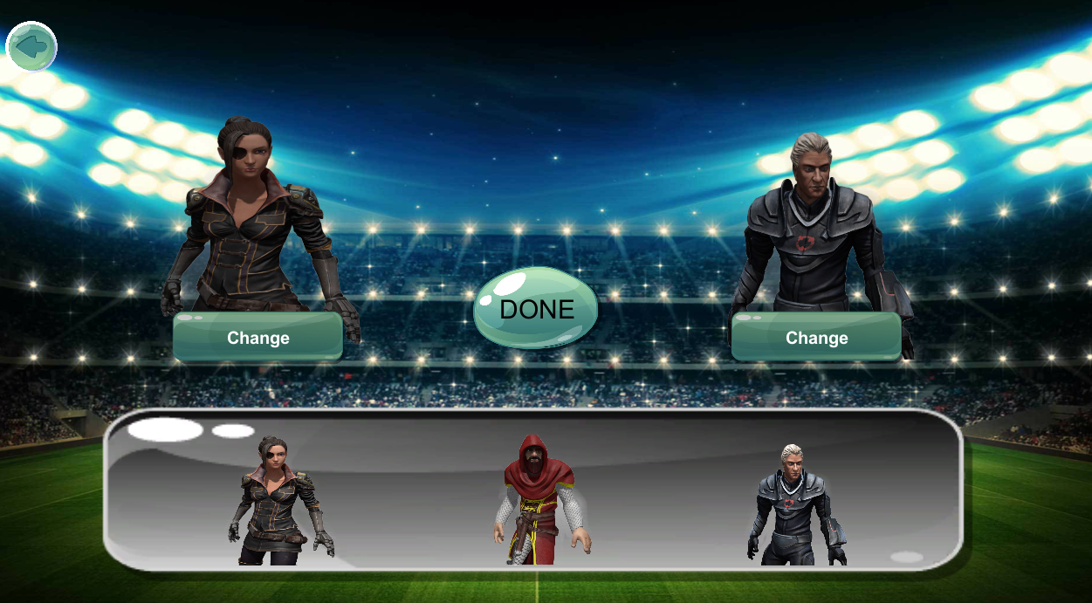

  - Standee

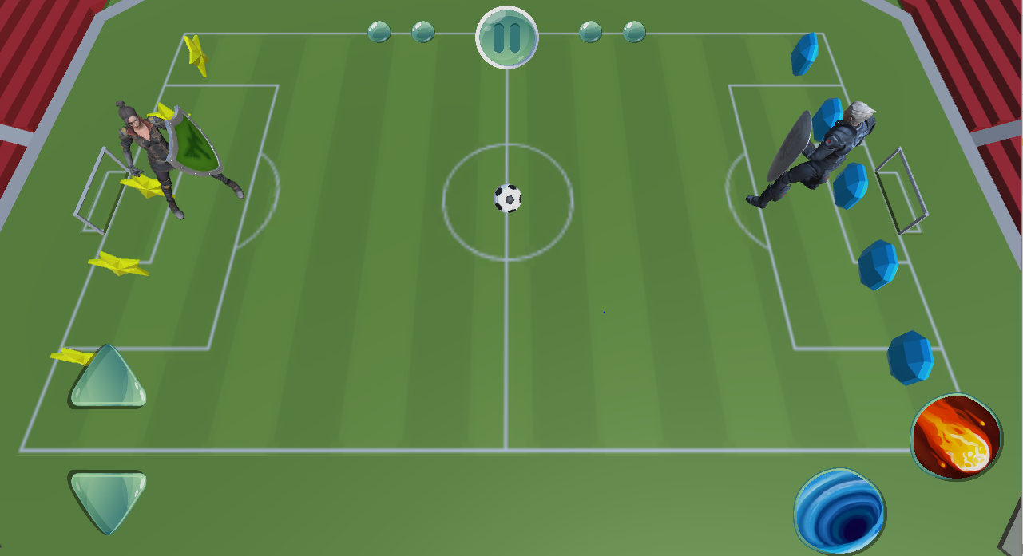

  - Banner

  - First Level heading [16 pt, Calibri, Bold, Left aligned]
[Paragraph Text 12 pt, Calibri, 1.5 Line Spacing, Justified]

    - Second level heading [14 pt, Calibri, Bold, Left aligned]
[Paragraph Text 12 pt, Calibri, 1.5 Line Spacing, Justified]

      - Third level heading [12 pt, Calibri, Bold, Left aligned]
[Paragraph Text 12 pt, Calibri, 1.5 Line Spacing, Justified

Appendix [no.]: Appendix Title
[Paragraph Text 12 pt, Calibri, 1.5 Line Spacing,Justified]
[Between 4 to 8 lines describe what is this chapter all about]

  - First Level heading [16 pt, Calibri, Bold, Left aligned]
[Paragraph Text 12 pt, Calibri, 1.5 Line Spacing, Justified]

    - Second level heading [14 pt, Calibri, Bold, Left aligned]
[Paragraph Text 12 pt, Calibri, 1.5 Line Spacing, Justified]

      - Third level heading [12 pt, Calibri, Bold, Left aligned]
[Paragraph Text 12 pt, Calibri, 1.5 Line Spacing, Justified]

Reference and Bibliography

Reference and Bibliography
[1] M. Sher, M. Rehman, “Title of the Paper” Conference name/Journal Name, Edition, Volume, Issue, ISBN/ISSN, PP, Publisher/City-Country, Year.

[2] Manjaly, T. (2018). C# Coding Standards and Best Programming Practices - CodeProject. [online] Codeproject.com. Available at: https://www.codeproject.com/Articles/8971/C-Coding-Standards-and-Best-Programming-Practices [Accessed 14 Aug. 2018].

[3] Unity. (2018). Programming in Unity: For programmers new to Unity - Unity. [online] Available at: https://unity3d.com/programming-in-unity [Accessed 14 Aug. 2018].

[4] Msdn.microsoft.com. (2018). Unity - Developing Your First Game with Unity and C#. [online] Available at: https://msdn.microsoft.com/en-us/magazine/dn759441.aspx [Accessed 14 Aug. 2018].

[5] Unity. (2018). 2D Game Creation - Unity. [online] Available at: https://unity3d.com/learn/tutorials/s/2d-game-creation [Accessed 14 Aug. 2018]

[6] Unity Forum. (2018). 2d game with 3d models. [online] Available at: https://forum.unity.com/threads/2d-game-with-3d-models.388119/ [Accessed 14 Aug. 2018].
[7] Wijman, T. (2018). Global Games Market Revenues 2018 | Per Region & Segment | Newzoo. [online] Newzoo. Available at: https://newzoo.com/insights/articles/global-games-market-reaches-137-9-billion-in-2018-mobile-games-take-half/ [Accessed 14 Aug. 2018].
[8] Tenzer, J. (n.d.). Exploration games for UML software design.

Index

Index

[A]
Assumptions and Dependencies
Architecture Diagram
Activity Diagram

[B]
Background
Business Rules
Best Practices

[C]
Communication Interfaces
Class Diagram
Component Diagram
Components
Comments

[D]
Document conventions
Design and Implementation Constraints
Description and Priorities
Deployment Diagram
Data Flow Diagram
Deployment Environment

[E]
Executive Summary
External Interface Requirement

[F]
Functional Requirement

[G]
Goals and Objectives
Gap Analysis
Gantt Chart
Good Programming Practices

[H]
Hardware Interfaces

[I]
Introduction
Intended Audience and Reading Suggestion
Implementation

[J]

[K]

[L]

[M]
Motivations and Challenges
[N]
Naming Conventions and Standards

[O]
Overall Description
Operating Environment
Other Non-Functional Requirements
Operation Contracts

[P]
Proposed solution
Project Plan
Purpose
Product Scope
Product Perspective
Product Functions
Performance Requirements
Pseudo Code
Programming Practices

[Q]
Quality Attributes

[R]
Roles and Responsibilities Matrix
Reference
Reference and Bibliography

[S]
Software Requirements and Specifications
Software Interfaces
System Features
Safety Requirements
Security Requirements
Software Quality Attributes
System Design
Sequence Diagram
State Transition Diagram

[T]

[U]
User Classes
User Documentation
User Interfaces
Use Case Analysis
Use Case Models

[V]

[W]
Work Breakdown Structure

[X]

[Y]

[Z]

