Online Autos

Final Year Project

Session 2018-2022

A project submitted in partial fulfillment of the degree of

BS in Computer Science


Department of Computer Science
Faculty of Computer Science & Information Technology
Superior University, Lahore

FALL 2021

Type (Nature of project) |  |  | [ ] Development [] Research [] R&D
Area of specialization |  |  | Software System
FYP ID |  |  | FYP-BCSM-F21-068
Project Group Members
Sr.# | Reg. # | Student Name |  | Email ID | *Signature
(i) | BCSM-F18-408 | MUHAMMAD SARFARAZ |  | Bcsm-f18-408@superior.edu.pk
(ii) | BCSM-F18-385 | Muhammad Mudassar |  | Bcsm-f18-385@superior.edu.pk
(iii) | BCSM-F18-358 | Zohaib Zahid |  | Bcsm-f18-358@superior.edu.pk

*The candidates confirm that the work submitted is their own and appropriate credit has been given where reference has been made to the work of others

Plagiarism Free Certificate

This is to certify that, WE Muhammad Sarfaraz Son of Muhammad Ramzan , group leader of FYP under registration no BCSM-F18-408 at Computer Science Department, Superior University, Lahore. WE declare that my FYP report is checked by my supervisor.

Date: June-2022 Name of Group Leader: Muhammad Sarfaraz Signature: _____________
Name of Supervisor: MR. Humayun Khan
Designation: Assistant Professor
Signature: ________________

Project Report
Online Autos
(Guest Accommodation)

Change Record
Author(s) | Version | Date | Notes | Supervisor’s Signature
 | 1.0 |  | <Original Draft>
 |  |  | <Changes Based on Feedback from Supervisor>
 |  |  | <Changes Based on Feedback From Faculty>
 |  |  | <Added Project Plan>
 |  |  | <Changes Based on Feedback from Supervisor>

APPROVAL
Project Supervisor
Comments: ___________________________________________________________________
_____________________________________________________________________________
Name:______________________________
Date:_______________________________ | Signature:__________________________

Project Manager
Comments: ___________________________________________________________________
_____________________________________________________________________________
Date:_______________________________ | Signature:__________________________

Head of the Department
Comments: ___________________________________________________________________
_____________________________________________________________________________
Date:_______________________________ | Signature:__________________________

Dedication

WE dedicate this project to God Almighty my creator, my strong pillar, my source of inspiration, wisdom, knowledge, and understanding. This project is dedicated to our parents who have never failed to give us financial and moral support, forgiving all our needs during the time we developed our system. This project is dedicated to our Adviser MR. Humayun Khan, without him continued support and counsel we could not have completed this process. Lastly, this project is dedicated to Superior University where we have taken support and environment to complete this project.

Acknowledgments

WE are really thankful to our supervisor MR. Humayun Khan from Superior University Lahore for his guidance, inspiration, constructive suggestion and encouragement that helped us throughout the evolution of this project. He has taken innumerable efforts to go through the project and make necessary corrections as and when needed. Finally, WE would like to thank the beginning teachers, mentor-teachers, and administrators in our university who assisted me with this project. Their excitement and willingness to provide feedback made the completion of this project an enjoyable experience.

Executive Summary

Online Autos is a free classified web application for vehicles where anyone can list a vehicles for sale and Buyers can see vehicle pictures and can directly get in touch with the sellers. The additional functionality of price prediction helps the users to get estimated price of vehicles .for Price prediction of used vehicles a database is utilized to get the estimated price of vehicle.
There are two different interfaces for the users of the application one for the seller of the vehicles and other for the buyer of vehicles. Where seller can input the required factors of vehicles and system will use AWE model to predict the price of the vehicles and generate the predicted price. If the seller is satisfied with predicted price, he/she can post an ad for selling the vehicles at the application. On the other hand buyer can see all the posts of the vehicles for sale or can input different factors of vehicles to get the list of his interested price range and can contact with the seller of vehicles he is interested. Thus the application will be helpful for both users seller and the buyer of vehicles as they can acknowledge easily the possible price of the vehicles.
Online purchasing and selling has become more wide spread in all sorts of industrial usage. It not only includes the vehicle or goods to be sold, it also has services which can be provided. Due to their low cost this expansion made the system to grow. Online purchasing and selling has become a standard method for procurement process. buyers can be maintained in a single database according to the preference, and they can be monitored. User’s data can be maintained in a confidential way for validity and integrity of contractual documentation. Neat reporting reduces paperwork, postage, photocopying and time beneficial. Multiple users can be communicated with a great ease.

Table of contents

Chapter 1 Introduction 11
Literature Review/Existing Solutions 12
MOTIVATION 13
Gap Analysis 13
Problem Statement 13
Proposed Solution 14
Work Breakdown Structure 14
Roles & Responsibility Matrix 15
Gantt Chart 16
Project Objectives 16
Chapter 2 Software Requirement Specifications 17
FUNCTIONAL & NON FUNCTIONAL REQUIREMENTS 18
USER REQUIREMENTS 19
SYSTEM REQUIREMENTS 20
SOARE REQUIREMENTSFTW 21
Functional Requirements 22
Chapter 3 Use Case Analysis 23
Use Case Model 24
Use Case Descriptions 25
Chapter 4 System Design 27
Architecture Diagram 28
Entity Relationship Diagram 29
Class Diagram 30
Sequence Diagram 31
Sequence Diagram 32
Activity Diagram 33
Activity Diagram 34
State Transition Diagram 35
Component Diagram 36
Deployment Diagram 36
Chapter 5 Implementation 37
Important Flow Control/Pseudo codes 38
Components, Libraries, Web Services and stubs 38
Deployment Environment 39
Tools and Techniques 39
Best Practices / Coding Standards 39
Version Control 39
Chapter 6 SOFTWARE TESTING 40
Unit Testing 41
Integration Testing 46
Chapter 7 CONCLUSION AND FUTURE ENHANCEMENTS 50
CONCLUSION 51
FUTURE ENHANCEMENTS 52
LIMITATIONS 52
Results and Outputs 53
Reference and Bibliography 4

List of Figures
Figure 1-1work break down structure 15
Figure 3-1 use case model 27
Figure 4-1 System designation 31
Figure 4-2 architecture 31
Figure 4-3 Entity Relationship Diagram 32
Figure 4-4 Class Diagram 33
Figure 4-5 Sequence Diagram 34
Figure 4-6 Activity Diagram 2 35
Figure 4-7 Activity Diagram 36
Figure 4-8 Activity Diagram 37
Figure 4-9 State Transition Diagram 38
Figure 4-10 Component Diagram 39
Figure 4-11 Deployment Diagram 39
Figure 7-1 Home 56
Figure 7-2 Ads 56
Figure 7-3 Team 1
Figure 7-4 Footer 1
Figure 7-5 2
Figure 7-6 seller dashboard 2
Figure 7-7 ad posting 3
Figure 7-8 contact us 3

List of Tables

1.1 label of first table of first chapter 7
2.1 label of first table of second chapter 14
2.2 label of second table of second chapter 14
2.3 label of third table of second chapter 15
2.4 label of fourth table of second chapter 16
2.5 label of fifth table of second chapter 17
2.6 label of sixth table of second chapter 17
2.7 label of seventh table of second chapter 18
3.1 label of first table of third chapter 23
3.2 label of second table of third chapter 23
3.3 label of third table of third chapter 24
3.4 label of fourth table of third chapter 24
3.5 label of fifth table of third chapter 25
3.6 label of sixth table of third chapter 25
6.1 label of First table of sixth chapter 44
6.2 label of second table of sixth chapter 45
6.3 label of third table of sixth chapter 47
6.4 label of fourth table of sixth chapter 49

Introduction

Determining whether the listed price of a used car is a challenging task, due to the many factors that drive a used vehicle’s price on the market. The focus of this project is developing machine learning models that can accurately predict the price of a used car based on its features, in order to make informed purchases. We implement and evaluate various learning methods on a dataset consisting of the sale prices of different makes and models . We will compare the performance of various machine learning algorithms like Linear Regression, Ridge Regression, Lasso Regression, Elastic Net, Decision Tree Repressor and choose the best out of it. Depending on various parameters we will determine the price of the car. Regression Algorithms are used because they provide us with continuous value as an output and not a categorized value because of which it will be possible to predict the actual price a car rather than the price range of a car. User Interface has also been developed which acquires input from any user and displays the Price of a car according to user’s inputs.

Literature Review/Existing Solutions
The competitors of the service that we are going to introduce in the market are very rare but somehow they are providing the same service in the market. some of these competitors are providing online this service and others are physically situated and providing the service of buying and selling the old vehicles.
For the purpose of online selling and buying of old goods OLX is at the top of the stack. As [1] The OLX marketplace is a platform for buying and selling services and goods such as electronics, fashion items, furniture, household goods, cars and vehicles. As it is the world's leading classifieds platform in growth markets. OLX makes it so easy to connect people to buy, sell or exchange used goods and services. but the problem with OLX is that only connects the seller and buyers and the prices varies according to the seller’s desire and demand so it is very difficult to the buyer to know the actual price of the thing he is going to buy
There are many used vehicle show rooms and traders in the market. People just visit there and sell their vehicles according to the market price or buy the used vehicle as seller and buyer have no idea of actual price of used vehicle thus they mostly did not satisfied with this kind trading.

MOTIVATION

The security based flaws in the current system motivated us to take up this project. We see a scope of improvement in the current system as they are susceptible to a lot of fraudulent activities. The users need to be verified before being able to sell or buy products and that is what we have tried to achieve by the means of this project.

Gap Analysis
The manufacturer fixes the price of a new vehicle in the industry with some additional costs incurred by the Government in the form of taxes. So customers buying a new vehicle can be assured of the money they invest to be worthy. But, due to the increased prices of new vehicle and the financial incapability of the customers to buy them, Used vehicle sales are on a global increase. Therefore, there is an urgent need for a Used vehicle Online Autos which effectively determines the worthiness of the vehicle using a variety of features. Existing System like Olx includes a process where a seller decides a price randomly and buyer has no idea about the vehicle and it’s value in the present day scenario. In fact, seller also has no idea about the Online Autos existing value or the price he should be selling the vehicle at. Determining whether the listed price of a used vehicle .

Problem Statement
The manufacturer fixes the price of a new vehicles in the industry with some additional costs
incurred by the Government in the form of taxes. So customers buying a new vehicles can be
assured of the money they invest to be worthy. But, due to the increased prices of new
vehicles and the financial incapability of the customers to buy them, Used vehicles sales
are on a global increase. Therefore, worthiness of the vehicles using a variety of features. Existing System like Olx includes a process where a seller decides a price randomly and buyer has no idea about the vehicles and it’s value in the present day scenario. In fact, seller also has no idea about the vehicles’s existing value or the price he should be selling the bike at. Determining whether the listed price of a used vehicles is a challenging task, due to the many factors that drive a used vehicle’s price on the market. in our country There is no trading platform for used bikes that provides the approximate for the sellers and buyers.

Proposed Solution
To overcome this problem we are going to develop a model which will be highly effective. Regression Algorithms are used because they provide us with continuous value as an output and not a categorized value. Because of which it will be possible to predict the actual price a vehicle rather than the price range of a vehicle. User Interface has also been developed which acquires input from any user and displays the Price of a vehicle according to user’s inputs and thus the system will helpful both seller’s and buyer’s where seller can post an ad of vehicle according to predicted price by the system. and the buyer also can take an estimate of used vehicle prices and can easily approach or contact by the seller

Work Breakdown Structure
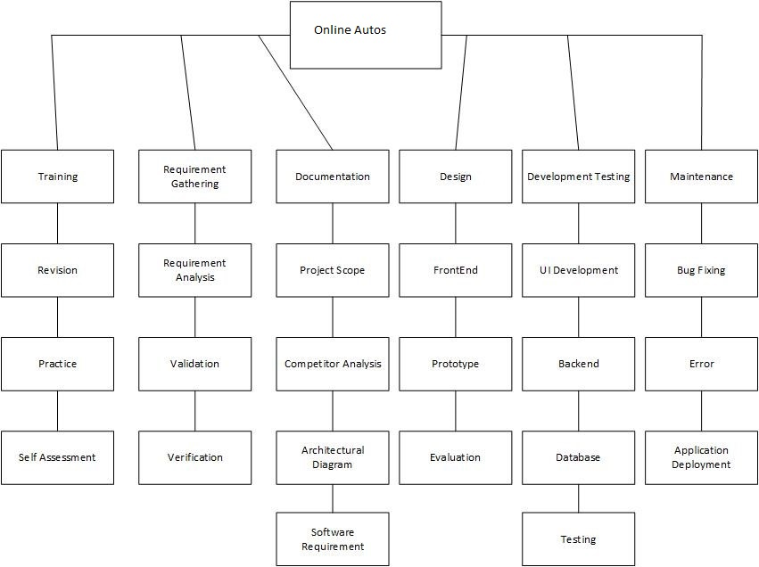

Figure 1-1work break down structure

Roles & Responsibility Matrix

Table 1-1 Roles and responsibility matrix
WBS # | WBS Deliverable | Activity # | Activity to Complete the Deliverable | Duration (# of Days) | Responsible Team Member(s) & Role(s)
1 | Training Session | PA-1.0 | Training session | 5 | Sarfaraz , Mudassar
2 | Requirement Gathering | PA-2.0 | Project requirement gathering | 10 | Zohaib Mudassar
3 | Documentation | PA-3.0 | Project documentation | 45 | Sarfaraz, Mudassar, Zohaib
4 | Designing | PA-4.0 | Project interface design | 30 | Sarfaraz , Zohaib
5 | Database | PA-5.0 | Project database design | 30 | Zohaib , Mudassar
6 | Coding | PA-6.0 | System  coding | 30 | Sarfaraz, Mudassar, Zohaib
7 | Bug Fixing | PA-7.0 | System bugs remove | 30 | Sarfaraz, Mudassar, Zohaib
8 | Final Testing | PA-8.0 | Complete Testing | 10 | Mudassar, Zohaib
9 | Maintenance | PA-9.0 | System maintenance | 12 | Sarfaraz, Zohaib

Gantt Chart
- Task Name | 20aug 021 | 30nov021 | 20Jan 022 | 30mar022 | 30may022
Planning
Research
Design
Implementation
Follow up
Table 1-2 Gantt chart

Project Objectives
The Objective is to develop a user-friendly site where any kind of Vahical can be posted and provide value-added services to the buyer and the sellers. The products will be authenticated and the site provides a safe environment for online users:
The main objectives of the project is to provide an online platform to the users of vehicles. where they can sell buy and predict the prices of their vehicles the price prediction functionality will help the users to get an estimated price of their vehicles. that will guide the users to sell or buy online with their satisfaction.
The main objectives are
- Secure registration of all users including a personal profile Administrators would authorize the vehicle to buying, set buying dates and Minimum buying amount for that product.
- At the time of signing up, the ID Number is checked and Mobile number is verified.
- Complete Search/Site Map of the entire site for easy access.
- Provide an online free platform for vehicles selling and buying.

Software Requirement Specifications
Let’s take a look at the requirements at user as well as the portal’s end.

FUNCTIONAL & NON FUNCTIONAL REQUIREMENTS

The functional capabilities which make up an e-purchasing system suitable for public procurement specified as the following:
Many-to-many functionality (Many buyers to many sellers), decentralized buyers and sellers, search for suppliers by name, category, locality code, and contract, create purchase requisitions , generate purchase orders while including optional approver workflow, receive goods into the system, allow for the customization of "buy policies", buyer data management, supplier data management.

Following are the non-functional requirements:

Performance
The system must be interactive and the delays involved must be less. So in every action- response of the system, there are no immediate delays. In case of opening windows forms, of popping error messages and saving the settings or sessions there is delay much below 2 seconds, in case of opening databases, sorting questions and evaluation there are no delays and the operation is performed in less than 2 seconds for opening, sorting, computing, posting > 95% of the files. Also when connecting to the server the delay is based editing on the distance of the 2 systems and the configuration between them so there is high probability that there will be or not a successful connection in less than 20 seconds for sake of good communication.

Safety

Information transmission should be securely transmitted to server without any changes in information

Reliability
As the system provide the right tools for discussion, problem solving it must be made sure that the system is reliable in its operations and for securing the sensitive details.

Availability

If the internet service gets disrupted while sending information to the server, the information can be send again for verification.

Security

The main security concern is for users account hence proper login mechanism should be used to avoid hacking. The tablet id registration is way to spam check for increasing the security. Hence, security is provided from unwanted use of recognition software.

Usability

As the system is easy to handle and navigates in the most expected way with no delays. In that case the system program reacts accordingly and transverses quickly between its states.

USER REQUIREMENTS
The system primarily has 3 types of users:

Seller module
A seller’s primary concern on such a portal would be security against fraudulent buyers and random Ads. The seller needs to know who got the vehicle and needs to act accordingly. The seller must be able to check his vehicle for Adding and should be able to add one easily. He should also be able to see the reviews about the vehicle and communicate with the customers or Adders regarding any issue that arises.

Buyer module
The Adder should first see which vehicle is been posted on the app which is to be auctioned along with all the needed information about it. If the Adder is interested to buy that product, then he can register for the auctioning and Ad the amount. At last, at the end of the auctioning the Adder should get to know the result. The buyer or the Adder should be able to give a feedback to the seller or

Admin module
The admin must be the one who controls the entire Online Autos by deciding the expiry time of each Ad. He must be able to add, remove or manage a category. Admin must be able to add or delete comments and take feedback from people regarding the processes going on in the portal.

SYSTEM REQUIREMENTS

Dedicated application server with minimum specification, are as:

Intel Core 2 Quad
Memory 2*2GB DDR3
Hard Disk 1 x 360 GB HDD SATA
Ethernet Card 10/100/1000 Mbps e. Microsoft Windows 2003 Small Business Server.

INTERFACE SPECIFICATIONS

The requirement specifications that are acquired from the first phase are studied in this phase and system design is carried out. System design phase describe the hardware to be used which in this project involves the use of laptops and a server and as an alternative the project makes use of a local host server XAMPP

User Interfaces

The user interface for the software shall be compatible to any browser such as Internet Explorer, Mozilla or Netscape Navigator by which user can access to the system.

Hardware Interfaces

Since the application must run over the internet, all the hardware shall require to connect internet will be hardware interface for the system. As for e.g. Modem, WAN – LAN, Ethernet Cross

Communications Interfaces


figure 2.1 communication interface 1

The e-store system shall use the HTTP protocol for communication over the internet and for the intranet communication will be through TCP/IP protocol suite.

SOARE REQUIREMENTSFTW

Software requirements are classified into broader areas into front end and back end.

Front end

The front end of the portal has been designed using HTML and CSS which allowed us to create a Real time portal for auctioning. HTML tags and CSS formatting.

Some of the commonly used tags in HTML are:

The <frame> element was used to break a single browser window into multiple independent browsing contexts.

Back end

In the backend we’ve used MySql as the database and PHP as a server. The queries were written in MySql and then imported to PHP and hence linked to the front end of the application.

Functional Requirements

Admin
- Login
- Add seller/user
- View profile/update/remove
- Add Online Autos s
- View history(seller/Buyer/User)

Seller
- Login
- Add vehicles
- Sell vehicles
- Delete vehicles
- View vehicles
- Update vehicles

Buyer
- can predict price
- can view vehicles
- can contact to seller
- View Details

Buyer can search the vehicles with different keywords from the list that is publically available on the site

Use Case Analysis

Use Case Model
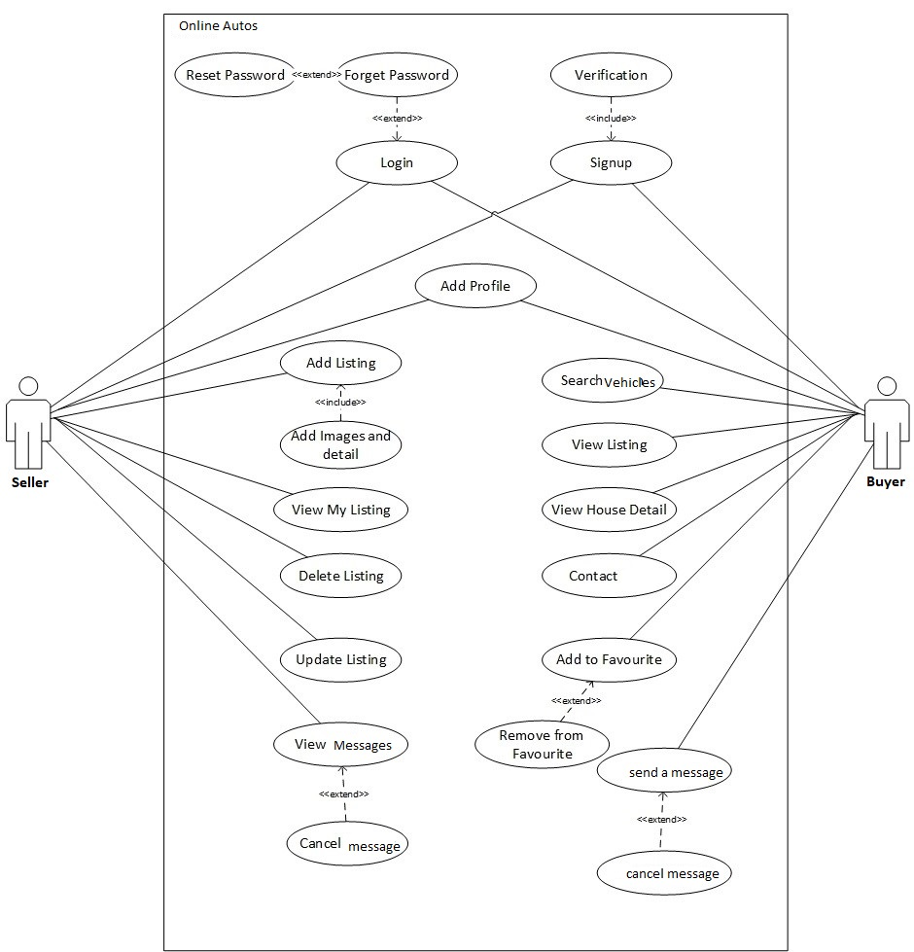
Figure 3-1 use case model

Use Case Descriptions
The use case description is a text that describes the functionality of use case diagram.
UC ID | UC001
UC Name | Login
UC Description | Admin will be able to login
UC Pre-Condition | Admin must be authorized and registered
UC Post-Condition | Admin moves to dashboard.
Normal Flow | Admin logs in successfully.
Alternative Flow | Invalid email or password.
Error Control | Enter your email and password.
Primary Actor | Admin
Secondary Actor | n/a
Comments | n/a
Table 3-1 use case description login
UC ID | UC002
UC Name | Manage all
UC Description | Admin can manage and perform different operation.
UC Pre-Condition | Admin must be logged in and must be in dashboard.
UC Post-Condition | Perform operations and manage activities
Normal Flow | Manage and update information
Alternative Flow | Check normal flow
Error Control | Improve AWe model
Primary Actor | System
Secondary Actor | n/a
Comments | n/a
Table 3-2 Use Case Description of Manage All

UC ID | UC003
UC Name | Predict Price
UC Description | Sellers and Buyers can predict prices
UC Pre-Condition | they must be in dashboard.
UC Post-Condition | They will be able to Predict old bike prices by entering required features
Normal Flow | they will be able to view the predicted prices
Alternative Flow | Prediction error
Error Control | Provide correct information
Primary Actor | Buyer and seller
Secondary Actor | System
Comments | n/a
Table 3-3 Use Case Description of Predict Price

UC ID | UC007
UC Name | Logout
UC Description | Admin will be able to log out.
UC Pre-Condition | Admin should be logged in.
UC Post-Condition | Admin is redirected to log in page.
Normal Flow | Admin is logged out of the system.
Alternative Flow | Admin is unable to log out.
Error Control | Refresh the system.
Primary Actor | Admin
Secondary Actor | n/a
Comments | n/a
Table 3-4 Use Case Description of Logout

System Design
System design is the process of defining the components, modules, interfaces, and data for a system to satisfy specified requirements. System development is the process of creating or altering systems, along with the processes, practices, models, and methodologies used to develop them

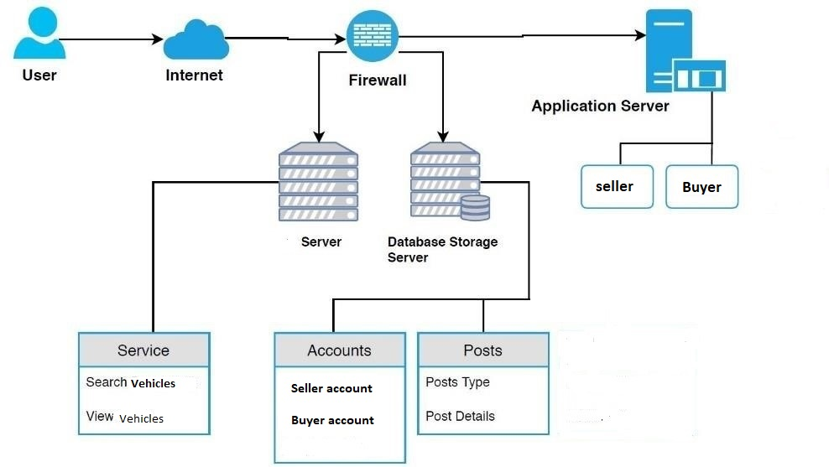
Figure 4-1 System designation

Architecture Diagram

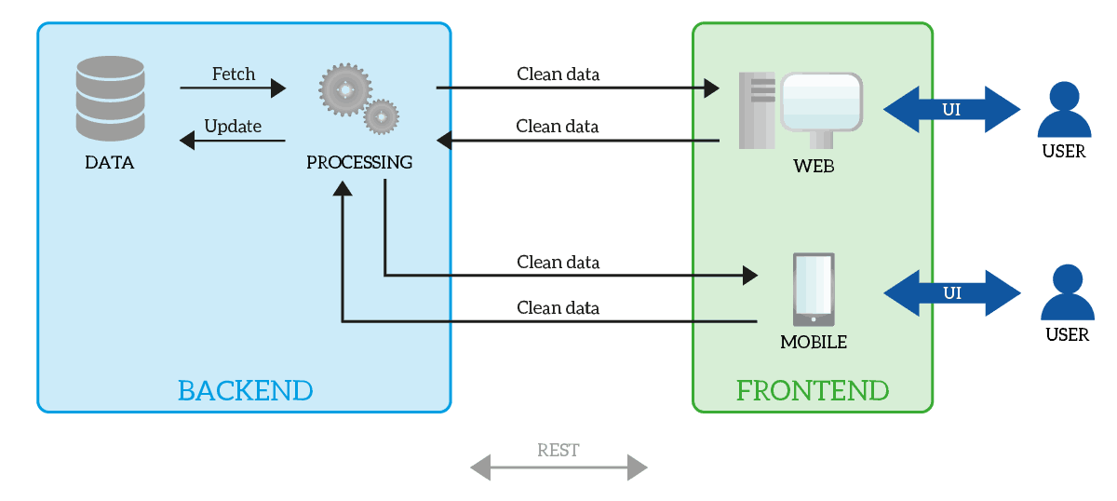
Figure 4-2 architecture

Entity Relationship Diagram
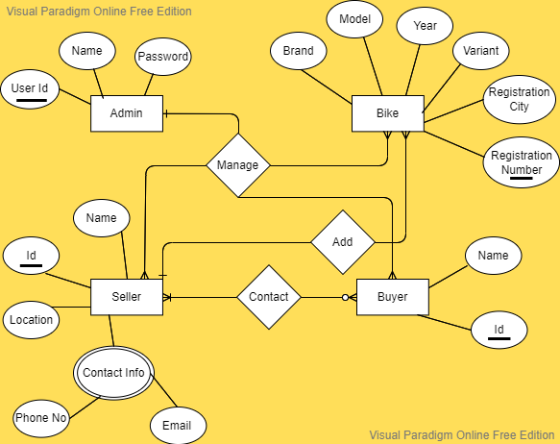
Figure 4-3 Entity Relationship Diagram
Vehicles

Class Diagram
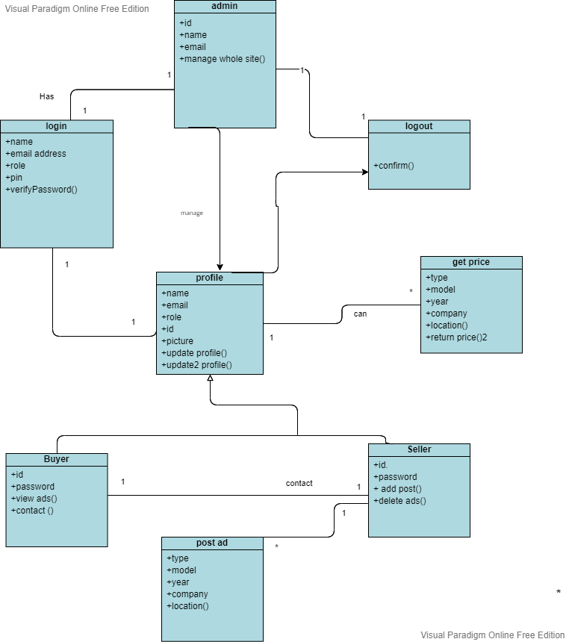
Figure 4-4 Class Diagram

Sequence Diagram
Seller side

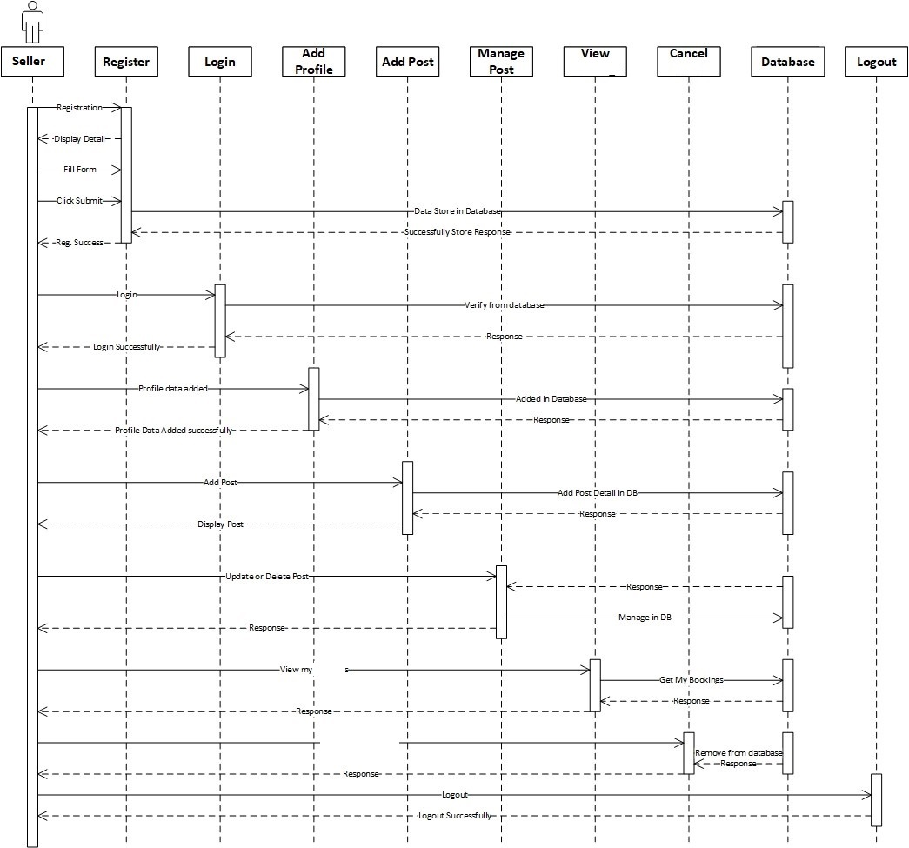
Figure 4-5 Sequence Diagram

Sequence Diagram
Buyer side
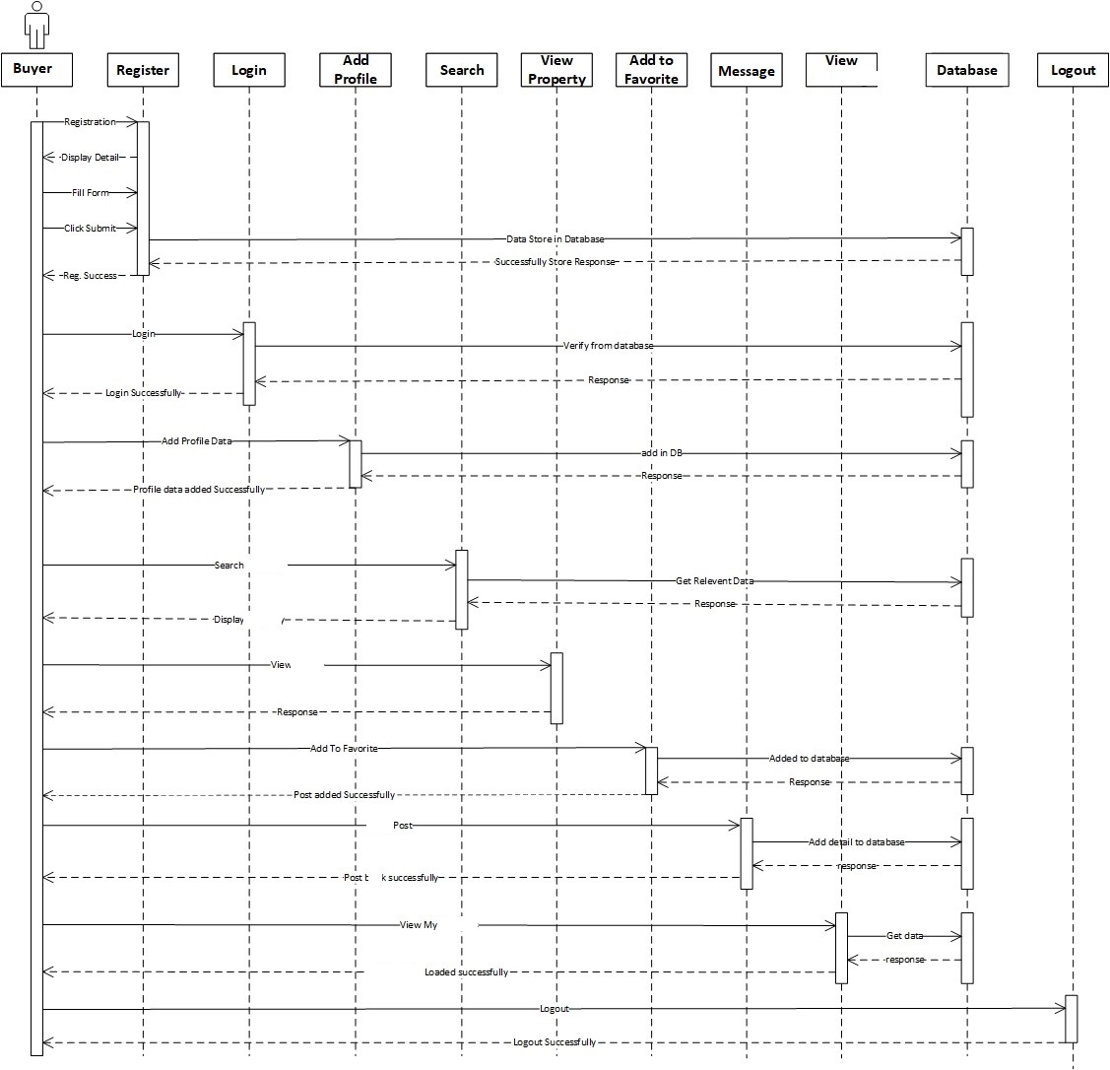
Figure 4-6 Activity Diagram 2

Activity Diagram
Seller side
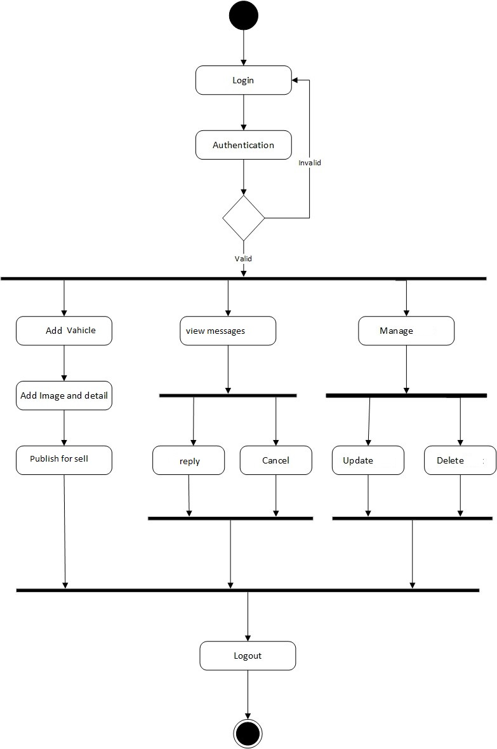
Figure 4-7 Activity Diagram

Activity Diagram
buyer side
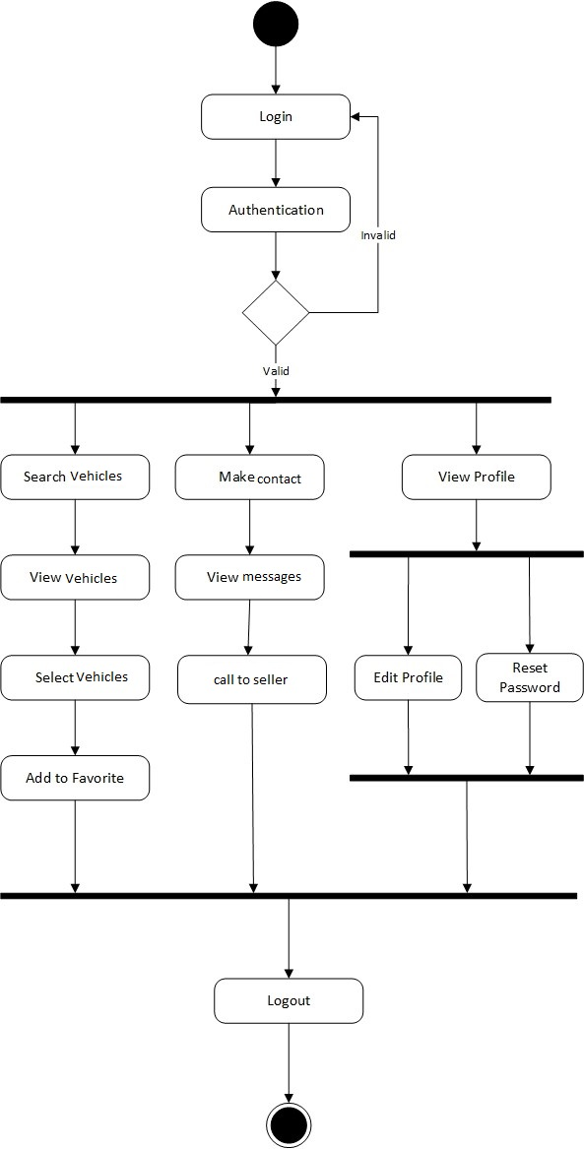
Figure 4-8 Activity Diagram

State Transition Diagram

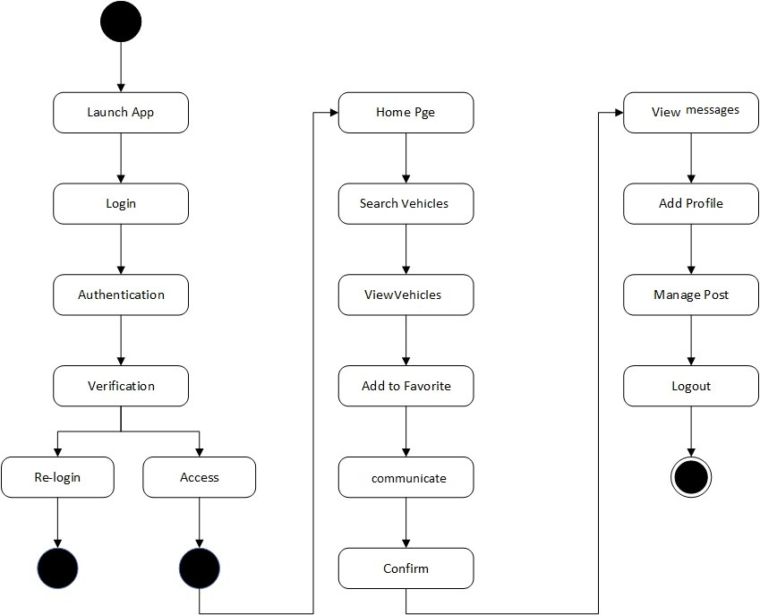

Figure 4-9 State Transition Diagram

- Component Diagram

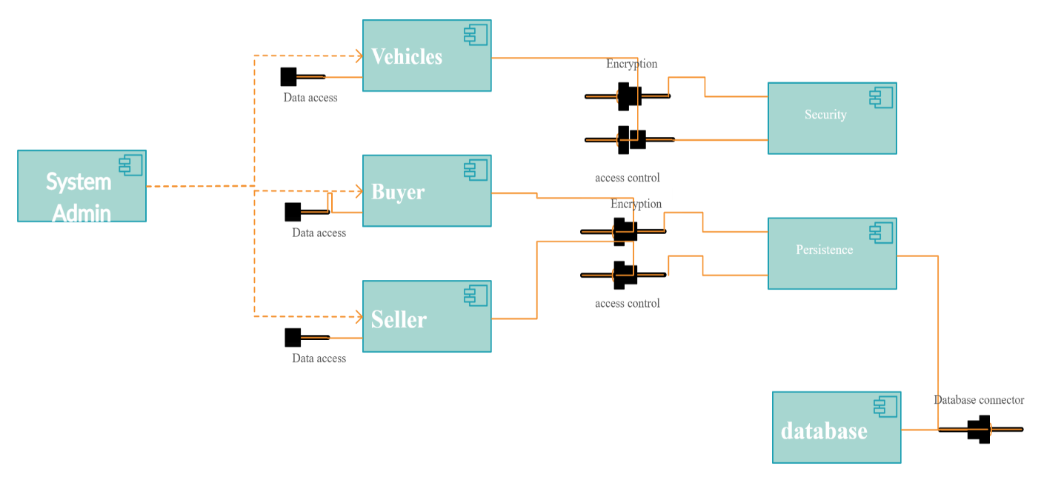
Figure 4-10 Component Diagram

Deployment Diagram

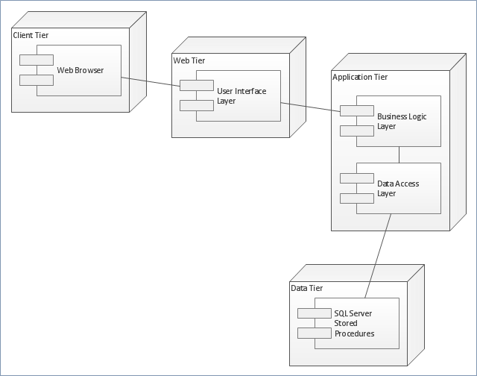
Figure 4-11 Deployment Diagram

Implementation

Important Flow Control/Pseudo codes
Admin Login
- Get login id
- Get login password
- If(loginid==entered user name &&password==enterd password)then
- Login successfully
- Else
- Login failed
- Endid
Seller
- get vehicle features
- get contact information
- if(entered features && information==true)
- store information in database
- else
- return to main
- get again related information’s
Buyer
- get vehicle features
- if(entered features matches with AWe model requirements)then
- predict price
- else
- get again
- get keywords to search

Components, Libraries, Web Services and stubs
- MySQL
- Rest Services
- Window communication protocol

Deployment Environment
It involves installation, configuration, testing and making changes to optimize the performance of the software.
• Installation
• Configuration
• Testing
• Changes software

Tools and Techniques
Software Designing Tools
Rational Rose, Lucid chart, Draw.io
Web Application
HTML/CSS, JavaScript, MySQL, Bootstrap, Php
Mobile Application
Android Studio ,Firebase DB

Best Practices / Coding Standards
- Communication with stakeholders.
- No repetition of coding
- Work Breakdown structure will be followed
- Feedback will be accepted and applied.
- Each requirement will be documented.

Version Control
Git and github

SOFTWARE TESTING
Software Testing is the process used to help identify the correctness, completeness, security, and quality of developed computer software.

Unit Testing

The primary procedure of testing is named unit testing. The Unit test affirms on most diminutive piece of programming arrangements the method. The unit testing is continually glass box orchestrated. In this, unmistakable strategies are attempted inverse to the particulars conveyed in the midst of layout for the techniques. Unit test is essentially for affirmation with the code made in the midst of the coding stage, and in this way the goal is to test the inward basis of the modules. It is customarily done by the vehicle architect of the module. In light of its adjacent association with contemplations of coding, and the coding stage is as frequently as conceivable called "Unit Testing with Coding." This test should be possible at the same time amid the vehicle era.

Test Case:- | SOAP-1
Name of Test:- | Product search
Description:- | To search vehicle in different categories
Sample Input:- | Search on the categories list
Expected output:- | Displayed the products of the searched categories
Actual output:- | Displayed the products of the searched categories
Final Result:- | Successful
Table 6-1 SOAP-1 -
Test Case:- | SOAP-2
Name of Test:- | Delete a product
Description:- | Deleting a vehicle from a specific category
Sample Input:- | Deleting a product
Expected output:- | Product is deleted from the specified category
Actual output:- | Product is deleted from the specified category
Final Result:- | Successful
Table 6-2 SOAP-2

Test Case:- | SOAP-3
Name of Test:- | CNIC card validation
Description:- | Validating the CNIC card of the user
Sample Input:- | Unique 12-digit Aadhaar number
Expected output:- | Aadhaar card is validated
Actual output:- | Valid Aadhaar
Final Result:- | Successful
Table 6-3 SOAP-3

Test Case:- | SOAP-4
Name of Test:- | Mobile number
Description:- | New user sign up form
Sample Input:- | Mobile number more than 10-digits
Expected output:- | Invalid mobile number
Actual output:- | Invalid mobile number
Final Result:- | Successful
Table 6-4 SOAP-4

Test Case:- | SOAP-5
Name of Test:- | Username
Description:- | Username in sign up form
Sample Input:- | Username with special characters
Expected output:- | Special characters not allowed
Actual output:- | Special characters not allowed
Final Result:- | Successful
Table 6-5 SOAP-5

Test Case:- | SOAP-6
Name of Test:- | CNIC card validation
Description:- | Validating the CNIC card
Sample Input:- | Less than 12-digits number
Expected output:- | CNIC number is invalid
Actual output:- | Invalid Aadhar
Final Result:- | Successful
Table 6-6 SOAP-6
Table 6.4 SOAP 7

Test Case:- | Test Case-7
Name of Test:- | Mobile number
Description:- | New user sign up form
Sample Input:- | Mobile number less than 10-digits
Expected output:- | Invalid mobile number
Actual output:- | Invalid mobile number
Final Result:- | Successful
Table 6-7 SOAP-7

Test Case:- | SOAP-8
Name of Test:- | Username
Description:- | Username in sign up form
Sample Input:- | Username
Expected output:- | Username already exists
Actual output:- | Username already exits
Final Result:- | Successful
Table 6-8 SOAP-8
Table 6.8: SOAP 8

Test Case:- | SOAP-9
Name of Test:- | Delete a product
Description:- | Deleting a vehicle from a specific category
Sample Input:- | Deleting a product
Expected output:- | Product is deleted from the specified category
Actual output:- | Product is deleted from the specified category
Final Result:- | Successful
Table 6-9 SOAP-9

Table 6.9: SOAP 9

Integration Testing

The another level of framework testing is named joining testing. Joining of a testing is an exact methodology for building up the venture structure, while driving tests to reveal botches associated with interfacing. In this, various attempted modules are joined into subsystems, which are then attempted. The target here is to check whether every one of the modules can be facilitated honestly.

    - Top-Down Integration: Top down fuse is a persistent approach to manage advancement of venture courses of action. Segments are fused by indicating downwards hurl the senator hierarchy of leadership beginning with the rule control fragment.
    - Bottom-Up Integration: Bottom up blend as its name deduces, begins Construction and testing with customized modules.
    - Regression Testing: In this test of a blend test strategy, backslide testing is that the

Test Case:- | SOAP 10
Name of Test:- | User Login form test
Description:- | Login of users
Sample Input:- | Username and password
Expected output:- | Account opens on successful user name and password entry
Actual output:- | The user will be entering into their page
Final Result:- | Successful
Table 6-10 SOAP-10

Test Case:- | SOAP-11
Name of Test:- | Admin Login form test
Description:- | Login of users
Sample Input:- | Username and password
Expected output:- | Account opens on successful user name and password entry

Actual output:- | The user will be entering into their page
Final Result:- | Successful
Table 6.11: SOAP 11

Test Case:- | Test Case-12
Name of Test:- | Add vehicle to the portal
Description:- | To add a vehicle in different categories.
Sample Input:- | Add a new product
Expected output:- | New vehicle is added in the respected category.
Actual output:- | New vehicle is added in the respected category.
Final Result:- | Successful
Table 6-11 SOAP-12

Test Case:- | SOAP-14
Name of Test:- | User name and login
Description:- | Login of users
Sample Input:- | Invalid password
Expected output:- | Password is not valid
Actual output:- | Incorrect password
Final Result:- | Successful

Table 6.14: SOAP 14

Test Case:- | SOAP-15
Name of Test:- | Sign up form
Description:- | New user sign up
Sample Input:- | 10-digit number
Expected output:- | Valid mobile number
Actual output:- | Valid mobile number
Final Result:- | Successful
Table 6.15: SOAP 15

Test Case:- | SOAP-13
Name of Test:- | User Login Form Test
Description:- | Login of users
Sample Input:- | Invalid user
Expected output:- | User doesn’t exist
Actual output:- | User does not exist
Final Result:- | Successful

Table 6.13: SOAP 1

Sample Input:- | Post a new item without uploading the image
Expected output:- | Product should be uploaded
Actual output:- | Cannot add vehicle since image not uploaded
Final Result:- | Unsuccessful
Remarks:- | The above SOAP is unsuccessful because the new vehicle will not be added until the image is not uploaded.

CONCLUSION AND FUTURE ENHANCEMENTS
The overall working of the system is concluded in this chapter with its limitations and future enhancements.

CONCLUSION

is a new experience and has greatly impacted the lives of consumers in its short time of existence. It is expected to grow constantly in years to come with advancements in technology. Online Autos has made consumers more effective and efficient in their behavior and has driven businesses to a new level, forcing many to make the necessary adjustments and changes to reach the new market of knowledgeable consumers. The results of this survey underscore the need for businesses to take the online market seriously. e-transformation in the global retail infrastructure. Internet has emerged as a cost effective means of doing business. Thanks to rising internet and higher incomes and more savvy population. Secured online payments, better to Electronic Stores, return policies and exciting discounts could help the Perceptions of Auction System Benefits. Online Autos organizations can use the relevant variables and factors, identified from the study, to formulate their strategies and plans in the country. The organizations can prioritize the consumer implicit and explicit requirements in Online Autos environment. The results can also be used by various organizations to identify their target 32 customer segments. The results of the study can be utilized by practitioners in 45% relooking or revamping their strategies for Secure online auction portal. Online websites should pay more attention to the female segments as results prove that females shop more in Online Autos as compared to men. So companies should devise the policies and strategies to attract more number of people in this segment in future also. With the advances in technology, more business opportunities will be discovered by companies. Electronic commerce will become an important part of the business in companies. Better understandings of consumer Online Autos behavior will help companies in getting more online consumers and increasing their e- business revenues. At the same time, as realized the benefits from e-auction, consumers are more willing to make purchases online. With the popularity of Internet, the number of Internet users will continue to grow and more Internet users will become online consumers, even regular online buyers. However, the evolvement of e-auction will bring new problems.

The changes in business operation, business environment, and economic condition etc. will affect consumer Online Autos behavior. Therefore, continuous efforts have to be devoted to studying consumer Online Autos 230 behavior in a dynamic way. With the knowledge of consumer Online Autos behavior, it is believed that e-auction will continue to grow and it will become not only an important business revenues channel, but also a part of people’s daily life.

FUTURE ENHANCEMENTS

It is not possible to develop a system that makes all the requirements of the user. User requirements keep changing as the system is being used. Some of the future enhancements that can be done to this system are:
As the technology emerges, it is possible to upgrade the system and can be adaptable to desired environment. Because it is based on object-oriented design, any further changes can be easily adaptable. Based on the future security issues, security can be improved using emerging technologies. Sub admin module can be added. An in-built web browser can be added. The future plan of this project is to improve design, implementation and documentation in such a way that anyone can use this project for better perform. We will develop the site more dynamically and the database work as well. In future we will add the following module for better improvement of the project: More security in the system, More user friendly system.

LIMITATIONS

The limitation of this system is that we can only authenticate dummy CNIC numbers for now which have been fed to the system. But the same can be applied on a bigger scale using the original CNIC portal on request from the government. The access to the verification is given to selected organizations.

Results and Outputs
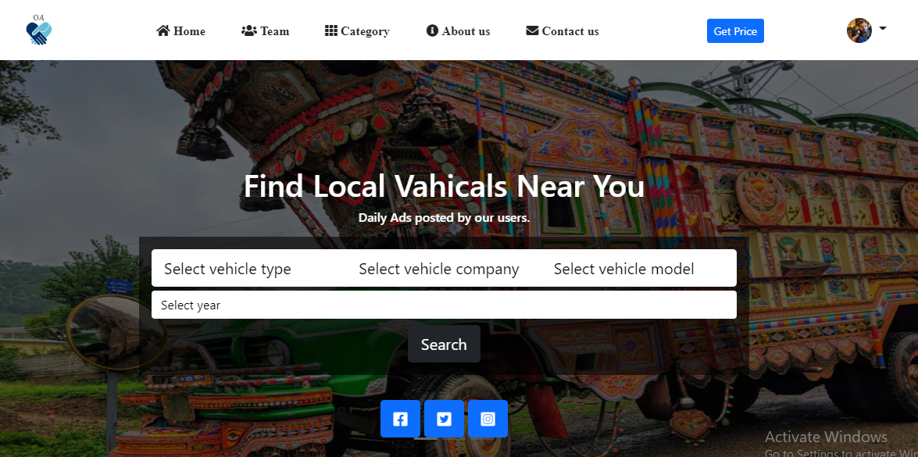

Figure 7-1 Home

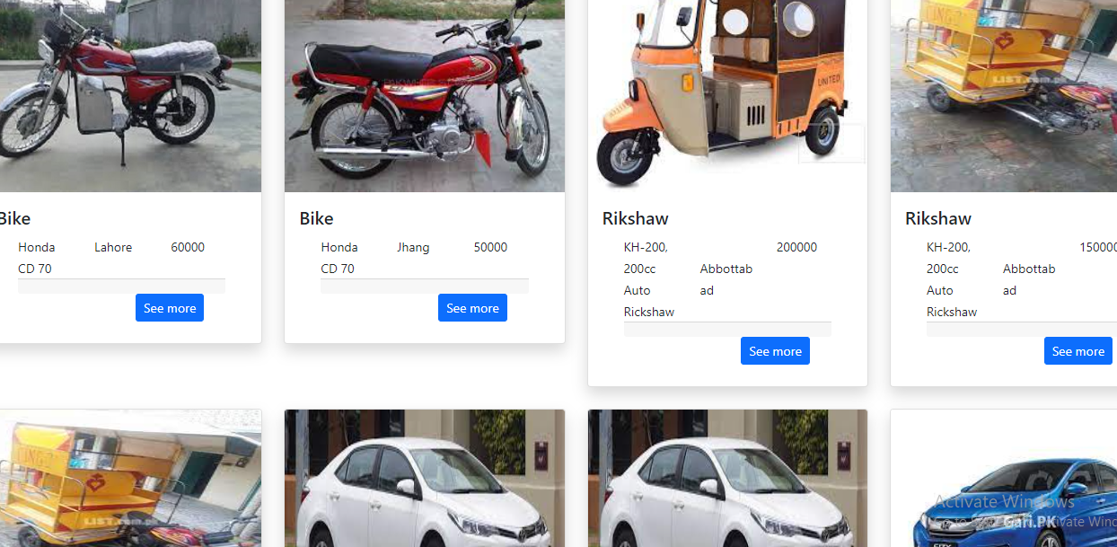

Figure 7-2 Ads

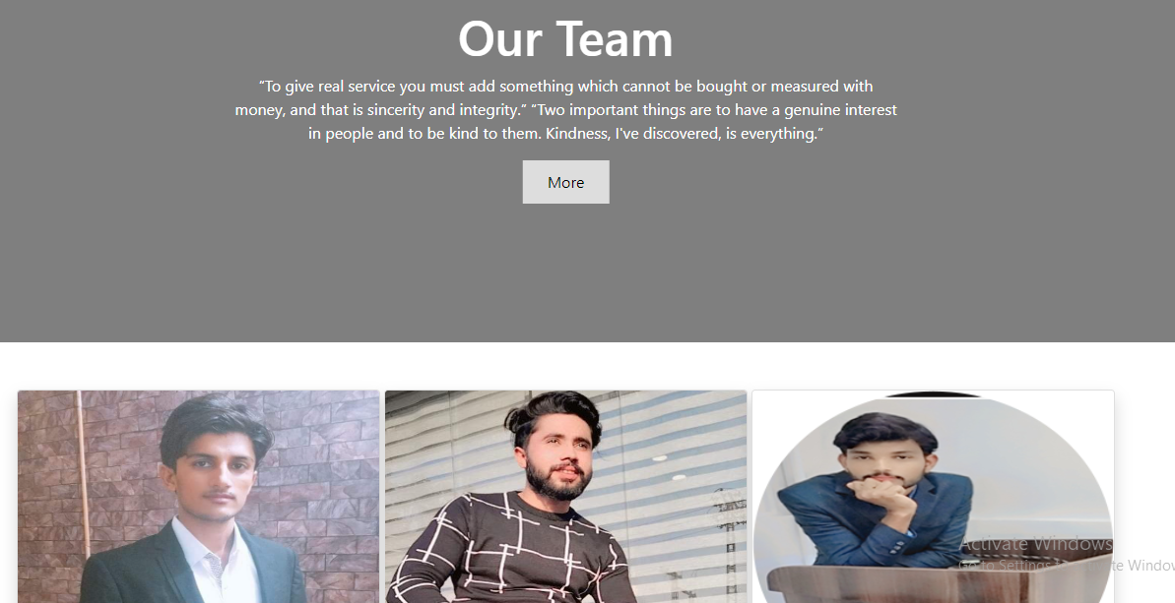
Figure 7-3 Team


Figure 7-4 Footer

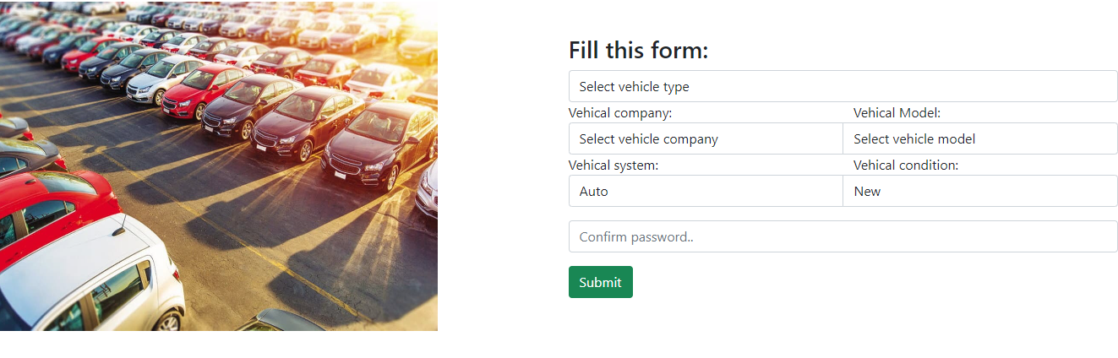
Figure 7-5

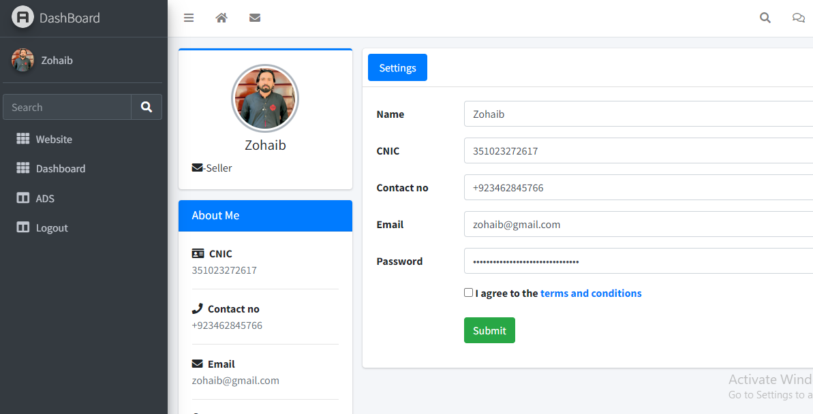
Figure 7-6 seller dashboard
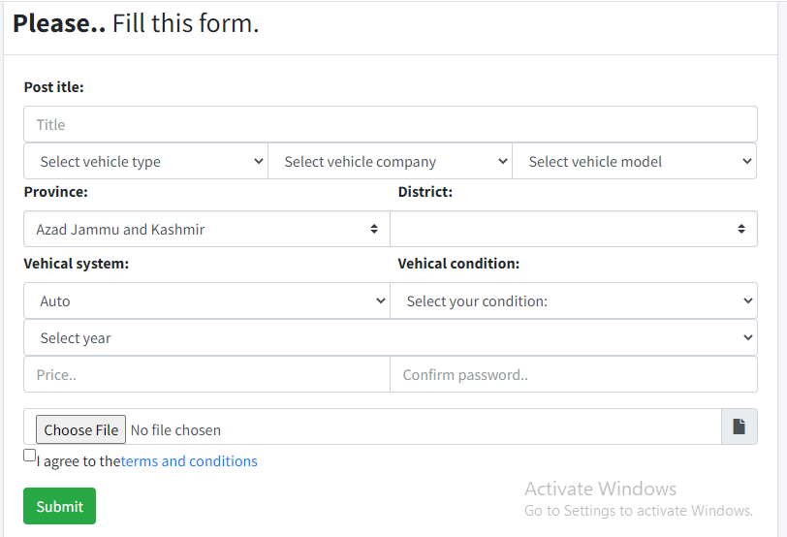
Figure 7-7 ad posting
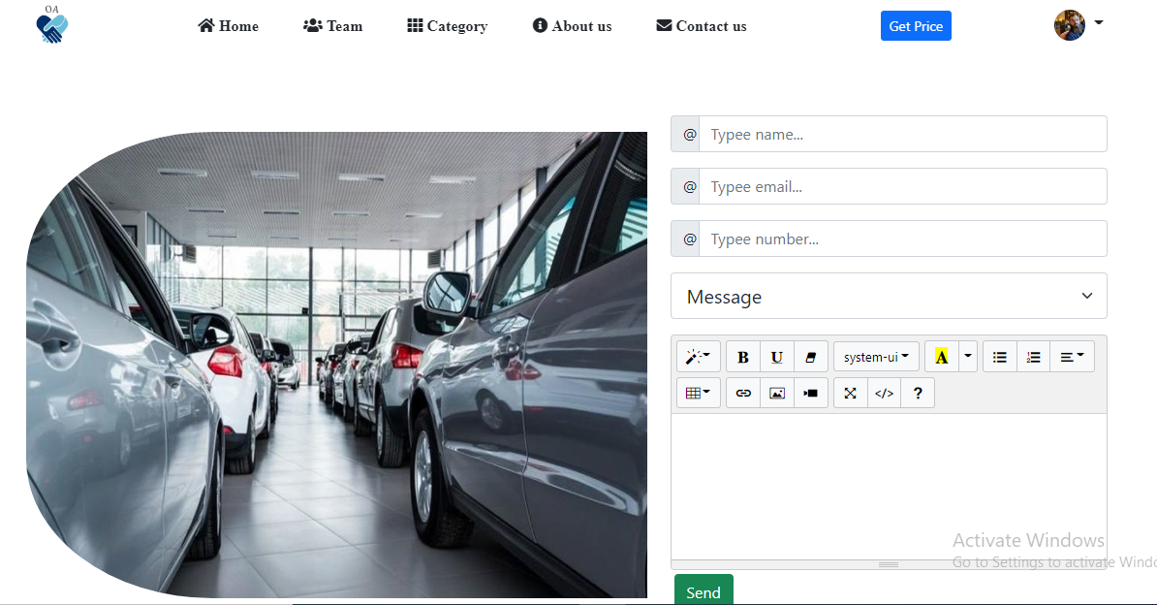
Figure 7-8 contact us

Reference and Bibliography

Reference and Bibliography

[1] M. Sher, M. Rehman, “Title of the Paper” Conference name/Journal Name, Edition, Volume, Issue, ISBN/ISSN, PP, Publisher/City-Country, Year.
[2] Listiani, M. (2009). Support vector regression analysis for price prediction in a car leasing application (Doctoral dissertation, Master thesis, TU Hamburg-Harburg).
[3] Richardson, M. S. (2009). Determinants of used car resale value. Retrieved from: https://digitalcc.coloradocollege.edu/islandora/object /coccc%3A1346 [accessed: August 1, 2018.]
[4] Wu, J. D., Hsu, C. C., & Chen, H. C. (2009). An expert system of price forecasting for used cars using adaptive neuro-fuzzy inference. Expert Systems with Applications, 36(4), 7809-7817.
[5] Du, J., Xie, L., & Schroeder, S. (2009). Practice Prize Paper—PIN Optimal Distribution of Auction Vehicles System: Applying Price Forecasting, Elasticity Estimation, and Genetic Algorithms to Used-Vehicle Distribution. Marketing Science, 28(4), 637-644.
[6] Gongqi, S., Yansong, W., & Qiang, Z. (2011, January). New Model for Residual Value Prediction of the Used Car Based on BP Neural Network and Nonlinear Curve Fit. In Measuring Technology and Mechatronics Automation (ICMTMA), 2011 Third International Conference on (Vol. 2, pp. 682-685). IEEE.
[7] Pudaruth, S. (2014). Predicting the price of used cars using machine learning techniques. Int. J. Inf. Comput. Technol, 4(7), 753-764.
[8] Noor, K., & Jan, S. (2017). Vehicle Online Autos using Machine Learning Techniques. International Journal of Computer Applications, 167(9), 27-31.
[9] Auto pijaca BiH. (n.d.), Retrieved from: https://www.autopijaca.ba. [accessed August 10, 2018].
[10] Weka 3 - Data Mining with Open Source Machine Learning Software in Java. (n.d.), Retrieved from: https://www.cs.waikato.ac.nz/ml/weka/. [August 04, 2018].
[11] Ho, T. K. (1995, August). Random decision forests. In Document analysis and recognition, 1995., proceedings of the third international conference on (Vol. 1, pp. 278-282). IEEE.
[12] Russell, S. (2015). Artificial Intelligence: A Modern Approach (3rd edition). PE.
[13] Ben-Hur, A., Horn, D., Siegelmann, H. T., & Vapnik, V. (2001). Support vector clustering. Journal of machine learning research, 2(Dec), 125-137.
[14] Aizerman, M. A. (1964). Theoretical foundations of the potential function method in pattern recognition learning. Automation and remote control, 25, 821- 837.
[15] sklearn.ensemble.RandomForestClassifier — scikit-learn 0.19.2 documentation.
(n.d.).Retrievedfrom: http://scikitlearn.org/stable/modules/generated/sklearn.ensemble.RandomForestClassifier.html [accessed: August 30, 2018].
[16] Used cars database. (n.d.) Retrieved from: https://www.kaggle.com/orgesleka/used-carsdatabase. [accessed: June 04, 2018].
[17] OLX. (n.d.), Retrieved from: https://olx.ba. [accessed August 05,2018].

