THE SUPERIOR COLLEGE LAHORE


Faculty of Computer Science & IT
Department of Computer Science

Final Year Project
PROJECT REPORT

Feed the Needy: Extra Food Management System

Project ID:[ FYP-BCSM-F20-002]

Project Team
Student Name | Student ID | Program | Contact Number | Email Address
ADNAN ASLAM | BCSM-F15-367 | BSCS | 03124186480 | Bcsm-f15-367@superior.edu.pk
M. UBAID NUMAN | BCSM-F16-197 | BSCS | 03053212268 | Bcsm-f16-197@superior.edu.pk
HUSNAIN JAMEEL | BCSM-F16-415 | BSCS | 03004985347 | Bcsm-f16-415@superior.edu.pk

Sir Talha Amjad (Lecturer)

Project Report
Feed the Needy: Extra Food Management System

Change Record
Author(s) | Version | Date | Notes | Supervisor’s Signature
 | 1.0 |  | <Original Draft>
 |  |  | <Changes Based on Feedback from Supervisor>
 |  |  | <Changes Based on Feedback From Faculty>
 |  |  | <Added Project Plan>
 |  |  | <Changes Based on Feedback from Supervisor>

APPROVAL
Project Supervisor
Comments: ___________________________________________________________________
_____________________________________________________________________________
Name:______________________________
Date:_______________________________ | Signature:__________________________

Project Manager
Comments: ___________________________________________________________________
_____________________________________________________________________________
Date:_______________________________ | Signature:__________________________

Head of the Department
Comments: ___________________________________________________________________
_____________________________________________________________________________
Date:_______________________________ | Signature:__________________________

Dedication
This work is done by keeping in mind solution to a communication problem between NGO’s & Restaurants. While completing this work our teachers and seniors helped us in every matter possible so that we could find best possible solution to the problem. We as a team worked day & night, conduct surveys ask NGO’s and Restaurants of Raiwind & Lahore that what are basic problems faced by them, We had try our best to come up with a solution to basic problems.

Acknowledgements

I am really thankful to my supervisor Mr. Talha Amjad . He helped us a lot in mapping our work and making it easier to work in different categories like how to design UI & UX with real life examples of his own application as a research work. He helped us in giving valuable information that what are the key aspects how NGO’s or Restaurants like to receive or convey their food which helped us in developed the solution as an application named Feed the Needy. In performing our project work, we had to take the help and guideline of some respected people, who deserve our greatest gratitude. We would also like to expand our deepest gratitude to all those who have directly and indirectly guided us in writing this project work. A android application which can be used by NGO’s, Restaurants and other domestic members at same time which will allow them to communicate easily in exchanging leftover food.

Executive Summary
The aim of this project to build a charity helping application which will help the NGO’s, Trust Organizations to get extra or left food from Hotels, Restaurants, Marriage halls, houses, School or College Canteens.
The application will register both the NGO’s and food providing organization. The Hotels and Restaurants will provide the information of food being left and NGO’s management will order it for free. Manager of NGO’s and Trusties Organization will send their representative to the respective Hostel or Restaurant or Marriage Hall to receive the food. The Project will be android based having different portals such as NGO’s Admin, Manager Food Provider and Admin Application who will register both the NGO and Manager. Our application not only help NGO’s, Hotels, Restaurants, Marriage halls but it will also found useful in the domestic region the houses and canteen can also send food for poor and needy by LOGIN Portal.
This project is not only limited in donating food it will also help NGO’s to collect wealth (Zakat) contribution from people who do not have much time to donate every single entity and verify for the eligibility of Zakat receiver.[ This feature will be added in future updates]
This application also aims to enhance the spirit of donation and helping. It also aim to lift the lower class of Pakistan.

Table of Contents
Dedication iv
Acknowledgements v
Executive Summary vi
Table of Contents vii
List of Figures ix
List of Tables x
Chapter 1 1
Introduction 1
1.1. Background 2
1.2. Motivations and Challenges 2
1.3. Goals and Objectives 2
1.4. Literature Review/Existing Solutions 2
1.5. Gap Analysis 2
1.6. Proposed Solution 2
1.7. Project Plan 3
1.7.1. Work Breakdown Structure 3
1.7.2. Roles & Responsibility Matrix 3
1.7.3. Gantt Chart 3
1.8. Report Outline 3
Chapter 2 4
Software Requirement Specifications 4
2.1. Introduction 5
2.1.1. Purpose 5
2.1.2. Document Conventions 5
2.1.3. Intended Audience and Reading Suggestions 5
2.1.4. Product Scope 5
2.1.5. References 6
2.2. Overall Description 6
2.2.1. Product Perspective 6
2.2.2. Product Functions 6
2.2.3. User Classes and Characteristics 6
2.2.4. Operating Environment 7
2.2.5. Design and Implementation Constraints 7
2.2.6. User Documentation 7
2.2.7. Assumptions and Dependencies 7
2.3. External Interface Requirements 8
2.3.1. User Interfaces 8
2.3.2. Hardware Interfaces 8
2.3.3. Software Interfaces 8
2.3.4. Communications Interfaces 9
2.4. System Features 9
2.4.1. System Feature 1 9
2.4.1.1. Description and Priority 9
2.4.1.2. Stimulus/Response Sequences 9
2.4.1.3. Functional Requirements 9
2.4.2. System Feature 2 10
2.4.2.1. Description and Priority 10
2.4.2.2. Stimulus/Response Sequences 10
2.4.2.3. Functional Requirements 10
2.4.3. System Feature 3 (and so on) 11
2.5. Other Nonfunctional Requirements 11
2.5.1. Performance Requirements 11
2.5.2. Safety Requirements 11
2.5.3. Security Requirements 12
2.5.4. Software Quality Attributes 12
2.5.5. Business Rules 12
2.6. Other Requirements 12
Chapter 3 13
Use Case Analysis 13
3.1. Use Case Model 14
3.2. Fully Dressed Use Cases 14
Chapter 4 15
System Design 15
4.1. Architecture Diagram 16
4.2. Domain Model 16
4.3. Entity Relationship Diagram with data dictionary 16
4.4. Class Diagram 17
4.5. Sequence / Collaboration Diagram 17
4.6. Operation contracts 17
4.7. Activity Diagram 18
4.8. State Transition Diagram 18
4.9. Component Diagram 18
4.10. Deployment Diagram 19
4.11. Data Flow diagram [only if structured approach is used - Level 0 and 1] 19
Chapter 5 20
Implementation 20
5.1. Important Flow Control/Pseudo codes 21
5.2. Components, Libraries, Web Services and stubs 21
5.3. Deployment Environment 21
5.4. Tools and Techniques 22
5.5. Best Practices / Coding Standards 22
5.6. Version Control 22
Appendices 23
Appendix A: Information / Promotional Material 24
Reference and Bibliography 27
Index 29

List of Figures

1.1 Caption of first figure of first chapter 6
1.2 Caption of second figure of first chapter 7
2.1 Caption of first figure of second chapter 14
2.2 Caption of second figure of second chapter 22
2.3 Caption of third figure of second chapter 26
5.1 Caption of first figure of fifth chapter 49
5.2 Caption of second figure of fifth chapter 49

List of Tables

1.1 label of first table of first chapter 6
1.2 label of second table of first chapter 7
2.1 label of first table of second chapter 14
2.2 label of second table of second chapter 22
2.3 label of third table of second chapter 26
5.1 label of first table of fifth chapter 49
5.2 label of second table of fifth chapter 49

Chapter 1

Introduction

Chapter 1: Introduction
In this Chapter, the aim of this project to build a charity helping application which will help the NGO’s, Trust Organizations to get extra or left food from Hotels, Restaurants, Marriage halls, houses, School or College Canteens.
The application will register both the NGO’s and food providing organization. The Hotels and Restaurants will provide the information of food being left and NGO’s management will order it for fee. Manager of NGO’s and Trusties Organization will send their representative to the respective Hostel or Restaurant or Marriage Hall to receive the food. The Project will be web based having different portals such as NGO’s Admin, Manager Food Provider and Admin Application who will register both the NGO and Manager. Our application not only help NGO’s, Hotels, Restaurants, Marriage halls but it will also be found useful in the domestic region the houses and canteen can also send food for poor and needy by LOGIN Portal.
This application also aims to enhance the spirit of donation and helping. It also aims to lift the lower class of Pakistan.

Background
It is being under notice in every single person that many of Marriage Hall, Hotels, Restaurants and canteen or cafeteria waste food in bulk amount just because they cannot utilize it. To save this food and delivered it to those who has no resources to earn their livelihood i.e. poor, needy, orphan, widows, old age homes living in NGO’s and Trust Organization. There is a need of build a bridge between them in order to save food and also supply it to those who are searching for it.

Motivations and Challenges
While working on this product we have to keep in mind that suitable information is only needed. We had conduct survey using questionnaire ask people about what problem do they face to that we had include five different categories in our app for easy access and two main panels one for donor and one for receiver. Both have different functionalities. The main challenge for us was the data base and how to make it responsive that the updated to receiver receives as soon as they are posted by donor. For this purpose we used Firebase and other tools that make it easy. Our teachers, seniors and Supervisors helped us in developing this product by telling us which type of information is to be there to be seen by each panel.

Goals and Objectives
Our main goal was to make a product which is easier to use and is responsive at the same time so that there should not be any delay in providing food to needy and charitable organization.
- User could be able to register with cell no or email id
- Individual (in case of not NGO’s) identity will be remain hidden
- Organization can sign online contracts and MoU’s with restaurants by using Feed the Needy
- The fundamental objective of our application is to save the food wastage and making ensure to fill up the appetite of hunger
- As for security purpose application is secured by PIN, Passwords etc.
- There won’t be any permission asked by app to enable camera or email sync etc. because it isn’t needed so it is secure and your private data in your device is safe as well.

Literature Review/Existing Solutions
Saylani Welfare International Trust is an organization which is doing the same task but its main drawback is it is not Online based system. The main aid of this Trust Organization is on Donation by Wealth. The organization made their own food and then served to needy. Agents and representative of Saylani Welfare International Trust collect money and then food is prepared for the needy and poor.
Strength: Provide freshly made food to needy and poor for free
Weakness: Donations are wealth based which are not forever and permanent
Opportunities: Online application of utilizing extra or leftover foods
Threads: laws and regulations of country

Gap Analysis

The restaurants face many difficulties in managing extra or leftover food and most of the time they bin the leftover food which can fill the appetite of hunger. The charity organizations and NGO’s also expense most of their funds and donations in just making and providing food. It is being under notice in every single person that many of Marriage Hall, Hotels, Restaurants and canteen or cafeteria waste food in bulk amount just because they cannot utilize it. To save this food and delivered it to those who has no resources to earn their livelihood i.e. poor, needy, orphan, widows, old age homes living in NGO’s and Trust Organization. There is a need of build a bridge between them in order to save food and also supply it to those who are searching for it.

Proposed Solution
Feed the Needy is a non-profit application enabling the exchange of excess food from the food industry to those who need it most. Marriage Halls, restaurants, cafeterias, and grocery stores post excess food on Feed the Needy web portal where local aid groups can secure it before they pick up and deliver it to those who benefit.
Marriage Halls, restaurants, cafeterias, hotels and grocery stores post excess food on the Waste No Food application. Aid group organizations, which have already been vetted for authenticity, can see what is available locally and confirm with transactions online to secure food. The food access is based on location. The organizations are responsible for all transportation and food handling

Project Plan

Conception and initiation:
Develop a application which helps NGO’s to get extra or leftover food form hotels without any Hassel by just opening a application there it is. Feed the Needy is a web-based application which has five main categories like Marriage Hall, Cafeteria, Restaurants, Hostels & Houses which will show information regarding their categories to help NGO’s eliminating wondering here and there to get how much extra food is there in cafeteria hotels and Restaurants

Definition and Planning:
To complete this product we first had to do some research for this purpose we use questionnaire to find out What NGO’s want and what restaurants has to deliver so that we could categorize in easy way possible.
1. Two different panels one for NGO’s and another one for Hotel management
2. Make application easier to use for everyone.
A time period of 6 months will be needed to complete the application which will be fully functional and can be available on internet.
We will be using , Xml and Kotlin as our main language to code with it
Apps layout and Documentation will be completed in the month of Dec.
GUI & Materialistic design will be completed until mid of Feb.
Making real time Database using Firebase and making it responsive requires a lot of time and this will be completed on April Mid with testing of app and making changes to it.
Launch:
In May, we will publish our application to internet when it is fully functional but before those changes will be made and make the most out of it.

Work Breakdown Structure

Below diagram hierarchy of our system its base on our functionality:

Roles & Responsibility Matrix

The purpose of roles & responsibility matrix is to identify who will do what.
WBS # | WBS Deliverable | Activity # | Activity to Complete the Deliverable | Duration  (# of Days) | Responsible Team Member(s) & Role(s)
1 | Planning | A |  | 10 days | Husnain Jameel
2 | Analysis Phase | B | A | 07 days | Adnan Aslam
3 | Design | C | B | 30 days | Ubaid
4 | Coding | D | C | 70 days | Adnan, Ubaid , Husnain
5 | User Interface | E | D | 22 days | Ubaid
6 | NGO and Hotels Data | F | D | 22 days | Adnan Aslam
7 | Google Maps | G | E | 15 days | Adnan, Husnain
8 | Admin Logins | H | F | 15 days | Husnain
9 | Architectural Design | I | G,H | 22 days | Ubaid
10 | Testing | J | I | 07 Days | Adnan

Gantt Chart

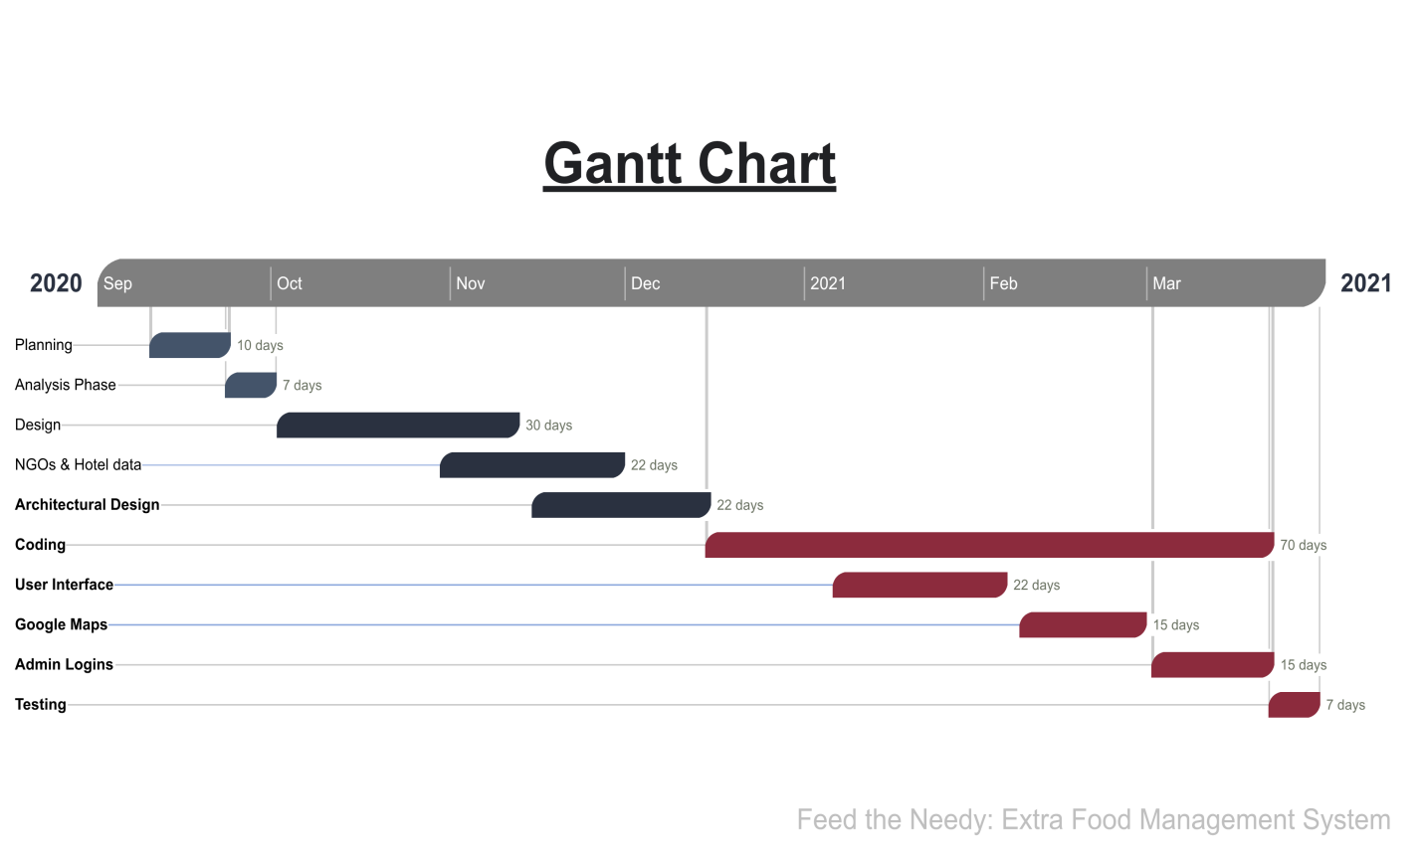

Report Outline
In this chapter we discuss about problem which we face and give you its solution, background of proposed system, why we introduce and what problem this system is solving, project plan of our proposed system how we make and gather information, what kind of task we have to make this project, what kind of challenges we face to make this project prototype, background and assign tasks to group members and their role models.

Chapter 2

Software Requirement Specifications

Chapter 2: Software Requirement Specifications

Introduction

Purpose

Feed the Needy is nonprofit application that provides a Android-based "marketplace" allowing excess food to be donated from the food service industry to qualified charities that work with the needy. One-third of all food is wasted, from farms, restaurants and grocery stores. Yet there has been no efficient way for groups that have excess food to donate to the millions of hungry Pakistanis. Feed the Needy is that medium. Donors who wish to donate their excess food can sign up and post excess food as it becomes available. Qualified charities in the vicinity of the donors, who have been verified by Feed the Needy, can claim the food. The charities are responsible for transportation and food handling.

Document Conventions
This document uses the following conventions.

DB: DATA BASE
ER: ENTITY RELATIONSHIP

GUI : Graphic User Interface

Intended Audience and Reading Suggestions
This Software Requirements document is intended for: − Developers who can review project’s capabilities and more easily understand where their efforts should be targeted to improve or add more features to it (design and code the application – it sets the guidelines for future development). − Project testers can use this document as a base for their testing strategy as some bugs are easier to find using a requirements document. This way testing becomes more methodically organized. − End users of this application who wish to read about what this project can do.

Product Scope
Feed the Needy is a common platform for the Charity Organization to find food and Restaurants, Cafeterias owners to find the related Charity organization for donating leftover eatables. In this project different restaurants will post their leftover food and eatables products and interested NGO’s or Charity Organizations can apply for food same as the charity organization can also request for food and different restaurants can contact them and can provide them food. In case of single food receiver the users can post their food demands on this platform and other users can help them by providing food without showing his/her identity. The user can also directly contact to the specific restaurant, person just by posting a demand on his/her timeline. We also maintain needy person’s data and will be shown to concern managements.

References
- En.wikipedia.org. (2020). Software requirements specification. [online] Available at:https://en.wikipedia.org/wiki/Software_requirements_specification
- Search Software Quality. (2020). How to write a Software Requirements Specification
- (SRS) document. [online] Available at:
https://searchsoftwarequality.techtarget.com/answer/How-to-write-a-Software-Requirements-Specification-SRS-document.
- Google Scholar Tradeoff Decisions in System Design by A. Terry Bahill Azad M. Madn

Overall Description

Product Perspective
The android based application as online donation system to offers Hotels and Restaurants convenient access to the NGO, Trusties and Poor. Several tools used during implementation include in the following:
Xml kotlin Language: A markup language that defines a set of rules for encoding documents in a format that is both human-readable and machine-readable. Kotlin is a statically typed programming language for the JVM, Android and the browser, 100% interoperable with Java
Firebase: Firebase is a platform developed by Google for creating mobile and web applications.
TESTING: Testing will be done by Android Studio Unit Testing.
Android: Android 5 and above versions supported
Reporting Tool: i.e. through data report

Product Functions
This product, web based integrated development environment, must have number of features which will allow users to use functionalities which have been listed below
- Sign up
- login
- Dashboard
- Profile creation and management
- Food Management
- News and Notification
- Different Portals for Admin, Donors and Receivers
- Viewing Food Items

User Classes and Characteristics
Users of this web based integrated development environment will mainly be software developers. Since it is reasonable to assume that an average developer has knowledge about functionalities and usage of IDE, we assume that our users will already be informed about basic functionality of the product. Also clear documentation and tutorials about the product feature will be provided.

Operating Environment
Main purpose of developing android-based application is to improve the software development process. To improve performance, software should run on variety of platforms and variety of connection speeds. Software should be lightweight so that it can run on a machine with slow internet connection. To make the web application lightweight, simple libraries and tools should be used at developing phase. Such as using xml and Kotlin instead of Java. To achieve this, android application should be developed by using the common technologies and tools which are provided by all common android versions and operating system such as android 5 etc.

Design and Implementation Constraints
Developers of the product should be aware that main feature of the intended product is portability. So they should use common libraries and tools that can work with all the common internet browser application with no problem. Developers should also be careful about the privacy of users. Since product will be sever based web application, all user data will be kept on server and necessary precautions should be taken to protect user data. Product will be server based web application and all user programs will be executed on server, developers should limit the privileges of the users so that they cannot harm other users’ data and system server.

Assumptions and Dependencies
- We are dependent on the platform of Android Studio for android app
- Firebase database will be used for data storage
- XML – Kotlin android studio platform will be used to build a application
- XML will be used for responsive GUI.
- Supportive for all android version such as Lollipop, Marshmallow, Nougat etc
- Our product will not be violating any ethnical or cultural rules
We’re aimed at designing and developing a total new interface which will be user friendly and easy to use.

External Interface Requirements

User Interfaces
The interface controls will be intuitive and easy to use. The user can move around, understand and interact with the application without the need for explanations or previous preparation. Best element in it is we have tried to imitate physical or mechanical elements: from pushing a button to the use of tabs on a site. Moreover it will provide the best user experience by presenting information to the user in comfortable and efficient way. Feed the Needy is just as gorgeous as it is functional, with minimal use of color, generous line spacing, and a well chosen combination of typography. Home page has a clear headline and tagline that lets user know what the product is about.

Hardware Interfaces
Since the application must run over the internet, all the hardware shall require to connect internet will be hardware interface for the system. As for e.g. Modem, WAN – LAN, Ethernet Cross-Cable. An internet connection is needed for application to run which is both possible with Wi-Fi or Landline connection, through which information will be retrieved from database and displayed on system screen. To run the application on browser with system of 1GB (Almost) of Ram with any processor type whether it is 64bit or 32bit can run the webpage.

Software Interfaces

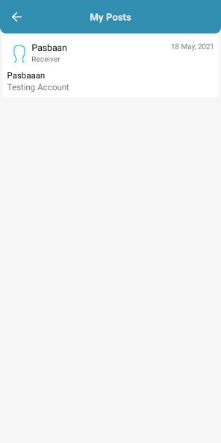
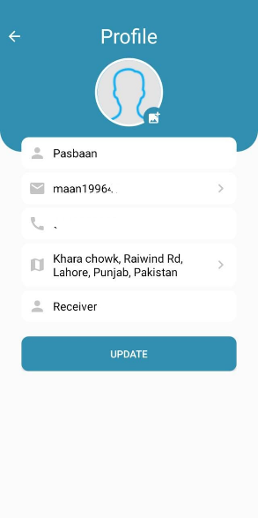


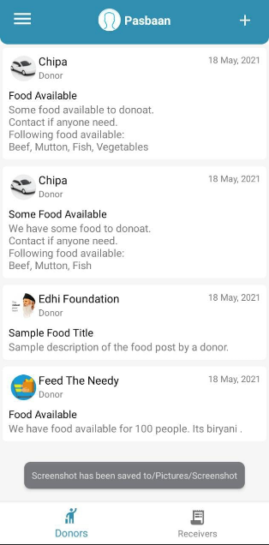
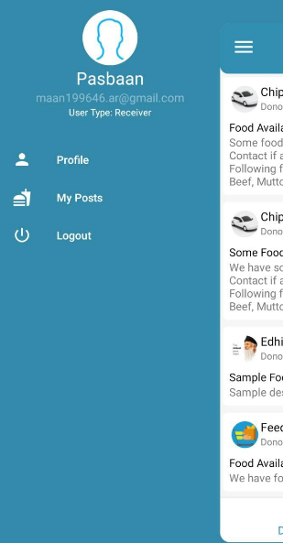
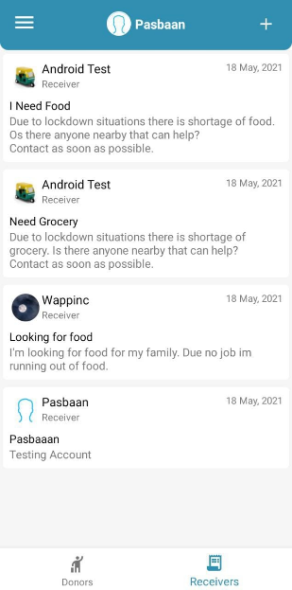

Communications Interfaces
The e-store system shall use the HTTP protocol for communication over the internet and for the intranet communication will be through TCP/IP protocol suite.

System Features
In this subsection, we will examine the features of the system in detail by categorizing them according to their functionality. For each of the feature, we will give an introduction, purpose, diagram and a stimulus/response sequence. Introduction part will give basic background information about the feature. After that, we will show a diagram for the feature representing flow of events.

System Feature 1
Provide information against food availability and reservation from database

Description and Priority
It is of High priority feature, without this feature application doesn’t work. The feature work is to get information from database and View/Edit/Delete and Update by the user with minimum time. Our system will maintains information of different Users, their orders. We will make web application that will guide the way to our delivery men, by using Dijkestra Algorithm they will able to deliver.

Stimulus/Response Sequences
Click "Register" Button: Account Registration
- The system shall allow a non-registered user to create a secure account.
- The system shall require the following information from the user: Name, Address.
- The system shall ask the user for a username and password.
- The system shall confirm the username and password are acceptable.
- The system shall store the information in the database.
Click "Login" Button: Account Login
- The system shall allow a registered user to log-in to their account.
- The system shall require a username and password from the user.
- The system will verify the username and password, and the user will be considered “logged-in”.
Click "Add to Cart" Button: Add to Cart
- The system shall allow a registered and logged-in user to temporarily save orders that are being considered for delivery into a list associated with their account.
- When viewing the cart list, the system shall display their products in the cart

Functional Requirements
Functional requirement is referring to the functionalities must be apply to a system. The functional requirements of vehicle tracking system and café product system are stated below.
- The system must be able to show information to user in real time.
- The system shall provide the login page
- System should react to the particular input and output
- Admin has all access of the system
- The system always be available to the user
- The system should update the information after the order been shifted for delivery
- The system should add the new donors
- The system should add the charity organization

System Feature 2

Description and Priority
It is of High priority feature, without this feature this application doesn’t work. The feature work is to get information from Server database and show it to the user with minimum time (each rated on a relative scale is 9)

Stimulus/Response Sequences
Product will be used via Google Play Store. Each user will have his own workspace, and he must be logged in to the server to access his workspace. Hence, first-time users must be complete registration process. To register to the system, user must specify some information asked during registration. After validation, registration will completed, and user will be informed.
There will be a login page so that user can type into his login information, and login to the system. Login information will be username or e-mail address and password specified in registration process. Server let through the user if the given username and password are matched with the ones in database saved in registration. If specified information is not matched, an error dialog will be shown. Otherwise, user will be redirected to his personal workspace.
When user forgets his password, he can request new one from the system by specifying his username or e-mail.

Functional Requirements
REQ-SF2-1: Login/sign in
- User Login Form
- Verify and validate user entered User name and Password
- If any or both are incorrect reassign user to login form with notification
- If both are entered valid open a session for user to his or her account
- Admin Login Form
- Verify and validate Name and Password
- If any or both are incorrect reassign user to login form with notification
- If both are entered valid open a session for Admin to admin panel.
REQ-SF2-2: Register/ Sign Up
- Data collection form for user details with formats and validation
- First and Last name (No Digits allowed length limit to 8 each)
- Email Address ( Email Format e.g abc@xyz.com, length limit to 25
- Contact number (Valid format of phone no (XXXX-XXXXXXX)
- Address (Alphanumeric length limited to 40)
- CNIC (valid format e.g XXXX-XXXXXXX-X)
- Username1 … (Minimal length 8)
- Password 1…. (Minimal Length 8 , any special character and not a username)
- Set Security PIN (numeric length 4)
REQ-SF2-3: View Record
- All tabs and categories
- About us
- Contact us
- Food Donors
- Charity Partner
- Food Facts
- Privacy Policy
REQ-SF-4: Add/Edit Record
1: Donor
- Upload post
- Edit information
- Add or Delete post
- Cancel the order
2: Admin
- Add Users
- Remove User
- View or show Post
- Cancel / Confirm order
- Update Information
- Send Notifications
REQ-SF-5: Edit Account
- Customer and Admin
- Update contact number
- Update Username (Format Apply)
- Update password (Format apply)
- Update food details (Donor and Admin Only)
REQ-SF-6: Report Management
Customer
- Total food daily, weekly, monthly
- Total food delivered
- Total pending
Admin
- Product Report
- Delivery Report
- Availability Report
- Pending Food Report

System Feature 3 (and so on)
- Functional requirement is referring to the functionalities must be apply to a system.
- The system must be able to show relevant information to user in real time.
- The system must be able to process the relevant information of food to user.
- The system must show the time of food availability of food to receiver
- The system shall be able to allow donor for the food post and update.
- System shall be able to view the information to the authorized users only
- User shall be able to view the pages of application.
- The system must be able to allow user retrieve related information from server
- System shall show the upload food posts
- User (Donor) shall modify the food post

Other Nonfunctional Requirements

Performance Requirements
The product shall be based on web and has to be run from a web server.
The product shall take initial load time depending on internet connection strength which also depends on the media from which the product is run.
The performance shall depend upon hardware components of the client/customer.

Safety Requirements
In this case data or anything cannot be loss but if someone accesses this for some wrong purpose then it might be harmful. So we make sure anyone who access this app is a valid person by giving them user name user id and password to access. To use this facility, one must be registered member of portals.

Security Requirements
Feed the Needy will be hosted on server, all the user data will be kept on the server. Product should be able to protect privacy of user data. Workspace of the user should only be accessed through user own credentials and any other user should not be able to access to the user private data.
Since execution will also be done in the machine in the server, user should be restricted in terms of user rights. User should only access to his own workspace and should not access to any other workspace with the programs they run on sever. Also rights of the user should be restricted so that user can not harm to system by the programs they run or by the commands they run on terminal.
Since all the data will be transferred on the web, system should also use an encryption and decryption mechanism only intended user can decode the data and work on the data.

Software Quality Attributes
- Adaptability
- Availability
- Correctness
- Flexibility
- Maintainability
- Portability
- Reliability
- Reusability
- Testability
- Usability

Business Rules
• If user want to order food than he has to first sign up.
• Application will not responsible for damage of any food.
• User has to follow terms and conditions of application.

Domain Requirements
There are no other requirements or specific thing needed to run the application or to run it in development phase all of the information is written above for better understanding.

Chapter 3

Use Case Analysis

Chapter 3: Use Case Analysis

The process of studying a procedure or business in order to identify its goals and purposes, and create systems and procedures that will achieve them in an efficient way. Another view sees system analysis as a problem-solving technique that breaks down a system into its component pieces for the purpose of the studying how well those component parts work and interact to accomplish their purpose.

Use Case Model

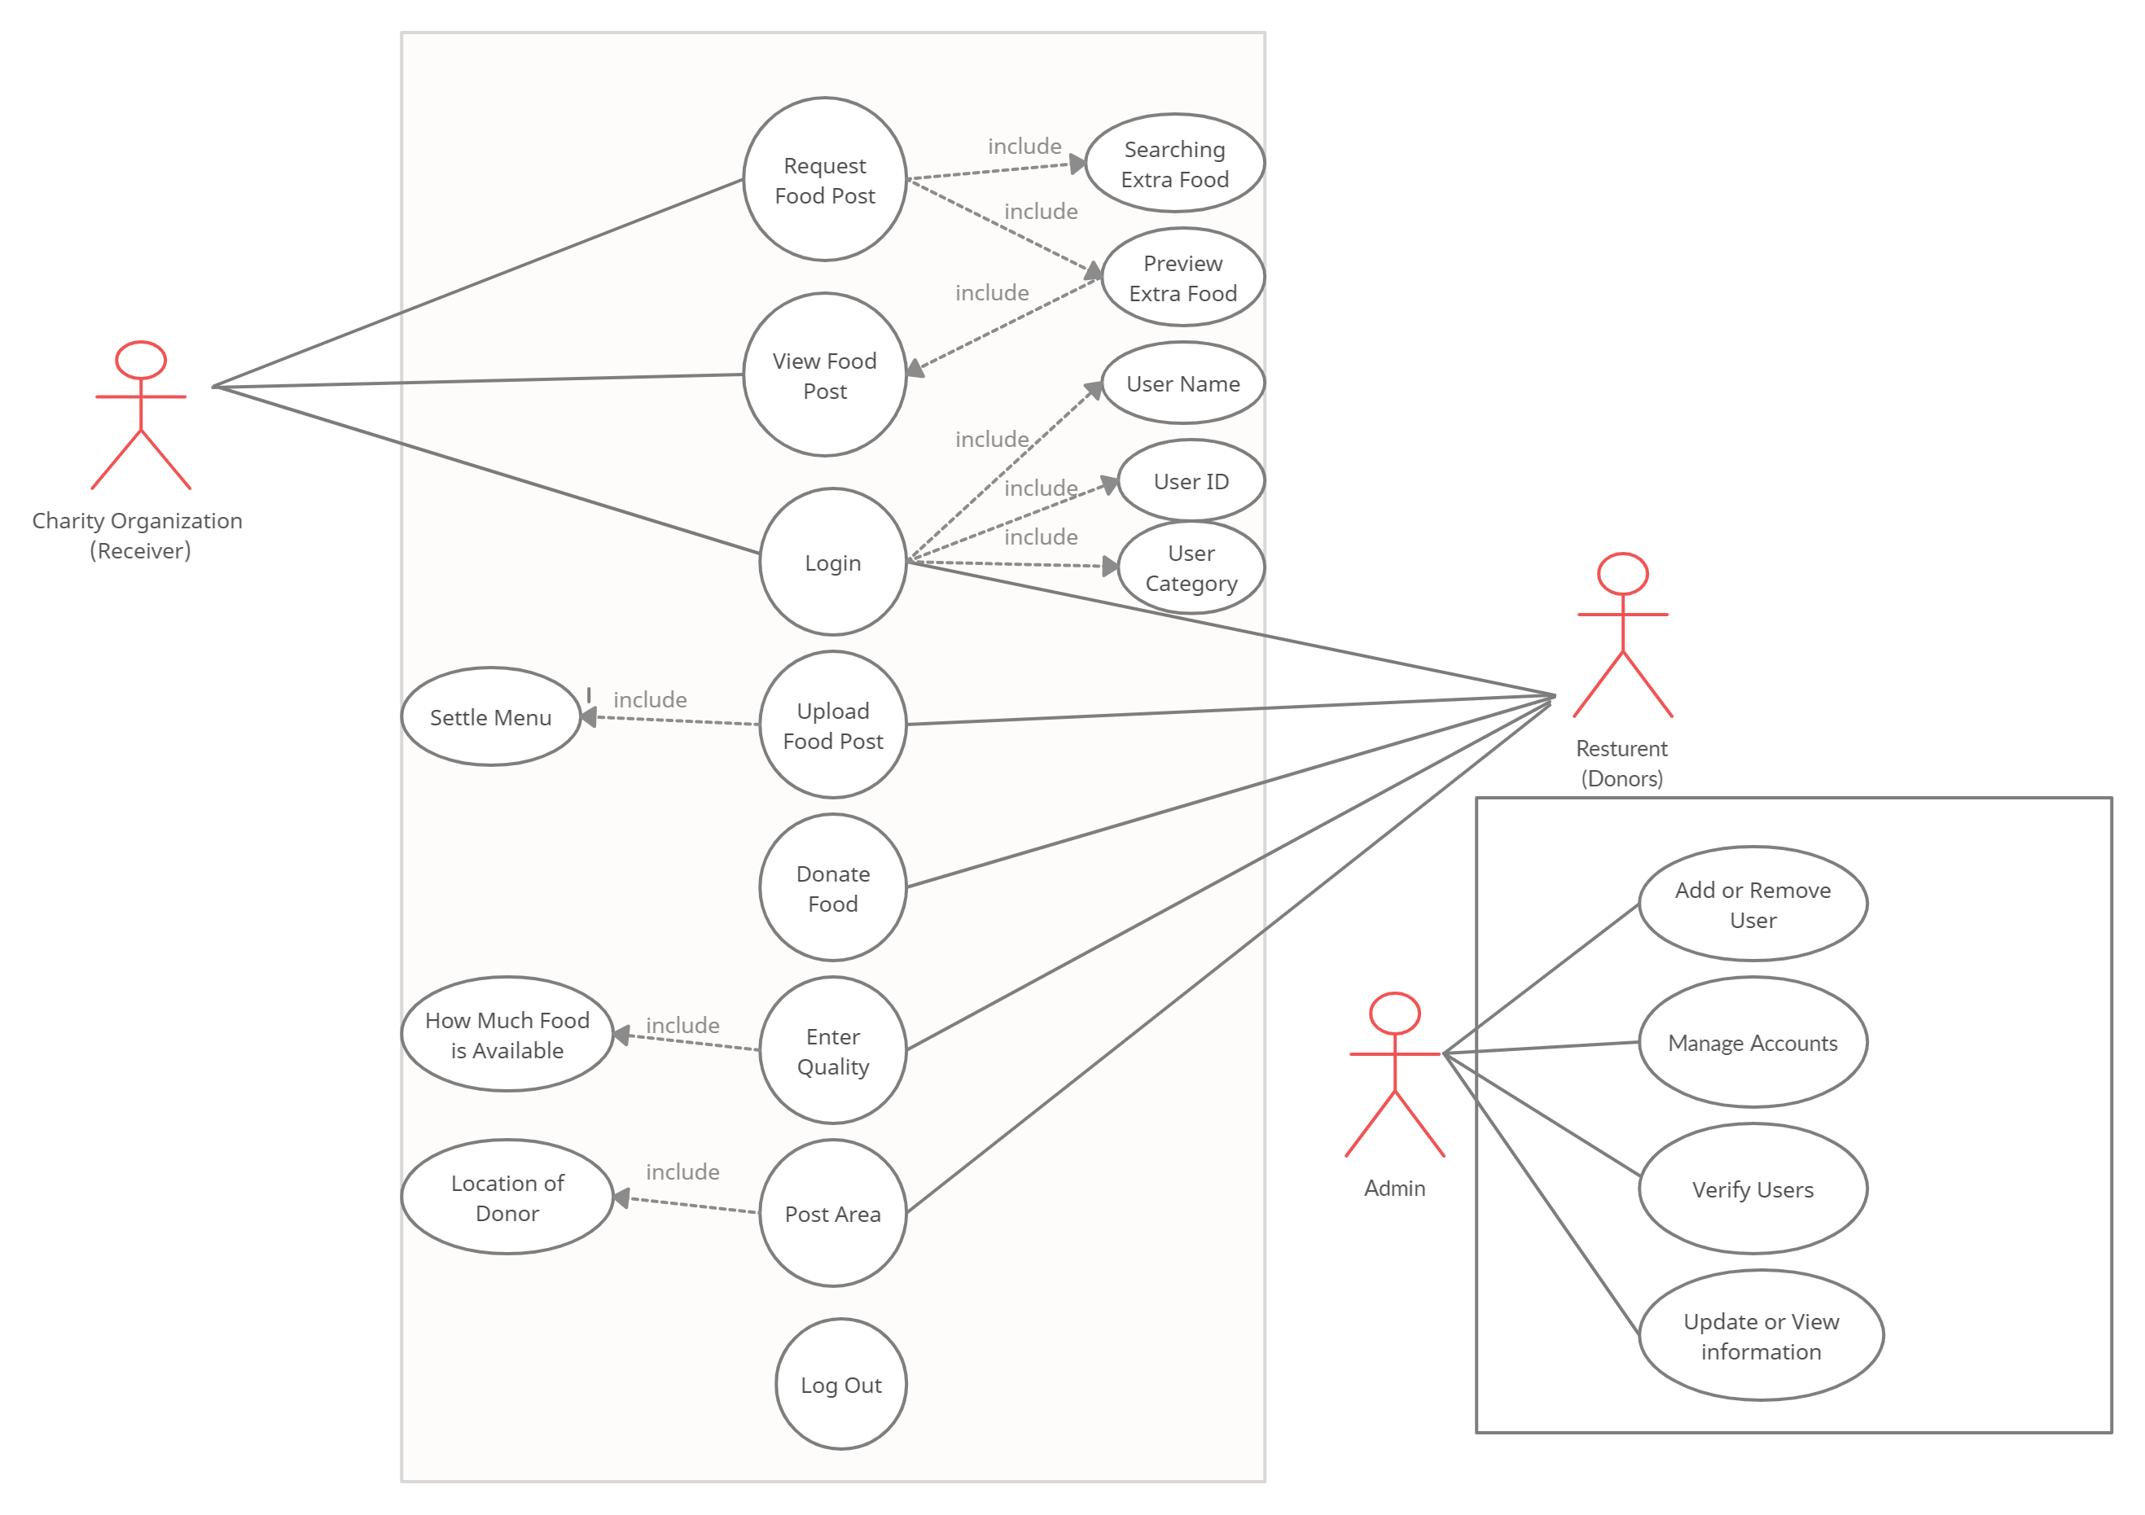

Use Cases Description
In this stage, analyses on existing systems have been made. Different charity applications have been studied and the main requirements had been founded with also by the help of Faculty members, supervisor, seniors and surveys that what problems are faced to fulfill the gap and give a solution.
Our system consists of three different parts one is Admin Portal in which admin or application owners will worked as a bridge to supply extra or leftover food to needy to fill their hunger. The admin has all the rights such as add post, update post, delete members and view application.
Second part of our application donor portal in which the donor has an access to add post, Update and modify post and Upload post. Donor portal will include the registrations of restaurants, hotels, marriage halls, cafeterias etc. They will also upload the estimate quantity of extra food, that how many persons can have it. Donor has to register himself in order to accomplish this task. Only validate and authorized users will allowed to enter to portal
The last is receiver portal in which charity organizations will register themselves to collect the leftover or extra food for the people they have in their shelters. They will also connect to the server and only relevant and prescribed information will be provided to them through their specific user name, user ID and password.

Chapter 4

System Design

Chapter 4: System Design
Systems design implies a systematic approach to the design of a system. It may take a bottom-up or top-down approach, but either way the process is systematic wherein it takes into account all related variables of the system that needs to be created—from the architecture, to the required hardware and software, right down to the data and how it travels and transforms throughout its travel through the system. Systems design then overlaps with systems analysis, systems engineering and systems architecture.

Architecture Diagram
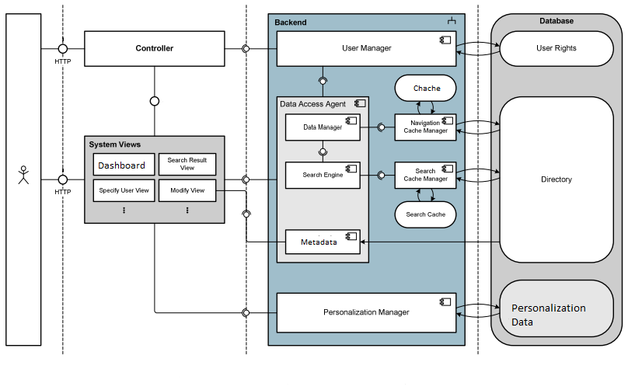

Domain Model
Database System

Retrieving Data

User

User can view information about food supply, Food Availability, Delete Post, Add post etc

Web Browsers

Will be used by admins to access information in database and can make changes to it

Admin

Can update information

Entity Relationship Diagram with data dictionary

Restaurant
NGOs
Marriage Hall

Charity Organizations
FEED THE NEEDY
User Name

Receiver ID
Password

Request
User
(Receiver)

Admin
User Name

Password
Donor ID
Admin ID
User Name

Post
User Donor
Password

Class Diagram

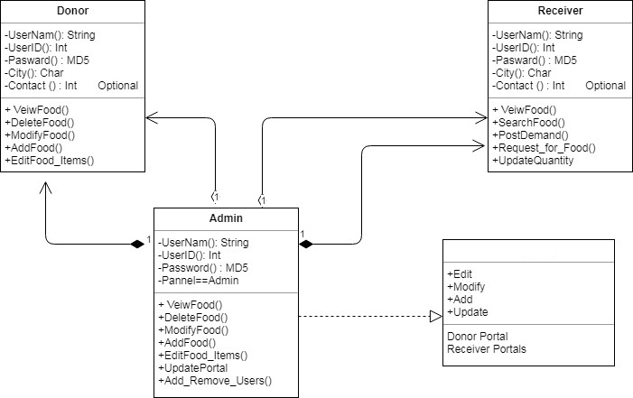
Feed the Needy

Sequence / Collaboration Diagram

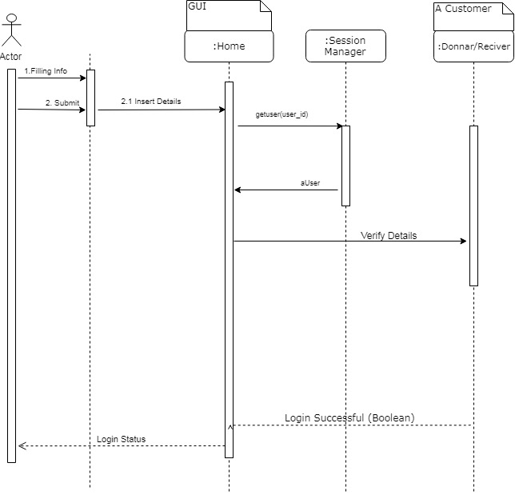

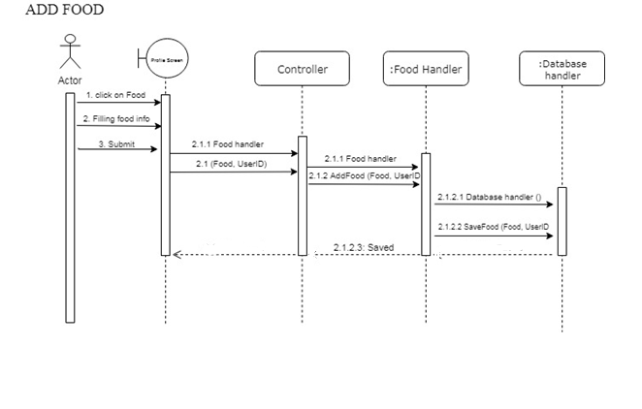
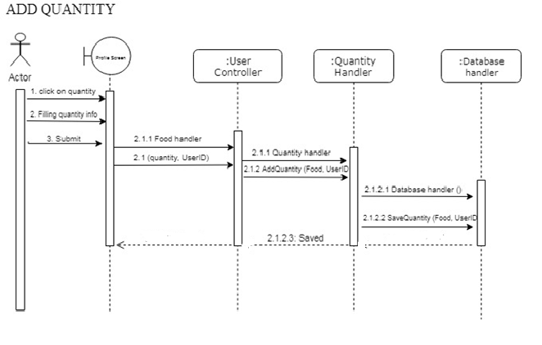

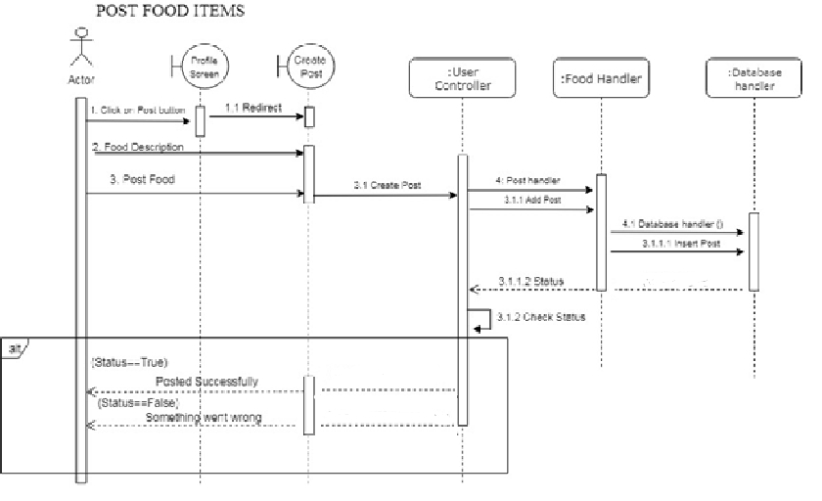
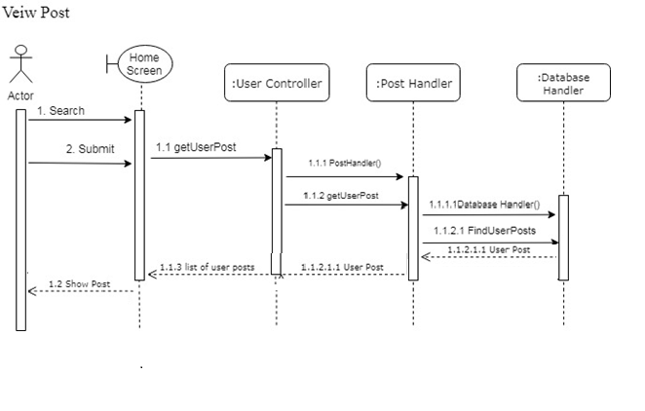

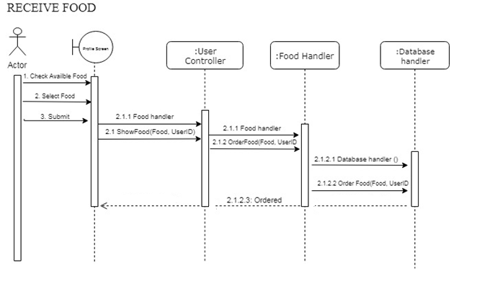

Activity Diagram

Login activity  Admin  Login  User  (Donor/Reciever) |  | Portal list activity  Menu  Select Category  Login |  | Portal info activity  Availability  Location  Quantity  Menu

State Transition Diagram
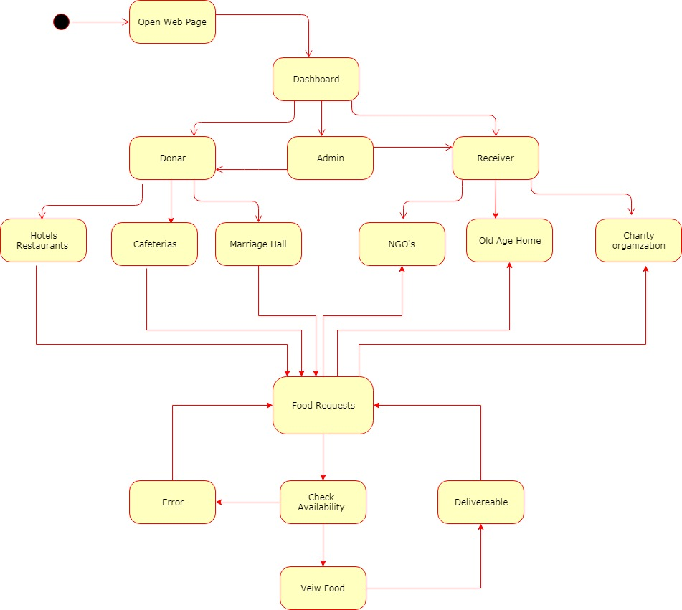

Component Diagram
See food details like types of food, Location etc.

Setup ID
View News and Highlights

Update, Modify Food Posts
Details of dishes & its availability can be viewed or when there are extra offers

User

Admin
Modify or delete Data like No of dishes, Availability
Can view Charities, Donors, Volunteers,

Can Update User and Food ID

Update, Delete, View, Modify
Portals

Deployment Diagram

Database
User Client

Restaurants
Cafeteria
Charity Org
NGO’s
Sending Data to App
Feed the Needy Application

Data Flow diagram
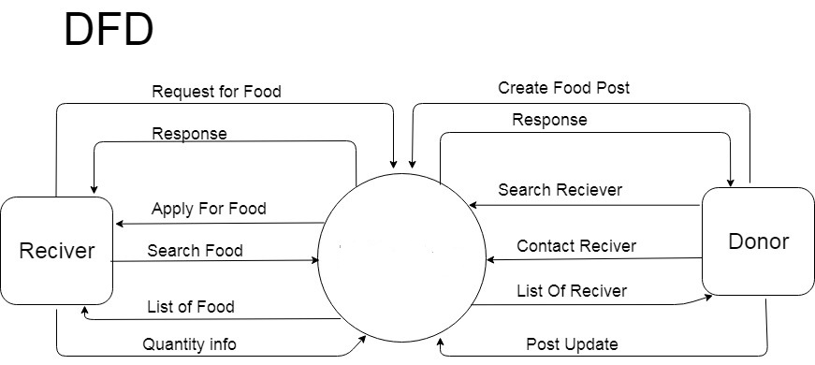

Feed the Needy

Chapter 5

Implementation

Chapter 5: Implementation
Implementation is the carrying out, execution, or practice of a plan, a method, or any design, idea, model, specification, standard or policy for doing something. As such, implementation is the action that must follow any preliminary thinking in order for something to actually happen.

Important Flow Control/Pseudo codes
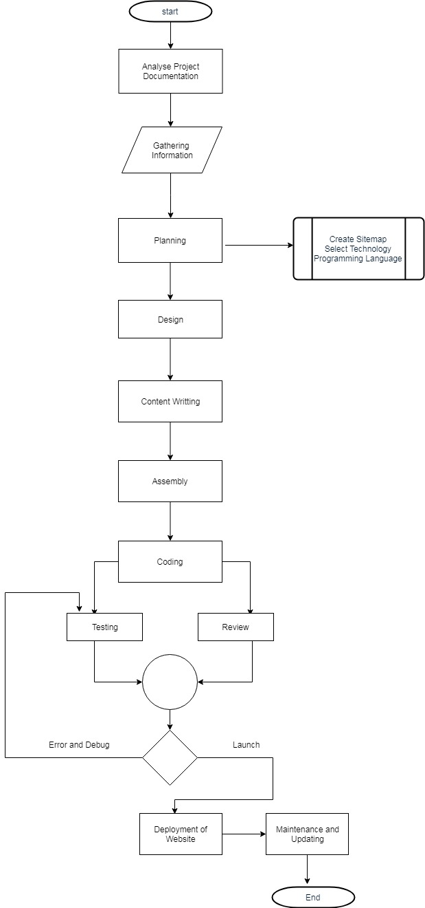

Components, Libraries, Web Services and stubs

Firebase App Hosting Service

VS code for web

Analytics Tools

Mobile Friendly Template and Theme

Sections That Visitors Expect

Media

Social Media Links and Integration
Libraries
Native Android studio libraries,
Google firebase

Deployment Environment
Our application is developed on Android Studio running latest version until now and XML , KOTLIN as our basic language while using Firebase database which will help data retrieving. Our application can easily run on Android 5 and above versions. It can also run 512 mb ram devices. It doesn’t need any extra permission to access personal information. So privacy will not an issue it will use Internet connection & Google maps that will show the route.

Tools and Techniques
The application for food donation system to offers Hotels and Restaurants convenient access to the NGO, Trusties and charity organizations. Several tools used during implementation include in the following:
FireBase Database: it allows combination, extraction, manipulation and organization of data in the NGO and Hotel database. It is an independent platform and therefore can be implemented and used across several such as Windows server and is compatible with various hardware mainframes. It is fast in performance, stable and provides services at a low cost.
XML: XML is the basic language to build up applications. It is a application based project so xml has a key role in implementing this project
Kotlin : This is for advanced user who find Kotlin codes easy to work with.
TESTING: Testing will be done by Android Studio Unit Testing
Android Versions : Lollipop , Msrdhmslloe , Nougut etc
Reporting Tool: i.e. through data report

Best Practices / Coding Standards
- Write Comments and Documentation:
Commenting your code and providing proper documentation will guide the other developers through the algorithm and logic that you implemented.
- Write readable yet efficient code:
Readable codes are easy to follow, yet use optimal space and time. When writing code you may often want to write it in as little lines as possible. Perhaps you can write an entire method or function in one line, but that only makes it harder to read and understand.
- Use helper methods:
A method should only implement what it needs to do. If a part of your implementation does something else, put it in a separate method and call that within your method.
- If avoidable, do NOT hard-code:
The only things that should be hard-coded are constants. That’s it.
- Write test cases. Don’t forget the edge cases: 0s, empty strings/lists, nulls, etc:
A function should always be based on test cases; not tests on functions.
- Use your IDE’s drop-down menu:
These are very helpful and will help you make less coding errors.
- APIs are handy:
Before implementing a method, make sure they’re not available for you to use. You don’t have to code if you can just import the functionality. It makes a developer’s life super easy. The famous saying is “Don’t reinvent the wheel” and it stands true in many cases. However, you should always consider the implications of importing a library, especially if it is third party.
- Pair programming/code review:
These are very helpful when it comes to refactoring your code. Others might see better implementation to optimize your code or just make your code more elegant.
- BACKUP AND SAVE YOUR WORK OFTEN:
Save and backups of the work should be done

Version Control
Microsoft Team Foundation Server (TFS)

Chapter 6

Testing and Evaluation

Chapter 6: Testing and Evaluation
This chapter is about the testing phase:
We test our application using different techniques like Use Case testing, Data flow testing, Unit testing, Integration testing, performance testing, stress testing, etc to check the performance of an application.

Use Case Testing:

1-Signup
Success Scenario | Step | Description
A: Actor  S: System | 1 | A: First name, Last name, email, password, Ph #
A: Actor  S: System | 2 | S: Check Existing Information
A: Actor  S: System | 3 | S: sign up
Extension | 2a | User Already Exist  S: Display error message account already exits

2-Login
Success Scenario | Step | Description
A: Actor  S: System | 1 | A: First name, Last name, email, password, Ph #
A: Actor  S: System | 2 | S: Validate password and email
A: Actor  S: System | 3 | S: Allow Account Access
Extension | 2a | Password and Email not valid  S: Display error message invalid Email or password

3-Logout
Success Scenario | Step | Description
A: Actor  S: System | 1 | A: log out from the application
A: Actor  S: System | 2 | S: Must be login
A: Actor  S: System | 3 | S: Deny Account Access
Extension | 2a | Internet may not available  S: Display error message ”User already logout”

4-Add Admin
Success Scenario | Step | Description
A: Actor  S: System | 1 | A: Add categories ,deal, Add/Delete product, Moving to cart.
A: Actor  S: System | 2 | S:
A: Actor  S: System | 3 | S: Add Post
Extension | 2a | S: Display error message “size or format invalid”

5-Delete Post
Success Scenario | Step | Description
A: Actor  S: System | 1 | A: Select category(by pushing)
A: Actor  S: System | 2 | S:Check i.e want to delete.
A: Actor  S: System | 3 | S: Delete category
Extension | 2a | Post not valid  S: Display error message “you are not allowed to delete “

6-Friends Search
Success Scenario | Step | Description
A: Actor  S: System | 1 | A: Enter item name
A: Actor  S: System | 2 | S: Check Availablibilty
A: Actor  S: System | 3 | S: Show all matching items
Extension | 2a | User not found  S: Display error message food does not exist

7-order placing
Success Scenario | Step | Description
A: Actor  S: System | 1 | A: select category
A: Actor  S: System | 2 | S: show Availablity
A: Actor  S: System | 3 | S: | Order added to cart
Extension | 2a | User not found  S: Display error message food does not exist

Boundary value analysis
Boundary testing in the process of testing that is between start point and extreme ends or boundaries between partials of input values.

Login username
Username that a person enter in the text box at the time of login must be correct and between 4 to 8 characters and unique.
If the username is not correct, the system must restrict the user at the current page.

Login password
Username that a person enter in the text box at the time of login must be correct and between 3 to 8 characters.
If the username is not correct, the system must restrict the user at the current page.

Text fields:
All text fields system have must accept only correct text
User must add those information which is needed and to the point
Text fields are name, city, country etc.

Numeric fields:
The numeric fields must accept only numbers
Numeric fields are mobile number, CNIC number, quantity of products etc.

Email fields:
Email fields are also available in the software system
Email fields must accept email formats.

Automatic filled fields:
Some fields in this system are automatic filled when a user keep data from one page to another, these fields automatically filled with information.
Keep in mind that these fields cannot edit or enter by the end user.

Unit testing

Test units | Test items | Input specifications | functionality | Result
Test unit 1 | Login to system | The fields of input and password cannot be empty.  The email and password must match with the registered username and password. | Enter the registered email, password, and press login button.  Get access to system | Successfully logged in to the system.
Test unit 2 | View Profile | In Main Profile, Every button will work ok every activity should be open correctly. | Test all the buttons and link, everything work ok. | Successfully checked whole Profile
Test unit3 | Connect to FireBase Database | Use Google Firebase database.  Enter correct username and password for authentication.  Check the connection successful message. | Connect server to database to save your updates into the database. | Successfully connected to database.

Test unit4 | Testing to add customer/admin/staff | Input can be a string, numbers, integers and floating digits. | Add customer/admin/staff successfully into database. | customer/admin/staff added successfully.
Test unit5 | Testing of add category , add deal. | Inputs can be string. | Add deal or category | Added successfully

Performance testing

Test case number: 01
Test case title: System response time testing

Table 6.9 – performance testing (System response time testing)
Test type | Performance testing | Test result
Required performance | The required response time of the system is less than 5 seconds
System performance | The actual performance response time is 4 seconds. | Test passed

Test case number: PT 02

Test case title: Page load time testing

Table 6.10 – Performance Testing (Page load time testing)
Test type | Performance testing | Test result
Required performance | The required page load time of the system is less than 3 seconds
System performance | The actual page load time is 2 seconds. | Test passed

Test case number: PT 03
Test case title: Huge number of users

Table 6.11 – performance testing (Huge number of users)
Test type | Performance testing | Test result
Required performance | System should perform normally and efficiently with a large number of users
System performance | System performed all activities normally with a large number of users. | Test passed

Test case number: PT 04
Test case title: Waiting time testing

Table 6.12 – performance testing (Waiting time testing)
Test type | Performance testing | Test result
Required performance | The average waiting time of the system is less than 3 seconds

System performance | The actual performance response time is 2 seconds in some circumstances. | Test passed

Test case number: PT 05
Test case title: Connection establish time testing

Table 6.13 – performance testing (Connection establish time testing)
Test type | Performance testing | Test result
Required performance | The connection must be established in less than 2 seconds
System performance | The actual connection establish time is about 1 second. | Test passed

Test case number: PT 06
Test case title: Database send/get information time testing

Table 6.14 – performance testing (Database send/get information time testing)
Test type | Performance testing | Test result
Required performance | The system should save or retrieve data from database in less than 5 seconds.
System performance | The actual time system send or get information to database in 3 second. | Test passed

Stress Testing
Stress testing is a process of measuring the stability and reliability of the system. Stress testing used to check the ability of system to handling the bugs and errors. Stress testing used to test the system’s ability of error handling during extremely heavy load.
To ensure that our system behaves normal during the stress we overload our system and examine the system’s behavior in extreme circumstances. The inventory management system behaves normally in unfavorable conditions and all of its features and functions perform their functionality.
Through this testing, we monitor our system and make sure our system
- System should save all data before crashing
- Make sure the connection from server
- If server no response, wait on login current page
- Make sure the saving of data and then show success message after operation done
- System should do deleting and updating of records correctly.

Chapter 7
Summary, Conclusion & Future Enhancements

Project Summary
The aim of this project to build a charity helping application which will help the NGO’s, Trust Organizations to get extra or left food from Hotels, Restaurants, Marriage halls, houses, School or College Canteens.
The application will register both the NGO’s and food providing organization. The Hotels and Restaurants will provide the information of food being left and NGO’s management will order it for fee. Manager of NGO’s and Trusties Organization will send their representative to the respective Hostel or Restaurant or Marriage Hall to receive the food. The Project will be web based having different portals such as NGO’s Admin, Manager Food Provider and Admin Application who will register both the NGO and Manager. Our application not only help NGO’s, Hotels, Restaurants, Marriage halls but it will also found useful in the domestic region the houses and canteen can also send food for poor and needy by LOGIN Portal. Not only food people can also donate used cloths or garments to the needy. We will provide them the right choices for their donations.
This project is not only limited in donating food it will also help NGO’s to collect wealth (Zakat) contribution from people who do not have much time to donate every single entity and verify for the eligibility of Zakat receiver.
This application also aims to enhance the spirit of donation and helping. It also aim to lift the lower class of Pakistan.

Achievements and Improvements
- Learnt to work in a team.
- Learnt time management.
- Learnt how to survive in a competitive business environment.
- We will try to improve & take care of our project, we will try to make it more secure, maintain its availability and it will be more responsive at a time.

Critical Review
We know our competitors and we’ve learnt how to survive in a market, for being stay in a market we must have to take a uniqueness to compete everyone in a business environment.

Lessons Learnt
Learnt how to make a successful project with absolutely no chances of failure& learnt how to survive in a market.

Future Enhancements/Recommendations
- Expanding its operation in other cities major cities of Pakistan it is our main goal.
- We will make android app where our customers will able to buy food items from our android app with full transaction process.

Appendices

Appendix A: Information / Promotional Material

  - Broacher

  - Flyer

  - Standee

  - Banner

Reference and Bibliography

Reference and Bibliography

[1] https://en.wikipedia.org/wiki/Software_requirements_specification
[2] https://www.softwaretestingclass.com/software-requirement-specification-srs/
[3] https://www.edrawsoft.com/flowchart-examples-for-students.php
[4] https://www.visual-paradigm.com/tutorials/data-flow-diagram-example-food-ordering-system.jsp
[5] http://www.cs.sjsu.edu/~pearce/modules/lectures/ooa/analysis/DomainModeling.htm
[6] http://www.agilemodeling.com/artifacts/activityDiagram.htm
[7] https://www.smartdraw.com/uml-diagram/
[8] https://cloud.smartdraw.com/?ex=cf65ecf0-649d-412b-bee2-f46b5baeea49
[9] https://creately.com/blog/diagrams/uml-diagram-types-examples/
[10] https://www.tutorialspoint.com/uml/uml_activity_diagram.htm

