SUPERIOR UNIVERSITY LAHORE

Faculty of Computer Science & IT

Final Year Project
PROJECT REPORT

AgriHub
Project ID: fyp-bscs-f18-014

Project Team
Student Name | Student ID | Program | Contact Number | Email Address
Muhammad Hashir Nazir | BCSM-F15-346 | BSCS | 0344-6688829 | iammhashirch@gmail.com
Muhammad Sajid Altaf | BCSM-F15-320 | BSCS | 0323-4309589 | Altafsajid007@gmail.com

Muhammad Javaid Iqbal
Lecturer

Project Report
Agri Hub

Change Record
Author(s) | Version | Date | Notes | Supervisor’s Signature
Sajid,Hashir | 1.0 |  | Project proposal
Sajid,Hashir | 1.1 |  | Project report for FYP-1
Sajid,Hashir | 1.2 |  | Nothing
Sajid,Hashir | 1.3 |  | The Project Plan for the Agri Hub will be used to define the work that will be done for this project. It is also indicative of who will do each project. The Statement of Work, Resource List, Roles, Risks, and Schedule will all be stated in this document.
Sajid,Hashir | 1.4 |  | Add foreign key for entity

APPROVAL
Project Supervisor
Comments: ___________________________________________________________________
_____________________________________________________________________________
Name:______________________________
Date:_______________________________ | Signature:__________________________

Project Manager
Comments: ___________________________________________________________________
_____________________________________________________________________________
Date:_______________________________ | Signature:__________________________

Head of the Department
Comments: ___________________________________________________________________
_____________________________________________________________________________
Date:_______________________________ | Signature:__________________________

Dedication
This work is dedicated to my Brother because my Brother motivate me to do this and give me suggestion and discuss about everything about market, support us to make this project and help me. We would like to dedicate this dissertation to our parents who always stand with us in every step of life.

Acknowledgements
I am really thankful to my supervisor who has guided us to make a wonderful website. Who has taught us how we manage our work and tell us pros and cons of our ideas. He is deal us very politely and give us suggestion we discus every think because they deal us like a brother. He has a best communication level. He gave me and my group more or more motivation and confidence. He did not refuse our idea but he enhances that idea. He teaches are her mind set and level.

Executive Summary
Agri Hub is a marketplace, that helps under employed farmers and under-utilized land to produce scalable and efficient organic farm funded by urban people around the world. This project will connect farmers, landowners, and the investors to create food organic plantation, and able to sale the crops directly to the customer like the highly networked supermarket.
This project like Airbnb has built the world’s largest hotelier, we’re building the world’s largest high-quality organic farm funded by urban people by making our world a better place. Agri Hub provide a platform to such farmer’s form where they can get opportunities like Money and Land without any interest.
Agri Hub is a valuable and a largest Hub for such investors. Agri hub provide the plate farm where investor invest online, see land online and select land where they invest his investment. Agri Hub provide a safe and profitable platform for those land investors. They only have to invest their land and get profit.

Table of Contents
Dedication 4
Acknowledgements 5
Executive Summary 6
Table of Contents 7
List of Figures 12
List of Tables 13
Chapter 1 14
Introduction 14
1.1. Background 16
1.2. Motivations and Challenges 17
1.3. Goals and Objectives 17
Vision Statement 17
Mission Statement 17
1.4. Literature Review/Existing Solutions 18
Market Overview 18
Market Needs 18
Market Trends 18
Industry Analysis 18
Porter’s Five Forces Model 21
Rivalry: 21
Threats of New Entrants: 21
Threats of Substitute Product: 21
Bargaining power of Supplier: 21
Bargaining Power of Buyer: 21
1.5. Gap Analysis 22
1.6. Proposed Solution 22
1.7. Project Plan 22
1.7.1. Work Breakdown Structure 23
1.7.2. Roles & Responsibility Matrix 23
Roles & Responsibility Matrix: 23
1.7.3. Gantt Chart 27
1.8. Report Outline 27
Chapter 2 28
Software Requirement Specifications 28
2.1. Introduction 29
In this chapter we will discuss about the purpose of the project we discuss about the feature of the project and explain. Implementation and design Intended Audience and Reading Suggestions product perspective and many more things about the project 29
2.1.1. Purpose 29
2.1.2. Intended Audience and Reading Suggestions 29
2.1.3. Product Scope 30
2.2. Overall Description 30
2.2.1. Product Perspective 31
2.2.2. Product Functions 31
2.2.3. User Classes and Characteristics 32
2.2.4. Operating Environment 33
2.2.5. Design and Implementation Constraints 33
2.2.6. User Documentation 33
2.2.7. Assumptions and Dependencies 34
2.3. External Interface Requirements 34
2.3.1. User Interfaces 34
2.3.2. Hardware Interfaces 36
2.3.3. Communications Interfaces 36
2.4. System Features 36
2.4.1. System Feature 1 37
2.4.1.1. Description and Priority 37
2.4.1.2. Stimulus/Response Sequences 37
2.4.1.3. Functional Requirements 37
2.4.2. System Feature 3 (and so on) 37
2.5. Other Nonfunctional Requirements 38
2.5.1. Performance Requirements 38
2.5.2. Safety Requirements 39
2.5.3. Security Requirements 39
2.5.4. Software Quality Attributes 39
2.5.5. Business Rules 40
2.6. Other Requirements 40
Chapter 3 41
Use Case Analysis 41
3.1. Use Case Model 42
3.2. Fully Dressed Use Cases 48
Use case name 50
Farmer 50
Stakeholder interest 50
Farmer want to see the land, check the land work and apply for work on land 50
Precondition 50
Farmer must be register in this system 50
Main scenario 50
Farmer log on to the system 50
Exceptions 50
ex1: system down 50
Use case name 51
Investor 51
Stakeholder interest 51
Investor want to see the land, check the land where they invest their money and apply for it 51
Precondition 51
Investor must be register in this system 51
Main scenario 51
Investor log on to the system 51
Exceptions 51
Ex1: system down 51
Use case name 52
Landowner 52
Stakeholder interest 52
Landowner want to provide his land for crops and make some money 52
Precondition 52
Landowner must be register in this system 52
Main scenario 52
Landowner log on to the system 52
Exceptions 52
ex1: system down 52
Chapter 4 53
System Design 53
4.1. Architecture Diagram 54
4.2. State transmission diagram 56
State transmission diagram for farmer: 56
State transmission diagram for investor: 56
State transmission diagram for landowner: 57
4.3. Operation contracts 57
4.4. Domain Model 59
4.5. Entity Relationship Diagram with data dictionary 60
4.6. Class Diagram 63
4.7. Sequence / Collaboration Diagram 64
4.8. ActivityDiagram 66
4.9. Component Diagram 69
4.10. Deployment Diagram 70
Chapter 5 73
Implementation 73
5.1. Important Flow Control/Pseudo codes 74
5.2. Components, Libraries and Web Services 76
5.3. Deployment Environment 77
5.4. Tools and Techniques 77
Best Practices / Coding Standards 77
5.5. Version Control 77

List of Figures

Figure 1: Project Introduction 14
Figure 2: Area under wheat cultivation, 1948-2015 17
Figure 3: Area under rice crops, 1948-2015. 18
Figure 4: Gantt chart 23
Figure 5: login user interface 30
Figure 6: registration user interface 30
Figure 7:Password reset user interface 31
Figure 8: Use Case for AgriHub 38
Figure 9: Farmer Usecase 39
Figure 10: Investor Usecase 40
Figure 11: Landowner Usecase 41
Figure 12: Admin Usecase 42
Figure 13: Architecture Diagram 50
Figure 14: State Diagram for Farmer 51
Figure 15: State Diagram for Investor 52
Figure 16: State Diagram for Landowner 53
Figure 17: Domain Model 55
Figure 18: Entity Relationship Diagram 58
Figure 19: Class Diagram 59
Figure 20: Collaboration Diagram for system 60
Figure 21: Collaboration Diagrams 62
Figure 22: Activity Diagram of Investor 64
Figure 23: Activity Diagram of Landowner 65
Figure 24: Activity Diagram of Farmer 66
Figure 25: Component Diagram of System 67
Figure 26: Modeling an embedded system 68
Figure 27: Client server system 69
Figure 28: Fully distributed system 70
Figure 29: Data searching 84
Figure 30: data Flow testing 85
Figure 31: unit testing for Registration page button 86
Figure 32: unit testing for send code button working 87
Figure 33: unit testing for Activation code 87
Figure 34: unit testing for Login button 88
Figure 35: unit testing for Active button 88
Figure 36: unit testing for Crops detail button 89
Figure 37: unit testing for farmer apply button 90
Figure 38: unit testing for admin permission button 90
Figure 39: unit testing for job apply button 91
Figure 40: unit testing for Apply job button 91
Figure 41:unit testing for investment button 92
Figure 42:unit testing for add land button 92
Figure 43:unit testing for update avatar button 93
Figure 44:unit testing for update button 94
Figure 45: unit testing for add bio data 94
Figure 46:apply permission 108
Figure 47:job apply 108
Figure 48:detail crops 109
Figure 49:investment 109
Figure 50:update picture 110

List of Tables
Table 1: Interface Design 21
Table 2: Website Development 21
Table 3: Database Interaction 21
Table 4: Tester 22
Table 5: Work Breakdown Structure 23
Table 6: Fully Dressed usecase of system 44
Table 7: Farmer usecase 46
Table 8: Investor Usecase 47
Table 9: Landowner usecase 48
Table 10: Operation Contract for Farmer 55
Table 11: Operation Contract for investor 55
Table 12: Operation contract for landowner 55
Table 13: Operation contract for admin 55
Table 14: data dictionary 57
Table 15: Admin testing 79
Table 16: sign up testing 80
Table 17: farmer testing 80
Table 18: landowner testing 81
Table 19: investor testing 82
Table 20: Extensions (Errors) 82
Table 21: integration testing each button 97
Table 22: integration testing for loading scene 98
Table 23: integration testing for update button 98
Table 28: Activity load time testing 101
Table 30: Waiting time testing 102
Table 31: Connection establish time testing 103
Table 32: Database send/get information time testing 103

Chapter 1

Introduction

Chapter 1: Introduction
Our project is about a marketplace that helps under employed farmers and under-utilized land to produce scalable and efficient organic farm funded by urban people around the world. We will connect farmers, landowners, and the investors to create food organic plantation, and we will be sale the crops directly to the customer like the highly networked supermarket.
Farmers
The main actor in this project is Farmer, Farmer is a person which has farming skills. They don’t have enough money to use their skill by getting land and investing in crops.
“Agri Hub” provide a platform to such farmer’s form where they can get opportunities like Money and Land without any interest.

Land Owners
Land Owners are those people who have land but don’t have Farming skills, time and money.
“Agri Hub” provides a safe and profitable platform for those land investors. They only have to invest their land and get profit.

Investors
Investors are like a primary actor in this project. They are such people who have money and them only want invest to get profit. They don’t know about farming and procedure even they don’t have time for such activity.
“Agri Hub” is a valuable and a largest Hub for such investors.
Our project is about a marketplace that helps under employed farmers and under-utilized land to produce scalable and efficient organic farm funded by urban people around the world.
We connect farmers, landowners, and the investors to create food organic plantation, and we sell the crops directly to the customer like the highly networked supermarket.
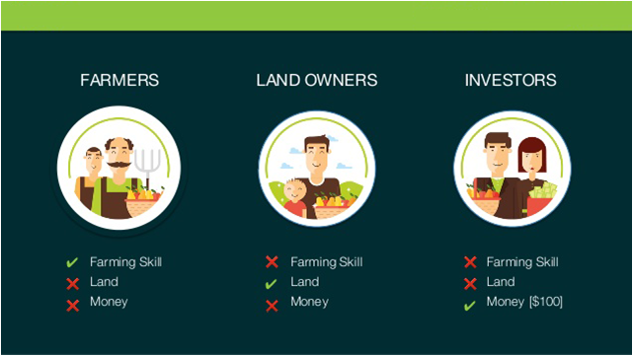
Figure 1: Project Introduction

Background

Another aspect of a software system is the use of a central database. This database is the basis for all actions in the system and can be trivially updated and used to aid in all of the system’s processes, meaning all of the required information is stored in one central location and thus is easily accessible. This is a far more reasonable storage method than a paper-based file system, where the time of traveling to and physically searching the records for the required information could be a burden. Human error could also be a factor in that mistakes could be made in the filing process which would not occur in a well written database system and mistakes or changes on physical records can be messy to correct.

Motivations and Challenges

While working on this product we have to keep in mind only suitable information is only needed. We had conduct survey using questionnaire ask farmers, Investor and landowner about what problem do they face when they invest their money and when they give their lands and what’s problem face when farmers want work their problem gives us Motivation to do something for that type of people. We make a website who gives a plate farm for that type of people.

Goals and Objectives

Vision Statement
Enhancing Agriculture concept, Grow Economy, Taking the Farming to Next Level and Reducing Unemployment Ratio.

Mission Statement
“Agri Hub” connects farmers, landowners, and the investors to create food organic plantation, and we sell the crops directly to the customer like the highly networked supermarket:
- To give halal profit to every investor.
- To Financially Facilitate the local Farmer.
- Provide Good Quality & Good Quantity of Organic Food.
- Reducing Unemployment
- Reducing waste of Money

Literature Review/Existing Solutions

Market Overview
Agriculture is an important sector of Pakistan's economy. This sector directly supports the country's population and accounts for 26 percent of gross domestic product (GDP). The major agricultural crops include cotton, wheat, rice, sugarcane, fruits and vegetables. The irrigation system of Pakistan belongs to one of the world's largest systems to support agricultural production.

Market Needs
One of the major needs is Farming process is too old in Pakistan. Farmers don’t know about hybrid seeds and new Technology to grow their crops production and reduce cost.
Farmer doesn’t need use transport to carry their crops to grain markets. The Farmer carry their crops to the grain market and waiting for selling their crops and this procedure reduce profit and increase their expenses.

Market Trends
The Market trend is to less cost and to get more profit via new technologies and new generation of seeds.
Farmer don’t need use transport to carry their crops to grain markets. The Framers will free from all these obstacles of selling and waste of time, money and Transport.

Industry Analysis
Industry Size and Structure
Agriculture is an important sector of Pakistan's economy. This sector directly supports the country's population and accounts for 26 percent of gross domestic product (GDP). The major agricultural crops include cotton, wheat, rice, sugarcane, fruits and vegetables. The irrigation system of Pakistan belongs to one of the world's largest systems to support agricultural production. There are two main seasons in Pakistan for production of crops: crops such as cotton, rice and sugarcane start in May and are harvested in November, whereas the wheat crop extends from November to April. A key urgent need to improve agricultural production is to use resources, mainly land and water, more efficiently. However, the change is mainly dependent on large landowners, who own 40 percent of arable land and control most of the irrigation systems, making it difficult to pass wide-ranging reforms. Pakistan is a net importer of agricultural products, with total annual imports of approximately 2 billion USD, including wheat, edible oils, pulses and food additives.
Pakistan plays a major role worldwide as a rice exporter, and it annually exports approximately 2 million tons, which is 10 percent of the world's trade. In Basmati rice, approximately 25 percent of exports is Pakistan's share. Rice exports are the second highest source of income in Pakistan. Rice grains fulfil approximately 60 percent of the population of Pakistan's food needs, and rice is a potential source of food worldwide for animals during the winter. Rice is an important food for Pakistan. The usage of pesticides increased after the 1950s, when 250 metric tons of pesticides were imported for greater improvement of production. Its usage increased by 2158.6 percent from 1952 to 2004.
Cotton is another cash crop of Pakistan, and Pakistan is the world's largest producer of raw cotton. In 2011-2012, Pakistan ranked as the 4th largest cotton producer, with a 9.81 percent share in global cotton. In the same period, Pakistan's yarn exports contributed 26.1 percent and 14.3 percent to the global market. Cotton exports accounted for 46 percent of Pakistan's total exports and provided 35 percent employment to the labor force (FAO, 2012; GOP, 2012). According to current agricultural policy, the Pakistan Central Cotton Committee has aimed to increase the production of cotton from 40 percent to 60 percent (PCCC, 2008).

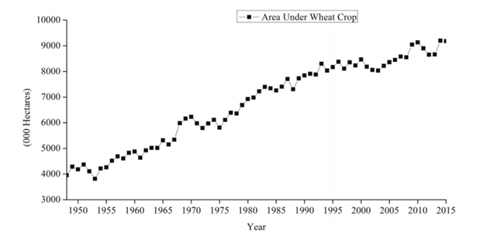
Figure 2: Area under wheat cultivation, 1948-2015
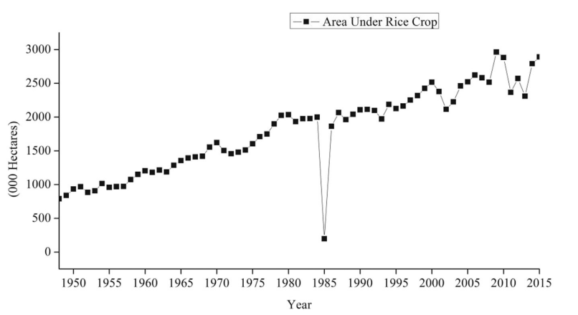
Figure 3: Area under rice crops, 1948-2015.

Porter’s Five Forces Model
The summarized form of industry analysis is done by porter’s five forces model that is given below:

Rivalry:
The level of competition with other is somehow prominent that there is not any company working on Agriculture solutions.

Threats of New Entrants:
Entry to this market is increasingly achieved through the diversification of operations by existing companies from other fields. Rivalry between market players is alleviated to an extent with larger players or offering their services by bringing innovation in Agriculture.

Threats of Substitute Product:
It may be possible that there exists any multinational company which is working on Agriculture solutions but on national level no one is working on this type of Agriculture/Farming.

Bargaining power of Supplier:
Skilled employees, as suppliers of technical knowledge and expertise, are an important input. And the farmer investor and land owner are also important input/source.

Bargaining Power of Buyer:
The market is fragmented with small players competing alongside large, multinational companies. Buyers range in size: larger buyers, with greater financial muscle, exert more buyer power.
Our product is newly brand in the market we will provide a plate form for farmer’s investors and landowners who invest their land and money. We will introduce a unique product which is so much different we will provide the services.

Gap Analysis

Our product is newly brand in the market we will provide a plate form for farmer’s investors and landowners who invest their land and money. We will introduce a unique product which is so much different we will provide the services.

Proposed Solution

“Agri Hub” will provide a platform to such famer’s farm where they can get opportunities like money and land without any interest.
“Agri Hub” will be able to provide a safe and profitable platform for those land investors. They only have to invest their land and get profit.
“Agri Hub” is a valuable and a largest Hub for such investors.

Project Plan

The Project Plan for the Agri Hub will be used to define the work that will be done for this project. It is also indicative of who will do each project. The Statement of Work, Resource List, Roles, Risks, and Schedule will all be stated in this document.

Work Breakdown Structure
Work Breakdown Structure is use to specify about the work how many time is required for work and which person is done for it

Roles & Responsibility Matrix

Roles & Responsibility Matrix:
The purpose of roles & responsibility matrix is to identify who will do what.

Table 1: Interface Design
 | Interface Designer
  Role
Member | Muhammad Hashir, Muhammad Sajid
Description | 1. Sketch a final design for the GUI

Table 2: Website Development
 | Website Development
  Role
 | Muhammad Hashir, Muhammad Sajid
  Member
Description | 1. make sure the tools  2. Make sure that the project works in various web browsers.

Role | Database Interaction
Member | Muhammad Hashir, Muhammad Sajid
Description | 1. Design and create a database for all necessary information that needs to be stored.  2. Ensure that there are queries created for every necessary function of the program.  3. Create the server that will allow clients to access the database.
Table 3: Database Interaction

Table 4: Tester
Role | Tester
Member | Muhammad Hashir
Description | 1. Fully test the code as components are created  2. Ensure that all components meet the requirements.

Table 5: Work Breakdown Structure
WBS # |  | WBS Deliverable | Activity # | Activity to Complete the Deliverable | Duration  (# of Days) | Responsible Team Member(s) & Role(s)
1 |  | Literature Review | 1.1 | 1.1.1 | 3 | Hashir
2 |  | Informal Requirements | 1.1 | 1.1.2 | 3 | Hashir
3 |  | Analysis Process | 1.2 | 1.2.1 | 3 | Sajid
4 |  | Formal Documentation | 1.2 | 1.2.2 | 4 | Sajid
5 |  | SRS | 1.2 | 1.2.3 | 7 | Sajid
6 |  | UML | 1.3 | 1.3.1 | 3 | Hashir
7 |  | Class Diagram | 1.3 | 1.3.2 | 2 | Sajid
8 |  | Deployment Diagram | 1.3 | 1.3.3 | 3 | Hashir
9 |  | Activity Diagram | 1.3 | 1.3.4 | 2 | Sajid
10 |  | Use Cases | 1.4 | 1.4.1 | 4 | Sajid
11 |  | ER Diagram | 1.4 | 1.4.2 | 3 | Sajid
12 |  | Sequence Diagram | 1.4 | 1.4.3 | 3 | Hashir
13 |  | System Sequence Diagram | 1.4 | 1.4.4 | 4 | Sajid
14 | Package Diagram |  | 1.4 | 1.4.5 | 3 | Hashir
15 | Network Diagram |  | 1.5 | 1.5.1 | 4 | Sajid
16 | WEB UI |  | 1.6 | 1.6.1 | 30 | Hashir,Sajid
17 | PHP (laravel) |  | 1.7 | 1.7.1 | 30 | Hashir
18 | MS SQL SERVER |  | 1.8 | 1.8.1 | 20 | Hashir,Sajid
19 | Module Testing |  | 1.9 | 1.9.1 | 15 | Sajid
20 | System Testing |  | 1.9 | 1.9.2 | 15 | Hashir
21 | Web App on server |  | 1.10 | 1.10.1 | 4 | Sajid,Hashir

Gantt Chart

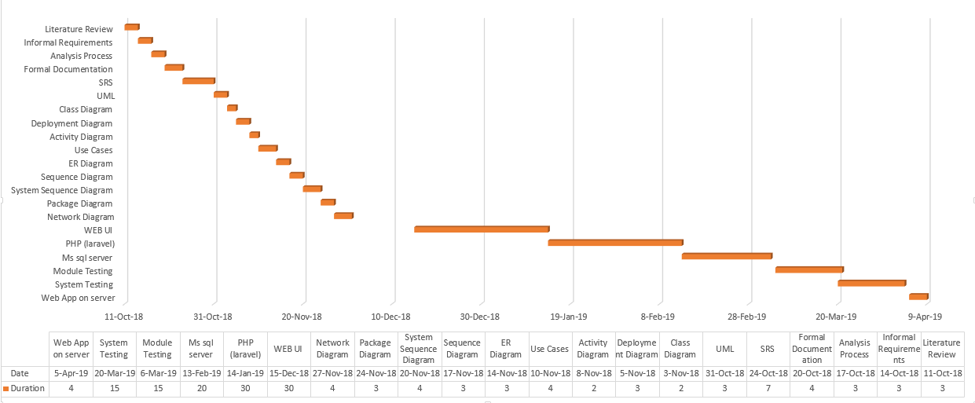

Figure 4: Gantt chart

Report Outline

In this chapter we discuss about problem which we face and give you its solution, background of proposed system, why we introduce and what problem this system is solving, project plan of our proposed system how we make and gather information, what kind of task we have to make this project, what kind of challenges we face to make this project prototype, background and assign tasks to group members and their role models.

Chapter 2

Software Requirement Specifications

Chapter 2: Software Requirement Specifications

Introduction

In this chapter we will discuss about the purpose of the project we discuss about the feature of the project and explain. Implementation and design Intended Audience and Reading Suggestions product perspective and many more things about the project

Purpose
Our purpose to make this website is to provide the plate form for those people who want work like farmer they looking for work, our website provides the plate form for the farmers they came our website and check the work and contact with us.
Our website provides the plate form for that type of investor who invest their money with safe and trustable place, our website provides the safest and trust able place for that type of investor.
Our website provides the plate form for that type of landowner who invest their land.

Intended Audience and Reading Suggestions

This document is written for developers of the system, project manager, client and complete staff of a retail store including an IT engineer who will look after the system after it is installed and operational. Document is written in proper manner so reader should read this document in the defined order.

Product Scope

The scope of this project is to connect those people who invest their land who want land for his crops and those type of people who invest their money. The Market trend is to less cost and to get more profit via new technologies and new generation of seeds which provide Healthy crops and lead to less cost.
Farmer don’t need use transport to carry their crops to grain markets. The Framers will free from all these obstacles of selling and waste of time, money and Transport.
“Agri Hub” will provide a platform to such famer’s farm where they can get opportunities like money and land without any interest.
“Agri Hub” will be able to provide a safe and profitable platform for those land investors. They only have to invest their land and get profit.
“Agri Hub” is a valuable and a largest Hub for such investors.

Overall Description

We will define the product perspective, product functions and features of our system user class and characteristics

Product Perspective

The software described in this SRS is the software for a complete agri hub system. The system is based on just software there is no hardware include in this product.
Our main perspective to provide a platform to such famer’s form where they can get opportunities like Money and Land without any interest and provide a safe and profitable platform for those land investors. They only have to invest their land and get profit and provide a platform valuable and a largest Hub for investors who invest his money.

Product Functions

The main function of our product is:
- Farmer see the land location and request on website where they like to work
- landowner invest the land using our website
- investor see and chose the land where they want to invest their money

User Classes and Characteristics
The end-users of this project fall into three user class categories,
- unskilled
- partly skilled
- Highly skilled
Unskilled user:
Unskilled user are those type of user who haven’t relevant prior skill or education other than basic abilities to operate an system
Partly skilled user:
The farmer, landowner and investor. They should be able to use the system and further be able to train others with minimal training themselves. They must be able to explain all elements of the user interfaces except the server. This class of user would be expected to have a junior high-school certificate education or equivalent.
Highly skilled user:
The software should not be needlessly complex, but it is still expected not to be entirely 'plug and play'. This class of user is expected to have a high-school certificate or equivalent, as well as extensive computer experience.

Operating Environment

- Angular is use for front-end in our project.
- PHP is use for back-end in our project with laravel framework.
- MYSQL is use for connectivity for Database in our project.
- Local host is use for server in our project.
- Angular has its own embedded debugging so that’s why we are not any type of software for debugging.

Design and Implementation Constraints

In the front end we are using angular JS using this language we make the frond-end of our project (Agri hub) and we are using PHP to make back end using laravel frame work. We are using SQL lite for database. The system must provide a capacity for parallel operation. The end system should also allow for seamless recovery, without data loss, from individual device failure. There must be a strong audit chain with all actions logged. It is worth noting that this system is likely to conform to what is available. With that in mind, the most adaptable and portable technologies should be used for the implementation. If the system is down, then customers must not notice, or notice that the system recovers quickly (seconds). The system must be reliable enough to run crash and glitch free more or less indefinitely, or facilitate error recovery strong enough such that glitches are never revealed to its end-users.

User Documentation

- Online documentation facility is available for the users to assess them for the easy use.
- A specific document should be prepared for the maintenance of the system and should say the system in easiest way.

Assumptions and Dependencies

- Client/User has an active Internet Connection
- Client/User runs an operating system which supports minimum requirements.
- Information retrieval from Database is important.

External Interface Requirements

User Interfaces
The means by which the user and a computer system interact, in particular the use of input devices and software in our project the user interface are given below.
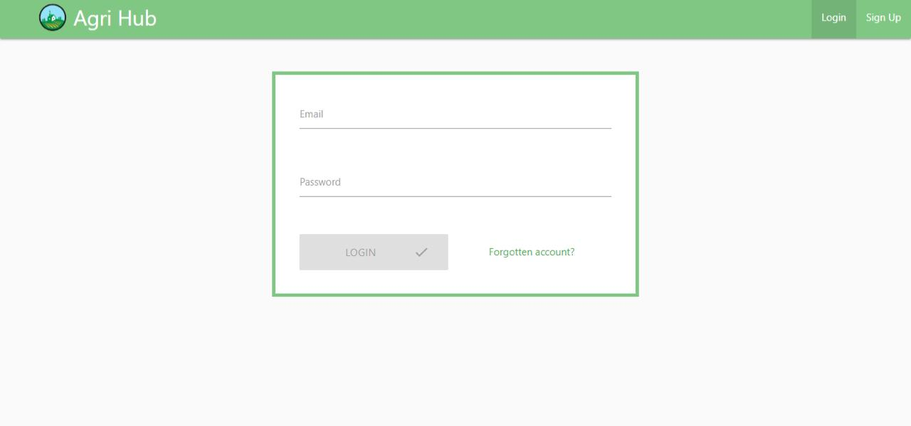
Figure 5: login user interface
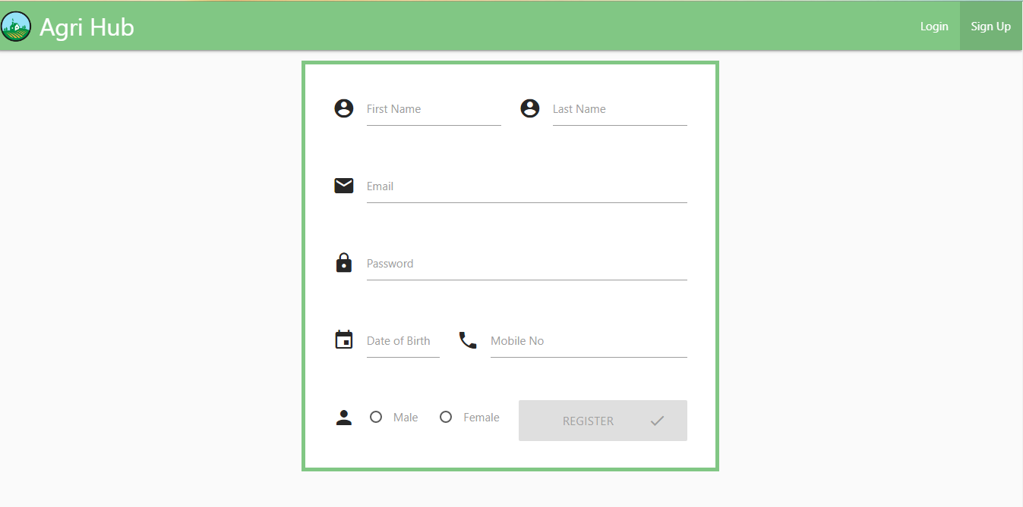
Figure 6: registration user interface
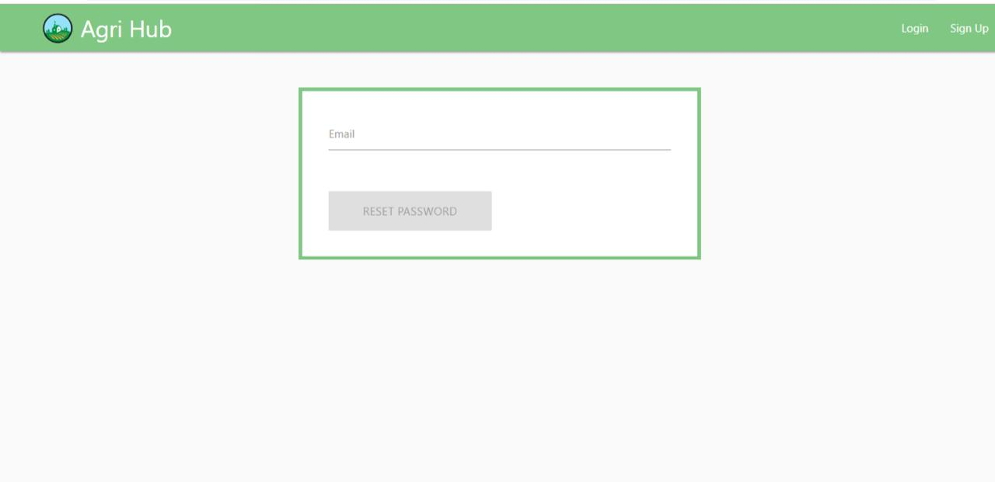
Figure 7:Password reset user interface

Hardware Interfaces

To run the website a cell phone or laptop, computer or higher and minimum of 1GB of Ram with any processor type whether it is 64bit or 32bit can run the application. An internet connection is needed for website to run which is both possible with Wi-Fi or Cellular Network, through which information will be retrieved from database and displayed on cell phone screen.

Communications Interfaces

The requirements associated with any communications functions required by this product, including e-mail, web browser, network server communications protocols, electronic forms, and so on. Define any pertinent message formatting. Identify any communication standards that will be used, such as FTP or HTTP. Specify any communication security or encryption issues, data transfer rates, and synchronization mechanisms.
- Client on Internet will be using HTTP/HTTPS Protocol.
- Client on intranet will be using TCP/IP protocol.

System Features

The system must be able to show information to user in real time. The system must be able to add or delete information in admin panel.
- Database should be working fine
- Internet connection is must

System Feature 1

Retrieve information form users and show it on the panel for admin and users as well.

Description and Priority

It is of High priority feature, without this feature this website doesn’t work. The feature work is to get information from users and show it to the Administration panel with minimum time (each rated on a relative scale is 9)

Stimulus/Response Sequences
This action performs after every 1 minute to retrieve information from database. User use websites or not this operation will perform.

Functional Requirements

Functional requirement is referring to the functionalities must be apply to a system. The Functional requirements of online agri hub system are stated below.
REQ-SF1-1: The system shall provide a registration page.
REQ-SF1-2: The system shall provide a login page.
REQ-SF1-3: The system must be able to allow user to show land.
REQ-SF1-4: internet connection is compulsory while filling the login/registration page.

System Feature 2 (and so on)

- Functional requirement is referring to the functionalities must be apply to a system.
- The system must be able to show information to user in real time.
- The system must be able to process the information of online transaction.
- The system will show the land for the user.

Other Nonfunctional Requirements

Nonfunctional requirements are usually some of constraint or restriction that must be considered when designing the solution. Nonfunctional requirements tend to identify user constraints and system constraints.
USABILITY: -
The software should be user friendly and easy to understand. Interface should be comfortable so that it will be easy for the user to operate. The tool must be intuitive or easily understood after the tutorials and user guide. Display should be presentable.
CHANGEABILITY:
The software should be designed in such a way that any future modifications or improvisation can be done with much more functionality.
Efficiency:
The project must be efficient such that it can select image and display in scaled manner within the GUI. Software should provide reliable result.
Portability:
The system should be able to run on any platform. This project runs on windows 98/2000/ XP/vista operating system.

Performance Requirements

- The website should able to show the lands for users.
- The website should provide the safe place where investor invest their money
- The website should provide the safe place where landowner gives their land for any doubt.
- The website should provide the place where a farmer comes and contact us for work.
- The website should allow user to access information in anywhere with anytime

Safety Requirements
In this case data or anything cannot be loss but if someone Access this for some wrong purpose then it might be harmful. So we make sure anyone who access this website is a valid person by giving them user name and password to access.

Security Requirements

User name and passwords only given to employee or users, no can access their information except admin of this system.
Some of the factors that are identified to protect the software from accidental or malicious access use, modification, destruction, or disclosure are described below. Specific requirements in this area could include the need to:
- Keep specific log or history data sets
- Assign certain functions to different modules
- Restrict communications between some areas of the program
- Check data integrity for critical variables
- Later version of the software will incorporate encryption techniques in the user/license authentication process.

Software Quality Attributes

This website gives you platform where you see and invest their money and land and this website provide you a platform where farmer or anyone who want to work on land, they come our website and contact us, but without internet you can’t use its functionalities. This website is not adaptive; its availability depends on internet; show you exact information whenever it is there. This website will run on any kind of web browser.

Business Rules
In this website internet and database should be working otherwise this website did not work.

Other Requirements

There are no other requirements or specific thing needed to run the website or to run it in development phase all of the information is written above for better understanding.

Chapter 3

Use Case Analysis

Chapter 3: System Analysis
In this chapter we will discuss about the use case and fully dressed use case. In use case we will define in this chapter each entity and its attributes and combine system and discuss about the system using fully dressed use case

Use Case Model

A use case is a methodology used in system analysis to identify, clarify, and organize system requirements. The use case is made up of a set of possible sequences of interactions between systems and users in a particular environment and related to a particular goal.
Figure 8: Use Case for AgriHub
Figure 9: Farmer Usecase
Figure 10: Investor Usecase

Figure 11: Landowner Usecase
Figure 12: Admin Usecase

Fully Dressed Use Cases

Fully dressed use cases show more detail and are structured; they are useful order to obtain a deep understanding of the goals, tasks, and requirements.

Table 6: Fully Dressed usecase of system
Use case name: | Create customer account
Scenario: | Create online customer account
Triggering event: | New customer want to new setup account online
Brief description: | Online customer create customer account by entering basic information and then following up with one or more addresses and a credit or debit card
Actors: | Customers
Preconditions: | Customer account subsystem must be available  Any status that the system must be in or conditions that must be met before the use case is started
Post condition: | Any status that the system must be in or conditions that must be met after the use case is completed successfully.  Customer must be created and save  One or more address must be created and save  Account must be created and save  Address and account must be associated with customer  Credit/debit card information must be validated
Stakeholder: | Landowner, investor and farmer
Assumption: | Any statement assumed to be true about the system
Flow of activities | Actor system
  1: customer indicates desire to create customer account and enters basic customer information  2: customer enters credit/debit card information. | 1.1: system create a new customer.  1.2: system prompts for customer addresses. 2.1 system create addresses. 2.2system prompts for creadit/debit card
Exception condition: | Basic customer data are incomplete  The address isn’t valid  Credit/debit information is not valid

Table 7: Farmer usecase
Use case name | Farmer
Stakeholder interest | Farmer want to see the crops, check the crop work and apply for work
Precondition | Farmer must be register in this system
Main scenario | Farmer log on to the system  Farmer searching the crop and they apply for work on crop  Farmer select crop to work on it  Farmer display crop details  Farmer confirm the work  Farmer logout
Exceptions | ex1: system down  - Display the message error  - Use case end  Ex2: land is not available  System display the message chose another land its already booked  Ex3: incomplete/incorrect information  - basic customer data are incomplete  - the address isn’t valid

Table 8: Investor Usecase
Use case name | Investor
Stakeholder interest | Investor want to see the Crops, check the Crops where they invest their money and apply for it
Precondition | Investor must be register in this system
Main scenario | Investor log on to the system  Investor searching the Crops and they apply for invest on their crops  Investor select crops to invest in  Investor display Crops details  Investor confirm the investment  Investor logout
Exceptions | Ex1: system down  - Display the message error  - Use case end  Ex2: land is not available  System display the message chose another land its already booked  Ex3: incomplete/incorrect information  - basic customer data are incomplete  - the address isn’t valid  - Credit/debit information is not valid

Table 9: Landowner usecase
Use case name | Landowner
Stakeholder interest | Landowner want to provide his land for crops and make some money
Precondition | Landowner must be register in this system
Main scenario | Landowner log on to the system  Landowner enroll his land  Landowner display land details  Landowner confirm the enrollment  Landowner logout
Exceptions | ex1: system down  - Display the message error  - Use case end  Ex2: incomplete/incorrect information  - basic customer data are incomplete  - the address isn’t valid

Chapter 4

System Design

Chapter 4: System Design
In this chapter we will discuss about the system designs in this chapter we will discuss how class diagram work when system is run, what is the architecture diagram before system is created, in this chapter we will discuss about the Sequence/ collaborate diagram and discuss about the system activity.

Architecture Diagram

Figure 13: Architecture Diagram

State transmission diagram

State transmission diagram for farmer:

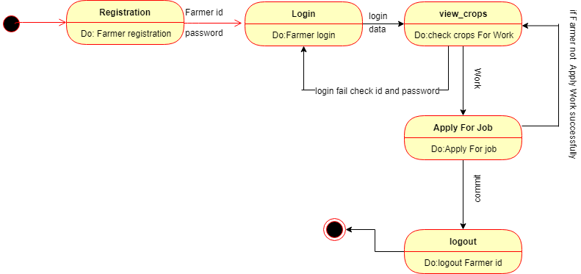
Figure 14: State Diagram for Farmer

State transmission diagram for investor:

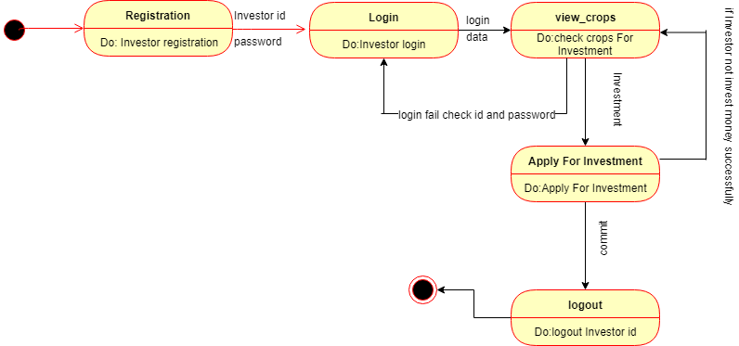
Figure 15: State Diagram for Investor

State transmission diagram for landowner:

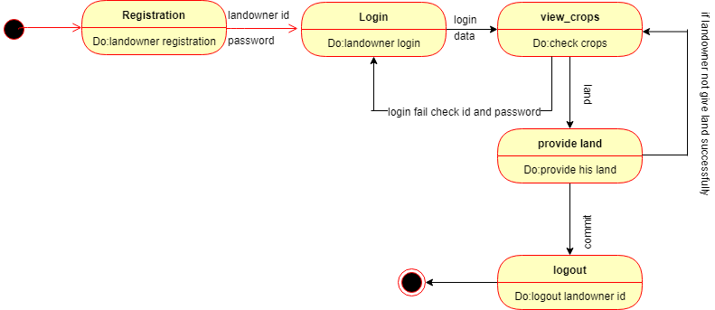
Figure 16: State Diagram for Landowner

Operation contracts

    - Operation contract for farmer
Table 10: Operation Contract for Farmer
Contract | Co1: searching work on Crops
Operation | Search Crops on work in database and return the result
Output | If farmer require on land then show land status otherwise notify this land is not exist for work
precondition | Farmers must be logged in into the system

    - Operation contract for investor
Table 11: Operation Contract for investor
contract | Co2: searching Crops for investment
operation | Search Crops on invest in database and return the result
Output | If Crops exist then show Crops status otherwise notify this Crop is not exist for investment
precondition | investor must be logged in into the system

    - Operation contract for landowner
Table 12: Operation contract for landowner
Contract | Co3: provide land
Operation | Provide detail about its land
Output | If land is fulfill requirements then notify acceptance otherwise notify your about decline
precondition | landowner must be logged in into the system

    - Operation contract for admin
Table 13: Operation contract for admin
Contract | Co4: Management
Operation | Manage system everything in system etc. land, investment
Output | if data is valid then it perform action otherwise show error
precondition | Admin must be logged in into the system

Domain Model

Figure 17: Domain Model

Entity Relationship Diagram with data dictionary

Table 14: data dictionary
Entity | Attributes | Data Type | Primary Key | Foreign Key | Null able
Admin | Id | Int | yes
 | Name | Varchar
 | Email | Varchar
 | Phone no | Number
 | City | Varchar
Farmer | FId | Int | Yes
 | Name | Varchar
 | Address | Varchar
 | Phone no | Number
 | City | Varchar
Landowner | LId | Int | Yes
 | Name | Varchar
 | Address | Varchar
 | Phone no | Number
 | City | Varchar
 | Email | Varchar
Land | Id | Int | Yes
 | Lid | Int |  | Yes
 | Invid | Int |  | Yes
 | Fid | Int |  | yes
 | Location | Varchar
 | Type | Varchar
 | Measure | Float
Investor | InvId | Int | Yes
 | Name | Varchar
 | Address | Varchar
 | Phone no | Number
 | City | Varchar
 | Email | Varchar
Payment | Id | Int | Yes
 | Amount | Float
 | Type | Varchar
 | Invid | Int |  | yes

Figure 18: Entity Relationship Diagram

Class Diagram
Figure 19: Class Diagram

Sequence / Collaboration Diagram

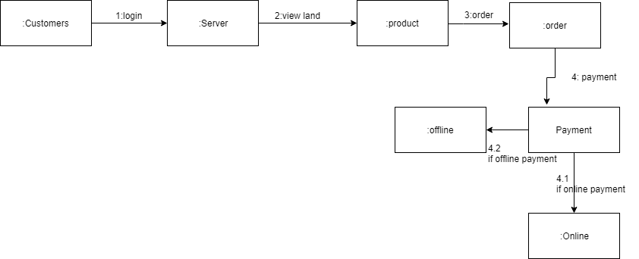
Figure 20: Collaboration Diagram for system

Figure 21: Collaboration Diagrams

Activity Diagram
Admin:

Investor:

Figure 22: Activity Diagram of Investor

Landowner:
Figure 23: Activity Diagram of Landowner
Farmers:
Figure 24: Activity Diagram of Farmer

Component Diagram

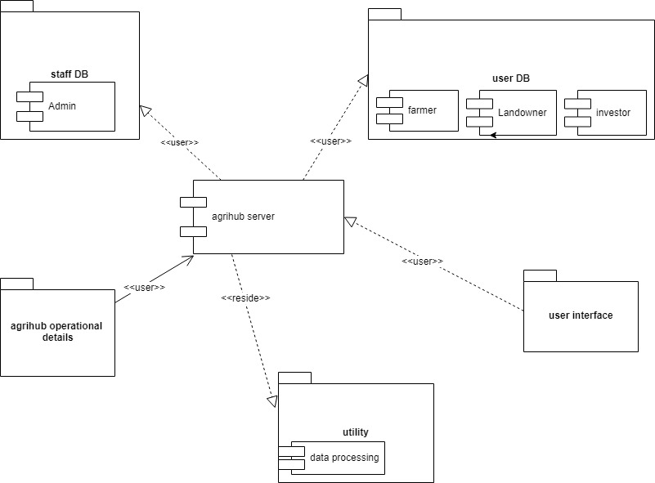
Figure 25: Component Diagram of System

Deployment Diagram

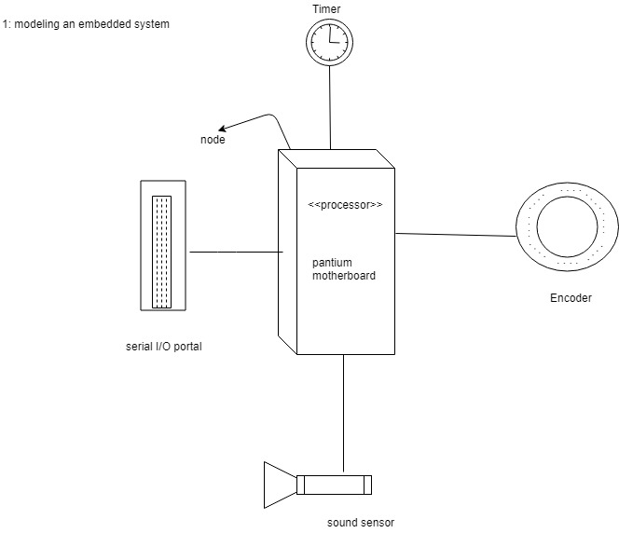
Figure 26: Modeling an embedded system

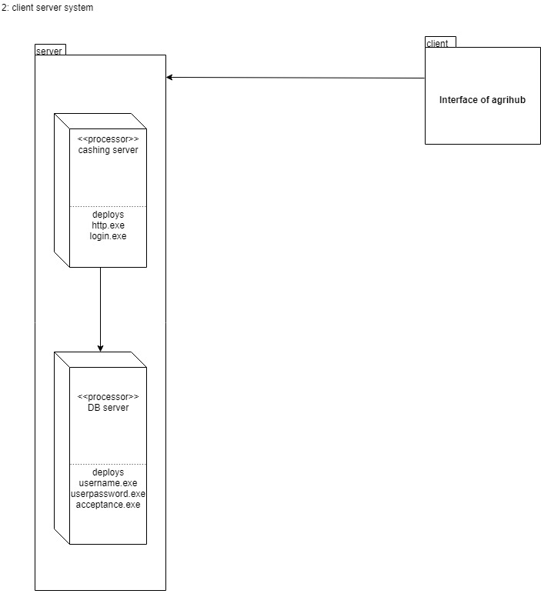
Figure 27: Client server system

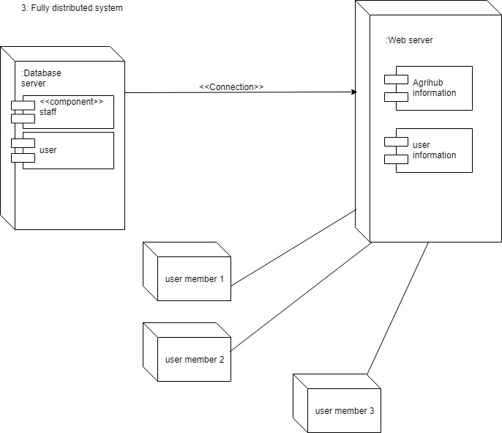
Figure 28: Fully distributed system

Chapter 5

Implementation

Chapter 5: Implementation
The process of putting a decision or plan into effect; execution.

In this chapter we will discuss about the pseudo codes or important flow control and we tell in this chapter what we use tool or techniques use in this system. In this chapter we will tell about what the library, webserver are use in this system implementation.

Important Flow Control/Pseudo codes

Sign In Page

If email and password validate
Login button enable
If user authorize
Login successfully
Else
Error message show
Else
Login button disable

Sign up page
If first name, last name, date of birth, email, password, gender fill
Enable register button
If button click
Register successfully
Else
Show about error
Else
Disable register button

Reset Page
If email exist
Rest Password send by email
Else
Show error account not exist

Components, Libraries and Web Services
Components:
- Login
- Registration
- Reset password
- Manage land
- Manage investment
- Manage farmer
- Manage analysis
- Added profile
- Manage profile
Web Server:
- Localhost
Library:
- Sentinel
- Passport
- Materialize CSS
- RxJS
- JQuery library

Deployment Environment

In our project we use Localhost Deployment Environment for backend and frontend.

Tools and Techniques
Techniques:
- Php(laraval)
- Java script (angular)
Tools:
- Webstorm
- PHPstorm

Best Practices / Coding Standards

Coding standards in our project is:
- OOP
- Framework

Version Control

In our project our version control is Github local repository.

Chapter 6

Testing and Evaluation

Chapter 6: Testing and Evaluation
Testing is a process, which reveals errors in the program. To make sure the unavailability of any error or bug, we run a simulation test on the system. Different cases and different types of testing will run to check the system is running well or not. If there is any error during the testing, then provide a solution to outcomes the errors. In this Chapter we provide the whole System testing and evaluation that how to use the system and what work has been done by which feature.

This chapter is the software test report of the multiple types of testing phases we faced during the Rolling Food project. It contains the results of tests, which were executed during the testing phases.

Use Case Testing
Login page testing (admin)
Table 15: Admin testing
Test Case ID | TC001
Test Case Summary | When admin click on login button it must be login and show the Dashboard page.
Prerequisites | User must be on login page and have username and password
Test Procedure | Verify the user Email and password.
Actual Result | User successful login.
Status | Successful.
Add user/ admin | Add a new user to the database to allow him to use services of system
Remove user | Remove a user to the database
Payment proceeding | Manage payments from customers.
Test Steps | - Navigate the login page  - Enter the Email  - Enter the password  - And click on Log In Button  - Add new user or admin  - Remove user  - Manage payment  - Logout

Sign up testing
Table 16: sign up testing
Test Case ID | TC002
Test Case Summary | User must be sign up after filling form.
Prerequisites | User must be on sign up page.
Test Procedure | Verify the inputs given in form.
Expected Result | User must be allotted username and password and show welcome message on Dashboard.
Actual Result | User successful sign Up
Status | Successful.
Test Steps | - Navigate the sign up page.  - Fill up the form.  - Select User Role (Farmer, Investor, Landowner)  - And click on Sign up button

Farmer Testing
Table 17: farmer testing
Test Case ID | TC003
Test Case Summary | Firstly fill the registration form and after this When Farmer click on login button it must be login and show the Dashboard page.
Prerequisites | User must be on login page and have username and password
Test Procedure | Verify the user Email and password.
Actual Result | User successful login.
Status | Successful.
Check work and apply | Farmer check the work after login and apply for work where he want.
Test Steps | - Navigate the login page  - Enter the Email  - Enter the password  - And click on Login Button  - Check the crops  - Apply for work  - Logout
Landowner Testing
Table 18: landowner testing
Test Case ID | TC004
Test Case Summary | Firstly fill the registration form and after this When landowner click on login button it must be login and show the Dashboard page.
Prerequisites | User must be on login page and have username and password
Test Procedure | Verify the user Email and password.
Actual Result | User successful login.
Status | Successful.
Provide land | Landowner provide the land throw this website
Test Steps | - Navigate the login page  - Enter the Email  - Enter the password  - And click on Login Button  - View crops  - View lands  - Provide the lands  - Cancel land  - Logout

Investor Testing
Table 19: investor testing
Test Case ID | TC005
Test Case Summary | Firstly fill the registration form and after this When investor click on login button it must be login and show the Dashboard page.
Prerequisites | User must be on login page and have username and password
Test Procedure | Verify the user Email and password.
Actual Result | User successful login.
Status | Successful.
invest | Investor gives invest
Test Steps | - Navigate the login page  - Enter the Email  - Enter the password  - And click on Login Button  - View Crops  - Give investment/ provide investment  - Cancel investment  - Logout

Extensions (Errors)
Table 20: Extensions (Errors)
No. | Step | Description
1-a | Login failed | Login failed if admin enter wrong username  System will display an error message
1-b | Login failed | Login failed if admin enter wrong password.  System will display an error message
2 | Registration failed | Registration will have failed if a new user doesn’t follow the rules  System will display an error message
3-a | Login failed | Login failed if farmer enter wrong username  System will display an error message
3-b | Login failed | Login failed if farmer enter wrong password.  System will display an error message
4-a | Login failed | Login failed if Investor enter wrong username  System will display an error message
4-b | Login failed | Login failed if Investor enter wrong password.  System will display an error message
5-a | Login failed | Login failed if Landowner enter wrong username  System will display an error message
5-b | Login failed | Login failed if Landowner enter wrong password.  System will display an error message

Boundary value analysis
Boundary testing in the process of testing that is between start point and extreme ends or boundaries between partials of input values.

Login username

- Username that a person enter in the text box at the time of login must be correct.
- If the username is not correct, the system must restrict the user at the current page.

Login password

- Username that a person enter in the text box at the time of login must be correct.
- If the username is not correct, the system must restrict the user at the current page.

Text fields:

- All text fields system has must accept only correct text
- User must add that information which is needed and to the point
- Text fields are name, city, country etc.

Numeric fields:

- The numeric fields must accept only numbers
- Numeric fields are mobile number, CNIC number, quantity of products etc.

Email fields:

- Emil fields are also available in the software system
- Email fields must accept email formats.

Data flow testing
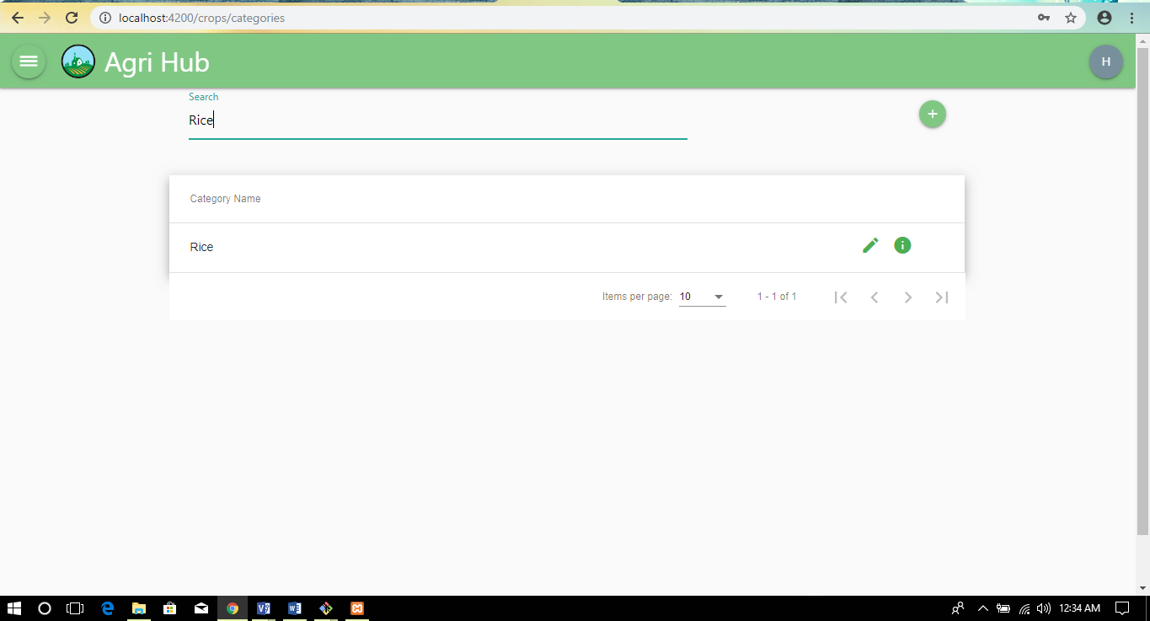
Figure 29: Data searching

In Figure 29 show us the data is fetch correctly from database in this project we use to store the data using SQL lite and this picture shows us database working correctly they fetch the data correct from database and shows us on screen. In this screen short you see that we search the rice and they give us correctly, its mean data is flow correctly.
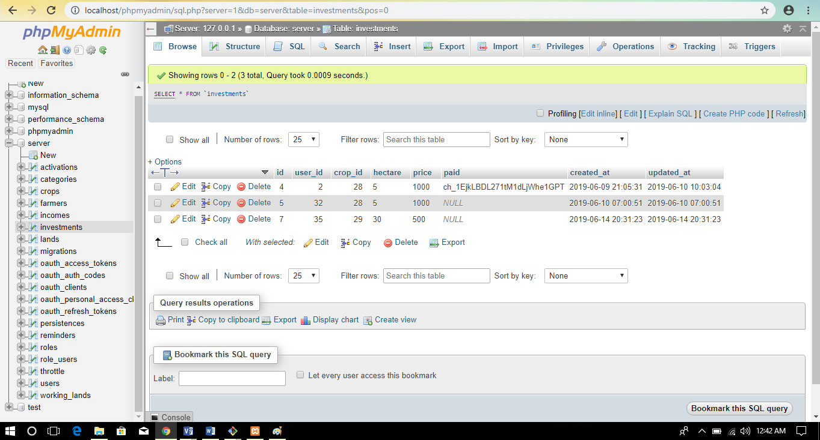
Figure 30: data Flow testing
Figure 30 show us that data is correctly flow on database system and store correctly as we want so we say that data flow testing is correct.

Unit testing
Unit testing is carried out screen-wise, each screen being identified as an object. Attention is diverted to individual modules, independently to one another to locate errors. This has enabled the detection of errors in coding and logic.

Point 01:
In unit testing we check all button working correctly or not.
Sign up button working correctly
Registration button working correctly
Send Code button working correctly
Login button working correctly

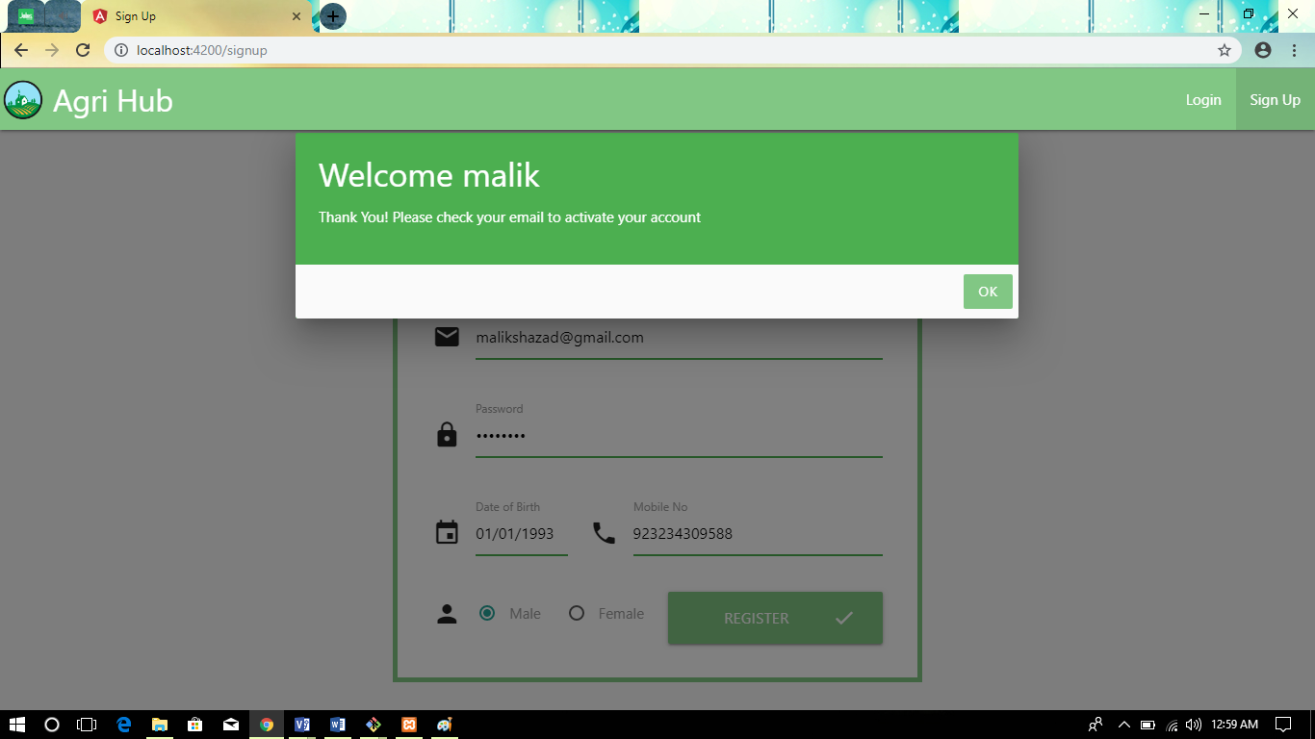
Figure 31: unit testing for Registration page button
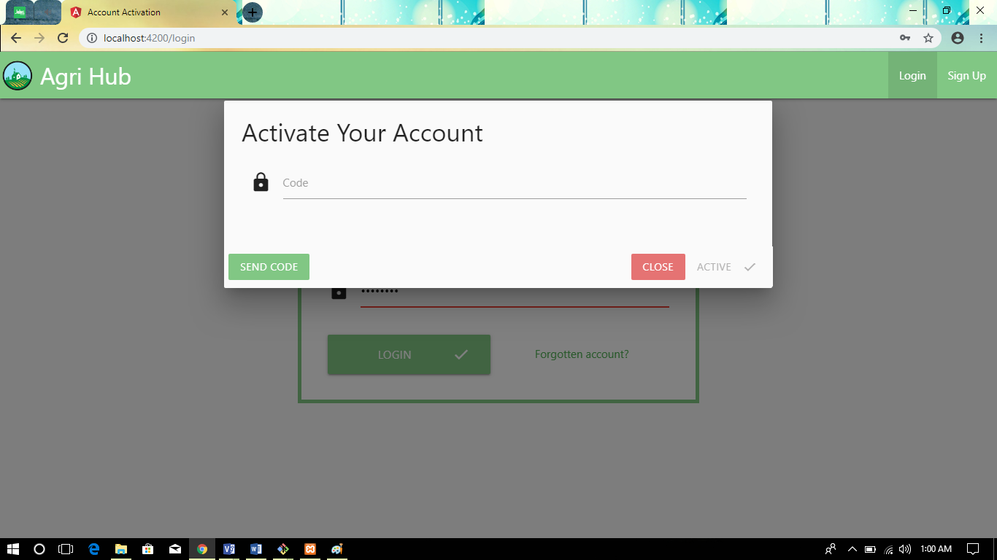
Figure 32: unit testing for send code button working
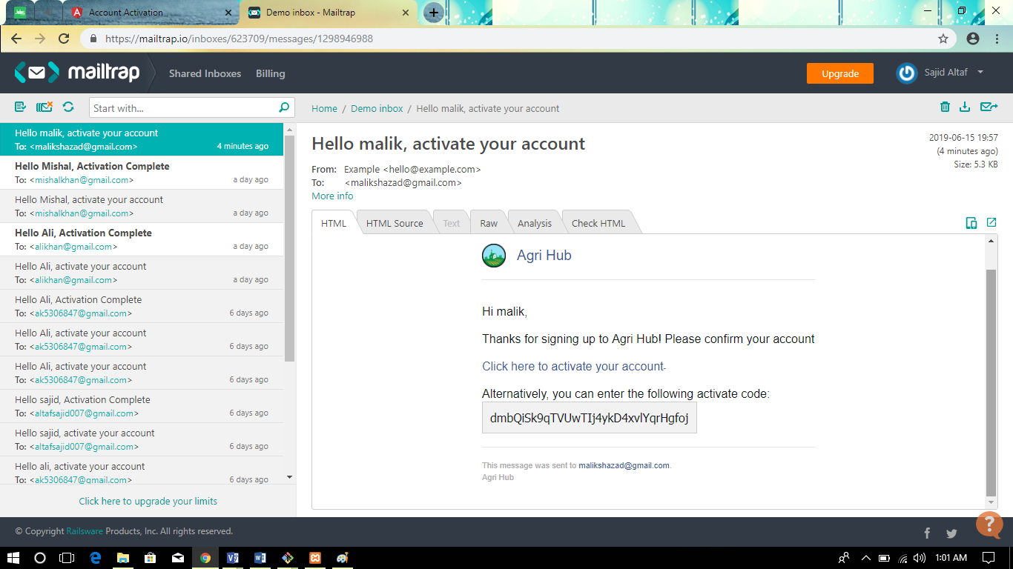
Figure 33: unit testing for Activation code

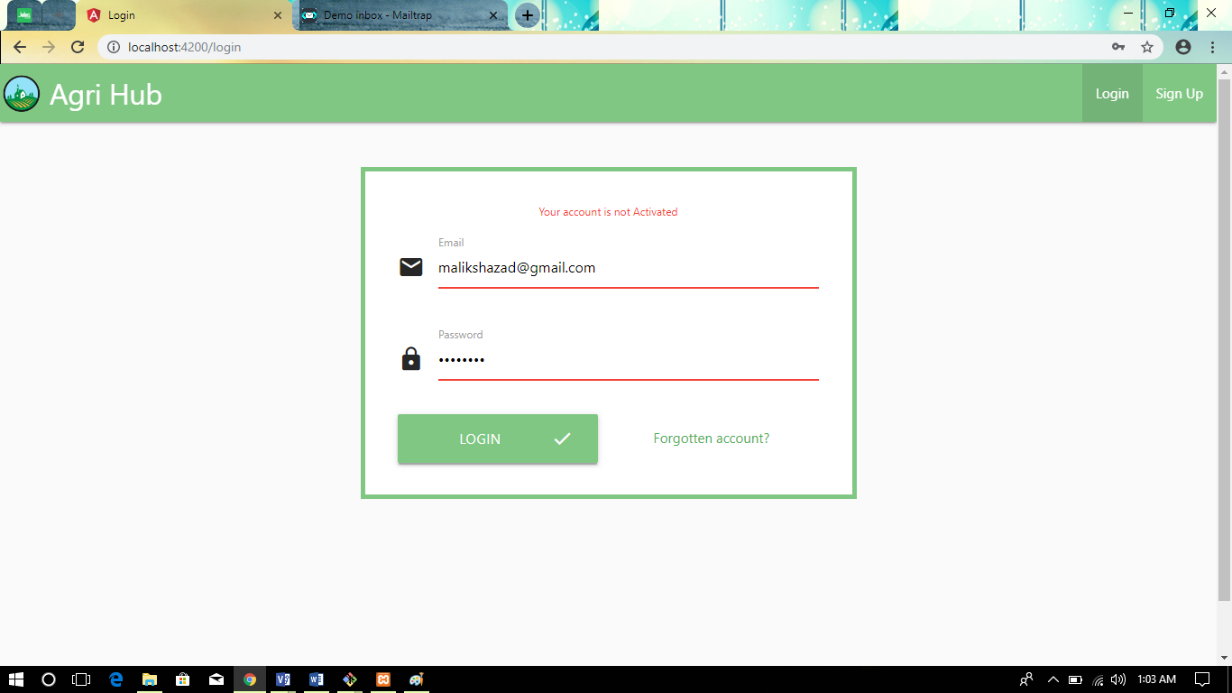
Figure 34: unit testing for Login button
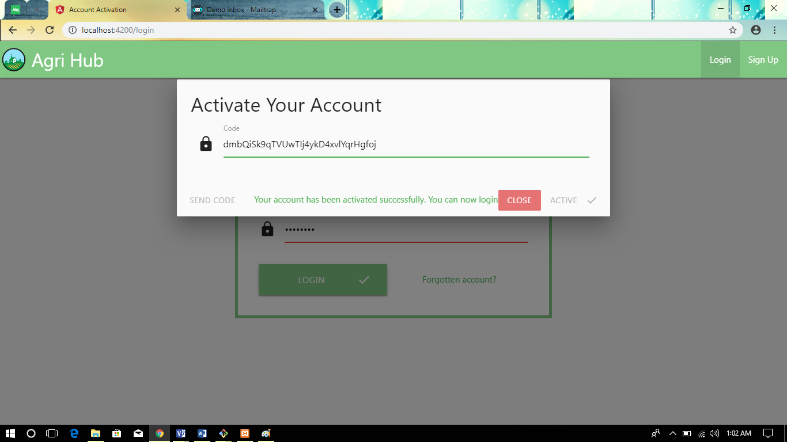
Figure 35: unit testing for Active button

Point 02:
Crops detail button working correctly
Apply button working correctly
Job apply button working correctly
Admin permission button working correctly
Investor button working correctly
Landowner add land button working correctly

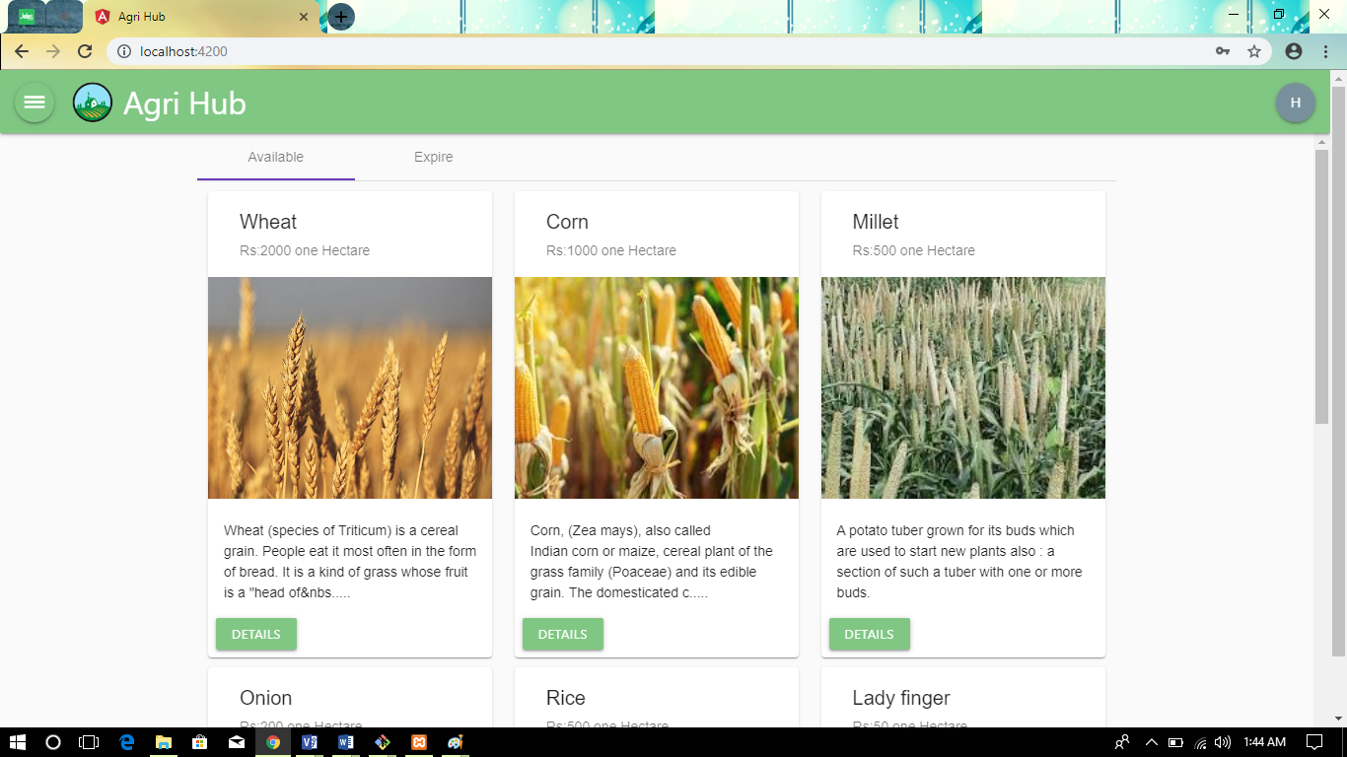
Figure 36: unit testing for Crops detail button

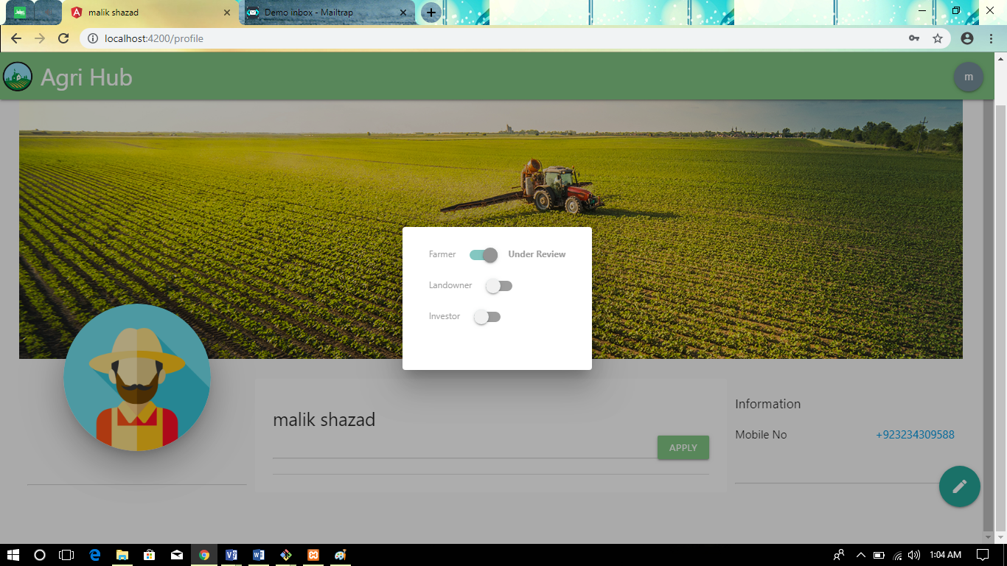
Figure 37: unit testing for farmer apply button
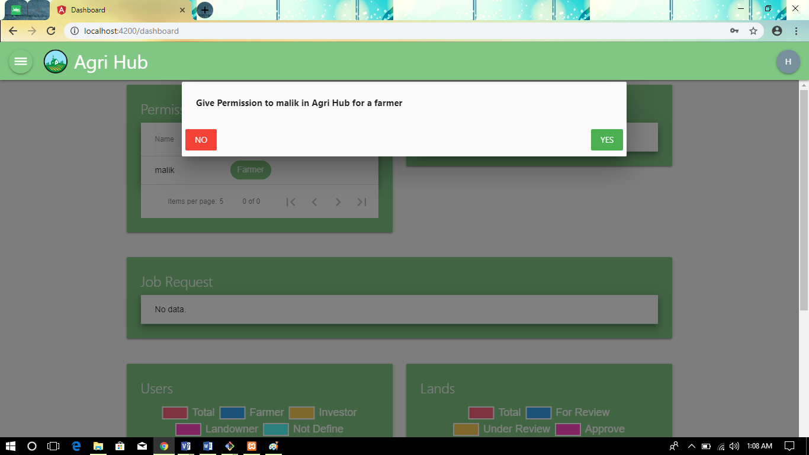
Figure 38: unit testing for admin permission button

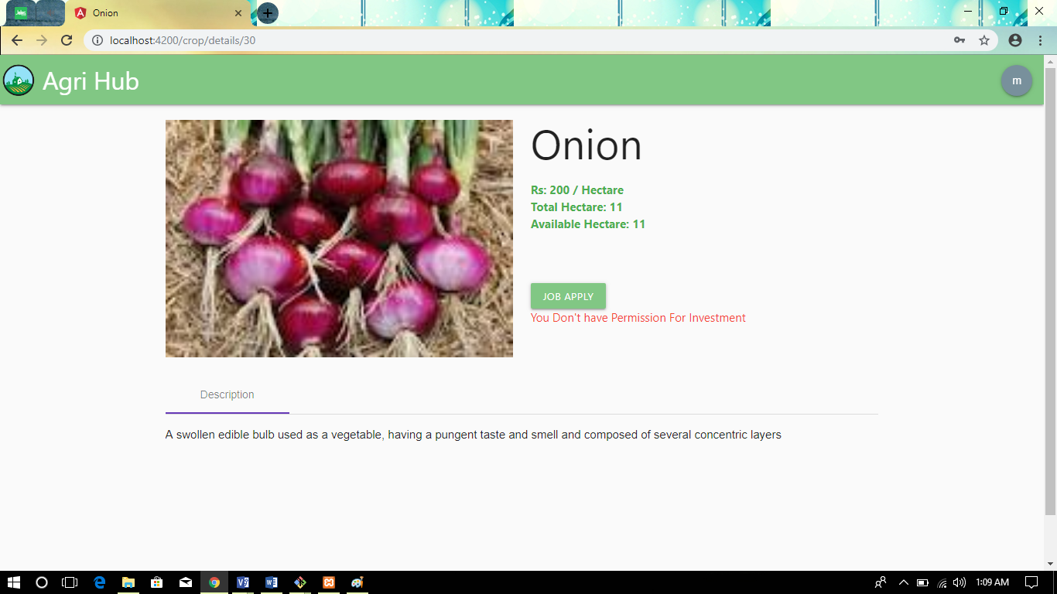
Figure 39: unit testing for job apply button

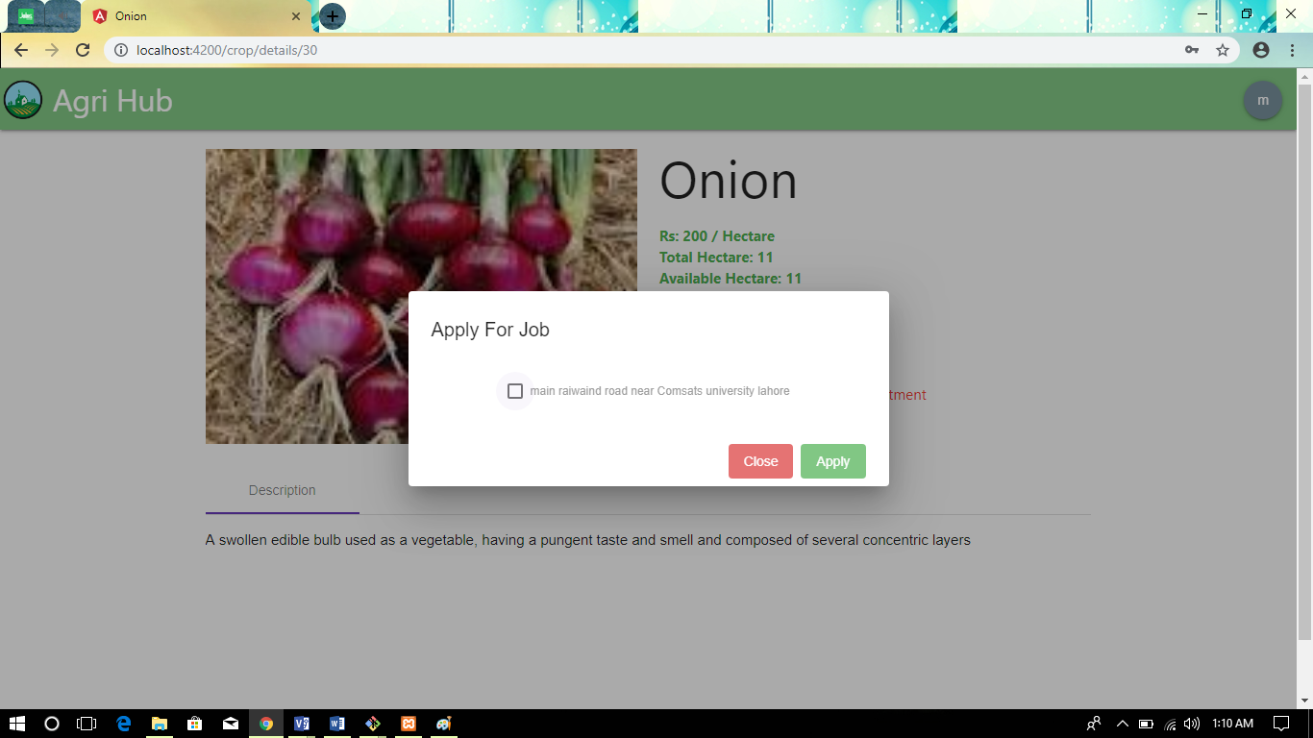
Figure 40: unit testing for Apply job button

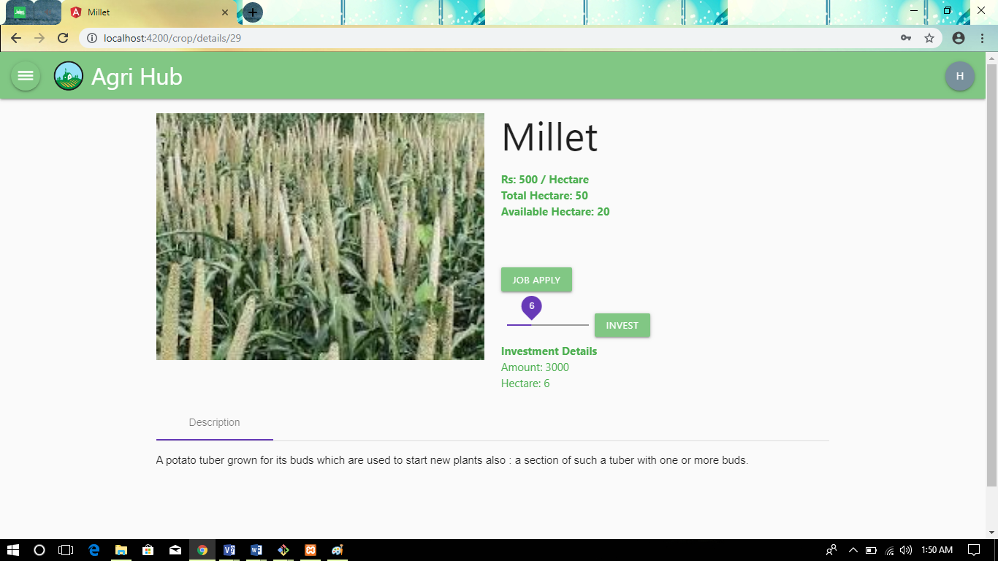
Figure 41:unit testing for investment button

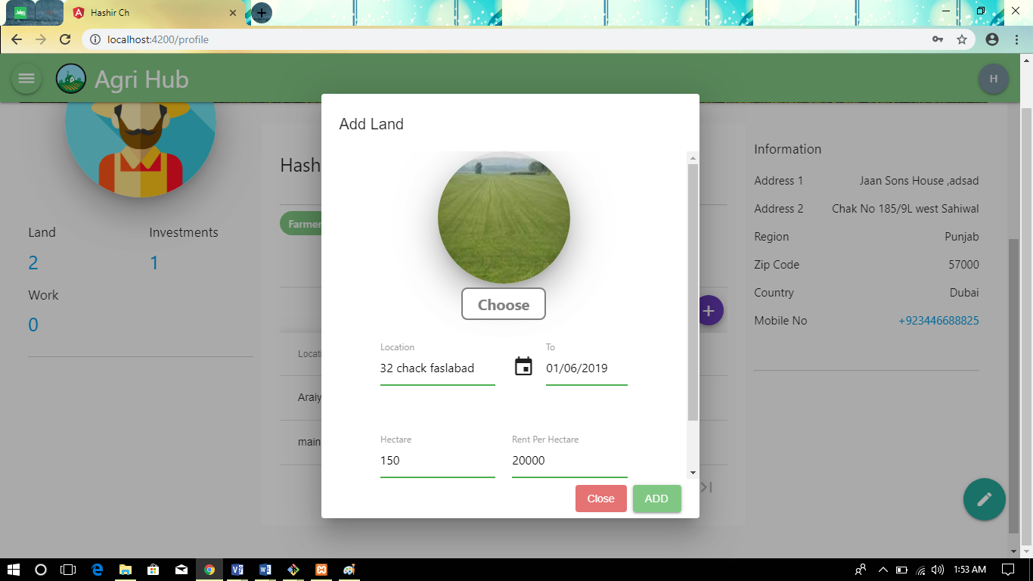
Figure 42:unit testing for add land button

Point 03:

Update avatar button working correctly
Add detail button working correctly
Update button working correctly
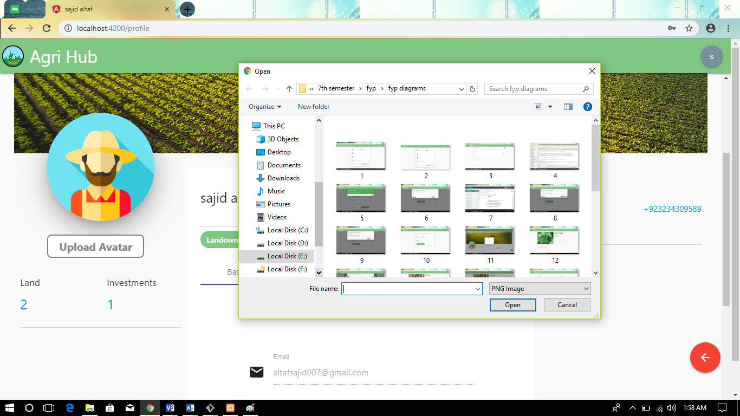
Figure 43:unit testing for update avatar button
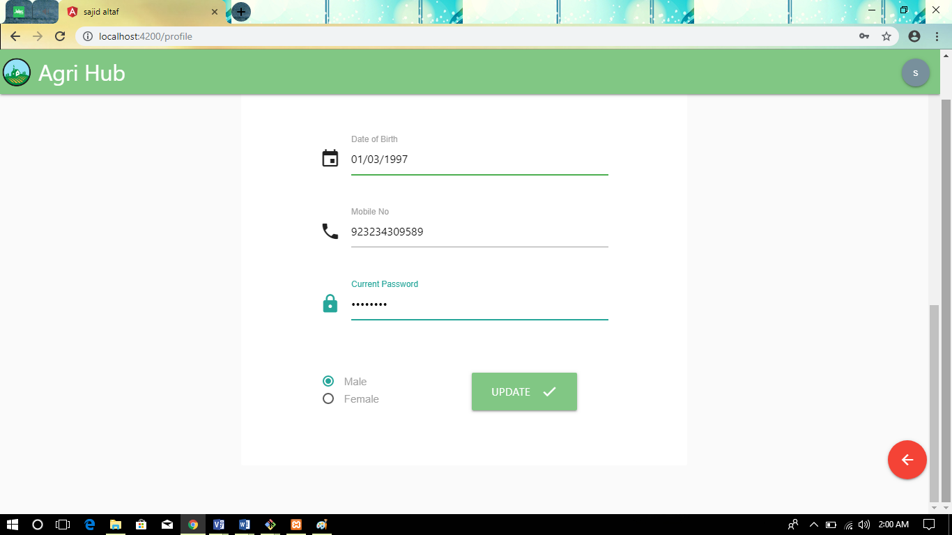
Figure 44:unit testing for update button
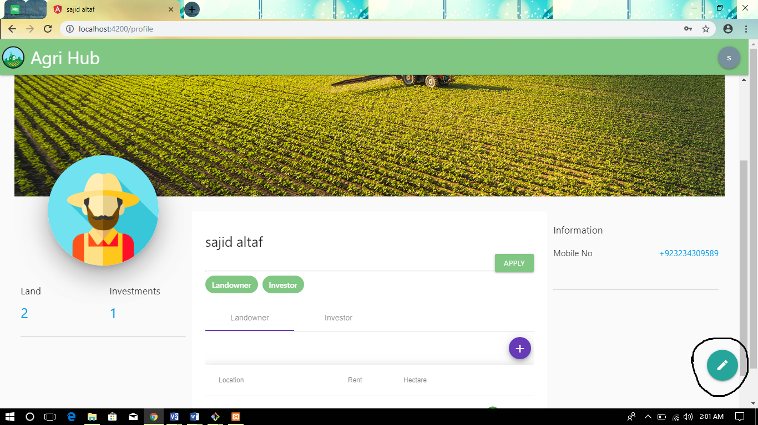
Figure 45: unit testing for add bio data

Integration testing

This testing strategies combines all the modules involved in the system. After the independent modules are tested, dependent modules that use the independent modules are tested. This sequence of testing layers of dependent modules continues until the entire system is constructed. Though each module individually, they should work after linking them together. Data may be lost across interface and one module can have adverse effect on another. Subroutines, after linking, may not do the desired function expected by the main routine. Integration testing is a systematic technique for constructing program structure while at the same time, conducting test to uncover errors associated with the interface. In the testing the programs are constructed and tested in the small segments
The integration testing of this project is done scene-wise. The components that were previously individually tested are now integrated into one scene and tested to see if they still perform as they should.

Table 21: integration testing each button
Test Case ID | IT_SC1_002
Test case Summary | To verify that all buttons behave as expected
Prerequisites | All button must be rendered.
Test Procedure | Click on each button to see if it performs correctly.
Expected Result | - Login button should provide you a dashboard.  - Detail button provide a detail of crops.  - Apply button send you requires for admin.  - Invest button should send your request for admin.  - Apply job button should send your request for admin.  - Logout button redirect you on login page.
Actual Result | - Login button provide user to enter in website.  - Detail button provide you a detail.  - Apply and invest button send your request from admin.  - Apply button send your position request from admin.  - Logout button redirect you on login page.
Status | Pass
Test Environment | PHP (Laravel)

Table 22: integration testing for loading scene
Test Case ID | IT_SC2_001
Testcase Summary | To verify that loading scene with animation shows up when going to next.
Prerequisites | A button that takes user to another scene must be pressed.
Test Procedure | Press each button that takes user to next or previous scene and see if loading scene shows up when the scene is being switched.
Expected Result | - Loading scene animation should be visible on scene switch.  - User must be taken to next scene when animation finishes.
Actual Result | - Loading scene animation is visible on scene switch.  - User is taken to next scene when animation finishes.
Status | Pass
Test Environment | PHP (Laravel) Angular

Table 23: integration testing for update button
Test Case ID | IT_SC3_002
Testcase Summary | To verify that clicking on update button update the data.
Prerequisites | All Update sprites must be rendered.
Test Procedure | Click on each button to see if it performs correctly.
Expected Result | - Unrecorded data not allow to update data.
Actual Result | - Unrecorded data not allow to update data .  - Nothing happens when user is not login.
Status | Pass
Test Environment | PHP (laraval ) Angular

Table 24: integration testing for interaction component
Test Case ID | IT_SC4_002
Testcase Summary | To verify that all interaction components behave correctly.
Prerequisites | None.
Test Procedure | Manually check that each interaction component is behaving correctly.
Expected Result | - Try should be login page.  - Upon clicking login button, it should be displayed the main page.  - When they enter the web it applies where the user full fill requirement.  - Apply button should not be interactable for a few seconds after being pressed.  - Apply work should be destroyed when admin reject his request or user delete his request.  - Update work using update button.  - Delete land or investment or farmer or using delete button.  - User should be send request again for same thing.  - User should be taken to main screen on pressing logout button
Actual Result | - Login button are behaving correctly  - update on pressing update button.  - Delete data on pressing delete button.  - Request send on pressing Apply button.  - User is taken to main screen on pressing Logout button
Status | Pass
Test Environment | PHP (laraval ) Angular

Table 25: integration testing for non-interaction component
Test Case ID | IT_SC4_003
Testcase Summary | To verify that all non- interaction components behave correctly.
Prerequisites | None.
Test Procedure | Manually check that each non- interaction component is behaving correctly.
Expected Result | - User login must start when the customer Register.  - User should Apply for work throw admin.  - User should Cancel land when its deal it’s not done with admin.  - User should Cancel investment when its didn’t give investment.  - User get profit after done work.
Actual Result | - User login must start when the customer Register.  - User should Apply for work throw admin.  - User should Cancel land when its deal it’s not done with admin.  - User should Cancel investment when its didn’t give investment.  - User get profit after done work.
Status | Pass
Test Environment | PHP (laraval ) Angular
Table 26: integration testing for status
Test Case ID | IT_SC5_002
Testcase Summary | To verify that land, investment, and work status.
Prerequisites | User must have check his status.
Test Procedure | User check his status where they invest their land or money and where user working.
Expected Result | - When button is clicked, user must be see his status.
Actual Result | - When button is clicked user must be see his status .
Status | Pass
Test Environment | PHP (laraval ) Angular

Performance testing

- Test case number: PT 01

Test case title: System response time testing
Table 27: System response time testing
Test type | Performance testing | Test result
Required performance | The required response time of the system is less than 2 seconds
System performance | The actual performance response time is 2 seconds. | Test passed

- Test case number: PT 02

Test case title: Activity load time testing
Table 28: Activity load time testing
Test type | Performance testing | Test result
Required performance | The required page load time of the system is less than 3 seconds
System performance | The actual page load time is 2 seconds. | Test passed

- Test case number: PT 03

Test case title: Huge number of users
Table 29: Huge number of users
Test type | Performance testing | Test result
Required performance | System should perform normally and efficiently with a large number of users
System performance | System performed all activities normally with a large number of users. | Test passed

- Test case number: PT 04

Test case title: Waiting time testing
Table 30: Waiting time testing
Test type | Performance testing | Test result
Required performance | The average waiting time of the system is less than 3 seconds
System performance | The actual performance response time is 2 seconds in some circumstances. | Test passed

- Test case number: PT 05

Test case title: Connection establish time testing
Table 31: Connection establish time testing
Test type | Performance testing | Test result
Required performance | The connection must be established in less than 2 seconds
System performance | The actual connection establish time is about 1 second. | Test passed

- Test case number: PT 06

Test case title: Database send/get information time testing

Table 32: Database send/get information time testing
Test type | Performance testing | Test result
Required performance | The system should save or retrieve data from database in less than 2 seconds.
System performance | The actual time system sends or gets information to database in 1 second. | Test passed

Stress Testing

Stress testing is a process of measuring the stability and reliability of the system. Stress testing used to check the ability of system to handling the bugs and errors. Stress testing used to test the system’s ability of error handling during extremely heavy load.
To ensure that our system behaves normal during the stress we overload our system and examine the system’s behavior in extreme circumstances. The (career recommender forum) behaves normally in unfavorable conditions and all of its features and functions perform their functionality.
Through this testing, we monitor our system and make sure our system
- System should save all data before crashing
- Make sure the connection from server
- If server no response, wait on login current page
- Make sure the saving of data and then show success message after operation done
- System should display of deleting and updating of records correctly.

Chapter 7

Summary, Conclusion and Future Enhancements

Chapter 7: Summary, Conclusion & Future Enhancements

Project Summary
Agri Hub is a marketplace that helps under employed farmers and under-utilized land to produce scalable and efficient organic farm funded by urban people around the world. We will connect farmers, landowners, and the investors to create food organic plantation, and we will able to sale the crops directly to the customer like the highly networked supermarket.
It’s kind of like Airbnb has built the world’s largest hotelier, we’re building the world’s largest high-quality organic farm funded by urban people by making our world a better place. Agri Hub provide a platform to such farmer’s form where they can get opportunities like Money and Land without any interest.
Agri Hub is a valuable and a largest Hub for such investors. Agri hub provide the plate farm where investor invest online, see land online and select land where they invest his investment. Agri Hub provide a safe and profitable platform for those land investors. They only have to invest their land and get profit.

Achievements and Improvements
During this complete project we face many challenges but the side of achievements is greater. Our project needs zero percent (0%) investment. Following are our biggest achievements:
Admin Module
The administrator panel is managing by administrators.it is responsible for accepting and rejecting the Customer requests and update the data.
Transaction Module
Transaction Module facilities the entries for programmer of work and Farmer, investor, landowner registration from the from-end of the web application. When a user if first enrolled with this website and registration is done at the beginning after filling the form user can check his status.
Improvements
As we know that there are always some accommodations of improvement in any system. Following are some basic improvements we need to change in future:

System quality
The quality is very important for the online system. Always keep an eye on the standard define quality ‘’the totality of features and characteristics of product or service that bears its ability to satisfy stated or implied needs.

Critical Review
Now a day’s everyone trying to look safe and profitable platform where they invest or provide his land for work or for crops our website provide a platform where they invest or gives his land for work.

Lessons Learnt
When you come to practical life you should learn multiple lessons. Our team also learns multiple lessons while promoting this idea. Following are some basic lessons which we learn during this complete project:
- Choose the right software:
Firstly, in technically side, you should choose the right software which is more beneficially for your system. You should not waste your time on pirated software. Selecting most appropriate software for your company will make your company healthier and profitable.

- Always consult with an expert:
Before taking a critical and crucial decision, always consult with an expert because their advice can be more effective for you at that stage. In our project we consult all the time with our coach (Muhammad Javaid Iqbal).

- Keep an eye on your customers:
For running Career Recommender Forum keep an eye on Customers. Admin should always keep an eye on records all the time to avoid misusing any features.

Future Enhancements/Recommendations
This online system we will provide basic services like portability or security. The future scope includes expend the technologies like Angular & PHP we can also add new technologies like angular, PHP many more for improving the efficiency of the software. The project will be useful for any country Farmer Investor and landowner. Project is flexible i.e. any change/modification in database may be performing easily. We will make android app in future.

Appendices

Figure 46:apply permission
Figure 47:job apply
Figure 48:detail crops
Figure 49:investment
Figure 50:update picture

Reference and Bibliography

Reference and Bibliography

[1] J. Youn te [online] http://www.kisanpoint.com/mrb/search.jsp
[2] J. Youn te [online] “https://www.farmers.gov/”
[3] J. gung te [online] https://enam.gov.in/web/

