An online clothing store system
for JWT authorization security
with web3 integration system

Final Year Project
Session 2019-2023

A project submitted in partial fulfillment of the degree of
BS in Computer Science


Department of Computer Science
Faculty of Computer Science & Information Technology
The Superior University, Lahore
Spring 2023
Type (Nature of project) |  |  | Development
Area of specialization |  |  | Web Development
FYP ID |  |  | FYP-BCSM-F22-016
Project Group Members
Sr.# | Reg. # | Student Name |  | Email ID | Signature
(i) | BCSM-F19-124 | Ammad Ahmed |  | bcsm-f19-124@superior.edu.pk
(ii) | BCSM-F19-221 | Muhammad Hamza |  | bcsm-f19-221@superior.edu.pk
(iii) | BCSM-F19-438 | Sadaf Shoukat |  | bcsm-f19-438@superior.edu.pk
The candidates confirm that the work submitted is their own and appropriate credit has been given where reference has been made to work of others.
Plagiarism Free Certificate
This is to certify that, I Ammad Ahmed S/O Maqsood Ahmed, group leader of FYP under registration no FYP-BCSM-F22-016 at Computer Science Department, The Superior University, Lahore. I declare that my FYP report is checked by my supervisor.
Date: | Leader: Ammad Ahmed | Signature: _____________
Supervisor: Mrs. Sabah Arif  Designation: Lecturer  Signature: _______________ |  | Co-Supervisor: Mrs. Arshia Naeem  Designation: Associate Professor  Signature: _____________
HOD: Dr. Irfan Ud Din
Signature: _______________

Project Report
[An online clothing store system for JWT authorization security with web3 integration system]
Change Record
Author(s) | Version | Date | Notes | Supervisor’s Signature

APPROVAL
Project Supervisor
Comments: ___________________________________________________________________
_____________________________________________________________________________
Name:______________________________
Date:_______________________________ | Signature:__________________________

Project Manager
Comments: ___________________________________________________________________
_____________________________________________________________________________
Date:_______________________________ | Signature:__________________________

Head of the Department
Comments: ___________________________________________________________________
_____________________________________________________________________________
Date:_______________________________ | Signature:__________________________

Dedication

We dedicate our project to our parents, teachers and to each group member. Our teachers make us able to face different challenges and win those challenges. Last but not least group members, who support us a lot and contribute their full efforts to make this project possible.

Acknowledgements

We sincerely appreciate to our supervisor whose contribution and constructive criticism has pushed us to expend the kind of efforts we have exerted to make this work as original as it can be. Thanks to her we have experienced true research and our knowledge on the subject matter has been broadened. We will never forget your kindness Ma'am.

Executive Summary

We propose the development of a comprehensive website using the MERN (MongoDB, Express, React, and Node.js) stack to support your digital growth strategy. This website will serve as a powerful tool to expose your brand to organic audiences through search engines and digital advertising, effectively boosting lead generation and driving business growth.

The MERN stack is a robust and highly scalable technology stack that combines industry-leading technologies to deliver a seamless user experience and robust functionality. MongoDB, a NoSQL database, will provide flexibility and scalability for handling large amounts of data. Express, a minimal and flexible web application framework for Node.js, will enable efficient server-side development. React, a popular JavaScript library, will allow for the creation of dynamic and interactive user interfaces. Node.js, a runtime environment, will facilitate the development of scalable and high-performing server-side applications.

By utilizing the MERN stack, we can ensure that your website is capable of supporting a high volume of traffic while remaining protected from malicious entities. The modern technologies employed in the website's hosting will enhance its performance, scalability, and security, providing a seamless user experience and bolstering customer trust.

Contents
An online clothing store system 1
Dedication 5
Acknowledgements 6
Executive Summary 7
Chapter 1 11
Introduction 11
1.1 Background 12
1.2 Motivations and Challenges 12
1.3 Goals and Objectives 13
1.4 Literature Review/Existing Solutions 13
1.5 Gap Analysis 13
1.6 Proposed Solution 14
1.7 Project Plan 14
1.8 Report Outline 17
1.9 Empathy Map 17
Chapter 2 18
Software Requirement Specifications 18
2.1 Introduction 19
2.2 Overall Description 20
2.3 External Interface Requirements 21
2.4 System Features 21
2.4.1.1 Description and Priority 22
2.4.1.2 Stimulus/Response Sequences 22
2.4.1.3 Functional Requirements 22
2.5 Nonfunctional Requirements 23
2.5.1 Performance Requirements 23
2.5.2 Safety Requirements 23
2.5.3 Security Requirements 23
2.5.4 Software Quality Attributes 23
2.6 Domain Requirements 24
Chapter 3 25
Use Case Analysis 25
3.1 System Analysis 26
3.2 Use Case Model 26
3.3 Use Case Descriptions 27
Chapter 4 31
System Design 31
4.1 Architecture Diagram 32
4.2 Entity Relationship Diagram with data dictionary 33
4.3 Sequence / Collaboration Diagram 34
4.4 Domain Model: 36
4.5 Class Diagram: 37
4.6 Activity Diagram: 38
4.7 Component Diagram 39
4.8 Deployment Diagram 40
4.9 State Transition Diagram: 41
4.10 Data Flow diagram: 42
Chapter 5 44
Implementation 44
5.1 Important Flow Control/Pseudo codes 45
5.2 Components, Libraries, Web Services and stubs 45
5.3 Deployment Environment 45
5.4 Tools and Techniques 45
5.5 Best Practices / Coding Standards 46
1.1 Version Control 46
Chapter 6 47
Testing and Evaluation 47
6.1 Use Case Testing 48
6.2 Equivalence partitioning 49
6.3 Boundary value analysis 50
6.4 Data flow testing 51
6.5 Unit testing 52
Chapter 7 54
Summary, Conclusion and Future Enhancements 54
Summary, Conclusion & Future Enhancements 55
7.1 Project Summary 55
7.2 Achievements and Improvements 56
7.2.1 Achievements: 56
7.2.2 Improvements: 56
7.3 Critical Review 57
7.4 Lessons Learnt 58
7.5 Future Enhancements/Recommendations 59
Appendices 61
Appendix A: Project Timeline 62
Appendix B: Work Breakdown Structure 62
Appendix C: Gantt Chart 62
Appendix D: Technical Specifications 62
Appendix E: User Personas 62
Appendix F: User Stories 62
Appendix G: Wireframes and Mockups 62
Appendix H: Test plans and results 63
Appendix I: Maintenance and Support Plan 63
Appendix J: Risk Assessment 63
Reference and Bibliography 64

Chapter 1

Introduction

Nowadays, with the advancement of technology, the web application development industry has seen significant growth. Traditional technologies such as Servlets, ASP.NET and PHP are the most used frameworks for web application development in the last few years. These technologies do not achieve the required performance standards of today's customers. MERN is used to describe a specific set of JavaScript-based technologies used in the web application development process. Designed with the idea of ​​making the development process as smooth as possible. All these factors play a very important role in the web application development process. All of this provides the ultimate framework for engineers to work within. Today, developers around the world are working to improve the user interface of the application and to improve the development process of creating applications in order to implement projects and development requirements on a given deadline. Because MERN is based on JavaScript, developers only need to know one coding language, which makes things a million times easier.

Background
In web services, the web application is stateless service. This means that the application will not remember the status of the applicant and it is up to him applicant to remember their statuses. To do so, the application uses the system implementation called "sessions". This session contains an identifier for the user and his authentication requirements. There are different ways to store session data. Most a common way is to use memory-based security cookies. Another method is to use a cache database such as Redis that will store session data on backend. In this way, every time a requester makes the request, the application server requires visiting the cache database for verification and validation. This repeated visit to the database per request is what inspires the use of JWT as a replacement, eliminating this need.

Motivations and Challenges
The difficulties in this project were to determine how we would create a system that would have all the basic functionality and how users would understand the web application and user interface to work. There was also a question of trust.

Goals and Objectives
The main goal is to simplify the verification of user/object authentication across multiple services/servers using a signature to validate the token. This saves resources and time for the backend server and reduces backend database session traffic only to authenticate the real user. Another goal is to secure identity claims with a signature implementation. The JWT itself can be signed using asymmetric cryptography public/private key pairs, ensuring that the content is not tampered with.

Literature Review/Existing Solutions
Creating sessions in an app where a huge number of user logs in is not a great idea. Admin should not manually send the notifications to the users. Lots of products and categories can increase the size of the application which can put more load on the server. Third-party delivery is not responsible for the damage.

Gap Analysis
Let's talk about the benefits of JSON Web Tokens (JWT) compared to Simple Web Tokens (SWT) and Security Assertion Markup Language Tokens (SAML). Since JSON is less verbose than XML, it is also smaller when encoded, making JWT more compact than SAML. This makes JWT a good choice for passing in HTML and HTTP environments. In terms of security, SWT can only be symmetric signed with a shared secret using the HMAC algorithm. However, JWT and SAML tokens can use a public/private key pair in the form of an X.509 certificate for signing. Signing XML using an XML digital signature without introducing obscure security holes is very difficult compared to the simplicity of JSON signing. JSON parsers are common in most programming languages ​​because they map directly to objects. Conversely, XML does not have a native document-to-object mapping. This makes JWTs easier to work with than SAML assertions. In terms of usage, JWT is used at an internet scale. This highlights the ease of client-side JSON web token processing on multiple platforms, especially mobile.

Proposed Solution
MongoDB provides rich data models and queries, making it a popular choice for many companies. There’s a wide range of features we can build out for our store using MongoDB. Uplifts developers’ productivity basically provides better maintainability and code growth because each component in React has its own internal logic that is easy to manipulate and consequently increases the efficiency of app development. In React, when a developer makes changes in an object, he or she only needs to change its state and make proper alterations. This way only a specific component will be updated. Node-Js infuses scalability into the app, Node-Js is one of the most powerful platforms that can be used for building eCommerce apps[1]. This surely makes the development faster. Admin authentication can be done. A graphical representation of monthly and yearly sales is also provided. Notification for user and admin both. Adding features that encourage users to play and collect reward with every purchase they make. Users should also know how often to expect new discounts and how much time they have to use them. An even better way is to use an on-site search solution that tracks the behavior of customers in real-time. There was information about hacks that leaked millions of user data from companies and services so, we can make it secure[2].

Project Plan
The Work Breakdown Structure (WBS) and Gantt Chart are shown below according to the activities we will be performing, with the relevant dates and responsibilities assigned to team members. All activities are specifically assigned to team leaders based on their relative abilities.

Work Breakdown Structure
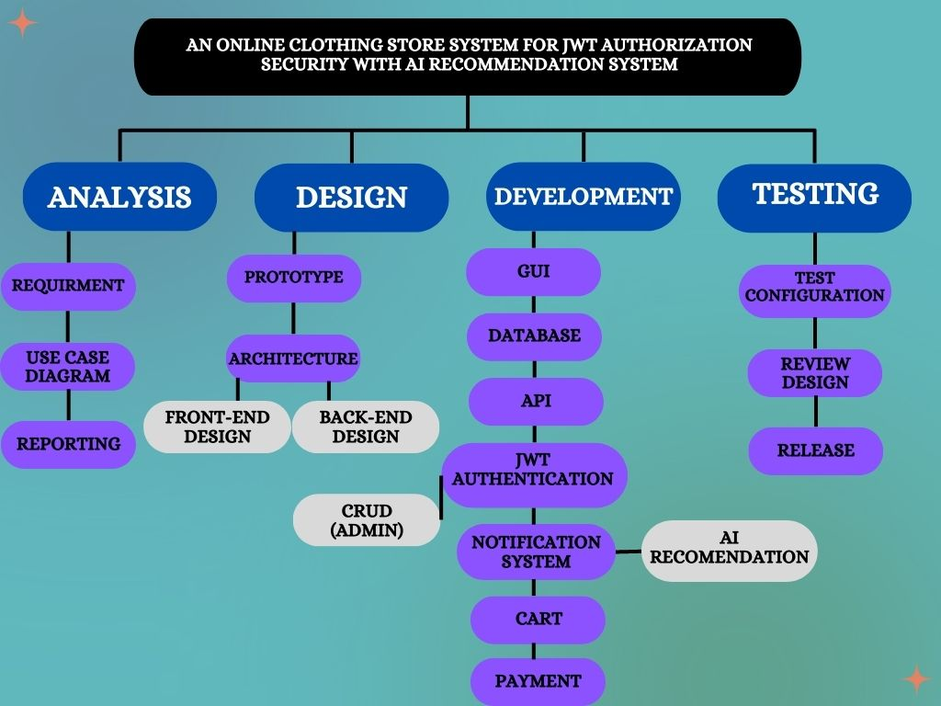

Gantt Chart
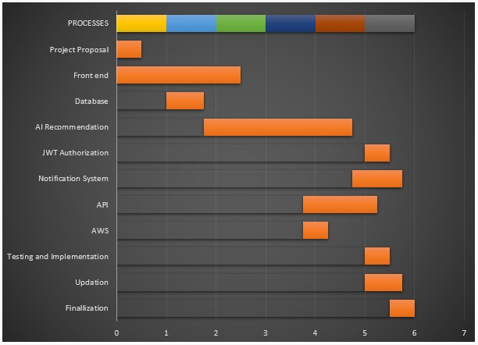

Roles & Responsibility Matrix
WBS # | WBS Deliverable | Activity # | Activity to Complete the Deliverable | Duration  (# of Days) | Responsible Team Member(s) & Role(s)
1 | Database | 1 | 3 weeks | 21 Days | Hamza
2 | Front end | 2 | 10 weeks | 74 Days | Sadaf
3 | Web3 integration | 3 | 2-3 months | 90 Days | Hamza/Ammad
4 | JWT Authorization | 4 | 1-2weeks | 7-14 Days | Ammad
5 | Notification system | 5 | 1 month | 30 Days | Hamza
6 | API | 6 | 6 weeks | 42 Days | Ammad
7 | AWS | 7 | 2 weeks | 14 Days | Hamza
8 | Testing/Implementation | 8 | 2 weeks | 14 Days | Ammad
9 | Updating | 9 | 3 weeks | 21 Days | Hamza / Sadaf
10 | Finalization | 10 | 2 weeks | 14 Days | Ammad / Hamza

Report Outline
If the company is selling a large number of products, the size of the application increase. Saving data in form of tables is no more efficient now. Now a days e-commerce users are increasing rapidly. More user means more generations of sessions. When a huge number of sessions is created, the server can get low. With the advancement of technology, there is no sense in sending notifications to the user by admin. With the presence of sockets, the notifications can be generated and visible to the user when he gets online. We have seen many e-commerce sites contracts with third-party for delivery. But this is not reliable. Many times, customers avoid online shopping because of a lack of trust.

Empathy Map
SAY: | DO:
I love the new techniques.  Confusing. | Doubtful of quality support.  Listening with complete satisfaction.
THINK: | FEEL:
Tries more new techniques.  How will these people do it? | Excited about new technologies.

Chapter 2

Software Requirement Specifications

Introduction

Purpose
The purpose of this software requirements specification document is to provide a detailed description of the functionality and operation of the website. This document will cover all features of the application. This document will cover all intended features and technical dependencies.

Document Conventions
The project's document is written in word, the code editor we used is Visual Studio Code and react, node JS, express JS and mongo dB are used as programming languages.

Intended Audience and Reading Suggestions
This document is intended for developers, project managers and users of this site who want to read what the site can do. The rest of the SRS includes the system work flow, how the system works, data flow on hosting and other technical features of the software.
For developers, there is a need to start from introduction and understand workflow diagrams.
The project manager's reading sequence is from the introduction to the class diagram and use cases.
For website users, it is necessary to read from the introduction and read all descriptions including scope and features.

Product Scope
The end product's target benefits and aims include the ability to provide suitable guidance on how to buy and maintain various variety aspects. It will provide chat room. It will allow the user to make payments.

References
https://outfitters.com.pk/

Overall Description

Product Perspective
This App contains the following sections:
• Admin
• Buyer
User can Purchase cloths, Filter, Chat and estimate cost. Admin can place ads.

User Classes and Characteristics
Classes | Characteristics
Admin | Audit all the activities using analytics with respect to user behavior, uploading of latest resource and website performance
Developer | Responsible for optimization, SEO, Inbound & outbound linking, navigation setup and ad-placement.

Operating Environment
Operating Environment for this app is as listed below:
- Wep App
- Operating System: Can be run on any operating system
- Database: mongodb
- play store: Chrome, Firefox and Internet Explorer etc.
- Platform: Visual studio Code.

Design and Implementation Constraints
- Payment integration will be difficult if we didn’t get the APIs.

Assumptions and Dependencies
- The third-party plugins that we use can cause performance issues related to the website's design.
- The website will be customized and manual designed according to the CMS uploading.

External Interface Requirements

User Interfaces
Users can see and search cloths published on the web application, but in order to buy, they must first log in. Once logged in, they can utilize the web program's features.

Hardware Interfaces
This is a web application, hence there are no equipment requirements for users. All the user has to do is sign up for an account on our website. Our user interface is simple and straightforward.

Software Interfaces
- Backend: node JS, express JS
- Front end: Visual Studio Code
- Database: mongodb

Communications Interfaces
This Web App will run on all devices. There will be no issue on running this web app on any operating system. User and admin can easily communicate with each other.

System Features

System Feature 1
The following document describe the complete Software Requirement Specification for this Web Application. The content of this document will be used by the project team as guidelines for implementing and testing. The document covers the whole system excluding the implementation details. By using this user can manage cloths such as add, buy, delete etc.

Description and Priority
It will be an online clothing website that will solve the problems of customers. Admin can add ads and can promote its service. Customers can view and buy the cloths they liked. They can chat on this platform as well.
High: we will make smart User interface because our main point that it should be user friendly.
Medium: Other Features like ads, filtering.
Medium: Cost estimate and chat box, payment integration.

Stimulus/Response Sequences
User will sign up/sign in. Then can view home page. He / She can view ads and can use cost estimator. If he is admin then he can post ads. And if customer he can buy.

Functional Requirements
The functional requirements are:
- Filter cloths by man, woman and children.
- Admin Panel to add cloths and see customer inquiries.
- Cloths features and types
- Admin can add property videos and photos.
- Cloths details photo, video, details and price.
- Admin review cloths and allow/disallow accordingly.
- Admin will verify products before publishing.
- Payment gateways.
- Admin website settings
- User management
- Dashboard Stats
- Manage products details.

Nonfunctional Requirements

Performance Requirements
Cloud based data storage should be able to ensure the integrity, efficiency and maintainability of data. It should be available 24/7. It should provide ease of use in different configurations or environments.

Safety Requirements
People have to return the product if there any fault.

Security Requirements
They have to provide all the authenticated information to sign up. They have to login before they can use any feature.

Software Quality Attributes
Accuracy:
The website and application will be available at any browser. The website and application will be available using any type of internet connection. The user interface will be responsive to enhance user experience.
Planned approach towards working:
The working in the organization will be well Planned and organized. The data will be stored properly in data stores, which will help in retrieval of information as well as its storage.
Reliability:
The reliability of the proposed system will be high due to above stated reasons. The reason for the increased reliability of the system is that now there would be proper storage of information.
Business Rules:
At the admin side, each user has their level for verification, level will define what kind of stakeholder he is and what kind of functionalities he will perform. At the admin side, managing the website roles will be assigned to each stakeholder. For example, if he’s a developer he’ll have access to the ad-units and customization menu. No stake holder can access the user data or activities except the admin.

Domain Requirements
Proper Navigation to the pages. Proper indexing should be done. All the posts and pages should be SEO optimized and in perfect with respect to readability. There should be a proper structure data for your website’s search engine presence.

Chapter 3

Use Case Analysis

System Analysis
This chapter is all about the roles and functionalities of the system and its actors in the use case form. All the primary and secondary actors with respect to their responsibilities. We have made a use case diagram in which we’ve properly defined each and every functional and nonfunctional requirement according to the respected id or levels. In the use case given below explains the relation between actors and their functionalities.

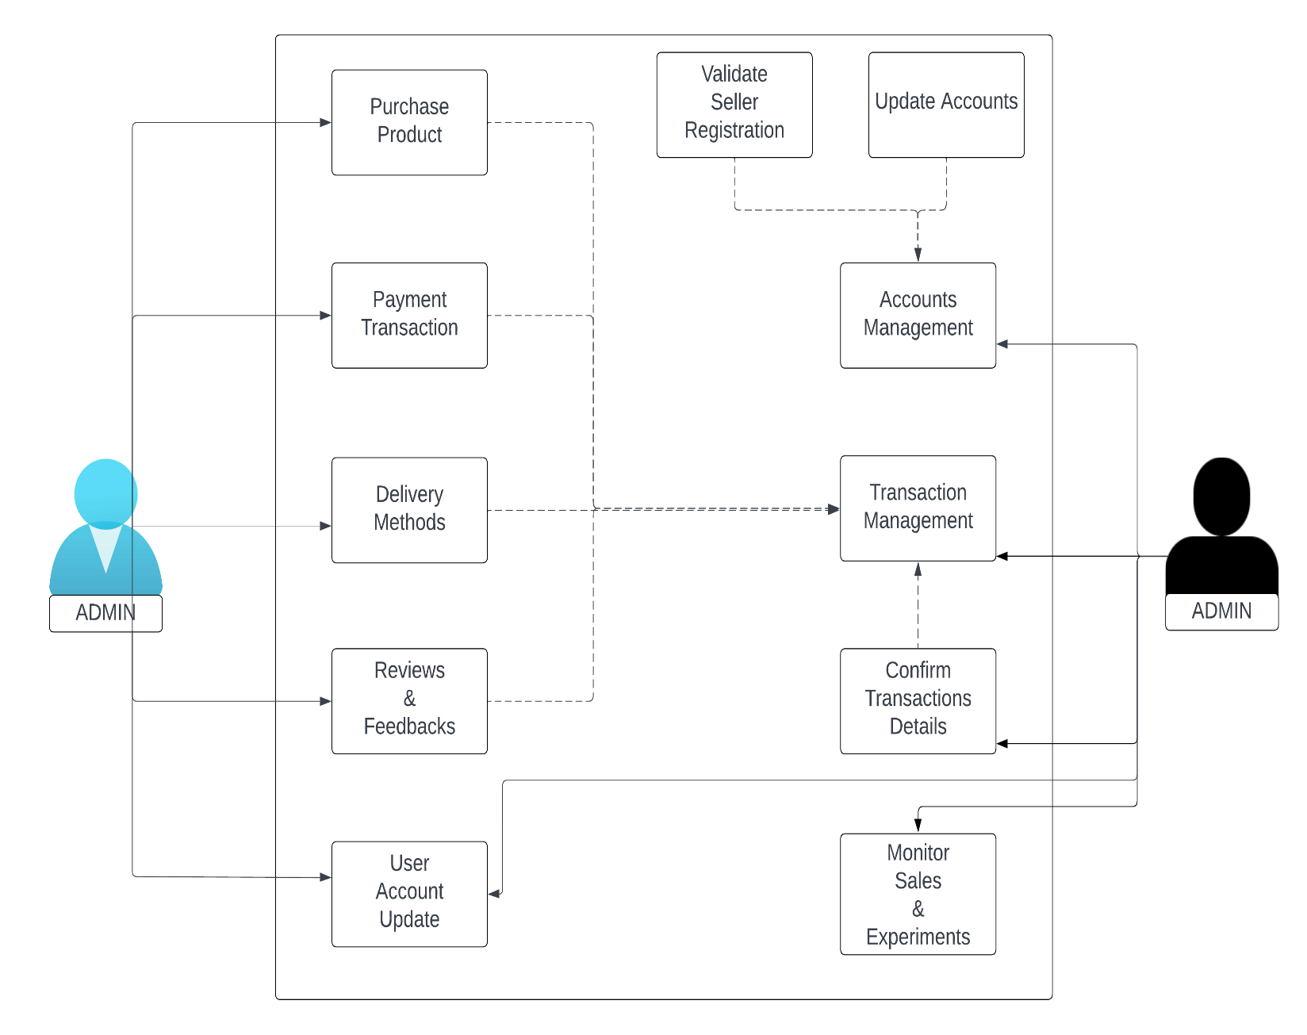
Use Case Model

Use Case Descriptions
Use Case | Registration
Actor | Admin/User
Description | The use case begins when the actor indicates the intent for registration into the system. It ends when the actor is registered or cancels the registration.
Pre-Condition | The registration exists.
Post-Condition | The actor registered successfully.

Use Case | Login
Actor | Admin/User
Description | The use case begins when the actor indicates the intent to login to the system. It ends when the actor is logged in or cancels login.
Pre-Condition | The login form shown to the user.
Post-Condition | The actor logged in successfully.

Use Case | Manage user profile
Actor | Seller/buyer
Description | The use case begins when the actor indicates the intent to view, update or delete profile. It ends when the actor closes the user dashboard form.
Pre-Condition | 1-The user dashboard record exists for editing/view.  2-The actor is logged in
Post-Condition | The user dashboard record is added or updated.

Use Case | Manage Product
Actor | Admin
Description | The use case begins when the actor indicates the intent to view, update, add or delete his/her product.
Pre-Condition | 1-The actor record exists for editing/view.  2-The actor is logged in.
Post-Condition | The actor record is updated.

Use Case | Add product
Actor | Admin
Description | The use case begins when the actor indicates the intent to add property. It ends when the actor added the product or exit the add product form.
Pre-Condition | 1-The add product form exists for adding product.  2-The actor is logged in.
Post-Condition | The admin added product successfully.

Use Case | Add Ad
Actor | Admin
Description | The use case begins when the actor indicates the intent to add Ad for the product. It ends when the actor added the product Ad or exit the add product Ad form.
Pre-Condition | 1-The add product form exists for adding product.  2-The actor is logged in.
Post-Condition | The admin added product successfully.

Use Case | Bidding
Actor | Buyer
Description | The use case begins when the actor starts chat for the product. It ends when the actor bid or cancel the bidding.
Pre-Condition | 1-The bided product exist for bidding.  2-The actor is logged in.
Post-Condition | The bidding is done successfully.

Use Case | Ask Question
Actor | User/buyer
Description | The use case begins when the actor indicates the intent to ask a question. It ends when the actor closes the query form.
Pre-Condition | The query form exists for asking a question.
Post-Condition | The question is asked successfully.

Use Case | Search Product
Actor | User/buyer
Description | The use case begins when the actor indicates the intent to search for the product according to his/her requirement.  It ends when the result is shown.
Pre-Condition | The searching form exists for searching.
Post-Condition | The product searched successfully.

Chapter 4

System Design

In this chapter all the diagrams are given so you can clearly check out the overall working graphically.

Architecture Diagram
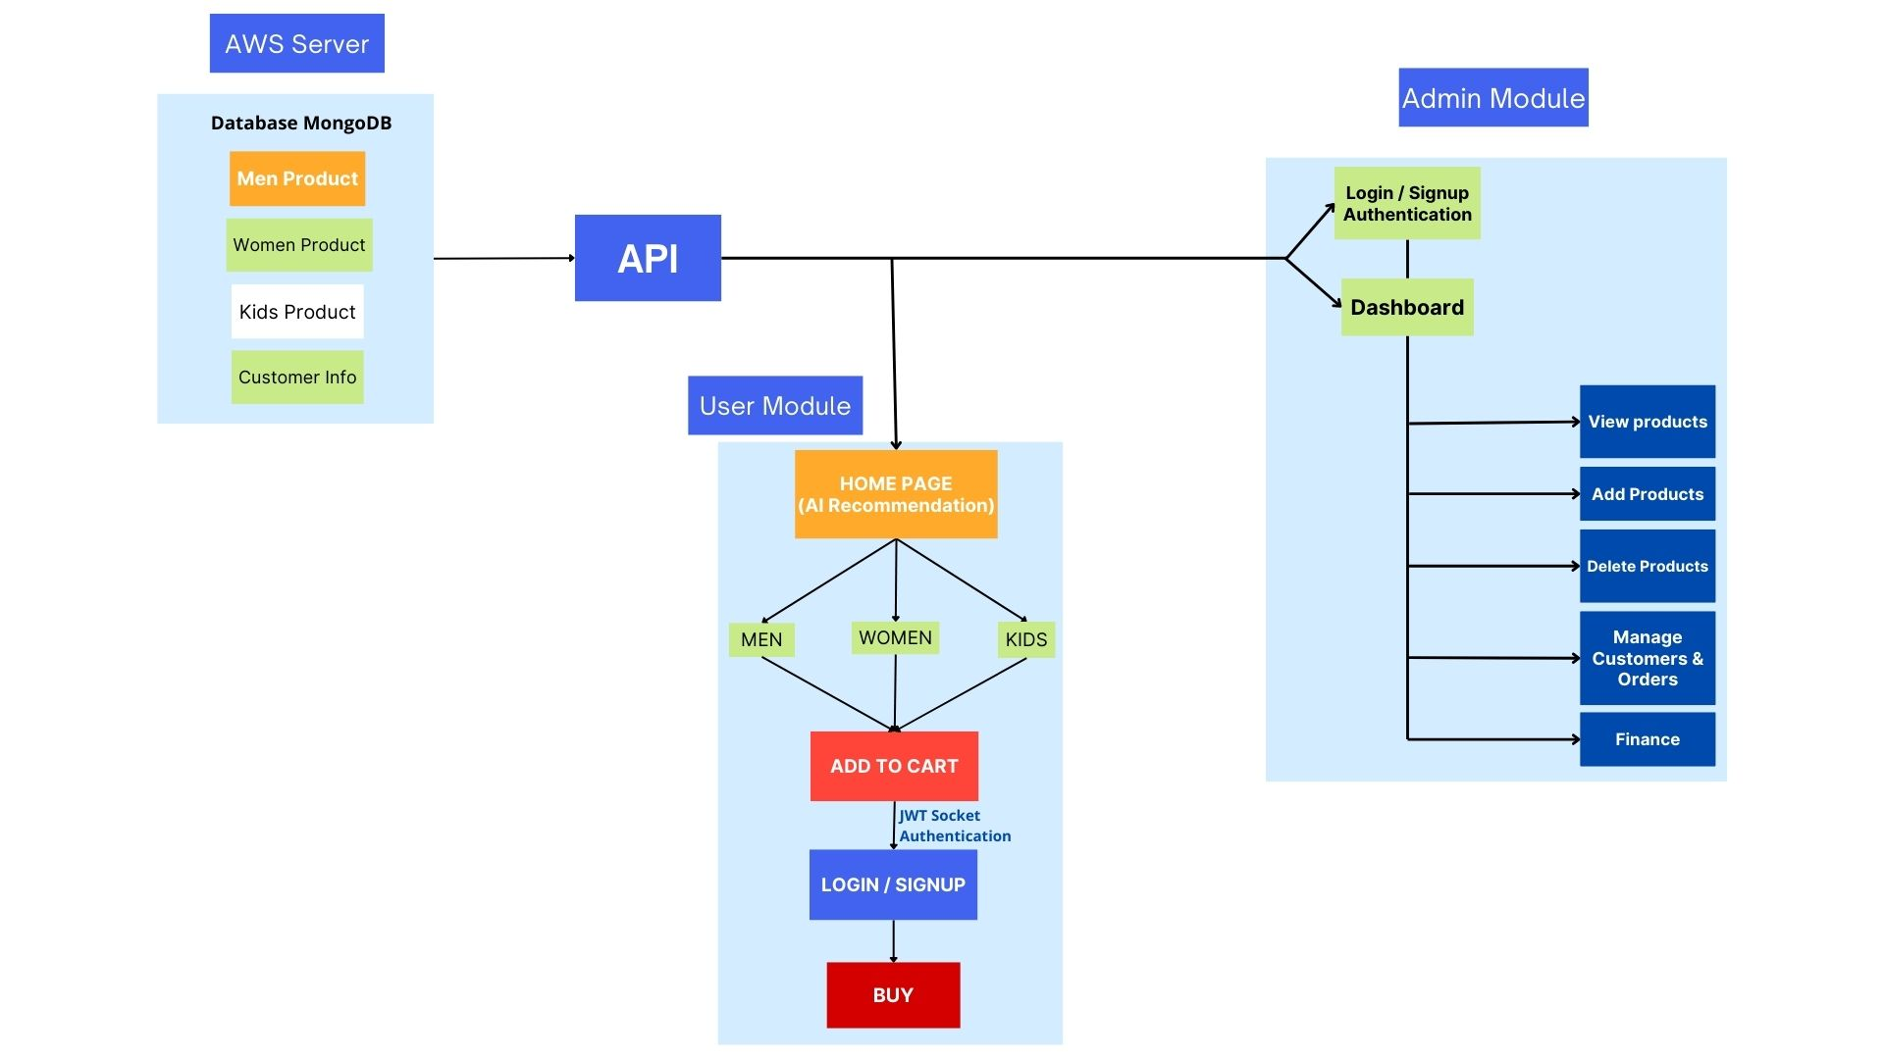

Entity Relationship Diagram with data dictionary
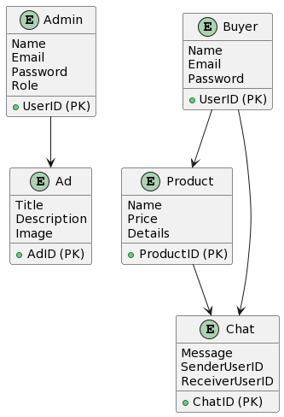

Sequence / Collaboration Diagram
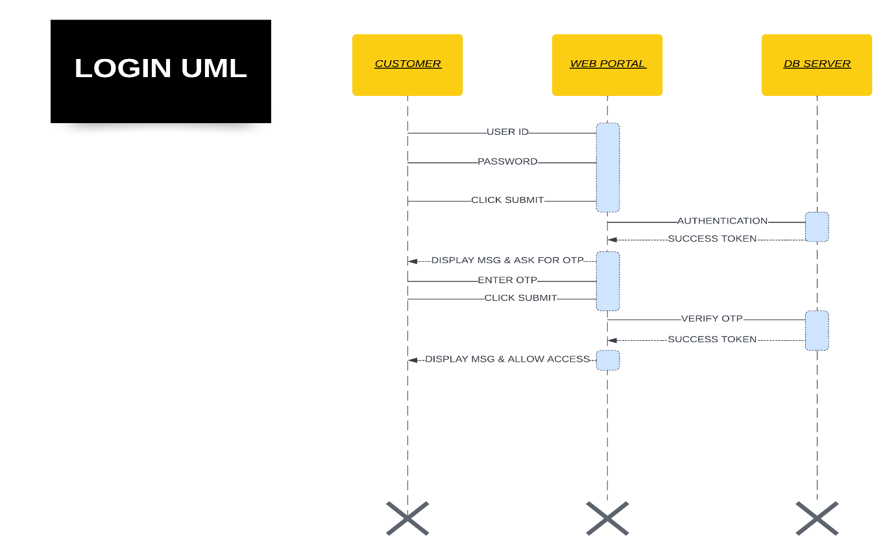
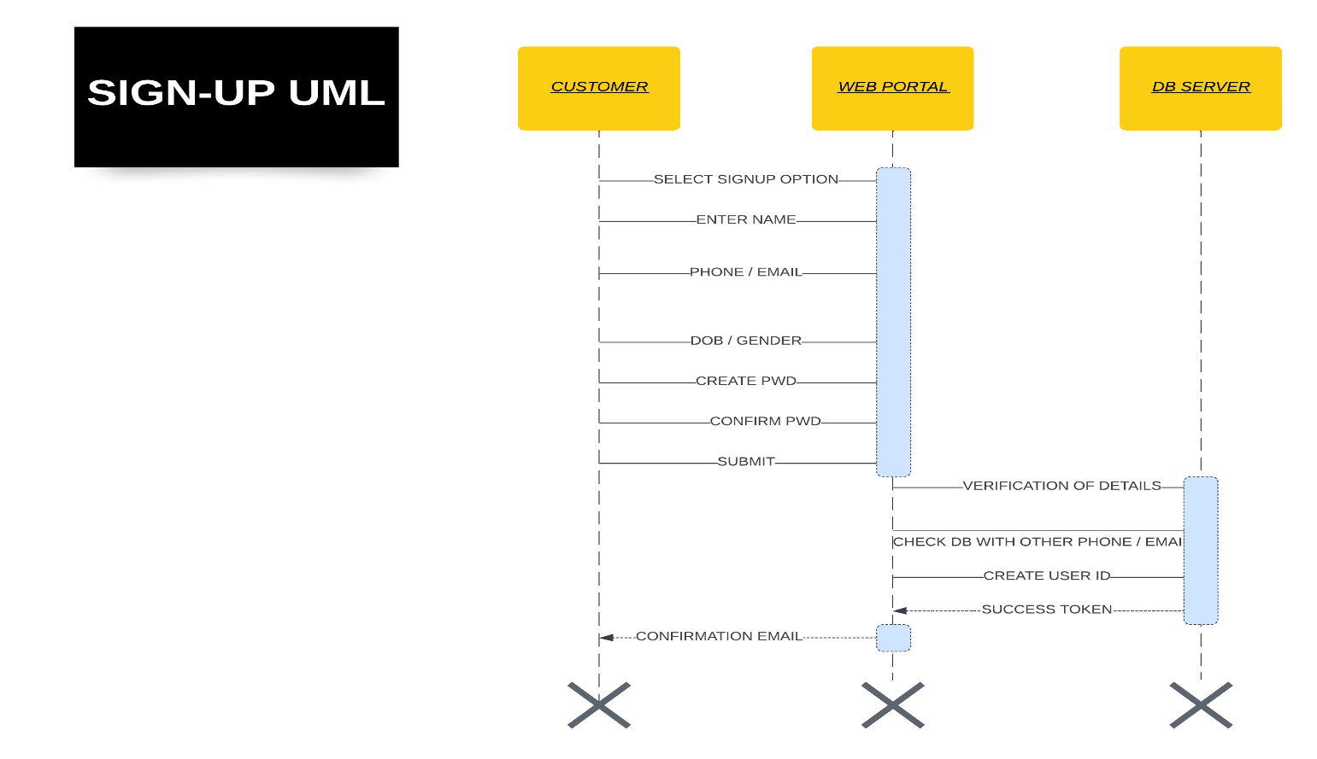
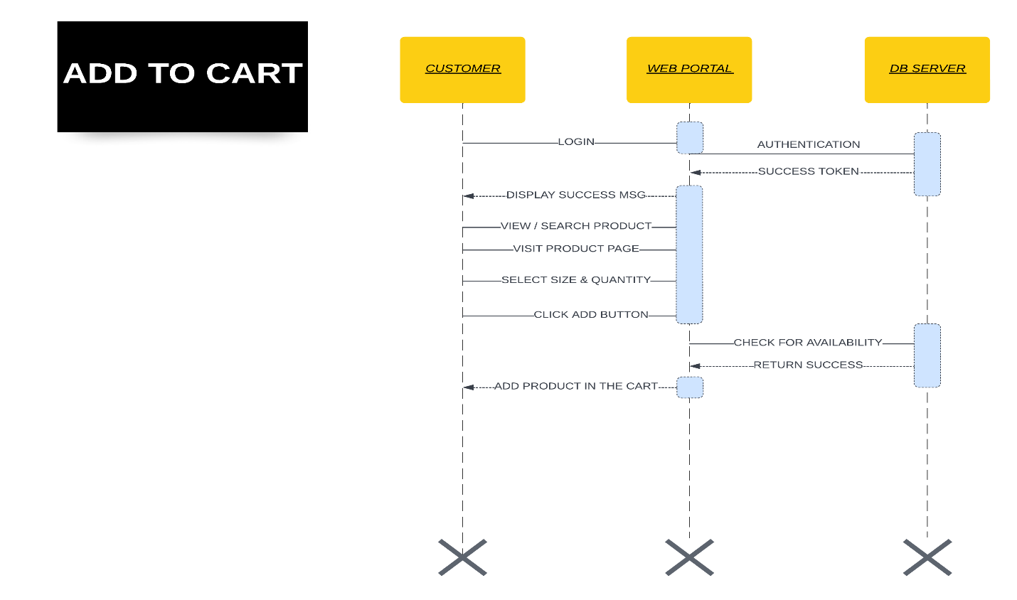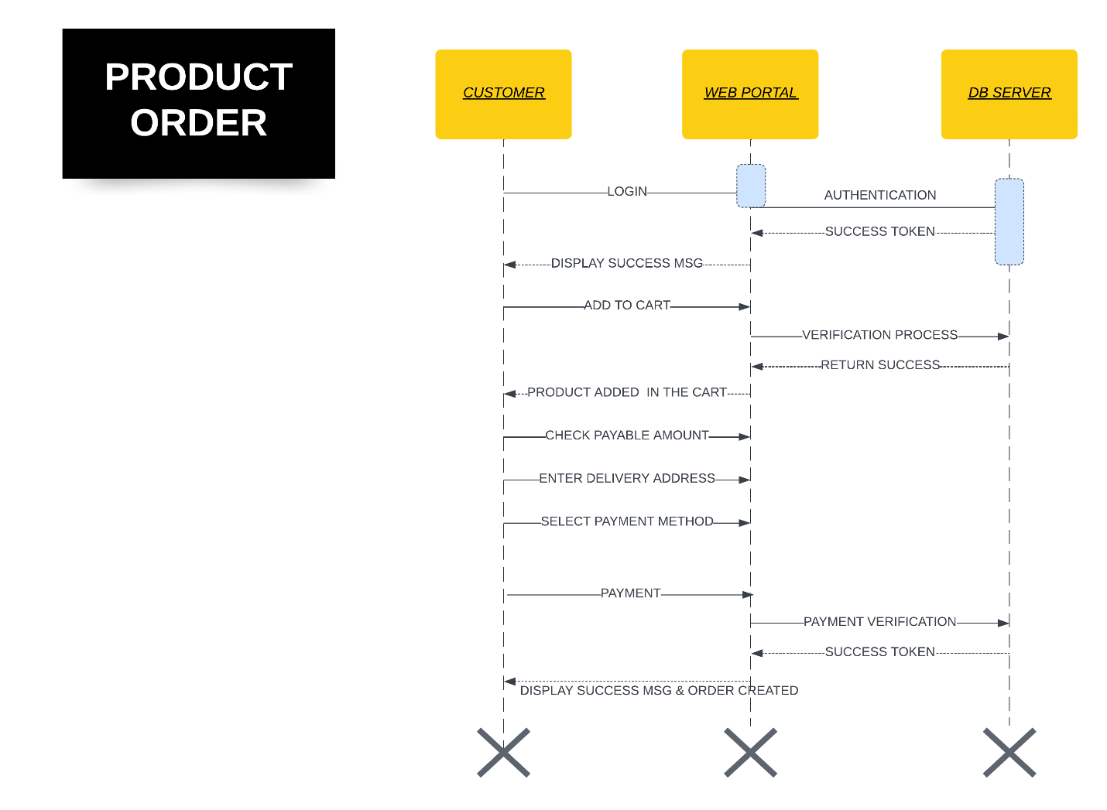

Domain Model:
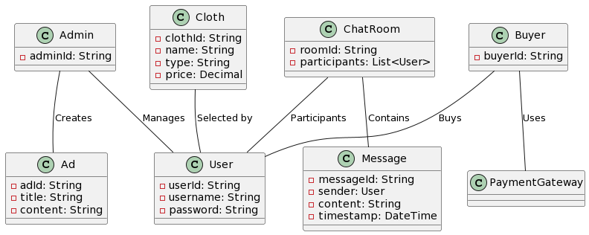

Class Diagram:
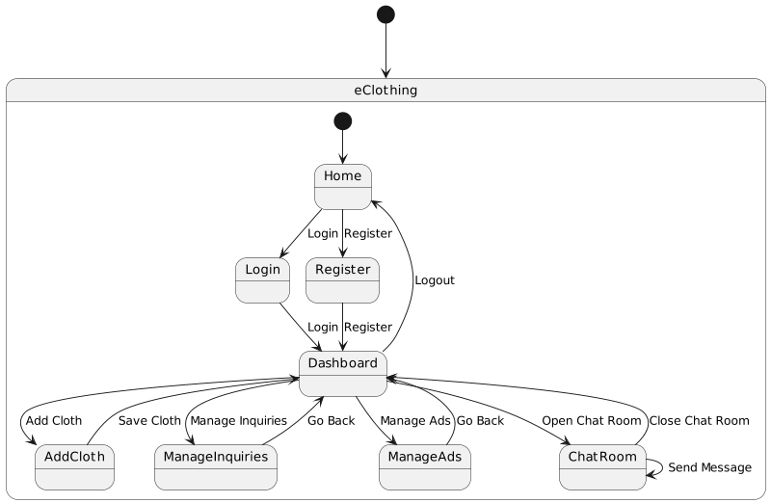

Activity Diagram:
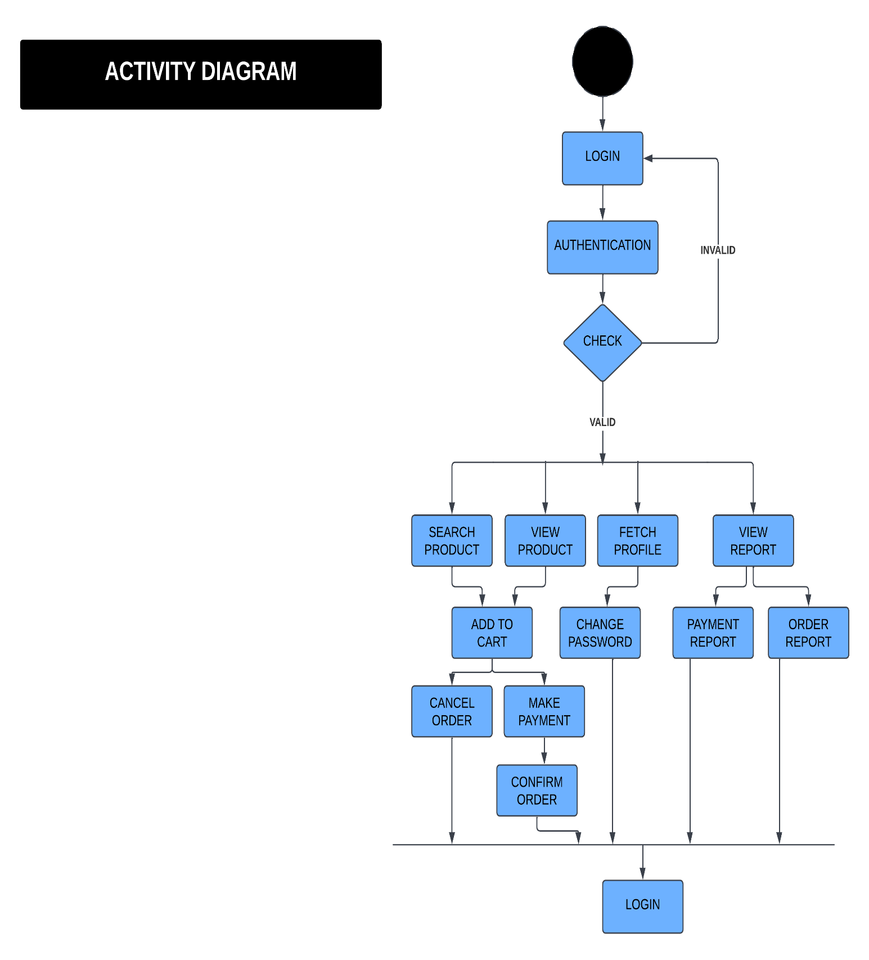

Component Diagram
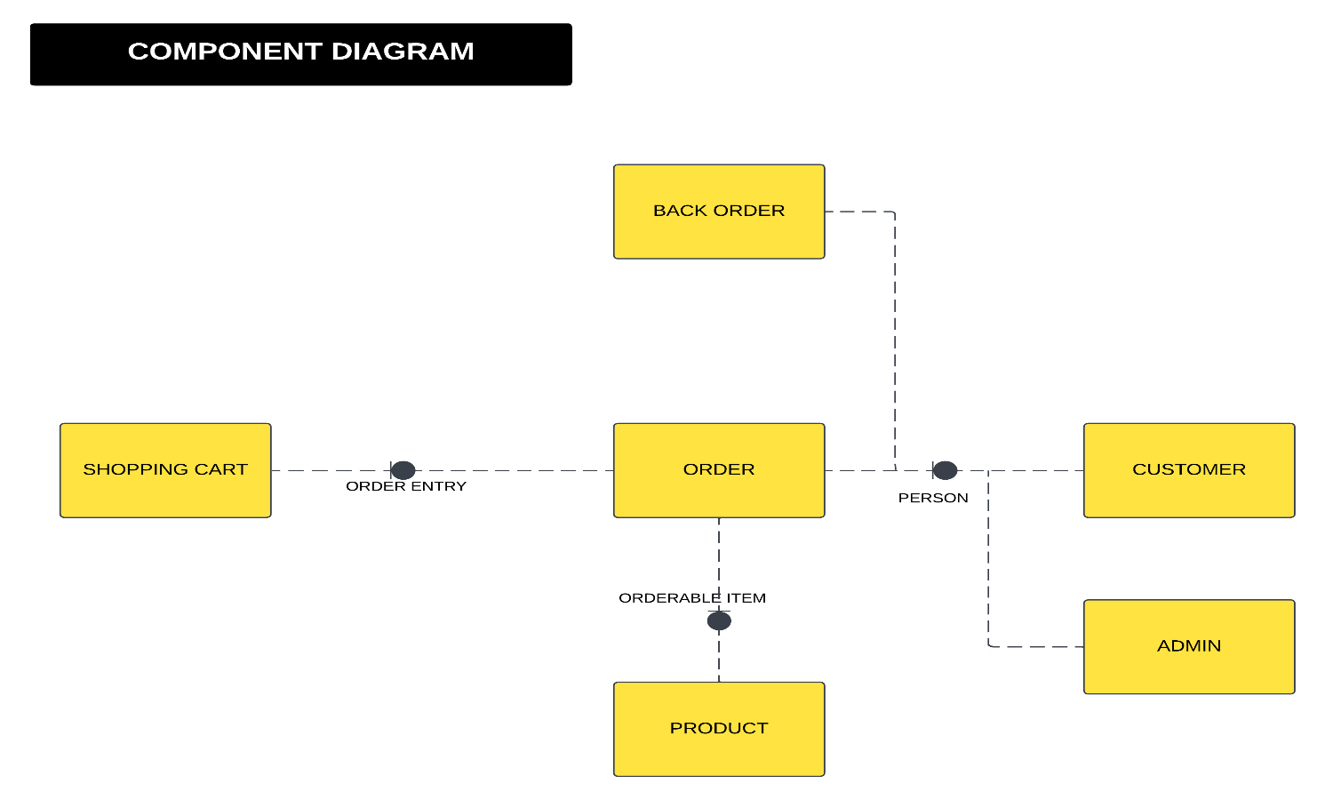

Deployment Diagram
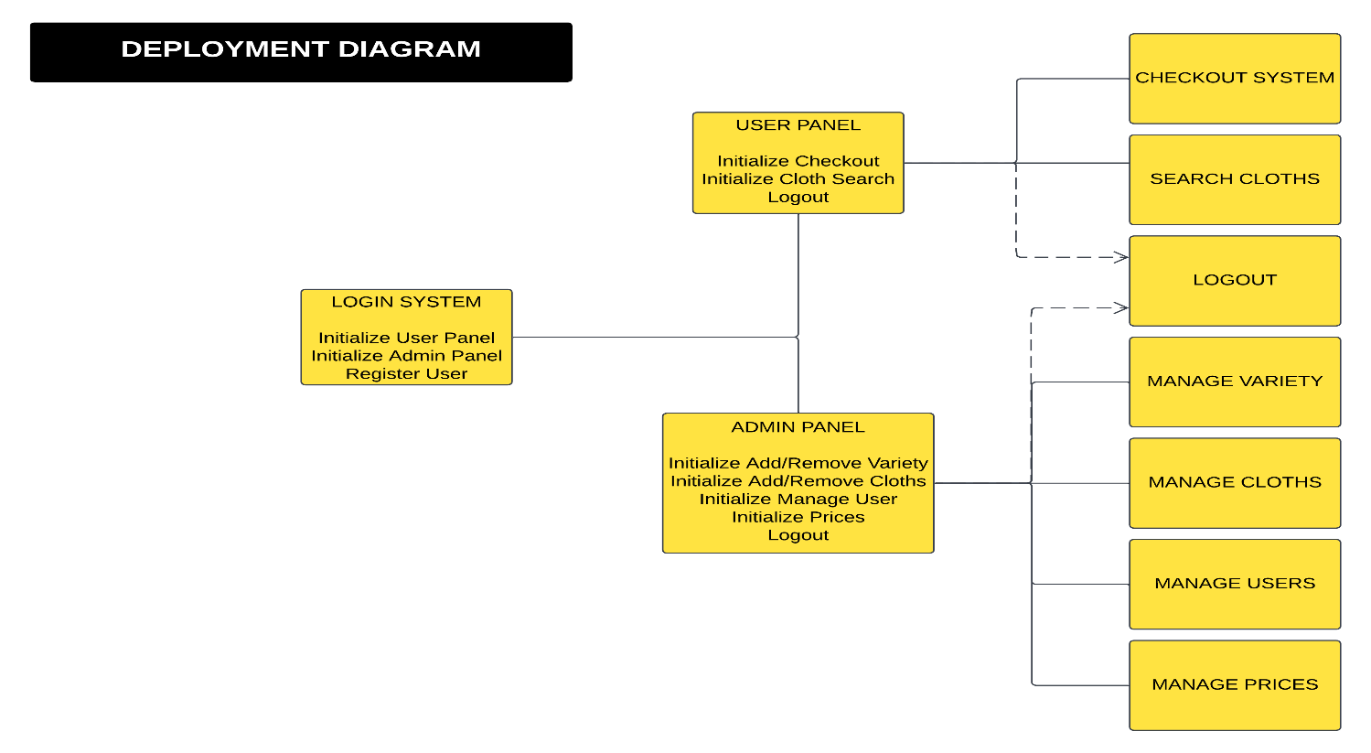

State Transition Diagram: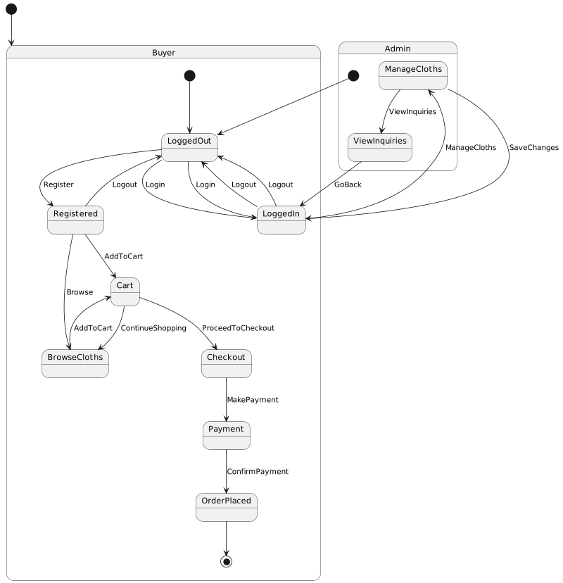

Data Flow diagram:
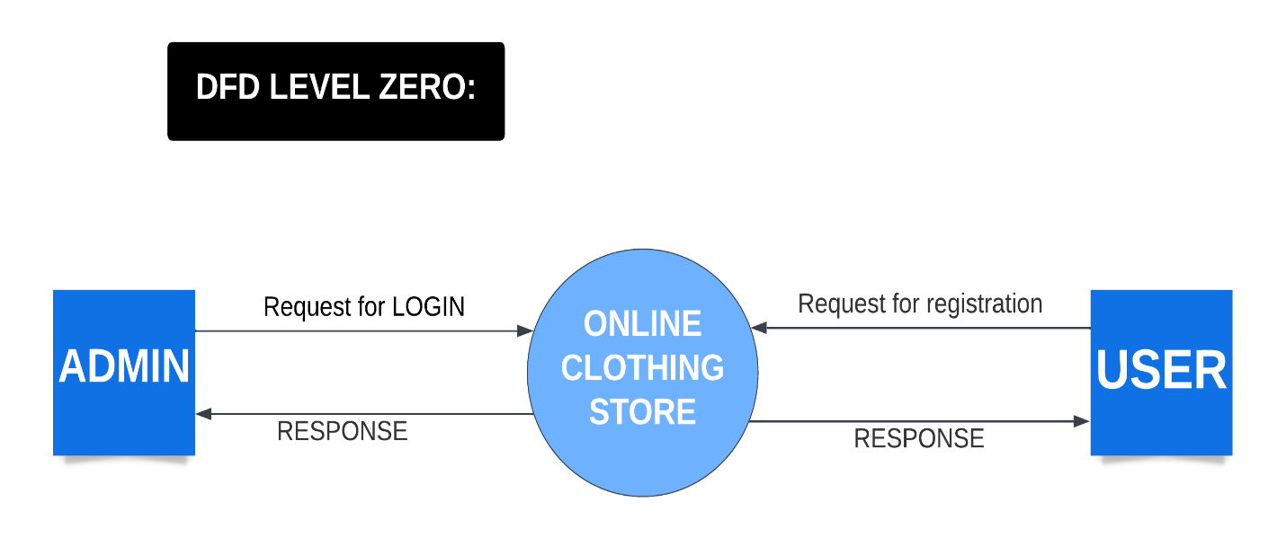

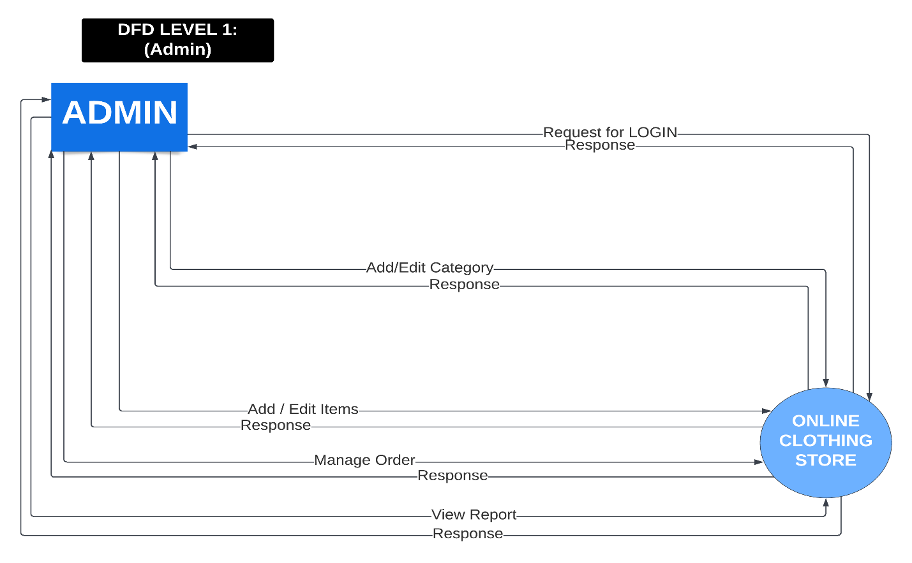
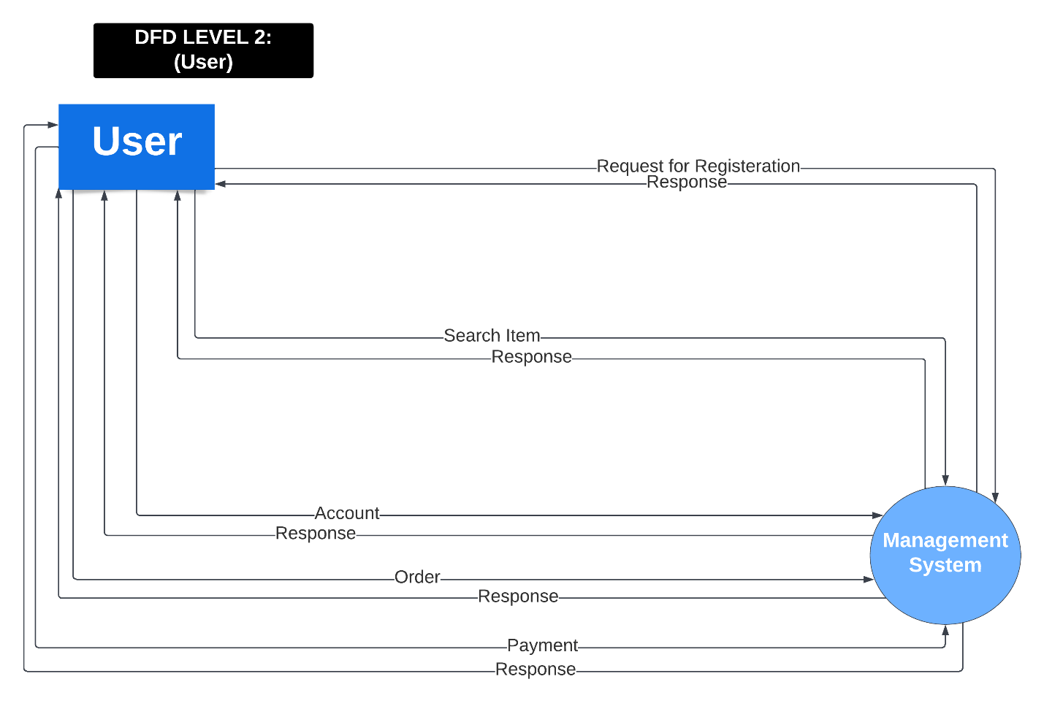

Chapter 5

Implementation

Implementation is that how we will implement our project. This describes how the flow of the project will move, With respect to both client and programmer. This will contain the flow control which will describe how the project works. The component and libraries that are been used in project implementation.

Important Flow Control/Pseudo codes
This is the control flow of the real estate website.
- User will open the website.
- Will login or register in it.
- They will search and select and cart the cloth they liked.
- Client can chat will agent also.

Components, Libraries, Web Services and stubs
Bootstrap: Bootstrap-UI, Material-UI(MUI)
React: React Rest Framework.

Deployment Environment
We have designed our frontend in Bootstrap using visual studio code.

Tools and Techniques
Tools:
- Visual Studio Code
Technology:
- Front-End: Bootstrap, React
- Back-End API: node JS, express JS
- Database: mongo db

Best Practices / Coding Standards
Component-Based Model
Component based model would be used to complete this project.
- Import: Import libraries and packages to for Bootstrap.
- APIs: APIs for the coordination of React.
- Packages and Modules: Packages and module name should be use for implementations.

Version Control
Version: 1.0.0
This is the version 1.0.0 of the project. Have made the complete design of the website. And start making the front end in Bootstrap. User signup and Sign In forms are completed yet. Adding and deleting product from local storage temporarily.

Chapter 6

Testing and Evaluation

In this chapter, the focus is on testing and evaluating the software system. The chapter explores the testing process, including test planning, test case design, and test execution. It discusses various testing techniques and strategies to ensure the functionality, reliability, and security of the system. The chapter also covers performance testing to assess the system's responsiveness and scalability under different load conditions. The chapter emphasizes the need for thorough testing and evaluation to identify and resolve any issues or defects before the software is deployed to production.

Use Case Testing
    - Test Case 1 (Registration):
1. Open the website.
2. Click on the "Register" button.
3. Fill in the required registration details such as name, email, password, etc.
4. Click on the "Submit" button.
Expected Result:
- User should be successfully registered and redirected to the login page.
- User's information should be stored in the database.
    - Test Case 2 (Searching Product):
1. Open the website.
2. Login using valid credentials.
3. Enter search criteria, such as dress type etc.
4. Click on the "Search" button.
Expected Result:
- The website should display a list of dresses that match the search criteria.
- The displayed dresses should include relevant details such as dress type.
- The search results should be accurate and relevant to the entered criteria.
    - Test Case 3 (Adding clothes to the cart):
1. Open the website.
2. Login using valid credentials.
3. Search for cloths using specific criteria.
4. Select a cloth from the search results.
5. Click on the "Add to Cart" button.
Expected Result:
- The selected dress should be successfully added to the user's cart.
- The cart should display the added dress along with its details.
- The user should be able to view and manage the dress in their cart.

Equivalence partitioning
    - User Registration:
Valid Equivalence Class:
- Name: "John Doe"
- Email: "john.doe@example.com"
- Password: "P@ssw0rd"
Invalid Equivalence Class:
- Name: Empty value
- Email: Invalid format (e.g., "john.doe")
- Password: Too short (less than 6 characters)
    - Cart Management:
Valid Equivalence Class:
- Add Product: Successfully adding a product to the cart.
- Remove Property: Successfully removing a product from the cart.
Invalid Equivalence Class:
- Add Property: Attempting to add an already added product to the cart.
- Remove Property: Attempting to remove a product that is not in the cart.
    - User Login:
Valid Equivalence Class:
- Email and Password: Valid and matching login credentials
Invalid Equivalence Class:
- Email and Password: Invalid or mismatched login credentials

Boundary value analysis
    - User Registration:
Minimum and maximum length of the name field:
  - Minimum: Name with 1 character
  - Maximum: Name with 50 characters
Minimum and maximum length of the email field:
- Minimum: Email with 5 characters
- Maximum: Email with 50 characters
Minimum and maximum length of the password field:
- Minimum: Password with 6 characters
- Maximum: Password with 20 characters
    - Product Search:
Minimum and maximum length of the dress type field:
- Minimum: dress type with 1 character
- Maximum: dress type with 100 characters
Minimum and maximum price range:
- Minimum: Price range with the lowest allowed value (e.g., $0)
- Maximum: Price range with the highest allowed value (e.g., $1000)
    - Cart Management:
Maximum number of products that can be added to the cart:
- Maximum: Adding the maximum allowed number of products to the cart
Removing the first and last product from the cart:
- First: Removing the product that was added first to the cart
- Last: Removing the product that was added last to the cart
    - User Login:
Minimum and maximum length of the email and password fields:
- Minimum: Email or password with the minimum allowed length (e.g., 5 characters)
- Maximum: Email or password with the maximum allowed length (e.g., 20 characters)

Data flow testing
- User provides registration details (name, email, password)
- User registration data is stored in the database and a confirmation email is sent (if applicable).
- User provides login credentials (email, password)
- User authentication is performed, and upon successful login, the user is granted access to their account.
- User specifies search criteria (cloth type)
- The system retrieves and displays a list of cloths matching the search criteria.
- User adds or removes products from their cart.
- The cart is updated accordingly, reflecting the added or removed products.
- User sends a message or vice versa.
- The message is delivered to the recipient, allowing for real-time communication.
- User provides payment information (credit card details, billing address).
- The payment information is securely processed, and a confirmation of the successful transaction is provided.
- User updates their profile information (name, contact details, preferences, etc.).
- The user's profile is updated in the system and the changes are reflected in their account.

Unit testing
    - User Registration Unit Test:
Test the registration process with valid user input and verify that the user is successfully registered and stored in the database.
Test the registration process with invalid or missing user input and verify that appropriate error messages or validations are triggered.
    - User Login Unit Test:
Test the login process with valid user credentials and verify that the user is authenticated and granted access to their account.
Test the login process with invalid or incorrect user credentials and verify that appropriate error messages or validations are triggered.
    - Product Search Unit Test:
Test the product search functionality with valid search criteria and verify that the expected properties are returned in the search results.
Test the product search functionality with invalid or incomplete search criteria and verify that appropriate error messages or validations are triggered.
    - Cart Management Unit Test:
Test adding products to the cart and verify that they are correctly added and reflected in the user's cart.
Test removing products from the cart and verify that they are correctly removed and reflected in the user's cart.
    - Communication (Chat) Unit Test:
Test the sending and receiving of messages and verify that messages are delivered accurately and in real-time.
    - Payment Processing Unit Test:
Test the payment processing functionality with valid payment information and verify that transactions are processed successfully.
Test the payment processing functionality with invalid or incomplete payment information and verify that appropriate error messages or validations are triggered.
    - User Profile Management Unit Test:
Test updating the user profile information and verify that the changes are correctly reflected in the user's account.

Chapter 7

Summary, Conclusion and Future Enhancements

Summary, Conclusion & Future Enhancements

Project Summary
The goal of this project is to develop a web application using the MERN stack (MongoDB, Express.js, React.js, and Node.js) to simplify the verification of user/object authentication across multiple services/servers. The project aims to improve performance, enhance user interface and experience, and provide a secure and efficient development process.
By utilizing the MERN stack, the development process becomes smoother and more streamlined, with developers only needing to know one coding language (JavaScript).
The main objectives of the project include implementing JSON Web Tokens (JWT) for authentication, which eliminates the need for repeated visits to a database per request. This improves resource utilization and reduces backend database session traffic, resulting in faster authentication and improved overall performance.
Additionally, the project focuses on securing identity claims by implementing signature-based authentication using public/private key pairs. This ensures the integrity of the token's content and prevents tampering.
The proposed solution leverages MongoDB for its rich data models and queries, providing a robust database solution for the web application. React.js is utilized for frontend development, offering modular components and efficient state management, leading to increased productivity and code maintainability. Node.js, known for its scalability, is used for the backend, ensuring fast and efficient development.
The project plan includes various phases such as project initiation, requirements gathering and analysis, design, development, testing and quality assurance, deployment and launch, and maintenance and support. Each phase is assigned to specific team members responsible for its successful completion.

Achievements and Improvements

Achievements:
      - Enhanced Security:
By implementing signature-based authentication using public/private key pairs, the project ensured the integrity of the token's content and prevented tampering. This added layer of security protected user identity claims and ensured a secure authentication process.
      - Improved User Experience:
The use of the MERN stack, with React.js for frontend development, resulted in an improved user interface and experience. React modular components and efficient state management allowed for smoother interactions, faster rendering, and a more responsive user interface.
      - Efficient Development Process:
The adoption of the MERN stack streamlined the development process by using a single coding language (JavaScript) for both frontend and backend. This reduced the learning curve and allowed developers to work more efficiently, resulting in faster development and increased productivity.

Improvements:
      - Scalability and Performance Optimization:
While the project achieved improved performance, further optimization and scalability measures could be implemented. This could involve optimizing database queries, implementing caching mechanisms, and utilizing load balancing techniques to handle increased user traffic and improve overall system performance.
      - Robust Error Handling and Logging:
Enhancing the error handling and logging mechanisms within the application would provide valuable insights for troubleshooting and debugging. This would help identify and address issues promptly, improving the overall reliability and stability of the web application.

      - Real-time Updates and Notifications:
Adding real-time updates and notifications within the web application could enhance the user experience by providing instant feedback and notifications for important events or actions. This could be achieved using technologies such as Web-Sockets or server-sent events.
      - Performance Monitoring and Analytics:
Integrating performance monitoring and analytics tools into the web application would allow for in-depth monitoring of system performance, user behavior, and application usage. This data could be used to identify bottlenecks, optimize features, and make data-driven decisions for further improvements.

Critical Review
The project summary does not provide a clear understanding of the specific functionalities and features of the web application. Without a detailed description of the project's scope, it is challenging to assess the project's effectiveness and its ability to meet specific user requirements.
The project summary does not explicitly mention user research or user testing to understand the target audience's needs and preferences. A user-centric approach is crucial for developing a successful web application that truly addresses user pain points and provides a seamless user experience.
While the project mentions improving performance standards, there is no mention of specific performance benchmarks or metrics to evaluate the project's success in achieving improved performance. Without clear benchmarks, it is difficult to assess whether the project has met its performance objectives.
The project plan briefly mentions testing and quality assurance phases but does not provide details on the types of testing to be performed or the level of rigor in ensuring the application's reliability and robustness. Thorough testing, including unit testing, integration testing, and system testing, is crucial to identifying and resolving issues before deployment.
The project plan briefly mentions maintenance and support but does not provide a comprehensive strategy for ongoing maintenance and support activities. A detailed plan outlining the approach to handling bug fixes, updates, and customer support is essential for ensuring the long-term success and sustainability of the web application.
The project summary does not delve into the technical details of the implementation, such as specific architectural choices, database design, or security measures. Without these details, it is challenging to assess the technical soundness of the project and the effectiveness of the chosen technologies.
The project summary does not discuss alternative approaches or technologies considered during the planning phase. A critical evaluation of alternatives would provide insights into the decision-making process and whether the chosen MERN stack is the most suitable solution for the project's requirements.

Lessons Learnt
- It is crucial to define the project's scope early on to ensure a clear understanding of the goals, objectives, and deliverables. A well-defined scope helps manage expectations and enables better planning and execution.
- User research and testing should be an integral part of the development process. Understanding the target audience's needs, preferences, and pain points helps create a web application that provides a seamless user experience.
- Establishing performance benchmarks and metrics is essential to evaluate the success of the project in achieving performance improvements. Clear benchmarks help measure and track progress and ensure that performance goals are met.
- A comprehensive testing strategy, including unit testing, integration testing, and system testing, is vital to identify and address issues before deployment. Rigorous quality assurance processes help ensure a reliable and robust web application.
- Planning for long-term maintenance and support is crucial for the success of the web application. Establishing processes and protocols for bug fixes, updates, and customer support helps maintain the application's functionality and address user concerns.
- Proper documentation of technical details, architectural choices, and security measures is essential for future reference and knowledge transfer. It helps developers understand the project's implementation and facilitates ongoing maintenance and updates.
- Reflecting on the project's successes and challenges allows for continuous learning and improvement. Identifying areas for improvement and incorporating feedback into future projects helps enhance processes and outcomes.

Future Enhancements/Recommendations
- Continuously improving the user interface (UI) and user experience (UX) of the web application can enhance user engagement and satisfaction. This includes refining the design, optimizing navigation, and ensuring intuitive interactions.
- Adapting the web application for mobile devices by implementing responsive design techniques will allow users to access and use the application seamlessly on different screen sizes and devices.
- Implementing advanced search and filtering options within the application can enhance user convenience and help users find relevant information or products more efficiently.
- Adding personalization features based on user preferences and behavior can enhance the user experience and increase user engagement. Additionally, incorporating a recommendation engine can suggest relevant products, content, or actions based on user data.
- Integrating social media platforms within the web application can enable users to share content, sign in using social media accounts, and facilitate social interactions among users.
- Providing multi-language support within the web application can expand its reach and cater to users from different regions and language preferences.
- Continuously monitoring and optimizing the application's performance by analyzing and improving database queries, caching mechanisms, and overall system architecture can ensure smooth and efficient operation even under high user loads.
- Implementing additional security measures, such as two-factor authentication (2FA), rate limiting, and data encryption, can further enhance the security of user data and protect against potential vulnerabilities.
- Integrating with popular third-party services, such as payment gateways, shipping providers, or marketing platforms, can enhance the functionality and capabilities of the web application and provide a seamless experience for users.
- Incorporating robust analytics and reporting capabilities within the web application can provide valuable insights into user behavior, application usage, and key performance metrics. This data can guide decision-making and help identify areas for improvement.

Appendices

Appendix A: Project Timeline
A detailed timeline outlining the key activities, milestones, and deadlines of the project.

Appendix B: Work Breakdown Structure
A hierarchical breakdown of the project tasks, subtasks, and deliverables, along with the assigned responsibilities and estimated durations.

Appendix C: Gantt Chart
A visual representation of the project schedule, showing the start and end dates of each task, task dependencies, and resource allocation.

Appendix D: Technical Specifications
Detailed technical documentation, including system architecture, database design, API specifications, and any other relevant technical details.

Appendix E: User Personas
Profiles of typical users, outlining their demographics, goals, behaviors, and pain points. User personas help understand the target audience and guide design decisions.

Appendix F: User Stories
Scenarios or narratives that describe specific user interactions with the web application. User stories provide insights into user requirements and help prioritize features and functionalities.

Appendix G: Wireframes and Mockups
Visual representations of the web application's user interface, illustrating the layout, navigation, and design of various screens. Wireframes and mockups help visualize the application's structure and aid in the design process.

Appendix H: Test plans and results
Documentation outlining the testing strategy, test cases, and expected results. It also includes the actual test results and any issues or bugs encountered during testing.

Appendix I: Maintenance and Support Plan
A plan outlining the approach and processes for ongoing maintenance, bug fixes, updates, and customer support. It includes details on how to handle user feedback and manage software updates.

Appendix J: Risk Assessment
Identification and assessment of potential risks and mitigation strategies. It includes an analysis of possible risks and their potential impact on the project's success, along with contingency plans.

Reference and Bibliography

[1] M. Sher, M. Rehman, “Title of the Paper” Conference name/Journal Name, Edition, Volume, Issue, ISBN/ISSN, PP, Publisher/City-Country, Year.

