The SUPERIOR College LAHORE


Faculty of Computer Science & IT

Final Year Project

PROJECT REPORT

[Canteen Automation System]

Project ID: [FYP-BSCS-F18-044]

Project Team
Student Name | Student ID | Program | Contact Number | Email Address
Muhammad Mughees | Bcsm-f15-196 | BSCS | 03234134779 | m.mughees2@gmail.com
Azmat Manzoor | Bcsm-f15-021 | BSCS | 03316428164 | azmatmanzoor62@gmail.com
M. kashif ismail | Bcsm-f15-052 | BSCS | 03224297484 | Kashif.ismail052@gmail.com

[Mr Zaman Aziz]
([Lecturer])

Project Report
[Canteen automation system]

Change Record
Author(s) | Version | Date | Notes | Supervisor’s Signature
M.Mughees, Azmat, Kashif | 1.0 |  | Proposal
M.Mughees, Azmat, Kashif | 1.1 |  | Template 3
M.Mughees, Azmat, Kashif | 1.2 | 01-12-18 | Template 5
 |  |  | <Added Project Plan>
 |  |  | <Changes Based on Feedback from Supervisor>

APPROVAL
Project Supervisor
Comments: ___________________________________________________________________
_____________________________________________________________________________
Name:______________________________
Date:_______________________________ | Signature:__________________________

Project Manager
Comments: ___________________________________________________________________
_____________________________________________________________________________
Date:_______________________________ | Signature:__________________________

Head of the Department
Comments: ___________________________________________________________________
_____________________________________________________________________________
Date:_______________________________ | Signature:__________________________

Dedication

We dedicating this project “Canteen automation system” to all those who have supported us in any way to complete this project within predefine duration. Especially our parents who have sacrificed for our future and provided us never ending prayers and support and also or beloved teachers who made us what we are today. We believe them as a great source of inspiration

Acknowledgements

I am really thankful to my supervisor Mr. Zaman Aziz for his priceless guidance constant encouragement and endless support in making the project possible. I really appreciate his guidance from the first to the final level that enabled me to complete this project. Without his advice and assistance it would be a lot harder to complete. I also sincerely thanks for the time spent on proofreading and correcting my mistakes. My sincere thanks go to all lecturers and staff members of the department of computer science, Superior College Lahore who helped me in many ways and made my educational journey at superior university Lahore enjoyable and unforgettable. Lastly, I would also like to thank my family, friends and every person who contribute to my final year project directly or indirectly. Please continue to inspire me for making great accomplishments.

Executive Summary
In this project canteen automation system enables the end user to register online, read and select the food from e-menu card and order food online by selecting the food. User can also use our system on his/her smart phone. When user selects some foods from e-menu card will directly appear in the screen near the chief who is going to cook the food for you. The system is Android based. If user uses this application then the work of waiter is minimum and easy. The big benefit of this is application that if space or table is not available in the Canteen than there will be chances that the waiters will be unavailable and the users can directly order the food to the chef online by using this application. The user will have a username and a password, by using which they can login into the system. Nowadays people have no time to spend their time in canteen and waiting for waiter to take their order. Many people visits of canteen for lunch break and there have short time to eat, return to their colleges, universities or offices. By using this software they can save their time.

Table of Contents
Dedication iv
Acknowledgements v
Executive Summary vi
Table of Contents vii
List of Figures x
List of Tables xi
Chapter 1 1
Introduction 1
1.1. Background 2
1.2. Motivations and Challenges 2
1.3. Goals and Objectives 3
1.4. Literature Review/Existing Solutions 4
1.5. Gap Analysis 4
1.6. Proposed Solution 4
1.7. Project Plan 5
1.7.1. Work Breakdown Structure 5
1.7.2. Roles & Responsibility Matrix 7
1.7.3. Gantt Chart 8
1.8. Report Outline 8
Chapter 2 10
Software Requirement Specifications 10
2.1. Introduction 11
2.1.1. Purpose 11
2.1.2. Document Conventions 11
DB: DATA BASE 11
2.1.3. Intended Audience and Reading Suggestions 11
2.1.4. Product Scope 11
2.1.5. References 11
2.2. Overall Description 12
2.2.1. Product Perspective 12
2.2.2. Product Functions 12
2.2.3. User Classes and Characteristics 13
2.2.4. Operating Environment 13
2.2.5. Design and Implementation Constraints 14
2.2.6. User Documentation 14
2.2.7. Assumptions and Dependencies 14
2.3. External Interface Requirements 14
2.3.1. User Interfaces 14
• XML 15
2.3.2. Hardware Interfaces 15
2.3.3. Software Interfaces 15
2.3.4. 15
2.3.5. Communications Interfaces 15
2.3.6. 15
2.4. System Features 15
2.4.1. System Feature 1 15
2.4.1.1. Description and Priority 15
2.4.1.2. Stimulus/Response Sequences 16
2.4.1.3. Functional Requirements 16
2.4.2. System Feature 2 16
2.4.2.1. Description and Priority 16
2.4.2.2. Stimulus/Response Sequences 17
2.4.2.3. Functional Requirements 17
2.5. Other Nonfunctional Requirements 18
2.5.1. Performance Requirements 18
2.5.2. Safety Requirements 18
2.5.3. Security Requirements 18
2.5.4. Software Quality Attributes 18
2.5.5. Business Rules 19
2.6. Other Requirements 19
Chapter 3 20
Use Case Analysis 20
3.1. Use Case Model 21
3.2. Fully Dressed Use Cases 25
Chapter 4 30
System Design 30
4.1. Architecture Diagram 31
4.2. Domain Model 32
4.3. Entity Relationship Diagram with data dictionary 33
4.4. Class Diagram 34
4.5. Sequence / Collaboration Diagram 35
4.6. Operation contracts 36
4.7. Activity Diagram 37
4.8. State Transition Diagram 38
4.9. Component Diagram 39
4.10. Deployment Diagram 40
4.11. Data Flow diagram [only if structured approach is used - Level 0 and 1] 41
Chapter 5 43
Implementation 43
5.1. Important Flow Control/Pseudo codes 44
5.2. Components, Libraries, Web Services and stubs 44
5.3. Deployment Environment 45
5.4. Tools and Techniques 45
5.5. Best Practices / Coding Standards 45
5.6. Version Control 46
Chapter 6 47
Testing and Evaluation 47
6.1. Equivalence partitioning 51
6.2. Boundary value analysis 51
6.3. Unit testing 52
6.4. Performance testing 54
6.5. Stress Testing 56
7.1. Project Summary 58
7.2. Achievements and Improvements 58
7.3. Critical Review 58
7.4. Lessons Learnt 58
7.5. Future Enhancements/Recommendations 59
Appendices 60

List of Figures

1.0 Gantt chart 9
3.0 Use case 1 23
3.1 use case 2 24
3.2 use case 3 25
4.0 architecture diagram 32
4.1 Domain model 33
4.2 Entity relationship diagram 34
4.3 Class diagram 35
4.4 Sequence Diagram 36
4.5 Sequence diagram 37
4.6 Activity diagram 38
4.7 State diagram Admin 39
4.8 State diagram Customer 39
4.9 Component diagram 40
4.10 Deployment diagram 41
4.11 DFD level 0 42
4.12 DFD level 1 43
5.0 Deployment environment 46

List of Tables

1 use case for login 25
2 use case for logout 26
3 use case for take order 26
4 use case for bill print 26
5 use case for add, remove items 27
6 use case for add offers 27
7 use case for update inventory 27
8 use case for forecasting 27
9 use case for sales for each day and month 28
10 use case for individual items 28
11 use case for total earning 28
12 use case for order place by customer 28
13 use case for offer 28
14 use case for order forecasting 29
15 use case for menu items 29
16 use case for place an order 29
17 use case for combo box selection 29
18 bill payment 30

Chapter 1

Introduction

Chapter 1: Introduction
In today age of fast canteen automation in the canteen, many canteens have chosen to focus on quick preparation. The main advantage of online ordering system is that it greatly simplifies the ordering process for both the customer and the canteen. When the customer visit the ordering app they are presented with an interactive and up to date menu complete with all available options and adjusting prices based on the selecting options. After making the selection the item is then added to their order, which the customer can review the details at any time before checking out. This provides instant visual confirmation of what was selected.

Background
Traditional companies and institutions are making use of e-commerce to overcome the boundaries of space and time. It allows them to globalize their operations and offer a more personalized service to the customers. Moreover, many entrepreneurs takes advantage of the benefits of e-commerce and creating new business models& taking new business ideas.
E-commerce has greatly evolved for forty years of existence and is still evolving continuously. When searching for e-commerce solutions, almost all offered systems are focused on building web-shops.

Motivations and Challenges
The purpose of a project is to advance one or more business objectives. Most projects start out closely aligned with these objectives, but gaps inevitably appear. Without redirection, projects and deliverables end up failing to meet expectations. We will try to complete on a time.
Late projects delaying the time at which a company can start reaping business benefits, payback period calculations and disrupting the long term return on investment. But we team together as a team will do it in a time. Overlapping projects are responsible for major inefficiencies and wasted budgets, time and resources. Redundant and duplicative projects are also unprofitable, increasing costs, prolonging schedules and diverting resources from more deserving projects, and we will make it our own.
Every project generates deliverables that the company uses to derive business value. When those deliverables arrive late or are incomplete, the business loses opportunities whether to earn revenues acquire customers or perhaps fix a problem. We as a team together will complete our project on a time, so we could earn profit. Many executives are unable to obtain the right information at the right time to effectively understand the present position of the business. Our team is capable to take a right decision in a right time.

Goals and Objectives
Following features we will provide, & following goals we will try to achieve:

- Satisfy the customer:
Our main purpose is to satisfy the customers & fulfill their needs.
- Time saving:
Some people do not have time to buy any Foods/Vegetables or stuff like that, so we are delivering at their home and restaurant saving their time.
- Reasonable price:
Our purpose is to provide the service to our customers in a reasonable price
- Application:
We are making a application for the ease of the customers where they can give an order.

Literature Review/Existing Solutions
People with the name canteen automation are working on it, idea is bit similar, and they deliver food items by just ordering in Application.
They didn’t even start working on their Application whereas we’ve thought to make it first. We are targeting people from social sites, from our website where our customers will able to give an order so we would able to deliver, just for the ease of customers not by just calling. We are taking order from our Application.
Also we’ve thought to do it commercially, in a large scale in the future. We aren’t just delivering fruits & vegetables also delivering some other stuff like meat, breads, and eggs like we use to eat daily.
Moreover we’re making an android app that will guide the way to our delivery men, by using Dijkestra Algorithm (it will display shortest path first) so they would able to deliver food items on a time.

Gap Analysis
Currently targeting Lahore only at first, but we are planning to expand its operation in other major cities of Pakistan.
Planned Strategy:
Our main purpose is to satisfy the customers & fulfill the needs of customers.

Proposed Solution
Solution of the problems:
- Satisfy the customer
- Time saving
- Reasonable price
- Fresh food at restaurant
- Delivery at reasonable price

Project Plan
 | Description of Work | Start and End Dates
Phase One | Android App | 5 Months

Work Breakdown Structure
Phase 1
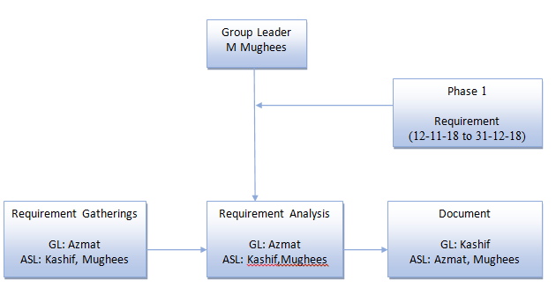
Phase 2
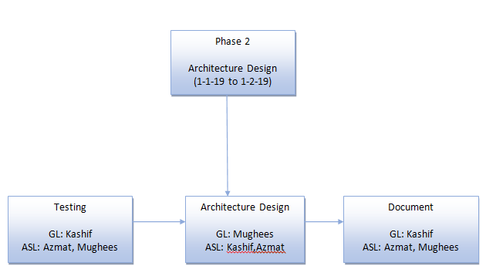
Phase 3
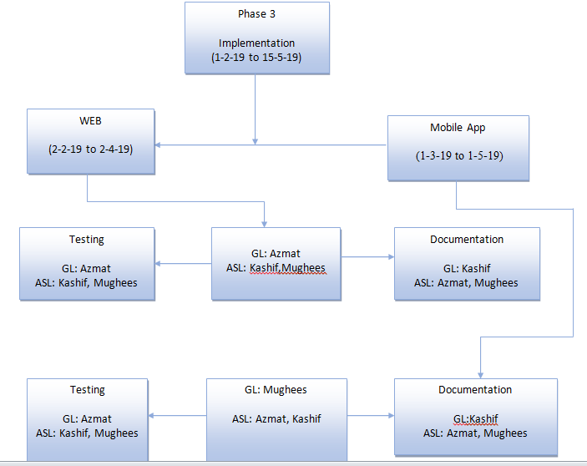

Roles & Responsibility Matrix
WBS # | WBS Deliverable | Activity # | Activity to Complete the Deliverable | Duration  (# of Days) | Responsible Team Member(s) & Role(s)
1 | Requirement Phase | 1 | 31-12-2018 | 40 | Mughees
2 | Requirement Gathering | 1 | 10-12-2018 | 40 | Azmat
3 | Requirement Analysis | 1 | 22-12-2018 | 10 | Azmat
4 | Requirement Document | 1 | 31-12-2018 | 10 | Kashif
5 | Architecture and Design Phase | 1 | 4-12-2018 | 10 | Kashif
6 | Architecture Testing | 1 | 22-01-2019 | 10 | Azmat
7 | Architecture Document | 1 | 01-02-2019 | 20 | Mughees
8 | Implementation Phase | 1 | 15-05-2019 | 40 | Mughees
9 | WEB | 1 | 01-04-2019 | 60 | Azmat
10 | Mobile Application | 1 | 29-04-2019 | 90 | Kashif
11 | System Testing | 1 | 15-05-2019 | 15 | Azmat
12 | Deployment | 1 | 30-05-2019 | 15 | Mughees
]

Gantt Chart
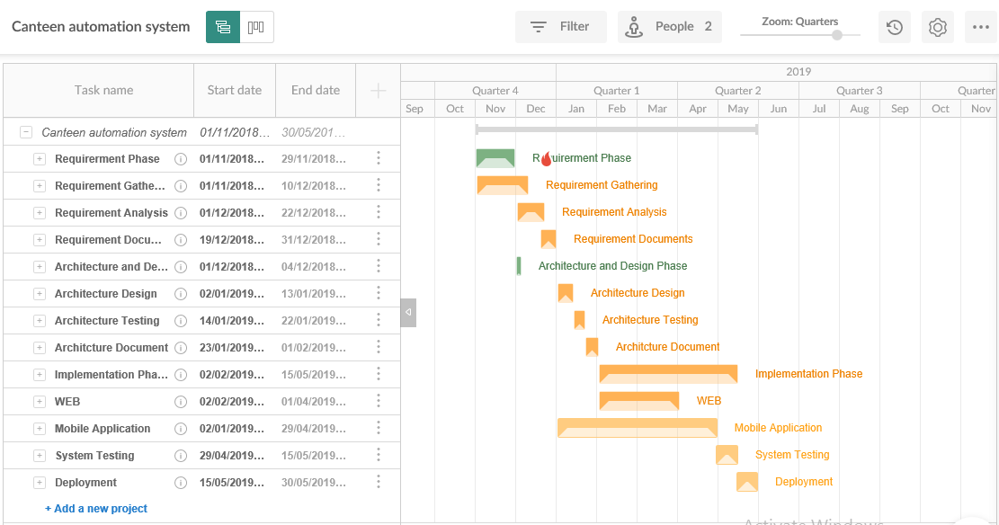
Fig 1.0 Gantt chart

Report Outline
- Introduction
    - What we are going to do?
  - Background
    - What currently happening in the market
  - Motivation & Challenges
    - Discussed in detail
  - Goals and Objectives
    - Discussed how to achieve our goals.
  - Existing System
    - Discussed what unique we are having, how could survive in a market
  - Gap Analysis
    - Discussed Gap Analysis & Discussed what is our planned strategy?
  - Proposed Solution
    - Discussed the solutions of the problems
  - Project Plan
    - Made a project plan so we could complete our project in a time.
  - Work Breakdown Structure
    - Discussed in detail
  - Rules & Responsibility
    - Divided task in team members
  - Gantt Chart
    - Made a chart so could complete our project in a time.

Chapter 2

Software Requirement Specifications

Chapter 2: Software Requirement Specifications

Introduction

Purpose
The introduction of the Software Requirements Specification (SRS) provides an overview of the entire SRS with purpose, scope, references and overview of the SRS. The aim of this document is to defining the problem statement in detail.

We are making Application with a name online canteen.com. Our idea is basically to deliver fresh food at canteen and home with a small amount of delivery charges.

Our main purpose is to provide the facility in every canteen and home if possible without the customer’s headache, without wasting their time, in a reasonable price by satisfying our customers while ensuring the highest quality and grade of the food.

Document Conventions
This document uses the following conventions.

DB: DATA BASE
ER: ENTITY RELATIONSHIP

Intended Audience and Reading Suggestions
This project is a prototype for the online order taking in resturants and it is not restricted within the college premises it is also has been implemented in the market . This project is useful for the restaurant owners, canteen owners and customers as well.

Product Scope
The purpose of the online canteen system is to ease taking orders and to create a convenient and easy-to-use application for customers, trying to buy food to order online. The system is based on a relational database with its restaurant management and reservation functions. We will have a database server supporting hundreds of major restaurants. Above all, we hope to provide a comfortable user experience along with the best pricing available.

References
https://krazytech.com/projects
Fundamentals of database systems by ramez elmarsi and shamkant b.navathe

Overall Description

Product Perspective
Our system will store the following information in our database:
Order detail:
Type of order, order number, order cost, total numbers of orders.
Customer description/ home addresses:
It includes customer name, address and phone number. This information may be used for keeping the records of the customers for any emergency or for any other kind of information.

Product Functions
The following list of function descriptions explains the major features
Account Registration
The registration function shall allow users to create secure accounts. The account will track the user’s name, address and password.
Account Login
The account login function shall allow account members to enter their username and password.
Add to Shopping Cart
Add to shopping cart function shall allow users to temporarily save orders in a list that are being considered for purchase.
Delete from Shopping Cart
The delete from shopping cart function shall remove any unwanted items from the cart.
Order
Users/account members will able to buy their products by giving an order
Checkout
Purchases will be in cash on delivery.
Update Account Information
The update account information function shall give account members access to edit their stored information.
Account Logout
The account logout function shall allow account members to exit their account for security purposes.

User Classes and Characteristics
The system comprises of 3 major modules and their sub modules as follows:
- Admin Login
- Take Order
- Bill Print
- Add/ Remove Food Items
- Add Offers
- Update Inventory
- Total Earnings

- Staff Login
- Order placed by Customer
- Offer

- User Login
- Menu Items
- Place an Order
- Combo Box Selection
- Bill Payment

Operating Environment
Operating environment for the airline management system is as listed below.
- client/server system
- Operating system: Android smart phones and tablets
- database: Fire base
- platform: Android studio ver:3.4

Design and Implementation Constraints
- We should follow the IEEE standards.
- Default Language will be English.
- Project will follow all the copyright and cyber laws of PTA (Pakistan Telecommunication Authority).

User Documentation
Users of the website must know how to navigate in a website.
- We will organize help-line for customer support in the future.
- We will make a blog canteen automation.blogspot.com for online help for the customers.

Assumptions and Dependencies
Android application, canteen automation is only accessible through the Internet, it is assumed that the end user has a connection to the Internet. It is also assumed that the user has an android phone able to display the application.

External Interface Requirements

User Interfaces
The system will provide the ability for users to access our website via the Internet.
Users
- Users will able to do
- Login
- Menu Items
- Place an Order
- bill Payment
- Users will able to delete their orders.
User Interface:

XML
- FIREBASES
- java

Hardware Interfaces
- Android phone : Must be an android operating system platform.

Software Interfaces

- Operating System: Android OS
- Development tool: Android studio,Java,JSON
- Database: Firebases

Communications Interfaces

- This project supports the Android Operating system environment
- The protocol used shall be HTTP and TCP.
.

System Features

System Feature 1

Description and Priority
Our system will maintains information of different Users, their orders. This project has a high priority. We will making web application that will guide the way to our delivery men, by using Dijkestra Algorithm they will able to deliver.

Stimulus/Response Sequences
Click "Register" Button: Account Registration
1. The system shall allow a non-registered user to create a secure account.
2. The system shall require the following information from the user: Name, Address.
3. The system shall ask the user for a username and password.
4. The system shall confirm the username and password are acceptable.
5. The system shall store the information in the database.
Click "Login" Button: Account Login
1. The system shall allow a registered user to log-in to their account.
2. The system shall require a username and password from the user.
3. The system will verify the username and password, and the user will be considered “logged-in”.
Click "Add to Shopping Cart" Button: Add to Shopping Cart
1. The system shall allow a registered and logged-in user to temporarily save orders that are being considered for purchase into a list associated with their account.
2. When viewing the shopping cart list, the system shall display the total price of their products in the cart.

Functional Requirements
- Admin login
- Staff login
- User login

System Feature 2
Admin can access the whole system. He can update & delete items.

Description and Priority
Admin can login & after logged in h
e can add other admin, he can add new items into website he can also update & delete items as well. He can add new categories & he can delete them as well.

Stimulus/Response Sequences
Click "Login" Button: Account Login
1. The system shall allow an admin to log-in.
2. The system shall require a username & id.
3. The system will verify the username and id, and the admin will be considered “logged-in”.
Click "add subadmin": for add & remove admin
- The system shall allow registered admin to add new admin.
- The system shall allow registered admin to delete registered admin.
- The system shall require the following information from the user: Name, id.
- The system shall ask the admin username and id.
- The system shall confirm the username and id which is acceptable.
- The system shall store the information in the database.

Click "categories" Button: add & remove categories
1. The system shall allow an admin to add categories.
2. The system shall require a username & id to add & remove categories.
3. The system shall allow an admin to remove categories.

Click "add products" Button: to add products
The system shall require a username & id to add products.

Click "Edit/Delete" Button: to edit or delete products
The system shall require a username to edit or delete products.

Functional Requirements

Click "subadmin" to add & remove admins
Click "Login" for account log in
Click "categories" Button for Adding and removing items.
Click "add products" for adding new products
Click "Edit/Delete" Button: to edit or delete products

Other Nonfunctional Requirements

Performance Requirements
For making a Website it is very necessary to improve speed, accuracy & performance of website

- Response time: The home page loaded in 2 seconds.
- Availability: The site will available 99.99% of the time.
- Throughput: Page hits per second or orders per hour.
- Capacity: Maximum throughput that can be achieved with acceptable response time
and availability.

Safety Requirements
- Once admin delete product adds or product categories or user account the data of
that product add can’t be retrieve. To handle this problem system gives warning
before delete the product.
- If any user has some problem while using the site, so he can contact via mail to
website maintainers.

Security Requirements
Security systems need database storage just like many other applications. However, the special requirements of the security market mean that vendors must choose their database partner carefully.

Software Quality Attributes
- Availability: Website should be available on time so user would able to access.
- Correctness: Correct item should display in the shopping cart so user could buy correct item.
- Maintainability: The administrators should be maintain website.
- Usability: Should satisfy customers need.

Business Rules
• If user want to order food than he has to first sign up.
• Application will not responsible for damage of any food.
• User has to follow terms and conditions of website.

Other Requirements
Usability: This application easy to use and easy to learn how to
operate.
Portability: This software can be used on different devices like
tablets, mobiles, laptops etc.
Flexibility: The functionality of this software can be increased after development
because documentation is available.

Chapter 3

Use Case Analysis

Chapter 3: System Analysis
This chapter describe about system use cases and how the different actors are interacting
with the system. In use case main functionalities of the system are defined that are divided
in different modules e.g. major use case in which all functionalities of the system are defined is divide into admin , user and staff module and each actor interacting with module and
Performing his module functionalities.

Use Case Model
Following are the three use cases i.e
Admin use case i.e use case 1.
Staff use case i.e use case 2.
User use case i.e use case 3.

Fig 3.0 use case

Fig 3.1 use case

Fig 3.2 use case

Fully Dressed Use Cases
Use Case: | Login
Actors: | admin, Customer, staff
Type: | Primary and essential
Description: | Initiated when a user attempts an action that is restricted. The user is then Prompted to enter in their username and password in order to proceed.
Includes: | NAME,ID
Extends: | None
Cross Ref:
Use-Cases: | None
Table 1:use case for login

Use Case: | Logout
Actors: | admin, Customer, staff
Type: | Primary and essential
Description: | The customer or manager will have the option to logout and if that user is inactive
Includes: | None
Extends: | None
Cross Ref:
Use-Cases: | User must have completed the Log In use case.

Table 2:use case for logout

Use Case: | Take order
Actors: | Admin
Type: | Primary and Essential
Description: | All the items are listed on a single page with item including its title, name and price.
Includes: | Select order and Price
Extends: | None
Cross Ref:
Use-Cases: | None

Table 3: use case for take order

Use Case: | Bill print
Actors: | Admin
Type: | Primary and Essential
Description: | Allows the Customer to place items into cart for later purchase.
Includes: | Price
Extends: | None
Cross Ref:
Use-Cases: | Log in is not compulsory
Table 4: use case for bill print

Use Case: | Add/remove food Item
Actors: | Admin
Type: | Primary and Essential
Description: | Allows the Admin to add items
Includes: | None
Extends: | Add offers
Cross Ref:
Use-Cases: | admin must have completed the Log In use case
Table 5: use case for add, remove food item

Use Case: | Add offers
Actors: | Admin
Type: | Primary
Description: | Let the admin add the offers.
Includes: | None
Extends: | None
Cross Ref:
Use-Cases: | admin must have completed the Log In use case
Table 6: use case for add offers

Use Case: | Update inventory
Actors: | Admin
Type: | Primary and Essential
Description: | Admin will make the list of items , description ,quantity and prices.
Includes: | None
Extends: | None
Cross Ref:
Use-Cases: | admin must have completed the Log In use case
Table 7: use case for update inventory

Use Case: | Sales for each day and month
Actors: | Admin
Type: | Primary
Description: | This will provide sales of each day and months.
Includes: | None
Extends: | Total earning
Cross Ref:
Use-Cases: | Admin must have completed the Log In and Checkout use cases
Table 9:use case for sales for each day and month

Use Case: | Sales for individual items
Actors: | Admin
Type: | Primary
Description: | This will provide sales of individual items.
Includes: | None
Extends:
Cross Ref:
Use-Cases: | Admin must have completed the Log In and Checkout use cases
Table 10: use case for sales for individual items
Use Case: | Total Earning
Actors: | Admin
Type: | Primary
Description: | This will provide total earning of products in a day or monts.
Includes: | None
Extends:
Cross Ref:
Use-Cases: | Admin must have completed the Log In and Checkout use cases
Table 11: use case for total earning
Use Case: | Order place by customer
Actors: | Staff
Type: | Secondary
Description: | This will provide order placed by customer to staff.
Includes: | Price and item
Extends:
Cross Ref:
Use-Cases: | staff must have completed the Log In and Checkout use cases
Table 12: use case for order place by customer

Use Case: | Offer
Actors: | Staff
Type: | Secondary
Description: | The staff will see the added offers by the admin.
Includes: | None
Extends:
Cross Ref:
Use-Cases: | Staff must have completed the Log In and Checkout use cases
Table 13: use case for offer
Use Case: | Order forecasting
Actors: | Staff
Type: | Secondary
Description: | The staff will see the order forecasting by the admin.
Includes: | None
Extends:
Cross Ref:
Use-Cases: | staff must have completed the Log In and Checkout use cases
Table 14:use case for order forecasting
Use Case: | Menu items
Actors: | User, admin
Type: | Primary
Description: | User will see menu items which is added by the admin.
Includes: | Price and item
Extends: | Place an order
Cross Ref:
Use-Cases: | user must have completed the Log In and Checkout use cases
Table 15: use case for menu items
Use Case: | Place an order
Actors: | User, admin
Type: | Primary
Description: | User will place order to admin.
Includes: | None
Extends: | Menu items
Cross Ref:
Use-Cases: | User, admin must have completed the Log In and Checkout use cases
Table 16: use case for place an order

Use Case: | Combo box selection
Actors: | User, admin
Type: | Primary
Description: | User will make box of different food items like(burger+ fries+ cold drink+ salad).
Includes: | None
Extends:
Cross Ref:
Use-Cases: | User and admin must have completed the Log In and Checkout use cases
Table 17:use case for combo box selection

Use Case: | Bill payment
Actors: | User
Type: | Secondary
Description: | User will make box of different food items like(burger+ fries+ cold drink+ salad).
Includes: | None
Extends: | Bill payments
Cross Ref:
Use-Cases: | User must have completed the Log In and Checkout use cases
Table 18: use case for bill payment

Chapter 4

System Design

Chapter 4: System Design
This chapter contains diagrams and models that represent the system. The whole system has been defines below.
This is an online application and the server will manage the delivery of most of the resources. We will also develop mobile application. The user will need a connection to the internet for accessing our system and all its features.

Architecture Diagram

Fig 4.0 architecture diagram

Domain Model
Fig 4.1 domain model

Entity Relationship Diagram with data dictionary
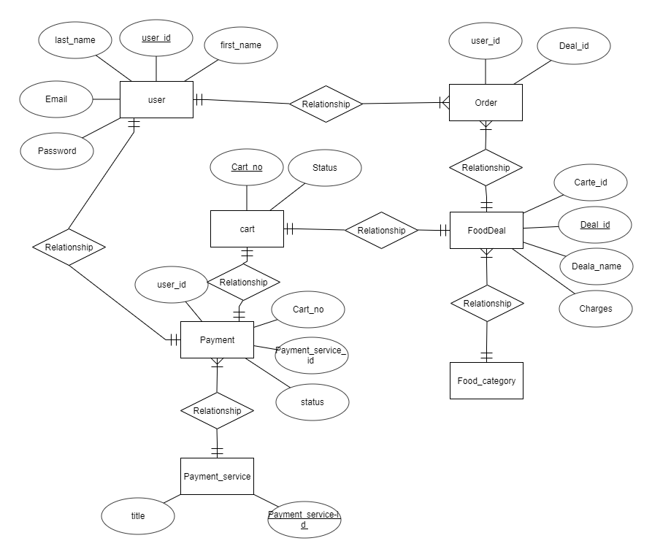
Fig 4.2 ER diagram

Class Diagram

Fig 4.3 class diagram

Sequence / Collaboration Diagram
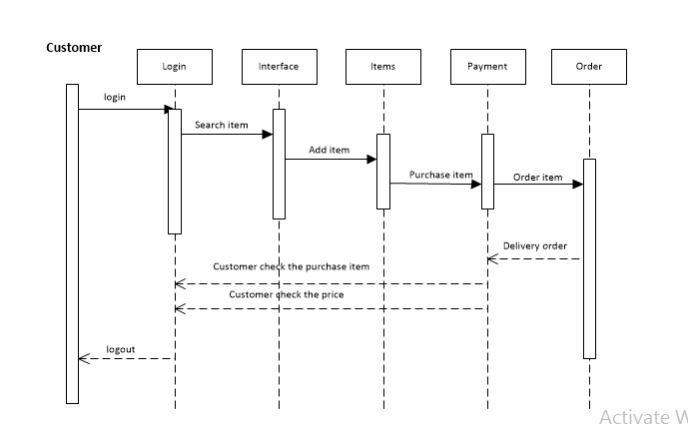
Fig 4.4 SD

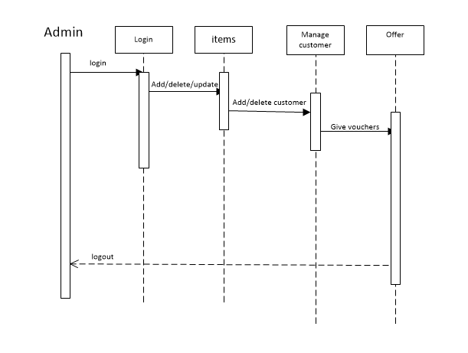
Fig 4.5 SD

Operation contracts
Operation: makenewsale()
Cross reference: Use Cases: Process of Selling
Pre-Conditions: None
Post-Conditions: Item for selling is created (instance creation)
Quantity (attribute modification)
Product Specification, based on item-id (association formed)

Operation: item (item-id, quantity, integer)
Cross reference: Use Cases: Process of Selling
Pre-Conditions: Selling
Post-Conditions: ItemID is created (instance creation)
ItemID was associated with current sale (association formed).
ItemID became quantity (attribute modification).
ItemID was associated with a productDescription, based on ItemID match (association formed).

Activity Diagram
Fig 4.6 Activity diagram

State Transition Diagram
Admin
Fig 4.7 ST diagram

Customer
Fig 4.8 ST diagram

Component Diagram
Fig 4.9 Component diagram

Deployment Diagram
Fig 4.10 Deployment diagram

Data Flow diagram [only if structured approach is used - Level 0 and 1]
Level 0

Fig 4.11 DFD

Level1
Fig 4.12 DFD

Chapter 5

Implementation

Chapter 5: Implementation
After defining the whole System design we are going to see how we will implement it, which types of tools & techniques that we are using to make it, which web servers are required for our application & which type of standards we should follow while coding. How we adjust interface like buttons.

Important Flow Control/Pseudo codes
Diagram of our system shows the whole process of working in different steps. If a user wants to buy an item, user should have an account first. If user is already register then user directly login and buy an item, if user isn’t already registered he must have to register himself to buy any item. To buy an item user can order items, if a user founds an item he can simply order. User can order many items if he wants to, on other hand Admin can manage all the items, orders and if the process is done user can logout.

Components, Libraries, Web Services and stubs
Web Servers:
- Apache HTTP Server/ Internet information server
Components:
- Domain name: canteenautomation.pk

Deployment Environment
Our website canteenautomation.pk will be hosted on different webservers.
Fig 5.0 Deployment environment

Tools and Techniques
Following tools will be used for the development.
- Fire base (Database)
- XML (for Front End Designing)
- Android Studio/Java /JSON ( Android App)
- Java

Best Practices / Coding Standards
- Communicate with all project stakeholders
- Create a risk response team
- Use a detailed work definition document
- Create a detailed work plan
- Document everything
- Ask for feedback
- Communicate the impact of project add-ons
- Manage new agreements
- Hold a wrap-up meeting

Version Control

Task # | Deliverable | Activity # | Duration  (# of Days) | Responsible Team Member(s) & Role(s)
1 | XML Designing & Coding | 1 | 2 Months | 2- Front End Designing & coding,  Azmat, Kashif Ismail
2 | Firebase Database | 2 | 1 Month | -Manage whole Database  Azmat, Kashif ismail
3 | Application Designing & Coding | 3 | 1 Month | 1-App Front end Designing & coding,  Mughees, Azmat, Kashif

Chapter 6

Testing and Evaluation

Chapter 6: Testing and Evaluation
This chapter is about the testing phase:
We test our application using different techniques like Use Case testing, Data flow testing, Unit testing, Integration testing, performance testing, stress testing, etc to check the performance of an application.

Use Case Testing:

1-Signup
Success Scenario | Step | Description
A: Actor  S: System | 1 | A: First name, Last name, email, password, Ph #
A: Actor  S: System | 2 | S: Check Existing Information
A: Actor  S: System | 3 | S: sign up
Extension | 2a | User Already Exist  S: Display error message account already exits

2-Login
Success Scenario | Step | Description
A: Actor  S: System | 1 | A: First name, Last name, email, password, Ph #
A: Actor  S: System | 2 | S: Validate password and email
A: Actor  S: System | 3 | S: Allow Account Access
Extension | 2a | Password and Email not valid  S: Display error message invalid Email or password

3-Logout
Success Scenario | Step | Description
A: Actor  S: System | 1 | A: log out from the application
A: Actor  S: System | 2 | S: Must be login
A: Actor  S: System | 3 | S: Deny Account Access
Extension | 2a | Internet may not available  S: Display error message ”User already logout”

4-Add Admin
Success Scenario | Step | Description
A: Actor  S: System | 1 | A: Add categories ,deal, Add/Delete product, Moving to cart.
A: Actor  S: System | 2 | S:
A: Actor  S: System | 3 | S: Add Post
Extension | 2a | S: Display error message “size or format invalid”

5-orders
Success Scenario | Step | Description
A: Actor  S: System | 1 | A: paid orders, unpaid orders
A: Actor  S: System | 2 | S: customer detail, order(total bill ,order quantity ,price)
A: Actor  S: System | 3 | S: Update order
Extension | 2a | Post not valid  S: Display error message size or format

6-Delete Post
Success Scenario | Step | Description
A: Actor  S: System | 1 | A: Select category(by pushing)
A: Actor  S: System | 2 | S: Check i.e want to delete.
A: Actor  S: System | 3 | S: Delete category
Extension | 2a | Post not valid  S: Display error message “you are not allowed to delete “

7-Friends Search
Success Scenario | Step | Description
A: Actor  S: System | 1 | A: Enter Friend Name or Emil address
A: Actor  S: System | 2 | S: Check user Available
A: Actor  S: System | 3 | S: Show all matching Users
Extension | 2a | User not found  S: Display error message User does not exist

8-Add customer
Success Scenario | Step | Description
A: Actor  S: System | 1 | A: Enter Friend Name or Emil address ,password, ph #
A: Actor  S: System | 2 | S: Check customer Available
A: Actor  S: System | 3 | S: Show all matching customer | Send request
Extension | 2a | User not found  S: Display error message User does not exist

9- order placing
Success Scenario | Step | Description
A: Actor  S: System | 1 | A: select category
A: Actor  S: System | 2 | S: show Available price
A: Actor  S: System | 3 | S: | Order added to cart
Extension | 2a | User not found  S: Display error message User does not exist

10-Add note
Success Scenario | Step | Description
A: Actor  S: System | 1 | A: Enter category in cart
A: Actor  S: System | 2 | S: Order added in cart
A: Actor  S: System | 3 | S: | Submit/cancel
Extension | 2a | User not found  S: Display error message User does not block

11-Check Quantity
Success Scenario | Step | Description
A: Actor  S: System | 1 | A: User have to added order in cart first
A: Actor  S: System | 2 | S: Select quantity
A: Actor  S: System | 3 | S: Order summary

Extension | 2a | Invalid ID  S: Display error message Internet not Available

12-staff
Success Scenario | Step | Description
A: Actor  S: System | 1 | A: staff have to login first
A: Actor  S: System | 2 | S: Check staff Profile Exists
A: Actor  S: System | 3 | S: staff account created
Extension | 2a | Profile not Valid  S: Display error message Profile does not updated

13-Comment
Success Scenario | Step | Description
A : Actor  S : System | 1 | A: entering invalid email or password
A : Actor  S : System | 2 | S: message showing(this password is invalid)
A : Actor  S : System | 3 | S: don’t signin to the account
Extension | 2a | Hostel Not Exists  S: Display error message does not have permission

Equivalence partitioning
This technique known as Equivalence Class Partitioning (ECP). In this technique, input values to the system or application divided into different classes or groups based on its similarity in the outcome.
Hence, instead of using each input value we can now use any one value from the group/class to test the outcome. In this way, we can maintain the test coverage while we can reduce a lot of rework and most importantly, the time spent.

Boundary value analysis
Boundary testing in the process of testing that is between start point and extreme ends or boundaries between partials of input values.

Login username
Username that a person enter in the text box at the time of login must be correct and between 4 to 8 characters and unique.
If the username is not correct, the system must restrict the user at the current page.

Login password
Username that a person enter in the text box at the time of login must be correct and between 3 to 8 characters.
If the username is not correct, the system must restrict the user at the current page.

Text fields:
All text fields system have must accept only correct text
User must add those information which is needed and to the point
Text fields are name, city, country etc.

Numeric fields:
The numeric fields must accept only numbers
Numeric fields are mobile number, CNIC number, quantity of products etc.

Email fields:
Emil fields are also available in the software system
Email fields must accept email formats.

Automatic filled fields:
Some fields in this system are automatic filled when a user keep data from one page to another, these fields automatically filled with information.
Keep in mind that these fields cannot edit or enter by the end user.

Unit testing

Table 6.3 – unit testing
Test units | Test items | Input specifications | functionality | Result
Test unit 1 | Login to system | The fields of input and password cannot be empty.  The email and password must match with the registered username and password. | Enter the registered email, password, and press login button.  Get access to system | Successfully logged in to the system.
Test unit 2 | View Profile | In Main Profile, Every button will work ok every activity should be open correctly. | Test all the buttons and link, everything work ok. | Successfully checked whole Profile
Test unit3 | Connect to FireBase Database | Use Google Firebase database.  Enter correct username and password for authentication.  Check the connection successful message. | Connect server to database to save your updates into the database. | Successfully connected to database.

Test unit4 | Testing to add customer/admin/staff | Input can be a string, numbers, integers and floating digits. | Add customer/admin/staff successfully into database. | customer/admin/staff added successfully.
Test unit5 | Testing of add category , add deal. | Inputs can be string. | Add deal or category | Added successfully

Performance testing

Test case number: 01
Test case title: System response time testing

Table 6.9 – performance testing (System response time testing)
Test type | Performance testing | Test result
Required performance | The required response time of the system is less than 5 seconds
System performance | The actual performance response time is 4 seconds. | Test passed

Test case number: PT 02

Test case title: Page load time testing

Table 6.10 – Performance Testing (Page load time testing)
Test type | Performance testing | Test result
Required performance | The required page load time of the system is less than 3 seconds
System performance | The actual page load time is 2 seconds. | Test passed

Test case number: PT 03
Test case title: Huge number of users

Table 6.11 – performance testing (Huge number of users)
Test type | Performance testing | Test result
Required performance | System should perform normally and efficiently with a large number of users
System performance | System performed all activities normally with a large number of users. | Test passed

Test case number: PT 04
Test case title: Waiting time testing

Table 6.12 – performance testing (Waiting time testing)
Test type | Performance testing | Test result
Required performance | The average waiting time of the system is less than 3 seconds

System performance | The actual performance response time is 2 seconds in some circumstances. | Test passed

Test case number: PT 05
Test case title: Connection establish time testing

Table 6.13 – performance testing (Connection establish time testing)
Test type | Performance testing | Test result
Required performance | The connection must be established in less than 2 seconds
System performance | The actual connection establish time is about 1 second. | Test passed

Test case number: PT 06
Test case title: Database send/get information time testing

Table 6.14 – performance testing (Database send/get information time testing)
Test type | Performance testing | Test result
Required performance | The system should save or retrieve data from database in less than 5 seconds.
System performance | The actual time system send or get information to database in 3 second. | Test passed

Stress Testing
Stress testing is a process of measuring the stability and reliability of the system. Stress testing used to check the ability of system to handling the bugs and errors. Stress testing used to test the system’s ability of error handling during extremely heavy load.
To ensure that our system behaves normal during the stress we overload our system and examine the system’s behavior in extreme circumstances. The inventory management system behaves normally in unfavorable conditions and all of its features and functions perform their functionality.
Through this testing, we monitor our system and make sure our system
- System should save all data before crashing
- Make sure the connection from server
- If server no response, wait on login current page
- Make sure the saving of data and then show success message after operation done
- System should do deleting and updating of records correctly.

Chapter 7
Summary, Conclusion &
Future Enhancements

Chapter 7: Summary, Conclusion & Future Enhancements

Project Summary
In this project canteen automation system enables the end user to register online, read and select the food from e-menu card and order food online by selecting the food. User can also use our system on his/her smart phone. When user selects some foods from e-menu card will directly appear in the screen near the chief who is going to cook the food for you. The system is app based. If user uses this app then the work of waiter is minimum and easy . The user will have a username and a password, by using which they can login into the system. Nowadays people have no time to spend their time in canteen and waiting for waiter to take their order. Many people visits of canteen for lunch break and there have short time to eat, return to their colleges, universities or offices. By using this software they can save their time.

Achievements and Improvements
- Learnt to work in a team.
- Learnt time management.
- Learnt how to survive in a competitive business environment.
- We will try to improve & take care of our project, we will try to make it more secure, maintain its availability and it will be more responsive at a time.

Critical Review
We know our competitors and we’ve learnt how to survive in a market, for being stay in a market we must have to take a uniqueness to compete everyone in a business environment.

Lessons Learnt
Learnt how to make a successful project with absolutely no chances of failure & learnt how to survive in a market.

Future Enhancements/Recommendations
- Expanding its operation in other cities major cities of Pakistan it is our main goal.
- We will make android app where our customers will able to buy food items from our android app with full transaction process.

Appendices

- Here the screenshots showing our app’s first page with sign in and sing up options with sign up form.
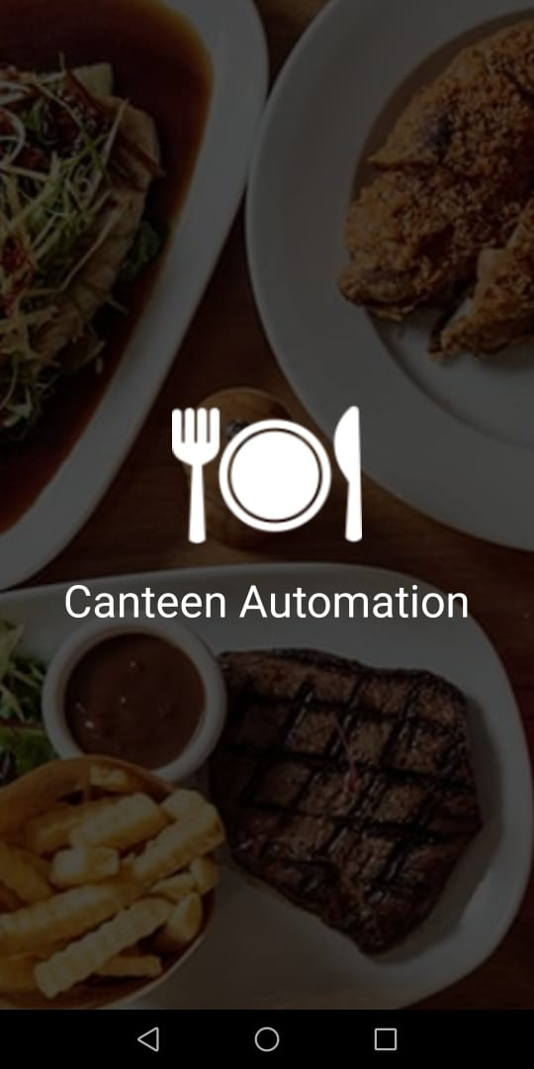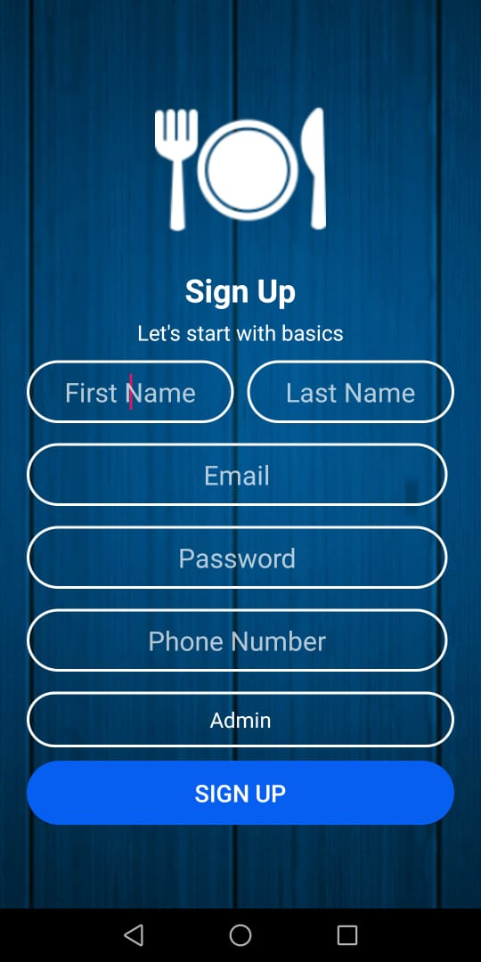

- Here the secreenshots showing our app’s sign in form by login in to the account by email address and password.
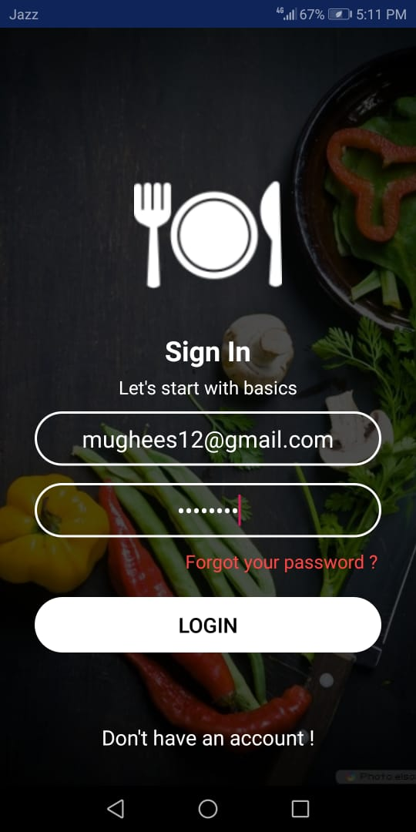

- Here the secreenshots showing our app’s category page after login in to the account by email address and password.
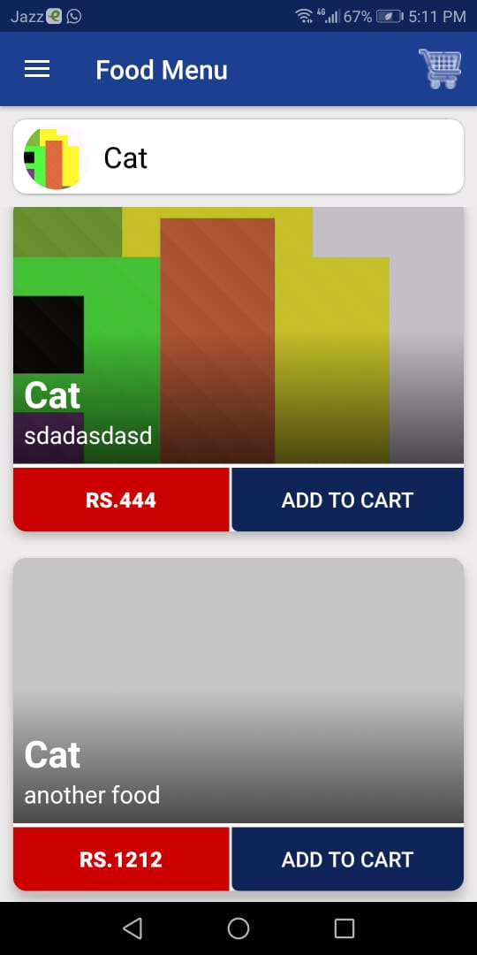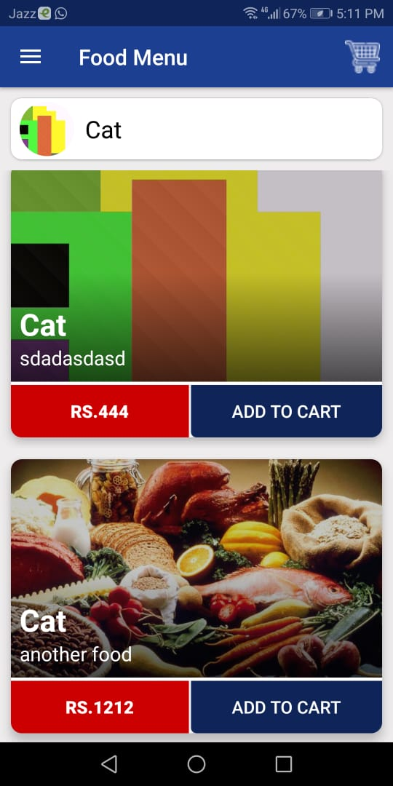
- Here the secreenshots showing our app’s delete categoy after login in to the account by email address and password.
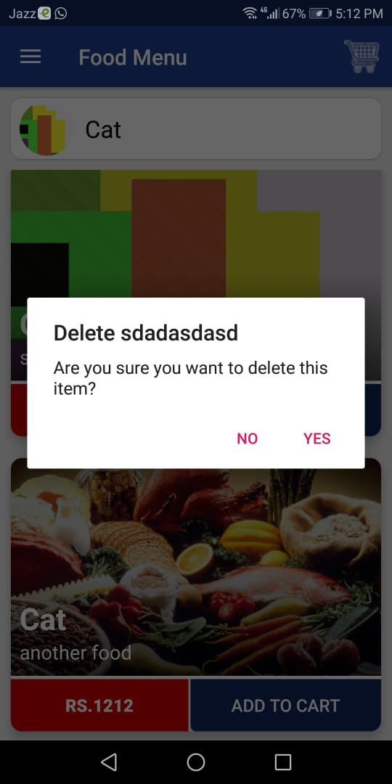
- Here the secreenshots showing our app’s category page after adding the categories after login in to the account by email address and password.

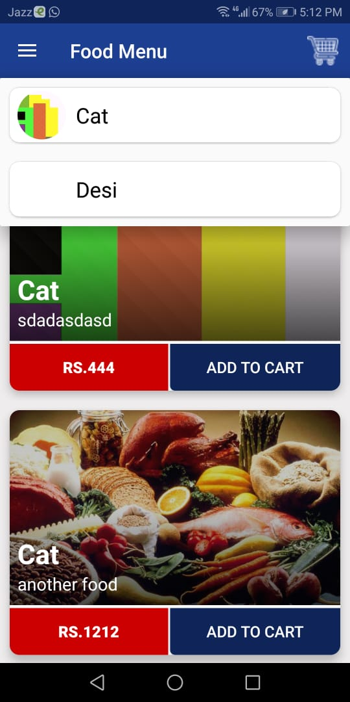

- Here the screenshots showing our app’s order details in sort of number of order placed by the customers after login in to the account by email address and password.

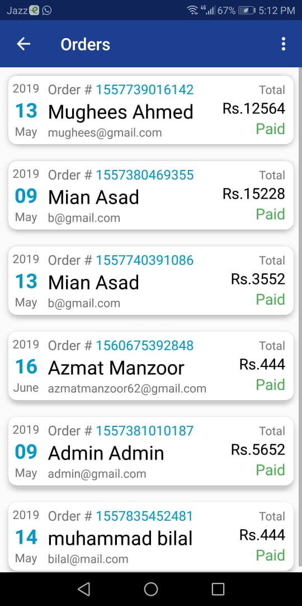

- Here the secreenshots showing our app’s order details with customers details after login in to the account by email address and password.

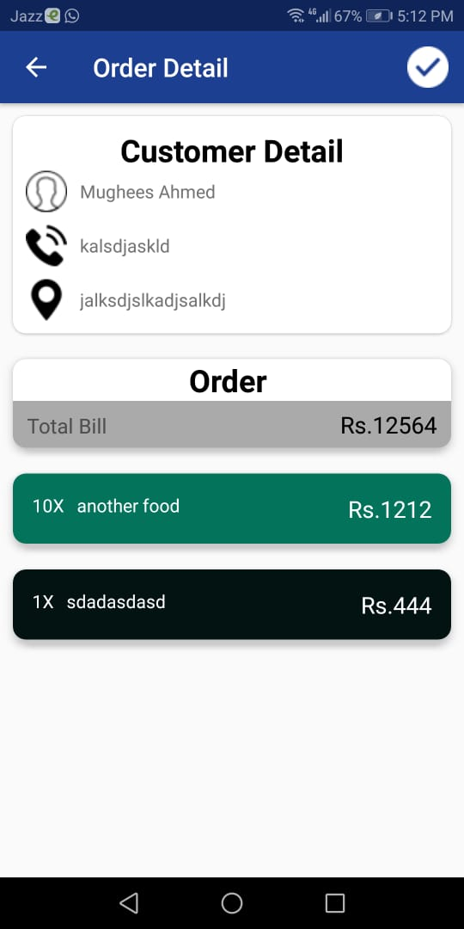

- Here the screenshots showing our app’s to select the quantity of an order placement after login in to the account by email address and password.

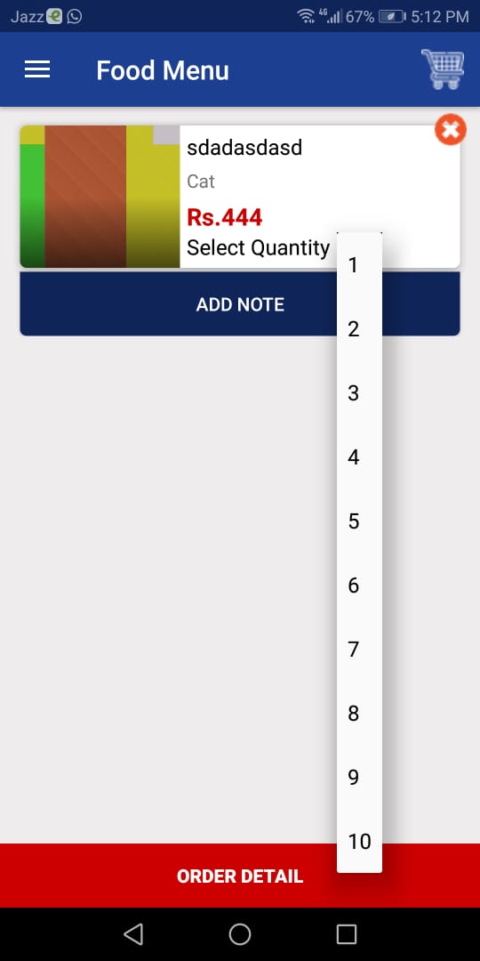

- Here the screenshots showing our app’s add note feature for customer ,staff and admin after login in to the account by email address and password.

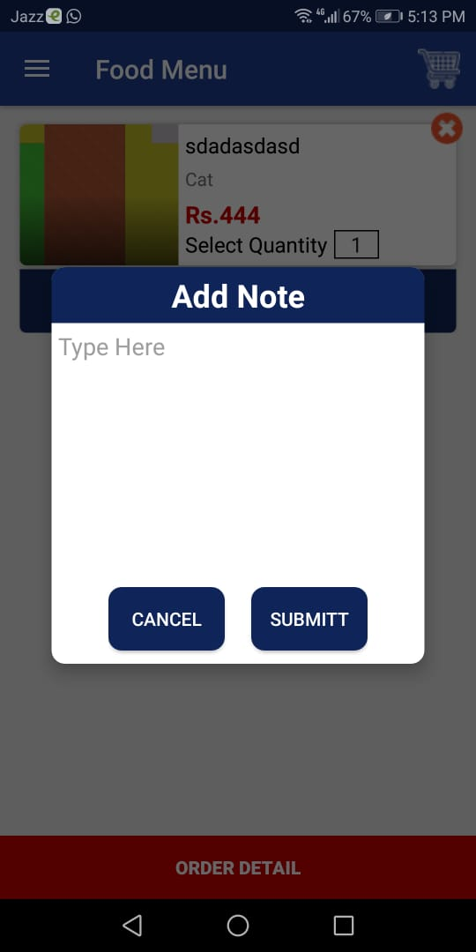

Type (Nature of project) |  |  | [ ] Development [ ] Research [ ] R&D
Area of specialization |  |  | Android
Project Group Members
Sr.# | Reg. # | Student Name |  | Email ID | *Signature
(i) | Bcsm-f15-196 | Muhammad Mughees |  | m.mughees2@gmail.com | m.mughees2@gmail.com
(ii) | Bcsm-f15-021 | Azmat Manzoor |  | azmatmanzoor62@gmail.com | azmatmanzoor62@gmail.com
(iii) | Bcsm-f15-052 | M. kashif ismail |  | Kashif.ismail052@gmail.com | Kashif.ismail052@gmail.com

*The candidates confirm that the work submitted is their own and appropriate credit has been given where reference has been made to work of others

Plagiarism Free Certificate
This is to certify that, I Muhammad Mughees S/D of Muhammad Sagheer group leader of FYP under registration no FYP-BSCS-F18-044 at Computer Science Department, the Superior College, Lahore. I declare that my FYP proposal is checked by my supervisor and the similarity index that is less than 20%, an acceptable limit by HEC. Report is attached herewith as Appendix D.
Date: 29-08-2019 Name of Group Leader: Muhammad Mughees Signature: _____________

Name of Supervisor: Zaman Aziz Co-Supervisor: Ms-Mahrukh
Designation: Lecturer Designation: Lecturer
Signature: ________________ Signature: _________________

HoD:
Signature: _______________

