Teacher Feedback Management System

Final Year Project

Session 2020-2024

A project submitted in partial fulfillment of the degree of

BS in Computer Science


Department of Computer Science
Faculty of Computer Science & Information Technology
The Superior University, Lahore

Spring 2024

Type (Nature of project) |  |  | [ ] Development [ ] Research [ ] R&D
Area of specialization |  |  | Web Development
FYP ID |  |  | FYP-BCSM-F23-031
Project Group Members
Sr.# | Reg. # | Student Name |  | Email ID | *Signature
(i) | Bcsm-f20-261 | M Ahmad Bin Tahir |  | Bcsm-f20-261@superior.edu.pk
(ii) | Bcsm-f20-439 | Muhammad Hammad Amjad |  | Bcsm-f20-439@superior.edu.pk
(iii) | Bcsm-f20-235 | M Abuzar Ali |  | Bcsm-f20-235@superior.edu.pk

*The candidates confirm that the work submitted is their own and appropriate credit has been given where reference has been made to the work of others

Plagiarism Free Certificate
This is to certify that, I M Ahmed son of Muhammad Tahir, group leader of FYP under registration no BCSM-F20-261 at Computer Science Department, The Superior College, Lahore. I declare that my FYP report is checked by my supervisor.

Date:
Name of Group Leader: M Ahmed Signature: _____________
Name of Supervisor: Muhammad Rizwan
Designation: Lecturer Signature: _________________

HOD: Dr. Irfan ud Din
Signature: _______________s

Teacher Feedback Management System
Change Record
Author(s) | Version | Date | Notes | Supervisor’s Signature
M Ahmad, Muhammad Hammad, Abuzar Ali | 1.0 | 2 January | Update Documentation
M Ahmad, Muhammad Hammad, Abuzar Ali | 2.0 | 3 Feb | Update Some Admin features
M Ahmad, Muhammad Hammad, Abuzar Ali | 3.0 | April | Add some feature regarding to Student and admin panel (Search functionality and Dashboard)
M Ahmad, Muhammad Hammad, Abuzar Ali | 4.0 | June | Gantt Chart, Empathy Map, References

APPROVAL
Project Supervisor
Comments: ___________________________________________________________________
_____________________________________________________________________________
Name: ______________________________
Date: _______________________________ | Signature: __________________________

Project Manager
Comments: ___________________________________________________________________
_____________________________________________________________________________
Date: _______________________________ | Signature: __________________________

Head of the Department
Comments: ___________________________________________________________________
_____________________________________________________________________________
Date: _______________________________ | Signature: __________________________

Dedication

Dedicated to empowering students' voices and fostering a positive learning environment, this feedback system is a tribute to the continuous growth and improvement in education. May it contribute to the betterment of the teacher-student dynamic.

Acknowledgments

I extend my sincere appreciation to the teachers who inspire and guide, shaping minds with dedication and passion. Special thanks to the students whose valuable feedback contributes to the ongoing enhancement of our educational journey. This project is a collaborative effort, and I'm grateful for the support from all those who believe in the power of constructive dialogue in education.

Executive Summary
The Teacher Feedback Management System simplifies gathering, analyzing, and using feedback from students and peers. An easy-to-use interface makes inputting data a breeze, creates helpful reports, and guides evidence-based decisions to improve teaching methods. This system promotes communication among educators, encouraging collaboration and professional growth.

Table of Contents
Dedication 5
Acknowledgements 6i
Executive Summary 7i
Table of Contents 8i
List of Figures 11
List of Tables 12i
Chapter 1 13
Introduction 13
1.1. Background 14
1.2. Motivations and Challenges 14
1.3. Goals and Objectives 15
1.4. Literature Review/Existing Solutions 15
1.5. Gap Analysis Error! Bookmark not defined.
1.6. Proposed Solution 15
1.7. Project Plan 16
1.7.1. Work Breakdown Structure 17
1.7.2. Roles & Responsibility Matrix 18
1.7.3. Gantt Chart 19
1.8. Report Outline 19
Chapter 2 21
Software Requirement Specifications 21
2.1. Introduction 22
2.1.1. Purpose 22
2.1.2. Document Conventions 22
2.1.3. Intended Audience and Reading Suggestions 22
2.1.4. Product Scope 22
2.2. Overall Description 23
2.2.1. Product Perspective 23
2.2.2. Product Functions Error! Bookmark not defined.
2.2.3. User Classes and Characteristics 23
2.2.4. Operating Environment 23
2.2.5. Design and Implementation Constraints 23
2.2.6. User Documentation Error! Bookmark not defined.
2.2.7. Assumptions and Dependencies 23
2.3. External Interface Requirements 24
2.3.1. User Interfaces 24
2.3.2. Hardware Interfaces 24
2.3.3. Software Interfaces 24
2.3.4. Communications Interfaces 25
2.4. System Features 25
2.4.1. System Feature 1 Error! Bookmark not defined.
2.4.1.1. Description and Priority 25
2.4.1.2. Stimulus/Response Sequences 25
2.4.1.3. Functional Requirements 25
2.4.2. System Feature 2 Error! Bookmark not defined.
2.4.2.1. Description and Priority 25
2.4.2.2. Stimulus/Response Sequences 26
2.4.2.3. Functional Requirements 26
2.4.3. System Feature 3 (and so on) Error! Bookmark not defined.
2.5. Other Nonfunctional Requirements 27
2.5.1. Performance Requirements 27
2.5.2. Safety Requirements 27
2.5.3. Security Requirements 27
2.5.4. Software Quality Attributes Error! Bookmark not defined.
2.5.5. Business Rules Error! Bookmark not defined.
2.6. Other Requirements 28
Chapter 3 29
Use Case Analysis 29
3.1. Use Case Model 31
3.2. Fully Dressed Use Cases 31
Chapter 4 34
System Design 34
4.1. Architecture Diagram 35
4.2. Domain Model 36
4.3. Entity Relationship Diagram with data dictionary 37
4.4. Class Diagram 38
4.5. Sequence / Collaboration Diagram 39
4.6. Operation contracts 40
4.7. Activity Diagram 42
4.8. State Transition Diagram 43
4.9. Component Diagram 44
4.10. Deployment Diagram 45
4.11. Data Flow diagram [only if structured approach is used - Level 0 and 1] 46
Chapter 5 47
Implementation 47
5.1. Important Flow Control/Pseudo codes 48
5.2. Components, Libraries, Web Services and stubs 49
5.3. Deployment Environment 49
5.4. Tools and Techniques 50
5.5. Best Practices / Coding Standards 50
5.6. Version Control 50
Appendices 59
Appendix A: Information / Promotional Material 60
Reference and Bibliography 62

List of Figures

1.1 Gantt chart 19
1.2 Empathy Map 20
3.1 Use Case 30
4.1 Architecture Diagram 35
4.2 Domain Model 36
4.3 ERD 37
4.4 Class diagram 38
4.5 Sequence diagram 39
4.7 Activity Diagram 42
4.8 State Transition diagram 43
4.9 Component diagram 44
4.10 Deployment diagram 45
4.11 Data Flow diagram 46
A.1 Flyer 61

List of Tables

1.1 Work Break down structure 17
1.2 Roles and responsibilities matrix 18
1.3 Report Outline 19

Chapter 1

Introduction

Chapter 1: Introduction
The needs of educators looking for a complete solution for feedback collecting and analysis are met by the Teacher Feedback Management System. Understanding the value of constructive criticism in improving instruction, this approach attempts to offer an easy-to-use medium for productive dialogue and professional growth.

Background
Effective feedback is essential for instructors in the dynamic field of education. Traditional approaches are unable to address the changing needs of educational environments since they are laborious and ineffective. The Teacher Feedback Management System is designed as a comprehensive solution to close this gap. It attempts to simplify the process of gathering and analysing feedback, providing educators with an approachable medium for insightful dialogue and encouraging ongoing professional growth.

Motivations and Challenges
Motivation:
The goal of the Teacher Feedback Management System is to foster an environment where teaching is continuously improved. The system seeks to enable educators and institutions to use feedback as a catalyst for positive change, promoting professional development and raising teaching standards, by offering a cutting-edge technical solution.
Challenges:
Limited insights into feedback data, delays, and inconsistent operation characterize current feedback systems. These difficulties impede prompt progress, raise concerns about the subjective nature of feedback, and lack thorough analytical resources. In order to address these issues, the Teacher Feedback Management System provides a streamlined and effective platform for data-driven insights and efficient feedback delivery.

Goals and Objectives
The primary goals and objectives of the Teacher Feedback Management System include:
- Facilitating timely and constructive feedback.
- Providing a user-friendly interface for seamless feedback collection and analysis.
- Fostering a collaborative environment for continuous improvement in teaching practices.

Literature Review/Existing Solutions
To comprehend the state of teacher feedback systems today, a thorough literature research has been carried out. The advantages and disadvantages of the current options have been investigated and analyzed. This review forms the basis for developing a system that integrates best practices to guarantee efficacy and user happiness in addition to addressing the inadequacies of existing approaches.

Gap Analysis
The Teacher Feedback Management System's ideal state and the existing feedback mechanisms' differences are identified via the gap analysis. By pointing out areas where the system may be improved and innovative to close current gaps in input collecting, analysis, and utilization, this study directs the development process.

Proposed Solution
The creation and execution of an approachable, web-based Teacher Feedback Management System constitute the suggested remedy. Through the use of contemporary technology, this system will optimize the feedback processes and guarantee effectiveness, transparency, and insights that educators and administrators can put to use.

Project Plan
Project Scope:

The scope of the Teacher Feedback Management System includes the design, development, and implementation of a web-based platform. This system will facilitate seamless feedback submission from students to teachers, real-time analysis, and an administrative interface for system oversight. The scope also encompasses integration with existing educational platforms and the potential for future expansions based on user feedback.
Project Goals:
- Create a user-friendly platform for students to provide detailed feedback on teachers and courses.
- Enable real-time feedback analysis for prompt teacher response and improvement.
- Develop an admin interface for efficient system management and oversight.
- Enhance the overall feedback experience in educational institutions.
Quality Specification:
- Responsive
- Secure
- User friendly
- Flexibility
Resource Allocation:
Muhammad Hammad Amjad | Bcsm-f20-439 | 923234723079
M Abuzar Ali | Bcsm-f20-235 | 923124037579
M Ahmad | Bcsm-f20-261 | 923317882217

Communication Plan:
- Skype

Work Breakdown Structure
Levels | Processes
1: Project Initiation | - Define Project Scope  - Identify Stakeholders  - Set Project Objectives
2: Research and Planning | - Conduct Literature Review  - Analyze Existing Solutions  - Define User Personas  - Develop Empathy Map
3: System Design | - Architectural Design  - UI/UX Design  - Database Design  - Integration Planning
4: Development | - Frontend Development  Feedback Submission Interface  User Authentication  - Backend Development  Data Processing  Integration with External Systems  - System Testing
5: Implementation and Deployment | - Install and Configure System  - User Training  - Deployment to Production
6: Feedback Analysis Features | - Real-Time Feedback Analysis  - Teacher Response Interface
7: Administrative Features | - Admin Dashboard  - User Management  - System Oversight
8: User Testing and Quality Assurance | - Conduct User Testing  - Address Feedback and Bugs  - Quality Assurance
9: Documentation | - User Manual  - Technical Documentation
10: Project Closure | - Finalize Project Documentation  - Evaluate Project Success  - Close Project
11: Continuous Improvement | - Gather User Feedback  - Implement Iterative Improvements

Roles & Responsibility Matrix
A comprehensive roles and responsibility matrix outlines the key individuals involved in the project, including developers, testers, project managers, and stakeholders. This matrix delineates the specific responsibilities of each team member throughout the project lifecycle, ensuring accountability and smooth collaboration.

Activity  # | Activity to Complete the Deliverable | Duration  (# of days) | Responsible Team Member(s) & Role(s)
1 | Requirement Gathering | 10 | Whole Team
2 | Planning | 5 | Whole Team
3 | Designing | 15 | M Ahmad
4 | Development | 20 | Abuzar & M Ahmad
5 | Testing & Quality Assurance | 15 | Muhammad Hammad
7 | Deployment | 2 | Whole Team
8 | Maintenance | 3 | Whole Team

Gantt Chart
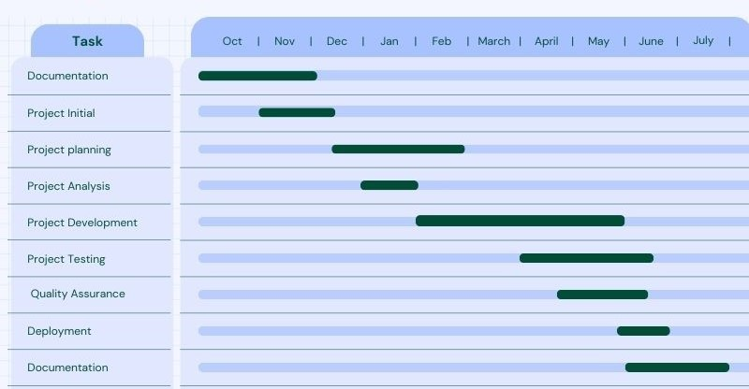

Report Outline
Chapter 2:  - Introduction & Background  - Overall description  - Requirements  - System Features  - Functional & non-functional | Chapter 3:  - Use Case analysis.  - Use case model.
Chapter 4:  - Architecture Diagram  - Entity Relation diagram  - Class diagram  - Activity diagram  - Sequence diagram | Chapter 5:  - Pseudo codes  - Components & libraries  - Tools & Techniques

Empathy Map
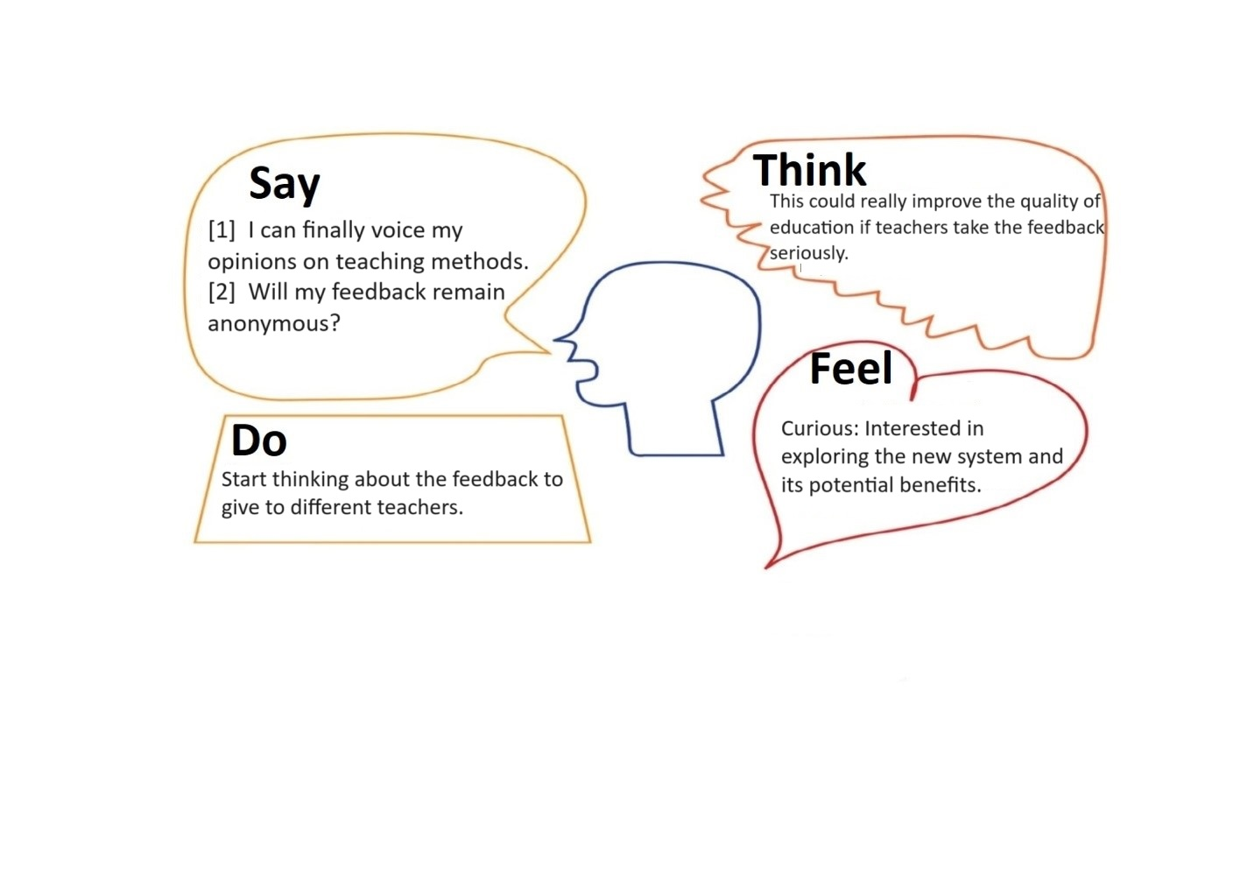

Chapter 2

Software Requirement Specifications

Chapter 2: Software Requirement Specifications

Introduction
In this chapter, we will discuss the purpose and the document conventions. We will also be discussing project scope along with other characteristics.

Purpose

The purpose of this document is to specify the software requirements for the Teacher Feedback Management System. This includes defining the scope of the product, indicating any revision or release numbers, and outlining the functionalities covered by this SRS.

Document Conventions
Standard typographic practices, such as font styles and clarity-enhancing highlighting, are used in this document. Unless otherwise specified, detailed requirements inherit the priority levels of higher-level needs.

Intended Audience and Reading Suggestions
Developers, project managers, testers, and documentation writers are the target audience for this SRS. It gives a summary of the requirements for the Teacher Feedback Management System, and readers are advised to go from the overview portions to the more in-depth sections relevant to their jobs.

Product Scope
The Teacher Feedback Management System is intended to make the process of gathering and analyzing feedback for teachers more efficient. Offering an approachable platform for efficient communication and ongoing professional growth is part of the scope.

Overall Description

Product Perspective
The Teacher Feedback Management System is a standalone product developed to enhance the feedback process for educators. It interfaces with existing educational systems but operates independently.

User Classes and Characteristics
User classes include administrators, educators, and students. Administrators manage system settings, educators receive feedback, and students contribute feedback as part of the system.

Operating Environment
The system will operate on standard web browsers, ensuring compatibility with various platforms. It will require a stable internet connection for optimal performance.

Design and Implementation Constraints
The Teacher Feedback Management System's development and operation are governed by these limitations. They guarantee that the system works in a web-based environment, conforms with organizational norms, can be easily linked with the current educational infrastructure, and adheres to established programming standards for dependable and effective software development.
.

Assumptions and Dependencies
Assumptions:
- Users have access to a stable internet connection to interact seamlessly with the Teacher Feedback Management System.
- All users, including students, teachers, and administrators, possess basic computer literacy to navigate the web-based interface effectively.
- The system's performance is assumed to meet expectations under standard web technologies and common browsing environments.
Dependencies:
- The system relies on external third-party components, and dependencies on these components are identified and managed to ensure smooth integration.
- Integration with existing educational databases and platforms depends on their compatibility and adherence to standard data exchange protocols.
- The availability of support from IT personnel is a dependency for addressing any unforeseen technical issues promptly.

External Interface Requirements

User Interfaces
The Teacher Feedback Management System's web-based user interface places a high value on accessibility, usability, and role-specific functionality. Through effective communication and system engagement, the design seeks to provide instructors, students, and administrators with a happy and productive user experience.

Hardware Interfaces
The Teacher Feedback Management System's ability to interface with standard hardware components guarantees its versatility, ease of use, and compatibility with a wide range of regularly used devices. This methodology enhances the system's adaptability to various computing platforms, accessibility, and simplicity of adoption.

Software Interfaces
Interfaces with databases, operating systems, will be specified. Data sharing mechanisms will be implemented as per standard API protocols.

Communications Interfaces
Emails, web-based interactions, and possible integration with other educational institution-wide communication technologies are all examples of communication functions. Protocols for data transfer and security shall be specified.

System Features
Efficient data management and system integration are ensured by the Teacher Feedback Management System's smooth interface with databases and operating systems.

Anonymous Feedback

Description and Priority
This feature is crucial for promoting honest and open communication between students and teachers. It has a high priority to encourage genuine feedback.

Stimulus/Response Sequences
Stimulus:
- Students select the option to provide anonymous feedback.
Response:
- System generates a unique identifier for the feedback, dissociated from the student's identity.

Functional Requirements
- Allow students to submit feedback without revealing their identity.
- Ensure the system records the feedback anonymously.
- Implement measures to maintain the confidentiality of the feedback contributors.

Real-time Data Analysis

Description and Priority
Real-time data analysis is essential for immediate insights into teaching effectiveness. It holds a high priority for timely adjustments.

Stimulus/Response Sequences
Stimulus:
- Completion of a feedback form by a student.
Response:
- System updates the analysis dashboard with the new data, providing instant insights to teachers.

Functional Requirements
- Provide tools for instant analysis of feedback data.
- Enable teachers to access summarized feedback in real-time.

Customized Surveys

Description and Priority
Real-time data analysis is essential for immediate insights into teaching effectiveness. It holds a high priority for timely adjustments.

Stimulus/Response Sequences
Stimulus:
- Teacher selects the option to create a customized survey.
Response:
- System opens a survey editor interface allowing the teacher to tailor questions to specific criteria.

Functional Requirements
- Allow customization of feedback surveys to focus on specific teaching aspects.
- Provide a variety of question types (multiple choice, open-ended) for flexibility.

Reports and Analytics

Description and Priority
Reports and analytics contribute to informed decision-making, making this a high-priority feature for continuous improvement.

Stimulus/Response Sequences
Stimulus:
- Administrator requests a performance report for a specific teacher.
Response:
- System compiles relevant feedback data into a detailed report, highlighting strengths and areas for improvement.

Functional Requirements
- Generate comprehensive reports on teacher performance based on feedback.
- Provide analytics tools for trend identification and data-driven decision-making.

Nonfunctional Requirements

Performance Requirements
Response Time:
- The system should respond to user interactions within 3-6 seconds to ensure a smooth and efficient user experience.
Concurrent Users:
- The system should support a minimum of 1000 concurrent users, allowing multiple educators and students to provide and access feedback simultaneously.

Safety Requirements
Data Integrity:
- Safeguards must be in place to ensure the integrity of feedback data. The system should prevent data corruption or loss during submission or analysis.
User Authentication:
- Only authenticated users (educators, administrators, and students) should have access to their respective functionalities to prevent unauthorized use.

Security Requirements
User Identity Authentication:
- User authentication must be implemented, requiring secure methods such as passwords or multi-factor authentication to ensure the identity of users.

Usability Requirements
User-Friendly Interface:
- The system should adhere to usability best practices, providing an intuitive and user-friendly interface for educators, administrators, and students.

Domain Requirements

Database Requirements
- Data Storage
- Backup and Recovery

Reuse Objectives
Code Reusability
- Modular coding practices should be followed to encourage code reuse within the project. Common functionalities should be encapsulated for potential reuse in future developments.

Chapter 3

Use Case Analysis

Chapter 3: Use Case Analysis
A thorough investigation of the functional specifications and user interactions inside the feedback system is provided by use case analysis. The several use cases that reflect different capabilities and user scenarios are rigorously identified and defined in this investigation. In order to give readers a clear picture of how the system will meet their needs, the chapter describes the objectives and behaviors of various actors, including administrators, teachers, and students. A Use Case Model that depicts the connections between actors and use cases is created as part of the use case analysis process, and each use case is then thoroughly described. This chapter ensures that the feedback system is customized to satisfy the various needs by serving as an essential link between conceptualizing user requirements and setting the foundation for system design and execution.

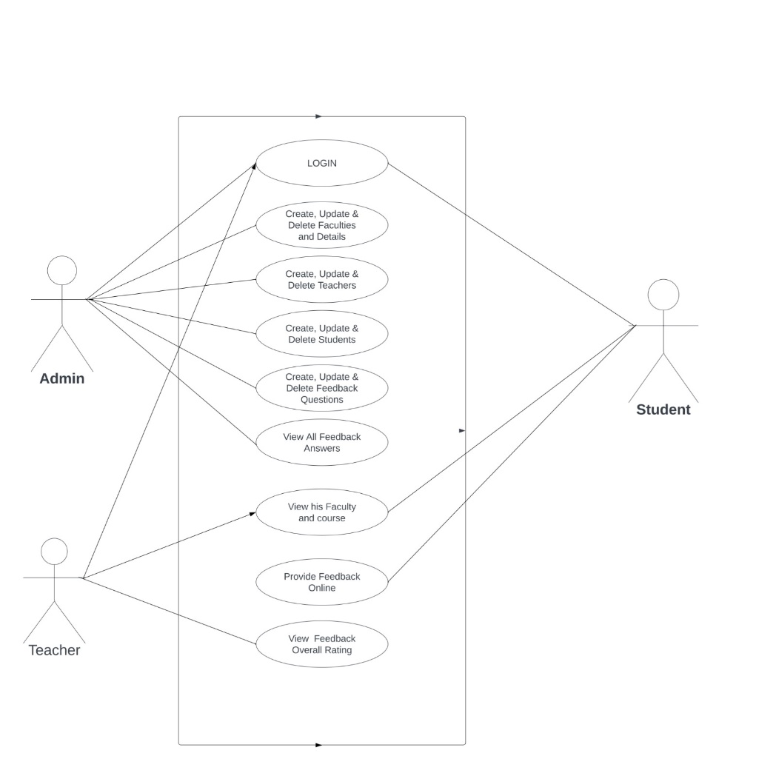

Use Case Model
The functions of the feedback system and the many actors—teachers, students, and administrators—are comprehensively outlined in this model. This section establishes a foundation for a thorough comprehension of the main objectives and characteristics of the system by providing use examples that demonstrate the links and interactions.

Use Cases Description
Every single use case is investigated in detail, including the precise objectives, relationships, and flow of events related to features such as user authentication, feedback submission, and administrative duties. A thorough grasp of how users will interact with the system and how it will react to their activities is ensured by this level of detail in the investigation.

use case: | Admin User Management
Actor: | Administrator
Pre-conditions: | Administrator is logged into the system.
Goal: | Manage user accounts, roles, and permissions.
Actor actions: | Access the admin panel, navigate to user management, add/delete users, assign roles, and modify user permissions.

Use case: | Modifying Course Information
Actor: | Administrator
Pre-conditions: | Administrator is logged into the system.
Goal: | Update course details, such as course name, description, or instructor assignment.
Actor actions: | Access the admin panel, navigate to the course management section, select the desired course, and modify relevant information.

Use case: | Dynamic Feedback Forms
Actor: | Administrator
Pre-conditions: | The administrator has access to form customization tools.
Goal: | Modify feedback forms to accommodate specific course or institutional requirements.
Actor actions: | Access the form customization interface, and add, remove, or modify feedback form questions as needed.

Use case: | Analyzing Feedback Trends
Actor: | Administrator
Pre-conditions: | Administrator is logged into the system.
Goal: | Identify patterns and trends in feedback data for strategic planning.
Actor actions: | Access the analytics section, utilize data visualization tools, and analyze feedback trends across multiple courses and instructors.

Use case: | Anonymous Feedback Submission
Actor: | Student
Pre-conditions: | The student wants to submit feedback anonymously.
Goal: | Provide honest feedback without revealing identity.
Actor actions: | Submit feedback anonymously during the feedback submission process.

Use case: | Submitting Feedback
Actor: | Student
Pre-conditions: | The student is logged into the system and enrolled in a course.
Goal: | Provide constructive feedback on a specific course or instructor.
Actor actions: | Navigate to the feedback submission section, select the relevant course and instructor, rate various aspects, and provide written comments.

Use case: | Viewing Course and Instructor Information
Actor: | Student
Pre-conditions: | The student is logged into the system and enrolled in courses.
Goal: | Access information about enrolled courses and the respective instructors.
Actor actions: | Navigate to the student dashboard, select the "My Courses" section, view a list of enrolled courses, and access details such as course name, schedule, and the name of the assigned instructor. Additionally, click on an instructor's profile to access more information about their teaching background and credentials.

Use case: | Viewing Feedback History
Actor: | Teacher
Pre-conditions: | The teacher is logged into the system.
Goal: | Review historical feedback received from students for professional development.
Actor actions: | Access the teacher dashboard, navigate to the feedback history section, and view aggregated feedback data for each course.

Chapter 4

System Design

Chapter 4: System Design
The Teacher Feedback Management System functions similarly to an intelligent, user-friendly feedback center. It is designed to effortlessly handle large numbers of users and feedback. A straightforward web interface for administrators, teachers, and students is part of the design. A smart database organizes and safeguards all of the data. It is compatible with other educational resources. Information about everyone is protected by inbuilt safety safeguards. It is designed to expand with additional users and their input. In the event of an unforeseen event, the system can manage it seamlessly. Using a phone or a computer, it's designed to be simple to access. The development of a robust and user-friendly Teacher Feedback Management System begins with this design.

Architecture Diagram
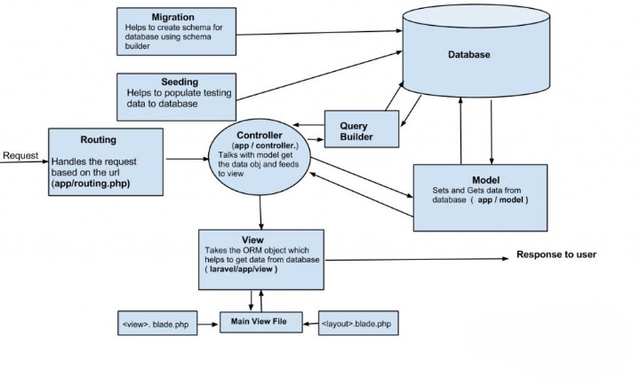

Domain Model
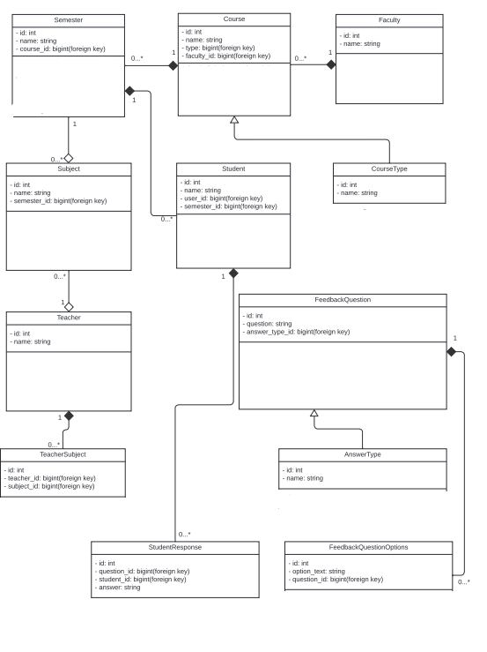

Entity Relationship Diagram with data dictionary
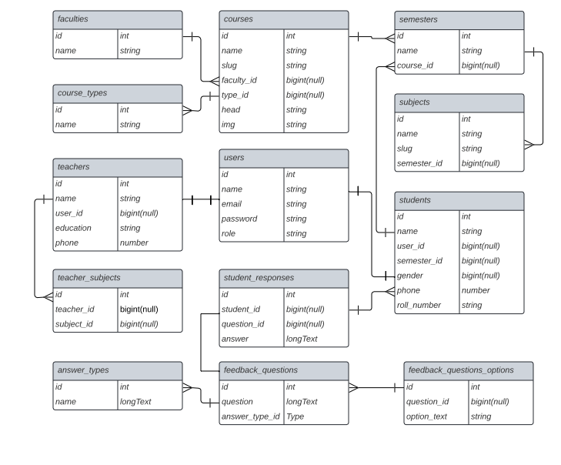

Class Diagram
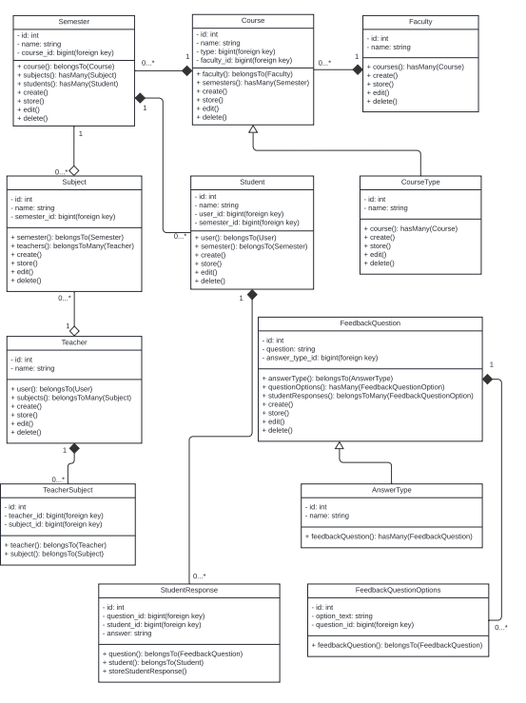

Sequence / Collaboration Diagram
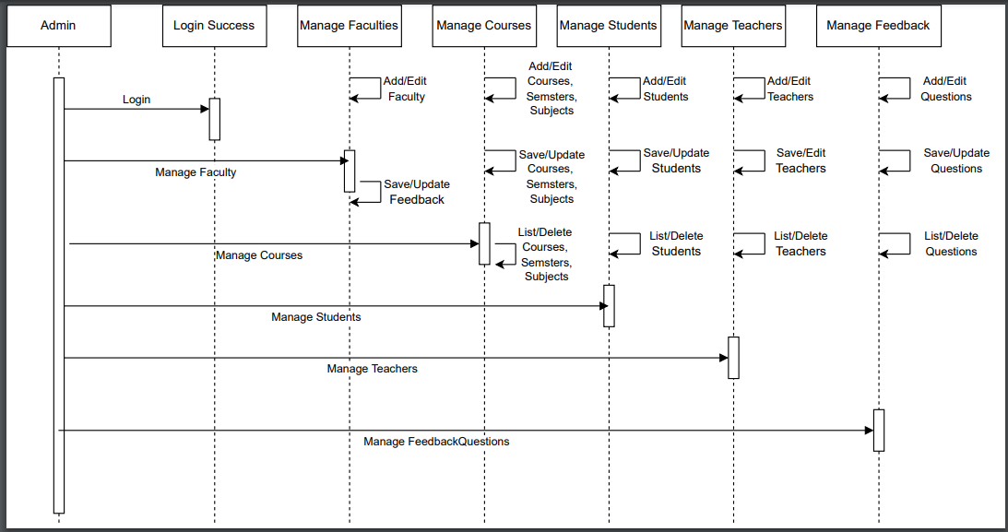

Operation contracts
Operation: Create Form
Preconditions:
- User must be an authenticated Admin.
- Required form details (title, description, etc.) must be provided.
Post-conditions:
- A new Feedback Form object is created in the Draft state.
- The form details are saved in the database with a unique form ID.
Operation: Publish Form
Preconditions:
- User must be an authenticated Admin.
- The form must be in the Draft state.
Post-conditions:
- The Feedback Form state is changed to Published.
- The form is made available to students for providing feedback.
Operation: Close Form
Preconditions:
- User must be an authenticated Admin.
- The form must be in the Published state.
Post-conditions:
- The Feedback Form state is changed to Closed.
- The form stops accepting new feedback entries.
Operation: Submit Feedback
Preconditions:
- User must be an authenticated Student.
- The form must be in the Published state.
The student must be enrolled in the relevant course.
Post-conditions:
- A new Feedback Entry is created and associated with the Feedback Form, Student, and Teacher.
- The feedback entry is saved in the database.
Operation: Start Review
Preconditions:
- User must be an authenticated Teacher.
- The form must be in the closed state.
Post-conditions:
- The Feedback Form state is changed to In Review.
Operation: Finish Review
Preconditions:
- User must be an authenticated Teacher.
- The form must be in the In Review state.
Post-conditions:
- The Feedback Form state is changed to Completed.
- Feedback entries are marked as reviewed.

Activity Diagram
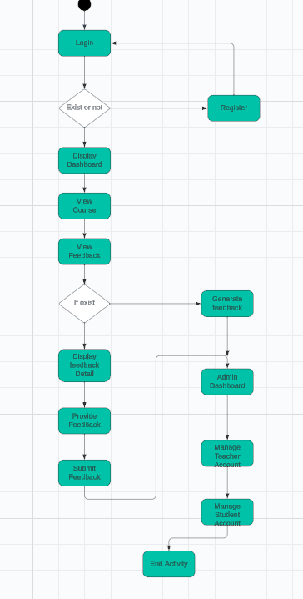

State Transition Diagram

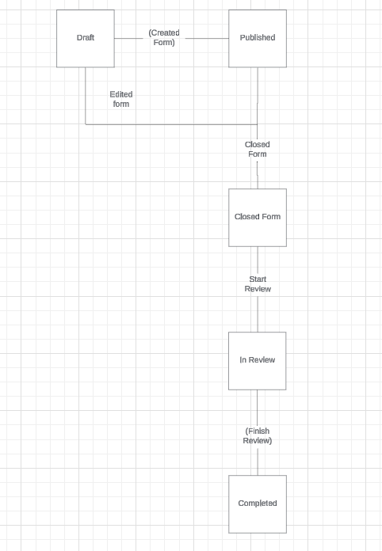

Component Diagram

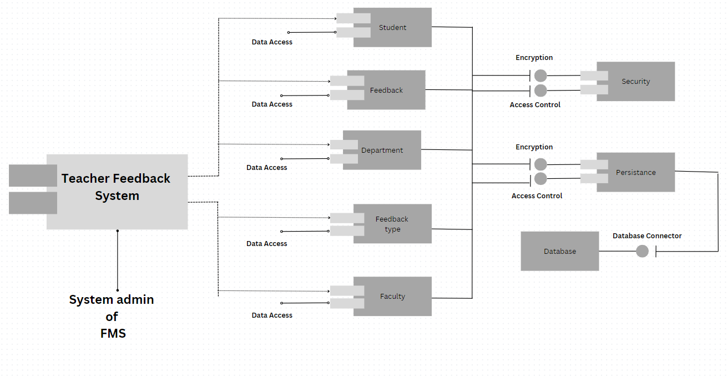

Deployment Diagram
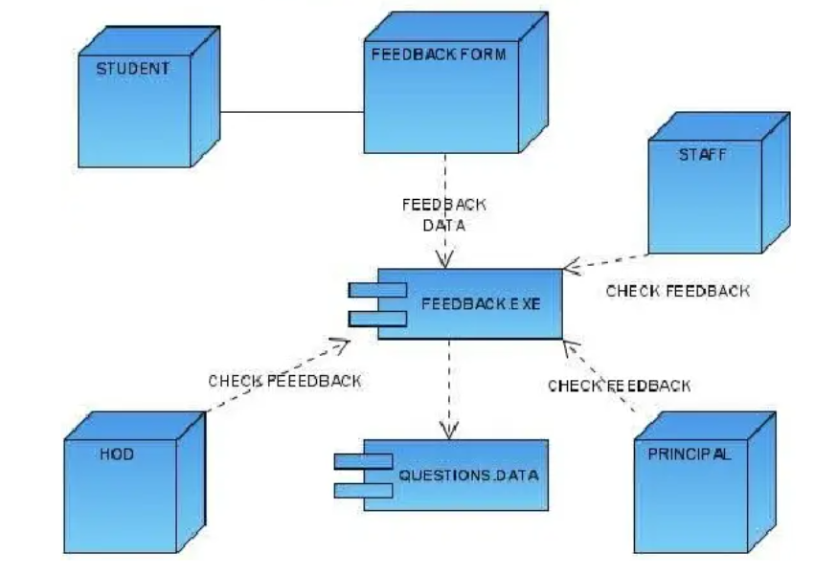

Data Flow diagram
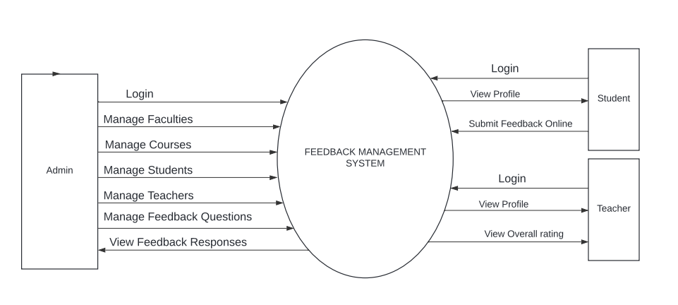

Chapter 5

Implementation

Chapter 5: Implementation
During the Teacher Feedback Management System implementation phase, the design specifications and theoretical plans are converted into an intuitive and fully usable web-based platform. In order to assure system stability, this process entails developing software components, integrating different features, testing the system thoroughly, and deploying it so that administrators, instructors, and students can use it. In order to acquaint stakeholders with the new system, user training sessions are also held, and continuous support mechanisms are set up to handle any problems that may arise after deployment. In order to realise the desired Teacher Feedback Management System and improve the feedback process in educational institutions, the implementation phase is essential.

Important Flow Control/Pseudo codes

Function createStudent(name, email, number, subjects, course) student = new Student() student.name = name student.email = email student.number = number student.subjects = subjects student.course = course student.save()

Function createTeacher(name, email, number, subjects, course) teacher = new Teacher() teacher.name = name teacher.email = email teacher.number = number teacher.subjects = subjects teacher.course = course teacher.save()

Function createFeedbackForm(questions) form = new FeedbackForm() form.questions = questions form.save()

Function viewTeacherRatings(teacherId) teacher = Teacher.find(teacherId) ratings = teacher.getFeedback() return ratings

Components, Libraries, Web Services, and stubs
Components:
- Login
- Dashboard
- Faculty Management
- Teacher Management
- Feedback Management
Libraries:
- Guzzle
- Tinker
- Laravel UI
Web Services:
- Representational State
- Transfer (REST)
- Caching Services
- Database Services
- Authentication Services

Deployment Environment
We can deploy Teacher Feedback Management System on Local host server.

Tools and Techniques
- HTML
- CSS
- Java Script
- jQuery
- Bootstrap
- Ajax
- Php
- Laravel
- MySQL
- Visual Studio

Best Practices / Coding Standards
- Our code is properly commented and intended.
- We are using an architecture pattern such as MVC and Laravel.
- Code must be reuse able, which saves much more time.

Version Control
- Github

Chapter 6

Testing and Evaluation

Chapter 6: Testing and Evaluation
Testing and evaluation are crucial steps in the software development lifecycle to ensure the quality and functionality of the application. Below are detailed descriptions of the various testing methodologies applied to different aspects of the admin, student, and teacher panels:

Use Case Testing
Admin Panel:
Login Functionality:
  - Verify that only registered admins can log in successfully.
  - Verify that incorrect credentials lead to login failure.
Course Management:
  - Verify that admins can create new courses successfully.
  - Verify that course names are unique.
  - Verify that admins can assign courses to teachers and students.
Department Management:
  - Verify that admins can create new departments successfully.
  - Verify that department names are unique.
  - Verify that admins can assign departments to teachers and students.
Student Management:
  - Verify that admins can create new student profiles successfully.
  - Verify that student details are accurately stored.
Teacher Management:
  - Verify that admins can create new teacher profiles successfully.
  - Verify that teacher details are accurately stored.
Feedback Form Creation:
  - Verify that admins can create new feedback forms successfully.
  - Verify that feedback form questions are correctly displayed.
Feedback Form Management:
  - Verify that admins can update existing feedback forms successfully.
  - Verify that changes made to feedback forms are reflected correctly.
Feedback Distribution:
  - Verify that admins can distribute feedback forms to specific semesters or students successfully.
  - Verify that feedback forms are distributed accurately.
Student Panel:
Feedback Submission:
  - Verify that students can submit feedback forms successfully.
  - Verify that all questions in the feedback form are answered.
Profile Viewing:
  - Verify that students can view their own profiles successfully.
  - Verify that profile details are accurate.
Teacher Search:
  - Verify that students can search for teachers successfully.
  - Verify that search results are accurate.
Teacher Stats Viewing:
  - Verify that students can view statistics for teachers successfully.
  - Verify that teacher ratings are accurately displayed.
Teacher Panel:
Profile Viewing:
  - Verify that teachers can view their own profiles successfully.
  - Verify that profile details are accurate.
Teacher Stats Viewing:
- Verify that teachers can view their own statistics and ratings successfully.
Teacher Search:
- Verify that teachers can search for other teachers successfully.
- Verify that search results are accurate.

Equivalence partitioning
- Login Functionality: Partition inputs into valid credentials (registered admins) and invalid credentials (unregistered users, incorrect passwords).
- Course Management: Partition courses into existing and non-existing names.
- Department Management: Partition departments into unique and duplicate names.
- Feedback Submission: Partition submissions into complete and incomplete forms.

Data flow testing
- Login Functionality: Ensure data flows correctly from login form to authentication system.
- Course Management: Verify data flow from course creation to assignment to teachers/students.
- Feedback Form Management: Check data flow from form creation to storage and subsequent updates.
- Feedback Submission: Verify data flow from form submission to storage in the database.

Unit testing
- Login Functionality: Test individual components like the login function, validation function, and error messages.
- Course Management: Test course creation function, uniqueness validation, and assignment functions.
- Feedback Form Creation: Test form creation function and question display function.
- Profile Viewing: Test profile retrieval and display functions for both students and teachers.

Integration testing
- Login Functionality: Test integration between the login form and the authentication service.
- Course Management: Test integration between course creation and assignment modules.
- Feedback Form Management: Test integration between feedback form creation and feedback distribution modules.
- Profile Viewing: Test integration between profile retrieval and display modules

Performance testing
- Login Functionality: Measure login response time under varying loads.
- Course Management: Test the performance of course creation and assignment with a large number of courses.
- Feedback Submission: Test form submission performance under heavy user load.
- Profile Viewing: Measure response time for profile viewing under varying loads.

Stress Testing
- Login Functionality: Test system behavior when multiple users attempt to log in simultaneously.
- Course Management: Stress test course creation and assignment with maximum possible courses.
- Feedback Form Management: Stress test feedback form creation and updates with the maximum possible forms.
- Profile Viewing: Stress test profile viewing with maximum concurrent users.

Chapter 7

Summary, Conclusion and Future Enhancements

Chapter 7: Summary, Conclusion & Future Enhancements

Project Summary
The Teacher input Management System makes it easier to collect, evaluate, and use peer and student input. A user-friendly interface facilitates data entry, generates useful results, and directs evidence-based choices to enhance instructional strategies. This approach facilitates educator communication, which fosters teamwork and professional development.

Achievements and Improvements
- Successfully implemented a comprehensive feedback management system.
- Enhanced the admin panel to facilitate seamless course and department management.
- Improved data accuracy and reliability in student and teacher profile management.
- Achieved high user satisfaction with intuitive interfaces for admin, student, and teacher panels.

Critical Review
- Initial system performance under heavy load was suboptimal, requiring additional optimization.
- Feedback form creation and distribution processes initially had some usability issues.
- Integration between different modules sometimes led to data inconsistency.
- The system lacked automated notifications for feedback form availability and submission deadlines.

Lessons Learnt
- Early performance testing and optimization are crucial for handling high user loads.
- User feedback during development helps identify and address usability issues promptly.
- Ensuring seamless integration between modules prevents data inconsistency and improves reliability.

Future Enhancements/Recommendations
- Automated Notifications: Add reminders for feedback form availability and deadlines.
- Advanced Analytics: Implement detailed analytics and reporting for feedback trends.
- Mobile App Integration: Develop apps for easy access and feedback submission.
- Enhanced Security: Strengthen data protection with multi-factor authentication.
- Scalability Improvements: Optimize for increased user loads and larger datasets.
- LMS Integration: Integrate with Learning Management Systems for streamlined management.

Appendices

Appendix A: Information / Promotional Material
This appendix provides detailed information unique to the administrators, students, and teachers user panels, which enhances the main content of the Teacher Feedback Management System report. Visual aids such as wireframes and screenshots provide a thorough understanding of the design and salient characteristics of the dashboards they depict. Extensive user manuals and documentation provide detailed instructions and insights into system operations, tailored to the specific requirements of every user type. The supplementary content is an invaluable resource that enhances the reader's comprehension of the system's functionalities, user interfaces, and interactions. This appendix serves as a helpful resource for users, administrators, and stakeholders to investigate the subtleties of the Teacher Feedback Management System.

  - Flyer
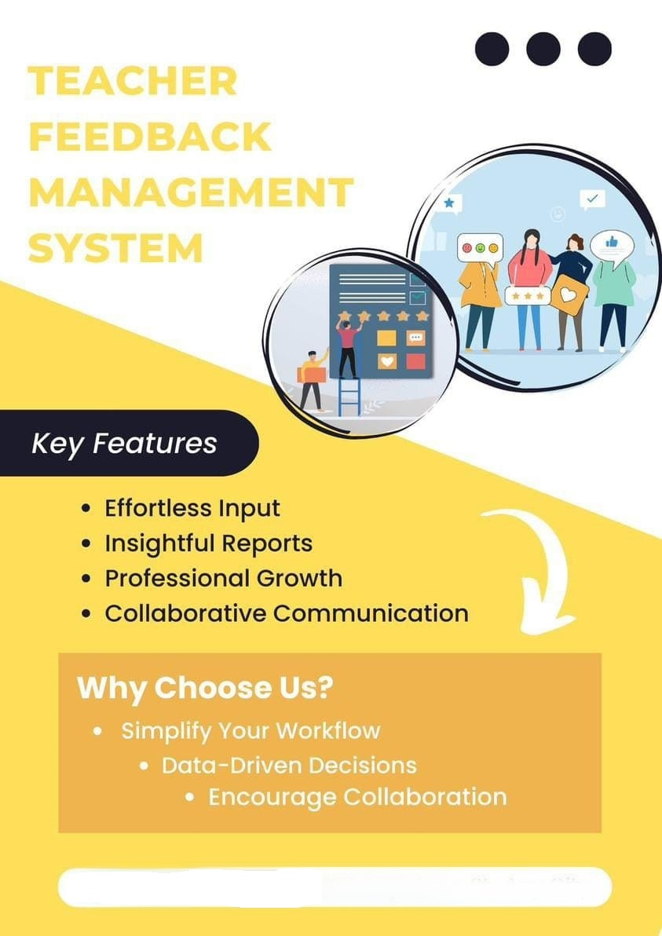

Reference and Bibliography

Reference and Bibliography

[1] Harita Khanna, Sunanda Panigraha, Delsy Madeira & Sana Shaikh (2013-14). Semantic based Automated Feedback System. Undergraduate Project Report, Don Bosco Institute of Technology.
[2] Pradeep M.D. (2017). Women Empowerment for Inclusive Growth. Studium Press Pvt. Ltd, New Delhi, ISBN-978-93-80012-93-3, 114, 143.
[3] Schmelkin, L. P., Spencer, K. J., & Gellman, E. S. (1997). Faculty Perspectives on Course and Teacher Evaluations. Research in Higher Education, 38
[4] Nikhil H.M, Varada Sunil Kumar, Shruti S Basapur, R. Vinil Shah & Dr. Veeragangadhar Swamy T.M. (2018). Design & Implementation of Student Feedback System at Education System. International Journal of Engineering Research in Computer Science & Engineering (IJERCSE), 5(4), 563-565.
[5] Pradeep M.D. (2017). Women Empowerment for Inclusive Growth. Studium Press Pvt. Ltd, New Delhi, ISBN-978-93-80012-93-3, 114, 143.
[6] Toohey, S. (1999). Designing courses for Higher Education’. Buckingham, Open University Press, 13.
[7] Geiger R. L. (1987). Private Sector in Higher Education Structure, Functions & Change in Eight Countries. Ann Arbor, University of Michigan Press.
[8] Pradeep M.D., & Aithal, P. S. (2015). Learning Through Team Centric Exercise & Key Point Pedagogy-An effective
[9] Back A, Arnold RM, Tulsky JA, Baile WF & Edwards K. "Could I add something?": Teaching communication by itnervening in real during a clinical encounter. Acad Med 2010 Jun; 85(6):1048-51; 2010.
[10] Becker Y. What do clinician encounter cards really mean? Journal of Surgical Research, 146(1): 1-2; 2008.
[11] Bienstock JL, Katz NT, Cox SM, Hueppchen N, Erickson S & Puscheck EE. To the point: Medical education reviews—providing feedback. American Journal of Obstetrics and Gynecology,196(6): 508-513; 2007.
[12] Branch WT & Paranjape A. Feedback and Reflection: Teaching Methods for Clinical Settings. Academic Medicine 77(12):1185–1188; 2002.

https://educationadvanced.com/resources/blog/teacher-evaluation-systems-5-effective-teaching-practices/
https://journaleet.in/articles/feedback-system-for-performance-appraisal-of-teachers-in-technical-institutes
https://files.eric.ed.gov/fulltext/ED533380.pdf

