Used Clothes Selling Website

Final Year Project

Session 2015-2019

A project submitted in partial fulfillment of the degree of

BS in Software Engineering


Department of Software Engineering
Faculty of Computer Science & Information Technology
The Superior College, Lahore

Spring 2019

Type (Nature of project) |  |  | [ ] Development [ ] Research [ ] R&D
Area of specialization |  |  | Website Development
FYP ID |  |  | FYP-BSSE-S18-012
Project Group Members
Sr.# | Reg. # | Student Name |  | Email ID | *Signature
(i) | BSEM-S15-031 | Talha Wahid |  | talhawahid55@gmail.com
(ii) | BSEM-S15-016 | Khawar Aslam |  | raokhawar89@gmail.com
(iii) | BSEM-S15-043 | Saad Rehman |  | saadr384@gmail.com

*The candidates confirm that the work submitted is their own and appropriate credit has been given where reference has been made to work of others

Plagiarism Free Certificate
This is to certify that, I Talha Wahid S/D of Muhammad Wahid, group leader of FYP under registration no FYP-BSSE-S18-012 at Software Engineering Department, The Superior College, Lahore. I declare that my FYP report is checked by my supervisor.

Date: 05-09-2019 Name of Group Leader: Talha Wahid Signature: _____________
Name of Supervisor: Asad Ullah Tariq Co-Supervisor: Mr. XYZ
Designation: Lecturer Designation: Associate Professor
Signature: ________________ Signature: _________________

HoD: Dr. Arfan Jaffar
Signature: _______________

Project Report
[Used Clothes Selling Website]

Change Record
Author(s) | Version | Date | Notes | Supervisor’s Signature
 | 1.0 |  | <Original Draft>
 |  |  | <Changes Based on Feedback from Supervisor>
 |  |  | <Changes Based on Feedback From Faculty>
 |  |  | <Added Project Plan>
 |  |  | <Changes Based on Feedback from Supervisor>

APPROVAL
Project Supervisor
Comments: ___________________________________________________________________
_____________________________________________________________________________
Name:______________________________
Date:_______________________________ | Signature:__________________________

Project Manager
Comments: ___________________________________________________________________
_____________________________________________________________________________
Date:_______________________________ | Signature:__________________________

Head of the Department
Comments: ___________________________________________________________________
_____________________________________________________________________________
Date:_______________________________ | Signature:__________________________

Dedication

This work is dedicated to our parents and beloved teachers.

Acknowledgements

I am really thankful to my supervisor Asad Ullah Tariq who helped us out throughout this project.

Executive Summary
Most of the people specially Ladies wear the costly designer dresses on the special events and after that their clothes are only hanging in the cupboards, they always want to sell those clothes but most of them are not able to do it because of market visiting issues.

On the other hand people who don’t afford such costly clothes are looking for the sellers who want to sale their clothes in good condition and good rates. People for now are using the OLX for posting their clothes ADS but that’s completely irrelevant because of less required information about dresses features.

We designed a website where people can easily post the ADS of their clothes by adding all the required information like used duration, fabric quality, faults mentioned, asking price etc. with their contact information so buyers can easily contact them for making quick deals.

For marketing the website, our plan is to launch a social media campaign with videos and info graphs stating the headache of taking care the costly clothes and not wearing them at all, and then proposing the solution that these clothes can be sold from home easily now on our website.

The potential of this project in the market is high because it’s the basic need of the people and there is not a single website working solely on this project. We will use the Paid advertisements and featured product system for the earnings purpose.

Table of Contents
Dedication iv
Acknowledgements v
Executive Summary vi
Table of Contents vii
List of Figures Error! Bookmark not defined.
List of Tables Error! Bookmark not defined.
Chapter 1 1
Introduction 1
1.1. Background 2
1.2. Motivations and Challenges 2
1.3. Goals and Objectives 2
1.4. Literature Review/Existing Solutions 2
1.5. Gap Analysis 2
1.6. Proposed Solution 2
1.7. Project Plan 3
1.7.1. Work Breakdown Structure 3
1.7.2. Roles & Responsibility Matrix 3
1.7.3. Gantt Chart 3
1.8. Report Outline 3
Chapter 2 4
Software Requirement Specifications 4
2.1. Introduction 5
2.1.1. Purpose 5
2.1.2. Document Conventions 5
2.1.3. Intended Audience and Reading Suggestions 5
2.1.4. Product Scope 5
2.1.5. References 6
2.2. Overall Description 6
2.2.1. Product Perspective 6
2.2.2. Product Functions 6
2.2.3. User Classes and Characteristics 6
2.2.4. Operating Environment 7
2.2.5. Design and Implementation Constraints 7
2.2.6. User Documentation 7
2.2.7. Assumptions and Dependencies 7
2.3. External Interface Requirements 8
2.3.1. User Interfaces 8
2.3.2. Hardware Interfaces 8
2.3.3. Software Interfaces 8
2.3.4. Communications Interfaces 9
2.4. System Features 9
2.4.1. System Feature 1 9
2.4.1.1. Description and Priority 9
2.4.1.2. Stimulus/Response Sequences 9
2.4.1.3. Functional Requirements 9
2.4.2. System Feature 2 10
2.4.2.1. Description and Priority 10
2.4.2.2. Stimulus/Response Sequences 10
2.4.2.3. Functional Requirements 10
2.4.3. System Feature 3 (and so on) 11
2.5. Other Nonfunctional Requirements 11
2.5.1. Performance Requirements 11
2.5.2. Safety Requirements 11
2.5.3. Security Requirements 12
2.5.4. Software Quality Attributes 12
2.5.5. Business Rules 12
2.6. Other Requirements 12
Chapter 3 13
Use Case Analysis 13
3.1. Use Case Model 14
3.2. Use Case Descriptions 14
Chapter 4 15
System Design 15
4.1. Architecture Diagram 16
4.2. Domain Model 16
4.3. Entity Relationship Diagram with data dictionary 16
4.4. Class Diagram 17
4.5. Sequence / Collaboration Diagram 17
4.6. Operation contracts 17
4.7. Activity Diagram 18
4.8. State Transition Diagram 18
4.9. Component Diagram 18
4.10. Deployment Diagram 19
4.11. Data Flow diagram [only if structured approach is used - Level 0 and 1] 19
Chapter 5 20
Implementation 20
5.1. Important Flow Control/Pseudo codes 21
5.2. Components, Libraries, Web Services and stubs 21
5.3. Deployment Environment 21
5.4. Tools and Techniques 22
5.5. Best Practices / Coding Standards 22
5.6. Version Control 22
Chapter 6 23
Testing and Evaluation 23
6.1. Use Case Testing 24
6.2. Equivalence partitioning 24
6.3. Boundary value analysis 24
6.4. Data flow testing 24
6.5. Unit testing 25
6.6. Integration testing 25
6.7. Performance testing 25
6.8. Stress Testing 25
Chapter 7 26
Summary, Conclusion and Future Enhancements 26
7.1. Project Summary 27
7.2. Achievements and Improvements 27
7.3. Critical Review 27
7.4. Lessons Learnt 27
7.5. Future Enhancements/Recommendations 28
Appendices 29
Appendix A: User Manual 30
Appendix B: Administrator Manual 31
Appendix C: Information / Promotional Material 32
Reference and Bibliography 35
Index 37

List of Figures

1.1 Caption of first figure of first chapter 6
1.2 Caption of second figure of first chapter 7
2.1 Caption of first figure of second chapter 14
2.2 Caption of second figure of second chapter 22
2.3 Caption of third figure of second chapter 26
5.1 Caption of first figure of fifth chapter 49
5.2 Caption of second figure of fifth chapter 49

List of Tables

1.1 label of first table of first chapter 6
1.2 label of second table of first chapter 7
2.1 label of first table of second chapter 14
2.2 label of second table of second chapter 22
2.3 label of third table of second chapter 26
5.1 label of first table of fifth chapter 49
5.2 label of second table of fifth chapter 49

Chapter 1

Introduction

Chapter 1: Introduction
Used Clothes selling website is designed for the people who want to sell their costly clothes after wearing them on their wedding events, parties and special occasions. On the other hand it will also help the people who want to buy the costly used clothes but not able to find the proper platform with actual prices and seller contact information.
It will actually help people to list their clothes for selling online and then make all the information easy to gather and make the quick deals.

Background
It is common that people wear costly special made dresses on their life events like weddings, special events etc. As we know, people can’t wear those clothes made for special days in normal routines so they try to resale it in good amount.
Also, the people who don’t afford to buy those costly clothes themselves try their best to find out the kind of dresses in less possible rates for obviously looking special on their life events.
The idea is to connect these two parties so they can start making some deals without going outside in the market for buying and selling.

Motivations and Challenges
Our motivation behind this project is that people should not need to throw away their costly clothes to dealers in cheap rates, instead they should be able to sale those clothes in good possible rates to the right customers.
Also, the buyers should not have to pay high prices for those used clothes in markets. Instead they should be connected directly to buyers for decent deals and do not have to bear the commission of dealers.

Goals and Objectives
The Implementation of Project has two goals. These goals provide a basis for the design of initiatives to achieve the objectives of the project.
- To provide the easy to use platform for selling your costly clothes.
- To help people in finding the quality clothes at good prices.
Objectives:
- People should be able to quickly post the ADS of their clothes by simply taking pictures and providing required information.
- The culture of selling the used clothes in cheap prices to dealers should be end.
- Buyers should be provided the complete transparency through original images and quality of the clothes.

Literature Review/Existing Solutions
There are no direct competitors in the market which are solely focused on this domain, but there is an indirect competitor OLX where people are currently posting ADS of their used costly clothes every day.

But they are missing the details options about the products like used duration, fabric quality, actual price, brand and other features for making the things clear.

Also, most of the people are unaware that they can buy the used clothes from OLX ADS because their marketing and awareness campaign only focuses on selling Goods.

Gap Analysis
Here are the details of the gap analysis with SWOT method.

Strengths:

There are a lot of AD posting websites are already working in the market where people are selling their products including devices, equipment etc. But when it comes to clothes everyone want to know the fabric and quality of the clothing.
So, our strength is that the website will be completely focused on the clothing and will have the complete features of adding the cloth quality, type and everything which will be compulsory for providing the transparency to the buyers.

Weakness:

Our weakness is that even the website is innovative we don’t have resources for creating the hype in the market for now, or for the marketing strategies like social media campaigns and paid text marketing to big level that might cause problem in creating the word of mouth.

Opportunities:

There are a lot of Ad posting websites which are working in the market but there is not a single website which is dedicated to the clothing only with all the required features for clothes.
So, with this highly targeted unique website jumping in the market will surely give us the big opportunity of doing business due to less similar products online.

Threats:

Our society prefers the old traditional method of selling the used clothes in the market to the dealers in cheap price, so it might be a threat to the business that people will still prefer the old method and not use our product if the marketing and reviews are not giving the right image of the website.

Proposed Solution
By looking at these major problems of selling and buying used clothes, we decided to design a website where people can easily post the ADS of their clothes along with all the necessary details and buyers can simply scroll the clothes and buy the one which is according to their needs and prices tag instead of getting forced by clothing dealers in the market.

Project Plan
This project is actually divided into the different modules with the help of immediately invoked functions for making the things clear and easy to understand in the programming of the whole project. And for databases it will only create the new databases upon adding the data and will save the memory of servers by removing the data if it’s removed from the front end.

Work Breakdown Structure
[Paragraph Text 12 pt, Calibri, 1.5 Line Spacing, Justified]

Roles & Responsibility Matrix
[Paragraph Text 12 pt, Calibri, 1.5 Line Spacing, Justified]
Talha Wahid: He will do the front end programming (UI) of the complete website by using the HTML, CSS, and Java Script language and have a lot of experience in front end programming already.

Khawar Aslam: He will do the backend programming including the databases and records of the users like buyers, sellers and ADS posted and will also program that in which format those records will be saved by using the SQL and PHP language.

Saad Rehman: He will work on the user-friendly features for making them more interactive and user friendly and will make sure that all the features are easy to use and will also keep testing the features which we built till the time.

Gantt Chart
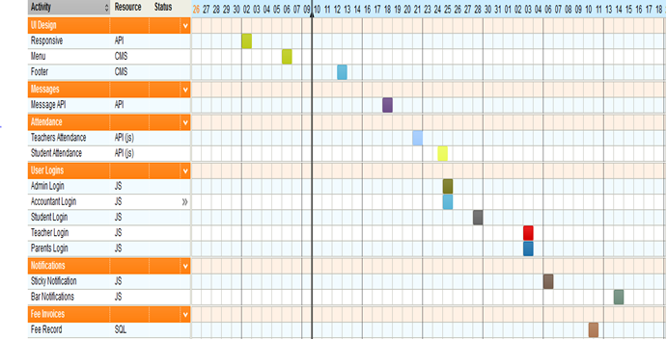

Report Outline
[Paragraph Text 12 pt, Calibri, 1.5 Line Spacing, Justified]

Chapter 2

Software Requirement Specifications

Chapter 2: Software Requirement Specifications

Introduction

Purpose

This SRS document contain complete website requirements for the Used cloths selling website and describe the design decisions, architectural design and the detailed design needed to implement the system. It provides the visibility in the design and provides information needed for software support.

Document Conventions

There is no highlighted content in this SRS document and all the requirements are equally important in this scenario as the website cannot work properly if a single component is missing from all the provided requirements.

Intended Audience and Reading Suggestions
The document is intended for the Project managers, Developers, Testers, and stake holders. You can start reading this document from the Executive Summary, problem statement and proposed solution for getting the quick understanding of this Used cloths selling Website.
This document also contains the exact features, problems in building them and the languages or platforms which we are going to use for building this product.

Product Scope
The product scope includes the following:
1: Sellers will post the original images of the clothes.
2: Sellers have to provide the clear information of clothes including fabric quality and type etc (it’s necessary)
3: Sellers have to provide the valid contact information and reachable hours.
4: Sellers have to make account before posting any ADS with complete details
5: Buyers have to create account with all the details for seeing the contact information of sellers behind ADS.

References
<List any other documents or Web addresses to which this SRS refers. These may include user interface style guides, contracts, standards, system requirements specifications, use case documents, or a vision and scope document. Provide enough information so that the reader could access a copy of each reference, including title, author, version number, date, and source or location.>

Overall Description

Product Perspective
It’s a new, self-contained product and the proposed system shall be deployed using client/server architecture and be compatible with Microsoft windows operating system.

The front end of system will be developed using sublime text (for HTML, CSS, PHP, Javascript) and backend will be developed using also SQL server (for SQL)

The system allows the user to login and then view their ADS data including the views, buyer messages.
System also allows the users to send messages to each other for making the fair deals online.

Product Functions
Here are the main functions of this website:
- Sellers will be able to post the ADS of their clothes.
- Sellers will be able to make accounts for seeing the views on their ADS and messages of the buyers.
- Buyers will be able to browse through the ADS.
- For checking the ADS poster contact details Buyers have to make the accounts for verification purpose.
- Buyers will be able to send the messages to the sellers for more information about products posted and for setting the meetings.

User Classes and Characteristics
- < Qualification: At least matriculation and comfortable with English.
- Experience: Should be well versed/informed about the process of classified sites.
- Technical Experience: Elementary knowledge of using internet on Smartphone or Computer.

Operating Environment
The product will be operating in Internet environment. Also it will be compatible with Linux hosting servers and open source hosting servers where it could be installed from the C-panel of the hosting. Its databases will be created in the files of website present on the hosting in the format of SQL which you can even manage from the front end.

Design and Implementation Constraints
Technology Constraints:
Proposed web application can be implemented with HTML/CSS for front end design
Purpose & for the database purpose, we can opt for MySQL/Oracle.

Interface Constraints:
Since, this is a Web based application so it should work on major browsers like Internet explorer, Mozilla Firefox, Google Chrome, Opera etc.

Safety and Security Constraints:
Since, application is intended for the Authenticated users only, we are using the login attempts authentication so after certain number of wrong login attempts the specific account will be blocked instead of getting it compromised.

User Documentation
The website will enlist the user manual in the learning and using page of the website, where all the basic to advanced things about the use of website will be enlisted clearly with a video tutorial which users can watch before starting using this simple classified website.

Assumptions and Dependencies
We planned to use the scripts written for classified sites and then mold it according to the requirements of our website, so if the script won’t work we have to write the one from the scratch which will require more time and developer power to complete the work.

Also, we are depending on the Google Adsense for earnings purpose and if that didn’t got approved at early stages of the website we have to use another way like featured ADS for matching the break-even point of this business.

External Interface Requirements

User Interfaces

The used clothes selling website will have the following User interfaces:

For Sellers:

Login: To allow the entry of only authorized users through valid login id and password.
Post ADS: For posting the ADS of their clothing related products with all details.

Check ADS Status: Sellers will be able to check their ADS status like views and messages.

For Buyers:

Login: To Allow the entry of only authorized users for the safety of contact information of buyers from non-serious buyers.

Browse ADS: After switching to buyer mode, users will be able to browse the ads posted from sellers in selected cities.

Message: Buyers will be able to send messages to Sellers.

Hardware Interfaces
Server side
The web application will be hosted on hosting C-panel Linux servers which are most of the time are provided by big hosting providers like Blue Host and the databases will only be created when required (After data uploading).

Client side
The system is a web based application; clients are requiring using a modern web browser such as Google Chrome major version 0.2.149, Internet Explorer 6 and Enable Cookies. The computer must have an Internet connection in order to be able to access the system

Software Interfaces
The used clothes selling system shall communicate with the Configurator to identify all the available components to configure the product.
The Used clothes selling system shall communicate with the content manager to get the product specifications, offerings and promotions.
The Used Clothes selling system shall communicate with CRM system to provide support.
The Used Clothes Selling system should communicate with security plugins for making sure the login credentials are valid.

Communications Interfaces

The HTTP protocol will be used to facilitate communications between the client and server.

- The java script supported web browser will be required to browse the website.

- An active cookie of already logged in account or fresh login will be required for full features.

System Features
<This template illustrates organizing the functional requirements for the product by system features, the major services provided by the product. You may prefer to organize this section by use case, mode of operation, user class, object class, functional hierarchy, or combinations of these, whatever makes the most logical sense for your product.>

System Feature 1
AD Posting

Description and Priority
The sellers can post the ADS of their used clothes by simply adding the original photos and required information about that dress. It’s a top priority feature of this classified website.

Stimulus/Response Sequences
Users will first log into their account and then will be able to post anything up for sell
with all the required information about that specific postings.

Functional Requirements
REQ-SF1-1: Users need to sign up first (Account holder) before posting anything.
REQ-SF1-2: Users need original photos of the dress.
REQ-SF1-3: Users need to fill all the required information about the dress before making this AD posting feature work successfully.

System Feature 2
Send Messages

Description and Priority
Sellers and buyers can exchange the messages by using their accounts through this website for the purpose of exchanging details and making fair deals.
It’s a high priority feature too.

Stimulus/Response Sequences
Users will first log into their account and then open the profile of someone (Seller or buyer), select the option of “Send Message” and then will be able to send messages to that specific person.

Functional Requirements
REQ-SF2-1: Users need to sign up first (Account holder) before messaging anyone.
REQ-SF2-2: Users need to find the profile of person which the need to contact.
REQ-SF2-3: Users need VALID account without warning for sending the messages successfully.

System Feature 3 (and so on)
Browse ADS
2.4.3.1 Description and Priority
Buyers can browse the ADS posted by the sellers for selecting the clothes by also using the filters like “Price range”, “fabric quality” etc. It’s a high priority feature too.
2.4.3.2 Stimulus/Response Sequences
Users will first log into their account and then open the Browse ADS option for seeing through all the ADS with the automatically selected filter of latest posted ADS first.
2.4.3.3 Functional Requirements
REQ-SF2-1: Users need to sign up first (Account holder) before browsing any ADS.
REQ-SF2-2: Users need to go to the Buying panel for finding the option of browse ADS on their account.
REQ-SF2-3: Users need VALID account (not flagged for any warnings) for browsing through the ADS.

Other Nonfunctional Requirements

Performance Requirements
The server should be able to operate on all major web browsers with all of its fundamental functions, Also it should not slow down the system even in the peak hours of the users.
The system should be able to delete the advertisements and users data on its own when its deleted by the users from the front end for better speed and less load.

Safety Requirements
The users should not be able to access the backend of the website even with SQL injections.
• The contact information of users should be stored in secured Database separately including emails, contact numbers etc.
• The Security SSL should be installed to the website protocol for securing the details of users as well.

Security Requirements
The system should provide a secure login to the users by using advanced secure login algorithms and after specific wrong login attempts account should be blocked and Provide access only to the authorized users as security is the key requirement of this system. This system uses a Database applications, hence the 'Weak Authentication' Threat should be taken care of.

Software Quality Attributes
System should be-

- Consistent in performance
- Safe and Secure
- Scalable
- Flexible
- User friendly
- Efficient
- Inter-operable
- Upgradable
- Available all the time.

Business Rules
For posting the advertisement of used clothes, users need to first fill the required form asking for all the details of product before posting the AD right away.

Users can only message the other once they are on the profile of that specific person, instead of sending the message by just searching user names.

Other Requirements
This website don’t have any other requirements.

Chapter 3

Use Case Analysis

Chapter 3: System Analysis
This section graphically shows how user interacts with the system. It describes a list of actions or event steps typically defining the interactions between a role and a system to achieve a goal. The actor can be a human or other external system. This section elaborates all the functional requirement of the system. It tells how system behaves with the specific user.

Use Case Model
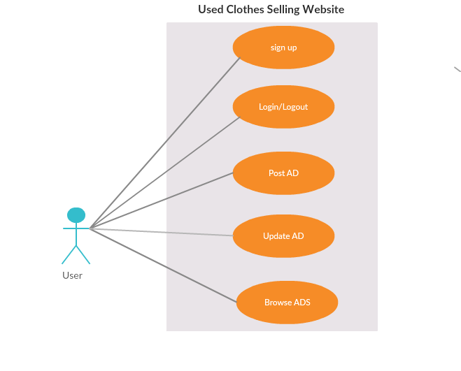

Use Case According to Admin:
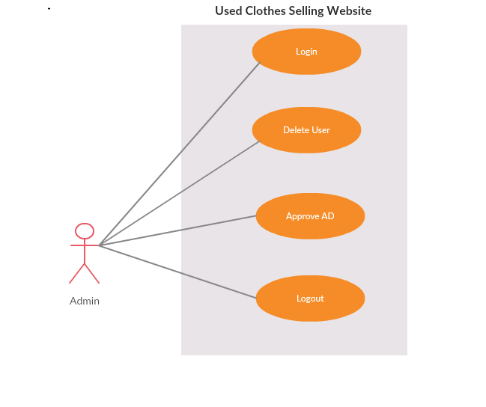

Use Case Descriptions
Use case Name: Post Ad
Brief Description: Sellers can post Ads of their used clothes for selling them online by attaching original photos and required information.
Primary Actors: Sellers
Stakeholders: Admin, Sellers, Buyers
Preconditions: User must be logged in to their account
Main Success Scenario: The Ad is posted and now is live for buyers to browse in their section.

Use case Name: Messaging
Brief Description: Sellers and Buyers can send messages to each other for making the deals and discussing the details.
Primary Actors: Sellers, Buyers
Stakeholders: Admin, Sellers, Buyers
Preconditions: User must be logged in to their account
Main Success Scenario: The Message is sent from one account to another.

Use case Name: Browse Ads
Brief Description: Buyers can go to the section of browse Ads and can check the details of all the ADS posted sellers.
Primary Actors: Buyers
Stakeholders: Admin, Sellers, Buyers
Preconditions: User must be logged in to their account
Main Success Scenario: The recent ADS are being shown to the buyers browse ADS section at the real time.

Chapter 4

System Design

Chapter 4: System Design

Architecture Diagram
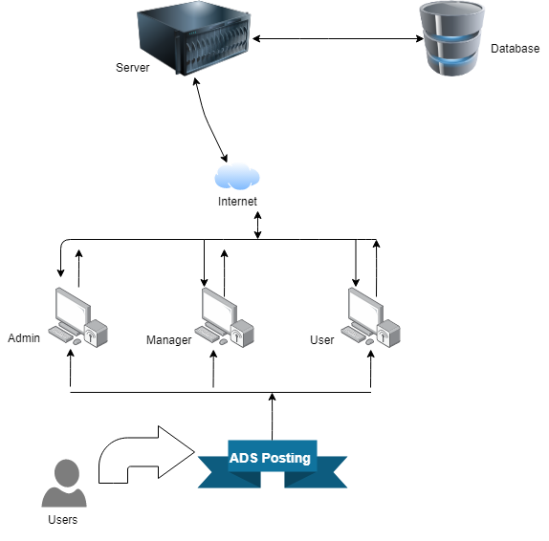

Domain Model
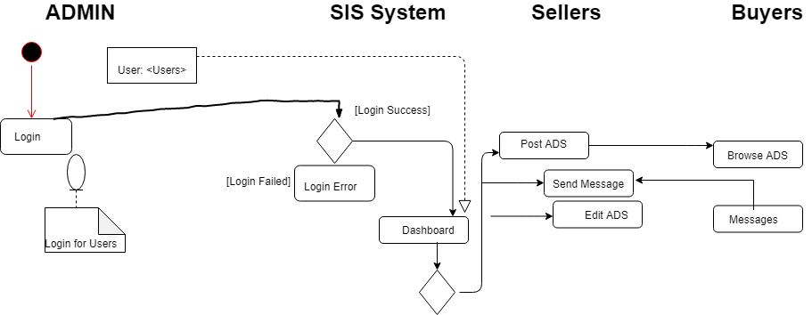

Entity Relationship Diagram with data dictionary
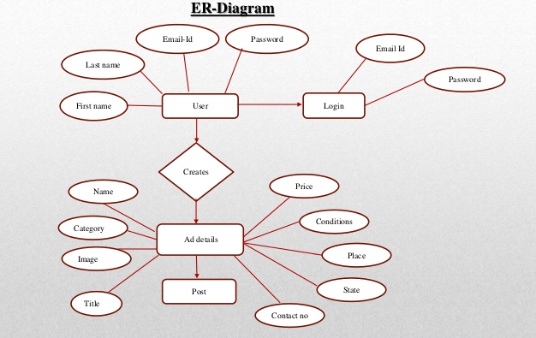

Class Diagram
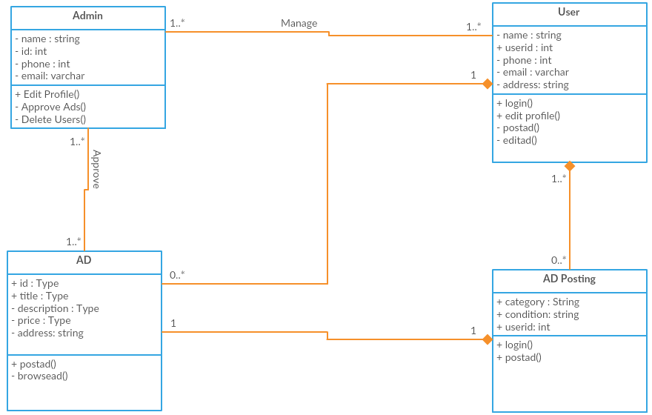

Sequence / Collaboration Diagram
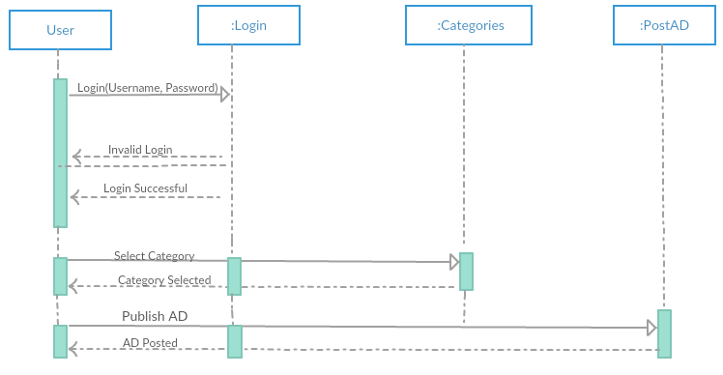

Sequence According to Admin:
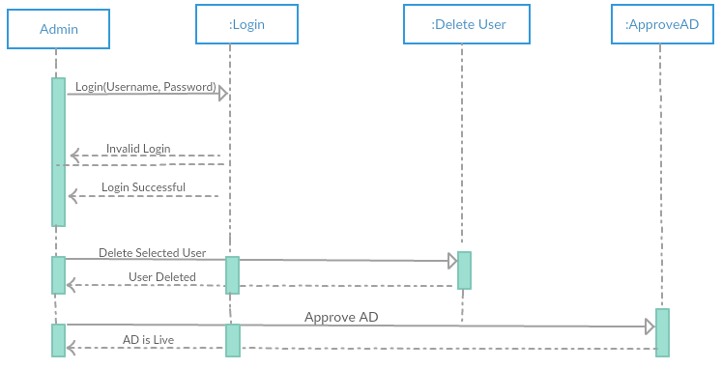

Operation contracts
Operation Contract01: User Login
Cross Reference: Use cases Login/Get account
Precondition: User is assigned the account
Post Condition: Entered login details matching with databases, reload the page, show users the dashboard with assigned data.

Operation Contract02: Post Ad
Cross Reference: Use cases Post Ad
Precondition: User is logged into the account
Post Condition: Entered details following the rules, reload the page, Ad posted successfully.

Operation Contract03: Send Messages
Cross Reference: Use cases Messaging
Precondition: User is logged into the account
Post Condition: Message is following the policy, new popup appears, Message sent to the Seller.

Activity Diagram
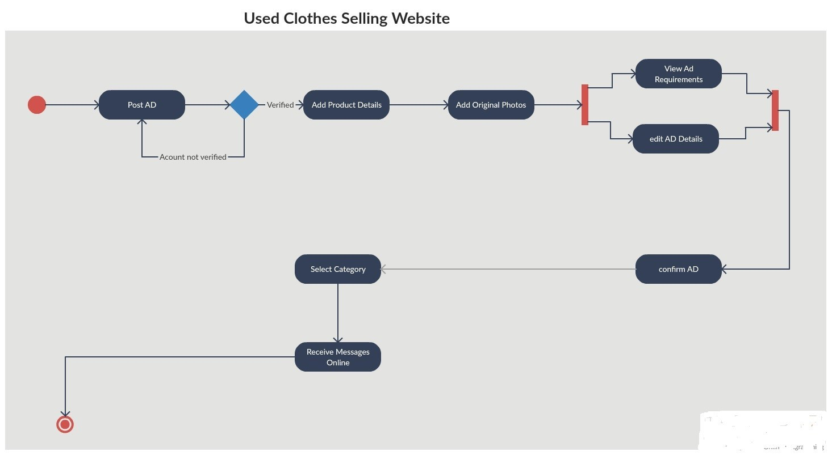

State Transition Diagram
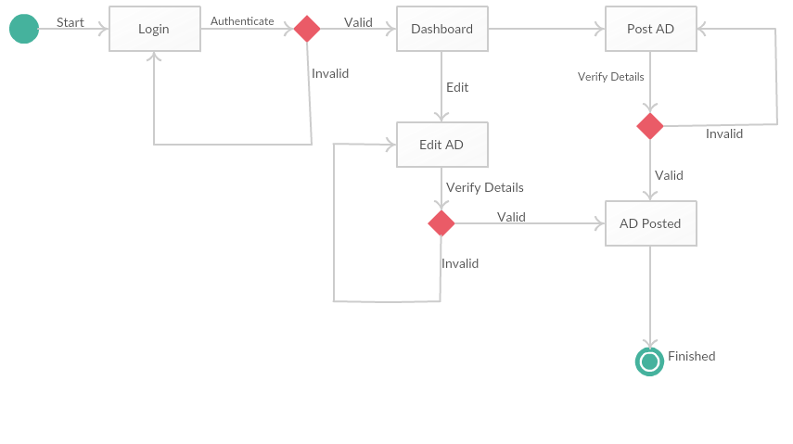

Component Diagram
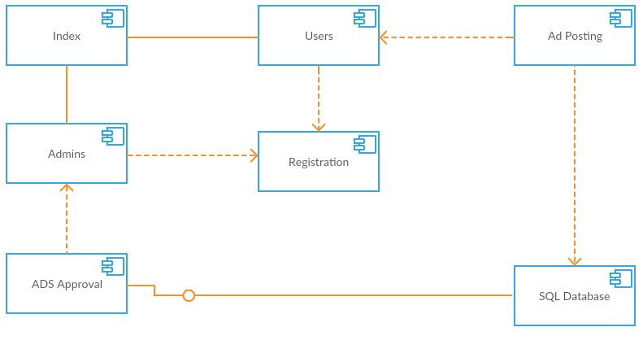

Deployment Diagram
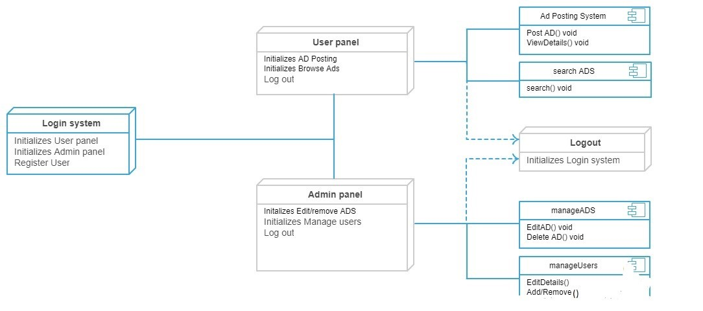

Data Flow diagram [only if structured approach is used - Level 0 and 1]
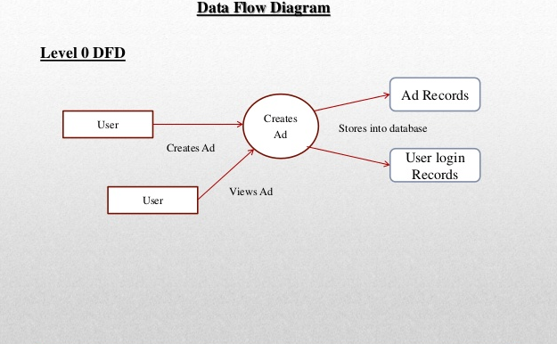

Chapter 5

Implementation

Chapter 5: Implementation
Implementation is the carrying out, execution, or practice of a plan, a method, or any design for doing something. As such, implementation is the action that must follow any preliminary thinking in order for something to actually happen.
In an information technology context, implementation encompasses all the processes involved in getting new software or hardware operating properly in its environment, including installation, configuration, running, testing, and making necessary changes. The word deployment is sometimes used to mean the same thing.
• Software implementation initiation allows to prepare the team work for the activities and to have all the necessary tools to accomplish the work.

Important Flow Control/Pseudo codes
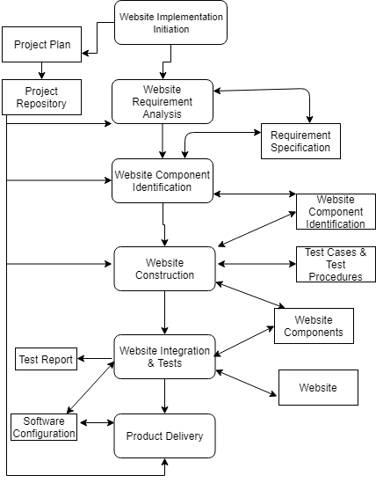

Components, Libraries, Web Services and stubs
IIS 7 Recommended Configuration. This enables the Web Server (IIS) role on your web server and installs the set of IIS modules and components that you need in order to host a PHP application.
IIS: Management Service. This installs the Web Management Service (WMSvc) in IIS. This service enables remote management of IIS websites and exposes the Web Deploy Handler endpoint to clients.
IIS: Basic Authentication. This installs the IIS Basic Authentication module. This lets the Web Management Service (WMSvc) authenticate the credentials you provide.
Web Deployment Tool 2.1 or later. This installs Web Deploy (and its underlying executable, MSDeploy.exe) on your server. As part of this process, it installs the Web Deploy Handler and integrates it with the Web Management Service.

Deployment Environment
• Create, or choose, a domain user account (the "non-administrator user") whose credentials you'll use to perform deployments.
• Install IIS 7.5, including the Web Management Service and the Basic Authentication module.
• Install Web Deploy 2.1 or later.
• Configure the Web Management Service to allow remote connections, and start the service.
• Create an IIS website to host the deployed content.
• Grant your non-administrator user permissions on your website in IIS Manager.
• Ensure that the Web Management Service delegation rules permit the service to add and change website content using your non-administrator user account.
• Configure any firewalls to allow incoming connections on port 8172.
• To host the Contact Manager sample solution specifically, you'll also need to:
Install php Script, Add MVC Framework into it and then load it on the databases of the server.

Tools and Techniques
For hosting this script we are using the C-panel of the hosting provider Go daddy and same for the databases.
For programming, we are using the modules techniques (object oriented programming) due to a lot of coding work and different persons are working so it will remove the confusions too.
The different kinds of languages we are going to use in our project are listed follow.
Frontend
- CSS
- HTML
- BOOTSTRAP
Backend
- PHP
Data Base
- SQL

Best Practices / Coding Standards

Object Name | Notation | Length | Plural | Prefix | Suffix | Abbreviation | Char Mask | Underscores
Class name | PascalCase | 128 | No | No | Yes | No | [A-z][0-9] | No
Constructor name | PascalCase | 128 | No | No | Yes | No | [A-z][0-9] | No
Method name | PascalCase | 128 | Yes | No | No | No | [A-z][0-9] | No
Method arguments | camelCase | 128 | Yes | No | No | Yes | [A-z][0-9] | No
Local variables | camelCase | 50 | Yes | No | No | Yes | [A-z][0-9] | No
Constants name | PascalCase | 50 | No | No | No | No | [A-z][0-9] | No
Field name | camelCase | 50 | Yes | No | No | Yes | [A-z][0-9] | Yes
Properties name | PascalCase | 50 | Yes | No | No | Yes | [A-z][0-9] | No
Delegate name | PascalCase | 128 | No | No | Yes | Yes | [A-z] | No
Enum type name | PascalCase | 128 | Yes | No | No | No | [A-z] | No

Version Control
There is no version control added to this script like a specific browser is required to use this applications instead you can also use this software with the older version of browsers (just need to be the javascript, cookies enabled) and the script will work perfectly fine both for the computer and android/ios users.

Chapter 6

Testing and Evaluation

Chapter 6: Testing and Evaluation
Software testing is a process, to evaluate the functionality of a software application with an intent to find whether the developed software met the specified requirements or not and to identify the defects to ensure that the product is defect free in order to produce the quality product.

Use Case Testing
Use case testing is a technique that helps us identify test cases that exercise the whole system on a transaction by transaction basis from start to finish.

Use Case for Login
Main Success scenario  A:Actor  S:System | Step
Main Success scenario  A:Actor  S:System | 1 | A:Insert User name & Password
Main Success scenario  A:Actor  S:System | 2 | B:Validate User name & Password
Main Success scenario  A:Actor  S:System | 3 | C:Allow access to Account
Extensions | 2A | User name not valid
Extensions | 2B | Password not valid

Use Case for Search ADS
Main Success scenario  A:Actor  S:System | Step
Main Success scenario  A:Actor  S:System | 1 | A:Scan Search
Main Success scenario  A:Actor  S:System | 2 | B:Validate Search
Main Success scenario  A:Actor  S:System | 3 | C:AD found
Extensions | 2A | AD record not found

Use Case for Ad Posting
Main Success scenario  A:Actor  S:System | Step
Main Success scenario  A:Actor  S:System | 1 | A:Insert Ad details
Main Success scenario  A:Actor  S:System | 2 | B:Validate details
Main Success scenario  A:Actor  S:System | 3 | C:Allow AD posting
Main Success scenario  A:Actor  S:System | 4 | D:List AD for View
Extensions | 2A | Complete required details
Extensions | 2B | Ad against the policies

Use Case for Sending Message
Main Success scenario  A:Actor  S:System | Step
Main Success scenario  A:Actor  S:System | 1 | A:Select person for sending Message
Main Success scenario  A:Actor  S:System | 2 | B:Validate message
Main Success scenario  A:Actor  S:System | 3 | C:Allow Sending message
Main Success scenario  A:Actor  S:System | 4 | D:Show message status
Extensions | 2A | Message not following policies
Extensions | 2B | Select someone to send message

Equivalence partitioning
Equivalence Partitioning is also known as Equivalence Class Partitioning. In equivalence partitioning, inputs to the software or system are divided into groups that are expected to exhibit similar behavior, so they are likely to be proposed in the same way.
Testing of Mobile Number:
Mobile Number must be 12 digit
Valid | Invalid | Invalid
923126037529 | 92312603752 | 9231260375299

Valid input: 12 digits
Invalid Input: 11 digits, 13 digits
Valid Class: Enter 12 digit mobile number = 923126037529
Invalid Class Enter mobile number which has less than 12 digits =92312603752
Invalid Class Enter mobile number which has more than 12 digits = 9231260375299

Testing of Email Address:
Your email must contain a valid pattern
Valid | Invalid | Invalid
talha@gmail.com | talhagmail.com | talha.com

Valid Class: Must follow the proper pattern

Testing of AD Description minimum characters Number:
AD Description must be equals or above 50 characters
Valid
Hi, there I am selling my newly purchased wedding dress (ladies) in red color, original snaps attached!
Invalid
Hi, there I am selling my

Valid input: 50 characters or above
Invalid Input: below 50 characters
Valid Class: Enter AD Description equals or above 50 characters = Hi, there I am selling my newly purchased wedding dress (ladies) in red color, original snaps attached!

Invalid Class Enter AD Description which has less than 50 characters = Hi, there I am selling my

Boundary value analysis

Boundary value analysis (BVA) is based on testing the boundary values of valid and invalid partitions. The Behavior at the edge of each equivalence partition is more likely to be incorrect than the behavior within the partition, so boundaries are an area where testing is likely to yield defects.

Testing on Password Text field
Name should be in between 8-12 characters
Valid | Invalid | Invalid
talha@123 | Talha@ | Talha@123456
Minimum boundary value is 8
Maximum boundary value is 12
Valid text length is 8,9,10, 7, 11, 12
Invalid text length is 7, 13
Test case 1: Text length of 7 (min-1) = Invalid
Test case 2: Text length of exactly 8 (min) = Valid
Test case 3: Text length of 9 (min+1) = Valid
Test case 4: Text length of 14 (max-1) = Valid
Test case 5: Text length of exactly 15 (max) = Valid
Test case 6: Text length of 16 (max+1) = Invalid

Data flow testing

Data Flow testing is one of the testing strategies, which focuses on the data variables and their values, used in the programming logic of the software product, by making use of the control flow graph. The basic idea behind this form of testing, is to reveal the coding errors and mistakes, which may results in to improper implementation and usage of the data variables or data values in the programming code. In this Project I have done static data flow testing in which I studied and analyzed the code without performing the actual execution of the code such as wrong header files or library files use or syntax error. While testing this I have remove anomalies from the code like variables are defined but they are not used. Some variables are defined twice

Unit testing
Unit Testing is done to check whether the individual modules of the source code are working properly. i.e. testing each and every unit of the application separately by the developer in developer’s environment.
- I have done this testing by keeping in mind the goal of the system. In this testing I have carefully checked the naming conventions.
- I have clearly checked the flow is correct between inside and outside the module.
- Verify the check statements
- Check the extreme boundaries values of output
- Loops are correct or not

Integration testing
Every software application contains multiple modules that converse with each other through an interface. Integrating these individual software modules and testing them together is known as Software Integration Testing. It is an extension to Unit testing. It is performed by either testers or developers.

TESTCASE ID | TEST CASE OBJECTIVE | TESTCASE DESCRIPTION | EXCEPTED RESULT
1 | Verify the integration between login and admin home page | Enter login credentials and do login | Admin home page should be displayed
2 | Verify the interaction between login and account manager home page | Enter login credentials and do login | Accounts manager  home page should be displayed
3 | Verify the interaction between admin home page and registered users data from Databases. | Click add User button. | User registration should be displayed

Performance testing
Performance testing plays a vital role. It is the only way to determine an application’s behavior at different levels of load and users. The goal of Performance Testing is not to find bugs but to eliminate performance bottlenecks. I performed performance testing manually. Many active sessions of the same application should be open for testing. Manually, we have determine the number of active sessions, number of database connections open, and number of threads running. The amount of CPU time, the memory being used and few more parameters can also be obtained. A quick preliminary database performance test is done manually to get the necessary information
J meter is the tool which we used for the performance testing.

Stress Testing
Stress Testing is defined as a type of Software Testing that verified the stability & reliability of the system. This test mainly determines the system on its robustness and error handling under extremely heavy load conditions.
We tested out website by using the fake robot traffic and it can bear up to 400+ real time sessions and will display the users Apology page with valid reason in case of error or server crash.

Chapter 7

Summary, Conclusion and Future Enhancements

Chapter 7: Summary, Conclusion & Future Enhancements

Project Summary
This website is about selling and buying the used clothes online similar to the classified website but it’s specifically designed for the used clothing marketplace. We developed this website application using the front end languages HTML, CSS, JAVASCRIPT and programming languages PHP with frameworks.
Used clothing is a big marketplace in Pakistan as well where people sell their costly clothes like wedding dresses at low prices while the buyer gets the same clothes at extremely high rates, By keeping this problem in mind we started this website so both buyers and sellers will be happy with their buying and selling prices.

Achievements and Improvements
Our achievement with this project is that we are providing the people who don’t afford to buy costly clothes for their events or special life occasions with big choice and also it’s an extra income for the people who buy a lot of fancy clothes on parties and then those dresses only hanging in their cup boards.

Critical Review
This document is for the stack holders of Used Cloths Selling Website. This document is very useful for all the persons related with this project. The UML diagrams in the document are drawn by following the book “Applying The UML And Patterns “.Moreover some patterns of diagrams are drawn using the online available tools including “draw.io” and “lucid chart”.The document start describing from the scope of the project and ends at testing phase. The foundation and deployment of the project is described. Last but not the least this document is a complete guide for the stockholders of this project

Lessons Learnt
Our team has learned that Time Management decide the success and failure of the project so it is necessary to do the tasks on the schedule time otherwise it will create burden and may led the project towards failure.

Future Enhancements/Recommendations
Future Enhancements in this project can be made by adding Artificial Intelligence detectors for fake and official photos of the clothes listed for selling and making sure the person don’t have any other profiles on the same device for making it best experience for the buyers.

Appendices

Appendix A: User Manual
[Paragraph Text 12 pt, Calibri, 1.5 Line Spacing, Justified]
[Between 4 to 8 lines describe what is this appendix all about]

Appendix A:
[Appendix Heading 1]: [20 pt, Calibri, Bold, Left aligned]

Text in 12-Point Size, Times New Roman, 1.5 Line Spacing.

Appendix B: Administrator Manual
[Paragraph Text 12 pt, Calibri, 1.5 Line Spacing, Justified]
[Between 4 to 8 lines describe what is this appendix all about]

Appendix C: Information / Promotional Material
[Paragraph Text 12 pt, Calibri, 1.5 Line Spacing, Justified]
[Between 4 to 8 lines describe what is this appendix all about]

  - Broacher


  - Flyer


  - Standee

  - Banner

  - First Level heading [16 pt, Calibri, Bold, Left aligned]
[Paragraph Text 12 pt, Calibri, 1.5 Line Spacing, Justified]

    - Second level heading [14 pt, Calibri, Bold, Left aligned]
[Paragraph Text 12 pt, Calibri, 1.5 Line Spacing, Justified]

      - Third level heading [12 pt, Calibri, Bold, Left aligned]
[Paragraph Text 12 pt, Calibri, 1.5 Line Spacing, Justified]

Appendix [no.]: Appendix Title
[Paragraph Text 12 pt, Calibri, 1.5 Line Spacing, Justified]
[Between 4 to 8 lines describe what is this chapter all about]

  - First Level heading [16 pt, Calibri, Bold, Left aligned]
[Paragraph Text 12 pt, Calibri, 1.5 Line Spacing, Justified]

    - Second level heading [14 pt, Calibri, Bold, Left aligned]
[Paragraph Text 12 pt, Calibri, 1.5 Line Spacing, Justified]

      - Third level heading [12 pt, Calibri, Bold, Left aligned]
[Paragraph Text 12 pt, Calibri, 1.5 Line Spacing, Justified]

Reference and Bibliography

Reference and Bibliography

[1] CRAIG LARMAN (October 30, 2004) ,APPLYING UML AND PATTERNS ,
[2] [Accessed 6 June 2019] https://www.lucidchart.com/
[3] [Accessed 6 June 2019] https://www.smartdraw.com/
[4] [Accessed 10 June 2019] Draw.io
[5][Accessed 12 June 2019] https://www.softwaretestingmaterial.com/sql-tutorial-complete/

Index

Index

[A]

[B]

[C]

