Isolation And In Vitro Efficacy of Bacteriophages Against Methicillin-Resistant Staphylococcus Aureus


A Thesis submitted in partial fulfillment of
the requirements for the degree of

MASTER OF SCIENCE
IN MICROBIOLOGY

Submitted by
Amina Shahzadi
SU92–MSMBW–F23–007

Session: 2023-2025
Supervised By
DR.Samiyya Abrar

DEPARTMENT OF BIOLOGICAL SCIENCES
THE SUPERIOR UNIVERSITY, LAHORE

AUTHOR’S DECLARATION

I, Amina Shahzadi, a student of “Microbiology”, at the Department of Biological Sciences, the Superior University, Lahore, hereby declare that this thesis titled, “Isolation And In Vitro Efficacy of Bacteriophages Against Methicillin Resistant Staphylococcus Aureus” is my own research work and has not been submitted, published, or printed elsewhere in Pakistan or abroad. Additionally, I will not use this thesis to obtain any degree other than the one stated above.
I fully understand that if my statement is found to be incorrect at any stage, including after the award of the degree, the university has the right to revoke my MS degree.

Signature of Student:________________________________
Name of Student:________________________________
Roll Number:________________________________
Date:________________________________

PLAGIARISM UNDERTAKING

I solemnly declare that the research work presented in this thesis titled, “Isolation And In Vitro Efficacy of Bacteriophages Against Methicillin-Resistant Staphylococcus Aureus” is solely my research work, and that the entire thesis has been completed by me, with no significant contribution from any other person or institution. Any small contribution, wherever taken, has been duly acknowledged.
I understand the zero-tolerance policy of the HEC and Superior University, Lahore, towards plagiarism. Therefore, I, as the author of the above-titled thesis, declared that no portion of my thesis has been plagiarized and that all material used from other sources has been properly acknowledged, cited, and referenced.
I undertake that if I am found guilty of any formal plagiarism in the above titled thesis, even after the award of the MS degree, the University reserves the right to revoke my degree, and that HEC and the University have the right to publish my name on the HEC/University website for submitting a plagiarized thesis.

Signature of Student:_______________________________
Name of Student:_______________________________

Signature Supervisor: ______________________________
Supervisor Name:______________________________

CERTIFICATE OF RESEARCH COMPLETION

It is certified that this thesis titled, “Isolation And In Vitro Efficacy of Bacteriophages Against Methicillin-Resistant Staphylococcus Aureus”, submitted by Amina Shahzadi, Roll No. SU92 MSMBW–F23–007, for MS/M.Phil “degree name” at “Faculty Name”, Superior University, is an original research work and contains satisfactory material to be eligible for evaluation by the Examiner(s) for the award of the above-stated degree.
No part of this dissertation has been submitted anywhere else for any other degree.
Supervisor Name: Dr. Samyyia Abrar
Designation: Assistant Professor in Department of Biological Science

Signature:

CERTIFICATE OF APPROVAL

This is to certify that the research work presented in this thesis, titled “Isolation and in vitro efficacy of bacteriophages against methicillin resistant Staphylococcus aureus” was conducted by “Amina Shahzadi” under the supervision of “Dr. Samyyia Abrar”

No part of this thesis has been submitted anywhere else for any other degree. This thesis is submitted to the Faculty of Sciences, The Superior University, Lahore in partial fulfillment of the requirements for the degree of Master of Science in the field of “MS Microbiology” in Faculty of Sciences at The Superior University, Lahore.

Student Name: Amina Shahzadi Signature:

Examination Committee:

Session Chair: Signature:

- External Examiner: Signature:

- Internal Examiner: Signature:

- Supervisor Name: Dr. Samyyia Abrar Signature:

- Name of HOD: Prof. Dr. Uqba Mehmood Signature:

- Name of Dean: Prof. Dr. Mohammad Naveed Babur Signature:

- Controller Examination: Dr. Muhammad Haris Signature:

DEDICATION

First of all, I will dedicate this study to my Almighty Allah, who gave me strength and knowledge for my everyday life.
To my parents, Mr. and Mrs. Muhammad Sadiq, for their understanding and for their overwhelming support morally and financially.
Along with my hardworking and respected supervisor.

ACKNOWLEDGEMENT

In the name of Allah, the most Gracious, the most Merciful. I am extremely thankful to “Almighty Allah”. Who is the entire source of knowledge and wisdom endowed to mankind, for providing me with the acumen and vision to complete this endeavor. I would like to express my profound gratitude to my supervisor Dr. Samyyia Abrar, for her wise counsel and encouraging attitude towards this study. I am extremely grateful to her for immensely facilitating me during my study period by ensuring the provision of favorable circumstances and conducive environment. This project would not have been possible without her support and expert guidance.
In the end, I would like to extend my deepest gratitude to my family members. Without their encouragement, I would not have been able to complete this endeavor.

TABLE OF CONTENTS

AUTHOR’S DECLARATION i
PLAGIARISM UNDERTAKING ii
CERTIFICATE OF RESEARCH COMPLETION iii
CERTIFICATE OF APPROVAL iv
DEDICATION v
ACKNOWLEDGEMENT vi
TABLE OF CONTENTS vii
LIST OF TABLES x
LIST OF FIGURES xi
LIST OF ABBREVIATIONS xii
ABSTRACT 1
CHAPTER ONE INTRODUCTION 2
CHAPTER TWO LITERATURE REVIEW 5
2.1 Bacteriophage Introduction 5
2.2 Application of Bacteriophage 5
2.3 Bacteriophage Specificity 6
2.4 Histroy of Phage Therapy 6
2.5 Life Cycle of Bacteriophage 7
2.5.1 Adsorption 7
2.5.2 Penetration 8
2.5.3 Synthesis of Phage Components 8
2.5.4 Maturation and Assembly 8
2.5.5 Release 8
2.6 Bacteriophage Therapy for Pathogen Control 8
2.7 Phage’s as a Bio-control Agents of MRSA 9
AIMS AND OBJECTIVES 11
CHAPTER THREE MATERIALS AND METHODS 12
3.1 Bacterial Isolation ad Confirmation 12
3.2 Bacteriophage collection from sewage sample 12
3.3 Bacteriophage Enrichment 12
3.4 Conformation Separation of Bacteriophage from Filter Liquid by Single Agar Layer Technique 12
3.5 Conformation of Lytic Bacteriophage by Double Agar Layer Technique 13
3.6 Purification of Bacteriophages 13
3.7 Bacteriophage for Staphylococcus aureus 14
3.8 Statistical analysis 14
CHAPTER FOUR RESULTS 15
4.1 Staphylococcus aureus 15
4.2 Sample Gathering 15
4.3 Inoculation on selective media 15
4.4 Incubation 16
4.5 Gram Staining 16
4.6 Biochemical Identification: 17
4.7 Conformation 17
4.8 Antibiotic susceptibility testing 17
4.9 Clinical Correlation 18
4.10 Antibiotic Susceptibility Testing 18
4.11 Preparation of Inoculum 18
4.12 Antibiotic Disks 18
4.13 Inoculation 18
4.14 Assessment and Interpretation 18
4.15 Results Reporting 19
4.16 McFarland standard 19
4.17 Vancomycin Testing 19
4.18 Methicillin 20
4.19 Bacteriophage Host Spectrum 22
4.19.1 Plaque Test 22
4.19.2 Spot test 23
CHAPTER FIVE DISCUSSION 26
CONCLUSION 29
CHAPTER 06 SUMMARY 30
LIST OF PUBLICATIONS 31
REFERENCES 32
ANNEXURE 36

LIST OF TABLES

Sr. No. | Description | Page No.
1 | Table 4.1: Mean zone of inhibition for different antibiotics used | 19
2 | Table 4.2: Relationship between type of sampling site in hospital and status of bacteriophage | 22

LIST OF FIGURES

Sr. No. | Description | Page No.
1 | Figure 4.1: Glycerol Stock having Staphylococcus aureus | 17
2 | Figure 4.2: Staphylococcus aureus on Mannitol salt agar (yellowish growth on Mannitol salt agar | 18
3 | Figure 4.3: Microscopic view of staphylococcus aureus (Gram Positive Cocci | 18
4 | Figure 4.4: Biochemical Identification by using Catalase Test | 19
5 | Figure 4.5: McFarland solution | 21
6 | Figure 4.6: Zone of Inhibition Methicillin, Vancomycin, oxacillin, Penicillin | 23
7 | Figure 4.7: Antibiotic susceptibility testing of selected strains | 23
8 | Figure 4.8: Preparation of culture for Bacteriophage Application | 24
9 | Figure 4.8: Plaque Test Result on Staphylococcus aureus Culture | 25
10 | Figure 4.9: Percentage of Strain of each Strain | 26

LIST OF ABBREVIATIONS

Abbreviations | Explanation
CLSI | Clinical and Laboratory Standard Institute
MRSA | Methicillin Resistance Staphylococcus aureus
VISA | Vancomycin Intermediate Staphylococcus aureus
VRSA | Vancomycin Resistance Staphylococcus aureus
SA | Staphylococcus aureus
HRM | High Resolution Microscopy
IMC | Isothermal Calorimeter
MSA | Mannitol salt agar
TSA | Tryptic soya agar
PFU | Plaque forming Unit
CFU | Colony Forming Unit

ABSTRACT
Staphylococcus aureus, a gram-positive bacterium, is a serious pathogen and is involved in causing various infections in humans, leading to increased morbidity and mortality. Its ubiquity on human skin plays an important role in causing nosocomial infections. Among them, multidrug-resistant bacteria are a common cause of hospital-acquired infections (HAIs), which involve in increasing death rates. Methicillin-resistant Staphylococcus aureus (MRSA) is one of an examples of how S. aureus resistance to different drugs makes it difficult to use therapeutic measures. This study investigated the use of bacteriophages, viruses that eat bacteria and can be used as a novel means of treating antibiotic-resistant S. aureus infections. By developing into pro-phages, which infect bacteria through either a lytic or lysogenic life cycle, bacteriophages play a critical part in the life cycle of the bacterial cell. Bacteriophages are a common entity on earth and, surprisingly, are ten times more abundant than bacteria. The lytic life cycle is a major threat to bacteria. The findings demonstrate the therapeutic potential of bacteriophages, especially when used to infections caused by bacterial biofilms. Treating Staphylococcus aureus infections is made more difficult by bacterial biofilms, which are notorious for being resistant to antibiotics. This is particularly true when medical indwelling devices are present. Because of their capacity to specifically target and destroy biofilms, bacteriophages appear to be a viable substitute for conventional antibiotics. The growing significance of bacteriophages in broadening the range of treatments available for Staphylococcus aureus infections is covered in this review, particularly in light of the rise in antibiotic resistance. Bacteriophages present a workable response to the pressing demand for alternative tactics brought on by the emergence of antibiotic resistance. Furthermore, their importance in resolving concerns about environmental safety is highlighted by their potential to be used as biotechnological weapons against pathogenic bacteria, especially strains that are resistant to antibiotics. To sum up, using bacteriophages as therapeutic agents offers a fresh and promising approach to combating infections caused by Staphylococcus aureus that are resistant to antibiotics. This study adds to the expanding body of information regarding the possible uses of bacteriophages to improve bacterial control and get around the problems caused by antibiotic resistance, especially when it comes to illnesses linked to biofilms.

CHAPTER ONE
INTRODUCTION
Gram-positive Staphylococcus aureus is an opportunistic pathogen and causative for human mortality and morbidity as well as other bacterial isolates in humans. Mostly present on human skin and its food born and nosocomial infection generating the excessive burden on health care center and causes a diverse range of infections. Besides this Staphylococcus aureus and other bacterial isolates play a major role in food poisoning, dairy industry and the causative agent of bovine mastitis [1]. The extensive uses of antibiotics and their therapeutics can lead to drug resistance which is an alarming threat for global health. The development rate of emerging Antibiotic medications is insufficient to replace those that have lost effectiveness over time. About 80,000 hospitalized patients are ill with this disease. Staphylococcus aureus that shows massive resistance against the antibiotics. Therefore, the resistance in case of Staphylococcus aureus and other bacterial isolates is not a huge range of life-threatening infections; it’s also changed the behavior of microorganism towards the antibiotics [2].
Gradually Staphylococcus aureus and other bacterial isolates gain resistance against the previously effective antimicrobial agents. The Staphylococcus aureus show increasing resistance against the methicillin therefore, called Methicillin resistance Staphylococcus aureus (MRSA) and other bacterial isolates. It’s difficult to arrest and to stop their growth because due to it resistance against antibiotics that are usually recommended [3]. Their resistance is not only against the Beta-Lactam antibiotics but also against the amino glycosides’ glycopeptides, and fluproquazones. Their remarkable resistance against the current antibiotics is dominant than the prior resistance. Since the problem is worsening and threat full extended from hospital to community environment. Up to 60% of community- and hospital-acquired S. aureus infections are caused by MRSA. In Pakistan, prevalence has been enhanced speedily from 5% in 1989 to 53% in 2013 [4].

The impact of bacterial biofilm and upkeep of persistent non-healing wound infection has been found with scientific literature. Increasing number of non-healing wound infections of MRSA and other bacterial isolates of their resistance has become the major problem and increasing the enumeration of patient with weekend immunity system has a critical issue in contemporary medicine. Unless the usage of antibiotics continues against microbial infections. Therefore, here we used another alternative form of antibiotics and environmentally friendly therapeutics against MRSA [5]. Since, there is not any side effect of these therapeutics on host. Perhaps, it is essential to develop new therapeutics to control MRSA infection. The new way of therapeutics like, Nano- technology, peptides gel, photodynamic therapy, pathogen inactivation, medicinal plants, and phage are also one of them to combat the bacterial infection. The uses of bacteriophage are one of the suitable alternative and complementary upcoming therapies to fight of the antibiotics resistance microorganisms that can kill a particular host. This concept, which is currently being examined by different nations, is known as phage therapy [6]. Bacteriophages or Phage’s are Viruses that attack on bacteria. Phage has fused with bacterial cells and become pro-phage to infect the bacteria. They have two types of life cycle the one is lytic and other is lysogenic life. The lytic life cycle of Phage has quieter threatening to bacteria and to Lysis bacteria. Bacteriophages are too numerous believed to outnumber bacteria by ten times. The bacteriophage numerously expended on earth. So, there is great interest in developing bacteriophage as a therapeutic agent instead of antibiotics for bacterial biofilms infection. Bacteriophages are ubiquities for bacteria that lysis of bacterial cell but not harm the human cell. Most of the studies have demonstrated that the bacteriophage treats the bacterial infection in animals, plants, humans and those that cause the multi-drug resistance bacterial strain. Despite several literatures are limited to date, promising results of the There are few research on bacteriophage therapy for biofilm, and those that do use in- vivo artificial systems have a hard time translating to wound biofilm settings [7].
70% of bacteriophages are present in sewage samples and their isolation and characterization from sewage samples is our priority. 20, 30 sample of sewage are isolated and transport to microbiological laboratories to grown on different Medias having bacterial culture Specifically Staphylococcus aureus. Bacteriophage has shown three types of characterization on bacterial culture plate, (plaque assays), (spot assays), (culture assays). Bacteriophage injects their Genetic material on host cell and reproduces in large number eventually to lysis the bacterial host by lytic life cycle.

Unlike the antibiotic bacteriophage kill the specific host and do not kill the human normal flora to prevent the bacterial symbiosis. Thus, application of phage inhibits the growth of resistance bacterial strains could be natural and non-toxic and effective substitute of antibiotics [8].
In present study we isolate the bacteriophage from sewage samples against the methicillin resistant Staphylococcus aureus (MRSA). The aim of our studies is to check out the in-vitro efficacy of bacteriophages against the Methicillin resistant Staphylococcus aureus (MRSA). This is the first study to isolate the bacteriophage from sewage sample and use against the MRSA resistance. Perhaps, there we will also demonstrate the in-vitro study of bacteriophage for MRSA. The isolated phage shows clear plaque formation to kill the MRSA resistance. The lytic assays showed a sharp decline in curve of OD600 of MRSA [9].
As discussed in numerous reviews and perspectives there are several potential benefits to using phages as antibacterial therapeutics. These benefits include the fact that lytic phage’s kill bacteria using entirely different mechanisms than antibiotics, making them effective against MDR pathogens and allowing for frequent synergies when combined with antibiotics the fact that phages frequently infect only one type of bacteria. Phage’s (self-replicating medications) aggregate precisely were bacterium. Since phages have enzymes which can degrade biofilm, which can be linked to challenging infections, which can further provide space to other antimicrobials to overcome this barrier. Phage therapy is being used safely number of human clinical trials, and phages are present and available everywhere in the environment and typically simple to isolate, made choosing a new phage which is active against a resistant strain. Phage can be less expensive to produce than other antibacterial [10]. Needed to eradicate pathogen cells at the site of infection because they replicate on the target

CHAPTER TWO
LITERATURE REVIEW

2.1 Bacteriophage Introduction
Bacteriophages, also referred to as phages, are viruses that exclusively replicate in bacterial cells and assault and infect bacteria. They are the most prevalent biological agent on earth and are found everywhere, with 70% of a sewage sample containing them. They differ significantly in terms of genetic makeup, size, and appearance. All bacteriophages, however, are made up of nucleic acid and their genome wrapped in a shell of phage-encoded proteins called capsids. These proteins serve to both protect the bacteriophage's genetic material and mediate its distribution towards the subsequent host cell. Electron microscopy has allowed for a detailed observation of numerous phage varieties, revealing structures resembling "heads," "legs," and "tails." Despite their appearance, phages lack mobility and rely on Brownian motion for spatial movement [11].

2.2 Application of Bacteriophage
Because they are essential to nearly every microbial community, bacteriophages have drawn attention from scientists. They have a huge influence on populations and environments as viral predators of bacteria. Numerous reviews address the applications of bacteriophages for different purposes, including the human body and the oceans. Since their discovery more than a century ago, bacteriophages first by Felix D'Herelle and then by Frederick Twort have been employed in eastern European countries to treat bacterial illnesses medically, whereas antibiotics were the mainstay in the rest of the globe. These days, diseases caused by bacteria that are resistant to many drugs pose a global risk. Both the Ludwik Herzfeld Institute of Immunology and Experimental Therapy in Wroclaw, Poland, and the Eliava Institute of Bacteriophages, Microbiology, and Virology in Tbilisi, Georgia which may have the longest history in bacteriophage therapy and Tbilisi, Georgia, treat patients from all over the world. The use of bacteriophages may prove beneficial not just for the medical profession but also for other domains where bacteria may pose a threat [12].

2.3 Bacteriophage Specificity
Just like other viruses, bacteriophages often only infect a specific strain, and they are very species-specific regarding their hosts. A bacteriophage mainly uses two stages of replication, including lytic or lysogenic, after attaching to a host. A lytic cycle starts when a phage binds to a host and further inserts its genome into the cytoplasm of the host. Materials from the host cell then transformed into viral genomes, which make copies of bacteriophage and a bacteriophage is released and ready to infect another host cell. The phage attaches itself to a susceptible host bacterium and inserts its genetic material into the cytoplasm of the host cell during the lysogenic replication cycle. By either integrating into the bacterial chromosome or existing as an episomal element, the phage genome is copied throughout this process and passed on to the progeny of the bacteria without inflicting any damage. Phage-containing bacteria are known as phages, and their matching host bacteria are known as lysogens. Prophages could return to a lytic replication cycle in the event of environmental disruption, which could result in the host's death [13].

2.4 Histroy of Phage Therapy
Twort explain his definition to the “glassy transformation” of his micrococcal colonies. Following the bacteriophage discoveries d, Herrell provide the bacteriophage as commercially use in clinic trial with doctor until 1978. Two doctors from Baylor University of medicine found that the bacteriophage and their uses of treatment experiment in United States in 1923. They concluded that the bacteriophage is a new way to combat the resistance infection in community (HoandMedicine2001). Until in 1990 in France the Phage therapy was utilized as a treatment (Ryan et al., 2011). Antibacterial resistance action of MRSA was discovered in many countries, and it is an emerging problem for community [14].
Bacteriophage discoveries are an accidental like that antibiotic at early Tweenteen century. The discovery of antibiotics was a revolutionary scientific method to treat fatal disease of Microorganisms. The frame became known as the "Antibiotic Generation," and this form of treatment proved to be the most effective in the modern period of catastrophic sickness [15]. The mass of antibiotics resistance was a full threat for community and will be burden of fatal cases. New and alternative therapy of bacteriophages must be considered to avoid the further mass of antibiotics resistance. The bacteriophages host specificity, mechanisms of action of bacteriophage, and wide variety of host, and some factors of the host that make better against the MRSA infection [16].
Discovered bacteriophage in London and in 1917, d, Herrell discovered them in Paris [17]. In addition to demonstrating the bacteriophage's limitless potential for propagation and studying its host specificity, d'Herelle made significant contributions to the field by interpreting phage plaques on the bacterial lawn as negative colonies made up of a single bacteriophage particle and using the counting of these plaques to calculate the bacteriophage concentration. In 1921, d'Herelle published a book on bacteriophages with the grand title "Bacteriophage and its role in immunity," despite the challenges of war. D'Herelle also documented physiological alterations (in enzymatic, antigenic, and cultural properties) in bacteria that had developed phage resistance (probably phage-resistant mutants). In addition, he had done a great deal of research on the frequency of bacteriophage in the natural world. He cleared the path for environmental virology by separating phage cultures unique to various bacteria, primarily those that cause various diseases, from water, animal faeces samples, and other sources [18].

2.5 Life Cycle of Bacteriophage
Bacteriophage life cycle has divided into two life cycles known as Lytic life cycle and Lysogenic life cycle. The lytic life cycle of bacteriophage is to burst the host cell and release their progeny. While the Lysogenic life cycle of bacteriophage is to be destroyed the host cell but replicate and reproduced with host cell. The Lytic life cycle of bacteriophage has the following steps [19].

2.5.1 Adsorption
When the bacteriophages are attached to the host cell outer surface by means of specific receptors present on host surface. The bacteriophage tails have the lysine protein to make pores on the host surface and will the bacteriophage easily enter the host cell [20]. Inside the host cell the phage releases its genome material and enters the next life cycle step called releasing stage.

2.5.2 Penetration
After the attachment of bacteriophage, they release their genomics material get inside the host cell. The tail of bacteriophage releases their genomic material towards the bacterial host by means of pore through lysozymes. After the penetration of bacteriophage, the eclipse phase must start. The eclipse phase follows the formation of protein which may be essential for their replication and production of many copies as well as structure protein that make the overall structure of bacteriophage with replication and expression of bacterial host machinery.

2.5.3 Synthesis of Phage Components
Once the phage discharges its nucleic acid into the cell, the building blocks required to create new viral particles are produced. At that point, the phage head, tail, and late protein components start to come back together to form a brand-new, whole phage. Early proteins that are also functional enzymes help to speed up the synthesis process. The cytoplasm and nucleus both contain these phage components.

2.5.4 Maturation and Assembly
The capsid is a protective protein shell that encases each segment of phage DNA. The phage DNA's head and tail proteins then unite as the process of maturation proceeds. Eventually, the tail structures come together to create a whole virion.

2.5.5 Release
After losing the bacterial cell that is infected, the newly created phage progeny are discharged. The phage's functional enzymes harm the cell membranes of bacteria throughout their replication process.

2.6 Bacteriophage Therapy for Pathogen Control
One of the effective treatments for antibiotic resistance that is safe and effective is bacteriophage therapy [21]. Their efficacy and specificity against the host are very appealing and specific and no side effect of bacteriophage on host cell has been found. The bacteriophage used as a treatment is to show very high success rate, about 85% rate in infected patient treatment. Especially in case of mixed like staphylococcus aureus, pseudomonas aeruginosa, Klebsiella, E. coli, vancomycin resistance enterococci, and many more [22]. The great specificity of bacteriophage against MRSA and their selectivity for specific bacteria by which means we can eliminate the pathogen from non-healing wound infection site. The MRSA show a great number of resistances against multi-drug that produced large number of illnesses in worldwide. Accordingly, to stomatology, dermatology, ophthalmology, paediatrics, gynaecology, gastroenterology, pulmonology, and urology, the phage treatment has been used widely in all these fields [23].
Bacteria from genera of E. coli, staphylococcus aureus, Klebsiella and other genera of bacteria are widely distributed in environment that shows more resistance against the antibiotics. There is only one therapy that knows a day the most successful to eliminate the bacteria from infected patient called bacteriophage. Significant antibiotics resistance bacteria pose a threat to humans and animals’ health. The application of bacteriophage against these bacteria has reduction of pathogen appears to be extremely promising and paramount method, because the reason is that they are present which account up to 10³¹ in every environment which is more than bacterial numbering.

2.7 Phage’s as a Bio-control Agents of MRSA
Phage therapy offers some additional advantages and disadvantages to confer the elimination of bacterial cell from infected sites. The phage therapy does not kill the normal flora of human because they are very specific against specific host bacterial cell. Contrarily, the bacteriophage is an infection-site-regulating, self-propagating virus. Compared to conventional antibiotics, the phage therapy is easiest way to kill the specific bacterial host in non-healing wound infection. Since the resistance mechanisms arose in antibiotics do not alter the phage therapy at site of wound infection of MRSA [24].
In addition, to phage therapy they suppress the growth of MRSA in wound site by application of in-vitro and as well as in-vivo phage application. Among, commercially avail phage therapy the bacteriophage formulation for therapeutics uses in humans is PYO Bacteriophage and staphylococcal Bacteriophage were created and applied to MRSA infection sites that weren't healing [25]. Staphylococcal bacteriophage application to stop the growth of MRSA successively in non-healing wound infection site. The bacteriophage applications to stop and to degrade the extracellular of MRSA components and to sterile that area. In addition to that this phage formulation exhibits the growth of MRSA biofilms at site of wound.
Here, we evaluated that the ability of S-bacteriophage and PYO bacteriophage eradication of MRSA and other bacterial sell biofilms. The application of bacteriophage in-vitro to stop the biofilm formation of methicillin resistance staphylococcus aureus to check their efficacy by means combining high resolution microscopy (HRM) with isothermal microcalorimetry (IMC). In addition, a Galleria mellonella model of systemic Staphylococcus aureus infection was used to illustrate the in-vivo effectiveness of bacteriophages.
Problem statement
Multi-drug resistance of Staphylococcus aureus (MRSA) is an emerging problem in non-healing wound infection. The quality of life is substantially reduced by chronic wounds. Due to the crisis of drug-resistant bacteria and biofilm formation, antibiotics are currently failing. Bacteriophage Therapy is reemerging and susceptible to eliminating and stopping the growth of Staphylococcus aureus (MRSA). The commercially available antibiotics are now falling to show high resistance by Staphylococcus aureus (MRSA) biofilm in non-healing wound infection.

AIMS AND OBJECTIVES
- Isolation and identification of Methicillin Resistant Staphylococcus aureus (MRSA) from glycerol stock.
- Isolation and Identification of Bacteriophage from sewage sample.
- This study aims to see the in-vitro efficacy of Bacteriophage therapy against Methicillin Resistant Staphylococcus aureus (MRSA).

CHAPTER THREE
MATERIALS AND METHODS

3.1 Bacterial Isolation and Confirmation
Bacterial strain of MRSA was collected from the glycerol stock from Institute of Chughtai Lab Head Office Lahore Department of Microbiology, already present in lab. The MRSA was identified based on culturing, gram staining, biochemical test, and microscopy demonstration. The strain of MRSA was growing on Mannitol salt agar (MSA). Coagulase and Catalase activities serve as the biochemical MRSA test. According to the clinical and laboratory standard institute's advice (CLSI) M100 Feb 2024, disc diffusion assay using a broth micro-dilution assay was used to confirm the organism's resistance to penicillin, methicillin, and oxacillin.

3.2 Bacteriophage collection from sewage sample
Hospital sewage wastewater was promptly transported to sterile glass bottles and stored at 4°C for subsequent use before being sent to the microbiological laboratory. 10 ml of many water sample tubes were inoculated into sterile falcons one at a time in order to often isolate bacteriophage for every bacterial strain. Then centrifuge for 20 minutes at 4000 rpm or 6000 rpm. The supernatant was then gathered using a sterile 15 ml syringe and 0.45 µm or 0.22 µm syringe filter (Membrane, Canada) and then placed into a second sterile 20 ml Falcon tube [26].

3.3 Bacteriophage Enrichment
At this point, 40 ml of Tryptic soya agar broth was mixed with 10 microliters of filtered phage sample in liquid and 100 microliters of the suspension of experimental bacteria. The mixture was then incubated for 24 hours at 37°C and 120 rpm in a shake incubator. 2 to 3 drops of chloroform were added, as a result, once the appropriate amount of time has passed, and the pure mixture after that then incubated once more for 15 minutes to ensure proper phage attachment. After centrifuging the mixture at 4000 or 6000 rpm for 20 minutes, it was filtered using syringe filters with pore sizes of 0.45 µm and 0.22 µm. In order to continue processing, the liquid filter was put into sterile falcon tubes and kept at 4°C.

3.4 Conformation Separation of Bacteriophage from Filter Liquid by Single Agar Layer Technique
The tested bacteria grow on Mannitol salt agar media, and 100 microliters of the filtered bacteriophage suspension, which has kept in the fridge, after then dropped over the medium having the bacteria. After the attachment and absorption process is finished, it is incubated for 24 hours at 37°C. As a positive control, plates with sterile distilled water were utilized as a bacteriophage solution. The plates were checked for plaque, which appeared as to be plaque on bacterial growth, after the 24-hour period has passed [27].

3.5 Conformation of Lytic Bacteriophage by Double Agar Layer Technique
Using the double-agar layer technique, it was possible to confirm the presence of lytic bacteriophage in a filtered liquid by focusing on individual plagues. The bacteriophage was produced in dilutions ranging from 1 to 10. Magnesium sulphate (SM) buffer and several bacteriophage dilutions were contained in each micro-tube. The bacterial solution under research was combined with 100 units of each bacteriophage dilution, and the mixture was then incubated at 30°C for 30 minutes. After that, the mixture was put into a tube that had been heated to 45°C and supplemented with 0.5% agar, holding 4.5 ml of Mannitol salt agar (Merck, Germany). After giving the mixture a good shake, it was quickly transferred onto a plate that had been specially prepared for each dilution using sterile Mannitol salt agar (Merck, Germany). After that, the resultant plate was placed in an incubator and left at 37°C for 24 hours. To measure the lytic activity, three methods were used: counting plaques (PFU), examining the morphology of the plagues, and creating clear regions [28].

3.6 Purification of Bacteriophages
Double agar layer approach was used to generate the plates with single and countable plaque, which was then used to purify the bacteriophage against the bacterial strains. To do this, a single plate's center was put with the tip of a sterile sample, which is then moved around the plate in a circle. The sampler's contents were poured into 4 to 5 ml of MSA broth. After that, 1 into 10 of the bacterial solution is added to TSA broth, and it is shaken for 24 hours at 120 rpm and 37 °C. Once some time has passed, the bacterial cell and phage mixture was centrifuged at 6000 rpm for 20 minutes, and the supernatant are then transferred into subsequent sterile tubes by passing through 0.45µm and 0.22µm syringe filters. Following the preparation of the dilution series, 1 into 10 of supernatant was combined with 1 to 9 of SM buffers containing host cells. All the plates were then incubated at 37 °C for 24 hours. To obtain entirely pure plagues of the phage‟s, this purification phase was repeated up to three times [29].

3.7 Bacteriophage for Staphylococcus aureus
The impact of each purified bacteriophage was evaluated on both its unique host and other strains in order to ascertain the host range of the bacteriophage. The spot test approach is employed for this. As a result, the thin layer of TSA agar is generated by mixing 90 microliters of the bacterial solution investigated with 4.5 ml of TSA broth containing 0.4% agar heated to 45°C. The plates were then covered and kept in incubator, and after that incubated at 37 °C for 24 hours. The results were checked to see if there is a phage restriction zone on the plate [30].

3.8 Statistical analysis
One-way Anova was used about the data of antibiotics against Staphylococcus aureus and isolation and in-vitro efficacy of bacteriophage from hospital side sewage samples against methicillin resistance Staphylococcus aureus (MRSA).

CHAPTER FOUR
RESULTS

4.1 Staphylococcus aureus
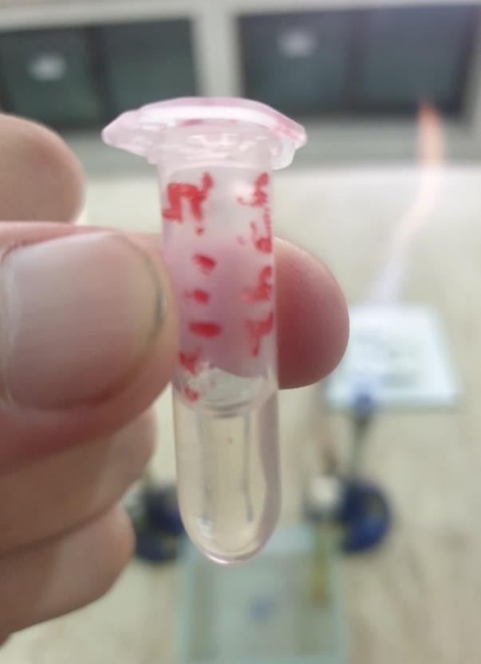
Staphylococcus aureus was identified and confirmed by a biological technique in order to be isolated from a glycerol stock of Chughtai Lab Head Office Lahore. Below is a quick rundown of the essential actions involved.
Figure 4.1: Glycerol Stock having Staphylococcus aureus

4.2 Sample Gathering
A wire loop was used to collect the Staphylococcus aureus from glycerol stock using aseptic procedures.

4.3 Inoculation on selective media
A selective agar medium, such as Blood Agar or Mannitol Salt Agar (MSA) is streaked with the obtained material. Because of its high concentration of salt, MSA promotes the growth of Staphylococci while suppressing the growth of many other bacteria.
On solid media such as MSA, Staphylococcus aureus usually develops golden- yellow colonies. Observations are based on the size, colour, and texture of the colonies.
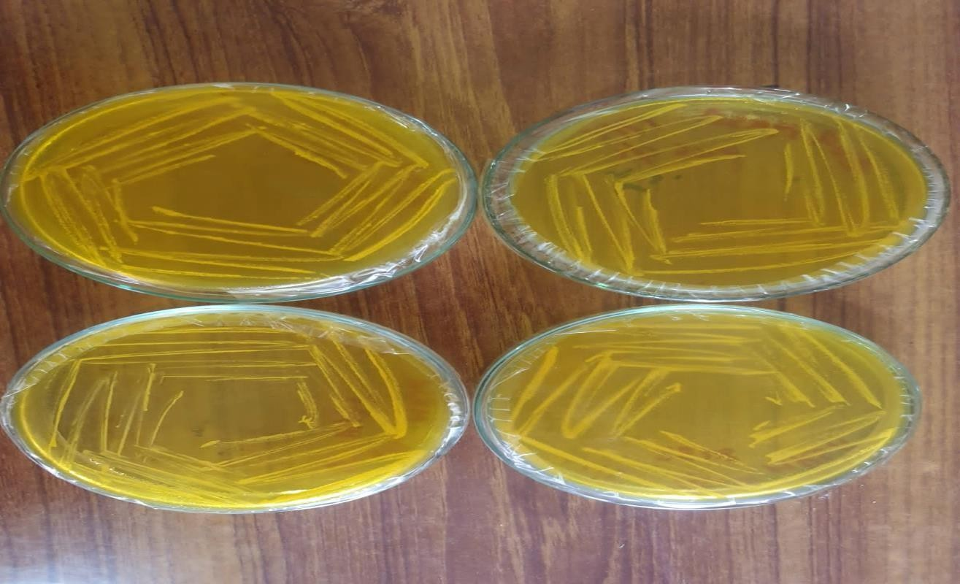
Figure 4.2: Staphylococcus aureus on Mannitol salt agar (yellowish growth on Mannitol salt agar

4.4 Incubation
The plates were incubated for 24 hours at the proper temperature (37°C) for growth.

4.5 Gram Staining
Gram staining is an important, widely used laboratory method to classify bacteria based on their cell walls characteristics. Basically, bacteria are treated with a series of reagents that include crystal violet, iodine, ethanol, and safranin. The bacteria that remained purple under the microscope after its washing with ethanol were classified as gram-positive and referred to as having retained the crystal violet stain. In contrast, those that lost the violet and took up the safranin appear pink are gram-negative. This difference helps in determining such as gram-negative or gram-positive since these groups would act differently regarding treatment using antibiotics.
Colonial Morphology
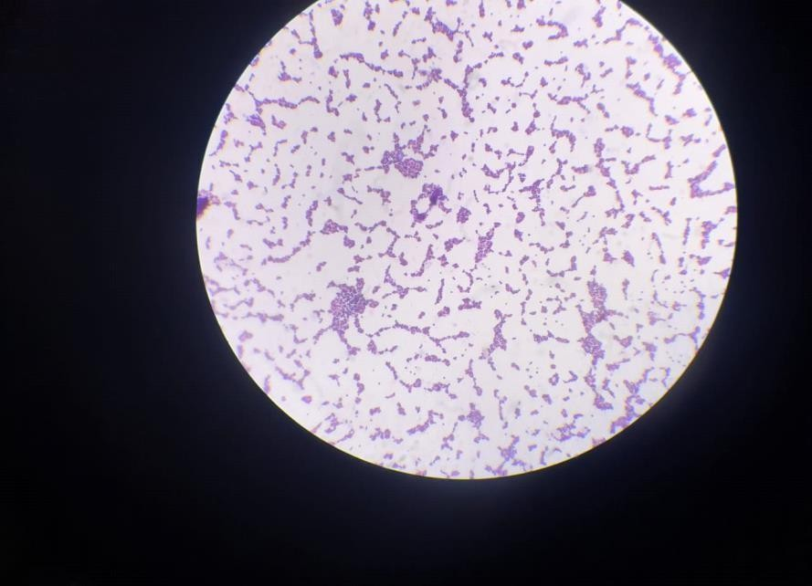
After Gram staining, Gram-positive Staphylococcus aureus was observed under a light microscope in the form of clusters, which mainly resemble bunches of grapes.

Figure 4.3: Microscopic view of staphylococcus aureus (Gram Positive Cocci

4.6 Biochemical Identification:
Catalase Test
Catalase Test is used to determine whether the bacterium provides the enzyme catalase, which decomposes hydrogen peroxide into water and oxygen. This test was conducted by taking some amount of bacterial culture on a slide and placing a drop of hydrogen peroxide over it. Bubbling indicates a positive catalase reaction, meaning the bacteria is catalase positive (for example, Staphylococcus).
When hydrogen peroxide is introduced, Staphylococcus aureus, which is catalase-positive, produces bubbles.
Coagulase Test
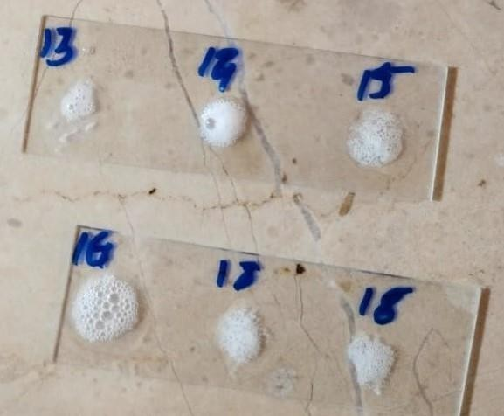
Because Staphylococcus aureus is coagulase-positive, this test aids in confirming the presence of the bacteria.
Figure 4.4: Biochemical Identification by using Catalase Test

4.7 Conformation
Additional testing such as Gram staining for identification.

4.8 Antibiotic susceptibility testing
In order of antibiotic susceptibility test action for therapy, this stage assesses the isolated Staphylococcus aureus susceptibility to several antibiotics.

4.9 Clinical Correlation
The importance of Staphylococcus aureus isolation is confirmed by interpreting the results in light of the patient's clinical symptoms and medical history.

4.10 Antibiotic Susceptibility Testing
One of the most important laboratory techniques for figuring out how well an antibiotic works against a particular bacterial strain, such Staphylococcus aureus, is antibiotic susceptibility testing. The bacterium Staphylococcus aureus causes a wide range of infections, from minor skin infections to more serious ailments like bloodstream infections and pneumonia. Antibiotic susceptibility testing's main objective is to identify whether it is resistant or susceptible. This is how the procedure operates.

4.11 Preparation of Inoculum
A concentrated suspension of bacteria known as a standardized inoculum is made. An agar medium that is solid is inoculated on its surface using this inoculum.

4.12 Antibiotic Disks
After adding disks containing antibiotics to the Mueller-Hinton agar, the plate is incubated. There is to be a region surrounding the disk where the bacteria have not grown sufficiently to be visible if an antibiotic stops the bacteria from developing or kills the bacteria. We refer to this as an inhibitory zone.

4.13 Inoculation
After that, the infected agar plates are incubated for a predetermined amount of time at a particular temperature. The bacteria multiply during this period, and if they are susceptible to a specific antibiotic, a clear region surrounding the antibiotic disk known as a zone of inhibition will become visible.

4.14 Assessment and Interpretation
The diameter of the inhibition zones surrounding each antibiotic disk is measured after incubation. Greater sensitivity is often indicated by larger zones, whereas resistance is suggested by smaller or non-existent zones.

4.15 Results Reporting
The drugs that work best against the particular strain of Staphylococcus aureus and those that might not work as well because of resistance are then relayed to the healthcare professional.

4.16 McFarland standard
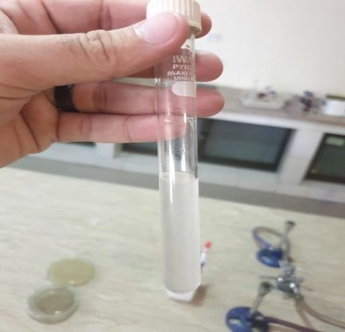
Barium sulphate or latex particle suspensions, known as McFarland standards, enable visual comparison of bacterial density.

Figure 4.5: McFarland solution

4.17 Vancomycin Testing
The current investigation attempts to assess the minimum inhibitory concentrations (MICs) of vancomycin among MRSA strains that are extracted from the glycerol stock belonging to human‟s sample.
The strains obtained from glycerol stock at Institute of Chughtai Lab Head Office Lahore Department of Microbiology were the sources of the bacteria. The MRSA isolates were verified using the Muller Hinton based Kirby-Bauer disk diffusion method. The MICs of MRSA isolates against vancomycin, respectively, were determined using the agar Plates, in accordance with the standard protocols advised by the Clinical Laboratory Standards Institute (CLSI) M100 Feb 2024.
The laboratory identification of the MRSA and VRSA isolates takes on more importance. Vancomycin-sensitive Staphylococcus aureus is defined by the updated Clinical Laboratory Standards Institute (CLSI) criteria as Staphylococcus aureus strains with minimum inhibitory concentrations (MIC) of less than 2µg/ml. A Staphylococcus aureus strain is classified as VISA if its minimum inhibitory concentration (MIC) is between 4 and 8 g/ml, and as VRSA if its MIC is greater than 8 µg/ml. The zone of Inhibition of vancomycin is in our results are about 14 Millimetre to 16 Millimeters. Therefore, vancomycin has to be sensitive for staphylococcus aureus (VISA).

4.18 Methicillin
Methicillin is a class of antibiotic that falls under the beta-lactam category of penicillin. Methicillin-sensitive Staphylococcus aureus (MSSA) and other Staphylococcus aureus infections are once widely treated with it. But over time, a lot of Staphylococcus aureus strains have become resistant to methicillin and other similar drugs. These strains of Staphylococcus aureus are known as methicillin-resistant strains (MRSA).
Clinical isolates of Staphylococcus aureus are analyzed using Mueller-Hinton agar plates. Using disks containing oxacillin, and methicillin, a suspension of Staphylococcus aureus isolates that is comparable to a 0.5 McFarland standard is evaluated. After 24-hour incubation at 35°C, the inhibitory zones are then assessed. Mueller-Hinton agar plates treated with 2% NaCl are used to calculate the minimum inhibitory concentrations (MICs) of oxacillin, Methicillin MICs are measured by swabbing a region devoid of any diameter zone of inhibition.

Table 4.1: Mean zone of inhibition for different antibiotics used
Antibiotics | Mean | ± S.E. | p-value
Penicillin | 4 | 0.53 | <0.001
Methicillin | 2.2 | 0.38 | <0.001
Vancomycin | 17.7 | 0.21 | <0.001
Oxacillin | 10.1 | 0.31 | <0.001

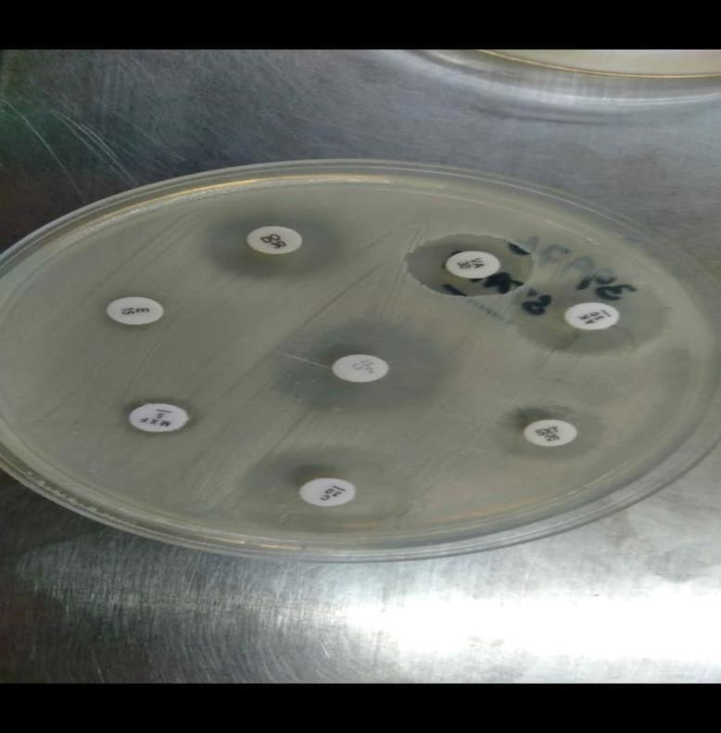

Figure 4.6: Zone of Inhibition Methicillin, Vancomycin, oxacillin, Penicillin

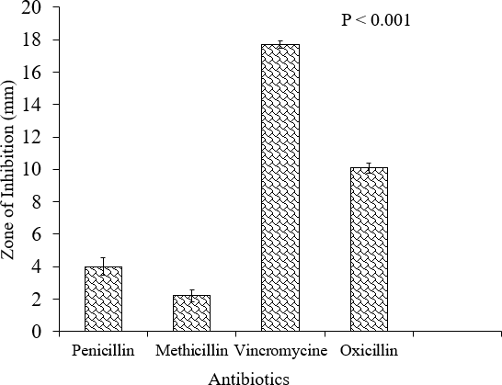
Figure 4.7: Antibiotic susceptibility testing of selected strains.

4.19 Bacteriophage Host Spectrum

4.19.1 Plaque Test
20 samples of phages have tested for their lytic efficacy (host range) against Staphylococcus aureus isolates from sewage water samples of different Hospitals from Lahore city using a plaque test and a subsequent plaque assay. To eliminate false positive results, the following plaque assays are carried out for all phage Staphylococcus aureus combinations that have a positive or unclear spot test.
While some of the Staphylococcus aureus isolates are lysed by some phage isolated from sewage water sample, nearly two-thirds of the examined isolates are lysed by at least some isolated Phage’s. Some isolates of Staphylococcus aureus are unable to be lysed by the phage’s employed in this investigation.

4.19.2 Spot test
Once the top layer (inoculated with the corresponding Staphylococcus aureus isolate) is prepared, 50 µL of each phage solution is spotted onto it. Positive outcome a clear zone that is larger than or equal to the core region, ambiguous outcome, a turbid zone negative, outcome bacterial lawn instead of a clear or turbid zone.
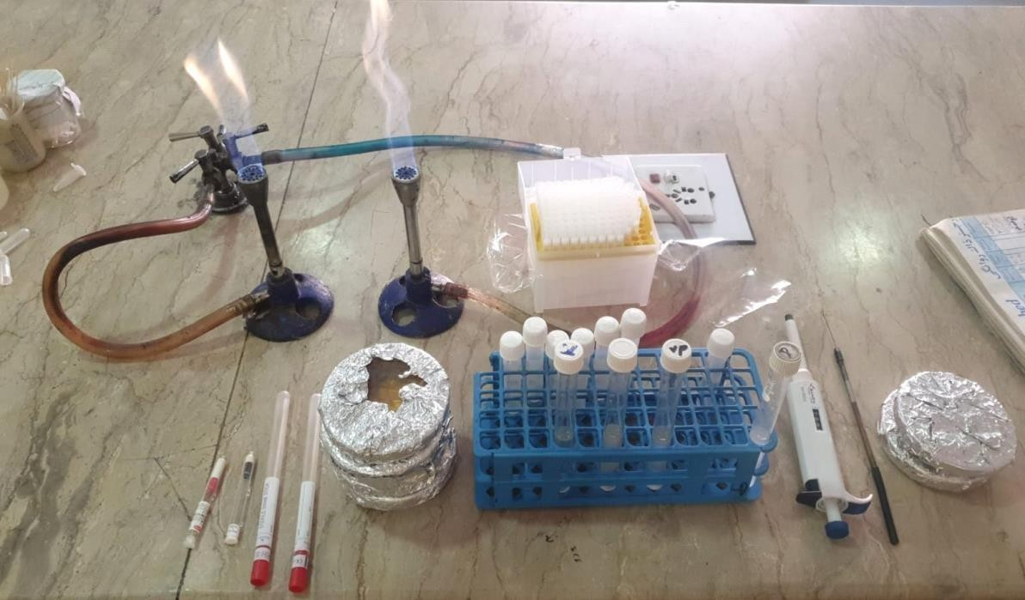
The Staphylococcus aureus isolate spot test results are shown on the image below, along with some unclear zone results of the examined pages. The 20 tested phages and Staphylococcus aureus isolate each have confusing spot test results. Spot test results for the 20 tested phages and Staphylococcus aureus isolate 6, 20 (right). Plaque assay is used to further analyze positive and ambiguous results.
Figure 4.8: Preparation of culture for Bacteriophage Application

Table 4.2: Relationship between type of sampling site in hospital and status of bacteriophage
 | Status of bacteriophage |  | p-value
Type of sampling  site in hospital | Yes | No | 0.22
Surgical Ward | 1 | 3 | 0.22
Emergency Ward | 2 | 2 | 0.22
Main sewage line | 3 | 1 | 0.22
T.B. Ward | 0 | 4 | 0.22
Dermatology Ward | 1 | 3 | 0.22
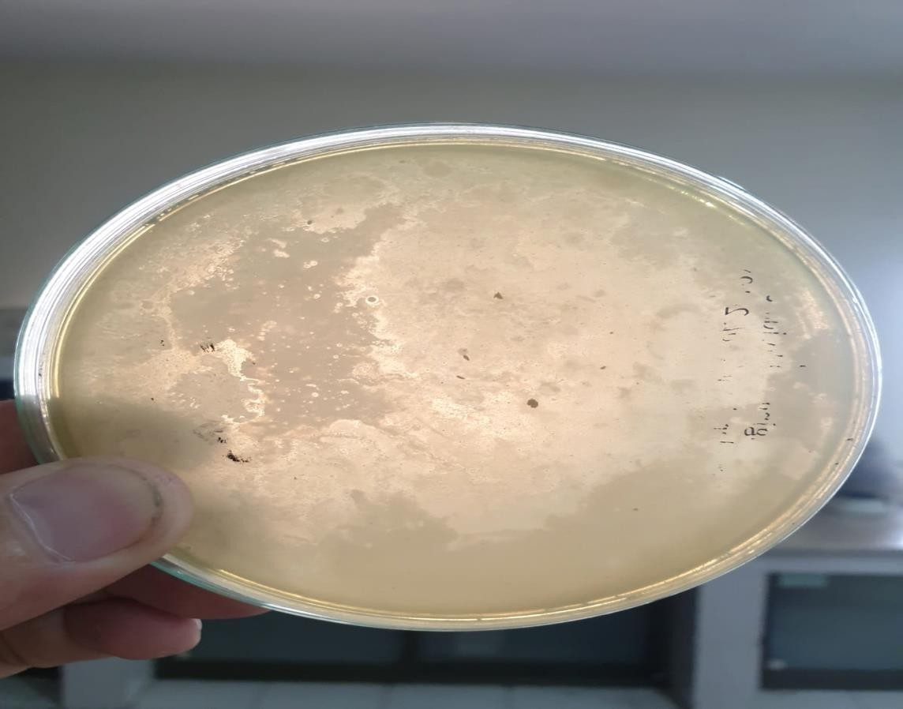
Figure 4.8: Plaque Test Result on Staphylococcus aureus Culture

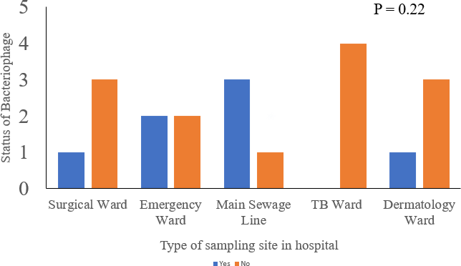
Figure 4.9: Percentage of Strain of each Strain

CHAPTER FIVE
DISCUSSION
Staphylococcus aureus is a gram-positive, coagulase-positive, non-motile coccoid bacterium that is a member of the Firmicutes phylum. There are 52 species and 28 subspecies in the genus Staphylococcus, with Staphylococcus aureus being the most clinically relevant. Twenty to forty percent of the general population has human commensal microbiota, which includes Staphylococcus aureus, in their nasal mucosa. The size and demography of the research populations, the methods used for culturing, and the quality of the sampling all affect the stated prevalence. When the skin or mucosal barriers are ruptured, mainly in cases of chronic skin conditions, including wound infections, or surgical operations, Staphylococcus aureus can cause infections. People who use invasive medical devices, such as central and peripheral venous catheters, are more vulnerable to Staphylococcus aureus infections, particularly those who have compromised immune systems [31].
Numerous diseases in humans and animals, including osteomyelitis, endocarditis, skin abscesses, and many more, are caused by Staphylococcus aureus. MRSA has arisen as a result of antibiotic overuse. The rise of MRSA strains emphasizes the need for future treatment advancements. It has been proposed that bacteriophages and antibiotic treatments may work better together than either one alone. This work emphasizes the potential utility of phage therapy as a treatment for Staphylococcal infections, which have proven difficult to cure with commonly used antibiotics. Phage therapy can be a suitable alternative therapy, particularly for germs that are resistant to many drugs. It has numerous potential applications in human medicine, dentistry, veterinary science, and agriculture. The world as a whole is home to a vast.
Phage’s that is capable of eliminating a wide range of distinct bacterial populations. Phage treatment is less expensive and has less detrimental effects on eukaryotic cells than traditional antibiotics. Bacterial cell membranes feature complementary receptors for phages. Common side effects of regular antibiotic therapy can be avoided thanks to bacteriophages unique affinity for specific bacterial strains. Furthermore, phage gene modification can enhance bacteriophages sensitivity and selectivity against different bacterial strains. Variations in phenotype can aid bacteria in evading the immune system and antibacterial therapies. Phage mutants can also be used to solve this issue [32].
Antibiotics mainly target ribosome, the cell envelope, and nucleic acids. Recent studies on drug discovery programs have identified several novel targets. Resistance can arise from mutations in chromosomal genes or due to horizontal transfer of resistance genes encoded by jumping genes or plasmids. Drugs can be eliminated by (i) efflux; (ii) enzymatic modification and neutralization of drugs; (iii) enzymatic modification of drug binding sites; (iv) bypass mechanisms involving the acquisition of a new target that is resistant to medicines; or (v) drug displacement to protect the target. Resistance may arise as a result of mutations. A drug's ability to reach its target can be reduced by (i) changing the drug target to avoid inhibitor binding, (ii) triggering multidrug resistance efflux pumps that are encoded chromosomally, and (iii) going through a series of mutations that change the structure and makeup of the cell wall and/or membrane. This article looks at the emergence of antibiotic resistance to currently prescribed medications as well as the potential for novel antibiotics and wise drug combination usage in the future [33].
The number of therapeutic options for bacterial infections has decreased due to the advent of antibiotic resistance. Furthermore, the fact that Staphylococcus aureus can form a biofilm in the presence of a medical indwelling device poses an additional challenge because only a small number of antibiotics, including vancomycin, daptomycin, Fosfomycin, and rifampicin, are effective in treating infections linked to staphylococcal biofilms. Because persisters are a subset of bacterial cells that are phenotypically tolerant to antibiotics are present, biofilm bacteria are often resistant to high concentrations of antibiotics, negating the need for protracted therapy. Consequently, bacteriophages have surfaced once again as a viable therapeutic option for biofilm-associated illnesses [34].
Similar to antibiotics, phage’s have the capacity to selectively and efficiently lyse bacterial cells, but they might not be able to pierce the thick matrix of biofilm extracellular polymeric material. On the other hand, mechanical wound care techniques like lavage or sharp debridement might apply shearing pressures that can damage the extracellular matrix stated before, however they might not completely remove the bacterial cells [35].
Like all viruses, bacteriophages replicate by infecting their host cells and releasing their progeny, which causes an exponential rise in the quantity of virus particles over time. Furthermore, we previously demonstrated that phage’s have the ability to eliminate persisted cells once they resume their typical growth phenotype. Thus, we assessed if all sessile bacteria could be eliminated by a longer exposure. All Staphylococcus aureus biofilm-embedded cells could be killed in vitro when the bacteria are cultured for five or seven days with PYO (106 PFU/ml) or Sb (107 PFU/ml), respectively. Phage contact with bacterial cells, including those confined to the deepest layers of the colon, may be facilitated by an extended exposure marked by an increase in the quantity of phages after bacterial lysis [36].
20 samples of phages have tested for their lytic efficacy (host range) against Staphylococcus aureus isolates from sewage water samples of different Hospitals from Lahore city using a plaque test and a subsequent plaque assay. To eliminate false positive results, the following plaque assay are carried out for all phage Staphylococcus aureus combinations that have a positive or unclear spot test. While some of the Staphylococcus aureus isolates are lysed by some phage isolated from sewage water sample, nearly two-thirds of the examined isolates are lysed by at least some isolated Phage’s. Some isolates of Staphylococcus aureus are unable to be lysed by the phage’s employed in this investigation.
Once the top layer (inoculated with the corresponding Staphylococcus aureus isolate) is prepared, 50 µL of each phage solution is spotted onto it. Positive outcome a clear zone that is larger than or equal to the core region, ambiguous outcome, a turbid zone negative, outcome bacterial lawn instead of a clear or turbid zone. The Staphylococcus aureus isolate spot test results are shown on the image below, along with some unclear zone results of the examined pages. The 20 tested phages and Staphylococcus aureus isolate each have confusing spot test results. Spot test results for the 20 tested phages and Staphylococcus aureus isolate 6, 20 (right). Plaque assay is used to further analyses positive and ambiguous results.

CONCLUSION
Bacteriophages exhibit encouraging potential in the fight against Staphylococcus aureus, providing a focused method of eliminating infections. Their ability to target specific bacterial strains with precision minimizes unintended damage to beneficial flora. Bacteriophages have the potential to treat S. aureus infections instead of antibiotics, thereby tackling the problem of antibiotic resistance.
Suggestion
The use of bacteriophage viruses, which infect and kill bacteria, presents a focused and possibly successful strategy for treating Staphylococcus aureus infections. Because of its specificity, flexibility in responding to changing bacterial strains, and potential to reduce antibiotic resistance, research advises investigating phage therapy. To prove safety and efficacy for broad use, more research and clinical trials are required.

CHAPTER 06
SUMMARY
The gram-positive opportunistic bacterial pathogen Staphylococcus aureus causes mortality and morbidity in humans. Mostly present on human skin and nosocomial infection generating the excessive burden on health care centre and causes a diverse range of infections. In HAI, multidrug-resistant bacteria were frequently found and were linked to high mortality. One major obstacle in the therapeutic therapy of infections was its resistance to various medications, such as methicillin-resistant Staphylococcus aureus (MRSA). Methicillin-resistant Staphylococcus aureus (MRSA), Vancomycin- intermediate Staphylococcus aureus (VISA), and Vancomycin-resistant Staphylococcus aureus were found in a few of the most well-known pathogens (VRSA).
Bacteriophage is a viruse that targets bacteria in their attacks. Phage and bacterial cells have united to form pro-phage, which was infected with the bacteria. They have two types of life cycle the one was lytic and other was lysogenic life cycle. Phage's lytic life cycle poses a serious threat to both bacteria. Bacteriophage was ten times more apparent than bacteria, making them the most prevalent on earth. So, there was a great interest in bacteriophage as a therapeutic agent instead of antibiotics for bacterial biofilms infection. Especially they were a promising option for bacterial control and environmental safety as a biotechnological weapon against pathogenic bacteria, especially those that are antibiotic-resistant. The number of therapeutic options for Staphylococcus aureus infections increased due to the advent of antibiotic resistance. Furthermore, the fact that Staphylococcus aureus can form a biofilm in the presence of a medical indwelling device poses an additional challenge because the number of antibiotics, including Methicillin, Penicillin, and Vancomycin has been show resistance in treating infections linked to Staphylococcal biofilms.

LIST OF PUBLICATIONS
Publication Title 1: Genomic epidemiology and characterization of difficult-to-treat resistant Pseudomonas aeruginosa isolates co-harboring blaOXA-50 and crpP causing bronchiectasis.
Author(s) Name: Lulu Jin1,5, HaoweiYe2,5, Hao Xu2, Amina shahzadi4, Xinling Pan1 & Danfeng
Journal Name: Scientific Reports
Web of Science SCIE,SSCI,ESCI): SCIE, Scopus(Q1, Q2, Q3, Q4): Q1, HEC Category: X
Link to Online Paper: https://www.nature.com/articles/s41598-025-95950-7

Publication Title 2: Hidden Messengers: The Uncharted Role of Microbial Small RNAs in Reprogramming Host Immunity During Chronic Infections
Author(s) Name: Amina Shahzadi1*, Syeda Ashal Fatima2, Siraj Munir3, Umia Shams4, Nazia Tanveer5, Asim Ali Zakir6, Zafar Ali7, Rabiya Bashir8, Muhammad Abbas Hasan9
Journal Name: Scholars Academic Journal of Biosciences
Journal homepage: https://saspublishers.com

REFERENCES
Álvarez A, Fernández L, Gutiérrez D, Iglesias B, Rodríguez A, García P. Methicillin- resistant Staphylococcus aureus in hospitals: Latest trends and treatments based on bacteriophages. Journal of clinical microbiology. 2019 Dec;57(12):10-128.
Amiri Fahliyani S, Beheshti-Maal K, Ghandehari F. Novel lytic bacteriophages of Klebsiella oxytoca ABG-IAUF-1 as the potential agents for mastitis phage therapy. FEMS microbiology letters. 2018 Oct;365(20):fny223.
Klebsiella oxytoca ABG-IAUF-1 as the potential agent for mastitis phage therapy. FEMS Microbiol. Lett. 365(20): fny223.
Ballesté E, Blanch AR, Muniesa M, García-Aljaro C, Rodríguez-Rubio L, Martín- Díaz J, Pascual-Benito M, Jofre J. 2022. Bacteriophages in sewage: abundance, roles, and applications. FEMS microbes. 3: tac009.
Beaudoin RN, DeCesaro DR, Durkee DL, Barbaro SE. 2007. Isolation of a bacteriophage from sewage sludge and characterization of its bacterial host cell. J. River Res. Appl. 3(1): 1 8
Biswas B, Adhya S, Washart P, Paul B, Trostel AN, Powell B, Carlton R, Merril CR, immunity. 2002. Bacteriophage therapy rescues mice bacteremic from a clinical isolate of vancomycin-resistant Enterococcus faecium. J. Infect Immun. 70(1), 204-210.
Chopra S, Harjai K, Chhibber S. 2016. Potential of combination therapy of endolysin MR-10and minocycline in treating MRSA induced systemic and localized burn wound infections inmice.Int. J. Med. Microbiol. 306(8): 707-716.
Craft KM, Nguyen JM, Berg LJ, Townsend SD. 2019. Methicillin-resistant Staphylococcus aureus (MRSA): antibiotic-resistance and the biofilm phenotype. J. MedChemComm. 10(8):1231-1241.
Drulis-Kawa Z, Majkowska-Skrobek G, Maciejewska B, Delattre A-S, Lavigne R, Science P.Learning from bacteriophages-advantages and limitations of phage and phage-encoded 2012. protein applications. J.Curr. Protein Pept. Sci. 13(8): 699-722.
Durbas I, Machnik G. 2022. Phage therapy: An old concept with new perspectives. J. Appl. Pharm. Sci. 12(5): 027-038.
El Haddad L, Harb CP, Gebara MA, Stibich MA, Chemaly RF. 2019. A systematic and critical review of bacteriophage therapy against multidrug-resistant ESKAPE organisms in humans. J.Clinical Infectious Diseases. 69(1): 167-178.
El Haddad L, Roy J-P, Khalil GE, St-Gelais D, Champagne CP, Labrie S, Moineau S. 2016.
Efficacy of two Staphylococcus aureus phage cocktails in cheese production. Int. J. Food Microbiol.217: 7-13.
Fanaei V, Validi M, Zamanzad B, Karimi A. 2021. Isolation and identification of specific bacteriophages against methicillin-resistant Staphylococcus aureus, extended-spectrum beta lactamases-producing Escherichia coli, extended-spectrum beta-lactamases-producing Klebsiella pneumoniae, and multidrug-resistant Acinetobacter baumannii in vitro. J.FEMS Microbiol. Lett. 368(19), fnab139.
Foster T. 2017. Antibiotic resistance in Staphylococcus aureus. Current status and future rospects. J. FEMS Microbiol. Rev. 41(3): 430-449.368(19): fnab139.
García R, Latz S, Romero J, Higuera G, García K, Bastías R. 2019. Bacteriophage production1models: An overview. J.Front. Microbiol. 10: 1187.
Golkar Z, Bagasra O, Pace D. G. 2014. Bacteriophage therapy: a potential solution for the antibiotic resistance crisis.J. Infect. Dev. Ctries. 8(02): 129-136.
Ho, K. 2001. Bacteriophage therapy for bacterial infections: rekindling a memory from the pre-antibiotic‟s era.J. Perspect. Biol. Med. 44(1): 1-16.
Kasman LM, Porter LD. 2022. Bacteriophages. J. StatPearls [Internet].2022 Sep 26.
Kutateladze M, Adamia R. 2010. Bacteriophages as potential new therapeutics to replace orsupplement antibiotics. J. Trends Biotechnol, 28(12): 591-595.
Letarov A, Kulikov E. 2017. Adsorption of bacteriophages on bacterial cells. J.Biochem. (Mosc.). 82: 1632-1658.
Learov A. 2020. History of early bacteriophage research and emergence of key concepts in virology. J. Biochem. (Mosc.). 85: 1093-1112.
Morozova VV, Vlassov VV, Tikunova N. V. 2018. Applications of bacteriophages in the treatment of localized infections in humans. J. Front. Microbiol. 9: 1696.
Nikolich MP, Andrey A. Filippov. 2020. Bacteriophage therapy: Developments and directions.J. antibiotics 9(3): 135.
Nasser A, Azizian R, Tabasi M, Khezerloo JK, Heravi FS, Kalani MT, Sadeghifard N, AminiR, Pakzad I, Radmanesh A, perspectives r. 2019. Specification of bacteriophage isolated against clinical methicillin-resistant staphylococcus aureus. J. Osong public health andresearch perspectives. 10(1): 20.
Pallavali RR, Degati VL, Lomada D, Reddy MC, Durbaka VRP. 2017. Isolation and in vitro evaluation of bacteriophages against MDR-bacterial isolates from septic wound infections.J.PloS one. 12(7): e0179245.
Pinto AM, Cerqueira MA, Bañobre-Lópes M, Pastrana LM, Sillankorva S. 2020.
Bacteriophages for chronic wound treatment: From traditional to novel delivery systems. J.virus. 12(2): 235.
Plumet L, Ahmad-Mansour N, Dunyach-Remy C, Kissa K, Sotto A, Lavigne J-P, Costechareyre D, Molle V, Microbiology I. 2022. Bacteriophage therapy for Staphylococcus aureus Infections: A review of animal models, treatments, and clinical trials. J.Front. cell. infect. microbiol. 808.
Pelfrene E, Willebrand E, Cavaleiro Sanches A, Sebris Z, Cavaleri MJ. 2016. Bacteriophage therapy: a regulatory perspective. J. Antimicrob Agents Chemother. 71(8): 2071-2074.
Ryan EM, Gorman SP, Donnelly RF, Gilmore BF, Pharmacology. 2011. Recent advances in bacteriophage therapy: how delivery routes, formulation, concentration and timing influencethe success of phage therapy. J. Pharm Pharmacol. 63(10): 1253-1264.
Rasool MH, Yousaf R, Siddique AB, Saqalein M, Khurshid M. 2016. Isolation,characterization, and antibacterial activity of bacteriophages against methicillin-resistant Staphylococcus aureus in Pakistan.Jundishapur J.Microbiol. 9(10).
Rasool MH, Yousaf R, Siddique AB, Saqalein M, Khurshid M. 2016. Isolation, characterization, and antibacterial activity of bacteriophages against methicillin-resistant Staphylococcus aureus in Pakistan. Jundishapur J.Microbiol. 9(10).
Seth AK, Geringer MR, Nguyen KT, Agnew SP, Dumanian Z, Galiano RD, Leung KP, Mustoe TA, Hong S, surgery r. 2013. Bacteriophage therapy for Staphylococcus aureus biofilm–infected wounds: a new approach to chronic wound care.J.Plast. Reconst. Surg.131(2): 225-234.
Saha D, Mukherjee R. 2019. Ameliorating the antimicrobial resistance crisis: phage therapy. J.phage thrpy. 71(7): 781-790.
Sulakvelidze A, Alavidze Z, Morris Jr J editors.; 2001.
Summers WC. 2001. Bacteriophage therapy. J. Annu. Rev. Microbiol. 55(1): 437-451.
Simon K, Pier W, Krüttgen A, Horz H-P. 2021. Synergy between Phage Sb-1 and Oxacillin against Methicillin-Resistant Staphylococcus aureus. J. antibiotics. 10(7): 849.
Seth AK, Geringer MR, Nguyen KT, Agnew SP, Dumanian Z, Galiano RD, Leung KP, Mustoe TA, Hong S. 2013. Bacteriophage Therapy for Staphylococcus aureus Biofilm Infected Wounds: A New Approach to Chronic Wound Care.J. Plast. Reconst. Surg. 131(2): 225-234.
Singh J, Yeoh E, Fitzgerald DA, Selvadurai H. 2023. A systematic review on the use of bacteriophage in treating Staphylococcus aureus and Pseudomonas aeruginosa infections in cystic fibrosis.
J. Paediatr. Respir. Rev. Taati Moghadam M, Khoshbayan A, Chegini Z, Farahani I, Shariati A, development, therapy.
Tkhilaishvili T, Wang L, Tavanti A, Trampuz A, Di Luca M. 2020. Antibacterial efficacy of two commercially available bacteriophage formulations, staphylococcal bacteriophage and PYO bacteriophage, against methicillin- resistant Staphylococcus aureus: Prevention and eradication of biofilm formation and control of a systemic infection of Galleria mellonella larvae. J. Front. Microbiol. 11: 110.

ANNEXURE

