THE SUPERIOR UNIVERSITY LAHORE


Faculty of Computer Science & IT
Department of Software Engineering

Final Year Project
PROJECT REPORT
Fall 2023

[Entrepreneur communication Platform]

Project ID: [FYP-MCSM-S22-06]

Project Team
Student Name | Student ID | Program | Contact Number | Email Address
Sana Hameed | MCSE_S22_003 | MCS | 0309-1436139 | sanasuperior12@gmail.com
Ayesha Hira | MCSE_S22_006 | MCS | 0306-96664497 | princesayisha07@gmail.com
Areeba sehar | MCSM_S22_017 | MCS | 0320-8659047 | areebasehar193@gmail.com

Muhammad Javaid Iqbal
(Lecturer)

Project Report

[Entrepreneur communication Platform]

Change Record
Author(s) | Version | Date | Notes | Supervisor’s Signature
Ayesha,Sana and Areeba | 1.0 |  | Template 1
Ayesha,Sana and Areeba | 1.2 |  | Documentation
Ayesha,Sana and Areeba | 1.3 |  | Review of layouts
Ayesha,Sana and Areeba | 1.4 |  | Review of Coding
Ayesha,Sana and Areeba | 1.5 | 05-06-2023 | Review of database

APPROVAL
Project Supervisor
Comments: ___________________________________________________________________
_____________________________________________________________________________
Name:______________________________
Date:_______________________________ | Signature:__________________________

Project Manager
Comments: ___________________________________________________________________
_____________________________________________________________________________
Date:_______________________________ | Signature:__________________________

Head of the Department
Comments: ___________________________________________________________________
_____________________________________________________________________________
Date:_______________________________ | Signature:__________________________

Dedication

First of all, we dedicate our project to Allah Almighty
And to whom the world owes its existence
Muhammad (Peace Be upon Him)
This humble effort is dedicated to
Our beloved parents who brought us
To the level of excellence where we
Are studying today looking for most
Promising and gleaming future ahead
For which they scarified most of the
Time of their life
&
To our respected and genius teachers
Who guided us throughout academic career!
And all those people
Who have remembered us in their prayers!
A lot of thanks for all my teachers!

. . . . .

Acknowledgements

I am really thankful to my supervisor who has Above all, I owe much tribute to the Almighty God who gave us a life worth living and I thank Him for giving us the strength to accomplish this project. The success and accomplishment of this project stems from efforts and dedication offered by many individuals whose support was either direct or indirect. I thank all of them for their devotion.
The author would like to express the sincere gratitude to their project advisor Muhammad Javaid Iqbal for his vigilant supervision, intellectual guidance, constructive advice and very kind attitude throughout the course of project.
Appreciate to the efforts of all our teachers whose teachings have brought us to this stage of academic zenith.
In the last but not the least, special gratitude with the deepest sense of respects to our parents whose love and affections kept us steep fast and enabled us to attain targets and goals of academic life. The authors are extremely indebted to their brothers and sisters whose constant encouragement provides us with the impetus that was necessary for attaining academic initiatives.

. . . . . . . . . .

Executive Summary

An entrepreneur and investor platform is a digital platform that connects entrepreneurs and investors, allowing them to interact and collaborate on business ideas and investment opportunities. The platform provides a range of features and tools to help entrepreneurs and investors connect, including messaging, project management, and crowdfunding capabilities. The platform is designed to be user-friendly and accessible to entrepreneurs and investors of all skill levels, with an emphasis on transparency, security, and ease of use. By providing a centralized hub for entrepreneurs and investors to connect and collaborate, the platform aims to foster innovation and drive economic growth.

Table of Contents
Dedication iv
Acknowledgements v
Executive Summary vi
Table of Contents vii
List of Figures ix
List of Tables x
Chapter 1 1
Introduction 1
1.1. Background 2
1.2. Motivations and Challenges 2
1.3. Goals and Objectives……………………………………………………………………………………………………3
1.4. Literature Review/Existing Solutions 3
1.5. Gap Analysis 4
1.6. Proposed Solution 4
1.7. Project Plan 5
1.7.1. Work Breakdown Structure 7
1.7.2. Roles & Responsibility Matrix 8
1.7.3. Gantt Chart 9
1.8. Report Outline 9
Chapter 2 11
Software Requirement Specifications 11
2.1. Introduction 12
2.1.1. Purpose 12
2.1.2. Document Conventions 12
2.1.3. Intended Audience and Reading Suggestions 13
2.1.4. Product Scope 14
2.1.5. References 15
2.2. Overall Description 15
2.2.1. Product Perspective 15
2.2.2. Product Functions 15
2.2.3. User Classes and Characteristics 16
2.2.4. Operating Environment 17
2.2.5. Design and Implementation Constraints 17
2.2.6. User Documentation 17
2.2.7. Assumptions and Dependencies 18
2.3. External Interface Requirements 19
2.3.1. User Interfaces 20
2.3.2. Hardware Interfaces 20
2.3.3. Software Interfaces 20
2.3.4. Communications Interfaces 21
2.4. System Features 21
2.4.1. System Feature 1 22
2.4.1.1. Description and Priority 22
2.4.1.2. Stimulus/Response Sequences 23
2.4.1.3. Functional Requirements 23
2.4.2. System Feature 2 25
2.4.2.1. Description and Priority 26
2.4.2.2. Stimulus/Response Sequences 26
2.4.2.3. Functional Requirements 28
2.4.3. System Feature 3 (and so on) 30
2.5. Other Nonfunctional Requirements 30
2.5.1. Performance Requirements 30
2.5.2. Safety Requirements 31
2.5.3. Security Requirements 32
2.5.4. Software Quality Attributes 33
2.5.5. Business Rules 34
2.6. Other Requirements 34
Chapter 3 35
Use Case Analysis 36
3.1. Use Case Model 36
3.2. Fully Dressed Use Cases 39
Chapter 4 46
System Design 47
4.1. Architecture Diagram 47
4.2. Domain Model 48
4.3. Entity Relationship Diagram with data dictionary 49
4.4. Class Diagram 50
4.5. Sequence / Collaboration Diagram 51
4.6. Operation contracts 51
4.7. Activity Diagram 54
4.8. State Transition Diagram 55
4.9. Component Diagram 57
4.10. Deployment Diagram 58
4.11. Data Flow diagram [only if structured approach is used - Level 0 and 1] 59
Chapter 5 .....................................................................................................................................66
Implementation ...........................................................................................................................67
5.1 Tool and Technique.........................................................................................................68
5.2 Best Practice/Coding……………………………………………………………………………………………………68 Standards......................................................................................................................................68
Chapter 6......................................................................................................................................69
Testing and Evaluation.................................................................................................................70
6.1 Use Case Testing..............................................................................................................70
6.2 Equivalence Partitioning..................................................................................................76
6.3 Boundary value Analysis..................................................................................................76
6.5 Unit Testing.....................................................................................................................77
6.6 Performance Testing......................................................................................................77
6.7 Stress Testing..................................................................................................................77
Chapter 7....................................................................................................................................78
Summary Conclusion and Feature Attachments........................................................................79
7.1 Project Summary...........................................................................................................79
7.2 Achievements and Improvements................................................................................79
7.3 Critical Review...............................................................................................................80
7.4 Lesson Learn..................................................................................................................80
7.5 Future Enhancements/Recommendations....................................................................80
Appendix………………………………………………………………………………………………………………………………….82
Appendix A: User Manual………………………………………………………………………………………………………… 83
Appendix B: Administrator Manual…………………………………………………………………………………………. 84
Reference and Bibliography…………………………………………………………………………………………………….. 85

List of Figures

Figure 1: Work break down structure 7
Figure 2: Gantt chart 9
Figure 3:: use case enterprenure 36
Figure 4: fully dressed use case 37
Figure 5: use case of investor 38
Figure 6 : Architecture Diagram 45
Figure 7: Domain Model 46
Figure 8: ERD diagram 47
Figure 9: Class Diagram 48
Figure 10: sequence diagram 49
Figure 11: Activity diagram of admin 51
Figure 12: Activity diagram of Enterprenure 52
Figure 13: state transition diagram 53
Figure 14 : state transition diagram for Admin 54
Figure 15 : Component Diagram 55
Figure 16: Deployment Diagram 56
Figure 17: DFD Diagram 57
Figure 18: sequence diagram of admin 58
Figure 19 : sequence diagram of login 59
Figure 20 : Sequence diagram of Enterprenure and investor 60
Figure 21 : sequence diagram of payment 61
Figure 22 : sequence diagram of start up 62
Figure 23: sequence diagram of ideas 63
Figure 24 : interface of login 77
Figure 25 :login for admin 82
Figure 26 :Register for enterprenure and investor 83
Figure 27 :selecting profile 84

List of Tables

Table 1:Role& Responsibility Matrix 8
Table 2 : Hardware Interfaces 19
Table 3 :User case of register 41
Table 4: User case of login 43
Table 5 : tool and technique 67
Table 6: Use case of enterprenure 70
Table 7 : use case of login 71
Table 9 : use case of update password 72
Table 10 : use case of delete data 73
Table 11: use case of search data 74
Table 12 : use case of record to display 75
Table 13: boundary analysis 77

Chapter 1

Introduction

Chapter 1: Introduction
Entrepreneur and investor platforms provide a space for entrepreneurs to showcase their business ideas and connect with investors who are interested in investing in these ideas. This platform also allows investors to learn more about the businesses and entrepreneurs they are interested in investing in. By creating this connection, entrepreneurs can find the funding they need to start and grow their businesses, while investors can find new and profitable investment opportunities.

Background
Entrepreneur and investor platforms are digital spaces that allow entrepreneurs and investors to connect and collaborate. These platforms can be accessed from anywhere in the world and provide a space for entrepreneurs to showcase their business ideas and connect with investors who are interested in investing in these ideas. Investors can use these platforms to discover new and profitable investment opportunities while entrepreneurs can find the funding they need to start and grow their businesses.

Motivations and Challenges
The motivation behind entrepreneur and investor platforms is to create a space where entrepreneurs and investors can connect and collaborate to create profitable business ventures. One of the biggest challenges these platforms face is building trust between entrepreneurs and investors. Entrepreneurs need to be able to trust that investors will provide the funding they need to start and grow their businesses, while investors need to be able to trust that entrepreneurs will use their funds responsibly. Another challenge is ensuring that the platform is accessible to entrepreneurs from all backgrounds and locations, so that everyone has an equal opportunity to succeed.

Goals and Objectives
The primary goal of entrepreneur and investor platforms is to facilitate connections between entrepreneurs and investors, allowing them to collaborate and create profitable business ventures. The objective of these platforms is to provide entrepreneurs with the funding they need to start and grow their businesses, while also providing investors with new and profitable investment opportunities. Additionally, these platforms aim to promote innovation and entrepreneurship by providing a space where entrepreneurs can showcase their ideas and receive feedback from investors. By achieving these goals and objectives, entrepreneur and investor platforms can help drive economic growth and create new job opportunities.

Literature Review/Existing Solutions
There are a number of entrepreneur and investor platforms that currently exist, such as AngelList, Gust, and Seed Invest. These platforms allow entrepreneurs to showcase their business ideas and connect with investors who are interested in investing in these ideas. They also provide investors with a way to discover new and profitable investment opportunities.

Some of the existing solutions in this space include equity crowdfunding, where investors can purchase equity in a business in exchange for funding, and revenue-based financing, where investors provide funding in exchange for a share of the business's revenue.

There are also a number of challenges facing these platforms, including building trust between entrepreneurs and investors, ensuring that the platform is accessible to entrepreneurs from all backgrounds and locations, and complying with regulatory requirements. Despite these challenges, entrepreneur and investor platforms continue to be an important tool for promoting innovation and entrepreneurship and driving economic growth.

Gap Analysis
Some of the gaps between entrepreneurs and investors in these platforms include:

1. Lack of trust: Entrepreneurs may have difficulty trusting investors to provide the funding they need, while investors may have difficulty trusting entrepreneurs to use their funds responsibly.

2. Access to funding: Entrepreneurs from certain backgrounds or locations may have difficulty accessing funding through these platforms, limiting their ability to start and grow their businesses.

3. Regulatory compliance: These platforms must comply with a range of regulations, which can be difficult and time-consuming.

4. Limited investor pool: The pool of investors on these platforms may be limited, making it difficult for entrepreneurs to find the funding they need.

5. Limited visibility: Entrepreneurs may have difficulty getting their business ideas in front of the right investors, limiting their ability to secure funding.

Proposed Solution
One proposed solution to address the gaps between entrepreneurs and investors in these platforms is to create a more transparent and accessible funding ecosystem. This could include:

1. Providing more resources and education for entrepreneurs to help them understand the funding process and prepare for investor meetings.

2. Creating a more diverse pool of investors by encouraging more investors from different backgrounds and locations to participate in these platforms.

3. Improving the vetting process for investors to help entrepreneurs identify trustworthy investors.

4. Providing more opportunities for entrepreneurs to showcase their ideas to investors, such as through pitch competitions or online demo days.

5. Streamlining the regulatory compliance process for these platforms to make it easier for entrepreneurs and investors to participate.

6. Encouraging more collaboration between entrepreneurs and investors to build trust and foster innovation.

By implementing these and other solutions, entrepreneur and investor platforms can help to create a more inclusive and accessible funding ecosystem that benefits entrepreneurs, investors, and the broader economy.

Project Plan
A project plan for developing an entrepreneur and investor platform could include the following steps:
Conduct market research to identify the needs and preferences of entrepreneurs and investors
in this space.
Develop a business plan and financial model for the platform, including revenue streams and cost projections.
Develop a user interface and user experience design for the platform, ensuring that it is user-friendly and accessible.

Develop the platform's core features, such as the ability for entrepreneurs to showcase their ideas and for investors to discover and invest in these ideas.

By following these steps and remaining focused on the needs of entrepreneurs and investors, a new entrepreneur and investor platform can help to create a more inclusive and accessible funding ecosystem that benefits all stakeholders.

Work Breakdown Structure

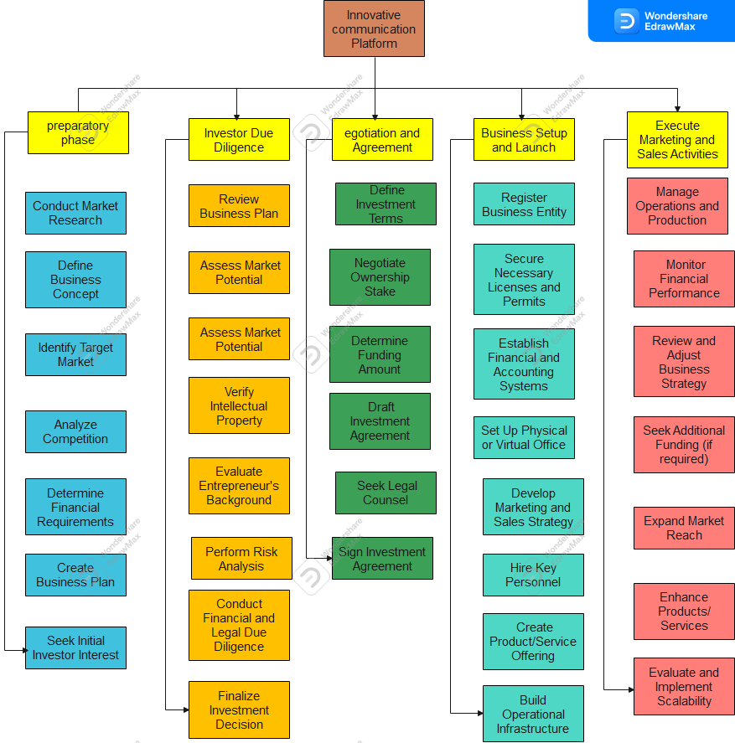

Fig 1: work Breakdown Structure

Roles & Responsibility Matrix

WBS # | WBS Deliverable | Activity # | Activity to Complete the Deliverable | Duration  (# of Days) | Responsible Team Member(s) & Role(s)
1 | Requirement gathering | 1 | Technical specification  Restricted areas  Available solutions. | 15 Days | Ayesha  Sana  Areeba
2 | Analysis | 2 |  | 10 Days | Ayesha  Sana  Areeba
3 | Architecture | 3 |  | 20 Days | Ayesha  Sana  Areeba
4 | Designing | 4 |  | 15 Days | Ayesha  Sana  Areeba
5 | Implementation &development | 5 |  | 90 Days | Ayesha  Sana  Areeba
6 | Database Module | 6 |  | 20 Days | Ayesha  Sana  Areeba
7 | Final testing | 7 |  | 10 Days | Ayesha  Sana  Areeba
8 | Documentation | 8 |  | 5 Days | Ayesha  Sana  Areeba
Table 1: Role& Responsibility Matrix

Gantt Chart

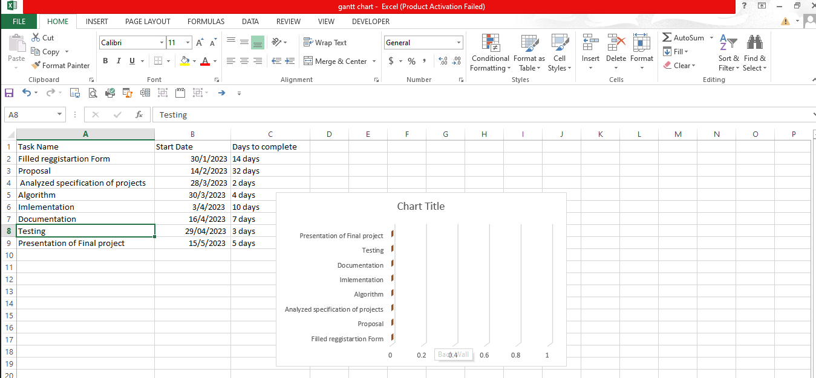
Figure 2: Gantt chart

Report Outline
An outline for a report on an entrepreneur and investor platform could include the following sections:

- The Requirement was gathered in about 15 Days.
- The Documentation was made in 2 months.
- The coding and data were implanted in almost 2 months.
- The Test were made, and errors were debugged after and through the coding period.
- Validation and finalization in added golden days.

Chapter 2

Software Requirement Specifications

Chapter 2: Software Requirement Specifications

Introduction

Purpose
The purpose of an entrepreneur and investor platform is to connect entrepreneurs with investors and provide them with resources and support to help them grow their businesses. It's a platform where entrepreneurs can pitch their ideas and receive funding, mentorship, and advice from experienced investors. Investors can use the platform to find promising startups and invest in their growth. The platform can also provide entrepreneurs with access to networking events, educational resources, and other tools to help them succeed.

Document Conventions
The software requirements specification (SRS) document is an important document that outlines the requirements for a software system. It provides a detailed description of the system's functionality, performance, and design constraints.
When creating an SRS document for an entrepreneur and investor platform, some document conventions to consider include:
Document structure: The document should have a clear and consistent structure, including headings, subheadings, and sections. The structure should be easy to navigate and follow.

Use of language: The language used in the document should be clear and concise, avoiding technical jargon and acronyms that may be unfamiliar to the audience.

Use of diagrams: Diagrams such as flowcharts, data flow diagrams, and use case diagrams can be used to help illustrate the system's functionality and design.

Use of tables: Tables can be used to present information in a clear and organized manner, such as requirements traceability matrices and system features matrices.
Use of appendixes: Appendixes can be used to provide additional information that may not be relevant to the main body of the document but is still important for the reader to know.

By following these document conventions, the SRS document for an entrepreneur and investor platform can be created in a clear and organized manner, making it easier for the audience to understand and use.

Intended Audience and Reading Suggestions
The intended audience for the software requirements specification (SRS) document for an entrepreneur and investor platform includes developers, project managers, stakeholders, and anyone involved in the development and implementation of the software system.

Reading suggestions for the SRS document include the following:

1. Read the document from beginning to end to get a comprehensive understanding of the software system and its requirements.

2. Pay attention to any diagrams, tables, or other visual aids that are used to help illustrate the system's functionality and design.

3. Use the table of contents and section headings to navigate the document and find specific information.

4. Take note of any requirements that may be particularly challenging or require further clarification.

5. Compare the requirements in the SRS document to any existing system architecture documents or user manuals to ensure consistency.

By following these reading suggestions, the intended audience will have a better understanding of the software system's requirements and be better equipped to develop and implement the system.

Product Scope
The product scope of the entrepreneur and investor platform software system is to provide a web-based platform that connects entrepreneurs with investors. The platform will allow entrepreneurs to create profiles and post information about their business ideas, while investors will be able to browse these profiles and connect with entrepreneurs who have promising ideas.

The platform will have the following features:

1. User registration and login: Users will be able to create accounts and log in to the platform.

2. Entrepreneur profiles: Entrepreneurs will be able to create profiles that include information about their business ideas, such as the industry, target market, and revenue projections.

3. Investor profiles: Investors will be able to create profiles that include information about their investment preferences, such as industry focus, investment size, and geographic location.

4. Search and browse: Investors will be able to search and browse entrepreneur profiles based on various criteria, such as industry, location, and revenue projections.

5. Messaging: Investors will be able to send messages to entrepreneurs to discuss their business ideas and potential investment opportunities.

6. Payment processing: The platform will include a payment processing system that allows investors to invest in entrepreneurs' business ideas.

By providing these features, the entrepreneur and investor platform software system will help entrepreneurs connect with investors

References
The following references were used in the development of the entrepreneur and investor platform software system:

1. "The Lean Startup" by Eric Reis
2. "Venture Deals" by Brad Feld and Jason Mendelson:
3. "Angel Investing" by David S. Rose:
4. "Startup Valuation" by Lorenzo Carver:
5. "The Business Model Canvas" by Alexander Osterwalder and Yves Pigneur:

By utilizing these references, the entrepreneur and investor platform software system was designed to incorporate best practices from the startup and venture capital industries, as well as provide a user-friendly platform for entrepreneurs and investors to connect.

Overall Description

Product Perspective
The entrepreneur and investor platform software system is a web-based platform that connects entrepreneurs with investors. The system is designed to be user-friendly and easy to navigate, with features that allow entrepreneurs to create profiles and post information about their business ideas, and investors to browse these profiles and connect with entrepreneurs who have promising ideas.

The platform will be developed using modern web technologies, such as HTML5, CSS3, and JavaScript, and will be compatible with all major web browsers. The system will be hosted on a cloud-based infrastructure to ensure scalability and reliability.

The entrepreneur and investor platform software system will be designed to be highly secure, with features such as SSL encryption and two-factor authentication to protect user data. The system will also comply with relevant data privacy regulations, such as GDPR and CCPA.

The entrepreneur and investor platform software system will be developed using an agile methodology, with frequent iterations and user feedback used to guide the development process. The system will be tested rigorously to ensure that it is reliable and user-friendly, and any bugs or issues will be addressed promptly.

Overall, the entrepreneur and investor platform software system will provide a valuable service to entrepreneurs and investors, helping to connect promising business ideas with the funding they need to succeed.

User Classes and Characteristics
The entrepreneur and investor platform software system is designed to serve two primary user classes: entrepreneurs and investors.

Entrepreneurs are individuals who have ideas for new businesses or products and are seeking funding to develop and launch their ideas. They are typically tech-savvy and comfortable using web-based platforms to connect with others. Entrepreneurs may have varying levels of business experience and may be located in different geographic regions.

Investors are individuals or organizations who are interested in investing in promising business ideas. They may be angel investors, venture capitalists, private equity firms, or other types of investors. Investors may have varying levels of experience and may be interested in investing in different types of businesses.

Operating Environment
The entrepreneur and investor platform software system will be a web-based platform that can be accessed through a web browser on any device with an internet connection. The system will be developed using modern web technologies, such as HTML5, CSS3, and JavaScript, and will be compatible with all major web browsers, including Chrome, Firefox, Safari, and Edge.

The system will be hosted on a cloud-based infrastructure to ensure scalability and reliability. The cloud-based infrastructure will be designed to handle large volumes of traffic and provide fast response times to users. The system will be deployed on a secure server that is protected by SSL encryption and two-factor authentication to ensure the security of user data.

Overall, the entrepreneur and investor platform software system will be designed to be highly available, scalable, and secure, providing a reliable and user-friendly platform for entrepreneurs and investors to connect and collaborate.

Design and Implementation Constraints
The design and implementation of the entrepreneur and investor platform software system will be subject to a number of constraints, including:

1. Compatibility: The system must be compatible with all major web browsers and operating systems to ensure that it is accessible to the widest possible audience.

2. Security: The system must be designed to be highly secure, with user data protected by SSL encryption and two-factor authentication. The system must also be designed to prevent unauthorized access and protect against common security threats, such as SQL injection and cross-site scripting attacks.

3. Scalability: The system must be designed to be highly scalable, with a cloud-based infrastructure that can handle large volumes of traffic and provide fast response times to users. The system must be able to scale up or down as needed to meet changing demand.

4. User Experience: The system must be designed to be user-friendly and easy to navigate, with features that are accessible to users of varying levels of technical expertise. The system must also be designed to be visually appealing and engaging, with a modern and responsive design.

5. Performance: The system must be designed to provide fast response times to users, with minimal latency and downtime. The system must also be optimized for performance, with efficient code and data structures that minimize resource usage.

6. Budget: The system must be designed to be implemented within a specific budget, with cost considerations taken into account throughout the design and implementation process.

Overall, the design and implementation of the entrepreneur and investor platform software system will be subject to a number of constraints, but will be carefully planned and executed to ensure that the system meets the needs of its users while remaining secure, scalable, and cost-effective.

Assumptions and Dependencies
The entrepreneur and investor platform software system is designed with the following assumptions and dependencies:
User Availability: The system assumes that users will be available to access the platform through a web browser and an internet connection.

User Location: The system does not assume that users will share their location with the system. If users choose to share their location, the system will be able to provide location-based recommendations.
User Data: The system assumes that users will provide accurate and up-to-date data when registering for the platform. The system also assumes that users will not share sensitive or inappropriate content on the platform.

System Updates: The system assumes that updates and maintenance will be required on a regular basis to ensure that the system remains secure, reliable, and up-to-date. The system is dependent on developers to perform these updates and maintenance tasks.

User Feedback: The system assumes that users will provide feedback on the platform, including suggestions for new features and improvements to existing features. The system is dependent on this feedback to improve and evolve over time.

Overall, the entrepreneur and investor platform software system is designed with a number of assumptions and dependencies that are critical to its operation. These assumptions and dependencies will be carefully monitored and managed to ensure that the system remains secure, reliable, and user-friendly over time.

External Interface Requirements

User Interfaces
The entrepreneur and investor platform software system is designed with the following user interfaces:

1. Registration Interface: This interface will allow users to create a new account on the platform. Users will be required to provide basic information, such as their name and email address, to register.

2. Login Interface: This interface will allow registered users to log in to the platform using their email address and password.

3. Profile Interface: This interface will allow users to manage their profile information, including their name, profile picture, and contact information.

4. Search Interface: This interface will allow users to search for other users, companies, and investment opportunities on the platform.

5. Messaging Interface: This interface will allow users to send and receive messages with other users on the platform.

6. Dashboard Interface: This interface will provide users with an overview of their account activity, including messages, notifications, and investment opportunities.

Overall, the user interfaces of the entrepreneur and investor platform software system are designed to be intuitive, user-friendly, and accessible to all users. These interfaces will be carefully tested and optimized to ensure that they meet the needs of users and provide a seamless experience on the platform.

Hardware Interfaces
The entrepreneur and investor platform software system that are going to be used are the hardware components that are required for the internet access. These have been mentioned in the following table.

WLAN | WAN | LAN | Ethernet cross-cable | Modem | Router
Table 2: Hardware Interface

Software Interfaces
External Interface Requirements for an entrepreneur and investor platform could include software interfaces such as APIs, SDKs, and web services that allow users to interact with the platform. These interfaces could be used to connect the platform to other systems and services, such as payment gateways, social media platforms, or other third-party applications. The specific software interfaces required for the platform would depend on the features and functionality of the platform.

Communications Interfaces
The entrepreneur and investor platform software system has the following communications interface requirements:

1. Email: The system will use email to send notifications to users, such as when a new message has been received or an investment proposal has been submitted.
2. Messaging: The system will have an internal messaging system that allows users to communicate with each other directly through the platform.
3. APIs: The system will use APIs to communicate with third-party services, such as payment processors or data providers.
4. social media: The system will allow users to share investment opportunities and other information through their social media accounts.

Overall, the communications interface requirements for the entrepreneur and investor platform software system are designed to provide users with a range of communication options. By leveraging email, messaging, APIs, and social media, the system will be able to provide a seamless and integrated experience for users.

System Features
The entrepreneur and investor platform software system has the following key features:

1. User Profiles: The system will allow users to create and manage their own profiles, which will include information about their experience, skills, and investment preferences.

2. Investment Opportunities: The system will allow entrepreneurs to post investment opportunities, which will include information about their business and the terms of the investment.
3. Investment Proposals: The system will allow investors to submit investment proposals in response to posted investment opportunities.
4. Internal Messaging: The system will have an internal messaging system that allows users to communicate with each other directly through the platform.
5. Investment Management: The system will provide tools for investors to manage their investments, including tracking investment performance and making adjustments to their portfolios.
6. Data Analytics: The system will provide data analytics tools that allow users to analyze trends and identify investment opportunities.

Overall, the entrepreneur and investor platform software system is designed to provide a comprehensive suite of features that enable entrepreneurs and investors to connect and collaborate effectively. By providing tools for investment management, data analytics, and internal communication, the system will help users make informed investment decisions and achieve their goals.

System Feature 1
The User Profiles feature allows users to create and manage their own profiles within the entrepreneur and investor platform software system. Users can include information about their experience, skills, and investment preferences in their profiles. This information can then be used to connect entrepreneurs with investors who have similar interests and goals.

Description and Priority
This feature is a high priority for the entrepreneur and investor platform software system, as it is a key component of the platform's functionality. The ability for users to create and manage their profiles is crucial in order to facilitate connections between entrepreneurs and investors who have similar interests and goals.

Stimulus/Response Sequences
Stimulus: A user creates a new profile on the entrepreneur and investor platform.

Response: The system prompts the user to input information about their experience, skills, and investment preferences. The user fills out the required fields and submits their profile.

Stimulus: A user logs in to their existing profile on the entrepreneur and investor platform.

Response: The system displays the user's profile information, including their experience, skills, and investment preferences. The user can edit or update their profile as needed.

Stimulus: A user searches for potential investors on the entrepreneur and investor platform.

Response: The system uses the information in the user's profile to suggest potential investors who have similar interests and goals. The user can review the suggested profiles and connect with investors as desired.

Stimulus: A user searches for potential entrepreneurs on the entrepreneur and investor platform.

Response: The system uses the information in the user's profile to suggest potential entrepreneurs who have similar interests and goals. The user can review the suggested profiles and connect with entrepreneurs as desired.

Functional Requirements
1. User Profiles
- The system must prompt users to input information about their experience, skills, and investment preferences.
- The system must allow users to edit or update their profile information as needed.
- The system must require users to input all required fields before submitting their profile.
- The system must display an error message if required fields are left blank.
- The system must allow users to upload a profile picture.
- The system must display the user's profile information to other users who have been granted access.
- The system must allow users to control which parts of their profile information are visible to other users.

2. Search Functionality
- The system must allow users to search for potential investors or entrepreneurs based on specific criteria, such as industry, location, or investment size.
- The system must display search results in a clear and organized manner.
- The system must allow users to filter search results based on additional criteria.
- The system must allow users to save their search criteria for future use.
- The system must display an error message if no search results are found.

3. Messaging
- The system must allow users to send and receive messages within the platform.
- The system must display an alert when a new message is received.
- The system must allow users to delete messages from their inbox.
- The system must allow users to report inappropriate or abusive messages.

4. Connection Requests
- The system must allow users to send connection requests to other users.
- The system must display an alert when a new connection request is received.
- The system must allow users to accept or decline connection requests.
- The system must allow users to block other users from sending connection requests.

5. Investment Tracking
- The system must allow users to track their investments and monitor the progress of businesses in which they have invested.
- The system must display investment data in a clear and organized manner.
- The system must allow users to filter investment data based on additional criteria.
- The system must allow users to export investment data to a spreadsheet.

6. Analytics and Reporting
- The system must provide analytics and reporting functionality to help users track the performance of their investments and identify trends in the market.
- The system must display analytics data in a clear and organized manner.
- The system must allow users to filter analytics data based on additional criteria.
- The system must allow users to export analytics data to a spreadsheet.

7. Payment Processing
- The system must allow users to initiate and receive payments within the platform.
- The system must use a secure payment processing system to protect.

System Feature 2
This feature enables entrepreneurs and investors to register and authenticate themselves on the platform, providing them with secure access to the system.

Key Components:

Registration: Users can create an account by providing their personal information, such as name, email address, and password.
User Profiles: Once registered, users can create and manage their profiles, including adding additional details like their expertise, interests, and investment preferences.
Authentication: The system verifies the user's identity during login using the provided credentials. This ensures that only authorized users can access the platform.
Password Recovery: Users can request a password reset if they forget their login credentials, with a secure process to regain access to their account.
Account Security: Measures such as encryption and secure storage of user data are implemented to protect user information from unauthorized access.

Description and Priority
Description:
System Feature 2 is an essential component of the entrepreneur and investor platform. It encompasses the functionality required to facilitate interactions between entrepreneurs seeking funding and potential investors. This feature provides a streamlined process for entrepreneurs to present their business ideas or projects to investors and enables investors to evaluate and make investment decisions based on the presented information.

Priority:
System Feature 2 holds a high priority in the platform as it directly contributes to the platform's core purpose of connecting entrepreneurs with investors. Its efficient implementation is crucial for ensuring a seamless experience for both entrepreneurs and investors, fostering a thriving ecosystem for funding and business opportunities.

Stimulus/Response Sequences
User Registration:

Stimulus: User selects the "Register" option on the platform.
Response: System prompts the user to provide their personal information such as name, email, and password.
Stimulus: User enters the required information.
Response: System verifies the information and creates a new user account.
User Login:

Stimulus: User selects the "Login" option on the platform.
Response: System presents a login form requesting the user's email and password.
Stimulus: User enters their login credentials.
Response: System verifies the credentials and logs the user into their account.
Entrepreneur Profile Creation:

Stimulus: Entrepreneur user selects the "Create Profile" option.
Response: System presents a form for the entrepreneur to enter their profile details such as bio, skills, and project information.
Stimulus: Entrepreneur enters the required profile information.
Response: System validates the information and saves the entrepreneur's profile.
Investor Search for Projects:

Stimulus: Investor user selects the "Search Projects" option.
Response: System presents a search interface where investors can specify search criteria such as industry, location, or funding requirement.
Stimulus: Investor enters the desired search criteria.
Response: System retrieves and displays a list of projects matching the search criteria.
Entrepreneur Project Submission:

Stimulus: Entrepreneur user selects the "Submit Project" option.
Response: System presents a project submission form where the entrepreneur can provide details about their project.
Stimulus: Entrepreneur fills in the project details and submits the form.
Response: System validates the information and saves the project submission.
Investor Project Evaluation:

Stimulus: Investor user selects a specific project from the search results.
Response: System displays detailed information about the project, including its description, financial projections, and team members.
Stimulus: Investor reviews the project information.
Response: System provides options for the investor to express interest, request further information, or decline the project.
Entrepreneur Project Updates:

Stimulus: Entrepreneur user selects a submitted project from their dashboard.
Response: System displays the project details and current status.
Stimulus: Entrepreneur updates the project status or provides additional information.
Response: System saves the updates and notifies interested investors about the changes.>

Functional Requirements
The system shall allow users to create a new account by providing a unique username, a valid email address, and a password.

The system should validate that the username is not already taken.
The system should validate that the email address is in the correct format.
The system should enforce password complexity rules (e.g., minimum length, required characters).
The system shall allow users to log in using their registered username and password.

The system should verify the provided credentials against the stored user information.
The system should display an error message if the login credentials are invalid.
The system shall provide a "Forgot Password" functionality for users who have forgotten their password.

The system should allow users to reset their password by sending a password reset link to their registered email address.
The system should validate the email address before sending the password reset link.
The system should generate a unique and temporary password reset token for each request.
The system shall allow users to update their account information, including username, email address, and password.

The system should validate that the updated username is not already taken.
The system should validate the updated email address for correctness.
The system should enforce password complexity rules for the new password, if provided.
The system shall provide a secure session management mechanism to maintain user authentication throughout the session.

The system should use industry-standard encryption algorithms for session management.
The system should expire user sessions after a certain period of inactivity.
The system shall display appropriate error messages when invalid inputs or error conditions occur during user interactions.

The system should provide clear and concise error messages that help users understand the issue.
The system should log error details for further analysis and troubleshooting purposes.
The system shall enforce access control to restrict certain features or information based on user roles and permissions.

The system should differentiate between different user roles, such as administrators and regular users.
The system should allow administrators to perform privileged actions, while regular users have limited access.
The system shall protect user data by implementing proper security measures.

The system should use secure protocols (e.g., HTTPS) for data transmission.
The system should store passwords securely using hashing and salting techniques.

System Feature 3 (and so on)

Nonfunctional Requirements

Performance Requirements
1. Response Time
- The system must respond to user actions within 2 seconds.
- The system must display search results within 5 seconds.
- The system must load user profiles within 3 seconds.

2. Scalability
- The system must be able to handle up to 100,000 users simultaneously.
- The system must be able to handle up to 1,000 search requests per minute.

3. Reliability
- The system must have an uptime of at least 99.9%.
- The system must be able to recover from a crash within 5 minutes.

4. Security
- The system must use encryption to protect user data.
- The system must use secure payment processing systems to protect financial data.
- The system must use multi-factor authentication to prevent unauthorized access.
- The system must have a system for detecting and preventing fraud.

5. Compatibility
- The system must be compatible with the latest versions of major web browsers.
- The system must be compatible with mobile devices.

6. Usability
- The system must be easy to use and navigate.
- The system must be accessible to users with disabilities.
- The system must be available in multiple languages.

7. Capacity
- The system must be able to store and manage large amounts of data.
- The system must be able to handle up to 10,000 new user registrations per day.

These performance requirements are necessary to ensure that the platform is fast, reliable, and secure, and can handle a large number of users and transactions.

Safety Requirements
1. Data Security
- The system must use encryption to protect user data.
- The system must use secure payment processing systems to protect financial data.
- The system must use multi-factor authentication to prevent unauthorized access.
- The system must have a system for detecting and preventing fraud.
- The system must comply with relevant data protection regulations.

2. User Safety
- The system must not allow users to post or exchange harmful or illegal content.
- The system must have a mechanism for reporting and removing harmful content.
- The system must have a mechanism for blocking or banning users who violate the platform's policies.
- The system must comply with relevant laws and regulations related to user safety.

3. System Security
- The system must be protected against cyber-attacks and hacking attempts.
- The system must have a mechanism for detecting and preventing security breaches.
- The system must comply with relevant security regulations and standards.

4. Safety Certifications
- The system must comply with relevant safety certifications, such as ISO 27001.

These safety requirements are necessary to ensure that the platform is safe and secure for users, and that it complies with relevant laws and regulations. The system must be designed to protect user data and prevent harmful content or behavior, and must comply with relevant safety certifications and standards.

Security Requirements
1. User Authentication
- The system must have a secure login process that requires a unique username and password.
- The system must use multi-factor authentication to prevent unauthorized access.
- The system must have a mechanism for resetting passwords and recovering accounts.

2. Data Security
- The system must use encryption to protect user data.
- The system must use secure payment processing systems to protect financial data.
- The system must have a mechanism for detecting and preventing fraud.
- The system must comply with relevant data protection regulations.

3. System Security
- The system must be protected against cyber-attacks and hacking attempts.
- The system must have a mechanism for detecting and preventing security breaches.
- The system must comply with relevant security regulations and standards.

4. Privacy
- The system must have a privacy policy that outlines how user data is collected, used, and shared.
- The system must have a mechanism for users to control their privacy settings.
- The system must comply with relevant privacy regulations and standards.

5. Security Certifications
- The system must comply with relevant security certifications, such as ISO 27001.

These security requirements are necessary to ensure that the platform is secure and protects user data. The system must have a secure login process and use encryption to protect user data and financial information. It must also comply with relevant data protection and privacy regulations and have a mechanism for users to control their privacy settings. The system must comply with relevant security certifications and standards to ensure that it is secure and trustworthy.

Usability Requirements
These usability requirements are necessary to ensure that the platform is user-friendly and accessible to all users. The system must have a user-friendly interface with clear and concise language, and must be accessible to users with disabilities. It must also be fast and responsive, with minimal lag or delay, and must be reliable and available to users at all times. The system must have clear and concise documentation that explains how to use the platform, and the documentation must be easily accessible to users.

Reliability Requirements
Reliability requirements for an entrepreneur and investor platform would ensure that the platform is dependable, consistent, and performs its intended functions without any errors or issues. This would include features such as uptime, data backup and recovery, security, and user support.

Maintainability/Supportability Requirements
Maintainability/Supportability requirements for an entrepreneur and investor platform would ensure that the platform can be easily maintained and updated to meet the needs of its users. This would include features such as documentation, user-friendly interfaces, and support for multiple devices and platforms. The platform should also be able to handle changes in user requirements and provide timely support for any issues that may arise.

Portability Requirements
Portability requirements for an entrepreneur and investor platform would ensure that the platform can be easily transferred or adapted to different environments or devices without any loss of functionality or data. This would include features such as compatibility with different operating systems, web browsers, and mobile devices. The platform should also be able to handle changes in hardware or software configurations and provide consistent performance across different platforms.

Efficiency Requirements
Efficiency requirements for an entrepreneur and investor platform would ensure that the platform can perform its intended functions in a timely and resource-efficient manner. This would include features such as fast response times, minimal resource usage, and scalability to handle large numbers of users and transactions. The platform should also be able to handle peak loads without any degradation in performance and provide timely feedback to users.

Domain Requirements
Domain requirements for an entrepreneur and investor platform would ensure that the platform meets the specific needs and requirements of its target users and industry. This would include features such as support for different types of businesses and investors, compliance with relevant regulations and standards, and integration with other platforms or services that are commonly used in the industry. The platform should also be able to handle different types of financial transactions and provide accurate and timely reporting to users.

Chapter 3

Use Case Analysis

Chapter 3: Use Case Analysis
This chapter describe about system use cases and how the different actors are interacting with the system. This system is all about use case of system and role we assign and categorize the user of solution. We describe the all terms about the use case model and use case diagram of every role.at the end we make a proper dressed use case model of our project.

Use Case Model
A use case diagram at its simplest is a representation of a user's interaction with the system that shows the relationship between the user and the different use cases in which the user is involved. A use case diagram can identify the different types of users of a system and the different use cases and will often be accompanied by other types of diagrams as well. The use cases are represented by either circles or ellipses.

Use Case Diagram for Entrepreneur

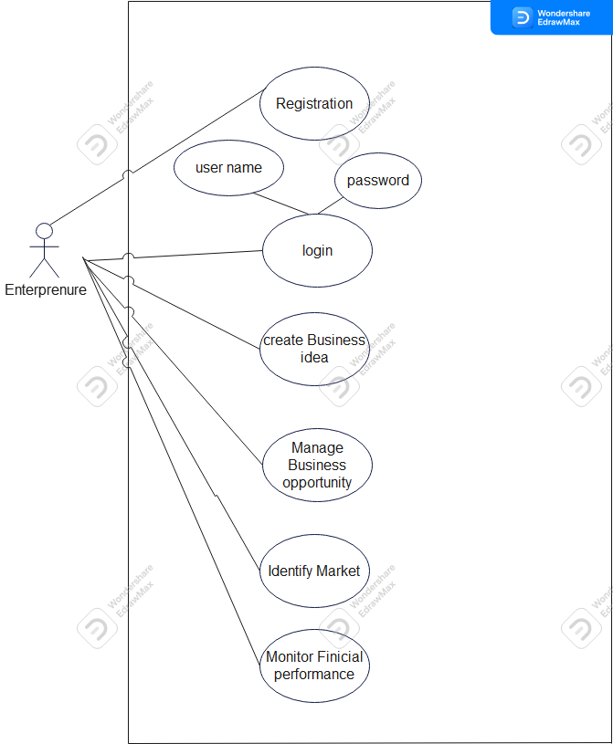
Fig 3: use case of Entrepreneur

Fully Dressed Use Case Diagram:

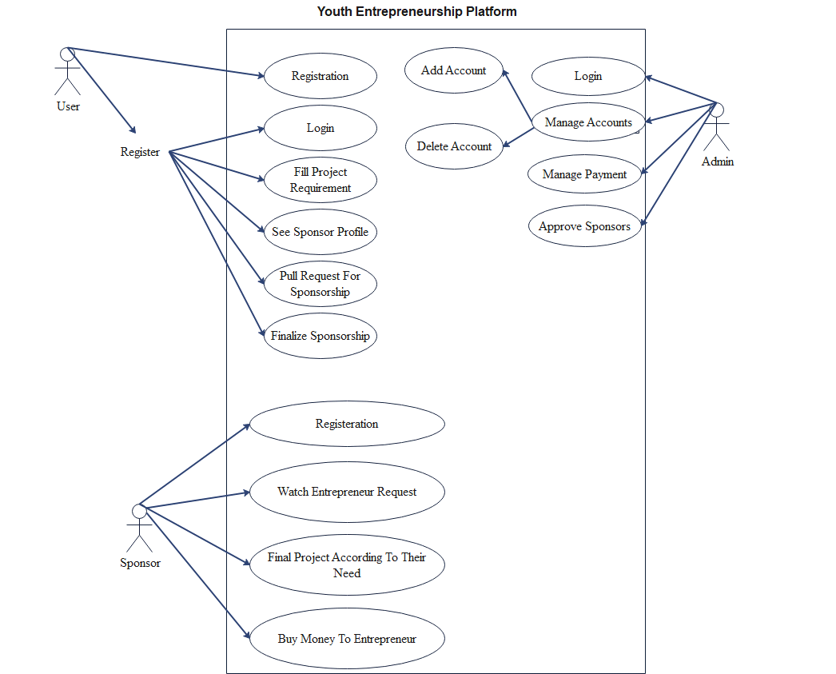
Fig 4: Fully Dressed Use case

Use Case Diagram for Investor
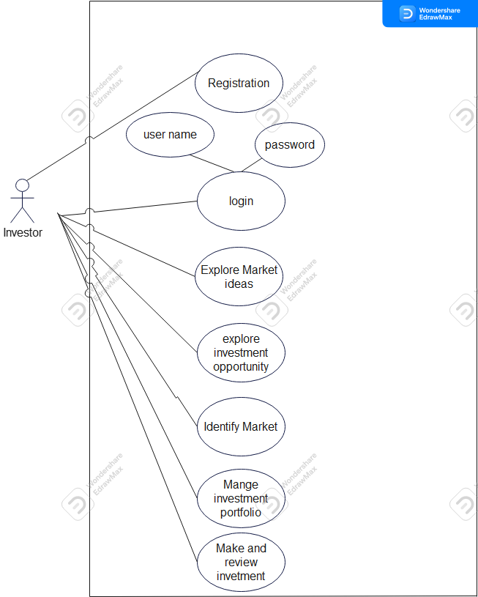
Fig 5: Use Case Diagram of investor

Use Cases Description

Use Case Descriptions
Name | Register
Brief Description | A user of the System creates an account
Actor(s) | Entrepreneur
Flow of Events
Basic Flow
This use case starts when a system user is not logged in to the system and goes to the login page.
- The System prompts the user for a username and password or register new account.
- The user selects registration option.
- The System prompts user for registration information, Username, password, etc
- The user enters in their information.
- System verifies information and creates account.
- The use case ends.
Alternate Flows
Title | Description
Cancel Registration | - The user selects the cancel option.  - The system returns the user to the home page without the user being logged in and any information entered has been erased.
Invalid Information Entered | - User clicks submit after entering information system asked for.  - System displays information with appropriate message to correct invalid information.  - User re-enters information.
Pre-Conditions
Title | Description
System | To logged in to the system the user must have the System
Internet | To logged in to the system the user must have the network on the System.
Post-Conditions
Title | Description
Success | The user entered successful information and is returned to the home page as a Logged In User
Failure | User is unable to log in for one or more reasons and is returned to the home page as a Guest.
Extension Points
If the User is unable to log in for one or more reasons the user must once check the internet Connection.
Table 3 : Use case of register

Name | Log In
Brief Description | The System user logs in to the System.
Actor(s) | Admin
Flow of Events
Basic Flow
This use case starts when a system user is not logged in to the system and goes to the login page.
- The System prompts the user for a username and password or register new account
- The user enters his/her username and password.
- The system validates the entered username and password, making sure that the entered username is a valid username in the System, and that the required password is entered for the entered username.
- The user is signed in and returned to the home page as a Logged In User.
- The use case ends.
Alternate Flows
Title | Description
User Fails Authentication | If the User entered an invalid username and/or password, the following occurs:  - The system describes the reasons why the User failed authentication.  - The system presents the User with suggestions for changes necessary to allow the User to pass authentication.  - The system prompts the User to re-enter the valid information.  - The Basic Flow continues where the User enters new information.
Pre-Conditions
Title | Description
Register | A user of the System creates an account
Post-Conditions
Title | Description
Success | The User is authenticated and the system displays a home page based on the user type.
Failure | User is unable to log in for one or more reasons.
Extension Points
The user must make sure that the entered username is a valid username in the System or entered password is a valid password.
Table 4: User case of login

Startup Discovery: The platform allows entrepreneurs to showcase their startup ideas and businesses to potential investors. Entrepreneurs can provide detailed descriptions of their ventures, including market analysis, competitive advantages, and financial projections. Investors can browse through various startup profiles to identify investment opportunities.

Investor Networking: The platform facilitates networking between entrepreneurs and investors. Entrepreneurs can connect with potential investors, discuss their ideas, and seek guidance or mentorship. Investors can also network with other investors to explore potential collaborations or co-investment opportunities.

Investment Opportunities: The platform provides a curated list of investment opportunities for investors. Entrepreneurs can list their fundraising needs, such as seed funding, venture capital, or angel investment, along with the investment amount required. Investors can review these opportunities, assess the viability of the ventures, and express interest in funding them.

Due Diligence: The platform offers tools and resources to conduct due diligence on startup opportunities. Investors can access comprehensive business plans, financial statements, market research, and other relevant documents shared by entrepreneurs. This helps investors make informed decisions and evaluate the potential risks and returns associated with an investment.

Deal Management: The platform supports the end-to-end deal management process. Entrepreneurs can negotiate investment terms, communicate with potential investors, and track the progress of funding discussions. Investors can manage their investment portfolio, track their commitments, and initiate investment transactions securely through the platform.

Investor Education: The platform provides educational resources, such as articles, webinars, and case studies, to help investors enhance their knowledge and understanding of various industries, investment strategies, and startup evaluation techniques. This enables investors to make more informed investment decisions and stay updated with the latest trends.

Post-Investment Support: The platform offers post-investment support and monitoring tools for investors. Investors can collaborate with entrepreneurs, provide guidance, and monitor the progress of their investments. The platform may also facilitate investor updates, performance tracking, and communication channels between investors and entrepreneurs.

Exit Strategies: The platform assists entrepreneurs and investors in exploring exit strategies. Entrepreneurs can present their growth plans, potential acquisition opportunities, or IPO strategies to attract investors seeking exit opportunities. Investors can analyze the exit options available and engage in discussions with entrepreneurs for a successful exit from their investments.

Overall, the entrepreneur and investor platform serve as a digital marketplace, connecting entrepreneurs and investors, providing tools for due diligence, facilitating deal management, and offering resources for education and support throughout the investment lifecycle.

Chapter 4

System Design

Chapter 4: System Design
The system design for an entrepreneur and investor platform could involve the following components:

1. User Authentication and Authorization
2. User Profile Management
3. Project Management
4. Payment Gateway Integration
5. Communication and Collaboration
6. Analytics and Reporting

Architecture Diagram

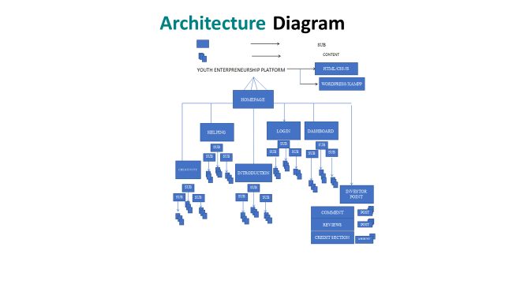
Fig 6: Architecture Diagram

Domain Model

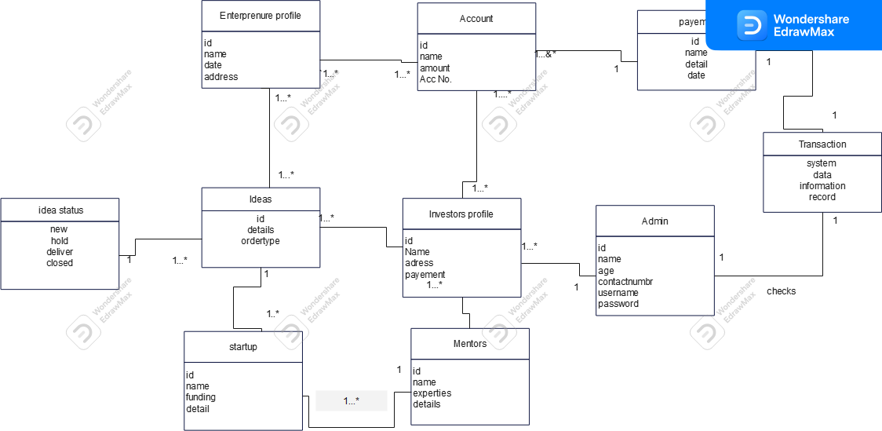

Fig 7: Domain Model

Entity Relationship Diagram with data dictionary

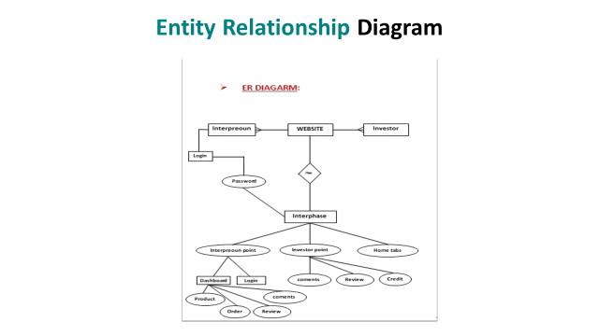
Fig 8: Entity Relationship Diagram

Class Diagram

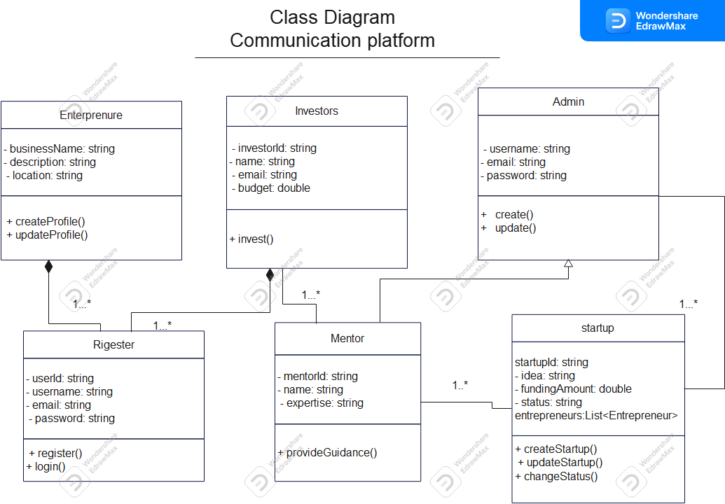

Fig 9: class diagram

Sequence / Collaboration Diagram
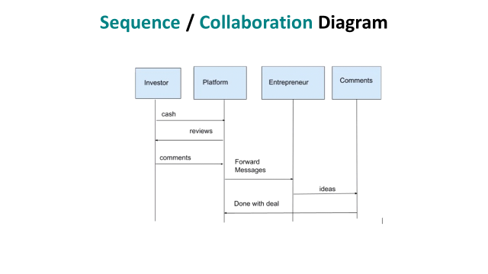
Fig 10: Sequence Diagram

Operation contracts

Contract CO: create Business idea
Operation: create business idea (EntID: EntID,quantity: integer)
Cross Reference: Use Cases: Create Business Idea
Precondition: There is a view Create Business idea underway
Postcondition: _A Entrepreneur Request instance Enp was created (instance-creation).
__Enp was associated with the current ideas (association formed).
__Enp. Quantity became quantity (attribute modification).
__Enp was associated with a New ideas, based on EnpID
match (association formed).

Contract CO: Manage Business
Operation: ManageBusinessopportunity (EntID: EntID,quantity: integer)
Cross Reference: Use Cases: Manage Business opportunity
Precondition: There is a view Manage Business underway
Postcondition: _A Manage Business instance MB was created (instance-creation).
__MB was associated with the current ideas (association formed).
__MB. Quantity became quantity (attribute modification).
__MB was associated with a New ideas, based on EnpID
match (association formed).

Contract CO: Investor Explore Idea
Operation: ExploreMarketIdeas (InvID: InvID,quantity: integer)
Cross Reference: Use Cases: Explore Market Ideas
Precondition: There is a view To Explore Market Ideas underway
Postcondition: _A Exploring ideas instance EI was created (instance-creation).
__EI was associated with the current ideas (association formed).
__EI. Quantity became quantity (attribute modification).
__EI was associated with a New ideas, based on InvID
match (association formed).

Contract CO: Investor Make and Review Investment
Operation: Makeand reviewinvestment(InvID: InID,quantity: integer)
Cross Reference: Use Cases: Make and review Investment
Precondition: There is a vie to make and review investment underway
Postcondition: _A Make and review instance In was created (instance-creation).
__In was associated with the current product (association formed).
__In. Quantity became quantity (attribute modification).
__In was associated with a new idea for invest, based on InvID
match (association formed).

4.7 Activity Diagram

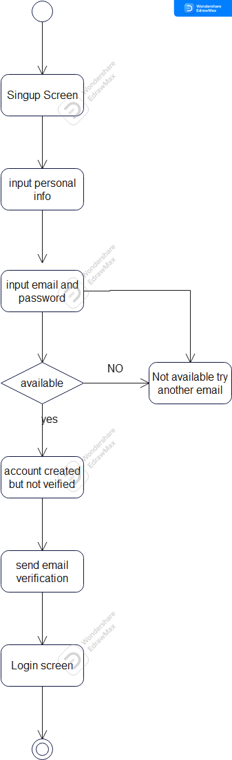 Fig 11: Activity diagram Admin
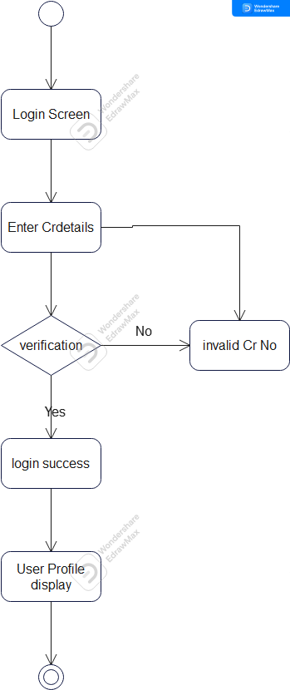Fig 12 : Activity Diagram for Ent/investor

State Transition Diagram
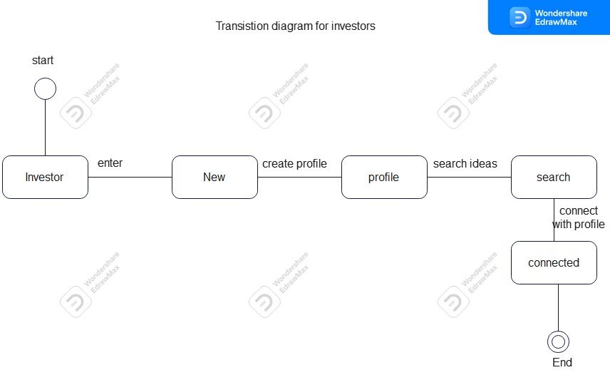

Fig 13: State transition Diagram
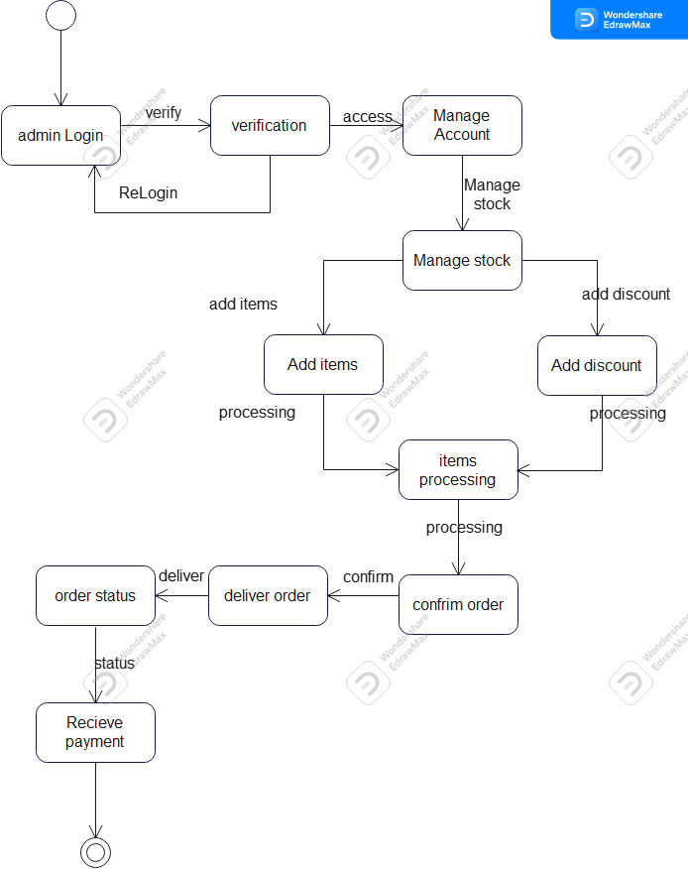

Fig 14: state transition for admin

Component Diagram

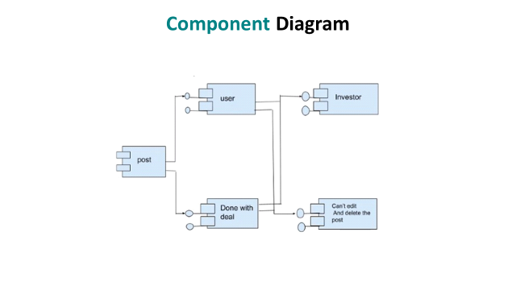
Fig 15: Component Diagram

Deployment Diagram

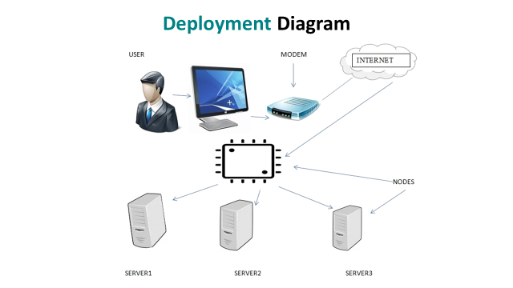

Fig 16: Deployment Diagram

Data Flow diagram:
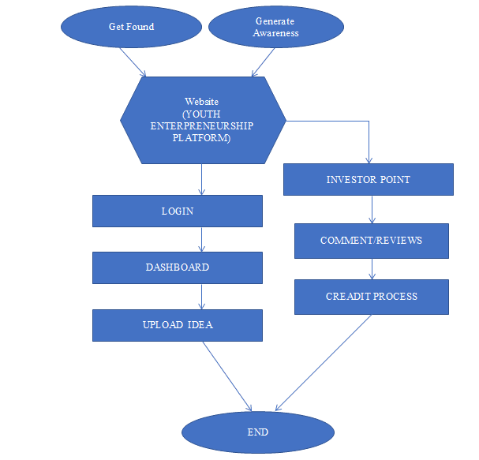

Fig 17: Data Flow Diagram

System Sequence diagram:
Admin

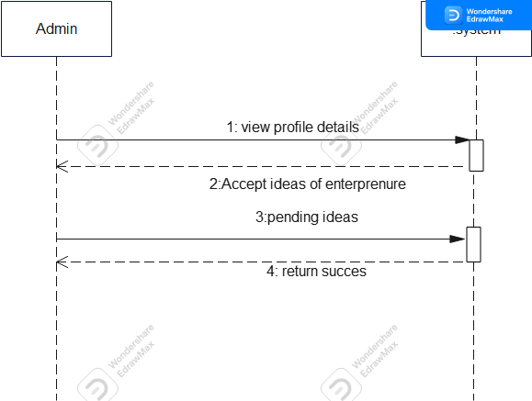
Fig 18: System sequence Diagram for Admin

System Sequence diagram:
Login

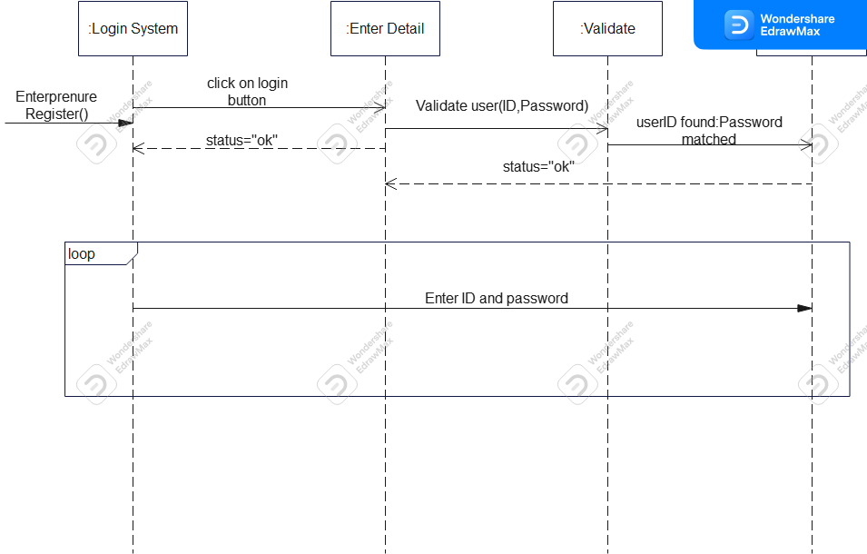

Fig 19: System Sequence Diagram for Login

System Sequence diagram:
Entrepreneur

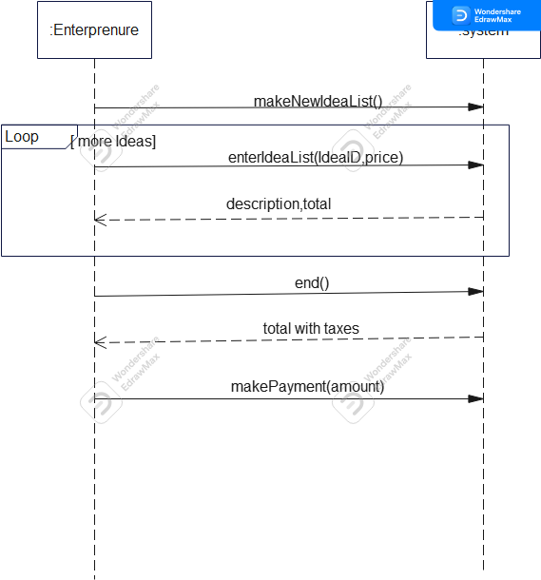

Fig 20: Sequence Diagram for Entrepreneur

System Sequence Diagram:
Payment

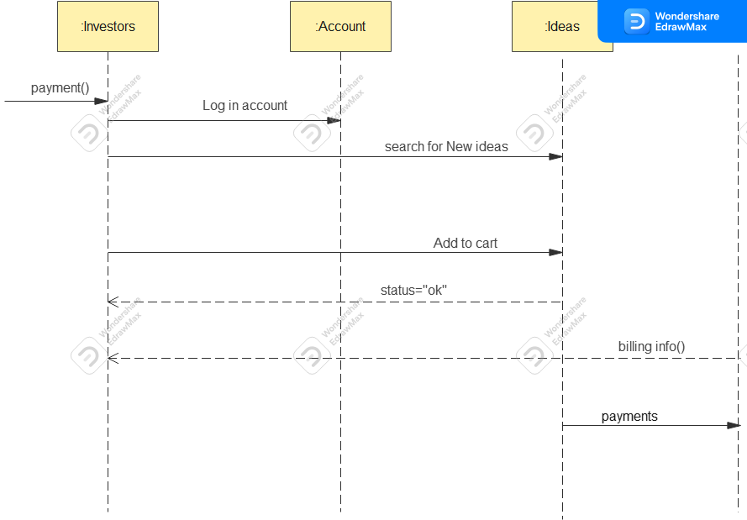

Fig 21: System Sequence Diagram for payment

System Sequence Diagram of Startup:

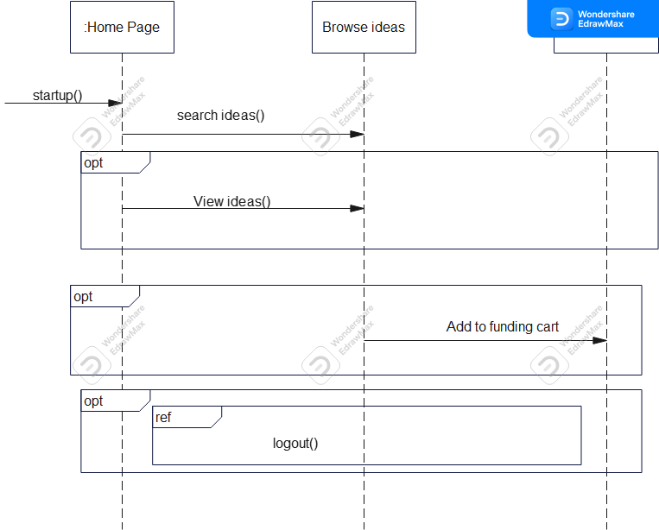

Fig 22: System Sequence Diagram for start up

System Sequence Diagram of Ideas:

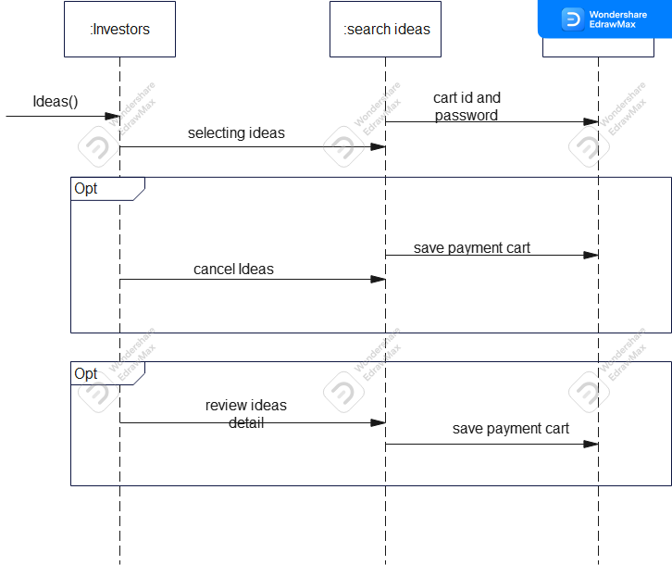

Fig 23: System Sequence Diagram for Ideas

Chapter 5

Implementation

Chapter 5: Implementation
Important Flow Control/Pseudo codes
- Services that this Web application will provide are the following: •
- There are two types of users
- 1. Entrepreneur who want to provide information about Ideas
- They will be able to create a profile with the necessary information (contact, location, etc.) ✓ Add/check reviews.
- 2. Investor Register themselves through system. ✓
- They will be able to access profiles based on the criteria they specify ✓
- Add/check reviews.
Components, Libraries, Web Services and stubs

- Components

- Front-end: The user interface components responsible for rendering and interacting with the application in the browser, such as HTML, CSS, and JavaScript.

- Back-end: The server-side components that handle data processing, business logic and interaction with databases.

- Libraries:

- Front-end Libraries: Additional JavaScript libraries that provide enhanced functionality, such as jQuery, Axios for making HTTP requests, D3.js for data visualization, and Bootstrap for responsive CSS styling.

- Back-end Libraries: Libraries specific to the chosen programming language or framework, such as SQL Alchemy for database interaction in Python, Spring Boot for Java

- Web Services:
- RESTful APIs: Representational State Transfer (REST) APIs that allow communication and data transfer between the front-end and back-end using standard HTTP methods like GET.

- Stubs:
- Mocking Libraries: Libraries like Mockito or Sinon.js that help create stubs or mocks for testing purposes. These allow to simulate the behavior of dependencies or external services during unit testing.
Deployment Environment
In Deployment environment we work on Visual studio for build our android based application

Tools and Techniques
Tool | Visual Studio
Languages | Html, CSS, Java Script, Php, Bootstrap
Data base | Firebase Database SQL, Xampp
Table 5 : tool and technique

Best Practices / Coding Standards
- Testing on Visual studio
- Use html, CSS and JavaScript language
- Use Php language

Version Control
Now we just working on version 1 after the passage of time we changed the version. From the start of the project number of versions updated and finalized now version 1.5 mentioned here.

Chapter 6

Testing and Evaluation

Chapter 6: Testing and Evaluation
Use Case Testing is a functional black box testing technique that helps testers to identify test scenarios that exercise the whole system on each transaction basis from start to finish.

Use Case Testing
6.1.1.
Test Suite ID | TS001
Test Case ID | TC001
Test Case Summary | To verify that by clicking Signup button username, password, email, phone# and address store in users detail in database.
Related Requirement | RSoo1: User should able to Sign up.
Prerequisites | No
Test Procedure | 1. Select fields in Signup form.  2. Enter user data in fields.  3. Click Signup button.
Test Data | Valid username: asad, ASad  Invalid username: 12 asad ./asad ,asad %^3  Valid password: 123Abc@5, Abc567$%9  Invalid password: 1_2ali, _ali12  Valid email:ali@gmail.com, 12ali@yahoo.com  Invalid email: ali.com, asad@yahoo  Valid phone# :03123456578  Invalid phone: @56rfgf7999, 2wstyyA
Expected Result | 1. If username, password, email and phone# are valid then store user data by clicking signup button.  2. If given inputs are invalid then display error message.  3. If fields are empty then show warning message.
Actual Result | 1. If name is valid, the result is as expected.  2. If name is not valid then invalid message displayed.  3. If fields are empty then warning massage displayed.
Status | Pass
Remarks | This test case is simple and easy.
Created By | Asad
Date of Creation | 04/01/2023
Executed By | Asad Malik
Date of Execution | 04/01/2023
Text Environment | OS: visual Studio Version
Table 6: Use case of Sign up
6.1.2:
Test Suite ID | TS001
Test Case ID | TC002
Test Case Summary | To verify Authentication or Login.
Related Requirement | RS002: User should able to Login.
Prerequisites | User should Signup first.
Test Procedure | 1. Select Username field and enter username.  2. Select Password field and enter password.  3. Click Login button.
Test Data | Valid username: Asad,asad  Invalid username: 1iqra, ./asad , asad%^3  Valid password: 123Aabc@, abMc567$%  Invalid password: 1_2asad, _asad12
Expected Result | 1. If username and password are valid then clicking the Login button user successfully login.  2. If username and password are invalid then clicking the Login button invalid message display.  3. If fields are empty then display warning message
Actual Result | 1. If fields are valid, the result is as expected.  2. If fields are not valid then invalid message displayed.  3. If fields are empty then warning message displayed.
Status | Pass
Remarks | This test case is simple and easy.
Created By | Asad malik
Date of Creation | 04/01/2023
Executed By | Asad Malik
Date of Execution | 04/01/2023
Text Environment | OS: Visual Studio Version
Table 7 : use case of login
6.1.3:
Test Suite ID | TS001
Test Case ID | TC003
Test Case Summary | To verify that wedding halls, restaurants, volunteer, consumer and non-profit organization once signup if they are forgot password then they can update it by email.
Related Requirement | RS003: user should able to update data.
Prerequisites | user should login.
Test Procedure | 1. Select fields.  2. Enter data in fields.  3. Click forgot password button.
Test Data | 04/01/19
Expected Result | 1. If enter data is valid then update data by clicking update button  2. If given inputs are invalid then display error message.  3. If fields are empty then display warning message.
Actual Result | 1. If fields are valid, the result is as expected.  2. If fields are not valid then invalid message displayed.  3. If fields are empty then warning message displayed.
Status | Pass
Remarks | This test case is simple and easy.
Created By | Asad Malik
Date of Creation | 04/01/2023
Executed By | Asad Malik
Date of Execution | 04/01/2023
Text Environment | OS: Visual Studio Version
Table 8 : use case of update password
6.1.4:

Test Suite ID | TS002
Test Case ID | TC004
Test Case Summary | To verify that wedding halls, restaurants, volunteer, consumer and non-profit organization once signup if they are deleted in database by performing crud operation by clicking Delete button.
Related Requirement | RS004: Admin can delete data.
Prerequisites | Admin should login.
Test Procedure | Click delete button.
Expected Result | If data is deleted by click button then message will appear
Actual Result | If action is valid, the result is as expected.
Status | Pass
Remarks | This test case is simple and easy.
Created By | Asad Malik
Date of Creation | 04/01/2023
Executed By | Asad Malik
Date of Execution | 04/01/2023
Text Environment | OS: Visual Studio Version 3.4
Table 9 : use case of delete data
6.1.5:
Test Suite ID | TS002
Test Case ID | TC005
Test Case Summary | To verify that data is searched by clicking search button.
Related Requirement | RS005: User should be able to search data.
Prerequisites | User should login.
Test Procedure | 1. Select search field.  2. Enter name in fields.  3. Click search button.
Expected Result | 1. If name is valid then show detail.  2. If name is invalid then display error message.  3. If field is empty then display warning message.
Actual Result | 1. If name is valid, the result is as expected.  2. If name is not valid then invalid message displayed.  3. If fields are empty then warning message displayed.
Status | Pass
Remarks | This test case is simple and easy.
Created By

Date of Creation | 04/01/2023
Executed By | Asad Malik
Date of Execution | 04/01/2023
Text Environment | OS: Android Studio Version 3.4
Table 10: use case of search data
6.1.6:
Test Suite ID | TS002
Test Case ID | TC006
Test Case Summary | To verify that record is display.
Related Requirement | RS006: User should be able to view data.
Prerequisites | User should login.
Test Procedure | 1. Enter name in fields.  2. Click View button.
Expected Result | 1. If name is valid then show detail.  2. If name is invalid then display error message.  3. If field is empty then display warning message.
Actual Result | 1. If name is valid, the result is as expected.  2. If name is not valid then invalid message displayed.  3. If fields are empty then warning message displayed.
Status | Pass
Remarks | This test case is simple and easy.
Created By | Asad Malik
Date of Creation | 04/01/2023
Executed By | Asad Malik
Date of Execution | 04/01/2023
Text Environment | OS: Visual Studio Version
Table 11 : use case of record to display

Equivalence partitioning
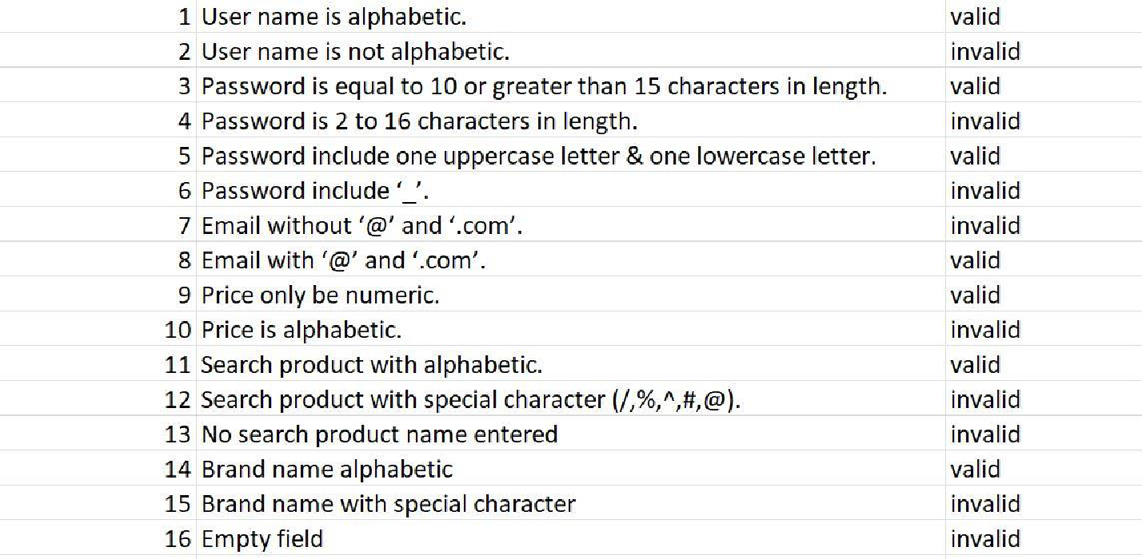

Boundary value analysis
Sr. |  | Partition 1 | Partition 2 | Partition 3
1. | Password | Less than 8 character | 1 – 8 character | 9 – 12
2. | Phone | <=0 | 1 - 11 | 9 – 12
Table 12: boundary analysis

Data flow testing

The relationship between one entity and another while performing a specific task in during data flow. Such as between the sign up and registration process etc.

Unit testing
In unit testing we have testified our different panel codes individually by performing different tests and by executing them individually, separately on different computers and they were successfully executed and they performed well.

Performance testing
In performance testing a particular certain situation is given to the website let’s just say a 100 users try to register at the same time so how the system recovers back gracefully with complete results. So according to our extracted results, around 100+ people were able to register in our website.

Stress Testing
Let’s say if 100 customers order at the same restaurants at the same time along with the same food level which increases the stress on the website at a maximum load how will the website will perform under these circumstances.
Activity | Description
Register | The user can register and save his/her information into the system
Login | The user can login using his/her credentials
Type of user | Upon registering, the user specifies which type of user they are
Manage profiles | The user can edit/disable their accounts
Browse Categories | The Investor can browse the profile of entrepreneur they want to invest them.
Search Profiles | The investor can search profiles based on the nearest
Call user | The user can call the phone number of the user
Send Notification | The Entrepreneur can send notification for possible ideas.
Add Reviews | The investor can add reviews concerning user
Confirm Ideas | The Investor can confirm receiving Ideas.
Check Notification | The Entrepreneur can check notifications for possible investment
Log out | The user can log out
Table 13: boundary analysis

Interface for Register:

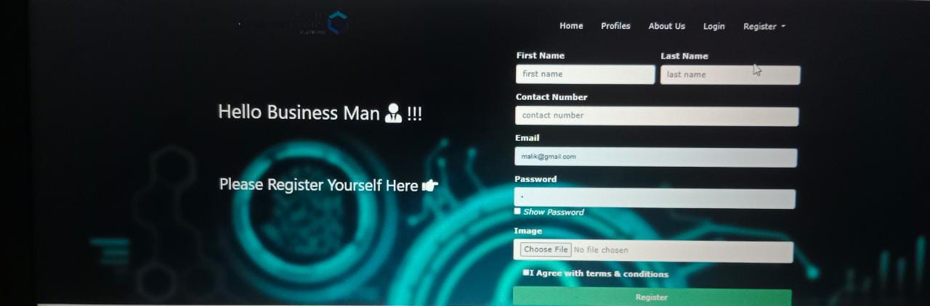
Fig 24 : User interface for register

Chapter 7

Summary, Conclusion and Future Enhancements

Chapter 7: Summary, Conclusion & Future Enhancements

Project Summary
The Entrepreneur and Investor Platform is a web application designed to connect entrepreneurs seeking funding with potential investors. The platform serves as a marketplace where entrepreneurs can showcase their business ideas, and investors can discover and invest in promising ventures. The goal of the platform is to facilitate meaningful connections and enable successful collaborations between entrepreneurs and investors.

Achievements and Improvements
Entrepreneurs and investors alike strive for various achievements and improvements. Entrepreneurs aim to launch successful businesses, achieve revenue and profit growth, expand into new markets, build a loyal customer base, innovate products or services, and demonstrate strong leadership. Improvements for entrepreneurs involve strategic planning, financial management, sales and marketing strategies, operational efficiency, risk management, networking, and fostering adaptability and innovation. On the other hand, investors seek achievements such as a diversified and successful investment portfolio, capital growth, outperforming market benchmarks, successful exits, impactful investments, and industry recognition. Investors can improve their skills through market research and analysis, due diligence, portfolio diversification, investment education, network building, risk management, and long-term planning. Both entrepreneurs and investors strive for continuous progress and success in their respective roles.

Critical Review
The critical element of our system is: Is our system is fast moving, give user friendly interface, not very costly, fulfill the specific requirements of the users at a runtime, has all the features which any organizations can require. To manage all these aspects, it took lot of time and hard work.

Lessons Learnt
We absorb very much from this project. This project sharpens our skills in html, CSS, JavaScript and a Visual studio many other tools and many management concepts as well as how to deal with a problem and how to stick for finding the solution of any problem until you fond. As well as technical skills this project also enhances our personal development skills such as team working, dedication.

Future Enhancements/Recommendations
As it has been already said, there is always room for further improvement. And since we plan to launch this website as our own startup, enhancements will keep coming.
The system has been built on react native, but at some point, we work on its efficiency, accessibility, flexibility, we are definitely going to scale it up which we believe ours is eventually going to become. We make it more user-friendly interface.

Appendices

Appendix A: User Manual
In this appendix section we describe the different phases of user interface and also describe how user can use our project
Appendix A: Admin
A.1. Login
User can login by entering name and password.

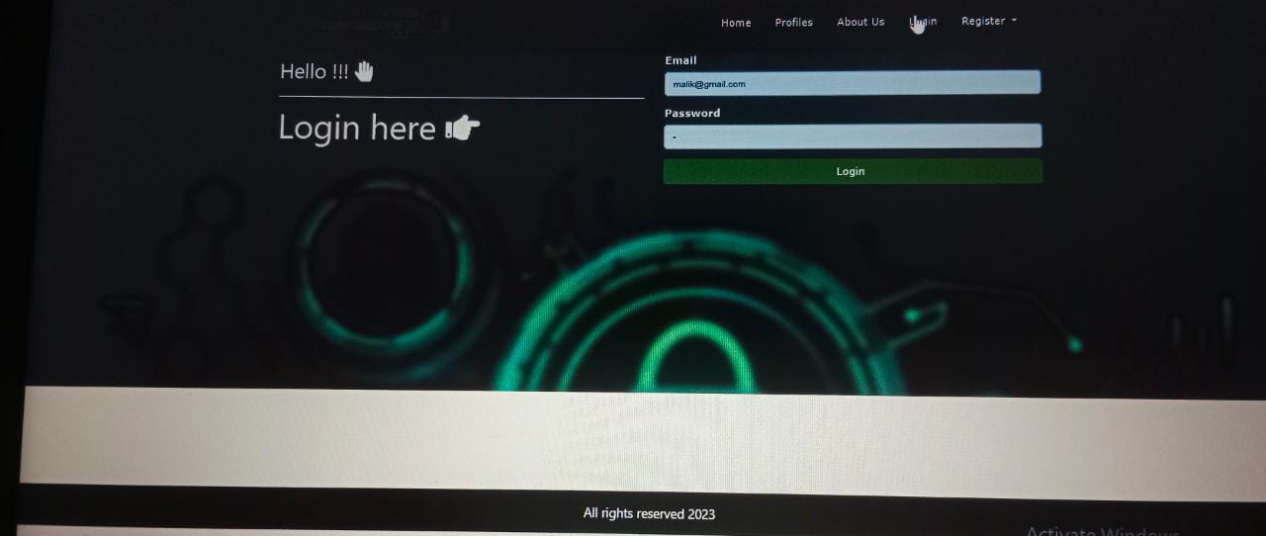

Fig 25: Login for Admin

A.1.2 Register
For entrepreneur and investor fills the registration form.in case if ser is not valid aur enter wrong name and password it will show an authentication warning.

Figure26: Register for both entrepreneur and investor

A.1.3 Select profile
Investor selects the Entrepreneur which he wants to select in idea profile.
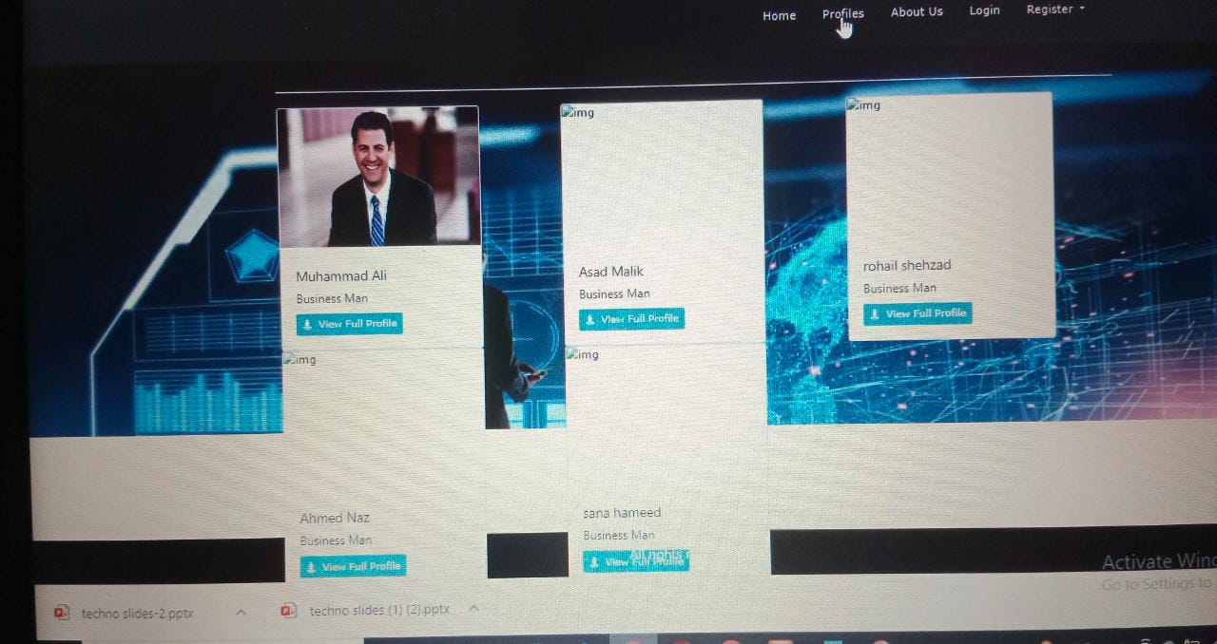
Figure27: selecting profile

Appendix B: Administrator Manual
In this appendix section we describe the different phases of admin interface and also describe how admin can manage the system.
  - Login
User can login by entering the password and username.

    - Admin
Admin can have a full of access and record of entrepreneur and investor.

