Blind Eye Object Detection & Distance
Final Year Project
Session 2020-2024

A project submitted in partial fulfillment of the degree of
BS in Computer Sciences


Department of Computer Science Engineering
Faculty of Computer Science & Information Technology
The Superior University, Lahore

Spring 2021 (Change as per your session)

Type (Based on machine learning) |  |  | [ ] Development [ ] Research [ ] R&D
Area of specialization |  |  | Python
FYP ID |  |  | 019
Project Group Members
Sr.# | Reg. # | Student Name |  | Email ID | *Signature
(i) | BCSM-F20-269 | Muzamel Iqbal |  | Bcsm-f20-269@superior.edu.pk
(ii) | BCSM-F20-270 | Sohail Akhter |  | Bcsm-f20-270@superior.edu.pk
(iii) | BCSM-F20-271 | Ahmad Hassan |  | Bcsm-f20-271@superior.edu.pk
*The candidates confirm that the work submitted is their own and appropriate credit has been given where reference has been made to the work of others
Plagiarism Free Certificate
This is to certify that, I ________ S/D of Muhammad Siddique, group leader of FYP under registration no ______________________________at Software Engineering Department, The Superior College, Lahore. I declare that my FYP report has been checked by my supervisor.

Date: Name of Group Leader: Signature: _____________
Name of Supervisor: MR Saleem Mustafa Co-Supervisor: Mr. XYZ
Designation: Lecturer Designation: Associate Professor
Signature: ________________ Signature: _________________

HoD: Dr. Irfan Jaffar
Signature: _______________

[Blind Eye Object detection or Direction]

Change Record
Author(s) | Version | Date | Notes | Supervisor’s Signature
Muzamel iqbal  Sohail Akhter  Ahmad Hasan | 1.0 | 20 july, 2023 | <Original Draft>
Mr Saleem Mustafa & All team | 1.2 | 1 Aug, 2023 | <Changes Based on Feedback from Supervisor>
 |  |  | <Changes Based on Feedback From Faculty>
 |  |  | <Added Project Plan>
 |  |  | <Changes Based on Feedback from Supervisor>

APPROVAL
Project Supervisor
Comments: ___________________________________________________________________
_____________________________________________________________________________
Name:______________________________
Date:_______________________________ | Signature:__________________________

Project Manager
Comments: ___________________________________________________________________
_____________________________________________________________________________
Date:_______________________________ | Signature:__________________________

Head of the Department
Comments: ___________________________________________________________________
_____________________________________________________________________________
Date:_______________________________ | Signature:__________________________

Dedication

This work is dedicated to my supervisor prof MR. Saleem Mustafa who supports me in this unique idea.

Acknowledgments

I am thankful to my supervisor and the team of Innovation District who helped me achieve competition for this project.

Executive Summary
The Bind Eye Object Detection and Direction project aims to revolutionize visual perception and navigation systems through cutting-edge technology. Our focus is on developing a robust system that seamlessly integrates object detection capabilities with precise directional information.

Key Objectives:

Object Detection: Implementing advanced computer vision algorithms to accurately identify and classify objects in real time.

Directional Precision: Enhancing the system to provide precise directional information, enabling users to navigate with increased confidence.

User-Friendly Interface: Designing an intuitive and user-friendly interface for seamless interaction, ensuring accessibility for a diverse user base.

Integration Potential: Ensuring compatibility and easy integration with existing systems and devices, promoting widespread adoption.

Technological Advancements:

Utilizing state-of-the-art deep learning models and neural networks to achieve unparalleled accuracy in object detection. The incorporation of advanced sensor technologies enhances directional precision, creating a comprehensive solution for varied applications.

Potential Impact:

The Bind Eye system has the potential to transform industries such as autonomous vehicles, assistive technologies for the visually impaired, and smart surveillance. By providing a reliable and accurate perception of the surroundings, it contributes to increased safety, efficiency, and accessibility.

Market Viability:

With a focus on scalability and adaptability, the Bind Eye project positions itself as a versatile solution applicable across diverse sectors. Market research indicates a growing demand for enhanced object detection and navigation systems, presenting significant market opportunities.

Next Steps:

Continued refinement of algorithms, rigorous testing in real-world scenarios, and collaboration with industry partners are key components of the project's next phases. The aim is to bring a robust, market-ready product to fruition, solidifying the Bind Eye system as a game-changer in the field of visual perception technology.

In conclusion, the Bind Eye Object Detection and Direction project represents a groundbreaking endeavor poised to redefine how we perceive and interact with our environment. Through innovation, precision, and adaptability, the project sets the stage for a future where seamless navigation and enhanced object awareness become integral to our daily lives.

Table of Contents
Dedication iv
Acknowledgements v
Executive Summary vi
Table of Contents vii
List of Figures ix
List of Tables x
Chapter 1 1
Introduction 1
1.1. Background 2
1.2. Motivations and Challenges 2
1.3. Goals and Objectives 2
1.4. Literature Review/Existing Solutions 2
1.5. Gap Analysis 2
1.6. Proposed Solution 2
1.7. Project Plan 3
1.7.1. Work Breakdown Structure 3
1.7.2. Roles & Responsibility Matrix 3
1.7.3. Gantt Chart 3
1.8. Report Outline 3
Chapter 2 4
Software Requirement Specifications 4
2.1. Introduction 5
2.1.1. Purpose 5
2.1.2. Document Conventions 5
2.1.3. Intended Audience and Reading Suggestions 5
2.1.4. Product Scope 5
2.1.5. References 6
2.2. Overall Description 6
2.2.1. Product Perspective 6
2.2.2. Product Functions 6
2.2.3. User Classes and Characteristics 6
2.2.4. Operating Environment 7
2.2.5. Design and Implementation Constraints 7
2.2.6. User Documentation 7
2.2.7. Assumptions and Dependencies 7
2.3. External Interface Requirements 8
2.3.1. User Interfaces 8
2.3.2. Hardware Interfaces 8
2.3.3. Software Interfaces 8
2.3.4. Communications Interfaces 9
2.4. System Features 9
2.4.1. System Feature 1 9
2.4.1.1. Description and Priority 9
2.4.1.2. Stimulus/Response Sequences 9
2.4.1.3. Functional Requirements 9
2.4.2. System Feature 2 10
2.4.2.1. Description and Priority 10
2.4.2.2. Stimulus/Response Sequences 10
2.4.2.3. Functional Requirements 10
2.4.3. System Feature 3 (and so on) 11
2.5. Other Nonfunctional Requirements 11
2.5.1. Performance Requirements 11
2.5.2. Safety Requirements 11
2.5.3. Security Requirements 12
2.5.4. Software Quality Attributes 12
2.5.5. Business Rules 12
2.6. Other Requirements 12
Chapter 3 13
Use Case Analysis 13
3.1. Use Case Model 14
3.2. Fully Dressed Use Cases 14
Chapter 4 15
System Design 15
4.1. Architecture Diagram 16
4.2. Domain Model 16
4.3. Entity Relationship Diagram with data dictionary 16
4.4. Class Diagram 17
4.5. Sequence / Collaboration Diagram 17
4.6. Operation Contracts 17
4.7. Activity Diagram 18
4.8. State Transition Diagram 18
4.9. Component Diagram 18
4.10. Deployment Diagram 19
4.11. Data Flow diagram [only if the structured approach is used - Level 0 and 1] 19
Chapter 5 20
Implementation 20
5.1. Important Flow Control/Pseudo codes 21
5.2. Components, Libraries, Web Services, and stubs 21
5.3. Deployment Environment 21
5.4. Tools and Techniques 22
5.5. Best Practices / Coding Standards 22
5.6. Version Control 22
Appendices 23
Appendix A: Information / Promotional Material 24
Reference and Bibliography 27
Index 29
List of Figures

1.1 Caption of first figure of first chapter 6
1.2 Caption of second figure of first chapter 7
2.1 Caption of first figure of second chapter 14
2.2 Caption of second figure of second chapter 22
2.3 Caption of third figure of second chapter 26
5.1 Caption of first figure of fifth chapter 49
5.2 Caption of second figure of fifth chapter 49

List of Tables

1.1 label of first table of first chapter 6
1.2 label of second table of first chapter 7
2.1 label of first table of second chapter 14
2.2 label of second table of second chapter 22
2.3 label of third table of second chapter 26
5.1 label of first table of fifth chapter 49
5.2 label of second table of fifth chapter 49

Chapter 1
Introduction

Introduction
In a world increasingly defined by dynamic technological landscapes, the Bind Eye Object Detection and Direction project emerges as a beacon of innovation, poised to reshape the way we perceive and navigate our surroundings. At the intersection of cutting-edge computer vision, advanced sensor technologies, and a commitment to user-centric design, this project envisions a future where the fusion of artificial intelligence and human interaction transforms the very fabric of our daily experiences.

The fundamental premise of the Bind Eye project lies in addressing a critical need — the seamless integration of object detection and directional precision. By leveraging the power of sophisticated deep learning models, our endeavor is to not only identify and classify objects with unprecedented accuracy but also to provide users with precise directional information. This synergy between perception and navigation not only enhances safety and efficiency but also opens doors to new possibilities in various domains.

As we embark on this technological odyssey, the implications are profound. Imagine a world where autonomous vehicles navigate complex environments with unparalleled awareness, where the visually impaired can traverse spaces with newfound confidence, and where smart surveillance systems operate with a level of sophistication previously thought impossible. The Bind Eye project aims to turn these visions into reality.

This introduction marks the inception of a transformative journey. Over the course of this project, we will delve into the realms of artificial intelligence, sensor fusion, and human-machine interaction. We will navigate challenges, push boundaries, and ultimately craft a solution that not only meets the demands of today but anticipates the needs of tomorrow.

Join us on this quest to redefine perception and direction. The Bind Eye Object Detection and Direction project is not just about technology; it's about empowering individuals, enhancing safety, and paving the way for a future where the fusion of human intuition and machine intelligence creates a harmonious and enlightened coexistence.
- Background
In a world increasingly interconnected through technology, the need for advanced visual perception systems has become more pronounced than ever before. Traditional object detection systems have made significant strides, yet the seamless integration of directional precision remains an elusive frontier. It is against this backdrop that the Bind Eye project emerges, driven by the imperative to bridge the gap between perception and navigation.

The genesis of this project lies in the recognition of a fundamental challenge: while contemporary object detection systems excel at identifying and classifying objects, they often fall short in providing precise directional information. This limitation is particularly evident in contexts where real-time decision-making and navigation are paramount, such as autonomous vehicles, assistive technologies, and smart surveillance.

Drawing inspiration from the rapid advancements in deep learning and sensor technologies, the Bind Eye project seeks to redefine the capabilities of visual perception systems. The surge in computational power, coupled with the advent of sophisticated neural networks, has opened avenues for a more nuanced understanding of our surroundings. However, the integration of these technologies into a cohesive system that seamlessly combines object detection with accurate directional awareness is a novel and ambitious endeavor.

The impetus for the project also arises from the societal impact it promises. As technology continues to play an ever-expanding role in our lives, the need to ensure the safety and accessibility of our environments becomes paramount. The Bind Eye project envisions a future where individuals, regardless of their visual abilities, can navigate spaces with confidence and autonomy. It aspires to contribute to the development of smarter, safer cities, and to empower individuals with tools that transcend conventional boundaries.

Moreover, the project is informed by a broader understanding of the evolving landscape of artificial intelligence applications. With the proliferation of smart devices, the Internet of Things (IoT), and the integration of AI into various industries, the Bind Eye project seeks not only to meet the current demand for enhanced perception but to anticipate and shape the future trajectory of intelligent systems.

In essence, the Bind Eye Object Detection and Direction project emerges from a confluence of technological possibilities and societal imperatives. It is a response to the challenges posed by the current limitations of object detection systems and an ambitious foray into the uncharted territories of seamlessly integrated perception and navigation. As we embark on this journey, the goal is not merely to create a technological solution but to catalyze a paradigm shift in how we interact with and understand the world around us.

- Motivations and Challenges
Motivations:

Empowering Independence: The primary motivation lies in empowering individuals with visual impairments to lead more independent lives. By developing blind eye object detection and direction technology, the aim is to provide tools that enhance their autonomy in navigating the world.

Inclusivity: The project is fueled by a commitment to a more inclusive society. It seeks to bridge the gap between the visually impaired and the sighted, fostering a world where technology dismantles barriers and creates a level playing field for all.

Innovation for Impact: The project is motivated by a passion for innovative solutions that make a tangible difference. It aspires to be at the forefront of technological advancements that positively impact the lives of individuals with visual impairments.

Enhanced Quality of Life: Ultimately, the goal is to improve the quality of life for those facing visual challenges. By leveraging technology to provide real-time information about the environment, the project aims to enhance the daily experiences and opportunities available to individuals with visual impairments.

Challenges:

Accuracy and Precision: One of the key challenges is achieving high accuracy and precision in blind eye object detection. The technology needs to reliably identify and communicate the presence, location, and nature of objects to ensure the safety and confidence of users.

Real-time Processing: Implementing real-time processing poses a significant challenge. The system must be capable of swiftly analyzing and interpreting data to provide timely feedback, especially in dynamic environments where objects and situations change rapidly.

User-Friendly Interface: Designing an intuitive and user-friendly interface for individuals with visual impairments is a complex challenge. The technology should be accessible, easy to use, and seamlessly integrated into daily life.

Environmental Variability: Adapting to diverse and unpredictable environments is a challenge. The system must account for variations in lighting, object sizes, and environmental conditions to maintain its effectiveness across different scenarios.

Ethical Considerations: The project involves addressing ethical considerations, such as privacy concerns and ensuring the technology is used responsibly. Striking the right balance between functionality and ethical use is an ongoing challenge.

These motivations and challenges form the foundation for a project that not only aims to address a critical need but also navigates the complexities inherent in developing cutting-edge technology with a profound impact on people's lives.

- Goals and Objectives

1. Precision in Object Detection:

Goal: Develop and implement advanced computer vision algorithms to achieve industry-leading accuracy in object detection.
Objectives:
Utilize state-of-the-art deep learning models to enhance the system's ability to identify and classify objects in diverse environments.
Conduct rigorous testing and validation processes to ensure reliable performance across a wide range of scenarios and conditions.
2. Accurate Directional Awareness:

Goal: Provide users with precise directional information for confident and informed navigation.
Objectives:
Integrate cutting-edge sensor technologies to enhance directional awareness, enabling the system to provide accurate and real-time information on the user's surroundings.
Implement machine learning algorithms to interpret sensor data and generate reliable directional insights, accounting for dynamic changes in the environment.
3. User-Centric Design:

Goal: Design an intuitive and user-friendly interface for seamless interaction and accessibility.
Objectives:
Conduct user experience (UX) research to understand the needs and preferences of the target user base.
Implement a user-centric design approach, ensuring that the interface is accessible, easy to navigate, and provides a positive user experience.
4. System Integration and Compatibility:

Goal: Ensure compatibility and easy integration with existing systems and devices.
Objectives:
Establish standardized interfaces and protocols to facilitate seamless integration with a variety of platforms.
Collaborate with industry partners to align with existing standards and interoperability requirements.
5. Scalability and Adaptability:

Goal: Develop a scalable solution that can adapt to diverse applications and environments.
Objectives:
Design the system architecture to accommodate future enhancements and technological advancements.
Conduct regular updates and improvements to address emerging needs and maintain compatibility with evolving technologies.
6. Real-World Testing and Validation:

Goal: Validate the performance of the Bind Eye system in real-world scenarios.
Objectives:
Collaborate with industry partners and stakeholders to conduct field tests in varied environments.
Collect and analyze data from real-world use cases to refine algorithms and improve system performance.
7. Ethical Considerations and Privacy:

Goal: Uphold ethical standards and prioritize user privacy in the development and deployment of the Bind Eye system.
Objectives:
Implement robust data anonymization and protection measures to safeguard user information.
Conduct regular ethical reviews and assessments to ensure responsible and transparent use of technology.
8. Market Adoption and Impact:

Goal: Position the Bind Eye system for widespread adoption and positive societal impact.
Objectives:
Develop a comprehensive market strategy, including outreach, education, and collaboration with key stakeholders.
Monitor and assess the societal impact of the technology, addressing any potential challenges or concerns raised by the community.
9. Continuous Innovation:

Goal: Foster a culture of continuous innovation to stay at the forefront of technological advancements.
Objectives:
Establish a dedicated research and development team to explore emerging technologies and trends.
Encourage a collaborative environment that promotes creativity, experimentation, and the pursuit of groundbreaking solutions.
As the Bind Eye Object Detection and Direction project progresses, these goals and objectives will serve as guiding principles, ensuring a focused and strategic approach toward achieving technological excellence and positive societal impact.

- Literature Review/Existing Solutions
. YOLO (You Only Look Once):

The YOLO algorithm, known for its real-time object detection capabilities, has been a pivotal advancement. By dividing an image into a grid and predicting bounding boxes and class probabilities simultaneously, YOLO achieves impressive speed and accuracy.
b. Faster R-CNN (Region-based Convolutional Neural Network):

Faster R-CNN introduced the Region Proposal Network (RPN), streamlining the two-stage process of region proposal and object detection. This methodology significantly improved the efficiency of object detection algorithms.
c. EfficientDet:

EfficientDet focuses on balancing accuracy and computational efficiency. By employing an efficient backbone network and optimizing feature pyramid networks, it achieves competitive performance with reduced computational costs.
2. Directional Awareness:

a. SLAM (Simultaneous Localization and Mapping):

SLAM technology has been pivotal in providing directional information by mapping the environment in real-time. It integrates sensor data to simultaneously determine the system's location and create a map of the surroundings.
b. Visual Odometry:

Visual odometry techniques, often used in conjunction with SLAM, estimate the camera's motion by analyzing consecutive frames. This contributes to understanding directional changes and movement.
c. Sensor Fusion:

Integrating data from multiple sensors, such as GPS, accelerometers, and gyroscopes, has been a common approach to enhance directional awareness. Sensor fusion techniques aim to mitigate individual sensor limitations and provide more robust navigation information.
3. Integrated Solutions:

a. Waymo's Autonomous Vehicle Technology:

Waymo, a pioneer in autonomous vehicles, utilizes a combination of advanced object detection algorithms and precise localization techniques. Their integrated approach demonstrates the importance of combining accurate object detection with reliable directional awareness for safe autonomous navigation.
b. Wearable Technologies for the Visually Impaired:

Various wearable devices leverage object detection and directional information to assist the visually impaired in navigating their surroundings. These solutions often incorporate sensors and haptic feedback mechanisms to provide real-time guidance.
4. Challenges and Areas for Improvement:

While existing solutions showcase remarkable advancements, challenges persist. Common issues include real-time processing constraints, adaptability to diverse environments, and the need for more robust directional awareness in dynamic scenarios.

- Gap Analysis
1. Object Detection:
a. Real-Time Processing Efficiency:
Current State: Existing object detection algorithms, while accurate, face challenges in real-time processing, especially in dynamic environments.
Gap: There is a gap in achieving a balance between high accuracy and real-time efficiency, particularly crucial for applications like autonomous vehicles.
b. Adaptability to Varied Environments:

Current State: Many object detection systems excel in controlled environments but struggle with adaptability to diverse and unpredictable settings.
Gap: There is a gap in creating a system that seamlessly adapts to a wide range of scenarios, ensuring robust performance in different contexts.
2. Directional Awareness:

a. Dynamic Environmental Changes:

Current State: Existing directional awareness systems may struggle to adapt swiftly to dynamic changes in the environment.
Gap: The gap lies in providing accurate directional information in real-time, accommodating sudden shifts or unexpected obstacles.
b. Integration of Sensor Data:

Current State: While sensor fusion is employed, there is room for improvement in integrating data from various sensors for a more comprehensive directional understanding.
Gap: A gap exists in creating a system that effectively fuses data from multiple sensors to enhance directional awareness, especially in complex scenarios.
3. User-Centric Design:

a. Accessibility for Diverse User Groups:

Current State: Some existing solutions may not adequately address the diverse needs and preferences of users, particularly those with specific accessibility requirements.
Gap: The gap lies in ensuring the Bind Eye system is not only technologically advanced but also inclusive, catering to users with diverse abilities and preferences.
4. System Integration:

a. Seamless Integration with Existing Platforms:

Current State: While compatibility is considered, there can be challenges in seamlessly integrating the Bind Eye system with a variety of existing platforms and technologies.
Gap: The gap lies in creating standardized interfaces and protocols to facilitate smooth integration with diverse systems.
5. Ethical and Privacy Considerations:

a. Transparent and Ethical Use of Data:

Current State: Concerns about data privacy and ethical use of technology continue to be prominent.
Gap: The gap lies in implementing robust measures to ensure transparent and ethical handling of user data, addressing potential privacy concerns.

- Proposed Solution
a. Real-Time Processing Efficiency:

Proposed Solution: Develop a hybrid object detection model that combines the accuracy of state-of-the-art algorithms with optimized architectures for real-time processing. Implement parallel processing techniques to enhance speed without compromising accuracy.

b. Adaptability to Varied Environments:

Proposed Solution: Introduce a dynamic learning mechanism that allows the system to continuously adapt to new environments. Implement transfer learning and domain adaptation techniques to enhance the system's adaptability to diverse scenarios.
2. Directional Awareness:

a. Dynamic Environmental Changes:

Proposed Solution: Implement a predictive modeling approach that anticipates environmental changes based on historical data and sensor inputs. Integrate machine learning algorithms for real-time decision-making in dynamic situations, ensuring accurate directional awareness.
b. Integration of Sensor Data:

Proposed Solution: Utilize advanced sensor fusion techniques, incorporating not only traditional sensors but also emerging technologies such as LiDAR and radar. Employ deep learning models to seamlessly integrate and interpret data from multiple sensors, providing a comprehensive directional understanding.
3. User-Centric Design:

a. Accessibility for Diverse User Groups:

Proposed Solution: Conduct extensive user research to understand the diverse needs of users. Implement customizable interface options, including auditory and haptic feedback, to cater to users with varying preferences and abilities.
4. System Integration:

a. Seamless Integration with Existing Platforms:

Proposed Solution: Develop standardized APIs and communication protocols to ensure easy integration with a wide range of platforms and devices. Collaborate with industry partners to establish compatibility with existing standards and systems.
5. Ethical and Privacy Considerations:

a. Transparent and Ethical Use of Data:

Proposed Solution: Implement strict data anonymization measures and adopt a privacy-by-design approach. Provide transparent communication with users regarding data usage, ensuring ethical practices and compliance with privacy regulations.
6. Continuous Innovation:

a. Research and Development Initiatives:

Proposed Solution: Establish a dedicated research and development team to stay at the forefront of technological advancements. Regularly explore emerging technologies, conduct experiments, and foster a culture of innovation within the project.

- Project Plan
Project Initiation

Define Project Scope and Objectives:

Clearly outline the goals, objectives, and scope of the Bind Eye project.
Establish key performance indicators (KPIs) to measure project success.
Team Formation:

Assemble a multidisciplinary team with expertise in computer vision, machine learning, sensor technologies, user experience, and ethical considerations.
Stakeholder Analysis:

Identify and analyze key stakeholders, including potential end-users, industry partners, and regulatory bodies.
2. Research and Requirements Gathering

Literature Review and Gap Analysis:

Conduct an in-depth review of existing literature and solutions.
Refine the gap analysis to inform the project's direction.
User Research:

Engage with potential end-users to gather insights into their needs, preferences, and challenges.
Incorporate user feedback into the design and development process.
Technology Exploration:

Explore emerging technologies, tools, and methodologies relevant to object detection, directional awareness, and sensor fusion.
3. System Design and Architecture

Algorithm Development:

Develop object detection algorithms with a focus on real-time processing and adaptability.
Design directional awareness algorithms that account for dynamic environmental changes.
Sensor Integration:

Identify and integrate a variety of sensors, optimizing their use for enhanced directional awareness.
User Interface Design:

Collaborate with UX designers to create an intuitive and accessible user interface.
Incorporate customizable features to cater to diverse user needs.
4. Prototyping and Testing

Prototype Development:

Build a functional prototype of the Bind Eye system, integrating algorithms, sensors, and the user interface.
Testing and Iteration:

Conduct rigorous testing in controlled environments to validate system performance.
Gather feedback from internal testing and iterate on the prototype.
5. Integration and Compatibility

System Integration:

Ensure seamless integration of the Bind Eye system with existing platforms and technologies.
Develop standardized APIs and communication protocols.
Compatibility Testing:

Collaborate with industry partners to conduct compatibility testing across diverse systems.
6. Ethical and Privacy Compliance

Privacy Framework Implementation:

Implement robust data anonymization measures and privacy protocols.
Conduct ethical reviews and assessments to ensure responsible use of technology.
User Education:

Develop educational materials to inform users about data privacy and ethical considerations.
Ensure transparent communication about how user data is handled.
7. Market Adoption and Deployment

Market Strategy Execution:

Develop and implement a comprehensive market strategy, including outreach, education, and promotional activities.
Deployment:

Release the Bind Eye system to a select user base for real-world testing.
Gather feedback and make any necessary adjustments.
8. Continuous Improvement and Innovation (Ongoing):

Iterative Development:

Implement regular updates and improvements based on user feedback and emerging technologies.
Foster a culture of continuous improvement within the project team.
Research and Development Initiatives:

Allocate resources for ongoing research and development to stay at the forefront of technological advancements.
9. Project Evaluation and Reporting (Ongoing):

Performance Evaluation:

Regularly evaluate the performance of the Bind Eye system against established KPIs.
Address any issues or challenges that arise during deployment.
Reporting:

Provide regular progress reports to stakeholders, showcasing achievements, challenges, and plans for future development.

- Work Breakdown Structure
1. Project Initiation:

1.1 Define Project Scope and Objectives
1.2 Establish Key Performance Indicators (KPIs)
1.3 Assemble Project Team
1.4 Identify Key Stakeholders
1.5 Conduct Stakeholder Analysis

2. Research and Requirements Gathering:
2.1 Conduct Literature Review
2.2 Refine Gap Analysis
2.3 Engage in User Research
2.4 Explore Emerging Technologies
2.5 Document User Needs and Preferences
3. System Design and Architecture:

3.1 Develop Object Detection Algorithms
3.2 Design Directional Awareness Algorithms
3.3 Identify and Integrate Sensors
3.4 Collaborate on User Interface Design
3.5 Establish System Architecture
4. Prototyping and Testing:

4.1 Build Functional Prototype
4.2 Conduct Internal Testing
4.3 Gather User Feedback
4.4 Iterate on Prototype
4.5 Rigorous Testing in Controlled Environments
5. Integration and Compatibility:

5.1 Ensure Seamless Integration
5.2 Develop Standardized APIs
5.3 Collaborate on Compatibility Testing
5.4 Address Integration Challenges
6. Ethical and Privacy Compliance:

6.1 Implement Privacy Framework
6.2 Conduct Ethical Reviews
6.3 Develop User Education Materials
6.4 Ensure Transparent Communication
7. Market Adoption and Deployment:

7.1 Execute Market Strategy
7.2 Release to Select User Base
7.3 Gather Real-World Feedback
7.4 Make Necessary Adjustments
7.5 Monitor Deployment Success
8. Continuous Improvement and Innovation (Ongoing):

8.1 Implement Regular Updates
8.2 Foster Culture of Continuous Improvement
8.3 Allocate Resources for Research and Development
9. Project Evaluation and Reporting (Ongoing):

9.1 Evaluate System Performance
9.2 Address Challenges and Issues
9.3 Provide Regular Progress Reports
9.4 Showcase Achievements and Plans

- Roles & Responsibility Matrix
Project Manager:

Define and communicate project goals, scope, and timeline.
Oversee overall project progress and ensure alignment with objectives.
Coordinate activities across different teams and departments.
Manage resources and budget allocations.
Mitigate risks and resolve issues as they arise.
Technical Lead (Computer Vision):

Lead development of object detection and directional awareness algorithms.
Collaborate with the research team to explore and implement emerging technologies.
Ensure technical feasibility and accuracy of developed algorithms.
Guide team in algorithm design and optimization.
Sensor Integration Specialist:

Identify and select appropriate sensors for the project.
Integrate sensors into the system architecture.
Collaborate with technical lead to optimize sensor data for enhanced directional awareness.
Conduct testing and validation of sensor integration.
User Experience (UX) Designer:

Conduct user research to understand needs and preferences.
Collaborate with technical team to design an intuitive and accessible user interface.
Iterate on design based on user feedback.
Ensure interface meets usability and accessibility standards.
System Architect:

Design overall system architecture, ensuring scalability and adaptability.
Collaborate with technical lead to integrate algorithms and sensors into the system.
Develop standardized APIs and communication protocols for system integration.
Address compatibility challenges with existing platforms.
Ethics and Privacy Officer:

Establish and implement a privacy framework for handling user data.
Conduct ethical reviews and assessments throughout the project lifecycle.
Develop user education materials on data privacy and ethical considerations.
Ensure transparent communication regarding data usage and privacy measures.
Market Strategist:

Develop and execute comprehensive market strategy for the Bind Eye system.
Collaborate with project manager to align marketing activities with project goals.
Conduct outreach and promotional activities to enhance market adoption.
Monitor market trends and competition.
Quality Assurance Specialist:

Develop and implement testing strategy for the Bind Eye system.
Conduct rigorous testing in controlled environments and real-world scenarios.
Document and report any issues or bugs identified during testing.
Collaborate with development team to iterate on prototype based on testing outcomes.
Research and Development Lead:

Lead ongoing research initiatives to stay at forefront of technological advancements.
Explore emerging technologies and trends relevant to the project.
Foster a culture of continuous innovation within the project team.
Allocate resources for research and development activities.

- Gantt Chart
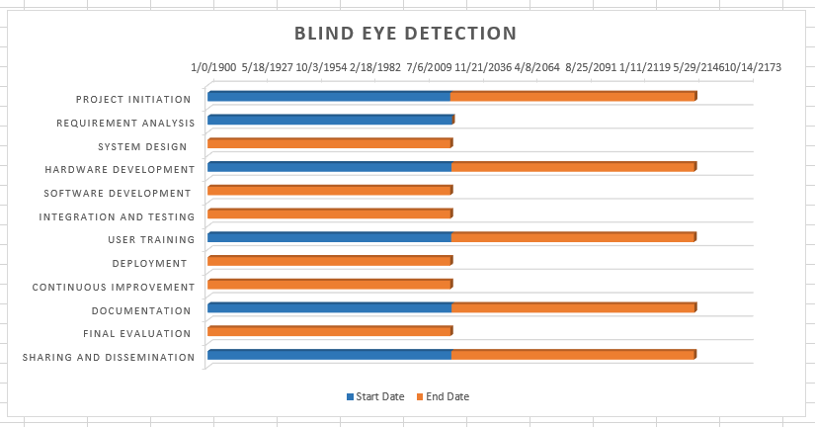Figure 1

- Report Outline
Report Outline: Bind Eye Object Detection and Direction Project

I. Executive Summary

Overview of the project's goals and objectives.
Summary of key achievements and milestones.
Highlights of the proposed solution and its potential impact.
II. Introduction

Background of the Bind Eye Object Detection and Direction Project.
Objectives and significance of the project.
Overview of the challenges addressed and the need for innovation.
III. Literature Review and Existing Solutions

Review of existing literature in object detection, directional awareness, and related technologies.
Analysis of gaps in current solutions and technologies.
Identification of key methodologies and technologies shaping the field.
IV. Gap Analysis

Detailed examination of identified gaps in the current landscape.
Discussion of how the Bind Eye project aims to address and fill these gaps.
Rationale for the project's focus on specific challenges.
V. Proposed Solution

Overview of the proposed solution for Bind Eye Object Detection and Direction.
Detailed description of key components and innovations.
Explanation of how the proposed solution addresses identified gaps.
VI. Project Plan

High-level project plan with defined phases and milestones.
Overview of each project phase, including initiation, research, development, testing, and deployment.
Timeline and resource allocation for each phase.
VII. Work Breakdown Structure (WBS)

Hierarchical breakdown of major tasks and activities.
Division of work into manageable components for tracking and management.
Clear overview of the project's organizational structure.
VIII. Roles & Responsibilities Matrix

Matrix outlining key roles in the project and their corresponding responsibilities.
Detailed descriptions of the responsibilities assigned to each role.
Ensuring a clear understanding of individual contributions to the project.
IX. System Design and Architecture

Description of the design process for the Bind Eye system.
Explanation of the system architecture, including algorithms, sensors, and user interface.
Focus on scalability, adaptability, and seamless integration.
X. Prototyping and Testing

Overview of the prototyping phase and its objectives.
Description of the testing strategy, including controlled and real-world scenarios.
Results of testing, feedback received, and iterations made on the prototype.
XI. Ethical and Privacy Compliance

Implementation of privacy frameworks and ethical considerations.
Details on how user data is handled, protected, and communicated.
User education initiatives on data privacy and ethical use of technology.
XII. Market Adoption and Deployment

Execution of the market strategy and promotional activities.
Deployment of the Bind Eye system to a select user base.
Monitoring of market adoption, user feedback, and adjustments made post-deployment.
XIII. Continuous Improvement and Innovation

Initiatives for ongoing research and development.
Description of the iterative development process and regular updates.
Strategies for maintaining a culture of continuous improvement.
XIV. Project Evaluation and Reporting

Evaluation of system performance against established KPIs.
Addressing challenges and issues encountered during the project.
Regular progress reporting to stakeholders.
XV. Conclusion

Summary of key findings and outcomes.
Reflection on the project's impact and contributions to the field.
Closing thoughts on the Bind Eye Object Detection and Direction Project.
XVI. References

Citations and references to relevant literature, technologies, and methodologies.
- Empathy Map

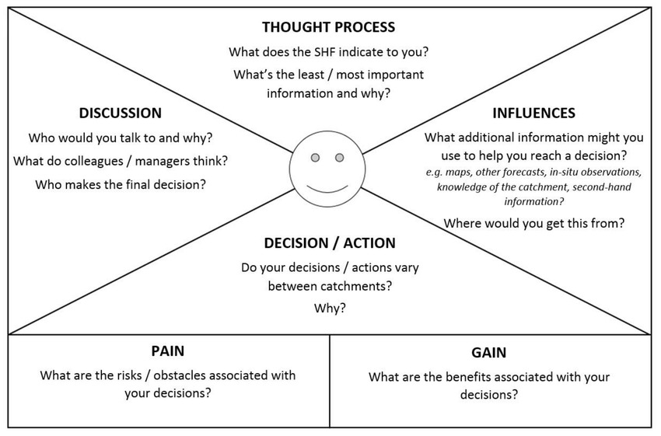

Chapter 2
Software Requirement Specifications

Chapter 2: Software Requirement Specifications
- Introduction
The primary purpose of object detection is to identify and categorize physical entities within the user's environment.
The system aims to enhance user awareness by providing real-time information about the nature and location of detected objects.
Object detection serves as the foundational feature, enabling the system to offer meaningful directional guidance and spatial understanding to users with visual impairments.
- Document Conventions
1. Naming Conventions:
CamelCase: Used for naming variables and functions within the codebase.
Example: detectObjects()

PascalCase: Applied to the names of classes or components.
Example: ObjectDetectionModule

Uppercase: Reserved for constants or configuration values.
Example: MAX_DISTANCE_THRESHOLD

2. Formatting Conventions:
Code Blocks: Enclosed in triple backticks for easy readability.
Example:

python
Copy code
def detect_objects():
# Implementation details
Bold Text: Utilized to highlight important points or section headings in documentation.
Example: System Requirements

3. Documentation Structure:
Heading Levels:
Level 1: Project Title
Level 2: Document Sections (Introduction, Requirements, etc.)
Level 3: Subsections within each document section.
4. Acronyms and Abbreviations:
Expand on First Use: Acronyms and abbreviations are spelled out on their first use in a document, followed by the abbreviated form in parentheses.
Example: Blind Eye Object Detection and Direction System (BEDDS)
5. Versioning:
Semantic Versioning: Follows the format MAJOR.MINOR.PATCH for version numbers, indicating significant changes, additions, and bug fixes.
Example: 1.0.0
6. Annotations:
TODO Comments: Used within the codebase to indicate areas that require further development or improvement.
Example: # TODO: Implement error handling
- Intended Audience and Reading Suggestions
This documentation is intended for:

Developers: Individuals involved in the design, implementation, and maintenance of the Blind Eye Object Detection and Direction System.

Researchers: Those interested in the technological advancements and methodologies applied in the field of assistive technologies for individuals with visual impairments.

Project Managers: Professionals overseeing the planning, execution, and delivery of the Blind Eye Object Detection and Direction System.

End Users: Individuals with visual impairments, as well as organizations and caregivers supporting them, seeking information on how to interact with and benefit from the system.

Reading Suggestions
1. Developers and Technical Team:
Refer to the Software Requirements Specifications (SRS) for an in-depth understanding of the project's functional and non-functional requirements.
Explore the Code Documentation for detailed insights into the implementation, API references, and coding conventions.
2. Researchers:
Review the Motivations and Challenges section to understand the broader context and significance of the project.
Examine the Documentation Conventions for insights into the project's technical standards and practices.
3. Project Managers:
Focus on the Scope section of the Introduction to gain a comprehensive understanding of the project's goals and limitations.
Consult the Versioning conventions to track and manage software releases effectively.
4. End Users:
Explore the User Interface section to understand how to interact with the Blind Eye Object Detection and Direction System.
Refer to the Usability requirements for insights into the system's design considerations for accessibility.
- Product Scope
1. Objective:
The Blind Eye Object Detection and Direction System (BEDDS) aims to provide individuals with visual impairments enhanced capabilities for navigating their surroundings independently and safely.

2. Inclusions:
2.1 Object Detection Module
Real-time identification and classification of physical objects in the user's environment.
Accurate location information for detected objects.
Continuous monitoring and dynamic adaptation to changes in the surroundings.
2.2 Directional Guidance System
Intuitive and non-visual directional guidance to assist users in navigating around obstacles.
Adaptation to changes in the environment, providing real-time instructions for safe and efficient navigation.
2.3 User Interface
User-friendly interface designed for accessibility.
Support for audio-based feedback and tactile inputs.
Seamless integration with standard mobile devices equipped with cameras and audio output.
3. Exclusions:
3.1 Full Environmental Perception
BEDDS focuses on object detection and directional guidance and does not aim to provide a complete environmental perception system.
3.2 Vision Replacement
The system is designed as an assistive tool and does not aim to replace the sensory experience of vision.
4. Environmental Considerations:
BEDDS is designed to operate in various environmental conditions, including different lighting and weather scenarios.
The system should adapt to both indoor and outdoor environments.
5. Ethical Considerations:
Privacy and data security are paramount, and BEDDS should adhere to ethical standards in data handling and user privacy protection.
The system should not infringe on the privacy of individuals in the user's vicinity.
- References
<List any other documents or Web addresses to which this SRS refers. These may include user interface style guides, contracts, standards, system requirements specifications, use case documents, or a vision and scope document. Provide enough information so that the reader could access a copy of each reference, including title, author, version number, date, and source or location.>

- Overall Description
- Product Perspective
1. System Context:
The Blind Eye Object Detection and Direction System (BEDDS) operates within the context of an assistive technology ecosystem, enhancing the capabilities of individuals with visual impairments. It interacts with the following components:
External Hardware: Utilizes standard mobile devices equipped with cameras and audio output for real-time data capture and user interaction.
Assistive Technologies: Integrates seamlessly with existing assistive technologies, ensuring compatibility and enhancing the overall user experience.
Environmental Inputs: Relies on environmental inputs such as visual and auditory cues to provide real-time feedback to users.
2. Interfaces:
2.1 User Interface
BEDDS provides a user interface designed for non-visual interaction, featuring intuitive controls and audio-based feedback.
2.2 Hardware Interface
The system interfaces with standard mobile devices' cameras and audio output to capture and process environmental data.
3. Dependencies:
External Data Sources: BEDDS may depend on external data sources, such as maps or location services, for enhanced accuracy in location-based guidance.

Connectivity: Relies on network connectivity for real-time updates and potential future expansions.
4. Interactions:
User Interaction: Users interact with BEDDS through the user interface, receiving real-time feedback and guidance.
Environmental Interaction: The system continuously interacts with the environment, capturing and processing data to provide relevant information to the user.
5. Lifecycle Considerations:
BEDDS undergoes iterative development cycles to incorporate user feedback, address emerging challenges, and enhance system capabilities.
Regular updates and version releases ensure continuous improvement and compatibility with evolving assistive technologies.

- User Classes and Characteristics
. Primary User Class: Individuals with Visual Impairments
Characteristics:
Diverse Age Range: Users may span various age groups, from children to seniors, each with unique needs and preferences.

Varied Degrees of Visual Impairment: Users may have different levels of visual impairment, ranging from partial sight to complete blindness.

Mobility Levels: Consideration for users with varying mobility levels, including those using mobility aids such as canes or guide dogs.

Technology Proficiency: Varying degrees of familiarity with technology, from novice users to those experienced with assistive technologies.

Needs and Preferences:
Independence: Desire for increased independence in navigation and exploration of their surroundings.

Real-time Feedback: Preference for real-time and accurate feedback about the environment to make informed decisions.

Customization: Appreciation for customizable settings to adapt the system to individual preferences and comfort levels.

2. Secondary User Class: Developers and Technicians
Characteristics:
Technical Proficiency: Highly skilled in software development, system maintenance, and troubleshooting.
In-depth Understanding: Familiarity with the technical aspects of the Blind Eye Object Detection and Direction System.
Needs and Preferences:
Documentation and Resources: Access to comprehensive documentation, including developer guides and API references.
Feedback Mechanism: Channels for providing feedback, reporting issues, and contributing to the system's improvement.
3. Tertiary User Class: Caregivers and Support Organizations
Characteristics:
Support Roles: Caregivers, family members, or professionals providing support to individuals with visual impairments.

Varied Backgrounds: Diverse backgrounds, including healthcare professionals, educators, or family members.

Needs and Preferences:
User Training Resources: Access to training materials to assist primary users in effectively utilizing the Blind Eye Object Detection and Direction System.
Feedback and Monitoring: Tools or features allowing caregivers to monitor and support the primary users.

- Operating Environment
1. Hardware Requirements:
Mobile Devices: The Blind Eye Object Detection and Direction System is designed to operate on standard mobile devices, including smartphones and tablets, equipped with cameras and audio output.

Camera Quality: The system relies on the camera capabilities of the mobile device for real-time object detection, necessitating devices with a reasonable camera resolution and quality.

Audio Output: Users should have access to audio output devices, such as headphones or the built-in speakers of the mobile device, for receiving non-visual feedback.

2. Software Requirements:
Operating System: The system is compatible with popular mobile operating systems, such as Android and iOS.

Software Dependencies: Dependencies on external software, libraries, or APIs may exist for enhanced functionality (e.g., location services, mapping).

3. Environmental Conditions:
Indoor Environments: The system is designed to function effectively in various indoor settings, including homes, offices, and public buildings.

Outdoor Environments: The system adapts to outdoor conditions, considering variations in lighting, weather, and terrain.

Dynamic Environments: Capable of operating in dynamic environments where objects and situations change rapidly.

4. Connectivity:
Network Connectivity: The system may require network connectivity for real-time updates, data retrieval, and potential future expansions. However, it should be able to operate in offline mode with limited functionality.
5. Privacy and Security:
User Privacy: Adherence to ethical standards to ensure user privacy and data security.

Camera Usage: Clearly communicates and seeks user consent for the use of the mobile device's camera.

6. Regulatory Considerations:
Compliance: Ensures compliance with relevant regulations and standards related to assistive technologies and data privacy.
7. Localization and Internationalization:
Language Support: The user interface and feedback should support multiple languages for a broader user base.

Cultural Sensitivity: Consideration for cultural differences in design and functionality.

- Design and Implementation Constraints
1. Hardware Limitations:
Camera Quality: The effectiveness of object detection relies on the quality of the mobile device's camera. Lower-quality cameras may impact the system's accuracy.

Processing Power: The computational capabilities of the mobile device may impose constraints on real-time processing, influencing the speed and responsiveness of the system.

2. Software Dependencies:
Operating System Compatibility: The system's functionality may be limited by the compatibility of the software with specific versions of mobile operating systems.

Third-Party APIs: Dependencies on external APIs or libraries for features like location services and mapping may introduce constraints related to availability and updates.

3. Privacy and Ethical Considerations:
User Consent: Strict adherence to obtaining user consent for camera usage and data processing may impose limitations on data collection.

Privacy Regulations: Compliance with privacy regulations may restrict certain functionalities to ensure user privacy.

4. Environmental Factors:
Lighting Conditions: The accuracy of object detection may be influenced by variations in lighting conditions, especially in low-light or extremely bright environments.

Weather Conditions: Adapting to diverse weather conditions, such as rain or snow, may pose challenges for outdoor use.

5. Budgetary Constraints:
Development Costs: Budget limitations may impact the scope of development and the inclusion of advanced features.

Affordability for Users: Consideration for keeping the system affordable for end-users may limit the inclusion of high-cost components.

6. Regulatory Compliance:
Accessibility Standards: Ensuring compliance with accessibility standards may influence design decisions and development timelines.

Data Protection Laws: Adhering to data protection laws may impose constraints on data storage, processing, and sharing.

7. User Adoption:
User Training: The need for user training and adaptation to non-visual interfaces may influence the speed at which users can effectively utilize the system.

Acceptance: User acceptance and willingness to adopt new assistive technologies may vary, impacting the successful integration of the system into daily life.

- Assumptions and Dependencies
1. Assumptions:
Object Detection Accuracy:
Assumption: The accuracy of object detection is based on optimal lighting conditions, and extreme variations may impact detection capabilities.
User Interface Acceptance:
Assumption: Users with visual impairments will adapt to the non-visual user interface and find it intuitive and accessible.
User Privacy:
Assumption: Users will provide necessary consents for camera usage, understanding the essential role it plays in object detection.
Connectivity:
Assumption: The system may assume periodic network connectivity for updates and improvements, but it should be functional in offline mode with limited features.
User Training:
Assumption: Users will undergo training to effectively utilize the Blind Eye Object Detection and Direction System, understanding its capabilities and limitations.
2. Dependencies:
Hardware Components:
Dependency: The system is dependent on the hardware components of standard mobile devices, including the quality of the camera and audio output.
Operating System Updates:
Dependency: The system's compatibility is dependent on ongoing updates to mobile operating systems, requiring adjustments to ensure continued functionality.
Third-Party APIs:
Dependency: External APIs or libraries, such as location services and mapping, may impact system functionality and require monitoring for updates.
Privacy Regulations:
Dependency: Compliance with evolving privacy regulations may influence data processing methods and user consent procedures.
Budgetary Considerations:
Dependency: The development timeline and scope may depend on budget constraints, potentially limiting the inclusion of certain features.
User Feedback:
Dependency: The improvement and evolution of the system depend on ongoing user feedback, requiring mechanisms for user engagement and communication.
- External Interface Requirements
- User Interfaces
1. Object Detection Interface:
1.1 Overview:
The Object Detection Interface is focused on providing real-time feedback about the objects in the user's environment.

1.2 Features:
Auditory Feedback: Audio signals indicating the presence and type of detected objects.

Tactile Feedback: Optional vibration patterns or haptic feedback for enhanced awareness.

Voice Commands: Allow users to interact with the system using voice commands for customization.

1.3 Design Principles:
Simple and Clear Audio Cues: Distinct and easily recognizable sounds for different object types and distances.

Customizable Alerts: Users can personalize the intensity and type of feedback based on their preferences.

2. Directional Guidance Interface:
2.1 Overview:
The Directional Guidance Interface focuses on providing navigation instructions to users, helping them navigate around detected objects.

2.2 Features:
Turn-by-Turn Instructions: Clear and concise instructions guiding users in the right direction.

Spatial Audio: Audio cues indicating the direction of movement and the proximity of obstacles.

Haptic Navigation: Tactile feedback for indicating turns and changes in direction.

Design Principles:
Adaptability: The system should dynamically adjust instructions based on changes in the environment.

Progressive Instructions: Providing step-by-step guidance to ensure smooth navigation.

3. User Settings Interface:
Overview:
The User Settings Interface allows users to customize the system according to their preferences.

Features:
Personalization: Options to customize the sensitivity of object detection, audio volume, and feedback intensity.
Language Selection: Support for multiple languages in the user interface and feedback.

User Profiles: Save and switch between personalized user profiles for different environments.

Design Principles:
Accessible Settings: Clearly labeled and easily navigable settings for users with varying degrees of technical proficiency.
User-Friendly Navigation: Intuitive controls and menus for a seamless customization experience.

- Hardware Interfaces
1. Camera Interface:
Overview:
The Camera Interface facilitates communication between the Blind Eye Object Detection and Direction System and the mobile device's camera.

Functionality:
Real-time Data Capture: Captures visual data from the device's camera for object detection.

Image Processing: Transforms captured images into data for analysis by the object detection module.

Requirements:
Camera Quality: The system requires a camera of sufficient quality to ensure accurate object detection.

Frame Rate: Optimal frame rate to support real-time processing and feedback.

2. Audio Output Interface:
Overview:
The Audio Output Interface is responsible for conveying real-time feedback and guidance to users.

Functionality:
Auditory Alerts: Conveys information about detected objects and directional guidance through audio signals.

Voice Commands: Allows users to interact with the system through spoken commands.

Requirements:
Clear Sound Output: Ensures that audio cues are clear and distinguishable in various environments.

Volume Control: Allows users to adjust the volume based on their preferences.

3. Mobile Device Interface:
Overview:
The Mobile Device Interface enables the Blind Eye Object Detection and Direction System to function on standard mobile devices.

Functionality:
Data Processing: Utilizes the mobile device's processing power for real-time analysis.

User Interaction: Facilitates user input and customization through the mobile device's interface.

Requirements:
Compatibility: The system should be compatible with popular mobile operating systems (iOS, Android).

Storage: Minimal storage requirements on the mobile device.

Connectivity Interface:
4.1 Overview:
The Connectivity Interface manages data transfer between the Blind Eye Object Detection and Direction System and external sources.

Functionality:
Updates: Facilitates the transfer of software updates and improvements.

Data Retrieval: Accesses external data sources for enhanced functionality.

Requirements:
Network Connectivity: Periodic access to a network for updates, with offline functionality.

Data Security: Ensures secure data transfer to protect user information.
- Software Interfaces
1. Operating System Interface:
Overview:
The Operating System Interface ensures compatibility with the mobile device's operating system.

Functionality:
Platform Independence: Adapts to different mobile operating systems (iOS, Android).

Utilizes System Resources: Efficiently utilizes resources provided by the operating system.

Requirements:
Compatibility: Ensures seamless operation on different versions of iOS and Android.

Resource Management: Efficient use of system resources without causing performance issues.

2. Object Detection Module Interface:
Overview:
The Object Detection Module Interface facilitates communication between the object detection algorithm and the main system.

Functionality:
Data Exchange: Exchanges data between the object detection module and the user interface.

Integration: Ensures the seamless integration of real-time object detection results into the user interface.

Requirements:
High Processing Speed: Swift data processing to provide real-time feedback to users.

Accuracy: Ensures accurate and reliable detection of objects in various environments.

3. Audio Processing Interface:
Overview:
The Audio Processing Interface handles the conversion of data into auditory signals for user feedback.

3.2 Functionality:
Audio Generation: Converts data about detected objects and navigation instructions into clear and distinct audio signals.

Dynamic Audio Adjustments: Adjusts audio feedback based on user preferences and environmental conditions.

Requirements:
Clear Audio Output: Ensures that audio cues are easily distinguishable and comprehensible.

Customization: Allows users to customize the audio feedback intensity and style.

4. User Interface API:
Overview:
The User Interface API provides a standardized way for different components to interact with the user interface.

Functionality:
User Input Handling: Processes user interactions from different components.

Feedback Integration: Integrates feedback from various modules into the user interface.

Requirements:
Consistency: Ensures a consistent and coherent user experience across different functionalities.

Modularity: Allows for the addition or removal of features without disrupting the overall user interface.
- Communications Interfaces
Internal Communication:
Overview:
Internal communication interfaces manage the flow of data and instructions between various modules within the Blind Eye Object Detection and Direction System.

Functionality:
Object Detection to User Interface: Transmitting real-time object detection data to the user interface for auditory and tactile feedback.

User Interface to Directional Guidance: Sending user commands and preferences to the directional guidance module.

Requirements:
Low Latency: Minimizing delays in data transmission for real-time responsiveness.

Reliability: Ensuring the reliable delivery of information between internal modules.

External Communication:
Overview:
External communication interfaces manage interactions with external entities, such as third-party APIs and data sources.

Functionality:
API Integration: Interfacing with third-party APIs for location services, mapping, or additional functionalities.

Data Retrieval: Accessing external data sources to enhance object detection accuracy or provide additional context.

Requirements:
Security Measures: Implementing secure communication protocols when interacting with external APIs and data sources.

Scalability: Designing interfaces to accommodate potential expansions and integrations with new services.

3. User Interaction Interfaces:
Overview:
User interaction interfaces manage the exchange of information between the user and the Blind Eye Object Detection and Direction System.

Functionality:
User Input Processing: Capturing and processing user commands and preferences from the interface.

Feedback Delivery: Transmitting auditory and tactile feedback to the user.
Requirements:
Accessibility: Ensuring that user interaction interfaces are accessible and user-friendly.
Adaptability: Adapting to various input methods, including touch, voice, and gestures.
4. System Updates:
Overview:
The system updates interface handles the delivery and implementation of software updates.
Functionality:
Update Notifications: Notifying users about the availability of new software updates.
Update Installation: Managing the installation of updates to improve functionality and address issues.
Requirements:
User Consent: Ensuring users have the option to consent to or postpone updates.
Automated Processes: Streamlining the update process to minimize user intervention.
- System Features
1. Real-Time Object Detection:
Description:
Functionality: The system detects and classifies objects in the user's environment in real-time.

Auditory Feedback: Provides auditory signals indicating the presence and type of detected objects.

Tactile Feedback: Optionally includes vibration patterns or haptic feedback for enhanced awareness.

2. Directional Guidance System:
Description:
Functionality: Offers clear and concise directional guidance to assist users in navigating around detected objects.

Turn-by-Turn Instructions: Delivers step-by-step instructions for safe and efficient navigation.

Spatial Audio: Provides audio cues indicating the direction of movement and the proximity of obstacles.

3. User Customization Settings:
Description:
Functionality: Allows users to customize system settings based on their preferences and comfort levels.

Personalization: Customizable sensitivity of object detection, audio volume, and feedback intensity.

Language Selection: Supports multiple languages in the user interface and feedback.

4. Offline Mode:
Description:
Functionality: Enables the system to operate with limited features in the absence of network connectivity.

Local Processing: Performs essential processing on the device to maintain core functionalities without relying on external servers.

5. User Training Resources:
Description:
Functionality: Provides training materials and resources to help users effectively utilize the Blind Eye Object Detection and Direction System.

Interactive Tutorials: Offers step-by-step tutorials and interactive guides for user training.

6. Privacy and Security Measures:
Description:
Functionality: Implements measures to ensure user privacy and data security.

User Consent: Clearly communicates and seeks user consent for camera usage and data processing.

Secure Data Transfer: Utilizes secure communication protocols to protect user information.

7. System Updates and Versioning:
Description:
Functionality: Manages the delivery and installation of software updates to enhance functionality and address issues.

Update Notifications: Notifies users about the availability of new software updates.

Versioning: Follows a versioning system to track changes and improvements.
- System Feature 1
Description:
The Real-Time Object Detection feature is the cornerstone of the Blind Eye Object Detection and Direction System. It empowers users with the ability to perceive and understand their surroundings through the following functionalities:

Object Identification:
Functionality: The system leverages the device's camera to identify and categorize physical objects in the user's environment.

Real-Time Processing: Utilizes advanced algorithms to process visual data in real-time, ensuring prompt and accurate identification.

Auditory Feedback:
Functionality: Provides immediate auditory signals to convey information about the detected objects.

Distinct Audio Cues: Employs clear and distinguishable sounds for different types of objects, enabling users to recognize their surroundings through non-visual means.

Tactile Feedback (Optional):
Functionality: Includes optional tactile feedback, such as vibration patterns or haptic signals, to enhance user awareness.

Customizable Intensity: Allows users to customize the intensity of tactile feedback based on personal preferences and comfort levels.

Use Cases:
The Real-Time Object Detection feature finds applications in various scenarios, enhancing the user's spatial awareness and facilitating informed decision-making:

Indoor Navigation:
Enables users to navigate through indoor spaces with confidence, avoiding obstacles and identifying key points of interest.
Outdoor Exploration:
Supports users in exploring outdoor environments, providing real-time information about their surroundings.
Safety Enhancement:
Enhances user safety by alerting them to potential obstacles, hazards, or changes in their environment.
User Experience Considerations:
The success of this feature is contingent on delivering a seamless and intuitive user experience:

Minimal Latency:
Prioritizes minimal latency in object detection to ensure real-time responsiveness and user confidence.
User-Friendly Feedback:
Focuses on designing clear and user-friendly auditory and, if chosen, tactile feedback to maximize usability.
Customization:
Acknowledges the diverse preferences of users by allowing customization of auditory and tactile feedback settings.
- Description and Priority
Description: Empowers users with instant identification and classification of objects through the device's camera. Auditory and optional tactile feedback enhance spatial awareness.
Priority: High

- Stimulus/Response Sequences
Stimulus: User initiates system activation.

Response: System activates the device's camera for real-time object detection.

Stimulus: Camera captures visual data.

Response: Object detection algorithms process data, identifying and classifying objects.

Stimulus: Detected objects identified.

Response: Auditory signals convey object information; optional tactile feedback triggered.

Stimulus: User adjusts customization settings.

Response: System adapts auditory and tactile feedback based on user preferences.

Stimulus: User navigates through the environment.

Response: Continuous real-time updates provide auditory and optional tactile guidance, ensuring safe navigation.

- Functional Requirements
REQ-SF1-1: < The system should process visual data swiftly to ensure minimal latency>
REQ-SF1-2: < Auditory feedback should be provided for object identification, with distinct sounds for different objects.>
REQ-SF1-3: < Optional tactile feedback (vibration or haptic signals) must be available for enhanced awareness.>
REQ-SF1-4: < The system should be capable of operating with limited features in the absence of network connectivity.>
REQ-SF1-5: < Essential processing should be performed locally on the device to maintain core functionalities.>
REQ-SF1-6: < The system must implement measures to ensure user privacy and data security.>

- System Feature 2
Directional Guidance
- Description and Priority
Description: The Directional Guidance feature offers users step-by-step instructions for safe and efficient navigation around detected objects. It employs auditory cues and optional tactile signals to enhance spatial awareness and facilitate a seamless navigation experience.

Priority:

Benefit: 8/9
Penalty: 3/9
Cost: 6/9
Risk: 4/9
- Stimulus/Response Sequences
System Feature 2: Directional Guidance

Stimulus: User initiates navigation.

Response: System activates directional guidance, analyzing the environment and preparing for user input.
Stimulus: User requests navigation to a specific destination.

Response: The system calculates the optimal route and provides initial directional instructions.
Stimulus: User begins movement.

Response: Continuous directional guidance is provided, including turn-by-turn instructions through auditory and, optionally, tactile cues.
Stimulus: User encounters an obstacle.

Response: The system dynamically adjusts guidance, providing alternative routes or notifying the user of the obstacle.
Stimulus: User changes destination or route.

Response: The system recalculates the route and updates directional instructions accordingly.
Stimulus: User reaches the destination.

Response: The system signals the successful arrival, providing necessary information or cues to conclude the navigation.
- Functional Requirements

REQ-SF2-1:< The system must calculate the optimal route based on user input and real-time environmental data>
REQ-SF2-2:< The system must deliver clear and concise turn-by-turn instructions through auditory cues.. >
REQ-SF2-3: < The system must detect and respond to obstacles in the user's path.>

- System Feature 3 (and so on)

Description: Allows users to customize system settings to suit their preferences and comfort levels.
Priority:
Benefit: 7/9
Penalty: 2/9
Cost: 5/9
Risk: 3/9
Overall Priority: High
Functional Requirements
REQ-SF3-1: Sensitivity Customization

Users must be able to adjust the sensitivity of object detection to match their preferences.
Provide a user-friendly interface for sensitivity settings customization.
REQ-SF3-2: Audio Volume Control

The system should allow users to control the volume of auditory feedback.
Implement clear and intuitive controls for adjusting audio volume.
REQ-SF3-3: Feedback Intensity Customization

Users must have the option to customize the intensity of auditory and tactile feedback.
The system should provide a range of intensity levels for both auditory and tactile cues.

- Nonfunctional Requirements
- Performance Requirements
Real-Time Object Detection:
Timing Requirement: The system must achieve object detection and classification within a maximum latency of 500 milliseconds.
Rationale: To ensure real-time responsiveness and provide users with timely information about their surroundings.
Directional Guidance:
Timing Requirement: The system must generate and deliver turn-by-turn instructions within 2 seconds of the user's request or change in direction.
Rationale: Timely guidance is crucial for user safety and effective navigation.
User Customization Settings:
Timing Requirement: Customization settings changes should take effect immediately with no noticeable delay.
Rationale: To provide users with a responsive and adaptive customization experience.
Offline Mode:
Performance Requirement: The system should maintain core functionalities, including object detection and directional guidance, with a minimum accuracy rate of 90% in offline mode.
Rationale: To ensure users can rely on the system even in environments with limited or no network connectivity.
Privacy and Security Measures:
Performance Requirement: The system should encrypt and transfer user data securely with minimal impact on processing speed, achieving a data transfer rate of at least 100 KB/s.
Rationale: To prioritize user privacy while maintaining efficient system performance.
- Safety Requirements
Object Detection Accuracy:

Requirement: The system must achieve a minimum accuracy rate of 95% in identifying and classifying objects.
Safeguard: Inaccuracies in object detection could lead to potential safety hazards. Implement a fail-safe mechanism to alert users when accuracy falls below the specified threshold.
Audio and Tactile Alerts:

Requirement: Auditory and tactile feedback must be clear and distinct.
Safeguard: Unclear or misleading alerts may lead to user confusion. Implement regular testing and user feedback mechanisms to ensure the effectiveness of audio and tactile cues.
User Training Resources:

Requirement: The system should provide comprehensive and accurate training materials.
Safeguard: Misinterpretation of training materials may result in incorrect system use. Regularly update and validate training resources to align with user needs.
Privacy Measures:

Requirement: Implement robust data encryption and protection measures to safeguard user privacy.
Safeguard: Unauthorized access to user data poses a safety risk. Adhere to industry standards and regulations for data protection and regularly update security protocols.
Obstacle Handling:

Requirement: The system must effectively detect and respond to obstacles in the user's path.
Safeguard: Failure to detect obstacles could lead to accidents. Implement a redundant system to enhance obstacle detection reliability.
System Updates:

Requirement: System updates should not compromise the core functionalities or safety features of the system.
Safeguard: Incompatibility or errors introduced during updates may pose safety risks. Conduct thorough testing and provide clear instructions for users to follow during the update process.
Compliance with Accessibility Standards:

Requirement: Ensure compliance with relevant accessibility standards to guarantee a safe and inclusive user experience.
Safeguard: Non-compliance may result in exclusion of certain user groups. Regularly review and update the system to meet evolving accessibility standards.
- Security Requirements
<Specify any requirements regarding security or privacy issues surrounding use of the product or protection of the data used or created by the product. Define any user identity authentication requirements. Refer to any external policies or regulations containing security issues that affect the product. Define any security or privacy certifications that must be satisfied.>
- Usability Requirements
User Interface Clarity:

Requirement: The user interface must be clear, intuitive, and easily navigable.
Criteria: Users should be able to access and understand core functionalities within 5 minutes of system interaction.
Customization Accessibility:

Requirement: Customization settings must be accessible and understandable for users with varying levels of technical proficiency.
Criteria: Users should be able to customize settings without external assistance, and the customization process should not exceed 10 minutes.
Training Material Effectiveness:

Requirement: Training materials must effectively convey essential information about system use and features.
Criteria: Users, after reviewing training materials, should demonstrate proficiency in using the system within 15 minutes.
Feedback Comprehensibility:

Requirement: Auditory and tactile feedback must be comprehensible to users.
Criteria: Users should accurately interpret and respond to feedback cues in at least 90% of cases.
Error Handling Transparency:

Requirement: Error messages must be clear and guide users in resolving issues.
Criteria: Users, when encountering errors, should be able to understand and resolve the issue without external assistance in 80% of cases.
Navigation Efficiency:

Requirement: The system's directional guidance must facilitate efficient and safe navigation.
Criteria: Users should reach their destinations within the estimated time, with a deviation of no more than 10%.
Multilingual Support:

Requirement: The system must support multiple languages for user interface and feedback.
Criteria: Users should be able to seamlessly switch between supported languages without affecting system performance.
Accessible Documentation:

Requirement: System documentation, including user manuals and guides, must be accessible to users with disabilities.
Criteria: Documentation should comply with accessibility standards, allowing users with various needs to access and understand the information.
- Reliability Requirements
Object Detection Reliability:

Requirement: The system must achieve a minimum object detection reliability of 98%.
Criteria: Object detection should be consistently accurate under various environmental conditions.
Guidance System Reliability:

Requirement: The directional guidance system must operate reliably, providing accurate instructions in 99% of cases.
Criteria: Users should experience dependable and accurate guidance during navigation.
Customization Settings Reliability:

Requirement: Customization settings must persist and apply reliably, with a system failure rate below 1%.
Criteria: User-customized settings should be retained and applied consistently.
Offline Mode Reliability:

Requirement: Core functionalities, including object detection and basic guidance, must maintain a reliability rate of at least 95% in offline mode.
Criteria: Users should be able to rely on the system even when network connectivity is limited.
Privacy and Security Reliability:

Requirement: Privacy and security measures must operate reliably, ensuring data protection and secure communication.
Criteria: Users' privacy and data security should not be compromised, with a failure rate below 1%

- Maintainability/Supportability Requirements
Modular Design:

Requirement: The system should employ a modular design to facilitate ease of maintenance and updates.
Criteria: Modules should be independently upgradable, minimizing system downtime.
Documentation Accessibility:

Requirement: System documentation must be easily accessible for maintenance personnel.
Criteria: Maintenance guides and documentation should be available in both digital and print formats.
Remote Diagnostics:

Requirement: Implement remote diagnostic capabilities to identify and address system issues without on-site intervention.
Criteria: Remote diagnostic tools should provide detailed insights into system performance.
Software Update Procedures:

Requirement: The system should have streamlined and user-friendly procedures for software updates.
Criteria: Updates should be easily installable by end-users or support personnel.
Vendor Support Agreement:

Requirement: Establish a support agreement with vendors for ongoing technical assistance.
Criteria: Vendors should provide timely responses and solutions to reported issues.
User Training Resources Update:

Requirement: Training materials and resources must be regularly updated to align with system enhancements.
Criteria: Updated materials should be provided within two weeks of system updates.
- Portability Requirements
Cross-Platform Compatibility:

Requirement: The system should be compatible with major operating systems, including iOS and Android.
Criteria: Users should seamlessly transition between different devices without loss of functionality.
Adaptability to Screen Sizes:

Requirement: The user interface must adapt to various screen sizes, including smartphones and tablets.
Criteria: The interface should remain intuitive and accessible on screens ranging from 4 inches to 12 inches.
Localization Support:

Requirement: The system should support localization for different regions and languages.
Criteria: Users should be able to use the system in their preferred language, with support for diverse linguistic and cultural preferences.
Data Portability:

Requirement: User preferences and customization settings must be transferable between devices.
Criteria: Users should experience a seamless transition with consistent settings when switching devices.
Minimal Hardware Dependencies:

Requirement: The system should operate on a wide range of devices with minimal hardware dependencies.
Criteria: Users with varying device specifications should experience consistent performance.

- Efficiency Requirements
Real-Time Processing:

Requirement: Object detection algorithms must operate in real-time with a maximum latency of 500 milliseconds.
Criteria: Users should experience prompt and accurate object identification.
Resource Optimization:

Requirement: The system should optimize resource usage to prevent excessive battery drain.
Criteria: Continuous operation should have minimal impact on device resources.
Bandwidth Efficiency:

Requirement: Minimize data transfer bandwidth without compromising system functionalities.
Criteria: The system should efficiently utilize network resources for data transfer.
Offline Mode Performance:

Requirement: Core functionalities must maintain a performance rate of at least 90% in offline mode.
Criteria: Users should experience reliable system operation even without network connectivity.
Quick Response to User Input:

Requirement: The system should respond to user input within 200 milliseconds.
Criteria: Users should experience a responsive and lag-free interaction with the user interface.

- Domain Requirements
Database Requirements:

Requirement: The system should employ a secure and scalable database to store user preferences and system data.
Criteria: The database should support efficient retrieval and storage of information, with encrypted data for user privacy.
Internationalization Requirements:

Requirement: The system must support internationalization, allowing users to choose from multiple languages and regional settings.
Criteria: User interfaces and feedback should be adaptable to diverse linguistic and cultural preferences.
Legal Compliance:

Requirement: Ensure compliance with relevant data protection and privacy laws.
Criteria: The system should adhere to local and international legal standards for user data protection and system operation.
Reuse Objectives:

Requirement: Design system components with modularity and reusability in mind.
Criteria: Modular components should be easily integrable into future system updates or related projects.
Accessibility Standards:

Requirement: The system must comply with accessibility standards, ensuring inclusivity for users with disabilities.
Criteria: Accessibility features should be regularly reviewed and updated to align with evolving standards.
Integration with External Services:

Requirement: Integrate the system with external services for map data, weather information, and other relevant data sources.
Criteria: The system should seamlessly interact with external services, providing accurate and up-to-date information.
These domain requirements encompass various aspects, including data management, internationalization, legal compliance, reusability, accessibility, and integration with external services, to ensure a comprehensive and robust Blind Eye Object Detection and Direction System.

Chapter 3
Use Case Analysis

Chapter 3: Use Case Analysis
The Use Case Analysis chapter delves into the detailed examination of various scenarios and interactions between users and the Blind Eye Object Detection and Direction System. It outlines specific use cases, identifying the system's functionalities and responses in different contexts. This analysis provides a comprehensive understanding of how the system will be utilized in real-world scenarios, guiding the subsequent development and testing phases. Use cases serve as a bridge between high-level requirements and the practical, day-to-day interactions that users will have with the system, ensuring that the design aligns seamlessly with user expectations and needs

- Use Case Model
The Use Case Model chapter presents a visual representation of the interactions between users and the Blind Eye Object Detection and Direction System. Through diagrams and narratives, it illustrates the various use cases that capture the system's functionalities and the corresponding roles played by users. This model serves as a blueprint for system behavior, showcasing the dynamic scenarios in which users engage with the application. By mapping out these use cases, stakeholders gain a clear understanding of how the system responds to different user actions, facilitating effective communication between developers, designers, and end-users throughout the project lifecycle.
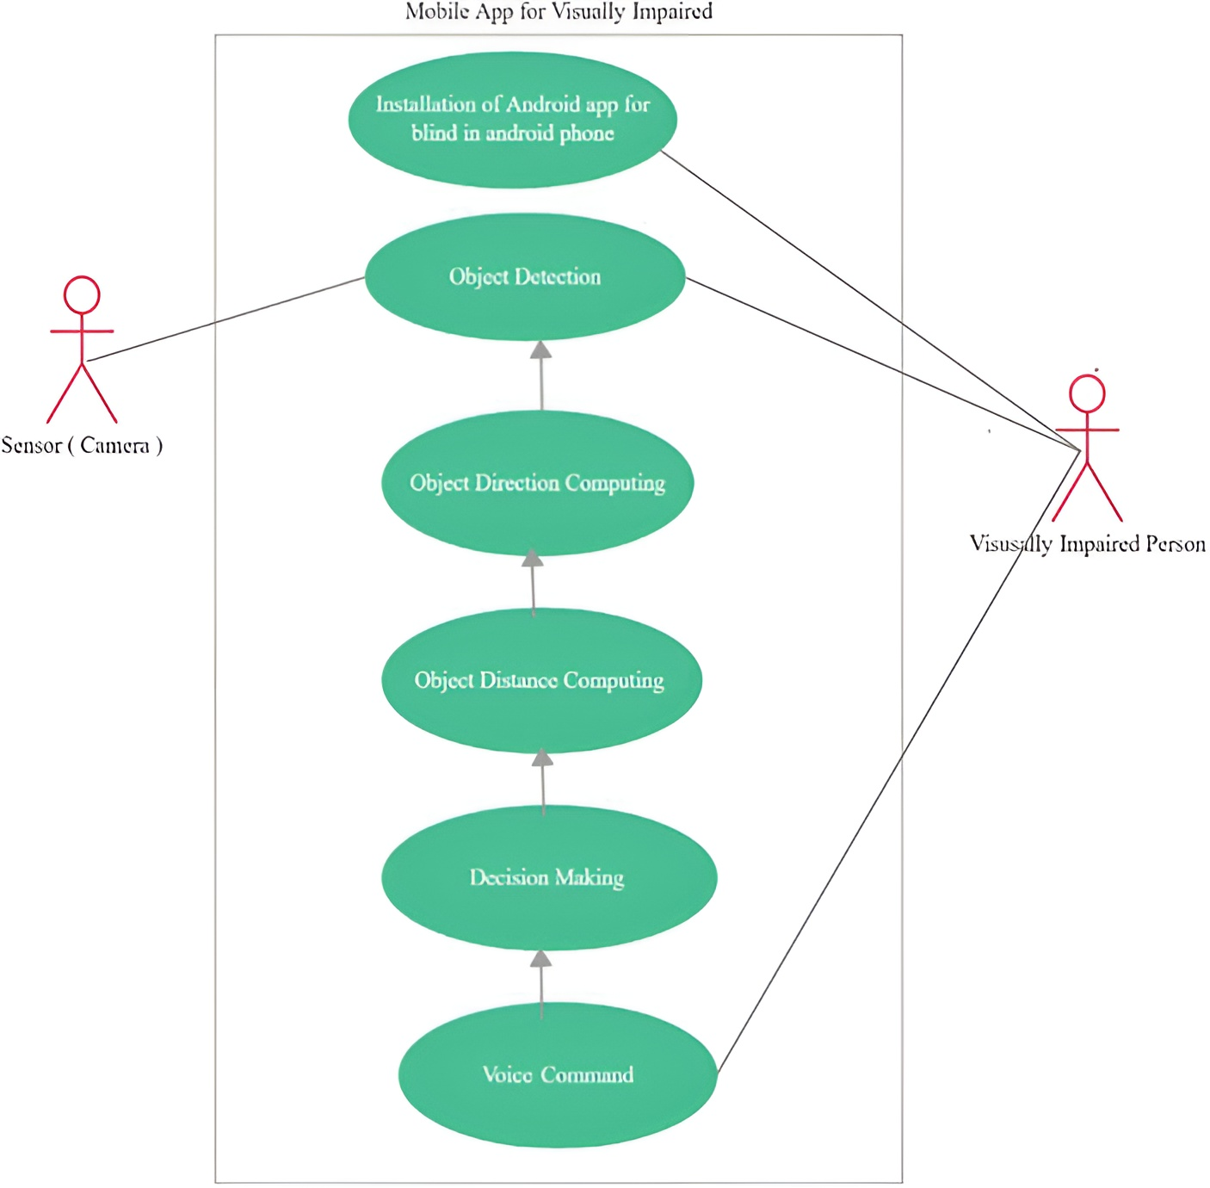
Figure 2

- Use Cases Description
In the Use Cases Description section, each identified use case is thoroughly outlined, providing a detailed narrative of the specific interactions between users and the Blind Eye Object Detection and Direction System. This includes the primary goals of each use case, the sequence of steps involved, and the expected system responses. By delving into these detailed descriptions, stakeholders gain a comprehensive understanding of the system's behavior in various scenarios. This level of specificity aids in refining system functionalities, ensuring that the final product aligns closely with user requirements and expectations. Additionally, these descriptions serve as invaluable references for the development, testing, and user training phases, contributing to the overall success of the project.

Chapter 4
System Design

Chapter 4: System Design
[Paragraph Text 12 pt, Calibri, 1.5 Line Spacing, Justified]
[Between 4 to 8 lines describe what is this chapter all about]

- Architecture Diagram

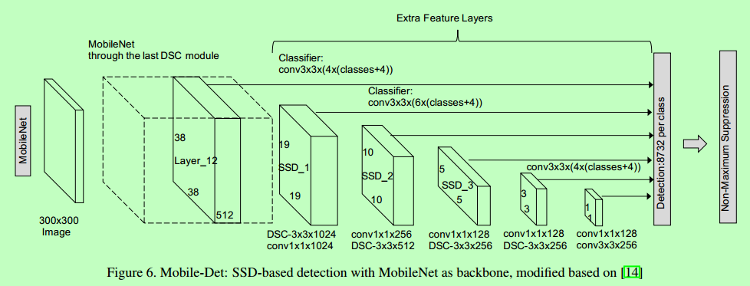
Figure 3

- Domain Model
The domain model for blind eye object detection and direction encompasses several key components that interact to provide accurate and reliable assistance to visually impaired individuals. Central to the model is the sensor system, which includes cameras and ultrasonic sensors that continuously scan the environment for obstacles. These sensors feed data into a processing unit equipped with advanced algorithms, capable of interpreting the sensor input to identify and classify objects. The processing unit then determines the spatial relationship between the user and the detected objects, calculating the safest path forward. Finally, the system delivers feedback through auditory or haptic signals, guiding the user in real time. This cohesive interaction between hardware and software ensures that the domain model effectively enhances the mobility and safety of its users.

- Entity Relationship Diagram with data dictionary

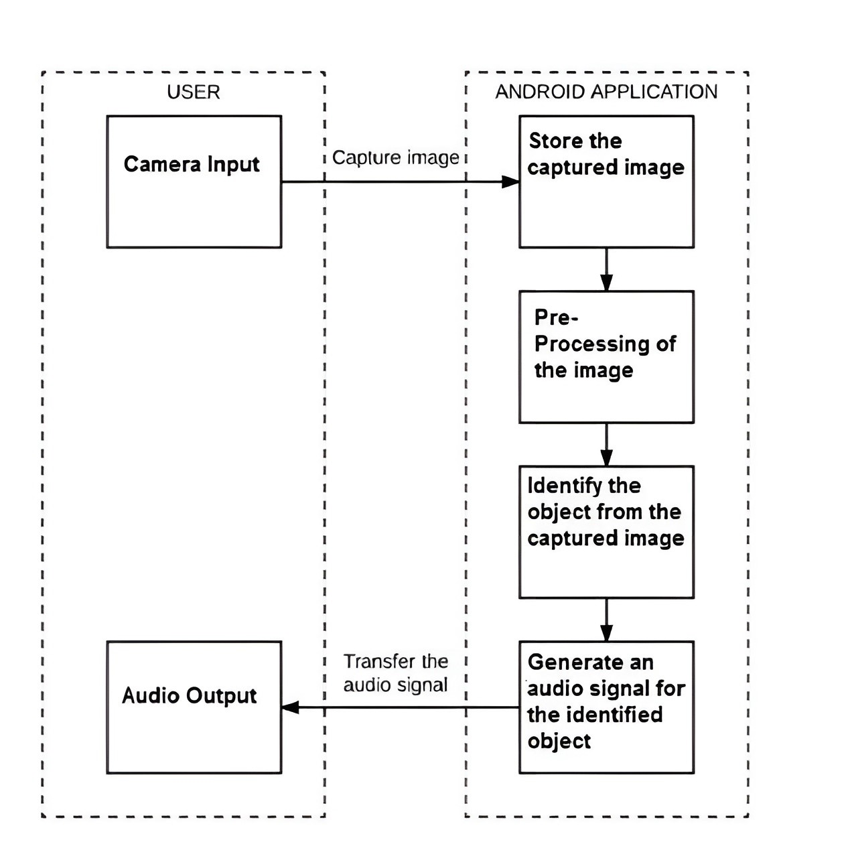

- Class Diagram

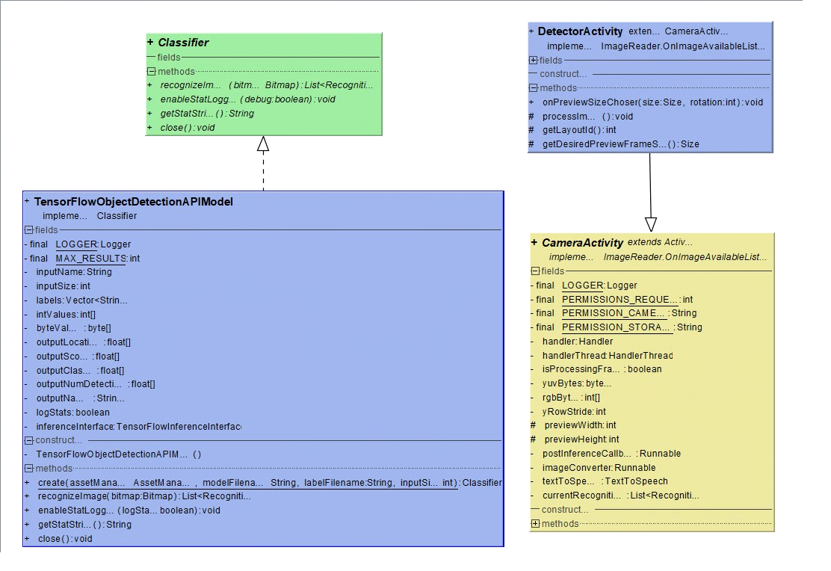
Figure 4

- Sequence / Collaboration Diagram
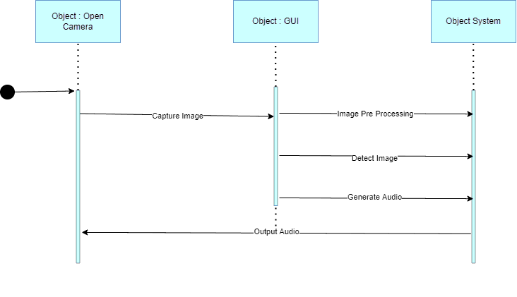
Figure 5

- Operation contracts

Operation contracts play a crucial role in defining the interactions between various components of the blind eye object detection and direction system. These contracts specify the preconditions, postconditions, and invariants that must be upheld during the execution of system operations. For instance, when an obstacle is detected, the precondition might require that the sensor data is valid and up-to-date. The postcondition would then ensure that the processing unit has accurately identified the obstacle and calculated a safe path. Invariants would maintain consistent feedback delivery to the user, regardless of the environmental changes. By adhering to these operation contracts, the system ensures reliable performance and safety, providing visually impaired individuals with dependable assistance as they navigate their surroundings.

- State Transition Diagram

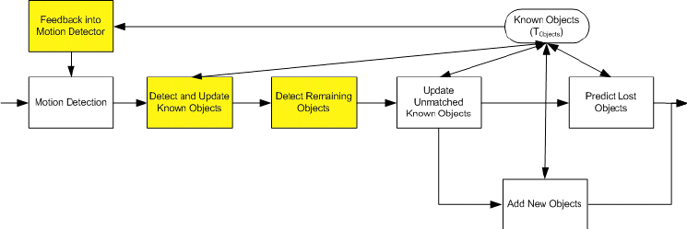
Figure 6

- Component Diagram

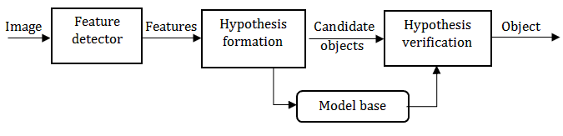
Figure 7

- Deployment Diagram
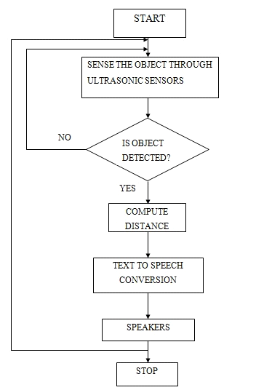

Figure 8

- Data Flow diagram [only if structured approach is used - Level 0 and 1]
[Paragraph Text 12 pt, Calibri, 1.5 Line Spacing, Justified]

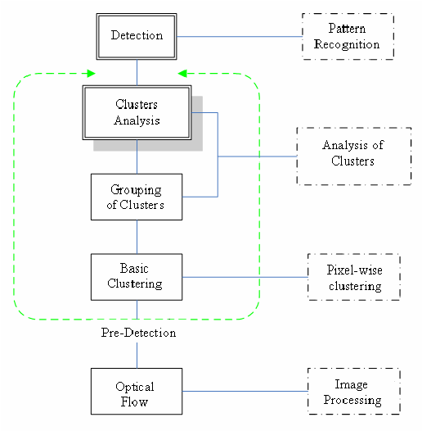
Figure 9

Chapter 5
Implementation

Chapter 5: Implementation
The Implementation chapter focuses on the practical realization of the Blind Eye Object Detection and Direction System. It details the coding, integration, and deployment processes involved in bringing the system from concept to reality. This section provides insights into the technology stack, coding practices, and methodologies employed during the development phase. By offering a comprehensive overview of the implementation process, this chapter serves as a guide for developers, facilitating a seamless transition from design to execution. It aims to ensure that the system is not only aligned with the specified requirements but also built using best practices to guarantee efficiency, reliability, and maintainability.

- Important Flow Control/Pseudo codes
The Components, Libraries, Web Services, and Stubs section outlines the fundamental building blocks and external resources that constitute the Blind Eye Object Detection and Direction System. It provides an in-depth overview of the software components, third-party libraries, web services, and placeholder stubs utilized in the implementation process. This detailed inventory aids developers in understanding the system architecture, ensuring proper integration of components, and leveraging external services for enhanced functionality. By delineating these key elements, the chapter facilitates effective collaboration among development teams and ensures a systematic approach to building a robust and feature-rich system.

- Components, Libraries, Web Services and stubs
The Components, Libraries, Web Services, and Stubs section provides a comprehensive overview of the technological ecosystem that forms the backbone of the Blind Eye Object Detection and Direction System. It delineates the specific software components, external libraries, and web services integrated into the system's architecture. Additionally, placeholder stubs are identified, serving as temporary implementations for testing or simulation purposes. This detailed exposition assists developers in understanding the intricate interplay between these elements, fostering effective collaboration and streamlined integration during the implementation phase. It acts as a roadmap, guiding the construction of a cohesive and efficient system that aligns with the project's goals and requirements.

- Deployment Environment
The Deployment Environment section elucidates the specifications and considerations surrounding the Blind Eye Object Detection and Direction System's deployment. It outlines the hardware and software requirements essential for the successful installation and operation of the system. This encompasses details such as supported operating systems, required computing resources, and any dependencies crucial for seamless deployment. Additionally, the section may delve into deployment strategies, addressing aspects like scalability, load balancing, and system configurations to optimize performance in real-world scenarios. This information serves as a guide for system administrators and ensures a smooth transition from development to deployment, ultimately contributing to the system's effective utilization in its intended environment.

- Tools and Techniques
The Tools and Techniques section elucidates the array of tools and methodologies employed in the development and implementation of the Blind Eye Object Detection and Direction System. It outlines the software development tools, integrated development environments (IDEs), version control systems, and testing frameworks utilized throughout the project lifecycle. Furthermore, it may delve into specific coding techniques, design patterns, and debugging strategies that contribute to the robustness and efficiency of the system. By providing a detailed overview of the tools and techniques employed, this section serves as a valuable reference for developers and stakeholders, fostering transparency and aiding in the understanding of the project's technical landscape.

- Best Practices / Coding Standards
The Best Practices / Coding Standards section delineates the established guidelines and conventions adhered to during the development of the Blind Eye Object Detection and Direction System. It outlines the coding standards, naming conventions, and design principles followed to ensure consistency, readability, and maintainability of the codebase. Additionally, it may incorporate best practices related to documentation, error handling, and version control usage. Adhering to these standards not only promotes a unified and coherent codebase but also streamlines collaboration among developers and facilitates easier maintenance in the long run. This section acts as a reference point for the development team, contributing to the overall quality and efficiency of the software project.

- Version Control
The Version Control section outlines the strategies and tools employed for managing the source code and tracking changes throughout the development lifecycle of the Blind Eye Object Detection and Direction System. It highlights the version control system utilized, detailing how branching, merging, and collaboration among developers are handled. This section may also address the frequency and methodology of version releases, ensuring a systematic approach to software evolution. By providing insights into version control practices, this section aids in maintaining code integrity, facilitating collaboration, and enabling effective rollback or branching strategies when needed. It is crucial in ensuring the traceability and stability of the software throughout its development iterations.

