THE SUPERIOR COLLEGE LAHORE


Faculty of Computer Science & IT

Final Year Project
PROJECT REPORT

[Muslim Traveller offline]

Project ID: [FYP-MCSM-F19-024]

Project Team
Student Name | Student ID | Program | Contact Number | Email Address
Ali raza | Mcsm-f18-041 | Mcs | 03484180627 | mcsm-f18-041@superior.edu.pk
Bisma aftab | Mcsm-f18-130 | Mcs | 03084383723 | mcsm-f18-130@superior.edu.pk
Hamza Ashraf | Mcsm-f18-019 | Mcs | 03060526465 | mcsm-f18-019@superior.edu.pk

[ Mr.Abuhuraira]

Project Report
[Muslim Traveller offline]

Change Record
Author(s) | Version | Date | Notes | Supervisor’s Signature
Hamza Ashraf  Ali Raza  Bisma Aftab | 1.0 |  | <Original Draft>
 |  |  | <Changes Based on Feedback from Supervisor>
 |  |  | <Changes Based on Feedback From Faculty>
 |  |  | <Added Project Plan>
 |  |  | <Changes Based on Feedback from Supervisor>

APPROVAL
Project Supervisor
Comments: ___________________________________________________________________
_____________________________________________________________________________
Name:______________________________
Date:_______________________________ | Signature:__________________________

Project Manager
Comments: ___________________________________________________________________
_____________________________________________________________________________
Date:_______________________________ | Signature:__________________________

Head of the Department
Comments: ___________________________________________________________________
_____________________________________________________________________________
Date:_______________________________ | Signature:__________________________

Dedication
This work is dedicated to my Brother because my Brother motivate me to do this and give me suggestion and discuss about everything about market, support us to make this project and help me. We would like to dedicate this dissertation to our parents who always stand with us in every step of life.

Acknowledgements
I am really thankful to my supervisor who has guided us to make a wonderful website. Who has taught us how we manage our work and tell us pros and cons of our ideas. He is deal us very politely and give us suggestion we discus every think because they deal us like a brother. He has a best communication level. He gave me and my group more or more motivation and confidence. He did not refuse our idea but he enhances that idea. He teaches are her mind set and level.

Executive Summary
Muslim traveler offline is an Android mobile Application specially design for Muslims who are in Travelling. When we traveled to another city we have no idea about qibla direction or have Quran majeed in many language offline. In our application , we give facility to user download our app once then he don’t need to connect internet he can use out app without internet. Our user can read daily hadees and doing tasbeeh for zikr as well.

Table of Contents
Dedication iv
Acknowledgements v
Executive Summary vi
Table of Contents vii
List of Figures Error! Bookmark not defined.
List of Tables Error! Bookmark not defined.
Chapter 1 1
Introduction 1
1.1. Background 2
1.2. Motivations and Challenges 2
1.3. Goals and Objectives 2
1.4. Literature Review/Existing Solutions 2
1.5. Gap Analysis 2
1.6. Proposed Solution 2
1.7. Project Plan 3
1.7.1. Work Breakdown Structure 3
1.7.2. Roles & Responsibility Matrix 3
1.7.3. Gantt Chart 3
1.8. Report Outline 3
Chapter 2 4
Software Requirement Specifications 4
2.1. Introduction 5
2.1.1. Purpose 5
2.1.2. Document Conventions 5
2.1.3. Intended Audience and Reading Suggestions 5
2.1.4. Product Scope 5
2.1.5. References 6
2.2. Overall Description 6
2.2.1. Product Perspective 6
2.2.2. Product Functions 6
2.2.3. User Classes and Characteristics 6
2.2.4. Operating Environment 7
2.2.5. Design and Implementation Constraints 7
2.2.6. User Documentation 7
2.2.7. Assumptions and Dependencies 7
2.3. External Interface Requirements 8
2.3.1. User Interfaces 8
2.3.2. Hardware Interfaces 8
2.3.3. Software Interfaces 8
2.3.4. Communications Interfaces 9
2.4. System Features 9
2.4.1. System Feature 1 9
2.4.1.1. Description and Priority 9
2.4.1.2. Stimulus/Response Sequences 9
2.4.1.3. Functional Requirements 9
2.4.2. System Feature 2 10
2.4.2.1. Description and Priority 10
2.4.2.2. Stimulus/Response Sequences 10
2.4.2.3. Functional Requirements 10
2.4.3. System Feature 3 (and so on) 11
2.5. Other Nonfunctional Requirements 11
2.5.1. Performance Requirements 11
2.5.2. Safety Requirements 11
2.5.3. Security Requirements 12
2.5.4. Software Quality Attributes 12
2.5.5. Business Rules 12
2.6. Other Requirements 12
Chapter 3 13
Use Case Analysis 13
3.1. Use Case Model 14
3.2. Use Case Descriptions 14
Chapter 4 15
System Design 15
4.1. Architecture Diagram 16
4.2. Domain Model 16
4.3. Entity Relationship Diagram with data dictionary 16
4.4. Class Diagram 17
4.5. Sequence / Collaboration Diagram 17
4.6. Operation contracts 17
4.7. Activity Diagram 18
4.8. State Transition Diagram 18
4.9. Component Diagram 18
4.10. Deployment Diagram 19
4.11. Data Flow diagram [only if structured approach is used - Level 0 and 1] 19
Chapter 5 20
Implementation 20
5.1. Important Flow Control/Pseudo codes 21
5.2. Components, Libraries, Web Services and stubs 21
5.3. Deployment Environment 21
5.4. Tools and Techniques 22
5.5. Best Practices / Coding Standards 22
5.6. Version Control 22
Chapter 6 23
Testing and Evaluation 23
6.1. Use Case Testing 24
6.2. Equivalence partitioning 24
6.3. Boundary value analysis 24
6.4. Data flow testing 24
6.5. Unit testing 25
6.6. Integration testing 25
6.7. Performance testing 25
6.8. Stress Testing 25
Chapter 7 26
Summary, Conclusion and Future Enhancements 26
7.1. Project Summary 27
7.2. Achievements and Improvements 27
7.3. Critical Review 27
7.4. Lessons Learnt 27
7.5. Future Enhancements/Recommendations 28
Appendices 29
Appendix A: User Manual 30
Appendix B: Administrator Manual 31
Appendix C: Information / Promotional Material 32
Reference and Bibliography 35
Index 37

List of Figures

1.1 Caption of first figure of first chapter 6
1.2 Caption of second figure of first chapter 7
2.1 Caption of first figure of second chapter 14
2.2 Caption of second figure of second chapter 22
2.3 Caption of third figure of second chapter 26
5.1 Caption of first figure of fifth chapter 49
5.2 Caption of second figure of fifth chapter 49

List of Tables

1.1 label of first table of first chapter 6
1.2 label of second table of first chapter 7
2.1 label of first table of second chapter 14
2.2 label of second table of second chapter 22
2.3 label of third table of second chapter 26
5.1 label of first table of fifth chapter 49
5.2 label of second table of fifth chapter 49

Chapter 1

Introduction

Chapter 1: Introduction
To perform religious obligation for every Muslim is necessary in every condition even if he/she is travelling to other places or countries. So to perform religious obligation during journey is a difficult. Because when we travel we do not have location of Qibla also we do not have Quran Majeed to recite holy Quran sometimes we have mobile phone to read Quran but for that internet is compulsory. We are creating mobile application in we are providing its user offline mode right direction of Qibla, Quran with translation in multiple languages, Tasbeeh for zikr, hadith shareef. User just have to download it once and can use it offline with all the features mentioned above.

Background
Another aspect of a software system is the use of a central database. This database is the basis for all actions in the system and can be trivially updated and used to aid in all of the system’s processes, meaning all of the required information is stored in one central location and thus is easily accessible. This is a far more reasonable storage method than a paper-based file system, where the time of traveling to and physically searching the records for the required information could be a burden. Human error could also be a factor in that mistakes could be made in the filing process which would not occur in a well written database system and mistakes or changes on physical records can be messy to correct.

Motivations and Challenges
While working on this product we have to keep in mind this app only for muslims of all world.
By using this app muslims can easily perform there religious obligation.
- Difficult to find exact direction of Qibla.
- Quran pak in only one language (Translation) and online.

Goals and Objectives
- Help muslims to read quran in multiple languages.
- Help muslims to find exact location of qibla.
- Help muslims to find timing of namaz.

Literature Review/Existing Solutions
There are many other Applications that also provide these features but individually and are online.
Some of them are:
1)Quran TV
2) Viral Quran
3) Quran Pak
4) Islam 360

Gap Analysis
Our application is newly app in the market we will provide a plate form for muslims to perform their worships in efficient manners . We will introduce a unique app which is so much different from other apps.

Proposed Solution
The proposed solution is to develop a Mobile Application to solve
such kind of problems. The application, which will work even in the absence of internet
connectivity. This Application will find the users current location coordinates. According to
this location information, it will calculate the direction of qibla. In addition, it will provide
full Quran will translation in any language. This app will also provide the digital tasbeeh
counter for Zikr of Allah. First, we find the necessity of this application from Islamic
literature and conducting interviews from some Muslims. The Muslims argued that this app
would be very helpful for all Muslims in the world.

Project Plan
Our project plan is well planned and organized.Our project is completely automated offline muslim traveler.

Work Breakdown Structure
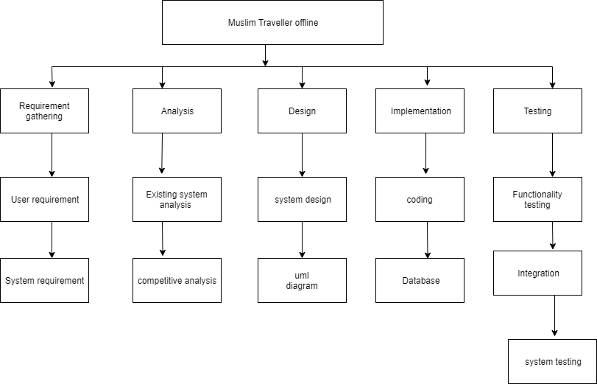

Roles & Responsibility Matrix
 | Interface Designer
  Role
Member | Hamza Ashraf, ali raza
Description | 1. Sketch a final design for the GUI

 | Application Development
  Role
 | Ali raza, bisma
  Member
Description | 1. make sure the tools  2. Make sure that the project works in various android app.

Gantt Chart
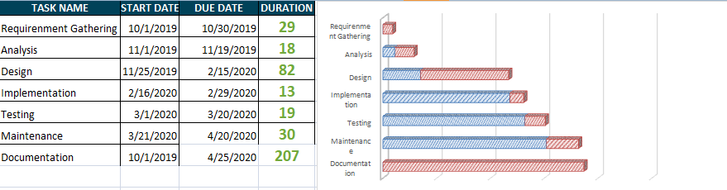

Report Outline
We are creating a Social app through which we cover alot of new features and some old one’s but in new way.

Chapter 2

Software Requirement Specifications

Chapter 2: Software Requirement Specifications

Introduction

Purpose
The main purpose of this appis that muslims can easily perform there religious obligation if he don’t have internet access in such area.once he download this app he don’t have need to acces interenet for using it till update notification cant reach to him.

Document Conventions
This application Requirements document is intended for:-

Developers who can review project’s capabilities and more easily understand where their efforts should be targeted to improve or add more features to it (design and code the application – it sets the guidelines for future development). − Project testers can use this document as a base for their testing strategy as some bugs are easier to find using a requirements document. This way testing becomes more methodically organized. End users of this website who wish to read about what this project can do.
Our document consists of following important conventions
UML (unified modeling language)
Data base
ERD (Entity relation diagram)
AD (Architecture diagram)
Sequence Diagramed
Activity diagram
STD

Intended Audience and Reading Suggestions
The different types of readers are:
Customer
Admin
Every customer can use this Application.

Product Scope
Ordinary every day activities can become rewarding acts of worship if a Muslim does them for the sake of pleasing Allah. Of them, the regular, consistent deeds are best. Allah’s Messenger, may the mercy and blessings of Allah be upon him, said, “The deeds most loved by Allah are those done regularly, even if they are minute.” We do not have to do anything extraordinary in our day to obtain divine rewards, but we should establish some daily routine that incorporates not only our daily prayers, but reading Quran, remembrance of Allah (adhkar), and other simple good deeds. This will bring satisfaction to the heart, heal the soul, and keep the believer on the Straight Path.

References
https://www.w3schools.com/html/
https://www.youtube.com/watch?v=mU6anWqZJcc
https://www.youtube.com/watch?v=5bMdjkfvONE

Overall Description

Product Perspective
This project is to provide a better online Social platform for people who have problems to fnd the quran majeed In different language on once app and having difficulty to finf excact location of qibla.

Product Functions
1.User select language and will able to read Quran in desire language.
2. User view Qibla direction.
3.User view prayers time.
4. User count the Tasbeeh.

User Classes and Characteristics
User of our appliaction can perform all functionalities which are :
Quran majeed in different languge, finding direction of qibla offline, tasbeeh for zikr, timings of prayers, bookmark for remaining quran pak .

Operating Environment
“Muslim travller” will operate with the at any android mobile . This application will be develop by android application software. The Hardware require use to develop is our app running at android app having 29.6 mb of memory.

Design and Implementation Constraints
The project intends to follow SCRUM (AGILE METHODOLOGY) for its development. Agility helps in time boxed iterative development, suggests adaptive planning and promote incremental delivery. To deal with changing requirements and yield frequent and small software increments which can be adjusted, documented and built on the project intends to use SCRUM as the process model.

User Documentation

Assumptions and Dependencies
We will provide high level service for android application to our Users. But some risk is effect on the system like: Inappropriate skills and experience. Working together as a team we face health factor of team like (illness issues) that affect us to complete our project within the specified time, but we are committed to our work InshaAllah we do our best and make it happen.

External Interface Requirements

User Interfaces

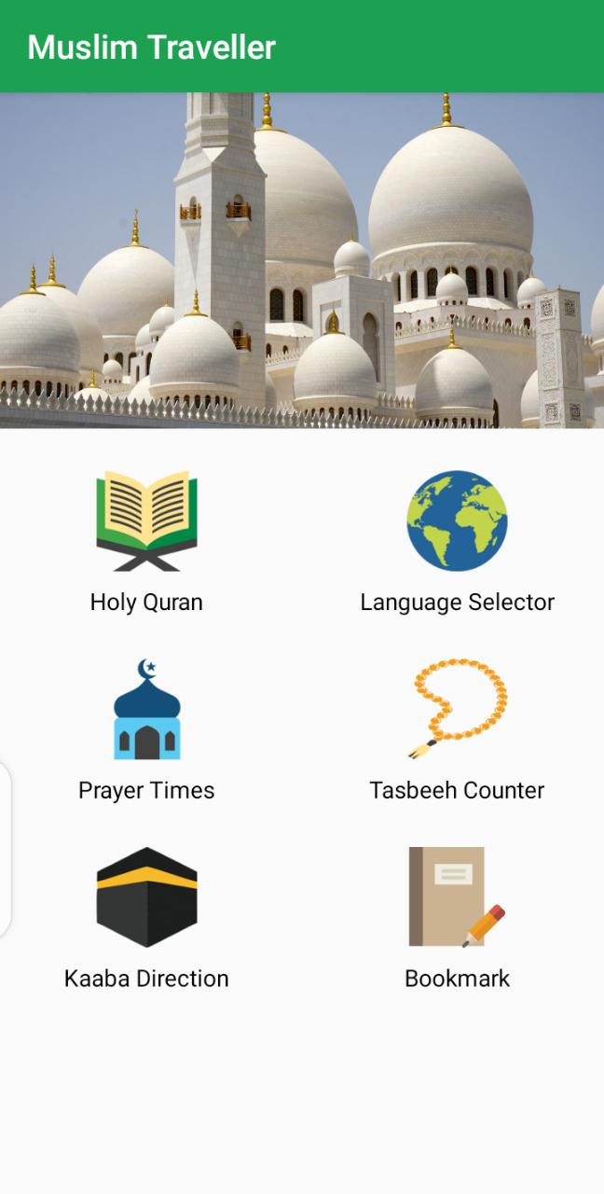

Hardware Interfaces
“Muslim travller” will operate with the at any android mobile . This application will be develop by android application software. The Hardware require use to develop is our app running at android app having 29.6 mb of memory.

Software Interfaces
PROJECT TYPE: Application
CODING LANGUAGE: HTML, PHP, Java
DATABASE: LOCALHOST
SOFTWARE: Android

Communications Interfaces
The requirements associated with any communications functions required by this product, including e-mail, web browser, network server communications protocols, electronic forms, and so on. Define any pertinent message formatting. Identify any communication standards that will be used, such as FTP or HTTP. Specify any communication security or encryption issues, data transfer rates, and synchronization mechanisms.
- Client on Internet will be using HTTP/HTTPS Protocol.
- Client on intranet will be using TCP/IP protocol.

System Features
The system must be able to show information to user in real time. The system must be able to add or delete information in admin panel.
- Database should be working fine
- Internet connection is must for downloading app when app is downloaded there is no need to connect internet for using it.

System Feature 1
Language selector

Description and Priority
It is of High priority feature, without this feature this application is incomplete. Ist you must select the language you want to read quran.

Stimulus/Response Sequences
When you select the language then go to holy quran option and read your desire language quran pak.

Functional Requirements
- Holy quran
- Language selector
- Prayer times
- Tasbeeh counter
- Kaaba directions
- bookmarks

System Feature 2

System Feature 3 (and so on)

Other Nonfunctional Requirements
Nonfunctional requirements are usually some of constraint or restriction that must be considered when designing the solution. Nonfunctional requirements tend to identify user constraints and system constraints.

Performance Requirements
- Performance: -
The software must be good according to performance; it should be fast and quick responsive.
Usability: -
The software should be user friendly and easy to understand. Interface should be comfortable so that it will be easy for the user to operate. The tool must be intuitive or easily understood after the tutorials and user guide. Display should be presentable.
Changeability:
The software should be designed in such a way that any future modifications or improvisation can be done with much more functionality.
Efficiency:
The project must be efficient such that it can select image and display in scaled manner within the GUI. Software should provide reliable result.
Portability:
The system should be able to run on any platform. This project runs on windows 7,9,10, XP/vista operating system.

Safety Requirements
In this case data or anything cannot be loss but if someone Access this for some wrong purpose then it might be harmful. So, we make sure anyone who access this application is a valid person.

Security Requirements

Software Quality Attributes
- Response Time
- Throughput
- Utilization
- Reliability.
- Recoverability.
- Maintainability.

Business Rules
In this application internet and database should be working otherwise this application did not work.

Other Requirements
There are no other requirements or specific thing needed to run the application or to run it in development phase all of the information is written above for better understanding.

Chapter 3

Use Case Analysis

Chapter 3: System Analysis
In this chapter we will discuss about the use case and fully dressed use case. In use case we will define in this chapter each entity and its attributes and combine system and discuss about the system using fully dressed use case.

Use Case Model
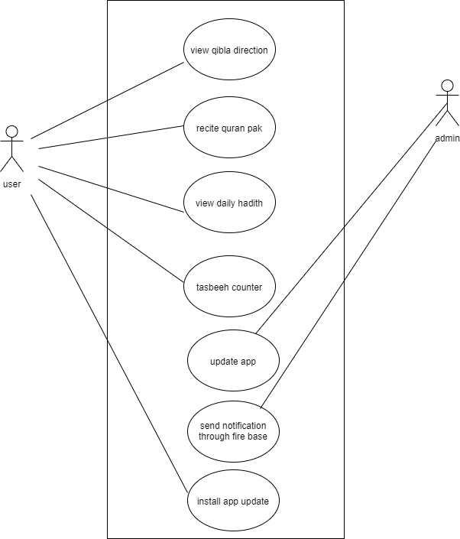

Use Case Descriptions
Use Case Section | Comment
Use case Name | User
Scope | Customer downloaded it to used the app
Primary Actors | User
Post-Conditions | After download customer is able to used the all function.
Main Scenario | - Customer opens Mobile App.  - Customer select language selector option.  - Customer read holy quran.  - Customer see prayers times.  - Customer locate kaba direction.

Chapter 4

System Design

Chapter 4: System Design

Architecture Diagram
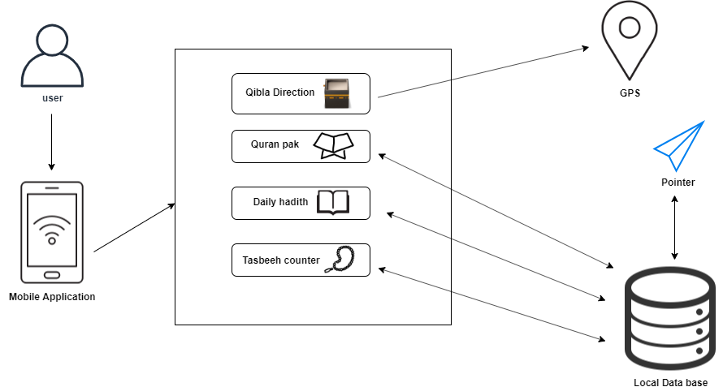

Domain Model
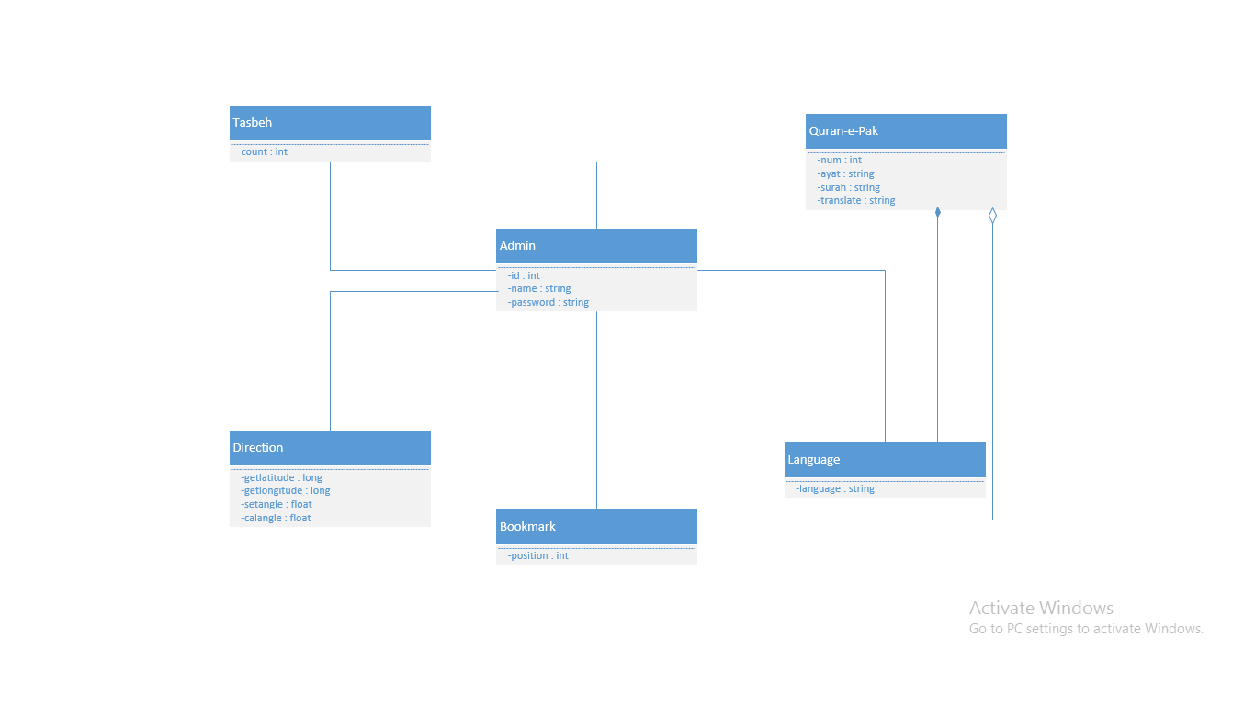

Entity Relationship Diagram with data dictionary
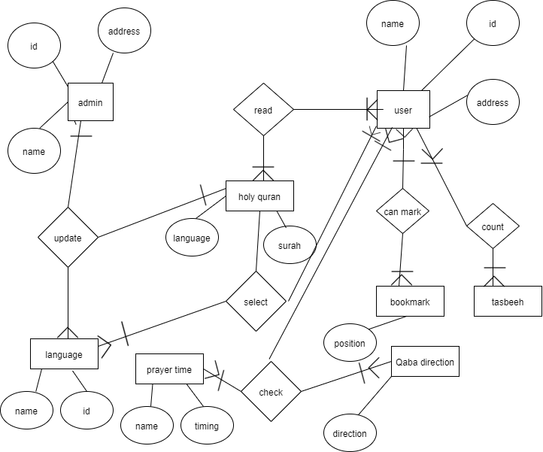

Class Diagram
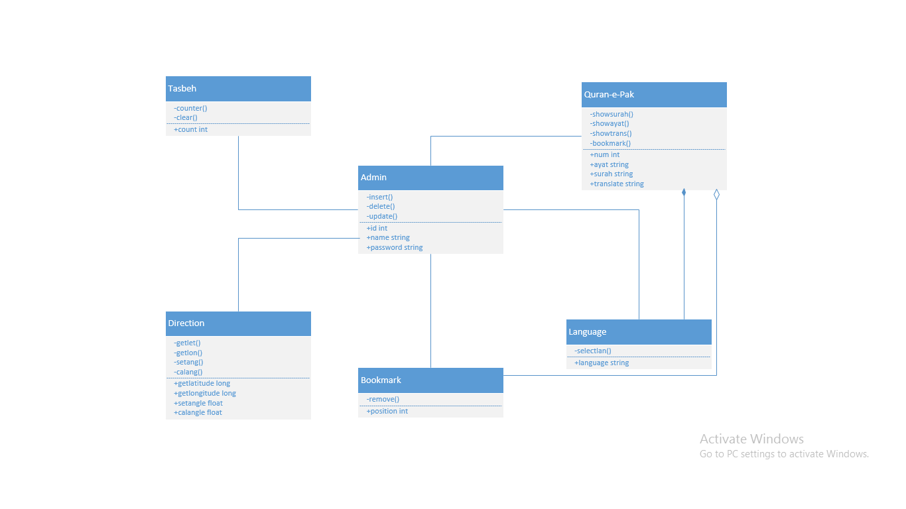

Sequence / Collaboration Diagram
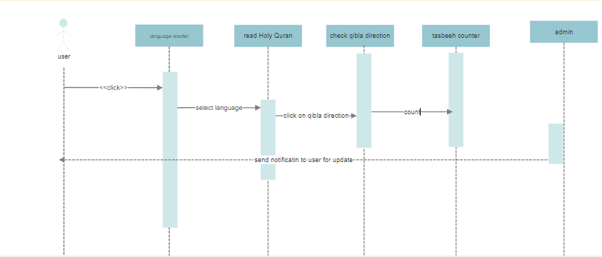

Operation contracts

Activity Diagram
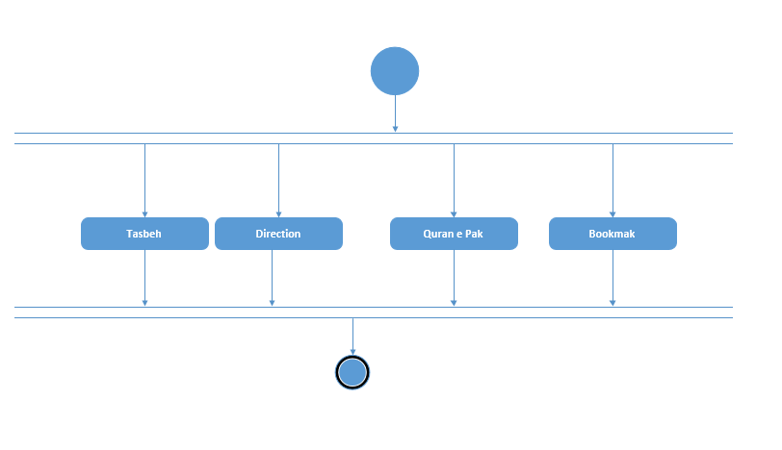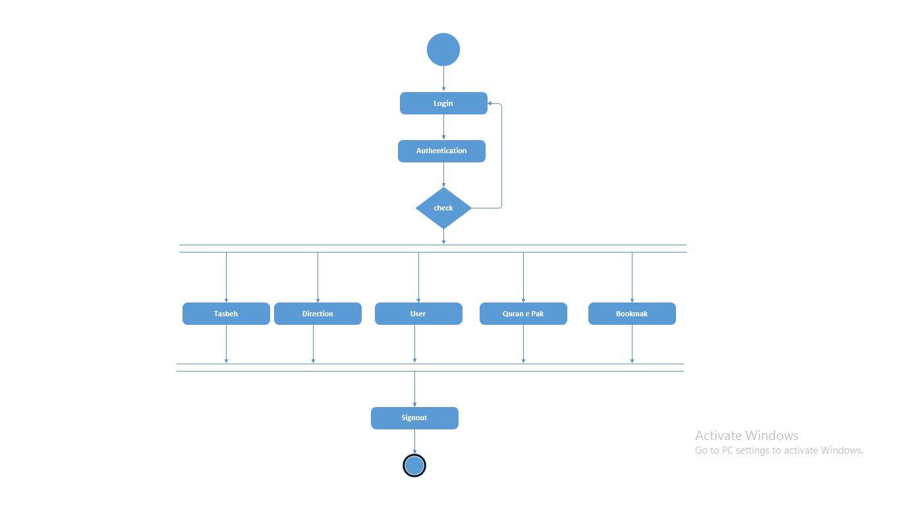

State Transition Diagram
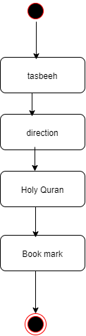

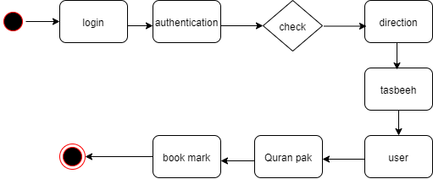

Component Diagram
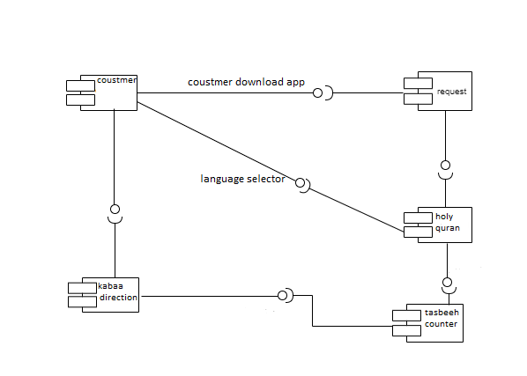

Deployment Diagram
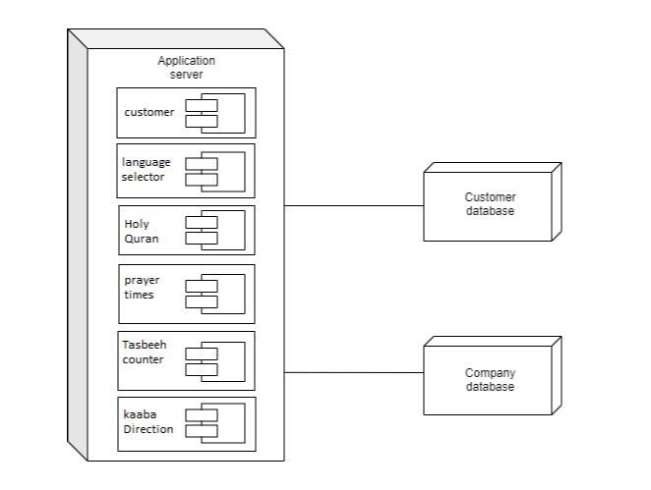

Data Flow diagram

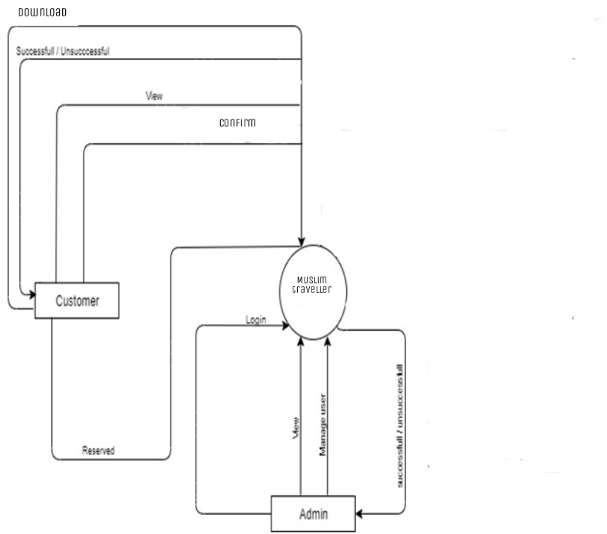
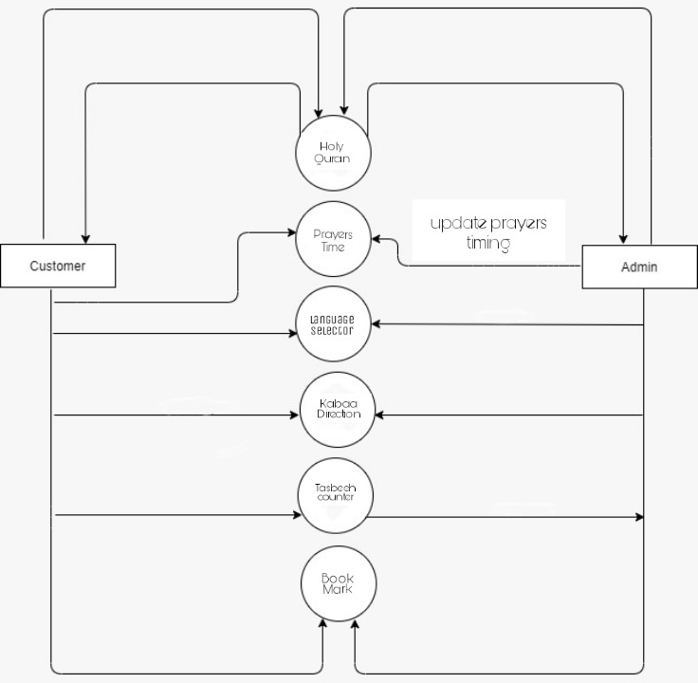

Level 1

Chapter 5

Implementation

Chapter 5: Implementation
In this chapter we will discuss about the pseudo codes or important flow control and we tell in this chapter what we use tool or techniques use in this system. In this chapter we will tell about what the library, webserver is use in this system implementation.

Important Flow Control/Pseudo codes
Pseudo codes mean how over project will work its complete flow we have described it in diagrams like UML diagram sequence diagrams etc. Pseudo code is simple. You just write out the steps to be taken to perform any task.

Components, Libraries, Web Services and stubs
Components
- Holy quran
- Language selector
- Prayer times
- Tasbeeh counter
- Kaaba directions
- Bookmarks

Deployment Environment

In our project we use Localhost Deployment Environment for backend and frontend

Tools and Techniques
Android studio.
XML : it is markup language that store data and design ,and for front hand use.
Java: This language describe the background working of the system.
SQLITE: we use this to enter database of the customer and company.

Best Practices / Coding Standards
- Define scope and objective
- Write readable code
- Project planning
- Android studio
- Java
- xml

Chapter 6

Testing and Evaluation

Chapter 6: Testing and Evaluation
Testing is the important part of the project. In testing, we find out error in the project and correct all the error in the project. We do different type of testing to check our project.
Testing and evaluation is very important phase for every project that we are going to develop.

Use Case Testing
It is the software testing that help to cover the entire system. It tests the scenario of the whole system from start to finish. It help to cover the functional requirement if the system. It is a sequence of step that helps to interact between actor and the system.

Equivalence partitioning
Equivalence partitioning is the one of the testing technique. In equivalence partitioning, input of the software or system is divided into the groups that are expected to have similar behavior, so they are likely to be proposed in the same way.

Boundary value analysis

Data flow testing
Data testing is the type of software testing which focus on the data variables and their values. The process is conducted to detect the error because of the incorrect usage of data variables and data values. It has nothing to do with data flow diagram. It is performed at two abstract levels: static data flow testing and dynamic data flow testing. Data flow testing has following limitations:
- Time consuming
- Costly process
- Testers provide good knowledge of programming.

Unit testing
Unit testing is the technique in which each module is tested individually to determine where the error is occurred. It is concerned with the functional correctness of each module. Doing this testing you found problem earlier, so fewer error are founds.
Each module is tested in the following strategies:
- Black box testing
- White box testing

Integration testing
Black box testing is the technique in which functionality of the system is tested without internal code. Only input and output of the system is testing. This type of testing is done on functional requirement. Black box testing is used to find out different errors:
- Interface error
- Incorrect and missing error
- Error in data structure
- Behavior or performance error
- Initialization and termination error

Performance testing

White box testing is the technique in which internal structure, design and coding are tested. It focuses in the flow of input and output. The following parameters are used to verify the white box testing:
- Output and input flow
- Security element
- Usability
- Design
- Coding

Stress Testing
Stress testing is the type of software testing in which robustness, stability and reliability of the system is tested. This testing is done to check the how much stress system can sustain. It is done to verify the system has saved the data before crashing or not. To verify that unexpected failure do not cause security issue. It ensures to display the error message when the system is under stress. Stress testing is depends upon different scenario:
- Monitor the system behavior when maximum number of users logged in at the same time.
- All users performing the critical operations at the same time.
- All users will be Accessing the same file at the same time.
- Hardware issues such as database server down or some of the servers in a server park crashed.

Chapter 7

Summary, Conclusion and Future Enhancements

Chapter 7: Summary, Conclusion & Future Enhancements

Project Summary
Muslim traveler offline is an Android mobile Application specially design for Muslims who are in Travelling. When we traveled to another city we have no idea about qibla direction or have Quran majeed in many language offline. In our application , we give facility to user download our app once then he don’t need to connect internet he can use out app without internet. Our user can read daily hadees and doing tasbeeh for zikr as well.
]

Achievements and Improvements
Worked in Professional manner and finally made a Complete product, integration of Fronted and backed, using Android Studio,XML, Java, and Tokens for Notifications.

Lessons Learnt
Hard Work is key to success, and determination make us hard work. Be consistent in your beliefs.

Appendices

Appendix A: Information / Promotional Material

Our promotional materials come in handy if you want to make your products repaired. Our services can practice design your products. We have a platform of highly talented graphic artists who can happily help you create great looking
A.1.Broacher

Delay due to covid-19

A.2.Flyer

Delay due to covid-19

A.3.Standee
Delay due to covid-19

A.4.Banner

Delay due to covid-19

Reference and Bibliograpy

Reference and Bibliography

[1] M. Sher, M. Rehman, “Title of the Paper” Conference name/Journal Name, Edition, Volume, Issue, ISBN/ISSN, PP, Publisher/City-Country, Year.
[2] https://www.researchgate.net/publication/263027693_Mobile_Food_Ordering_Application_using_Android_OS_Platform

[3] https://www.researchgate.net/publication/212065783_The_Application_of_Wireless_Food_Ordering_System

[4] http://www.arpnjournals.org/jeas/research_papers/rp_2018/jeas_0618_7159.pdf

[5] VOL. 13, NO. 12, JUNE 2018 ISSN 1819-6608 ARPN Journal of Engineering and Applied Sciences ©2006-2018 Asian Research Publishing Network (ARPN). All rights reserved.

[6] Michael Yosep Ricky Computer Science Department, School of Computer Science, Bina Nusantara University, Jakarta, Indonesia.

Index

Index

[A]

[B]

[C]

