KNOWLEDGE STATES
(www.KnowledgeStates.com)
Session 2013-2017



Submitted To:
Lec. Muhammad Mumtaz Ali
(Supervisor)
  - Submitted By:
  - Ahmad Kaleem (BSSE-14215)
  - Adnan Ali (BSSE-14255)
  - Sidra Iqbal (BSSE-14327)

Document version: 1.5
Date: 08-Nov-2017

Bachelor of Science in Software Engineering (Hons.)
Department of Computer Science and Information Technology

Declaration
We hereby declare that this project, neither whole nor as a part has been copied out from any source. It is further declared that we have developed this project and accompanied report entirely on the basis of our personal efforts. If any part of this project is proved to be copied out from any source or found to be reproduction of some other. We will stand by the consequences. No Portion of the work presented has been submitted of any application for any other degree or qualification of this or any other university or institute of learning.

_________________ _______________ Ahmad Kaleem Adnan Ali Sidra Iqbal
(BSSE-14215) (BSSE-14255) (BSSE-14327)

Meeting Performa

Department of CS & IT
Superior University, Lahore
Final Year Project – Minutes of Meeting
Progress Report
Project Title: _____________________________________________________________
Supervisor: ______________________________________________________________
 |  |  |  | Progress of tasks
 | Student |  |  | Progress of tasks
 | Student |  |  | assigned in previous |  |  | New tasks |  |  | Date |  |  | Signatures
 | Name |  |  | assigned in previous |  |  | New tasks |  |  | Date
 | Name |  |  | Meeting
I, ______________________, being Project Supervisor of this group, certify that above mentioned information is true as per my knowledge and concern. I allow the group to present its Final Year Project to the Panel.
___________________
Signature of Supervisor

Certificate of Approval
It is to certify that the final year project of BS (SE) “Knowledge states” was developed by “Ahmad Kaleem (BSSE-14215)”, “Adnan Ali (BSSE-14255)”, and “Sidra Iqbal (BSSE-14327)”. Under the supervision of “Mr. Mumtaz Ali” and that in his opinion it is fully adequate, in scope and quality for the degree of Bachelors of Science in Software Engineering.

________________________
Supervisor

________________________
FYP Manager

________________________
Head of Department
(Department of CS&IT)

Project Registration
Project ID (for office use)
Type (Nature of project) |  |  | [ ] Development |  | [ ] Research | [ ] R&D
 |  |  | Project Group Members
Sr.# | Roll # | Student Name |  | CGPA | Email ID | Phone # | Signature
(i)
(ii)
(iii)
Name & Signature of Advisor
(If students are eligible for FYP)
Plagiarism Free Certificate
This is to certify that, I am ________________________ S/D/o _______________________, group leader of FYP under registration no ____________________ at Computer Science Department & Information Technology, Superior University, Lahore. I declare that my FYP proposal is checked by my supervisor and the similarity index is ________% that is less than 20%, an acceptable limit by HEC. Report is attached herewith as Appendix A.
Signature: ________________
I ___________________ show my consent to supervise the project titled;
_________________________________________________________________________
which consists of above listed students as group members
Date & Signature: _____________________
Designation: _____________________

Approval of FYP Committee

Committee Member 1: Name: ___________________ Designation: ________________

[ ] Accepted [ ] * Deferred [ ] *Rejected Signature: __________________

*Remarks: _______________________________________________________________

Committee Member 2: Name: ___________________ Designation: ________________

[ ] Accepted [ ] * Deferred [ ] *Rejected Signature: __________________

*Remarks: _______________________________________________________________

FYP Manager: Fahad Sabah

[ ] Accepted [ ] *Deferred [ ] *Rejected Signature:_____________________

*Remarks: _______________________________________________________________

DEDICATION
𝒟edicated
To

Our Parents, Teachers and Friends

ACKNOWLEDGEMENTS
Alhamdulillah, all praises to Allah Almighty, the most Merciful and the most Gracious, for the strengths and His blessings in completing this Project.
Working on this project was indeed a challenging task that demanded immense efforts. But we feel proud to express our deepest sense of gratitude and appreciation to our supervisor Mr. Mumtaz Ali for his kind help, advice, inspired guidance, unlimited support, sympathetic attitude and sincere personal involvement throughout the development of project.
We would never have been able to reach this stage but for the prayers and great support of our families. Thanks and best wishes for all those who have made this learning experience so wonderful for us.

- Tabe of contents
Declaration 2
Meeting Performa 3
Certificate of Approval 4
Project Registration 5
Approval of FYP Committee 6
DEDICATION 7
ACKNOWLEDGEMENTS 8
Chapter 1 Project Proposal 11
1.1 Abstract 12
1.2 Background and Justification 13
1.3 Project Architecture 14
1.4 Project Methodology 15
1.5 Project Scope 15
1.6 High level Project Plan 15
• Requirements 16
• Analysis 16
• Design 16
• Implementation: 16
1.7 Final Testing: 16
1.8 Presentation/delivery: 16
1.9 Gantt-Chart 17
1.10 Features 18
1.11 Learning outcomes 19
Application: 20
Human dimension: 20
Caring: 20
Learning how to learn 20
1.12 Student’s Preparation 20
Chapter 2 Requirements 22
2.1. Functional Requirements 23
2.2. Non-Functional Requirements 26
Chapter 3 Design and Architecture 28
SDLC Model 29
• Scrum Model 29
3.1. Data BAse Diagram 30
3.3. Use cases 38
Chapter 4 Implementation 52
4.1. Project Implementation 53
4.1.1. Login 53
4.1.2 Question Posting 54
4.1.3 Blog Posting 55
4.1.4. News Posting 56
4.1.5. Fun Facts Posting 57
4.1.6. Create a job 58
Chapter 5 Testing 59
5.1. Verification 60
5.2. Test Cases 60
• 5.2.1. Test Cases for Admin 60
Chapter 6 User Manual 67
6.1. Application’s Overview 68
Chapter 7 Conclusion and Future Work 82
7.1. Conclusion 83
7.2 Future Work 83
Chapter 8 References 84

Chapter 1 Project Proposal

1.1 Abstract

Everything is available on Internet for Example how to code? [1] How to assemble a car? [2] How to drive? [3] Same goes for many fields’ people are facing problem in their life on daily bases, for the sake of getting solutions they browse Internet, looking for solution or meet experts for the solution of their problems. They visit different websites for the sake of solution of their problem. Student looking for solutions of their projects and assignments. Some websites provide solutions regarding to programming. Some are providing solutions regarding to medical but no one can provide solution for all aspects of life. So there are problem for experts and other people both for looking a platform that is specifically related to or serve their field. There are number of website but all are in vein.
What we are offering in solution.
- Knowledge States an Online platform for people to search the solution of the problem they are facing.
- We are offering every field whether it is related to medical, [2] technology, property and many more at one website.
- People can also find professionals related to every field.
- They can contact them directly by request a chat pin, ask questions online at same platform, at the end their problem will be solved.
- If user want to ask a questions then firstly user have to login and then they can ask the question.
- They can share their own ideas, suggestions and ask for answer & questions.
- We are providing online services to everyone through whom they can get rid of their routine problems by reading blogs, asking questions and having discussions with different people and professionals.
- People will be able to create their profile so that they can browse our website properly.
- For companies there will be a free job portal they can post the job ad for free. This portal will attract the professional to stay on the website.

1.2 Background and Justification
We had talked about different forums which are providing solution for the problems online but There registration method and criteria for maintaining user profile is too difficult. If someone asks an unprofessional question people report them and the profile this person will be blocked after 3 stars down. [1] In some websites like Qoura.com user needs followers of the related field in which he/she is stuck. Otherwise no one will answer their problem. So how can students and beginners will survive?

1.3 Project Architecture
- User browse the application on any browser the URL route send request to the controller it awakes the action which needs to be awoke according to the URL route and the view engine generates the View page on the screen. User needs to sign-up/login to perform any action, like Ask Question, like or Report a question, Like or Report the Blogs and same goes for News and Jobs Portal.

User Internet

Business layer

Data Base

Web browser

Web_server

Figure 1.1: Knowledge States Project Architecture [5]

1.4 Project Methodology

The project intends to follow SCRUM (AGILE METHODOLOGY) for its development. Agility helps in time boxed iterative development, suggests adaptive planning and promote incremental delivery [6]. To deal with changing requirements and yield frequent and small software increments which can be adjusted, documented and built on the project intends to use SCRUM as the process model.

1.5 Project Scope

Following are the inclusion of software project
- Any visitor can see question related to any category and read blog, check articles and tutorials. Anyone can watch video tutorials
- User will be allowed to Ask Questions and start discussions.
- Questions and Answers will be authenticated through voting.
- People can manage their profile and see news feeds and get notified related to their interest.
- User can read articles and do blogging and share their knowledge by providing tutorials for free.
- There is also a section of news and articles which will be published by admin.
- After all the basic functionalities are implemented we will make this platform a work media for the researcher, students and for professionals by providing access to paid tutorials and research papers for free.
- HR (Human Resource) department of any company will authenticate and register as a company to get access for job portal for free. Company will see the user’s performance likes which he/she got by other users whom he/she helped.
- User is allowed to maintain his/her resume on that platform.
- These all are the basic functionalities enhancement will be mentioned soon.

1.6 High level Project Plan

Following will be the framework activities in process pattern and each iteration. [7]

Requirements
  - We will gather requirement about the basic working of forums.
  - We will gather requirements from the professionals, researchers of different fields and also consult with our FYP advisor. Those who are using different forums for R&D ask questions and help others to get rid of their problems.

Analysis
Fixing requirements

Design
  - Design testing

Implementation:
The project intends to follow SCRUM (agile methodology) for its development.

1.7 Final Testing:
We will release beta version each phase for testing get user’s review and also for data gathering.

1.8 Presentation/delivery:
Finally we will be able to launch its complete bug’s free version.

1.9 Gantt-Chart
Knowledge States Timeline

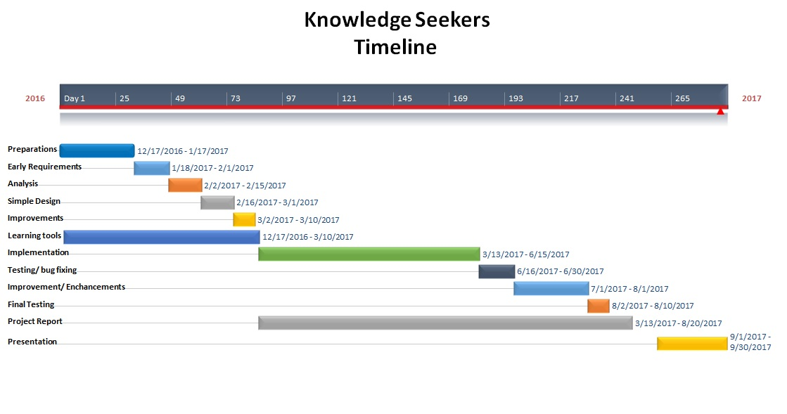
Figure 1.2: Gantt chart for Knowledge States

1.10 Features


People can search for the solution of the problem they are facing, if they didn’t find solution; they put their query and get the best possible solution.


People can Share their Experience & knowledge and can answer the queries related to their profession. They can vote the question as authentic and mark the answer as correct by liking.



Everyone will stay up-to-date by the news related to every profession and field; people are allowed to give their reviews.

If you’re feeling bored and have ten minutes to kill, then why not, you check out the awesome list of random and funny facts on Knowledge States

User needs to sign-up/sign-in for performing any action. User will manage their profile and other user will ranked their profile when he/she helped to solve their problem.


Companies will get a free job portal and can see the user profile and contact to the professional on this platform by reviewing their performance. [4]
Deliverables
December 2016
- Requirements Specifications
- Simple Design
- High Level Design
Spring 2017
- High Level Design (final)
- Implementation
- Project Report
- Final Product
- Presentation

1.11 Learning outcomes

- Foundations:
We are able to work on following tools and languages

TOOLS | LANGUAGES
- Visual Studio 2015 community | - Asp.net MVC (C-sharp)
- Microsoft SQL | - HTML/CSS
- Adobe Photoshop  - Illustrator | - Java Script/JQuery

Application:
After doing this project we will be able to implement above described tools and technologies in professional world.

Human dimension:
- During the whole duration of project we will learn how to work in a group.
- We will improve weakness of each other during the working of project.

Caring:
- During the project working we will apply legal engineering principle.
- We will apply the ethics during work group.

Learning how to learn
We learned during the project that how we could learn independently

1.12 Student’s Preparation
Ahmad Kaleem
- Asp.net MVC
- Databases
- JQuery
- Software engineering 1
- Software engineering 2
- Designing (Photoshop, illustrator)

Adnan Ali
- Asp.net MVC
- Databases
- JQuery
- Designing (Photoshop, illustrator)
- Software engineering 1
- Software engineering 2

Sidra Iqbal
- Asp.net MVC
- Designing (Photoshop, illustrator)
- Software engineering 1
- Software engineering 2
- SRS (Software Requirement & Specifications)

Chapter 2 Requirements

2.1. Functional Requirements
- Knowledge states allow different privileges and access rights to following persons.
- Authorized user has right to
- Ask a question
- Answer to a question
- Mark a question as correct
- Report to a question
- Like or report the blog
- Comment against blog
- Create a job
- apply for a job
- create a company
- Unauthorized user has no right to
- Ask a question
- Answer to a question
- Mark a question as correct
- Report to a question
- Post a blog
- Like or report the blog
- Comment against blog
- Create a job and apply for a job
- Admin has right to
- Delete a user
- Ask a question
- Answer to a question
- Delete a question
- Mark a question as correct
- Report to a question
- Post a blog
- Delete a blog
- Like or report the blog
- Comment against blog
- Create a job
- Create a company
- Post news and fun facts
- Knowledge states will register individual profile of each user, save and maintain
- Unique user name
- User image
- User gender
- User country
- User email
- User description
- User companies
- User jobs
- User stats
- Questions
- Answers
- user can search for the solution of the problem they are facing, if he didn’t find solution, they put their query and get the best possible solution
- User can Share their Experience & knowledge and can answer the queries related to his profession. They can vote the question as authentic and mark the answer as correct by liking
- Everyone will stay up-to-date by the news related to every profession and field, people are allowed to give their reviews
- If you’re feeling bored and have ten minutes to kill, then why not, you check out the awesome list of random and funny facts on Knowledge states
- User needs to sign-up/sign-in for performing any action. User will manage their profile by their interest and other user will ranked their profile when he/she helped to solve their problem. User will allow creating their resume on this platform
- Companies will get a free job portal and can see the online resume and contact to the professional on this platform by reviewing their performance. [8]

2.2. Non-Functional Requirements
- Usability
This web application should work in all browsers such like as Safari, Google Chrome, Internet Explorer and Firefox [9]. Application should be responsive and work properly on each dimension e.g: Mobile layout, Tab layout etc.
- Reliability
Application shall give reliable response all the time. Multiple testing techniques should be used to ensure that
- Availability
Application should be available 24/7 for users.
- Mean Time to Repair (MTTR)
Application should be fault tolerant. If it doesn’t and breakdown, application should be recovery as soon as possible.
- Accuracy
Application should be faster/light weighted and provide accuracy to all users.
- Access Reliability
Application shall provide 100% access reliability.
- Performance
Application can easily support multiple users on same time.
- Response Time
The application should respond to any request triggered within three seconds and complete within ten sec or less. Page should also load properly and faster on low bandwidth [9].

- Throughput
As the user increased the number of process will automatically increase.
- Capacity
Application should be able to handle maximum users at same time in operating environment.
- Resource Utilization
We use light weight components, so the Application will utilize fewer resources.
- Supportability
Languages: C#, JavaScript, JQuery, CSS3 and HTML5.
Framework: ASP.NET MVC 5.
IDE: Microsoft Visual Studio 2015 Community.
Database: Microsoft SQL server management studio 2014.
- Design Constraints
The Application designed in such a way it can be visible on most all of the browsers.
- Software Language Used
The languages that shall be used for development of the project are as follows
- C-Sharp
- JQuery
- HTML 5
- JavaScript
- CSS 3
- Development Tools
- Visual Studio 2015 community
- Microsoft SQL server management 2014
- Adobe Photoshop
- Illustrator

Chapter 3 Design and Architecture

SDLC Model
SCRUM (AGILE METHODOLOGY) is used for the development of this project. [12]

Scrum Model
Agility helps in time boxed iterative development, suggests adaptive planning and promote incremental delivery. To deal with changing requirements and yield frequent and small software increments which can be adjusted, documented and built on the project intends to use SCRUM as the process model [11].

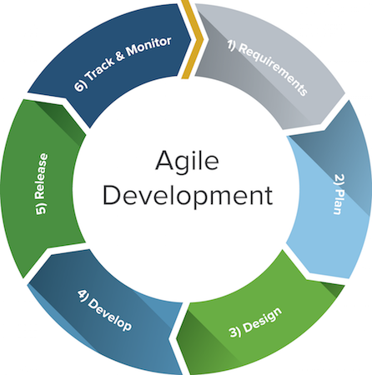

Figure:3.1 Process Model For Knowledge States[11]
As our project is web based, so we chose agile model because requirements must change at every step. Agile allows making a new iteration at each step of development in the project and improving the product quality. In Agile, there is a high collaboration between the client and project team, it gives high customer satisfaction, reduce risks and project control improves. At every step of development new iteration can easily add to the project [12].

Data BAse Diagram
- Every user either he’s a admin or client or any other interact with these on Knowledge States according to their roles

- AspNetUsers
- AspNetUserRoles
- AspNetRoles
- UserProfiles
- QuestionPosting
- BlogPosts
- JobPosts
- JobApplicants
- CompanyProfile
- Tbl_NewsReport
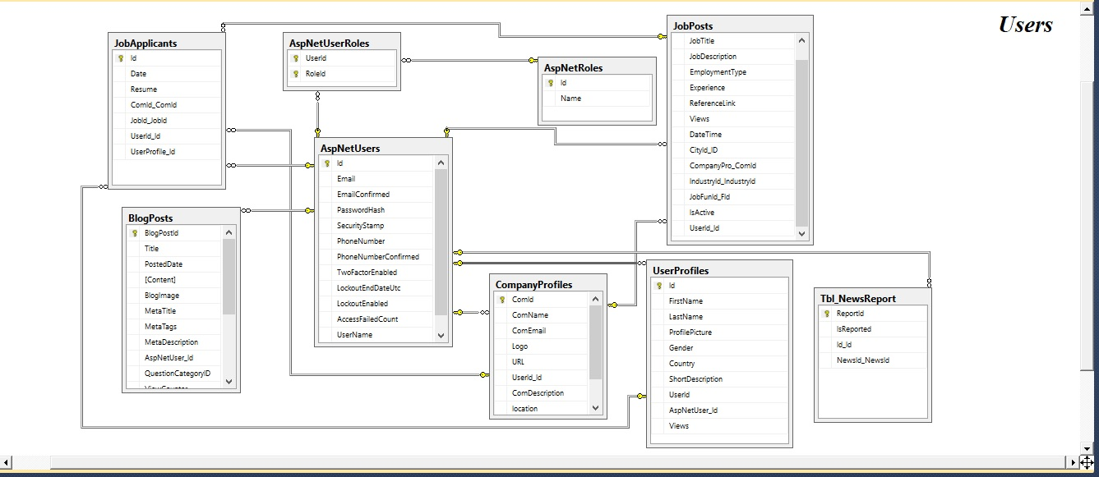
Figure 3.2 Knowledge States User’s ERD
- Tables needed for user profile management

- AspNetUsers
- UserProfiles
- UserprofileViewerIps
- JobApplicants

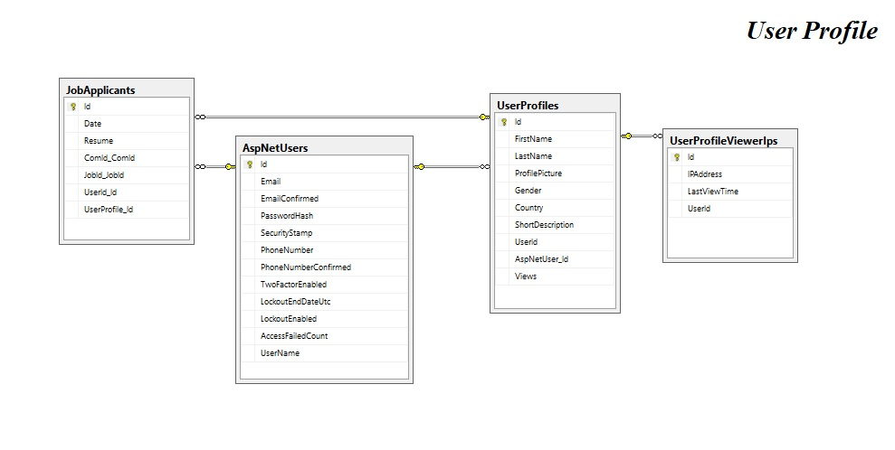
Figure 3.3 Knowledge States User Profile ERD

- Question posting and related tables

- QuestionPostings
- QuestionCategories
- QuestionTags
- LikeReport
- QuestionComments
- CommentLikes
- ViewerAddressRecords

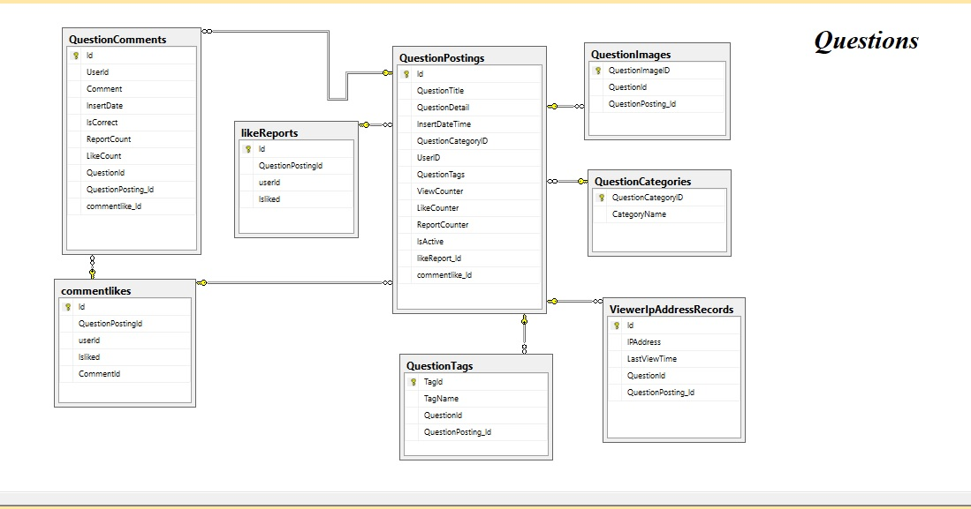
Figure 3.4 Knowledge States Question’s ERD

- Blog Posting and related tables

- BlogPosts
- QuestionCategories(Blogs and Questions have same categories)
- BlogTags
- BloglikeReports
- BlogComments
- BlogCommentLikes
- ViewerAddressRecordBlogs
- AspNetUsers
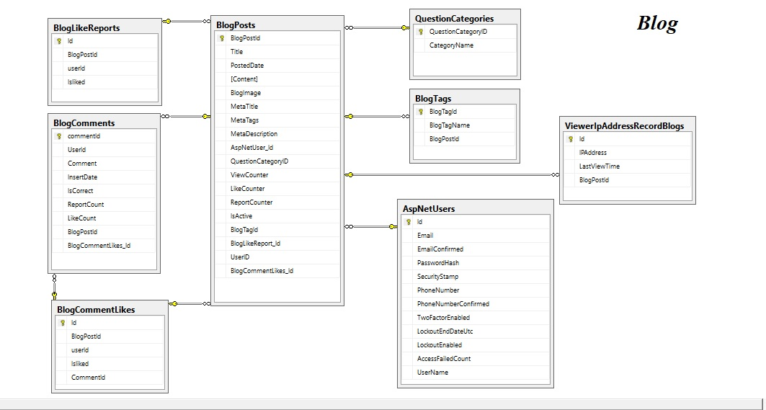Figure 3.5 Knowledge States Blog’s ERD

- Job portal

- JobPosts
- ComanyProfiles
- City
- Industries
- JobFunctions
- Skills
- JobVieverIps
- JobApplicants
- AspNetUsers

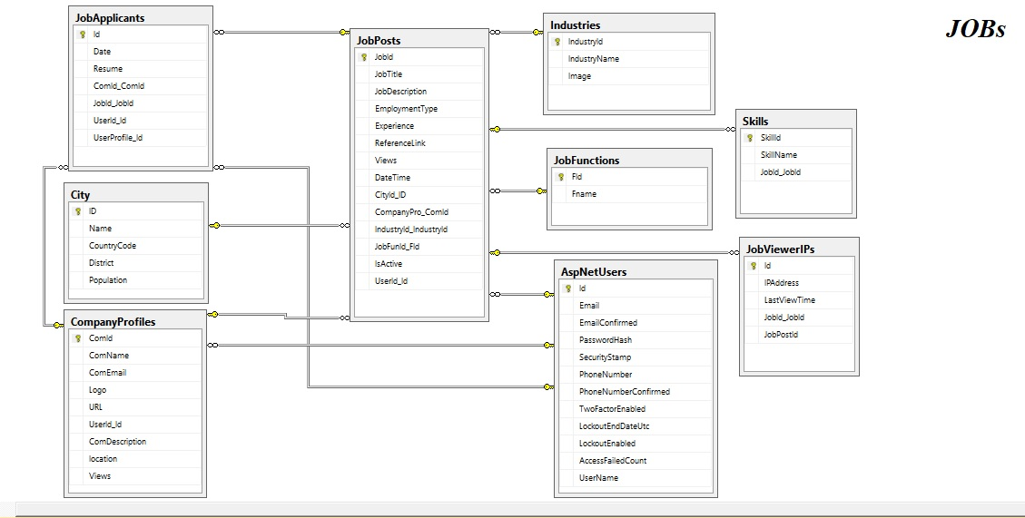
Figure 3.6 Knowledge States Job’s ERD

- Job Providing Companies

- JobPosts
- JobApplicants
- CompanyProfiles
- CompanyViewerIps
- AspNetUsers

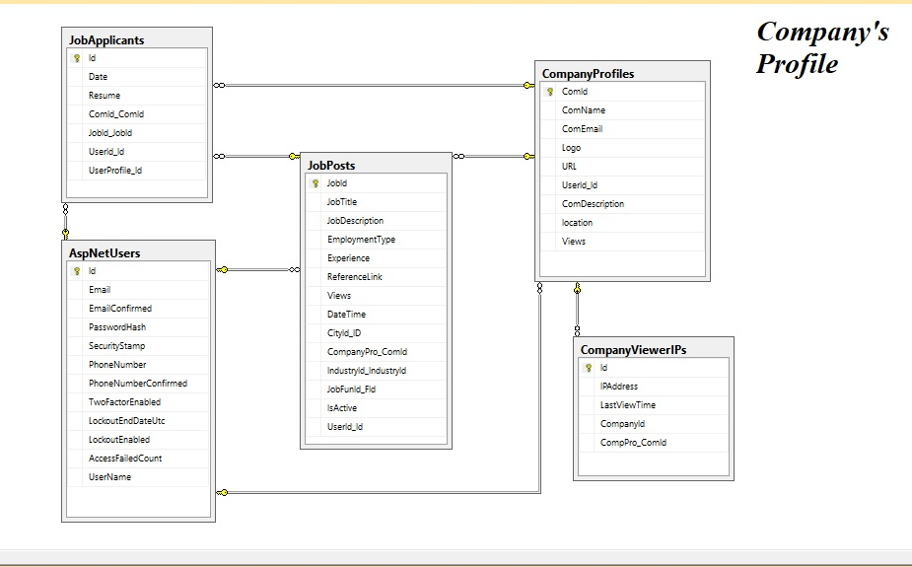
Figure 3.7 Knowledge States Company Profile ERD

- News & Articles related tables

- Tbl_News
- City
- Tbl_NewsCategory
- Tbl_NewsType
- Tbl_NewsPriority
- Tbl_NewsIpRecords
- Tbl_NewsReport

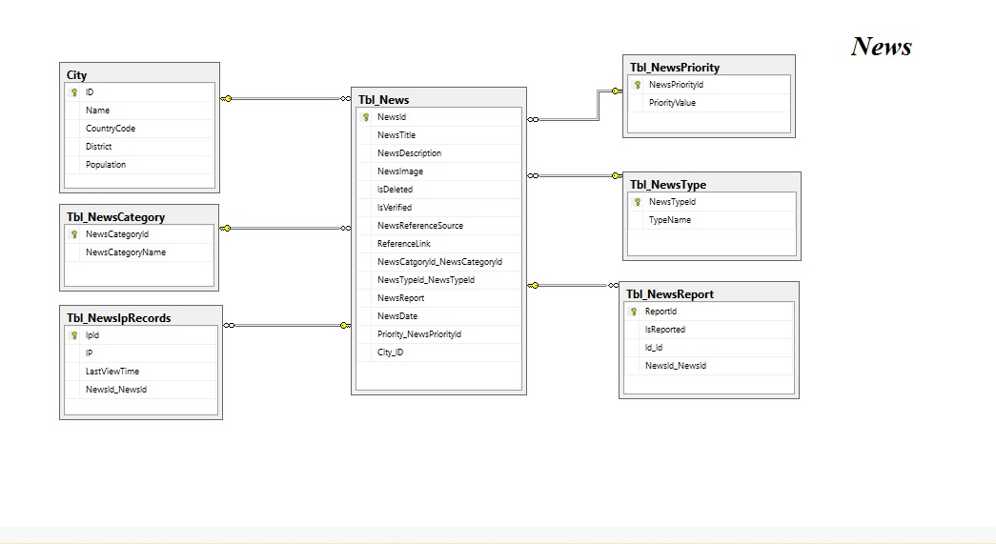
Figure 3.8 Knowledge States News Section ERD
- Fun Facts and other related tables

- Facts
- Country
- City
- LikeReports
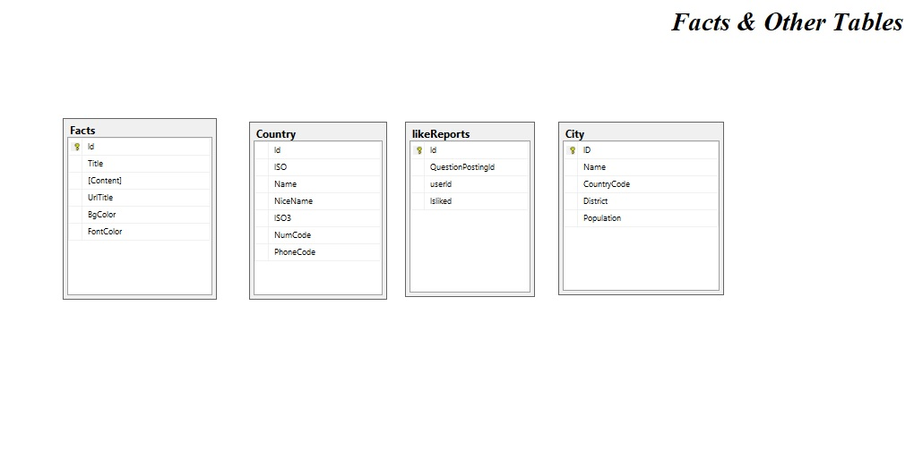
Figure 3.9 Knowledge States Fact’s ERD

3.3. Use cases

Use Case: 1 [13]
Name: Register/Signup
Actor: Client (User)
Description:
When any user Register/Signup for Knowledge States this use case will begin. The application asks for his information. Application will verify the provided information and on verification register user as member of Knowledge States. The user will now be allowed to become Authorized user of Knowledge States.
Precondition:
The user must have unique email

Events
User Action | Application’s Response
1. When any user Register/Signup for Knowledge States this use case will begin | 2. Application will ask for Unique email
3. The User will provide his id | 4. Application will verify the Unique email
 | 5. Application will ask for other basic information
6. User provide the information | 7. Application save the information in repository
 | 8. Update the user list

Alternative Course:
Line 4: Invalid text/Wrong email will indicate error message

Use Case: 2
Name: Login/Sign in
Actor: Admin, Client (User).
Description:
When any user wants to login/Sign-in in Knowledge States this use case will begin. The Application asks for user name and password. The user will give the username, password. Application will verify the provided information and on verification give access of Knowledge States with predefined access privileges of actor.
Precondition:
The user must enter valid username/email and valid password to get login.
Events
User Action | Application’s Response
1.Use case will begins when any user of Knowledge States wants to login
 | 2. Application will ask for valid username and password
3. The user will provide username, password
 | 4. The Application will verify the username, password
 | 5. The Application will determine the access privilege level of user
 | 6. The Application will also give access to user with determined privilege level

Alternative Course:
Line 3: Wrong User name, password; Application asks to re-enter.
Line 4: client is not a user; Application will display a message to indicate him non user

Use Case: 3
Name: Lost Password
Actor: Client (User).
Description:
When any Registered wants to login Knowledge States but forgot the password this use case will begin. The Application will ask for user email for password recovery. The user will give email. Then Application will send a password recovery link to user provided email.
Precondition:
The user must have to provide email.

Events
User Action | Application’s Response
1.This use case begins when user of Knowledge States wants to recover his password
 | 2. Application will ask for email
3. The user will provide email
 | 4. Application will send recover password link to provided email

Alternative Course:
Line 3: invalid email, Application will indicates error message.

Use Case: 4
Name: Question Posting
Actor: Client (User), Admin.
Description:
This use case begins when any user or also admin of knowledge states wants to submit a question. The Application firstly verify the user either he authorized or not when any user trying to post a question. After verification Application asks for question title, question category, tags and description. The user will give question title, question category, tags and description. Then Application will post the question and show a successful notification to user.
Precondition:
The user must be authorized otherwise he can’t ask a question.
Events
User Action | Application’s Response
1.This use case begins when any user of Knowledge States wants to post a question
 | 2. Application checks either user authorized or not
 | 3. Application will ask for question title, question category, tags and description from authorized user.
4. User provides question title, question category, tags and description.
 | 5. Application will verify that either user fill the question post form complete or not
 | 6. The Application posts the question.
 | 7. Application updates the question list.

Alternative Course:
Line 2: unauthorized user, Application indicate error.
Line 4: Question posting form is not complete. Application indicates error message.

Use Case: 5
Name: Job creating
Actor: Admin, Client (User).
Description:
This use case begins when user or admin of knowledge states wants to create a job. Only authorized user and admin can create a job. The Application asks for job title, company, industry, job functions, skills, country, city, employment type, seniority level, reference link and description. The Admin or user will give all this required information. Then Application will verify and create the job.
Precondition:
Only user or admin can create the job.

Events
User Action | Application’s Response
1.This use case begins when Admin or user of Knowledge States wants to create a job
 | - Application will verify user authorization
 | - Application will ask for job title, company, industry, job functions, skills, country, city, employment type, seniority level, reference link and description
- User provides job title, company, industry, job functions, skills, country, city, employment type, seniority level, reference link and description.
 | - The Application will verify the all required information
 | - The Application create the job
 | - Application updates the job list.

Alternative Course:
Line 3: Job creating form is not complete; Application indicates error message.

Use Case: 6
Name: Apply for job
Actor: Client (User)
Description:
When authorized user of knowledge states wants to apply for job this use case begins. The Application includes user’s public profile and ask user to upload resume. Application send a mail to job’s company through knowledge states mail.
Precondition:
Only authorized user can apply for the job.
Events
User Action | Application’s Response
- This use case begins when user of Knowledge States wants to apply for a job
 | - Application verify user authorization
 | - Application asks for user first name, last, email and user resume
- User provides resume to Application
 | - The Application get user data and generate a mail to job’s company

Alternative Course:
Line 3: Job applies form is not complete; Application indicates error message.

Use Case: 7
Name: Blog Posting
Actor: Admin, Blogger.
Description:
This use case begins when admin of knowledge states wants to post a blog. The Application will ask for Blog title, Blog category, tags, image URL, date and description. The Admin will give Blog title, Blog category, tags, image URL, date and description and the Application will post the Blog with all required information.
Precondition:
Only admin can post the Blog.
Events
User Action | Application’s Response
1.This use case begins when Admin of Knowledge States wants to post a Blog
 | 2. Application asks for Blog title, Blog category, tags, image URL, date and description
3. Admin provides Blog title, Blog category, tags, image URL, date and description.
 | 4. The Application will verify the required information
 | 5. The Application Submit the Blog with all given required information.
 | 6. Application will update the blog list.

Alternative Course:
Line 3: Blog posting form not complete; Application indicates error message.

Use Case:8
Name: News and Articles
Actor: Admin, Content Writer.
Description:
This use case begins when admin of knowledge states wants to post News and Articles. The Application asks for News title, news type, country, city, category, news priority, reference link, and news reference Resource and description. The Admin will give News title, news type, country, city, category, news priority, reference link, news reference Resource and description and Application will post the news.
Precondition:
Admin and Content Writer can post the News and Articles.
Events
User Action | Application’s Response
1.This use case begins when Admin of Knowledge States wants to post a News and Articles
 | 2. Application will ask for News title, news type, country, city, category, news priority, reference link, news reference Resource and description
3. Admin provides News title, news type, country, city, category, news priority, reference link, news reference Resource and description.
 | 4. The Application will verify the required information
 | 5. The Application will submit the news and articles.
 | 6. The Application will update the news list.

Alternative Course:
Line 3: News posting form is not complete; Application indicates error message.

Use Case: 9
Name: Fun facts posting
Actor: Admin, Content Writer.
Description:
This use case begins when admin of knowledge states wants to post fun facts. The Application asks for fact title, URL title, description, font color and background color. The Admin will give fact title, URL title, description, font color and background color. Application will post the fun facts.
Precondition:
Admin or Content Writer can post the fun facts.
Events
User Action | Application’s Response
1.This use case begins when Admin of Knowledge States wants to post a fun facts
 | 2. Application will ask for fact title, URL title, description, font color and background color.
3. Admin provides fact title, URL title, description, font color and background color.
 | 4. The Application verify the required information
 | 5. The Application Submit the fun facts with all given required information.
 | 6. Application will update the fun facts.

Alternative Course:
Line 3: Fun Facts posting form not complete; Application indicates error message.

Chapter 4 Implementation

4.1. Project Implementation

We use Microsoft Visual studio 2015 community [14] for our web application. And use Entity Framework [15] for database connectivity with Microsoft SQL Server 2014. [18] Through Entity Framework there is no need to directly Interact with SQL server we just declare (Models) classes and the attributes it automatically create database and tables. Also we don’t need to write queries through Entity Framework we just write Lamda query in C-Sharp and it converts automatically.
The main modules developed are:

Login
We use Asp.Net Identity Framework [15] to authenticate user in our Application [2]. Asp.Net MVC uses the IPrinciple through which it checks the either any role is assigned to the current user who are trying to make login. If user registers in application, user will allocate a “client” role while user is registering himself. Password Hasher will encrypt the Password and punch a security stamp. Both are default Asp.Net MVC5 UserManager Function to secure the Application.
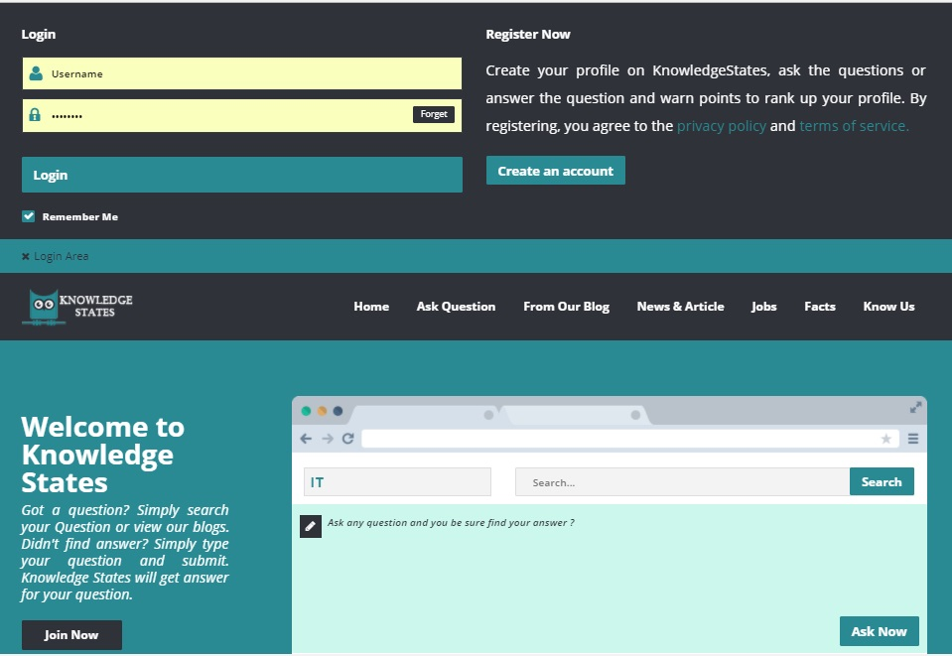
Figure 4.1 Knowledge States login Area

4.1.2 Question Posting
Authorized user (client) is allowed to ask a question by submitting Question title, select or enter the matching Category and Tags (sub-categories) and some detail description to tell what problem they are facing and what type of solution they required. After submitting the Form through JQuery [17] value will get and send to controller action through Ajax. [17] If the response will get true value page will redirect to the submitted to Question otherwise alert box will appear with the custom error.
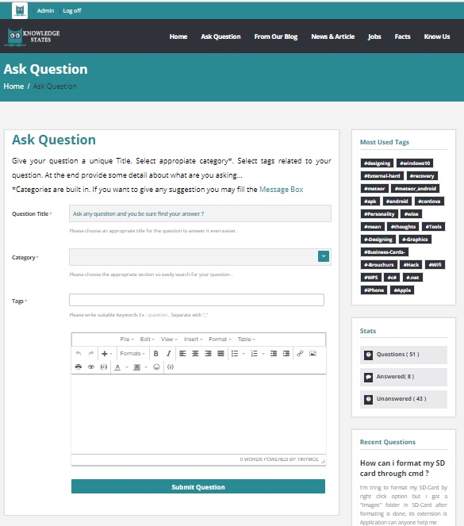
Figure 4.2 Knowledge States Ask Question Page

4.1.3 Blog Posting
Blog is a shared by Admin and Bloggers. Bloggers needs to fill up the given form and submit it. After submitting the form JQuery will get the values from Html TextBoxes and sent to the controller after submitting the Article to database Main-Image will be uploaded after getting success as a response.
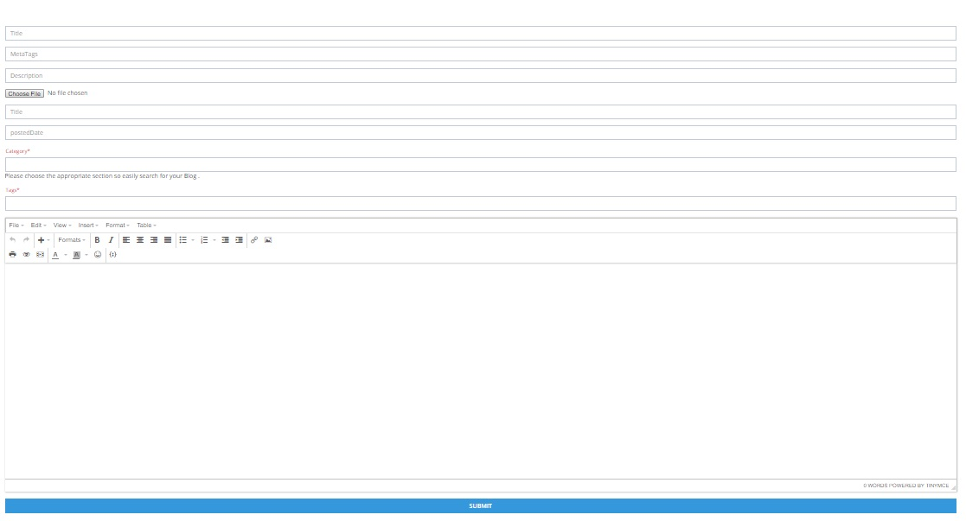
Figure 4.3 Knowledge States Blog Posting Page

4.1.4. News Posting
News, Articles or reviews are all posted by the Bloggers or Content Writer. Here they needs to fill-up form with required fields and it will be published on site. In news section there will also be a data about research and new discoveries.
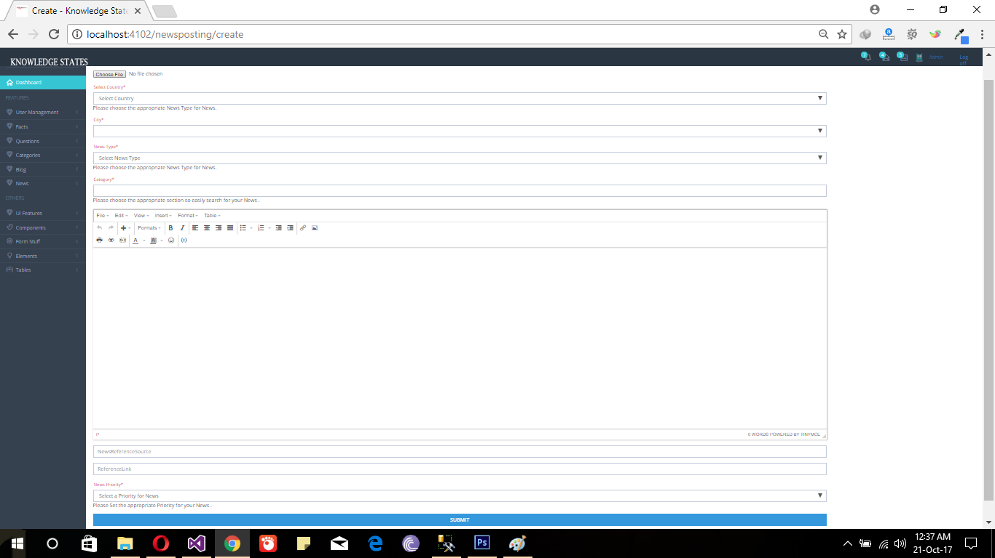
Figure 4.4 Knowledge States News Posting Page

4.1.5. Fun Facts Posting
Fun Facts also published by content provider.
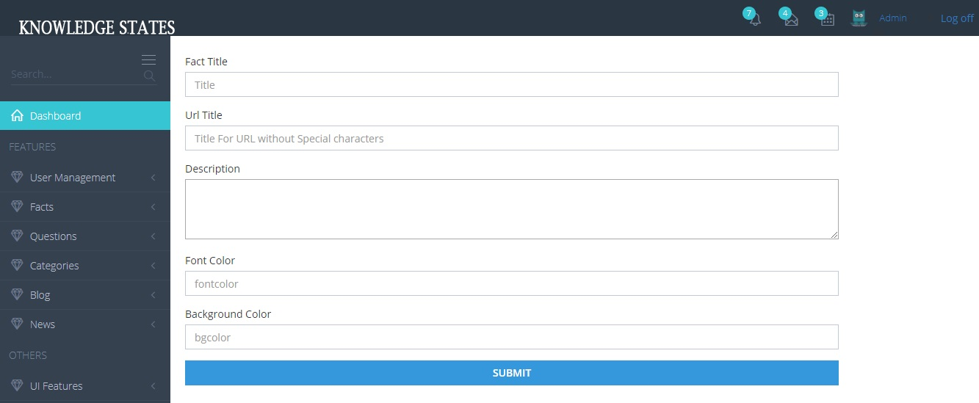
Figure 4.5 Knowledge States Fact Posting Page

4.1.6. Create a job
Job Portal is designed for the job providing companies and facilitates the users to get their desired job. Authenticated User is allowed to post a job after providing company’s data and Job-title, Company Profile, Industry, Job Functions, Skills, location and Job Description is needed to be entering to publish a Job. Other users are allowed to apply online through Knowledge States.
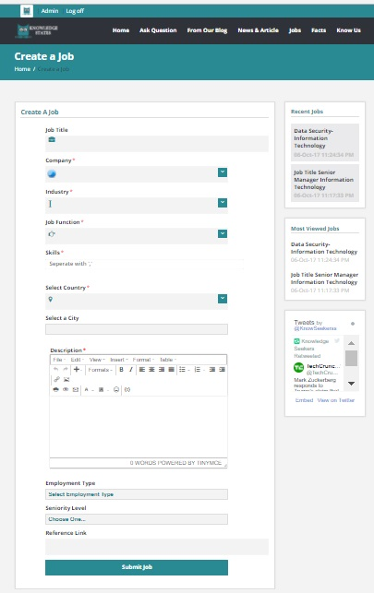
Figure 4.6 Knowledge States Job Posting Page

Chapter 5 Testing

5.1. Verification
Verification is takes place at starting of the project development process [19] and we can detect any defect means any feature of the product or application is not up to the mark. So verification was done after completion of each phase. We tested each phase completed to verify the requirements either client needs meet or not. Our team verifies every phase of application development process. So by testing we verify either we developed the right product or not.

5.2. Test Cases

5.2.1. Test Cases for Admin
Test ID: 1 Software: Knowledge States Modulation: Login-Module Test Name: Login
Preconditions | Admin is already registered.
Actions | 1. Enter valid user name and password and click login button  2. Click sign out  3. Without entering user name click login button  4. Without entering password click login button  5. Enter wrong password or user name and click login button
Expected Results | 1. Application will redirect to the Admin-Dashboard.  2. Login page for Admin will be appears.  3. An error message will display that user name field is empty  4. An error message will display that password field is empty  5. Error message will display that user name and password are invalid
Result | All the above actions are handled by UMS as per expected results

Test Description: Test case tests the behavior of Application when user wants to login then how Application responds. Application allow user that have admin role to login with valid username and password and prevent user from login with invalid username and password or having other role instead of admin.
Testing Environment: Laptop (Core i5), 1TB HDD, 8GB RAM, ASP.NET MVC 5, SQL Server 2014. [20]
Tested By: Adnan Ali and Sidra Iqbal Date: 17/06/2017

Test ID: 2 Software: Knowledge States Modulation: Question Module Test Name: Question Posting
Preconditions | Only Authorized user can post question
Actions | 1. Enter question title, question category, tags and description and click submit question button  2. Empty question title box and click submit question button  3. Question category is not selected or entered click submit question button  4. Empty tags box click submit question button  5. Empty description click submit question button
Expected Results | 1. Application will redirect to the single question page after publishing.  2. Error message will be displayed that question title field is empty  3. Error message will be displayed that question category field is empty  4. Error message will be displayed that tags field is empty  5. Error message will be displayed that description field is empty
Result | All the above actions are handled by UMS as per expected results

Test Description: Test case tests the behavior of Application when user wants to post the question and Application allow user to submit question with question title, question category, tags and description and Application prevent users to post question with empty question title, question category, tags and description fields.

Testing Environment: Laptop (Core i5), 1TB HDD, 8GB RAM, ASP.NET MVC 5, SQL Server 2014.
Tested By: Adnan Ali and Sidra Iqbal Date: 21/07/2017

Test ID: 3 Software: Knowledge States Modulation: Blog Module Test Name: Blog Posting
Preconditions | Only Admin can post Blog
Actions | 1. Enter Blog title, Blog category, tags, image, date and description and click submit Blog button  2. Empty Blog title field and clicked submit Blog button  3. Empty Blog category field and clicked submit Blog button  4. Empty Blog tags field and clicked submit Blog button  5. No image is selected and clicked submit Blog button  6. Empty date time field clicked submit Blog button  7. Empty description field and clicked submit Blog button
Expected Results | 1. Application will redirect to blog list after publishing.  2. Error message will be displayed that Blog title field is empty  3. Error message will be displayed that Blog category field is empty  4. Error message will be displayed that tags field is empty  5. Error message will be displayed that image URL field is empty  6. Error message will be displayed that date field is empty  7. Error message will be displayed that description field is empty
Result | All the above actions are handled by UMS as per expected results

Test Description: Test case tests the behavior of Application when admin wants to post the blog and Application allow admin to submit blog with Blog title, Blog category, tags, image URL, date and description and Application prevent users to post blog with empty Blog title, Blog category, tags, image URL, date and description fields.
Testing Environment: Laptop (Core i5), 1TB HDD, 8GB RAM, ASP.NET MVC 5, SQL Server 2014.
Tested By: Adnan Ali and Sidra Iqbal Date: 15/08/2017

Test ID: 4 Software: Knowledge States Modulation: News and Articles Module Test Name: News an articles Posting
Preconditions | Only Admin can post News and Articles
Actions | 1. Enter News title, news type, country, city, category, news priority, reference link, and news reference Resource and description and click submit button  2. Empty News title field and clicked to submit button  3. Empty News type field and clicked submit button  4. Empty country field and clicked submit button  5. Empty city field and clicked submit button  6. Empty category field and clicked submit button  7. Empty news priority field and clicked submit button  8. Empty reference link and clicked submit button  9. Empty news reference Resource and clicked submit button  10. Empty description and clicked submit button
Expected Results | 1. Application will be redirect to news list after publishing.  2. Error message will be displayed that News title field is empty  3. Error message will be displayed that news type field is empty  4. Error message will be displayed that country field is empty  5. Error message will be displayed that city field is empty  6. Error message will be displayed that category field is empty  7. Error message will be displayed that news priority field is empty  8. Error message will be displayed that reference link field is empty  9. Error message will be displayed that news reference Resource field is empty  10. Error message will be displayed that description field is empty
Result | All the above actions are handled by UMS as per expected results

Test Description: Test case tests the behavior of Application when admin wants to post the News and Articles and Application allow admin to submit News with News title, news type, country, city, category, news priority, reference link, and news reference Resource and description and Application prevent user to post news with empty News title, news type, country, city, category, news priority, reference link, and news reference Resource and description fields.

Test ID: 5 Software: Knowledge States Modulation: Fun facts Module Test Name: fun facts posting
Preconditions | Only admin and content writer can post fun facts
Actions | 1. Enter fact title, URL title, description, font color and background color and click submit question button  2. Empty fact title field and clicked submit button  3. Empty URL title field and clicked submit button  4. Empty description field and clicked submit button  5. Empty font color field and clicked submit button  6. Empty background field color and clicked submit button
Expected Results | 1. Application will redirect to the fact list after publishing.  2. Error message will be displayed that fact title field is empty  3. Error message will be displayed that URL title field is empty  4. Error message will be displayed that description field is empty  5. Error message will be displayed that font color field is empty  6. Error message will be displayed that background color field is empty
Result | All the above actions are handled by UMS as per expected results

Test Description: Test case tests the behavior of Application when admin wants to post the fun facts and Application allow admin to submit fun facts with fact title, URL title, description, font color and background color and Application prevent user to post fun facts with empty fact title, URL title, description, font color and background color fields. [20]

Testing Environment: Laptop (Core i5), 1TB HDD, 8GB RAM, ASP.NET MVC 5, SQL Server 2014.
Tested By: Adnan Ali and Sidra Iqbal Date: 10/09/2017

Chapter 6 User Manual

6.1. Application’s Overview

Knowledge States homepage

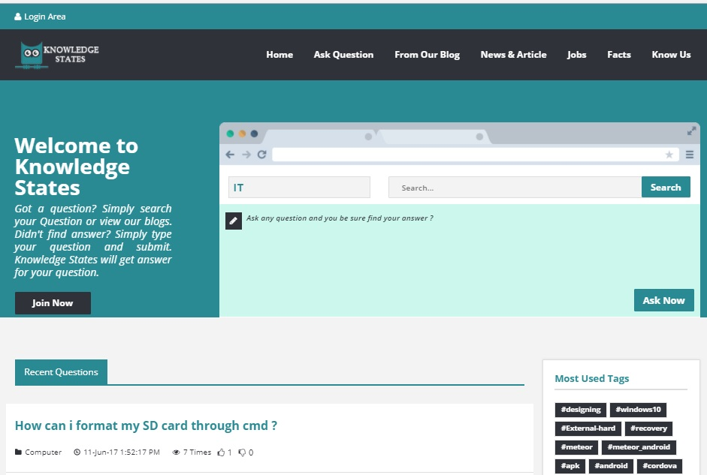
Figure 6.1 Knowledge States Home Page

Application allow User to sign-up
For sign-up user must need unique username and valid email address. Password must be at least of 6 characters with upper and lower case letters and specials characters also included. These details are required while user register himself. When user signed up, he receives a welcome email.
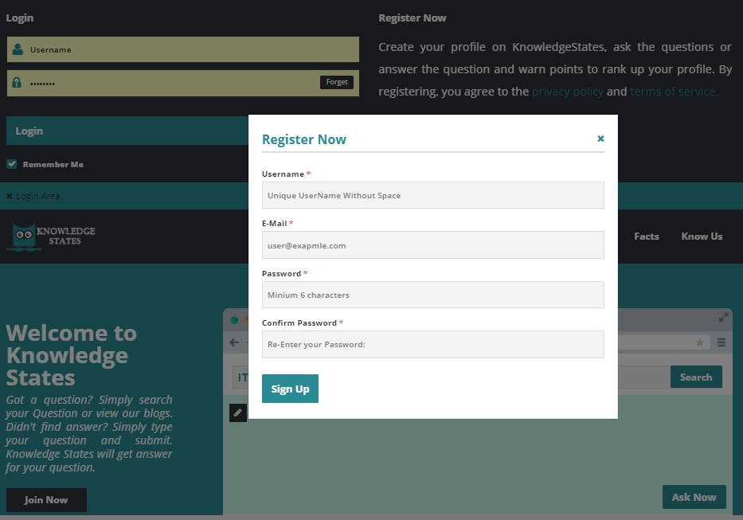
Figure 6.2 Knowledge States Register Pop

Application provide user login area
User can login to application by providing valid username and valid password. If username or password is invalid, user can’t get access to his account.
Figure 6.3 Knowledge States Login Area

Application allow User to manage his profile
Authorized User can see his profile about, jobs, questions, companies, user stats and he can easily edit his profile about, companies, jobs and can also delete jobs. But he can’t delete his own posted questions.
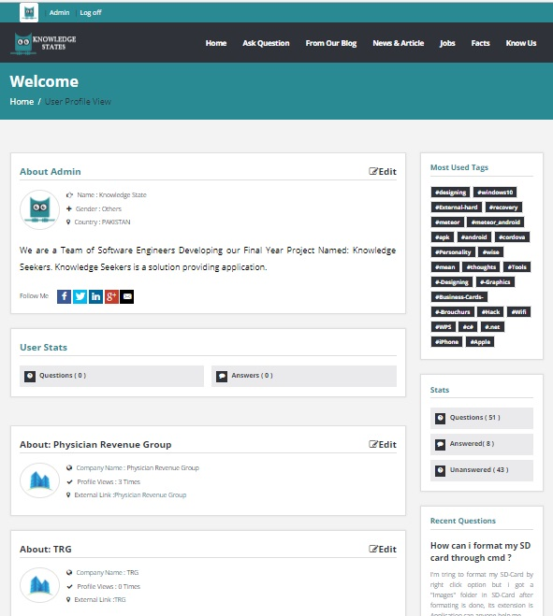
Figure 6.4 Knowledge States User Profile

The application provide user a way to recover his lost password
User can recover his account because application provides a way to recover his account through his email. Application sent a recover account link to his email. User can see the Confirmation notification when mail sent to user mail from knowledge states.
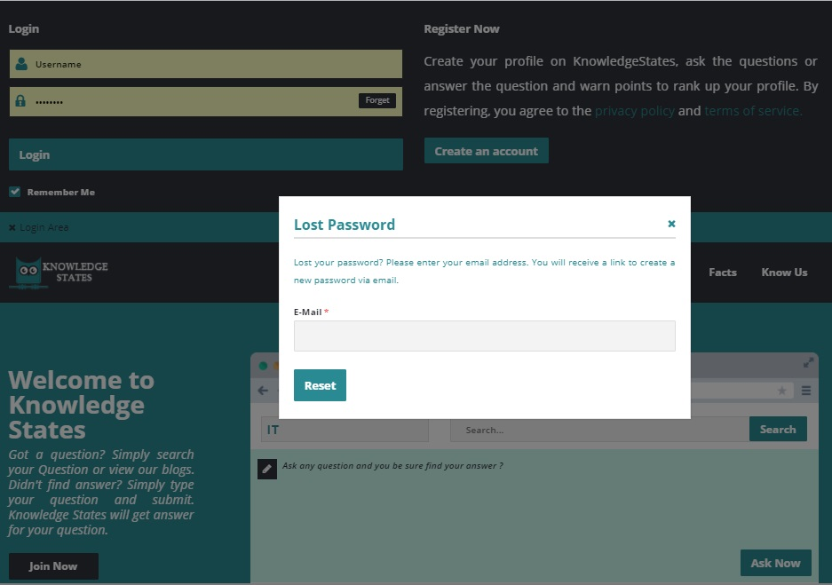
Figure 6.5 Knowledge States Lost Password

User can search and post a question
User can search any question and also ask a question at knowledge states homepage. At homepage when user click on ask now a new page open, Where user can submit his question by filling the question form which included question title, category, tags and description of question.

- User can search the question

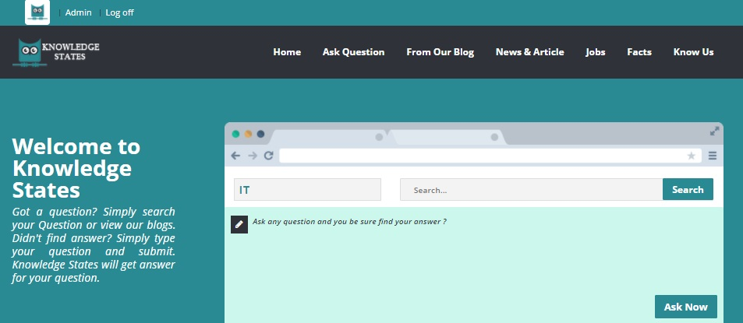
Figure 6.6 Knowledge States Search Bar

- User submit the question

Figure 6.7 Knowledge States Ask Question Page

User answer to questions or like or report to questions
If user is authorized then he can easily comment to a question. If he likes the question then he can mark the question as correct. If user didn’t like the question or he considered the question is irrelevant then he reports a question. When a question reported 50 times irrelevant then question automatically remove from the site.
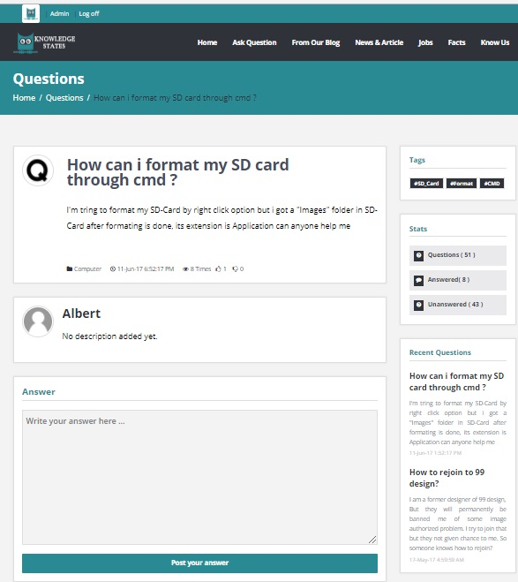
Figure 6.8 Knowledge States Question’s single Page
- User can create and apply for a job
Any authorized user can create a job by providing company information and job details. He can also apply for a job and the user mail for job sent to job’s company through knowledge states mail. User can easily upload his resume for jobs apply. But unauthorized user can’t apply for a job; he can just view the job.
- User create a job
Figure 6.9 Knowledge States Job Posting

- User apply for a job

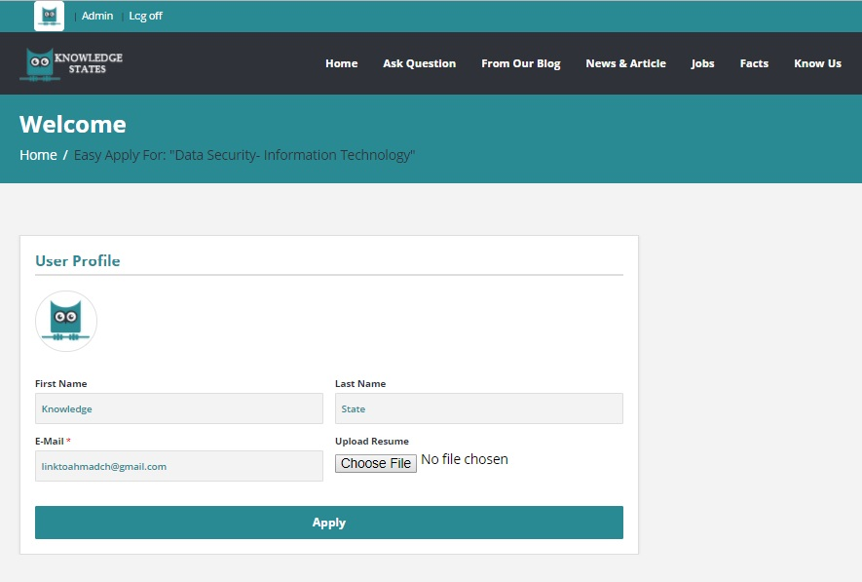 Figure 6.10 Knowledge States Easy Apply For Jobs

User can read blogs and comments against blog
If user is authorized then he can comment to a blog also but unauthorized only can read the blog. If blog is irrelevant then authorized user report a blog. Only admin can post the blog, delete or edit the blogs. User can only read or comment against blog.
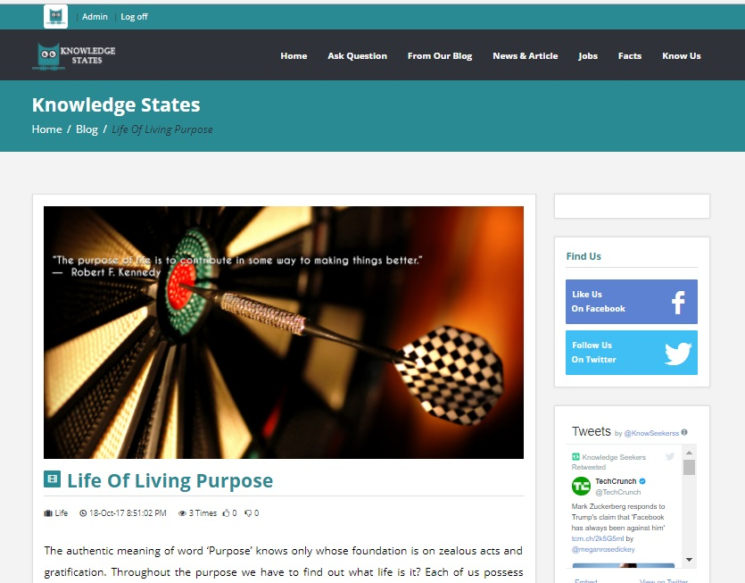
Figure 6.11 Knowledge States Blog’s Single Page

User can read fun facts and view latest news
Both authorized and unauthorized users can view the latest news and read the fun facts. There’s no authorization applied for this section. But only admin can post the news and fun facts.
- User can read fun facts

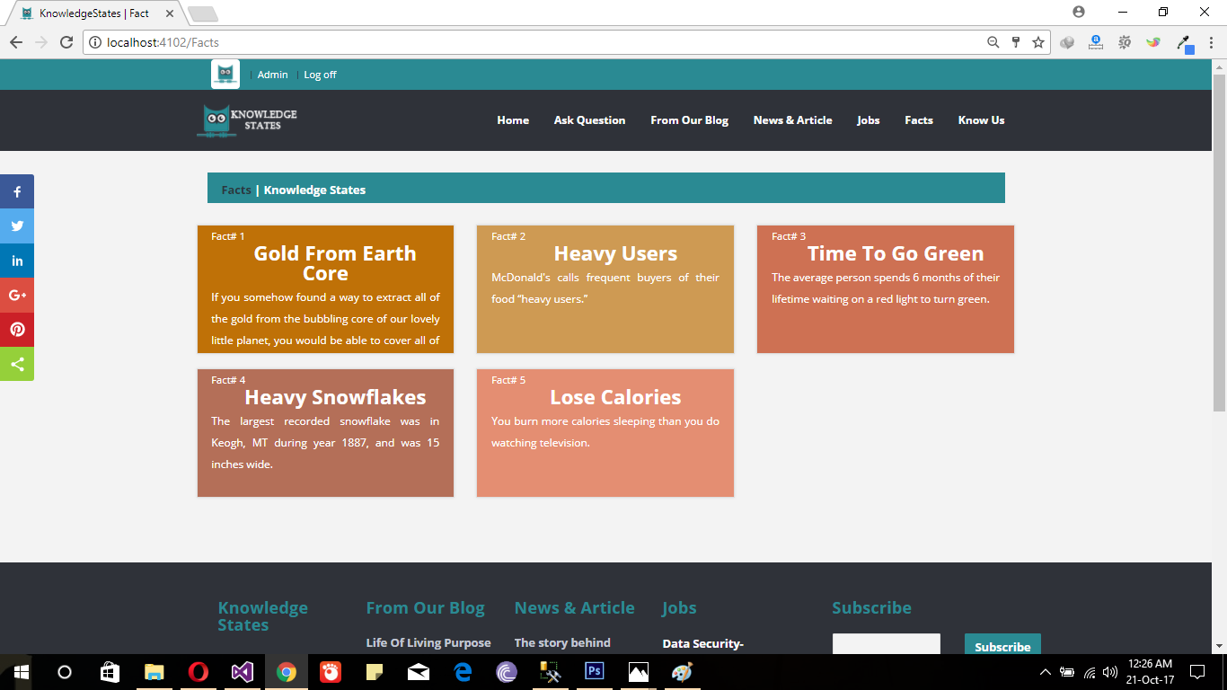
Figure 6.12 Knowledge States Facts

- User can view news&Articles

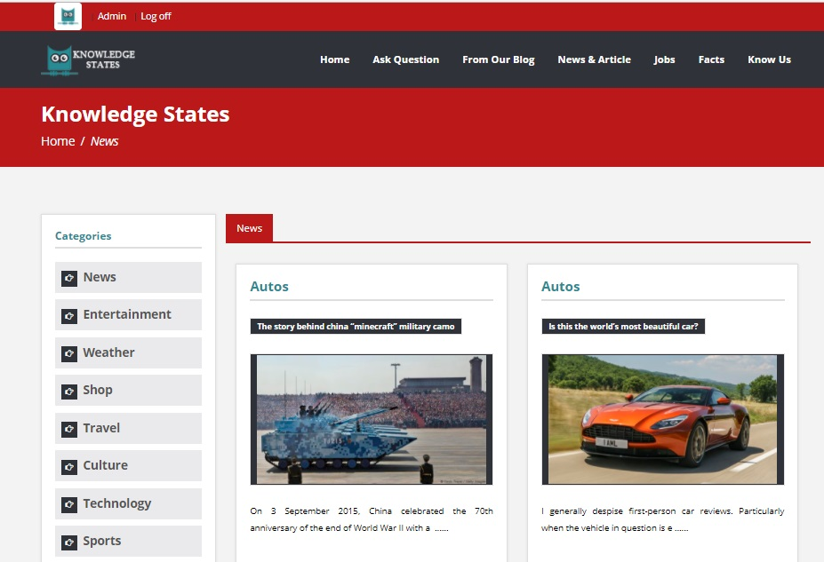
Figure 6.13 Knowledge States News

User can follow and subscribe knowledge states
User can follow the knowledge states on Facebook and on twitter and can get the latest Newsletters and articles by subscribing on knowledge states.

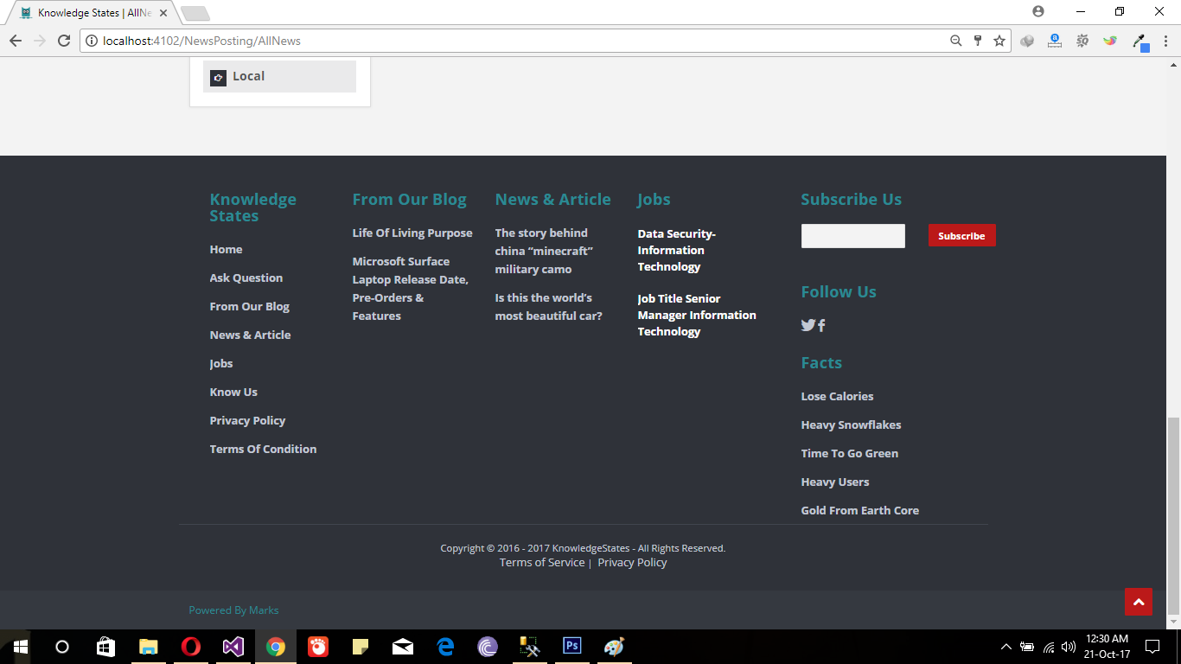
Figure 6.14 Knowledge States Footer

Chapter 7 Conclusion and Future Work

7.1. Conclusion
The main purpose of this final year project is to judge the young graduates skills which they learnt during their degree program. So, our team developed a unique web application (knowledge States) for solving people’s problems online. We work day and nights, face different critical problems but our team do their best to make this happened.

Future Work
We almost complete our application but these are future features which we added in our web application as soon as possible.
    - Live Chatting: User can easily chat with other user or directly connected to professional by including live chatting feature into our application
    - Push Notifications: push notifications added as soon as possible. Due to push notification feature user can easily know who respond to him.
    - Interest based profiling: Work on interest based profiling shows the user interest. So each user can easily see the other user interest in the form of News Feeds.

Chapter 8 References
8.1 References
- Internet Web page: Jeff Atwood and Joel Spolsky. Stack OverFlow. Stack Overflow is a privately held Website, Its features questions and answers on a wide range of topics in computer programming. 16-2-2016. http://stackoverflow.com/.

- Wikihow.com. (2017). wikiHow - How to do anything. [online] Available at: http://www.wikihow.com/.

- Internet Web page: Web Med. Web Med is providing tips and tricks how to use medicine and what things has to prevent. http://www.webmd.com/

- LinkedIn. (2017). Jobs. [online] Available at: https://www.linkedin.com/jobs/.

- Sei.cmu.edu. (2017). Software Architecture | Overview. [online] Available at: https://www.sei.cmu.edu/architecture/

- Itinfo.am. (2017). Software Development Methodologies. [online] Available at: http://www.itinfo.am/eng/software-development-methodologies/

- Bizfluent. (2017). High-Level Project Plan?. [online] Available at: https://bizfluent.com/about-6570755-high-level-project-plan-.html

- Ofni Systems. (2017). Functional Requirements (Functional Requirement Specifications, Functional Specs, FRS, FS). [online] Available at: http://www.ofnisystems.com/services/validation/functional-requirements/

- About Functional and Non-Functional Requirements
http://searchsoftwarequality.techtarget.com/answer/Functional-and-nonfunctional-requirements
- Msdn.microsoft.com. (2017). Software Architecture and Design. [online] Available at: https://msdn.microsoft.com/en-us/library/ee658093.aspx

- 3.bp.blogspot.com. (2017). Agile Development. [online] Available at: https://3.bp.blogspot.com/-n-iuTK2So1E/WDGrvCsoJlI/AAAAAAAAAxQ/PkdHp5GoFg081Uf5baioT000Y4VOcQl8gCLcB/s1600/Agile%2BDevelopment.png.

- Advanced Development Methods, Inc, “Origins of SCRUM”, 1996 at http://www.controlchaos.com/

- Brandenburg, L. (2017). Use Case. [online] Bridging-the-gap.com. Available at: http://www.bridging-the-gap.com/what-is-a-use-case/

- About Visual Studio, Author: Team Microsoft, https://www.visualstudio.com/vs/community/

- About ASP.NET MVC5, Author: Abhenry, https://docs.microsoft.com/en-us/aspnet/mvc/mvc5

- The Official Microsoft ASP.NET Site. (2017). Identity. [online] Available at: https://www.asp.net/identity

- jquery.org, j. (2017). jQuery. [online] Jquery.com. Available at: https://jquery.com

- Lynda.com - from LinkedIn. (2017). SQL Server 2014 Essential Training. [online] Available at: https://www.lynda.com/SQL-Server-tutorials/SQL-Server-2014-Essential-Training/363873-2.html

- What is verification in software testing?, istqbexamcertification, http://istqbexamcertification.com/what-is-verification-in-software-testing-or-what-is-software-verification/

- www.tutorialspoint.com. (2017). Test Case. [online] Available at: https://www.tutorialspoint.com/software_testing_dictionary/test_case.htm

