THE SUPERIOR COLLEGE LAHORE



Faculty of Computer Science & IT
Department of Software Engineering

Final Year Project
REPORT (Part-1)

[Wedding Estimator Using Data Mining Techniques]

Project ID: ID 70]

Project Team
Student Name | Student ID | Program | Contact Number | Email Address
Hammad khan (Project Leader) | BCSM-F16-413 | Bscs |  | hammadkhan60@gmail.com
M. Qasim | BCSM-F16-112 | Bscs |  | mq25422@gmail.com
Usman Haider | BCSM-F16-063 | Bscs |  | usmanhb@gmail.com

[Project Supervisor]
(Mam Asmarra)
Project Report
[Wedding estimator using data mining techniques]

Change Record
Author(s) | Version | Date | Notes | Supervisor’s Signature
 | 1.0 |  | <Original Draft>
 |  |  | <Changes Based on Feedback from Supervisor>
 |  |  | <Changes Based on Feedback From Faculty>
 |  |  | <Added Project Plan>
 |  |  | <Changes Based on Feedback from Supervisor>

APPROVAL
Project Supervisor
Comments: ___________________________________________________________________
_____________________________________________________________________________
Name:______________________________
Date:_______________________________ | Signature:__________________________

Project Manager
Comments: ___________________________________________________________________
_____________________________________________________________________________
Date:_______________________________ | Signature:__________________________

Head of the Department
Comments: ___________________________________________________________________
_____________________________________________________________________________
Date:_______________________________ | Signature:__________________________

Dedication:
This work is dedicated to my Team and my Teacher. More than this work is dedicated to our beloved parents who have been source of inspiration and gave us strength. Every member put their effort to so I really appreciate their efforts and time management. Also this work is dedicated to our Supervisor Mam Asmara Akram. Who helped us with time to time to give complete shape of our project and documentation.

Acknowledgements:
I have taken efforts in this project report. However, it would not have been possible without the kind support and help of many individuals and organizations. I would like to express my deep gratitude to Mam. Asmara Akram my final year project supervisor, for their patient guidance, enthusiastic encouragement and useful critiques of this project.

Executive Summary
The booking system is a streamlined process to ensure:
• Volunteers can easily manage hall bookings.
• People hiring the hall get all the information they need at the right time
• Payments and deposits are made and refunded correctly
• The hall is protected against damage and misuse. The process you select for booking your hall can be as simple or developed as you choose and should reflect the skills and experience of the people managing the hall. If you feel comfortable with using computers and the internet you may be able to arrange to have an online bookings site, or conduct most of your business via email. Alternatively a paper based system might suit you better, or a combination of the two. At the end of the day your bookings system should be easy to use and ensure the right information goes to the right place at the right time.

Table of Contents
Dedication iv
Acknowledgements v
Executive Summary vi
Table of Contents vii
List of Figures ix
List of Tables x
Chapter 1 1
Introduction 1
1.1. Background 2
1.2. Motivations and Challenges 2
1.3. Goals and Objectives 2
1.4. Literature Review/Existing Solutions 2
1.5. Gap Analysis 2
1.6. Proposed Solution 2
1.7. Project Plan 3
1.7.1. Work Breakdown Structure 3
1.7.2. Roles & Responsibility Matrix 3
1.7.3. Gantt Chart 3
1.8. Report Outline 3
Chapter 2 4
Software Requirement Specifications 4
2.1. Introduction 5
2.1.1. Purpose 5
2.1.2. Document Conventions 5
2.1.3. Intended Audience and Reading Suggestions 5
2.1.4. Product Scope 5
2.1.5. References 6
2.2. Overall Description 6
2.2.1. Product Perspective 6
2.2.2. Product Functions 6
2.2.3. User Classes and Characteristics 6
2.2.4. Operating Environment 7
2.2.5. Design and Implementation Constraints 7
2.2.6. User Documentation 7
2.2.7. Assumptions and Dependencies 7
2.3. External Interface Requirements 8
2.3.1. User Interfaces 8
2.3.2. Hardware Interfaces 8
2.3.3. Software Interfaces 8
2.3.4. Communications Interfaces 9
2.4. System Features 9
2.4.1. System Feature 1 9
2.4.1.1. Description and Priority 9
2.4.1.2. Stimulus/Response Sequences 9
2.4.1.3. Functional Requirements 9
2.4.2. System Feature 2 10
2.4.2.1. Description and Priority 10
2.4.2.2. Stimulus/Response Sequences 10
2.4.2.3. Functional Requirements 10
2.4.3. System Feature 3 (and so on) 11
2.5. Other Nonfunctional Requirements 11
2.5.1. Performance Requirements 11
2.5.2. Safety Requirements 11
2.5.3. Security Requirements 12
2.5.4. Software Quality Attributes 12
2.5.5. Business Rules 12
2.6. Other Requirements 12
Chapter 3 13
Use Case Analysis 13
3.1. Use Case Model 14
3.2. Fully Dressed Use Cases 14
Chapter 4 15
System Design 15
4.1. Architecture Diagram 16
4.2. Domain Model 16
4.3. Entity Relationship Diagram with data dictionary 16
4.4. Class Diagram 17
4.5. Sequence / Collaboration Diagram 17
4.6. Operation contracts 17
4.7. Activity Diagram 18
4.8. State Transition Diagram 18
4.9. Component Diagram 18
4.10. Deployment Diagram 19
4.11. Data Flow diagram [only if structured approach is used - Level 0 and 1] 19
Chapter 5 20
Implementation 20
5.1. Important Flow Control/Pseudo codes 21
5.2. Components, Libraries, Web Services and stubs 21
5.3. Deployment Environment 21
5.4. Tools and Techniques 22
5.5. Best Practices / Coding Standards 22
5.6. Version Control 22
Appendices 23
Appendix A: Information / Promotional Material 24
Reference and Bibliography 27
Index 29

List of Figures

1.1 Caption of first figure of first chapter 6
1.2 Caption of second figure of first chapter 7
2.1 Caption of first figure of second chapter 14
2.2 Caption of second figure of second chapter 22
2.3 Caption of third figure of second chapter 26
5.1 Caption of first figure of fifth chapter 49
5.2 Caption of second figure of fifth chapter 49

List of Tables

1.1 label of first table of first chapter 6
1.2 label of second table of first chapter 7
2.1 label of first table of second chapter 14
2.2 label of second table of second chapter 22
2.3 label of third table of second chapter 26
5.1 label of first table of fifth chapter 49
5.2 label of second table of fifth chapter 49

Chapter 1

Introduction

Chapter 1: Introduction
A web based hall booking management system provides the searching facilities based on various factor. Web based hall booking management system will be going to develop web portal for searching wedding halls. This web based portal will be used to check the availability of wedding, so we do not need to go and visit places. The user can save time and money to search for hall. Information of individual’s hall is stored in database. Owner of the hall can insert his details in web portal as he will be a member of web portal he can edit his information and update.

Background
The background of our project is that if we want to book halls for wedding or other different events we can do it from our homes with the help of internet and browsing a user friendly website. This process is time saving and we can also book saloon and rental cars as well through this website.

Motivations and Challenges
They keep all payment information on papers. You have to visit hall to see if the hall is available at the specific date. Manual Records of clients. There is no system to check the past expenses on any event.
You have to personally visit the halls to see the decor. We have to visit the halls to get the rates and we have to visit different halls to get discount.

Goals and Objectives
The main objective of the hall booking management system is to manage the details of customer’s booking and payment. It manages all the information about payment. It tracks the details about hall. It will provide the searching facilities based on various factors; Such as payment, hall name. This application will manage the information of booking dates.

Literature Review/Existing Solutions
There are existing systems but they are not working in market. Websites are avail but not working properly.

Gap Analysis
Gap analysis compare the feature of our proposed project and the other related type of project is (venuu.com, shadibox.com). Our proposed project’s feature is listed below.
- Event Type.
- Date.
- Time.
- Saloon.
- Car Rental.

Proposed Solution
We will provide everything on one page. We will be providing all in one package you can book your events, you can pre-book your event, you can see if the date is available, you can hire a photographer according to his budget , car rental info will be on screen.

Project Plan
Task | Start Date | # Days Required | Percent Complete
Develop broad plan | 9/4/19 | 10 | 100
Present plan to council | 9/4/19 | 10 | 100
Identify team | 9/4/19 | 10 | 100
Train team | 9/15/19 | 11 | 100
Develop detailed plan | 9/30/19 | 15 | 100
Conduct preliminary research | 10/7/19 | 7 | 100
Identify key practices | 10/14/19 | 7 | 100
Identify benchmark partners | 10/30/19 | 20 | 25
Collect public data | 11/10/19 | 21 | 50
Analyze public data | 11/18/19 | 8 | 0
Identify current state | 11/30/19 | 12 | 0
Develop benchmark questions | 12/6/19 | 6 | 0
Visit benchmark partners | 12/18/19 | 12 | 0
Develop new process | 1/7/20 | 20 | 0
Present new plan to council | 1/10/20 | 3 | 0

Work Breakdown Structure
Level | WBS | Task Description | Assigned To | Start | End | Notes
1 | 1 | Phase 1
2 | 1.1 | Task Level 1 Description | Usman Haider | Sept,11 | sept, 25 | Problem Statement + User Requirement
2 | 1.2 | Task Level 2 Description | Hammad Khan | Sept,11 | sept, 25 | Functional Requirement
3 | 1.2.1 | Task Level 3 Description | Qasim | Sept,11 | sept, 25 | Non-func + Use case 1.0
3 | 1.2.2 | Task Level 3 Description | Hammad Khan | sept,26 | oct, 15 | Use case 2.0 + DFD Diagram
4 | 1.2.2.1 | Task Level 4 Description | Qasim | sept,26 | oct, 15 | DFD Diagram
4 | 1.2.2.2 | Task Level 4 Description | Usman Haider | sept,26 | oct, 15 | Domain Model + Class Diagram
4 | 1.2.2.3 | Task Level 4 Description | Qasim | oct,16 | nov,1 | Fully dressed Usecase
2 | 1.3 | Task Level 2 Description | Hammad Khan | oct,16 | nov,1 | Fully Dressed Usecase
1 | 2 | Phase 2
2 | 2.1 | Task Level 2 Description | Qasim | oct,16 | nov,1 | System interaction diagram
3 | 2.1.1 | Task Level 3 Description | Usman Haider | nov,2 | dec, 1 | Interaction Diagram
3 | 2.1.2 | Task Level 3 Description | Hammad Khan | nov,2 | continue… | State Diagram
1 | 3 | Phase 3
2 | 3.1 | Task Level 2 Description | Qasim | nov,2 | continue… | Activity diagram
3 | 3.1.1 | Task Level 3 Description | Hammad Khan | nov,2 | continue… | Testing

Gantt Chart

Proposed Methodology
We will provide everything on one page. We will be providing all in one package you can book your events, you can pre-book your event, you can see if the date is available, you can hire a photographer according to his budget , car rental info will be on screen.

Report Outline
1.8.1 Final Documentation Introduction:
We are going to develop a website that is very beneficial for customer to get all the facilities on one platform regarding to the hall booking for events and décor with the help of pictures.

1.8.2 Literature / Market Survey:
We have seen problem for the customer to book a hall for their events and wedding they have to search halls one by one and visit them to know if they are available on their desire dates and according to their budget.

1.8.3 System Design:
In this phase, different types of diagram build for the project like ERD, Deployment diagram, data flow diagram, and communication and class diagram. It depends upon developer understanding. Architecture design diagram is one of high-level design. These diagrams help to understand the system problem how to build.

1.8.4 Implementation:
Implement the code according to requirement of the system. Here, we can divide work into small modules to reduce the complexity of the system and after implementing all types of modules, all modules will be decomposed

Chapter 2

Software Requirement Specifications

Chapter 2: Software Requirement Specifications

Introduction
A web based hall booking management system provides the searching facilities based on various factor. Web based hall booking management system will be going to develop web portal for searching wedding halls. This web based portal will be used to check the availability of wedding, so we do not need to go and visit places. The user can save time and money to search for hall. Information of individual’s hall is stored in database. Owner of the hall can insert his details in web portal as he will be a member of web portal he can edit his information and update.
The main objective of the hall booking management system is to manage the details of customer’s booking and payment. It manages all the information about payment. It tracks the details about hall. It will provide the searching facilities based on various factors; Such as payment, hall name. This application will manage the information of booking dates.

Purpose
The main objective of the Hall Booking System is to manage the details of Payment, Booking Dates, Booking, Customers, Hall.. The purpose of the project is to build an application program to reduce the manual work for managing the Payment, Booking Dates, Inventory, and Booking.

Document Conventions

This document follows MLA Format. Bold-faced text has been used to emphasize section and sub-section headings. Highlighting is to point out words in the glossary and italicized text is used to label and recognize diagrams.

Intended Audience and Reading Suggestions
This project is a prototype for the wedding estimator and it is restricted with in Lahore city. This has been implemented under the guidance of supervisor. This project is useful for the people who want to book halls for events and wedding purposes.

Product Scope
In future User can submit his requirement of Hall and it directly displayed to owner. When owner login to website User can display the user details and requirement in calendar and he can online show the conformation of booking for particular owner. After submitting the requirement of user, owner can receive message that he has received enquiry of user and details of user as well as user get the message that he/she want to book the Hall is conformed or not. We will add the payment gateway for payment of Hall. Hence the user can directly do the payment online to the owner’s bank account.

References
No Reference.

Requirement Gathering

Technique selected
Survey and Questionnaire.

Reason of Selection
There are existing systems but they are not working in market. Websites are avail but not working properly.

User Classes and Characteristics
User of the system could be able to:
- Search for halls.
- View venues.
- View decors.
- View prices.
- Book halls.

Operating Environment
- Distributed database.
- Client server.
- Operating system (Windows).

Design and Implementation Constraints
The project is made on Laravel.
Phpstrom, phpmyadmin, Wampp, laravel 5.8, facebook comment API.

User Documentation
- User friendly.
- Tutorials for understanding the system.

Assumptions and Dependencies
Let us assumed that this system is used in different applications:
- Search for halls for event.
- View venues for event.
- View decors for event.
- View prices for event.
- Book halls for event.

External Interface Requirements (For Networking)

User Interfaces
The GUI of website is fully responsive and attractive. In user interface include header body and footer. Header contain website logo, Register, sign in links and navigation bar. Body contain all courses list in categorical form.

Hardware Interfaces (if hardware included)
No there is not any hardware interface or component is used it’s totally based on software.

Software Interfaces
We will use fully responsive theme which are created in HTML, CSS, JAVASCRIPT, we will use Notepad++, subline or above tool for development. Database will design in SQL server database.

Communications Interfaces
Describe the requirements associated with any communications functions required by this product, including e-mail, web browser, network server communications protocols, electronic forms, and so on. Define any pertinent message formatting. Identify any communication standards that will be used, such as FTP or HTTP. Specify any communication security or encryption issues, data transfer rates, and synchronization mechanisms.

Functional Requirement
- System Login:
- Login by Admin
- Login by User

- Dashboard of Admin:
- Can manage activities
- Can view bookings
- Can view user’s requirements
- Update available date and time.

- Dashboard of User:
- Can view available date and time
- Can view venue and decoration
- Can do bookings
- Can view rates and reviews of previous users
- Can add ratings and review
- Can choose payment method

Other Nonfunctional Requirements
Reliability:
The system will be user friendly.
It’s responding time is minor.
Less ambiguous.
Maintain ability:
System can be easily maintained.
Source code and development related documents will be controlled under a version controlled system.
Security:
User id and password will be unique and confidential.
Login will be in a secure way.
Availability:
System will be available 24 Hrs.

Model Used: Scrum Agile Model:
When we will develop the project many of the changes will occur, Can do maximum changes, and user and developer are constantly in interaction with each other.

Business Rules
Placing Order Rule:
Customer will select a hall according to his design and budget and then place the order on his respective dates.
Payment Rule:
A customer can pre-book his desired hall and this pre booking will be last for 6 hours days. If he wants to confirm his booking then he has to pay according to the given method.
Tax Rule:
Tax shall be applied according to the government policies.

Other Requirements
List of users
- Admin.
- User.
Use Cases:
• Admin can directly login this Application but the User used to register to login this system.
• Admin can do all activities in this system and the User, who Add appliances, well observe the Bill of appliances consumption, control the appliances power etc.

Chapter 3

Use Case Analysis

Chapter 3: System Analysis:
First use cases are View Hall, Select Hall, Confirm Chart/List, Advance Payment and Client Register. View Halls use case could be used by customer if customer only wants to find or see some halls and their details.
Client Register use case allows customer to register on the application. Pay method is part of making purchase.

Use Case Model
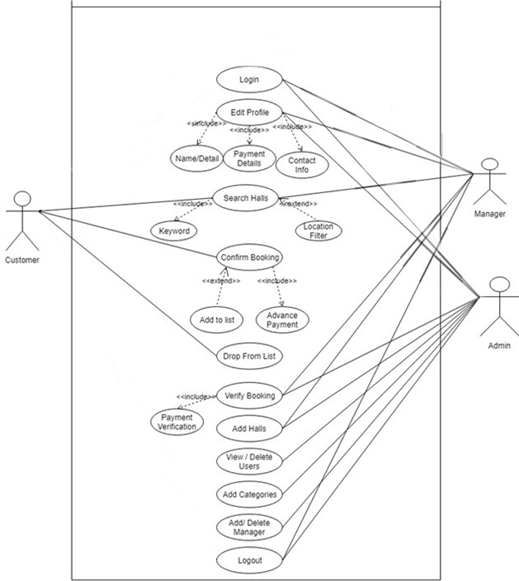

Customer may search for halls, view halls, add halls to Cart or Wish list. All these use cases are extending use cases because they provide some optional functions allowing customer to find halls

Fully Dressed Use Cases
Use Case: | Login
Actors: | Manager, System
Type: | Primary and essential
Description: | Admin and Manager have proper rights to login/logout that customer id who is inactive for many periods of time.
Includes: | None
Extends: | None
Cross Ref:
Use-Cases: | User must have completed the Log In use case.

Use Case: | Edit Profile
Actors: | Manager, Admin
Type: | Primary and Essential
Description: | All users can update their profile name, contact and payment details. Admin have the rights to override these updates or approve them.
Includes: | Name, Contact Info, Payment Info.
Extends: | None
Cross Ref:
Use-Cases: | None

Use Case: | Search Halls
Actors: | Customer, Manager
Type: | Primary and Essential
Description: | If customers / managers are interested in some other halls they can search halls within location or using keywords.
Includes: | Keyword
Extends: | Location
Cross Ref:
Use-Cases: | Log in is not compulsory

Use Case: | Add Halls
Actors: | Manager, Admin
Type: | Primary and Essential
Description: | Admin gives proper rights to the manager to add halls.
Includes: | None
Extends: | None
Cross Ref:
Use-Cases: | Manager must have completed the Log In use case

Use Case: | Edit halls
Actors: | Manager
Type: | Primary
Description: | Manager has hold to control and edit all the hall details.
Includes: | None
Extends: | None
Cross Ref:
Use-Cases: | Manager must have completed the Log In use case

Use Case: | Confirm Booking
Actors: | Customer
Type: | Primary and Essential
Description: | It takes the halls which the customer place in their list and processes them for booking it.
Includes: | Advance Payment
Extends: | Add to List
Cross Ref:
Use-Cases: | Customer must have completed the Log In use case

Use Case: | Verify Booking
Actors: | Admin, Manager
Type: | Secondary
Description: | When the customers take order in checkout they acted, the admin gives the rights to manager to verify their payments.
Includes: | Send Email, Confirmation SMS
Extends: | None
Cross Ref:
Use-Cases: | Customer, Manager must have completed the Login and Confirm Booking use cases

Use Case: | Drop from List
Actors: | Customer
Type: | Secondary
Description: | Customer can drop the previous added halls from the list before updating or proceeding to the payment verification section.
Includes: | None
Extends: | None
Cross Ref:
Use-Cases: | Admin must have completed the Login.

Use Case: | View / Delete Users
Actors: | Admin
Type: | Secondary
Description: | Admin can view user, verify the user and delete the inactive users.
Includes: | None
Extends: | None
Cross Ref:
Use-Cases: | Admin must have completed the Login.

Use Case: | Add / Delete Managers
Actors: | Admin
Type: | Secondary
Description: | Admin can view user, verify the managers and delete them.
Includes: | None
Extends: | None
Cross Ref:
Use-Cases: | Admin must have completed the Login.

Use Case: | View / Delete Category
Actors: | Admin
Type: | Secondary
Description: | Admin can view, update or delete the entire categories of halls or other details encapsulated.
Includes: | None
Extends: | None
Cross Ref:
Use-Cases: | Admin must have completed the Login.

Use Case: | Logout
Actors: | Manager, Admin
Type: | Primary and Essential
Description: | Admin have proper rights to login/logout that customer id who is inactive for many periods of time.
Includes: | None
Extends: | None
Cross Ref:
Use-Cases: | Customer, Manager, Admin must have completed the Login.

Use Case Specification
3.3.1 Description:
A) Unique identifier:

3.3.2 Use case value:
Who they are finding good and reasonable venue for their wedding and other events can easily browse the website and search for halls and see their availability in their desired range and prices and can easily edit and delete their bookings if they want to change the date and timing of their booking and also they can make payment in desired way.
A) Priority:
- High.
B) Urgency:
- High.
C) Actor:
- Customer.
- Manager.
- Admin.
3.3.3 Assumptions:
- In use cases there are some assumptions and dependencies as follows: -
- To register yourself you have to login or signup.
- To fulfill requirement, you have to add require information.
- To select date and time for their events.
- To pay money you have to fulfill requirements.
3.3.4 Constraints:
There are some constraints in use case specifications as follows:
Customer side constraints: -
- Customer can login, sign up, fulfill requirements, add require information if and only if customer is registered in our website.
- Secondly customer can select date and time for their event after registration and completing above options.
- Third step is décor selection and what type of design they want.
Manager side constraints:-
Manager can contact client, set profile, receive order, performs tasks only when the Manager is registered on our website.
Admin side constraints: -
Admin have no constraints because admin can perform all his tasks without any dependencies. He can transfer order, add/update order, delete order, views customer's complaint.
3.3.5 Triger:
- When customer decided to place order after selection.
3.3.6 Primary scenario:
Customer: -Select venue, design, dates and place order.
Manager: Confirm booking.
3.3.7 Precondition:
Manager: Manager have to register before login.
Customer: customer have to register before login.

Chapter 4

System Design

Chapter 4: System Design
The system design describes the system requirement, operating environment system and subsystem architecture, files and database design, input format, output layout, user interface, detailed design processing logic, an external interface.

Architecture Diagram
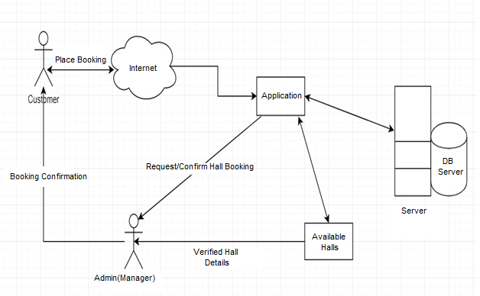

Domain Model
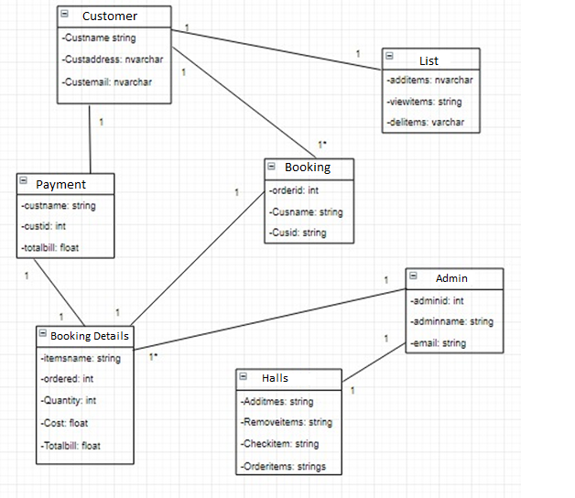

Entity Relationship Diagram with data dictionary
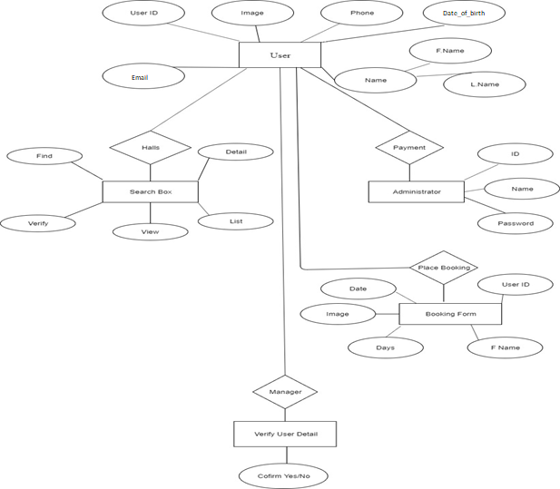

Class Diagram
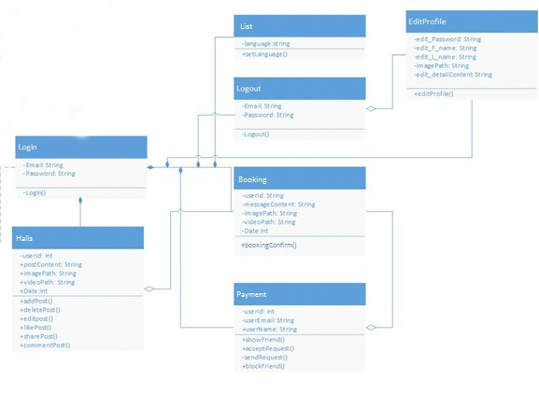

Sequence / Collaboration Diagram
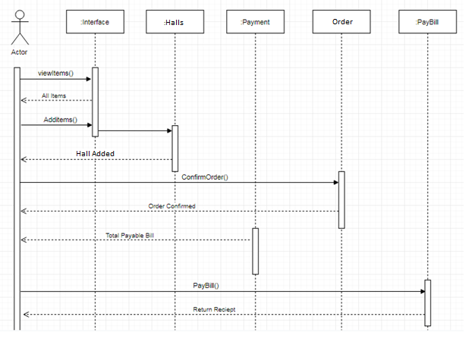

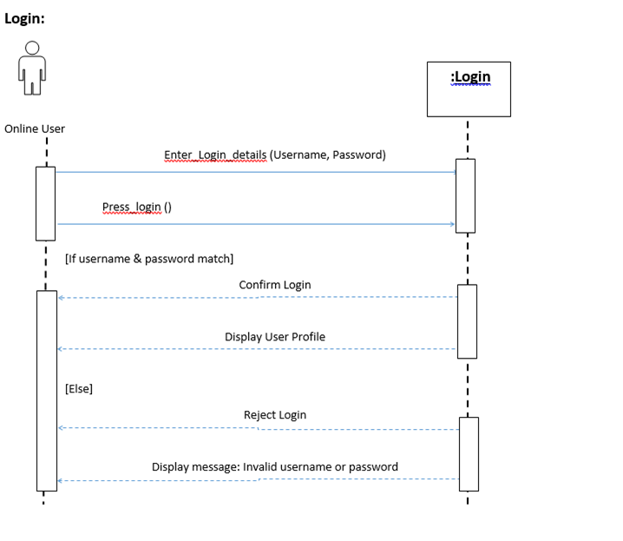

Operation contracts
- Operation contracts#1
Operation name: | Registration (f_name, l_name, email, password, image)
Cross Reference: | Use case Registration
Pre-condition: | User should be online
Post-condition: - | User will be associated with profile (login)  Objective: User  Attribute: (f_name,l_name,email,password,image)  Association: relationship between user and registration

- Operation contracts#2
Operation name: | Login (username, password)
Cross Reference: | Use case Login
Pre-condition: | User should be registered
Post-condition: - | User will be successfully log in and enter into the timeline  Objective: User  Attribute: (username, password)  Association: the relationship between user and login

- Operation contracts#3
Operation name: | Add_Hall (userId, postId, postContent, imagePath, videoPath, Date)
Cross Reference: | Use case View Halls
Pre-condition: | User should be logged in and online.
Post-condition: - | Hall will be uploaded.  Objective: User  Attribute: (userId, postId, postContent, imagePath, videoPath,Date)  Association: relationship between user and add hall.

- Operation contracts#4
Operation name: | View_Hall(postId)
Cross Reference: | Use case View Halls
Pre-condition: | User should be logged in & online.
Post-condition: - | Detail successfully view with colored icon by the user  Objective: User  Attribute: (postId)  Association: relationship between user and view hall.

- Operation contracts#5
Operation name: | Add_List(postId)
Cross Reference: | Use case Add to list
Pre-condition: | User should be logged in and online.
Post-condition: - | Added hall successfully to the list.  Objective: User  Attribute: (postId)  Association: relationship between user and AddList.

- Operation contracts#6
Operation name: | Remove_List(postId)
Cross Reference: | Use case Remove List
Pre-condition: | User should be logged in and online.
Post-condition: - | Removed from the cart/list.  Objective: User  Attribute: (postId)  Association: relationship between user and list.

- Operation contracts#7
Operation name: | Delete_Hall(postId)
Cross Reference: | Use case Delete Hall
Pre-condition: | Manager should be logged in, online and Hall ad owner.
Post-condition: - | The hall will be deleted and removed from profile of the manager.  Objective: Manager/Admin  Attribute: (postId)  Association: relationship between manager and Delete_Hall

- Operation contracts#8
Operation name: | Confrim_Booking (userId, userEmail)
Cross Reference: | Use case Confirm Booking
Pre-condition: | User should be logged in, online  Requested user must be existing in database
Post-condition: - | If the requested user will get payment method view.  Objective: User  Attribute: (userId, userEmail)  Association: relationship between user and confirm_Booking

- Operation contracts#9
Operation name: | Verify_Payment (userEmail)
Cross Reference: | Use case Payment
Pre-condition: | User should be logged in and exist in Database.
Post-condition: - | The user will be verified if payment process in valid and complete.  Objective: User  Attribute: (userEmail)  Association: the relationship between user and payment

- Operation contracts#10
Operation name: | Search_Hall(Data Mining)
Cross Reference: | Use case Search Hall
Pre-condition: | User should be logged in and online.
Post-condition: - | User will get nearest affordable hall and details in the list view.  Objective: User  Attribute: (userEmail)  Association: relationship between user and search hall.

- Operation contracts # 11
Operation name: | Update_profile(userId ,userEmail, userName)
Cross Reference: | Use case Update Profile
Pre-condition: | User should be logged in and online  Searched data should be available in the database
Post-condition: - | The profile will be updated after valid information.  Objective: User  Attribute: (userId ,userEmail, userName)  Association: the relationship between user and update_profile.

- 0peration contracts#14
Operation name: | new_Hall(name, picture, bio)
Cross Reference: | Use case Add Halls
Pre-condition: | Manager should be logged in and online
Post-condition: - | Manager added new hall details.  Objective: User  Attribute: (name,picture,bio)  Association: relationship between Manager and new_hall

- Operation contracts#15
Operation name: | Send_masseges(userId, messageContent, ImagePath, videoPath, Date)
Cross Reference: | Use case Update Hostel
Pre-condition: | User should be logged in and online
Post-condition: - | Message sent to the destination  Objective: User  Attribute: (userId, messageContent, ImagePath, videoPath, Date)  Association: relationship between user and Send_masseges

Activity Diagram
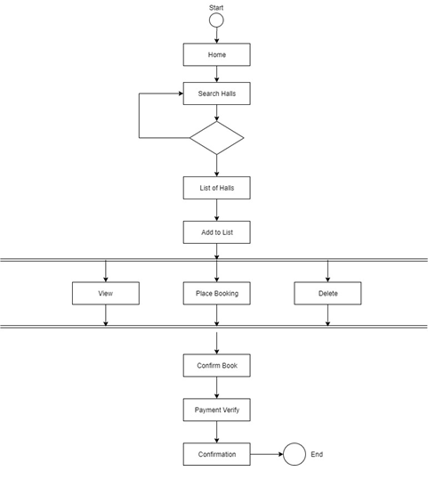

State Transition Diagram
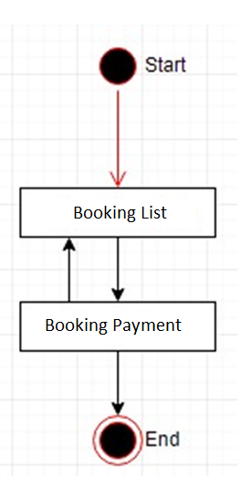

Component Diagram (Applicable in FYP2)
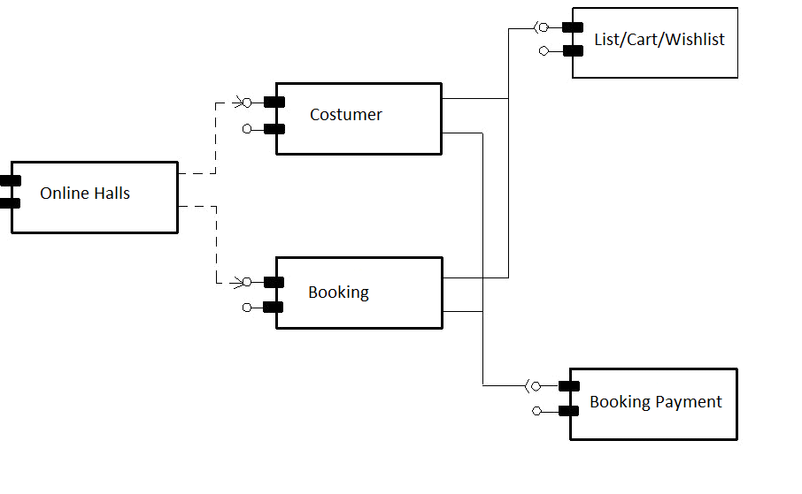

Deployment Diagram(Applicable in FYP2)
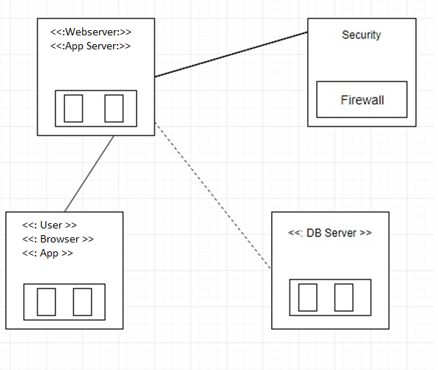

Data Flow diagram [only if structured approach is used - Level 0 and 1]
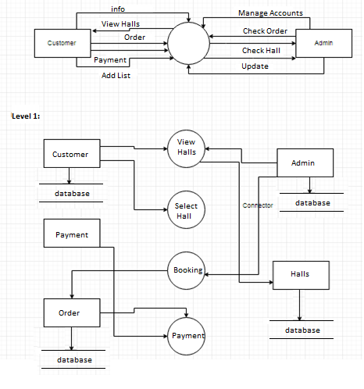

Chapter 5

Implementation

Chapter 5: Implementation
After defining the System design, now we will find the requirements which is capable of running our application and how we can implement it.

Important Flow Control/Pseudo codes
Flow control Diagram shows the proper process of our working system. Which show different steps if the customer wants to book any hall for event, they should have an account first, if customer isn’t already registered, he must have to register himself to book any hall available in the required area under price control, otherwise they can view any hall. If the customer wants to book or place a booking for hall, then Admin/Manager will manage the whole process.

Components, Libraries, Web Services and stubs
Web Servers:
- HTTP APACHE Server, Internet information server and further more if needed.
- Application Management (SQLite, Firebase)

Deployment Environment
• Android Base Mobile
• Application Server
• Database Server

Tools and Techniques
• PHP
• Laravel
• Sublime
• PhpStrom
• Json
- XML

Best Practices / Coding Standards
- The code should not have any trailing whitespace to avoid creating unnecessary diff issues.
- Function and classes are always commented on showing expected input and output
- GUI should be user-friendly
- Let photos say what you can’t say
- Document everything
- Demand for Feedback

Version Control
• Git

Deployment Environment

Tools and Techniques
For website:
- HTML: page layout has been designed in HTML
- CSS: CSS has been used for all designing part.
- JavaScript all the validation task and animations has been developed by javascript
- PHP: All the business logic has been written in PHP
- MYSQL: MYSQL database has been used as database for the project

Version Control

For web:
Xampp version 3.2

Chapter 6

Testing and Evaluation

Chapter 6: Testing and Evaluation
In this chapter soft wear team disscuss about the testing of the project. In which software team make use cases for testing and pass this project with different phases of testing. For this purpose selenium automatic testing toll used.in which we compare that our tests result are according to requirements.

Test Use Cases

LOGIN

Test case id | 01
test suit id | Login-01
Actor | Admin
test case summary | Admin can Login himself by using correct username and password
Related requirement | Admin should enter password and user name
Test procedure | Check admin enter username  Check admin enter password  This username is register  This username entered correct password  User login on system if information is correct  If user information is wrong its will show error
Test data | Username =UsmanHaider  Password=123456
Expected result | User successful login on system

Equivalence partitioning
Test case no 3:
Date and time can’t be empty and we can’t choose previous date.

UNVALID | VALID | UNALID
Blank | 13/7/2020 | 24 January

Test case no 3:
Description for booking can’t be empty.

UNVALID | VALID | VALID
Blank | Hall Booking | I Want to book hall

Data flow testing
In the data flow testing we check our variables defined well not repeated variables. Like we use some variables but not declare and the deallocating the variables of our system.

TEST CASE 1:
- O string name , string email , string password
- Read name , email, password
- Get name email, password,
- Use in user profile

Data flow of test case

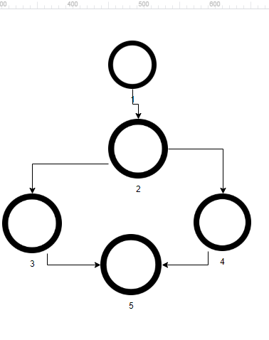
Variables | Define at node | Used at node
Name | 1 | 2
password | 1 | 3,4,5
Email | 1 | 3,4,5

Test case 2
Define at test case 1 and still use in test case 2.

Test case 3
1 define date and time , string description
2 get description
3 show to doctor date and description

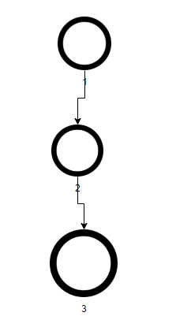
Variables | Define at node | Used at node
Date and time | 1 | 2,3
description | 1 | 3

TEST CASE 4: prescription
Variables | Define at node | Used at node
Date and time | 1 | 2,
Description | 1 | 3,4,5
suggestion | 1 | 5

Performance testing
We did performance testing online at G t matrix. Simply we paste the url and generate test report automatically
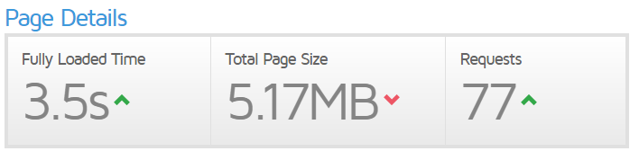
Recommendation for performance testing
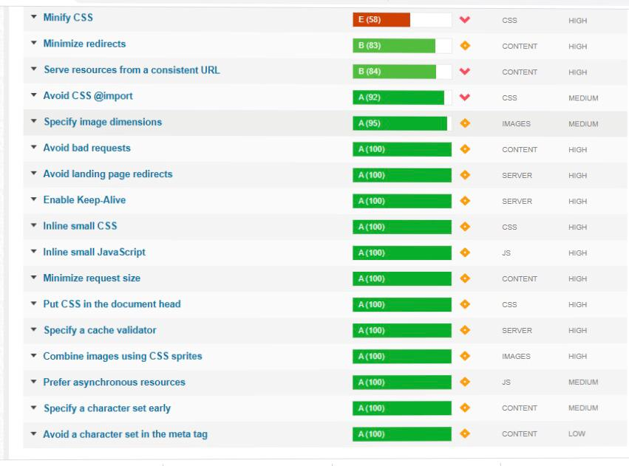

  - Unit Testing:
A unit testing is kind of level testing that involves individual component testing. Basically main purpose of this testing to check every component of the system is working well. The purpose is to validate that each unit of the software performs as designed. A unit is the smallest testable part of any software. It usually has one or a few inputs and usually a single output

Signup and login

Module Name | Test Data
Sign up | Name: Usmanhaider  Pass: 12345
login | User id:223 passowrd arbaz121
Admin | Validation  Usman Profile

Chapter 7

Summary, Conclusion and Future Enhancement

Chapter 6: Summary, Conclusion and Future Enhancement
The booking system is a streamlined process to ensure:
• Volunteers can easily manage hall bookings.
• People hiring the hall get all the information they need at the right time
• Payments and deposits are made and refunded correctly
• The hall is protected against damage and misuse. The process you select for booking your hall can be as simple or Developed as you choose and should reflect the skills and experience of the people managing the hall. If you feel comfortable with using computers and the internet you may be able to arrange to have an online bookings site, or conduct most of your business via email. Alternatively a paper based system might suit you better, or a combination of the two. At the end of the day your bookings system should be easy to use and ensure the right information goes to the right place at the right time.

Achievemnets and Improvements:
Clear Concept of Laravel
Learn programming
Searched information from research paper

Improvements
Increases online booking
Easily Maintained data of Halls
Manual records will be converted in Digital records

Critical Review:
The project we have made maintains the data of halls. Client can view halls. If a client want to have online booking he can book halls online of his choice. You can also have reviews from our valued customers. Hall types are available farm house, Banquet halls, Mansion and Country Clubs. There are two gateway methods for payment. Heather you want to have manual payment or you can also have online payment through Banks.FAQ option is in the website question answers can be done. You can also contact team Wedding Estimator if you have any query.

Lessons learnt:
Software team learnt Concept of Laravel
Cleared the concept of HTML and CSS for front end.
Learn uml
Using tools of Rational rose
Time Management for the project

Future Enhancements/Recommendations
In future you can improve and take many enchantments like you can add feature of Vendor System.
Add Google Maps so that you can have live location.
If you want to login as a user in future User login system will be available.

Appendices

Appendix A: Information / Promotional Material
[Paragraph Text 12 pt., Calibri, 1.5 Line Spacing, Justified]
[Between 4 to 8 lines describe what this appendix all about is]

  - Broacher

  - Flyer

  - Standee

  - Banner

  - First Level heading [16 pt., Calibri, Bold, Left aligned]
[Paragraph Text 12 pt., Calibri, 1.5 Line Spacing, Justified]

    - Second level heading [14 pt., Calibri, Bold, Left aligned]
[Paragraph Text 12 pt., Calibri, 1.5 Line Spacing, Justified]

      - Third level heading [12 pt., Calibri, Bold, Left aligned]
[Paragraph Text 12 pt., Calibri, 1.5 Line Spacing, Justified]

Appendix [no.]: Appendix Title
[Paragraph Text 12 pt., Calibri, 1.5 Line Spacing, Justified]
[Between 4 to 8 lines describe what this chapter all about is]

  - First Level heading [16 pt., Calibri, Bold, Left aligned]
[Paragraph Text 12 pt., Calibri, 1.5 Line Spacing, Justified]

    - Second level heading [14 pt., Calibri, Bold, Left aligned]
[Paragraph Text 12 pt., Calibri, 1.5 Line Spacing, Justified]

      - Third level heading [12 pt., Calibri, Bold, Left aligned]
[Paragraph Text 12 pt., Calibri, 1.5 Line Spacing, Justified]

Reference and Bibliography

Reference and Bibliography

[1] M. Sher, M. Rehman, “Title of the Paper” Conference name/Journal Name, Edition, Volume, Issue, ISBN/ISSN, PP, Publisher/City-Country, Year.
[2] ……

Index

Index

[A]

[B]

[C]

