Abstract:

"BOLD KNIGHT" is a name of this Game that build for the purpose of Final Year Project under CS & IT Faculty at Superior University Lahore. This is a 3D 1st-person shooting game in a Virtual Reality that created using C# and Java Script in Unity Development Kit. The purpose of this document is to explain each phase of development from scratch to complete project, that how it gone through development methods, analyzed and development processes took out for making a complete working game and for providing information about which situations went wrong and right about the FYP and the lessons and experiences that we were able to learn from though out the project development time period and our communication.

Table of Contents
1. INTRODUCTION 6
1.1. Background 6
1.2. Project Objectives 6
1.3. Project Organization 7
1.4. Definitions, Acronyms and Abbreviations 7
2. TECHNICAL SUMMARY 8
2.1. System to be developed 8
2.2. Development Tools and Equipment 9
3. METHODOLOGY 9
3.1. The proposed GDLC (Game development life cycle) 9
3.2. Development Process 10
3.2.1 Initiation 10
3.2.2 Pre-production 10
3.2.3 Production 10
3.2.4 Testing 11
3.2.5 Beta 11
3.2.6 Release 11
4. RESULT 11
5. PROJECT OVERVIEW 12
5.1. Background 12
5.2. Purpose 13
6. Deliverables and Documentations 13
6.1. Scope 13
6.1.1. In Scope 13
6.1.2. Out of Scope 13
6.2. PLANS 14
6.2.1. Milestone Plan 14
6.2.2. Phase 1 14
6.2.3. Phase 2 15
6.2.4. Phase 3 15
6.3. Phases 15
6.4. Documentation Plan 16
7. REQUIREMENTS 16
7.1. Development Requirements 16
7.2. System Requirements 16
8. PROJECT ORGANIZATION 17
8.1. Roles and Responsibility 17
8.2. QUALITY PLAN 17
9. RISK ANALYSIS 18
9.1. Overview 18
9.2. Project Risks 18
10. System / Requirements 18
10.1. Functional Requirements 19
10.2. Non-Functional Requirements 20
11. Design and Architecture 22
11.1. System Architecture 22
11.2. Game Flow 23
11.3. Use Case Diagram 24
11.4. Class Diagram 25
25
11.5. Project Plan 26
12. DISCUSSION 27
12.1. What Went Right? 27
12.1.1. A Clear Vision 27
12.1.2. Great Communication and Team 27
12.1.3. 3D Models 28
12.1.4. Physics 28
12.2. What Went Wrong? 28
12.2.1. Limited Time 28
12.2.2. Late Feature Addition 28
12.2.3. Integration of 2D, 3D and VR 28
13. Evaluation 29
14. Conclusion 29
14.1. Advantages 29
14.2. Disadvantages 30
15. Further Development or Research 30
References 31
Data Gathering 31
Video Tutorial 31
Assets 31
Appendix A 32
Appendix B 37

INTRODUCTION
"BOLD KNIGHT" is a 3-D FPS (first-person shooter) Virtual Reality game that builds as a Final Year project in the Faculty CS & IT at Superior University Lahore. The main purpose of this document is to explain each phase of development life cycle from scratch to complete game and the out puts of every phase of this game.

Background
According to the analysis the gaming industry is the fastest growing industry among all of others. This industry is growing in a ratio of 7.8 % to 7.9 % from previous year, which means a millions of users are coming in almost every day. Smart phones are playing the most vital role for this industry as the most of users are from smart mobiles which has growth rate of 19 % from previous year 2016. However, the changes in technology occur almost every day towards more improvement and more fun, same like Virtual Reality is the new emerging technology that can take place in every field for providing a real time experience and can entertain users more efficiently in which the user will feel itself in that environment.
As our team consists of five members, on the beginning when we have to decide the project as our FYP we want to do something that we do not have experienced before, so after very long discussion all of us agreed on game development using the new emerging technology Virtual Reality.
Actually, on that time we knew that we are going to take a big risk as we were not much familiar to the game development and also Virtual reality that is a very new technology. But, there was a big difference on that time in our attitudes and we were more motivated than before for learn and experience something new in the face of Final Year Project.
As there are many kind of games are exist in market. 1st-person shooting is one of the most known games. The FPS game using Virtual Reality is a game which will give feelings to the users as he/she itself inside the world of this game; as using VR headset the player will feel the entire gaming environment like real time environment. Nowadays, kind of a first-person shooting games are one of the most desired games according to the users.
This was an opportunity for us to learn something big and something new in the face of final year project. So, we decided to achieve this opportunity.

Project Objectives
The aim of choosing this project is to develop a three-dimensional FPS game in VR that coded in C# using Unity game development studio and Virtual reality plug-ins. The project covers all needed aspects with complete game level. The game involved everything that should fulfill the requirements of first person shooter, a single player game with full of action. The aim of this project is to gain and improve our knowledge in the field of game development as well as integrate with new emerging technology that is "Virtual Reality".

Project Organization
As our team based on five members, we didn't specify any role for individuals for the purpose of learning, instead of we assign different tasks on each phase to individuals. Everyone played a vital role in every phase to ensure that the work on game can continue and fulfill our desires. However, after the complete learning phase we specify the tasks for individuals that are written below with designation.
Roll No | Name | Designation
14301 | Mohammad ShazaibMushtaq | Lead Programmer
14305 | Muhammad Irfan | Documentation
14358 | H.ZubairMushtaq | Lead Designer
14319 | M.Fahad | Story Board
14258 | M.Asif | Artist
Table 1-1-3 Project Organization

Definitions, Acronyms and Abbreviations
Term | Definition
Bold Knight | Name of the game
FPS | First-person shooter
3D | Three-Dimensional
VR | Virtual Reality
GDK | Game development kit
GDD | Game development design
UI | User Interface
GVR | Google Virtual Reality (plug-in)
Table 1-4 Meanings

TECHNICAL SUMMARY

System to be developed
"BOLD KNIGHT" is 3D first-person shooter Virtual Reality game based on action, where the user will take place of the Hero to kill enemy of humans and will enjoy the game environment like real time by wearing VR box headset. Inspiration for this game came from many FPS games like most famously "RESIDENT EVIL" as well as the technology of Virtual Reality.
This game based on a story on the person who survived in effected state of the world where every human were turned into mindless human killers like zombies. The action will start at the point when our Hero will realize that there is no way to live without kills all of them before they got him.
As the game totally based on action; so the game entirely provides a rush of adrenaline. The only aim is to shoot all enemies till not a single enemy is left behind for attacking on the player so that he/she can survive for long time.
This project contains single level game. The game starts in Desert Area, where the destruction of world was started. In further, the game includes one checkpoint for save the game; so the player can start the game on that checkpoint later on.
The user will play this game from a 1st-person view in a 3-Dimensional environment with VR box. In this way user will feel the environment of game through the main character eyes. This will give feelings like if players itself is inside game environment and it will become more realistic with VR box.
The users will control the main character, which is the most healthy survivors from that effected states. The power of our Hero as a player are running in any way to Desert area, shooting , changing weapons, reloading, collecting and picking up weapons as well as ammo.
When the player start the game the player will have an empty hand without any weapon and ammo so, the player will clear some distance for reaching in Desert area that is enemies’ home-town. During the game, player will have the ability to pick up weapons and ammos by searching them in Desert Village where they are located.
At the starting point of game the player will have 100% health. When enemies will attack on the player the health will be down. Damage will base on how much severely attack happened form enemy. The enemy can may attack on the player in some ways; but they will not have the power to use guns neither they can increase their health. But the player allowed in many cases as he is a only power against enemies so that he can increase his health and can use many weapons against enemies. The player will only have a single life. If player's health comes down to 0 %, he will become dead and game will finish. If the player kills all the enemies before the health reduce to zero or lower, the player will win the game. If our hero kill all the enemies and save other states to be effected, our hero will become world's hero No.1.

Development Tools and Equipment
Tools and equipment that were used in development are written below.
- Unity Version 5.3 or above
- Android Studio, SDK tools and JDK
- Mono Development
- Microsoft Visual Studio 2017 Community
- Blender
- Google VR SDK for Unity
- VR box

METHODOLOGY

The proposed GDLC (Game development life cycle)
GDLC proposed to explain the three questions of research: which criteria were needed to build a game, quality control for game that was included in each phase and how to build a game with perfect quality.
- The GDLC that proposed was selected after the comparison and analysis from the previous game development work that are relevant to this project according to the steps on which game will build in a good manners.
- This GDLC work as an iterative approach that allows higher degree for changes that can occur at any phase of development.
- This GDLC used for the quality controls on each development phase for the purpose of maintaining the quality for game.
GDLC consist on six phases which are given and define below: [1]
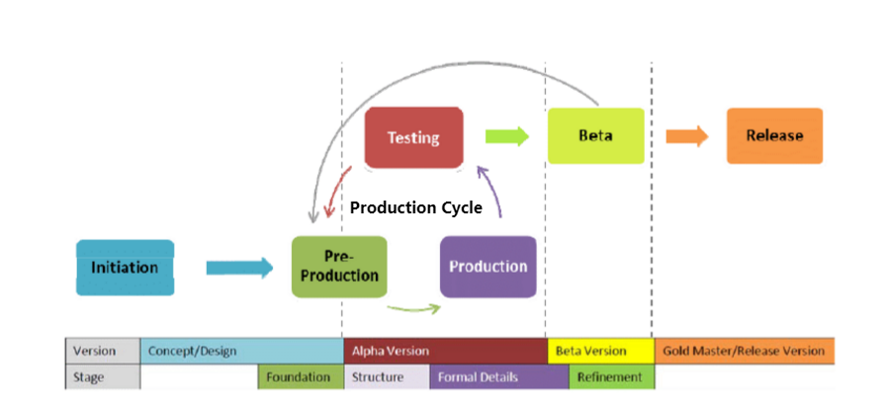
Figure 3-1: Life Cycle

Development Process
The six phases of GDLC:

3.2.1 Initiation
The most initial phase game development is to write down rough idea and thoughts about what kind of game we have to build. It will generate little rough idea and description about what to be builds.

Pre-production
Pre-production is the most important phase of GDLC. Pre-production involves game design and game prototype. The steps included in game design is to focus on explaining game genre, game play, story line, challenges, characters, technical aspects, fun factors and element documentation in GDD(game development design). After GDD creation, 2nd step is to generate useable prototype on which game design and whole rough idea can be achieve. In this GDLC the 1st iteration is create prototype for foundation of elements and structure for game, and next iteration involve formal details about elements and purification of them.

Production
Production is a phase of GDLC which involves development of assets, source code and integration of them together. Formal details and purification are related prototypes in this phase. Formal details are a complete structure of mechanism and assets. The activities of production which are related to the development and purification of formal details are stabling game according to quality controls, for including new features, performance and bug controlling. Refinement is a proper prototype that includes improvement of game, the quality control for fun and accessibility are related to this. The main purpose of these refinements is to build more fun, challenging and easy to understand game, with very little changes in this phase.

Testing
This phase of GDLC is the most crucial phase when it comes to the testing, it based on internal testing from developer side for increasing quality of game while finding errors and bugs if they occur during playing game for improving its usability. It includes each phase of prototype during implementation. The testing report can may a bug report, development process and request for change. It will decide after viewing and analyzing the testing report that whether we have to move further on next phase (BETA) or reiterate development cycle if something went wrong.

Beta
In this phase we did beta testing that used third party or external testers. it includes the methods as similar to the previous methods. Two types of selection methods for tester, open beta and closed beta, open beta allow to anyone who is register can participate, and closed beta testing is only for invited participants individually.

Release
At the time of this phase product just finalized and ready for deliver after goes though from each GDLC phase. The release of game involves game delivery, Documentation, planning for maintenance and extensions.

RESULT
Result in a positive way has the gives us a lot of motivation what we have built. If the result shows none or errors then it is totally a waste of our time. So we did it very consciously and preciously. As our team consists of 5 members so we all focused equally for everything in every phase for make it perfect in aspects. As we don't know anything previously about game development so it becomes too much difficult for us to developed the game. However, by the tutorials from YouTube, it helps us a lot in development of this project.
As documentation is very necessary for any project to make it successful so documentation is done very carefully with the open eyes. Documentation is used till the end of the project for every phase.
Lack of knowledge about game development, we faces many difficulties. In starting we have no idea of what mechanism is used for this project, even nothing about VR technology. As the time passes, difficulties are become easier and understandable to us. And improve our skills in the field of gaming.
Due to shortage of time we cannot make any assets for game, so we find free and suitable assets according to our need from the unity free assets. And by the help of our tutorials we done our best and understand the depth of the game development and the result we achieve, is the destiny according to our need "FPS-VR Game". Now we are capable to build something extra ordinary according to someone's desire.
Testing phase uses many time to make our project free from errors and the test plan we made are followed many times. By using testing phases our product perform properly and successfully. Alpha testing and Beta testing are the testing phases which we used to make our project sufficient.
We realize that we have gained a lot of experience and knowledge about game development at the end of this project. We done almost everything that the project needed. FPS-VR game, the name describes/clear the summary of the game. See first, kill first. In future further implementations will do to for any kind of VR-FPS game like more missions, levels, enemies and more action.

PROJECT OVERVIEW

Background
According to the analysis the gaming industry is the fastest growing industry among all of others. This industry is growing in a ratio of 7.8 % to 7.9 % from previous year, which means a millions of users are coming in almost every day. Smart phones are playing the most vital role for this industry as the most of users are from smart mobiles which has growth rate of 19 % from previous year 2016. However, the changes in technology occur almost every day towards more improvement and more fun, same like Virtual Reality is the new emerging technology that can take place in every field for providing a real time experience and can entertain users more efficiently in which the user will feel itself in that environment..
There are many games available according to user desires. FPS games are one of the most preferable games in gaming industry. As we build this game in Virtual Reality, the user feels that the environment around him is real. The camera is fixed on the main character. So, he will just think that he is in his imaginations while viewing game environment with VR box.
As we are 5 students of BSSE of Superior University Lahore, we choose this project as our final year project according to our interest and reasons behind that there are a lot of opportunities in gaming field and there were a lot more phases to learn.

Purpose
The cause of choosing this project is to develop a 3D FPS game in VR that coded in C# using Unity game development studio and Virtual reality plug-ins. The project covers all needed aspects with complete game level. The game involved everything that should fulfill the requirements of first person shooter, a single player game with full of action. The aim of this project is to gain and improve our knowledge in the field of game development as well as integrate with new emerging technology that is "Virtual Reality".

Deliverables and Documentations

Scope

In Scope
The game will base on full requirement of First Person Shooter needed with the goal in mind of being fun.
- Single Player
- Mobile Based
- Single Level
- Action Based
- 3D Platform
- 2D Platform of GUI for menu system
- Science Fiction
- Written in C# for Unity
- Plugin with Virtual Reality

Out of Scope
- No Multilevel
- No Multiplayer
- No Console Based

PLANS

Milestone Plan
The milestones of the project are given below in the form of a table.
Figure 6.2.1: Milestone

Phase 1
Milestone | Scope | Output
Milestone 1 | Pre-Production | Project Plan
Milestone 2 | Game Design | Create Environment
Milestone 3 | Test Planning | Test plan
Milestone 4 | First playable | Working Prototype on game
Table 6-2-2 Phases of Project

Phase 2
Milestone | Scope | Output
Milestone 5 | Alpha Testing | Prototype of game updated with AI and some features as animation etc.
Milestone 6 | Beta Testing | Prototype of game updated with user interface, VR and music.
Table 6-2-3 Testing Phases

Phase 3
Milestone | Scope | Output
Milestone 7 | Game Release | Test Report/Final Production
Milestone 8 | Post Production | Final Report/User Manual
Table 6-2-4 Release Phases

Phases
The table of Project phase shows the complete information of activities and expected documented output.

Phase | Activity | Output
Documentation Phase | Project Plan | Project Plan
Game Design Phase | Game Design Document | Game Design Document
Pre-Alpha Phase | Test Plan, Basic world, Controls | Test Plan
Alpha Phase | Collision Detection, Physics, Animation, Enemy AI | Alpha Version Product
Beta Phase | Player interface, Sounds and music | Beta Version Product
Postmortem Phase | Bug fixed, Integration Test, System testing Bug fixed, Integration Test, System testing | Test Report
Post-Product Phase | Final Report, User manual | Final Report
Presentation Phase | Present the project | Presentation
Table 6-3 Documentation Phases

Documentation Plan
The table below provides information on dates when the documents related to the project will be delivering.

Name | Purpose
Project Plan | Organize the project
Game Design Document | Describe the design of game
Test Plan | Define all test activities
Test Report | Define all test cases
Final Report | Summarize the project
User Manual | Describe how to play the game
Table 6-4 Documentation Plan

REQUIREMENTS

Development Requirements
- Unity5.3 are above
- Mono Development
- Google VR SDK Tools

System Requirements
- Window 8 or higher version
- 8 GB RAM or higher
- VR Headsets

PROJECT ORGANIZATION

Roles and Responsibility
The table below provides information on the roles within game development project and their responsibilities.
Project Team Role | Responsibilities
Lead Programmer | Will be responsible for creating a playable level for the game
Art Designer | Responsible for creating the 3d assets for the game
Story Board | Responsible for idea
Lead Designer | Responsible for game design
Paper work | Responsible for documentation
Table 8-1 Role Management

QUALITY PLAN
The goal of the plan is to make assure that “FPS” is an error free game. In every part of the development, testers will conduct in to test the mechanisms and the level of the game and make assure that game is free of errors. Still more, testers will comments and give their feedback on “FPS” how’s their experience and any suggestion for improving the game.
We divide quality plan into two phrases.
- Module Testing: Module testing will performed during coding using debug messages to check that written code want result. An important requirement is that the code will compile with zero bugs.
- Integration Testing: Integration testing will perform after finish of module testing in order to validate if each module can work fine with each other.

RISK ANALYSIS

Overview
The major risk of this project is time, and whether the objectives of the vision will be succeeded. If some objectives is not achieved on time it causes the drop of project. But we done it according to our decided time and remain safe from this cause. Due to fixed time, the amount of man hours needed for the completion of project increased to achieve the destiny.

Project Risks
  - High Risks:
- New to programming for Unity
- Find more sample games built in Unity and try to understand
- Problems with meeting the milestone deadline
- Work harder to meet the deadline
- Unrealistic project scheduling
- Unrealistic project scheduling
  - Medium Risk:
- Problems with audio and graphics
- Try to find eligible audio and graphics
- Problems within development environment
- Review and re prioritize functional requirements
  - Low risks:
- Insufficient effort of team members
- Take a little break for motivation

System / Requirements
As the game evolves so do the requirements, which means it’s necessary to include. This section covers the functional and non-functional requirements of the game.

Functional Requirements
This section describes the basic needs for the game that are required in order to run this game up in the time.
Main Menu: A responsive main menu for the game where the gamer can choose and click the given options to instantiate.
Characters: Set of characters in the game which will act as either the AI or the player character.
Setting: Main Menu also includes the setting options to opt the volume of the game who player wants.
Sci-fic Weapons: Weapons for the player in order to damage or kill an enemy by choosing from different weapons.
Play Game: First option on the Main Menu for the gamer to start new or continue game.
Game Completed: After the complete of player’s first mission and able to recognize that game is completed. Once the player kills all zombie enemies of the game a game complete screen will show and bring back to the main menu after few seconds.
Continue Game: The player should be able to continue the game. An area with sign board will help the player to save the game. If any unfortunate thing happens during the game, continue game options in the Main Menu starts the game from the last save point.
Kill/Damage Enemies: The most important part of the game where the player shoots the enemies in order to complete its mission in the game. The game become more challenging because the damage powers of the enemy are much higher than the player’s killing power.
Player Movement: Player can go in any direction, rotate, jump and shoot.
Quit Game: This option will display on multiple screen to quit or leave the game. Once you click the game will close and need to restart the game in order to play again.
Health System: The life of a player depends on its health system. Health will decrease by the enemy attack. If health ends, the player will lose the game and a game over screen will display.
Target System: Cross hair will display at the middle of the screen to aim and the weapon animates back and forth to virtualize a real experience when the player shoots.
Enemy AI: The game consists on several enemies. The enemies attack the player if the player getting closer to the enemies, which makes the game interesting and challengeable.
  - Assets, Audio and Animation Engineering:
The game will continuously render models and textures 60 fps. Asset graphics must be realistic to feel the player a believable environment. A perfect sound system for the game is necessary to create interest of the player to make this 3D environment complete. The system must also have compatible and suitable animations of the player/enemy including attacking, running and walking etc.
  - Data Requirements:
In the background, all data will pass during the game. Data variables will monitor and keep the position of the enemies and the player and save record of the enemies and player health.
  - User Requirements:
The user requirements explain what the user needs to run and play the game, a VR headset and smartphone capable of running these high graphic games. If the game uploads on the Play Store or App Store, Internet access will also be required to download the application.
  - Usability Requirements:
The game is easily understandable from the start by easily visible to provide a straight understanding of the game. The game shouldn’t overwhelm the users and the GUI should be simple and responsive.

Non-Functional Requirements
  - Performance/Response Time Requirement
It is very important to maintain that the game doesn’t create any performance or graphical problems as this can lead to a simulator sickness game play. The game needs to run at a persistently and consistentlyfps to ensure that the animations and graphics remain simply smooth.
The game should be immediate to the response time so that whenever the player starts an action in the game, the response will also be immediate.
  - Availability Requirement:
Once the user has downloaded and installed the game on a smartphone using VR headset it should be available to play whenever and wherever they want. The game will be built for smartphones using VR which will make the game easily available.
  - Security Requirement:
This game will never need to ask permission for the player’s location or any personal information which ensure the proper security privileges.
  - Maintainability Requirement:
Game can be easily maintained after the release through online update patches. These updates can be used to fix any problems in the game.
  - Reusability Requirement:
The game scripts could be reused to any another FPS, fantasy, horror or survival game. The assets are easily assessable through Internet made for reusability.

Design and Architecture

System Architecture

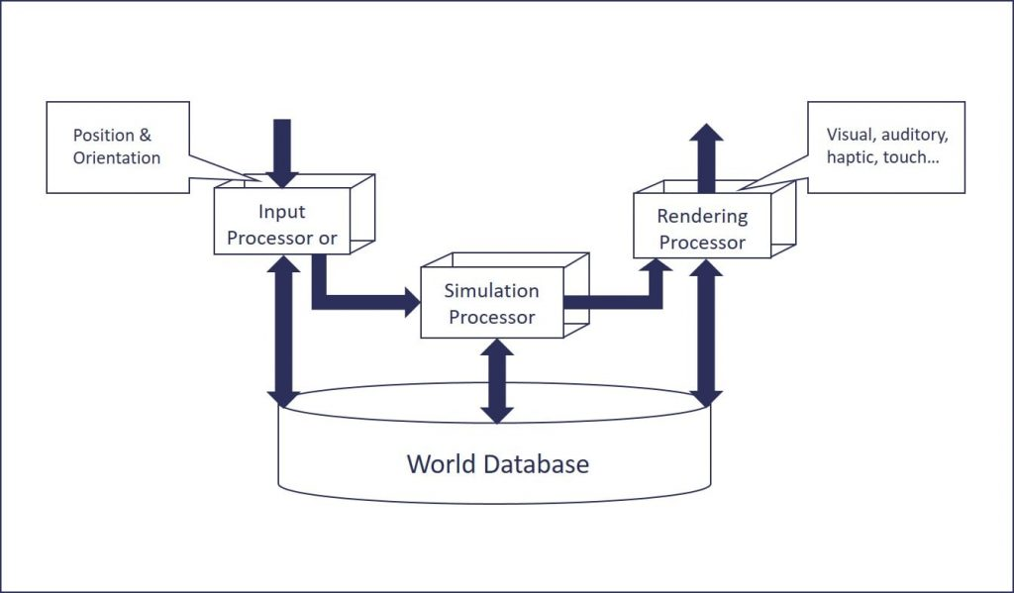
Figure 11.1: System architecture

Game Flow
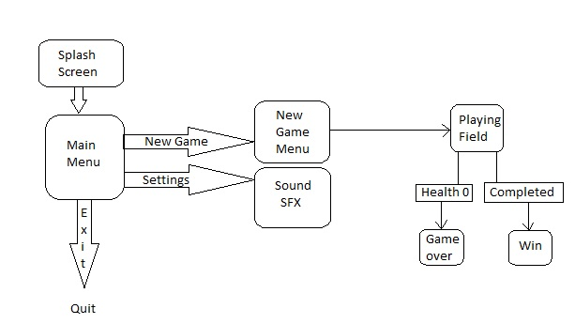
Figure 11.2: Flow Chart

Use Case Diagram

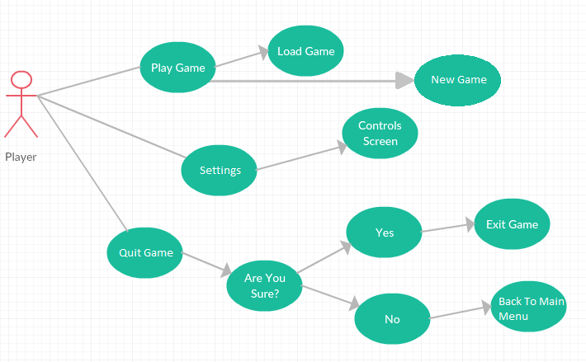
Figure 11.3: Use Case Diagram
When game starts by the player, first splash screen then main menu will be displayed. The player will see 3 options to select from. The ‘Play Game’ option will enable two sub-options. First one is the ‘Continue Game’ and second one is the ‘New Game’ option. The ‘Settings' option will bring the player to a control screen that will show the controls for the game and the ‘Quit Game’ option will allow the player to quit the game and exit the application.

Class Diagram

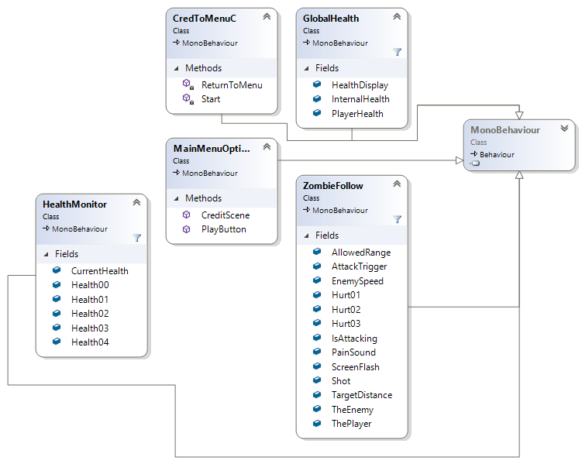
Figure 11.4: Class diagram

Project Plan
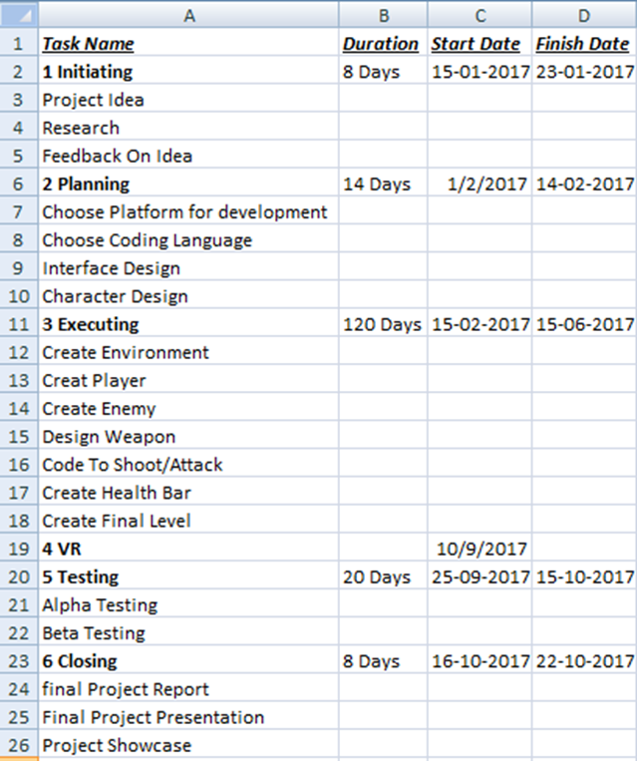

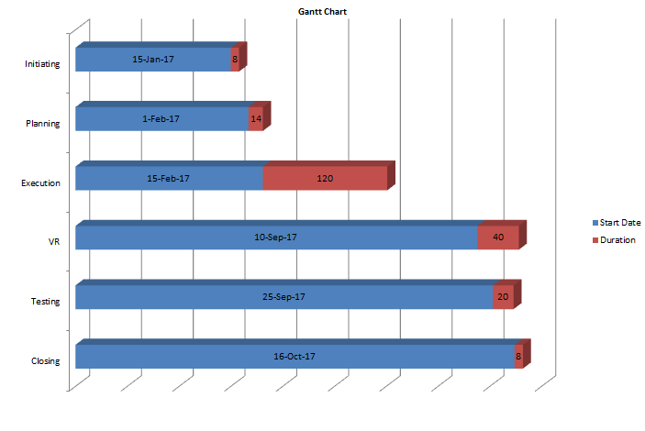

Figure 11.5: Gantt chart

DISCUSSION

What Went Right?

A Clear Vision
As someone said, “If a person does not know about what domain he is steering for, then no wind will favorable to him.” So from the starting of the project, we had a clear idea about we have to build. The following reasons how we feel that we can do this and we have to do this.
In gaming industry, many FPS games are available as samples for learning as well as Virtual Reality. We got many options to learn from available games sample tutorials. This was helped us a lot to start developing and setting up the. While analyzing the existing games, we pick up similar features from different places. However, when it was a time for deciding about genre of game, we thought in a very unique way. By analyzing from history of FPS games it becomes easy for us to decide for what to be build and will be the most important and unique aspects.
We learned in the duration of this project is that anything can be possible by hard work and with strong focus, you just have the courage of taking risk in yourself. If vision is clear about what to make then everything is achievable with courage and determination.

Great Communication and Team
'Communication' is the most critical and biggest issue for groups, but that was one of the best things in our team. The cause of good communication is that all of us live together in one house from almost 1st semester. In the whole project process whenever anyone from group got stuck at some point, the other members are every time around him for support.
We all know about each other from almost first semester. We took semester projects together many times throughout the degree. We always like to work together in a same team and enjoyed company of everyone. We get things easier to pick for learning when we are around, so we took the benefit of this situation in our Final Year Project.
All team members were much aware about the basic needs to higher decisions what will be good for project and how we can succeed in this. We pay our complete attention to this project and worked in a sufficient manner for making the complete game. All members always motivate each other on every phase of development for encouragement; if anyone faced some kind of difficulty in any task then all others were always ready to support him together and provide help.

3D Models
Cause of limited time and without having much experience in modeling, the design and making of 3-D environment models for the project was not possible and out of scope. So, we were decided to use free 3-D models in our project according to game requirements from asset store. At starting we were worried about if we could not get any models according to the requirements then it gives a lot bad results to us. Somehow, we found useful assets according to our game needs, and we adopted them into our game and start working for further.

Physics
The Physics offered from the Unity itself for developing more efficient game. Using physic was best decisions about the project. At beginning without having much knowledge we were thought how we can implement physics in game for working like real time, Unity gives us a favor in this part for providing a complete physics implementation and were not allowed us to lose focus from the game.

What Went Wrong?

Limited Time
The problem we faced was limited time for the project. As the fact that we didn't had any kind of knowledge in the field of game development, we had to manage other subjects and semester projects with our learning for game development at beginning. This situation leads to slow down the progress of game development. However, we managed all the things with our learning on game development. This situation resulted in just putting us in phase where stress and pressure disturbed us a lot throughout development phase. We felt the impacts of limited time during learning, implementation and testing phase.

Late Feature Addition
When development phase of game were completed, we realized that we can add more features in this game for make it look like more efficient. We thought that when user will experience this game in virtual Reality headset then the main menu should be responsive with the rotation of user's head; this feature can increase beauty of the game. So, we were started to implementation of responsive main menu in our game, now this feature is part of this finalized game. We updated our design document accordingly this change.

Integration of 2D, 3D and VR
We built our game in VR 3D environment and menu system in 2D platform using GVR (google Virtual Reality plugin). Game and menu worked smoothly before integration of them. While they were worked separately, everything went in good manners. After the integration of GUI and game with VR plugin the problems were pushed out. Somehow, we start searching for those issues and found some samples related to that problem and found some miner mistakes that we did. However, we debug the issues that were occurred. We can't forget the phase of searching and finding the solution for that miner issues was so much irritating for us.

Evaluation
To make game free of errors/bugs, we tested it regularly on each phase, so that the game can work perfectly.
We play game many times for testing purpose. Some of the issues were occurred, after the integration of 2D UI-design, 3D environment and Virtual Reality plugins.
First of all, issues were occurred in responsive menu, it got stuck and not worked properly with rotation of headset.
Second issue that occurred totally disturbed our mind. The issue is in joy-stick controlling that is not working properly.
Third the most difficult and out of thought the issue occurred is VR plugin.

Conclusion

Advantages
There are a lot of advantages of developing this project throughout. It gives a huge amount of benefits to us about to learn something new and help us in improving our skills in the field of game development. Now we have multiple of ideas beyond someone’s thought to develop such a game that someone desires to play. Firstly we didn’t know anything about gaming and there is no proper subject of gaming in our course. Now we know mostly things about gaming. Knowledge about Unity, Mono-develop, blender, asserts and VR technology.
Another advantage is, it increase our programming skills in C# and Java Script. Both these languages are the backbone of this project in Unity. By doing coding on daily basis, help us in improving our skills and acknowledge us a lot.
Playing game in VR, realize that we are actual playing this game in real time environment. Now a day, VR is an emerging technology in gaming field. Most of the games are built in VR technology. VR is a new experience for us to learn, understand and explore it. By the Grace of God, now we can develop game for any platform as well as in VR Technology, a more sufficient and more desirable game according to user need.
The most interesting thing is there are lots of tutorials of FPS available on internet especially on You-tube. That’s a huge benefit for us to learn and develop. By the help of you tube we develop the game and learn how unity works. As we have no previous experienced of game development, it disturbed allot, we spent many hours daily to learn from you-tube. By the help of tutorials we develop this game. Uses free asserts, create 3D environment according to our need. We really enjoyed the scenes that are created from our hand, it’s a first time experienced for us.

Disadvantages
Disadvantage is as we have no experience of game development before, it dishearten us. FPS is large and complex game to build and to make it playable state. With the help of tutorials we develop it. Amount of hours we spent on you tube to learn and make it. As we all have no experience of game development, we wasted a lot of our precious time on you tube to learn and getting ourselves familiar with unity and VR technology. We have basics C# and JavaScript skills but not enough for this development.

Further Development or Research
In future we can expand this game by adding new features.
- New and more environments
- More levels with more action
- Option of multiplayers
- Option of difficult level
- New weapons feature
- Paid weapons features
- New enemies like trend can add up
We feel that we have not limited our options with the style of game we have chosen. The possibilities are endless and the story can be developed. We can re-use the environment in as many levels as we wish.

References

Data Gathering
[1]. https://www.researchgate.net/publication/271548605_Game_development_life_cycle_guidelines

Video Tutorial
https://www.jvunity.weemble.com

https://www.devassets.com

https://www.youtube.com/MatthewHallberg

https://www,youtube.com/ChromeFXFilms

Assets
http://devassets.com
Unity Asset Store

Appendix A

Screen Shots

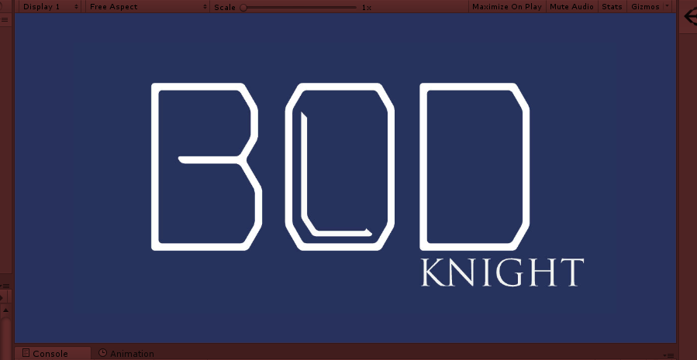
Figure A.I: Game Name
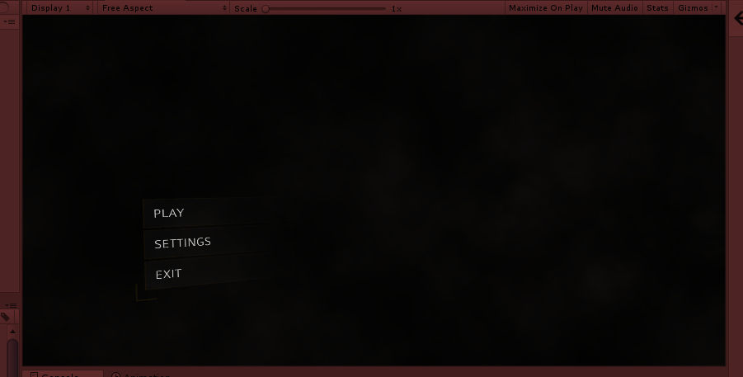
Figure A.II: Responsive Menu
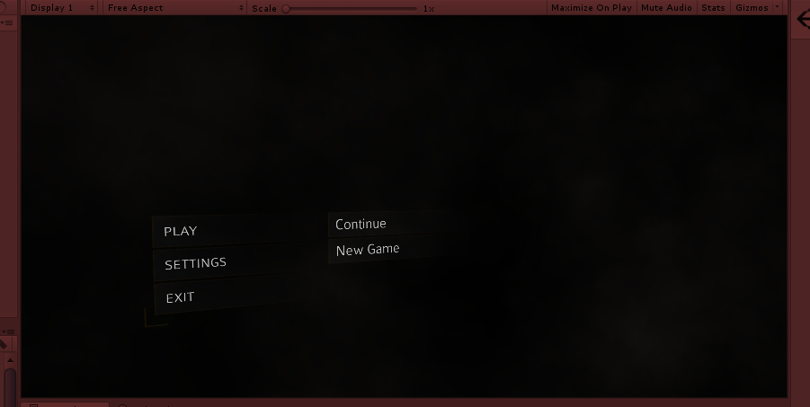
Figure A.III: Play Options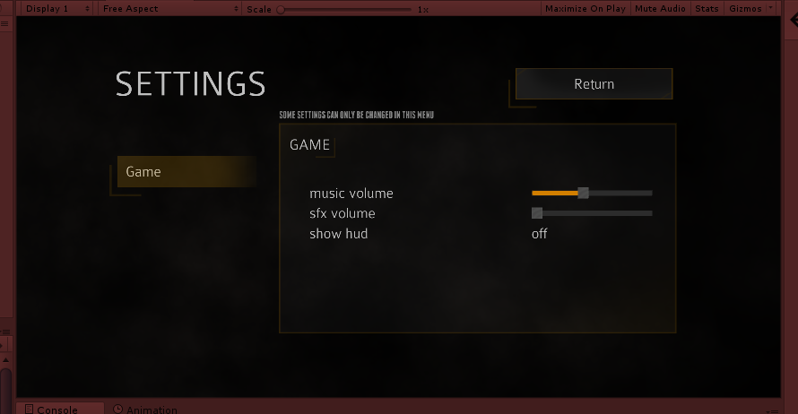
Figure A.IV: Settings
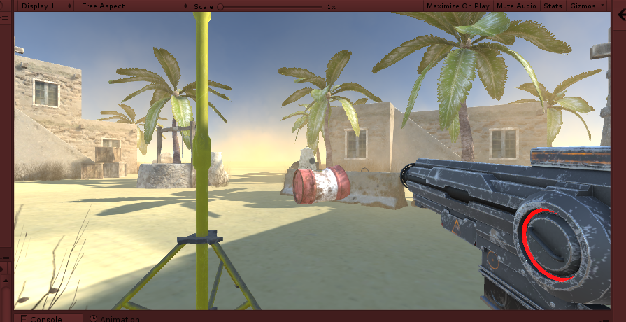
Figure A.V: Play Mode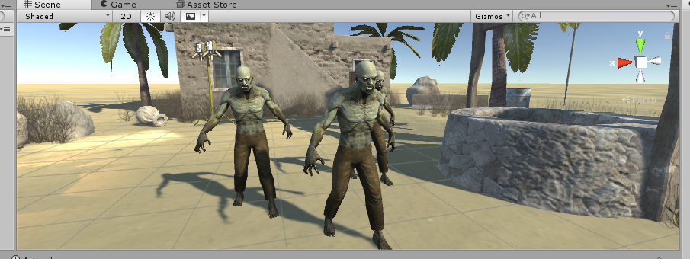
Figure A.VI: Enemy
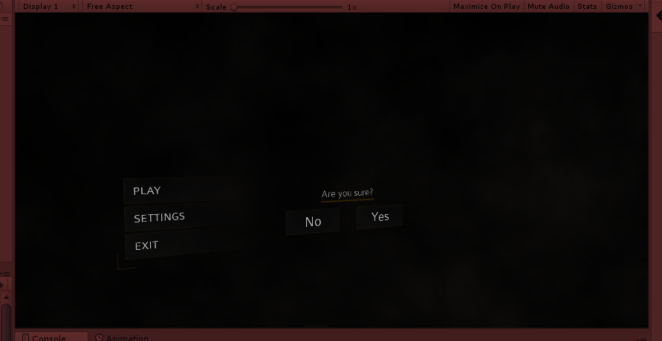
Figure A.VII: Quit Option

Appendix B

Test Protocols

  - Main Menu System
Test Case ID | Test Case | Action | Excepted Result | Test Status
1 | Main Menu | I-Player desired to play game,  II-player starts game | Main menu should display. | Pass
1.A | New Game Menu | I-Player starts game, II-Menu push up,  III-player select to “play game” main menu | In “Main menu” sub-menu should display | Pass
1.A.I | Play Game | I-Player starts game,  II-Menu push up,  III-Player select to play game,  III-Sub-menu push up,  IV-Player select “New Game” or “Continue game” | From “Sub-menu” player should enter in new game or continue game. | Pass
1.B | Setting | I-Player starts game,  II-Menu push up,  III-Player select settings,  main-menu | “Settings” sub-menu should display. | Pass
1.B.I | Audio | I-Player starts game,  II-Menu push up,  III-Player select “settings”  main-menu,  IV-Sub-menu push up,  V-Player choose “Audio”,  VI- Sub-menu push-up,  VII- Player make change in audio settings,  VIII- Player can return to “Settings” main-menu. | “Audio” settings from sub-menu should change. | Pass
1.B.II | Return to Main-Menu | I- Player starts game,  II- Menu push up,  III- Player select “settings”  main-menu,  IV-Sub-menu push up,  V- Player select “ Return to Main-Menu”  Main-Menu item | Main-Menu should display. | Pass
1.C | Exit | I- Player starts game,  II- Menu push up,  III- Player want to close game,  IV- Player click on “exit”  main-menu |  | pass

  - The Game
Test Case ID | Test Case | Action | Excepted Result | Test Status
1 | Begin Game | I- Player starts game,  II- Main-Menu push up,  III- Game will start | Game should start | Pass
2 | End Game | I- When mission will complete.  II- player exit game in main-menu.  III- Player return to menu | Game should end. | Pass
3.I | Graphics | I- Player starts game,  II- Main-Menu push up,  III- Graphics of game display.  IV- Game will start. | Graphics that requested should display | Pass
3.II | Enemies | I- Player Shoot enemies.  II- Game will request for enemy graphics. | Enemy should display. | Pass
3.IV | Fire Effect | I- Player fire on enemy.  II- Game will request for fire effect graphics. | Fire effect should be display | Pass
3.V | Weapons | I- Player change his weapons.  II- New weapon display.  III- Game request for Weapon model from graphics.  IV- Game show new weapon. | Weapon Should display. | Pass

  - Sound

Test Case ID | Test Case | Action | Excepted Result | Test Status
1 | Music | I- Player starts game,  II- Main-Menu push up, | The music Should play till the end of main-menu screen. | Pass
2 | Sound Effect | I- Game require to play music.  II- Game program access sound effects.  III- Game will play sound effect similar to game phase. | Game should play sound effect for similar to game phases. | Pass

  - Combat
Test Case ID | Test Case | Action | Excepted Result | Test status
1 | Shoot | Player hit “Shoot” button. | 1- Player should fire to enemy from his weapon.  2- Ammo counter should decrease according to fires. | Pass
2 | Take Damage | Enemy attacks on the player. | Player health should come down. | Pass
3 | Die | I- Enemy attacks on the player.  II- Health comes down according attacks.  III- Health touch to zero or below | The player should die and game should end. | Pass
4 | Change Weapon | Player hit on key to weapon changing | The Player current weapon should change. | Pass
5 | Reload Weapon | Player hit on key for reloading his weapon. | The ammo numbers of player weapon should increase after reloading. | Pass

