SUPERIOR UNIVERSITY LAHORE

Faculty of Computer Science & IT
Final Year Project
PROJECT REPORT
AO BOOK KARO
Project ID: [FYP-BSCS-F18-035]
Project Team
Student Name | Student ID | Program | Contact Number | Email Address
Faizan Ahmad (L) | BCSM-F15-257 | BSCS | 03164411041 | Faizymughal52@gmail.com
Zainab Nawazish | BCSM-F15-144 | BSCS | 03314263483 | Zainabkhokhar15@gmail.com
Anam Dawood | BCSM-F15-283 | BSCS | 03054110599 | anamdawood112@gmail.com

[Sir Umair Zafar Khan]
(Lecturer)
Project Report
AO BOOK KARO
Change Record
Author(s) | Version | Date | Notes | Supervisor’s Signature
 | 1.0 |  | <Original Draft>
 |  |  | <Changes Based on Feedback from Supervisor>
 |  |  | <Changes Based on Feedback From Faculty>
 |  |  | <Added Project Plan>
 |  |  | <Changes Based on Feedback from Supervisor>

APPROVAL
Project Supervisor
Comments: ___________________________________________________________________
_____________________________________________________________________________
Name:______________________________
Date:_______________________________ | Signature:__________________________

Project Manager
Comments: ___________________________________________________________________
_____________________________________________________________________________
Date:_______________________________ | Signature:__________________________

Head of the Department
Comments: ___________________________________________________________________
_____________________________________________________________________________
Date:_______________________________ | Signature:__________________________

Dedication

We dedicate this project to
God Almighty our creator,
To the society to whom it is for.
This work is dedicated to
My respected parents,
Who educated me and enabled me
To reach at this level
Of my life.
Their guidance, motivation,
Encouragement and trust made me
To complete this project.

Acknowledgements

I am really thankful to my supervisor Sir Umair Zafar Khan for his kind attention and keen interest throughout the course of this work by providing valuable guidance and continuous support that helped us a lot in our work. Last but not the least, I would also thank to my group members for their cooperative nature and supportive behavior throughout this project.

Executive Summary
Online hotel systems are important in life of a modern hotel as it ensures the proper working of hotel, makes it efficient and provides many choices to customers to select or book according to their needs and demands. The consumer`s need for reliable and accurate information when booking has never been greater. Unfortunately, the booking process has never been that complicated, thanks to the rapid growth of internet. This growth has been so significant that travel has become the largest source of commerce on internet.

Table of Contents

Dedication iv
Acknowledgements v
Executive Summary vi
List of Figures ix
List of Tables x
Chapter 1 1
Introduction 1
.1. Background 2
.2. Motivations and Challenges 2
.3. Goals and Objectives 3
.4. Literature Review/Existing Solutions 4
.5. Gap Analysis 4
.6. Proposed Solution 5
.7. Project Plan 6
.7.1. Work Breakdown Structure 7
.7.2. Roles & Responsibility Matrix 7
.7.3. Gantt chart 8
.8. Report Outline 8
Chapter 2 9
Software Requirement Specifications 9
.1. Introduction 10
.1.1. Purpose 10
.1.2. Document Conventions 10
The document is prepared using Microsoft Word using Calibri font. The fixed font size that has been used to type this document is 12pt with 1.5 line spacing. It has used the bold property to set the headings of this document. 10
.1.3. Intended Audience and Reading Suggestions 10
.1.4. Product Scope 10
.1.5. References 12
.2. Overall Description 12
.2.1. Product Perspective 12
.2.2. Product Functions 13
.2.3. User Classes and Characteristics 13
.2.4. Operating Environment 13
.2.5. Design and Implementation Constraints 13
.2.6. User Documentation 13
.2.7. Assumptions and Dependencies 13
.3. External Interface Requirements 14
.3.1. User Interfaces 14
.3.2. Hardware Interfaces 14
.3.3. Software Interfaces 14
.3.4. Communications Interfaces 14
.4. System Features 14
.5. Other Nonfunctional Requirements 18
.5.1. Performance Requirements 18
.5.2. Safety Requirements 18
.5.3. Security Requirements 18
.5.4. Software Quality Attributes 18
.5.5. Business Rules 19
.6. Other Requirements 19
Chapter 3 20
Use Case Analysis 20
3.1. Use Case Model 22
3.2. Fully Dress Use Case 23
Chapter 4 28
System Design 28
4.1. Architecture Diagram 29
4.2. Domain Model 30
4.3. Entity Relationship Diagram with data dictionary 31
4.4. Class Diagram 32
4.5. Sequence / Collaboration Diagram 33
4.6. Activity Diagram 49
4.7. State Transition Diagram 50
4.8. Component and Deployment Diagram 50
4.9. Data Flow diagram [only if structured approach is used - Level 0 and 1] 51
Chapter 5 56
Implementation 56
5.1. Components, Libraries, Web Services and stubs 58
5.2. Deployment Environment 58
5.3. Tools and Techniques 58
5.4. Best Practices / Coding Standards 59
Chapter 6 60
Testing and Evaluation 60
6.1. Use Case Testing 61
6.2. Boundary Value Analysis 72
6.1. Unit testing 72
6.2. Integration testing 72
6.3. Performance testing 73
6.4. Stress Testing 73
Chapter 7 74
Summary, Conclusion and Future Enhancements 74
7.1. Project Summary 75
7.2. Achievements and Improvements 75
7.3. Critical Review 76
7.4. Lessons Learnt 76
7.5. Future Enhancements/Recommendations 76
Appendices 77
Appendix A: User Manual 78
Appendix B: User Interface 78
Reference and Bibliography 79

List of Figures

1.1 Caption of first figure of first chapter 6
1.2 Caption of second figure of first chapter 7
2.1 Caption of first figure of second chapter 14
2.2 Caption of second figure of second chapter 22
2.3 Caption of third figure of second chapter 26
5.1 Caption of first figure of fifth chapter 49
5.2 Caption of second figure of fifth chapter 49

List of Tables

1.1 label of first table of first chapter 6
1.2 label of second table of first chapter 7
2.1 label of first table of second chapter 14
2.2 label of second table of second chapter 22
2.3 label of third table of second chapter 26
5.1 label of first table of fifth chapter 49
5.2 label of second table of fifth chapter 49

Chapter 1

Introduction

Chapter 1: Introduction
Online booking system is popular now for booking hotel rooms. People book hotels by using internet facility by protecting their privacy and financial information. Customers can get knowledge about hotel`s facilities, environment, products, and many more things by online survey to compare facilities of hotels. Preceding to the internet, customer could write or telephone hotel directly or hire an agent for this. Online system will provide each and every thing about hotel`s facilities, environment, etc. Online hotel reservation systems are increasing in importance and greatly facilitate consumer`s activity. The internet has enabled hotels to contract directly with customers. It has reduce the role of agents, customer can directly contact to the hotel and book hotel for the according to their needs and demands.

Background
The existence of many computerized systems and innovations through which we find information conveniently, justifies the old age saying “Necessity is the mother of all inventions”. The need to share information and man`s desire to communicate from long distances called for the birth of World Wide Web. With the advent of internet, many businesses that people conducted were made feasible. Buying and selling of products is now done online without movement of consumer from his location.

Motivations and Challenges
Reserving a hotel is not an easy task. To succeed in hotel business managers should work on multiple channels and issues to overcome it.
Some of the problems related to software which exist in hotel reservation system are:
- Cranky and outdated user interface
- The software may not be fast and efficient enough to handle multiple operations
- Many softwares lack for multiple languages and currencies to meet the needs of hotels.
Reservation systems should have several features to increase reservations and bookings:
- User friendly interface
- Manageable bookings
- Integrated payments methods
- Reallocations of rooms
- Availability of rooms
- Cancelation availability to users
- Discount offers
- Launch of user friendly websites

Goals and Objectives
Hotels play the role of providing guests a home away from home. It’s the facility which facilitates the guest`s further attraction towards place as it makes that place more convenient.

The most fundamental objective of an online hotel reservation is to increase the global research of hotel website. People around the world can access it which will increase of number of bookings. It will also be a time savior. Besides this, another main objective is to manage all the information regarding to the reservation. The main purpose is to reduce manual work.

Other common objectives fulfilled by online hotel reservation systems are:
- To provide a platform to manage on-desk and online bookings
- To display organized information of hotel, prices and pictures.
- To add multiple hotels/rooms to the system.
- To change prices of hotel rooms when needed.
- View of availability of rooms in real time.
- Store customer information which can be accessed anytime.
- A user-friendly interface for customers for the easy booking process.
- To provide a secure payment gateway for online transaction.
- Our main goal is to provide full facilities to our customers and make peaceful environment and facilitates them with their full needs.
- To enable online booking via the internet.
- To enable automated data entry methods.
- Ensure efficient and reliable communication within the hotel.
- Avoid data entry errors by use of input masks.
- Enable easy authorized modification of data.
- Enforce security measures to avoid unauthorized access to guest records.
- Enable fast and easy retrieval of guest records and data for fast reference activities.

Literature Review/Existing Solutions
Hotel booking system is for managing all the activities performed in hotel. A developing number of hotels are building their own websites to market their hotels directly to the customers. Booking systems are in need of something very fast and well organized. Since the advance technology takes place, online booking system was invented which provides an easiest way of booking online without wasting time. It results in the legal protection of customers with regard to online bookings. It considered to provide consistent and updated information. Mostly it happens, when customer starts an online booking procedure, the website obliged to display all the related information in front of a customer.

Gap Analysis
My problem tells that the tourist faces some problem while booking so we provide a proper platform for them that will make booking and the staff have a proper procedure to manage every sort of things.
So we make an easy way for tourist to booking their hotels like on our website and application. My website or app booked their rooms when they go for tour. When they open our website they set touring areas and our website tells the hotels according to their touring location. When they reached their destination they easily go to hotel and no booking procedure just tells her id and hotel staff give room keys.

Proposed Solution
Hotels have been around a very long time, using various methods of keeping records. Historically, the records were saved manually but they were not reliable and efficient. Since the advance technology has taken place, all the manual work has been converted to computerized system. Present systems are not well organized and accurate. Sometimes, bookings are being overlapped so the customer had to face in convenience. And the major issue is that what we see is not we are getting and this is because user cannot have access on hotel information. Another issue is the delay of information in collecting and processing of customer`s data.
What we have proposed is that the customer can select the services according to his needs and demands. The customer can select his own environment, products, services and class. Customer`s requirements will be fulfilled according to their budget.

Project Plan
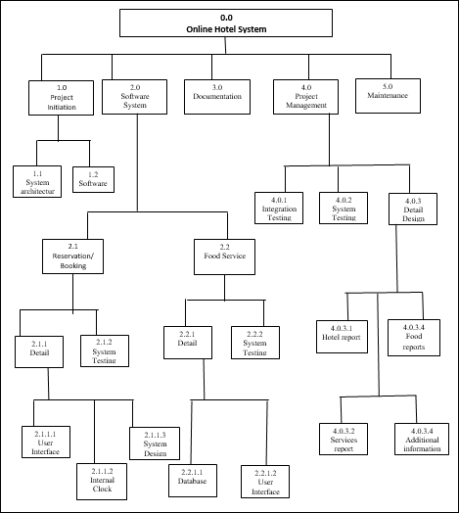
Figure 1: Work breakdown Structure

Work Breakdown Structure
The purpose of roles & responsibility matrix is to identify who will do what.

Roles & Responsibility Matrix
WBS # | WBS Deliverable | Activity # | Activity to Complete the Deliverable | Duration  (# of Days) | Responsible Team Member(s) & Role(s)
1 | Learning Process |  |  | 4 | Zainab  Faizan  Anum
2 | Requirement gathering |  |  | 7 | Zainab  Faizan  Anum
3 | Documentation |  |  | 5 | Zainab  Faizan  Anum
4 | Interface |  |  | 10 | Zainab  Faizan  Anum
5 | Backend |  |  | 30 | Faizan  Zainab  Anum
6 | Testing |  |  | 10 | Faizan  Zainab  Anum
7 | Debugging |  |  | 10 | Faizan  Zainab  Anum
Table 1: Roles and Responsibilities Matrix

Gantt chart
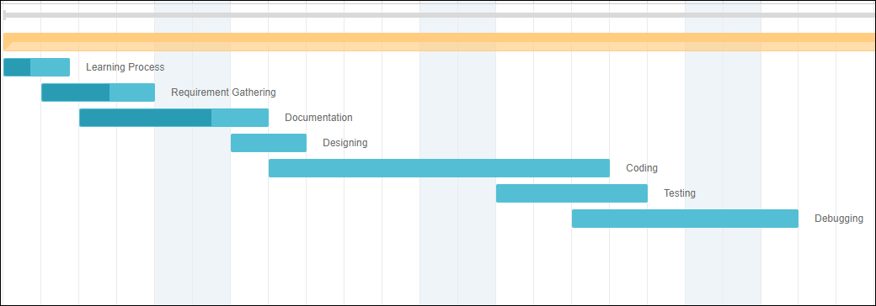
Figure 2: Gantt chart

Report Outline
Documentation is made in 1 year.

Chapter 2

Software Requirement Specifications

Chapter 2: Software Requirement Specifications

Introduction
This software requirement specification will provide an overview of an entire system.

Purpose
This SRS will provide a detailed description of hotel reservation system. This SRS will allow for a complete understanding of what is to be expected of the hotel reservation system to be constructed.

Document Conventions

The document is prepared using Microsoft Word using Calibri font. The fixed font size that has been used to type this document is 12pt with 1.5 line spacing. It has used the bold property to set the headings of this document.
Serial No. | Abbreviation | Definition
1 | UI | User Interfaces
2 | DB | Databases
3 | SQL | System Query Language
4 | HTML | Hyper Text Markup Language
5 | PHP | Personal Home Page-Hypertext Preprocessor
Table 2: Document Conventions

Intended Audience and Reading Suggestions
The intended audience of this document would be user, admin, and the project team with the objective to refer and analyze the information.

Product Scope
The system will cover booking, accommodation, meals, and accounts details. Moreover, special services such as laundry, ironing and room service will be automated by the system also, not to forget the additional facilities information that will be efficiently handled by the system. To help the system smoothly carry out its intended purpose to meet the hotel management needs.
The following tables will be used to store data:
- Booking table:
The table contains guest details that will be input when the guest books into the hotel. For booking, the system will give room for online booking, personal visit to the booking office, telephone calls or facsimiles. For online booking, the guest will have to log on to the hotel’s website and fill his/her personal details in the booking web page provided by the system. For telephone call the guest provides his personal details over the phone as the hotel’s booking staff do the actual entry of the details into the system. For personal visit to the hotel, the guest provides his details verbally which the booking staff enters into the computer system. The table has the following fields: (regno, fname, sname, nationality, id card no, gender contacts, address, email, Date)
- Extra facilities and services :
The table contains the accommodation details of a guest. These details help 7 ABC uniquely identify the guest with his room and services offered for the room. These details include: (regno, fname, sname, id card no, Room no, Category, Telephone ext, charges, amount charged, Total charge, Rcpt no, Payment, Nationality)
- Additional table (features):
The table contains guest details input on admission of the guest into the hotel at the reception. This information keeps track of the duration that the guest has stayed at the hotel. If the guest intends to stay for more than a day, he has to book in for accommodation in advance; else, his information will be input into the system at the reception. The guest luggage information is entered in the system to ensure maximum security of luggage at the hotel. For this to become a reality, the following fields have been used :( room no, out date, in date, luggage, Id card no, nationality, sname, fname, regno)

- Meals table
The table contains the hotels catering transactions information. This information is vital as this department is the backbone of any hotel aspiring to achieve its goals and realize its maximum potential. The table contains the following records:( date, regno, fname, sname, id card no, Meal, charges, rcpt no, payment, Nationality, Amount charged, Total amount, Room service). The system will enable automatic calculation of the total amount charged for the meals offered to guests. Room service refers to provision of meals to guests in their rooms. Room service is charged 5% of the charge of the meal.
- Laundry table
The table contains laundry details for clothes washed at the hotel laundry. The table contains the following fields (date, fname, sname, regno, id card no, linen, type, charges, rcpt no, payment, Number of clothes, Amount charged, Total amount)
- Ironing table
This table contains the ironing service information for the clothes washed both at the hotel and outside the hotel. Payment is done on clothes that are washed outside the hotel. Clothes washed at the hotel laundry are not charged. The table contains the following fields (Total amount, Amount charged, Number of clothes, payment, Rcpt no, charges, type, linen, Nationality, id card no, sname, fname, regno, date)

References
  - IEEE 830-1998 standard for writing SRS document.
  - I Summerville, Software Engineering, 8th ed, Addison- Wesley, 2007.

Overall Description

Product Perspective
This system is a self-contained software product which will overcome all issues of today`s systems. This system will provide easy access to the system and it will contain user friendly functions with attractive interfaces. The outcome of this project will increase the efficiency of all the tasks in hotel reservation.

Product Functions
This system will handle the following:
  - Bookings/ Reservations
  - Payments
  - Issue bills
  - Management of guests/room/staff/inventory
  - Confirmation mails

User Classes and Characteristics
The users of this system are:
- Customer
Customer will look after his reservations according to his needs and demands
- Manager
Manager will be responsible for managing resources
- Receptionist
The receptionist`s duty will be the ensurance of bookings and reservations.

Operating Environment
It will include hardware and software requirements.

Design and Implementation Constraints
Software development provide best effort in developing the system. In order to maintain the reliability of the system, some design and implementation constraints are applied. Availability of website for hotel reservation system will make the system portable and easier for the users to use. When designing the interface, we will have the capability of tools like, HTML 5, CSS, MY SQL, JAVA script and Bootstrap.

User Documentation
User manual provided will give a clear idea in interacting with the system.

Assumptions and Dependencies
- The user of the system must have its unique ID and password for login purpose
- The user must have a proper and active internet connection
- The backup ability must be available to avoid any kind of data loss.
- Assuming all the users for this system have basic computer knowledge and knows how to operate with this system.

External Interface Requirements

User Interfaces
The interface of the system should be user friendly so that everyone can use it.
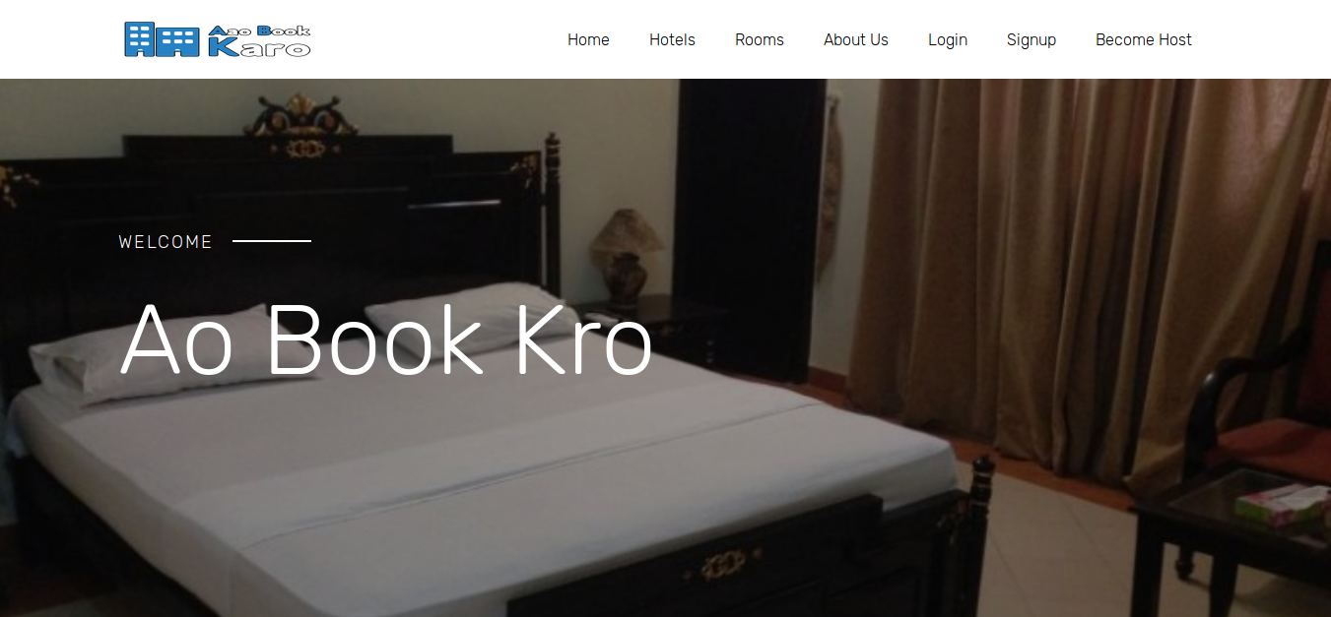
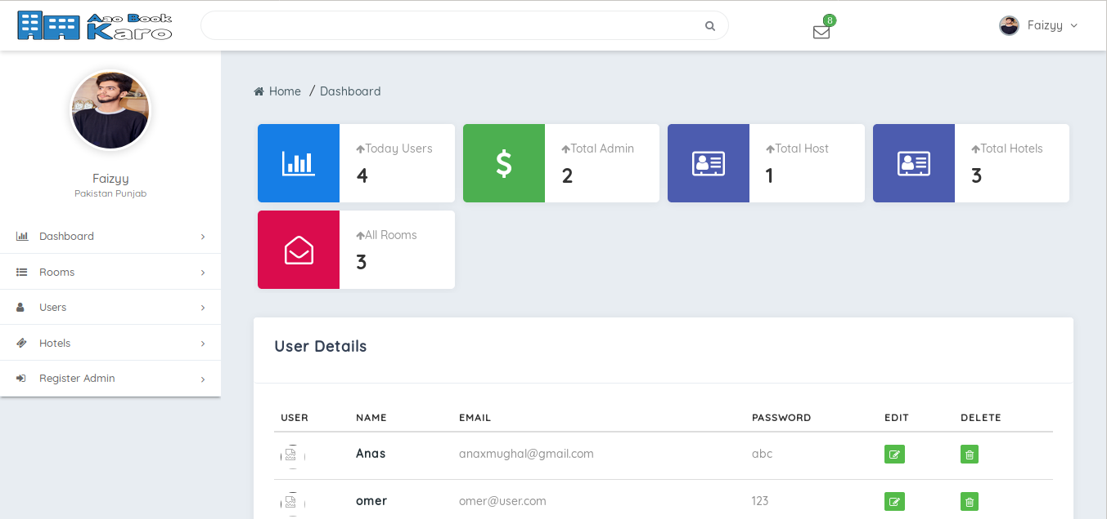

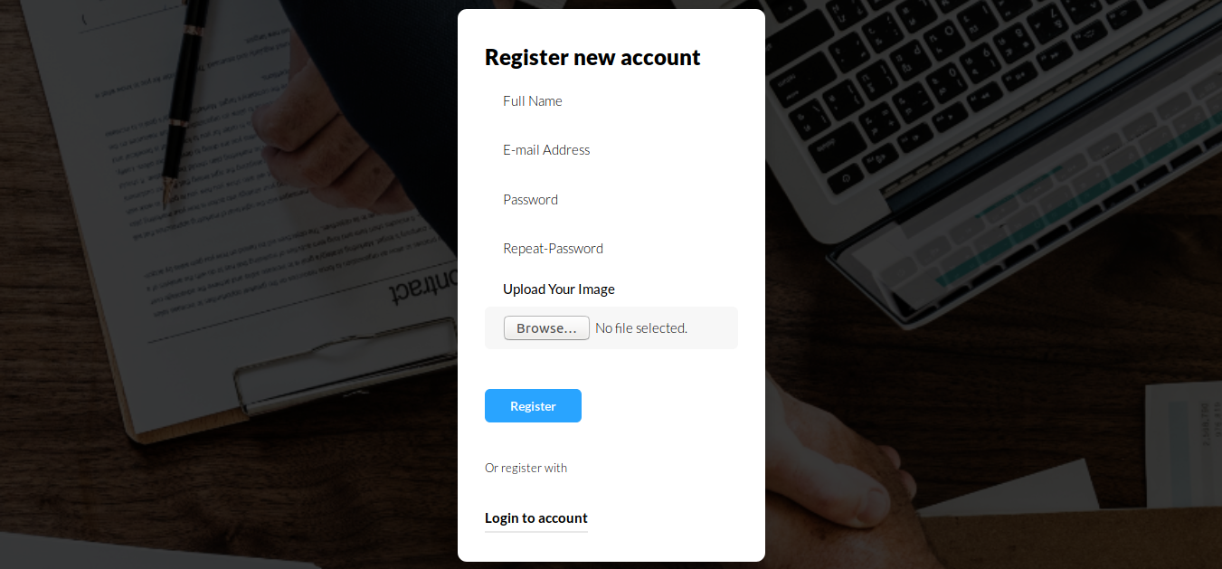
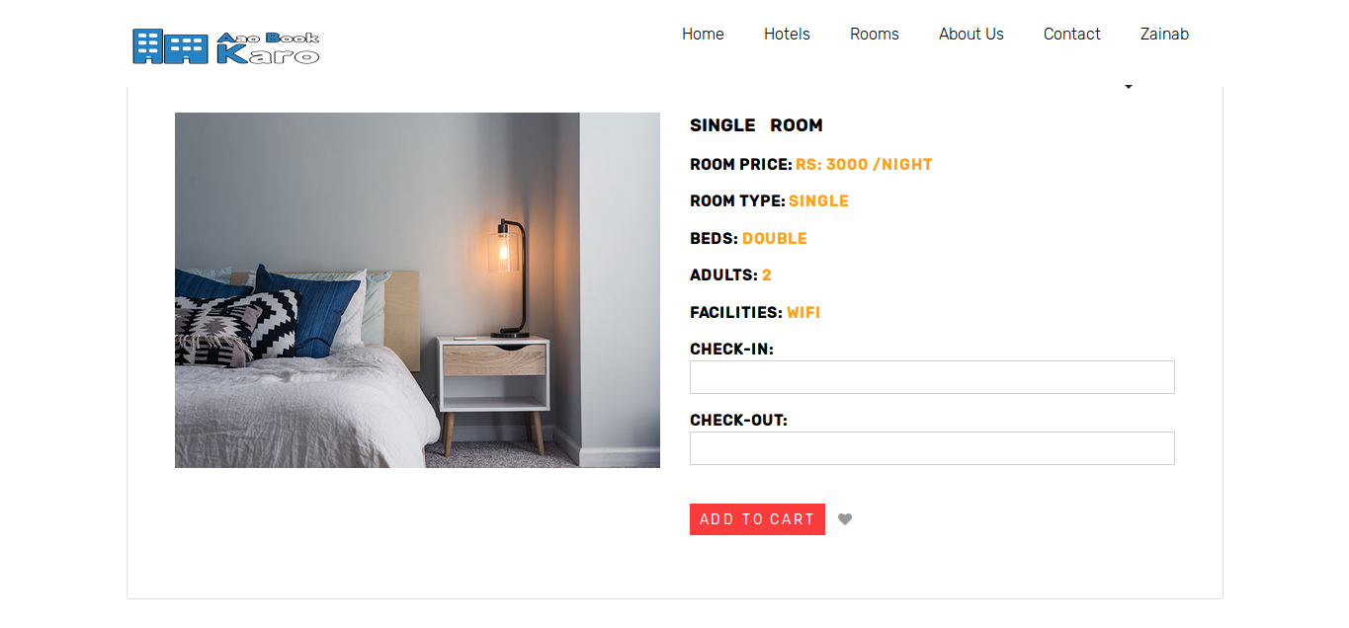

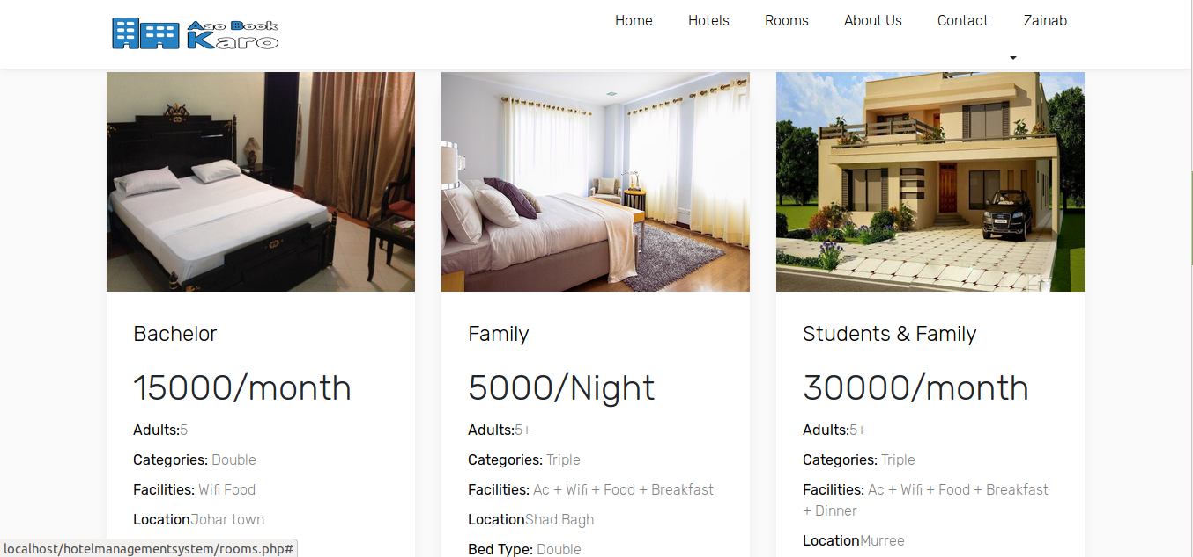
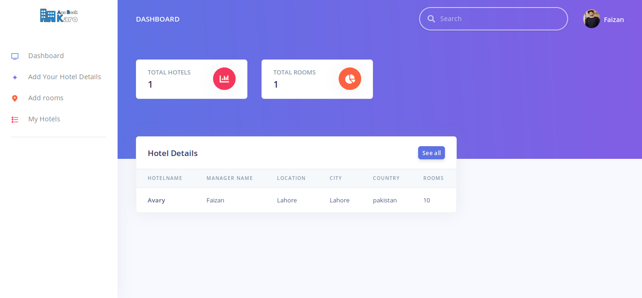

Hardware Interfaces
It includes the requirement of computer/device where the system will be used by the user where the reservations details and confirmation mails will be sent to the users. So there will be a need of active and proper internet connection. Client should able to keep a stable connection.

Software Interfaces
The computer this software going to install need to have Windows operating system and on that XML will be installed and that will be the platform where the particular system will run. The data transmission will be regarding to XML, HTML 5, CSS, Java script and Laravel.

Communications Interfaces
When a specific reservation reserved at the same time an email will be sent to both members account. Both parties will be notified in order to reserve. To achieve this, proper internet connection will be needed.

System Features
The functional requirements of the system are as follows:
Registration:
- A page for Registration will be created
- Page contain following task fields “User Name”, “Email”, “Password”.
- After entering the following task fields then it will go to the registration function.
- From there all fields go to the database for verification.
- After verification from db.
- Successful registration message showed.
- Assigned unique id and password to every registered customer
Login/Logout:
- A page for login/logout will be created
- Page contains two task fields “Username”, “Password”, “Change Password” and “Confirm Password”.
- After entering the two task fields then it will go to the login function.
- From there both the fields go to the database for verification.
- After verification from db.
- Successful login message showed.
Reservation/ Booking:
- A page for Reservation will be created.
- Page contains following fields “Total members”, “Check-in date”, “Check-out date”, “Status”, “Number of nights”, “No of Rooms”, “No of guest Per Room”.
- After entering the following fields then it will go the reservation function.
- Then following fields go to the database for verification.
- After verification from db.
- Successful Reservation message showed.
Search Rooms:
- A page for Search Rooms will be created.
- A page contains following fields “Check-in”, “Check-out”, “No of Nights”, “Total members”.
- After entering the following fields then it will go the Search Room function.
- Then following fields go to the database for verification.
- After verification from db.
- If the Room is available Successful message showed.
Payment:
- A page for Payment will be created.
- Page contains following fields “Username”, “Total payment”, “Credit Card Details”.
- After entering the following fields then it will go the Payment function.
- Then following fields go to the database for verification.
- After verification from db.
- Successful message showed.
Issue Bills:
- A page for Issue Bill will be created.
- Page contains following fields “Billing no”, “Quantities”, “Price per Product”, “Total Bill”, “Taxes”, “Date” and “Services”.
- After entering the following fields then it will go the Issue Bill function.
- Then following fields go to the database for verification.
- Total cost is calculated according to the Services. After verification from database.
- Successful message showed And Print the Bill.
Set Room Rates:
- A page for Set Rates will be created.
- Page contains following fields “Single Room”, “Double Room”, “Master Room”.
- After entering the following fields then it will go the Set Rates function.
- Then following fields go to the database.
- Successful message showed.
Manage Staff:
- A page for Manage Staff will be created.
- Page contains following fields “Employee Code”, “Employee Name”, “Gender”, “Employee address”, “CNIC”, “Salary”, “Age”, and “Email”.
- Check boxes contain Add, Delete, and Update Member.
- After entering the following fields then it will go the Manage Staff function.
- Then following fields go to the database for verification.
- After verification from db.
- Successful Added, Deleted or Update message showed.
Manage Stoke:
- A page for Manage Stoke will be created.
- Page contains following fields “Materials”, “track all meals purchased”, “ payments” , “View Items”, “Place Order”, “Room Products”, “Kitchen Products”, and Other Products.
- Check boxes contain “Add Product”, “Delete Product”, “Update Product”.
- After entering the following fields then it will go the Manage Stoke function.
- Then following fields go to the database for verification.
- After verification from db.
- Successful message showed According to the want.
Manage Guest:
- A page for Manage Guest will be created.
- Page contains following fields “Name”, “Address”, “Phone no”, “Email”.
- Check boxes contain “Add guest”, “Delete guest”, “Update guest”.
- After entering the following fields then it will go the Manage guest function.
- Then following fields go to the database for verification.
- After verification from db.
- Successful message showed According to the want.
Manage Room:
- A page for Manage Guest will be created.
- Page contains following fields “Room no”, “Room Type”, “Description”, “Price”.
- Check boxes contain “Add Room”, “Delete Room”, “Update Room”.
- After entering the following fields then it will go the Manage Room function.
- Then following fields go to the database for verification.
- After verification from db.
- Successful message showed According to the want.

Other Nonfunctional Requirements

Performance Requirements
- Performance is measured in terms of reports generated weekly and monthly.
- The load time for user interfaces screen shall take no longer than two seconds.
- The log in information shall be verified within five seconds.
- Queries shall return within five minutes.

Safety Requirements
- User must be authenticated.
- System Protect from others harm full users. Safety is very important for system
- Unauthorized User cannot access the website.
- The database should be backup every hour.
- The details need to be mentioned properly.

Security Requirements
- After entering the password and user id the user can access this profile.
- All the data must be stored and secure.
- All external communication between the data server and client must be encrypted

Software Quality Attributes
This system will provide you with best and correct services. The working of this system will depend on the availability of an active and proper internet connection. The system will be run using windows operating system.

Business Rules
This is will be a website which will work properly with a proper internet connection.

Other Requirements
- Reliability:
Specify the factor required to establish the required reliability of the software system at time of delivery.
- Availability Requirements:
The system shall be available during normal hotel operating hours.
- Maintability Requirement:
System has to be easily maintained and updated

Chapter 3

Use Case Analysis

Chapter 3: System Analysis
The current manual system uses paperwork and direct human language communication by mouth to manage the hotel. This delays information transmission in the hotel. Booking is done through phone calls or through visit to the hotel booking office. The guest’s personal details such as Name, Age, Nationality, and Duration of stay, are input during booking in. The booking office orders for preparation of the guest’s room before his/ her check in date. The documents are transferred manually to the filling department for compilation of the guest’s file. On the reporting date the file is transferred to the reception. On checking in the guest is given the key to his allocated room, he also specify if he needs room service. The receptionist hands over the guest’s file to the accountant on the next table. Here the guest pays accommodation and meals fee. The guest’s file is updated on daily basis of his expenditure costs. The accounts department generates the bills on daily basis and delivered to the guests in their rooms at dusk by the service maids. The guest pays at the accounts desk, where the receipts are generated. For a one meal customer the bill is generated immediately after ordering and he pays at the accountant desk before leaving. During checking out of guests, their expenditure outlines are generated a day before check out date. The guests receive their outlines at the accounts desk as they check out, where they pay for bills balances if any.

Use Case Model
Figure 3: Use Case

Fully Dress Use Case
Login & Logout Use Case:
Name: | Login & Logout
Scope: | The user logs into the system and user profile will be displayed.
Actor: | Admin, User.
Stakeholders And Interest: | Admins and User want a secure login into the system for having access to their profiles.
Pre-condition: | There is no precondition for this use case.
Success Guarantee: | User profile will be displayed.
Main Success Scenario: | - The user clicks on Login button  - if id and password are validated, then the user is given access to the application  - User profile will be displayed.
Extensions: | - If user enters incorrect username or password, system will display message of invalid User.  - Afterwards ask them to re-enter fields or provide Forget Password Option.

Table 3: Login & Logout Use Case

Registration Use Case:
Name: | Registration
Scope: | User’s account will be created into the system to get access to the application.
Actor: | User.
Stakeholders And Interest: | - User wants to register to the site, to create their profile
Pre-condition: | There is no precondition for this use case.
Success Guarantee: | User will be successfully registered.
Main Success Scenario: | - After filling all the details in the registration form, the mandatory ones which are marked by * has to be filled necessarily.  - user registration form will be successfully submitted.  - Now they can login to the system anytime.
Extensions: | - When user don’t fill the mandatory details which are marked by * and enter wrong code in human verification field.  - user registration form will not be successfully submitted.  - A dialog box, which contains message “ Not registered, Please Try Again”, will be displayed.
Table 4: Registration Use Case

Table 5: Book Room Use Case

Book Room Use Case:
Name: | Book Room
Scope: | The system will display the rooms according to consumer’s specifications.
Actor: | User.
Stakeholders And Interest: | If user wants to search room by entering, he/she can do this by entering keywords.
Pre-condition: | There is no precondition for this use case.
Success Guarantee: | A click on Search button will display the result of all the rooms matching the specification.
Main Success Scenario: | - Click onBook Room Option  - After entering text in search field. A click on Book button will display the result of all the rooms matching the specification.  - The system will display the rooms according to specifications.
Extensions: | If products are not found , system will display nothing.

Search Room Use Case:
Name: | Search Room
Scope: | The system will display the rooms according to consumer’s specifications.
Actor: | User.
Stakeholders And Interest: | If user wants to search room by entering, he/she can do this by entering keywords.
Pre-condition: | There is no precondition for this use case.
Success Guarantee: | A click on Search button will display the result of all the rooms matching the specification.
Main Success Scenario: | - Click on Search product Option  - After entering text in search field. A click on Search button will display the result of all the rooms matching the specification.  - The system will display the rooms according to specifications.
Extensions: | If products are not found , system will display nothing.
Table 6: Search Room Use Case

Chapter 4

System Design

Chapter 4: System Design
The Chapter is all about how the software is going to work and how will the processes be executed as we see we have several diagrams that shows how really is the system performing and what will be the requirements to perform the operations required tasks as well as the diagrams and data clearly describes the process and shows a great help in understanding the content easily.

Architecture Diagram

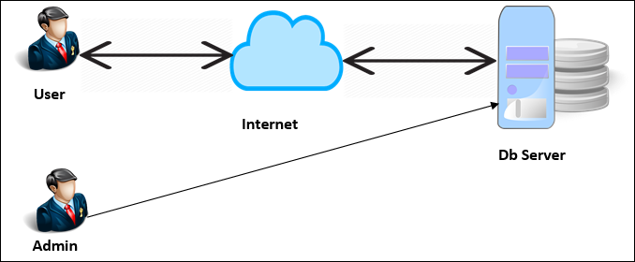
Figure 4: Architecture Diagram

Domain Model
Figure 5: Domain Model

Entity Relationship Diagram with data dictionary

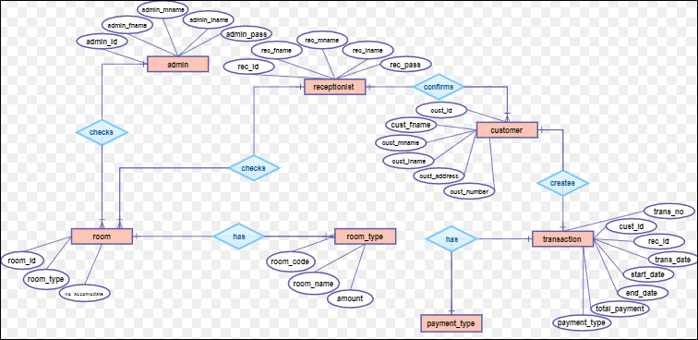
Figure 6: Entity Relationship Diagram

Class Diagram
Figure 7: Class Diagram

Sequence / Collaboration Diagram
Registration:

Figure 8: Sequence Diagram 1

OPERATIONAL CONTRACTS:
- Operation Name :
- Registration(Username, Password, Email)
- Cross Reference:
- Use Case: Online Registration
- Pre-Condition:
- Visit the website
- Post Condition
- Customer object has been created
- (Username, Password, Email)
- Customer Associate with the Registration page

Login:
Figure 9: Sequence Diagram 2

OPERATIONAL CONTRACTS:

- Operation Name :
- Login/Logout (Username, Password)
- Cross Reference:
- Use Case: Online login/Logout
- Pre-Condition:
  - Must Registered
- Post Condition
  - Customer object has been created
  - (Username, Password)
  - Customer Associate with the Login/Logout page.

Receptionist Login:

Figure 10: Sequence Diagram 3

OPERATIONAL CONTRACTS:

- Operation Name :
- Login/Logout (Username, Password)
- Cross Reference:
  - Use Case: Online login/Logout
- Pre-Condition:
  - Must Registered
- Post Condition
  - Receptionist object has been created
  - (Username, Password)
  - Receptionist Associate with the Login/Logout page

Manager Login :

Figure 11: Sequence Diagram 4

OPERATIONAL CONTRACTS:

- Operation Name :
- Login/Logout (Username, Password)
- Cross Reference:
  - Use Case: Online login/Logout
- Pre-Condition:
  - Must Registered
- Post Condition
  - Manager object has been created
  - (Username, Password)
  - Manager Associate with the Login/Logout page

Room Book
Figure 12: Sequence Diagram 5
OPERATIONAL CONTRACTS:
- Operation Name :
- Book Room (Check-in date, Check-out date, Status, No of Nights, No of Rooms, No of Guest Per Room)
- Cross Reference:
- Use Case: Book Room
- Pre-Condition:
- None
- Post Condition
- Room object has been created
- (Check-in date, Check-out date, Status, No of Nights, No of Rooms, No of Guest Per Room)
- Customer Associated with Rooms
Search Room

Figure 13: Sequence Diagram 6

OPERATIONAL CONTRACTS:

- Operation Name :
- Search Room (Check-in date, Check-out date, Room Price, No of Nights, Total Members)
- Cross Reference:
- Use Case: Search Room
- Pre-Condition:
- Must Login
- Post Condition
- None

Payment

Figure 14: Sequence Diagram 7

OPERATIONAL CONTRACTS:

- Operation Name :
- Payment (User Name, Total Payment, Credit Card, Cash)
- Cross Reference:
- Use Case: Receive Payments
- Pre-Condition:
- None
- Post Condition
- None

Issue Bill

Figure 15: Sequence Diagram 8

OPERATIONAL CONTRACTS:
- Operation Name :
- Issue Bill (“Billing no”, “Quantities”, “Price Per Product”, “Total Bill”, “Taxes”, “Date” and “Services)
- Cross Reference:
- Use Case: Generate Issue Bill
- Pre-Condition:
- Receptionist must enter the login page
- Post Condition
- Bill object has been created
- (“Billing no”, “Quantities”, “Price Per Product”, “Total Bill”, “Taxes”, “Date” and “Services)
- Customer Associate with Receptionist

Set Room Rates:

Figure 16: Sequence Diagram 9

OPERATIONAL CONTRACTS:

- Operation Name :
- Set Room Rate (Single Room, Double Room, Master Room)
- Cross Reference:
- Use Case: Set Room Rates
- Pre-Condition:
- Must excess the Manager login page
- Post Condition
- None

Manage Guest:

Figure 17: Sequence Diagram 10

OPERATIONAL CONTRACTS:

- Operation Name :
- Manage Guest(Room Reservation, Room no, Guest no, Address, Phone no)
- Cross Reference:
- Use Case: Manage Guest
- Pre-Condition:
- Receptionist must enter the login page
- Post Condition
None

Manage Inventory

Figure 18: Sequence Diagram 11

OPERATIONAL CONTRACTS:
- Operation Name :
- Manage Inventory (Name, Price, Product, Add, Delect, Update)
- Cross Reference:
- Use Case: Manage inventory
- Pre-Condition:
- Receptionist must enter the login page
- Post Condition
- None

Manage Rooms

Figure 19: Sequence Diagram 12
OPERATIONAL CONTRACTS:
- Operation Name :
- Manage Room(Room NO, Room Type, Description, Price, Add Room, Delect Room, Update Room)
- Cross Reference:
- Use Case: Manage Room
- Pre-Condition:
- Receptionist must enter the login page
- Post Condition
- Room object has been created
(Room NO, Room Type, Description, Price, Add Room, Delect Room, Update Room)
- Receptionist associate with Room

Manage Staff

Figure 20: Sequence Diagram 13

OPERATIONAL CONTRACTS:
- Operation Name :
- Manage Staff (employee name, employee code, Address, Contact, CNIC, Salary, Age, Gender, Add Employee)
- Cross Reference:
- Use Case: Manage Staff
- Pre-Condition:
- Manager must enter the login page
- Post Condition
- Staff object has been created
(employee name, employee code, Address, Contact, CNIC, Salary, Age, Gender, Add Employee)
- Staff associate with manager
Manage Stoke:
Figure 21: Sequence Diagram 14

OPERATIONAL CONTRACTS:
- Operation Name :
- Manage Stoke(“Materials”, “track all meals purchased”, “ payments” , “View Items”, “Place Order”, “Room Products”, “Kitchen Products”, and Other Product, Delect Product”.
- Cross Reference:
- Use Case: Manage Stoke
- Pre-Condition:
- None
- Post Condition
- Products object has been created
(“Materials”, “track all meals purchased”, “ payments” , “View Items”, “Place Order”, “Room Products”, “Kitchen Products”, and Other Product, Delect Product”.
- Inventor associate with inventor

Order

Figure 22: Sequence Diagram 15

OPERATIONAL CONTRACTS:

- Operation Name :
- Order (meal name, Type, Price)
- Cross Reference:
- Use Case: ORDER MEAL
- Pre-Condition:
- Must Member of Hotel
- Post Condition
- Meal ,Product object
- Order (meal name, Type, Price)
- Customer associate with the inventory

Activity Diagram
Figure 23: Activity Diagram

State Transition Diagram
Figure 24: State Transition Diagram

Component and Deployment Diagram
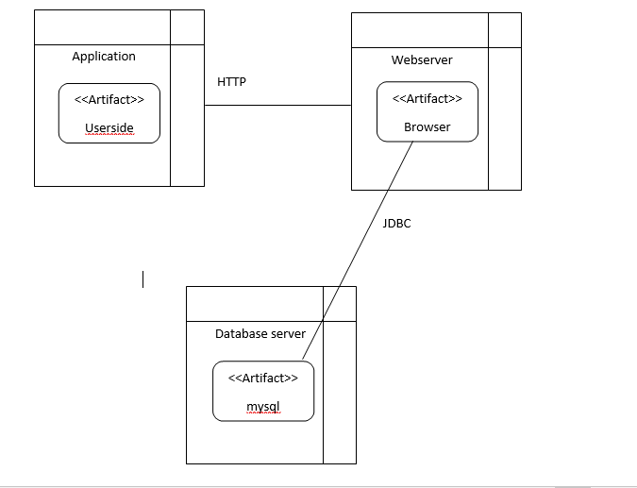
Figure 25: Component and Deployment Diagram

Data Flow diagram [only if structured approach is used - Level 0 and 1]

Figure 26: DFD Context level

LEVEL 0:

Figure 27: DFD level 0

Figure 28: Level 1 & 2

Figure 29: DFD level 3

Figure 30: DFD level 4

LEVEL 5
Figure 31: DFD level 5

Chapter 5

Implementation

Chapter 5: Implementation

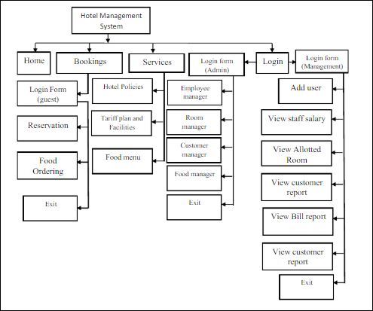

Figure 32: Implementation

Components, Libraries, Web Services and stubs
Components:
- Properly Structured Website
Website is easy to use
- User Friendly
Website is user friendly website. Every person can easily use all the features of the website. User can easily register their profile.
Languages and Libraries:
    - PHP
    - My SQL
    - Java script
    - HTML 5
    - CSS
    - Bootstrap
Web Services
- 24-hr access.

Deployment Environment
This system is a website on which operations will be performed.

Tools and Techniques
PHP
It is a server-side scripting language designed for Web development. It provides latest
Functionalities regarding saving, fetching, updating and deleting the data.
Microsoft Word
Microsoft word is the word processor and would be used for documentation purpose
Throughout the whole project.

Microsoft Excel
Microsoft excel is spreadsheet and would be used for data analysis throughout the Whole project.
Microsoft Project
Microsoft Projects provides extensive features on project management with a
Prominent feature of project scheduling. Gantt charts, resource allocations. This would be used as a project management tool throughout the whole project.
Draw.io
Draw.io is a tool for modeling different diagrams which would be addressed during Analysis and design phases of the project.
Project Modeling
Rational Rose and Microsoft Visio are to be used to draw use cases with different
Perspectives as they support the language of Rational Unified Process (RUP). Use case
Diagram, Data Flow Diagram (DFD), domain model and all other OOAD analysis and
Design diagrams are supported.
Server
Server is required where whole data is stored.

Best Practices / Coding Standards
- No coding repetition
- Function and classes are always commented showing expected input and output.
- Stable Requirements and Scope
- Defined Organization, Systems, and Roles
- Quality Assurance
- Planned Commitments

Chapter 6

Testing and Evaluation

Chapter 6: Testing and Evaluation
The philosophy behind testing is to find mistakes or errors. Testing performs a critical role for quality assurance and for checking reliability of software. Its purpose is to demonstrate that a program works by showing that is has no error. We can also say that it is a process of execution of software with intention to find mistakes or errors.

Use Case Testing
6.1.1. Registration
Test Suite ID | TS001
Test Case | Registration
Test Case Summary | To verify that by clicking Signup button name, password, email, and image store in user detail in database.
Related Requirement | User should able to Sign up.
Prerequisites | No
Test Procedure | 1. Open Signup Form.  2. Enter user data in fields.  3. Click Signup button.
Test Data | Valid name: Faizan, FAIZAN, Faizan_Ahmad  Invalid name: numeric keys  Valid password: 123Abc@5, Abc567$%9  Valid email:faizy@gmail.com, 12faizy@yahoo.com  Invalid email: ali.com, ali@yahoo  Invalid email: Already registered
Expected Result | 1. If password, email are valid then store user data by clicking signup button.  2. If given inputs are invalid then display error message.  3. If fields are empty then show warning message.  4. If Password and confirm password don’t match then show error.  5. If email already registered then show error.
Actual Result | Test Successful
Status | Pass
Remarks | This test case is simple and easy.
Created By | Faizan Ahmad
Date of Creation | 04/24/2019
Executed By | Faizan Ahmad
Date of Execution | 04/30/2019
Text Environment | OS: Window 10  Browser: Mozilla

Table 7: Use Case Test for Registration

6.1.2. Login
Test Suite ID | TS001
Test Case | Login
Test Case Summary | To verify Authentication or Login.
Related Requirement | User should able to Login.
Prerequisites | User should Signup first.
Test Procedure | 1. Select email field and enter Email.  2. Select Password field and enter password.  3. Click Login button.
Test Data | Valid email: faizy@gmail.com  Invalid email: faizy.com  Valid password: 123Aabc@, abMc567$%
Expected Result | 1. If email and password are valid then clicking the Login button user successfully login.  2. If email and password are invalid then clicking the Login button invalid message display.  3. If fields are empty then display warning message  4. If Email don’t exist then display error.  5. If password don’t match with Email.
Actual Result | Test Successful.
Status | Pass
Remarks | This test case is simple and easy.
Created By | Faizan Ahmad
Date of Creation | 04/22/19
Executed By | Faizan Ahmad
Date of Execution | 04/30/19
Text Environment | OS: Window 10  Browser: Mozila Firefox
Table 8: Use Case Test for Login

6.1.3. Room Booking
Test Suite ID | TS001
Test Case | Room Booking
Test Case Summary | Firstly a form has to be filled in which user have to enter the data according to his needs and then move to the additional things if he want to add then receipt will show.
Related Requirement | Admin should able to update prices.
Prerequisites | Admin should login.
Test Procedure | 1. Select Rooms Data  2. Enter Continue Button.  3. Add additional information if he want.  4. Click Submit Button.  5. Receipt Generate.  6. Click Confirm Booking.  7. Payment.  8. Proceed Payment
Test Data | 04/01/19
Expected Result | 1. If Fields will Empty then display error.  2. When click on submit button then display current budget  3. Show additional things if user want to add it.  4. If add Additional things then generate Receipt and show total amount.  5. If he don’t want to add additional things then Receipt will only generate the Current Budget.  6. Add credit card numbers.  7. Bot Bank Will show the payment proceed.
Actual Result | 1. If Fields will Empty then display error.  2. When click on submit button then display current budget  3. Show additional things if user want to add it.  4. If add Additional things then generate Receipt and show total amount.  5. If he don’t want to add additional things then Receipt will only generate the Current Budget.  6. Add credit card numbers.  7. Proceed Payment Bot don’t create.
Status | Pass
Remarks | This test case is simple and easy.
Created By | Faizan Ahmad
Date of Creation | 04/01/19
Executed By | Faizan Ahmad
Date of Execution | 04/01/19
Text Environment | OS: Window 10  Browser: Mozila Firefox
Table 9: Use Case Test Room Booking

6.1.4. Contact
Test Suite ID | TS002
Test Case ID | Contact
Test Case Summary | If any user have any query then he will send a message to admin by clicking on contact button and then he will send message to admin.  Admin Will receive all Messages from all users and solved out the queries.
Related Requirement | User have to signup first.
Prerequisites | User should login.
Test Procedure | Click Send message.
Expected Result | - If fields are empty then display error message.  - Email or Name will auto generate in field by the account that is login.  - Send message and display message sent notification.
Actual Result | Test Successful
Status | Pass
Remarks | This test case is simple and easy.
Created By | Faizan Ahmad
Date of Creation | 04/01/19
Executed By | Faizan Ahmad
Date of Execution | 04/01/19
Text Environment | OS: Window 10  Browser: Mozila Firefox
Table 10: Use Case Test Contact
6.1.5. Admin
Test Suite ID | TS002
Test Case | Admin
Test Case Summary | Login from his credentials and open admin panel.
Related Requirement | Admin can only register.
Prerequisites | Admin registered.
Test Procedure | Admin will have login page.
Expected Result | - Enter Valid Email faizy@gmail.com  - Invalid Email faizy.com  - Fields empty then show error.  - Password matched with email.
Actual Result | Test Successfull
Status | Pass
Remarks | This test case is simple and easy.
Created By | Faizan Ahmad
Date of Creation | 04/01/19
Executed By | Faizan Ahmad
Date of Execution | 04/01/19
Text Environment | OS: Window 10  Browser: Mozila Firefox
Table 11: Use Case Test Admin

6.1.6. View Records
Test Suite ID | TS002
Test Case ID | View Records
Test Case Summary | To view all record from users and admins.
Related Requirement | Admin should be able to view data.
Prerequisites | Admin should login.
Test Procedure | Admin Will view all records
Expected Result | Everything will be display like users, admins, booking, rooms, Messages, and have all rights.
Actual Result | Test Successful
Status | Pass
Remarks | This test case is simple and easy.
Created By | Faizan Ahmad
Date of Creation | 04/01/19
Executed By | Faizan Ahmad
Date of Execution | 04/01/19
Text Environment | OS: Window 10  Browser: Mozila Firefox
Table 12: Use Case Test View Records

6.1.7. Modifications
Test Suite ID | TS002
Test Case ID | Modifications
Test Case Summary | To update data of user, admin, and booking and rooms and also can delete data.
Related Requirement | Admin should be able to view data.
Prerequisites | Admin should login.
Test Procedure | Admin Will Update and delete data
Expected Result | - Update Users  - Update admins  - Add users  - Add admins  - Update rooms  - Add rooms  - Delete Admin  - Delete Users  - Delete rooms  - Edit Profile
Actual Result | Test Successful
Status | Pass
Remarks | This test case is simple and easy.
Created By | Faizan Ahmad
Date of Creation | 04/01/19
Executed By | Faizan Ahmad
Date of Execution | 04/01/19
Text Environment | OS: Window 10  Browser: Mozila Firefox
Table 13: Use Case Test Modifications

Boundary Value Analysis
Email Address:
Test Scenario# | Test Scenario Description | Expected Outcome
1 | Enter 0 to 7 characters in Email address field including “@” sign. | System should not accept
2 | Enter 7 to 20 characters in Email address field including “@” sign. | System should accept
3 | Enter 20 to 25 characters in Email address field including “@” sign. | System should not accept

Table 14: Boundary Value Analysis 1

Password:
Test Scenario# | Test Scenario Description | Expected Outcome
1 | Enter 0 to 7 characters in password field | System should not accept
2 | Enter 8 to 13 characters in password field | System should accept
3 | Enter 13 to 14 character in password field | System should not accept
Table 15: Boundary Value Analysis 2

Unit testing
This is concerned with knowledge about testing a program unit, developed by a single individual, to determine that it is free of errors and mistakes. In unit testing, local data structures, boundary conditions, paths and errors are tested. Test cases are design to check errors due to computations, comparisons and flows. After development, review and verification of source code unit test case design begin.

Integration testing
After unit testing, we perform integration testing. Its goal is to see if module can be integrated properly. This testing activity can be considered as testing the design and hence the emphasis on testing module interactions. In this step, all modules are integrated from main system.

Performance testing
Performance testing is for checking how the system works and perform. It examines responsiveness, stability, scalability, reliability and speed of system.

Stress Testing
The goal of stress system is to analyze the behavior of system after a failure. Stress testing is used to check that the system works under normal conditions or not. The main purpose of stress testing is to make sure that the system recovers after failure.

Chapter 7

Summary, Conclusion and Future Enhancements

Chapter 7: Summary, Conclusion & Future Enhancements

Project Summary
This project AO BOOK KARO is a web based application that allows hotel manager to handle all hotel activities online. The ability to manage hotel bookings make this system flexible and convenient. The hotel manager is a very busy person and does not have the time to sit and manage the entire activities manually on paper. This application gives him the power and flexibility to manage the entire system from a single online system. Hotel management project provides room booking, staff management and other necessary hotel management features. The system allows the manager to post available rooms in the system. Customers can view and book room online. Admin has the power of either approving or disapproving the customer’s booking request. Other hotel services can also be viewed by the customers and can book them too. The system is hence useful for both customers and managers to portable manage the hotel activities.

Achievements and Improvements
Presently, persons attach significance to travelling. Every single day, large numbers men and women worldwide love travelling. Every day, tens of millions men and women travel for personal and business motives. Business trips are typical. The hotel industry is the greatest market presently. It's no wonder that, many more people are engaged in the hospitality sector. If you are intending to start business in the hotel market, it’s recommended to focus on hotel management software. Hotel management software is significant to ensure success. Hotel management software can be described as practical choice. The World Wide Web has changed us. The Online World has completely revolutionized the world of business. The net has changed our technique for running business. At this time, large numbers of business owners understand the incredible importance of software for their results. Hotel management software, trust accounting software.
Now a days hotels are providing many other facilities, this project can be improved with the improvements in hotels. Utmost care and backups procedures must be established to ensure 100 % successful implementations of computerized banking system. In case of system failure, the organization should be in a position to process the transaction with another organization or if the worst comes to the worst, it should be in a position to complete it manually.

Critical Review
The critical element of our system are: is the developed system fast moving, give user friendly interface, not very costly, fulfill the specific requirements of the users at a runtime, has all the features which any institute can require. To manage all these aspects, it took lot of time and hard work.

Lessons Learnt
We have learnt very much from this project. This project enhances our skills in PHP, and many other tools and many management concepts as well as how to deal with a problem and how to stick for finding the solution of any problem until you fond. As well as technical skills this project also enhances our personal development skills such as team working, dedication.

Future Enhancements/Recommendations
This project can be used in the hotel after adding some useful modules in the project for which hotel are providing services. Utmost care and backup procedures must be established to ensure 100 % successful implementation of the computerize hotel system. In case of system failure, the organization should be in a position to process the transaction with another organization if the worst comes to the worst, it should be in a position to complete it manually.

Appendices

Appendix A: User Manual
In this appendix section we describe the different phases of user interface and also describe how user can interact with our portal.

Appendix A: Interface

A2: REGISTRATION

A3: User Interface
B3: HOME PAGE
A3: Host Panel
A4: Admin Panel

A5: BOOK ROOM

Reference and Bibliography

Reference and Bibliography

  - IEEE 830-1998 standard for writing SRS document.
  - I Summerville, Software Engineering, 8th ed, Addison- Wesley, 2007.

