SUPERIOR UNIVERSITY LAHORE

Smart Language Translate

Final Year Project

Session 2016-2020

A project submitted in partial fulfillment of the degree of

BS in Computer Science


Department of Computer Science
Faculty of Computer Science & Information Technology
The Superior College, Lahore

Spring 2020

Type (Nature of project) |  |  | [ ] Development [ ] Research [ ] R&D
Area of specialization |  |  | Mobile Application(JAVA ,XML ,FIREBASE, JASON )
FYP ID |  |  | FYP-09
Project Group Members
Sr.# | Reg. # | Student Name |  | Email ID | *Signature
(i) | Bcsm-f16-376 | Muhammad Ahsan |  | Mianahsan34056@gmail.com
(ii)
(iii)

*The candidates confirm that the work submitted is their own and appropriate credit has been given where reference has been made to work of others

Plagiarism Free Certificate
This is to certify that, I ________ S/D of Muhammad Siddique, group leader of FYP under registration no ______________________________at Software Engineering Department, The Superior College, Lahore. I declare that my FYP report is checked by my supervisor.

Date: Name of Group Leader: _________________ Signature: _____________
Name of Supervisor: Mam. Asmara Co-Supervisor:
Designation: Lecturer Designation: Associate Professor
Signature: ________________ Signature: _________________

HoD: Dr. Arfan Jaffar
Signature: _______________
PROJECT REPORT

[TRANSTALK]

Project ID:[FYP-09]

Project Team
Student Name | Student ID | Program | Contact Number | Email Address
Muhammad Ahsan  ( Group Leader) | BCSM-f16-376 | BSCS | 0349-0040096 | mianahsan34056@gmail.com

Project Report
[TRANSTALK]

Change Record
Author(s) | Version | Date | Notes | Supervisor’s Signature
 | 1.0 |  | <Original Draft>
 |  |  | <Changes Based on Feedback from Supervisor>
 |  |  | <Changes Based on Feedback From Faculty>
 |  |  | <Added Project Plan>
 |  |  | <Changes Based on Feedback from Supervisor>

APPROVAL
Project Supervisor
Comments: ___________________________________________________________________
_____________________________________________________________________________
Name:______________________________
Date:_______________________________ | Signature:__________________________

Project Manager
Comments: ___________________________________________________________________
_____________________________________________________________________________
Date:_______________________________ | Signature:__________________________

Head of the Department
Comments: ___________________________________________________________________
_____________________________________________________________________________
Date:_______________________________ | Signature:__________________________

Dedication

This project is dedicated to our parents, loved ones, to all our professor who taught us the best kind of knowledge, to all the respondents, our friends for giving us the strength to overcome pressure while doing this project and to all the people who make this study possible. Most especially to group mates, this is the fruit of our work! Allah bless you.

Acknowledgements

Our deepest gratitude goes to Allah Almighty who has provided all that is needed to complete this project. He has been the source of our strength throughout this project and on his wings only have we soared. Our team would like to thank the people who helped us make this project possible. To our mentor Mam Asmara Akram and our advisor Mam Asmara Akram who patiently taught us everything, we need to know. Thank you we appreciate from the depth of our heart. Also, to their statistician for always making sure, documentation and diagram were correct. The group appreciates everything you have done. And they were so honored to have you as their statistician. And now the group would like to thank all the people who supported them, their families, friends, and classmates. Especially their parents who helped them with everything financially, to their friends who believed that they can finish the study despite all the struggles, depression, and stress they experienced in the making of this project.We were really thankful to our supervisors who support us in everything related to this project.

Executive Summary
TRANSTALK is a Urdu and Multilanguage chatting application with the specialty of language translation into ten to twenty formal languages as per required. User can only translate incoming or outgoing text/audio messages into different languages, upload different type of posts like text posts, basically this app is design to promote Urdu language.
This application is designed to overcome the problem of understanding social applications with non-native language
Making and exploring new trends would become easy. This application is also beneficial for our country because there is no any social application or messenger developed in Pakistan, So, For the first time in Pakistan a social application is going to launch and we make sure that there is going to be lots of features and many functionalities in this application which would be helpful for the people to communicate and socialize their selves easily and explore a lot of information in their language and also it will make a trend among people like other messaging application.

Table of Contents
Dedication vi
Acknowledgements vii
Executive Summary viii
Table of Contents ix
List of Figures xii
List of Tables xiii
Chapter 1 1
Introduction 1
1.1. Background 2
1.2. Motivations and Challenges 2
1.3. Goals and Objectives 3
1.4. Literature Review/Existing Solutions 3
1.5. Gap Analysis 4
1.6. Proposed Solution 4
1.7. Project Plan 4
1.7.1. Work Breakdown Structure 5
1.7.2. Roles & Responsibility Matrix 6
1.7.3. Gantt Chart 7
1.8. Report Outline 7
Chapter 2 8
Software Requirement Specifications 8
2.1. Introduction 9
2.1.1. Purpose 9
2.1.2. Document Conventions 9
2.1.3. Intended Audience 9
2.1.4. Product Scope 10
2.1.5. References 10
2.2. Overall Description 10
2.2.1. Product Perspective 10
2.2.2. Product Functions 11
2.2.3. User Classes and Characteristics 11
2.2.4. Operating Environment 11
2.2.5. Design and Implementation Constraints 12
2.2.6. Assumptions and Dependencies 12
2.3. External Interface Requirements 12
2.3.1. User Interfaces 12
2.3.2. Hardware Interfaces 13
2.3.3. Software Interfaces 13
2.4. System Features 13
2.4.1. User registration 13
2.4.1.1. Description and Priority 13
2.4.1.2. Stimulus/Response Sequences 13
2.4.1.3. Functional Requirements 13
2.4.2. Login/logout 14
2.4.2.1. Description and Priority 14
2.4.2.2. Stimulus/Response Sequences 14
2.4.2.3. Functional Requirements 14
2.4.3. Change language 14
2.5. Other Nonfunctional Requirements 15
2.5.1. Performance Requirements 15
2.5.2. Safety Requirements 15
2.5.3. Security Requirements 15
2.5.4. Software Quality Attributes 15
2.6. Other Requirements 16
Chapter 3 17
Use Case Analysis 17
3.1. Use Case Model 18
3.2. Fully Dressed Use Cases 19
Chapter 4 24
System Design 24
4.1. Architecture Diagram 25
4.2. Domain Model 26
4.3. Entity Relationship Diagram with data dictionary 27
4.4. Class Diagram 28
4.5. Sequence / Collaboration Diagram 29
4.6. Operation contracts 32
4.7. Activity Diagram 37
4.8. State Transition Diagram 38
4.9. Component Diagram 41
4.10. Deployment Diagram 42
4.11. Data Flow diagram 42
Chapter 5 44
Implementation 44
5.1. Important Flow Control/Pseudo codes 45
5.2. Components, Libraries, Web Services and stubs 46
5.3. Deployment Environment 47
5.4. Tools and Techniques 47
5.5. Best Practices / Coding Standards 47
5.6. Version Control 48
Chapter 6 49
Testing and Evaluation 49
6.1. Use Case Testing 50
6.2. Boundary value analysis 53
6.3. Performance testing 54
6.4. Stress Testing 57
Chapter 7 58
Summary, Conclusion and Future Enhancements 58
7.1. Project Summary 59
7.2. Achievements and Improvements 59
7.3. Critical Review 60
7.4. Lessons Learnt 61
7.5. Future Enhancements/Recommendations 61

List of Figures

1.1 Caption of first figure of first chapter 6
1.2 Caption of second figure of first chapter 7
2.1 Caption of first figure of second chapter 14
2.2 Caption of second figure of second chapter 22
2.3 Caption of third figure of second chapter 26
5.1 Caption of first figure of fifth chapter 49
5.2 Caption of second figure of fifth chapter 49

List of Tables

1.1 label of first table of first chapter 6
1.2 label of second table of first chapter 7
2.1 label of first table of second chapter 14
2.2 label of second table of second chapter 22
2.3 label of third table of second chapter 26
5.1 label of first table of fifth chapter 49
5.2 label of second table of fifth chapter 49

Chapter 1

Introduction

Chapter 1: Introduction
Basically, in this chapter we introducing the main steps of our project. This introduction contains the background, Motivation/Challenges, Goals/Objectives, Solutions, Gap Analysis, Gantt Chart, Project Plan, Report Online. This material of introduction helps to understand the main issues related to this project.

Background
The expectation of this project is to design an easy interface to overcome the problem of how to easily understand and use a messaging application to communicate with people of different native-languages through messages, Even a user can translate outgoing and incoming messages in to different languages .

Motivations and Challenges
Our team is too much motivated to make an enjoyable messaging application interface in our national language because through this we can make an identity of our country in which people of different cultures in Pakistan make their accounts to communicate with each other to make spicy gossips , to share different kind of information which is helpful for others, to share multimedia which is entertain able or enjoyable for others. Also, people of global world will explore a lot of information about Pakistan through this app. our team is too much motivated to develop this interface to support the way people communicate or interact with social apps

Goals and Objectives
The goal of our team is to provide the best language translate application interface for the people of Pakistan and make a trend between people to engage with TRANSTALK. To make the best features ever in social apps which are interesting, easy to use, easy to learn, enjoyable, explore-able with some suspense and excitement. Also, we want to make our country progressive in technology field through making this type of projects.

Literature Review/Existing Solutions
Mostly people of our country don't know the English or other languages so they face a difficulty of using social applications and messengers. The main problem for them is to understand the difficult words of English to make an account of social application and then update any information in it. There are many messaging applications but there is no one exist which is totally in Urdu or attain the ability to translate text/audio into multiple languages and have an easy interface. But the interface of application is totally in English and difficult to understand So, TRANSTALK is being developed to overcome this difficulty and provide an engaging experience for the user.
Summery
Text to text
The invention relates to a real-time language translation technique for text-based conversations. The messages forming the text-based conversation amongst a plurality of participants to the conversation are translated in real-time either from a user language to a conversation language of the conversation, or from the conversation language to the user language. The result is that the user is able to Seamlessly converse in a text-based conversation (in the conversation language) using a language other than the conversation language. The invention is particularly advan tageous for on-line text-based conversations, wherein users of on-line text-based conversations are able to Seamlessly converse with each other in different languages.
The invention can be implemented in numerous ways, including as a System, a method, or as a computer readable medium.

The present approaches to machine translation are similar in their reliance on hand-written rules to the approaches to Speech recognition twenty years ago. Roughly Speaking, the present approaches to machine translation can be classified into one of three categories: direct, interlingual, and transfer.

An advantage of the invention is that user are able to communicate in text-based conversations on an international level without language barriers. Each member of the conversation no longer needs to understand the language in which the conversation is held. A user can select his or her own language and converse with the other members of the conversation as though he or she was fluent in the conversation language. Also, the necessary language translation is performed in essentially real-time So that the user requiring translation is not hindered.

Gap Analysis
Now a day there are many trending messaging applications with a number of traffic of users but some of the features of these applications are difficult to understand by some users who are non-fluent in English. TRANSTALK is a friendly user interface application in which the features are very easy to understand., So, features of this app is better than other apps in which user can easily post the status, upload a media file (audio), edit his/her profile and explore people and information of different people.

Proposed Solution
To overcome these problems. "TRANSTALK" is the best solution for the people of Pakistan who don't know or understand English or other languages. It should be very easy to use, Effective to use, Easy to learn. There is no difficult user interface. User easily message anyone in Urdu, read others messages and also can translate incoming/outgoing messages both (text, audio), posts, , easily use the features of the app, customize the profile.

Project Plan
Details:
In this application user make a profile by providing a unique mobile number, uploading a profile picture and setting a name with some biography which is then updated any time,
Update Features:
The different type of features all over the application will be up to date and new features will implement regularly.

Work Breakdown Structure

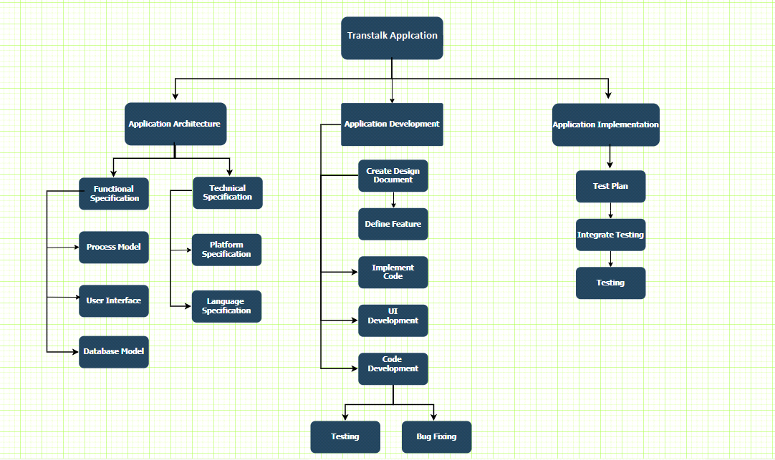
Fig 1.7

Roles & Responsibility Matrix

WBS # | WBS Deliverable | Activity # | Activity to Complete the Deliverable | Duration  (# of Days) | Responsible Team Member(s) & Role(s)
1 | Research & Analysis | 1.1 | Research | 5 | Hamza Faisal & Mutahir nasir Farooqi
 |  | 1.2 | Analysis | 5 | Team
2 | Planning | 2.1 | Assign Responsibility | 1
3 | Development | 3.1 | Requirement Gathering | 7 | Mutahir nasir Farooqi & Muhammad Ahsan
 |  | 3.2 | Requirement Analysis | 7 | Team
 |  | 3.3 | Designing System | 14 | Muhammad Ahsan & Mutahir nasir Farooqi
 |  | 3.4 | Development | 40 | Team
 |  | 3.5 | Testing | 30 | Team
4 | Maintenance & Deployment | 4.1 | Maintenance | 4 | Team
 |  | 4.2 | Deployment | 3 | Team

Gantt Chart

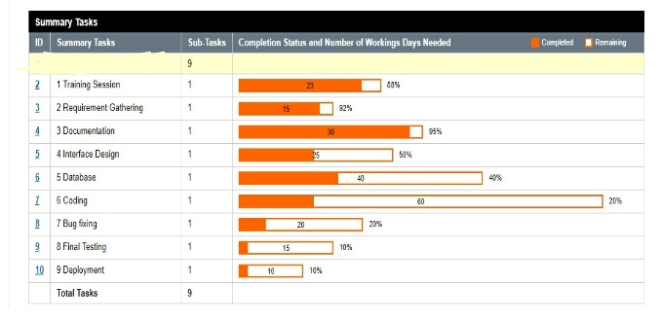

Fig 1.7.3

Report Outline
TRANSTALK provides a friendly user interface to the users. All the features are easy to understand.
- User can easily translate language in Urdu/English and 15-20 other languages.
- Upload the text posts and multimedia (audio) posts.
- Edit your profile and settings easily.

Chapter 2

Software Requirement Specifications

Chapter 2: Software Requirement Specifications

Introduction
The word "TRANSTALK" is combination of two words, “translate” means convert one language into other and “talk” means to communicate. In this app, a user should make its profile with some description.

Purpose
Our purpose is to make Pakistan's no 1 communication application totally in Urdu with the ability to translate one language into other for reliable communication. Which helps us to promote our language and make the user comfortable while using this application. With this application, we want to make other country’s user to explore and learn our culture.

Document Conventions
When writing then SRS document for "TRANSTALK" the following terminologies are used:
To make the document more effective and readable we used font: Calibri
- Line spacing: 1.5 line spacing
- Font Size: 12pt
- headings: 14pt
- Headings are bold and highlighted with attractive colors.
This document is intended to the audience in which such as developers, project managers, marketing staff, testers, and documentation writers and also for those End Users who really want to know about for what purpose this application is developed for.

Intended Audience
People of all age groups owing a smartphone.

Product Scope
There is no social app which is totally in Urdu to different language. So, “TRANSTALK” should make a big interest in people’s mind. Especially in Pakistan, people have much interest in this type of social applications as they have different accounts on this type of applications which make a trend in public. So “TRANSTALK” will be informative, joy able and efficient for the people as it will make a trend to translate as if required and post as well, the easy interface will be beneficial for the people who don’t understand English.

References
We use Stack Overflow to remove errors in code
https://stackoverflow.com/
The official website of the android contains a brief description of the tools
https://developer.android.com/

Overall Description

Product Perspective
TRANSTALK is a very useful, reliable and enjoyable application for those who want to enjoy social application in our own language, or for those people who don't feel comfort in English. It also provides learning opportunity by translating text/audio messages into multiple languages. All you have to do is download it for free from Google play store, install it and have fun.

Product Functions
Features:
- Login (email, password)
- Chat ( audio/ text)
- Select language
- Update Information

While registration these fields will be required
- Email address in which the user verified
- First Name
- Second Name
- Phone Number

User Function:
• Register
• Profile edit

User Classes and Characteristics
Admin:
The administrator can add, edit or clear words that you want to translate. Admin manage all functionality on TRANSTALK.
User:
Texting is the feature of our product which could avail by any user.

Operating Environment
It is android application hence it can be run on any android mobile with:
- minimum 4.4 KitKat android version.
- Ram: minimum of 512 GB
- Rom: 200 MBS.

Design and Implementation Constraints
The device will have 8GB RAM.
Good quality Internet connection required.
Operating System Windows 10
Tools:
Android Studio 3.2.1
Google Firebase
- XML
- JAVA
- JSON

Assumptions and Dependencies
In this application, the user must create an account and register his/her self through email verification. User must have a smartphone and at least 4.4 version of Android. Also, the user must have internet access because TRANSTALK is an online application.
- User must remember the password that he/she gives in signup account to login into his/her account.
- To upload post user must give access to multimedia in his/her phone.
- User must take care of the privacy of other users.

External Interface Requirements

User Interfaces
The application provides a user-friendly and interactive user interface. In this application, the user will easily understand the use of every element and enjoy the user experience.
User can interact with following things:
- User can enjoy the application in multiple languages.
- Translate incoming and outgoing messages.

Hardware Interfaces
- It is android application hence it can be run on any android mobile with minimum 4.4 KitKat android version.
- Ram: minimum of 512 GB
- Rom: 200 MBS.

Software Interfaces
Android Studio 3.2.1
Google Firebase
- XML
- JAVA
- JSON

System Features

User registration

Description and Priority
User registration has a priority value. Whenever the user installs the application and working for the first time, he/she has to get registered first.

Stimulus/Response Sequences
- The application launched from the Android home screen
- User is prompted to profile Data
- A form gets open to enter the fields
- Info goes to the database and gets stored in the database.
- After registration, the user is prompted to dashboard

Functional Requirements
REQ-SF1-1: User gets registered and is able to use the app.

Login/logout

Description and Priority

User has to authenticate if he/she is not logged in. He/she can also log out if wanted. This feature has 2ndhighest priority at most.

Stimulus/Response Sequences
- The application launched from the Android home screen
- User is prompted to log in
- A form gets open to enter the fields
- Info goes to the database and gets compared by existing info
- After authentication, the user is prompted to dashboard
- If the user is logging out, simply user is session out

Functional Requirements
REQ-SF1-1: User gets logged in/ logged out
Translate languages in different.

Change language

      - Description and Priority
This feature is specifically for those users who are fluent in the English Language. Can convert language in Urdu.
      - Stimulus/Response Sequences
- The user selects language in which user comfortable
- Database store it and next when user login they don't want to change language
- See the information of language
      - Functional Requirements
REQ-SF2 See the information of language -1: User should know English or Urdu language

Other Nonfunctional Requirements

Performance Requirements
- Android version should be greater than 5.0 for better performance of an application.
- User must have a good internet connection to really enjoy the performance of an application.
- Size of the application should be small that it can be accessible in every mobile if mobile is low storage mobile.

Safety Requirements
Only authorized member or user can log in into an application. Data should be saved in encrypted form so that in case of attack or hack data will be unreadable or unacceptable. The Database may get crashed or damaged due to some viruses. Therefore, it is mandatory to have a backup for your data in some other servers also.

Security Requirements
- Email authentication would be required to assess or to enter an application.
- Users are unable to change the information instead of its own basic information.

Software Quality Attributes
Privacy and security of the user is our basic and most important motive.
Availability:
Users can access their accounts anytime anywhere.
Integrity:
Better component design to get better performance at peak time.
Correctness:
Application is design in that way that it should be free from errors.
Reliability:
Application is reliable and the user can trust that it's 100% reliable.

Security:
Application is 100% secure and users save their data with no worry. Before storing data on a database, data is encrypted so that no one can access or steal user's personal information.
Easy to Use:
Application is easy to use and learn. Users can use this application in multiple languages. Which makes it very easy to understand.

Other Requirements
The system must store the entire User information in Database. For each user data saved with its unique Email id in the database.

Chapter 3

Use Case Analysis

Chapter 3: System Analysis

Use Case Model
Fig 3.1

Fully Dressed Use Cases
- Registration
Fully Dressed Use Case
 | Use case Name | Registration
 | Scope | Register function
 | Level | User goal
 | Actor | User, Admin
 | Stakeholder | User, Admin
 | Pre-Condition | Internet Connection
 | Post-Condition | Login
 | Success Scenario | Registered
 | Extension | - -

- Login

Fully Dressed Use Case
 | Use case Name | Login
 | Scope | Login
 | Level | User Goal
 | Actor | User, Admin
 | Stakeholder | User, Admin
 | Pre-Condition | - Must be registered  - Must be online
 | Post-Condition | Access to Timeline
 | Success Scenario | Successfully login
 | Extension | - -

- Edit Profile

Fully Dressed Use Case
 | Use case Name | Edit Profile(name,picture,bio)
 | Scope | Profile
 | Level | User Goal
 | Actor | User
 | Stakeholder | User
 | Pre-Condition | - Must be Login  - Internet Connection
 | Post-Condition | The profile should be edit
 | Success Scenario | Profile edit successfully
 | Extension | --

- Edit Name

Fully Dressed Use Case
 | Use case Name | Edit Name
 | Scope | Name
 | Level | User Goal
 | Actor | User
 | Stakeholder | User
 | Pre-Condition | - Must be Login  - Internet Connection  - User must have to open edit profile  - User must remove the old name and enter a new name
 | Post-Condition | The name should be edit with a new name
 | Success Scenario | Name edit successfully
 | Extension | --

- Edit Profile Picture

Fully Dressed Use Case
 | Use case Name | Edit Profile Picture
 | Scope | Profile Picture
 | Level | User Goal
 | Actor | User
 | Stakeholder | User
 | Pre-Condition | - Must be Login  - Internet Connection  - User must have to open edit profile  - User must remove the old picture and upload a new one
 | Post-Condition | The new profile picture uploaded on profile
 | Success Scenario | Profile Picture successfully updated
 | Extension | --

- Update EMAIL

Fully Dressed Use Case
 | Use case Name | Update Email
 | Scope | Email
 | Level | User Goal
 | Actor | User
 | Stakeholder | User
 | Pre-Condition | - Must be Login  - Internet Connection  - User must have to open edit profile  - User should remove the old email and enter the new email
 | Post-Condition | User should enter the new email
 | Success Scenario | email successfully updated
 | Extension | --

Chapter 4

System Design

Chapter 4: System Design
The system design describes the system requirement, operating environment system and subsystem architecture, files and database design, input format, output layout, user interface, detailed design processing logic, an external interface.

Architecture Diagram
We divided a system architecture in three-part application, services & authentication and database, As Shown in the figure.
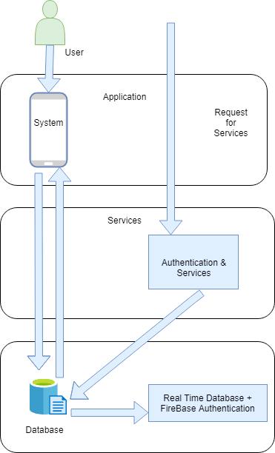
Fig 4.1

Domain Model
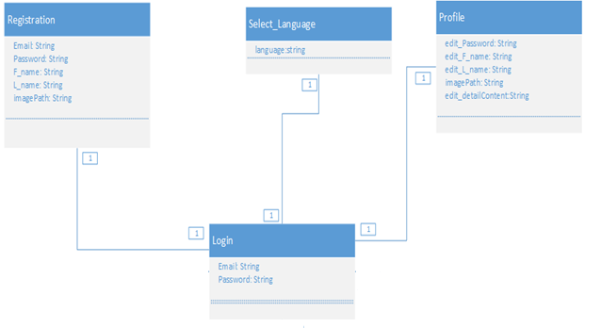
Fig 4.2

Entity Relationship Diagram with data dictionary

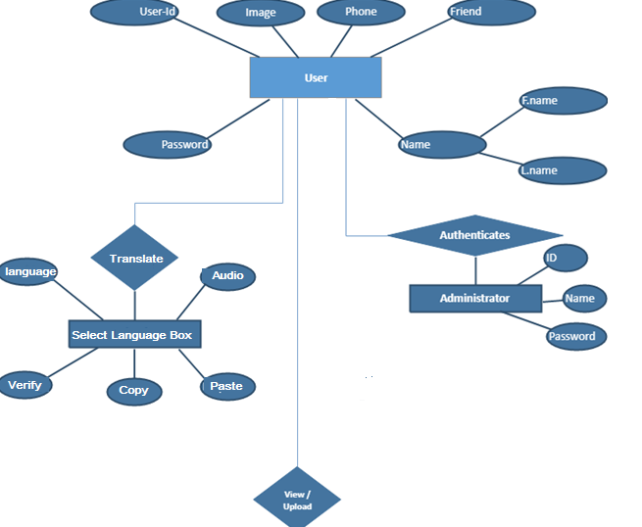
Fig 4.3

Class Diagram

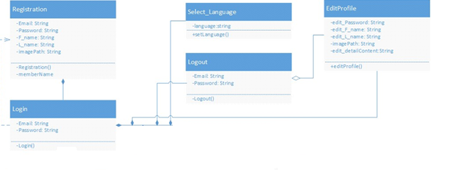

Fig 4.5

Sequence / Collaboration Diagram
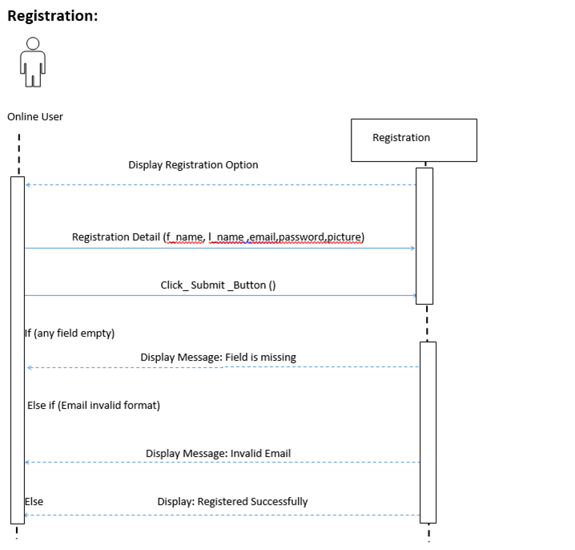

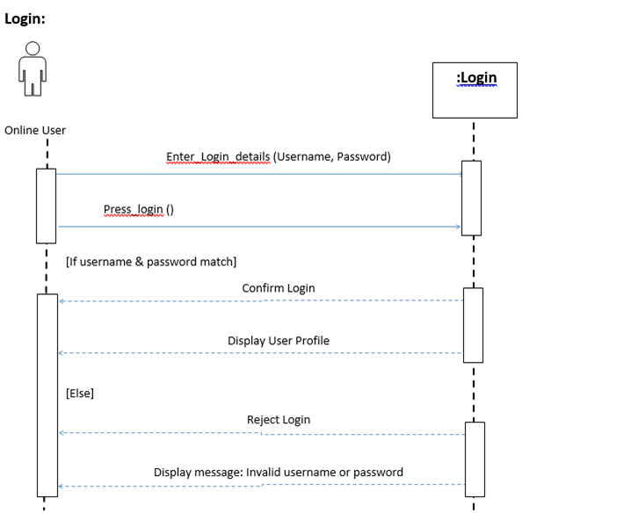
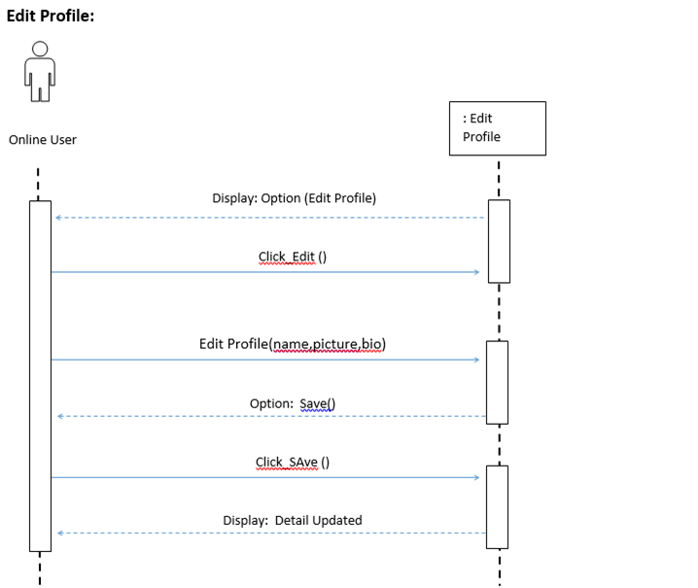

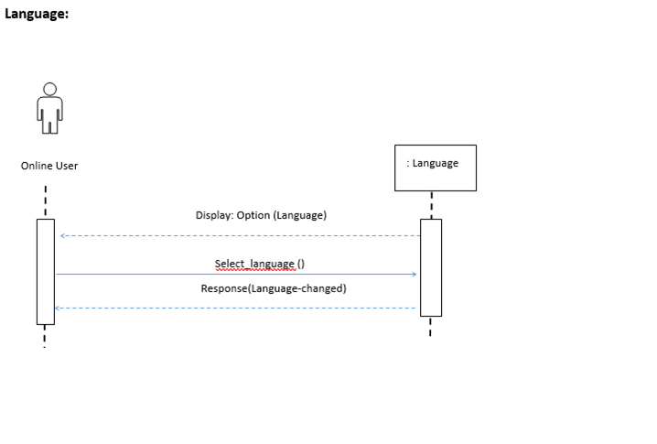

Fig 4.5

Select language
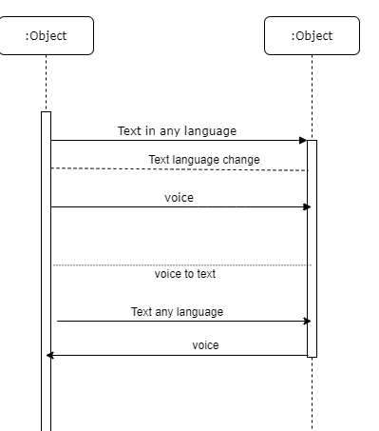

Operation contracts
- Operation contracts#1
Operation name: | Registration (f_name, l_name, email, password, image)
Cross Reference: | Use case Registration
Pre-condition: | User should be online
Post-condition: - | User will be associated with profile (login)  Objective: User  Attribute: (f_name,l_name,email,password,image)  Association: relationship between user and registration

- Operation contracts#2

Operation name: | Login (username, password)
Cross Reference: | Use case Login
Pre-condition: | User should be registered
Post-condition: - | User will be successfully log in and enter into the timeline  Objective: User  Attribute: (username, password)  Association: the relationship between user and login

- Operation contracts#3
Operation name: | select_language(language)
Cross Reference: | Use case Select Language
Pre-condition: | User should be logged in and online
Post-condition: - | The language will be selected and changed according to the selection  Objective: User  Attribute: (language)  Association: the relationship between user and language

- Operation contracts#4
Operation name: | Logout (userId)
Cross Reference: | Use case Logout
Pre-condition: | User should be logged in and online
Post-condition: - | User will be logged out  Objective: User  Attribute: (userId)  Association: the relationship between user and Logout

- 0peration contracts#5
Operation name: | Update_profile(name, picture, bio)
Cross Reference: | Use case Update Profile
Pre-condition: | User should be logged in and online
Post-condition: - | User record updated  Objective: User  Attribute: (name,picture,bio)  Association: relationship between user and Update_profile

Activity Diagram
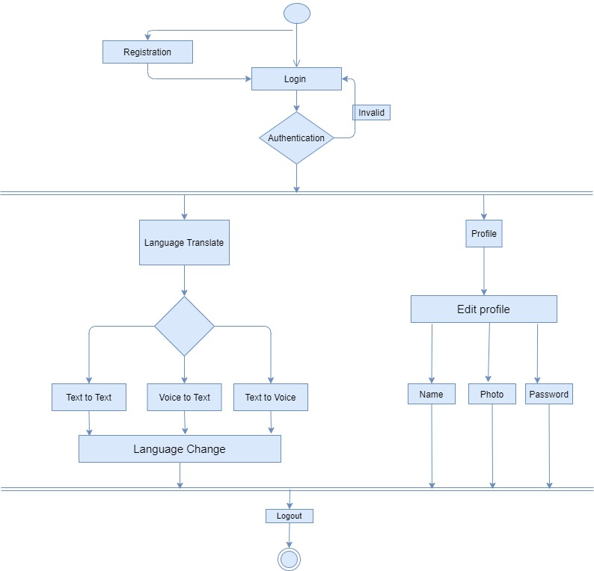
Fig 4.7

State Transition Diagram

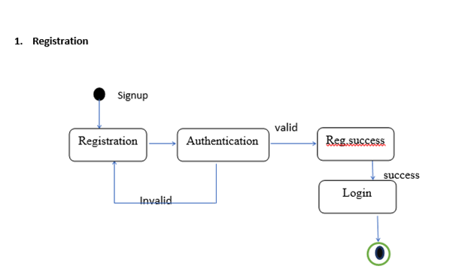
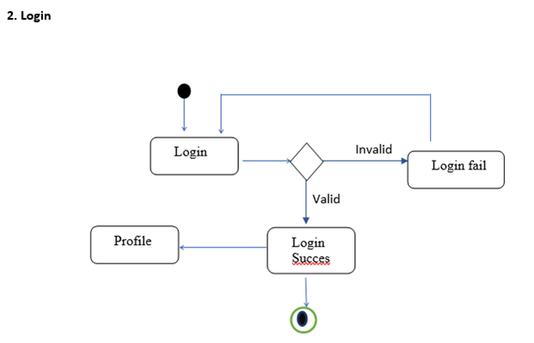
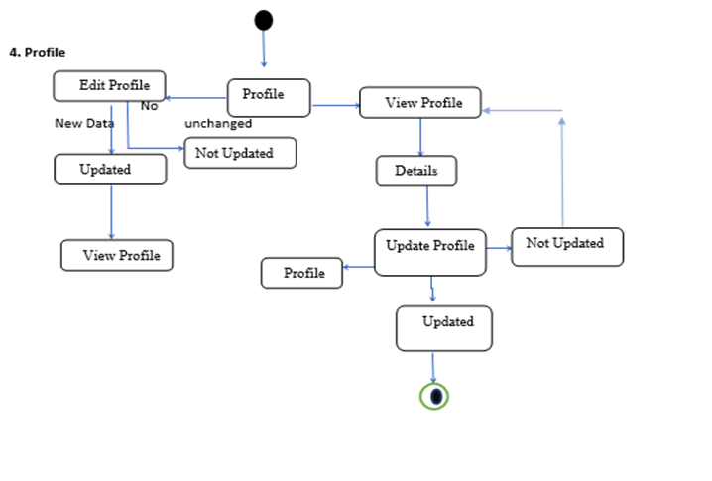

Fig 4.8

Component Diagram
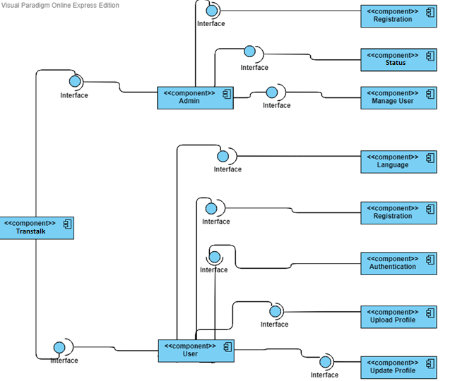
Fig 4.9

Deployment Diagram
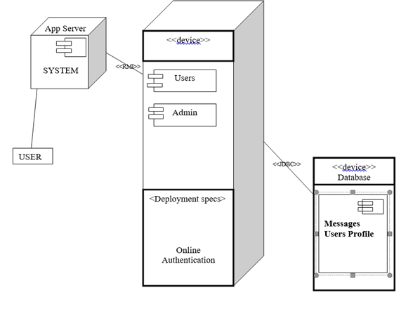
Fig 4.10

Data Flow diagram
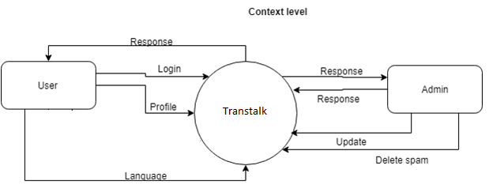
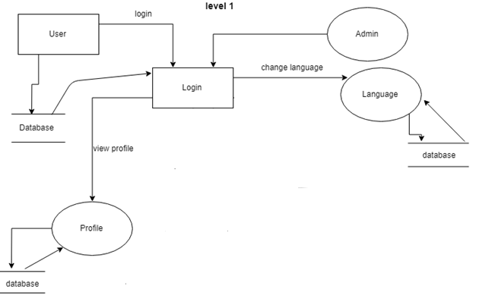
Fig 4.11

Chapter 5

Implementation

Chapter 5: Implementation

Important Flow Control/Pseudo codes
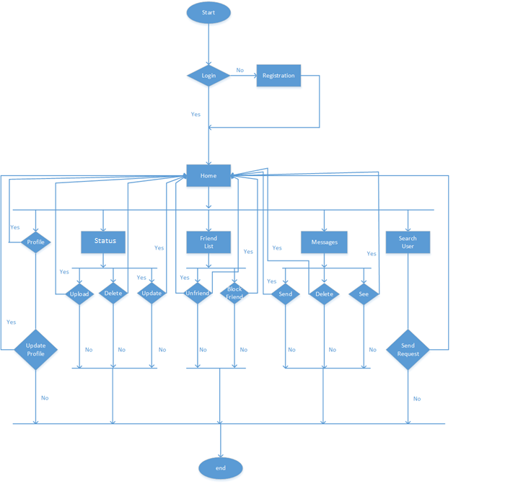
Fig 5.1

Components, Libraries, Web Services and stubs

- Libraries
Libraries are the combination of the different functions which are used in the development of the project to make the different functions easy. The functions are associated with the libraries so that function over the different activities is easy to perform. Few of different libraries used in our project are written below.

import android.content.ContentValues;
import android.content.Context;
import android.database.Cursor;
import android.database.firebase;
import android.content.Intent;
import android.support.v7.app.AppCompatActivity;
import android.os.Bundle;
import android.view.ContextMenu;
import android.view.Menu;
import android.view.MenuItem;
import android.view.View;
import android.widget.Button;
import android.widget.Toast;
import android.widget.Button;
import android.widget.EditText;
import android.widget.Toast;

Web Services:
- Google Firebase

Deployment Environment
• Android Base Mobile
• Application Server
• Database Server

Tools and Techniques
• Java
• Android Studio
• Subline
• Firebase
• Json
- XML

Best Practices / Coding Standards
- The code should not have any trailing whitespace to avoid creating unnecessary diff issues
- Function and classes are always commented on showing expected input and output
- GUI should be user-friendly
- Let photos say what you can’t say
- Document everything
- Demand for Feedback

Version Control
• Git
• Mercurial
• Subversion

Chapter 6

Testing and Evaluation

Chapter 6: Testing and Evaluation
Testing is a process, which reveals errors in the program. To make sure the unavailability of any error or bug, we run a simulation test on the system. Different cases and different types of testing will run to check the system is running well or not. If there is any error during the testing, then provide a solution to outcomes the errors. In this Chapter we provide the whole System testing and evaluation that how to use the system and what work has been done by which feature.

Use Case Testing
Different cases are testing during this session such as the functionality of users and admin
Main success scenario:

Table 6.1 – use case testing

Actor: Admin
No. | Steps | Description
1 | Login as admin | Login to system with correct username and password  System will redirect to next page
2 | Add a user | Add a new user to the database to allow him to use services of app
3 | Check system | Check the whole system at anytime
4 | Translate | Translate words in different languages
5 | Voice -to-text | Translate voice to text.
Actor: Customer
No. | Steps | Description
1 | Registration | To get access to the system a user must get registered
2 | Login | Login to the system with correct name and password  System will redirect to next page
3 | Translate | Translate language
4 | Text-to-text | Text-to-text language
5 | Logout | Logout success with press logout button  System will redirect to login page

Actor: Vendor
No. | Steps | Description
1 | Login as a user | Login to system with correct username and password  System will redirect to next page
2 | Add a text | Add a new text
3 | Update Delete profile | Check and change the profile at anytime
4 | Add edit and Remove any text or voice | User can delete any text or voice

Extensions (Errors)
Table 6.2 – use case testing extension
No. | Step | Description
1-a | Login failed | Login failed if admin enter wrong username  System will display an error message
1-b | Login failed | Login failed if admin enter wrong password.  System will display an error message
2 | Registration failed | Registration will failed if a new user don’t follow the rules  System will display an error message
3-a | Login failed | Login failed if customer enter wrong username  System will display an error message
3-b | Login failed | Login failed if customer enter wrong password.  System will display an error message
4-a | Login failed | Login failed if Vendor enter wrong username  System will display an error message
5-b | Login failed | Login failed if Vendor enter wrong password.  System will display an error message

Boundary value analysis
Boundary testing in the process of testing that is between start point and extreme ends or boundaries between partials of input values.

Login username

- Username that a person enter in the text box at the time of login must be correct and unique.
- If the username is not correct, the system must restrict the user at the current page.

Login password

- Username that a person enter in the text box at the time of login must be correct and greater then 5 characters.
- If the username is not correct, the system must restrict the user at the current page.

Text fields:

- All text fields system has must accept only correct text
- User must add those information which is needed and to the point
- Text fields are name, email, phone number etc.

Numeric fields:

- The numeric fields must accept only numbers
- Numeric fields are mobile number.

Email fields:
- Emil fields are also available in the software system
- Email fields must accept email formats.

Automatic filled fields:

- Some fields in this system are automatic filled when a user keep data from one page to another, these fields automatically filled with information.
- Keep in mind that these fields cannot edit or enter by the end user.

Performance testing:
- Test case number: PT 01

Test case title: System response time testing

Test type | Performance testing | Test result
Required performance | The required response time of the system is less than 2 seconds
System performance | The actual performance response time is 2 seconds. | Test passed

- Test case number: PT 02

Test case title: Activity load time testing

Test type | Performance testing | Test result
Required performance | The required page load time of the system is less than 3 seconds
System performance | The actual page load time is 2 seconds. | Test passed

- Test case number: PT 03

Test case title: Huge number of users

Test type | Performance testing | Test result
Required performance | System should perform normally and efficiently with a large number of users
System performance | System performed all activities normally with a large number of users. | Test passed

- Test case number: PT 04

Test case title: Waiting time testing

Test type | Performance testing | Test result
Required performance | The average waiting time of the system is less than 3 seconds
System performance | The actual performance response time is 2 seconds in some circumstances. | Test passed

- Test case number: PT 05

Test case title: Connection establish time testing

Test type | Performance testing | Test result
Required performance | The connection must be established in less than 2 seconds
System performance | The actual connection establish time is about 1 second. | Test passed

- Test case number: PT 06

Test case title: Database send/get information time testing

Test type | Performance testing | Test result
Required performance | The system should save or retrieve data from database in less than 2 seconds.
System performance | The actual time system sends or gets information to database in 1 second. | Test passed

Stress Testing:
Stress testing is a process of measuring the stability and reliability of the system. Stress testing used to check the ability of system to handling the bugs and errors. Stress testing used to test the system’s ability of error handling during extremely heavy load.
To ensure that our system behaves normal during the stress we overload our system and examine the system’s behavior in extreme circumstances. The (Translaer app) management system behaves normally in unfavorable conditions and all of its features and functions perform their functionality.
Through this testing, we monitor our system and make sure our system
- System should save all data before crashing
- Make sure the connection from server
- If server no response, wait on login current page
- System should display of deleting and updating of records correctly.

Chapter 7

Summary, Conclusion and Future Enhancements

Chapter 7: Summary, Conclusion & Future Enhancements

Project Summary
Translater app system makes your event easy to understand.All the features are available on our Mobile Application.
Translater language Translate the words in different languages
Translater app it can translate languages in text-to-text,text-to-voice
Voice-to-text etc.

Achievements and Improvements
There are many peoples and many companies available in market whose are waiting to complete our project because they are willing to invest money, time and effort with us to encourage this beautiful idea.

- Achievements:
During this complete project we face many challenges but the side of achievements is greater. Our project needs zero percent ( 0% ) investment . Following are our biggest achievements:
1:Translate languages
2:text-to-text
3:text-to-voice
4:voice-to-voice

Improvements
As we know that there is always some accommodations of improvement in ay management system. Following are some basic improvements we need to change in future:

- Physical count
It is good approach to rely on inventory system, but we should never fully depend on a system. We should also translate words in different languages.

- App quality
The quality is very important for use. Always keep an eye on the quality control and never compromise on quality. The good quality makes better.

- System level:
Our system should be not clutter with too much information. We should only provide basic information for user. Otherwise user become confuse and not be able to use our app.

Critical Review
Now a days, everyone is trying to maintain a balance between what needed and what demanded. Every business organization wants to earn big profit .our business will also earn 100% profit without any scared of loss to users.
The important objective review of inventory management is
- Minimizing System investments
Most of the organizations, catering companies, use lot of money for publicity. if they stop money advertising their business will also stop. But if they come to oue plate form we are providing 0% initial investment for any company.

- Satisfactory level of services
Most of the translater apps has no features to translate voice to text or text to voice.

Lessons Learnt
When you come to practical life you should learn multiple lessons. Our team also learns multiple lessons while promoting this idea. Following are some basic lessons which we learn during this complete project:
- Choose the right software:
Firstly in technically side, you should choose the right software which is more beneficially for your system. You should not waste your time on pirated software. Selecting most appropriate software for your company will make your company more healthy and profitable.
- Always consult with an expert:
Before taking a critical and crucial decision, always consult with an expert because their advice can be more effective for you at that stage. In our project we consult all the time with our supervisor (MAM ASMARA) and secondly we also consult different catering services to know what user need all the time.

Future Enhancements/Recommendations
It is a very good approach to think about the future of your app. In our app we also think for future also because for the ease of user and also to earn more profit by our ideas. Some of them are as follow:
1:Translate 15-20 languages
2:Voice-to-text
3:text-to-voice
4:text-to-text.

