SUPERIOR UNIVERSITY LAHORE


Faculty of Computer Science & IT

FINAL YEAR PROJECT
PROJECT Report

Smart Card
Project Team
Student Name | Student ID | Program | Contact Number | Email Address
M.Haital Rana | 15111 | BS-IT 8 | 03064253425 | mhaital81@gmail.com
M.Zulqarnain | 15137 | BS-IT 8 | 03078096196 | ranazulqar96@gmail.com
Sheikh Usman | 15108 | BS-IT 8 | 03104588495 | Sheikhzzz420@gmail.com

Sir Khurram Jillani

Project Report
[Smart Card]

Change Record
Author(s) | Version | Date | Notes | Supervisor’s Signature
 | 1.0 |  | <Original Draft>
 |  |  | <Changes Based on Feedback from Supervisor>
 |  |  | <Changes Based on Feedback From Faculty>
 |  |  | <Added Project Plan>
 |  |  | <Changes Based on Feedback from Supervisor>

APPROVAL
Project Supervisor
Comments: ___________________________________________________________________
_____________________________________________________________________________
Name:______________________________
Date:_______________________________ | Signature:__________________________

Project Manager
Comments: ___________________________________________________________________
_____________________________________________________________________________
Date:_______________________________ | Signature:__________________________

Head of the Department
Comments: ___________________________________________________________________
_____________________________________________________________________________
Date:_______________________________ | Signature:__________________________

Dedication

We are very thankful to our advisor Khurram Jillani and Mumtaz Ali who give us very good ideas and guidelines to complete this work.. .

Acknowledgements

We are thankful to all those people who participated in this activity. We are very thankful to our advisor Khurram Jillani and Mumtaz Ali who give us very good ideas and guidelines to complete this work. We are very thankful to entire IT Security faculty who gave me strength and helped me in all thick and thin. In a begging this thesis we face many difficulties but with the help of Almighty Allah we complete this work. Our advisor Sir Khurram Jillani and Mumtaz Ali helps us a lot and courage to I complete this work.

Executive Summary
This project is about school and colleges. With this project parents can get daily report of attendance with online status. If student is present or absent, parents can check online status. For this we make website to check the report for attendance.

Table Of Contents
Dedication---------------------------------------------------------------------------------------------------------------
Acknowledgement----------------------------------------------------------------------------------------------------
Executive Summary---------------------------------------------------------------------------------------------------
Table of Contents-----------------------------------------------------------------------------------------------------
List Of figures---------------------------------------------------------------------------------------------------------
Chapter 1 --------------------------------------------------------------------------------------------------------------
Introduction------------------------------------------------------------------------------------------------------------
1.1 Background--------------------------------------------------------------------------------------------------------
1.2 Motivation and Challenges-------------------------------------------------------------------------------------
1.3 Goals and objectives---------------------------------------------------------------------------------------------

1.4 Literature Review/Existing Solutions ------------------------------------------------------------------------
1.5 Gap Analysis--------------------------------------------------------------------------------------------------------
1.6 Proposed solution-------------------------------------------------------------------------------------------------
1.7 Project Plan---------------------------------------------------------------------------------------------------------
1.8 Report Outline-----------------------------------------------------------------------------------------------------
Chapter 2-----------------------------------------------------------------------------------------------------------------Software Requirement Specifications-----------------------------------------------------------------------------
2.1Introduction ---------------------------------------------------------------------------------------------------------
2.2 Overall Description------------------------------------------------------------------------------------------------
2.3 External Interface Requirements------------------------------------------------------------------------------
2.4Other Nonfunctional Requirements---------------------------------------------------------------------------
Chapter 3-----------------------------------------------------------------------------------------------------------------
Use Case Analysis-------------------------------------------------------------------------------------------------------
System Analysis---------------------------------------------------------------------------------------------------------
3.1UseCase Model------------------------------------------------------------------------------------------------------
3.2 Use Case Description-----------------------------------------------------------------------------------------------
Chapter 4 -----------------------------------------------------------------------------------------------------------------
System Design-----------------------------------------------------------------------------------------------------------
4.1 Architecture Diagram---------------------------------------------------------------------------------------------
4.2 ER Diagram----------------------------------------------------------------------------------------------------------
4.3 Class Diagram-------------------------------------------------------------------------------------------------------
4.4 Activity Diagram----------------------------------------------------------------------------------------------------
4.5 Component Diagram----------------------------------------------------------------------------------------------
Chapter 5------------------------------------------------------------------------------------------------------------------
Implementation---------------------------------------------------------------------------------------------------------
5.1Components, Libraries, Web Services and stubs------------------------------------------------------------
5.2 Tools and Techniques---------------------------------------------------------------------------------------------
5.3 Version Control-----------------------------------------------------------------------------------------------------
Chapter 6------------------------------------------------------------------------------------------------------------------
Testing and Evaluation-------------------------------------------------------------------------------------------------
6.1Usecase Testing------------------------------------------------------------------------------------------------------
6.2 Unit Testing----------------------------------------------------------------------------------------------------------
6.3 Integration Testing ------------------------------------------------------------------------------------------------
6.4 Performance Testing----------------------------------------------------------------------------------------------
Chapter 7 -----------------------------------------------------------------------------------------------------------------
Summary, Conclusion and future enhancement ----------------------------------------------------------------
7.1 Project Summary --------------------------------------------------------------------------------------------------
7.2 Achievements and improvements -----------------------------------------------------------------------------
7.3 Critical Review ------------------------------------------------------------------------------------------------------
7.4 Lesson Learnt--------------------------------------------------------------------------------------------------------
7.5 Future Enhancements/Recommendations-------------------------------------------------------------------
Appendices---------------------------------------------------------------------------------------------------------------

Appendix A: Screen Shot of Main Page ---------------------------------------------------------------------------
Appendix A:Code of Main Page-------------------------------------------------------------------------------------
References----------------------------------------------------------------------------------------------------------------

List Of figures:
Figure 1, Figure 2 from Chapter 1
Figure 3 from Chapter 2
Figure 4, Figure 5, Figure 6, Figure 7, Figure 8 from Chapter 3
Figure 9, Figure 10, Figure 11, Figure 12, Figure 13, Figure 14, Figure 15, Figure 16 from Chapter 4

Chapter 1

Introduction

Chapter 1: Introduction
The real theme behind online attendance system is to take the online attendance of students in any college or university. Cards which have barcode to be shown in front of the barcode scanner, and then the attendance of the respective person is noted down. Most of the institutes worried about student’s security. We can also remove by checking the student card with barcode that the student is enrolling in institute database or not? The traditional method is insecure. And the solution is barcode attendance system. This system can be used to allow entrance for student in school, college, and university. It also can be used to take attendance of any organization. Its ability to uniquely identify every student based on their barcode ID card which make the process of allowing security access easier and secure as compared to regular method. Students only show their ID card in front of reader and attendance will be marked.

Background
1.1.1Barcode Reader
[1]A barcode scanner is an electronic device that can scan and output printed barcodes to the computer. Like a flatbed scanner, it consists of a light source, a lens and a light sensor translating optical impulses into electrical ones. Nearly all barcode readers contain decoder circuitto judge the barcode's image data provided by the sensor and sending the barcode's content to the reader's port.

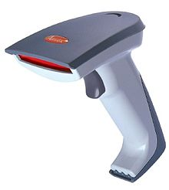
Figure 1

1.1.2The History of Barcode
- Barcode (also bar code) is an optical, machine-readable, representation of data; the data usually describes something about the object that carries the barcode. Traditional barcodes systematically represent data by varying the widths and spacing’s of parallel lines, and may be referred to as linear or one-dimensional (1D). Later, two-dimensional (2D) variants were developed, using rectangles, dots, hexagons and other geometric patterns, called matrix codes or 2D barcodes, although they do not use bars as such. Initially, barcodes were only scanned by special optical scanners called barcode readers. Later application software became available for devices that could read images, such as smart phones with cameras.
- An early use of one type of barcode in an industrial context was sponsored by the Association of American Railroads in the late 1960s. Developed by General Telephone and Electronics (GTE) and called KarTrak ACI (Automatic Car Identification), this scheme involved placing colored stripes in various combinations on steel plates which were affixed to the sides of railroad rolling stock. Two plates were used per car, one on each side, with the arrangement of the colored stripes encoding information such as ownership, type of equipment, and identification number. The plates were read by a trackside scanner, located for instance, at the entrance to a classification yard, while the car was moving past. The project was abandoned after about ten years because the system proved unreliable after long-term use. Barcodes became commercially successful when they were used to automate supermarket checkout systems, a task for which they have become almost universal. Their use has spread too many other tasks that are generically referred to as automatic identification and data capture (AIDC). The very first scanning of the now ubiquitous Universal Product Code (UPC) barcode was on a pack of Wrigley Company chewing gum in June 1974. QR codes, a specific type of 2D barcode, have recently become very popular.
- Other systems have made inroads in the AIDC market, but the simplicity, universality and low cost of barcodes has limited the role of these other systems, particularly before technologies such as radio frequency identification (RFID) became available after 2000.
- In 1948 Bernard Silver, a graduate student at Drexel Institute of Technology in Philadelphia, Pennsylvania, US overheard the president of the local food chain, Food Fair, asking one of the deans to research a system to automatically read product information during checkout. Silver told his friend Norman Joseph Woodland about the request, and they started working on a variety of systems. Their first working system used ultraviolet ink, but the ink faded too easily and was expensive.
- Convinced that the system was workable with further development, Woodland left Drexel, moved into his father's apartment in Florida, and continued working on the system. His next inspiration came from Morse code, and he formed his first barcode from sand on the beach. "I just extended the dots and dashes downwards and made narrow lines and wide lines out of them." To read them, he adapted technology from optical soundtracks in movies, using a 500-watt incandescent light bulb shining through the paper onto an RCA935photomultiplier tube (from a movie projector) on the far side. He later decided that the system would work better if it were printed as a circle instead of a line, allowing it to be scanned in any direction.
- On 20 October 1949, Woodland and Silver filed a patent a
- Application for "Classifying Apparatus and Method", in which they described both the linear and bull's eye printing patterns, as well as the mechanical and electronic systems needed to read the code. The patent was issued on 7 October 1952 as US Patent 2,612,994. In 1951, Woodland moved to IBM and continually tried to interest IBM in developing the system. The company eventually commissioned a report on the idea, which concluded that it was both feasible and interesting, but that processing the resulting information would require equipment that was some time off in the future.
- IBM offered to buy the patent, but the offer was not accepted. Philco purchased the patent in 1962 and then sold it to RCA sometime later.

1.1.3 Computer Identics Corporation
- In 1967, with the railway system maturing, Collins went to management looking for funding for a project to develop a black-and-white version of the code for other industries. They declined, saying that the railway project was large enough, and they saw no need to branch out so quickly.
- Collins then quit Sylvania and formed the Computer Identics Corporation. As its first innovations, Computer Identics moved from using incandescent light bulbs in its systems, replacing them with helium–neon lasers, and incorporated a mirror as well, making it capable of locating a barcode up to several feet in front of the scanner. This made the entire process much simpler and more reliable, and typically enabled these devices to deal with damaged labels, as well, by recognizing and reading the intact portions.
- Computer Identics Corporation installed one of its first two scanning systems in the spring of 1969 at a General Motors (Buick) factory in Flint, Michigan. The system was used to identify a dozen types of transmissions moving on an overhead conveyor from production to shipping. The other scanning system was installed at General Trading Company's distribution center in Carlstadt, New Jersey to direct shipments to the proper loading bay.

1.1.4 Universal Product Code
In 1966 the National Association of Food Chains (NAFC) held a meeting on the idea of automated checkout systems. RCA, who had purchased the rights to the original Woodland patent, attended the meeting and initiated an internal project to develop a system based on the bullseye code. The Kroger grocery chain volunteered to test it.
In the mid-1970s, the NAFC established the Ad-Hoc Committee for U.S. Supermarkets on a Uniform Grocery-Product Code to set guidelines for barcode development. In addition, it created a symbol-selection subcommittee to help standardize the approach. In cooperation with consulting firm, McKinsey & Co., they developed a standardized 11-digit code for identifying products. The committee then sent out a contract tender to develop a barcode system to print and read the code. The request went to Singer, National Cash Register (NCR), Litton Industries, RCA, Pitney-Bowes, IBM and many others. A wide variety of barcode approaches was studied, including linear codes, RCA's bullseye concentric circle code, starburst patterns and others.
In the spring of 1971, RCA demonstrated their bullseye code at another industry meeting. IBM executives at the meeting noticed the crowds at the RCA booth and immediately developed their own system. IBM marketing specialist, Alec Jablonover, remembered that the company still employed Woodland, and he established a new facility in North Carolina to lead development.
In July 1972, RCA began an eighteen-month test in a Kroger store in Cincinnati. Barcodes were printed on small pieces of adhesive paper, and attached by hand by store employees when they were adding price tags. The code proved to have a serious problem; the printers would sometimes smear ink, rendering the code unreadable in most orientations. However, a linear code, like the one being developed by Woodland at IBM, was printed in the direction of the stripes, so extra ink would simply make the code "taller" while remaining readable. So on 3 April 1973, the IBM UPC was selected as the NAFC standard. IBM had designed five versions of UPC symbology for future industry requirements: UPC A, B, C, D, and E.
NCR installed a test bed system at Marsh's Supermarket in Troy, Ohio, near the factory that was producing the equipment. On 26 June 1974, Clyde Dawson pulled a 10-pack of Wrigley's Juicy Fruit gum out of his basket and it was scanned by Sharon Buchanan at 8:01 am. The pack of gum and the receipt are now on display in the Smithsonian Institution. It was the first commercial appearance of the UPC.
In 1971, an IBM team was assembled for an intensive planning session, thrashing out, 12 to 18 hours a day, how the technology would be deployed and operate cohesively across the system, and scheduling a roll-out plan. By 1973, the team was meeting with grocery manufacturers to introduce the symbol that would need to be printed on the packaging or labels of all of their products. There were no cost savings for a grocery to use it, unless at least 70% of the grocery's products had the barcode printed on the product by the manufacturer. IBM projected that 75% would be needed in 1975. Yet, although this was achieved, there were still scanning machines in fewer than 200 grocery stores by 1977.
Economic studies conducted for the grocery industry committee projected over $40 million in savings to the industry from scanning by the mid-1970s. Those numbers were not achieved in that time-frame and some predicted the demise of barcode scanning. The usefulness of the barcode required the adoption of expensive scanners by a critical mass of retailers while manufacturers simultaneously adopted barcode labels. Neither wanted to move first and results were not promising for the first couple of years, with Business Week proclaiming "The Supermarket Scanner That Failed" in a 1976 article.
On the other hand, experience with barcode scanning in those stores revealed additional benefits. The detailed sales information acquired by the new systems allowed greater responsiveness to customer habits, needs and preferences. This was reflected in the fact that about 5 weeks after installing barcode scanners, sales in grocery stores typically started climbing and eventually leveled off at a 10–12% increase in sales that never dropped off. There was also a 1–2% decrease in operating cost for those stores, and this enabled them to lower prices and thereby to increase market share. It was shown in the field that the return on investment for a barcode scanner was 41.5%. By 1980, 8,000 stores per year were converting.
Sims Supermarkets were the first location in Australia to use barcodes, starting in 1979.
The global public launch of the barcode was greeted with minor skepticism from conspiracy theorists, who considered barcodes to be an intrusive surveillance technology, and from some Christians, pioneered by a 1982 book The New Money System 666 by Mary Stewart Relfe, who thought the codes hid the number 666, representing the number of the beast. Television host Phil Donahue described barcodes as a "corporate plot against consumers".

Industrial adoption

In 1981, the United States Department of Defense adopted the use of Code 39 for marking all products sold to the United States military. This system, Logistics Applications of Automated Marking and Reading Symbols (LOGMARS), is still used by DoD and is widely viewed as the catalyst for widespread adoption of barcoding in industrial uses.^{[17]}

Use

Barcodes such as the UPC have become a ubiquitous element of modern civilization, as evidenced by their enthusiastic adoption by stores around the world; most items other than fresh produce from a grocery store now have UPC barcodes. This helps track items and also reduces instances of shoplifting involving price tag swapping, although shoplifters can now print their own barcodes.^{[18]} In addition, retail chain membership cards (issued mostly by grocery stores and specialty "big box" retail stores such as sporting equipment, office supply, or pet stores) use barcodes to uniquely identify consumers, allowing for customized marketing and greater understanding of individual consumer shopping patterns. At the point of sale, shoppers can get product discounts or special marketing offers through the address or e-mail address provided at registration.

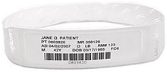

Example of barcode on a patient identification wristband.

They are widely used in the healthcare and hospital settings, ranging from patient identification (to access patient data, including medical history, drug allergies, etc.) to creating SOAP Notes with barcodes to medication management. They are also used to facilitate the separation and indexing of documents that have been imaged in batch scanning applications, track the organization of species in biology, and integrate with in-motion checkweighers to identify the item being weighed in a conveyor line for data collection. They can also be used to keep track of objects and people; they are used to keep track of rental cars, airline luggage, nuclear waste, registered mail, express mail and parcels. Bar-coded tickets allow the holder to enter sports arenas, cinemas, theatres, fairgrounds, and transportation, and are used to record the arrival and departure of vehicles from rental facilities etc. This can allow proprietors to identify duplicate or fraudulent tickets more easily. Barcodes are widely used in shop floor control applications software where employees can scan work orders and track the time spent on a job.

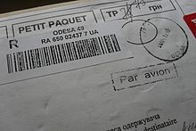

Barcoded parcel

Barcodes are also used in some kinds of non-contact 1D and 2D position sensors. A series of barcodes are used in some kinds of absolute 1D linear encoder. The barcodes are packed close enough together that the reader always has one or two barcodes in its field of view. As a kind of fiducial marker, the relative position of the barcode in the field of view of the reader gives incremental precise positioning, in some cases with sub-pixel resolution. The data decoded from the barcode gives the absolute coarse position. An "address carpet", such as Howell's binary pattern and the Anoto dot pattern, is a 2D barcode designed so that a reader, even though only a tiny portion of the complete carpet is in the field of view of the reader, can find its absolute X,Y position and rotation in the carpet. Some 2D barcodes embed a hyperlink to a web page. A capable cell phone might be used to read the pattern and browse the linked website, which can help a shopper find the best price for an item in the vicinity. Since 2005, airlines use an IATA-standard 2D barcode on boarding passes (Bar Coded Boarding Pass (BCBP)), and since 2008 2D barcodes sent to mobile phones enable electronic boarding passes. Some applications for barcodes have fallen out of use. In the 1970s and 1980s, software source code was occasionally encoded in a barcode and printed on paper (Cauzin Softstripand Paper byte are barcode symbologies specifically designed for this application), and the 1991 Barcode Battler computer game system used any standard barcode to generate combat statistics. [1]

Motivations and Challenges
We face many challenges to make this project. The first is to configure all the modules because if modules are not configured then the project is not working properly.

Goals and Objectives
Online student attendance system is online application developed for attendance of students in college or university. The attendance of students will be taken by ID cards and attendance will be automatically saved in database. Students can see also their result on website. Parents also updated by online system on daily basis. The main objective is to update the parents about attendance and remove the traditional paper system.

Literature Review/Existing Solutions
I read many literatures and report on this system; many of the people say that this system is very good because this system is provide the unique value to a specific person. By this system many of the organization get the security and easiness in work. This system is very good to remove the traditional paper method into an online system with unique value. Uniqueness is the main part of this system. Every barcode is unique. By unique value we can easily trace of our object.

Gap Analysis
In many European countries every system is advance but in Pakistan there is a big gap in technology and traditional method. Many of the organizations are using the old paper method inn their routine work. But now a day’s some advanced organization, institute and companies accept the technology and convert their old methods.

Proposed Solution
In this project we will make a website for parents to check the attendance. By website we can take attendance with barcode reader and manually. For this there is big work on website. Firstly we will make a website after this we connect a hardware component and in the last we will integrate the website and hardware.
- Collaboration:
We should design to promote collaboration. It means we integrate all the hardware and software modules.

- Cloud Technology
Cloud technology has made its mark and for good reason. The convenience of having your project management accessible to team members whether they are in the office, on a project site or collaborating from half-way around the world is invaluable. Your choice should be a solution that gives you the option of web based or cloud technology.
- User interface familiarity
To reiterate, Project management software is dependent on its users. If the interface is user friendly and familiar to team members there will be less of a learning curve and less resistance to using the tool. Project management tools that work from inside Microsoft Outlook have the advantage of familiarity and ease of use.
- Scheduling
Successful project management should have the goals of staying on schedule and delivering the project on time. Project management software that has the capability of alerting team members about impending deadlines and other actionable issues will help you meet those goals.

Project Plan
Process Model

The Scrum process:
The Scrum process motivate practitioners to work with what they have and continually evaluate what is working and what is not working. Communication is the most important part of the process, is carried out through meetings, called Events.
Daily Scrum
The Daily Scrum is a short stand-up meeting that happens at the same place and time each day. At each meeting, the team reviews work that was completed the previous day and plans what work will be done in the next 24 hours. This is the time for team members to speak up about any problems that might prevent project completion.
Sprint Planning Meeting
A Sprint sends to the time frame in `which work must be completed, and it's often 30 days. Everyone participates in setting the goals, and at the end, at least one increment -- a usable piece of software -- should be produced.
Sprint Review.
This is the time to show off the increment.
Sprint Retrospective.
A Sprint Retrospective is a meeting that's held after a Sprint ends. During this meeting, everyone reflects on the Sprint process. A team-building exercise may also be offered. An important goal of a Sprint Retrospective is continuous improvement.
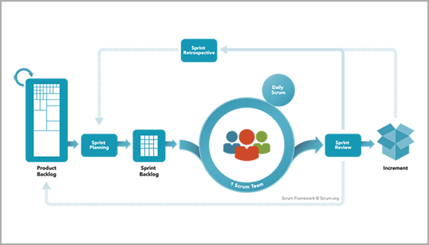
Figure 2
The Scrum framework shows how the elements of Scrum revolve around the Scrum team.

Work Breakdown Structure
We divide our work into modules.
- 1st Module
Design a Template:
Our first module is to design the template of our project this template design in PHP framework. But for good looking we add some bootstrap classes.
- 2nd Module
Making Database and joining links
Secondly we make the data base in which we save the data of attendance.
In this module we create a part of this website. In this part we connect the PHP with database.
- 3rd Module
2nd Method to take Attendance
In 3rd module we design the method of take attendance manually because if barcode is not working properly then teacher take attendance manually on the website.

Report Outline
In this chapter our team provides the introductive information about our project. I read blogs thesis and many of the research paper on this topic. So because this is the introductive part so I copy some data like history from various sites. So I want this is not included in plagiarism report because history and this type of data is not writing by our mind because this is the fixed data that we can’t change the history.

Chapter 2

Software Requirement Specifications

Chapter 2: Software Requirement Specifications

Introduction
This system can be used to allow access for student in school, college, and university. It also can be used to take attendance. Its ability to uniquely identify each person based on their barcode ID card make the process of allowing security access easier, faster and secure as compared to regular method.
Students or workers only need to place their ID card on the reader and they will be allowed to enter the campus.

Purpose
Online student management system is online application developed for attendance of students in college or university. The attendance of students will be taken by Barcode cards and attendance will be automatically saved in database. Students can see also their result. Parents also updated by attendance result on daily basis. The main objective is to update the parents about attendance and remove the traditional paper system.

Product Scope
This document provides the clear path for Prototype, development and maintenance of online attendance management project. This application can be adapted by any of organization, company or any institute. Some of the features are given below:
- This project provides the safe system of attendance in Educational departments.
- This project provides search student facility based on different criteria.
- Setup the complete attendance and result.
- Parents and students are able to view the attendance reports.
- Unique ID Attendance

Overall Description

Product Perspective
The barcode scanner based attendance system is used by companies and institutes to improve their efficiency of employees and students. The barcode scanner based attendance system reduces the overhead in maintain the student attendance record. This project provides various features like record of attendance and record of result. The RFID system can be understood by the given below figure:
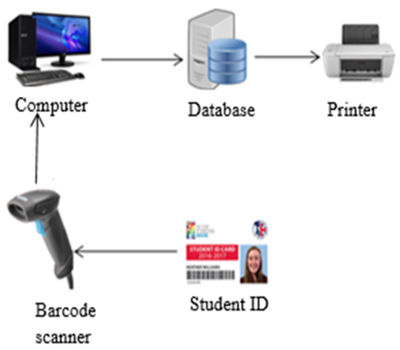
Figure 3 ch2

Product Functions
Following points illustrate the functionality of product:
- Secure attendance of students
- Search students on different criteria
- Send automatically records of attendance on website
- Students and parents view the detail of attendance and result

User Classes and Characteristics
The project consists of three main users:
- Administrator Login
- Student Login
- Parent Login
- Teacher Login
Characteristics of users as follow:
- Administrator
- Admin has all the rights means add student, delete student, add parents, delete parents and update records of students.
- Maintain the records of all students and parents.
- Student
- Students have logins
- Student can view the attendance record
- Parent
- Parents can also check the attendance record
- Teacher Login
- Teacher Login For take Attendance
- View attendance
- Enroll student

Operating Environment
- Hardware Components
- Barcode reader
- PC or Laptop
- Software Components
- Windows Operating System
- Xamp for PHP framework

Constraints
- Barcode Reader must be provided in the class
- Each student must have the Barcode ID cards

External Interface Requirements

User Interfaces
Following user interface will be required by the system
- This project will require every student to carry a Barcode ID card.
- This project requires a Barcode reader in the class or office.

Hardware Interfaces
Following hardware will be require
- Barcode reader
- Barcode attached ID card
Barcode Reader
These readers require for detecting the student’s attendance.
Barcode ID Cards
Barcode ID cards will be required by students to make their attendance record.

Software Interface
- Xamp
Xamp server is use to make and run the PHP WEB. We make PHP website to handle all the features. We use 3.2.2 version. We also make the database in the local host server of Xamp.
2.3.4 Requirements
Barcode based student Attendance System is a system which completely revolves around
proper management of an institute student’s attendance. The project lays most of the effort in making the system easy to handle and manage by the end users and providing ideal benefits to them in relate to managing the attendance of students. Efforts will be prepared to make the system more and more realistic.
Functional Requirements
- Secure registration of students
- Students attendance must be secure
- Parent’s able to view attendance reports
- Teacher take and view Attendance and Enroll Student
Decomposition of Functional Requirements
Barcode based Student Attendance System doesn‘t only provides flexible attendance system for students but also provide an organization with a fully organized system which take cares of new Students registration, making existing Students enable to view their profile, schedule management.
- Registration:
Registration module as the name goes will deal with the basic registration process of students in school or college. Registration process will go in a hierarchy which means registration of students will be done by operator and those of operators will be done by admin.
- Attendance:
Attendance module is the main part of the project as complete story goes around it. I will aim at complete maintenance of student attendance. It will also keep track of all the requests being made by an employee regarding any leaves and then further approval of it by operator.
- Login:
This will be a simple login module which will ask the students for their user name and password. After providing correct username and password student will be able to access his/her profile.

Other Nonfunctional Requirements
Non Functional Requirements
- Secure access of confidential data (user‘s information).
- 24 X 7 availability
- Flexible service based architecture will be highly desirable for future extension

Chapter 3

Use Case Analysis

Chapter 3: System Analysis
Introduction
In this chapter we design all the system with their use case diagrams. In the use case diagrams we will show that how the system is and how different clients deal with their respective modules. Every module will be justified in the use case diagrams.

Use Case Model
Admin Use case diagram:
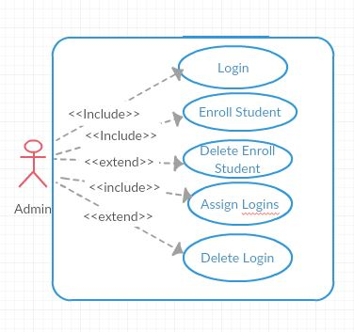
Figure 4 ch3
Student Use Case:
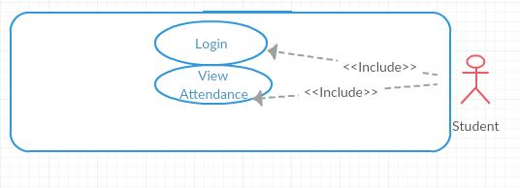
Figure 5 ch3
Parent Use Case:
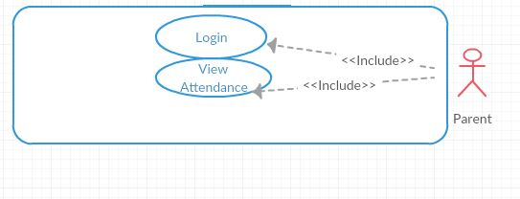
Figure 6 ch3

Teacher Use Case:
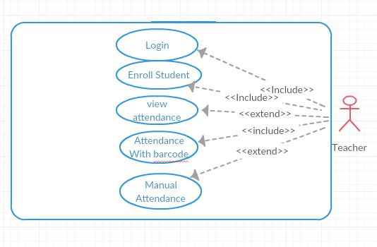
Figure 7 ch3
System Use Case:
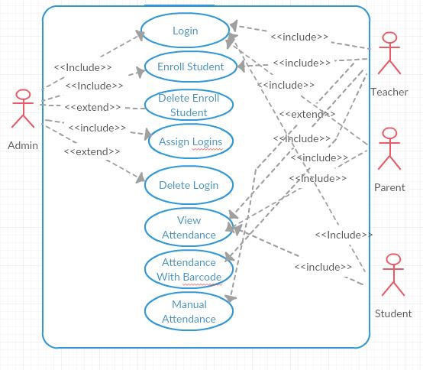
Figure 8 ch3

Use Case Descriptions

1st Use Case Diagram:
In the first use case diagram we show that how the administrator deals with their system. In the diagram it shows that how many modules could be run and whose modules can be change.
Modules that admin can be deal with it those are shown below:
- Admin can check attendance result
- Admin can add parents
- Admin can add students
- Admin has a login
- Admin can delete the student add the student
- Admin can delete and add the Parent’s login
- Admin can add and delete the teacher’s login
2ndUse Case Diagram:
In the second use case diagram we show that how the student deals with their respective modules. In the diagram it shows that whose modules can be run the student.
The modules that students can be deal with it those are shown below:
- Students can check attendance result
- Students have logins
3rdUse Case Diagram:
In the third use case diagram we show that how the parents deal with their respective modules. In the diagram it shows that whose modules can be run the parents.
The modules that parents can be deal with it those are shown below:
- Parents can check attendance result
- Parents have logins
4thUse Case Diagram
In the fourth use case diagram we show that how the teacher deals with their respective modules. In the diagram it shows that whose modules can be run the teacher.
The modules that parents can be deal with it those are shown below:
- Teacher take attendance
- Teacher enroll students
- Teacher has login

Chapter 4

System Design

Chapter 4: System Design
Introduction
In this chapter we make all the diagrams about this project. Mean activity diagrams, architectural diagrams, ERD diagrams etc. With this chapter we can imagine all the system into running form.

Architecture Diagram
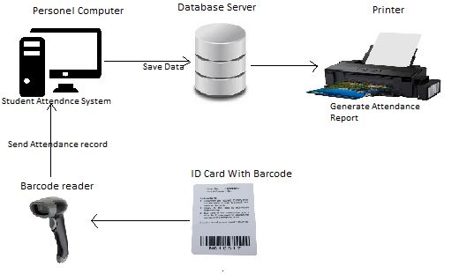
Figure 9 ch4

Entity Relationship Diagram

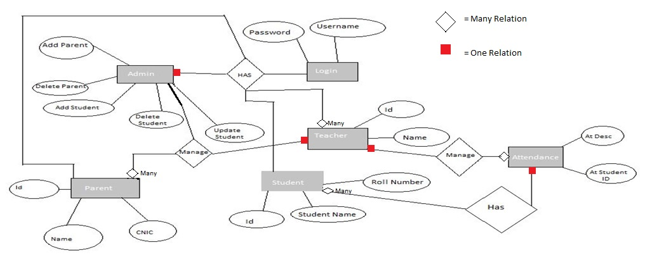
Figure 10 ch4

Class Diagram
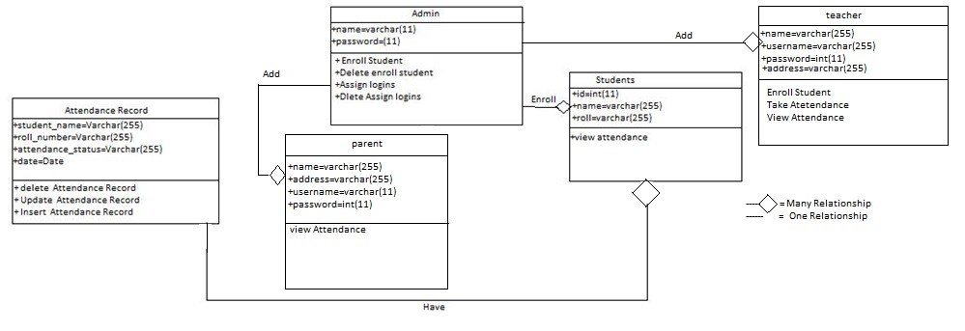
Figure 11 ch4

Activity Diagram
This is the Activity Diagram of admin rights.
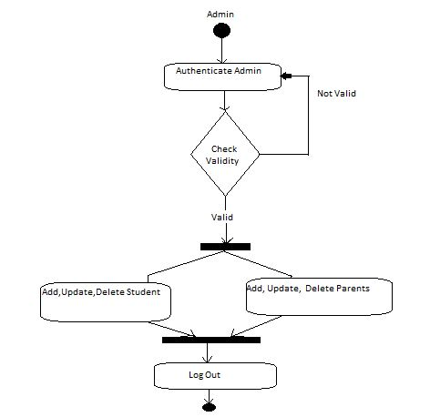
Figure 12 ch4

Component Diagram
This is the main component diagram. This diagram shows that user interact with web browser and the database.
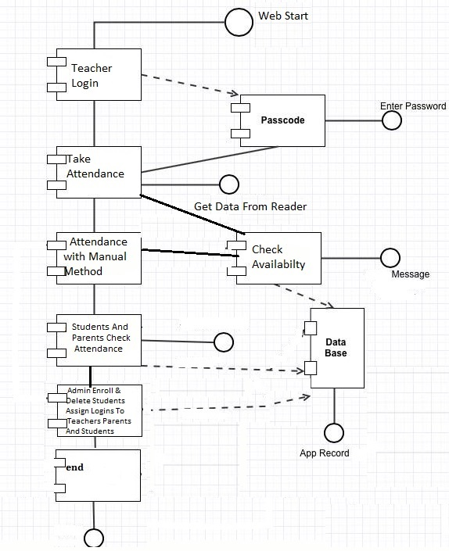
Figure 13 ch4

Sequence Diagram: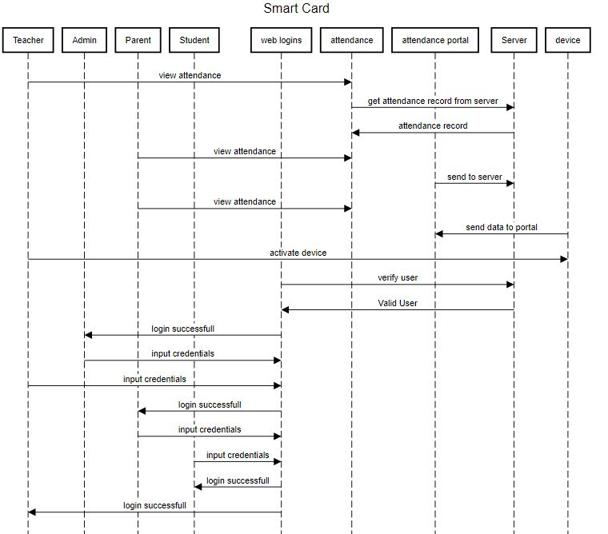
Figure 14 ch4
Deployment Diagram:

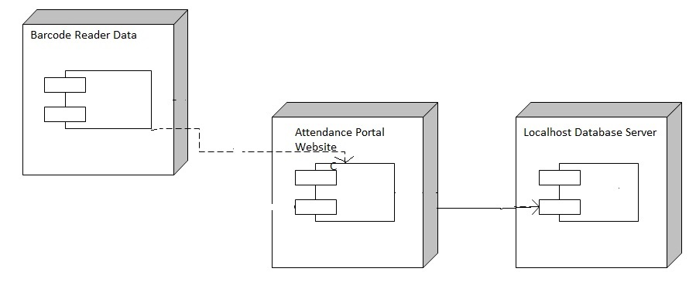
Figure 15 ch4
Barcode Reader
The image which is given below is the image of barcode reader which is main part of this project. From this barcode reader we scan any barcode and enroll the student’s attendance. Students have ID card which have barcode tags by this reader we scan barcode and student will be enroll with their respective ID.
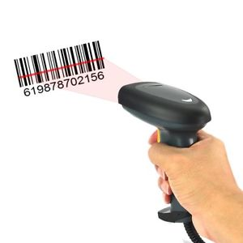
Figure 16 ch4

Chapter 5

Implementation

Chapter 5: Implementation
Introduction
In this chapter we discuss about implementation. How we implement hardware with software and how software components configure. Because if all the components are not configure then our project will not working perfectly.

Components, Libraries, Web Services and stubs
Components:
- We use Bootstrap classes for better look of our website
- Use the java script in Bootstrap
- Html And CSS
- PHP
Libraries:
- We use the bootstrap libraries
- Using JavaScript libraries

Tools and Techniques
Xampp:
We use xampp Server for making the PHP Interface. Xamp is the Localhost Server for PHP Framework.

Version Control
In this Project we mainly use version control software for easiness and reliability. We use Xampp. Xampp is open source free software for making the PHP interface. Because this is open source so it is not important that what the version of Xampp is. Our code will be run on any version.

Chapter 6

Testing and Evaluation

Chapter 6: Testing and Evaluation
Introduction:
The testing phase is very compulsory in any project to check the status of the project. We use different methods for testing.

Use Case Testing
- In this phase we test the web module. In this module we check that the attendance with barcode reader is working properly or not?
- After this we check the login system to check the privacy
- After this we check the 2nd method of taking attendance in case of emergency(barcode not work properly)
- In the last we check the attendance result

Unit testing
We divide the whole project into different units. For testing we check the every unit. After testing every unit that those are working properly, we assure that project is working in properly manner.

Integration testing
Integration testing is very important.
- Convert the whole project into modules
- Check working of every module
- After this integrate all the modules
- After integrating the modules recheck the project that all modules work good or not?
- Adopt good strategies for integrating the modules

Performance testing
In the last we test the progress of our project.
- Check the performance of project
- Assure that project is perform as it is that is claim in requirement contract
- If this is perform as it is that is claim in contract then it is assure that is assure that project is perform 100 % performance.

Chapter 7

Summary, Conclusion and Future Enhancements

Chapter 7: Summary, Conclusion & Future Enhancements

Project Summary
In past people were facing lots of problems due to security issues. But now time has changed! Our System will provide application to the people in order to keep their precious goods, business area, offices, banks etc. Our era attendance system also provides security systems with the entry of unique value. Its providing agencies available in the market have to face a lot of competition; however, we hold market advantage by providing unique and innovative security system. Our project is providing quality services and products.
The main features of the security systems are:
- 100 % Security Ensured
- Access Reliability
- Efficiency
- User Friendly
- Overcome bunk system

Achievements and Improvements
Our biggest achievement is to complete our project because this project tells us how we perform in all semester during our bachelor degree. This project is the result of our studies.

Critical Review
We face a lot of problem during this project. But all are overcome with the passage of time. During this activity we met with lot of people and new teachers. By this we achieve a great experience.

Lessons Learnt
We face many problems and we disheartened many times but the only lesson we learnt “Never Lose Hope”.

Future Enhancements/Recommendations
This project is prototype for some students so we plan in future for whole university. We add departments, classes, teachers and many more modules. And the app is using onluy for watching attendance result so we enhance the app with all control.

Appendices

AppendixA: Screen Shot of Main Page

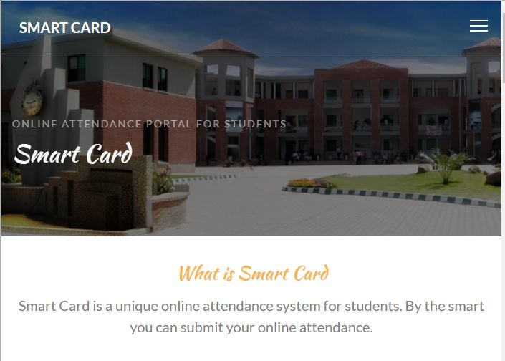

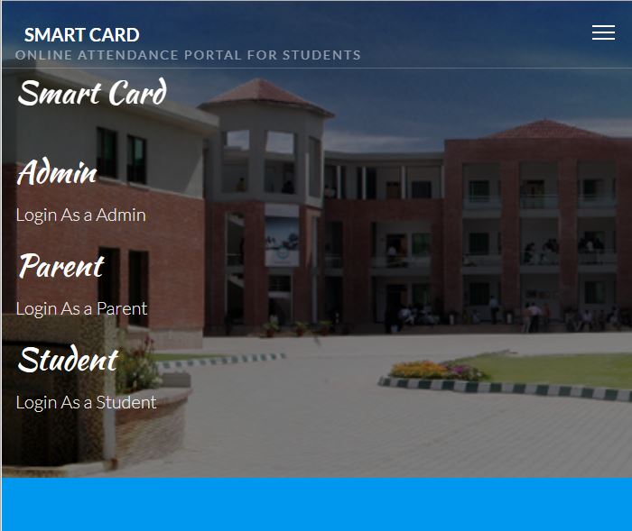

AppendixA: Code of Main Page
<!DOCTYPE HTML>
<html>
<head>
<meta charset="utf-8">
<meta http-equiv="X-UA-Compatible" content="IE=edge">
<title>Smart Card</title>
<meta name="viewport" content="width=device-width, initial-scale=1">
<!-- Facebook and Twitter integration -->
<meta property="og:title" content=""/>
<meta property="og:image" content=""/>
<meta property="og:url" content=""/>
<meta property="og:site_name" content=""/>
<meta property="og:description" content=""/>
<meta name="twitter:title" content="" />
<meta name="twitter:image" content="" />
<meta name="twitter:url" content="" />
<meta name="twitter:card" content="" />
<link href="https://fonts.googleapis.com/css?family=Lato:300,400,700" rel="stylesheet">
<link href="https://fonts.googleapis.com/css?family=Kaushan+Script" rel="stylesheet">
<!-- Animate.css -->
<link rel="stylesheet" href="css/animate.css">
<!-- Icomoon Icon Fonts-->
<link rel="stylesheet" href="css/icomoon.css">
<!-- Themify Icons-->
<link rel="stylesheet" href="css/themify-icons.css">
<!-- Bootstrap -->
<link rel="stylesheet" href="css/bootstrap.css">
<!-- Magnific Popup -->
<link rel="stylesheet" href="css/magnific-popup.css">
<!-- Bootstrap DateTimePicker -->
<link rel="stylesheet" href="css/bootstrap-datetimepicker.min.css">
<!-- Owl Carousel -->
<link rel="stylesheet" href="css/owl.carousel.min.css">
<link rel="stylesheet" href="css/owl.theme.default.min.css">
<!-- Theme style -->
<link rel="stylesheet" href="css/style.css">
<!-- Modernizr JS -->
<script src="js/modernizr-2.6.2.min.js"></script>
<!-- FOR IE9 below -->
<!--[if lt IE 9]>
<script src="js/respond.min.js"></script>
<![endif]-->
</head>
<body>
<div class="gtco-loader"></div>
<div id="page">
<!-- <div class="page-inner"> -->
<nav class="gtco-nav" role="navigation">
<div class="gtco-container">
<div class="row">
<div class="col-sm-4 col-xs-12">
<div id="gtco-logo"><a href="index.html">Smart Card</a></div>
</div>
<div class="col-xs-8 text-right menu-1">
<ul>
<li class="has-dropdown">
<a href="services.html">Services</a>
<ul class="dropdown">
<li><a href="#">Food Catering</a></li>
<li><a href="#">Wedding Celebration</a></li>
<li><a href="#">Birthday's Celebration</a></li>
</ul>
</li>
<li><a href="contact.html">Contact</a></li>
<li class="btn-cta">
<a href="login.html"><span>LOGIN</span></a></li>
</ul>
</div>
</div>
</div>
</nav>
<header id="gtco-header" class="gtco-cover gtco-cover-md" role="banner" style="background-image: url(images/img_bg_1.jpg)" data-stellar-background-ratio="0.5">
<div class="overlay"></div>
<div class="gtco-container">
<div class="row">
<div class="col-md-12 col-md-offset-0 text-left">
<div class="row row-mt-15em">
<div class="col-md-7 mt-text animate-box" data-animate-effect="fadeInUp">
<span class="intro-text-small">Online Attendance Portal For Students</span>
<h1 class="cursive-font">Smart Card</h1>
</div>
</div>
</div>
</div>
</div>
</header>
<div class="gtco-section">
<div class="gtco-container">
<div class="row">
<div class="col-md-8 col-md-offset-2 text-center gtco-heading">
<h2 class="cursive-font primary-color">What is Smart Card</h2>
<p>Smart Card is a unique online attendance system for students. By the smart you can submit your online attendance.</p>
</div>
</div>
<div class="col-lg-4 col-md-4 col-sm-6">
<a href="images/img_4.jpg" class="fh5co-card-item image-popup">
<figure>
<div class="overlay"><i class="ti-plus"></i></div>
<img src="images/img_4.jpg" alt="Image" class="img-responsive">
</figure>
<div class="fh5co-text">
<h2>Muhammad Haital</h2>
<p>Team Leader of this project. This is the FYP Project. And this project is submitted in Superior University Raiwand Road Lahore</p>
</div>
</a>
</div>
<div class="col-lg-4 col-md-4 col-sm-6">
<a href="images/img_5.jpg" class="fh5co-card-item image-popup">
<figure>
<div class="overlay"><i class="ti-plus"></i></div>
<img src="images/img_5.jpg" alt="Image" class="img-responsive">
</figure>
<div class="fh5co-text">
<h2>Muhammad Zulqarnain</h2>
<p>Team Member of this project. This is the FYP Project. And this project is submitted in Superior University Raiwand Road Lahore</p>
</div>
</a>
</div>
<div class="col-lg-4 col-md-4 col-sm-6">
<a href="images/img_6.jpg" class="fh5co-card-item image-popup">
<figure>
<div class="overlay"><i class="ti-plus"></i></div>
<img src="images/img_6.jpg" alt="Image" class="img-responsive">
</figure>
<div class="fh5co-text">
<h2>Sheikh Usman</h2>
<p>Team Member of this project. This is the FYP Project. And this project is submitted in Superior University Raiwand Road Lahore</p>
</div>
</a>
</div>
</div>
</div>
</div>
<div id="gtco-features">
<div class="gtco-container">
<div class="row">
<div class="col-md-8 col-md-offset-2 text-center gtco-heading animate-box">
<h2 class="cursive-font">Our Services</h2>
<p>Our Services is to provide the online student attendance system by a unique value. For this purpose we use a smart card. Only those students can submit their attendance those have the Smart Cards.</p>
</div>
</div>
<div class="row">
<div class="col-md-6 col-sm-6">
<div class="feature-center animate-box" data-animate-effect="fadeIn">
<span class="icon">
<i class="ti-face-smile"></i>
</span>
<h3>Online Attendance</h3>
<p>Our first Service is to shift the manual attendance record into online system.</p>
</div>
</div>
<div class="col-md-6 col-sm-6">
<div class="feature-center animate-box" data-animate-effect="fadeIn">
<span class="icon">
<i class="ti-thought"></i>
</span>
<h3>By Unique value</h3>
<p>Our second Service is to confirm the attendance with unique value.</p>
</div>
</div>
</div>
</div>
</div>
<div class="gtco-cover gtco-cover-sm" style="background-image: url(images/img_bg_1.jpg)" data-stellar-background-ratio="0.5">
<div class="overlay"></div>
<div class="gtco-container text-center">
<div class="display-t">
<div class="display-tc">
<h1>&ldquo; Their high quality of service makes me back over and over again!&rdquo;</h1>
</div>
</div>
</div>
</div>
<div id="gtco-subscribe">
<div class="gtco-container">
<div class="row animate-box">
<div class="col-md-8 col-md-offset-2 text-center gtco-heading">
<h2 class="cursive-font">Get Started</h2>
<p>Click Below To LOGIN</p>
</div>
</div>
<div class="row animate-box">
<div class="col-md-4 col-md-offset-4 text-center gtco-heading">
<a href="login.html"><button class="btn btn-default btn-block">Click Here</button></a>
</div>
</div>
</div>
</div>
<footer id="gtco-footer" role="contentinfo" style="background-image: url(images/img_bg_1.jpg)" data-stellar-background-ratio="0.5">
<div class="overlay"></div>
<div class="gtco-container">
<div class="row row-pb-md">
<div class="col-md-12 text-center">
<div class="gtco-widget">
<h3>Get In Touch</h3>
<ul class="gtco-quick-contact">
<li><a href="#"><i class="icon-phone"></i> +923064253425</a></li>
<li><a href="#"><i class="icon-mail2"></i> mhaital81@gmail.com</a></li>
</ul>
</div>
<div class="gtco-widget">
<h3>Get Social</h3>
<ul class="gtco-social-icons">
<li><a href="https://www.facebook.com/hetal.rana.397"><i class="icon-twitter"></i></a></li>
<li><a href="https://www.facebook.com/hetal.rana.397"><i class="icon-facebook"></i></a></li>
</ul>
</div>
</div>
<div class="col-md-12 text-center copyright">
<p><small class="block">&copy; Copy Rights. All Rights Reserved.</small>
</div>
</div>
</div>
</footer>
<!-- </div> -->
</div>
<div class="gototop js-top">
<a href="#" class="js-gotop"><i class="icon-arrow-up"></i></a>
</div>
<!-- jQuery -->
<script src="js/jquery.min.js"></script>
<!-- jQuery Easing -->
<script src="js/jquery.easing.1.3.js"></script>
<!-- Bootstrap -->
<script src="js/bootstrap.min.js"></script>
<!-- Waypoints -->
<script src="js/jquery.waypoints.min.js"></script>
<!-- Carousel -->
<script src="js/owl.carousel.min.js"></script>
<!-- countTo -->
<script src="js/jquery.countTo.js"></script>
<!-- Stellar Parallax -->
<script src="js/jquery.stellar.min.js"></script>
<!-- Magnific Popup -->
<script src="js/jquery.magnific-popup.min.js"></script>
<script src="js/magnific-popup-options.js"></script>
<script src="js/moment.min.js"></script>
<script src="js/bootstrap-datetimepicker.min.js"></script>
<!-- Main -->
<script src="js/main.js"></script>
</body>
</html>

References

Reference
[1] https://en.wikipedia.org/wiki/Barcode

