The SUPERIOR UNIVERSITY LAHORE


Faculty of Computer Science & IT

Final Year Project
PROJECT REPORT

E-Donations

Project ID: FYP-MCSM-S21-007
Project Team
Student Name | Student ID | Program | Contact Number | Email Address
Ameer Muawiya | mcsm-s20-005 | MCS | 0302-2764565 | mcsm-s20-005@superior.edu.pk
Bushra Ghaffar | mcsm-s20-001 | MCS | 0336-4504929 | mcsm-s20-001@superior.edu.pk
Mahnoor Shoaib | mcsm-s20-015 | MCS | 0309-6213508 | mcsm-s20-015@superior.edu.pk

Muhammad Javaid Iqbal
Lecturer

Project Report
E-Donations

Change Record
Author(s) | Version | Date | Notes | Supervisor’s Signature
Ameer, Bushra and Mahnoor | 1.0 | 27/02/2021 | Template 1
Ameer, Bushra and Mahnoor | 1.2 | 02/06/2021 | Documentation
Ameer, Bushra and Mahnoor | 1.3 | 18/10/2021 | Review of layouts
Ameer, Bushra and Mahnoor | 1.4 | 04/12/2021 | Review of Coding
Ameer, Bushra and Mahnoor | 1.5 | 30/12/2021 | Discussion of Backend
Ameer, Bushra and Mahnoor | 1.6 | 31/12/2021 | Review of Database
Ameer, Bushra and Mahnoor | 1.7 | 31/12/2021 | Review of Final Project

APPROVAL
Project Supervisor
Comments: ___________________________________________________________________
_____________________________________________________________________________
Name:______________________________
Date:_______________________________ | Signature:__________________________

Project Manager
Comments: ___________________________________________________________________
_____________________________________________________________________________
Date: _______________________________ | Signature: __________________________

Head of the Department
Comments: ___________________________________________________________________
_____________________________________________________________________________
Date: _______________________________ | Signature: __________________________

Dedication

First of all, we dedicate our project to Allah Almighty
And to whom the world owes its existence
Muhammad (Peace Be Upon Him)
This humble effort is dedicated to
Our beloved parents who brought us
To the level of excellence where we
Are studying today looking for the most
Promising and gleaming future ahead
For which they sacrificed most of the
Time of their life
&
To our respected and genius teachers
Who guided us throughout our academic career!
And all those people
Who have remembered us in their prayers!
A lot of thanks to all my teachers!

Acknowledgements

Above all, I owe much tribute to the Almighty God who gave us a life worth living and I thank Him for giving us the strength to accomplish this project. The success and accomplishment of this project stem from efforts and dedication offered by many individuals whose support was either direct or indirect. I thank all of them for their devotion.
The author would like to express sincere gratitude to their project advisor Muhammad Javaid Iqbal for his vigilant supervision, intellectual guidance, constructive advice and very kind attitude throughout the project. Appreciate the efforts of all our teachers whose teachings have brought us to this stage of academic zenith.
In last but not least, special gratitude with the deepest sense of respect to our parents whose love and affections kept us steep fast and enabled us to attain targets and goals of academic life. The authors are extremely indebted to their brothers and sisters whose constant encouragement provides us with the impetus that was necessary for attaining academic initiatives.

Executive Summary
The proposed system has the functionality to facilitate deserving people. Different restaurants, wedding halls, and volunteers donate their food items (edible) to the NGO’s, Trust organization, in the society. It is a unique idea in Pakistan and there is no existing system in Pakistan. This system is also known as Ethe -Donations system. According to the survey, this system is only used in five countries all over the world. This system is a bridge between donors and consumers, they can register and get services online using this system. The deserving people who need food according to their demands can send requests to nearby NGOs or Trust organizations using this system. The requests from the deserving people and the NGO or Trust organizations go to the system and then forward to the restaurant, wedding halls and other donating communities. Then the donor accepts the request and provides food to donate. This app also keeps a feedback section for both donor and needy people to avoid, deceive, misbehaviour and fraud. In this app, we will provide services for donations and deserving people.

Table of Contents
Dedication iv
Acknowledgements v
Executive Summary vi
Table of Contents vii
List of Figures ix
List of Tables x
Chapter 1 1
Introduction 1
1.1 Background 2
1.2 Motivations and Challenges 4
1.3 Goals and Objectives 4
1.4 Literature Review/Existing Solutions 4
1.5 Gap Analysis 4
1.6 Proposed Solution 4
1.7 Project Plan 5
1.8 Work Breakdown Structure 5
1.9 Roles & Responsibility Matrix 6
1.1 Gantt Chart 7
Chapter 2 8
Software Requirement Specifications 8
Introduction 9
2.1 Purpose 9
2.2 Document Conventions 9
2.3 Intended Audience and Reading Suggestions 9
2.4 Product Scope 9
2.5 References 10
2.6 Overall Description 10
2.6.1 Product Perspective 10
2.6.2 Product Functions 10
2.6.3 User Classes and Characteristics 10
2.6.4 Operating Environment 11
2.6.5 Design and Implementation Constraints 12
2.6.6 User Documentation 12
2.6.7 Assumptions and Dependencies 12
2.6.8 External Interface Requirements 12
2.6.9 User Interfaces 13
2.6.10 Hardware Interfaces 13
2.6.11 Software Interfaces 13
2.6.12 Other Nonfunctional Requirements 15
Chapter 3 17
Use Case Analysis 17
3.1. Use Case Model 18
3.2. Use Case Descriptions 23
Chapter 4 28
System Design 28
4.1. Architecture Diagram 29
4.2. Domain Model 30
4.3. Entity Relationship Diagram with data dictionary 31
4.4. Class Diagram 32
4.5. Sequence / Collaboration Diagram 33
4.6. Activity Diagram 36
4.7. State Transition Diagram 38
4.8. Component Diagram 39
4.9. Deployment Diagram 39
4.10. Data Flow diagram 40
Chapter 5 42
Implementation 42
5.1. Tools and Techniques 44
5.2. Best Practices / Coding Standards 44
Chapter 6 45
Testing and Evaluation 45
6.1. Use Case Testing 46
6.2. Equivalence partitioning 52
6.3. Boundary value analysis 52
6.4. Data flow testing 52
6.5. Unit testing 53
6.6. Performance testing 53
6.7. Stress Testing 53
Chapter 7 55
Summary, Conclusion and Future Enhancements 55
7.1. Project Summary 56
7.2. Achievements and Improvements 56
7.3. Critical Review 56
7.4. Lessons Learnt 56
7.5. Future Enhancements/Recommendations 57
Appendices 58
Appendix A: User Manual 59
Appendix B: Administrator Manual 61
Appendix C: Information / Promotional Material 62
Reference and Bibliography 63

List of Figures
Figure 1: Work break down structure 5
Figure 2: Gantt chart 7
Figure 7: use case of admin 19
Figure 10: use case of Donor 20
Figure 13: use case of Receiver 21
Figure 8: fully dressed use case 22
Figure 14: Architecture Diagram 29
Figure 15: Domain Model 30
Figure 16: ERD diagram 31
Figure 17: Class Diagram 32
Figure 18: sequence diagram of admin 33
Figure 19: sequence diagram of a user 34
Figure 21: sequence diagram of volunteer 35
Figure 24: sequence diagram of consumer 35
Figure 25: Activity diagram of admin 36
Figure 26: Activity of Donor/Receiver 37
Figure 28: state transition diagram 38
Figure 29: Component Diagram 39
Figure 30: Deployment Diagram 39
Figure 31: DFD Level-0 40
Figure 32: DFD level-1 41
Figure 34: interface of login 59
Figure 35: interface of sign up 60
Figure 36: interface of functionalities 61

List of Tables
Table 1:Role& Responsibility Matrix 6
Table 2: Hardware Interfaces 13
Table 3: User case of register 24
Table 4: User case of login 26
Table 5: use case of consumer 27
Table 6: tool and technique 44
Table 7: Use case of Sign up 47
Table 8: use case of login 48
Table 9: use case of update password 49
Table 10: use case of delete data 50
Table 11: use case of search data 51
Table 12: use case of record to display 52
Table 13: boundary analysis 52

Chapter 1

Introduction

Chapter 1: Introduction
Project E-Donations aims to develop an application for welfare in society. This app is used for sharing food in society. For this, needy people, NGOs and trusts who need food search the nearest Restaurant, wedding Hall or volunteers who share their excess food. This is a unique initiative. For This Firstly, the NGOs and Trust create their profiles who need food. The Restaurant, wedding hall and volunteer (single person) known as a donor also create their profile the admin also create profiles who manage both donor and consumer accounts respectively. The NGO send a request for food per head quantity and the Donor. The app also keeps the review and feedback of both donor and consumer. This is the first-ever Application to provide a single platform for donors and deserving people can donate their food in a single click timely. While we look back toward application development and revolution, different applications are providing home delivery facility services, traditionally. There is no mobile app for social welfare in Pakistan, but this is the first app that will use to share excess food as a donation. It is an online service the purpose of this application is to provide donated food to needy and deserving ones in a faster way. This mobile app changes the way people live to make their life better and create social awareness for humanity.

Background
- The present food movement has its roots in the efforts of John Van Hengel, a retired businessman who began volunteering at a soup kitchen in Phoenix, Arizona in the late 1960s. To support the program, he began soliciting donations of food products from area grocery stores, but soon his efforts were generating more food than the soup kitchen could handl.
- Van Hengel decided to set up a warehouse where he could store the donated products for distribution to charities feeding hungry people in Phoenix. it was the birth of the first food bank and the foundation for a movement that would spread across the nation, beginning in the early 1970s.
- In 1976, the federal government gave John van Hegel’s food bank a grant to assist in developing food banks throughout the nation. The impetus for growth had been increased by the passage of the 1976 Tax Reform Act, which made it more financially advantageous for companies to donate their products. This federally-funded development expanded and ultimately incorporated to manage solicitation of donations from national donors and develop standards for food banks about storage capacity, quality control and management.
- By 1982, federal funding was discontinued; however, America's Second Harvest increased its pursuit of alternative sources of financial support and in 1984, the national office was moved to Chicago, Illinois. The organization continued to grow as the practice of food banking gained acceptance and support from the food industry and local social service providers feeding hungry Americans.
- With many major cities having food banks by the mid-1980s, network expansion slowed and America's Second Harvest's focus shifted to improving existing programs. Professionalism and efficiency of food bank operations improved dramatically, resulting in a much greater amount of food and grocery products being distributed by the Network.
- In 1999, the name of the national organization was officially changed to America's Second Harvest with a focused goal of ending hunger in America. In March of 2000, America's Second Harvest merged with Food chain, the nation's largest food-rescue organization - producing the most comprehensive and efficient charitable food rescue and distribution organization in the country.
- In 2008, America's Second Harvest changed its name to Feeding America. As the nation’s largest domestic hunger-relief charity, Feeding America's network members supply food to more than 25 million Americans each year, including 9 million children and 3 million seniors. Serving the entire United States, more than 200-member food banks operate 63,000 agencies that address hunger through emergency food assistance and programs.
[1] https://www.hungernwnc.org/about-us/history%20of%20food%20banking.htm

Motivations and Challenges
Now a day people use more mobiles for the internet for different purposes. It is very easy to use for everyone. It is the app only for donation food. A great new idea to help people through mobile apps. The close gap between fortune and unfortunate people in society.

Goals and Objectives
Donation sharing food is an advanced concept to donate food quickly on time. It is a completely social and non -profit app. It brings to close the gap between fortunate people and unfortunate people in society.

Literature Review/Existing Solutions
We create a social app that is easy to use for everyone. In this app different NGSO-TRUT who need foods according to their requirement can send requests near the restaurant, wedding hall and volunteer admin will approve their request and provide food in a quick time. Allowing excess food to be donated from the foodservice industry to qualified charities that work with the needy. E-donation act as a medium that connects Donors who wish to donate food with Charities that work with the needy, and thus helps in diverting the excess to the needy to reduce the problem of food wastage

Gap Analysis
There is no online mobile app before this creates for food donation online. This app creates for social welfare and non-profit organization that collect food according to their demand from different restaurants, wedding halls and volunteers.

Proposed Solution
The main purpose of this app is to provide an easy and faster solution in the new searching styles in all the cities. In this era, everything is moving so fast that we cannot afford any delay. This application will allow the users to donate food timely to avoid food wastage and reduce the ratio of food spoiling
- Registration of both donor and consumers
- Admin manage both accounts.
- NGOs give request and donor approved requests.

Project Plan
This is our project plan that talks about how our Android Application operates by and with the following responsibility matrix, WBS and Gantt chart.

Work Breakdown Structure
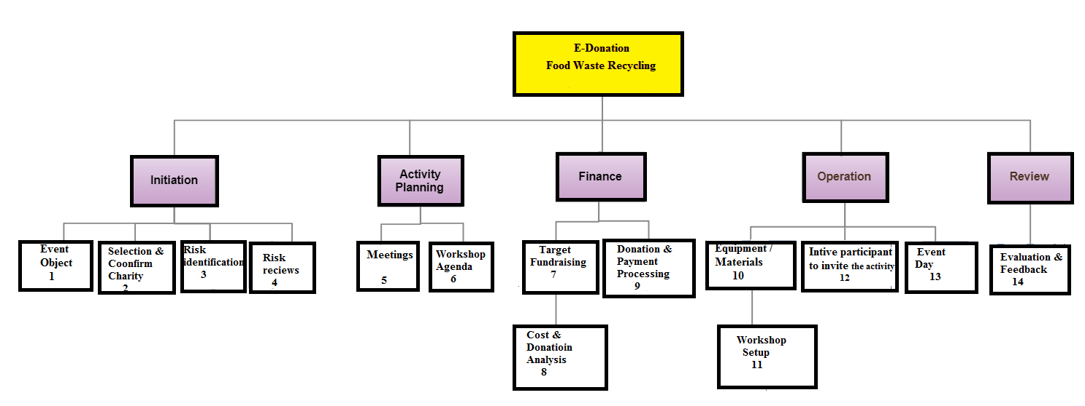
Figure 1: Work break down structure

Roles & Responsibility Matrix
WBS # | WBS Deliverable | Activity # | Activity to Complete the Deliverable | Duration  (# of Days) | Responsible Team Member(s) & Role(s)
1 | Requirement gathering | 1 | Technical specification  Restricted areas  Available solutions. | 15 Days | Ameer  Bushra  Mahnoor
2 | Analysis | 2 | Technical specification  Restricted areas  Available solutions. | 10 Days | Ameer  Bushra  Mahnoor
3 | Architecture | 3 | Requirements of a system from users, doctors, customers &  Other stakeholders | 20 Days | Ameer  Bushra  Mahnoor
4 | Designing | 4 | Information architecture | 15 Days | Ameer  Bushra  Mahnoor
5 | Implementation &development | 5 | UI Designing,  Backend and Database  coding | 90 Days | Ameer  Bushra  Mahnoor
6 | Database Module | 6 | Database  Coding and Rules | 20 Days | Ameer  Bushra  Mahnoor
7 | Final testing | 7 | Unit Testing  acceptance testing  and system testing | 5 Days | Ameer  Bushra  Mahnoor
8 | Documentation | 8 | Project Documentation. | 25 Days | Ameer  Bushra  Mahnoor
Table 1:Role& Responsibility Matrix

Gantt Chart

Figure 2: Gantt chart

Report Outline
- The Requirement was gathered in about 15 Days.
- The Documentation was made in a whole year.
- The coding and data were implanted in almost 4 months.
- The Test was made, and errors were debugged after and through the coding period.
- Validation and finalization in added golden days.

Chapter 2

Software Requirement Specifications

Chapter 2: Software Requirement Specifications

Introduction

Purpose
This mobile application is used for social welfare. The application performance should be optimized, and response time should be minimized. this app is a social app used to donate food items and excess food to reduce the ratio of wastage of food.

Document Conventions
This record is. Its degree is to portray the necessities of the Advertisement Management System and its affiliations. This report has been composed after the AMS and considers that future changes to this program ought to be incorporated into this prerequisites determination record for keeping up its helpful part. To the extent the program usage is concerned while it’s not been actualized, this record can be utilized as a manual for improvement of the framework. CSS, VCSS property, descriptor, and pseudo-class names are specified by single quotes. Values are specified by single quotes. Document language element names are in upper case Letters. Document language attribute names are in lower case letters and specified by Double quotes.

Intended Audience and Reading Suggestions
This application is highly scalable. Its purpose is to enable a sense of solidarity in the community. The app has a societal impact since it aims to close the gap between the less fortunate people and the more unfortunate in terms of quality of life.

Product Scope
E-donation, originally designed for food donations on a small and large scale the product aims at satisfying the requirements of needy organizations through donations over the net. The application shall ask the user/donor to register his/her details into the system and then he/she can login and put-up food to donate. Similarly, organizations can register in the system and then put up their food requirements. Also, a donor can view the list of it food put up by seekers and can donate the same, if possible. In the same way, seekers can view the list of items put up by donors and if required, can claim the donated item by contacting the donor. The main objectives of the proposed application include reduction in wastage of food, making food, making food available to orphanages, old age homes and other such organizations, which will also inculcate values of sharing and sensitivity among people.

References
IEEE standard document for software requirement specification.

Overall Description

Product Perspective
E-donation will provide a platform for donors and seekers after they successfully register into the system. If a user wishes to donate something, he/she can send a request in the application. We are aiming to avoid the major wastage that usually happens in the country and that is foodstuffs. We are looking and expecting to update and refine the donation system the application will be beneficial if donors and seekers are located near each other.

Product Functions
Donor (restaurants, wedding hall), Receiver (NGOs, nonprofit organization) and Admin. The Donor performs operations like Registration and Login into the System. He can also put-up food for donation and view all donation requests. The Admin and Donor both can view the Receiver’s location. The Admin can also monitor and update the database. The Admin and Receiver both can view the Donor’s location. The Receiver can also perform operations like requesting items, viewing requested food.

User Classes and Characteristics
There is the following use of our Application
Administrators:
- The administrators have complete control over all the activities that can be performed.
- They verify the user after he/she registers.
- They must provide rules for the Login.
- They must maintain the website and update the same making necessary changes at times.
- They must take care of the security issues involved in the login.
- They must inform the users about their login status and keep them updated about the progress through emails.
Users/donors:
- They are the registered members of the system. They can view all the features.
- User should be familiar with the terms like login, register etc.
- Two types of users are included donor and receiver/consumer.
- General user has the access to view the specific features whereas, admin, donner receiver and registered user can view, update or add the features.
- They can see the requirement or request from the consumer receiver/consumer.
- They are the registered members of the system. They can view all the features.
- User should be familiar with the terms like login, register etc.
- They can view all the features.
- User should be familiar with the terms like login, register etc.
- They can request the required quantity of food

Operating Environment
This system will operate in browsers like Mozilla, Firefox, and Opera and for their different version also.
- It can be opened on Windows, android and iPhone.
- The processor should be core 2 duo or above.
- The processor’s speed should be 2.8 GHz or greater.
- Ram should be or greater than 512 MB.

Design and Implementation Constraints
There are the following design and implementation constraints that we should keep in our mind during the development of the application.
- This system is working for a single server
- Limited to HTTP/HTTPS.
- Sketch or proto.io for prototyping the system
- XAMPP server for the localhost
- MYSQL used to manage the database specification
- Operating system required for this application is windows kit Kat 4.0 android or any other higher version

User Documentation
Latterly, the use of mobile devices and wireless network applications became more and more widespread. The project has solved the issue that people donate food manually by visiting each organization number of times. It provides a single platform for donors and consumers to donate food timely and securely to the needy people

Assumptions and Dependencies
Some assumptions and dependencies should be fulfilled for use of this application:
- User should have basic knowledge of the English language and computer and smartphone usage.
- Admin monitoring the use of Website/application.
Users have a basic understanding of how to operate computers and computer software.

External Interface Requirements
For Users
- The users will be able to register to the system.
- The user will be able to select his role (like a doctor, patient etc.) during registration.
- The user will be able to login into the system.
- The donor will be able to post details about his donation.
- The receiver will be able to browse nearby donators, using Advanced Search Options.
For Admin
- The admin will be able to login into the system.
- The admin will be able to create a user login for the user.
- The admin will be able to edit details.
- The admin will be able to add new types and roles.
- The admin will be able to contact the concerned donors.
- The admin will have access to the public data posted on the app.
- The admin will be able to remove users

User Interfaces
The App will provide a user-friendly interface. Where he can login and get services. The interface is friendly for both donors and accepter.

Hardware Interfaces
This is an online system so the hardware interface that is going to be used are the hardware components that are required for internet access. These have been mentioned in the following table.
WLAN | WAN | LAN | Ethernet cross-cable | Modem | Router
Table 2: Hardware Interfaces

Software Interfaces
- External machine interfaces
- External Machine interface is not required since computation will be done on Windows OS and Android OS.
- External system interfaces
- This will only include the Firebase database for the products.
- Human interface
- The software will use a Graphical User Interface coded in XML.
Communications Interfaces
The e- donation system shall use the HTTP protocol for communication over the internet and for the intranet communication will be through TCP/IP protocol suite.
System Features
The system is going to consist of multiple modules, each separately developed with its features.
Register Account
Description and Priority
If the customer/user wants to buy the product then he/she must be registered, the unregistered user can’t able to use our auto-generate LMS. For this purpose, the user/customer will register to the system.
Stimulus/Response Sequences
- user first clicks on the button or link to initiate the registration process.
- System prompts the user to fill out his/her first name, last name, address, email address, and password.
- User enters fields.
- System validates the user's information.
- System creates a new account for the user.
Functional Requirements
REQ-SF1-1: System must be able to verify and validate the information.
REQ-SF1-2: The system must encrypt the password of the user to provide security.
Login/Logout Account

Description and Priority
This feature is used by the user to login into the system. A user must login with his username and password to the system after registration. If they are invalid, the user is not allowed to enter the system
Stimulus/Response Sequences
- User clicks on the button or link to initiate the login process.
- System prompts the user for his/her email and password.
- System verifies the information.
- System displays account home page to the user.
- User clicks the button or link to initiate the logout process.
Functional Requirements
REQ-SF2-1: Username and password will be provided after user registration is confirmed.
REQ-SF2-2: Password should be hidden from others while typing it in the field.

Other Nonfunctional Requirements
Performance Requirements
- Response time: The home page loaded in 3-5 seconds.
- Availability: The site will available 99.99% of the time.
- Throughput: Page hits per second or orders per hour.
- Capacity: Maximum throughput that can be achieved with acceptable response time and availability.
- Safety Requirements: Once the admin deletes a record or user account the data of that user can’t be retrieved. To handle this problem system gives a warning before deleting the record.
Safety disclaimers will be given to both students and teachers.
If any user has some problem while using the site, he can contact via mail the website maintainer
- Security Requirements: Security is one of the major concerns these days. Our system is based on the following security parameters which are given below:
- This software keeps the information of students and teachers safe.
- User will be registered after verification of user data.
- Secure login and logout. If the renter forgets his account credential then he has to get a new credential through his sign-up e-mail.
- Admin area will be secured.
Software Quality Attributes
- Usability: This website should be easy to use and easy to learn how to operate.
- Correctness: When the user search for something but the spelling is not right the system search related to that spelling or give autocomplete search.
- Portability: This product can be used on different devices like tablets, mobiles, laptops etc.
- Robustness: This software can handle many problems itself like if the user forgets his password so the system gives it the option to re-write the name and user password.
- Flexibility: The functionality of this software can be increased after development because documentation is available.
- Performance: The loading speed of web pages onto a Clients web browser is quite good.
- Reliability: This software is reliable.
- Maintainability: Admin of the website will maintain the working of this software.
- Security: This software is secure enough to use. This software keeps the information of users safe.
Business Rules
- If the user wants to perform some crud operation then he/she has to first sign up.
- User has to follow the terms and conditions of the website.

Chapter 3

Use Case Analysis

Chapter 3: System Analysis
This chapter describes system use cases and how the different actors are interacting with the system. This system is all about the use case of the system and the role we assign and categorize the user of the solution. We describe all terms of the use case model and use case diagram of every role. in the end, we make a properly dressed use case model of our project.

Use Case Model
A use case diagram at its simplest is a representation of a user's interaction with the system that shows the relationship between the user and the different use cases in which the user is involved. A use case diagram can identify the different types of users of a system and the different use cases and will often be accompanied by other types of diagrams as well. The use cases are represented by either circles or ellipses.
Actor:
An actor is a person or external system that plays a role in one or more interaction with the system. And represented with:

Use case:
Use case Describes a sequence of actions that provides something of measurable value to an actor and is drawn as a horizontal ellipse

System boundary
Indicates the scope of the system project. Anything within the box represents functionalities inside in scope.


Use case model for Admin:

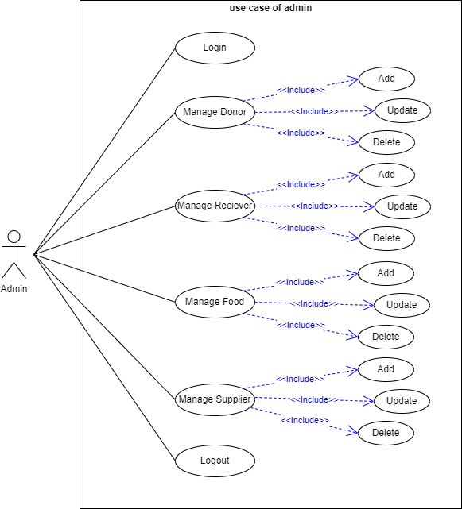
Figure 3: use case of admin

Use Case of Donor

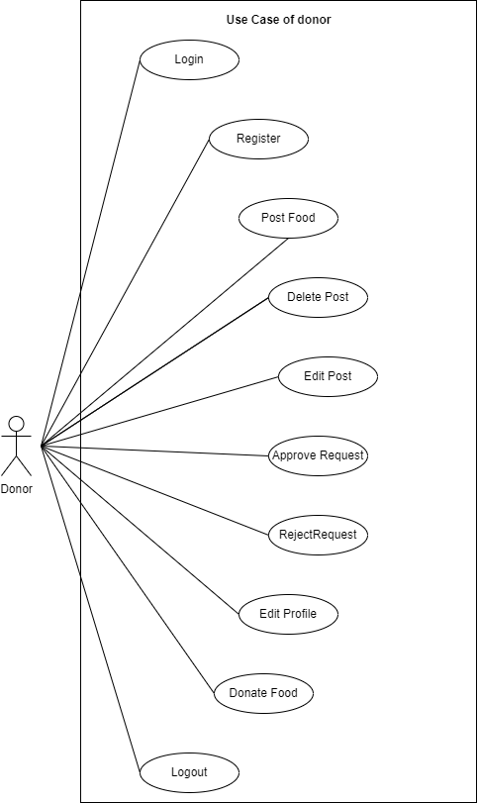
Figure 4: use case of Donor

Use Case of Receiver

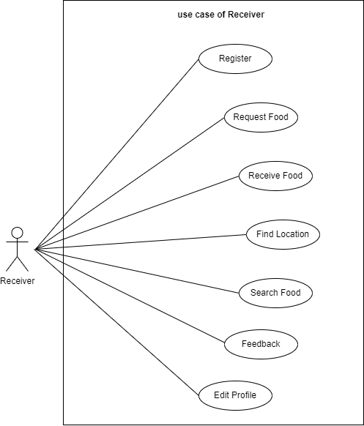
Figure 5: use case of Receiver

Fully dressed use case

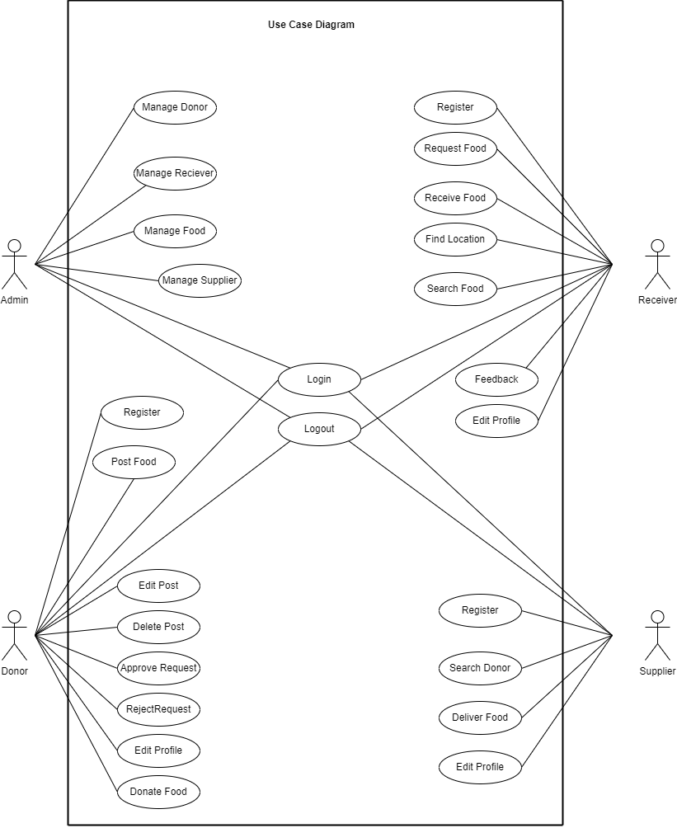
Figure 6: fully dressed use case

Use Case Descriptions
Name | Register
Brief Description | A user of the system creates an account
Actor(s) | Admin
Flow of Events
Basic Flow
This use case starts when a system user is not logged in to the system and goes to the login page.
- The System prompts the user for a username and password or registers a new account.
- The user selects the registration option.
- The System prompts the user for registration information, username, password, etc
- The user enters in their information.
- System verifies information and creates an account.
- The use case ends.
Alternate Flows
Title | Description
Cancel Registration | - The user selects the cancel option.  - The system returns the user to the home page without the user being logged in and any information entered has been erased.
Invalid Information Entered | - User clicks submit after entering the information the system asked for.  - System displays information with appropriate messages to correct invalid information.  - User re-enters information.
Pre-Conditions
Title | Description
System | To log in to the system the user must have the System
Internet | To log in to the system the user must have the network on the System.
Post-Conditions
Title | Description
Success | The user entered successful information and is returned to the home page as a Logged In User
Failure | The user is unable to log in for one or more reasons and is returned to the home page as a Guest.
Extension Points
If the User is unable to log in for one or more reasons the user must once check the Internet Connection.
Table 3: User case of register
Name | Log In
Brief Description | The System user logs in to the System.
Actor(s) | Logged In User
Flow of Events
Basic Flow
This use case starts when a system user is not logged in to the system and goes to the login page.
- The System prompts the user for a username and password or registers a new account
- The user enters his/her username and password.
- The system validates the entered username and password, making sure that the entered username is valid in the System, and that the required password is entered for the entered username.
- The user is signed in and returned to the home page as a Logged In User.
- The use case ends.
Alternate Flows
Title | Description
User Fails Authentication | If the user entered an invalid username and/or password, the following occurs:  - The system describes the reasons why the User failed authentication.  - The system presents the user with suggestions for changes necessary to allow the User to pass authentication.  - The system prompts the user to re-enter the valid information.  - The Basic Flow continues where the User enters new information.
Pre-Conditions
Title | Description
Register | A user of the system creates an account
Post-Conditions
Title | Description
Success | The User is authenticated and the system displays a home page based on the user type.
Failure | The user is unable to log in for one or more reasons.
Extension Points
The user must make sure that the entered username is valid in the System or entered password is a valid password.
Table 4: User case of login
Name | Consumer Request For Food
Brief Description | The consumer may be a whole family or single person who request food in their nearest area.
Actor(s) | Consumer
Flow of Events
Basic Flow
This use case starts when a student accesses the “Application Form" feature of the system.
- The system asks the student to enter the appropriate information to get admission to the school (e.g. Student Name, Father Name, Gender, CNIC, DOB, etc...).
- Student enters appropriate information and clicks submit.
- System validates student information.
- Student is returned to the student panel.
- This Use Case ends.
Alternate Flows
Title | Description
Invalid Information Entered | - The system displays an “Invalid Information” error after the user submits the information and asks the Student to re-enter the information.  - Student re-enters information and clicks submit.
Cancel Submitted Application Form | - Consumer clicks cancel after selecting the “Application Form” feature.  - System returns consumer to the consumer panel.
Pre-Conditions
Title | Description
Register | A user of the system creates an account
Login | The System user logs in to the System.
Post-Conditions
Title | Description
Success | The new student information is added to the database.
Failure | Student information is not added for one or more reasons.
Extension Points
If the consumer information form is not submitted for one or more reasons the student must re-enter or fill valid information in all the requisite information and re-submit the application form.
Table 5: use case of consumer

Chapter 4

System Design

Chapter 4: System Design
The Chapter is all about how the software is going to work and how will the processes be executed see we have several diagrams that show how is the system performing and what will be the requirements to perform the operations required tasks as well as the diagrams and data clearly describes the process and shows a great help in understanding the

Architecture Diagram
Following Architecture Diagram of e donation is a graphical representation to understand, clarify, and communicate ideas about the game structure and the user requirements that the game must support.

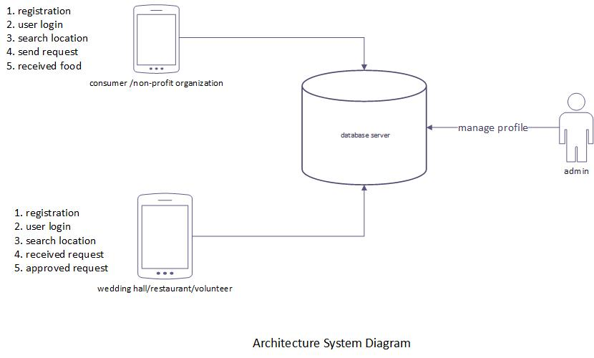
Figure 7: Architecture Diagram

Domain Model
A domain model is a formal representation of a knowledge domain with concepts, roles, datatypes, individuals, and rules, typically grounded in a description logic in the following figure we use a spiral model
In the Iterative model, the iterative process starts with a simple implementation of a small set of the software requirements and iteratively enhances the evolving versions until the complete system is implemented and ready to be deployed.

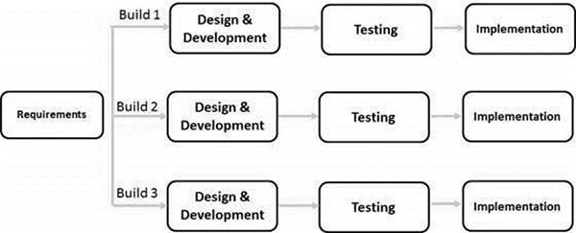
Figure 8: Domain Model

Entity Relationship Diagram with data dictionary
An entity-relationship diagram (ERD) is a data modelling technique that graphically illustrates an information system’s entities and the relationships between those entities.

ERD diagram
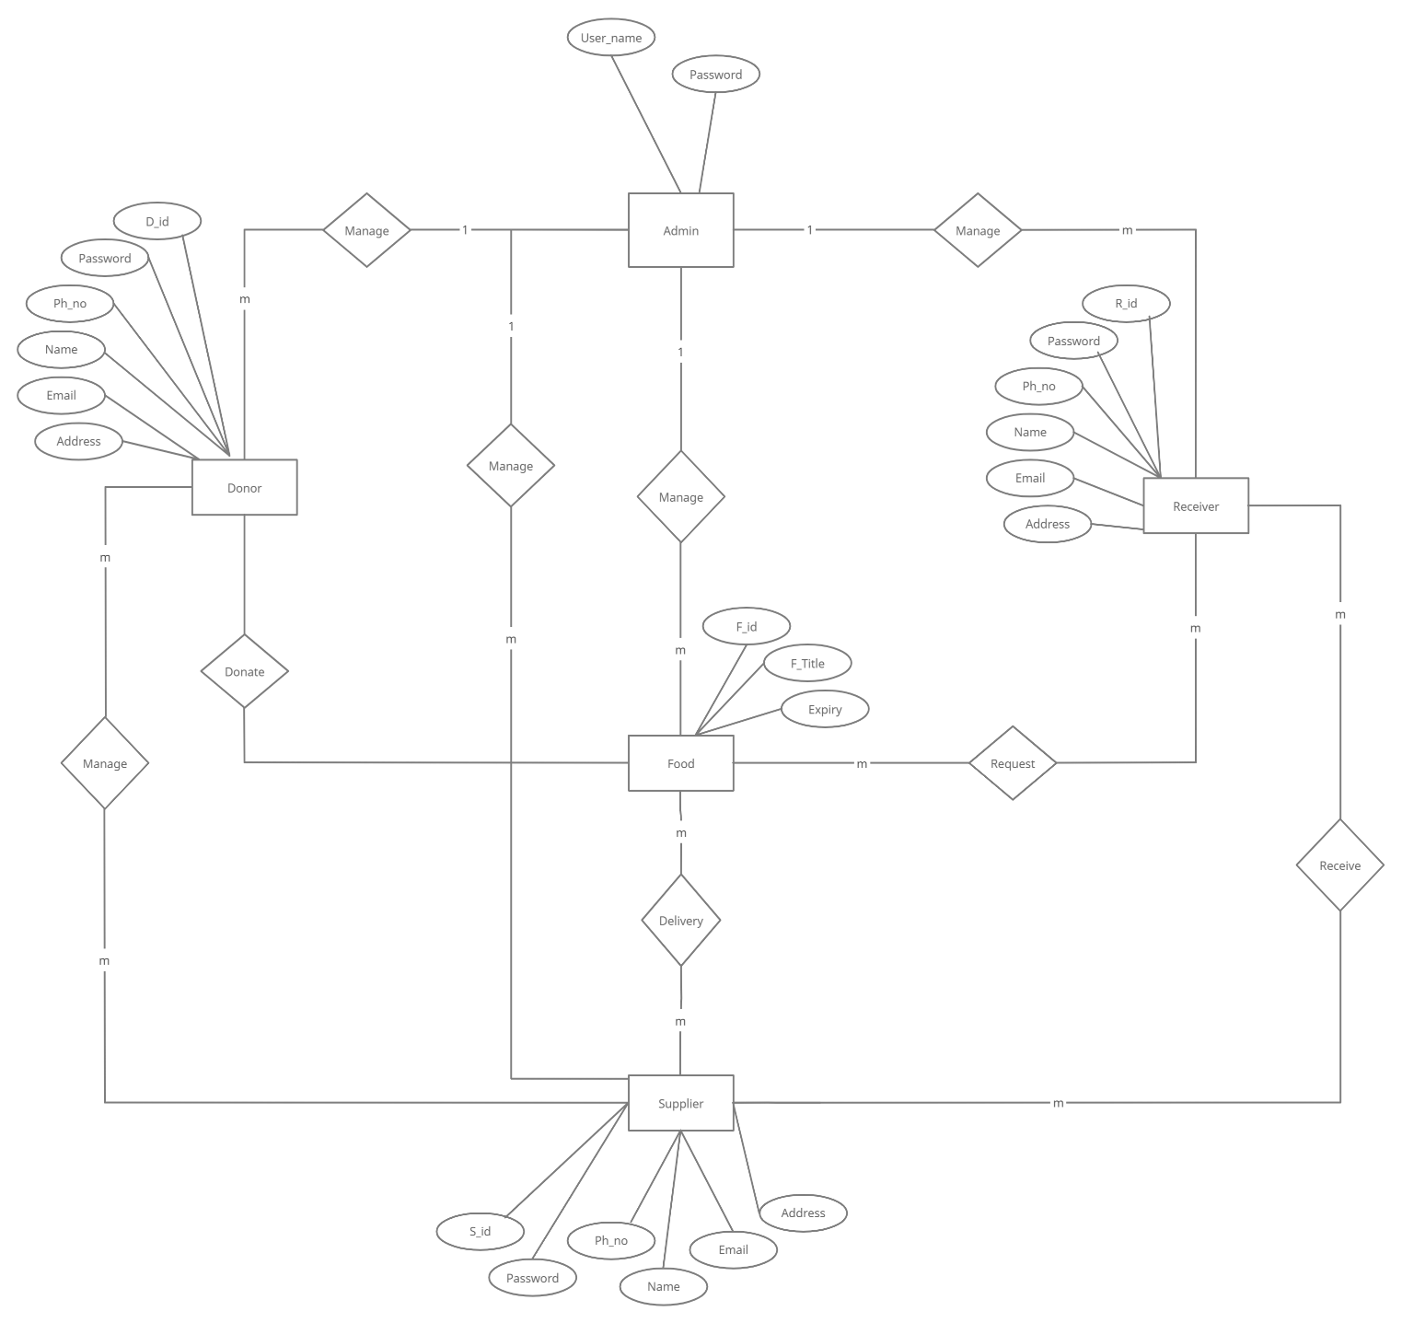
Figure 9: ERD diagram

Class Diagram
The following Class Diagram of our project gives an overview of e donation system by displaying its classes, attributes and operations:
Class diagram

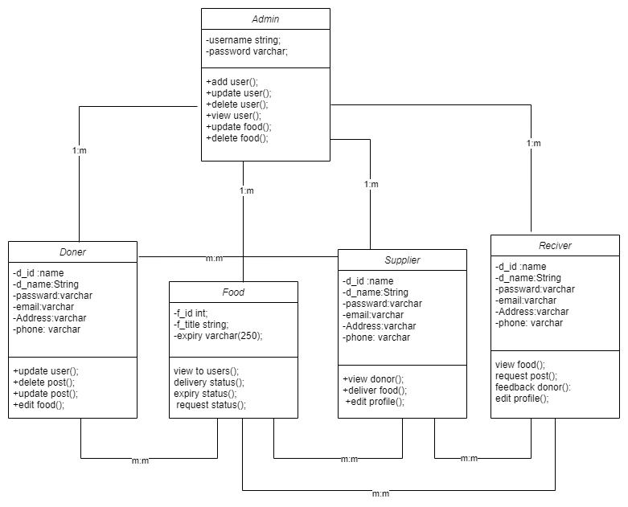
Figure 10: Class Diagram

Sequence / Collaboration Diagram
The following Sequence Diagram shows the system’s objects interactions arranged in a time sequence. It depicts the objects and classes involved in the scenario and the sequence of messages exchanged between the objects needed to carry out the functionality of the system
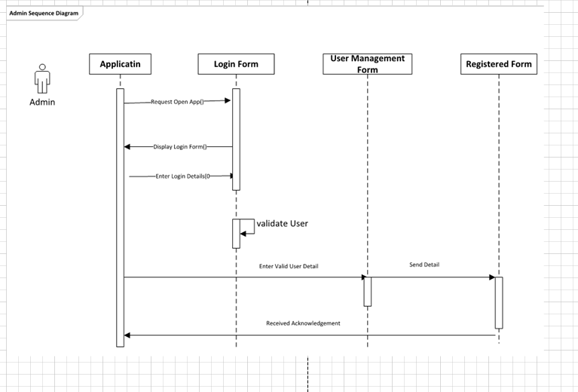
Figure 11: sequence diagram of admin

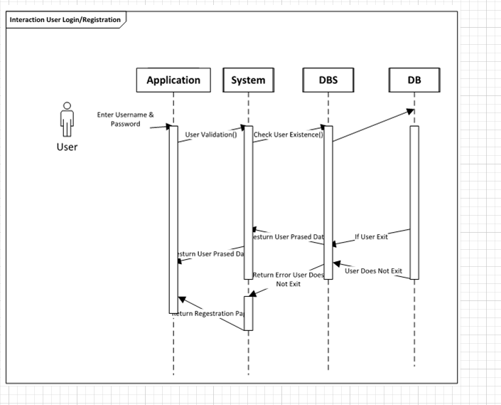
Figure 12: sequence diagram of a user

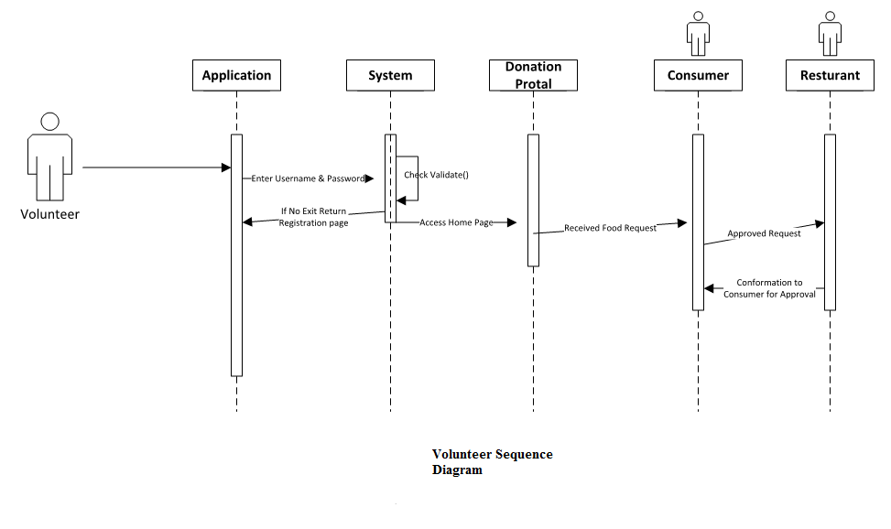
Figure 13: sequence diagram of volunteer
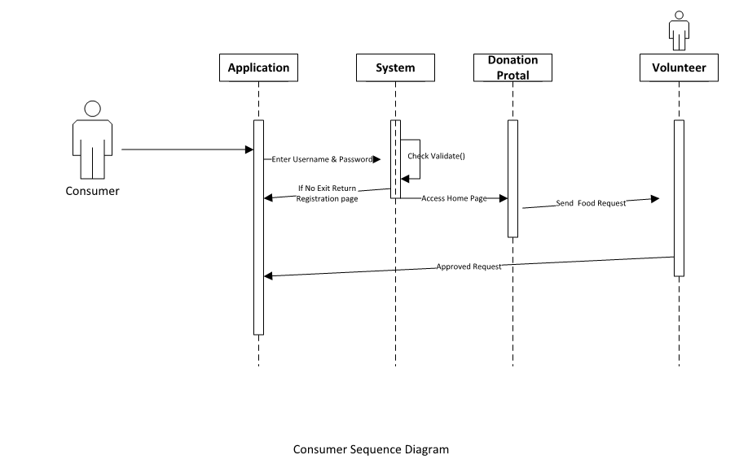
Figure 14: sequence diagram of consumer

Activity Diagram
Activity diagrams are graphical representations of workflows of stepwise activities and activities with support for choice, iteration and concurrency in the following diagrams we present the graphical image of the system
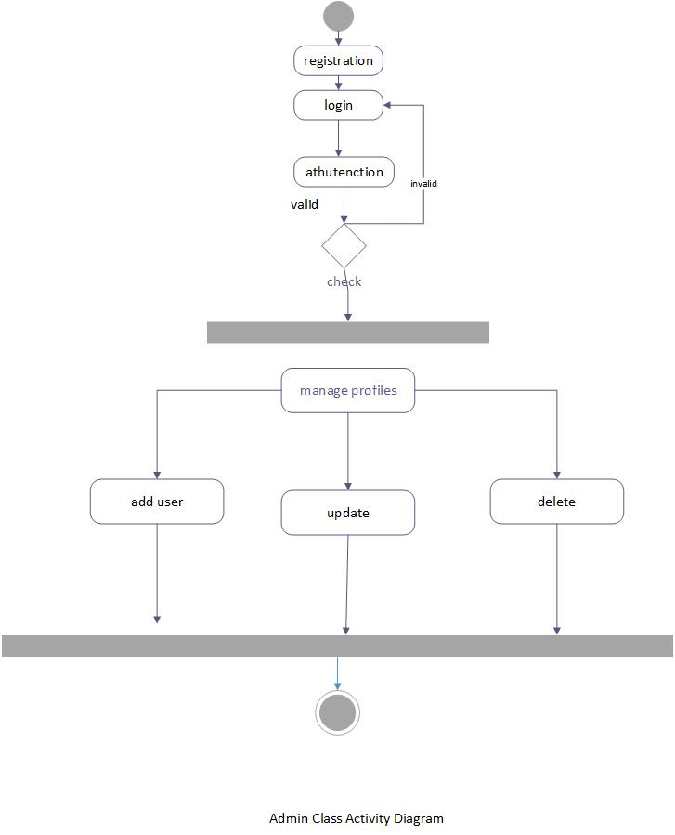
Figure 15: Activity diagram of admin
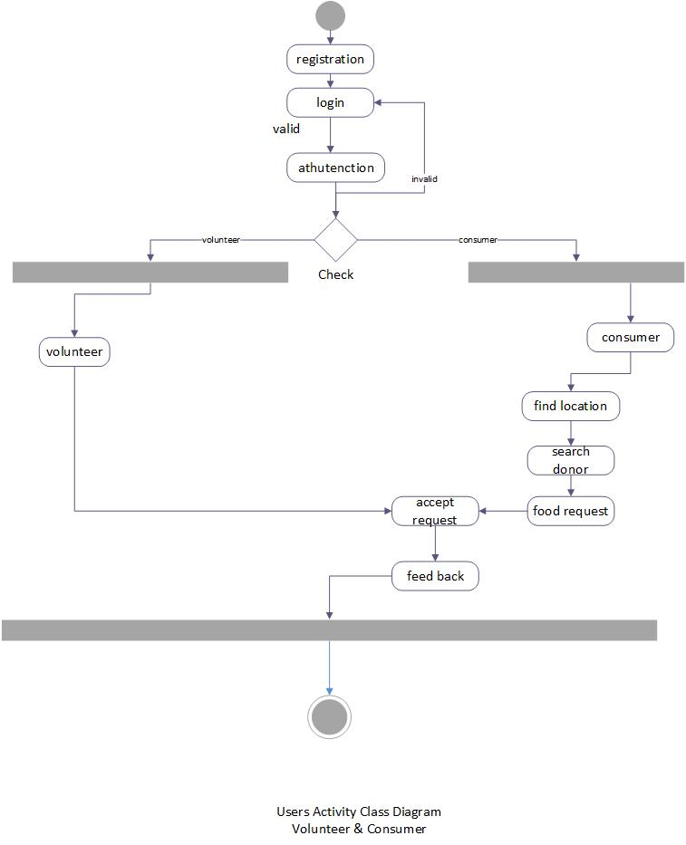
Figure 16: Activity of Donor/Receiver

State Transition Diagram
A diagram consisting of circles to represent state and directed line segments to represent transitions between the states. One or more actions (outputs) may be associated with each transition. The diagram represents the proper state of e donation system
State transition diagram
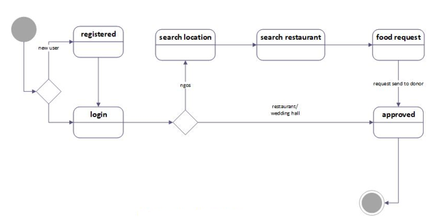
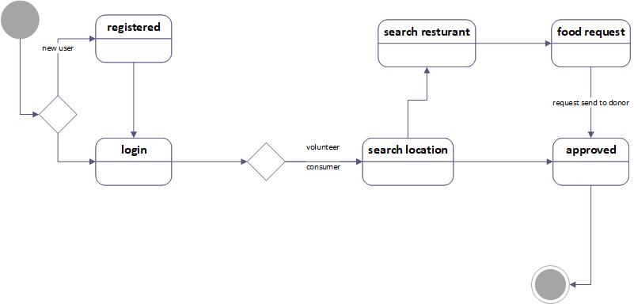
Figure 17: state transition diagram

Component Diagram

A component diagram allows verification that a system's required functionality is acceptable. These diagrams are presenting the flow and verification system
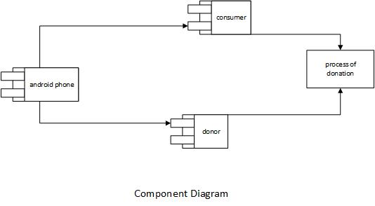
Figure 18: Component Diagram

Deployment Diagram
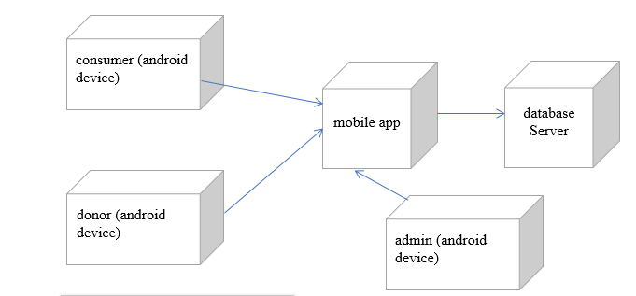
Figure 19: Deployment Diagram

Data Flow diagram
A data-flow-diagram (DFD) is a way of representing a flow of data of a process or a system. The DFD also provides information about the outputs and inputs of each entity and the process itself.
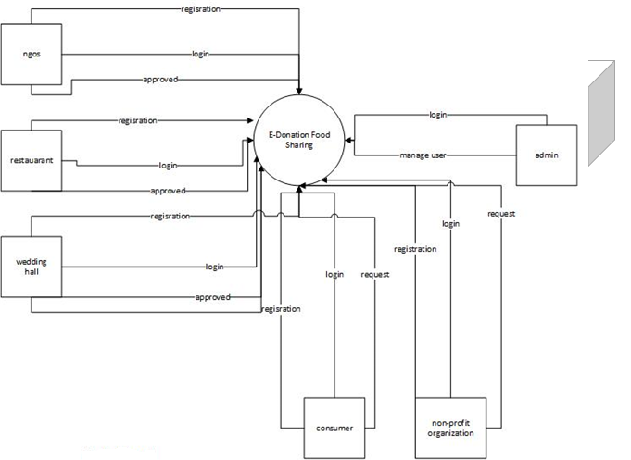
Figure 20: DFD Level-0
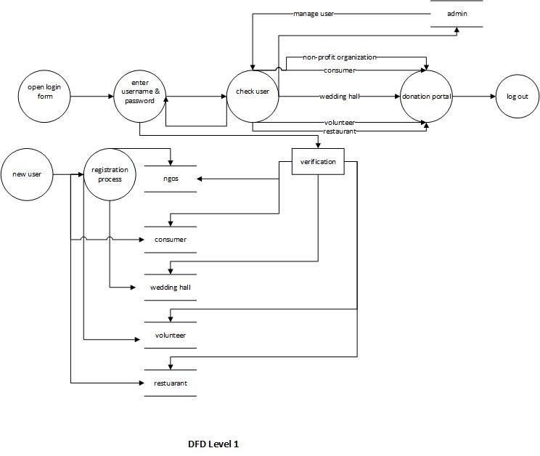
Figure 21: DFD level-1

Chapter 5

Implementation

Chapter 5: Implementation
Important Flow Control/Pseudo codes
- Services that this application will provide are the following: •
- There are two types of users
- 1. Users who want to provide information about families.
- They will be able to create a profile with the necessary information (contact, location, etc.) ✓ Add/check reviews.
- 2. Users who want to donate. ✓
- They will be able to access profiles based on the criteria they specify ✓
- Add/check reviews.
Components, Libraries, Web Services and stubs
- Gson. Gson is a Java library used for serializing and desterilizing Java objects from and into JSON. ...
- Retrofit. From their site: "Retrofit turns your REST API into a Java interface.” ...
- Event Bus. ...
- Active Android. ...
- Universal Image Loader
Deployment Environment
In the Deployment environment, we work on android studio to build our android based application

Tools and Techniques
Tool | Android Studio 4.1
Design | Adobe XD
Languages | JAVA, XML
Database | Firebase
Table 6: tool and technique

Best Practices / Coding Standards
- Testing on android studio
- Use java language
- Use XML language
Version Control
Now we just working on version 1 with time we changed the version. From the start of the project number of versions updated and finalized now version, 1.5 is mentioned here.

Chapter 6

Testing and Evaluation

Chapter 6: Testing and Evaluation
Use Case Testing is a functional black-box testing technique that helps testers to identify test scenarios that exercise the whole system on each transaction basis from start to finish.

Use Case Testing
6.1.1.
Test Suite ID | TS001
Test Case ID | TC001
Test Case Summary | To verify that by clicking the Signup button username, password, email, phone# and address store in users detail in the database.
Related Requirement | RSoo1: The user should be able to Sign up.
Prerequisites | No
Test Procedure | 1. Select fields in the signup form.  2. Enter user data in fields.  3. Click the Signup button.
Test Data | Valid username: Iqra, IQRA  Invalid username: 12 iqra ./iqra ,iqra %^3  Valid password: 123Abc@5, Abc567$%9  Invalid password: 1_2iqra, _iqra12  Valid email:ali@gmail.com, 12ali@yahoo.com  Invalid email: ali.com, iqra@yahoo  Valid phone# :03123456578  Invalid phone: @56rfgf7999, 2wstyyA
Expected Result | 1. If the username, password, email and phone# are valid then store user data by clicking the signup button.  2. If given inputs are invalid then display an error message.  3. If fields are empty then show a warning message.
Actual Result | 1. If the name is valid, the result is as expected.  2. If the name is not valid then an invalid message is displayed.  3. If fields are empty then a warning message is is displayed.
Status | Pass
Remarks | This test case is simple and easy.
Created By | Rabia Saleem
Date of Creation | 04/01/19
Executed By | Rabia Saleem
Date of Execution | 04/01/19
Text Environment | OS: Android Studio Version 3.4
Table 7: Use case of Sign up
6.1.2:
Test Suite ID | TS001
Test Case ID | TC002
Test Case Summary | To verify Authentication or Login.
Related Requirement | RS002: The user should able to Login.
Prerequisites | The user should Signup first.
Test Procedure | 1. Select the Username field and enter the username.  2. Select the Password field and enter a password.  3. Click the Login button.
Test Data | Valid username: Iqra,iqra  Invalid username: 1iqra, ./iqra , iqra%^3  Valid password: 123Aabc@, abMc567$%  Invalid password: 1_2iqra, _iqra12
Expected Result | 1. If username and password are valid then clicking the Login button user successfully login.  2. If username and password are invalid then clicking the Login button invalid message display.  3. If fields are empty then display a warning message
Actual Result | 1. If fields are valid, the result is as expected.  2. If fields are not valid then an invalid message is displayed.  3. If fields are empty then a warning message is displayed.
Status | Pass
Remarks | This test case is simple and easy.
Created By | Rabia Saleem
Date of Creation | 04/01/19
Executed By | Rabia Saleem
Date of Execution | 04/01/19
Text Environment | OS: Android Studio Version 3.4
Table 8: use case of login
6.1.3:
Test Suite ID | TS001
Test Case ID | TC003
Test Case Summary | To verify that we, restaurants, volunteers, consumers and non-profit organizatiorganizations once signup if they forget the password then they can update it by email.
Related Requirement | RS003: user should be able to update data.
Prerequisites | user should login.
Test Procedure | 1. Select fields.  2. Enter data in fields.  3. Click forgot password button.
Test Data | 04/01/19
Expected Result | 1. If enter data is valid then update data by clicking the update button  2. If given inputs are invalid then display an error message.  3. If fields are empty then display a warning message.
Actual Result | 1. If fields are valid, the result is as expected.  2. If fields are not valid then an invalid message is displayed.  3. If fields are empty then a warning message is displayed.
Status | Pass
Remarks | This test case is simple and easy.
Created By | Ameer Muawiya
Date of Creation | 04/01/22
Executed By | Ameer Muawiya
Date of Execution | 04/01/22
Text Environment | OS: Android Studio Version 4.1
Table 9: use case of update password
6.1.4:

Test Suite ID | TS002
Test Case ID | TC004
Test Case Summary | To verify that wed, restaurants, volunteer, consumer and non-profit organize organizations once signup if they are deleted in the database by performing crud operation by clicking Delete button.
Related Requirement | RS004: Admin can delete data.
Prerequisites | Admin should login.
Test Procedure | Click the delete button.
Expected Result | If data is deleted by click button then the message will appear
Actual Result | If the action is valid, the result is as expected.
Status | Pass
Remarks | This test case is simple and easy.
Created By | Rabia Saleem
Date of Creation | 04/01/22
Executed By | Ameer Muawiya
Date of Execution | 04/01/22
Text Environment | OS: Android Studio Version 4.1
Table 10: use case of delete data
6.1.5:
Test Suite ID | TS002
Test Case ID | TC005
Test Case Summary | To verify that data is searched by clicking the search button.
Related Requirement | RS005: The user should be able to search data.
Prerequisites | The user should login.
Test Procedure | 1. Select the search field.  2. Enter a name in fields.  3. Click the search button.
Expected Result | 1. If the name is valid then show detail.  2. If the name is invalid then display an error message.  3. If the field is empty then display a warning message.
Actual Result | 1. If the name is valid, the result is as expected.  2. If the name is not valid then an invalid message is displayed.  3. If fields are empty then a warning message is displayed.
Status | Pass
Remarks | This test case is simple and easy.
Created By | Ameer Muawiya
Date of Creation | 04/01/22
Executed By | Ameer Muawiya
Date of Execution | 04/01/22
Text Environment | OS: Android Studio Version 4.1
Table 11: use case of search data
6.1.6:
Test Suite ID | TS002
Test Case ID | TC006
Test Case Summary | To verify that record is the display.
Related Requirement | RS006: The user should be able to view data.
Prerequisites | The user should login.
Test Procedure | 1. Enter a name in fields.  2. Click the View button.
Expected Result | 1. If the name is valid then show detail.  2. If the name is invalid then display an error message.  3. If the field is empty then display a warning message.
Actual Result | 1. If the name is valid, the result is as expected.  2. If the name is not valid then an invalid message is displayed.  3. If fields are empty then a warning message is displayed.
Status | Pass
Remarks | This test case is simple and easy.
Created By | Ameer Muawiya
Date of Creation | 04/01/22
Executed By | Ameer Muawiya
Date of Execution | 04/01/22
Text Environment | OS: Android Studio Version 4.1
Table 12: use case of record to display

Equivalence partitioning

Boundary value analysis
Sr. |  | Partition 1 | Partition 2 | Partition 3
1. | Password | Less than 8 character | 1 – 8 character | 9 – 12
2. | Phone | <=0 | 1 - 11 | 9 – 12
Table 13: boundary analysis

Data flow testing
The relationship between one entity and another while performing a specific task during data flow. Such as between the signup and registration process etc.

Unit testing
In unit testing, we have testified our different panel codes individually by performing different tests and by executing them individually, separately on different computers and they were successfully executed and they performed well.

Performance testing
In performance testing, a particular certain situation is given to the website let’s just say 100 users try to register at the same time so how the system recovers back gracefully with complete results. So according to our extracted results, around 100+ people were able to register on our website.

Stress Testing
Let’s say if 100 customers order at the same restaurants at the same time along with the same food level which increases the stress on the website at a maximum load how will the website will perform under these circumstances.
Activity | Description
Register | The user can register and save his/her information into the system
Login | The user can login using his/her credentials
Type of user | Upon registering, the user specifies which type of user they are
Manage profiles | The user can edit/disable their accounts
Browse Categories | The donators can browse the categories of lup they want to donate to.
Search Profiles | The donators can search profiles based on the nearest
Call user | The user can call the phone number of the user
Send Notification | The donator can send notification for possible donation
Add Reviews | The donators can add reviews concerning user
Confirm Donation | The user can confirm receiving donations
Check Notification | The user can check notifications for possible donations
Log out | The user can log out

Interface for Login:
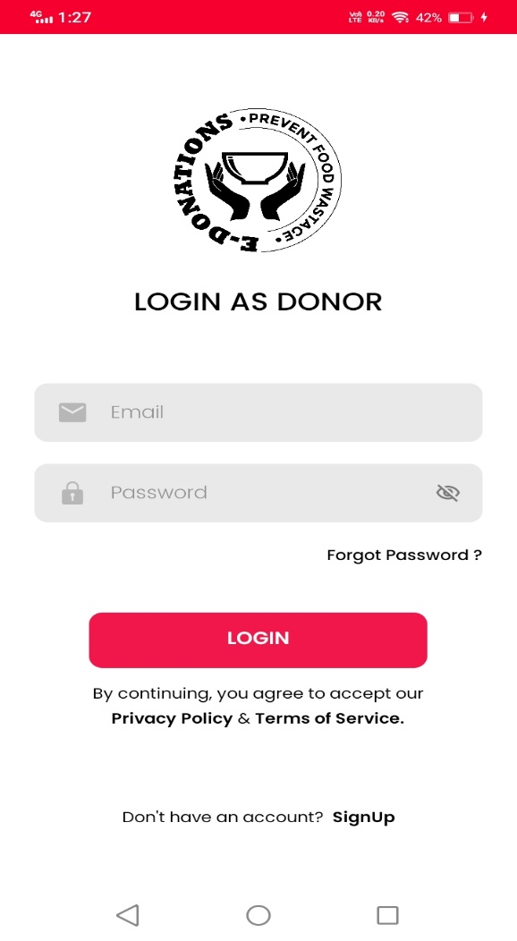

Chapter 7

Summary, Conclusion and Future Enhancements

Chapter 7: Summary, Conclusion & Future Enhancements

Project Summary
Now that the project E- DONATION is completed so that I can explain the purpose of the app it is a mobile app. The main purpose of this app is to control food wastage and forward this food to needy and unprivileged people by collecting the extra food from wedding halls and restaurants to the NGO’S and nonprofit organizations online within no time. Our software would generate the interface and its associated functionalities according to the requirement of both organizations. This system will provide many features in a single platform.
That said, there is always room for improvement

Achievements and Improvements
The biggest achievements here are that we were able to enhance our skills to the professional extend that we learned in four years of studying and apply them to this project. We learned software architecture design techniques, UML modelling, project management, testing and much more, and were able to apply it all in this project.
The next big achievement is the things we learnt during this project. New languages, frameworks, libraries, different software’s for diagrams Database. All that will be useful for us in the future. We learn Creative thinking.

Critical Review
The critical element of our system is: Is our system is fast-moving, give a user-friendly interface, is not very costly, fulfil the specific requirements of the users at runtime, has all the features which any organization can require. To manage all these aspects took a lot of time and hard work.

Lessons Learnt
We absorb very much from this project. This project sharpens our skills in XML and Andriod studio many other tools and many management concepts as well as how to deal with a problem and how to stick to finding the solution of any problem until you are fond. As well as technical skills this project also enhances our personal development skills such as team working, dedication.

Future Enhancements/Recommendations
As it has been already saying, there is always room for further improvement. And since we plan to launch this website as our startup, enhancements will keep coming.
The system has been built on react native, but at some point, we work on its efficiency, accessibility, flexibility, we are going to scale it up which we believe ours is eventually going to become. We make it a more user-friendly interface.

Appendices

Appendix A: User Manual
In this appendix section, we describe the different phases of the user interface and also describe how users can use our project
Appendix A: E-donation
A.1. Login
Users can login by entering names and passwords.
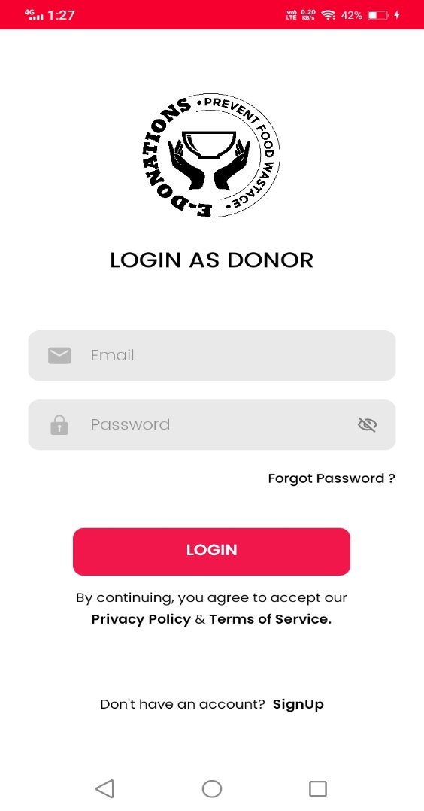

Figure 22: interface of login
A.1.2 Signup
The user fills the registration form.in case if ser is not valid or enter wrong name and password it will show an authentication warning
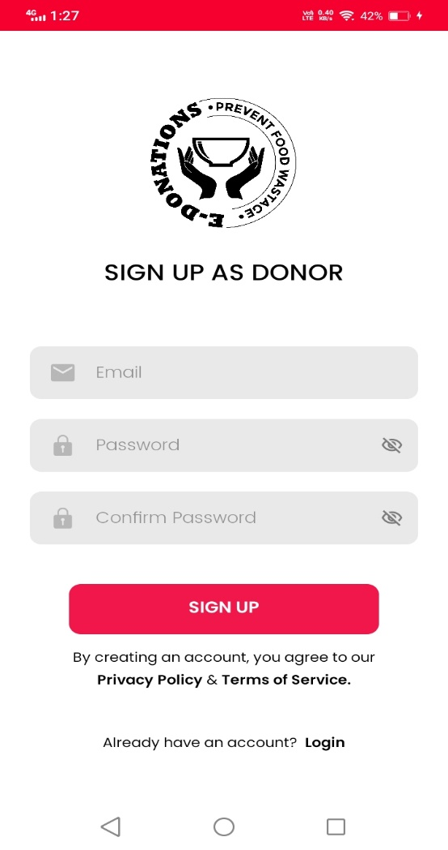

Figure 23: interface of sign up
A.1.3 Select functionalities
User selects the functionalities which he wants in LMS.
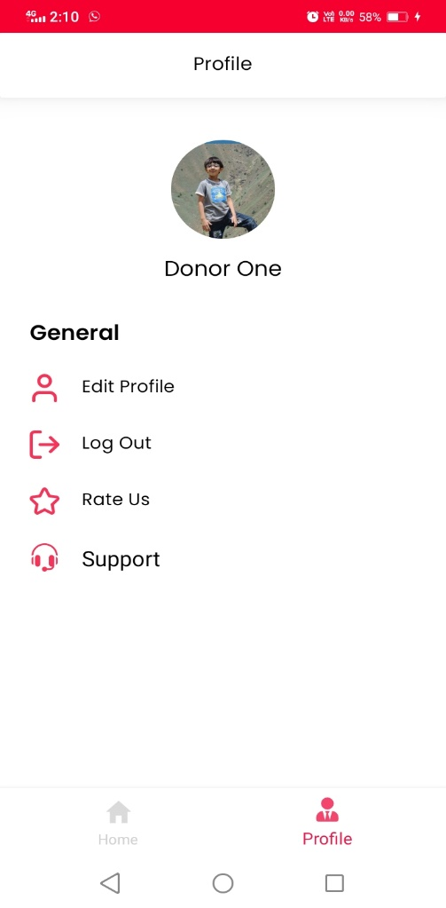
Figure 24: interface of functionalities

Appendix B: Administrator Manual
In this appendix section, we describe the different phases of the admin interface and also describe how the admin can manage the system.
  - Login
Users can login by entering the password and username.

    - Manage Donor Panel
Admin can have full access to and record of donations of food donated and consumed by the user.
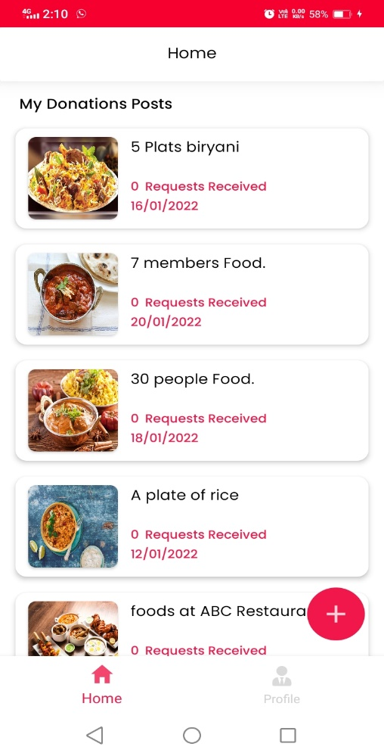

Appendix C: Information / Promotional Material
In the Appendix, we add promotional material about our application and application. We add these to promote our application.
  - Banner
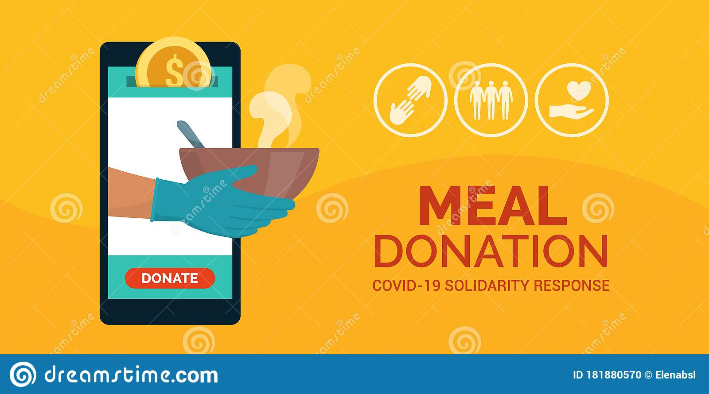
E-Donations

Reference and Bibliography

Reference and Bibliography

[1] Jes K.et el [Online Available] www.rescuingleftovercuisine.org/
[2] K.et el [Online Available] www.annakshetra.org/
[3] Lere H.et el [Online Available] happylifewelfare.org/share-dabba-compaign.html
[4] [Online Available] Kaine L.et el [Online Available] usf.vc/entrepreneur-info/India-meteoric-rise-smartphones/
[5] [Online Available] www.epa.gov/recycle/reducing-wasted-food-home
[6] [Online Available] http://www.youthkiawaaz.com/2014/09/innovative-trick-dabbawalas-m
umbai-feeding-many-hungry-children-city/&cat=General&ip=192.168.3.93
&user=-&reason=Group
[7] [Online Available] www.indiaactivities.com/caring-activities/donate-leftover-excess-food/
[8] [Online Available] http://developer.android.com/training/basics/firstapp/index.html
[9] [Online Available] www.http://thecsrjournal.in/food-wastage-in-india-a-serious-concern/
[10] [Online Available] https://www.google.co.in/?gfe_rd=cr&ei=FRXYVpC0DqnG8AeB_6HIDA&gwsrd=ssl#q=android+tutorial+for+beginners+with+examples
[11] [Online Available] www.olio.com/
[12] [Online Available] www.stmungo.org.com/
[13] [Online Available] https://www.doh.wa.gov/CommunityandEnvironment/Food/FoodWorkerandIndustry/CharityFoodDonations

