DESIRED COVER

WEBSITE

FINAL YEAR PROJECT

SESSION 2016-2020

A project submitted in partial fulfillment of the degree of

BS in Computer Sciences


Department of Computer Science
Faculty of Computer Science & Information Technology
The Superior College, Lahore

FALL 2020

Type (Nature of project) |  |  | [ ] Development [ ] Research [ ] R&D
Area of specialization |  |  | Web designer
FYP ID |  |  | FYB-Group066
Project Group Members
Sr.# | Reg. # | Student Name |  | Email ID | *Signature
(i) | Bcsm-s16-014 | Najam-ul-Hassan |  | Najamulhassancr7@gmail.com
(ii) | Bcsm-s16-100 | Shahzaib Riaz |  | Shahzaibriaz575@gmail.com
(iii)

*The candidates confirm that the work submitted is their own and appropriate credit has been given where reference has been made to work of others

Plagiarism Free Certificate
This is to certify that, I ________ S/D of Muhammad Siddique, group leader of FYP under registration no ______________________________at Software Engineering Department, The Superior College, Lahore. I declare that my FYP report is checked by my supervisor.

Date: Name of Group Leader: _________________ Signature: _____________
Name of Supervisor: Sir Fawad Naseem Co-Supervisor: Mr. XYZ
Designation: Lecturer Designation: Associate Professor
Signature: ________________ Signature: _________________

HoD: Dr. Arfan Jaffar
Signature: _______________

Project Report
[Desired Covers]

Change Record
Author(s) | Version | Date | Notes | Supervisor’s Signature
 | 1.0 |  | <Original Draft>
 |  |  | <Changes Based on Feedback from Supervisor>
 |  |  | <Changes Based on Feedback From Faculty>
 |  |  | <Added Project Plan>
 |  |  | <Changes Based on Feedback from Supervisor>

APPROVAL
Project Supervisor
Comments: ___________________________________________________________________
_____________________________________________________________________________
Name:______________________________
Date:_______________________________ | Signature:__________________________

Project Manager
Comments: ___________________________________________________________________
_____________________________________________________________________________
Date:_______________________________ | Signature:__________________________

Head of the Department
Comments: ___________________________________________________________________
_____________________________________________________________________________
Date:_______________________________ | Signature:__________________________

Dedication

We would like to express our gratitude and appreciation to all those who gave us the possibility to complete this report. A special thanks to our final year project supervisor, Sir Zaman Aziz and Sir Ahsasn Bilal, whose help, stimulating suggestions and encouragement, helped us to coordinate our project especially in writing this report and to our colleagues in the Department of Computer Science and Technology of Superior University for their support.

Acknowledgements

We are highly indebted to our project guide Sir Zaman Aziz from Superior group of colleges for his guidance, inspiration, constructive suggestion and encouragement that helped us throughout the evolution of this project. He has taken innumerable efforts to go through the project and make necessary corrections as and when needed.
Our sincere thanks go to all lecturers and members of the staff of the Department of Computer Science and Technology, SUL, who helped us in many ways and made our education journey at SUL pleasant and unforgettable. Many thanks go to CS group member for their excellent co-operation, inspirations and supports during this study. This four-year experience with all you guys will be remembered as an important memory for us to face the new chapter of life as a software engineer.
We acknowledge our sincere indebtedness and gratitude to our parents for their love, dream and sacrifice throughout our life. We are really thankful for their sacrifice, patience, and understanding that were inevitable to make this work possible. Their sacrifice had inspired us from the day we learned how to read and write until what we have become now. We cannot find the appropriate words that could properly describe our appreciation for their devotion, support and faith in our ability to achieve our dreams.
Lastly, we would like to thank any person which contributes to our final year project directly or indirectly. We would like to acknowledge their comments and suggestions, which was crucial for the successful completion of this study.

Executive Summary
Desire Covers is an e-commerce mobile case shopping website. It enables the customers to design their mobile cases according to their desire. Quality covers would be provided to the customers at their door steps. This not only provides the customers their willing mobile cases but also saves a lot of their time in selecting and purchasing the mobile case.
Using Desire Covers customers can not only create and buy customized cases but can also view the already created designs that would be printed on the case on selecting them. They can also see the cover’s specifications such as prices, quality and features in details section in the view product page. Customers can also search their desired covers of specific model and brand using desired covers search bar.
Website of Desired Covers will work as a channel & forum of demands so every customer who wants his mobile cover have to visit this website so this will help us to achieve our secondary revenue stream which is digital marketing. As visitors of this website will be mobile users so we will provide digital marketing to different mobile accessories production companies.

Table of Contents
Dedication iv
Acknowledgements v
Executive Summary vi
Table of Contents vii
List of Figures ix
List of Tables x
Chapter 1 1
Introduction 1
1.1. Background 2
1.2. Motivations and Challenges 2
1.3. Goals and Objectives 2
1.4. Literature Review/Existing Solutions 2
1.5. Gap Analysis 2
1.6. Proposed Solution 2
1.7. Project Plan 3
1.7.1. Work Breakdown Structure 3
1.7.2. Roles & Responsibility Matrix 3
1.7.3. Gantt Chart 3
1.8. Report Outline 3
Chapter 2 4
Software Requirement Specifications 4
2.1. Introduction 5
2.1.1. Purpose 5
2.1.2. Document Conventions 5
2.1.3. Intended Audience and Reading Suggestions 5
2.1.4. Product Scope 5
2.1.5. References 6
2.2. Overall Description 6
2.2.1. Product Perspective 6
2.2.2. Product Functions 6
2.2.3. User Classes and Characteristics 6
2.2.4. Operating Environment 7
2.2.5. Design and Implementation Constraints 7
2.2.6. User Documentation 7
2.2.7. Assumptions and Dependencies 7
2.3. External Interface Requirements 8
2.3.1. User Interfaces 8
2.3.2. Hardware Interfaces 8
2.3.3. Software Interfaces 8
2.3.4. Communications Interfaces 9
2.4. System Features 9
2.4.1. System Feature 1 9
2.4.1.1. Description and Priority 9
2.4.1.2. Stimulus/Response Sequences 9
2.4.1.3. Functional Requirements 9
2.4.2. System Feature 2 10
2.4.2.1. Description and Priority 10
2.4.2.2. Stimulus/Response Sequences 10
2.4.2.3. Functional Requirements 10
2.4.3. System Feature 3 (and so on) 11
2.5. Other Nonfunctional Requirements 11
2.5.1. Performance Requirements 11
2.5.2. Safety Requirements 11
2.5.3. Security Requirements 12
2.5.4. Software Quality Attributes 12
2.5.5. Business Rules 12
2.6. Other Requirements 12
Chapter 3 13
Use Case Analysis 13
3.1. Use Case Model 14
3.2. Use Case Descriptions 14
Chapter 4 15
System Design 15
4.1. Architecture Diagram 16
4.2. Domain Model 16
4.3. Entity Relationship Diagram with data dictionary 16
4.4. Class Diagram 17
4.5. Sequence / Collaboration Diagram 17
4.6. Operation contracts 17
4.7. Activity Diagram 18
4.8. State Transition Diagram 18
4.9. Component Diagram 18
4.10. Deployment Diagram 19
4.11. Data Flow diagram [only if structured approach is used - Level 0 and 1] 19
Chapter 5 20
Implementation 20
5.1. Important Flow Control/Pseudo codes 21
5.2. Components, Libraries, Web Services and stubs 21
5.3. Deployment Environment 21
5.4. Tools and Techniques 22
5.5. Best Practices / Coding Standards 22
5.6. Version Control 22
Chapter 6 23
Testing and Evaluation 23
6.1. Use Case Testing 24
6.2. Equivalence partitioning 24
6.3. Boundary value analysis 24
6.4. Data flow testing 24
6.5. Unit testing 25
6.6. Integration testing 25
6.7. Performance testing 25
6.8. Stress Testing 25
Chapter 7 26
Summary, Conclusion and Future Enhancements 26
7.1. Project Summary 27
7.2. Achievements and Improvements 27
7.3. Critical Review 27
7.4. Lessons Learnt 27
7.5. Future Enhancements/Recommendations 28
Appendices 29
Appendix A: User Manual 30
Appendix B: Administrator Manual 31
Appendix C: Information / Promotional Material 32
Reference and Bibliography 35
Index 37

List of Figures

1.1 Caption of first figure of first chapter 6
1.2 Caption of second figure of first chapter 7
2.1 Caption of first figure of second chapter 14
2.2 Caption of second figure of second chapter 22
2.3 Caption of third figure of second chapter 26
5.1 Caption of first figure of fifth chapter 49
5.2 Caption of second figure of fifth chapter 49

List of Tables

1.1 label of first table of first chapter 6
1.2 label of second table of first chapter 7
2.1 label of first table of second chapter 14
2.2 label of second table of second chapter 22
2.3 label of third table of second chapter 26
5.1 label of first table of fifth chapter 49
5.2 label of second table of fifth chapter 49

Chapter 1

Introduction

Chapter 1: Introduction
Using Desire Covers customers can not only create and buy customized cases but can also view the already created designs that would be printed on the case on selecting them. They can also see the cover’s specifications such as prices, quality and features in details section in the view product page. Customers can also search their desired covers of specific model and brand using desired covers search bar.

Background
With the steady rise of smartphone usage in the last five years or so, mobile phone accessories have also gained a lot of popularity with the masses. While there are a lot of accessories available for smartphones, only a handful are actually useful. And one of the most useful accessories available today is cases for smartphones.
Smartphones have indeed evolved to become very technologically advanced and sophisticated. They are capable of doing things that we would have never dreamed off a decade ago. However, as mobile phones have become more advanced, they have also become more and more fragile. Smartphone manufacturers will, of course, tell you that their products are capable of protecting themselves from most common accidents. But none of us a willing to trust their word, and take a chance especially if the smartphone is expensive.
According to a survey, people who don’t use mobile phone cases are 70 percent more likely to damage their phones compared to people who use protective covers. As a result, mobile phone cases have become a necessity and today the cell phone cover industry has transformed into a multi-billion dollar industry. No matter what mobile case or cover you require – ranging from extremely rugged cases to ultra-thin covers – it is all there.

Motivations and Challenges
People generally ask a lot of questions while shopping for a mobile back cover. They are concerned about the phone case material, quality, protection capability, durability, design, color, style and value for money.
One question that no one really asks (but dying to know the answer to) is how exactly mobile back covers are made & can we customize them?
This question draws my attention towards a gray area present in the market of mobile covers that people wants mobile covers for their phones or phone of their loved ones according to their own wish.
The most challenging part to fill this desire of people is that we cannot make every happy with our design because everyone have their own interest & taste for mobile covers. Some of the most considerable challenges are as follows:

- Capital/Cost
- Customization implementation.
- Training.
- Acceptance.

Capital:
A lot of money is required to set up any online software. People purchase this software membership but due to its high cost they could not afford it. Many single and multi-practice offices have already scaled back the work force to a lean amount. Any reduction in customer volume will hurt the bottom line and the ability to continue to make payments on any system.

Online systems awareness:
To promote online system is also a big challenge. To set it up, we require support, staff and time. Reduction in staff can lead to understaffed to install or implement a successful online system. In this case you have to hire staff.

Training:
Training is required no matter what software you have installed in your organization or online. Training provides better progress and higher user satisfaction. This training is costly and one of the challenges too.

Acceptance:
People generally do not accept changes easily. It is very difficult to make people interested in
Something. So marketing of Desired Covers and making people to adopt it is a challenge.

Goals and Objectives
The main objective of this project is to provide mobile users with an advanced and efficient system that will not only improve product quality but also make things easier for them by this e-commerce system.
We want to provide Pakistan with a system that will:
- Enhance mobile covers manufactures ability to provide high quality mobile covers.
- Provide customers with customized mobile cases.
- Save their time by providing their product at their door steps.
In short, we want to provide ease to general public of Pakistan.

Literature Review/Existing Solutions
I have studied and find out that, people who don’t use mobile phone cases are 70 percent more likely to damage their phones compared to people who use protective covers.
As a result, mobile phone cases have become very popular and today the cell phone cover industry has transformed into a multi-billion-dollar industry. No matter what mobile case or cover you require – ranging from extremely rugged cases to ultra-thin covers – it is all there but there aren’t any customization options for designs of mobile covers for customers available in the market.

Gap Analysis
Target Item | Current State | Future State | Improvement Steps
Software Requirement Specifications | Requirements of User Interface are Complete.  Requirements Gathering for online System are partially complete. | Completing The Requirement Specification to be completed as soon as possible to start implementation. | We will make some changes after testing the software.  Change only require when it needed.
Use Case Analysis | Working on Use case model is in progress. | Complete Use case model and Fully Dressed Use case to clearly define the path for design and implementation | If cases not go as our software requirements so we will improve or make some changes.
System Design | Architecture diagram and use cases diagram done others are still in progress. | And it will be completed soon further work then start the implementation on it. | System design improve when user use the software and then when it need some changes we will make more better
Implementation | Working on front end initial pages and front end almost completed | Software will be complete. | Improve design or functionality with the time.
Documentation and Project Testing | Just gathering requirements through documentation and make documentation yet. | When documentation will be completed implementation will be start. | Fixing the bugs and improve the project as per requirements.

Proposed Solution
We will provide you with a system that will include the following features:
- An online system that will help the mobile user to design his own or select a pre-set design’s template for his mobile cover.
- Online membership account i.e., immediate access to previously made any design, history and any current promotions that will help the customer to use for his new mobile or to gift a mobile cover their love ones.
- Save the customer from hustles of market from which they are allergic.
- Delivery at their doorstep will save mobile users from extra efforts of finding mobile cover in the market.
It will reduce the cost of extra expenses as all the possible options can be accessed online that will prevent the mobile users from the burden of visiting markets. From there they can even download their design’s anytime anywhere using internet.

Project Plan
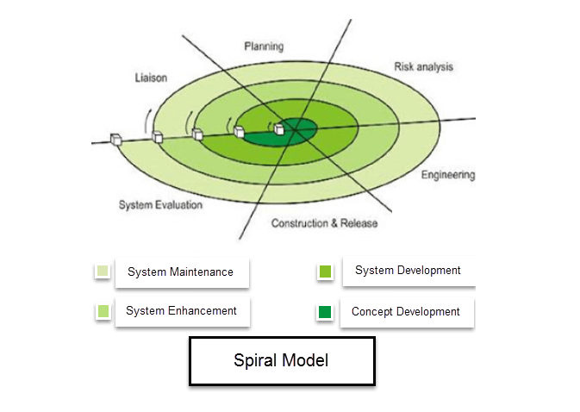
As “Desired Cover” is a project that involves production of customized mobile covers as per customer’s desires. The designing and customization of design requires that consumer’s feedback of product should be incorporated during prototyping phase, as mobile accessories market have very short room for the new comers and consumer’s expectations for any new mobile accessories production company, are very high, moreover “Desired Covers” will operate through digital channels i.e. Website & social media pages, as per market analysis about consumer’s demand for digital stores are very clear that a website should:
- Consist of a User friendly UI.
- Should operate on “Convenient Input operations” (Touch, digital pens etc.)
- Website should be vibrant and attractive.
To comply with these market and consumer’s requirements it is necessary that we take feedback from consumers and our potential customers regarding our prototype(s) (website & social media pages) on every stage before commercial launch of the desired Covers.
Spiral model allows for the building of a highly customized product, and user feedback can be incorporated from early on in the project. But the risk you run is creating a never-ending spiral for a project that goes on and on.

Work Breakdown Structure
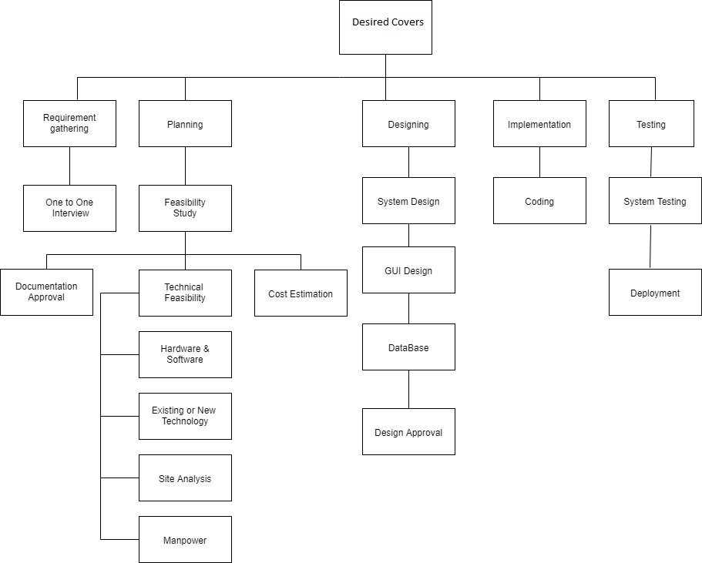

Roles & Responsibility Matrix
- Requirements
- Gathering requirements
  - Survey Result
1.2. Investigate other systems
2. Document the requirement
- Design
- Alternative graphical design
- Prototyping
- Finalize Functional Design
- Testing
- Unit Testing
- Integration Testing
- Implementation
- Installation
- User support documentation
- User training
- Installation testing and verification
- Maintenance.
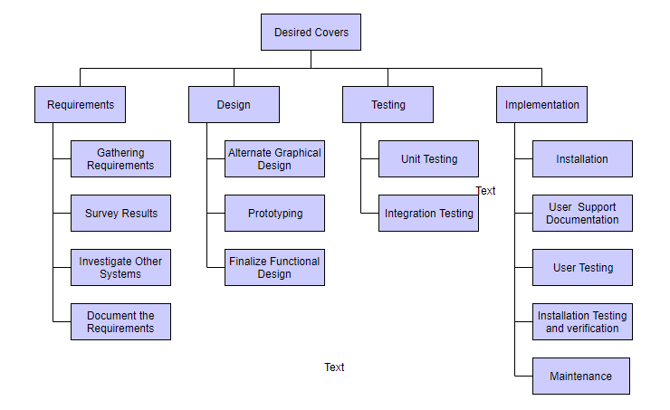

- WBS # | WBS Deliverable | Activity # | Activity to Complete the Deliverable | Duration  (# of Days) | Responsible Team Member(s) & Role(s)
1 | Project Plan | 1 | Research on  requirements  problem statement | 8 | Najam  Sahazaib
2 | Software Requirement Specification Document | 2 | Requirement Elicitation  Requirement Analysis | 16 | Najam  Sahazaib
3 | Architecture Diagram | 3 | Architecture Design | 7 | Najam  Sahazaib
4 | Use Case Diagram | 3 | UML Design | 3 | Najam  Sahazaib
5 | Fully Dress Use Case | 3 | UML Design | 3 | Najam  Sahazaib
6 | Domain Model | 3 | UML Design | 2 | Najam  Sahazaib
7 | Class Diagram | 3 | UML Design | 2 | Najam  Sahazaib
8 | Operation Contracts | 3 | UML Design | 5 | Najam  Sahazaib
9 | Sequence Diagram | 3 | UML Design | 5 | Najam  Sahazaib
10 | Activity Diagram | 3 | UML Design | 2 | Najam  Sahazaib
11 | State Machine Diagram | 3 | UML Design | 2 | Najam  Sahazaib
12 | Entity Relationship Diagram | 3 | Database Design | 4 | Najam  Sahazaib
13 | Software Design Document | 3 | Architecture Design  UML Design | 25 | Najam  Sahazaib
14 | User Interface | 3 | User Interface Design | 8 | Najam  Sahazaib
16 | Desired Covers  System | 4  5  6 | Implementation  Testing  Deployment | 144 | Najam  Sahazaib

Gantt chart
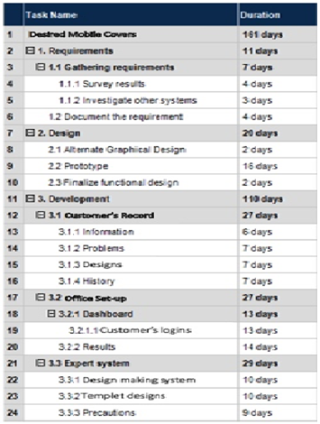

Report Outline
- This report define the phases of requirement gathering, documentation, development environment, E-drawing environment, implementation and expected deliverables as well as presentation layer, business logic layer, data management layer, physical layer and clearly define the role and responsibilities of each person on each phases for the successful development of project.

- Introductions
Provide an introduction and discuss brief descriptions of background, motivation and challenges. Goals and objectives, literature review and existing solution, gap analysis proposed solution, project plan, WBS, roles and responsibilities matrix and provide a project Gantt chart.

- Software Requirement and Specifications
Provide an introduction and discuss the brief description of Software Requirement Specifications, product perspectives and functions also discuss Operating Environment, Design and Implementation Constraints, User Documentation, Assumptions and Dependencies, User, Hardware, Software, Communications and Other Non-functional, Performance, Safety, Security, Software Quality Attributes and Business Rules of the project.

- Use Case Analysis
Provide a visual representation of system use cases their description tables and detailed analysis.

- System Design
Provide UML based visual representation of Architecture Diagram, Domain Model, and Entity Relationship Diagram with the data dictionary, Class Diagram, Sequence / Collaboration, Diagram, Operation contracts, Activity Diagram, State Transition Diagram, Component Diagram and system Deployment Diagram for a better understanding of system architecture.

- Implementation
Provide knowledge of Important Flow Control/Pseudo codes, Components, Libraries, Web Services and stubs, Deployment Environment, Tools and Techniques, Best Practices / Coding Standards, Version Control for the implementation of the project.

Chapter 2

Software Requirement Specifications

Chapter 2: Software Requirement Specifications

Introduction
Provide an introduction and discuss brief descriptions of background, motivation and challenges. Goals and objectives, literature review and existing solution, gap analysis proposed solution, project plan, WBS, roles and responsibilities matrix and provide a project Gantt chart.

Purpose
The main objective of this project is to provide desire covers for every one anywhere in town with the help of given template designs moreover; we are providing freedom to create our own design on this platform. Aanyone can place any type of image on their covers.
We are providing your order at your doors steps on just a few clicks.

Document Conventions
This document use following Conventions Convention | Description
Main Section Titles | Font: Calibri Face: Bold Size: 12  Line Spacing 1.5
Sub Section Titles | Font: Calibri Face: Bold  Size: 12
Other Text Explanations | Font: Calibri Face: Normal  Size: 12
DB | Database
ISP | Internet Service Provider
UML | Unified Model Language
HTTPS | Hyper Text Transfer Protocol Secured
Html | Hypertext markup language
SSL | Secure Socket Link
API | Application Programming Interface
TLS | Transport Layer Security
SSL | Secured Socket Layer
Php | Pre-processor hypertext
MY-SQL | Microsoft Structured Query Language
SRS | Software Requirement and Specifications
DOB | Date of Birth
KB, GB | Kilobyte, Gigabyte

Intended Audience and Reading Suggestions
This system has been implemented under the guidance of a supervisor and an understanding team i.e.,
- System analysts
- System architects
- Project managers
- Developers
- Users
- Documentation writers
Following are reading suggestions for the intended audience to read their respective portion to easily understand the document in each type:

Audience type | Reading Suggestions
System analysts | Chapter 2: SRS  Chapter 3: Use case Analysis
System Architects | Chapter 4: System Design
Developers | Chapter 2: SRS  Chapter 4: System Design Chapter 5: Implementation
Project managers | Complete Document
Documentation writers | Complete Document
User Manuals | Appendix

Product Scope
Desire Covers will be a web based online store which will work as time saver for mobile phone users as it will enable customers to buy a mobile cover as per their own required design, quality & all these features containing mobile cover will be provided at customer’s doorstep.
Just like any other online store, “Desire Covers” will enable the customer to browse the firm's range of products and services regarding mobile covers, view photos or images of the printable designs for covers, along with information about the cover specifications, features and prices. Desire Covers will enable shoppers to use "search" features to find covers of specific models or brands.
Website of Desired Covers will work as a channel & forum of demands so every customer who wants his mobile cover have to visit this website so this will help us to achieve our secondary revenue stream which is digital marketing. As visitors of this website will be mobile users so we will provide digital marketing to different mobile accessories production companies.

References
https://www.printshoppy.com/
https://phonecase.pk/
https://www.pickshop.pk/product/products/mobile-cases/custom-mobile-cover/
And many more…

Requirement Gathering

Technique selected
For our project we are going use three techniques, all these techniques are one of the well-known techniques for gathering requirements and all techniques are being used for a long time. These techniques are enlisted below:

Observation
By observing users, an analyst can identify a process flow, steps, pain points and opportunities for improvement. Observations can be passive or active (asking questions while observing). Passive observation is better for getting feedback on a prototype (to refine requirements), where active observation is more effective at getting an understanding of an existing business process. Either approach can be used.

Active Observation:
While in active observation, the consultant will ask the user questions during the session. Observations should always be done without bias, as in other requirement gathering techniques, the analyst must simply record what is presented to them, and avoid making comments on whether they believe what is correct or not. A checklist can provide to be useful, with key points already noted and the consultant verifying events on their list. For example, they can check if a user uses certain features, the frequency of events, triggers that cause different uses. Taking detailed notes is helpful in recording unexpected events. There may be events unknown to the analyst ahead of time, they can be captured by taking notes of the event and why it occurred. Video recorders may be used, but must always be approved with the user and their company.

Focus Group:
A focus group is a gathering of people who are representative of the users or customers of a product to get feedback. The feedback can be gathered about needs/opportunities/ problems to identify requirements, or can be gathered to validate and refine already elicited requirements. This form of market research is distinct from brainstorming in that it is a managed process with specific participants.

Brainstorming:
Brainstorming is a group creativity technique by which efforts are made to find a conclusion for a specific problem by gathering a list of ideas spontaneously contributed by its members.

Reason of Selection
- In other words, brainstorming is a situation where a group of people meet to generate new ideas and solutions around a specific domain of interest by removing inhibitions. People are able to think more freely and they suggest as many spontaneous new ideas as possible. All the ideas are noted down without criticism and after the brainstorming session the ideas are evaluated.

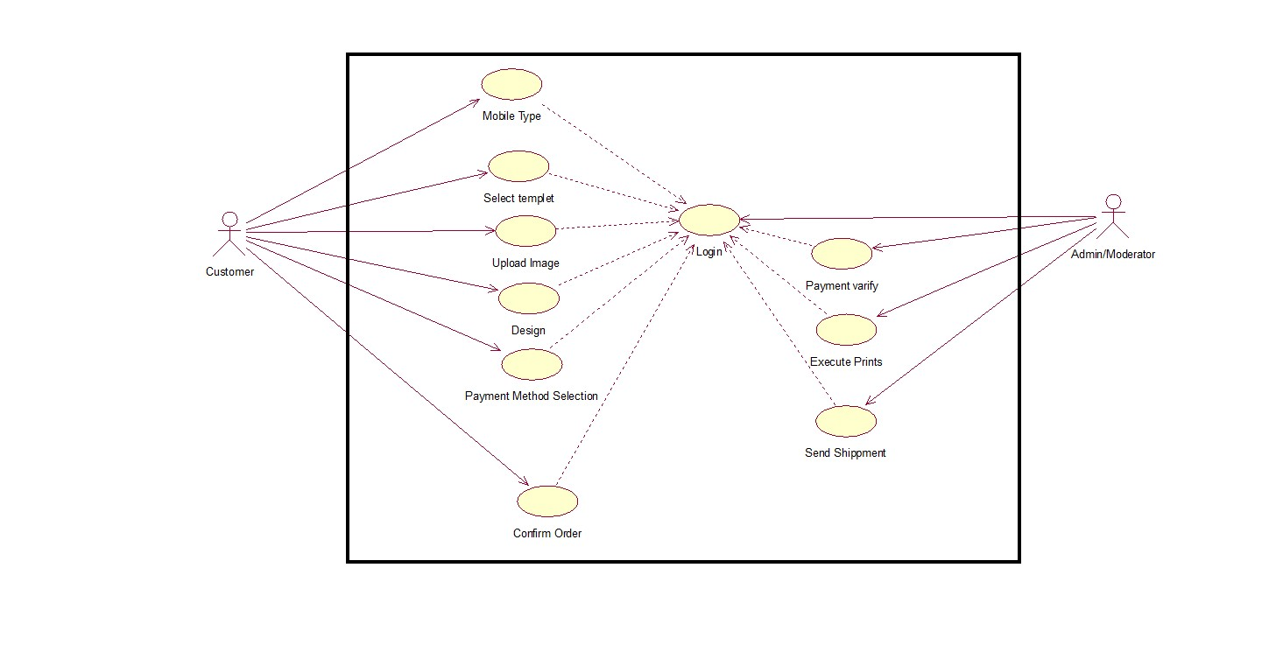
User Classes and Characteristics

Operating Environment
Hardware platform: PC/Laptop/Cellphone/Tablet PC’s.
Operating system and versions: Windows 7/8/8.1/10.
Applications/Web Browsers: Google Chrome.

Design and Implementation Constraints
Following are the design and implementation constraints for website Desired Covers:
- Regulatory policies: Global Ethical Cyber rules
- Hardware limitations: The response time of less than 1 minute, Minimum RAM 2GB
- Interfaces to other applications: Web API’s communications

Tools and techniques
Implementation Tools | Implementation Methodology
MS Word 2013 | Documentation production.
Draw.io | UML Modelling and diagrams.
Notepad | Hypertext markup language used to create document on world wide web.
Notepad++ | Hypertext preprocessor is scripting language that is especially suited to server-side web development.
MY SQL | MY SQL is free open source data base management system. A (DBMS) that manages database and connect them to software.
Neo load | Online testing tool to test the system functionality.
WBS schedule Pro | For creating work break-down structure.

- Language requirements: HTML5, CSS, JavaScript, Bootstrap, PHP-5
- Communications protocols: HTTPS protocols, ISP, Web Services
- Security considerations: Secure data transfer over HTTPS protocols.
- Programming standards: Maintainable well commented Code.

User Documentation
1. User manual attached appendix.
2. Admin User Documentation attached as an appendix.
3. Testing Report attached as an appendix.
4. Final Report.

Assumptions and Dependencies
Desired Covers is a web-based software. Due to its web-based nature; following are the
Assumption and dependencies that could affect the system requirements and limits its
Functionality:
- It will be deployed on a web server so due to unavailability of web server system may not be available during downtime or server maintenance activities.
- Devices with outdated systems and digital certificate may not be able to access the system.
- Common internet issues may also cause system components out of reach.
- Hardware and software not meeting the above requirements may not support the system functionality.
- Application and other software components may not work properly on different devices.
- An unexpected change in the major component of the project may also affect system functionality.

External Interface Requirements (For Networking)

User Interfaces
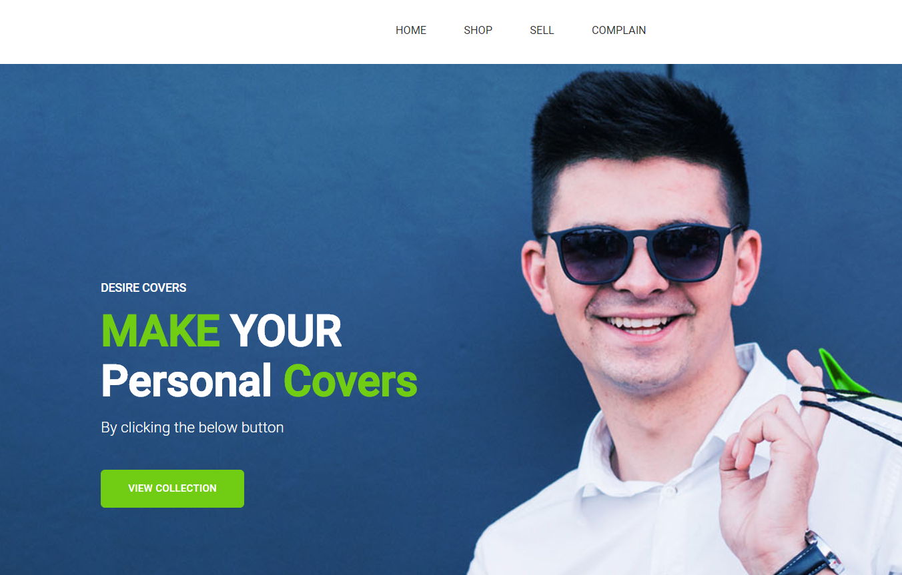

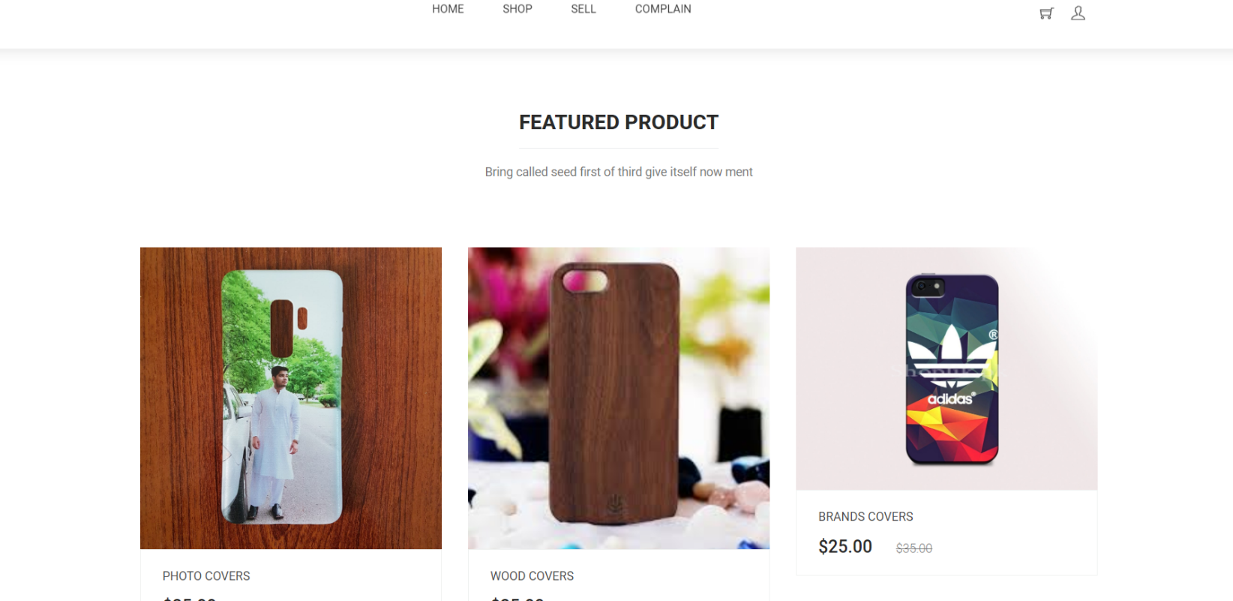
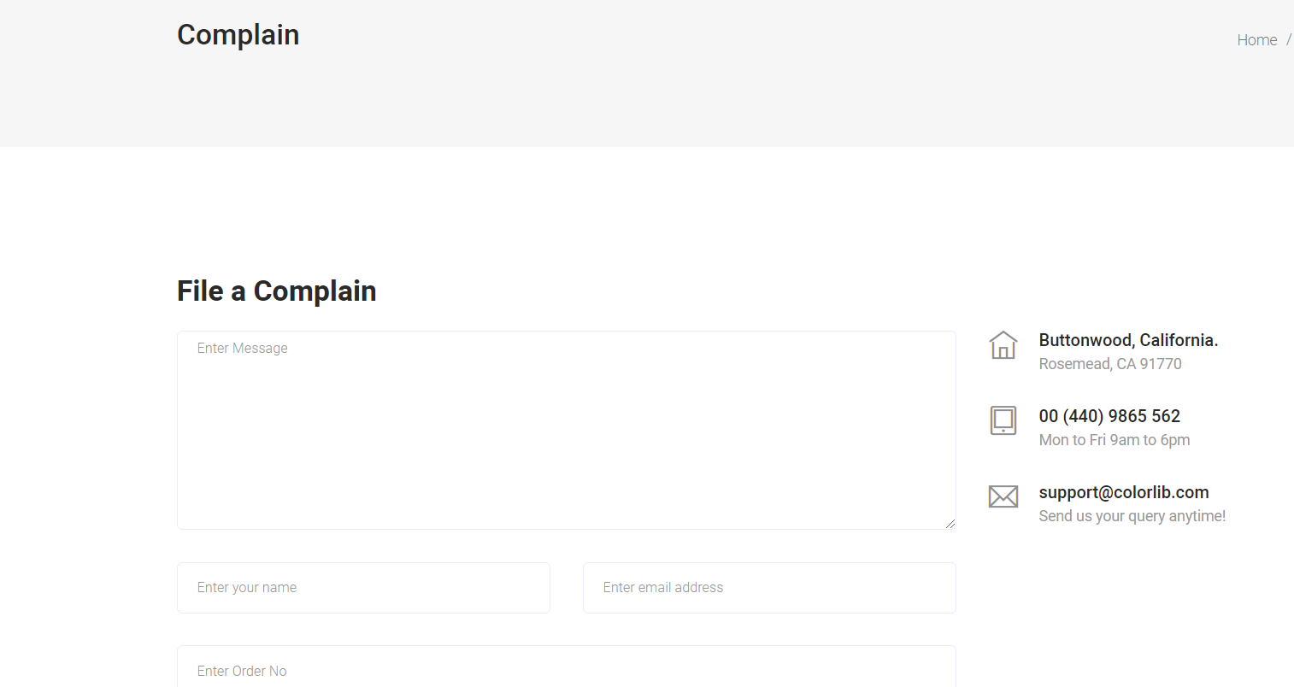

Hardware Interfaces (if hardware included)
Hardware interface:

- Workstations:
  - Desktop computer
  - Laptop
  - Tablet PC
- Server

Workstations:
It refers to the hardware that holds everything that customer needs to perform their actions. These include:
- Desktop:
It consists of CPU, monitor, keyboard and mouse. It isn’t a portable device. It works with a number of network arrangements.

- Laptop:
It is a fully functional computer that is small enough to be portable. It can also be used as a desktop machine. It can take advantage of wireless as well as traditional networks. Laptop PC with the minimum i3 processor and 2 GB RAM is used to implement an online system.

- Tablet-PC:
It is as powerful as a PC but it doesn’t require a keyboard or a mouse instead it use stylus/pen. They also have handwriting recognition tools that can detect poor handwriting accurately. Tablet PC with the minimum quad-core processor and 1 GB RAM is used to implement in an online system.

Server:
There are basically two types of servers i.e., web based and client-based server. It is purchased depending upon the size of the website. In online server dependency is very high so, we should purchase it keeping all facts and figures in mind.
Hardware Requirements for Desired Covers web system:
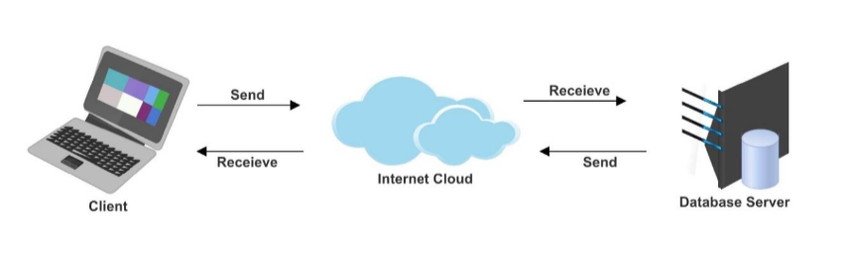

Software Interfaces
- Software components:
Implementation Tools | Implementation Methodology
MS Word 2013 | Documentation production.
Draw.io | UML Modelling and diagrams.
Notepad | Hypertext markup language used to create document on world wide web.
Notepad++ | Hypertext preprocessor is scripting language that is especially suited to server-side web development.
MY SQL | MY SQL is free open source data base management system. A (DBMS) that manages database and connect them to software.
Neo load | Online testing tool to test the system functionality.
WBS schedule Pro | For creating work break-down structure.

- Language: HTML5, CSS, JavaScript, Bootstrap, PHP-5
- Databases: MySQL
- Browser Support: Chrome / Firefox
- Graphic: Corel x6

Communications Interfaces
- Web browser: Google Chrome.
- Network server communications protocols: HTTPS, FTP and TCP/IP for communication over the internet.
- Electronic forms: Web form in PHP.
- Communication standards: HTTPS, TCP/IP and FTP communication standards should be implemented.
- Communication security: HTTPS communication security will be based on Secured Socket Layer or Transport Layer Security.
- Encryption issues: HTTPS communication security based on Secured Socket Layer (SSL) or Transport Layer Security (TLS) may not achieve over public internet networks

Functional Requirement
Hardware requirements
- Internet connection
- Computer
- Laptop ( pc, tablets, pads)
- Mobile phone ( smarts phones)
- Printer

Software requirements
- Operating system ( windows, mac, Linux)
- Browser( Html5 supported or latter)
- Data base server( My sql, oracle)
- Desire cover shall be network based.
- Customer shall login.
- Customer will selected create or upload design.
- Customer will describe phone model and size.
- Customer confirm cover.
- Customer will selected payment method (online banking, credit, cellular payments method)
- Customer will confirm order.
- Admin shall login.
- Admin will receive selected design.
- Admin will confirm orders.
- Admin will proceed order.

Other Non-functional Requirements:

Performance Requirements
Following are the performance requirements for our system Desired Covers:
- Response Time: 0.8 is the limit at which user feels the system is responding instantaneously. So the software should respond within 0.8 seconds.
- Workload: Sever load distribution over distributed environment during heavy user’s traffic.
- Measurement Period: The period over which the response time is measured. This is particularly important where workload varies over the day.

Safety Requirements
- Data should be highly secured i.e., encrypted sensitive data.
- Always updated and backed up daily.
- There should be nothing to install. Just login with the web browser you already have.
- Alert notification in case of any miscellaneous activity.

Security Requirements
Following are the security requirements for online system:
- Sessions will be used to manage user sessions to implement security for an account.
- HTTPS communication security based on Secured Socket Layer (SSL) or Transport Layer Security (TLS) may or may not achieve over public internet networks.

Software Quality Attributes
Following are the quality characteristics of the product that will implement to achieve system quality goals.

- Adaptability: Adaptive to different operating environment
- Availability: 24*7 availability
- Correctness: Content will be short, legible and correct.
- Flexibility: Can be used on multiple hardware’s like Laptop PC Tablet PC and Smart Phones
- Maintainability: System will be easy to maintain for other.
- Reliability: System must be reliable for the user.
- Reusability: Can be reused for different but for the same purpose.
- Robustness: Fast recovery from downfall.
- Testability: System should be easy to test.
- Usability: Easy to use and understand for the user of the system.

Business Rules
Following are the business rules for Design covers:
- The website should load quickly.
- Security from hackers is important.
- Use .com to access the system.
- Unless there really is no alternative don’t use a dash/hyphen in between words in a domain name.

Other Requirements
    - Data
- Data access
  - Determine how the data will be accessed for index selection
- Source
  - Uploads or downloads from an existing system
  - Data entry by internal users

    - Database Requirements
- Database configurations
- Storage configurations
- The hosting server must support the MS SQL 2014 database architecture.

    - Legal requirements:
- Legal requirements that should fulfil by the Cyber act of Pakistan National Law and Pakistan Telecommunication Authority.

Chapter 3

Use Case Analysis

Chapter 3: System Analysis
By observing users, an analyst can identify a process flow, steps, pain points and opportunities for improvement. Observations can be passive or active (asking questions while observing). Passive observation is better for getting feedback on a prototype (to refine requirements), where active observation is more effective at getting an understanding of an existing business process. Either approach can be used.

Use Case Model

3.2. Fully Dressed Use Case:

Register Customer:
Use case name: | Register Customers.
Scenario: | Customer can register himself by entering his details in the system.
Brief description: | Customer will enter the information in the form to register himself. He provides his name, email, password, etc., and general information to get them registered.
Actors: | - Customer.
Stake holders and interests: | - Customer can register himself in the system.
Pre-conditions: | - Customer opens the form to register the himself in the system (In order to register, customer should not already have an account with the same email).
Post-conditions: | - “Customer registered successfully” message will appear.  - Customer will be registered in the system and can use the system.  - He selects the mobile phone model and customize his cover design and can place order.
Flow of activities: | Actors: | System:
Flow of activities: | - Enter required information.  - Clicks on the submit button.  - Account created. | - Information recorded in DB.  - Approved the registration.  - Customer registered.
Success scenario: | After the customer enters the information and clicks on the submit button, it is recorded in database and the customer’s account is created.
Failure scenario: | Customer enters wrong format for email/ph.one_no.  Required information is left blank.  Aaccount is already registered.

Login:
Use case name: | Login.
Scenario: | Registered User will login to his/her to account to use the system.
Brief description: | User logged in the account by providing his email and password to avail the services.
Actors: | - Admin.  - Customer.
Stakeholders and interests: | - User can manage his account or utilize the service.
Pre-conditions: | - User should be registered.
Post-conditions: | - User can login to his account. And avail the services.
Flow of activities: | Actors: | System:
Flow of activities: | - User enters email and password.  - Account logged in. | - System verifies it and gives access to the account.  2.2. System allows user to manage his account and utilize services provided.
Success scenario: | After entering email and password user would be able to access his/her account and can utilize the services provided.
Failure scenario: | User enters incorrect email or password. User can also forget the password that leads to a failure scenario.

- Select Mobile Brand:
Use case name: | Select Brand.
Scenario: | User will select the brand of his mobile.
Brief description: | User will select the brand of his mobile to see the already created template or to customize design according to the structure of the mobile
Actors: | - Customer. .
Stakeholders and interests: | - User login to his account and selects the model to create design according to his desire.
Pre-conditions: | - User should be logged in.
Post-conditions: | - User selects the model of the selected brand and customize his willing design.
Flow of activities: | Actors: | System:
Flow of activities: | - User enters the model.  - Template occur according to that model. | - System verify the model entered and return a template accordingly.
Success scenario: | After entering the model a template occur for the user to customize design accordingly.
Failure scenario: | Server not loading or user enters a wrong model or the model isn’t existing.

- Select Template:
Use case name: | Select Template.
Scenario: | User will select the template to design the mobile cover.
Brief description: | User will select the template of the specific model and start to design it as his desire.
Actors: | - Customer. .
Stakeholders and interests: | - User select the template to start designing.
Pre-conditions: | - User selects the mobile model.
Post-conditions: | - User starts designing the mobile cover by selecting the suitable template.
Flow of activities: | Actors: | System:
Flow of activities: | User enters the model and selects template. | System verifies the model and returns the template accordingly.
Success scenario: | After selecting template the user can upload images or design cover using different features.
Failure scenario: | Server not working properly.

- Upload Image:
Use case name: | Upload Image.
Scenario: | User can also upload image that he wants to print on his mobile cover
Brief description: | User can also upload image of his desire that he wanted to be printed on his mobile cover.
Actors: | - Customer.
Stakeholders and interests: | - User uploads image and gets it printed on the mobile case.
Pre-conditions: | - User should select the model and template
Post-conditions: | - User can place the order after designing.
Flow of activities: | Actors: | System:
Flow of activities: | - User uploads image.  . | System saves the image on the case as done by the user.
Success scenario: | After uploading the image, user can see his mobile’s final look on finalizing the cover designing.
Failure scenario: | Server not working properly.

- Place order:
Use case name: | Place order.
Scenario: | After designing the case fully, the user will now place the order.
Brief description: | User will place the order after designing the case.
Actors: | - Customer. .
Stakeholders and interests: | - User will place the order.
Pre-conditions: | - User completed the design.
Post-conditions: | - User can place the order.
Flow of activities: | Actors: | System:
Flow of activities: | - User completed the design phase.. | 2.2. System saves the design which is further processed for the cover development.
Success scenario: | After completing the design user successfully places order.
Failure scenario: | Server not working properly.

Chapter 4

System Design

Chapter 4: System Design
This document completely describes the system at the architecture level, including subsystems and their services, hardware mapping, data management, access control, global software control structure, and boundary conditions. The SD defines a virtual machine that implements all requirements in the Rapid Application Development (RAD), and it should provide a foundational guide for further implementation details all the way to an executable solution.

Architecture Diagram
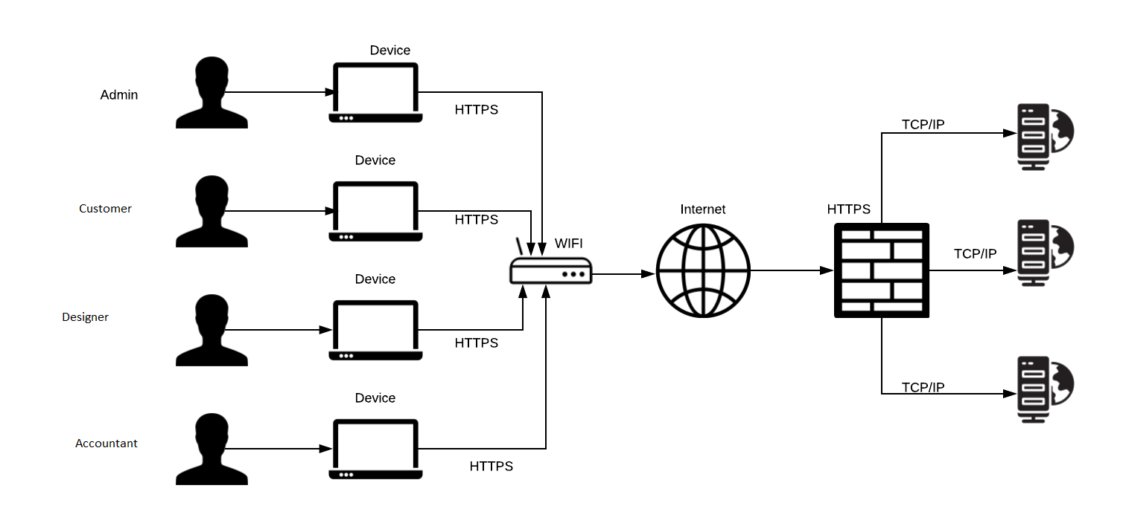

Domain Model
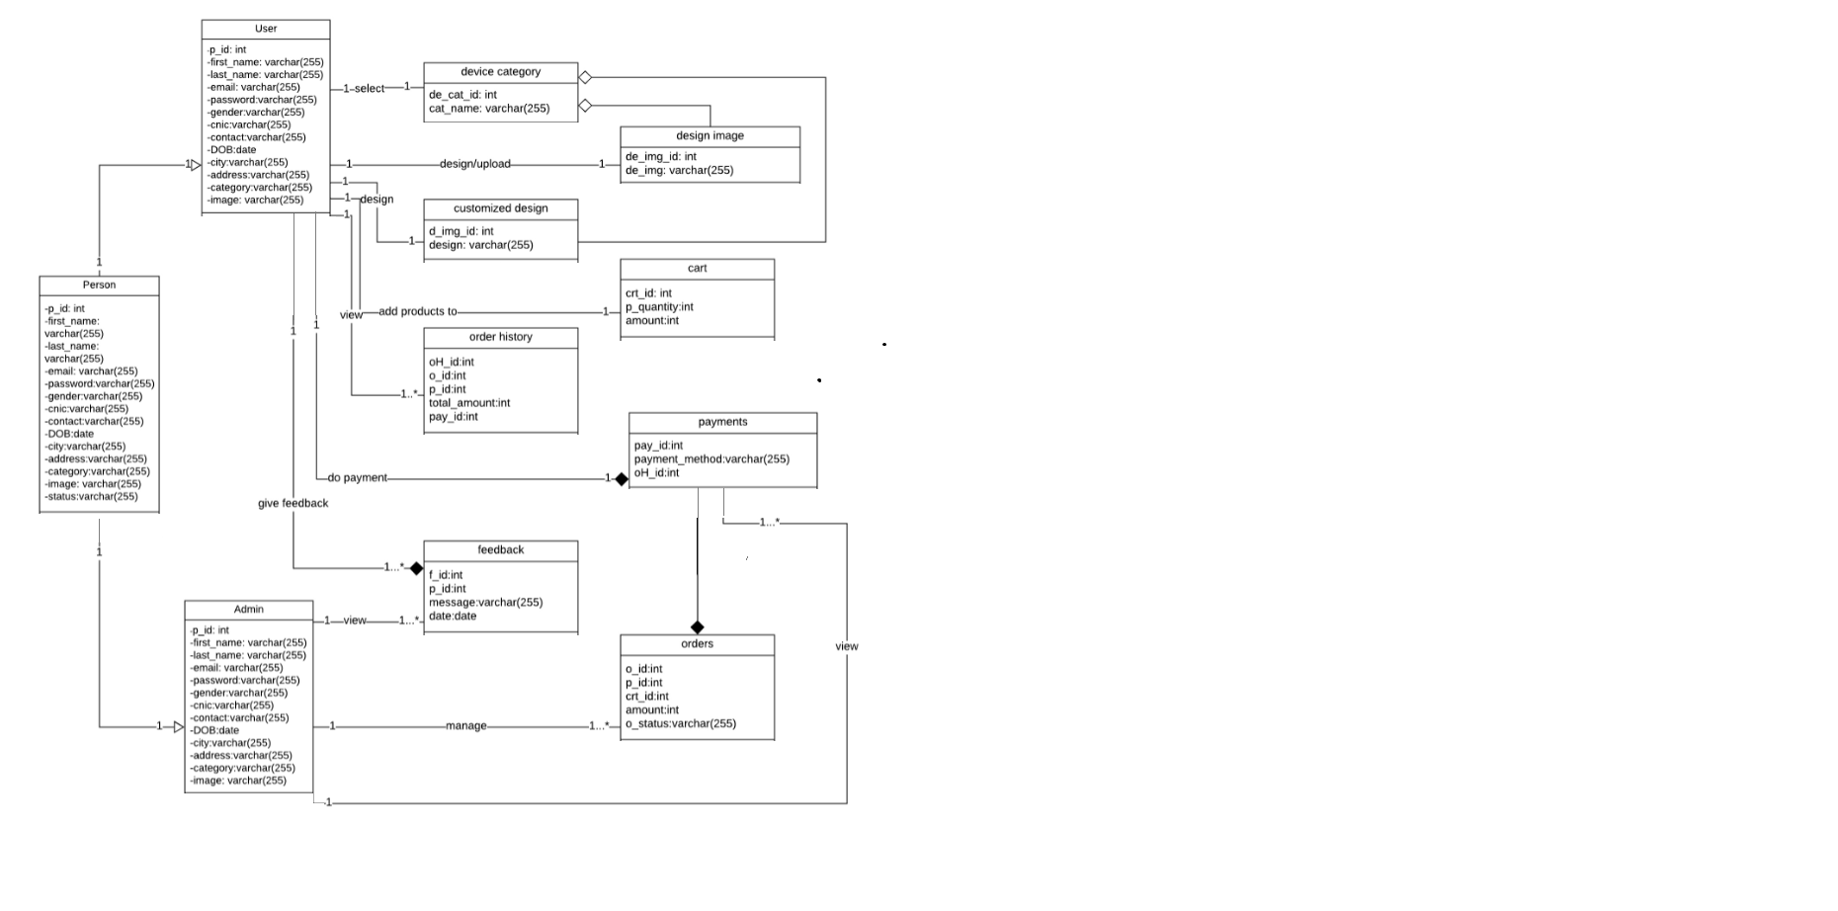

Entity Relationship Diagram with data dictionary
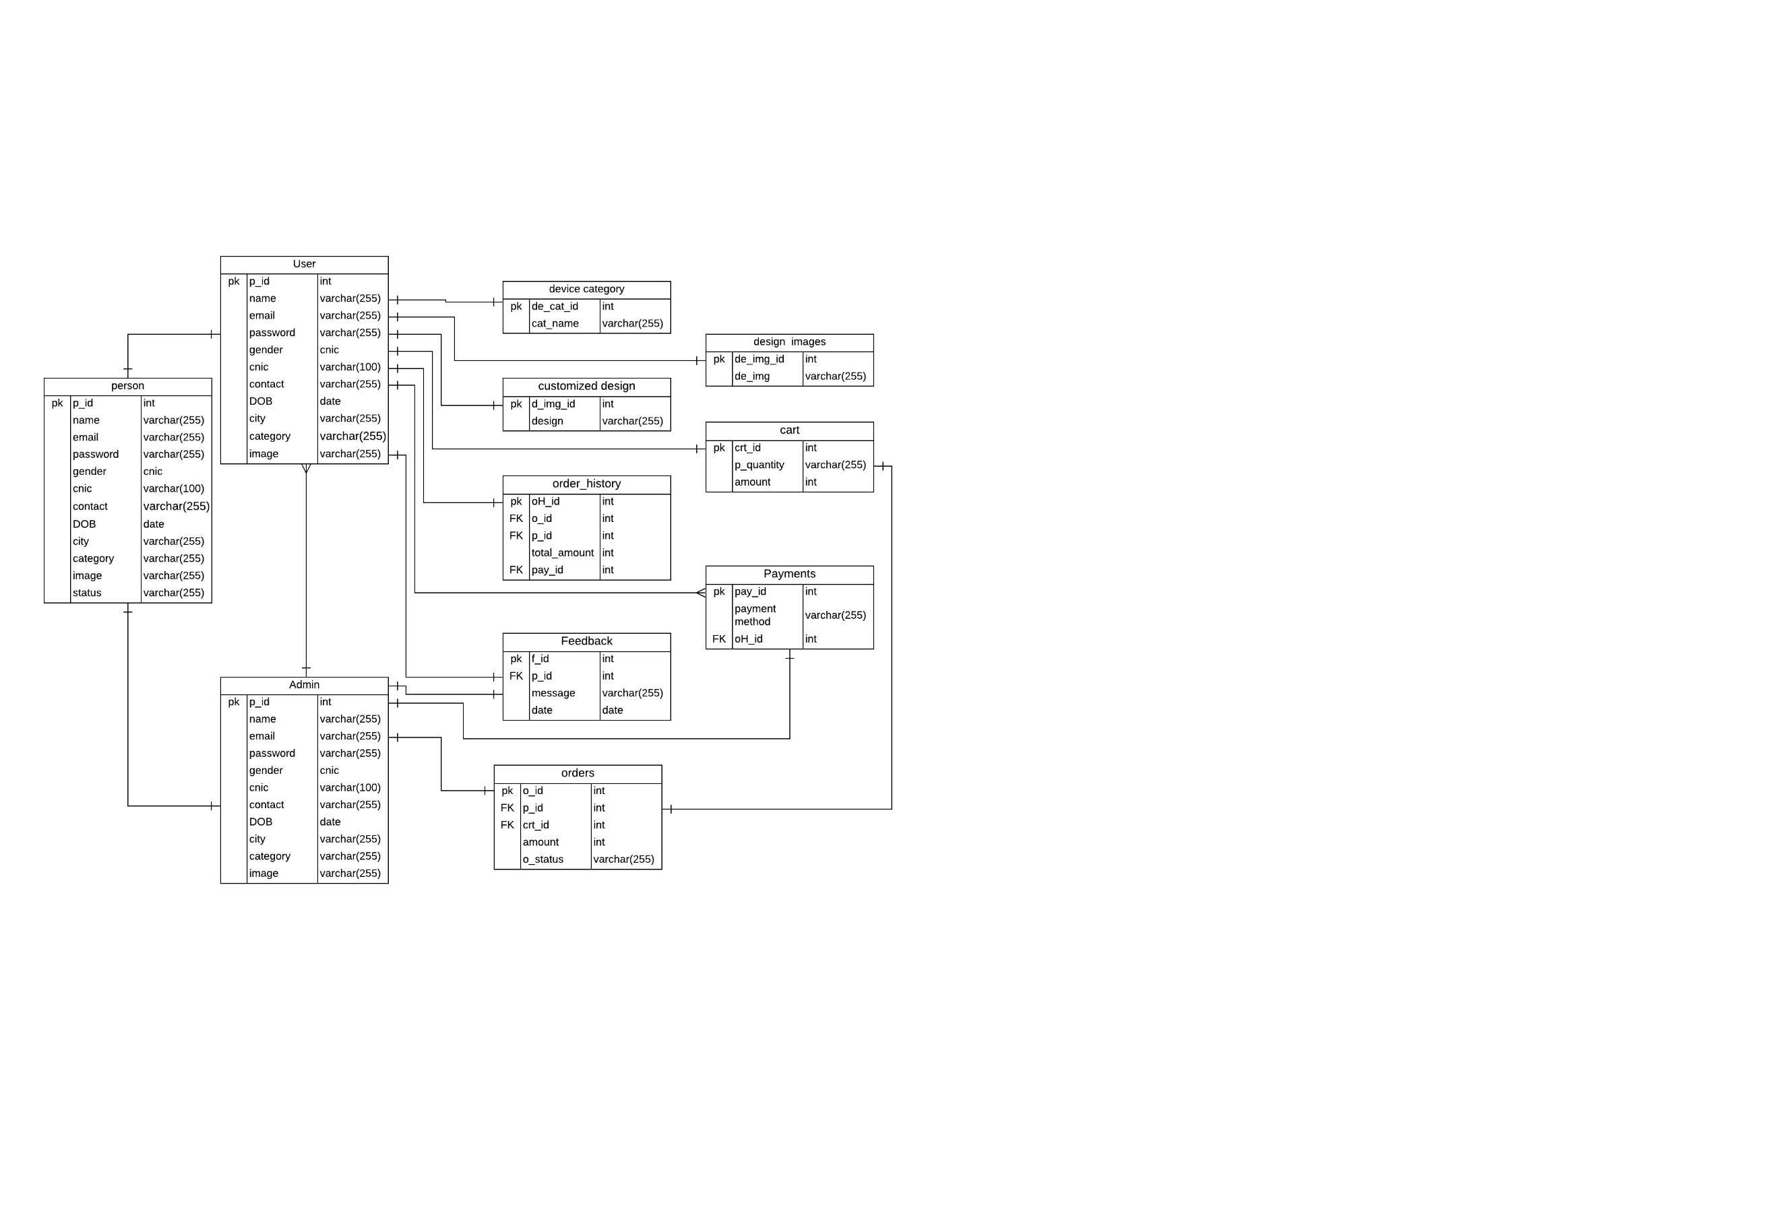

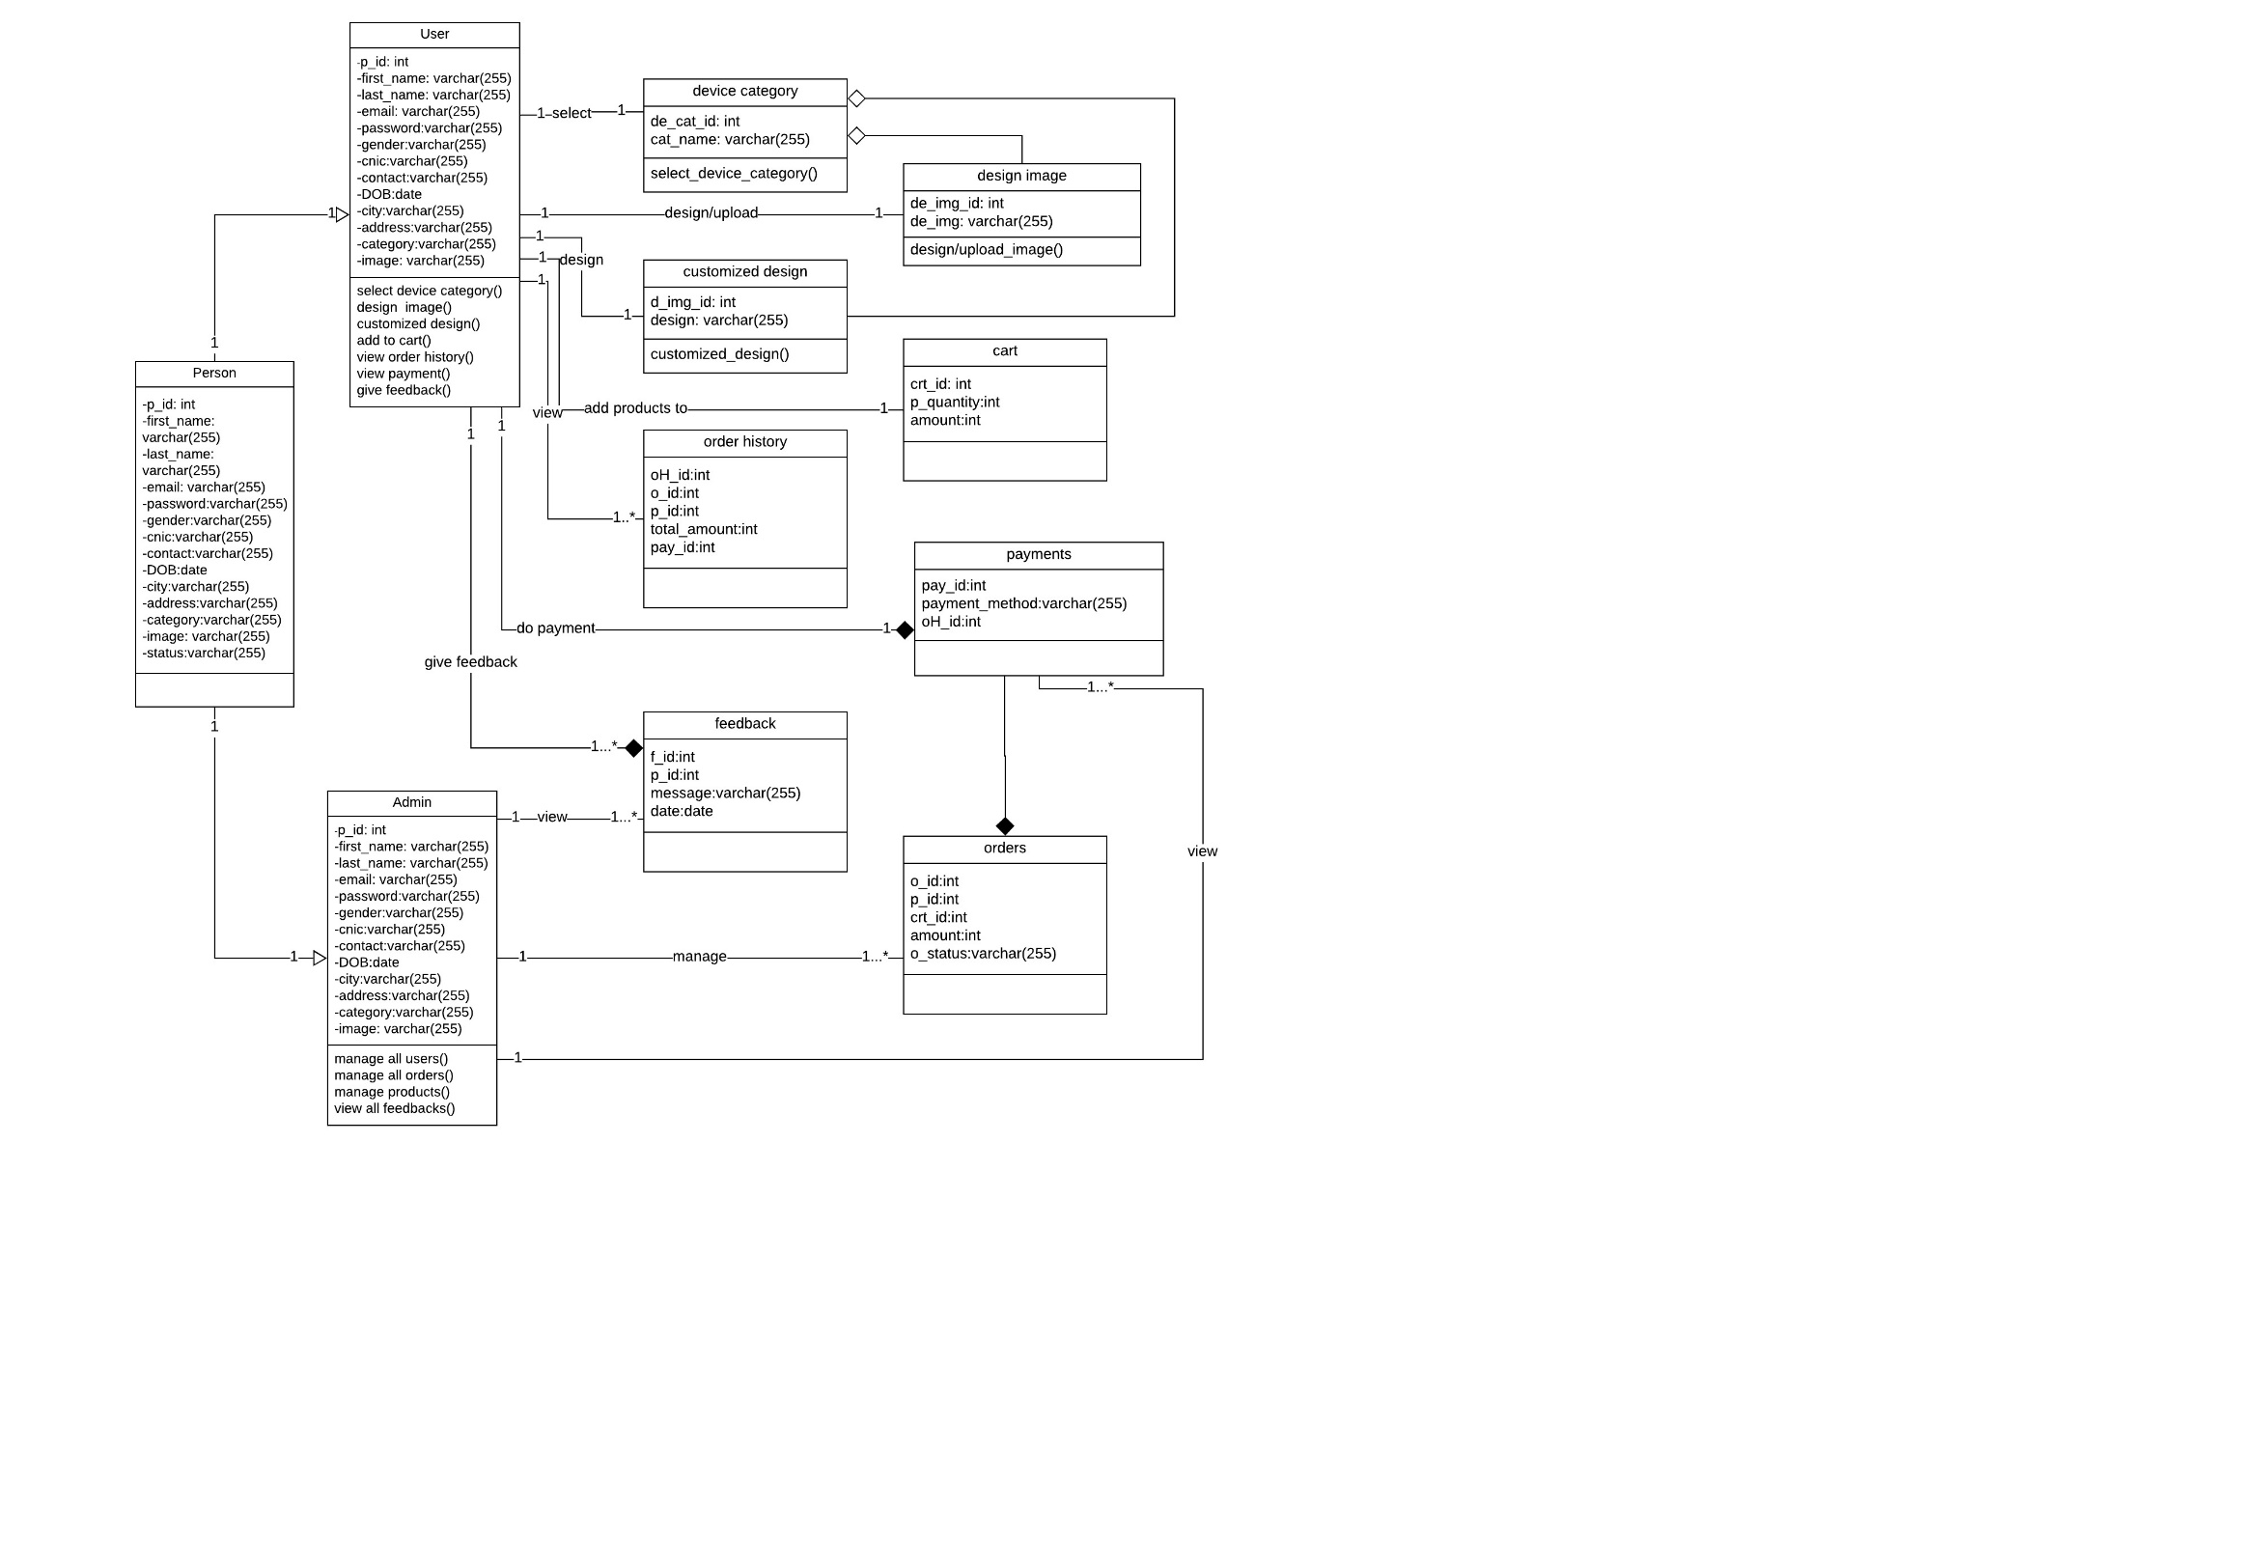
Class Diagram

Sequence / Collaboration Diagram
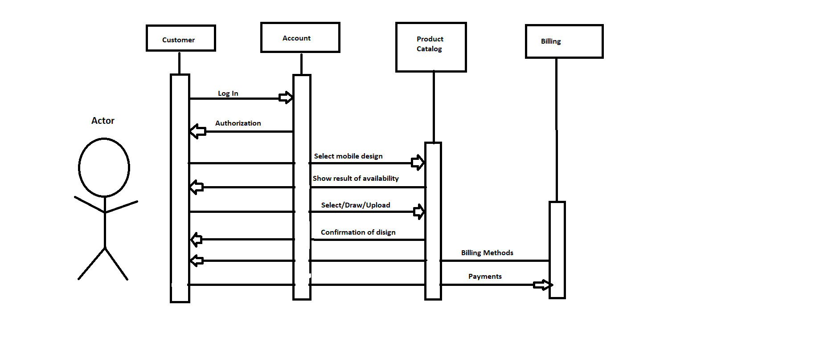

Activity Diagram
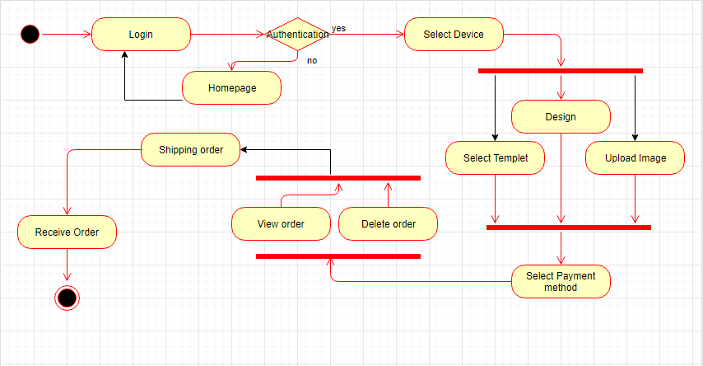

State Transition Diagram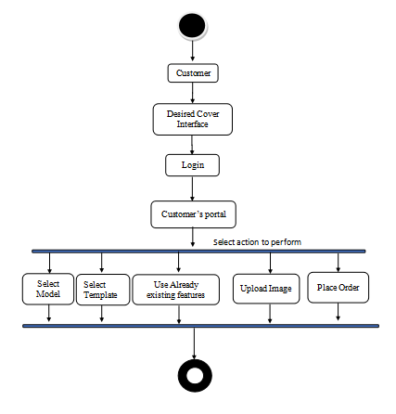

Component Diagram
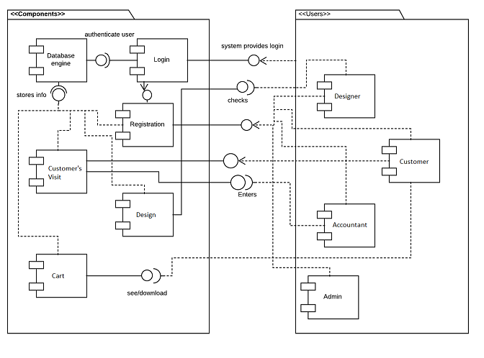

Deployment Diagram
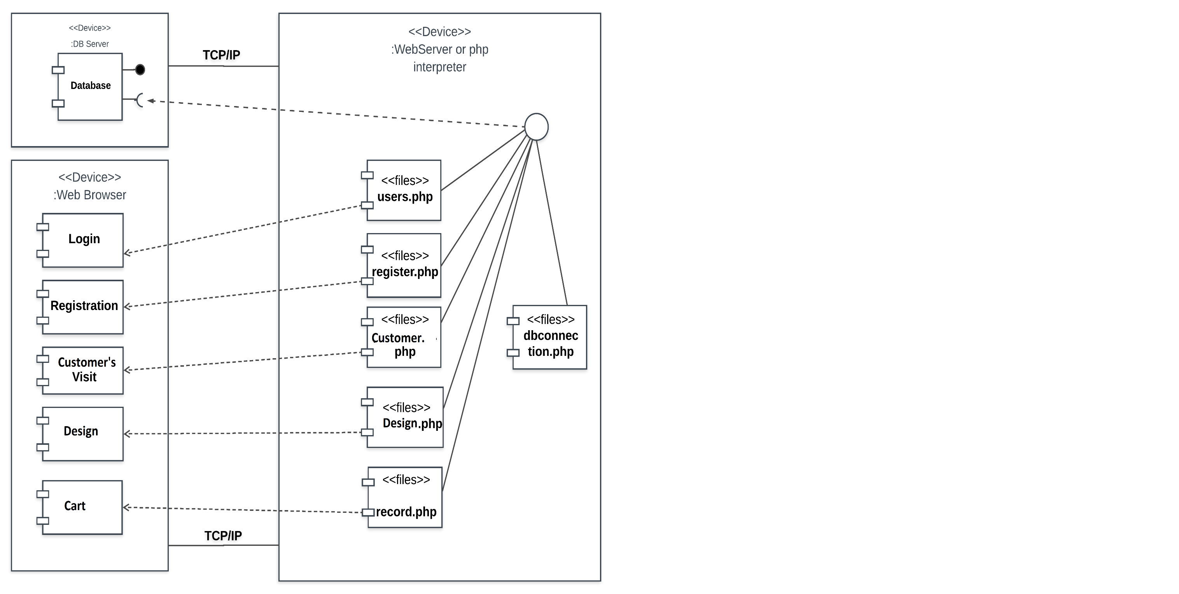

Data Flow diagram 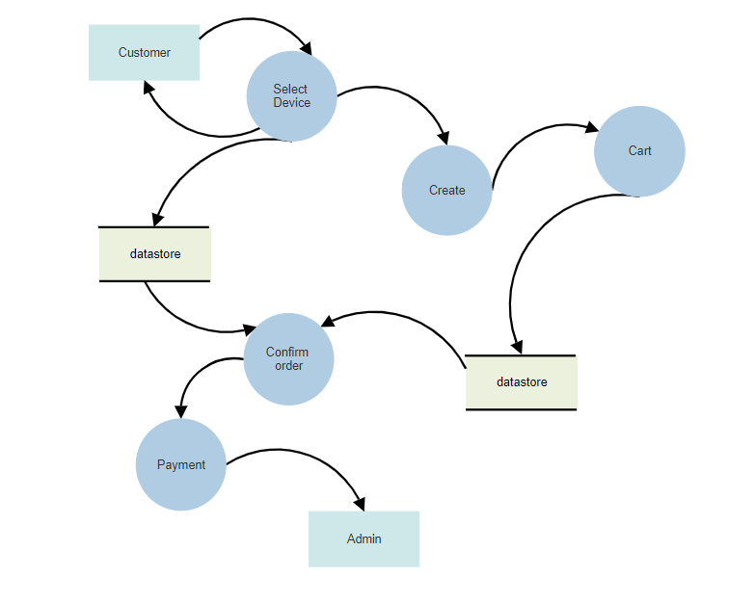

Chapter 5

Implementation

Chapter 5: Implementation
This is a task with the goal to build up a cover where a user can edit content with the help of this site we provide a user simplest way to get their own website within just few steps without confusing interface and ads interference. Our solution isn't made for professional web developers it’s made for anybody with a desire to have their own little corner of the internet. No designers, developers, or webmasters necessary. A user having less coding knowledge can easily add, edit and format the website’s content.

Important Flow Control/Pseudo code

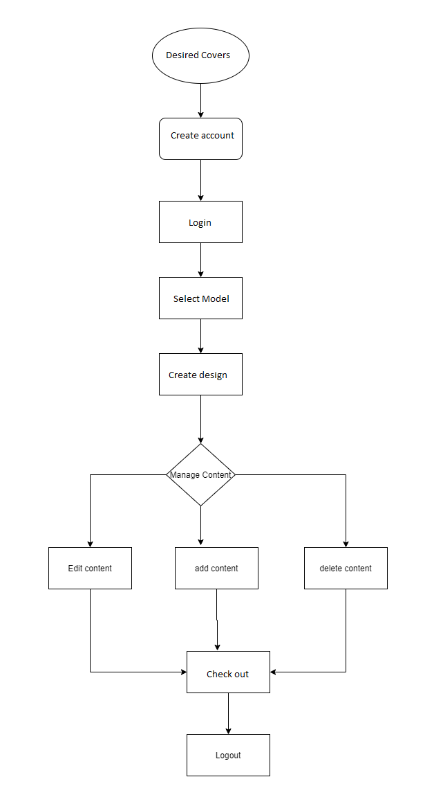

Components, Libraries, Web Services and stubs
Components:
1. Properly Structured Website
Desired Covers website application is easy to use. If a user’s wants to get a custom made cover, they can easily edit and get. If a user’s can view Design they can easily view. If users want to choose by choice they also can chose according to their desire. Our website has a simple structure, with the most important pages accessible from the main tittle bar. My website is very secure and easy to use.
2. User Friendly
Desired Covers website application is user friendly website. Every person can easily use all the features of the website. User can easily login and edit content and publish just in clicks.
Languages and Libraries:
Bootstrap4, PHP, JavaScript, HTML, CSS
Web Services
- 24-hr access
- Users can edit content delete content and add content from their chosen Design.
- Editor can make alteration after publication.

Deployment Environment
Here we need a domain on which the Desired Covers will exists and through the domain,
People will access the website
Browser
- Safari
- Chrome
- Firefox
- MS edge
Server
- Bandwidth: 6GB
- Space: 500MB

Tools and Techniques
- PHP
- It is a server-side scripting language designed for Web development. It provides latest
- Functionalities regarding saving, fetching, updating and deleting the data.
- Microsoft Word
- Microsoft word is the word processor and would be used for documentation purpose
- Throughout the whole project.
- Microsoft Excel
- Microsoft excel is spreadsheet and would be used for data analysis throughout the
- Whole project.
- Microsoft Project
- Microsoft Projects provides extensive features on project management with a
- Prominent feature of project scheduling. Gantt charts, resource allocations. This would be
- Used as a project management tool throughout the whole project.
- Draw.io
- Draw.io is a tool for modeling different diagrams which would be addressed during
- Analysis and design phases of the project. ). Use case
- Diagram, Data Flow Diagram (DFD), domain model and all other OOAD analysis and
- Design diagrams are supported.
- Server
- Server is required where whole data is stored.

Best Practices / Coding Standards
- No coding repetition
- Function and classes are always commented showing expected input and output.
- Stable Requirements and Scope
- Defined Organization, Systems, and Roles
- Quality Assurance
- Planned Commitments

Chapter 6

Testing and Evaluation

Chapter 6: Testing and Evaluation
At this stage we will test all the units individually and check if each unit or module is working properly or not. After this integrated testing will be perform to check the result of two or more than two unit or module working together. After running these test we will perform stress testing on the units.

Use Case Testing
Main Scenarios | Serial No | Steps
Actors/Users | 1 | Enter username  Enter Password
 | 2 | Validate Username and Password
 | 3 | Allow access to System
Extensions | 1a | Invalid Username  System shows an error message
 | 2b | Invalid Password  System shows an error message

Table 22: Login Test Case Table

Main Scenarios | Serial No | Steps
Actors/Users | 1 | Preview design
 | 2 | Display Design
Extensions | 1a

Table 23: Preview Test Case Table

Main Scenarios | Serial No | Steps
Actors/Users | 1 | Select Category and Create
 | 2 | Validate if Login
 | 3 | Allow access to System
Extensions | 1a | Redirect to login page for login

Table 24: Choose Test Case Table

Main Scenarios | Serial No | Steps
Actors/Users | 1 | Click on Selected design div to edit content  Close your site between editing
 | 2 | Validate if session start
 | 3 | Allow access to content editable  Check new Values  Update data
Extensions | 1a | Session expired
 | 2b | System redirect to login page.

Table 24: Edit Test Case Table

Main Scenarios | Serial No | Steps
Actors/Users | 1 | Click on Publish button  Enter Domain name
 | 2 | System save domain in Db
 | 3 | Select design and create
Extensions | 1a | Session expired
 | 2b | System redirect to login page.

Table 25: Publish Test Case Table

Main Scenarios | Serial No | Steps
Actors/Users | 1 | Select delete icon to delete content
 | 2 | Validate if Login
 | 3 | Delete
Extensions | 1a | Not login  Redirect to login page for login

Table 26: Delete Content Test Case Table

Main Scenarios | Serial No | Steps
Actors/Users | 1 | Select add icon to add content
 | 2 | Validate if Login
 | 3 | Delete
Extensions | 1a | Not login  Redirect to login page for login

Equivalence partitioning
Equivalence partitioning or equivalence class partitioning (ECP) is a software
Testing technique that divides the input data of a software unit
Into partitions of equivalent data from which test cases can be derived. In
Principle, test cases are designed to cover each partition at least once.
Derived Equivalence Classes

- User Name with alphabets. (Valid)
- User Name with number or special characters.(Invalid)
- Email with @ and .com .(Valid)
- Email without @ or .com .(Invalid)
- Password include Uppercase, Lowercase ,special character and numbers more than 8 characters.(Valid)
- Password with less than 8 characters .(valid)
- Domain name with .com (valid)
- Domain name without .com (Invalid)
- Paragraphs with length <300 (valid)
- Paragraphs with length <300 (Invalid)

SR | Test Data | Expected Outcome | Classes Covered
1 | NAJAM ul Hassan | T
2 | muqad22l# | F
3 | m@gmail.com | T
4 | muqaddas223# | F
5 | Pakistan123 | T
6 | mm.com | T
7 | ff.com43 | F

Unit testing
- Unit testing is a level of software testing that involves individually testing unit of code to ensure that it works on its own, independent of the other units. The key purpose is to validate that every single unit of the software performs as perfectly designed.

Module Name | Test Data | Expected Result | Actual Result
User | Najam  najamulhassancr7@gmail.com | Data Should be stored. | Pass
View Gellar | Food blog  Food blog/index.php | Data Should be stored. | Pass
Preview | Foodblog  Business/other/Foodblog/index.php | Selection preview | Pass
Edit Template | NAJAM  Foodblog/index.php | Edit design by user who is login | Pass
Delete  Design | NAJAM  Foodblog/index.php | Design should be delete by user who is login | Pass
Add data | Bens barky into own their way to come … next line | Add pictures  Add paragraphs  Text  headings | pass
Publish | ff.com | Publish should be done on entering domain name by user | pass

Integration testing
Test id | Test case description | Procedure | Expected Result | Actual Result
1 | When click Login button user should be login to his account. | 1. Enter username and password  2. Click Login | If User and Password is correct user should login | User Login successfully
2 | When click to select category, category should be selected | 1. click start here button | When user click category should be selected and Id should be save. | Category selected successfully
3 | When click to select type, type should be selected | 1. click start here button  2. select category | When user click to select type Id should be save. | Type selected successfully
4 | Click on forget password a four digit code will be send on your email address | 1. Click Forget password  2. Enter Email.  3. Code will be send to that email. | If email is right user will be send an email with a code to reset password | Password Reset successfully.
5 | When click in Edit | 1.Must be login  2.click on edit button | When user click on edit button edit mode of design should be on that user can edit all content and make website for himself | Edit and Update successfully
7 | When Click on Publish button | 1.Must be login  2.editmode on  3.click on publish | When user click on publish button enter domain name page should be open user enter domain name for his/her website and click ok | Publish template successfully

Performance testing
- In software engineering, performance testing is in general, a testing practice
- Performed to determine how a system performs in terms of responsiveness and
- Stability under a particular workload.
- Test case: 01
- Test case title: System response time testing
Test type | Performance testing | Test result
Required performance | The required response time of the system is less than 5 second.
System performance | The actual performance response time is 4 seconds. | Test passed

- Table 31: performance testing (System response time testing) Table

- Test case: 02
- Test case title: Page Load time Testing
Test type | Performance testing | Test result
Required performance | The required response time of the system is 5 second.
System performance | The actual performance response time is 3 seconds. | Test passed

- Table 32: performance testing (Page Load Time Testing) Table

- Test case: 03
- Test case title: Huge number of users
Test type | Performance testing | Test result
Required performance | System should perform normally and efficiently with a large number of users.
System performance | System performed all activities normally with a large number of users. | Test passed

- Table 33: performance testing (Huge number of users) Table

- Test case: 04
- Test case title: Waiting Time Testing
Test type | Performance testing | Test result
Required performance | The average waiting time of the system is less than 3 seconds.
System performance | The actual performance response time is 2 seconds in some circumstances. | Test passed

- Table 34: performance testing (Waiting Time Testing) Table

- Test case: 05
- Test case title: Connection establish time testing
Test type | Performance testing | Test result
Required performance | The connection must be  established in less than 2 seconds
System performance | The actual connection establish  time is about 1 second | Test passed

- Table 35: performance testing (Connection establish time testing) Table

- Test case: 06
- Test case title: Database send/get information time testing
Test type | Performance testing | Test result
Required performance | The system should save or retrieve data from database in less than 5 seconds.
System performance | The actual time system sends or get information to database in 3 second. | Test passed

Stress Testing
Stress testing is the process of determining the ability of a computer, network, program or device to maintain a certain level of effectiveness under unfavorable conditions.
Stress testing is a process of measuring the stability and reliability of the system. Stress testing used to check the ability of system to handling the bugs and errors. Stress testing used to test the system’s ability of error handling during extremely heavy load. To ensure that our system behaves normal during the stress we overload our system and examine the system’s behavior in extreme circumstances. The café Automation system behaves normally in unfavorable conditions and all of its features and functions perform their functionality.
Through this testing, we monitor our system and make sure our system
- System should save all data before crashing
- Make sure the connection from server
- If server no response, wait on login current page
- Make sure the saving of data and then show success message after operation done
- System should do deleting and updating of records correctly.

Chapter 7

Summary, Conclusion and Future Enhancements
Chapter 7: Summary, Conclusion & Future Enhancements

Project Summary
Desire Covers is an e-commerce mobile case shopping website. It enables the customers to design their mobile cases according to their desire. Quality covers would be provided to the customers at their door steps. This not only provides the customers their willing mobile cases but also saves a lot of their time in selecting and purchasing the mobile case.

Achievements and Improvements
Through this project we learned how to work as a team to achieve a goal more over it increases our leaning. We learned project management, UML modeling, Software Quality assurance, testing and much more. It improves our codding skill and bring it to a next level. We learn JQuery, HTML, CSS, PHP linking with each other to create this website and we hope we will work more and more to achieve more skills.

Lessons Learnt
Lessons learned from this project are as following:
- Learn how to work as a team
- Learn a lot about project management
- Learn about the Importance of documentation of the projects
- Learn about new techniques and tools
- Learn about importance of Time management
- Learn how to create logics
- Learn to use different approaches to solve a problem
- Learn how to meet requirement of the customer.
- Learn Communication skill to improve development as we work in team
- Learn about testing
- Learn about debugging and error handling
- Learn to develop better documentation.

Future Enhancements/Recommendations
- Depends on feedbacks from the users.
- Work on Database so response time may decrease.
- Work more on HCI(Human Computer Interaction).
- Work on mobile ready website Application.

Reference and Bibliography

Reference and Bibliography

- IEEE 830-1998 standard for writing SRS document.
- Summerville, Software Engineering, 8th ed, Addison- Wesley, 2007.

