SUPERIOR UNIVERSITY LAHORE


Faculty of Computer Science & IT

Final Year Project
PROJECT REPORT

[Hostel Finder]

Project Team
Student Name | Student ID | Program | Contact Number | Email Address
Umar Ikram | Bcsm-s15-005 | CS | 0321 6755534 | gowatcherr@gmail.com
Tahir Bilal | Bcsm-s15-046 | CS | 0313 4996183 | Tahirbilal16@gmail.com
M. Amin | Bcsm-s15-053 | CS | 0341 5500988 | Mainamin153@gmail.com

[Rabia Younas]
([Supervisor])
Project Report
[Hostel Finder]

Change Record
Author(s) | Version | Date | Notes | Supervisor’s Signature
 | 1.0 |  | <Original Draft>
 |  |  | <Changes Based on Feedback from Supervisor>
 |  |  | <Changes Based on Feedback From Faculty>
 |  |  | <Added Project Plan>
 |  |  | <Changes Based on Feedback from Supervisor>

APPROVAL
Project Supervisor
Comments: ___________________________________________________________________
_____________________________________________________________________________
Name:______________________________
Date:_______________________________ | Signature:__________________________

Project Manager
Comments: ___________________________________________________________________
_____________________________________________________________________________
Date:_______________________________ | Signature:__________________________

Head of the Department
Comments: ___________________________________________________________________
_____________________________________________________________________________
Date:_______________________________ | Signature:__________________________

Dedication

We dedicate this research to my parents; love ones, especially to our Families for giving us strength to overcome pressure while doing this project and friends, to all the respondents, to our professor and to all the people who make this study possible. Most especially to group mates, this is the fruit of our work! Allah blesses.

Acknowledgements

This application was developed by the grace of Allah who gave us knowledge and wit to finish and established this application entitled Hostel Finder.
Our group would like to thank the following people who helped to make this study possible. To their mentor Miss. Rabia Younas who patiently taught us everything we need to know. Thank you we appreciate from the bottom of our heart. Also, to their statistician our friend Zain for always making sure, documentation and diagram were correct. The group appreciate everything you have done. And they were so honored to have you as their statistician. And now the group would like to thank all the people who supported them, their families, friends, and classmates. Especially their parents who helped them with everything financially, to their friends who believed that they can finish the study despite of all the struggles, depression, and stress they experienced in the making of this research. VERY BIG THANKS YOU to all of you and GODBLESS!!!!

Executive Summary
We are developing mobile app that allow students to book rooms of hostels. This application will let students to select the hostel of their choice and preference. The search results of hostels will be filtered by price, area, no of rooms, availability of facilities i.e (ac, internet services, cooking facility etc).
This application will help students to search for the hostel in their respective area without having to visit and meet the owner of each hostel. And that will help students save a lot of their precious time. All of the names of hostels are provided by our database.
Students suffer from a lot of hassle when looking for hostels within their location. We are focusing on students from all over Lahore and proving them with temporary residence.
Our goal is to make sure that students are being provided with proper clean rooms, regular meals and proper facilities.
It’s difficult for students to go through long and hectic process to look for the hostel that better suit their need. Student life can also be very busy and visiting different hostels in different parts of city can take precious time for some students.
Some hostel owner try to take advantage of students by charging more or try to hide issues in their hostels. Students would never get to know about the problem with hostel until they make advance payment to owner and has to live there for some time. Therefore students are stuck in hostel for a month or so.
This cause student time and money and can be quite stressful for some students especially during examination period.
We tried to overcome this issue by making App that allows optimized search result when entered key words. Students can search the hostels near the area by entering location of their area.
Hostels with improper and nonexistent facilities will be mentioned in our app with Bad reviews.
So students can make their mind before booking for rooms.
Pictures of rooms will allow students to see the cleanliness and condition of rooms. And that will help

Table of Contents
Dedication iii
Acknowledgements iv
Executive Summary v
Table of Contents vii
List of Figures ix
List of Tables ix
Chapter 1 1
Introduction 1
1.1. Background 2
1.2. Motivations and Challenges 2
1.3. Goals and Objectives 3
1.4. Literature Review/Existing Solutions 3
1.5. Gap Analysis 4
1.6. Proposed Solution 4
1.7. Project Plan 4
1.7.1. Work Breakdown Structure 5
1.7.2. Roles & Responsibility Matrix 6
1.7.3. Gantt chart 6
6
1.8. Report Outline 6
Chapter 2 7
Software Requirement Specifications 7
2.1. Introduction 8
2.1.1. Purpose 8
2.1.2. Document Conventions 8
2.1.3. Intended Audience and Reading Suggestions 8
2.1.4. Product Scope 8
2.1.5. References 9
2.2. Overall Description 9
2.2.1. Product Perspective 9
2.2.2. Product Functions 9
2.2.3. User Classes and Characteristics 10
2.2.4. Operating Environment 10
2.2.5. Design and Implementation Constraints 11
2.2.6. User Documentation 11
2.2.7. Assumptions and Dependencies 11
2.3. External Interface Requirements 12
2.3.1. User Interfaces 12
2.3.2. Hardware Interfaces 12
2.3.3. Software Interfaces 12
2.3.4. Communications Interfaces 13
2.4. System Features 13
2.4.1. User registration 13
2.4.1.1. Description and Priority 13
2.4.1.2. Stimulus/Response Sequences 13
2.4.1.3. Functional Requirements 13
2.4.2.1. Description and Priority 13
2.4.2.2. Stimulus/Response Sequences 13
2.4.2.3. Functional Requirements 14
2.4.3. Location tracking by GPS 14
2.4.3.1. Description and Priority 14
2.4.3.2. Stimulus/Response Sequences 14
2.4.3.3. Functional Requirements 14
2.4.4. Filter Search Option 14
2.4.4.1. Description and Priority 14
2.4.4.2. Stimulus/Response Sequences 14
2.4.4.3. Functional Requirements 14
2.4.5. User sees the hostel’s information or compare it with others 15
2.4.5.1. Description and Priority 15
2.4.5.2. Stimulus/Response Sequences 15
2.4.5.3. Functional Requirements 15
2.4.6. Manage hostels 15
2.4.6.1. Description and Priority 15
2.4.6.2. Stimulus/Response Sequences 15
2.4.6.3. Functional Requirements 15
2.4.7. Sharing info to WhatsApp, face book, SMS 15
2.4.7.1. Description and Priority 15
2.4.7.2. Stimulus/Response Sequences 15
2.4.7.3. Functional Requirements 16
2.5. Other Nonfunctional Requirements 16
2.5.1. Performance Requirements 16
2.5.2. Safety Requirements 16
2.5.3. Security Requirements 16
2.5.4. Software Quality Attributes 16
2.5.5. Business Rules 17
Payment gateways: 17
2.6. Other Requirements 17
Chapter 3 18
Use Case Analysis 18
3.1. USECASE 19
3.2. Fully Dressed USECASE 20
Chapter 4 26
System Design 26
3.8. Operation Contracts 38
Chapter 5 47
Implementation 47
5.1. Important Flow Control/Pseudo codes 48
5.2. Deployment Environment 49
5.3. Tools and Techniques 49
5.1. Best Practices / Coding Standards 49
5.2. Version Control 49
Chapter 6 58

List of Figures

1.1 Caption of first figure of first chapter 6
1.2 Caption of second figure of first chapter 7
2.1 Caption of first figure of second chapter 14
2.2 Caption of second figure of second chapter 22
2.3 Caption of third figure of second chapter 26
5.1 Caption of first figure of fifth chapter 49
5.2 Caption of second figure of fifth chapter 49

List of Tables

1.1 label of first table of first chapter 6
1.2 label of second table of first chapter 7
2.1 label of first table of second chapter 14
2.2 label of second table of second chapter 22
2.3 label of third table of second chapter 26
5.1 label of first table of fifth chapter 49
5.2 label of second table of fifth chapter 49

Chapter 1

Introduction

Chapter 1: Introduction
In this chapter we introducing the elementary steps of our project. The introduction includes the background, Motivation/Challenges, Goals/Objectives, Solutions, Gap Analysis, Gantt chart, Project Plan and Report Online. These topics will shed the light on important issues regarding the Project and help to understand the rudimentary details of the project to some extent.

Background
We are developing mobile app that allow students to book rooms of hostels. This application will let students to select the hostel of their choice and preference. The search results of hostels will be filtered by price, area, no of rooms, availability of facilities i.e. (ac, internet services, cooking facility Etc.).
This application will help students to search for the hostel in their respective area without having to visit of each hostel. And that will help students save a lot of their time.

Motivations and Challenges
We are motivated to provide better hostel’s solutions to students who live in Lahore but they are from outside of the city. The current system is flawed. Majority of Students in Lahore have to rely on conventional method to look for hostels. They usually get the information about hostel near the area from their friends. And have to visit each hostel to get all the information, inspect room conditions and to know current pricing of rooms.
There are also some websites and Apps that provide database for selected hostels in some selected areas.
But there is no app or website in Lahore that provide pictures of hostel rooms, Has online authentication and automatically search nearby hostels Etc.
We introduced this Application to help student overcome this issue.
What we providing in this app is something new and will have a positive impact in student’s lives.
To introduce and encourage students to use our application is not easy as most students rely on their peers and friends to book rooms. To break conventional method and to persuade students to use our app we have come up with marketing strategy.

Goals and Objectives
Our goal is to make sure that students are being provided with proper clean rooms, regular meals and proper facilities and affordable rooms. We want to provide convenience for the students as students are the future of this country. By doing so we wow to contribute in the development of our country and nation.
Our objectives are following:
- To make student right decision
- To make a successful and profitable application
- To make convenience for the student
- To help students save time from their busy schedule

Literature Review/Existing Solutions
Students when going to university/college out of their cities, they consult their university management or friends to organize the hostel for them. But In this era of information technology Students are more and more rely on the internet and websites to get the information which they want.
The first Hostel booking website https://www.hostelbookers.com/ was founded in 1999 that covers the whole EU region. The website is quite helpful but the data is quite outdated.
According to Mobile Marketing Statics 2016, more people are using Smartphone, tablets than ever before and they outnumber the computer users by three to one. There is a need for the application in market for the online hostel booking application. But so far in Lahore region there is no application that addresses this issue.
Students have to suffer from a lot of headache while searching new room for their stay. They have to meet with local landlords to find somewhere nice.

Gap Analysis
There are many app to book hostel’s rooms in the word. But there is no current working application in Pakistan to find desired place. On this application you can compare hostels with others apply filters on search and find best results. This application will help students to search for the hostel in their respective area without having to visit and meet the owner of each hostel. And that will help students save a lot of their precious

Proposed Solution
Better solution for App to run smoothly we have adopted solutions that allow better optimized search result when key words are entered. Students can search the hostels near the area by entering location of their area zip code or important location names. Hostels with improper and nonexistent facilities will be mentioned in our app with Bad reviews.
So students can make their mind before booking for rooms.
Pictures will allow students to see the cleanliness and condition of rooms. These actions would facilitate student make the right choice before booking for hostel rooms.

Project Plan
- Details:
This application will let students to select the hostel of their choice and preference. The search results of hostels will be filtered by price, area, no of rooms, availability of facilities i.e (ac, internet services, cooking facility etc
- New Hostel:
In which we have to add pictures of rooms and hostel location, contact number .postal address and fill the other requirements in the database table.
- Package of Hostel:
In which we have to classify the hostel according to chosen package(premium ,Golden , platinum) by its owner.

Work Breakdown Structure

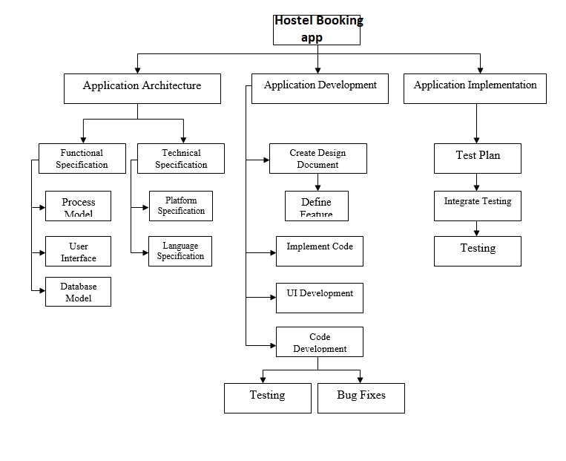

Roles & Responsibility Matrix
Start Date | Due Date | Duration | Team Member Roles
7/10/2018 | 8/5/2018 | 26 | Tahir Bilal, M. Amin , Umar ikram
8/5/2018 | 8/15/2018 | 10 | Umar ikram, Tahir Bilal
8/16/2018 | 8/20/2018 | 5 | Tahir Bilal,M. Amin ,Umar ikram
8/21/2018 | 8/31/2018 | 11 | M. Amin , Tahir Bilal
9/1/2018 | 9/25/2018 | 25 | Umar Ikram, M. Amin
9/26/2018 | 11/9/2018 | 45 | Tahir Bilal, M. Amin , Umar ikram
11/10/2018 | 11/30/2018 | 20 | Umar ikram
11/30/2018 | 12/10/2018 | 10 | Tahir Bilal
12/11/2018 | 12/25/2018 | 15 | Tahir Bilal, M. Amin
12/26/2018 | 12/31/2018 | 6 | Umar Ikram, M. Amin

Gantt chart

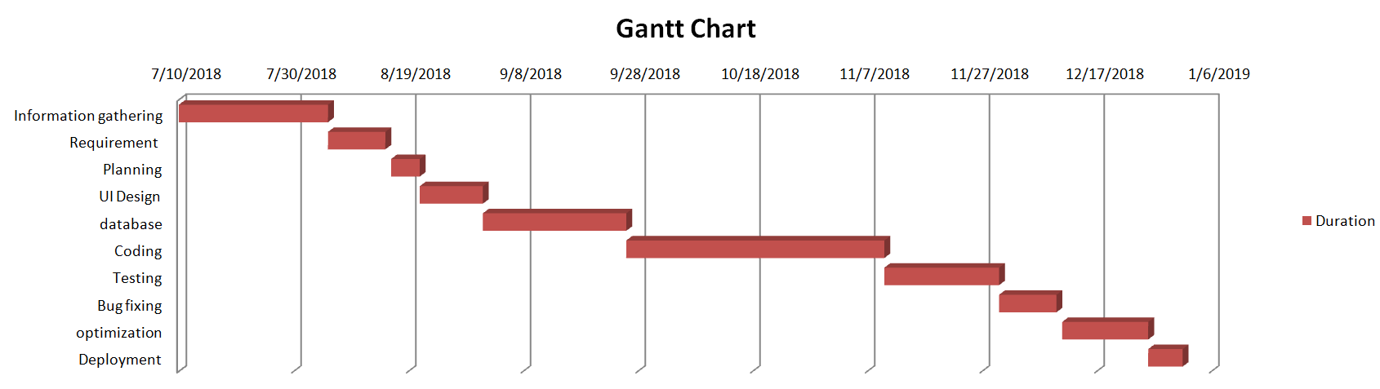

Report Outline
This application will let students to select the hostel of their choice and preference.
The search results of hostels will be filtered by price, area, no of rooms, availability of Facilities i.e. (ac, internet services, cooking facility).
All of the names of hostels are provided by our database.
Our goal is to make sure that students are being provided with proper clean rooms, regular meals and proper facilities. \
So students can make their mind before booking for rooms.

Chapter 2

Software Requirement Specifications

Chapter 2: Software Requirement Specifications

Introduction

Purpose
The purpose of the SRS document is to provide the detailed information UI and backend functionalities of hostel finder. It will cover the each user end feature (User Interface UI) and also covers the features of system. This document will briefly explain the entire software development process as well as technical and hardware dependencies.

Document Conventions
Standards or typographical conventions that were followed when writing this SRS, such as
Font: Calibri Line spacing: 1.5 line spacing Font Size:12pt, headings 14pt Text Alignment Justified

Intended Audience and Reading Suggestions
This document is intended to the audience in which such as developers, project managers, marketing staff, testers, and documentation writers and also for those End Users who really want to know about for this application is developed for.

Product Scope
This application will let students to select the hostel of their choice and preference. The search results of hostels will be filtered by price, area, no of rooms, availability of facilities i.e. (ac, internet services, cooking facility etc. User can suggest hostel via whatsapp,facebook to his friends as well.
This application will help students to search for the hostel in their respective area without having to visit and meet the owner of each hostel. And that will help students save a lot of their precious time. All of the names of hostels are provided by our database

References
The official website of the android contains a brief description of the project,
- https://developer.android.com/
Stack Overflow to help use out to removing errors in code
- https://stackoverflow.com/

Overall Description

Product Perspective
Hostel Finder is a very useful and timesaving program for those who want to change or finding the new hostel within manageable price with good facilities. All you have to do is download it for free from Google play store, install it and search hostel according to your requirement.

Product Functions
Features
- Admin
- Login (username, password)
- Manage hostel ( Add/ Update/ Delete)
- Dashboard
- Manage Profile

(While adding Hostel these fields will be required)
- Hostel name
- Address
- Package (Bronze, Premium, Platinum)
- Longitude, Latitude
- Pictures of hostel & its rooms
- Owner Contact number
- Facilities
- Hostel price per room
- Room’s condition
- User Features
- Pictures of hostel and its rooms
- Number of facilities provided in each hostel
- User can share hostels via Facebook, WhatsApp and sms.
- Contact number of hostel’s owner
- Postal address of hostel
- Show location on Google map
- Search by location , facilities
- Hostel Reviews
- Automatically search nearby hostels

User Classes and Characteristics
- Admin:
Administrators can add, edit & delete Hostels. Admin can manages all functionalities of hostels.
- User:
User can view hostels and also make contact with hostels owner. Customer can also write feedbacks of hostel and its services.
- General public
General public can use the system to see the product, their prices and quantity available. General user cannot give feedback.

Operating Environment
Operating environment for web server Apache is given below
Memory:
At least 2 gigabyte (GB) of RAM.

CPU:
We can achieve significant performance improvements with a large processor cache. Look closely at the L1, L2, and L3 cache options available
Disk Space:
At least 10 GB of Disk space.

Design and Implementation Constraints
Device will have 8GB internal memory.
Good quality Internet connection required.
Operating System Windows 10
Tools:
- Android Studio 3.0.1

User Documentation
User documentation components are available on project’s official website.

Assumptions and Dependencies
To use the application user must have Smartphone. Hostel owner should me directly connected with the admin for Golden and platinum packages.

Supplier:
We have assumed that the Application will be running on a properly working on android operating system and database system with an Internet connection that allows this system to perform all communications with end user.
Assumptions:
- User with accounts can edit their own accounts
- The manager account’s username and password maybe hard coded.
- The manager cannot be a customer.

External Interface Requirements

User Interfaces
In this application we provide user friendly and interactive user interface. We apply default GUI standards in this application. In this application user will easily understands the use of every element and enjoy the user experience. User can easily search their desired place by applying different filters.
User can choice categories of hostels i.e. (Boys /Girls hostels)
- Number of facilities provided in each hostel
- User can share hostels via Facebook, WhatsApp and SMS.
- Contact with hostel’s owner
- Show location on Google map
- Search by location , facilities
- Online authentication
- Hostel Reviews
- Hostel comparison with respect to price/facilities/location
- Automatically search nearby hostels

Hardware Interfaces
Android operating system
This application support on every android device (mobile / Tablet etc.). It automatically adjust according to the screen size.

Software Interfaces
- Firebase
- Android Operating system
- Java
- Retrofit
- Material dialogs
- AXloading button

Communications Interfaces
This application use different API for communication interface. Also the web server also receive requests on secure protocols (HTTPS) and confidential data requests will be 2048bit encrypted. Encryption will be provided by Commode Securities

System Features

User registration

Description and Priority
User registration has the prior value. Whenever user installs the app or an admin start working for the first time, he/she has to get registered first.

Stimulus/Response Sequences
- Application launched from the Android home screen
- User is prompted to select account type
- A form gets open to enter the fields related to account type
- Info goes to database and gets stored in database.
- After registration, user is prompted to dashboard

Functional Requirements
REQ-SF1-1: User/admin gets registered and be able to use the app.
    - Login/ Logout

Description and Priority
User/ admin have to authenticate if he/she is not logged in. He/she can also logout if wanted. This feature has 2ndhighest priority at most.

Stimulus/Response Sequences
- Application launched from the Android home screen
- User is prompted to signup/ login
- A form gets open to enter the fields
- Info goes to database and gets compared by existing info
- After authentication, user is prompted to dashboard
- If user is logging out, simply user is session out

Functional Requirements
REQ-SF1-1: User/admin gets logged in/ logged out

Location tracking by GPS

Description and Priority
Location tracking always looks for the location of user for best results.

Stimulus/Response Sequences
- Not Applicable

Functional Requirements
REQ-SF2-1: System gets the user’s location.
REQ-SF2-2: User sees the nearby hostels.

Filter Search Option

Description and Priority
App provides filter search to all users. User/ admin can search hostels by location, price, place, ratings or facilities.

Stimulus/Response Sequences
- User clicks the search bar.
- Adds the related search.
- Add filter.
- Information goes to database and database shows the best possible results.

Functional Requirements
REQ-SF-2-1: User would be able to see the favorable results specified in filters.

User sees the hostel’s information or compare it with others

Description and Priority
This feature is specifically for users with medium priority.

Stimulus/Response Sequences
- User selects hostel
- Database provide the data
- Sees the info of hostel
- User selects to compare the hostel with nearby other hostels
- Database compares the hostel with others and sends the results to user

Functional Requirements
REQ-SF2-1: User would be able to see and compare the hostel info

Manage hostels

Description and Priority
This feature is specifically for admin with high priority.

Stimulus/Response Sequences
- Admin add/update/delete hostel
- Database provide the data and save the data/ operation applied

Functional Requirements
REQ-SF2-1: Admin can add/ update/ delete the hostel

Sharing info to WhatsApp, facebook, SMS

Description and Priority
This feature is specifically for users with medium priority.

Stimulus/Response Sequences
- User selects hostel
- Database provide the data
- Sees the info of hostel
- User selects to share info
- User choose where ton share the info
- App shares the info to targeted place

Functional Requirements
REQ-SF2-1: User would be able to user share info on whatsapp/ facebook/ SMS.

Other Nonfunctional Requirements

Performance Requirements

- It requires powerful server with high quality internet.
- Application should be light weighted so application will work in most kinds of platforms even when internet is very slow.
- Performance requirement is a storage space there are number of pictures of different hostels higher storage will helps to improve the performance.

Safety Requirements
The Database may get crashed or damaged due to some viruses. Therefore it is mandatory to have backup for your data. Ups/inverter facility should be there in case of power failure.

Security Requirements
- User cannot edit or modify anything except their personal information.
- Proper user Authentication Will be provided.
- Email and phone number authentication would be required in the case for unusual login/ reset of password.

Software Quality Attributes
Secure access to users.
Availability:
24X7 availability.
Integrity:
Better component design to get better performance at peak time.
Correctness:
App should be free of error
Reliability:
App is 99% reliable
Security:
- App is 100% secure for hostels to provide info to admin and for users to access the info about hostels. Users are provided with 200% authentic and updated info of hostels
Easy to Use:
This app is easy to learn and easy to use

Business Rules

Payment gateways:
- Easy paisa
- HBL
- Jazz Cash

Other Requirements
The system must store the entire Hostel’s information all the data shall be stored in text. For each Hostel contains its unique ID, name, postal address (optional) shall be stored in database table.

Chapter 3

Use Case Analysis

Chapter 3:
- System Analysis
System analysis is responsible for designing and processing information system. Here we are presenting the system’s actors and their interactions with system, in the form of use cases.
Actors:
- Admin
- Users

USECASE

Fully Dressed USECASE
- Signup

Fully Dressed Use Case
 | Use case Name | Signup
 | Scope | Signup function
 | Level | User goal
 | Actor | User, Admin
 | Stakeholder | User, Admin
 | Pre-Condition | Internet Connection
 | Post-Condition | Login
 | Success Scenario | Registered
 | Extension | -

- Login

Fully Dressed Use Case
 | Use case Name | Login
 | Scope | Login
 | Level | User Goal
 | Actor | User, Admin
 | Stakeholder | User, Admin
 | Pre-Condition | - Must be registered  - Must be online
 | Post-Condition | Access to Services
 | Success Scenario | Login Success
 | Extension | - -

- Logout

Fully Dressed Use Case
1 | Use case Name | Logout
2 | Scope | Logout
3 | Level | User Goal
4 | Actor | User, Admin
5 | Stakeholder | User, Admin
6 | Pre-Condition | - Must be login  - Must be online
7 | Post-Condition | decline of Services
8 | Success Scenario | Logout Success
9 | Extension | - -
- Add Hostel

Fully Dressed Use Case
 | Use case Name | Add Hostel
 | Scope | Hostels
 | Level | User Goal
 | Actor | Admin
 | Stakeholder | Admin
 | Pre-Condition | - Must be Login  - Internet Connection
 | Post-Condition | Add/ Update/ Delete Hostel
 | Success Scenario | Hostel added
 | Extension

- Update Hostel

Fully Dressed Use Case
 | Use case Name | Update Hostel
 | Scope | Hostels
 | Level | User Goal
 | Actor | Admin
 | Stakeholder | Admin
 | Pre-Condition | - Must be Login  - Internet Connection  - Hostel should be added before
 | Post-Condition | Hostel should be updated
 | Success Scenario | Hostel updated
 | Extension | --

- Delete Hostel

Fully Dressed Use Case
 | Use case Name | Delete Hostel
 | Scope | Hostels
 | Level | User Goal
 | Actor | Admin
 | Stakeholder | Admin
 | Pre-Condition | - Must be Login  - Internet Connection  - Hostel should exist
 | Post-Condition | Hostel should be deleted
 | Success Scenario | Hostel removed
 | Extension | --

- Filter Search

Fully Dressed Use Case
 | Use case Name | Filter Search
 | Scope | Hostels
 | Level | User Goal
 | Actor | User
 | Stakeholder | User
 | Pre-Condition | - Must be registered  - Must be online
 | Post-Condition | Search more/ Share Info
 | Success Scenario | List searched info
 | Extension | - -

- View Profile

 | Use case Name | View Profile
 | Scope | Profile
 | Level | User Goal
 | Actor | User, Admin
 | Stakeholder | User, admin
 | Pre-Condition | - Must log in  - Must be online  - User Exist
 | Post-Condition | See more
 | Success Scenario | Successfully visited profile
 | Extension | - -

- Share Info

Fully Dressed Use Case
 | Use case Name | Share Information
 | Scope | Sharing
 | Level | User Goal
 | Actor | User
 | Stakeholder | User
 | Pre-Condition | - Must be registered  - Must be online  - Hostel Exist
 | Post-Condition | See more
 | Success Scenario | Share on Whatsapp/Fb/SMS
 | Extension | - -

- Update Profile

Fully Dressed Use Case
 | Use case Name | Update Profile
 | Scope | Profile
 | Level | User Goal
 | Actor | User, Admin
 | Stakeholder | User, admin
 | Pre-Condition | - Must be registered  - Must be online  - User Exist
 | Post-Condition | See more
 | Success Scenario | Profile Updated
 | Extension | - -

- Delete Profile

Fully Dressed Use Case
 | Use case Name | Delete Profile
 | Scope | Profile
 | Level | User Goal
 | Actor | User, Admin
 | Stakeholder | User, admin
 | Pre-Condition | - Must be registered  - Must be online  - User Exist
 | Post-Condition | SignUp
 | Success Scenario | Profile Deleted
 | Extension | - -

12-View Hostel

Fully Dressed Use Case
 | Use case Name | View Hostel
 | Scope | Hostels
 | Level | User Goal
 | Actor | User, Admin
 | Stakeholder | User, admin
 | Pre-Condition | - Must be registered  - Must be online  - Hostel Exist
 | Post-Condition | See more/ Share Info
 | Success Scenario | Hostel Showed
 | Extension | - -
13-Rate Hostel

Fully Dressed Use Case
 | Use case Name | Rate Hostel
 | Scope | Hostels
 | Level | User Goal
 | Actor | User
 | Stakeholder | User
 | Pre-Condition | - Must be registered  - Must be online  - Hostel Exist
 | Post-Condition | See more
 | Success Scenario | Hostel Rated
 | Extension | - -

14-Comment Hostel

Fully Dressed Use Case
 | Use case Name | Comment Hostel
 | Scope | Hostels
 | Level | User Goal
 | Actor | User
 | Stakeholder | User, admin
 | Pre-Condition | - Must be registered  - Must be online  - Hostel Exist
 | Post-Condition | See more/ Share Info
 | Success Scenario | Hostel Updated
 | Extension | - -

15-Add Package

Fully Dressed Use Case
 | Use case Name | Add Package
 | Scope | Packages
 | Level | User Goal
 | Actor | Admin
 | Stakeholder | Admin
 | Pre-Condition | - Must be Login  - Internet Connection
 | Post-Condition | Add/ Update/ Delete Package
 | Success Scenario | Package added
 | Extension

16-Update Package

Fully Dressed Use Case
 | Use case Name | Update Package
 | Scope | Packages
 | Level | User Goal
 | Actor | Admin
 | Stakeholder | Admin
 | Pre-Condition | - Must be Login  - Internet Connection  - Package should be added before
 | Post-Condition | Package should be updated
 | Success Scenario | Package updated
 | Extension | --

17-Delete Package

Fully Dressed Use Case
 | Use case Name | Delete Package
 | Scope | Packages
 | Level | User Goal
 | Actor | Admin
 | Stakeholder | Admin
 | Pre-Condition | - Must be Login  - Internet Connection  - Package should exist
 | Post-Condition | Package should be deleted
 | Success Scenario | Package removed
 | Extension | --

Chapter 4

System Design

Chapter 4: System Design
The system design describe the system requirement, operating environment system and subsystem architecture, files and database design ,input format ,output layout, user interface ,detailed design processing logic and external interface.

  - System Architecture Diagram

USER

Application

Request for Services
SYSTEM

Services

Authentication & services

Database

+Real-time Database+
Firebase Authentication
DB

  - Entity Relationship Diagram

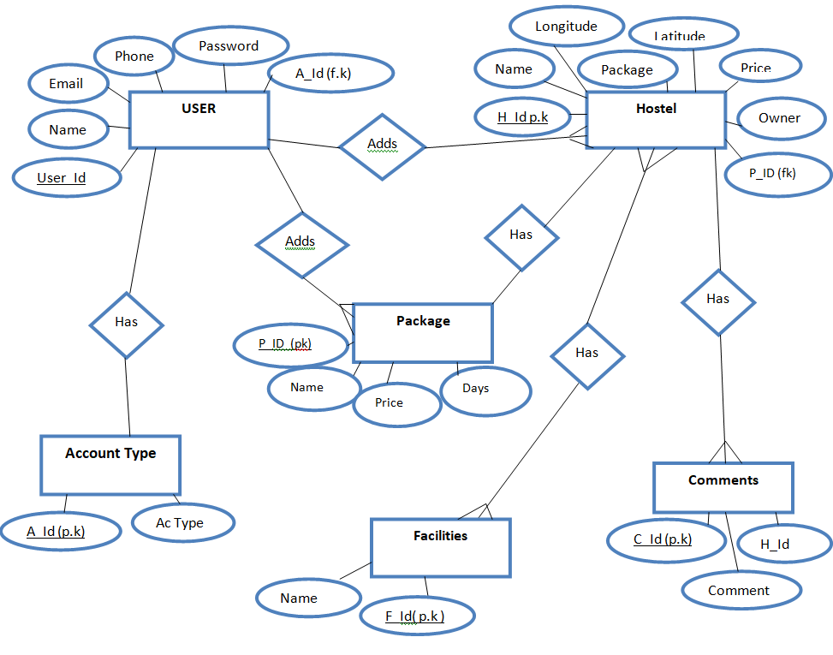

  - Domain Model

  - Class Diagram

  - Sequence/ Collaboration Diagram

7. Login

12-Update profile

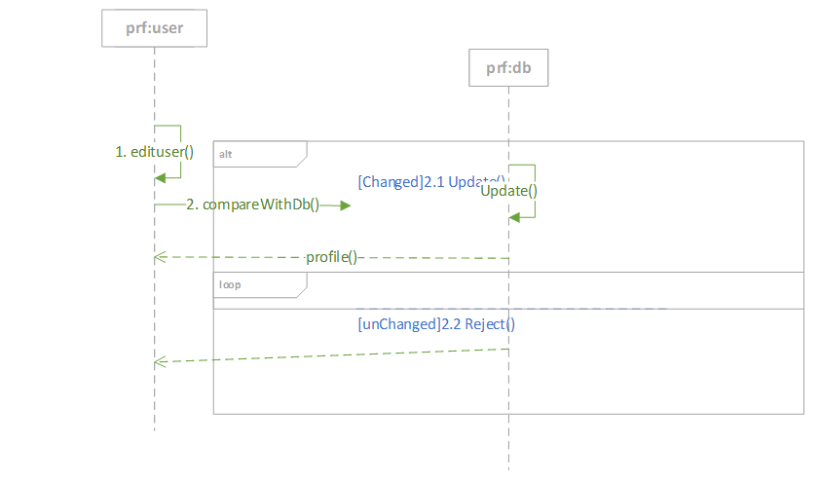
13-Delete Profile:

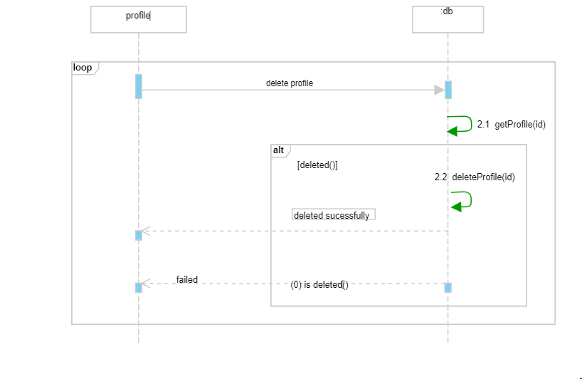

15-Comment Hostel
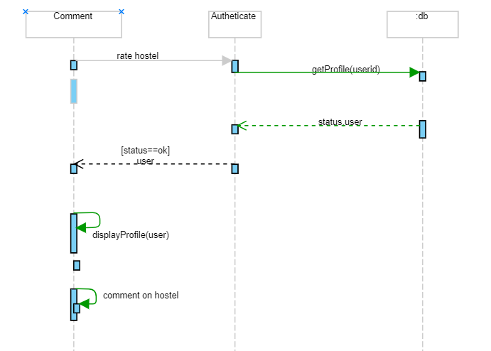

16-Show Profile
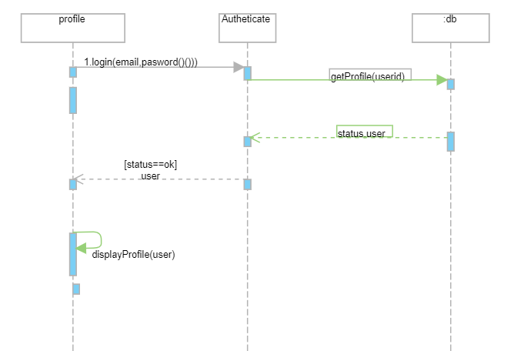

17- Rate app:

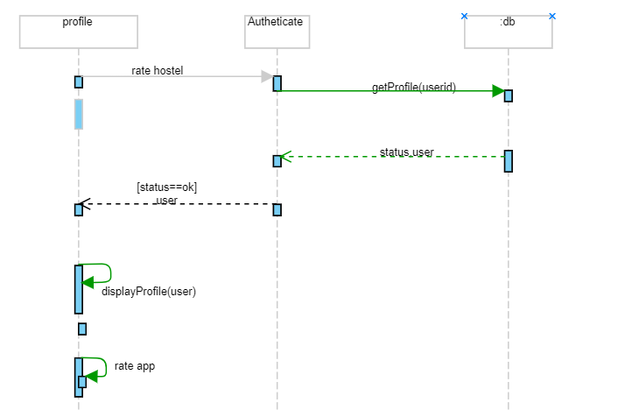

Operation Contracts

OC#1
Operation name: Add_package(name, duration, price)
Cross Reference: Use case Add Package
Pre-condition: User should be logged in, online
Post-condition:
- Package gets instantiate with attributes name, duration and price

OC#2
Operation name: Update_package(id, name, duration, price)
Cross Reference: Use case Update Package
Pre-condition: User should be logged in and online
Post-condition:
- Not applicable
OC#3
Operation name: Delete_package(id)
Cross Reference: Use case Delete Package
Pre-condition: User should be logged in
Post-condition:
-Not Applicable

OC#4
Operation name: Add_hostel (name, owner name, price, rating, long, lat, price, internet, cooking, contact)
Cross Reference: Use case Add Hostel
Pre-condition: User should be logged in, online and should be a admin
Post-condition:
- Hostel gets instantiate with attributes name, owner name, price, rating, long, lat, price, internet, cooking, contact
OC#5
Operation name: Update_hostel(id, name, owner name, price, rating, long, lat, price, internet, cooking, contact)
Cross Reference: Use case Update Hostel
Pre-condition: User should be logged in, online and be an admin
Post-condition:
- Not applicable

OC#6
Operation name: Delete_hostel(id)
Cross Reference: Use case Delete Hostel
Pre-condition: User should be logged in, online and admin
Post-condition:
- Not applicable
OC#7
Operation name: Registration (name, email, password, phone)
Cross Reference: Use case Registration
Pre-condition: User should be online.
Post-condition:
- An instance of user is created with having attributes (u_id, name, password, email, phone, address)
- User is associated with profile
OC#8
Operation name: Login (username, password)
Cross Reference: Use case Login
Pre-condition: User should be registered
Post-condition: Not applicable

OC#9
Operation name: Logout (u_id)
Cross Reference: Use case Logout
Pre-condition: User should be logged in and online
Post-condition:
- Not applicable

OC#10
Operation name: searchHostel(name, location, price,rating,internet and cooking)
Cross Reference: Use case Filter Search
Pre-condition: User should be logged in and online
Post-condition:
- Not applicable
OC#11
Operation name: Share_info(hostel_id, link, app)
Cross Reference: Use case Share Hostel Info
Pre-condition: User should be logged in and online
Post-condition:
- Not applicable
  - Activity Diagram
View Profile
If changes don’t exist
Update
If changes exist
Update Profile
deleted
Added
Update
If changes exist
If changes don’t exist
View
Not added
Update
Delete
Add
Hostels
Packages
shared
Not shared
Share Info
If results exist
Search Hostel
If admin
If user
Registration

If results don’t exist

  - State Diagram

1. Registration Signup
Login
valid
Authentication
Reg. Success
Registration

success

Invalid

2. Login

login
Invalid
Login Fail

valid
Profile
Login Success

3. Logout
Error message
error
Logout

logout
Logout
Login

4. Profile
Edit Profile

Profile
View Profile
No
Updated
New Data unchanged
Not Updated
View Profile
Details
Not Updated

Profile
update profile

Updated

5. Manage Packages

Delete
Edit Package
Packages

New Data add exist
Add
Delete
Add
Updated

View Packages

6. Manage Hostels

Delete
Edit Hostel
Hostels
not exist
New Data add exist
Add
Delete
Add
Updated

View Hostels

7. Filter Search
Search
Results
Search Again

no
exist

8. Share Info

Search
Results
Search Again
Share Results
Shared
Not Shared

no
exist

  - Component Diagram

Hostel Finder
Persistence
Security
Database
Data Access
Data Access
Data Access
Hostels
Payments
ADMIN
USERS

  - Deployment Diagram

USER
<<device>>
Database
Hostels Records

Users Records

Payments
<Deployment specs>

Online Authentication
Payments
Admin
Users
<<device>>

App Server

SYSTEM

USER
<<JDBC>>
<<RMI>>

Chapter 5

Implementation

Chapter 5: Implementation

Important Flow Control/Pseudo codes

No
Yes

NoNO
Yes
Start

Is New
Welcome
Home
List of Hostels
Search
filter
Call
Share
Hostel Details
Get Location
Yes

END

0140.

Deployment Environment
- Android Base Mobile
- Application Server
- Database Server

Tools and Techniques
- Java
- Android Studio
- Subline
- Firebase
- Json
- Xml

Best Practices / Coding Standards
- Mobile-friendly app
- Let photos say what you can’t
- Document everything
- Demand for Feedback

Version Control
- Git
- Mercurial
- Subversion

Chapter 6
Testing and Evaluation

Use Case Testing:
Success Scenario | Step | Description
A : Actor  S : System | 1 | A: Enter username , email, password and user information
A : Actor  S : System | 2 | S:Check Existing Information
A : Actor  S : System | 3 | S:Create Account
Extension | 2a | User Already Exist  S:Display error message
1-Singup

2-Login
Success Scenario | Step | Description
A : Actor  S : System | 1 | A: Enter email and password
A : Actor  S : System | 2 | S:Validate password and email
A : Actor  S : System | 3 | S:Allow Account Access
Extension | 2a | Password and Email not valid  S:Display error message

3-Logout
Success Scenario | Step | Description
A : Actor  S : System | 1 | A: logout from application
A : Actor  S : System | 2 | S: Must be login
A : Actor  S : System | 3 | S: Deny Account Access
Extension | 2a | Internet may not available  S:Display error message package already exists

4-Add Hostel
Success Scenario | Step | Description
A : Actor  S : System | 1 | A: Enter hostel name, address, contact etc.
A : Actor  S : System | 2 | S: Check Existing Information
A : Actor  S : System | 3 | S:Add Hostel
Extension | 2a | Hostel Already Exists  S:Display error message package does not exists

5-Update Hostel
Success Scenario | Step | Description
A : Actor  S : System | 1 | A: Select hostel name, address
A : Actor  S : System | 2 | S:Check Hostel Available
A : Actor  S : System | 3 | S:Update Hostel
Extension | 2a | Hostel not valid  S:Display error message package does not exists

6-Delete Hostel
Success Scenario | Step | Description
A : Actor  S : System | 1 | A: Select hostel name
A : Actor  S : System | 2 | S:Check hostel Available
A : Actor  S : System | 3 | S:Delete Hostel
Extension | 2a | Hostel not valid  S:Display error message city already exists

7-Filter Search
Success Scenario | Step | Description
A : Actor  S : System | 1 | A: Enter hostel name, address, city etc.
A : Actor  S : System | 2 | S:Check Hotel Available
A : Actor  S : System | 3 | S:Show all matching hostel
Extension | 2a | Hostel not found  S:Display error message city does not exists

8-View Profile
Success Scenario | Step | Description
A : Actor  S : System | 1 | A: User have to login first
A : Actor  S : System | 2 | S:Check User ID Available
A : Actor  S : System | 3 | S:Show user profile
Extension | 2a | Invalid ID  S:Display error message city does not exists

9-Share info
Success Scenario | Step | Description
A : Actor  S : System | 1 | A: Select hostel name, add contact
A : Actor  S : System | 2 | S:Check Existing Information
A : Actor  S : System | 3 | S:Share hostel
Extension | 2a | Hostel Not Exists  S:Display error message already exists

10-Update Profile
Success Scenario | Step | Description
A : Actor  S : System | 1 | A: Select user name, address,
A : Actor  S : System | 2 | S:Check User Profile Exists
A : Actor  S : System | 3 | S:Update profile
Extension | 2a | Profile not Valid  S:Display error message does not exists

11-Delete Profile
Success Scenario | Step | Description
A : Actor  S : System | 1 | A: Select user name, address.
A : Actor  S : System | 2 | S:Check User Profile Exists
A : Actor  S : System | 3 | S:Delete User Profile
Extension | 2a | No Such Profile Exists  S:Display error message does not exists

12-View Hostel
Success Scenario | Step | Description
A : Actor  S : System | 1 | A: Select Hostel Name
A : Actor  S : System | 2 | S:Check Hostel Available
A : Actor  S : System | 3 | S:Show Hostel
Extension | 2a | Hostel Not Exists  S:Display error message already exists

13-Rate Hostel
Success Scenario | Step | Description
A : Actor  S : System | 1 | A: Select Hostel Name
A : Actor  S : System | 2 | S:Check Hostel Exists
A : Actor  S : System | 3 | S:Rate Hostel
Extension | 2a | Hostel Not Exists  S:Display error message does not exists

14-Comment Hostel
Success Scenario | Step | Description
A : Actor  S : System | 1 | A: Select Hostel Name
A : Actor  S : System | 2 | S:Check Hostel Exists
A : Actor  S : System | 3 | S:Comment Hostel
Extension | 2a | Hostel Not Exists  S:Display error message does not exists

15-Add Package
Success Scenario | Step | Description
A : Actor  S : System | 1 | A: Enter Package name, price, description
A : Actor  S : System | 2 | S:Check Package Already have
A : Actor  S : System | 3 | S:Add Package
Extension | 2a | Package is Already Exists  S:Display error message already buy

16-Update Package
Success Scenario | Step | Description
A : Actor  S : System | 1 | A: Select package name.
A : Actor  S : System | 2 | S:Check Package Exists
A : Actor  S : System | 3 | S:Update Package
Extension | 2a | Package Not Exists  S:Display error message does not exists

17- Delete Package
Success Scenario | Step | Description
A : Actor  S : System | 1 | A: Select package name.
A : Actor  S : System | 2 | S: Check Package Exists
A : Actor  S : System | 3 | S: Delete package
Extension | 2a | Package Not Exists  S:Display error message does not exists

