Final Year Projects Report For BSCS Program



SUPERVISOR NAME:

SUBMISSION DATE:

Faculty of Computer Sciences & Information Technology
Superior University
PATROLLING ROBOT

By
Syed Samair Tariq BCS-14331
Faiz-ur-Rehman BCS-14362
Khawar Javed BCS-14274
Awais Jamshaid BCS-14248

Project Supervisor: Sir Khurram Jillani
Superior University, Lahore

Faculty of CS&IT
Superior University, Lahore

BS Project Certificate

This is to certify that Faiz-ur-rehman (14362), Syed Samair Tariq (14331), Khawar Javed(14274), Awais Jamshaid(14248), have completed their BS Project titled “Patrolling robot”.
The project is submitted to the B.S. projects committee of Superior University, Lahore, Pakistan for evaluation. The project is a prototype and execution of the requirements for the degree of Bachelors in computer sciences.

_________________ ___________________
Khurram Jillani Dean
Project Supervisor Faculty of CS&IT

Submission Pro-Forma

Name: Syed Samair Tariq Registration#: 14331
Name: Faiz-ur-rehman Registration#: 14362
Name: Khawar Javed Registration#: 14274
Name:Awais Jamshaid Registration#: 14248

Address: Superior University, Raiwind Road, Lahore, Pakistan.

Project Title: “PATROLLING ROBOT”.
Project Supervisor: Sir Khurram Jillani
This Project is submitted in accordance with the rules laid down by the Superior University, Lahore, Pakistan as part of the requirement for the award of the degree of Bachelors in Computer Sciences. We declare that the work presented in this report is our own except where due references or acknowledgement is given to work of others.

_____________________
Signature of Student
Syed Samair Tariq
Samairtariq72@gmail.com

_____________________
Signature of Student
Faiz-ur-Rehman
fayzeraze@gmail.com

_____________________
Signature of Student
Khawar Javed
Jk.khawar@gmail.com

_____________________
Signature of Student
Awais Jamshaid
Awaisjamshaid001@gmail.com

______________________
Signature of Supervisor
Sir Khurram Jillani
Dated: - ______________

Dedication

In the name of Allah the most gracious and the most merciful, we would like to dedicate our humble efforts to our parents.
Mr and Mrs. Tariq
Mr and Mrs. Razi Qureshi
Mr. and Mrs. Javed
Mr. and Mrs. Jamshaid
Our parents guided us, supported us and most importantly believed in us, even when we lost faith in ourselves; they pushed us towards the achievement of our goals.

Abstract
The army is combating on different borderline areas with the help of monitoring techniques. There are several systems developed for the border monitoring techniques over the years. Still the soldiers die as these monitoring systems do not detect all the points where they can be attacked. The purpose of the project is to introduce a new way to monitor the borders using image processing for this we have proposed and experimentally demonstrated a system for the extensive monitoring and surveillance of the military border using sensors, camera, robot and a blue-tooth module. Our robot patrols an assigned area while detecting any movement or attack and in the case of any intrusion detection the installed camera captures a real time image of the current situation and alerts the control center by transmitting the image wirelessly.
Acknowledgments

Starting up, in the name of Allah the most beneficent and the most generous, he says in the Holy Quran: “Read in the name of thy lord, who created you”.
Thanking Him who not only created us, but also gave us the five senses to gather knowledge and then gave us the ability to think and maneuver this knowledge. Secondly, we are eternally grateful to our parents for their support and help which has led us to this moment in our life. Our gratitude can by no means be equal to the efforts our parents put into our upbringing, nurturing and their dedication to our education, for giving us courage and believing in us throughout. Thirdly, we are very grateful to our project supervisor sir Khurram Jilani, for his endless support and guidance throughout our academic career. He has been a great teacher and a leader who has led us brilliantly along our project with patience and motivated us to excel. We would also like to acknowledge our teachers who directed us through obstacles to accomplish our goals. Our teachers pushed us to our limits so that we can learn to overcome our greatest failure and guided us and for training us to fight against all odds to accomplish our goals. In the end we would like to thank our University for providing us the platform where our skills are polished by our teachers.

List of Acronyms

IR - Infrared
CPU - Central processing unit
ROM - Read only memory
RAM - Random access memory
I/O - Input/output
MCU - Microcontroller Unit
RF - Radio Frequency
PC - Personal computer
DC - Direct current
RGB - Red Green Blue
DLL - Data Link Layer
AI - Artificial Intelligence
IECU - Intelligent error control unit
MP - Mega pixel
ID - Identity
JPEG or JPG - Joint Photographic Experts Group
TIFF - Tagged Interchange File Format
BMP - Bitmap
GIFF - Graphic interchange file format
PNG - Portable network graphics
CMOS - Complementary metal-oxide semiconductor
PCB - Printed circuit board
IC - Integrated circuit
VLSI - Very Large Scale Integration
ALU - Arithmetic and logic unit
EEPROM - Electrically Erasable Programmable Read-only Memory
PWM - Pulse Width Modulation
ADC - Analog-to-digital converter
UART - Universal Asynchronous Receiver/Transmitter
TX -Transmitter
RX -Receiver
LCD -Liquid crystal display
DDR -Double-data-rate
IR -Infra red
LED -Light Emitting Diode

Table of Contents
1 Chapter 15
Introduction 15
1.1 Needs/Problems 15
1.2 Objectives of FYP 17
1.3 Project Features 17
1.4 Project Goals 18
1.5 BASIC BLOCK DIAGRAM 18
1.6 REPORT STRUCTURE 19
2 Chapter 20
2.1 Overview of Basic Topic 20
2.2 Procedures/ Scope of work 21
3 CHAPTER 22
3.1 Introduction 22
3.2 BLOCK DIAGRAM 22
3.3 Description of block diagram 23
3.4 Image acquisition 23
3.5 Feature Extraction 23
3.6 Flow Chart 25
3.6.1 Result 25
4 CHAPTER 26
4.1 Introduction 26
4.2 RADIO FREQUENCY 26
4.3 What is radio frequency? 26
4.4 Radio frequency module 27
4.5 Features 27
4.6 Pin Configuration 28
5 CHAPTER 29
5.1 Introduction 29
5.2 Types 31
5.2.1 8-bit microcontroller 32
5.2.2 16-bit microcontroller 32
5.2.3 32-bit microcontroller 33
5.3 Memory type 33
5.3.1 Embedded microcontroller 33
5.3.2 External memory microcontroller 33
5.4 Instruction set 33
5.4.1 Complicated Instruction Set Computer (CISC) architecture microcontroller: 33
5.4.2 Diminished Direction Set PC (RISC) microcontroller: 34
5.5 Memory design 34
5.5.1 Harvard memory design microcontroller: 35
5.5.2 Princeton memory engineering microcontroller: 35
5.6 Use in this project: 35
6 Chapter 39
6.1 Introduction 39
6.2 Procedure 39
6.3 Accuracy 40
6.4 Bluetooth System 40
6.5 Steps: 40
6.6 Use in Project 41
7 Chapter 42
7.1 Introduction 42
7.2 Characteristics 42
7.3 Sensing 42
7.4 Movement 42
7.5 Energy 43
7.6 Intelligence 43
7.7 Robots Used For the Surveillance Purposes 43
7.7.1 Remote Controlled Robot 43
7.7.2 Mine Detector Robot 44
7.7.3 Radiation Detector Robot 44
7.7.4 Uncrewed Robot 44
7.7.5 Night Vision Based Robot 44
7.7.6 GPS Based Robot 44
7.7.7 Quad Copter Based Robot 44
7.7.8 Bluetooth Based Robot 45
7.8 Use of Robotics in the Project 45
8 CHAPTER 46
8.1 Complete block diagram 46
8.2 Description 47
8.3 COMPLETE MODEL 48
8.4 PIR Sensors 48
8.5 System design 49
8.6 List of equipment 50
9 Chapter 9 51
9.1 Results 51
9.1.1 SCENARIO-I 51
9.1.2 SCENARIO-II 53
9.2 PIR Sensors 54
10 Chapter 10 57
APPENDIX- I 58
11 APPENDIX- II 59
11.1 ARDUINO CODING 59
11.2 DESKTOP CODING 63
12 Bibliography 70

Summary
This Robot is made for the border surveillance in order to provide effective security services. This Robot will work with the help of a Microcontroller AT Mega 256 integrated on a Training Board Arduino Mega.
A microcontroller is an extremely integrated chip that contains all the components including a controller. This Chip comprises of a CPU, ROM, RAM & I/O ports. A microcontroller is intended for a very specific duty to control a particular system, so that the parts can be simplified and condensed. Microcontrollers are sometimes called an embedded microcontroller, which is one part of larger device or system. The program to be implemented is burnt on the on chip ROM using the related computer software and a burner device. The program written for a microcontroller is normally in C++ language.
This Microcontroller performs all the Controlling tasks. Each Individual components are connected to the Microcontroller and report to it. After reporting, the Microcontroller orders other components to perform their task accordingly.
This Robot is programmed in a way that it continuously patrols the border as soon as any sensor detects, the sensor interrupts the microcontroller, the Microcontroller stops the robot and orders the Bluetooth module connected with the Receiving End Microcontroller to alert the Base Station, after that the Microcontroller requests the camera to capture a real time image which is then transmitted wirelessly to the End device using the Bluetooth Module and the Microcontroller.

Anticipated Result:
The robot we designed is for the security purpose and to detect any movement nearby and alert the authority about any movement captured and it’s a prototype, our expectation from it to send the alert message

Anticipated Budget:
S.No | Product Name | Price
1 | Body | 1500
2 | Tyres (6) | 3000
3 | Motors (2) | 2000
4 | Arduino Mega | 1200
5 | Bluetooth Module HC-05 | 700
6 | Motor Controller | 500
7 | Jumper Wires | 200
8 | IR Camera | 4000
9 | Obstacle Detector | 800
10 | Belts | 4000
11 | Equipment | 5000
12 | Battery | 1200
13 | Total | 24100

1 Chapter

Introduction
Our Project Border Monitoring is based on a surveillance robot that patrols the border area and will replace the border patrolling soldiers, and have many advantages of replacing the soldier.
- No Tiredness from patrolling 24/7
- Reduced Food & Other Costs
- Increased Night Vision
- Safety of Precious Life
- Motion Sensing

Needs/Problems
This Border Monitoring Robot will work on borders for Security and Surveillance, where security is a major issue so as to protect the border from any intruder or trespasser from entering our territory. This Robot will have the following features:
- The main idea of our project was designed keeping in mind the precious life of a border patrolling/monitoring soldiers, as their life is important however is prone to greater threats due to attacks from enemy countries.
- Visibility problems arise during the night time, as visibility is low due to darkness and our soldiers are unable to have perfect vision. Therefore with the help of an IR Camera we will minimize those issues in turn increasing night vision.
- Night sensing issues will also be minimized as it will be able to sense perfectly during night time too.
- Motion detection will be made possible to minimize threats through the implementation of PIR Module due to which complete communication will take place wirelessly using a Bluetooth Module.
- The IR camera will capture an image in case of detection and that image will also be sent to our Base Station using the Bluetooth Module Interfaced through the Arduino, so that the Base Station can get the real time situation of the border and the forces can design strategies according to the captured situation.
- The Sensors mentioned above will be connected in such an effective manner that they can detect even small potential movement dangerous in regard to crossing the border line.
- Sensors will also be used in an effective energy efficient manner, as energy has to be saved for longer battery intervals.
This Robot will have the ability to perform the following functions:
- Detect Potential movements on the border line.
- Detect anything near the border with the help of PIR Module, by transmission of ultrasonic waves.
- Reducing risk of threat to the Border Patrol Soldier’s life.
- Will detect trespassers.
- Alert our Control Centre or Base Station
- As soon as the sensors sense anything it will take an image of the border and transmit it wirelessly to the Base station.
- Will Provide extended night vision.

This Robot will work with the help of a Microcontroller AT Mega 256 integrated on a Training Board Arduino Mega. A microcontroller is an extremely integrated chip that contains all the components including a controller. This Chip comprises of a CPU, ROM, RAM & I/O ports. A microcontroller is intended for a very specific duty to control a particular system, so that the parts can be simplified and condensed. Microcontrollers are sometimes called an embedded microcontroller, which is one part of larger device or system. The program to be implemented is burnt on the on chip ROM using the related computer software and a burner device. The program written for a microcontroller is normally in C++ language.
This Microcontroller performs all the Controlling tasks. Each Individual components are connected to the Microcontroller and report to it. After reporting, the Microcontroller orders other components to perform their task accordingly. This Robot is programmed in a way that it continuously patrols the border as soon as any sensor detects, the sensor interrupts the microcontroller, the Microcontroller stops the robot and orders the Bluetooth module connected with the Receiving End Microcontroller to alert the Base Station, after that the Microcontroller requests the camera to capture a real time image which is then transmitted wirelessly to the End device using the Bluetooth Module and the Microcontroller.

Objectives of FYP
The Following are the objectives of our project:
- Provide safety to soldiers
- Border Patrol
- Trespasser Detection
- Alerting the Base Station
- Image Capture
- Image Transfer

Project Features
This project has features like:
- Border Patrolling Robot
- Increased Border Security
- Vision Based Waypoint Establishment
- Increased Night Vision
- Reduced Risk of Soldier Life
- An Automated System for Border Security
- Cost Effective

Project Goals
The Purpose of this Robot is to have an efficient Trespasser detection System at our Border Line. For this purpose we aim to design a Vision based Robot with Sensors & an IR Camera for the security of our Border.

BASIC BLOCK DIAGRAM
.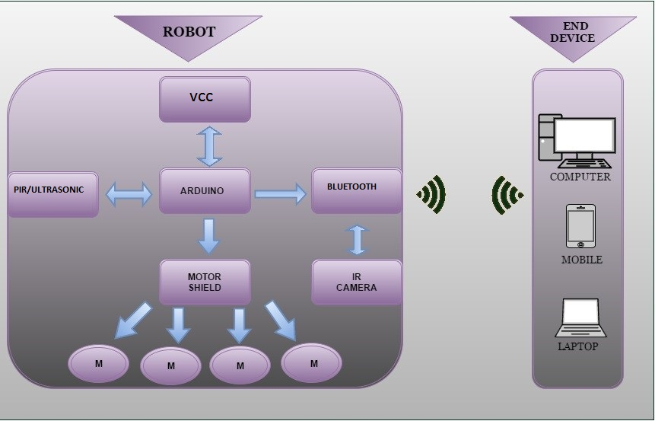

Figure 1.1 Basic block diagram

REPORT STRUCTURE
TABLE 1.1 Structure of report

CHAPTERS | DESCRIPTION
CHAPTER 1 | Introduction of the project
CHAPTER 2 | The overview and background work
CHAPTER 3 | Coordinates input and pre-processing
CHAPTER 4 | Radio Frequency Module
CHAPTER 5 | Microcontroller Unit
CHAPTER 6 | Bluetooth
CHAPTER 7 | Robotics
CHAPTER 8 | PIR Sensors
CHAPTER 9 | Analysis & Results
CHAPTER 10 | Conclusion

Chapter
BACKGROUND REVIEW

Overview of Basic Topic
The basis of our project is border monitoring using sensors. This task is further completed using a microcontroller based robot with deployed sensors which will be functional on the military border in turn minimizing the need of the border patrolling soldier.
The purpose of our project is to secure the border, and only let authorized personnel’s inside, blocking/stopping trespassers from passing by or entering the territory. For this purpose we have designed a Vision Based Robot backed up by a Microcontroller (Arduino) for the purpose of effective patrolling, the entire system will be connected to the control center for wireless image transfer using a Radio Frequency device (Bluetooth Module) making our Robot wireless.
The first part of our project deals with the Vision Based Robot using Microcontroller, and this task is divided in 3 parts:
- Border Patrolling by the Vision Based Robot
- Sensors start sensing for any motion.
- Microcontroller remains alert for any detection.
As soon as any motion is detected by any of the Sensors, the Robot stops at the current position and the information is conveyed to the Microcontroller (Arduino) which acts as the bridge between sensors and the Control Centre and alerts the soldiers. The Microcontroller connected to the Bluetooth Module instructs the camera to capture a real time image of the current situation at the border line and transmits the image wirelessly using Radio Frequency to the Control Center. After all of the above process Vision Based Robot continues on its patrolling task enabling the sensors to sense for any updates.

Procedures/ Scope of work
Border Monitoring is an Interesting aspect to study, due to its importance of application, not only in Pakistan but globally, due to the increasing risk of life of a border patrolling soldier risking his life at the border. This project is not only helpful for the military for Border security, but it can also be implemented on other places which require security such as shopping malls. Some work has been done on the Trespasser detection in the research paper FlegSens (2009) published, which involved a model consisting of PIR sensors to effectively detect the movement of any intruder or trespasser passing by the territory. This project can further be enhanced by the advancement of sensors such as the addition of the PIR Sensor, the proximity sensor, the IR Sensor etc. further advancement can be made using different equipment for different purposes such as an IP Camera.

The researcher separated the [9] problem in four successive steps:

Figure 2.1 Basic Block Diagram

CHAPTER
Input and Pre-processing

Introduction
In This chapter we will discuss the basic steps of input & preprocessing used in our project in Arduino IDE, we have explained this task using block diagrams pictures and coding. The Arduino IDE is software that provides an ease in writing the code and simply upload it to your Arduino based board. The Arduino IDE provides an ease in accessing your Arduino and using your microcontroller and all its ports effectively.

BLOCK DIAGRAM
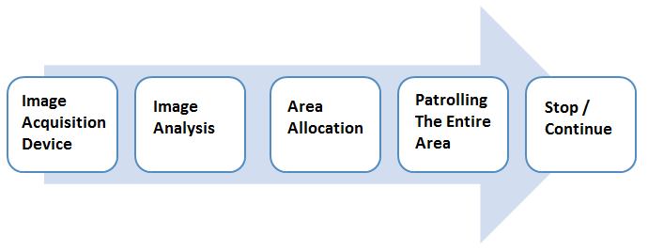
Figure 3.1 steps for Robot Patrol

Description of block diagram
Figure 3.1 shows the flow of the procedure that leads to coordinates extraction. In order to understand the process, we need to know, why coordinates acquisition is needed. We need to acquire the coordinates of an entire area the initial and ending coordinates of the whole area using the code that we have made, to define the waypoints to the robot for patrol. The Robot is trained in this instance through a code so that it patrols the entire area using the coordinates we provide. Figure 3.1 shows the pre-processing that is needed in this procedure to acquire the coordinates. This procedure is briefly explained below:
- Code is executed for the extraction of the coordinates.
- Coordinates are acquired at the boundary lines of the patrol area.
- Coordinates are burned to the robot.
- Our Robot initializes the Coordinates.
- Then it checks the conditions provided to it.
- And finally starts patrolling the area provided in the Coordinates.

Image acquisition
The first stage of any vision system is that the image acquisition stage when the image has been obtained, numerous strategies of process are often applied to the image to perform the various totally different vision tasks needed nowadays. However, if the image has not been non inheritable satisfactorily then the supposed tasks might not be doable, even with the help of some type of image improvement.

Feature Extraction
The first part of this project deals with the coordinates which are acquired by vision techniques to guide the robot about its path and range. We are using a smart infrared camera to find coordinates of initial and final destination of paths with the Arduino. The most essential and most abundant requirement of our project is the coordinate’s extraction as the whole process depends upon the coordinates processing and these coordinates leads the robot to its path for patrolling. Image acquisition device sense the path and translate it according to MCU to accelerate the robot.

Flow Chart
Obstacle
No Yes

Move

Goal
No Yes
Stop
Surveillance

Chart 3.1 Coordinates Extraction Chart

Result
Coordinates extracted successfully

CHAPTER
Radio Frequency Module

Introduction
For communication we have several devices, technologies, we have divided it by four main mediums of communication, them being:
- Wired
- Wireless
- Sound (acoustic)
- Light (optical)
With communication being an ever growing need, it is surely an ever growing technology. Communication maybe wired, wireless, acoustic or optical, it is always needed. These mediums are further divided into different forms and technologies. As per the need in our project, we will discuss the wireless communication, which is further classified technology wise as cellular, radio, microwave, Bluetooth, infrared, Wi-Fi, and satellite communication. In our project we chose to use radio technology, as it is a reliable, simple, and effective, and is much less expensive than any other technologies mentioned above.

RADIO FREQUENCY

We are going to discuss that what is radio frequency.

What is radio frequency?
Radio frequency (RF) is considered to be one of the most important forms of wireless communication since a very long time. It was introduced in the early 1900’s by Guglielmo Marconi and Karl Ferdinand Braun when they employed the radio waves for communication. The RF has the oscillating rate in the range of 3 KHz to 300GHz, same as radio waves.
The RF has a wide spectrum, which we have studied in our basic courses that can accommodate a very high amount of bandwidth and large amount of data. The transmission and receiving is done using the transmitter and receiver, also known as the RF module.

Radio frequency module
An RF Module is a minute electronic circuit that is used to transmit and receive radio signals on one of the several carrier frequencies permitted by national and international regulations governing the use of radio for communication.
The RF module comprises of two parts, which is general, as all communication modules need a transmitter and a receiver. The transmitter and receiver modules are both small PCB sub-assemblies that are capable of transmitting, receiving, modulating and demodulating a radio wave to carry data. The module we have chosen for our project is HC-05.

Features
These are the common features of this module
- Low power consumption
- 32 bit RISC CPU
- 9600 Minimum Baud Rate
- 80dBm sensitivity
- Up to +4dBm RF transmit power
- 3.3 to 5 V I/O
- PIO ( Programmable I/O) Control
- With Integrated antenna
- With edge connector

Pin Configuration
This is the pin configuration of the HC-05 Bluetooth Module: 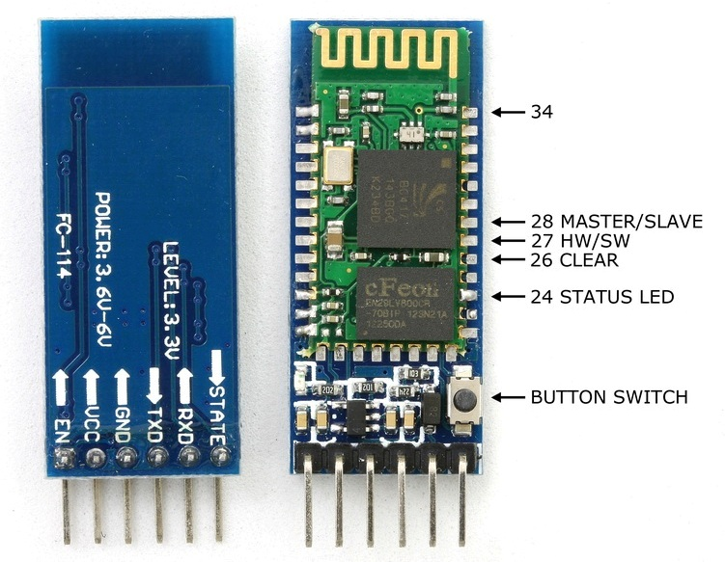 Figure 4.1 RF transmitter IC ESP 8266

CHAPTER
Microcontroller

Introduction
Microcontroller could be a unified chip that could be a part of Associate in nursing embedded system. The microcontroller contains of a processor, RAM, ROM, I/O ports, and timers sort of a commonplace laptop. However, as they're meant to hold out solely one specific task to regulate a system, they have a tendency to be a lot of compact and simplified so they'll comprise all the functions needed on one chip. The term ‘microprocessor’ and ‘microcontroller’ have invariably been confused with one another each of them are meant for real time application. They share several general options and at a similar time they need major variations. Physically, each the IC’s square measure similar and can't be differentiated by gazing them. These IC’s square measure obtainable in several versions, ranging from half dozen pin to, as high as, eighty to one hundred pins or maybe higher, relying upon the options it's expected to deliver.
But it's rather opposite within the case with Microcontrollers.
Microcontroller could be a unified chip that could be a part of Associate in nursing embedded system. The microcontroller contains of a processor, RAM, ROM, I/O ports, and timers sort of a commonplace laptop. However, as they're meant to hold out solely one specific task to regulate a system, they have a tendency to be a lot of compact and simplified so they'll comprise all the functions needed on one chip. The term ‘microprocessor’ and ‘microcontroller’ have invariably been confused with one another each of them are meant for real time application. They share several general options and at a similar time they need major variations. Physically, each the IC’s square measure similar and can't be differentiated by gazing them. These IC’s square measure obtainable in several versions, ranging from half dozen pin to, as high as, eighty to one hundred pins or maybe higher, relying upon the options it's expected to deliver.
But it's rather opposite within the case with Microcontrollers.
Microcontroller features a processor, additionally with a set quantity of RAM, computer memory and alternative peripherals, that square measure all embedded on one chip. A microcontroller differs wide from a microchip as a microchip is employed to make a multi-function processor or device and wishes many chips to handle a variety of tasks that square measure needed to be performed. A microcontroller, however, is supposed to be additional self-sufficing and freelance, and functions as a miniature, dedicated laptop.
The gigantic advantage of microcontrollers, as critical victimization larger microprocessors, is that the quantity of elements used and style prices are often controlled and unbroken to a minimum. They are usually designed victimizations CMOS (complementary metal chemical compound semiconductor) technology, that is Associate in nursing economical producing technique that uses less power and is additional immune to power spikes as compared to the opposite techniques of producing used.

Types
CLASSIFICATION OF MICROCONTROLLERS

Figure 5.1 Classification of microcontroller

Today extraordinary makers deliver microcontrollers with an extensive variety of highlights accessible in various renditions. A few makers are AT Mega, Microchip, Philips, Motorola and so on.
The figure demonstrates the different sorts of microcontrollers. The microcontrollers are arranged as far as inward transport width, implanted microcontroller, guideline set, memory engineering, IC chip or VLSI center for various record and family. For a similar family, there might be different forms with different sources.
• Bits
• Memory sort
• Instruction set
• Memory design
• MCU family

8-bit microcontroller
At the point when interior transport in a MCU is 8-bit transport and the ALU plays out the math and rationale operations on a byte at a direction, the MCU is 8-bit microcontroller. Cases of 8-bit MCUs are Intel 8031/8051, PIC1x and Motorola MC68HC11 families.

16-bit microcontroller
At the point when interior transport in a MCU is 16-bit transport and the ALU performs number juggling and rationale operations on the operand expressions of 16 bits at the directions, the MCU is 16-bit microcontroller. Essential 16-bit MCUs are broadened 8051XA, PIC2x, Intel 8096 and Motorola MC68HC12 families. 16-bit MCU gives more noteworthy exactness and execution when contrasted with the 8-bit MCU.

32-bit microcontroller
At the point when interior transport for the information move operations in a MCU is 32-bit transport and the ALU performs number juggling and rationale operations on operand expressions of 32 bits at the directions, the MCU is 32-bit microcontroller. Imperative 32-bit MCUs are Intel/Atmel 251 family, PIC3x, Motorola M683xx and ARM 7 or 9 or 11 processor-based microcontroller families. These give more prominent accuracy and execution contrasted with the 16-bit MCUsBits selection. (Internet source, n.d.)

Memory type

Embedded microcontroller

At the point when an implanted framework has a MCU that has all the equipment and programming units in a solitary unit, the MCU is called installed microcontroller. A not very many outside unit or framework is available for preparing amid the control or utilization of the outer gadgets. For instance, a phone handset circuit utilizes an inserted microcontroller.

External memory microcontroller
At the point when an installed framework has a MCU that has all the equipment and programming units introduce not as a solitary unit and has all or part of the memory unit remotely interfaced utilizing an interfacing circuit which is known as the paste circuit, the MCU is called an external memory microcontroller. For instance, 8031 has the program memory which is interfaced remotely to it. The 8051 has both interior and also outside program memory.

Instruction set

Complicated Instruction Set Computer (CISC) architecture microcontroller:
At the point when a MCU has a direction set that backings many tending to modes for the number juggling and coherent guidelines and when there are the memory gets to amid the ALU operations and the information exchange directions, the MCU is said to have CISC-engineering. CISC gives adaptability in picking different methods for playing out the information exchange, math and different operations. For instance, it is doable to include substance of two registers and memory or include the bits at two memory addresses in a CISC. Directions are of variable number of bytes in the CISC. These can take shifting measures of time interim for execution. A case is Intel 8096.

Diminished Direction Set PC (RISC) microcontroller:
At the point when a MCU has a guideline set that backings a couple of tending to modes for the number juggling and consistent directions and only a couple (stack, store, push and pop) guidelines for the information exchange, the MCU is said to be of RISC engineering. RISC gives no adaptability in picking the wide range of methods for playing out the number juggling and rationale operations. These operations are performed after the heap of operands in the registers, and the aftereffects of these operations are set in registers. The enlist substance are later on put away in the memory. RISC actualizes every guideline in a solitary cycle utilizing an alternate hardwired control. It utilizes a littler measure of hardware. It has less power dispersal. There is lessened direction set. Directions are of settled number of bytes and set aside a settled aggregate of time for usage. It has many registers. In this manner, operations can be performed utilizing them. The requirement for outer bring, from the recollections is extraordinarily decreased. (An outside get is to be finished by the CPU for an operand all the more every now and again in the CISC). The RISC gives a higher execution in registering than the CISC. This is on the grounds that little need of the outside brings, which takes a lot of processor time. Elite is additionally a direct result of hardwired execution of guidelines. A case of RISC design is the ARM processor family-based MCU.
Nowadays most microchip and microcontroller plans depend on RISC center, which are on account of the CISC highlights can simply be given to programming, with a suitable compiler on the chip or an interior circuit which deciphers the codes for the RISC center.

Memory design

Harvard memory design microcontroller:
At the point when a MCU has a particular memory address space for the program memory and information memory, it is said to have Harvard memory design in the processor. The MCU has isolate guidelines, and henceforth isolate control signals, for the information exchanges from the two recollections. For instance, 8051 has an address space in the vicinity of 0x0000 and 0xFFFF for the program memory bank and separate memory in the vicinity of 0x0000 and 0xFFFF for the information memory bank. A memory bank spares the bytes amid operations.

Princeton memory engineering microcontroller:

At the point when a MCU has a typical memory address space, usable for the program memory and information memory, it is said to have Princeton memory engineering in the processor. For instance, 68HC11 has an address space in the vicinity of 0x0000 and 0xFFFF for the program memory codes and a similar space in the vicinity of 0x0000 and 0xFFFF for the information bytes. It has no different directions, and henceforth no different control signals for information exchanges from and to these two arrangements of recollections. Program and information can be put away on a similar memory chip or unit inside same address square.

Use in this project:
In this project, the MCU we have selected to use Arduino Mega. Arduino is an open-source prototyping stage in view of simple to-use equipment and programming. Arduino boards can read inputs - light on a sensor, a finger on a button- and transform it into an output - initiating a motor, turning on an LED. You can order your board what to do by sending an arrangement of directions to the microcontroller on the board. It has a high performance RISC CPU, and it offers the following key features:

KEY FEATURES | ARDUINO AT Mega
Operating Voltage | 5V
Microcontroller | ATMega256
Input Voltage | 7-9V
Digital I/O Pins | 54(Of which 14 are PWM)
PWM Digital I/O pins | 14
Analog Input Pins | 16
DC Current per I/O Pin | 20mA
DC Current for 3.3 v Pin | 50mA
Flash Memory | 256Kb
SRAM | 8Kb
EEPROM | 1Kb
Clock Speed | 16 MHz
TABLE 5.1 features of Arduino AT Mega
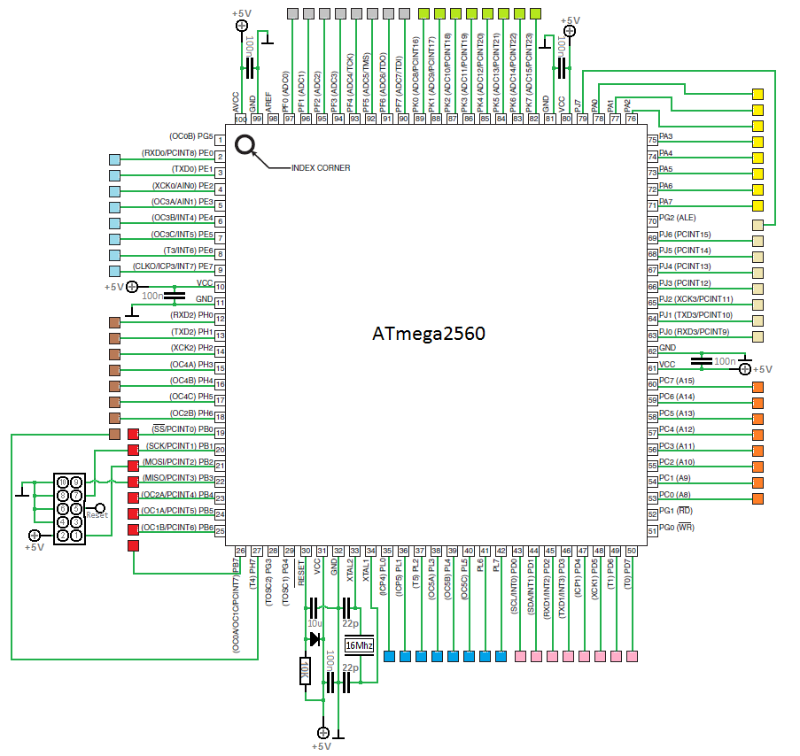
Figure 5.2 ATMega328 Pins
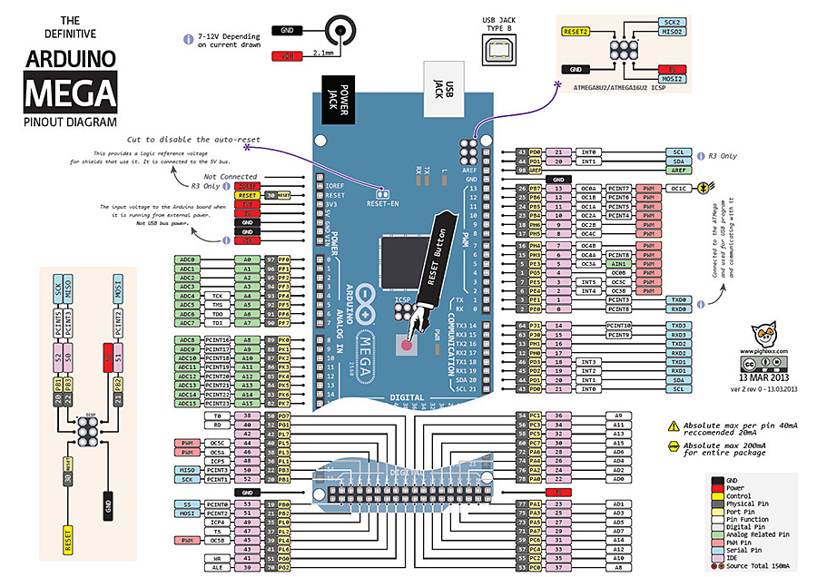

Figure 5.3 Arduino AT Mega 256 Pin Description

Chapter
BLUETOOTH

Introduction
Bluetooth is the name given to another innovation standard utilizing short-run radio connections, planned to supplant the cable(s) associating versatile as well as settled electronic gadgets. The standard characterizes a uniform structure for an extensive variety of gadgets to speak with each other, with negligible client exertion.
Its key highlights are heartiness, low many-sided quality, low power and minimal effort. The innovation likewise offers remote access to LANs, PSTN, the cell phone organize and the Web for a large group of home machines and versatile handheld interfaces.
The prompt requirement for Bluetooth originated from the want to associate peripherals and gadgets without links. The accessible innovation IrDA OBEX (IR Information Affiliation Question Trade Convention) is situated in IR interfaces that are restricted to observable pathway associations. Bluetooth joining is additionally powered by the interest for versatile and remote access to LANs, Web over portable and other existing systems, where the spine is wired yet the interface is allowed to move. This makes the system simpler to use as well as expands its scope. The favorable circumstances and fast multiplication of LANs propose that setting up individual range organizes, that is, associations among gadgets in the nearness of the client, will have numerous valuable employments.

Procedure
Two Bluetooth gadgets locate each other: When the two gadgets: Gadget 1 and gadget 2 locate each other it is conceivable to identify what they are. Regularly the discoverable gadget will demonstrate what kind of gadget it is cellphone, headset, and so forth, alongside its Bluetooth gadget name

Accuracy
Turning Bluetooth on won't enhance area exactness or empower close-by administrations, unless you happen to be inside scope of at least one iBeacons (Bluetooth Low Vitality reference points). Yet, in the event that you are, here's the means by which that enhances area exactness: Whoever introduced the iBeacon registers its area in a focal database.

Bluetooth System
Remote control of and correspondence between a cell phone and a Bluetooth good auto stereo framework. Remote control of and correspondence with iOS and Android gadget telephones, tablets and compact remote speakers.
Remote systems administration between PCs in a limited space and where little transfer speed is required.

Steps:
- Pair the Phone
- Scan Module for new devices
- Check tab of Bluetooth in System Setting
- Check the name that was set earlier
- Set Passcode (0000 or 1234)
- Turn on Arduino
- Notice BT Bee’s status LED blinks intermittently

Use in Project
Bluetooth is a remote innovation that enables two distinct gadgets to associate. Each Bluetooth gadget has at least one profiles introduced. These profiles figure out what the gadget is able to do, for example, "Sans hands" (portable headsets) or "Human Interface Gadget" we used it to connect our Arduino with the App

Chapter
ROBOTICS

Introduction
The concept of Robotics generally came from the field of Engineering specifically Mechanical, Electrical, Electronic Engineering & Computer Sciences. These fields deal in the body designing. Specific calculation, the working & construction of the robots.
Robots are extremely powerful machines which perform tasks assigned to them. Robots can work in environments where human access is difficult or near to impossible. The field of Robotics is an autonomous growing field and as we know technology is advancing day by day & with this advancement new robots are being developed to perform specific tasks. They can also perform daily routine tasks and can also perform tasks that are vulnerable to human life such as bomb diffusion, mine diffusion, shipwreck exploration etc.

Characteristics
Generally any robot must possess the following characteristics in order to work effectively & efficiently. These characteristics also help in determining a machine whether to call that machine a robot or a metallic piece of machine.

Sensing
A robot must be able to possess sensing quality. The sensing tasks performed by a robot are done with the help of sensors mainly Temperature, Displacement, Motion, Velocity & other kinds of sensors.

Movement
A robot should have the ability to move in its surroundings. Whether the movement is due to legs of a robot, wheels given to a robot or the caterpillar legs. But in order to count any machine as a robot we see that whether the robot can move or any of its part can move like the arm of a robot.

Energy
In order to count the machine as a robot it must have some source of energy to power itself up. The source can be a solar panel, an AC voltage supply or a DC voltage source such as a battery.

Intelligence
A robot must possess some kind of Intelligence. A quality on which the device should be able to make some decisions on its own. This quality requires some programming on behalf of which the robot performs tasks on its own depending upon the conditions. The programming if fed on to the memory of the robot and with the help of a microcontroller & using the programming the robot becomes an able decision making machine.

Robots Used For the Surveillance Purposes
The Robots used for surveillance purposes up till now are:
- Remote Controlled Robot
- Mine Detector Robots
- Radiation Detector Robots
- Uncrewed Robots
- Night Vision Based Robots
- GPS Based Robot
- Quad copter Surveillance Robot

Remote Controlled Robot
A Remote controlled robot is a Robot controlled by a remote. This Robot is normally a Radio frequency controlled device, infrared device or Cable control device.

Mine Detector Robot
Mine detector Robots efficiently detect mines and other bombs deployed under the land by the change in the resistance of the coils deployed in the robot.

Radiation Detector Robot
Radiation detector Robots are also termed as Particle detectors as they can detect high energy particles that are produced by Nuclear Reactions or any other kind of reactions.

Uncrewed Robot
Uncrewed or Unmanned Robots are the Robots that have no person inside it. They can be Remote guided or can be intelligent robots working on the intelligence phenomenon and taking decisions on their own.

Night Vision Based Robot
Night Vision Based robots are the robots that can serve or can work for surveillance at places where there is not enough light for a normal person to see. These robots use the Night vision phenomenon or the Infrared Lights to detect or identify an object and can serve purposefully there.

GPS Based Robot
A GPS based robot is a robot that works with the help of GPS way guidance like the one used in our project. This Robots extracts coordinates of the current location on which it is and then it extracts coordinated of the destination or the desired location on which it has to reach and then creates waypoints for the desired location accordingly.

Quad Copter Based Robot
A Quad Copter Based robot is the one that uses the Quad Copter Base for the surveillance or object detection, it detects objects from the air while it is moving or surveying the whole area from the air providing the live video of the location being monitored. This Robot can be used in placed where it is difficult for a man to go such as; place caught by fire or some sort of natural calamity or disaster etc.

Bluetooth Based Robot
A Bluetooth based robot is the one that we are using for our project. In this project we are using Bluetooth for connectivity purpose because the robot is wireless based. It can go anywhere with the help base station.

Use of Robotics in the Project
Our project Border Monitoring via Wireless Sensor Robot is comprised of a Vision Based Robot that is intended to work on a Military/Army border line for the surveillance and effective detection of trespassers. Our robot comprises of all of the above mentioned characteristics needed to term our device as a perfect robot. This robot works on the phenomenon of a Vision Based Guided Waypoint Follower and patrols the border area by following a series of coordinates and with following it performs other tasks such as sensing tasks (Motion Sensing) and also captures an image in the case of some kind of detection. We have used Camera which help the robot guide its way in order to patrol an area. Other sensors such as PIR Module are used which perform sensing tasks. An Infrared imaging camera is used which captures a real time image of the border in the case of an alarm and transmits it wirelessly to the control room alerting them of the current situation at the border. In addition to it the Infrared Camera provides an increased night vision at night.

CHAPTER
SYSTEM DESIGN

Complete block diagram

Figure 8.1 complete block diagram

Description
Our Block diagram shows the overall procedure of the flow of the project.
- Coordinates acquisition using the Vision techniques.
- Border Patrolling on the basis of extracted coordinates.
- Obstacle Sensing.
- Intrusion Detection by the help PIR Sensor.
- Motors stop in turn stopping the Robot as soon as the intruder is detected.
- Image capture via the IR Camera used.
- Once the Image is transferred the robot continues its patrolling.

COMPLETE MODEL
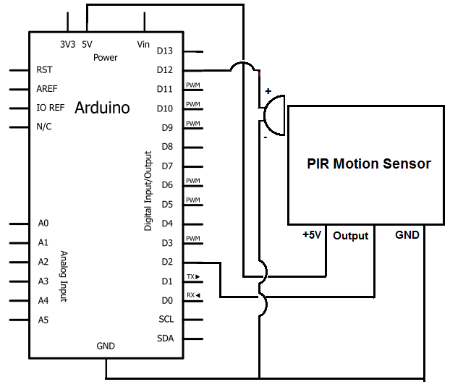

PIR Sensors
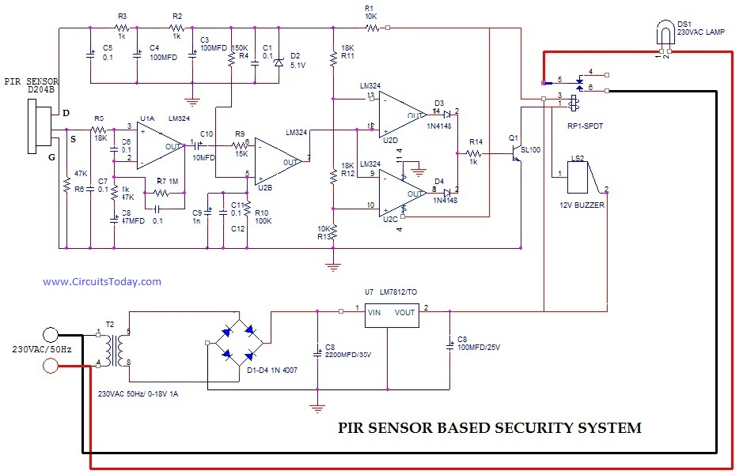

System design

(PIR Sensors, n.d.)
Figure 8.3 Circuit Diagram
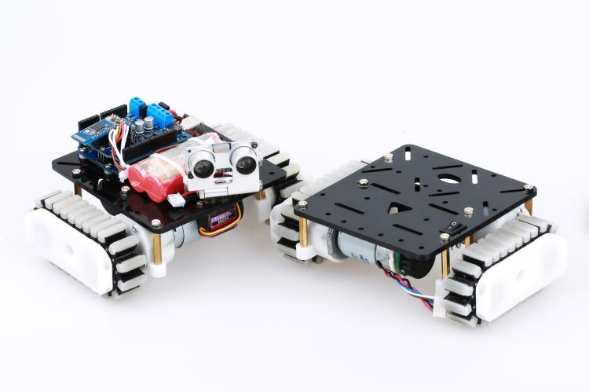
Figure 8.4 complete circuitry
(PIR based tanks, n.d.)

List of equipment

NAME | MODEL | SPECIFICATION | FEATURES
Microcontroller | Arduino AT mega 256
Camera
Bluetooth module | HC-05
Battery
Sensors | PIR  Sensor
Motor | Dc motor
TABLE 8.1 List of equipment

Chapter 9
Analysis and Results

Results

SCENARIO-I
No one is present between the areas being patrolled
When scenario-I occurs the following steps take place:-

Figure 9.1 Border Patrol

SCENARIO-II

Intruder is detected between the areas being patrolled.
When scenario-II occurs the following steps take place:-

Figure 9.2 Intrusion Detection

PIR Sensors
We will take a glance that however a PIR sensing element works and the way to use it with the Arduino Board for police investigation motion. we are going to take an example of a person's or associate degree animal once a person's or animal body will get within the vary of the sensing element it'll sight a movement as a result of the human or animal body emits energy during a type of infrared emission. That’s wherever the name of the sensing element comes from, a Passive Infra-Red sensing element and also the term “passive” means sensing element isn't victimization any energy for police investigation functions, it simply works by police investigation the energy given off by the opposite objects. The module conjointly consists a specially designed cowl named lense that focuses the infrared signals onto the pyro electrical sensing element.
PIR sensors have a 3-pin connection at the side or bottom. One pin will be ground, another will be signal and the last pin will be power. Power is usually up to 5V. Sometimes bigger modules don’t have direct output and instead just operate a relay which case there is ground, power and the two switch associations. Interfacing PIR with microcontroller is very easy and simple. The PIR acts as a digital output so all you need to do is listening for the pin to flip high or low. The motion can be detected by checking for a high signal on a single I/O pin. Once the sensor warms up the output will remain low until there is motion, at which time the output will swing high for a couple of seconds, then return low. If motion continues the output will cycle in this manner until the sensors line of sight of still again. The PIR sensor needs a warm-up time with a specific end goal to capacity fittingly. This is because of the settling time included in studying nature’s domain. This could be anyplace from 10-60 seconds. Throughout this time there ought to be as little movement as could reasonably be expected in the sensors field of perspective. (PIR SENSORS BASIC APPLICATION, n.d.)

Figure 9.3 when no intruder is present.

Figure 9.4 in Presence of the Intruder.

Chapter
CONCLUSION
At present in our country there hasn’t been used a system which might mechanically notice human intrusion in addition because the presence of any explosive materials at the borders. Presently one or additional troopers area unit required to patrol the border space during this project, we have a tendency to introduce Border security robot, a wireless detector specification for patrol to cut back the human involvement and accustomed improve the detection accuracy of current patrol systems The human involvement reduced with the assistance of PIR detector, IR camera, blue tooth module, Wi-Fi module. Whole of our robot can work with the assistance of a Microcontroller AT Mega 256 integrated on a coaching Board Arduino Mega. 2 L293D driver ICs area unit accustomed drive the two motors. Drivers make sure the correct operating voltage for DC motor and conjointly defend the microcontroller from being injured attributable to the rear electrical phenomenon generated within the motor. This project offers lots of scope for adding newer options. We are able to program the robot specified it can notice objects and reach them. Thus, we will build it utterly autonomous. Also, with the presence of camera and Bluetooth package, the robot has the aptitude of finding the most effective route attainable to achieve an explicit location. Also, by creating it sturdier and giving it further protection, we will build it AN all-terrain robot, which might build it ideal for a police investigation robot. There is conjointly the choice of adding sound process to the remote pc, so giving it bigger police investigation capabilities. The chances area unit endless. This robot in its current state provides a platform for additional analysis into rising its capabilities.

APPENDIX- I

EQUIPMENT | SPECIFICATIONS
CAMERA | IR Wireless Camera
Bluetooth |  | HC-05
MICRO-CONTROLLER |  | Arduino Mega
SENSORS |  | PIR Sensor
MOTOR |  | DC Motors.

APPENDIX- II

ARDUINO CODING
void setup() {
// put your setup code here, to run once:

pinMode(8,OUTPUT);
pinMode(9,OUTPUT);
pinMode(10,OUTPUT);
pinMode(11,OUTPUT);
Serial.begin(9600);

}

void forward()
{
Serial.println("fORWARD");
digitalWrite(8,HIGH);
digitalWrite(9,LOW);
digitalWrite(10,LOW);
digitalWrite(11,HIGH);

}
void backward()
{
Serial.println("backward");
digitalWrite(8,LOW);
digitalWrite(9,HIGH);
digitalWrite(10,HIGH);
digitalWrite(11,LOW);
void left()
{
Serial.println("left");
digitalWrite(8,HIGH);
digitalWrite(9,LOW);
digitalWrite(10,LOW);
digitalWrite(11,LOW);

}
void right()
{
Serial.println("right");
digitalWrite(8,LOW);
digitalWrite(9,LOW);
digitalWrite(10,LOW);
digitalWrite(11,HIGH);

}
void stop()
{
Serial.println("stop");
digitalWrite(8,LOW);
digitalWrite(9,LOW);
digitalWrite(10,LOW);
digitalWrite(11,LOW);

}

void loop() {

char ch;
if(Serial.available())
{ ch=Serial.read();

if(ch=='F')
{
FORWARD();
}

if(ch=='B')
{
BACKWARD();
}

if(ch=='L')
{
LEFT();
}
if(ch=='R')
{
RIGHT();
}
if(ch=='S')
{
STOP();
}
}

DESKTOP CODING

using System;
using System.Collections.Generic;
using System.ComponentModel;
using System.Data;
using System.Drawing;
using System.Linq;
using System.Text;
using System.Threading.Tasks;
using System.Windows.Forms;
using System.IO.Ports;

namespace khawar
{
public partial class Form1 : Form

{
private SerialPort myport;
public Form1()
{
InitializeComponent();
myport = new SerialPort();
myport.PortName = "COM3";
myport.BaudRate = 9600;
myport.Open();
}

private void button1_Click(object sender, EventArgs e)
{
myport.Write("F");
}

private void button3_Click(object sender, EventArgs e)
{
myport.Write("R");
}

private void button5_Click(object sender, EventArgs e)
{
myport.Write("S");
}

private void button2_Click(object sender, EventArgs e)
{
myport.Write("L");
}

private void button4_Click(object sender, EventArgs e)
{
myport.Write("B");
}
}
}

Image Processing:
import cv2
import argparse
import datetime
import imutils
import time
import os

def diffImg(t0, t1, t2):

d1 = cv2.absdiff(t2, t1)

d2 = cv2.absdiff(t1, t0)

return cv2.bitwise_and(d1, d2)
# construct the argument parser and parse the arguments
ap = argparse.ArgumentParser()
ap.add_argument("-v", "--video", help="path to the video file")
ap.add_argument("-a", "--min-area", type=int, default=15000, help="minimum area size")
args = vars(ap.parse_args())

if args.get("video", None) is None:
#Initializing the Default Camera
cam = cv2.VideoCapture(0)
time.sleep(0.25)

# otherwise, we are reading from a video file
else:
cam = cv2.VideoCapture(args["video"])

winName = "Movement Indicator"

cv2.namedWindow(winName, cv2.WINDOW_AUTOSIZE)

# Read three images first:

#Readind 1st frame
t_minus = cv2.cvtColor(cam.read()[1], cv2.COLOR_RGB2GRAY)

#Readind 2nd frame
t = cv2.cvtColor(cam.read()[1], cv2.COLOR_RGB2GRAY)

#Readind 3rd frame
t_plus = cv2.cvtColor(cam.read()[1], cv2.COLOR_RGB2GRAY)

#Image Counter
i=0

while True:
(grabbed, frame) = cam.read()
text = "Unoccupied"

# if the frame could not be grabbed, then we have reached the end
# of the video
if not grabbed:
break
#Showing Difference in Frame -> If Black There is no Change otherwise you can observe the change
cv2.imshow( winName, diffImg(t_minus, t, t_plus) )
#Calculating the difference of two consecutive frames
frameDelta=cv2.absdiff(t,t_plus)

thresh = cv2.threshold(frameDelta, 25, 255, cv2.THRESH_BINARY)[1]
thresh = cv2.dilate(thresh, None, iterations=2)
(_,cnts, _) = cv2.findContours(thresh.copy(), cv2.RETR_EXTERNAL,cv2.CHAIN_APPROX_SIMPLE)
#If countour is detected then show bounding rectangle against the variation
for c in cnts:
if cv2.contourArea(c) < args["min_area"]:
continue
(x, y, w, h) = cv2.boundingRect(c)
cv2.rectangle(frame, (x, y), (x + w, y + h), (0, 255, 0), 2)
text = "Occupied"
cv2.imwrite('Alert\FrameNew%d.png'%i,frame)
i+=1
#Writing Text on Main Screen
cv2.putText(frame, "Room Status: {}".format(text), (10, 20),
cv2.FONT_HERSHEY_SIMPLEX, 0.5, (0, 0, 255), 2)#BGR
cv2.putText(frame, datetime.datetime.now().strftime("%A %d %B %Y %I:%M:%S%p"),
(10, frame.shape[0] - 10), cv2.FONT_HERSHEY_SIMPLEX, 0.35, (0, 0, 255), 1)

# Read next image

t_minus = t

t = t_plus

#Recording Video of change
t_plus = cv2.cvtColor(cam.read()[1], cv2.COLOR_RGB2GRAY)
vvw = cv2.VideoWriter('mymovie.avi',cv2.VideoWriter_fourcc('X','V','I','D'),2,(640,480))
frameslist = os.listdir('.\\Alert')
howmanyframes = len(frameslist)
print('Frames count: '+str(howmanyframes))

for i in range(0,howmanyframes):
#print(i)
theframe=cv2.imread('.\\Alert\\'+frameslist[i])
vvw.write(theframe)
cv2.imshow("Security Feed", frame)
key = cv2.waitKey(10)

if key == 27:
cam.release()
cv2.destroyAllWindows()
break

print "Goodbye"

Bibliography

Internet source. (n.d.). Retrieved from Linkmix: http://www.linkmix.in/microcontroller/
PIR based tanks. (n.d.). Retrieved from Google: https://www.google.com.pk/search?rlz=1C1CHBD_enPK756PK756&biw=1242&bih=535&tbm=isch&sa=1&q=tank++robot+pictures+for+pir+sensors&oq=tank++robot+pictures+for+pir+sensors&gs_l=psy-ab.12...0.0.0.13018.0.0.0.0.0.0.0.0..0.0....0...1..64.psy-ab..0.0.0....0.ZPdgO
PIR Sensors. (n.d.). Retrieved from Google: https://www.google.com.pk/search?rlz=1C1CHBD_enPK756PK756&tbm=isch&q=pir+sensor+circuit+diagram+with+arduino+ATmega+256+pics&spell=1&sa=X&sqi=2&pjf=1&ved=0ahUKEwjspOjOy4XXAhWDcRQKHbwECoQQBQghKAA&biw=1242&bih=535&dpr=1.1#imgrc=hgMRQKW_Ie4SEM:
PIR SENSORS BASIC APPLICATION. (n.d.). Retrieved from Elprocus: https://www.elprocus.com/pir-sensor-basics-applications/

Plagiarism Report


