SUPERIOR UNIVERSITY LAHORE


Faculty of Computer Science & IT

Final Year Project
PROJECT REPORT

[Facial Recognition]

Project ID: [MCSM-F16-002]

Project Team
Student Name | Student ID | Program | Contact Number | Email Address
Samsaam Qasim | MCSM-F16-010 | MCS | 0332-3232163 | Samsaamqasim5@gmail.com
Tanzeel Mirza | MCSM-F16-019 | MCS | 0333-4007421 | Tanzeelmirza6@gmail.com

[Mr Umar Hameed]
(Junior Lecturer)
Project Report
[Facial Recognition]

Change Record
Author(s) | Version | Date | Notes | Supervisor’s Signature
 | 1.0 |  | <Original Draft>
 | 2.0 |  | <Changes Based on Feedback from Supervisor>
 | 2.5 |  | <Changes Based on Feedback From Faculty>
 | 3.0 |  | <Added Project Plan>
 | 3.0 |  | <Changes Based on Feedback from Supervisor>

APPROVAL
Project Supervisor
Comments: ___________________________________________________________________
_____________________________________________________________________________
Name:______________________________
Date:_______________________________ | Signature:__________________________

Project Manager
Comments: ___________________________________________________________________
_____________________________________________________________________________
Date:_______________________________ | Signature:__________________________

Head of the Department
Comments: ___________________________________________________________________
_____________________________________________________________________________
Date:_______________________________ | Signature:__________________________

Dedication

This work is dedicated to our “parents” without whose sole contribution we could not achieve anything in our life.

Acknowledgements

At the outset, all praise be only to Allah, the Omnipotent to accept this effort and to consider it for His sake only without Whose Grace this work would have not been accomplished. We would like to express our profound thanks to our Supervisor “Sir Umar Hameed”. This whole and frequently providing constructive suggestions work throughout our period of study at the Superior University from 2016 to 2018. I owe my greatest debts and thanks to my dearest group members “Tanzeel Mirza” and his truly extraordinary patience and emotional support.

Executive Summary
Facial recognition technology (FRT) has emerged as an attractive solution to address many contemporary needs for identification and the verification of identity claims. It brings together the promise of other biometric systems, which attempt to tie identity to individually distinctive features of the body, and the more familiar functionality of visual surveillance systems.
FRT has proven effective, with relatively small populations in controlled environments,.Much of our personal information is stored in our phone and it is important to protect it.
This technology is introduced by many new mobiles like Samsung, Apple, Huawei, Oppo etc. But these mobiles have built-in function. But our app contains face detection as well as detect your expressions as well also you can make emoji according to your expressions by clicking your photo. Our app can also detect emotions whether you are happy or sad.
Our main aim is to provide interaction and innovation environment in the field of Android Apps in which user can enjoy and get the best far experience in app and its features. Our goal is to make the people together in a fun environment that user can completely involve in our app.
Femoji is the type of app where you can create emoji just by giving expression with different categories it is a fun app. The main part is it is a research based project which we have implement in form of Android Application.

Table of Contents
Dedication iv
Acknowledgements v
Executive Summary vi
Table of Contents vii
Chapter 1 3
Introduction 3
1.1. Background 4
1.2. Motivations and Challenges 4
1.3. Goals and Objectives 4
1.4. Literature Review/Existing Solutions 5
1.5. Gap Analysis 5
1.6. Proposed Solution 5
1.7. Project Plan 5
1.7.1. Work Breakdown Structure 6
1.7.2. Roles & Responsibility Matrix 7
1.7.3. Gantt Chart 7
1.8. Report Outline 8
Chapter 2 9
Software Requirement Specifications 9
2.1. Introduction 10
2.1.1. Purpose 10
2.1.2. Document Conventions 10
2.1.3. Intended Audience and Reading Suggestions 10
2.1.4. Product Scope 10
2.2. Overall Description 2
2.2.1. Product Perspective 2
2.2.2. Product Function 2
2.2.3. User Classes and Characteristics 2
2.2.4. Operating Environment 2
2.2.5. Design and Implementation Constraints 3
2.2.6. User Documentation 3
2.2.7. Assumptions and Dependencies 3
2.3. External Interface Requirements 4
2.3.1. User Interfaces 4
2.3.2. Hardware Interfaces 4
2.3.3. Software Interfaces 5
2.3.4. Communications Interfaces 5
2.4. System Features 5
2.4.1. Main Menu Functions 5
2.4.1.1. Description and Priority 5
2.4.1.2. Stimulus/Response Sequences 6
2.4.1.3. Functional Requirements 6
2.5. Other Nonfunctional Requirements 6
2.5.1. Performance Requirements 6
2.5.2. Safety Requirements 7
2.5.3. Security Requirements 7
2.5.4. Software Quality Attributes 7
2.5.5. Business Rules 7
2.6. Other Requirements 7
Chapter 3 8
Use Case Analysis 8
3.1. Use Case Model 9
3.2. Use Case Diagram 10
Chapter 4 11
System Design 11
4.1. Architecture Diagram 12
4.2. Entity Relationship Diagram 13
4.3. Class Diagram 14
4.4. Sequence / Collaboration Diagram 15
4.5. Domain Model 15
4.6. Activity Diagram 16
4.7. Component diagram 17
4.8. Data Flow diagram 18
4.9. Deployment Diagram 19
Chapter 5 20
Implementation 20
5.1. Important Flow Control/Pseudo codes 21
5.2. Components, Libraries, Web Services and stubs 21
5.3. Deployment Environment 23
5.4. Tools and Techniques 24
Keywords 24
Google Vision Library 24
5.5. Best Practices / Coding Standards 24
5.6. Version Control 24
Chapter 6 25
Testing and Evaluation 25
6.1. Use Case Testing 26
6.2. Equivalence partitioning 27
6.3. Boundary value analysis 27
6.4. Data flow testing 28
6.5. Unit testing 29
6.6. Integration testing 30
6.7. Performance testing 31
6.8. Stress Testing 31
Chapter 7 32
Summary, Conclusion and Future Enhancements 32
7.1. Project Summary 33
7.2. Achievements and Improvements 33
7.3. Critical Review 34
7.4. Lessons Learnt 34
7.5. Future Enhancements/Recommendations 34
Appendices 35
Appendix A: Information / Promotional Material 36
Appendix B: App Menu 38

Chapter 1

Introduction

Chapter 1: Introduction
This chapter describes about the introduction and background of Face Recognition technology. It is about the detailed background of Face Recognition technology. It includes the first Face recognition service (FRS) and further enhancements of this technology. The motivation and challenges in this technology. We describe our goals and objectives to using this technology. We enlist the existing solutions and problem statement in this chapter. The planning of our project, also describe work breakdown structure and roles of our team members. Finally we are written a report outline for our project.

Background
Face recognition technology was commonly viewed as something straight out of science fiction. But over the past decade, this ground-breaking technology has not become just viable but it has become widespread. Existing some mobile devices have only built-in feature. So how other smartphone user can use that feature. With our app it would be easy to use face recognition service in any mobile. User can make face emojis and detect emotions through our app.

Motivations and Challenges
Our motivations are to create easy environment where user can know how to use face features in their real life, every person uses mobile device with great features. In Pakistan people don’t know much more about face recognition. Because face recognition introduces in very expensive mobiles not everyone should buy. With our app every person should know about Face Recognition technology and able to use its features. We feel very glad and honorable if a person would enjoy features of our App. It is very easy to use for every person.

Goals and Objectives
Our main aim is to provide interaction and innovation environment in the field of Android Apps in which user can enjoy and get the best far experience in app and its features. Our goal is to make the people together in a fun environment that user can completely involve in our app.

Literature Review/Existing Solutions
This technology is introduced by many new mobiles like Samsung, Apple, Huawei, Oppo etc. But these mobiles have built-in function. But our app contains face detection as well as detects your expressions as well also you can make emoji according to your expressions by clicking your photo. Our app can also detect emotions whether you are happy or sad.

Gap Analysis
Smartphone users cannot have such built-in function except rare mobiles even existing feature have poor result and also there is no such app. There is not any proper app available which can make your face emoji by detecting your face expressions. You can also get inspired by our quotes according to your mood.

Proposed Solution
By looking this gap, we proposed a app that is truly based on FRT and contains a Face expression feature in it. By using this app users can make face emoji and detects their emotions. Facial recognition analyzes the characteristics of a person's face images input through a mobile camera. It measures the overall facial structure, including distances between eyes, nose, mouth, and jaw edges.

Project Plan
Our firstly plan is to design a beautiful and easy interference App. Then we will move towards development phase. The main part of our app is to detect face and make face emoji.

Work Breakdown Structure

Roles & Responsibility Matrix
The purpose of roles & responsibility matrix is to identify who will do what.
WBS # | WBS Deliverable | Activity # | Duration  (# of Days) | Responsible Team Member(s) & Role(s)
1 | Data Gathering | 1 | 3 weeks | Samsaam Qasim,  Tanzeel Mirza
2 | Java Learning | 2 | 4 weeks | Samsaam Qasim,  Tanzeel Mirza
3 | Libraries Work | 3 | 4 weeks | Samsaam Qasim,  Tanzeel Mirza
4 | SQL lite Work | 4 | 3 week | Tanzeel Mirza
5 | Create GUI | 5 | 4 weeks | Samsaam Qasim,  Tanzeel Mirza
6 | App Development | 6 | 5 weeks | Samsaam Qasim,  Tanzeel Mirza

Gantt Chart

Report Outline
- Introduction
- Data Analysis
- Project Scope
- Goals and Objectives
- Existing Solution
- Gap Analysis
- Project Plan

Chapter 2

Software Requirement Specifications

Chapter 2: Software Requirement Specifications

Introduction
In this section the documentation of this report is specified. It specifies the purpose, document convention, document scope and also provides a suggestion for the readers of the document.

Purpose
The main goal or purpose of this document is to define the functionality and purpose of our app. This SRS include all the specifications like design, interface. There requirements and components. The main purpose of this SRS is to provide a complete understanding that what we are building in this app.

Document Conventions
The whole document is written in MLA format. Topics introduced in section and subsection headings in a bold text. Highlighting is to point out words in the glossary and italicized text and includes various diagrams like UML, ERD, DFD, etc.

Intended Audience and Reading Suggestions
Our project document has been done under the guidance of our supervisor and can be useful for any app development team. Student who wants to write document related to this project. After reading this project developer and project managers completely understand with SRS of this app.

Product Scope
The product scope with the passage of time technology is advancing to the better way. Over the past century in the field of apps there is a big enhancement occurring. Peoples want the technology that is more interactive revolutionary. This document includes the formal requirements of our app “Facity”. This document describes the system features and internal requirement specification of our app. In this era the industries willing to adapting full scale FR technology. This technology will increase become more presents in user’s daily life.

Overall Description
The overall description gives the detail about the whole features and systems of our project.

Product Perspective
The development of a software from nothing to it’s released position is an important physical act from any software development company. It has need of much money put into business in terms of hard work and price and also makes more fixed the belief person for whom one does work sense of being mixed up, knowledge about person for whom one does work market (example: Google services). We have got facts together some interesting articles from the web. The development of any software in software industry is an important goal of any software solution company.

Product Function
Summarize the major functions the product must perform or must let the user perform. Details will be provided in Section 3, so only a high level summary (such as a bullet list) is needed here. Organize the functions to make them understandable to any reader of the SRS. A picture of the major groups of related requirements and how they relate, such as a top level data flow diagram or object class diagram, is often effective.

User Classes and Characteristics
This is face detection app by which user can make emoji by giving face expression and detect emotions by clicking their photos.

Operating Environment
Face Recognition is our mobile application which will be available for Operating system Android. Android version is must be greater than 4.0. And mobile ram must be greater than 512MB. In hardware specification, Mobile must have a camera and good screen graphics. They have web services and sharing option. And our app should have an access of camera of user mobile and gallery.

Design and Implementation Constraints
- Welcome Screen (App logo)
- Nav-Drawer menu
- Emotion Detection/Face Emoji
- Open Camera
- Inspired yourself by quotes
- About us
- Rate our app

User Documentation
Our app is simple and reliable for every user. But in just beginning process we should aware everyone to how they can use our app. We will provide some videos and advertise our app where users can see how they can use our app and get benefits from our app. We also provide information to user how they can use their face expression for different apps. In our app two option which is help full for user if they did not know how to use our app is through tutorials and by giving their feedback.

Assumptions and Dependencies
Our app totally depends on user mobile permission for access their hardware. Because our app had some major features which is necessary for they can access user camera, storage, location and gallery. If any of these hardware is not available for our app. Our app might not be working well for user and they can’t give user a to 100% response.

External Interface Requirements

User Interfaces
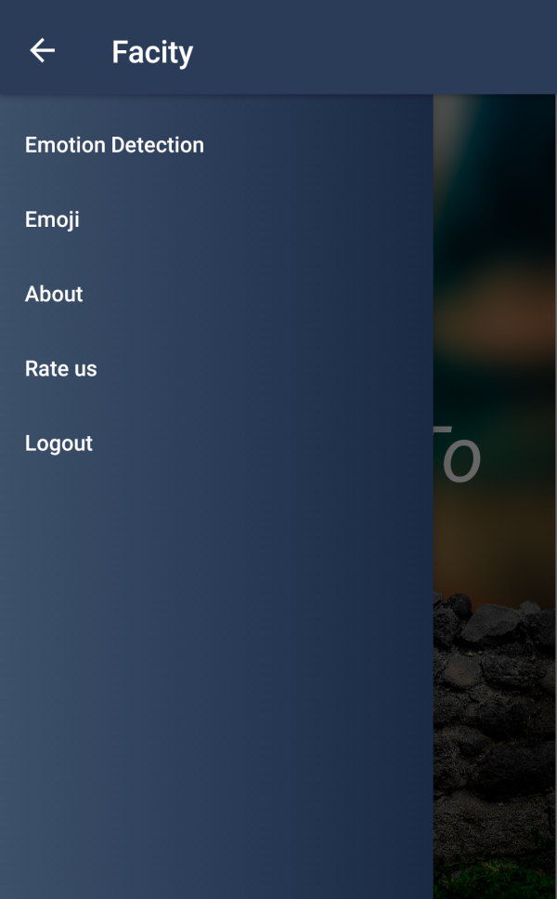

Hardware Interfaces
Our Face Recognition app shall provide minimum hardware requirement. The following hardware configurations are required for Mobile using the Face Recognition App.
- Android 4.0 and greater
- 50mb free hard drive space
- 1GB Ram and greater
- Camera 5mp and greater
- Processor 1.2 GHZ and greater

Software Interfaces
Our App has been developed using Java Development Kit.
Working Tools:
- Android Studio
- Google play services library
- SQL lite database

Communications Interfaces
As we know this is Face detection so this app must need camera to click photos and make emojis and detect emotions.

System Features
This app is designed in 3 main layers
- Main Menu
- Emotion Detection
- Face Emoji

Main Menu Functions

Description and Priority
It is the main and basic part of the function that directs to the other part of this app. It’s the first scene of our game called the User Interface of our app and the basic component of any app.

Stimulus/Response Sequences
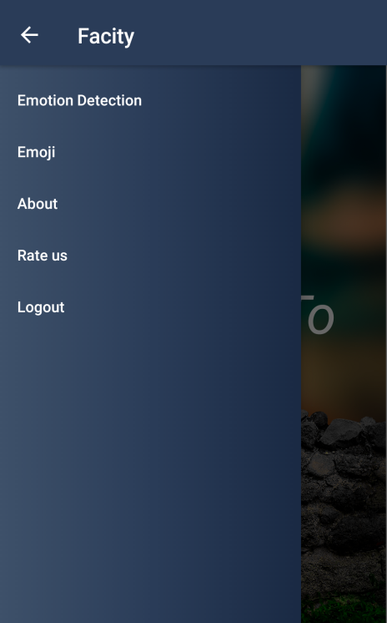

Functional Requirements
This section contains all the functionality of the main menu in detail
REQ-SF1-1: By clicking Emotion Detection you can check your emotion whether you are happy or sad.
REQ-SF1-2: By clicking emoji you can make you face emoji by giving expressions.
REQ-SF1-3: By clicking log out you can logout from app.

Other Nonfunctional Requirements

Performance Requirements
We can use different methods for boosting application performance.
- CPU Optimization
- Faster Face detection
- Faster Emotion detection
- Faster make face emoji
With the help of these methods we can achieve maximum performance of our application.

Safety Requirements
Our app is totally safe for every user it is design in such a way that there is not any chance of hacking.

Security Requirements
There is no security issue because when person face detect and emoji is created user can save its picture in gallery our app access gallery but there is no any person who is accessing the app user is the main person who give access to gallery just because to save pictures in it.

Software Quality Attributes
The software quality attributes of our app is
- Performance
- Availability
- Correctness
- Usability
- Testability
- Security

Business Rules
Not available

Other Requirements
We have covered almost all the necessary requirements for our document. There are no other requirements of our app project “Facity” that we are using in our app.

Chapter 3

Use Case Analysis

Chapter 3: System Analysis
This chapter describes the system analysis and models of our app. These models tell us how the user interacts with the system and what the sequence of activities that occur as the software is used.

Use Case Model
The below table summarize the use case model of our system.

Level – 0 | Level – 1 | Level – 2
App ( Facity ) | Emotion Detection | Take photo
App ( Facity ) | Emotion Detection | Load from gallery
App ( Facity ) | Emotion Detection | Check emotion
App ( Facity ) | Emotion Detection | Back
App ( Facity ) | Face emoji | Make emoji
App ( Facity ) | Face emoji | Emoji Categories
App ( Facity ) | Logout

Use Case Diagram

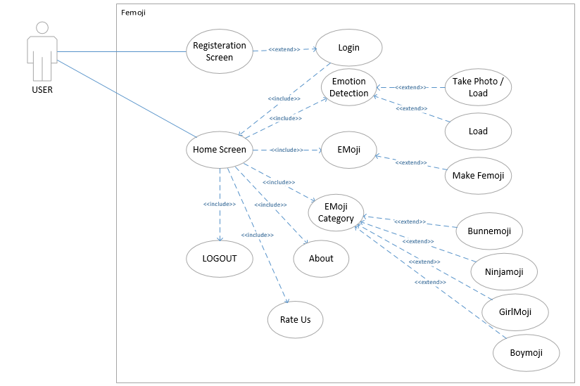

Chapter 4

System Design

Chapter 4: System Design
This chapter describes about the system design of our app. This will include the different types of diagrams. These different types of diagrams of software engineering which we are using for detailed design of our android application “Facity”.

Architecture Diagram

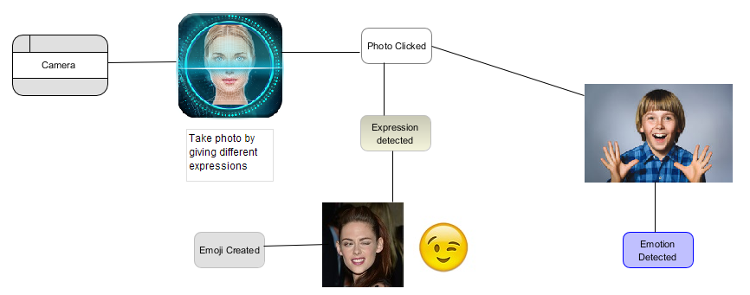

Entity Relationship Diagram
The entity relationship diagram is not applicable for our application because we are not save any type of data in our database server except Registration.

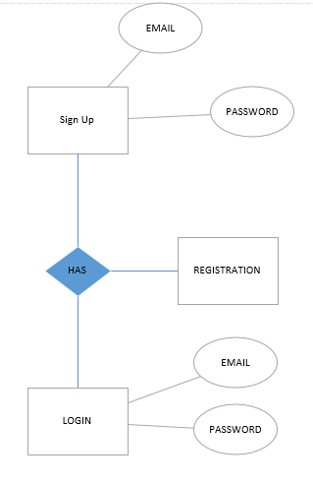

Class Diagram

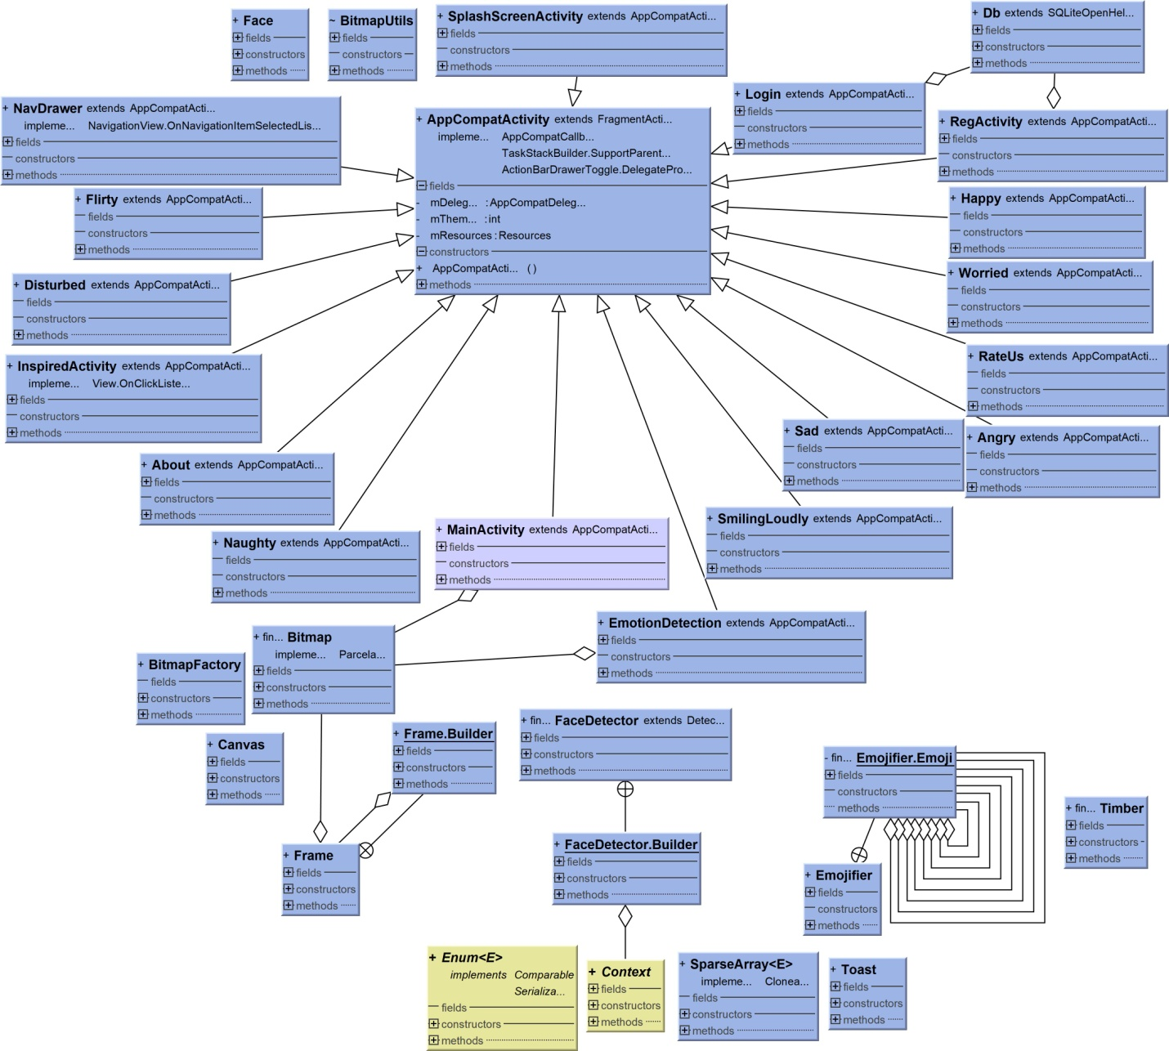

Sequence / Collaboration Diagram
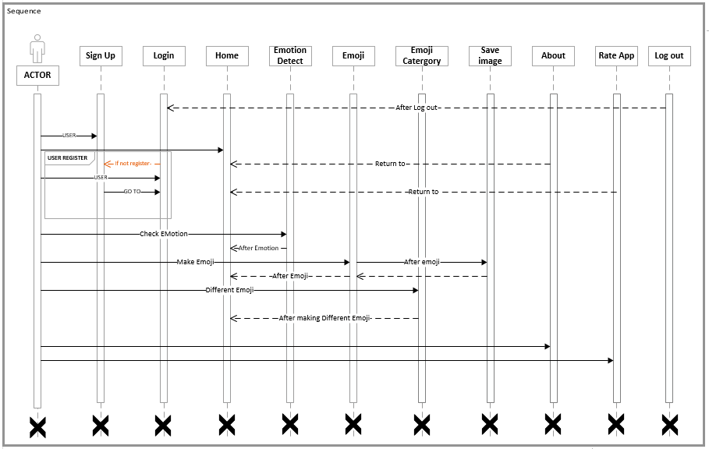

Domain Model
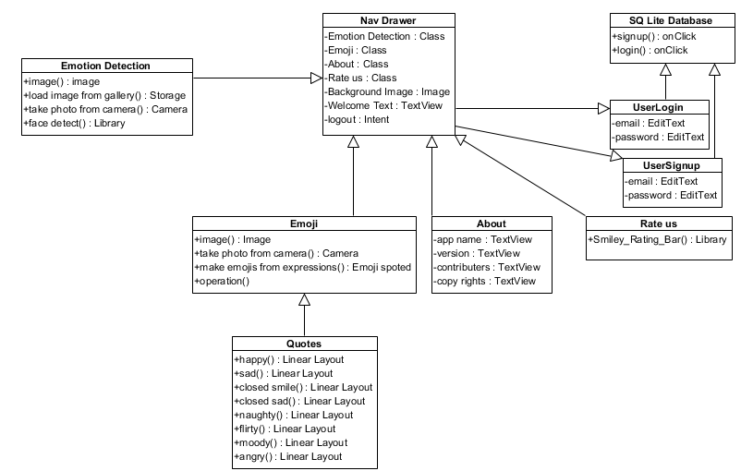

Activity Diagram
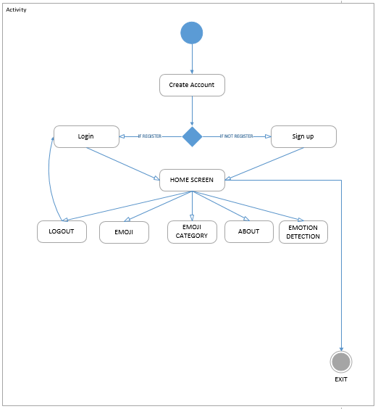

Component diagram
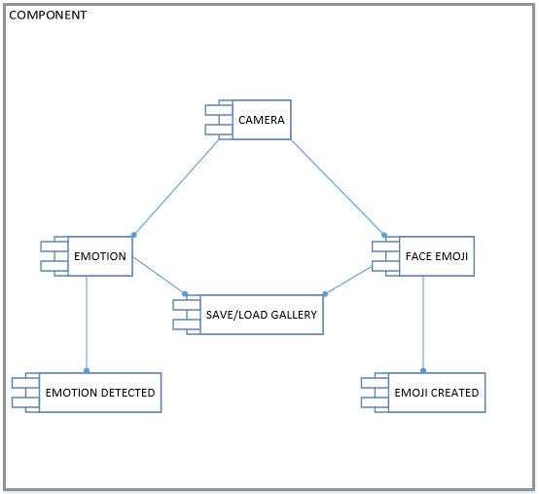

Data Flow diagram
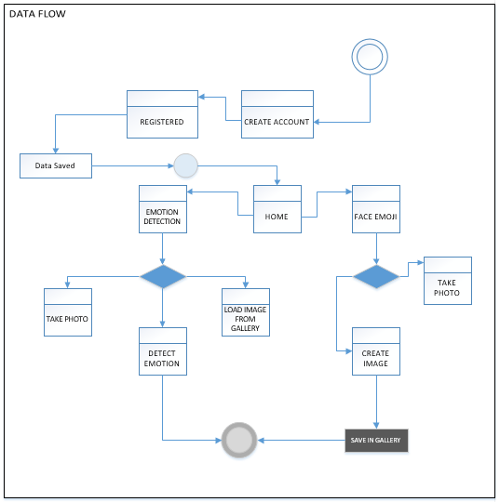

Deployment Diagram

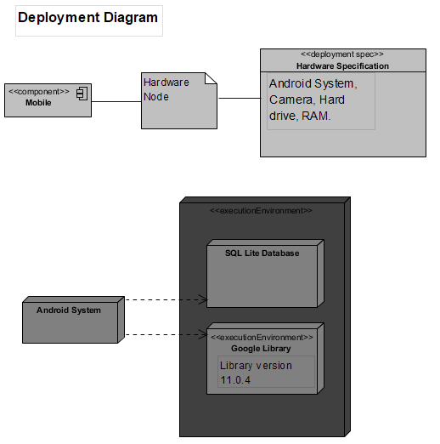

Chapter 5

Implementation

Chapter 5: Implementation
This chapter covers the implementation of our project features and implementation flow control of our app. This chapter also describes the components, libraries and web services used in our application project. The deployment environment, tools and techniques and coding standards are explained in this chapter that we are using in our application project.

Important Flow Control/Pseudo codes
We use waterfall model software engineering technique for developing our project.

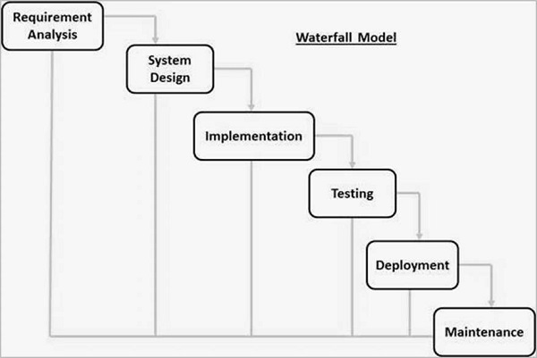

Components, Libraries, Web Services and stubs
The Android studio components we used in our app
Layouts
- Linear Layout
- Relative Layout
- Drawer Layout
Other Components
- Buttons
- Image view
- Text view
- Floating action button
- Splash screen
- Mobile Camera
Libraries
- Com.google.android.gms.vision.Frame
- Com.google.android.gms.vision.face.Face
- Com.google.android.gms.vision.face.FaceDetector.Landmark
- Android.graphics.Bitmap
- Android.graphics.BitmapFactory
- Android.graphics.Canvas
- Android.util.SparseArray
Web Services
We used web services of Google vision.

Stubs
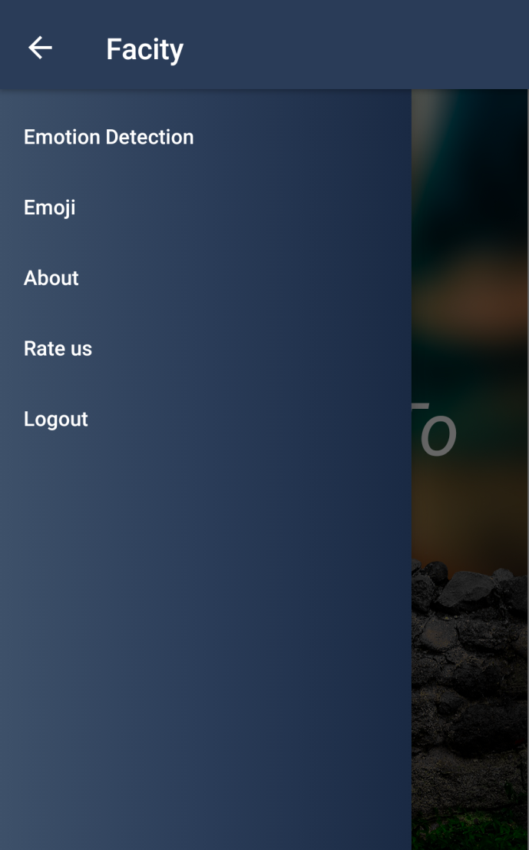

Deployment Environment
For developing our mobile app, we use Android studio to develop application. SQL Lite is use for database. We define system in different ways using domain model and other many diagrams which defines working of our app very extremely. The best thing about being a software developer is that software needs changing accordingly the customer requirement. This is exciting it also means that software developers must always be think and try to learn about new technique’s, programming languages in which there are different types of technique’s that are used for control the streaming of the customer.

Tools and Techniques
Tools | Android Studio, SQL lite
Languages | Java, XML
Keywords | Google Vision Library
Database | SQL Lite

Best Practices / Coding Standards
For maintaining and reliable application, you have to perform work in best practices and also use best coding standard. There are lots of standard in the programming industry but we choose JAVA. JAVA is the one of the best standard language in which we ensure the user requirements with good practices. SQL Lite is also used for database because through the query structured we maintain data, and also save record of each customer.

Version Control
Application will create to solve the current world environment. So, the developer develops the app accordingly the current problem. In app changes are desperately needed according to user requirements. Version control is the process in which we change features of app in demand of Users.

Chapter 6

Testing and Evaluation

Chapter 6: Testing and Evaluation
This chapter includes some test cases for the app to check if the app works properly in various situations. In this whole chapter we check each aspect of app according to its performance and appearance. Testing each part of the app give us a detailed report of our app which gives us a better understanding of application and its life cycle.

Use Case Testing
In use case testing we generally test our app covering all aspects.
User Interface (UI) | Test for graphics.
 | Test for orientation Portrait.
 | There should not be cutting background
 | Test for there is not overlapping object
 | Test for enable disable images, icons, buttons.
 | Font displayed efficiently.
Performance during Face Detection | Face is detecting efficiently.
Performance during creating Face Emoji | Test the creating time of Face Emojis and they work properly.
Performance during Checking Emotion | The work efficiently
Core Structure of App | Test App Logic and Environment
 | Navigation Bar Option
Memory Leak | Check App when device memory is low

Equivalence partitioning
Invalid | Valid | Invalid
User Name<1 | User Name In Between 1-40 | User Name > 40
User Password < 6 | User Password In Between 6-30 | User Password > 30
User Name Include Numeric Value | User Name Include Alphabetic Values | User Name Include Special Characters
User Name First Letter Small | User Name First Letter Capital | User Name First Letter Numeric or Other
Generating face emoji <1 | Generating Face emoji Between 1-3 | Generate Face Emoji > 3
Detect Face<1 | Detect Face Between 1-3 | Detect Face>3

Boundary value analysis
Invalid (min-1) | Valid (min, +min, -max, max) | Invalid (max+1)
User Name(-1) | User Name In Between 1-40 | User Name(41)
User Password (-5) | User Password In Between 6-30 | User Password (31)
User Name Include Numeric Value | User Name Include Alphabetic Values | User Name Include Special Characters
User Name First Letter Small | User Name First Letter Capital | User Name First Letter Numeric or Other
Generate Face Emoji(-1) | Generate Face Emoji Between 1-3 | Generating Face Emoji (4)
Detect Face(-1) | Detect Face Between 1-3 | Detect Face (4)

Data flow testing
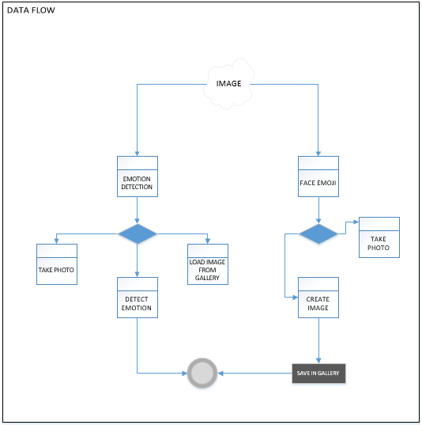

Unit testing
With the help of unity testing you can avoid from stupid bugs and write a sustainable code for your application. By using unit testing you get the early feedback through series of tests and avoid any type of regression in app and enrooted to object oriented design and create during documentation of your code.
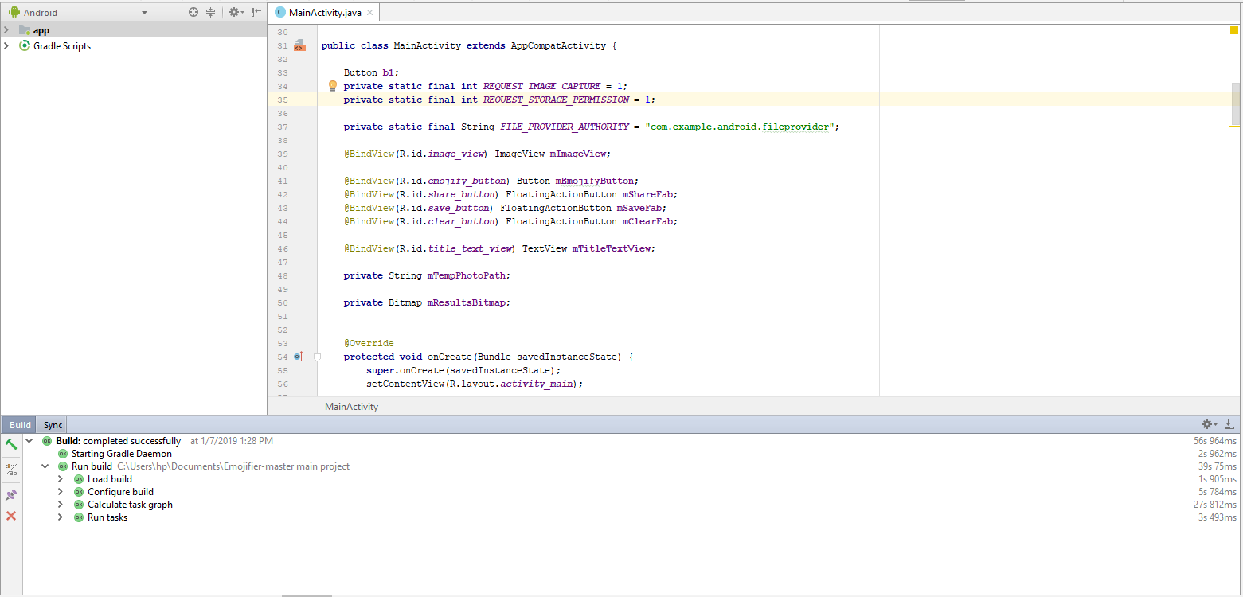
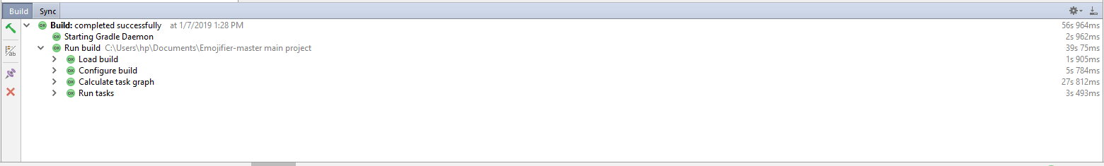
Android itself provides the features of unit testing of by building the app. So we ran our script tests for the betterment and find there is no error to be fixed in this code all the scripts to be tested and android studio made them clear.

Integration testing
Our app consist of 3 phases. In addition, we test all phases systematically.
In first phase, we test our UI interface is showing properly or efficiently. We test all buttons or layout is working properly.
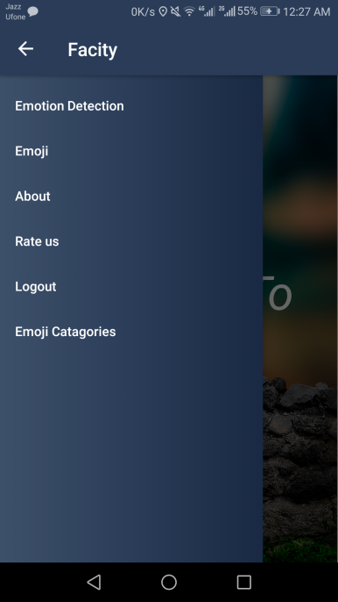
In second scene we are detecting emotions and everything is working properly.
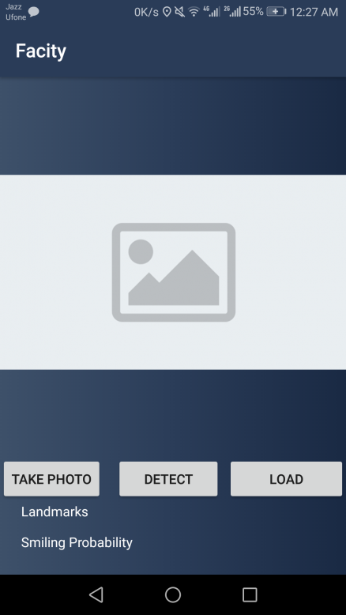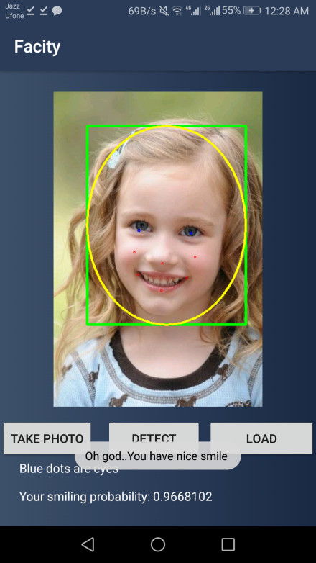

Third and Last Scene are the main and final scene of the app that includes the main part of app in which user can create emoji just by giving their expressions.
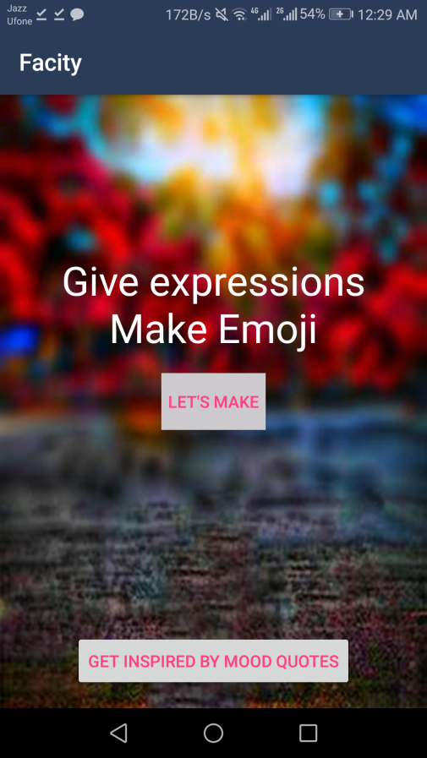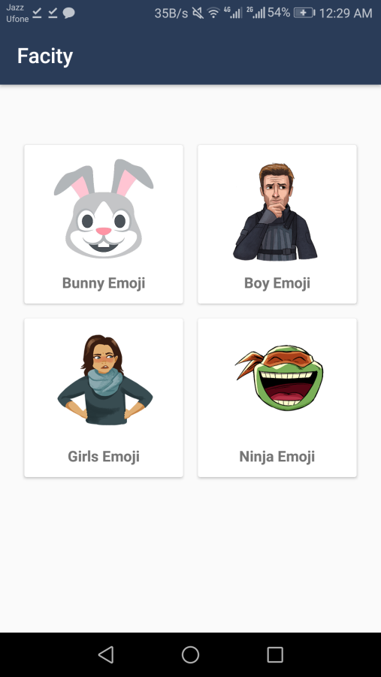

Performance testing
For performance testing of our app. Android studio provides itself a feature to test the performance of our app using Android Profiler and performance test features. It can test the requirements of your system and your app and display the result. We can test the CPU usage, system test, memory consumption and many other unit test.
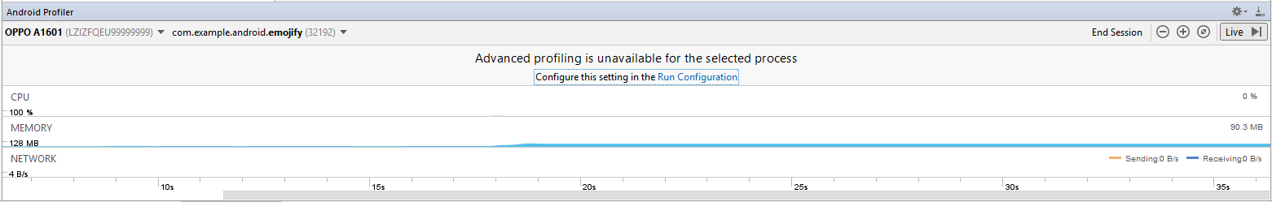

Stress Testing
In this testing we test the strength of a software by pushing to its limits so that we can came to know about how much this software goes far. In our app we ran a series of test on different devices to test the app stability. There is no app crash problem every thing is working properly.

Chapter 7

Summary, Conclusion and Future Enhancements

Chapter 7: Summary, Conclusion & Future Enhancements

Project Summary
This technology is introduced by many new mobiles like Samsung, Apple, Huawei, Oppo etc. But these mobiles have built-in function. But our app contains face detection as well as detect your expressions as well also you can make emoji according to your expressions by clicking your photo. Our app can also detect emotions whether you are happy or sad.

Achievements and Improvements
During this process of app development we learnt a lot of skills like :-
- Android Studio
- Working with libraries
- Creating an Environments
- Best Coding practices
- Layouts
- Face Dimensions
- Java and XML Coding
- Object oriented coding
- Building and running mobile application
- Logic behind face application
- UI/UX designing
- Creative thinking
these are the achievements and improvements we think we learn so far from this final project and that takes our interest in android application to take pursue our future with this field.

Critical Review
Femoji is the type of app where you can create emoji just by giving expression with different categories it is a fun app. The main part is it is a research based project which we have to implement in form of Android Application.

Lessons Learnt
We absorb very much from this project. This project sharpens our skills in Android Studio, designing tools and many management concepts as well as how to deal with a problem and how to stick for finding the solution of any problem until you found. As well as technical skills, this project also enhances our personal development skills such as team working, dedication. We learnt various types of techniques in android application development for the creation of app. Our passion of making a unique app that contains the enjoyment element in an innovative environment and we succeeded it. We continue our work after this to make it through worldwide. This project is a stepping stone for us in the beginning we don’t even know that if we accomplished it or not but due to our hardworking and research we do it and it’s an achievement for us that motivates us to do better and more.

Future Enhancements/Recommendations
So generally, there are many enhancements we want to put in our game i.e.
- Enhance the categories of Emoji
- Adding social connectivity in app
- Adding a feature for blind persons
- Increase the performance of app
- Adding new measurements
- Adding Object Detection

Appendices

Appendix A: Information / Promotional Material
In the appendix section we describe the different phases of user interface and also describe how user can use our project. Secondly we describe our promotional plan and promotional materials like broucher, banner, standee and other marketing materials. We also describe other interfaces of our application project.
  - Broacher
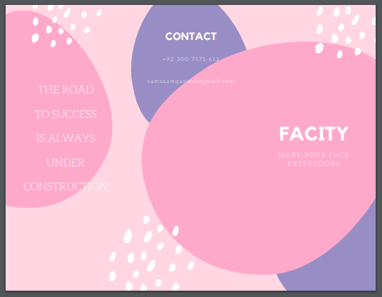

  - Flyer
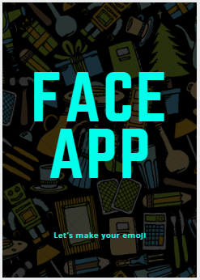
  - Banner


Appendix B: App Menu
  - Emotion Detection
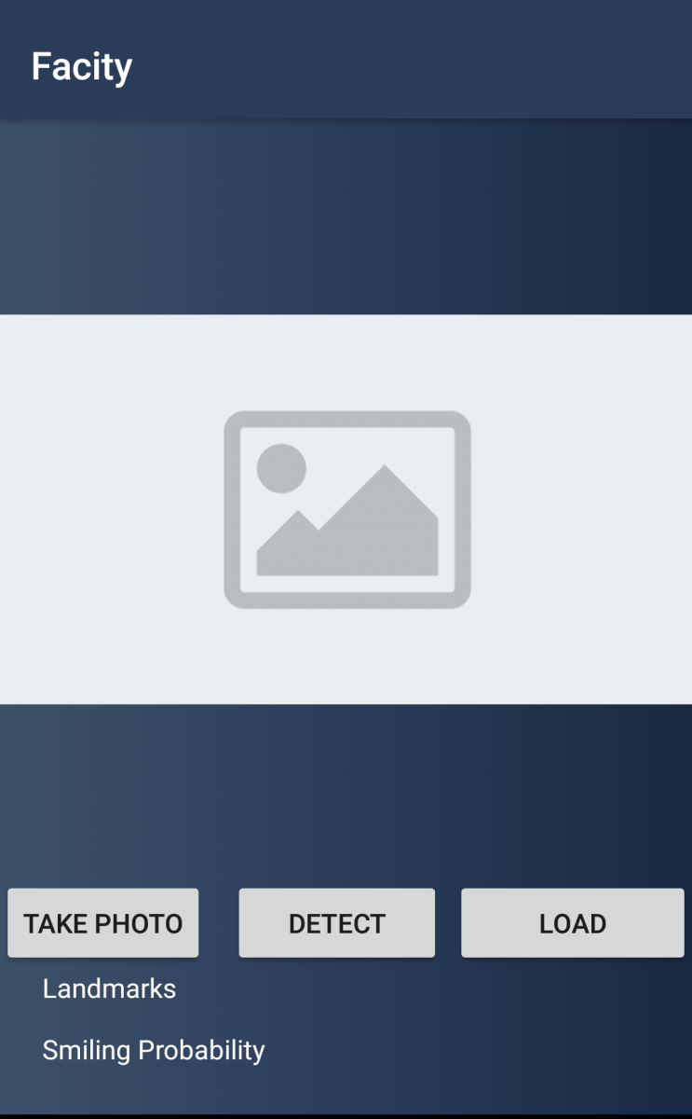

    - Face Emoji
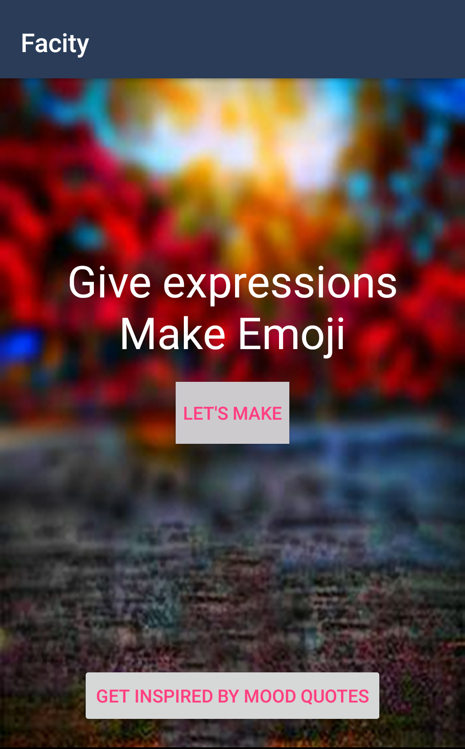

      - Registration
