SUPERIOR UNIVERSITY LAHORE


Faculty of Computer Science & IT

Final Year Project
PROJECT REPORT

[Virtual Office Assistant]

Project ID: [007]

Project Team
Student Name | Student ID | Program | Contact Number | Email Address
HASEEB MAJID | BSCS-F14-145 | BSCS | 03218879968 | Shahh8517@gmail.com
M.BILAL ANWAR | BSCS-F14-144 | BSCS | 03124409059 | Bilaldogar088@gmail.com
NOMAN RAZA | BSCS-F14-009 | BSCS | 03215989949 | Numanraza101@gmail.com
MUHAMMAD SALEEM | BSCS-F14-102 | BSCS | 03400596492 | Superioruniversity30@gmail.com

[Sir Fawad Nasim]
([Professor])
Project Report
[Virtual Office Assistant]

Change Record
Author(s) | Version | Date | Notes | Supervisor’s Signature
 | 1.0 |  | <Original Draft>
 |  |  | <Changes Based on Feedback from Supervisor>
 |  |  | <Changes Based on Feedback From Faculty>
 |  |  | <Added Project Plan>
 |  |  | <Changes Based on Feedback from Supervisor>

APPROVAL
Project Supervisor
Comments: ___________________________________________________________________
_____________________________________________________________________________
Name:______________________________
Date:_______________________________ | Signature:__________________________

Project Manager
Comments: ___________________________________________________________________
_____________________________________________________________________________
Date:_______________________________ | Signature:__________________________

Head of the Department
Comments: ___________________________________________________________________
_____________________________________________________________________________
Date:_______________________________ | Signature:__________________________

Dedication

The accomplishment of our productive task is dedicated to our supportive parents and our Advisor. Who stimulated us for this significant success.

Acknowledgements

First of all, we would like to thank “ALLAH ALMIGHTY” who has given us the strength to accomplish this task successfully. After that, efforts from our Advisor “SIR FAWAD NASIM SAHAB” can’t be neglected. The guideline he provided us at every milestone of this project from idea generation to final product was incomparable. It was not possible to complete this without his interference.
One major phase of this project was reading emails and download attachment. Because we are handling html page to read the email by their id’s the issue was that Google was changing their id’s at run time which could not be an easy task. In this matter our Advisor “SIR FAWAD NASIM SAHAB ” helped us a lot without his help it could not be so easy.

Executive Summary
A virtual robot that will help a user to perform most of the daily (office and personal) tasks on the computer. This virtual robot is called an Office Assistant (OA). Meetings and reminders can be scheduled through OA, reading of unread e-mails can also be done by OA. The OA will keep track of all the meetings and reminders. OA can surf the web for some particular information and save it for future use. OA can read document and prepare summaries. OA can prepare documents like spreadsheets, presentations and letters etc. In a net shell OA can perform all the tasks of a human personal assistant.

Table of Contents
Dedication iv
Acknowledgements v
Executive Summary vi
Table of Contents vii
Chapter 1 1
Introduction 1
1.1. Background 2
1.2. Motivations and Challenges 2
1.3. Goals and Objectives 3
1.4. Literature Review/Existing Solutions 3
1.5. Gap Analysis 4
1.6. Proposed Solution 4
1.7. Project Plan 4
1.7.1. Work Breakdown Structure 4
1.7.2. Roles & Responsibility Matrix 5
1.7.3. Gantt Chart 6
1.8. Report Outline 6
Chapter 2 8
Software Requirement Specifications 8
2.1. Introduction 9
2.1.1. Purpose 9
2.1.2. Document Conventions 9
2.1.3. Intended Audience and Reading Suggestions Error! Bookmark not defined.
2.1.4. Product Scope 9
2.1.5. References 10
2.2. Overall Description 10
2.2.1. Product Perspective 10
2.2.2. Product Functions 10
2.2.3. User Classes and Characteristics 11
2.2.4. Operating Environment 11
2.2.5. Design and Implementation Constraints 11
2.2.6. User Documentation 11
2.2.7. Assumptions and Dependencies 11
2.3. External Interface Requirements 11
2.3.1. User Interfaces 11
2.3.2. Hardware Interfaces 12
2.3.3. Software Interfaces 12
2.3.4. Communications Interfaces 12
2.4. System Features 12
2.4.1. System Feature 1 12
2.5. Other Nonfunctional Requirements 15
2.5.1. Performance Requirements 15
2.5.2. Safety Requirements 15
2.5.3. Security Requirements 16
2.5.4. Software Quality Attributes 16
2.5.5. Business Rules 16
2.6. Other Requirements 17
Chapter 3 18
Use Case Analysis 18
3.1. Use Case Model 19
3.2. Use Case Descriptions 21
Chapter 4 26
System Design 26
4.1. Architecture Diagram 27
4.2. Domain Model 28
4.3. Entity Relationship Diagram with data dictionary 30
4.4. Class Diagram 31
4.5. Sequence / Collaboration Diagram Error! Bookmark not defined.
4.6. Operation contracts 33
4.7. Activity Diagram 33
4.9. Component Diagram 35
4.10. Deployment Diagram 36
4.11. Data Flow diagram [only if structured approach is used - Level 0 and 1] 37
Chapter 5 38
Implementation 38
5.1. Important Flow Control/Pseudo codes 39
5.2. Components, Libraries, Web Services and stubs 39
5.3. Deployment Environment 40
5.4. Tools and Techniques 40
5.5. Best Practices / Coding Standards 43
5.6. Version Control 43
Chapter 6 44
Testing and Evaluation 44
6.1. Use Case Testing 45
6.2. Equivalence partitioning 45
6.3. Boundary value analysis 46
6.4. Data flow testing 46
6.5. Unit testing 47
6.6. Integration testing 48
6.7. Performance testing 48
6.8. Stress Testing 50
Chapter 7 51
Summary, Conclusion and Future Enhancements 51
7.1. Project Summary 52
7.2. Achievements and Improvements 52
7.3. Critical Review 53
7.4. Lessons Learnt 53
7.5. Future Enhancements/Recommendations 53
Reference and Bibliography 54

Chapter 1

Introduction

Chapter 1: Introduction
1) People are busy in their office work and other activities , so they don’t have enough time to prepare their office work because they have lots of other things to do and they forget to check their reminders, email’s. So in this way this system will be helpful for those people to done their office task. We have to give the task to this application then this will run automatically and collect relevant data to that particular task and make a summarize document on it ,save it in a new file and then alert after completing task and wait for user response. Working of our system is just like a virtual robot. It will work as a personal assistant which will perform all tasks like assignments, presentations, checking email and alerts us regarding any kind of announcements. Students shows carelessness to check important notifications, so our system will help to solve this problem it will automatically check student specific emails and alert about recent email.
2) Any company can hire a person for this purpose but a student can’t hire a person for this purpose that’s why we are going to design such project because it save’s money and time also. As we know that if any student pay all his/her attention to this kind of things like reminders, leaves and schedule for classes he can’t concentrate on study and in this way he wastes his lot of time, student have no need to login and on different accounts, our system will check and take a record and will alert user for new announcements.
3) So this system is very helpful for every one and students can get advantage from this application.

Background
A virtual robot that will help a user to perform most of the daily (office and personal) tasks on the computer. This virtual robot is called an Office Assistant (OA). Meetings and reminders can be scheduled through OA, reading of unread e-mails can also be done by OA. The OA will keep track of all the meetings and reminders. OA can surf the web for some particular information and save it for future use. OA can read document and prepare summaries. OA can prepare documents like spreadsheets, presentations and letters etc. In a net shell OA can perform all the tasks of a human personal assistant.

Motivations and Challenges
Our main objective is to design such software that is just like office assistant. This product help those students who have no time to schedule their meeting , checks mail ,read the topic ,generate the summarization and those who can’t afford to hire someone for work that is performed by an office assistant.

Goals and Objectives
End product will be a desktop application that will perform the following tasks
- Schedule meetings and reminders.
- Read emails e.g. specific emails like gmails.
- keeping track of all the meetings and reminders, like Gmail and superior portal
- Surfing web for some particular tasks, save it for future use.
- Read document and prepare summaries.
Prepare documents like Assignments, tasks, office work

Literature Review/Existing Solutions

Brief Description
GmailAssistant is a notifier for multiple Gmail and Google Apps email accounts. It accesses your accounts securely using IMAP over SSL. Choose from various notification options (unread mails in Inbox only, All Mails, or with specified labels) and alert methods (popup message, chime, blink keyboard LED). Runs on any OS with the Java Runtime Environment (JRE 6+). GmailAssistant is free and open source software written in Java and released under the GNU GPL license version 2.

Main Features
- Single-File Deployment: GmailAssistant is contained in just a single executable JAR file
- Zero Installation: Just double-click on GmailAssistant.jar to run
- No Traces Left Behind: GmailAssistant does not generate logs or modify system files
- Convenient Features: Always on top, SOCKS proxy support, save/load program and account settings in encrypted profile files, automatic profile loading, adjustable mail check frequency, persistent and navigable popup messages, and more!
- Easy Updates: The latest release of GmailAssistant is only a mouse-click away

Gap Analysis
- Related Work.
- Feasibility of system feature.
- Tools used to develop.
- Prototyping of tools
- Introduction
- Functional Requirement
- Non Functional Requirement
Proposal

1.6. Proposed Solution
Basically this system is designed for students .In this way our application try to fulfill the maximum needs of students regarding summarization, emails, meeting schedule, class reminder, alerting of leaves, prepare presentation, prepare spreadsheets, write a letter etc. In other words our application provide services of office assistant.

1.7. Project Plan
Our main objective is to design such software that is just like office assistant. This product help those students or persons who have no time to schedule meeting checks mail ,read the topic ,generate the summarization and those who can’t afford to hire someone.

1.7.1 Work Breakdown Structure
Virtual office Assistant (VOA)

1. Analysis
2. Requirement Engineering
3. Research
4. Design
5. Implementation and Testing.

1. ANALYSIS
- Related Work.
- Feasibility of system feature.
- Tools used to develop.
- Prototyping of tools
- Introduction
- Functional Requirement
- Non Functional Requirement
- Proposal

2. REQUIREMENT ENGEENERING
- Detailed understating of problems
- Objective of system
- SRS version1
- Nature of solution

(3) RESEARCH
  - Find new tools
  - Research and learn to integrate different technology.

(4)AND DESIGN
- Solution Design
- Follow Software engineering.
  - Class diagram
  - Uml diagram
  - Data flow diagram
  - Activity diagram
  - Sequence diagram
- SRS Version 2
(5)IMPLEMENTATION AND TESTING
- Implementation
- Testing.
SRS3

Roles & Responsibility Matrix
- Bilal and haseeb for build the software.
- Saleem is for documentation.
- Noman raza is for presentation.

Gantt Chart
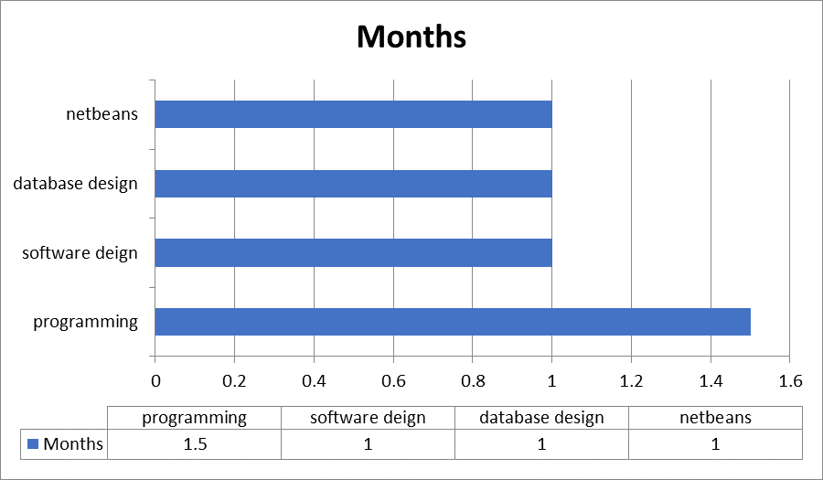

Report Outline
- Introduction
    - What we are going to do?
  - Background
    - What currently happening in the market
  - Motivation & Challenges
    - Discussed in detail
  - Goals and Objectives
    - Discussed how to achieve our goals.
  - Existing System
    - Discussed what unique we are having, how could survive in a market
  - Gap Analysis
    - Discussed Gap Analysis & Discussed what is our planned strategy?
  - Proposed Solution
    - Discussed the solutions of the problems

  - Project Plan
    - Made a project plan so we could complete our project in a time.
  - Work Breakdown Structure
    - Discussed in detail
  - Rules & Responsibility
    - Divided task in team members
  - Gantt Chart
    - Made a chart so could complete our project in a time.

Chapter 2

Software Requirement Specifications

Chapter 2: Software Requirement Specifications

Introduction

Purpose
- A virtual robot which will facilitate a user to perform most of the daily (office and personal) tasks on the pc.. This virtual robot is called an Office Assistant (OA). Conferences and reminders will be scheduled through OA, reading of uninformed

E-mails may also be done by OA. The OA can keep track of all the conferences and reminders. OA will surf the online for a few explicit info and reserve it for future use. OA will scan document and prepare summaries. OA will prepare documents like spreadsheets, shows and letters etc.

Document Conventions
Font | Size | Description
Times new Roman | 18 | Chapter heading
Times new Roman | 14 | Basic document text
Times new Roman | 18 | Chapter sub-Headings
Times new Roman | 16 | References

Product Scope
Most of the people haven't any time to scan some email, schedule their meeting; they forget their reminder of conferences and have less time to reply to the current email. Our project build a schedule for meeting, build reminder and alarm us for uncheck emails.

Basically this system is designed for students. In this approach our application try and fulfill the utmost desires of scholars relating to summarize of text, emails, meeting schedule, category reminder, alerting of leaves, prepare presentation, prepare spreadsheets, write a letter etc. In alternative words our application offer services of AN workplace assistant.

References
- Resources Required
- Just three laptop or Desktop for all time.
- References/Bibliography
- [1] http://en.wikipedia.org/wiki/Web_crawler
- [2] http://en.wikipedia.org/wiki/Web_scraping
- [3] nutch.apache.org/
- [4] j-spider.sourceforge.net/
- [5] www.cs.cmu.edu/~rcm/websphinx/
- [6] http://en.wikipedia.org/wiki/Heritrix

Overall Description

Product Perspective
A virtual robot that will help a user to perform most of the daily (office and personal) tasks on the computer. This virtual robot is called an Office Assistant (OA). Meetings and reminders can be scheduled through OA, reading of unread e-mails can also be done by OA. The OA will keep track of all the meetings and reminders. OA can surf the web for some particular information and save it for future use. OA can read document and prepare summaries. OA can prepare documents like spreadsheets, presentations and letters etc. In a net shell OA can perform all the tasks of a human personal assistant.

Product Functions
- Schedule meetings and reminders.
- Read emails e.g. specific superior emails.
- keeping track of all the meetings and reminders, like Gmail and superior portal
- Surfing web for some particular tasks, save it for future use.
- Read document and prepare summaries.
- Prepare documents like Assignments, tasks, office work.

User Classes and Characteristics

Project is related to learning purpose, we have one user class according to the needs of our project.

- USER :
A user is a person who can interact with this application and can get maximum of his work through it like (Assignments, presentations, etc.).

Operating Environment

- This will use windows operating system for running this application.

We will use java language for the purpose of development of this application which will work on desktop as well as in future it will work on android application (if Time is enough).

Design and Implementation Constraints
For development purpose we work in java

User Documentation
- [1] http://en.wikipedia.org/wiki/Web_crawler
- [2] http://en.wikipedia.org/wiki/Web_scraping
- [3] nutch.apache.org/
- [4] j-spider.sourceforge.net/
- [5] www.cs.cmu.edu/~rcm/websphinx/.

Assumptions and Dependencies
Initially we will not assume anything as development phase start we will take some assumptions if required.

External Interface Requirements

User Interfaces
• Front-end software: java (net beans used).
• Back-end software: SQL Server

Hardware Interfaces
• Processor: Pentium 3 or Higher.

• RAM: 1GB or Higher

Software Interfaces
• Operating System: Windows
• Development tool: Java, net beans
• Database: Sql Server

Communications Interfaces
This project supports only java netbeans because it’s a desktop application

System Features
OA, reading of unread e-mails can also be done by OA. The OA will keep track of all the meetings and reminders. OA can surf the web for some particular information and save it for future use. OA can read document and prepare summaries.

System Feature 1
2.4.1.1. Description and Priority
- Read emails e.g. specific superior emails
- keeping track of all the meetings and reminders, like Gmail and superior portal
- Surfing web for some particular tasks, save it for future use.
- Read document and prepare summaries.
2.4.1.2: Stimulus/Response Sequences
1. The system shall allow a only registered user to enter a registered email.
2. The system shall require the following information from the user: email, password and specific email.
3. The system shall ask the user for a email and password.
4. The system shall confirm the username and password are acceptable.
Prepare documents like Assignments, tasks, office work Functional Requirements

2.4.1.3. Functional Requirements
Requirements Of Front End user | Mechanism And Functionality
Configuration Page in which user enter its information | - user name  - emails (specific emailaddress,sorted email address, important emails, list down name of people which we want to check mails.)  - passwords  - websites (superior portal, Gmail, Hotmail, yahoo mail)  - Saving information database is created and save in to database.  - Alert configuration (top five, top ten, top hundred)  - Define interval to perform tasks like after one hour.
Search Against assignment file from internet | - Read a question and auto enter a question on google and save results.  - BufferI/o Are used for reading data from file and web Element is used for enter query on internet and for extracting links.  - we use Web crawler which extract the links and save it into frontier and visit links one by one and for fetching data from url web scrapper is involved
Search Against file from Folder | - Asked the path of folder Using Scanner input.  - For searching Crawler is involved and extracting information web scrapper is used.
Update configuration | - Extract information from data base against user and display it after editing saved into database

Requirements Of Front End user | Mechanism And Functionality
Start Application | - For opening web browser like Gmail link and Web Element is used for auto entering email and password And for alerting  - We use Google Api’s for alerting Go to that link and download a file from that link using web Element  - System perform all task after specific define interval like check every one hour.  - System Use selenium Drivers i.e.  org.openqa.selenium.WebDriver;  importorg.openqa.selenium.WebDriver;
Search Against assignment file from internet | - Read a question and auto enter a question on google and save results.  - Buffer I/o Are used for reading data from file and web Element is used for enter query on internet and for extracting links.  - we use Web crawler which extract the links and save it into frontier and visit links one by one and for fetching data from url web scrapper is involved
Create Summary | - For Opening Browser Web Driver Are Used And For Putting data to that urland send to summarization tool.  - Get summarize data from tool and then save into file.
Alert , Sending text | Top 20 emails alerts and send top 10 summarize email sms  Top 10 assignments alerts send 10 sms about assignment completion.  After generating a summery alert us send a sms after generate summary.

    - System Feature 2:
Admin can access the whole system. He can update & delete items.
2.4.2.1. Description and Priority
Admin can login & after logged
delete them user from database.

2.4.2.2. Stimulus/Response Sequences
Click "Login" Button: create document
1. The system shall allow an admin to log-in.
2. The system shall require a username & email and password.
3. The system will verify the email and password, and the admin will be considered
4-when the system verify the email and password then check the unread email from the specific email which the user entered .
5-Then prepare the document scrap data from google.
6-when the document is prepared .It stores in the computer
shall confirm the username and id which is acceptable. 6. The system shall store the information in the database.

Other Nonfunctional Requirements

Performance Requirements
This application will be able to process and show its results against queries which is sended over the network in less than 60 sec although there will be a possibility that if there is network issue can result in possible delays.

Safety Requirements
We will facilitate with exception handling if any file is corrupted.
We provide backup server which save our data in case of loss.

Security Requirements
This works online so there are lots of issues regarding its safety.This application is open source
As we are handling gmail for alerting .So may be someone can hack your password that’s why we will use encryption techniques to resolve this issue.

Software Quality Attributes
Reusability:
Our product is open source So anyone can change it for different purpose.

Availability:

- This Application will be easily available over internet.

Security:

There is as such no problem of security, because this is learning product and open source.

System Qualities:

Supportability:

This will support windows application

Testability:

This will be tested on custom build data set.

Business Rules
Our main objective is to design such software that is just like office assistant. This product help those students who have no time to schedule their meeting , checks mail ,read the topic ,generate the summarization and those who can’t afford to hire someone for work that is performed by an office assistant.

Other Requirements
We have to learn how to use selenium drivers and tool.
Usage of different java libraries
To get id’s of variables we used google source code.
Email is opened through id.

Chapter 3

Use Case Analysis

Chapter 3: System Analysis
Use Case Model

Fully Dressed Use Cases

Use Case Model
Requirements Of Front End user | Mechanism And Functionality
Start Application | - For opening web browser like Gmail link and Web Element is used for auto entering email and password And for alerting  - We use Google Api’s for alerting Go to that link and download a file from that link using web Element  - System performs all tasks after specific define interval like check every one hour.  - System Use selenium Drivers i.e.  org.openqa.selenium.WebDriver;  importorg.openqa.selenium.WebDriver;
Search Against assignment file from internet | - Read a question and auto enter a question on Google and save results.  - Buffer I/O Are used for reading data from file and web Element is used for enter query on internet and for extracting links.  - we use Web crawler which extract the links and save it into frontier and visit links one by one and for fetching data from url web scrapper is involved
Create Summary | - For Opening Browser Web Driver Are Used and For Putting data to that URL and send to summarization tool.  - Get summarize data from tool and then save into file.
Alert , Sending text | Top 20 emails alerts and send top 10 summarize email sms  Top 10 assignments alerts send 10 sms about assignment completion.  After generating a summery alert us send a sms after generate summary.

Use Case Descriptions

Use-Case 1:

Configuration:

Identifier |  | UC-3.1.1. register user
Purpose |  | To registered new user
Primary Actor |  | User
Priority |  | High
Pre-conditions |  | Application must be started
Post-conditions |  | User entered to the application
Typical Course of Action
S# | Actor Action |  | System Response
1 | User enter his name
2 | User enter his password
3 | User Enter Email or Portal Address
4 | User Enter Password
5 | User clicks on submit button
 |  |  | System saves the name and password
4 |  |  | System display the main menu of application to the user
Alternate Course of Action
S# | Actor Action |  | System Response
1 | User enter invalid name or character  (i.e. user enter Numeric values) |  | .
 |  |  | System show error message that name is incorrect(Regular Expression is used)
2 | User enter invalid password
System shows error pop-up that you entered invalid password please try again
(Regular Expression is used)

Use-Case 2:

4.2.2.4 Update configuration:

Identifier |  | UC-4.2.2.4 Update user Profile
Purpose |  | To update user profile
Priority |  | Low
Pre-conditions |  | User is logged in.
Post-conditions |  | User profile is updated.
Typical Course of Action
S# | Actor Action |  | System Response
1 | Clicks on my profile button.
 |  |  | Profile button is activated.
2 | Clicks on update profile.
 |  |  | Ask to update profile fields.
3 | Update changes and click save.
 |  |  | Saves new changes.
Table 4.2.2.4: Update user Profile

Use Case 3

4.3.3.1 Display main menu:

Identifier |  | UC-4.3.3.1 Display main menu
Purpose |  | To display the main menu.
Primary Actor |  | User
Priority |  | High
Pre-conditions |  | User must be logged in.
Post-conditions |  | User entered to the application.
Typical Course of Action
S# | Actor Action |  | System Response
1 | Clicks on menu button.
 |  |  | Shows the main menu with default options.

Table 4.3.3.1: Display main menu
Use Case 4

4.4.4.1 starts listening e-mails:

Identifier |  | UC-4.4.4.1 starts listening e-mails
Purpose |  | To cc
Primary Actor |  | User
Priority |  | High
Pre-conditions |  | User should be logged in to the application.
Post-conditions |  | User can select action to perform from main menu.
Typical Course of Action
S# | Actor Action |  | System Response
1 | Clicks on “starts listening e-mail” tab.
 |  |  | It automatically login the user, listening e-mails. then alert via text.
Alternate Course of Action
S# | Actor Action |  | System Response
 | Clicks on “starts listening e-mail” tab
1 |  |  | Shows an error message, network problem.
Table 4.4.4.1: starts listening e-mails

Use Case 5

4.4.4.1Create documents:
Identifier |  | UC-4.4.4.1 Create documents
Purpose |  | To Create documents
Primary Actor |  | User
Priority |  | Medium
Pre-conditions |  | User should be in main menu of the application.
Post-conditions |  | User can move back to main menu of application.
Typical Course of Action
S# | Actor Action |  | System Response
1 | Clicks on “Create documents ” tab.
Do you want to create word document/ppt/excel sheet?.
Or do you want to create summary?
2 | User clicks on desired document type
 |  |  | Started creating documents.
2 |  |  | After creating, asked from user do you want to save documents?
3 | User select desired action
 |  |  | Documents saved/not saved.

Use Case 6

4.4.4.1 Search documents:

Identifier |  | UC-4.4.4.1 Search documents
Purpose |  | To Search documents
Primary Actor |  | User
Priority |  | Medium
Pre-conditions |  | User should be in main menu of the application.
Post-conditions |  | User can move back to main menu of application.
Typical Course of Action
S# | Actor Action |  | System Response
1 | Clicks on “Search documents ” tab.
 |  |  | Browse from computer or search from web?
2 | User clicks on desired document type
 |  |  | Started searching documents.
3 | User entered file name to search from pc
 |  |  | Searching successful
Alternate Course of Action
S# | Actor Action |  | System Response
1 | User entered file name to search from pc
 |  |  | Search not found

Chapter 4

System Design

Chapter 4: System Design
- Firstly as application is installed first time at your system configuration page is displayed in front of you which will ask you to enter your personal information in it like email addresses and portal user name along with their password so that’s it could login and listen emails or new notifications or announcements after configuration page a new menu is displayed which contains start ,Documentation, Stop, Edit Profile, Close Application
- Start:
On Click Start button our application auto login to email or portal using information which is provided on configuration time and start listening and after every 20 minutes it will check your email or portal for any new notification
- Documentation:
On Click Documentation Button a new menu is displayed which contains following options

Architecture Diagram
- Download File
- Search From Web
- Search From Folder
- Make Summary

I.ON Click Download File button it will download attached file from new email or any new file uploaded on portal.
II. On click Search from web it will automatically search from web through web crawler and scrapper.
III. On click Search from folder it will automatically search from the specific folder through web scrapper.
IV.On click Make summary Button it will auto open browser and use summarization tool to summarize data and display it.

Domain Model

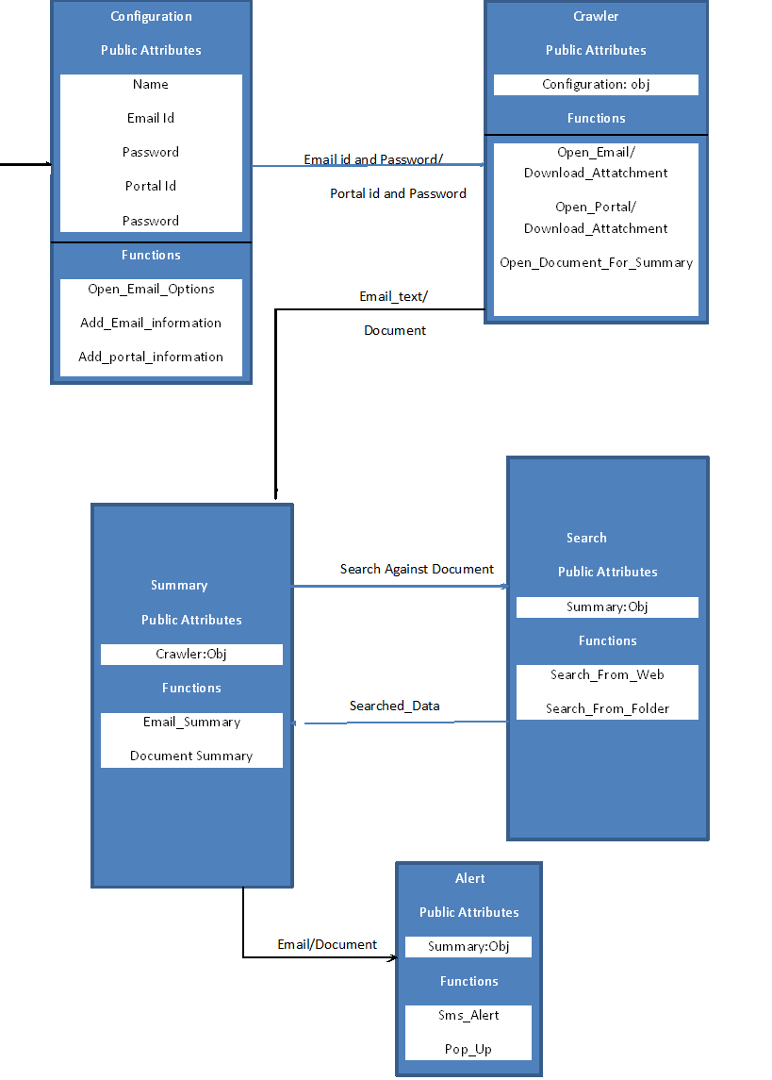

Entity Relationship Diagram with data dictionary
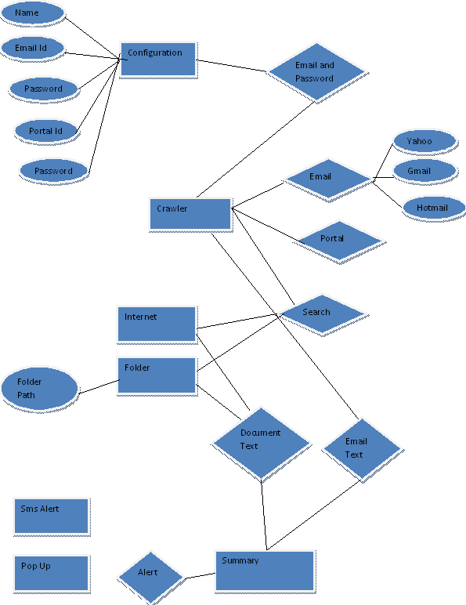

Class Diagram
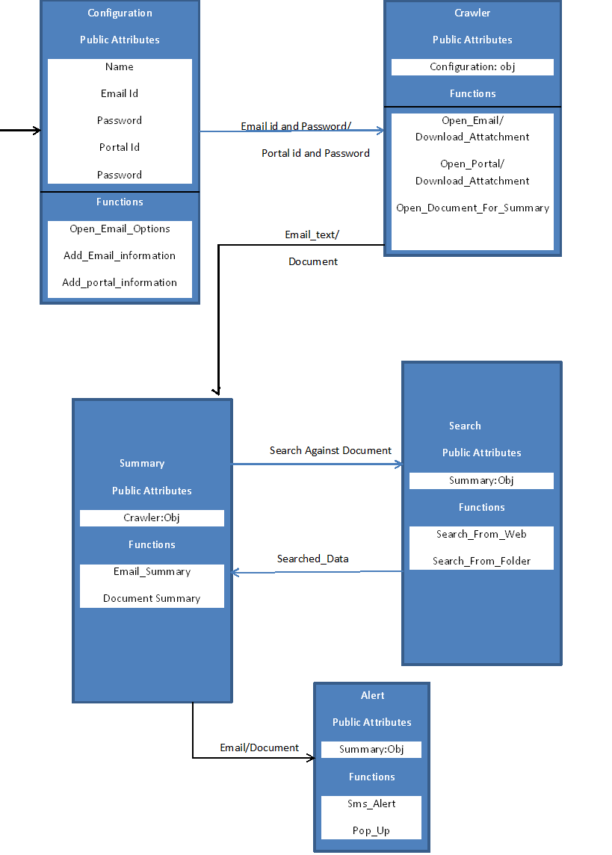

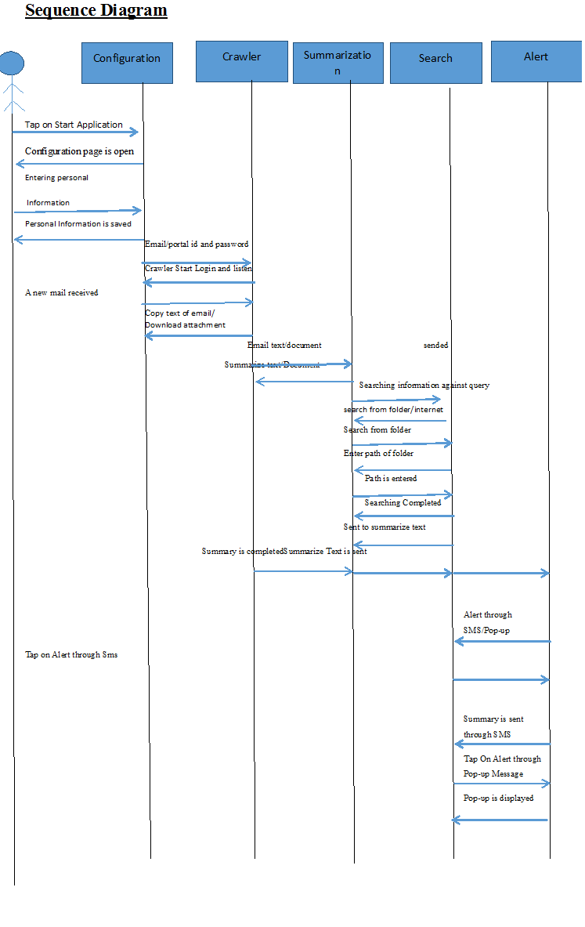

Operation contracts
- Operation: email , password
- Cross reference: Use Cases: Process of check unread emails
- Pre-Conditions: read emails
- Post-Conditions: Assignment is created (instance creation)
- Generate notification

Activity Diagram

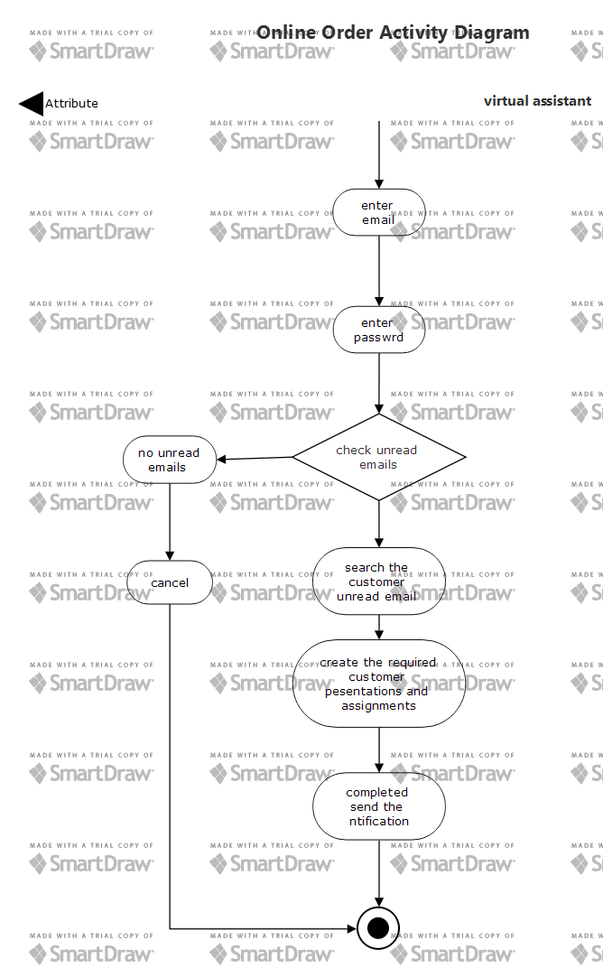

Component Diagram
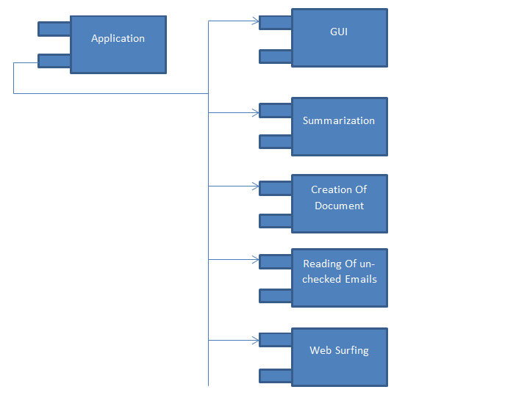

Deployment Diagram
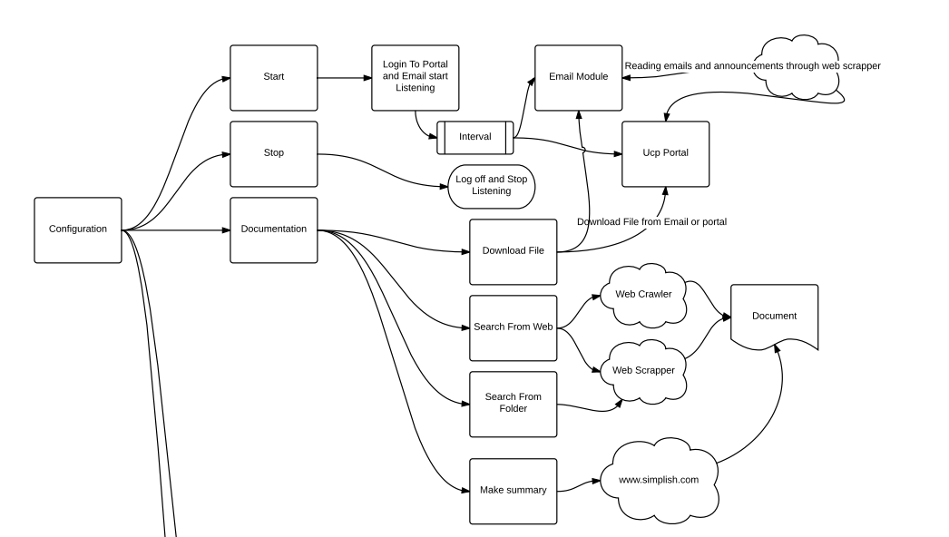

Data Flow diagram
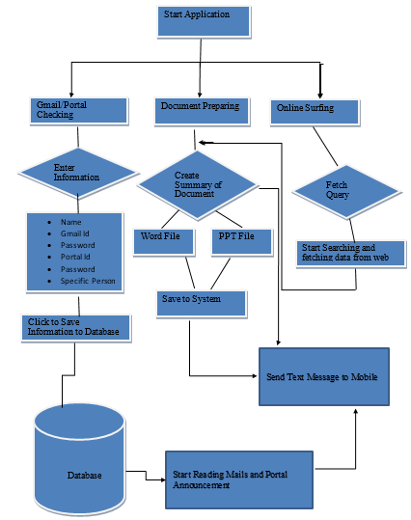

Chapter 5

Implementation

Chapter 5: Implementation
After defining the whole System design we are going to see how we will implement it, which types of tools & techniques that we are using to make it, which web servers are required for our website & which type of standards we should follow while coding.

Important Flow Control/Pseudo codes
A virtual robot that will help a user to perform most of the daily (office and personal) tasks on the computer. This virtual robot is called an Office Assistant (OA). Meetings and reminders can be scheduled through OA, reading of unread e-mails can also be done by OA. The OA will keep track of all the meetings and reminders. OA can surf the web for some particular information and save it for future use. OA can read document and prepare summaries. OA can prepare documents like spreadsheets, presentations and letters etc. In a net shell OA can perform all the tasks of a human personal assistant.

Components, Libraries, Web Services and stubs
- Web scrapper
- Java programming
- Netbeans
- Firefox
- Selenium

Deployment Environment
In Deployment environment the web scrapper is used and java Collected libraries and jdk-tools and selenium libraires is used .
- Human Copy And Paste
- Text grepping and regular expression matching
- HTTP programming
- HTML parsers
- DOM parsing
- Web-scraping software

Tools and Techniques
TECHNIQUES:
- DISTRIBUTED CRAWLING
- FOCUSED CRAWLING
DISTRIBUTED CRAWLING:
Distributing crawling activity through multiple processes may help build scalable, easily configured system that is fault tolerant system. Splitting load reduces hardware requirements and at the same time increase the overall download speed and reliability. Every work that is done in a fully distributed fashion, there is no central coordinator.
Focused Crawling:
Mainly General purpose of all web crawlers is to get as many link as it can form a complete set of url’s .whereas purpose of focused crawler is only get those pages which are relevant to specific topic thus it can reduce the amount of network traffic and downloads. The main goal of focused crawler is to selectively seeking those pages those are relevant to predefined set of topics. Topics are specified using the exemplary documents, but not using keywords. Instead of collecting and indexing all possible web documents to be able to answer all those possible queries, Focused crawler analyze its boundary to find the links that are related to crawl, and reject irrelevant links of web.
Techniques that are used in web scrapper are following
- Human Copy And Paste
- Text grepping and regular expression matching
- HTTP programming
- HTML parsers
- DOM parsing
- Web-scraping software
- Vertical aggregation platforms
- Semantic annotation recognizing
- Computer vision web-page analyzers

HUMAN COPY AND PASTE:
Sometimes web scraping technology cannot replace a manual review of a human being and copy and paste, and sometimes it may be the only viable solution when obstacles scraping sites explicitly set up to prevent the machine automation.
Text grepping and regular expression matching:
A simple but powerful approach to extracting information from Web pages can be based on the UNIX grep command or regular programming languages investment term facilities (e.g. Perl or Python).
HTTP programming:
Static and dynamic web pages can be recovered by posting HTTP requests to the remote Web server using socket programming.
HTML parsers:
Many sites have large collections of pages generated dynamically from an underlying source structured as a database. The data of the same class are generally coded related pages by a script or a common pattern. In data mining, a program that detects these patterns in a particular source of information extracted from the content and translates it into a relational form, is called an envelope. Wrapper generation algorithms assume that a packaging in take system entry pages conform to a common model and can be easily identified in terms of a common system of URLs. In addition, some data query languages for semi structured such as XQuery and HTQL can be used to analyze HTML pages and retrieve and transform content page.

DOM parsing:
By integrating a full web browser, like Internet Explorer or Mozilla browser, programs can retrieve the dynamic content generated by client-side scripts. These browser controls also analyze Web pages in a DOM tree, based on which programs can recover some of the pages.

Web-scraping software:
There are many software tools available that can be used to customize web scraping solutions. This software can attempt to automatically recognize the one-page data structure or provide a recording interface that eliminates the need to manually write code scraping the web, or some script functions that can be used to extract and transform the content and database interfaces that can store the scraped data in local databases.
Vertical aggregation platforms:
There are several companies that have developed specific vertical crop platforms. These platforms to create and monitor a multitude of "bots" for specific vertical without loop man-in, and no work related to a specific target site. The preparation is to establish the knowledge base for vertical together, then the platform creates robots automatically. The robustness of the platform is measured by the quality of the information it collects (usually the number of fields) and scalability (how fast it can accommodate hundreds or thousands of sites). This scalability is mainly used to target the Long Tail aggregators are common sights complicated or too labor intensive to harvest.
Semantic annotation recognizing:
The pages being scraped can embrace metadata or annotations and semantic annotations, which can be used to locate specific data extracts. If annotations are integrated into the pages, the format Micro fact, this technique can be considered as a special case of the DOM analysis. In another case, annotations, organized into a semantic layer are stored and managed separately from the Web pages, so that the scrapers can recover data schema and instructions of this layer before scraping pages.
Computer vision web-page analyzers:
There are efforts by using machine learning and computer vision that attempt to identify and extract information from web pages interpreting pages visually as a hum

OPEN TEXT SUMMARIZATION TOOL:
Automatic text summarization is a technique where a computer program summary document. And highlighted text on the computer (summarized) text returned. Open Text Summarizer is an open source tool for summarizing texts. The program reads the text and decide which sentences are important and which are not. It ships with Ubuntu, Fedora, and other Linux distros.

Best Practices / Coding Standards
- Communicate with all project stakeholders
- Create a risk response team
- Use a detailed work definition document
- Create a detailed work plan
- Document everything
- Ask for feedback
- Communicate the impact of project add-ons
- Manage new agreements
- Hold a wrap-up meeting

Version Control
Task # | Deliverable | Activity # | Duration  (# of Days) | Responsible Team Member(s) & Role(s)
1 | programming | 1 | 1.5 Months | 2- Front End Designing & coding  Bilal Anwar, haseeb majid
2 | Database design | 2 | 1 Month | -Manage whole Database  Bilal Anwar, haseeb majid
3 | Application Designing & Coding | 3 | 1 Month | 1-App Front end Designing & coding, Bilal Anwar, haseeb majid  Noman raza, muhammad saleem
4 | Android Database | 4 | 1 Month | 1- Manage whole Database, Nouman Bilal Anwar, haseeb majid  Noman raza, muhammad saleem

Chapter 6

Testing and Evaluation

Chapter 6: Testing and Evaluation
Software testing is very important because of the many reasons; Software testing is required to point out the defects and errors that were made during the development phases. It's essential since it makes sure of the Customer's reliability and their satisfaction in the application. It is very important to ensure the Quality of the product. Quality product delivered to the customers helps in gaining their confidence. Evaluation can help you identify areas for improvement and
Ultimately help you realize your goals more efficiently.

Use Case Testing
Use Case Testing is a functional black box testing technique that helps testers to identify test
Scenarios that exercise the whole system on each transaction basis from start to finish.

• Use Cases capture the interactions between 'actors' and the 'system'.
• 'Actors' represents user and their interactions that each user takes part into.
• Test cases based on use cases and are referred as scenarios.
- User enter his email and password and enter the specific email that the user want to make the assignments of specific email.
- If the user enter non registered email then error occurs

Equivalence partitioning
Equivalence partitioning is a Test Case Design Technique to divide the input data of software into different equivalence data classes. Test cases are designed for equivalence data class. A use of this method reduces the time necessary for testing software using less and effective test cases, while validating Sign up form we’ve set values:
• A text field permits only numeric characters (e.g. phone number)
• Length must be 12-14 characters long (e.g. phone number length)
In phone number length numbers from 12 to 14 are equivalent and are valid & numbers from 14 or above all are invalid. And numbers from 0-11 are invalid.

Boundary value analysis
Boundary value analysis is a test case design technique to test boundary value between partitions (both valid boundary partition and invalid boundary partition).
A boundary value is an input or output value on the border of an equivalence partition, includes minimum and maximum values at inside and outside boundaries. While validating Sign up form we’ve set values:
• Email should only accept Gmail, Yahoo, and Hotmail.
• Password should be with a valid length of 10-20.
In test case 9, 10, 11 are the minimum values which is Boundary Values. And 19, 20, 21 are maximum values of Boundary Values.
Test Scenario Description Expected Outcome
Boundary Value = 9 System should NOT accept
Boundary Value = 10 System should accept
Boundary Value = 11 System should accept
Boundary Value = 19 System should accept
Boundary Value = 20 System should accept
Boundary Value = 21 System should NOT accept

Data flow testing
Data flow testing is a family of test strategies based on selecting paths through the program's control flow in order to explore sequences of events related to the status of variables or data
objects.
Data Flow testing is very important that can helps us to pinpoint many issues:
• A variable that is declared but never used within the program.
• A variable that is used but never declared.
• A variable that is defined multiple times before it is used.
• Deallocating a variable before it is used.
So, while data flow testing some undeclared variables shouldn’t be the part of our project. It is better to be removed.

Unit testing
The unit testing was done after the coding phase. The purpose of the unit testing was to locate errors in the current module, independent of the other modules. Some changes in the coding were done during the testing phase. Finally, all the modules were individually tested following bottom to top approach, starting with smallest and lowest modules and then testing one at a time.
Testing
• Checked all the validations on each field.
• Wrong inputs in the fields of the forms.
• Database testing.
• Validation of Checked error e.g. syntax error.
Benefits of Unit Testing:
• Codes are more reusable. In order to make unit testing possible, codes need to be modular. This means that codes are easier to reuse.
• Unit testing increases confidence in changing/ maintaining code.

Integration testing
Integration testing is a level of software testing where individual units are combined and tested as a group. The purpose of this level of testing was to expose faults in the interaction between integrated units. Integration testing is an important part of the testing cycle as it makes it easier to find the defect when two or more modules are integrated.

Performance testing
Performance testing is the process of determining the speed or effectiveness of a
computer, network, software program or device.
Software Performance testing is type of testing perform to determine the performance of system to major the measure, validate or verify quality attributes of the system like responsiveness, Speed, Scalability, Stability under variety of load conditions. It is very important to interact with the system.
• Processor Usage - amount of time processor spends executing non-idle threads
. • Memory use - amount of physical memory available to processes on a computer.
• Disk time - amount of time disk is busy executing a read or write request.
• Bandwidth - shows the bits per second used by a network interface.
• Private bytes - number of bytes a process has allocated that can't be shared amongst other processes. These are used to measure memory leaks and usage.
• Committed memory - amount of virtual memory used.
• Memory pages/second - number of pages written to or read from the disk in order to resolve hard page faults. Hard page faults are when code not from the current working set is called up from elsewhere and retrieved from a disk.
• Page faults/second - the overall rate in which fault pages are processed by the processor.
This again occurs when a process requires code from outside its working set.
• CPU interrupts per second - is the avg. number of hardware interrupts a processor is receiving and processing each second.
• Network bytes total per second - rate which bytes are sent and received on the interface including framing characters.
• Response time - time from when a user enters a request until the first character of the response is received.
• Throughput - rate a computer or network receives requests per second.
• Amount of connection pooling - the number of user requests that are met by pooled connections. The more requests met by connections in the pool, the better the performance will be.
• Maximum active sessions - the maximum number of sessions that can be active at once.
• Hit ratios - This has to do with the number of SQL statements that are handled by cached data instead of expensive I/O operations. This is a good place to start for solving bottlenecking issues.
• Hits per second - the no. of hits on a web server during each second of a load test.
• Rollback segment - the amount of data that can rollback at any point in time.
• Database locks - locking of tables and databases needs to be monitored and carefully tuned.
• Top waits - are monitored to determine what wait times can be cut down when dealing with the how fast data is retrieved from memory
• Thread counts - An applications health can be measured by the no. of threads that are running and currently active.
• Garbage collection - It has to do with returning unused memory back to the system. Garbage collection needs to be monitored for efficiency.

Stress Testing
Stress testing is used to test the stability & reliability of the system. This test mainly determines the system on its robustness and error handling under extremely heavy load conditions.
The goal of stress testing is to analyze the behavior of the system after failure. For stress testing to be successful, system should display appropriate error message while it is under extreme conditions.
Tool for Stress Testing
Stress Tester: This tool provides extensive analysis of the web application performance, provides results in graphical format, and it is extremely easy to use. No high-level scripting is required and gives good return on investment.

Chapter 7

Summary, Conclusion and Future Enhancements

Chapter 7: Summary, Conclusion & Future Enhancements

Project Summary
A virtual robot that will help a user to perform most of the daily (office and personal) tasks on the computer. This virtual robot is called an Office Assistant (OA). Meetings and reminders can be scheduled through OA, reading of unread e-mails can also be done by OA. The OA will keep track of all the meetings and reminders. OA can surf the web for some particular information and save it for future use. OA can read document and prepare summaries. OA can prepare documents like spreadsheets, presentations and letters etc. In a net shell OA can perform all the tasks of a human personal assistant.

Achievements and Improvements
Learnt to work in a team.
• Learnt time management.
• Learnt how to survive in a competitive business environment.
• We will try to improve & take care of our project, we will try to make it more secure, maintain its availability and it will be more responsive at a time.

Critical Review
We know our competitors and we’ve learnt how to survive in a market, for being stay in a market we must have to take a uniqueness to compete everyone in a business environment.

Lessons Learnt
Learnt how to make a successful project with absolutely no chances of failure & learnt how to
survive in a market.

Future Enhancements/Recommendations
Expanding its operation in other cities major cities of Pakistan it is our main goal.

Reference and Bibliography

Reference and Bibliography

[1] http://en.wikipedia.org/wiki/Web_crawler
[2] http://en.wikipedia.org/wiki/Web_scraping
[3] nutch.apache.org/
[4] j-spider.sourceforge.net/
[5] www.cs.cmu.edu/~rcm/websphinx/
[6] http://en.wikipedia.org/wiki/Heritrix

