SUPERIOR UNIVERSITY LAHORE


Faculty of Computer Science & IT

Final Year Project
PROJECT REPORT (Part-1)

[Health Band]

Project ID: [cs09]

Project Team
Student Name | Student ID | Program | Contact Number | Email Address
Farrukh Hafeez | Bcsm-f14-62 | Bs-cs | 03076017364 | Asadr1919@gmail.com
Asad ur Rehman | Bcsm-f14-108 | Bs-cs | 03353574786 | Farrukhhafeez48@gmail.com
Adeel Hameed | Bcsm_f14_194

[Project Supervisor]
([Designation])

Project Report
[Health Band]

Change Record
Author(s) | Version | Date | Notes | Supervisor’s Signature
 | 1.0 |  | <Original Draft>
 |  |  | <Changes Based on Feedback from Supervisor>
 |  |  | <Changes Based on Feedback From Faculty>
 |  |  | <Added Project Plan>
 |  |  | <Changes Based on Feedback from Supervisor>

APPROVAL
Project Supervisor
Comments: ___________________________________________________________________
_____________________________________________________________________________
Name:______________________________
Date:_______________________________ | Signature:__________________________

Project Manager
Comments: ___________________________________________________________________
_____________________________________________________________________________
Date:_______________________________ | Signature:__________________________

Head of the Department
Comments: ___________________________________________________________________
_____________________________________________________________________________
Date:_______________________________ | Signature:__________________________

Abstract

By understanding the rapid growth in Hospitality system and not having much time in daily routine busy life something really interested was needed to be implemented to give services to all of those communities who are need to protect their lovely family members and want to get notification of any Disease like temperature, Heart Attack or any other issue. They also have the facility to get notification or message to relevant person.
Also due to the increasing demand of people related with technological equipment i.e. Android Phones, Tabs, Mac books etc. There is huge amount of people who want each thing feasible by having that tool in their mobile or any other equipment which is capable of these systems.

Acknowledgements

We want to express our deepest thanks to our project supervisor Respected Mr. Qasim Zia for their constructive and innovative guidance Secondly would like to thank our friends, colleagues, fellows, seniors and teachers for supporting us through this period.
We truly acknowledge the cooperation and help from Mr.Muhammad Ijaz & Muhammad Asif, I.T Officer. He has been a constant source of guidance throughout the course of this project. We would also like to thank to our entire teacher. We found their consistence help and guidance throughout this project.

Executive Summary
Health Band is an innovative solution for detecting and locating a person whose health in in grave danger. It's mostly designed as a remote rescue system for people who are at risk of having stroke, cardiac arrest and heart attack. Health Band is a Smartphone synced mobile health monitoring bracelet capable of reading a human's vital signs (pulse rate and body-temperature.

Table of Contents
Abstract iv
Acknowledgements v
Executive Summary vi
Table of Contents vii
List of Figures ix
List of Tables x
Chapter 1 1
Introduction 1
1.1. Motivations and Challenges 2
1.2. Goals and Objectives 2
1.3. Literature Review/Existing Solutions 2
1.4. Proposed Solution 3
1.4.1. Work Breakdown Structure 3
1.4.2. Roles & Responsibility Matrix 3
1.4.3. Grantt Chart 4
Chapter 2 5
Software Requirement Specifications 5
3.1.1. Purpose 6
3.1.2. Document Conventions 6
3.1.3. Intended Audience and Reading Suggestions 6
3.1.4. Product Scope 6
3.1.5. References 7
3.2. Overall Description 7
3.2.1. Product Perspective 7
3.2.2. Product Functions 7
3.2.3. User Classes and Characteristics 7
Count every heartbeat 7
3.2.4. Design and Implementation Constraints 8
3.2.5. User Documentation 9
3.2.6. Assumptions and Dependencies 9
3.3. External Interface Requirements 9
3.3.1. User Interfaces 9
3.3.2. Hardware Interfaces 10
3.3.3. Software Interfaces 10
3.3.4. Communications Interfaces 10
15.1. System Features 11
15.1.1. System Feature 1 11
Functional Requirements 12
15.1.2. System Feature 2 12
15.1.2.1. Description and Priority 12
The health Band has been an international fitness trackers hit, and for good reason – the range has been so cheap you might as well give them a go, and people have in their millions. And to some extent they do the job of helping you realize of how active (or sedentary) you are, they're comfortable and the sleep tracking works. 12
Functional Requirements 12
The problem for health band is that fitness trackers, good ones, are getting cheaper and cheaper. So as it continues to add features to its line-up, here with the health band an OLED display joins heart rate tracking, its competitors slash the prices of their feature packed devices. 12
15.2. Other Nonfunctional Requirements 12
15.2.1. Performance Requirements 12
15.2.2. Safety Requirements 13
15.2.3. Security Requirements 13
15.2.4. Software Quality Attributes 13
15.2.5. Business Rules 13
15.3. Other Requirements 13
Chapter 3 14
Use Case Analysis 14
3.1. Use Case Model 15
3.2. Use Cases 16
Chapter 4 18
System Design 18
4.1. Architecture Diagram 20
4.2. Entity Relationship Diagram with data dictionary 21
Collaboration Diagram: 21
4.3. Sequence diagram 22
4.4. Activity Diagram 23
4.5. State Transition Diagram 24
4.6. Component Diagram 24
4.7. Data Flow diagram 25
Chapter 5 26
Implementation 26
5.1. Pseudo codes 27
5.2. Components, Libraries, Web Services and stubs 27
5.3. Deployment Environment 28
5.1. Tools and Techniques 28
Chapter 6 29
Testing and Evaluation 29
6.1. Equivalence partitioning 30
6.1. Boundary value analysis 31
6.2. Unit testing 31
6.3. Integration testing 32
Chapter 7 33
Summary, Conclusion and Future Enhancements 33
7.1. Project Summary 34
7.2. Achievements and Improvements 34
7.3. Critical Review 35
7.4. Lessons Learnt 35
7.5. Future Enhancements/Recommendations 35
Appendices 36
Appendix A: User Manual 37
Appendix B: Administrator Manual 40
Appendix C: Information / Promotional Material 40
Appendix [no.]: Appendix Title 45
Reference and Bibliography 46
Index 48

List of Figures

1.1 Caption of first figure of first chapter 6
1.2 Caption of second figure of first chapter 7
2.1 Caption of first figure of second chapter 14
2.2 Caption of second figure of second chapter 22
2.3 Caption of third figure of second chapter 26
5.1 Caption of first figure of fifth chapter 49
5.2 Caption of second figure of fifth chapter 49

List of Tables

1.1 label of first table of first chapter 6
1.2 label of second table of first chapter 7
2.1 label of first table of second chapter 14
2.2 label of second table of second chapter 22
2.3 label of third table of second chapter 26
5.1 label of first table of fifth chapter 49
5.2 label of second table of fifth chapter 49

Chapter 1

Introduction

Chapter 1: Introduction
Health Band
Health Band is an innovative solution for detecting and locating a person whose health in in grave danger. Actually this health band for those people who suffering from heart disease,
Body temperature. Health band is smart device synced mobile health monitoring bracelet capable of reading human vital signs like pulse rate and body temperature.
To create this health band the things which are used (scrap pierce, battery, Bluetooth, temperature sensor and etc element.
Control this band through mobile android app.

Motivations and Challenges
There are certain health conditions that are completely unpredictable. People who are at risk of collapsing, cardiac arrest, heart attack and stroke are most likely to be found dead when it's too late. According to CDC, heart-failure ranks first in their list of the top leading causes of death while stroke ranks fourth.

Goals and Objectives
Old patient , hospital patients home oldies, youngsters, athletic sports man All uses to remember and attention about her his heath ,

Literature Review/Existing Solutions
Competitive device name:
- Massimo’s mighty sat pulse ox
- med wand
- life fuels smart nutrition bottle
- belt good vibes

Proposed Solution

The basic purpose of this project is that patients which is in maintenance, his/her blood pressure usually high, or higher than normal.
Sometime if blood pressure is goes to very high then it may cause death or reached the patient near the death. To avoid this all situation if we have any device which alert when the blood pressure of our patient goes to high.
For this purpose many heath bands is already available in the market but we create health brand in which we add new features.

Work Breakdown Structure
- The first step in making the project is making a comfortable bracelet to wear. I've used a scrap piece of canvas for this.
- I chose to use a 3.7v (1,000mAh) Lithium battery which I salvaged from a working phone battery.
- Building the freestyle mcu
- Build the connecting a Bluetooth module
- Iy sensors
- The prototype yet to be tested
- Control this band through the mobile android app.

Roles & Responsibility Matrix
List the key personnel who will be responsible for completion of the project, as well as other personnel involved in the project.
Client | superior
Sponsor | Asad
Project manager | Farruk-hafeez
Team | Asad ur rehman Adeel hameed ,

Grantt Chart
Sr. # | Task Name | Duration Time
Sr. # | Task Name | March |  |  |  |  | April |  |  |  | May |  |  |  |  | June
Sr. # | Task Name | 1st Week | 2nd Week |  | 3rd Week | 4th Week | 1st Week | 2nd Week | 3rd Week | 4th Week | 1st Week | 2nd Week | 3rd Week | 4th Week | 1st Week |  | 2nd Week | 3rd Week | 4th Week
1 | Design Admin Backend
2 | Implementation of Backend
3 | Testing Admin Panel
4 | Design IOS App
5 | Implementation of App
6 | Testing App
7 | Design Frontend Admin Panel
8 | Implementation
9 | Testing

Chapter 2

Software Requirement Specifications

Chapter 2: Software Requirement Specifications

- Introduction

Purpose
Health Band is an innovative solution for detecting and locating a person whose health in in grave danger. It's mostly designed as a remote rescue system for people who are at risk of having stroke, cardiac arrest and heart attack. Health Band is a Smartphone synced mobile health monitoring bracelet capable of reading a human's vital signs (pulse rate and body-temperature)

Document Conventions
Paragraph Text 12 pt, Calibri, 1.5 Line Spacing, Justified

Intended Audience and Reading Suggestions
Such as developers, project managers, marketing staff, users, testers, and documentation writers. Describe what the rest of this SRS contains and how it is organized. Suggest a sequence for reading the document, beginning with the overview sections and proceeding through the sections that are most pertinent to each reader type.

Product Scope
Old patient , hospital patients home oldies, youngsters, athletic sports man All uses to remember and attention about her his heath ,

References
<https://
- ww.googlesciencefair.com/projects/en/2015/d70e617d9bb04012e99e36e468dd125faf55459f8748fb70e2b720db6acd611a
- https://www.youtube.com/watch?v=82T_zBZQkOE
- https://www.youtube.com/watch?v=QePOo6toJFg
- https://www.youtube.com/watch?v=Bj3RipRs5Cs

Overall Description

Product Perspective
many heath bands is already available in the market but we create health brand in which we add new features .

Product Functions
The basic function of this project is that patients which is in maintenance, his/her blood pressure usually high, or higher then normal.
Sometime if blood pressure is goes to very high then it may cause death or reached the patient near the death. To avoid this all situation if we have any device which alert when the blood pressure of our patient goes to high.
For this purpose many heath bands is already available in the market but we create health brand in which we add new features

User Classes and Characteristics

Count every heartbeat

With a built-in motion sensor, health band knows exactly when you begin your workout.
you don't have to switch modes or tell it before you start. measure your heart rate to adjust
the length and intensity of workouts. keep calm and work toward your fitness goals.

Unlock in an instant
Health band carries you run identity .when you are close to your android smart phone, it unlocks instantly –no passcodesor finger print needed.

Another feature

Dle alerts send a gentle buzz when you
have been sitting still for too long. these
reminders tell you when it's time for a short
walk or water break.

Operating Environment
I succeeded in building a working prototype of the HealthBand while my friend was able to create a working Android app. The HealthBand was able to sync successfully to the mobile app.The project had some errors and misreadings. One was the body temperature. The project read it as 36.2° Celsius (wrist temp) while the medical grade thermometer read it as 36.8° Celsius (armpit temp). There was a small small discrepancy. In the end, we were able to fix it by recalibrating. I found out that the temperature reading capability of the project I not medically accurate thus it could only be used for reference. The pulse monitor on the other hand was fairly accurate and was able to acquire almost the same reading in comparison to the EKG from the hospital where my dad works.

Design and Implementation Constraints
- The first step in making the project is making a comfortable bracelet to wear. I've used a scrap piece of canvas for this.
- I chose to use a 3.7v (1,000mAh) Lithium battery which I salvaged from a working phone battery.
- Building the freestyle mcu
- Build the dconnecting a bluetooth module
- Iy sensors
- THE PROTOTYPE YET TO BE TESTED
- Control this band through the mobile android app.

User Documentation
Assembling the health band guide
take the strape and braclet traker
insert tracker into strape
put braclet on the hand
install the app and use

Assumptions and Dependencies
‘We need to realize that heart disease is the leading cause of death ‘in women,’ says Bierman. Most important: ‘Simple lifestyle changes can reduce the risk ‘of a heart attack by 80percent.
Failing to take preventive measures, as well as underestimating the risk and not knowing the symptoms of heart attack, means women are less likely to seek time-critical treatment. And the misperception around its seriousness in women persists within the medical community. ‘We are closing the gap,’ says Bierman. ‘But it’s just as important for women to know about their heart disease risk and what they can do to reduce it.

External Interface Requirements

User Interfaces
There are three basic tabs as you can see on the bottom of the screen- Status, play and profile. Lets explore them one by one.

Below is the extended screenshot of app home page. You will notice that the number of steps which is in dial format in previous screenshot, turns into text in order to allow app to display more information on the screen once you scroll down.

Hardware Interfaces
The health Band is a fairly effective little device at keeping track of step count. The problem is that the application used is closed source and obfuscated.
I want to figure out the protocol used to communicate with the band, fetch data about steps, sleep, etc, and be able to aggregate it.

Software Interfaces
Health band 2 display text support (you can now see incoming caller contact names, contents of notifications you receive or set completely custom text for your notifications)
health band text customization (you have full control over the text you want to display on the bracelet, enter your own text or use our wizards to insert various parameters into it)
health band text parameters (we offer you predefined parameters like $contact, $title, $content, $time and many more, use them to create your own text that you would like to see on the bracelet; these parameters even supports substring notations - for example $application(0,5) will display first 5 characters of application name, see display text customization for more details)
health band text filter and replace (filter and replace feature allows you to filter out, replace and extra certain digits, words or characters from the notification text just before displaying it on the bracelet)
:health band text extractions (use our predefined or your own custom regular expressions to extract certain parts of text from your notifications, we offer you wizards to use common text extractions e.g. for sms verification codes, email addresses and so on, learn more about the syntax)

Communications Interfaces
- This is a very raw communication between health band and Android application using Bluetooth, every communication is not encrypted by health band so we can sniff the data requested/received from health Band device, you can find the UUID of Service, Characteristic and Descriptor on the Internet, here is a very simple UUID to read Heart Rate, Alarm, and Battery Info that I used in this application:
- Basic Service:
- Uuid of service: 0000fee0-0000-1000-8000-00805f9b34fb
- battery info characteristic: 00000006-0000-3512-2118-0009saf100700
- Alert Service
- Uuid of service: 00001802-0000-1000-8000-00805f9b34fb
- new alert characteristic: 00002a06-0000-1000-8000-00805f9b34fb
- Heart Rate Service
- Uuid of service: 0000180d-0000-1000-8000-00805f9b34fb
- measurement characteristic: 00002a37-0000-1000-8000-00805f9b34fb
- control characteristic: 00002a39-0000-1000-8000-00805f9b34fb
- descriptor: 00002902-0000-1000-8000-00805f9b34fb

System Features
- LOCATION ACCES IN CASE OF ACCIDENT
- BLOOD PRESSURE
- WATER RESISTANCE
- The smart alarm
- Mobile application app
- Tracking features

System Feature 1

Description and Priority
The 24/7 activity tracker features an upgraded pedometer algorithm and a more accurate optical heart rate sensor, along with the usual step, calorie, and distance tracking. Health band optical heart rate sensors work by shining a LED light on the skin and measuring how the light is scattered by blood flow. Of course, sleep tracking is still a key feature, breaking down your deep sleep and light sleep patterns.

Functional Requirements
Health Band 2 will automatically monitor the status of your activities. When you sit still for too long, it will vibrate to prompt you to get off the sofa.
With the addition of a display, you get some basic Smartphone notifications as well. The Health Band 2 will vibrate and notify you via the screen on incoming calls, texts and other notifications. For detail, you will need to look to your Smartphone. The device is also capable of unlocking your health band phone and there is a silent vibrating alarm to wake you up in the morning.

System Feature 2
LOCATION ACCES IN CASE OF ACCIDENT

Description and Priority

The health Band has been an international fitness trackers hit, and for good reason – the range has been so cheap you might as well give them a go, and people have in their millions. And to some extent they do the job of helping you realize of how active (or sedentary) you are, they're comfortable and the sleep tracking works.

Functional Requirements

The problem for health band is that fitness trackers, good ones, are getting cheaper and cheaper. So as it continues to add features to its line-up, here with the health band an OLED display joins heart rate tracking, its competitors slash the prices of their feature packed devices.

Other Nonfunctional Requirements

Performance Requirements
The band contains the core tracker which is around 9 mm thick, and 36 mm in length. It is inserted into a hypoallergenic TPSiV wristband, which has anti-UV and anti-microbal properties. The tracker is inserted into the charger module, which can be connected to a 5.0 V external power source. It is also called "health band"

Safety Requirements
First of all, let me tell you that this particular wristband is water, dust, and corrosion protected, and its IP rating is IP67. That means you can enjoy this wristband in dust, corrosion, and water activities for around 30 minutes. But do not forget to avoid water whose water depth is more than 1 meter. So now you can stay relaxed that your wristband will not get damaged due to your sweat, dust, or even from any scratch which you can get to experience while maintaining your fitness regime.

Security Requirements
That's where this guide comes in. We've compiled a list of the top Health Band 2 tips and tricks.Apart from the unreliable Smartphone app notifications, and some app crashes, we've had fewer teething problems with this, more expensive health band device than the first two though that clearly hasn't been the case for everyone. In short, you get what you pay for. Still, third party apps have sprung up on the Google Play Store to fill in some of the gaps.

Software Quality Attributes
we are performing a health band water proof test. The smart wristband which is meant for fitness tracking is rated as IP67 waterproof which allows the bracelet to be held in water for a maximum of 30 minutes at a depth of 1 meter. Now this does not mean you should take the Mi band 2 swimming but it can actually survive splashes or falling into water without you loosing your device.

Business Rules
location access features benefits for business rules.

Other Requirements
Alarming system is other requirement.

Chapter 3

Use Case Analysis

Use Case Model
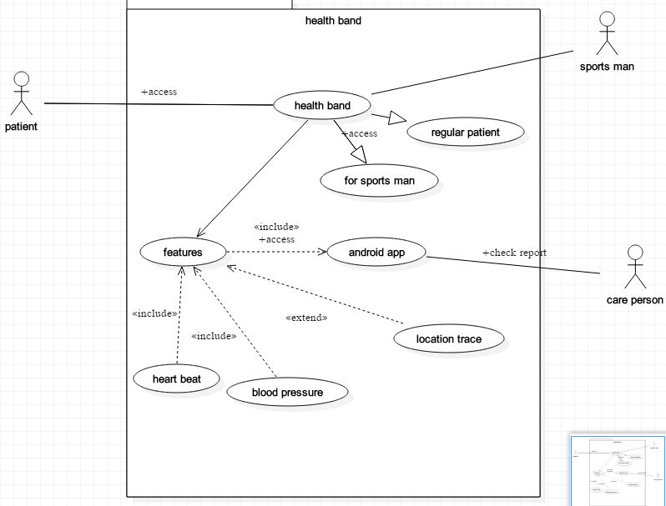
Health Band is fully designed application

Use Cases
Use case name | Create new health band
Use case id | 001
Usecase scenerio | Create new health band system
Brief description | We create system which take health status through scensor and give information about health

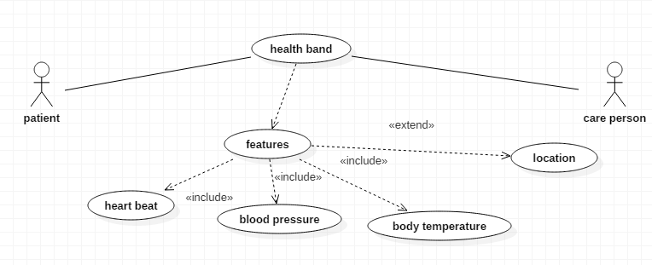

Use case name | Android app
Use case id | 002
actor | Android display
Brief description | Show the information
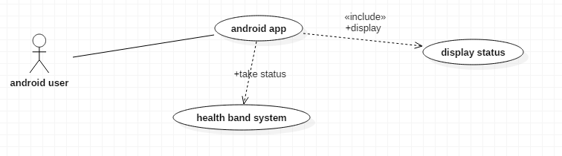

Chapter 4

System Design

Chapter 4: System Design
Use case ID | Any ID
Use case name | Create log in
Description | User create his/her login for registration
Pre-condition | User must have device to see website
Basic flow | User must have internet access
Alternative flow | Internet disconnected or device not working properly
Post condition | User successfully create login

Class diagram
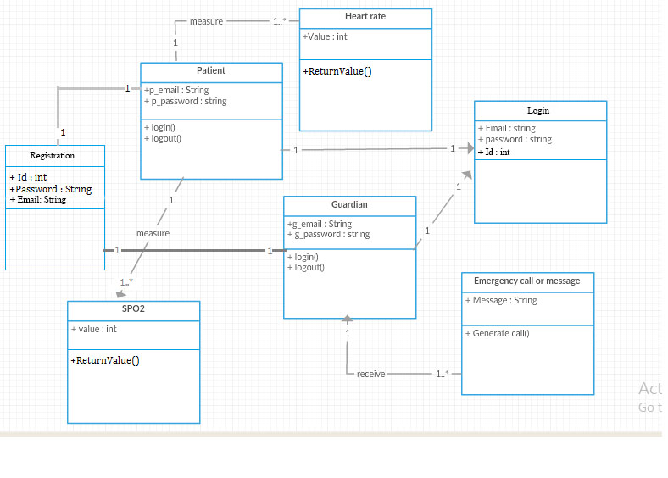

Architecture Diagram

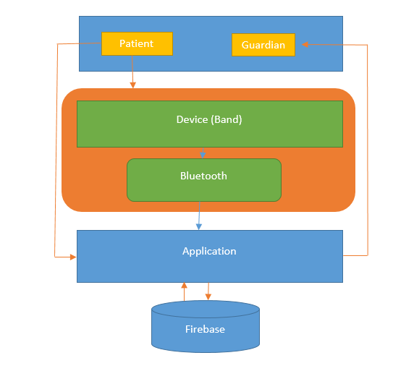

Entity Relationship Diagram with data dictionary
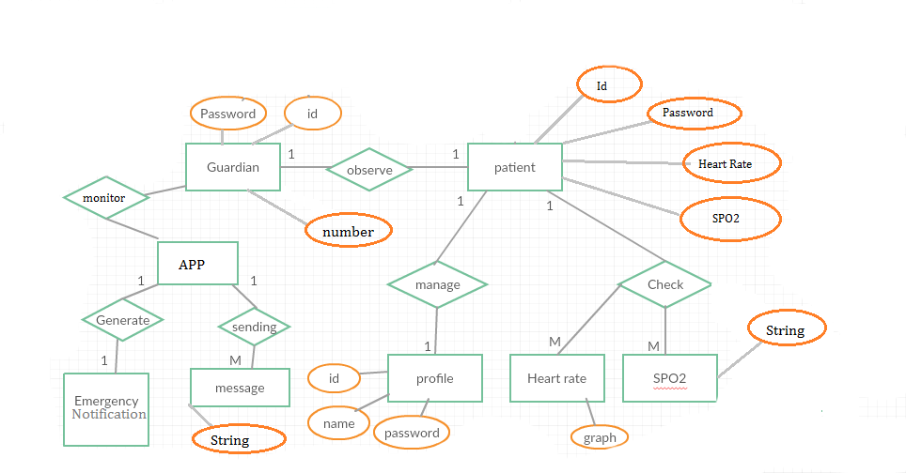

Collaboration Diagram:
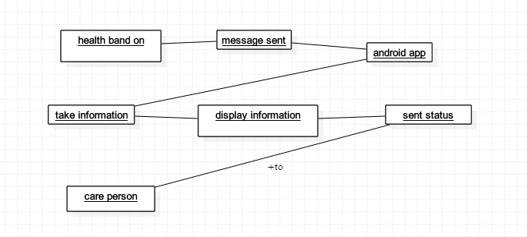

Sequence diagram
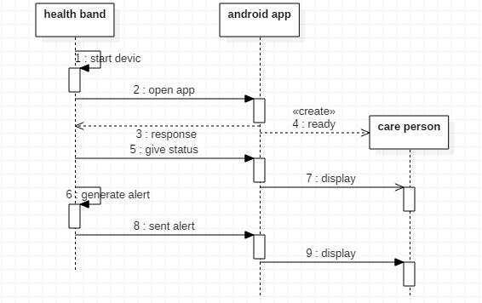

Activity Diagram
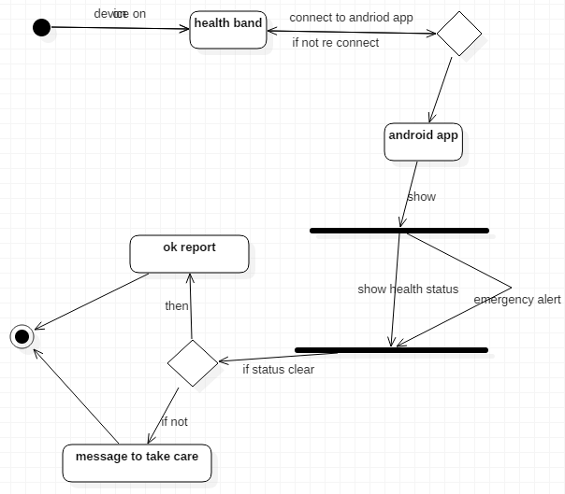

State Transition Diagram

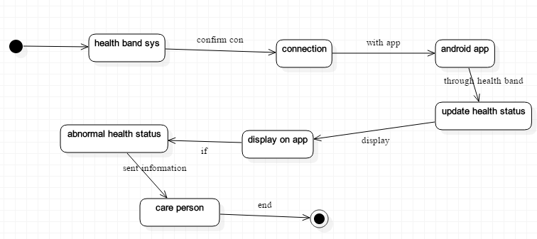

Component Diagram

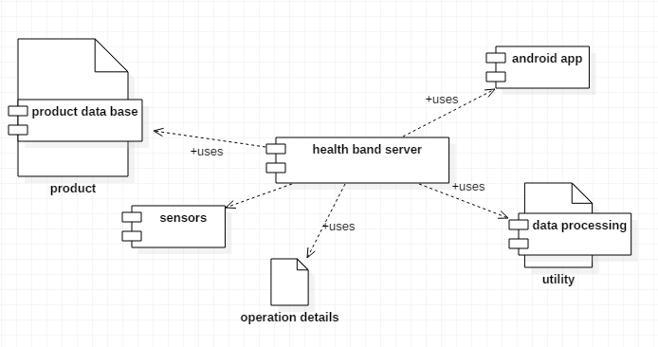

Data Flow diagram

Level 0
Health Band

guardian
device

Level 1
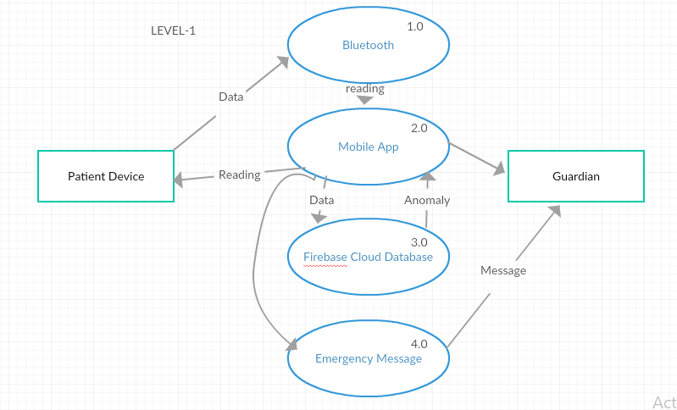

Chapter 5

Implementation

Chapter 5: Implementation

Pseudo codes
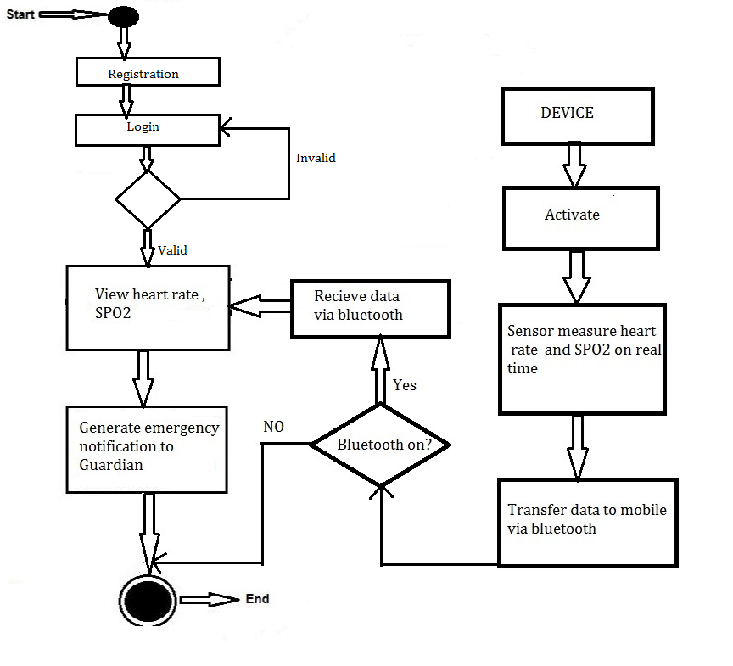

Components, Libraries, Web Services and stubs
Components
Hardware:
- Arduino Nano(Micro Controller)
- Bluetooth Module( HC-05)
- Heart Rate & Spo2 (MAX30100)
Software:
- Android Studio (Java)
- Arduino IDE( Arduino C)
- Python
- Google Firebase
Libraries
- Python(Tensor Flow)
- Python (Anaconda)
- Google Firebase Database Library
- Max 30100 Library
Web Services
- Google Firebase Real Time Database
- Google Firebase Authentication

Deployment Environment
- There are two deployment environment one is Android OS and cloud base environment where our data will be store. We used android studio to build our App and connected with the Hardware components like Bluetooth module all the data fetch by the Bluetooth module control by an Arduino Nano Microcontroller.

Tools and Techniques
Hardware

- Arduino(Microcontroller)
- Bluetooth Module
- Heart Rate Sensor
- SpO₂ Sensor
- Temperature

Software

- Android Studio
- Arduino IDE
- Google firebase

Chapter 6

Testing and Evaluation

Chapter 6: Testing and Evaluation

Equivalence partitioning
- 6.2.1 Equivalence Partitions (EP) for Enable Password:

Invalid | Valid | valid | Invalid | Valid
< 1 | Min –8 | >8 | Numeric | Alphanumeric
 |  |  |  | (Special
 |  |  |  | characters)

Test Case Id | Input | Output
01 | 1554 | Incorrect
02 | shs223 | Incorrect
03 | shs22312 | Correct
04 | Jloiih56 | Correct
05 | 256_885 | Incorrect

Boundary value analysis

Invalid | Valid | valid | Invalid | valid
< 1 | Min – 8 | >8 | Numeric | Alphanumeric
 |  |  |  | (Special
 |  |  |  | characters)

Test Case Id | Input | Output
01 | 1554 | Incorrect
02 | shs223 | Incorrect
03 | shs22312 | Correct
04 | Jloiih56 | Correct
05 | 256_885 | Incorrect

Unit testing
The primary goal of unit testing is to take the smallest piece of testable part in the application,Isolate it from the remainder of the code, and determine whether it behaves exactly as youExpect.Each unit is tested separately before integrating them into modules to test the interfaces between modules.

Integration testing
- After completion of our module along with testing, modular coding strategy was used. After integrating the module with the complete application, time was given to our team to test their part of module completely and thoroughly. As the whole application is divided into several modules, there were a lot of variable names and function names, which were common to all the modules. There existed a lot of session variables, which we had to incorporate into our module, but as different modules were being developed simultaneously we had to hard code things in place of the session variables in our module. So at the time of integration a lot of hardcoded things had to be removed and session variables were replaced.

Chapter 7

Summary, Conclusion and Future Enhancements

Chapter 7: Summary, Conclusion & Future Enhancements

Project Summary
Health band is an innovative solution for providing patient health care facility. Our main focus to develop this project to digitalize our environment and smart solution. This project contribute in the medical industry to easily measure patients physical parameters like Heart-rate and Spo2 using a mobile App and easy carry hand Band.
We used deep learning to measure accuracy, prediction and health condition of a patient. Deep learning also beneficial for detecting anomaly detection of sensor. So at the end Smart Scout contribute to improving a person health condition and predict us on real time of a patient health condition.

Achievements and Improvements
Throughout this year, we have come across many challenges that we have never met before. This was our first time that we have to be in charge of the whole project, and this was a yearlong project. In addition, it was our first time to deal with programming on Android, Arduino, Machine learning, Python and hardware. We have learnt a lot from machine learning, Hardware integration and android development, which was really valuable and beneficial to our final year project. At the beginning, we were new to Data mining we have to spent massive time on studying the specifications of the platform and trial running the tutorials and sample codes before proposing our project idea to our supervisor. However, those spent time were worthwhile. Technically, the challenge was the Control of number of complains we received from the end users and how we handle and resolve complains. Our complete project is very challenging in which we face challenges one after other. The main challenge was handling Data.
Personally, we have to be more self-discipline as besides completing our final year project; we have also courses to take in the semesters. Time management was the most precious thing we have learnt in this project. All in all, we had a great experience and we have learnt a lot.

Critical Review
health band is an innovative solution for detecting a person whose health in grave danger and informing concerned persons about that danger. It is a smart device application system that provide patient care and health monitoring 24/7. This band capable of reading a human's Pulse Rate, ECG, SpO₂ and body-temperature.First of all, we will develop the band to sense the subject’s physical parameters (like pulse-rate, ECG, SPO2 and body temperature). This band will send the data to the mobile app. Our mobile app will use Machine Learning (both Regression and Classification) to analyze subject parameter and hence determine whether subject is in normal or critical condition and prompt the physician or close relatives of the subject (specified in the app at start) if user is in the danger.
Second main feature of our app will be to use ensemble of sensor readings for anomaly detection of a faulty reading from any sensor of the three (whether it’s through interference, attenuation or some other factor)

Lessons Learnt
There are bundle of things that we learnt throughout this project. We came to know how to interact with physical world through sensors and actuators. Now we came to know how software interacts with hardware. Whole of this world was new to us. We have successfully finished this project with the help of team effort and most importantly with the guidance of our advisor who is very much cooperative.

Future Enhancements/Recommendations
Future aspects:

- Blood Pressure Measurement
- Increased Accuracy
- Making user-friendly product’s prototype
- ICU/CU Monitoring Facility

Appendices

Appendix A: User Manual
This is Mobile App title
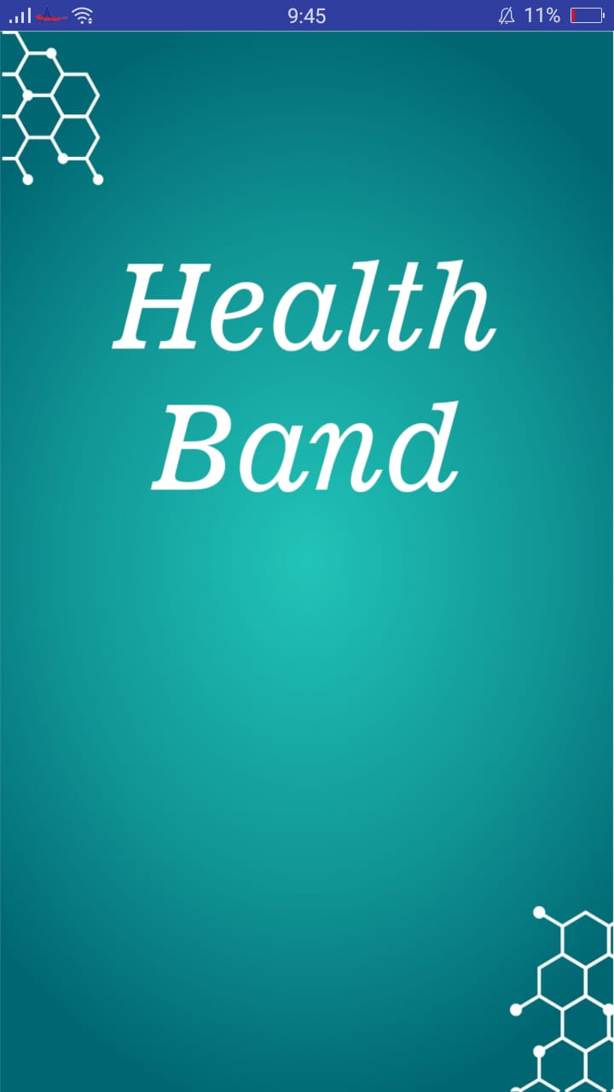

Appendix A: ul design
This is Registration screen where user Register yourself.
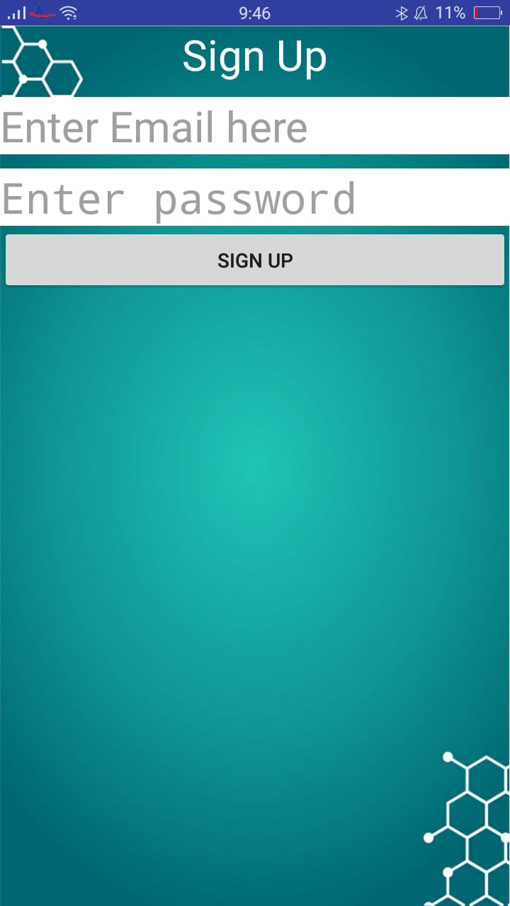

  - User interface

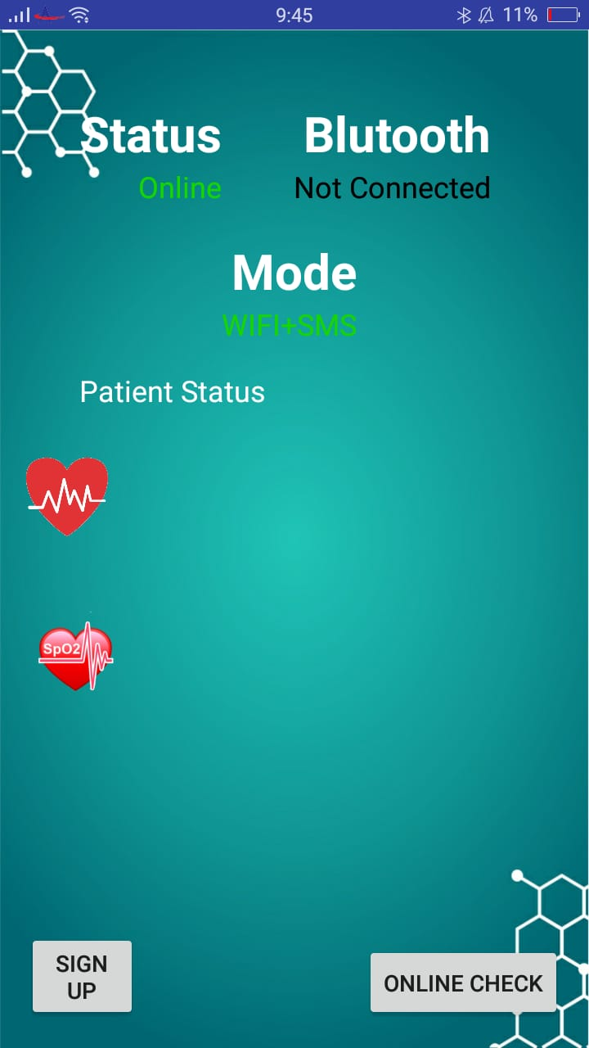

    - Second level heading [14 pt, Calibri, Bold, Left aligned]
[Paragraph Text 12 pt, Calibri, 1.5 Line Spacing, Justified]

      - Third level heading [12 pt, Calibri, Bold, Left aligned]
[Paragraph Text 12 pt, Calibri, 1.5 Line Spacing, Justified]

Appendix B: Administrator Manual
[Paragraph Text 12 pt, Calibri, 1.5 Line Spacing,Justified]
[Between 4 to 8 lines describe what is this appendix all about]

  - First Level heading [16 pt, Calibri, Bold, Left aligned]
[Paragraph Text 12 pt, Calibri, 1.5 Line Spacing, Justified]

    - Second level heading [14 pt, Calibri, Bold, Left aligned]
[Paragraph Text 12 pt, Calibri, 1.5 Line Spacing, Justified]

      - Third level heading [12 pt, Calibri, Bold, Left aligned]
[Paragraph Text 12 pt, Calibri, 1.5 Line Spacing, Justified]

Appendix C: Information / Promotional Material
[Paragraph Text 12 pt, Calibri, 1.5 Line Spacing, Justified]
[Between 4 to 8 lines describe what this appendix all about is]

  - Broacher


  - Flyer


  - Standee


  - Banner



  - First Level heading [16 pt, Calibri, Bold, Left aligned]
[Paragraph Text 12 pt, Calibri, 1.5 Line Spacing, Justified]

    - Second level heading [14 pt, Calibri, Bold, Left aligned]
[Paragraph Text 12 pt, Calibri, 1.5 Line Spacing, Justified]

      - Third level heading [12 pt, Calibri, Bold, Left aligned]
[Paragraph Text 12 pt, Calibri, 1.5 Line Spacing, Justified]

Appendix [no.]: Appendix Title
[Paragraph Text 12 pt, Calibri, 1.5 Line Spacing, Justified]
[Between 4 to 8 lines describe what is this chapter all about]

  - First Level heading [16 pt, Calibri, Bold, Left aligned]
[Paragraph Text 12 pt, Calibri, 1.5 Line Spacing, Justified]

    - Second level heading [14 pt, Calibri, Bold, Left aligned]
[Paragraph Text 12 pt, Calibri, 1.5 Line Spacing, Justified]

      - Third level heading [12 pt, Calibri, Bold, Left aligned]
[Paragraph Text 12 pt, Calibri, 1.5 Line Spacing, Justified]

Reference and Bibliography

Reference and Bibliography

[1] M. Sher, M. Rehman, “Title of the Paper” Conference name/Journal Name, Edition, Volume, Issue, ISBN/ISSN, PP, Publisher/City-Country, Year.
[2] ……

Index

Index

[A]

[B]

[C]

