SUPERIOR UNIVERSITY LAHORE



Final Year Project
PROJECT REPORT (Part-2)

Rolling Food

Project ID: BSSE-S18-016

Project Team
Student Name | Student ID | Program | Contact Number | Email Address
Mahnoor Khan | BSEM-S15-061 | BSSE-8A | 0323-4908415 | Mahnoorkhan942@gmail.com
Hafiz Muhammad Umer | BSEM-F14-112 | BSSE | 0342-5724443 | Champumar322@gmail.com

Project Supervisor: Muhammad Javaid Iqbal
(Jr. Lecturer)

Project Report
Rolling Food

Change Record
Author(s) | Version | Date | Notes | Supervisor’s Signature
Mahnoor Khan | 1.0 | 11th June,2018 | Original Draft
Mahnoor Khan  Hafiz Muhammad Umer | 2.0 | 15th June,2018 | Changes Based on Feedback from Supervisor
Mahnoor Khan  Hafiz Muhammad Umer | 3.0 | 27th June,2018 | Changes Based on Feedback from Faculty
Mahnoor Khan  Hafiz Muhammad Umer | 4.0 | 8th Jul,  2018 | Added Project Plan
Mahnoor Khan | 5.0 | 15th Aug, 2018. | Changes Based on the errors
Mahnoor Khan  Hafiz Muhammad Umer | 6.0 | 1st Oct,  2018 | Changes in the Final Report Based on Feedback from Supervisor
Mahnoor Khan | 7.0 | 12th Nov,  2018 | Changes in the Project Based on Feedback from Supervisor
Mahnoor Khan  Hafiz Muhammad Umer | 8.0 | 7th Dec,  2018 | Changes in the Final Report Based on Feedback from Supervisor

APPROVAL
Project Supervisor
Comments: ___________________________________________________________________
_____________________________________________________________________________
Name: ______________________________
Date: _______________________________ | Signature: __________________________

Project Manager
Comments: ___________________________________________________________________
_____________________________________________________________________________
Date: _______________________________ | Signature: __________________________

Head of the Department
Comments: ___________________________________________________________________
_____________________________________________________________________________
Date: _______________________________ | Signature: __________________________

Dedication

This work is dedicated to my father, who was always there for me when I needed support to survive my education life, my practical life. He made me enough passionate from his words and lessons that I gave the necessary time and hard work to my education needed to be successful. May he always be with me...Amen

Acknowledgments

I would also like to acknowledge with much appreciation and special gratitude I give to our final year Supervisor Muhammad Javaid Iqbal and to the Teachers, whose contribution in stimulating suggestions and encouragement, helped us to coordinate our project especially in writing this report. A special thanks go to my teammate, Hafiz Muhammad Umer, who help me to assemble the parts and gave suggestion about many points.

Executive Summary
Rolling Food is the 2D game with the 3D effects introduced in it. This document is aimed to explain every process involved for the development of this game such as analysis for basic requirements, designing the complete game with latest tools like unity platform, developing the game in 2D with the 3D effects and at the last testing and deployment of this game. Also, to fulfill the basic requirements for final year project for the award of BSSE degree. During development of the Rolling Food, a detailed description and implementation using the Unity Game Engine used and understand. The purpose was to deploy this real-time project on play store and to learn the game development platform. Rolling Food is not completely 3D game but it’s the 2D game and has several 3D effects during playing this game.

Table of Contents
Dedication iv
Acknowledgments v
Executive Summary vi
Table of Contents vii
List of Tables x
List of Figures xi
Chapter 1 14
Introduction 14
1.1. Background 15
1.2. Motivations and Challenges 15
1.3. Goals and Objectives 16
1.4. Literature Review/Existing Solutions 17
1.5. Gap Analysis 18
1.6. Proposed Solution 18
1.7 Project Plan 19
1.7.1 Work Breakdown Structure 21
1.7.2 Roles & Responsibilities Matrix 21
1.7.3 Gantt Chart 23
Chapter 2 25
Software Requirement Specifications 25
2.1 Introduction 26
2.1.1 Purpose 26
2.1.2 Document Conventions 26
2.1.3 Intended Audience and Reading Suggestions 26
2.1.1 Project Scope 26
2.2 Overall Description 27
2.2.1 Product Perspective 27
2.2.2 Product Functions 28
2.2.3 User Classes 29
2.2.4 Operating Environment 30
2.2.5 Design and Implementation Constraints 30
2.2.6 User Documentation 31
2.2.7 Assumptions and Dependencies 31
2.3 External Interface Requirements 31
2.3.1 User Interfaces 31
2.3.2 Hardware Interfaces 32
2.3.3 Software Interfaces 33
2.3.4 Communications Interfaces 33
2.4 System Features 34
2.4.1 System Feature 1 34
2.4.1.1 Description and Priority 34
2.4.1.2 Stimulus/Response Sequences 34
2.4.1.3 Functional Requirements 34
2.4.2 System Feature 2 34
2.4.2.1 Description and Priority 35
2.4.2.2 Stimulus/Response Sequences 35
2.4.2.3 Functional Requirements 35
2.4.3 System Feature 3 35
2.4.3.1 Description and Priority 35
2.4.3.2 Stimulus/Response Sequences 35
2.4.3.3 Functional Requirements 35
2.5 Other Nonfunctional Requirements 35
2.5.2 Safety Requirements 36
2.5.3 Security Requirements 36
2.5.4 Software Quality Attributes 36
2.5.5 Business Rules 37
Chapter 3 38
Use Case Analysis 38
3.1. Use Case Model 40
3.2. Fully Dressed Use Cases 44
Chapter 4 54
System Design 54
4.1. Architecture Diagram 56
4.2. Class Diagram 57
4.3. Sequence / Collaboration Diagram 58
4.4. Operation contracts 59
4.5. Activity Diagram 61
4.6. State Transition Diagram 63
4.7. Component Diagram 63
4.8. Deployment Diagram 65
4.9 Data Flow diagram 66
Chapter 5 69
Implementation 69
5.2 Components, GameObjects, Variables, C# scripts and scenes 73
5.3 Deployment Environment 75
5.4 Tools and Techniques 75
5.5 Best Practices / Coding Standards 81
Naming Conventions and Standards 81
Good Programming Practices 82
Comments 82
Exception Handling 82
Chapter 6 83
Testing and Evaluation 83
6.1. Use Case Testing 85
6.2. Compatibility Testing 96
6.3. Data flow testing 96
6.4. Unit testing 98
6.5. Integration testing 105
6.6. Performance testing 114
Chapter 7 119
Summary, Conclusion and Future Enhancements 119
7.1. Project Summary 121
7.2. Achievements and Improvements 121
7.3. Critical Review 123
7.4. Lessons Learnt 124
7.5. Future Enhancements 125
Appendices 126
Appendix A: Promotional Material 127
Reference and Bibliography 130
Index 132

List of Tables
Table 1 Roles & Responsibilities Matrix 22
Table 2 Fully Dressed Use Case GameplayRollingFood 44
Table 3 Fully Dressed Use Case MenuRollingFood 45
Table 4 Fully Dressed Use Case SelectWorldRollingFood 47
Table 5 Fully Dressed Use Case SelectTruckRollingFood 48
Table 6 Fully Dressed Use Case PauseRollingFood 49
Table 7 Fully Dressed Use Case ExitRollingFood 50
Table 8 Fully Dressed Use Case InAppPurchaseRollingFood 51
Table 9 Fully Dressed Use Case RateUsRollingFood 52
Table 10 Fully Dressed Use Case MoreGamesRollingFood 53
Table 11 UCID001 85
Table 12 UCID002 86
Table 13 UCID003 88
Table 14 UCID004 90
Table 15 UCID005 91
Table 16 UCID006 92
Table 17 UCID007 93
Table 18 UCID008 94
Table 19 UCID008 95
Table 20 IT_SC1_001 105
Table 21 IT_SC1_002 106
Table 22 IT_SC1_003 107
Table 23 IT_SC2_002 108
Table 24 IT_SC2_003 108
Table 25 IT_SC3_001 109
Table 26 IT_SC3_002 109
Table 27 IT_SC3_003 110
Table 28 IT_SC4_001 110
Table 29 IT_SC4_002 111
Table 30 IT_SC5_001 111
Table 31 IT_SC5_002 111
Table 32 IT_SC5_003 112
Table 33 IT_SC6_001 113
Table 34 IT_SC6_002 114

List of Figures
Fig. 1 Spiral Modeling for the Rolling Food 20
Fig. 2 Work Breakdown Structure 21
Fig. 3 Gantt Chart Rolling Food 24
Fig. 4 Use Case Diagram Rolling Food 40
Fig. 5 Use Case Diagram MenuRollingFood 41
Fig. 6 Use Case Diagram SelectWorldRollingFood 42
Fig. 7 Use Case Diagram SelectTruckRollingFood 43
Fig. 8 Architecture Diagram Rolling Food 56
Fig. 9 Class Diagram Rolling Food 57
Fig. 10 Sequence Diagram Rolling Food 58
Fig. 11 Activity Diagram Rolling Food 62
Fig. 12 State Transition Diagram Rolling Food 63
Fig. 13 Component Diagram Rolling Food 64
Fig. 14 Deployment Diagram Rolling Food 65
Fig. 15 DFD Level0 Rolling Food 66
Fig. 16 DFD Level1 Rolling Food 67
Fig. 17 DFD Level2 Rolling Food 68
Fig. 18 Deployment environment 75
Fig. 19 Screenshot1 77
Fig. 20 Screenshot2 78
Fig. 21 Screenshot3 79
Fig. 22 Screenshot4 80
Fig. 23 Screenshot5 81
Fig. 24 DataFlowTesting-1 97
Fig. 25 DataFlowTesting-2 98
Fig. 26 UnitTestingScene1-1 99
Fig. 27 UnitTestingScene1-2 99
Fig. 28 UnitTestingScene2-1 100
Fig. 29 UnitTestingScene3-1 101
Fig. 30 UnitTestingScene3-2 101
Fig. 31 UnitTestingScene4-1 102
Fig. 32 UnitTestingScene4-2 103
Fig. 33 UnitTestingScene4-3 103
Fig. 34 UnitTestingScene4-4 104
Fig. 35 UnitTestingScene4-5 104
Fig. 36 UnitTestingScene4-6 105
Fig. 37 PerformanceTest-1 115
Fig. 38 PerformanceTest-2 115
Fig. 39 PerformanceTest-3 116
Fig. 40 PerformanceTest-4 116
Fig. 41 PerformanceTest-5 117
Fig. 42 PerformanceTest-6 117
Fig. 43 PerformanceTest-7 118
Fig. 44 Brochure Rolling Food 127
Fig. 45 Flyer Rolling Food 128
Fig. 46 Banner Rolling Food 129

Final Year Project Part-2
Rolling Food (Game)

Chapter 1

Introduction

Chapter 1: Introduction
This chapter aims to make a brief summary of the methodology used in the creation of our Final Year Game Development Project “Rolling Food” and write up of the project report.

Background
This document explains the complete project report of our Final Year Project, which is developed by the 2 team members of this project i.e. Mahnoor Khan and Hafiz Muhammad Umer. The project is a 2D game with 3D modeling and effects, named Rolling Food. This document is aimed to explain every process involved in the implementation of our Final Year Project. It provides the deep background study of the game development also with the reasons for not considering the alternative ways of creating this game and justification of the decision for our project to build a 2D Game. We make a detailed description of “Unity Game Engine” the main tool used in the creation of our game.

Motivations and Challenges
Despite the economic instability and crisis deeply affecting the world, the analysts published that the game industry has grown at a rate of 57% surprisingly. Even as I type these words, millions of people are playing games in front of their cellphones. In April 2018, Newzoo released the latest quarterly update of its Global Games Market Report service. They forecast that 2.3 billion gamers across the globe will spend $137.9 billion on games in 2018. This represents an increase of +13.3% from the year before, or $16.2 billion. Digital game revenues will take 91% of the global market with $125.3 billion. The reason for this growth can be stated that the game industry can appeal to any user with different tastes.
Not only game development is currently a growing and vibrant market, also one of the many reasons that motivated as to go for such project is that but it also eliminates the need for expensive hardware, and it does not require a big team to develop a 2D game with 3D modeling. Hence, it can generate good revenue, yet saves development cost.
Fitting our game in the games store was the first and the most difficult challenge we faced. In order to find it, it was necessary to study the game development in Unity and mobile game market thoroughly. After getting skilled in “Unity- game development tool”, we studied that what kind of games and trends are currently in place, to know what works and what doesn’t.
Setting up a good story for our game idea was also a time-consuming thing we faced. It was based on the analysis we made on earlier about current trends. Obviously, we required an idea which was new or least common, yet exciting on games store.

Goals and Objectives
Our main objective is to create a 2d game (with a touch of 3D assets) that can run on both Android and iOS devices, by the game creating tool called Unity and programming language C#. Also, that each level is aimed to be a complete level of a scenario of the game with specific challenges, will be asked to the user to complete, after which user can jump on the next level. The user will play as a chef (also as an assistant in higher levels). The objective is to make our game about food delivery with challenges in it. It will be based on a truck that will be a mini restaurant itself and will deliver food around the world. Every level will be based on a different city and with the progress of levels, different and exciting modifications will be done with the truck and with the chef. Also, an assistant will be provided in the higher levels of which skills will be also modified timely. The game will be having 25+ levels with specific challenges with each level, that must be completed to jump to the next level. In this Game, the chef can cook tons of fabulous cuisines and become a top chef o the place of the level. We will use various ingredients to serve lots of delicious dishes and desserts.
The goals of our project include:
- Strategies and challenges that will be enjoyable for all age group users
- Making this available for Android devices (both phones and tabs) and iOS devices (both iPhones and iPads).
- Strategies are supposed to teach the value of money and time management when running a small business.
- Difficulty level increases with the passage of time making it more challenging.
- Make this as fast as possible than 3D games by the idea of using 3D modeling in a 2D game.
- Making users so satisfied and involved with the game that makes them wish to buy in-app purchases game items (powers, food items, truck items, etc.) that user can buy whenever those items are unlocked.
- Provide more than 5 different trucks with different kitchen looks.
- Virtual employees to support the truck management.
- Provide different from different cities and accordingly different dishes.
- Manage the size of the game would be as less as possible so that it can be played offline.

Literature Review/Existing Solutions
The history of game making begins with the development of the first video games created had little entertainment value, and their development focus was separate from user experience, in fact, these games required mainframe computers to play them. OXO, written by Alexander S. Douglas in 1952, was the first computer game to use a digital display. In 1958, a game called Tennis for Two, which displayed its output on an oscilloscope was made by Willy Higginbotham, a physicist working at the Brookhaven National Laboratory. In 1961, a mainframe computer game called Spacewar! was developed by a group of Massachusetts Institute of Technology students led by Steve Russell.
Till now, many advancements in game development have been made and creating and selling games is currently a vibrant business that has peak selling records recently. Following are the successful games made by the same game-creating tool “Unity” that we will as a platform for our game Rolling Food:
- Deus Ex: The Fall.
- Assassin's Creed: Identity.
- Satellite Reign.
- Escape plan.
- Temple Run Trilogy.
- Rust.
- Battlestar Galactica Online.
- Wasteland 2.

Gap Analysis
Since the major concern of our game project is to make our game faster than complete 3D games (our game is 2D with 3D but the animations, game effects used are 3D), highly user involved, capable of running on all of the Android cellphones and tabs, iOS iPhones and iPads, and Windows cell phones. Hence, the actual performance of the game is matched with the desired performance of the game. This is done by the right choice of game-development tool, feasible project plan, and skilled development team members. (details of which will be discussed later in this documentation)

Proposed Solution

The game Rolling Food is a 2D game with 3D modeling that is about food delivery and containing exciting and difficult challenges in it. It is based on a truck that is a mini restaurant itself and delivers food around the world. Every level is based on a different city and with the progress of levels, different and exciting modifications is done with the truck and with the chef. Also, an assistant is provided in the higher levels whose which skills will be also modified timely. The game has 25+ levels with specific challenges with each level, that must be completed in order to jump to the next level. In this Game, the chef can cook tons of fabulous cuisines and become a top chef in this addictive time-management food truck cooking game. The truck will travel across the world and spread the Rolling Food Craze. We will use various ingredients to serve lots of delicious dishes and desserts. In this game, we are giving strategic missions to users that are interesting and will teach the value of money and time management when running a small business. This game is exciting for both kids and adults. It involves strategic planning, needed to complete levels, and we have also included daily challenges that if successfully completed, different rewards will be gifted as a result to the users. And also, it includes in-app purchases game items (powers, food items, truck items, etc) that user can buy whenever those items are unlocked.
The idea of this game is not very common, the concept of food trucks with multiple colors and powers is either not or rarely available in any game. Moreover, it has multiple kitchen looks. For good graphics, we are willing to use the 3D Model characters with 3D effect images, in our 2D game. The idea of this is to have a game that is reduced and compressed size wise, as compared to a completely 3D game. Most of the games of this standard are online i.e. they need an internet connection to be played, but this game will be able to play offline. Also, our game has a huge group of users as it will be able to run on Android devices (both phones and tabs) and iOS devices (both iPhones and iPads).

Project Plan
Creating mobile games is a complicated task that involves the expertise of many skilled professionals from various disciplines including computer science, art, and media design and business. The pressure on game development to get to market as quickly as possible means that there are often schedule overruns with correspondingly poor time estimation. Classic software engineering issues associated with game development can include requirements management, configuration management, and verification and validation; these problems can be magnified by geographically distributed teams. So, the Project Plan for our Final Year Project Rolling Food is given the most importance. The major concern of our planning is game development phase. Our Project Plan for the development phase of our project is to follow the “Spiral Model” that will allow us the flexibility, iterations, and interactivity which must be needed for a quality game development. During the development of the game on Unity and Visual Studio platforms, many processes like testing will be performed over and over again. Also, the game has several features and for each feature, the steps of the Spiral Model has been repeated, which means each iteration of Spiral Model has resulted output of one feature. It has also happened to repeat the steps for the same feature of the game for the betterment or correction (that is what Spiral Modelling is actually known for).
The steps are:
Planning
Designing
Implementation
Play-Test
Evaluation
with Risk Management in each step.
The following is a pictorial representation of the steps of Spiral Modelling used for the development of our Final Year Project-Rolling Food. That will allow us the flexibility, iterations, and interactivity which must be needed for a quality game development. Rough-Sketch of Project Plan for processes used:

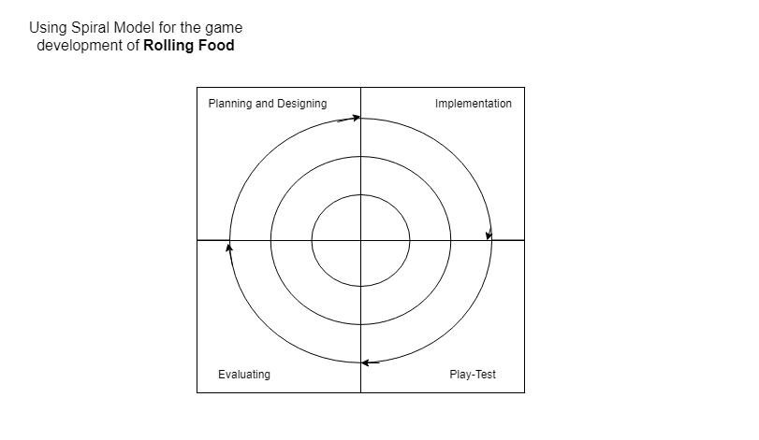
Fig. 1 Spiral Modeling for the Rolling Food

Work Breakdown Structure
The following chart explains the Work Breakdown Structure of our game project i.e. the critical work elements, tasks, and processes, of our project are illustrated to portray their relationships to each other and to the project as a whole.
Fig. 2 Work Breakdown Structure

Roles & Responsibilities Matrix
The following table explains the participation of project members and their roles in completing tasks or deliverables for the Final Year Project Rolling Food:

Table 1 Roles & Responsibilities Matrix
WBS # | WBS Deliverable | Activity # | Activity to Complete the Deliverable | Duration  (# of Days) | Responsible Team Member(s) & Role(s)
1 | Project Training | 1  2 | Training for the gain of skills in Game development tool “Unity”  Training for the gain of skills in Game designing tool “Adobe Illustrator” | 40 | Mahnoor Khan  Muhammad Umer
2 | Project Planning | 1  2  3  4 | Create Vision Document  Setting tasks between the team members  Creating WBS & Gantt Chart to manage time efficiently  Documenting Project proposal | 10 | Mahnoor Khan  Muhammad Umer
3 | Research | 1  2  3 | Research mobile game market thoroughly and scope  Research on trending games  Mechanic Research | 7 | Mahnoor Khan  Muhammad Umer
4 | Graphics  Designing | 1  2  3 | Ideas collection of graphics by the Inspiration from other games  Designing Graphics  Finalizing Graphics | 7 | Mahnoor Khan  Muhammad Umer
5 | Development | 1  2  3  4  5 | Prototyping  Coding  Testing of modules and integration  Outcome  Last check and documentation | 65 | Mahnoor Khan  Muhammad Umer
6 | Testing | 1  2  3  4  5 | Component Testing  Integration Testing  Use case Testing  Compatibility Testing  Deployment Testing | 10 | Mahnoor Khan  Muhammad Umer
7 | Documentation | 1  2 | Completing the Diagrams  Formalizing the documentation | 17 | Mahnoor Khan  Muhammad Umer

Gantt Chart
The following Gantt chart (created using Microsoft Excel) is a graphical depiction of our project schedule. It's is a type of bar chart that shows the start and finish dates of several elements of a project.
Here, the starting edge of the orange bar represents the starting date of the specific process, while end edge of the orange bar represents the time when that specific process ends.
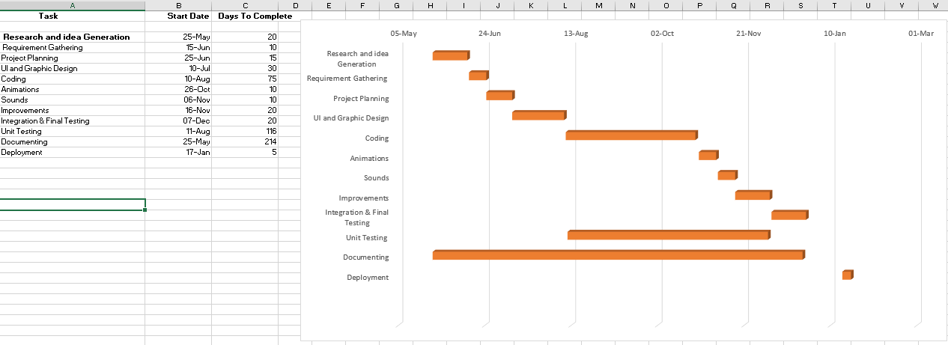
Fig. 3 Gantt Chart Rolling Food

Chapter 2

Software Requirement Specifications

2.1 Introduction
Explains the Software specification and Requirements of the game Rolling Food, for the successful deployment.

Purpose
This chapter will serve to formalize and document the requirements of our Final Year Project “Rolling Food”. Upon approval, this document will serve as a complete explanation and an agreement that the elicited requirements fully specify the functions and behaviors required for our game to be developed. It will additionally be used to evaluate the solutions proposed during the modeling phase and validate the implementation during the development phase of this game.

Document Conventions
This document follows the Calibri format and the font size is 11. The bold-faced text has been used to emphasize sections and italicized text is used to label and recognize diagrams. And the all text is Justified.

Intended Audience and Reading Suggestions
The document is mainly created for the approval of our Final Year Project of Software Engineering and hence the main intended audience is the approval panel of the Superior University that will declare the status of our project. Also, the documentation may help the team members (Mahnoor Khan & Muhammad Umer) to keep a track of all aspects (features, processes used, model used, risks identified, risks reasons, processes used to remove risks) of the game application and that will help for future improvements and updates in the game and may also be essential when the team members may create a similar project. It may also help the user to understand the project in detail.

Project Scope
Our main objective is to create a 2d game with 3D modeling that can run on both Android and iOS devices, by the game creating tool called Unity and programming language C#. Also, that each level is aimed to be a complete level of a scenario of the game with specific challenges, will be asked to the user to complete, after which user can jump on the next level. The user will play as a chef (also as an assistant in higher levels). The objective is to make our game about food delivery with challenges in it. It is based on a truck that is a mini restaurant itself and will deliver food around the world. Every level is based on a different city and with the progress of levels, different and exciting modifications will be done with the truck and with the chef. Also, an assistant is provided in the higher levels of which skills will also be modified timely. The game has 25+ levels with specific challenges with each level, that must be completed to jump to the next level. In this Game, the chef can cook tons of fabulous cuisines and become a top chef of the place of the level. We will use various ingredients to serve lots of delicious dishes and desserts.
The scope of our project includes:
- Strategies and challenges that will be enjoyable for all age group users
- Making this available for Android devices (both phones and tabs) users and iOS devices (both iPhones and iPads) users.
- Strategies is supposed to teach the value of money and time management when running a small business.
- Make this as fast as possible than 3D games by the idea of using 3D modeling in a 2D game.
- Manage the size of the game would be as less as possible so that it can be played offline.
- Difficulty level increases with the passage of time making it more challenging.
- Making users so satisfied and involved with the game that makes them wish to buy in-app purchases game items (powers, food items, truck items, etc) that user can buy whenever those items are unlocked.
- Provide more than 5 different trucks with different kitchen looks and equipment.
- Virtual employees to support the truck management.
- Provide different levels with different cities and accordingly different dishes.

Overall Description
Following points explain the Overall Description of the project:

Product Perspective
While our project Rolling Food, itself is not a continuation of any predecessor, its implementation is made possible through the game development tool Unity and its ability to compile and build updation for use on both iPhones and Android mobile devices. Although it’s not a continuation but inspired by different games available on games store.
Since smartphones these days are full of tons of games, therefore, one of our goals while designing the game is to be able to let the user understand the gameplay at the first look no matter how often and how least he opens the game, we are achieving this by showing the control guide screen every time at the beginning of the game, hence engaging the user every time with the game. We have tried to avoid creating the story primarily because the users (especially when it comes to small smartphone games) find it really annoying instead our game model focuses on gaining the score by achieving the difficulty level. The game would allow the users to pause the game by stopping the frames being executed, so it wouldn’t create aggressive feedback like recently hyped game flappy bird did.

Product Functions
Following Are the Major Features of the game:
- Rolling Food is a 2D game with 3D modeling i.e. the game is coded as 2D but the animations, game effects used will be 3D. Make this as fast as possible than 3D games by the idea of using 3D modeling in a 2D game.
- The game is able to run on Android devices (both tabs and phones), iOS devices (both iPads and iPhones).
- The user will play as a chef/chef assistant in the game and will deliver food to its customers.
- Since it is based on a truck that is a mini restaurant itself and delivers food around the world, hence, every level is based on a different city i.e. each time you pass a level, the game will provide a new place graphics with the different type of foods that is to be delivered.
- Also, an assistant has provided in the higher levels whose which skills will be also modified timely.
- with the progress of levels, different and exciting modifications will be done with the truck and with the chef.
- The game has 25+ levels with specific challenges with each level, that must be completed in order to jump to the next level.
- the chef can cook tons of fabulous cuisines and become a top chef in this addictive time-management food truck cooking game. We will use various ingredients to serve lots of amazing recipes of delicious dishes and desserts like Coffee, Pizza, Sandwich, Cake, BBQ, Burger, French Fries, ice cream and shakes.
- It involves strategic planning, needed to complete levels, and will also include daily challenges that if successfully completed, different rewards will be gifted as a result to the users.
- it includes in-app purchases game items (powers, food items, truck items, etc) that user can buy whenever those items are unlocked.
- the game will be able to play offline.
- The game would allow the users to pause the game by stopping the frames being executed.
- difficulty increases with the increase in levels.

User Classes
Following are the major classes for our project users:
- iPhone users:
The game will be available for the iPhone users, hence will be available on Apple Store.
- iPad users:
As described above, the game will be available on Apple Store, also the resolution and graphics will be in a wise that will make able to run efficiently on big screens iPads too.
- Android Phone users:
The game will be available for the Android phones users, hence will be available on Play Store.
- Android Tab users:
As described above, the game will be available on Play Store, also the resolution and graphics will be in a wise that will make able to run efficiently on big screens Android Tabs too.
- Kids:
Kids love when a game provides continuously new and colorful stuff. In this game, we are giving a variety of modifications done with every level that will be joyful for kids. Since it is based on a truck that is a mini restaurant itself and delivers food around the world. Hence, every level is based on a different city .i.e. each time you pass a level, the game will provide a new place graphics with a different type of foods that is to be delivered. Also, will teach kids the value of money and time management.
- Adults:
In this game, we are giving the strategic missions to users that will be interesting and exciting for adults too. Difficulty increases with the increase in levels of the games which will even grab the interest of the adults too.

Operating Environment
Unity is an ultimate game development platform having the capability to generate the games for Android devices and iOS devices:
- First, for the development of the game:
-a Windows 10 laptop is required
- with Unity installed in it
- with Visual Studio installed in it
- with Adobe Illustrator installed in it
- After the development of the game, for making the game to be able to run on Android devices (Building game for android phones and tabs):
-An android phone with the latest version of Android OS installed.
- After the development of the game, for making the game to be able to run on iOS devices (Building game for iPhones and iPads):
-A Mac computer running OS X 10.11 or later
-XCode installed in Mac computer
-The latest version of Unity installed in Mac
-An iOS device with the latest version installed.

Design and Implementation Constraints
Following are the constraints related to the implementation and design of our Final Year Project:
• This game would not be able to run on an android device having less than Android OS Version 4.0 installed.
• This game would not be able to run on an iOS device having less than iOS Version 6 installed.
• The game development must be done on Unity of at least Version 1.0 or above, installed in a Windows 10 laptop.
• The development of game scenes must be done according to the game theme and story.
• When designing game characters, team member must notice that any famous cartoon or movie character cannot be there game character (Copyright Policy).
The game must complete its development, testing and documentation till the end of 8th Semester (December 2018).

User Documentation
Since our project is a game, which doesn’t require to provide proper documentation to players in order to be played, however:
- We have designed the game that will be able to let the user understand the gameplay at the first look no matter how often and how least he opens the game, we are achieving this by showing the control guide screen every time at the beginning of the game, hence engaging the user every time with the game.
- We will provide the story of the game in the Game Store that can be read before the user downloads the game, that will help the user understand what kind of our game is, what kind of challenges and goals will they face in our game, etc.

Assumptions and Dependencies
No special assumptions or dependencies have been identified for our game project Rolling Food, else these basic two, which are the assumptions/dependencies that can affect our Software Requirements:
- Project member availability and performance: There can be some important or emergency cases that can make one our team unavailable, this can have an influence on the performance of development.
- Budget Limitations: Although the idea of developing a game eliminates the need for expensive hardware and it does not require a big team to develop a 2D game with 3D modeling, but any failure in laptops can cause the budget to a get influenced.

External Interface Requirements

User Interfaces
The user interface includes the view of the game world and controls provided to the user:
View of the Game World:
The View of the Game World of Rolling Food is a 2D game with 3D modeling that is about food delivery and \containing exciting and difficult challenges in it. It is based on a truck that is a mini restaurant itself and delivers food around the world. The user will face different levels and every level is based on a different city with different customers and with the progress of levels, the user will enjoy different and exciting modifications that will be done with the truck and with the chef. Also, an assistant will be provided in the higher levels whose which skills will be also modified timely. The game has 25+ levels with specific challenges with each level, that the user must be complete in order to jump to the next level. In this Game, the chef can cook tons of fabulous cuisines and become a top chef in this addictive time-management food truck cooking game. The truck will travel across the world and spread the Rolling Food Craze. We will use various ingredients to serve lots of delicious dishes and desserts.

Controls provided to the user:
The user will be playing the role of the chef/assistant in the game and will deliver food. The chef’s job will be to cook the food according to the instructions that will be provided in the game and then deliver food to the customers within the time given. The earlier the player delivered food to the specific customer, the more points will be granted. The customer will appear continuously during the level and the player will deliver the food to all customer in time, only then the player can pass that specific level. If the level passed, the chef’s skills will be better than previous level i.e. the delivery speed of the chef will be increased. Along with skill increase, the difficulty level of the next level will also increase i.e. customers will appear more quickly and time slot for cooking and delivering food for every customer will be shortened. If the player failed to pass the level, the same level will appear on the screen with the same chef’s skill and difficulty level of the Level.

Hardware Interfaces
The hardware interfaces are the mobile or tab devices that will make players to be able to play the game.
- iPhones:
The game will be available for the iPhone users, hence will be available on Apple Store.
- iPads:
As described above, the game will be available on Apple Store, also the resolution and graphics will be in a wise that will make able to run efficiently on big screens iPads too.
- Android Phones:
The game will be available for the Android phones users, hence will be available on Play Store.
- Android Tabs:
As described above, the game will be available on Play Store, also the resolution and graphics will be in a wise that will make able to run efficiently on big screens Android Tabs too.

Software Interfaces
Our game Rolling Stone will be made under a series of game development tools that will serve as the software interfaces:
- First, for the development of the game:
-a Windows 10 laptop is required
- with Unity installed in it
- with Visual Studio installed in it
-with Adobe Illustrator cc installed in it (for game designing)
- After the development of the game, for making the game to be able to run on Android devices (Building game for android phones and tabs):
-An android phone with the latest version of Android OS installed.
- After the development of the game, for making the game to be able to run on iOS devices (Building game for iPhones and iPads):
-A Mac computer running OS X 10.11 or later
-XCode installed in Mac computer
-The latest version of Unity installed in Mac
-An iOS device with the latest version installed.

Communications Interfaces
Following are the means of communication with our users:
- Our users will able to rate our game or give a written feedback through the App Store (in case of iPhone users) or PlayStore (in case of Android Users) or Windows Store (in case of Windows phone users)
- The users will be allowed to directly email us to give feedback or report an issue on our email address that will be provided on apps store when downloading our game and also in the game (by clicking on “contact” button).

System Features
Following illustrates the organizing of the functional requirements for the game Rolling Food by system features, the major services provided by the game.

System Feature 1
Allow the user to choose between multiple trucks.

Description and Priority
The game has the feature to allow the user to choose between multiple trucks having the unique feature like some trucks can give food delivery in less than 3 sec. Each truck has updated equipment installed in them helping the user in food management. As the game is regarding the delivering food or meal to specific areas that’s why trucks are the most and having high priority.

Stimulus/Response Sequences
To buy the new truck user must have enough coins. The first user has to see ad resulting in free coin, which will help the user to buy the first truck. After reaching the limit, that user can buy the 2nd level truck. Whenever you reached the level that you can buy the updated truck you will get the notification.

Functional Requirements
REQ-SF1-1: User truck unlocks the new food items providing more coins, results in more earning.
REQ-SF1-2: Unlocking new trucks will allow the user to deliver food faster.
REQ-SF1-3: Every city has new food trucks resulting in new food items and challenges.

System Feature 2
Virtual employee’s

Description and Priority
It’s a middle-level priority number (6). It will enhance the user experience by hiring the virtual employee. This will reduce the waiting time of the user result in more earning.

Stimulus/Response Sequences
Game User need to buy the Virtual Employee at a certain level after having mentioned the number of coins. After having coins, the virtual employee response depends upon the task assigned to him. Every Virtual Employee will reduce minimum 1 Sec of waiting time.

Functional Requirements
Following are the Functional Requirements
REQ-SF2-1: User must have a certain number of coins to buy the virtual employee
REQ-SF2-2: Virtual Employee will get paid
REQ-SF2-3: VE will reduce the waiting time.

System Feature 3
Time challenge management and Interactive user engagement.

Description and Priority
It’s one of the most important game features. We are designing the user challenges and interactive user interfaces that will result in an increase of our game players.

Stimulus/Response Sequences
The movement of the vehicle and the interaction of this with the user is going to count in this. It stimulates the user to move towards the truck and move away from the truck if food is not delivered on time.

Functional Requirements
Following are the Functional Requirements
REQ-SF2-1: user can Pause the game and stop it.
REQ-SF2-2: In-app purchases are included to buy the premium trucks and virtual employees
REQ-SF2-3: Can buy our premium city having more complicated missions

Other Nonfunctional Requirements
Following is an explanation of non-functional attributes of the project Rolling Food.

    - Performance Requirements
Based on the capabilities of current phones and tablets, performance should not be an issue. However, phones and tabs with weaker hardware may incur some difficulties and potentially run slower. The game design is tailored in order to give an enjoyable experience on all Android, iOS and Windows phones, regardless of hardware. The functionality of the game is simplistic enough, but not trivial, and the graphics will not be overly detailed so the system does not become slowed down, making it as fast as possible than 3D games by the idea of using 3D modeling in a 2D game.

Safety Requirements
Rolling Food will not affect or damage any of the other applications installed on the player’s phone. The game will also not cause any overheating of the player’s phone; therefore, the phone's internal components will not be damaged. Rolling Food should not be played when the player’s attention is divided among multiple tasks to prevent potential harm to the player. The player should take a break after every two hours of continuous play to prevent eyestrain and repetitive strain injury.

Security Requirements
Rolling Food will not ask for any personal information from the player and will thus be unable to compromise such information. There is no player authentication required to play Rolling Food. The player simply has to download the application in order to start playing Rolling Food. That being said, anyone who has access to the player’s phone will have the ability to play Rolling Food. If any unauthorized player acquires the original player’s phone, that unauthorized player will be able to play Rolling Food. It is the responsibility of the Player to make sure that no unauthorized player/ person will have access to his or her phone.

Software Quality Attributes
To ensure reliability and correctness, Rolling Food will respond to the player’s commands in a timely manner. When the player makes the food plate deliver, the prefab and transform component of the gameObjects would respond immediately, the player should see the effects of this command within milliseconds not 10 seconds after the effect. For adaptability and flexibility, Rolling Food will automatically save the player’s progress after every level completion. That way, in the event that the player’s phone runs out of battery during game-play, the player can resume game-play at a reasonable starting point. In terms of usability, the graphical user interface is very intuitive for the player to use. The beginning levels of Rolling Food will also slowly introduce each of the unique controls available to the player as well as any other game mechanics the player may need to know to complete the level. In more complicated and elaborate levels, these introductions and hints will not be available because the player will have already been introduced to all the tools needed to complete the level. This method will ensure that the player gradually learns all the game mechanics and also enjoys a challenging game-play experience. Our game focuses on both ease of use and ease of learning while not leaning towards one or the other. Rolling Food should be a game that any player can pick up and play instantly without much downtime in figuring out the controls. The controls are easy and intuitive to use and the player will not be bombarded by having to use all the controls at once in the beginning levels. The gameplay will ease the player into learning and using each of the controls by gradually introducing each control as the player progresses through the game and completes each level. By the end of any given level, the player should be familiar with and fully able to use the controls introduced in that level and all the controls introduced in previous levels.

Business Rules
The topic 1.7.2 Roles and Responsibilities Matrix in this document explain the Business rules of this Final Year Project Rolling Food.

Chapter 3

Use Case Analysis

Chapter 3: System Analysis
This chapter provides an understanding for analysis of functions and their interactions with other functions of the game, using Use Case Models. Systems Analysis. It is a process of collecting and interpreting facts, identifying the problems, and decomposition of a system into its components. It is a problem-solving technique we used for our game Rolling Food that helped us improve the functionality and ensured us that all the components of the system work efficiently to accomplish their purpose.

Use Case Model
Following use case diagrams, that are the graphic depiction of the interactions among the elements of a game and actors of the game:
    - Use Case diagram GamePlayRollingFood
Fig. 4 Use Case Diagram Rolling Food
    - Use Case diagram MenuRollingFood

Fig. 5 Use Case Diagram MenuRollingFood
    - Use Case diagram SelectWorldRollingFood
Fig. 6 Use Case Diagram SelectWorldRollingFood
    - Use Case diagram SelectTruckRollingFood

Fig. 7 Use Case Diagram SelectTruckRollingFood

Fully Dressed Use Cases
The following are the Fully Dressed Use Cases of the game of Rolling Food, that means, this completes all the sections of the use case specifications i.e. the basic flow, the alternative flow, special requirements, Pre/Post specifications are also described.

    - Fully Dressed Use Case for GameplayRollingFood
Table 2 Fully Dressed Use Case GameplayRollingFood
Tittle | GameplayRollingFood
Primary Actors | Player
Secondary Actors | Games Store
Stake Holders | Manager, Coder, Game Players, Games Store
Pre-conditions | - The user must possess iPhone/iPad/Android Phone/Android Tablet.  - The user must download the game from Apple Games Store/PlayStore.  - The user must install the game after it is downloaded.
Post-conditions | - The game level has been played by the user.
Status | Developed
Owner | Mahnoor Khan, Muhammad Umer
Basic Flow | - The level selection screen appears that let Player SelectLevel.  - The Game Initiates the game play and game environment.  - The game customer characters appear.  - Players fill the tray with right items.  - Player drag the tray to the customer on time.  - Player collects the coins from the customer and coins added.  - Player completes the Level.
Alternate/Extended Flow | - The level selection screen appears that displays levels list let Player SelectLevel.  4.1 If Player select the level that is locked, error message appears.  4.2 If Player select the level that is unlocked, flow transfers to Process ID:2 Game Initiates.  - The Game Initiates the game play and the game environment.  - The game customer characters appear.  3.1 If game customer character appears on the left side, left collider is on.  3.2 The game customer character appears on the right side, right collider is on.  - Players fill the tray with right items.  4.1 If the player fills the tray with wrong items, tray wasted.  - Player drags the tray to the customer on time.  5.1 If the player drags tray to the wrong customer, customer serve fails.  5.1 If the player doesn’t drag the tray before the given time to the customer, customer serve fails.  - Player collects the coins from the customer and coins added.  6.1 Player doesn’t collect coins.  - Player completes the Level.  7.1 If Player fails the level, Retry Message appears.  7.2 If Player wins the level, MenuRollingFood appears

    - Fully Dressed Use Case for MenuRollingFood
Table 3 Fully Dressed Use Case MenuRollingFood
Tittle | MenuRollingFood
Primary Actors | Player
Secondary Actors | Games Store
Stake Holders | Manager, Coder, Game Players, Games Store
Pre-conditions | - The user must possess iPhone/iPad/Android Phone/Android Tablet/Windows Phone.  - The user must download the game from Apple Games Store/PlayStore.  - The user must install the game after it is downloaded.
Post-conditions | - The user selected options from the menu (Play/InAppPurchase/RateUs/MoreGames/TruckSelection)  - The user performed options from menu (Play/InAppPurchase/RateUs/MoreGames/TruckSelection)
Status | Developed
Owner | Mahnoor Khan, Muhammad Omer
Basic Flow | - The Game Menu options appears.
Alternative Flow | 1.The Game Menu options appears.  1.1 If the Player clicks Play and the flow transfers to UseCase: RollingFood, Process ID:6. Game Initiates.  1.2 If the Player clicks InAppPurchase flow transfers to InAppPurchase  1.3 If the Player clicks RateUs flow transfers to RateUs.  1.4 If the Player clicks MoreGames flow transfers to MoreGames.  1.5 If the Player clicks TruckSelection, flow transfers to TruckSelection.

    - Fully Dressed Use Case for SelectWorldRollingFood
Table 4 Fully Dressed Use Case SelectWorldRollingFood
Tittle | SelectWorldlRollingFood
Primary Actors | Player
Secondary Actors | Games Store
Stake Holders | Manager, Coder, Game Players, Games Store
Pre-conditions | - The user must possess iPhone/iPad/Android Phone/Android Tablet/Windows Phone.  - The user must download the game from Apple Games Store/PlayStore.  - The user must install the game after it is downloaded.  - The user must click world option in the map page.
Post-conditions | - The selected world has been opened by the user with new levels controls and environment.
Status | Developed
Owner | Mahnoor Khan, Muhammad Omer
Basic Flow | - The World selection screen appears.  - The player selects the world.  - The levels screen of the world appears.
Alternative Flow | - The World selection screen appears.  - The player selects the world.  - If the player selects the unlocked  - If the player selects the World1, the levels screen of World1 appears.  - If the player selects the World1, the levels screen of World2 appears.  - If the player selects the World2, the levels screen of World3 appears.  - If the player selects the World3, the levels screen of World1 appears.  - If the player selects the World5, the levels screen of World5 appears.  - If the player selects the locked level, error message appears.

    - Fully Dressed Use Case for SelectTruckRollingFood
Table 5 Fully Dressed Use Case SelectTruckRollingFood
Tittle | SelectTruckRollingFood
Primary Actors | Player
Secondary Actors | Games Store
Stake Holders | Manager, Coder, Game Players, Games Store
Pre-conditions | - The user must possess iPhone/iPad/Android Phone/Android Tablet.  - The user must download the game from Apple Games Store/PlayStore.  - The user must install the game after it is downloaded.  - The user must have enough coins to purchase when selecting an unlocked truck.
Post-conditions | - The user selected the truck.  - The user purchased the new truck.  - The user played game with the new truck controls and environment
Status | Developed
Owner | Mahnoor Khan, Muhammad Umer
Basic Flow | - The truck selection screen appears.  - The Player SelectTruck.  - The player clicks the next button and flow transfers to Process ID:6. Game Initiates.
Alternative Flow | - The truck selection screen appears.  - The Player SelectTruck.  2.1 If Player selects the Truck that is locked  2.1.1 if the player’s coins less than the purchase price of the Truck, NotEnoughCoins message appears.  2.1.2 if the player player’s coins greater than the purchase price of the Truck, TruckSelected message appears and purchase price deduct from coins.  2.2 If Player selects the Truck that is unlocked, TruckSelected message appears  - The player clicks the next button and flow transfers to Process ID:6. Game Initiates.

    - Fully Dressed Use Case for PauseRollingFood
Table 6 Fully Dressed Use Case PauseRollingFood
Tittle | PauseRollingFood
Primary Actors | Player
Secondary Actors | Games Store
Stake Holders | Manager, Coder, Game Players, Games Store
Pre-conditions | - The user must possess iPhone/iPad/Android Phone/Android Tablet.  - The user must download the game from Apple Games Store/PlayStore.  - The user must install the game after it is downloaded.  - The user must click pause button from the menu.
Post-conditions | - The game gets paused
Status | Developed
Owner | Mahnoor Khan, Muhammad Umer
Basic Flow | - Player clicks pause from the menu.  - Player clicks resume from the menu.

    - Fully Dressed Use Case for ExitRollingFood
Table 7 Fully Dressed Use Case ExitRollingFood
Tittle | ExitRollingFood
Primary Actors | Player
Secondary Actors | Games Store
Stake Holders | Manager, Coder, Game Players, Games Store
Pre-conditions | - The user must possess iPhone/iPad/Android Phone/Android Tablet.  - The user must download the game from Apple Games Store/PlayStore.  - The user must install the game after it is downloaded.  - The user must click exit button from the menu.
Post-conditions | - The game quits.
Status | Developed
Owner | Mahnoor Khan, Muhammad Umer
Basic Flow | - The player clicks the ExitGame button from the menu.  - The game exits.

    - Fully Dressed Use Case for InAppPurchaseRollingFood
Table 8 Fully Dressed Use Case InAppPurchaseRollingFood
Tittle | InAppPurchaseRollingFood
Primary Actors | Player
Secondary Actors | Games Store
Stake Holders | Manager, Coder, Game Players, Games Store
Pre-conditions | - The user must possess iPhone/iPad/Android Phone/Android Tablet.  - The user must download the game from Apple Games Store/PlayStore.  - The user must install the game after it is downloaded.  - The user must click InAppPurchase button from the menu.  - The cell must be connected to the internet.
Post-conditions | - Player purchased the bundle of desire
Status | Developed
Owner | Mahnoor Khan, Muhammad Umer
Basic Flow | - The player clicks the coins the bundle of choice.  - The pay by the google/ iOS account  - Coins added
Alternative Flow | - The player clicks the coins bundle of choice.  1.1 The connection error message appears.  - The pay by the google/iOS account  2.1 Invalid account error  - Coins added to the players account.

    - Fully Dressed Use Case for RateUsRollingFood
Table 9 Fully Dressed Use Case RateUsRollingFood
Tittle | RateUsRollingFood
Primary Actors | Player
Secondary Actors | Games Store
Stake Holders | Manager, Coder, Game Players, Games Store
Pre-conditions | - The user must possess iPhone/iPad/Android Phone/Android Tablet.  - The user must download the game from Apple Games Store/PlayStore.  - The user must install the game after it is downloaded.  - The user must click RateUs button from the menu.  - The cell must be connected to the internet.
Post-conditions | - Player rated the game.
Status | Developed
Owner | Mahnoor Khan, Muhammad Umer
Basic Flow | - The player clicks the RateUs button.  - The game directs to the game account link on playstore/AppStore
Alternative Flow | - The player clicks the RateUs button.  - The game directs to the game account link on playstore/AppStore  2.1 The connection error message appears.
    - Fully Dressed Use Case for MoreGamesRollingFood
Table 10 Fully Dressed Use Case MoreGamesRollingFood
Tittle | MoreGamesRollingFood
Primary Actors | Player
Secondary Actors | Games Store
Stake Holders | Manager, Coder, Game Players, Games Store
Pre-conditions | - The user must possess iPhone/iPad/Android Phone/Android Tablet.  - The user must download the game from Apple Games Store/PlayStore.  - The user must install the game after it is downloaded.  - The user must click MoreGames button from the menu.  - The cell must be connected to the internet.
Post-conditions | - Player linked to our games account on the playstore/AppsStore by the game.
Status | Developed
Owner | Mahnoor Khan, Muhammad Umer
Basic Flow | - The player clicks the MoreGames button.  - The game directs the player to our game account link on playstore/AppStore
Alternative Flow | - The player clicks the MoreGames button.  - The game directs the player to our game account link on playstore/AppStore  2.1 The connection error message appears.

Chapter 4

System Design

Chapter 4: System Design
From the architecture point of view, maybe the most specific feature of this game is to have a fully 2D logic (i.e. gameplay), but a 3D rendering. Therefore, the GameLogic uses only internal 2D data, and the GameGraphics 3D data, which are construct both with internal 3D contents and the 2D information from the logic. This is emphasizing by the following explanations and diagrams.

Architecture Diagram
Following Architecture Diagram of Rolling Food is a graphical representation to understand, clarify, and communicate ideas about the game structure and the user requirements that the game must support.

Fig. 8 Architecture Diagram Rolling Food

Class Diagram
The following Class Diagram of our project gives an overview of Rolling Food by displaying its classes, attributes and operations:

Fig. 9 Class Diagram Rolling Food

Sequence / Collaboration Diagram
The following Sequence Diagram shows game objects interactions arranged in time sequence. It depicts the objects and classes involved in the scenario and the sequence of messages exchanged between the game objects needed to carry out the functionality of the gameplay.
Fig. 10 Sequence Diagram Rolling Food

Operation contracts
The Operations Contracts are explained in a detailed manner in Chapter#3 (Fully Dressed Uses Cases). The Pre-Conditions are the same for every operation of Rolling Food, however the Post-Conditions vary to the operations. Following are the operation contracts for the major operations of the game:

Contract CO1: Rolling Food Gameplay
Operation Name | Rolling Food Gameplay
Cross Reference | Use Cases: RollingFood
Pre-conditions | - The user must possess iPhone/iPad/Android Phone/Android Tablet/Windows Phone.  - The user must download the game from Apple Games Store/PlayStore/Windows Store.  - The user must install the game after it is downloaded.
Post-conditions | - The game has been played by the user.

Contract CO2: Display Menu
Operation Name | Display Menu
Cross Reference | Use Cases: MenuRollingFood
Pre-conditions | - The user must possess iPhone/iPad/Android Phone/Android Tablet/Windows Phone.  - The user must download the game from Apple Games Store/PlayStore/Windows Store.  - The user must install the game after it is downloaded.
Post-conditions | - The user selected options from the menu (Settings/Play/InAppPurchase/RateUs/ExitGame)  - The user performed options from menu (settings/ play game/ made purchases/ rated game/ existed game)

Contract CO3: Select Level

Operation Name | Select Level
Cross Reference | Use Cases: SelectLevelRollingFood
Pre-conditions | - The user must possess iPhone/iPad/Android Phone/Android Tablet/Windows Phone.  - The user must download the game from Apple Games Store/PlayStore/Windows Store.  - The user must install the game after it is downloaded.  - The user must clear a level to jump to the new level.  - The user must fulfill the specific goals to clear the specific level
Post-conditions | - The level has been played by the user with new level controls and environment.  - The user win/loss the level.  - New Level is added to Map level list.

Contract CO4: Select Truck

Operation Name | Select Truck
Cross Reference | Use Cases: SelectTruckRollingFood
Pre-conditions | - The user must possess iPhone/iPad/Android Phone/Android Tablet/Windows Phone.  - The user must download the game from Apple Games Store/PlayStore/Windows Store.  - The user must install the game after it is downloaded.  - The user must have enough coins to purchase when selecting an unlocked truck.
Post-conditions | - The user selected the truck.  - The user purchased the new truck.  - The user played game with the new truck controls and environment

Activity Diagram
The following activity diagram visually presents a series of major actions and the flow of control of our game Rolling Food. It explains the dynamic behavior of our game. The figure of Activity Diagram of Rolling Food is on the next page:
Fig. 11 Activity Diagram Rolling Food

State Transition Diagram
The following State Transition Diagram explains the states of the Game Rolling Food from the game being started by the player to the game being ended.

Fig. 12 State Transition Diagram Rolling Food

Component Diagram
The following Component Diagram shows the dependencies and interactions between hardware and software components used in our project game Rolling Food. Every component represents a modular part of our game, for example, includes the script files for the scenes, the game assets, the Game Objects, the hardware used, the setups used, etc.

Fig. 13 Component Diagram Rolling Food

Deployment Diagram
The following diagram shows the structure of our game project in its deployed environment i.e. the physical deployment of the components

Fig. 14 Deployment Diagram Rolling Food

Data Flow diagram
The following Data Flow Diagram (using Yourdon & Coad notations) captures the flow of data in our Rolling Food. The diagram will help in developing an understanding of game’s functionality and what are the different sources of data for game implementation, what different transformations take place on data and what are final outputs generated by these transformations.

    - Data Flow Diagram Level0:
The following Data Flow Diagram Level0, also known as context diagram is containing one process that generalizes the function of the entire game:
Fig. 15 DFD Level0 Rolling Food

    - Data Flow Diagram Level1:

Fig. 16 DFD Level1 Rolling Food
    - Data Flow Diagram Level2:

Fig. 17 DFD Level2 Rolling Food

Chapter 5

Implementation
Chapter 5: Implementation
For the implementation of our 2D game with 3D Models used, we will use Unity and Visual Studio as platforms. More than an engine, Unity gives you everything you need to develop quality content, boost your productivity, and connect with your players. The all-in-one editor of Unity offers the latest and best tools for developing, launching and earning revenue from 2D games. From this section onwards, I will be explaining the basics of the implementations of our game project Rolling Food and how it works. Here I will explain the necessary script functions that are required to create this game.
  - Pseudocode
Following is the Pseudocode of our game Rolling Food, for the basic game play of one scene (written in the C# language):
START

1.The game is being opened by the Player and Introduction Game Play starts.
  - ELSE the Player skips the introduction.
2.The Game Menu options appears.
2.1 IF the Player clicks Play and the flow transfers to Process ID:6. Game Initiates.
2.2 ELSE the Player clicks InAppPurchase.
2.3 ELSE the Player clicks RateUs.
2.4 ELSE the Player clicks MoreGames.
2.5 ELSE the Player clicks Setting.
    - IF the Player Set Volume.
    - ELSE IF the Player Set Music.
    - ELSE IF the Player Set Notifications.

3.The Map of the game appears that PRINT levels list (completed and locked).

4.The Level Selection screen appears that let Player select the level.
4.1 IF Player select the level that is locked, error message appears.
4.2 ELSE IF Player select the level that is unlocked, flow transfers to Process ID:5 Truck Selection.

5.The Truck Selection screen appears that let Player select the Truck.
5.1 IF Player selects the Truck that is locked, and the player doesn’t have enough coins to purchase the Truck, error message appears.
5.2 ELSE IF Player selects a Truck that is locked and Player has enough coins to purchase the Truck, flow transfers to Process ID:2.2 InAppPurchase.
5.3 ELSE IF Player selects a Truck that is unlocked, flow transfers to Process ID:6. Game Initiates

6.The Game Initiates the game play and Player begins to play.

7.Player plays the game with Play Controls.

8.Player completes the Level.
8.1 IF Player fails the level, Retry Message appears.
8.2 ELSE IF Player wins the level, level get add in the map list as completed and flow transfers to Process ID:6. Game Initiates.

9.Player Pauses the game.
9.1 IF player clicks the Pause button, and then clicks the Resume button, flow transfers to Process ID:6. Game Initiates.
9.2 ELSE IF player clicks the Pause button, and then click the Menu button, flow transfers to Process ID:2 Game Menu.

10.Player Exists the game.
10.1 IF Player click “No”, flow transfers to Process ID:2 Game Menu.
10.2 IF Player click “Yes”, game Exits.

END

Components, GameObjects, Variables, C# scripts and scenes
Following are the fundamental building blocks in Unity that will make us able to create Gameplays for Rolling Food:
    - Components
Components define and control the behavior of GameObjects they are attached to. A simple example would be the creation of a light, which involves attaching a celebration Light Component to a GameObject truck when it clears a game Level.
Following are different Unity Components that will use to implement our game.
- Collider
- Joint
- Animator
- Canvas
- Sprite
- RigidBody
- Drag
- Scroll
- ParticleSystem
- Prefab
    - GameObjects
Every kind of content in Unity begins with a GameObject. Any object in our game is a GameObject: characters (Chef, Assistant, Customers), lights, special effects, etc.
    - Variables
Components have any number of editable properties that can be tweaked via the Inspector window in the editor, and/or via script. In the above example, some properties of the light are the range, color, and intensity.
    - Scenes
Everything that runs in our game Rolling Food exists in a scene. When we package our game for a platform, the resulting game is a collection of one or more scenes, plus any platform-dependent code we add. A scene, for example, is a level in a game, though we can have multiple levels in one scene file by just moving the player/camera to different points in the scene.
-6 scenes for Menu: a scene for menu and five more scenes for five different options of a menu (Play, InAppPurchase, RateUs, Settings, Exit)
-1 scene for map
-1 scene for level selection
-1 scene for truck selection
-50+ scenes for 25 levels of the game
-1 scene for the level win
-1 scene for level loss
-and so, on.
    - C# Scripts
With the use of C# scripts, made us enable to implement your own game logic and behavior by simply applying them to the game objects of our game. For the purpose, Visual Studio is used, connected with Unity. The script Components let us do many things:
-trigger game events,
-check for collisions,
-apply physics,
-respond to user input, and much, much more.

Deployment Environment
Since our project Rolling Food is a game, hence in the deployment environment, there has been a:
-a cell phone (iPhone/ Android Phone/ Windows Phone) or a Tablet (iPad/ Android Tablet)
-with our Game Rolling Food Installed in it.
- The game will be downloaded from the Games Store (PlayStore /Apple Apps Store/Windows Store) and after installation may frequently connected the Games Store when user updates the game, rate the game or buy in-app purchases.
Fig. 18 Deployment environment

Tools and Techniques
Unity is an ultimate game development platform having the capability to generate the games for Android devices, iOS devices, and Windows phones. It allows the programmer to build a 2D game with 3D effects i.e. the programmer can create a 2D project, as we did, and can apply 3D graphics, at any time and at any stage of development. For the coding of the scenes present in Unity, Visual Studio is used. The Visual Studio IDE lets development teams of all sizes build mobile games, with build services for iOS, Windows, and Android. Provided us rich development tools, that helped us code faster, less error-prone and efficiently with our choice of language.
- First, for the development of the game:
-a Windows 10 laptop is required
- with Unity installed in it
- with Visual Studio installed in it
-with Adobe Illustrator installed in it (game designing)
- After the development of the game, for making the game to be able to run on Android devices (Building game for android phones and tabs):
-An android phone with latest version of Android OS installed.
- After the development of the game, for making the game to be able to run on iOS devices (Building game for iPhones and iPads):
-A Mac computer running OS X 10.11 or later
-XCode supported software installed in Mac computer
-The latest version of Unity installed in Mac
-An iOS device with latest version installed.

    - Screen Shots During Development-Rolling Food:
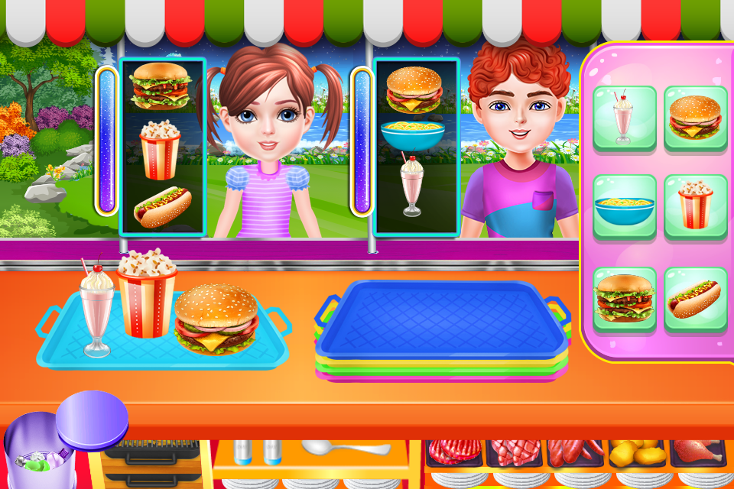
Fig. 19 Screenshot1

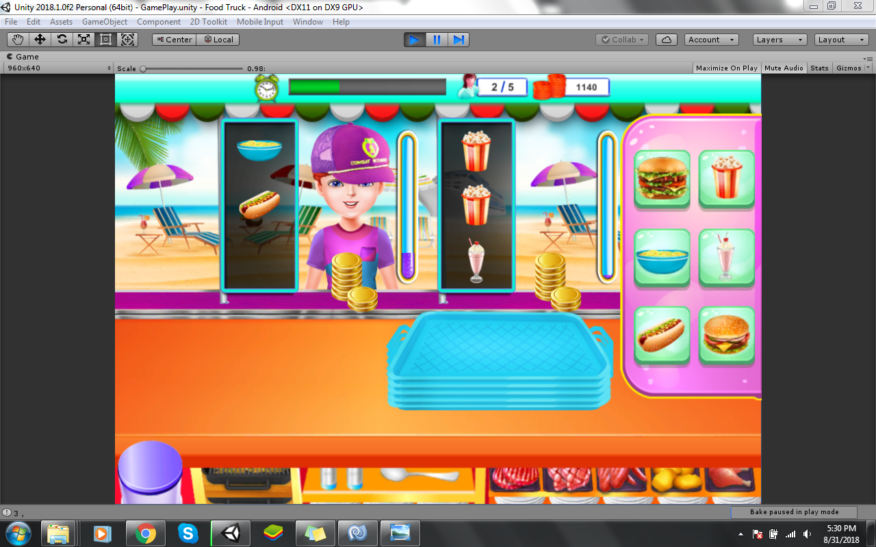
Fig. 20 Screenshot2

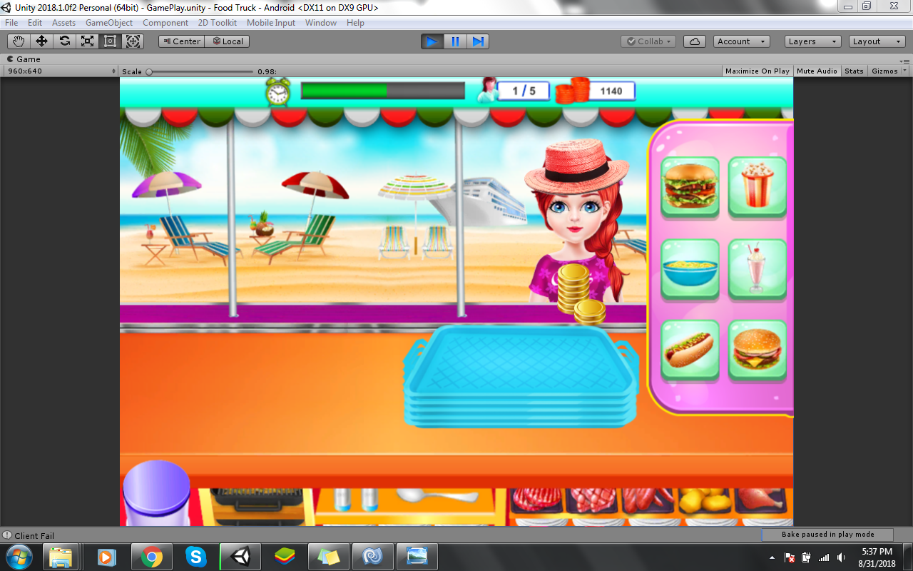
Fig. 21 Screenshot3
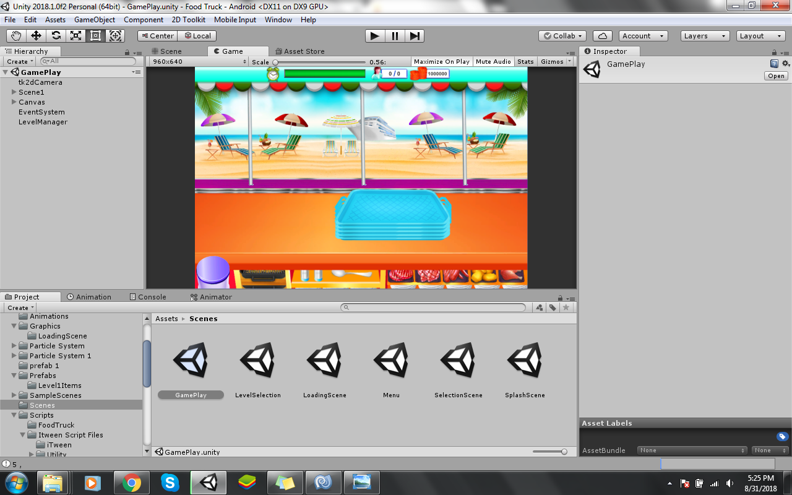
Fig. 22 Screenshot4

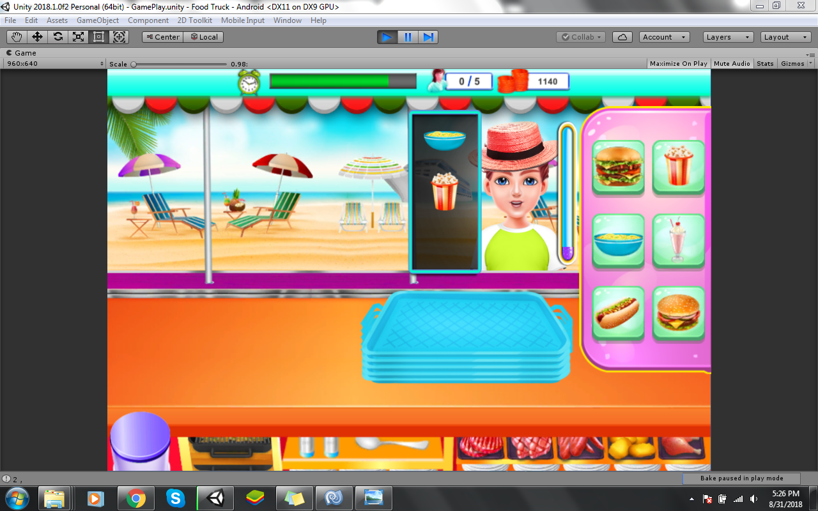
Fig. 23 Screenshot5

Best Practices / Coding Standards
Since using C# language for the coding of our game in Visual Studio, in addition of Unity, following and some coding standards and practices we will follow while implementing our game project:

Naming Conventions and Standards
Following Name Conventions and Standards are used while the coding phase of our game:
- Pascal casing: the first character of all words is upper case and the other characters are lower case.
- Camel casing: the first character of all words, except the first word, is upper case and other characters are lower case.

Good Programming Practices
We have avoid using too large files. If a file has 300-400 lines of code, we must consider refactoring the code into helper classes. We have avoid writing very long methods. A preferred method of our game has been of 1-60 lines of code. If we had a method more than 70 lines of code, we had must consider refactoring it into separate methods.

Comments
Not writing comments for every line of code and every variable declared and only wherever required. Good, readable code will require very few comments and that is what we will do.

Exception Handling
We will never do a "catch exception and do nothing." If we happen to hide an exception, we will never know if the exception happened or not. So, in the case of exceptions, we will give a friendly message to the user, but log the actual error with all possible details about the error, including the time it occurred, the method and class name, etc. We will only catch the specific exception, not generic exceptions.

Chapter 6

Testing and Evaluation

Chapter 6: Testing and Evaluation
This chapter is the software test report of the multiple types of testing phases we faced during the Rolling Food project. It contains the results of tests, which were executed during the testing phases.

Use Case Testing
Table 11 UCID001
Use Case ID | UCID001
Title | MenuRollingFood
Objective | To open the menu and the selected option (Settings/Play/InAppPurchase/RateUs/ExitGame) page appears.
Actors | Player
Pre-conditions | - The user must possess iPhone/iPad/Android Phone/Android Tablet.  - The user must download the game from Apple Games Store/PlayStore.  - The user must install the game after it is downloaded.  - The user must click the menu option
Post-conditions | - The user selected options from the menu (Settings/Play/InAppPurchase/RateUs/ExitGame) page appears
Main Success Scenario | The Game Menu options page appears.
A: Actor  S: System
  Steps | Description
  1 | S: The Game Menu options page appears.  Play  InAppPurchase  RateUs  ExitGame  Settings  No Adds
  2 | A: The Player clicks Play
  3 | S: the flow transfers to Game Initiates.
  4 | A: The Player clicks InAppPurchase
  5 | S: flow transfers to InAppPurchase
  6 | A: The Player clicks RateUs
  7 | S: flow transfers to RateUs
  8 | A: The Player clicks ExitGame
  9 | S: flow transfers to ExitGame
  10 | A: The Player clicks Settings
  11 | S: flow transfers to Settings
  12 | A: The Player clicks No Adds
  13 | S: flow transfers to No Adds
Extension | N/A

Table 12 UCID002
Use Case ID | UCID002
Title | SelectWorldlRollingFood
Objective | To open the selected world.
Actors | Player
Pre-conditions | - The user must possess iPhone/iPad/Android Phone/Android Tablet.  - The user must download the game from Apple Games Store/PlayStore.  - The user must install the game after it is downloaded.  - The user must click the worlds option on the map screen.
Post-conditions | - The selected world has been opened by the user with new levels controls and environment.
Main Success Scenario | The World selection screen appears, the player selects the world and the levels screen of the world appears.
A: Actor  S: System
  Steps | Description
  1 | S: The World selection screen appears.  World1  World2  World3  Workd4  World5
  2 | A: The player selects the unlocked World1.
  3 | S: the levels screen of the World1 appears.
  4 | A: The player selects the unlocked World2.
  5 | S: the levels screen of the World2 appears.
  6 | A: The player selects the unlocked World3.
  7 | S: the levels screen of the World3 appears.
  8 | A: The player selects the unlocked World4.
  9 | S: the levels screen of the World4 appears.
  10 | A: The player selects the unlocked World5.
  11 | S: the levels screen of the World5 appears.
Extension
  2a | The World1 is locked.  S: error selection message for world1 appears.
  4a | The World2 is locked.  S: error selection message for world2 appears.
  6a | The World3 is locked.  S: error selection message for world3 appears.
  8a | The World4 is locked.  S: error selection message for world4 appears.
  10a | The World5 is locked.  S: error selection message for world5 appears.

Table 13 UCID003
Use Case ID | UCID003
Title | SelectTrucklRollingFood
Objective | To open the selected world.
Actors | Player
Pre-conditions | - The user must possess iPhone/iPad/Android Phone/Android Tablet.  - The user must download the game from Apple Games Store/PlayStore.  - The user must install the game after it is downloaded.  - The user must click the Truck option on the truck selection screen.
Post-conditions | - The selected truck has been saved by the player.  - The selected truck has been purchased by the player.
Main Success Scenario | The player selects the trucks and the selection is saved.
A: Actor  S: System
  Steps | Description
  1 | S: The Truck selection screen appears.  Truck1  Truck2  Truck3  Truck4
  2 | A: The player selects the unlocked Truck1.
  3 | S: the Truck1 selection is saved.
  4 | A: The player selects the unlocked Truck2.
  5 | S: the Truck2 selection is saved.
  6 | A: The player selects the unlocked Truck3.
  7 | S: the Truck3 selection is saved.
  8 | A: The player selects the unlocked Truck4.
  9 | S: the Truck4 selection is saved.
  10 | A: the player clicks the next button
  11 | S: flow transfers to Game Initiates.
Extension
  2a | If the Truck1 is locked and purchase price is greater than player’s coins:  S: not enough coins message for truck1 appears.
  2b | If the Truck1 is locked and purchase price is less than player’s coins:  S: the Truck1 selection is purchased.
  4a | If the Truck2 is locked and purchase price is greater than player’s coins:  S: not enough coins message for truck2 appears.
  4b | If the Truck2 is locked and purchase price is less than player’s coins:  S: the Truck2 selection is purchased.
  6a | If the Truck3 is locked and purchase price is greater than player’s coins:  S: not enough coins message for truck3 appears.
  6b | If the Truck3 is locked and purchase price is less than player’s coins:  S: the Truck3 selection is purchased.
  8a | If the Truck4 is locked and purchase price is greater than player’s coins:  S: not enough coins message for truck4 appears.
  8b | If the Truck4 is locked and purchase price is less than player’s coins:  S: the Truck4 selection is purchased.
Table 14 UCID004
Use Case ID | UCID004
Title | GameplayRollingFood
Objective | To play the level of the game.
Actors | Player
Pre-conditions | - The user must possess iPhone/iPad/Android Phone/Android Tablet.  - The user must download the game from Apple Games Store/PlayStore.  - The user must install the game after it is downloaded.
Post-conditions | - The selected level has been played.
Main Success Scenario | The game level has been played by the user.
A: Actor  S: System
  Steps | Description
  1 | S: The level selection screen appears
  2 | A: The player selects the level.
  3 | S: The Game Initiates the game play and game environment.
  4 | S: The game customer characters appear.
  5 | A: Players fill the tray with right items buttons.
  6 | S: selected items appear on the tray.
  7 | A: Player drag the tray to the customer on time
  8 | Customer served number added.
  9 | A: Player collects the coins from the customer
  10 | S: the coins are added.
  11 | A: Player completes the Level.
  12 | S: the level progress saved.
Extension
  2a | If the level selected is a locked level  S: error message appears.
  4a | If game customer character appears on the left side  S: left customer collider is on.
  4b | If game customer character appears on the right side  S: right customer collider is on.
  5a | If the player fills the tray with wrong items  S: tray saved as wasted.
  7a | If the player drags tray to the wrong customer  S: Failed serve added
  7b | If the player doesn’t drag the tray before the given time to the customer  S: Failed serve added
  9a | Player doesn’t collect coins.  S: no coins added
  11a | If Player fails the level  S: retry level box appears
  11b | If player win the level  S: level progress saved  S: Menu appears

Table 15 UCID005
Use Case ID | UCID005
Title | PauseRollingFood
Objective | To pause the level of the game.
Actors | Player
Pre-conditions | - The user must possess iPhone/iPad/Android Phone/Android Tablet.  - The user must download the game from Apple Games Store/PlayStore.  - The user must install the game after it is downloaded.  - The user must click the pause button.
Post-conditions | - The game gets paused.  - The game gets resumed.
Main Success Scenario | The player clicks the pause button and then clicks the resume button.
A: Actor  S: System
  Steps | Description
  1 | A: Player clicks pause from the menu.
  2 | S: Game level gets paused.
  3 | A: Player clicks resume from the menu.
  4 | S: Give access to game where paused.
Extension | N/A

Table 16 UCID006
Use Case ID | UCID006
Title | ExitRollingFood
Objective | To exit the game.
Actors | Player
Pre-conditions | - The user must possess iPhone/iPad/Android Phone/Android Tablet.  - The user must download the game from Apple Games Store/PlayStore.  - The user must install the game after it is downloaded.  - The user must click the exit button.
Post-conditions | - The game quits.
Main Success Scenario | The player clicks the exit button, the game progress saves and the game exits.
A: Actor  S: System
  Steps | Description
  1 | A: Player clicks exit from the menu.
  2 | S: Game progress gets saved.
  3 | S: game exits.
Extension | N/A

Table 17 UCID007
Use Case ID | UCID007
Title | InAppPurchaseRollingFood
Objective | To exit the game.
Actors | Player
Pre-conditions | - The user must possess iPhone/iPad/Android Phone/Android Tablet.  - The user must download the game from Apple Games Store/PlayStore.  - The user must install the game after it is downloaded.  - The user must click the InAppPurchase button.  - The cell must be connected to the internet.
Post-conditions | - Player purchased the bundle of desire
Main Success Scenario | The player clicks the InAppPurchase button, chooses the bundle of choics and pays by the google/iOS account.
A: Actor  S: System
  Steps | Description
  1 | A: Player clicks InAppPurchase from the menu.
  2 | S: Bundles list appears on the screen.
  3 | A: player selects the bundle.
  4 | S: The game asks to pay by the google/ iOS account
  5 | A: The user purchases the bundle
   | S: coins added.
Extension
  4a | Internet connections fails  S: connection error message appears.
  4b | Invalid google/iOS account  S: log in fail message appears

Table 18 UCID008
Use Case ID | UCID008
Title | RateUsRollingFood
Objective | To rate the game.
Actors | Player
Pre-conditions | - The user must possess iPhone/iPad/Android Phone/Android Tablet.  - The user must download the game from Apple Games Store/PlayStore.  - The user must install the game after it is downloaded.  - The user must click RateUs button from the menu.  - The cell must be connected to the internet.
Post-conditions | - Player rated the game.
Main Success Scenario | The player clicks the RateUs button, and gives the rating to the game.
A: Actor  S: System
  Steps | Description
  1 | A: Player clicks RateUs from the menu.
  2 | S: The game directs to the game account link on playstore/AppStore
  3 | A: player submits the rating.
Extension
  2a | Internet connections fails  S: connection error message appears.

Table 19 UCID008
Use Case ID | UCID008
Title | MoreGamesRollingFood
Objective | To link the player to our game account.
Actors | Player
Pre-conditions | - The user must possess iPhone/iPad/Android Phone/Android Tablet.  - The user must download the game from Apple Games Store/PlayStore.  - The user must install the game after it is downloaded.  - The user must click MoreGames button from the menu.  - The cell must be connected to the internet.
Post-conditions | - Player rated the game.
Main Success Scenario | The player clicks the MoreGames button, and links to the playstore/App store account to the game.
A: Actor  S: System
  Steps | Description
  1 | A: Player clicks MoreGames from the menu.
  2 | S: The game directs to the game account link on playstore/AppStore
  3 | A: player links to the account
Extension
  2a | Internet connections fails  S: connection error message appears.

Compatibility Testing
For compatibility testing of Rolling Food, we played the game on different testing environments. By running these tests, we learned how the game looks and behaves on different compatible devices.
Here are the specifications for the testing environments used.
Android Operating System Versions:
• Jellybean (4.3)
• Kit-Kat (4.4)
• Lollypop (5.1.1)
• Marshmallow (6.0)
• Nougat (7.0)
• Oreo (8.0)
Game performed normally on all the android versions mentioned above. Versions older than jellybean were ignored because only 0.5% devices are currently running them.
Screen Sizes:
• 1920x1080 (16:9)
• 1280x720 (16:9)
• 960x640 (3:2)
• 1280x800 (16:10)
The UI and sprites of the game compressed and stretched according to the screen size they were running.

Data flow testing
In Unity, PlayerPrefs are used to store and access player preferences between game sessions. So, to store the progress of the player, PlayerPrefs is been used multiple times in our project Rolling Food to control the flow of data. In order to check this flow, every case is been tested. Following are the player preferences we have made successful storage and access of i.e. the code for the following is working correctly without any errors:
- At start of the game, PlayerPrefs is used to restore the player’s level progress.
- To restore the trucks already bought.
- To store the total coins player has.
- To store the highest score.
- To access the coins and make deduction when something being bought.
- To access trucks number and make increment when another truck is bought
- To access level number and make increment when new level is unlocked.
All these preferences have been checked by playing the game in the unity repeatedly and checking if the progress has been saved or not. If not, the errors have been checked and debugged.
To check the data flow for testing, values of the PlayerPrefs is been checked by the technique of printing the its value at the console while play(Unity). Following screenshots explain more about how it is used by code in c#:

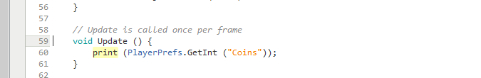
Fig. 24 DataFlowTesting-1

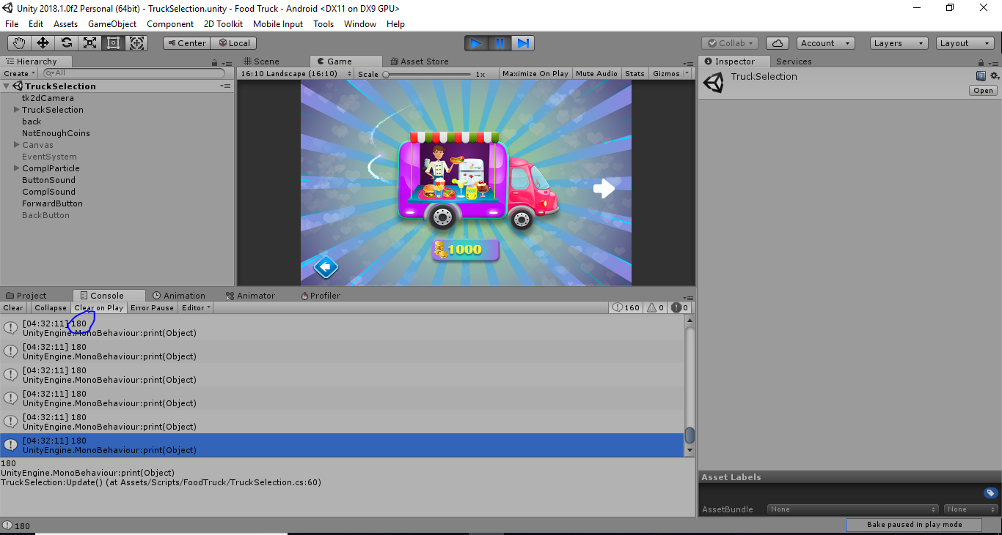
Fig. 25 DataFlowTesting-2

Unit testing
For the Unit Testing of Rolling Food, we performed the testing of every scene individually and also made subunits of each unit(scene) and did their testing for possible errors i.e. we considered every scene as a unit of the project and the functions used in the code of that scene is considered as subunit.
Following are the screenshots of every scene done during the unit testing of that scene, with all the errors removed in their C# Scripts as shown:
- Unit Testing of Scene1(Menu)
In the Menu Scene, every buttons and other selections were checked. All the errors found in these subunits were removed, as shown in the screenshots i.e.:
-C# Script code for Play Button checked
-C# Script code for Shop Button checked
-C# Script code for Truck Button checked
-C# Script code for More Games Button checked
-C# Script code for Rate Us Button checked

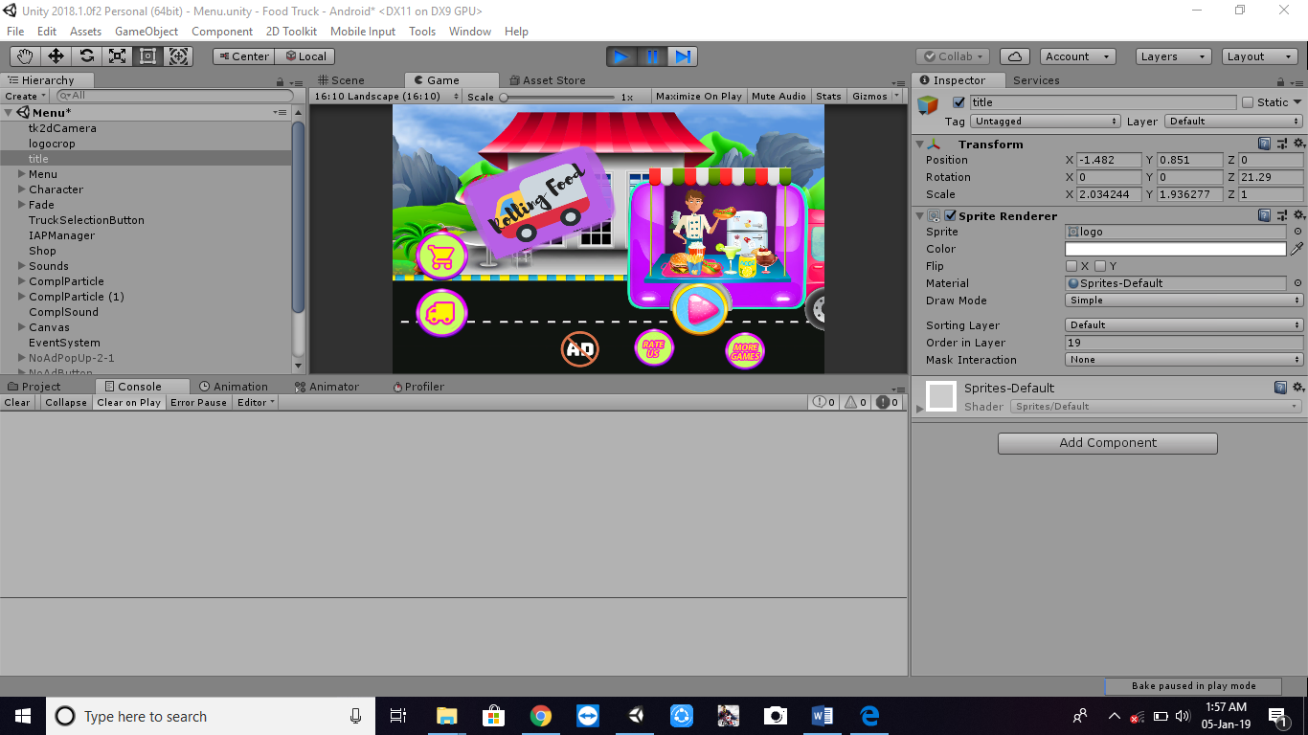
Fig. 26 UnitTestingScene1-1

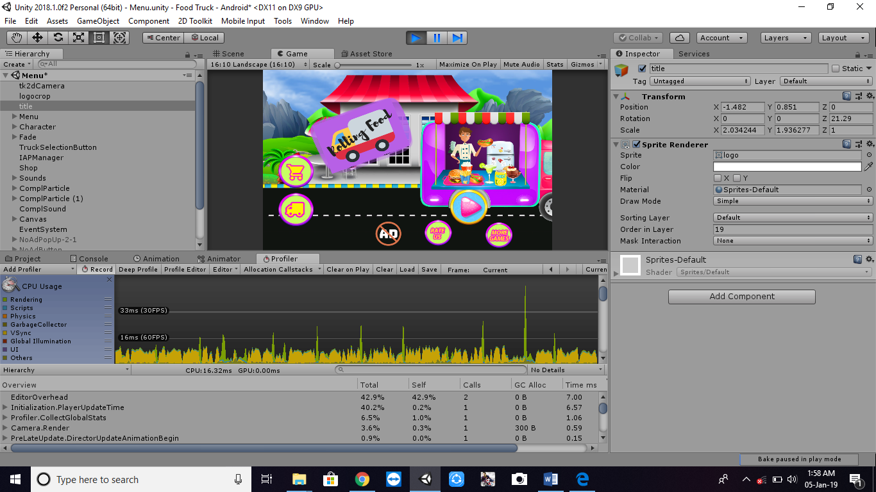
Fig. 27 UnitTestingScene1-2

- Unit Testing of Scene2(World Selection)
In the World Selection Scene, every buttons and other selections were checked. All the errors found in these subunits were removed, as shown in the screenshots i.e.:
-C# Script code for World1 Button checked
-C# Script code for World2 Button checked
-C# Script code for World3 Button checked
-C# Script code for World4 Button checked
-C# Script code for World5 Button checked
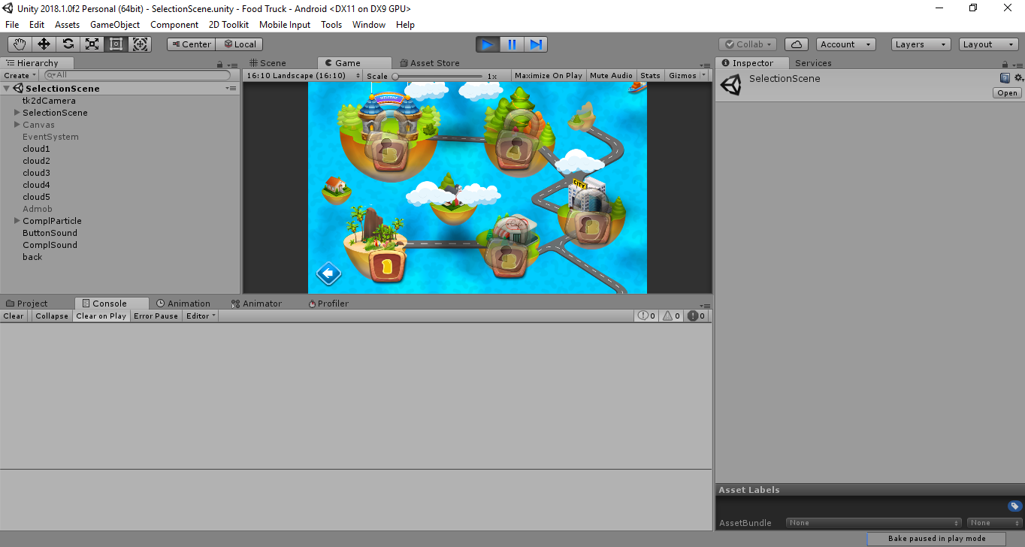
Fig. 28 UnitTestingScene2-1

- Unit Testing of Scene3 (Truck Selection)
In the Truck Selection Scene, every buttons and other selections were checked. All the errors found in these subunits were removed, as shown in the screenshots i.e.:
-C# Script code for Truck1 Button checked
-C# Script code for Truck2 Button checked
-C# Script code for Truck3 Button checked
-C# Script code for Truck4 Button checked

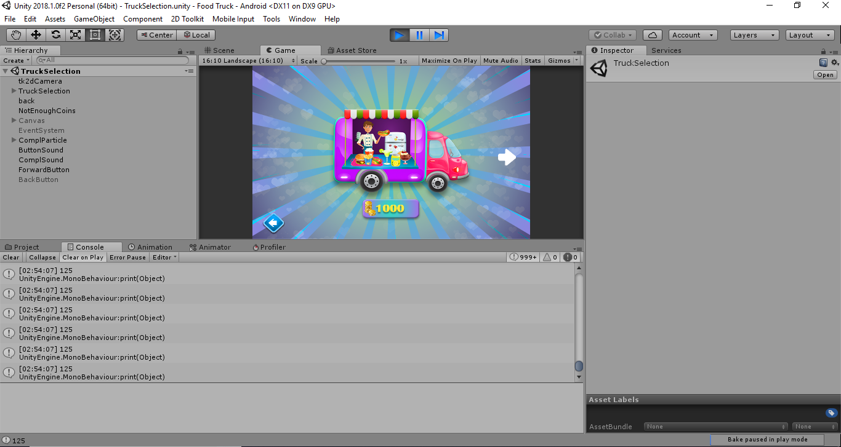
Fig. 29 UnitTestingScene3-1

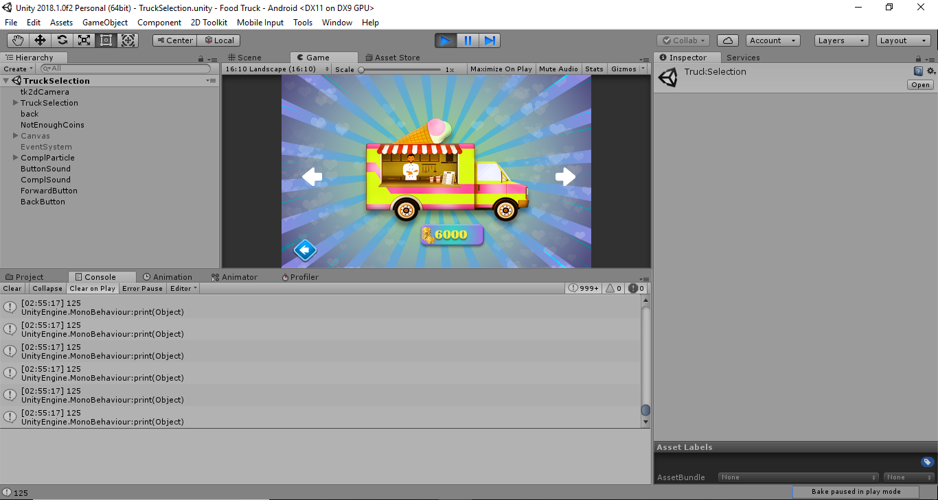
Fig. 30 UnitTestingScene3-2

- Unit Testing of Scene4 (Gameplay)
In the Gameplay Scene, every buttons and other selections were checked. All the errors found in these subunits were removed, as shown in the screenshots i.e.:
-C# Script code for Left Customers checked
-C# Script code for Right Customers checked
-C# Script code for Win Selection checked
-C# Script code for Loss Selection checked
-C# Script code for Tray Drag checked
-C# Script code for Coins Got checked
-C# Script code for Bin checked
-C# Script code for Level Win checked
-C# Script code for Level Lost checked
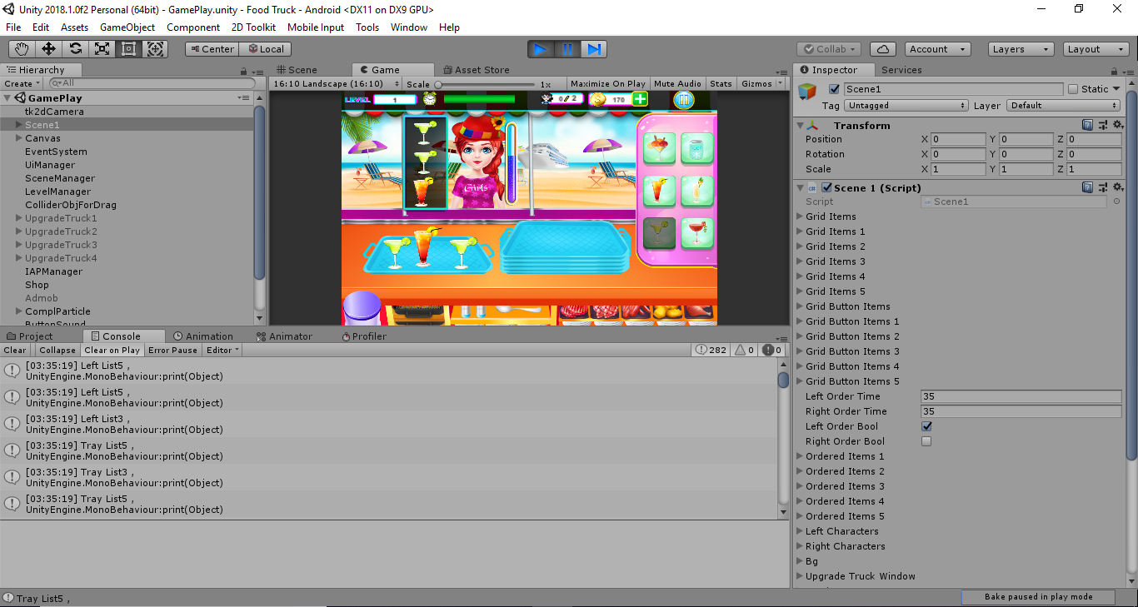
Fig. 31 UnitTestingScene4-1

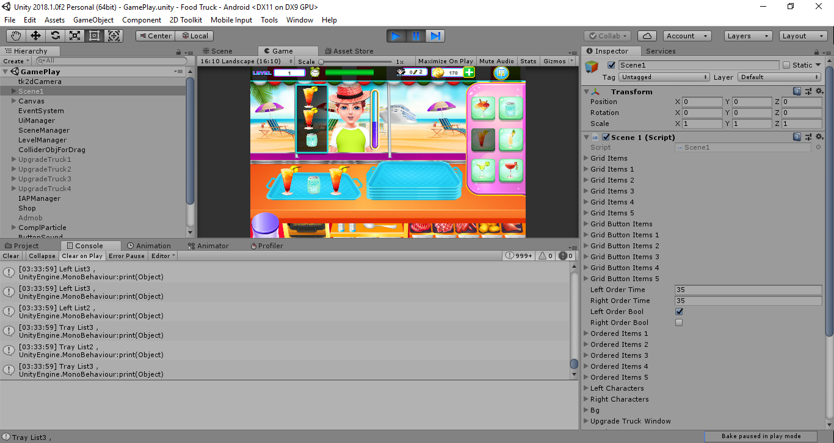
Fig. 32 UnitTestingScene4-2

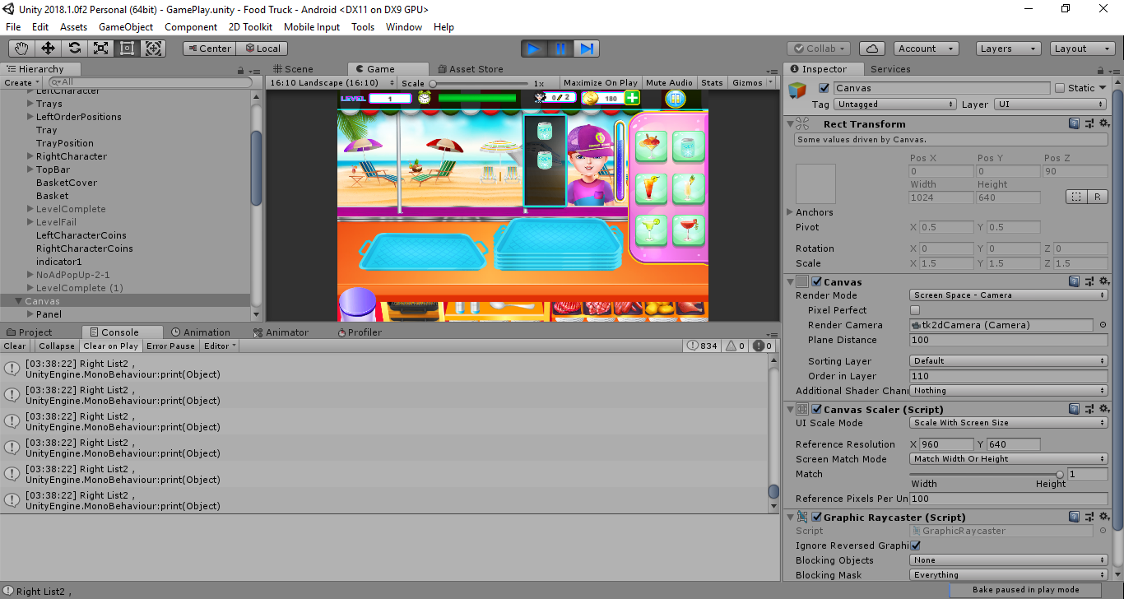
Fig. 33 UnitTestingScene4-3

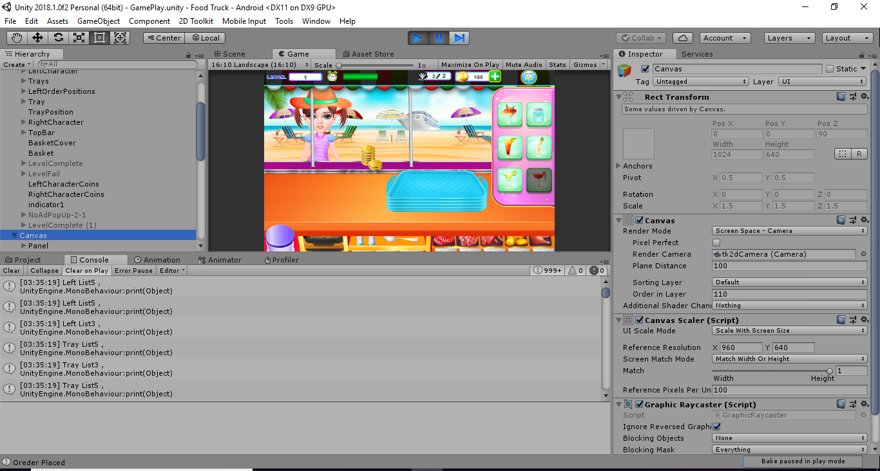
Fig. 34 UnitTestingScene4-4

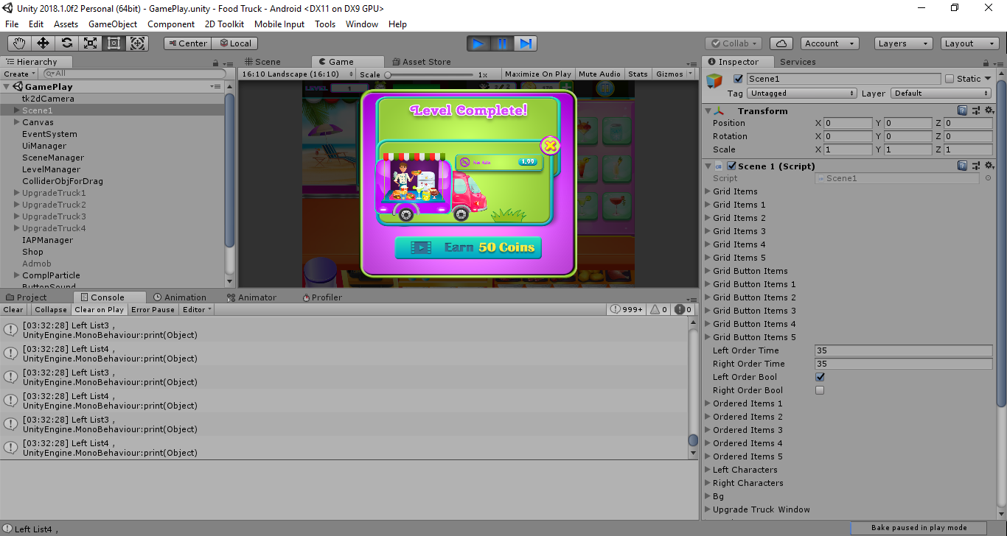
Fig. 35 UnitTestingScene4-5

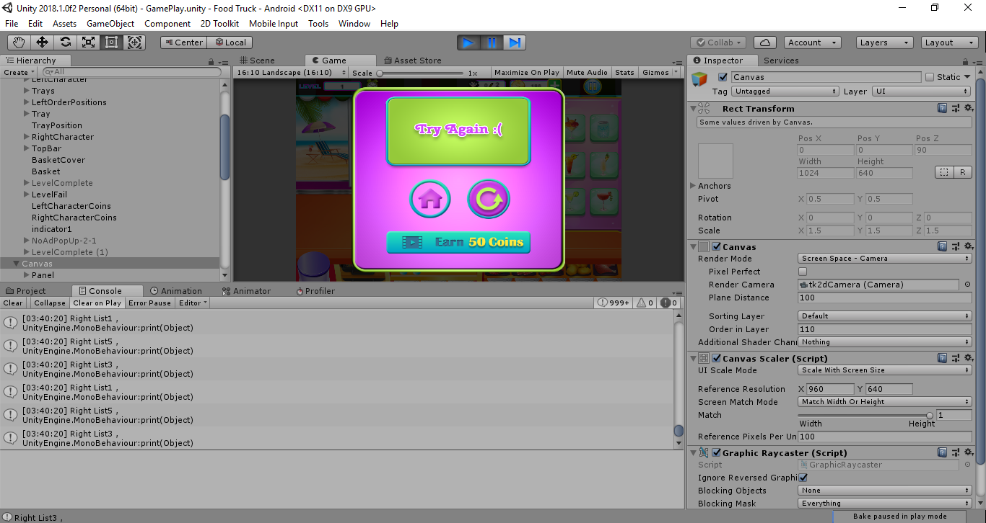
Fig. 36 UnitTestingScene4-6

Integration testing
The integration testing of this project is done scene-wise. The components that were previously individually tested are now integrated into one scene and tested to see if they still perform as they should.
Scene 1 (Main Screen):
Table 20 IT_SC1_001
Test Case ID | IT_SC1_001
Testcase Summary | To verify that all sprites in this scene render correctly.
Prerequisites | None.
Test Procedure | Manually check that each required sprite is being displayed on the screen
Expected Result | - When user starts the game, all sprites except the in-app purchase pop-up should be visible in their respected places on the screen.  - In-App pop-up should not be visible unless user clicks shop button.  - Daily Reward pop-up should render once main scene animation is finished.
Actual Result | - All sprites are being displayed in their respected places.  - In-App pop-up is not being rendered automatically.  - Daily rewards pop-up shows up after animation is finished.
Status | Pass
Test Environment | OS: Android OS 5.1.1 (Lollipop)

Table 21 IT_SC1_002
Test Case ID | IT_SC1_002
Testcase Summary | To verify that all buttons behave as expected
Prerequisites | All button sprites must be rendered.
Test Procedure | Click on each button to see if it performs correctly.
Expected Result | - Play button should take user to level selection.  - Shop button should display an in-app purchase pop-up  - Truck button should take user to truck selection.  - Rate us button should redirect user to app’s page on Play Store.  - More games button should redirect user to publisher’s page on Play Store.
Actual Result | - Play button takes user to level selection.  - Shop button displays an in-app purchase pop-up  - Truck button takes user to truck selection.  - Rate us button redirects user to app’s page on Play Store.  - More games button redirects user to publisher’s page on Play Store.
Status | Pass
Test Environment | OS: Android OS 5.1.1 (Lollipop)

Table 22 IT_SC1_003
Test Case ID | IT_SC1_003
Testcase Summary | To verify that integrated ad(s) are working
Prerequisites | Device must be connected to the internet.
Test Procedure | Connect to the internet and see if ad(s) are being displayed.
Expected Result | Banner ad should be visible on top-center of screen when internet is connected.
Actual Result | Banner ad shows up on top-center of screen when connected to internet.
Status | Pass
Test Environment | OS: Android OS 5.1.1 (Lollipop)

Scene 2 (Loading Screen):
Test Case ID | IT_SC2_001
Testcase Summary | To verify that loading scene with animation shows up when going to next.
Prerequisites | A button that takes user to another scene must be pressed.
Test Procedure | Press each button that takes user to next or previous scene and see if loading scene shows up when the scene is being switched.
Expected Result | - Loading scene animation should be visible on scene switch.  - User must be taken to next scene when animation finishes.
Actual Result | - Loading scene animation is visible on scene switch.  - User is taken to next scene when animation finishes.
Status | Pass
Test Environment | OS: Android OS 5.1.1 (Lollipop)

Table 23 IT_SC2_002
Test Case ID | IT_SC2_002
Testcase Summary | To verify that all sprites in this scene render correctly.
Prerequisites | None.
Test Procedure | Check that each required sprite is being displayed on the screen
Expected Result | - All sprites in the scene should show up  - Animation should play
Actual Result | - All sprites in the scene are visible.  - Animation plays correctly.
Status | Pass
Test Environment | OS: Android OS 5.1.1 (Lollipop)

Table 24 IT_SC2_003
Test Case ID | IT_SC2_003
Testcase Summary | To verify that integrated ad(s) are working
Prerequisites | Device must be connected to the internet.
Test Procedure | Connect to the internet and see if ad(s) are being displayed.
Expected Result | - Banner ad should be visible on top-center of screen when internet is connected.  - Interstitial ad should show up after the loading animation finishes.
Actual Result | - Banner ad shows up on top-center of screen when connected to internet.  - Interstitial ad shows up after loading animation completes.
Status | Pass
Test Environment | OS: Android OS 5.1.1 (Lollipop)

Scene 3 (Level Selection):
Table 25 IT_SC3_001
Test Case ID | IT_SC3_001
Testcase Summary | To verify that all sprites in this scene render correctly.
Prerequisites | None.
Test Procedure | Manually check that each required sprite is being displayed on the screen
Expected Result | When scene loads, all sprites in the scene should be displayed properly.
Actual Result | All sprites are rendered and are showing in their correct places.
Status | Pass
Test Environment | OS: Android OS 5.1.1 (Lollipop)

Table 26 IT_SC3_002
Test Case ID | IT_SC3_002
Testcase Summary | To verify that clicking on a level takes to sub-level selection.
Prerequisites | All level sprites must be rendered.
Test Procedure | Click on each level to see if it performs correctly.
Expected Result | - Unlocked levels should take user to sub-level selection.  - Nothing should happen when locked level is pressed
Actual Result | - Unlocked levels take the user to sub-level selection.  - Nothing happens when locked level is pressed
Status | Pass
Test Environment | OS: Android OS 5.1.1 (Lollipop)

Table 27 IT_SC3_003
Test Case ID | IT_SC3_003
Testcase Summary | To verify that integrated ad(s) are working
Prerequisites | Device must be connected to the internet.
Test Procedure | Connect to the internet and see if ad(s) are being displayed.
Expected Result | Banner ad should be visible on top-center of screen when internet is connected.
Actual Result | Banner ad shows up on top-center of screen when connected to internet.
Status | Pass
Test Environment | OS: Android OS 5.1.1 (Lollipop)

Scene 4 (Sub-level Selection):
Table 28 IT_SC4_001
Test Case ID | IT_SC4_001
Testcase Summary | To verify that all sprites in this scene render correctly.
Prerequisites | None.
Test Procedure | Manually check that each required sprite is being displayed on the screen
Expected Result | When scene loads, all sprites in the scene should be displayed properly.
Actual Result | All sprites are rendered and are showing in their correct places.
Status | Pass
Test Environment | OS: Android OS 5.1.1 (Lollipop)

Table 29 IT_SC4_002
Test Case ID | IT_SC4_002
Testcase Summary | To verify that clicking on a level takes to gameplay.
Prerequisites | All level sprites must be rendered.
Test Procedure | Click on each level to see if it performs correctly.
Expected Result | - Unlocked levels should take user to gameplay.  - Nothing should happen when locked level is pressed
Actual Result | - Unlocked levels take the user to gameplay.  - Nothing happens when locked level is pressed
Status | Pass
Test Environment | OS: Android OS 5.1.1 (Lollipop)

Scene 5 (Gameplay):
Table 30 IT_SC5_001
Test Case ID | IT_SC5_001
Testcase Summary | To verify that all sprites in this scene render correctly.
Prerequisites | None.
Test Procedure | Manually check that each required sprite is being displayed on the screen
Expected Result | When scene loads, all sprites in the scene should be displayed properly.
Actual Result | All sprites are rendered and are showing in their correct places.
Status | Pass
Test Environment | OS: Android OS 5.1.1 (Lollipop)

Table 31 IT_SC5_002
Test Case ID | IT_SC5_002
Testcase Summary | To verify that all interactable components behave correctly.
Prerequisites | None.
Test Procedure | Manually check that each interactable component is behaving correctly.
Expected Result | - Tray should be dragged on the table.  - Upon clicking food item, it should be displayed on the tray.  - Upon dragging the tray towards customer or trash bin, food items on the tray should also be dragged along with the tray.  - Food items should not be interactable for a few seconds after being pressed.  - Tray along with food items should be destroyed when giving to customer or thrown in trash bin.  - Game should be paused on pressing pause button.  - Game must resume on pressing resume button.  - Game should restart on pressing restart.  - User should be taken to main screen on pressing exit button  - User should be taken to next level on pressing next button.
Actual Result | - Tray is behaving as it should  - Food items are behaving correctly  - Game pauses on pressing pause button.  - Game resumes on pressing resume button.  - Game restarts on pressing restart.  - User is taken to main screen on pressing exit button  - User is taken to next level on pressing next button.
Status | Pass
Test Environment | OS: Android OS 5.1.1 (Lollipop)

Table 32 IT_SC5_003
Test Case ID | IT_SC5_003
Testcase Summary | To verify that all non-interactable components behave correctly.
Prerequisites | None.
Test Procedure | Manually check that each non-interactable component is behaving correctly.
Expected Result | - Customer timer animation must start as soon as the customer arrives.  - Customer should leave when correct order is delivered or the time runs out.  - Game should be over when game timer runs out  - Game should be over when user completes required number of orders.  - Customer should give coins when correct ordered is delivered.  - Game over pop-up must be displayed when game is over.
Actual Result | - Customer timer animation starts when the customer arrives.  - Customer leaves when correct order is delivered, or the time runs out.  - Game is over when game timer runs out.  - Game is over when user completes required number of orders.  - Customer gives coins when correct ordered is delivered.  - Game over pop-up is displayed when game is over.
Status | Pass
Test Environment | OS: Android OS 5.1.1 (Lollipop)

Scene 6 (Truck Selection):
Table 33 IT_SC6_001
Test Case ID | IT_SC6_001
Testcase Summary | To verify that all sprites in this scene render correctly.
Prerequisites | None.
Test Procedure | Manually check that each required sprite is being displayed on the screen
Expected Result | When scene loads, all sprites in the scene should be displayed properly.
Actual Result | All sprites are rendered and are showing in their correct places.
Status | Pass
Test Environment | OS: Android OS 5.1.1 (Lollipop)

Table 34 IT_SC6_002
Test Case ID | IT_SC6_002
Testcase Summary | To verify that trucks are purchased correctly.
Prerequisites | User must have required amount to coins to make the purchase.
Test Procedure | Purchase the truck then go to gameplay to see if truck interior is changed.
Expected Result | - When button is clicked, user must be able to purchase the selected truck.  - Upon purchasing, the amount of coins truck costs should be subtracted from the coins users has.
Actual Result | - When button is clicked, user will be able to purchase the selected truck.  - Upon purchasing, the amount of coins truck costs is subtracted from the coins users has.
Status | Pass
Test Environment | OS: Android OS 5.1.1 (Lollipop)

Performance testing
For optimizing the performance of our project game Rolling Food, we used one the Unity build-in feature, that is Profiler Window. The Unity Profiler Window helps you to optimize your game and reports how much time is spent in the various areas of the game. When using the profiling tool, we focused on those parts of the game that consume the most time. We compared profiling results before and after code changes and determined the improvements needed. Following screenshots explains more:
- Performance check of CPU usage of every scene (we made sure that even at the highest peaks, the amount of time each of the sessions took during a specific frame, be less than 1s):
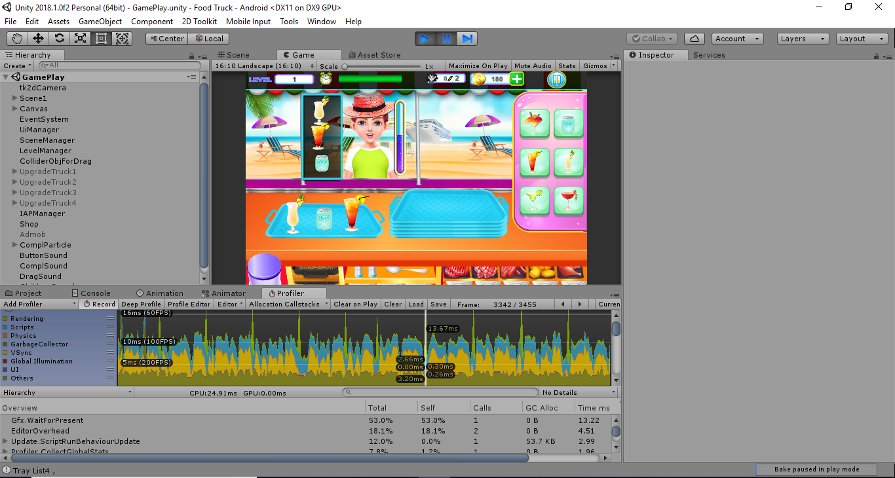
Fig. 37 PerformanceTest-1

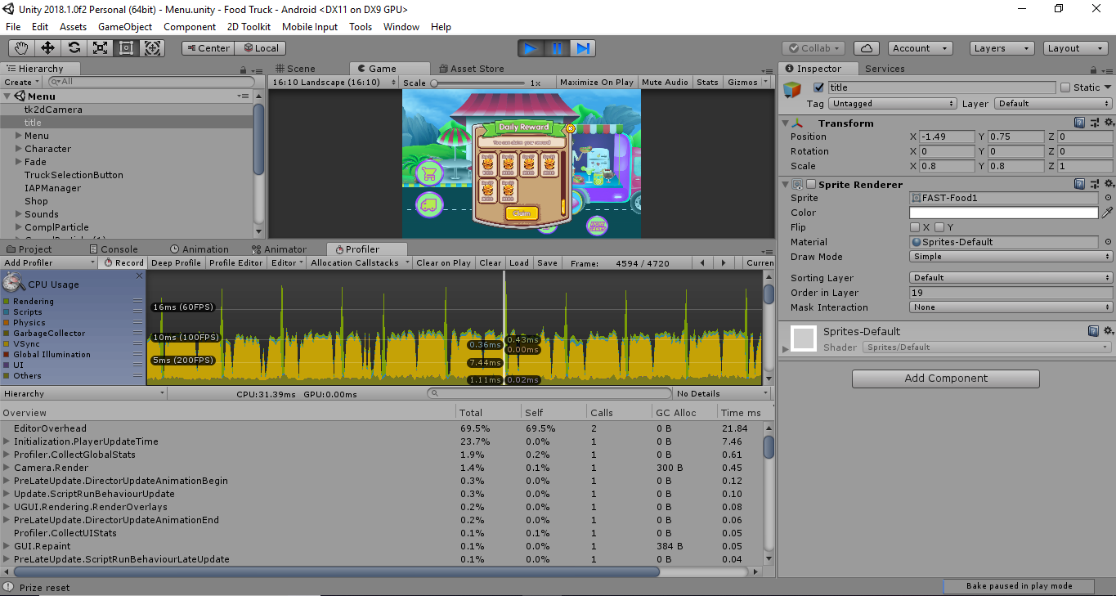
Fig. 38 PerformanceTest-2

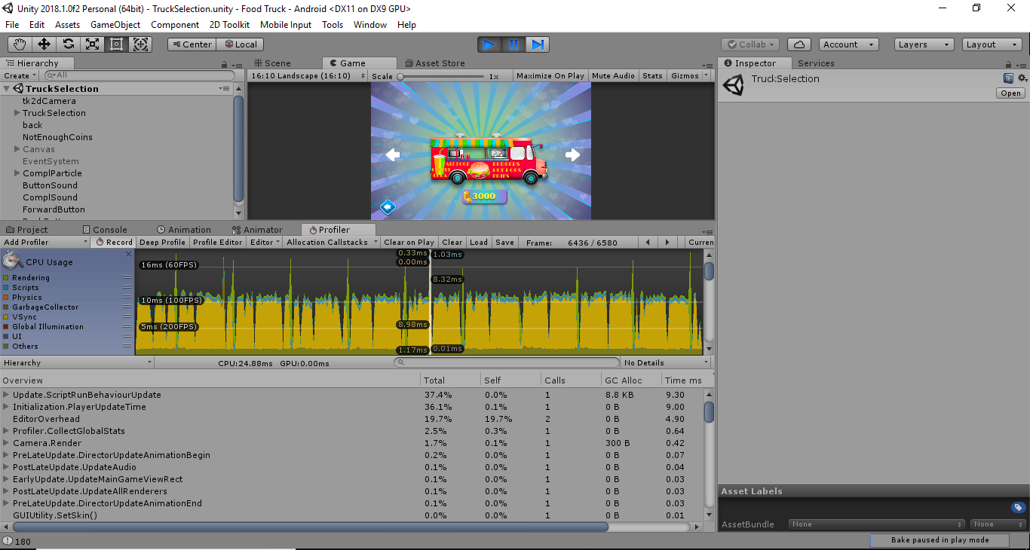
Fig. 39 PerformanceTest-3

- Performance check of Memory Usage of every scene (we made sure the size of textures, sounds, animations, don’t slower the performance of the game)
Lowering the Resolutions of the textures:
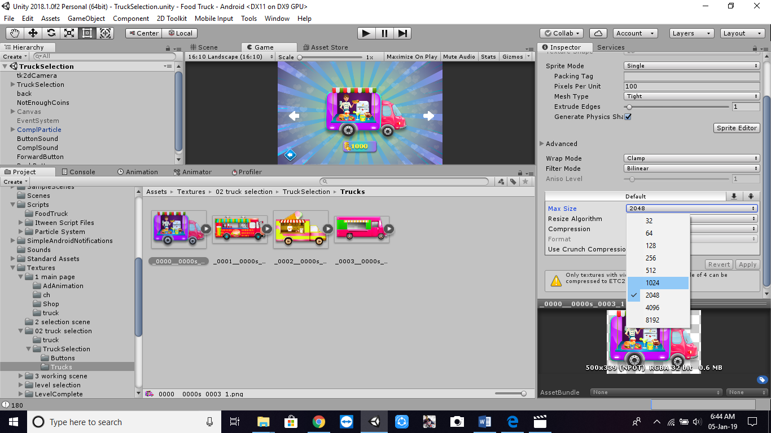
Fig. 40 PerformanceTest-4

Optimizing Memory Usage:
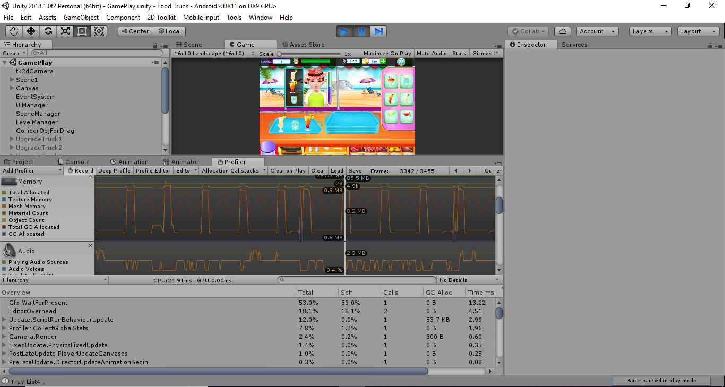
Fig. 41 PerformanceTest-5

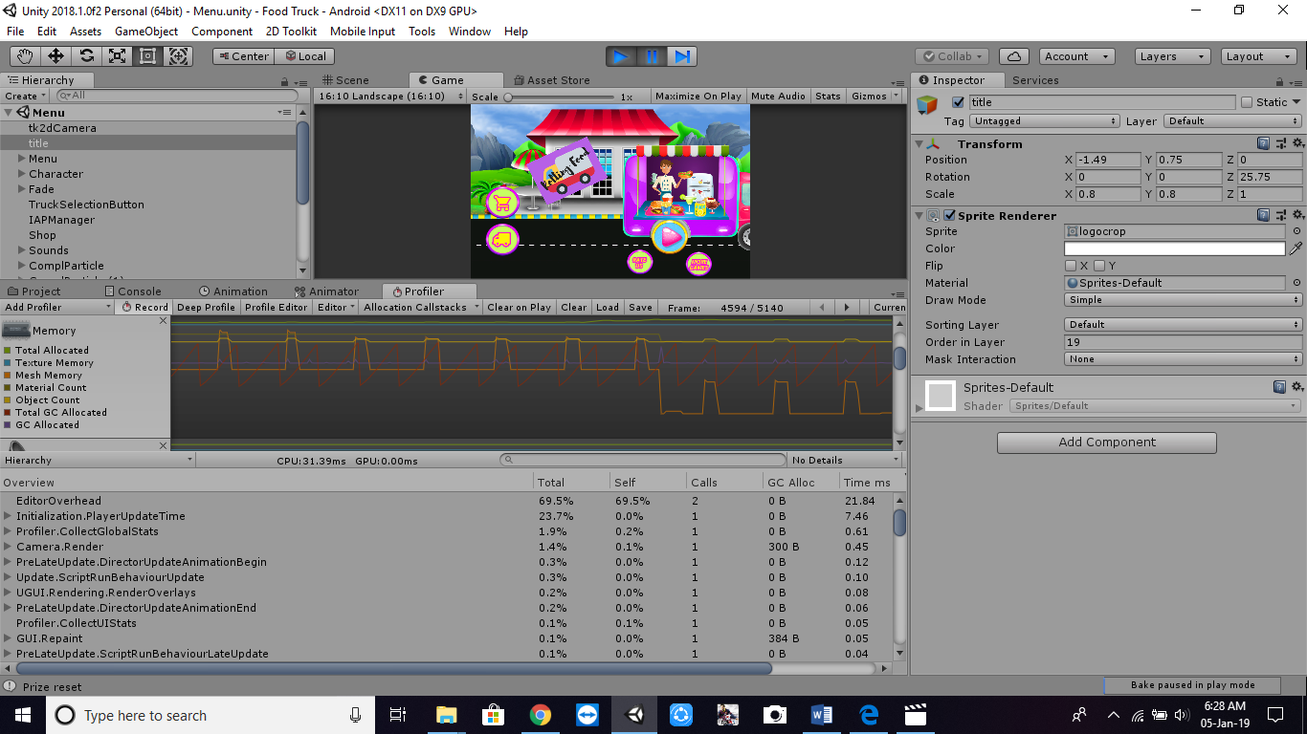
Fig. 42 PerformanceTest-6

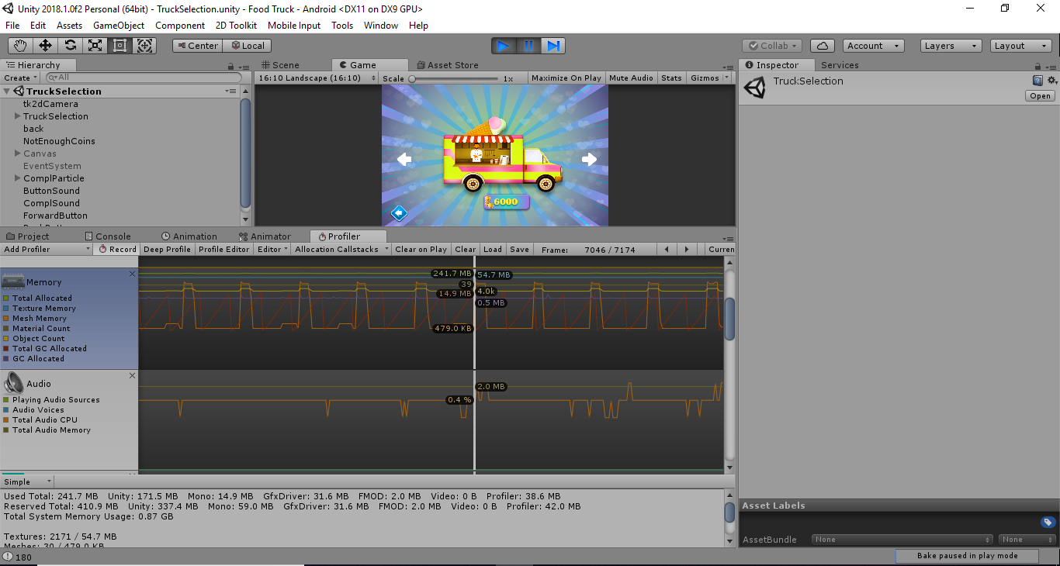
Fig. 43 PerformanceTest-7

Chapter 7

Summary, Conclusion and Future Enhancements

Chapter 7: Summary, Conclusions, and Future Enhancements
This chapter includes the final thoughts and conclusions of the project Rolling Food, including the elaboration of the experience we had and the lessons we learned. Also, includes the aims we shall implement in the future regarding this project.

Project Summary
Several fresh business models and new kinds of games are hence getting interesting to enter in Games Market. Since a study proves that mobile gaming will continue to be the largest segment following 10 years of double-digit growth. In total, mobile revenues will grow +25.5% year on year to reach $70.3 billion. This means that for the first time, more than half of all game revenues will come from the mobile segment. Smartphones will account for 80% of this, or $56.4 billion, with the remaining 20% coming from tablets. The fact that the games market has such high future scope with a lesser amount of investment motivated us to make our project of this field. Our main objective is to create a 2d game (with a touch of 3D assets) that can run faster on both Android and iOS devices than a purely 3D game, using the game creating tool called Unity and Visual Studio. While our project Rolling Food, itself is not a continuation of any predecessor, but inspired by different games available on games store. Since smartphones these days are full of tons of games, therefore, one of our goals while designing the game is to be able to let the user understand the gameplay at the first look no matter how often and how least he opens the game, we are achieving this by showing the control guide screen every time at the beginning of the game, hence engaging the user every time with the game. Also, the game is built to give its user a much faster, battery efficient experience than that of 3D games. Make this as fast as possible than 3D games by the idea of using 3D modeling in a 2D game. Also, manage the size of the game would be as less as possible so that it can be played offline. This document has explained every process involved in the implementation of our Final Year Project. It provides the deep background study of the game development also with the reasons for not considering the alternative ways of creating this game and justification of the decision for our project to build a 2D Game. We make a detailed description of “Unity Game Engine” the main tool used in the creation of our game.

Achievements and Improvements
Our main achievement is that we have created a 2d game (with a touch of 3D assets) than can run on both android and iOS devices, by the game creating tool called Unity and programming language C#. Each level completes a level of a scenario of the game with specific challenges, will be asked to user to complete, after which user can jump on the next level. The objective was to make our game about food delivery with challenges in it. It is based on a truck that will be a mini restaurant itself and will deliver food around the world. Every level will be based on a different city and with the progress of levels, different and exciting modifications will be done with the truck and with the chef. Also, an assistant will be provided in the higher levels of which skills will be also modified timely. The game will be having 25+ levels with specific challenges with each level, that must be completed to jump to the next level. In this Game the chef can cook tons of fabulous cuisines and become a top chef of the place of level.
The major achievements of our project include:
• Strategies and challenges are enjoyable for all age group users
• Making this available for Android devices (both phones and tabs), iOS devices (both iPhones and iPads) and Windows phones.
• Strategies will teach the value of money and time management when running a small business.
• Difficulty level increases with the passage of time making it more challenging.
• Making this as fast as possible than 3D games by the idea of using 3D modeling in a 2D game.
• Making users so satisfied and involved with the game that make them wish to buy in-app purchases game items (powers, food items, truck items, etc.) that user can buy whenever those items are unlocked.
• Provide more than 10 different trucks with different kitchen looks and equipment.
• Provide different with different cities and accordingly different dishes.
• Manage the size of the game would be as less as possible, so that it can be played offline.
While creating this project, we did find some areas we needed to improve. Game development is a complex process, and one important game development choice is to consider the developer perspective to produce good-quality software games by improving the game development process.
Following are the major improvements we made while the development of this project:
• The resolutions of the graphics are lower down by overriding the defaults for a specific platform (Android and iOS), this have increased the performance speed of the game and reduced the build size.
• Meshes and imported Animation Clips are compressed so that they take up less space in our game file. Mesh compression only produces smaller data files and does not use less memory at run time. Animation keyframe reduction produces smaller data files and uses less memory at run time.
• We have tried best to minimize use of complex mathematical operations such as pow, sin and cos in pixel shaders to the least.
• To know what is actually causing performance issues we have used Profiler during development of game on unity, which is a great way to get an in-depth look at how your game is performing. Profiler can be found under Window>Profiler and it will run when you play your game.
• Realizing that as a lot of things in the game, is not in the use (made it the first place though, for the early requirement) we turned it off. Leaving only what is necessary on while the rest we made disabled and/or turned off.
• Clearing the code of the game (written in C#) by correct use of Coroutines and Update Methods.

Critical Review
A game designer does not have to be an expert critic (nor vice versa), but an understanding of how to critically analyze games is a useful skill to have. With this ability, a game developer can learn more by playing other people’s games, figuring out what works and what doesn’t (and why), and applying those lessons to their own designs. It’s far cheaper to learn from other people’s mistakes than your own. During a critical analysis of our project Rolling Food, the following are the questions we considered well:
- What challenges do the players face? What actions can players take to overcome those challenges?
- Does the size of the game worth downloading?
- Is the game has a fair engagement with its users?
- What is the game’s intended audience? Is the game appropriate for that audience?
Illustrating the question#1, the controls are smooth and give response on real time, if used on the correct time, the controls will overcome the challenges in the game levels. Pointing at the question#2, the build size of the game is been reduced at the end (using the techniques explained in Achievements and Improvements). On the question#3 the game includes daily challenges that if successfully completed, different rewards will be gifted as a result to the users. Also, it includes in-app purchases game items (powers, food items, truck items, etc.) that user can buy. Feedback will also be taken by the users, and updations will be done accordingly. Illustrating the question#4, the game is appropriate for all age groups players. Also, the game will be able to run on Android devices (both tabs and phones), iOS devices (both iPads and iPhones).

Lessons Learnt
During the development of our FYP, there are some points we learned from the experience and will consider in our future projects. The major lesson learnt are the following:
- Game development is not easy:
We learned that it was necessary to study the game development in Unity, have a good grip on C# programming language, before you start a game project. Not only that, one must study mobile game market thoroughly, and understand what’s in the trend. After getting skilled in “Unity- game development tool”, you can start with your project, elsewise, you will make sure risks to the quality of the game.
- Analyze the game you make:
Setting up a good story for our game idea was also a time-consuming thing we faced. It was based on the analysis we made on earlier about current trends. Obviously, we required an idea which was new or least common, yet exciting on games store. Also, we made an analysis on what user expect, why will user download such game and why he/she wont, etc.
- Having rules and guidelines does not guarantee success:
Just because you have the recipe of some dish, doesn’t mean you will cook it perfect. Same rule applies to the game development. There are chances that the first game anyone develop doesn’t succeed, it may probably fail. Not because that developer sucks. There is one thing education and training cannot replace, experience. There are things that you will learn only when you develop, finish and publish your games. Being a self-conscious developer is the key and we tried to guide ourselves towards the correct path, teaching ourselves from our mistakes.

Future Enhancements
Following are our goals as future enhancements:
- We will transform the game into a multi-player game to increase user retention.
- We will be creating more new levels up to 150.
- We will be creating new kinds of daily challenges to increase the user involvement even more.
- We will introduce 15 new trucks.
- We will introduce 15 new cities and hence new dishes and customers of that city kind.
- We will be given more often daily rewards to the loyal users.

Appendices

Appendix A: Promotional Material
  - Brochure
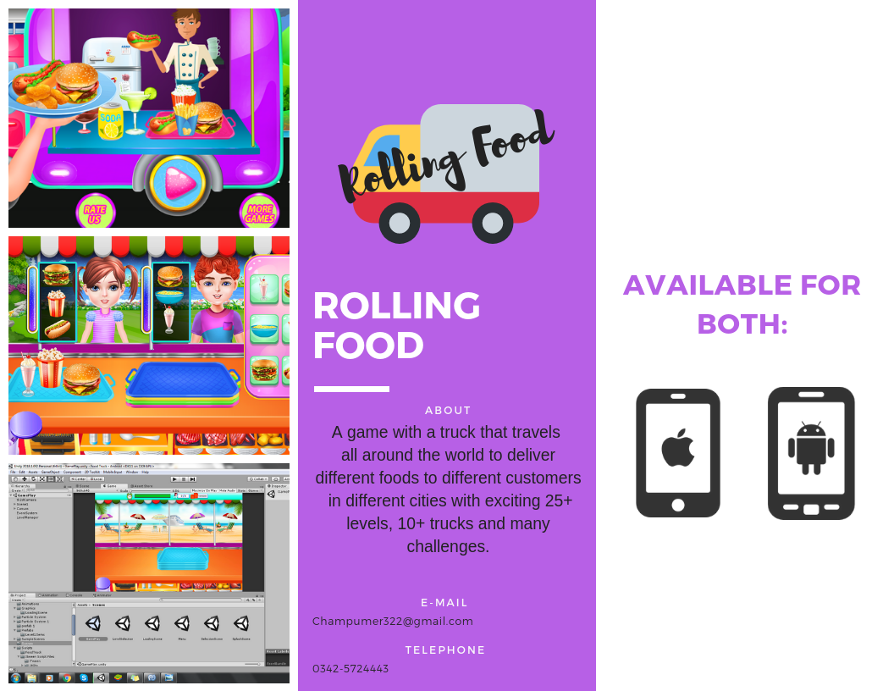
Fig. 44 Brochure Rolling Food

  - Flyer
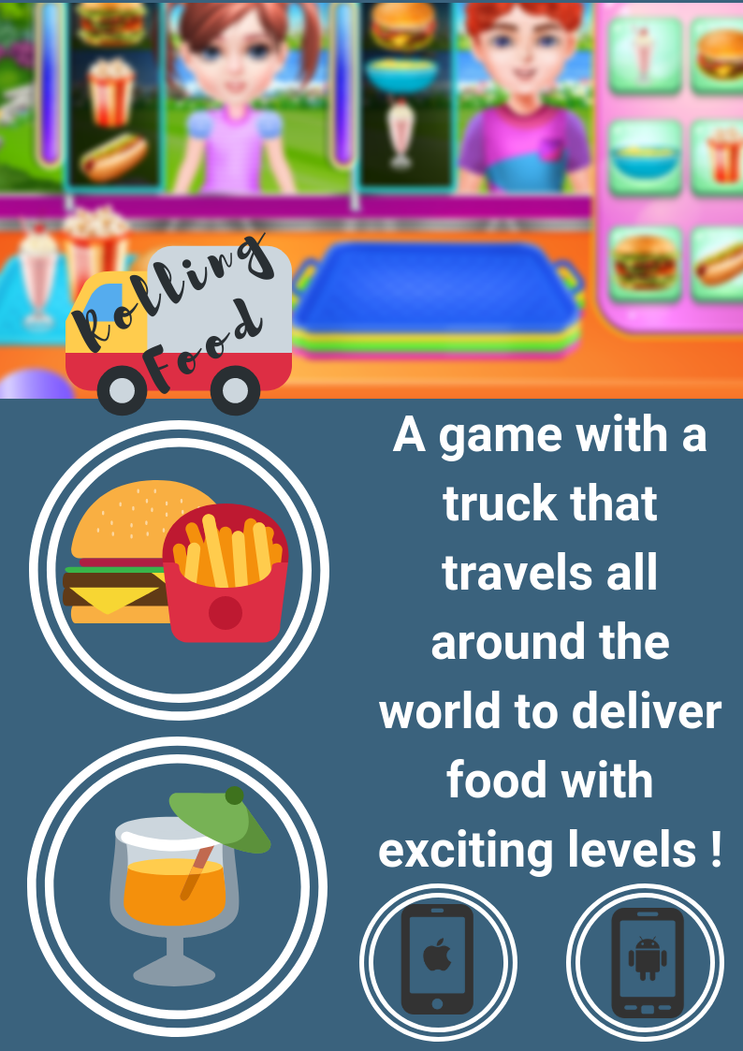
Fig. 45 Flyer Rolling Food

  - Banner
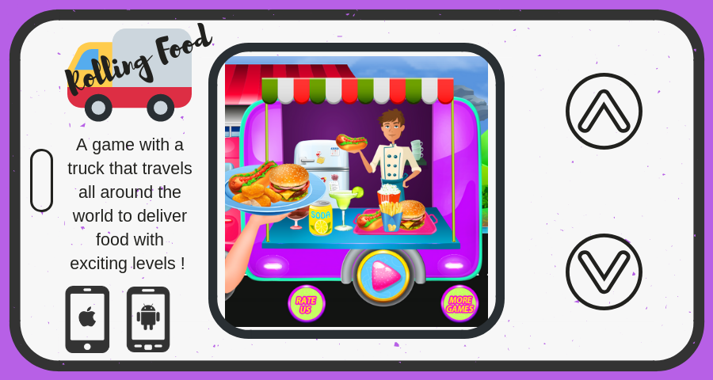
Fig. 46 Banner Rolling Food

Reference and Bibliography

Reference and Bibliography

[1] Manjaly, T. (2018). C# Coding Standards and Best Programming Practices - CodeProject. [online] Codeproject.com. Available at: https://www.codeproject.com/Articles/8971/C-Coding-Standards-and-Best-Programming-Practices [Accessed 14 Aug. 2018].

[2] Unity. (2018). Programming in Unity: For programmers new to Unity - Unity. [online] Available at: https://unity3d.com/programming-in-unity [Accessed 14 Aug. 2018].

[3] Msdn.microsoft.com. (2018). Unity - Developing Your First Game with Unity and C#. [online] Available at: https://msdn.microsoft.com/en-us/magazine/dn759441.aspx [Accessed 14 Aug. 2018].

[4] Unity. (2018). 2D Game Creation - Unity. [online] Available at: https://unity3d.com/learn/tutorials/s/2d-game-creation [Accessed 14 Aug. 2018]

[5] Unity Forum. (2018). 2d game with 3d models. [online] Available at: https://forum.unity.com/threads/2d-game-with-3d-models.388119/ [Accessed 14 Aug. 2018].
[6] Wijman, T. (2018). Global Games Market Revenues 2018 | Per Region & Segment | Newzoo. [online] Newzoo. Available at: https://newzoo.com/insights/articles/global-games-market-reaches-137-9-billion-in-2018-mobile-games-take-half/ [Accessed 14 Aug. 2018].

Index

Index

[A]
Assumptions and Dependencies 29
Architecture Diagram 53
Activity Diagram 54

[B]
Background 2
Business Rules 28
Best Practices 70

[C]
Communication Interfaces 23
Class Diagram 49
Component Diagram 57
Components 66
Comments 71

[D]

Document conventions 14
Design and Implementation Constraints 19
Description and Priorities 24
Deployment Diagram 58
Data Flow Diagram 59
Deployment Environment 58

[E]

Executive Summary vi
External Interface Requirement 21

[F]

Functional Requirement 25

[G]
Goals and Objectives 3
Gap Analysis 5
Gantt Chart 11
Good Programming Practices 70

[H]
Hardware Interfaces 22

[I]
Introduction 2
Intended Audience and Reading Suggestion 14
Implementation 62

[J]

[K]

[L]

[M]
Motivations and Challenges 2

[N]
Naming Conventions and Standards 69

[O]
Overall Description 16
Operating Environment 19
Other Non-Functional Requirements 27
Operation Contracts 51

[P]
Proposed solution 5
Project Plan 6
Purpose 14
Product Scope 15
Product Perspective 16
Product Functions 17
Performance Requirements 26
Pseudo Code 62
Programming Practices 70

[Q]
Quality Attributes 27

[R]
Roles and Responsibilities Matrix 9
Reference and Bibliography 77

[S]
Software Requirements and Specifications 14
Software Interfaces 23
System Features 24
Safety Requirements 26
Security Requirements 27
Software Quality Attributes 27
System Design 47
Sequence Diagram 50
State Transition Diagram 56

[T]

[U]
User Classes 18
User Documentation 20
User Interfaces 21
Use Case Analysis 30
Use Case Models 31

[V]

[W]
Work Breakdown Structure 8

[X]

[Y]

[Z]

