Expert Labour Platform

Final Year Project

Session 2022-2023

A project submitted in partial fulfillment of the degree of

Masters in Computer Sciences


Department of Computer Sciences
Faculty of Computer Science & Information Technology
Superior University, Lahore

Spring 2022
Type (Nature of project) |  |  | [ ] Development [ ] Research [ ] R&D
Area of specialization
FYP ID
Project Group Members
Sr.# | Reg. # | Student Name |  | Email ID | *Signature
(i) | MCSM-S22-014 | Muhammad Ahad |  | mcsm-s22-014@Superior.edu.pk
(ii) | MCSE-S22-008 | Ghafra Nudrat |  | mcse-s22-008@Superior.edu.pk
(iii) | MITM-S22-010 | Muhammad Bin Aqeel |  | Mitm-s22-010@Superior.edu.pk

*The candidates confirm that the work submitted is their own and appropriate credit has been given where reference has been made to work of others

Plagiarism Free Certificate
This is to certify that, I Muhammad Ahad, group leader of FYP under registration no FYP-MCSM-F22-019 at Computer Science Department, The Superior University, Lahore. I declare that my FYP report is checked by my supervisor.
Date: Name of Group Leader: Muhammad Ahad Signature: _____ _____
Name of Supervisor: Sir Muhammad Fiaz
Designation: Lecturer
Signature: ________________

HOD: Dr. Asad Naqvi
Signature: _______________

Project Report
Expert Labor Platform

Change Record
Author(s) | Version | Date | Notes | Supervisor’s Signature
 | 1.0

APPROVAL
Project Supervisor
Comments: ___________________________________________________________________
_____________________________________________________________________________
Name: ______________________________
Date: _______________________________ | Signature: __________________________

Project Manager
Comments: ___________________________________________________________________
_____________________________________________________________________________
Date: _______________________________ | Signature: __________________________

Head of the Department
Comments: ___________________________________________________________________
_____________________________________________________________________________
Date: _______________________________ | Signature: __________________________

Dedication

I dedicate this work to Allah, the Almighty, who is my creator and a source of inspiration, knowledge, and insight. Throughout this programmer, He has been my source of strength, and I have only been able to fly on His wings. I also dedicate this work to my parents and instructors, who have supported me along the way and ensured that I put up the effort necessary to complete what I have begun.
I'm grateful. There is no way to put a number on my affection for you all. May Allah be with you.

Acknowledgements

My supervisor is the most encouraging person I have ever met, and he has given us this wonderful opportunity to develop our futures. I couldn't be more grateful for him. I would want to convey my sincere gratitude to GOD Almighty for his kindness, wisdom, and protection in helping me get over the challenges of this task. For their intellectual upbringing, I owe a great deal to my supervisor, Mr. Muhammad Fiaz, as well as the entire staff of our department of Information Technology. I want to express my sincere gratitude to my parents' beloved siblings, whose moral and financial support cannot be overstated. Also, a hearty thanks and special greetings to all of my friends—there are too many to list—whose support helped this work succeed.

Executive Summary

The Expert Labor Platform is proposed to replace the current manual system. Our system will overcome unemployment which is increasing day by day. The manual system is difficult and takes a lot of time. This project will help those people who are unemployed like labors which could be a painter, gardener or carpenter etc. They do not have any monthly or specific job. This project will help these users to provide their services anytime. This project will provide a proper searching to users so that they would be able to find the right person and right service to avail. They can search the labor according to the city name they are living in which will provide ease in finding the labor.

Table of Contents
Chapter 1 10
Introduction 10
1.1. Background 10
1.2. Motivations and Challenges 10
1.3. Goals and Objectives 11
1.4. Literature Review/Existing Solutions 12
1.5. Problem Statement 12
1.6. Proposed Solution 12
1.7. Project Plan 12
1.7.1. Work Breakdown Structure ( GANTT CHART ) 13
1.7.2. Roles & Responsibility Matrix 13
1.8. Report Outline 14
Chapter 2 15
Software Requirement 15
Specifications 15
2.1. Development Setup 15
2.2. Deployment setup 15
2.3. Algorithms 15
2.4. Constraints 15
2.4.1. Assumptions 16
2.4.2. System constraints 16
2.4.3. Restrictions ,
2.4.4. Limitations 16
2.4.5. User Documentation 16
2.4.6. Assumptions and Dependencies 16
2.5. Requirement Analysis 16
Chapter 3 17
Use Case AnalysisError! Bookmark not defined.
3.1 Requirements …………………………………………………………………….....17
3.2 List of Actors ………………………………………………………………………18
3.3 List of use case ……………………………………………………………………….21
3.4 User Interfaces (Mock Screens) ………………………………………………………24
Chapter 4 ……………………………………………………………………………………..35
System Design …………………………………………………...…………………………35
4.1. Architecture Diagram....................................................................................................35
4.2. Entity Relationship Diagram with data dictionary 36
4.3. Class Diagram 37
4.4 UML Sequences Diagrams …………………………………………………………38
4.5. Sequence / Collaboration Diagram …………………………………………………..39
4.5.1 Sequences Diagrams 39
4.5.2 Collaboration Diagram 42
Chapter 5………………………………………………………………………………………44
Implementation details ………………………………………………………………………..44
5.1 Development Setup …………………………………………………………………..44
5.2 Deployment Setup ……………………………………………………………………44
5.3 Algorithms...………………………………………………………………….………44
5.4 Constraints …………………………………………………………………...………44
5.4.1 Assumptions…………………………………………………………………………..44
5.4.2 System Constraints……………………………………………………………..…….44
5.4.3 Restrictions……………………………………………………………………...……44
5.4.4 Limitations……………………………………………………………………………44
Chapter 6 ……………………………………………………………………………………..45
Testing ………………………………………………………………………………………...45
6.1 Extended Test Cases …………………………………………………………………45
6.2 Decision Table ………………………………………………………………………45
6.2.1 Decision Coverage Table ……………………………………………………………45
6.3 Traceability Matrix ………………………………………………………………….48
6.3.1 RID vs UCID (Requirement vs use cases) …………………………………………..48
6.3.2 Prototypes (RID vs PID) …………………………………………………………….48
6.3.3 Coverage (UCID vs TID) …………………………………………………………….49
Chapter 7……………………………………………………………………………………….50
Results / Output Statistics …………………………………………………………………...50
7.1 % Completion …………………………………………………………………………..50
7.2 % Accuracy……………………………………………………………………………...50
7.3 % Correctness …………………………………………………………………………50
Chapter 8……………………………………………………………………………………….51
Conclusion……………………………………………………………………………………51
Chapter 9 ………………………………………………………………………………………52
Future Work …………………………………………………………………………………..52

Chapter 1

Introduction
Introduction
Our project is Expert labor platform. The idea of this project came to overcome this type of problem we are going to make our web application where the people get appropriate result that’s why we are creating an application which will provide a platform to labors like painters, gardeners, carpenters or mechanics etc.
On the other hand, unemployment which is increasing day by day. There are many people who do not have degrees but they do have some other skills which help them for living, but the problem is they do not have proper platform where they can sell their skills and earn some handsome amount.
This app will provide a searching facility which find right person at right place, user can also see the ratings and reviews of the labor they want to hire and they can also communicate with them through message inbox or call them. The interface of this application will be simple and easy to use for all kind of user.

To overcome the manual searching of the labor by going shop to shop we develops a system on which a user can register first. After registering it in the system, the user can search any kind of service and can get the labor of that specific service whether it is for the maintenance of door, sofas, furniture, carpets or even it can be for the service of their cars.
On the admin side of the web application, the admin can see all the orders placed by the user and can add new services or even admin can update the old service.
The Household service android application and website is also very useful
The UML diagram has been drawn which is useful to display the flow of the process throughout the system so even an inexperienced people can easily get the idea of the proposed system

Background
The aim of Expert Labor Platform is to serve its clients at reasonable price. Through this, we will provide the facilities to the customer so that they can keep their home maintain. And unemployment which is increasing day by day. The people who do not have degrees but they do have some other skills which help them for living, but the problem is they do not have proper platform where they can sell their skills and earn some handsome amount. So, this will help them.

Motivations and Challenges
The idea of this project came from unemployment which is increasing day by day. There are many people who do not have degrees but they do have some other skills which help them for living. The objective of this project is to provide a proper platform to people who want to sell their skill in the form of labor and earn handsome amount.

Goals and Objectives
The main objective of Expert Labor Platform is to serve its clients at reasonable price. Nowadays, everything is digitalized from booking a cab to booking a doctor’s appointment. But there is no platform to book the labor for the maintenance of the homes. So the idea came to our mind to develop an web application so that the people can get any kind of labor on a single click. Through this, we will provide the facilities to the customer so that they can keep their home maintain. And unemployment which is increasing day by day. The people who do not have degrees but they do have some other skills which help them for living, but the problem is they do not have proper platform where they can sell their skills and earn some handsome amount. So, this will help them.

Literature Review/Existing Solutions
- Registration of the user: User can register on our site either to find a job or find a person who can do our job
- Login of the user or admin
- View available services: View the services a provide to the users
- Request for a service by the customer : View the services a person can avail from our site
- Upload a service by the admin: Add a new service for our site

- See pending Orders of the customers: All the service that a user has availed but not completed
- View/ Reply feedback of the customers: A person can leave a review for the service he/she availed.

Problem Statement
We have observed some drawbacks in the old system:
- The old system has been deactivated.
- Records management is difficult.
- There are no restrictions on the timing of service delivery.
- There are no covered services.
- Finding a paper service provider is difficult.
- 24-hour service is not provided.

Proposed Solution
- Easy access to housekeeping services.
- Offer housekeeping services at any time.
- Online Payment from JazzCash.
- Saves a lot of time of the customer.

Project Plan
In this section, we'll split up the work among our team members according to a weekly schedule. It is described as per timetable in the large chartExpert Labor Platform is developed on the knowledge of web development which includes both front and the backend. In development phase we will use different tools and languages which include HTML, CSS, Java script, Bootstrap. PHP is used as a scripting language to connect the both front end and the backend. In software we will use sublime text and Xampp.

Work Breakdown Structure ( GANTT CHART )
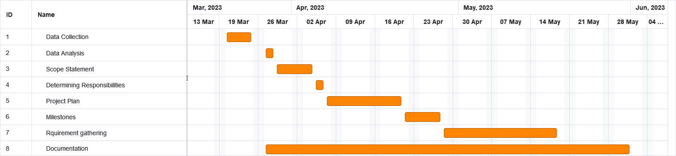

Roles & Responsibility Matrix

WBS # | WBS Deliverable | Activity # | Activity to Complete the Deliverable | Duration  (# of Days) | Responsible Team Member(s) & Role(s)
 | 1.1 Initial | 1.1.1 | Research | 20 | All team members
 | 1.1 Initial | 1.1.2 | Analysis | 12 | All team members
 | 1.2 Planning | 1.2.1 | Scope Statement | 5 | Muhammad Ahad
 | 1.2 Planning | 1.2.2 | Determining Responsibilities | 2 | Ghafra
 | 1.2 Planning | 1.2.3 | Project Plan | 10 | All team members
 | 1.2 Planning | 1.2.4 | Milestones | 5 | All team members
 | 1.3 | 1.3.1 | Requirement gathering | 12 | All team members
 | 1.4 |  | Documentation |  | All Team Members

Report Outline
A web application is developed which provide online service booking where user can book any kind of service for the maintenance of their homes it can be door fitting, wall painting, door painting, car wash, Sofa Cleaning etc. This will facilitate the user to book the service in a single click. On the other side, the admin of the system can manage all the service orders booked by the customers. Admin can also look on the feedback and queries of the user as well.

Chapter 2

Software Requirement

Specifications

Development Setup
VsCode: The backend of this project is based on this tool as it covers the window devices.
HTML/CSS: This tool/language is used in VsCode for developing the scripts to operate the Expert Labor System.

Deployment setup
The system will be deployed to web application that is used to provide services at the door step. Getting Information of customer and service provider is a challenging task because for this, we attached a separate script in VsCode which is the main source of sending the Information to Admin

Algorithms
- Expert Labor Platform have used multiple libraries or separate code for the development.
- Expert Labor Platform created separate code for getting Information of Customer and Service Provider.
- Expert Labor Platform have written separate script for all Database.

Constraints

Assumptions
- System will be maintained by the admin portal.
- The user will be unaware, that Admin monitories every step.

System constraints
- Full time internet connection is required to use the application.
- The software must be functional and synced with the server.

Restrictions
- No restrictions currently reside to use this application as of yet.

Limitations
Internet connectivity is required for this web application system to be in running state. It’s independent from the limitation of internet.

User Documentation
List the user documentation materials that will be included with the programmer, such as user manuals, online assistance, and tutorials. Please include any existing distribution formats or standards for user documentation.

Assumptions and Dependencies
In order to finish all the pieces of our system, we will develop it ourselves and use languages and frameworks necessary.

Requirement Analysis
Functional Requirements | User has to be register themselves/ Signup  User has to be clarified which service they want  User has proper Internet connection
Non-Functional Requirements | Online Transaction  Availability on web application
Data Requirements | Data be stored automatically at backend when you login/signup
External interface requirements | System needs proper Internet connection to connect.

Chapter 3

Requirements Analysis

3.1 Requirements
Table 1: Table of Requirements

Functional Requirements | User has to be register themselves/ Signup  User has to be clarified which service they want  User has proper Internet connection
Non-Functional Requirements | Online Transaction  Availability on web application
Data Requirements | Data be stored automatically at backend when you login/signup
External interface requirements | System needs proper Internet connection to connect.

3.2 List of Actors
- System Admin
- Service provider
- Customer

3.3 List of use cases
- Registration of the user
- Login of the user or admin
- View available services
- Request for a service by the customer
- Upload a service by the admin
- See pending Orders of the customers
- View/ Reply feedback of the customers

3.2 System Use Case Diagram
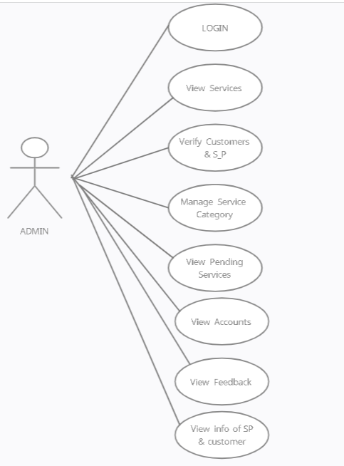
Figure 1: Use Case Diagram for Admin with Explanation
Use case diagram represent the use case view of a system. This showing different functionality of admin. How they interact with the system. What are the functionalities that admin can perform on the system.

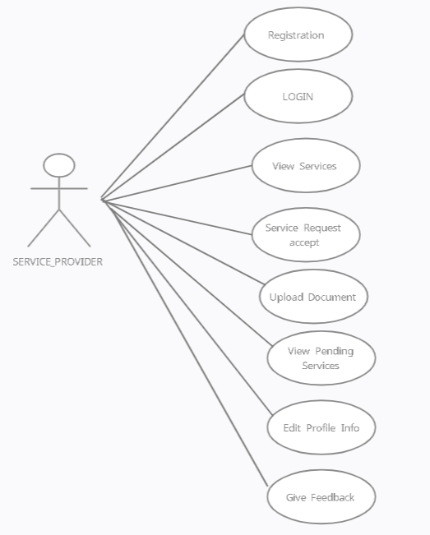
Figure 2 : Use Case Diagram for Service Provider with Explanation

Use case diagram represent the use case view of a system. This showing different functionalities of admin. How they interact with the system. What are the functionalities that admin can perform on the system.

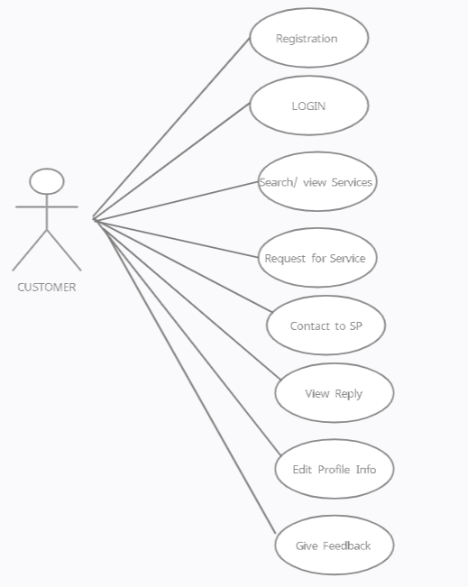
Figure 3 : Use Case Diagram for Customer with Explanation

Use case diagram represent the use case view of a system. This showing different functionalities of admin. How they interact with the system. What are the functionalities that admin can perform on the system.

3.3 Extended Use Cases

Table 2 :Extended Use Case For Admin
Use Case ID: | UC-1
Use Case Name: | ADMIN
Created By: |  |  | Last Updated By:
Date Created: | 15-August-2022 |  | Last Revision Date: | 20-August-2022
Actors: |  | Admin, Service Provider, Customer
Description: |  | Login to the system, then monitories all accounts that are verified.
Trigger: |  | When Admin login the account, all the progress or details are open on his screen and he can handle or make changes.
Preconditions: |  | - Admin must have to login.  - Must have login and password.
Post conditions: |  | When admin make changes it take few second’s to be changed.
Normal Flow: |  | - Login to Admins account  - Check the activities  - Make changes if any required  - Monitories working of service provider  - Give feedback replies
Exceptions: |  | If the Admin enters and wrong Passpord  - Login failed  - Message to Admin to re-enter Password  - Admin enters right PIN
Frequency of Use: |  | Whenever Admin Login the correct Password.
Special Requirements: |  | It must be helpful because service should be provided at your door step.
Assumptions: |  | Admin login the account, all the progress or details are open on his screen and he can handle/ control or make any changes.
Notes and Issues: |  | If your internet connection is not stable , you may not able to perform any working or changes

Table 3 :Extended Use Case For Service Provider
Use Case ID: | UC-2
Use Case Name: | SERVICE PROVIDER
Created By: |  |  | Last Updated By:
Date Created: | 21-August-2022 |  | Last Revision Date: | 22-August-2022
Actors: |  | Admin, Service Provider, Customer
Description: |  | Register, Login, then view or request services.
Trigger: |  | When successfully register and login the account, all the services or details are open on screen.
Preconditions: |  | 1. SP must have to register.  2. Must have login and password.
Post conditions: |  | When SP accept request then it shows the contact and address of the customer.
Normal Flow: |  | - Register  - Login to account  - View Services  - View feedback  - Contact  - Edit profile
Exceptions: |  | If the SP enters and wrong password  - Login failed  - Show enter Password again  - SP enters right PIN
Frequency of Use: |  | Whenever SP Login the correct Password.
Special Requirements: |  | It must be helpful because service should be given in just few clicks.
Assumptions: |  | Register, Login, then view or request services.
Notes and Issues: |  | If your internet connection is not stable , you may not able to perform any working or changes

Table 4 : Extended Use Case For Customer
Use Case ID: | UC-3
Use Case Name: | CUSTOMER
Created By: |  |  | Last Updated By:
Date Created: | 21-August-2022 |  | Last Revision Date: | 22-August-2022
Actors: |  | Admin, Service Provider, Customer
Description: |  | Register, Login, then view or request services.
Trigger: |  | When successfully register and login the account, all the services or details are open on screen.
Preconditions: |  | 1. Customer must have to register.  2. Must have login and password.
Post conditions: |  | When customer send request then it shows the contact and address of SP.
Normal Flow: |  | - Register  - Login to account  - View Services  - Request for service  - Give/ View feedback  - Contact  - Edit profile
Exceptions: |  | If the Customer enters and wrong Password  - Login failed  - Show enter Password again  - User enters right PIN
Frequency of Use: |  | Whenever Customer Login the correct Password.
Special Requirements: |  | It must be helpful because service should be provided at your doorstep.
Assumptions: |  | Register, Login, then view or request services.
Notes and Issues: |  | If your internet connection is not stable , you may not able to perform any working or changes

3.4 User Interfaces (Mock Screens)
Login Page:

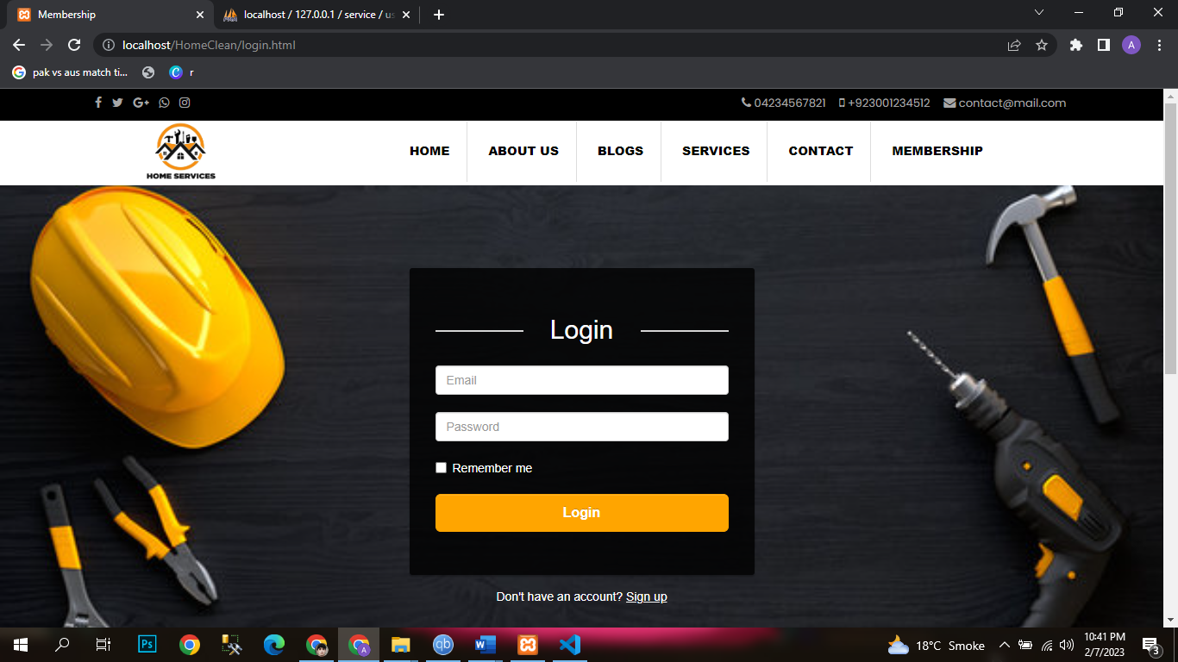
Sign up Page:

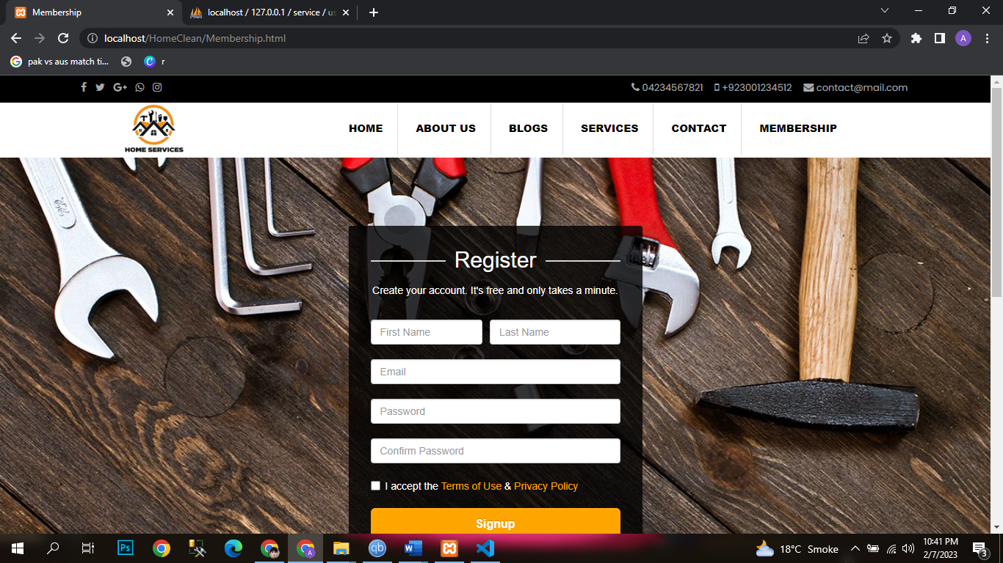

Admin Dashboard:

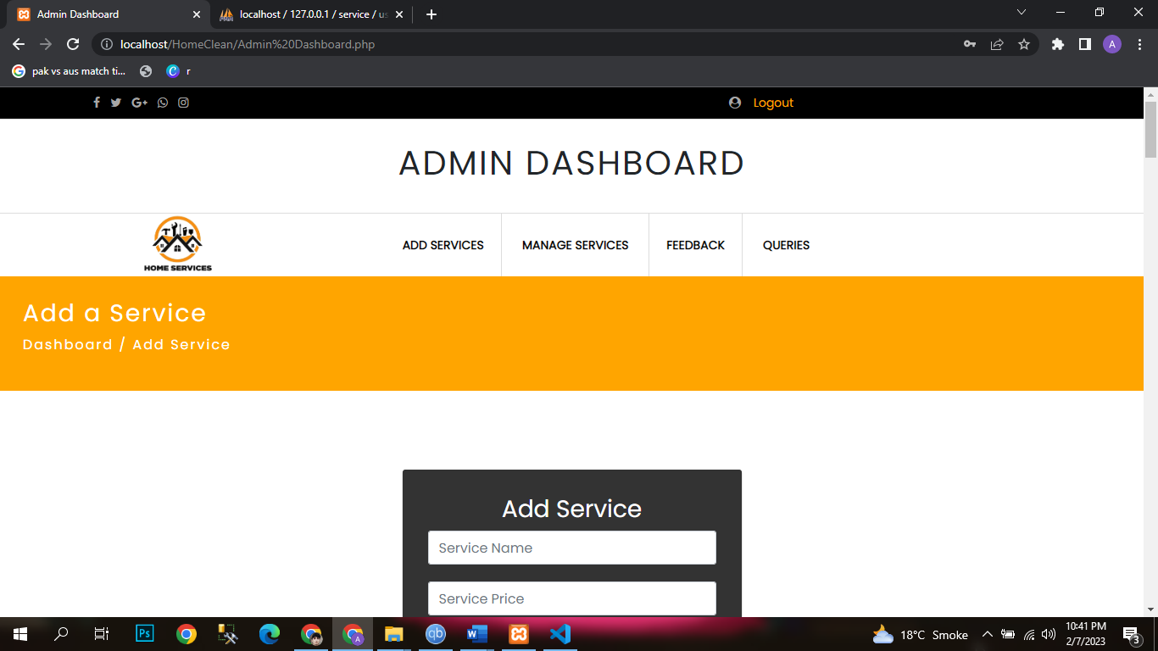

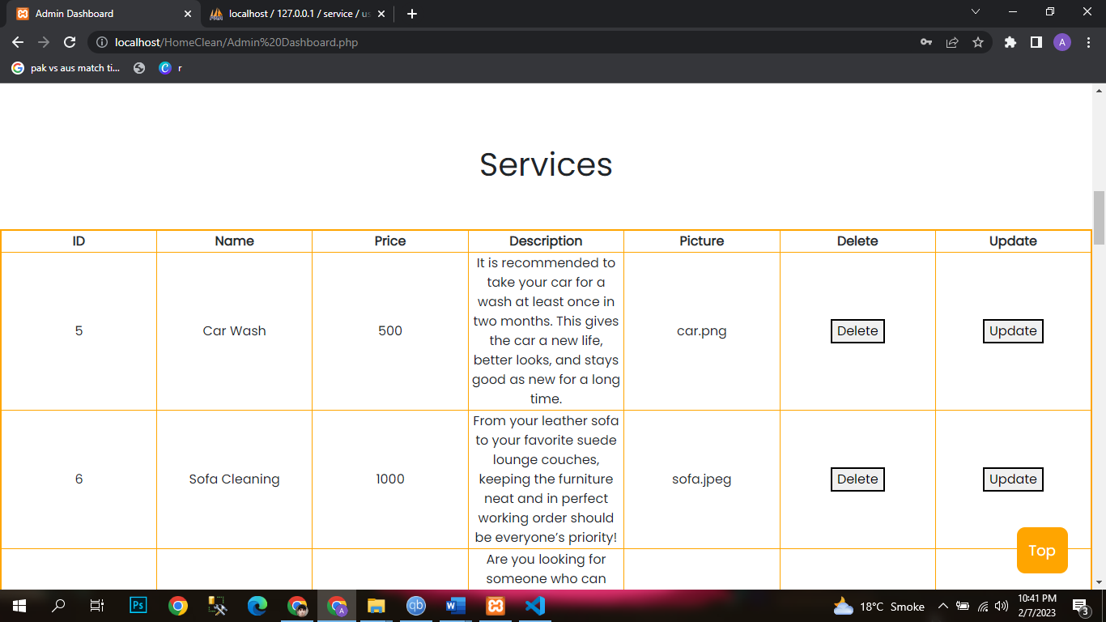

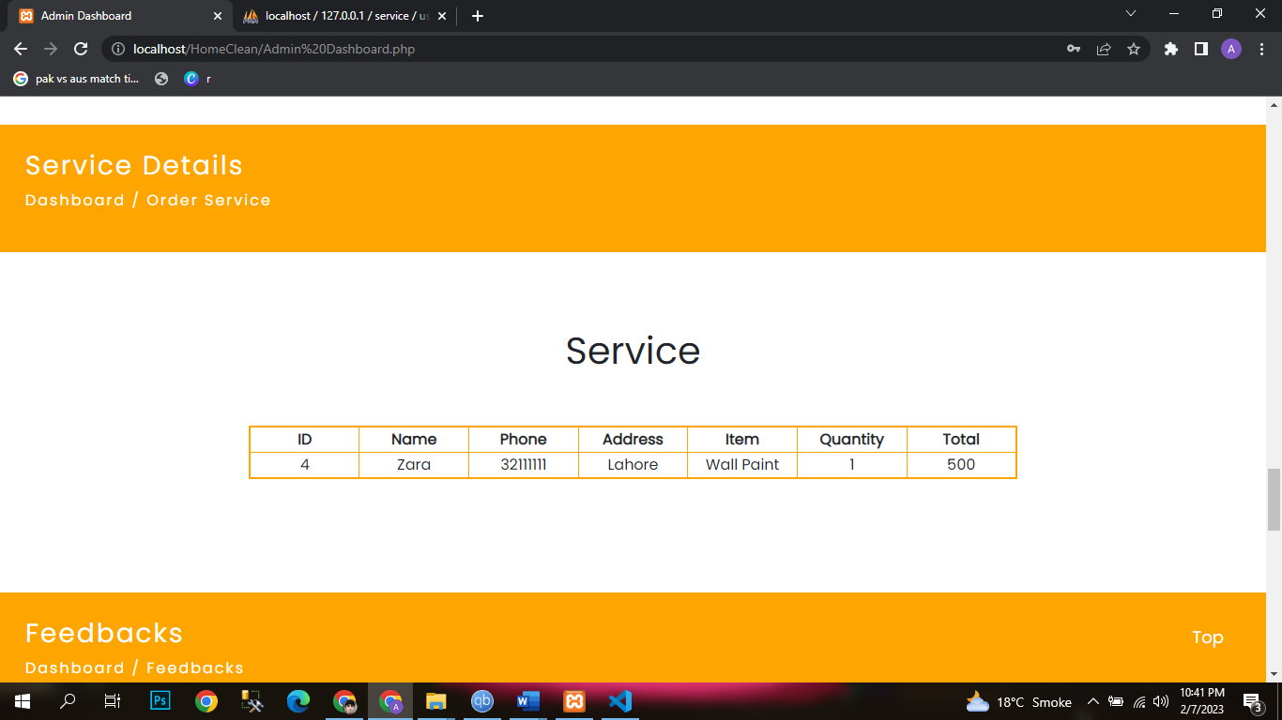

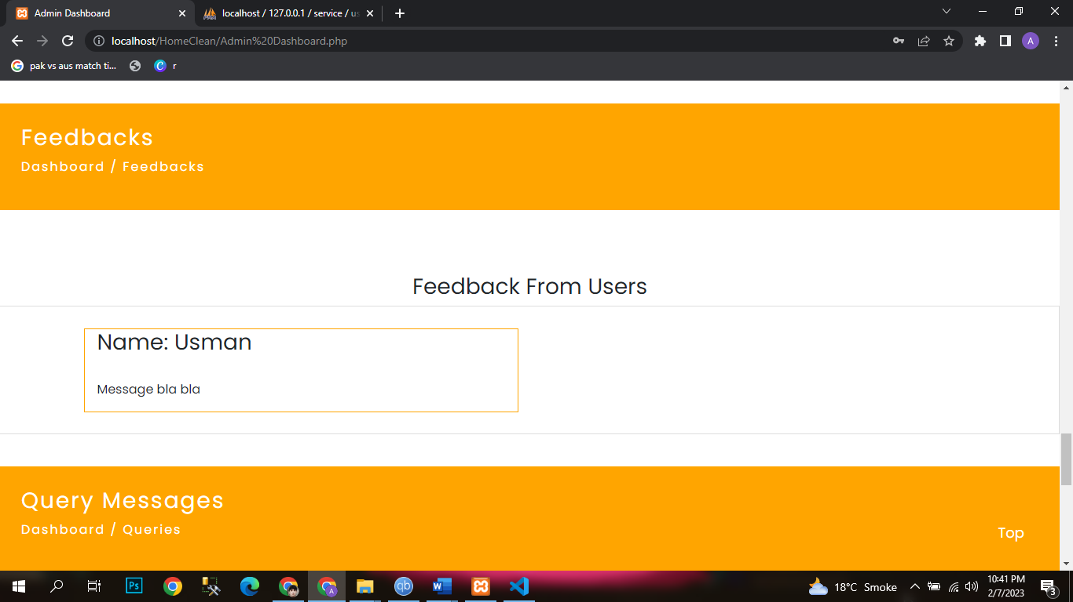

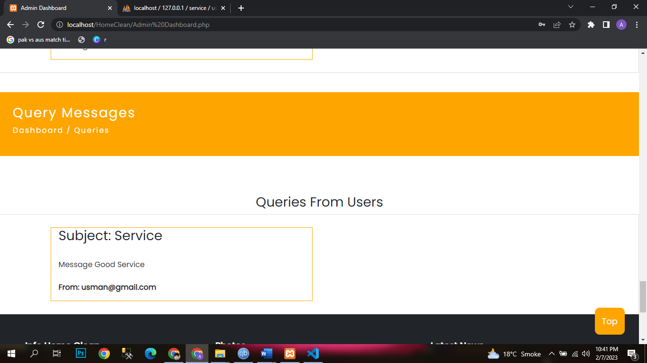

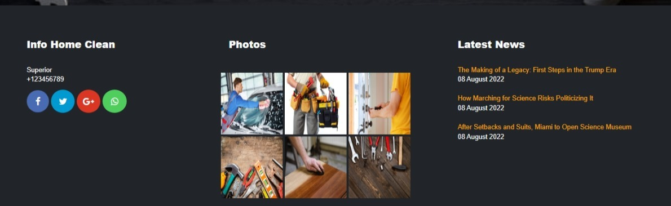

Page:

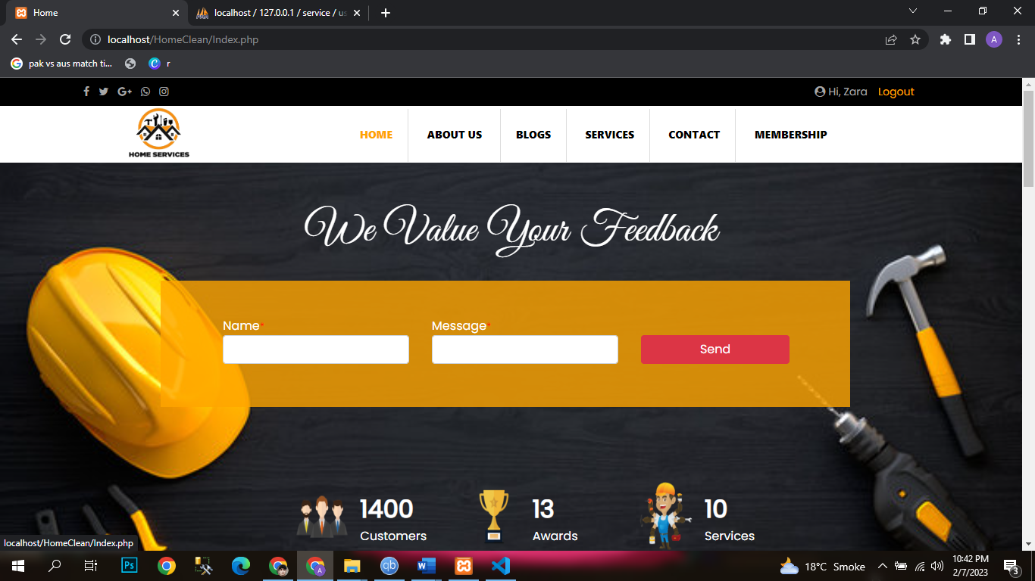

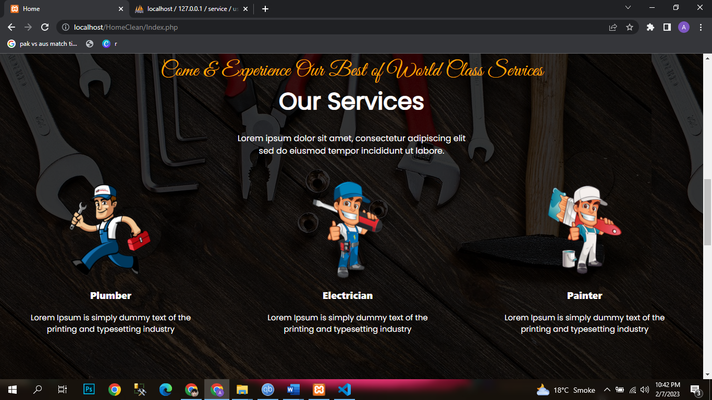

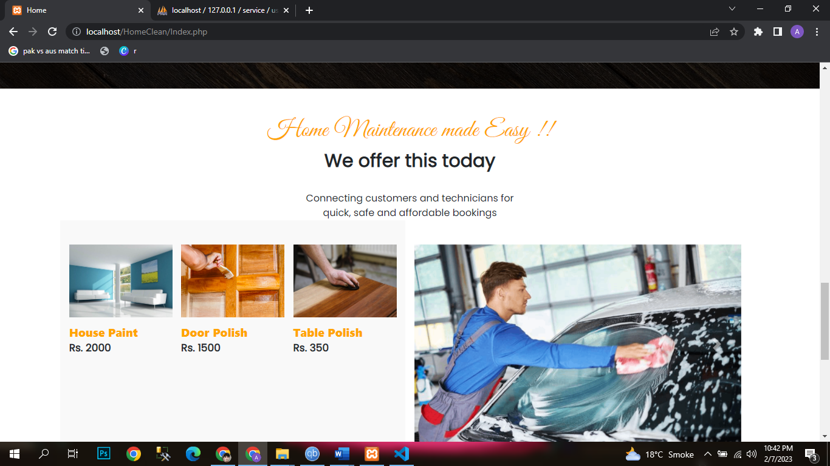

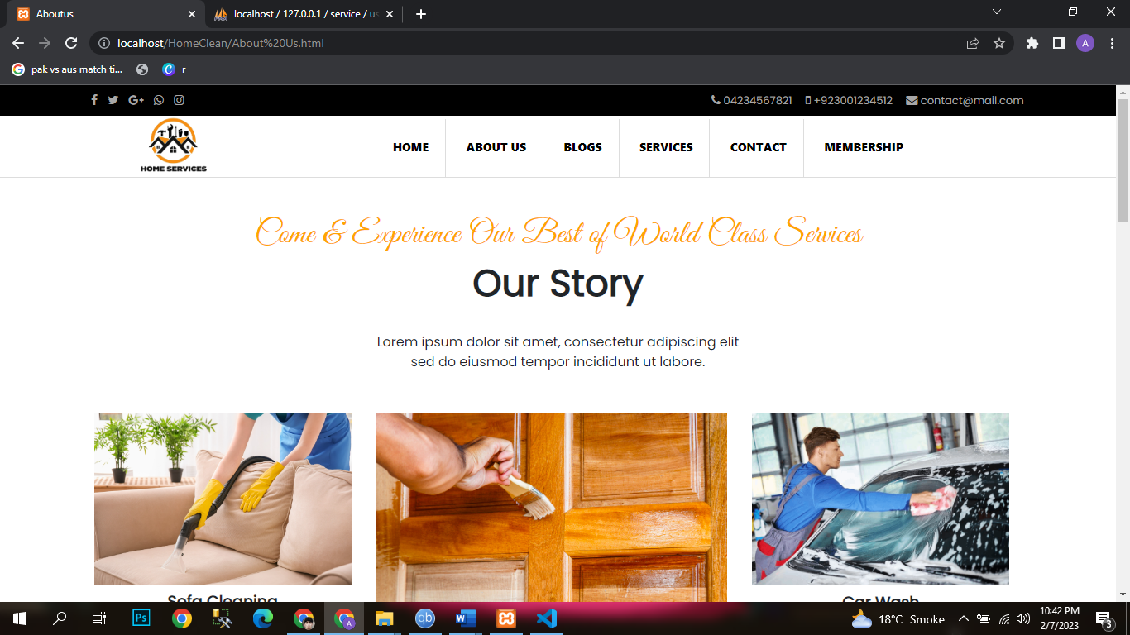

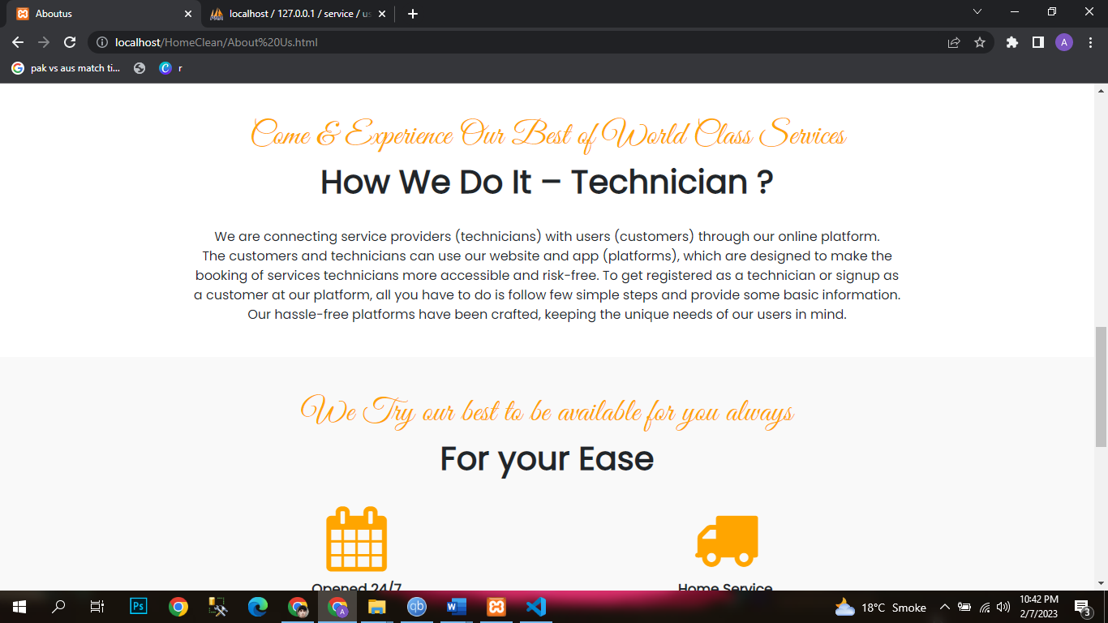

Blogs:

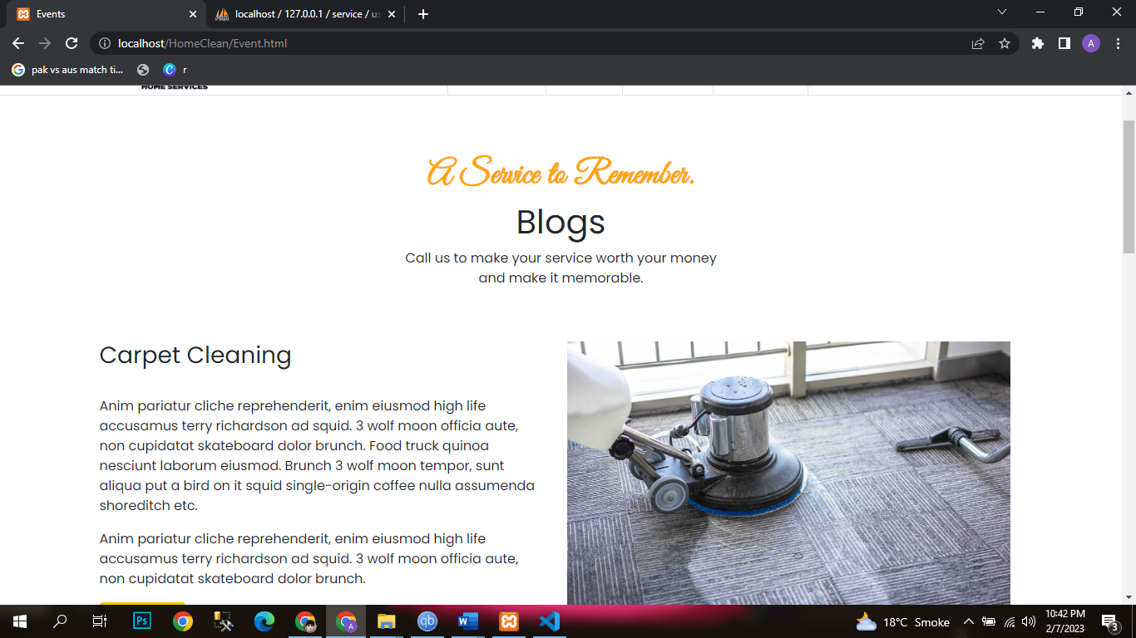

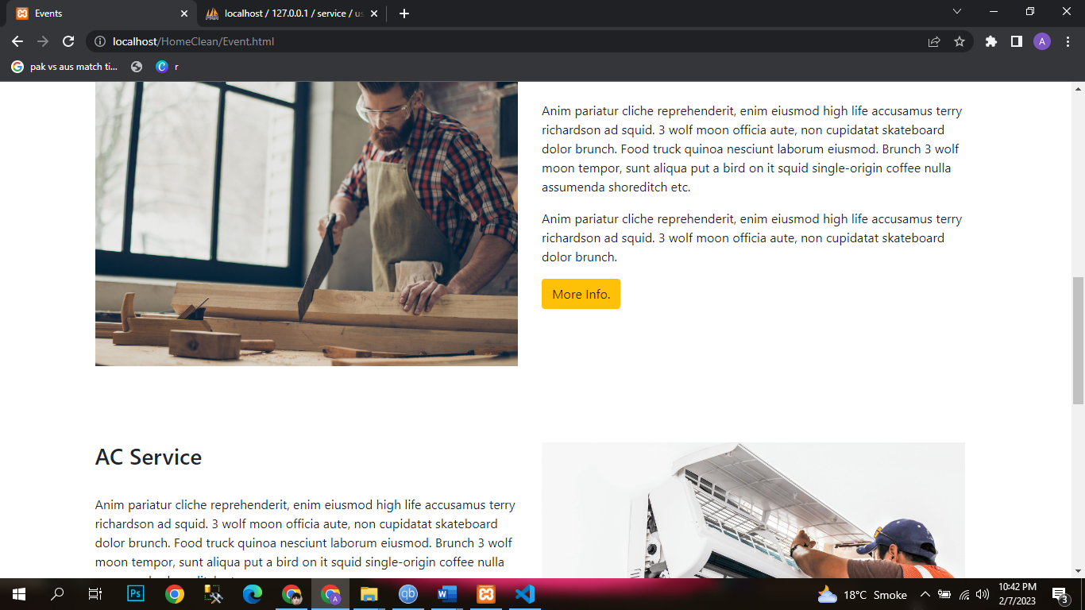

Services:

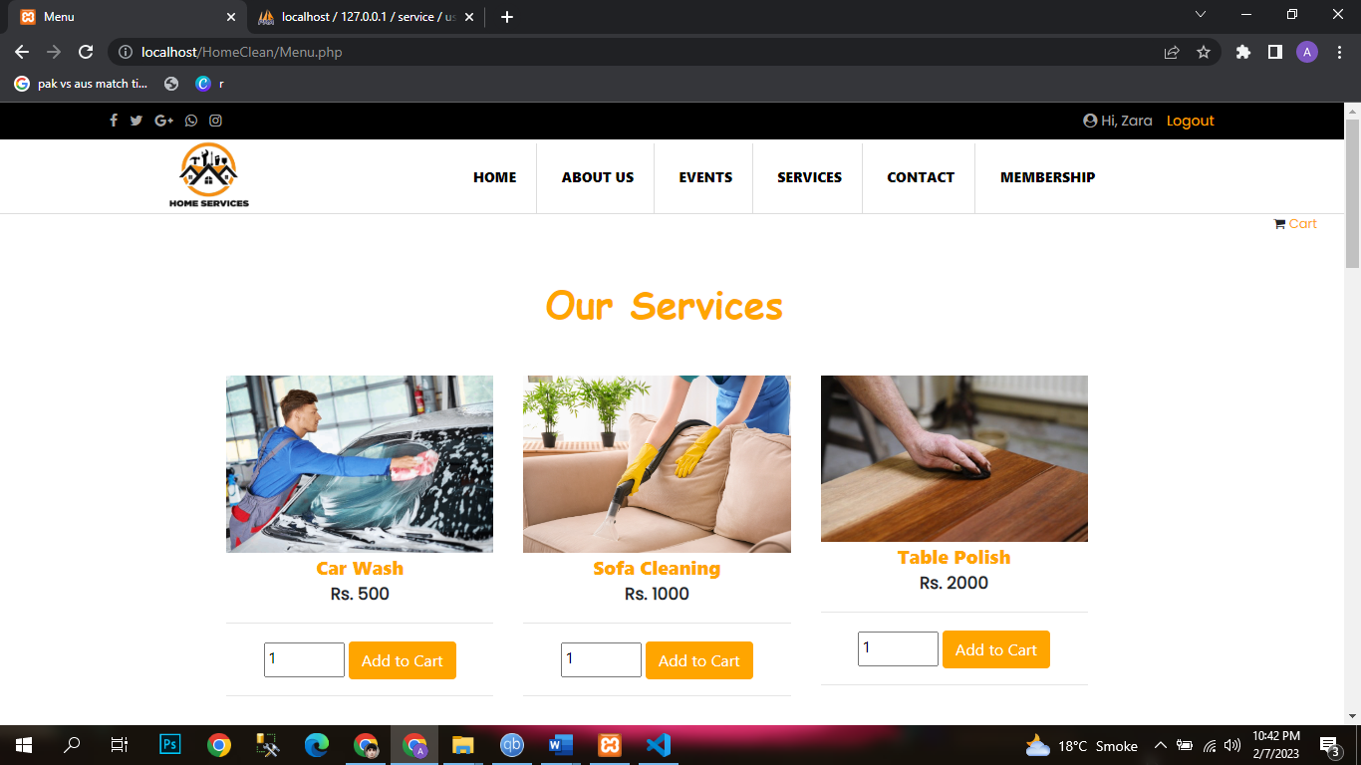

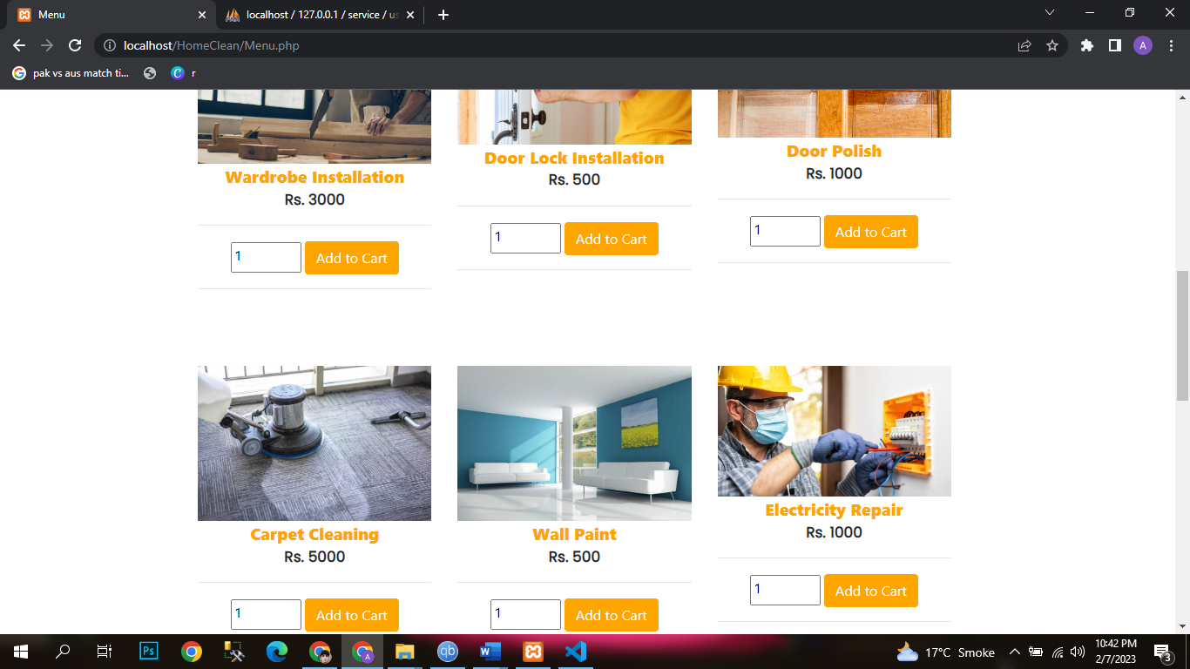

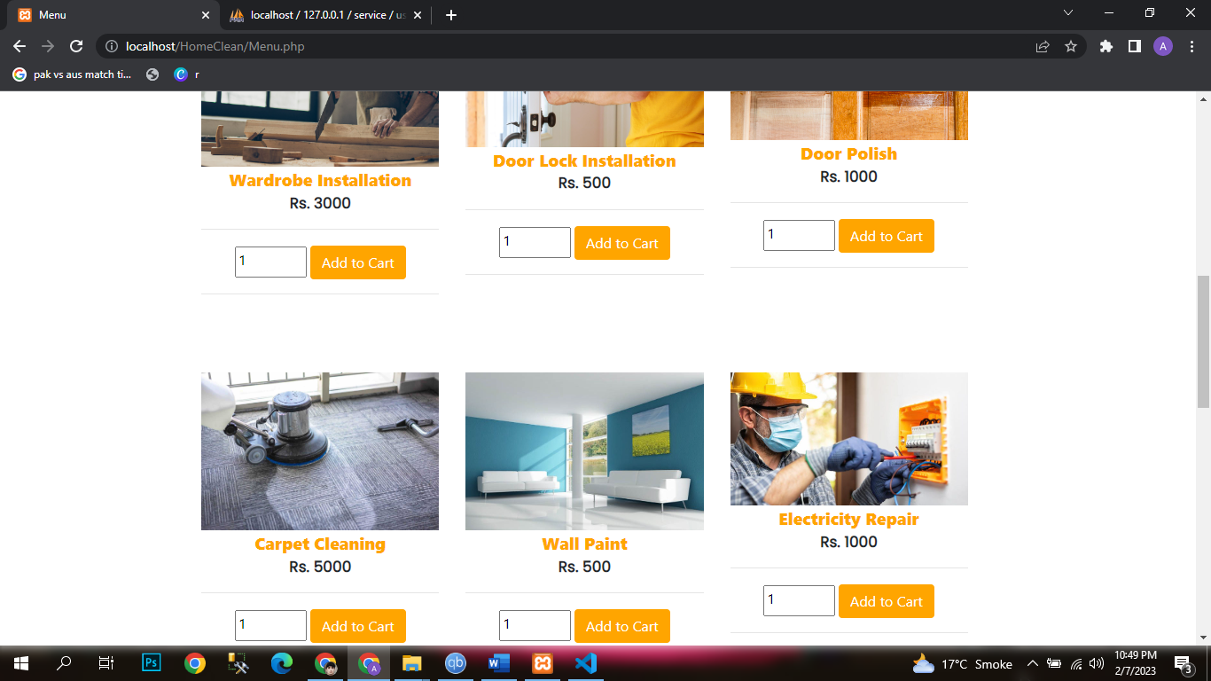

Contact Page:
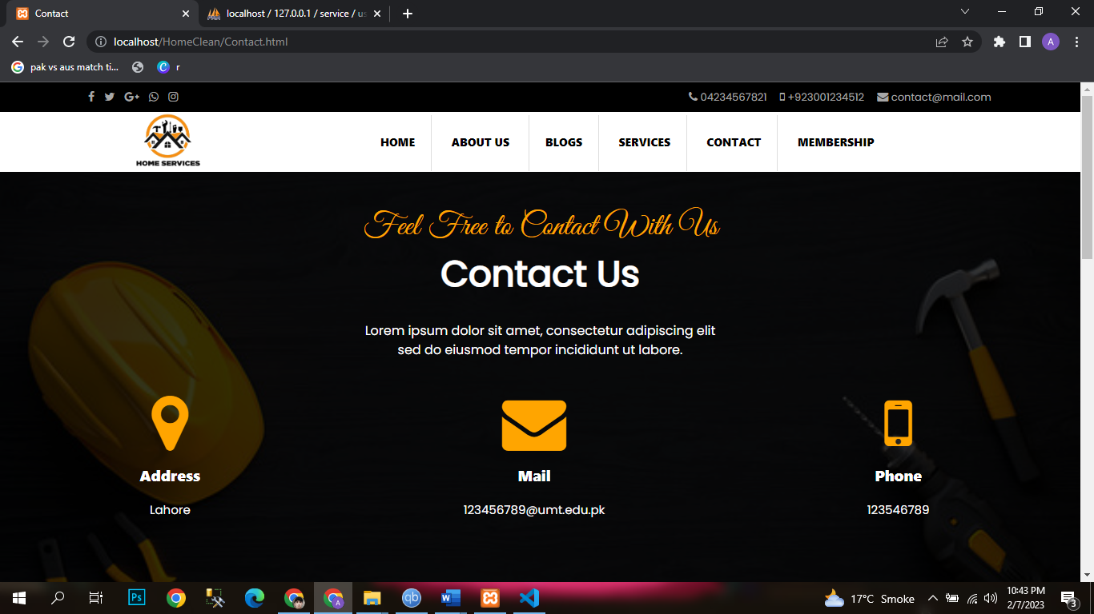

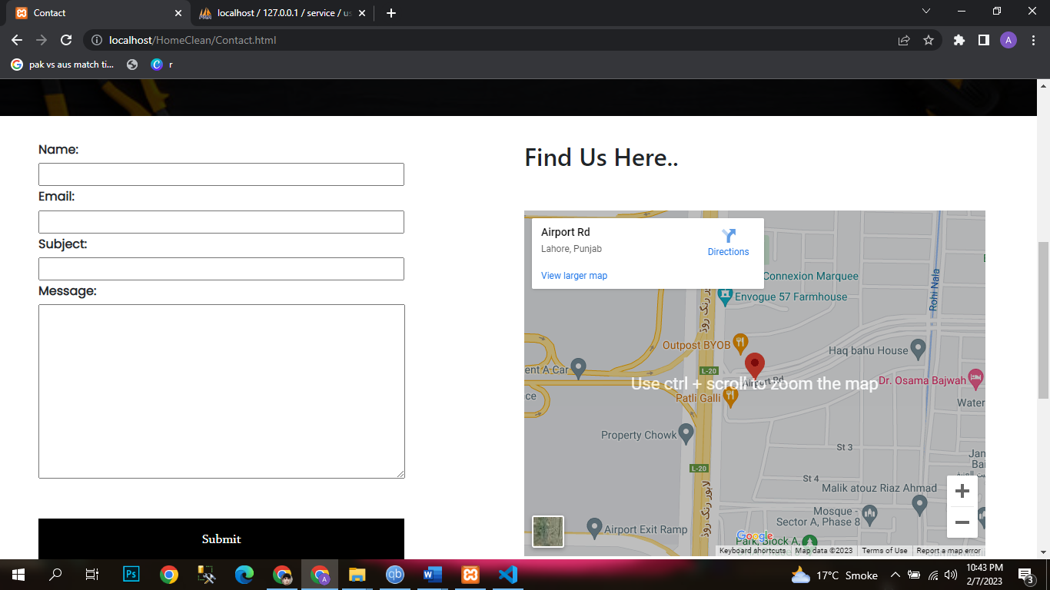

Cart:
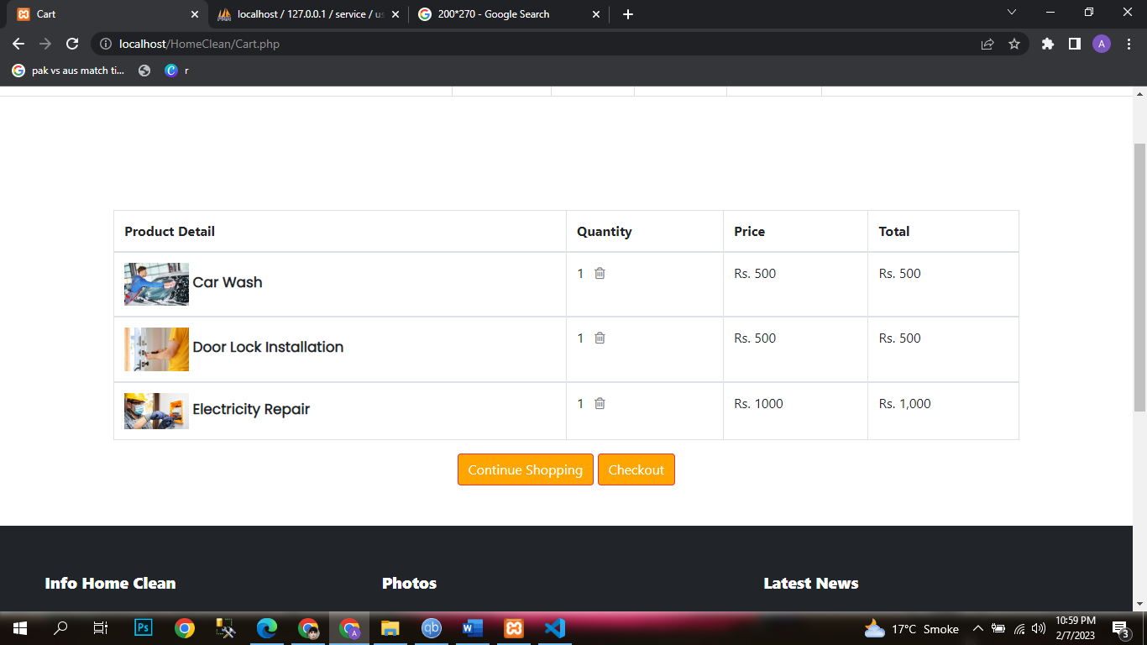
Checkout Page:
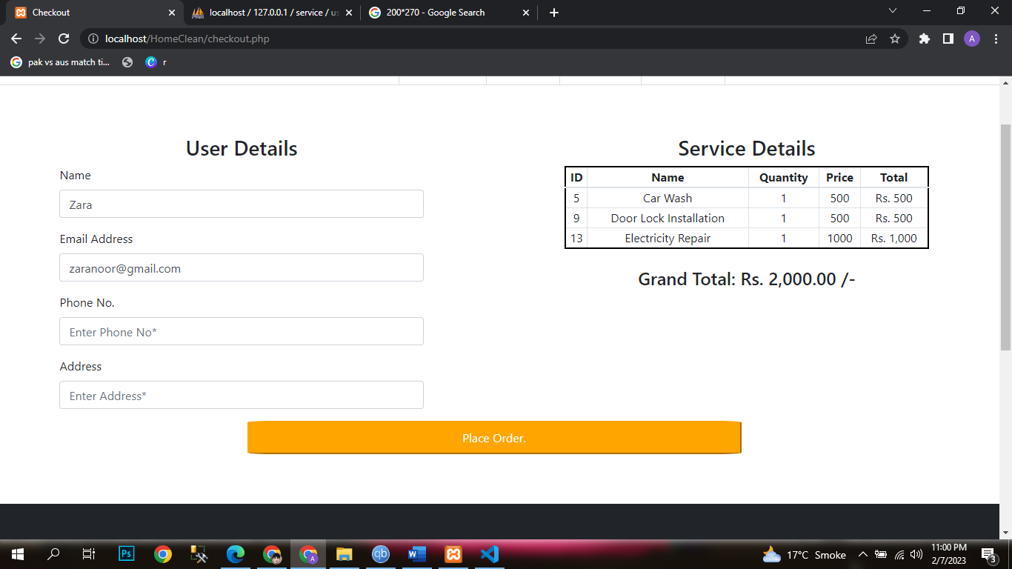

Chapter 4

System Design
The major diagrams and models needed to graphically represent the system are included in this chapter. Below is a basic description of the system design:
This project is based on hardware. The project was examined by our staff. Therefore, we made a general mobile application so that anybody might use it to operate it in the future.

Architecture Diagram

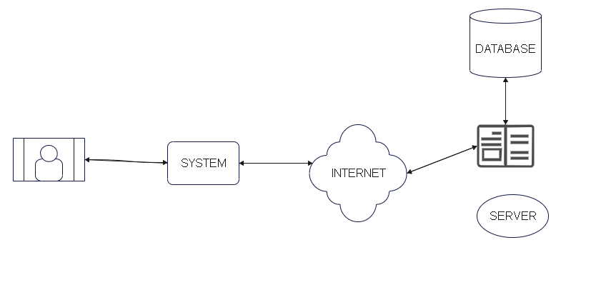
Figure 4 : System Architecture
Figure 4 shows that how the architecture of the Expert Labor system is working and also shows the representation of the database server and internet connectivity. The admin will get the information by logging into the Admins Account.

Entity Relationship Diagram with data dictionary

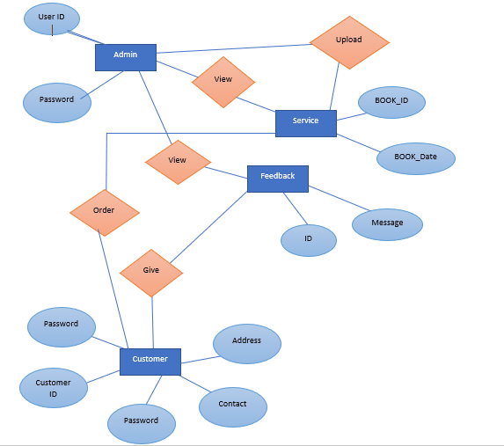
Figure 5 : Entity Relationship Diagram

Figure 10 shows that Admin has to login to perform action like manage service categories reply feedbacks contact SP, Service Provider and Customer has to register first then login to account.

Class Diagram
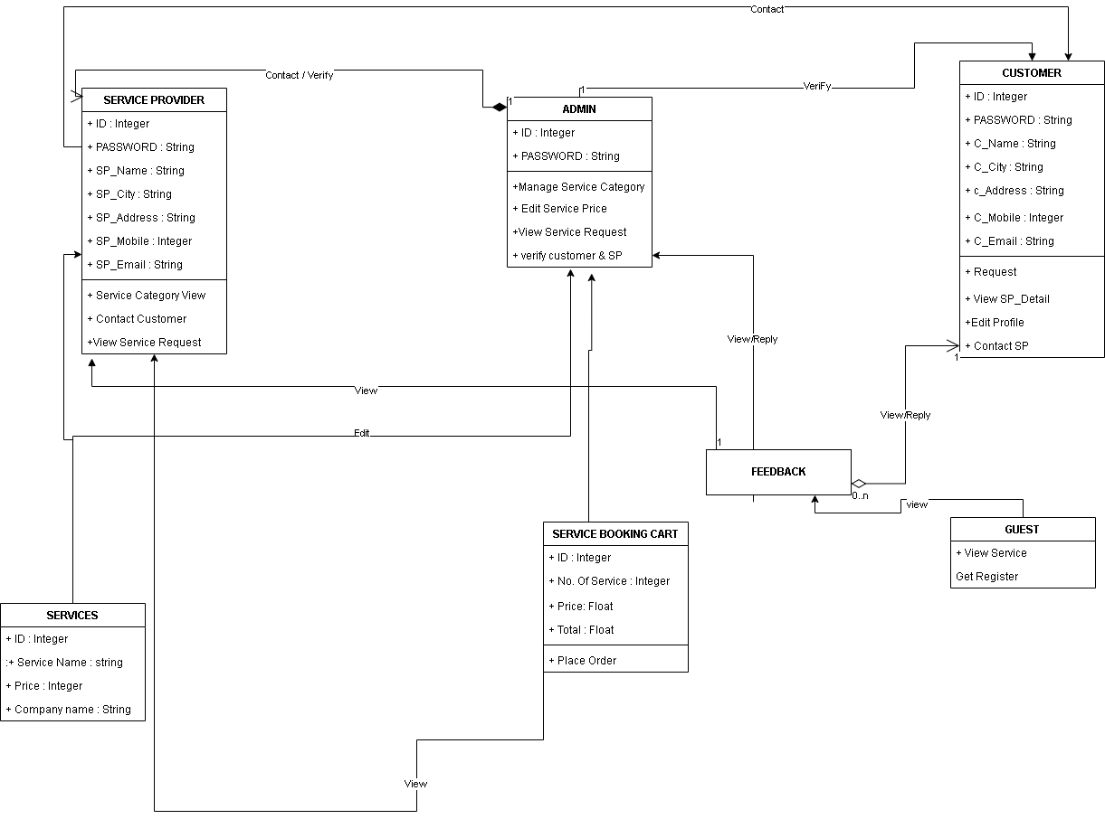

4.4 UML Sequences Diagrams
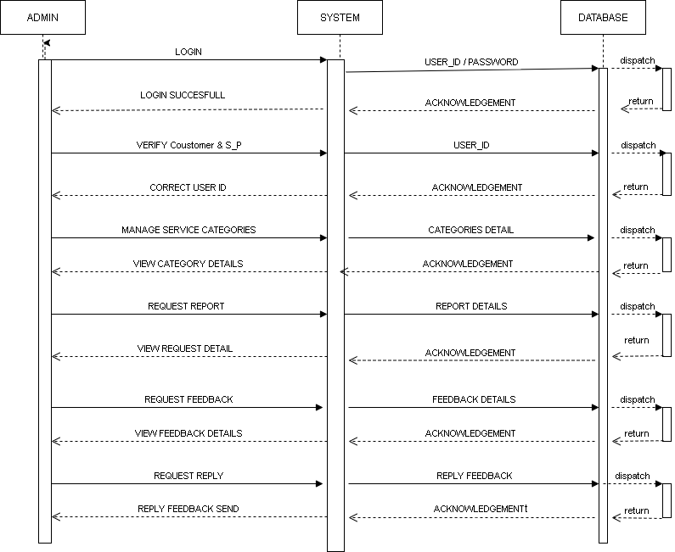

Figure 5 : UML Sequence Diagram for Admin
Figure 6 display the sequence of messages passed between the different objects of the Expert Labor system that are system administrator. It also shows the actions that the admin needs to perform in order to fetch the data.

4.5 Sequence / Collaboration Diagram

4.5.1 Sequences Diagrams

Figure 6 : UML Sequence Diagram for Admin
Figure 6 display the sequence of messages passed between the different objects of the Expert Labor system that are system administrator. It also shows the actions that the admin needs to perform in order to fetch the data.

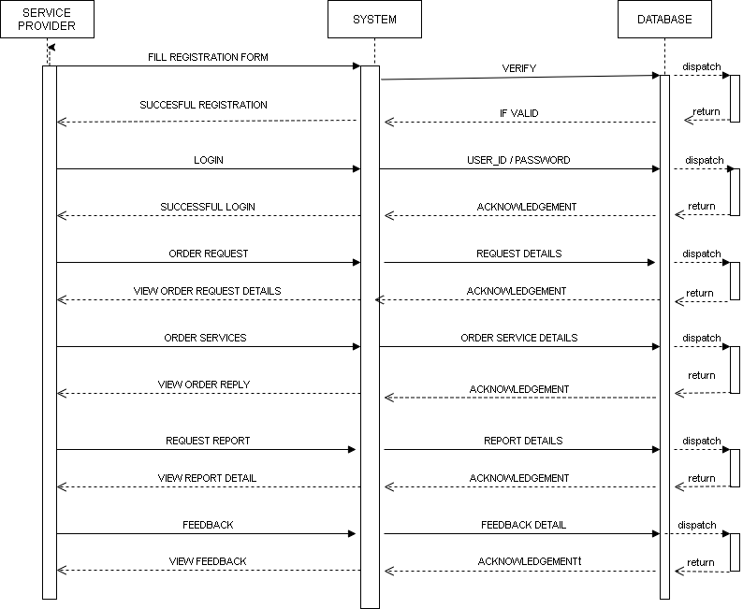

Figure 7: Sequence Diagram for Customer
Figure 7 shows the sequence of messages passed between the different objects of the Expert Labor system that are system administrator. It also shows the actions that the SP needs to perform in order to fetch the data.

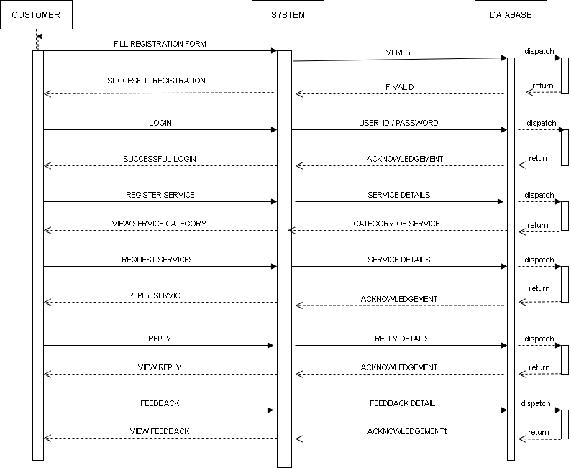

Figure 8: Sequence Diagram for Customer
Figure 8 shows the sequence of messages passed between the different objects of the Expert Labor system that are system administrator and the victim. It also shows the actions that the Customer needs to perform in order to fetch the data.

4.5.2 Collaboration Diagram
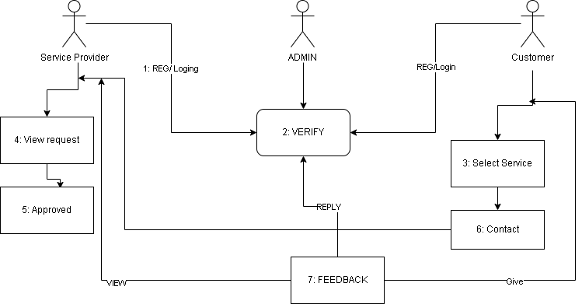

Collaboration Diagrams
Figure 9 display the sequence of messages passed between the different objects of the Expert Labor system that are system administrator. It also shows the actions that the admin needs to perform in order to fetch the data

Other UMLs

ERD
Figure 9 : Entity Relationship Diagram

Figure 10 shows that Admin has to login to perform action like manage service categories reply feedbacks contact SP, Service Provider and Customer has to register first then login to account.

Chapter 5
Implementation Detail

5.1 Development Setup
VsCode: The backend of this project is based on this tool as it covers the window devices.
HTML/CSS: This tool/language is used in VsCode for developing the scripts to operate the Expert Labor System.

5.2 Deployment setup
The system will be deployed to web application that is used to provide services at the door step. Getting Information of customer and service provider is a challenging task because for this, we attached a separate script in VsCode which is the main source of sending the Information to Admin

5.3 Algorithms
- Expert Labor Platform have used multiple libraries or separate code for the development.
- Expert Labor Platform created separate code for getting Information of Customer and Service Provider.
- Expert Labor Platform have written separate script for all Database.

5.4 Constraints

5.4.1 Assumptions
- System will be maintained by the admin portal.
- The user will be unaware, that Admin monitories every step.

5.4.2 System constraints
- Full time internet connection is required to use the application.
- The software must be functional and synced with the server.

5.4.3 Restrictions
- No restrictions currently reside to use this application as of yet.

5.4.4 Limitations
Internet connectivity is required for this web application system to be in running state. It’s independent from the limitation of intern

Chapter 6
Testing

6.1 Extended Test Cases
Table 5 : Extended Use Case For Service Provider
Test Case ID: 1 |  |  |  |  | Test Design By:
Test Module Name: Authorized User |  |  |  |  | Test Design Date: 23/08/2023
Test Priority: High |  |  |  |  | Test Executed By:
Test Title/ Name: To test login function of SP |  |  |  |  | Test Executed Date:
Description |  | Test that the user must be Registered to use system.
Pre-Condition |  | User must have valid credentials.
Dependencies
Step | Test Step |  | Test Data | Expected Result |  | Actual Result | Status (Pass/Fail) | Notes
1 | Enter email address |  | user@gmail.com |  |  |  | Pass
2 | Enter password |  | xyz@123 |  |  |  | Pass
3 | Click on login |  |  | The user is logged in |  | The user successfully logged in.
Post Condition: User can now use the application.

Table 6 : Extended use case for Admin

Test Case ID: 2 |  |  |  |  | Test Design By: Usman Tahir
Test Module Name: Authorized User |  |  |  |  | Test Design Date: 23/08/2023
Test Priority: High |  |  |  |  | Test Executed By: Usman Tahir
Test Title/ Name: To test login function of Admin |  |  |  |  | Test Executed Date: 23/08/2023
Description |  | Test that the user must have correct ID and Password to use system.
Pre-Condition |  | User must have valid credentials.
Dependencies
Step | Test Step |  | Test Data | Expected Result |  | Actual Result | Status (Pass/Fail) | Notes
1 | Enter email address |  | user@gmail.com |  |  |  | Pass
2 | Enter password |  | xyz@123 |  |  |  | Pass
3 | Click on login |  |  | The user is logged in |  | The user successfully logged in.
Post Condition: User can now use the application.

Table 7 : Extended Use Case For Customer
Test Case ID: 2 |  |  |  |  | Test Design By: Usman Tahir
Test Module Name: Authorized User |  |  |  |  | Test Design Date: 23/08/2023
Test Priority: High |  |  |  |  | Test Executed By: Usman Tahir
Test Title/ Name: To test login function of Customer |  |  |  |  | Test Executed Date: 23/08/2023
Description |  | Test that the user must be Registered to use system.
Pre-Condition |  | User must have valid credentials.
Dependencies
Step | Test Step |  | Test Data | Expected Result |  | Actual Result | Status (Pass/Fail) | Notes
1 | Enter email address |  | user@gmail.com |  |  |  | Pass
2 | Enter password |  | xyz@123 |  |  |  | Pass
3 | Click on login |  |  | The user is logged in |  | The user successfully logged in.
Post Condition: User can now use the application.

6.2 Decision Table

6.2.1 Decision coverage table

Table 8 :Decision Coverage Table
Conditions | Rule 1 | Rule 2
Register | T | F
Internet availability | T | T
Login | T | T

6.3 Traceability Matrix

6.3.1 RID vs UCID (requirements vs use cases)

Table 9: RID vs UCID
UCID  /RID | R  1 | R  2 | R  3 | R  4 | R  5 | R  6
UC 1 |  |  |  |  | ✔
UC 2
UC 3
UC 4
UC 5
UC 6

6.3.2 Prototypes (RID vs PID)
Table 10 :RID vs PID
UCID/RID | R  1 | R  2 | R  3 | R  4 | R  5 | R  6
PID 1 | - - | ✔ |  | ✔ |  | ✔
PID 2 |  | ✔ | ✔
PID 3 | ✔ | ✔ |  | ✔
PID 4 | ✔ | ✔ |  |  |  | ✔
PID 5 | ✔ | ✔ | ✔ |  | ✔
PID 6 | ✔ | ✔ |  | ✔ |  | ✔

6.3.3 Coverage (UCID vs TID)
Table 11: UCID vs TID
UCID/RID | R  1 | R  2 | R  3 | R  4 | R  5 | R  6
TID 1 | - - | ✔
TID 2 |  | ✔
TID 3 | ✔ | ✔ |  |  |  | ✔
TID 4 | ✔ | ✔
TID 5 |  | ✔ | ✔ |  | ✔
TID 6 | ✔ | ✔ |  | ✔ |  | ✔

Chapter 7
Results/output statistics

7.1 %completion
Our project is completed as we defined in our scope.

7.2 %accuracy
We have completed our project and by testing our test cases we got accuracy of our project

7.3 %correctness
Every function of project is working well so we also get correctness of our project as we discussed in our scope.

Chapter 8
Conclusion

A web application is developed which provide online service booking where user can book any kind of service for the maintenance of their homes it can be door fitting, wall painting, door painting, car wash, Sofa Cleaning etc. This will facilitate the user to book the service in a single click. On the other side, the admin of the system can manage all the service orders booked by the customers. Admin can also look on the feedback and queries of the user as well.

Chapter 9
Future Work

In future we will make an application for mobile as well and in the web application we will put the location option for the admin so that they can reach the user’s home easily.

