SUPERIOR UNIVERSITY LAHORE



Faculty of Computer Science & IT

Final Year Project
PROJECT REPORT (Part-I)

GROCEPK
Project ID: CS-05

Project Team

Student Name | Student ID | Program | Contact Number | Email Address
Badar imam | BSCM-F14-080 | CS | 03026546700 | badar_imam@hotmail.com
Tahir zaman | BSCM-14-149 | CS | 03316773016 | tahirzamankhadim@gmail.com

Sir Qasim zia
(LECTURER)

Project Report
Grocepk

Change Record
Author(s) | Version | Date | Notes | Supervisor’s Signature

APPROVAL
Project Supervisor
Comments: ___________________________________________________________________
_____________________________________________________________________________
Name: ______________________________
Date: _______________________________ | Signature: __________________________

Project Manager
Comments: ___________________________________________________________________
_____________________________________________________________________________
Date: _______________________________ | Signature: __________________________

Head of the Department
Comments: ___________________________________________________________________
_____________________________________________________________________________
Date: _______________________________ | Signature: __________________________

Dedication:
We give this project to God Almighty my creator, my strong pillar, my source of motivation, sense, information and sympathetic. We can perform well in our final year project. Our inspiration has made sure that we give it all it takes to finish that which we have started. Thank you.
Our love for you all can never be quantified.

Acknowledgements:
Our deepest appreciation goes to our supervisor who has provided all that was needed to complete this project and the program for which it was undertaken for. There was never lack or want. They corporate with us and provide specific information for our final year project and describe the aspect about our project.

Executive Summary:
GROCEPK will be an online store which is a place like Super market most of the products is available in our app and website that’s improve shopping by make it faster and easier which improve the shopping easier. User can select and choose the Products. Life is so much busy everyone needs something that save their time. Grocery is something that we need daily in majority of houses both men and women work they don’t have time to buy grocery because of their busy schedule or mostly men have jobs from 9 to 5 and it is difficult for them to spare some time for this little “grocery” thing? Seeing this problem, we came up with an idea that there should be something time saving something that will bring ease to the lives of busy person. GROCEPK is the solution. You can have you desire grocery at your doorstep in just few time by ordering on our web/app. We have an online portal through which any one can order anything like flour, milk, vegetable spices, meat etc. This is the need of every house and as we did survey about this Business 70% of people are willing to buy things online rather to go to the stores.

Table of Contents
Dedication 3
Acknowledgements 4
Executive Summary 5
Table of Contents 6
List of Figures 7
List of Tables 9
Chapter 1 10
Introduction 10
1.1. Background 11
1.2. Motivations and Challenges 11
1.3. Goals and Objectives 12
1.4. Literature Review/Existing Solutions 12
1.5. Gap Analysis 13
1.6. Proposed Solution 13
1.7. Project Plan 14
1.7.1. Work Breakdown Structure 14
1.7.2. Roles & Responsibility Matrix 15
1.7.3. Gantt Chart 16
1.8. Report Outline 17
Chapter 2 18
Software Requirement Specifications 19
2.1. Introduction 19
2.1.1. Purpose 19
2.1.2. Document Conventions 19
2.1.3. Intended Audience and Reading Suggestions 20
2.1.4. Product Scope 20
2.1.5. References 20
2.2. Overall Description 20
2.2.1. Product Perspective 21
2.2.2. Product Functions 21
2.2.3. User Classes and Characteristics 21
2.2.4. Operating Environment 22
2.2.5. Design and Implementation Constraints 22
2.2.6. User Documentation 22
2.2.7. Assumptions and Dependencies 22
2.3. External Interface Requirements 23
2.3.1. User Interfaces 23
2.3.2. Hardware Interfaces 23
2.3.3. Software Interfaces 24
2.3.4. Communications Interfaces 24
2.4. System Features 24
2.4.1. System Feature 1 25
2.4.1.1. Description and Priority 25
2.4.1.2. Stimulus/Response Sequences 25
2.4.1.3. Functional Requirements 25
2.4.2. System Feature 2 26
2.4.2.1. Description and Priority 26
2.4.2.2. Stimulus/Response Sequences 26
2.4.2.3. Functional Requirements 26
2.4.3. System Feature 3 (and so on) 26
2.5. Other Nonfunctional Requirements 26
2.5.1. Performance Requirements 26
2.5.2. Safety Requirements 27
2.5.3. Security Requirements 27
2.5.4. Software Quality Attributes 27
2.5.5. Business Rules 27
2.6. Other Requirements 27
Chapter 3 28
Use Case Analysis 28
3.1. Use Case Model 31
3.2. Fully Dressed Use Cases 33
Chapter 4 35
System Design 35
4.1. Architecture Diagram 36
4.2. Domain Model 37
4.3. Entity Relationship Diagram with data dictionary 38
4.4. Class Diagram 39
4.5. Sequence / Collaboration Diagram 40
4.6. Operation contracts 41
4.7. Activity Diagram 42
4.8. State Transition Diagram 43
4.9. Component Diagram 43
4.10. Deployment Diagram 44
4.11. Data Flow diagram [only if structured approach is used - Level 0 and 1] 44
Chapter 5 45
Implementation 45
5.1. Important Flow Control/Pseudo codes 45
5.2. Components, Libraries, Web Services and stubs 46
5.3. Deployment Environment 46
5.4. Tools and Techniques 46
5.5. Best Practices / Coding Standards 47
5.6. Version Control 47
Chapter 6 48
Testing and Evaluation 48
6.1. Use Case Testing 48
6.2. Equivalence partitioning 49
6.3. Boundary value analysis 49
6.4. Data flow testing 50
6.5. Unit testing 56
6.6. Integration testing 56
6.7. Performance testing 57
6.8. Stress Testing 57
Chapter 7 58
Summary, Conclusion and Future Enhancements 59
7.1. Project Summary 59
7.2. Achievements and Improvements 59
7.3. Lessons Learnt 60
7.5. Future Enhancements/Recommendations 60
Appendices 61
Appendix A: Information / Promotional Material 61
Reference and Bibliography 66

Chapter 1
Introduction:
Our project is to make a website and an app it will be selling grocery and other household products that will provide 7 days a week service of ordering and delivering products. The android app or website has a user-friendly design and easily accessible to everyone. The only thing which is required is an internet connection and by lowest possible clicks one will get everything he/she needs at his/her doorstep. Our project will have a complete range of house hold and house usage products for the customers. Users can buy the items from the listing products.

Background:
The system is limited to area as the store generally caters the need of people Living in a territory. Customers must take pain to go to the shop in case of heat, cold, rain etc. No common platform and easy facility normally available where many dealers can interact with one as many stores have products of just one company or dealer.

Motivations and Challenges:

- The system should be fast.
- Smooth business of products.
- Termination of data must be avoided

Goals and Objectives:
- Identify the project aims and objectives
- Understanding requirements and specification
- Methods of analysis documentation and analysis
- Budget planning
- User requirements

Literature Review/Existing Solutions:
- Our store has best quality products.
- Ensures hygienic and salubrious product supply
- Prices will be feasible
- Availability of all the products

Gap Analysis:
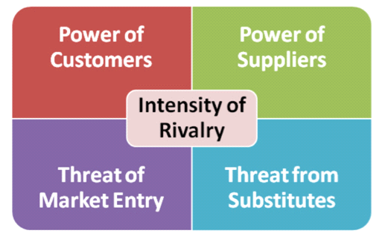

Proposed Solution:
In the proposed website there are different parts or modules which are summarized as follows.

CUSTOMER REGISTRATION:
Customers are required to record on the website before they can do the shopping. The website also provides several structures for the non-registered user. Here they can choose their id and all the details regarding them are collected and a mail is sent to the email address for confirmation.

SHOPPING CART:
Shopping cart module tries to simulate the working of a store where user can view each design, color, size and price of the product available. The items they like can be added to the logical cart and can be removed if not required later. Billing and other compensation related matters are handled here.

ADMINISTRATION:
This is the part of the website where the administrators can add delete or update the product information. Administrators are also responsible for adding and deleting the customers from the website. In addition, newssheet and advancements are also handled by the site administrator via e-mail.
SEARCH:
This ability is provided to both registered and unregistered user. User can search for the obtainability and type of products available on the website.
EMAILING:
Emailing module is concerned about promotions and newsletter and is handled by the administrator. This module is also troubled about sending activation and warning mails.
Project Plan
Cart Shopping:
The product list of the selected class and customer can select the required quantity and add the product to shopping cart by clicking on the button add to cart.
Product Details:
It will show the product information to the administration and enable user to add, adapt, and delete any product from the system and enable user to update product price.
Add new product:
It will used to add new product to the system and upload the product photo.
Recompense Types:
It will used to enter or delete or modify the payment type.
Main Category:
It will used to create new main group or update old main category name.
Category:
It will used to create new type or update old category name

Work Breakdown Structure:

Roles & Responsibility Matrix:

WBS # | WBS Deliverable | Activity # | Activity to Complete the Deliverable | Duration  (# of Days) | Responsible Team Member(s) & Role(s)
1 | Requirement gathering | 1 | Functional And non-functional requirement | 1 week | Both
2 | Establish Design | 2 | Front-end Design,  Responsiveness,  Panels, Color Schema | 4 months | Both
3 | Initial Prototype | 2 | Front-end, Back-end | 4 months | Both
4 | Web-Development | 2 | Specifications and consults with developers | 4months | Both
5 | Admin Panel | 2 | Finalize Database specifications | 1 week | Both
6 | Database Module | 3 | ERD, Design Tables, Update  Delete, Edit | 1 week | Both
7 | Implementation | 5 | Back-end coding | 3 week | Both
8 | Final Completion | 6 | Run the project | 2 weeks | Both

Gantt chart:
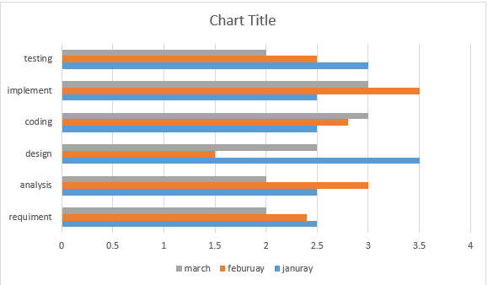

Report Outline:
- Interface Design
- The system will be professional in its arrival and it has a accessible interface for the user to input the related data and obtain the corresponding results.
- Usability Requirements.
- Ease of custom.
- The system will be able to be used quickly and easily. It will be forgiving if an error is made and will ask for authorization before entering in a timely process.
- Ease of education.
- This system will be easy to learn for a beginner user.
- Accessibility requirements.
- It is not now planned to add accessibility to the request.
- Presentation Requirements.
- Speediness and dormancy requirements.
- The system will produce a viable Order within a sensible amount of time and provide response on the progress.
- Safety critical requirements
- There are not felt to be any safety serious requirements for this system.
- Reliability and Obtainability requirements
- This program will be available either through the web or on a machine.
- Healthiness requirements
- The program will have sufficient error handling abilities that it will not crash any other part of the system.
- Scalability or extensibility requirements
- Software Requirements
- Internet Browser such as Internet Explorer 6.0 and higher or another browser of the same generation is required to access the application.
- Maintainability and Support Requirements.
- Maintenance of the system.
- New product, category and Vouchers must able to be added by the admin. This system must easily maintainable.
- Supportability.
- There will be online help and/or a printed manual.
- Portability requirements.
- The product is expected to run under any operating system that run explorer IE or other web browser and its successors or through a web browser.
- Security Requirements.
- Access requirements.

Chapter 2
Software Requirement Specifications

Introduction
Purpose:
- Customer can look through the product collection and add items to our shopping cart. They can proceed to counter as long as their shopping cart is not empty.
- Customer will require to login to the system when they ensue to counter, or they can create an account if they not yet have one.
- The order will charge by COD (Cash on Delivery) or to the credit card registered in customer's account.
- Customer need to deliver full name, email address, phone number, credit card and billing address details when creating an account.
- Customer can login to the system to continue their account information, such as changing phone number, Address, and credit card details, and check the status of their orders.
Document Conventions:
Potential users of this system are administrators and Customers of grocepk. The Customer will enter the required data in the Order form. Also, the admin must fill his form with required material. However, the Customer will register themselves, enter restraints into the software, and build Orders. The administrator will have knowledge with the way the Order should be filled. The Customer will be anywhere from a beginner with using computer programs to an expert
Intended Audience and Reading Suggestions:
The purpose of the SRS is to clearly and correctly define the requirements of the Superstore for Remote Sensing Data and Images system being developed. The SRS documents and describes all functions that the final product should perform thus, it serves as a developer orientation for product design and operation.
Product Scope:
- Our project goals at business process mechanization we must tried mechanizing various processes at online grocery ordering system.
- To use resources in a different manner by increasing their efficiency.
- It please the user requirement.
- Have a good user interface
- Be stretchy
- Delivered on time within the budget
- Attract the customer to purchase
References:
- Google.com
- Youtube.com
- Udemy.com
- Pluralsight.com
Overall Description:
This document contains the problem declaration that the current system is finish which is obstructing the growth instances of the company. It further contains a list of the investors and users of the proposed solution. It also illustrates the needs and wants of the stakeholders that were identified in the suggesting exercise as part of the requirements works. It further lists and briefly describes the major features and a brief description of each of the proposed system.
Product Perspective:
The SRS pronounces the system from the user perception and then groups system requirements into two sections behavioral and non-behavioral. Behavioral requirements define what the system does by examining inputs to the system, outputs from the system, and the relations between these inputs and outputs. Non-behavioral requirements define the qualities of the system as it performs its job, including efficiency, consistency, safety, maintainability.

Product Functions:
- User launch the app.
- User search the items in categories.
- User can view the desired products detail information.
- User can order and checkout the products.
- User can browse more products and then close the app.

User Classes and Characteristics
Administrators:
Administrators are the ones who enhances or administers the groups for the products and administers the Sellers.
Vendors/Sellers:
Sellers will add their goods to the database, which will be seen in the website to the end users or say clients who can buy the products by choosing the one they need. Sellers will have the special freedoms than the end users and have ability to achieve the products added by them.
End Users/Customers:
The end user will be the one who visits the website and buys products online from the ones added by the Vendors/Sellers.
Operating Environment:
Web services are independent. On the client side, no extra software is required. A programming language with XML (Extensible Markup Language) and HTTP client support, for example, is enough to get you started. On the server side, merely a web server or application server is required. It is possible to web service enable an existing application without writing a single line of code. Web services are self-describing. Neither the client nor the server knows or cares about anything besides the format and content of request and response messages. The definition of the message format travels with the message.

Design and Implementation Constraints:
- The main restriction here would be the checking the authenticity of the buyer, which is not always possible. There can be security risks involved.
- The developed system should run under any stage (UNIX, Linux, Mac, Windows etc.) that contains a web browser which supports asp.net.
User Documentation:
Consumers seduced by accessibility and availability continue to sink towards online stores, they create a demand for classier shopping cart software. You can now choose advanced shopping cart features that help you sell and succeed online like never before.

Assumptions and Dependencies:
- The details connected to the product, customer, payment and service deal provided manually.
- Administrator is created in the system already.
- Roles and tasks are predefined.
- Specific Requirements
External Interface Requirements
User Interfaces:
- Login interface
- Registration
- There will be a screen presenting data about product that the shop having.
- If the customers select the buy button, then another screen of shopping cart will be opened.
- After ordering for the product, the system will have sent one copy of the bill to the customer Email address

Software Interfaces:
Grocepk is the featuring android app which relates to the admin panel and through APIs Server is connected with the database and also store data the data is loaded in the app both need internet connection is essential to connection front end and back end
The system is on server, so it requires the language asp.net, android studio. The system requires Data Base also for the store the any contract of the system like SQL. System also require DNS for the naming on the internet. At the last user need web browser for interact with the system.

Communications Interfaces:
Grocepk app will communicate with back end server through authentication the request I based on the token based encrypted algorithm back end server has the database that contains all the data The two parties should be associated by LAN or WAN for the communication purpose. HTTP information exchange. The Website Order system shall send an e-mail confirmation to the customer that the items they ordered will be delivered.

System Features:
The product shall be based on web and must be run from a web server.
The product shall take initial load time depending on internet connection strength which also depends on the media from which the product is run.
The performance shall depend upon hardware components of the client/customer.
System Feature 1
Description and Priority:
Shopping carts are like engines that keep online stores running smoothly. You'll be taking your customers along for the ride, so you'll want to choose a shopping cart that not only meets your needs, but theirs as well. While your unique goals and budget will determine which ecommerce shopping cart is right for your online store, certain ecommerce shopping cart features can help you boost customer confidence and encourage repeat sales.
Stimulus/Response Sequences:
Shopping cart can help you keep customers informed every step of the way - even after their order is placed. Computerized order confirmation emails and shipping notification emails build client confidence in their purchase and in your brand. If a customer registers, they should be able to track their order by logging into an account created upon registration.
Functional Requirements:
- Registration If customer wants to buy the product then he/she must be registered, unregistered user cannot go to the shopping cart.
- Login Customer logins to the system by entering valid user id and password for the shopping.
- Changes to Cart Changes to cart means the customer after login or registration can make order or cancel order of the product from the shopping cart.
- Payment In this system we are dealing the mode of payment by Cash. We will extend this to credit card, debit card in the future.
- Logout After ordering or surfing for the product customer has to logout.
System Feature 2
Description and Priority:
The system shall allow user to select the support type he wants.
The system shall allow user to enter the customer and product information for the system shall display the customer support contact numbers on the screen the system shall allow user to enter the contact number for support personnel to call.

Stimulus/Response Sequences:
The system shall display detailed information of the selected products. The system shall provide browsing options to see product details.

Functional Requirements:
The remaining sections of this document provide a general description, including characteristics of the users of this project, the product's hardware, and the functional and data requirements of the product. General description of the project is discussed in section 2 of this document. Section 3 gives the functional requirements, data requirements and constraints and assumptions

REQ--1: login
REQ--2: admin
REQ--3: shopping cart
REQ--4: database
REQ--5: items
REQ--6: search bar

System Feature 3 (and so on):
- Having an online grocery web site would make other life easier, it would reduce the traffic on the local grocery store, and the buyer will feel comfortable buying from his/her own home.
- These days computer is an important device that is a must have in every house. Computers made our life much easier and practical.

Other Nonfunctional Requirements
Performance Requirements:
- The system allow user to create profile and set his credential.
- The system shall authenticate user identifications to view the profile.
- The system shall allow user to update the profile information.
- The system shall display both the active and completed order history in the customer profile.
- Safety Requirements
The system shall use secure sockets in all transactions that include any confidential customer information. The system shall automatically log out all customers after a period of inactivity. The system shall confirm all transactions with the customer is connected with web browser. The system shall not leave any cookies on the customer’s computer containing the user’s password. The system shall not leave any cookies on the customer computer containing any of the user’s confidential information.
Security Requirements:
The customer web browser shall never display a customer PIN. It shall always be rebounded with special characters on behalf of typed characters.
The purchaser web browser shall never display a customer praise card number after retrieving from the database. The system back-end servers shall never display a customer’s password. The customer’s password may be reset but never shown. The system back-end servers shall only be accessible to authenticated administrators. The system front-end android application shall be encoded.

Software Quality Attributes:
- The Grocepk system shall communicate with the Configurator to identify all the available components to arrange the product.
- The Grocepk shall communicate with the calm manager to get the product specifications, offerings and promotions.
- The Grocepk system shall communicate with bill Pay system to identify available payment methods, authenticate the payments and process expense.
- The store system shall communicate to credit organization system for handling supporting options.
Business Rules:
We are working as a broker between the both parties which is particularly ready to work with each other our app Grocepk is the gateway between customer and there are many features in our complete store categories and sub categories and products

Other Requirements:
Grocepk app will sold items to customers and companies thus the database is uniquely assign id and specific name, address, contact number, location, store code and also products have unique id and item id , sort items ,sort the order to communicate with other easy to understand the available products.

Chapter 3
System Analysis
It is an easy way to buy your grocery. It can be very effective for the working mothers since they can do all their shopping easily, they can do it at any place. Online grocery shopping may have unique foods or Products that your local grocery store doesn't have. An online shopping aims at making shopping comfortable and enjoyable process.

Use Case Model/Diagram:

# | Actor | Use Case
1 | Registered User  (Customer, Administrator) | Login system  (Username & Password)
2 | Customer | Fill the Form (with the required Customer Information)
3 | Customer | Display Old Orders& select one of them to display it's items
4 | Customer | Start New Orders & select required product and quantity
5 | Customer | Fill Payment Details and send order
6 | Administrator | Display Product Details and add new products
7 | Administrator | Display Category list and can add/modify theme
8 | Administrator | Create, Modify & Display main category
9 | Administrator | Create, Modify & Display payment type
10 | Administrator | Register new admin employee
11 | Administrator | Change current user password after log in
12 | Administrator | Display customer orders
13 | Administrator | Create, Modify & Display Country Information

Fully Dressed Use Cases:
- Main scenario flow chart
- User opens the app
- User search through the available categories
- User select the category
- User search the desire products
- User search sub category
- User buy products
- User view the products and information in the categories
- User add the product in the cart
- User enters bill information
- User close the app
- Product is delivered in the address in 2-3 days
- Alternative flow
- User open the app
- User open the categories
- User browse the product
- User select the product
- User view the products and image
- User adds the products and details about the product
- User enter the product into cart
- User proceeds the checkout
- User closes the app
- Product delivered in 2-3days
- User select the category
- User open the app
- User select product
- User view the products
- User view the detail about the product
- User add the product in cart
- User enter bill info
- User proceeds to checkout
- User closes the app
- User selects the sub category
- User open the app
- User browse the product
- User select the products
- User view the products
- User adds the products and info details
- User proceeds to checkout
- Item are delivered in 2-3 days
- User browses through available products
- User browses through the products
- User selects the products
- User view the items
- User get information about products
- User enter billing information
- User closes the app
- User select the products
- User browses through the products
- User selects the products
- User view the products
- User add the products into cart
- User view the description
- User view the items
- User get information about products
- User enter billing information
- User closes the app
- User views the products and info details
- User browses through the products
- User selects the products
- User view the products
- User add the products into cart
- User view the description
- User view the items
- User get information about products
- User enter billing information
- Item are delivered in 2-3 days working days
- User views information and price about items
- User browses through the products
- User selects the products
- User view the products
- User add the products into cart
- User view the description
- User view the items
- User get information about products
- User enter billing information
- Item are delivered in 2-3 days working days
- User views specification and get order in 2-3 days
- User browses through the products
- User selects the products
- User view the products
- User add the products into cart
- User view the description
- User view the items
- User get information about products
- User enter billing information

Chapter 4
System Design

- Architecture Diagram

- Domain Model
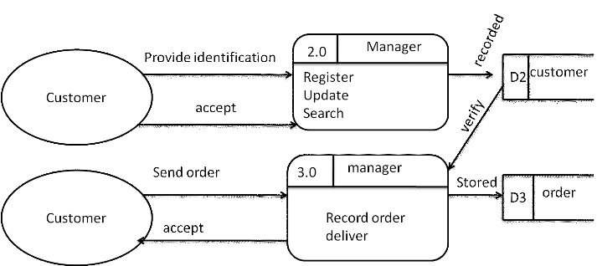

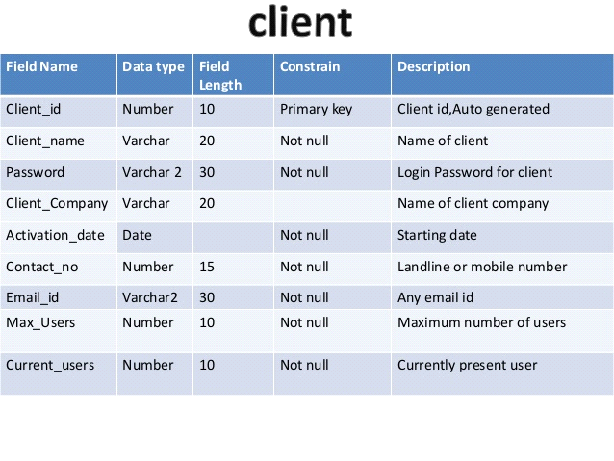
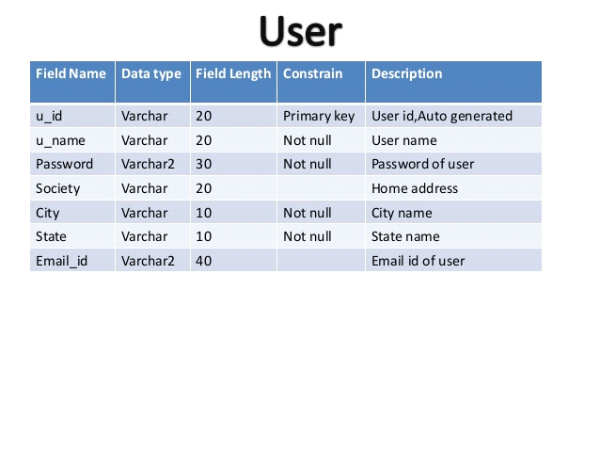
Class Diagram
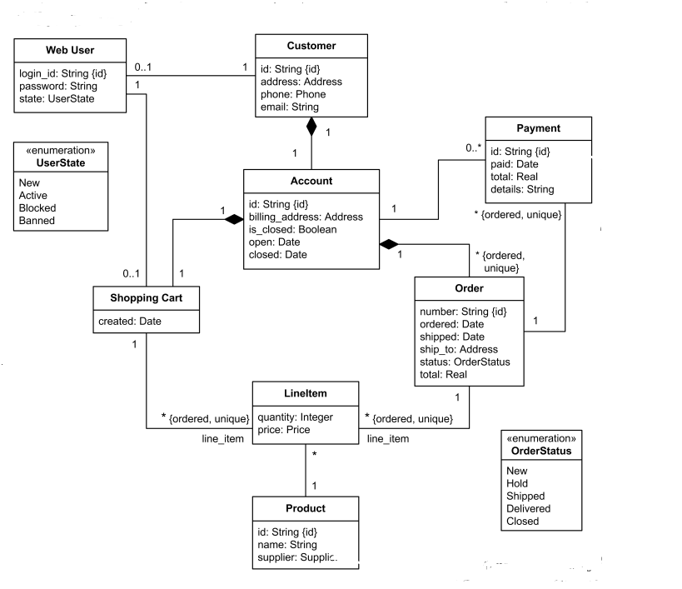

Sequence / Collaboration Diagram:

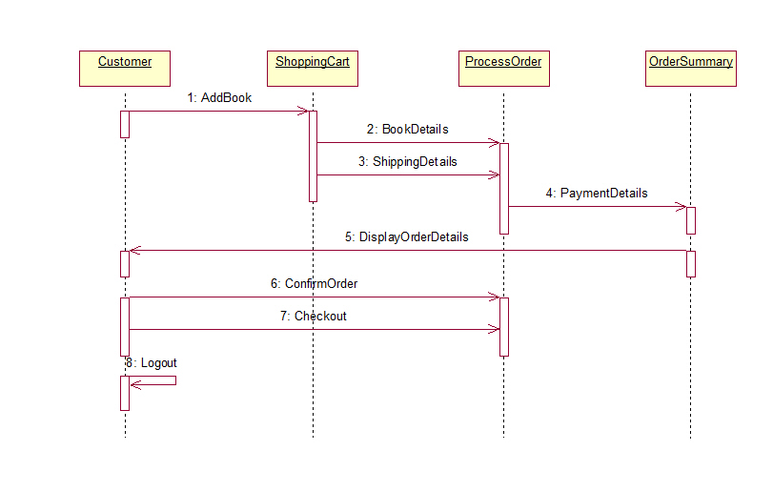
Operation contracts
Traditional consumer protection guidelines:
These protect purchasers and consumers whether they are buying the goods over the counter of a shop or over the internet. For instance, the Sale of Goods Act gives certain rights to purchasers about the quality of the goods they receive, and their rights if the goods fail to live up to these standards.

Online guidelines:
These guidelines are new and were brought into force largely to protect consumers' rights when they buy products either over the internet or by telephone. Information that must be supplied

The various regulations share a central theme:
Companies should not hide themselves from purchasers and should provide as much information to purchasers as possible.

State Transition Diagram:
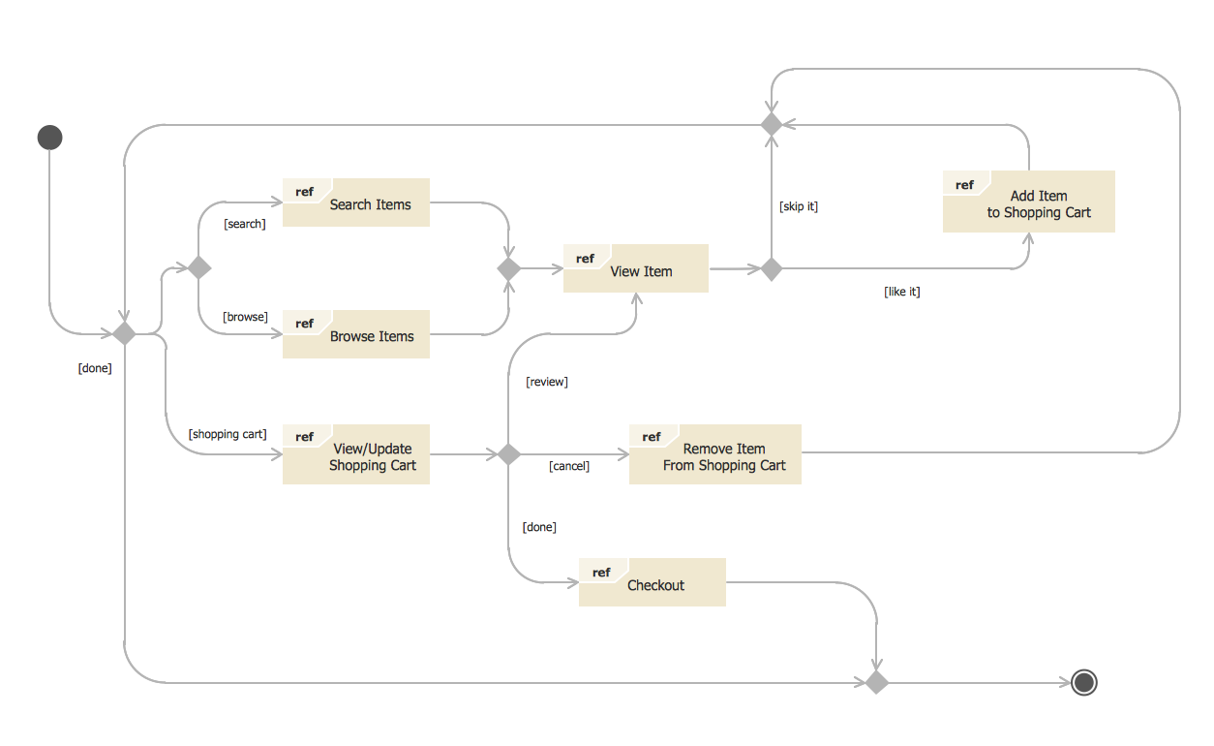

- Component Diagram:
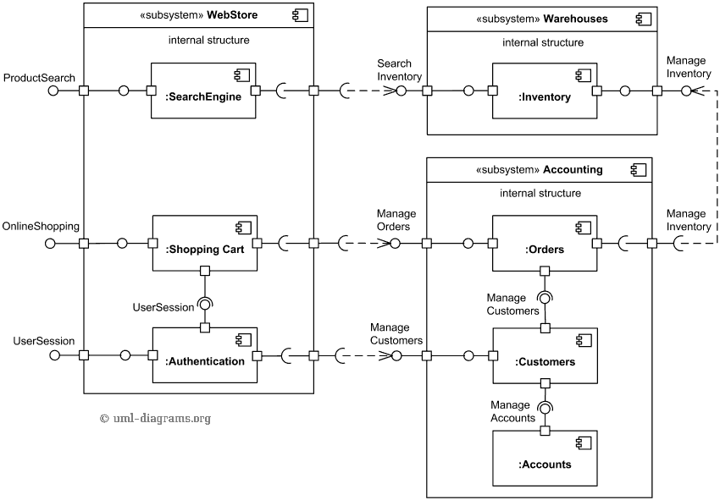

- Deployment Diagram
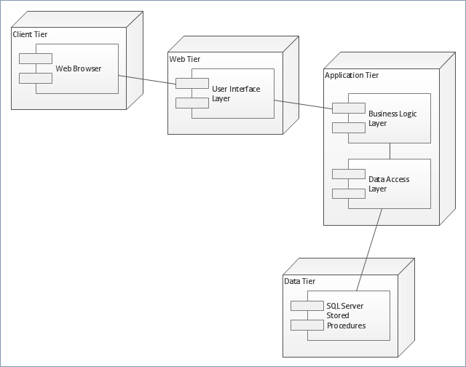

- Data Flow diagram
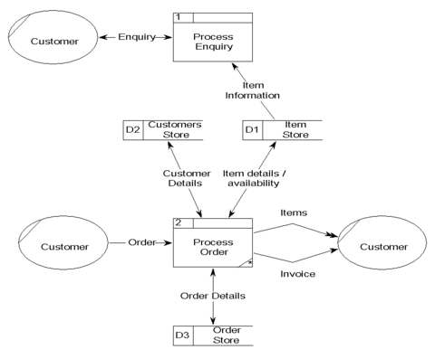

Chapter 5
Implementation
The all the specification is implemented in the android app through android studio and connected with the database which is designed in the visual studio both android app and database relates to each other through API process is particularly authentication through these API.
Important Flow Control/Pseudo codes:
- Avoid recursive loops in the system
- Avoid complex structure in the method of implementation throughout the process
- Process description properly defined
- Prefer nested and switch statements in the complex conditions
- Nested loops are used in the system
Components, Libraries, Web Services and stubs:
Products, items, database APIs are used in the system backend and frontend to communicate with each other properly through this the system working to server is communicate through APIs.

Deployment Environment:
Deployment environment is android studio in which app working is operational. backend server and front server are connected with each other which is particularly through APIs to communicate with each other for front end and back end panels.

Tools and Techniques:
- Visual studio
- MySQL
- .NET
- programming

Best Practices / Coding Standards:
- Proper specification is required to solve the problem
- Proper error checking
- More efficiency
- Rechecking the code properly
- Write the code in one statement
- Use parentheses to make sure statement is closed

Version Control:
Mercurial or Subversion or git are used in the application structure.

Chapter 6

Testing and Evaluation

Chapter 6: Testing and Evaluation

6.1. Use Case Testing
6.1.1. Admin login
Table no. 6.1.1
Positive Test Case
ID | TC_01
Priority | High
Description | Admin should be logged in after entering the correct email and password if the user is registered.
Reference | Functional Requirement reference.
User | Admin
Pre-Conditions | (i) | System is online
 | (ii) | Login form should be working
 | (iii) | The user should have internet access
Steps | (i) | Open the web link to the system
 | (ii) | Enter username
 | (iii) | Enter the password
 | (iv) | Press login
Input Criteria | Username: xyz Password: ******
Expected  Result | Admin panel will be open.
Status | Pass

Table no. 6.1.2
Negative Test Case
ID | TC_01
Priority | High
Description | Admin should not be logged in after entering the incorrect email and password if the user is registered.
Reference | Functional Requirement reference.
User | Admin
Pre-Conditions | (i) | System is online
 | (ii) | Login form should be working
 | (iii) | The user should have internet access
Steps | (i) | Open the web link to the system
 | (ii) | Enter username
 | (iii) | Enter the password
 | (iv) | Press login
Input Criteria | Username: abc Password: ****
Expected  Result | Admin panel will not be opened.
Status | Pass

6.1.2. Add User
Table no. 6.2.1
Positive Test Case
ID | TC_02
Priority | High
Description | Admin will add new Users
Reference | Functional Requirement reference
User | Admin
Pre-Conditions | - The system should be working  - Admin should be logged in
Steps | (i) Admin will be logged in to the system (ii) Admin will check new authenticated Users (iii) Click on Add User button.
Input Criteria | Click the “Add User” button
Expected  Result | User added in the system
Status | Pass

Table no. 6.2.2
Negative Test Case
ID | TC_02
Priority | High
Description | Admin will add new Users
Reference | Functional Requirement reference
User | Admin
Pre-Conditions | - The system should be working  - Admin should be logged in
Steps | (i) Admin will be logged in to the system (ii) Admin will check new authenticated Users (iii) Click on Add User button.
Input Criteria | Not Click on the “Add User” button
Expected  Result | User not added in the system
Status | Pass

6.1.3. Delete User account

Table no. 6.3.1
Positive Test Case
ID | TC_03
Priority | High
Description | Admin delete a User account
Reference | Functional Requirement reference
User | Admin
Pre-Conditions | - Admin should be logged in  - There should be an existing account which admin wants to delete
Steps | - Admin will be logged in to the system  - Admin will check whether there is an existing account or not  - Click on the “Delete User” button
Input Criteria | Click the “Delete User” button
Expected  Result | User deleted from the system
Status | Pass

Table no. 6.3.2
Negative Test Case
ID | TC_03
Priority | High
Description | Admin delete a User account
Reference | Functional Requirement reference
User | Admin
Pre-Conditions | - Admin should be logged in  - There should be an existing account which admin wants to delete
Steps | - Admin will be logged in to the system  - Admin will check whether there is an existing account or not  - Click on the “Delete User” button
Input Criteria | Not Click the “Delete User” button
Expected  Result | User not deleted from the system
Status | Pass

Equivalence partitioning
Add User
- Table no. 6.9.1
Field Name | Data type | Invalid | Valid | Invalid
First Name | String | Less than 1, no numeric, special characters | Character 1-15 | More than 15  not accept
Last Name | String | Less than 1, no numeric, special characters | Character 1-15 | More than 15  not accept
Email | Email | Missing ‘.’ | Must be valid email type | Missing ‘@’
Password | Varchar | Less than 8 not accepted | Alphanumeric characters >=8 | Less than 8 not accepted
Phone | Digits | Less than and greater than 13 not accepted | 13 number  digits | First, 2 digits should be ‘03’
CNIC | Digits | Less than 15  not accepted | CNIC Number pattern in  numeric | Greater than 15 not accepted

Login
Table no. 6.9.2
Field Name | Data type | Invalid | Valid | Invalid
Email | Email | Missing ‘.’ | Must be valid email type | Missing ‘@’
Password | Varchar | Less than 8 not accepted | Alphanumeric characters >=8 | Less than 8 not accepted

Table no. 6.9.2

6.3. Boundary value analysis
N/A

6.4. Data flow testing
Most of the product uses the variables to make the data flow within the program. The program may use multiple variables to calculate values for different variables. Now, these variables get some values from the user interface or sometimes from different sources. This complexity makes a program full of risk. So testing these variable data flow makes sense and Dataflow testing concept can be used to test all the variables from the program.
Levels of Dataflow Testing:
- Static data flow testing
- Identifying Potential Defects within the program.
- Analyzing code for defects
- The code will not be executed
- Dynamic data flow testing
- We will execute the program
- Looks like a control flow testing
- List out the path need test
About Variables:
There are two types of variable in a program called use and definition occurrence.
Definition Occurrence: Values are assigned to variables.
Use Occurrence: Values are used in the program from other variables.
Predicate Use Occurrence: Value of this type of the variable will be used to an execution path.
Computational Use Occurrence: Value of variable will be used to calculate the value of another variable.
Def-Use Pair Variable: It is a pair of Definition Occurrence and Uses Occurrence.

Unit testing

The level of testing is called unit testing. In this, different modules are tested against the specifications produced during design for the modules. Unit testing is essential for verification of the code produced during the coding phase, and hence the goal is set to test internal logic of the modules.

Integration testing

The next level of testing is often called the integration testing in this many tested modules are combined into subsystems, which are then tested. The goal here is to see if the modules can be integrated properly, the emphasis being on testing interface between modules, this testing activity can be considered as testing design, and hence the emphasis on testing modules interactions.

Performance testing
Performance testing should be carried out after the implementation of the product. We shall test the speed, accuracy, and effectiveness of functions as well as quantitative test e.g. response time of any function. We have tested the performance of our system by checking the working of every complex operation, again and again, multiple times. We have followed the following steps.
- List of all complex functions especially database related function.
- Assess response time and accuracy of core functions.
- Risk assessment of error or exception code (if any).

Stress Testing
Stress testing should also be carried out after the implementation of the product. We shall test the product’s robustness, availability, and reliability under extreme conditions. The goal of stress testing is to identify application issues that arise or become apparent only under extreme conditions. We have tested our system by simultaneously using our system as a different user and performing their associated tasks in a continuous manner. Following steps have been followed:
- We have analyzed system behavior under high traffic.
- We have gathered statistics reviews about crashing app, time taking operations and shall resolve those issues in later revisions.

Chapter 7

Summary, Conclusion and Future Enhancements

Chapter 7: Summary, Conclusion & Future Enhancements

Project Summary
GROCEPK will be an online store which is a place like Super market most of the products is available in our app and website that’s improve shopping by make it faster and easier which improve the shopping easier. User can select and choose the Products. Life is so much busy everyone needs something that save their time. Grocery is something that we need daily in majority of houses both men and women work they don’t have time to buy grocery because of their busy schedule or mostly men have jobs from 9 to 5 and it is difficult for them to spare some time for this little “grocery” thing? Seeing this problem, we came up with an idea that there should be something time saving something that will bring ease to the lives of busy person. GROCEPK is the solution. You can have you desire grocery at your doorstep in just few time by ordering on our web/app. We have an online portal through which any one can order anything like flour, milk, vegetable spices, meat etc. This is the need of every house and as we did survey about this Business 70% of people are willing to buy things online rather to go to the stores.

Achievements and Improvements
During this process of product development we learned a lot of skills.
With respect to the product, the biggest obstacle we have faced is the awareness of such products in the native market; we have overcome this hinder to some extent by showcasing our idea and prototype at various events where we have found the very encouraging response by the audience. Soon we’ll launch our product with the best benefits.

Lessons Learnt
We absorb very much from this project. This project sharpens our skills in hardware development, designing tools, and many management concepts as well as how to deal with a problem and how to stick for finding the solution to any problem until you fond. As well as technical skills this project also enhances our personal development skills such as team working, dedication. Our passion for making a unique product that contains innovation and nationwide best achievement and we succeeded it. We continue our work after this to make it through worldwide. This project is a stepping stone for us, in the beginning, we don’t even know that if we accomplished it or not but due to our hardworking and research we do it and it’s an achievement for us that motivates us to do better and more.

Future Enhancements/Recommendations
So generally, there are many enhancements we want to put in our product i.e.
- Upgrade to the more better interface.
- Soon launch Android/IOS app.
- Promote through Sci

Appendices

Appendix A: User Manual
In the appendix section, we describe the different phases of the user interface and also describe how a user can use our project. Secondly, we describe our promotional plan and promotional materials like broacher, banner, standee, and other marketing materials. We also describe other interfaces of our project.
Appendix A: User Manual

There is no user manual for our project at this time.
A.1. First Level Heading
N/A
A.1.1. Second level heading
N/A
A.1.1.1. Third level heading
N/A

Appendix B: Administrator Manual
There is no administration manual for our project.
B.1. First Level Heading
N/A

B.1.1. Second level heading
N/A
B.1.1.1. Third level heading
N/A

Appendix C: Information / Promotional Material
This chapter describes the promotional material that we used for the promotion of our Project “Grocepk”

  - Broacher

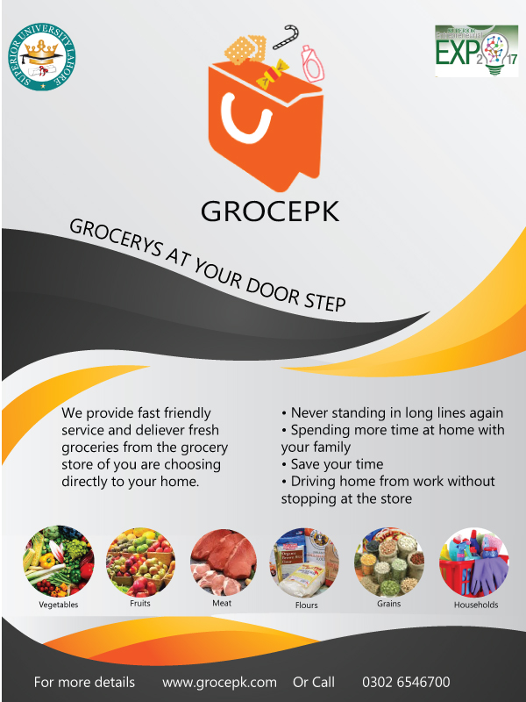

  - Standee
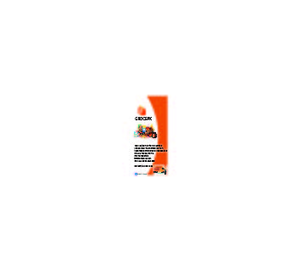

  - Banner
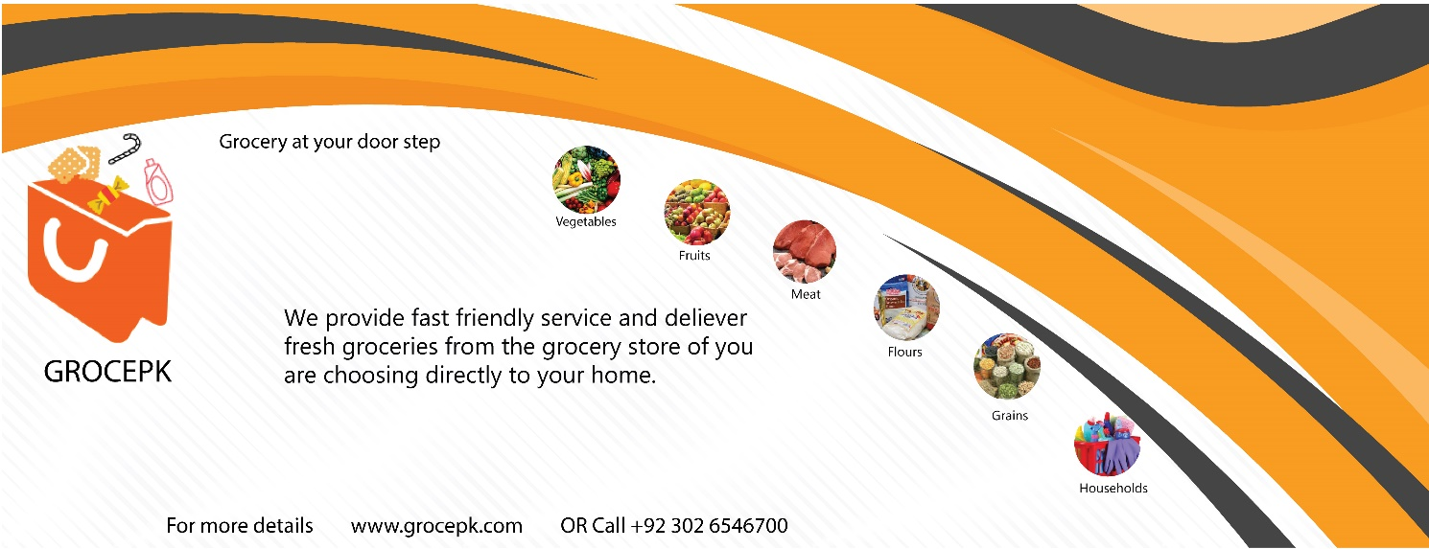

Reference and Bibliography

Reference and Bibliography

www.google.com
www.bing.com
www.youtube.com
Index

Index

[A]

[B]

[C]

