Dual Axis Solar Tracking System

Final Year Project

Session 2018-2022

A project submitted in partial fulfillment of the degree of

BS in Computer Sciences


Department of Computer Sciences
Faculty of Computer Science & Information Technology
Superior University, Lahore

Spring 2022
Type (Nature of project) |  |  | [ ] Development [ ] Research [ ] R&D
Area of specialization
FYP ID |  |  | FYP-BCSM-F21-015
Project Group Members
Sr.# | Reg. # | Student Name |  | Email ID | *Signature
(i) | BCSM-F17-174 | Rashid Latif |  | BCSM-F17-174@Superior.edu.pk | Rashid Latif
(ii) | BCSM-F17-182 | Muhammad Ali |  | BCSM-F17-182@Superior.edu.pk | M.Ali
(iii) | BCSM-F17-212 | Muhammad Muazam |  | BCSM-F17-212@Superior.edu.pk | M.Muazam

*The candidates confirm that the work submitted is their own and appropriate credit has been given where reference has been made to work of others

Plagiarism Free Certificate
This is to certify that, I Rashid S/D of Abdul Latif, group leader of FYP under registration no FYP-BCSM-F21-015 at Computer Science Department, The Superior University, Lahore. I declare that my FYP report is checked by my supervisor.

Date: Name of Group Leader: Rashid Latif Signature: _____Rashid_____
Name of Supervisor: Miss.Maria
Designation: Lecturer
Signature: ________________

HoD: Dr. Irfan-ud-Din
Signature: _______________

Project Report
Dual Axis Solar Tracking System

Change Record
Author(s) | Version | Date | Notes | Supervisor’s Signature
 | 1.0

APPROVAL
Project Supervisor
Comments: ___________________________________________________________________
_____________________________________________________________________________
Name:______________________________
Date:_______________________________ | Signature:__________________________

Project Manager
Comments: ___________________________________________________________________
_____________________________________________________________________________
Date:_______________________________ | Signature:__________________________

Head of the Department
Comments: ___________________________________________________________________
_____________________________________________________________________________
Date:_______________________________ | Signature:__________________________

Dedication

I dedicate this work to Allah, the Almighty, who is my creator and a source of inspiration, knowledge, and insight. Throughout this programmer, He has been my source of strength, and I have only been able to fly on His wings. I also dedicate this work to my parents and instructors, who have supported me along the way and ensured that I put up the effort necessary to complete what I have begun.
I'm grateful. There is no way to put a number on my affection for you all. Allah be with you.

Acknowledgements

My supervisor is the most encouraging person I have ever met, and he has given us this wonderful opportunity to develop our futures. I couldn't be more grateful for him. I would want to convey my sincere gratitude to GOD Almighty for his kindness, wisdom, and protection in helping me get over the challenges of this task. For their intellectual upbringing, I owe a great deal to my supervisor, Ms. Maria Iqbal (OUR LECTURER), as well as the entire staff of our department of Computer Science. I want to express my sincere gratitude to my parents' beloved siblings, whose moral and financial support cannot be overstated. Also, a hearty thank you and special greetings to all of my friends—there are too many to list—whose support helped this work succeed.

Executive Summary
The whole procedure includes reading data from several sensors, evaluating it digitally, and then determining the precise location of the sun in relation to the east and west. Once more, the system is provided with certain fixed values based on the sun's position in relation to the north and south axes of the earth. The system as a whole is capable of tracking the sun's movement both in a horizontal and vertical axis. The entire system is split into two components to streamline the design and implementation process.
These are listed below:
Designing a mechanical system (A) or an electrical circuit (B).
Design of mechanical systems
(A). Because the goal was to create an energy-efficient solar tracking system, which required the tracking motors to operate intelligently, assembling the mechanical system was the most difficult aspect of this system.
Electrical circuit design:
(B). Three units essentially make up the entire electrical system. These are the movement adjustment unit, the control unit, and the sensor unit. Light, time, and position are three separate parameters that the sensor unit senses and translates into the necessary electrical impulses. The control unit receives the electrical signals from the sensor unit at that point.
A device called solar tracking is designed to increase power output, particularly for photovoltaic solar panels. In this research, a small-scale functioning model was created for demonstration reasons after a full-scale Dual-Axis Solar Tracker System was examined in challenging weather circumstances. SKF has the chance to access all four sectors with a single product by industrializing the dual axis solar tracker. The difficult part is demonstrating that the product is technically sound and cost-effective.

Table of Contents
Dual Axis Solar Tracking System i
Final Year Project i
Session 2018-2022 i
BS in Computer Sciences i
Plagiarism Free Certificate ii
Dedication v
Acknowledgements vi
Executive Summary vii
List of Figures xi
List of Tables xii
Chapter 1 14
Introduction 14
1.1. Background 15
1.2. Motivations and Challenges 15
1.3. Goals and Objectives 16
1.4. Literature Review/Existing Solutions 16
1.5. Gap Analysis 16
1.6. Proposed Solution 16
1.7. Project Plan 17
1.7.1. Work Breakdown Structure 18
1.7.2. Roles & Responsibility Matrix 18
1.7.3. Gantt chart 19
1.8. Report Outline 19
Chapter 2 20
Software Requirement 20
Specifications 20
2.1. Introduction 21
2.1.1 Purpose 21
2.1.1. Document Conventions 21
2.1.2. Intended Audience and Reading Suggestions 21
2.1.3. Product Scope 21
2.1.4. References 22
2.2. Overall Description 22
2.2.1. Product Perspective 22
2.2.2. Product Functions 22
2.2.3. User Classes and Characteristics 22
2.2.4. Operating Environment 22
2.2.5. Design and Implementation Constraints 23
2.2.6. User Documentation 24
2.2.7. Assumptions and Dependencies 24
2.3. External Interface Requirements 24
2.3.1. User Interfaces 24
2.3.2. Hardware Interfaces 24
2.3.3. Software Interfaces 25
2.3.4. Communications Interfaces 25
2.4. System Features 25
2.4.1. System Feature 1 25
2.4.1.1. Description and Priority 25
2.4.1.2. Stimulus/Response Sequences 25
2.4.1.3. Functional Requirements 26
2.4.2. System Feature 2 26
2.4.2.1. Description and Priority 26
2.4.2.2. Stimulus/Response Sequences 26
2.4.2.3. Functional Requirements 26
2.4.3. System Feature 3 (and so on) 26
2.5. Other Nonfunctional Requirements 26
2.5.1. Performance Requirements 27
2.5.2. Safety Requirements 27
2.5.3. Security Requirements 27
2.5.4. Software Quality Attributes 27
2.5.5. Business Rules 27
2.6. Other Requirements 27
Chapter 3 28
Use Case Analysis 28
Use Case Model 29
3.1. Use Case Descriptions 29
Chapter 4 30
System Design 30
4.1. Architecture Diagram 31
4.2. Domain Model 32
4.3. Entity Relationship Diagram with data dictionary 33
4.4. Class Diagram 34
4.5. Sequence / Collaboration Diagram 35
4.6. Operation contracts 35
4.7. Activity Diagram 37
4.8. Component Diagram 38
4.9. Deployment Diagram 39
4.10. Data Flow diagram 40
Chapter 5 41
Implementation 41
5.1. Important Flow Control/Pseudo codes 42
5.2. Components, Libraries, Web Services and stubs 46
5.3. Deployment Environment 48
5.4. Tools and Techniques 48
5.5. Best Practices / Coding Standards 49
5.6. Version Control 49
Chapter 6 50
Testing and Evaluation 50
6.1. Use Case Testing 51
6.2. Equivalence partitioning 54
6.3. Boundary value analysis 58
6.4. Data flow testing 58
6.5. Unit testing 59
6.6. Integration testing 60
6.7. Performance testing 60
6.8. Stress Testing 60
Chapter 7 61
Summary, Conclusion and Future Enhancements 61
7.1. Project Summary 62
7.2. Achievements and Improvements 62
7.3. Critical Review 63
7.4. Lessons Learnt 63
7.5. Future Enhancements/Recommendations 63
Appendices 1
Appendix A: User Manual 2
Appendix B: Administrator Manual 3
Appendix C: Information / Promotional Material 4
Appendix [no.]: Appendix Title 6
Reference and Bibliography 7
Index 9

List of Figures

1.7.1 Work Break Down Structure 18
1.7.2 Roles and Responsibility Matrix 18
1.7.3 Gantt Chart 19
2.2.5 Design and Implementation Constraints 23
2.3.1 User Interfaces 24
2.3.2 Use Case Model 29
4.1 Architecture Diagram 31
4.2 Domain Model 32
4.3 Entity Relationship Diagram 33
4.4 Class Diagram 34
4.5 Sequence/ Collaboration Diagram 35
4.6 Activity Diagram 37
4.7 Component Diagram 38
4.8 Deployment Diagram 39
4.9 Data Flow Diagram 40
5.3 deployment Environmental Diagram 48

List of Tables

1.7.2 Roles & Responsibility Matrix 18
6 Implementation 42
6.1 Use Case Testing 51
6.7 Equivalence Portioning 53
6.10 Unit Testing 59

Chapter 1

Introduction

Chapter 1: Introduction
Due to the inevitable future depletion of fossil fuel inventories, renewable energy sources have gained the interest among researchers, entrepreneurs, investors, and decision-makers worldwide. Some of the emerging sources of energy include hydroelectricity, biomass, solar, wind, and geothermal. They are seen to be acceptable alternatives to fossil fuels since they are renewable. Among such types of energy, photovoltaic systems (PV) energy is among the most frequently used. Solar cells are now being implemented more commonly in homes as a result of research and development programs to improve their efficiency and lower their cost. According to the World Energy Council (IEA), solar panel capacity has expanded by an average of 49% yearly since the early 2000s.

Background
Renewable energy, especially green energy, is greatly needed and in demand. In the future, we'll need an energy source that will be available to future generations as a sustainable energy source. We need to develop our green energy market for a number of reasons, including the need for a sustainable energy market as well as the need to provide future generations with renewable energy. In contrast to oil, which has clearly not grown sustainably in recent years, green energy has. Electricity is necessary to run most of our daily activities, including running our homes, businesses, and other establishments, and its production requires large power plants that cost billions of dollars to operate. But what if we could eliminate the need for all the resources that go into producing this energy and instead use green energy to supply power directly to users like corporations, the military, or even individual homes.

Motivations and Challenges
The project's inspiration stemmed from solar energy's societal impact. Solar panels and other energy-saving devices must be employed to their fullest extent in the face of a worldwide energy crisis. The need for techniques that can maximize their energy gathering is therefore great. Solar tracking systems are one of these techniques. The use of these devices has increased over the past ten years, giving rise to various tracking systems. In fact, a former CWU student has already finished a solar tracker. The goal of this project is to create a fully functional, dual-axes, active solar tracker that will outperform the current version. Through an unprecedented period of technological development, humanity has grown enormously dependent on energy. The source of electricity has become the most important responsibility for society. The solar cell was created in an effort to expand the supply of electricity. A solar cell is a device that uses the photoelectric effect to capture light energy directly into electricity.

Goals and Objectives
The dual-axis tracker's main goal is to track the sun's position in order to use energy as efficiently as possible. The change in angular velocity is estimated using the assumption that the tracker would change positions every.01 seconds and the assumption that the sun moves at a speed of 15 degrees per hour. Appendix A2 contains the analysis, while Appendix B5 contains references to the data.

Literature Review/Existing Solutions
The use of solar energy has another issue. Due to the Earth's perpetual motion, permanent solar energy panels are typically not oriented straight toward the sun. If this system's failure to achieve the highest efficiency is the result. The bigger option for using this technology to get the entire output power is the solar tracking equipment. This is the main justification behind the implementation of the solar tracker project. The solar tracking system must move with the sun in addition to creating more electricity. Indirectly, the cost of putting up more photovoltaic power will likely decrease. Solar electricity, which is only accessible in additional equipment, has the major drawback that it means controlling a significant time to adjust the sun's beams.

Gap Analysis
The scope of testing and evaluation will be narrowly focused on one component in respect to the stated need and performance forecast and won't need to assess other factors as severely. For instance, straightforward calculations or measurements will be used to assess the weight, price, and construction. On the other hand, the tolerance of the axis ranges is a very significant aspect that needs to be checked and given a more thorough evaluation. The altitudinal axis must be able to maintain a degree that optimizes energy absorption while retaining above a set angle in order to avoid structural collapse. A minimum 180-degree rotation of the azimuthal axis is required. The PV's theoretical power output will indeed be contrasted with both the findings of the analysis to ensure that the panel can establish a horizontal relationship with the sunshine within 1-3 deg of fall off.

Proposed Solution
In order to ensure that photovoltaic arrays receive the maximum amount of sunshine all through the day, solar panels are installed atop a device called a solar tracker, which monitors the sun's course across the sky. After discovering the sunlight, the tracker will make an effort to travel through the path to make sure the right sunlight is collected. Single-axis solar monitors and the double sunlight trackers are the two types of sensor mounts that are available. On single-axis solar trackers, the axles can be either two - dimensional. The horizontal form is used in tropical regions where the sun rises relatively high at midday but the days are short. While summer days can be quite long and the sun somehow doesn't rise very high at higher elevations, the vertical type is a worker. The solar tracker system is the most basic and popular method.

Project Plan
In this section, we'll split up the work among our team members according to a weekly schedule. It is described as per timetable in the large chart. Finding the best source of sunlight for the solar panel is another objective of this project. The project divides hardware and software development into two different segments. As the world's population increases, we are concerned that we will run out of electricity. Hydroelectric plants, nuclear reactors, windmills, and solar arrays are just a handful of the many ways to generate electricity. These two sources of energy aren't renewable, therefore we can't rely completely on them. It is challenging to harness nuclear and hydroelectric energy. Both solar and wind energy are renewable sources of energy, and numerous power plants have been constructed using these technologies as of late. We are developing trackers with two axes or two orientations. In this arrangement, the direction of the solar panel can be changed in both X and Y directions. This increases the effectiveness of the solar system by allowing the Sun's rays to be focused more accurately. The proposed tracking method is more efficient in tracing the sun due to PV panel rotation on two axes. The tracker is built using two stepper motors, four LDR sensors, and a PIC microprocessor. Using light sensor and one motor, the tracker is oriented towards to the sun. The tracker is oriented to approach the sun's north-south rays using the other set of sensors and the motor at its base. Only two stepper motors are employed in this arrangement. The lower panel holder follows the sun's parabolic path, while the upper panel holder follows it linearly using stepper motors. In order to operate the stepper motors and sensors, an Arduino microcontroller is needed. The microprocessor issues the command to the motors based on the information from the sensors. When the LDR sensors detect light, a signal is sent to the microcontroller.

Work Breakdown Structure
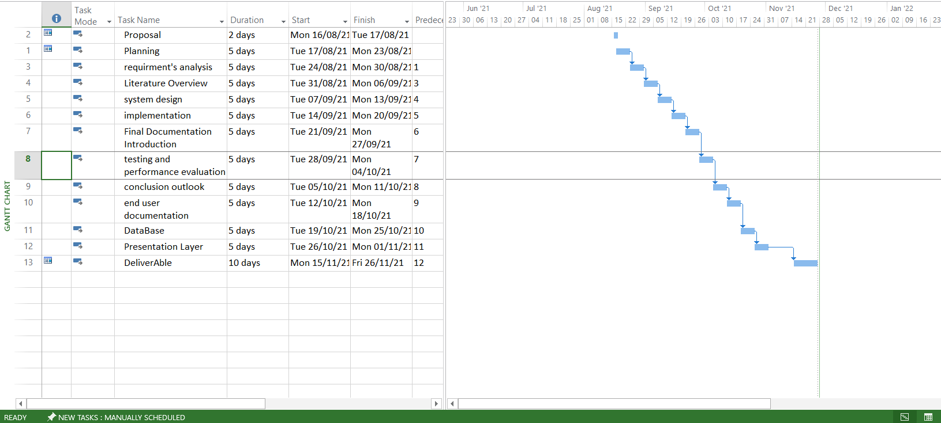

Roles & Responsibility Matrix

WBS # | WBS Deliverable | Activity # | Duration  (# of Days) | Responsible Team Member(s)  & Role(s)
2.1 | Planning |  | 5 | Rashid Latif
2.2 | 1.1.Requirments analysis | 1 | 10 | M. Ali
2.3 | 1.1. System Design | 2 | 15 | Rashid Latif
2.4 | 1.1. Implementation | 3 | 20 | Rashid Latif
2.6 | Final Documentation Introduction | 4 | 25 | M. Ali
2.5 | Testing & Performance Evaluation | 5 | 35 | M. Muazam
2.7 | Conclusion & Outlook | 6 | 40 | M. Muazam
2.8 | End User Documentation | 7 | 45 | M. Ali
2.9 | System Administrator Documentation | 8 | 50 | M. Muazam
2.10 | Database | 9 | 55 | Rashid Latif

Gantt chart

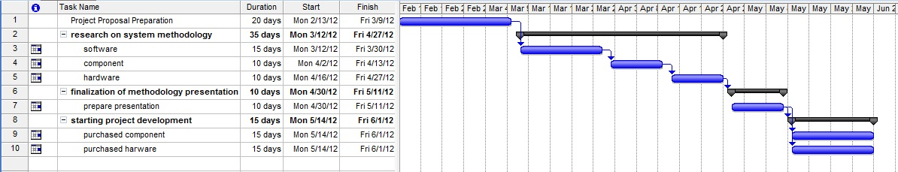

Report Outline
A hardware-based solution system called the Dual Axis and Solar Tracking System enables users to track the sun's location for best energy efficiency. Its architecture is able to track the sun's azimuth and elevation and adjust the solar panels to achieve maximum smoothness at any time or location transverse direction universities with electrically controlled device layout, sensors, embedded controllers, AC motors, and the GSM automated report of failure notification. This ensures that solar panels always face the sun and enables them to function at their most effective level. With a dual-axis architecture, this system uses four groups of CDS as sensing elements to detect voltage changes and calculate the sun azimuth angle. The integrated controller serves as the main system controller. An AC motor and motorized faders (EW) can be used to lock perpendicular solar panels into position (north-south). Software written in C allows for quick and precise tracking of solar angular positions and can also operate on two axes. In comparison to a fixed solar power system, our testing findings demonstrate that combining a dual-axis solar tracking system with a solar power system increases generating power capacity by 30% and has a low failure rate. By utilizing this technology, conventional tracking systems can be made more reliable and more beneficial.

Chapter 2

Software Requirement

Specifications

Chapter 2: Software Requirement Specifications

Introduction

2.1.1 Purpose

Normally, a mirror is oriented and sunlight is directed along a fixed axis towards a stationary receiver using dual-axis tracking. Because they monitor the sun both vertically and horizontally, these trackers help to maximize solar power generation.

Document Conventions

A solar tracker is essentially a gadget that solar panels are mounted on that follows the sun's path across the sky to make sure that the panels receive the most sunlight possible throughout the day. The tracker will attempt to go through the path after locating the sunlight to make sure the best sunlight is picked up. There are two different types of tracker mounts: single-axis solar trackers and double-axis solar trackers.

Intended Audience and Reading Suggestions
The dual axis system's target market is any place that uses electricity, including residences, businesses, cooperative sectors, and mills. All audiences are included in our audience, just as there are three different audiences: distinct populations: the "lay," "managerial," and "experts" audiences. The "lay" audience is the group of inexperienced professionals. They relate to articles' human-interest elements. We will include a book with the project so that everyone can quickly learn how to use it properly. We will also include a tangible comment area on the project.

Product Scope
The tracking capability and longevity can be extended by using more powerful motors, but the cost will be slightly higher. However, utilizing Arduino instead of the microcontroller board will make it less expensive, albeit being more challenging. Whether they are single-axis or dual-axis, solar trackers will aid in maximizing solar energy. It now seems to be quite relevant in terms of the future of the solar tracker industry. When compared to a stationary PV system, photovoltaic tracking systems with single and dual axes, as well as the proper control systems, can boost electrical energy by 22–56 percent. The most prevalent and effective types of control are those based on sensors and microprocessors.

References
https://digitalcommons.cwu.edu/cgi/viewcontent.cgi?article=1094&context=undergradproj
http://fypsaya.blogspot.com/p/my-proposal.html
https://rcciit.org/students_projects/projects/ee/2018/GR1.pdf

Overall Description

Product Perspective
A solar tracker is essentially a gadget that solar panels are mounted on that follows the sun's path across the sky to make sure that the panels receive the most sunlight possible throughout the day. The tracker will attempt to go through the path after locating the sunlight to make sure the best sunlight is picked up. There are two different types of tracker mounts: single-axis solar trackers and double-axis solar trackers. Axles on single-axis solar trackers can be either horizontal or vertical.

Product Functions
The dual-axis tracking device moves in sync with the sun to maximize solar energy collecting. Polar-axis tracking and altitude-azimuth tracking are the two subcategories of the dual-axis tracking system based on the kind of axis. Polar-axis tracking is also known as spinning-elevation tracking. Single-axis solar trackers and double-axis solar trackers are the two types of tracker mounts that are available. On single-axis solar trackers, the axles can be either vertical or horizontal.

User Classes and Characteristics
When a user installs Dual Axis Solar Detection, it truly functions as an autonomous drive system that runs without any input from the user. If an issue does arise, however, the user may simply attach an Arduino device to the system to fix it.

Operating Environment
At mega Microcontroller
Solar Panel
Servo Motor
- DC Motor
- Rain Sensor
- Humidity Sensor
- Temperature Sensor
- Resistor
- Capacitors
- Transistors
- Cables and Connectors
- Diodes
- PCB and Breadboards
- LED
- Transformer/Adapter
- Push Buttons
- Switch
- IC
- IC Sockets
- Arduino Compiler
- Programming Language: C

Design and Implementation Constraints
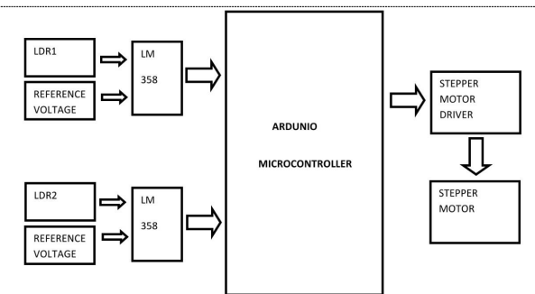
This is how the hardware implementation of this project appears. Here, the LM358 low power dual operational amplifier is used to test an LDR, a photo diode, and a photo transistor. These are then linked to the Stepper motor driver and Arduino microcontroller, respectively.

User Documentation
List the user documentation materials that will be included with the programmer, such as user manuals, online assistance, and tutorials. Please include any existing distribution formats or standards for user documentation.

Assumptions and Dependencies
In order to finish all the pieces of the solar tracking system, we will assemble it ourselves and use aftermarket items as necessary.

External Interface Requirements

User Interfaces

A tiny LCD in the Dual Axis Solar System simply displays voltage or the detection of the sun and rain.

There is no intricate or common user interface in this project.
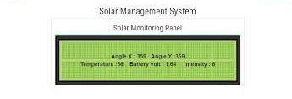

Hardware Interfaces
- DC Motor
- Rain Sensor
- Humidity Sensor
- Temperature Sensor
- Resistor
- Capacitors
- Transistors
- Cables and Connectors
- Diodes
- PCB and Breadboards
- LED
- Transformer/Adapter
- Push Buttons
- Switch
- IC
- IC Sockets

Software Interfaces
The application will be having the user interface only.

Communications Interfaces
Describe the specifications needed for any communication features this product may require, such as email, a web browser, network server communications protocols, electronic forms, etc. Please offer any message formats that are required. Indicate any communication standards that will be used, such as HTTP or FTP. Data transfer rates, synchronization processes, and any issues with communication security or encryption should all be mentioned.

System Features
- ON/OFF lights
- Led Indictors
- Sensor Alerts
- 360 Angle Rotation
- Panel Auto Rotation

System Feature 1

Description and Priority

Dual-axis systems function similarly to single-axis systems, but they are more effective in absorbing solar energy because they spin their axes along vertical and horizontal axes. Panel. In solar tracking systems, solar panels are mounted on a movable frame to follow the direction of the sun throughout the day. Patterns of stimuli and reaction.

Stimulus/Response Sequences
List the user activities and system responses that cause the desired behavior as specified in the feature's requirements. These will correspond to the dialogue-related use-case components.

Functional Requirements
Through the Arduino device the user will operating and controlling the Solar tracking system
REQ-SF1-1: Check Weather detection
REQ-SF1-2: Rotation Control
REQ-SF1-3: Auto On/Off
REQ-SF1-4: Power Generation
REQ-SF1-5: Photovoltaic generate electric power
REQ-SF1-6: Panel Rotation according to sunlight

System Feature 2

Description and Priority

The dual-axis operates similarly to the single axis, but by spinning its axis along both vertical and horizontal axes, it is better able to gather solar energy [1]. Panel. Solar panels are installed on a moving frame in solar tracking systems to follow the path of the sun throughout the day. Stimulus and response cycles.

Stimulus/Response Sequences
He can auto-lock or unlock the rotation, switch on and off the light, check how much battery life is left, and receive total counts of voltages. We will use an LCD tool to obtain all necessary operations on the LCD as well as the voltage that is dropped.

Functional Requirements
Through the Arduino device the user will operating and controlling the Solar tracking system

- REQ-SF1-1: Check Weather detection
- REQ-SF1-2: Rotation Control
- REQ-SF1-3: Auto On/Off
- REQ-SF1-4: User Control

System Feature 3 (and so on)

Other Nonfunctional Requirements
Maintainability
Reliability
Supportability
Quality
Efficiency

Performance Requirements
If the product has performance requirements for use in different scenarios, list them here and explain why they are necessary so that developers can fully grasp the goal and make the best possible design decisions. The timing relationships for real-time systems should be specified. Make these specifications as exact as you can. For particular functional needs or features, you might need to specify performance requirements.

Safety Requirements
Two axes A polar dual-axis solar system has been created, taking efficiency and safety into consideration. Rotating actuators, which are connected to worm gears to block the system in the stationary positions, power both motions (daily and seasonal). By merging the mechanical construction of the solar tracker with the electrical control system at the virtual prototype level, the tracking system is approached from a mechatronic perspective. By limiting the angular field of daily motion and the number of actuating actions, the tracking technique hopes to preserve as much solar energy as possible.

Security Requirements
Sensor Detection when the solar panel turned off or remove from the device.
- Sensor
- Auto locked

Software Quality Attributes

Business Rules
Do solar trackers justify the extra cost? Solar trackers do produce more power, but in most circumstances they are not worth the extra money. More solar panels might be installed for less money than a tracking system since solar panels are more affordable than before.

Other Requirements
Installation
Licensing and Certification
Equipment Standards and Warranties

Chapter 3

Use Case Analysis

Chapter 3: System Analysis
The Dual Axis Tracking System is, at last, turning becoming a reality thanks to the advancement of new electronic technologies and their combination with more established, conventional building technologies. Users may easily programmer Arduino to rotate up, down, left, or right according to their own needs by simply entering the appropriate code into the system.

Use Case Model

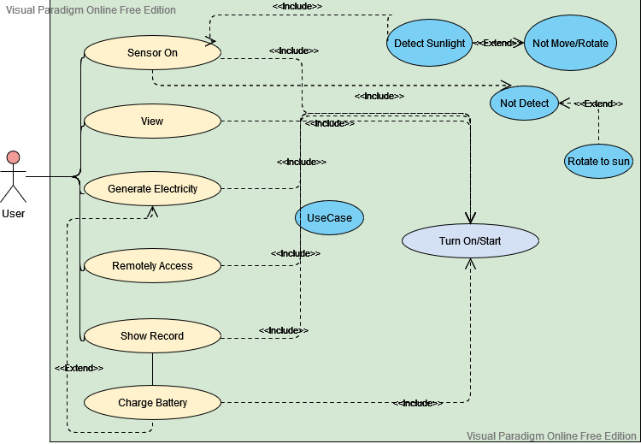

Use Case Descriptions
A collection of connected success and failure scenes that show on-screen actors using the framework to further an aim make up a utilization case. A circumstance is a specific series of interactions and relationships between performance artists and the discourse framework.

Chapter 4

System Design

Chapter 4: System Design
System Design
The major diagrams and models needed to graphically represent the system are included in this chapter. Below is a basic description of the system design:
This project is based on hardware. The project was examined by our staff. Therefore, we made a general mobile application so that anybody might use it to operate it in the future.

Architecture Diagram
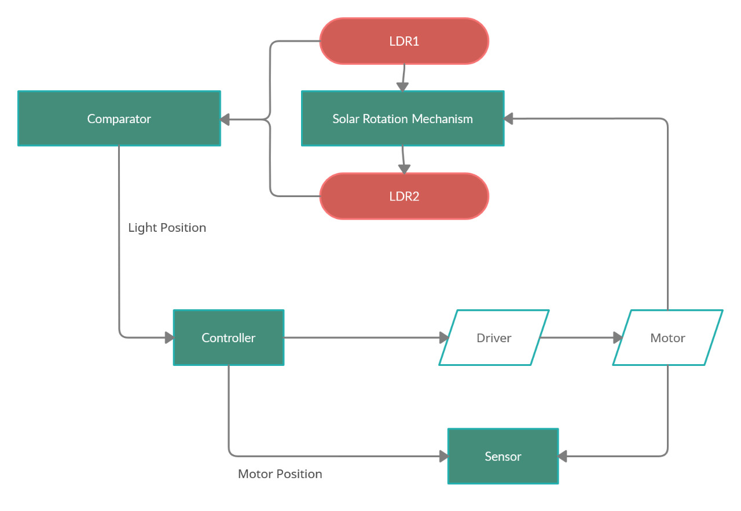

Domain Model
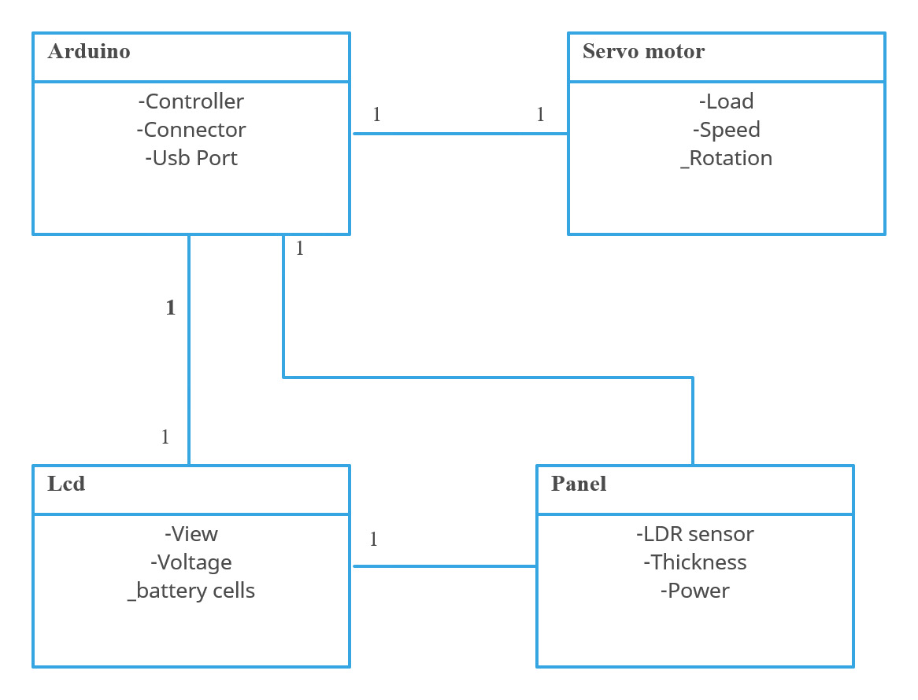

Entity Relationship Diagram with data dictionary
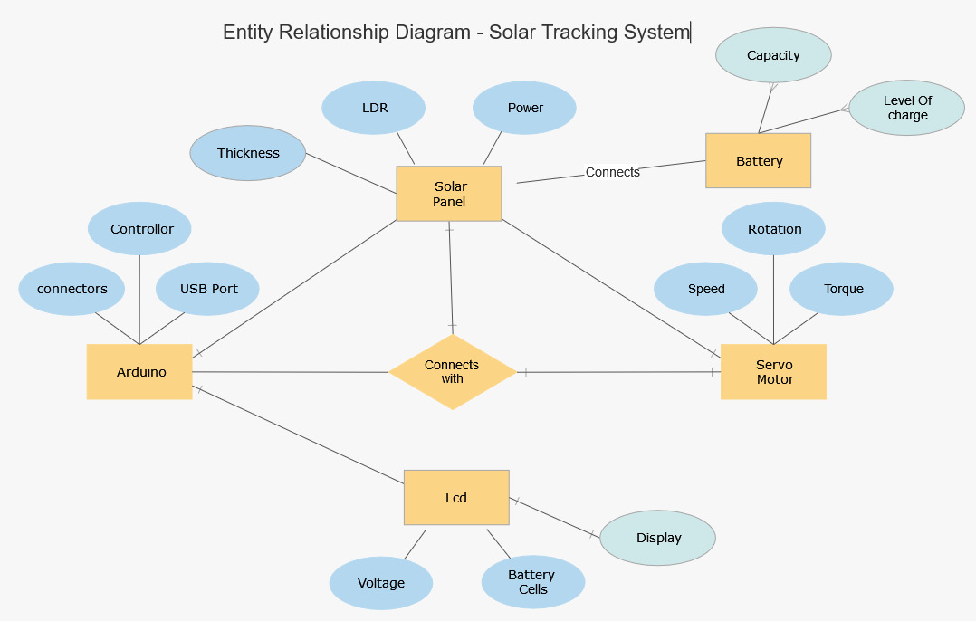

Class Diagram
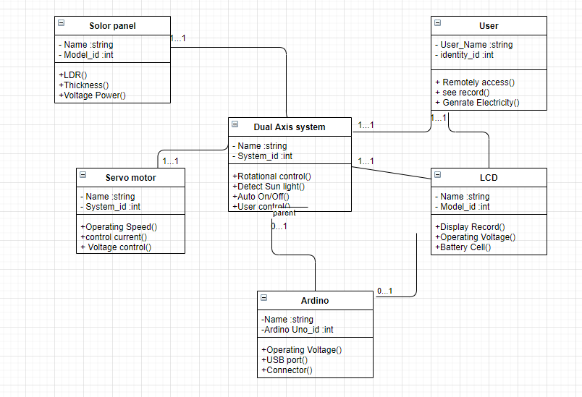

Sequence / Collaboration Diagram
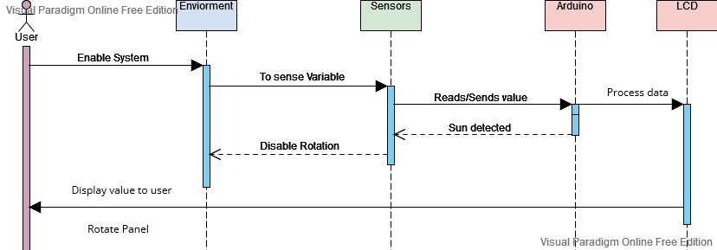

Operation contracts

Operation Contract#1

Name: Sensor on.
Responsibilities: Detect sun light.
Cross References: Use Case: Not move rotate able.
Exceptions: None.
Preconditions: Must be ON.
Post conditions: Not Detect

Operation Contract#2

Name: View.
Responsibilities: Turn ON.
Cross References: Use Case: Charge Battery.
Exceptions: None.
Preconditions: Must be ON.
Post conditions: Generate Electricity

Operation Contract#

Name: Generate Electricity
Responsibilities: Detect sun light.
Cross References: Use Case: Charge Battery.
Exceptions: None.
Preconditions: Must be ON.
Post conditions: Not Detect

Operation Contract#2

Name: Remotely Access
Responsibilities: None.
Cross References: Use Case: Charge Battery.
Exceptions: None.
Preconditions: Must be ON.
Post conditions: Generate Electricity

Operation Contract#2

Name: show record
Responsibilities: None.
Cross References: Use Case: Detect sun light.
Exceptions: None.
Preconditions: Must be Rotate.
Post conditions: Charge Battery

Activity Diagram
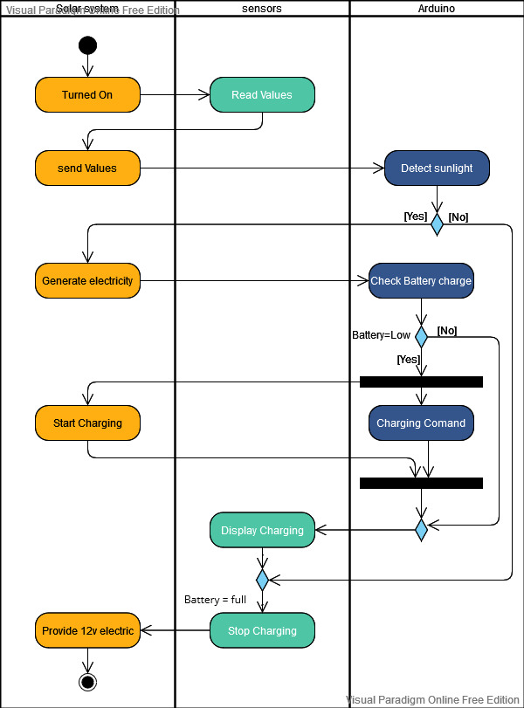

Component Diagram
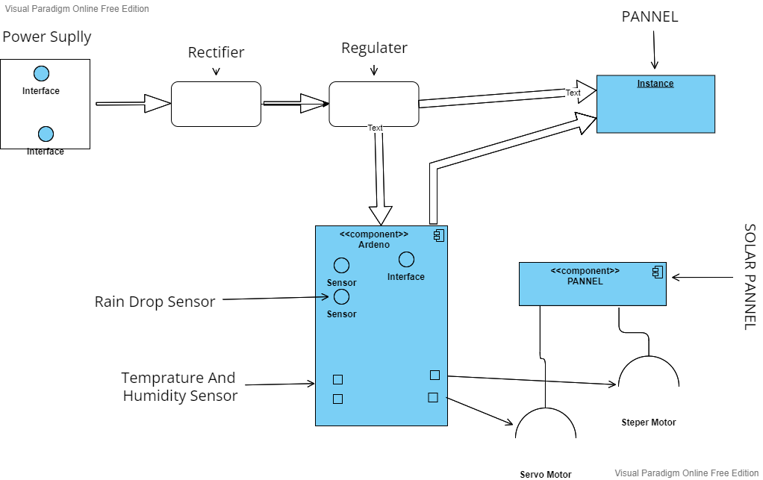

Deployment Diagram
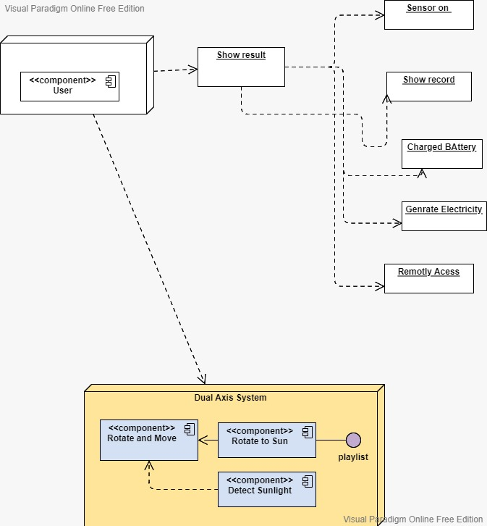

Data Flow diagram

Context level DFD – 0 level
The context level data flow diagram (DFD) illustrates how the system works as a whole. The system's whole user module is described in the (o) level DFD. The Dual Axis and Solar Tracking System's data flow diagram below demonstrates how two users may control the system and user.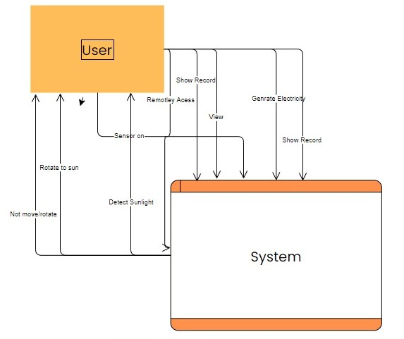

Chapter 5

Implementation

Chapter 5: Implementation
The chapter only provides a high-level overview of our project, including the technologies, approaches, best practices, and coding standards, as well as the third-party libraries and tools we'll be using to get the job done. Including requirement collection, analysis, design, implementation, testing, and deployment, we receive all the information we want for all the development phases. When implementing a system, we build the platform and determine whether it satisfies the criteria.

Requirement  Gathering & Analysis | We will gather all of the crucial needs throughout this phase, and all relevant assets and requirements will be available for analysis.  Then, the many areas of implementation's viability are developed (including time and cost).
Planning | On the basis of the evaluated facts and requirements, a strategy will be established during this phase. Each phase's duration and cost will also be determined.
Design | The development model will be chosen at this phase, and the supervisor will confirm it.
Implementation | Execution in accordance with specifications following the design phase.
Testing | Testing will examine functionality and requirements. There will be both dynamic and static testing. Dynamically using testing tools and statically by manually checking each piece of code. Static testing will decrease execution faults and enable us to detect errors.
Deployment | The system will be deployed when tests are finished and no new faults are found. Regression testing is carried out when faults are found or when changes are made as required.

Important Flow Control/Pseudo codes
Arduino Panel:
- Connectors
- Controller
- USB Port
Solar Panel:
- Thickness
- LDR
- Power
Servo Panel:
- Speed
- Rotation
- Torque
LCD Panel:
- Voltage
- Battery cell
- Display/Screen
Pseudo codes

int motorA1 = 5;
int motorA2 = 6;
int motorB1 = 9;
int motorB2 = 10;

int ldrX_1 = A3;
int ldrX_2 = A2;
int ldrY_1 = A1;
int ldrY_2 = A0;

int ldrXU = 0;
int ldrXD = 0;
int ldrYU = 0;
int ldrYD = 0;

void setup() {
Serial.begin(9600);

pinMode(motorA1, OUTPUT);
pinMode(motorA2, OUTPUT);
pinMode(motorB1, OUTPUT);
pinMode(motorB2, OUTPUT);

digitalWrite(motorA1, LOW);
digitalWrite(motorA2, LOW);
digitalWrite(motorB1, LOW);
digitalWrite(motorB2, LOW);
Serial.println("Welcome to start");
}

void loop()
{
ldrXU = analogRead(ldrX_1);
ldrXD = analogRead(ldrX_2);
ldrYU = analogRead(ldrY_1);
ldrYD = analogRead(ldrY_2);

Serial.print("XUP= ");
Serial.println(ldrXU);

Serial.print("XDown= ");
Serial.println(ldrXD );

Serial.print("YUP= ");
Serial.println(ldrYU);

Serial.print("YDown= ");
Serial.println(ldrYD);

if (ldrXU > 700)
{
digitalWrite(motorA1, HIGH);
digitalWrite(motorA2, LOW);
digitalWrite(motorB1, LOW);
digitalWrite(motorB2, LOW);
delay(500);
digitalWrite(motorA1, LOW);
digitalWrite(motorA2, LOW);
digitalWrite(motorB1, LOW);
digitalWrite(motorB2, LOW);
}

else if (ldrXD > 700)
{
digitalWrite(motorA1, LOW);
digitalWrite(motorA2, HIGH);
digitalWrite(motorB1, LOW);
digitalWrite(motorB2, LOW);
delay(500);

}

else if (ldrYU > 700)
{
digitalWrite(motorA1, LOW);
digitalWrite(motorA2, LOW);
digitalWrite(motorB1, HIGH);
digitalWrite(motorB2, LOW);
delay(500);

}

else if (ldrYD > 700)
{
digitalWrite(motorA1, LOW);
digitalWrite(motorA2, LOW);
digitalWrite(motorB1, LOW);
digitalWrite(motorB2, HIGH);
delay(500);
}

else
{
digitalWrite(motorA1, LOW);
digitalWrite(motorA2, LOW);
digitalWrite(motorB1, LOW);
digitalWrite(motorB2, LOW);
}
}

Components, Libraries, Web Services and stubs
- At mega Microcontroller
- Solar Panel
- Servo Motor
- DC Motor
- Temperature Sensor
- Cables and Connectors
- LED
- IC Sockets

Deployment Environment

Tools and Techniques

- At mega Microcontroller
- Solar Panel
- Servo Motor
- DC Motor
- Temperature Sensor
- Cables and Connectors
- LED
- IC Sockets
- Arduino Compiler
- Programming Language: C

Best Practices / Coding Standards
- Manage Requirements.
- Use Component Based Architecture.
- Visually Model Hardware
- Verify Hardware Quality
- Control Changes to hardware
Coding Standards:
- Compliance with industry standards
- Consistent code quality
- Reduced development costs
- No more than one statement per line

Version Control
GIT
GIT is a version-control system for keeping track of changes made to computer files and organizing teamwork on those files. It will be used to track changes in any group of files, although it is typically used for source-code management in software development.

Chapter 6

Testing and Evaluation

Chapter 6: Testing and Evaluation
The process of testing and evaluating systems and components in order to compare them to requirements and specifications The outcomes are analyzed in order to gauge design, performance, supportability, and other advancements. Engineering tools like developmental testing and assessment are employed throughout the acquisition cycle to lower risk.
Testing can be used to guarantee the quality of a system, capability, or product (for example, by having the proper product constructed correctly). For testing to be effective, it must occur only at the end of development. It must be routinely treated over the duration of its whole life cycle.

Use Case Testing
Using the use case testing approach, we may find test cases that run the entire system transaction by transaction, from beginning to end.

Use Case Test 1
Use Case Name |  | Sensor on
Use Case Description |  | User Sensor on for using the system
Actors |  | User,
Pre-Condition |  | 1. User must Turn On the system
Post-Condition |  | User On the system and detect sunlight and rotate to sun
Main Scenario | Serial Number | Steps
Actor System | 1 | User On the system and system detect sunlight for energy
Actor System | 2 | System Validate all the input fields.
Actor System | 3 | Rotate with system
Extension | 2a | If any input field was not detect then system can’t generates energy.

Use Case Test 2
Use Case Name |  | View
Use Case Description |  | User view the system
Actors |  | User,
Pre-Condition |  | 1. User must view Turn On/Start the system
Post-Condition |  | User on the system can view the energy that system produce
Main Scenario | Serial Number | Steps
Actor System | 1 | User on the system can view the system that system Turn On and charge the battery
Actor System | 2 | System Validate the Turn On and battery charge
Actor System | 3 | Rotate with system
Extension | 2a | If system did not validate the battery process and Turn On then system can’t generates energy.

Use Case Test 3
Use Case Name |  | Generate Electricity
Use Case Description |  | Generate Electricity with the help of sun
Actors |  | User,
Pre-Condition |  | User can use the system and system can generate the electricity with the help of sun
Post-Condition |  | User on the system can generate the energy and store them on the battery
Main Scenario | Serial Number | Steps
Actor System | 1 | system can produce the energy and store in the battery
Actor System | 2 | System Validate the battery charge for produce electricity
Actor System | 3 | Rotate with system and generate the electricity
Extension | 2a | If system did not detect the sun light process then system Turn Off and can’t generates electricity.

Use Case Test 4
Use Case Name |  | Remotely Access
Use Case Description |  | Remotely access with system Turn On or detect sun light
Actors |  | User,
Pre-Condition |  | User have a remotely access with system to move rotational and turn On the system to detect sunlight
Post-Condition |  | User on the system can remotely access with system for saving energy in battery
Main Scenario | Serial Number | Steps
Actor System | 1 | User have a access remotely to check energy produce or not in battery
Actor System | 2 | System Validate the remotely access for produce electricity in battery
Actor System | 3 | Remotely with system and Turn On the system
Extension | 2a | If system did not access with remotely then Invalid input fields System can’t show energy

Use Case Test 5

Use Case Name |  | Show Record
Use Case Description |  | User on the system and see the records the energy produce
Actors |  | User,
Pre-Condition |  | System can show the record while the sensor is On or Off during the sunlight detect
Post-Condition |  | User on the system can show Off the result while system is Turn On in case of successfully
Main Scenario | Serial Number | Steps
Actor System | 1 | User have a access to see the record while sensor On rotate with sunlight
Actor System | 2 | System show the records all the input fields.
Actor System | 3 | Show record with system
Extension | 2a | If any input field was invalid then system can’t show the record

Equivalence partitioning

Test Case 1:

Test Case Suite | TS001
Test Case id | TC001
Test Case summary | To verify that Sensor
Related Requirement | System should be able to sensor on if system detect the sunlight
Test Procedure | - Detect the sunlight  - Rotate to sun and sensor on
Test Data | User Name: Muhammad Moazzam, Rashid Latif, Muhammad Ali,
Expected Result | - System should sensor on while detect the sun light  - System should generate electricity while rotational move
Actual Result | If sensor on then system generate the energy  if sensor not on the system not moving and can’t produce the energy
Status | Valid
Remarks | This is an sensor on procedure test case
Created By | Muhammad Moazzam, Rashid Latif, Muhammad Ali,
Date of Creation | 28/02/2022
Test Environment | Physically

Test Case 2:

Test Case Suite | TS002
Test Case id | TC002
Test Case summary | To verify that view the system
Related Requirement | User should be able to view the system that detect the sunlight or not
Test Procedure | 1 .view the system Turn On/Start  2 .view the system and show the battery charge
Test Data | User Name: Muhammad Moazzam, Rashid Latif, Muhammad Ali,
Expected Result | - User should view the record while detect the sun light  - User should view to generate electricity during detect sunlight
Actual Result | User on the system can view the system that system Turn On and charge the battery
Status | Valid
Remarks | This is an view of the system procedure test case
Created By | Muhammad Moazzam, Rashid Latif, Muhammad Ali,
Date of Creation | 28/02/2022
Test Environment | Physically

Test Case 3:
Test Case Suite | TS003
Test Case id | TC003
Test Case summary | To verify that generate electricity on the system
Related Requirement | System should be able to generate energy on the system during the detect to sunlight
Test Procedure | 1 .Turn On the system  2 .generate electricity and charge the battery
Test Data | User Name: Muhammad Moazzam, Rashid Latif, Muhammad Ali,
Expected Result | 3 .System should generate electricity while detect the sun light  4 .System should view to generate electricity during rotational move
Actual Result | system can produce the energy and store in the battery
Status | Valid
Remarks | This is an generate electricity of the system procedure test case
Created By | Muhammad Moazzam, Rashid Latif, Muhammad Ali,
Date of Creation | 28/02/2022
Test Environment | Physically

TestCase4:

Test Case Suite | TS004
Test Case id | TC004
Test Case summary | To verify that show record on the system
Related Requirement | User should be able to see the record on the system during the rotational move
Test Procedure | 1 .Turn On the sensor and system  2 .generate electricity and show record
Test Data | User Name: Muhammad Moazzam, Rashid Latif, Muhammad Ali,
Expected Result | 3 .System should generate electricity while detect the sun light  4 .System should view to generate electricity during rotational move
Actual Result | User have a access to see the record while sensor On and rotational move with sunlight
Status | Valid
Remarks | This is an Show record of the system procedure test case
Created By | MuhammadMoazzam, Rashid Latif, Muhammad Ali,
Date of Creation | 28/02/2022
Test Environment | Physically

Boundary value analysis
Boundary testing involves comparing boundaries or extreme endpoints between input value segments. The testing is called "boundary testing" because the boundary values are the extreme ends, such as Start-End, Lower-Upper, Maximum-Minimum, and Just Inside-Just Outside values. The cornerstone of boundary value testing is to choose input variable values at their:
1 Minimum
2 Just above the minimum
3 A nominal value
4 Just below the maximum
5 Maximum

Data flow testing
This intricacy increases the risk in a programmer. Testing these variable data flows makes sense, and the notion of dataflow testing may be used to test all the program's variables.
Testing Levels for Dataflow:
Testing the static data flow
Examining the Simulator for Potential Defects.
Checking for errors in the code
The programed will run.

Testing of dynamic data flow

We'll run the software.
It appears to be a control flow test.
List the paths that need testing.

Unit testing
A white-box testing method is unit testing. Verification of all hardware system modules is the major focus of this exam. The following modules are unit tested:
    - Unit testing for the module User Management is tested by valid user
    - Unit testing for the module the efficiency of system is provided by testing User,
    - Unit testing for the module of sensor on.
    - Unit testing for the module of generate electricity

    - Unit testing for the module to remotely access of their relative module.
    - Unit testing for the module show record and view, and charge the battery

Test cases for unit testing of modules:

Test Case No | Test item | Input Specifications | Output Specifications | Pass / Fail | Description
1 | Sensor on | Detect sunlight | Generate electricity | Pass | To verify sensor on mechanism and system  authentication
2 | view | User turn on the system | Charge the battery | Pass | To view a system for produce energy
3 | Generate Electricity | Detect sunlight | generate electricity and charge the battery | Pass | System should be able to generate energy on the system during the detect to sunlight
4 | Remotely access | User turn on the system | Remotely access with system Turn On or detect sun light | Pass | User have a remotely access with system to move rotational and turn On the system to detect sunlight
5 | Charge battery | Charge the battery while detect the sun | Produce the energy and save into battery | Pass | System can store energy into batter

Integration testing
The method for verifying the interfaces of hardware components is called integration testing. Each hardware part is individually tested, and they are all combined to work as a unit. To make sure the components are functioning properly after interacting, testing are carried out.
The system is put through integration testing once each module is incrementally combined. Test after integrating all components.

Performance testing
To ensure that the system performs in accordance with the standards, performance testing is used. Each unit module has undergone satisfactory testing. The incorporation of these modular units.

Stress Testing
Performance testing ought to be done after the product has been put into use. We'll evaluate the hardware, the precision and usefulness of the functions, as well as do quantitative tests, such measuring the reaction time of each function. We have regularly and numerously tested each difficult process to see how well our system performs. The steps below have been completed by us.
  - Assess response time and accuracy of core functions.
  - Risk assessment of error or exception (if any).

Chapter 7

Summary, Conclusion and Future Enhancements

Chapter 7: Summary, Conclusion & Future Enhancements

Project Summary
A dual axis sun tracking device can help Pakistan enhance its renewable energy resources. The economy of Pakistan is significantly influenced by electricity. The World Bank estimates that Pakistan's current energy needs could be satisfied by solar photovoltaic (solar PV) power generation on just 0.071 percent of the nation's land area. In this initiative, we talk about information about new technologies and energy. The populace will be able to obtain all the materials required to increase their access to power from this. Additionally, he would be able to speak with the solar specialists for advice. People can receive expert advice on cutting-edge electrical technologies. By giving the people of Pakistan access to the most recent solar research knowledge, the solar sector and government solar department can assist them. In order to boost solar energy.

Achievements and Improvements
Our successes include promoting Pakistan's Dual Axis and Solar Tracking System and guiding the populace. We also assist those who wish to advance the energy industry. The project's major goal is to boost Pakistan's solar production by doing research, developing novel solar practices, and promoting their implementation.
    - Solar extension can become more diverse, knowledge-intensive, demand-driven, and hence more successful in satisfying people's information demands thanks to information technology.
    - It has the potential to deliver new information services to rural regions, where consumers will have considerably more influence over existing information sources.

    - This may aid in reorienting people's organization’s toward the general growth of small-scale solar producers. Organized small-scale manufacturers may even have a competitive advantage over larger businesses with the right knowledge.
    - To promote economic cohesion among the peoples.
In general, the future trends for Dual Axis Solar Tracking System indicate a need to improve infrastructure, policy support systems, equipment and human resources. The shortage of IT-trained workers is one of the most persistent worries. Internet access points might be built in Pakistan's rural communities under this proposal. The goal should be to sustainably advance rural development with the aid of these booths and to construct stands that are practical over the long term, therefore the following technique is suggested in terms of Dual axis solar tracking system. We may advance the state of information communication technology (ICT) services by raising awareness of our offerings among potential customers. To protect agriculture's environmentally friendly production techniques. The user will be able to obtain all the knowledge required to grow in solar from this system. Additionally, he would be able to speak with the solar specialists for advice.

Critical Review
The most important and crucial aspect of this approach is obtaining a 100% outcome. Which albeit more challenging is still achievable. The sun may be used to generate power for the user. But how does it operate? How does it provide a solution? The crucial component is there. Focusing on these criteria, we created a system that provides the most accurate results possible for us.

Lessons Learnt
The accuracy of the technology we are building to assist the sun generate power is 90%. And we're working to get the best outcome possible. Using this technique to get project goals and objectives is a significant problem for us.

Future Enhancements/Recommendations
In the future, we want to achieve both an excellent outcome and 100% accuracy. And we will consider this system to be a significant advancement in the field of energy, assisting the user in obtaining the information they need on solar energy.

Reference and Bibliography

Reference and Bibliography

https://digitalcommons.cwu.edu/cgi/viewcontent.cgi?article=1094&context=undergradproj
http://fypsaya.blogspot.com/p/my-proposal.html
https://rcciit.org/students_projects/projects/ee/2018/GR1.pdf

