StudyIn

Final Year Project
Session: 2019-2021

A project submitted in Partial fulfillment of the degree of
Masters in Computer Sciences


Department of Information Technology
Faculty of Computer Science & Software Engineering
The Superior College, Lahore

Spring 2021

Type (Nature of project) |  | [ ] Development [ ] Research [ ] R&D
Area of specialization |  | App Development
FYP ID |  | FYP-MCSM-F20-010
Project Group Members
Sr.# | Reg. # | Student Name | Email ID | *Signature
(i) | MCSM-F19-063 | Fiyaz Hussain | fiyaz1997@gmail.com
(ii) | MCSM-F19-060 | Faisal Ali | faisalaliansari786@gmail.com
(iii) | MCSM-F19-074 | Muhammad Sahil | mrking4009@gmail.com

*The candidates confirm that the work submitted is their own and appropriate credit has been given where reference has been made to work of others

Plagiarism Free Certificate
This is to certify that, I ________ S/D of Riaz Hussain, group leader of FYP under registration no ______________________________at Computer Sciences Department, The Superior College, Lahore. I declare that my FYP report is checked by my supervisor.

Date: Name of Group Leader: _________________ Signature: _____________
Name of Supervisor: Dr. ABC Co-Supervisor: Mr. XYZ
Designation: Lecturer Designation: Associate Professor
Signature: ________________ Signature: _________________

HoD: Dr. Arfan Jaffar
Signature: _______________

Project Report
StudyIn

Change Record
Author(s) | Version | Date | Notes | Supervisor’s Signature
Fiyaz Hussain  Faisal Ali  Muhammad Sahil | 1.0 | 15-02-2021 | Original Draft
Fiyaz Hussain  Faisal Ali  Muhammad Sahil | 1.1 | 18-02-2021 | Diagrams Updated
 |  |  | <Changes Based on Feedback From Faculty>
 |  |  | <Added Project Plan>
 |  |  | <Changes Based on Feedback from Supervisor>

APPROVAL
Project Supervisor
Comments: ___________________________________________________________________
_____________________________________________________________________________
Name:______________________________
Date:_______________________________ | Signature:__________________________

Project Manager
Comments: ___________________________________________________________________
_____________________________________________________________________________
Date:_______________________________ | Signature:__________________________

Head of the Department
Comments: ___________________________________________________________________
_____________________________________________________________________________
Date:_______________________________ | Signature:__________________________

Dedication

First of all, we dedicate our project to Allah Almighty

And to whom the world owes its existence

Muhammad (Peace Be upon Him)

This humble effort is dedicated to

Our beloved parents who brought us

To the level of excellence where we

Are studying today looking for most

Promising and gleaming future ahead

For which they scarified most of the

Time of their life

&

To our respected and genius teachers

Who guided us throughout academic career!

And all those people

Who have remembered us in their prayers!

A lot of thanks for all my teachers!

Acknowledgements
Above all, we owe much tribute to the Almighty Allah who gave us a life worth living and we thank Him for giving us the strength to accomplish this project. Throughout this project we have received a great deal of support and assistance.
We would first like to thank our supervisor, Professor Fatima Riaz, whose expertise was invaluable in formulating the research questions and methodology. Your insightful feedback pushed us to sharpen our thinking and brought our work to a higher level.
The success and accomplishment of this project stems from efforts and dedication offered by many individuals whose support was either direct or indirect. We thank all of them for their devotion. We would also like to thank our teachers for their valuable guidance throughout our studies. They provided us with the tools that we needed to choose the right direction and successfully complete our project.
In addition, we would like to thank our parents for their wise counsel and sympathetic ear. You are always there for us. Finally, we could not have completed this project without the support of our friends who provided stimulating discussions as well as happy distractions to rest our mind outside of our project.

Executive Summary

Some say that wisdom comes with age while others insist that it comes from learning. Nowadays, thanks to the internet, learning is open to all. Hence, people in the countries where traditional learning is facing various obstacles can take advantage of online learning. So far, e-learning has been effective to the people that understood its value.
Our website and mobile application make online learning easy and fun. It’s basic and unique feature is that it is social website and application rather than traditional boring learning websites. It has attractive way of learning that creates aptitude of learning in the user.

Table of Contents
Dedication v
Acknowledgements vi
Executive Summary vii
Table of Contents viii
List of Tables xiii
Chapter 1 1
Introduction 1
1.1 Background 2
1.2 Motivations and Challenges 3
1.3 Goals and Objectives 3
1.4 Literature Review/Existing Solutions 3
1.5 Proposed Solution 4
1.6 Project Plan 5
1.6.1 Work Breakdown Structure 5
1.6.2 oles & Responsibility Matrix 7
1.6.3 Gantt Chart 8
1.7 Report Outline 8
Chapter 2 9
Software Requirement Specifications 9
2.1 Introduction 10
2.1.1 Purpose 10
2.1.2 Document Conventions 10
2.1.3 Intended Audience and Reading Suggestions 10
2.1.4 Product Scope 10
2.1.5 References 11
2.2 Overall Description 11
2.2.1 Product Perspective 11
2.2.2 User Classes and Characteristics 11
2.2.3 Operating Environment 12
2.2.4 Design and Implementation Constraints 12
2.2.5 Assumptions and Dependencies 13
2.3 External Interface Requirements 13
2.3.1 User Interfaces 13
2.3.2 Hardware Interfaces 13
2.3.3 Software Interfaces 14
2.3.4 Communications Interfaces 14
2.4 System Features 14
2.4.1 Account Managing 14
2.4.1.1 Description and Priority 14
2.4.1.2 Stimulus/Response Sequences 15
2.4.1.3 Functional Requirements 15
2.4.2 Friends Section 15
2.4.2.1 Description and Priority 15
2.4.2.2 Stimulus/Response Sequences 16
2.4.2.3 Functional Requirements 16
2.4.3 Posting Data 16
2.4.3.1 Description and Priority 16
2.4.3.2 Stimulus/Response Sequences 17
2.4.3.3 Functional Requirements 17
2.4.4 Classroom/Groups 17
2.4.4.1 Description and Priority 17
2.4.4.2 Stimulus/Response Sequences 18
2.4.4.3 Functional Requirements 18
2.4.5 Payments 18
2.4.5.1 Description and Priority 18
2.4.5.2 Stimulus/Response Sequences 19
2.4.5.3 Functional Requirements 19
2.5 Nonfunctional Requirements 19
2.5.1 Performance Requirements 19
2.5.2 Safety Requirements 20
2.5.3 Security Requirements 20
2.5.4 Usability Requirements 20
2.5.5 Reliability Requirements 20
2.5.6 Maintainability/Supportability Requirements 20
2.5.7 Portability Requirements 21
2.5.8 Efficiency Requirements 21
2.6 Domain Requirements 21
Chapter 3 22
Use Case Analysis 22
3.1 Use Case Model 24
3.2 Use Cases Description 25
Chapter 4 27
System Design 27
4.1 Architecture Diagram 28
4.2 Domain Model 29
4.3 Entity Relationship Diagram with data dictionary 30
4.4 Class Diagram 31
4.5 Sequence / Collaboration Diagram 32
4.6 Activity Diagram 35
4.7 State Transition Diagram 36
4.8 Component Diagram 36
4.9 Deployment Diagram 37
Chapter 5 38
Implementation 38
5.1 Important Flow Control/Pseudo codes 39
5.2 Components, Libraries, Web Services and stubs 40
5.3 Deployment Environment 41
5.4 Tools and Techniques 42
Chapter 6 43
Testing and Evaluation 43
6.1 Use Case Testing 44
6.2 Equivalence partitioning 50
6.3 Boundary value analysis 51
6.4 Data flow testing 51
6.5 Unit testing 51
6.6 Performance testing 51
6.7 Stress Testing 51
Chapter 7 54
Summary, Conclusion and Future Enhancements 54
7.1 Project Summary 55
7.2. Achievements and Improvements 55
7.3 Critical Review 55
7.4 Lessons Learnt 55
7.5 Future Enhancements/Recommendations 56
Appendices 57
Appendix A: E-Learning 58
A 1 Login 58
A 2 Signup 59
A 3 Select functionalities 59
Appendix B: Administrator Manual 60
B 1. Login 60
B 1.1 Manage Panel 60
Appendix C: Information / Promotional Material 61
C 1. Post 61
C 2 Inbox 61
C 3. Groups 62
Reference and Bibliography 63
Reference and Bibliography 64

List of Tables
Table 6.1 Use case of Sign up 44
Table 6.2 Use case of log in 45
Table 6.3 Use case of update password 46
Table 6.4 use case of delete data 47
Table 6.5 Use case of search data 48
Table 6.6 Use case of record to display 49
Table 6.7 Boundary analysis 51
Table 6.8 Stress Testing 52

Chapter 1

Introduction

Chapter 1: Introduction
Our project is about StudyIn, a mobile application which is developed with the intention of making a contribution in the provision of virtual study concept all over the world. It is a social app which allows everyone to participate in the effort of spreading education across the globe. This system deals with every educational problem faced by institutions, teachers, students and their parents. It is so unique system that has no bounds of class and subject. Every subject of any class can be taught and over this social system. Teacher can earn through this system by his/her relevant subjects. They can find students for their online classes and home tuitions for their earning.

1.1 Background
- The current social media online education system has brought into existing by considering lack of such platform which offers free and all type of courses. The main aim of this project is to erect all the boundaries which students face in form of money, limited available courses, lack of access to different online websites and many other hurdles
- In 1728, Caleb Phillips begins advertising private (mail) correspondence courses in the Boston Gazette newspaper. Informal “correspondence educations” can be found thereafter, with varying degrees of quality and consistency.
- In 1858, The University of London becomes the first university in the world to offer full degrees through distance learning, with its “External Programmed.”
- The University of Wisconsin-Madison sends course materials and lectures on phonograph records to distance learners, embracing new technology as a means of distance education and setting the stage for online learning in 1906.
- Pennsylvania State University is the first college or university to broadcast courses over the radio, increasing the speed and efficiency of contact between distance learners and course content in 1922.
- The StudyIn online system mostly offers free courses with secure and private user profile and it is the only social learning system which has no bound of courses and classes. StudyIn supports audio, video and photo material.

1.2 Motivations and Challenges
One of the challenges faced by those who work in education is motivating the students to learn. Educational situations reveal that uninterested or apathetic students, who make the minimum of effort in undertaking academic activities. For the author, the student’s motivation is highlighted as one of the principal determinants for obtaining success in learning activities and, therefore, must be prioritized in the planning of teaching strategies adopted by the teachers. Our app will be motivated the students and also teachers.

1.3 Goals and Objectives
To appreciate the challenges of communicating across culture to develop virtual work capabilities based on leading research and practice on remote interaction and computer mediated communication. To enhance students' ability to make effective decisions about leading and participating in virtual work structures.

1.4 Literature Review/Existing Solutions
LinkedIn
LinkedIn is a social network specifically designed for career and business professionals to connect.
Facebook
Facebook is one of the fastest growing social networks worldwide. By creating Facebook profile, the user can fill different information about him and share content with others.
Talent LMS
With a highly intuitive interface, TalentLMS creates a distraction-free environment and makes learning a breeze. Your learners navigate through the platform easily, and access information in a snap. It allows the user to use his/her exiting training materials or build courses from scratch. Talent LMS hosts virtual training sessions right on the platform. Integrate with videoconferencing tools like zoom, and keep your training personal.
Coursera
Coursera has partnered with leading universities in the U.S. and around the world to provide online courses covering dozens of different subjects. Recently, they’ve introduced “specializations”—10 different course pathways that will lead to an official certification from associated universities.
Udemy
With an average of 800 new courses added to their repertoire every month, Udemy is a bit more expensive than its competitors. Costs vary broadly, ranging from $10 to $500 for different courses; the most popular Udemy courses in business and technology tend to be upwards of $100.

1.5 Proposed Solution
StudyIn website is the platform which addresses all the mentioned problems with social media concepts. It allows students, teachers and parents to create their account and explore world of education with fun and ease. This system is a platform for every object which is related to education system including teachers, parents, students and educational institutes, which allow them to share study material in terms of files, audio, video and pictures.
This system contains timeline, post wall, groups and pages for every user and these will contain material of their related subjects. As it a social system so it has no bound for subjects and classes and every user can share problems and their solution for any class. Teachers can teach students and can create systemize classes. Parents are also the user of this system so they can interact with teachers and can discuss issues for their children and can find tutors for them.
Basically it is a free platform and has no prices for its users but user can manually create their groups for earning where they can teach other user with tuition fee. This fee system is managed by this system and it bound users to pay their fee.

1.6 Project Plan
Below is our project plan that tells about how our system operates by and with following responsibility matrix, WBS and Gantt chart.

1.6.1 Work Breakdown Structure
- Project Management
  - Work Breakdown Structure (WBS)
  - Roles & Responsibility Matrix
  - Change Control System
- Reports / Documentation
  - Final Documentation Introduction
  - Literature / Market Survey
  - Requirements Analysis
  - System Design
  - Implementation
  - Testing & Performance Evaluation
  - Conclusion & Outlook
  - End User Documentation
  - Application Administration Documentation
  - System Administrator Documentation
- System
  - Development Environment
    - IDE
    - Version Control
    - Server
    - Database
  - Presentation Layer
    - Deliverable 1
    - Deliverable 2
    - . . .
  - Business Logic Layer
    - Deliverable 1
    - Deliverable 2
    - . . .
  - Data Management Layer
    - Deliverable 1
    - Deliverable 2
    - . . .
  - Physical Layer
    - Deliverable 1
    - Deliverable 2
    - . . .

1.6.2 oles & Responsibility Matrix
WBS | WBS Deliverable |  | Activity # | Activity to Complete | Duration |  | Responsible
# |  |  |  | the Deliverable | (# | of | Team Member(s)
 |  |  |  |  | Days) |  | & Role(s)
1 | Requirement |  | 1 | Technical specification | 15 Days |  | Fiyaz Hussain
 | gathering |  |  | Restricted areas |  |  | Faisal Ali
 |  |  |  | Available solutions. |  |  | Muhammad Sahil
2 | Analysis |  | 2 |  | 7 Days |  | Fiyaz Hussain
 |  |  |  |  |  |  | Faisal Ali
 |  |  |  |  |  |  | Muhammad Sahil
3 | Architecture |  | 3 |  | 7 Days |  | Fiyaz Hussain  Faisal Ali
4 | Designing |  | 4 |  | 20 Days |  | Fiyaz Hussain
 |  |  |  |  |  |  | Faisal Ali
5 | Implementation |  | 5 |  | 90 Days |  | Fiyaz Hussain
 | &development |  |  |  |  |  | Faisal Ali
 |  |  |  |  |  |  | Muhammad Sahil
6 | Database Module |  | 6 |  | 15 Days |  | Fiyaz Hussain
 |  |  |  |  |  |  | Faisal Ali
 |  |  |  |  |  |  | Muhammad Sahil
7 | Final testing |  | 7 |  | 15 Days |  | Fiyaz Hussain
 |  |  |  |  |  |  | Faisal Ali
 |  |  |  |  |  |  | Muhammad Sahil
8 | Documentation |  | 8 |  | 20 Days |  | Fiyaz Hussain
 |  |  |  |  |  |  | Faisal Ali

Gantt Chart
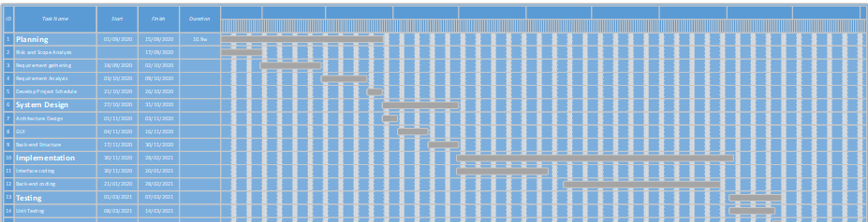

1.7 Report Outline
- The Requirement was gathered in about 10 Days.
- The Documentation was made in a 20 Days.

Chapter 2

Software Requirement Specifications

2.1 Introduction

2.1.1 Purpose
StudyIn is a social media type android app and website which is built for the online education for students, parents and teachers. It has an android application for mobile phones and a website for laptop and computers. It is going to be its first release in the market. It has vast range of user in form of parents, students and teachers and it will gain user attraction due to is unique system.

2.1.2 Document Conventions
This SRS is written completely in Calibri font with headings make bold and line space of 1.5 in whole of the document. The SRS is divided in different sections and each section has more sub sections. The main of this SRS is to make reader familiar with the product. Sub sections of each main section have details about product and its manufacturing.

2.1.3 Intended Audience and Reading Suggestions
StudyIn has completely transformed the way in which learning is imparted to students. Unlike traditional chalk and board method of teaching, eLearning makes learning simpler, easier, and more effective.
StudyIn can be used as important and powerful tool to improve quality and efficiency of education. By means of e-learning the traditional teaching methods can be changed so that it is not necessary to attend in the classroom physically

2.1.4 Product Scope
Basically this system deals with every object related to learning system. It allows students, teachers and parents to create their account and explore world of education with fun and ease. Teachers can teach students and can create systemize classes. Parents are also the user of this system so they can interact with teachers and can discuss issues for their children and can find tutors for them. Basically it is a free platform and has no prices for its users but user can manually create their groups for earning where they can teach other user with tuition fee. This fee system is managed by this system and it bound users to pay their fee.
Parents are also the user of this system so they can interact with teachers and can discuss issues for their children and can find tutors for them. It is so unique system that has no bounds of class and subject. Every subject of any class can be taught and over this social system. Teacher can earn through this system by his/her relevant subjects. This system is a platform for every object which is related to education system including teachers, parents, students and educational institutes, which allow them to share study material in terms of files, audio, video and pictures.

2.1.5 References
[1] | "How to use LinkedIn," Social Media Examiner, 2020. [Online]. Available: https://www.socialmediaexaminer.com/how-to-use-linkedin-for-competitor-research/. [Accessed 21 October 2020].
[2] | "Facebook | Overview, History," Britannica, 2020. [Online]. Available: https://www.britannica.com/topic/Facebook. [Accessed 21 October 2020].
[3] | "TalentLMS: Cloud LMS Software," Talent LMS, [Online]. Available: https://www.talentlms.com/. [Accessed 22 October 2020].
[4] | "Software Architecture & Design," Tutorials Point, [Online]. Available: https://www.tutorialspoint.com/software_architecture_design/introduction.htm. [Accessed 22 October 2020].

Overall Description

2.2.1 Product Perspective
StudyIn enables you to study or teach from anywhere in the world. This means there’s no need to commute from one place to another, or follow a rigid schedule. On top of that, not only do you save time, but you also save money, which can be spent on other priorities. The virtual classroom is also available anywhere there’s an internet connection, and a good way to take advantage of this is to travel. For example, if you’re studying abroad and want to get a job, online education is a great choice.

2.2.2 User Classes and Characteristics
There are essentially two classes of users for StudyIn Application.

Administrators:

- The administrators have complete control over all the activities that can be performed.
- Allowed to conduct a live class, share whiteboard and screen, upload course content, notes, assignments and other educational material
- They verify the user after he/she registers.
- They must provide rules for the Login.
- They must maintain the website and update the same making necessary changes at times.
- They must take care of the security issues involved in the login.
- They must inform the users about their login status and keep them updated about the Progress through emails.
Users:
- They are the registered members of the system. They can view all the features.
- They are able to choose a course, attend a live class, appear for a test, view and download course content
- They are able to see the requirement or request from consumer receiver/consumer.

2.2.3 Operating Environment
This system will operate in browsers like Google Chrome, Mozilla, Firefox, and Opera and for their different version also.
- It can be open on window, android.
- The processor should be core 2 duo or above.
- The processor’s speed should be 2.8 GHz or greater.
- Ram should be or greater than 512 MB.

2.2.4 Design and Implementation Constraints
There are the following design and implementation constraints that we should keep in our mind during developing of the application.
- This system is working for single server
- Limited to HTTP/HTTPS.
- Sketch or proto.io for prototyping the system
- XAMPP server for the local host
- MYSQL used for manage the database specification
- Operating system required for this application is windows kit Kat 4.0 android or any other higher version

2.2.5 Assumptions and Dependencies
It is assumed that alumni data will be made available for the project in some phase of its completion. Until then, test data will be used for providing the demo for the presentations. It is assumed that the user is familiar with an internet browser and also familiar with handling the keyboard and mouse.
Since the application is a web based application there is a need for the internet browser. It will be assumed that the users will possess decent internet connectivity.

External Interface Requirements

2.3.1 User Interfaces
<Describe the logical characteristics of each interface between the software product and the users. This may include sample screen images, any GUI standards or product family style guides that are to be followed, screen layout constraints, standard buttons and functions (e.g., help) that will appear on every screen, keyboard shortcuts, error message display standards, and so on. Define the software components for which a user interface is needed. Details of the user interface design should be documented in a separate user interface specification.>

2.3.2 Hardware Interfaces
This is an online application so the hardware interfaces that are going to be used are the hardware components that are required for the internet access and a browser which supports CGI, HTML & JavaScript.

2.3.3 Software Interfaces
External machine interfaces
External Machine interface is not required since computation will be done on Windows OS and Android OS.
External system interfaces
This will only include the Firebase database for the products.
Human interface
The software will use a Graphical User Interface coded in XML.

2.3.4 Communications Interfaces
The StudyIn use the HTTP protocol for communication over the internet and for the intranet communication will be through TCP/IP protocol suite.

2.4 System Features

2.4.1 Account Managing

2.4.1.1 Description and Priority
This feature is responsible for creating, deleting and updating accounts of the user by his requirement. It is a high priority feature as without this feature user is not able to use the product. It contains risk of account blocking upon false provided information. It has 9 points on scale.

2.4.1.2 Stimulus/Response Sequences
System

User
Input Date
Account Successfully Generated
Login page
Successfully Login
Main Profile
Successfully
Update Profile
Successfully
Update Profile
Successfully

2.4.1.3 Functional Requirements
REQ-SF1-1: Create account
REQ-SF1-2: Login
REQ-SF1-3: Profile
REQ-SF1-4: Update Profile
REQ-SF1-5: Delete Profile

Friends Section

2.4.2.1 Description and Priority
This feature is responsible for adding and removing of friends. It is a high priority feature as without this feature user is not able to gain main aim of the product. It contains risk of account blocking and fake friends. It has 7 points on scale.

2.4.2.2 Stimulus/Response Sequences
System

User
Friend Page
Successfully
Suggested Friends Page
Successfully
Add Remove Friends
Successfully
Block Friends
Successfully

2.4.2.3 Functional Requirements
REQ-SF2-1: Friend List
REQ-SF2-2: Suggested Friends
REQ-SF2-3: Add/Remove Friends
REQ-SF2-4: Block Friends

Posting Data

2.4.3.1 Description and Priority
This feature is responsible for adding and removing data to and from the application. Adding post is key feature which helps other user to find you and also you can find your study mates. It contains risk of account blocking account by posting inappropriate data. It has 7 points on scale.

2.4.3.2 Stimulus/Response Sequences
System

User
Home Page
Successfully
Main Profile
Successfully
Add Remove Post
Successfully
Edit Post
Successfully

2.4.3.3 Functional Requirements
REQ-SF3-1: Home Page
REQ-SF3-2: Main Profile
REQ-SF3-3: Add/Remove Post
REQ-SF3-4: Edit Post

Classroom/Groups

2.4.4.1 Description and Priority
This feature is responsible for creating, deleting and updating groups and classrooms. Groups are common where every user can post and add other users but classrooms are private and only teachers can create and post in classroom. Teacher can allow other users to post data for specific time. It contains risk of account blocking account by posting inappropriate data. It has 7 points on scale.

2.4.4.2 Stimulus/Response Sequences
System

User
Home Page
Successfully
Create Groups
Successfully
Create Classroom
Successfully
Post Data
Successfully

2.4.4.3 Functional Requirements
REQ-SF4-1: Home Page
REQ-SF4-2: Create Groups
REQ-SF4-3: Create Classroom
REQ-SF4-4: Post Data

Payments

2.4.5.1 Description and Priority
This feature is responsible for creating, deleting and updating payment methods. Payment methods allow teachers to receive payments from classroom courses. It contains risk of account blocking account by making fraud.

2.4.5.2 Stimulus/Response Sequences
System

User
Main Profile
Successfully
Create Payment
Successfully
Update Payment
Successfully Updated
Delete Payment
Successfully

2.4.5.3 Functional Requirements
REQ-SF5-1: Profile
REQ-SF5-2: Create Payment
REQ-SF5-3: Update Payment
REQ-SF5-4: Delete Payment

Nonfunctional Requirements

2.5.1 Performance Requirements
Response time: The home page loaded in 3-5 seconds.
Availability: The site will be available 100% of the time.
Throughput: A standard throughput rate.
Capacity: Maximum throughput that can be achieved with acceptable response time and availability.

2.5.2 Safety Requirements
This product has some safety issues in form of illegal and irrelevant data sending. If someone sends this type of data then user can report the data and also can block the sender for more safety.

2.5.3 Security Requirements
There is strong security system in the product but if you can think that there is any security issue with your account then just let us know with valid reason and we will take and suggest necessary actions.

2.5.4 Usability Requirements
User needs an account by signing up so he can be a registered user of the system and can manipulate the system for different purpose. There is need of login for new session after every successful previous session.
System sends user to home screen after successful login and allow the user so the user go through different sections of the software.

2.5.5 Reliability Requirements
If a user is disconnected during an audio/video conference (without the user explicitly logging out), then the connection will be restored as soon as possible without asking for his/her credentials. If, however, the connection cannot be re-established, then the time when the user was disconnected for future reference, the current state of the user’s work will be saved, and the user will be logged off. If the connection between the user and the system is broken prior, the system shall enable the user to save the current state and continue from that state once the connection is restored. The system should backup user data at regular intervals to avoid loss.

2.5.6 Maintainability/Supportability Requirements
Since the product is properly documented and all the systematic and standardized ways are used to design and deploy a project, we can make changes, fix any issues or bugs, trace any deficiency and can add new functionalities at any level.

2.5.7 Portability Requirements
The design of the StudyIn application should allow the application to run on all widely used browsers. The design of the StudyIn application should cater for different screen sizes (desktop, laptop, tablet, and smart phones) and input mediums (touch screen via keyboards and mice). StudyIn should be able to run on different operating systems.

2.5.8 Efficiency Requirements
Response time, throughput, process capacity and storage capacity are the major efficiency requirements for this project.

2.6 Domain Requirements
One of the prerequisites for the development of a software system is that we have a definition and a clear understanding of the contents of the application domain concerned. This is the part of an organization for which we are to develop application software. This means that the application domain is our starting point and the context for our software development.
Many development methodologies take this understanding of the application domain for granted. They assume that the developers somehow know what domain they have to deal with. In our experience, however, this is a crucial issue within a software project, so we make it explicit in our application-oriented approach.

Chapter 3

Use Case Analysis

Chapter 3: Use Case Analysis
Use case analysis, in simple terms, represents the various ways software would react based upon the input that it receives. A use case analysis is used to design a system from the viewpoint of the end user, the person actually using the site or software. It is used to determine and convey system behavior information. The use case analysis attempts to convey information on the system requirements and usage, the role of the user, the system actions in response to the user, and what the user will receive from the system.

3.1 Use Case Model
Login
Edit Profile
Profile
Add Friend
Posting
Like, Share Comment
Messages
Create Group
Report
Create Classroom
Add Payment
Generate Exam
Manage Users
Login
Manage Friends
Manage Post
Manage Share
Manage Report
Manage Data
Register Profile
Manage Payment

Parent

Teacher
Student

Admin

3.2 Use Cases Description
Login: Being a registered user, he will have to login into the system after that he can utilize the functionalities of the application.
Register Profile: By having registration module the user will get the privilege to register themselves as a member of the StudyIn. By giving their basic information.
Edit Profile: In this privacy function if any changes that are made with the Student, Teacher and Parent profile the detailed information are sent to the email of the Student, Teacher and Parent.
Add Friend: This will allow registered Student, Teacher and Parent to view friends. This module allows Student, Teacher and Parent to find their friends from the application who is as a registered user of StudyIn. After searching the friends this module allows Student, Teacher and Parent to send friend request to them if he wants to add him/her to his friend list.
Post: In this module Student, Teacher and Parent can able to post the status on their profile as we can say it as a home post which user write publicly.
Like Share Comment: Application wills also providing the privilege to Student, Teacher and Parent so the Student, Teacher and Parent can like, share and comment on the post of others.
Message: This feature will allow the Student, Teacher and Parent to send the message to their added friends on the app.
Create Group: This module will help the student and teacher to create their own group in which the selective person can collaborate.
Report: As social networking is increasing the problem of fake profile is increasing, in this function if user found someone as a fake or inappropriate person so he/she can inform it about to the administrator.
Classroom: Teacher can create a private classroom where he can teach his students to assign work and post announcements to students with payment.
Add Payment: This function is created for teachers to receive payment through different methods.
Generate Exam: This function allows conducting exam through different methods.
Manage Users: Every user has its own permissions. Each of these roles is given their own credentials (username/password) so that they can log in to the StudyIn app. The access level that each user role has when they log in depends on their setting and permission.
Manage Post: Manage post who can post and the quality of content posted. Only allowed the user to post their content related to education.
Manage Share: Admin manages shared post of the users and takes appropriate actions with required situations.
Manage Data: Admin manage the whole application data and deletes irrelevant data from the application.

Chapter 4

System Design

Chapter 4: System Design
Definition: System design is the process of defining the components, modules, interfaces, and data for a system to satisfy specified requirements. System development is the process of creating or altering systems, along with the processes, practices, models, and methodologies used to develop them. The purpose of the System Design process is to provide sufficient detailed data and information about the system and its system elements to enable the implementation consistent with architectural entities as defined in models and views of the system architecture.

4.1 Architecture Diagram
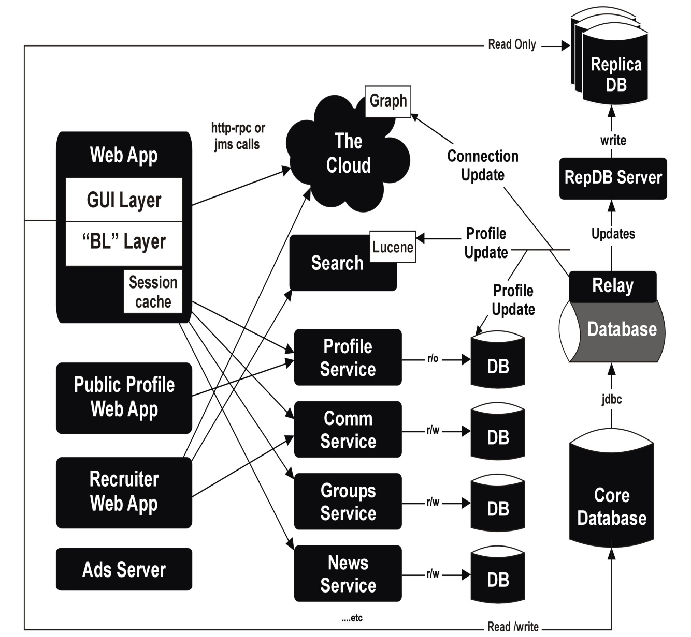

4.2 Domain Model
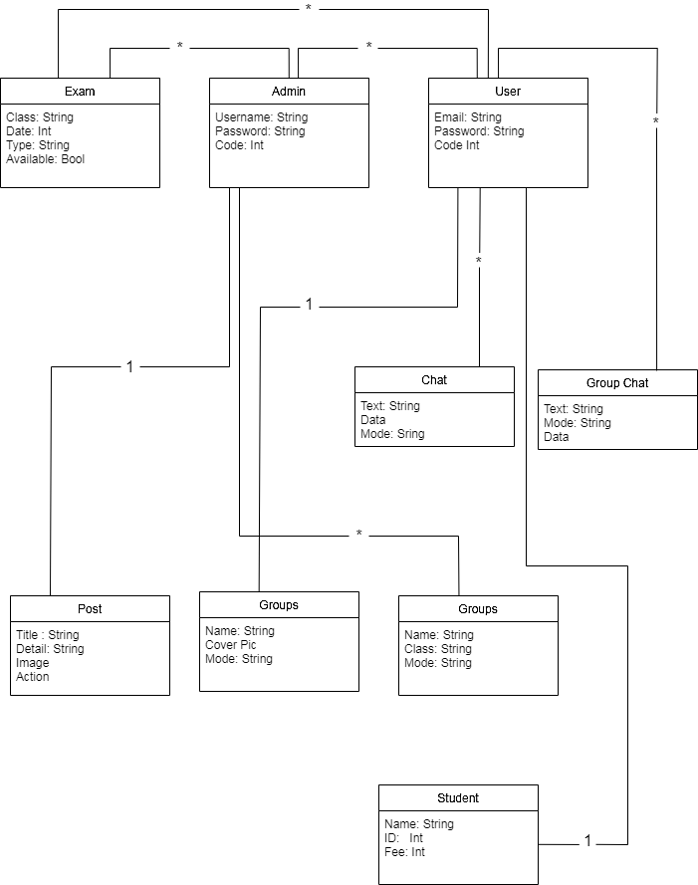

4.3 Entity Relationship Diagram with data dictionary
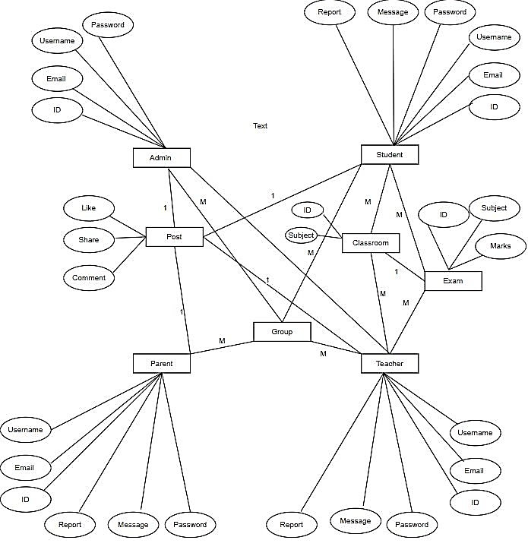

4.4 Class Diagram
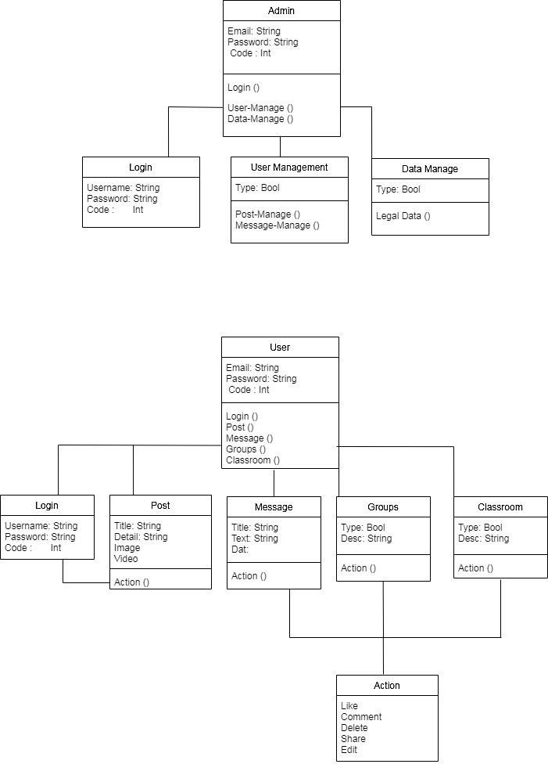

4.5 Sequence / Collaboration Diagram
System
System

User
Input Date
Account Successfully Generated
Login page
Successfully Login
Main Profile
Successfully
Update Profile
Successfully
Update Profile
Successfully

User
Friend Page
Successfully
Suggested Friends Page
Successfully
Add Remove Friends
Successfully
Block Friends
Successfully

System
System

User
Home Page
Successfully
Main Profile
Successfully
Add Remove Post
Successfully
Edit Post
Successfully

User
Home Page
Successfully
Create Groups
Successfully
Create Classroom
Successfully
Post Data
Successfully

System

User
Main Profile
Successfully
Create Payment
Successfully
Update Payment
Successfully Updated
Delete Payment
Successfully

4.6 Activity Diagram
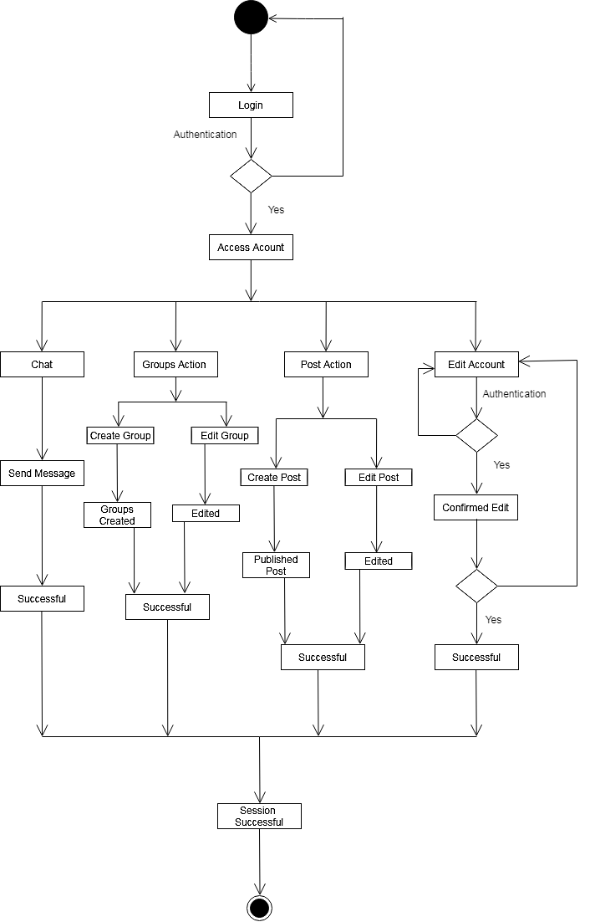

State Transition Diagram

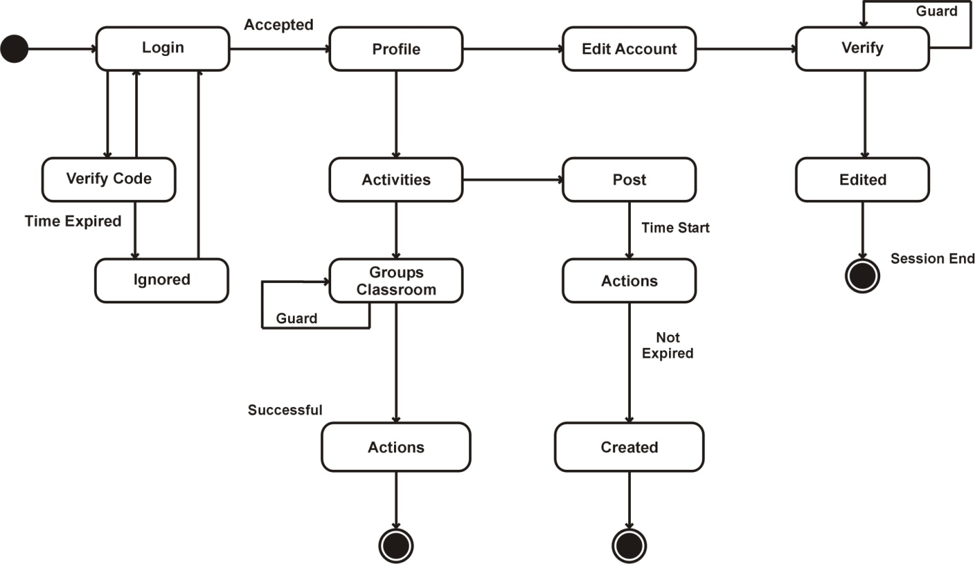

4.8 Component Diagram

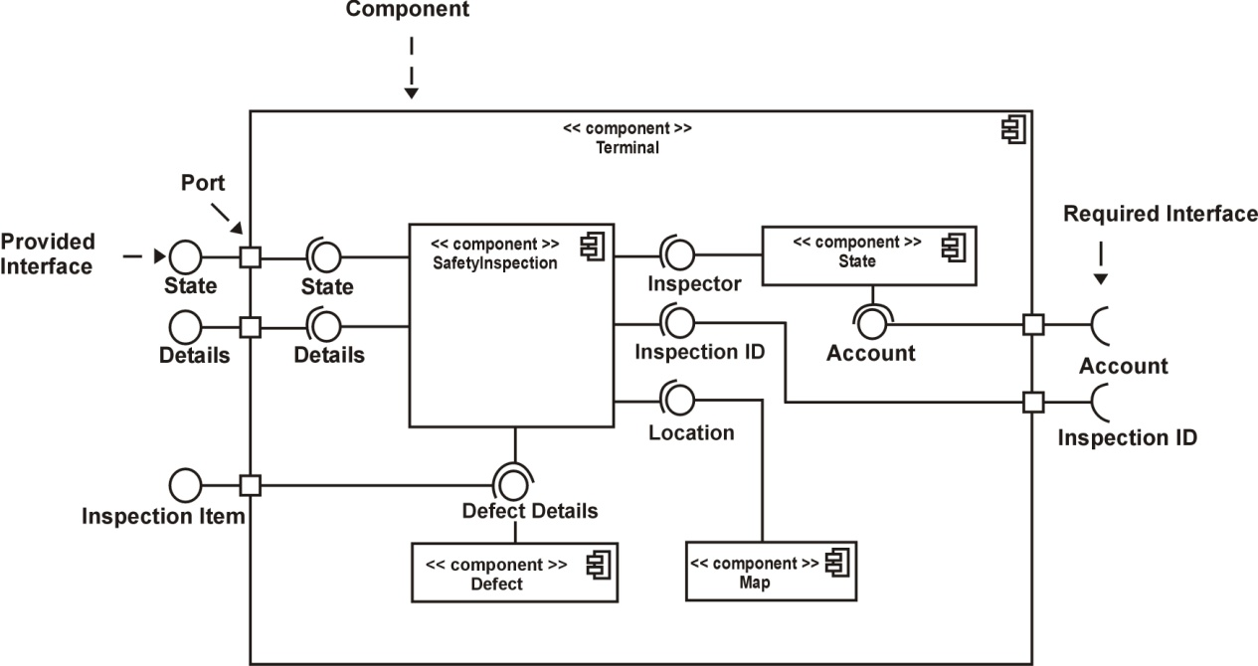

4.9 Deployment Diagram

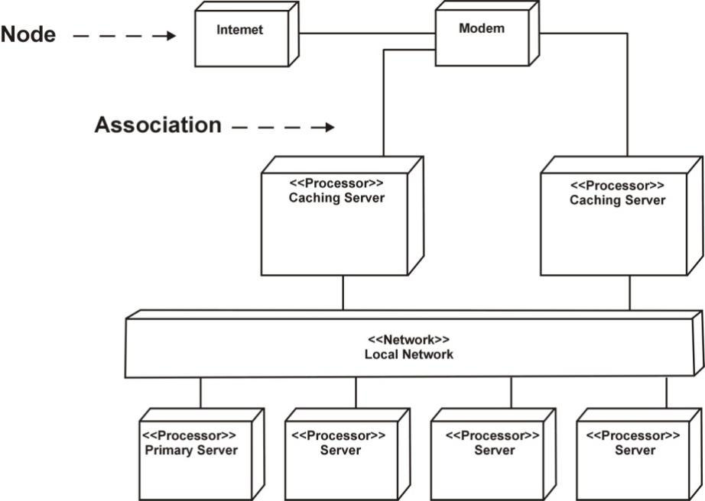

Chapter 5

Implementation

Chapter 5: Implementation
The software implementation stage involves the transformation of the software technical data package (TDP) into one or more fabricated, integrated, and tested software configuration items that are ready for software acceptance testing. Software implementation of the framework for the template-based modeling includes several libraries, which provide building blocks for the templates.

5.1 Important Flow Control/Pseudo codes
import React from 'react';
export default class TabList extends React.Component {
state = {
active: 0
};
render() {
return (
<div>
<a className="tab" href="#" onClick={this.handleChangeTab(0)}>Hot Deals</a>
<a className="tab" href="#" onClick={this.handleChangeTab(1)}>Featured</a>
<a className="tab" href="#" onClick={this.handleChangeTab(2)}>Porn</a>

{this.renderActiveTab()}
</div>
);
}

handleChangeTab(index) {
return () => {
this.setState({ active: index });
};
}
renderActiveTab() {
switch(this.state.active) {
case 0:
return <Component />
case 1:
return <Component />
case 2:
return <Component />
}
}
}

5.2 Components, Libraries, Web Services and stubs
JQuery, react, react-native, bootstrap are libraries used in our project.XML Interface for Network Services and JSON-WSP web services are used.
import React from "react";
import { render } from "@testing-library/react";
import "jest-dom/extend-expect";
import sinon from "sinon";
import * as ToStubComponent from "./to-stub-component";
import { App } from "./app";
describe("Sinon stub", function() {
beforeAll(function() {
sinon.stub(ToStubComponent, "default").returns(<div>A stub</div>);
});
it("basic React components", function() {
const { container } = render(<App />);
expect(container).toHaveTextContent("A stub");
});
});
Components
class Admin extends React.Component {
render() {
retturn (
// different actions
);
}
}
class Students extends React.Component {
render() {
retturn (
// different actions
);
}
}

class Teachers extends React.Component {
render() {
retturn (
// different actions
);
}}
class Parents extends React.Component {
render() {
retturn (
// different actions
);
}
}

5.3 Deployment Environment
We use idea of custom environment variables to configure our React app for specific environments. We use a custom environment variable called REACT_APP_STAGE to denote the environment our app is in. And we configure two environments for our app: One that we will use for our local development and also to test before pushing it to live.
Call this one dev.
And our live environment that we will only push to, once we are comfortable with our changes. Call it production.
The first thing we do is to configure our build system with the REACT_APP_STAGE environment variable.

5.4 Tools and Techniques
VS Code
Expo
Node Package Manager
React
React-Native
Bootstrap

Chapter 6

Testing and Evaluation

Chapter 6: Testing and Evaluation

Use Case Testing is a functional black box testing technique that helps testers to identify test scenarios that exercise the whole system on each transaction basis from start to finish.

6.1 Use Case Testing

Table 6.1 Use case of Sign up
Test Suite ID | TS001
Test Case ID | TC001
Test Case Summary | To verify that by clicking Signup button username, password,
 | email, phone# and address store in users detail in database.
Related Requirement | RSoo1: User should able to Sign up.
Prerequisites | No
Test Procedure | 1. |  |  | Select fields in Signup form.
 | 2. |  |  | Enter user data in fields.
 | 3. |  |  | Click Signup button.
Test Data | Valid username: sahil, SAHIL
 | Invalid username: 12 sahil ./sa ,as %^3
 | Valid password: 123Abc@5, Abc567$%9
 | Invalid password: 1_2ss, _aa12
 | Valid email:ali@gmail.com, 12ali@yahoo.com
 | Invalid email: ali.com, s//@yahoo
 | Valid phone# :03044644009
 | Invalid phone: @56rfgf7999, 2wstyyA
Expected Result | 1. If username, password, email and phone# are valid then
 | store user data by clicking signup button.
 | 2. |  |  | If given inputs are invalid then display error message.
 | 3. |  |  | If fields are empty then show warning message.
Actual Result | 1. |  |  | If name is valid, the result is as expected.
 | 2. |  |  | If name is not valid then invalid message displayed.
 | 3. |  |  | If fields are empty then warning massage displayed.
Status | Pass
Remarks |  |  | This test case is simple and easy.
Created By |  |  | Muhammad Sahil
Date of Creation |  |  | 04/05/21
Executed By |  |  | Muhammad Sahil
Date of Execution |  |  | 04/05/21
Text Environment |  |  | OS: Android Studio

Table 6.2 Use case of log in
Test Suite ID |  |  | TS001
Test Case ID |  |  | TC002
Test Case Summary |  |  | To verify Authentication or Login.
Related Requirement |  |  | RS002: User should able to Login.
Prerequisites |  |  | User should Signup first.
Test Procedure |  |  | 1. | Select Username field and enter username.
 |  |  | 2. | Select Password field and enter password.
 |  |  | 3. | Click Login button.
Test Data |  |  | Valid username: sahil,SAHIL
 |  |  | Invalid username: sd, ./zz , xzxc%^3
 |  |  | Valid password: 123Aabc@, abMc567$%
 |  |  | Invalid password: 1_2de, -ra12
Expected Result |  |  | 1. If username and password are valid then clicking the Login
 |  |  | button user successfully login.
 |  |  | 2. | If username and password are invalid then clicking the
 |  |  | Login button invalid message display.
 |  |  | 3. | If fields are empty then display warning message
Actual Result |  |  | 1. | If fields are valid, the result is as expected.
 |  |  | 2. | If fields are not valid then invalid message displayed.
 |  |  | 3. | If fields are empty then warning message displayed.
Status |  | Pass
Remarks |  | This test case is simple and easy.
Created By |  | Muhammad Sahil
Date of Creation |  | 04/05/21
Executed By |  | Muhammad Sahil
Date of Execution |  | 04/05/21
Text Environment |  | OS: Android Studio

Table 6.3 Use case of update password
Test Suite ID |  | TS001
Test Case ID |  | TC003
Test Case Summary |  | To verify that students, parents, teachers, and non-profit organization once signup if they are forgot password then they can update it by email.
Related Requirement |  | RS003: user should able to update data.
Prerequisites |  | user should login.
Test Procedure |  | 1. |  | Select fields.
 |  | 2. |  | Enter data in fields.
 |  | 3. |  | Click forgot password button.
Test Data |  | 04/01/19
Expected Result |  | 1. If enter data is valid then update data by clicking update
 |  | button
 |  | 2. |  | If given inputs are invalid then display error message.
 |  | 3. |  | If fields are empty then display warning message.
Actual Result |  | 1. |  | If fields are valid, the result is as expected.
 |  | 2. |  | If fields are not valid then invalid message displayed.
 |  | 3. |  | If fields are empty then warning message displayed.
Status |  | Pass
Remarks | This test case is simple and easy.
Created By | Muhammad Sahil
Date of Creation | 04/05/21
Executed By | Muhammad Sahil
Date of Execution | 04/05/21
Text Environment | OS: Android Studio

Table 6.4 use case of delete data
Test Suite ID | TS002
Test Case ID | TC004
Test Case Summary | To verify that wedding halls, restaurants, volunteer,
 | consumer and non-profit organization once signup if they
 | are deleted in database by performing crud operation by
 | clicking Delete button.
Related Requirement | RS004: Admin can delete data.
Prerequisites | Admin should login.
Test Procedure | Click delete button.
Expected Result | If data is deleted by click button then message will appear
Actual Result | If action is valid, the result is as expected.
Status | Pass
Remarks | This test case is simple and easy.
Created By | Muhammad Sahil
Date of Creation | 04/05/21

Executed By | Muhammad Sahil
Date of Execution | 04/05/21
Text Environment | OS: Android Studio

Table 6.5 Use case of search data
Test Suite ID | TS002
Test Case ID | TC005
Test Case Summary | To verify that data is searched by clicking search button.
Related Requirement | RS005: User should be able to search data.
Prerequisites | User should login.
Test Procedure | 1. | Select search field.
 | 2. | Enter name in fields.
 | 3. | Click search button.
Expected Result | 1. | If name is valid then show detail.
 | 2. | If name is invalid then display error message.
 | 3. | If field is empty then display warning message.
Actual Result | 1. | If name is valid, the result is as expected.
 | 2. | If name is not valid then invalid message displayed.
 | 3. | If fields are empty then warning message displayed.
Status | Pass
Remarks | This test case is simple and easy.
Created By | Muhammad Sahil
Date of Creation | 04/05/21
Executed By | Muhammad Sahil
Date of Execution | 04/05/21

Table 6.6 Use case of record to display
Test Suite ID |  | TS002
Test Case ID |  | TC006
Test Case Summary |  | To verify that record is display.
Related Requirement |  | RS006: User should be able to view data.
Prerequisites |  | User should login.
Test Procedure |  | 1. | Enter name in fields.
 |  | 2. | Click View button.
Expected Result |  | 1. | If name is valid then show detail.
 |  | 2. | If name is invalid then display error message.
 |  | 3. | If field is empty then display warning message.
Actual Result |  | 1. | If name is valid, the result is as expected.
 |  | 2. | If name is not valid then invalid message displayed.
 |  | 3. | If fields are empty then warning message displayed.
Status |  | Pass
Remarks |  | This test case is simple and easy.
Created By |  | Muhammad Sahil
Date of Creation |  | 04/05/21
Executed By |  | Muhammad Sahil
Date of Execution |  | 04/05/21
Text Environment |  | OS: Android Studio

6.2 Equivalence partitioning

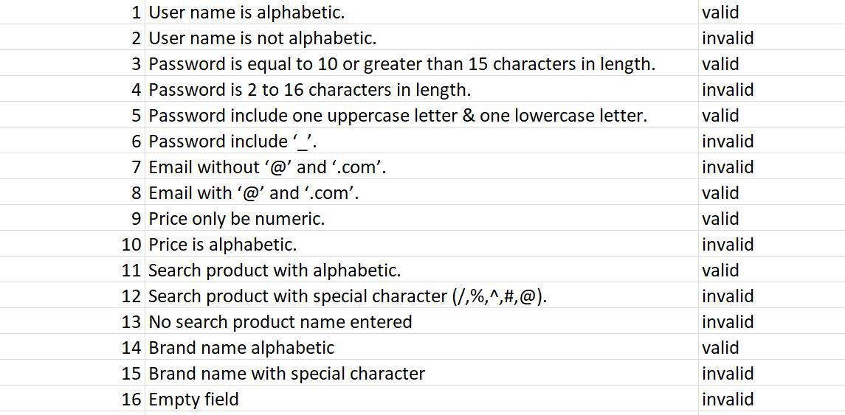

6.3 Boundary value analysis

Table 6.7 Boundary analysis
Sr. |  | Partition 1 | Partition 2 |  | Partition 3
1. | Password | Less than 8 character | 1 | – 8 character | 9–12
2. | Phone | <=0 | 1 | - 11 | 9–12

6.4 Data flow testing
The relationship between one entity and another while performing a specific task in during data flow. Such as between the sign up and registration process etc.

6.5 Unit testing
In unit testing we have testified our different panel codes individually by performing different tests and by executing them individually, separately on different computers and they were successfully executed and they performed well.

6.6 Performance testing
In performance testing a particular certain situation is given to the website let’s just say a 100 users try to register at the same time so how the system recovers back gracefully with complete results. So according to our extracted results, around 100+ people were able to register in our website.

6.7 Stress Testing
Let’s say if 100 customers order at the same restaurants at the same time along with the same food level which increases the stress on the website at a maximum load how will the website will perform under these circumstances.

Table 6.8 Stress Testing

 | Activity |  |  | Description
 | Register |  |  | The user can register and save his/her information into the
 |  |  |  | system
Login |  |  |  | The user can login using his/her credentials
 | Type of user |  |  | Upon registering, the user specifies which type of user they
 |  |  |  | are
Manage profiles |  |  |  | The user can edit/disable their accounts
 | Browse Categories |  |  | The donators can browse the categories of lup they want
 |  |  |  | to donate to.
Search Profiles |  |  |  | The donators can search profiles based on the nearest
 | Call user |  |  | The user can call the phone number of the user
Send Notification |  |  |  | The donator can send notification for possible donation
 | Add Reviews |  |  | The donators can add reviews concerning user
Confirm Donation |  |  |  |  | The user can confirm receiving donations
Check Notification |  |  |  |  | The user can check notifications for possible donations
Log out |  |  |  |  | The user can log out

Interface for Login:

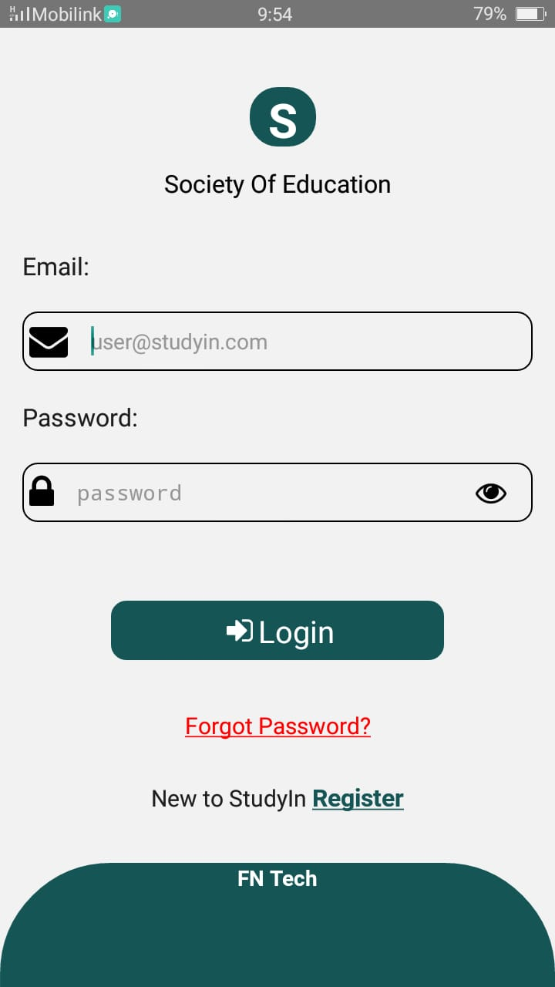

Chapter 7

Summary, Conclusion and Future Enhancements

7.1 Project Summary
Now that the project StudyIn is completed so that I can explain the purpose of the app it is basically a mobile app. The main purpose of this app is spread knowledge in needy people by teachers , students online within no time . Our software would generate the interface and its associated functionalities according to the requirement of both organizations. This system will provide many features in a single platform. That said, there is always room for improvement

7.2. Achievements and Improvements
The biggest achievements here are that we were able to enhance our skills to the professional extend that we learned in two years of studying and apply it to this project. We learned software architecture design techniques, UML modeling, project management, testing and much more, and were able to apply it all in this project.

The next big achievement is the things we learnt during this project. New languages, frameworks, libraries, different software’s for diagrams Database. All that will be useful for us in our futures. We learn Creative thinking.

7.3 Critical Review
The critical element of our system is: Is our system is fast moving, give user friendly interface, not very costly, fulfill the specific requirements of the users at a runtime, has all the features which any organizations can require. To manage all these aspects it took lot of time and hard work.

7.4 Lessons Learnt
We absorb very much from this project. This project sharpens our skills in react native many other tools and many management concepts as well as how to deal with a problem and how to stick for finding the solution of any problem until you found. As well as technical skills this project also enhances our personal development skills such as team working, dedication.

7.5 Future Enhancements/Recommendations
As it has been already said, there is always room for further improvement. And since we plan to launch this website as our own startup, enhancements will keep coming.

The system has been built on react native, but at some point we work on its efficiency, accessibility, flexibility, we are definitely going to scale it up which we believe ours is eventually going to become. We make it more user friendly interface.

Appendices

Appendices
In this appendix section we describe the different phases of user interface and also describe how user can use our project

Appendix A: E-Learning

A 1 Login

User can login by entering name and password.

Forget password

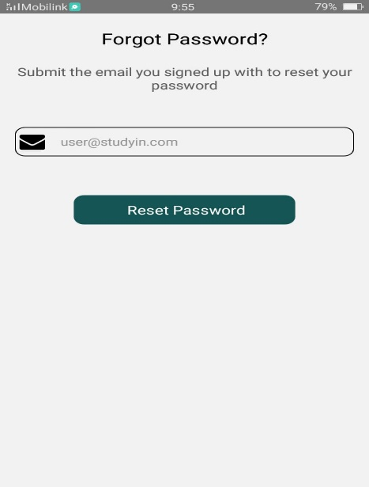

A 2 Signup
User fills the registration form. in case if ser is not valid or enter wrong name and password it will show a authentication warning

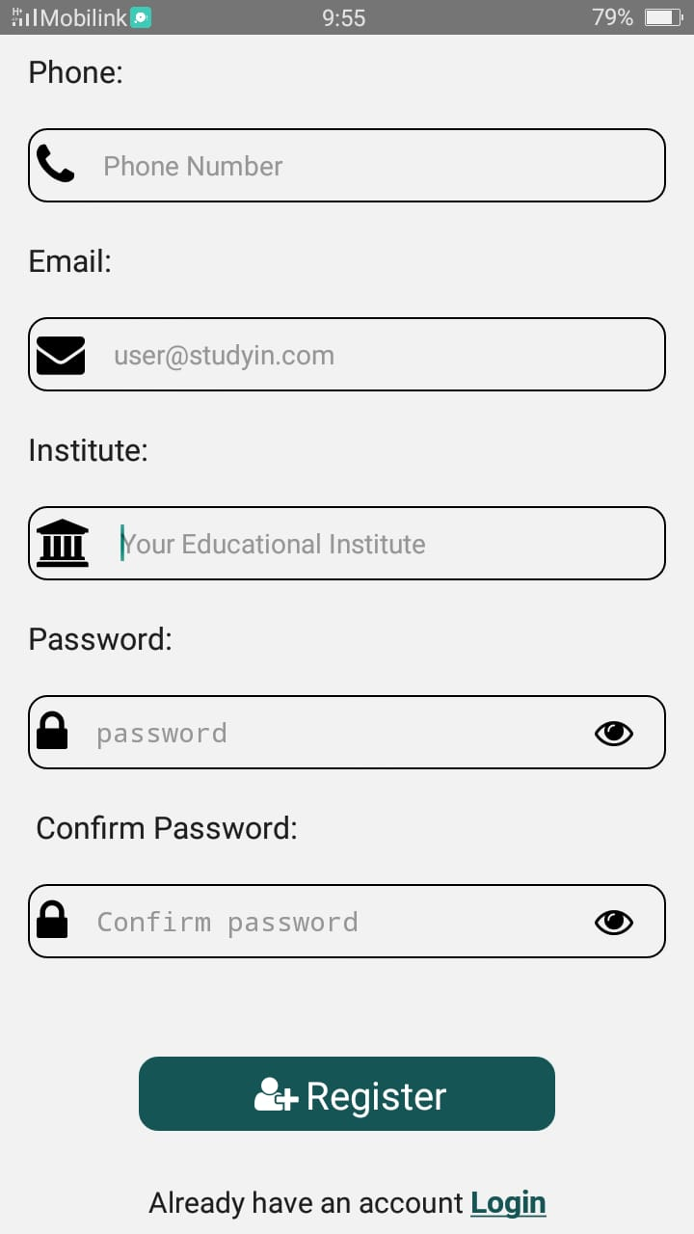

A 3 Select functionalities
User selects the functionalities which he wants in App.

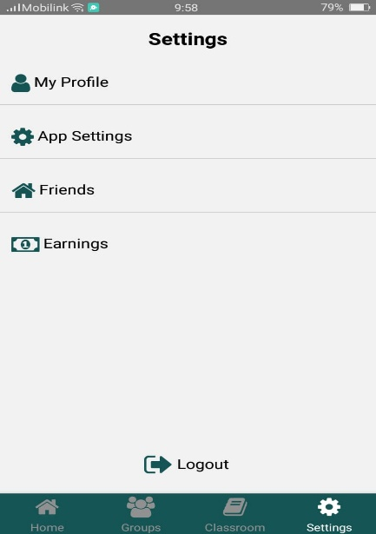

Appendix B: Administrator Manual
In this appendix section we describe the different phases of admin interface and also describe how admin can manage the system.

B 1. Login
User can login by entering the password and username.

B 1.1 Manage Panel

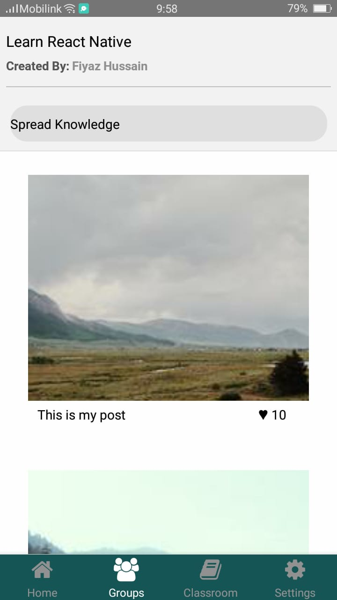

Appendix C: Information / Promotional Material
In Appendix we add promotional material about our application and application. We add these for promote our application.

C 1. Post
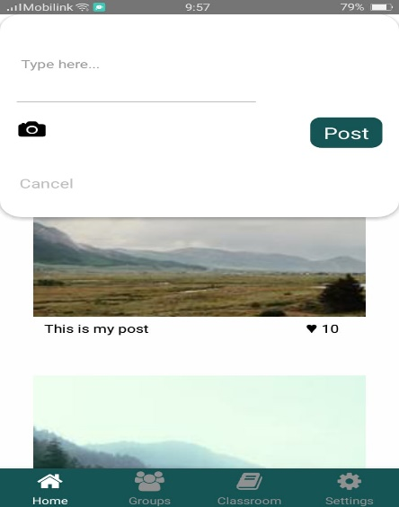

C 2 Inbox

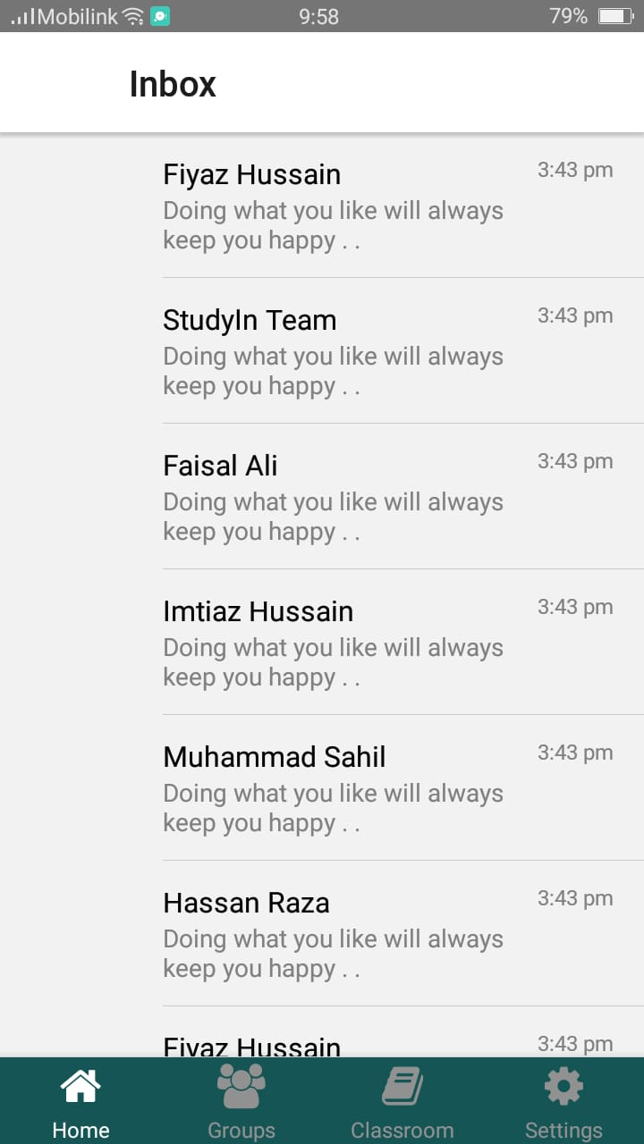

C 3. Groups

Reference and Bibliography

Reference and Bibliography
[1] Jes K.et el [Online Available] www.rescuingleftovercuisine.org/
[2] K.et el [Online Available] www.annakshetra.org/
[3] Lere H.et el [Online Available] happylifewelfare.org/share-dabba-compaign.html
[4] [Online Available] Kaine L.et el [Online Available] usf.vc/entrepreneur-info/India-meteoric-rise-smartphones/
[5] [Online Available] www.epa.gov/recycle/reducing-wasted-food-home
[6] [Online Available] http://www.youthkiawaaz.com/2014/09/innovative-trick-dabbawalas-m umbai-feeding-many-hungry-children-city/&cat=General&ip=192.168.3.93 &user=-&reason=Group
[7] [Online Available] www.indiaactivities.com/caring-activities/donate-leftover-excess-food/
[8] M. Sher, M. Rehman, “Title of the Paper” Conference name/Journal Name, Edition, Volume, Issue, ISBN/ISSN, PP, Publisher/City-Country, Year.
[9] https://material-ui.com/
[10] https://reactnativeelements.com/
[11] https://reactnative.dev/
[12] https://reactjs.org/

