



Dedicated to Our beloved Parents

HI-TECH FEEDS Sale/Purchase System



FINAl year Project Report

submitted By:

HAFIZ BILAL BCS 12337

USMAN KHALID BCS 12356

KASHIF ALI BCS 12361

IBRAHIM BCS 12350

AHSAN ALI BCS 12374

Supervisor:
Asst. Prof Fareed ud din

BS COMPUTER SCIENCE
(4Years Programme)

The Department of Computer Science & Information Technology,
The Superior University
15-Km-Main Raiwind Road, Lahore.

HI-TECH FEEDS Sale/Purchase System

Undergraduate project submitted to
The Department Of Computer Science & Information Technology

As partial fulfillment for the award of degree
Bachelor of Science in Computer Science

Name | Registration No #
Hafiz Bilal  Usman Khalid  Kashif Ali  Ibrahim  Ahsan Ali | BCS 12337  BCS 12356  BCS12361  BCS 12350  BCS 12374

Supervisor:
Asst. Prof. Fareed ud Din
Department of CS&IT,
SUL, Raiwind Road, Lahore.

Signature: _______________ Signature: _______________
Hafiz Bilal BCS12337 Usman Khalid BCS12356

Signature: _______________ Signature: _______________
Kashif Ali BCS12361 Ibrahim BCS12350

Signature: _______________
Ahsan Ali BCS12374

Final
Approval

The project titled

HI TECH SALE/PURCHASE SYSTEM
By

Hafiz Bilal (BCS 12337)
Usman Khalid (BCS12356)
Kashif Ali (BCS12361)
Ibrahim (BCS12350)
Ahsan Ali (BCS12374)

Supervisor: ______________________________________________

Fareed ud Din
Assistant Professor
Department of CS& IT
SUL, Lahore.

HOD: __________________________________________________

M.Azam Chaudhary
Head of Department
Department of CS&IT
SUL, Lahore.

DECLARATION

I, hereby declare that this project neither as a whole nor as a part plagiarism .It is further declared that I have developed this project and the accompanied report entirely on the basis of my personal efforts made under the sincere guidance of my supervisor No portion of the work presented in this report has been submitted in support of any other degree of qualification of this or any other university or institute.
If found I shall stand responsible.

Date: _________________

Date of Project Submission

Signature: _______________ Signature: _______________
Hafiz Bilal BCS12337 Usman Khalid BCS12356

Signature: _______________ Signature: _______________
Kashif Ali BCS12361 Ibrahim BCS12350

Signature: _______________
Ahsan Ali BCS12374

CERTIFICATE

It is certified that (Hafiz Bilal, Usman Khalid, Kashif Ali, Ibrahim, Ahsan Ali) have carried out all the work related this project under my supervision at Department of Computer Science & Information Technology, Superior University , Lahore, Pakistan.
The work fulfils the requirement for award of Bachelor of Science in Computer Science degree.

Date: __________________

Date of Project Submission Supervisor:

_____________

Fareed ud Din
(Assistant Professor)

Special Thanks:
Good teachers are a rare breed. They are knowledgeable, patient, enthusiastic and kind. They manage all this in the face of students who often don't want to be taught.
It's the least we can do to say "Thank you Sir Fareed!" once in a while.
We are thankful for your supervision not only for this project but for our whole university. You were great teacher, or we can must say you was great guidance for us.
Sir Fareed! Really we don’t have words to say thank you for your moral support & for your efforts.

Preface

We all thank you to show your interest in this Project Report. This is a final year project report written by five students who are students of Superior University Lahore, Computer Science and Information Technology (CS&IT) Department. We are Hafiz Bilal, Usman Khalid, Kashif Ali, Ibrahim and Ahsan Ali and we study in Bachelor of Science in Computer Science

This is a technical report that contain the detailed explanation o our project. we will explain the idea of our project and the implementation process in detail and systematically. Report is divided into six chapters; each chapter with a specific focus. We hope this approach allows you can read our project report easily. Lastly, if you have any comment on our project, please feel free to contact us.

Acknowledgement

First and foremost we are thankful to Almighty Allah, through His guidance we have reach this point in our lives without his guidance we were unable to get successful.

We are very grateful to our parents who provided us with all the resources and luxuries, and supported us in every possible way during the period of this project.

We are extremely thankful to Sir Fareed-ud-din (Lecturer, CS&IT Department), our advisor, who offered his precious time whenever we needed. His full encouragement and even he was very much cooperative with us, during the achievement of this project. Finally yet importantly, we acknowledge the efforts of our teachers who have been our source of inspiration throughout the university years and have shared their knowledge and skills with us.

We also place on record, our sense of gratitude to one and all, who directly or indirectly, have lent their hand in this project.

Contents
Preface 8
Acknowledgement 9
Abstract 11
Introduction 12
Project Introduction 12
Sale, Purchase and Inventory 12
Sale 12
Purchase 13
Inventory Management 15
About Company 16
Management System Standards 17
Goals and Objectives 18
Tools 18
Microsoft Visual Studio 2012 18
SQL Management Studio 2012 19
Architecture 20
Software Development Lifecycle 20
Literature Review 21
Problem Statement 22
Problem Background 22
Problem Statement 22
Old System Pictures 23
Deliverables 26
Requirement Analysis 26
Functional Requirements 27
Non Functional Requirements 28
RESEARCH METHODOLOGY/ PROPOSED APPROACH 29
Database Explanation 30
Bags 30
Bilty Information 30
Items 32
Purchase 33
SUPPLIER AND CUSTOMER 34
Use Cases 35
ADMIN 35
Warehouse manager of sale department 36
Warehouse manager of purchase department 37
NEW system snapshots: 38
Bilty information 38
38
38
Item unit 39
Item Information 39
Goods Receive Note 40
Login/Sign In 40
Invoice 41
Purchase Order 41
Inward Weightment 42
REPORTS 43
Users & User Level: 43
Units: 44
Type of Bags: 44
Supplier: 45
Sale Order: 45
Sale Invoice: 46
Purchase Order: 46
Products Trans. Master: 47
Price: 47
Price Title: 48
Price Period: 48
Payable Invoice: 49
Location: 49
Loading Sheet: 50
Items: 50
Goods Receive Note: 51
Customers: 52
Category: 52
Bility: 53
Bag Types: 53
Bag Capacity: 54
References: 55

Abstract

The use of Management System is a much needed requirement to run any company i.e shops, hospitals, companies and even in the factories. The most common thing the management system is a sale purchase management system. This system is being using widely in the whole world, this can make the work very easy and one can do the work easily.
This project is a management system of a company that is manufacturing feeds. The phase in which we are working is sale purchase system of the company Hi-Tech Feeds.
Hi-Tech Group is a well-established organization and credible name in the Poultry Sector in Pakistan. Its first unit Hi-Tech Feeds was established in the heart of Pakistan, Lahore. The professional leadership of its founding partners turned the unit into a mega industrial outfit. Its financial roll over and organizational structure have been catalyst to establishment of our poultry breeder farms, hatcheries, an edible oil mill, a pharmaceutical company, another large feed manufacturing unit at Sahiwal for poultry and animals agriculture farming and livestock.

Introduction

Project Introduction

A management system is the framework of policies, processes and procedures used to ensure that an organization can fulfill all tasks requires achieving its objectives. Management system is a basic need for any organization to run easily in this modern era. Management is mean how to manage something in a way to find that thing easy. Now a day’s management system is being used everywhere, in every aspect of life.
Sale purchase management system or inventory management system plays vital role in industries. A section of supply chain management, inventory management supervises the flow of goods from manufacturers to warehouses and from these facilities to point of sale. A key function of inventory management is to keep a detailed record of each new or returned product as it enters or leaves a storehouse or point of sale.
Inventory control, a similar term, is the area of inventory management that is apprehensive with minimizing the total cost of inventory while maximizing the capability to provide customers with product in a timely manner.

Sale, Purchase and Inventory

Sale
Sales management is a business authority which is focused on the practical application of sales techniques and the management of Organization sales operations. It is an important business function as sales through the sale of products and services and resulting profit.
Sales planning involve strategy, setting profit-based sales targets, quotas, sales forecasting, demand management and the writing and execution of a sales plan.
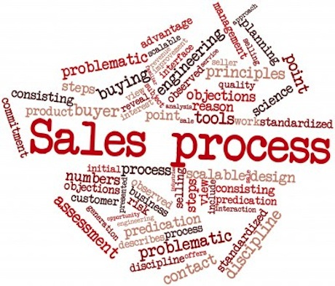
A sales plan is a strategic document that outlines the business targets, resources and sales activities. It typically follows the lead of the marketing plan, strategic planning and the business plan with more specific detail on how the objectives can be achieved through the actual sale of products and services.

Purchase
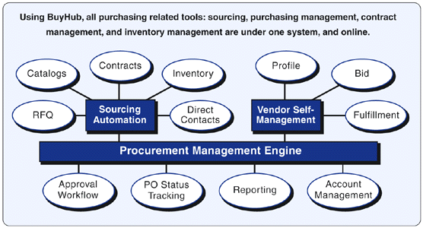
The purchasing management department ensures that all goods, supplies and inventory needed to operate the business are ordered and kept in stock. It is also responsible for controlling the cost of the goods ordered, controlling inventory levels and building strong relationships with suppliers.
- Purchasing is the function of buying Goods & Services from External Source to an Organisation.
- Purchase department buys Raw Materials, Spare parts, services etc. as Required by the company or Organisation.
- Purchase management is One of the most Crucial Area of the Entire Organisation. Thus, Needs Intensive management.
- Purchase is the Main Activity in Area of Material management.
- Purchasing management is a department in an organization responsible for purchasing activities.
- Purchase is Most Important Function in any Organization.
- Purchase is the first element which affects the product cost.
- Purchase management decides profitability of the Company.
- Purchasing management also covers the areas of outsourcing and in sourcing.
- Purchasing management is the management of purchasing process, and related aspects in an organization.

Objectives and Principle of Purchase Management system
- To purchase the required material at minimum possible price by following the company policies.
- To keep department expenses low.
- Development of good & new vendors (suppliers).
- Development of good relation with the existing suppliers.
- Training & development of personal employees in department.
- To maintain proper & up to date records of all transactions.
- Participating in development of new material and products.
- To contribute in product improvement.
- To take Economic "MAKE OR BUY" decisions.
- To avoid Stock- out situations.
- To develop policies & procedure.

Principle or 8 R’s
- Buying Material at Right QUALITY.
- In the Right QUANTITY.
- From the Right SOURCE.
- At the Right PRICE.
- Delivered at the Right PLACE in.
- At the Right TIME.
- With Right mode of TRANSPORT.
- With Right CONTRACT.

Inventory Management
Inventory management tracks the shape and percentage of stocked goods. At different locations within a facility, or within many locations of a supply network, inventory management must precede the regular and planned course of production and stocking of materials.
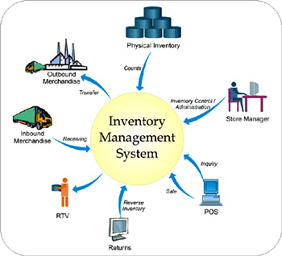
Inventory management addresses a number of concerns, including: replenishment lead time; carrying costs of inventory; asset management; inventory forecasting; inventory valuation; inventory visibility; future inventory price forecasting; physical inventory; available physical space for inventory; quality management; replenishment; returns and defective goods; and demand forecasting. By effectively managing these issues, a business can achieve optimal inventory levels. However, the management process is on-going as a business and its needs shift and respond to the wider environment.

Inventory management often involves a retailer seeking to acquire and maintain a proper merchandise assortment while ordering, shipping, handling, and related costs are kept in check. It requires systems and processes that identify inventory requirements, set targets, provide replenishment techniques, report actual and projected inventory status, and handle all functions related to the tracking and management of material. These include the monitoring of material moved into and out of stockroom locations, as well as the reconciling of inventory balances. Processes may also include ABC analysis, lot tracking, and cycle counting support.

About Company

The Company we are studying is Hi Tec Feeds, a privatized company.Hi- Tec Feeds is an animal feed production company. They are a big organization with about more than 1000 employees. They have two warehouses (Lahore, Sahiwal) and a Head Office in Lahore. Most of thework done at Hi Tec Feeds is of a contract nature. When a client company approachesthem and presents them with a demand, they deliver the required products. Hi Tec Feeds has a simple managementstructure. There is a board of directors who advise a company president. Underthe president are managers who oversee day-to-day operations of the company. And under them are the various offices.The current system they are using consists of record management system. This system includes purchase of raw materials from suppliers and then the production department produces the products and stores the products in the warehouse.

As mentioned that the company works on contract basis, if a customer wants to purchase a product from company, customer first places an order to the head office and also pays in

advance, but the company also gives products on credit to its loyal customers or distributers. Then the head office generates a Delivery Order (DO) and transfers it to the warehouse. The warehouse then checks the Delivery Order (DO) generated by Head Office. The company has a contract with some transport company which provides vehicles for transportation of products from warehouse to customers/distributers. The company first calculates the weight of empty vehicle and then loads the required products into the vehicle, then after loading the products into the vehicle they again calculate the vehicle weight, after that they calculate the Net Weight = (Loaded vehicle - Empty vehicle) and then checks the Net weight with the weight mentioned on Delivery Order (DO). Then they deliver products to the clients.
They also purchases raw materials from the suppliers. There might be a new supplier or existing supplier. In this process the Head Office analyzes the present raw materials, if the stock of raw materials is not enough; the Head Office generates a Demand Order (DO) consists of quantity required, type of raw materials etc. Head office informs the suppliers about the demand of raw materials by many means; by email, phone call or by text message. Then the supplier sends the raw materials to the warehouse on vehicle, at the warehouse the weight of the vehicle loaded with raw materials is calculated and after unloading the raw materials from vehicle, they again calculate the weight of empty vehicle; then they calculate the Net Weight = (Loaded vehicle - Empty vehicle) and then checks the Net weight with the weight mentioned on the Demand Order (DO).
The Demand Orders and Delivery Orders are generated by Sales or Purchase Managers from Head Office. Then at the warehouse, the staff of warehouse confirms the Sale or Purchase as mentioned on the Demand or Delivery Order. At the end of each day they perform closing by checking the Delivery Order or Demand Order generated and the sale or purchase completed.

Management System Standards
ISO management system standards provide a model to follow when setting up and operating a management system. Like all our standards, they are the result of international, expert consensus and therefore offer the benefit of global management experience and good practice.
These standards can be applied to any organization, large or small, whatever the product or service and apart from of the sector of activity.

The benefits of an valuable management system include:
- More efficient use of resources
- Improved risk management, and
- Increased customer satisfaction as services and products consistently deliver what they promise.

Goals and Objectives
The objectives of this system are as following:
- To monitor the vehicles remotely everyday
- To provide the mobility to the costumers as well as the specialists by eliminating the need of in-housed examination.
- To bring the automation in the field by providing a real time Management System.

Tools
During the development in this project the tools we use for the completion of this project are:
- Microsoft Visual Studio 2012
- SQL Management Server 2012

Microsoft Visual Studio 2012
Microsoft Visual Studio is an integrated development environment (IDE) from Microsoft. It is used to develop computer programs for Microsoft Windows, as well as web sites, web applications and web services. Visual Studio uses Microsoft software development platforms such as Windows API, Windows Forms, Windows Presentation Foundation, Windows Store and Microsoft Silverlight. It can produce both native code and managed code.
Visual Studio includes a code editor supporting IntelliSense (the code completion component) as well as code refactoring. The integrated debugger works both as a source-level debugger and a machine-level debugger. Other built-in tools include a forms designer for building GUI applications, web designer, class designer, and database schema designer. It accepts plug-ins that enhance the functionality at almost every level—including adding support for source-control systems (like Subversion) and adding new toolsets like editors and visual designers for domain-specific languages or toolsets for other aspects of the software development lifecycle (like the Team Foundation Server client: Team Explorer).
Visual Studio supports different programming languages and allows the code editor and debugger to support (to varying degrees) nearly any programming language, provided a language-specific service exists. Built-in languages include C, C++ and C++/CLI (via Visual C++), VB.NET (via Visual Basic .NET), C# (via Visual C#), and F# (as of Visual Studio 2010). Support for other languages such as Python, and Ruby among others is available via language services installed separately. It also supports XML/XSLT,HTML/XHTML, JavaScript and CSS. Java (and J#) were supported in the past.

SQL Management Studio 2012

Microsoft SQL Server is a relational database management system developed by Microsoft. As a database server, it is a software product with the primary function of storing and retrieving data as requested by other software applications which may run either on the same computer or on another computer across a network (including the Internet).
SQL Server 2012's new features and enhancements include Always On SQL Server Failover Cluster Instances and Availability Groups which provides a set of options to improve database availability, Contained Databases which simplify the moving of databases between instances, new and modified Dynamic Management Views and Functions, programmability enhancements including new spatial features, metadata discovery, sequence objects and the THROW statement, performance enhancements such as Column Store Indexes as well as improvements to On Line and partition level operations and security enhancements including provisioning during setup, new permissions, improved role management, and default schema assignment for groups

Architecture
3-Tier architecture generally contains UI or Presentation Layer, Business Access Layer (BAL) or Business Logic Layer and Data Access Layer (DAL) that is connected to the database by store procedures and models.
Presentation Layer (UI)
Presentation layer cotains pages like .aspx or windows form where data is presented to the user or input is taken from the user this can be designed as by the expectation of the users. Presentation layer includes buttons, grids, text field etc.
Business Access Layer (BAL) or Business Logic Layer
BAL contains business logic, validations or calculations related with the data, if needed. I will call it Business Access Layer in my demo. In this layer we write all the logic compared to the project as from the name this tell the business logic of the project, all the calculation, technical work are done in the Business logical layer or BAL
Data Access Layer (DAL)
DAL contains methods that helps business layer to connect the data and perform required action from the database that is created in SQL server, might be returning data or manipulating data (insert, update, delete etc) by the help of store procedures.

Software Development Lifecycle

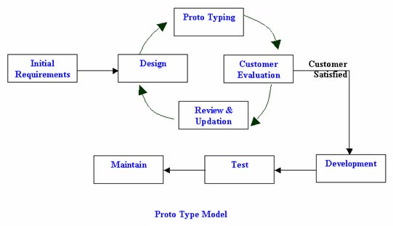
The lifecycle we are using in making our project is Prototype model. The Prototyping Model is a systems development method (SDM) in which a prototype (an early approximation of a final system or product) is built, tested, and then reworked as necessary until an acceptable prototype is finally achieved from which the complete system or product can now be developed. This model works best in scenarios where not all of the project requirements are known in detail ahead of time. It is an iterative, trial-and-error process that takes place between the developers and the users.

Literature Review

Hi tech sale / purchase system is totally according to requirements of the company. As we have already shown the picture of software which is already working for sale & purchase in Hi tech. The information technology is growing day by day. They need advancement in their software through which will able to keep record for each thing they have purchase or sale like purchasing of raw material or sale of goods.
The company was facing the problem with their old system like wrong inputs, not a user friendly interface, wrong billing.
We have made this software using the ASP.Net technology covering all the given factors. Basically the user will login into the system, on the front screen he get the entry form of receiving raw material from the manufacturer. The user have to enter the vehicle number, net weight of the truck , gross weight of the truck, total number of bag, how much weight is being carried by each bag. After Unloading user will give the goods receive note to the truck driver.
Using this software user can mention the unit of receiving goods. User can also mention the type of bags, weight of the bags etc.
Similarly when the company will sale out raw material or goods, Operator will give the delivery address, invoice of the material that will shipped.
Hi Tech have multiple branches at multiple cities , so in this software according to the requirement we have the form in which user can mention the branch address .Each copy of the sale of the good or purchase of a raw material will be sent to the head quarter of the company.
Further maintenance / updating of the software can be done according to the given requirement of the user.

Problem Statement

Problem Background

The problem they are facing are, some of the staff members inputs ambiguous weight or they input wrong vehicle information and present any other non-registered vehicle and by doing this they commit fraud. For this problem they want images of vehicle coming in or out of the warehouse. There are many steps involved in the process of solving problem. These steps involve billing the client, purchasing materials, checking inventory and soon. Due to the rapid growth of the company, many standard procedures used to perform these tasks are becoming insufficient to meet the needs of the company and their clients.
We have already carried out a Feasibility Study and a Requirements Analysis at HI Tech Feeds and determined that there are few areas that need the greatest attention is the accurate information of the system. The management agrees that this area of their business requires immediate attention and they are actually considering the conclusions of our Feasibility Study. The system was originally designed for a much smaller workforce, but with recent growth and workforce expansion, the system has become inadequate, thus impeding efficiency. This has resulted in relatively large project delays, inventory wastage and increased cost of maintaining the legacy system.

Problem Statement

A problem statement is a concise description of the issues that need to be addressed by a problem solving team and should be presented to them (or created by them) before they try to solve the problem.
Hence the Problem that we faced are much so we helped the company to resolve that problem. The Management system that there are using is a desktop application that is a big flaw for the company. Only admin was authorized to login the application that was a big problem because their offices are located on different places of Pakistan like Sahiwal etc. a person from the head office or from the factory was using that system whereas this system is needed in other warehouses also. Other problem we faced that was of sale and purchase, they were not editable once the admin have entered the sale or purchase he was unable to redo or edit that so this prob;em was also facing by them. Oth4er problem was their databse problem, once the data is entered then it can be used but if they want to enter another data then they have to delete the previous data then they were able o store other data.

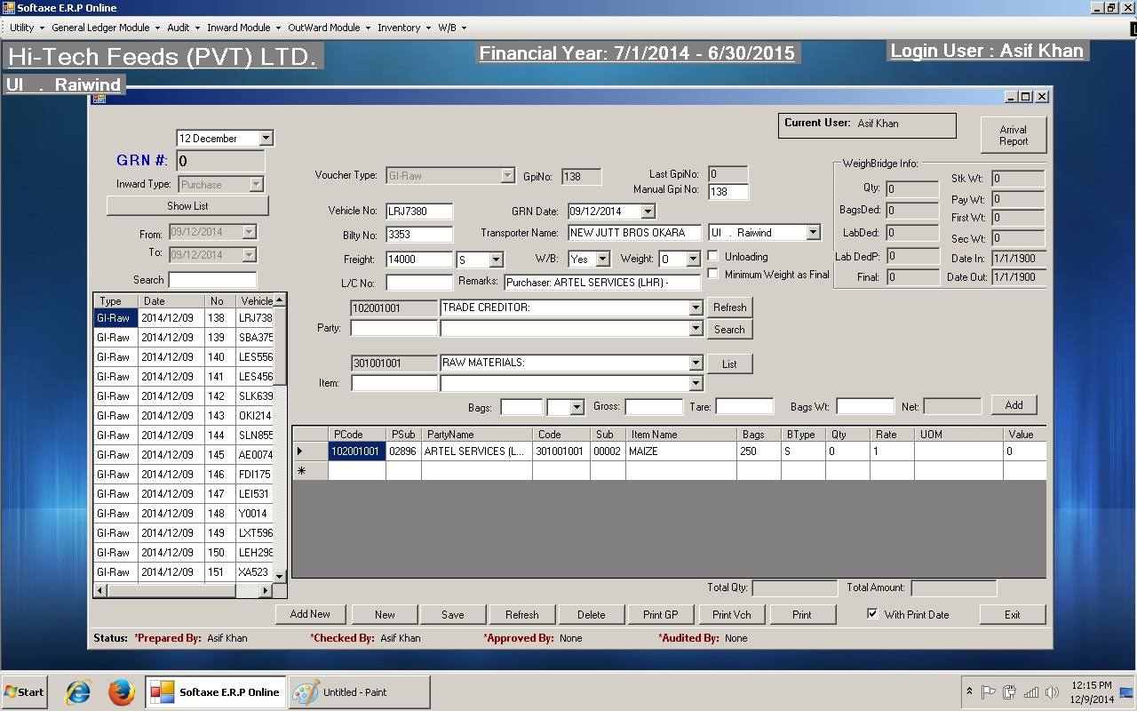
Old System Pictures

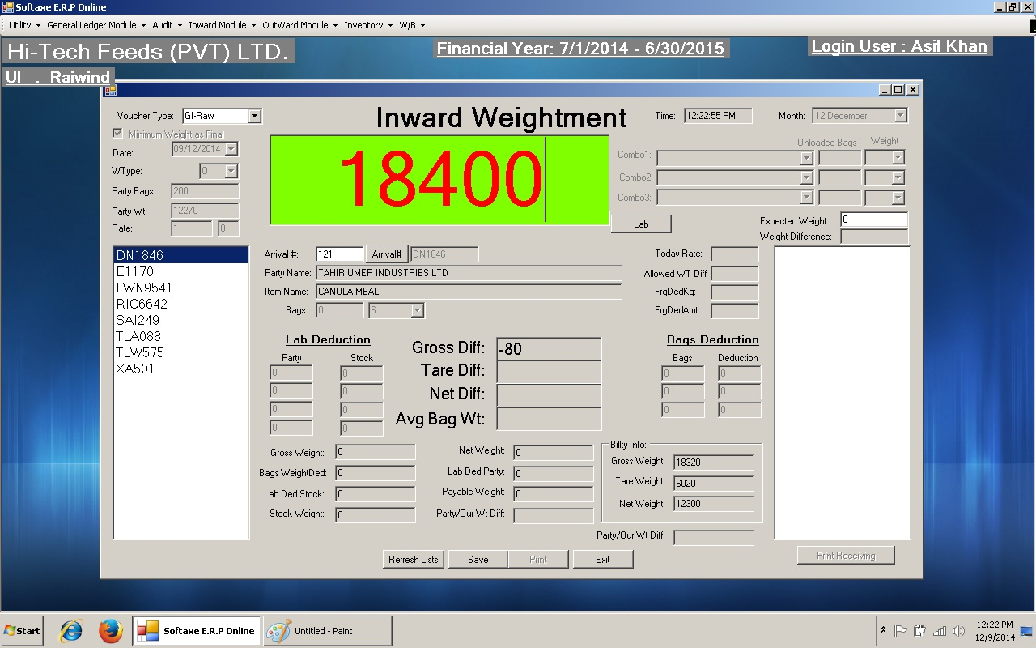
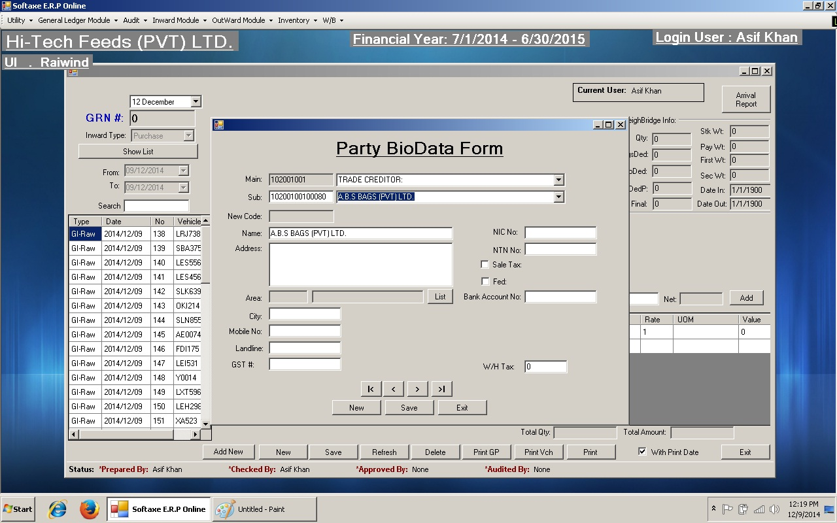
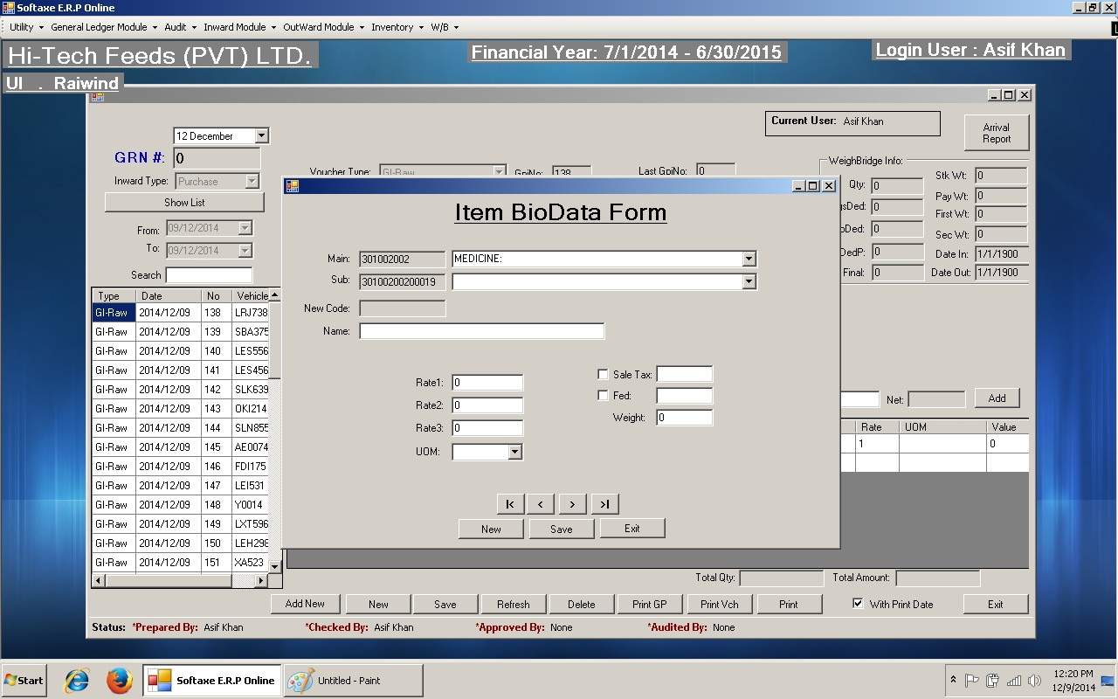

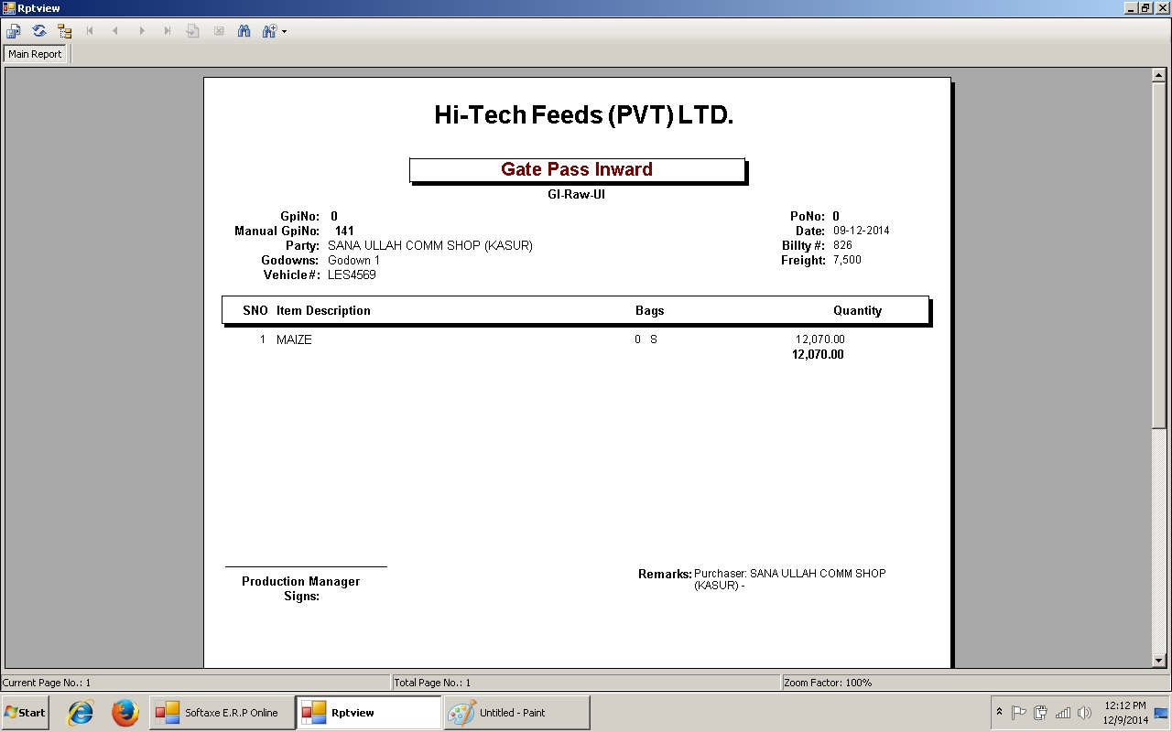
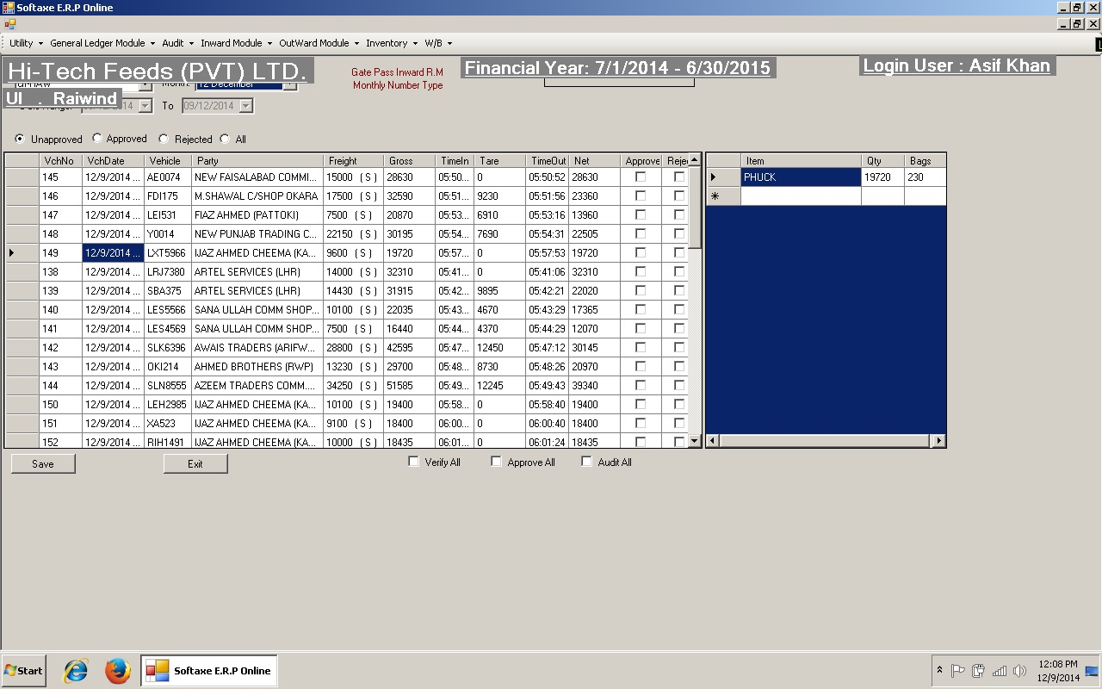

Deliverables
After many meeting with the company we get all the requirement and then we offered them a complete management system to their company which is web based and can be access from anywhere in Pakistan, no issue of database and sale purchase and inventory.
As such there is no Hardware unit to be delivered but we are providing them a user friendly software that can be very useful to them.

Requirement Analysis
The first stage in designing a solution to this problem is to determine the requirements of the new system. The requirements are documented and given to us. What follows below is the list of functional and non-functional requirements for the new system generated by that study.

Functional Requirements

- Details of data storage
Inventory Items
- Name
- Location
- Date of Order
- Cost of item
- Details of output
- Inventory list screen
- Add new item screen
- Remove item screen
- Check location screen
- Check-out item screen
- Update item screen
- Place order screen
- Print order screen
- Print reports screen/Print hard copy
- Inventory Reports (various reports)
- Personnel Reports (various reports)
- Project Reports (various reports)

- Details of input
  - Current inventory system info (paper files)
  - Shipping order
  - Item name
  - Item amount
  - Item date
  - Persons name who ordered the item

- Details of Information Processing
- Inventory item
- Amount remaining
- Amount used by production

- Sold Items
- Total items Sold
- Customer Information
- Purchased Items
- Total Materials Purchased
- Supplier Information

Non Functional Requirements
- Software Requirements
  - MS Windows Server2008 R2
  - MS SQL Server
  - MS ASP.NET C#
- Hardware Requirements
  - Intel Core i5 or higher
  - 1 TB hard disk space
  - 8 GB RAM or Higher
  - Laser Printer
  - Weighing Machine
  - GSM Device
- Security Requirements
- User name and Password identification for all users
- IP based Cameras.

- Interface Requirements
- Simple interface
- No large user manual required
- Short training session
- Lifecycle Requirements
  - System upgradeable
  - Development time < 6 months

- Economic Requirements
All the equipment is already being used by old system. So we do not need to buy new equipment.

RESEARCH METHODOLOGY/ PROPOSED APPROACH

.
The word methodology is defined as a system which comprises the ethics, practices and procedures which are applied to a specific division of knowledge. Methodology refers to the way in which information is found or the way something is done. Methodology includes the methods, techniques and procedures which are used to collect and analyze information.

A methodology is defined as something that represents a package comprising practical ideas and proven practices for a given area of activity. Methodology includes the planning, the development of the design and the management of the systems which are based on information technology.

The word methodology refers to a documented approach which is used to perform activities in a manner which is coherent, consistent, accountable and repeatable. Methodology is a process that mainly consists of intellectual activities. Usually only the end goal of the methodological process is manifested as the product or result of the physical work. In software, the term methodology is used to a specific series of steps or a procedure which governs the activities of analysis and design.

Database Explanation
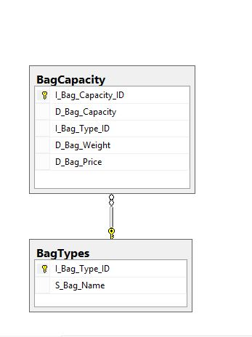

Bags
The bags that we bet from the Bilty or from the warehouse are recorded in the database. Bag Capacity and Bag types are also defined like it is a polythene bag or any other bag. Bag weight, capacity etc all are store in the database from there it can be accessed easily.

Bilty Information
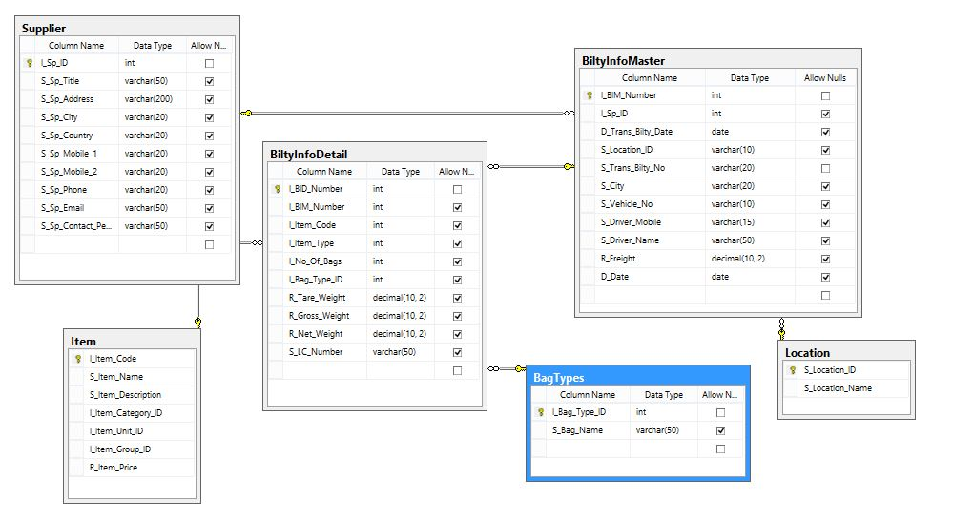

In bilty information we kept all the information about the bilty that we get from the warehouse or other sources etc. As you can see from the database diagram we have many tables for the bilty information like suppliers, bilty information detail, item, bag types, location and bilty information master. Below is the explanation of the main tables of bilty information:
SUPPLIERS
Suppliers are those parties that supplies goods or resources to companies they are also known as vendors. The entire detail of the supplier is recorded in the database like name, ID, address, city, country, mobile and Email. Once the information have been saved then whenever he come then all his information will be displayed against its ID.

BILTY INFORMATION DETAIL
Bility information is recorded in this table when a bilty come then the driver or the resource person handover the bilty paper to the authorize person then he will check all the entities that are on that table which are bilty number, item code, item type, number of bags, bag type ID, tare weight (the weight when the vehicle is empty), gross weight (the weight when goods are on the vehicle), net weight (difference between tare and gross weight).
BILTY INFORMATION MASTER
In this table the information of bilty master is stored like transfer bilty date, location ID (all locations of the company have different ID’s), transfer bilty number, city (form which city the vehicle has came), vehicle number, driver contact number, drivers name, fright and date.

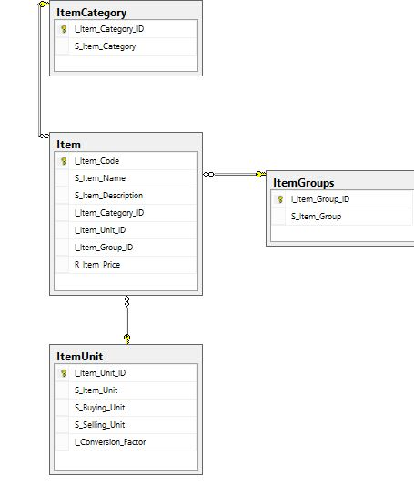
Items

In items table we can see that there are many tables like item category, item groups, item and item unit. In these tables all the information of the items are stored in the tables like their ID, name, description, price etc. the main item that are used in this company is wanda and bardana.

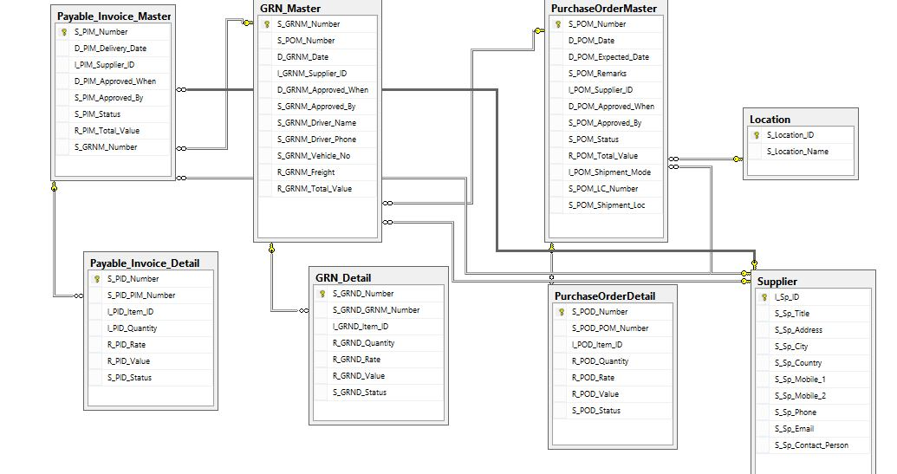
Purchase
Getting any goods from any company or shop by giving them money is called purchase. As you can see form the database diagram there are many tables that that related to Purchase. All the detailed description of purchase is recorded in purchase segment. The main tables to be explained as follows:
PURCHASE ORDER MASTER
In purchase order master table all the purchase detail is recorded like the POM number, date, expected date, remarks, supplier ID, approved when and by (approved by the admin or the authorize persons), status (weather the goods are delivered or not), total value, and shipment mode (by air, land or water).
PURCHASE ORDER DETAIL
In this table the order detail are discussed like the number, item ID, quantity, rate, value and status.

GRN MASTER
In GRN master all the detail of GRN is recorded that includes purchase order master number which is attached by the foreign key to the purchase order master table, date, supplier ID, approved when and by whom, driver ID and his phone number etc.

SUPPLIER AND CUSTOMER
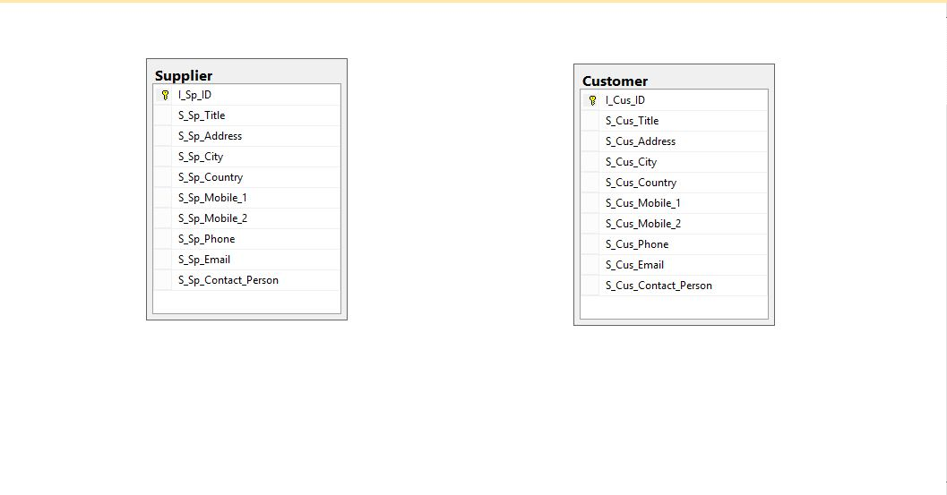

Use Cases

ADMIN
Admin is a person that can handle all the important data of the company, first of all the admin will be log in to the system by his username and password then he will able to access the main things. He can view the products, view the raw materials, view the suppliers and he also can view the buyers

Warehouse manager of sale department

Warehouse manager also plays an important role in managing the warehouse. He also have to be logged in to access the company matters, he can also maintain his check list according the policy of the company like he can check the delivery order, buyer information, weight of empty vehicle, he can also generate first weight slip, can check weight of loaded vehicle. He can also view the products that came in that vehicle i.e. number of bags and he also has the authority to generate the gate pass.

Warehouse manager of purchase department

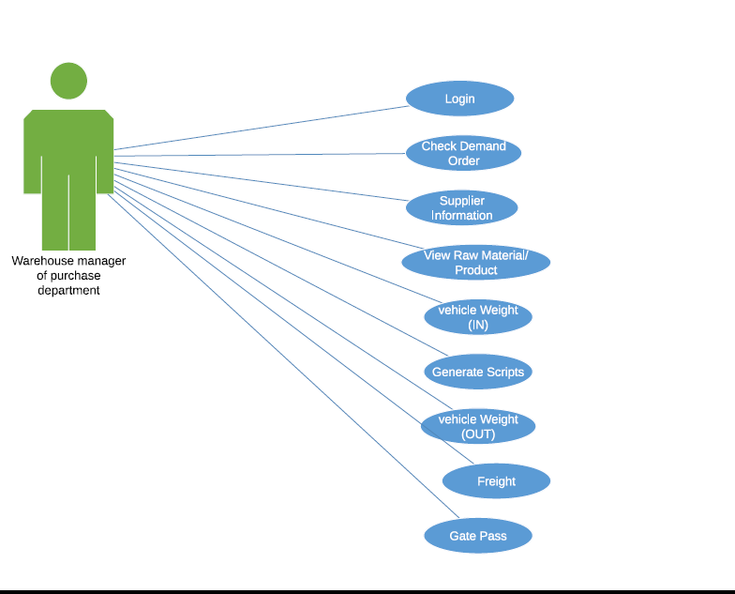

NEW system snapshots:

Bilty information
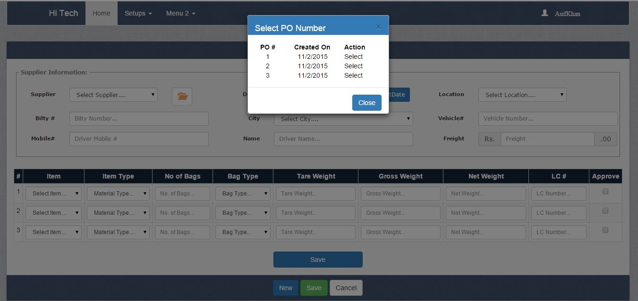
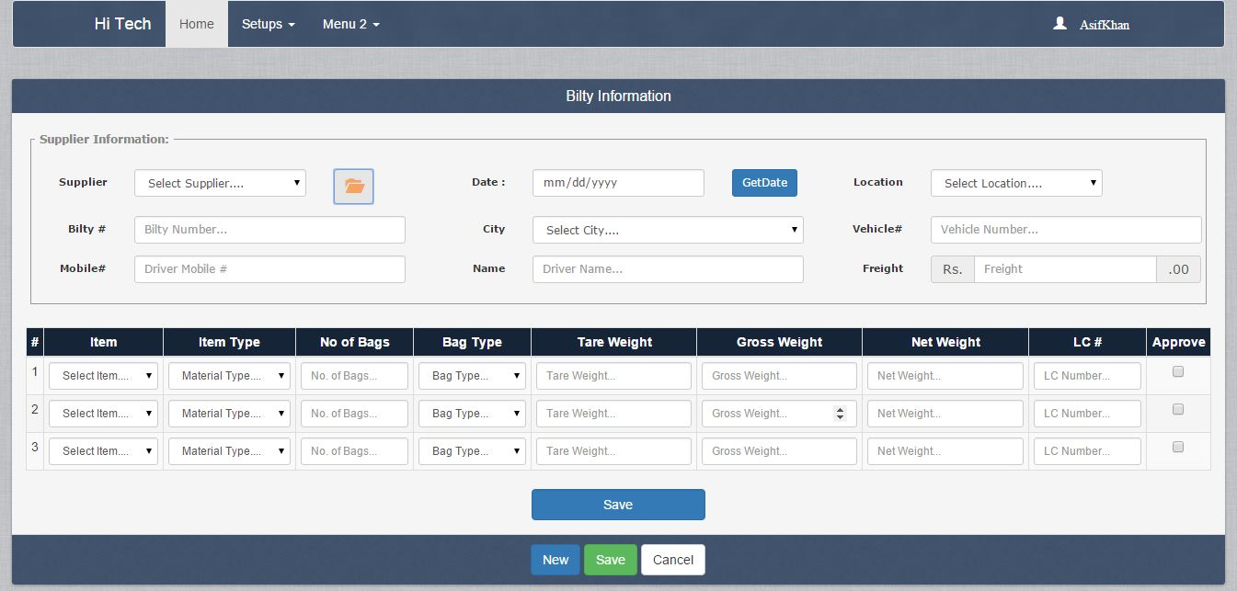

Item unit

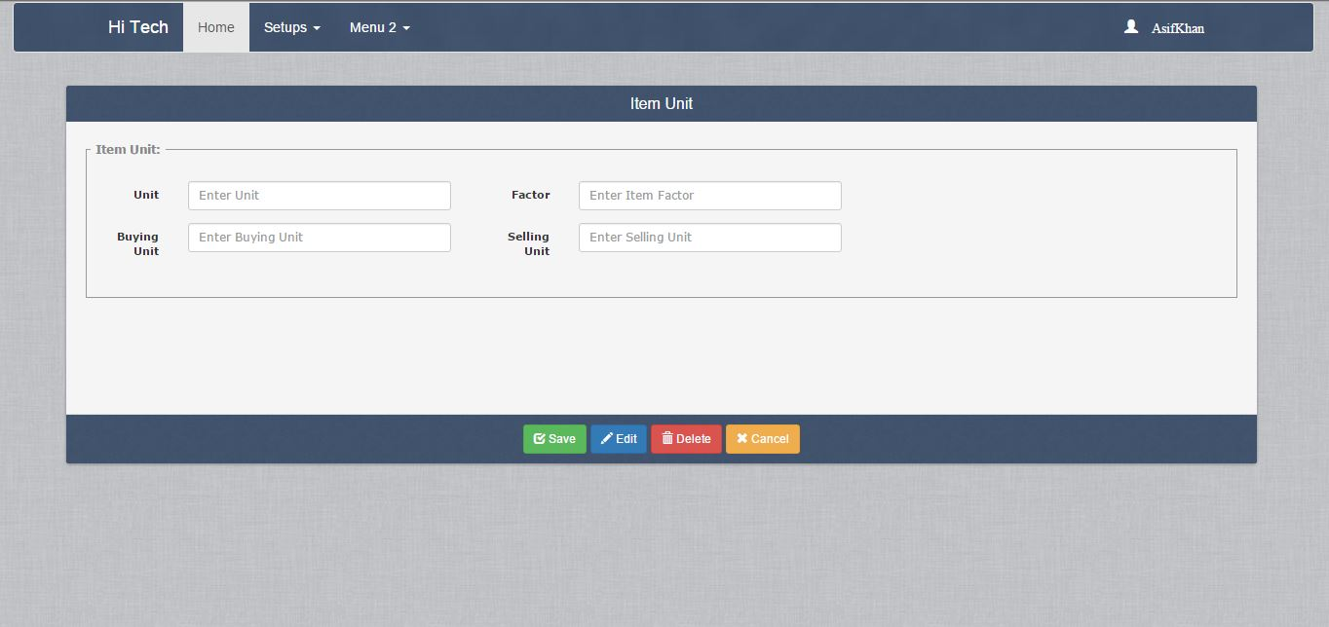

Item Information

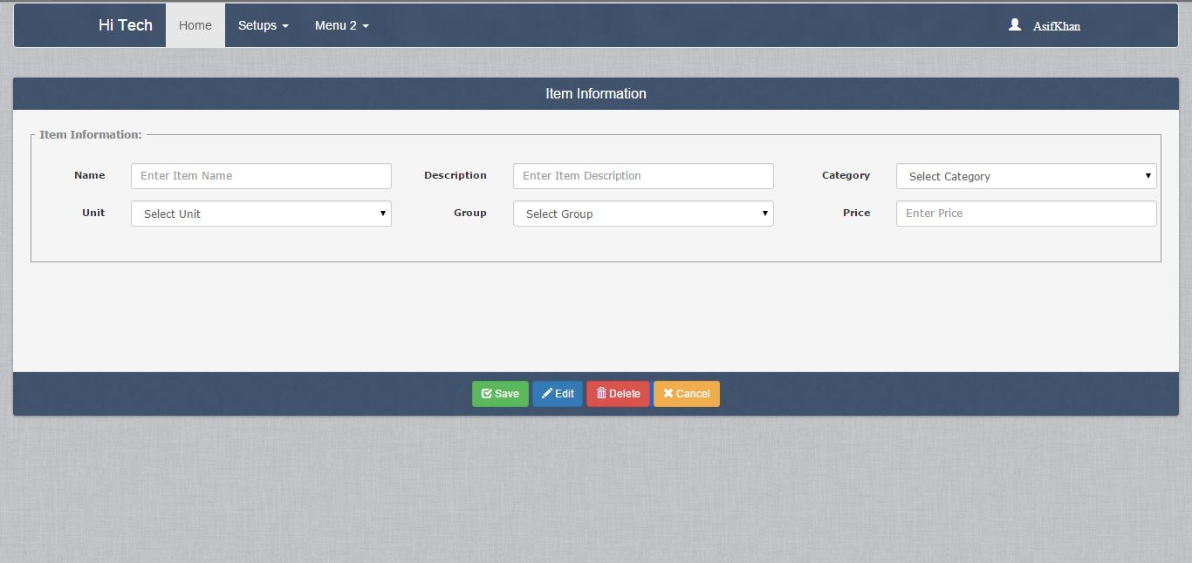
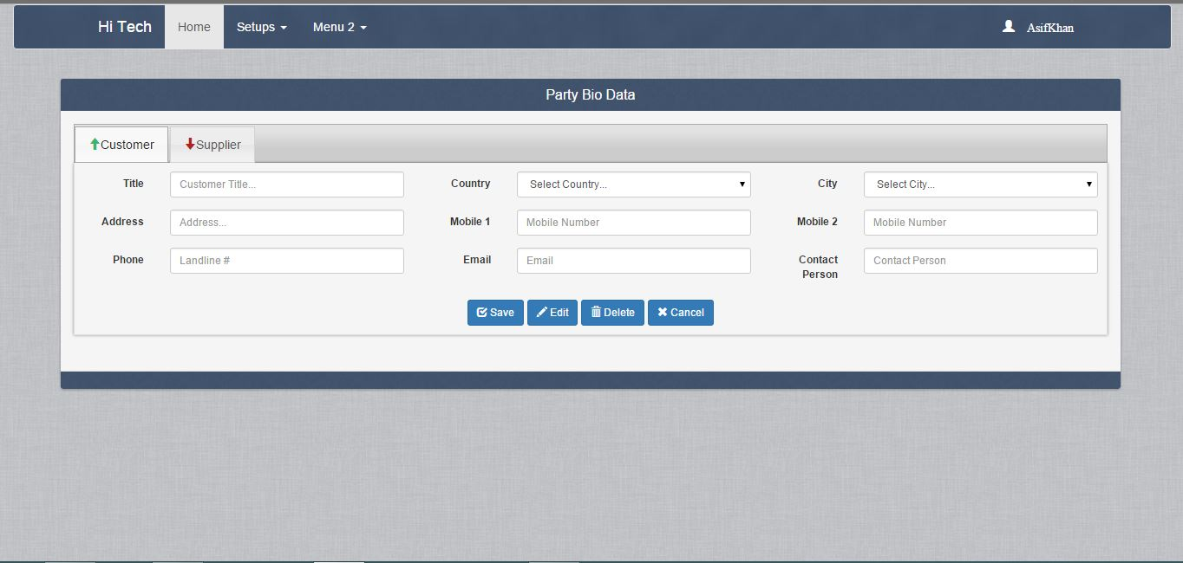

Goods Receive Note
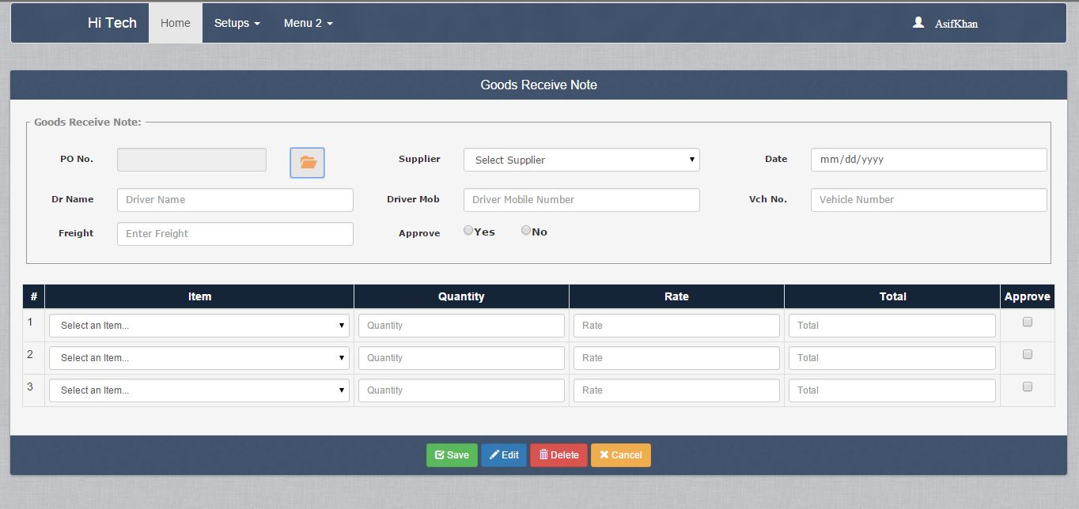

Login/Sign In
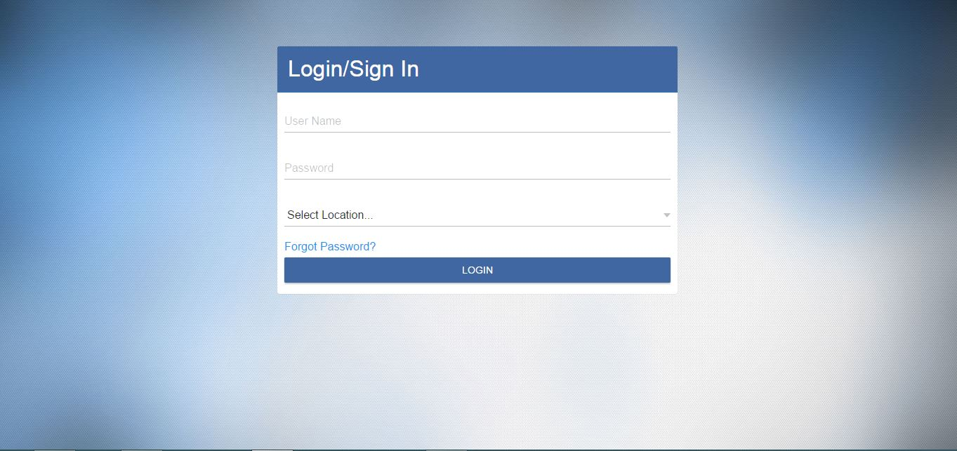

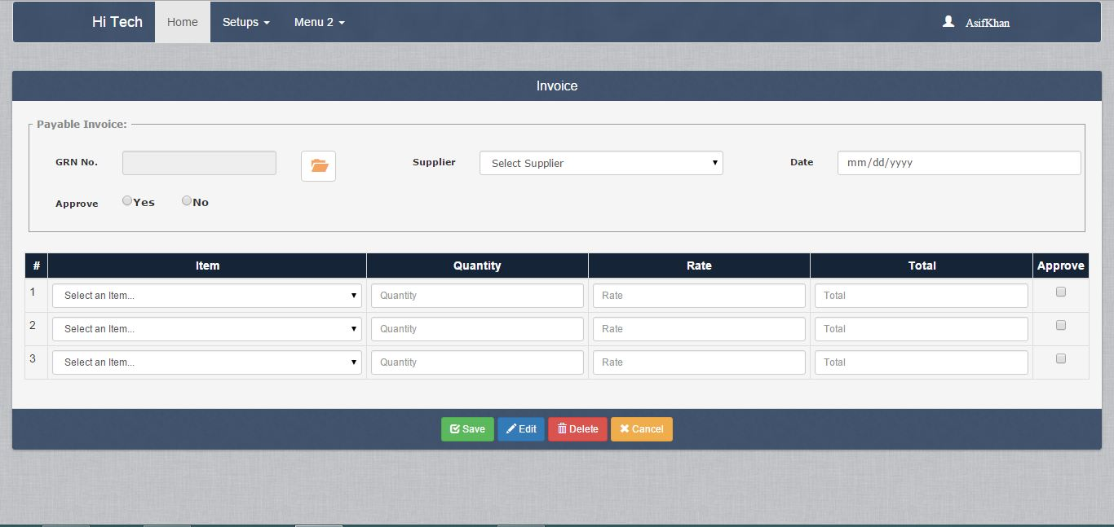
Invoice

Purchase Order
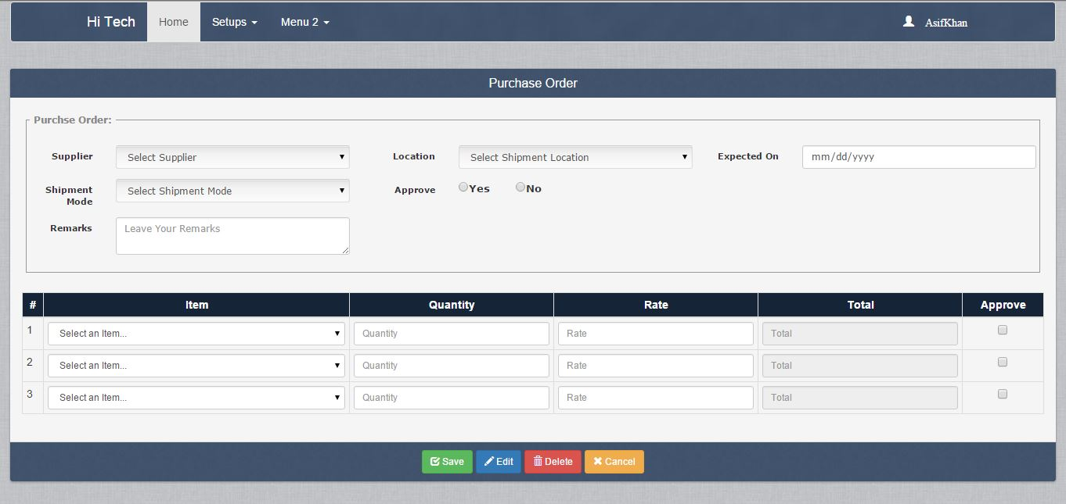

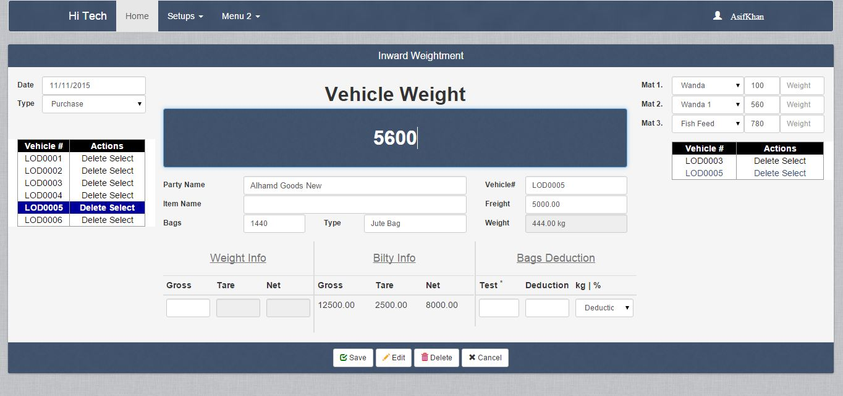
Inward Weightment

REPORTS

Users & User Level: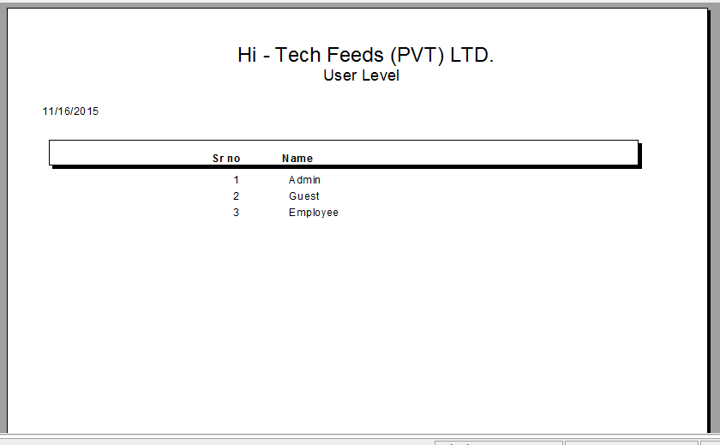
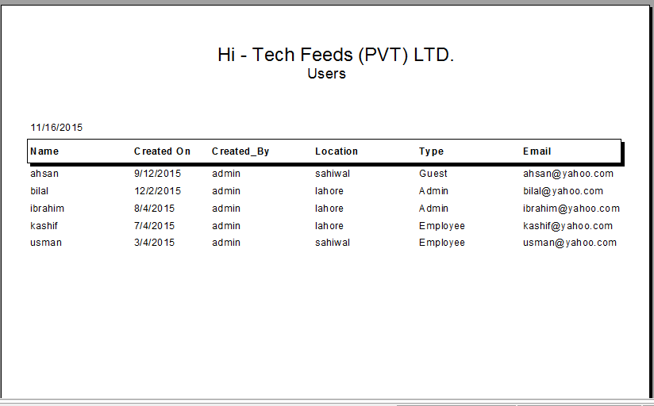

Units:
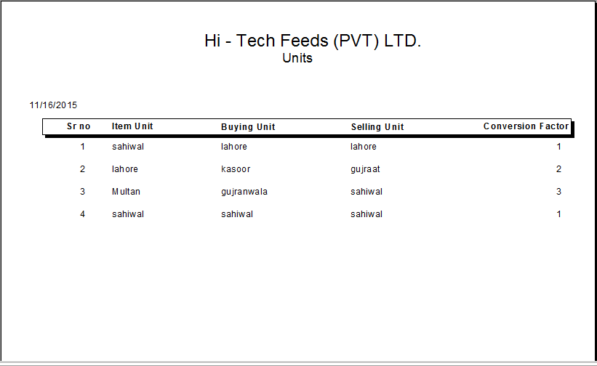

Type of Bags: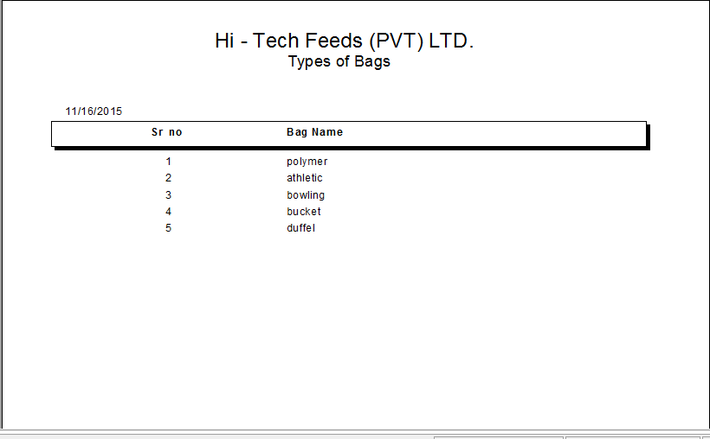

Supplier:
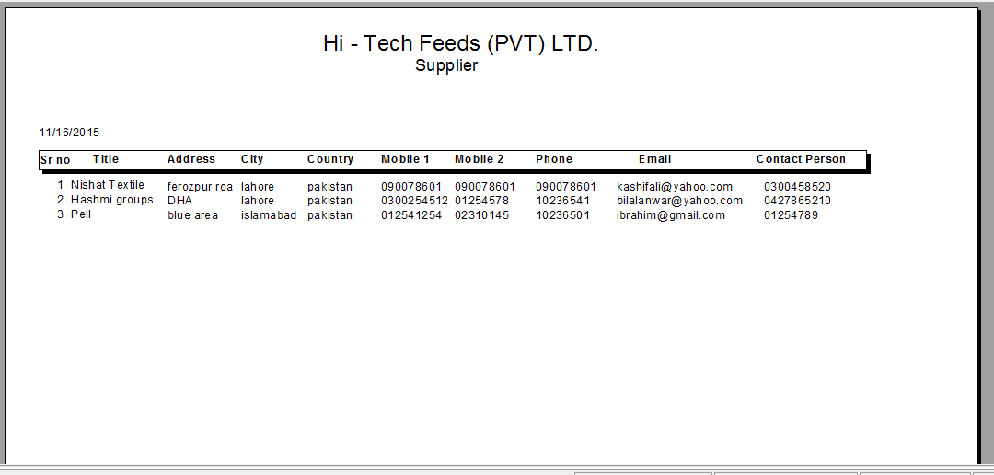

Sale Order:
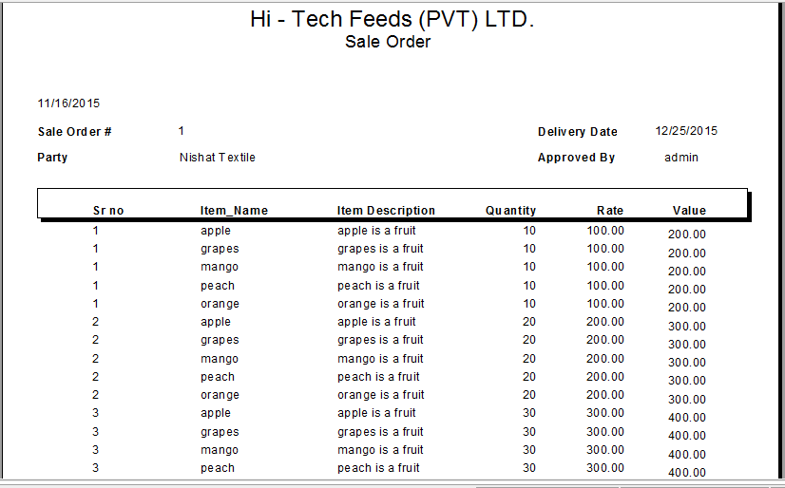

Sale Invoice:
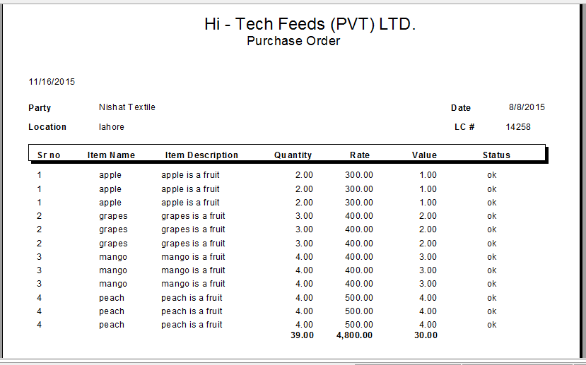

Purchase Order:

Products Trans. Master:
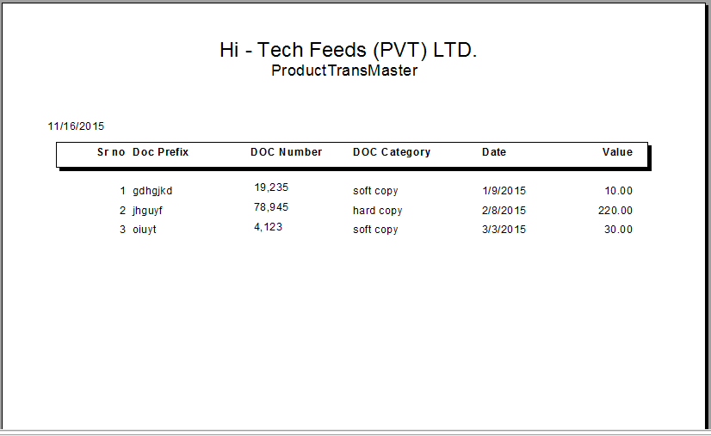

Price:
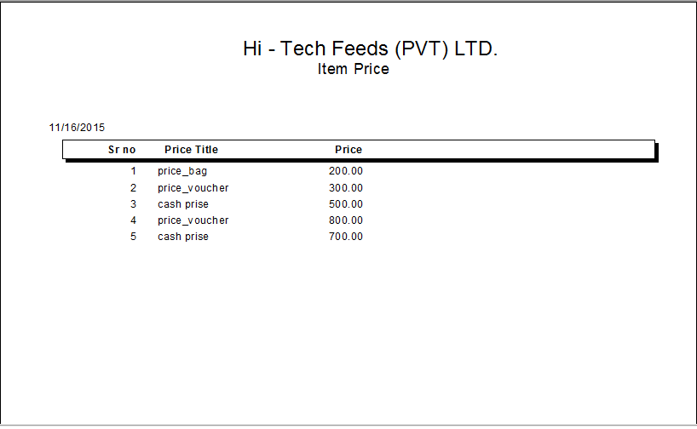

Price Title:
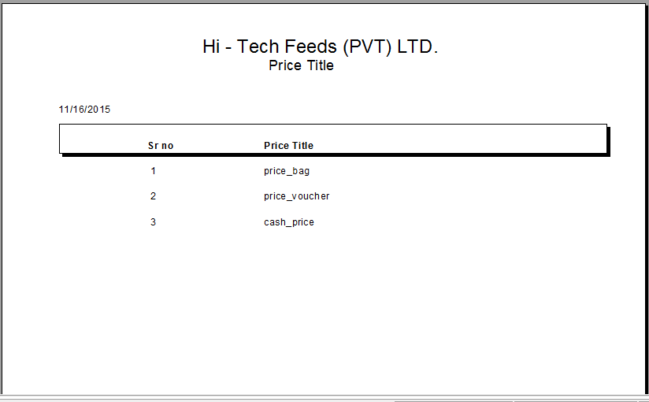

Price Period:
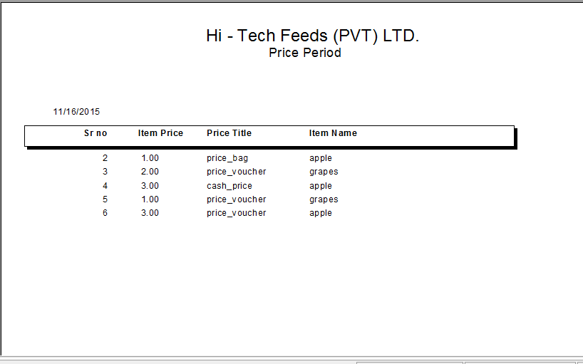

Payable Invoice:
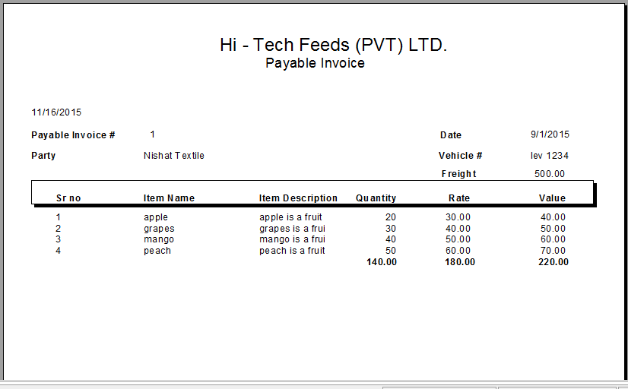

Location:
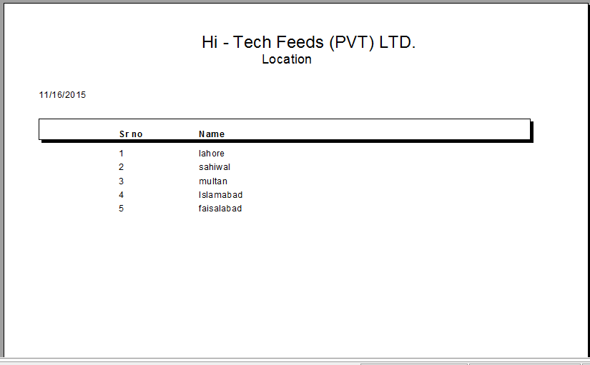

Loading Sheet:

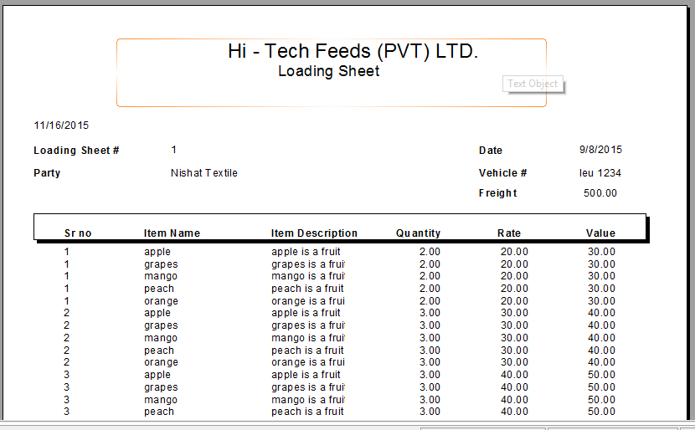

Items:
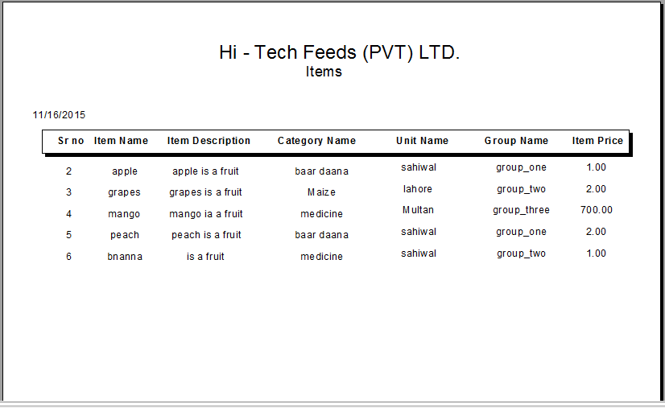

Goods Receive Note:

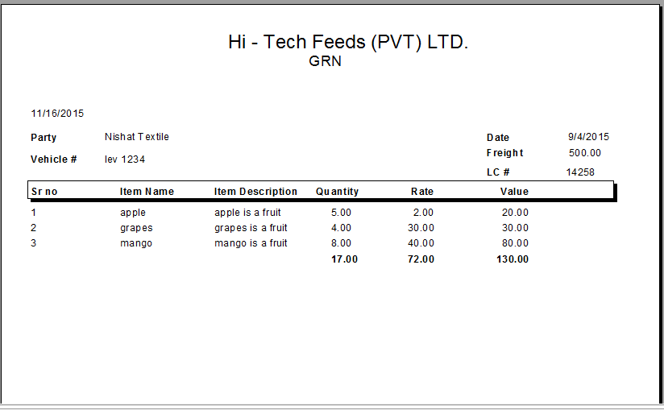

Gate Pass Inward:

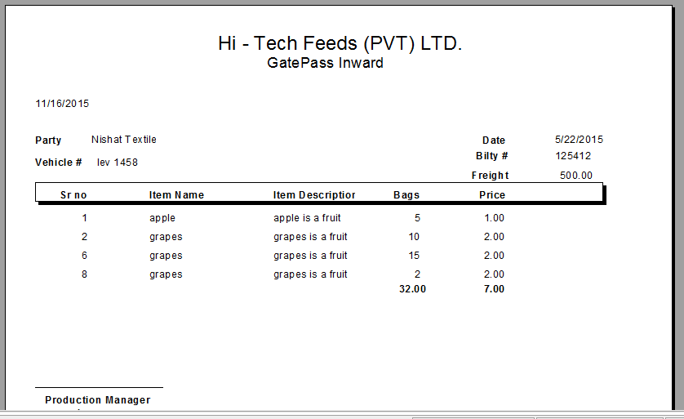

Customers:

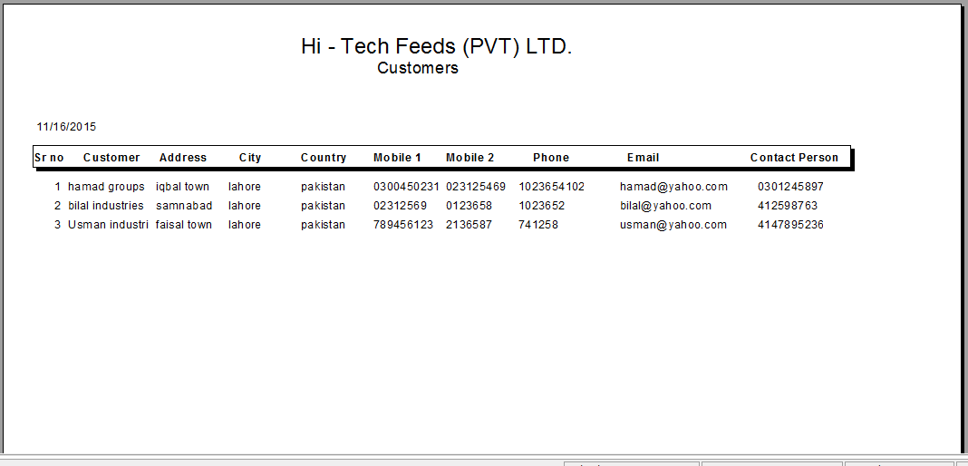

Category:

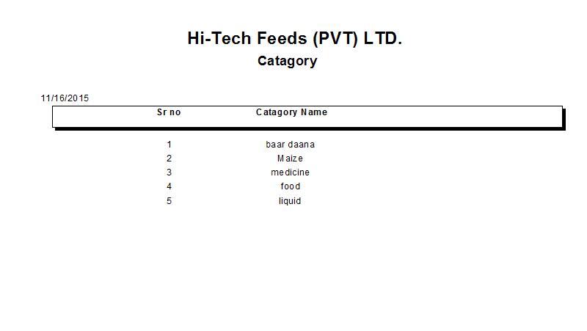

Bility:

Bag Types:
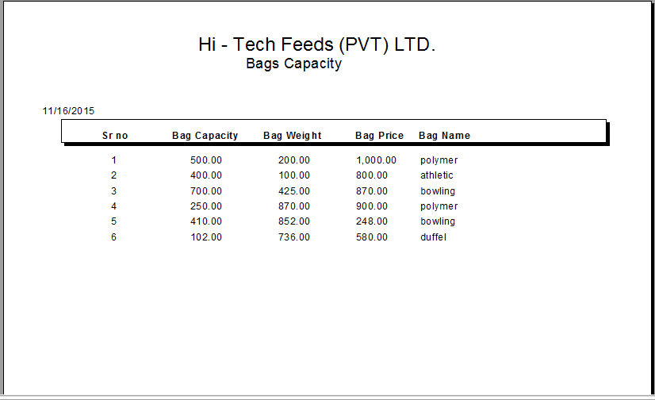

Bag Capacity:

References:

http://www.businessdictionary.com/definition/supplier.html#ixzz3rAPmFrMs
https://www.youtube.com/watch?v=g-Ayl9BhnOw
http://codingresolved.com/discussion/190/crystal-reports-in-asp-net/p1
www.asp.net/downloads/archived-v11/starter-kits/reports
www.tomjewett.com/dbdesign/dbdesign.php?page=tables.php
https://codex.wordpress.org/Database_Description
http://www.extendstudio.com/documentation/fusioncharts-for-dw-developer-edition/documentation/docs/database-table-method-examples.html
http://rowlandsgroup.com/content/sales-purchasing-and-inventory-system
http://www.kalpaksolutions.com/inventory_sales_purchase_payroll_systems.php
http://www.capterra.com/inventory-management-software/
Source: Boundless. “Inventory Management.” Boundless Business. Boundless, 21 Jul. 2015. Retrieved 06 Nov. 2015 from https://www.boundless.com/business/textbooks/boundless-business-textbook/operations-management-10/controlling-the-supply-chain-72/inventory-management-338-7464/

