SUPERIOR UNIVERSITY LAHORE


Faculty of Computer Science & IT

Final Year Project
PROJECT REPORT (Part-1)

[Mobile tv application]

Project ID: [FYP-BSSE-S18-015]

Project Team
Student Name | Student ID | Program | Contact Number | Email Address
Zaheer abbas | BSEM-S15-017 | BSSE | 03025400184 | Xaheerabbas963@gmail.com
Zain ul Abidin | BSEM-S15-003 | BSSE | 03082078716 | Zainrasheed30@gmail.com

[Umair Zafar Khan]
Project Report
[Title of Project]

Change Record
Author(s) | Version | Date | Notes | Supervisor’s Signature
 | 1.0 |  | <Original Draft>
 |  |  | <Changes Based on Feedback from Supervisor>
 |  |  | <Changes Based on Feedback From Faculty>
 |  |  | <Added Project Plan>
 |  |  | <Changes Based on Feedback from Supervisor>

APPROVAL
PROJECT SUPERVISOR
Comments: ___________________________________________________________________
_____________________________________________________________________________
Name: ______________________________
Date: ______________________________ | Signature:__________________________

PROJECT MANAGER
Comments: ___________________________________________________________________
_____________________________________________________________________________
Date:_______________________________ | Signature:__________________________

HEAD OF THE DEPARTMENT
Comments: ___________________________________________________________________
_____________________________________________________________________________
Date:_______________________________ | Signature:__________________________

Dedication

This work is dedicated to my respected teachers and faculty of computer science department. They are the Constant source of guidance throughout the course of this project. We would also like to thank Mr. Umair zafar khan for his help and guidance throughout this project. We are also thankful to our friends and families whose silent support led us to complete our project documentation.

Acknowledgements

We truly acknowledge the cooperation and help make by ________________, Chairman, Department of Information Technology, superior university lahore. He has been a constant source of guidance throughout the course of this project. We would also like to thank Mr. _____________________ for his help and guidance throughout this project. We are also thankful to our friends and families whose silent support led us to complete our project.

Executive Summary
Our system named Mobile tv Application is entertainment-based system. Its Interface is like entertainment website. A lot of people browse the internet for entertainment but due to limited data they spend lot of their money to entertain themselves. Sometimes the entertainment content is of very low quality. Therefore, we decided to make a system which provide entertainment of very good quality at very affordable price also the unlimited entertainment can be access on both mobile and laptops. MTA will Provide high quality movies, songs and dramas. It also provides Live streaming option by which a user can watch live channels which he wants.

Table of Contents
Dedication iv
Acknowledgements v
Executive Summary vi
Table of Contents vii
List of Figures ix
List of Tables x
Chapter 1 1
Introduction 1
1.1. Background 2
1.2. Motivations and Challenges 2
1.3. Goals and Objectives 2
1.4. Literature Review/Existing Solutions 2
1.5. Gap Analysis 2
1.6. Proposed Solution 2
1.7. Project Plan 3
1.7.1. Work Breakdown Structure 3
1.7.2. Roles & Responsibility Matrix 3
1.7.3. Gantt Chart 3
1.8. Report Outline 3
Chapter 2 4
Software Requirement Specifications 4
2.1. Introduction 5
2.1.1. Purpose 5
2.1.2. Document Conventions 5
2.1.3. Intended Audience and Reading Suggestions 5
2.1.4. Product Scope 5
2.1.5. References 6
2.2. Overall Description 6
2.2.1. Product Perspective 6
2.2.2. Product Functions 6
2.2.3. User Classes and Characteristics 6
2.2.4. Operating Environment 7
2.2.5. Design and Implementation Constraints 7
2.2.6. User Documentation 7
2.2.7. Assumptions and Dependencies 7
2.3. External Interface Requirements 8
2.3.1. User Interfaces 8
2.3.2. Hardware Interfaces 8
2.3.3. Software Interfaces 8
2.3.4. Communications Interfaces 9
2.4. System Features 9
2.4.1. System Feature 1 9
2.4.1.1. Description and Priority 9
2.4.1.2. Stimulus/Response Sequences 9
2.4.1.3. Functional Requirements 9
2.4.2. System Feature 2 10
2.4.2.1. Description and Priority 10
2.4.2.2. Stimulus/Response Sequences 10
2.4.2.3. Functional Requirements 10
2.4.3. System Feature 3 (and so on) 11
2.5. Other Nonfunctional Requirements 11
2.5.1. Performance Requirements 11
2.5.2. Safety Requirements 11
2.5.3. Security Requirements 12
2.5.4. Software Quality Attributes 12
2.5.5. Business Rules 12
2.6. Other Requirements 12
Chapter 3 13
Use Case Analysis 13
3.1. Use Case Model 14
3.2. Fully Dressed Use Cases 14
Chapter 4 15
System Design 15
4.1. Architecture Diagram 16
4.2. Domain Model 16
4.3. Entity Relationship Diagram with data dictionary 16
4.4. Class Diagram 17
4.5. Sequence / Collaboration Diagram 17
4.6. Operation contracts 17
4.7. Activity Diagram 18
4.8. State Transition Diagram 18
4.9. Component Diagram 18
4.10. Deployment Diagram 19
4.11. Data Flow diagram [only if structured approach is used - Level 0 and 1] 19
Chapter 5 20
Implementation 20
5.1. Important Flow Control/Pseudo codes 21
5.2. Components, Libraries, Web Services and stubs 21
5.3. Deployment Environment 21
5.4. Tools and Techniques 22
5.5. Best Practices / Coding Standards 22
5.6. Version Control 22
Appendices 23
Appendix A: Information / Promotional Material 24
Reference and Bibliography 27
Index 29

List of Figures

1.1 Caption of first figure of first chapter 6
1.2 Caption of second figure of first chapter 7
2.1 Caption of first figure of second chapter 14
2.2 Caption of second figure of second chapter 22
2.3 Caption of third figure of second chapter 26
5.1 Caption of first figure of fifth chapter 49
5.2 Caption of second figure of fifth chapter 49

List of Tables

1.1 label of first table of first chapter 6
1.2 label of second table of first chapter 7
2.1 label of first table of second chapter 14
2.2 label of second table of second chapter 22
2.3 label of third table of second chapter 26
5.1 label of first table of fifth chapter 49
5.2 label of second table of fifth chapter 49

Chapter 1

Introduction

Chapter 1: Introduction
Mobile tv Application will provide an effective source of entertainment to the people. People use different online entertainment sources to entertain themselves but the content is not in the high-quality format on the other side their data packages are not enough to even watch a full movie. Using the online sources are quite expensive for an ordinary user because first they have to purchase a data package from his service provider then they have to subscribe for the online entertainment for good quality content. That is much expensive and also user has to face the streaming problem. Those Systems leads to many problems like slow data loading, low content quality that wastes valuable time and money. We are providing the solution of all these problems by the Wireless Cable Network. Our system will provide unlimited entertainment at single cost. Our system will also reduce the data loading problem that will save the valuable time.

Background

Motivations and Challenges
Our team is fully motivated to perform daunting task of developing this system. We realize that how big this is going to be and we as a team are the source of motivation for ourselves. All challenges motivated us more and more to complete this project.

Goals and Objectives
This project will provide entertainment to the customers. Our project is different from the other entertainment website they are more costly and limited data. Our project will provide entertainment unlimited at low cost.

Literature Review/Existing Solutions
- The project deals with the Offline entertainment. It uses the bootstrap, jQuery, PHP, JavaScript to perform the following function. Through this we will provide Movie, Dramas, Songs and live streaming to our customer. This is a technically feasible according to all other developers.

Gap Analysis
Our project is feasible for both developer and end users. As we are making this web application in team work so there is no cost while developing this application. The Technologies that are being use are easily available on different websites.so on all three stages of this web application will feasible.

Proposed Solution
This project will provide entertainment to the customers. Our project is different from the other entertainment website they are more costly and limited data. Our project will provide entertainment unlimited at low cost.

Project Plan
SR# | Name of Activity | Dependencies | Duration
A | Detail study of requirements | N/A | 1 week
B | Proposal making | A | 3 weeks
C | Analysis | A, B | 2 weeks
D | Application interface designing | N/A | 6 weeks
E | Application development | D | 6 weeks
F | Testing refinement | D, E | 4 weeks
G | Finalization | D, E | 4 weeks

Work Breakdown Structure
WBS # | WBS Deliverable | Activity # | Activity to Complete the Deliverable | Duration  (# of Days) | Responsible Team Member(s) & Role(s)
 | Literature Review | 1.1 | 1.1.1 | 3 | zaheer Abbas
 | Informal Requirement | 1.1 | 1.1.2 | 6 | Zain ul abideen
 | Analysis process | 1.2 | 1.2.1 | 3 | Zain ul abideen
 | Formal Documentation | 1.2 | 1.2.2 | 3 | Zaheer Abbas
 | SRS | 1.2 | 1.2.3 | 3 | Zaheer Abbas
 | Deployment Diagram | 1.3 | 1.3.3 | 3 | Zaheer Abbas
 | Activity Diagram | 1.4 | 1.4.1 | 2 | Zain ul abideen
 | Use Cases | 1.4 | 1.4.2 | 3 | Zaheer Abbas
 | ER Diagram | 1.4 | 1.4.3 | 1 | Zaheer Abbas
 | Sequence Diagram | 1.4 | 1.4.4 | 1 | Zain ul abideen
 | Package Diagram | 1.4 | 1.4.5 | 2 | Zaheer Abbas
 | Network Diagram | 1.5 | 1.5.1 | 2 | Zain ul abideen
 | WEB UI | 1.6 | 1.6.1 | 5 | Zain, zaheer
 | Java script developer | 1.6 | 1.6.2 | 4 | Zaheer, zain
 | Visual Studio | 1.7 | 1.7.1 | 4 | Zaheer Abbas
 | php | 1.7 | 1.7.2 | 4 | Zain ul abideen
 | MS SQL SERVER | 1.8 | 1.8.1 | 5 | Zaheer Abbas
 | Module Testing | 1.9 | 1.9.1 | 3 | Zaheer Abbas
 | System Testing | 1.9 | 1.9.2 | 3 | Zain ul abideen
 | Web APP on Server | 1.10 | 1.10.1 | 3 | Zaheer Abbas

Roles & Responsibility Matrix
Indication of amount of work of each member is expressed in terms of Task and its allocation by the following given table
Task# | Task | Dependencies | Engineer
T1 | Proposal | None | Zain ul Abideen
T2 | Feasibility Report | T1 | Zaheer Abbas
T3 | Cost Estimation | T2 | Zain ul Abideen
T4 | System Specification and Analysis | T2 | Zaheer Abbas
T5 | Domain Model | T!,T2 | Zaheer Abbas
T6 | Allocate Requirements | None | Zain ul Abideen
T7 | Application Development | T4.T5 | Zaheer abbas
T8 | User | T7 | Zain ul abideen
T9 | Processing | T7, T8 | Zaheer abbas
T10 | Testing | T9 | Zain ul abideen
T11 | Showing | T7, T8, T9, T10 | Zaheer abbas

Gantt Chart
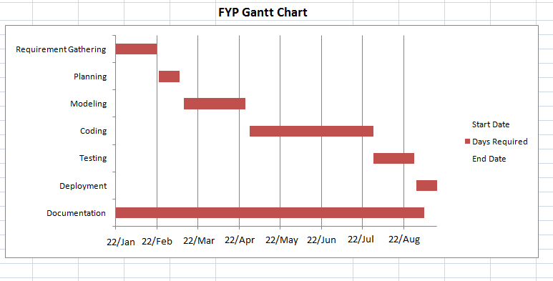

Report Outline
This report describes the goals, functional requirements non-functional requirements WBS work activity class diagram collaboration diagram role and responsibilities of all
group members.

Chapter 2

Software Requirement Specifications

Chapter 2: Software Requirement Specifications

Introduction
The project mobile tv application is about accessing the cable channel on laptop and mobile devices Offline through wireless. Also sharing the media like songs (videos, audios), Movies, Dramas, cartoons etc. through this System. Proposed project will work on laptop and mobile devices through the application installed on them. People can get entertainment through this app at very low cost.
Technology is advancing with at a fantastic rate. Now almost every person has a smart phone or laptop. Entertainment is an important part of everybody’s life. The data packages are expensive and limited. As people want high quality videos at low rate but the data packages are not enough to fulfill their needs. They are looking for alternate source to solve their problem.
Mobile tv application will provide them a better internet source where they can watch high quality entertainment videos and TV channels to entertain themselves. We are also providing the facility to user to demand for entertainment.

Purpose
The purpose of this SRS is to gather this sort of requirements. Which is divided into two phases.

Phase I
Phase I of this system contains admin panel responsible for following task:
- Manage the user account
- Add the data to the system
- Update the data on the system
- Response to user demand.
- Arrange data in specific categories

Phase II
Phase II of this system contains user panel which can perform following task:
- User first register on the system.
- He must login to get entertained.
- User can watch movies, songs and dramas.
- User can live stream the channels
- User can demand for movies.

Document Conventions
Main headings of the project are bold. while their explanation is in Calibri font. The words in capital letters describe the abbreviation. Numbering shows the table of intent.

Intended Audience and Reading Suggestions
All mobile users, movie lover’s, song and dramas viewers, and those whose want to pocket mobile tv at any where and wants entertainment whole time by listening and enjoying songs.
Reading suggestion of this project is to maintain and provide our best service for our users and provide them a proper interface which gives a whole new world of entertainment.

Product Scope
Scope is a very dominant factor in every project. Our scope of the Project is every person who use internet and search for the entertainment like movies, songs etc. Our system will provide them Movies of almost all category They can watch movies they want. Our system will provide Songs. Our system will provide Dramas which also have category. Admin will assign login id and password to the user. System will Provide unlimited entertainment to the user.

Phase I
Phase I of this system contains admin panel responsible for following task:
- Manage the user account
- Add the data to the system
- Update the data on the system
- Response to user demand.
- Arrange data in specific categories

Phase II
Phase II of this system contains user panel which can perform following task:
- User first register on the system.
- He must login to get entertained.
- User can watch movies, songs and dramas.
- User can live stream the channels
User can demand for movies.

References
https://krazytech.com/projets
- Fundamentals of SRS by ramez elmarsi and shamkant b.navathe.
- Instagaint.com
- https://www.criticaltools.com/
- https://www.cse.msu.edu/~cse435/Handouts/SRSExample-webapp.doc

Overall Description
Vision of our project is to entertain the customer. Also make entertainment unlimited faster and cheaper. Our System will work very easily on mobile and laptop user can watch his favorite movies, songs and dramas in high quality format. It will provide user unlimited browsing.

Product Perspective
Channel detail:
it describes all the channels movies songs and dramas which can subscribed.
Customer description:
It includes customer code, name, address and phone number. This information may be used for keeping the records of the customer for any query or for any other kind of information.
subscription detail:
It includes customer details, code number, date of subscription and date will subscription ends.

Product Functions
Use case Id | 01
Use case Name | Registration
Actor | User, Admin
Brief Description | The user register himself in order to use the system. `
Preconditions | The system should display the registration interface
Basic Flow | In this module the user enters his/her user name and password, the system validates the data than allow the user to proceed further
Alternate Flow | Without registration he cannot use the system.
Post Conditions | User is registered to the system and the data should be store in the database also showing success message.

.

2: Watch Movies
Use case Id | 02
Use case Name | Watch Movies
Actor | User
Brief Description | User can select the movies he wants to watch also a list of movies should be display
Preconditions | User should be successfully login to the system
Basic Flow | In this module the user selects the category of media from the menu then play a movie
Alternate Flow | The system should display proper error message if any problem found
Post Conditions | Selected movie should be play

3: Watch Songs
Use case Id | 03
Use case Name | Watch Songs
Actor | User
Brief Description | User can select the songs he wants to watch also a list of Songs should be display
Preconditions | User should be successfully login to the system
Basic Flow | In this module the user selects the category of media from the menu then play a song.
Alternate Flow | The system should display proper error message if any problem found
Post Conditions | Selected song should be play

4: Watch Dramas
Use case Id | 04
Use case Name | Watch Dramas
Actor | User
Brief Description | User can select the songs he wants to watch also a list of Songs should be display
Preconditions | User should be successfully login to the system
Basic Flow | In this module the user selects the category of media from the menu then play a drama.
Alternate Flow | The system should display proper error message if any problem found
Post Conditions | Selected drama should be play

5: Live Streaming
Use case Id | 05
Use case Name | Live Streaming
Actor | User
Brief Description | User can select the Live Stream option then list of channels should be display where he can select favorite channel
Preconditions | User should be successfully login to the system
Basic Flow | In this module the user selects the channel he wants to stream
Alternate Flow | The system should display proper error message if any problem found
Post Condition | Perform live streaming.

6: Updating
Use case Id | 06
Use case Name | Updating
Actor | Admin
Brief Description | The admin can update the media on the systems.
Preconditions | The user should register to the system and updating page should displayed.
Basic Flow | In this module the admin selects the category of media from the menu then perform any updating
Alternate Flow | If already updated then the system should ask for replacement.
Post Conditions | Save changes display Success Message

7: Search
Use case Id | 07
Use case Name | Search
Actor | User
Brief Description | Here user can search for specific content
Preconditions | Search bar should be display
Basic Flow | He can search for movie song and drama
Alternate Flow | Proper error message if content not found
Post Conditions | Result should be appeared.

User Classes and Characteristics
Users of the system should be able to retrieve all information about the movies, dramas, and songs from the database. The system will support two types of user privileges, Customer, and system owner. Customers will have access to customer functions, and the system owner will have access to both customer and application management functions. The customer should be able to do the following functions:
- Watch the movie
• enjoy the songs
• watch dramas
• cancel his subscriptions
• select area
• view his history
The Employee should have following management functionalities:
- CUSTOMER FUNCTIONS.
• Get all customers who have subscribed.
• Get all information about customer.
• View movies and dramas schedule.
- ADMINISTRATIVE
• Add/Delete a movie or drama
• Update subscriptions rates

Operating Environment
The environment in which the software will operate, is user should be an android user, should have operating system, should have a subscription of the wireless network provided by the system owner.

Design and Implementation Constraints
Php Storm
Php Storm features a rich and intelligent code editor for PHP that actually "gets" your code and deeply understands its structure.
Sql Server:
We will Sql server is used for creation of our database. Sql database can be handled easily with ASP.Net. So that’s why it is a good tool for database operations.
MS Visio
We will use MS Visio in our project for documentation purpose to draw use cases, entity diagrams etc.
Adobe Photoshop
We will use adobe Photoshop for creation of logo of our website. Moreover, other design things of a website can also be easily managed by Photoshop and we will do that
HTML
We will use html because it is the basic means to generate a website. Without this language we cannot create a website.
CSS
We will use CSS to style our website according to our requirement. As styling is also a main thing in our website so we will use this language
JavaScript
We will use JavaScript as a client-side scripting language. This means that JavaScript code is written into an HTML page.
jQuery
It is a fast and concise JavaScript Library that simplifies HTML document traversing, event handling, animating, and Ajax interactions for rapid web development
Bootstrap
Bootstrap is the most popular HTML, CSS, and JavaScript framework for developing responsive, mobile-first websites.
System owner will be responsible for all these queries
Device Fault
Connection Problem
High Data loading
Operating system may crash due to some technical fault.
DB server may slow down or fail due to load of data.

User Documentation
User manual will be provided by the web application, a section of help for the user will be provided in the websites.

Assumptions and Dependencies
Let us assume that this is a mobile tv and it is used in the following application:
- A request for subscription/cancellation of the network provided by the mobile network by any source and any destination, in case of not using his subscription no payment will be granted back.
- Regular customers will be provided a special discount offers and bonuses.
- All the queries and complains will be solved in the next versions and updates of the application.

External Interface Requirements

User Interfaces
An interface is provided in which all the options will appear, user can easily interact with the website and application to select whether the user wants to watch movies, dramas, songs, or anything else. Different images of the different movies will be shown which appears as icon to select and watch the movie or drama which the user want. if any error occurs an error box will be shown which shows the error and its solution message. Standard buttons will be provided to select the categories of the movies, dramas, and songs.

Hardware Interfaces
system should have a hardware interacting system through which user can interact with web application. A wireless hardware will be necessary through which user will be connected .

Software Interfaces
- MS Visio
We will use MS Visio in our project for documentation purpose to draw use cases, entity diagrams etc.
- Adobe Photoshop
We will use adobe Photoshop for creation of logo of our website. Moreover, other design things of a website can also be easily managed by Photoshop and we will do that
- HTML
We will use html because it is the basic means to generate a website. Without this language we cannot create a website.
- CSS
We will use CSS to style our website according to our requirement. As styling is also a main thing in our website so we will use this language
- JavaScript
We will use JavaScript as a client-side scripting language. This means that JavaScript code is written into an HTML page.
- jQuery
It is a fast and concise JavaScript Library that simplifies HTML document traversing, event handling, animating, and Ajax interactions for rapid web development
- Bootstrap
Bootstrap is the most popular HTML, CSS, and JavaScript framework for developing responsive, mobile-first websites.

System Features

Registration
Use case Id | 01
Use case Name | Registration
Actor | User, Admin
Brief Description | The user register himself in order to use the system. `
Preconditions | The system should display the registration interface
Basic Flow | In this module the user enters his/her user name and password, the system validates the data than allow the user to proceed further
Alternate Flow | Without registration he cannot use the system.
Post Conditions | User is registered to the system and the data should be store in the database also showing success message.

Functional Requirements
User could register to use the system
The system should display the registration interface
In this module the user enters his/her user name and password, the system validates the data than allow the user to proceed further
Without registration he cannot use the system.
User is registered to the system and the data should be store in the database also showing success message

Watch Movies
Use case Id | 02
Use case Name | Watch Movies
Actor | User
Brief Description | User can select the movies he wants to watch also a list of movies should be display
Preconditions | User should be successfully login to the system
Basic Flow | In this module the user selects the category of media from the menu then play a movie
Alternate Flow | The system should display proper error message if any problem found
Post Conditions | Selected movie should be play

Functional Requirements
User can select the movies he wants to watch also a list of movies should be display
User should be successfully login to the system
In this module the user selects the category of media from the menu then play a movie
The system should display proper error message if any problem found

Selected movie should be play.

Watch Songs
Use case Id | 03
Use case Name | Watch Songs
Actor | User
Brief Description | User can select the songs he wants to watch also a list of Songs should be display
Preconditions | User should be successfully login to the system
Basic Flow | In this module the user selects the category of media from the menu then play a song.
Alternate Flow | The system should display proper error message if any problem found
Post Conditions | Selected song should be play

Functional Requirements
User can select the songs he wants to watch also a list of Songs should be display.
In this module the user selects the category of media from the menu then play a song.
The system should display proper error message if any problem found.
Selected song should be play.

Watch Dramas
Use case Id | 04
Use case Name | Watch Dramas
Actor | User
Brief Description | User can select the songs he wants to watch also a list of Songs should be display
Preconditions | User should be successfully login to the system
Basic Flow | In this module the user selects the category of media from the menu then play a drama.
Alternate Flow | The system should display proper error message if any problem found
Post Conditions | Selected drama should be play

Functional Requirements

User can select the songs he wants to watch also a list of Songs should be display.
In this module the user selects the category of media from the menu then play a drama.
The system should display proper error message if any problem found.
Selected drama should be play.

5: Live Streaming
Use case Id | 05
Use case Name | Live Streaming
Actor | User
Brief Description | User can select the Live Stream option then list of channels should be display where he can select favorite channel
Preconditions | User should be successfully login to the system
Basic Flow | In this module the user selects the channel he wants to stream
Alternate Flow | The system should display proper error message if any problem found
Post Condition | Perform live streaming.

Functional Requirements
User can select the Live Stream option then list of channels should be display where he can select favorite channel.
User should be successfully login to the system.
In this module the user selects the channel he wants to stream.

The system should display proper error message if any problem found.

Perform live streaming.

Other Nonfunctional Requirements

Performance Requirements
- The system should be easy to interact.
- System should be speedy and reliable.
- System should be Easily approach able.
- System should be user friendly.

Safety Requirements
(1) If the network is slow in performance then it can irritate client and client can reject it due to slow performance of network.
(2) If the data on server is not according to the user requirement then it can be rejected by the user.
(3) If the system is very complex which cannot access by the client easily then it is failure of the system.
(4) The documentation relating to test planning, test design specification, test specification development and test cases development should do accurately and efficiently otherwise it can lead the failure of the test.

Security Requirements
Website should be encrypted and secured by https protocols.
Information of the register user should not be public.
Non-register user cannot be login.
A user whose payment is out dated will not be access the mobile tv network.

Software Quality Attributes
These are some quality attributes which will be provided:
Availability
System will be always available and will not be down at any time.

Maintainability
System will be maintained on regular basis and errors and bugs will be remove.

Usability
System will be easily useable and approachable.

Flexibility
System will be flexible according to user.

Business Rules
Roles | Members
Detail Study of Requirement | Zain ul abidin
Proposal Making | Zaheer Abbas
Analysis | Zain ul abidin
Application Interface Design | Zaheer Abbas
Application Development | Zain ul abidin
Testing Refinement | Zaheer Abbas
Finalization | Zaheer Abbas, Zain ul abidin

Other Requirements
Legal requirement

There will be some copyright issue because we will provide videos and movies so this can be done by taking permission from the author. Also, Permission of PEMRA is necessary. and ethically also feasible.

Reuse objective

Documentation should be done in a way that a new developer can understand it easily.

Chapter 3

Use Case Analysis

Chapter 3: System Analysis
A user can enter on the system through a proper gateway, which is a login button after that
User can watch movies, watch songs, watch dramas, get updates and after using all these features they can logout from the system.
Analysis Level Use Case Diagram
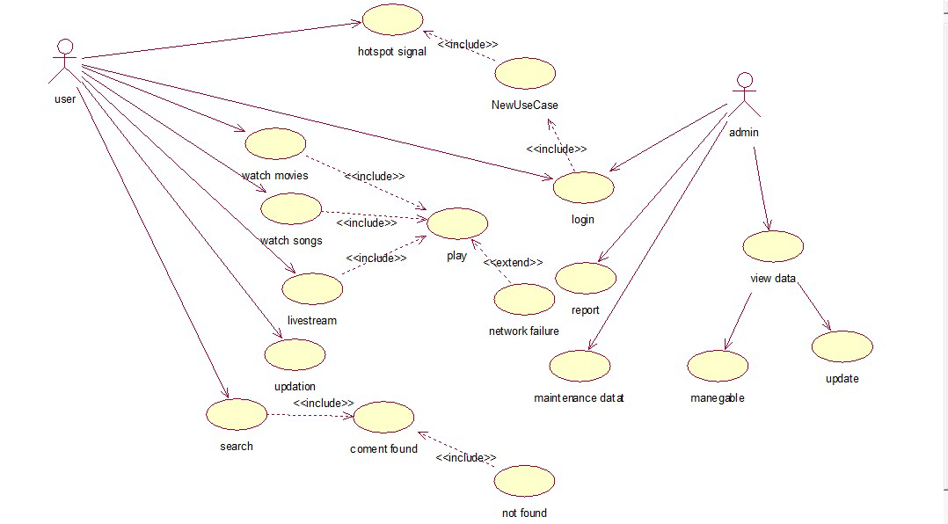

Use Case Model
Above use case diagram show how the system different function will work. Use case diagram show the basic flow of the system. There are two actors which are directly interacting with system.
Analysis Level Use case diagram of the wireless cable network show the basic flow of the system. Following are use cases:
- Registration
- Watch movies
- Watch songs
- Watch Dramas
- Live Streaming
- Updation
High Level Use Case Diagram of mobile tv application.

Fully Dressed Use Cases
This use case describes the admin or end user accessibilities. The roles of both stakeholders are defined in it

Chapter 4

System Design

Chapter 4: System Design
The UML system sequence diagram (SSD) illustrates events sequentially input from an external source to the system.

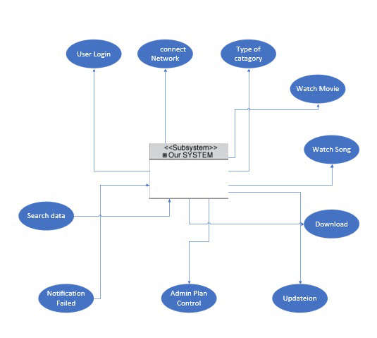

Architecture Diagram

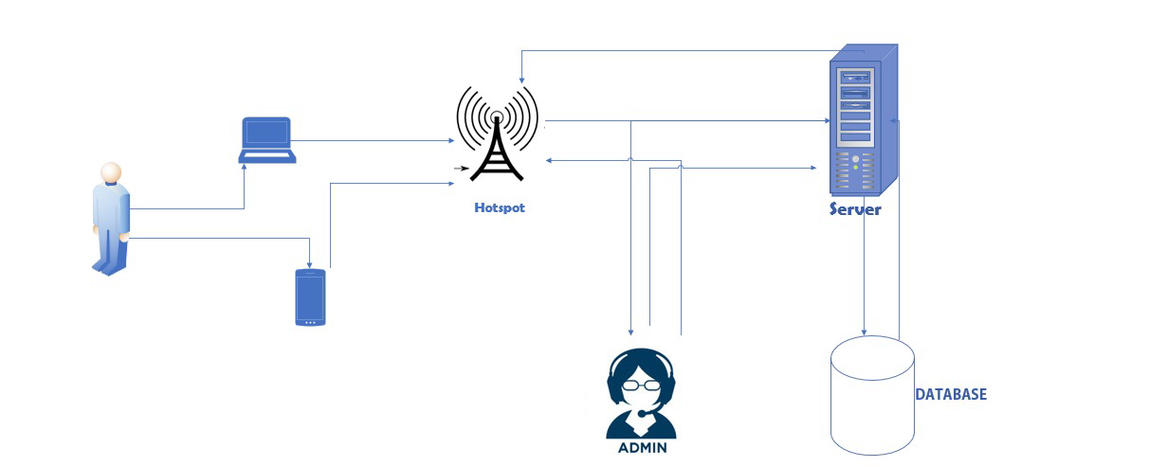

Domain Model

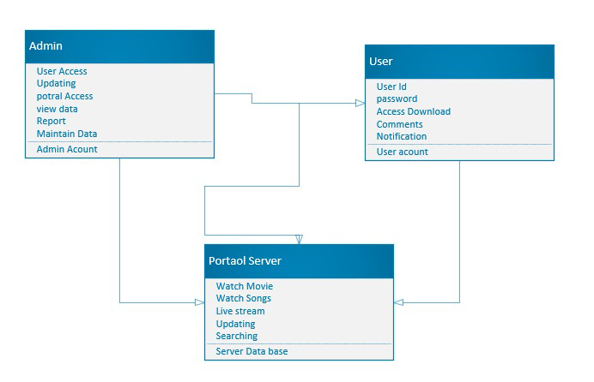

Entity Relationship Diagram with data dictionary
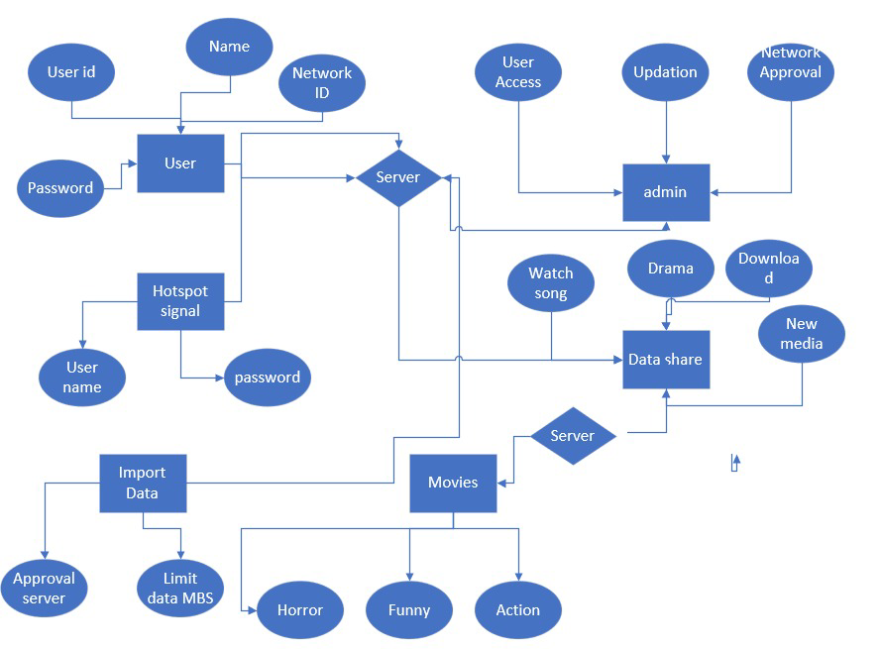

Class Diagram

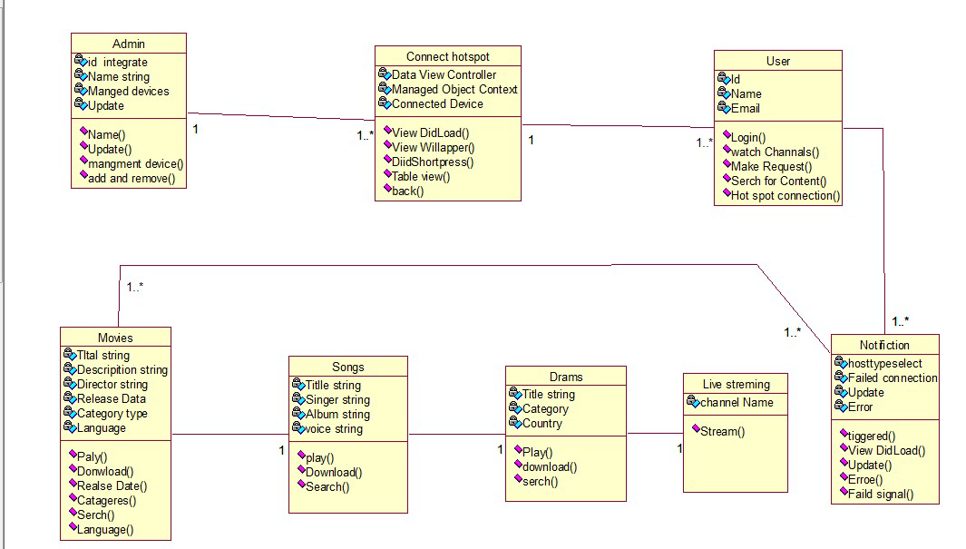

Sequence / Collaboration Diagram

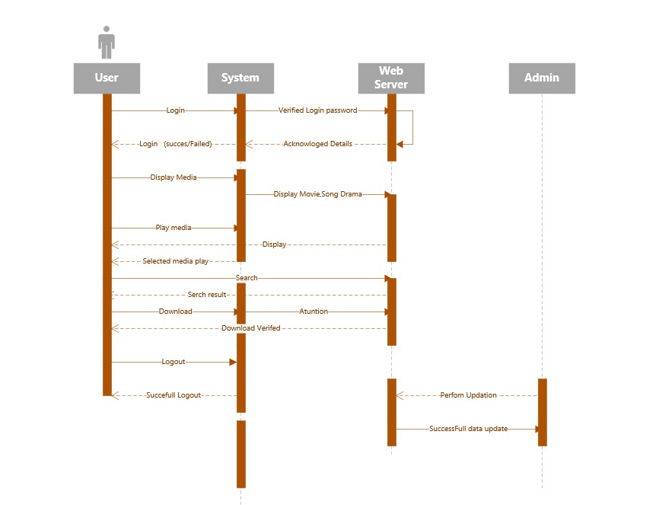

Collaboration Diagram

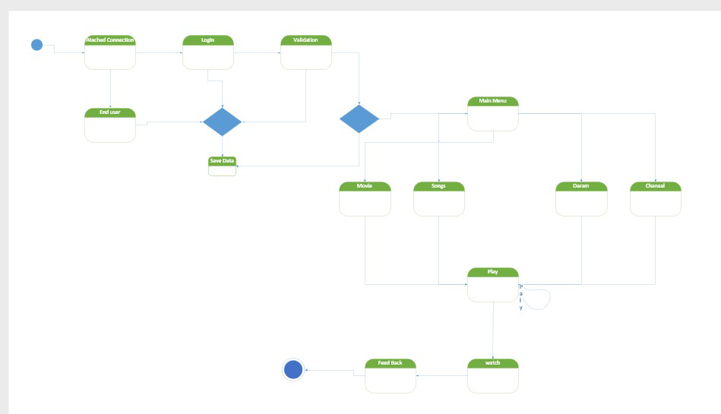

Operation contracts
A UML Operation contract identifies system state changes when an operation happens. Effectively, it will define what each system operation does. An operation is taken from a system sequence diagram. It is a single event from that diagram. A domain model can be used to help generate an operation contract.

Operation Contract Syntax
Name: Login Request ( )
Responsibilities: It helps the User to make request for login
Cross References: Use case: Registration
Exceptions: none
Preconditions: Enter Data into Login form
Post conditions: Performed Form Validation
Name: Make Request for Movie ( )
Responsibilities: It helps the User to make request for Movies
Cross References: Use case: Request
Exceptions: none
Preconditions: Enter Data into Request form
Post conditions: Request Received by Admin
Name: Search for Content ( )
Responsibilities: It helps the User to make Search for content for the content
Cross References: Use case: Search
Exceptions: none
Preconditions: Enter Data into Search Bar
Post conditions: Match Data to be showed.

Activity Diagram

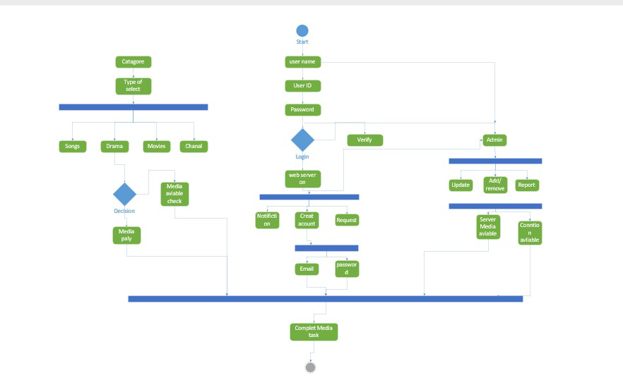

State Transition Diagram
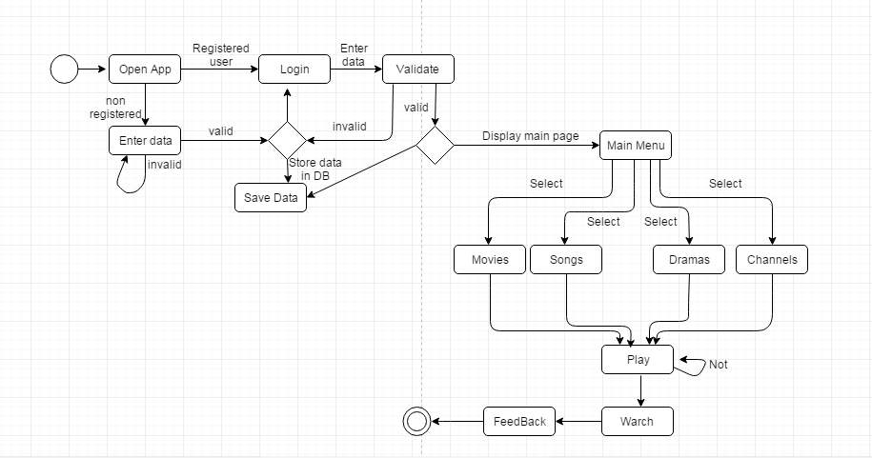

Component Diagram
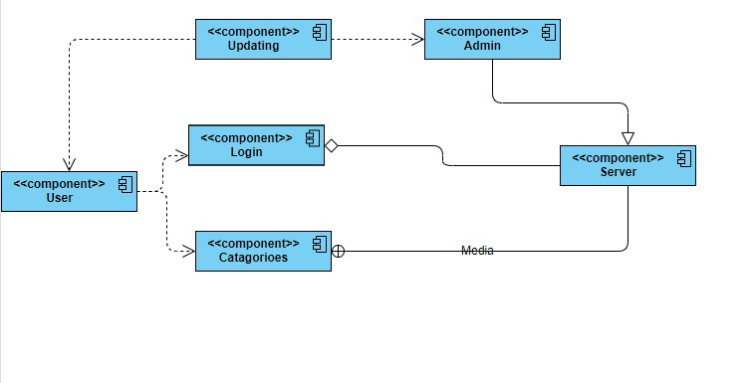

Deployment Diagram
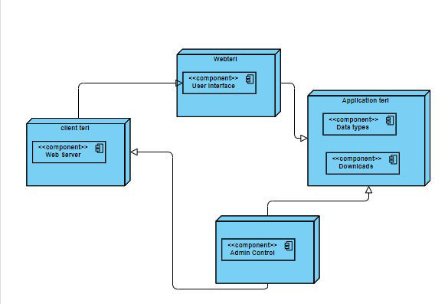

Data Flow diagram

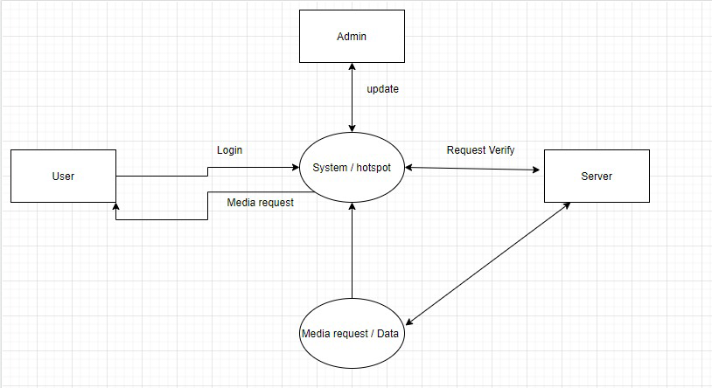

Chapter 5

Implementation

Chapter 5: Implementation
These are the steps which will be followed to implement a strategy to complete this project.
STEPS IN IMPLEMENTATION
Step #1: Evaluation of the Strategic Plan.
In this step an evaluation plan is described which evaluates the whole product and timeframe and other requirement through which this system will be completed.

Step #2: Development of an implementation structure
An implementation structure is defined which explains how to complete the project and in which procedure.

.
Step #3: Executional plan.
In this step all the coding is executes and runs and errors and bugs are noticed.

Step #4: testing
In this phase testing is performed and applications is made.

Important Flow Control/Pseudo codes
Data will be transvers to user at right time from main server to local area network of user. because it is possible for a sending computer to transmit information at a faster rate than the destination computer can receive and process it.

Components, Libraries, Web Services and stubs
In mobile tv application system identified by a URI, whose public interfaces and technologies and components defined within the basic architecture, such as: Server. HTTP client. Stub. Client. XML. XML. POST… HTTP Jason library.

Tools and Techniques
SWOT Analysis
Strength: -
Strength of the mobile tv application to provide the people wireless network tv entertainment at local area network.
Weakness: -
It may not be financially feasible in some areas.
opportunities: -
it may can grow and give very much amount of revenue.
Threats: -
Market competitors are always threating for this project.

Best Practices / Coding Standards
Coding of this project should be done in a way that unknown developers can easily understand it.
For example:
Commenting with code.

Version Control
New version of this app depend upon the market competitors or user need and the scope of the project.

Appendices

Appendix A: Information / Promotional Material
Project promotion with the help of social media like Facebook YouTube
  - Broacher


  - Flyer
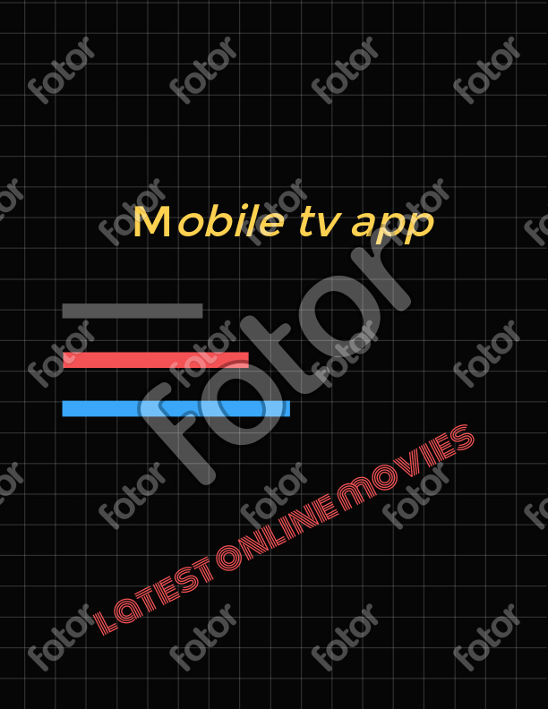

  - Standee
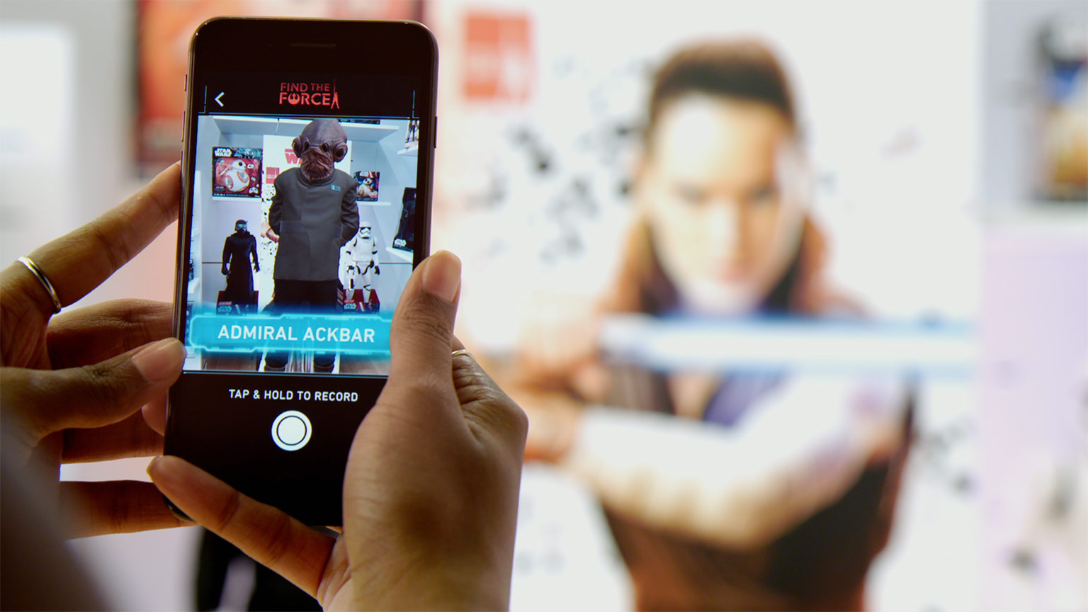

  - Banner

Appendix [no.]: Appendix Title
[Paragraph Text 12 pt., Calibri, 1.5 Line Spacing, Justified]
[Between 4 to 8 lines describe what is this chapter all about]

  - First Level heading [16 pt., Calibri, Bold, Left aligned]
[Paragraph Text 12 pt., Calibri, 1.5 Line Spacing, Justified]

    - Second level heading [14 pt., Calibri, Bold, Left aligned]
[Paragraph Text 12 pt., Calibri, 1.5 Line Spacing, Justified]

      - Third level heading [12 pt., Calibri, Bold, Left aligned]
[Paragraph Text 12 pt., Calibri, 1.5 Line Spacing, Justified]

Reference and Bibliography

Reference and Bibliography

[1] M. Sher, M. Rehman, “Title of the Paper” Conference name/Journal Name, Edition, Volume, Issue, ISBN/ISSN, PP, Publisher/City-Country, Year.
[2] ……

Index

Index

[A]

[B]

[C]

