SUPERIOR UNIVERSITY LAHORE


Faculty of Computer Science & IT

Final Year Project
PROJECT REPORT

Google Map Based Hostel Finder App
Project ID: [FYP-F19-020]

Project Team
Student Name | Student ID | Program | Contact Number | Email Address | Signature
Sohaib Raza | MCSM-S19-022 | MCS | 03078577274 | MCSM-S19-022@superior.edu.pk
Aamir Sohail | MCSM-F19-188 | MCS | 03331414741 | MCSM-f19-188@superior.edu.pk
Muhammad Awais | MCSM-S19-030 | MCS | 03037186514 | MCSM-S19-030@superior.edu.pk

Supervisor: Sir Fayyaz Dogar
Project Report
Google Map Based Hostel Finder
Change Record
Author(s) | Version | Date | Notes | Supervisor’s Signature
 | 1.0 |  | <Original Draft>
<Changes Based on
Feedback from
Supervisor>
<Changes Based on
Feedback From Faculty>
 |  |  | <Added Project Plan>
<Changes Based on
Feedback from
Supervisor>

APPROVAL

PROJECT SUPERVISOR
Comments: ___________________________________________________________________
_____________________________________________________________________________

Name:______________________________
Date:_______________________________ Signature:__________________________

PROJECT MANAGER
Comments: ___________________________________________________________________
_____________________________________________________________________________

Date:_______________________________ Signature:__________________________

HEAD OF THE DEPARTMENT
Comments: ___________________________________________________________________
_____________________________________________________________________________

Date:_______________________________ Signature:__________________________

Dedication

We dedicate this project to Allah Almighty our creator, our parents who help us a lot and give us everything we want. Also they appreciate us and they believe on ourselves. We also dedicate this project to our teacher. We can never make this project without our teachers. He makes us able to do this and we are very thankful to our teachers. Thank you very much our teachers. May Allah bless you all.

Acknowledgements

All praises to Almighty Allah, Who makes us able to complete this task. Our words of special thanks to Sir Fayyaz Dogar (our Project Supervisor) who played a major role in the fulfillment of this project, without their valuable direction this might be an impossibility for us.
We will remember the whole batch, in accompany to whom we set in an academic journey, which is being concluded now. Thank you for being there, my dear fellows. We are out of justifiable words to stretch thanks to our commendable parents, our friends and our colleagues who been tolerant during our hectic hours of study, research and development of the project.

Executive Summary
In this project, the Android application is developed. The main aim of this app is to help strangers to find out the hostel's location. Most of the times it became drastically impossible for people to settle down in a new environment. This app will help those people to find out the hostel location without any worry and difficulty. With the help of this app, anybody can see the pictures of rooms and specialties as well. They can easily find out the locations with the help of an Android phone. Maps are also available to find out the hostel location. Moreover owners of hostels can add their locations on google map with the help of this application. First of all they have to make an account on this application. On this account they will add all the specifications related to their hostels. It will include all the facilities that will be available to customers like internet, cafes and pictures of the rooms. So on the whole this application is beneficial both for the people who are trying to find a better accommodation and other who want to develop their business through google map.

Table of Contents
Dedication iv
Acknowledgements v
Executive Summary vi
Table of Contents vii
List of Figures viii
List of Tables x
Chapter 1 1
Introduction 1
1.1. Background 2
1.2. Motivations and Challenges 2
1.3. Goals and Objectives 3
1.4. Literature Review/Existing Solutions 3
1.5. Gap Analysis 3
1.6. Proposed Solution 4
1.7. Project Plan 5
1.7.1. Work Breakdown Structure 5
1.7.2. Roles & Responsibility Matrix 6
1.7.3. Gantt chart 7
1.8. Report Outline 7
Chapter 2 8
Software Requirement Specifications 8
2.1. Introduction 9
2.1.1. Purpose 9
2.1.2. Document Conventions 9
2.1.3. Intended Audience and Reading Suggestions 9
2.1.4. Product Scope 10
2.1.5. References 11
2.2. Overall Description 11
2.2.1. Product Perspective 11
2.2.2. Product Functions 11
2.2.3. User Classes and Characteristics 12
2.2.4. Operating Environment 12
2.2.5. Design and Implementation Constraints 12
2.2.6. User Documentation 12
2.2.7. Assumptions and Dependencies 12
2.3. External Interface Requirements 13
2.3.1. User Interfaces 13
2.3.2. Hardware Interfaces 13
2.3.3. Software Interfaces 13
2.3.4. Communications Interfaces 13
2.4. System Features 13
2.4.1. System Feature 1 14
2.4.1.1. Description and Priority 14
2.4.1.2. Stimulus/Response Sequences 14
2.4.1.3. Functional Requirements 14
2.4.1.1. Description and Priority 15
2.4.1.2. Stimulus/Response Sequences 15
2.4.1.3. Functional Requirements 15
2.4.2.1. Description and Priority 16
2.4.2.2. Stimulus/Response Sequences 16
2.4.2.3. Functional Requirements 16
2.4.3. System Feature 3 (and so on) 16
2.5. Other Nonfunctional Requirements 16
2.5.1. Performance Requirements 16
2.5.2. Safety Requirements 16
2.5.3. Security Requirements 17
2.5.4. Software Quality Attributes 17
2.5.5. Business Rules 17
2.6. Other Requirements 17
Chapter 3 18
Use Case Analysis 18
3.1. Use Case Model 19
3.2. Fully Dressed Use Cases 20
Chapter 4 25
System Design 25
4.1. Entity Relationship Diagram with data dictionary 27
4.2. Class Diagram 28
4.3. Sequence / Collaboration Diagram 29
4.4. Operation contracts 32
4.5. Activity Diagram 33
4.6. Component Diagram 37
4.7. Deployment Diagram 38
4.8. Data Flow diagram 38
4.12 Test Cases: 39
Chapter 5 41
Implementation 41
5.1. Components, Libraries, Web Services and stubs 42
5.2. Deployment Environment 42
5.3. Tools and Techniques 43
5.4. Best Practices / Coding Standards 43

List of Figures

1.1 Work Break Down Structure 5
1.2 Gantt Chart 7
2.1 Methodology Diagram: 14
3.1 Use case 19
4.1 Entity Relationship Diagram with data dictionary 27
4.2 Class Diagram 28
4.3 Sequence Diagram User Login 29
4.4 Sequence Diagram User Search Hostel 29
4.5 Sequence Diagram Admin login 30
4.6 Sequence Diagram Owner login 30
4.7 Sequence Diagram Owner Add Hostel 31
4.8 User Activity 33
4.9 Hostel Owner Activity 34
4.10 Admin Activity 35
4.11 Component Diagram 37
4.12 Deployment Diagram 38
4.13 Data Flow Diagram 38

List of Tables

1.1 roles & responsibility matrix 6
4.1 Login test case. 39
4.2 Registration Test Case 40

Chapter 1

Introduction

Chapter 1: Introduction

The main purpose of this project is to develop an Android mobile application that helps the people that go to new areas and don’t know about hostels location. It will help them to search for new hostels around them. They can check the specifications of the hostels. Users can see room images and check what things are provided. It will help them to locate hostels easily using android phones. He can online book the room using smartphones. He can check distance and map for hostel location.

1.1. Background
When new students take admission to college and university or when any new person goes to a new place he has no idea about this new place and he also doesn’t know about any near hostel. He spent most of the time searching for the hostel. So, we will design this application Hostel Finder for these peoples and students, by using this application the user can easily search the nearest hostel from his current location by clicking only one button.
The distance of the hostel from the current location of the user is also shown on the main page and then user can easily select the near hostel and this is the easiest way to find the hostels nearest and also check the specifications of every room and the services are provided by the hostel owner. This application will save your time and money to search for the hostel and also provides good facilities.
Few years ago promotions were based on hand made advertisements like pamphlets, booklets and newspapers. It was so time taking. Owners has to face a lot of difficulties. It was totally time wasting to discuss details with everyone. But now the world has been changed. It is the time of multimedia. Nobody has time to arrange separate meetings. This application on google map will facilitate both the users and hostel honors.

1.2. Motivations and Challenges
Being a human whenever someone goes through misery we should act like “it’s not our problem” to be ok with it instead we should try to help them out the best way we could. In my life, I’ve been through some incidents like these which motivated me for taking a step forward. Now as I am going to become a software engineer there’s been always something in my head to be a good citizen.

1.3. Goals and Objectives

Hostels play the role of providing students a home away from home. It’s the facility that facilitates the student’s further attraction towards the place as it makes that place more convenient. People around the world can access it. It will also be a time savior. Besides this, another main objective is to manage all the information regarding the best services. The main purpose is to reduce manual work.

Other common objectives fulfilled by online hostel finder systems are:
- To display organized information of hostel, prices, and pictures.
- To add multiple hostels/rooms to the system.
- To change the prices of hostel rooms when needed.

1.4. Literature Review/Existing Solutions

Despite this application, there are a lot of fake applications on Google play store. Most of the applications give information restricted to hotel rooms. But this application is specifically about hostel accommodations. Through this app, new students and anybody can easily find out the hostels. This application will be uploaded on Google play store to facilitate every person.

1.5. Gap Analysis
Currently, we are giving facilities to the peoples for use this project only in Pakistan but with the passage of time, we will deploy this project in all over the world. We will also enhance the accuracy of this project and introduce extra features in it like order rooms online and so on.

1.6. Proposed Solution
The main purpose of this project is to develop an Android mobile application that helps the students to find hostels and see info about them. It helps those people who go to new areas and don’t know about hostels location. It will help them to search new hostels around them. They can check the specifications of the hostels. Users can see room images and check what things are provided. It will help them to locate easily using android phones. He can check distance and map for hostel location.

1.7. Project Plan

1.7.1. Work Breakdown Structure


Hostel Finder
Analysis
Design
Testing
Implementation
Develop
Understanding
Problem
Feasible soultion
Requirement
Gathering
(
Fun
,
Non
-
fun
)
Function Design
(
3
d model or
diagrams
)
System Design
(
design components
of architecture
,
modules
)
Coding
(
transforming the
design of a system into
a java language format
.)
Existing Solutions
User Interface
Documentation
Mock Testing
Requirement
Analysis
Deploy in android
devices

Fig 1.1 Work Break Down Structure

1.7.2. Roles & Responsibility Matrix

The purpose of roles & responsibility matrix is to identify who will do what.

WBS  # | WBS Deliverable | Activity # | Activity to  Complete the Deliverable | Duration (# of Days) | Responsible  Team Member(s) & Role(s)
 | Literature/Markey  Survey | 1 | Visit market | 2 days | M Awais  Aamir Sohail  Sohaib Raza
 | Requirement  Analysis | 3 | Requirement Analysis | 7 Days | M Awais  Aamir Sohail  Sohaib Raza
 | System Design | 4 | Architecture Design | 8 days | M Awais,  Aamir Sohail,  Sohaib Raza
 | Interface | 5 | User Interface | 20 Days | M Awais  Aamir Sohail  Sohaib Raza
 | Implementation | 6 | Customer Login | 20 Days | M Awais  Aamir Sohail  Sohaib Raza
 | Problems | 7 | Customer Problem | 10 Days | M Awais  Aamir Sohail  Sohaib Raza

Table no 1.1

1.7.3. Gantt chart

u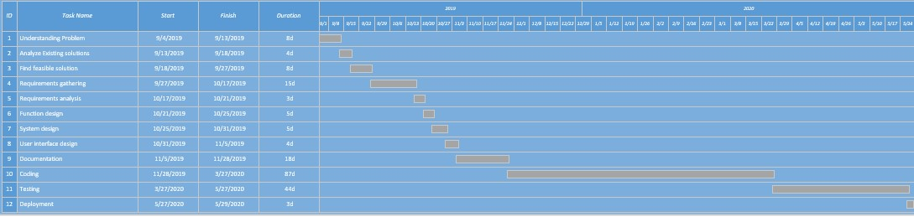
Fig 1.2 Gantt chart

1.8. Report Outline
- User dashboard 50% complete
- User interface 50% complete

Chapter 2

Software Requirement Specifications

Chapter 2: Software Requirement Specifications

2.1. Introduction

2.1.1. Purpose
Hostel Finder is an android application where you can search the nearest hostels and check their room’s specifications. No Application like Hostel finder by using Google map available on any play store and the purpose of our application is that to provide the facility to strangers to find any hostel nearly from his current location and thus a user can also book the room from the hostel by using this app. Reduce research, complexity and time saving help the user in taking good decision quickly.

2.1.2. Document Conventions
Main Section:
- Font: Calibri
- Face: Bold
- Size: 20

Sub Section:
  - Font: Calibri
  - Face: Bold
  - Size: 16

Other Text:
  - Font: Calibri
  - Face: Normal
  - Size: 12

2.1.3. Intended Audience and Reading Suggestions
The intended audience of this document would be user, admin, and the project team to refer and analyze the information.

2.1.4. Product Scope
The scope of this project is vary vast most of the students are living in hostels or any new person comes in any country they have no idea about nearly hostels or hotels and he also don’t know about which specifications and services are provided by these hostels. This application helps strangers and students to find the nearly hostel from his current location and the distance from the user current location to hostel are also shown on page. So, user can easily select nearly hostel and he can also check the specification of room and the services are provided by the hostel owner. It will provide the easiest way to find the hostels nearest.
2.1.4 Methodology:
Iterative SDLC model is feasible due to some reasons which are followings:
Due to smaller iterations, testing and debugging is very easy.
- We can apply parallel development in it
- Some functions can be developed quickly.
- Easy to control risk (due to small iterations, it is easy to control risk instead of bigger iteration)

2.1.5 Methodology Diagram:
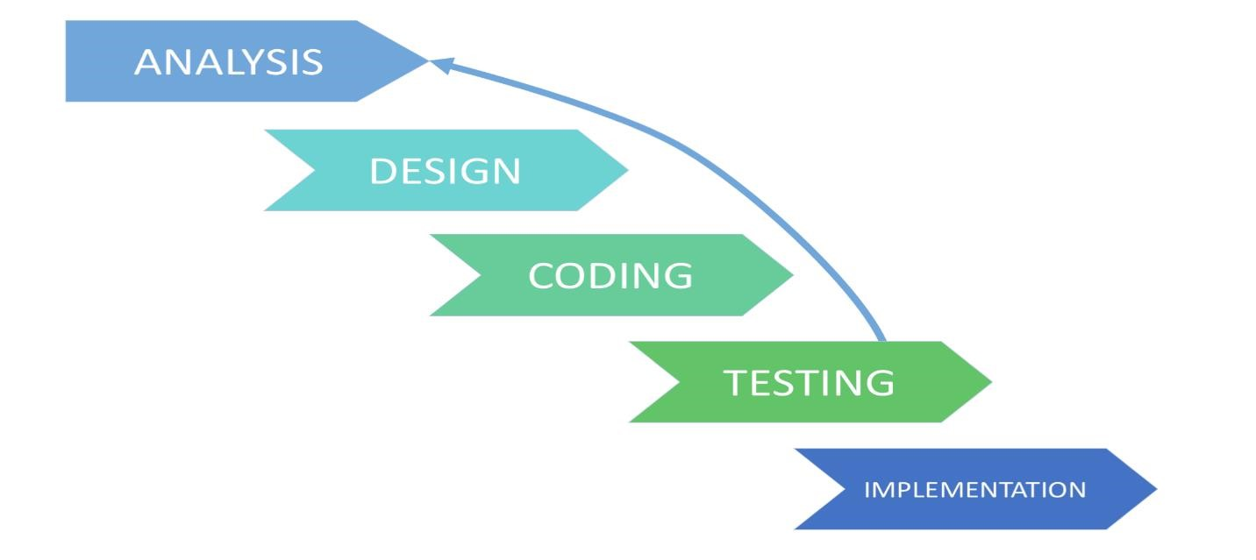
Fig 2.1 Methodology Diagram

2.2. Overall Description

2.2.1. Product Perspective
Hostel Finder is a user-friendly application for every person and anyone can easily access this application. It will provide the easiest way to find the hostels nearest and also check the specifications of every room before booking.

2.2.2. Product Functions
Our Project will feature a following things:
- User can easily find the nearest hostel.
- Specifications of the every hostel is provided.
- You can also check the distance of hostel from your current location.
- This shows nearest hostels to locate easily.

2.2.3. User Classes and Characteristics
The users of this system are:
- Customer
Customer will look for hostels locations according to his needs and demands
- Manager
Manager will be responsible for managing resources.
Hostel Owner
Hostel owner will provide information about hostel location and rooms.

2.2.4. Operating Environment
It will include software requirements.

2.2.5. Design and Implementation Constraints
This application uses many different software interfaces. An operating system is an essential product for the operation of the program as it is an android studio based Platform. Android studio is used for development purposes. The Internet is necessary for the execution of the program.

2.2.6. User Documentation
User manual provided will give a clear idea in interacting with the system.

2.2.7. Assumptions and Dependencies
- The user of the system must have its unique ID and password for login purpose.
- The user must have a proper and active internet connection • User’s mobile have google services enabled.
- The backup ability must be available to avoid any kind of data loss.
- Assuming all the users for this system have basic computer knowledge and knows how to operate with this system.

2.3. External Interface Requirements

2.3.1. User Interfaces
- Front-end : Xml
- Back-end : Java

2.3.2. Hardware Interfaces
It includes the requirement of a computer/device where the system will be used by the user where the reservations details and confirmation mails will be sent to the users. So there will be a need for active and proper internet connection. The client should able to keep a stable connection.

2.3.3. Software Interfaces
- Development Tool:
Android Studio
- Database:
The Firebase Real-time Database is a cloud-hosted NoSQL database • Operating Environment: Android Smart Devices

2.3.4. Communications Interfaces
Android device: Any smart phone with operating system android KitKat will serve as a communication interface for our Application. Mobile devices having a screen resolution of 720p or above will be optimal.

2.4. System Features

2.4.1. System Feature 1
- User firstly make account (sign up) providing the required information.
- Customer can search the hostel.
- User can see information of selected hostel and other specifications.

2.4.1.1. Description and Priority
Description: Customer sign up form needs to fulfil its required information.
- Full name
- Password
- Confirm Password
- Contact Number

Priority: High

2.4.1.2. Stimulus/Response Sequences
User Action:
User can launch the Application from their Android Devices Response:
Application will be started and shows up the sign up page which will require the basic information to sign up. User Action:
User will give basic information into the required areas and click on signup button Response:
System will check all the information given by the user and allow the user to be a member of system. In case of any wrong information given in specific areas by the user. The system will show the Error message about regarding issue and allow them to Re-fill the correct information.

2.4.1.3. Functional Requirements
The functional requirements of the system are as follows:
Registration:
- A page for Registration will be created
- The page contains the following task fields “User Name”, “Email”, “Password”.
- After entering the following task fields then it will go to the registration function.
- From there all fields go to the database for verification.
- After verification from DB.
- The successful registration message showed.
- Assigned unique id and password to every registered customer Login
- A page for login will be created
- The page contains two task fields “Username”, “Password”.
- After entering the two task fields then it will go to the login function.
- From there, fields go to the database for verification.
- After verification from DB.
- A successful login message showed.

Search Hostels:
- Users can see search hostels.

Check Distance:
- Users can check the distance.
See Rooms:
- Users can see images of the rooms of the hostel.
2.4.1. Login
User can make an account and use login as well.

2.4.1.1. Description and Priority
Login is a feature allowing users to sign in our Application. BY Signing in our Application user can entertain all the feature. Priority of this feature is high because assessing this feature user can completely interacts all aspects and functionality of our system.

2.4.1.2. Stimulus/Response Sequences
- Check unique email for registration
- Check correct email and password for login

2.4.1.3. Functional Requirements
The system should have a user registration process in order to get login into the system for users.
2.4.2. Registration

2.4.2.1. Description and Priority
This function will be used to determine the distance so that a person can easily check distance of the hostel from his current location. Application will use our current location to add the new hostel and also check nearby hostels from the user current location.

2.4.2.2. Stimulus/Response Sequences
• Access current location

2.4.2.3. Functional Requirements
Determine the current location is compulsory to find the nearby hostel. For this purpose, keeping your location option on from your android devices is necessary. Once your current location is detected, it will show all nearby hostels easily, efficiently and accurately.

2.4.3. System Feature 3 (and so on)

2.5. Other Nonfunctional Requirements

2.5.1. Performance Requirements
Our App needs to load in no more than 4 seconds and there should be no latency or lag during app use. Response time refers to the waiting time while the system accesses, queries and retrieves the information from the database (Firebase). Any latency in using the app would make this App less entertaining and frustrating for users and thus App will lose its efficiency.

2.5.2. Safety Requirements
- User must be authenticated.
- System Protect from others harm full users. Safety is very important for system • Unauthorized User cannot access the website.
- The database should be backup every hour.
- The details need to be mentioned properly.

2.5.3. Security Requirements
The privacy policy of this Application suggests that all the data of the user will be kept, sent and retrieved by the permission of the users and their needs. Users will be able to access only their personal information and not that of other customers.
- After entering the password and user id the user can access this profile.
- All the data must be stored and secure.
- All external communication between the data server and client must be encrypted

2.5.4. Software Quality Attributes
Quality attributes that concern our product include: availability, maintainability, portability, reliability, reusability, robustness, testability, and usability. We need our product to be available to our users and they need to be able to use our product in the manner it was intended. Our product needs to be maintainable in case we should need to change in data. Reliability needs to be implemented in our project because we don’t want our product to crash or to lag.

2.5.5. Business Rules
Simple user can only use this application to add new his own hostel on his current location and further the user can also search hostel nearly from his current location. Admin can use all features of this application and if he found some bug, he will contact with coder to fix it.

2.6. Other Requirements
The system must be completed within the time frame allotted for development. Appropriate funding must be acquired to make required upgrades to existing system by and software and acquire skill personnel to develop project.

Chapter 3

Use Case Analysis

Chapter 3: System Analysis
In previous times works were based on long hectic routines. It usually requires a lot of effort and time to get the results. Now work of days can be done in hours with the help of this application. Previously users do not know how to contact with honors to find out the rooms. They don’t have any idea about rent as well. But now we are making an android application on which prices of rooms and specification will be displayed for the ease of users. This application will be helpful for the users to find out budget friendly rooms.

3.1. Use Case Model
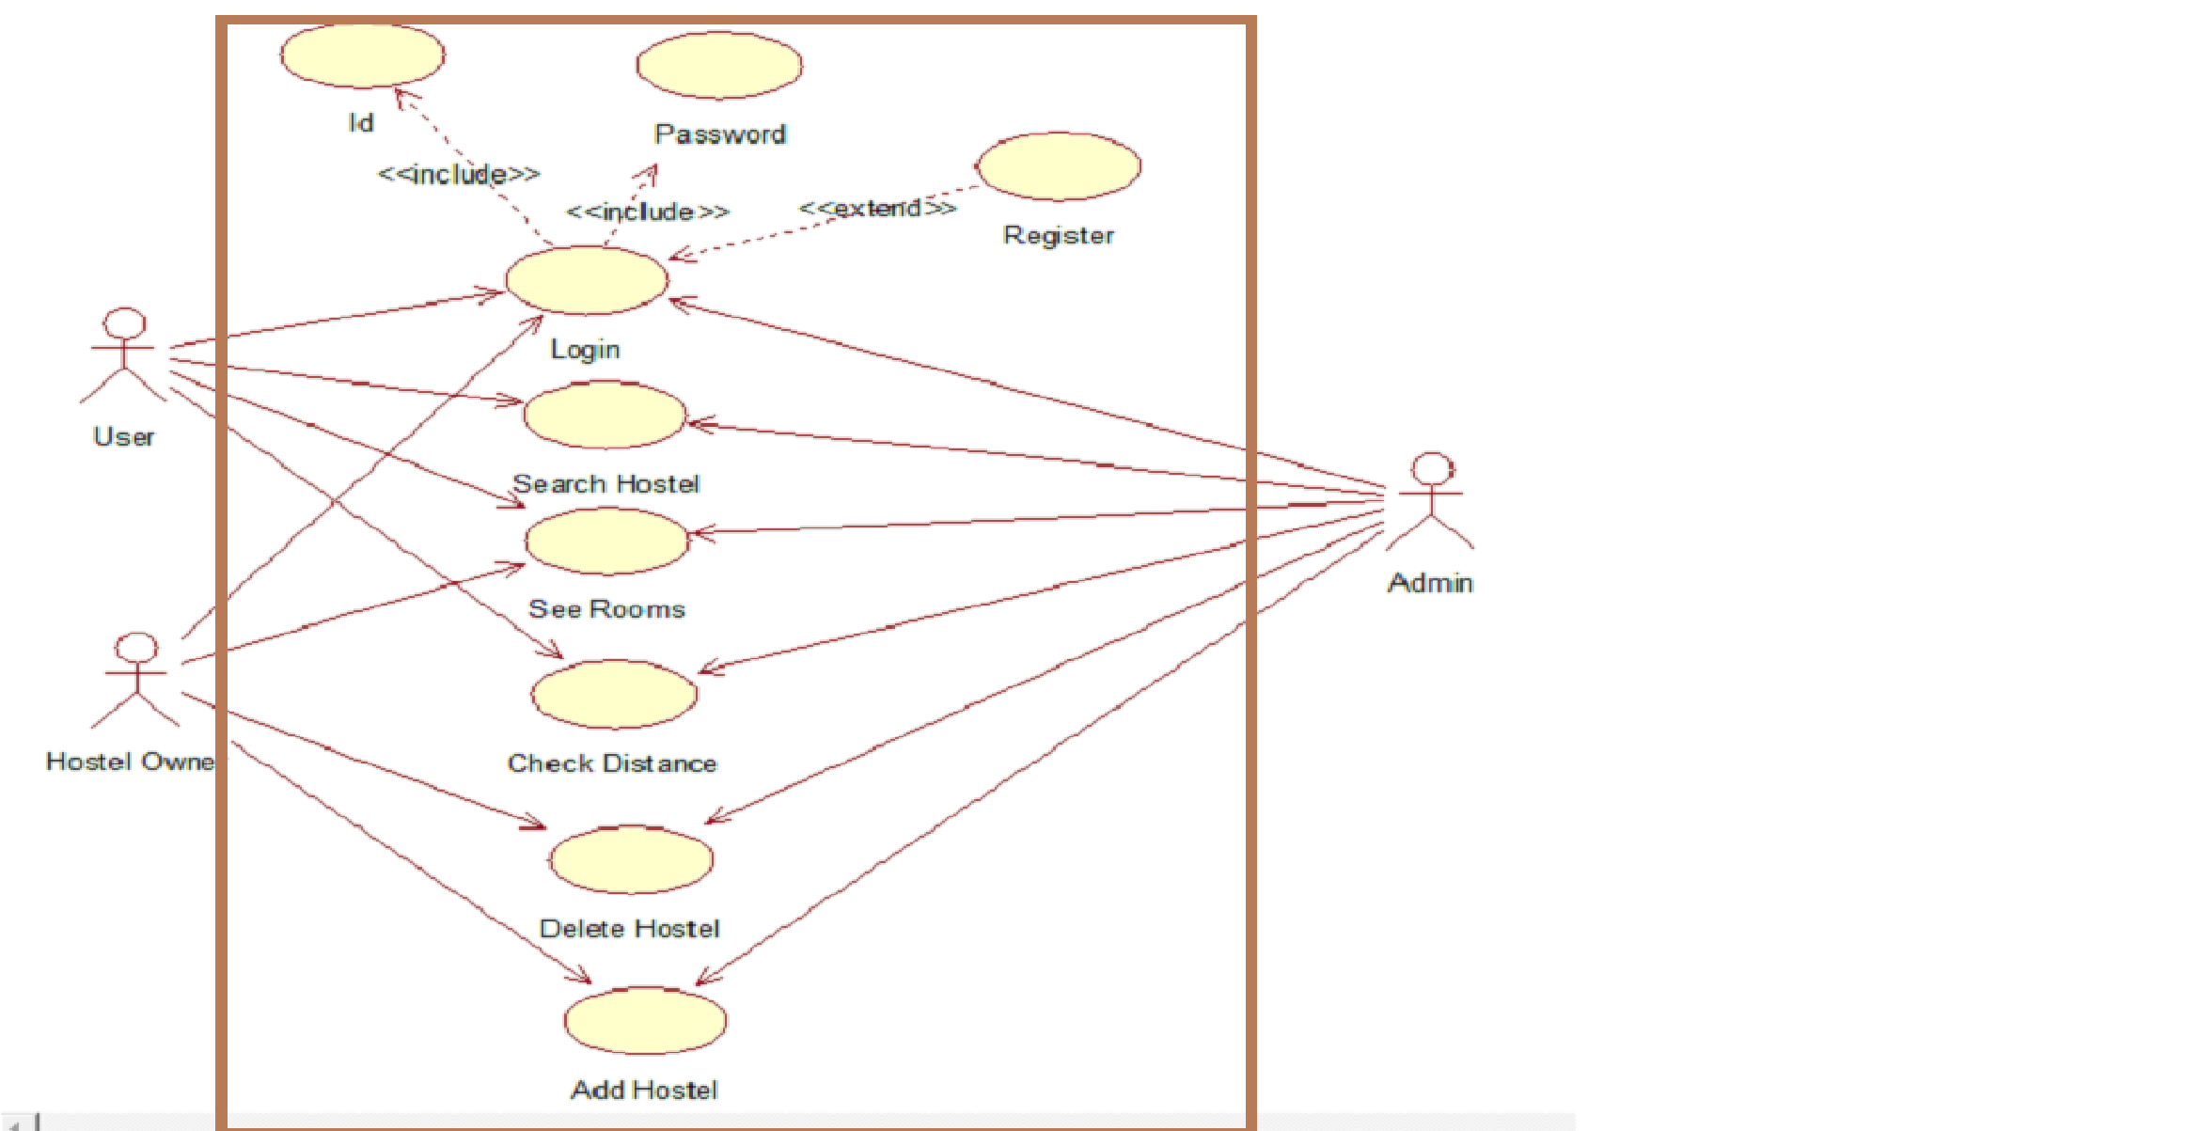

Fig 3.1 Use Case Diagram

3.2. Fully Dressed Use Cases
USE CASE SPECIFICATION

3.2.1 New User Registration/Sign Up

Use Case Name | Register
Description | To register a new User.
Primary Actor | User
Secondary Actor | None
Pre-Condition | None
Post Condition | The information that can be stored in firebase.
Main Flow | - User must click on sign up button.  - Fill the boxes with the given information.  - After fill all the entries click on save button.  - The new user will be registered.

3.2.2 Login
Use Case Name | Login (Hostel Owner or User).
Description | - Users must log in to find Hostels.  - Hostel Owner must login to add hostels or delete Hostels.
Primary Actor | User, Hostel Owner
Secondary Actor | None
Pre-Condition | Must be login
Post Condition | The data can be stored in Firebase
Main Flow | - Hostel Owner or User must click on the login button.  - Hostel Owner or Users enter their id and password.  - After enter id and password click on the login button  - The different new window will be open for Hostel Owner or User.

3.2.3 Search Hostel
Use Case Name | Search Hostel
Description | To search for a new hostel.
Primary Actor | User
Secondary Actor | None
Pre-Condition | Must be login  The device location is on.
Post Condition | Search Successfully.
Main Flow | - User must click on search button.  - Fill the boxes with the given information.  - After fill, all the entries click on Search Button.  - The Hostel will be shown to him.

3.2.4 See information.

Use Case Name | See info.
Description | To see the information of the selected hostel.
Primary Actor | User
Secondary Actor | None
Pre-Condition | - Must be login.  - The particular hostel is selected
Post Condition | Information will show to him successfully.
Main Flow | 1. Admin must click on Images button 2. The information will be shown to him.

3.2.5 Check Distance.
Use Case Name | Check Distance
Description | The user wants to check the distance from his location to hostels.
Primary Actor | User
Secondary Actor | None
Pre-Condition | - Must be login.  - The particular hostel is selected.
Post Condition | The Distance is displayed on the screen.
Main Flow | - User must click on check distance button.  - Distance will be shown to him.

3.2.6 Add Hostel
Use Case Name | Add Hostel
Description | The Hostel Owner wants to add his hostel to the application.
Primary Actor | Hostel owner.
Secondary Actor | None
Pre-Condition | Must be login.
Post Condition | The Hostel is registered to application.
Main Flow | - Users must click on the check add hostel.  - Hostel registered successfully.

3.2.7 Delete Hostel.
Use Case Name | Delete Hostel
Description | The Hostel Owner wants to Delete his hostel from the application.
Primary Actor | Hostel owner.
Secondary Actor | None
Pre-Condition | Must be login.  The Hostel is registered to application.
Post Condition | The Hostel is unregistered to application.
Main Flow | - Users must click on the check Delete hostel.  - Hostel unregistered successfully.

Requirement Gathering:

We used one to one meetings/interviews and brainstorming because using these techniques we can gather good information from the users/stakeholders who are not sure what they need or they lack in certain areas. Some people feels shy to speak in a group so one to one meeting/interviews are the best for them. The ideas collected from the users can be analyzed/reviewed and can be implemented if they are related to our system. People can come up with innovative ideas it is also an efficient way to get requirements out of stake holders

Chapter 4

System Design

Chapter 4: System Design
Hostel finder application is a mobile device. This application communicates with the server using HTTPS/SSL connection as a transport protocol. The Application will send request to the server and the server responds to the Application and will authenticate the user login. Wi-Fi or Mobile data will be required. Firebase database will be used to manage and store user data.

4.1. Entity Relationship Diagram with data dictionary
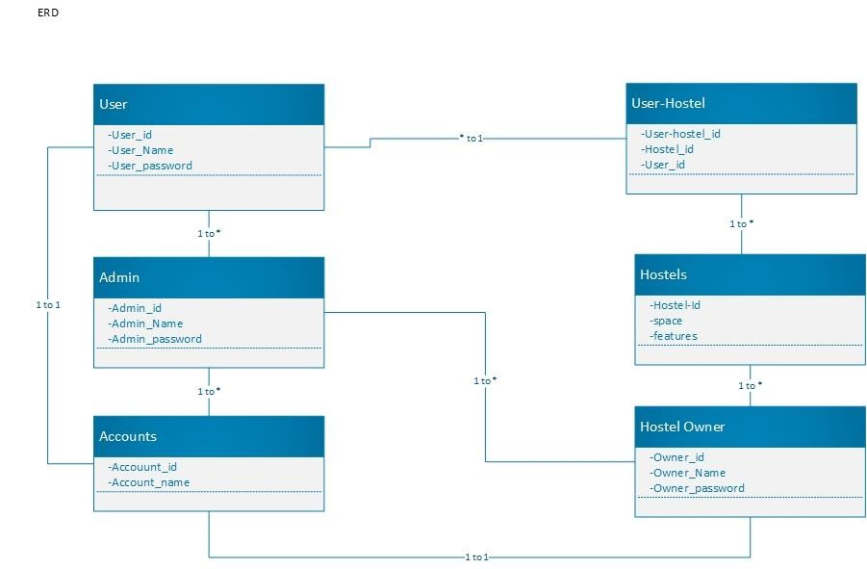

Fig 4.3 Entity Relationship Diagram

4.2. Class Diagram
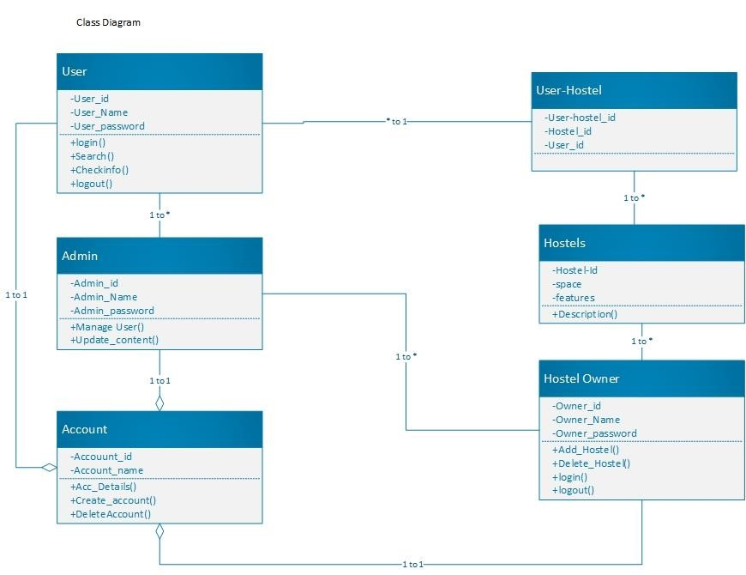

Fig 4.4 Class Diagram

4.3. Sequence / Collaboration Diagram

4.3.1 Sequence Diagram User Login
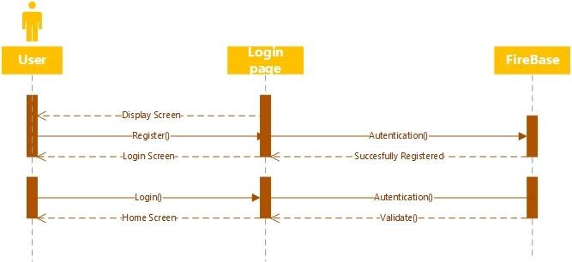

Fig 4.3 Sequence Diagram User Login 4.3.2 Sequence Diagram User Search Hostel
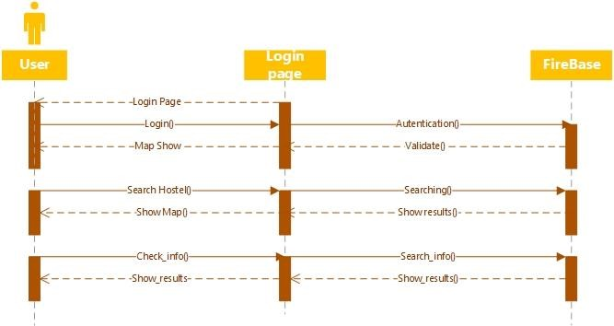
Fig 4.4 Sequence Diagram User Search Hostel

4.3.3 Sequence Diagram Admin Login
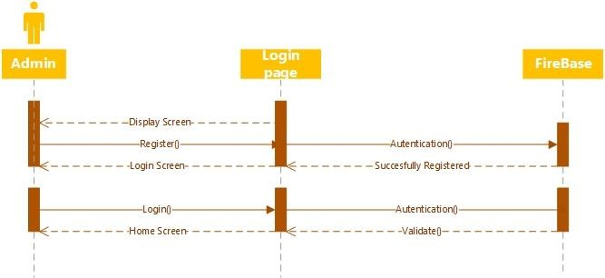

Fig 4.5 Sequence Diagram Admin Login 4.3.4 Sequence Diagram Hostel Owner Login
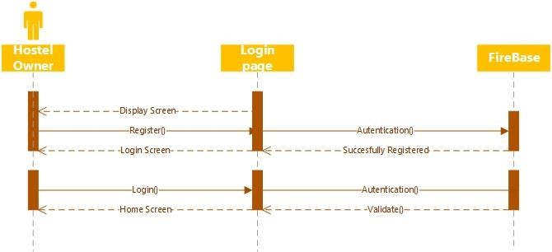
Fig No 4.6 Sequence Diagram Hostel Owner Login

4.3.5 Sequence Diagram Owner Add Hostel
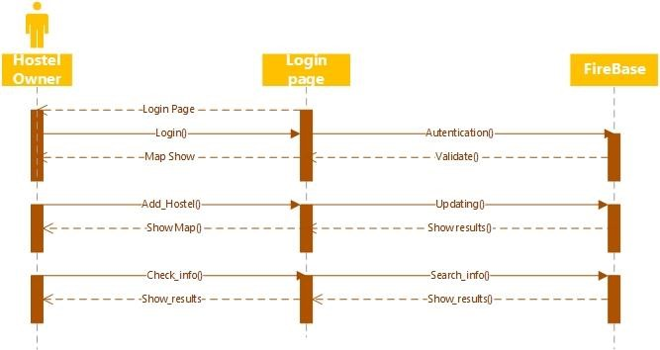
Fig 4.7 Sequence Diagram Owner Add Hostel

4.4. Operation contracts
4.6.1. Operation contract# 1
Name: Sign in for all user

Responsibilities: User logged in Cross reference: Use case: Sign in
Exception: Invalid user or password
Preconditions: User must have account
Post condition: Successfully signed in

4.6.2. Operation contract # 2 Name: Sign out for all user Responsibilities: User logged in Cross reference: Use case: none Exception: None
Preconditions: Must logged in
Post condition: Log out successfully

4.6.3. Operation contract # 3
Name: Admin Account
Responsibilities: Manage all hostels
Cross reference: Use case: Account management Exception: Pre-occupied or invalid user id or phone number.
Preconditions: User must be logged in.
Post condition: Account managed successfully.
4.6.4. Operation contract # 4
Name: Hostel

Responsibilities: Search hostel Cross reference: Use case: Account management
Exception: Pre-occupied or invalid user id or phone number
Preconditions: User must be logged in
Post condition: Hostel find successfully

4.5. Activity Diagram

4.7.1 User Activity
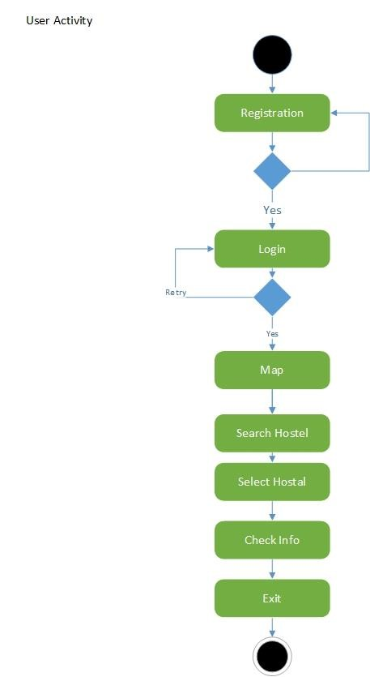
Fig 4.8 Activity User Admin

4.7.2 Hostel Owner Activity
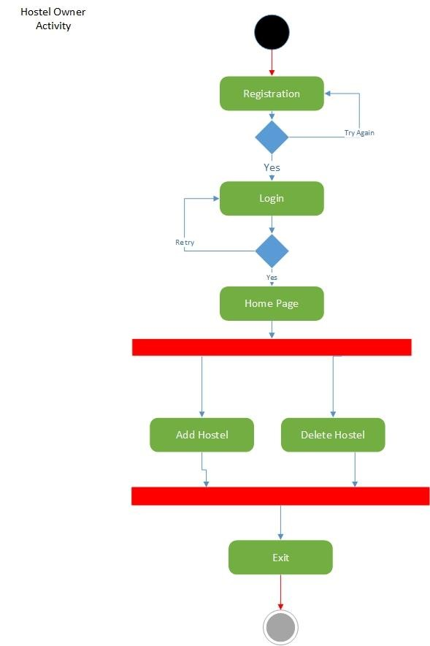
Fig 4.9 Activity Hostel Owner

4.7.3 Admin Activity
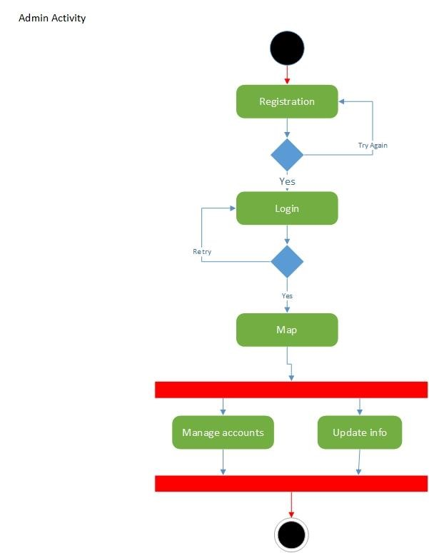
Fig 4.10 Activity Admin

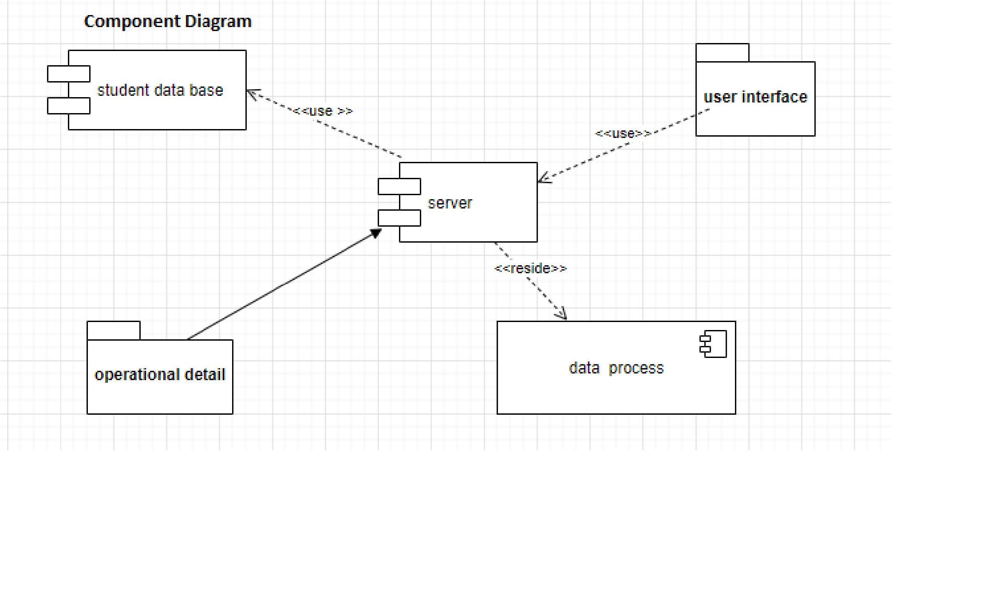
4.6. Component Diagram
Fig 4.11 Component Diagram

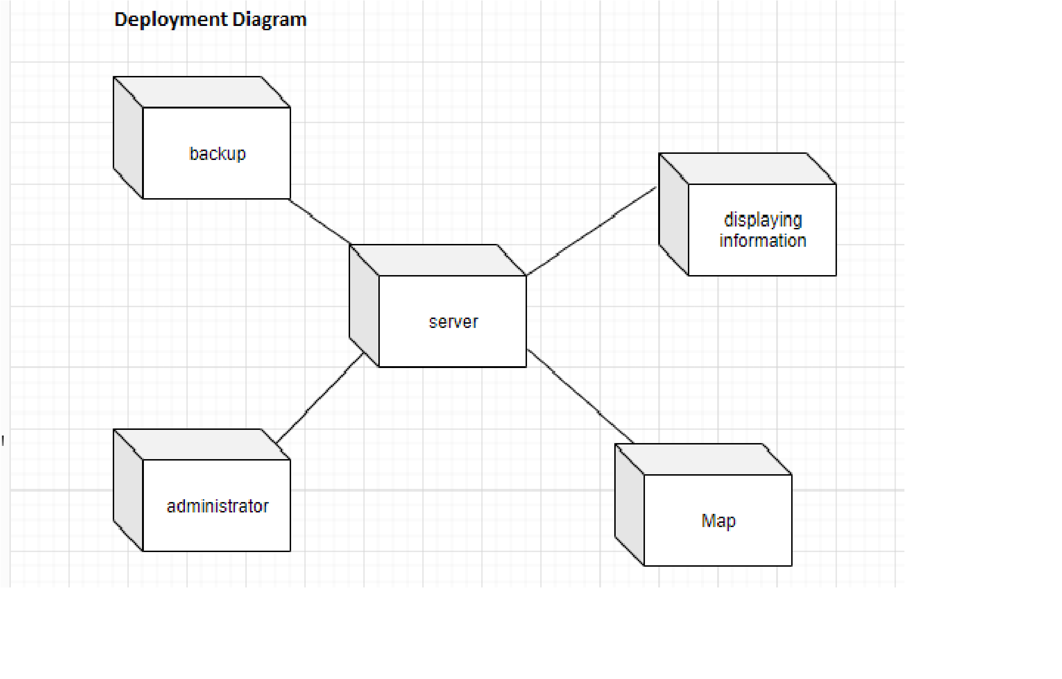
4.7. Deployment Diagram
Fig 4.12 Component Diagram

4.8. Data Flow diagram
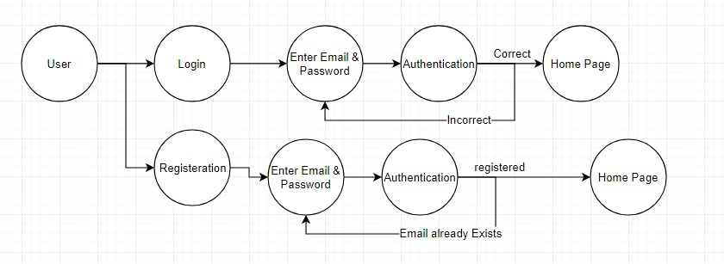
Fig 4.13 Data Flow Diagram

4.12 Test Cases:

4.12.1 Login Test case table

Test Scenario | Test Case | Test Steps | Test Data | Preconditio ns | Expected results | Actual  Results | Pass/  Fail
Check Login functionality | Check response on entering valid email and password | - Launch  application  1.5 Click on Login button  - Enter Email  - Enter Password 4. Click on login button | Email:tim extv123@ gmail.com Password: zeeshan12  3 | User Must  be registered | Login must be successful | Login  Successful | Pass

Table no 4.1

4.12.2 Registration test case.

Test  Scenario | Test Case | Test Steps | Test Data | Preconditi ons | Expected results |  | Actual  Results | Pass/Fail
Registration functionality | Check response on entering unique and valid email and password | - Launch  application  1.5 Click on registration button  - Enter  Email  - Enter  Password  - Click on  Register button. | Email:timex  tv123@gma  il.com  Password:ze eshan123 | User email  Must be  unique | Registered must successful | be | Register  Successful | Pass

Table No 4.2

Chapter 5

Implementation

Chapter 5: Implementation
This chapter describes all the tool and techniques related to the project This chapter describes all the implementation strategy like as implementation standers and guidelines that can be helpful during development control flow of all business logics and data. Describes libraries, web services also components of all projects with development environments they can achieved by best development practices and version control strategy.

5.1. Components, Libraries, Web Services and stubs

5.2.1. Components
- We are specially focused on client satisfaction which we should fulfill.
- Our project is designed to fulfill the requirements of both the users and hostel honor’s.

5.2.2. Libraries
We can use many libraries in our Android Application. Some of them are as follows
Retrofit (Communication Bridge between App and admin Panel)
•Glide (Load image in image preview)
- Recycle view (Display listing)
- Card view (Design list items)

5.2. Deployment Environment
We will deploy our project Android Application on Goggle play store first of all we upload the beta version of this applications and also apply many testing methodologies on the application to improve its performance so we can enhance the user experience and functionality of our application.

5.3. Tools and Techniques
Platform for this application will be Google play store. This application will be made for Android mobile phones. We made it on Android studio through Java language. Data of this application will be stored online through fire base. A new student will easily find out the hostel room by logging into the application. There he will find the detailed description about the accommodations. So this application will help the new students to have a safe fine environment without complexities.

5.4. Best Practices / Coding Standards
Superior coding techniques and programming practices are hallmarks of the professional programmer. The bulk of programming consists of making a large number of small choices while attempting to solve a large set of problems. How wisely those choices are made depends largely set of problems. How wisely those choices are made depends largely upon the programmer’s skill the expertise.

