Tutor finder

Final Year Project

Session 2020-2024

A project submitted in partial fulfillment of the degree of

BS in Computer Science


Department of Computer Science
Faculty of Computer Science & Information Technology
The Superior University, Lahore

Fall 2024

Type (Nature of project) |  |  | [ ] Development [ ] Research [ ] R&D
Area of specialization |  |  | Mobile App Development
FYP ID |  |  | FYP-BCSM-S24-016
Project Group Members
Sr.# | Reg. # | Student Name |  | Email ID | Signature
(i) | Bcsm-f20-148 | Muhammad Salman Shahzad |  | Bcsm-f20-148@superior.edu.pk
(ii) | Bcsm-f20-070 | Muhammad Asif |  | Bcsm-f20-070@superior.edu.pk
(iii) | Bcsm-s21-065 | Muhammad Sajeel Zafar |  | Bcsm-s21-065@superior.edu.pk

*The candidates confirm that the work submitted is their own and appropriate credit has been given where reference has been made to work of others

Plagiarism Free Certificate
This is to certify that, I Muhammad Salman Shahzad S/O of Muhammad Hanif, group leader of FYP under registration no BCSM-F20-148 at Computer Science, The Superior University, Lahore. I declare that my FYP report is checked by my supervisor.

Date: 10-11-24 Name of Group Leader: Muhammad Salman Shahzad Signature: __________

Name of Supervisor: Muhammad Jameel
Signature: ________________

HoD: Dr. M Azam
Signature: _______________

Tutor Finder

Change Record
Author(s) | Version | Date | Notes | Supervisor’s Signature
Salman | 1.0 | 1-5-24 | Tools
Sajeel | 1.0 | 10-7-24 | Artificial Intelligence Integration
Salman | 1.2 | 16-9-24 | Payment Gateway
Asif | 1.3 | 20-9-24 | Backend
Sajeel | 1.4 | 26-9-24 | UI Changes
Salman | 1.4 | 30-9-24 | Database
Sajeel | 1.4 | 4-10-24 | State management
Salman | 1.7 | 10-10-24 | Responsiveness
Asif | 2.0 | 13-10-24 | Performance
Sajeel | 2.1 | 17-10-24 | App size
Salman | 2.3 | 25-10-24 | Multidex support
Sajeel | 2.4 | 30-10-24 | Analytics and crash reporting
Salman | 2.5 | 04-11-24 | Code maintainability
Asif | 2.7 | 06-10-24 | Platform-specific features
Salman | 2.7 | 10-10-24 | Final Testing

APPROVAL
Project Supervisor
Comments: ___________________________________________________________________
_____________________________________________________________________________
Name:______________________________
Date:_______________________________ | Signature: __________________________

Project Manager
Comments: ___________________________________________________________________
_____________________________________________________________________________
Date: _______________________________ | Signature: __________________________

Head of the Department
Comments: ___________________________________________________________________
_____________________________________________________________________________
Date: _______________________________ | Signature: __________________________

Dedication

In dedication to the culmination of our efforts, we extend our deepest gratitude to all those who have contributed to the realization of this project.
To our families, whose unwavering support, encouragement, and understanding have been the cornerstone of our journey. Your belief in our abilities and sacrifices made this endeavor possible.
To our esteemed supervisor, Ma’am Javaria Qadeer, for their invaluable guidance, expertise, and unwavering commitment. Their mentorship and insightful feedback have shaped our project's direction and enriched our learning experience.
To our fellow team members, whose collaboration, dedication, and synergy have been instrumental in overcoming challenges and achieving our goals. Your tireless efforts and shared vision have brought this project to fruition.
To our friends and peers, for their encouragement, understanding, and inspiration throughout this endeavor. Your encouragement and positivity have fueled our determination and perseverance.
Finally, to the pursuit of knowledge, innovation, and excellence. May this project serve as a testament to our commitment to continuous learning and making a meaningful impact in our chosen field.

With sincere appreciation,

Salman
Asif
Sajeel Zafar

Acknowledgements
We would like to thank all those who have had a part in completing this project and made it possible. First and foremost, we would like to Thanks our supervisor Ma’am Javaria Qadder for his valuable guidance, encouragement, and support throughout this project. The knowledge, guidance, and faithful support of their students have been a key factor in the improvement of our work and in helping us to overcome the problems that we face. Above all, we are very thankful to our families for the endless love, patience, and understanding that they have offered us during this project. Their support and their constant motivation have been the constant factor for them. We would also like to thank Superior University for giving us the resources, facilities, and environment suitable for our project to succeed. Also, I would like to thank our friends and peers for their encouragement, and they also gave us their insights and advice during this journey. The assistance and solidarity they provided made this experience extra special and fun. We also appreciate the people, the organizations, and the resources whose work and achievements have in one way or another helped our project.

I am grateful to all of you who have joined this journey and for your invaluable contributions.

Salman Shahzad, Asif , Sajeel Zafar

Executive Summary
Tutor Finder is an innovative platform designed to bridge the gap between students and tutors by providing a comprehensive online solution for finding and connecting with qualified educators. This platform addresses several critical challenges in the traditional tutoring ecosystem, including the difficulty students face in finding suitable tutors, the necessity of physical attendance for tutoring sessions, the lack of accurate and reliable tutor feedback, and the need for a structured attendance and test system. By leveraging modern technologies and best practices, Tutor Finder aims to revolutionize the way tutoring services are accessed and delivered.

The core functionality of Tutor Finder includes a robust search mechanism that allows students to find tutors based on specific subjects, qualifications, and availability. This eliminates the traditional barrier of geographical limitations, enabling students to connect with tutors from anywhere, thus providing a wider pool of expertise and flexibility in scheduling. The platform also integrates a feedback system where students can rate and review tutors. This transparent feedback mechanism helps other students make informed decisions based on the experiences of their peers, fostering a trustworthy and reliable learning environment.

To ensure the effectiveness and efficiency of the tutoring sessions, Tutor Finder incorporates a comprehensive attendance and test system. This system not only tracks student participation but also facilitates regular assessments to monitor progress and provide insights into areas needing improvement. Such features are crucial in maintaining the quality and consistency of the tutoring provided, ensuring that students achieve their educational goals.

The development of Tutor Finder utilizes state-of-the-art tools and technologies. The platform is built on Google Firebase, which offers a real-time database, authentication, cloud functions, messaging, and analytics, ensuring robust and scalable back-end support. The front-end development is carried out using Android Studio, providing a seamless and intuitive user experience across mobile devices. Adhering to best practices and coding standards, the development team employs the MVVM architecture to maintain a clean separation of concerns and enhance code maintainability.

In terms of security and performance, Tutor Finder implements rigorous error handling, comprehensive testing strategies, and consistent version control. These practices ensure that the platform remains reliable, secure, and user-friendly. The integration of essential libraries and components, such as Retrofit for networking, Dagger for dependency injection, and Glide for image loading, further enhances the functionality and performance of the application.

Overall, Tutor Finder stands as a transformative solution in the education sector, providing students with easy access to quality tutoring, enabling tutors to reach a broader audience, and ensuring a structured and effective learning process. This platform not only meets the current demands of online education but also sets a new standard for the future of tutoring services.

Table of Contents
Tutor finder iPlagiarism Free Certificate ii
Dedication v
Acknowledgements vi
Executive Summary vii
Table of Contents ix
List of Figures xii
List of Tables xiii
Chapter 1 1
Introduction 1
1.1. Background 2
1.2. Motivations and Challenges 2
1.3. Goals and Objectives 3
1.4. Literature Review/Existing Solutions 3
1.5. Gap Analysis 5
1.6. Proposed Solution 5
1.7. Project Plan 6
1.7.1. Work Breakdown Structure 6
1.7.2. Roles & Responsibility Matrix 8
1.7.3. Gant Chart 9
Chapter 2 12
Software Requirement Specifications 12
3.1. Introduction 13
3.1.1. Purpose 13
3.1.2. Document Conventions 13
7.1.1. Intended Audience and Reading Suggestions 13
12.1.1. Product Scope 13
12.1.2. References 14
12.2. Overall Description 14
12.2.1. Product Perspective 14
12.2.2. User Classes and Characteristics 14
15.1.1. Operating Environment 14
15.1.2. Design and Implementation Constraints 14
15.1.3. Assumptions and Dependencies 14
15.2. External Interface Requirements 15
15.2.1. User Interfaces 15
15.2.2. Hardware Interfaces 15
15.2.3. Software Interfaces 15
15.2.4. Communications Interfaces 15
15.3. System Features 15
15.3.1.1. Description and Priority 16
15.3.1.2. Description: This feature allows users (both students and tutors) to register for an account, log in, and authenticate their identity. 16
15.3.1.3. Priority: 9 16
15.3.1.4. Stimulus/Response Sequences 16
15.3.1.5. Description and Priority 17
Priority: 9 17
15.3.1.6. Stimulus/Response Sequences 17
15.3.1.7. Functional Requirements 17
1.1.1.1. Description and Priority 17
1.2. Nonfunctional Requirements 19
1.2.1. Performance Requirements 19
1.2.2. Safety Requirements 20
1.2.4. Usability Requirements 20
1.2.5. Reliability Requirements 20
1.2.6. Maintainability/Supportability Requirements 21
1.2.7. Portability Requirements 21
1.2.8. Efficiency Requirements 21
1.3. Domain Requirements 22
Chapter 3 24
Use Case Analysis 24
3.1. Use Case Diagram 26
3.2. Use Cases Description 27
Chapter 4 28
System Design 28
4.1. Architecture Diagram 30
4.2. Entity Relationship Diagram with data dictionary 32
4.3. Class Diagram 33
4.4. Sequence / Collaboration Diagram 34
4.5. Operation contracts 34
4.6. Activity Diagram 36
4.7. State Transition Diagram 37
4.8. Component Diagram 38
4.9. Deployment Diagram 39
4.10. Data Flow diagram [only if structured approach is used - Level 0 and 1] 40
Chapter 5 42
Implementation 42
5.1. Important Flow Control/Pseudo codes 44
5.2. Components, Libraries, Web Services and stubs 45
5.3. Deployment Environment 46
5.4. Tools and Techniques 47
5.5. Best Practices / Coding Standards 48
5.6. Version Control 48
Chapter 6 49
Testing and Evaluation 49
6.1. Use Case Testing 50
6.2. Equivalence partitioning 50
6.3. Boundary value analysis 50
6.4. Data flow testing 51
6.5. Unit testing 51
6.6. Integration testing 51
6.7. Performance testing 51
6.8. Stress Testing 52
Chapter 7 53
Summary, Conclusion and Future Enhancements 53
7.1. Project Summary 54
7.2. Achievements and Improvements 54
7.3. Critical Review 54
7.4. Lessons Learnt 55
7.5. Future Enhancements/Recommendations 55
Reference and Bibliography 56
Index 58

List of Figures

Figure 1 Gant Chart………………………………………………………………………………………………………… 9
Figure 2 Empathy Map…………………………………………………………………………………………………….9
Figure 3 Use Case Diagram………………………………………………………………………………………………26
Figure 4 Architecture Diagram…………………………………………………………………………………………30
Figure 5 ERD……………………………………………………………………………………………………………………. 32
Figure 6 Class Diagram……………………………………………………………………………………………………. 33
Figure 7 Activity Diagram………………………………………………………………………………………………. 36
Figure 8 State Transition Diagram………………………………………………………………………………… 37
Figure 9 Component Diagram……………………………………………………………………………………….. 40
Figure 10 Deployment Diagram……………………………………………………………………………………… 39
Figure 11 Deployment Diagram 2…………………………………………………………………………………… 40
Figure 12 Data Flow Diagram Level 0 ……………………………………………………………………………… 40
Figure 13 Deployment Diagram Level 1…………………………………………………………………………… 41

List of Tables

Table 1 Literature Review…………………………………………………………………………………………………………… 4
Table 2 WBS………………………………………………………………………………………………………………………………… 6
Table 3 Gantt Chart…………………………………………………………………………………………………………………… 9

Chapter 1

Introduction

Chapter 1: Introduction
Education remains a cornerstone for personal and professional development in today's fast-paced world. As the demand for quality education grows, so does the need for effective and convenient tutoring solutions. Traditional tutoring methods, which often require physical attendance and rely on limited word-of-mouth feedback, no longer address modern students’ diverse needs. TutorFinder is an iOS and Android mobile app that complements students’ efforts to find a desirable teacher. It connects students to teachers for quality education and interactive learning. It's also beneficial for tutors. Now, with the app’s help, they can reach more students, track their progress, and earn more via our platform.

Background
The traditional method of finding and engaging tutors often involves significant logistical challenges. Students and parents typically rely on local advertisements, word-of-mouth referrals, or physical visits to tutoring centers, which limits their options to a small geographical area. Furthermore, the necessity for physical attendance at tutoring sessions can be restrictive, especially for students with busy schedules or those living in remote areas. These limitations can prevent students from accessing the best possible educational support. In response to these challenges, Tutor Finder aims to provide a comprehensive online platform that connects students with qualified tutors from across the globe, facilitating convenient and effective learning experiences.

Motivations and Challenges
The primary motivation behind the development of Tutor Finder is to democratize access to quality education. By providing a platform where students can easily find and interact with tutors, the project seeks to overcome the geographical and logistical barriers inherent in traditional tutoring methods. Key challenges addressed by Tutor Finder include the difficulty of finding qualified tutors, the inconvenience of physical attendance, the lack of reliable feedback mechanisms, and the absence of structured attendance and test systems. By addressing these issues, Tutor Finder aims to enhance the accessibility, convenience, and effectiveness of tutoring services.

Goals and Objectives

- Developing a user-friendly interface for students to search and select tutors based on their specific needs.
- Implementing a reliable feedback system to ensure transparency and help students make informed decisions.
- Integrating a robust scheduling and attendance tracking system to streamline session management.
- Providing tools for regular assessments and progress tracking to enhance the learning experience.
- Ensuring secure and efficient payment processing to facilitate seamless transactions between students and tutors.

Literature Review/Existing Solutions

Study/Platform | Key Features | Strengths | Weaknesses/Gaps | TutorFinder’s Contribution
Chegg Tutors | Online tutoring, live sessions, wide subject range. | Comprehensive tutoring options, flexible scheduling. | Limited to web-based, some issues with tutor availability. | Mobile app integration, better tutor quality control, and feedback.
Wyzant | Tutors across various subjects, both in-person and online. | Wide range of subjects, tutor profiles with reviews. | Tutor quality inconsistency, limited feedback transparency. | Unified feedback and rating system, structured attendance tracking.
Preply | Specializes in language tutoring, global tutor network. | Extensive tutor network, flexible class scheduling. | Focuses mainly on languages, lack of progress tracking tools. | Focus on all subjects, progress monitoring tools for students.
Italki | Language learning platform, video and text chat lessons. | Strong focus on language learning, flexible tutoring hours. | Lacks holistic education features, no integrated assessment tools. | More subject diversity, integrated tools for assessments and feedback.
Khan Academy | Free online courses, structured lessons. | High-quality free content, self-paced learning. | No personalized tutoring, limited interaction with instructors. | Personalized tutoring options alongside free content.
Coursera | Online courses from universities, certification programs. | High-quality courses, recognized certifications. | Lack of one-on-one tutoring, no real-time interactive classes. | Integration of real-time interactive tutoring and course completion.
TutorFinder (Proposed) | Mobile app connecting students and tutors, feedback system, progress tracking. | Global reach, personalized tutoring, flexible schedules, cost-effective. | None identified (addressing gaps in feedback, scheduling, progress tracking). | Comprehensive solution: global access, transparent feedback, full integration of progress tracking and attendance systems.

Gap Analysis
- Lack of a unified feedback and rating system that ensures transparency and reliability.
- Insufficient tools for tracking attendance and managing session schedules.
- Limited integration of assessment tools for monitoring student progress.
- Inconsistent tutor quality and availability across different subjects.
- Tutor Finder aims to fill these gaps by offering a holistic platform that integrates all necessary features to provide a seamless and effective tutoring experience.

Proposed Solution
For Students
- Easily find the best tutor via our app. With student’s review and feedback about the teachers.
- Classes will be available for 1-to-1 or 1-to-many.
- Online interactive classes will save lots of travel time for the students.
- Pocket-friendly education, Not very expensive.
- Maintain quality of education via student.
- Complete health & mental security while learning online.
- Easily review the missing class and post his/her queries to the teacher.
- Students can compete with each other via our platform.
- Easy fee payment options via Wallets, Credit Card, and online banking.
For Teachers
- Reaching more students will create more income.
- Save lots of time.
- Easily track all student records via the app and send them improvement tests.
- Less monthly expenses to run the class like Space Rent, Chair, Table Expenses, and Electricity bills.
- Teachers can record their videos and upload them to the system. It can save their time and can give more attention to the students.

Project Plan
The project plan for Tutor Finder encompasses the complete lifecycle of the project, from initial planning and development through to deployment and maintenance. This structured approach ensures that all aspects of the project are thoroughly considered and managed, minimizing risks and maximizing the chances of successful delivery. The plan includes the development of a detailed Work Breakdown Structure (WBS), a Roles and Responsibility Matrix, and a Gantt Chart to visually represent the project timeline and milestones.

Work Breakdown Structure

WBS # | WBS Deliverable | Activity | Activity to Complete the Deliverable | Duration (Days) | Responsible Team Member(s)
1.1 | Work Breakdown Structure (WBS) | 1.1.1 | Develop a hierarchical outline of project tasks | 10 | Salman
1.2 | Roles & Responsibility Matrix | 1.2.1 | Define roles and responsibilities for each team member | 10 | Asif
1.3 | Change Control System | 1.3.1 | Establish a process for managing and tracking project changes | 5 | Asif
2.1 | Final Documentation Introduction | 2.1.1 | Write an introduction to the final project documentation | 5 | Salman
2.2 | Literature Market Survey | 2.2.1 | Conduct a literature review and market survey | 10 | Sajeel
2.3 | Requirements Analysis | 2.3.1 | Identify and document user requirements | 15 | Sajeel
2.4 | System Design | 2.4.1 | Design the overall system architecture | 15 | Salman
2.5 | Implementation | 2.5.1 | Develop and implement the application | 80 | Team (All Members)
2.6 | Testing & Performance Evaluation | 2.6.1 | Conduct thorough testing and evaluate performance | 30 | Team (All Members)
2.7 | Conclusion & Outlook | 2.7.1 | Summarize key findings and discuss future prospects | 10 | Team (All Members)
2.8 | End User Documentation | 2.8.1 | Create user-friendly instructions for the app | 5 | Team (All Members)
2.9 | Application Administration Documentation | 2.9.1 | Develop documentation for app administration | 5 | Team (All Members)
2.1 | System Administrator Documentation | 2.10.1 | Create documentation for system administration | 5 | Team (As Needed)
3.1.1 | IDE Selection | 3.1.1.1 | Choose an Integrated Development Environment (IDE) | 2 | Team (All Members)
3.1.2 | Version Control Setup | 3.1.2.1 | Set up a version control system (e.g., Git) | 2 | Team (All Members)
3.1.3 | Server Selection | 3.1.3.1 | Choose a server to host the application | 2 | Team (All Members)
3.1.4 | Database Selection | 3.1.4.1 | Select a database management system | 4 | Sajeel
Project Initiation

- Requirements gathering
- Feasibility study
- Project charter creation
Planning

- Detailed project plan development
- Risk assessment and mitigation planning
- Resource allocation
Design

- UI/UX design
- Database schema design
- System architecture design
Development

- Front-end development (Android app)
- Back-end development (Firebase integration)
- API development
Testing

- Unit testing
- Integration testing
- User acceptance testing (UAT)
Deployment

- Preparation of deployment environment
- Deployment to Google Play Store
- Initial rollout and monitoring
Maintenance

- Bug fixing and updates
- Performance monitoring
- User support and feedback integration

Roles & Responsibility Matrix

Project Manager: Salman Shahzad
UI/UX: M-Asif
Backend: Sajeel
Frontend Development: Salman Shahzad

Gant Chart
- TASK | ASSIGNED TO | START | END | DUR | %
Project Management | Salman Shahzad | 22/02/24 | 30/10/24 | 215 | 100
Requirements Analysis | Salman Shahzad | 25/03/24 | 10/04/24 | 15 | 7
Design | M-Asif | 10/04/24 | 25/04/24 | 15 | 7
AI Model Creation | All Members | 25/04/24 | 25/05/24 | 30 | 14
Application Development | Sajeel | 25/05/24 | 25/06/24 | 30 | 14
Frontend Development | Salman Shahzad | 25/05/24 | 25/06/24 | 30 | 14
Backend Development | Sajeel | 25/06/24 | 25/07/24 | 30 | 14
AI Model Integration | M-Asif | 25/07/24 | 05/08/24 | 10 | 4.66
Deployment | Salman Shahzad | 05/08/24 | 25/08/24 | 20 | 9.3
Maintenance and Operations | Salman Shahzad, M-Asif, Sajeel | 25/08/24 | 30/10/24 | 65 | 30

Empathy Map
THINK & FEEL
- I want the best qualified tutor
- Score good marks in exam/competition
- Need to improve & learn new skills
- I want to save the travel time & cost
- Can I get pocket-friendly tuitions?
- Interactive learning
- I want to improve my study habits
- Thinking about future goals
- How do I improve my study habits?
HEARING
- Listening to lectures
- Tutor command/feedback
- This is your 12th Grade. You must score at least 95%
- Friends Conversation
- Most of the classes will be online due to the pandemic
- Take counselling for your future
PAINS
- Network Issue
- Stress about completing the course
- Hectic schedule
- Looking for best-qualified tutor
- Non-interactive classes
- Expensive tuitions
- Travel time for offline classes
- Looking for a qualified tutor nearby

SEEING
- Looking for offline/online tutor
- Advertisement /Social Media Ad / Google Search for tuition
- Peers working/watching others learn a new skill
- Study material
- Pre-recorded videos
- Rating & reviews from tutor & student
- Notifications / Alerts

DO & SAY
- How to get better results.
- Clearing doubts with tutor/students/
- Google / YouTube
- Studying hard to clear exams / competition
- Exploring / reading new books apart from the syllabus
- Solving previous question papers
- Preparing a schedule for the exam
GAINS
- Easily finding a qualified tutor
- Good marks to get admission to a good college
- Getting more time for extra activities
- Saving money & time.
- Motivation & appreciation from tutor, parents, and friends

Chapter 2

Software Requirement Specifications

Chapter 2: Software Requirement Specifications

Introduction

Purpose

This Software Requirements Specification (SRS) document specifies the requirements for the Tutor Finder application, which aims to connect students with tutors for online learning. The SRS covers the entire system's functionality, from user interface to backend services, providing a comprehensive guide for developers, testers, and stakeholders.

Document Conventions
- Bold: Emphasis on key elements or requirements.
- Italic: Definitions or explanations.
- Monospaced font: Code snippets or commands.
- Each requirement statement is uniquely numbered for easy reference.

Intended Audience and Reading Suggestions
- Developers: To understand the functional and non-functional requirements for implementing the system.
- Project Managers: To track the progress and ensure all requirements are met.
- Marketing Staff: To understand the capabilities and features of the product.
- Testers: To design and execute test cases based on the requirements.
- Documentation Writers: To create user manuals and other documentation.

Product Scope
The Tutor Finder application is designed to facilitate online tutoring sessions by connecting students with qualified tutors across various subjects. The platform offers search functionality, booking and payment processing, session scheduling, feedback and rating systems, and performance tracking. The primary objectives are to provide accessible and quality education, streamline the tutor selection process, and ensure effective learning through regular assessments.

References
n/a

Overall Description

Product Perspective
The Tutor Finder application is a new, self-contained product developed to offer a comprehensive solution for online tutoring. It integrates various components such as the user interface, backend services, and external APIs. The product interfaces with Google Firebase for real-time database services, authentication, and cloud functions.

User Classes and Characteristics
- Students: Users seeking tutoring services. Vary in age, educational level, and technical expertise.
- Tutors: Individuals offering tutoring services. Require features for scheduling, payment management, and receiving feedback.
- Administrators: Manage the platform, handle disputes, and ensure system integrity. High technical expertise is required.

Operating Environment
The application will run on Android devices (version 5.0 and above) & IOS. It requires internet connectivity to access Firebase services and integrate with payment gateways.

Design and Implementation Constraints
<Describe any items or issues that will limit the options available to the developers. These might include: corporate or regulatory policies; hardware limitations (timing requirements, memory requirements); interfaces to other applications; specific technologies, tools, and databases to be used; parallel operations; language requirements; communications protocols; security considerations; design conventions or programming standards (for example, if the customer’s organization will be responsible for maintaining the delivered software).>

Assumptions and Dependencies
- Reliable internet access for all users.
- Continued availability and support of Google Firebase services.
- Dependencies on third-party APIs for payment processing and notifications.
- User data security and privacy must be maintained according to regulatory standards.

External Interface Requirements

User Interfaces

Login/Signup Screens: User authentication.

Search and Filter Options: Find tutors based on subjects and availability.

Tutor Profiles: Display tutor qualifications, ratings, and reviews.

Booking System: Schedule sessions with selected tutors.

Feedback System: Rate and review tutors post-session.

Hardware Interfaces
- The application will interface with mobile hardware such as cameras and microphones for virtual sessions.
- Device-specific features like touchscreens will be fully utilized for user interaction.

Software Interfaces
- Google Firebase: For authentication, real-time database, and cloud functions.
- Payment Gateway APIs: For processing transactions securely.
- Notification Services: For sending session reminders and updates.

Communications Interfaces
- The application will use HTTPS for secure communication between the client and server.
- Supports standard protocols such as HTTP/2 for efficient data transfer.
- E-mail and push notifications for user communication.

System Features

User Registration and Authentication

Description and Priority

Description: This feature allows users (both students and tutors) to register for an account, log in, and authenticate their identity.

Priority: 9

Stimulus/Response Sequences

User Action: The user opens the app and selects "Sign Up."

System Response: Display the registration form.

User Action: The user fills out the registration form with the required details and submits.

System Response: Validate the information, create a new user account, and send a confirmation email.

User Action: The user receives the confirmation email and clicks on the verification link.

System Response: Verify the user's email and activate the account.

User Action: The user opens the app and selects "Login."

System Response: Display the login form.

User Action: User enters credentials and submits.

System Response: Authenticate the user and direct them to the dashboard.

Functional Requirements
REQ-URA-1: The system must provide a registration form with fields for username, email, password, and role (student or tutor).
REQ-URA-2: The system must validate the email format and password strength.
REQ-URA-3: The system must send a confirmation email upon successful registration.
REQ-URA-4: The system must verify the user's email when the confirmation link is clicked.
REQ-URA-5: The system must provide a login form with fields for email and password.
REQ-URA-6: The system must authenticate users against stored credentials.
REQ-URA-7: The system must lock the account after five failed login attempts and provide a "Forgot Password" option.
Search and Filter Tutors

Description and Priority

Description: This feature allows students to search for tutors based on subject, availability, ratings, and other criteria.

Priority: 9

Stimulus/Response Sequences

User Action: Student opens the "Search Tutors" page.

System Response: Display the search and filter options.

User Action: Student enters search criteria (e.g., subject, location, availability) and submits.

System Response: Display a list of tutors matching the criteria.

User Action: Student selects a tutor from the list.

System Response: Display the tutor's profile with detailed information and ratings.

Functional Requirements
REQ-SFT-1: The system must provide search fields for subject, location, availability, and rating.
REQ-SFT-2: The system must return a list of tutors that match the search criteria.
REQ-SFT-3: The system must display tutor profiles with detailed information, including qualifications, availability, and ratings.
REQ-SFT-4: The system must allow students to sort the search results by rating, price, and availability.
Scheduling and Enrollment

Description and Priority

Description: This feature allows students to enroll in subjects with different teachers.
Priority: High
14.3.3.2. Stimulus/Response Sequences
User Action: The student selects a time slot from a tutor's available schedule.
System Response: Display a booking confirmation dialog.
User Action: Student confirms the booking.
System Response: Schedule the session, update the tutor's availability, and send confirmation notifications to both parties.
User Action: Tutor views their schedule.
System Response: Display the tutor's upcoming sessions and availability.
14.3.3.3. Functional Requirements
REQ-BSS-1: The system must display available time slots for each tutor.
REQ-BSS-2: The system must allow students to book a session by selecting an available time slot.
REQ-BSS-3: The system must update the tutor's availability upon successful booking.
REQ-BSS-4: The system must send booking confirmation notifications to both the student and tutor.
REQ-BSS-5: The system must provide tutors with a view of their upcoming sessions and availability.
14.3.4. Feedback and Ratings
14.3.4.1. Description and Priority
Description: This feature allows students to provide feedback and rate their tutors after each session.
Priority: Medium

14.3.4.2. Stimulus/Response Sequences
- User Action: Student completes a tutoring session.
- System Response: Prompt the student to provide feedback and rate the tutor.
- User Action: Student submits feedback and rating.
- System Response: Store the feedback and update the tutor's overall rating.
14.3.4.3. Functional Requirements
REQ-FR-1: The system must prompt students to provide feedback and rate the tutor after each session.
REQ-FR-2: The system must allow students to rate tutors on a scale of 1 to 5 stars.
REQ-FR-3: The system must store student feedback and ratings.
REQ-FR-4: The system must calculate and display the tutor's average rating based on student feedback.
14.3.5. Payment Processing
14.3.5.1. Description and Priority
Description: This feature allows students to pay for tutoring sessions through the application.
Priority: High
14.3.5.2. Stimulus/Response Sequences
- User Action: Student books a tutoring session.
- System Response: Display the payment options.
- User Action: The student selects a payment method and completes the transaction.
- System Response: Process the payment and send a receipt.
14.3.5.3. Functional Requirements
REQ-PP-1: The system must provide secure payment processing options (e.g., credit card, PayPal).
REQ-PP-2: The system must securely process payments and handle any errors.
REQ-PP-3: The system must send a payment confirmation and receipt to the student.
REQ-PP-4: The system must update the session status to "Paid" upon successful payment.

Nonfunctional Requirements

Performance Requirements
- Response Time: The system should respond to user actions (e.g., login, search, booking) within 2 seconds under normal conditions and within 5 seconds during peak load times.
- Scalability: The system must support up to 10,000 concurrent users without degradation in performance.
- Throughput: The system must handle at least 500 transactions per second to accommodate simultaneous bookings and payments.
- Load Testing: The system must be load tested to ensure it can handle expected peak usage scenarios, such as the start of academic terms.

Safety Requirements

Data Integrity: The system must ensure data integrity during transactions to prevent loss or corruption of user information.

Error Handling: The system must provide clear error messages and rollback procedures to handle failures gracefully without losing user data.

Compliance: The system must comply with educational and e-commerce regulations to ensure user safety and data protection.

Security Requirements

Authentication: The system must use secure authentication mechanisms, including multi-factor authentication (MFA) for added security.

Data Encryption: All sensitive data, including user credentials and payment information, must be encrypted both in transit and at rest.

Access Control: The system must implement role-based access control (RBAC) to ensure users only access data and functions appropriate to their roles.

Security Audits: Regular security audits must be conducted to identify and mitigate vulnerabilities.

Usability Requirements
- User Interface: The application must have an intuitive and user-friendly interface, adhering to standard UI/UX design principles to ensure ease of use.
- Accessibility: The system must comply with accessibility standards (e.g., WCAG 2.1) to accommodate users with disabilities.
- User Feedback: The system must provide mechanisms for users to give feedback on usability and report issues.

Reliability Requirements
- Uptime: The system must have an uptime of 99.9% to ensure availability for users.
- Backup: Regular data backups must be performed to prevent data loss in case of system failure.
- Recovery: The system must have a disaster recovery plan to restore services within 2 hours of a critical failure.

Maintainability/Supportability Requirements
- Code Quality: The codebase must follow best practices and coding standards to ensure readability and maintainability.
- Documentation: Comprehensive documentation must be provided for both end-users and developers, including user guides, API documentation, and system architecture descriptions.
- Support: The system must include support mechanisms, such as a help desk and user forums, to assist users with issues.

Portability Requirements
- Platform Compatibility: The system must be compatible with major web browsers (e.g., Chrome, Firefox, Safari) and mobile operating systems (Android and iOS).
- Data Portability: Users must be able to export their data in standard formats (e.g., CSV, JSON) for use in other applications.

Efficiency Requirements

- Resource Utilization: The system must efficiently utilize server resources to minimize costs and improve performance.
- Power Efficiency: For mobile applications, the system must be optimized to minimize battery consumption.

Domain Requirements
1.3.1. Database Requirements
Database Technology: The system will use Google Firebase as the primary database for its real-time data synchronization, scalability, and ease of integration with the Android Studio development platform.
Data Structure: The database must support a structured and unstructured data model to accommodate various types of information such as user profiles, tutor details, course materials, session records, feedback, and payment transactions.
Backup and Recovery: Regular automated backups must be implemented to prevent data loss and ensure data recovery in case of any failures.
Data Security: Access to the database must be secured with strong authentication and encryption mechanisms to protect sensitive information from unauthorized access.
1.3.2. Internationalization Requirements
Multi-Language Support: The system must support multiple languages to cater to a global audience. This includes translating the user interface, messages, notifications, and documentation into various languages.
Localized Content: The system should provide localized content, such as currency formats, date formats, and cultural nuances, to enhance the user experience for different regions.
Timezone Handling: The system must accurately handle time zones to schedule and manage tutoring sessions across different regions.
1.3.3. Legal Requirements
Data Protection: The system must comply with data protection regulations, such as GDPR (General Data Protection Regulation) for users in the European Union and CCPA (California Consumer Privacy Act) for users in California, to ensure the privacy and security of user data.
Content Licensing: Any educational content or materials provided through the platform must comply with copyright laws and licensing agreements.
Accessibility Compliance: The system must adhere to accessibility standards (e.g., WCAG 2.1) to ensure that it is usable by people with disabilities.
1.3.4. Reuse Objectives
Modular Design: The system must be designed with modularity in mind, allowing for the reuse of components across different projects. This includes user authentication modules, payment processing modules, and feedback management modules.
API Integration: The system should provide well-documented APIs to facilitate integration with other educational platforms and services.
Scalability: The architecture should support easy scaling to accommodate future growth and additional features without requiring significant redesign.
1.3.5. Reporting and Analytics
Usage Analytics: The system must collect and analyze data on user behavior, session attendance, and engagement to provide insights into system usage and areas for improvement.
Performance Reports: Tutors should have access to performance reports on their teaching effectiveness based on student feedback and session outcomes.
Compliance Reports: The system must generate compliance reports to ensure adherence to educational standards and legal requirements.
1.3.6. Communication and Notifications
Real-Time Notifications: The system should provide real-time notifications for session reminders, feedback, and important updates to both students and tutors.
Communication Channels: The system must support multiple communication channels, including email, SMS, and in-app messaging, to facilitate interaction between students and tutors.
Session Recording: The system should have the capability to record tutoring sessions (with user consent) for review and quality assurance purposes.

Chapter 3

Use Case Analysis

Chapter 3: Use Case Analysis
This chapter provides a detailed examination of the primary functionalities and interactions within the Tutor Finder application through the use of use cases. It outlines the various scenarios in which different user roles (students, tutors, administrators) interact with the system to achieve their specific goals. Each use case is described in terms of its triggers, main flow, alternative flows, and exceptions, offering a comprehensive view of the system's behavior under various conditions. By illustrating these interactions, the chapter helps in understanding the requirements, guiding the design process, and ensuring that all user needs are met effectively.

Use Case Diagram
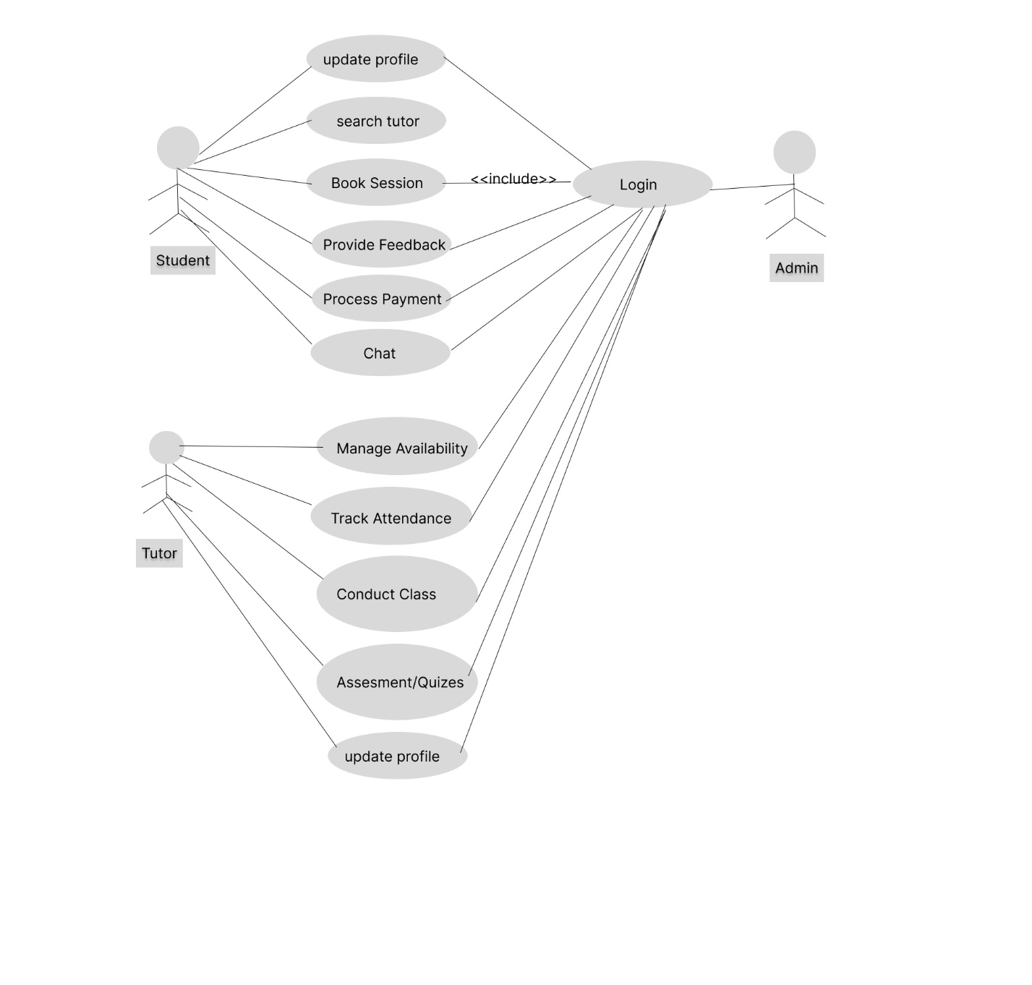

Use Cases Description
Student: This actor represents the users who are looking for tutors and attending sessions. Their use cases include registration, login, searching for tutors, booking and attending sessions, leaving feedback, and viewing their schedule.
Tutor: This actor represents the tutors who are offering their services through the platform. Their use cases include registration, login, setting availability, accepting bookings, conducting sessions, viewing feedback, and viewing their schedule.
Administrator: This actor represents the administrative users who manage the platform. Their use cases include login, managing users and tutors, viewing reports, and managing content on the platform.

Chapter 4

System Design

Chapter 4: System Design
This chapter focuses on the architectural framework and detailed design of the Tutor Finder application. It elaborates on the structural components, their interactions, and the technologies employed to build the system. Key elements such as the database schema, user interface design, application logic, and integration points with external services are meticulously described. By presenting class diagrams, sequence diagrams, and other design artifacts, this chapter provides a clear blueprint for developers to follow, ensuring that the system is robust, scalable, and maintainable. It bridges the gap between requirements and implementation, laying the groundwork for the development phase.

Architecture Diagram
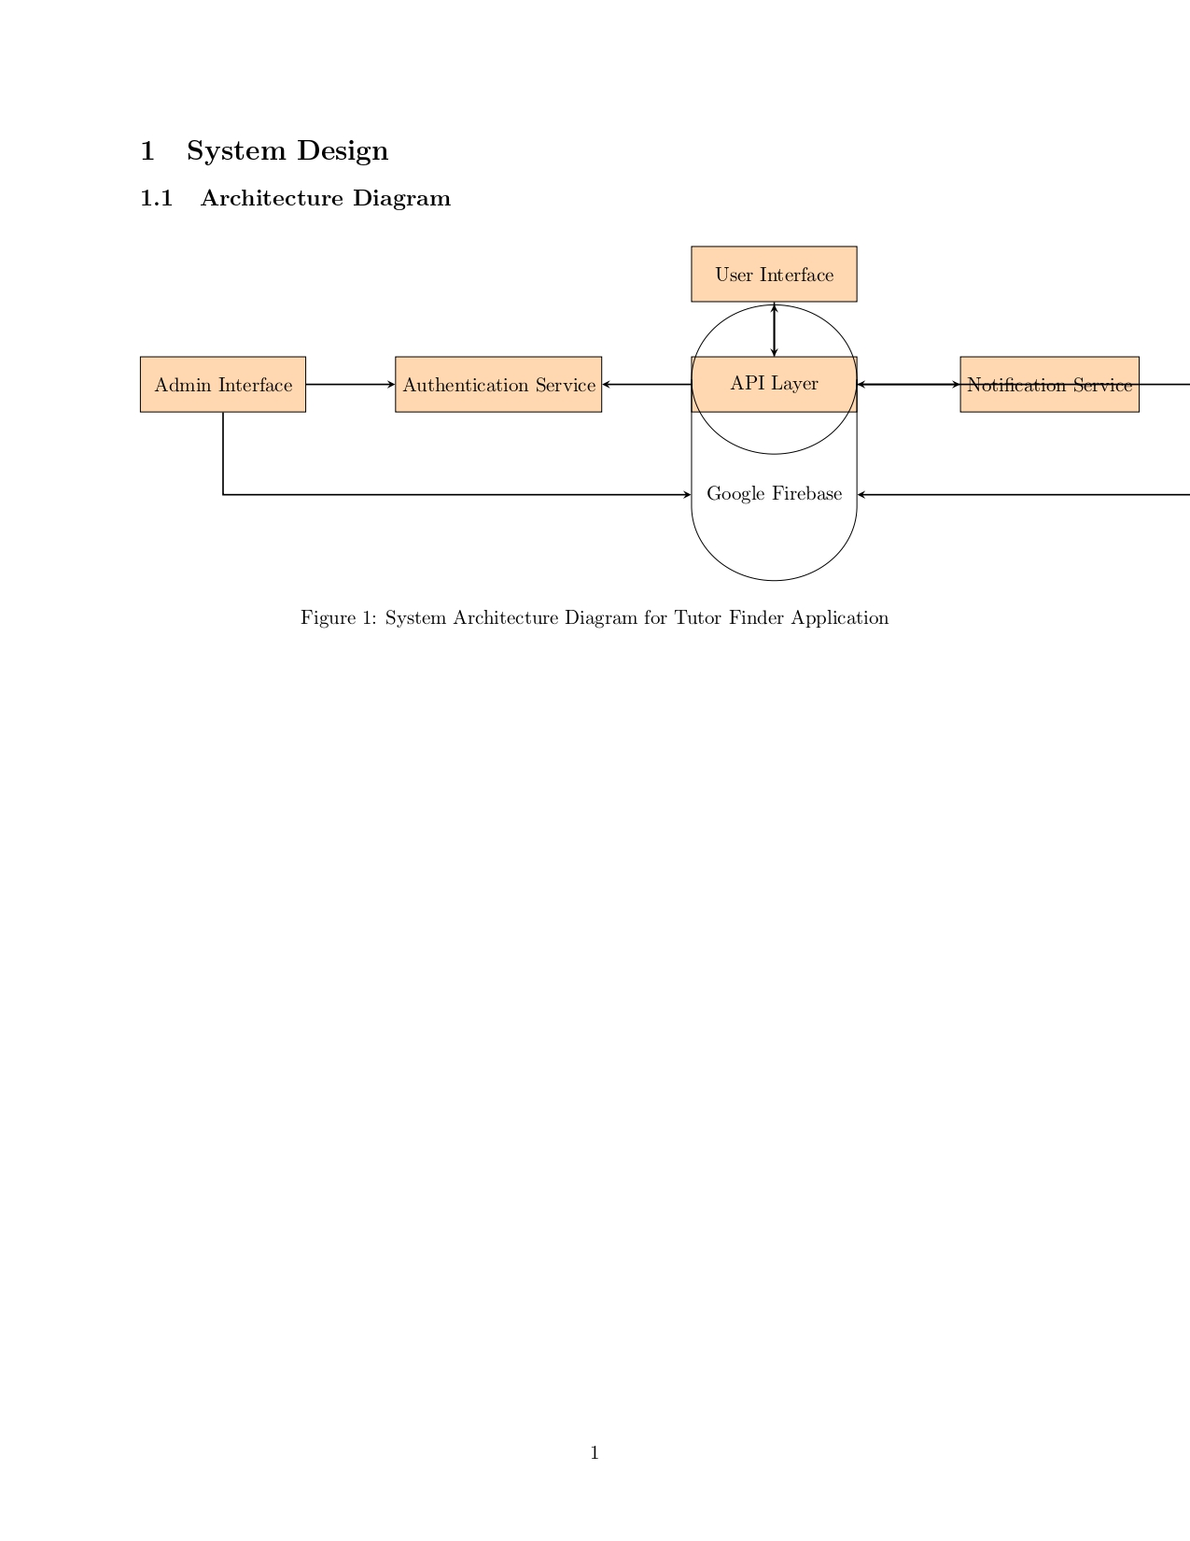

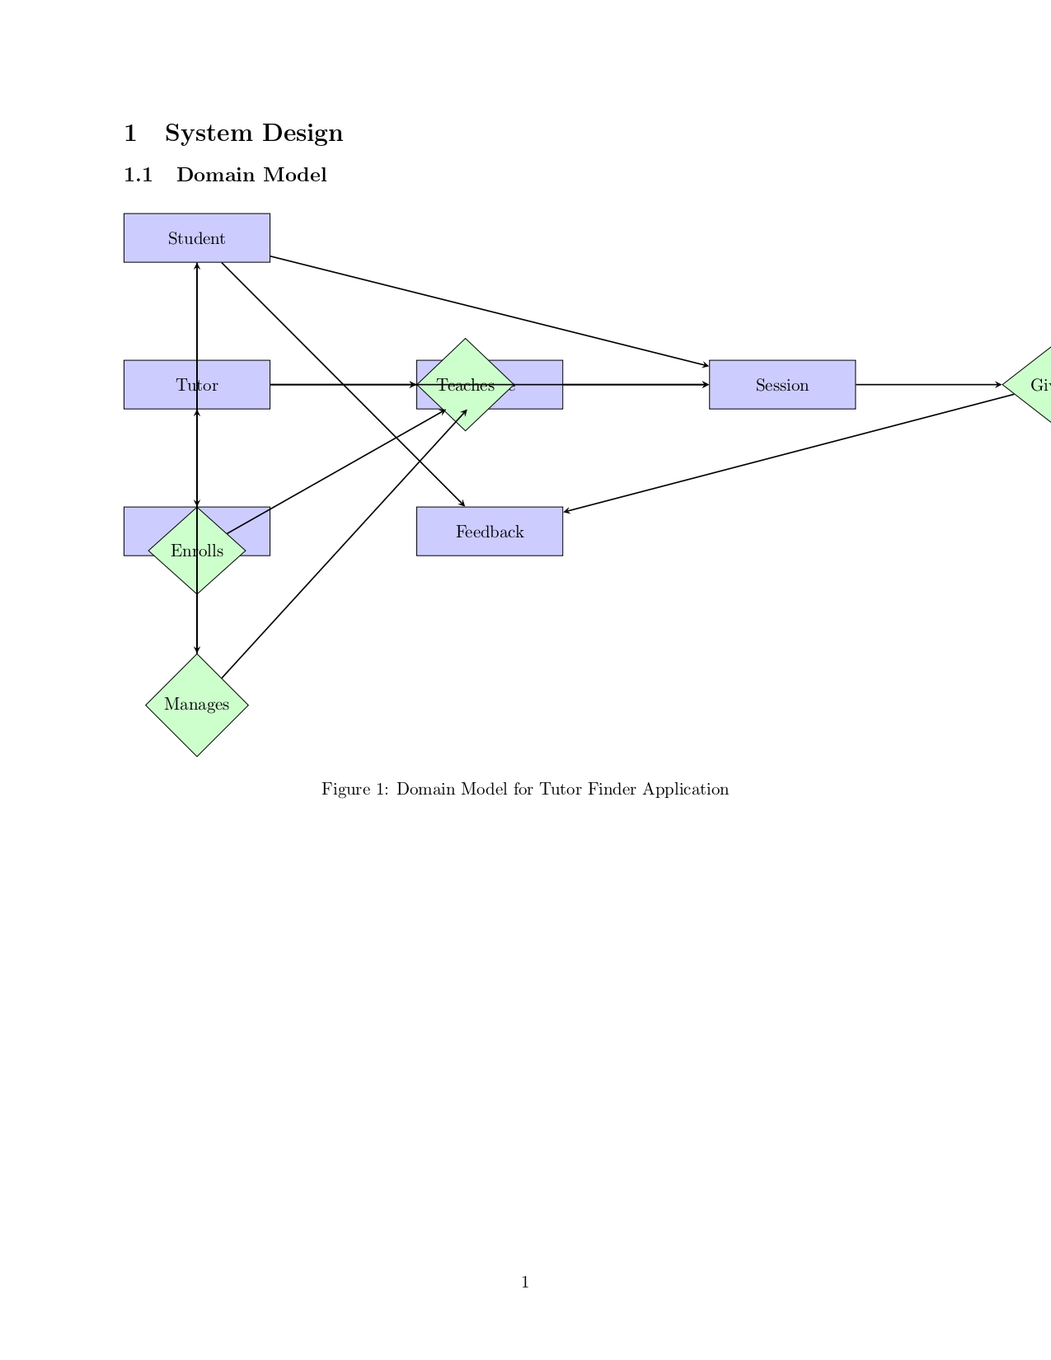

Entity Relationship Diagram with data dictionary
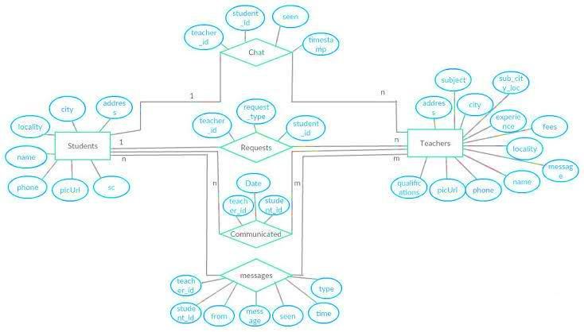

Class Diagram
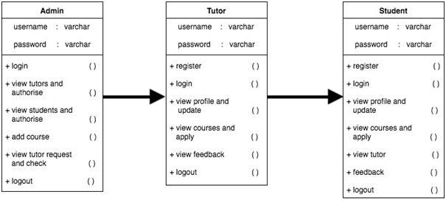

Sequence / Collaboration Diagram

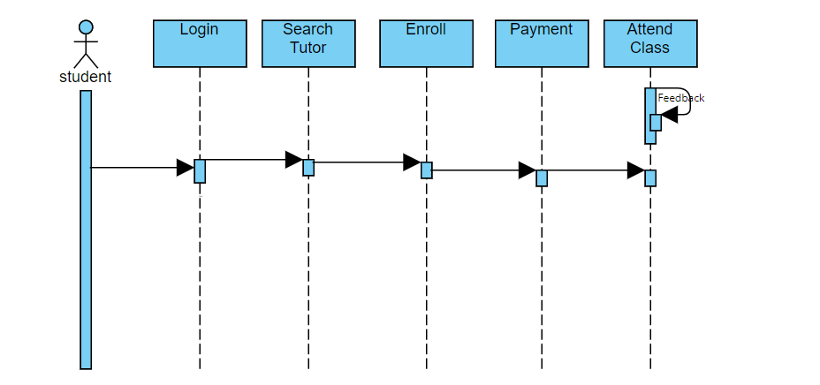

Operation contracts



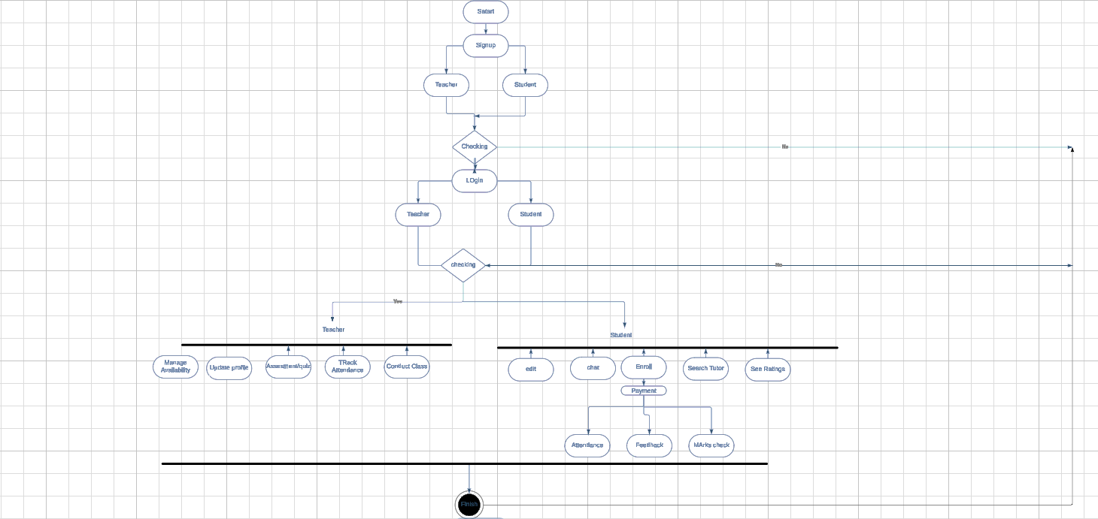
Activity Diagram

State Transition Diagram
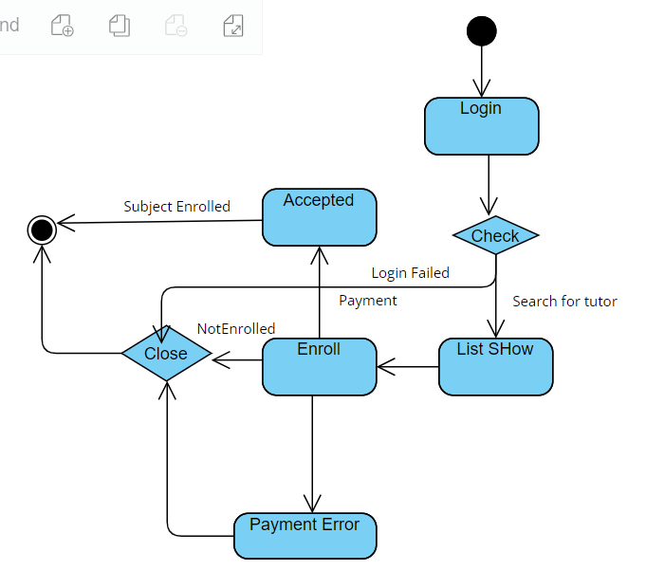

Component Diagram

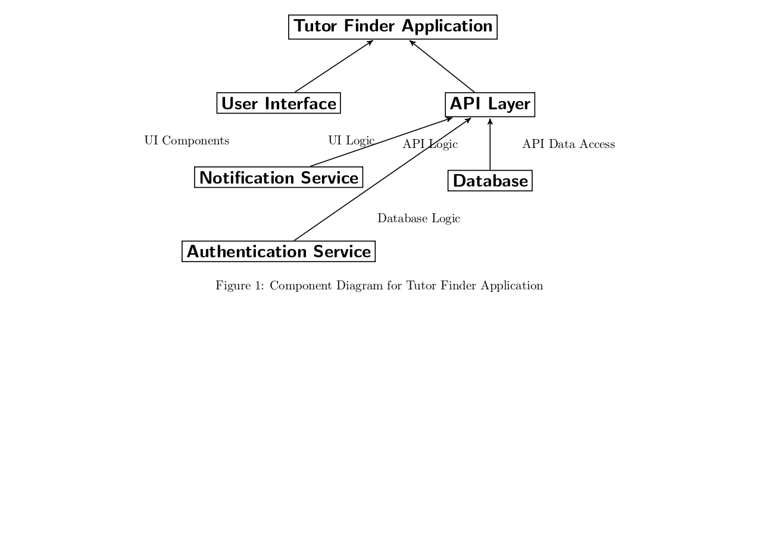

Deployment Diagram

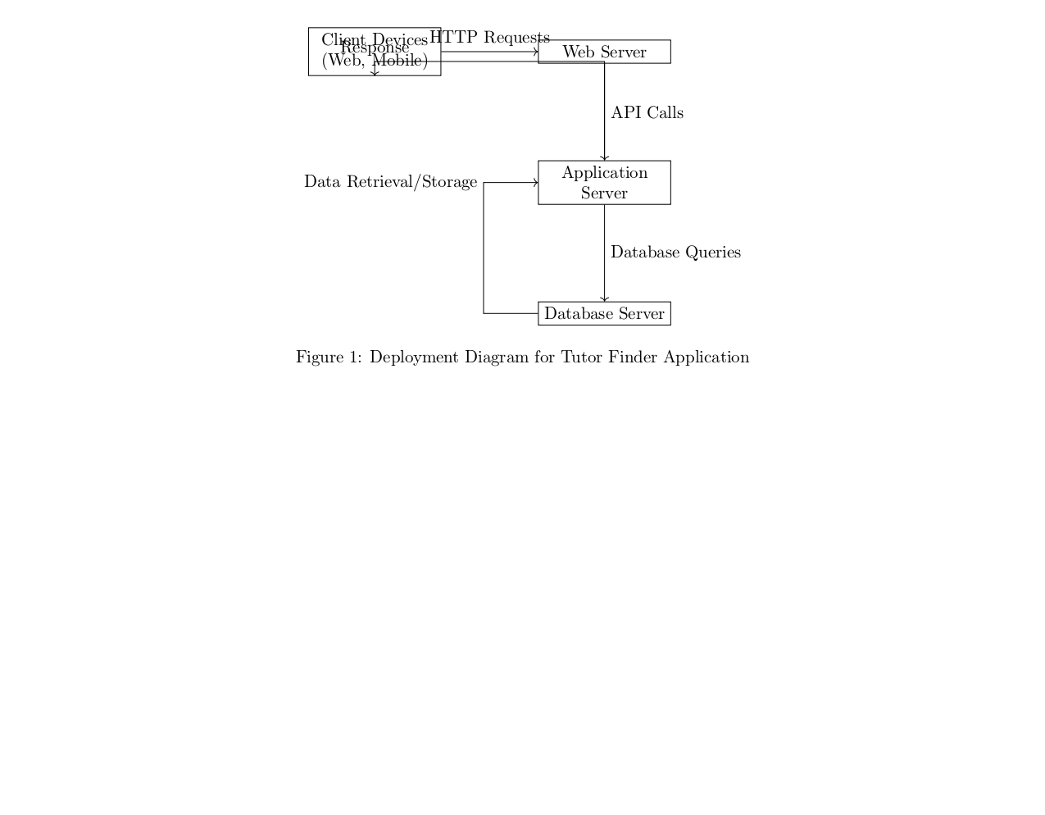

Data Flow diagram [only if structured approach is used - Level 0 and 1]

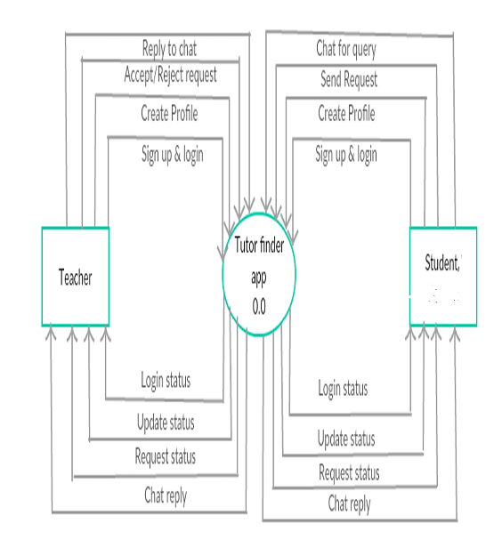
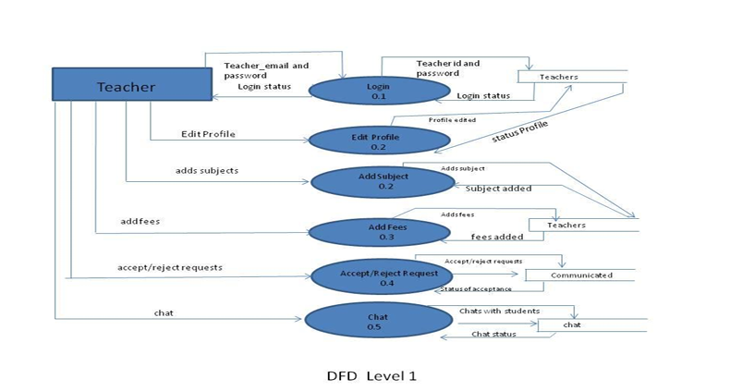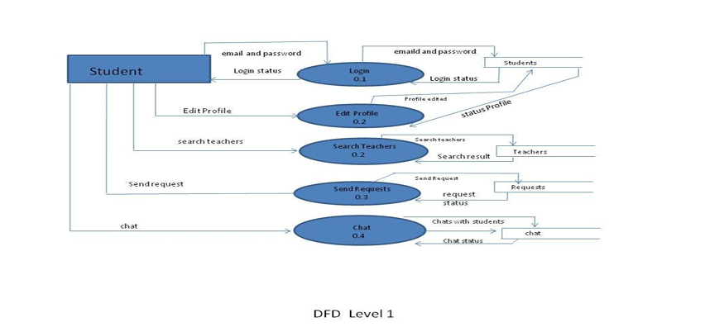

Chapter 5

Implementation

Chapter 5: Implementation
The Implementation chapter of the Tutor Finder project outlines the process of translating the design specifications into functional software. This chapter details the actual coding, configuration, and integration of various components necessary to build the Tutor Finder application. It covers aspects such as setting up the development environment, writing code for different modules, integrating third-party services like Firebase, implementing user authentication and authorization mechanisms, and ensuring data security. Additionally, this chapter may discuss testing methodologies employed during the implementation phase to verify the correctness and robustness of the software. By providing insights into the technical aspects of building the application, this chapter serves as a bridge between the design and the final product, offering valuable information for developers and stakeholders involved in the project.

Important Flow Control/Pseudo codes
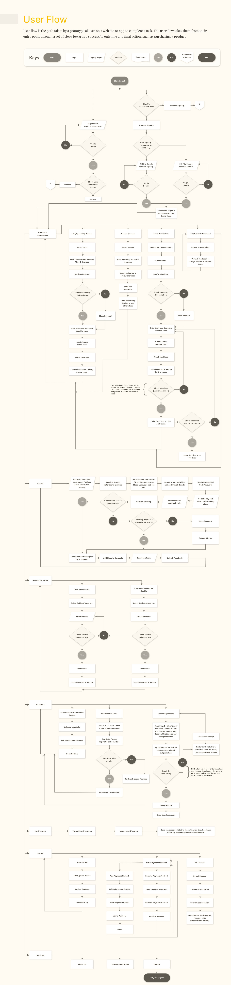

Components, Libraries, Web Services and stubs

Networking

OkHttp: An HTTP client for handling requests and responses.
Dependency Injection

Dagger/Hilt: Libraries for dependency injection to manage dependencies efficiently.
Image Loading

Glide/Picasso: Libraries for image loading and caching.
User Interface
Material Components for Android: For implementing Material Design UI components.
Persistence

Room: A persistence library to provide an abstraction layer over SQLite.
Authentication

Firebase Authentication: To handle user sign-in and authentication.
Push Notifications

Firebase Cloud Messaging (FCM): To send push notifications to users.
Analytics

Firebase Analytics: For tracking user interactions and app performance.
Crash Reporting

Firebase Crashlytics: To monitor and report app crashes in real time.

Deployment Environment
Hosting Platform: Tutor Finder is hosted on a cloud infrastructure provider such as Amazon Web Services (AWS), Google Cloud Platform (GCP), or Microsoft Azure. The choice of hosting platform is based on factors like scalability, reliability, and geographical location of target users.

Server Infrastructure: The application is deployed on virtual machines (VMs) or containers managed by the hosting platform. Load balancers may be utilized to distribute incoming traffic across multiple instances for improved performance and availability.

Operating System: The servers run on a Linux-based operating system such as Ubuntu, CentOS, or Debian. These operating systems offer stability, security, and compatibility with the software stack used by Tutor Finder.

Web Server: Tutor Finder utilizes a robust web server software such as Nginx or Apache HTTP Server to serve web pages, handle HTTP requests, and manage SSL/TLS encryption for secure communication between clients and servers.

Database: The application's database is hosted on a separate server or a managed database service provided by the hosting platform. Google Firebase, MySQL, PostgreSQL, or MongoDB may be used as the database technology, depending on the specific requirements of Tutor Finder.

Networking: Network configurations are optimized for security, performance, and scalability. This includes firewall rules, network access controls, and Virtual Private Network (VPN) connections to ensure secure communication between application components and external services.

Content Delivery Network (CDN): To improve the delivery speed and reliability of static assets (such as images, scripts, and stylesheets), Tutor Finder may leverage a CDN like Cloudflare or Amazon CloudFront. This helps reduce latency and offloads traffic from the origin server.

Monitoring and Logging: Comprehensive monitoring and logging solutions are implemented to track the application's performance, availability, and security. Tools like Prometheus, Grafana, ELK Stack (Elasticsearch, Logstash, Kibana), or cloud-native monitoring services provided by the hosting platform are utilized for monitoring and logging.

Backup and Disaster Recovery: Regular database and application data backups are performed to prevent data loss in case of hardware failures, data corruption, or accidental deletions. Disaster recovery plans are in place to restore the application to a functional state in the event of catastrophic failures or outages.

Scalability and High Availability: The deployment architecture is designed to scale horizontally and vertically to handle increasing user traffic and workload. Auto-scaling configurations, redundant infrastructure, and failover mechanisms are implemented to ensure high availability and fault tolerance.

Tools and Techniques
Database: Google Firebase.
Development Platform: Android Studio.
Tools Used
Android Studio with Flutter

Best Practices / Coding Standards

Code Structure

• Use the Model-View-ViewModel (MVVM) architecture pattern to separate concerns and improve code maintainability.
• Organize the project into packages such as ui, model, viewmodel, repository, and network.
Naming Conventions

• Use clear and consistent naming conventions for classes, methods, variables, and resources.
• Follow the Java/Kotlin naming conventions: PascalCase for classes and interfaces, camelCase for methods and variables.
Code Documentation

Comment code where necessary to explain complex logic.

Version Control
• Use Git for version control.
• Follow Git branching strategies such as Gitflow for managing feature development, bug fixes, and releases.

Chapter 6

Testing and Evaluation

Chapter 6: Testing and Evaluation
This chapter focuses on the testing and evaluation methodologies applied to ensure the reliability, functionality, and performance of the Tutor Finder application. Various testing strategies are implemented to validate the app’s features, ensure consistent performance, and verify compatibility across different devices. The testing process covers both individual components (unit testing) and their interactions (integration testing), along with more extensive performance and stress tests. Testing strategies like equivalence partitioning and boundary value analysis aid in identifying potential issues and ensuring a robust user experience.

Use Case Testing
Use case testing was performed to ensure that the Tutor Finder app's key scenarios work as expected. Use cases included scenarios like user registration, tutor search, session booking, and feedback submission. Each scenario was tested for correctness to ensure users can easily navigate and achieve their objectives within the app.

Equivalence partitioning
Equivalence partitioning helped in minimizing the number of test cases by categorizing input data into classes. For example, testing different age ranges or user roles (student, tutor) ensured that inputs from each category yielded expected outcomes, enhancing efficiency without compromising coverage.

Boundary value analysis
Boundary value analysis was used to test the app’s response to extreme values within input ranges, such as the maximum or minimum allowed lengths for usernames and passwords. This testing method was crucial in ensuring the app’s stability at edge cases, preventing potential user input errors.

Data flow testing
Data flow testing was conducted to validate how data moves through the app, especially in scenarios involving user authentication and session scheduling. This testing helped identify any potential data leaks or incorrect data handling that could disrupt the app’s functionality or security.

Unit testing
Each individual component was tested in isolation to ensure it functioned as expected. Firebase integration, user login, and the tutor booking system were thoroughly tested. Unit testing allowed the team to quickly isolate and fix issues at the code level, ensuring reliable core functionality.

Integration testing

Integration testing examined how individual components interacted within the app. For example, how the front end retrieved and displayed data from Firebase or how the scheduling feature updated the tutor's availability. Integration testing ensured that each component worked seamlessly together for a smooth user experience.

Performance testing
Performance testing evaluated the app’s responsiveness under normal usage. Key metrics such as loading times and response rates were measured, especially for functionalities like tutor search and session booking. Ensuring that the app performed consistently under varied conditions was essential for user satisfaction.

Stress Testing
Stress testing subjected the app to extreme load conditions to examine its stability. For instance, handling a large number of simultaneous logins or session bookings was tested to determine how the app responded under maximum usage. The objective was to ensure that the app could handle spikes in usage without compromising functionality.

Chapter 7

Summary, Conclusion and Future Enhancements

Chapter 7: Summary, Conclusion & Future Enhancements

Project Summary
The Tutor Finder project aims to provide a convenient, online solution for students seeking tutoring assistance. The app connects students with tutors based on various filters, including subject expertise and availability. Additionally, features like feedback, scheduling, and performance tracking ensure a structured learning experience, meeting the project's objectives.

Achievements and Improvements
Tutor Finder achieved several key milestones, including a user-friendly interface for tutor search, a reliable feedback system, and secure payment processing. These features were implemented to ensure transparency, enhance accessibility, and improve the user experience. Continuous improvements in interface design and security protocols have contributed to the app's reliability and usability.

Critical Review
The project successfully addresses key pain points in traditional tutoring but encountered challenges in maintaining consistent user experience under peak loads. Further work is needed to enhance the app's response times and scale its backend infrastructure to support an increasing user base. Improvements in data analytics can also enhance the feedback system by providing deeper insights into tutor performance.

Lessons Learnt
The project highlighted the importance of using robust testing methods and a structured development framework. Key lessons included the value of user feedback in refining features, the necessity of security considerations in app development, and the advantages of scalable backend solutions like Firebase for real-time data updates and storage.

Future Enhancements/Recommendations
- AI-based Tutor Matching: Implementing machine learning to provide better tutor recommendations based on student preferences and learning history.
- Multi-Language Support: Expanding language options to cater to a global audience, enhancing accessibility for non-English-speaking users.
- Enhanced Analytics: Integrating advanced data analytics to offer performance insights to both students and tutors, facilitating a more data-driven approach to learning.
- Video Session Recording: Adding options to record tutoring sessions (with consent) for review and quality control.

Reference and Bibliography

Reference and Bibliography

[1] M. Sher, M. Rehman, “Title of the Paper” Conference name/Journal Name, Edition, Volume, Issue, ISBN/ISSN, PP, Publisher/City-Country, Year.
[2] ……

Index

Index

[A]

[B]

[C]

