SUPERIOR UNIVERSITY LAHORE


Faculty of Computer Science & IT

Final Year Project
PROJECT REPORT

[Smart Steering]

Project ID:[FYP-BSCS-S18-008]

Project Team
Student Name | Student ID | Program | Contact Number | Email Address
AsadIshtiaq (Leader) | BCSM-S15-003 | BSCS | 0321-8199917 | asadahmedabbassi@gmail.com
Muhammad Bilal | BCSM-S15-029 | BSCS | 0304-0902498 | bilaljutt775@gmail.com
KainatAdrees | BCSM-S15-033 | BSCS | 0301-3126237 | kainatadrees@gmail.com

Sir KhurramJillani
(Assistant Professor)

Project Report
Smart Steering

Change Record
Author(s) | Version | Date | Notes | Supervisor’s Signature
 | 1.0 |  | <Original Draft>
 |  |  | <Changes Based on Feedback from Supervisor>
 |  |  | <Changes Based on Feedback From Faculty>
 |  |  | <Added Project Plan>
 |  |  | <Changes Based on Feedback from Supervisor>

APPROVAL
Project Supervisor
Comments: ___________________________________________________________________
_____________________________________________________________________________
Name:______________________________
Date:_______________________________ | Signature:__________________________

Project Manager
Comments: ___________________________________________________________________
_____________________________________________________________________________
Date:_______________________________ | Signature:__________________________

Head of the Department
Comments: ___________________________________________________________________
_____________________________________________________________________________
Date:_______________________________ | Signature:__________________________

Dedication

This work is dedicated to Allah Almighty Our Creator Who taught Human and parents of all members, who taught us that the best kind of knowledge to have is that which is learned for its own sake. It is also dedicated to best supervisor Prof KhurrumJilaniunder whose supervision we did all this work, who taught us that even the largest task can be accomplished if it is done one step at a time.

Acknowledgements

We are thankful to Allah Almighty who gave us health, thoughts and the opportunity to complete this work. We feel great pleasure in expressing our deep and sincere gratitude to our knowledgeable and dedicated supervisor, Mr. KhurrumJilani, Assistant Professor of Computer Science & IT Department who supervised our project lightheartedly and proficiently made the dispatch of intimidating workload possible by persistent guidance communicated to us. We are also thankful to have such a supporting project group Mr. Asad Ishtiaq, Mr Muhammad Bilal AndKainatAdrees; our coordination helped us a lot in our project work. May ALLAH Almighty grant great rewards to all of the above-mentioned personalities here and hereafter who played their significant roles in enabling us to dispatch our humble efforts in form of this project.

Executive Summary
There are lot of inventions have been made with the help of technology in recent times to facilitate human beings for that cause we have introduced Smart Steering for automobile industry. Smart steering is a modern technology having multiple functions to detect driver’s current state of mind and physical condition. Functions like breath detector and pulse sensor will scan the driver’s alcoholic, health condition and sleepy state of mind to be automatically operating the vehicle. That will help out to reduce the accidents and mortality rates. For making the whole business plan, first of all we describe the form of our business that what actually our business is and then about our team and managerial structure. We describe our mission which is very clear to facilitate human beings; we describe our vision, values and Goals. We did industry and market analysis very deeply. We clearly define our industry size and structure and then use porter’s five forces mode and then we did competitor’s analysis very deeply, then we did SWOT analysis then define about advanced technology which will be used then we define about our unique value proposition. After that, we did marketing strategies. First of all segmentation and then our targeting of our customer and then officially define our marketing mix strategy (product, price, place, promotion and people). After doing a lot of research on market and industry analysis. We finally prepare our financial plan which is the main thing. First of all we prepare a complete document on our startup business expenses and then operating cost and expenses is prepared which is the expense of during the business. After that a complete document is prepared on revenue generation, income statement, balance sheet, break even analysis, ratio analysis, operating cost flow, list of resources and cost of resources. By the combination of industry and market analysis, description of our business, marketing strategy and financial plan, we prepare our complete business plan.

Table of Contents
Dedication iv
Acknowledgements v
Executive Summary vi
Table of Contents vii
List of Figures x
List of Tables xi
Chapter 1 1
Introduction 1
1.1. Background 2
1.2. Motivations and Challenges 2
1.3. Goals and Objectives 2
1.4. Literature Review/Existing Solutions 3
1.5. Gap Analysis 3
1.6. Proposed Solution 3
1.7. Project Plan 4
1.7.1. Work Breakdown Structure 4
1.7.2. Roles & Responsibility Matrix 5
1.7.3. Gantt chart 6
1.8. Report Outline 6
Chapter 2 7
Software Requirement Specifications 7
2.1. Introduction 8
2.1.1. Purpose 8
2.1.2. Document Conventions 8
2.1.3. Intended Audience and Reading Suggestions 8
2.1.4. Product Scope 9
2.1.5. References 10
2.2. Overall Description 10
2.2.1. Product Perspective 10
2.2.2. Product Functions 10
2.2.3. User Classes and Characteristics 11
2.2.4. Operating Environment 11
2.2.5. Design and Implementation Constraints 11
2.2.6. User Documentation 12
2.2.7. Assumptions and Dependencies 12
2.3. External Interface Requirements 12
2.3.1. User Interfaces 12
2.3.2. Hardware Interfaces 12
2.3.3. Software Interfaces 12
2.3.4. Communications Interfaces 13
2.4. System Features 13
2.4.1. System Feature 1 13
2.5. Other Nonfunctional Requirements 15
2.5.1. Performance Requirements 15
2.5.2. Safety Requirements 15
2.5.3. Security Requirements 15
2.5.4. Software Quality Attributes 16
2.5.5. Business Rules 16
Chapter 3 17
Use Case Analysis 17
3.1. Use Case Model 18
Chapter 4 29
System Design 29
4.1. Architecture Diagram 30
4.2. Domain Model 31
4.3. Entity Relationship Diagram with data dictionary 31
4.4. Class Diagram 32
4.5. Sequence / Collaboration Diagram 33
4.6. Operation contracts 34
4.7. Activity Diagram 35
4.8. State Transition Diagram 37
4.9. Component Diagram 39
4.10. Deployment Diagram 40
4.11. Data Flow diagram 40
Chapter 5 43
Implementation 43
5.1. Important Flow Control/Pseudo codes 44
5.2. Components, Libraries, Web Services and stubs 59
5.3. Deployment Environment 59
5.4. Tools and Techniques 59
5.5. Best Practices / Coding Standards 61
5.6. Version Control 61
Chapter 6 62
Testing and Evaluation 62
6.1. Use Case Testing 63
Boundary value analysis 70
6.2. Data flow testing 70
6.3. Unit testing 71
6.4. Integration testing 71
6.5. Performance testing 71
6.6. Stress Testing 72
Chapter 7 73
Summary, Conclusion and Future Enhancements 73
7.1. Project Summary 74
7.2. Achievements and Improvements 75
7.3. Critical Review 75
7.4. Lessons Learnt 75
7.5. Future Enhancements/Recommendations 76
Appendices 77
Appendix A: User Manual 78
Appendix B: Administrator Manual 78
Appendix C: Information / Promotional Material 79
Appendix [no.]: Appendix Title 83
Reference and Bibliography 84
Index 85

List of Figures

1.7.2 Work break down structure ……………………………………………..…………………………………………….. 4
2.3.4 Communications Interfaces …………………………….…………………………………………..………….. 14
3.1.1 Use Case Diagram for User …………………………………….………………………………………………………. 18
3.1.2. Use case diagram for admin……………………………………………………………………………………………. 19
3.1.3. Fully dressed use case…………………………………………………………………………………………………….. 20
4.1. Architecture Diagram………………………………………………………………………………………………………30
4.2. Domain Model …………………………………………………………………………………………………..…………. 31
4.3. Entity Relationship Diagram……………………………………………………………………………………………. 31
4.4. Class Diagram ……………………………………………………………………………………………..………………. 32
4.5.1. Admin Sequence Diagram………………………………………………………………………………………………. 33
4.5.2. User Sequence Diagram …………………………………………………………………………………………………. 34
4.7.1. Activity Diagram for User……………………………………………………………………………………………….. 35
4.7.2. Activity Diagram for Admin……………………………………………………………………………………..…….. 36
4.8.1. State Transition diagram for user……………………………………………………………………………..……. 37
4.8.2. State Transition Diagram for admin…………………………………………………………………………..…… 38
4.9. Component Diagram…………………………………………………………………………………………………..…. 39
4.11.1. Data flow diagram for login/logout(Level 0 and 1)……………………..………………………………..… 40
4.11.2. Data Flow diagram for User……………………………………………………………………………………………. 41
4.11.3. Data flow diagram for Admin…………………………………………………………………………………………. 42

List of Tables

1.7.2. Roles and responsibility matrix……………………………………………………………………………………….. 5
1.7.3. Gantt Chart……………………………………………………………………………………………………………………… 6
2.1.2. Document Convention…………………………………………………………………………………………………….. 8
3.2.1 User Sign in Function………………………………………………………………………………………………………. 21
3.2.2. User sign out Function…………………………………………………………………………………………………….. 21
3.2.3. User view data sheet Function………………………………………………………………………………………… 22
3.2.4. User can change credentials Function…………………………………………………………………………….. 23
3.2.5. Admin Add user Function………………………………………………………………………………………………… 24
3.2.6. Admin Delete user Function……………………………………………………………………………………………. 25
3.2.7. Admin can see data sheet Function…………………………………………………………………………………. 26
3.2.8. Admin can change Credentials………………………………………………………………………………………… 26
3.2.9. Admin sign in Function……………………………………………………………………………………………………. 27
3.2.10. Admin Sign out Function…………………………………………………………………………………………………. 28
6.1.1. Admin Login Use Case Testing…………………………………………………………………………………………. 63
6.1.1. Admin Login Use Case Testing………………………………………………………………………………………… 64
6.1.2. Admin add user Use Case Testing……………………………………………………………………………………. 65
6.1.2. Admin add user Use case Testing……………………………………………………………………………………. 66
6.3.1. Admin Delete user Use Case Testing……………………………………………………………………………….. 67
6.3.1. Admin Delete User Use Case Testing……………………………………………………………………………….. 68

Chapter 1

Introduction

Chapter 1: Introduction
In this chapter we are going to describe about our product. Our product is all about the automation smart steering its existing solutions, its proposed solutions, literature reviews, Gantt chart to describe the work completion with respect to time, roles and responsibilities matrix to tell what are the responsibilities of our team members who will do the specific tasks of our project completion.

Background
Our project background is related to the automation of the vehicles and it is about the specific class of vehicles. Our background idea came from the motivation that if high class vehicle owners can enjoy the automation of their vehicles then why economy class vehicle owners can’t? So then we proposed a solution to make the economy class vehicles automated by providing them an automated steering with extra-ordinary features.

Motivations and Challenges
Our background idea came from the motivation that if high class vehicle owners can enjoy the automation of their vehicles then why economy class vehicle owners can’t? Our main challenge is to get our customers in trust that this product is helpful, secure and reliable enough for them to enjoy their vehicles as automated vehicle.

Goals and Objectives
“Set the highest industry standard for quality across all areas of our operations”.
Smart steering case has some goals in it can be achieve by giving quality of services. Some goals are following:
• People will make their car almost automated
• More security of vehicles
• People could check their phone notifications of screen

Literature Review/Existing Solutions
Our current C class car doesn’t have any security measures even there is no air bags in them. The current situation is very devastating which give us a vast hope to do this project.
List of existing solutions in Pakistan are given below:
- JDM Expertise a fine option to find car automation of various different parts at one place.
- There is no other company which work on car automation in Pakistan. As Pakistan is under-development phase so Pakistan use to import such kind of things

Gap Analysis
As we know that our existing economy class vehicles are not automated after using our product their safety, reliability and security will be highly focused as existing solution are not giving the security solution. Our main focus is on the safety of our vehicle and the owner of the car. After using our smart steering people will experience more safe and more ease in their car while driving.

Proposed Solution
We are providing click buttons in the steering for the Security of the Vehicles. We are providing a solution for drivers who drive during drunk condition that after detection of certain value of his/her Alcoholic condition there will be a notification generated on his/her mobile to alert the driver. On the other hand, many people Feel Sleepy during driving there will be a sensor in steering which will continuously detect the eye retina of the driver and if he is sleep then shake sensor or a vibrator will vibrate to make him/her awake.
We are giving another functionality for the heart and blood pressure persons to get notified about their condition on their mobile. Or we are providing Car

Project Plan
Following are our project plan to complete and finalize our work with respect to responsibilities, work and time. We defined work break down structure and roles and responsibilities matrix according to responsibility and time.

Work Breakdown Structure

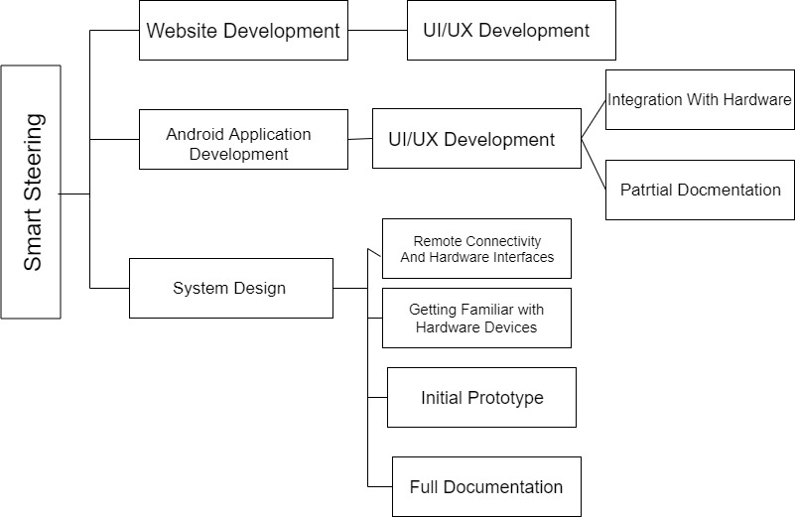

Figure 1.1

Roles & Responsibility Matrix

WBS # | WBS Deliverable | Duration  (# of Days) | Responsible Team Member(s) & Role(s)
1 | Requirement Gathering | 3d | M Bilal , Asad Ishtiaq , Kainat
2 | UX-UI Design (Web,App) | 8d | AsadIshtiaq , Kainat
3 | Website Coding | 10d | M Bilal , AsadIshtiaq
4 | Hardware Design | 8d | Kainat, Asad Ishtiaq, Kainat
5 | Application Development | 10d | AsadIshtiaq, M Bilal
6 | Testing & Deployment | 5d | Kainat , M Bilal
7 | Final Documentation | 11d | M Bilal, Kainat, Asad Ishtiaq

Table 1.7.2

Gantt chart
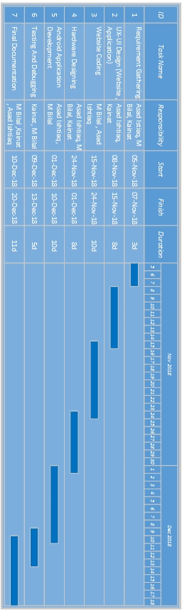

Figure 1.7.3

Report Outline
- Summarized all project requirements in first part and mentioned all functional requirements.
- Briefly explained our product. All functional and non-functional requirements of product are described in 2nd part.
- Usecase diagram is drawn in 3rd part of this document.
- UML diagrams are placed in 4th part of document.
- At the end there is implementation procedure described

Chapter 2

Software Requirement Specifications

Chapter 2: Software Requirement Specifications

Introduction

Purpose
The project purpose is to build a steering which provide facility for economy class vehicle owners who doesn’t have any safety measures in their cars. Actually we build this steering because we want to provide safety in economy class vehicles too because human life is very important. People often sleep while driving cars some drink alcohol due to which most of car accident caused. We help them by providing Functions like breath detector and pulse sensor will scan the driver’s alcoholic, health condition and sleepy state of mind to be automatically generate an notification on their mobile application to let them aware. That will help out to reduce the accidents and mortality rates.

Document Conventions
The document covers the conventions as described by the template given to us by the management
Font style | Calibri
Text size | 12
Line spacing | 1.5
Paragraph | Justified
URL | Color-blue and italic

Table 2.1.2

Intended Audience and Reading Suggestions
Intended audience of this report are:
1. Developer
2. Project tester
3. Customer

Reading Suggestion: The System includes the following reading suggestions.
- Overall Description: It defines the general factors that affect the product and its requirements.
- System Features: It specify overall features available in the system.
- External Interface Requirements: It defines the hardware, software, user as well as communication interface of the system.
- Other Non-functional Requirements: It describes the non-functional requirements likeperformance requirements, software quality requirements, and safety and security requirements

Product Scope
There are lots of inventions have been made with the help of technology in recent times to facilitate human beings for that cause we have introduced Smart Steering for automobile industry .We are going to make a smart steering. In this age of automation we think about to automate our vehicles for the ease of almost every vehicle from economy to high class vehicles. In our product we almost cover every type of vehicle from car to heavy traffic. In this smart steering we are going to give people many in less. Our product scope covers not only nation market but also international market. At starting our target market is national but with the passage of time our scope is also for the international market. Our main aim is to automate every type of vehicle or especially the economy class vehicles with those features which are not present in economy class vehicles by giving them simply a smart steering in very affordable price. The main features of our product are as follow:
Notify driver about:
• Over speeding
• If drunk
• If sleepy
• Blood pressure level
• Heart beat
• Click buttons for security
Over-speeding drivers will be notified on their about their over-speeding and precaution message to reduce their speed. We are providing a solution for drivers who drive during drunk condition that after detection of certain value of Alcohol his/her car will be limited to a certain limit. On the other hand, many people Feel Sleepy during driving there will be a sensor in steering which will continuously detect the eye retina of the driver and if he is sleep then shake sensor or a vibrator will vibrate to make him/her awake.
We are giving another functionality for the heart and blood pressure persons to get notified about their condition on their mobile. Or we are providing Car GPS to track their car current location.

References
All references will be provided at the end of this SRS report.

Overall Description

Product Perspective
The all new project which will not only safe the life of the people but will also reduce the accidents. And own of the car will also feel safer which his/her kid is driving the car. Because we provide complete update to the owner of the car with the help of application. It’s a perfect example of human computation interaction.

Product Functions

The following list and description of the main feature and functionality of Smart Steering. In this system customer will apply the different pattern on the security button in order to make the engine on. After that the steering wheel will activate the breath sensor to check either the drive is in a state to drive the car or not. Then after every sec the eye retina camera will check the driver eyes to make sure he/she is waking. If any of these check is negative it will vibrate and will not allow the drive to ride the car.

- Security button pattern
- Pulse sensor and breath sensor will scan the driver’s alcoholic, health condition
- Applying specific pattern to turn the engine.
- If alcohol is detected then a mobile notification will be generated.
- If driver sleep during driving the vibrator will vibrate the steering in order to awake the driver.

User Classes and Characteristics
Smart Steering is yet easy product to use so, but as it is entertaining product and we want it to be used by the specific type of vehicles like economy class vehicles that don’t have features for much automation.

Operating Environment
- IDE Our mobile application will be developed on android studio which use(xml, java, mysql)
- Version Control Version control of Android studio id (GIT, Mercurial, or Subversion).
Version control of arduino suite is (SVN, GIT).
- Database SqLite.

Design and Implementation Constraints
This product is initially being developed for a non-profit organization with a limited budget, and therefore is constrained to low-cost methods of implementing the system. Since the system will be implemented in hardware, the development team will be locked into using android studio and arduino studioto do the majority of the implementation work.
The team has selected java language to implement the Code Behind functionality of the application. The team will be using the android studio Integrated Development Environment to edit and create the application.
The customer’s organization will be solely responsible for maintaining the software after final product has been delivered. Since the organization will not have a large budget for maintenance, strict and thorough documentation needs to be generated to provide a third party with a method of understanding and maintaining the internal aspects of the system.

User Documentation
As stated in a previous section, extensive online help will be available at all times when using the system. This online help will guide the user, which may or may not be computer or Internet knowledgeable, through each aspect of the system

Assumptions and Dependencies
- It is assumed that the application will be developed using android studio.
- It is assumed that the hardware will be coded on arduino studio.
- It is assumed that the application will notify if sensor will detect any thing.
- It is assumed that the system will interact with a SQLite 2011 database.

External Interface Requirements

User Interfaces
All hardware products have its own interfaces which can be user-friendly enough and users can manipulate with it. The Menu is also an important thing while making come into existence the SRS document part.

Hardware Interfaces
Smart Steering has sensors which detect or check the physical condition of the driver and regularly generate notifications on drivers phone if something went wrong with the driver and on the other hand these notifications will be sent to the web-server to save them as a record on web-server.

Software Interfaces
The software interfaces for this product are an android application through which the user can connect with his/her car steering(hardware) or get notified about the health and physical condition of driver.

Android Studio
Android Studio is the official Integrated Development Environment (IDE) for Android application development, based on the IntelliJ IDEA. On top of IntelliJ's, there is a powerful code editor and developer tool; Android Studio offers even more advantageous features that enhance your productivity when building Android applications.

Communications Interfaces

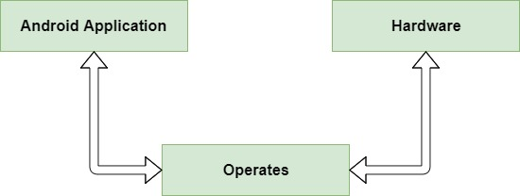

Figure 2.3.4

System Features
<This template illustrates organizing the functional requirements for the product by system features, the major services provided by the product. You may prefer to organize this section by use case, mode of operation, user class, object class, functional hierarchy, or combinations of these, whatever makes the most logical sense for your product.

System Feature 1
Registration of the new user is the 1st feature of our mobile application

      - Description and Priority
User will register by admin by giving them a specific id with their steering manual.

      - Stimulus/Response Sequences

The id password will be provided on the time of buying the product.To change and manage settings of the steering.
      - Functional Requirements
REQ-SF1-1:Add new users in data base.
REQ-SF1-2:User should be registered by admin.
REQ-SF1-3:should give proper id password to the user.

    - System Feature 2

      - Description and Priority

Our main priority is to make the economy cars safe in use such as we will provide notification on user mobile app if he is feeling sleepy or drive in drunk condition. Our middle priority is the safety of vehicle we will give the click buttons in the steering so it can be only unlocked by the owner him/herself. Our last priority is to manage the mobile notifications to get owner notified about his/her physical or chemical body condition.

      - Stimulus/Response Sequences

User will interact with the mobile or steering click buttons so he/she can on/off the ignition of the vehicle and enjoy the automated features of our smart steering.

      - Functional Requirements

Our main functional or SRS is to get signals from the hardware according to the physical and chemical condition of the owner and vehicle physically. And then get notified on mobile application screen of the user. Rather than we are making a website to make customers or people aware about our product and get them helped according to their queries.

REQ-SF2-1: electronic signal through sensors embedded in smart steering
REQ-SF2-2: Get owner login to the mobile application portal so he/she can change settings or get notifications
REQ-SF2-3: our main purpose is to send notifications to user mobile screen so he can drive safely and enjoy the features of smart steering.

Other Nonfunctional Requirements

Performance Requirements

The performance of hardware cannot be led the system as we are using Arduino chip which is best for such task. We are using many other sensors to get the user notified on mobile screen. We are also using alert sensors (vibrator, shake) to get owner notified physically.
But if we talk about application the performance of our application is depend upon the range as we are connecting the hardware with application through Bluetooth. As Bluetooth has a certain range in which it can transfer data.
On the other hand if we talk about our web-server data uploading it will efficiently upload user data to the server but it must require internet so application could be able to send data on the website.

Safety Requirements

If in case of any damage to the hardware due to over-heating our customers can claim us in 60 days. Or if there is damage in the software then they can easily download it from the play-store again in case of deletion and corruption of the software.

Security Requirements
The buttons pattern should be in hidden or secrete places so that the pattern will be hidden. The application must be able to link up with the internal system in order for users to properly log in and be identified and so the application can send data to our website data to display on website.

Software Quality Attributes
The primary attribute of this application will be usability given the large amount of data and information that will be presented on such a small screen, as well as the user’s ability to input data into the device in a reasonable manner that should not be that much more difficult than if they were at an actual computer.
As usability is hard to quantify, substantial user testing will be needed and feedback gathered in order to determine if the application can generally be considered usable, because this application will be on a phone, portability is also important. We don’t want it to take up so much space or be too slow causing the users to not be able to fit it on the device.

Business Rules
- Starting from national level
- Expansion of business all over the world
- Providing high quality service
- Fit into the mind of the customer
- Image building of Pakistan that lead to increase in the market
- Reducing cost of business
- Use of more advanced technology

Chapter 3

Use Case Analysis

Chapter 3: System Analysis
This chapter is all about the use case diagrams which tells that how the system will react and flow of data in software and the work flow made by the hardware of our smart steering. These diagrams are a complete structural flow and working of our smart steering including software and hardware.

Use Case Model
    - Use Case Diagram for User:
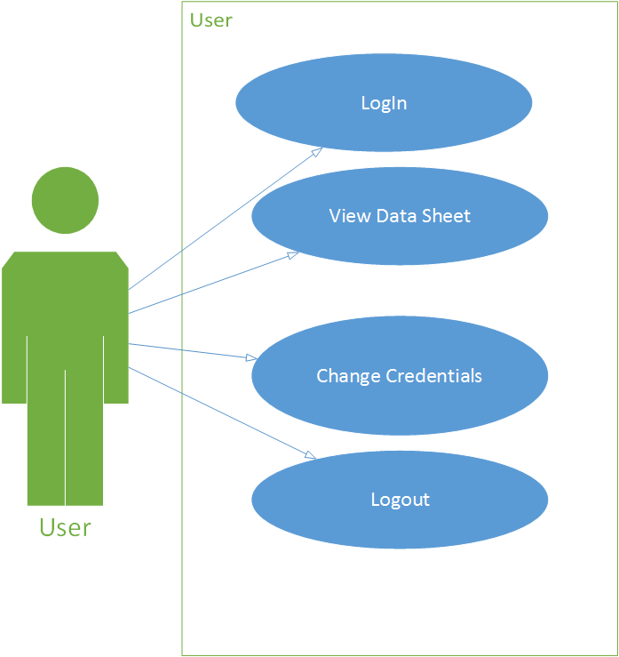
Figure 3.1.1

    - Use Case for Admin:

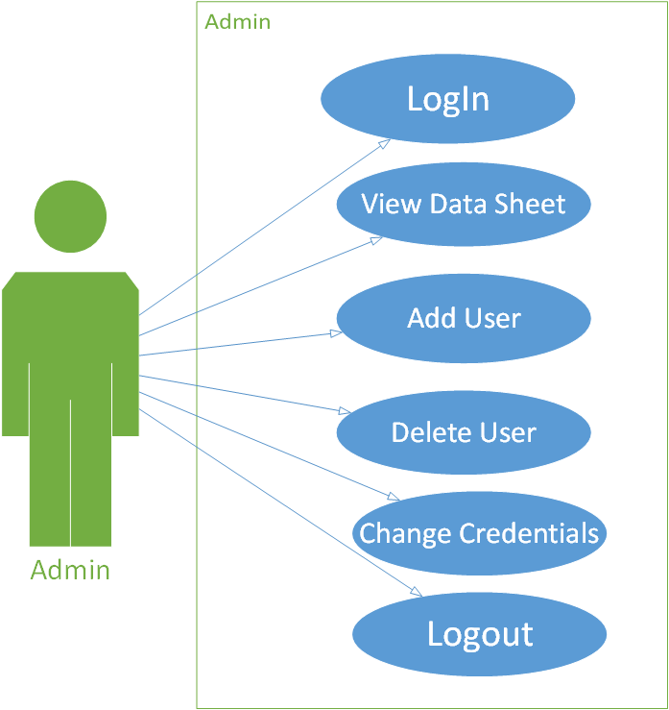
Figure 3.1.2

    - Fully Dressed Use Case

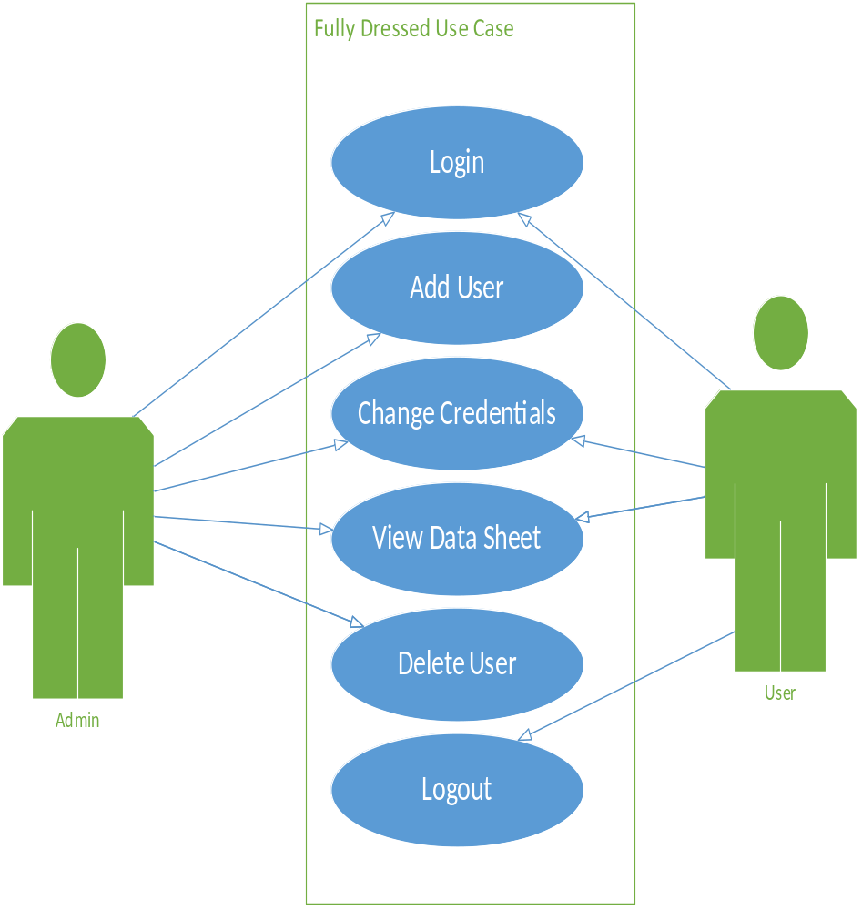

Figure 3.1.3

  - Use Case Descriptions

    - User Sign in Function

Title | Allow user to sign in
Requirement | User must be registered throw admin
Rational | Login to the system
Restriction or Risk | Wrong or correct login sent to database
Dependency | Pc , Internet connection
Priority | Safety , timing

Use case 1

Sign In

Actor
- Regular User
Preconditions
- Must be register throw Admin
Basic flow
- User wants to sign in
Alternate flows
- User don’t want to view result
Post Condition
- User must Sign Out
Table 3.2.1
    - User Sign out Function

Title | Allow user to sign out
Requirement | User must be registered throw admin
Rational | Logout to the system
Restriction or Risk | Wrong or correct login sent to database
Dependency | Pc , connection Internet
Priority | Safety , timing
Use case 2

Sign Out

Actor
- Regular User
Preconditions
- User must be registered throw Admin
- User must be successfully sign in

Basic flow
- User wants to sign out
Alternate flows
- User don’t want to view his/her data
Post Condition
- User must sign out
Table 3.2.2

    - User View data sheet Function

Title | Allow user to view data sheet
Requirement | User must be registered throw admin
Rational | Login to the system and view data sheet
Restriction or Risk | Wrong or correct login sent to database
Dependency | Pc , connection to Internet
Priority | Safety , timing
Table 3.2.3

Use case 3

View data sheet

Actor
- User
Preconditions
- User must log in
Basic flow
- Student wants to see data sheet
Alternate flows
- None
Post Condition
- User must log out

    - User can change credentials

Title | Allow user to change credentials
Requirement | User must be registered throw admin
Rational | Login to the system and change credentials
Restriction or Risk | Wrong or correct login sent to database
Dependency | Pc , connection to Internet
Priority | Safety , timing

Table 3.2.4

Use case 3

User change credentials
Actor
- User
Preconditions
- User must log in
Basic flow
- Student wants to change credentials
Alternate flows
- None
Post Condition
- User credentials must change

    - Admin add user

Title | Allow admin to add user
Requirement | Admin must be registered
Rational | Login to the system and add new user
Restriction or Risk | Wrong or correct login sent to database
Dependency | Pc , connection to Internet
Priority | Safety , timing

Use case 3

Admin add user
Actor
- Admin
Preconditions
- Admin must log in
Basic flow
- Admin wants to add user
Alternate flows
- None
Post Condition
- User must be added
Table 3.2.5

    - Admin delete user

Title | Allow admin to delete user
Requirement | Admin must be registered or logged in
Rational | Login to the system and delete user
Restriction or Risk | Wrong or correct login sent to database
Dependency | Pc , connection to Internet
Priority | Safety , timing

Use case 3

Admin delete user
Actor
- Admin
Preconditions
- Admin must log in
Basic flow
- Admin wants to delete user
Alternate flows
- None
Post Condition
- User must be deleted
Table 3.2.6

    - Admin can see data sheet

Title | Allow admin to see data sheet
Requirement | Admin must be logged in
Rational | Login to the system and see data sheet
Restriction or Risk | Wrong or correct login sent to database
Dependency | Pc , connection to Internet
Priority | Safety , timing
Use case 3

Admin see data credentials
Actor
- Admin
Preconditions
- Admin must log in
Basic flow
- Admin wants to see data sheet
Alternate flows
- None
Post Condition
- Admin can see data sheet
Table 3.2.7

    - Admin can change credentials

Title | Allow admin to change credentials
Requirement | Admin must be logged in
Rational | Login to the system and change credentials
Restriction or Risk | Wrong or correct login sent to database
Dependency | Pc , connection to Internet
Priority | Safety , timing

Use case 3
Admin change credentials
Actor
- Admin
Preconditions
- Admin must log in
Basic flow
- Admin wants to change credentials
Alternate flows
- None
Post Condition
- Admin must changed credentials
Figure 3.2.8

    - Admin Sign in Function
Title | Allow Admin to sign in
Requirement | Admin must be registered
Rational | Login to the system
Restriction or Risk | Wrong or correct login sent to database
Dependency | Pc , Internet connection
Priority | Safety , timing
Figure 3.2.9

Use case 1

Sign In

Actor
- Regular Admin
Preconditions
- Must be register throw Admin
Basic flow
- Admin wants to sign in
Alternate flows
- Admin don’t want to view result
Post Condition
- Admin must Sign In
Figure 3.2.9

    - Admin Sign out Function

Title | Allow admin to sign out
Requirement | Admin must be re sign in
Rational | Login to the system
Restriction or Risk | Wrong or correct login sent to database
Dependency | Pc , Internet connection
Priority | Safety , timing

Table 3.2.10

Use case 1

Sign In

Actor
- Regular Admin
Preconditions
- Must be sign in
Basic flow
- admin wants to sign out
Alternate flows
- admin don’t want to view result
Post Condition
- admin must Sign in

Chapter 4

System Design

Chapter 4: System Design
In these diagrams we will show you how our product will work and interact with the user and admin.

Architecture Diagram

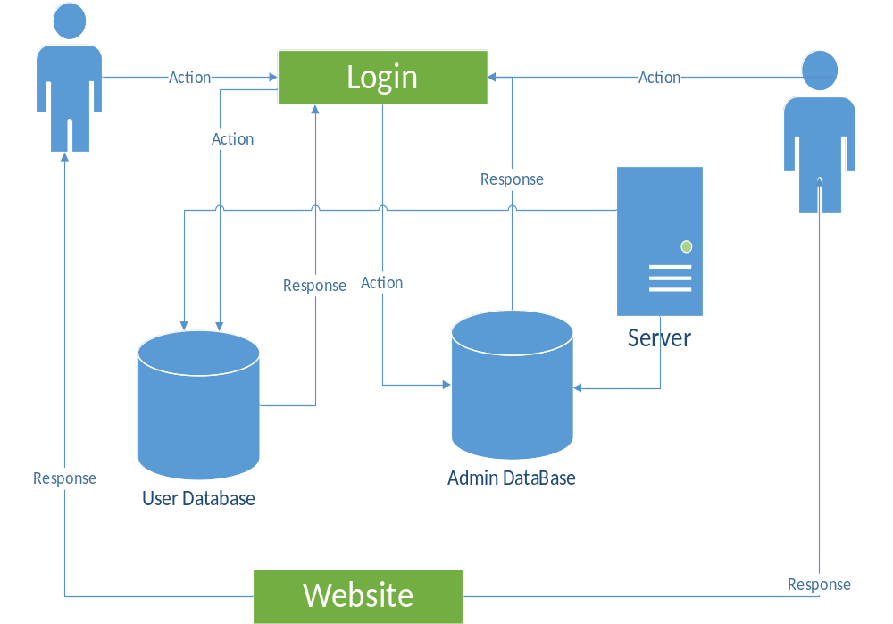Figure 4.1

Domain Model

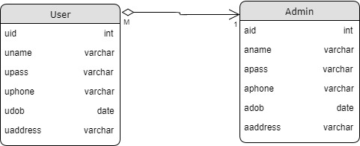

Figure 4.2

Entity Relationship Diagram with data dictionary
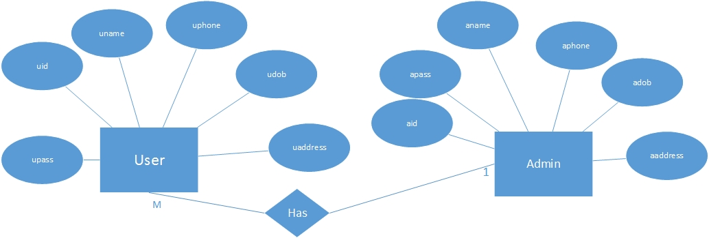Figure 4.3

Class Diagram
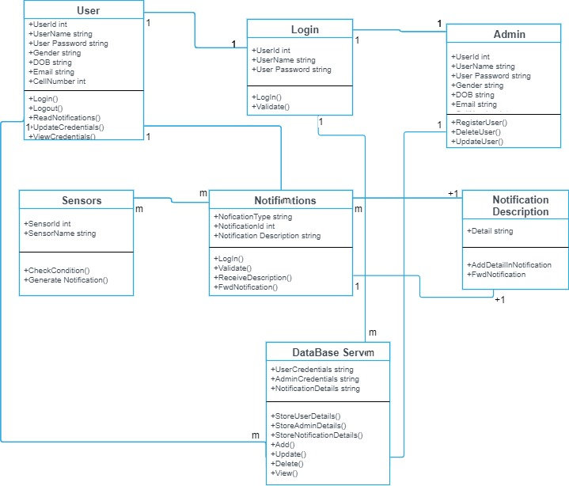
Figure 4.4

Sequence / Collaboration Diagram
4.5.1.Admin Sequence Diagram
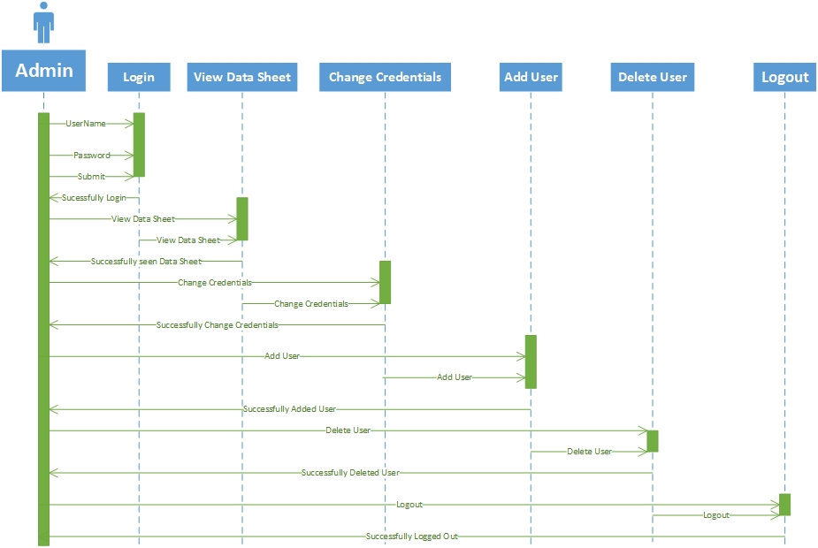
Figure 4.1.5

4.5.2.Sequence Diagram for User

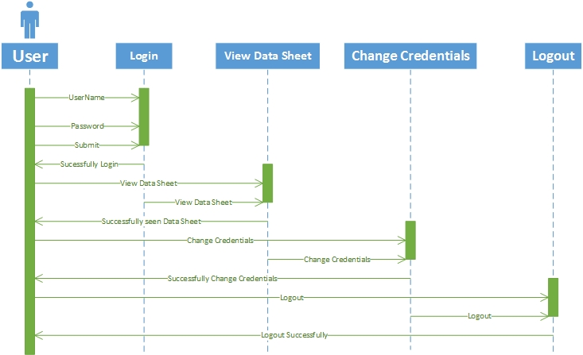
Figure 4.5.2

Operation contracts
Aumloperating contracts identifies system state changes when an operation happens. Effectively, it will define what each system operation does. An operation is taken from a system sequence diagram. It is a single event from that diagram. A domain model can be used to help generate an operating contracts.

Activity Diagram
4.7.1. Activity Diagram for User
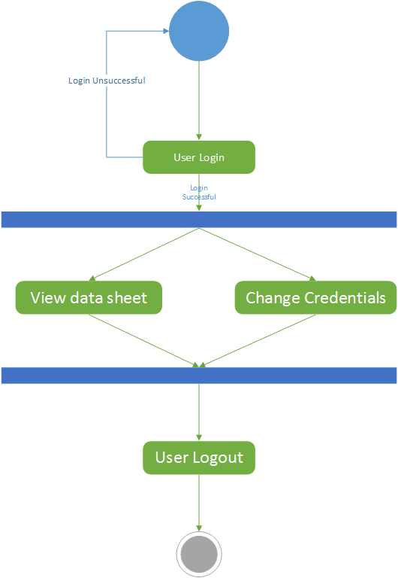
Figure 4.7.1

4.7.2. Activity Diagram for Admin

Figure 4.7.2

State Transition Diagram
4.8.1. State transition diagram for user

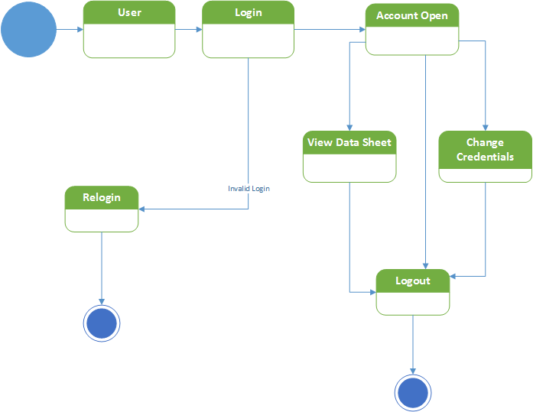

Figure 4.8.1

4.8.2. State Transition Diagram for Admin

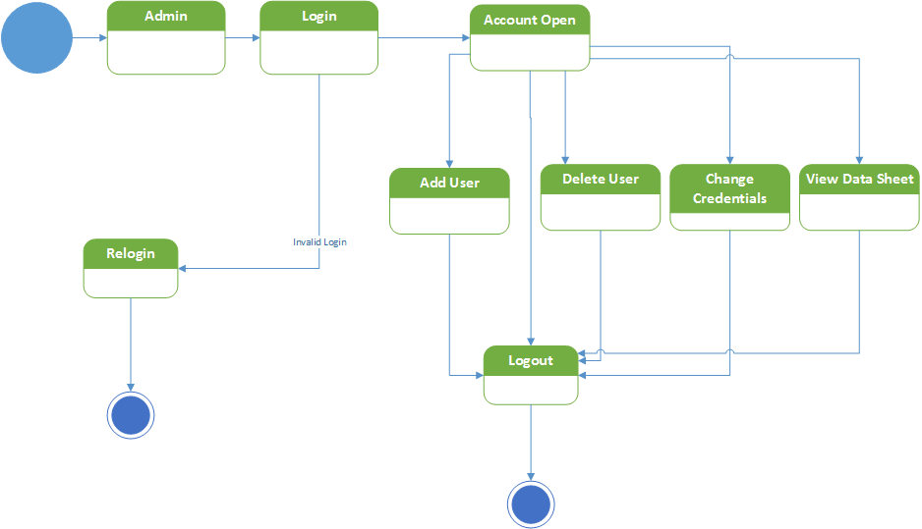Figure 4.8.2

Component Diagram
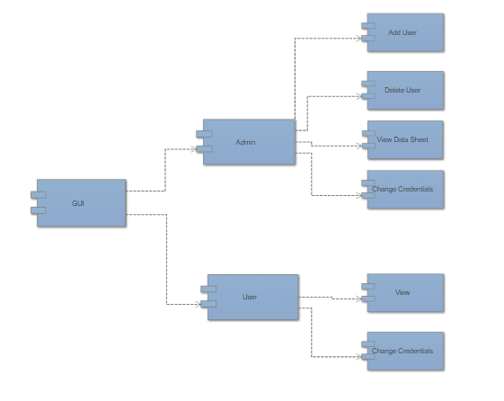
Figure 4.9

Deployment Diagram
N/A

Data Flow diagram
4.11.1. Data Flow Diagram for Login/Logout

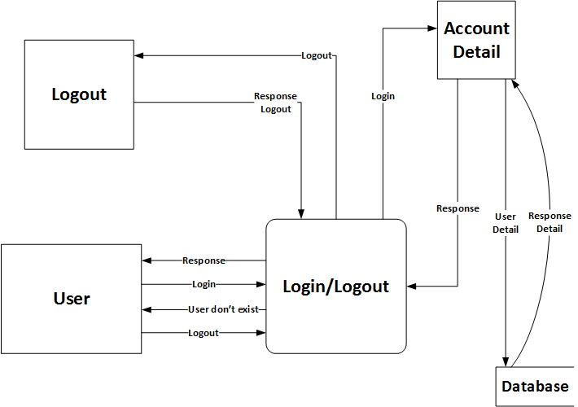

Figure 4.11.1

4.11.2. Data Flow Diagram for User
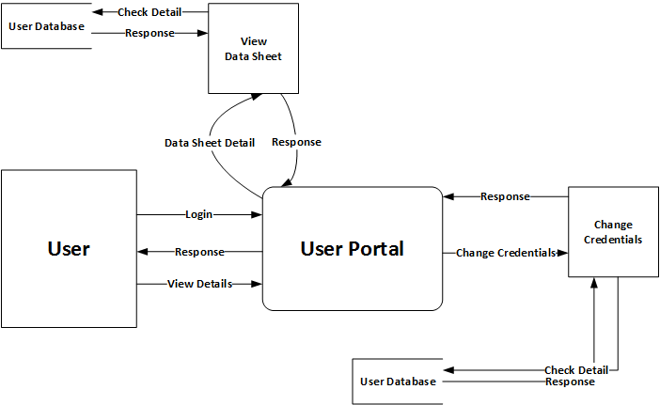

Figure 4.11.2

4.11.3. Data Flow Diagram for Admin

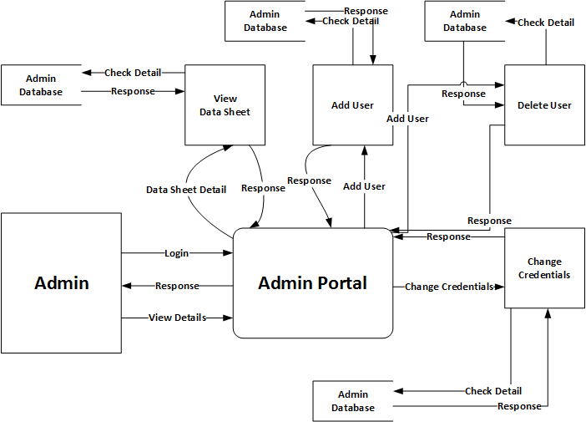
Figure 4.11.3

Chapter 5

Implementation

Chapter 5: Implementation
We are going to implement both software and hardware also. As our software include Website for promotion or Telling People about our brand and product and let people aware of our product. On the hardware side our product has:
• Steering wheel
• Sensors
• Vibrator
• Shake sensor
• A battery
• An Arduino (Micro-controller)
• Steering case for covering all these

Sensors will perform different functions like heart beat sensor will continuously check the heart beat and blood pressure of the driver. Whereas click buttons are used for secret combination for the security of the vehicle. Shake sensor or vibrator is for to get the driver awake if he sleeps during the driving. Breadth sensor will check the alcohol values of the driver breath and notify the driver about his/her alcoholic condition on the screen. Arduino is the major component of the hardware which controls all the sensors it’s a microcontroller device attached to a battery.
Software implementation initiation allows to prepare the team work of the activities and to have the all necessary activities tools to accomplish work.

Important Flow Control/Pseudo codes

#define RED 8
#define GREEN 7
#define BLUE 6
#define LOCK 5

constint pin[] = {0, 0, 1, 2, 3}; // The code to unlock
constintpinLength = sizeof(pin) / sizeof(int); // Length of the code

constint buttons[] = {12, 11, 10, 9}; // Arduino pins the buttons are connected to
constintbuttonsLength = sizeof(buttons) / sizeof(int); // Number of buttons connected
bool pressed[buttonsLength]; // Which buttons were pressed pressed when last checked
intabc=1;
int index = 0; // Index of current pin digit
bool correct = true; // If input matches pin
int attempt = 0;

// Variables
intpulsePin = 0; // Pulse Sensor purple wire connected to analog pin 0
int alcohol = 1; // Alcohol Sensor wire Connected to analog pin 1
int shock = 2; // Shock Sensor wire Connected to analog pin 2
int shock_0;
intalch_level;
intblinkPin = 53; // pin to blink led at each beat
//intfadePin = 8; // pin to do fancy classy fading blink at each beat
intfadeRate = 0; // used to fade LED on with PWM on fadePin
constintProxSensor=2;
intinputVal = 0;
intlast_bpm;
// Volatile Variables, used in the interrupt service routine!
volatileint BPM; // int that holds raw Analog in 0. updated every 2mS
volatileint Signal; // holds the incoming raw data
volatileint IBI = 600; // int that holds the time interval between beats! Must be seeded!
volatileboolean Pulse = false; // "True" when User's live heartbeat is detected. "False" when not a "live beat".
volatileboolean QS = false; // becomes true when Arduino finds a beat.

// Regards Serial OutPut -- Set This Up to your needs
staticbooleanserialVisual = false; // Set to 'false' by Default. Re-set to 'true' to see Arduino Serial Monitor ASCII Visual Pulse

volatileint rate[10]; // array to hold last ten IBI values
volatile unsigned long sampleCounter = 0; // used to determine pulse timing
volatile unsigned long lastBeatTime = 0; // used to find IBI
volatileint P = 512; // used to find peak in pulse wave, seeded
volatileint T = 512; // used to find trough in pulse wave, seeded
volatileint thresh = 525; // used to find instant moment of heart beat, seeded
volatileint amp = 100; // used to hold amplitude of pulse waveform, seeded
volatilebooleanfirstBeat = true; // used to seed rate array so we startup with reasonable BPM
volatilebooleansecondBeat = false; // used to seed rate array so we startup with reasonable BPM

void setup()
{
// Set LED and unlock pins to output
pinMode(RED, OUTPUT);
pinMode(GREEN, OUTPUT);
pinMode(BLUE, OUTPUT);
pinMode(LOCK, OUTPUT);

// Set buttons to inputs
for (inti = 0; i<buttonsLength; ++i)
{
pinMode(buttons[i], INPUT);
}

pinMode(53, OUTPUT); // Pin 53 has an LED connected on most Arduino boards:
pinMode(ProxSensor,INPUT); //Pin 2 is connected to the output of proximity sensor
pinMode(shock,INPUT);
pinMode(blinkPin,OUTPUT); // pin that will blink to your heartbeat!
// pinMode(fadePin,OUTPUT); // pin that will fade to your heartbeat!
Serial.begin(9600); // we agree to talk fast!
interruptSetup(); // sets up to read Pulse Sensor signal every 2mS
// IF YOU ARE POWERING The Pulse Sensor AT VOLTAGE LESS THAN THE BOARD VOLTAGE,
// UN-COMMENT THE NEXT LINE AND APPLY THAT VOLTAGE TO THE A-REF PIN
// analogReference(EXTERNAL);

}

// Where the Magic Happens
void loop()
{
digitalWrite(BLUE, !index); // Show blue LED if index is 0

// Loop buttons
for (inti = 0; i<buttonsLength; ++i)
{
//If the button is pressed
if (digitalRead(buttons[i]))
{
Serial.print("Button is pressed");
Serial.print('\r');
if(pressed[i]) return; // Ignore if already pressed
pressed[i] = true; // Set current button as pressed

correct = correct &&i == pin[index]; // If the pin doesn't match set correct to false

if (++index == pinLength)
{ // Increment digit index and check if last digit
if (correct)
{ // Unlock and show green LED if code is correct
Serial.print("Unlocked");
Serial.print('\r');
digitalWrite(GREEN, HIGH);
Serial.print("abc=0");
Serial.print('\r');
abc=0;
digitalWrite(LOCK, HIGH);
attempt = 0; // Reset timer
Serial.print("Resetting Timer");
Serial.print('\r');
delay(1000); // Leave LED/motor on for 1 second
} else
{ // The code is incorrect
attempt++; // Increase a timer

for(int j = 0; j < attempt; j++)
{ // Take longer if is not first attempt
for(int k = 0; k < 5; k++)
{ // Flash red LED

digitalWrite(RED, HIGH);
delay(100);
digitalWrite(RED, LOW);
delay(100);
}
}

abc=1;
Serial.print("abc=1");
Serial.print('\r');
Serial.print("Sensors OFF");
Serial.print('\r');
// Turn off LED/motor
digitalWrite(GREEN, LOW);
digitalWrite(LOCK, LOW);
digitalWrite(RED, LOW);

}

// Reset for next attempt
index = 0;
correct = true;
}
} else { // Button is not pressed
pressed[i] = false; // Set current button as not pressed
}
}

delay(10); // Run every 10ms

if(abc==0){

Serial.print("Sensors ON");
Serial.print('\r');
// serialOutput();

Serial.print("H");
Serial.print("|");
Serial.println(alch_level);
Serial.print("|");

Serial.println(shock_0);
Serial.print("|");
if(digitalRead(ProxSensor)== HIGH) //Check the sensor output
{
digitalWrite(53, LOW); // set the LED on
}
else
{
digitalWrite(53, HIGH); // set the LED off
}
inputVal = digitalRead(ProxSensor);
Serial.println(inputVal);
//delay(1000);

if (QS == true) // A Heartbeat Was Found
{
// BPM and IBI have been Determined
// Quantified Self "QS" true when arduino finds a heartbeat
fadeRate = 255; // Makes the LED Fade Effect Happen, Set 'fadeRate' Variable to 255 to fade LED with pulse
serialOutputWhenBeatHappens(); // A Beat Happened, Output that to serial.
QS = false; // reset the Quantified Self flag for next time
}else
{
if(BPM<999)
{
Serial.print("|");
Serial.println(last_bpm);
}

}
alch_level = analogRead(alcohol);
shock_0 = analogRead(shock);

ledFadeToBeat(); // Makes the LED Fade Effect Happen
delay(200); // take a break
}
}

voidledFadeToBeat()
{
fadeRate -= 15; // set LED fade value
fadeRate = constrain(fadeRate,0,255); // keep LED fade value from going into negative numbers!
// analogWrite(fadePin,fadeRate); // fade LED
}

voidinterruptSetup()
{
// Initializes Timer2 to throw an interrupt every 2mS.
TCCR2A = 0x02; // DISABLE PWM ON DIGITAL PINS 3 AND 11, AND GO INTO CTC MODE
TCCR2B = 0x06; // DON'T FORCE COMPARE, 256 PRESCALER
OCR2A = 0X7C; // SET THE TOP OF THE COUNT TO 124 FOR 500Hz SAMPLE RATE
TIMSK2 = 0x02; // ENABLE INTERRUPT ON MATCH BETWEEN TIMER2 AND OCR2A
sei(); // MAKE SURE GLOBAL INTERRUPTS ARE ENABLED
}

//void serialOutput()
//{ // Decide How To Output Serial.
// if (serialVisual == true)
// {
// arduinoSerialMonitorVisual('-', Signal); // goes to function that makes Serial Monitor Visualizer
// }
// else
// {
// sendDataToSerial('S', Signal); // goes to sendDataToSerial function
// }
//}

voidserialOutputWhenBeatHappens()
{
if (serialVisual == true) // Code to Make the Serial Monitor Visualizer Work
{
Serial.print("|");
Serial.println(BPM);
}
else
{
Serial.print("|");
Serial.println(BPM);
last_bpm = BPM;

// sendDataToSerial('B',BPM); // send heart rate with a 'B' prefix
// sendDataToSerial('Q',IBI); // send time between beats with a 'Q' prefix
}
}
//void arduinoSerialMonitorVisual(char symbol, int data )
//{
// constintsensorMin = 0; // sensor minimum, discovered through experiment
// constintsensorMax = 1024; // sensor maximum, discovered through experiment
// intsensorReading = data; // map the sensor range to a range of 12 options:
// int range = map(sensorReading, sensorMin, sensorMax, 0, 11);
// // do something different depending on the
// // range value:
// switch (range)
// {
// case 0:
// Serial.println(""); /////ASCII Art Madness
// break;
// case 1:
// Serial.println("---");
// break;
// case 2:
// Serial.println("------");
// break;
// case 3:
// Serial.println("---------");
// break;
// case 4:
// Serial.println("------------");
// break;
// case 5:
// Serial.println("--------------|-");
// break;
// case 6:
// Serial.println("--------------|---");
// break;
// case 7:
// Serial.println("--------------|-------");
// break;
// case 8:
// Serial.println("--------------|----------");
// break;
// case 9:
// Serial.println("--------------|----------------");
// break;
// case 10:
// Serial.println("--------------|-------------------");
// break;
// case 11:
// Serial.println("--------------|-----------------------");
// break;
// }
//}

voidsendDataToSerial(char symbol, int data )
{
Serial.print(symbol);
Serial.println(data);
}

ISR(TIMER2_COMPA_vect) //triggered when Timer2 counts to 124
{
cli(); // disable interrupts while we do this
Signal = analogRead(pulsePin); // read the Pulse Sensor
sampleCounter += 2; // keep track of the time in mS with this variable
int N = sampleCounter - lastBeatTime; // monitor the time since the last beat to avoid noise
// find the peak and trough of the pulse wave
if(Signal < thresh && N > (IBI/5)*3) // avoid dichrotic noise by waiting 3/5 of last IBI
{
if (Signal < T) // T is the trough
{
T = Signal; // keep track of lowest point in pulse wave
}
}

if(Signal > thresh && Signal > P)
{ // thresh condition helps avoid noise
P = Signal; // P is the peak
} // keep track of highest point in pulse wave

// NOW IT'S TIME TO LOOK FOR THE HEART BEAT
// signal surges up in value every time there is a pulse
if (N > 250)
{ // avoid high frequency noise
if ( (Signal > thresh) && (Pulse == false) && (N > (IBI/5)*3) )
{
Pulse = true; // set the Pulse flag when we think there is a pulse
//digitalWrite(blinkPin,HIGH); // turn on pin 13 LED
IBI = sampleCounter - lastBeatTime; // measure time between beats in mS
lastBeatTime = sampleCounter; // keep track of time for next pulse

if(secondBeat)
{ // if this is the second beat, if secondBeat == TRUE
secondBeat = false; // clear secondBeat flag
for(inti=0; i<=9; i++) // seed the running total to get a realisitic BPM at startup
{
rate[i] = IBI;
}
}

if(firstBeat) // if it's the first time we found a beat, if firstBeat == TRUE
{
firstBeat = false; // clear firstBeat flag
secondBeat = true; // set the second beat flag
sei(); // enable interrupts again
return; // IBI value is unreliable so discard it
}
// keep a running total of the last 10 IBI values
wordrunningTotal = 0; // clear the runningTotal variable

for(inti=0; i<=8; i++)
{ // shift data in the rate array
rate[i] = rate[i+1]; // and drop the oldest IBI value
runningTotal += rate[i]; // add up the 9 oldest IBI values
}

rate[9] = IBI; // add the latest IBI to the rate array
runningTotal += rate[9]; // add the latest IBI to runningTotal
runningTotal /= 10; // average the last 10 IBI values
BPM = 60000/runningTotal; // how many beats can fit into a minute? that's BPM!
QS = true; // set Quantified Self flag
// QS FLAG IS NOT CLEARED INSIDE THIS ISR
}
}

if (Signal < thresh && Pulse == true)
{ // when the values are going down, the beat is over
//digitalWrite(blinkPin,LOW); // turn off pin 13 LED
Pulse = false; // reset the Pulse flag so we can do it again
amp = P - T; // get amplitude of the pulse wave
thresh = amp/2 + T; // set thresh at 50% of the amplitude
P = thresh; // reset these for next time
T = thresh;
}

if (N > 2500)
{ // if 2.5 seconds go by without a beat
thresh = 512; // set thresh default
P = 512; // set P default
T = 512; // set T default
lastBeatTime = sampleCounter; // bring the lastBeatTime up to date
firstBeat = true; // set these to avoid noise
secondBeat = false; // when we get the heartbeat back
}
sei(); // enable interrupts when youre done!
}// end

Components, Libraries, Web Services and stubs
Libraries and Web Services:
- WI-FI ESP-8266
- Open CV

Components:
- Arduino Mega 2560
- Sensors
- LDR Sensor
- Wi-Fi Shield
- Pulse Sensor
- Vibrator
- Bluetooth HC-05
- Steering
- Battery

Deployment Environment
- Conference rooms
- Collages
- School
- Universities
- Teachers Offices

Tools and Techniques
Application and tools that would be used during this project preparation are as follow:

.NET
.NET is language which is supported in the .NET framework. It provides latest functionalities regarding desktop based application development.
Microsoft Word
Microsoft word is the word processor and would be used for documentation purpose through the whole project.
Microsoft Excel
Microsoft excel is spreadsheet and would be use for data analysis throughout the whole project.
Microsoft Project
Microsoft project provides extensive feature on project management with a prominent feature of project scheduling. Gantt charts, resource allocation. This would be used as a project management tool throughout the whole project.
Draw.io
Draw.io is a tool for modeling different diagram which would be address during analysis and design phase of project.
Project Modeling
Rational Rose and Microsoft Visio are to b used to draw use cases with different perspectives as the support the language of Rational Unified Process (RUP). Use case diagram, Data Flow Diagram (DFD), domain model and all other OOAD analysis and design diagrams are supported.
Server
Server is required where the user data would be stored and other services would be available and processing would be done.

Best Practices / Coding Standards
Java coding standards.
• It is highly recommended to follow coding standards.
• Whenever we are writing any components the name of the components should reflect the purpose functionality.

Coding Standards:
• Usually interfaces names are adjectives.
• Should starts with upper case letter and if it contains multiple words every inner word should starts with upper case letter.

Coding Standards for interfaces:
• Usually interfaces names are adjectives.
• Should starts with case and if it contains multiple words every inner words should starts with upper case letter.

Version Control
- Android studio version min version4.2 kit-Kat max 8.1 Oreo.
- Mobile device min and maximum version 2.1.3.

Chapter 6

Testing and Evaluation

Chapter 6: Testing and Evaluation

Use Case Testing
6.1.1 Admin login:

Table 6.1.1
Positive Test case
Priority | High
Description | Admin Should be logged in after entering the correct email and password if the user id registered.
Reference | Functional Requirement reference.
User | Admin
Pre-Conditions | - System is online  - Login from should be working  - The User have internet Access
Steps | - Open the web link to the System  - Enter the User name  - Enter The password  - Press login
Input Criteria | Username: abcPassword:********
Expected Result | Admin panel will be open
Status | Pass

Negative Test Case
Priority | High
Description | Admin should not be logged in after the entering the incorrect email and password if the user is registered.
Reference | Functional Requirement reference.
User | Admin
Pre-Conditions | - System is online  - Login from should be working  - The user should have internet access
Steps | - Open the web link to the System  - Enter the User name  - Enter the User Password  - Press Login
Input Criteria | Username: xyz Password******
Expected Result | Admin panel will not be opened
Status | Pass

Table 6.1.1

6.1.2Add User

Positive Test Case
Priority | High
Description | Admin will add new Users
Reference | Functional Requirement reference.
User | Admin
Pre-Conditions | - The System should be working  - Admin should be logged in
Steps | - Admin will be logged into the System  - Admin will be check into authenticate Users  - Click on add users button
Input Criteria | Click the “Add User” buttons
Expected Result | User added in the System
Status | Pass

Negative Test Case
Priority | High
Description | Admin will add new Users
Reference | Functional Requirement reference.
User | Admin
Pre-Conditions | - The System should be working  - Admin should be logged in
Steps | - Admin will be logged into the System  - Admin will be check into authenticate Users  - Click on add users buttons
Input Criteria | Not click on the “Add User”buttons
Expected Result | User not added in the System
Status | Pass
Table 6.1.2

6.3.1 Delete User Account
Table 6.3.1
Positive Test Case
Priority | High
Description | Admin will delete a User account
Reference | Functional Requirement reference.
User | Admin
Pre-Conditions | - Admin should be logged in  - There should be existing account which admin want to delete
Steps | - Admin will be logged into the System  - Admin will be check whether there is an existing account or not  - Click on “Delete User” button
Input Criteria | Click the “Delete User”buttons
Expected Result | User deleted from the System
Status | Pass

Negative Test Case
Priority | High
Description | Admin will delete a User account
Reference | Functional Requirement reference.
User | Admin
Pre-Conditions | - Admin should be logged in  - There should be existing account which admin want to delete
Steps | - Admin will be logged into the System  - Admin will be check whether there is an existing account or not  - Click on “Delete User” buttons
Input Criteria | Not click the “delete User “Buttons
Expected Result | User not deleted from the System
Status | Pass
Table 6.1.3

Equivalence Partitioning
Add User
Table 6.3.3
Field Name | Date Type | Valid | Invalid | Invalid
Name | String | Less than 1,no numeric special characters | Character1-15 | More Than 15 not accepted
ID | Int | Must include integers | Must include other than character type | “null”@
Password | Varchar | Less than 8 is not accepted | Alphanumeric  value >8 | More than 8 not accepted
Dob | Date | If include date type integers | If include characters or special symbols | Include characters or special symbols
Address | Varchar | Must be filled | N/A | N/A
Phone | Digits | Less than and more than 13 not accepted | 13 number digits | First 2 digits should be 0,3

Login
Table 6.3.4
Field Name | Data Type | Valid | Invalid | Valid
Email | Email | Null | Must be valid mail type | “null”@
ID | INT | If input valid id | If input wrong it | Ex:qw22
Password | Varchar | Less than 8 is not accepted | Alphanumeric  value >8 | More than 8 not accepted

Boundary value analysis

Data flow testing
Most of the product uses the variables to make the data flow within the program. The program may use multiple variables to calculate values for different variables. Now, these variables get some values from the user interface or sometimes from different sources. This complexity makes a program full of risk. So testing these variable data flow makes sense and Dataflow testing concept can be used to test all the variables from the program.
Levels of Dataflow Testing:
- Static data flow testing :
- Identifying Potential Defects within the program.
- Analyzing code for defects Project Report: Smart Steering
- Code will not execute

- Dynamic data flow testing:
- We will execute the program
- Looks like a control flow testing
- List out the path need test

Unit testing

A unit testing framework for Arduino platforms inspired by ArduinoUnit and Google Test. The unit tests run in the embedded controller, not in a simulator or emulator. It is almost a drop-in replacement of ArduinoUnit with some advantages. AUnit supports timeouts and test fixtures. It sometimes consumes 50% less flash memory on the AVR platform, and it has been tested to work on the AVR, ESP8266, ESP32 and Teensy platforms. The sister AUniter project provides command line tools to verify upload and validate the unit tests. The AUniter tools can be used in a continuous integration system like Jenkins.

Integration testing

This project includes:
- Smart Steering
- Mobile App
- Website
Smart Steering has sensors which detect or check the physical condition of the driver and regularly generate notifications on drivers phone if something went wrong with the driver and on the other hand these notifications will be sent to the web-server to save them as a record on web-server.

Performance testing

Performance testing should be carried out after the implementation of the product. We shall test the speed, accuracy, and effectiveness of functions as well as quantitative test e.g. response time of any function. We have tested the performance of our system by checking the working of every complex operation, again and again, multiple times.

We have followed the following steps.
- List of all complex functions especially database related function.
- Assess response time and accuracy of core functions.
- Risk assessment of error or exception code.

Stress Testing

Stress testing should also be carried out after the implementation of the product. We shall test the product’s robustness, availability, and reliability under extreme conditions. The goal of stress testing is to identify application issues that arise or become apparent only under extreme conditions. We have tested our system by simultaneously using our system as a different user and performing their associated tasks in a continuous manner. Following steps have been followed:
- We have analyzed system behavior under high traffic.
- We have gathered statistics reviews about crashing app, time taking operations and shall resolve those issues in later revisions.

Chapter 7

Summary, Conclusion and Future Enhancements

Chapter 7: Summary, Conclusion & Future Enhancements

Project Summary

There are lot of inventions have been made with the help of technology in recent times to facilitate human beings for that cause we have introduced Smart Steering for automobile industry. Smart steering is a modern technology having multiple functions to detect driver’s current state of mind and physical condition. Functions like breath detector and pulse sensor will scan the driver’s alcoholic, health condition and sleepy state of mind to be automatically operating the vehicle. That will help out to reduce the accidents and mortality rates. For making the whole business plan, first of all we describe the form of our business that what actually our business is and then about our team and managerial structure. We describe our mission which is very clear to facilitate human beings; we describe our vision, values and Goals. We did industry and market analysis very deeply. We clearly define our industry size and structure and then use porter’s five forces mode and then we did competitor’s analysis very deeply, then we did SWOT analysis then define about advanced technology which will be used then we define about our unique value proposition. After that, we did marketing strategies. First of all segmentation and then our targeting of our customer and then officially define our marketing mix strategy (product, price, place, promotion and people). After doing a lot of research on market and industry analysis. We finally prepare our financial plan which is the main thing. First of all we prepare a complete document on our startup business expenses and then operating cost and expenses is prepared which is the expense of during the business. After that a complete document is prepared on revenue generation, income statement, balance sheet, break even analysis, ratio analysis, operating cost flow, list of resources and cost of resources. By the combination of industry and market analysis, description of our business, marketing strategy and financial plan, we prepare our complete business plan.

Achievements and Improvements

During this process of product development we learned a lot of skills:
- Hardware Development
- Working on IOT sensors.
- Best Coding practices.
- Integration of different objects on a single platform.
- Creative Thinking.
With respect to the product, the biggest obstacle we have faced is the awareness of such products in the native market; we have overcome this hinder to some extent by showcasing our idea and prototype at various events where we have found the very encouraging response by the audience.

Critical Review

We are awesome as we are persistent that we will aware the globe about the potential of this hybrid of living beings and machines we don’t need to replace living beings with machines but we need to incorporate living senses with better computing systems to fully explore the horizons of nature.
It is the demand of the native market and in the whole world, no such product is officially working to reduce such accidents activities so we are hoping that it'll have the best impact on the market.

Lessons Learnt

We absorb very much from this project. This project sharpens our skills in hardware development, designing tools, and many management concepts as well as how to deal with a problem and how to stick for finding the solution to any problem until you find it. As well as technical skills this project also enhances our personal development skills such as team working, dedication. Our passion for making a unique product that contains innovation and nationwide best achievement and we succeeded it. We continue our work after this to make it through worldwide. This project is a stepping stone for us, in the beginning, we don’t even know that if we accomplished it or not but due to our hardworking and research we do it and it’s an achievement for us that motivates us to do better and more.

Future Enhancements/Recommendations

In the future enhancements of smart steering we will think about to give the access to user data to traffic police so in case if someone got accident police can check the driver physical and chemical condition that either a driver was in a state of driving or not. On the other hand we will think about to control the car (ex: reducing its speed) if driver is not in a state of driving effectively.

Appendices

AppendixA: User Manual
Our product smart steering is easy to install, it can be installed easily by the mechanic, with the steering there is an android app which will show us pop ups whenever heartbeat of the person driving is increased or he/she falls asleep in unusual conditions user data is saved in database why he/she can view from its mobile application. On steering there is a special pattern which is link to cars ignition which ensures drivers safety as well.

AppendixA:

N/A

  - First Level heading
N/A

    - Second level heading
N/A

Appendix B: Administrator Manual
N/A
  - First Level heading
N/A

    - Second level heading
N/A

      - Third level heading
N/A

Appendix C: Information / Promotional Material
Here we are discussing our marketing or promotional material in which broachers, banners, flyers, standees, visiting cards are included so people could be aware of the product.

  - Broacher
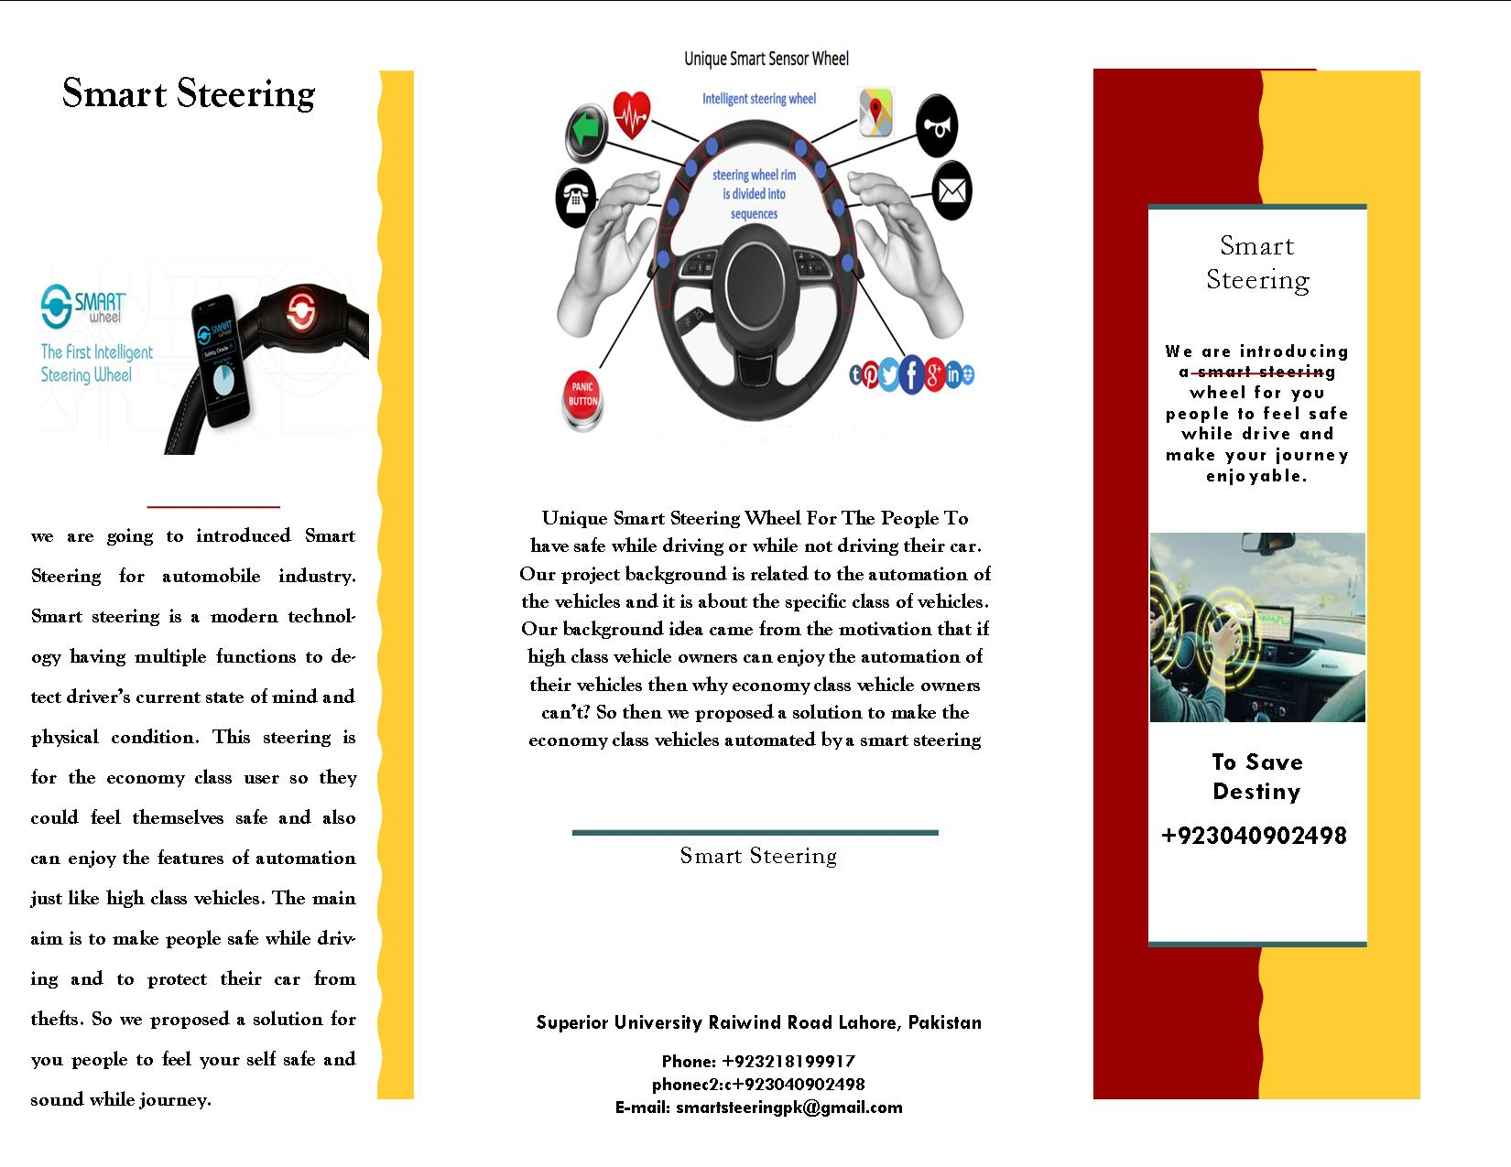

  - Flyer

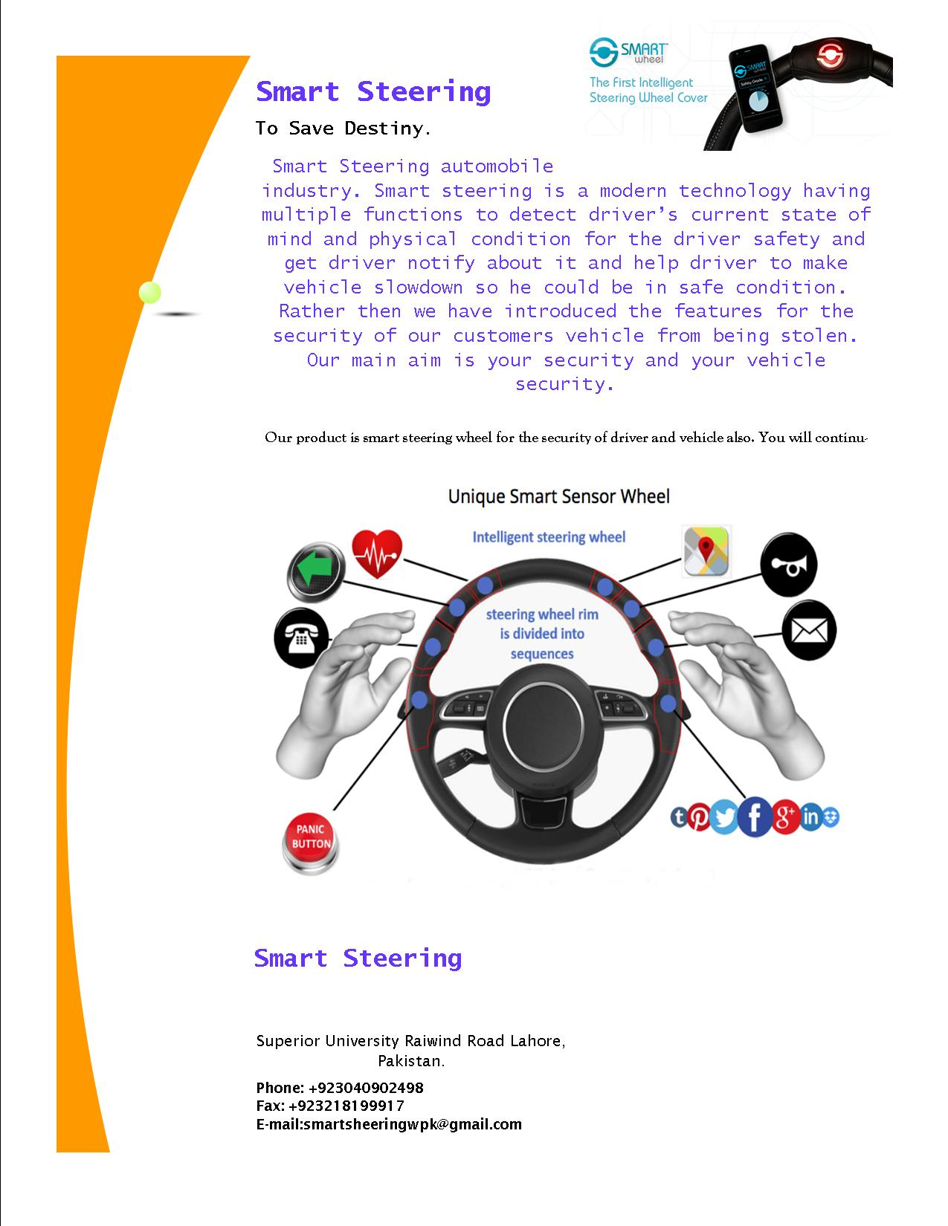

  - Standee

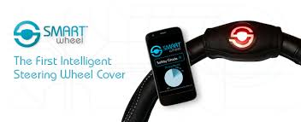

  - Banner
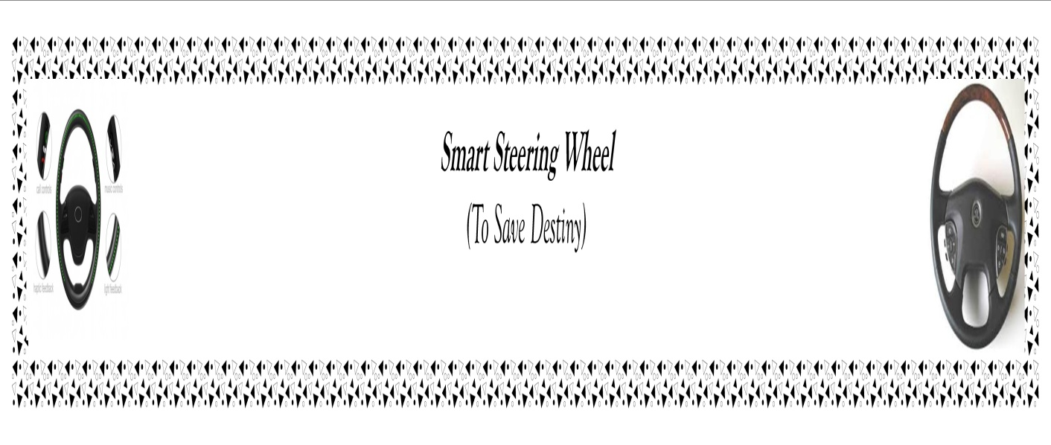

  - First Level heading
N/A

    - Second level heading
N/A

      - Third level heading
N/A

Appendix [no.]: Appendix Title
N/A

  - First Level heading

    - Second level heading
N/A

      - Third level heading
N/A

Reference and Bibliography

Reference and Bibliography

[1] Arase, Y., Ren, F., Xie, X.: User activity understanding from mobile phone sensors. In: Ubicomp ’10, pp. 391–392. ACM Press, New York (2010)
[2] Teece, D.: Profiting from technological innovation: implications for integration collabora-tion, licensing and public policy. Research Policy 15, 285– 305 (1986)
[3] (PDF) The Smart Steering Wheel Cover Design: A Case Study of Industrial-Academic Collaboration in Human- Computer Interaction. Available from: https://www.researchgate.net/publication/280699424_The_Smart_Steering_Wheel_Cover_Design_A_Case_Study_of_Industrial-Academic_Collaboration_in_Human-_Computer_Interaction [accessed Jan 07 2019].
[4] Brandtner, P., Auinger, A., Helfert, M.: Principles of Human Computer Interaction in Crowdsourcing to Foster Motivation in the Context of Open Innovation. In HCII, ACM Press, New York 2014.
[5] “In 2005, 4,459 people ages 16–19 died in motor-vehicle crashes in the United States.”

[6] Bennett, J., Krause, J. K., &Cech, L. S. (2014). Patent issued for sensor system for steering wheel for vehicle. Journal of Engineering, , 11348

Index

Index

[A]

[B]

[C]

