MED-GO

Final Year Project

Session 2016-2020

A project submitted in partial fulfillment of the degree of

BS in Computer Science


Department of Computer Science
Faculty of Computer Science & Information Technology
The Superior College, Lahore

FALL 2019

Type (Nature of project) |  |  | [ ] Development [ ] Research [ ] R&D
Area of specialization |  |  | Mobile Application and Web Development
FYP ID |  |  | FYP19-GRP-029
Project Group Members
Sr.# | Reg. # | Student Name |  | Email ID | *Signature
(i) | BCSM-F16-255 | Danish Shakeel |  | Bcsm-f16-255@superior.edu.pk
(ii) | BCSM-F16-090 | Muhammad Amir |  | Bcsm-f16-090@superior.edu.pk
(iii) | BCSM-F16-081 | Obaidullah Yousaf |  | Bcsm-f16-081@superior.edu.pk

*The candidates confirm that the work submitted is their own and appropriate credit has been given where reference has been made to work of others

Plagiarism Free Certificate
This is to certify that, I Danish Shakeel Son of Arshad Shakeel, group leader of FYP under registration no FYP19-GRP-029 at Software Engineering Department, The Superior College, Lahore. I declare that my FYP report is checked by my supervisor.

Date: 07/06/2020 Name of Group Leader: Danish Shakeel Signature: danish
Name of Supervisor: Mr. Farrukh Ehsan Co-Supervisor: Mr. Asadullah Tariq
Designation: Senior Lecturer Designation: Lecturer
Signature: ________________ Signature: _________________

HoD: Dr. Arfan Jaffar
Signature: _______________

Project Report
[MED-GO]

Change Record
Author(s) | Version | Date | Notes | Supervisor’s Signature
 | 1.0 |  | <Original Draft>

APPROVAL
Project Supervisor
Comments: ___________________________________________________________________
_____________________________________________________________________________
Name:______________________________
Date:_______________________________ | Signature:__________________________

Project Manager
Comments: ___________________________________________________________________
_____________________________________________________________________________
Date:_______________________________ | Signature:__________________________

Head of the Department
Comments: ___________________________________________________________________
_____________________________________________________________________________
Date:_______________________________ | Signature:__________________________

Dedication

This work is dedicated to our Parents who worked hard for us to get to this stage.

Acknowledgements

I am really thankful to my supervisor who has been an excellent mentor, Sir Farrukh Ehsan, who helped us every step of the way and is one of the main reasons why we might choose Mobile Application development as a profession.

Executive Summary
Our application is designed to deliver medicine to customers in a matter of minutes. Customers will be able to place the order regarding their specific medicine and the paid volunteers within the local area reach will pick up the product from the nearest medical store and deliver it to their doorstep.

Similarly, our app allows customers to locate registered blood donors in their area according to their existing information available within the app.

The basic problems that people in dire need of medicine face nowadays is that medicine is not delivered to their home, sometimes not all medicines from the prescription are found in the same medical store and some other problems include unable to track specific blood donors.

As discussed earlier, our application is specifically designed to mitigate these issues. Our target market is such customers who require medicine to be delivered to their doorstep.

Table of Contents
Dedication iv
Acknowledgements v
Executive Summary vi
Table of Contents vii
Chapter 1 1
Introduction 1
1.1. Background 2
1.2. Motivations and Challenges 2
1.3. Goals and Objectives 2
1.4. Literature Review/Existing Solutions 2
1.5. Gap Analysis 2
1.6. Proposed Solution 2
1.7. Project Plan 3
1.7.1. Work Breakdown Structure 3
1.7.2. Roles & Responsibility Matrix 3
1.7.3. Gantt Chart 3
1.8. Report Outline 3
Chapter 2 4
Software Requirement Specifications 4
2.1. Introduction 5
2.1.1. Purpose 5
2.1.2. Document Conventions 5
2.1.3. Intended Audience and Reading Suggestions 5
2.1.4. Product Scope 5
2.1.5. References 6
2.2. Overall Description 6
2.2.1. Product Perspective 6
2.2.2. Product Functions 6
2.2.3. User Classes and Characteristics 6
2.2.4. Operating Environment 7
2.2.5. Design and Implementation Constraints 7
2.2.6. User Documentation 7
2.2.7. Assumptions and Dependencies 7
2.3. External Interface Requirements 8
2.3.1. User Interfaces 8
2.3.2. Hardware Interfaces 8
2.3.3. Software Interfaces 8
2.3.4. Communications Interfaces 9
2.4. System Features 9
2.4.1. System Feature 1 9
2.4.1.1. Description and Priority 9
2.4.1.2. Stimulus/Response Sequences 9
2.4.1.3. Functional Requirements 9
2.4.2. System Feature 2 10
2.4.2.1. Description and Priority 10
2.4.2.2. Stimulus/Response Sequences 10
2.4.2.3. Functional Requirements 10
2.4.3. System Feature 3 (and so on) 11
2.5. Other Nonfunctional Requirements 11
2.5.1. Performance Requirements 11
2.5.2. Safety Requirements 11
2.5.3. Security Requirements 12
2.5.4. Software Quality Attributes 12
2.5.5. Business Rules 12
2.6. Other Requirements 12
Chapter 3 13
Use Case Analysis 13
3.1. Use Case Model 14
3.2. Use Case Descriptions 14
Chapter 4 15
System Design 15
4.1. Architecture Diagram 16
4.2. Domain Model 16
4.3. Entity Relationship Diagram with data dictionary 16
4.4. Class Diagram 17
4.5. Sequence / Collaboration Diagram 17
4.6. Operation contracts 17
4.7. Activity Diagram 18
4.8. State Transition Diagram 18
4.9. Component Diagram 18
4.10. Deployment Diagram 19
4.11. Data Flow diagram [only if structured approach is used - Level 0 and 1] 19
Chapter 5 20
Implementation 20
5.1. Important Flow Control/Pseudo codes 21
5.2. Components, Libraries, Web Services and stubs 21
5.3. Deployment Environment 21
5.4. Tools and Techniques 22
5.5. Best Practices / Coding Standards 22
5.6. Version Control 22
Chapter 6 23
Testing and Evaluation 23
6.1. Use Case Testing 24
6.2. Equivalence partitioning 24
6.3. Boundary value analysis 24
6.4. Data flow testing 24
6.5. Unit testing 25
6.6. Integration testing 25
6.7. Performance testing 25
6.8. Stress Testing 25
Chapter 7 26
Summary, Conclusion and Future Enhancements 26
7.1. Project Summary 27
7.2. Achievements and Improvements 27
7.3. Critical Review 27
7.4. Lessons Learnt 27
7.5. Future Enhancements/Recommendations 28
Appendices 29
Appendix A: User Manual 30
Appendix B: Administrator Manual 31
Appendix C: Information / Promotional Material 32
Reference and Bibliography 35
Index 37

Chapter 1

Introduction

Chapter 1: Introduction
People who are unable to fetch medicine by themselves, our Application will provide paid volunteers to buy and deliver them to your doorstep. In simple words, the premises of our app revolve around a medicine delivery system with some other helpful functionalities. This Application targets people who are in need of any kind of medicine, disabled, sick, etc. Users shall be able to place an order regarding their selected medicine and our paid volunteers within the local area reach will buy and deliver those medicines at the user’s doorstep. Another functionality we shall help provide will be the ease to track down volunteer blood donors in the user area, registered with the Application.

Motivations and Challenges
Disabled people are unable to go and fetch medicine or medicinal products by themselves. This alone is the best motivation for us to work on our proposed application.

Goals and Objectives
- Instant delivery after order placement
- Medicine Tracking for availability
- Medicine Order Placement
- Economical delivery charges
- Medicine Advice chat box
- Chat box to manage customer prescriptions
- Blood Donor Tracking
- Market target will be mostly patients, sick people or people unable to drive automobiles
- Interactive User Interface
- 24/7 services
- Medicine Quality Assurance

Literature Review/Existing Solutions
www.Dawai.pk
www.Medicalstore.com.pk
www.Shifa4u.com.pk
www.Sehat.com.pk
Most of these systems also deliver medicine to people’s homes but the difference is that these are individual systems, they have specific delivery times, their delivery charges depend on the weight of the product, some of these systems bases of operations might not be located in the same place as that of the user also sometimes not all the prescript medicines are available at an individual system. Other issues include bad UI design, slow processing, slow customer help, and delivery services.
Our Application will be specifically designed to mitigate these issues. As already discussed, our app does not target an individual store. All the information stored in our app will be fetched through information collected from different medical stores. Whereas, for delivery, our app is quite different because the placed order shall ping the paid volunteer in the customer area reach to find out where the medicine is available in the nearest store, buy it, and deliver it to the customer’s doorstep. And as far as delivery charges go, its emphasis will be laid on only the distance the paid volunteer will have to travel to buy and deliver the product. And neither of these apps provides the functionality of tracking blood donors in the customer area reach.

Proposed Solution
Our Application will provide the functionality to allow users to place an order regarding their required medicine. This order shall be placed on the information provided by drug stores around the area where the user has placed their order in. A paid volunteer shall accept the order and fetch the required medicine from the nearest drug store and deliver it to the user’s doorstep.
Another main functionality would be that users will also register their blood group. This shall allow users to track and request the assistance of volunteer blood donors in the same area of the user.

Project Plan
In the following section we shall use Gantt chart to illustrate our project planning structure;

Work Breakdown Structure
Initiate Project
Develop Project Charter
Define Scope
Define Requirements
Identify High-Level Roles
Develop High-Level Budget
Identify High-Level Control Strategies
Finalize Charter and Gain Approvals
Consolidate and Publish Project Charter
Hold Review Meeting
Revise Project charter
Gain approvals
Plan Project
Develop a Work Plan
Develop Work Breakdown Structure
Develop Project Staffing Plan
Develop Project Schedule
Develop Project Budget
Develop a Project Control Plan
Develop a Communication Plan
Develop a Quality Management Plan
Finalize Project Plan and Gain Approvals
Execute and Control Project
Design Framework
Define framework stages and activities
Design framework content formats
Design web framework delivery tool
Build the Framework
Write the framework content
Review framework content for quality
Build web tool prototype
Test the Framework
Test usability of a web tool
Test usability of content
Adjust framework based on user feedback
Implement Framework
Move the framework to the production environment
Announce the availability of a framework
Close the Project
Conduct Post-Project Review

Roles & Responsibility Matrix
WBS # | WBS Deliverable | Activity to Complete the Deliverable | Duration | Responsible Team Member(s)
WBS # | WBS Deliverable | Activity to Complete the Deliverable | (# of Days) | Responsible Team Member(s)
1 | Initiate Project | 08/19/2019 - 08/28/2019 | 10
1.1 | Develop Project Charter
1.1.1 | Define Scope | 8/19/2019 | 1 | Muhammad Amir
1.1.2 | Define Requirements | 8/20/2019 | 1 | Muhammad Amir
1.1.3 | Identify High-Level Roles | 8/21/2019 | 1 | Obaidullah Yousaf
1.1.4 | Develop High-Level Budget | 8/22/2019 | 1 | Obaidullah Yousaf
1.1.5 | Identify High-Level Control Strategies | 8/23/2019 | 1 | Obaidullah Yousaf
1.1.6 | Finalize Charter and Gain Approvals | 8/24/2019 | 1 | Danish Shakeel
1.1.6.1 | Consolidate and Publish Project Charter | 8/25/2019 | 1 | Danish Shakeel
1.1.6.2 | Hold Review Meeting | 8/26/2019 | 1 | Danish Shakeel
1.1.6.3 | Revise Project charter | 8/27/2019 | 1 | Muhammad Amir
1.1.6.4 | Gain approvals | 8/28/2019 | 1 | Danish Shakeel
2 | Plan Project | 8/29/2019 | 7
2.1 | Develop a Work Plan
2.1.1 | Develop Work Breakdown Structure | 08/29/2019 - 08/30/2019 | 2 | Danish Shakeel
2.1.2 | Develop Project Staffing Plan | 8/31/2019 | 1 | Obaidullah Yousaf
2.1.3 | Develop Project Schedule | 09/01/2019 - 09/02/2019 | 2 | Muhammad Amir
2.1.4 | Develop Project Budget | 09/03/2019 - 09/04/2019 | 2 | Danish Shakeel
2.2 | Develop Project Control Plan | 09/5/2019 - 09/012/2019 | 12
2.2.1 | Develop Communication Plan | 09/5/2019 - 09/08/2019 | 4 | Muhammad Amir
2.2.2 | Develop Quality Management Plan | 09/8/2019 - 09/012/2019 | 5 | Muhammad Amir
2.3 | Finalize Project Plan and Gain Approvals | 9/4/2019 | 1

Continued Roles & Responsibility Matrix
3 | Execute and Control Project | October to April | Approx 6 months
3.1 | Design Framework | 10/01/2019 - 12/13/2019 | 76 | Danish Shakeel/Muhammad Amir/Obaidullah Yousaf
3.1.1 | Define framework stages and activities | 10/01/2019 - 10/26/2019 | 27 | Danish Shakeel/Muhammad Amir/Obaidullah Yousaf
3.1.2 | Design framework content formats | 10/27/2019 - 11/21/2019 | 26 | Danish Shakeel/Muhammad Amir/Obaidullah Yousaf
3.1.3 | Design web framework delivery tool | 11/22/2019 - 12/13/2019 | 23 | Danish Shakeel/Muhammad Amir/Obaidullah Yousaf
3.2 | Build the Framework | 12/14/2019 - 02/02/2019 | 51 | Danish Shakeel/Muhammad Amir/Obaidullah Yousaf
3.2.1 | Write the framework content | 12/14/2019 - 01/12/2020 | 30 | Danish Shakeel/Muhammad Amir/Obaidullah Yousaf
3.2.2 | Review framework content for quality | 01/13/2020 - 01/17/2020 | 5 | Danish Shakeel/Muhammad Amir/Obaidullah Yousaf
3.2.3 | Build web tool prototype | 01-18-2020 - 02/02/2020 | 16 | Danish Shakeel/Muhammad Amir/Obaidullah Yousaf
3.3 | Test the Framework | 02/03/2020 - 02/09/2020 | 7 | Danish Shakeel/Muhammad Amir/Obaidullah Yousaf
3.3.1 | Test usability of the web tool | 02/03/2020 - 02/03/2020 | 2 | Danish Shakeel/Muhammad Amir/Obaidullah Yousaf
3.3.2 | Test usability of content | 02/04/2020 - 02/05/2020 | 2 | Danish Shakeel/Muhammad Amir/Obaidullah Yousaf
3.3.3 | Adjust framework based on user feedback | 2/6/2020 - 02/09/2020 | 3 | Danish Shakeel/Muhammad Amir/Obaidullah Yousaf
3.4 | Implement Framework | 02/10/2020 - 02/20/2020 | 10 | Muhammad Amir/Obaidullah Yousaf
3.4.1 | Move the framework to the production environment | 02/10/2020 - 02/18/2020 | 8 | Muhammad Amir/Obaidullah Yousaf
3.4.2 | Announce the availability of a framework | 02/19/2020 - 02/20/2020 | 2 | Muhammad Amir/Obaidullah Yousaf
4 | Close the Project | 2/21/2020
4.1 | Conduct Post-Project Review | 2/21/2020 | 1 | Danish Shakeel

Gantt Chart
Task | Start Date | # Days Required | Percent Complete
Define Scope | 8/19/19 | 1 | 100
Define Requirements | 8/20/2019 | 1 | 100
Identify High-Level Roles | 8/21/2019 | 1 | 100
Develop High-Level Budget | 8/22/2019 | 1 | 100
Identify High-Level Control Strategies | 8/23/2019 | 1 | 100
Finalize Charter and Gain Approvals | 8/24/2019 | 1 | 100
Consolidate and Publish Project Charter | 8/25/2019 | 1 | 100
Hold Review Meeting | 8/26/2019 | 1 | 100
Revise Project charter | 8/27/2019 | 1 | 100
Gain approvals | 8/28/2019 | 1 | 50
Develop Work Breakdown Structure | 8/29/19 | 2 | 100
Develop Project Staffing Plan | 8/31/19 | 1 | 25
Develop Project Schedule | 9/1/19 | 2 | 60
Develop Project Budget | 9/3/19 | 2 | 30
Develop Communication Plan | 9/5/19 | 4 | 40
Develop Quality Management Plan | 9/8/2019 | 5 | 55
Finalize Project Plan and Gain Approvals | 9/4/2019 | 1 | 43
Define framework stages and activities | 10/1/2019 | 27 | 62
Design framework content formats | 10/27/2019 | 26 | 73
Design web framework delivery tool | 11/22/2019 | 23 | 83
Write the framework content | 12/14/2019 | 30 | 80
Review framework content for quality | 1/13/2020 | 5 | 45
Build web tool prototype | 1/18/2020 | 16 | 81
Test usability of the web tool | 2/3/2020 | 2 | 69
Test usability of content | 2/4/2020 | 2 | 61
Adjust framework based on user feedback | 2/6/2020 | 3 | 75
Move the framework to the production environment | 2/10/2020 | 10 | 62
Announce the availability of a framework | 2/19/2020 | 8 | 64
Close the Project | 2/21/20 | 2 | 100
Conduct Post-Project Review | 2/21/2020 | 1 | 100

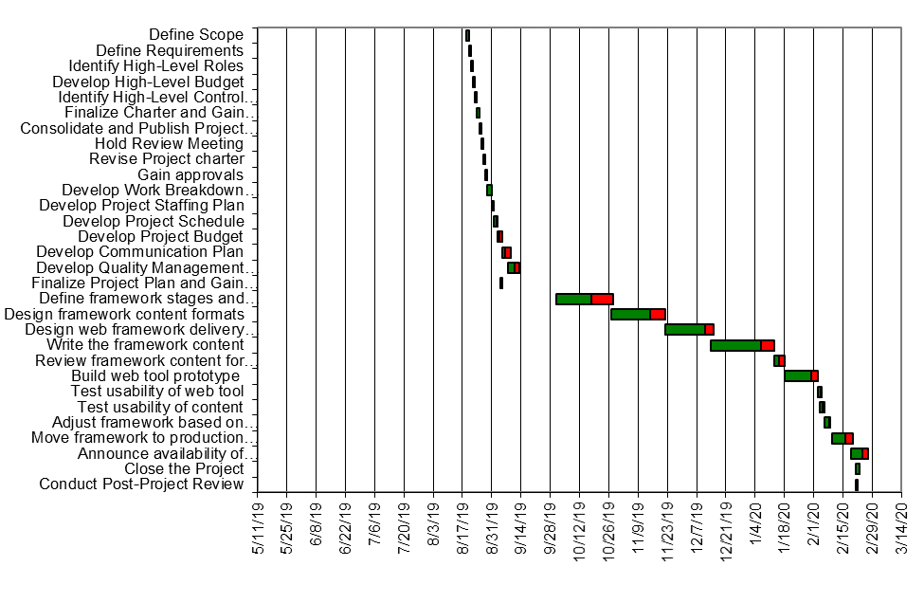

Proposed Methodology
We will be using Agile Methodology while developing the proposed system because it anticipates change and allows for much more flexibility than traditional methods. The purpose is to maintain the product's quality in the entire phase of development. Backtracking is the best advantage of agile methodology which is a disadvantage if working with waterfall models. Error tracking and resolving are much more efficient as compared to other models. So agile methodology might be best to follow whilst developing our proposed system.

Report Outline
- Introduction, Motivation, Goals, Gap Analysis, Proposed Solution
- Project Plan, WBS, Roles and Responsibility Matrix, Gantt Chart
- Building Methodology

Chapter 2

Software Requirement Specifications

Chapter 2: Software Requirement Specifications

Introduction

Purpose
Application targets people who are in need of any kind of medicine, disabled, sick, etc. Users shall be able to place an order regarding their selected medicine and our paid volunteers within the local area reach will buy and deliver those medicines at the user’s doorstep. Another functionality we shall help provide will be the ease to track down volunteer blood donors in the user area, registered with the Application.

Intended Audience and Reading Suggestions
Audience: Disabled People, Application Buyers, Random people to collect feedback, Blood Donors, Donee.
Sequence:
- Introduction, Motivation, Goals, Gap Analysis, Proposed Solution
- Project Plan, WBS, Roles and Responsibility Matrix, Gantt Chart
- Building Methodology

Product Scope
In the following project we will design an android application and admin-controlled website to deliver health, safe and quality assured medicinal products. The platform is designed for two types of users, Managers, Admin and Customers. Admins will manage all operations including data management adding data into database based on records collected from different medical stores, customers will place orders and Managers will accept orders to deliver products.

Requirement Gathering

Technique selected
Interview was used as the requirement gathering technique regarding the design for the following application. An Interview easily captures exactly what the customer needs and wants and lists out the aspects that are to be associated with the application.

Reason of Selection

Because the most important factor for some product or systems success is customer satisfaction. Customer satisfaction is definitely achieved if the products or systems itself are designed according to the customers need and requirements. Also, issues and errors can be easily detected and resolved by conducting interviews. Therefore, our group made up their minds to use interview as our official requirement gathering technique and we conducted thorough interviews against the mentioned two pharmacies to get to know what actually the users want in our system.

User Classes and Characteristics
Disabled People - Who aren’t able to fetch medicine for themselves
Unavailability – Sometimes due to unavailability of medicine within local area, people might tend to look forward to our application
Donee – People who require blood for donation

Operating Environment
This application will be available for all android devices. Each generation of laptop will be able to run the website application also.

User Documentation
No manual on paper shall be delivered. The app will come with its own set of tutorials that might help user understand and work through the application firsthand.

Assumptions and Dependencies
Assumptions: Typical errors regarding android studio.
Dependencies: Concepts from apps like FoodPanda or Cheetay might be referred to regarding implementation of maps dependency.

External Interface Requirements

User Interfaces

In this section, we shall present the Visual part of computer application through which the user will interact with the software. It determines how commands are given to the computer or the program and how information is displayed on the screen.

Customer

- Registration
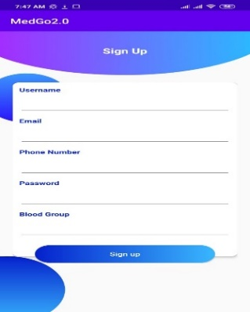

- Login-As
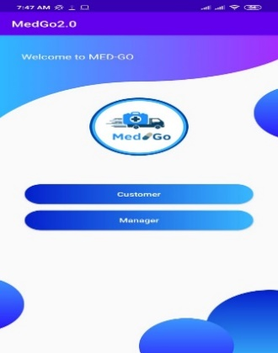

- Login
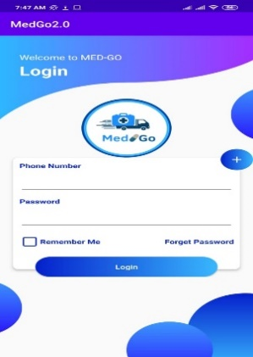

- Index
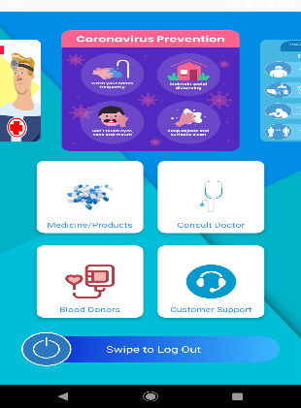

- Blood-Group
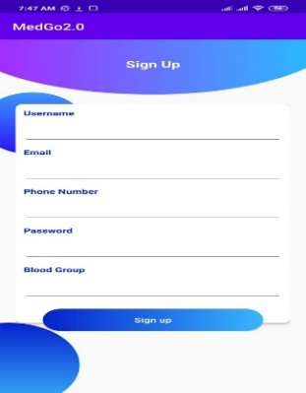

- Consult

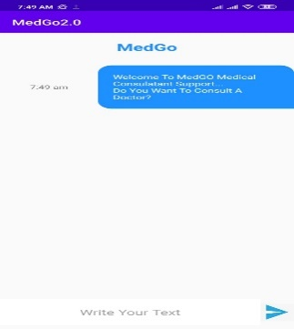

- Catalog
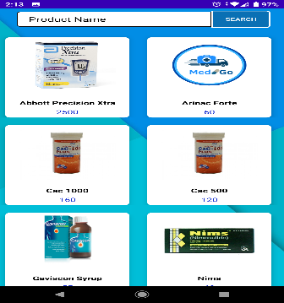

- Product Info
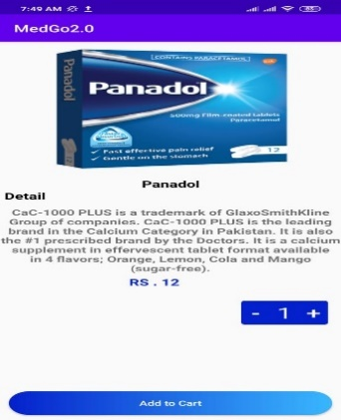

- Navigation Bar
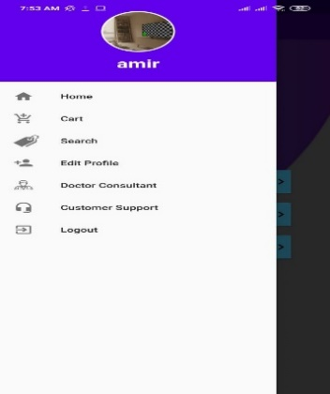

- Cart
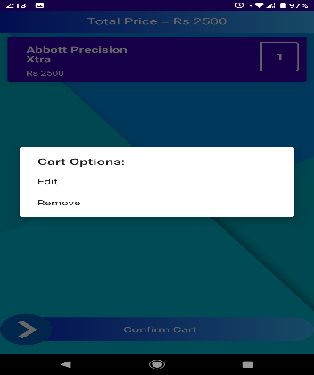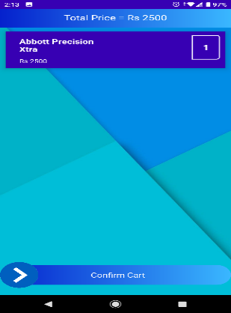

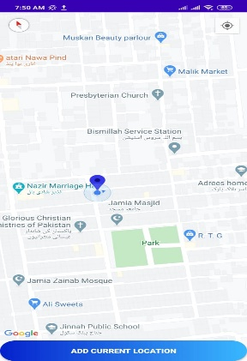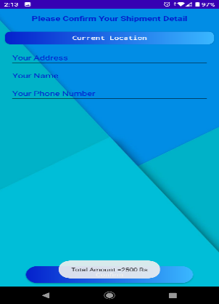

- Search
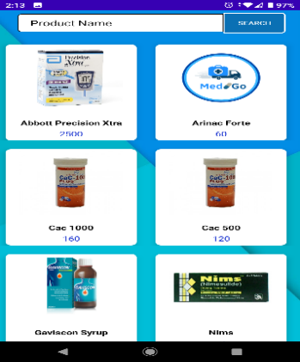
- Edit Profile
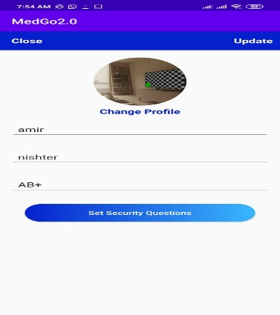
Manager

- Order
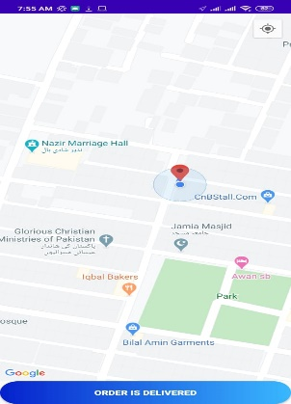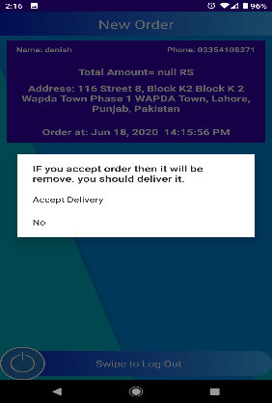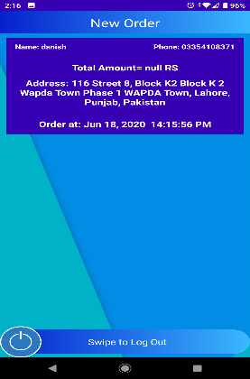

Administrator

- Login
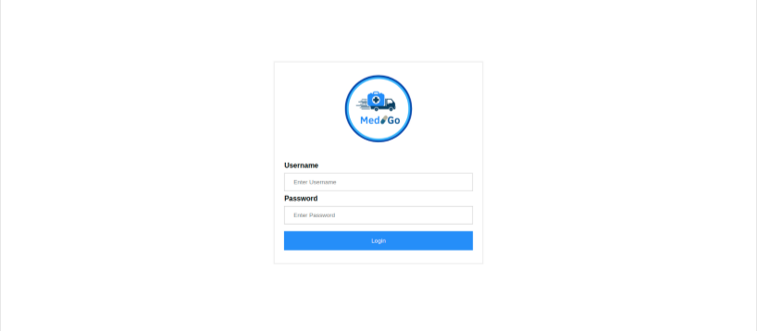
- Index
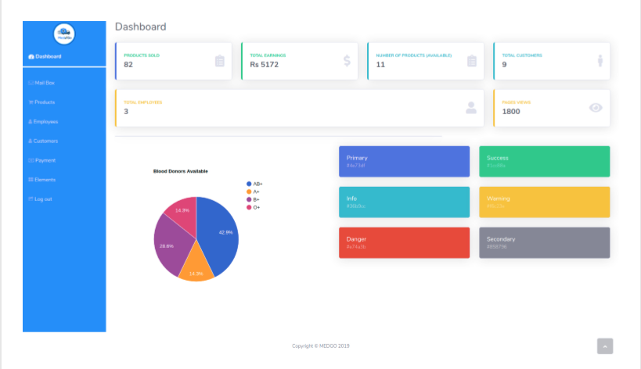

- Mail-Box
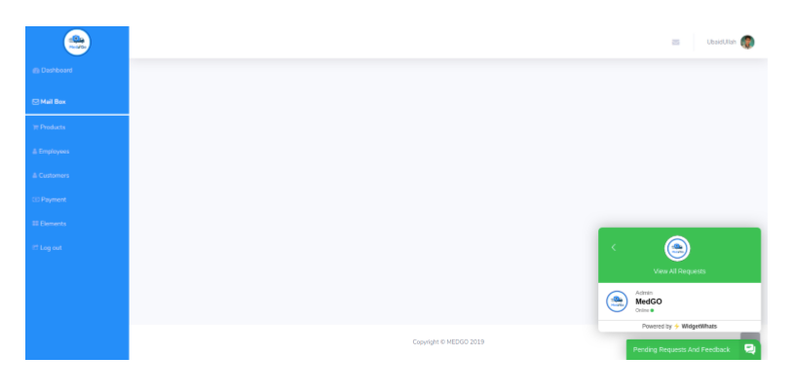

- Products
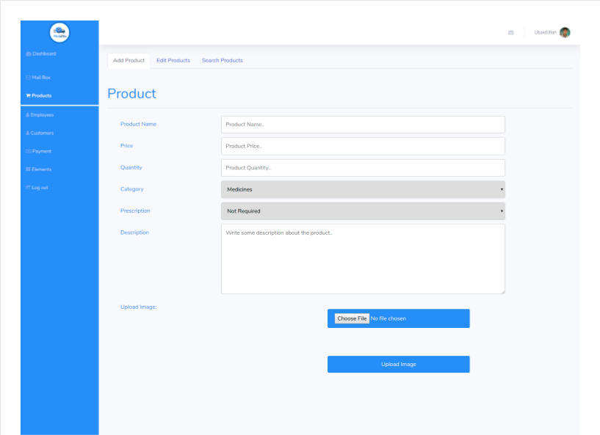
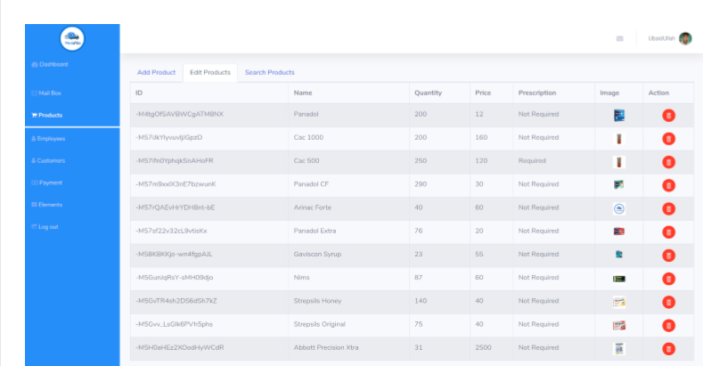
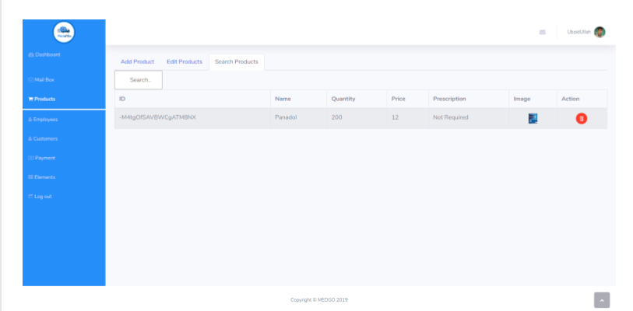

- Employees
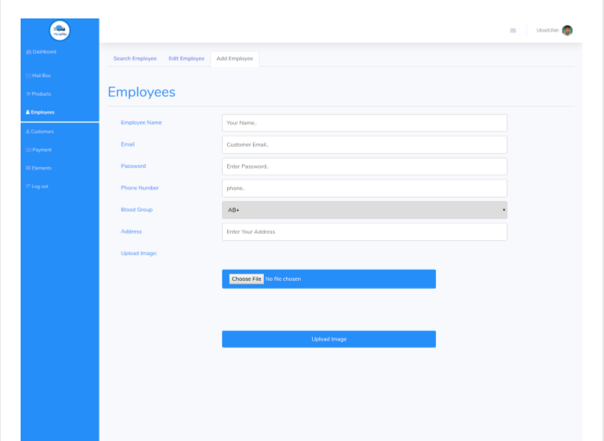

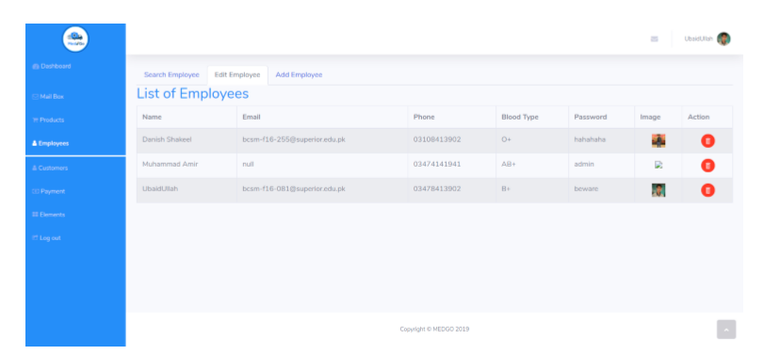

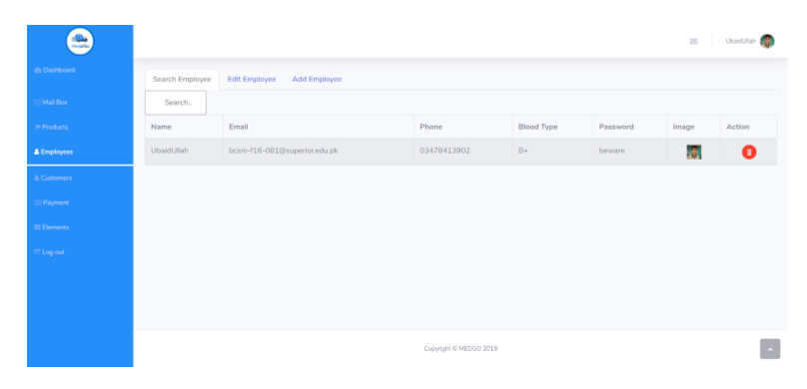

- Payments
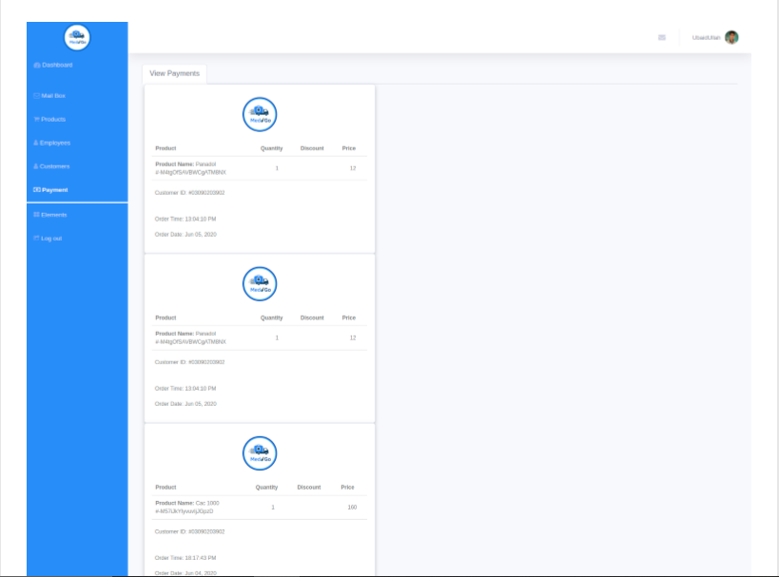
- Elements
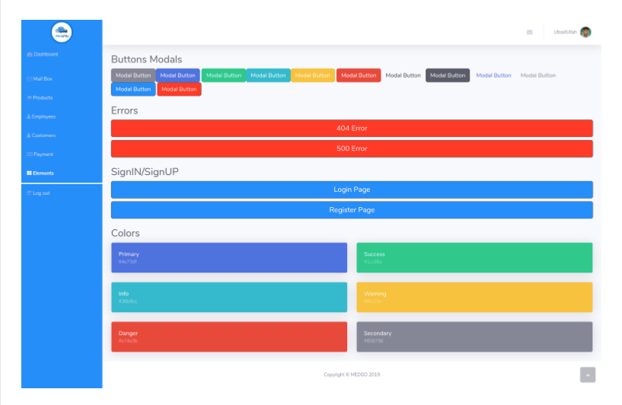
- Logout
To logout either press profile image to view logout button or directly click logout button in navigation bar.

Communications Interfaces
In case of android app, the application will include a chat option that would allow users to either communicate with a doctor or send prescription for the order to be confirmed against particular medicines.

Functional Requirement

REQ-SF-1: The first page when you open the website should be of Sign-in/Signup containing the following functionalities;
REQ-SF-1.1: The system should consist of a registration functionality so that visitors new to the site should be able to easily register themselves. Customers are optionally required to share their blood group and location for donation purposes.
REQ-SF-1.2: A login functionality that varies differently between admin, manager, and customer.
REQ-SF-1.3: Customers and Managers should be able to manage their profiles.
REQ-SF-1.3: A forget password option should be available allowing users to recover their accounts in case if they forget their passwords.

On Customers end, the Home page should have the following functionalities;
REQ-SF-2: Viewing products option.
REQ-SF-3: An option to view a well-designed product catalog.
REQ-SF-4: A convenient searching functionality to find and retrieve a product more easily.
REQ-SF-5: A Virtual cart functionality that allows the user to add and update their products.
REQ-SF-6: The cart functionality must also consist of an order placement button, which when pressed, places customers order and also a cancel order button which cancels the placed order.
REQ-SF-7: After order placement, Customers should be able to select a suitable payment method which allows customers to select from two types of payment procedures which are;
Cash on Delivery
REQ-SF-8: In return, the receipt should be displayed on the customer screen.
REQ-SF-9: In case if a prescription is required, user can select Send Prescription option to capture and send the prescription image,
REQ-SF-10: A Finding Blood Donor option which allows users to search for specific blood donors in the vicinity.
On Managers end, the Home page should have the following functionalities;
REQ-SF-11: Proper record maintenance option of products.
REQ-SF-12: Viewing products option.
REQ-SF-13: An adding product functionality.
REQ-SF-14: An updating and deleting functionality for products based on their records.
REQ-SF-15: A convenient searching functionality to find and retrieve a product more easily.
REQ-SF-16: A manage prescription functionality which allows users to retrieve user prescriptions and grant medicine access to specified users.
REQ-SF-17: After accepting an order, search the nearest medical store in the vicinity to purchase and deliver medicine.

On Admins end, the Home page should have the following functionalities;
REQ-SF-16: Surveillance of the entire system
REQ-SF-17: Proper record maintenance option for managers.

On the other hand, the system should be able to perform the following functionalities automatically;
REQ-SF-19: Customer record maintenance.
REQ-SF-20: Sorting of products.
REQ-SF-21: Updation of stock on the basis of each purchase made against the total sold quantity of products.
REQ-SF-22: Proper organization of products.
REQ-SF-23: Record maintenance of sales and profit made per day.

Moving on to how these Requirements will actually be implemented in the system;

- Sign-in/Signup
  - Registration
    - New customers should not be given direct access to the site.
    - Each new customer must have to first register themselves.
    - Each Customer is assigned a new Id upon registration.
    - Each customer should be assigned a security backup pin upon registration.
  - Login
    - Customers should login to access the features of the system.
    - Customers and managers should be allowed to view and update their login information.
    - Login functionality should vary differently among customer, manager and administrator.
  - Forget Password
    - If user forgets his/her password they would be directed to a page to enter a security pin assigned to them upon registration.
    - It may contain;

Variables | Constraints
Customer_id | Char/String length==13
Customer_name | Char/String (min>=3 && max <=25)
Customer_contact_number | Integer (length==11)
Customer_address | Char/String(min>=10 && max <=50)
CNIC | Integer (Length==13)
Password | Char/String(min>=3 && max <=15)
Admin_id | Char/String length==8
Password | Char/String(min>=3 && max <=15)
Manager_id | Char/String length==8
Password | Char/String (min>=3 && max <=15)
Security_Pin | Integer (Length==5)

- Add Product
  - Should contain an adding product functionality so that manager may add products in a sorted manner whenever new products are bought.
2.2 Manager should first ask the administrators permission before adding the new stock.
    - Once the request is approved, then the manager should proceed to his liking.
    - Both Managers and Admin should be able to view products from product page after adding.
    - It may contain;

Variables | Constraints
Product_id | Char/String (min>=5 && max <=15)
Product_name | Char/String (min>=3 && max <=25)
Product_cat | Char/String Char/String (min>=5 && max <=15)
Product_price | Float
Product_sale_price | Float
Stock | Integer

- Update/Delete Product
  - Should contain an updating and deleting product functionality in a sorted manner so that admin may update or delete old products whenever needed.
    - Manager should first ask the administrators permission before updating or deleting the stock.
    - Once the request is approved, then the manager should proceed to his liking
    - It may contain

Variables | Constraints
Product_id | Char/String (min>=5 && max <=15)
Product_name | Char/String (min>=3 && max <=25)
Product_cat | Char/String (min>=5 && max <=15)
Product_price | Float
Product_sale_price | Float
Stock | Integer

- Catalogue
4.1 View Catalogue
  - Offering customers a well-designed catalogue containing all the products available with exclusive offers, discounts also.
    - The catalogue may contain all information regarding products etc.
    - It may contain;

Variables | Constraints
Product_id | Char/String (min>=5 && max <=15)
Product_name | Char/String (min>=3 && max <=25)
Product_cat | Char/String (min>=5 && max <=15)
Product_sale_price | Float

  - Search Catalogue
    - Advanced form of product searching functionality.
    - This functionality offers ease of use for both customer and manager to directly view the product they are searching for.
    - It may contain ;

Variables | Constraints
Product_id | Char/String (min>=5 && max <=15)
Product_name | Char/String (min>=3 && max <=25)

- Virtual Cart
  - Customers should be each assigned a virtual cart.
    - Providing customers with a shopping cart functionality so that they may keep their selected products in check.
    - Products will be added on basis of name with quantity also, into the cart.
    - Allow View and change option for cart.
    - Provide an option for placement of orders. Also view Receipt option.
    - Upon order placement, an order number is assigned to customers order with order date. These have no link with test cases.
    - Provide an option for cancellation of orders.
    - It may contain

Variables | Constraints
Cart_id | Integer
Product_Name | Char/String (min>=3 && max <=25)
Quantity | Integer
Price | Float
Customer_id | Char/String length==13
Password | Char/String (min>=3 && max <=15)
Order_ID | Integer
Order_Date | Integer

  - Payment Method
    - After confirming order, Customer is to select the payment method.
They are of two types; Cash on Delivery, Online Transaction
  - Receipt generation
    - For this customer has to press confirm order for purchasing the products.
    - Once approved the bill is then calculated and receipt is showed to the customer.
It may contain ;

Variables | Constraints
Product_name | Char/String (min>=3 && max <=25)
Product_sale_price | Float
Quantity | Integer
Total_Bill | Integer

- Manage Employees
  - Management of employees.
    - This functionality allows administrators to view all managers.
    - This functionality allows administrators to add new managers.
    - This functionality allows administrators to update their manager records.
    - This functionality allows administrators to delete their manager records.

Variables | Constraints
Manager_id | Char/String (min>=5 && max <=15)
Manager _name | Char/String (min>=3 && max <=25)
Password | Char/String(min>=3 && max <=15)
Rank | Char/String (min>=3 && max <=6)

- Check Reports
  - Reports maintenance.
    - Proper maintenance of reports will be conducted.
    - All sales made per day shall be recorded.
    - Report of sales made per day will be generated.
    - Profit will also be taken into account.
    - Both Manager and Admin will view reports.
    - It may contain ;

Variables | Constraints
Sales | Integer
Profit | Integer

Other Nonfunctional Requirements

Reliability
It is necessary for the system to be online 24 hours per day and 7 days per week, regardless of any time-zone.
The proposed system in which the developer designs should be reliable so it efficiently interacts with the user. Secure access to confidential data.

Security
All users must have significant logins and must log in according to them. To avoid unauthorized access, logins should remain protected in times of system failure. No customer must have more than one account.

Usability
Getting registered must not take more than a minute or two.
Placing an order must not take more than a minute.
It should be easy to use for the customer and manage for admin.
People with no training shall be able to use the system.
The system should be portable to various operating environments.
If current hosting is not suitable for the system, it should be moved to another one in a minimum amount of time.

User-Friendly
The system should be user-friendly in all manners. It should take less time for customers to get registered and for all users to login.

Implementation
The system is implemented using both XML/Java for Mobile App and Bootstrap/HTML with backend being managed through Python language. Responsive web designing is used for making the website compatible with any type of screen.

Delivery
The whole system is expected to be delivered in five months of time with weekly evaluation by project guide

Efficiency
After the system is implemented, the customer can purchase medicines in an efficient manner without the need to actually learning to use the application

Chapter 3

Use Case Analysis

Chapter 3: System Analysis
In this chapter, we will design diagrams which will fully analyze how our system tends to actually function. These diagrams are part of the software engineering process which helps user detail their project. These diagrams are basically the map of a project defining the users the flow of the proposed project.

Use Case Model
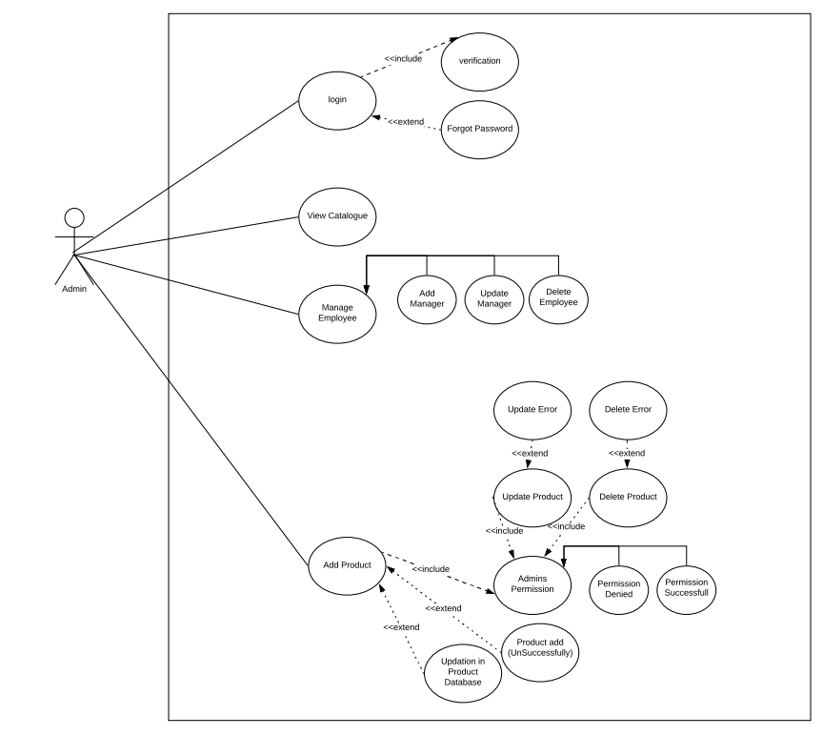
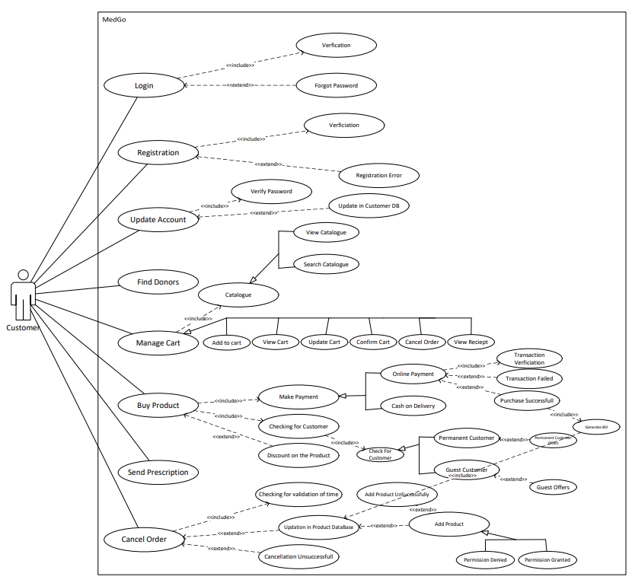
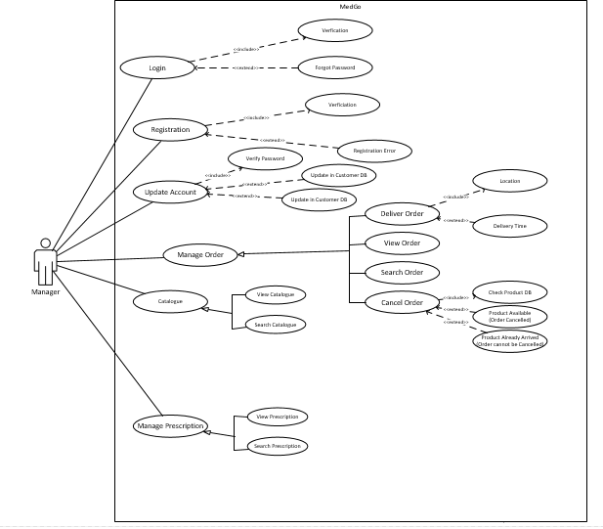

Fully Dressed Use Cases
F.D.U.C 1.0
Use case Name | Registration
Scope | Used for registration purposes.
Primary Actors | Customer, Manager
Stakeholders and Interests | Customer: Customer uses it to register on the app.  Manager: Manager uses it to register on the app.
Pre-Conditions | N/A
Post-Conditions | After registration customer is able to view profile and view products etc.
Main Scenario | - Customer/Manager opens webapp/mobile app.  - Customer/Manager selects Signup option  - Customer/Manager enters all required information.  - Customer/Manager registers themselves into the system.
Failure Case/ Alternative Case | Failure  If the functionality fails it would be due to network problem or adding already existing information for registration. | Alternative Case  The alternative would be to add non existing information.
Frequency of Occurrence | If discussed per day, Customer can use this functionality only once in a lifetime.
F.D.U.C 2.0
Use case Name | View Profile
Scope | Users use it to view their profile
Primary Actors | Customer, Admin, Manager
Stakeholders and Interests | Customer: Customer uses it to register on the system and view profile.
Pre-Conditions | Users must be logged in, to access their profile
Post-Conditions | After viewing profile, users perform required tasks.
Main Scenario | - Users open webapp/mobile app.  - Users log into the app.  - Select view profile option.  - View their profile.
Failure Case/ Alternative Case | Failure  If the functionality fails it would be due to network problem. | Alternative Case
Frequency of Occurrence | If discussed per day, Users can use this functionality countless times.

F.D.U.C 3.0
Use case Name | Update Profile
Scope | All users use it to manage their profile
Primary Actors | Customer, Manager, Admin
Stakeholders and Interests | All Users: All Users uses it to update their profile on the system.
Pre-Conditions | Users must be logged in, to access and update their profile
Post-Conditions | After Updating Profile users are able add ,view products etc
Main Scenario | - Users open webapp/mobile app.  - Users log into the app.  - Select view profile option.  - Select Update profile option.  - Update profile.  - Select confirm option.
Failure Case/ Alternative Case | Failure  If the functionality fails it would be due to network problem or another link set up instead of Update Profile Page. | Alternative Case
Frequency of Occurrence | If discussed per day, Customer can use this functionality only once in a lifetime.
F.D.U.C 4.0
Use Case Section | Comment
Use Case Name | Login
Scope | Users use it to log in to the app
Primary Actors | Customer, Manager, Admin
Stakeholders and Interests | Customer: Customer uses it to login to the app.  Manager: Manager uses it to login to the app.  Admin: Admin uses it to login to the app.
Pre-Conditions | N/A
Post-Conditions | After logging in, all users can perform their specified operations
Main Scenario | - Users open web/mobile app.  - Select Sign-in option.  - Customer logs into the app.  - Admin logs into the app.  - Manager logs into the app.
Failure Case/ Alternative Case | Failure  If the functionality fails it would be due to network problem or if a different link is set up instead of the login page. | Alternative Case  Forget Password
Frequency of Occurrence | If discussed per day admin and manager uses this functionality to login countless times.
F.D.U.C 5.0
Use Case Section | Comment
Use Case Name | Add Product
Scope | Used to add new products into the system
Primary Actors | Manager
Stakeholders and interests | Manager: Manager uses it to place new products to the system.  Admin: Admin permits the manager to place new products to the system.  Customer: After new products are added to the system, customer is able to purchase them.
Pre-Conditions | Manager should be logged in to the app.
Post-Conditions | After adding products Manager is able to update or delete them if required.
Main Scenario | - Manager opens webapp/mobile app.  - Manager logs in to the app  - Selects add product page option.  - Adds new products.  - Views the products added.
Failure Case/  Alternative Case | Failure  If the functionality fails it would be due to network problem or if a different link is set up instead of the add product page. | Alternative
Frequency of occurrence | If discussed per day, Manager uses this functionality to add products once.
F.D.U.C 6.0
Use Case Section | Comment
Use Case Name | View Product
Scope | Used to view products available in the system
Primary Actors | Manager, Admin
Stakeholders and interests | Manager: Manager uses it to view new products added to the system.  Admin: Admin views or permits the manager to view the products from the system.  Customer: After new products are added to the system, customer is able to purchase them.
Pre-Conditions | Manager and Admin should be logged in to the app.
Post-Conditions | After viewing products Manager is able to update or delete them if required.
Main Scenario | - Manager/Admin opens webapp/mobile app.  - Manager/Admin logs in to the app  - Selects view product page option.  - Views the products.
Failure Case/  Alternative Case | Failure  If the functionality fails it would be due to network problem or if a different link is set up instead of the view product page. | Alternative  Search Product
Frequency occurrence | If discussed per day, Manager and Admin use this functionality countless times.
F.D.U.C 7.0
Use Case Section | Comment
Use Case Name | Update Product
Scope | Used to update products available in the system
Primary Actors | Manager
Stakeholders and interests | Manager: Manager uses it to update the products part of the system.  Admin: Admin permits the manager to update the products in the system.  Customer: After products are updated, customer is able to purchase them.
Pre-Conditions | Manager should be logged in to the app.  The record of product to be updated should be available.
Post-Conditions | After updating products Manager is able to view, add or delete products if required.
Main Scenario | - Manager opens webapp/mobile app.  - Manager logs in to the app  - Selects update product page option.  - Updates the products.  - Selects confirm option.
Failure Case/  Alternative Case | Failure  If the functionality fails it would be due to network problem or if a different link is set up instead of the update product page. | Alternative
Frequency occurrence | If discussed per day, Manager uses this functionality countless times.
F.D.U.C 8.0
Use Case Section | Comment
Use Case Name | Delete Product
Scope | Used to delete products part of the system
Primary Actors | Manager
Stakeholders and interests | Manager: Manager uses it to delete the products part of the system.  Admin: Admin permits the manager to delete the products in the system.  Customer: After products are delete, customer is not able to view or purchase them.
Pre-Conditions | Manager should be logged in to the app.  The record of product to be deleted should be available.
Post-Conditions | After deleting products Manager is able to view, add or update other products if required.
Main Scenario | - Manager opens webapp/mobile app.  - Manager logs in to the app  - Selects delete product page option.  - Selects the products to delete.  - Deletes the products.  - Selects confirm option.
Failure/  Alternative | Failure  If the functionality fails it would be due to network problem or if a different link is set up instead of the delete product page. | Alternative
F.D.U.C 9.0
Use Case Section | Comment
Use Case Name | View Catalogue
Scope | Used to view a catalogue containing all products
Primary Actors | Customer, Admin, Manager
Stakeholders and interests | Admin: Admin permits manager to add new products to the system.  Manager: Manager adds new products to system.  Customer: After products are added, customer can view all the products through catalogue.  Admin: After products are added, Admin can view all the products through catalogue.  Manager: After products are added, Manager can view all the products through catalogue.
Pre-Conditions | Customer, Admin, Manager should be logged in to the app
Post-Conditions | After viewing catalogue, customer will add selective products to cart and purchase them.
Main Scenario | - Customer opens webapp/mobile app.  - Customer logs into the app.  - Selects catalogue option.  - Views all products.
Failure Case/  Alternative Case | Failure  If the functionality fails it would be due to network problem or if a different link is set up instead of the view catalogue option. | Alternative  Search Product
Frequency of occurrence | If discussed per day, Customer uses this functionality to view products more than once.

F.D.U.C 10.0
Use Case Section | Comment
Use Case Name | Search Catalogue
Scope | Used to Search the catalogue containing all products
Primary Actors | Customer, Manager
Stakeholders and interests | Admin: Admin permits manager to add new products to the system.  Manager: Manager adds new products to system.  Customer: After products are added, customer views the products through catalogue.  Admin: Admin can view specific products by selecting search catalogue option.
Pre-Conditions | Customer should be logged in to the app  Admin should be logged in to the app
Post-Conditions | After viewing catalogue, customer will add selective products to cart and purchase them.
Main Scenario | - Customer/Admin opens webapp/mobile app.  - Customer/Admin logs in to the app  - Selects catalogue option.  - Searches for a specific product.
Failure Case/  Alternative Case | Failure  If the functionality fails it would be due to network problem or if a different link is set up instead of the search catalogue option. | Alternative  View Catalogue
Frequency occurrence | Customer/Admin uses this functionality to view products more than once.
F.D.U.C 11.0

Use Case Section | Comment
Use Case Name | Add to cart
Scope | Used by customer so that they can add selective products to cart.
Primary Actors | Customer
Stakeholders and interests | Manager: Manager adds new products to the system.  Customer: Customer uses it to add new products to the cart.  Customer: After new products are added to cart, customer views cart.
Pre-Conditions | Customer should be logged in to the app.  Customer must use catalogue to add products into cart
Post-Conditions | After adding products to cart Customer is able to update or delete them if required.
Main Scenario | - Customer opens webapp/mobile app.  - Customer logs into the app.  - Selects products from catalogue.  - Adds products to cart.  - Views the products added.
Failure Case/  Alternative Case | Failure  If the functionality fails it would be due to network problem or if a different link is set up instead of the add to cart option.
Frequency of occurrence | If discussed per day, Customer uses this functionality to add products more than once.
F.D.U.C 12.0

Use Case Section | Comment
Use Case Name | View Cart
Scope | Used by customer to view products added to cart
Primary Actors | Customer
Stakeholders and interests | Manager: Manager adds new products to the system.  Customer: Customer adds new products to the cart.  Customer: After new products are added to cart, customer views cart.
Pre-Conditions | Customer should be logged in to the app.
Post-Conditions | After viewing products from cart Customer is able to add, update or delete products if required.
Main Scenario | - Customer opens webapp/mobile app.  - Customer logs into the app.  - Selects products from catalogue.  - Adds products to cart.  - Views the products added.
Failure Case/  Alternative Case | Failure  If the functionality fails it would be due to network problem or if a different link is set up instead of the view cart option. | Alternative
Frequency of occurrence | If discussed per day, Customer uses this functionality to view products more than once.

F.D.U.C 13.0

Use Case Section | Comment
Use Case Name | Update Cart
Scope | Used by customer to update products added to cart
Primary Actors | Customer
Stakeholders and interests | Manager: Manager adds new products to the system.  Customer: Customer adds new products to the cart.  Customer: After new products are added to cart, customer views and updates cart.
Pre-Conditions | Customer should be logged in to the app.  Customer must add products to cart to be able to update them
Post-Conditions | After updating products from cart Customer is able to add or delete products if required.
Main Scenario | - Customer opens webapp/mobile app.  - Customer logs into the app.  - Selects products from catalogue.  - Adds products to cart.  - Views the products added.  - Updates the products.
Failure Case/  Alternative Case | Failure  If the functionality fails it would be due to network problem or if a different link is set up instead of the update cart option. | Alternative.
Frequency of occurrence | If discussed per day, Customer uses this functionality to update products more than once.

F.D.U.C 14.0

Use Case Section | Comment
Use Case Name | Confirm order
Scope | Customer uses it to confirm their order
Primary Actors | Customer
Stakeholders and interests | Customer: Customer uses it to confirm order of products added to cart.  Tax Agencies: After order is confirmed, the tax displayed with total bill will go to tax agency.
Pre-Conditions | Customer should be logged in to the app.  Customer must add products to cart to confirm order.
Post-Conditions | When the customer confirms his order, he may purchase new product and also cancel his order.
Main Scenario | - Customer opens webapp/mobile app.  - Customer logs into the app.  - Customer searches for the product.  - System displays the product detail.  - Customer adds product to cart.  - Customer confirm the order.
Failure Case/  Alternative Case | Failure  If the functionality fails it would be due to network problem or if a different link is set up instead of the confirm order page. | Alternative
Frequency of occurrence | If discussed per day, Customer should use this functionality for order confirmation countless times.

F.D.U.C 15.0

Use Case Section | Comment
Use Case Name | Cancel order
Scope | Customer uses it to cancel the order that was confirmed before
Primary Actors | Customer
Stakeholders and interests | Customer: Customer first confirm his order.  Upon some crisis or for some reason, Customer uses this to cancel order.
Pre-Conditions | Customer should be logged in to the app.  Customer must have placed an order if required to cancel it.
Post-Conditions | When the customer confirms his order, but he likes the other product.so, he first cancels his first order and then place order for the other product.
Main Scenario | - Customer opens webapp/mobile app.  - Customer logs into the app.  - Customer should search for the product.  - Customer confirm the order.  - But the customer doesn’t have money to purchase this product.  - Then customer cancel his order
Failure Case/  Alternative Case | Failure  If the functionality fails it would be due to network problem or if a different link is set up instead of the cancel order page. | Alternative
Frequency of occurrence | If discussed per day, Customer may use this functionality to cancel order more than once.

F.D.U.C 16.0

Use Case Section | Comment
Use Case Name | Payment method
Scope | Customer uses it to select payment method
Primary Actors | Customer
Stakeholders and interests | Customer: Customer first confirms his order and then select the payment method.  Tax Agencies: After order is confirmed, the tax displayed with total bill will go to tax agency.
Pre-Conditions | Customer should be logged in to the app.  Customer must place an order to select payment method.
Post-Conditions | When the customer selects payment method, he may view other products or log out.
Main Scenario | - Customer opens webapp/mobile app.  - Customer logs into the app.  - Customer searches for the product.  - Customer adds product to cart.  - Customer confirms the order.  - Customer views the order.  - Customer selects payment method.
Failure Case/  Alternative Case | Failure  If the functionality fails it would be due to network problem or if a different link is set up instead of the select payment method page. | Alternative
Frequency of occurrence | If discussed per day, Customer should use this functionality of selecting payment method more than once.

F.D.U.C 17.0

Use Case Section | Comment
Use Case Name | Add Manager
Scope | Used to add new managers into the system
Primary Actors | Admin
Stakeholders and interests | Admin: Admin adds new managers to the system.  Manager: Manager manages the system.  Customer: Customer uses the system.
Pre-Conditions | Admin should be logged in to the app.  Admin should interview a manager to hire and add their record into system.
Post-Conditions | After adding Managers, Manager is able to manage the whole system.
Main Scenario | - Admin opens webapp/mobile app.  - Admin logs in to the app  - Selects add Manager page option.  - Adds new Employee.  - Views the Employee added.
Failure Case/  Alternative Case | Failure  If the functionality fails it would be due to network problem or if a different link is set up instead of the add Manager page. | Alternative
Frequency of occurrence | If discussed per day, new Admins use this functionality based on how many Employees he needs to manage the system.

F.D.U.C 18.0

Use Case Section | Comment
Use Case Name | Update Managers
Scope | Used to update Managers part of the system
Primary Actors | Admin
Stakeholders and interests | Admin: Admin uses it to update the Managers part of the system.  Manager: Manager manages the system.  Customer: Customer uses the system to purchase products.
Pre-Conditions | Admin should be logged in to the app.  Admin should add Managers to system if it is required to update their ranks
Post-Conditions | After updating Managers, Admin is able to view, add or delete them if required.
Main Scenario | - Admin opens webapp/mobile app.  - Admin logs in to the app  - Selects Manager page option.  - Updates the Managers.  - Selects confirm option.
Failure Case/  Alternative Case | Failure  If the functionality fails it would be due to network problem or if a different link is set up instead of the update Manager page. | Alternative
Frequency of occurrence | If discussed per day, Admin uses this functionality based on Employee behavior and work.

F.D.U.C 19.0

Use Case Section | Comment
Use Case Name | Delete Managers
Scope | Used to delete Managers part of the system
Primary Actors | Admin
Stakeholders and interests | Admin: Admin uses it to delete the Managers part of the system.  Manager: Manager manages the system.  Customer: Customer uses the system to purchase products.
Pre-Conditions | Admin should be logged in to the system.  Admin should add Managers to system if it is required to delete their records
Post-Conditions | After deleting Managers, Admin is able to view, add or update other Managers if required.
Main Scenario | - Admin opens webapp/mobile app.  - Admin logs in to the app  - Selects delete Manager page option.  - Selects the products to delete.  - Deletes the Managers.  - Selects confirm option.
Failure Case/  Alternative Case | Failure  If the functionality fails it would be due to network problem or if a different link is set up instead of the delete Manager page. | Alternative
Frequency of occurrence | If discussed per day, Admin uses this functionality based on Employee behavior and work.

F.D.U.C 20.0

Use Case Section | Comment
Use Case Name | Permission
Scope | Used by manager to request permission from admin.
Primary Actors | Manager
Stakeholders and interests | Manager: Manager asks permission to add, update, delete products from system.  Manager: Manager asks permission to check sales and profit reports.  Admin: Admin permits the manager to perform above mentioned tasks.
Pre-Conditions | Manager should be logged in to the app.
Post-Conditions | Manager can manage products or view reports.
Main Scenario | - Manager opens webapp/mobile app.  - Manager logs in to the app  - Requests permission by giving ID.  - After being permitted performs required tasks.
Failure Case/  Alternative Case | Failure  If the functionality fails it would be due to network problem or if a different link is set up instead of the permission option. | Alternative
Frequency of occurrence | If discussed per day, Manager uses this functionality more than once.

F.D.U.C 21.0
Use Case Section | Comment
Use Case Name | Check Reports
Scope | Used by both Manager and Admin to view daily sales and profit reports.
Primary Actors | Manager, Admin
Stakeholders and interests | Manager: Manager asks permission to check sales and profit reports.  Admin: Admin permits the manager to perform above mentioned tasks.  Admin: Admin checks reports.
Pre-Conditions | Manager and Admin should be logged in to the app.
Post-Conditions
Main Scenario | - Manager/Admin opens webapp/mobile app.  - Manager/Admin log in to the app  - Admin selects checks reports option.  - Manager requests permission by giving ID.  - After being permitted performs checks reports.
Failure Case/  Alternative Case | Failure  If the functionality fails it would be due to network problem or if a different link is set up instead of the check reports option. | Alternative
Frequency of occurrence | If discussed per day, Manager or Admin use this functionality once.

F.D.U.C 22.0
Use Case Section | Comment
Use Case Name | Find Donor
Scope | Customer uses it to find blood donors in the area.
Primary Actors | Customer
Stakeholders | Customer: Customer tracks donors on basis of the blood the donors registered in the app.
Pre-Conditions | It is compulsory that the customer is logged into the webapp.
Post-Conditions | Customer can request for donor help.
Main Scenario | - Customer opens webapp/mobile app.  - Customer logs into the app.  - Customer selects Track donor option  - Customer enters blood required.  - Customer request for donor help if donor is found.
Failure Case/  Alternative Case | Failure  If the functionality fails it would be due to network problem or if a different link is set up instead of the find donor option. | Alternative
Frequency of occurrence | If discussed per day, Customer use this functionality once.
F.D.U.C 23.0
Use Case Section | Comment
Use Case Name | Send Prescription
Scope | Customer uses it to send prescription to manager.
Primary Actors | Customer
Stakeholders and interests | Customer: Customer selects medicine to buy and if prescription is required sends image to manager.
Pre-Conditions | It is compulsory that the customer is logged into the webapp.  Customer must have selected the required medicine.
Post-Conditions | Customer can place order if prescription is considered valid.
Main Scenario | - Customer opens webapp/mobile app.  - Customer logs into the app.  - Customer searches medicine and selects add to card option.  - Customer selects prescription image.  - Customer waits for manager reply.
Failure Case/  Alternative Case | Failure  If the functionality fails it would be due to network problem or if a different link is set up instead of the send prescription option. | Alternatice
Frequency of occurrence | If discussed per day, Customer use this functionality multiple times.

F.D.U.C 24.0

Use Case Section | Comment
Use Case Name | Manage Prescription
Scope | Used to check and validate prescription image.
Primary Actors | Manager
Stakeholders and interests | Manager: Manager checks prescription sent by customer and validates if it is original or not.
Pre-Conditions | Manager should be logged in to the app.
Post-Conditions | Manager can manage confirm customer order.
Main Scenario | - Manager opens webapp/mobile app.  - Manager logs in to the app  - Manager checks prescription option  - After validating, user confirms order for the customer.
Failure Case/  Alternative Case | Failure  If the functionality fails it would be due to network problem or if a different link is set up instead of the manage prescription option. | Alternative
Frequency of occurrence | If discussed per day, Manager uses this functionality more than once.

F.D.U.C 25.0

Use Case Section | Comment
Use Case Name | Deliver Order
Scope | Used to confirm if order can be placed.
Primary Actors | Manager
Stakeholders and interests | Manager: Manager checks prescription sent by customer and validates if it is original and selects deliver order option or in case of simple order confirms order delivery.
Pre-Conditions | Manager should be logged in to the app.
Post-Conditions | Manager can delivercustomer order.
Main Scenario | - Manager opens webapp/mobile app.  - Manager logs in to the app  - Manager checks prescription option  - Manager checks order option.  - After validating, user confirms order for the customer.
Failure Case/  Alternative Case | Failure  If the functionality fails it would be due to network problem or if a different link is set up instead of the manage prescription option. | Alternative
Frequency of occurrence | If discussed per day, Manager uses this functionality more than once.

Chapter 4

System Design

Chapter 4: System Design
In this chapter, we will design diagrams which will fully depict how our system tends to actually function. These diagrams are part of the software engineering process which helps user detail their project. These diagrams are basically the map of a project defining the users the flow of the proposed project.

Architecture Diagram
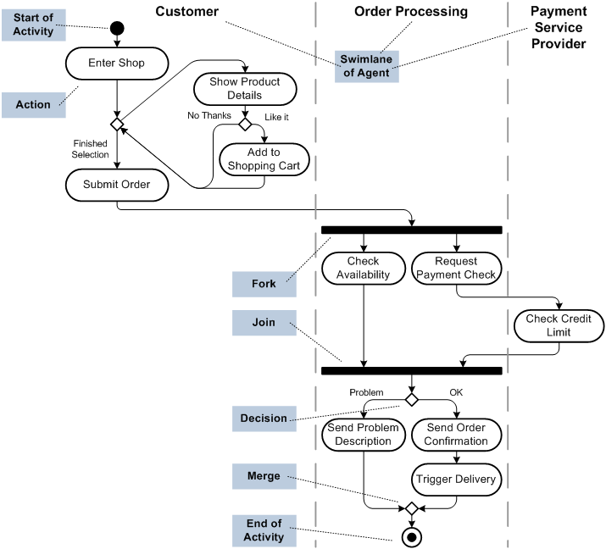

Domain Model
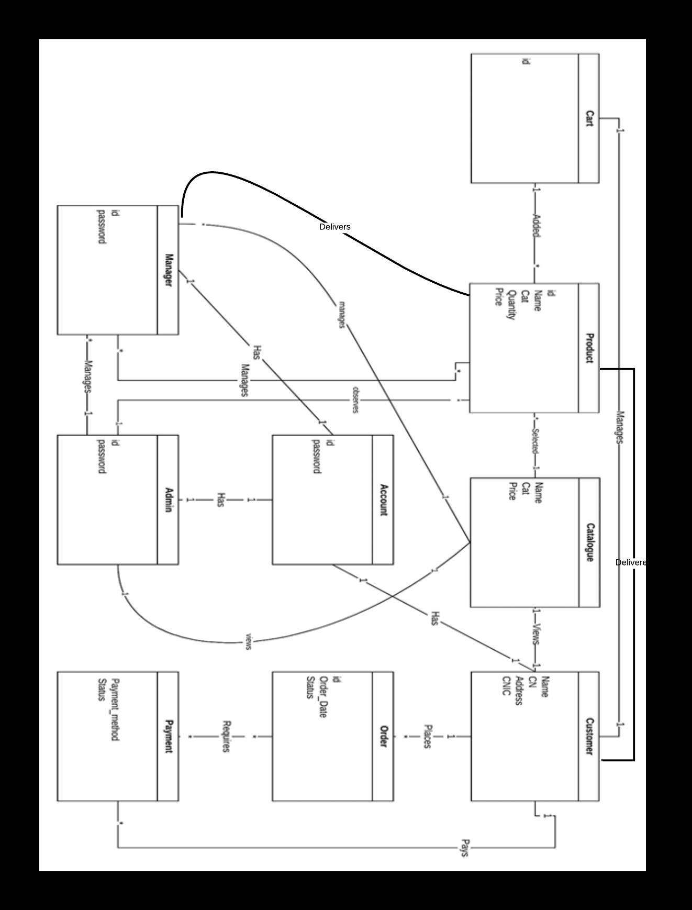

Class Diagram
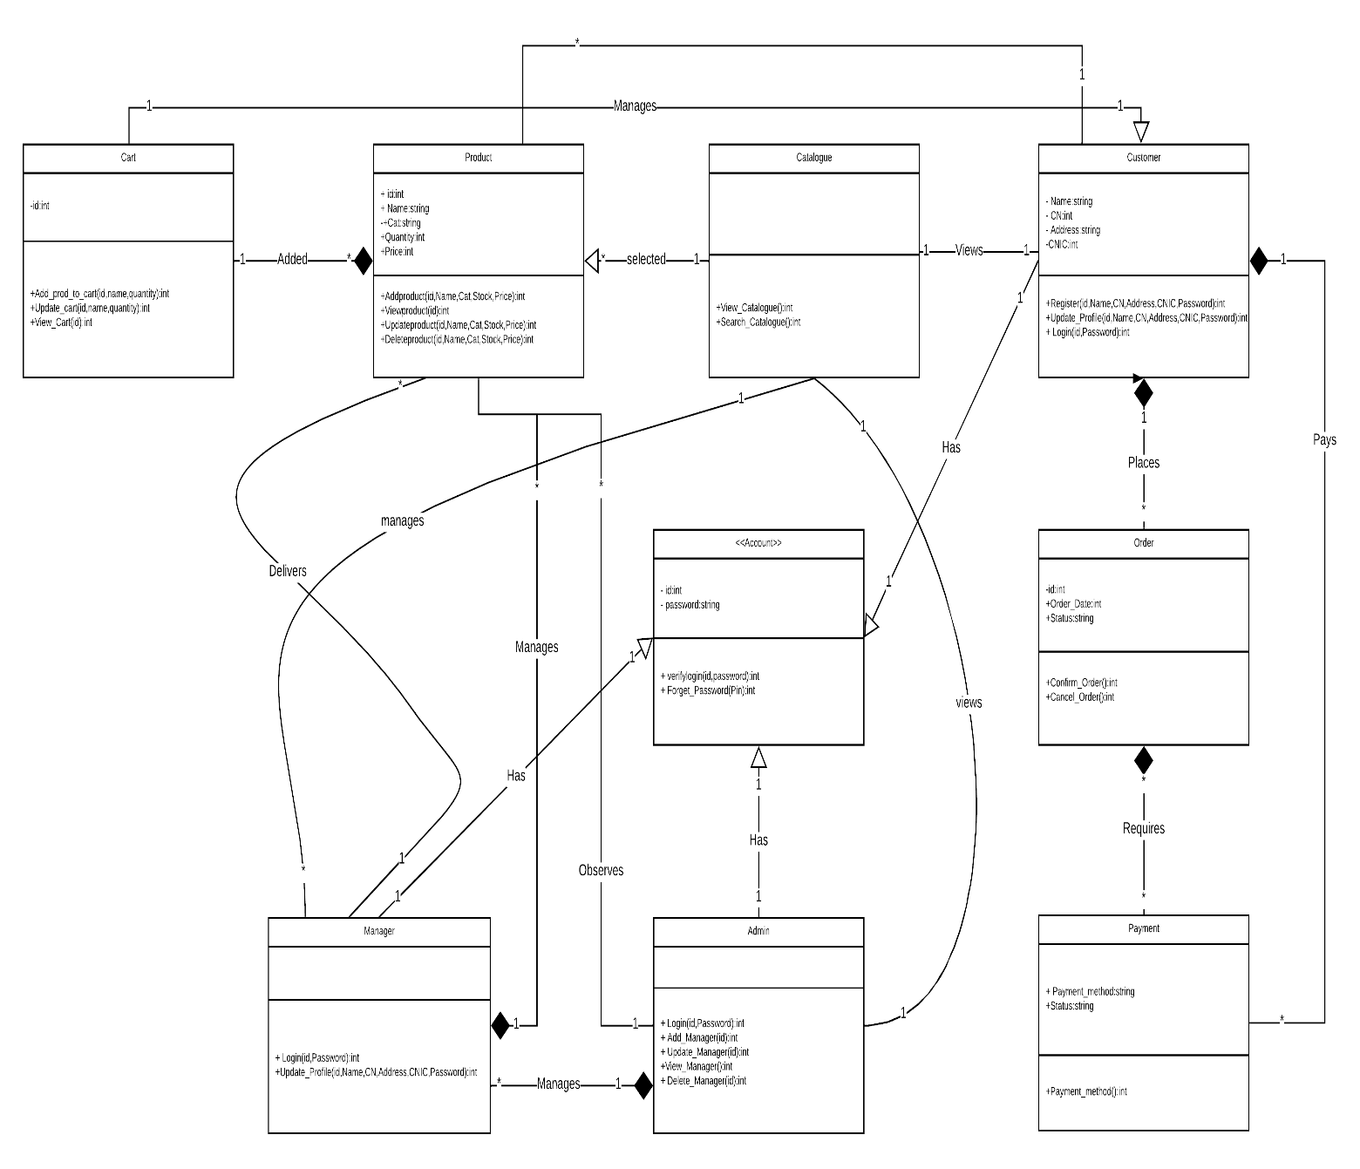

Sequence / Collaboration Diagram
S.D 1.0

S.D 2.0
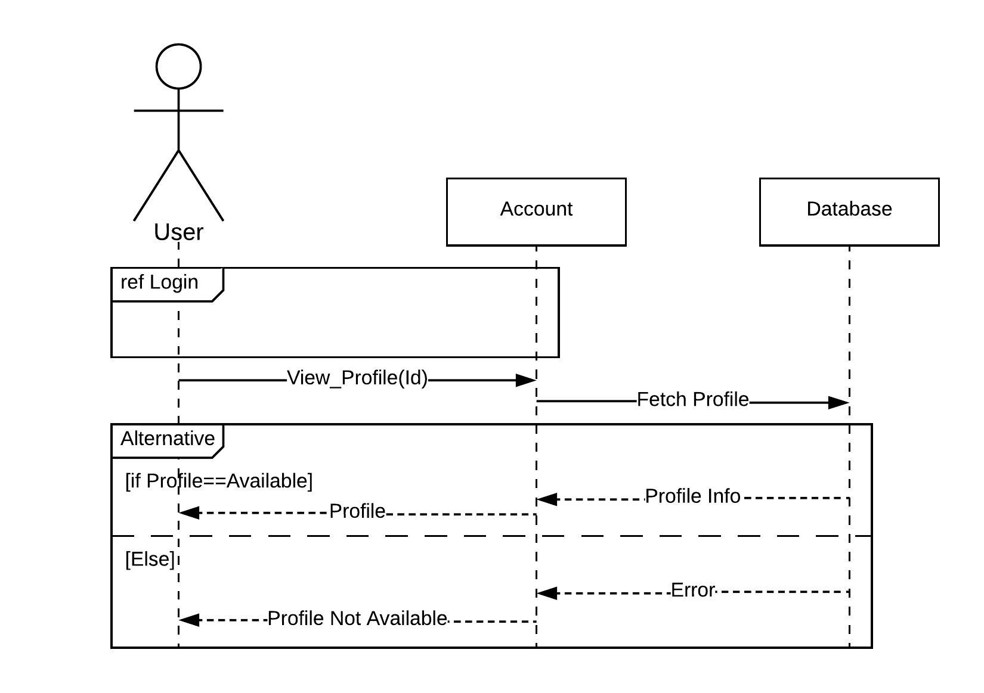
S.D 3.0
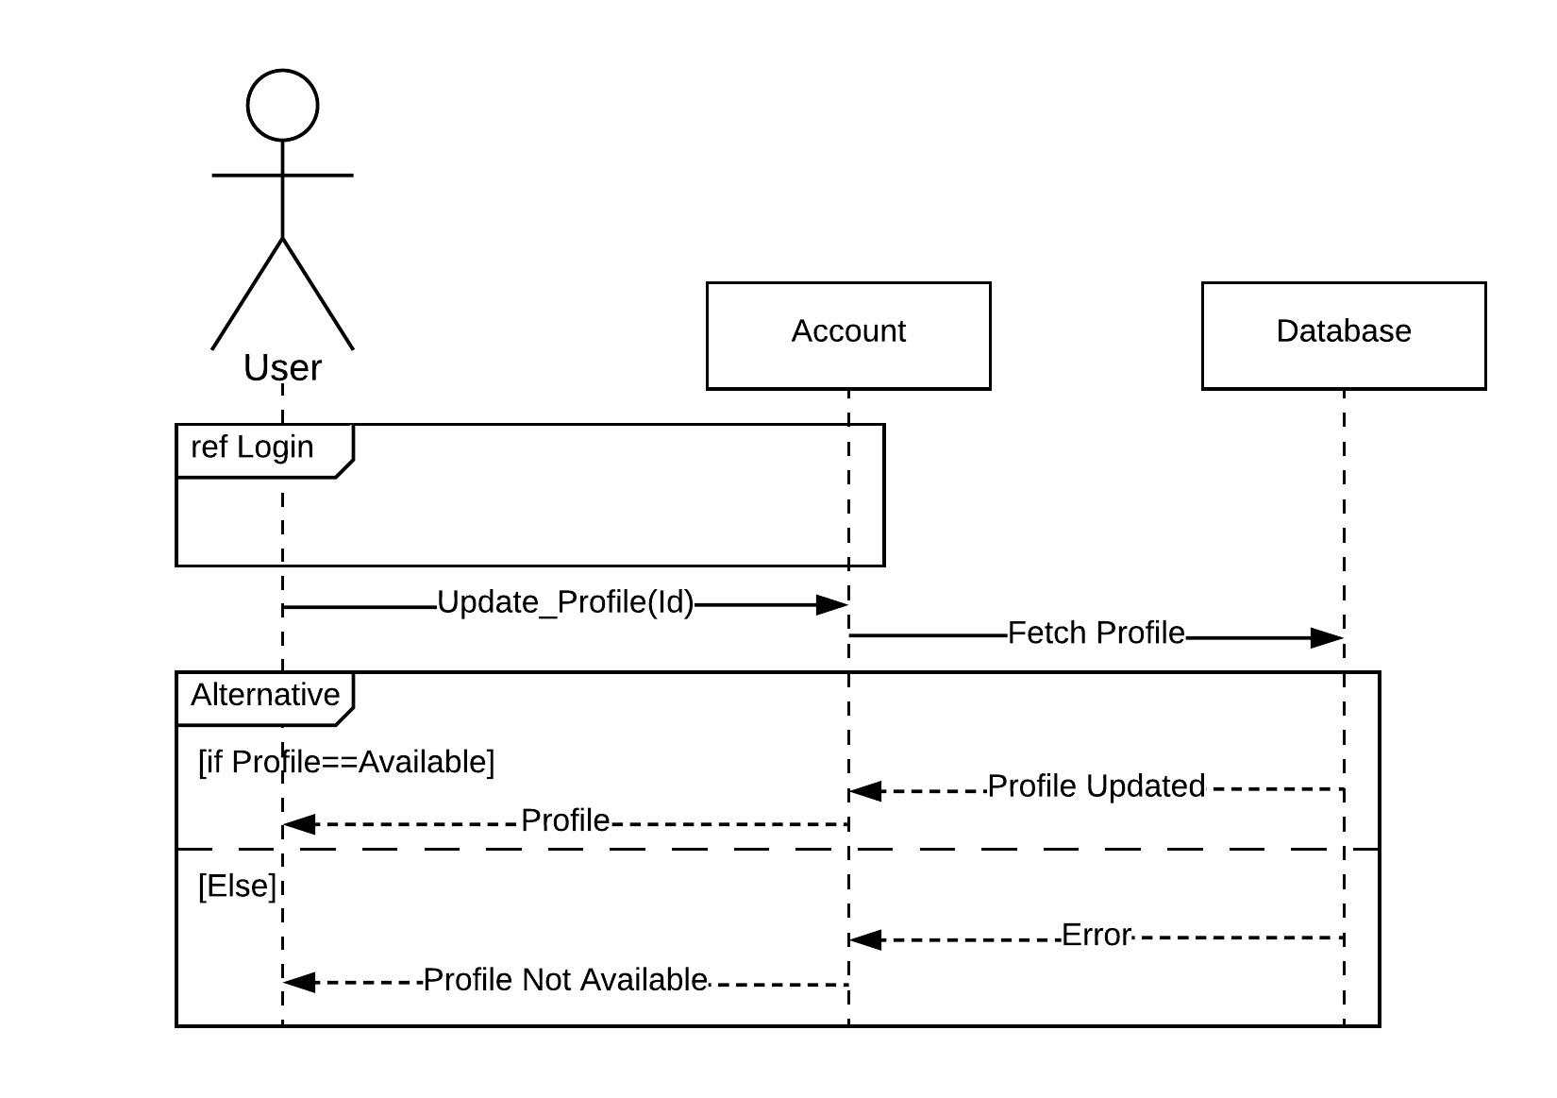
S.D 4.0

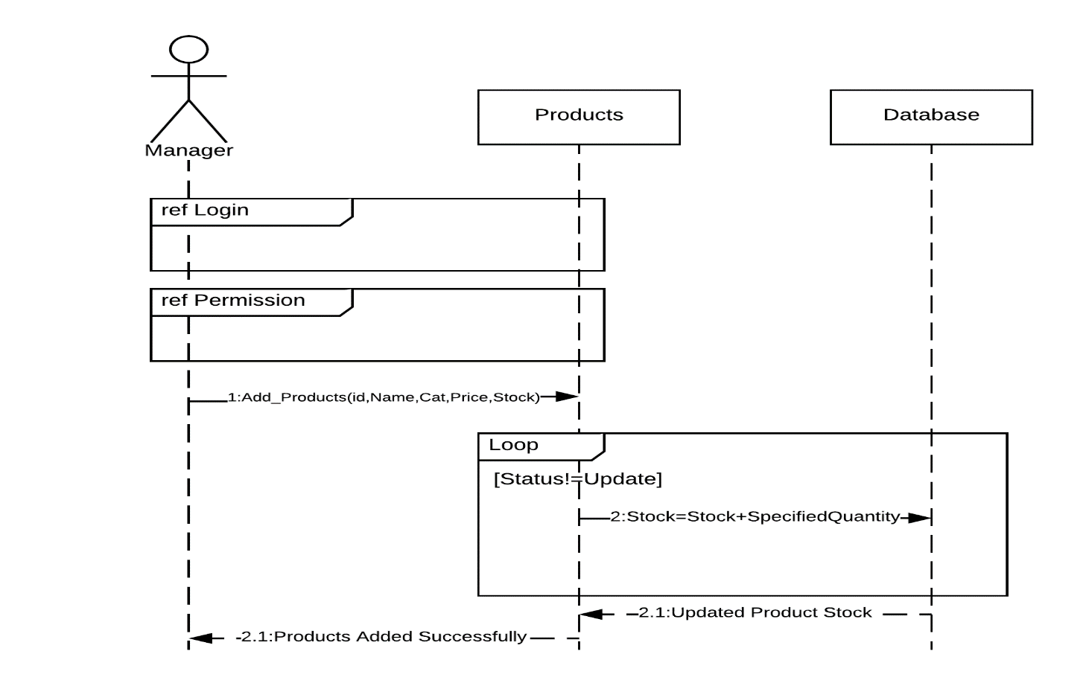S.D 5.0

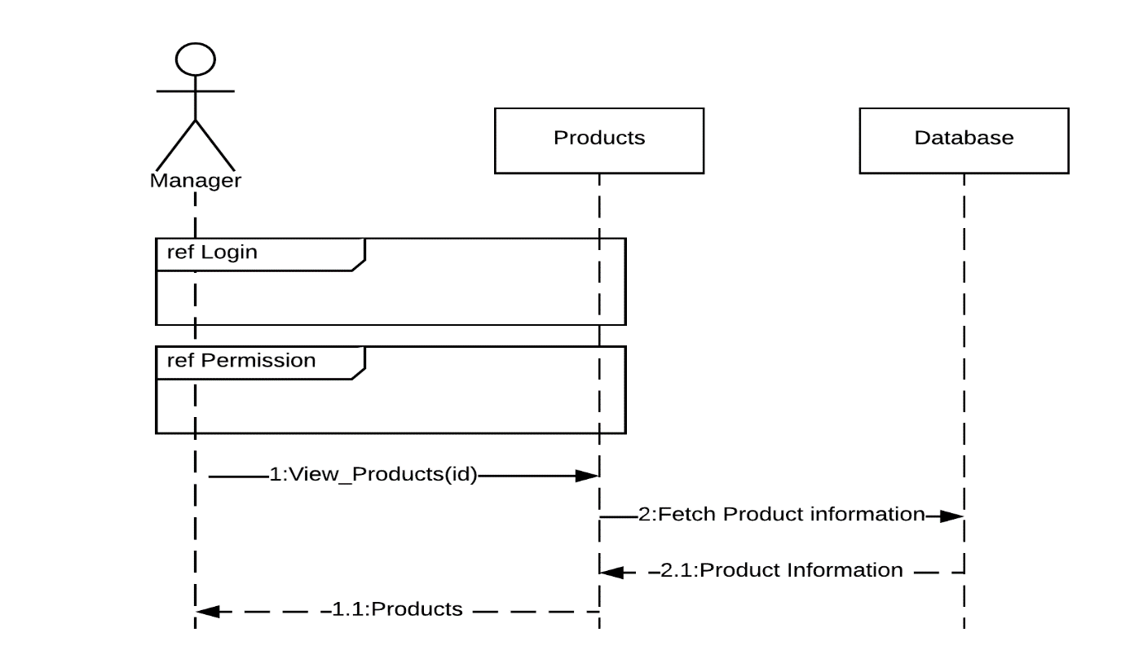S.D 6.0
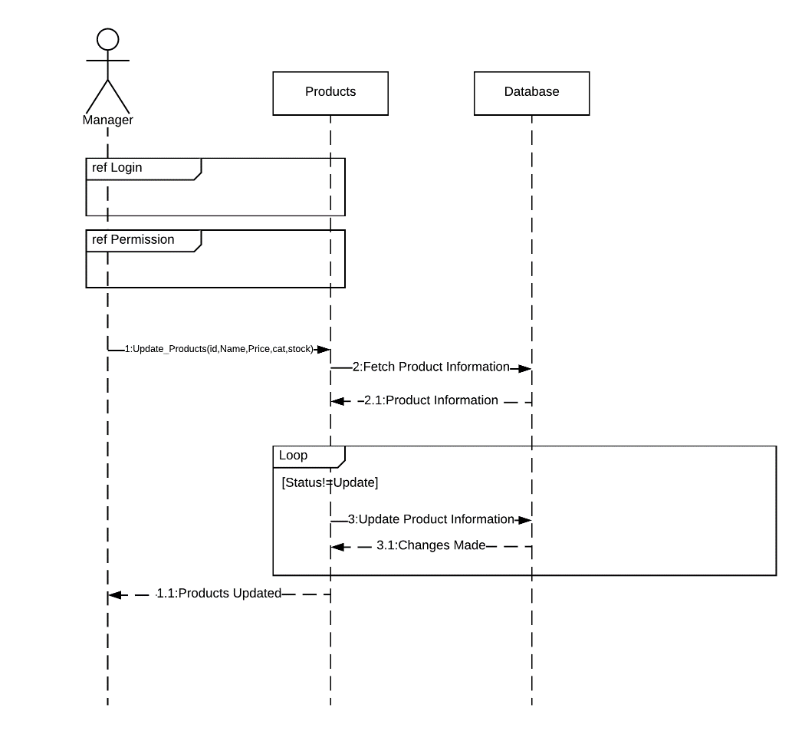S.D 7.0

S.D 8.0
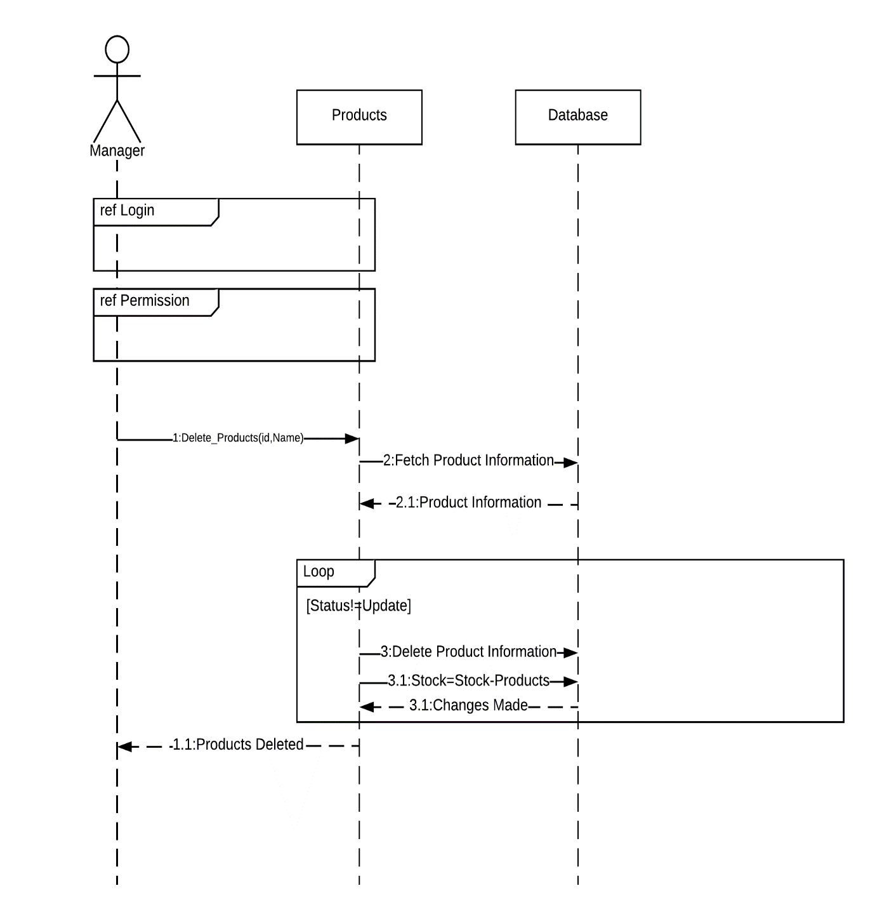

S.D 9.0
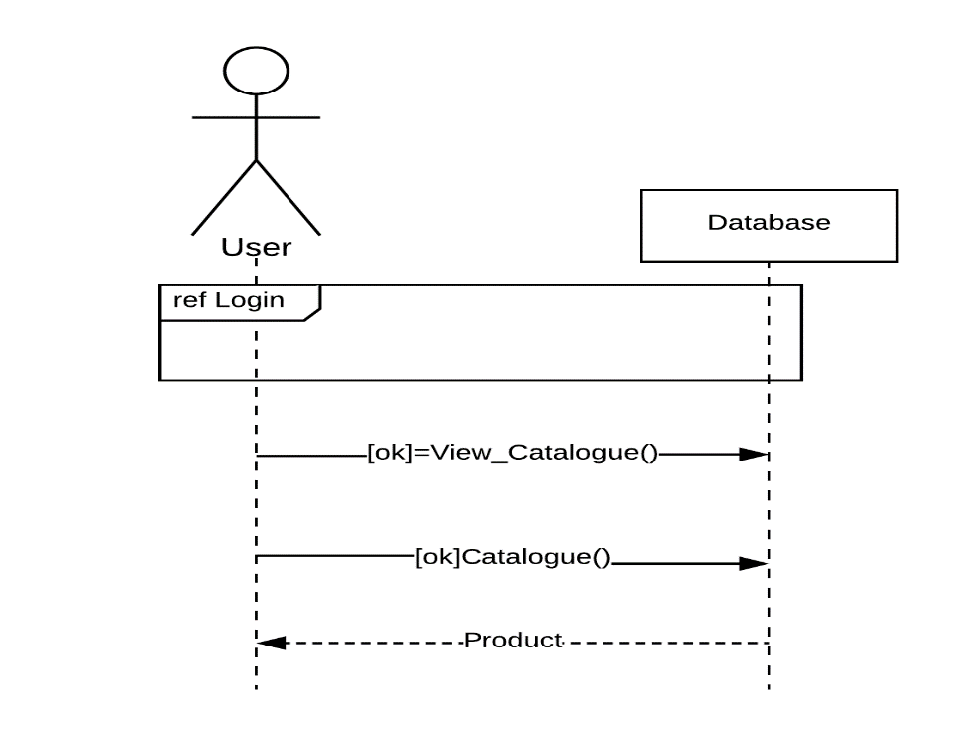

S.D 10.0

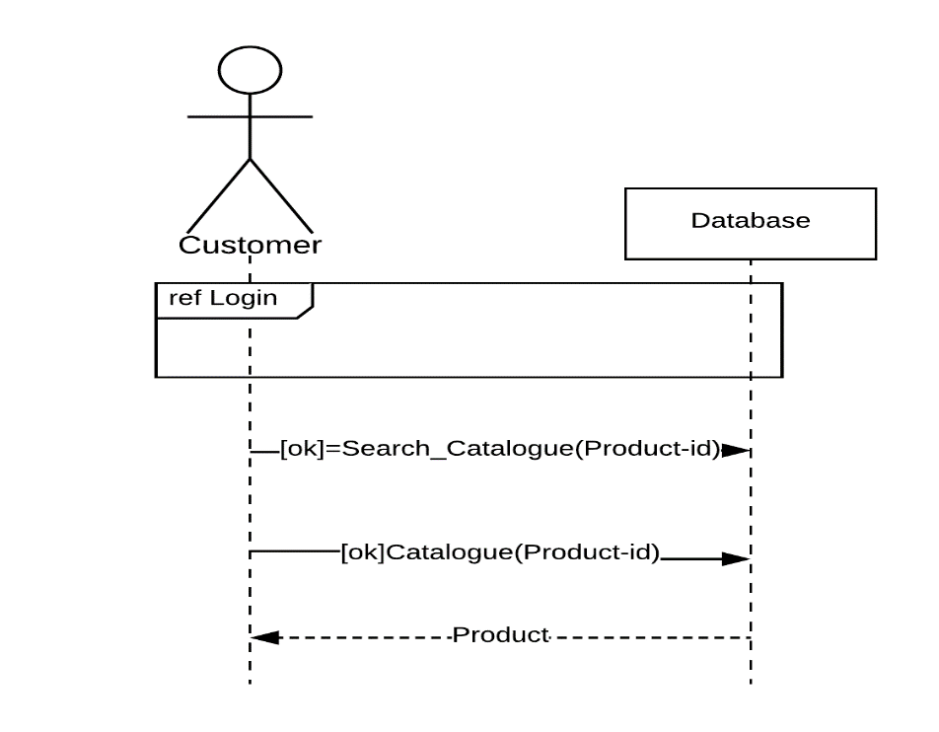

S.D 11.0
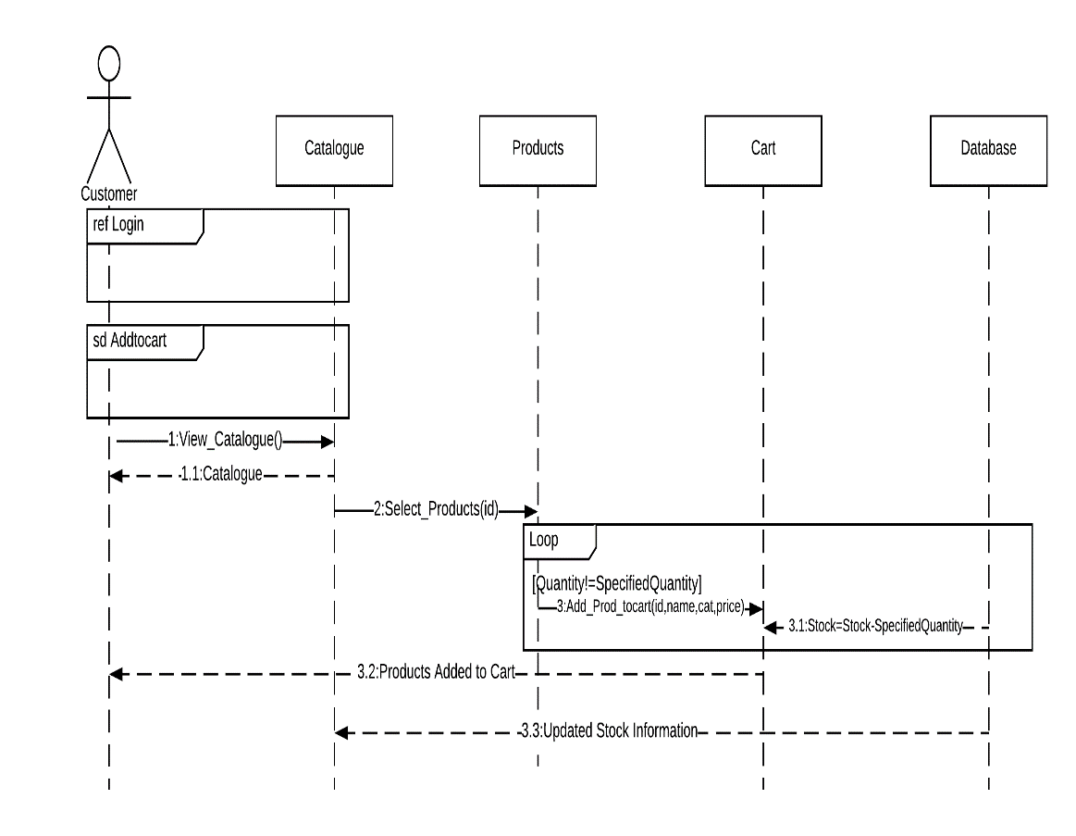

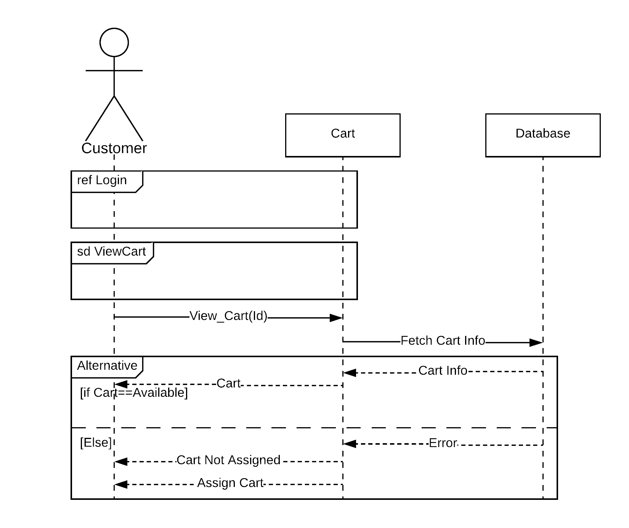S.D 12.0

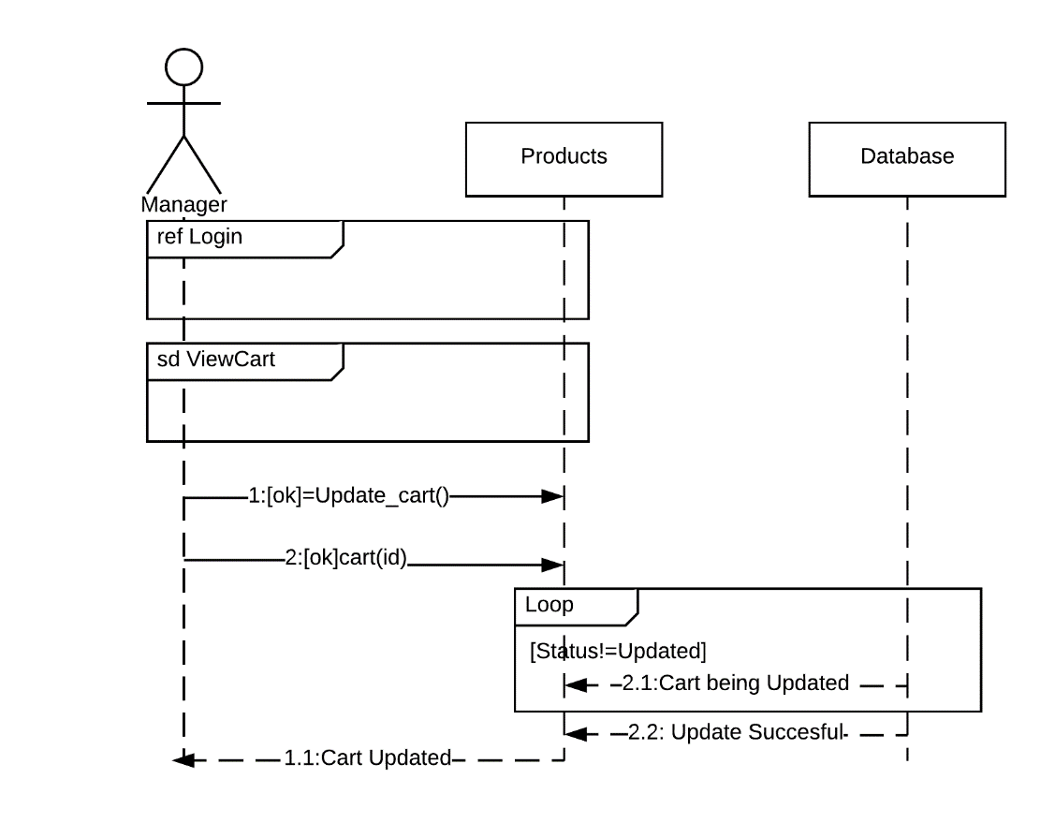S.D 13.0

Customer

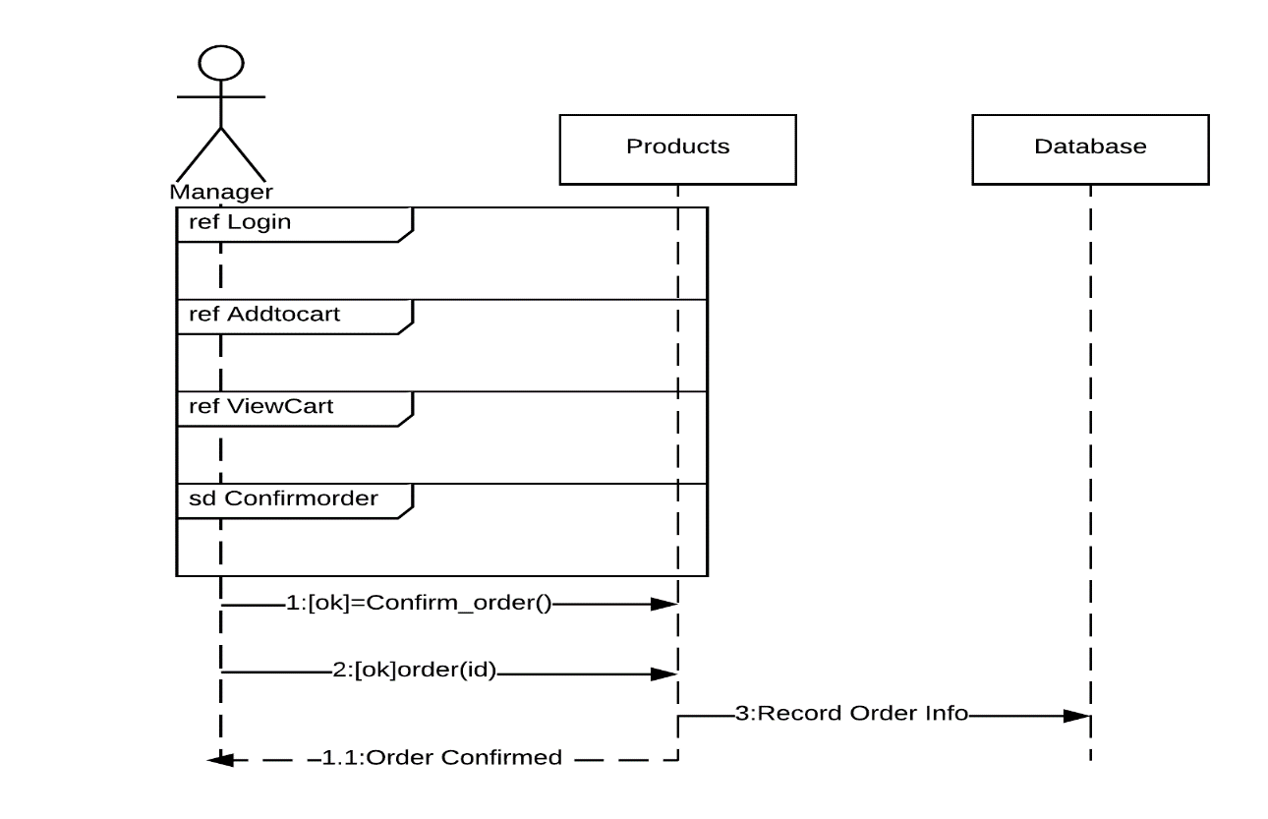S.D 14.0
Customer
Cart
Cart

Customer
S.D 15.0
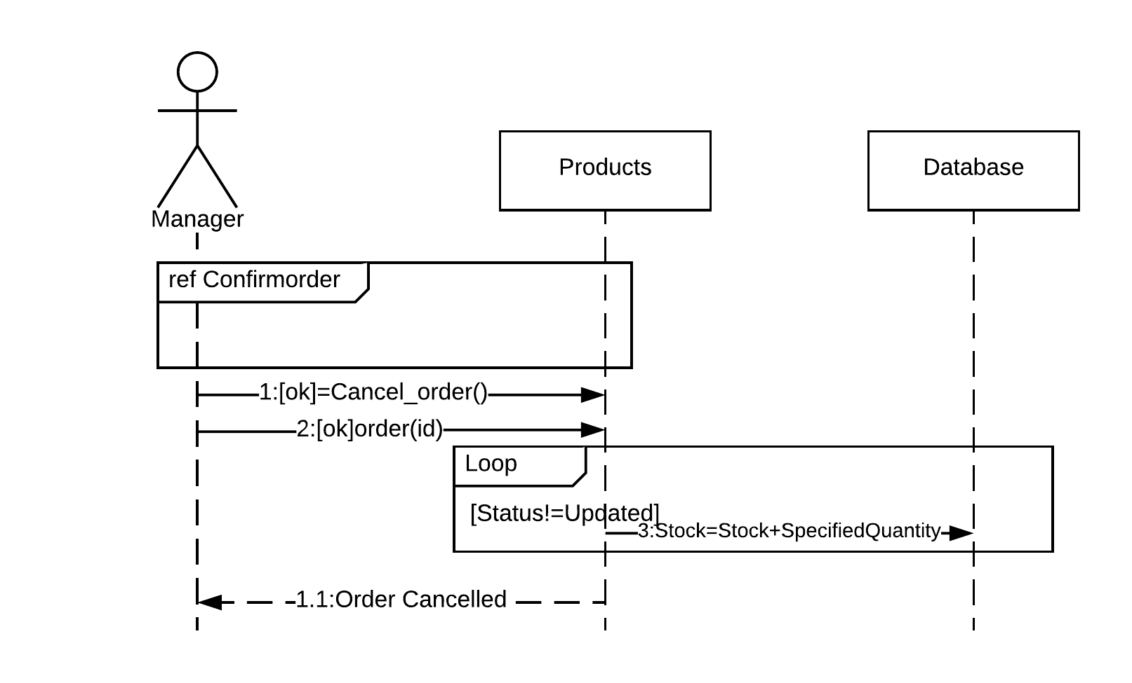
Cart
Customer
Customer
S.D 16.0
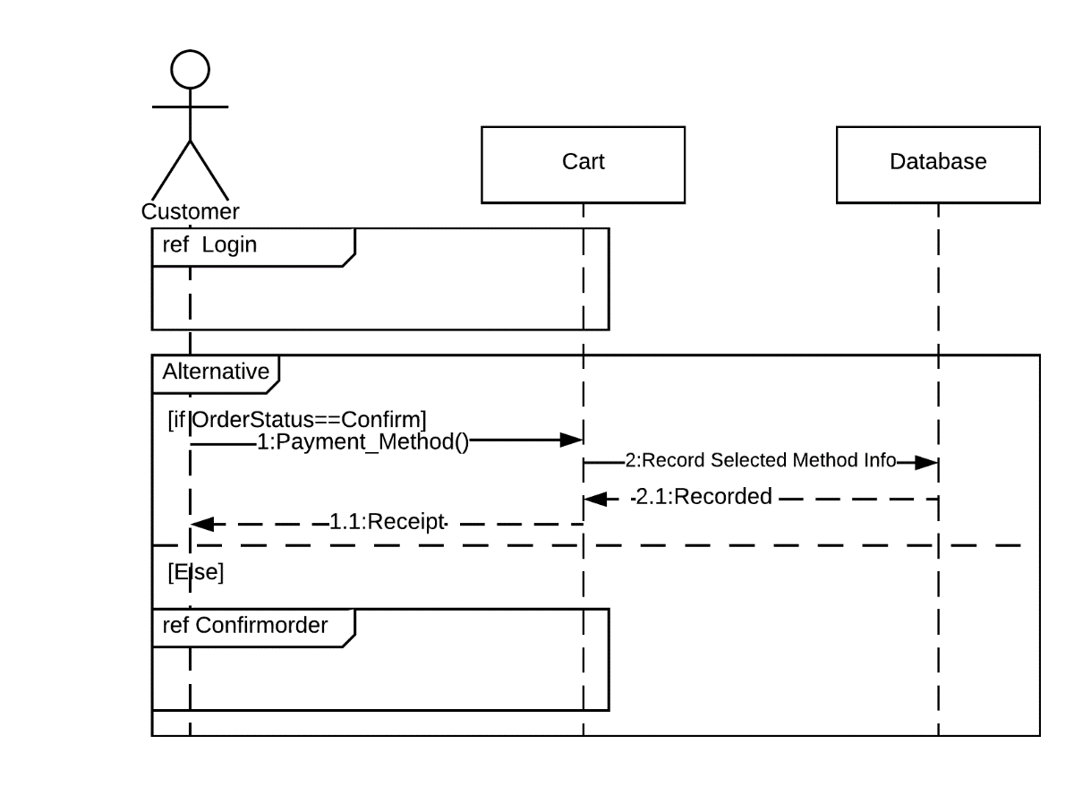

S.D 17.0
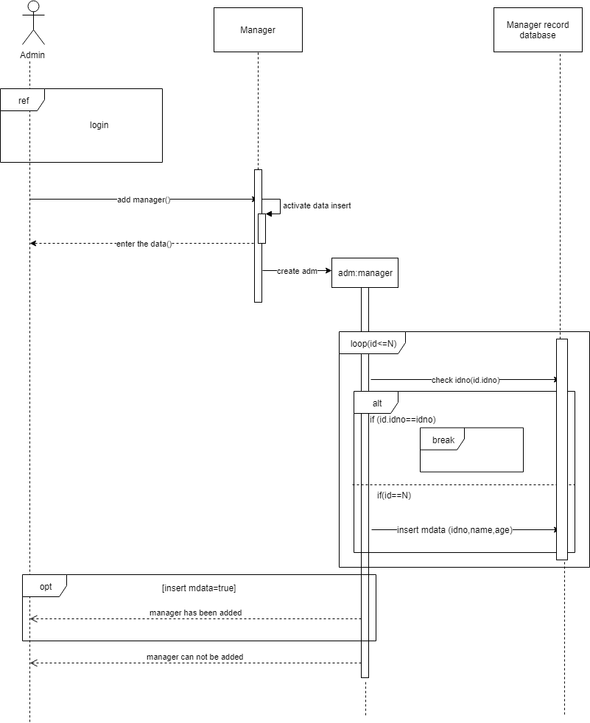

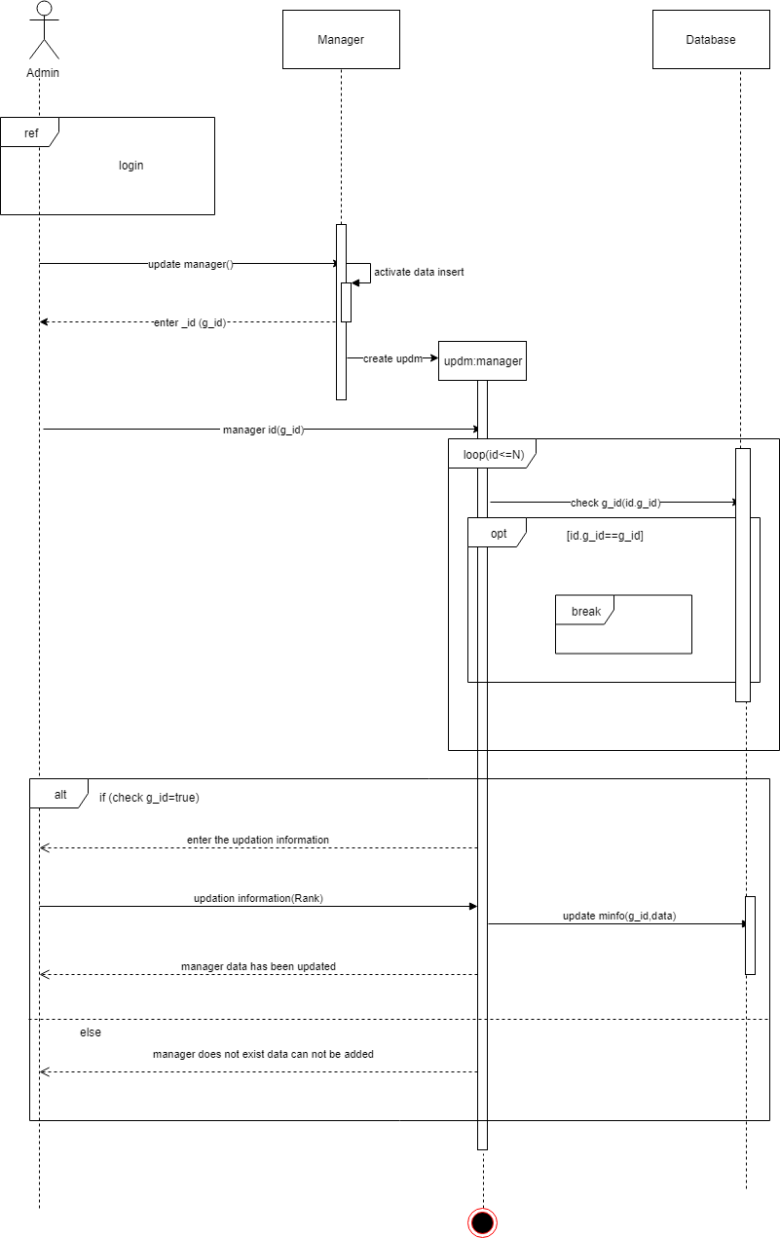S.D 18.0

S.D 19.0

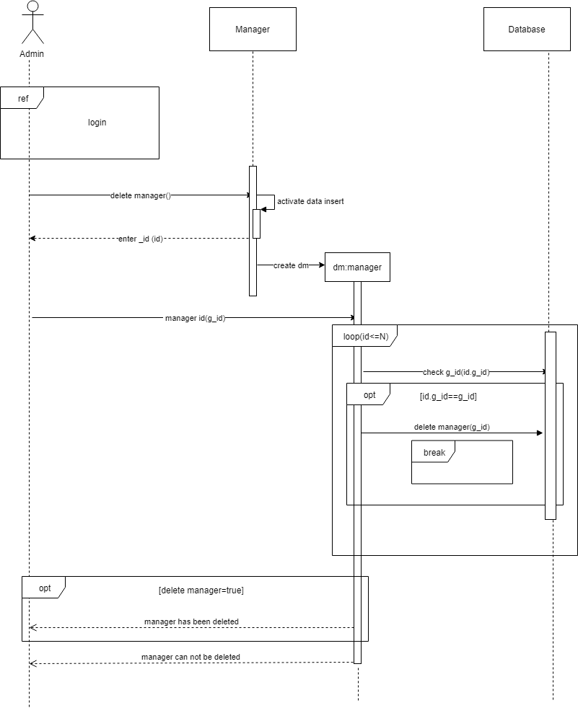

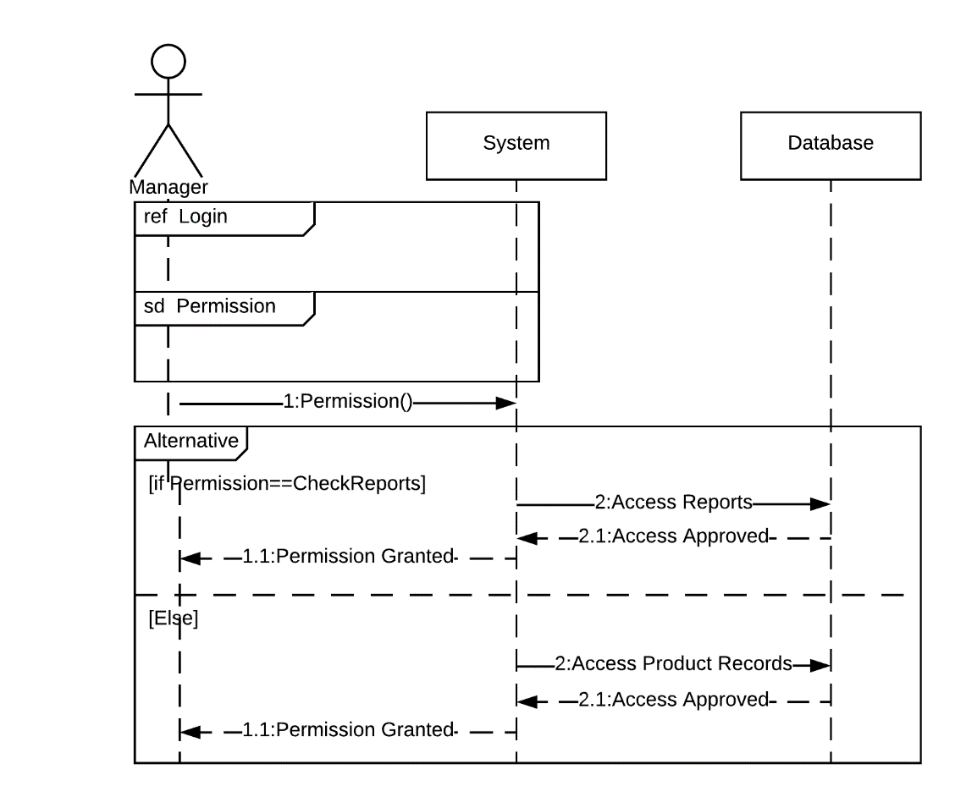S.D 20.0

S.D 21.0
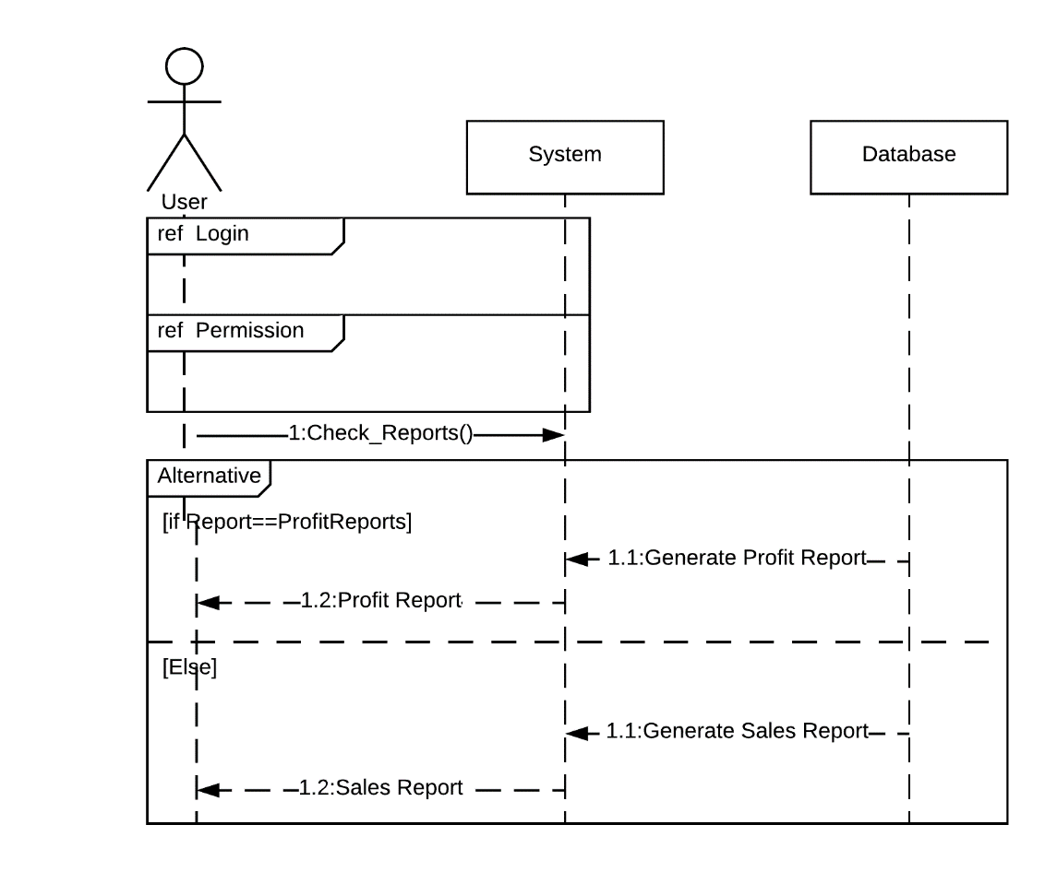

Operation contracts
O.C 1.0 Registration
Headings | Sub-Headings
Operations |  | Register( )
Cross-Reference | Use-Case | Registration, View Profile
Cross-Reference | Scenario | Registration
Pre-  Conditions |  | N/A
Post-Conditions | Instantiation | An instance “A” of Account was created.  An instance “C” of Customer was created.
Post-Conditions | Attribute Modification | A.Id becomes ID.  A.Name becomes Name.  R.CN becomes CN  A.Address becomes Address.  A.CNIC becomes CNIC.  A.PW becomes PW
Post-Conditions | Association | A was associated with Customer.

O.C 2.0 View Profile
Headings | Sub-Headings
Operations |  | View_Profile( )
Cross-Reference | Use-Case | View Profile
Cross-Reference | Scenario | View Profile
Pre-  Conditions |  | Users must be logged in, to access their profile
Post-Conditions | Instantiation | An instance “P” of Profile was created.  An instance “C” of Customer was created.  An instance “A” of Admin was created.  An instance “M” of Manager was created.
Post-Conditions | Attribute Modification | N/A
Post-Conditions | Association | P was associated with Admin.  P was associated with Customer.  P was associated with Manager.

O.C 3.0 Update Profile
Headings | Sub-Headings
Operations |  | Update_Profile( )
Cross-Reference | Use-Case | Update Profile, View Profile
Cross-Reference | Scenario | Update Profile
Pre-  Conditions |  | Users must be logged in, to access and update their profile
Post-Conditions | Instantiation | An instance “P” of Profile was created.  An instance “C” of Customer was created.  An instance “A” of Admin was created.  An instance “M” of Manager was created.
Post-Conditions | Attribute Modification | P.Id becomes ID.  P.Name becomes Name.  P.CN becomes CN  P.Address becomes Address.  P.CNIC becomes CNIC.  P.PW becomes PW
Post-Conditions | Association | P was associated with Admin.  P was associated with Customer.  P was associated with Manager.

O.C 4.0 Login
Headings | Sub-Headings
Operations |  | Login( )
Cross-Reference | Use-Case | Login, View Profile
Cross-Reference | Scenario | Login
Pre-  Conditions |  | N/A
Post-Conditions | Instantiation | An instance “A” of Account was created.  An instance “C” of Customer was created.  An instance “a” of Admin was created.  An instance “M” of Manager was created.
Post-Conditions | Attribute Modification | A.Id becomes ID.  A.PW becomes PW
Post-Conditions | Association | A was associated with Admin.  A was associated with Customer.  A was associated with Manager.

O.C 5.0 Add Product

Headings | Sub-Headings
Operations |  | Addproducts( )
Cross-Reference | Use-Case | Add Products, View Products
Cross-Reference | Scenario | Add Products
Pre-  Conditions |  | Manager should be logged into the system
Post-Conditions | Instantiation | An instance “P” of Products was created.  An instance “M” of Manager was created.
Post-Conditions | Attribute Modification | P.id becomes id.  P.name becomes name.  P.category becomes category  P.stock becomes stock.  P.price becomes price.
Post-Conditions | Association | P was associated with Manager.

O.C 6.0 View Product

Headings | Sub-Headings
Operations |  | Viewproducts( )
Cross-Reference | Use-Case | View Products
Cross-Reference | Scenario | View Products
Pre-  Conditions |  | Manager should be logged into the system  Admin should be logged into the system
Post-Conditions | Instantiation | An instance “P” of Products was created.  An instance “M” of Manager was created.  An instance “A” of Admin was created.
Post-Conditions | Attribute Modification | N/A
Post-Conditions | Association | P was associated with Manager.  P was associated with Admin.

O.C 7.0 Update Product

Headings | Sub-Headings
Operations |  | Update_Products( )
Cross-Reference | Use-Case | Update Products, View Products
Cross-Reference | Scenario | Update Products
Pre-  Conditions |  | Manager should be logged into the system  The record of the product to be updated should be available
Post-Conditions | Instantiation | An instance “P” of Products was created.  An instance “M” of Manager was created.
Post-Conditions | Attribute Modification | P.id becomes id.  P.name becomes name.  P.category becomes category  P.stock becomes stock.  P.price becomes price.
Post-Conditions | Association | P was associated with Manager.

O.C 8.0 Delete Product

Headings | Sub-Headings
Operations |  | Delete_Products( )
Cross-Reference | Use-Case | Delete Products, View Products
Cross-Reference | Scenario | Delete Products
Pre-  Conditions |  | Manager should be logged into the system  The record of the product to be deleted should be available
Post-Conditions | Instantiation | An instance “P” of Products was created.  An instance “M” of Manager was created.
Post-Conditions | Attribute Modification | P.id becomes id.  P.name becomes name.
Post-Conditions | Association | P was associated with Manager.

O.C 9.0 View Catalogue

Headings | Sub-Headings
Operations |  | View_Catalogue( )
Cross-Reference | Use-Case | View Catalogue
Cross-Reference | Scenario | View Catalogue
Pre-  Conditions |  | Manager should be logged into the system  Admin should be logged into the system.  Customer should be logged into the system.
Post-Conditions | Instantiation | An instance “Cat” of Catalogue was created.  An instance “C” of Customer was created.  An instance “A” of Admin was created.  An instance “M” of Manager was created.
Post-Conditions | Attribute Modification | N/A
Post-Conditions | Association | Cat was associated with Admin.  Cat was associated with Customer.  Cat was associated with Manager

O.C 10.0 Search Catalogue

Headings | Sub-Headings
Operations |  | Search_Catalogue( )
Cross-Reference | Use-Case | Search Products, View Products
Cross-Reference | Scenario | Search Products
Pre-  Conditions |  | Manager should be logged into the system.  Customer should be logged into the system.
Post-Conditions | Instantiation | An instance “Cat” of Products was created.  An instance “M” of Manager was created.  An instance “C” of Customer was created.
Post-Conditions | Attribute Modification | Cat.Id becomes Id.  Cat.Name becomes Name.
Post-Conditions | Association | Cat was associated with Manager.  Cat was associated with Customer.

O.C 11.0 Add Product to Cart
Headings | Sub-Headings
Operations |  | Add_prod_to_cart( )
Cross-Reference | Use-Case | Add to Cart, View Cart
Cross-Reference | Scenario | Add to Cart
Pre-  Conditions |  | Customer should be logged into the system  Customer must use catalogue to add products into cart
Post-Conditions | Instantiation | An instance “Cart” of Cart was created.  An instance “C” of Customer was created.
Post-Conditions | Attribute Modification | Cart.id becomes id.  Cart.name becomes name.  Cart.quantity becomes quantity.
Post-Conditions | Association | Cart was associated with Customer.
O.C 12.0 View Cart
Headings | Sub-Headings
Operations |  | View_Cart( )
Cross-Reference | Use-Case | View Cart
Cross-Reference | Scenario | View Cart
Pre-  Conditions |  | Customer should be logged into the system  Customer must add products to cart to be able to view them
Post-Conditions | Instantiation | An instance “Cart” of Cart was created.  An instance “C” of Customer was created.
Post-Conditions | Attribute Modification | N/A
Post-Conditions | Association | Cart was associated with Customer.
O.C 13.0 Update Cart
Headings | Sub-Headings
Operations |  | Update_Cart( )
Cross-Reference | Use-Case | Update Cart, View Cart
Cross-Reference | Scenario | Update Cart
Pre-  Conditions |  | Customer should be logged into the system  Customer must add products to cart to be able to update them
Post-Conditions | Instantiation | An instance “Cart” of Cart was created.  An instance “C” of Customer was created.
Post-Conditions | Attribute Modification | Cart.id becomes id.  Cart.name becomes name.  Cart.quantity becomes quantity.
Post-Conditions | Association | Cart was associated with Customer.

O.C 14.0 Confirm Order
Headings | Sub-Headings
Operations |  | Confirm_Order( )
Cross-Reference | Use-Case | Confirm Order, View Order
Cross-Reference | Scenario | Confirm Order
Pre-  Conditions |  | Customer should be logged into the system  Customer must add products to cart to confirm order
Post-Conditions | Instantiation | An instance “Cart” of Cart was created.  An instance “C” of Customer was created.
Post-Conditions | Attribute Modification | N/A
Post-Conditions | Association | Cart was associated with Customer.
O.C 15.0 Cancel Order
Headings | Sub-Headings
Operations |  | Cancel_Order( )
Cross-Reference | Use-Case | Cancel Order, View Order
Cross-Reference | Scenario | Cancel Order
Pre-  Conditions |  | Customer should be logged into the system  Customer must have placed an order if required to cancel it
Post-Conditions | Instantiation | An instance “Cart” of Cart was created.  An instance “C” of Customer was created.
Post-Conditions | Attribute Modification | Cart.id becomes id.
Post-Conditions | Association | Cart was associated with Customer.
O.C 16.0 Payment Method
Headings | Sub-Headings
Operations |  | Payment_Method( )
Cross-Reference | Use-Case | Payment Method
Cross-Reference | Scenario | Payment Method
Pre-  Conditions |  | Customer should be logged into the system  Customer must place an order to select payment method
Post-Conditions | Instantiation | An instance “Pay” of Payment was created.  An instance “C” of Customer was created.
Post-Conditions | Attribute Modification | N/A
Post-Conditions | Association | Pay was associated with Customer.

O.C 17.0 Add Manager
Headings | Sub-Headings
Operations |  | Add_Managers( )
Cross-Reference | Use-Case | Add Managers, View Managers
Cross-Reference | Scenario | Add Managers
Pre-  Conditions |  | Admin should be logged into the system  Admin should interview a manager to hire and add their record into system
Post-Conditions | Instantiation | An instance “M” of Manager was created.  An instance “A” of Admin was created.
Post-Conditions | Attribute Modification | M.id becomes id.
Post-Conditions | Association | M was associated with Admin.
O.C 18.0 Update Manager
Headings | Sub-Headings
Operations |  | Update_Managers( )
Cross-Reference | Use-Case | Update Managers, View Managers
Cross-Reference | Scenario | Update Managers
Pre-  Conditions |  | Admin should be logged into the system  Add should add managers into system if it is required to update their ranks
Post-Conditions | Instantiation | An instance “M” of Manager was created.  An instance “A” of Admin was created.
Post-Conditions | Attribute Modification | M.Rank becomes Rank.
Post-Conditions | Association | M was associated with Admin.
O.C 19.0 Delete Manager
Headings | Sub-Headings
Operations |  | Delete_Managers( )
Cross-Reference | Use-Case | Delete Managers, View Managers
Cross-Reference | Scenario | Delete Managers
Pre-  Conditions |  | Admin should be logged into the system  Add should add managers into system if it is required to delete their records
Post-Conditions | Instantiation | An instance “M” of Manager was created.  An instance “A” of Admin was created.
Post-Conditions | Attribute Modification | M.id becomes id.
Post-Conditions | Association | M was associated with Admin.
O.C 20.0 Permission
Headings | Sub-Headings
Operations |  | Permission( )
Cross-Reference | Use-Case | Permission
Cross-Reference | Scenario | Permission
Pre-  Conditions |  | Manager should be logged into the system
Post-Conditions | Instantiation | An instance “Permission” of Permission was created.  An instance “M” of Manager was created.
Post-Conditions | Attribute Modification | Permission.Id becomes id.
Post-Conditions | Association | Permission was associated with Admin.
O.C 21.0 Sales Reports
Headings | Sub-Headings
Operations |  | ViewSalesReport( )
Cross-Reference | Use-Case | View Sales Report
Cross-Reference | Scenario | View Sales Report
Pre-  Conditions |  | Admin should be logged into the system.  Manager should be logged into the system.
Post-Conditions | Instantiation | An instance “SR” of Sales was created.  An instance “M” of Manager was created.  An instance “A” of Admin was created.
Post-Conditions | Attribute Modification | N/A
Post-Conditions | Association | SR was associated with Manager.  SR was associated with Admin.
O.C 22.0 Profit Reports
Headings | S-Headings
Operations |  | ViewProfitReport( )
Cross-Reference | Use-Case | ViewProfitReport
Cross-Reference | Scenario | ViewProfitReport
Pre-  Conditions |  | Admin should be logged into the system.  Manager should be logged into the system.
Post-Conditions | Instantiation | An instance “PR” of Sales was created.  An instance “M” of Manager was created.  An instance “A” of Admin was created.
Post-Conditions | Attribute Modification | N/A
Post-Conditions | Association | PR was associated with Manager.  PR was associated with Admin.

Activity Diagram
A.D 1.0 Registration/Login
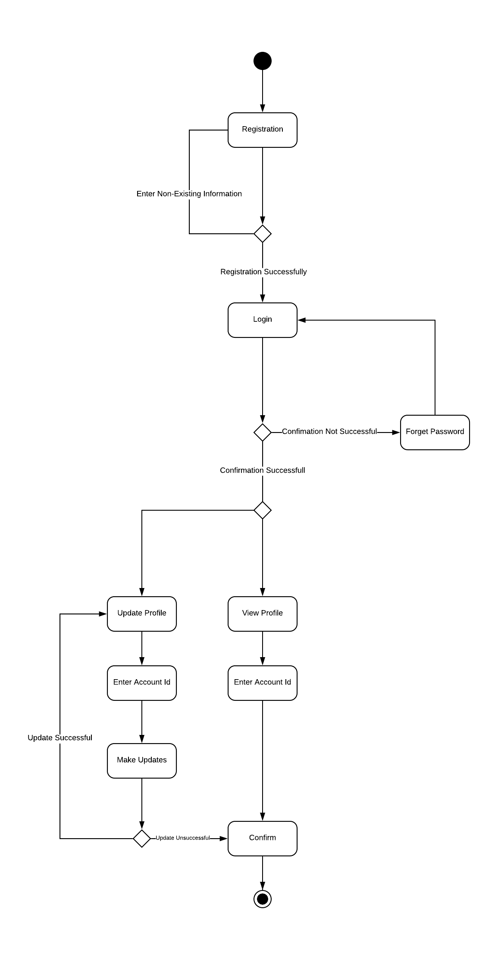
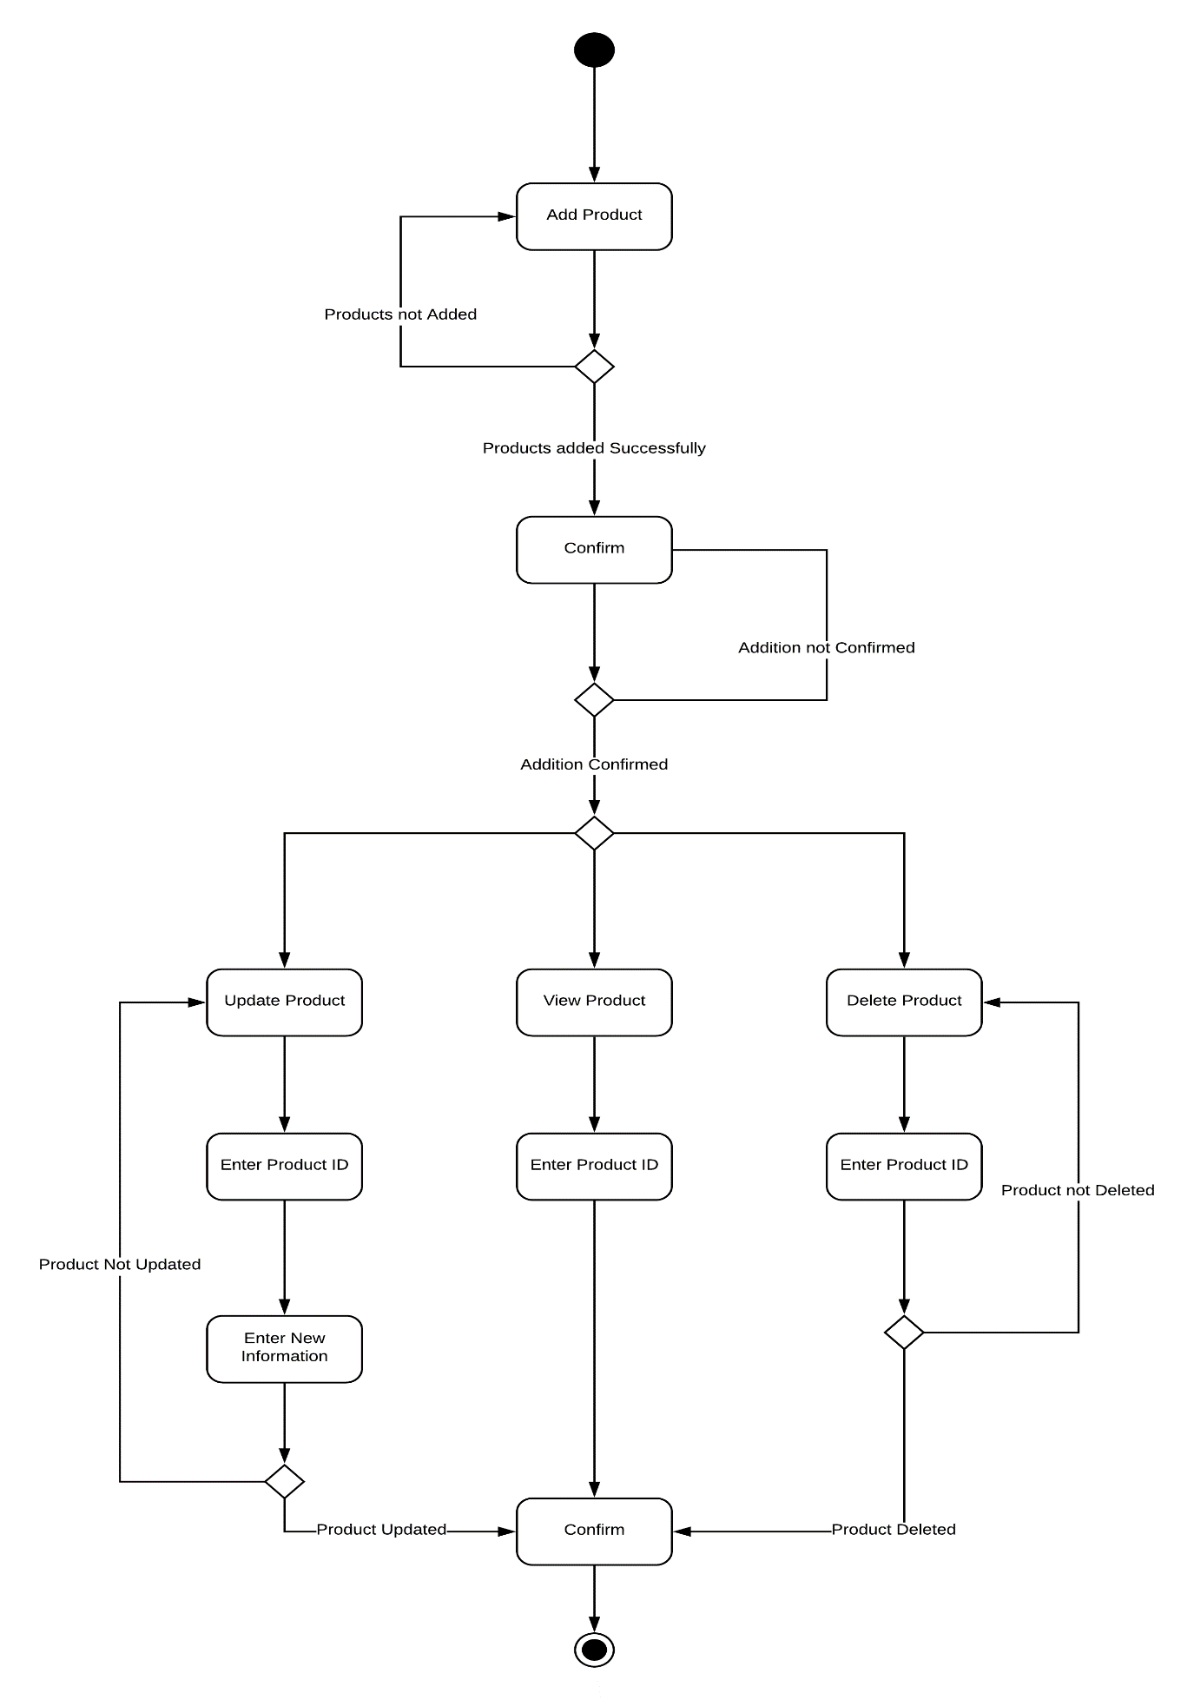A.D 2.0 Product Related Operations

A.D 3.0 Manager Related Operations
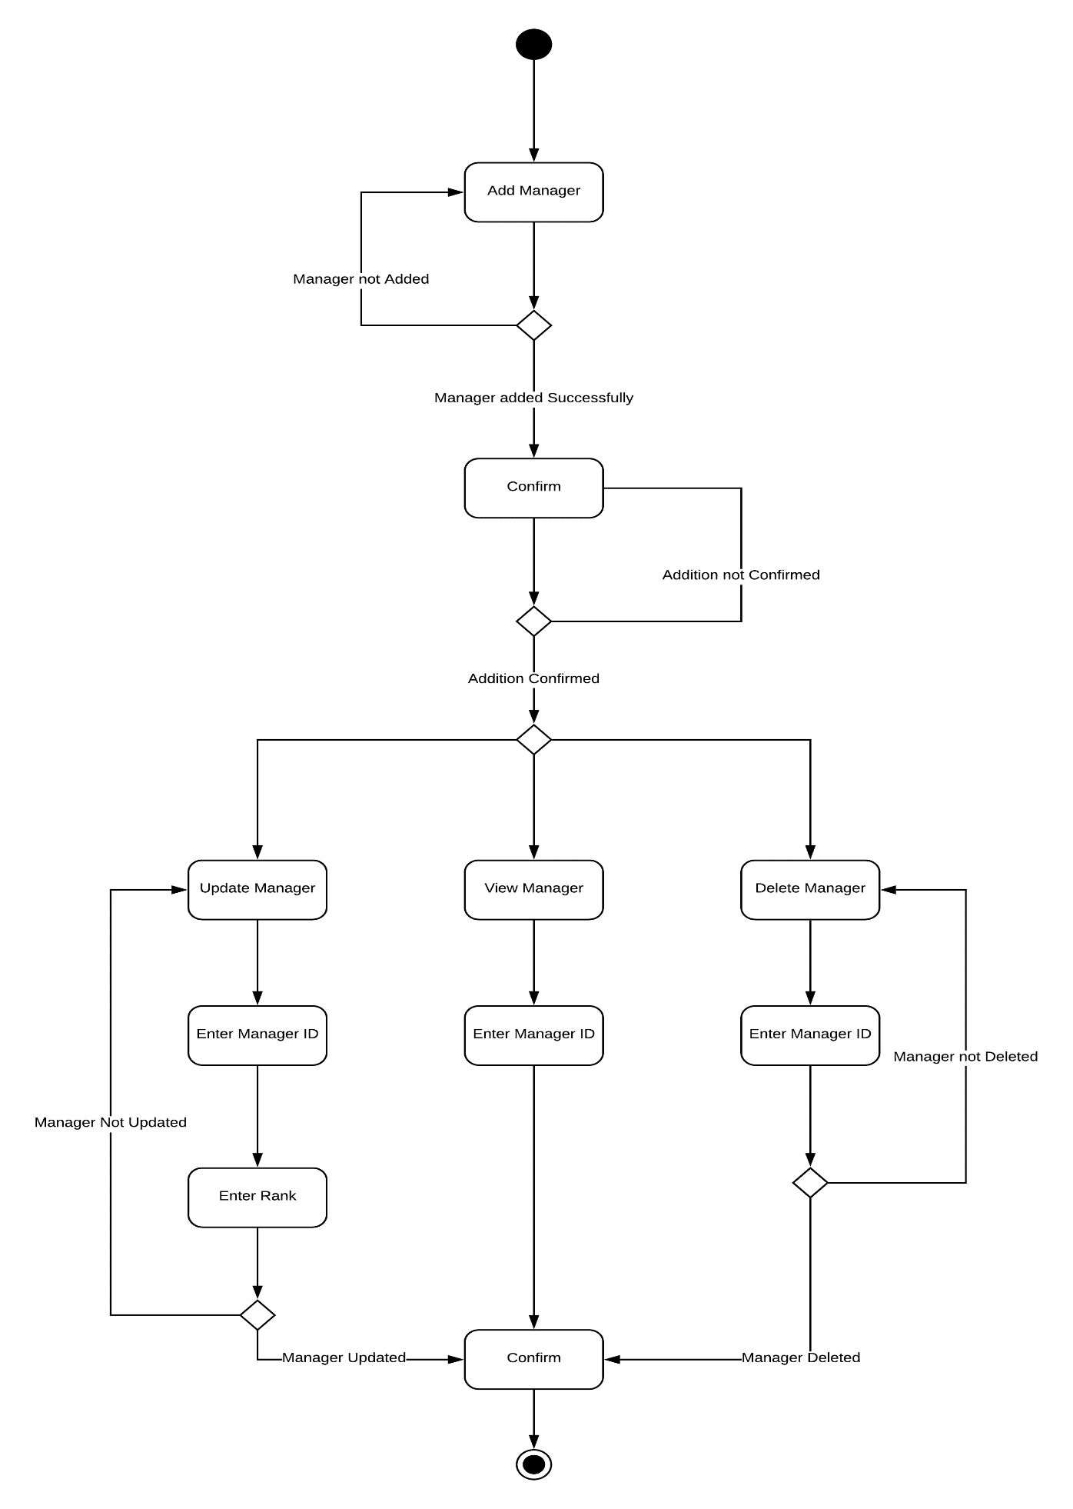

A.D 4.0 Cart Related Operations
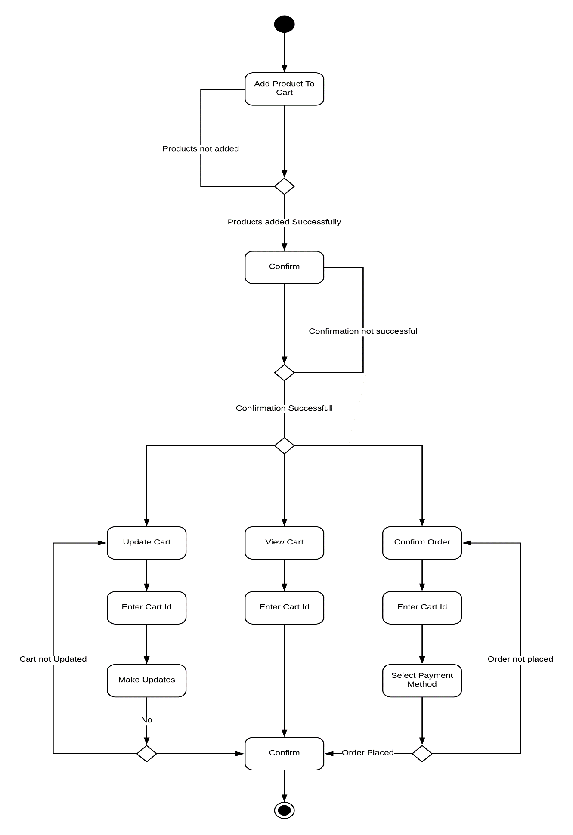

A.D 5.0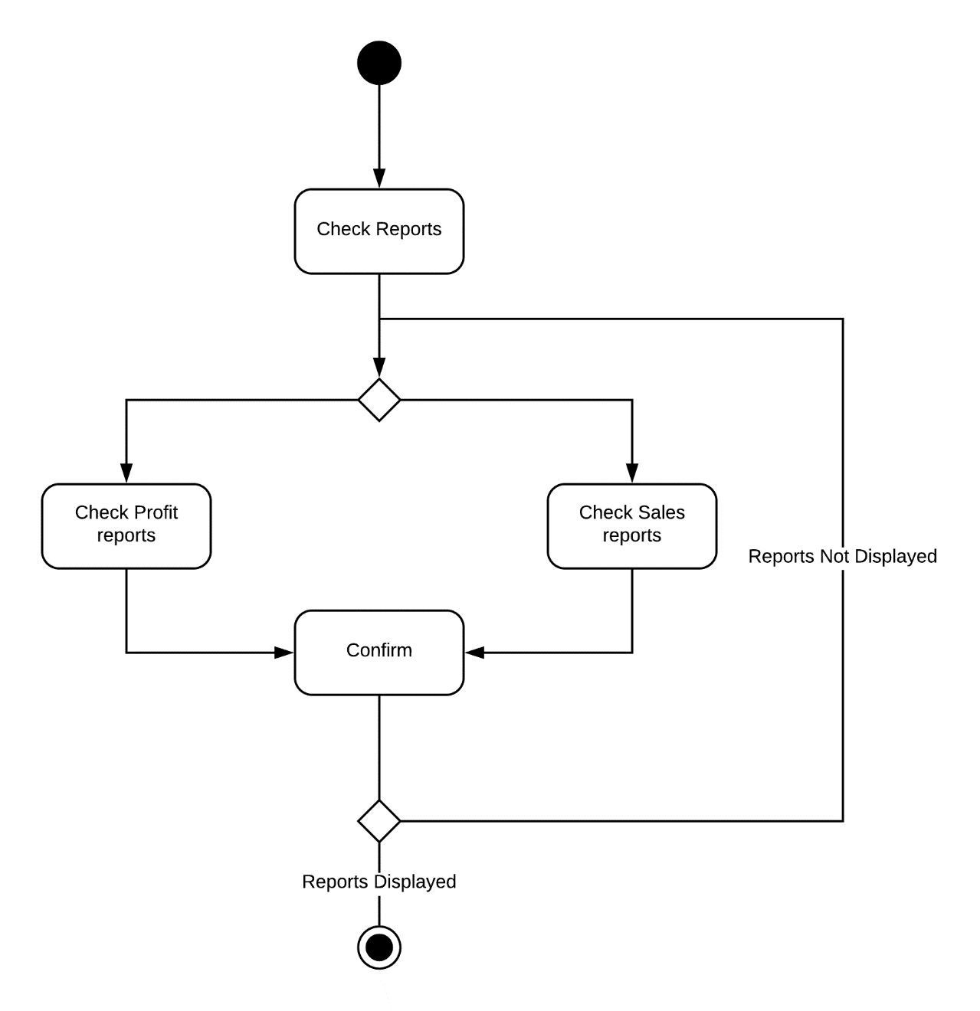 Reports Related Operations

A.D 6.0 Track Donor

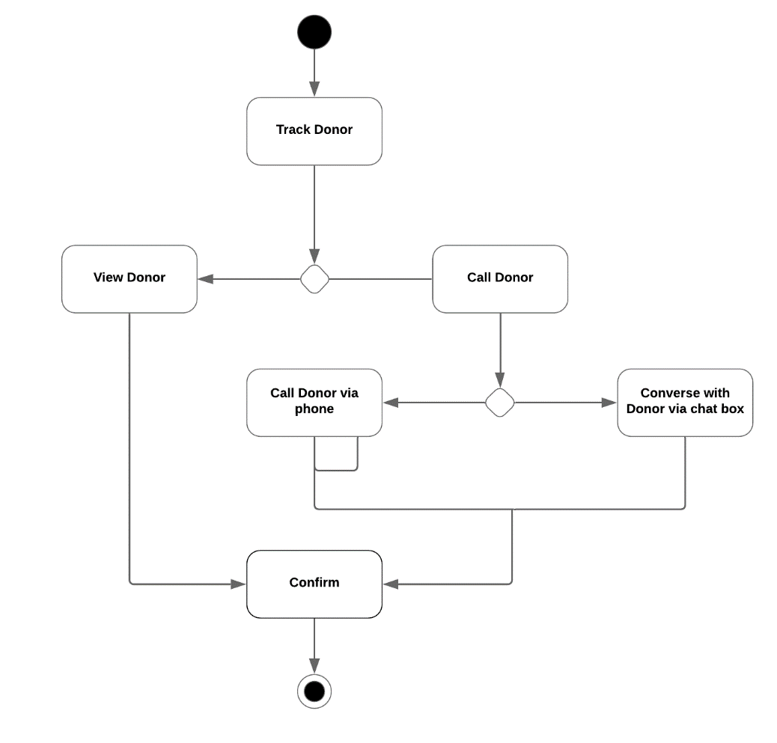

State Transition Diagram
S.D 1.0

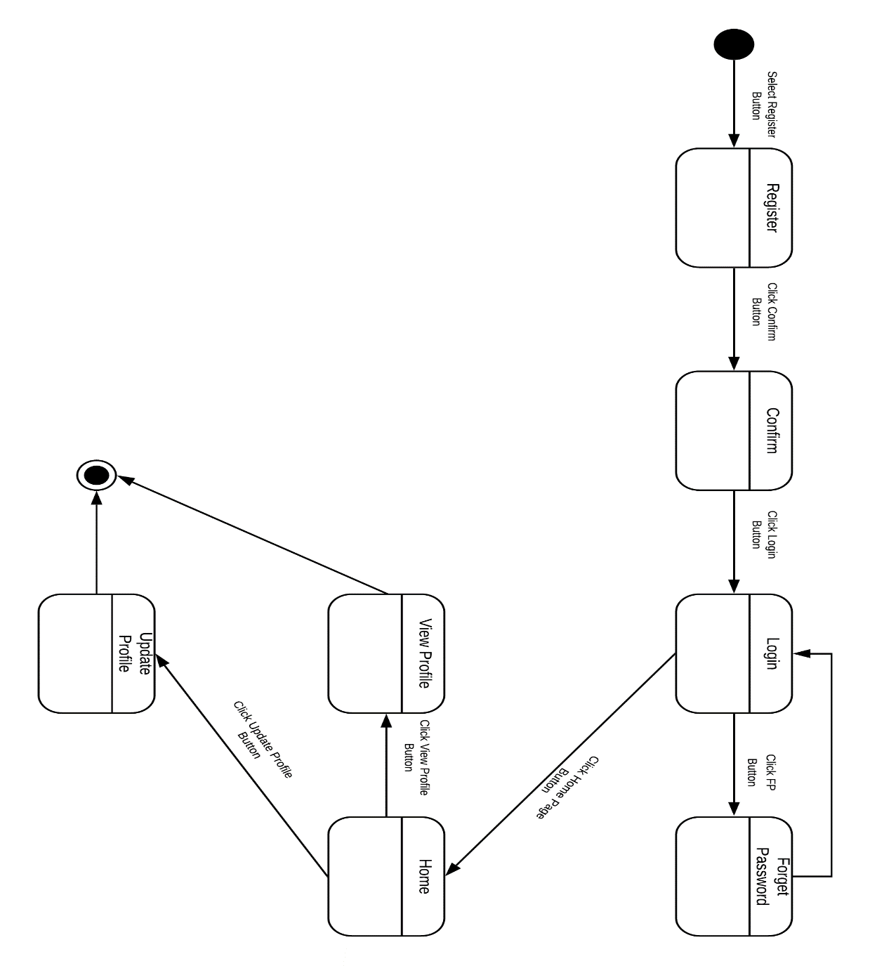

S.D 2.0

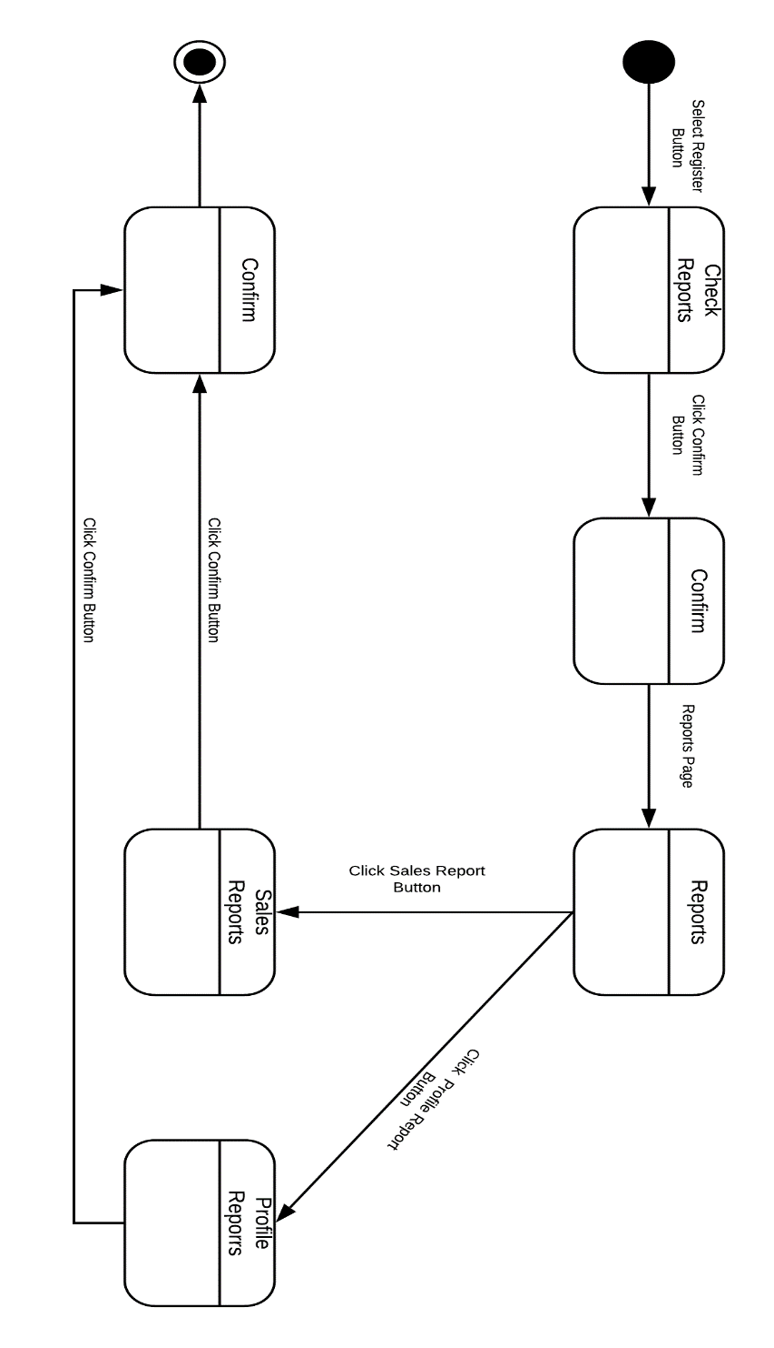

S.D 3.0

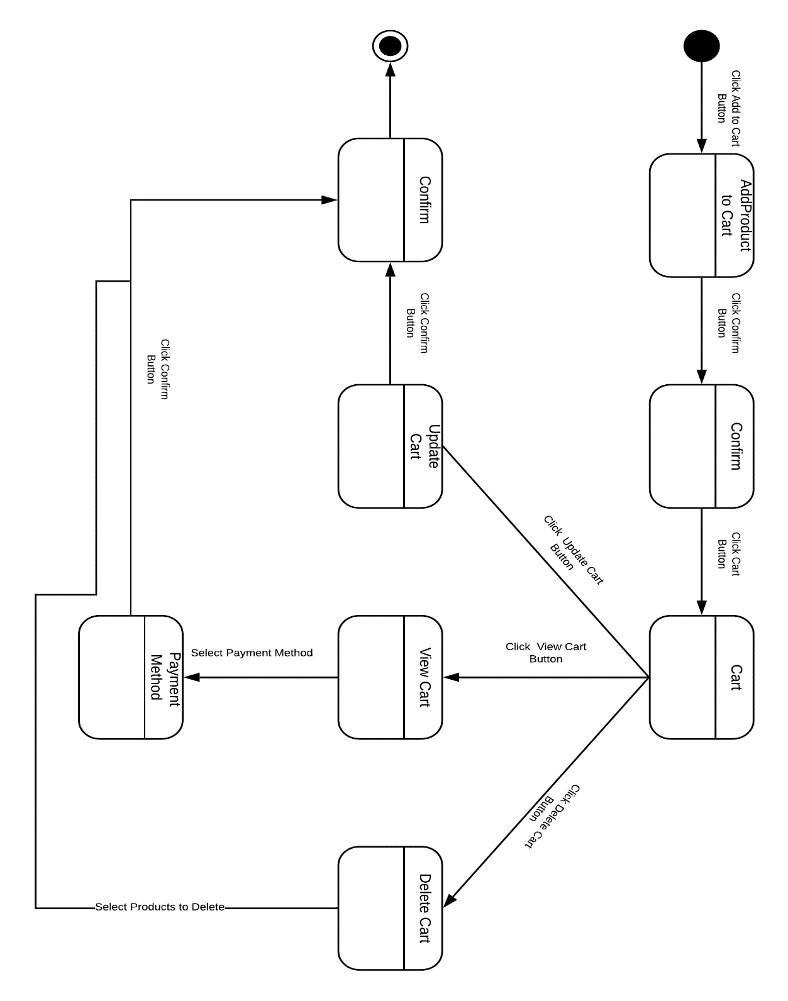

S.D 4.0

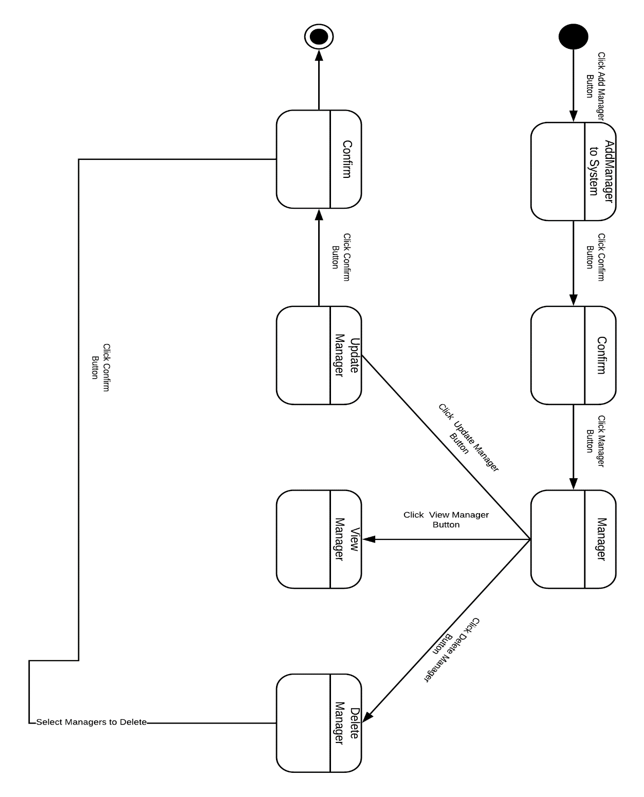

S.D 5.0
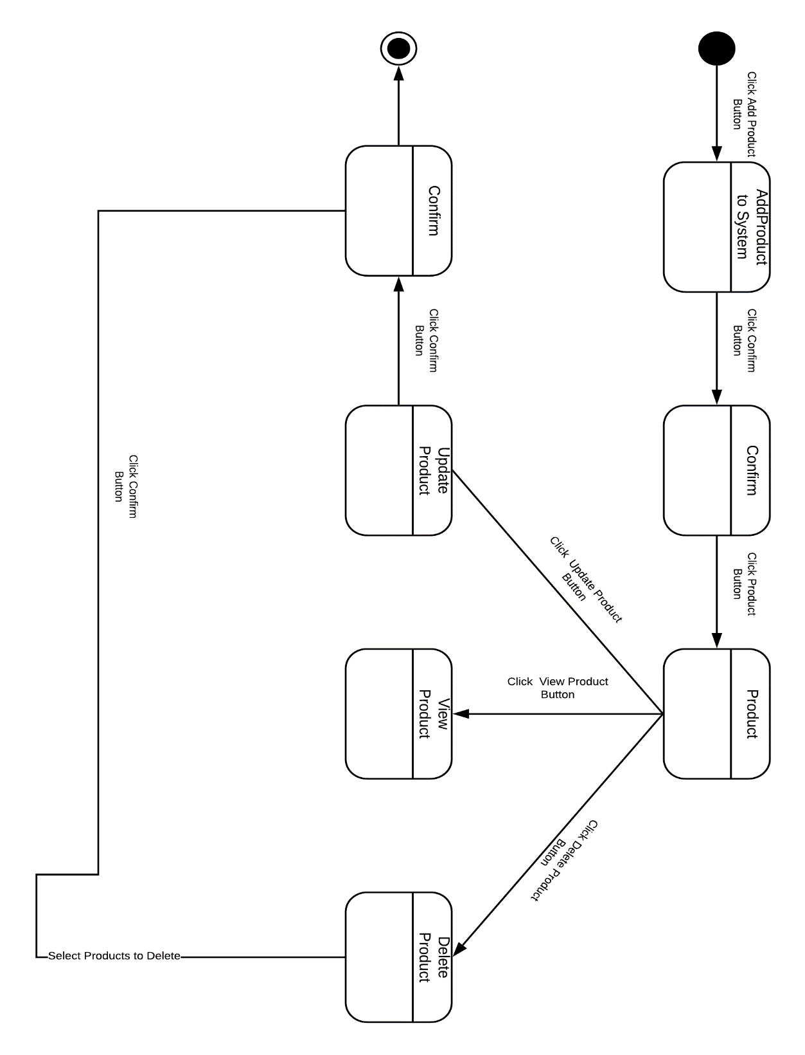

Component Diagram

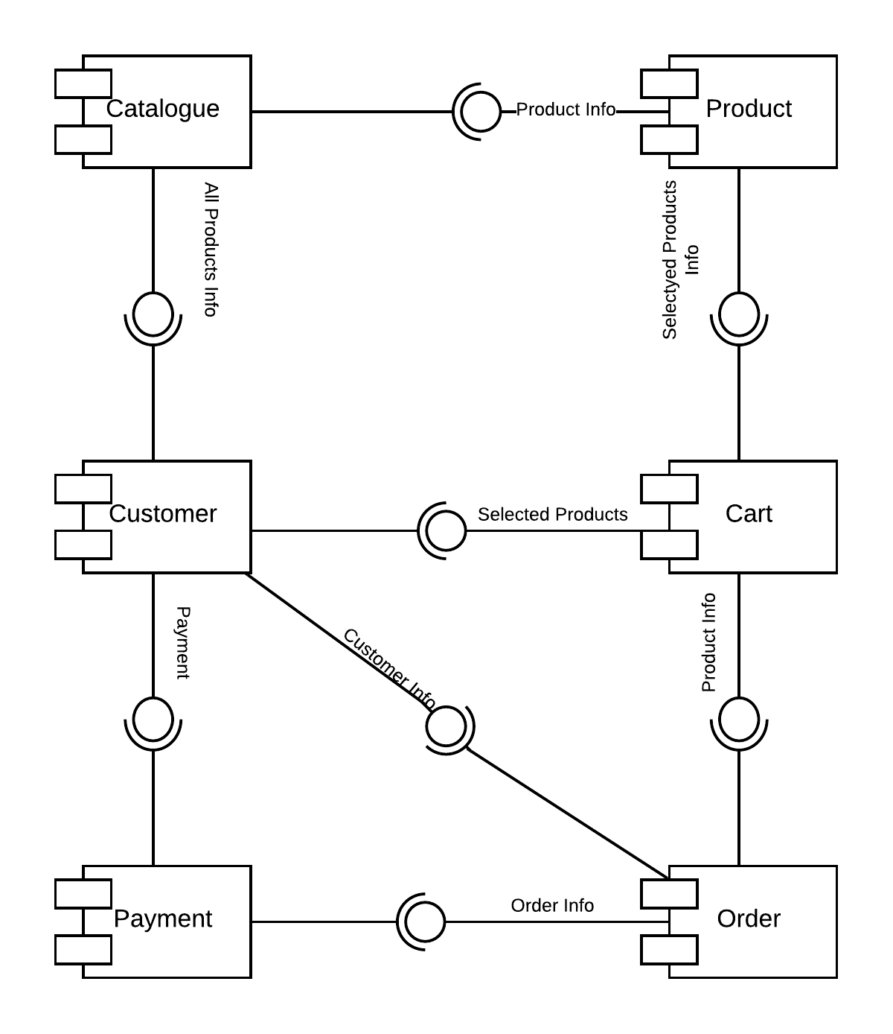

Deployment Diagram
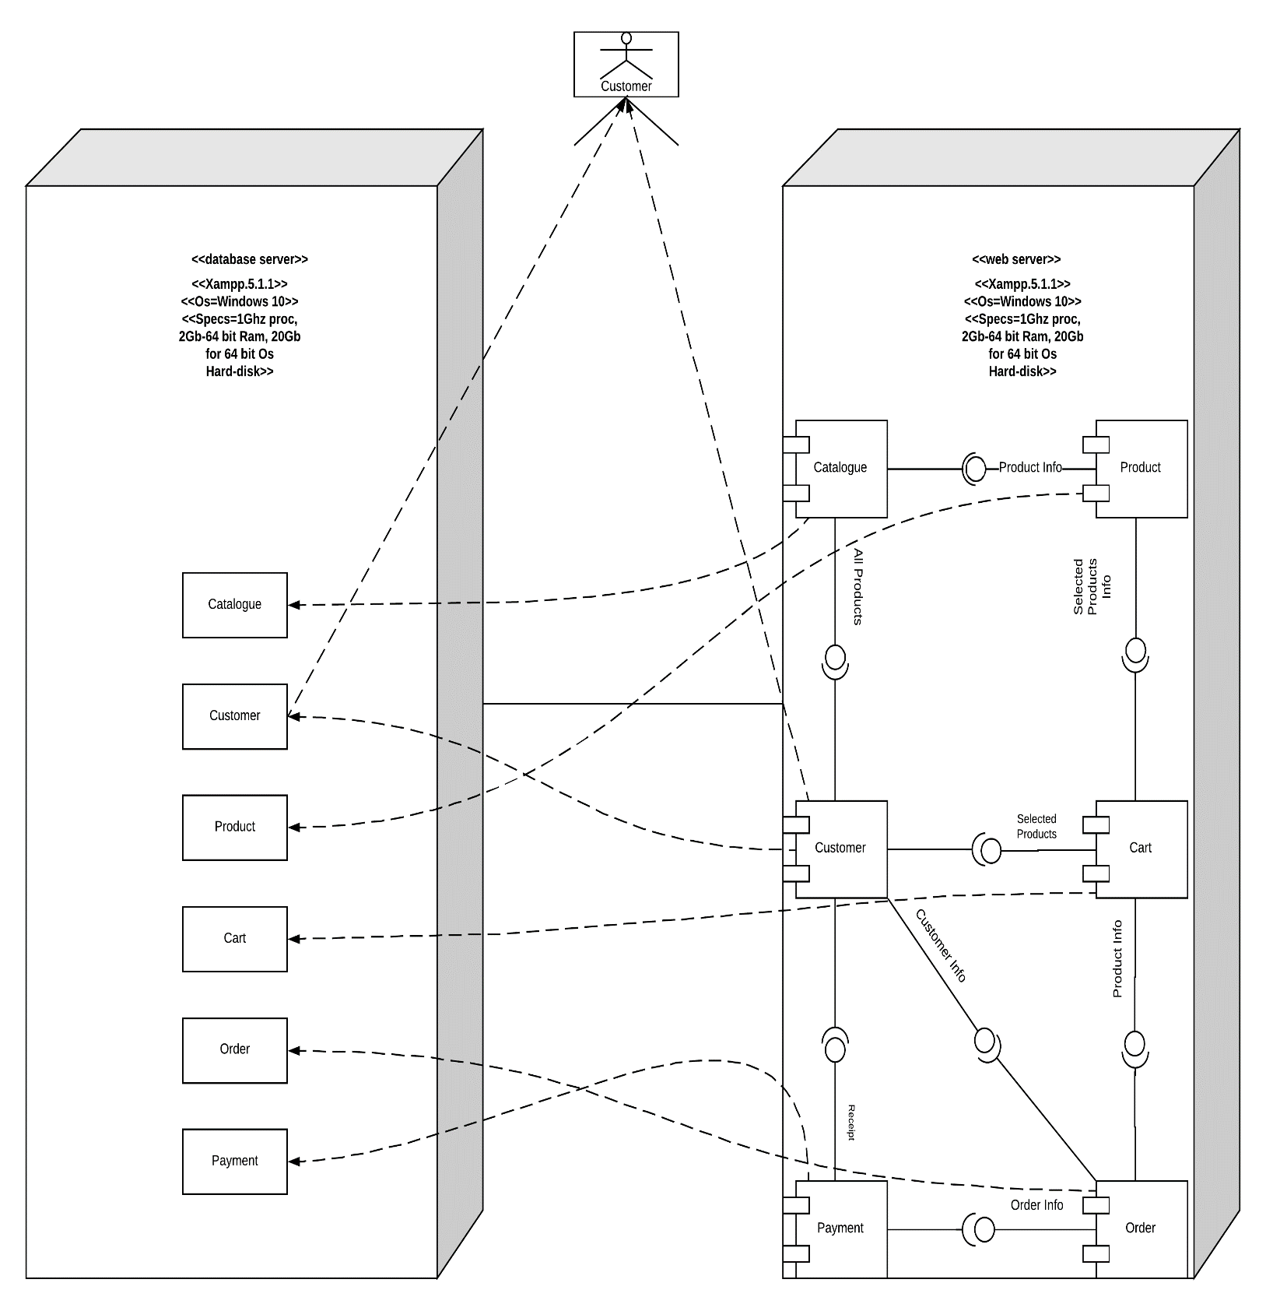

Data Flow diagram
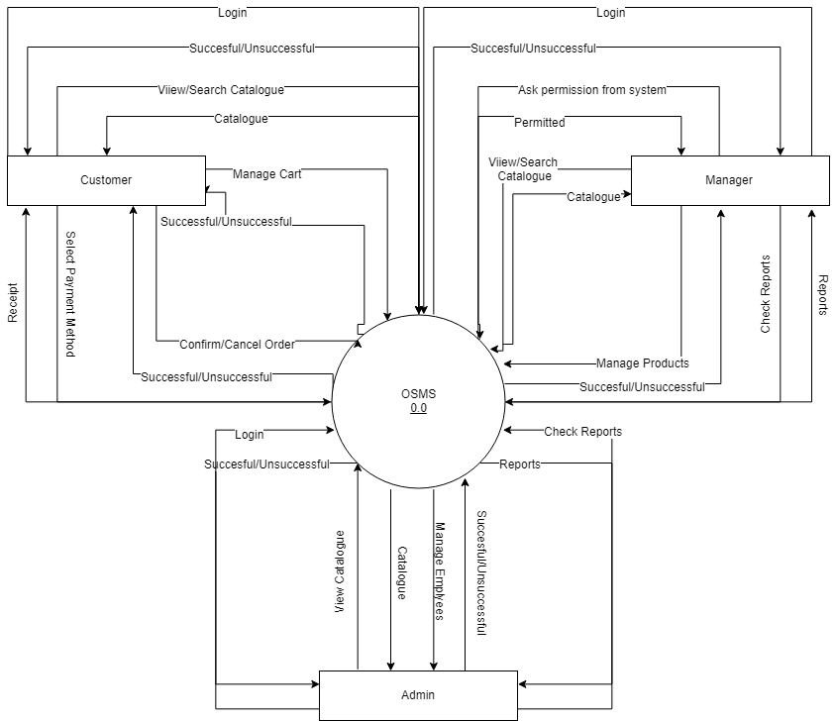Context Level

Level 0

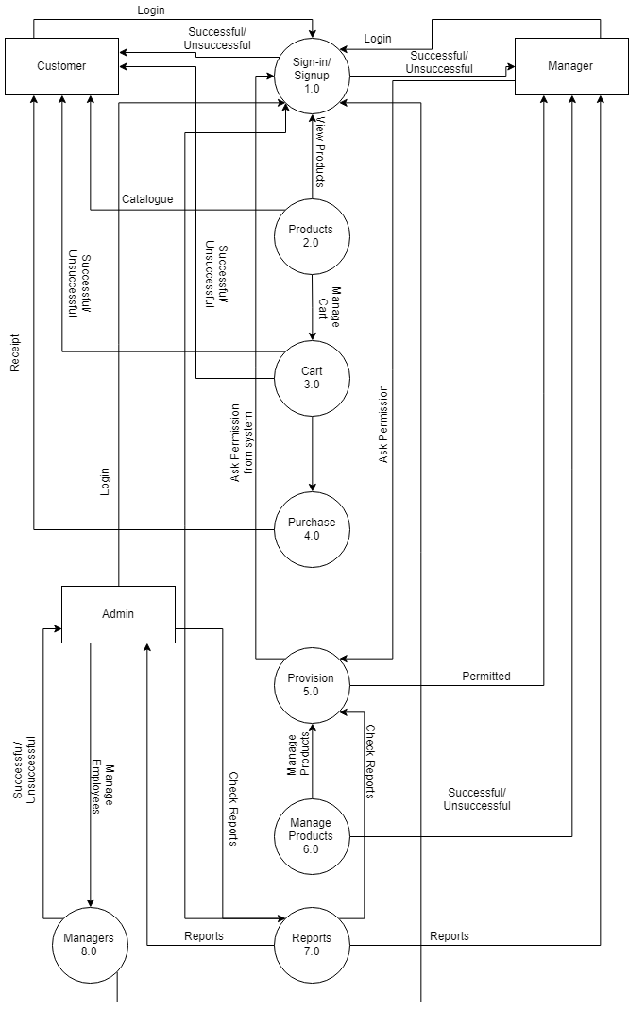

Level 1
Forget Password

Chapter 5

Implementation

Chapter 5: Implementation
This section depicts that the code will be developed and deployed into the real-world environment. Here, we have listed out some methods to give an idea of our perspective.

Important Flow Control/Pseudo codes
Register Code
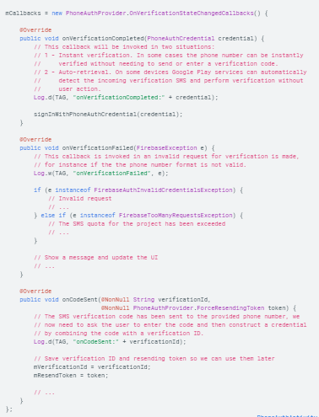
Login Code
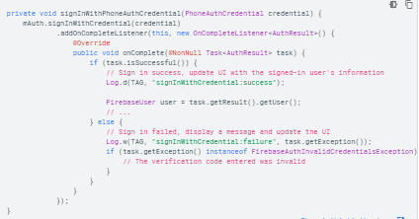

Components, Libraries, Web Services and stubs
- Firebase Firestore
- Secure user profile
- Administration Module

Deployment Environment
Firebase Firestore will be used as the main database server. Stages include; Development: Code will be designed and user requirements will be exploited, Testing- Different iterations of testing will be performed, Code conciseness- Code will be lessened but made more efficient.

Tools and Techniques
Tools
Mobile Application
Android Studio
Web Application
Brackets, Visual Studio Code, Bootstrap Studio
Software Designing Tools
Lucidchart.com, Draw.io
Techniques
Mobile Application
XML and Java and Firebase
Web Application
HTML/CSS, Firebase, Bootstrap

Best Practices / Coding Standards
- Communication with stakeholders.
- No repetition of coding
- Work Breakdown structure will be followed
- Feedback will be accepted and applied.
- Each requirement will be documented.

Version Control
We are planning to launch v 1.0 of Med-Go in the upcoming months. First changes will be made according to user feedback.

Chapter 6

Testing and Evaluation

Chapter 6: Testing and Evaluation
The process by which a system or components are compared against requirements and specifications through testing. The results are evaluated to access progress of design, performance and supportability. Test-case specification is performed in above section for system testing by keeping in mind several issues, which are discussed in the following subtopics.

Use Case Testing
Use Case Testing is a functional black box testing technique that helps testers to identify test scenarios that exercise the whole system on each transaction basis from start to finish.

- Use Cases capture the interactions between ‘actors’ and the ‘system’
- ‘Actors’ represent user and the interaction that each user takes part into.
- Test cases are based on use cases and are referred to as scenarios.
Sign-Up
Main Success Scenario | Step | Description
A = Actor | 1 | A: Provide required Information
S = System | 2 | S: System saves data in database creating profiles of customers
Extension | 2a | S: User will have to Login

Login
Main Success Scenario | Step | Description
A = Actor | 1 | A: Enter Number and Password
S = System | 2 | S: Validate Password
 | 3 | S: App access allowed
Extension | 2a | S: Invalid Password, Message displayed on screen requesting for valid password.
Catalog
Main Success Scenario | Step | Description
A = Actor | 1 | A: Look for required product
S = System | 2 | S: System displays available products
Extension | 1a | User must traverse through the catalog to view desired product

Select Products
Main Success Scenario | Step | Description
A = Actor | 1 | A: View Product Detail, Add product to cart
S = System | 2 | S: System adds selected products to cart
Extension | 2a

Submit Order
Main Success Scenario | Step | Description
A = Actor | 1 | A: Confirm order, Add shipment info
S = System | 2 | S: System stores order info
Extension | 2a | S: System doesn’t allow another order from same user until previous order is accepted.

Deliver Order
Main Success Scenario | Step | Description
A = Actor | 1 | A: Manager accepts order to view shipment info
S = System | 2 | S: Removes order info from database as a sign of order acceptance
Extension | 2a | S: System removes order restriction from specific User

Bill Payment
Main Success Scenario | Step | Description
A = Actor | 1 | A: Manager Shoe Receipt and Accepts payment
S = System | 2 | S: System is verified regarding payment
Extension | 2a | S: Record of user receipt is maintained.

Manage Accounts
Main Success Scenario | Step | Description
A = Actor | 1 | A: Admin will manage accounts when required
S = System | 2 | S: Show account information
Extension | 2a | S: User accounts should be available

Logout
Main Success Scenario | Step | Description
A = Actor | 1 | A: Select Logout
S = System | 2 | S: System displays Logout Message
Extension | 2a | S: Invalid Password, Message displayed on screen requesting for valid password.

Equivalence partitioning
Mobile Number: Must have 11 digits

Invalid | Valid | Invalid
O33541083721 | O3354108371 | O33541083

Email: Must follow original email format

Invalid | Valid | Invalid
danishsurfersgmail.com | danishsurfers@gmail.com | danishsurfers@gmailgmail.com

Password: Must be of 6 at-least characters

Invalid | Valid | Invalid
1122 | 123456 | 12345

Boundary value analysis
Login Through Number
Invalid  (min-1) | Valid  (Min/Max) | Invalid  (max+1)
10 | 11 | 12

Login Password
Invalid  (min-1) | Valid  (Min/Max) | Invalid  (max+1)
5 | 25 | 26

Data flow testing
Data Flow testing is a family of test strategies based on selecting paths through the programs control flow in order to explore sequences of events related to the status of variables or data objects.
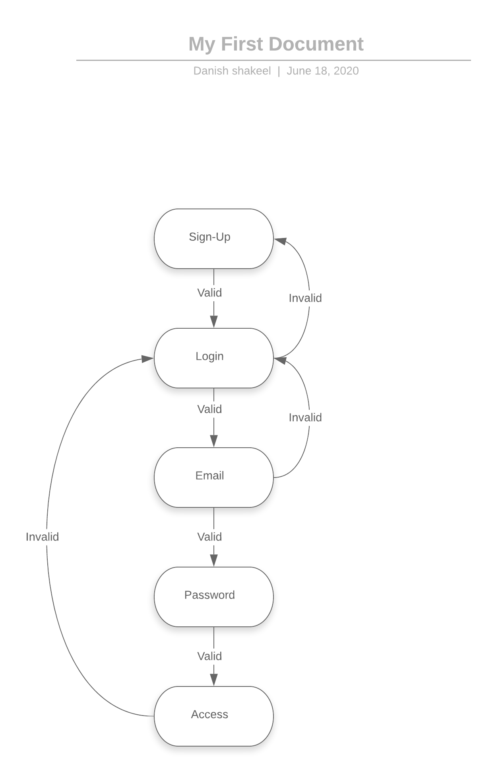

Unit testing
Unit Testing is a White-Box Testing technique. The main consideration in this technique is verification of all modules of the software system. Each Module is unit tested as follows;
- Unit Testing for the Module User Management is tested by either valid or invalid user.
- Unit Testing for the Module User Account Management is provided by testing Login, logout, creating new, updating or deleting a user account.
- Unit Testing for the Module Detail of order result gives details accurately.
- Unit Testing for the Module Add/Update/Delete Product detail.

TC Num | Identifier | Test Item | Input Specifications | Output Specifications | Pass/Fail | Description
1 | UTS-SU-01 | Sign-Up | Fill all required fields | Login  Screen | Pass | Sign-Up required for every user.
2 | UTS-LOG-01 | Login | Number, Password | Error Message/ Guide Screen | Pass | User Login info is authenticated.
3 | UTS-SR-01 | Search for Product |  | Catalog not visible | Pass | To view available products in the system.
4 | UTS-SEL-01 | Select for Order |  | Add Product to Cart | Pass | Select the required products needed.
5 | UTS-SUB-01 | Submit Order | Product selected for order | Order is submitted | Pass | Order received by Manager
6 | UTS-PRO-01 | Accept Order | Accept submitted Order | Customer details are provided | Pass | Manager accepts the Order.
7 | UTS-DO-01 | Deliver Order | Customer details are provided | Receive  Payment | Pass | Food is delivered by the Manager

Integration testing
Integration testing is the technique for testing the interfaces of software components. Each software component is unit tested and then integrated to perform together. The tests are conducted to ensure that the components are working properly after interfacing.

All modules are integrated by an incremental approach and integration testing of the system is performed as follows;

- Integrate login module and test that the software is properly connected to the database.
- Integrate all modules and test by adding/updating/deleting records.

TC Num | Identifier | Test Item | Input Specifications | Output Specifications | Pass/Fail | Description
1 | ITS-REG-01 | Sign-Up  /Login | First Signup is required then Login. | Verified User can access application. | Pass | Sign-Up required for every user.
2 | ITS-CAT-02 | Admin, Catalog | Add, Update, Delete Product info. | Catalog displays on main page of application. | Pass | Admin will enter all information required for product.
3 | ITS-ORD-03 | Customer, Cart | Customer adds product to cart and fills delivery location info | Quantity of order can be changed; Bill will be generated | Pass | Must provide address, pin location through maps and contact

Chapter 7

Summary, Conclusion and Future Enhancements

Chapter 7: Summary, Conclusion & Future Enhancements

Project Summary
Our Application is about delivering certified medicines to customer’s doorstep. We are providing the service of delivering any and every type of medicinal items from door to door. Placing an order with Med-Go could not be more convenient. Customers visit our application and choose from a variety of available products. The customer will place the order through the app and will receive total cost which will include bill payment as well as delivery charges. Our concept is fully deployed on Google Play Store and is available for reviewing.

Achievements and Improvements
- Main achievement is that the major market target for our Application are disable and sick people. Using our app, they can get their medicines delivered on their doorstep.
- Learnt to work in a team.
- Learn how to pitch and defend our concept.
- We will try to improve our project, making it more secure, responsive and efficient.

Critical Review
Main goal is we are providing a platform where users are able to easily buy medicinal products or anything available on a medical store and have them delivered at their doorstep. We are providing a platform for both customers and volunteer couriers. Customers will be able to place orders easily whereas our volunteer couriers will deliver them. These couriers will have a signed contract with our startup. The contract would include information regarding how income will be generated and distributed among the startup members.

Lessons Learnt
We learnt how to work as a team and create a complete successful project without any failure. We briefly learned about the core concepts of android development as well as JANGO for Web development. We also learnt how to pitch and defend our project along with suggesting information regarding income generation.

Future Enhancements/Recommendations
We will make both our android and web applications more stable, releasing newer versions so that we could make them as efficient as possible. We might also try improving the User Interface making them more phenomenal and convenient to work with.

Appendices

Appendix A: User Manual
This appendix includes a detailed step by step walkthrough of how our customer and manager (courier) handles and works through our mobile Application which is based on placing orders, checking blood donor information for customers and delivering orders (for couriers).

Customer

- Registration
Here, customers are able to register to app by providing the required information.

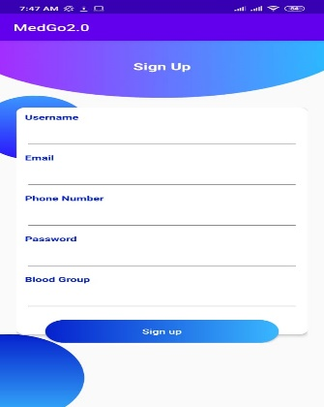

- Login-As
This is a required field where it is specified to select the type of user.

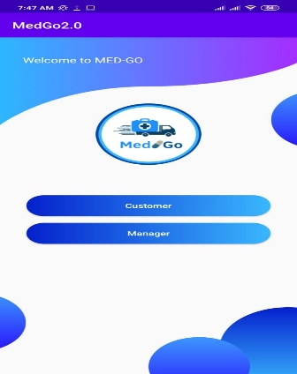

- Login
Login to system by providing required existing information.

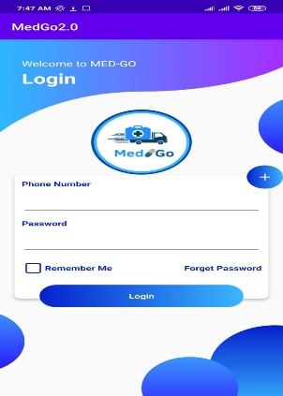

- Index
Main page.

- Blood-Group
Information of customers having different blood-groups.

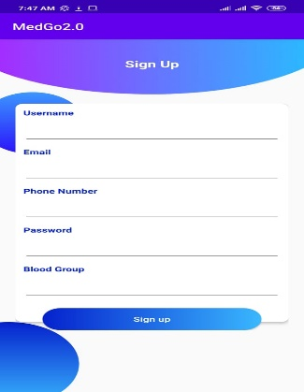

- Consult
This option leads you directly to a WhatsApp chat group where you will be able to consult a doctor regarding medicine.

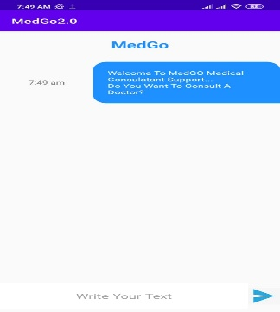

- Catalog
A catalog showing all products available in system.

- Product Info
Upon selecting a product its information is displayed. Here you can also add product to cart on basis of required quantity up to 9.

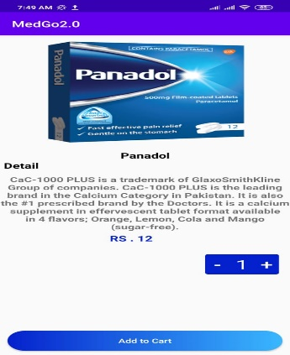

- Navigation Bar
Allows customers to navigate different sections of the system.

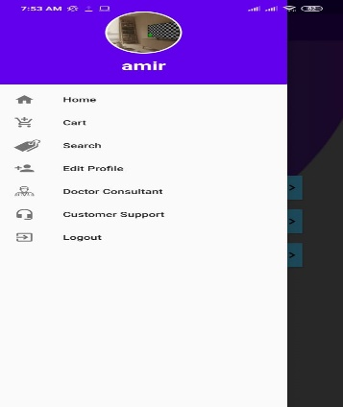

- Cart
Select Cart option from navigation bar or cart emote button from main screen to open cart. Here customer can view cart information.

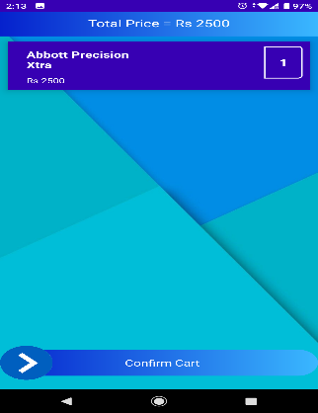

Cart data can be updated or removed by selecting specific product.

Select Next option to enter order details. Select current location option so system can get your current location from maps automatically and select Add Current Location option. Then Press Confirm button to confirm your order.
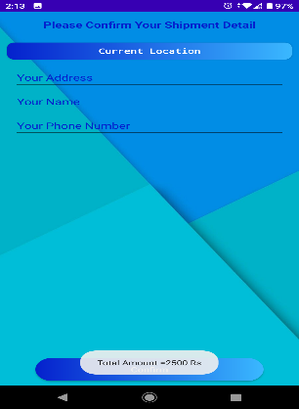

- Search
Here, users are able to search products.

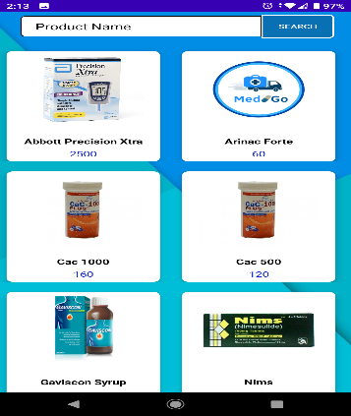

- Edit Profile
Here customers are able to edit their profile.

Manager

- Order
When manager signins to the system, the list of orders is displayed he selects specific order regarding preference to deliver. Manager can select to accept it. Upon accepting the order details are displayed to manager. Manager can then view location of customer. The geolocation pin is to be pressed and Maps option is to be selected so that the manager can view the order location where order is to be delivered. Here manager is also able to view Medical stores along the way using Google Maps. After delivering order manager selects Order Delivered option.

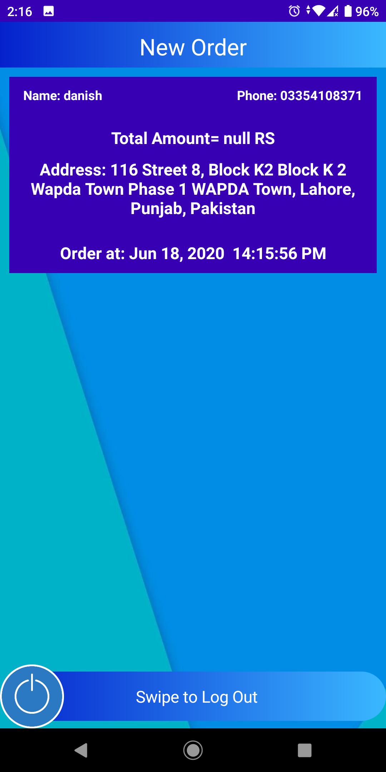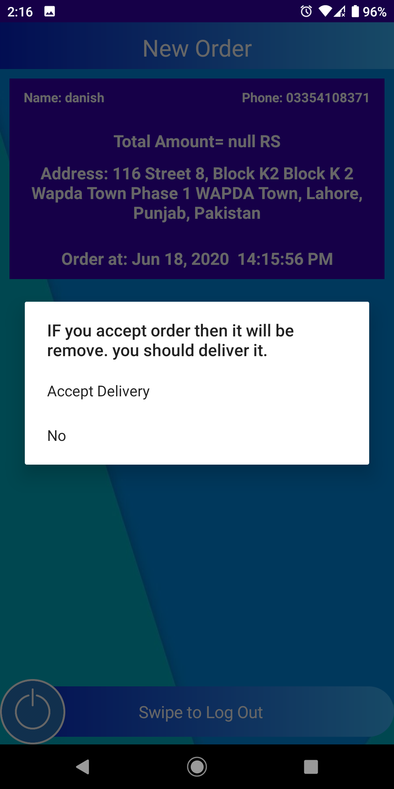

Appendix B: Administrator Manual
This appendix includes a detailed step by step walkthrough of how our Admin handles and works through our Web Application which is based to managing the employees, customers and most importantly, the products for the system.

- Login
Admin will login to system with their own specific username (mail) and password.

- Index
Here, Admin can view most of operations being carried out in system. Check number of items sold. Income generated. Number of customers, managers(employees) and products available. Also, blood group of customers are specified according to different colors.

- Mail-Box
This section allows us to check pending notifications, connected to WhatsApp.
- Products
This section allows admin to add products into system based on information collected from medical stores.

This section allows admin to edit products from system.

This section allows admin to search products from system.

- Employees
This section allows admin to add employees(managers) into system.

This section allows admin to edit employees from system.

This section allows admin to edit employees from system.

- Payments
This section includes all receipts generated from customer orders. Payments can be searched by product name, order date or customer id.

- Elements
This section is for making future updates to UI of Web-App or rather managing errors in case of a critical situation.

- Logout
To logout either press profile image to view logout button or directly click logout button in navigation bar.

Appendix C: Promotional Material
This section includes different materials that we shall use to promote our application. Promotional Material means all material used in the promotion of, or otherwise in connection with, the Business and includes artwork, advertising materials, display materials, packaging materials, brochures, Banners etc.

  - Brochure

  - Standee

  - Banner


Reference and Bibliography

Reference and Bibliography

[1] Elujoba, A. A., Odeleye, O. M., & Ogunyemi, C. M. (2005). Traditional medicine development for medical and dental primary health care delivery system in Africa. African journal of traditional, complementary and alternative medicines, 2(1), 46-61.

[2] Pinney, J. M., Henningfield, J. E., Shiffman, S., Gitchell, J., & Cone, E. J. (2002). U.S. Patent No. 6,358,060. Washington, DC: U.S. Patent and Trademark Office.

[3] Avery, R. L., & Luttrull, J. K. (2001). U.S. Patent No. 6,251,090. Washington, DC: U.S. Patent and Trademark Office.

[4] Lewis, C., & Hernandez, S. (2009). U.S. Patent No. 7,481,219. Washington, DC: U.S. Patent and Trademark Office.

[5] Barton, A. J. (2012). The regulation of mobile health applications. BMC medicine, 10(1), 46.

[6] Free, C., Phillips, G., Watson, L., Galli, L., Felix, L., Edwards, P., ... & Haines, A. (2013). The effectiveness of mobile-health technologies to improve health care service delivery processes: a systematic review and meta-analysis. PLoS medicine, 10(1).

[7] Weinstein, R. S., Lopez, A. M., Joseph, B. A., Erps, K. A., Holcomb, M., Barker, G. P., & Krupinski, E. A. (2014). Telemedicine, telehealth, and mobile health applications that work: opportunities and barriers. The American journal of medicine, 127(3), 183-187.

[8] Koutkias, V., Chouvarda, I., Goulis, D. G., Avramides, A., Adamidis, D., Louridas, G., & Balas, E. A. (2002). Home care delivery through the mobile telecommunications platform: the Citizen Health System (CHS) perspective. International journal of medical informatics, 68(1-3), 99-111.

[9] Jain, N., Gupta, B. P., Thakur, N., Jain, R., Banweer, J., Jain, D. K., & Jain, S. (2010). Phytosome: a novel drug delivery system for herbal medicine. Int J Pharm Sci Drug Res, 2(4), 224-228.

[10] Patrick, K., Griswold, W. G., Raab, F., & Intille, S. S. (2008). Health and the mobile phone. American journal of preventive medicine, 35(2), 177-181.

