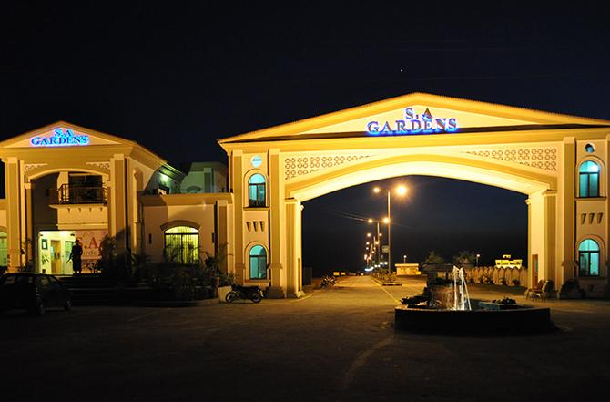
SOCIETYMANAGEMENT
SYSTEM

In the name of Allah, the Most Beneficent and the most Merciful

” And He (Allah) has subjected to you all that is in heavens and all that is in the earth. Verify in it are signs for the people who thinks deeply”.
(Al-Quran: 41; 53)





Department of CS and IT

SOCIETY MANAGEMENT SYSTEM
Developed By
Farhan Asif | ( 14212 )
Imran Ghafoor | ( 14202 )
Amir Nazir | ( 14222 )

Submission On
October 2015
Superior Group of Colleges,
University Campus, Lahore

Final Approval
Department of CS and IT

SOCIETY MANAGEMENT SYSTEM
Developed By
Farhan Asif | ( 14212 )
Imran Ghafoor | ( 14202 )
Amir Nazir | ( 14222 )

Project Supervisor: Sir Rehan Ahmad
Session:(2013 - 2015)
“The Department of Computer Science & Information Technology, the Superior University Lahore has approved this Final Year Project. The Project is submitted in partial fulfillment of the requirements for the degree of Masters of Information Technology.”
DEAN CS & IT Department

Proof Reading Certificate

It is to certify that we have read the document meticulously and circumspectly. We are convinced that the resultant project does not contain any spelling, punctuation or grammatical mistakes as such. All in all we find this document well organized and we are in no doubt that its objectives have been successfully met.

__________________
Mr. Rehan Ahmad
Lecturer, CS&IT Dep superior university, Lahore

Preface
The main purpose of our Website, Society Management System, is to take Orders. All the relevant details will available for user and can apply all the relevant packages to the related requirements. This will help to reduce the administrator of the website and users / customers the manual work and will save users and administrator time.
This work is submitted as a memory to the Department of CS & IT Superior University Lahore for the practical fulfillment of the requirements for the degree of Masters in Information Technology.

Acknowledgement
On the successful completion of this project, first of all we thank to Allah who gave courage and intelligence to complete it. We dedicated our work to the most respectful personality of the world and beloved PROPHET (PBUH) of Allah then to our parents, teachers, friends and all those persons who prayed and helped us in our project.
In the outset,we want to thank our supervisor Mr. Rehan Ahmad who always gave us kind attention whenever we visited him. His ample guidance and suggestions were invaluable in the successful completion of this project.
We are also extremely compelled to Mr. Rehan Ahmad, (our Project advisor) who provided us valuable knowledge about this project report. Also we extend our gratitude to anyone who has directly or indirectly helped in this project. At the end we must be grateful to our parents who gave us not only time but everything they could manage for us, for our studies and for our happiness and we are with their prays whatever we are now.

Abstract
This project is aimed at developing a society management system that is of importance to either an organization or a company. The Society Management System (SMS) is an intranet based application that can be accessed throughout the specified group. This system can be used to automate the workflow of Society application and their approvals.
Society management system is an integrated web application that handles various activities of a Society. Every human being can be seen the rates and facilitates of the Plots of the society through internet connected computers. Through links that displays in the home page the user can access different options of the website assigned to him.

Chapter # 1

History
1.Traditional system:
Before online implementation of society management system, all the activities of societies are managed through register work, manually. It was such a difficult process to manage all the activities through paper work. Too much time was consumed and it was very slow process of handling activities.Society currently use a manual system for the management and maintenance of critical information. The current system requires numerous paper forms, with data stores spread throughout the society management infrastructure. Often information (on forms) is incomplete, or does not follow management standards. Forms are often lost in transit between departments requiring a comprehensive auditing process to ensure that no vital information is lost. Multiple copies of the same information exist in the hospital and may lead to inconsistencies in data in various data stores.

2. Drawbacks of previous system:
Earlier systems were working with Traditional File System. Following are the list of difficulties faced by the society management in the era of file handling system:

  - Difficulty in location of guest files:
Due to the large number of guests’ files, location of guest files during checking in, updating of daily expenditures, receipt generation and checking out is extremely difficult for the society employees.

  - Large storage space:
The physical files occupy too much space of about two plots full of storage cabinets. This occupies the societies space that could have otherwise been used for income generation by the society.
2.3 Human and computational errors:
Many errors enabled by the system due to tedious computations required during data processing cost the society management heavily.
  - Poorly generated records:
Such data as the customer's record is omitted. This leads to security problems at the society such as armed robberies.
  - Complains from customer:
Due to poor management of documents encouraged by the manual system, several cases were reported where customer complained of overcharging, charging of services not used by the customer.
  - Poor communication:
Due to poor communication between the departments, customers are often over charged with services they didn’t order.
3. Objective of the System:
Main aim in developing society management system is to provide an easy way not only to automate all functionalities of a society, but also to provide full functional reports to top management of society with the finest of details about any aspect of society. We are committed to bring the best way of management in the various forms of society management system. We understand that society management system in not a product to be sold; it is a bridge between the society and customers. So we can say the Core purpose of designing “Society Management System” is to manage the task related to the society customers/employees and to reduce time to searching of appropriate customer in society view.
4. Manual system structure:
As shown in figure 1.1, the manual system of hotel management is very much difficult to handle. In this system every customer entry is made by hand. The booking is confirmed through phone calls or personnel visits. The booking office then inform to the accounting office to enter the cash or credit details in the books of accounts. The guest bill or accommodation file is maintained separately. If the user has to search about the record of any single customer, it is a time consuming process to search a record from the manually made registers. A simple hotel management process is shown in the figure given below:
Booking by phone calls and visits
Accommodation department

Booking office
Accounting
Customer file storage
Information Office
Electricity bill and expenditure outline

Manual system structure
Chapter # 2

INTRODUCTION
- Introduction:
This is a web-related application that permits us to approach the entire knowledge regarding the society facilities etc. This application is also called as property management system. This general application planned for aiding the people about details on the plots and rates. The administrator would maintain the accounts of the pupil and employees and upload the current information regarding the society.
The main problem projected is that registrar particulars are reported manually in distinct records, which is a laborious job. Handling and updating these records manually increase the chances of mistakes. It takes a lot of time and needs many employees to accomplish the task. It even lacks security and disability to produce various types of reports.
In order to solve these problems, a new system has been created, that attempts to operate the whole procedure considering the database integration approach.
- Several controls help the application to be friendly to the users.
- The entire project maintenance is made simpler and more adaptable.
- Internet access is possible.
- Several tiers have been employed to offer file upload.
- During the process of project progression, there is no chance of data mishandling.
- It offers great degree of security employing various protocols.
2. Purpose:
During the past several decades’ personnel function has been transformed from arelatively obscure record keeping staff to top level management function.There are many factors that have influenced this transformation like technologicaladvances, professionalism, and general recognition of human beings as most importantresources.
- A computer based management system is designed to handle all the primaryinformation required to calculate monthly statements. Separate database ismaintained to handle all the details required for the correct statement calculationand generation.
- This project intends to introduce more user friendliness in the various activities such as record updating, maintenance, and searching.
- The searching of record has been made quite simple as all the details of the customer can be obtained by simply keying in the identification of that customer.
- The entire information has maintained in the database or Files and whoever wants to retrieve can’t retrieve, only authorization user can retrieve the necessary information which can be easily be accessible from the file.
- The main objective of the entire activity is to automate the process of day to day activities of Society like:
For Employees:
- Easy to query all related details of customer and employee.
- Easy to generate payroll of individual employee.
For Society:
- Collective records of customers of all the plots.

This project has some more features:
- System Connectivity
- No data duplication
- No Paper Work Required
- Time Efficient
- Automatic data validation
- User friendly environment
- Data security and reliability
- Fast data insertion & retrieval

3. Advantages:
Society management system project is useful for the authorities who keep track of all the users registered in a particular state. The authority can add plots packages, plots details, availability of plots, generate bill etc.
The following steps that give the detailed information of the need of proposed system are:
  - Performance:
During past several decades, the records are supposed to be manually handled for all activities. The manual handling of the record is time consuming and highly prone to error. To improve the performance of the Society Management System, the computerized system is to be undertaken. This project is fully computerized and user friendly even that any of the members can see the report and status of the company.
  - Efficiency:
The basic need of this website is efficiency. The website should be efficient so that whenever a new user submits his/her details the website is updated automatically. This record will be useful for other users instantly.
3.3 Control:
The complete control of the project is under the hands of authorized person who has the password to access this project and illegal access is not supposed to deal with. All the control is under the administrator and the other members have the rights to just seethe records not to change any transaction or entry.

  - Security:
Section In charges can only have access to their sections. Other section in charge can make changes in other sections record.
Portability:
The system will be portable to run over the latest platforms available in the market like windows etc.
User Friendly:
The interface of the system should be user friendly that the user can easily understand the system.
Usability
System should be user friendly.
Interface
Interface should be user friendly and easy to learn and navigate. It should provide simple environment.
Reliability
The System should be able to complete its on-going operations in spite of any error or problem within defined response time.
Capacity
The System should be capable of supporting multiple users at a time
Performance Efficiency
The System should be capable of supporting multiple users at a time without affecting the performance.
Maintenance
The application is developed in a way that it can be easily understood and maintained. It should be flexible enough to stand with change and exceptions. The system should also handle new requirements. The system should well coordinate to produce an integrated working environment

  - The Overall Description:
This describes the general factors that affect the product and its requirements. This section does not state specific requirements. Instead it provides a background for those requirements, which are defined in section 3, and makes them easier to understand.
  - Project Perspective
The SMS is an independent stand–alone system. It is totally self–contained.
Hardware Interfaces
The SMS will be placed on PC’s throughout the society.
Software Interfaces
All databases for the SMS will be configured using SQL server 2008. These databases include society plot's and customer's information. These can be modified by the end users. The plots and database will include the plot numbers id and name and if they are vacant or occupied. The customer’s information database will contain all the information of the customer such as first name, last name, number of occupants, assigned room, default room rate(may be changed), phone number, whether or not the plot is guaranteed, confirmation number, automatic cancellation date, expected check in date and time, actual check in date and time, expected check out date and time, amount owed by customer, and abbreviated customer feedback.
5. Terms:
MS SQL Microsoft Structured Query Language
GUI Graphical User Interface
RAM Read Access Memory
SMS society Management System
ERD entity relation diagram

6 . System requirements:
6.1 Tools and Technology
Following tools and technologies are used for the development of hotel management system.
6.1.1 Hardware
- Pentium Duo 2 with 1.83 GHz processor.
- 2GB RAM
- 100GB Hard Disk
- DVD’s for backup of data
6.1.2 Tools
- Html | Basic Website Language
- CSS | For Layout Style Sheet
- Asp.net | For dynamic pages coding
- Visual studio 2012 | For Code Editing
- SQL server 2012 | For Database Design & Storage
- Visual Paradigm 12.2 | For UML Diagrams
Tools for development

6.1.2 SQL server 2012:
The Basic reasons to use MY-SQL are given below:
- SQL server delivers a comprehensive data platform that provides built-in security and availability.
- Lower storage costs through Data and Backup Compression.
- Optimize business processes with high performance and scalability.
- The ability to encrypt an entire database.
- Dates and Times. New data types: Date, Time, Date Time Offset.
- The ability to pass an entire table to a stored procedure.
- Centralize reporting and data analysis with data warehousing.
6.1.3 Visual studio 2012:
Microsoft Visual Studio is an integrated developing environment (IDE) from Microsoft. Visual studio is used to develop console and graphical user interfaceapplications along with Windows Forms or WPF applications, websites, web applications, and web services in both native code together with managed code for all platforms supported by Microsoft Windows. The .NET Runtime is required to run any of the applications that you create with a .NET language. When you compile any of the .NET languages it is converted in to a human-readable "Intermediate Language" (or "IL") code, that the .NET Runtime then compiles using the "Just in Time" (or "JIT") compiler.
ASP.NET
ASP.NET is a server-side web application framework designed for web development to produce dynamic Web pages. ASP.NET is not limited to script languages; it allows you to make use of .NET languages. It allows developers to build very compelling applications by making use of Visual Studio, the development tool provided by Microsoft. ASP.NET is purely server-side technology. ASP.NET drastically reduces the amount of code required to build large applications.ASP.NET provides a simple and easy to perform common tasks, from simple form submission and client authentication configuration and deployment site.
CSS
CSS stands for Cascading Style Sheet define how to display HTML elements. External Style Sheets can save a lot of work and are stored in CSS file. It is feature being added to HTML that gives both Web site developers and users more control over how pages are displayed. With CSS, designers and users can create style sheets that define how different elements, such as headers and links, appear. These style sheets can then be applied to any Web page.
HTML
Hypertext Markup Language (HTML) is the main markup language for creating web pages and other information that can be displayed in a web browser.HTML elements form the building blocks of all websites. HTML allows images and objects to be embedded and can be used to create interactive forms. It provides a means to create structured documents by denoting structural semantics for text such as headings, paragraphs, lists, links, quotes and other items. It can embed scripts written in languages such as JavaScript which affect the behavior of HTML web pages.HTML elements in ASP.NET files are, by default, treated as text. To make these elements programmable, add a run at="server" attribute to the HTML element. This attribute indicates that the element should be treated as a server control.
7. Methodology:
This project, SMS, is developed using Microsoft Visual Studio 2012and Microsoft SQL Server 2008 database on iterative and incremental development models with the collaboration of the system’s user.
8. User Characteristic:
From the requirement specification of my client, it is stated that all users of the software program are required to have the at least all of following characteristic
All users must be comfortable with using a computer.
Users must be knowledgeable in real estate business.
Chapter # 3

Feasibility report & techniques
Project Feasibility Report
This website is to develop an online order taking system for hotel. It will take orders from the customers and manage the orders automatically from the administrator site.
Following are the feasibilities of the project:
Technical Feasibility
Project is going to be developed by implementing the available modern open source technologies that are well established and highly secured with their distinctive features. Project team members are highly capable, competent and skilled to implement the modern technologies that would use to develop the whole project.
Operational Feasibility
We will try our level best to make our project that promises secured online order taking system and will provide information about the products that are available to purchase. Modern open source technologies and our team member skill would try to make sure the user friendly environment in our project.
Economic Feasibility
Economic feasibility of any project is measured on the basis of benefits that particular project will produce. As the project is all about online order taking system therefore it is relatively possesses high development and maintenance cost as compared to desktop projects. This project will definitely enhance the confidence level on the e-commerce. We will try our level best to enhance the trust of users by implementing secure order taking system.
Schedule Feasibility
Time is an important factor for the completion and evaluation of the Project. We are able to develop this project within time. We have about 2 months for the completion of project. Resources are equally allocated to each group member and all team members are present in working hours according to the schedule.
Specification Feasibility
Requirements are well defined and clear to all the team members. The proposed System will manage the following tasks.
- Online Reservation
- Administrative Tasks
For online order taking management system we need information about the customers. Also the database about variety of products is needed. Then in the light of rules and regulations, proposed system is developed.
Information Feasibility
The Feasibility Study has thoroughly explored the technical issues around the development, including its scope, contents, services, procedures and standards. It includes an outline business plan. We believe it has not only met its original objectives, but exceeded them. Motivational Feasibility
The basic motivation of the project is to satisfy end user by providing its distinctive and attractive features.
Legal & Ethical Feasibility

Ethical laws vary from nation to nation and country to country but we will try our level best to fulfill those moral values and ethical issues which are acceptable by any nation of the world.

Chapter # 4

Requirement Analysis

Critical path analysis:
The critical path method (CPM) or critical path analysis is a mathematically based algorithm for scheduling s set of project activities. It is an important tool for effective project management.
Task | Description | Objective
1. | - Project Initiation | Project Proposal
2. | - Conceptual System Development  - Scope of the Project  - Project perspectives  - Feasibility Study  - Tools and techniques
3. | - Planning | Project Management Plan
4. | - Requirement Analysis | Functional Requirement Document
5. | - Design | Detailed System Design
6. | - Development  - Database Creation  - Create Interfaces
7. | - Integration and Test
8. | - Implementation

Requirement analysis:
This section contains all the software requirements at a level of detail, that when combined with the system context diagram, use cases, and use case descriptions, is sufficient to enable designers to design a system to satisfy those requirements, and testers to test that the system satisfies those requirements.
Interfaces
The Hotel Management System will use the standard input/output devices for a personal computer. This includes the following:
- Keyboard
- Mouse
- Scanner
- Monitor
- Printer
Software Interfaces
The system shall interface with an SQL server.
Hardware Interfaces
The system shall run on a Microsoft Windows based system.
Communication Interfaces
The system will be a stand-alone product that will use any WAN network for the provision of internet.

User Interfaces
The User Interface Screens are described in table given below:
Screen Name | Description
Login | Log into the system as a customer or Manager (administrator)
Blocks Profile | Check Block categories, rates available for specified blocks
Plot information | Plot ID, Type, Charges details
Plot Booking | Customer Details, Plot No. , Price, Transfer Date, Allotment Date
Item Information | Group ID, Item name, Item details
Menu | Name of menu. Rates, No. of dishes, Package detail
Check-in and Checkout | Modify, check-in customer (with or without a reservation), adjust rate, special requests, generate bill, accept payment type/credit card, Checkout customer
Outdoor Booking | Customer detail, No. of persons, Rate, Bill calculated, Discount, Payable amount, Advance, Payment process
Outdoor catering | Customer bio-data, decoration and meal selected, payments
Purchase Items | Date. Department, Item Details, Rates and Discount
Functional Requirements:
“Functional requirements define the fundamental actions that system must perform.”
The functional requirements for the system are divided into subcategories:
- Any user cans Register Login, Change password and Profile.
- Any user can visit this site from their home PC, Laptop or Mobile.
- Admin can generate salary slips of staff and admin can also see credit detail of customers
- Admin can announce new offers and packages.
- Admin can update system and information; they have ability to add employees.
- Customer can give suggestion and feedback. Admin can view that feedback and suggestions.
- Admin can see visitor status and block any visitor /customer.
- Plots will confirmed by manager after receiving payments.
Nonfunctional Requirements
Does not describe any functionality of system but they describe how system works what kind of tools will use to develop any system. Non -functional requirements for this system are these
Performance Requirements
Performance requirements define acceptable response times for system functionality.
The load time for user interface screens shall take no longer than two seconds.
The log in information shall be verified within five seconds.
Queries shall return results within five seconds.

Logical Database Requirements
The logical database requirements include the retention of the following data elements. This list is not a complete list and is designed as a starting point for development.
Booking/Reservation System
- Customer first name
- Customer last name
- Customer address
- Customer phone number
- Payment type
Design Constraints
The Society Management System shall be a stand-alone system running in a Windows environment. The system shall be developed using ASP.NET and an SQL server database.
Standards Compliance
There shall be consistency in variable names within the system. The graphical user interface shall have a consistent look and feel.
Reliability
Specify the factors required to establish the required reliability of the software system at time of delivery.
Availability
The system shall be available during normal hotel operating hours.

Security
Customer Service Representatives and Managers will be able to log in to the Hotel Management System. Customer Service Representatives will have access to the Reservation/Booking and Food subsystems. Managers will have access to the Management subsystem as well as the Reservation/Booking and Food subsystems. Access to the various subsystems will be protected by a user log in screen that requires a user name and password.
Maintainability
The Hotel Management System is being developed in ASP.NET and it is an object oriented programming language and shall be easy to maintain.
Portability
The Hotel Management System shall run in any Microsoft Windows environment that contains SQL server database.

Chapter # 5

Testing

Test Case Specification

Software testing is the process of analyzing a software item to detect the differences between existing and required conditions (that is, bugs) and to evaluate the features of the software item.

Software testing is an important technique for assessing the quality of a software product. There are two basic classes of software testing, black box testing and white box testing.

The Basics of Software Testing

Black Box Testing: Black box testing (also called functional testing) is testing that ignores the internal mechanism of a system or component and focuses solely on the outputs generated in response to selected inputs and execution conditions.

White box test: White box testing is testing that takes into account the internal mechanism of a system or component.

Types of Testing

There are several types of testing that can be done on this system. Each type of test has a “specification” that defines the correct behavior the test is examining so that incorrect behavior (an observed failure) can be identified. These types are given as followed:
- Functional Testing
- Unit Testing
- Integration Testing
- Regression Testing
- Beta Testing
- Acceptance Testing

“We have performed “Functional Testing” under the opacity of Black Box Testing to test the functionality of the website”

Test Plan

Objectives

The test plan for the system should support following objectives:
- Identify which feature of the system will be tested.
- Define the pass/Fail criteria for each feature to be tested.
- Specify the testing approaches that will be used during testing.
- Identify the deliverables of the testing process

Tested Features

This section outlines all the features that will be tested
 | Features Identifier | Description
 | Test Case 1 | System Login
 | Test Case 2 | user registration
User | Test Case 3 | Plot Availability Check
 | Test Case 4 | Make reservation
 | Test Case 5 | Make payment
 | Test Case 6 | Cancel reservation
 | Test Case 7 | Edit profile

 | Features Identifier | Description
 | Test Case 8 | System Login
 | Test Case 9 | Manage Employee
Admin | Test Case 10 | Manage users
 | Test Case 11 | Manage Blocks
 | Test Case 12 | Manage Plots
 | Test Case 13 | Manage Bill

Test case for User Requirements

System login (Test Case 1)

Purpose: Test that users can login with the proper Username and password
Incorrect Input: Wrong username and password (the combination of username and password that doesn’t match with the one in the database)
Pass Criteria: An appropriate message should be display and the user should not be allow to login
Correct Input: Right username and password
Pass criteria: User should be able to login on the website and directed to the secure web page requested
Steps:
1. Visit login web page
2. Enter username
3. Enter password
4. Click Login button
5. Check if the message is to re-enter username and password

User Registration (Test Case 2)
Purpose: Test that registration of user is working properly and data saves in db..
Incorrect Input: Text that does not approve the criteria to add detail.
Pass Criteria: An appropriate message should be display that entry is successful.
Correct Input: Text that approve criteria.
Pass Criteria: The save message should be displayed
Steps:
1. Add detail
2. Click on save button
3. Check whether the data is saved or not in database.

Plot Availability Check(Test Case 3)
Purpose: Test Plot Availability checker is working properly or not
Pass criteria: Website should be show correct result on checking room availability
Steps:
1. enter allotment date
2. enter transfer date
3. Check the result displaying

Make Reservation (Test Case 4)
Purpose: Test the Room is reserved on desired Date
Pass Criteria: Room should be Reserve without any problem
Steps:
1. Visit the Make Reservation page
2. Select Plot
3. Fulfill the form of Plot Reservation

Make Payment (Test Case 5)
Purpose: Test that Click on Make Payment work properly
Pass Criteria: The sales account record must be entered in database
Steps:
1. Visit the Active Reservation Page
2. Click on Make Payment

Cancel Reservation (Test Case 6)
Purpose: Test that Canceling the reservation work as expected.
Pass Criteria: Detail should be Delete from active reservation
Steps:
1. login the user Account
2. Click on the Active Reservation

Edit Profile (Test Case 7)
Purpose: Test that Editing at user side work as expected.
Incorrect input: No values put in Fields
Correct Input: Provide all values to the fields
Pass Criteria: Detail should be updated
Steps:
1. Visit front end Webpage
2. Click on the update button

Test case for Admin Requirements

System Login (Test case 8)
Purpose: Test that admin can login with the proper Username and password
Incorrect Input: Wrong username and password (the combination of username and password that doesn’t match with the one in the database)
Pass Criteria: Page will be reload again and the user should not be allow to login
Correct Input: Right username and password
Pass criteria: User should be able to login on the website and directed to the secure web page requested
Steps:
1. Visit login web page
2. Enter username
3. Enter password
4. Click Login button
5. Check if the same page reloads again means re-enter username and password

Manage Employee (Test case 9)
Purpose: To test that employee module working fine
Incorrect input: Employee Already Exist.
Pass Criteria: An appropriate message should be displayed and the employee should not be allowed to register for an account with that username.
Correct Input: Employee name is not in use with other existing input.
Pass criteria: Administration should be able to register employee with the website.
Steps:
1. Visit the Employee Page
2. Fill all the fields of the page
3. Click Save button

Manage Users (Test case 10)
Purpose: Test that User information updated correctly when user update his account information from the front end of the website
Pass Criteria: The information of that user is updated, but the information of all others users remain same
Steps:
1. View the page
2. View the user list
3. View the page data and user information table in the database both having same data related to customers
Manage Blocks (Test case 11)
Purpose: Test that admin add and update the Blocks and showing on the website correctly
Incorrect Input: All required fields are not filled, Update with empty fields
Correct Input: Fill all the fields, Update fields with correct information
Pass Criteria: Block successfully added in the Society, Block successfully updated into the Society
Steps:
1. Select add Block in the categories.
2. Click add Block button.
3. Add the Block detail its name, type, Address description etc.
4. Click add Block button product will be added
5. Select Manage Block in the menu.
6. Click edit Block link for the particular branch that you want to edit
7. Update the Block information i.e. its name type, address description etc.
8. Click update Block button Block information will be update

Adopt Methodology

Our adopted methodology is “VU Process Model”. It is the combination of water fall model and spiral model. It has the merits of both models and It will make our product documented driven, less risky more maintainable, more flexible, reusable and more efficient. User interaction would also be done in this model make our product more comprehensive and user friendly.
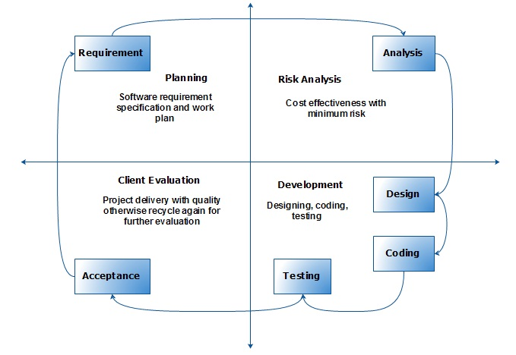
Vu process model has four phases which further divides the waterfall processes. These processes are in iteration until system meets to client requirement.
Reasons:

There are number of reasons to choose the “VU Process Model”. These reasons are given below;

- It Provides a Systematic and disciplined approach.
- It is fully documents driven approach.
- The focal intent of this model is to focus on the user & business requirements and analysis of the risk at each step.
- Performance and skills of the worker proceed to success.
- Reliable to verify the risk at each step.
- Fulfill the user needs.
- Increase the probability of correctness.
- By using spiral model the methodology becomes very sensitive to the risk.
- Slickly find the user requirement & give them result more efficiently.
- Easily divide product in different steps by using sequential model
- It is very reliable to understand the way of process.
- The maintainability would be increased by adopting this model.
- Make our product efficient more maintainable and flexible.
Work Plan (Use MS Project to create Schedule/Work Plan)

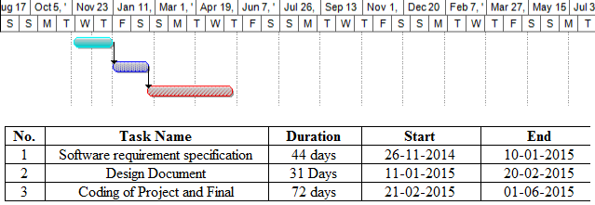
Chapter # 6

System development Life cycle

System Development Life Cycle
The Systems Life Cycle (SLC) is a type of methodology used to describe the process for building information systems, intended to develop information systems in a very deliberate, structured and methodical way, reiterating each stage of the life cycle. Several systems development frameworks have been partly based on SDLC, such as the structure Analysis and design method.
Systems development phases:
The System Development Life Cycle framework provides a sequence of activities for system designers and developers to follow. It consists of a set of steps or phases in which each phase of the SDLC uses the results of the previous one.
A Systems Development Life Cycle (SDLC) adheres to important phases that are essential for developers, such as planning, analysis, design, and implementation and are explained in the section below. A number of system development life cycle (SDLC) models have been created: waterfall, fountain, spiral, rapid prototyping, incremental, and synchronize and stabilize. The oldest of these, and the best known, is the waterfall model: a sequence of stages in which the output of each stage becomes the input for the next. These stages can be characterized and divided up in different ways, including the following:
- Project planning, feasibility study:
It establishes a high-level view of the intended project and determines its goals.
- Systems analysis, requirements definition:
It defines project goals into defined functions and operation of the intended application and analyzes end-user information needs.

- Systems design:
System design describes desired features and operations in detail, including screen layouts, business rules, process diagrams, pseudo code and other documentation.
- Implementation:
The real code is written here.
- Integration and testing:
Integration and testing brings all the pieces together into a special testing environment, then checks for errors, bugs and interoperability.
- Acceptance, installation, deployment:
This is the final stage of initial development, where the software is put into production and runs actual business.
- Maintenance:
This, the least glamorous and perhaps most important step of all, goes on seemingly forever
Systems Development Life Cycle is divided in ten steps from definition to creation and
modification of IT work products:
WBS (Work breakdown structure):
A WBS task may rely on one or more activities (e.g. software engineering, systems engineering) and may require close coordination with other tasks, either internal or external to the project. Any part of the project needing support from contractors should have a Statement of work (SOW) written to include the appropriate tasks from the SDLC phases. The development of a SOW does not occur during a specific phase of SDLC but is developed to include the work from the SDLC process that may be conducted by external resources such as contractors and structure.

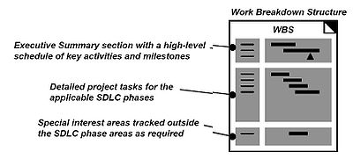
Work breakdown structured organization
Modeling with UML:
UML is a standard that has adopted by majority of the industry as well as the standard governing boards such as ANSI and Object Management Group (OMG). UML allows people to develop several different types of diagrams that represent various aspects of the system. Rational Rose supports the majority of these modules, as follows:

- Context Level Diagram
- Level 1 data flow diagram
- Use Case Diagrams
- E-R diagrams

Data flow diagrams (level 1):
The level 1 DFD provides detail descriptions about the flow of the data in each module. The hotel management is a complicated system that is used by different users according to their requirements. The Level 1 DFD shows the data flow in a more descriptive manner
Plot Reservation:
Customer
Plot Reservation
Plot
requested
Display available
Confirmation
Allocated to
DFD level 1 Plot reservation
Bill Scheduling:

Consumer
Block Capacity
Plot
Units Service charge
Bill Generate
Displayed to
Allotted by
generate
contains
Measured by
Made bookings
DFD level 1 Bill scheduling
Use Case Model

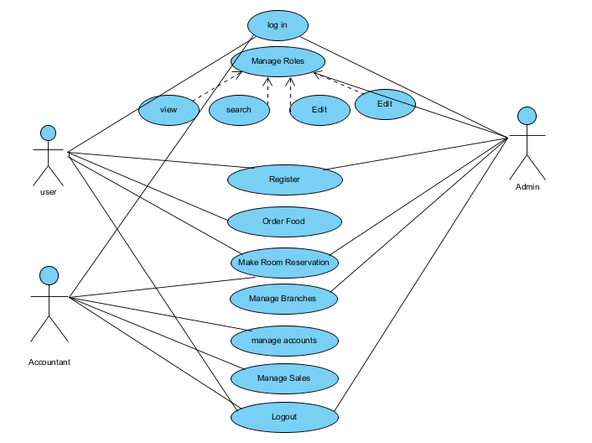

User Use Case Diagram

Can see the Society profile, can register an become user and see business schedules and terminal and make reservation after login

Visitor

Admin Use Case Diagram

Add delete employee, event, pakages.edit or view all customer and employee

Change Plot Rates and development Charges

Generate salaries of staff and see credit detail of customer

Admin

Will take money out of credit card after booking of plots

Customer Use Case Diagram

Signup option, send email/SMS, register change his profile or password and give feedback

Plot booking payments

Customer

Designing the Project

- Introduction to Design Document
During the improvement of software project for new system, Analysis phase plays an essential role. In it we try to touch and cover each and every edge of the system. Every system has some key areas which are of great importance as compared to other components of the system. In this phase, specifically those key areas are measured as a special case and observed in real depth. All the requirements (Functional and Non-functional) are first of all gathered and then with the collaboration of end users of the system the final requirements for new system are finalized. The importance of this phase can be visualized in this way that if any requirement is missed out during this phase then the final product will miss the every object. Therefore this phase takes much more time than any other phases.
Following steps are taken during Analysis and Design phase.
- To develop tool independent system requirement.
- Capturing high level entities and interaction among them.
- Defining and refining each system and subsystem domain.
- Capturing low level detail of each module.
- ER diagram will show entities, properties and their relationship with each other.
- Developing different types of diagram to present the flow of information, user interaction, system states etc to show the static and dynamic behavior of system.
- Architecture Diagram

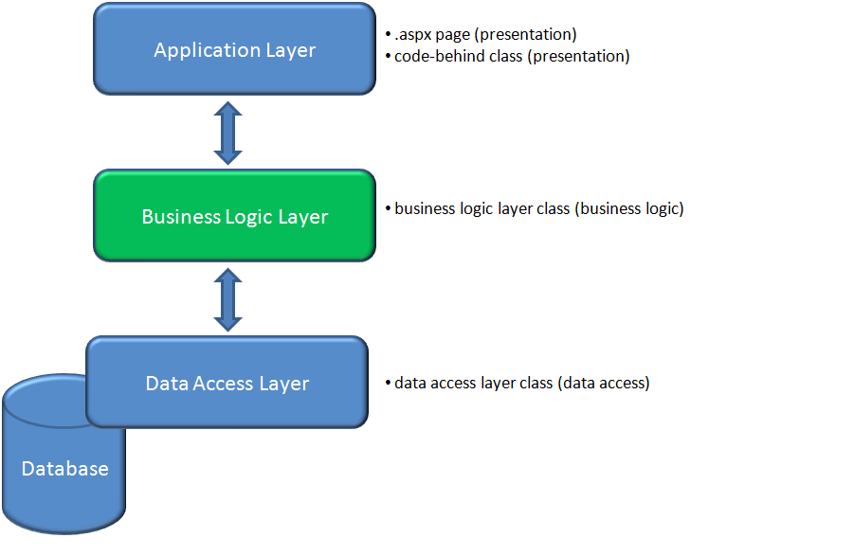

ERD Diagram
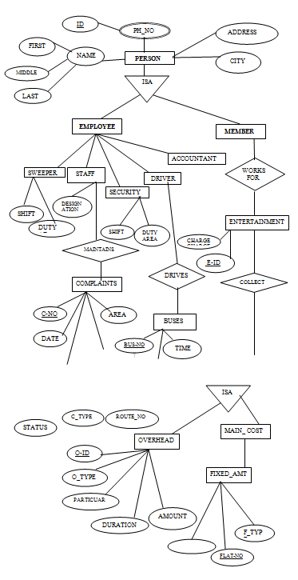

Database Diagram

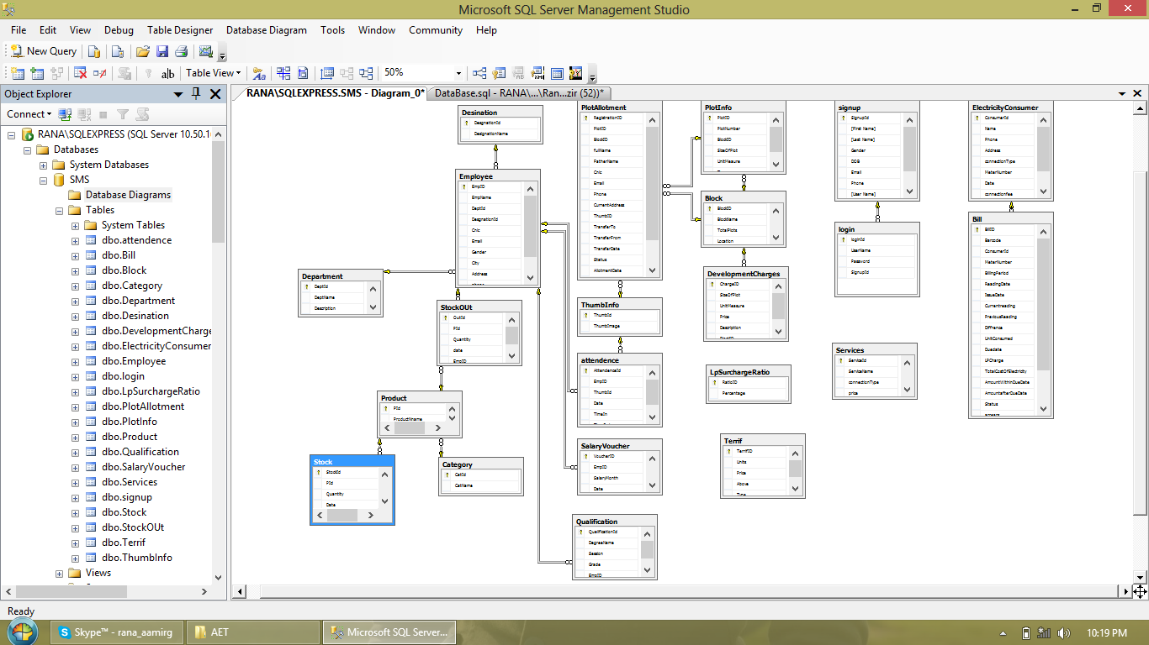

- Class Diagram
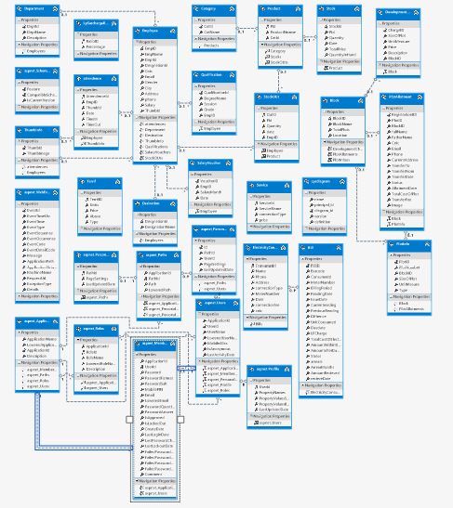

Sequence Diagrams

1.Interaction Sequence Diagram:
Log In
User System Database

Open Web Form

Show Database

Enter ID and username

Send data to Database

Verification
Exist

Give Access

Data does not exist enter correct Details

2.Interaction Sequence Diagram:
Select Plot
User System Database

Open Room Detail Form

Show Form

Select the room type

Send data to DB

Verification
Exist Show on databases
<----------------------------------------------------------------------------------------------------

Choose the dates
And press submit
Send data to DB Verification

Data saved in DB

--------------------------------------------------------------------------------------------------------

N If dates mismatched
Select different dates please
<----------------------------------------------------------------------------------------------------

3.Interaction Sequence Diagram:
Check Record
User System Database

Open Form

Show DB

Enter ID or choose a
name

Send data to DB

Verification
Exist Show on databases
<----------------------------------------------------------------------------------------------------

Press Details

Send data to DB

Data shown From DB

--------------------------------------------------------------------------------------------------------

N not Exist
Enter correct ID
<----------------------------------------------------------------------------------------------------

4.Interaction Sequence Diagram:
Modify Record
User System Database

Open Web Form

Show Database

Enter ID or select from
list

Send data to Database

Verification
Exist Show on Database

Make Changes

P Press Modify

Send data to Database

Data Modify from Database

Not Exist
Enter the correct Id

5.Interaction Sequence Diagram:
Receive Payment
User System Database

Open bill Form

Show Form

Enter ID or choose a
name

Send data to DB

Verification
Exist Show on databases
<----------------------------------------------------------------------------------------------------

Press Bill Details

Send data to DB

Data shown From DB

--------------------------------------------------------------------------------------------------------

Receive Payment
And update status Send data to DB

N Data saved to DB

Not Exist
Enter correct ID
<----------------------------------------------------------------------------------------------------

Activity Diagrams

1.Activity Diagram:
Search

Open Form

Enter ID/Name

Send data to DB

Search ID

Exist Not Exist

ID Match
Enter Correct ID

Check Record

2.Activity Diagram:

Modify

Enter ID
Open Form

Send data to DB

Not Exist Exist

Make Changes

Press Modify

Send to DB

New Record Save

3.Activity Diagram:

Login

Enter ID
Open Form

Send data to DB

Not Exist Exist

Give access
Create New ID

Enter New Record

Record added

4.Activity Diagram:

Book Plot

Open Form

Press Booking

Select Room

Choose Dates

If already taken Exist

Press Submit

Send to DB

Record Saved

5.Activity Diagram:

Receive Payment

Enter ID
Open Form

Send data to DB

Not Exist Exist

Press Bill Details

Receive cash

Press update status

User Interface
1: Login

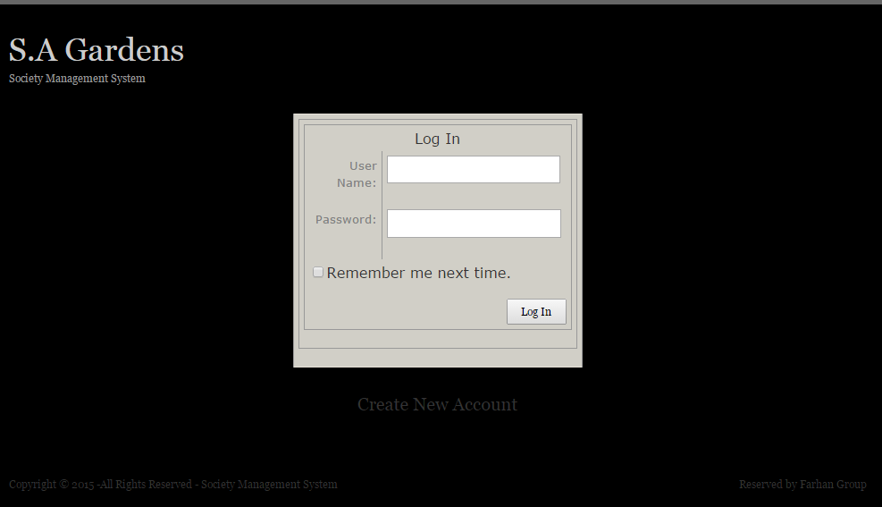

2: Sign Up

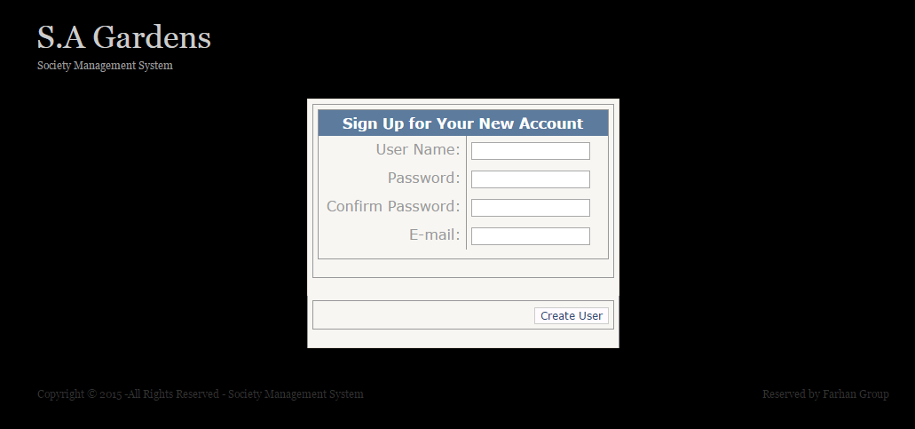
3: Home Page

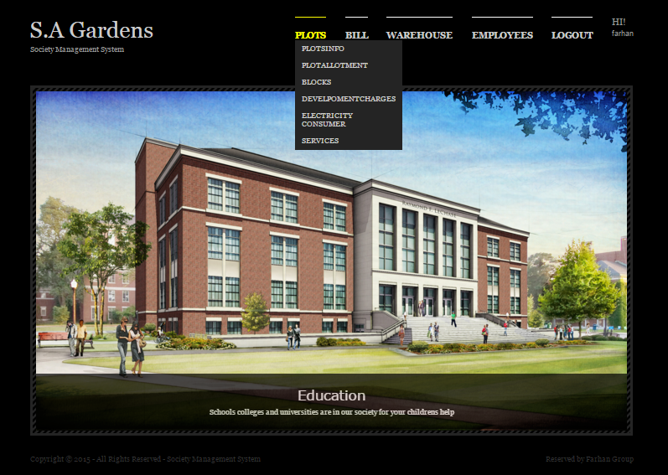

4: Add Employee

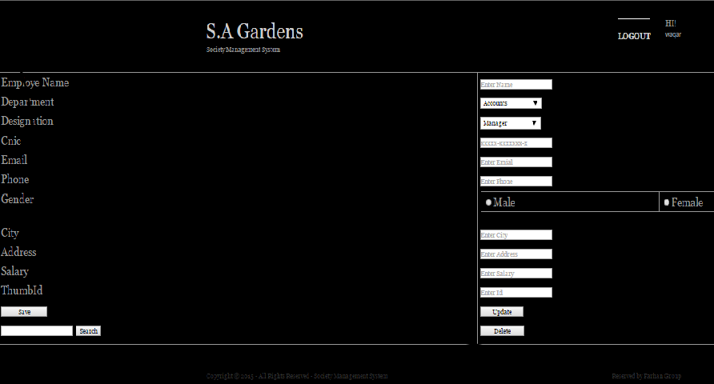
4: Viewers

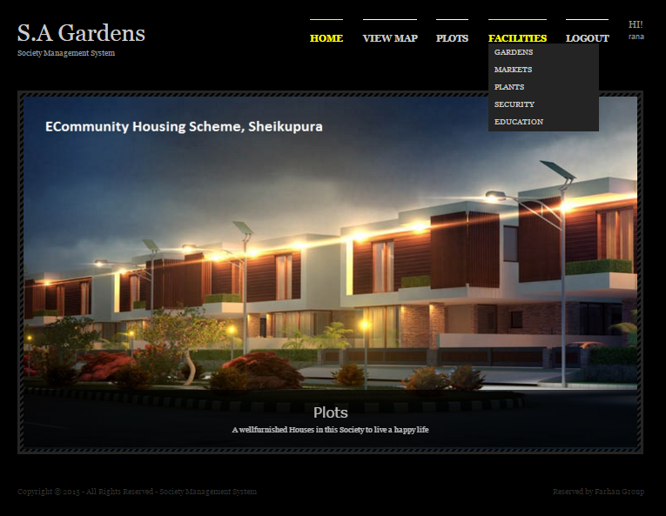

User Roles

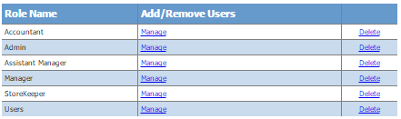

User's

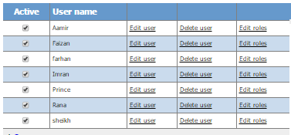

User Interface Design

There are many factors that must be considered when designing the user interface of a soft-ware because the user must be able to interact with the system in a way that the system will understand whatever the input given by the user. Therefore, the quality of the interface and software in general must pass the usability testing standard. Some usability factors, such as fit for use, ease of learning, task efficiency, ease to remember, subjective satisfaction and under-stand ability but all be put into consideration when designing the user interface.
Fit for use deals with the system’s task support that the user has in the real life. The other factors only deal with the ease of use or how user friendly the system is. ( Siren Loosen, 2005).
Making user interaction as simple as possible when designing the user interface is very important and this must be considered during functional requirement phase of a software de-signs. To create an operational, usable and user friendly interface, the technical functionality with visual element must put into consideration.
In actual fact, there are ten fundamental “heuristics” principles that must be followed when a user interface program is to be design. These are more of a rule of thumb rather than usability specific rules. (Nielsen, J. 2005. Ten Usability Heuristics)
Visibility of system status

During the design of a system, the user interface design should make sure the interface is able to inform the user what is going on at every point in time with appropriate feedback.
Match between system and the real world

The system should be able to communicate to the user in the language the user understands rather than computer language that is, making information appear in natural and logical order. The following are 10 heuristics general principles stated by Jacob Nielsen in his book titled
User control and freedom

User often make mistake by clicking buttons which are not relevant to his/her current task, therefore a clearly mark “exit” button should designed on the interface. Or better still, “undo” and “redo” should to place on the interface too.
Consistency and standards

Platform conventions are important part of user interface design because user should be able to know that a word that is read before still means the same thing when the same is encountered on another line
Error prevention

It is better to carefully design a software where there is no is no error. Either eliminate error-prone conditions or check for them and present users with a confirmation option before they commit to the action.
Recognition rather than recall

The user should not be forced to remember what he/she had seen before from one part of the dialogue to another. Objects, actions and many other options should be made very visible so that the user will easily remember while instructions for use of the system should be visible or easily retrievable whenever appropriate
Flexibility and efficiency of use

Accelerators, unseen by the novice user, may often speed up the interaction for the expert user such that the system can cater to both inexperienced and experienced users. Allow users to tailor frequent actions.
Aesthetic and minimalist design

Information which is not relevant to the dialogue should not be placed on the design because all other dialogue with compete the relevant information thereby diminishing their visibility.
Help users recognize, diagnose, and recover from errors

Error messages should be expressed in plain language (no codes), precisely indicate the problem, and constructively suggest a solution.
Help and documentation

Even though it is better if the system can be used without documentation, it may be necessary to pro-vide help and documentation. Any such information should be easy to search, focused on the user's task, list concrete steps to be carried out, and not be too large.
Modules and interfaces

Authentication management

Every user who wants to use this software is authenticated my means of username and password which is already created by the administrator and is stored in the database. All entered parameter of the password are matched with information stored in the database, therefore only authenticated users can log on to the program with limited access.
The only one who has access to the entire module and interfaces of the software and can create a new user to access the software.

Plot Allotment and transfer history

In this module the plot allotment is recorded. There are many important points that are including in that module is the followings:

- Plot Registration
- Plot Transfer
- Plot Location (information module for web visitors)
- Plot Rates (information module for web visitors)
- Facilities of Society (information module for web visitors)
- Transfer History
- Plot type (commercial or residential)
- Block name and number
- Current rate including development charges
- Location (facing park ,main blue ward etc)
- Price of the plot

Transfer history:
This module also has the functionalities to maintain records for the transfer of plot one party to other

- Seller name
- Purchaser name
- Contract detail
- Transfer fee
- Commission record of real estate agent

Warehouse Management

In this module well mange’s the society warehouse department all the material that is (issue or receive) recorded in that module. The main features of that particular module are as following.

- Stock in
- Stock out
- Category of martial (raw or furnished)
- Available stock
- Remaining stock
- Issuing date record
Accounts Management

Society has own employees for controlling all the functionalities being performed in a society. SMS also control the accounts functionality for the employees and for the record keeping of the society accounts. This module perform following functionalities

- Generate salaries
- Debtors
- creditors
- liabilities
- expenses
- revenue
- account receivable
- account payable
- bank account management

Employee Attendance Management

This module mange’s the employee attendance management has following features

- name
- date of join
- designation
- department
- time in
- time out
- shift
In which module we will make a complete process of employee.

AJAX:
We use Ajax to make a automatic clock and for making a error less pages due to this we have to understand the dependencies between same names through LINQ query.
RDLC Reports:
We make a RDLC reports for making record and watch the records anywhere easily.

Barcode | Consumer Id | Meter Number | Previous Reading | Unit Consumed | Total Cost Of Electricity | Amount after Due Date | Status | Bill ID
121 | Total |  |  |  |  |  |  | 0
Total |  |  |  |  |  |  |  | 0

Other Functionalities

Security

Every member staff and resident of society requires a username and password to log on to the system. The administrator of this system register each member staff allotting username and password to each and he/she can also revoke access if it is deemed fit for any reason. The data of database are protected through multiple layers of security which includes but not limited to passwords which are encrypted (should the society decide to take the software online with networking available but since this is a standalone software, the password is not encrypted) but each member is required to protect their password and change on the first logging when created by the administrator.

Performance requirement

For any software developed in this modern time, one of the most important things to do regularly is to update and upgrade and fix whatever bugs found. The following are the list of maintenance required for this software:
• Database archiving
• Password encryption
• Antivirus protection.
• Password update every 72 days

Error handling

The system also has error and debugging code within the software to prevent system collapse and krypton 2 professional encryption programs is embedded within the software security layer to prevent hacking it when installed over internet network. Also, within the code itself, SQL inject susceptible characters had being cleaned up.

Installation

After developing and testing the software, the next thing is to deploy the software and run it. For the purpose of this project, the installation and deployment of the software will be done from a compact disc (CD) from which the software had been copied to and will be run on a window platform.

Conclusions

Society management system is an integrated web application that handles various activities of a Society. Every human being can be seen the rates and facilitates of the Plots of the society through internet connected computers or internet enabled mobile devices. Through links that displays in the home page the user can access different options of the website assigned to him.
Attribute of this software and most importantly, a backup facility is included in the software in case of unexpected crash.
Understanding the complexity of software development process and life circle was quite challenging and demanding, therefore a lot of man power, coding and research were done for this project to be completed. The main scope of this project is to develop complete package society management system.
At the beginning of this project, everything look really simple and easy but as time went by, it was realized that there is more to the development of the software especially the coding part, though at the end of it all it was worth it because the result is satisfying because the main objective was realized
There are still limitations to the development of this software because at the moment, the software is stand alone and cannot communicate with other another computer from another branch of the society head office. Improvement is still needed to further enhance it so that in future it can communicate with other computers which have same software installed on them.
Furthermore, at the moment the response of the software is delayed due to some technicalities that cannot be resolved at the moment due to time constrain of this the thesis. It must be stated at this point that the project is still on-going and many bugs are being fixed as testing goes on.

Bibliography

http://www.nada.kth.se/~karlm/mvk/mvk08_lec2.pdf (28.7.2015)
Software Process Modeling
Patrick Waterston, Stephan Wei be l Z ah l, Diet mar Paul books (28.7.2015)

http://creately.com/diagram/example/i9duq86u2/society+management+system(29.7.2015)
http://creately.com/diagram/example/hjaa511d2/Society+Management+System (29.7.2015)
http://seminarprojects.org/c/use-case-diagram-for-society-management (29.7.2015)
http://read.pudn.com/downloads161/doc/728810/SRS(Final).pdf (30.7.2015)
http://www.projectcorner.in/housing-society-management-system-college-project-c-net-synopsis/ (01.8.2015)

Influence of Housing Systems on the Performance and Reproductive Characteristics of Werner Rabbits Reared in Port Harcourt, Rivers State, Nigeria L. NDOR, O.J. OWEN1 AND V.N. NYECHE Department of Animal Science, Rivers State University of Science and Technology, P.M.B 5080, Port Harcourt, Nigeria (2.8.2015)
https://en.wikibooks.org/wiki/SQL_Exercises/Employee_management(5.8.2015)
Steve McConnell
Code Complete: A Practical Handbook of Software Construction (6.8.2015)
Elisabeth Freeman,
Head First Design Patterns (6.8.2015)
Steve McConnell
Rapid Development (7.8.2015)
Erich Gamma
Design Patterns: Elements of Reusable Object-Oriented Software (8.8.2015)
Bruce Schneider
Applied Cryptography: Protocols, Algorithms, and Source Code (2nd Edition) (8.8.2015)
Robert C. Martin
Agile Software Development: Principles, Patterns and Practices (8.8.2015)
https://manager.coop/(9.8.2015)
http://www.ijera.com/papers/Vol4_issue2/Version 1/CF4201547551.pdf(10.8.2015)

