SUPERIOR UNIVERSITY LAHORE

Faculty of Computer Science & IT
Final Year Project
Easy Life
Project ID: [FYP-MCSM-S19-003]
Project Team
Student Name | Student ID | Program | Contact Number | Email Address
M Aqib Zahoor | MCSM-S18-002 | MCS | 03022786985 | Chaqib186@gmail.com
Hasnain Khalid | MCSM-S18-001 | MCS | 03047333919 | Mcsm-s18-001@gmail.com
Ali Hassan | MCSM-S18-014 | MCS | 03097183872 | Mcsm-s18-014@gmail.com
Project Supervisor: Irfan Khalid
Project Report
Easy Life
Change Record
Author(s) | Version | Date | Notes | Supervisor’s Signature
 | 1.0 |  | <Original Draft>
 |  |  | <Changes Based on Feedback from Supervisor>
 |  |  | <Changes Based on Feedback From Faculty>
 |  |  | <Added Project Plan>
 |  |  | <Changes Based on Feedback from Supervisor>

APPROVAL
Project Supervisor
Comments: ___________________________________________________________________
_____________________________________________________________________________
Name:______________________________
Date:_______________________________ | Signature:__________________________

Project Manager
Comments: ___________________________________________________________________
_____________________________________________________________________________
Date:_______________________________ | Signature:__________________________

Head of the Department
Comments: ___________________________________________________________________
_____________________________________________________________________________
Date:_______________________________ | Signature:__________________________

Table of Contents
Dedication vi
Acknowledgements vii
Executive Summary viii
CHAPTER 1 1
INTRODUCTION TO PROBLEM 1
1.1 INTRODUCTION 2
1.2 PURPOSE 2
1.3 EXISTING SOLUTION 3
1.4 PROPOSED SOLUTION 3
1.5 GAP ANALYSIS 3
CHAPTER 2 4
Software Requirements Specification 4
2.1 Purpose 5
2.2 Document conventions 5
2.3 Intended Audience and reading audience 5
2.4 Project Scope 5
2.5 Overall Description 6
2.5.1 Product perspective 6
2.5.2 Product function 6
2.5.3 User characteristics 6
2.6 Constraints 6
2.6.1 Regularly policy 6
2.6.2 Hardware limitations 7
2.6.3 Audit function 7
2.6.4 Parallel operations 7
2.6.5 Control functions 7
2.6.6 Criticality of an application 7
2.6.7 Reliability requirement 7
2.6.8 Safety and Security considerations 7
2.6.9 Assumptions and dependencies 8
2.6.10 Apportioning of the requirement 8
2.7 Specific Requirement 8
Non-functional requirements 8
2.7.1 Usability 8
2.7.2 Reliability 8
2.7.3 Performance 8
2.7.4 Design constraints 9
2.7.5 Portability 9
2.7.6 Maintainability 9
2.7.7 License agreement 9
2.7.8 Functional requirements 10
APPENDIX 11
Chapter 3 12
Usecase Analysis 12
3.1 USECASE DIAGRAM 13
3.2 USECASE DESCRIPTIONS 14
3.2.1 Register 14
3.2.2 Login 14
3.2.3 Request Professional 15
3.2.4 Chose Work Category 15
3.2.5 Chat 16
3.2.6 Accept Request 16
3.2.7 Contact 17
3.2.8 Location 17
3.2.9 Check History 18
3.2.10 Complain 18
3.2.11 Approve professional 19
3.2.12 Solve Issues 19
Chapter 4 20
System Design 20
4.1. Architecture Diagram 21
4.2. Entity Relationship Diagram with data dictionary 22
4.2.1 ERD by Ahmad Ali Shah 22
4.2.2 ERD by Shaheer Ahmad Ghauri 23
4.3 Class Diagram 24
4.4. Sequence Diagram 25
4.4.1 For Administrator 25
4.4.2 For Management 26
4.4.3 For Customer 27
4.4.4 For Service Management 28
4.5 Activity diagram 29
4.5.1 For Administrator 29
4.5.2 For Management 30
4.5.3 For Customer 31
4.5.4 For Service Management 32
4.6. State Transition Diagram 33
4.7. Component Diagram 34
4.8. Data flow Diagram 35
4.9 Collaboration Diagram 36
4.10 Deployment Diagram 37

List of Table
Table 1.1 Gap analysis--------------------------------------------------------------------------------------3
Table 3.1 – Register----------------------------------------------------------------------------------------14
Table 3.2 – Login--------------------------------------------------------------------------------------------14
Table 3.3 - Request professional------------------------------------------------------------------------15
Table 3.4 - Choose work category----------------------------------------------------------------------15
Table 3.5 -chat-----------------------------------------------------------------------------------------------16
Table 3.6 - Accept request--------------------------------------------------------------------------------16
Table 3.7 – Contact-----------------------------------------------------------------------------------------17
Table 3.8 – Location----------------------------------------------------------------------------------------17
Table 3.9 - Check history----------------------------------------------------------------------------------18
Table 3.10 – Complain-------------------------------------------------------------------------------------18
Table 3.11 - Approve professional----------------------------------------------------------------------19
Table 3.12 - Solve issues-----------------------------------------------------------------------------------19

List of figures
Fig 3.1 - Usecase diagram-------------------------------------------------------------------------------13
Fig 4.1 - Architecture diagram-------------------------------------------------------------------------21
Fig 4.2 - Entity relationship diagram with data dictionary--------------------------------------22
Fig 4.2.1 - By Ahmed Ali Shah--------------------------------------------------------------------------22
Fig 4.2.2 - By Shaheer Ahmed Ghauri----------------------------------------------------------------23
Fig 4.3 - Class diagram-----------------------------------------------------------------------------------24
Fig 4.4 – Sequence----------------------------------------------------------------------------------------25
Fig 4.4.1- For administrator-----------------------------------------------------------------------------25
Fig 4.4.2-For Management------------------------------------------------------------------------------26
Fig 4.4.3-For Customer-----------------------------------------------------------------------------------27
Fig 4.4.4 For Service Management--------------------------------------------------------------------28
Fig 4.5 - Activity diagram--------------------------------------------------------------------------------29
Fig 4.5.1 - For administration---------------------------------------------------------------------------29
Fig 4.5.2 - For management-----------------------------------------------------------------------------30
Fig 4.5.3 - For customer----------------------------------------------------------------------------------31
Fig 4.5.4 - For service management-------------------------------------------------------------------32
Fig 4.6 - State transition diagram----------------------------------------------------------------------33
Fig 4.7 - Component diagram---------------------------------------------------------------------------34
Fig 4.8 - Data flow diagram------------------------------------------------------------------------------35
Fig 4.9 - Collaboration diagram-------------------------------------------------------------------------36
Fig 4.10 - Deployment diagram-------------------------------------------------------------------------37

Dedication
To all those who have supported, encouraged, challenged, and inspired us and specially to our Beloved Parents, honorable teachers and friends for all their guidance, love and attention which has made it possible for us to make it up to this point and as well as the Supervisor who bestowed us with the courage the commitment and the awareness to follow the best possible route, by their unmatchable style and by best possible training.

Acknowledgements
I am really thankful to my supervisor who has guide us to make a wonderful app. Who has teaches us how we manage our work and tell us pros and cons of our ideas. He is deal us very politely and give us suggestion we discus every think because they deal us like a brother. He has a best communication level. He gave me and my group more or more motivation and confidence. He did not refuse our idea but he enhances that idea. He teaches are her mind set and level.

Executive Summary
We want to develop an application similar to careem and uber but instead provide services like plumber, electrician, carpenter etc. People will directly communicate with professionals to get the required services through chat option which we provide in our application and also see the location by using gps or google map pointer.
In our application we provide two type of account one is service provider account that is for professionals and second one is user account which is for users.
We aim to be the largest employment creator in Pakistan and to be the people’s choice for getting their home repair, maintenance, service and daily chores done at the touch of their fingertips.

CHAPTER 1

INTRODUCTION TO PROBLEM

1.1 INTRODUCTION

Easy Life is design to provide quality service to the users, it is divided into two modules that is designed for the use of both user and service provider. Both modules are interconnected. Our idea is to provide the platform on which every type of service is available on just one click. Any type of professional work there without any investment, they just get a register and start working they do not need any type of shop.
And same is the criteria with user, user just register their account with their Email address and Login to system and call for services available on the app.
What's new?
Our product provides the real time communication like uber and careem which is not provided yet, it provides location and chat feature. There is no third-party involvement user can directly communicate with the service provider and ask for the time and other queries and user also send the location of the place where they need the service.

Some companies are providing these services like electricians, plumbers, carpenters, teachers etc. but they do not provide the direct communication of the user and service providers they act as third party .Finding these kind of services is very time consuming our product provides these services on just one click at your door step user just search of the desire category and text the service providers and tells about the problem after this user send the location .

1.2 PURPOSE

Purpose is to provide quality services to the users on a single click because finding these services in this era is very time consuming and headache task there are some apps who provides some services but because of third party involvement cost of the service is increased by two times.

Another Purpose is to provide work to the professional without any investment they just start their business after getting register to start these kinds of businesses they need a shop and the advance of the shop 100000 approximately. Unemployment in our country is increased due to the lack of opportunities and investment.

Everyone can earn money if they have an investment but with our any one can earn money without investment.

User and professionals just register through email address and with some personal details.
Some apps providing these kind of services but they have static rates because of their business models they do not provide real time communication to both user and professional , user does not pay to the professional they pay to the company who hire the professional and company pays the professional and company also take 30 to 50 percent commission and as the result of it user has to pay more than the worth of the service and in the result of it user does not call for the service again because of the high prices . we solve this problem because of our business model we provide direct communication we have a chat and location option.
They can chat with each other and see their current location and can estimate time.

1.3 EXISTING SOLUTION

Here I have a list of some app that provide these kinds of services.

- Sakoon.pk
- Mechanic ustad.com
- Kareger.pk

These apps provide these kind of services but their way of providing services is different .They have some specific kind of professionals who work for them they does not provide direct communication they act as third part between the professionals and the service consumer and as a result of it cost of the service is increased by two times.

1.4 PROPOSED SOLUTION

Our solution is to provide the direct communication between you and the service providers. You can contact through our chat option and ask for a possible solution and send your current location to them.

1.5 GAP ANALYSIS
Table No:1.1
Desire State | Current State | Action State
No third-party involvement | Third party involve | Through a design
Real time chat | No real time chat | Firebase etc.
Location of place | No location | Use google API
Low prices | High prices | Through a business model

CHAPTER 2

Software Requirements Specification

2.1 Purpose

Purpose of this document is to present the detailed description of our product what we are going to develop. We will explain the scope of our product and the main function of our product what our product will do and under which constraints it must operate.

2.2 Document conventions

This document was created based on the IEEE template for SRS documentation.

2.3 Intended Audience and reading audience

People’ who wants quick service at their door step on just a single click, People who has skills who want to work and earn, but they do not have money to invest.

2.4 Project Scope

Umbrella is the product which is very use full for both the service provider and client. Both of them were actually served by this software. Now a day’s clients want the service in fastest way and service provider do not want to invest but they want to earn money.
This service is better than other existing solutions because of our business model which is direct communication. We provide chat feature for the direct communication with the service provider and we also provide the location feature using google API user can send the location where he wants to get serve. Both the user and professional can sign up with Email address and with some personal information. Both of them can edit their personal information in real time add user can also see the status.

2.5 Overall Description

2.5.1 Product perspective

Umbrella users developed for everyone who has skills in any kind of field like teaching, plumber, mechanics, carpenters, cleaner, car service and builders. User can take appointment from service provider and ask them to come or can go service provider place through location service that we provide in our app. And all this is done on just a single click.

2.5.2 Product function

- Registration of a professional.
- Registration of a user.
- Login of a professional.
- User can send a message.
- Professional can send a message.
- User can send a location.
- Both of them have setting options (edit personal settings).
- Rate the professionals.
- Search for a category.

2.5.3 User characteristics
Education level of professional is considered according to the service they provide.
e.g. if we search for a teacher then education level is very important and if we want plumber then education level is not important.
Experience and quality of work done by professional is measured on the ratings which is provided by the user.
App is very simple to use like other apps any type of person can use it easily.
Education level of user is not very important in our product because we are using very using very common terms that we use in our daily life and our user interface is very friendly so that a person who use WhatsApp or Facebook can easily use the app.

2.6 Constraints

2.6.1 Regularly policy
Policies are often Imposed by the country law every country has different rules and regulations. Our policy is that we can apply check to our product that no service is provided against the law of Pakistan.

2.6.2 Hardware limitations

Our product is used between API level 16 to API level 28 of android.

2.6.3 Audit function

No need of audit because in the limited stage of this project we give only option this is COS (cash on service).

2.6.4 Parallel operations

User can do parallel operations, we are working in android so because of the listeners in java parallel operations are easily operated.

2.6.5 Control functions

Now a day every function in every app I explore yet is done on click so there are no other control functions. Users who is familiar with touch screen interfaces can use our product with ease.

2.6.6 Criticality of an application

Criticality of an application depends on the servers on which application is being developed. We can take care of it according to the response of targeted.

2.6.7 Reliability requirement

Our product is reliable between the API level 16 & 28. We can further enhance it in future and we can also upgrade our servers according to the traffic we also plan to use amazon web services in future to manage users properly.

2.6.8 Safety and Security considerations
We want you to get your work done by professional freely, make the most of your time, and be connected to the people and places that matter most to you. That’s why we are committed to safety, from the creation of new standards to the development of technology with the aim of reducing incidents.

2.6.9 Assumptions and dependencies

It is assumed that some of the data will be made available for the project in some phases of its completion. Until the test data will be used for providing, he demoes of report. It is assumed that the user is familiar with internet and also familiar with handling of touch screen interfaces.
For now, the product is android based so there is no need of browser settings. It will be assumed that the user will possess decent internet connectivity.

2.6.10 Apportioning of the requirement

For now, we are using g-mail authentication but in the future, we also add phone number authentication. We also want our product on a web in future. We also want to integrate our product with uber for transport facilities in the future.

2.7 Specific Requirement

Non-functional requirements

2.7.1 Usability
Every developer on designer wants to increase the usability of their product.
We add a help section for the people who stuck somewhere they can explore this section and can easily solve their problems.

2.7.2 Reliability
Reliability is something which can be tested when the traffic is increased. As I mentioned earlier, we use AWS in the future for better service. For now, we use open fire or fire base etc.

2.7.3 Performance
Before deploying our product, we test it on some users in the real environment and we going to use later upgrade to save time and space like, recycler view, view model, live data for the best performance.

2.7.4 Design constraints
These constraints are typically imposed by the customer, organization or external regulations.
Our admin is responsible for this constraint because they have access to data base, so admin observes all the services which is provided and if anything goes against the regulations, they are allow to stop them.

2.7.5 Portability
Portability testing refers to the testing with ease of moving one product or software from one environment to another. One example includes testing of a product which is well functioning in api 15 and measuring its behaviour in api 20. This is measured in terms of the effort involved in the task. Our application run's on android operating system.

2.7.6 Maintainability
Every app has an ongoing maintenance cost once it's published - no matter who builds it. Our monthly pricing plans make it easier for you to predict how much your app will cost over time.
Once your app is published, you still have to create new content, track how your app is performing, and let your users know what's new. If your app relies on a server to store information like user records, or payment history, you'll also have to pay to manage this information.
Every app requires ongoing maintenance and content updates to keep users happy, engaged, and coming back for more. Depending on the complexity of your app, you can also incur additional costs for servers, emergency maintenance, push notifications, payment processing, and more.

2.7.7 License agreement
we establish limited warranty information and disclaimers of liability, which you can include in your license agreement. Use the End User License Agreement document if: You create software and wish to license its use, rather than sell it to a user. You sell software or offer it for download.

2.7.8 Functional requirements

- Create Account
- User Login
- Professional Login
- Manage their account
- Navigate the professional
- Select the professional
- Search the category
- Text them for appointment time
- Location Tracking
- Status

Chapter 3

Usecase Analysis

3.1 USECASE DIAGRAM
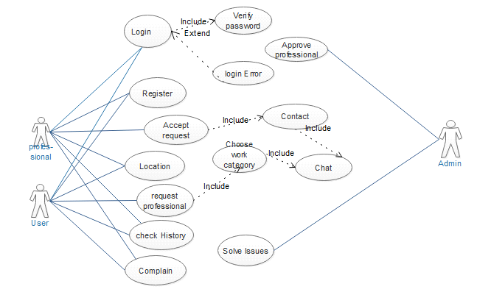Figure:3.1

3.2 USECASE DESCRIPTIONS

3.2.1 Register

Table No:3.1
Use Case ID | UC_01
Use Case Name | Register
Description | User and professional must register to use application
Primary Actor | User, Professional
Secondary Actor
Pre-Condition | Phone No and email is Necessary
Post-Condition | A login account is created
Basic Flow | Actor Action | System Action
 | User & Professional can register  themselves | System store the information in database and verify it than create a login.
Alternate Flow | N/A

3.2.2 Login
Table No:3.2
Use Case ID | UC_02
Use Case Name | Login
Description | User and professional can login in the app to use the service.
Primary Actor | User, Professional
Secondary Actor
Pre-Condition | Must have Login details. (email, password)
Post-Condition | If the login details are valid than they can login otherwise it shows a Login error.
Basic Flow | Actor Action | System Action
 | User & professional can login into the app | System verifies the login details than Allows the App Access else it return an Error
Alternate Flow | N/A

3.2.3 Request Professional
Table No:3.3
Use Case ID | UC_03
Use Case Name | Request Professional
Description | User can request professional for their work.
Primary Actor | User
Secondary Actor
Pre-Condition | User must have login Account to request a professional
Post-Condition | After that it shows a category of professional so user can choose the category.
Basic Flow | Actor Action | System Action
 | User request the professional to get their work done. | System return the categories to the professional.
Alternate Flow | N/A

3.2.4 Chose Work Category
Table No: 3.4
Use Case ID | UC_04
Use Case Name | Choose work Category
Description | After requesting the professional the user choose a category of work.
Primary Actor | User
Secondary Actor
Pre-Condition | User must request for professional to choose work category
Post-Condition | After choosing the request will be sent to eligible professional
Basic Flow | Actor Action | System Action
 | Choose the category to request the professional. | System will send the request to the eligible professionals.
Alternate Flow | N/A

3.2.5 Chat
Table No:3.5
Use Case ID | UC_05
Use Case Name | Chat
Description | User and professional can chat with each other.
Primary Actor | User, professional
Secondary Actor
Pre-Condition | User must request for the professional
Post-Condition | After eligible professional Accept the request than they can chat with each other
Basic Flow | Actor Action | System Action
 | User can chat with the professional about work | System provides the chat facility
Alternate Flow | N/A

3.2.6 Accept Request
Table No:3.6
Use Case ID | UC_06
Use Case Name | Accept Request
Description | Professional Accepts the user request for work
Primary Actor | Professional
Secondary Actor
Pre-Condition | To Accept request there must be a request from the user
Post-Condition | Professional must go to the work
Basic Flow | Actor Action | System Action
 | He Accepts the request to work | System send a notification to the user and details of professional
Alternate Flow | N/A

3.2.7 Contact
Table No:3.7
Use Case ID | UC_07
Use Case Name | Contact
Description | Professional can contact the user to talk about work
Primary Actor | Professional
Secondary Actor
Pre-Condition | Must Accept the work request
Post-Condition | Professional can talk about the work details
Basic Flow | Actor Action | System Action
 | Contacts the user to talk about work | System provides chat facility
Alternate Flow | N/A

3.2.8 Location
Table No:3.8
Use Case ID | UC_08
Use Case Name | Location
Description | User and professional can see each others location
Primary Actor | User, Professional
Secondary Actor
Pre-Condition | Must a work call could be sent by user and Accepted by Professional
Post-Condition | Can see each other live location
Basic Flow | Actor Action | System Action
 | Can see each other location | System provides GPS facility for the location
Alternate Flow | N/A

3.2.9 Check History
Table No: 3.9
Use Case ID | UC_09
Use Case Name | Check History
Description | User and professional can check their history.
Primary Actor | Professional, User
Secondary Actor
Pre-Condition | Must have a work history
Post-Condition | Can see the work history
Basic Flow | Actor Action | System Action
 | Can see the work history | System can collects the history details from database and return it
Alternate Flow | N/A

3.2.10 Complain
Table No: 3.10
Use Case ID | UC_10
Use Case Name | Complain
Description | User and professional can complain about any issues
Primary Actor | User, professional
Secondary Actor
Pre-Condition | Must have a work history
Post-Condition | They can complain about issues
Basic Flow | Actor Action | System Action
 | Complain about issues | System send the complain to the Admin
Alternate Flow | N/A

3.2.11 Approve professional
Table No:3.11
Use Case ID | UC_11
Use Case Name | Approve Professional
Description | Admin Approves the professionals
Primary Actor | Admin
Secondary Actor
Pre-Condition | Must have approval request from professionals
Post-Condition | Verify the details and approve the professional
Basic Flow | Actor Action | System Action
 | Approve the professionals | After Admin approve the professional the information for login is added into the database for login.
Alternate Flow | N/A

3.2.12 Solve Issues
Table No: 3.12
Use Case ID | UC_12
Use Case Name | Solve issues
Description | Admin solve the issues of the user & professional
Primary Actor | Admin
Secondary Actor
Pre-Condition | There must have an issue reported
Post-Condition | Must have to solve the issues
Basic Flow | Actor Action | System Action
 | Solves the issues | System returns the status to issues
Alternate Flow | N/A

Chapter 4

System Design

4.1. Architecture Diagram

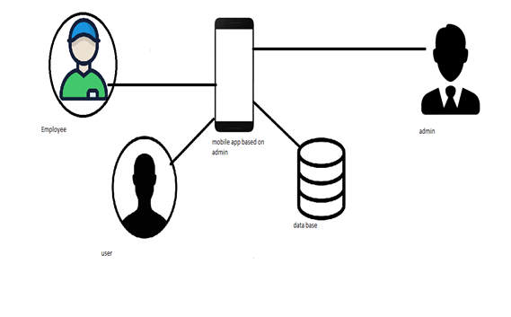
Figure 4.1

4.2. Entity Relationship Diagram with data dictionary

4.2.1 ERD
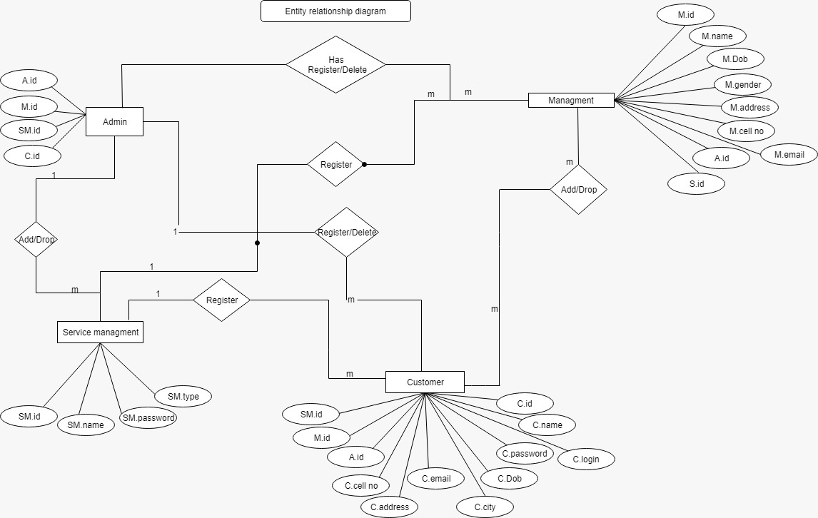Figure 4.2.1

4.2.2 ERD

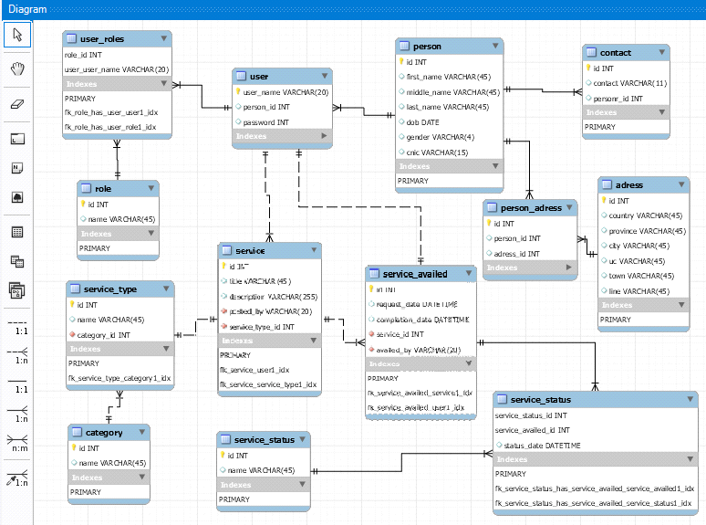Figure 4.2.2

4.3 Class Diagram

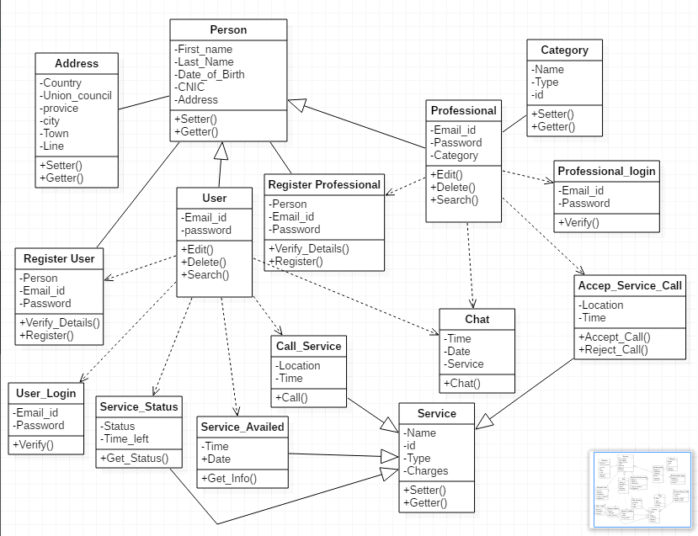
Figure 4.3

4.4. Sequence Diagram

4.4.1 For Administrator
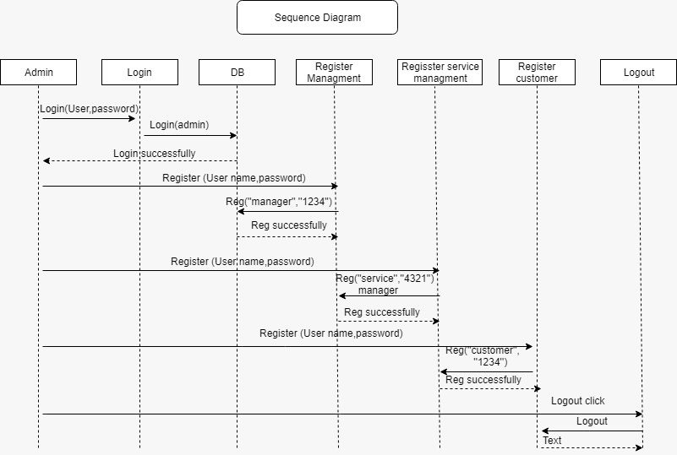
Figure 4.4.1

4.4.2 For Management
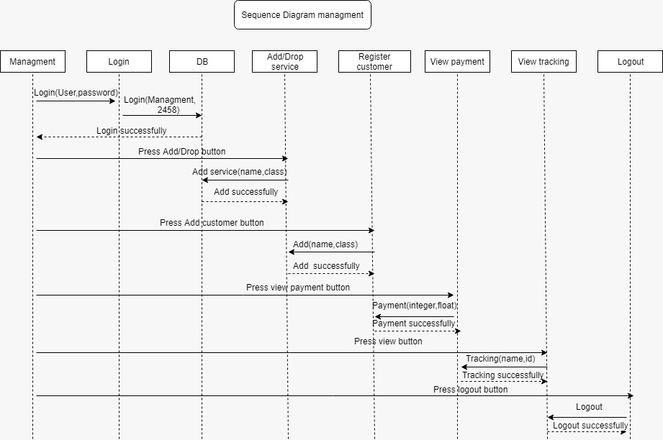
Figure 4.4.2

4.4.3 For Customer
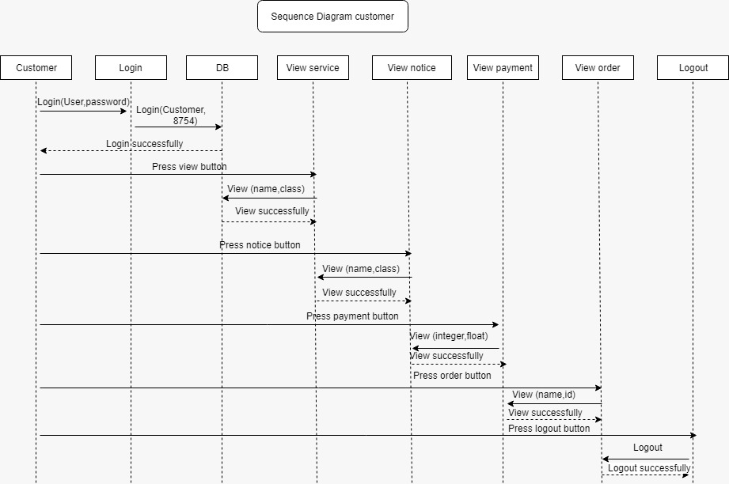
Figure 4.4.3

4.4.4 For Service Management

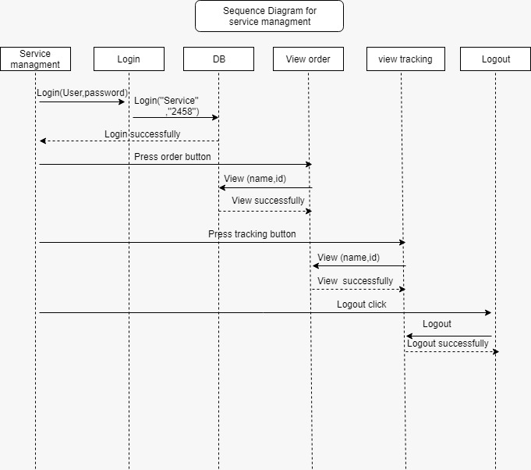
Figure 4.4.4

4.5 Activity diagram

4.5.1 For Administrator
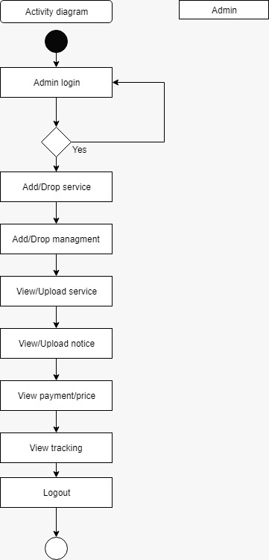
Figure 4.5.1

4.5.2 For Management
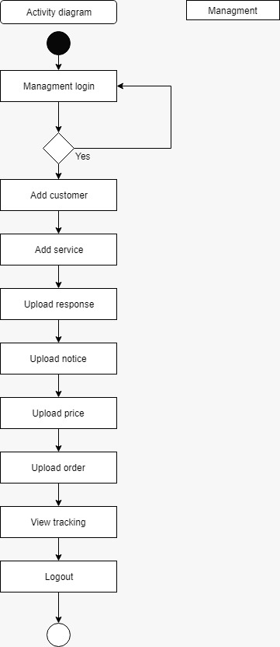
Figure 4.5.2

4.5.3 For Customer
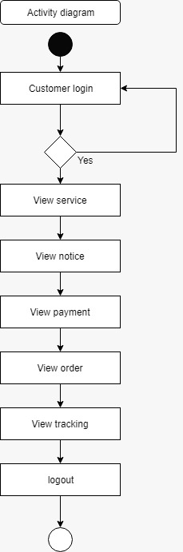
Figure 4.5.3

4.5.4 For Service Management
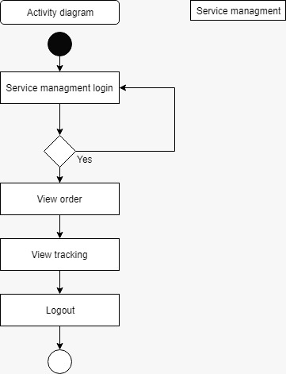
Figure 4.5.4

4.6. State Transition Diagram

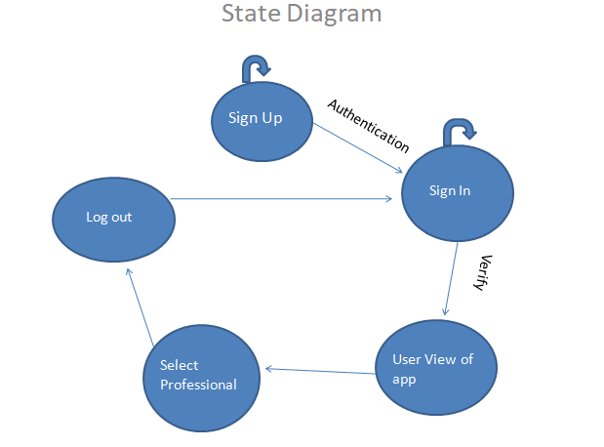
Figure 4.6

4.7. Component Diagram
1. Note: ” Website portion is optional ”

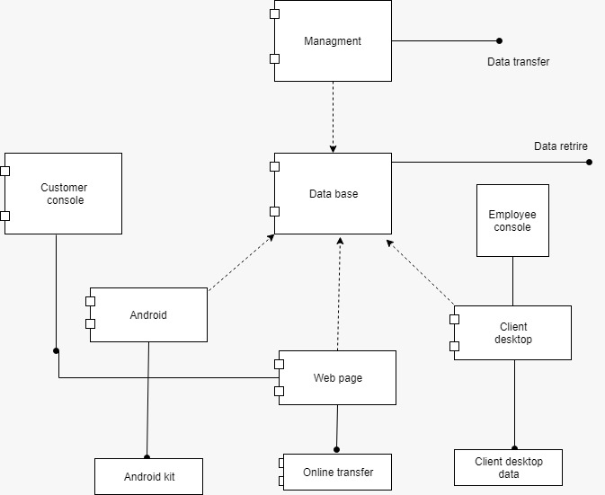

Figure 4.7

4.8. Data flow Diagram

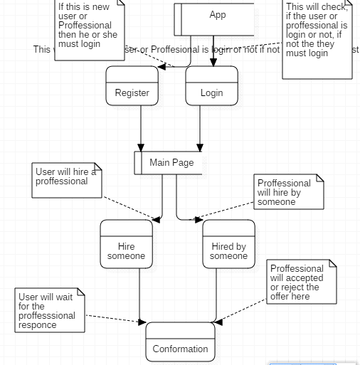
Figure 4.8

4.9 Collaboration Diagram
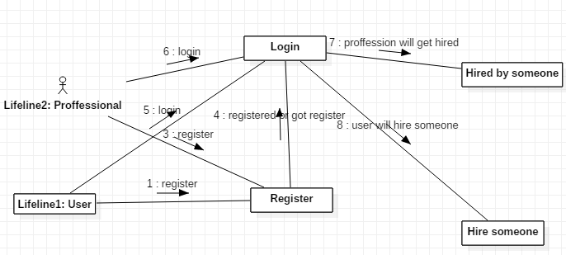
Figure 4.9

4.10 Deployment Diagram

Note: ” Website portion is optional ”
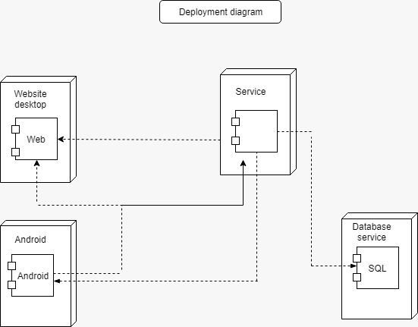
.
Figure 4.10

Chapter 5

Implementation

Chapter 5 Implementation

DATABASE

]. Database in firebase is a cloud-based database and does not need SQL-based queries to store and retrieve data. Firebase database is highly reliable and superfast means that data is updated and synchronized in no time. We also use the firebase authentication feature that provides us to authenticate user phone number, email, facebook and Gmail validation ^{[5]}.
There are six main roots
- Customer
- User
- admin
- services
- complain
- Work complete

Advantages for using Firebase.

Chat:

Instead of using the HTTP requests, Firebase real-time Database uses synchronization of data every time data changes, any device which are connected with the real-time database receives that update just within milliseconds. Firebase provides collaborative and immersive experiences without having to think about networking coding.

Offline:
Offline data connection android app cannot work and connect user and worker.

Software used for Android development

Android studio:

Android studio is an integrated development environment used for the development of android applications.

JSON
JavaScript Object Notation is a lightweight data-interchange format. It is easy for humans to read and write. It is easy for machines to parse and generate. These properties make JSON an ideal data-interchange language.

Errors during Android Development:
This error occurred because the old version of the dependencies added were not being supported and synced by the latest version of the android studio that was android 3.0.1 at that moment.

Module Integration Error:

Performing module based coding on different machines and integrating them afterwards on a single machine caused errors because the project names were different as well as the project had different android versions whereas the coding layouts were different in certain conditions.

Linking a java file with multiple Xml files:

During the creation of a map activity the java file was not being linked with other xml files which resulted in the crash of the application.

Auto Acceptation of Customers Request:

During the coding of map Activity whenever we generated a request from the customers side the customer’s request automatically got accepted by the nearby available Karigar whereas the objective was that the worker should accept the request based on his own personal choice

Extending an Activity:

When applying multiple extends to the same java file in android studio the java file displayed errors which resulted in the inability to run the application.

Important Flow Control/Pseudo codes
- IDE: Android Studio 3.2.1
- OS: Android
- Data store: SQLITE,

Components, Libraries, Web Services and stubs
- Microsoft Android Studio
- Draw.io or Visio

Deployment Environment
- MY SQL
- JAVA
- Xml

Tools and Techniques
- Comments and documentation make the code easy to understand.
- Code must be readable.
- Code must be reusable which saves a lot of time.
- Avoid the hard-code that cannot be understandable.
- Conform to the coding standards and user requirements.
- Use of IDE’s drop-down menu.
- Pair programming and code review is also an efficient way.
- Backup and save the data. So, there is no fear of loss of data.

Version Control
- Team Foundation Server (TFS) is used for version control which is the Development software by Microsoft which includes revision control.

Appendices
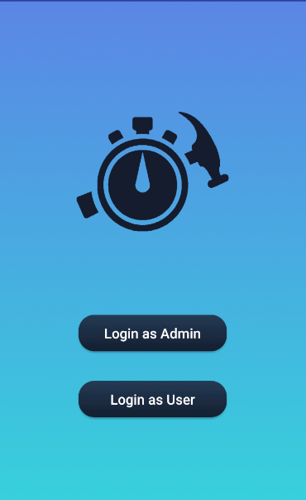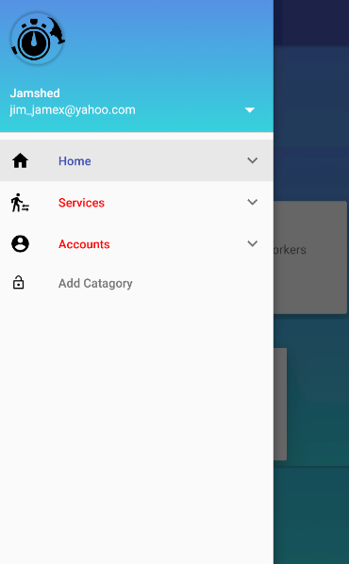
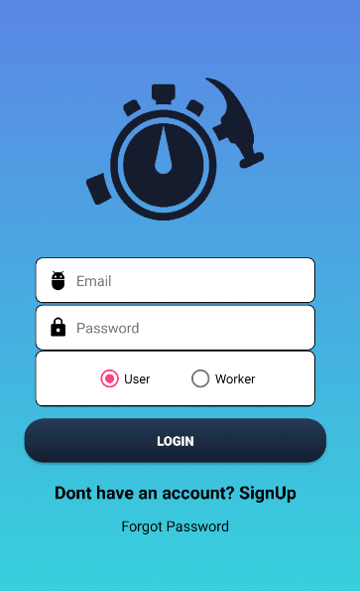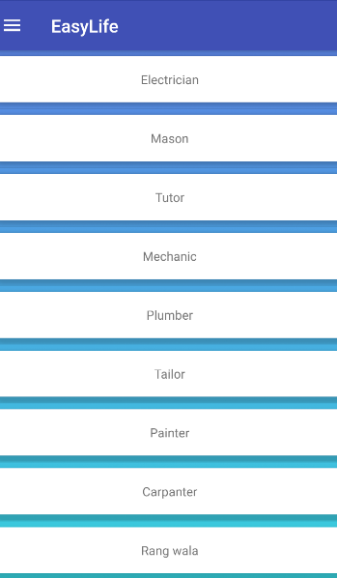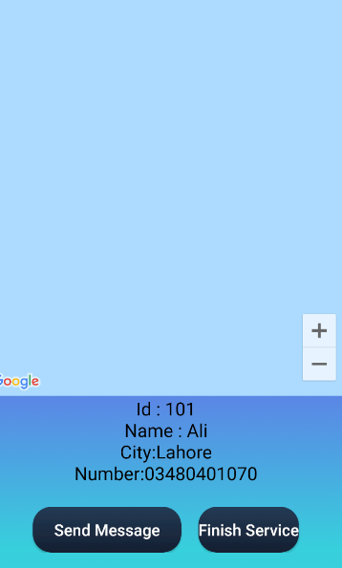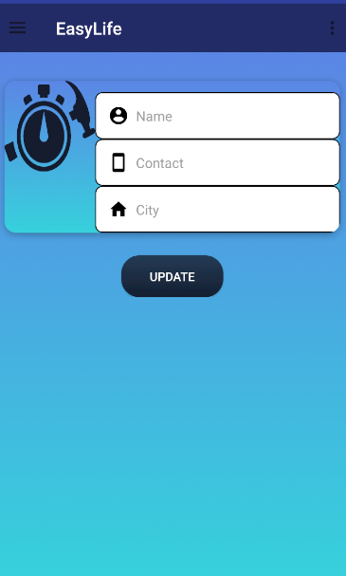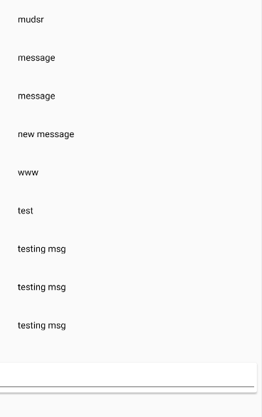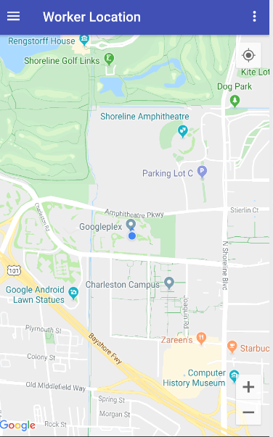

Chapter 7
Testing
- Test Case for professional signup account

Positive Test Case
ID | TC_SIGNUP_SUCCESS
Priority | High
Description | To verify professional is authenticated to system.
Reference | Functional Requirement reference
Users | Administrator.
Pre-requisites | A System isonline.  B professional must have required information which has to ask by system administration  C User has internetaccess.
Steps | A Open the web link to system. B Enter Name  C Enter Password.  D enter cnic  E choose the profession.  F enter signup
Input | Name, password, cnic, profession
Expected result | Successfully signup and can enter loggin page now
Status | Tested, passed.

Negative Test Case
ID | TC_SIGNUP_FAILURE
Priority | High
Description | To verify professional authentication to system.
Reference | Functional Requirement reference
Users | Administrator.
Pre-requisites | A System isonline.  B professional must have required information which has to be asked by the system administration  C User has internetaccess.
Steps | A Open the web link to system. B Enter name  C Enter Passwor D enter cnic  E choose the profession.  F enter signup
Input | Incorrect name with special character,cnic digits missing or password length short.
Expected result | Does not allows access to system features and notifies the error.
Status | Tested, passed.

- Test Case for user signup account

Positive Test Case
ID | TC_SIGNUP_SUCCESS
Priority | High
Description | To verify user is authenticated to system.
Reference | Functional Requirement reference
Users | Administrator.
Pre-requisites | A System isonline.  B user must have required information which has to ask by system administration  C User has internetaccess.
Steps | A Open the web link to system. B Enter Name  C Enter Password.  D enter e-mail  E enter signup
Input | Name, password, email
Expected result | Successfully signup and can enters login page for login.
Status | Tested, passed.

Negative Test Case
ID | TC_SIGNUP_FAILURE
Priority | High
Description | To verify user authentication to system.
Reference | Functional Requirement reference
Users | Administrator.
Pre-requisites | A System isonline.  B user must have required information which has to be asked by the system administration  C User has internetaccess.
Steps | A Open the web link to system. B Enter name  C Enter Passwor D enter e-mail  E enter signup
Input | Incorrect name with special character or password length short.
Expected result | Does not allows access to system features and notifies the error.
Status | Tested, passed.

- Test Case for userlogin account

Positive Test Case
ID | TC_LOGIN_SUCCESS
Priority | High
Description | To verify user authentication to system.
Reference | Functional Requirement reference
Users | Administrator.
Pre-requisites | - System isonline.  - User must have active login credentials provided by system administrator.  - User has internetaccess.
Steps | A Open the web link to system. B Enter loginid  C Enter Password. D PressLogin.
Input | Login id and password
Expected result | Successfully enters the system and main home page opens.
Status | Tested, passed.

Negative Test Case
ID | TC_LOGIN_FAILURE
Priority | High
Description | To verify user authentication to system.
Reference | Functional Requirement reference
Users | Administrator.
Pre-requisites | - System isonline.  - User must have active login credentials provided by system administrator.  - User has internetaccess.
Steps | A Open the web link to system. B Enter loginid.  C Enter Password. D PressLogin.
Input | Incorrect Login id or password or deactivated credentials.
Expected result | Does not allows access to system features and notifies the error.
Status | Tested, passed.

- Test Case for professional login account

Positive Test Case
ID | TC_LOGIN_SUCCESS
Priority | High
Description | To verify professional authentication to system.
Reference | Functional Requirement reference
Users | Administrator.
Pre-requisites | - System isonline.  - professionalmust have active login credentials provided by system administrator.  - User has internetaccess.
Steps | A Open the web link to system. B Enter loginid  C Enter Password. D PressLogin.
Input | Login id and password
Expected result | Successfully enters the system and main home page opens.
Status | Tested, passed.

Negative Test Case
ID | TC_LOGIN_FAILURE
Priority | High
Description | To verify professional authentication to system.
Reference | Functional Requirement reference
Users | Administrator.
Pre-requisites | - System isonline.  - User must have active login credentials provided by system administrator.  - User has internetaccess.
Steps | A Open the web link to system. B Enter loginid.  C Enter Password. D PressLogin.
Input | Incorrect Login id or password or deactivated credentials.
Expected result | Does not allows access to system features and notifies the error.
Status | Tested, passed.

- Test Case for verification of professional

Positive Test Case
ID | TC_verification_SUCCESS
Priority | High
Description | To verify professional authentication to system.
Reference | Functional Requirement reference
Users | Administrator.
Pre-requisites | A System isonline.  B professional must give the right information about him/her  C professional must have to signup.
Steps | A Open the web link to system. B Enter user name as per cnic  C Enter Password. D Enter cnic correctly.  E enter email
Input | Name, cnic and e-mail
Expected result | Successfully verifies if the information is correct checked by administration.
Status | Tested, passed.

Negative Test Case
ID | TC_verification_FAILURE
Priority | High
Description | To verify professional authentication to system.
Reference | Functional Requirement reference
Users | Administrator.
Pre-requisites | A System isonline.  B professional must give the right information about him/her  C professional must have to signup.
Steps | A Open the web link to system.  B Enter user name as per cnic  C Enter Password. D Enter cnic correctly.  E enter email
Input | Incorrect user name , or cnic
Expected result | Does not verify the signup
Status | Tested, passed.

- Test Case for chat module

Positive Test Case
ID | TC_chatmodule_SUCCESS
Priority | High
Description | To verify chat module
Reference | Functional Requirement reference
Users | Administrator.
Pre-requisites | - System isonline.  - User must have active login credentials provided by system administrator.  C User has internetaccess.
Steps | A Open the web link to system. B Enter user name as per cnic  C Enter Password.  D user books an appointment  E search for a professional.  F user choose a professional  G open chat head  H write text to professional  I send the chat with send button
Input | String , numeric values, alpha numeric value
Expected result | Successfully sends the message to the professional.
Status | Tested, passed.

Negative Test Case
ID | TC_chat_module_FAILURE
Priority | High
Description | To verify chat module
Reference | Functional Requirement reference
Users | Administrator.
Pre-requisites | - System isonline.  - User must have active login credentials provided by system administrator.  C User has internetaccess.
Steps | A Open the web link to system. B Enter user name as per cnic  C Enter Password.  D user books an appointment  E search for a professional.  F user choose a professional  G open chat head  H write text to professional  I send the chat with send button
Input | Left blank in chat dialog , or doesnot press send button
Expected result | Does not verify the chat module
Status | Tested, passed.

- Test Case for hiring

Positive Test Case
ID | TC_chatmodule_SUCCESS
Priority | High
Description | To verify user can hire professional module
Reference | Functional Requirement reference
Users | Administrator.
Pre-requisites | - System isonline.  - User must have active login credentials provided by system administrator.  C User has internetaccess.
Steps | A Open the web link to system. B Enter user name as per cnic  C Enter Password.  D user books an appointment  E search for a professional.  F user choose a professional  G if professional available  H select the professional  I hire the professional
Input | Choose professional by hiring from the available
Expected result | Successfully sends the message to the professional.
Status | Tested, passed.

Negative Test Case
ID | TC_chat_module_FAILURE
Priority | High
Description | To verify hiring
Reference | Functional Requirement reference
Users | Administrator.
Pre-requisites | - System isonline.  - User must have active login credentials provided by system administrator.  C User has internetaccess.
Steps | A Open the web link to system. B Enter user name as per cnic  C Enter Password.  D user books an appointment  E search for a professional.  F user choose a professional  G if professional available  H select the professional  I hire the professional
Input | No professional available, dntpres the hire button
Expected result | Does not verify the hire module
Status | Tested, passed.

- Test Case for Rating Services

Positive Test Case
ID | TC_RATING_SUCCESS
Priority | High
Description | To give feedbacks in the form of rating.
Reference | Functional Requirement reference
Users | Administrator.
Pre-requisites | - System isonline.  - User must login to the system.  - User has internetaccess.  - User must use any of the required service.
Steps | - Login to the app.  - Demand services.  - Use required services  - After finishing give stars
Input | Swipe on stars
Expected result | Feedbacks send to the system.
Status | Tested, passed.

Negative Test Case
ID | TC_RATING_FAILURE
Priority | High
Description | To give feedbacks in the form of rating.
Reference | Functional Requirement reference
Users | Administrator.
Pre-requisites | - System isonline.  - User must login to the system.  - User has internetaccess  - User must use any of the required service.
Steps | - Login to the app.  - Demand services.  - Use required services  - After finishing give stars
Input | Does not swipe in right direction.
Expected result | Stars not working and feedback not sent.
Status | Tested, passed.

- Test Case For Tracking.

Positive Test Case
ID | TC_TRACKING_SUCCESS
Priority | High
Description | To track Service Provider.
Reference | Functional Requirement reference
Users | Administrator.
Pre-requisites | System isonline.  User must login to the system.  User has internetaccess.  User must use any of the required service.  User must map access.
Steps | Login to the app.  Demand services.  Give location to service provider  Track service provider using Google map.
Input | Click on tracking
Expected result | Show location of service provider.
Status | Tested, passed.

Negative Test Case
ID | TC_TRACKING_SUCCESS
Priority | High
Description | To track Service Provider.
Reference | Functional Requirement reference
Users | Administrator.
Pre-requisites | System isonline.  User must login to the system.  User has internetaccess.  User must use any of the required service.  User must map access.
Steps | Login to the app.  Demand services.  Give location to service provider  Track service provider using Google map.
Input | Does not request for tracking.  Wrong location entered.
Expected result | Tracking fails to open route.
Status | Tested, passed.

- Test Case for Payment.

Positive Test Case
ID | TC_PAYMENT_SUCCESS
Priority | High
Description | To give payment to Service Provider.
Reference | Functional Requirement reference
Users | Administrator.
Pre-requisites | System isonline.  User must login to the system.  User has internetaccess.  User must use any of the required service.
Steps | Login to the app.  Demand services.  After finishing work.  Give money by hand to the Service Provider
Input | Click on finish service
Expected result | Popup message regarding thanks for using.
Status | Tested, passed.

Negative Test Case
ID | TC_PAYMENT_SUCCESS
Priority | High
Description | To give payment to Service Provider.
Reference | Functional Requirement reference
Users | Administrator.
Pre-requisites | System isonline.  User must login to the system.  User has internetaccess.  User must use any of the required service.
Steps | Login to the app.  Demand services.  After finishing work.  Give money by hand to the Service Provider
Input
Expected result
Status | Tested, passed.

- Test Case for Ranking.

Positive Test Case
ID | TC_RANKING_SUCCESS
Priority | High
Description | To see the list of top ranked Service Provider.
Reference | Functional Requirement reference
Users | Administrator.
Pre-requisites | System isonline.  User must login to the system.  Open dashboard.
Steps | Login to the app  Open dashboard.  Click on top ranked list
Input | Click on top ranked list
Expected result | Show the list of top ranked Service Provider overall.
Status | Tested, passed.

Negative Test Case
ID | TC_RANKING_SUCCESS
Priority | High
Description | To see the list of top ranked Service Provider.
Reference | Functional Requirement reference
Users | Administrator.
Pre-requisites | System isonline.  User must login to the system.  User has internetaccess.  User must use any of the required service.
Steps | Login to the app.  Demand services.  After finishing work.  Give money by hand to the Service Provider
Input | User don’t click on list button.
Expected result | Does not show the list of top ranked Service Provider.
Status | Tested, passed.

5.2.0 EQUIVALENCE PORTIONING FOR USER
5.2.0.0 USER SIGN UP
Variable | Valid Classes | Invalid Classes
First Name | Alphabets only  Should not contain Special characters  Must not an empty field | Special Characters.  Empty Field.
Last Name | Alphabets only  Should not contain Special characters  Must not an empty field | Special Characters.  Empty Field.
Email | Alpha numeric containing “@” | Any input value without “@” sign

Pass word | Alphabets, numeric, special characters min of length 8 | Space between letters  Empty Field
Confirm Password | Alphabets, numeric, special characters min of length 8.  Must match to password field | Space between letters  Empty Field  length less than 8  Not matched to password field
Contact Number | Numeric value | Alphabets, Special characters  2 Empty field
5.2.0.1 USER SIGN IN
Variable | Valid Classes | Invalid Classes
Email | Alpha numeric containing “@” | Any input value without “@” sign
Password | Length should be greater than equal to 8  May contain special characters(#,$,@etc) | Length less than 8  Empty Field

5.2.0.2 USER SIGN OUT
Variable | Valid Classes | Invalid Classes
Back logout button | Button has been click | Button has not been click.

References
- Android API: http://developer.android.com/reference/packages.html
- The Java Tutorials: http://docs.oracle.com/javase/tutorial/
- Android User Interfaces: http://developer.android.com/guide/topics/ui/index.html
- Layout: http://developer.android.com/guide/topics/ui/declaring-layout.html
- Google Maps: http://code.google.com/android/add-ons/google-apis/maps-overview.html
- Iconography: http://developer.android.com/guide/practices/ui_guidelines/icon_design.html
- Sample Source Code: http://developer.android.com/resources/samples/get.html
- Google Map Set: http:// google-maps-in-android-application-with-new-google-maps-android-api-v2-using-supportmapfragment

