SUPERIOR UNIVERSITY LAHORE


Faculty of Computer Science & IT

Final Year Project
PROJECT REPORT

[Online Transport System]

Project ID: [023]

Project Team
Student Name | Student ID | Program | Contact Number | Email Address
Ahsan Siddique | BSEM-F14-145 | BSSE | 0306-4446673 | ahsan54966@gmail.com
Muhammad Afzal | BSEM-F14-149 | BSSE | 0344-5789808 | Afzalr871@gmail.com
Nabeel Shaokat | BSEM-F14-155 | BSSE | 0345-7214650 | nabeelshaokat@gmail.com
Zeeshan Yasin | BSEM-F14-160 | BSSE | 0346-2304003 | itszeexhan@gmail.com

[Project Supervisor]
Mr. Zaman Aziz

Project Report
[Online Transport System]

Change Record
Author(s) | Version | Date | Notes | Supervisor’s Signature
 | 1.0 |  | <Original Draft>
 |  |  | <Changes Based on Feedback from Supervisor>
 |  |  | <Changes Based on Feedback From Faculty>
 |  |  | <Added Project Plan>
 |  |  | <Changes Based on Feedback from Supervisor>

APPROVAL
Project Supervisor
Comments: ___________________________________________________________________
_____________________________________________________________________________
Name:______________________________
Date:_______________________________ | Signature:__________________________

Project Manager
Comments: ___________________________________________________________________
_____________________________________________________________________________
Date:_______________________________ | Signature:__________________________

Head of the Department
Comments: ___________________________________________________________________
_____________________________________________________________________________
Date:_______________________________ | Signature:__________________________

Dedication

This work is dedicated to our beloved parents who support us to get quality education in quality institute.

Acknowledgements

I have taken efforts in this project report. However, it would not have been possible without the kind support and help of many individuals and organizations. I would like to express my deep gratitude to Professor Zaman Aziz my final year project supervisor, for their patient guidance, enthusiastic encouragement and useful critiques of this project. I would also like to thanks Professor Mujahid Rafique, Professor Ammar Hassan and Zia Naqi (CEO of SPELL Company) for useful advices and their crucial time.

Executive Summary
We are going to develop a transport management system for Sindhu Transport Company (PVT) LTD. We will develop the system according to our customer requirements.
Our client manually handles records. They are using mobile calls when they want to know the location of vehicles. They cannot save the previous record that’s why they are not able to generate the progress report of business. They provide tickets manually to bus passengers. They provide carriages to only those companies who know them. Unknown customers have no medium to contact with them for online transport requests. They require software to manage their all record. We will provide a web base system. With the help of system, they can manage records on daily base and generate a report of their profit and loss weekly, monthly and yearly. As well as annually report will help to predict about their previous year’s record. They can track location of their trucks and buses. Customer can reserve there tickets online and also both carriage and bus customers can payment online.

We have finalized the requirements, but it can be changed according to customer need because we are following agile approach in which customer engaged with us. We have designed our system architecture. We are following client server n tier architecture for our software.

Table of Contents
Dedication iv
Acknowledgements v
Executive Summary vi
Table of Contents vii
List of Figures xv
List of Tables xvi
Chapter 1 1
Introduction 1
1.1. Background 2
1.2. Motivations and Challenges 3
1.3. Goals and Objectives 3
1.4. Literature Review/Existing Solutions 3
1.5. Gap Analysis 4
1.6. Proposed Solution 4
1.7. Project Plan 5
1.7.1. Work Breakdown Structure 5
1.7.2. Roles & Responsibility Matrix 7
1.7.3. Gantt chart 7
1.8. Report Outline 7
Chapter 2 8
Software Requirement Specifications 8
2.1. Introduction 9
2.1.1. Purpose 9
Purpose of this document is to describe the external behavior of the system. In this document every kind of requirement will finalized. It describe the nonfunctional requirement, design requirements and also provide the other detail which will clear the whole idea about the transport management System requirements. 9
2.1.2. Document Conventions 9
2.1.3. Intended Audience and Reading Suggestions 9
2.1.4. Product Scope 10
2.1.5. References 11
2.2. Overall Description 11
2.2.1. Product Perspective 11
2.2.2. Product Functions 12
Function must be performed by Customers 12
2.2.3. User Classes and Characteristics 18
2.2.4. Operating Environment 18
2.2.5. Design and Implementation Constraints 19
2.2.6. User Documentation 19
2.2.7. Assumptions and Dependencies 19
2.3. External Interface Requirements 20
2.3.1. User Interfaces 20
2.3.2. Hardware Interfaces 21
2.3.3. Software Interfaces 21
3.1.1. Communications Interfaces 22
3.2. System Features 22
Functional Requirement 1 22
Functional Requirement 2 23
Functional Requirement 3 23
Functional Requirement 4 23
Functional Requirement 5 24
Functional Requirement 6 24
Functional Requirement 7 24
Functional Requirement 8 25
Functional Requirement 9 25
Functional Requirement 10 25
Functional Requirement 11 26
Functional Requirement 12 26
Functional Requirement 13 26
Functional Requirement 14 27
Functional Requirement 15 27
Functional Requirement 16 27
Functional Requirement 17 28
Functional Requirement 18 28
Functional Requirement 19 28
Functional Requirement 20 29
Functional Requirement 21 29
Functional Requirement 22 29
Functional Requirement 23 30
Functional Requirement 24 30
Functional Requirement 25 30
Functional Requirement 26 31
Functional Requirement 27 31
Functional Requirement 28 31
Functional Requirement 29 32
Functional Requirement 30 32
Functional Requirement 31 32
Functional Requirement 32 33
Functional Requirement 33 33
Functional Requirement 34 34
Functional Requirement 35 34
3.2.1. System Feature 1 35
3.2.1.1. Description and Priority 35
3.2.1.2. Stimulus/Response Sequences 35
3.2.1.3. Functional Requirements 35
3.2.2. System Feature 2 35
3.2.2.1. Description and Priority 36
3.2.2.2. Stimulus/Response Sequences 36
3.2.2.3. Functional Requirements 36
3.2.3. System Feature 3 (and so on) 36
3.3. Other Nonfunctional Requirements 37
3.3.1. Performance Requirements 37
3.3.2. Safety Requirements 38
3.3.3. Security Requirements 38
3.3.4. Software Quality Attributes 39
3.3.5. Business Rules 40
3.4. Other Requirements 40
Chapter 3 41
Use Case Analysis 41
3.1. Use Case Model 42
3.2. Use Case Descriptions 43
Chapter 4 48
System Design 48
4.1. Architecture Diagram 49
4.2. Domain Model 50
4.3. Entity Relationship Diagram with data dictionary 51
Data Item 52
Data Type 52
Data Farmate 52
Field Size 52
Description 52
Example 52
Data Item 52
Data Type 52
Data Farmate 52
Field Size 52
Description 52
Example 52
Data Item 53
Data Type 53
Data Farmate 53
Field Size 53
Description 53
Example 53
Data Item 53
Data Type 53
Data Farmate 53
No of bytes per storage 53
Description 53
Example 53
Data Item 54
Data Type 54
Data Farmate 54
No of bytes per storage 54
Description 54
Example 54
Data Item 54
Data Type 54
Data Farmate 54
No of bytes per storage 54
Description 54
Example 54
Data Item 55
Data Type 55
Data Farmate 55
No of bytes per storage 55
Description 55
Example 55
Data Item 55
Data Type 55
Data Farmate 55
Field Size 55
Description 55
Example 55
Data Item 56
Data Type 56
Data Farmate 56
No of bytes per storage 56
Description 56
Example 56
Data Item 57
Data Type 57
Data Farmate 57
No of bytes per storage 57
Description 57
Example 57
Data Item 57
Data Type 57
Data Farmate 57
No of bytes per storage 57
Description 57
Example 57
Data Item 57
Data Type 57
Data Farmate 57
No of bytes per storage 57
Description 57
Example 57
Data Item 58
Data Type 58
Data Farmate 58
No of bytes per storage 58
Description 58
Example 58
Data Item 58
Data Type 58
Data Farmate 58
No of bytes per storage 58
Description 58
Example 58
Data Item 59
Data Type 59
Data Farmate 59
No of bytes per storage 59
Description 59
Example 59
Data Item 59
Data Type 59
Data Farmate 59
No of bytes per storage 59
Description 59
Example 59
Data Item 60
Data Type 60
Data Farmate 60
No of bytes per storage 60
Description 60
Example 60
4.4. Class Diagram 61
4.5. Sequence / Collaboration Diagram 62
4.6. Operation contracts 64
4.7. Activity Diagram 65
4.8. State Transition Diagram 70
4.9. Component Diagram 71
4.10. Deployment Diagram 72
4.11. 0 LevelData Flow diagram 72
4.12. 1 Level Data Flow diagram 73
4.13. 2 Level Data Flow Diagram 74
1. Sign up Login Data Flow Diagram 74
2. Add Vehicle Data Flow Diagram with Report Generate 75
3. Add Ride Data Flow Diagram 75
4. Booking Ride Data Flow Diagram 76
5. Online Payment Data Flow Diagram 76
6. Add Terminal Data Flow Diagram 77
Chapter 5 79
Implementation 79
5.1. Important Flow Control/Pseudo codes 80
5.2. Components, Libraries, Web Services and stubs 80
5.3. Deployment Environment 81
5.4. Tools and Techniques 81
Development Tools 81
Web Application 81
Software Designing Tool 81
Testing Tool 81
Documentation Tools 81
Techniques 81
Programming Techniques 82
Web Application Techniques 82
Testing Techniques 82
5.5. Best Practices / Coding Standards 82
5.6. Version Control 83
Chapter 6 84
Testing and Evaluation 84
6.1. Use Case Testing 85
Use Case Test 1: 85
Use Case Test 2: 86
Use Case Test 3: 87
Use Case Test 4: 88
Use Case Test 5: 89
Use Case Test 6: 90
Use Case Test 7: 91
Use Case Test 8: 92
Use Case Test 9: 93
Use Case Test 10: 94
Use Case Test 11: 95
6.2. Equivalence partitioning 96
6.3. Boundary value analysis 96
6.4. Data flow testing 96
6.5. Unit testing 96
6.6. Integration testing 96
6.7. Performance testing 97
6.8. Test Cases 99
3.8.1. Test Case: 1 99
3.8.2. Test Case: 2 103
3.8.3. Test Case 3 107
3.8.4. Test Case 4 111
3.8.5. Test Case 5 115
3.8.6. Test Case 6 118
3.8.7. Test Case 7 120
3.8.8. Test Case 8 124
3.8.9. Test Case 9 128
3.8.10. Test Case 10 131
3.8.11. Test Case 11 134
3.8.12. Test Case 12 138
3.8.13. Test Case 13 141
3.8.14. Test Case 14 144
3.8.15. Test Case 15 146
3.8.16. Test Case 16 149
3.8.17. Test Case 17 152
3.8.18. Test Case 18 155
3.8.19. Test Case 19 159
3.8.20. Test Case 20 163
3.8.21. Test Case 21 166
3.8.22. Test Case 22 168
3.8.23. Test Case 23 172
3.8.24. Test Case 24 174
3.8.25. Test Case 25 178
3.8.26. Test Case 26 180
3.8.27. Test Case 27 182
3.8.28. Test Case 28 186
3.8.29. Test Case 29 190
3.8.30. Test Case 30 193
3.8.31. Test Case 31 195
3.8.32. Test Case 32 199
3.8.33. Test Case 33 206
6.9. Stress Testing 208
Chapter 7 209
Summary, Conclusion and Future Enhancements 209
7.1. Project Summary 210
7.2. Achievements and Improvements 210
7.3. Critical Review 210
7.4. Lessons Learnt 211
7.5. Future Enhancements/Recommendations 211
Appendices 213
Appendix A: User Manual 214
Appendix B: Administrator Manual 215
Appendix C: Information / Promotional Material 216
Appendix [no.]: Appendix Title 220
Reference and Bibliography 222
Index 224

List of Figures

1.1 Caption of first figure of first chapter 6
1.2 Caption of second figure of first chapter 7
2.1 Caption of first figure of second chapter 14
2.2 Caption of second figure of second chapter 22
2.3 Caption of third figure of second chapter 26
5.1 Caption of first figure of fifth chapter 49
5.2 Caption of second figure of fifth chapter 49

List of Tables

1.1 label of first table of first chapter 6
1.2 label of second table of first chapter 7
2.1 label of first table of second chapter 14
2.2 label of second table of second chapter 22
2.3 label of third table of second chapter 26
5.1 label of first table of fifth chapter 49
5.2 label of second table of fifth chapter 49

Chapter 1

Introduction

Chapter 1: Introduction
This project is about a transport company who has large number of trucks and buses which faces many problems. Due to large setup company deals with large and complex data. Records are not managed in proper way so that’s why they face problems to generate profit/loss reports and also their company data. They cannot track their vehicles properly. They use to calls to know about vehicle locations. Big issue in exploring their business because they have no identity in Pakistan due to the gap between them and their customers. Customers prefer online payments but they don’t have such method which provides them online payments. Their bus passengers don’t know what timing of bus route is and also don’t have accessibility of online ticket reservation and payments. So we will provide such a system which will resolve all problems that mentioned above.

Background
In Pakistan we have batch transport systems which contain record management systems but that systems are only accessible in user computer where they have installed. That system store data on daily bases and generate reports. [1] Daewoo Bus System has online bus schedules, online ticket reservation and payments. They have very good system but they don’t have customer’s customized dashboards where customers can access their live and previous locations. In carriage booking system we find these features online requests just online requests on [2] ALLPAKISTANBOOKING system where users can post the transport requests. But they don’t gives responses to customers. They just get data of users from there databases and call them on their given number and then they send their trucks on booking. They don’t have location tracking for customers and truck owners. Mostly customers don’t know where delivery is and how much time required delivering goods. They don’t have online payments methods for online payments. System is not recording whole booking info. So Companies cannot generate reports of their business. Systems are just like just static websites who holds out dated data. [3] Truck Ada is also online booking system where users can post their requests, requests approved by the administration. They don’t provide location tracking and online payments and it is only for one Transport Company which deals with all customers and it’s not user friendly. Its response time is very poor and its availability is very low. Mostly users gets problem in registration phases. Company has not proper management strategy in system.

Motivations and Challenges
Usage of English language can create a challenge for us because mostly users cannot understand English properly. So System can be developed in Urdu language which will support the users. Installation in complex environment will create problems in start because changing manual large system to automatic cloud system is not easy to do. We will deals with online payments so we will face a lot of challenges because in this module we have to deal with secret information of the users.

Goals and Objectives
- [Our first and major goal of our system is to generate finical and other business reports which can help our customer to achieve business intelligence. And it can achieve by efficient record management system which will provide by our software system.

- Our Second goal is people will get benefits of online transport booking by just placing online transport requests and also pay the charges and fares online. We can achieve this goal with the help of online truck booking and bus seat reservation system when customers can online payments with help of online payment methods.

- Our third and main goal is that company persons and customers must know where is their goods when they books vehicle so we can achieve this by location tracking feature where both company persons and customers can view the live locations of the vehicles.

Literature Review/Existing Solutions
In existing system, some features exist which we have mentioned above. But mostly systems are batch system they don’t have cloud computing. They stores data on their own computers. They cannot view their records when they stand away from their systems. We have surveyed, many peoples saves data in excels sheets that consume a lot of time and also not user friendly. And one of the most key feature online transport booking is not available in Pakistan computer systems. Most of the transport companies use location tracking but they outsources from tracking agencies they don’t have their own custom dashboards for tracking.

Gap Analysis
Now we discuss the gap between our client environment and our software system. Customers and Company has lack of communication. They are using note books for profit calculation which consumes a lot of time. They cannot track their buses and trucks. They are not providing online booking and payments. Bus passengers cannot reserve online tickets and also online payments.
So there’s big gap between the software system and client environment. For covering this gap we have to implement our all system requirement that mentioned earlier in the document.

Proposed Solution
We are going to provide them web base solution. System will save all records of company and can generate reports. So we will provide online booking where everybody who needs carriages can request for it. We will provide location tracking where company, customers and driver can get locations. We provide them online bus seat reservation with online payment. Customer will able to see the schedules and other information for booking on the system. Passengers can reserve their tickets and payment online by using this system.

Project Plan

Work Breakdown Structure
Phase 1

Phase 2

Phase 3

Phase 4

Roles & Responsibility Matrix

Name & Organization | Project Role | Project Responsibilities
Online Transport system. | Project Sponsor | This person is concern with funding and verifying the requirements of the project. This one is our key stakeholder.
Ahsan Siddique | Project Officer | This person will handle the project technically. And also monitor the contracting activities.
Muhammad Afzal | Project Manager | A person who will control the all activities of the project with quality, scope set of projects. This will control throughout the final deliverable and satisfy the customer.
Zeeshan Yasin | Business Steward | This person will monitor the project from business point of view.
Nabeel Shaokat | Security Steward | This person is responsible for securing the system data.

Gantt chart
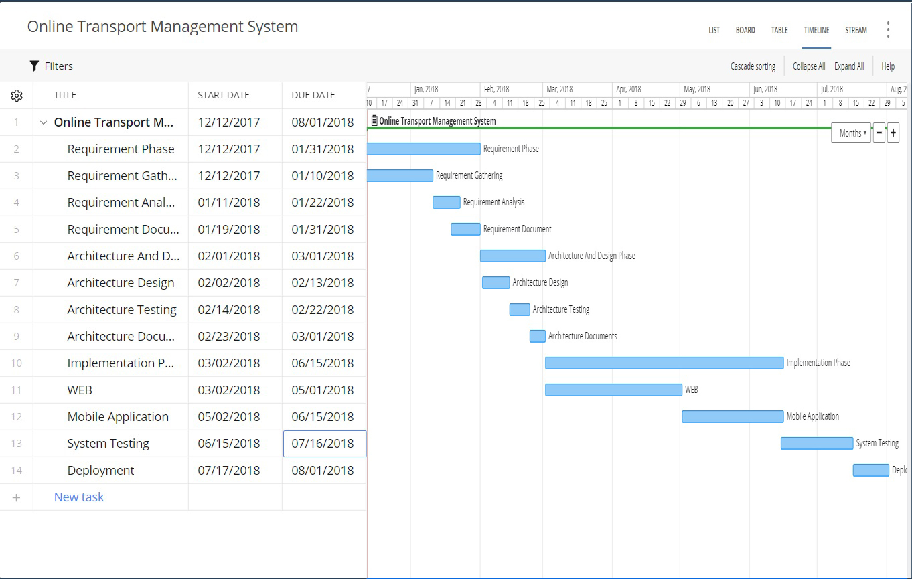

Chapter 2

Software Requirement Specifications

Chapter 2: Software Requirement Specifications

Introduction

Purpose of this document is to describe the external behavior of the system. In this document every kind of requirement will finalized. It describes the nonfunctional requirement, design requirements and also provide the other detail which will clear the whole idea about the transport management System requirements.

Purpose

Document Conventions
Document contains headings and paragraphs.
First Heading: is bold, Font is Calibri and Size is 16.
Second Heading: is bold, Font is Calibri and Size is 14.
Paragraph: Font is Calibri, Size is 12 and line spacing is 1.5.
DB: Database
ERD: Entity Relationship Diagram
SRS: Software Requirement Specification
API’s: Application programming interface

Intended Audience and Reading Suggestions
In first section purpose of the document described where every reader can understand the purpose of the document. In second section we described the product scope where stakeholders can get the idea of the system. In overall description stakeholders can clear whole idea of the systems. Developers can understand the requirements of the system. Designers can understand the design requirements in the user interface requirement sections. Tester can prepare test cases for testing the features of the system. Customers can verify their functional requirements.

Product Scope
- We are doing record keeping of users, vehicles, drivers, rides, bookings and bus schedules.
- We are providing online truck booking where customers can request for booking and companies approve them.
- We are providing bus seat reservation where customers can view fares and reserve bus seats.
- We are providing online tracking where customers, companies and driver can view the locations of destination, source and current location.
- We are providing report generation where companies can generate profit (monthly, yearly and custom), comparative routes profit, drivers and vehicle reports.
- We are providing online payments where users can pay online fares using payment gateways and also can pay offline payments.

References
[1]
https://truckada.pk/?gclid=EAIaIQobChMIvoPJyZf22QIVqLizCh2HkgYbEAEYASAAEgI8HfD_BwE
[2]
http://www.daewoo.com.pk/
[3]
http://www.allpakistan.org
[4]
https://ganttpro.com/landing/index-
[5]
https://creately.com/
[6]
https://loadimpact.com/

[7]
https://tools.pingdom.com/

[8]
https://www.webpagetest.org/result/180815_K5_c27add5d931d58c18292ac781dee196a/

[9]
https://website.grader.com/results/onlinetruckada.com

Overall Description

Product Perspective
Basically, this product is belongs to transport products family. There are many kinds of software products in transport field like as UBER and CREAM. They are car booking systems. Our system is a large system which include the carriages and buses management. So, UBER and CREAM can be just a single functionality of our system.

Product Functions
Function must be formed by Company
- Record Entry (Driver, Vehicle, Rides and other).
- Track their Buses and trucks
- Report generate (Profit/loss weekly, monthly, yearly, Driver, Vehicles and Comparative)
- Confirm Booking
- Add Bus Terminals and Bus Schedules
- View Online Buses Schedules and Fair info.

Function must be performed by Customers
- Schedule and Fairs info
- Seat Booking and carriage booking
- Online Payment
- View bus and truck locations.

Function must be performed by Driver
- View Location

Activity Diagram
Will elaborate the whole system how external entities communicate with system features.

Add Vehicle:

Add Driver
Add Vehicle Booking

Add Ride

Add Terminal

User Classes and Characteristics
We defined different user classes in below table. Company owner’s not required high level knowledge for interacting with system. Company Manager or Admin should have technical knowledge for interacting with system. Customer should know how to communicate on internet or how to work on business applications. Driver only need to use the smart mobile phone, they just need to open the mobile application.

Classes | Functionality Privilege | Technical/Non-Technical | Education Level
Company Manger | Record Management, Confirm Booking,  Reports Generation, Add and View Schedules and Vehicle Tracking | Technical | Matric
Driver | View Location | Non-Technical | Not Required
Customer | Online Payment, Request Booking, View Schedules,  Ticket Reservation and Payments. | Technical or Non-Technical | Matric

Operating Environment
Our client is currently using CORE 2 Duo System with 8GB RAM, 500 GB Hard Drive and 2.8 GHZs Processor. Window 7 is installed in System and Google Chrome Application also installed in system where our software will run. On the other side we choose windows plesk where we will deploy our system on cloud.

Design and Implementation Constraints
Mange the location data may be it will create memory storage limitation trouble for us.
We need to convert voice to text for that customer who cannot write. It will also create hardware trouble because we need strong voice detector hardware from customer.
We need to use NOSQL for location tracking module because we need a good response time on this module.
We need to be careful when we call the API’s because we need efficient response time.
User interface should be very simple which can be understandable for full non-technical person.
We need HTTPS for secure communication.
We have to deal with SQL SERVER.
Naming Convention approach should be same throughout the development.
MVC approach should be followed in programming which will helpful for efficient memory management.
Data should be encrypted when it comes from the user to the databases.
Customer should be verified with it personal email or phone number.

User Documentation
We will provide the user manuals for the user as hard paper form and video Tutorials. After reading manual user will able to use software easily. We will organize seminars and provide tutorials for system users learning.

Assumptions and Dependencies
We depend on the online payment API’s where user can pay their charges online. In future if these API’s will not work then we will have to change this requirement or register to new payment method.
We are using Google Maps APIs, so in future if this APIs fails to work with our system then we need to find alternate feature of the system.
If new technology or techniques arrive in future and our user would demand for the new technology then we will change the system requirements.
In future due to large data may be we will have need advance database system to manage our records

External Interface Requirements

User Interfaces
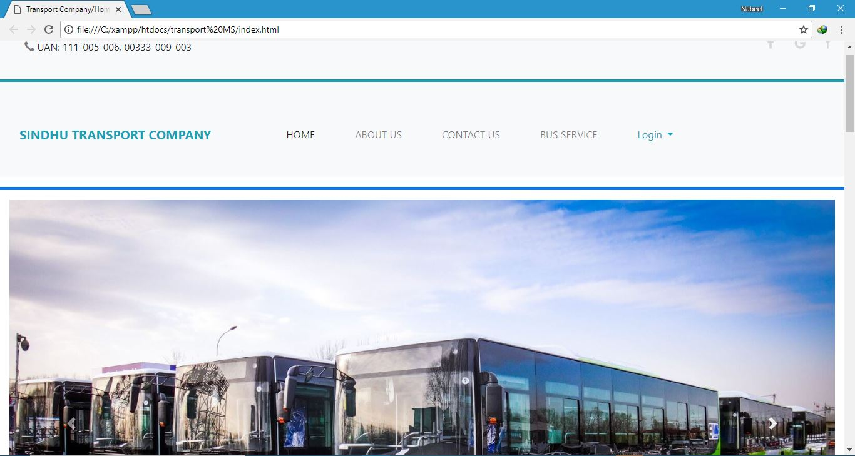

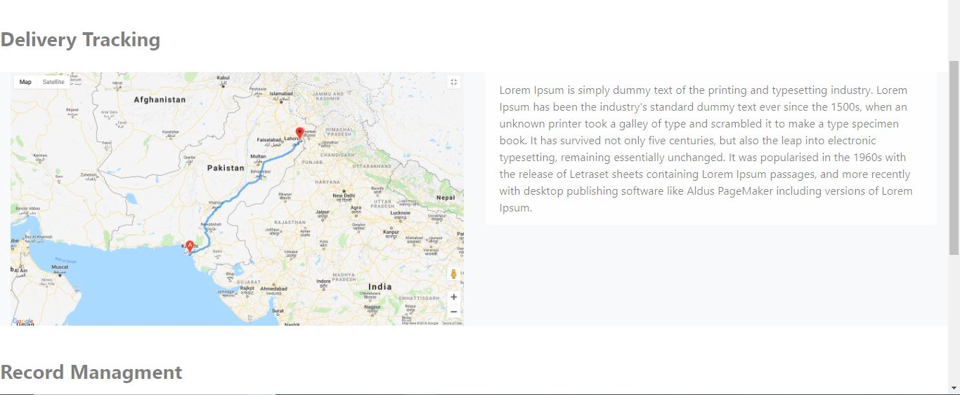

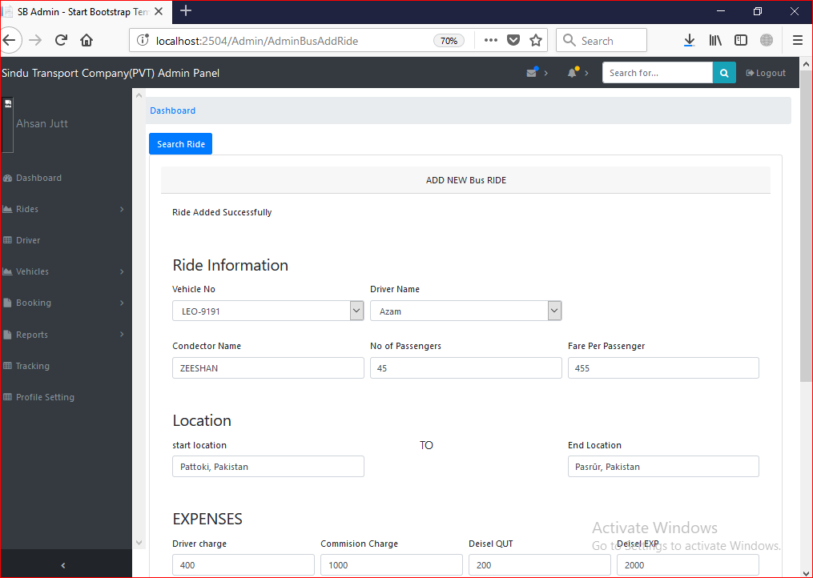

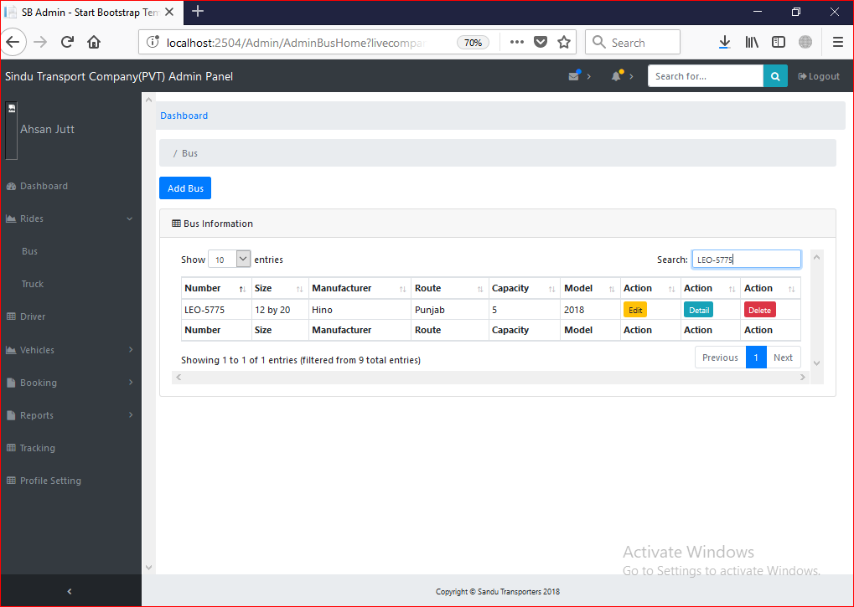

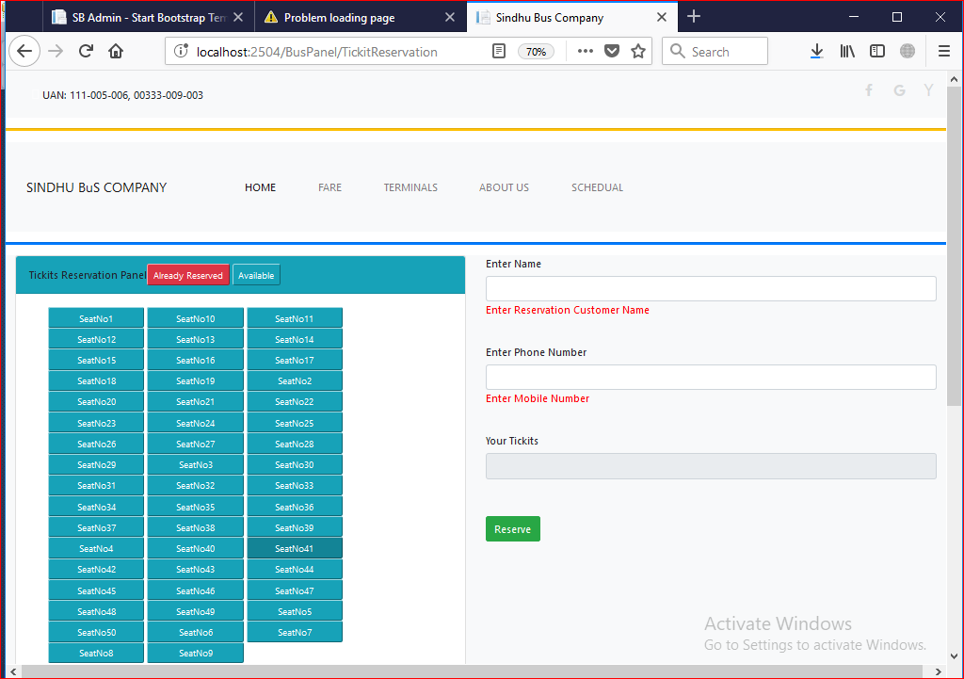
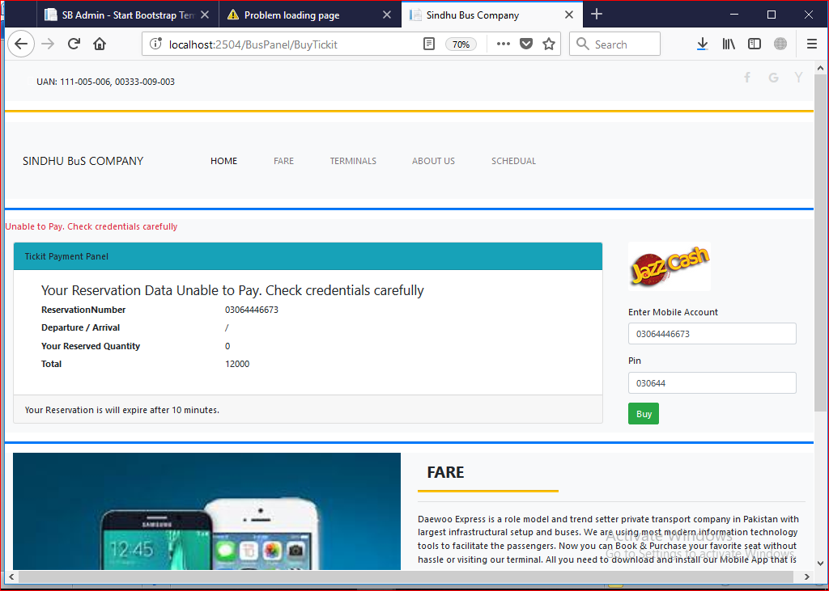

Hardware Interfaces
Our System will work through internet connectivity. So we will use all those hardware devices and configuration that will use to connect with internet. So we need the modems, wires, WAN, LAN networks and Ethernet Cross cables etc.
So here is the complete hardware illustration in the given below diagram:

Software Interfaces

Software Used | Description
Operating System | We have chosen Windows Operating System for the best support and its friendliness.
Database | For storing database we choose Sql Server Databases.
Tools | We will use visual studio, PhpStorm, Android Studio, Sql Server and Wamp Server for development.
Libraries | We have used .NET Framework libraries, Google Map Libraries, JQuery Data Tables, Quartz and Crystal Reports.
Components | Payment verification alerts, map location notifications.

Communications Interfaces
Booking alerts will transfer to customers after confirmation using smtp Gmail protocol. HTTP protocol will be used by our web network communication system for communication between customer and admin. HTTP standard will be used. AES encryption algorithms will be used for encrypting user data. Internet Data rate will be according to the customer internet data rate.

System Features

Functional Requirement 1

Identifier | FR-001
Title | System Registration
Requirement | System must be Register the User
Rational | To make login with system
Restriction and risk | Valid inputs
Dependencies | NULL
Priority | High

Functional Requirement 2

Identifier | FR-002
Title | System Login
Requirement | System must be login the User
Rational | To interact with system
Restriction and risk | Valid user name and password
Dependencies | FR-001
Priority | High

Functional Requirement 3
Identifier | FR-003
Title | Add vehicle
Requirement | System must be Add the Vehicle
Rational | To Add new Vehicle
Restriction and risk | Valid inputs
Dependencies | FR-002
Priority | High

Functional Requirement 4
Identifier | FR-004
Title | Update vehicle
Requirement | System must be Update Vehicle Record
Rational | To Update Vehicle Record
Restriction and risk | Valid inputs
Dependencies | FR-003
Priority | High

Functional Requirement 5
Identifier | FR-005
Title | Search vehicle
Requirement | System must be Search Vehicle Record
Rational | To Search Vehicle Record
Restriction and risk | Valid inputs
Dependencies | FR-003
Priority | High

Functional Requirement 6
Identifier | FR-006
Title | Delete vehicle
Requirement | System must be Delete Vehicle Record
Rational | To Update Delete Record
Restriction and risk | Valid inputs
Dependencies | FR-003
Priority | High

Functional Requirement 7
Identifier | FR-007
Title | Record Ride
Requirement | System must Record Ride
Rational | To record the ride data
Restriction and risk | Valid inputs
Dependencies | FR-003
Priority | High

Functional Requirement 8
Identifier | FR-008
Title | Update Ride
Requirement | System must be Update Ride Record
Rational | To Update Ride Record
Restriction and risk | Valid inputs
Dependencies | FR-007
Priority | High

Functional Requirement 9
Identifier | FR-009
Title | Delete Ride
Requirement | System must be Delete Ride Record
Rational | To Delete Ride Record
Restriction and risk | Valid inputs
Dependencies | FR-007
Priority | High

Functional Requirement 10
Identifier | FR-010
Title | Search Ride
Requirement | System must be Search Ride Record
Rational | To Search Ride Record
Restriction and risk | Valid inputs
Dependencies | FR-007
Priority | High

Functional Requirement 11
Identifier | FR-011
Title | Add Driver
Requirement | System must be Add Driver
Rational | To Add new Driver
Restriction and risk | Valid inputs.
Dependencies | FR-002
Priority | High

Functional Requirement 12
Identifier | FR-012
Title | Update Driver
Requirement | System must be Update Driver Record
Rational | To Update Driver Record
Restriction and risk | Valid inputs.
Dependencies | FR-011
Priority | High

Functional Requirement 13
Identifier | FR-013
Title | Search Driver
Requirement | System must be Search Driver Record
Rational | To Search Driver Record
Restriction and risk | Valid inputs.
Dependencies | FR-011
Priority | High

Functional Requirement 14
Identifier | FR-014
Title | Delete Driver
Requirement | System must be Delete Driver Record
Rational | To Delete Driver Record
Restriction and risk | Valid inputs.
Dependencies | FR-011
Priority | High

Functional Requirement 15
Identifier | FR-015
Title | Calculate profit
Requirement | System must be generate profit report
Rational | To calculate profit
Restriction and risk | Valid inputs.
Dependencies | FR-007
Priority | High

Functional Requirement 16
Identifier | FR-016
Title | Generate Custom Report
Requirement | System must be Generate Custom Report
Rational | To Generate Custom Report
Restriction and risk | Valid inputs.
Dependencies | FR-007
Priority | High

Functional Requirement 17
Identifier | FR-017
Title | View driver report
Requirement | System must be generate driver report
Rational | To generate driver report
Restriction and risk | Valid inputs.
Dependencies | FR-011
Priority | High

Functional Requirement 18
Identifier | FR-018
Title | View vehicles report
Requirement | System must be generate vehicle report
Rational | To generate vehicle report
Restriction and risk | Valid inputs.
Dependencies | FR-003
Priority | High

Functional Requirement 19
Identifier | FR-019
Title | Vehicle booking request
Requirement | System must be add vehicle booking request
Rational | Add booking record
Restriction and risk | Valid inputs.
Dependencies | FR-001
Priority | High

Functional Requirement 20
Identifier | FR-020
Title | Approved Booking Request
Requirement | System must be approved vehicle booking request
Rational | Request approve by system.
Restriction and risk | Valid inputs.
Dependencies | FR-019
Priority | High

Functional Requirement 21
Identifier | FR-021
Title | View Live Bookings
Requirement | System must show live bookings.
Rational | To show live booking.
Restriction and risk | Valid inputs.
Dependencies | FR-020
Priority | High

Functional Requirement 22
Identifier | FR-022
Title | Complete Booking
Requirement | System must allow user to complete the booking.
Rational | To complete the booking.
Restriction and risk | Request must approved by system.
Dependencies | FR-020
Priority | High

Functional Requirement 23
Identifier | FR-023
Title | Payments
Requirement | System must allow users to pay fare.
Rational | To pay online payments.
Restriction and risk | Valid inputs
Dependencies | FR-022,FR-034
Priority | High

Functional Requirement 24
Identifier | FR-024
Title | Show vehicle location
Requirement | System must be Show vehicle location
Rational | To Show vehicle location
Restriction and risk | Valid inputs.
Dependencies | FR-020
Priority | High

Functional Requirement 25
Identifier | FR-025
Title | Add Terminal
Requirement | System must add terminal.
Rational | To add terminal.
Restriction and risk | Valid inputs.
Dependencies | FR-001
Priority | High

Functional Requirement 26
Identifier | FR-026
Title | Search Terminal
Requirement | System must search the terminals.
Rational | To search terminal.
Restriction and risk | Valid inputs for searching.
Dependencies | FR-025
Priority | High

Functional Requirement 27
Identifier | FR-027
Title | Delete Terminals
Requirement | System must delete the terminals.
Rational | To delete terminal.
Restriction and risk | Valid inputs for deleting.
Dependencies | FR-025
Priority | High

Functional Requirement 28
Identifier | FR-028
Title | Update Terminals
Requirement | System must update the terminals.
Rational | To update terminal.
Restriction and risk | Valid inputs for updating.
Dependencies | FR-025
Priority | High

Functional Requirement 29
Identifier | FR-029
Title | Add Route
Requirement | System must add terminal.
Rational | To add terminal.
Restriction and risk | Valid inputs.
Dependencies | FR-001
Priority | High

Functional Requirement 30
Identifier | FR-030
Title | Search Route
Requirement | System must search the route.
Rational | To search route.
Restriction and risk | Valid inputs for searching.
Dependencies | FR-029
Priority | High

Functional Requirement 31
Identifier | FR-031
Title | Delete Route
Requirement | System must delete the route.
Rational | To delete route.
Restriction and risk | Valid inputs for deleting.
Dependencies | FR-029
Priority | High

Functional Requirement 32
Identifier | FR-032
Title | Update Route
Requirement | System must update the route.
Rational | To update route.
Restriction and risk | Valid inputs for updating.
Dependencies | FR-029
Priority | High

Functional Requirement 33

Identifier | FR-033
Title | View Fares
Requirement | System must show bus fares.
Rational | To show bus fares.
Restriction and risk | Valid inputs.
Dependencies | FR-029
Priority | High

Functional Requirement 34

Identifier | FR-034
Title | Ticket Reservation
Requirement | System must allow bus customers to reserve ticket.
Rational | To reserve tickets.
Restriction and risk | Valid inputs for reservation.
Dependencies | FR-029
Priority | High

Functional Requirement 35
Identifier | FR-035
Title | Cancel Ticket Reservation
Requirement | System must cancel ticket.
Rational | To cancel tickets.
Restriction and risk | Unpaid fares till 15 minutes
Dependencies | FR-034
Priority | High

Other Nonfunctional Requirements

Performance Requirements
Performance requirements depend on response time, workload and scalability.

Response Time:
Second 0.1 is required to load the pages and perform the operations. If we implements this response time it will be effective feedback from customer. 1 second to 10 second is the extreme delay that will produce satisfied feedback but if it will cross 10 seconds user will thinks to do other tasks or become hyper.
Our system performs the online payments, so system should have good response time on online payments.
Owner and company manager generate the reports from the system and it should take 1 to 5 seconds maximum.
Customers and company will gets live locations of the vehicles and system should update the location after 5 second.

Scenario | Daily Users | Pages | Think Time
Generate Reports | 100 | Login, Search data, Pdf Views | 5 sec
Book Vehicles | 50 | Login, Booking Page and Confirm Booking Page | 3 sec
Track Location | 50 | Login, Location pages | 5 sec
Online Payment | 30 | Login, online payment page | 10 sec

Scalability:
System should have limit to entertain 1,000 users at one time. If it will increase, then system should be scalable where we can increase the system limit to entertain users.

Safety Requirements
If there is extensive damage to a wide portion of the database due to catastrophic failure, such as a disk crash, the recovery method restores a past copy of the database that was backed up to archival storage (typically tape) and reconstructs a more current state by reapplying or redoing the operations of committed transactions from the backed up log, up to the time of failure.

Security Requirements
Company credentials should securely move in the system. Passwords should be encrypted when it transfer on network layer.
User Accounts information should be secret when they payments for the online booking and seat reservation.
Every kind of data should be secret and cannot reveal because in case of reveal data legal acts can charge against company by law.
System location should be accurate. In case of wrong location customer and company can face economically problems where company can loss vehicles and customer can loss their goods.
We need database for storing our application data. So for security reasons we must choose database partners carefully.

Software Quality Attributes
Availability:
All product features should available when user require. System should provide online booking when user wants. System should entertain online booking when customers request for booking. System should provide the vehicle locations during the booking duration. System should generate reports when company admin generates the reports. Every time system should entertain users when system users wants.
Correctness:
System should perform all task accurately. System should provide accurate and up to date information to the customers and company admin.
Flexibility:
System should be flexible if in future user want any change or extend the system then system should allow the developers to extend the system.
Maintainability:
System should be maintainable mean if we want to maintain any functionality then system must allow to change it or redesign the functionalities.
Portability:
System should be portable. System must be workable on every operating system, on any hardware configuration and in any kind of environment.
Reusability:
System feature should be reusable, if same feature needs in future for any other project, then system should be reuse.
Testability:
All System features should be testable.
Usability:
All system features should be usable and user friendly. System feature should execute efficiently and effectively. System UI should be user understandable and guide the user to perform the user related tasks.

Business Rules
Manager: Record Management, Confirm Booking, Reports Generation, Add and View Schedules and Vehicle Tracking
Customer: Online Payment, offline payment, Request Booking, View Schedules, view vehicle location, View fares
Driver: Vehicle location

Other Requirements
Work should be done according to all standard methods and rules. No industry rule should violate.

Chapter 3

Use Case Analysis

Chapter 3: System Analysis

Use Case Model

Use Case Descriptions

Login

Add Vehicle

Booking Vehicle

Report generating

Add Driver
Seat Reservation

Ride Order

Add Schedule

Use case of Fare

Add Terminal

Chapter 4

System Design

Architecture Diagram

Domain Model

Entity Relationship Diagram with data dictionary
ERD

Data dictionary
Data Dictionary of Transport Management System:

User:

Data Item | Data Type | Data Farmate | Field Size | Description | Example
User_id | int | NNNNN | 5 | Uniquely identifier for user | 12345
User_first_name | nvarchar |  | 25 | First name of user | Nabeel
User_last_name | nvarchar |  | 25 | Last name of user | Hassan
User_phone_no | nvarchar |  | 11 | Phone no of user | 0345-7214650
User_address | nvarchar |  | 30 | Address of user | 99A Iqbal town Lahore
User_cnic | nvarchar | XXXXX-XXXXXXX-X | 13 | Cnic of of user | 34602-4578987-5
User_email | nvarchar | XXX@gmail.com | 25 | Email of user | Itxzeeshan@gmail.com
User_password | navrchar | XXXX12 | 20 | Password of user | Hassan123456
User_Role_id | Integer | NNNNN | 5 | Role_id used here as foreign key | 12345
User_Image_id | nvarchar |  | 10 | Image_id used here as a foreign key | M543
Companyname | nvarchar |  | 30 | Name of company | Sindhu transport company
CompanyType | nvarchar |  | 25 | Type of Company | Transport Company
UserCity | nvarchar |  | 20 | City of user | Lahore

Data Dictionary of Transport Management System:

Truck:

Data Item | Data Type | Data Farmate | Field Size | Description | Example
TruckCatagory | nvarchar |  | 10 | Category of truck | 40feet,60feet
TruckRating | nvarchar |  | 20 | Views about truck | 1,2,3,4
TruckType | nvarchar |  | 20 | Type of truck | Truck or container
TruckId | nvarchar | LEC-XXXX | 10 | Truck id | LEC-1122

Data Dictionary of Transport Management System:

Roles:

Data Item | Data Type | Data Farmate | Field Size | Description | Example
Role_id | integer | NNNN | 4 | Uniquely identify role id | 1234
Role_name | nvarchar | XXXX | 20 | Role name | Admin or user or other
Role_salary | nvarchar | XXX,XXX | 20 | Salary of admin or other someone | 20,000
Role_company | nvarchar |  | 10 | Company role

Data Dictionary of Transport Management System:

Company info:

Data Item | Data Type | Data Farmate | No of bytes per storage | Description | Example
CompanyRegNum | Nvarchar | LEC-XXXX | 15 | Registration No of Company | LEC-1543
CompanyOwner | nvarchar | Xxxxx Xxxxx | 25 | Owner of company | Nabeel Hassan
CompanyVehicleQuantity | nvarchar | XXX | 3 | No of Vehicle in the company | 100
CompanyWorth | nvarchar | XXX,XXX,XXX | 10 | Worth of company | 5,000,000
CompanyAddress | nvarchar |  | 25 | Address of company | Ismail town pattoki
CompanyPhoneNumber | nvarchar | XXX-XXXXXXXX | 11 | Phone number of company | 042-22552255
CompanyUserId | integer | NNNN | 4 | User id as a foreign key | 1234

Data Dictionary of Transport Management System:

Driver Info:

Data Item | Data Type | Data Farmate | No of bytes per storage | Description | Example
DriverSalary | nvarchar | XX,XXX | 15 | Salary of driver | 30,000
DriverExperience | nvarchar |  | 10 | Experience of Driver | 5 year
DriverType | nvarchar |  | 20 | Type of driver | Bus driver or truck driver
DriverPosition | nvarchar |  | 20 | Position of driver | First or second
DriverRouteCharge | nvarchar | XX,XXX | 10 | Route charges of driver | 05,000
DriverUserId | integer | NNNN | 4 | Here user id as a foreign key | 1234
DriverCompanyId | integer | NNNN | 4 | Here company id as a foreign key | 1234
Data Dictionary of Transport Management System:

Bus Reservation:

Data Item | Data Type | Data Farmate | No of bytes per storage | Description | Example
ReservationId | integer | NNNN | 4 | Uniquely identify | 1234
ReservationPhoneNumber | nvarchar | XXXX-XXXXXXX | 11 | Phone number of reservation | 0344-1111111
ReservationCustomerName | nvarchar |  | 25 | Name of customer seat reservation | Nabeel Hassan
ReservationTicketId | nvarchar | NNNN | 4 | Ticket id of seat reservation | 1234
BookedAt | Time |  | 7 | Booking time | 00:00:00
Paymentstatus | Nvarchar |  | 7 | Payment paid or unpaid
Livestatus | nvarchar |  | 12 | Live or not

Data Dictionary of Transport Management System:

Vehicle:

Data Item | Data Type | Data Farmate | No of bytes per storage | Description | Example
Vehicle_Number | nvarchar | LEC-XXXX | 10 | No of vehicle | LEC-1234
Vehicle_Catagory | nvarchar |  | 10 | Category of Vehicle | Truck or container
Vehicle_Size | nvarchar |  | 10 | Size of vehicle | 40 feet,70feet
Vehicle_Capacity | Nvarchar |  | 20 | Capacity of vehicle | 50 ton
Vehicle_Manufacturer | nvarchar |  | 20 | Manufacturer of vehicle | Volvo,Toyota
Vehicle_Routing | nvarchar |  | 20 | Routs for vehicle | Pattoki to Lahore
Vehicle_ImageUrl | nvarchar |  | 20 | Image of vehicle

Data Dictionary of Transport Management System:

Ride:

Data Item | Data Type | Data Farmate | Field Size | Description | Example
Ride_Id | Integer | NNNN | 4 | Uniquely identify ride | 1234
Ride_Source | nvarchar |  | 15 | Source of ride | Lahore
Ride_Destination | nvarchar |  | 15 | Destination of ride | Karachi
Ride_DieselExpenses | integer | XX,XXX | 10 | Diesel expenses of ride | 12,222
Ride_MaintenanceExpenses | integer | XX,XXX | 10 | Maintenance Expenses of ride | 10,000
Ride_FoodExpenses | integer | XX,XXX | 10 | Food expenses of ride | 02,500
Ride_MobileExpenses | integer | XX,XXX | 10 | Mobile expenses of ride | 00,400
Ride_TaxExpenses | integer | XX,XXX | 10 | Tax expenses of ride | 02,000
Ride_DriverCharges | integer | XX,XXX | 10 | Driver charges of ride | 10,000
Ride_CommissionCharger | integer | XX,XXX | 10 | Commission charges of ride | 05,000
Ride_DieselQuantity | nvarcher | XXX leter | 15 | Diesel spend on ride | 400 leter
Ride_DriverId | Integer | NNNN | 4 | Driver id as a foreign key | 1234
Ride_VehicleNumber | Integer | NNNN | 4 | Vehicle Number as a foreign key | 1,2,3,4
Ride_ProfitLoss | integer |  | 15 | Profit or loss of ride | Profit of loss in PKR
Ride_Seller | nvarchar | Xxxxx | 20 | Who transfer the goods | Afzal
Ride_Buyer | nvarchar | Xxxxx | 20 | Who receive the goods | Hassan
RideFare | integer | XX,XXX | 10 | Fare of ride | 50,000
RideDate | date | MM/DD/YYYY | 10 | Date of ride | 12/12/2017
RideDetail | nvarchar |  | 20 | Detail of ride | Goods name
RidePassenger | nvarchar |  | 20 | No of passengers in a ride | 70 passenger
ConductorName | nvarchar | Xxxxx | 20 | Name of conductor | Zesshan
RidePassengerFare | Integer | X,XXX | 10 | Fare of passenger | 2,000
RideType | nvarchar |  | 20 | Type of ride | Bus or truck
Ride_CompanyId | ineteger | XXXX | 4 | As a foreign key | 4

Data Dictionary of Transport Management System:

PrimaryBooking:

Data Item | Data Type | Data Farmate | No of bytes per storage | Description | Example
BookingId | Integer | NNNN | 4 | Uniquely identify bookingid | 1,2,3,4
BookingSource | nvarchar | Xxxxx | 15 | Where from | Lahore
BookingDestination | nvarchar | Xxxxx | 15 | Where to | Islamabad
BookingGoodsDetail | Nvarchar |  | 20 | Detail of goods | Briks,potato
BookingQuantity | nvarchar |  | 20 | Quantity of goods | 100 bags
BookingWeight | nvarchar |  | 20 | Weight of goods | 100 mund
BookingFare | Integer | XX,XXX | 10 | Fare of booking | 80,0000
BookingDate | date | MM/DD/YYYY | 10 | Date of booking | 11/11/2017
BookingRequestDate | Date | MM/DD/YYYY | 10 | Date of request for booking | 12/02/2017
BookingTimeArrival | nvarchar | XX hours | 10 | Time required for arrival | 20 hours
BookingCustomerId | Integer | XXXX | 4 | Foreign key | 1,2,3,4
BookingPhoneNumber | nvarchar | XXXX-XXXXXXX | 11 | Phone number for booking the order | 0345-5555555
BookingStatus | Nvarchar |  | 20 | Live or booking is not live
BookingServiceType | nvarchar |  | 30 | It can be full or partial truck booking | 10 person together get the booking
BookingMaterialType | Nvarchar |  | 20 | It can be machinery or raw material
BookingVehicleType | nvarchar |  | 20 | Which type of vehicle for booking | Truck or container
BookingSourceLat | nvarchar | XX.XXXX | 10 | Latitude for source | 32.1212
BookingSourcelon | nvarchar | XX.XXXX | 10 | Longitude for source | 65.1425
BookingDestinationLat | nvarchar | XX.XXXX | 10 | Latitude for destination | 12.3412
BookingDestinationLon | nvarchar | XX.XXXX | 10 | Longitude for destination | 23.1234

Data Dictionary of Transport Management System:

Payment:

Data Item | Data Type | Data Farmate | No of bytes per storage | Description | Example
Payment_id | integer | NNNN | 4 | Uniquely identify payment id | 1,2,3,4
PaymentCustomerId | integer | NNNN | 4 | As a foreign key | 1,2,3,4
PaymentTotal | integer | XXX,XXX | 15 | Total payment | 055,555
PaymentMethod | nvarchar |  | 20 | Payment method | Visa/jazzcash
Remarks | nvarchar |  | 20

Data Dictionary of Transport Management System:

Location:

Data Item | Data Type | Data Farmate | No of bytes per storage | Description | Example
LocationId | integer | NNNN | 4 | Uniquely identify location id | 1,2,3,4
LocationLong | nvarchar | XX,XXXX | 15 | Longitude for location | 12.3421
LocationLat | nvarchar | XX.XXXX | 15 | Latitude for location | 17.2341
LocationVehicleNumber | Integer | NNNN | 4 | As a foreign key | 1,2,3,4

Data Dictionary of Transport Management System:

Live booking:

Data Item | Data Type | Data Farmate | No of bytes per storage | Description | Example
LiveBookinId | integer | NNNN | 4 | Uniquely identify live booking id | 1,2,3,4
LiveCompanyId | integer | NNNN | 4 | As a foreign key | 1,2,3,4
LiveCustomerId | Integer | NNNN | 4 | As a foreign key | 1,2,3,4
LiveStatus | Nvarchar |  | 20 | Status live or not live
LiveVehicleNumber | Integer | NNNN | 4 | As a foreign key | 1,2,3,4
LivePrimaryBookinId | integer | NNNN | 4 | As a foreign key | 1,2,3,4
LiveApprovedDate | Date | MM/DD/YYYY | 15 | Live approved date | 12/5/2017
LiveDriverId | Integer | NNNN | 4 | As a foreign key | 1,2,3,4

Data Dictionary of Transport Management System:

Jazzcashpayment:

Data Item | Data Type | Data Farmate | No of bytes per storage | Description | Example
paymentId | integer | NNNN | 4 | Uniquely identify payment id | 1,2,3,4
PaymentPhoneNumber | nvarchar | XXXX-XXXXXXX | 11 | Phone number for payment | 0333-3333333
PaymentPhoneCode | nvarchar | XXXXXX | 6 | Payment phone code | 000000
PaymentRemainingBalance | Nvarchar | XXXXX | 20 | Remaining balance in account | 12,222

Data Dictionary of Transport Management System:

Complete booking:

Data Item | Data Type | Data Farmate | No of bytes per storage | Description | Example
CompleteBookinId | integer | NNNN | 4 | Uniquely identify live booking id | 1,2,3,4
CompleteCompanyId | integer | NNNN | 4 | As a foreign key | 1,2,3,4
CompleteCustomerId | Integer | NNNN | 4 | As a foreign key | 1,2,3,4
CompletePayStatus | Nvarchar | XXXXX | 20 | Paid or unpaid | 10000
CompleteVehicleId | Integer | NNNN | 4 | As a foreign key | 1,2,3,4
LivePrimaryBookinId | integer | NNNN | 4 | As a foreign key | 1,2,3,4
LiveApprovedDate | Date | MM/DD/YYYY | 15 | Live approved date | 12/5/2017
LiveDriverId | Integer | NNNN | 4 | As a foreign key | 1,2,3,4
CompleteDate | date | MM/DD/YYYY | 15 | Complete booking date | 12/30/2017
CompleteFinalFare | integer | XX,XXX | 15 | Final fare of complete booking | 90,000
CompleteFare | Integer | XX,XXX | 15 | Booking complete fare | 75,000
CompleteMisExpenses | Integer | XX,XXX | 15 | Extra expenses that include after the booking complete | 10,000
CompletePayMethod | Nvarchar | XX,XXX | 15 | Pay method after complete the booking
CompleteSuccessStatus | Nvarchar |  | 15 | Success status after complete the booking
completePrimaryTableId | Integer | NNNN | 4 | As a foreign key | 1,2,3,4

Data Dictionary of Transport Management System:

Bus Ticket:

Data Item | Data Type | Data Farmate | No of bytes per storage | Description | Example
TicketId | integer | NNNN | 4 | Uniquely identify live booking id | 1,2,3,4
SeatNumber | Nvarchar | X,XX,XXX | 10 | Seat no of bus | 1,22,33
SeatFare | Nvarchar | XXXX | 10 | Fare of seat | 1000
SeatStatus | Nvarchar |  | 20 | Booked or not booked
TicketRouteId | Integer | NNNN | 4 | As a foreign key | 1,2,3,4

Data Dictionary of Transport Management System:

Bus Terminal:

Data Item | Data Type | Data Farmate | No of bytes per storage | Description | Example
TerminalId | integer | NNNN | 4 | Uniquely identify terminal id | 1,2,3,4
TerminalName | Nvarchar | XXXXXX | 15 | Name of terminal | Pattoki
TerminalAddress | nvarchar | XXXXXXXXX | 20 | Address of terminal | Thokar niaz baig Lahore
CompanyId | integer | NNNN | 4 | As a foreign key | 1,2,3,4
TerminalCity | nvarchar | XXXX | 20 | City of terminal | Islamabad
Imageurl | Nvarchar |  | 50 | Image of terminal | 1,2,3,4

Data Dictionary of Transport Management System:

Bus Route:

Data Item | Data Type | Data Farmate | No of bytes per storage | Description | Example
RouuteId | integer | NNNN | 4 | Uniquely identify live booking id | 1,2,3,4
RouteDepartureTime | Time | XX:XX | 20 | Route departure time | 12:00
RouteArrivalTime | Time | XX:XX | 20 | Route arrival time | 04:00
RouteClass | nvarchar |  | 20 | Business or economy class
RouteDay | Nvarchar | XXX | 20 | Day of the routes | Monday ,Tuesday
RouteBusId | integer | NNNN | 4 | As a foreign key | 1,2,3,4
RouteDeparture | Nvarchar | XXXX | 15 | Departure city | Lahore
RouteArrival | Nvarchar | XXXXX | 15 | Arrival city | Islamabad
CompanyId | Integer | NNNN | 4 | As a foreign ley | 1,2,3,4

Class Diagram

Sequence / Collaboration Diagram
Part 1

Part 2

Operation contracts

Activity Diagram
Add Vehicle:

Add Driver:

Booking Vehicle:

Add Ride:

Add Terminal

State Transition Diagram

Component Diagram

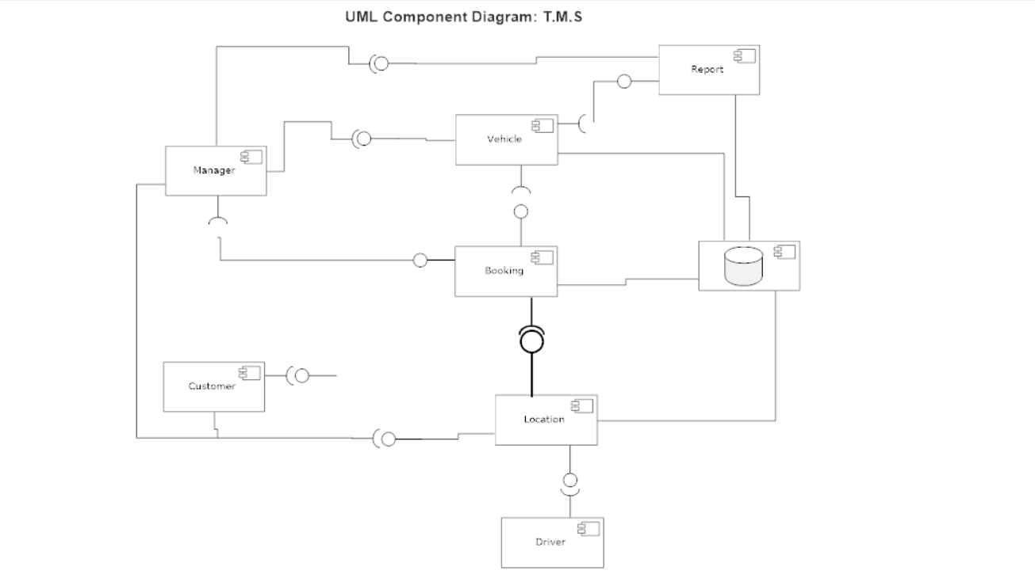

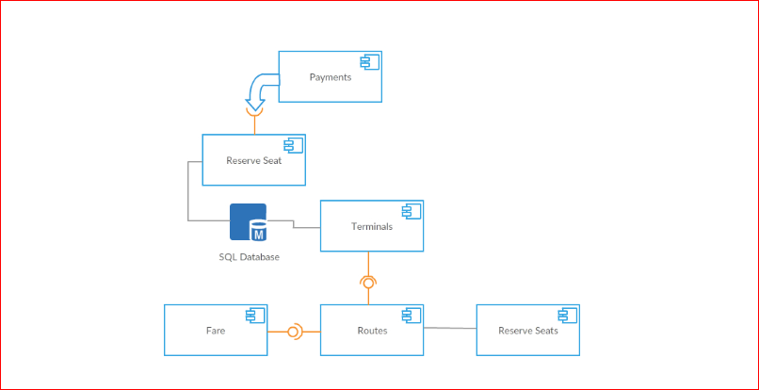

Deployment Diagram

0 Level Data Flow diagram

1 Level Data Flow diagram

2 Level Data Flow Diagram

Sign up Login Data Flow Diagram

Add Vehicle Data Flow Diagram with Report Generate

Add Ride Data Flow Diagram

Booking Ride Data Flow Diagram

Online Payment Data Flow Diagram

Add Terminal Data Flow Diagram

- Add Route Data Flow Diagram

- Seat Reserve Data Flow Diagram

- Add Driver Data Flow Diagram

Chapter 5

Implementation

Chapter 5: Implementation

Important Flow Control/Pseudo codes
Every user is compulsory to sing up and login account to access the system. Those are external actors that communicate with system manger, user, customer and driver.
Firstly manger insert, update, delete and search the vehicle.
Manger can be insert driver data. Manger can record daily base ride. Manger is able to generate the report custom, weekly, monthly, yearly.
Customer send the request to company if the vehicle is available company assign vehicles for booking, booking starts, and driver also received the booking location.
Customer has option to pay fares online and offline payment. Customer gets the current location of online booking.

Components, Libraries, Web Services and stubs
Libraries: .NET Framework libraries, Google Map Libraries, JQuery Data Tables, Quartz and Crystal Reports.
Components: Payments verification alerts, Map location notifications and booking alerts.

Deployment Environment
Hardware: Core 2 duo, 500 GB Hard Drive, 2.8 GHZ, 8 GB RAM
Operating System: Window 7
Application: Google Chrome
Network: Modem, LAN WAN connections, Ethernet cables

Tools and Techniques

Development Tools

Web Application
Visual Studio 2013, PhpStorm and SQL Server 2012.

Software Designing Tool
Microsoft Visio, Adobe Photoshop

Testing Tool
PinDong, Website Grader, Google Chrome, Firefox and Web Page Performance, Loadimpact, webpagetest.

Documentation Tools
Microsoft Office.

Techniques

Programming Techniques

Web Application Techniques
.Net Framework 4.5, C Sharp, HTML/CSS, JavaScript, JQuery, Bootstrap, SQL, Ajax and JSON.

Testing Techniques
We will use Agile Model which will cover all these testing technique.
Unit Testing, Integration Testing, System Testing, and Alpha & Beta Testing.

Best Practices / Coding Standards
- Consistent Naming Scheme.
- Avoid Deep Nesting
- Limit Line length
- Files and Folder Organizations
- Capitalize SQL Special Words.
- Object Oriented Approach.

Version Control
We have used Google drive where we handled our project with speed and efficiency. We can easily manage and share our code with other team members by using Google Drive.

Chapter 6

Testing and Evaluation

Chapter 6: Testing and Evaluation

Use Case Testing

Use Case Test 1:

Use Case Name | Sign Up
Use case Description | User registration for using the system.
Actors | Admin, Customer, Driver
Pre-Condition | System must be connected to network.
Post-condition | After successful registration user can registered with system.

Main Scenario | Serial Number | Steps
A:Actors  S:System | 1 | A:Enter First Name, Last Name, Email, CNIC, Company Name, Address, Password, Image, Mobile Number, City, Company Type
A:Actors  S:System | 2 | S: Validate All input fields.
A:Actors  S:System | 3 | S:Registered with System
Extensions | 2a | If any input has validation error then system generates error message.

Use Case Test 2:

Use Case Name | Login
Use case Description | A user Login to access the system features.
Actors | Admin, Customer, Driver
Pre-Condition | System must be connected to network.
Post-condition | After successful login user can login to system Dashboard.

Main Scenario | Serial Number | Steps
A:Actors  S:System | 1 | A: Enter phone Number and Password.
A:Actors  S:System | 2 | S: Validate Phone Number and Password.
A:Actors  S:System | 3 | Allow Access to System Dashboard
Extensions | 2a | Invalid Password and Username  Then System show error message.

Use Case Test 3:

Use Case Name | Add Vehicle
Use case Description | To Add Vehicle in System.
Actors | Admin
Pre-Condition | System must be connected to network.  Admin must be login to system.
Post-condition | Vehicle Successfully Added in the system.

Main Scenario | Serial Number | Steps
A:Actors  S:System | 1 | A: Enter Vehicle Number, Category, Capacity, Size, Manufacturer, Model, Route, and Image.
A:Actors  S:System | 2 | S: Validate input fields.
A:Actors  S:System | 3 | S: Register vehicle into system. Admin can update, search and delete the vehicle.
Extensions | 2a | Invalid input fields.  Then System show error message.

Use Case Test 4:

Use Case Name | Booking Vehicle
Use case Description | To Book online Vehicles, Track vehicles and pay fares.
Actors | Admin, Driver and Customers.
Pre-Condition | System must be connected to network.  Users must be registered and login to system.
Post-condition | Booking vehicles, Tracking vehicles and pay fares successfully.

Main Scenario | Serial Number | Steps
A:Actors  S:System | 1 | A:Enter Service Type, Truck type, Delivery Hours, Product Name, Quantity weight, Budget, Material, mobile Number, Date, Loading place and Delivery place, Longitude Latitude, Payment Methods, total fare.
A:Actors  S:System | 2 | S: Validate input fields.
A:Actors  S:System | 3 | S: Booking Request created then Admin Verify the Booking and Company and Customer track delivery and customer pay online fares with verified account.
Extensions | 2a | Invalid input fields.  Then System show error message.

Use Case Test 5:

Use Case Name | Report Generating
Use case Description | To Generate profit, drivers, rides and vehicle reports weekly, monthly, yearly and custom.
Actors | Admin.
Pre-Condition | System must be connected to network.  Admin must be registered and login to system.  System should have all records for reporting.
Post-condition | Admin generate profit, drivers, vehicles and rides reports.

Main Scenario | Serial Number | Steps
A:Actors  S:System | 1 | A: Enter vehicle number, date, and driver type.
A:Actors  S:System | 2 | S: Validate input fields.
A:Actors  S:System | 3 | S: Reports generate on the base of user requirements.
Extensions | 2a | Invalid input fields.  Then System show error me sage.

Use Case Test 6:

Use Case Name | Add Driver
Use case Description | To add driver in system.
Actors | Admin
Pre-Condition | System must be connected to network.  Admin must be login to system.
Post-condition | Driver successfully added in the system.

Main Scenario | Serial Number | Steps
A:Actors  S:System | 1 | A: Enter Driver Name, Capacity, Size, Manufacturer, Model, Route, and Image.
A:Actors  S:System | 2 | S: Validate input fields.
A:Actors  S:System | 3 | S: Register vehicle into system. Admin can update, search and delete the vehicle.
Extensions | 2a | Invalid input fields.  Then System show error message.

Use Case Test 7:

Use Case Name | Add Ride
Use case Description | User add daily base ride
Actors | Admin
Pre-Condition | System must be connected to network.  Admin and must be registered and login to system.
Post-condition | Admin add daily base ride in a system

Main Scenario | Serial Number | Steps
A:Actors  S:System | 1 | A:Enter Vehicle Number, driver name, seller, Buyer, location, driver charge, commission charge, diesel quantity, Diesel Expense, Tool Plaza Expense, Mobile Expense,  Food Expense, Maintenance Expense, Ride Income, Ride Detail, Date
A:Actors  S:System | 2 | S: Validate input fields.
A:Actors  S:System | 3 | S: System record the ride and calculate the profit.
Extensions | 2a | Invalid input fields.  Then System show error message.

Use Case Test 8:

Use Case Name | Add Terminal
Use case Description | Admin can search, insert, update and delete terminal.  Customer can view terminal.
Actors | Admin, Customer.
Pre-Condition | System must be connected to network.  Admin must be registered and login to system.
Post-condition | Terminal added, searched, updated and deleted.

Main Scenario | Serial Number | Steps
A:Actors  S:System | 1 | A: Enter Terminal Name, Terminal City, Terminal Image and Terminal Address.
A:Actors  S:System | 2 | S: Validate input fields.
A:Actors  S:System | 3 | S: Record Terminals, Update Terminals, Search Terminals and Delete Terminals.
Extensions | 2a | Invalid input fields.  Then System show error message.
Extensions | 3a | Terminal already exist.  Then System show error messages.

Use Case Test 9:

Use Case Name | Add Schedule
Use case Description | Admin can search, insert, update and delete bus schedules.  Customer can view routes.
Actors | Admin, Customer.
Pre-Condition | System must be connected to network.  Admin must be registered and login to system.
Post-condition | Schedule added, searched, updated and deleted.

Main Scenario | Serial Number | Steps
A:Actors  S:System | 1 | A: Enter departure, arrival, departure time, arrival time, day, bus id, fare, and route class.
A:Actors  S:System | 2 | S: Validate input fields.
A:Actors  S:System | 3 | S: Record routes, update routes, search routes and delete routes.
Extensions | 2a | Invalid input fields.  Then System show error message.
Extensions | 3a | Schedule already exist.  Then System show error messages.

Use Case Test 10:

Use Case Name | Fare
Use case Description | Customer can view Fares.
Actors | Customer.
Pre-Condition | System must be connected to network.
Post-condition | Fare visible to customer.

Main Scenario | Serial Number | Steps
A:Actors  S:System | 1 | A: Enter Departure.
A:Actors  S:System | 2 | S: Validate input fields.
A:Actors  S:System | 3 | S: View departures, arrival name, fare and class of the route.
Extensions | 2a | Invalid input fields.  Then System show error message.

Use Case Test 11:

Use Case Name | Seat Reservation
Use case Description | Customer can reserve seats. Seats reserve only for 15 minutes and customer pay fare then confirm the reservation.
Actors | Customer.
Pre-Condition | System must be connected to network.
Post-condition | Customer reserved seats after payment fare.

Main Scenario | Serial Number | Steps
A:Actors  S:System | 1 | A: Enter departure, arrival, date, jazz cash account no and security code.
A:Actors  S:System | 2 | S: Validate input fields.
A:Actors  S:System | 3 | S: View seats panel and reserve seats and pay fares.
Extensions | 2a | Invalid input fields.  Then System show error message.
Extensions | 3a | Not Payment in 15 minutes.  System unreserved seats if customer not paid in fifteen minutes after reservation time.
Extensions | 3b | Invalid Account Number.  System generate error if account is invalid and has no balance then system generate errors.

Boundary value analysis
Boundary Value Analysis 001

Boundary Value Analysis for CNIC
Invalid | Valid | Invalid
0 - 12 | 13 | 13 - …..

Boundary Value Analysis 002

Boundary Value Analysis for Phone Number
Invalid | Valid | Invalid
0 - 10 | 11 | 12 - …..

Boundary Value Analysis 003

Boundary Value Analysis for Login
Invalid | Valid | Invalid
0 - 10 | 11 | 12 - …..

Boundary Value Analysis 004

Boundary Value Analysis for Password
Invalid | Valid | Invalid
0 - 5 | 6 - 14 | 15 - …..

Boundary Value Analysis 005

Boundary Value Analysis for Pin Code of Add New Bus
Invalid | Valid | Invalid
0 - 5 | 6 | 7 - …..

Boundary Value Analysis 006

Boundary Value Analysis for Driver Charge
Invalid | Valid | Invalid
0 | 0 – 6 | 7 - …..

Boundary Value Analysis 007
Boundary Value Analysis for Payment Security Code
Invalid | Valid | Invalid
0 – 5 | 6 | 7 - …..

Performance testing

With Website Grader

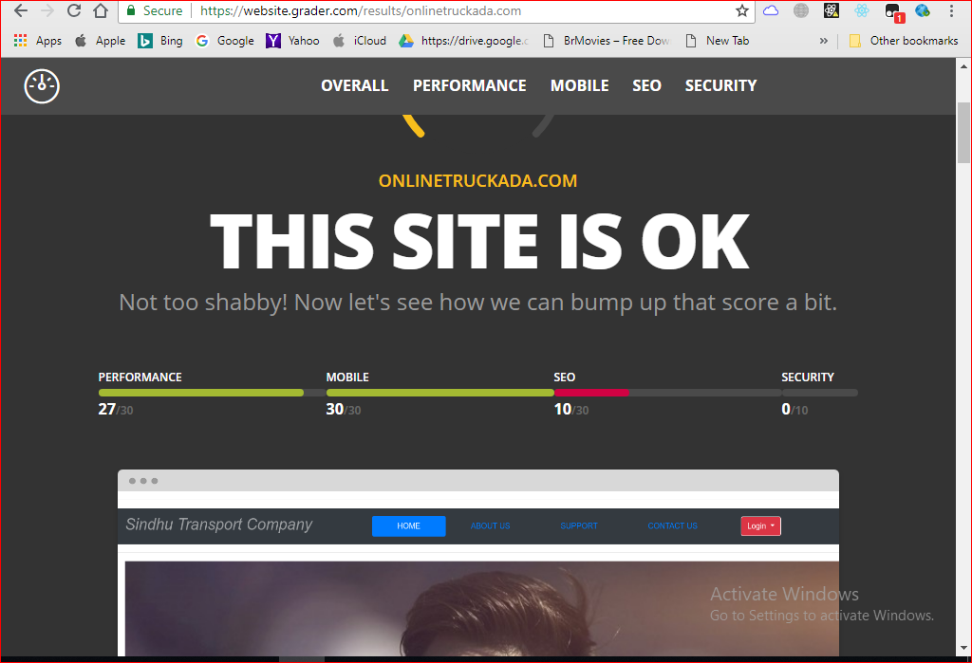

With Pindong
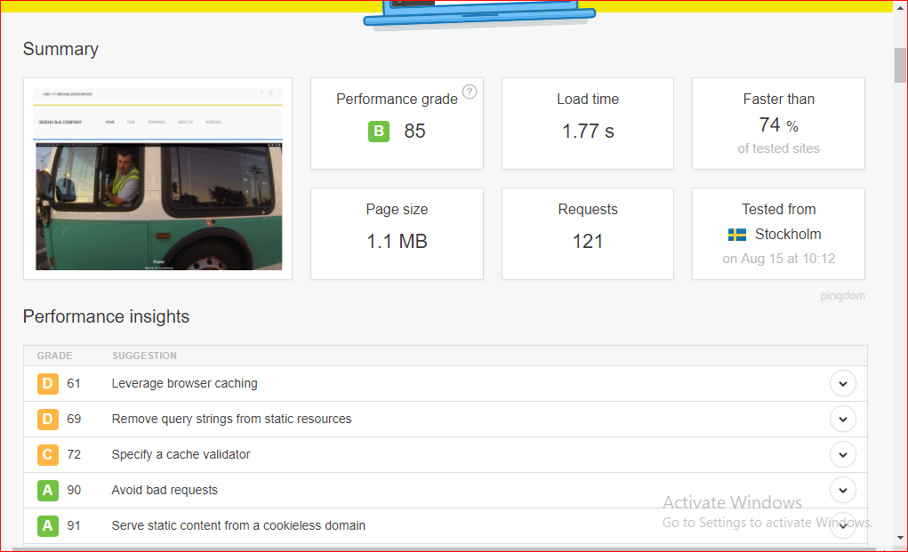

With webpage Performance

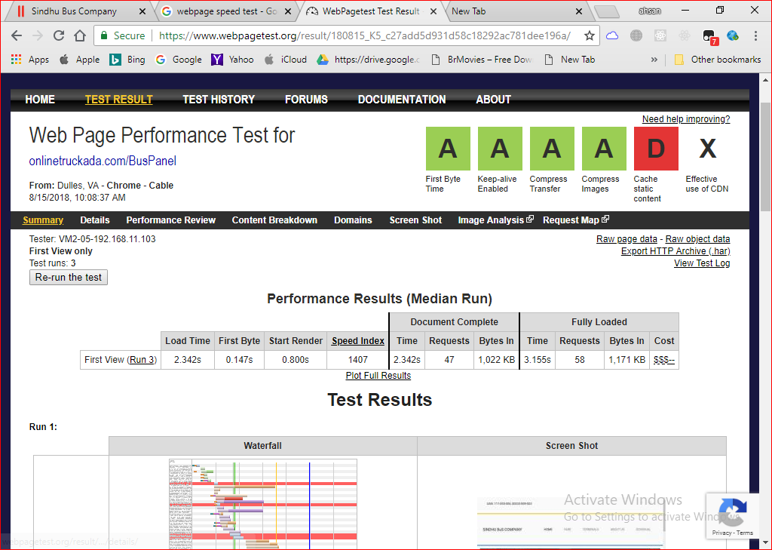

Test Cases

Test Case: 1

Test Case Suite | TS001
Test Case Id | TC001
Test Case Summary | To verify that User Registration Process work.
Related Requirement | User Should be Register via First Name, Last Name, Email, CNIC, Company Name, Address, Password, Confirm Password, Image, Mobile Number, City, and Company Type.
Prerequisites | None
Test procedure | - Enter First Name into First Name field.  - Enter Last Name into Last Name field.  - Enter Email into Email field.  - Enter CNIC in CNIC field.  - Enter Company Name in Company Name field.  - Enter Address in Address field.  - Enter Password in Password field.  - Enter Confirm Password in Confirm Password field.  - Choose Image from Image upload Control.  - Enter City in City field.  - Enter Company Type in Company Type field.  - Enter Register Button
Test Data | First Name:  Empty, 12542, !@#$^&, Zeeshan123, Zeeshan Yasin, Zeeshan.  Last Name:  Empty, 12542, !@#$^&, Zeeshan123, Zeeshan Yasin, Zeeshan.  Email:  zeeshan2334, Zee@, .money, 12!@#, itszeexhan@gmail.com.  CNIC:  Zeeshan142, @$#!%*, 1200.25, 3530123040037.  Company Name:  Empty, 12542, !@#$^&, Zeeshan123, Zeeshan Yasin,  Address:  Empty, 71-A Ali Town  Password :  Empty, zeeshan, zeeshan12, 123432, !@#$%^&, Zeeshan00  Confirm Password:  Empty, zeeshan12, 123432, !@#$%^&, Zeeshan00  Image :  Empty, zeeshan.doc, Zeeshan.html, Zeeshan.PNG, JPG,  City:  Empty, !@#$%^&, Shaah123, Lahore  Company Type:  Empty, !@#$%^&, Shaah123, Lahore, Rahimyar khan
Expected Result | - System should register user if user enter valid fields.  - System should generate error if the all inputs are not valid.  - System should generate error if fields are empty.
Actual Result | - If we entered valid inputs then system logging in the user.  - If we entered invalid inputs then system generate error message.  - If we lefts fields empty then system generate error Required Field.
Status | Pass
Remarks | This is Registration Process test case.
Created By | Zeeshan Yasin
Date of Creation | 13/08/2018
Executed By | Ahsan Siddique
Date of Execution | 14/08/2018
Test Environment | OS: Windows 10  Browser: Mozilla Firefox 4.22, Google Chrome.

Test Case with Wrong Data and Empty Fields

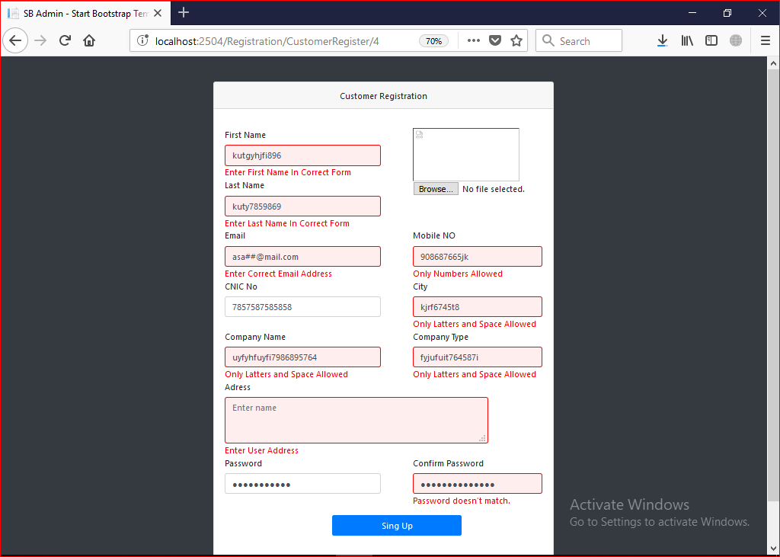

Test Case: 2

Test Case Suite | TS002
Test Case Id | TC002
Test Case Summary | To verify that user Login.
Related Requirement | User should be able to login via Phone Number and Password.
Prerequisites | TC001 User Registration: User must Registered.
Test procedure | - Enter the Phone Number into Phone Number Field.  - Enter Password in Password field.  - Press Login button.
Test Data | Username:  ahsan54966, empty, ahsan$$;d;d, 0314kk325, 03462304003  Password:  ahsanjutt1, ahsan, empty, !@#$%, Zeeshan00.
Expected Result | - System should Login user if user enters valid Phone Number and Password.  - System should generate Error if the Phone Number and Password is invalid.  - System should generate Error if the Phone Number and Password field is empty.
Actual Result | - If we enter valid Phone Number and Password then system logging in the User.  - If we entered invalid Phone Number and Password then system generate Error message.  - If we lefts fields empty then system alerts to enter Phone Number and Password.
Status | Pass
Remarks | This is Login Module test case.
Created By | Zeeshan Yasin
Date of Creation | 13/08/2018
Executed By | Ahsan Siddique
Date of Execution | 14/08/2018
Test Environment | OS: Windows 10  Browser: Mozilla Firefox 4.22, Google Chrome

Test Case with Wrong Data

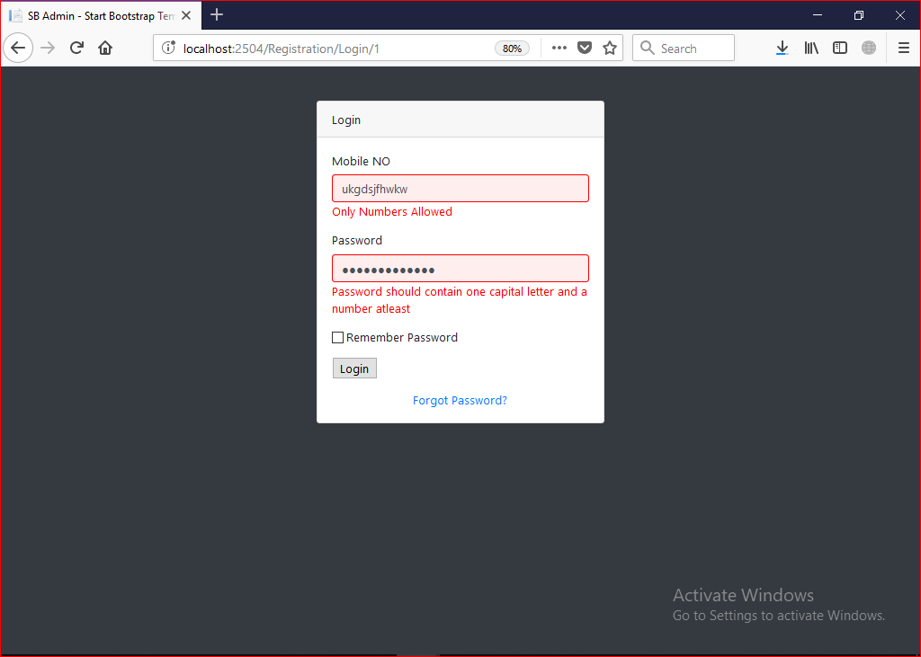

Successful Login

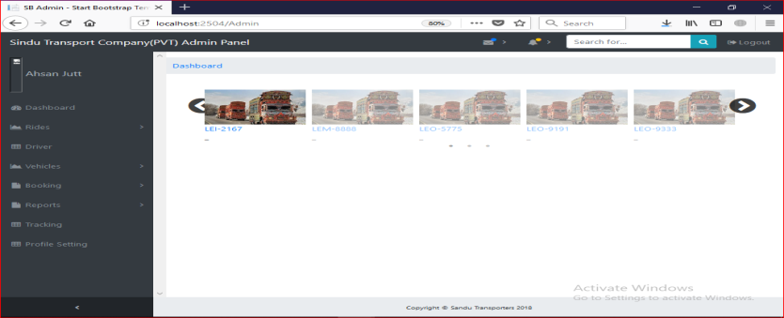

Test Case 3
Test Case Suite | TS003
Test Case Id | TC003
Test Case Summary | To verify that information of vehicle stores in the system.
Related Requirement | Vehicle information Should be store into the system.
Prerequisites | TC002 Login: Admin should be Login.
Test procedure | - Enter the Vehicle Number.  - Enter Pin code  - Enter Vehicle Capacity  - Enter Company Manufacturer  - Enter Vehicle Size  - Enter Vehicle Model  - Enter Route  - Upload Image  - Enter Vehicle Rating
Test Data | Vehicle Number :  Empty, 1412, !@#33, as655, assadc, OKL1254, OKL-2247  Pin code :  Empty, aaaa, w!@#r, 10.1, aa11, 12345678910  Vehicle Capacity :  Empty, 50 Ton  Company Manufacturer :  Empty, Toyota  Vehicle Size:  Empty, 15 by 15  Vehicle Model :  Empty, 2018  Route :  Empty, Punjab  Upload Image :  Empty, .JPG, .PNG  Vehicle Rating:  Empty, 1, 2 ,3
Expected Result | - System should store the data of Vehicle if given input is valid.  - System Generate error if the required information for Vehicle is not valid.
Actual Result | - If we enter valid Inputs then system store Vehicle.  - If we entered invalid Inputs then system generate Error message.  - If we lefts fields empty then system error to enter all fields
Status | Pass
Remarks | This is Vehicle data entry test case.
Created By | Zeeshan Yasin
Date of Creation | 13/08/2018
Executed By | Ahsan Siddique
Date of Execution | 14/08/2018
Test Environment | OS: Windows 10  Browser: Mozilla Firefox 4.22, Google Chrome

Test Case with Wrong Data
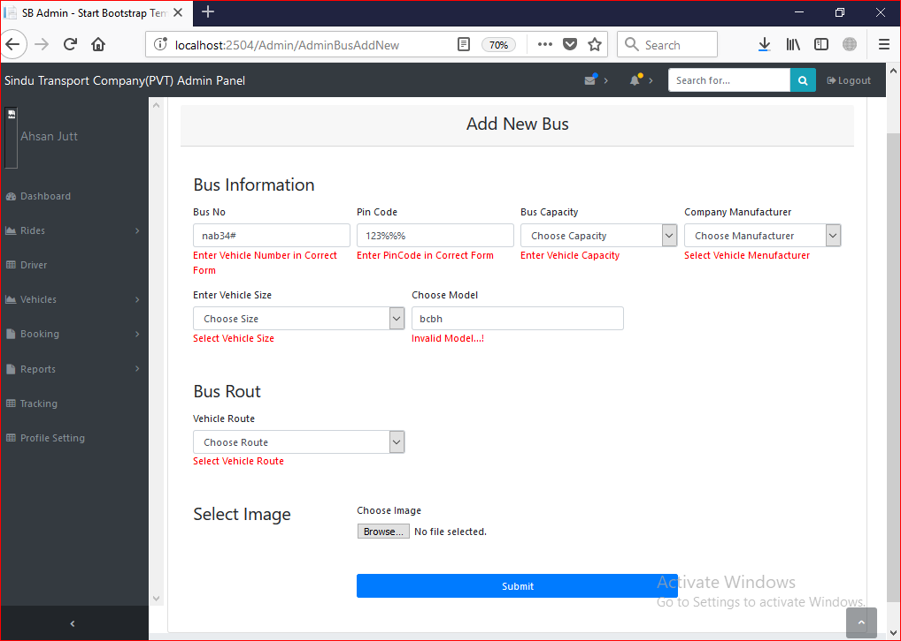
Test Case with Correct Data

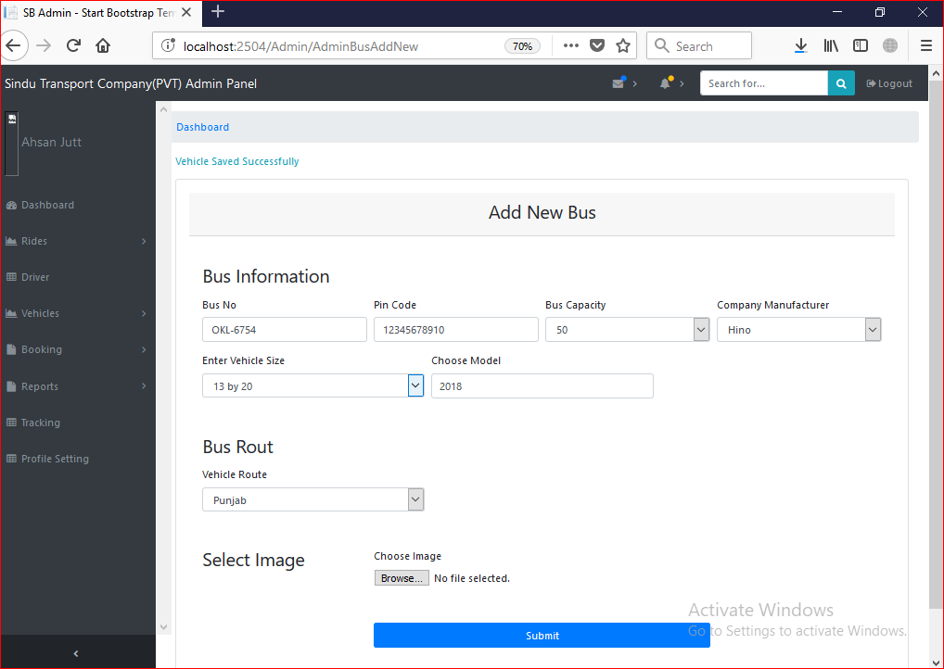

Test Case 4

Test Case Suite | TS004
Test Case Id | TC004
Test Case Summary | To Update information of vehicle in the system.
Related Requirement | Vehicle data should Update from system.
Prerequisites | TC002: Admin should login into system.  TC003: System should have vehicle records.  Information to be entered for Update record should be unique and valid.
Test procedure | Insert the information into form fields then press Update button to Update the information into database.
Test Data | Vehicle Number :  Empty, 1412, !@#33, as655, assadc, OKL1254, OKL-2247  Pin code :  Empty, aaaa, w!@#r, 10.1, aa11, 12345678910  Vehicle Capacity :  Empty, 50 Ton  Company Manufacturer :  Empty, Toyota  Vehicle Size :  Empty, 15 by 15  Vehicle Model :  Empty, 2018  Route :  Empty, Punjab  Upload Image :  Empty, .JPG, .PNG  Vehicle Rating :  Empty, 1, 2 ,3
Expected Result | - System should Update the data of Vehicle if given input is valid and unique.  - System Generate error if the required information for vehicle id is not unique and vehicle data is not valid.
Actual Result | If I enter valid and unique information to system then system update data from vehicle records otherwise shows the warning message to add valid data and unique id.
Status | Pass
Remarks | This is Vehicle Update data test case.
Created By | Zeeshan Yasin
Date of Creation | 13/08/2018
Executed By | Ahsan Siddique
Date of Execution | 14/08/2018
Test Environment | OS: Windows 10  Browser: Mozilla Firefox 4.22, Google Chrome

Test Case Update Date
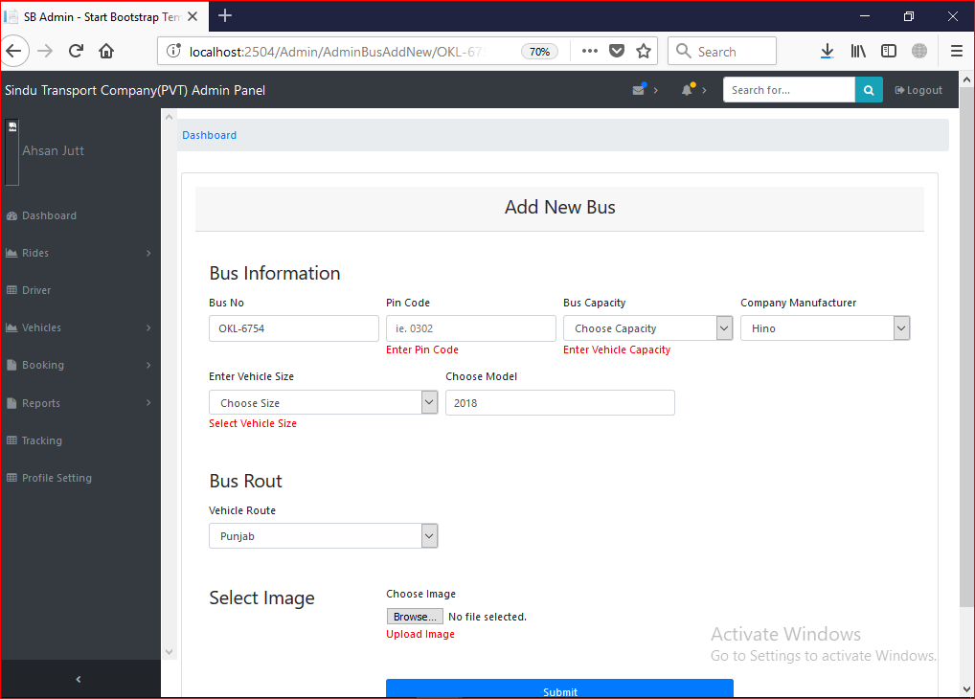
After successfully update record

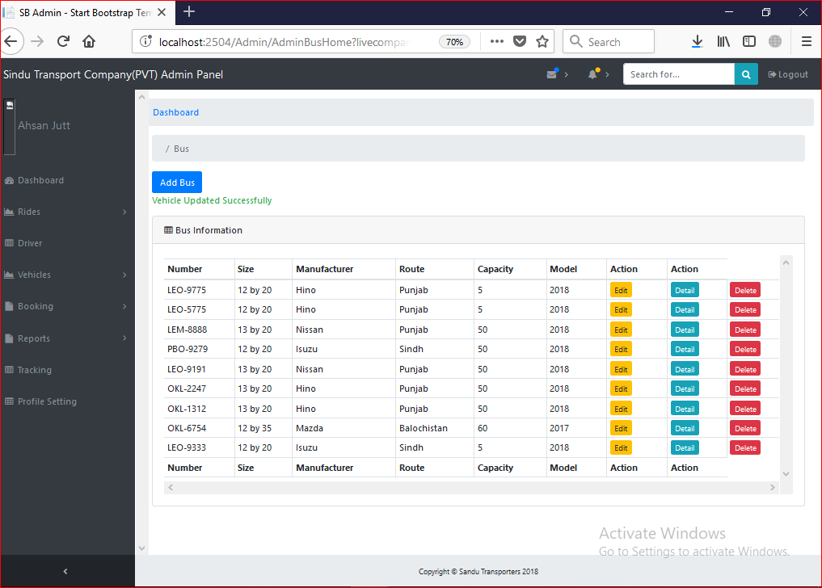

Test Case 5

Test Case Suite | TS005
Test Case Id | TC005
Test Case Summary | To verify that information of vehicle search from system.
Related Requirement | System must be Search Vehicle Record.
Prerequisites | TC002: Admin should login into system.  TC003: System should have vehicle records.  Information to be entered for searching record should be unique and valid.
Test procedure | Enter the information into form fields then press search button to search the information into database.
Test Data | Vehicle Number: Empty, P6823g, jdgjadg, 78875, P-1524
Expected Result | - System show the all records against the entered id if id or input is unique.  - System Generate error if the required information for Vehicle is not valid.
Actual Result | If I enter valid and unique information to system then system Search data from record otherwise shows the error message to search valid and unique data.
Status | Pass
Remarks | This is Vehicle search data test case.
Created By | Zeeshan Yasin
Date of Creation | 13/08/2018
Executed By | Ahsan Siddique
Date of Execution | 14/08/2018
Test Environment | OS: Windows 10  Browser: Mozilla Firefox 4.22, Google Chrome

Test Case with Empty Field or Invalid Data

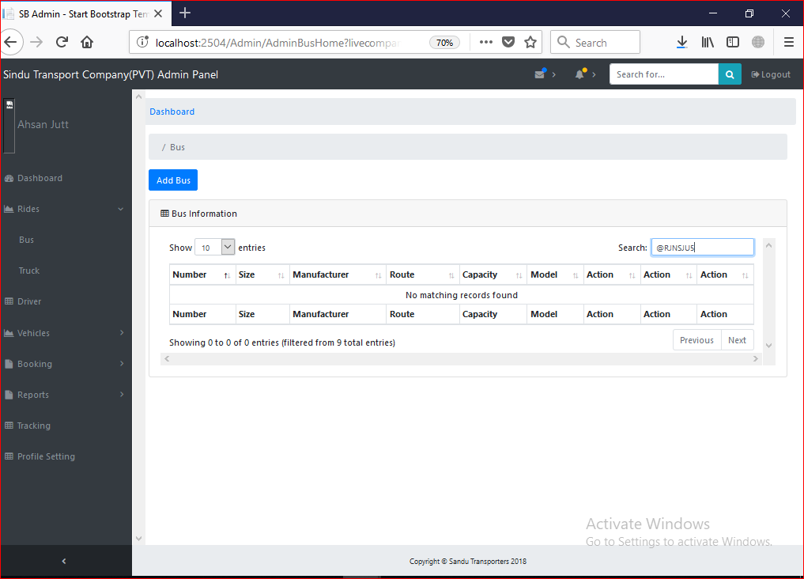

Test Case with Valid Data

Test Case 6

Test Case Suite | TS006
Test Case Id | TC006
Test Case Summary | To verify that information of Vehicle Deleted from the system.
Related Requirement | Vehicle data Should Delete from the system.
Prerequisites | TC002: Admin should login into system.  TC003: System should have vehicle records.  Information to be entered for Deleting record should be unique and valid.
Test procedure | Enter the information into form fields then press Delete button to Delete the information from database.
Test Data | Vehicle Number: Empty, P6823g, jdgjadg, 78875, P-1524
Expected Result | - System should delete the results against given input if input is valid and unique.  - System Delete the all records against the sleeted id if id or input is unique.  - System Generate error if the required information for Vehicle is not valid.
Actual Result | If I select valid and unique information to system then system Delete data from Records otherwise shows the error message to select valid and unique data.
Status | Pass
Remarks | This is Vehicle Delete data test case.
Created By | Zeeshan Yasin
Date of Creation | 13/08/2018
Executed By | Ahsan Siddique
Date of Execution | 14/08/2018
Test Environment | OS: Windows 10  Browser: Mozilla Firefox 4.22, Google Chrome

On Clicking Delete button:

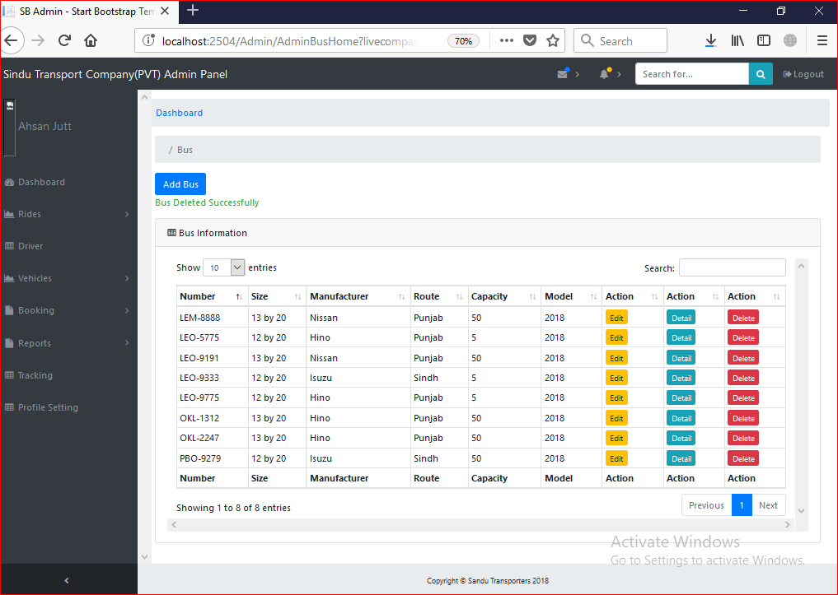

Test Case 7

Test Case Suite | TS007
Test Case Id | TC007
Test Case Summary | To verify that Ride Record stores in the system.
Related Requirement | Ride data Should store into the system.
Prerequisites | TC002: Admin should login into system.  Information to be entered should be valid and unique.
Test procedure | Enter the Ride data into form fields then press Submit button to store the information into database.
Test Data | - Ride Source: Empty, ok, okk, ,,,,,,,,,,,,,,,,,,,,,,,,,,,,,,,,,,,,,,,,,,,, , Lahore  - Ride Destination: Empty, ok, okk, ,,,,,,,,,,,,,,,,,,,,,,,,,,,,,,,,,,,,,,,,,,,, , Lahore  - Diesel Expense: Empty, sdf, ah2d, ,,,,@#, 012345, 123456  - Mobile Expense: Empty, sdf, ah2d, ,,,,@#, 012345, 123456  - Food Expense: Empty, sdf, ah2d, ,,,,@#, 012345, 123456  - Tax Expense: Empty, sdf, ah2d, ,,,,@#, 012345, 123456  - Driver Charges: Empty, sdf, ah2d, ,,,,@#, 012345, 123456  - Commission Charges: Empty,sdf, ah2d, ,,,,@#, 012345, 123456  - Diesel Quantity: Empty, sdf, ah2d, ,,,,@#, 012345, 123456  - Vehicle Number: Empty, Vehicle Number  - Profit: Empty, sdf, ah2d, ,,,,@#, 012345, 123456  - Seller: Empty, asdhf34, afkj55@, Zeeshan, Zeeshan Yasin  - Buyer: Empty, asdhf34, afkj55@, Zeeshan, Zeeshan Yasin  - Date: Empty, Select Date  - Ride Details: Empty, asdhf34, afkj55@, Grapes, Banana fruit.  - Passenger Fare: Empty, sdf, ah2d, ,,,,@#, 012345, 123456  - Conductor Name: Empty, asdhf34, afkj55@, Zeeshan, Zeeshan Yasin  - Ride Type: Empty, Select Date  - Company Id: Empty, Select Date
Expected Result | - System should store the data of Ride if given input is valid.  - System Generate error if the required information for Ride is not valid and unique.
Actual Result | If I enter valid and unique information to system then system store data into Ride table otherwise shows the error message to add valid data.
Status | Pass
Remarks | This is Ride data entry test case.
Created By | Zeeshan Yasin
Date of Creation | 13/08/2018
Executed By | Ahsan Siddique
Date of Execution | 14/08/2018
Test Environment | OS: Windows 10  Browser: Mozilla Firefox 4.22, Google Chrome

Test Case with Wrong Data

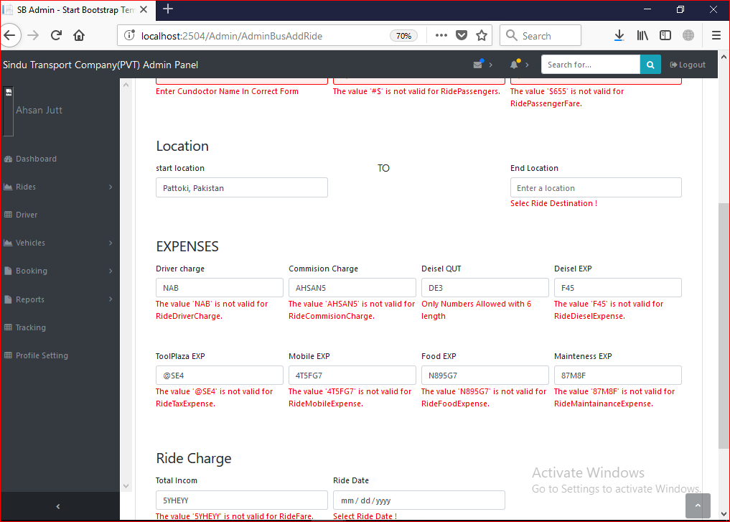

Test Case with Valid Data:

Test Case 8

Test Case Suite | TS008
Test Case Id | TC008
Test Case Summary | To Update information of Ride in the system.
Related Requirement | Ride data should Update from system.
Prerequisites | TC002: Admin should login into system.  TC00: System should have Ride records.  Information to be entered for Update record should be unique and valid.
Test procedure | Insert the information into form fields then press Update button to Update the information into database.
Test Data | - Ride Source: Empty, ok, okk, ,,,,,,,,,,,,,,,,,,,,,,,,,,,,,,,,,,,,,,,,,,,, , Lahore  - Ride Destination: Empty, ok, okk, ,,,,,,,,,,,,,,,,,,,,,,,,,,,,,,,,,,,,,,,,,,,, , Lahore  - Diesel Expense: Empty, sdf, ah2d, ,,,,@#, 012345, 123456  - Mobile Expense: Empty, sdf, ah2d, ,,,,@#, 012345, 123456  - Food Expense: Empty, sdf, ah2d, ,,,,@#, 012345, 123456  - Tax Expense: Empty, sdf, ah2d, ,,,,@#, 012345, 123456  - Driver Charges: Empty, sdf, ah2d, ,,,,@#, 012345, 123456  - Commission Charges: Empty,sdf, ah2d, ,,,,@#, 012345, 123456  - Diesel Quantity: Empty, sdf, ah2d, ,,,,@#, 012345, 123456  - Vehicle Number: Empty , Vehicle Number  - Profit: Empty, sdf, ah2d, ,,,,@#, 012345, 123456  - Seller: Empty, asdhf34, afkj55@, Zeeshan, Zeeshan Yasin  - Buyer: Empty, asdhf34, afkj55@, Zeeshan, Zeeshan Yasin  - Date: Empty, Select Date  - Ride Details: Empty, asdhf34, afkj55@, Grapes, Banana fruit.  - Passenger Fare: Empty, sdf, ah2d, ,,,,@#, 012345, 123456  - Conductor Name: Empty, asdhf34, afkj55@, Zeeshan, Zeeshan Yasin  - Ride Type: Empty, Select Ride Type  - Company Id: Empty
Expected Result | - System should Update the data of Ride if given input is valid and unique.  - System Generate error if the required information for Ride id is not unique and Ride data is not valid.
Actual Result | If I enter valid and unique information to system then system update data from Ride records otherwise shows the warning message to add valid data and unique id.
Status | Pass
Remarks | This is Ride Update data test case.
Created By | Zeeshan Yasin
Date of Creation | 13/08/2018
Executed By | Ahsan Siddique
Date of Execution | 14/08/2018
Test Environment | OS: Windows 10  Browser: Mozilla Firefox 4.22, Google Chrome

Test Case with putting Valid Data

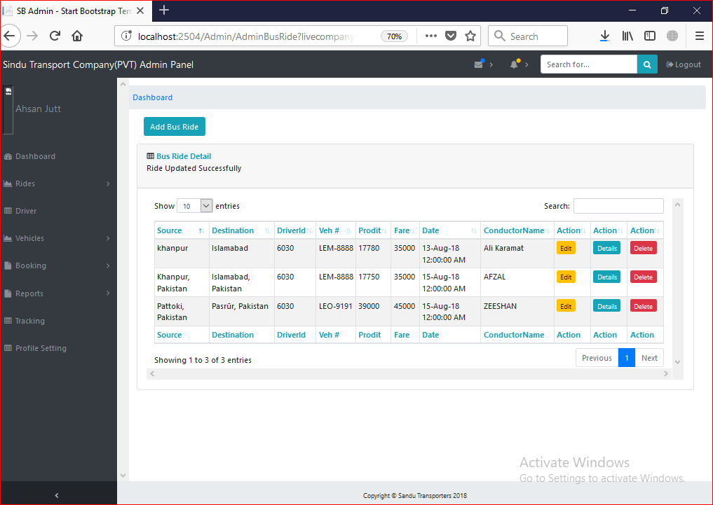

Test Case 9
Test Case Suite | TS009
Test Case Id | TC009
Test Case Summary | To verify that information of Ride search from system.
Related Requirement | System must be Search Ride Record.
Prerequisites | TC002: Admin should login into system.  TC00: System should have Ride records.  Information to be entered for searching record should be unique and valid.
Test procedure | Enter the information into form fields then press search button to search the information into database.
Test Data | Vehicle Number: Empty, P6823g, jdgjadg, 78875, P-1524  Ride Source: Empty, ok, okk, ,,,,,,,,,,,,,,,,,,,,,,,,,,,,,,,,,,,,,,,,,,,, , Lahore  Ride Destination: Empty, ok, okk, ,,,,,,,,,,,,,,,,,,,,,,,,,,,,,,,,,,,,,,,,,,,, , Lahore  Vehicle Number: Empty, Vehicle Number  Profit: Empty, sdf, ah2d, ,,,,@#, 012345, 123456  Seller: Empty, asdhf34, afkj55@, Zeeshan, Zeeshan Yasin  Buyer: Empty, asdhf34, afkj55@, Zeeshan, Zeeshan Yasin  Date: Empty, Select Date  Ride Details: Empty, asdhf34, afkj55@, Grapes, Banana fruit.  Passenger Fare: Empty, sdf, ah2d, ,,,,@#, 012345, 123456
Expected Result | - System show the all records against the entered Input if input is unique.  - System Generate error if the required information for Ride is not valid.
Actual Result | If I enter valid and unique information to system then system Search data from record otherwise shows the error message to search valid and unique data.
Status | Pass
Remarks | This is Ride search data test case.
Created By | Zeeshan Yasin
Date of Creation | 13/08/2018
Executed By | Ahsan Siddique
Date of Execution | 14/08/2018
Test Environment | OS: Windows 10  Browser: Mozilla Firefox 4.22, Google Chrome

Test Case with Empty Field or wrong Data
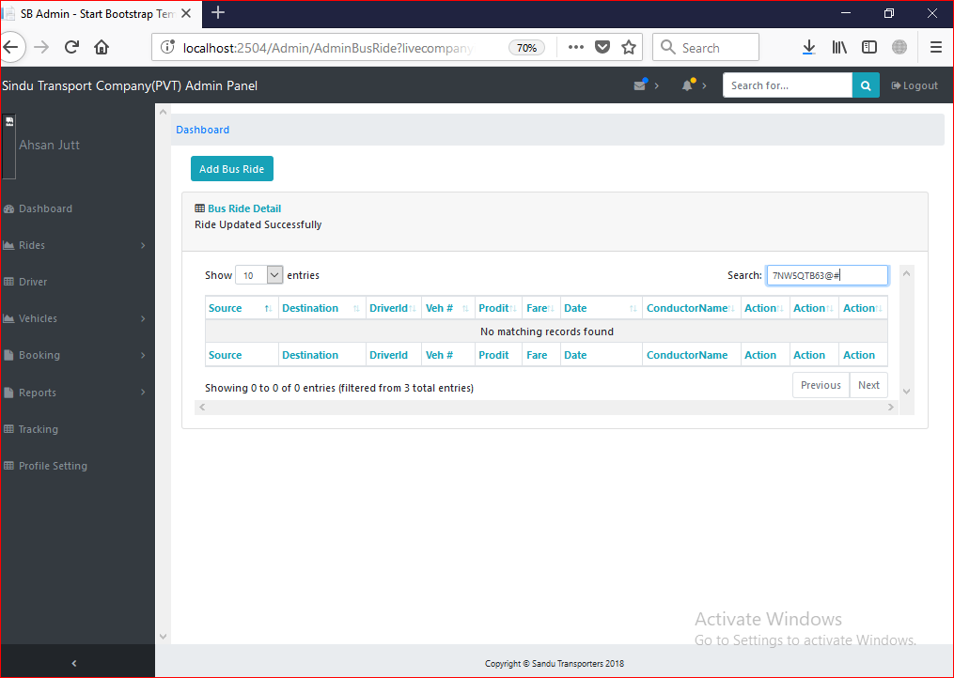

Test Case with putting Valid Data 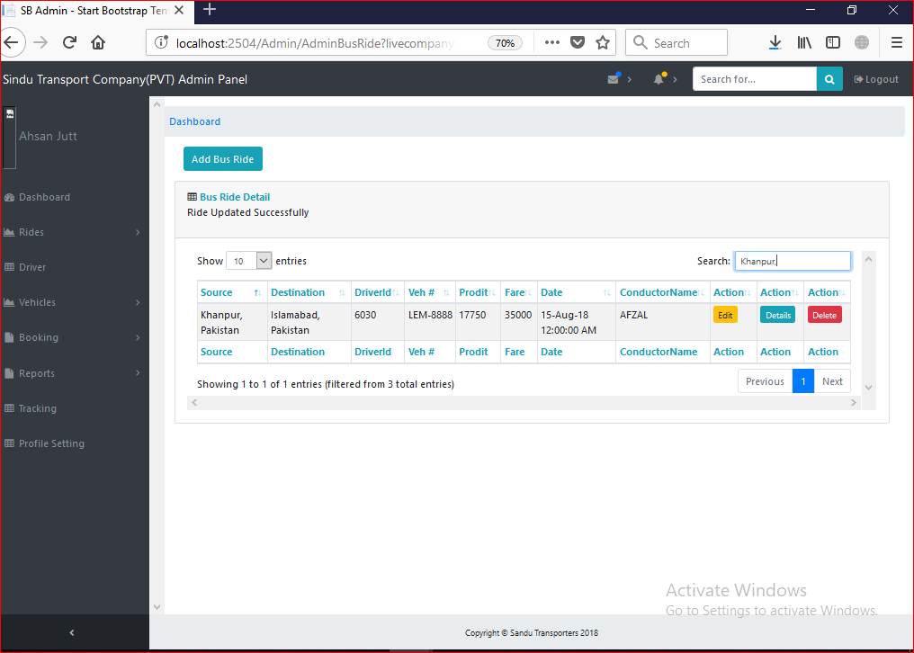

Test Case 10

Test Case Suite | TS010
Test Case Id | TC010
Test Case Summary | To verify that information of Ride Deleted from the system.
Related Requirement | Vehicle data Should Delete from the system.
Prerequisites | TC002: Admin should login into system.  TC007: System should have Ride records.  Information to be entered for Deleting record should be unique and valid.
Test procedure | Click on Delete button.
Test Data | Vehicle Number: Empty, P6823g, jdgjadg, 78875, P-1524
Expected Result | - System should delete the results against given input if input is valid and unique.  - System Delete records against the sleeted id if id or input is unique.  - System Generate error if the required information for Ride is not valid.
Actual Result | If I select valid and unique information to system then system Delete data from Records otherwise shows the error message to select valid and unique data.
Status | Pass
Remarks | This is Ride Delete data test case.
Created By | Zeeshan Yasin
Date of Creation | 13/08/2018
Executed By | Ahsan Siddique
Date of Execution | 14/08/2018
Test Environment | OS: Windows 10  Browser: Mozilla Firefox 4.22, Google Chrome

Test Case with putting Valid Data

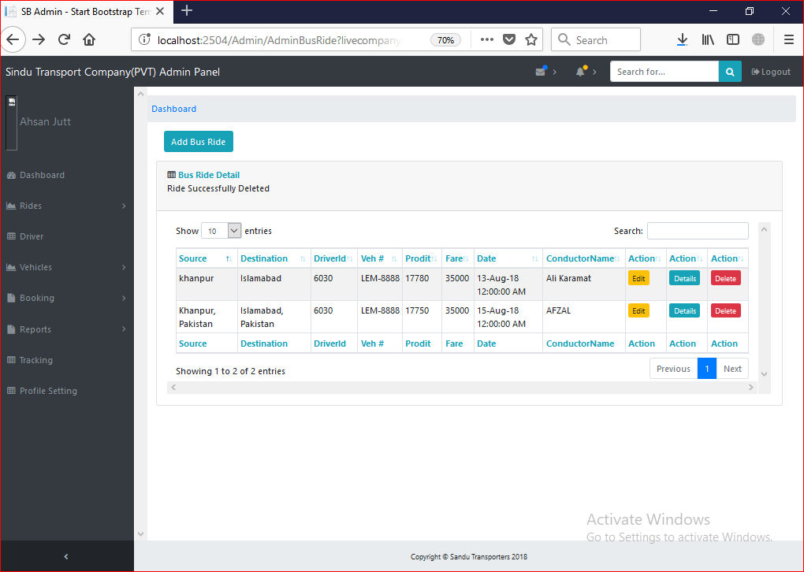

Test Case 11

Test Case Suite | TS011
Test Case Id | TC011
Test Case Summary | To verify that Driver Record stores in the system.
Related Requirement | TC002: Admin should login into system.  Driver data Should store into the system.
Prerequisites | Admin Should register with system and also should login into system.  Information to be entered should be valid and unique.
Test procedure | Enter the Driver data into form fields then press Submit button to store the information into database.
Test Data | - First Name: Empty, asdhf34, afkj55@, Zeeshan  - Last Name: Empty, asdhf34, afkj55@, Zeeshan  - Mobile Number: Empty, asdhf34, afkj55@, 10.1,03462304003  - CNIC: Empty, asdhf34, afkj55@, Zeeshan, 1.1. 3530155455647  - Salary: Empty, asdhf34, afkj55@, Zeeshan, 1000000  - Experience: Empty, asdhf34, afkj55@, Zeeshan, 1, 12  - Position: Empty, Position  - Address: Empty, asdhf34, afkj55@, Zeeshan, 71A Ali Town  - Image: Empty. Upload Image  - City: Empty, asdhf34, afkj55@, Okara, Wazir Abad  - Route Charge: Empty, Select Route Charge  - Driver Type: Empty, Select Driver Type
Expected Result | - System should store the data of Driver if given input is valid.  - System Generate error if the required information for Driver is not valid and unique.
Actual Result | If I enter valid and unique information to system then system store data into Driver table otherwise shows the error message to add valid data.
Status | Pass
Remarks | This is Driver data entry test case.
Created By | Zeeshan Yasin
Date of Creation | 13/08/2018
Executed By | Ahsan Siddique
Date of Execution | 14/08/2018
Test Environment | OS: Windows 10  Browser: Mozilla Firefox 4.22, Google Chrome

Test Case with Empty Field and Wrong Data

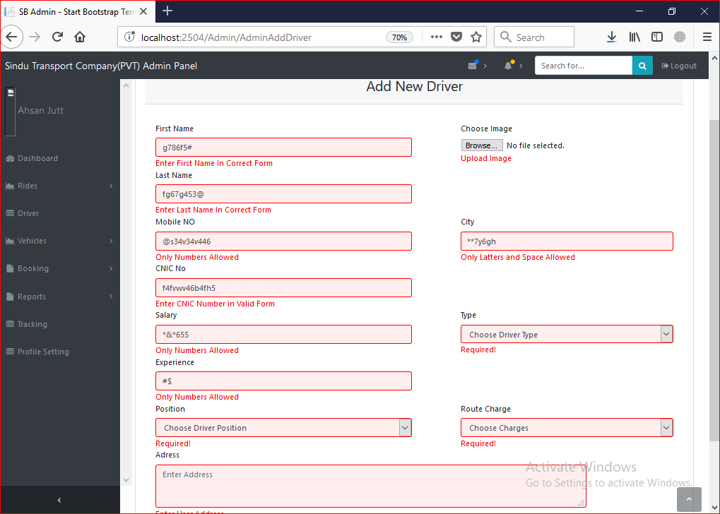

Test Case with Valid Data:

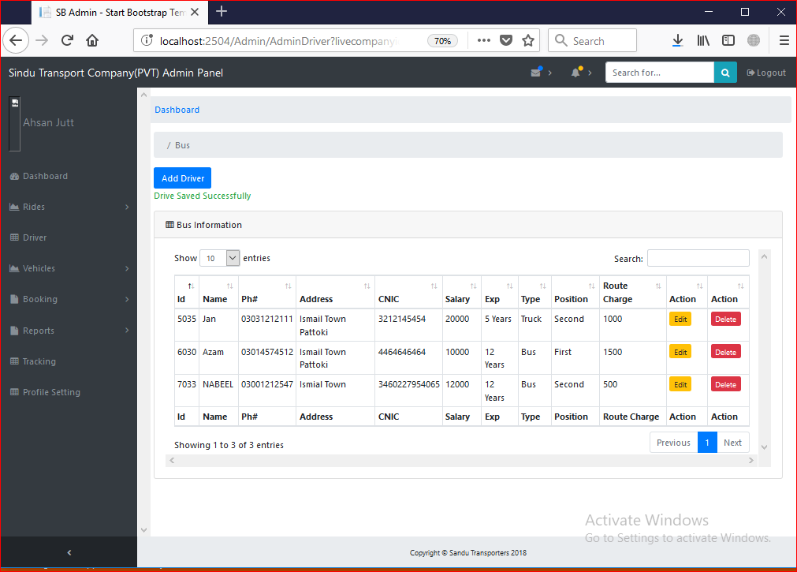

Test Case 12

Test Case Suite | TS012
Test Case Id | TC012
Test Case Summary | To Update information of Driver in the system.
Related Requirement | Driver data should Update from system.
Prerequisites | TC002: Admin should login into system.  TC011: System should have Driver records.  Information to be entered for Update record should be unique and valid.
Test procedure | Insert the information into form fields then press Update button to Update the information into database.
Test Data | - First Name: Empty, asdhf34, afkj55@, Zeeshan  - Last Name: Empty, asdhf34, afkj55@, Zeeshan  - Mobile Number: Empty, asdhf34, afkj55@, 10.1,03462304003  - CNIC: Empty, asdhf34, afkj55@, Zeeshan, 1.1. 3530155455647  - Salary: Empty, asdhf34, afkj55@, Zeeshan, 1000000  - Experience: Empty, asdhf34, afkj55@, Zeeshan, 1, 12  - Position: Empty, Select Position  - Address: Empty, asdhf34, afkj55@, Zeeshan, 71A Ali Town  - Image: Empty, upload Image  - City: Empty, asdhf34, afkj55@, Okara, Wazir Abad  - Route Charge: Empty, Select Route Charge  - Driver Type: Empty, Select Driver Type
Expected Result | - System should Update the data of Driver if given input is valid and unique.  - System Generate error if the required information for Driver id is not unique and Ride data is not valid.
Actual Result | If I enter valid and unique information to system then system update data from Driver records otherwise shows the warning message to add valid data and unique id.
Status | Pass
Remarks | This is Driver Update data test case.
Created By | Zeeshan Yasin
Date of Creation | 13/08/2018
Executed By | Ahsan Siddique
Date of Execution | 14/08/2018
Test Environment | OS: Windows 10  Browser: Mozilla Firefox 4.22, Google Chrome

Test Case with valid Data:

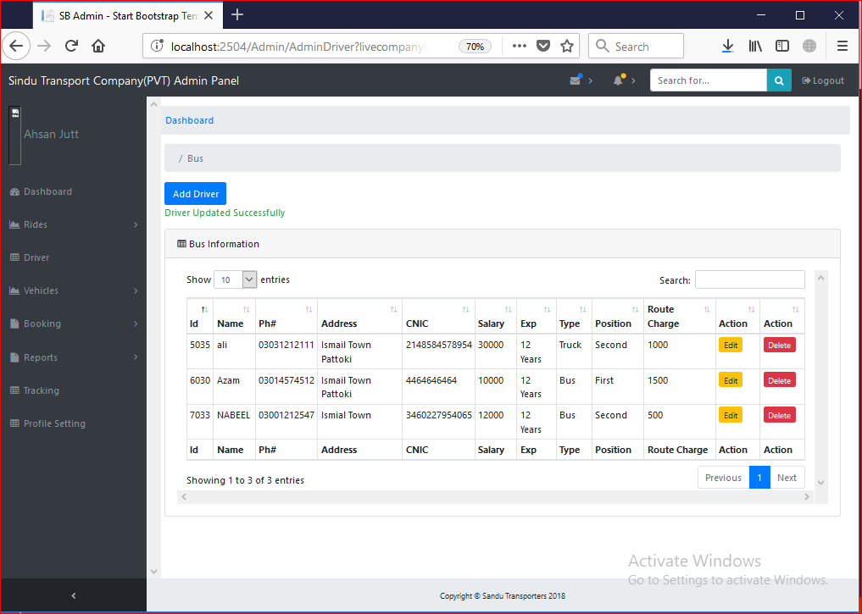

Test Case 13

Test Case Suite | TS013
Test Case Id | TC013
Test Case Summary | To verify that information of Driver search from system.
Related Requirement | System must be Search Driver Record.
Prerequisites | TC002: Admin should login into system.  TC011: System should have Driver records.  Information to be entered for searching record should be unique and valid.
Test procedure | Enter the information into form fields then press search button to search the information into database.
Test Data | - First Name: Empty, asdhf34, afkj55@, Zeeshan  - Last Name: Empty, asdhf34, afkj55@, Zeeshan  - Mobile Number: Empty, asdhf34, afkj55@, 10.1,03462304003  - CNIC: Empty, asdhf34, afkj55@, Zeeshan, 1.1. 3530155455647  - Salary: Empty, asdhf34, afkj55@, Zeeshan, 1000000
Expected Result | - System show the all records against the entered Input if input is unique.  - System should not show anything if the required information for Driver is not valid.
Actual Result | If I enter valid and unique information to system then system Search data from record otherwise shows the error message to search valid and unique data.
Status | Pass
Remarks | This is Driver search data test case.
Created By | Zeeshan Yasin
Date of Creation | 13/08/2018
Executed By | Ahsan Siddique
Date of Execution | 14/08/2018
Test Environment | OS: Windows 10  Browser: Mozilla Firefox 4.22, Google Chrome

Test Case with Entering Valid Data:

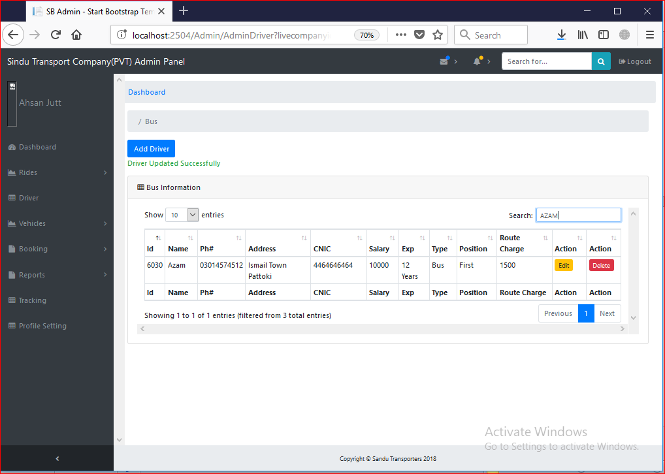

Test Case 14

Test Case Suite | TS014
Test Case Id | TC014
Test Case Summary | To verify that information of Driver Deleted from the system.
Related Requirement | Driver data Should Delete from the system.
Prerequisites | TC002: Admin should login into system.  TC011: System should have Driver records.  Information to be entered for Deleting record should be unique and valid.
Test procedure | Click on Delete button.
Test Data | Driver Id: Empty
Expected Result | - System should delete the results against given input if input is valid and unique.  - System Delete records against the sleeted id if id or input is unique.  - System Generate error if the required information for Ride is not valid.
Actual Result | If I select valid and unique information to system then system Delete data from Records otherwise shows the error message to select valid and unique data.
Status | Pass
Remarks | This is Driver Delete data test case.
Created By | Zeeshan Yasin
Date of Creation | 13/08/2018
Executed By | Ahsan Siddique
Date of Execution | 14/08/2018
Test Environment | OS: Windows 10  Browser: Mozilla Firefox 4.22, Google Chrome

Test Case with Pressing Delete Button:

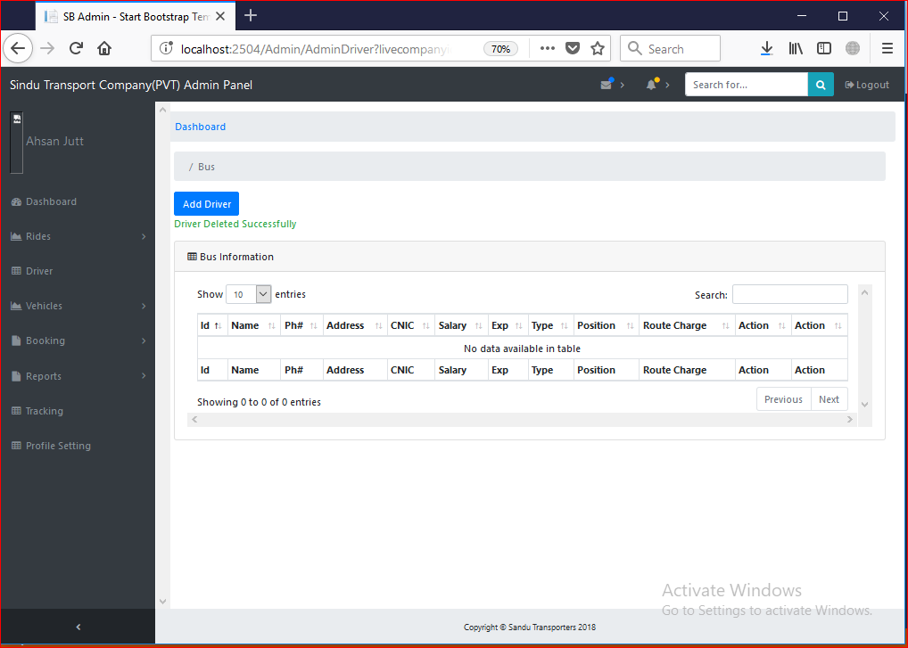

Test Case 15

Test Case Suite | TS015
Test Case Id | TC015
Test Case Summary | To verify that system generate Profit reports.
Related Requirement | System must have Ride records.
Prerequisites | TC002: Admin should login into system.  TC007: System should have Ride records.  Information to be entered for report should be unique and valid.
Test procedure | - Select Vehicle Number:  - Select Date:  - Press Generate Report button:
Test Data | Select Vehicle Number: Empty, Choose Vehicle Number  Select Date: Empty, Choose Date
Expected Result | - System should generate profit report against valid values.  - System generates errors if entered data is not valid.
Actual Result | System generated reports against values by Admin or User.  System generated Alert if input is invalid
Status | Pass
Remarks | This is Profit Generate test case
Created By | Zeeshan Yasin
Date of Creation | 13/08/2018
Executed By | Ahsan Siddique
Date of Execution | 14/08/2018
Test Environment | OS: Windows 10  Browser: Mozilla Firefox 4.22, Google Chrome

Test Case with Empty Field

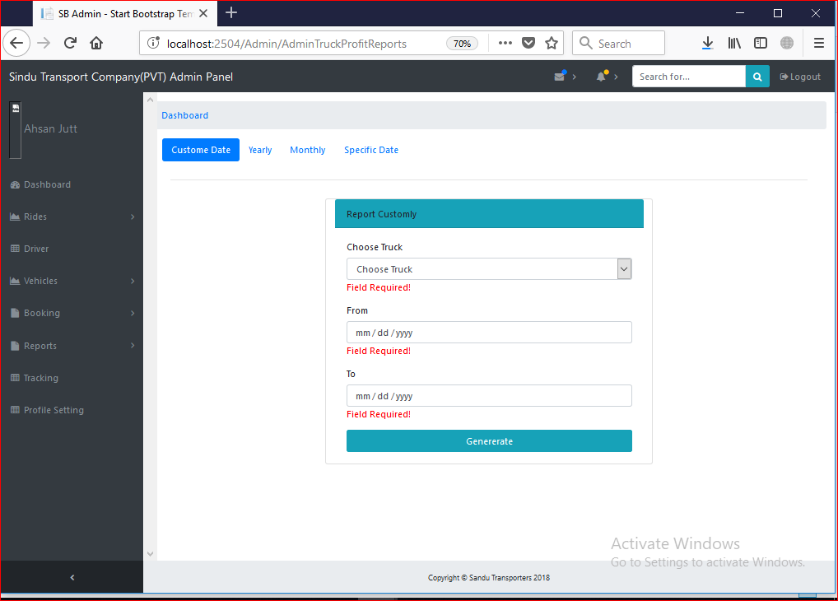

Test Case with Putting Valid Data:

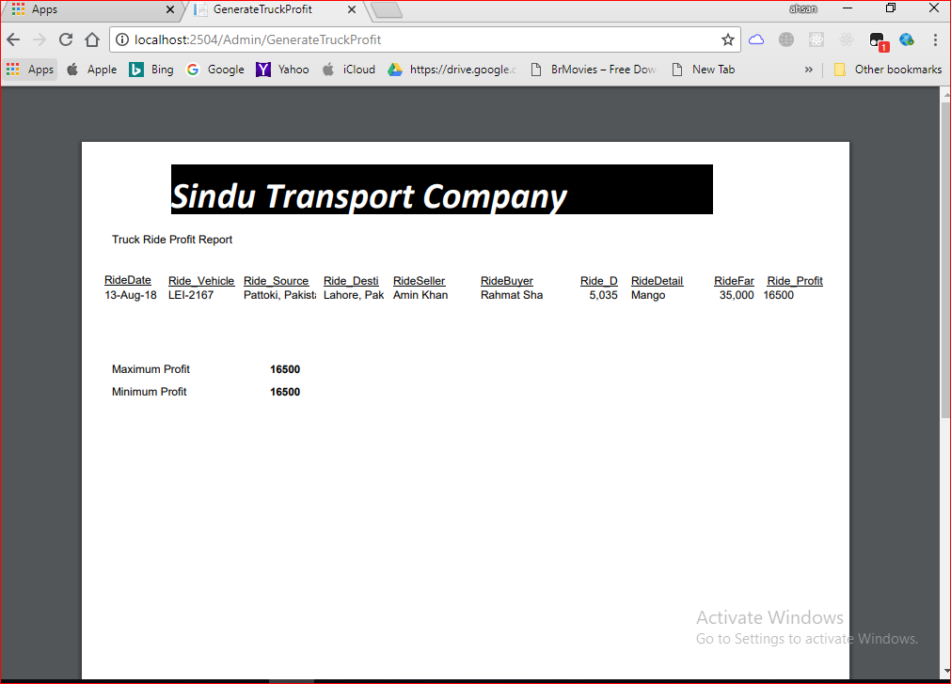

Test Case 16

Test Case Suite | TS016
Test Case Id | TC016
Test Case Summary | To verify that system generate Driver reports.
Related Requirement | System must have driver records.
Prerequisites | TC002: Admin should login into system.  TC011: System should have driver records.  Information to be entered for report should be unique and valid.
Test procedure | Select Driver Category.  Press Generate Report button:
Test Data | Select Driver Category : Empty, Choose Driver Category(First, Second)
Expected Result | System should generate driver report against valid values.  System generates errors if entered data is not valid.
Actual Result | System generated reports against values by Admin or User.  System generated Alert if input is invalid
Status | Pass
Remarks | This is Profit Driver test case
Created By | Zeeshan Yasin
Date of Creation | 13/08/2018
Executed By | Ahsan Siddique
Date of Execution | 14/08/2018
Test Environment | OS: Windows 10  Browser: Mozilla Firefox 4.22, Google Chrome

Test Case with Empty Field

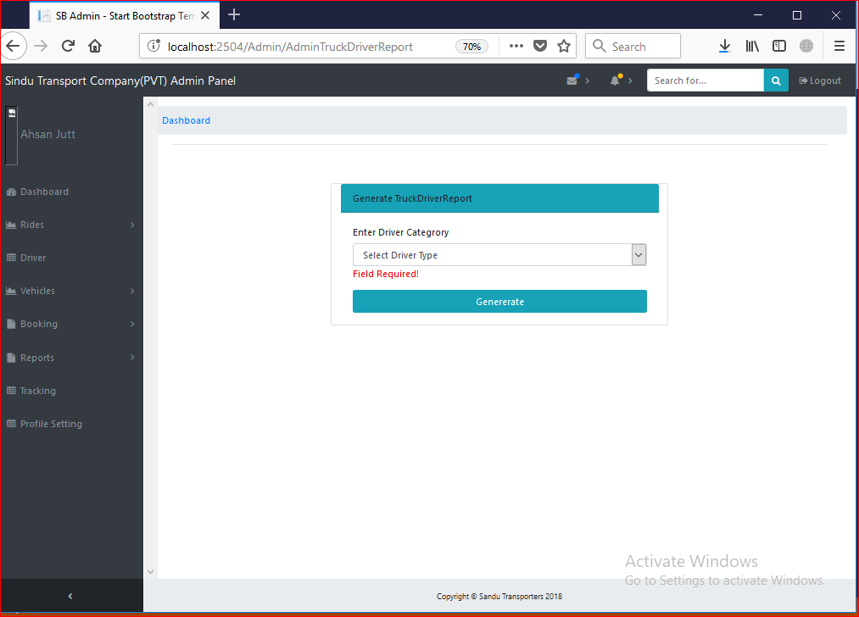

Test Case with Valid Data:

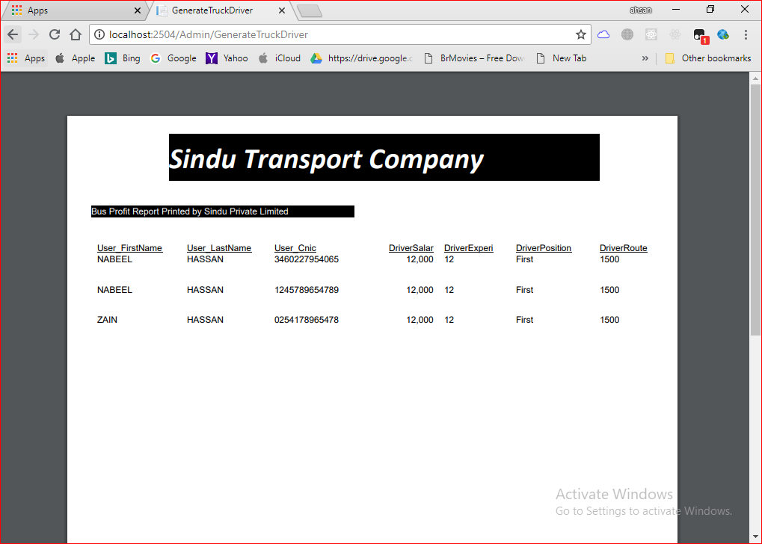

Test Case 17

Test Case Suite | TS017
Test Case Id | TC017
Test Case Summary | To verify that System generate vehicle report.
Related Requirement | System must calculate the vehicle report.
Prerequisites | TC002: Admin should login into system.  TC003: System should have vehicle records.  Information to be entered for report should be unique and valid.
Test procedure | - Select Vehicle Manufacturer.  - Press Generate Report button:
Test Data | Vehicle Manufacturer: Empty, Choose Vehicle Manufacturer (Hino, Mazda)
Expected Result | - System should generate Vehicle report against valid values.  - System generates errors if entered data is not valid.
Actual Result | System generated reports against values by Admin or User.  System generated Alert if input is invalid
Status | Pass
Remarks | This is salary calculation module test case.
Created By | Zeeshan Yasin
Date of Creation | 13/08/2018
Executed By | Ahsan Siddique
Date of Execution | 14/08/2018
Test Environment | OS: Windows 10  Browser: Mozilla Firefox 4.22, Google Chrome

Test Case with Empty Field

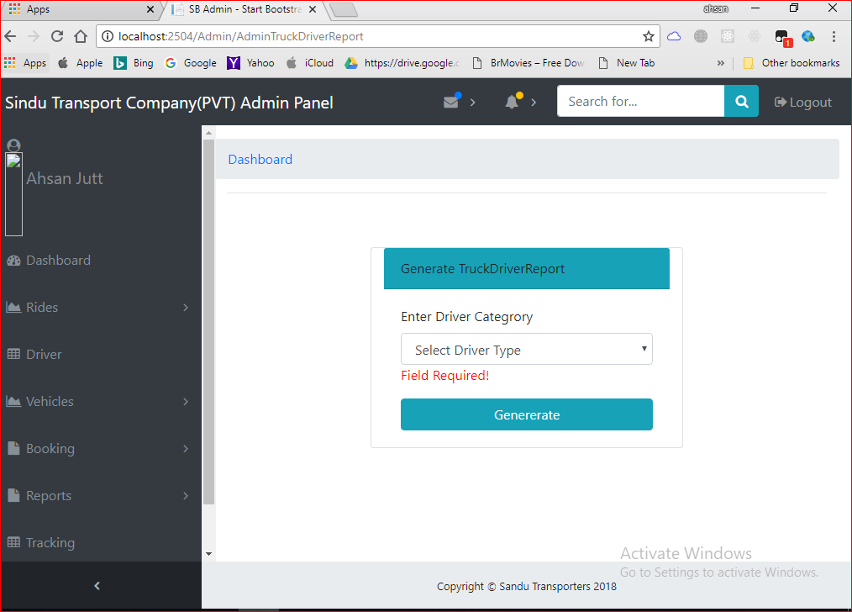

Test Case with Pitting Correct Data

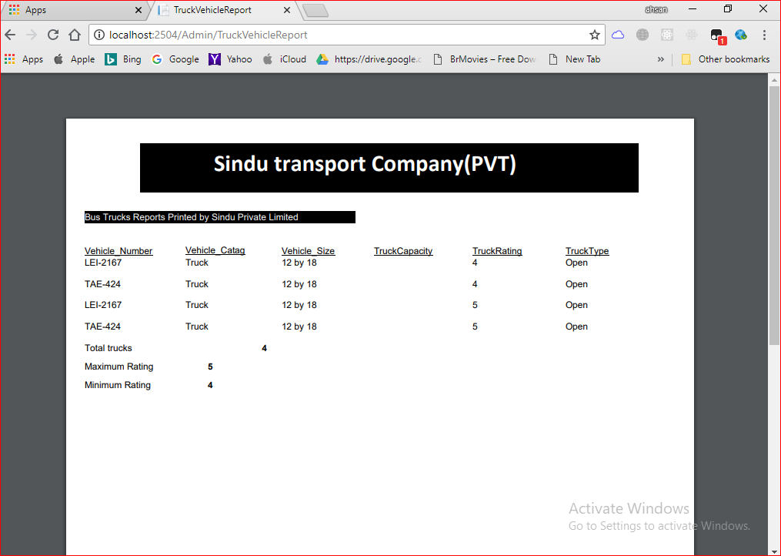

Test Case 18

Test Case Suite | TS018
Test Case Id | TC018
Test Case Summary | To verify that System must be allow to user to request for Truck Booking
Related Requirement | System must add truck Booking Request.
Prerequisites | TC002: Admin should login into system.  Information to be entered for vehicles should be unique and accurate.
Test procedure | Enter the unique id of the vehicles into form fields then press calculate profit button to calculate the salary of the driver.
Test Data | - Source: Empty, Rahim Yar Khan, Punjab  - Destination: Empty, Okara, Punjab  - Quantity: Empty, 12#$%, 1234, 30 Bag  - Weight: Empty, 11111#$, 30, 30 Ton  - Fare: Empty, ydhufs,hhh4, 50000  - Booking Date: Empty  - Request Date: Empty  - Time arrival: Empty,  - Service Type: Empty,  - Material Type: Empty,  - Vehicle Type: Empty,
Expected Result | - System should create Booking Request when User’s inputs are valid and unique.  - System Generate error if the required information for Booking Request is not valid.
Actual Result | If I enter valid inputs then system generate Booking Request and it generate errors on invalid inputs.
Status | Pass
Remarks | This is Vehicle Booking Request test case.
Created By | Zeeshan Yasin
Date of Creation | 13/08/2018
Executed By | Ahsan Siddique
Date of Execution | 14/08/2018
Test Environment | OS: Windows 10  Browser: Mozilla Firefox 4.22, Google Chrome

Test Case with Empty Field and Wrong Data

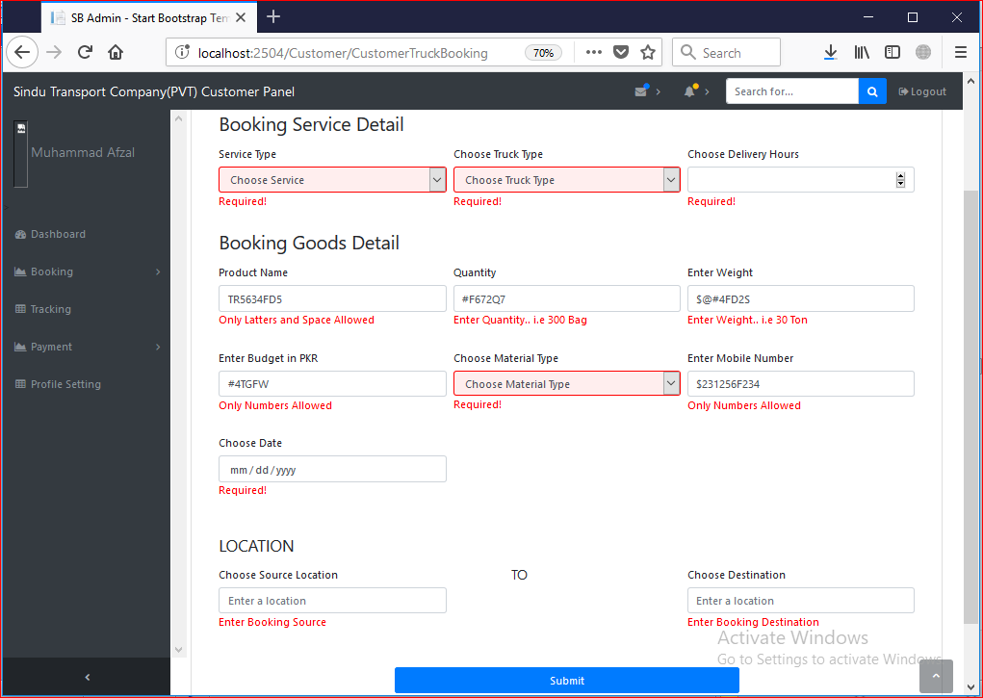

Test Case with Valid Data:

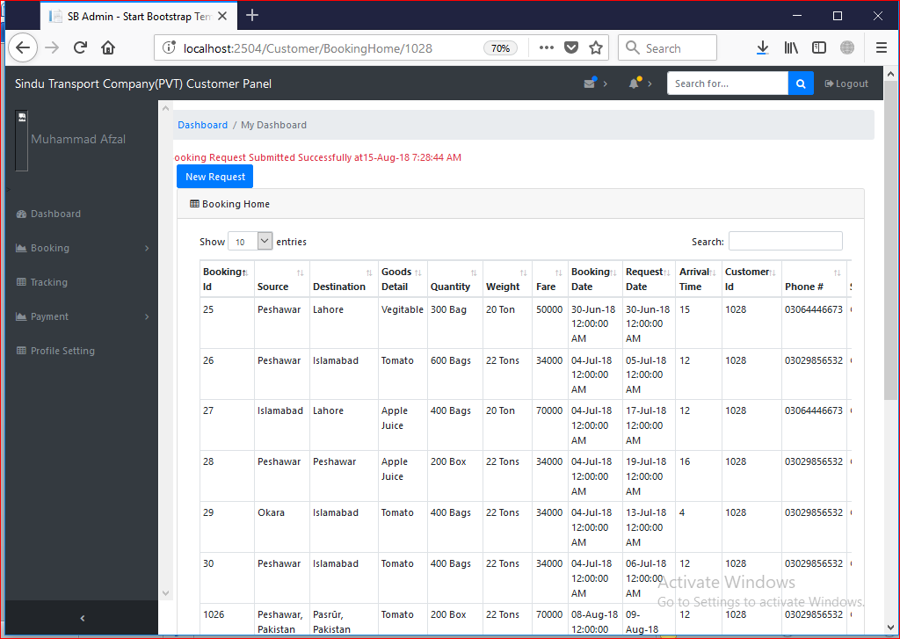

Test Case 19

Test Case Suite | TS019
Test Case Id | TC019
Test Case Summary | To verify that System must Approve Booking Request.
Related Requirement | System must Approve Truck Booking Request.
Prerequisites | TC002: Admin should login into system.  TC018: System must have Booking Request.  Information to be entered for Approving Booking should be unique and accurate.
Test procedure | Enter the unique id of the vehicles into form fields then press calculate profit button to calculate the salary of the driver.
Test Data | - Source: Empty, Rahim Yar Khan, Punjab  - Destination: Empty, Okara, Punjab  - Quantity: Empty, 12#$%, 1234, 30 Bag  - Weight: Empty, 11111#$, 30, 30 Ton  - Fare: Empty, ydhufs,hhh4, 50000  - Booking Date: Empty  - Request Date: Empty  - Time arrival: Empty,  - Service Type: Empty,  - Material Type: Empty,  - Vehicle Type: Empty,  - Driver Name: Empty  - Vehicle Number: Empty
Expected Result | - System should Approve Booking Request when User’s inputs are valid.  - System Generate error if the required information for Approving Booking Request is not valid.
Actual Result | If I enter valid inputs then system Approve Booking Request and it generate errors on invalid inputs.
Status | Pass
Remarks | This is Truck Approve Booking Request test case.
Created By | Zeeshan Yasin
Date of Creation | 13/08/2018
Executed By | Ahsan Siddique
Date of Execution | 14/08/2018
Test Environment | OS: Windows 10  Browser: Mozilla Firefox 4.22, Google Chrome

Test Case with Empty Field and Wrong Data

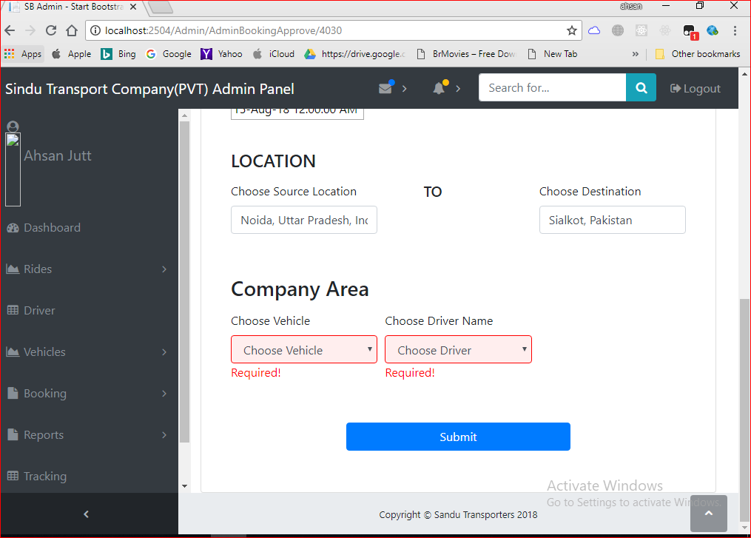

Test Case with Valid Data:

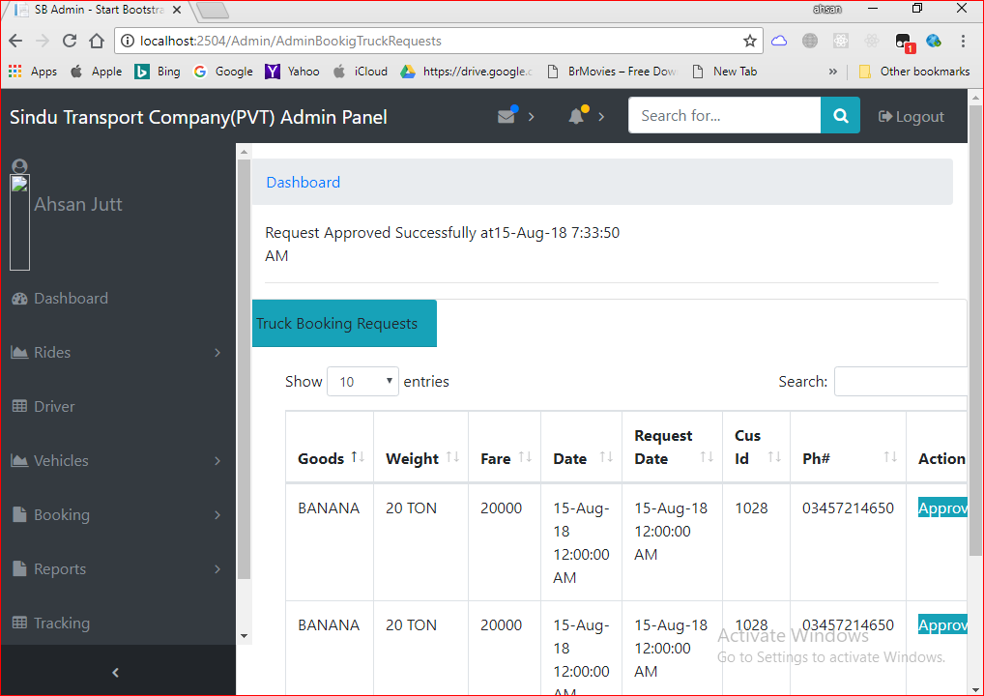

Test Case 20

Test Case Suite | TS020
Test Case Id | TC020
Test Case Summary | To verify that System must Show Live Bookings.
Related Requirement | System must show live Booking.
Prerequisites | TC002: Admin should login into system.  TC019: Booking should be Approved By system.
Test procedure | Click on Live booking Button
Test Data | - Button Click to View Live Booking.
Expected Result | - System should Show Live Booking when User’s click on Live Booking Button.
Actual Result | If I clicked on Live Booking button then system show Live Booking.
Status | Pass
Remarks | This is View Live Booking test case.
Created By | Zeeshan Yasin
Date of Creation | 13/08/2018
Executed By | Ahsan Siddique
Date of Execution | 14/08/2018
Test Environment | OS: Windows 10  Browser: Mozilla Firefox 4.22, Google Chrome

Test Case with Approve Request:

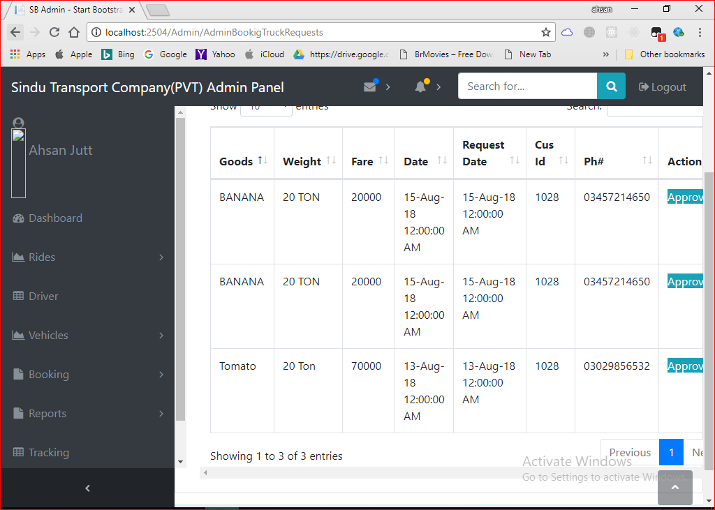
Test Case with Approving Request:
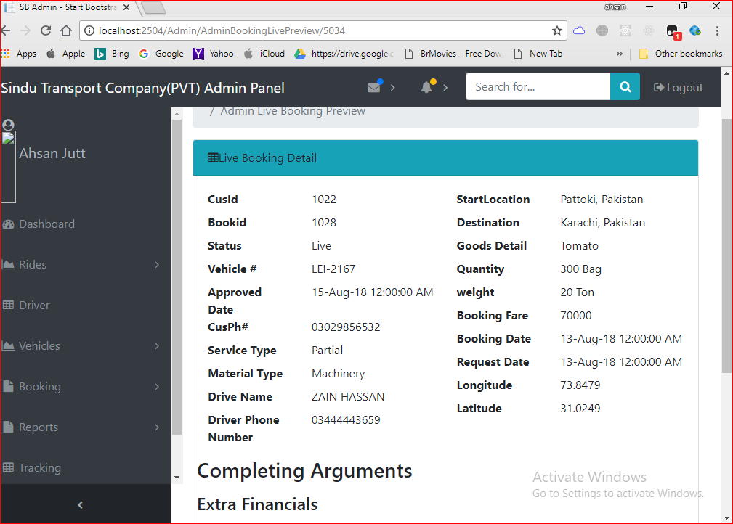

Test Case 21

Test Case Suite | TS021
Test Case Id | TC021
Test Case Summary | To verify that System must allow to user to Complete Truck Booking
Related Requirement | System must allow user to Complete Truck Booking.
Prerequisites | TC002: Admin should login into system.  TC019: Booking should be Approved By system.  Information to be entered for complete booking should be unique and accurate.
Test procedure | Enter the valid data into form fields then press complete booking button to complete booking.
Test Data | Miscellaneous : Empty, dugus773, 32rbuwe&&&&^, 087868, 50007  Payment Method: Empty  Payment Status : Empty
Expected Result | System should complete Booking Request when User’s inputs are valid.  System Generate error if the required information for complete booking is not valid.
Actual Result | If I enter valid inputs then system complete Booking and it generate errors on invalid inputs.
Status | Pass
Remarks | This is Complete Booking Request test case.
Created By | Zeeshan Yasin
Date of Creation | 13/08/2018
Executed By | Ahsan Siddique
Date of Execution | 14/08/2018
Test Environment | OS: Windows 10  Browser: Mozilla Firefox 4.22, Google Chrome

Test Case with Empty Field

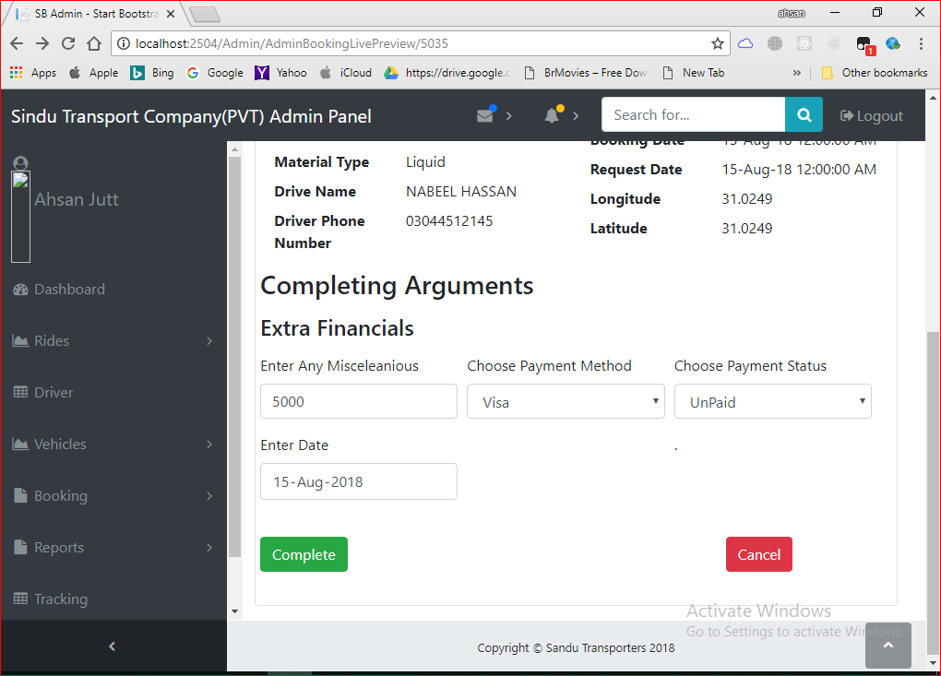

Test Case 22

Test Case Suite | TS022
Test Case Id | TC022
Test Case Summary | To verify that System must allow user to pay online payments.
Related Requirement | System must allow users to pay fare
Prerequisites | TC002: Admin should login into system.  TC021: Booking Should be completed.  Information to be entered for payments should be accurate.
Test procedure | Enter the payments credentials into form fields then press Payment button to pay online fares.
Test Data | - Payment Method: Empty, Radio(Jazz cash, Easy Paisa)  - Account Number: Empty idgwd67d7, d87wdwdgwjdg, 03064446673  - Security Code: Empty, dhhdgja, 87dagds, 030644
Expected Result | - System should pay fares when User’s inputs are valid.  - System Generate error if the required information for payments is not valid.
Actual Result | If I enter valid inputs then system accept the payments and it generate errors on invalid inputs.
Status | Pass
Remarks | This is Payments Request test case.
Created By | Zeeshan Yasin
Date of Creation | 13/08/2018
Executed By | Ahsan Siddique
Date of Execution | 14/08/2018
Test Environment | OS: Windows 10  Browser: Mozilla Firefox 4.22, Google Chrome

Test Case with Empty Field and Wrong Data

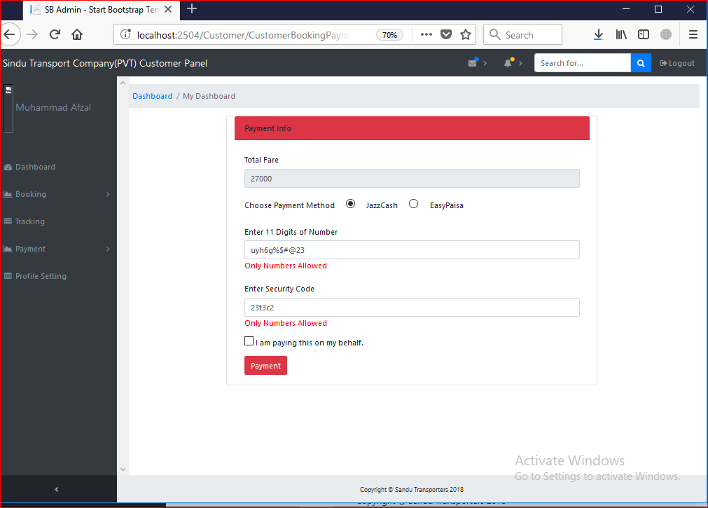
Test Case with Valid Data:
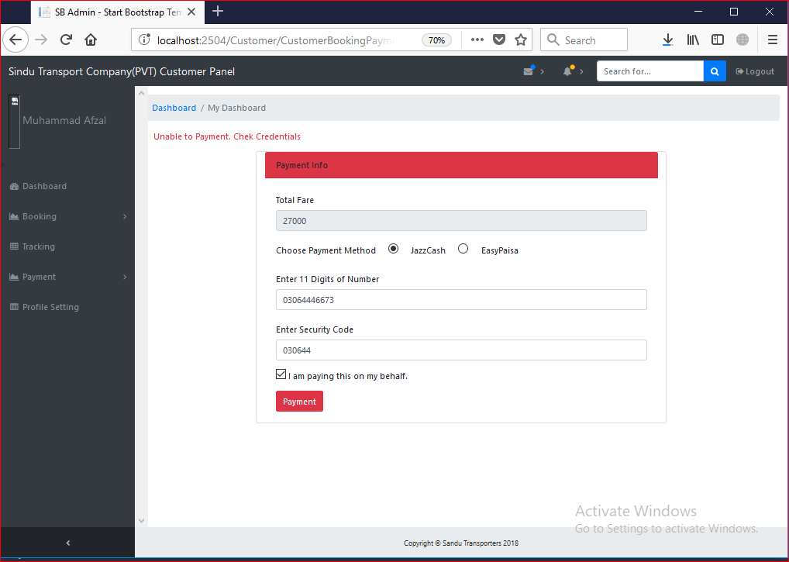

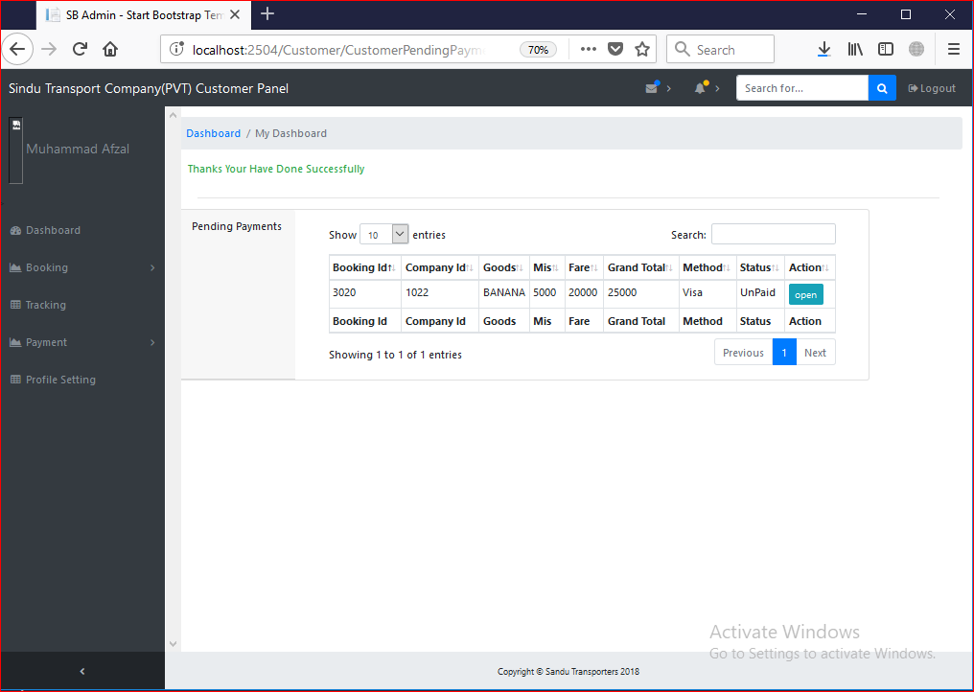

Test Case 23

Test Case Suite | TS023
Test Case Id | TC023
Test Case Summary | To verify that System must show vehicle location.
Related Requirement | System must show location of vehicle.
Prerequisites | TC002: User should login into system.  TC019: User must approve booking request.
Test procedure | Select the vehicle on home page.
Test Data | No Data for test only view page and click button
Expected Result | - System should show the locations of the vehicle when user click on vehicle.
Actual Result | - System View the location when we click on vehicle button.
Status | Pass
Remarks | This is Show Vehicle Location test case.
Created By | Zeeshan Yasin
Date of Creation | 13/08/2018
Executed By | Ahsan Siddique
Date of Execution | 14/08/2018
Test Environment | OS: Windows 10  Browser: Mozilla Firefox 4.22, Google Chrome

Test Case with Correct info

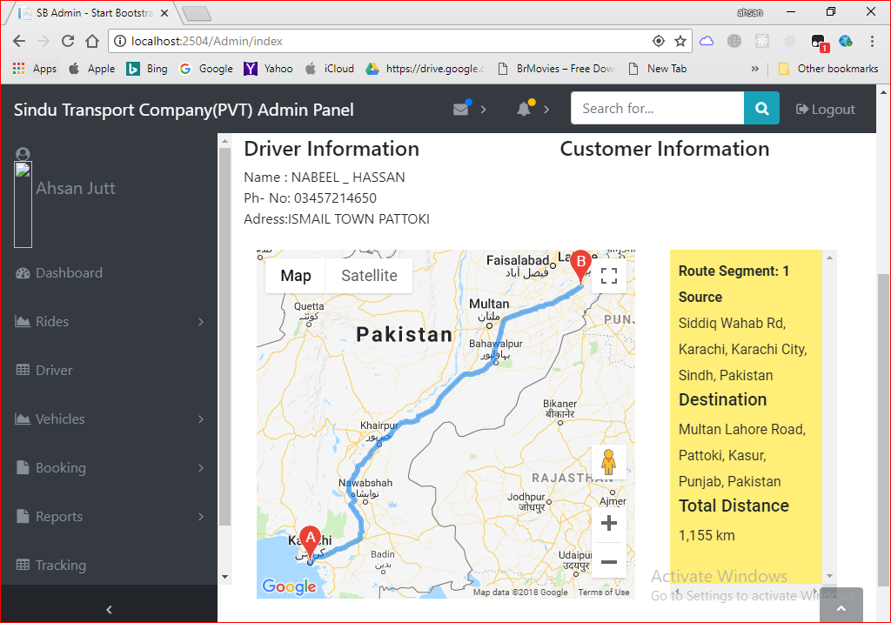

Test Case 24

Test Case Suite | TS024
Test Case Id | TC024
Test Case Summary | To verify that System must allow user to record terminals.
Related Requirement | System must add terminal.
Prerequisites | TC002: Admin should login into system.  Information to be entered for terminals should be accurate.
Test procedure | Enter the information into form fields then press search button to the information into database.
Test Data | - Name: Empty, &&&%%qodjo, ...0.1, 121, Jinnah Terminal  - City: Empty,’,,,,,,,,,,,,,,,,,,,,,,,,,,,,,,,,,,,,,,,,,,,,,,,,,,,,,,,,,,,,,,,,,,,,,,’  - Image: Empty ahsan.txt, ahsan.png, ahsan.jpg  - Address: Empty, &&&%%qodjo, ...0.1, 121, Pattoki, Pakistan
Expected Result | - System should store the terminal in database if inputs are valid.  - System should generate validation errors if input is not valid.
Actual Result
Status | Pass
Remarks | This is Vehicle Booking Request test case.
Created By | Zeeshan Yasin
Date of Creation | 13/08/2018
Executed By | Ahsan Siddique
Date of Execution | 14/08/2018
Test Environment | OS: Windows 10  Browser: Mozilla Firefox 4.22, Google Chrome

Test Case with Wrong input and Empty Field

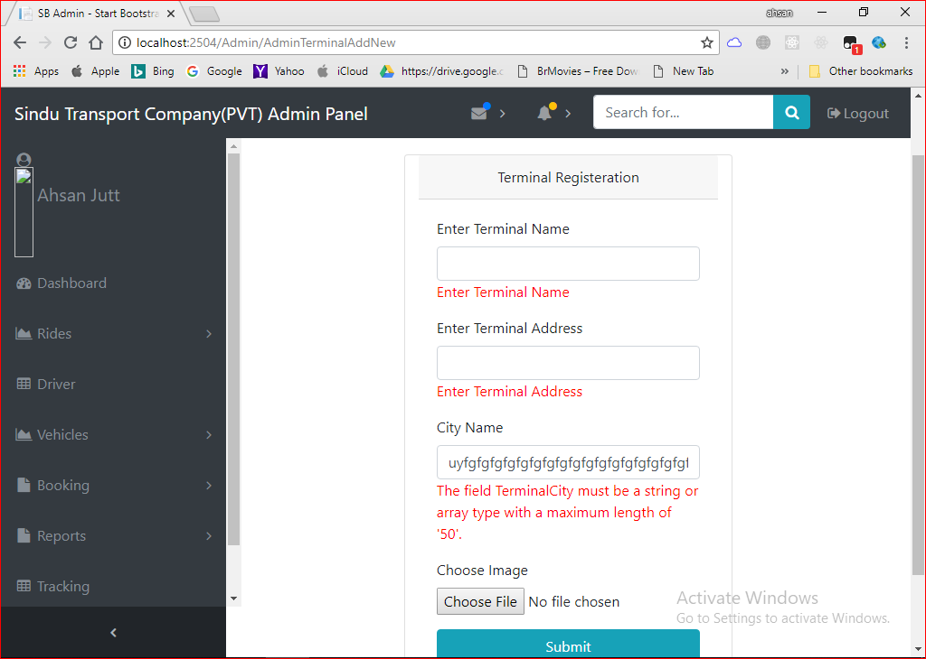

Test Case with Correct Data
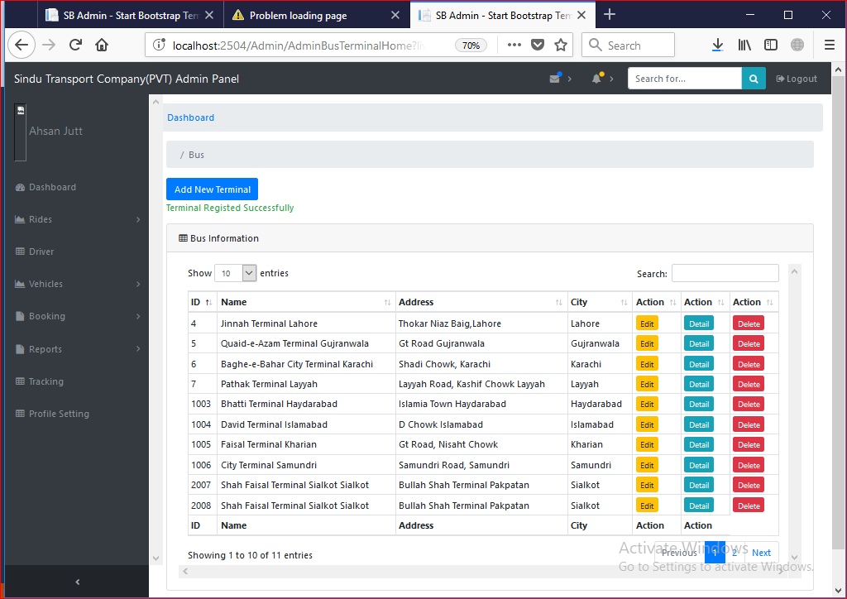

Test Case 25

Test Case Suite | TS0025
Test Case Id | TC025
Test Case Summary | To verify that System must allow user search terminal records.
Related Requirement | System must search terminal.
Prerequisites | TC002: Admin should login into system.  TC024: Terminals should add before search.
Test procedure | Enter the information into form fields then press search button to search the information into database.
Test Data | - Name: Empty, &&&%%qodjo, ...0.1, 121, Jinnah Terminal  - City: Empty,’,,,,,,,,,,,,,,,,,,,,,,,,,,,,,,,,,,,,,,, Pattoki  - Address: Empty, &&&%%qodjo, ...0.1, 121, Pattoki, Pakistan
Expected Result | System show the all records against the entered Input if input is valid and unique.  System should not show anything if the required information for terminals not valid.
Actual Result | If I enter valid and unique information to system then system Search data from record otherwise shows the error message data is not available.
Status | Pass
Remarks | This is Search Terminal Request test case.
Created By | Zeeshan Yasin
Date of Creation | 13/08/2018
Executed By | Ahsan Siddique
Date of Execution | 14/08/2018
Test Environment | OS: Windows 10  Browser: Mozilla Firefox 4.22, Google Chrome

Test Case with Empty Field
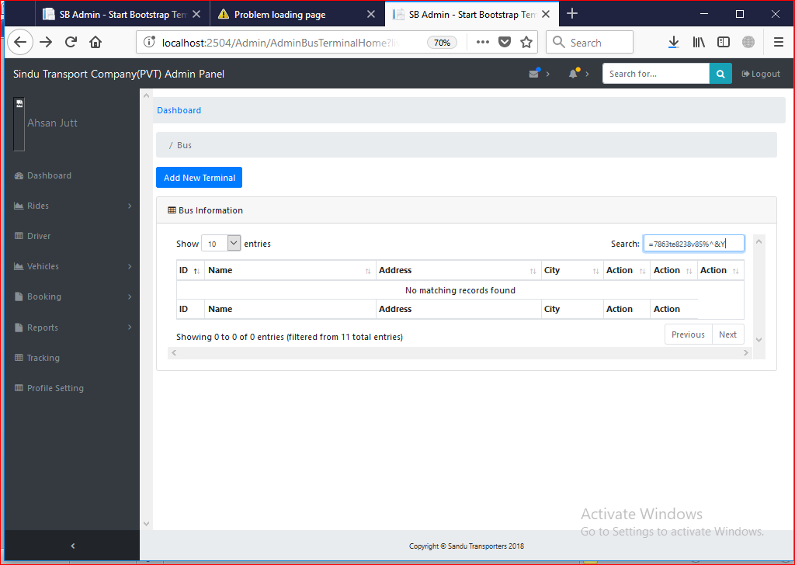
Test Case with Correct data
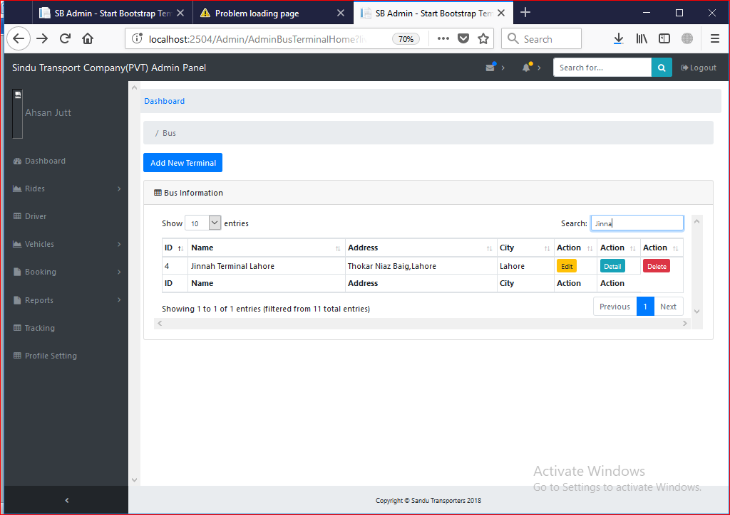

Test Case 26

Test Case Suite | TS026
Test Case Id | TC026
Test Case Summary | To verify that System must allow to user to delete terminals.
Related Requirement | System must delete terminals.
Prerequisites | TC002: Admin should login into system.  TC024: Terminals should add.
Test procedure | Click on delete button.
Test Data | Not Data only click on button.
Expected Result | - System should delete terminal when admin click on button.  - System Generate error if the delete button has no value.
Actual Result | - System deleted terminal when admin press delete button.  - System generates error if button has no value.
Status | Pass
Remarks | This is Terminal Delete test case.
Created By | Zeeshan Yasin
Date of Creation | 13/08/2018
Executed By | Ahsan Siddique
Date of Execution | 14/08/2018
Test Environment | OS: Windows 10  Browser: Mozilla Firefox 4.22, Google Chrome
Test Case with Pressing Delete Button:

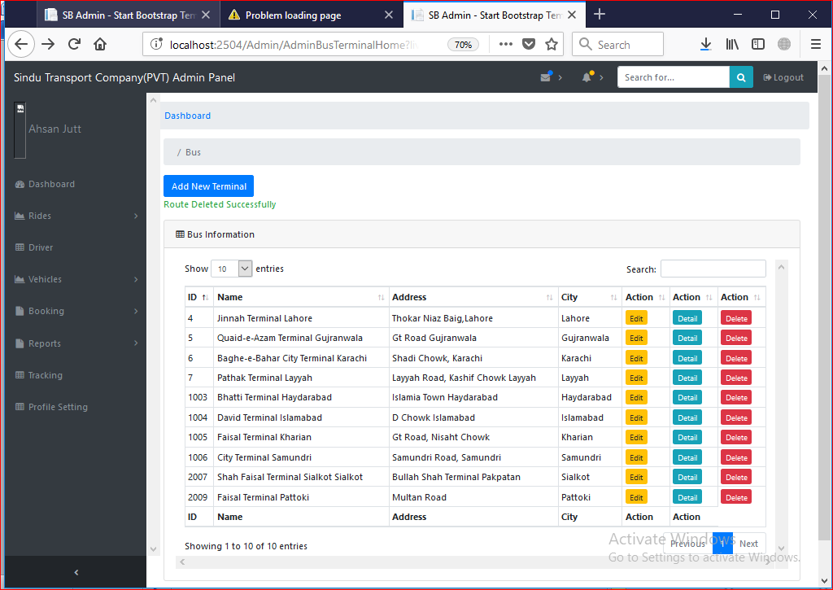

Test Case 27

Test Case Suite | TS027
Test Case Id | TC027
Test Case Summary | To Update terminal records.
Related Requirement | Terminal data should update from system.
Prerequisites | TC002: Admin should login into system.  TC024: System should have terminal records.  Information to be entered for Update record should be unique and valid.
Test procedure | Insert the information into form fields then press Update button to Update the information into database.
Test Data | - Name: Empty, &&&%%qodjo, ...0.1, 121, Jinnah Terminal  - City: Empty,’,,,,,,,,,,,,,,,,,,,,,,,,,,,,,,,,,,,,,,,,,,,,,,,,,,,,,,,,,,,,,,,,,,,,,,’  - Image: Empty ahsan.txt, ahsan.png, ahsan.jpg  - Address: Empty, &&&%%qodjo, ...0.1, 121, Pattoki, Pakistan
Expected Result | System should Update the data of terminal if given input is valid and unique.  System Generate error if the required information for terminal id is not unique and terminal data is not valid.
Actual Result | If I enter valid and unique information to system then system update data from terminal records otherwise shows the warning message to add valid data and unique id.
Status | Pass
Remarks | This is Terminal Update data test case.
Created By | Zeeshan Yasin
Date of Creation | 13/08/2018
Executed By | Ahsan Siddique
Date of Execution | 14/08/2018
Test Environment | OS: Windows 10  Browser: Mozilla Firefox 4.22, Google Chrome

Test Case with Empty or Wrong Field

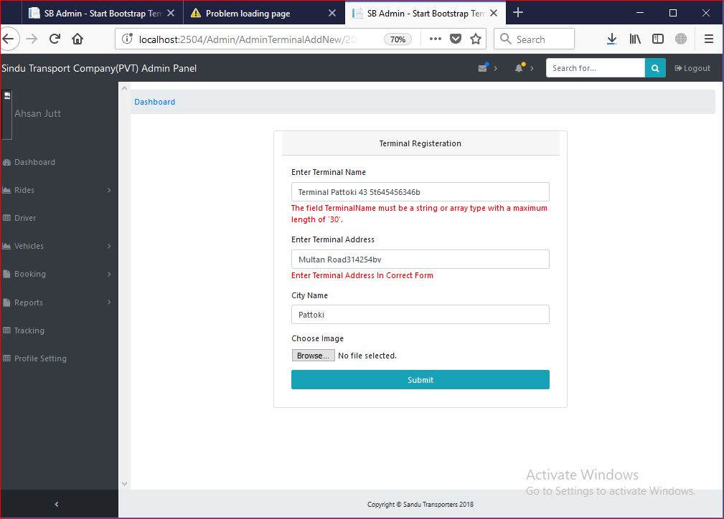
Test Case with Correct Data:

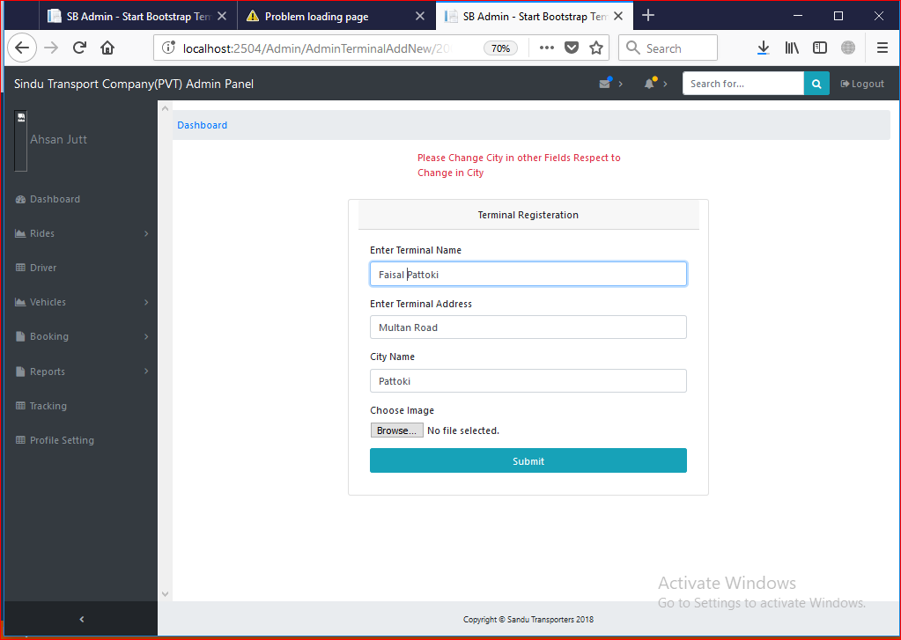

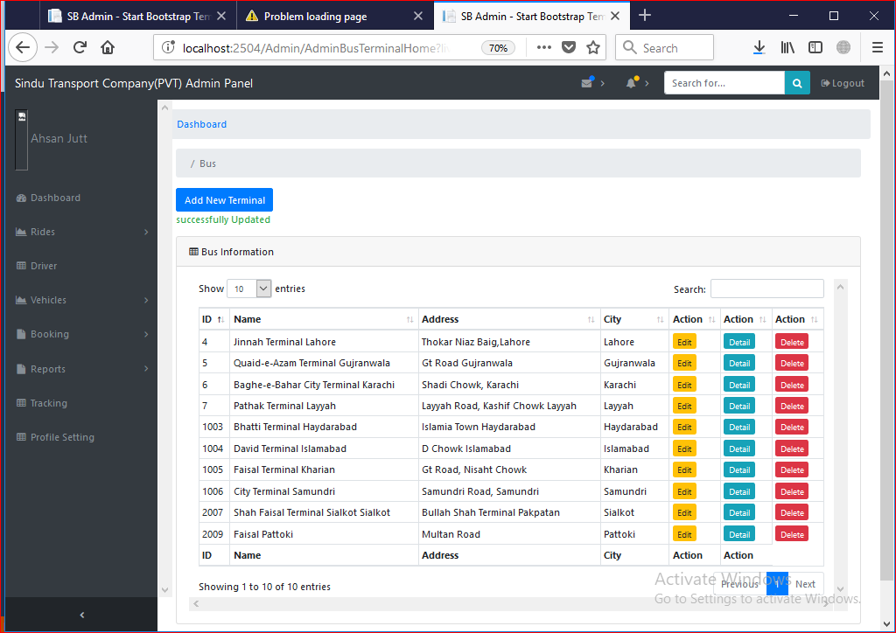

Test Case 28

Test Case Suite | TS028
Test Case Id | TC028
Test Case Summary | To verify that System must allow user to add routes.
Related Requirement | System must add routes.
Prerequisites | TC002: Admin should login into system.  Information to be entered for routes should be accurate.
Test procedure | Enter the information into form fields then press search button to the information into database.
Test Data | - Departure: Empty, List Values.  - Arrival: Empty, List Values.  - Fare: $^%$, 8777777878,uydwgdfuwg,dasgd7578@#,55000  - Departure Time: Empty, Select Time  - Arrival Time: Empty, Select Time  - Day: Empty, Select Route  - Class: Empty, Select Class  - Bus: Empty , Select Bus
Expected Result | System should store the Route or schedule in database if inputs are valid.  System should generate validation errors if input is not valid.
Actual Result | - System stored Route or schedule in database if inputs are valid.  - System generated validation errors if input field are invalid.
Status | Pass
Remarks | This is Add Route test case.
Created By | Zeeshan Yasin
Date of Creation | 13/08/2018
Executed By | Ahsan Siddique
Date of Execution | 14/08/2018
Test Environment | OS: Windows 10  Browser: Mozilla Firefox 4.22, Google Chrome

Test Case with Empty Field
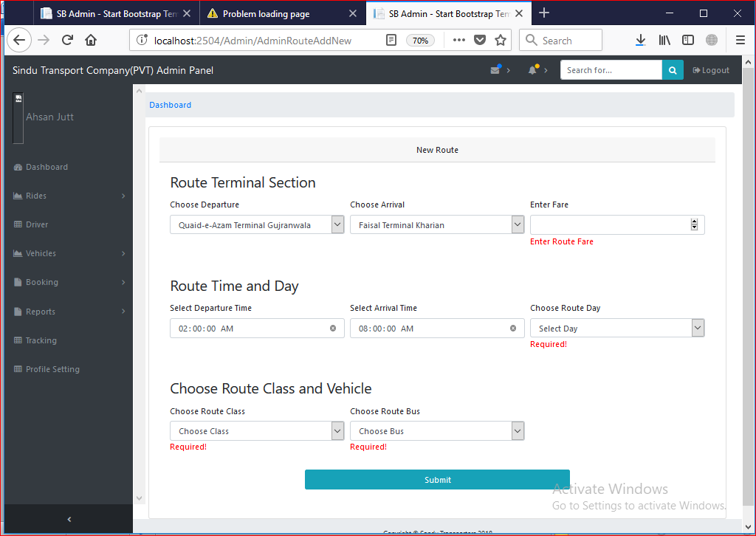

Test Case with Putting Valid Data:

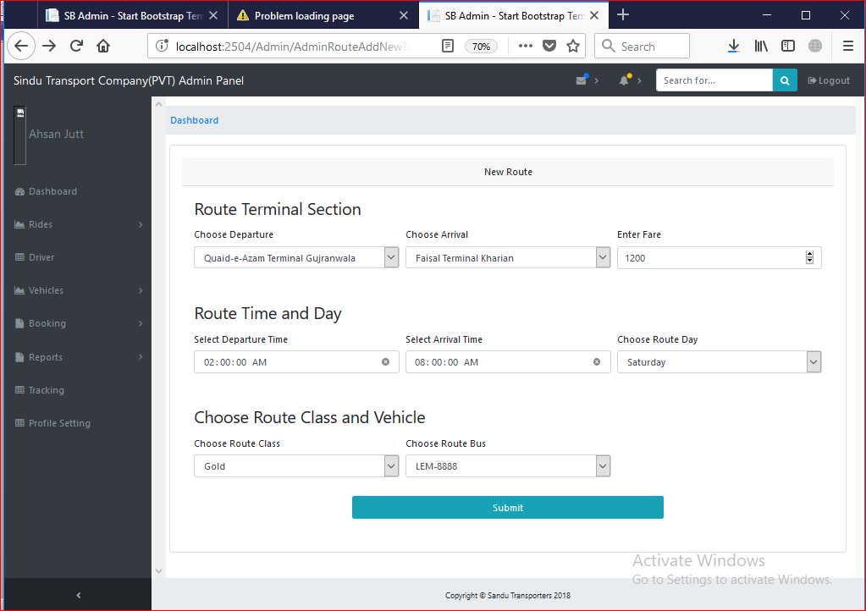

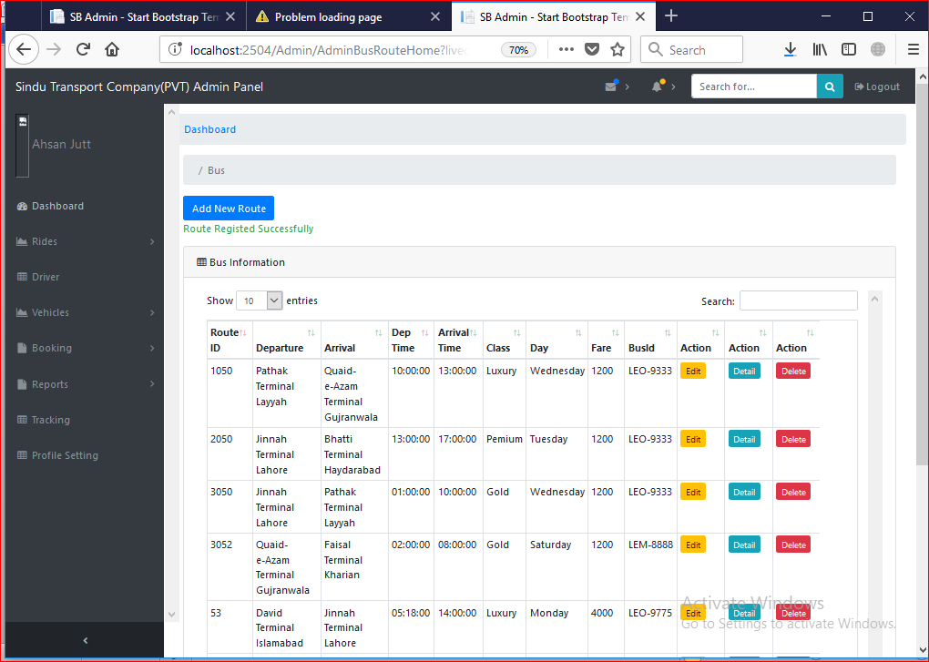

Test Case 29

Test Case Suite | TS029
Test Case Id | TC029
Test Case Summary | To verify that System must allow user search route records.
Related Requirement | System must search route.
Prerequisites | TC002: Admin should login into system.  Anonymous user can view routes or schedules on bus panel.  TC030: Route should add before search.
Test procedure | Enter the information into form fields then press search button to search the information into database.
Test Data | - Departure: akdhak,dag4324, Empty, Islamabad  - Arrival: Empty, 2782c,^&%^%&%, Lahore  - Fare: $^%$, 8777777878,uydwgdfuwg,dasgd7578@#,55000  - Departure Time: Empty, $^%$, 8777777878,uydwgdfuwg, 12:00  - Arrival Time: Empty, $^%$, 8777777878,uydwgdfuwg, 12:00  - Day: Empty, $^%$, 8777777878,uydwgdfuwg, Mond6567, Monday  - Class: Empty, $^%$, 8777777878,uydwgdfuwg, Business, Gold  - Bus: Empty , $^%$, 8777777878,uydwgdfuwg, P-1524
Expected Result | System show the all records against the entered Input if input is valid and unique.  System should not show anything if the required information for route not valid.
Actual Result | If I enter valid and unique information to system then system Search data from record otherwise shows the error message data is not available.
Status | Pass
Remarks | This is Search Route Request test case.
Created By | Zeeshan Yasin
Date of Creation | 13/08/2018
Executed By | Ahsan Siddique
Date of Execution | 14/08/2018
Test Environment | OS: Windows 10  Browser: Mozilla Firefox 4.22, Google Chrome

Test Case with Empty Field
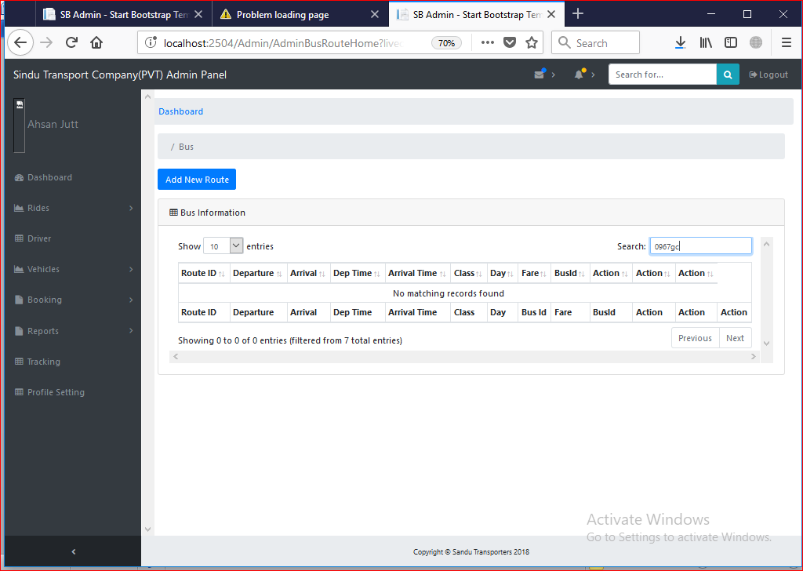

Test Case with Valid Data
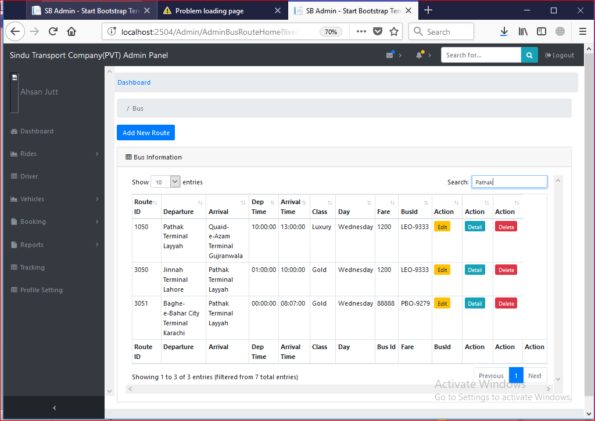

Test Case 30

Test Case Suite | TS030
Test Case Id | TC030
Test Case Summary | To verify that System must allow to user to delete routes.
Related Requirement | System must delete routes.
Prerequisites | TC002: Admin should login into system.  TC030: Routes should be add.
Test procedure | Click on delete button.
Test Data | Not Data only click on button.
Expected Result | System should delete route when admin click on button.  System Generate error if the delete button has no value.
Actual Result | System deleted route when admin press delete button.  System generates error if button has no value.
Status | Pass
Remarks | This is Route Delete test case.
Created By | Zeeshan Yasin
Date of Creation | 13/08/2018
Executed By | Ahsan Siddique
Date of Execution | 14/08/2018
Test Environment | OS: Windows 10  Browser: Mozilla Firefox 4.22, Google Chrome

Test Case with Pressing Delete button

Test Case 31

Test Case Suite | TS031
Test Case Id | TC031
Test Case Summary | To Update route records.
Related Requirement | Route data should update from system.
Prerequisites | TC002: Admin should login into system.  TC030: System should have route records.  Information to be entered for Update record should be unique and valid.
Test procedure | Insert the information into form fields then press Update button to Update the information into database.
Test Data | - Departure: Empty, List Values.  - Arrival: Empty, List Values.  - Fare: $^%$, 8777777878,uydwgdfuwg,dasgd7578@#,55000  - Departure Time: Empty, Select Time  - Arrival Time: Empty, Select Time  - Day: Empty, Select Route  - Class: Empty, Select Class  - Bus: Empty , Select Bus
Expected Result | - System should Update the data of route if given input is valid and unique.  - System Generate error if the required information for route id is not unique and route data is not valid.
Actual Result | If I enter valid and unique information to system then system update data from route records otherwise shows the warning message to add valid data and unique id.
Status | Pass
Remarks | This is Route Update data test case.
Created By | Zeeshan Yasin
Date of Creation | 13/08/2018
Executed By | Ahsan Siddique
Date of Execution | 14/08/2018
Test Environment | OS: Windows 10  Browser: Mozilla Firefox 4.22, Google Chrome

Test Case with Empty Field

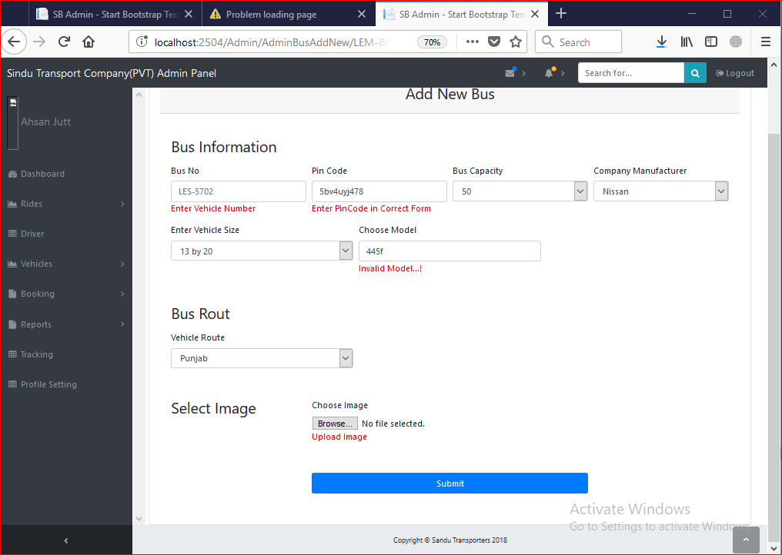

Test Case with Valid:
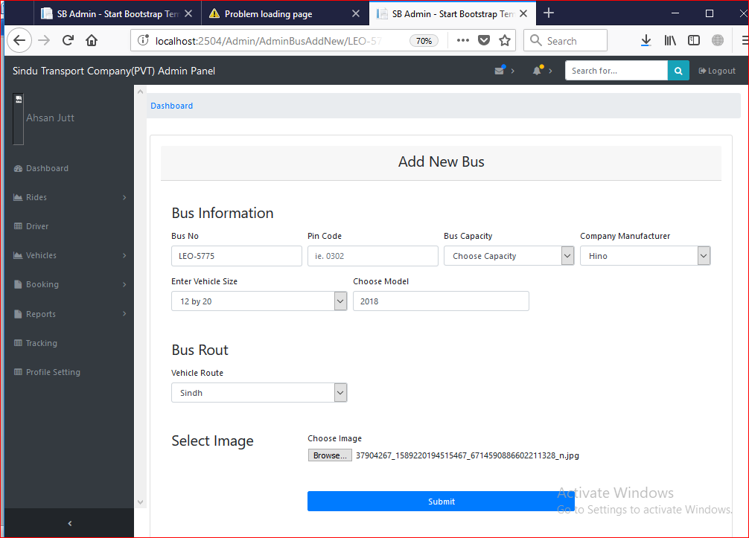
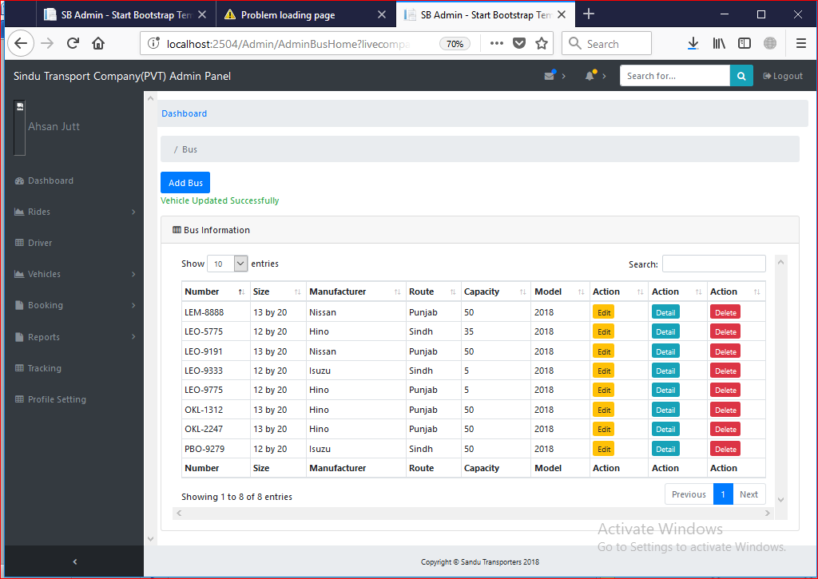

Test Case 32

Test Case Suite | TS032
Test Case Id | TC032
Test Case Summary | To verify system allow the user to reserve ticket.
Related Requirement | System must allow bus customers to reserve ticket.
Prerequisites | TC030: System should have route records.
Test procedure | Select departure, and arrival with date. Then reserve ticket and enter credentials and click on reserve button.
Test Data | - Departure: Empty, List Values.  - Arrival: Empty, List Values  - Date: Empty, Choose Date  - Name: Empty, Ahsantrdyh0978, $#*(%^, 1365, Ahsan Siddique  - Phone Number: Empty, UJYFDK896*(,uu(^, 03064446673
Expected Result | - System should reserve the ticket if given input is valid and unique.  - System Generate error if the required information for route id is not unique and route data is not valid.
Actual Result | - System reserved ticket if I put accurate and valid data in input fields.  - System generate errors if input fields are invalid.
Status | Pass
Remarks | This is Ticket Reservation data test case.
Created By | Zeeshan Yasin
Date of Creation | 13/08/2018
Executed By | Ahsan Siddique
Date of Execution | 14/08/2018
Test Environment | OS: Windows 10  Browser: Mozilla Firefox 4.22, Google Chrome

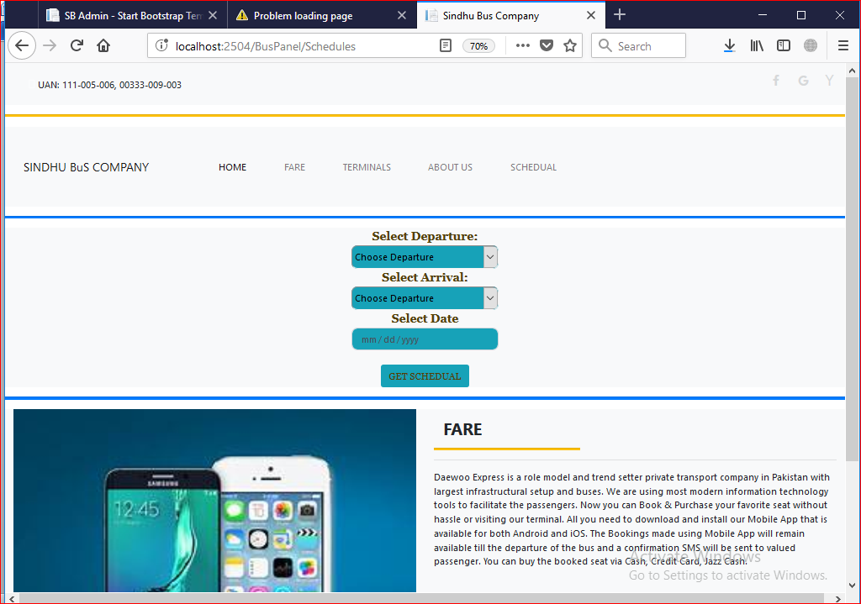

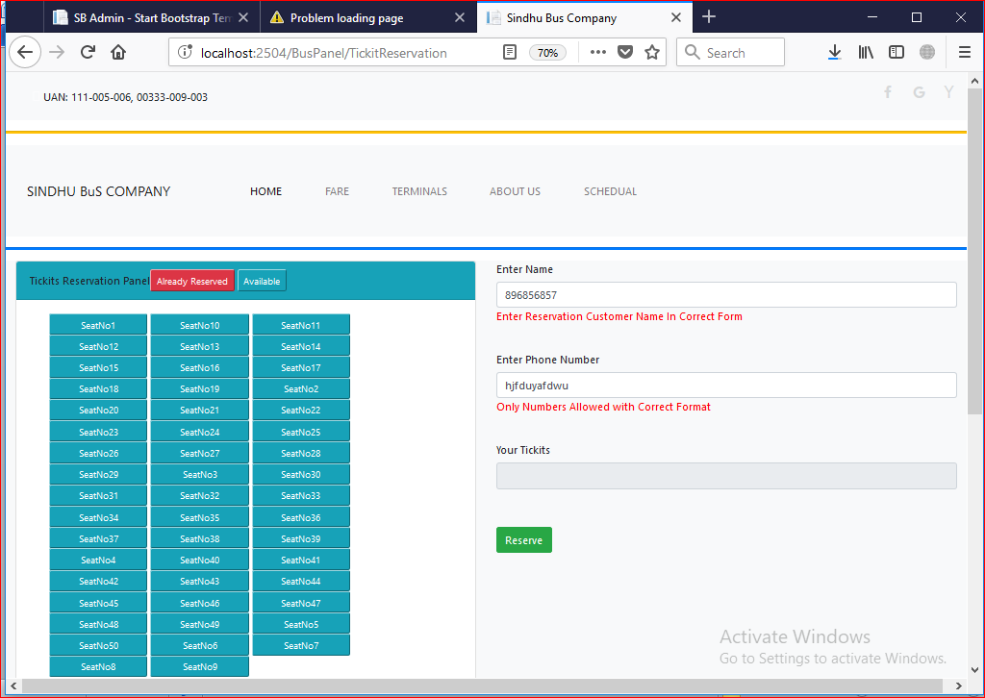

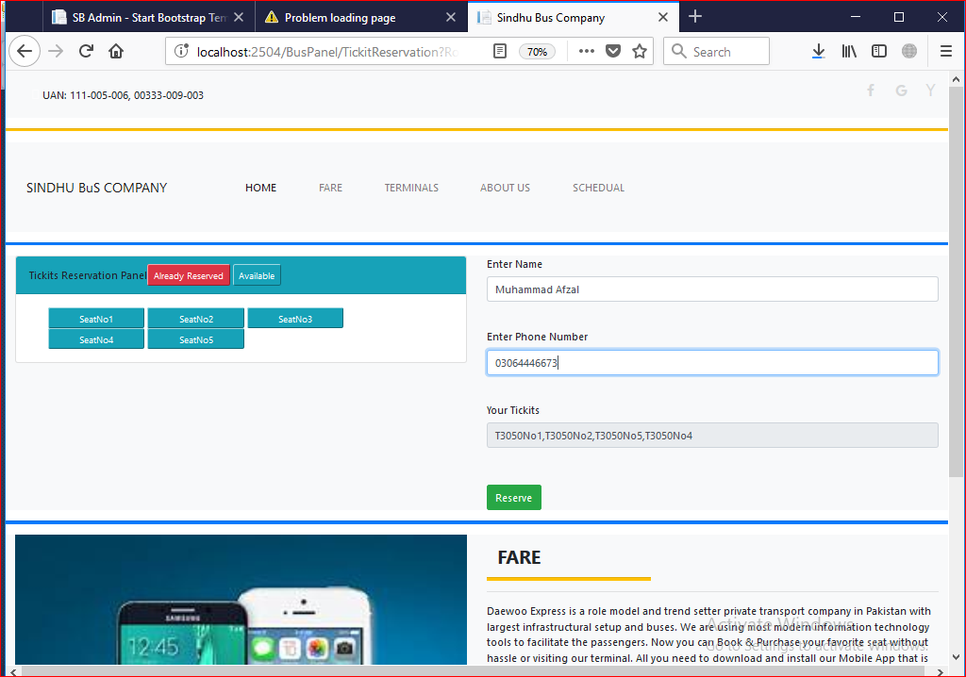
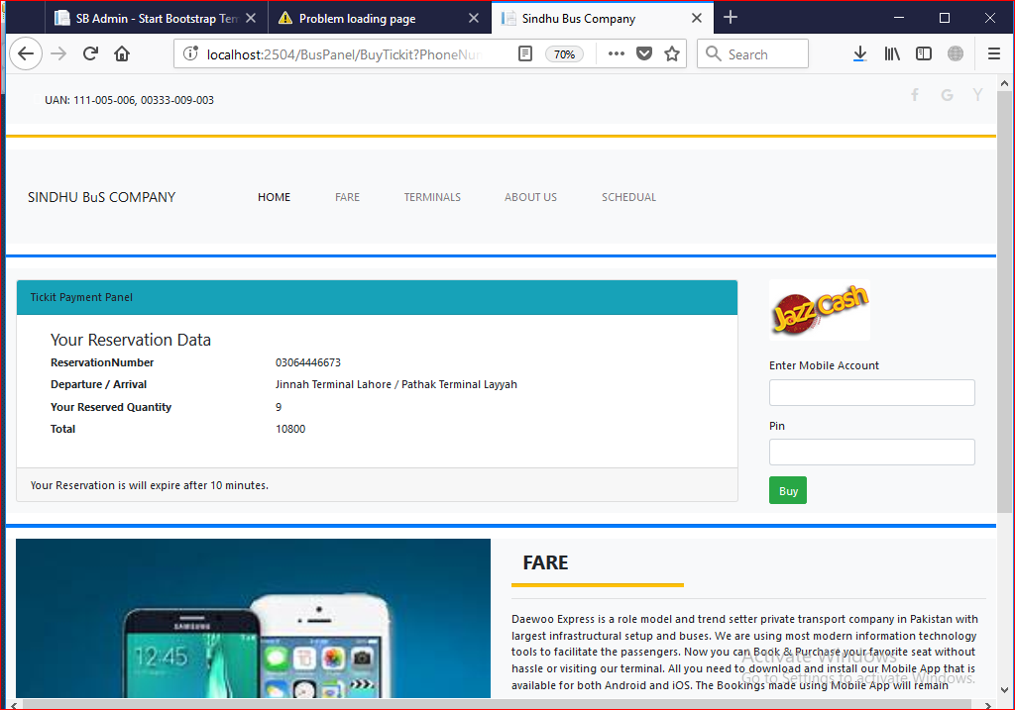
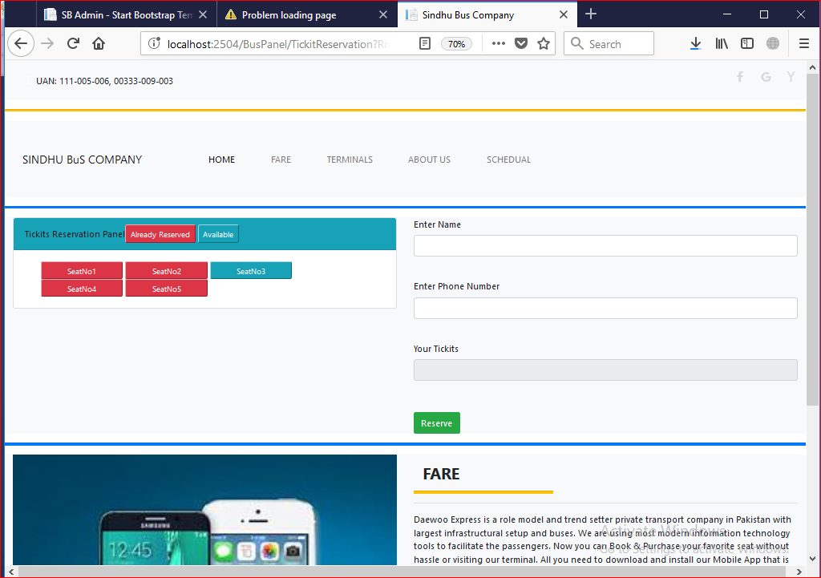

Test Case 33

Test Case Id | TC033
Test Case Summary | To verify system cancel ticket reservation.
Related Requirement | System must cancel ticket.
Prerequisites | TC032: Ticket should have reserved.
Test procedure | Its system job that unreserved the ticket on the base of payment. We reserve the ticket.
Test Data | No Data for this test its server oriented.
Expected Result | Tickets should unreserved after 15 minutes if customer not pays the fares.
Actual Result | System unreserved the tickets if customer not pay charges.
Status | Pass
Remarks | This is Ticket cancel data test case.
Created By | Zeeshan Yasin
Date of Creation | 13/08/2018
Executed By | Ahsan Siddique
Date of Execution | 14/08/2018
Test Environment | OS: Windows 10  Browser: Mozilla Firefox 4.22, Google Chrome

Stress Testing

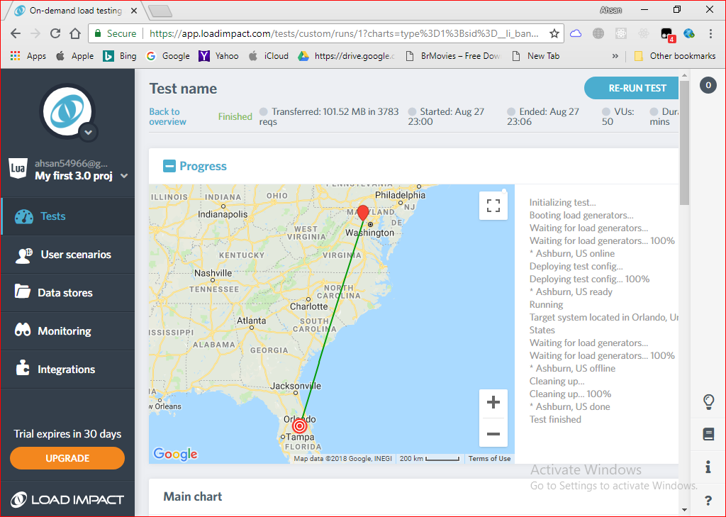

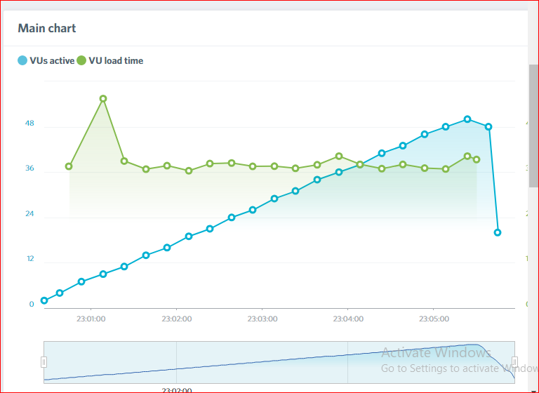

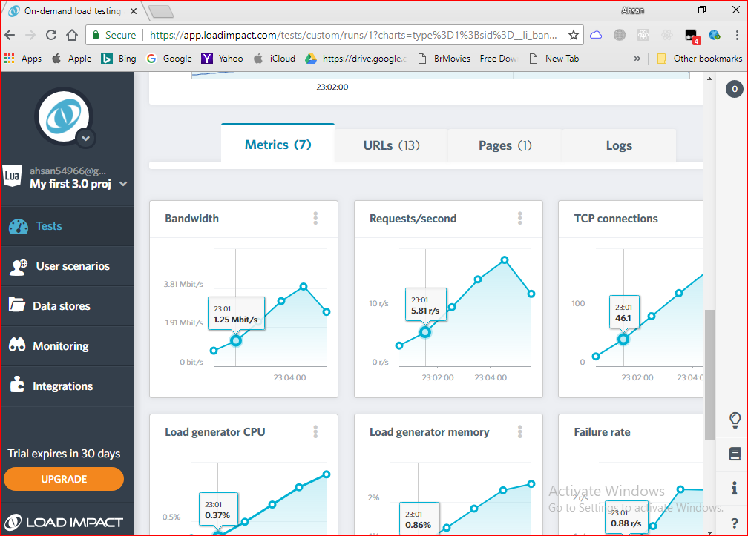

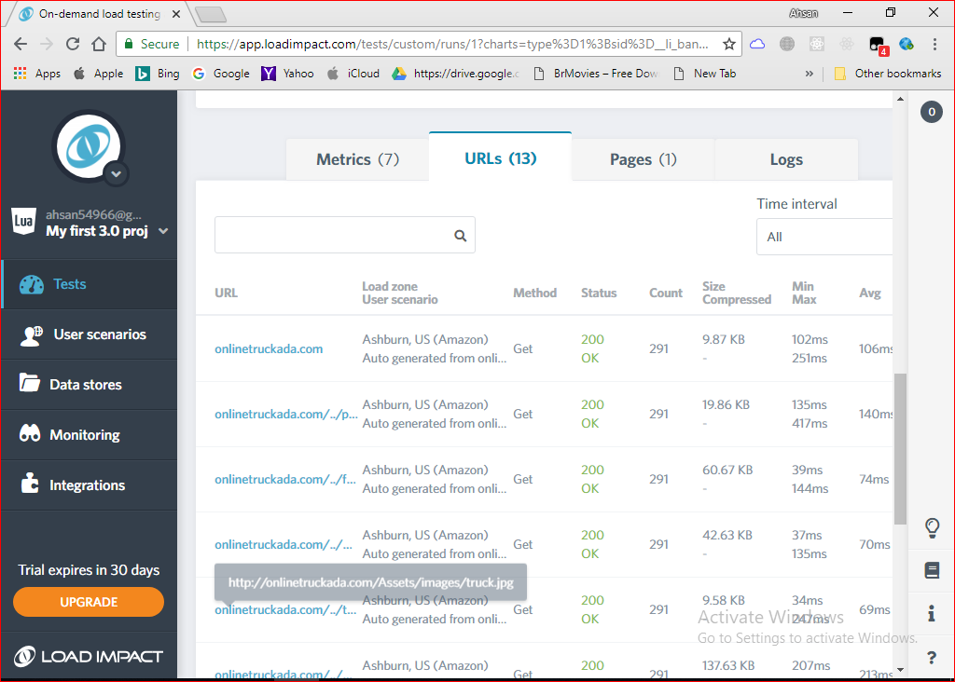

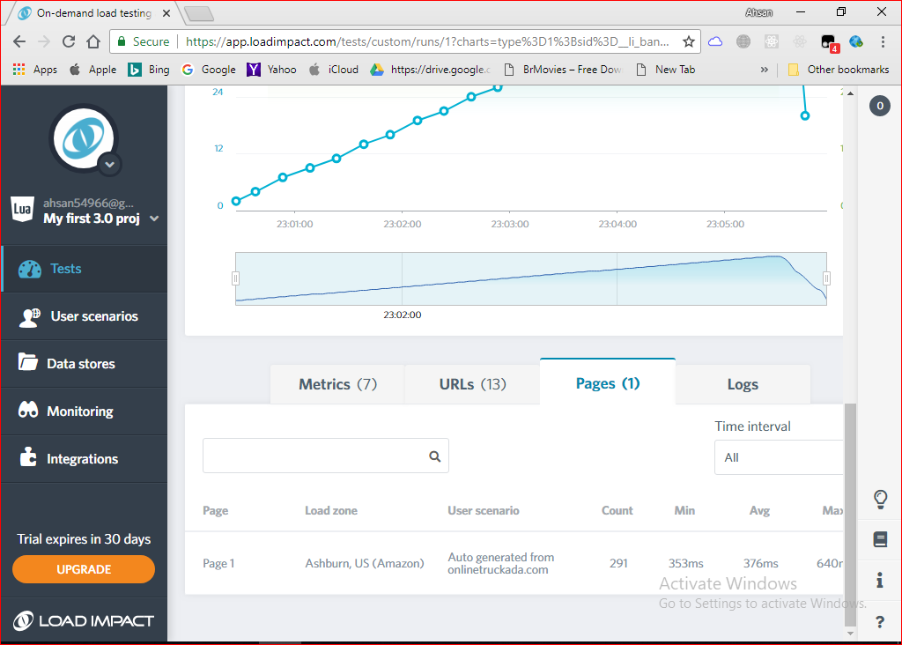

Chapter 7

Summary, Conclusion and Future Enhancements

Chapter 7: Summary, Conclusion & Future Enhancements

Project Summary
A project named online transport management has completed and deployed successfully. It was complex, but it handled with effective software engineering principles. Requirement gathering was impressive. Requirement engineer visit client environment and collect requirements from customer via interviews and questioners. Then requirement refined by feasibility study, critical analysis formed them into final requirements.
The main objective of this project is to provide overview of the project and readers can learn project by reading this document. Stakeholders can get whole idea about the project. The other objective of this document is that it can be used for future systems. Final goal of this document is to formally close this project summarize all required information.

Achievements and Improvements
We have cover most of our scope. We have achieved reporting functionalities, Record Management, Location Tracking, Online Truck Booking, Bus Seat Reservation, Online Payments and User Registration. All modules confirm the user requirements user can perform all the tasks according to their needs.
We need improvements in usability, because our usability is not effective its satisfied, but we need to make more attentive interface that help the user to get enjoy able experience. We need to improve our security because this system has too much scope that’s why it’s difficult to control the security of the system. We need to improve the system to show data in charts for users. We need to use advance API’s of google map to help the online booking users to get better quality of service.

Critical Review
Do you satisfy with the usability of the system?
Answer: Yes I am satisfied but it should be more attractive. We will use the system functions and then we will give feedback on how system is working.
Is system fulfilling your expectations?
Answer: Yes for now system fulfill our expectations but we are going to use cloud system first time that’s why we will needs changes if this system will not work on our business strategy.
Is your data secured with in system?
Answer: Yes.
Is this system adding values in your business?
Answer: Yes it helps us to grow our business in Pakistan and we can entertain customers online. We can keep our records in efficient manners. We can take optimal decisions with the help of previous records. We can calculate profit faster than paper work. It can save our time.
Is this system economically beneficial?
Answer: Yes this system can help the small transporter to get the opportunity like those companies who are have more bookings than small companies.

Lessons Learnt
It is customer base and team base project so the first lesson which we learn is that how to take requirements from client and how to refine them how to measure them they are feasible or not. Second one is that how to work in team. How you manage your task under a team environment. How you communicate in team enjoinment and it is one of the biggest lessons that we learned in this project.
One of important thing that we realize software development is not possible without software engineering. Because software engineering provides a bundle of principles that confirm and control the software development and they also provide quality experience to customer. We realize that time, scope and cost management is the key processes in software management. So we also learn how to market the project in market and how to think competitively against other competitors.

Future Enhancements/Recommendations
Now we have web-based system and in future we want to develop mobile applications that will allow the users to easily access the system and will improve the quality user experience. Currently we are using web-based tracking and its good, but we want improve more location accuracy that’s why we will use trackers to improve location accuracy. Currently we have only demo payments in our project but in future we want online payments in real environment that’s will allow the users to pay fares online with help of jazz cash and visa. We will also use the SMS API’s that will use to send location of vehicles to customers and transport company. In future we will also implements data mining that will help the transport companies to take efficient and optimal decisions for their business. Transport travel companies can predict where most of the people going and how much benefit on different routes.

Appendices

Appendix A: User Manual

Our client is not technical so we are providing Video tutorial as user manual. Some drivers are not educated so they found difficulties to understand user manual.

https://www.youtube.com/channel/UCh7XSKGy-QG6q8_7GTk8ytg/videos?disable_polymer=1

Appendix C: Information / Promotional Material

  - Broacher
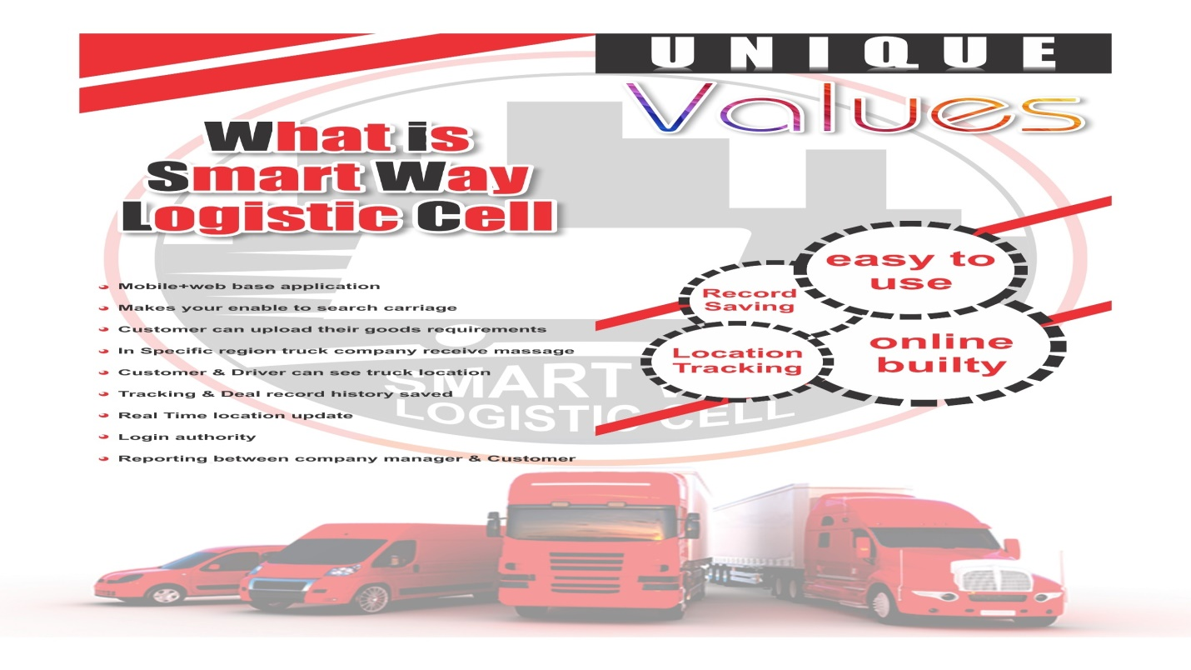
  - Flyer
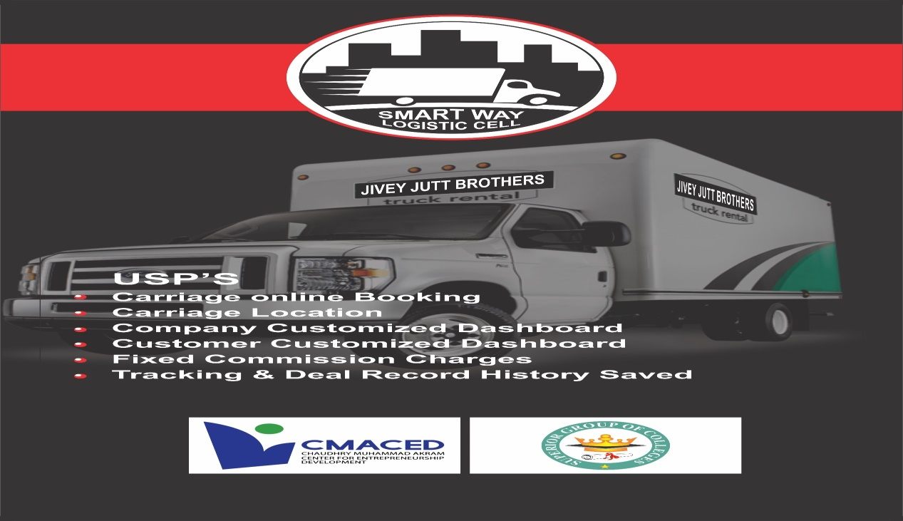
  - Standee
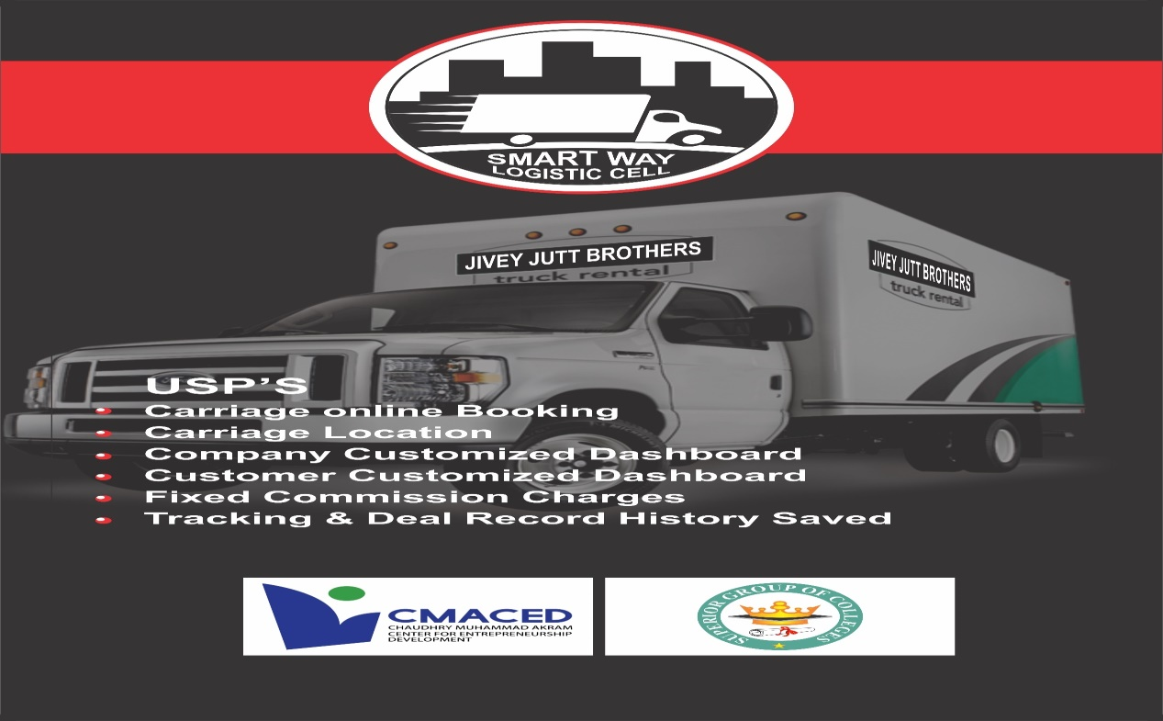

  - Banner

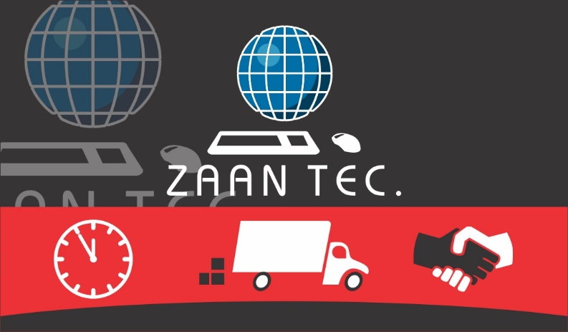

Reference and Bibliography

Index

Index

[1]
Daewoo Bus System
http://www.daewoo.com.pk/

[2]
ALL PAKISTAN BOOKING
http://www.allpakistan.org/

[3] TRUCK ADDA
https://truckada.pk/

