THE SUPERIOR COLLEGE LAHORE


Faculty of Computer Science & IT
Department of Software Engineering

Final Year Project
PROJECT REPORT (Part-1)

[VR Based Dream Organizer]

Project ID: [FYP19-GROUP-062]

Project Team
Student Name | Student ID | Program | Contact Number | Email Address
BCSM-F16-128 | Usama Fasih | BSCS | 0306 5780599 | Usamafasih599@gmai.com
BCSM-F16-285 | Ameer Hamza | BSCS | 0302 4704103 | hamzazulifqar510@gmail.com
BCSM-F16-476 | Arslan Akram | BSCS | 0315 7172730 | arslan24.akram@gmail.com

[Project Supervisor]
([Designation])
Project Report
[VR Based Dream Organizer]

Change Record
Author(s) | Version | Date | Notes | Supervisor’s Signature
 | 1.0 |  | <Original Draft>
 |  |  | <Changes Based on Feedback from Supervisor>
 |  |  | <Changes Based on Feedback From Faculty>
 |  |  | <Added Project Plan>
 |  |  | <Changes Based on Feedback from Supervisor>

APPROVAL
Project Supervisor
Comments: ___________________________________________________________________
_____________________________________________________________________________
Name:______________________________
Date:_______________________________ | Signature:__________________________

Project Manager
Comments: ___________________________________________________________________
_____________________________________________________________________________
Date:_______________________________ | Signature:__________________________

Head of the Department
Comments: ___________________________________________________________________
_____________________________________________________________________________
Date:_______________________________ | Signature:__________________________

Dedication

All our efforts and struggles of educational life are dedicated to our dear parents; without their love and support, it would never have been possible. We also dedicate this work to our honorable and respected teachers, especially to our supervisor, who taught and supported us in achieving the ultimate result.

Acknowledgements

We thank Allah for giving us the ability to perform the essential tasks and achieve the desired result. The prayers and support from our parents played no less role in helping us catch the kite of success. We are really thankful to our teachers for their generous transfer of knowledge and uncountable support. It was a really good experience, a very memorable one; for what we are today is the hard work of our teachers and their extensive support and well wishes for us.

Executive Summary
Our project consists of a web app which has been built to aid the viewers in selecting their desired venues and to provide them location availabilities where they can get their events organized such as marriages, birthday parties, get together, etc. A little work has been done on this subject in case of computer technology in order to facilitate the people. Our aim is to provide one platform that covers all the essential spots where attention is required.
Keeping it simple, this has been made with an architect easy to understand by ordinary people. The homepage gives access to main pages like venues, dashboard, register, sign up, etc. User can jump to venues page to select any venue that he likes. The venue has an option to book that particular hall. The search button on the homepage leads to the search page where the user can search for the hall in terms of area or the venue name.
Moreover, our project also welcomes owners. Owners can sign-up and register their hall, providing details such as address, contact, services, pricing, etc. In short, we have tried our best to provide a flawless B2C platform where the customers can get in touch with the service providers directly.

Table of Contents
Dedication iv
Acknowledgements v
Executive Summary vi
Table of Contents vii
List of Figures ix
List of Tables x
Chapter 1 1
Introduction 1
1.1. Background 2
1.2. Motivations and Challenges 2
1.3. Goals and Objectives 2
1.4. Literature Review/Existing Solutions 2
1.5. Gap Analysis 2
1.6. Proposed Solution 2
1.7. Project Plan 3
1.7.1. Work Breakdown Structure 3
1.7.2. Roles & Responsibility Matrix 3
1.7.3. Gantt Chart 3
1.8. Report Outline 3
Chapter 2 4
Software Requirement Specifications 4
2.1. Introduction 5
2.1.1. Purpose 5
2.1.2. Document Conventions 5
2.1.3. Intended Audience and Reading Suggestions 5
2.1.4. Product Scope 5
2.1.5. References 6
2.2. Overall Description 6
2.2.1. Product Perspective 6
2.2.2. Product Functions 6
2.2.3. User Classes and Characteristics 6
2.2.4. Operating Environment 7
2.2.5. Design and Implementation Constraints 7
2.2.6. User Documentation 7
2.2.7. Assumptions and Dependencies 7
2.3. External Interface Requirements 8
2.3.1. User Interfaces 8
2.3.2. Hardware Interfaces 8
2.3.3. Software Interfaces 8
2.3.4. Communications Interfaces 9
2.4. System Features 9
2.4.1. System Feature 1 9
2.4.1.1. Description and Priority 9
2.4.1.2. Stimulus/Response Sequences 9
2.4.1.3. Functional Requirements 9
2.4.2. System Feature 2 10
2.4.2.1. Description and Priority 10
2.4.2.2. Stimulus/Response Sequences 10
2.4.2.3. Functional Requirements 10
2.4.3. System Feature 3 (and so on) 11
2.5. Other Nonfunctional Requirements 11
2.5.1. Performance Requirements 11
2.5.2. Safety Requirements 11
2.5.3. Security Requirements 12
2.5.4. Software Quality Attributes 12
2.5.5. Business Rules 12
2.6. Other Requirements 12
Chapter 3 13
Use Case Analysis 13
3.1. Use Case Model 14
3.2. Fully Dressed Use Cases 14
Chapter 4 15
System Design 15
4.1. Architecture Diagram 16
4.2. Domain Model 16
4.3. Entity Relationship Diagram with data dictionary 16
4.4. Class Diagram 17
4.5. Sequence / Collaboration Diagram 17
4.6. Operation contracts 17
4.7. Activity Diagram 18
4.8. State Transition Diagram 18
4.9. Component Diagram 18
4.10. Deployment Diagram 19
4.11. Data Flow diagram [only if structured approach is used - Level 0 and 1] 19
Chapter 5 20
Implementation 20
5.1. Important Flow Control/Pseudo codes 21
5.2. Components, Libraries, Web Services and stubs 21
5.3. Deployment Environment 21
5.4. Tools and Techniques 22
5.5. Best Practices / Coding Standards 22
5.6. Version Control 22
Appendices 23
Appendix A: Information / Promotional Material 24
Reference and Bibliography 27
Index 29

List of Figures

1.1 Caption of first figure of first chapter 6
1.2 Caption of second figure of first chapter 7
2.1 Caption of first figure of second chapter 14
2.2 Caption of second figure of second chapter 22
2.3 Caption of third figure of second chapter 26
5.1 Caption of first figure of fifth chapter 49
5.2 Caption of second figure of fifth chapter 49

List of Tables

1.1 label of first table of first chapter 6
1.2 label of second table of first chapter 7
2.1 label of first table of second chapter 14
2.2 label of second table of second chapter 22
2.3 label of third table of second chapter 26
5.1 label of first table of fifth chapter 49
5.2 label of second table of fifth chapter 49

Chapter 1

Introduction

Chapter 1: Introduction
VR Based Dream organizer is one of the events, weddings, parties and functions organizers. This platform will help in planning, designing, decoration, catering management and other services necessary for organizing events. These could be family events, corporate events, gala nights, conferences, exhibitions, seminars and weddings.
Dream organizer solutions provides dedicated, sincerely committed and highly profiled events management services, specializing in planning and coordinating luxury events for Pakistani families located locally or internationally. We have also established strong relationships with specialist suppliers of the Event Management industry and more specifically the wedding industry. We know our suppliers both personally and professionally, therefore we have every faith that impeccable results will be delivered to each of our client.

Background
- Everyone wants to celebrate the special events in a remarkable way, thus the need for a special venue arises. This inevitable task is undertaken by Dream organizer in a satisfactory manner.
- The most notable problem people face is the lack of knowledge of the available halls in the specific location. Likewise, availability of the halls is another hurdle to face. Issues such as these result in a lot of hard work by the customer by manually visiting the halls and burning time and fuel. However, how great would it be if you get all the information without taking a single step out of your doorstep?
- The purpose of our project is to bring the vendors and customers closer digitally by providing a platform for their direct interaction. This field has been ignored ever since but is a vital necessity and we’ve felt the need for giving it a proper attention. Although some tries have been made in the past but they lack in one aspect or another. Our aim is to cover that gap and provide a one stop platform to fill the needs and satisfy our users. From user location to venue details (including menu, sound system, light system and all-important details) we have tried our best to cover it all with minimum amounts of error.
- With all the other event management platforms working in Pakistan, our project stands out of the crowd due to its attractive design and very user-friendly interface. However, this is not the end to it. Our team has planned to work more over it and to keep improving by keeping an eye on the market and making our product flawless by implementing new and creative ideas that help it work better.

Motivations and Challenges
Not to mention the time and energy spent while searching for a hall physically, with Smart Event Corridor the results are at the distance of a few clicks, saving time and energy ultimately.

Goals and Objectives
Keeping in mind the sole problem, we came up with a plan to build an application that would save time and facilitate our users.
- A database of event halls where the users can search and view.
- Possibility of online booking.
- Freedom for the hall owners (vendors) to publish their halls.
- User booking approval by the owners.
- 24/7 Accessibility.

Literature Review/Existing Solutions
There have been several such platforms in the market but unfortunately, they are either obsolete or lacking in one fashion or the other. The need for one platform that covers all the essential user requirements in eminent. Thus, looking at such factors we have built a platform that eliminates all lacking and provides an almost complete platform. Named below are the running systems, described are their lacking.
- Not user friendly
- Difficult to understand the site map
- Complicated
- Unnecessary options (messy)
- Very difficult to locate venues
- No details about venue services
- Lacking menu detail
- Lacks venue details
- Lacks service details
- More like a third-party service

Gap Analysis
The following is a concise gap analysis of our application.
- Current State: Basic structure of our application is very well done. We have structured it in an easy to use manner for the user. Currently, however, we have put dummy data in our website to give an overall view.
- Future State: We then plan to put real data by entering real time halls in our database. As the application is launched, we will keep on expanding it by including more areas, users and owners.
- Gap Description: The gap only remains in temporary data and real time date. We have only imaginary data but not factual information. Official data shall be required before launching the application.
- Bridging the Gap: This gap will be bridged by meeting various venue hall owners in person and inviting them to join our platform. Initially we will offer our services for free and as the traffic generates and the vendors feel satisfied with our services, we may then apply service fee. After the initial bridging, our customers and clients will follow along online and we may not need to meet them physically.

Proposed Solution
In this system all the services will combine on one platform. System will store, maintain and retrieve data from its database which can be used for further analysis. This system will provide latest notifications to its users. It will be time saving activity. The data will be in centralized way available to all event managers. Participants will register for any event from anywhere. Dream Organizer will keep records of participants also.

Project Plan
Planning
- Requirement gathering
- Finding functional and non-functional requirement
- Choosing tools and techniques
- Choosing architecture
- People
- Project manager
- Project team
- End user
- Others
Designing
- Architecture
- Front end
- Back end
Implementation
- Codding front end
- Coding back end
Testing
- Black box testing
- White box testing
- Gray box testing
- Website testing
Maintenance

Work Breakdown Structure
A work break-down structure (WBS) is used for breaking down a project into easily manageable components or bites. To make complex web-based Application more manageable we use work break down structure. WBS (work break down structure) is a tree like structure, each tree node further expands & leaves the smallest tasks.
Following is the work break down structure table for our application.

Roles & Responsibility Matrix
Ameer Hamaz  Usama Faish | Usama Faish  Ameer Hamza  Arslan Akram | Arslan Akram  Ameer Hamza
Backend development & Code | Research | Frontend Dev, Design & Code
Report | Database & DB Administrator | Documentation
Team Structure, members name and their responsibilities are below.

Gantt Chart
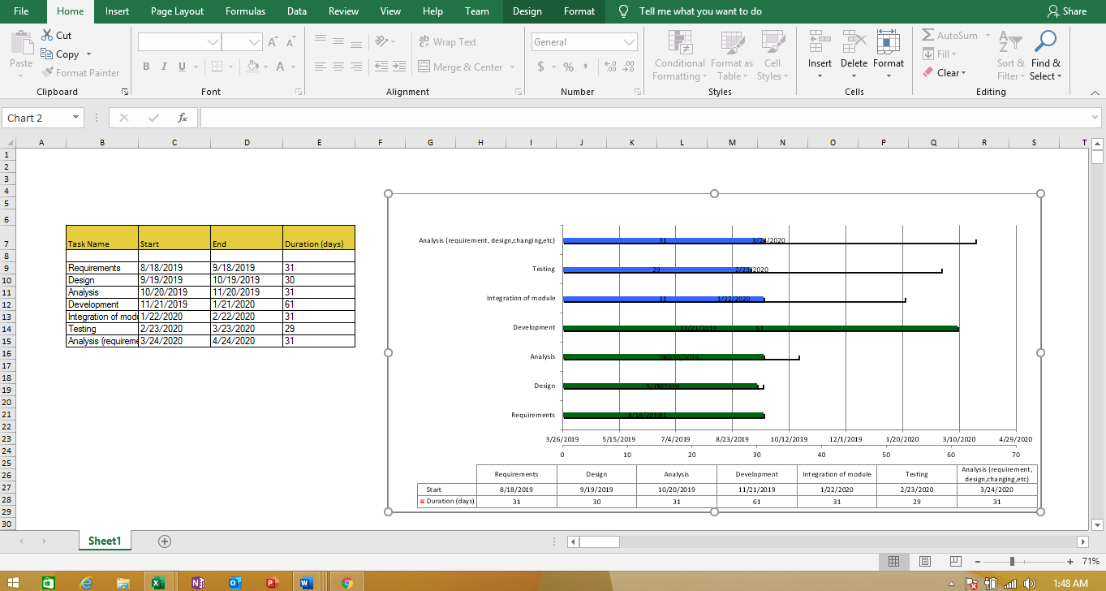

Proposed Methodology
- Every person wants to make time special for special ones on special moments. So, they need a good place to spend these moments. Event halls provide them a good place to celebrate their special times like weeding ceremony.
- Problem is that customer don not know how many good halls are available nearby to his locality. And he does not know either they are free or booked. So, he has to go and heck every hall which is really a time costly work. So, we are developing a online platform for business owners and customers, how can get services online.
- The purpose of our project is to bring the vendors and customers closer digitally by providing a platform for their direct interaction. This field has been ignored ever since but is a vital necessity and we’ve felt the need for giving it a proper attention. Although some tries have been given on it but they lack in one aspect or another. Our aim is to cover that gap and provide a one stop platform to fill the needs and satisfy our users. From user location to venue details (including menu, sound system, light system and all-important details) we have tried our best to cover it all with minimum amounts of error.
- With all the other event management platforms working in Pakistan, our project stands out of the crowd due to its attractive design and very user-friendly interface. However, that is not the end to it. Our team has planned to work more over it and to keep improving by keeping an eye on the market and making our product flawless by implementing new and creative ideas that help it work better.
- Finally, our aim to provide the best platform in the market that is almost flawless and meets all the user demands that are necessary to make it the best one out in the market, spiral model is used.
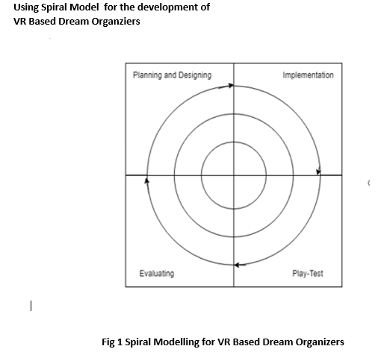

Report Outline
- Abstract
- An outlook of report.
- 1 SUMMARY
- Comprehensive summary of report contents.
- 2 KEY GRAPHS
- The graphs used in the document
- 3 BASIC ORGANIZATION
- Structural data in the report.
- 3.1 Introduction
- Similar to the summary, it may include the problem statement.
- 3.2 Experimental Design/Materials and Methods
- Development details.
- 3.3 Data Exploration/Analysis
- Market analysis.
- 4 ROLES AND RESPONSIBILITY
- Group member names and their roles and responsibilities in developing the application.

Chapter 2

Software Requirement Specifications

Chapter 2: Software Requirement Specifications

Introduction

Purpose
The cons of existing platforms discussed in section 1.4 are kept in mind while making this project. We have covered all the discussed issues in our project. For example, we have included in our project;
- Integration of google map
- Visual mapping
- Hall address
- Hall details (services, menu, cost, etc.)
- Friendly UI
- Mobile compatibility
- Etc.

Document Conventions
This document uses the conventions as defined below.
Description | Appearance
File names  Directory  Application names  PHP variables  Coding  Emphasized  Quoted text | File.extesion  Smart Event Corridor/src/img  Application.exe  $variable  <code>goes here</code>  This is an emphasized sentence  “quote”

Intended Audience and Reading Suggestions
- This document comprises of details ranging from the user interfaces to the backend coding. Therefore, it can be used by both, the users of the product as well as the developers so as to learn the different tactics we have used in our project that may result helpful in their work.
- Users: This report provides a brief introduction on the functionalities of project, throwing a light on the different ways the user can manipulate it to achieve the result. So, it can be helpful for the user to read this document in order to get the most out of our product.
- Developers: With all those technologies used in our project, it would be worthwhile for the developers to give it a glance and study the related topics of interest for the sake of knowledge or to use them in their own products
- Testers: This document deals with all the basic details on the working of the product. Hence, it would be better for the testers to go through this.
- Writers: This can be used as a template for the current or future writers of similar categories.

Product Scope
We have used agile model development for this project. With the growing population, the need for event venues is increasing day by day. With this trend in mind, we are working over the various aspects to make our product everlasting and sustainable. The competition in the market is not to be ignored and our product till today is the one that satisfies all user requirements and it covers all the basic requirements.

References
<List any other documents or Web addresses to which this SRS refers. These may include user interface style guides, contracts, standards, system requirements specifications, use case documents, or a vision and scope document. Provide enough information so that the reader could access a copy of each reference, including title, author, version number, date, and source or location.>

Requirement Gathering

Technique selected
<Describe the technique used in requirement gathering i.e. questionnaire, interview , workshop , audio, observation sheet, videos,.etc>

Reason of Selection
<Describe the reason why you have selected a particular technique>

User Classes and Characteristics
Our users may include two main categories
1. Registered Users
The users availing our services (such as booking a venue) have an option to sign-up for an account on our website. With this, their record is kept safe in their profile and they can view their booking, payments, favorites, etc in a later time.
2. Owners
The vendors are the service providers, that is, they register their halls/venues at our website and allow the users to interact with them. Vendors have the control over their venues, such that, they can update, edit, delete, add details to a specific venue or altogether add new venues or delete old ones.

Operating Environment
Our product works on all the computing devices that have an internet connection and a web browser.

Design and Implementation Constraints
Constraint include the unavailability of internet connection, out dated web browsers, an out of order computing system and/or out dated computing devices.

User Documentation
The user documents include two parts
1. User Manual
User manual describes the options the user has to interact with the product
2. Operator manual
Operator manual has the document for the developer who is supposed to maintain, run or repair the product

Assumptions and Dependencies
- Our product is user mobile friendly and it can be oriented with the device screen or resolution. With this the user can access it from anywhere with his or her laptop.
- However, if the computing device or mobile phones behave unexpectedly, the results would not show up accurately.
- As an example. Let us take old browsers (Internet Explorer 6 or lower) which are not updated with the latest technology used in our product and hence, this constraint will cause an error.

External Interface Requirements(For Networking)

User Interfaces
<Describe the logical characteristics of each interface between the software product and the users. This may include sample screen images, any GUI standards or product family style guides that are to be followed, screen layout constraints, standard buttons and functions (e.g., help) that will appear on every screen, keyboard shortcuts, error message display standards, and so on. Define the software components for which a user interface is needed. Details of the user interface design should be documented in a separate user interface specification.>

Hardware Interfaces (if hardware included)
With bootstrap installed in our project, we have made it device friendly. The product can be accessed from all the computing devices with various screen dimensions such as PC, laptop, smartphone, etc.

Software Interfaces
- Our product can run in a web explorer such as internet explorer, google chrome, safari, etc. However outdated explorers such as IE5, opera old etc. are unable to work properly with the advanced scripts used in our project and hence it is recommended to use a latest browser for the use of our product.
- For the browser to run correctly, it is necessary that the system requirements should be appropriate and a browser should be used that is in accordance with the system.
- With the points mentioned above, it is not hard to access the product with any device.

Communications Interfaces
The VR Based Dream Organizer application will have a network server that is web-based and created using the PHP language. The server exists to retrieve information from the database and calculate payments. The product also calls for a database system that stores user information and transaction history between users. The HTTP server will use a push protocol to push notifications of updates onto the Android phones. Furthermore, whenever a user opens the VR Based Dream Organizer app from their phone, a pull protocol will be used to retrieve and sync the latest transaction updates from the server.

Functional Requirement
The database allows the owner to upload information regarding his/her menu. The users can access this data using VR Based Dream Organizer. Using the information stored in the database, VR Based Dream Organizer works with various features.
REQ-SF1-1: Customer:
Registration
- New customers should not be given direct access to the site.
- Each new customer must have to first register themselves.
- Each Customer is assigned a new Id upon registration.

Login
- Customers should login to access the features of the system.
- Customers should be allowed to view and update their login information.
- Login functionality should vary differently among customer, owner and administrator.

Forget Password
- If user forgets his/her password they would be directed to a page to enter a security pin assigned to them upon registration.
- It may contain;
View Hall
- Offering customers, a well-designed view hall containing all the city hall and overall hall available with full description.
- The view hall may contain all information regarding halls etc.
- It may contain
Search Hall
- Advanced form of hall searching functionality.
- This functionality offers ease of use for both customers to directly view the hall they are searching for.
- It may contain;

View Booking
- Providing customer with a booking functionality so that they may keep their selected hall in check.
- Boking Hall will be added on basis of name.
- Allow View and change option for booking detail.
- Provide an option for update of booking detail.
- Upon booking update, a booking number is assigned to customers booking with booking date. These have no link with test cases.
- Provide an option for cancellation of booking.
- It may contain;

REQ-SF1-2: Owner:
Registration
- New Owners should not be given direct access to the site.
- Each new Owners must have to first register themselves.
- Each Owners is assigned a new Id upon registration.

Login
- Owners should login to access the features of the system.
- Owners should be allowed to view and update their login information.
- Login functionality should vary differently among customer, owner and administrator.

Forget Password
- If user forgets his/her password they would be directed to a page to enter a security pin assigned to them upon registration.
- It may contain;
Add Hall
- Should contain adding hall functionality so that owner may add hall.
- Once the request is approved, then the Owner should proceed to his liking.
- Owner should be able to view hall from hall page after adding.

Update/ Delete Hall
- Should contain updating and deleting hall functionality in a website Database so that owner may update or delete old hall whenever needed.
- Once the request is approved, then the Owner should proceed to his liking.

It may contain

View Booking
- Providing owner with a booking functionality so that they may keep their selected hall in check.
- Boking Hall will be added on basis of name.
- Allow View and change option for booking detail.
- Provide an option for update of booking detail.
- Upon booking update, a booking number is assigned to customers booking with booking date. These have no link with test cases.
- Provide an option for cancellation of booking.
- It may contain;

View Booking Report:
- Detail maintenance.
- Proper maintenance of detail will be conducted.
- Detail of booking made per day will be generated.
- Both Owner will view Detail.
- It may contain;

REQ-SF1-3: Admin:

Login
- Admin should login to access the features of the system.
- Admin should be allowed to view and update their login information.
- Login functionality should vary differently among customer, owner and administrator.

Manage Customers/Owner
- Management of owner and customer.
- This functionality allows administrators to view all owner and customer.
- This functionality allows administrators to add new owner and customer.
- This functionality allows administrators to update their owner and customer records.
- This functionality allows administrators to delete their owner and customer records.

View Booking Report
- Detail maintenance.
- Proper maintenance of detail will be conducted.
- Detail of booking made per day will be generated.
- Both Owner and Admin will view Detail.
- It may contain;
REQ-SF1-4: Virtual Hall:

VR Design Virtual Hall

- An imaginary space that independently exist from the real hall.
- The medium used to create this space is of course a simulation made of visual elements rendered with computer graphics.
- Relations and interactions between these elements are defined by rules set by the creator..

Sensory Feedback

- VR headsets track the position of the users within a given space so that the computer renders the changes of positions. Users moving their heads or bodies will be given the illusion that they are moving in the virtual world.
- The input here is as close to reality as possible, to move around users don’t press a button, they actually move around.

Immersion
- When user use VR BOX he immersed in it.
- VR headset allow this by occupying their whole field of vision, while headphones achieve the same result, thus fully immersing the user in real hall.

Other Nonfunctional Requirements

Performance Requirements.

Safety Requirements.

Security Requirements.

Software Quality Attributes.
- Business Rules.

Performance Requirements

The product should be responsive with appropriate computing system and a working internet connection.

Safety Requirements
With the use of PHP language, the product is made very secure with the vendor/user data safe.

Security Requirements
Users and vendors should be very while setting up the password.
The password should be a strong one.
Moreover, the applicants shall be very cautious not to share their password online or at any uncertain times.

Software Quality Attributes
The data should be authentic where the system is quick to respond.

Business Rules
The initial setup of owners should be free of cost. Once the setup is running, the service fee shall be implied to all the vendors. This system shall be free of cost.

Other Requirements

Reliability
- It is necessary for the system to be online 24 hours per day and 7 days per week, regardless of any time-zone.
- The proposed system which the developer designs should be reliable so it efficiently interacts with user. Secure access of confidential data.

Usability

Getting registered must not take more than a minute or two.
- Placing an booking must not take more than a minute.
- It should be easy to use for customer and manage for admin.
- People with no training shall be able to use the system.

User-Friendly
- The system should be user friendly in all manners.
- It should take less time for customers to get registered and for all to owner login.

Chapter 3

Use Case Analysis

Chapter 3: System Analysis

Analysis Document
This document comprises of details ranging from the user interfaces to the backend coding. It can be used by both, the users of the product as well as the developers so as to learn the different tactics we have used in our project that may result helpful in their work.

Users
This report provides a brief introduction on the functionalities of project, throwing a light on the different ways the user can manipulate it to achieve the result. So, it can be helpful for the user to read this document in order to get the most out of our product.

Developers
With all those technologies used in our project, It would be worthwhile for the developers to give it a glance and study the related topics of interest for the sake of knowledge or to use them in their own products

Testers
This document deals with all the basic details on the working of the product. Hence, it would be better for the testers to go through this.

Writers
This can be used as a template for the current or future writers of similar categories.

Product Scope
As the need for event venues is increasing, we are working over the various aspects to make our product everlasting and sustainable. Our product till today is the one that satisfies all user requirements and it covers all the basic requirements.
Vision
This project is to assist superior human beings. We rise by lifting others

[Use Case Model
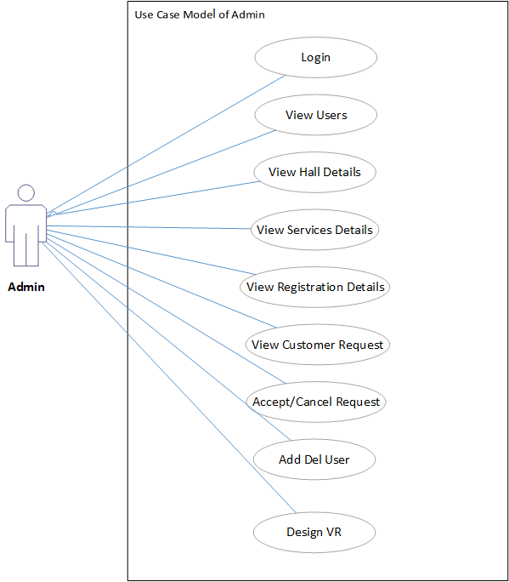

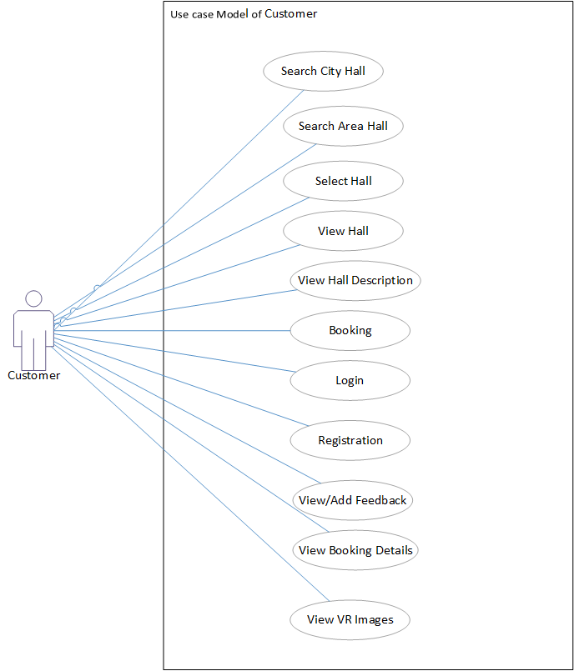

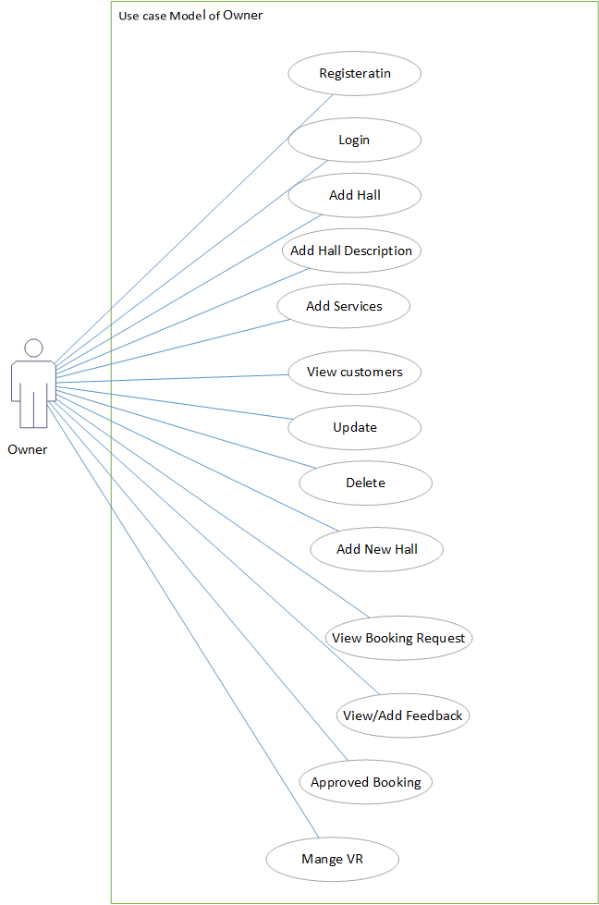

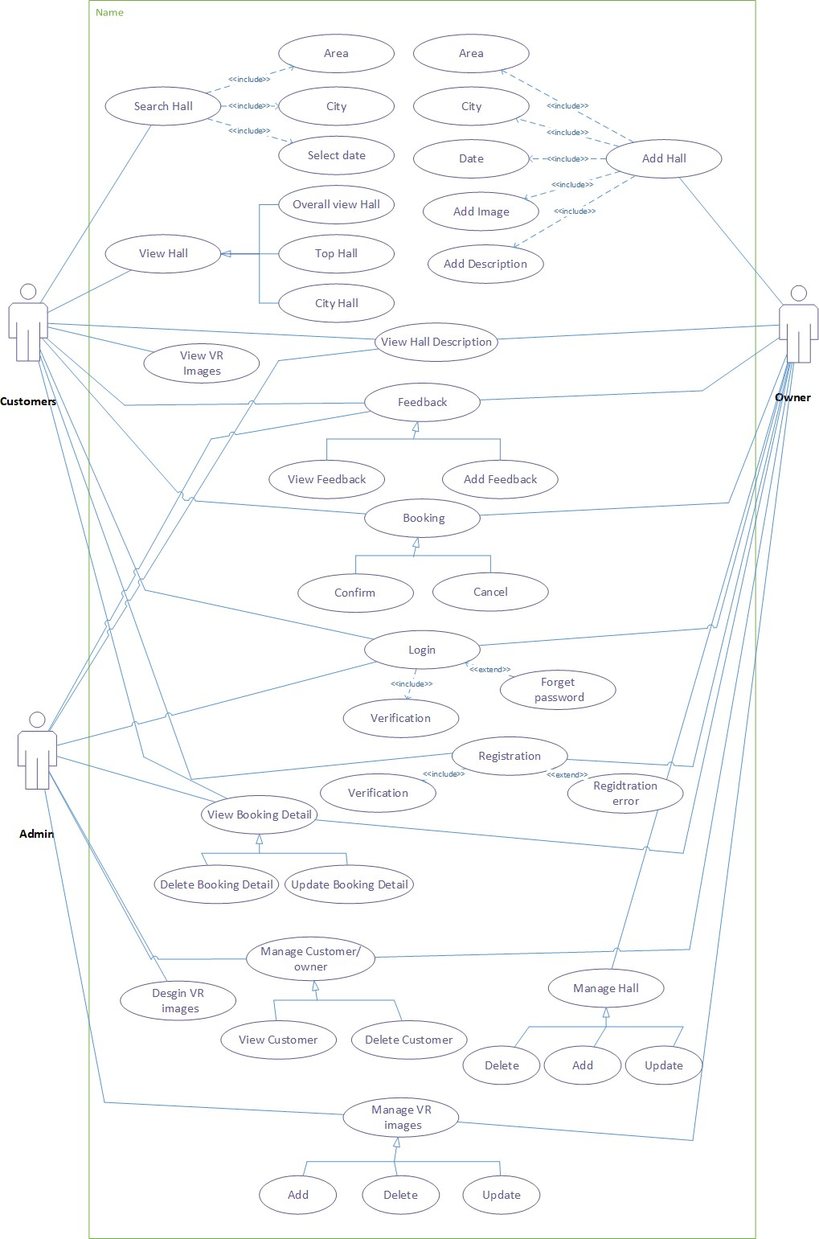
Fully Dressed Use Cases

Use Case Specification
F.D.U.C 1.0

Use case Name | Registration
Scope | Customer uses it to register himself into the site
Primary Actors | Customer ,Owner
Stakeholders and Interests | Customer: Customer uses it to register on the site.  Owner: Owner uses it to register on the site.
Pre-Conditions | N/A
Post-Conditions | After registration customer and owner is able to view profile.
Main Scenario | - Customer opens website.  - Customer selects Signup option  - Customer enters all required information.  - Customer registers themselves into the system.  - Owner opens website.  - Owner selects Signup option  - Owner enters all required information.  - Owner registers themselves into the system.
Failure Case/ Alternative Case | Failure  If the functionality fails it would be due to network problem or adding already existing information for registration. | Alternative Case  The alternative would be to add non existing information.
Frequency of Occurrence | If discussed per day, Customer can use this functionality only once in a lifetime.

F.D.U.C 2.0

Use case Name | View Profile
Scope | Users use it to view their profile
Primary Actors | Customer, Admin, Owner
Stakeholders and Interests | All user:All uses it to register on the system and view profile.
Pre-Conditions | Users must be logged in, to access their profile
Post-Conditions | After viewing profile, users perform required tasks.
Main Scenario | - Users open website.  - Users login to the site.  - Select view profile option.  - View their profile.
Failure Case/ Alternative Case | Failure  If the functionality fails it would be due to network problem. | Alternative Case
Frequency of Occurrence | If discussed per day, Users can use this functionality countless times.

F.D.U.C 3.0

Use case Name | Update Profile
Scope | All users use it to manage their profile
Primary Actors | Customer, Owner
Stakeholders and Interests | Customer: Customer uses it to update their profile on the system.  Owner: Owner uses it to update their profile on the system.
Pre-Conditions | Users must be logged in, to access and update their profile
Post-Conditions | After Updating Profile users are able add ,view Hall etc
Main Scenario | - Users open website.  - Users log into the site.  - Select view profile option.  - Select Update profile option.  - Update profile.  - Select confirm option.
Failure Case/ Alternative Case | Failure  If the functionality fails it would be due to network problem or another link set up instead of Update Profile Page. | Alternative Case
Frequency of Occurrence | If discussed per day, Customer can use this functionality only once in a lifetime.

F.D.U.C 4.0

Use Case Section | Comment
Use Case Name | Login
Scope | Users use it to log in to the site
Primary Actors | Customer, Owner, Admin
Stakeholders and Interests | Customer: Customer uses it to login to the site.  Owner: Owner uses it to login to the site. Admin: Admin uses it to login to the site.
Pre-Conditions | N/A
Post-Conditions | After logging in, all users can perform their specified operations
Main Scenario | - Users open website.  - Select Sign-in option.  - Customer logs into the site.  - Admin logs into the site.  - Owner logs into the site.
Failure Case/ Alternative Case |  | Failure  If the functionality fails it would be due to network problem or if a different link is set up instead of the login page. | Alternative Case Forget Password
Frequency of Occurrence |  | If discussed per day admin and Owner uses this functionality to login countless times.

F.D.U.C 5.0

Use Case Section | Comment
Use Case Name | Add Hall
Scope | Used to add new Hall into the system
Primary Actors | Owner
Stakeholders and interests | Owner: owner uses it to place new hall to the system.  Customer: After new Hall is added to the system, customer is able to view them.
Pre-Conditions | Owner should be logged in to the site.
Post-Conditions | After adding hall owner is able to update or delete them if required.
Main Scenario | - Owner opens website.  - Owner logs in to the site  - Selects add hall page option.  - Adds new hall.  - Views the hall added.
Failure Case/ Alternative Case | Failure  If the functionality fails it would be due to network problem or if a different link is set up instead of the add hall page.
Frequency of occurrence | If discussed per day, Owner uses this functionality to add halls once.

F.D.U.C 6.0

Use Case Section | Comment
Use Case Name | View Hall
Scope | Used to view halls available in the system
Primary Actors | Owner, Admin, Customer
Stakeholders and interests | Owner: Owner uses it to view new halls added to the system.  Admin: After new halls are added to the system, Admin is able to view them.  Customer: After new halls are added to the system, customer is able to view them.
Pre-Conditions | Owner and Admin should be logged in to the site.
Post-Conditions | After viewing halls Owner is able to update or delete them if required.
Main Scenario | - Owner/Admin opens website.  - Owner/Admin logs in to the site  - Selects view hall page option.  - Views the halls.
Failure Case/ Alternative Case | Failure  If the functionality fails it would be due to network problem or if a different link is set up instead of the view hall page. | Alternative Search Hall
Frequency of occurrence | If discussed per day, Owner and Admin use this functionality countless times.

F.D.U.C 7.0

Use Case Section | Comment
Use Case Name | Update Hall
Scope | Used to update halls available in the system
Primary Actors | Owner
Stakeholders and interests | Owner: Owner uses it to update the halls part of the system.  Customer: After halls are updated, customer is able to view them.
Pre-Conditions | Owner should be logged in to the site.  The record of hall to be updated should be available.
Post-Conditions | After updating halls Owner is able to view, add or delete halls if required.
Main Scenario | - Owner opens website.  - Owner logs in to the site  - Selects update hall page option.  - Updates the halls.  - Selects confirm option.
Failure Case/ Alternative Case | Failure  If the functionality fails it would be due to network problem or if a different link is set up instead of the update hall page. | Alternative
Frequency of occurrence | If discussed per day, Owner uses this functionality countless times.

F.D.U.C 8.0

Use Case Section | Comment
Use Case Name | Delete Hall
Scope | Used to delete halls part of the system
Primary Actors | Owner
Stakeholders and interests | Owner: Owner uses it to delete the halls part of the system.  Customer: After halls are delete, customer is not able to view them.
Pre-Conditions | Owner should be logged in to the site.  The record of hall to be deleted should be available.
Post-Conditions | After deleting halls Owner is able to view, add or update other halls if required.
Main Scenario | - Owner opens website.  - Owner logs in to the site  - Selects delete hall page option.  - Selects the halls to delete.  - Deletes the halls.  - Selects confirm option.
Failure Case/ Alternative Case | Failure  If the functionality fails it would be due to network problem or if a different link  is set up instead of the delete hall page. | Alternative
Frequency of occurrence | If discussed per day, Owner uses this functionality countless times.

F.D.U.C 9.0

Use Case Section | Comment
Use Case Name | View Hall
Scope | Used to view a catalogue containing all halls
Primary Actors | Customer, Admin, Owner
Stakeholders and interests | Admin: Admin permits Owner to add new halls to the system.  Owner: Owner adds new halls to system.  Customer: After halls are added, customer can view all the halls through city wise,overall hall, top rating hall.  Admin: After halls are added, Admin can view all the halls through city wise,overall hall, top rating hall.  Owner: After halls are added, Owner can view all the halls through city wise,overall hall, top rating hall.
Pre-Conditions | Customer should be logged in to the site  Admin should be logged in to the site Admin should be logged in to the site
Post-Conditions | After viewing catalogue, customer will add selective halls .
Main Scenario | - Customer opens website.  - Customer logs in to the site  - Selects city wise,overall hall, top rating hall option.  - Views all halls.
Failure Case/ Alternative Case | Failure  If the functionality fails it would be due to network problem or if a different link is set  up instead of the view option. | Alternative Search Hall
Frequency of occurrence | If discussed per day, Customer uses this functionality to view halls more than once.

F.D.U.C 10.0

Use Case Section | Comment
Use Case Name | Search Hall
Scope | Used to Search the containing all halls
Primary Actors | Customer, Owner
Stakeholders and interests | Admin: Admin permits Owner to add new halls to the system.  Owner: Owner adds new halls to system.  Customer: After halls are added, customer views the halls through location and date. Customer: Customer can view specific halls by selecting search location and date. Admin: Admin can view specific halls by selecting search location and date option.
Pre-Conditions | Customer should be logged in to the site  Admin should be logged in to the site
Post-Conditions | After viewing, customer will add selective halls to view and booked them.
Main Scenario | - Customer/Admin opens website.  - Customer/Admin logs in to the site  - Selects option.  - Searches for a specific hall.
Failure Case/ Alternative Case | Failure  If the functionality fails it would be due to network problem or if a different link is set  up instead of the search option. | Alternative View Hall
Frequency of occurrence | If discussed per day, Customer/Admin uses this functionality to view halls more than once.

F.D.U.C 11.0

Use Case Section | Comment
Use Case Name | Add to booking
Scope | Used by customer so that they can add selective halls to booking.
Primary Actors | Customer
Stakeholders and interests | Owner: Owner adds new halls to the system.  Customer: Customer uses it to add new halls to the booking page.  Customer: After new halls are added to booking page, customer views booking detail.
Pre-Conditions | Customer should be logged in to the site.  Customer must use catalogue to add halls into booking
Post-Conditions | After adding halls to booked Customer is able to update or delete them if required.
Main Scenario | - Customer opens website.  - Customer logs in to the site  - Selects halls.  - Adds halls to Booking page.  - Views the halls added.
Failure Case/ Alternative Case | Failure  If the functionality fails it would be due to network problem or if a different link  is set up instead of the add to booking page option. | Alternative
Frequency of occurrence | If discussed per day, Customer uses this functionality to add halls more than once.

F.D.U.C 12.0

Use Case Section | Comment
Use Case Name | View Booking detail
Scope | Used by customer to view halls added to booking page
Primary Actors | Customer
Stakeholders and interests | Owner: Owner adds new halls to the system.  Customer: Customer adds new halls to the booking.  Customer: After new halls are added to booked, customer views booking.
Pre-Conditions | Customer should be logged in to the site.
Post-Conditions | After viewing halls from booking page Customer is able to add, update or delete  halls if required.
Main Scenario | - Customer opens website.  - Customer logs in to the site  - Selects halls .  - Adds halls to bookingpage.  - Views the halls added.
Failure Case/ Alternative Case | Failure  If the functionality fails it would be due to network problem or if a different link is set up instead of the view booking page option. | Alternative
Frequency of occurrence | If discussed per day, Customer uses this functionality to view halls more than once.

F.D.U.C 13.0

Use Case Section | Comment
Use Case Name | Update booking detail
Scope | Used by customer to update halls added to bookingpage
Primary Actors | Customer
Stakeholders and interests | Owner: Owner adds new halls to the system.  Customer: Customer adds new halls to the bookingpage.  Customer: After new halls are added to cart, customer views and updates bookingpage.
Pre-Conditions | Customer should be logged in to the site.  Customer must add halls to bookingpage to be able to update them
Post-Conditions | After updating halls from bookingdetail Customer is able to add or delete halls if required.
Main Scenario | - Customer opens website.  - Customer logs in to the site  - Selects halls.  - Adds halls to bookingpage.  - Views the halls added.  - Updates the halls.
Failure Case/ Alternative Case | Failure  If the functionality fails it would be due to network problem or if a different link is set up instead of the update booking detail  option. | Alternative.
Frequency of occurrence | If discussed per day, Customer uses this functionality to update halls more than once.

F.D.U.C 14.0

Use Case Section | Comment
Use Case Name | Confirm booking
Scope | Customer uses it to confirm their booking
Primary Actors | Customer/Owner
Stakeholders and interests | Customer: Customer uses it to confirm booking of halls added to bookingpage.  Owner: Owner uses it to confirm booking of halls added to bookingpage.
Pre-Conditions | Customer should be logged in to the site.  Customer must add halls to bookingpage to confirm booking.  Owner should be logged in to the site.  Owner must add halls to bookingpage to confirm booking and send conformation message.
Post-Conditions | When the customer confirms his booking, he may add new hall and also cancel his booking.  When the Owner confirms his booking, he may be cancel his booking.
Main Scenario | - Customer opens website.  - Customer logs into the site.  - Customer searches for the hall.  - System displays the hall detail.  - Customer adds hall.  - Customer/Owner confirm the booking.
Failure Case/ Alternative Case | Failure  If the functionality fails it would be due to network problem or if a different link  is set up instead of the confirm bookingpage. | Alternative
Frequency of occurrence | If discussed per day, Customer should use this functionality for booking confirmation countless times.

F.D.U.C 15.0

Use Case Section | Comment
Use Case Name | Cancel booking
Scope | Customer uses it to cancel the booking that was confirmed before
Primary Actors | Customer, owner
Stakeholders and interests | Customer: Customer first confirm his booking.  Upon some crisis or for some reason, Customer uses this to cancel booking.
Pre-Conditions | Customer should be logged in to the site.  Customer must have placed an booking if required to cancel it.  Owner should be logged in to the site.  Owner must have placed an booking if required to cancel it.
Post-Conditions | When the customer confirms his booking, but he likes the other hall.so, he first cancels his  first booking and then place booking for the other hall.
Main Scenario | - Customer opens website.  - Customer logs into the site.  - Customer should search for the hall.  - Customer and owner confirm the booking.  - Then customer and owner cancel his booking
Failure Case/ Alternative Case | Failure  If the functionality fails it would be due to network problem or if a different link is set up instead of the cancel booking page. | Alternative
Frequency of occurrence | If discussed per day, Customer and Owner may use this functionality to cancel booking  more than once.

F.D.U.C 16.0

Use Case Section | Comment
Use Case Name | Delete Owners/Customer
Scope | Used to delete Owners part of the system
Primary Actors | Admin
Stakeholders and interests | Admin: Admin uses it to delete the Owners and customer part of the system.  Owner: Owner manages the system.  Customer: Customer manages the system.
Pre-Conditions | Admin should be logged in to the system.  Admin should delete Owners to system if it is required to delete their records
Post-Conditions | After deleting Owners, Admin is able to view, delete Owners if required.
Main Scenario | - Owner opens website.  - Owner logs in to the site  - Selects delete Owner and Customer page option.  - Selects the halls to delete.  - Deletes the Owners.  - Deletes the Customer.  - Selects confirm option.
Failure Case/ Alternative Case | Failure  If the functionality fails it would be due to network problem or if a different link is set up instead of the delete Owner and customer page. | Alternative
Frequency of occurrence | If discussed per day, Admin uses this functionality based on Owner behavior and work.

F.D.U.C 17.0

Use Case Section | Comment
Use Case Name | View Booking Reports
Scope | Used by both Owner and Admin to view daily booking reports.
Primary Actors | Owner, Admin
Stakeholders and interests | Owner: Owner view booking reports. Admin: Admin view booking reports.
Pre-Conditions | Owner and Admin should be logged in to the site.
Post-Conditions
Main Scenario | - Owner/Admin opens website.  - Owner/Admin log in to the site  - Admin view booking reports.  - Owner view booking reports.
Failure Case/ Alternative Case | Failure  If the functionality fails it would be due to network problem or if a different link is set up instead of the view booking reports  option. | Alternative
Frequency of occurrence | If discussed per day, Owner or use this functionality once.

Chapter 4

System Design

Chapter 4: System Design
Following is the system design, explained in various discrete steps for clear grip and understanding.

Architecture Diagram
This project is built on a simple and basic architecture. The homepage shows links to the main areas of the page such as halls and bookings. Users can visit those pages to view and or book halls. Whereas the owners have the option to view/edit/delete data/information/bookings.
Architecture

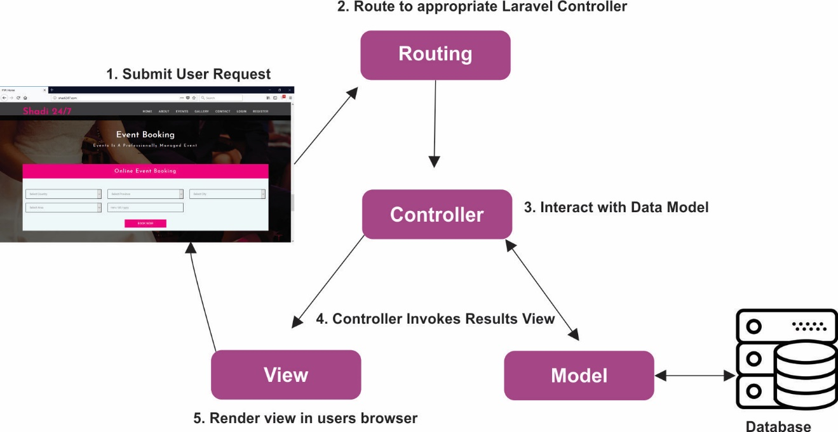

Domain Model
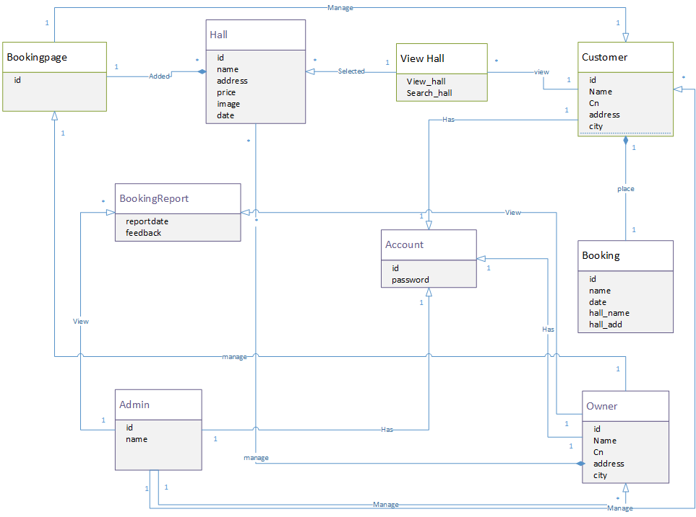

Entity Relationship Diagram with data dictionary
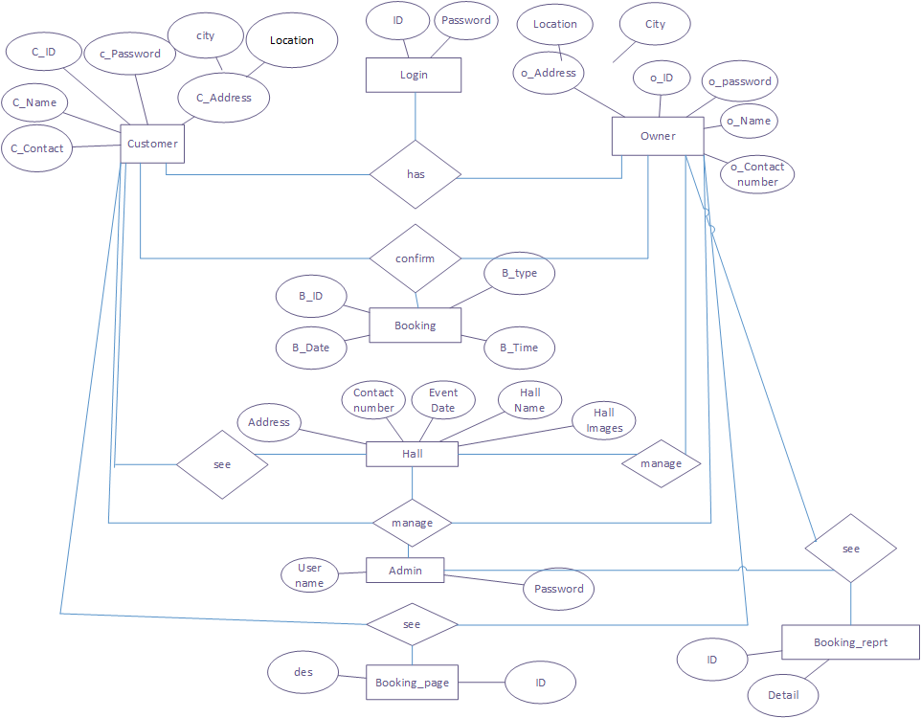

Class Diagram
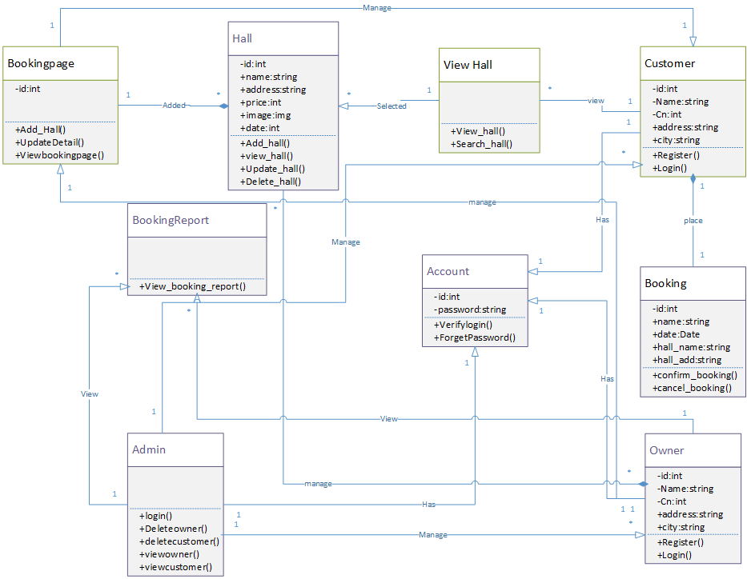

Sequence / Collaboration Diagram
S.D 1.0
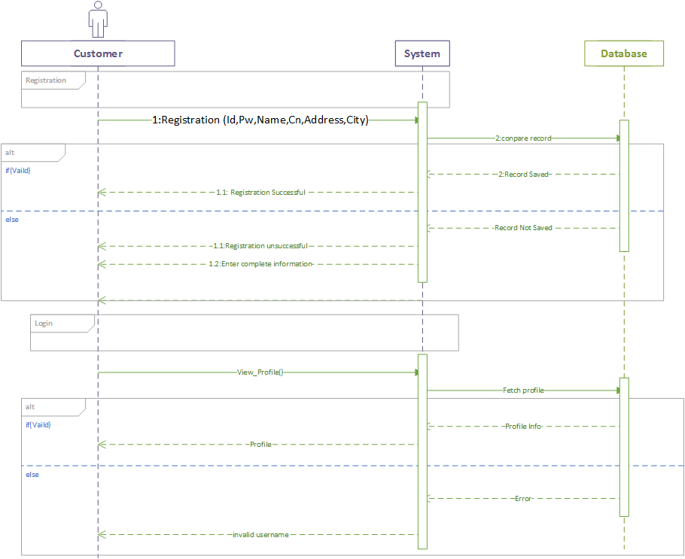

S.D 2.0

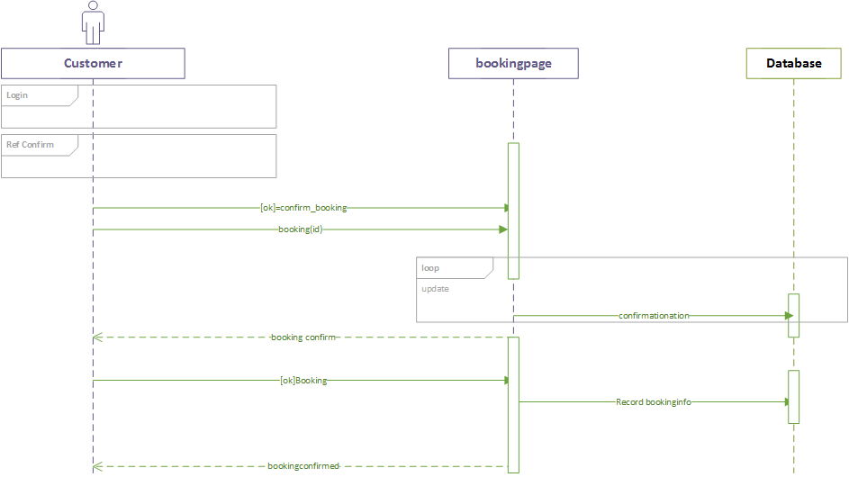
S.D 3.0
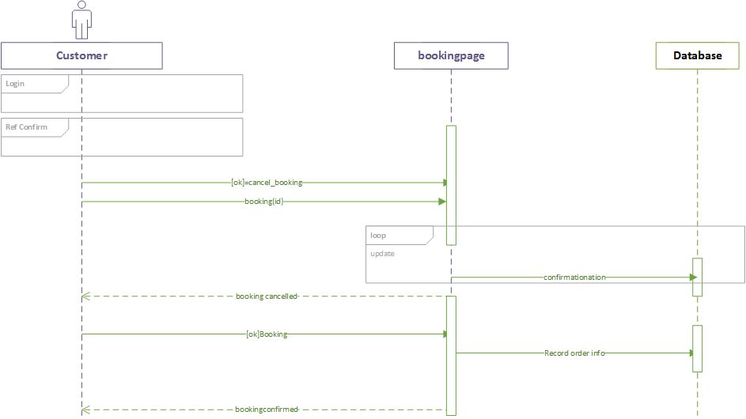

S.D 4.0
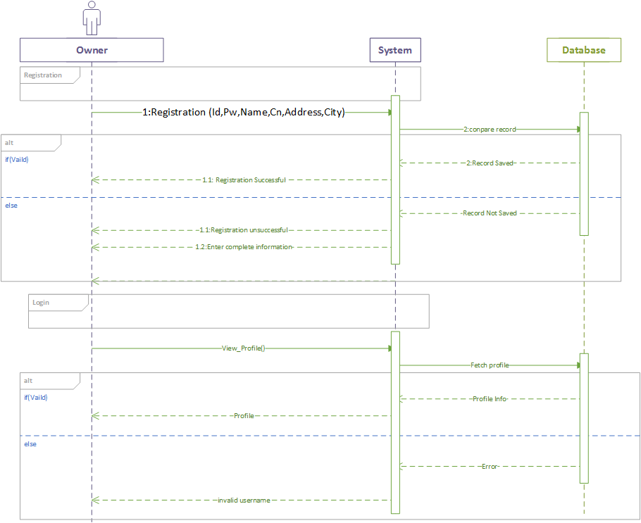

S.D 5.0
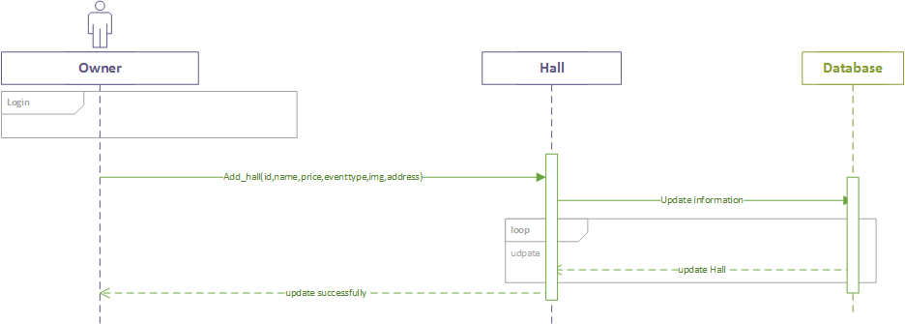
S.D 6.0
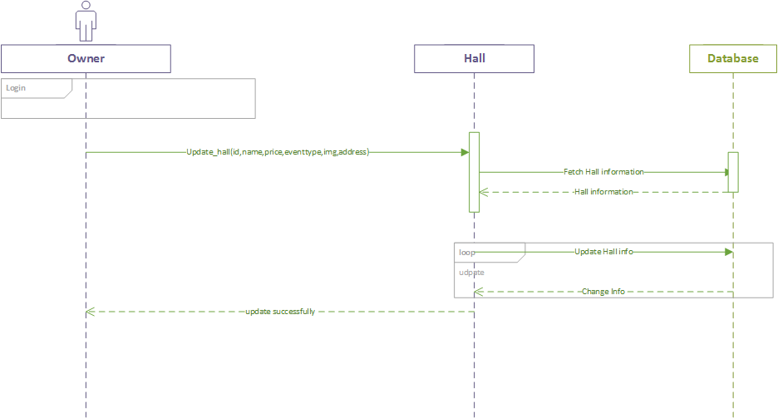

S.D 7.0
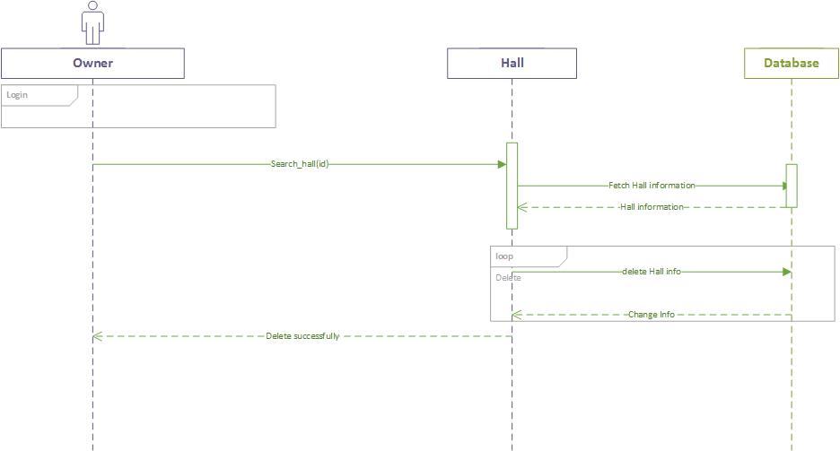
S.D 8.0
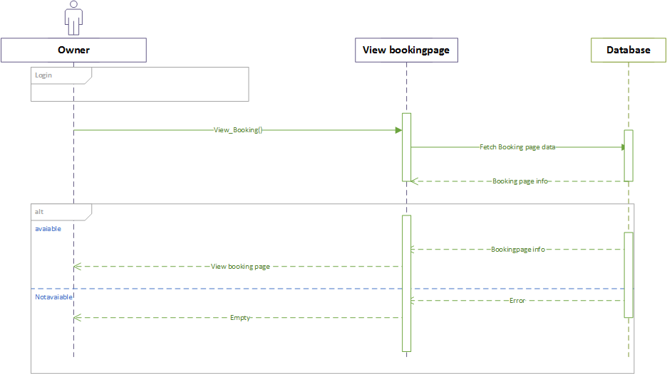

S.D 9.0
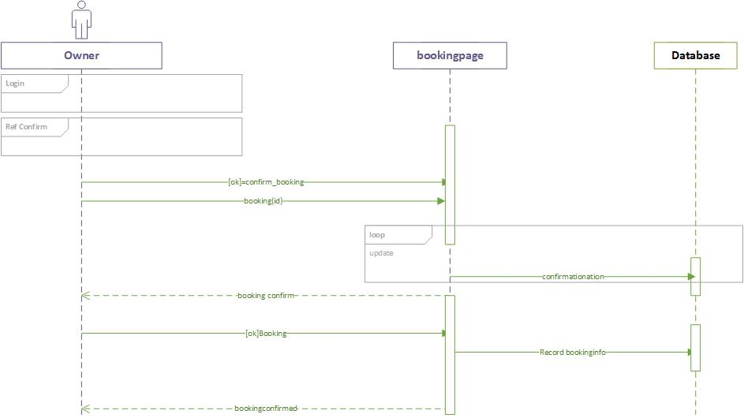
S.D 10.0
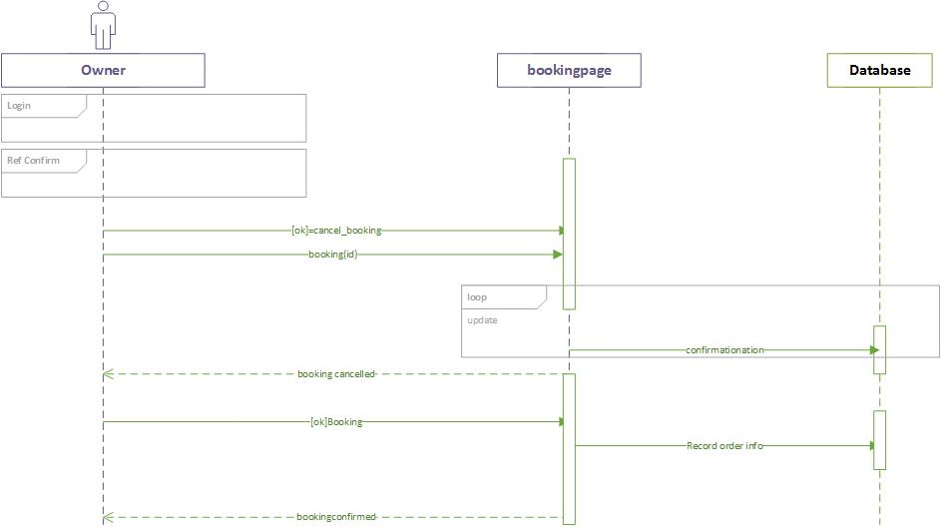

S.D 11.0
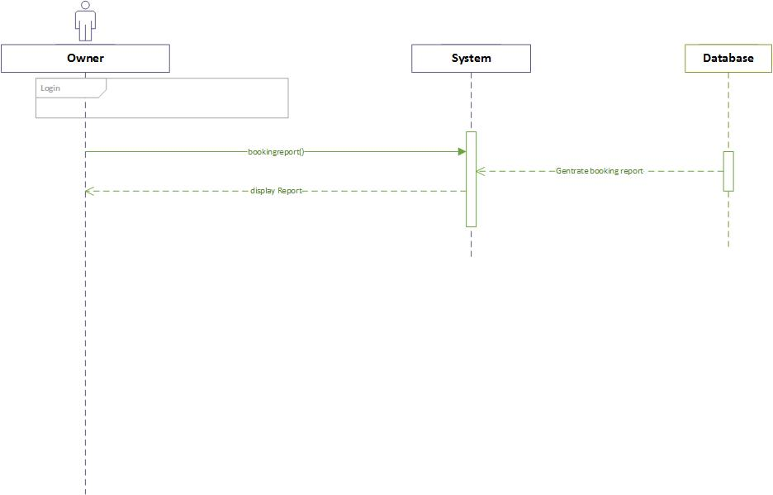
S.D 12.0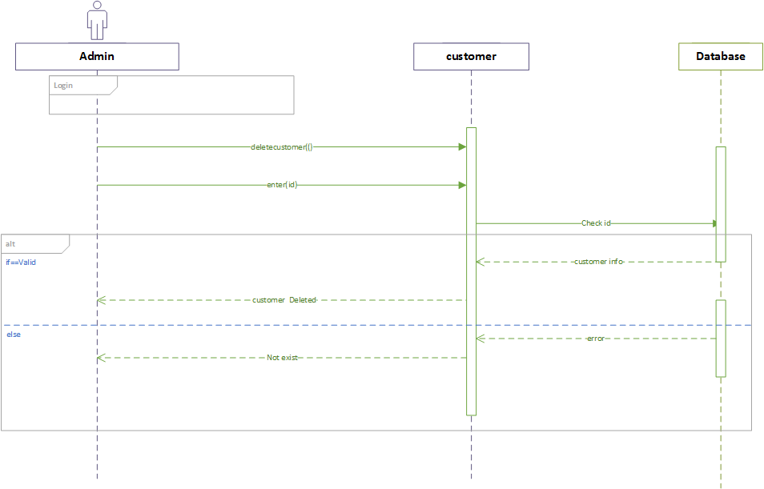

S.D 13.0
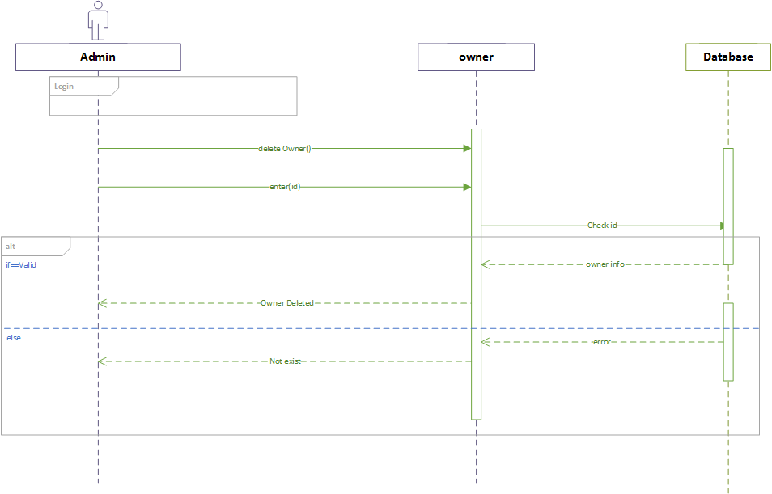

S.D 14.0

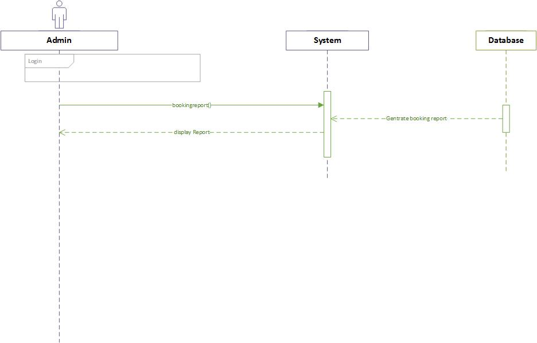

Operation contracts
O.C 1.0 Registration

Headings | Sub-Headings
Operations |  | Register( )
Cross-Reference | Use-Case | Registration, View Profile
Cross-Reference | Scenario | Registration
Pre-  Conditions |  | N/A
Post-Conditions | Instantiation | An instance “A” of Account was created.  An instance “C” of Customer was created.
Post-Conditions | Attribute Modification | A.Id becomes ID.  A.Name becomes Name.  R.CN becomes CN  A.Address becomes Address.  A.CNIC becomes CNIC.  A.PW becomes PW
Post-Conditions | Association | A was associated with Customer.

O.C 2.0 View Profile

Headings | Sub-Headings
Operations |  | View_Profile( )
Cross-Reference | Use-Case | View Profile
Cross-Reference | Scenario | View Profile
Pre-  Conditions |  | Users must be logged in, to access their profile
Post-Conditions | Instantiation | An instance “P” of Profile was created.  An instance “C” of Customer was created.  An instance “A” of Admin was created.  An instance “M” of Owner was created.
Post-Conditions | Attribute Modification | N/A
Post-Conditions | Association | P was associated with Admin.  P was associated with Customer.  P was associated with Owner.

O.C 3.0 Update Profile

Headings | Sub-Headings
Operations |  | Update_Profile( )
Cross-Reference | Use-Case | Update Profile, View Profile
Cross-Reference | Scenario | Update Profile
Pre-  Conditions |  | Users must be logged in, to access and update their profile
Post-Conditions | Instantiation | An instance “P” of Profile was created.  An instance “C” of Customer was created.  An instance “M” of Owner was created.
Post-Conditions | Attribute Modification | P.Id becomes ID.  P.Name becomes Name.  P.CN becomes CN  P.Address becomes Address.  P.PW becomes PW
Post-Conditions | Association | P was associated with Customer.  P was associated with Owner.

O.C 4.0 Login

Headings | Sub-Headings
Operations |  | Login( )
Cross-Reference | Use-Case | Login, View Profile
Cross-Reference | Scenario | Login
Pre-  Conditions |  | N/A
Post-Conditions | Instantiation | An instance “A” of Account was created.  An instance “C” of Customer was created.  An instance “a” of Admin was created.  An instance “M” of Owner was created.
Post-Conditions | Attribute Modification | A.Id becomes ID.  A.PW becomes PW
Post-Conditions | Association | A was associated with Admin.  A was associated with Customer.  A was associated with Owner.

O.C 5.0 Add Hall
Headings | Sub-Headings
Operations |  | Addhall( )
Cross-Reference | Use-Case | Add Hall, View Hall
Cross-Reference | Scenario | Add Hall
Pre-  Conditions |  | Owner should be logged into the system
Post-Conditions | Instantiation | An instance “P” of Hall was created.  An instance “M” of Owner was created.
Post-Conditions | Attribute Modification | P.id becomes id.  P.name becomes name.  P.Cn becomes CN  P.type becomes type.  P.price becomes price.  P.date becomes date.  P.image becomes image.  P.address becomes address.
Post-Conditions | Association | P was associated with Owner.

O.C 6.0 View Hall

Headings | Sub-Headings
Operations |  | Viewhall( )
Cross-Reference | Use-Case | View Hall
Cross-Reference | Scenario | View Hall
Pre-  Conditions |  | Owner should be logged into the system  Admin should be logged into the system
Post-Conditions | Instantiation | An instance “P” of Halls was created.  An instance “M” of Owner was created.  An instance “A” of Admin was created.
Post-Conditions | Attribute Modification | N/A
Post-Conditions | Association | P was associated with Owner.  P was associated with Admin.

O.C 7.0 Update Hall

Headings | Sub-Headings
Operations |  | Updatehall( )
Cross-Reference | Use-Case | Update Hall, View Hall
Cross-Reference | Scenario | Update Hall
Pre-  Conditions |  | Owner should be logged into the system  The record of the hall to be updated should be available
Post-Conditions | Instantiation | An instance “P” of Hall was created.  An instance “M” of Owner was created.
Post-Conditions | Attribute Modification | P.id becomes id.  P.name becomes name.  P.type becomes type  P.date becomes date.  P.price becomes price.
Post-Conditions | Association | P was associated with Owner.

O.C 8.0 Delete Hall

Headings | Sub-Headings
Operations |  | Delete_Halls( )
Cross-Reference | Use-Case | Delete Halls, View Halls
Cross-Reference | Scenario | Delete Halls
Pre-  Conditions |  | Owner should be logged into the system  The record of the hall to be deleted should be available
Post-Conditions | Instantiation | An instance “P” of Halls was created.  An instance “M” of Owner was created.
Post-Conditions | Attribute Modification | P.id becomes id.
Post-Conditions | Association | P was associated with Owner.

O.C 9.0 Search Halls

Headings | Sub-Headings
Operations |  | Search_ Halls( )
Cross-Reference | Use-Case | Search Halls, View Halls
Cross-Reference | Scenario | Search Halls
Pre-  Conditions |  | Owner should be logged into the system.  Customer should be logged into the system.
Post-Conditions | Instantiation | An instance “Ca” of Halls was created.  An instance “M” of Owner was created.  An instance “C” of Customer was created.
Post-Conditions | Attribute Modification | Ca.Id becomes Id.  Ca.Name becomes Name.
Post-Conditions | Association | Ca was associated with Owner .  Ca was associated with Customer.

O.C 10.0 Add Hall to Bookingpage

Headings | Sub-Headings
Operations |  | Add_hal_to_ Bookingpage( )
Cross-Reference | Use-Case | Add to Bookingpage, View Bookingpage
Cross-Reference | Scenario | Add to Bookingpage
Pre-  Conditions |  | Customer should be logged into the system
Post-Conditions | Instantiation | An instance “bp” of bookingpage was created.  An instance “C” of Customer was created.
Post-Conditions | Attribute Modification | bp.id becomes id.  bp.name becomes name.  bp.quantity becomes quantity.
Post-Conditions | Association | bp was associated with Customer.

O.C 11.0 View Bookingpage

Headings | Sub-Headings
Operations |  | View_Bookingpage( )
Cross-Reference | Use-Case | View Bookingpage
Cross-Reference | Scenario | View Bookingpage
Pre-  Conditions |  | Customer should be logged into the system  Customer must add halls to Bookingpage to be able to view them
Post-Conditions | Instantiation | An instance “Bp” of bookingpage was created.  An instance “C” of Customer was created.
Post-Conditions | Attribute Modification | N/A
Post-Conditions | Association | Bp was associated with Customer.

O.C 12.0 Update Bookingpage

Headings | Sub-Headings
Operations |  | Update_Bookingpage( )
Cross-Reference | Use-Case | Update bookingpage, View bookingpage
Cross-Reference | Scenario | Update bookingpage
Pre-  Conditions |  | Customer should be logged into the system  Customer must add halls to Bookingpage to be able to update them
Post-Conditions | Instantiation | An instance “bp” of Bookingpage was created.  An instance “C” of Customer was created.
Post-Conditions | Attribute Modification | bp.id becomes id.  bp.name becomes name.
Post-Conditions | Association | bp was associated with Customer.

O.C 13.0 Confirm Booking

Headings | Sub-Headings
Operations |  | Confirm_Booking( )
Cross-Reference | Use-Case | Confirm booking, View booking
Cross-Reference | Scenario | Confirm booking
Pre-  Conditions |  | Customer should be logged into the system  Customer must add halls to bookingpage to confirm booking.
Post-Conditions | Instantiation | An instance “bp” of bookingpage was created.  An instance “C” of Customer was created.
Post-Conditions | Attribute Modification | N/A
Post-Conditions | Association | Bp was associated with Customer.

O.C 14.0 Cancel Booking

Headings | Sub-Headings
Operations |  | Cancel_Booking( )
Cross-Reference | Use-Case | Cancel Booking, View Booking
Cross-Reference | Scenario | Cancel Booking
Pre-  Conditions |  | Customer should be logged into the system  Customer must have placed a Booking if required to cancel it
Post-Conditions | Instantiation | An instance “Bp” of Bookingpage was created.  An instance “C” of Customer was created.
Post-Conditions | Attribute Modification | Bp.id becomes id.
Post-Conditions | Association | Bp was associated with Customer.

O.C 16.0 Add Owner

Headings | Sub-Headings
Operations |  | Add_Owners( )
Cross-Reference | Use-Case | Add Owner s, View Owner s
Cross-Reference | Scenario | Add Owner s
Pre-  Conditions |  | Admin should be logged into the system  Admin should interview a Owner to hire and add their record into system
Post-Conditions | Instantiation | An instance “M” of Owner was created.  An instance “A” of Admin was created.
Post-Conditions | Attribute Modification | M.id becomes id.
Post-Conditions | Association | M was associated with Admin.

O.C 17.0 Update Owner
Headings | Sub-Headings
Operations |  | Update_Owner s( )
Cross-Reference | Use-Case | Update Owners, View Owners
Cross-Reference | Scenario | Update Owners
Pre-  Conditions |  | Admin should be logged into the system  Add should add Owner s into system if it is required to update their ranks
Post-Conditions | Instantiation | An instance “M” of Owner was created.  An instance “A” of Admin was created.
Post-Conditions | Attribute Modification | M.id becomes id.
Post-Conditions | Association | M was associated with Admin.

O.C 18.0 Delete Owner

Headings | Sub-Headings
Operations |  | Delete_Owner s( )
Cross-Reference | Use-Case | Delete Owner s, View Owner s
Cross-Reference | Scenario | Delete Owner s
Pre-  Conditions |  | Admin should be logged into the system  Add should add Owner s into system if it is required to delete their records
Post-Conditions | Instantiation | An instance “M” of Owner was created.  An instance “A” of Admin was created.
Post-Conditions | Attribute Modification | M.id becomes id.
Post-Conditions | Association | M was associated with Admin.

O.C 19.0 Booking Reports

Headings | Sub-Headings
Operations |  | ViewBookingReport( )
Cross-Reference | Use-Case | ViewBookingReport
Cross-Reference | Scenario | ViewBookingReport
Pre-  Conditions |  | Admin should be logged into the system.  Owner should be logged into the system.
Post-Conditions | Instantiation | An instance “bR” of Booking report was created.  An instance “M” of Owner was created.  An instance “A” of Admin was created.
Post-Conditions | Attribute Modification | N/A
Post-Conditions | Association | bR was associated with Owner .  bR was associated with Admin.

Activity Diagram

A.D 1.0
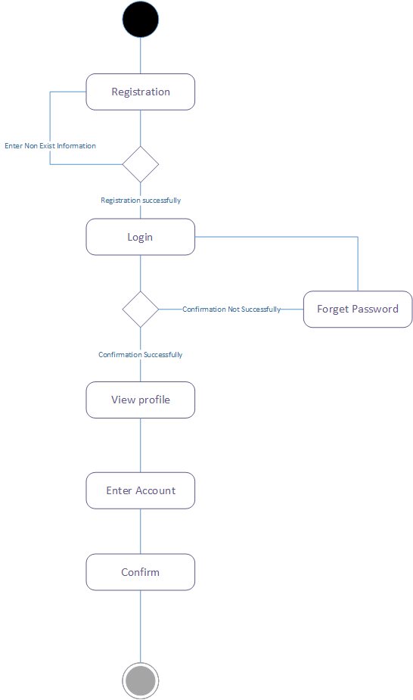

A.D 2.0
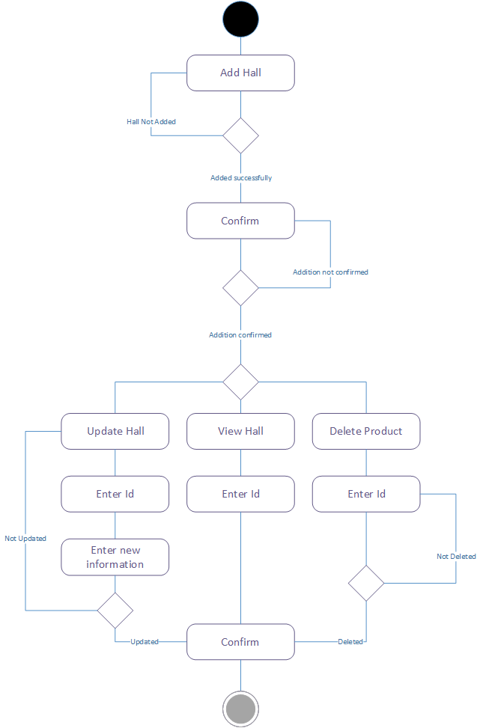

A.D 3.0
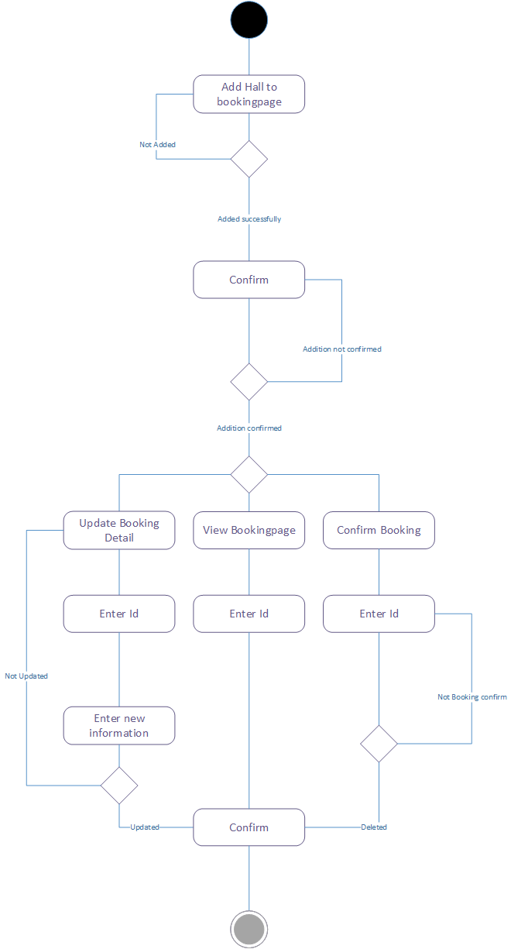

A.D 4.0
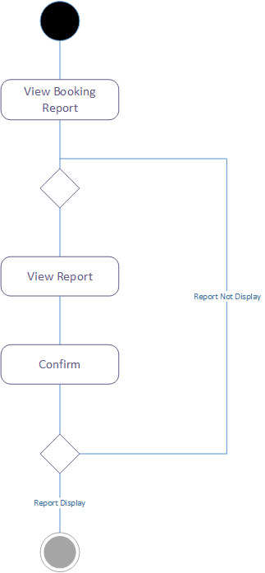

A.D 5.0
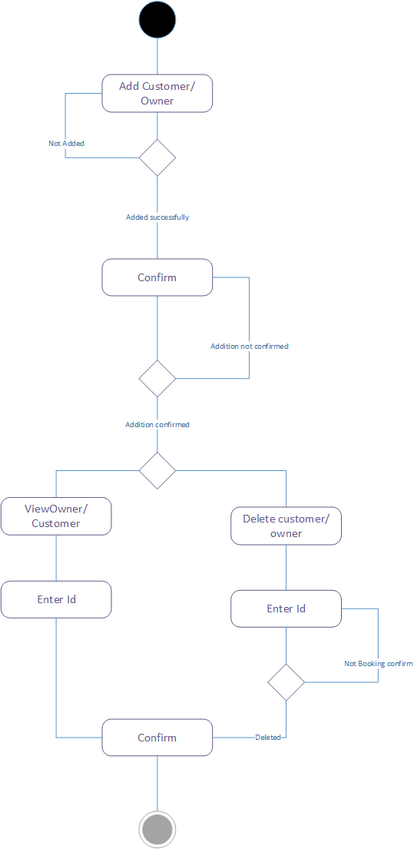

A.D 6.0
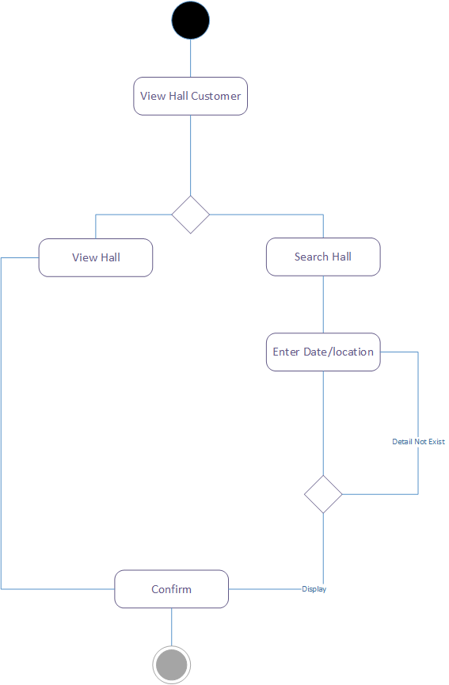

State Transition Diagram
S.D 1.0

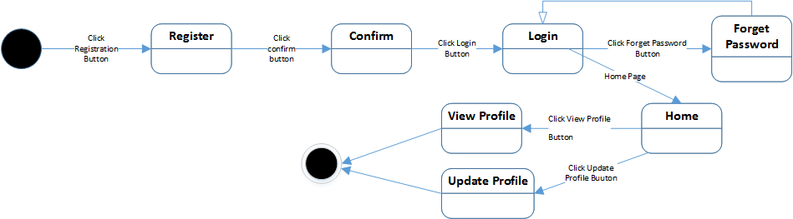
S.D 2.0

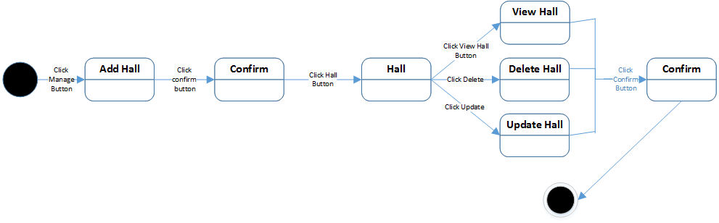
S.D 3.0

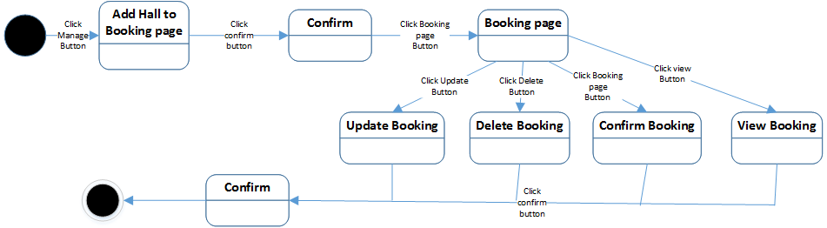

S.D 4.0
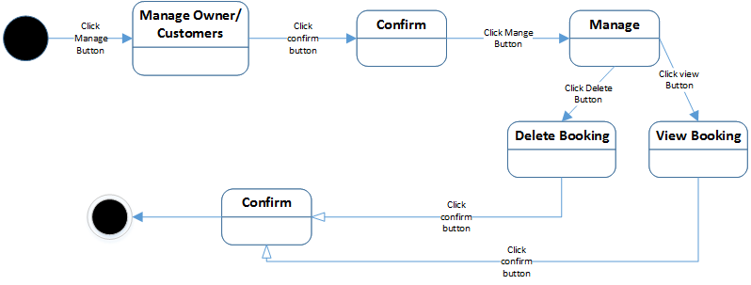

S.D 5.0

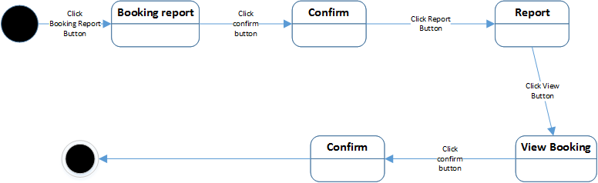

S.D 6.0

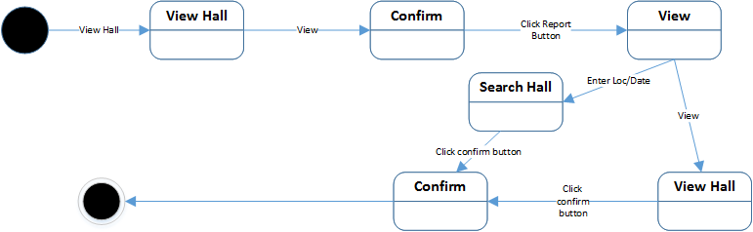

Component Diagram (Applicable in FYP2)
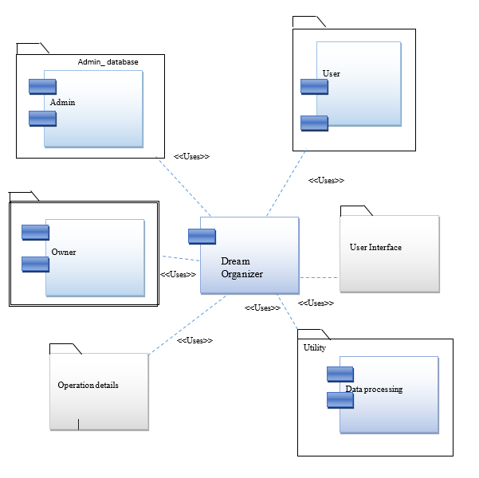

Deployment Diagram (Applicable in FYP2)
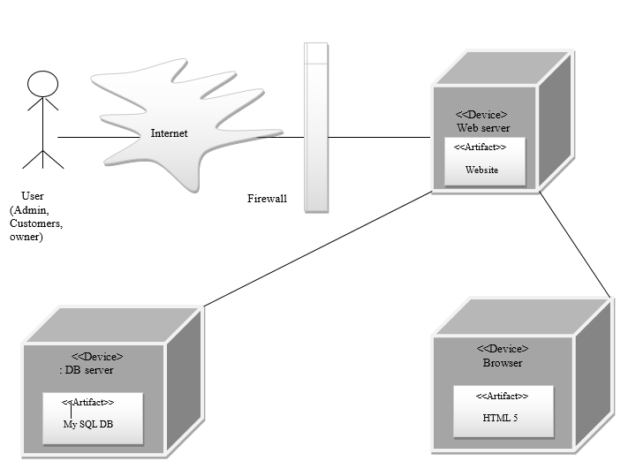

Data Flow diagram
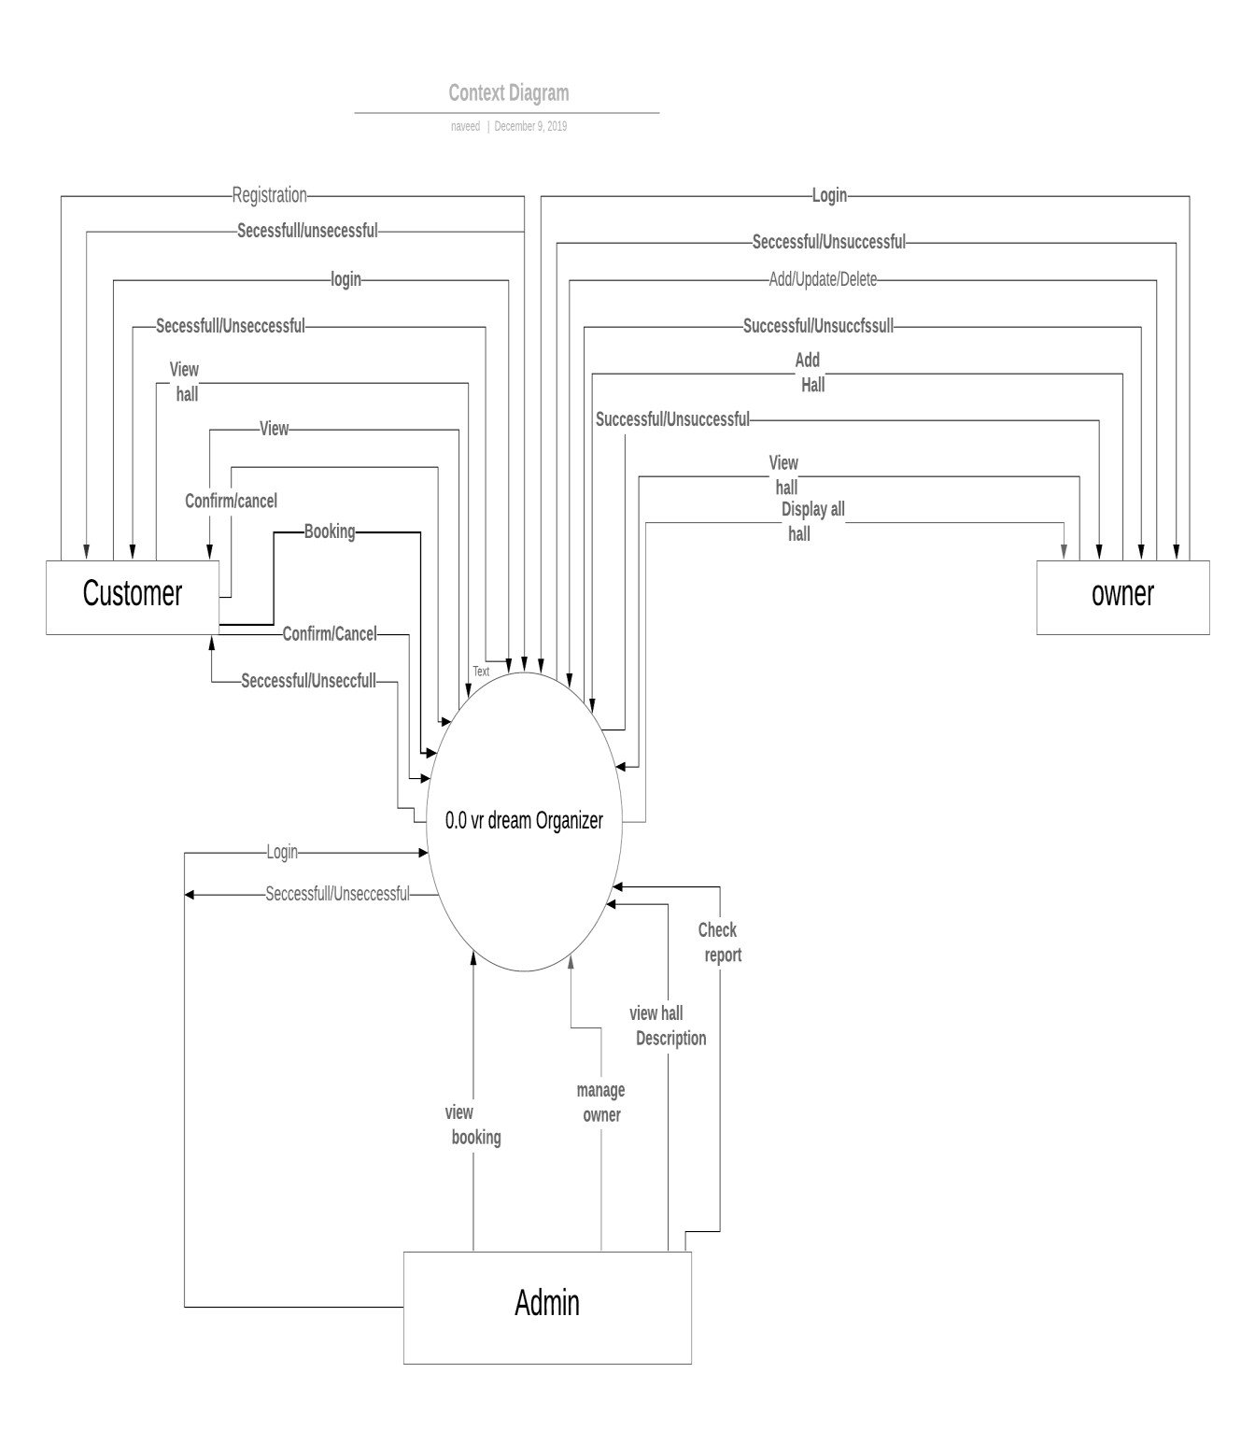

Chapter 5

Implementation

Chapter 5: Implementation
[Paragraph Text 12 pt, Calibri, 1.5 Line Spacing, Justified]
[Between 4 to 8 lines describe what is this chapter all about]

Important Flow Control/Pseudo codes
[Paragraph Text 12 pt, Calibri, 1.5 Line Spacing, Justified]

Components, Libraries, Web Services and stubs
Components
Our application is considered of two main components.
- Front end
Front-end is made user friendly and good looking by using the bootstrap (version 4.0). From homepage to contact page, we have given our project an awesome look without compromising over users’ comfort. For example, with bootstrap we have built a mobile first layout. This means that our application will be compatible in 99% of the browsers as well as various screen dimensions, resolutions and sizes.
- Back end
We have used core php for our back-end programming. As php is an open source language, there are many developments day to day in this field and we can enhance our application with the passage of time.

Deployment Environment
VR Based Dream Organizer uses cloud computing to connect users to service providers. Each venue or hall has its specific page with the reference to the owner and other related information. The user can select through various options, finalize a venue and do online booking. All of this is done by the database at our servers where the owners as well as the customers can interact.

Tools and Techniques

Languages: | Tools
HTML  CSS  PHP  MYSQL | NOTEPAD++  Adobe Dreamweaver  XAMPP  Premiere Pro CC 2015

Best Practices / Coding Standards
We have first made out a layout, a road map of the site and them by using bootstrap libraries we have constructed it a way that catches the eye of the user. After completing the front end, we made it working integrating it with PHP.

Version Control
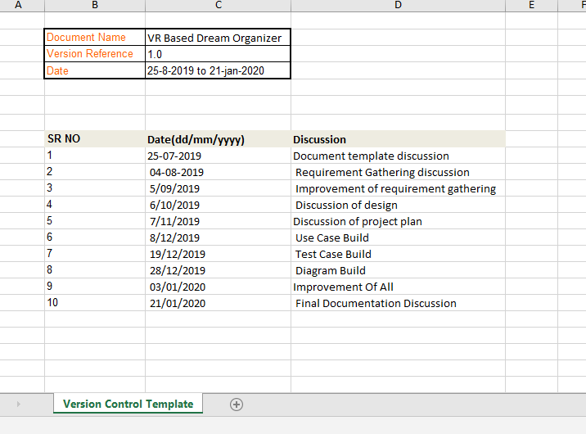

Chapter 6

Testing and Evaluation

Chapter 6: Testing and Evaluation
Designing interactive systems with graphic user interfaces is an important step in the development of online websites. Dreamevent.com booking systems have improved in the last decade and they are now widely used all over the world. However, it is important to understand online booking needs and preferences and to take them into account. In this regard, several online booking systems rely on customer preference elicitation while others suggest products based on other customers recommendations. An evaluation and testing method is utilized to obtain user feedback on how effective the system is and how easy it is to use, compared to other systems.
  - Use Case Testing
In this post we will see some high level test cases of an booking website covering general UI test cases, product buy flow test cases and product creation panel test cases.
General Test Cases
Verify that user is able to navigate through all the booking across different categories.
Verify that all the links and banners are redirecting to correct product/category pages and none of the links are broken.
Verify that all the text - product, category name, price and vendor description are clearly visible.
Verify that all the images - product and banner are clearly visible.
Verify that category pages have relevant product listed specific to the category.
Verify that correct count of total products is listed on the category pages.
Search - Verify that on searching the entire product satisfying the search criteria are visible on the search result page.
Search - Verify the more relevant product for the search term is displayed on the top for a particular search term.
Search - Verify that count of products is correctly displayed on the search result page for a particular search term.
Filtering - Verify that filtering functionality correctly filters product based on the filter applied.
Filtering - Verify that filtering works correctly on category pages.
Filtering - Verify that filtering works correctly on the search result page.
Filtering - Verify that correct count of total products is displayed after a filter is applied.
Sorting - Verify that all the sort options work correctly - correctly sort the products based on the sort option chosen.
Sorting - Verify that sorting works correctly on the category pages.
Sorting - Verify that sorting works correctly on the search result page.
Sorting - Verify that sorting works correctly on the pages containing filtered result, after applying filters.
Product Buy Flow - Test cases
Verify that on the product page, user can select the desired attribute of the product e.g. wedding event, photographer etc.
Verify that user can add to booking one or more booking.
Verify that user can add booking to wish list.
Verify that user can buy booking added signing in to the application (or as per the functionality of the website).
Verify that user can successfully buy more than one booking that were added to his/her account.
Verify that user cannot add more than available inventory of the product.
Verify that the limit to the number of booking a user can by is working correctly by displaying error message and preventing user from buying more than the limit.
Verify that the delivery can be declined of for the places where shipping is not available.
Verify that Cash on Delivery option of payment is working fine.
Verify that the different pre-paid methods of payments are working fine
Verify that product booking functionality works fine.
User (Buyer) Registration - Test cases
Verify that all the specified fields are present on the registration page.
Verify that the required/mandatory fields are marked with * against the field.
Verify that for better user interface dropdowns, radio buttons and checkboxes etc fields are displayed wherever possible instead of just textboxes.
Verify the page has both submitted and cancel/reset buttons at the end.
Verify that clicking submit button after entering all the required fields, submits the data to the server.
Verify that clicking cancel/reset button after entering all the required fields, cancels the submit request and resets all the fields.
Verify that whenever possible validation should take place at client side.
Verify that not filling the mandatory fields and clicking submit button will lead to validation error.
Verify that not filling the optional fields and clicking submit button will still send data to server without any validation error.
Check the upper limit of the textboxes.
Check validation on date and email fields (only valid dates and valid email Id’s should be allowed).
Check validation on numeric fields by entering alphabets and special characters.
Verify that leading and irregular spaces are trimmed.
Verify that entering blank spaces on mandatory fields lead to validation error.
Verify that after making a request to the server and then sending the same request again with the same unique key will lead to server side validation error.

Seller - booking creation Test cases
Verify that authenticated sellers get access to booking creation panel specific to the authorized categories.
Verify that booking creation panel is working fine for single product creation.
Verify that booking creation panel is working fine for multiple product creation.
Verify that maximum booking creation limit for seller is working fine, limiting seller to create more than the desired number of products.
Verify panel validation for checking mandatory fields.
Verify that duplicate product creation is restricted through panel.
Verify that seller can update information and booking of existing products.
Verify that product created by seller get visible on the website after certain period of time.
Verify that updating made by seller get visible on the website after certain period of time.
  - Equivalence Partitioning
Equivalence Partitioning = Equivalence Class Partitioning = ECP
In this technique, only one condition to be tested from each partition. Because we assume that, all the conditions in one partition behave in the same manner by the software. In a partition, if one condition works other will definitely work. Likewise we assume that, if one of the conditions does not work then any of the conditions in that partition will work. Equivalence partitioning is a testing technique where input values set into classes for testing.
- Valid Input Class = Keeps all valid inputs.
- Invalid Input Class = Keeps all Invalid inputs.
- A text field permits only numeric characters.
- Length must be 6-10 characters long.
Partition according to the requirement should be like this:
While evaluating Equivalence partitioning, values in all partitions are equivalent that’s why 0-5 are equivalent, 6 – 10 are equivalent and 11- 14 are equivalent.

  - Boundary value Analysis
Both valid boundary partition and invalid boundary partition
Another Case:
Test cases for the website whose input box accepts numbers between 1-1000 Valid range 1-1000, Invalid range 0 and Invalid range 1001 or more

Like this:
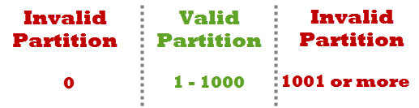

Write Test Cases for Valid partition value, Invalid partition value and exact boundary value.
- Test Cases 1: Consider test data exactly as the input boundaries of input domain i.e.
- Values 1 and 1000. Test Cases 2: Consider test data with values just below the extreme edges of input.
- Domains i.e. values 0 and 999. Test Cases 3: Consider test data with values just above the extreme edges of input.
- Domain i.e. values 2 and 1001. Over to you on Boundary Value Analysis and Equivalence Class.
  - Unit Testing
Using Unit testing frameworks we write unit tests quickly and easily. Most of the programming languages do not support unit testing with the inbuilt compiler. Third party open source and commercial tools can be used to make unit testing even more fun.

List of popular Unit Testing Tools for different programming languages:
Java framework – JUnit
PHP framework – PHPUnit
C++ frameworks – UnitTest++ and Google C++
NET framework – NUnit
Python framework – py.test

  - Integration Testing
We feel that Integration testing is complex and requires some development and logical skill. That’s true! Then what is the purpose of integrating this testing into our website testing strategy?
- In the real world, when website of online booking (Dreameventorg.com) is developed, it is broken down into smaller modules and individual developers are assigned 1 module. The logic implemented by one developer is quite different than another developer, so it becomes important to check whether the logic implemented by a developer is as per the expectations and depiction the correct value in accordance with the set standards.
- Many a time the face or the structure of data changes when it travels from one module to another. Some values are appended or removed, which causes issues in the later modules.
- Modules also interact with some third party tools or APIs which also need to be tested that the data accepted by that API / tool is correct and that the response generated is also as expected.
- A very common problem in testing frequent requirement change. Many a time developer deploys the changes without unit testing it. Integration testing becomes important at that time
Here we should understand that Integration testing does not happen at the end of the cycle, rather it is conducted simultaneously with the development. So in most of the times, all the modules are not actually available to test and here is what the challenge comes to test something which does not exist!
The main function or goal of this testing is to test the interfaces between the units/modules.

  - Performance Testing
The purpose of this document is to define/explain how Performance Testing will be performed on the online booking website (Dreameventorg.com) for the current and future state.
Dreameventorg.com is an booking website. This website will be used to fulfill customer requirements.
Dreameventorg.com an website that will have its own stores and perform online booking process and will perform basic functionality of online booking but will have some new features like any brand if they want to open their on this website they can open but they will be strictly announced to have order delivering facilities on their own behalf. So this thing will bring easiness for customer to get their order from desired brand by nearby shop within one day. And if customer wants to order a booking which belongs to other region.
It is being assumed that the Performance environment data will be a copy of the production data and the required Test data will be provided by the project team.

  - Stress Testing
Stressing anything beyond a point results in serious consequences in humans, machine or program it either causes serious damages or breaks it completely.
Similarly, in this tutorial, we will learn how to stress test web applications along with its effect.
In order to avoid any permanent damage to your apps or websites when they are stressed i.e. heavily loaded, we need to find the breaking point and in turn the solution to avoid such conditions. Just think how it would be when your booking website goes down during Christmas sale.
Enlisted below are some Examples of real cases where it is of high importance to stress test an app or website:
- Commercial booking apps or websites need to perform stress testing as the load becomes very high during festivals, sale or special offer period.
- Financial apps or websites need to perform stress test as the load increases at times like when a company share goes up, a lot of people log in to their accounts to buy or sell, online booking websites redirect ‘Net-bankers’ for payment etc.
- Web or emailing apps need to be stress tested.
- Social networking websites or apps, blogs etc., need to be stress tested etc.

Chapter 7
Summary, Conclusion & Future Enhancement

Chapter 7: Summary, Conclusion & Future Enhancement

  - Project Summary
Dreameventorg.com is an Booking website that will have its own vendors. It will service online booking process and will perform basic functionality of online booking. It will have some new features like any brand if they want to open their book on this website they can open. They will be strictly announced to have order delivering facilities on their own behalf. So this thing will bring easiness for customer to get their order from desired brand by nearby shop within one day. If customer wants to order which belongs to other region of his city then he will wait for one day to receive his order by using msg. These are some common thing in this website but what’s new here is “booking cost will be charged from distance of customer and event”. Website will use customer location and shop location while ordering the product. Customer will be notifying with calculated distance form booking cost according this order.

  - Achievements and Improvement
There’s more competition than ever online as you try to boooking. Customers are looking for more than just a utilitarian booking site, they want an experience. How can you tempt them away from the big companies and over to you?

- Identify your own brand’s personality
Booking on a big box store’s website, you feel that there’s no sense of personality or anything that makes what’s on offer unique. You’re a smaller store, but you can show them exactly how it’s done. Identify what it is about you that make you special. What speaks to your customers? Incorporate that into everything you do on your site.
For example, the Man Crates brand sends out ‘manly’ themed crates of goods. On their help page, there’s a graphic that features a fist holding a crowbar, with a caption that reads ‘try harder.’ It fits their brand’s personality perfectly.
- Proofread all your website content
Every single word of a copy on your website needs to be proofread. That’s because your customers are paying attention, and they want to know if your site can be trusted. Spelling mistakes and errors are often the signs of a less than legitimate business, so they’ll know to steer clear.
If you want a professional to proofread the content for you, get in touch with the staff at UK Writings.
- Improve your emails
Think about how you communicate with your customers. You want your emails to be upbeat and friendly, encouraging the customer to return while giving them important information about their order. Rewrite your automated emails to fit this objective.
- Have product reviews written for you
Customers trust product reviews, as they’re unvarnished descriptions of how the product actually works. If you have them on your site, you’re much more likely to get people buying that product from you.
If you’re just starting out though, it can be hard to get product reviews as you’ve only sold a few units. That’s where professional writing services come in. Companies such as Boom Essays and Essayroo have professional writers on staff that can create genuine, personal reviews of your products, which you can then paste onto your site.
- Be genuine
When you book in real life, you feel more comfortable with stores whose employees are honestly happy to see you. The same goes for online . Those with a friendly attitude are seen to be more genuine, and customers are much more likely to shop with them. Keep that in mind when writing your copy.
- Check and improve your grammar
While speaking about the quality of your copy, check the grammar of your website at the moment. If it isn’t up to scratch, it can cause problems as customers may not be able to understand what you’re saying to them. If they can’t, you can wave goodbye to many potential sales.
- Use recommendation engines
There are many online stores that use this technique to great effect. Based on what the customer is browsing, the engine will give them recommendations for what to buy next. Show the customer that you’re paying attention to what they might want or need.
- Appeal to the buyer’s emotions
The best website copy isn’t just a bland description of what the product does, but what it can do for the customer. Tell them what it will do, how it can make their life better. Appeal to heart rather than the head, and you’ll get many more sales.
- Use the ‘customer service tone’
Online, you want to replicate how employees may speak to you in a store. That means you must try and adopt a friendly, yet direct tone of writing. Tell your customers ‘you’re all set!’ when they complete an order, and be honest in thanking them when they buy from you. That tone is much better than the standard web copy you see on many stores.
- Be enthusiastic about what you’re selling
Overall, you need to be enthusiastic about what you’re selling. Show the customer that you really care about what you’re offering. If you care about what you do, that enthusiasm will shine through and rub off on your customers.
There are the ten tips you need to keep in mind when you want to optimize the online customer experience. Show them why they should shop with you. Soon they won’t go anywhere else.

  - Critical Review
In the history of management science, no topic has been the object of more academic research over such a short time than the Internet. This technology has provided a new interface linking businesses as well as individuals, and spanning many fields, from information systems to marketing, worldwide.
With the proliferation of websites (one hundred fold growth in ten years), academic and empirical research has sought to evaluate the features of booking websites most likely to maximize Internet technology adoption, to attract Internet users, turn them into cyber buyers, encourage customer loyalty, improve service and ultimately increase profits. However, there has been great diversity in the research, with different skills involved (information technology, marketing, communication, etc.), as well as a wide range of websites being analyzed.
The Internet is a field of research that is still evolving, with businesses and customers learning together, and little is known about how to develop commercial websites to maximize profit.

  - Lesson learnt
The main lesson that we have learnt during developing this project was how to give importance to time, how to work hard and how to face all problems created by other people.

  - Future enhancement and recommendations

We covered at least all aspects of booking website but we are looking to add some new features in future like open booking in all over the Pakistan instead of registering. We are also looking to add events on this sites let suppose if someone gets 1000 orders from customers then this vendor will be shown as trending.

Appendices

Appendix A: Information / Promotional Material
[Paragraph Text 12 pt, Calibri, 1.5 Line Spacing, Justified]
[Between 4 to 8 lines describe what is this appendix all about]

  - Broacher

  - Flyer

  - Standee

  - Banner

  - First Level heading [16 pt, Calibri, Bold, Left aligned]
[Paragraph Text 12 pt, Calibri, 1.5 Line Spacing, Justified]

    - Second level heading [14 pt, Calibri, Bold, Left aligned]
[Paragraph Text 12 pt, Calibri, 1.5 Line Spacing, Justified]

      - Third level heading [12 pt, Calibri, Bold, Left aligned]
[Paragraph Text 12 pt, Calibri, 1.5 Line Spacing, Justified]

Appendix [no.]: Appendix Title
[Paragraph Text 12 pt, Calibri, 1.5 Line Spacing, Justified]
[Between 4 to 8 lines describe what is this chapter all about]

  - First Level heading [16 pt, Calibri, Bold, Left aligned]
[Paragraph Text 12 pt, Calibri, 1.5 Line Spacing, Justified]

    - Second level heading [14 pt, Calibri, Bold, Left aligned]
[Paragraph Text 12 pt, Calibri, 1.5 Line Spacing, Justified]

      - Third level heading [12 pt, Calibri, Bold, Left aligned]
[Paragraph Text 12 pt, Calibri, 1.5 Line Spacing, Justified]

Reference and Bibliography

Reference and Bibliography

[1] M. Sher, M. Rehman, “Title of the Paper” Conference name/Journal Name, Edition, Volume, Issue, ISBN/ISSN, PP, Publisher/City-Country, Year.
[2] ……

Index

Index

[A]

[B]

[C]

