Fit-Superior
Final Year Project
Session 2019-2021
Project ID MCSM-S19-
A project submitted in partial fulfillment of the degree of
Master in Computer Science (MCS)


Department of Information Technology faculty of Computer Science & Information Technology
The Superior University, Lahore
PROJECT REPORT

[SU Blood Donor MS]

Project ID: [ ]
Project Team
Sr. No | Reg. | Student Name | Email ID | *Signature
(i) | MCSM-S19=012 | AMIR SHAHZAD | Mcsm-s19-012@superior.edu.pk
(ii) | MCSM-S19-043 | FARHANA RASHEED | Mcsm-s19-043@superior.edu.pk
(iii) | MCSM-F18-027 | ABDUR REHMAN | Mcsm-f18-027@superior.edu.pk

*The candidates confirm that has the work submitted id their own and appropriate credit has been given where reference made to work of others
Plagiarism Free Certificate
This is to certify that, I Amir Shahzad S/D of Ghulam Qadir, group leader of FYP under registration no MCSM-S19-012at Computer Science Department, The Superior College, Lahore. I declare that my FYP HEC. Report is attached herewith as Appendix D.

Date: 28-05-2021 Name of group Leader: Amir Shahzad Signature: _________________

Name of Supervisor: Mr. Rohail Shehzad
Designation: Lecturer
Signature: _________________
HOD:
Signature: _________________

Project Report
SUBDMS: (Superior University Blood Donor MS)

Change Record
Author(s) | Version | Date | Notes | Supervisor’s Signature
Amir, Farhana, Abdul Rehman | 1.0 | 12-10-2020 | <Original Draft>
Amir, Farhana ,Abdul Rehman | 1.1 | 02-01-2021 | <Changes Based on Feedback from Supervisor>
Amir, Farhana ,Abdul Rehman | 1.2 | 03-02-2021 | <Changes Based on Feedback From Faculty>
Amir, Farhana ,Abdul Rehman | 1.3 | 12-05-2021 | <Added Project Plan>
Amir, Farhana ,Abdul Rehman | 1.4 | 05-06-2021 | <Changes Based on Feedback from Supervisor>

APPROVAL
Project Supervisor
Comments: ___________________________________________________________________
_____________________________________________________________________________
Name: Rohail Shehzad
Date:_______________________________ | Signature:_____________________________

Project Manager
Comments: ___________________________________________________________________
_____________________________________________________________________________
Date:_______________________________ | Signature:__________________________

Head of the Department
Comments: ___________________________________________________________________
_____________________________________________________________________________
Date:_______________________________ | Signature:__________________________

Acknowledgements

Many people have provided their contributions towards successful completion of this study and we would like to express our gratitude to them without forgetting the Almighty God for directing my life.
We would like to express to special thanks of gratitude to our supervisor MR Rohail Shehzad who gave us the opportunity to do this project. We are also thankful to our parents and friends who helped us. We are not making this project just for sake of marks but to also increase our knowledge.

Executive Summary
The system that is going to be developed is SU Blood Bank Management System (BBMS). This is a android database application system that is to be used by the blood banks or blood centers as a means to advertise the nationwide blood donation events to the public and at the same time allow the public to make online reservation and request for the blood. The system keeps the record of all the donors, recipients, blood donation programs, rejected bloods. For internal works and activities intranet is used and for interaction with public internet is used. Base on the android development which using java, for front end work XML, database.
The system provides security features through username-password matching where only authorized user can access the system with different authorization level. The blood bank staffs can manage the blood stock starting from the blood collection, to blood screening, processing, storage, transference and transfusion through this system.
The persons who like to donate blood registers in my app as well as he can modify the details if necessary, giving the Login Id and Password. The persons in need of blood searches for the persons having the same blood group and within the city. If he found a donor in his city then he gets the total details of the donor, if he doesn’t find any donor then he is given the contact numbers and addresses of the Life Saving Contact Persons for major cities.

Table of Contents
Dedication iv
Acknowledgements v
Executive Summary vi
Table of Contents vii
List of Figures ix
List of Tables x
Chapter 1 1
Introduction 1
1.1. Background 2
1.2. Motivations and Challenges 2
1.3. Goals and Objectives 2
1.4. Literature Review/Existing Solutions 2
1.5. Gap Analysis 2
1.6. Proposed Solution 2
1.7. Project Plan 3
1.7.1. Work Breakdown Structure 3
1.7.2. Roles & Responsibility Matrix 3
1.7.3. Gantt Chart 3
1.8. Report Outline 3
Chapter 2 4
Software Requirement Specifications 4
2.1. Introduction 5
2.1.1. Purpose 5
2.1.2. Document Conventions 5
2.1.3. Intended Audience and Reading Suggestions 5
2.1.4. Product Scope 5
2.1.5. References 6
2.2. Overall Description 6
2.2.1. Product Perspective 6
2.2.2. Product Functions 6
2.2.3. User Classes and Characteristics 6
2.2.4. Operating Environment 7
2.2.5. Design and Implementation Constraints 7
2.2.6. User Documentation 7
2.2.7. Assumptions and Dependencies 7
2.3. External Interface Requirements 8
2.3.1. User Interfaces 8
2.3.2. Hardware Interfaces 8
2.3.3. Software Interfaces 8
2.3.4. Communications Interfaces 9
2.4. System Features 9
2.4.1. System Feature 1 9
2.4.1.1. Description and Priority 9
2.4.1.2. Stimulus/Response Sequences 9
2.4.1.3. Functional Requirements 9
2.4.2. System Feature 2 10
2.4.2.1. Description and Priority 10
2.4.2.2. Stimulus/Response Sequences 10
2.4.2.3. Functional Requirements 10
2.4.3. System Feature 3 (and so on) 11
2.5. Other Nonfunctional Requirements 11
2.5.1. Performance Requirements 11
2.5.2. Safety Requirements 11
2.5.3. Security Requirements 12
2.5.4. Software Quality Attributes 12
2.5.5. Business Rules 12
2.6. Other Requirements 12
Chapter 3 13
Use Case Analysis 13
3.1. Use Case Model 14
3.2. Use Case Descriptions 14
Chapter 4 15
System Design 15
4.1. Architecture Diagram 16
4.2. Domain Model 16
4.3. Entity Relationship Diagram with data dictionary 16
4.4. Class Diagram 17
4.5. Sequence / Collaboration Diagram 17
4.6. Operation contracts 17
4.7. Activity Diagram 18
4.8. State Transition Diagram 18
4.9. Component Diagram 18
4.10. Deployment Diagram 19
4.11. Data Flow diagram [only if structured approach is used - Level 0 and 1] 19
Chapter 5 20
Implementation 20
5.1. Important Flow Control/Pseudo codes 21
5.2. Components, Libraries, Web Services and stubs 21
5.3. Deployment Environment 21
5.4. Tools and Techniques 22
5.5. Best Practices / Coding Standards 22
5.6. Version Control 22
Chapter 6 23
Testing and Evaluation 23
6.1. Use Case Testing 24
6.2. Equivalence partitioning 24
6.3. Boundary value analysis 24
6.4. Data flow testing 24
6.5. Unit testing 25
6.6. Integration testing 25
6.7. Performance testing 25
6.8. Stress Testing 25
Chapter 7 26
Summary, Conclusion and Future Enhancements 26
7.1. Project Summary 27
7.2. Achievements and Improvements 27
7.3. Critical Review 27
7.4. Lessons Learnt 27
7.5. Future Enhancements/Recommendations 28
Appendices 29
Appendix A: User Manual 30
Appendix B: Administrator Manual 31
Appendix C: Information / Promotional Material 32
Reference and Bibliography 35
Index 37

List of Figures
1.1 Caption of first figure of first chapter 6
1.2 Caption of second figure of first chapter 7
2.1 Caption of first figure of second chapter 14
2.2 Caption of second figure of second chapter 22
2.3 Caption of third figure of second chapter 26
5.1 Caption of first figure of fifth chapter 49
5.2 Caption of second figure of fifth chapter 49

List of Tables

1.1 label of first table of first chapter 6
1.2 label of second table of first chapter 7
2.1 label of first table of second chapter 14
2.2 label of second table of second chapter 22
2.3 label of third table of second chapter 26
5.1 label of first table of fifth chapter 49
5.2 label of second table of fifth chapter 49

Chapter 1

Introduction
The blood is the specialized bodily fluid that delivers necessary substances to the body's cells, such as nutrients and oxygen. Blood banking is a cache or bank of blood or blood components, gathered as a result of blood donation, stored and preserved for later use in blood transfusions. In addition to this, the blood type of patients also needs to be determined for compatibility sake for a blood transfusion. It is possible in some situations that the patient is unable to get the required amount of blood at the right time due to a lack of interrelationship in the form of a networked database among the blood banks, which leads to a lack of knowledge of updated record of all blood donors.
Today mobile and mobile-based applications have become this part of our day to day life. The revolution in mobile computing and many functions in the blood app the field and the mobiles got smaller, faster, and reliable as the decades passed. This Android application is developed to easily search for blood in nearby areas for emergencies. In this Android app, one will get clear access to blood in the real-time and right place.

Background
Blood transfusion is an essential component of the health care system of every country and patients who require blood transfusion service as part of the clinical management of their condition have the right to expect that sufficient and safe blood will be available to meet their needs. However, this is not always the case, especially in developing countries. To recruit and retain adequate regular voluntary non-remunerated blood donors the motivators and barriers of donors must be understood. Equally important to this goal is the knowledge of blood donors.

Motivations and Challenges
Some of the threats and challenges that you will however be facing whilst starting your blood bank center are; security requirements, accreditations, laboratory and storage equipment as well as the and state regulations if you are looking to run a private blood bank center.
The retention of previous donors and the recruitment of new donors is a serious challenge for many blood donation services in their effort to prevent blood shortages. More and more services make use of some sort of donation incentives. However, the use of (material) incentives to motivate blood donors is fiercely controversial, and there is a longstanding (ethical) debate about whether it should be allowed that donors receive material rewards. Interestingly, this debate is dealt with in almost complete absence of systematic empirical evidence on the effectiveness of material incentives in encouraging people to donate. In this article, we argue that the discussion on what is ethical in motivating blood donors should be enriched with empirical evidence based on field experiments. We confront the Titus controversy with recent results from an experiment administering lottery tickets as a motivation device. Moreover, we take up a neglected phenomenon in the study of blood donors: many no donors are not principally against donating blood; they have just never made up their mind about becoming active blood donors. We propose active decisions as a mechanism to transform latent prosaically preferences into actual prosaically behavior.

Goals and Objectives
The goals and objectives of the SU Blood Bank Management System are as follows:
- To provide a means for the blood bank to publicize and advertise blood donation programs.
2. To allow the probable recipients to make search and match the volunteer donors, and make request for the blood.
3. To provide an efficient donor and blood stock management functions to the blood bank by recording the donor and blood details.
4. To improve the efficiency of blood stock management by alerting the blood bank staffs when the blood quantity is below it par level or when the blood stock has expired.
5. To provide synchronized and centralized donor and blood stock database.
6. To provide immediate storage and retrieval of data and information.

Literature Review/Existing Solutions
The system we present here is adequate for searching blood donors for available blood and thereby saving valuable time and money. This application provides necessary options to serve people on their emergency need making them free from worrying for blood by providing lot of donors at a single click.
Blood Management Android Application is a mobile-based application. This application is to create an e-Information about the Receiver and organization that are related to donating the blood. This software help to register all the donors, Blood collection details, blood issued details etc. When registration is completed, then the user no need to login it will open automatically on home page. They can modify their account information by updating username, mobile number, and blood group and contact details. A user is able to send blood request from the home page. This application provides track facilities to hospital, fire station, police station and ambulance using Google map API. It will make easier to find and contact with donors when needed. There is add on facility of emergency calling available as an option. Interface with grouping and testing machine provides user-friendly communication. This application sends blood request to nearest hospital for reminding location and contact number. Donor can used this application through android-based mobile phone.

Gap Analysis
The following is a concise gap analysis of our application.
Current State: Basic structure of our application is very well done. We have structured it in an easy to use manner for the user.
Future State: we then plan to put real data by entering real time halls in our database. As the application is launched, we will keep on expanding it by including more areas, users and vendors.
Gap Description: The gap only remains in temporary data and real time sate. We have only imaginary data but not factual information. Official data shall be required before launching the
Application.
Bridging The Gap: This gap will be bridge by meeting various venue hall owners in person and inviting them to join our platform. Initially we will offer our service for free and as the traffic generates and the vendor feel satisfied with our services, we may then apply service fee. After the initial bridging, our customers and clients will follow along online and we may not need to meet them physically.

Proposed Solution
The purpose of the SU blood bank management system is to simplify and automate the process of searching for blood in case of emergency and maintain the records of blood donors, recipients, blood donation programs and blood stocks in the bank. The application needs to be downloaded. After downloading the application, the registration form will appear. Basic, detailed information such as name, address, contact person, blood type, emergency contact, etc. is required for registration. If the person is already registered, they need to sign in. If he forgets his password, he can click on the "Forgot Password" button, which will send an SMS with the username and password to the registration number.
The user gets various options on screen:
• Blood banks
• Need Blood
• Search donors
• Organize blood camp
• Search nearby Hospital
• Requirement for blood
• Request for blood
• Speed dial
• Profile update

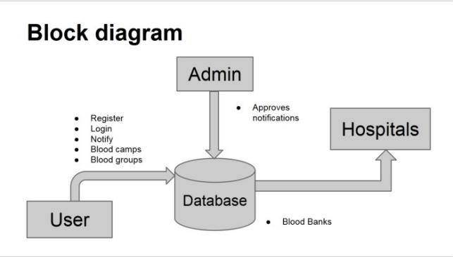

Users can search for blood banks and need blood. They can view other people who have registered, and they can search for donors by location or type. He can organize blood storage by providing the location and date of the event. This information is added to the blood storage. Using GPS, "Find nearby Places" can search for nearby hospitals and provide directions to the hospital. The user can also request the required blood by providing a short description. Registered users are notified of this publication request. Information about the request will be added to the "Blood Request" option. Users can also check various first-aid details. He can update his personal information.

Project Plan
Every person wants to make time special for special moments. Our project SU Blood Manage work very moments, we are working on Blood donor application because, it’s real problem in daily life every time and every person of the world. In daily basis, blood need every person in the world blood required every OTP or hospital and lab or any delivery time man, women, etc. Our application work on searching blood, save data to easy access on new Donor Blood group, donor ID, Donor address and city etc. We are work to more efficient working in the ………
This is an android based project which will play an important role in saving the lives of human beings and which is also its main aim developed an android application will include all the relevant features to provide a means of communication between blood seekers, blood donors & blood banks. This will help the users in such a way that users can locate different volunteer blood donors and blood banks in their locality through GPS and then request for the blood in case of emergency. The users will be able to view information about different blood banks along with the blood available in their repository, the information of the registers users who need blood in case of emergency and the blood donors who wish to donate blood when required. All the personal information about blood donors will be kept at the backend database. A complete document about the software will be given to the blood bank administration in order to future maintenance of the system. A user manual will be provided to the system administrator with some simple explanations about the system and its features. A simple webpage will be designed for online registration & user guidance & when the donor submits his/her details through the internet simple guidance will also be given to the donor.

- Donor Registration
- Blood Login
- Blood Donor
- Equipment’s
- Stick
- Blood Recipient
- Blood collection
- Camp
- Stock details
- Blood issued

Work Breakdown Structure
Work breakdown structure (WBS) in project management is a method for completing a complex, multi-step project. Breaking it down into smaller chunks means work can be done simultaneously by different team members, leading to better team productivity and easier project management.

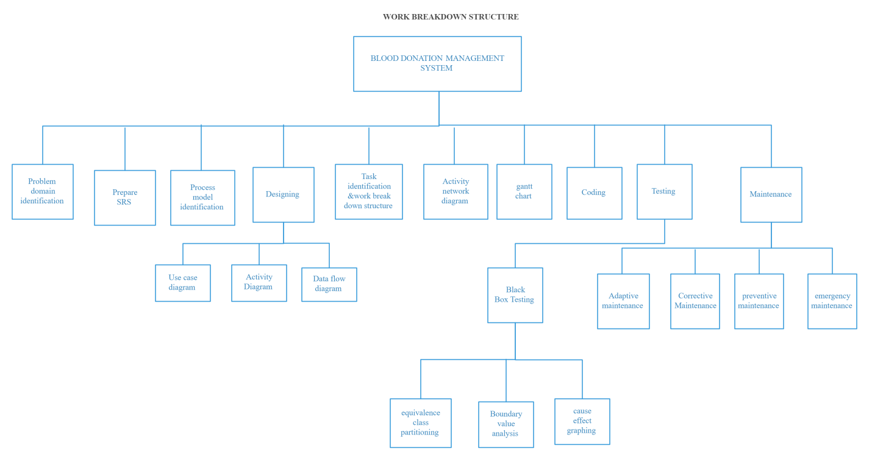

Roles & Responsibility Matrix

Roles | Name | Responsibility | Stage exist function
QA manager | Amir Shahzad | Management of SQA Function | Approved
Owner of the UO Blood Center | Abdul Rehman | Help to define product quality expectations. Also represent user | Approved
QA consultant | Farhana Rasheed | Audit the project and approved it with the perspective of QA. | Approved
Project Manager | M Rohail Shahzad | Approve project for implementation | Approved

Gantt chart

 | NOV | DEC |  | JANUARY | FEBRARY |  | MARCH |  | APRIL |  | MAY | JUNE
Requirement
Design
Code testing
Integration
User Manual
Report
Testing

 | NOV |  | DEC |  | JAN |  | FEB |  | MAR |  | APR |  |  | MAY |  | JUN
Requirement
Design
Code testing
Integration
User Manual
Report
Testing

Report Outline
The system is able to generate pre-defined reports such as the list of donors, recipients, staffs, the blood quantity in the bank and charts.
Chapter 2: Software Requirement Specifications

Introduction
The Blood Bank Android Project is one of the great technical life saver application. The main aim of this application is to reduce the time spent in searching of blood donors in case of emergency. This system will keep track of all the latest updates relevant to the people who donate blood and who had donated blood in case of emergency.
This Blood Bank Android Project system will specify all the details related to the donor such as their name, their address, their mobile number, their blood group and so on. The one who need blood, just have to login into the system which will hardly take few seconds and then the one who needs the blood get access to all the available group of bloods in nearby blood banks as well as details of those who can donate blood in urgent.

Purpose
The proposed Blood Bank Android Project system will help the needy person, access to all the donors of the blood of the particular group, nearby to their place, in a minutes of time. The details will include the name of the donor, his/her blood group, contact number and address.

Document Conventions
The format for headings is as followed:
- Major headings are in bold 18pt font,
- Concurrent headings in bold 14pt font.

Intended Audience and Reading Suggestions
Anybody can use this blood bank management system to donor as well as who need blood e.g., Public, Hospitals, Blood Banks, etc.

Product Scope
The system is used for maintaining all the process and activities of blood bank management system. The system can be extended to be used for maintaining records of hospital, organ donation and other similar sectors.
While developing the system, there shall be space for further modification. There shall be a proper documentation so that further enhancement becomes easy. As a whole the system is focused to work with blood bank management system and on additional modification it can be also used as management systems of similar organizations.
- Stakeholders
- System Owner: The Blood Bank
2) System Users:
• Administrators: has full privilege on the system's functions
Staffs of Blood Bank: has privilege on the system's functions as assigned by the administrator
• Public: can view the blood donation events and donate or can make requests for donation (Donor and Recipients fall under this category)
B) Data
- Data about Donor and recipients
- Donor/ Recipient Id
- Name
- Sex
- Blood Group
- Address
- Contact Number
- Email Address
- Diseases (if any)
- Blood Id
- Event Id
2. Donation program ➢
- Organizer
- Event Id
- Date of Donation
- Venue
- Volunteers

3. Blood
- Blood Id
- Blood Group
- Date of collection
- Expiry date
4. Staff
- Staff Id
- Name
- User Name
- Password

Overall Description

Product Perspective
- To provide a means for the blood bank to publicize and advertise blood donation programs.
- To provide an efficient donor and blood stock management functions to the blood bank by recording the donor and blood details
- To improve the efficiency of blood stock management by alerting the blood bank staffs when the blood quantity is below it par level or when the blood stock has expired
- To provide pure blood with no wastages blood is been collected in different types of packs. They are double, triple, and triple (AS), quadruple pack.
- To provide synchronized and centralized donor and blood stock database.
- To provide immediate storage and retrieval of data and information

Product Functions

Class Of Use Cases | Use Cases | Descriptions
Use case related to system authorization of system administrator. | 1. Login of admin.  2. Change password of admin. | 1. Login admin into the system.  2. Change login password of the admin system.
Use case related to registration of donor. | 1. Register the donor by himself.  Change personal, contact details by system admin. | Store personal Contact, Medical detail of donor.  2. Change personal and contact details of donors.
Use related to the change registration details of donor. | 1. Change personal, Contact detail by the donor himself.  2. Change personal, contact details by system admin. | 1. Change personal and contact details of donors.  2. Change personal and contact details of donors.
Use cases related to withdraw names from the donor list. | 1. Withdraw reg. details by the donor.  2. Withdraw reg. details by the admin. | 1. Delete all details of an exact donors by themselves. 2. Delete all details of an exact donors by the system admin.
Use cases related to inform blood donation details. | Send blood donation details to the relevant donors. | Inform the requirement of the blood group to donors who has same blood group.

User Classes and Characteristics
- System Owner: The Blood Bank
- System User:
Administrators: has full privilege on the system’s function
Public: Can view the blood donation events and donate are can make requests for donation (Donor and recipients fall under the category).

Operating Environment
- Operating System :
- Intel 4 1.5GHz or above
- 512MB Ram
- Minimum 8 GB HDD

Design and Implementation Constraints
Who uses internet connection will be guided through small and clear descriptions. Every donor may get user name and a password in order to log into the will authenticate the accuracy of the
Donor’s mobile numbers through counting the numbers of characters in the entered mobile number system uses the donor registration number and the identity card number to identify each donor separately. Inside the system the administrator has more advance function than the donor. The hospital doctor is not a user of the system. But the doctor connects to the system in a different manner. The doctor mainly has the connection with the system admin.

Assumptions and Dependencies
- The researchers assume the following assumptions:
- Internet connectivity is needed for the online blood management system. Internet speed may affect the perception of the systems users with regards to the system effectiveness and efficiency.
- Blood transfusion should be performed by medical or professional doctors only. The over-all safety depends on the success of the medical operation.
- There are:
- Every donor has a mobile phone.
- The system doesn’t keep the details of the gathering stock of blood.
- The system database will be accessible in real time.
- The donor doesn’t submit any fake reports to his system.
- The donors who want to contribute to a donation will definitely reply to the request of system.
- A doctor or a patient can request for an exact blood group. But the request comes through blood bank authorities to the system admin. Therefore, doctor, patient are not directs users of the system.

External Interface Requirements
- The system provides some advance features to the system admin than the donor. If the system admin logs in, the system interface provides some main command buttons to the admin.
- Change login password.
- Edit donor profile details.
- Search donors for an exact blood group and send messages.
- Update the database.
- Send blood testing details.
- Search details from the database.

If the donors log in, the system will provide another different interface with different commands.

Change login passwords.
- Edit personal, contact details
- Details related to contributions to donations.
- Future blood donation details.
- Withdraw name from the system.

User Interfaces
UI testing exposes how the user can see the app and send request end user perspective. It is significant to ensure that we carry out UI testing to make sure the experience is optimistic or that they at least get the correct feedback from the Blood app.
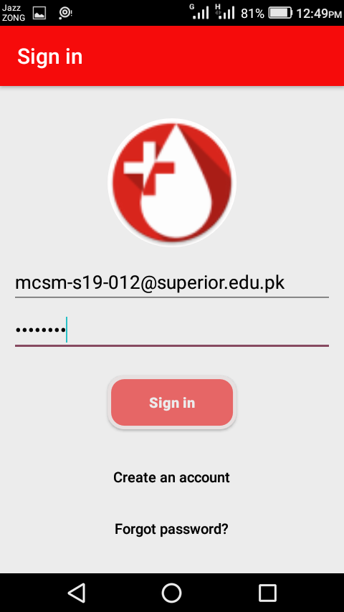
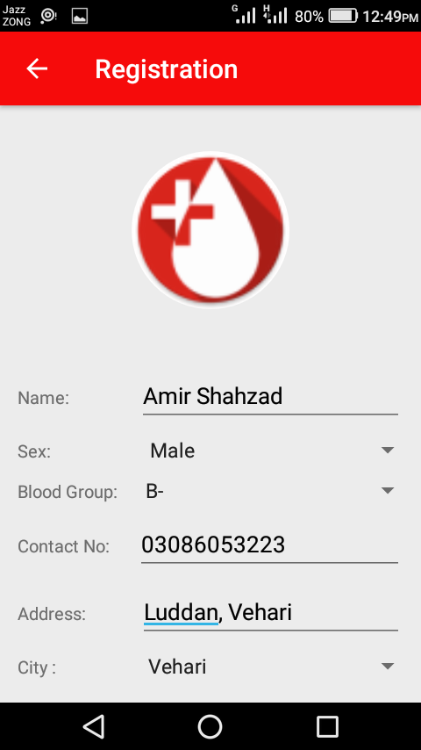
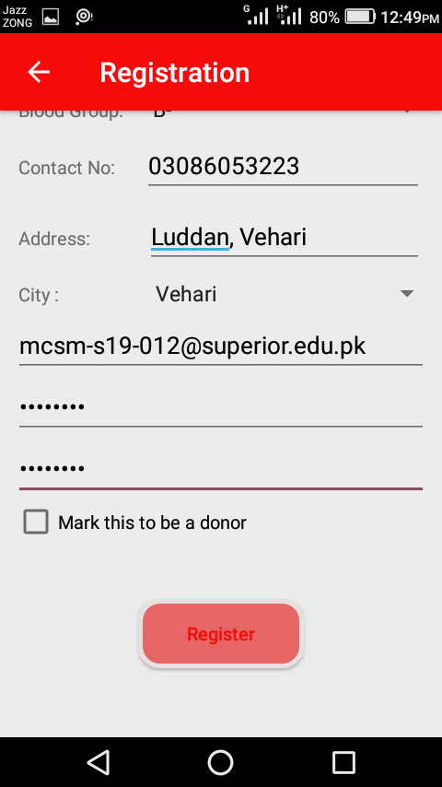
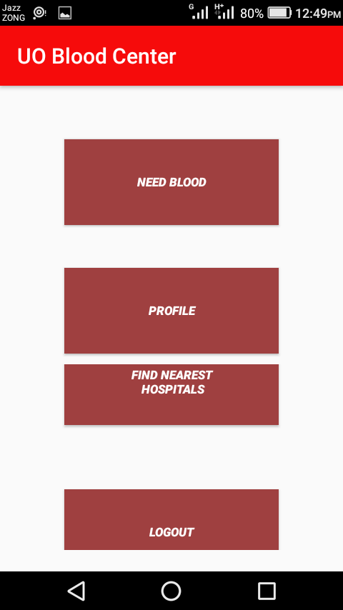
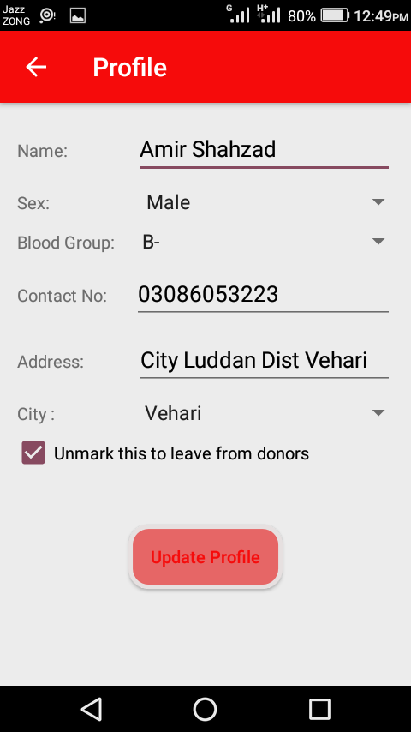
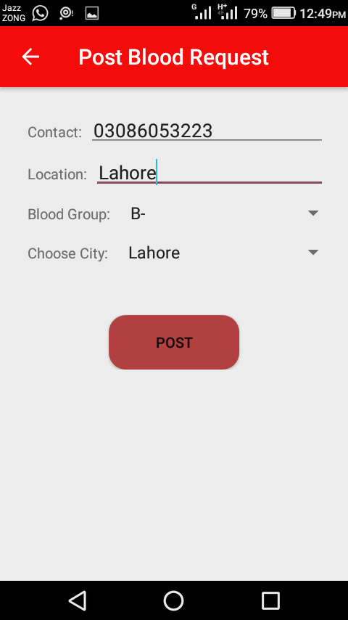
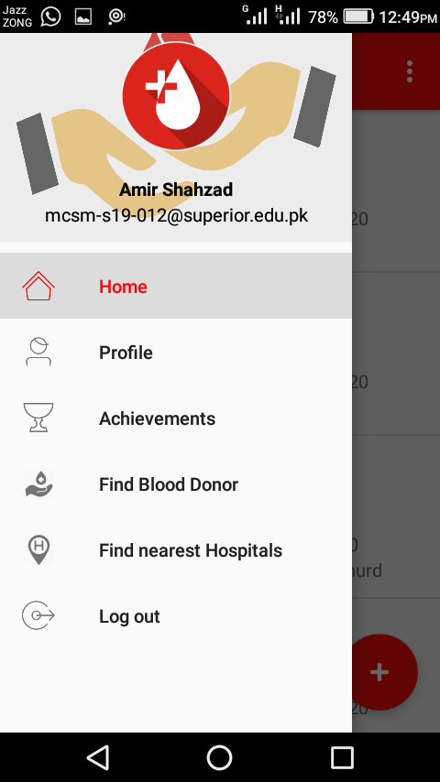
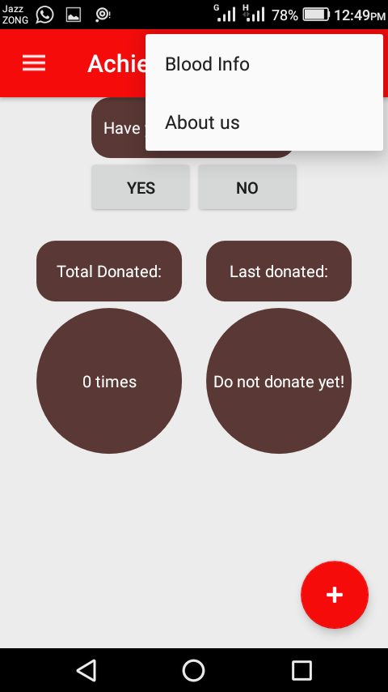
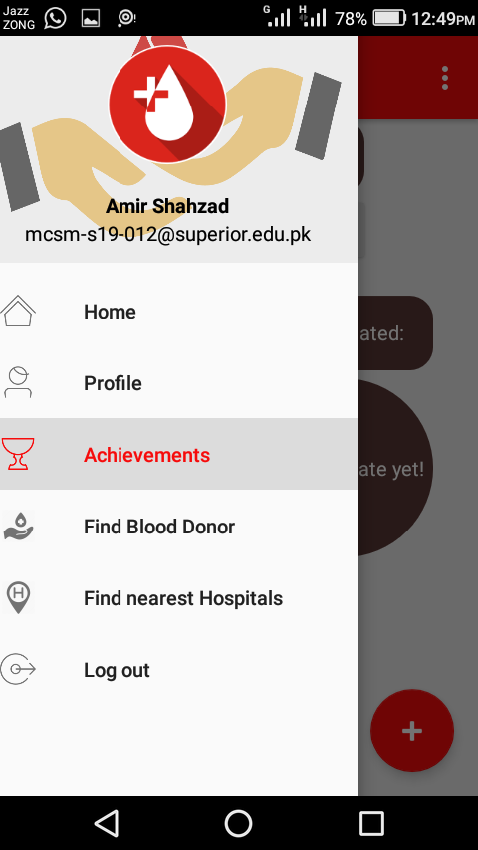
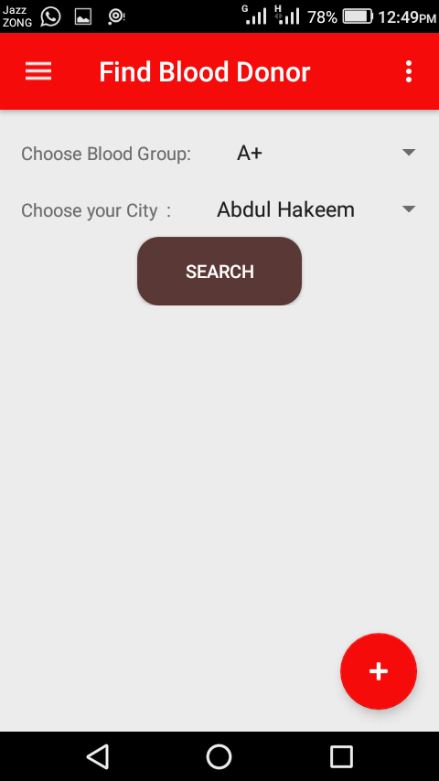
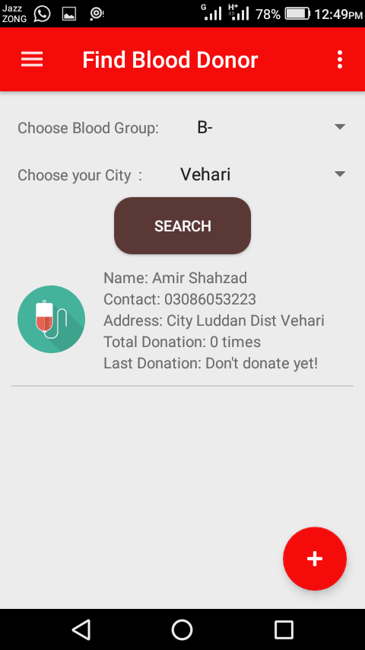

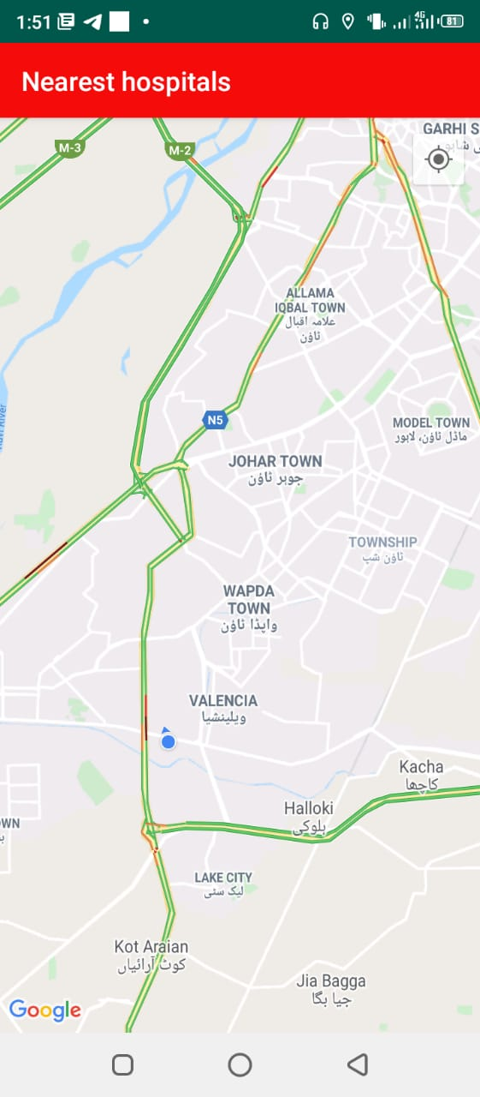

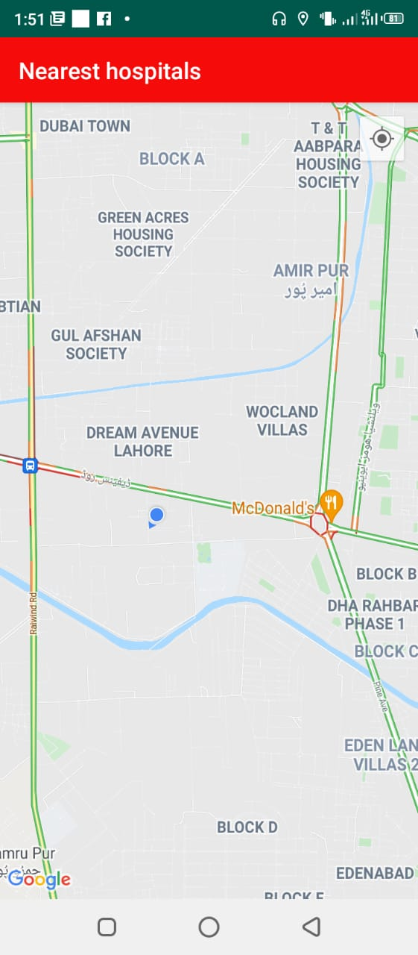

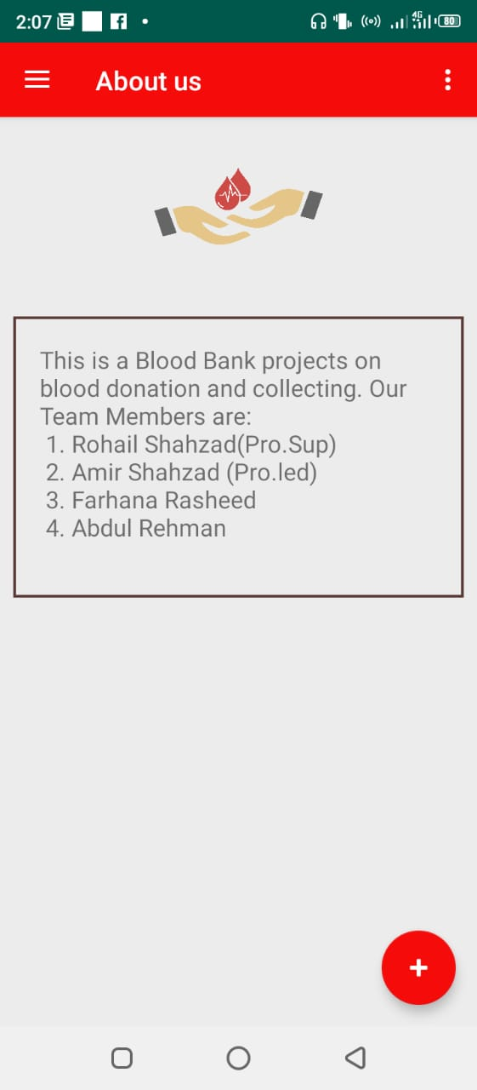

Hardware Interfaces
There are some basic requirement for operating app in mobile.
- 1GHz or High processor
- 512 MB RAM
- 500 MB Hard Disk

Software Interfaces
This is a project of SU BLOOD DONOR application it’s build for blood collection center in many user donate own blood and in this app save blood donor data like information of donor’ (Name, number, address, city, email, etc.) The version of this application is 1.0 and collect firebase data, operating system android mobile type.

Communications Interfaces
There are:
- Should run on 500GHz, 64MB Machine.
- Should have a proper internet connection.
- The response time for occurs a change will be more than 4 seconds.
- The response time for access the database will be no more 5 seconds.

System Features
There are:
- Donor management-donor registration, managing donor database, recording their physical and medical statistics.
- Blood requisition and issuance of blood.
- Being a Android system, can be implemented throughout the state. Separate users accounts can be created for each blood bank.
- Patient register/blood sample receiving register, donor register, blood issue register and discarded blood report.
- List of donors who are eligible for donation on a particular date with contact number.

System Feature 1
- Sign Up
- Login
- Donor Profile
- Blood Stock
- Reporting
- Searching
- Updating

Description and Priority
There are some:
- Information of all blood banks donor details, donate blood with their interest and others will do in future.
- Interested in donating the blood can register.
- General users want to contact blood donors by checking interested to donate blood; he can also take the help of this site.
- Rapid response of urgent request for blood components.
- Checking pre-transfusion samples and request
- Selecting of suitable blood component of each clinical conditions.
- Safe delivery and handling of blood components.
- Inventory and stock management.
- Interactions with the blood establishment.

Functional Requirements

The system is designed and developed keeping in view that it should be user-friendly, Searching should be easy, and it should have the good and easy display and user ease is given to the user.
Here, there is a detailed functional requirement.
- Login of admin.
- Blood Donor.
- Change the login password of admin.
- Register the donor by himself.
- Register the donor by system admin.
- Login of the donor.
- Change the login password of donor.
- Change personal, contact details by the donors himself.
- Change personal, contact details by the system admin.
- Withdraw reg. details by the donor.
- Withdraw reg. details by the admin.
- Send blood donation details to the relevant donors.
- Send blood testing details.

System Feature 3 (and so on)
There are some features of blood bank management system are:
- Generating reports on stock- blood group wise, area wise and expiry date wise.
- Donor database-blood group wise and area wise.
- Maintain and update unique donor identifications.
- Track and maintain all the donor types- voluntary, exchange and directed.
- Improved the Effectiveness and Efficiency of blood bank- faster response time and better control.
- Accurate database/Record management.
- Blood cross match and result storage facility.
- Rejected donor database for donor control and identifications.
- Blood transfusion related diseases control and preventions.
- Searched facility for destroyed and expired blood.
- Comprehensive donor database with search facility.
- Unique donor ID and patient record ID for managing future list.
- Improve blood bank processes by providing efficient and continuous software support.

Other Nonfunctional Requirements
A characteristic of a quality SRS is that in addition to describing the functional requirements of a system, it will also provide detailed coverage is of the non-functional requirements. In practice, this would entail detailed analysis of issues such as availability, security, usability and maintainability. However, as this document is only an outline specification, It doesn’t contain the same degree of rig our that would normally be expected in a formal SRS. Therefore, the sections below should be seen as indicative rather than providing specific (i.e. Testable) requirements.

Performance Requirements
- The system is interactive and the delays involved are less.
- When connecting to the server the delay is based editing on the distance
Of the 2 systems and the configuration between them so there is high probability
That there will be or not a successful connection in less than 20 seconds for sake of
Good communication.

ii. Safety Requirements
Blood bank modules maintain details about the donors and recipients. These blood bank modules are linked to other modules in the software for wards and OT in the hospitals, whereby, any and all blood requirements using surgeries etc. That happens in the hospitals are known to the bank. Important information and parameters such as availability of blood, cross-matching between donors and recipient’s blood groups and blood transfusions reactions are recorded. Also, the interactions with other blood banks within in hospitals or outside and delivery/recipients of blood bags between these banks or hospitals are recorded and maintained.
- The blood request queue screen, from where all the daily transfusions can be handled.
- Fresh blood and stored blood request processing.
- Blood returns is made easy in the blood bank management system.
- Transfusion detailed and charging.
- Destruction Details.
- Blood bank management system is integrated with lab module for blood cross match and grouping.

Security Requirements
- The system use SSL (secured socket layer) in all transactions that include
Any confidential customer information.
- The system must automatically log out all customers after a period of
Inactivity.

Software Quality Attributes
The system will processes some quality attributes to the users:
- Reliability: The system has the ability to work all the times without failures apart from network failure. A donor can have the faith on the system. The authorities will keeps the privacy of all donors in a proper manner. When the doctors found any disease in the testing stage after providing relevant details to the donor the system keeps the secretively of the donor.
- Robustness: The entire system includes every function which is always help to the system to work correctly and strongly in all conditions. 3.

- Interoperability: Therefore the system includes the ability to work with the other applications which are also run on the same website.

Other Requirements
Security: The system doesn’t have a tight security system. Because People who log into the system are volunteers who like to donate blood for innocent patients. But the system consists of some security features.
- Details of any other donor.
- If a donor doesn’t manage to provide hi user name and a password in three times the user automatically will log out from the website.

Chapter 3

Use Case Analysis
System Analysis
Preliminary Investigation:
First in the system development process is preliminary Investigation. Preliminary Investigation is conducted in the following phases.
- Project clarification
- Feasibility study
- Project appraisal
Project clarification is the process of selecting a project request for further study. When a system development or modification request is made, the first systems activity, the preliminary investigation, begins the activity has three parts: Request clarification, feasibility study and project appraisal. Many request from employees and users in organization are not clearly stated.
Therefore before any systems investigation can be considered, the project request must be examined to determine preciously what the originator wants. This is called Request clarification.

Reliability
The system can be used by different users concurrently

Availability
The system is available 24/7

Portability
Skiers can post any time
- Robustness
The system cannot be broken down.

Maintainability:
The system is very easy to maintain.

Usability:
The system is easy to use.

3.1 Use Case Model
Use case models are the model of how different types of users interrelate with the application to solve a problem.

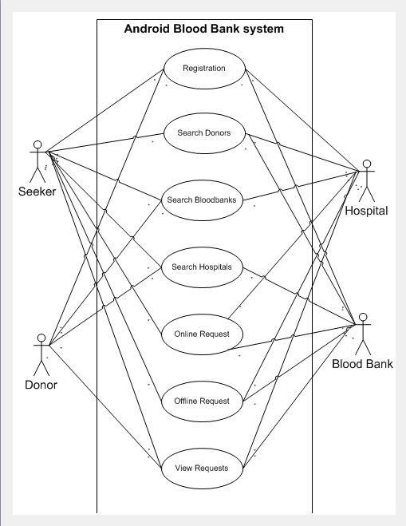

Use Case Descriptions
Essential use cases also known as business use case, it is a simplified, abstract, generalized use case that seizures the intentions of a user in desired technology and enactment independent manner.

User intention | App responsibility
Sign in/Login  Mark as a Donor  Enter your Data  Select blood group | Create your account  Login to the application successfully  Add you as a donor put your relevant data as a donor  Allow users to see your name, Contact no and blood group  Select your relevant Blood group  Provide your relevant information

Chapter 4

System Design
- The system can be installed in any android phone and required a machine with Pentium IV processor, 512 MB ram, 1GB Storage to implement the system. The system is implemented in JDK10.0.1, Android 4.4 kit Kat, java, and Android Studio.
- The application needs to be downloaded. After downloading the application, the registration form will appear. Basic, detailed information such as name, address, contact person, blood type, emergency contact, etc. is required for registration. If the person is already registered, they need to sign in. If he forgets his password, he can click on the "Forgot Password" button, which will send an SMS with the username and password to the registration number.
- The user gets various options on screen:
- Blood banks
- Need Blood
- Search donors
- Search nearby Hospital
- Requirement for blood
- Request for blood
- Profile update

Users can search for blood banks and need blood. They can view other people who have registered, and they can search for donors by location or type. He can organize blood storage by providing the location and date of the event. This information is added to the blood storage. Using GPS, "Find nearby Places" can search for nearby hospitals and provide directions to the hospital. The user can also request the required blood by providing a short description. Registered users are notified of this publication request. Information about the request will be added to the "Blood Request" option. Users can also check various first-aid details. He can update his personal information.
The system can be installed in any Android phone and required a machine with Pentium IV
Processor, 512 MB ram, 1GB storage to implement the system. The system is implemented
In JDK10.0.1, Android 4.4(Kit Kat), java, and Android Studio
The system can be installed in any Android phone and required a machine with Pentium IV
Processor, 512 MB ram, 1GB storage to implement the system. The system is implemented
In JDK10.0.1, Android 4.4(Kit Kat), java, and Android Studio
Design:
The system can be installed in any Android phone and required a machine with Pentium IV
Processor, 512 MB ram, 1GB storage to implement the system. The system is implemented
In JDK10.0.1, Android 4.4(Kit Kat), java, and Android Studio.

Architecture Diagram
An application architecture is a consistent plan that needs to be made before the development process starts. This plan provides a map of how the different application components should be organized and tied together.

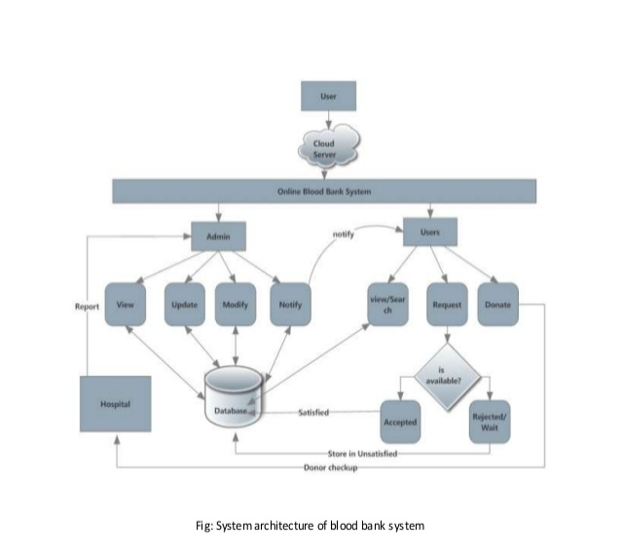

Domain Model
A deployment diagram is also a UML diagram type that demonstrate the execution architecture of a software system, including nodes such as hardware software execution environments, and connecting them.

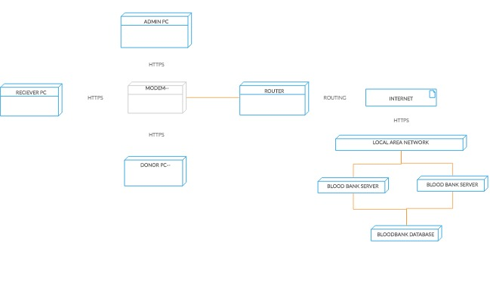

Entity Relationship Diagram with data dictionary
ER Diagram is a graphical representation of a data model using entities, their attributes
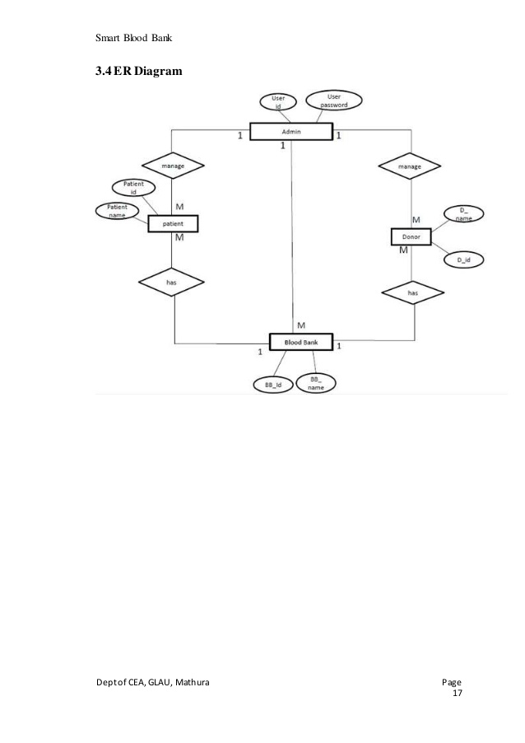

Class Diagram
A Class diagram is the main building block of object oriented modeling. These diagrams are used to show the different kind of objects in a system also their attributes and their operations and the relationships among them.

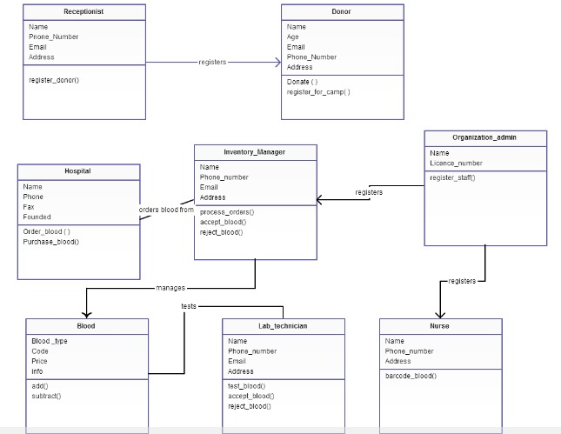

Sequence / Collaboration Diagram
A sequence diagram is a type of communication diagram because it describes how & in what in respective order objects works together. This diagram is used by software developer’s professionals to understand necessities for a new system or to document an existing process.

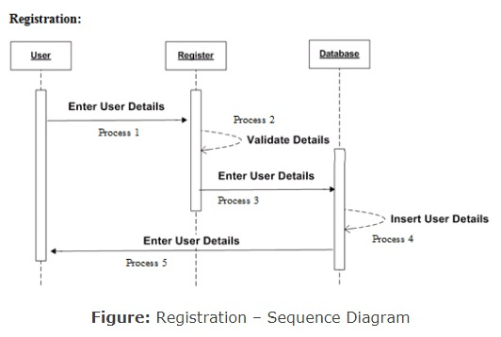

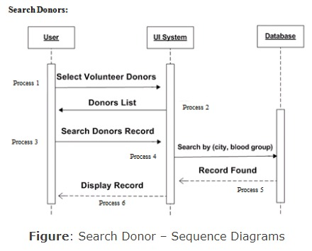

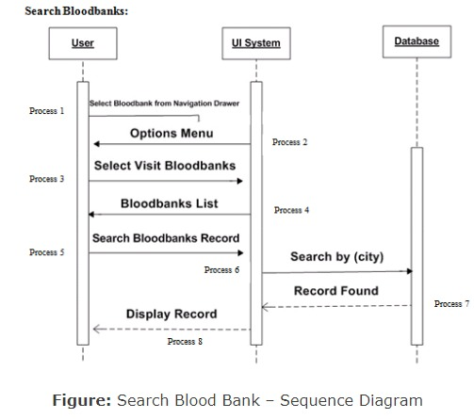

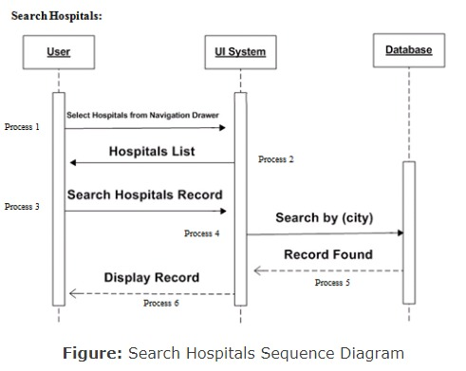

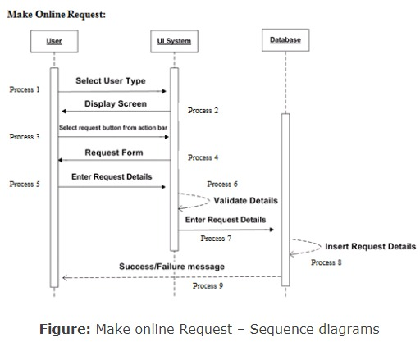

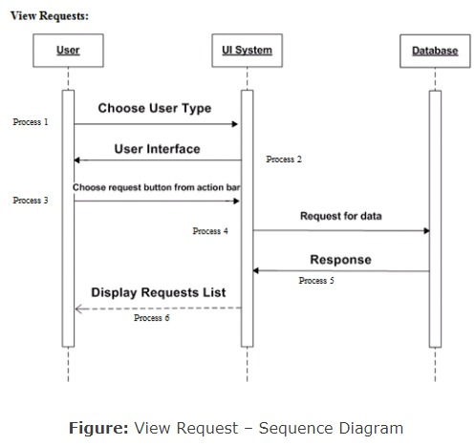

Activity Diagram
An activity diagram visually grants a series of activities or flow of control in a system similar to a flowchart or any data flow diagram.

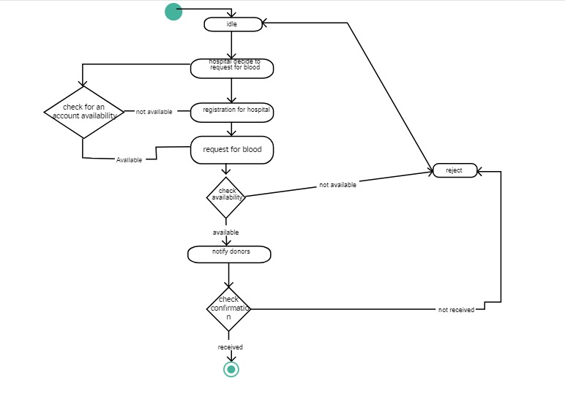

Diagram
A state transition diagram is a digraph whose nodes are states and whose directed arcs are transitions labelled by event names. ... State transition diagrams have a number of applications. They are used in object-oriented modelling techniques to represent the life cycle of an object.

HBS

Donor Registration

Donor Decide to Blood
Donor Checking

If eligible
Take Blood

If not pure
Discard Blood
Test & Process Blood

If Pure
Send Blood To Blood Bank

If Not Verified
Verify & Store Blood

Deliver To Hospital

S

DB

Component Diagram

It is also known as a UML component diagram, it describes the organization and connection of the physical components in a system.

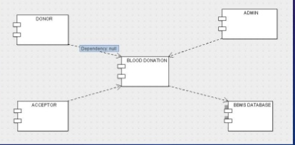

Deployment Diagram
A deployment diagram is also a UML diagram type that demonstrate the execution architecture of a software system, including nodes such as hardware software execution environments, and connecting them.

Data Flow diagram [only if structured approach is used - Level 0 and 1]
- A data flow diagram is a graphical tool used to describe and analyze movement of data through a system. These are the central tool and the basis from which the other components are developed. The transformation of data from input to output, through processed, may be describe logically and independently of physical components associated with the system. These are known as logical data flow diagrams.
The physical data flow diagram show the actual
Advantages of Proposed System:
- Easy way to find donors
- Shorter time
- No need to search blood or wait inline
- Users can find their own specific blood type
Users can find the contact information of the donor
- The user can communicate with the donor by sending a call or message directly to the donor by using the detailed information provided in the app.
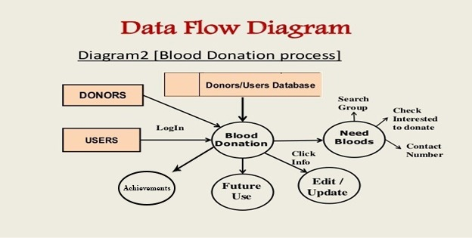

Chapter 5

Implementation
After all information has been gathered and the design has been created, we will start to develop the system to make sure that it is able to use by different user. Then, will the dietary suggestion system suggest the best diet plan for the user. App is completed run process in which different module and I am sure all module accurate no any stage. This is mobile application use easily in any android mobile phone not required special storage specification etc.

Important Flow Control/Pseudo codes
Important Flow Control Structures
There are three types of flow of control
- Sequential flow
- Selection or Conditional flow
- Iterative flow

Components, Libraries, Web Services and stubs
In this project:
implementation 'androidx.recyclerview:recyclerview:1.0.0'
implementation 'androidx.lifecycle:lifecycle-extensions:2.0.0'
implementation 'com.google.firebase:firebase-core:18.0.2'
implementation 'com.google.firebase:firebase-database:19.7.0'
implementation 'com.google.firebase:firebase-auth:20.0.3'
implementation 'com.google.android.gms:play-services-maps:17.0.0'
implementation 'com.google.android.gms:play-services-location:18.0.0'
implementation 'com.google.android.gms:play-services-places:17.0.0'
implementation 'com.toptoche.searchablespinner:searchablespinnerlibrary:1.3.1'

Deployment Environment
Android Studio sets up new projects to deploy to the Android Emulator or a connected device with just a few clicks. Once your app is installed.

FOR INSTALLATION
- Android Studio
Android Studio is the official integrated development environment for Google's Android operating system, built on Jet Brains' IntelliJ IDEA software and designed specifically for Android development.
- Mobile Application
Blood donor Mobile app is the act or process by which a mobile app is developed for mobile devices, such as personal digital assistants, enterprise digital assistants or mobile phones. Mobile application development is the process to making software for smartphones and digital assistants, most commonly for Android. The software can be preinstalled on the device, downloaded from a mobile app store or accessed through a mobile web browser. Mobile app development is rapidly growing. Mobile application development is the process of creating software applications that run on a mobile device, and a typical mobile application utilizes a network.

Tools and Techniques
There are hundreds of cloud and 3rd party services that mobile application developers can leverage to speed up the development and delivery of their applications. However, it’s unlikely that a developer is going to be able to become an expert in each of these individual services.
Instead, the mobile developers should look for a development environment that makes it easier for them to integrate, use, and consume the most commonly required capabilities into their application quickly and easily, while still preserving the freedom to take advantage of the many individual services available.
Essential
- User Sign-up
- Login
- Check Sign Make Donor
- Analytics and User Engagement
- Real Device Testing
Data Services
- Cloud Storage
- Firebase Data Storage
- Real-time and Offline Data
- Application Logic/Cloud Functions
Machine Learning
- Conversational Bots
- Data Collection
ANDROID STUDIO
- IntelliJ IDE
IntelliJ IDEA is undoubtedly the top-choice IDE for software developers. Efficiency and intelligence are built into the design, which enables a very smooth development workflow experience, from design, implementation, building, deploying, testing, and debugging, to refactoring!
- JAVA JDK(1.8)
MVVM
MVVM architecture is a Model-View-View Model architecture that removes the tight coupling between each component. Most importantly, in this architecture, the children don't have the direct reference to the parent, they only have the reference by observables. The above image is taken from another Minors blog. So, the image credit goes to the writer of that blog.
- Model: It represents the data and the business logic of the Android Application. It consists of the business logic - local and remote data source, model classes, and repository.
- View: It consists of the UI Code (Activity, Fragment), XML. It sends the user action to the View Model but does not get the response back directly. To get the response, it has to subscribe to the observables which View Model exposes to it.
- View Model: It is a bridge between the View and Model (business logic). It does not have any clue which View has to use it as it does not have a direct reference to the View. So basically, the View Model should not be aware of the view who is interacting with. It interacts with the Model and exposes the observable that can be observed by the View.
This is all about the MVVM, now let's move to the implementation part of it.
- SOLID DESIGN PETTERN (SINGAL RESPOSE, I, D, O)
- FIREBASE (FIREBASE ATHENTICATION AND FIREBSAE REAL TIME DATABASE)
- FRONTEND (XMAL) BACKEND WITH JAVA

Best Practices / Coding Standards
There are some resources of application use for
<resources>
<string name="app_name">SU Blood Donor</string>
<string name="title_activity_login">Sign in</string>
<string name="home">Home</string>
<string name="profile">Profile</string>
<string name="achiev">Achievements</string>
<!-- Strings related to login -->
<string name="signup">Register</string>
<string name="prompt_email">Email</string>
<string name="register">Create an account</string>
<string name="forgotpass">Forgot password?</string>
<string name="prompt_password">Password</string>
<string name="prompt_confirm_password">Confirm password</string>
<string name="action_sign_in_short">Sign in</string>
<string name="navigation_drawer_open">Open navigation drawer</string>
<string name="navigation_drawer_close">Close navigation drawer</string>
<string name="nav_header_title">Android Studio</string>
<string name="nav_header_subtitle">android.studio@android.com</string>
<string name="nav_header_desc">Navigation header</string>
<string name="reset">Reset</string>
<string name="displayName">Full Name</string>
<string name="mobile">Mobile No</string>
<string name="userAddress">Address</string>
<string name="nearH">Find nearest Hospitals</string>
<string name="fndBlood">Find Blood Donor</string>
<string name="lgout">Log out</string>
<string name="devinfo">About us</string>
<string name="bloodinfo">Blood Info</string>
<string-array name="division list">

Version Control
There are version control tools:
- APK 1.0
Android Package (APK) is the package file format used by the Android operating system, and a Signature-Version: 1.0
- GIT
Git is a free and open source distributed version control system designed to handle everything from small to very large projects with speed and efficiency. It is easy to learn and has a tiny footprint with lightning fast performance
- GITBASH
GUI Clients. Git comes with built-in GUI tools (git-gui, gitk), but there are several third-party tools for users looking for a platform-specific experience.
- GITHUD
- Mobile → Actions → Code spaces → Packages → Security → Code review → Project management → ...
- Team.
- Learn and contribute. Topics → Collections → Trending → Learning Lab → Open source guides → ...
- Compare plans → Contact Sales →

Chapter 6

Testing and Evaluation
Users interact with your app on a variety of levels, from pressing a button to downloading information onto their device. Accordingly, you should test a variety of use cases and
Interactions as you iteratively develop your app. As your app expands, you might find it necessary to fetch data from a server, interact with the device's sensors, access local storage, or render complex user interfaces. The versatility of your app demands a comprehensive testing strategy.

Use Case Testing
Use Case Name Registration Actor(s) Blood Donor, Blood Seeker, Hospitals, Blood Banks Purpose for user registration Pre Conditions User selected the registration form to fill Post Conditions Information is valid. Saved in database Invalid Information.

User Action
- System Response User fill the required fields
- The system will save the data in the database.
- Use Case Name Search Donors Actor(s) Blood Seeker, Hospitals, and Blood Banks.

Use Cases Description of Blood Bank Project.
- Use case 1: User Registration.
- Use case 2: Login
- Use Case 3: Search Blood banks.
- Use Case 4: Search Hospitals.
- Use case 7: Make an online request.
- Use case 8: Make an offline request.
- Use Case 8: Search Donors.
- Use Case 9: View Requests

Equivalence partitioning
Software Testing is imperative for a bug-free application; this can be done manually or even automated. Although automation testing reduces the testing time, manual testing continues to be the most popular method for validating the functionality of software applications. Here, we are explaining the most important manual software testing techniques.
The topics discussed in this article are:
- Black Box Testing Technique
- Boundary Value Analysis (BVA)
- Equivalence Class Partitioning

Boundary value analysis
BVA is another Black Box Test Design Technique, which is used to find the errors at boundaries of input domain (tests the behavior of a program at the input boundaries) rather than finding those errors in the center of input. So, the basic idea in boundary value testing is to select input variable values at their: minimum, just above the minimum, just below the minimum, a nominal value, just below the maximum, maximum and just above the maximum. That is, for each range, there are two boundaries, the lower boundary (start of the range) and the upper boundary (end of the range) and the boundaries are the beginning and end of each valid partition. We should design test cases which exercise the program functionality at the boundaries, and with values just inside and outside the boundaries. Boundary value analysis is also a part of stress and negative testing.

Data flow testing
Data Flow Testing is a specific strategy of software testing that focuses on data variables and their values. It makes use of the control flow graph.
Steps of Data Flow Testing

- Creation of a data flow graph.
- Selecting the testing criteria.
- Classifying paths that satisfy the selection criteria in the data flow graph.
- Develop path predicate expressions to derive test input.

Unit testing
At this phase, the system will be tested. If there is any error occur or detected, it must be solved at this phase and if there any changes made, it need to be re-implement back to design phase to make sure that the flow of the system is not affected. There are some blood donor finder applications such as Blood app by Red Cross which allows the donor to book appointment with blood banks. In this report we are able to get all the details of blood bank management ... Testing FUCTIONAL TESTING Here the system is a black box whose ... it approaches namely the top-down approach in which the integration is carried.

Integration testing
INTEGRATION TESTING is a level of software testing where individual units / components are combined and tested as a group. The purpose of this level of testing is to expose faults in the interaction between integrated units. Test drivers and test stubs are used to assist in Integration Testing.

Performance testing
ANDROID: The performance of the application is very speedily work like 1 to 2 second’s for every step application must online. This application required data for perform any activity without internet cannot perform any task or activity in blood donor application. This is reliable application no conflict any time if internet is good. This is an enterprise-scale load testing tool that can generate real-life and reliable load scenarios, even in most complex systems.
BEST PERFORMANCE TESTING TOOLS
- DATA FLOW TESTING
- UNIT TESTING
- INTEGRATION TESTING
- STRESS TESTING

Stress Testing
In this we have tested many methods, one of which is stress testing. Check the working of the project. Err Performance of Running Speed. User create login like (full Name, Email, Number, Location, address, City). In this application more one person login at a time and perform activity.

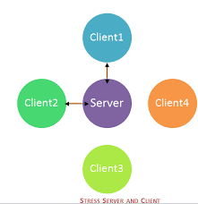

Chapter 7

Summary, Conclusion and Future Enhancements

Project Summary
The Blood Bank Information System which helps to manage the records of donors at a blood bank. The system will allow the blood bank to login using a secret password and easily manage the records of the blood donors. The main objective of this application is to automate the complete operations of the blood bank as it needs to maintain hundreds of thousands of records. There are various modules available for the system such as user login screen that enables user to enter the user password and login name to enter application. Others are menu form, donor registration, recipient management, blood management and blood reservation module.
The advantages of the system would be as follows:
- Access to the system secured by login.
- Search facility for finding blood donors based of various search criteria.
- Search facility for finding Patients (acceptors) based of various search criteria.

Achievements and Improvements
In this application we achieved all most modules and we will try to add more module in future. In future we will add to Google map for easily search near hospitals it is possible to set range distance. In next phase fully try improve performance capture module.

Blood donor application achievement as follows:
- User Registration.
- Login
- Search Blood banks.
- Search Hospitals.
- Make an online request.
- Make an offline request.
- Search Donors.
- View Requests
- Add donor and user
- Search blood donor through blood group.
- About info

Critical Review
The process of donor selection required on-going monitoring and evaluation to ensure that it achieves its objectives of ensuring donor and patient health and safety and a sufficient supply of safe and blood products.
The main parameters to be monitored includes:
Donor Selection Criteria
- Age: Our program will not consider donation from individuals under the age of 18 or any person mentally incapable of making an informed decision.
- Smoking: There are many known health risks from smoking.
- Drug Use: Potential donors must not use any illicit drugs.
- Health Problems: Donors must be healthy individuals.

Lessons Learnt
It has great pleasure for me to work on this exciting and challenges project. This project proved good for me and my team member as it provided practical knowledge of not only developing android studio based application. But also about all handling procedure related with “SU Blood Donor App” that will be great demand in future.

BENEFIT’S:
- It’s a android-enabled project
- This project offers user to enter the data through simple and interactive forms. This is very helpful for the client to enter the desired information through so much simplicity.
- The user is mainly more concerned about the validity of the data, whatever he is entering. There are checks any new creation, data entry or updating so that the u enter the valid and invalid data, which cannot create problems at later date.
- Sometimes the user finds in the later stages of using project that he needs to update some of the information that he entered earlier. There are options for him by which he can update the records.
- User is provided the option of monitoring the records he entered earlier. He can see the desired records with the variety of options provided by him.
- Data storage and retrieval will become faster and easier to maintain because data is stored in a systematic manner and in a firebase database.
- Decision making process would be greatly enhanced because of faster processing of information since data collection from information available on mobile takes much less time than manual system.
- Through these features it will increase the efficiency, accuracy and transparency,

Future Enhancements/Recommendations
In Future we will add Google Maps and Places API Google APIs is a set of application programming interfaces (APIs) developed by Google which allow communication with Google Services and their integration to other services. Examples of these include Search, Gmail, Translate or Google Maps. Third-party apps can use these APIs to take advantage of or extend the functionality of the existing services. The APIs provide functionality like analytics, machine learning as a service (the Prediction API) or access to user data (when permission to read the data is given). Another important example is an embedded Google map on a website, which can be achieved using the Static maps API Places API [2] or Google Earth API [3].

---------------------------------------------THANK YOU SO MUCH----------------------------------------------------

