Online News Portal
Final Year Project
Session 2018-2022

A project submitted in partial fulfillment of the degree of

BS in Computer Science

Department of Software Engineering
Faculty of Computer Science & Information Technology
Superior University, Lahore
Spring 2022

Type (Nature of project) |  |  | [ ] Development [ ] Research [ ] R&D
Area of specialization
FYP ID |  |  | FYP-BCSM-F21-053
Project Group Members
Sr.# | Reg. # | Student Name |  | Email ID | *Signature
(i) | Bcsm-f18-274 | M Hamza |  | Bcsm-f18-274@superior.edu.pk
(ii) | Bcsm-f18-251 | Talha bin Nasir |  | Bcsm-f18-251@superior.edu.pk
(iii) | Bcsm-f18-295 | Abdullah Raheel |  | Bcsm-f18-295@superior.edu.pk
*The candidates confirm that the work submitted is their own and appropriate credit has been given where reference has been made to work of others
Plagiarism Free Certificate
This is to certify that, I M. Hamza, S/D of Muhammad Javaid, group leader of FYP under registration no Bcsm-f18-274 at Software Engineering Department, The Superior University, Lahore. I declare that my FYP report is checked by my supervisor.
Date: 06-01-22 Name of Group Leader: M Hamza Signature:
Name of Supervisor: Ma’am Maria Iqbal
Designation: Lecturer
Signature: ________________
HOD: Dr. Irfan-ud-Din
Signature: _______________

Project Report
Online News Portal
Change Record
Author(s) | Version | Date | Notes | Supervisor’s Signature
 | 1.0 |  | <Original Draft>
 |  |  | <Changes Based on Feedback from Supervisor>
 |  |  | <Changes Based on Feedback from Faculty>
 |  |  | <Added Project Plan>
 |  |  | <Changes Based on Feedback from Supervisor>

APPROVAL
Project Supervisor
Comments: ____________________________________________________________________
____________________________________________________________________
Name: _______________________
Date: ________________________ | Signature______________________
Project MANAGER
Comments: ____________________________________________________________________
____________________________________________________________________
Name: _______________________
Date: ________________________ | Signature________________________
HEAD OF DEPARTMENT
Comments: ____________________________________________________________________
____________________________________________________________________
Name: _______________________
Date: ________________________ | Signature______________________

Dedication
This work is Dedicated to our parents first of all, who bear all our expenses and never gave up on us, and been supportive for us throughout the degree and then to all my teachers who play a big role in polishing our personality, groomed our mentality, implicit many things in our knowledge, and above all our supervisor (Ma’am Maria Iqbal) who been helping us out in every problem and make things easy for us.

Acknowledgements
We are really thankful to our supervisor ma’am maria Iqbal Because of her past experience regarding CS & IT, her kind behavior, this project is made possible. She was very cooperative, while working on this project we faced many difficulties but the way she suggests us solution for the problems was tremendous. Her work and support to us is definable.

Executive Summary
We are living in 21st century and every individual either that’s a child or a young man we are getting advance and still moving towards more advancement so with this advancement we expect things to get easier and easier so we made an online news portal we already have a lots of news web pages so why this but the challenges I saw in different news pages is fake news because fake news get buy quick and then I got motivation to make an online news portal where no nobody up their hands on the uniqueness of content nobody will claim the news is fake and add a bad review.
Online news portal will have precise and every news category to spread knowledge and to fulfill their expectations regarding news.
Admin will handle the users and manage the news according to the category, first the admin will publish with complete copyrights of author the news and then user will able to see the news and give their feedback.
Besides Online news portal is a blog site so we can generate a fancy revenue from this site by publishing different blogs according to their category in our news portal website

Table of Contents
Dedication V
Acknowledgements VI
Executive Summary VII
Table of Contents VIII
List of Figures X
List of Tables XI
Chapter 1 12
1.1 Background 13
1.2 Motivations and Challenges 13
1.3 Literature Review/Existing Solutions 14
1.4 Gap Analysis 15
1.5 Proposed Solution 15
1.6 Project Plan 16
1.6.1 Work Breakdown Structure 18
1.6.2 Roles & Responsibility Matrix 19
1.6.3 Gantt Chart 1
1.7 Report Outline 1
Chapter 2 2
2.1 Introduction 3
2.1.1 Purpose 3
2.1.2 Document Conventions 3
2.1.3 Intended Audience and Reading Suggestions 3
2.1.4 Product Scope 3
2.1.5 References 3
2.2 Overall Description 4
2.2.1 Product Perspective 4
2.2.2 Product Functions 4
2.2.3 User Classes and Characteristics 4
2.2.4 Operating Environment 4
2.2.5 Design and Implementation Constraints 5
2.2.6 User Documentation 5
2.2.7 Assumptions and Dependencies 5
2.3 External Interface Requirements 5
2.3.1 User Interfaces 5
2.3.2 Hardware Interfaces 5
2.3.3 Software Interfaces 6
2.3.4 Communications Interfaces 7
2.4 System Features 7
2.4.1 System Feature 1 7
2.4.1.1 Description and Priority 7
2.4.1.2 Functional Requirements 7
2.4.2 System Feature 2 7
2.4.3 System Feature 3 (and so on) 8
2.4.4 Performance Requirements 8
2.4.5 Safety Requirements 8
2.4.6 Security Requirements 8
2.4.7 Software Quality Attributes 8
2.4.8 Business Rules 9
Chapter 3 10
3.1 Use Case Model 11
3.2 Use Case Descriptions 12
Chapter 4 13
Chapter 4: 14
4.1 Architecture Diagram 14
4.2 Domain Model 14
4.3 Entity Relationship Diagram with data dictionary 15
4.4 Class Diagram 16
4.5 Sequence / Collaboration Diagram 17
4.6 Activity Diagram 18
4.7 Component Diagram 19
4.8 Deployment Diagram 20
4.9 Data Flow diagram 21
Chapter 5 22
Chapter 5: 23
5.1 Important Flow Control/Pseudo codes 23
5.2 Components, Libraries, Web Services and stubs 23
5.3 Deployment Environment 23
5.4 Tools and Techniques 23
5.5 Best Practices / Coding Standards 24
5.6 Version Control 24
Chapter 6 25
Chapter 6: 26
6.1 Use Case Testing 26
6.2 Boundary value analysis 31
6.3 Data flow testing 32
6.4 Unit testing 33
6.5 Performance testing 35
Chapter 7 36
Chapter 7: 37
7.1 Project Summary 37
7.2 Achievements and Improvements 37
7.3 Critical Review 38
7.4 Lessons Learnt 38
7.5 Future Enhancements/Recommendations 38

List of Figures
Figure 1 Home Page 6
Figure 2 Architecture Diagram 14
Figure 3 Domain Model 14
Figure 4 Entity Relationship Diagram with data dictionary 15
Figure 5 Class Diagram 16
Figure 6 Sequence / Collaboration Diagram 17
Figure 7 Activity Diagram 18
Figure 8 Component Diagram 19
Figure 9 Deployment Diagram 20
Figure 10 Data Flow Diagram 21

List of Tables
Table 1 Gantt Chart 1

Chapter 1
Introduction

Chapter 1:

Introduction
These days we live during a time of Information Communication and Technology. We can't imagine a solitary second without innovation. From morning to night, we want the assistance of innovation. This is the progressive season of PC innovation. A large portion of the work relies upon web applications. Thus, whenever, anyplace, anybody can get to a site by means of the web for a minimal price and we can track down our expectable and most refreshed data from the site. At present data is one the most important asset in the ongoing scene. We have fostered our task so we can mindful individuals.
- Background
In ancient days we don’t have any source or platform to read news online the first newspaper to go online was the Columbus dispatch on July 1, 1980 Beginning in 1987, the Brazilian newspaper jomaldodia ran on the state owned ebratel network, moving to the internet in 1990s.In 1990s hundreds of U.s newspaper were published online version but did not yet offer much interactivity. One example is Britain weekend city press Review, which provide a weekly news Summary online beginning in 1995, today online news has become a huge part of society which leads to people argue whether or not it is good for society.
- Motivations and Challenges

Motivations:

The investigation of the information uncovered that practically all respondents utilized online entertainment. In light of variable examination results, their inspirations for doing so are diversion, data chasing, individual utility and comfort.

Entertainment:
The things motivate me to do this project is that it’s a great source of finding a diversion from problems a great day of relaxation and amusement and fun as well we can pass our time through this entertainment news it helps us to get rid of emotional release.

Habit:

The deliberate perusing of information or getting to news at explicit season of day or through favored news media or more all we mindful from the things happening inside and beyond our country.

Social Utility:

Social sympathy or knowledge into the conditions of others relating to others feeling of having a place it's a shared conviction for discussion and social collaboration.

Surveillance:

Finding out about pertinent circumstances and occasions in the public arena, world, and prompt setting, individual significance interest and general interest.

Challenges:

The two information recommend there is a high pace of dishonest practices in web-based media in Nigeria. Counterfeit news rank first, while different issues like an absence of objectivity , absence of respectability , intrusion of protection , disdain discourses and melodrama were viewed as normal in web-based media Goals and Objectives.

Some of the time client have deal with issues like extremely small text styles , absence of photographs or designs, substitutions of explicit news on another page during perusing the paper on the web.
- Literature Review/Existing Solutions

Literature Review:

A ton of undertaking work has carried on Online News Portal System. Right now, Online News Portal sites are accessible. Be that as it may, the majority of this site is static and conventional. There is no element that can make individuals mindfulness. To this end we have done this task. Our undertaking has many elements that can mindful individuals. By utilizing this site one can get increasingly more data that helps individuals in their everyday existence.

Existing Solution:
As far as the Existing solution is concerned, we may have different online new we b pages or portal we have been giving same services as we will give but here, we are talking on who is more precise who have realistic and unique content with references.
- Gap Analysis
In the modern era where we are going toward era of digitalization and technology we need everything in our hands instead of watching news on radio in old days and then in gray level picture tv in black and white days we can watch news and being aware of things going around us in our mobile phone by only searching of our desire topics the internet world is full of information we extract our favorite article and read it anywhere anytime through we won’t have to bound to sit at a specific place and watch the news it is reliable and will do save our time which is very important for everyone.
- Proposed Solution
The point of proposed framework is to foster an arrangement of further developed offices. The proposed framework can conquer every one of the constraints of the current framework. The framework gives appropriate security and diminishes the manual work.
- Security of data.
- Ensure data accuracies.
- Proper control of the higher officials.
- Minimize manual data entry.
- Minimum time needed for the various processing.
- Greater efficiency.
- Better service.
- User friendliness and interactive.
- Minimum time required.
- Project Plan

Programming project plan can be considered to be the accompanying:

1) Within the association: How the undertaking is to be carried out? What are different imperatives (time, cost, staff)? What is market system?

2) With regard to the client: Weekly or convenient gatherings with the client with show on status reports. Client's criticism is additionally taken and further adjustment and advancements are finished. Project achievements and expectations are additionally introduced to the client.

For a fruitful programming project, the accompanying advances can be followed:
- Select a project
  - Identifying project’s aims and objectives
  - Understanding requirements and specification
  - Methods of analysis, design and implementation
  - Testing techniques
  - Documentation
- Project milestones and deliverables
- Budget allocation
  - Exceeding limits within control
- Project Estimates
  - Cost
  - Time
  - Size of code
  - Duration
- Resource Allocation
  - Hardware
  - Software
  - Previous relevant project information
  - Digital Library
- Risk Management
  - Risk avoidance
  - Risk detection

    - Work Breakdown Structure

Online news portal

Initiative
Planning
Execution
Final Testing

Gather information
Scope
Front-end
Bugs fixing
Improvement
DB Tables
Schedule
References

Back-end

    - Roles & Responsibility Matrix
The purpose of roles & responsibility matrix is to identify who will do what.
WBS # | WBS Deliverable | Activity # | Activity to Complete the Deliverable | Duration (# of Days) | Responsible Team Member(s) &  Role(s)
1 | Requirements Gathering | 1 | Surveys, Questions, Interviews and  Research | 7 | Areej Anwar, Khizer Shoaib
2 | Requirements  Analysis | 2 |  | 10 | Ali Sheraz,  Yasir Akram
3 | Documentation | 3 | UML, SRS | 20 | Asadullah Shahid,  Areej Anwar
4 | Designing | 4 | Frontend Development and | 41 | Ali Sheraz, Khizer  Shoaib, Asadullah Shahid
5 | Implementation | 5 | Back-end Development, REST Apis, Mobile Application  Development | 59 | Ali Sheraz, Areej Anwar, Asadullah Shahid
6 | Testing | 6 | Developer Testing,  User Testing | 30 | Khizer Shoaib,  Yasir Akram
7 | Deployment | 7 | Deployment on live  Server | 20 | Ali Sheraz,  Asadullah Shahid

    - Gantt Chart
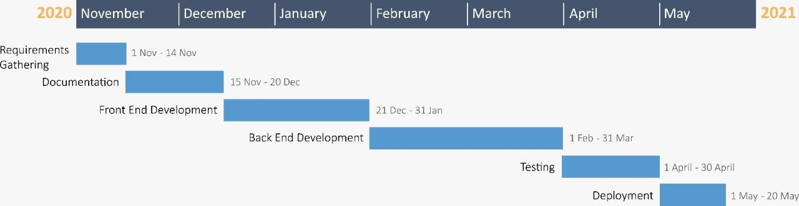
Table 1 Gantt Chart
- Report Outline

We are Creating the web base online news portal it will displays all the available news details, website settings, menus, sub-menus, and so on. In addition, the system allows the managing of sidebar menus and sub-menus too. This project is divided into two categories: Client-Side and Admin Panel.

Chapter 2
Software Requirement Specifications

Chapter 2: Software Requirement Specifications

  - Introduction
    - Purpose

The motivation behind SRS (Software Requirement Specification) archive is to depict the outer way of behaving of the online paper. It characterizes the tasks, execution and connection points and quality confirmation prerequisite of the online paper. The total programming prerequisites for the framework are caught by the SRS (Software Requirement Specification).
    - Document Conventions
This document is written in a simple English language 12pt body font size, 14pt headings font Size and Calibri font style. Every heading starts with number to describe the sequence of Document.
    - Intended Audience and Reading Suggestions
This document is intended for developers, the project owner and the user of this project as well.
    - Product Scope
The Online news portal will reduce the fakeness of content which have on a very larger amount on internet. people will get the authentic news with easy wording people will aware from the news with a very low cost this system will dynamically provide facilities , a part from that you can generate a fancy revenue from this site.
    - References
- Visit many local websites
- CNN & NY Times
- The Washington Post
  - Overall Description
    - Product Perspective

Portray the unique circumstance and beginning of the item being determined in this SRS. For instance, state whether this item is a follow-on individual from an item family, a trade for specific existing frameworks, or a new, independent item. On the off chance that the SRS characterizes a part of a bigger framework, relate the prerequisites of the bigger framework to the usefulness of this product and recognize interfaces between the two. A straightforward graph that shows the significant parts of the general framework, subsystem interconnections, and outer points of interaction can be useful.
    - Product Functions
- Get register yourself
- Enter and surf the website
- Collect news & information of your desire
- You can comment on a news
- Admin will handle the comment section
    - User Classes and Characteristics
- Any kind of class can get help or information from this system.
- This system is specially operate on educational level
- An uneducated community will be less satisfied as compare to educated
    - Operating Environment
- HP windows
- Operating system window 10
- 8 GB Ram
- 500 GB HDD
- 35 GB or Above network connection
    - Design and Implementation Constraints
Online News Portal User interface is designed in HTML 5, CSS, Bootstrap and the backend of this system in Php with database (MY sql).
    - User Documentation
- User Policies
- User Privacy
    - Assumptions and Dependencies
- The interface would be done in bootstrap 5
- If there is any update version come that has to be done
  - External Interface Requirements
    - User Interfaces

The UI necessities are worried about the UI and how data is introduced to the client. This site is essentially for people groups from business class and foundation. Thus, connection point will be exceptionally straightforward and simple to utilize or have emotionally supportive network for clients to help them.
    - Hardware Interfaces

Just the suggested setup (fundamental necessities of a PC framework) no other explicit equipment is expected to run the product. The equipment setup incorporates.
      - RAM: 4 GB,
      - Basic requirement of this website are a good internet connection and a system that support web browser.
      - Mobile with latest API level or minimum 14.2.

    - Software Interfaces
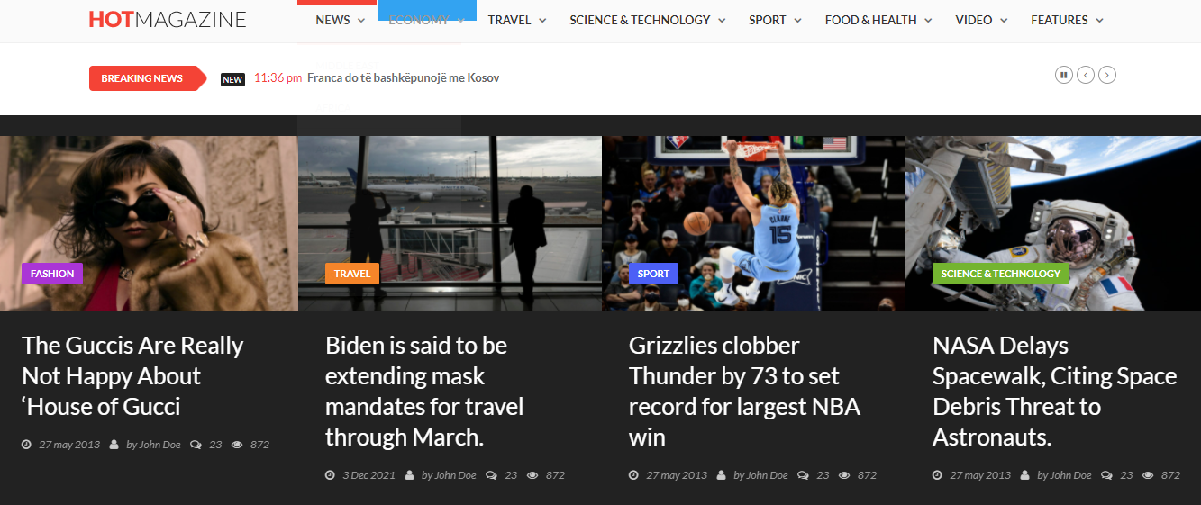
Figure 1 Home Page

    - Communications Interfaces
The Customer must connect to the Internet to access the Website:
▪ Dialup Modem of 52 kbps
▪ Broadband Internet
▪ Dialup or Broadband Connection with an Internet Provider.
  - System Features
- Headlines.
- Categorization.
- Easy to navigate Design.
- Color scheme.
    - System Feature 1
      - Description and Priority

News Portal is a web-based correspondence vehicle for web clients which are perused everywhere. A news entrance is a passage to news; This is by and large considered an Internet association with a news source however the meaning of a "Gateway" would incorporate a paper, magazine or some other admittance to news.
      - Functional Requirements
REQ-SF1-1: <Signup/Login >
REQ-SF1-2: <Updation notification>
REQ-SF1-3: <User feedback>
    - System Feature 2
- The website authority should ensure the customer provide real product
- Customer support is available from the authority
- Customer information security confirm.
- Manage customer information.
- To increase efficiency of managing the authority work.
    - System Feature 3 (and so on)
    - Performance Requirements
- Availability of net
- Device
    - Safety Requirements
- Security
- Reliability
- privacy
    - Security Requirements
User record or data will handle the admin and never reveal to anyone
    - Software Quality Attributes
- Availability
- Reliability
- Scalability
- Reliability:
Regular checks would be applied to the data that would make sure that data is clean in terms of its reliability. Online News Portal system will ensure the privacy of members status and ensure full control over record, so that resource allocation is not possible without administrator authority.
- Availability:
The system will available 24 hours with no lack of connection all you just need is the internet to access the website.
- Maintainability:
The data would be effectively maintained and the web panel will be on a server with high-speed Internet capability. The physical machine to be used will be determined by the administrators themselves. The speed of the connection will depend on the hardware used rather than characteristics of this system.
    - Business Rules
The system will work normal until or unless any user used abusive language if it happens that user’s account will be disabled.

Chapter 3
Use Case Analysis

Chapter 3: System Analysis
This chapter consists of use case model which is mostly used to model interactions between
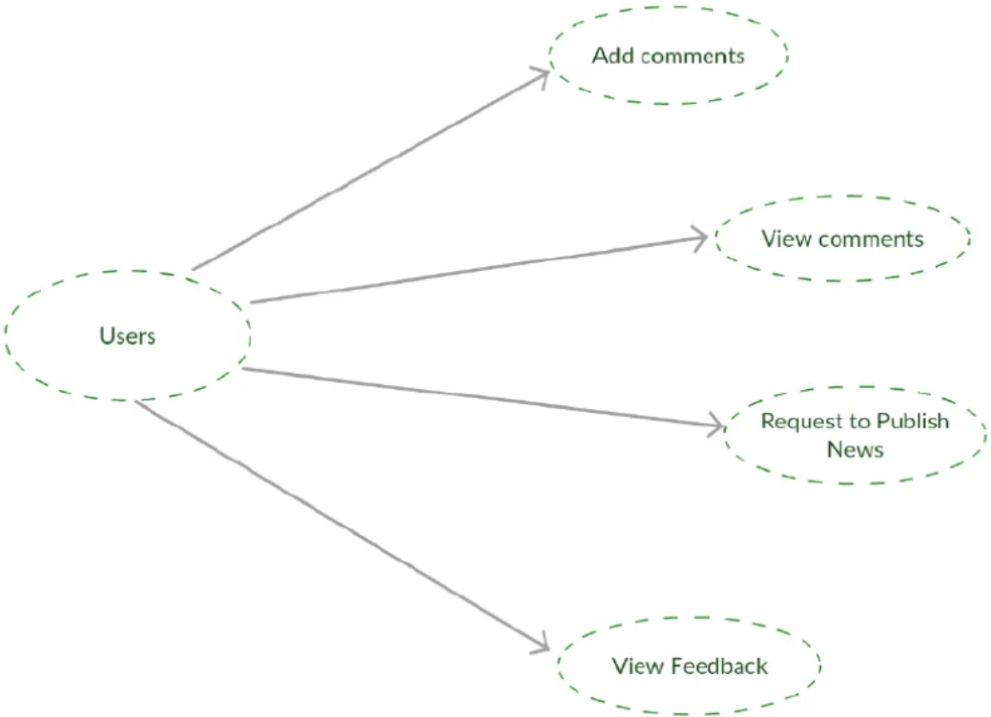
a system and external actors (users or other systems) and use case description.
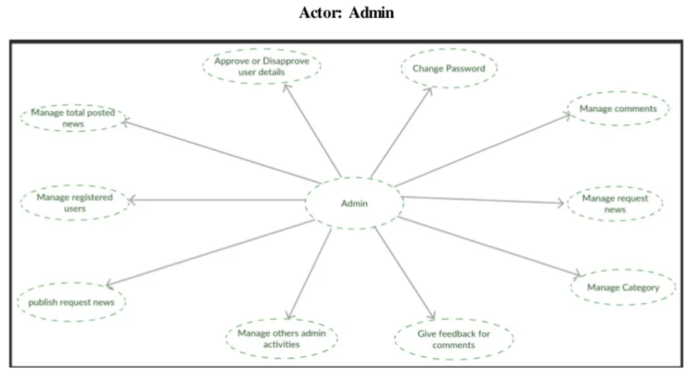
  - Use Case Model

  - Use Case Descriptions

User:
First the user will sign up by authentic mail id the data will saved in database then user will have to login by same id if he doesn’t do that he or she will not able to get entry in the website if he or she enter in the site he/she can search or view any post according to the desire he/she can also give feedback on that specific post , if the user want to logout his/her self or want to login by different email the user can logout his/her self by clicking the user icon and select the exit option.
Admin:
The same goes to admin, the admin has to login himself by admin panel if the admin correctly login the admin panel he can create post and upload it in the right category, the admin will handle the data or record of all user who register his/her self on our website, the admin can remove the post if the article regarding the news isn’t showing, the admin can disable the user account if anyone use abusive or bad language in the feedback or comment section.

Chapter 4
System Design

Chapter 4: System Design
  - Architecture Diagram
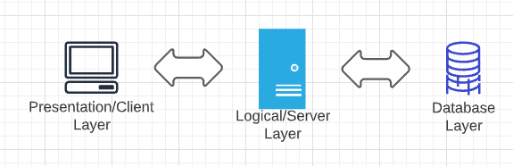
Figure 2 Architecture Diagram
  - Domain Model
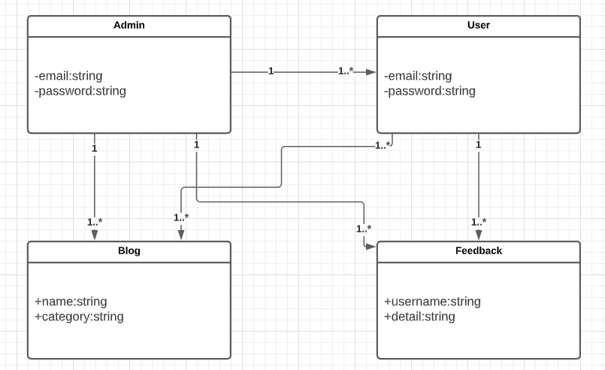
Figure 3 Domain Model

  - Entity Relationship Diagram with data dictionary
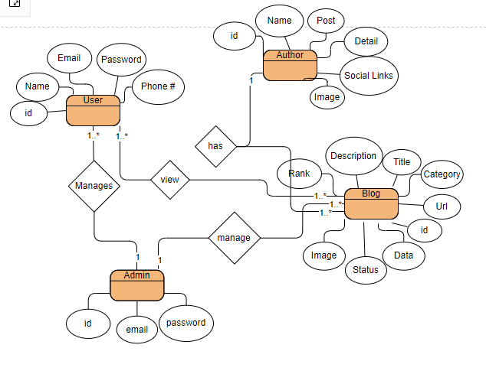
Figure 4 Entity Relationship Diagram with data dictionary

  - Class Diagram
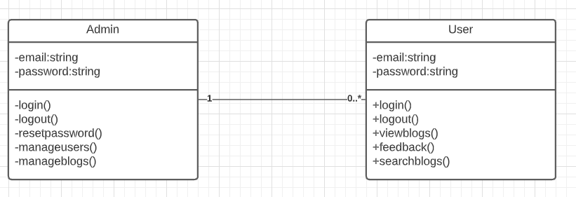
Figure 5 Class Diagram

  - Sequence / Collaboration Diagram
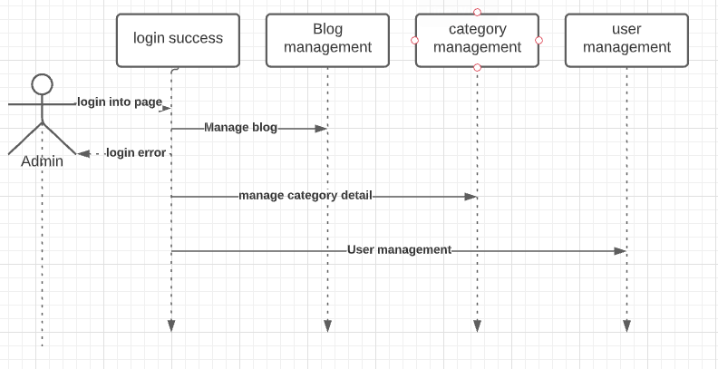
Figure 6 Sequence / Collaboration Diagram
  - Activity Diagram
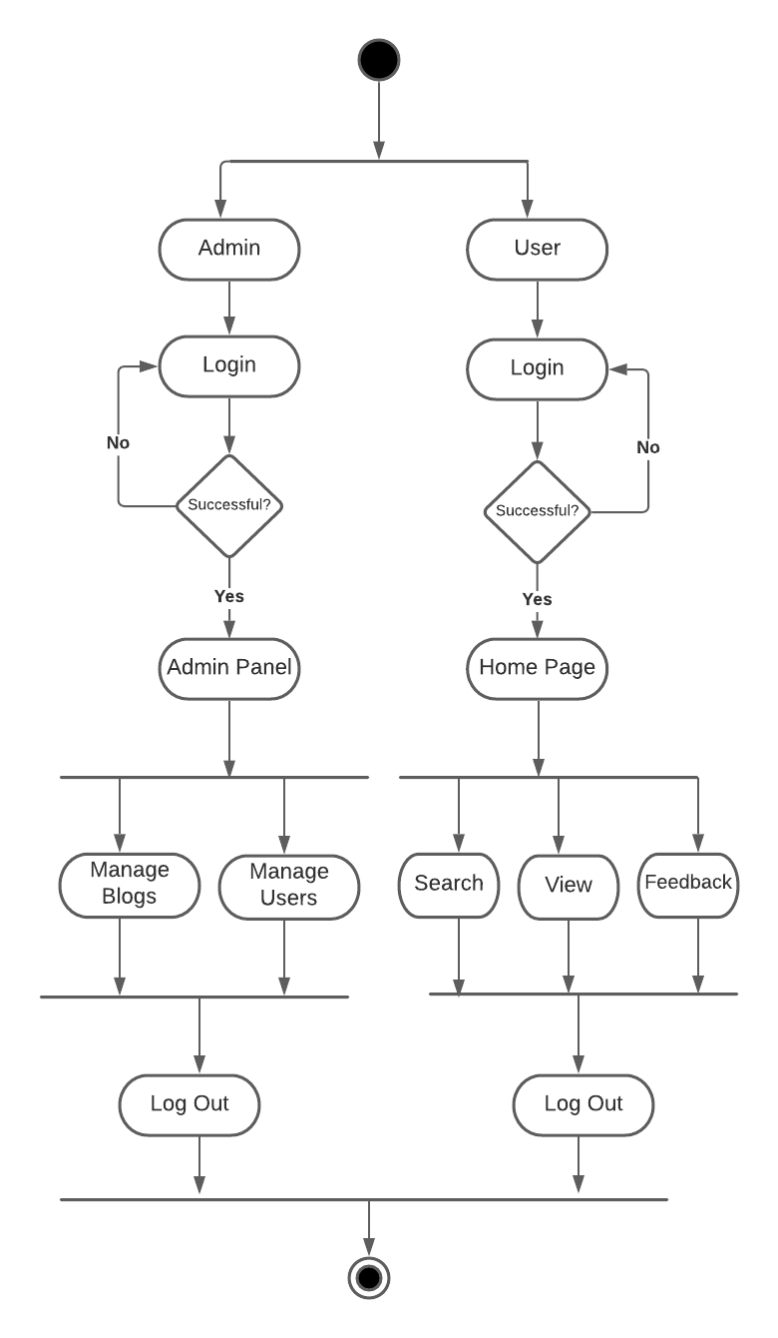
Figure 7 Activity Diagram

  - Component Diagram
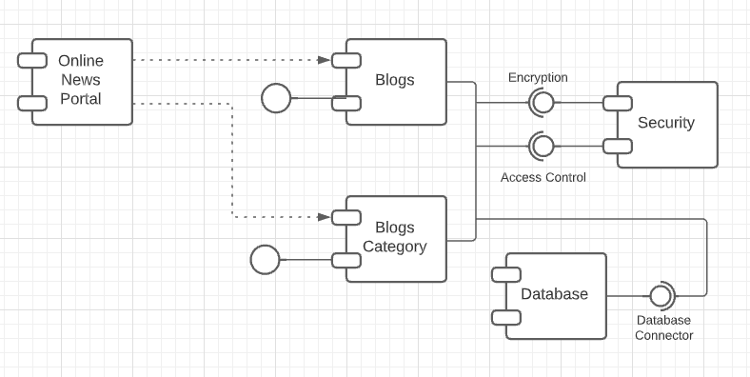
Figure 8 Component Diagram

  - Deployment Diagram
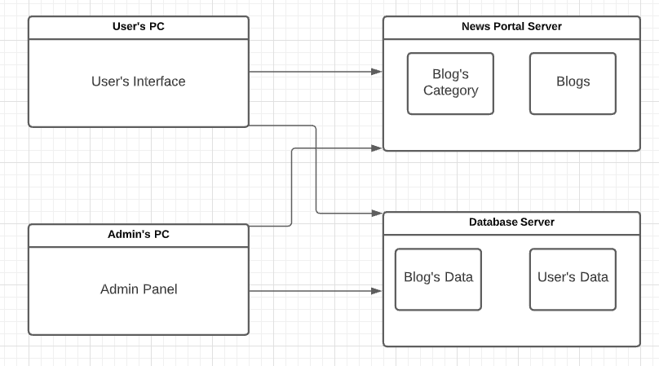
Figure 9 Deployment Diagram

  - Data Flow diagram

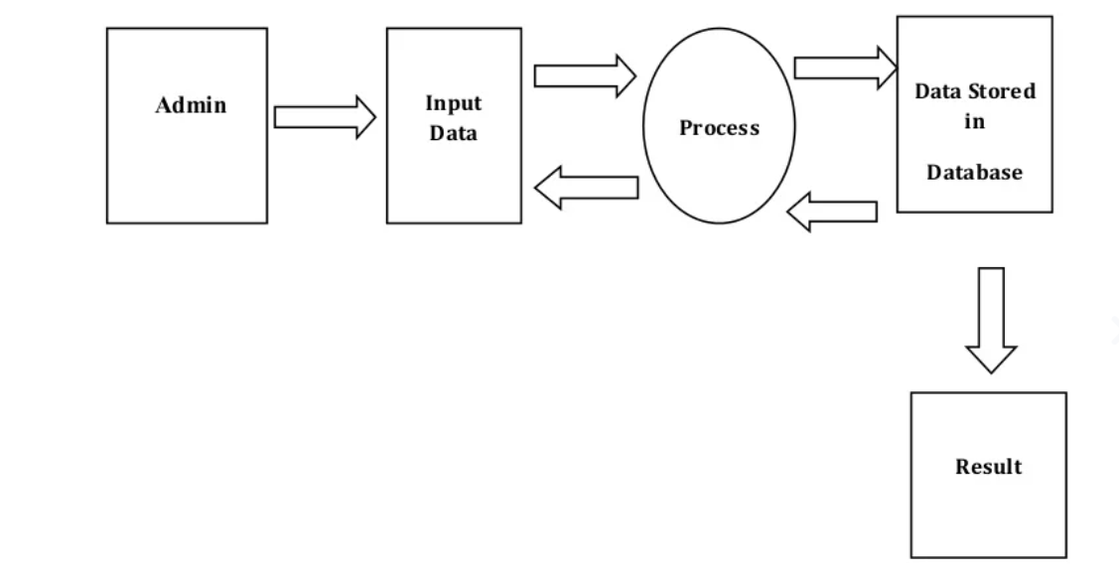
Figure 10 Data Flow Diagram

Chapter 5
Implementation

Chapter 5: Implementation
Implement an e-commerce website starts with having good knowledge of e-commerce business in place such as consistently managing news and user data as well.
  - Important Flow Control/Pseudo codes
Pseudo code means how our project will work its complete flow diagram has drawn above.
  - Components, Libraries, Web Services and stubs
- Text
- Images
- Button
- Input Field
- MYSQL Database
- Feedback
  - Deployment Environment
This Web application doesn’t require any heavy system to develop. It just require a simple team who work hard and have work potential to solve any problem.
  - Tools and Techniques

Front-end:
- HTML 5
- CSS
- Bootstrap

Back-end:
- Database (My Sql)
- PHP

Tools:
- Visual Studio
- Xampp
  - Best Practices / Coding Standards
- The coding should be error free.
- The system should be user friendly so that it is easy to use for the users.
- The system should have more capacity and provide fast access to the database.
- The system should provide search facility and support quick transactions.
- The E-Commerce Store is running twenty-four hours a day.
- Users may access from any computer that has internet browsing capabilities and an internet connection.
- User must have their correct usernames and passwords to enter into their online accounts and do actions.
  - Version Control

Front-end:
- HTML5
- CSS3
- Bootstrap

Back-end:
- PHP
- Database (MySQL)

Chapter 6
Testing and Evaluation

Chapter 6: Testing and Evaluation
  - Use Case Testing

Test Case  Name: | User Can Sign in |  | Use Case Reference: | UC 1
Test Case ID: | TC-1 |  | QA Test Engineer | M Hamza
Version | 1.0 |  | Code Developer | Abdullah Raheel
Test Date | 07 april 2022 |  | Reviewed By | Talha Bin Nasir
Revision  History | None
Objective | User can Sign in
Environment | Website Chrome Browser
Assumptions | User should have stable internet and User have to Enter valid details
Pre-requisites | User should connect to Internet
S. # | Execution Description |  | Expected Output | Procedure  Result
1. | User surf  The website |  | System will display the home Screen | Displayed
2. | User want to sign up sign in |  | System will validate the details and Sign In the account. | Account  Signed in
Comments:
Status |  | - Pass o Fail o Not Executed

Test Case  Name: |  | Admin can  view all user |  | Use Case Reference: | UC 2
Test Case ID: |  | TC-2 |  | QA Test Engineer | M Hamza
Version |  | 1.0 |  | Code Developer | Abdullah Raheel
Test Date |  | 07 april 2022 |  | Reviewed By | Talha Bin Nasir
Revision  History |  | None
Objective |  | Admin can view all users
Environment |  | Website Chrome Browser
Assumptions |  | Admin have stable internet
Pre-requisites |  | Admin should connect to Internet  Admin should login the System
S. # | Execution Description |  |  | Expected Output |  | Procedure Result
1. | Admin will login with its credentials |  |  | System will display the main Dashboard |  | Displayed
Comments:
Status |  |  | - Pass o Fail o Not Executed

Test Case  Name: | Admin can  delete users | Use Case Reference: | UC 3
Test Case ID: | TC-3 | QA Test Engineer | Khizar Shoaib
Version | 1.0 | Code Developer | Ali Sheraz
Test Date | 10 May 2021 | Reviewed By | Yasir Akram
Revision  History | None
Objective | Admin can delete users
Environment | Website Chrome Browser
Assumptions | Admin have stable internet

Pre-requisites |  | Admin should connect to Internet  Admin should login the System
S. # | Execution Description |  |  | Expected Output | Procedure Result
1. | Admin will click on particular user |  |  | System will display the profile of that user | Displayed
2. | Admin will click on delete user button |  |  | System will delete that user. | System updated
Comments:
Status |  |  | - Pass o Fail o Not Executed

Test Case  Name: | User can publish blogs | Use Case Reference: | UC 4
Test Case ID: | TC-4 | QA Test Engineer | M Hamza
Version | 1.0 | Code Developer | Abdullah Raheel
Test Date | 10 May 2021 | Reviewed By | Talha Bin Nasir
Revision  History | None
Objective | User can edit blogs
Environment | Website Chrome Browser
Assumptions | User have stable internet

Test Case  Name: |  | Admin will  review Blogs |  | Use Case Reference: | UC 2
Test Case ID: |  | TC-2 |  | QA Test Engineer | M Hamza
Version |  | 1.0 |  | Code Developer | Abdullah Raheel
Test Date |  | 07 april 2022 |  | Reviewed By | Talha Bin Nasir
Revision  History |  | None
Objective |  | Admin Review pending blogs
Environment |  | Website Chrome Browser
Assumptions |  | Admin have stable internet
Pre-requisites |  | Admin should connect to Internet  Admin should login the System
S. # | Execution Description |  |  | Expected Output |  | Procedure Result
1. | Admin will login with its credentials |  |  | System will display the main Dashboard |  | Displayed
Comments:
Status |  |  | - Pass o Fail o Not Executed

Test Case  Name: |  | Admin can live the blogs |  | Use Case Reference: | UC 2
Test Case ID: |  | TC-2 |  | QA Test Engineer | M Hamza
Version |  | 1.0 |  | Code Developer | Abdullah Raheel
Test Date |  | 07 april 2022 |  | Reviewed By | Talha Bin Nasir
Revision  History |  | None
Objective |  | Admin can live the blogs
Environment |  | Website Chrome Browser
Assumptions |  | Admin have stable internet
Pre-requisites |  | Admin should connect to Internet  Admin should login the System
S. # | Execution Description |  |  | Expected Output |  | Procedure Result
1. | Admin will login with its credentials |  |  | System will display the main Dashboard |  | Displayed
Comments:
Status |  |  | - Pass o Fail o Not Executed

  - Boundary value analysis
Limit esteem examination (BVA) depends on testing the limit upsides of legitimate and invalid segments. The Behavior at the edge of every identicalness segment is bound to be wrong than the conduct inside the parcel, so limits are a region where testing is probably going to yield surrenders. Each segment has its most extreme and least qualities, and these greatest and least qualities are the limit upsides of a parcel. A limit an incentive for a substantial parcel is a legitimate limit esteem. Likewise, a limit an incentive for an invalid parcel is an invalid limit esteem. Tests can be intended to cover both legitimate and invalid limit values. While planning experiments, a test for every limit esteem is picked.

For user Sign-In

Attributes | Invalid partition | Valid partition | Invalid partition
E-mail | no @gmail.com | Must in @gmail.com | no @gmail.com
Password | Below 8 chars | Between 8 to 50 chars | Above 50 chars
For user creation

Attributes | Invalid partition | Valid partition | Invalid partition
Username | Below 8 chars | Between 8 to 50 chars | Above 50 chars
Email | no @gmail.com | Must in @gmail.com | no @gmail.com
password | Below 8 chars | Between 8 to 50 chars | Above 50 chars

  - Data flow testing

Modules  no: | Module’s description | Expected result | Actual result | Status
01 | User Sign in | Validate data from  server | Data validate | Pass
02 | Add Blog | Data must be stored in data base | Data stored | Pass
03 | Edit Blogs | Data must be stored in data base | Data stored | Pass
04 | Delete Blog | Data must be stored in data base | Data stored | Pass

  - Unit testing

Test Case | Step Details | Test Data | Expected Result | Actual Result | Pass/F ail
Sign In | - Open website.  - Enter username and password | Username: hamza123@g mail.com Password:  1234 | User will be logged in successfully | User logged in | Pass

Admin can view users. | - Open website  - Login as Admin.  - Click on view  user’s button.  - Click on specific  user to view their details. | User Displayed=  “Abdullah” | User’s Data will be displayed Successfully. | User’s Data Displayed. | Pass
Admin can delete users. | - Open website  - Login as Admin.  - Click on view  users  - Click on particular user To view.  Click on delete  user button. | User Deleted =  “Talha” | User will be deleted Successfully. | User Deleted. | Pass

  - Performance testing
- Maximum Response time is less 7 sec.
- Average response time 5 sec.
- Peak number of requests 10000.

Constraints | Response Time
website Startup | Less than 5 sec (Sometimes depend on internet Speed)
Data fetching | Less than 2 sec (Sometimes depend on internet Speed)
website state update | Less than 1 sec
Transition in website | 0.5 sec
Redirecting between inner pages of website | Less than 3 sec

Chapter 7
Summary, Conclusion and Future Enhancements

Chapter 7: Summary, Conclusion & Future Enhancements
  - Project Summary
We are living in 21st century and every individual either that’s a child or a young man we are getting advance and still moving towards more advancement so with this advancement we expect things to get easier and easier so we made an online news portal we already have a lots of news web pages so why this but the challenges I saw in different news pages is fake news because fake news get buy quick and then I got motivation to make an online news portal where no nobody up their hands on the uniqueness of content nobody will claim the news is fake and add a bad review.
Online news portal will have precise and every news category to spread knowledge and to fulfill their expectations regarding news.
Admin will handle the users and manage the news according to the category ,first the adk8min will publish with complete copyrights of author the news and then user will able to see the news and give their feedback.
Besides Online news portal is a blog site so we can generate a fancy revenue from this site by publishing different blogs according to their category in our news portal website
  - Achievements and Improvements
Online news portal will target the audience that is tired or fed up of getting fake news published on the internet and looking for the source that provide them with authentic news. Make your site easy to browse.
Optimize your news site. Find keywords, pronto! Use shareable images. ...
Keep your site operational. Improve your site loading speed. Make your site mobile-friendly.
Build relevant links.
Use social media. Be present everywhere. Find the best times to post. ...
Get featured in Google News
  - Critical Review
The lede (or lead) of a news article is the first sentence, usually written as one paragraph, that tells the most important information of the story. When writing a lede, it is helpful to use the “tell a friend” strategy. Because mostly people used to read just first paragraph of the article so you make sure to put informational data in first 50 words to make your user interested to read the whole article.
  - Lessons Learnt
Online News Sites play a vital role in educating and informing Mass with latest updates, current happenings around the globe. People don't have much more time to read the Printed newspaper with yesterday's happening, so they always follow web portals or Electronic Media for getting latest News
  - Future Enhancements/Recommendations
Online news portal can be enhanced by giving panels to user as well rather than taking news by admin and then study it verify it and then publish it
User can publish a news by himself and it will be under a review if the news is authentic then it will be published

