SUPERIOR UNIVERSITY LAHORE


Faculty of Computer Science & IT

Final Year Project
PROJECT REPORT (Part-1)

[CallonRent]

Project ID: [write ID here Issued by FYP Manager]

Project Team
Student Name | Student ID | Program | Contact Number | Email Address
Talal Tahir | Bitm-f15-063 | BSIT | 0323-1613031 | Talaltahir789@gmail.com
Hafiz M Hassan | Biitm-f15-030 | BSIT | 0323-1418204 | Wajidbaig24@gmail.com
Usama Kashif | Bitm-f15-007 | BSIT | 0304-0048306 | Usamakashif135@gmail.com

[Fawad Nasim]
([Assistant Professor])
Project Report
[CallonRent]

Change Record
Author(s) | Version | Date | Notes | Supervisor’s Signature
 | 1.0 |  | <Original Draft>
 |  |  | <Changes Based on Feedback from Supervisor>
 |  |  | <Changes Based on Feedback From Faculty>
 |  |  | <Added Project Plan>
 |  |  | <Changes Based on Feedback from Supervisor>

APPROVAL
Project Supervisor
Comments: ___________________________________________________________________
_____________________________________________________________________________
Name:______________________________
Date:_______________________________ | Signature:__________________________

Project Manager
Comments: ___________________________________________________________________
_____________________________________________________________________________
Date:_______________________________ | Signature:__________________________

Head of the Department
Comments: ___________________________________________________________________
_____________________________________________________________________________
Date:_______________________________ | Signature:__________________________

Dedication

The work is dedicated to our Team and Teachers.
All members of our group worked as team to achieve best of our Project. Every member put their effort to so I really appreciate their effort and time management that helped me to complete this document.
Also our Supervisor Prof. Fawad Nasim who helped us with time to time to give complete shape of our project and guide us to overcome project weakness and better understand our project to develop real time product and its documentation.

Acknowledgements
I would like to show my greatest appreciation to my project in-charge, Prof. Fawad Nasim. I can’t say thank you enough for the tremendous support and help. I feel motivated and encouraged every time I attend his meeting. Without his encouragement and guidance this project work would not have materialized.

Executive Summary
In this document we will complete five chapters. Every chapter has its own value and importance. In the chapter 1, we will give complete introduction of our project which includes project background, goals, objective, values and challenges. PLUS, we will make a complete work break-down structure(WBS) which shows the complete project components with specific required time.
Chapter 2: We’ve conduct all requirements that includes functional and non-functional and show every requirement with its purpose in the system to clearly understand system requirements and we’ve done some feasibility study to check either this requirement exists in this system or not.
Chapter 3: We did use case analysis to clearly understand system requirements that interact with a specific role to complete its purpose.
Chapter 4: We make system design. In system design we divide our project into components and make diagrams to show every single component and identify every component have own requirements that must be consider while developing the CallonRent.
We will make different architecture diagrams to clearly describe the modules, interfaces and data in the system. This chapter Also shows that how every module is integrating to the each other.
Chapter 5: We defined all of our implementation work, deployment, environment, languages, libraries, tools & techniques, components, and coding standards to refine the track of implantation process.

Table of Contents
Dedication iv
Acknowledgements v
Executive Summary vi
Table of Contents vii
List of Figures ix
List of Tables x
Chapter 1 1
Introduction 1
1.1. Background 2
1.2. Motivations and Challenges 2
1.3. Goals and Objectives 2
1.4. Literature Review/Existing Solutions 2
1.5. Gap Analysis 2
1.6. Proposed Solution 2
1.7. Project Plan 3
1.7.1. Work Breakdown Structure 3
1.7.2. Roles & Responsibility Matrix 3
1.7.3. Gantt Chart 3
1.8. Report Outline 3
Chapter 2 4
Software Requirement Specifications 4
2.1. Introduction 5
2.1.1. Purpose 5
2.1.2. Document Conventions 5
2.1.3. Intended Audience and Reading Suggestions 5
2.1.4. Product Scope 5
2.1.5. References 6
2.2. Overall Description 6
2.2.1. Product Perspective 6
2.2.2. Product Functions 6
2.2.3. User Classes and Characteristics 6
2.2.4. Operating Environment 7
2.2.5. Design and Implementation Constraints 7
2.2.6. User Documentation 7
2.2.7. Assumptions and Dependencies 7
2.3. External Interface Requirements 8
2.3.1. User Interfaces 8
2.3.2. Hardware Interfaces 8
2.3.3. Software Interfaces 8
2.3.4. Communications Interfaces 9
2.4. System Features 9
2.4.1. System Feature 1 9
2.4.1.1. Description and Priority 9
2.4.1.2. Stimulus/Response Sequences 9
2.4.1.3. Functional Requirements 9
2.4.2. System Feature 2 10
2.4.2.1. Description and Priority 10
2.4.2.2. Stimulus/Response Sequences 10
2.4.2.3. Functional Requirements 10
2.4.3. System Feature 3 (and so on) 11
2.5. Other Nonfunctional Requirements 11
2.5.1. Performance Requirements 11
2.5.2. Safety Requirements 11
2.5.3. Security Requirements 12
2.5.4. Software Quality Attributes 12
2.5.5. Business Rules 12
2.6. Other Requirements 12
Chapter 3 13
Use Case Analysis 13
3.1. Use Case Model 14
3.2. Fully Dressed Use Cases 14
Chapter 4 15
System Design 15
4.1. Architecture Diagram 16
4.2. Domain Model 16
4.3. Entity Relationship Diagram with data dictionary 16
4.4. Class Diagram 17
4.5. Sequence / Collaboration Diagram 17
4.6. Operation contracts 17
4.7. Activity Diagram 18
4.8. State Transition Diagram 18
4.9. Component Diagram 18
4.10. Deployment Diagram 19
4.11. Data Flow diagram [only if structured approach is used - Level 0 and 1] 19
Chapter 5 20
Implementation 20
5.1. Important Flow Control/Pseudo codes 21
5.2. Components, Libraries, Web Services and stubs 21
5.3. Deployment Environment 21
5.4. Tools and Techniques 22
5.5. Best Practices / Coding Standards 22
5.6. Version Control 22
Appendices 23
Appendix A: Information / Promotional Material 24
Reference and Bibliography 27
Index 29

List of Figures

1.1 Caption of first figure of first chapter 6
1.2 Caption of second figure of first chapter 7
2.1 Caption of first figure of second chapter 14
2.2 Caption of second figure of second chapter 22
2.3 Caption of third figure of second chapter 26
5.1 Caption of first figure of fifth chapter 49
5.2 Caption of second figure of fifth chapter 49

List of Tables

1.1 label of first table of first chapter 6
1.2 label of second table of first chapter 7
2.1 label of first table of second chapter 14
2.2 label of second table of second chapter 22
2.3 label of third table of second chapter 26
5.1 label of first table of fifth chapter 49
5.2 label of second table of fifth chapter 49

Chapter 1

Introduction

Chapter 1: Introduction
A highly versatile and inimitable project is about to develop a site which is named as www.CallonRent.com
This platform will be a marketplace for individuals to list, find, and book interesting places and tours around the globe using the web or from a cell phone or tablet. Regardless of whether a flat for a night, a palace for seven days or for a month and to book a tour, CallonRent associates individuals with interesting travel experiences at a reasonable & flexible price. This consists of a front end along with the Web Admin panel.

Background
The idea of CallonRent came through when we see some difficulties to find a hotel in Kashmir Valley. When we are making a minute ago travel game plans. We need a hotel to be booked when we reach there.
Online lodging and private property reservation entry is a well-known strategy for booking inn rooms. Travelers can book rooms on their phones by utilizing on the web security to ensure their protection and money related data.
Online gateway is additionally useful for making a minute ago travel courses of action. Inn may drop the cost of a room if a few rooms are as yet accessible. There are a few Websites that uniquely in scans for arrangements on rooms. An online inn reservation and private property entryway, normally online a focal reservation framework is a modernized framework that stores and conveys data of an inn, resort or other cabin offices.

Motivations and Challenges

Motivations:
The development in the industry of tourism urged to an idea that there should be a platform in Pakistan for the overseas tourists and the domestic people which have great fond of traveling. Plus, there is no such platform with having an additional module of tourism industry where user can book and plan a tour with friends or family.

Challenges:
The biggest challenge in this area and era that how we can educate our people to fulfill their travel needs by just using their device while sitting in their place/homes. Plus, other challenge is our competitors which are working in this domain already and have the users on their website and the second biggest challenge is to switch the users of those platforms to our platform.

Goals and Objectives
Goals:
Our main goal is to promote tourism industry of Pakistan and from the user perspective allowing user to book a hotel or tour from home without visiting their office and from our perspective our goal is to earn a reputable reputation in tourism industry and to earn commission from every booking which will be made on our platform plus earnings by the users visiting our website and the website will be connected to the Google AdSense.

Objectives:

The most important objectives of ‘CallonRent’ a web based portal is to increase the global reach of a hotel reservation website. Through it, hoteliers are able to post ad of their hotel rooms so that various users around the world can access the website. Thus it increases the chances of a number of bookings. Also, it saves a lot of time and effort for customers as they can conveniently book hotel rooms from their homes.
Other commonly objectives fulfilled by our online web based portal are:
- To provide a platform to manage on-desk and online bookings.
- To display an organized information of hotel/tours with prices pictures.
- To add multiple hotels/tours to the system.
- View of availability of rooms in real time.
- A user-friendly interface for customers for the easy booking process.
- Store customer information which can be accessed anytime.
- To provide a secure payment gateway for online transaction.

Literature Review/Existing Solutions
Mighty big platforms which are working on this domain where user can book hotels and motels from their platforms like www.booking.com although this and mighty other websites are our competitors but with the passage of time and with the unique idea of implementing the tourism industry we will overcome with SEO techniques and digital marketing and the other thing online booking system is implemented by some renowned hotels small businesses and private properties aren’t involved in these websites and our motive is to take over all the small business and hotels to grow their sales. Some of the existing mighty platforms are discussed below.

- www.Airbnb.com

Airbnb is a mighty good platform for online bookings of hotels and private properties and it contains an additional module of restaurant bookings where user can also search and book a restaurant from their platform. It is actually our biggest competitor in the market which is recently launched in Pakistan.
But, a very good thing for us that it doesn’t contains any module regarding tourism industry which is the most powerful advantage for us because we had it in our website.

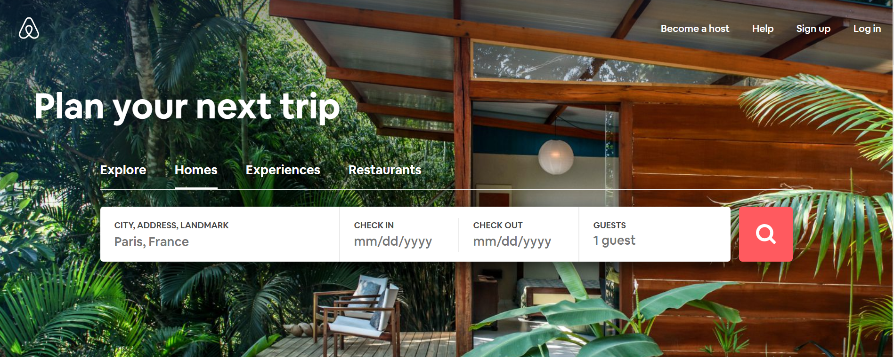

- www.Booking.com
www.booking.com is a vast platform for car rentals, Airport Taxis, Flights and hotel booking like some other platforms are working in Pakistan but the sadly or gladly this platform also has no module of tourism industry and actually there is no such platform having this module onto their platform.

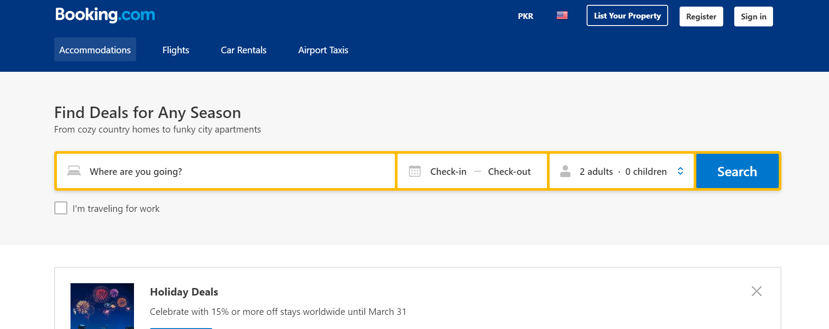

Gap Analysis
Gap Analysis is actually the comparison of actual performance with potential or desired performance and the solution we are going to proposed.
Mighty big platforms offering number of services like car rentals, flight booking and room booking but there is no such platform for tourism industry where tour companies can offer their services to the end-user.
Internet has become the most important media of communication nowadays, especially in making hotel reservations. In the past, consumers reserved hotels via travel agents, by phone or even they came directly to hotels. But now they can reserve hotels without spending too much time and efforts by visiting Online Portals via their websites.

Proposed Solution
In Pakistan there are more than hundred hotels which are gaining their international customers as well as domestic but online booking system via website is implemented by some renowned hotels only so the platform CallonRent is one of the project which is required to be implemented in Pakistan. Although we have chosen it. Besides,
We are introducing a platform which is actually a full pledge business model where not only the hotel owners can post their ads but, also the owners of private properties can post their ads too.
we are adding modules and features in our platform like ‘Private Properties’ where private owners can also take advantage by posting the ad of their house, lodges for a day or a month.
Another module we are adding is ‘Tourism Industry’ where user can view the tour posts by some renown tourist companies and can book seats by paying them online through our payment gateway.

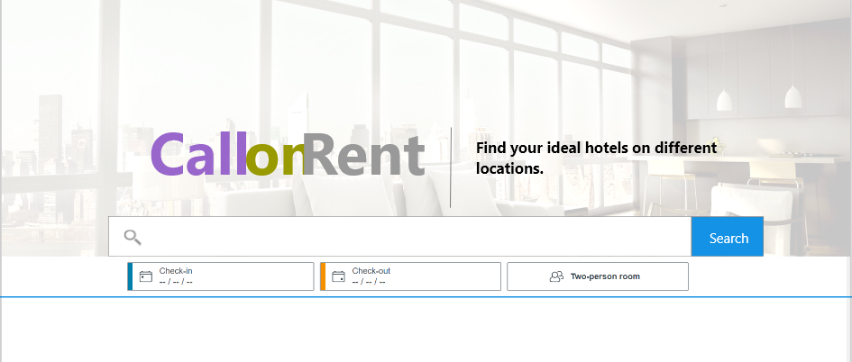

Project Plan
Our task plan depends on our methodology of building the website. We will be utilizing distinctive ways to deal with make our item along these lines, it would be half breed process. Our first methodology is to illuminate our prerequisites as much as we can and disseminate these necessities on further sub necessities to make work simple. We investigations our necessities and refine them by the estimating the actualize capacity of the modules or functionalities. Our execution depends on our WBS which we clarify below in points of interest.

Work Breakdown Structure

WBS Deliverable | Activity to Complete the Deliverable | Duration  (# of Days)
Project Plan | - Research on  - requirements  - problem statement | 5
Software Requirement Specification Document | - Requirement Elicitation  - Requirement Analysis | 30
Architecture Diagram | - Architecture Design | 1
Use Case Diagram | - UML Design | 5
Fully Dress Use Case | - UML Design | 4
Domain Model | - UML Design | 1
Class Diagram | - UML Design | 1
Operation | - UML Design | 3
Sequence Diagram | - UML Design | 5
Activity Diagram | - UML Design | 2
State Machine Diagram | - UML Design | 2
Entity Relationship Diagram | - Database Design | 3
Software Design Document | - Architecture Design  - UML Design | 5
Frontend development | - User Interface Design (web) | 25
Backend development | - Implementation  - Testing  - Deployment | 150

Roles & Responsibility Matrix

The purpose of roles & responsibility matrix is to identify who will do what.

WBS # | WBS Deliverable | Activity # | Activity to Complete the Deliverable | Duration  (# of Days) | Responsible Team Member(s) & Role(s)
 |  | 1 | Documentation | 32 | Team
 |  | 2 | Map Coordination | 20 | Hafiz M Hassan
 |  | 3 | Front-end development | 20 | Usama Kashif
 |  | 4 | Back-end development | 25 | Talal Tahir
 |  | 5 | Admin Panel | 32 | Talal Tahir

Gantt Chart

This chart specifies the start and ending date of the project.

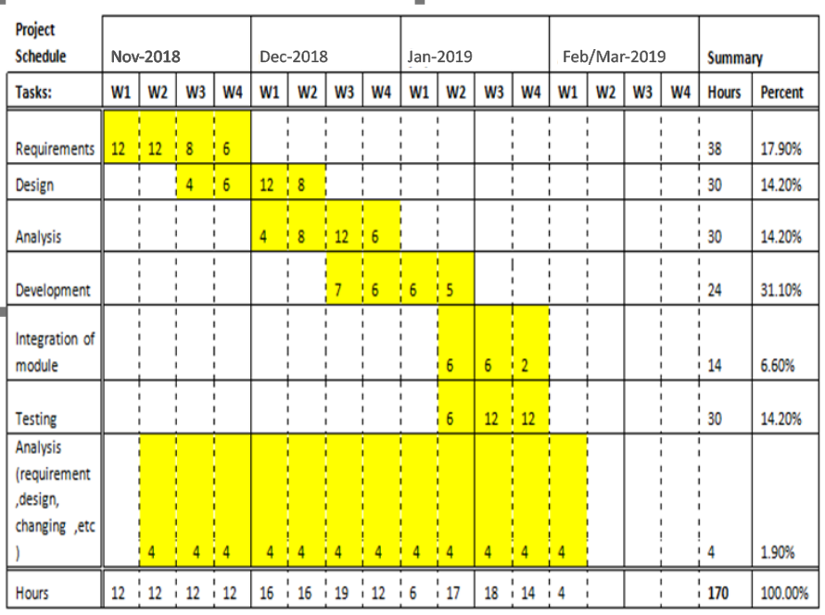

Report Outline
CallonRent – a lodging company, helps people rent extra space in homes to travelers through its website and to book tours from the respective platform. The brief background and/or history of company is the final year project which we have to submit and actually we choose this project it our dream project to complete with. And, the importance of this report outline is to let other business allow to know CallonRent story & try to use its methods / practices to achieve success.
The development caused by internet banking and electronic transactions has contributed to facilitate various kinds of banking transactions to the customers and reduce the time and effort spent by them.

Chapter 2

Software Requirement Specifications

Chapter 2: Software Requirement Specifications

Introduction

Purpose
The Existing platforms are working globally and we want to launch this project domestically and to promote the tourism industry of Pakistan. One of the main problems is that our people are not actually aware of these online web portals or tours companies which we want to demonstrate our people to do so.
To meet escalating guest expectations hoteliers, need to ensure that their reservation system is
a modern hotel reservation system with seamless integration features enables hotels to not just maximize bookings via the hotel's own website but also via various online channels Document Conventions.
Stander manage of documentation has been followed in the request of normalized the work. In a request to make efficient platform
All requirements in the document must have a priority level of 1, 2, or 3. Priority level 1 specifies that the requirement is essential. Priority level 2 specifies that the requirement may be included in the end but is not necessary to product functionality. Priority level 3 specifies extra features of the product that may be included after all level 1 and 2 requirements are adequately completed
Following are the document conventions of this SRS

NAME | DESCRIPTION
SRS | Software Requirement Specification
ADMIN | A person who will be managing the platform for its intended purpose
USER | A person who can book hotel or tour from the given ads by the Service Provider.
Service Provider | Service Provider can post ads of their category.
DB | Data base

Document Conventions
The standards used for the creation of this document are mentioned below
Font: Calibri
Font Size:12
Font Alignment: Justified
Microsoft office preferred heading hierarchy is used in the creation of this document to explain the topic, sub topic, child sub topics.

Intended Audience and Reading Suggestions
This SRS is mainly developed for the project development team. In this team, there are the project manager, developer, coder and documentation writer, database staff, project supervisor and user of the project. This document is having its beneficial effect for the Marketers, Stake Holders & the Service Providers, so they can get all the understandings about the whole scope, flow, functionality, pros & cons and the solutions to overcome. This document intended for the following peoples.
User
This document is intended to the user to make them ensure that this document is well meeting the need of the users.
Project Manager
This SRS document is also very important for the project manager to ensure that he can manage all the resources in a well manner and can estimate the time & cost easily by referring to the SRS document and that it contains all the information require planning the project.
Project Developer
This will give step by step guide to the developer to develop the system functionalities by keeping all the functional & Non-functional requirements of the system in mind. The project developer will refer to the SRS document to make sure that they developed exactly according to the requirements.
Database Staff
The SRS document help to database staff to check that authorized person uses this system and correct data manipulate.
Document Writer
The document writer reading the SRS document is to ensure that they understand the document well enough to be able to write the users manuals.
QA & Testers
This document will be a bridge for the QA staff as they will get all the knowledge about the scope and the functional & Non-functional requirements and the features. They will create bug sheets & test cases using the Use cases and other constraints.
Maintenance
The SRS document helps the maintenance engineers to understand the functionality of the system, a clear knowledge of the functionality can help them to understand design and code.
Sequence/Priority
The whole document is worthy for the whole audience we have described above but some parts are the document are necessary to read for respective users about which we have mentioned below
- The user can read the whole SRS document but for him, Introduction, overall description and System features is much required the software performance.
- A tester must be aware of coding language and visit through the code section and check the required output. QA & tester must rely to the Uses cases, functional & non-functional requirements as well so that they can test the system according to the requirements
- The document writer should write the qualitative document so that it comes easy and understandable to everyone
- For project Manager & Developers, whole the document is necessary to read out
- Marketers can get well understandings about target audience, problems & constraints and can use this beneficial data to market the product.
- Stake holders can get the idea about the business logic, business use & growth from the document

Product Scope
Callonrent is going to decrease the gap between users and travelling
This will be a basically service providing website which will have 3 users. User/Traveler which will come to the platform to book a service (rooms, private property, tour package). 2nd one will be the service provider which can be a hotel, a property owner or a tourism company which can offer his service for the user on the website. User can select one service and make payments to book the service.
3rd and the most important user will be admin which will be all in all to manage all the actions performed on the website by the user/traveler and the service provider as well.
The basic goal is to serve the users/travelers with residence in all the area of the country specially where the user has to face difficulties, by moving physical appearance booking method to remotely bookings so that user can book a residence by his gadget (PC, Mobile, Tab) while sitting in his bed room so that he/she can all set before the journey.
Our objective is to promote the tourism industry as well as decreasing the residence risk by allowing the user to use software to set all the things up

References
For the reference we will surely want to mention a mighty platform www.airbnb.com which is already running over the globe. We would like to follow it in business logic & UI (layout) but with the addition of a functionality in our system which is for tour companies to post their packages.

Overall Description

Product Perspective
We can say it is a replacement of existing systems but having additional features. Like we have hotel reservation website but user can now be able to book a room after viewing different hotels and can book a property as well. The platform is giving a wide range for selection to the user. The basic purpose is to give the residency services of all the kinds on one platfrom

Product Functions
For user/Traveler
- Sign Up
- Login
- Search a Service
- View Search Results
- Book a Service
- Make Payments
- Edit profile details
- Logout
For Service Provider
- Sign Up
- Login
- Create a Service
- Post an ad
- Manage services
- Edit profile details
- Logout

User Classes and Characteristics
The website will have a simple and understandable UI/UX because the target audience is about all the People. While we are going to give the unique services so every individual can go the platform and get a service.

Operating Environment
- The minimum capability to kick the system to run of a device will be
- For Android (from 5.0 to up)
- For iOS (from 4 to up)
- For PC (having a good RAM will robust the system)

Design and Implementation Constraints
<Describe any items or issues that will limit the options available to the developers. These might include: corporate or regulatory policies; hardware limitations (timing requirements, memory requirements); interfaces to other applications; specific technologies, tools, and databases to be used; parallel operations; language requirements; communications protocols; security considerations; design conventions or programming standards (for example, if the customer’s organization will be responsible for maintaining the delivered software).>

User Documentation
We will deploy a proper user manual named “How it works” and make its pdf available for the user to download it from the website also we will make a CMS page to tell user how it work step by step.

Assumptions and Dependencies
<List any assumed factors (as opposed to known facts) that could affect the requirements stated in the SRS. These could include third-party or commercial components that you plan to use, issues around the development or operating environment, or constraints. The project could be affected if these assumptions are incorrect, are not shared, or change. Also identify any dependencies the project has on external factors, such as software components that you intend to reuse from another project, unless they are already documented elsewhere (for example, in the vision and scope document or the project plan).>

External Interface Requirements

User Interfaces
We will use a simple, sleek and modern UI keeping the things in mind that our user can be from every class.
Golden rules for UI will kept in mind while designing the front-end.
The website layout will be a replica of the website Kayak.com and we will change the design only and apply animations to make it in modern look.

Hardware Interfaces
Website will be supportive and responsive in all the devices PC’s, Tabs Mobile (android & iOS). The minimum capability to kick the system to run of a device will be
For Android (from 5.0 to up)
For iOS (from 4 to up)
For PC (having a good RAM will robust the system)

Communications Interfaces
Browser: Goggle Chrome, Opera, Mozilla and all other supporting html & CSS
Also communication between the website and the server will be secure and we will use SSL and shift to HTTPS on live.

System Features
The system will have the listed functional and non-functional features.

Functional Requirements

User
- Sign Up (Button)
  - Can sign up using his/her google account.
    - Note: There will be a sign-up button, upon click it will redirect the user towards google accounts to enter their credentials, after successful signup, it redirects the users towards CallonRent Dashboard.
- Log In (Button)
  - Can log in using his/her google account.
    - Note: There will be a Login button, upon click it will redirect the user towards google accounts to enter their credentials after successful login can reach to his /her dashboard.
- Can Search (Button)
  - When the user clicks on Search button can see “Posts by Service Provider”.
  - Can search by category
Note: When a new user comes to the dashboard he/she can see empty dashboard other can view listed on Search the dashboard. And can see the “Past search history”
- Create bookings (Button)
  - When the user clicks on create bookings button can see “Listings by category”.
Note: When a new user comes to the dashboard he/she can see empty dashboard other can view Booking made by him.
- Can contact Service Provider
  - When the user wants to get any queries from the Service Provider he can contact the Service Provider by
His given number/Email

- Can view terms & conditions page

(Upon click on the Terms and conditions, it will redirect the users to page where he/she can read the terms and conditions of the platform).

- Affiliated Companies (Link Button clickable)
  - Can view the list of companies
- Log out (Link Button) Upon click It will log out the user from the site immediately.
  - Can log out from his/her account.

Service Provider
- Sign Up (Button)
  - Can sign up using his/her google account.
    - Note: There will be a sign-up button, upon click it will redirect the user towards google accounts to enter their credentials, after successful signup, it redirects the users towards CallonRent Dashboard.
- Log In (Button)
  - Can log in using his/her google account.
    - Note: There will be a Login button, upon click it will redirect the user towards google accounts to enter their credentials after successful login can reach to his /her dashboard.
- Can Post ad (Button)
  - When the Service Provider clicks on Post an ad button can “add Posts by category”.
  - Can add price
  - Can add picture
  - Can add detail
  - Can add Email
  - Can add Title
- Submit (Button)
  - When the user clicks on Submit button post will be submitted and will show in the listing by category”.
- Can Edit Post(button)
  - When the Service Provider wants to Edit the post, he/she can edit the descroption/title by clicking on the edit button.

- Can view queries

        - Can view the queries made by the user about the relevant post/ad

- Can buy subscription(button)
  - When a Service Provider buys a subscription his/her post will automatically be on the first
- Log out (Link Button) Upon click It will log out the user from the site immediately.
  - Can log out from his/her account.

Admin

- Log In
  - Can log in by adding following details
    - Username
    - Password
- Profile Management
  - Can view/edit their profile detail
- Content Management
  - Can manage the content of the website pages
  - Can customize menu items
- Role Management
  - Can create more admin users
  - Can set the roles for each admin user
  - Can set the permissions for each role
- User Management
  - Can view all registered users on the website.
  - Can view all the activities of all registered users.
- Can view bookings
  - Can view the booking made on the website by the users.
- Subscription packages Management
  - Can view all subscription packages on the website.
  - Can add/edit features and price of any subscription package.
  - Can delete any subscription package.
- Can view registered users
  - Can view and manage the registered users
    - User
    - Service Provider
- Can Block users
  - Can block and unblock the registered users
    - User
    - Service Provider
- Can view queries
  - Can view the queries between
    - User
    - Service Provider
- Chat
  - Can reply to user’s chat.
- Log out
  - Can log out from the website.

Other Nonfunctional Requirements

Performance Requirements
The System will be dynamic and it will be able to process the browsing and show the results in less than seconds, although slow processing can delay in the result.
The system will be dependable on 3rd party API which is used for payment processing in terms of performance requirements as if the three occurs an issue in the payments due to 3rd party than the performance of the system will be affected.

Safety Requirements
The goal is
- To develop an interactive, dynamic and timely service for the users.
- To develop a modern, sleek System while retaining simplicity and maximum security
Each screen will contain appropriate content and it will be displayed in well-mannered fashion
Simple to navigate, dynamic, tech-savvy and innovative look-and-feel.

Security Requirements
The system will have to be secure as it will contain the Very much important details of the user such that Credit/debit card data for payments. SO, we will use SSL Certificate for that purpose.
and a server which will get encrypted requests and return data in encryptions

Software Quality Attributes
Tourism Packages listing by different companies are the most attract features for the users so that they can book a tour also they will have the facility to book a residence for the area where they are travelling so it will be a plus.

Business Rules
Business rules for the products will be mentioned below
- Admin will get percentage commission on the booking of every single service

Other Requirements
Legal Requirements
While we are integrating a new module for property owners to list their properties and the users/traveler to book a property from a stranger person so there exists a security risk and we are well known of it so we will use a legal way to make our business register by using a lawyer to get permissions and NTN from the Law Enforcement Agencies.
Further all the user will be verified by email and phone number so that user identity and tracking will not be an issue in the future.

Chapter 3

Use Case Analysis

Chapter 3: System Analysis
A business is a system made up of methods, procedures, and routines. The first step in solving a problem that involves a system is analyzing that system. In this chapter we are going to work on the use cases of this project.

Use Case Model
A utilization case is an accumulation of related achievement and disappointment situations that
depict on-screen characters utilizing the framework to help an objective. A situation is a particular succession of activities and associations amongst performing artists and the
framework under discourse

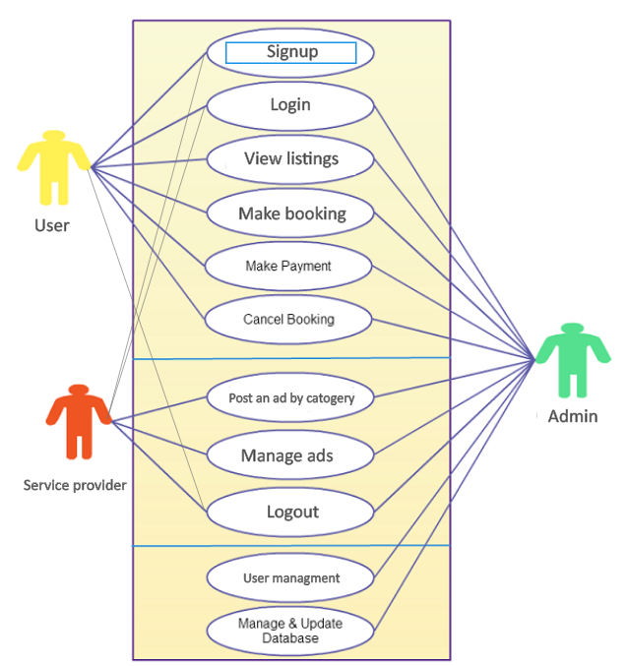

Fully Dressed Use Cases
In these use case we will define how the single use case is working in that environment what will be used to let that use case work in the environment

Sign up
ID: | SF-001
Title: | Sign up
Description: | The first thing user will do is to register himself with unique user name and with unique password
Primary Actor: | User who can add post and who can book service
Preconditions: | The user has open the Website
Postconditions: | User is registered now
Main  Success Scenario: | The user has open our website and he/she has find out that he have to registered himself he has click the sign up button and the form will open with the following field  First Name  Last Name  username  Password  Email address
Extensions: | If the username/email is registered before or the username/email didn’t follow the format, he/she will be notified with the error message and same goes for password if the password is not string or did not meet the format that is being provided he/she will be notified with a popup screen.
Frequency of Use: | This Use case will be used for once
Status: | Pass
Priority: | The priority of this use case is high as without registering he/she will not be able to book/post-ad into the website

Login

ID: | SF-002
Title: | Login
Description: | The user is registered now he/she will not have logged into the account with filling into the respective fields.
Primary Actor: | User who will post an ad or book any service
Pre-conditions: | User registered himself
Post-conditions: | User can login now
Main  Success Scenario: | The user is registered now and can post ad by category/book any service from the listing. while logging in into the website he/she needs two fields username and password with filling both fields he/she will enter into the system
Extensions: | If the username or password is wrong the error message will be shown onto the screen and if he forgot the password, he/she will be shown forgot password option which will ultimately take him into recover account or help option
Frequency of Use: | This Use case will be used for once
Status: | Pass
Priority: | The priority of this use case is high as without logging in himself he will not be able to use the system

Manage Ads (Service provider)

ID: | SF-003
Title: | Manage Ads
Description: | Registered User (Service provider) can now delete/edit posts respectively into website
Primary Actor: | Vendor who is offering any service
Preconditions: | User login into the system
Postconditions: | User can now edit or delete posts
Main  Success Scenario: | The registered user (Service provider) is now logged into the website and he/she can see a lot of modules in front of him the first module tells him to delete/edit services into his website
Extensions: | If the user does not like or have any problem with the service, he/she is offering then he/she can delete/edit or can add post again respectively
Frequency of Use: | This Use case can be used many times
Status: | Pass
Priority: | The priority of this use case is high and user (Service provider) can edit or delete any post any time

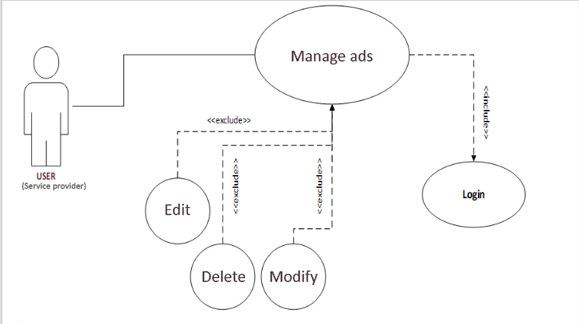

Post an ad by category (Service provider)

ID: | SF-004
Title: | Add Post
Description: | Registered User (Service provider) can now add posts respectively into website
Primary Actor: | Vendor who is offering any service
Preconditions: | User login into the system
Postconditions: | User can now add posts
Main  Success Scenario: | The registered user (Service provider) is now logged into the website and he/she can see a lot of modules in front of him the first module tells him to add post services into his website
Extensions: | If the user does not like or have any problem with the service, he/she is offering then he/she can add post again respectively
Frequency of Use: | This Use case can be used many times
Status: | Pass
Priority: | The priority of this use case is high and user (Service provider) can edit or delete any post any time

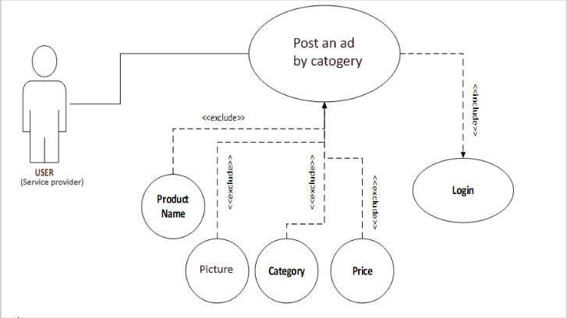

Make Payment (User)

ID: | SF-005
Title: | Make Payments
Description: | The most important part of the website is to make payment after the booking is done by the end-user. The payments gateway will be integrated into the website from which user will pay online.
Primary Actor: | User who will book any service from the listings
Preconditions: | User will logged into the website
Postconditions: | Payments will automatically deduct from the buyer account when online transaction is made
Main  Success Scenario: | When user will pay the payment a confirmation email will sent to the both user and service provider
Extensions: | The user who will buy any service will provide his credit card through the payment gateway and amount will be deducted automatically.
Frequency of Use: | This Use case can be used many times
Status: | Pass
Priority: | The priority of this use case is high as the main focus of the point of sale system is to handle sales and let the merchant know what is happening in terms of money

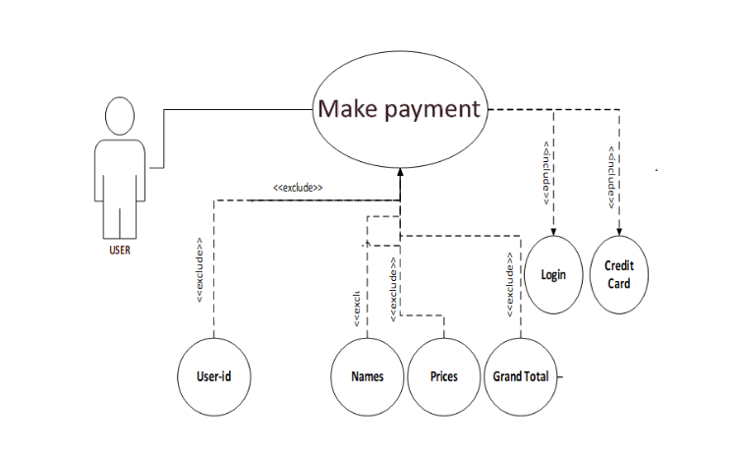

Make Booking (User)

ID: | SF-006
Title: | Make booking
Description: | Registered User (User) can now book any service from the listing by catogery
Primary Actor: | User who is logged in
Preconditions: | User login into the system
Postconditions: | User can now book any service
Main  Success Scenario: | The registered user (user) is now logged into the website and he/she can book any service from the website
Extensions: | The user can now book any post provided in the listigs by category and by service providers
Frequency of Use: | This Use case can be used many times
Status: | Pass
Priority: | The priority of this use case is high and user (Service provider) can edit or delete any post any time
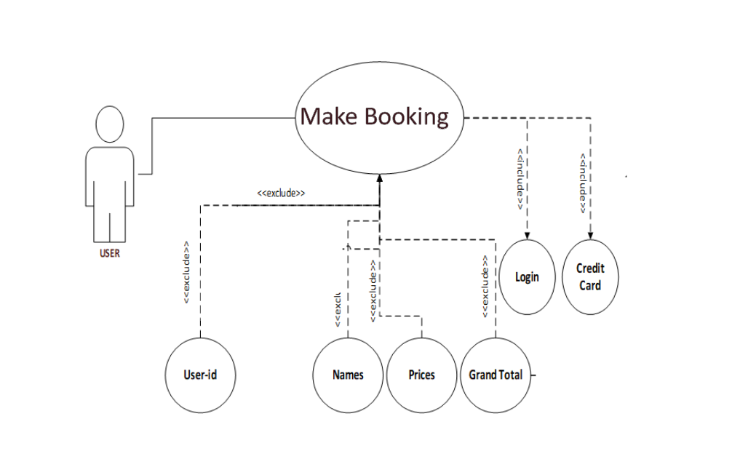

View Listing (User)

ID: | SF-007
Title: | View listing
Description: | Registered User (User) can now view list provided by any service provider from the listing by catogery
Primary Actor: | User who is logged in
Preconditions: | User login into the system
Postconditions: | User can now view any service
Main  Success Scenario: | The registered user (user) is now logged into the website and he/she can view any service from the website
Extensions: | The user can view any post provided in the listigs by category and by service providers
Frequency of Use: | This Use case can be used many times
Status: | Pass
Priority: | The priority of this use case is high and user (Service provider) can edit or delete any post any time
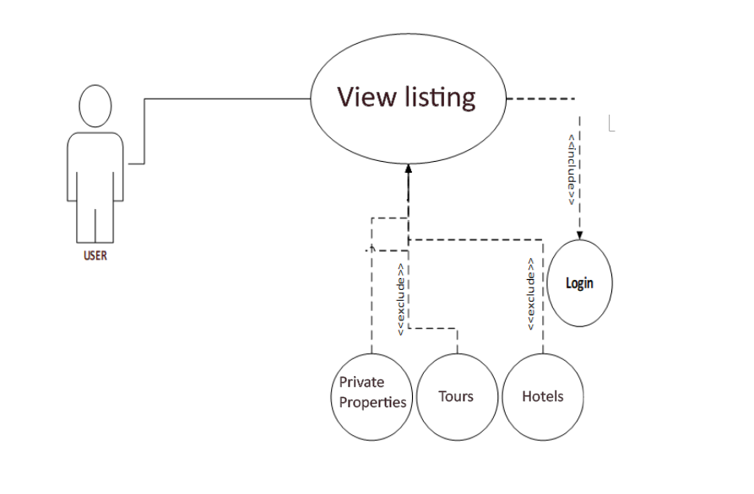

Manage and update DB (Admin)

ID: | SF-008
Title: | Manage and update DB
Description: | Registered User (User) can now book any service from the listing by catogery
Primary Actor: | Super Admin
Preconditions: | Admin logged into the system
Postconditions: | Admin can now Manage and update DB
Main  Success Scenario: | The admin is now logged into the website and he/she can Manage and update DB
Extensions: | The admin can now view any post provided in the listings by category and by service providers
Frequency of Use: | This Use case can be used many times
Status: | Pass
Priority: | The priority of this use case is high and user (Service provider) can edit or delete any post any time

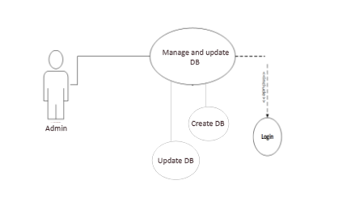

User Management (Admin)

ID: | SF-009
Title: | User Management
Description: | User management (Admin) can block/unblock any user from the website.
Primary Actor: | Admin
Preconditions: | Admin logged into the system
Postconditions: | Admin can have access to the user management
Main  Success Scenario: | The admin is now logged into the website and he/she can Manage user management
Extensions: | The admin can now view any post, bookings and payments of the user of the website.
Frequency of Use: | This Use case can be used many times
Status: | Pass
Priority: | The priority of this use case is high and user (Service provider) can edit or delete any post any time

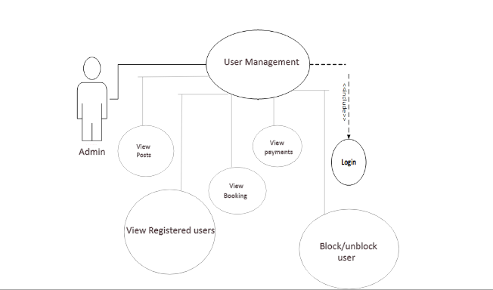

Logout
ID: | SF-010
Title: | Logout
Description: | After the user done all his operations now he needs a safe exit for that he has to logout from the system
Primary Actor: | User/Service-provider/Admin who was logged in to our website
Preconditions: | User will click the logout button
Postconditions: | The user will automatically come out from the system
Main  Success Scenario: | If the he is unable to logout, he will be given help option in that system will ask his username and password again a then ask him to leave through logout option
Frequency of Use: | This Use case will be used many times
Status: | Pass
Priority | The priority of this use case is high as the user should logout from the system to prevent misuse of the authority

Chapter 4

System Design

Chapter 4: System Design
System design shows how the system interacts and collaborate with its modules to the user and also a developer. The project team can easily identify an error in the system before deploy to the end user.
Following are the diagram of point of sale system

Architecture Diagram
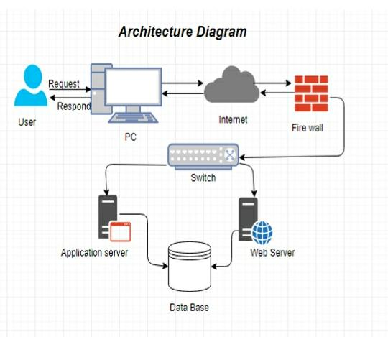

Domain Model
A space express describes important abstract classes in an issue area. It is the most essential antiquity to make amid protest situated study. A space display is generally utilized as a wellspring of motivation for planning programming objects
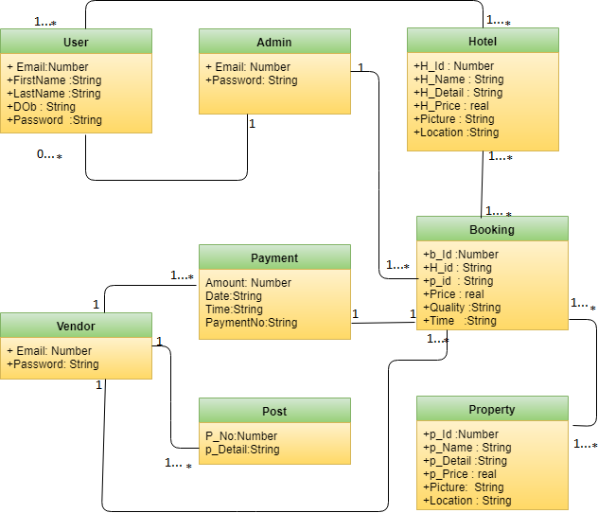

Entity Relationship Diagram with data dictionary
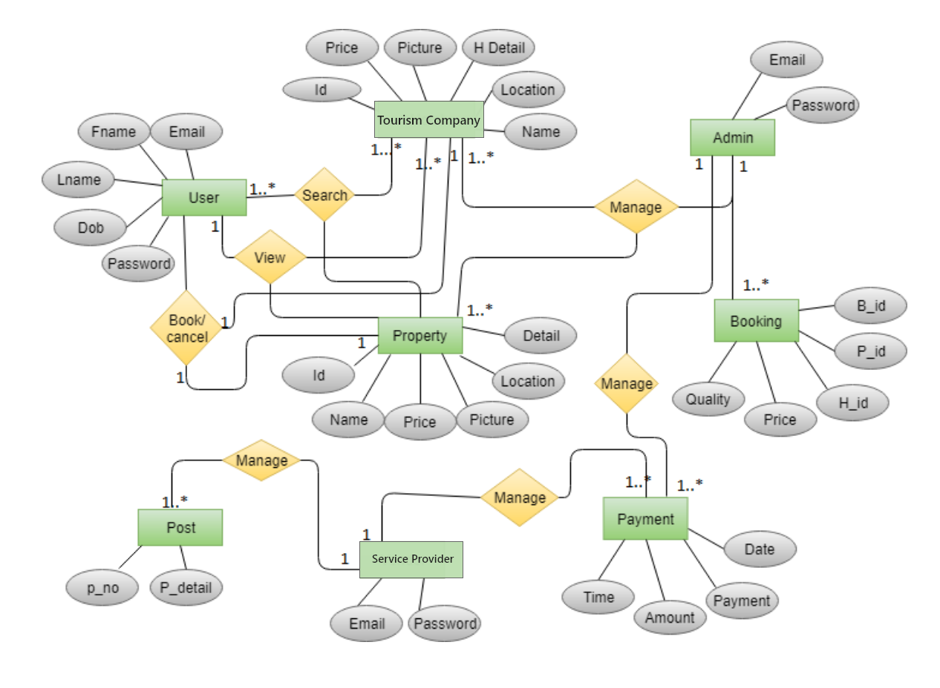

Class Diagram
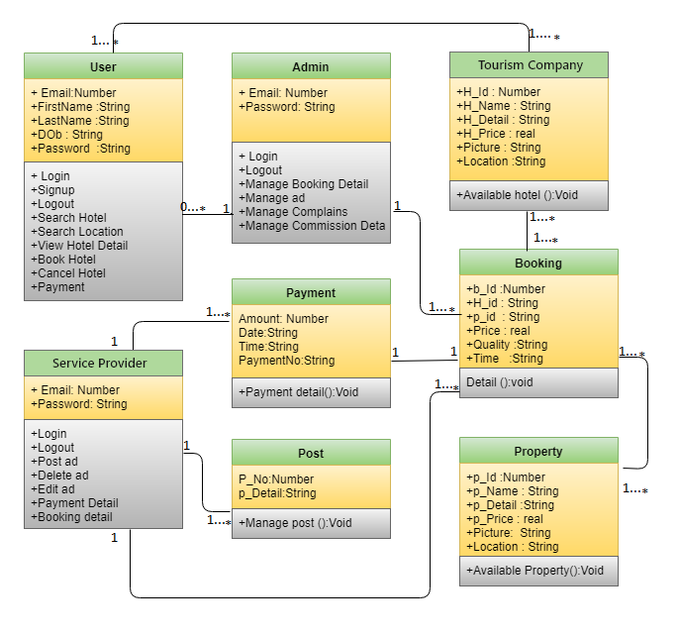

Sequence / Collaboration Diagram
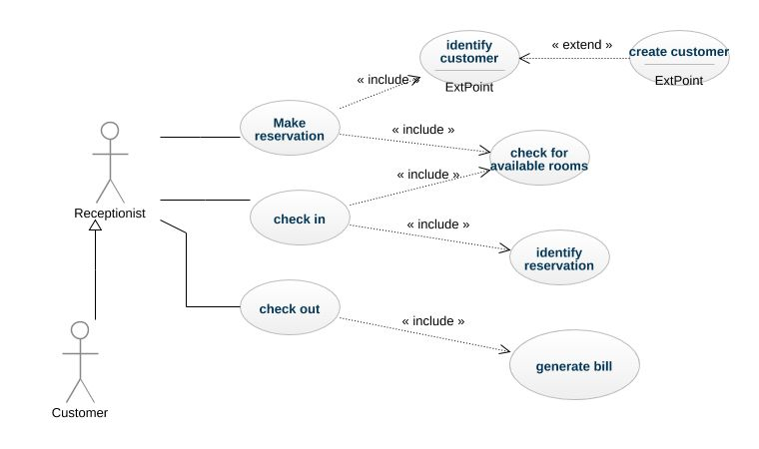

Activity Diagram

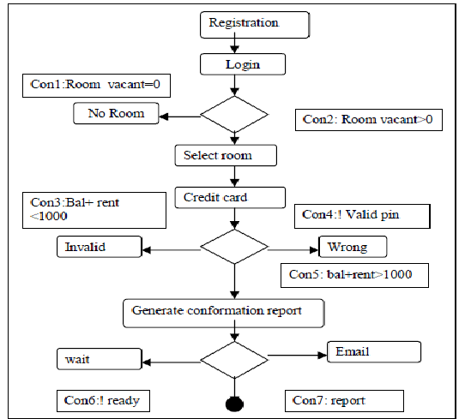

State Transition Diagram
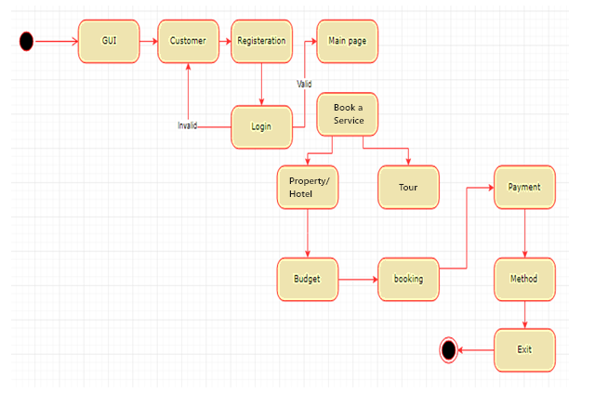

Component Diagram
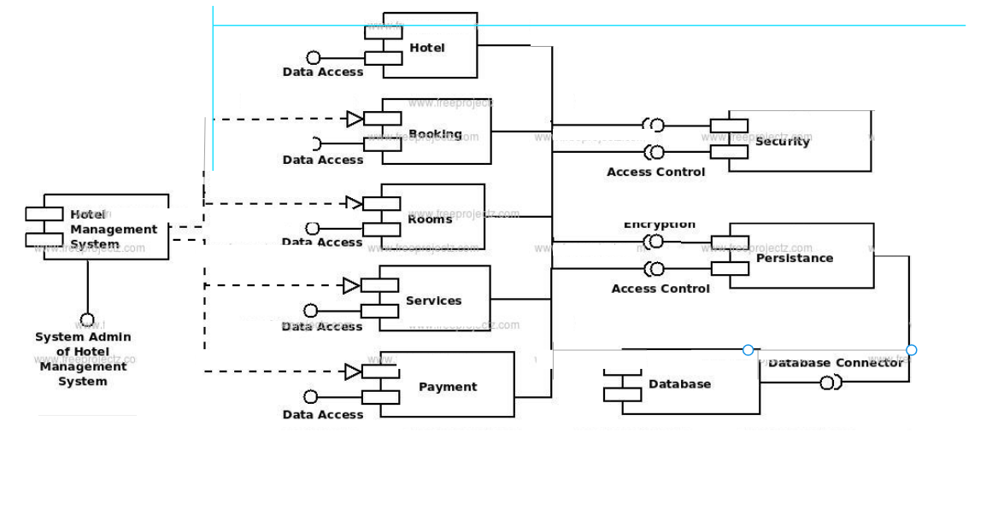

Deployment Diagram
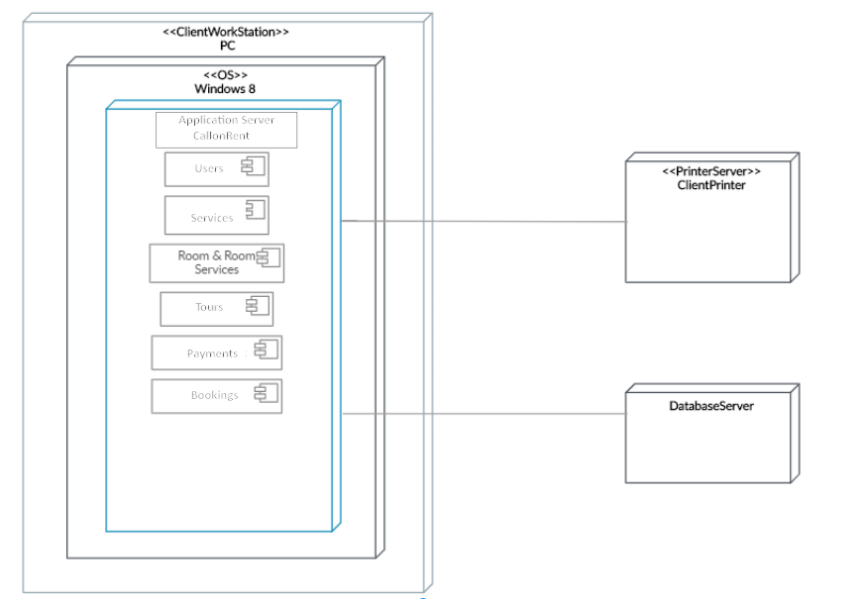

Data Flow diagram

Level 0

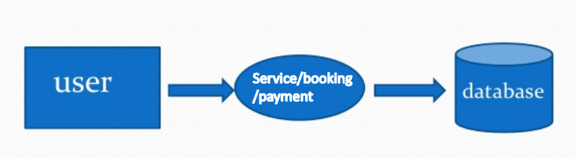

Level 1
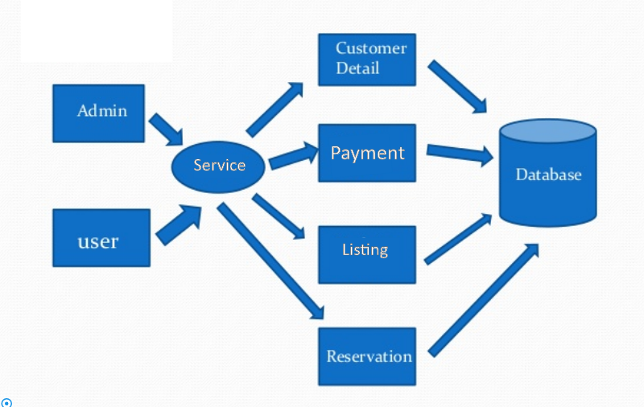

Chapter 5

Implementation

Chapter 5: Implementation
In this chapter, we are going to explain that how we will implement our project, under which working conditions it will be implemented, what kind of tools and techniques we are going to use.

Important Flow Control/Pseudo codes
Hotel reservation system is an important part in the life of a modern hotel, because it ensures proper work of the hotel, making it efficient and provides the option to book a room online. It holds information for the workers and administration about the rooms and the hotel overall.

Components, Libraries, Web Services and stubs
Components:
1. Properly Structured Website
CallonRent website is easy to use. If a user wants to book a hotel, private Property or any tour they can easily book from our portal. Our Portal has a simple structure, with the most important pages accessible from the main navigation bar.

2. Mobile Friendly platform(Responsiveness)
Today, the world of technology is evolving quickly; more and more people have been using their mobile devices to get their needs done. Our Portal is mobile friendly(Responsive) and can be run on all android/Iphone devices.
Web Services
- Users can straightforwardly book hotel/Private property and tour.
- 24-hrs access
- All required information about the locations will be provided.
- Guide selection on the go.

Deployment Environment
This portal will be deployed on a server of a hosting platforms like GoDaddy and from where we will buy our domain for this platform which is www.CallonRent.com The hardware on which it will run will be dual core generation or higher with NVIDIA graphics installed with the operating system Microsoft windows 7 or higher.

Tools and Techniques
These are some of the tools and technique requires developing our product.
- Languages: Laravel(PHP), HTML 5, CSS 3, Javascript
- Database: MySQLi
- Graphical Tools: Adobe xd CC
We are going to use Agile and Speed programming approaches for this project

Best Practices / Coding Standards
- Test-first programming,
- Rigorous, regular refactoring,
- Continuous integration,
- Simple design,
- Pair programming,
- Sharing the codebase between all programmers,
- A single coding standard to which all programmers adhere.

Version Control
CallonRent is a web-based reservation system that’s designed specifically for tour and activity operators. It provides tour and hotel reservation system. It is built

Appendices

Appendix A: Information / Promotional Material
We are going to use Digital marketing and gorilla marketing techniques for promoting our product.

  - Flyer

  - Standee

  - Banner

Reference and Bibliography

Reference and Bibliography

1. Wiki. Tourism in Pakistan. Wikipedia. [Online] https://en.wikipedia.org/wiki/Tourism_in_Pakistan.
2. propakistani. tourism industry. propakistani. [Online] https://propakistani.pk/2017/08/11/tourism-industry-.
3. Findmyadventure. home. Findmyadventure. [Online] FindMyAdventure.com.
4. Tripkar. Home. Tripkar. [Online] https://tripkar.com/.
5. Tripadvisor. Home. TripAdvisor. [Online] https://www.tripadvisor.com/.
6. Buffalostour. Barriers. Buffalostour. [Online] https://www.buffalotours.com/blog/travel-tips-conquering-the-language-barrier-in-southeast-asia/.
7. Draw. blank diagram. Draw. [Online] www.draw.io.
8. Zuzkerburg, Mark. pages. Facebook. [Online] www.Facebook.com.
9. Zuckerburg, Mark. pages. Instagram. [Online] www.Instagram.com.

Index

Index

[A]

[B]

[C]

