SUPERIOR UNIVERSITY LAHORE

Faculty of Computer Science & IT
FINAL YEAR PROJECT
PROJECT PROPOSAL& PLAN
Online Railway reservation system
Project ID: [FYP-BCSM-F18-034]

Project Team
Student Name | Student ID | Program | Contact Number | Email Address
Ahmad Arshan | BCSM-F15-234 | bscs | 03319700197 | Ahmadarshan192gb94@gmail.com
M.Zubair Iqbal | BCSM-F15-194 | bscs | 03044401897 | zubairiqbal117@gmail.com
M.Uneeb Babar | BCSM-F15-174 | bscs | 03234228322 | Uneeb322@gmail.com

Supervisor
Mr.Umair khan
Lecturer

Project Report
[Online Railway reservation system]

Change Record
Author(s) | Version | Date | Notes | Supervisor’s Signature
Ahmad Arshan  Zubair iqbal  Uneeb babar | 1.0 |  | <Original Draft>
 |  |  | <Changes Based on Feedback from Supervisor>
 |  |  | <Changes Based on Feedback From Faculty>
 |  |  | <Added Project Plan>
 |  |  | <Changes Based on Feedback from Supervisor>

APPROVAL
Project Supervisor
Comments: ___________________________________________________________________
_____________________________________________________________________________
Name:______________________________
Date:_______________________________ | Signature:__________________________

Project Manager
Comments: ___________________________________________________________________
_____________________________________________________________________________
Date:_______________________________ | Signature:__________________________

Head of the Department
Comments: ___________________________________________________________________
_____________________________________________________________________________
Date:_______________________________ | Signature:__________________________

Dedication

All our efforts and struggles of educational life are dedicated to our dear parents without their love and support; it would never have been possible. We also dedicate this work to our honorable and respected teachers, especially to our supervisor Mr. UMAIR Khan and
Co-supervisor M.Ahmad who taught and supported us in achieving the ultimate result.
Thank you to all the teachers they teach me in whole degree.
Thank so much

Acknowledgements
We thanks to Allah for giving us the ability to perform the essential tasks and achieve the desired result.
We are really thankful to our teachers and huge thanks supervisor and co-supervisor for their generous transfer of knowledge and uncountable support. It was a really good experience, a very memorable one; for what we are today is the hard work of our teachers and their extensive support and well wishes for us.
We are not able to achieve this goal without you sir. Thank you Mr.Umair Khan and M.ahmad.

Executive Summary
Booking a train ticket standing in a queue or online has been a challenge for the common man. Though the Reservation Systems have gotten better over the years, a lot more needs to be done on this front to make booking of train tickets easier and transparent. The citizen community online has come together to collectively identify the key issues, root causes and solutions for Improving the Pakistan Railways Reservation System. In Online Reservation system we are providing many facilities for humans of Pakistan we can sale tickets online and people can cancel their tickets also. People can see the route of every train at their systems online or by GPS system. To use this system, its users should be registered and should have a valid login and password to make their reservation. Even if users who have not their valid login id and password can make new registration and get their id and set password as per their choice. The main objective of this login module is to keep each passengers safe which will not allowed to make fraud and make their transactions secure.
So there are many objectives as following:
- Online Booking / Cancelation from anywhere
- Secure authenticated system to reduce fraud
- Rich features like Detail of Trains / Routes / Available Tickets / Shortest Paths / Recommended Trains / Estimated Fair Calculator etc
- Confirmation through Email / SMS on every Transaction and communication
- Providing feasible environment to customers
- Customer feedback blog
- Comprehensive Reports System

Table of Contents
Dedication iv
Acknowledgements v
Executive Summary vi
Chapter 1 1
Introduction 1
1.1. Background 2
1.2. Motivations and Challenges 2
1.3. Goals and Objectives 3
1.4. Literature Review/Existing Solutions 3
1.5. Gap Analysis 4
1.6. Proposed Solution 4
1.7. Project Plan 4
1.7.1. Work Breakdown Structure 4
1.7.2. Roles & Responsibility Matrix 5
1.7.3. Gantt chart 6
1.8. Report Outline 6
Chapter 2 8
Software Requirement Specifications 8
2.1. Introduction 9
2.1.1. Purpose 9
2.1.2. Document Conventions 9
2.1.3. Intended Audience and Reading Suggestions 9
2.1.4. Product Scope 10
2.1.5. References 10
2.2. Overall Description 10
2.2.1. Product Perspective 10
2.2.2. Product Functions 10
2.2.3. User Classes and Characteristics 11
2.2.4. Operating Environment 12
2.2.5. Design and Implementation Constraints 12
2.2.6. User Documentation 13
2.2.7. Assumptions and Dependencies 13
2.3. External Interface Requirements 13
2.3.1. User Interfaces 13
2.3.2. Hardware Interfaces 13
2.3.3. Software Interfaces 14
2.3.4. Communications Interfaces 14
2.4. System Features 14
2.4.1. System Feature 1 14
2.4.1.1. Description and Priority 15
2.4.1.2. Stimulus/Response Sequences 15
2.4.1.3. Functional Requirements 15
2.4.2. System Feature 2 16
2.4.2.1. Description and Priority 16
2.4.2.2. Functional Requirements 17
2.5. Other Nonfunctional Requirements 17
2.5.1. Performance Requirements 17
2.5.2. Safety Requirements 17
2.5.3. Security Requirements 17
2.5.4. Software Quality Attributes 17
2.6. Other Requirements 18
Chapter 3 19
Use Case Analysis 19
3.1. Use Case Model 20
3.2. Fully Dressed Use Cases 23
Chapter 4 29
System Design 29
4.1. Architecture Diagram 30
4.2. Domain Model 31
4.3. Entity Relationship Diagram with data dictionary 33
4.4. Class Diagram 34
4.5. Sequence / Collaboration Diagram 36
4.6. Operation contracts 37
4.7. Activity Diagram 38
4.8. State Transition Diagram 39
4.9. Component Diagram 40
4.10. Deployment Diagram 41
4.11. Data Flow diagram [only if structured approach is used - Level 0 and 1] 42
Chapter 5 45
Implementation 45
Chapter 6 48
Testing and Evaluation 48
Chapter 6: Testing and Evaluation 49
6.1. Use Case Testing 49
6.2. Equivalence partitioning 57
6.3. Boundary value analysis 64
6.4. Data flow testing 64
6.5. Unit testing 65
6.6. Integration testing 65
6.7. Performance testing 65
6.8. Stress Testing 65
Chapter 7 66
Summary, Conclusion and Future Enhancements 66
7.1. Project Summary 67
7.2. Achievements and Improvements 67
7.3. Critical Review 67
7.4. Lessons Learnt 67
7.5. Future Enhancements/Recommendations 67
Appendices 68
Broacher 68
Reference and Bibliography 77

Chapter 1

Introduction

Chapter 1: Introduction
Railway reservation system Software has to be developed for automating the manual
Reservation system of railway. The system should Track the train through GPS system. The software takes the current system date and time as the date of issue and calculates the amount to be paid by the user. This system can save the previous record of every passenger .Store and Retrieve the information .User friendly interface to administrator and customer.
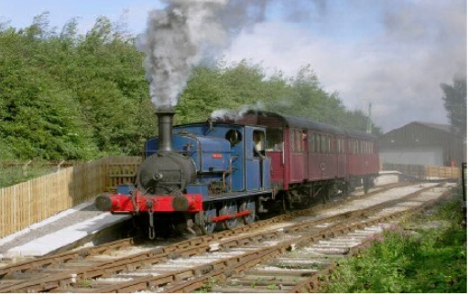

Background
In the existing reservation system is done manually by a user at railway customer center.
The system will clearly identify users easily book or buy their train ticket at their home.
The system is for peoples and the users of the system easily login. Easily search for train
And ticket and then buy ticket through over the system

Motivations and Challenges
Know these days our railway facing many issues and problems .Poor Management in this system and did not know about the schedule of the trains and facing many problems. Many people reserve their tickets and but if they want to cancel their tickets so they can not cancel their tickets. Our management did not know that where the train arrived or on which time train arrived on the destination. People can purchase their tickets on stations by covering many miles. Old system cannot save the records of the passengers.

Goals and Objectives
Our goal is to save the passenger time and help them buying a ticket at their home. The system will help them guide how to find there train.
- Satisfy the customer:
Our main purpose is to satisfy the customers & fulfill their needs.
- Time saving:
Some people do not have time to buy ticket in the line in railway station, so we are develop a reservation system for that people they can easily book a ticket and purchased it and saving their time.
- Website:
We are making a website for the ease of the customers they can book their ticket any where if they need.

Literature Review/Existing Solutions
There are several researchers who have contributed in finding out problems of Pakistan railway and there solutions, we are also included in some of these followers A well performing rail transport infrastructure is vital for a country’s development. Investment in a country’s infrastructure directly affects economic growth as producersfind the best markets for their goods, reducing transpora-tion time and cost, andgenerating employment opportunities. Pakistan Railways plays a significant role by providing a safe, economical and environment friendly mode of transport
Railways are a valuable source of employment while generating large amounts of revenue to the benefit of the economy. An effective railway system facilitates commerce and trade, reduces transportation cost (monetary and non-monetary), and promotes rural development and national integration while reducing the burden on commuters. However, there has been massive shift from railways to road transport, with latter now accounting for 90 percent of passenger traffic and 96 percent of freight traffic.

Gap Analysis
We don’t have any direct competitor in our railway system but expect government of Pakistan. We will generate report on daily basis by the user which will help us to remove the gap between user and system

Proposed Solution
People can purchase their tickets online and people can also pay the fare online. People can purchase or can cancel the tickets at their home. People can see the schedule time of every train .The system should Track the train through GPS system. This system can save the previous record of every passenger .Store and Retrieve the information .User friendly interface to administrator and customer. A comprehensive reporting system will be available for the administration. Customers / Admin will use secure login to enter in the system which will reduce the fraud.

Project Plan
 | Description of Work | Start and End Dates
Phase one | Website | 6Months

Work Breakdown Structure
1.7.1.1Reports / Documentation
    - Final Documentation Introduction
Will be soon
    - Literature / Markey Survey
    - Requirements Analysis
    - System Design
    - Implementation
    - Testing & Performance Evaluation
    - Conclusion & Outlook
    - End User Documentation
    - Application Administration Documentation
    - System Administrator Documentation
- System
  - Development Environment
    - .Net
    - database
    - SQL Server
    - CSS/ html/JS
  - Presentation Layer
    - MVC5
    - SignalR
    - Front End Designing
  - Business Logic Layer
    - ER Diagram
    - Database Design & Implementation
  - Data Management Layer
    - Server Side Scripting
    - Front End Integration
  - Physical Layer
    - Deployment on Test Server
    - Testing & Bug Fixing
    - Deployment on Production Server

Roles & Responsibility Matrix
- Website Front End Designing & Back end coding:
  - AHMAD ARSHAN
- Bug fixing and error handling:
  - Zubair iqbal ,Uneeb babar
- Web Database:
  - Zubair iqbal , AHMAD ARSHAN

Gantt chart
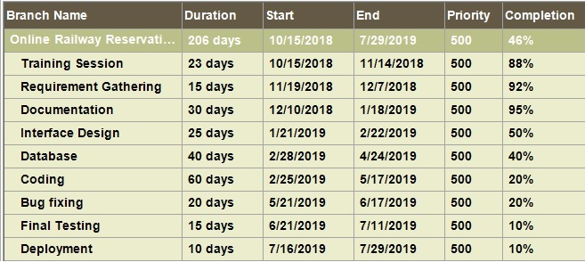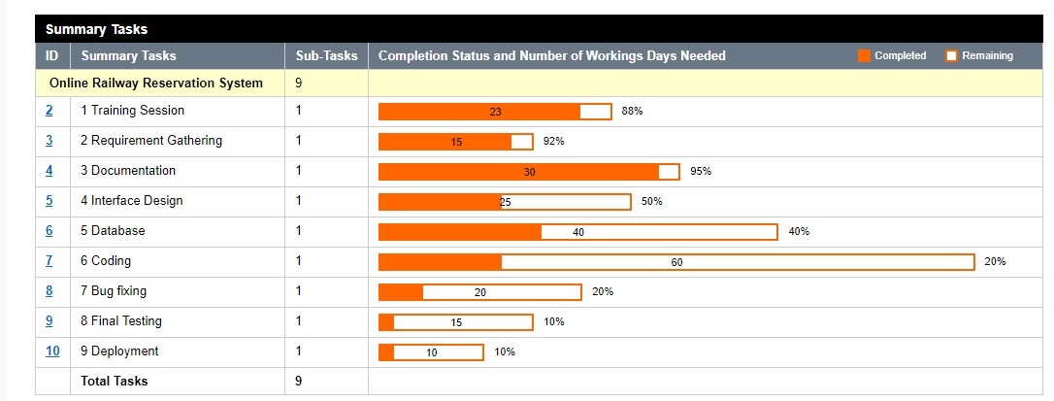

Report Outline
- Introduction
    - What we are going to do?
  - Background
    - What currently happening now in these days railway system
  - Motivation & Challenges
    - No one
  - Goals and Objectives
    - Discussed how to achieve our goals.
  - Gap Analysis
    - Discussed Gap Analysis and what is our planned?
  - Proposed Solution
    - Discussed the solutions of the problems
  - Project Plan
    - Made a project plan so we could complete our project in a time.
  - Work Breakdown Structure
    - Discussed in detail
  - Rules & Responsibility
    - Divided task in team members
  - Gantt Chart
    - Made a chart so could complete our project in a time.

Chapter 2

Software Requirement Specifications

Chapter 2: Software Requirement Specifications

Introduction

Purpose
The introduction of the Software Requirements Specification (SRS) provides an overview of the entire SRS with purpose, scope, references and overview of the SRS. The aim of this document is to defining the problem statement in detail.

We are making a .net web base website with a name online railway reservation system. Our idea is basically for how to save time when we buy a ticket on the railway station

Our main purpose is to provide the facility in every home if possible without the customer’s headache, without wasting their time.

Document Conventions
This document uses the following conventions.
Tool: SQL server2012, Adobe Dreamweaver, Visual Studio 2012
Framework: MVC5
Notification: SignalR
Design: CSS/HTML/JS
DB: SQL Database

Intended Audience and Reading Suggestions

Our goal is to save the passenger time and help them buying a ticket at their home. The system will help them guide how to find there train. Satisfy the customer our main purpose is to satisfy the customers & fulfill their needs. Some people do not have time to buy ticket in the line in railway station, so we are develop a reservation system for that people they can easily book a ticket and purchased it and saving their time.

Product Scope
The scope of project is depends upon the targets of a business. However, it is applicable in online system. Our System is based on all the railway databases where customer’s reserve their seat or check the schedule of trains arrival time and the tracks where they go and the customer save their time and they will be recorded in the database.

References

Overall Description

Product Perspective
Our system will store the following information in our database:
Reservation:
Type of reservations, seat booking, cost, total numbers of seats.
Customer description:
It includes customer name, address and phone number. This information may be used for keeping the records of the customers for any emergency or for any other kind of information.

Product Functions
The following list of function descriptions explains the major features
Account Registration
The registration function shall allow users to create secure accounts with your CINC no. The account will track the user’s name, address and password.

Account Login
The account login function shall allow account members to enter their username and password.

Reservation
Add to seats how much they required function shall allow users to temporarily save request a list that are being considered for purchase.
Delete seats
I they do need so they can delete from booking function shall remove any unwanted requirements from the order.
Order
Users/account members will able to buy their products by giving an order
Checkout
Purchases will be in cash on delivery and easy paisa or any other resource they can give it.
Update Account Information
The update account information function shall give account members access to edit their stored information.
Account Logout
The account logout function shall allow account members to exit their account for security purposes.

User Classes and Characteristics
The system will support two types of user privileges Customer and Admin/Employee. Customers will have access to customer functions, and the Admin will have access of the system management.

The customer should be able to do the following functions:
- Place a booking
- Select an a route where they go
- Edit a booking (in case of wrong bookings selected or wrong information is added within specific time limit)
- Delete a booking (in case wrong information is added or user isn’t interested to buy)
- Update profile

Admin /Team management functions:
- Get all booking of customers (view booking)
- Manage those booking (in case wrong information is provided or a wrong booking is given, delete or verify them)
- Allow delivery men/women to give a booking to the destination path.
- Add trains
- Add schedule
- Add time
- Modification
- Updates
- Add drop

Operating Environment
Operating environment for our system is as listed below.
- It can be open on window XP, 98, 7, 8 and 10.
- The processor should be at least Pentium 4 or above.
- The processor speed should be greater than 240Mhz
- The video device should support graphics. For the clear view of graphics and to see video latest flash player should be installed.
- Operating system: Windows
- Ram should be or greater than 512 Mb.
- Asp.net
- MVC5 frame work.

Design and Implementation Constraints
- We should follow the IEEE standards.
- Default Language will be English.
- Project will follow all the copyright and cyber laws of PTA (Pakistan Telecommunication Authority).

User Documentation
Users of the website must know how to navigate in a website.
- We will organize help-line for customer support in the future.

Assumptions and Dependencies
Website is only accessible through the Internet; it is assumed that the end user has a connection to the Internet. It is also assumed that the user has a web browser able to display the website. (I.E. Chrome, Microsoft Internet Explorer 4+ or compatible browser)

External Interface Requirements

User Interfaces
The system will provide the ability for users to access our website via the Internet.
Users Interface:

Users will able to login, create account, view their book, view their train timing, view the tracks could see their transaction.
Users will able to delete their booking.
User Interface:
- Front-end software: visual studio, Dreamweaver.
- Back-end software: SQL

Hardware Interfaces
- Processor: Intel 2,4GHz and above
- RAM:4GB
- Monitor: VGA Color Monitor
- Hard:10GB

Software Interfaces
- Operating System: Unix, Linux, Mac, Windows
- Development tool: html, CSS, JavaScript, asp. Net, MVC5
- Database: SQL server, SignalR, JSON, Bootstrap

Communications Interfaces
- This project supports most of the web browsers. E.g. Chrome, Internet Explorer.
- The protocol used shall be HTTPS.
- The Port number used will be 80 and 8080.
- Through notification

System Features
This template illustrates organizing the functional requirements for the product by system features, the major services provided by the product. You may prefer to organize this section by use case, mode of operation, user class, object class, functional hierarchy, or combinations of these, whatever makes the most logical sense for your product. Our system will maintains information of different Users, their booking. This project has a high priority because we are using MVC5, SignalR and security algorithms. We will make a Website that will guide the way how to use this and how can buy with advance reporting.

System Feature 1
If we have any update about train so our system will generate a notification to users about that train on which passenger want to travel. For example if train is not arrival on time or many others updating about train. So user can get notification on their number.
Register in the system as a user:
To be a part of system user need to register first so that user can get notification for any update.

Description and Priority
It is very high feature of the system without this user can’t get notification about any update.

Stimulus/Response Sequences
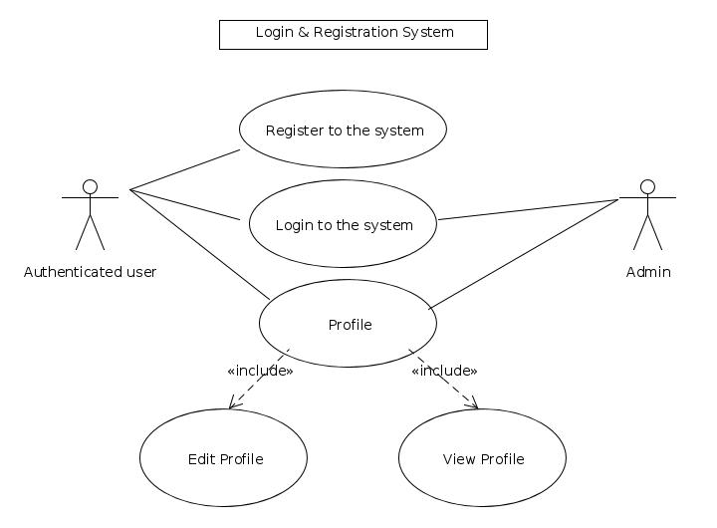

Functional Requirements
REQ-SF1-1:
<Sign up>
NAME: (valid input “only alphabets” (invalid input”turns the input in red color”)
Password: (valid input “all characters more than length of 8”) (invalid input “less than 8 characters turns the column in red color”)
REQ-SF1-2: <log in>
Username: (valid (alphabets only)) (invalid input (non-alphabets our empty turns in to red))
Password: valid (authorized password) in valid (empty or invalid password turns into red color).

System Feature 2
Our system will maintains information of different Users, their orders booking.

Description and Priority
Click "Register" Button: Account Registration
- The system shall allow a non-registered user to create a secure account.
- The system shall require the following information from the user: Name, Address.
- The system shall ask the user for a username and password.
- The system shall confirm the username and password are acceptable.
- The system shall store the information in the database.
Click "Login" Button: Account Login
- The system shall allow a registered user to log-in to their account.
- The system shall require a username and password from the user.
- The system will verify the username and password, and the user will be considered “logged-in”.

Click "Add to booking"
- Check schedule
- Add source
- Add location
- Book seat which type of class
- Seat/birth

Functional Requirements
- Click "Register" Button for Account Registration
- Click "Login" Button: for Account Login
- Click "booking" Button for Add to reservation

Other Nonfunctional Requirements

Performance Requirements
Above mentioned hardware should be available for better performance

Safety Requirements
When important features will be tested once If there is extensive damage to a wide portion of the database due to catastrophic failure, such as a disk crash, the recovery method restores a past copy of the database that was backed up to archival storage and reconstructs a more current state by reapplying or redoing the operations of committed transactions from the backed up log, up to the time of failure.

Security Requirements
Our system should authenticate the every user and when they register him. We must take their CNIC number and their address. Our system also be secure on network while we using https for security purpose. The system use secured socket layer in all transaction that include any confidential customer

Software Quality Attributes
Portability: This software can be used on different devices like
Tabs, mobiles, laptops etc.
Robustness: This software can handle many problems itself like if
User forgets his password so system gives it option to re-write name and user password.
Flexibility: The functionality of this software can be increased after development
Because documentation is available.
Availability: Website should be available on time so user would able to access.
Maintainability: The administrators should be maintaining website.
Usability: Should satisfy customers need.

Other Requirements
Other requirements will be collected by daily basis report generation system by the user.

Chapter 3

Use Case Analysis

Chapter 3: System Analysis
Creating Use Cases to describing the whole scenario how it is going to work. Describing actors and their purposes. How users will login, create account & make purchases. And users can edit booking in case of wrong order is selected or wrong information is added within specific time limit.

Use Case Model
Top level customer use cases View by customer working what they will do
Client Register use case allows customer to register on the web site. Checkout is part of making purchase.
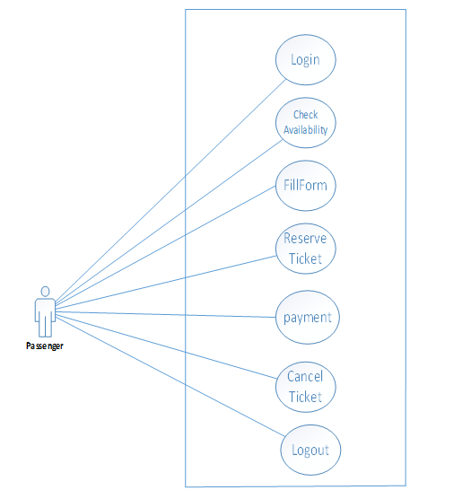Use case 1.0

Use case1.0
Use case 2.0

Fully Dressed Use Cases

Fully dressed use case
 | Use case name | Login
 | Scope | Open front page of Railway web site
 | Level | User goal
 | Primary Actor | Passenger, Admin
 | Stakeholder | User and Admin
 | Precondition | User name, Password
 | Post condition | Login to system
 | Success Scenario | The user login with user name and password which is given to him if it’s correct the user can login.
 | Extension | Checkup Username and Password is incorrect Login is fail.

Fully dressed use case
1. | Use case name | Logout
2. | Scope | To Register in the system
3. | Level | User goal
4. | Primary Actor | Passenger
5. | Stakeholder | User and Admin
6. | Precondition | All required input fields
7. | Post condition | The Admin and user can Logout
8. | Success Scenario | The user logout by all required output fields.
9. | Extension | Logout from the web

Fully dressed use case
1. | Use case name | Check and Search Train
2. | Scope | Get the information of every train
3. | Level | User goal
4. | Primary Actor | Passenger
5. | Stakeholder | User
6. | Precondition | All required input fields
7. | Post condition | User can check and search the information of every train
8. | Success Scenario | .user can get the information of trains
9. | Extension | User can get the information of trains and updating.

Fully dressed use case
1. | Use case name | Reserve Ticket
2. | Scope | Passenger can reserve their Ticket.
3. | Level | Passenger and Goal
4. | Primary Actor | Passenger
5. | Stakeholder | User and Admin
6. | Precondition | All required input fields
7. | Post condition | User can reserve their Ticket.
8. | Success Scenario | . User can reserve their Ticket.
9. | Extension | Reservation of Ticket

Fully dressed use case
1. | Use case name | Payment
2. | Scope | Buy the Ticket.
3. | Level | User and Admin Goal
4. | Primary Actor | User
5. | Stakeholder | User and Admin
6. | Precondition | All required input fields
7. | Post condition | User can Buy their Tickets.
8. | Success Scenario | . User can Buy their Tickets.
9. | Extension | Make Payment of Tickets

Fully dressed use case
1. | Use case name | Cancel Ticket
2. | Scope | Cancel the Ticket.
3. | Level | User Goal
4. | Primary Actor | User
5. | Stakeholder | User And Admin
6. | Precondition | All required input fields
7. | Post condition | User can cancel the Ticket
8. | Success Scenario | User can cancel the Ticket
9. | Extension | Cancelation of Tickets
Fully dressed use case
1. | Use case name | Update Train Details
2. | Scope | Admin can update Train Details
3. | Level | Admin Goal
4. | Primary Actor | Admin
5. | Stakeholder | Admin
6. | Precondition | All required input fields
7. | Post condition | Admin Can update the Train Details
8. | Success Scenario | . Admin Can update the Train Details
9. | Extension | updating the Train Details

Fully dressed use case
1. | Use case name | Issue Ticket
2. | Scope | Admin can issue the ticket of train to passenger
3. | Level | Admin and user goal
4. | Primary Actor | Admin
5. | Stakeholder | Admin and user
6. | Precondition | All required input fields
7. | Post condition | Admin can issue the tickets
8. | Success Scenario | .Admin can issue the tickets
9. | Extension | Issue of tickets

Fully dressed use case
1. | Use case name | Show Notification of any Update
2. | Scope | Admin can show the notification of any update
3. | Level | Admin goal
4. | Primary Actor | Admin
5. | Stakeholder | Admin and user
6. | Precondition | All input field required
7. | Post condition | Admin can show the notification of any update
8. | Success Scenario | Admin can show the notification of any update to User
9. | Extension | Notification of any update

Chapter 4

System Design

Chapter 4: System Design
We are designing the whole system conceptually, just to clear out how our system will look like. We have made different diagrams, different designs, Model, ER Diagram to see how our system will work& how we will manage it.

Architecture Diagram
This diagram show what system will do and how can data flow and interaction between user and system.

Domain Model
It is bit more clear now how our system will work. If a user wants to a ticket and how book or how register himself and payment process will be on cash.

Entity Relationship Diagram with data dictionary

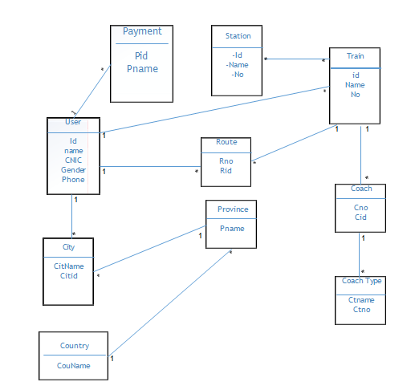

Entity Name | Entity Description | Column Name | Column Description | Data Type | Length | Primary key | Null able | Unique
User | User is someone who use this application | ID  Name | For the unique identification of user record Name of user | Integer  varchar | 10  200 | True  False | False  True | False  False
Check and search train | User can check and search train information | Tid  Name | For the unique identification of train  Train name | Integer  varchar | 500  500 | True  False | False  False | False  False
Ticket | Ticket which can be reserved or bought by user | Ticid | For the unique identification of ticket | Integer | 200 | False | False | False
Account | Account through user deposit their fare | Aid | For the unique identification of Account | Integer | 200 | True | False | False

Class Diagram
Class diagram simply explains how our system will work. User id password is must require for login in their accounts.

Sequence / Collaboration Diagram

Operation contracts

Activity Diagram

State Transition Diagram

Component Diagram

Deployment Diagram

Data Flow diagram [only if structured approach is used - Level 0 and 1]
Context Level Diagram

Level 0

Level 1

Chapter 5

Implementation

Chapter 5: Implementation
We are going to implement this Railway Reservation System in .Net Technologies. HTML/CSS and Java scripting as front end, C-Sharp as backend. And SQL server will be used to manage our database.

- Components, Libraries, Web Services and stubs
It will be in ASP.Net MVC 5. We will be using required libraries for MVC. Signal I R for chatting / notification. Images will be stored in separate database using SQL File streaming. Web services will also be created on requirement.

- Deployment Environment

For deployment windows server 2012 or higher will be required with Net framework 4.5 and SQL server 2012.

- Tools and Techniques
Web based application developed in .Net Framework. Following tools & technologies will be used:
- Visual studio
- C#
- MVC
- SQL server
- Html
- CSS
- Java script
- JSON
- Bootstrap
- Signal IR
- Best Practices / Coding Standards
We will be using common best coding conventions. We will follow programming practices. Code will be properly commented.
- Version Control

Proper versions of the project will be controlled using Vault third party free software. Version will be changed on every major change.

Chapter 6

Testing and Evaluation

Chapter 6: Testing and Evaluation

Use Case Testing
Use Case Test 1

Use Case Name | Sign up
Use Case Description | User registration for using the system
Actors | Admin, User
Pre-Condition | System must be connected to network
Post-Condition | User register with system after registration successfully to the system

Main Scenario | Serial Number | Steps
Actor System | 1 | User should be registering himself via Full Name, Gender, CNIC, Address, DOB, Phone, Email and Password.
Actor System | 2 | System Validate all the input fields.
Actor System | 3 | Registered with system
Extension | 2a | If any input field was invalid then system generates error.

Use Case Test 2

Use Case Name | Log in
Use Case Description | A user login to access the system features.
Actors | Admin, User
Pre-Condition | System must be connected to network
Post-Condition | After login user can login to system dashboard.

Main Scenario | Serial Number | Steps
Actor System | 1 | Enter email and password
Actor System | 2 | System validate email and password
Actor System | 3 | Allow access to system dashboard
Extension | 2a | Invalid password and username  Then system should show error message

Use Case Test 3

Use Case Name | Search Trains
Use Case Description | Search the trains online
Actors | User
Pre-Condition | System must be connected to network
Post-Condition | User search the trains with their requirements

Main Scenario | Serial Number | Steps
Actor System | 1 | Actor can search the trains
Actor System | 2 | System validate input fields
Actor System | 3 | System list down the different trains info
Extension | 2a | System input fields  Then system show error

Use Case Test 4:

Use Case Name | Reservation
Use Case Description | Reserve the tickets online
Actors | User
Pre-Condition | User must be registered login and to system
Post-Condition | Reservation Successfully

Main Scenario | Serial Number | Steps
Actor System | 1 | Actor can reserve or cancel their tickets
Actor System | 2 | System validate input fields
Actor System | 3 | System reservation request created by user and verify by admin after payment
Extension | 2a | Invalid input fields  System show error message

Use Case Test 5:

Use Case Name | Update Train details
Use Case Description | To update the details of trains
Actors | Admin
Pre-Condition | Admin must be login to system
Post-Condition | Admin successfully update the Train details

Main Scenario | Serial Number | Steps
Actor System | 1 | Actor can Update the details of train
Actor System | 2 | System validate the input fields
Actor System | 3 | System register the admin for any update details
Extension | 2a | Invalid input fields  System show error message

Use Case Test 6:

Use Case Name | Show Notification
Use Case Description | Admin can send notification to user
Actors | Admin
Pre-Condition | Admin must be login to system
Post-Condition | Admin send the notification successfully

Main Scenario | Serial Number | Steps
Actor System | 1 | Admin can send notification to user
Actor System | 2 | Valid input fields
Actor System | 3 | System can access the admin to send notification
Extension | 2a | Invalid input fields  System show error message

Use Case Test 7:

Use Case Name | Payment
Use Case Description | Passenger can view fares
Actors | Passenger
Pre-Condition | System must be connected to system
Post-Condition | Fare visible to passenger

Main Scenario | Serial Number | Steps
Actor System | 1 | Actor enter departure
Actor System | 2 | System validate input fields
Extension | 2a | Invalid input fields  System show error message

Use Case Test 8:

Use Case Name | Issue ticket
Use Case Description | Admin can issue ticket
Actors | Admin
Pre-Condition | System must be connected to system

Main Scenario | Serial Number | Steps
Actor System | 1 | Actor can issue the ticket
Actor System | 2 | System can confirm the payment of passenger
Extension | 2a | Invalid input fields  System show error message

Equivalence partitioning

Test Case Suite | TS001
Test Case id | TC001
Test Case summary | To verify that user registration
Related Requirement | User should be register himself via Full name, Gender, CNIC, Address, DOB, Phone, Email, Password.
Test Procedure | - Enter full name in full name field  - Enter gender in gender field  - Enter CNIC in CNIC field  - Enter address in address field  - Enter DOB in DOB field  - Enter phone number in phone number field  - Enter email in email field  - Enter password in password field
Test Data | Full Name  Gender  CNIC  Address  DOB  Phone Number  Email  Password

Expected Result | System should register user if user enter valid fields  System should generate error if all the inputs are not valid
Actual Result | System entered the user if user enter valid fields  System generate error if all the inputs are not valid
Status | Pass
Remarks | This is registration process test case
Created By | Muhammad Zubair Iqbal
Date of Creation | 10/05/2019
Test Environment | OS: Windows 8  Google Chrome  UC: Browser

Test Case 2:-
Test Case Suite | TS002
Test Case id | TC002
Test Case summary | To verify that user login
Related Requirement | User should be able to login to email and password
Test Procedure | - Enter email Id in email field  2. Enter password in password field
Test Data | Email: XYZ@gmail.com  Password: User123
Expected Result | - System should login user if user entered valid fields  - System should generate error if enter any invalid field
Actual Result | If we entered valid email and password system can login successfully  if we entered invalid email and password system generate error message
Status | Pass

Remarks | This is login procedure
Created By | Muhammad Zubair Iqbal
Date of Creation | 10/05/2019
Test Environment | OS: Windows 8  Google Chrome  UC : Browser

Test Case Suite | TS003
Test Case id | TC003
Test Case summary | To verify admin responsibilities
Related Requirement | On admin dashboard
Test Procedure | - Login  - Update details of trains  - Add, delete and update  - Show notification  - Issue tickets  - Logout
Test Data | - Update  - Send notification  - Issue tickets
Expected Result | System should store data  System should retrieve data  System should generate error message any invalid data enter
Test Case 3:-

Actual Result | 1.System should store data  2.System should retrieve data  3.System should generate error message any invalid data enter
Status | Pass
Remarks | Admin responsibilities data entry test case
Created By | Muhammad Zubair Iqbal
Date of Creation | 10/05/2019
Test Environment | OS: Windows 8  Google Chrome  UC: Browser

Test Case Suite | TS004
Test Case id | TC004
Test Case summary | To verify user responsibilities
Related Requirement | User dashboard
Test Procedure | - Login  - Search trains  - Reserve tickets  - Cancel tickets  - Payment  - Logout
Test Data | - Search trains  - Reserve tickets  - Cancel tickets  - Payment
Expected Result | - System should update the data if valid input fields given.  - System should generate error message if invalid data given.
Test Case 4:-

Actual Result | If we entered valid data then system update the data otherwise generate the error message
Status | Pass
Remarks | Update data test case
Created By | Muhammad Zubair Iqbal
Date of Creation | 10/05/2019

Test Environment | OS: Windows 8  Google Chrome  UC: Browser

Boundary value analysis
Analysis simply means selection value close to limits of the class.
We have these input classes.
- Less than equal to 5.
- Greater than 5.

Data flow testing
The flow test is the form of white box test and a texture test, which usually continue at the points where the data value received from the variables and the points where they are checked. The basic idea of this form of testing is the detection of errors and coding error. Check if the entire data variable present in programming code has been initialized.
- Make sure all condition is working properly.
- Make sure all condition are met in a define state.
- Check all the types and size of variable data correctly.
- Delete this line code that is not used in this project.

Unit testing
Tool used for unit testing
- Coded UI Testing

Integration testing
- The integration test is performed to determine if the components interact with each other. Integration can do after component testing. Check the modules to interact with other modules. The integration test is applied when creating module.
- In the test technique, we tested the work of combining different modules. After the development of the modules, we integrate them and checked the behavior of the modules during the execution.
- If all modules work properly if we integrate another module in which we integrate modules.
- We have tested the operation of the modules; it works after the integration of this system.

Performance testing
Performance testing done by manually. The main purpose of load testing is to check the response time and our application portability power. Performance testing is done by performing multiple tasks at same time.

Stress Testing
In this we check the stability of our software .it is also done by manually. We perform this testing by adding in database and by fetching many types of data from database.

Chapter 7

Summary, Conclusion and Future Enhancements
Chapter 7: Summary, Conclusion & Future Enhancements

Project Summary
ONLINE RAILWAY RESERVATION system has been completed and successfully implemented. The collection of requirements was impressive. We refined requirements by the feasibility study, critical analysis, made it a final requirement.
The main objective of this project is to give an overview of the project. Readers can learn the project by reading this document. The other purpose of this document is that can be used for future system.

Achievements and Improvements
To complete this project is our achievement. In this software we implement all the railway system features but we implement some new innovative features in this project.

Critical Review
We will use the functions of the system, and then give some information about how it works. We are satisfied with our system and also satisfied the usability of the system it should be more attractive .The system is meeting our expectations. It is secure system and our data protected in the system. In business value our project or system helps us to grow it all over Pakistan and we will keep our customers online and manage them online.

Lessons Learnt
In this project learn many new things. Language selection is the main subject for us of this project. We want to work on different platform and we want to use something different so then we decided to work on .net MVC framework. We have work first time on dot net .it was so difficult for us to done the project on .net. We learn how to use the framework and how to use visual studio.
We have created database on SQL server, the relationship between the different modules is confusing.
We also generate a prototype to understand this system.
We also understand how modules are connected. This reduces the errors because all data has been collected in one place.

Future Enhancements/Recommendations
In future we will develop an android application. Currently we using web-based, in future we want to add some new features to help the user for purchasing their tickets and reserve their seats online.

Appendices

Broacher

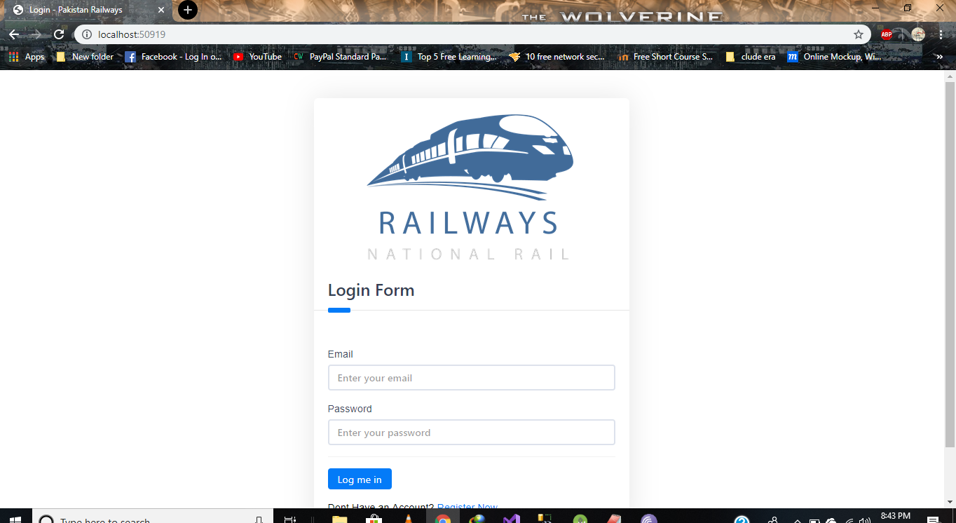
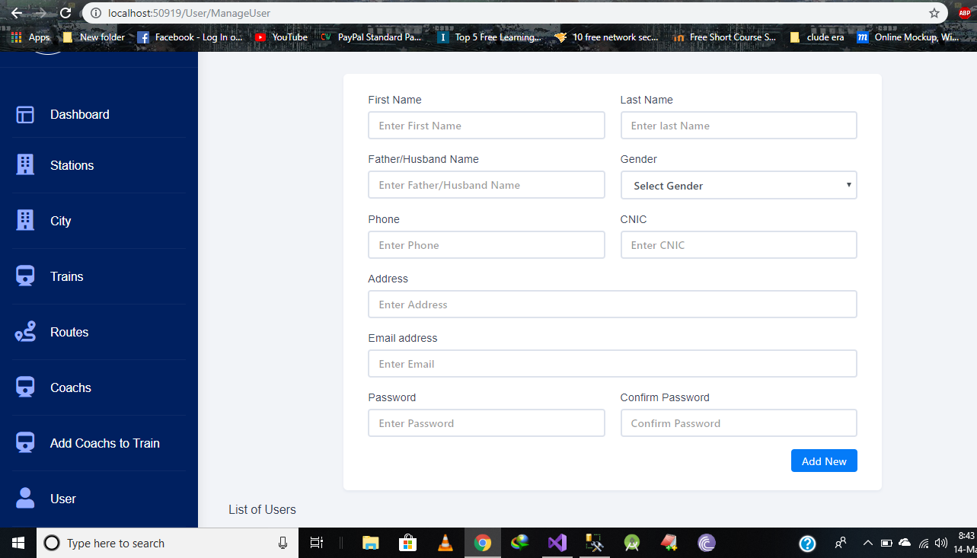
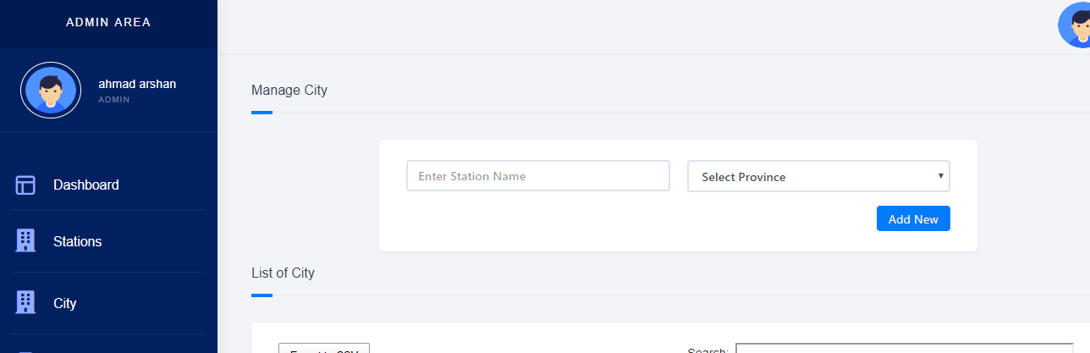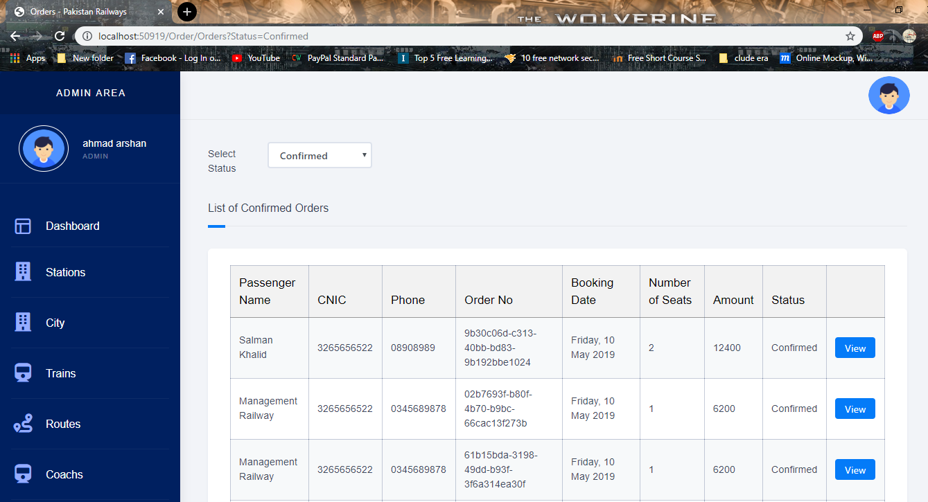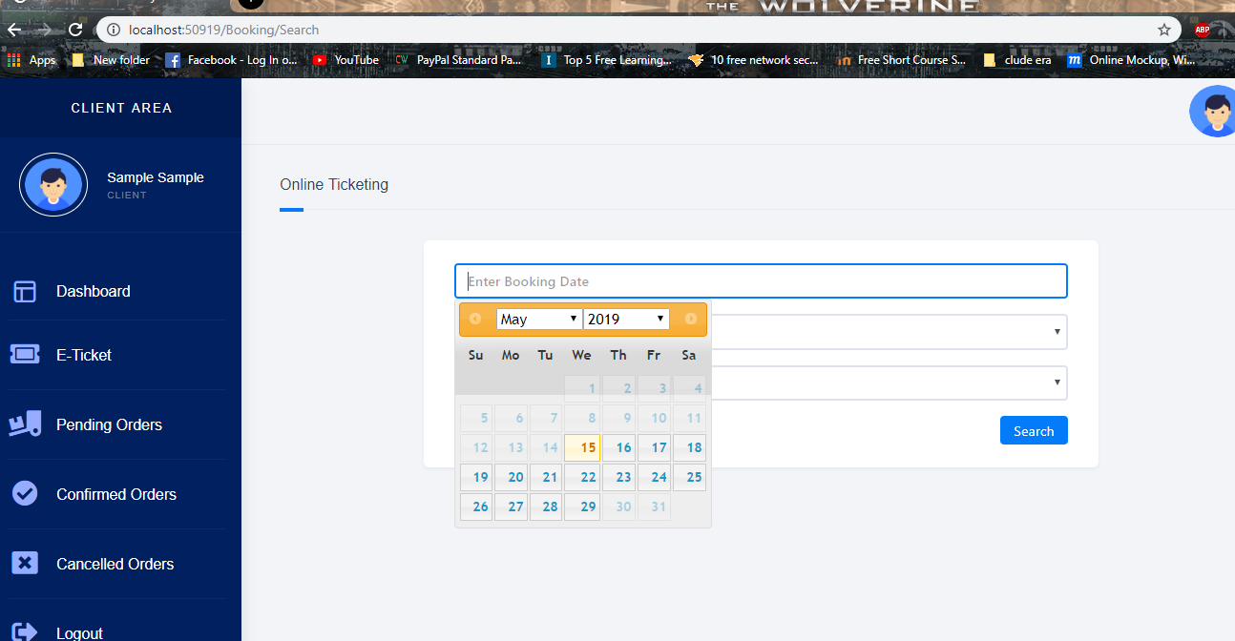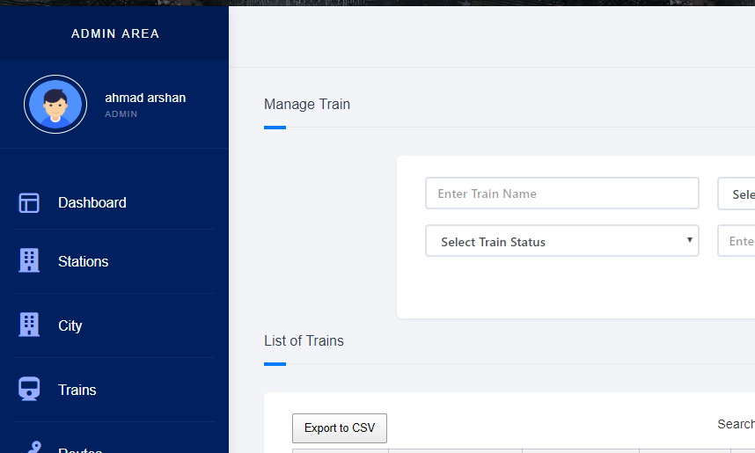
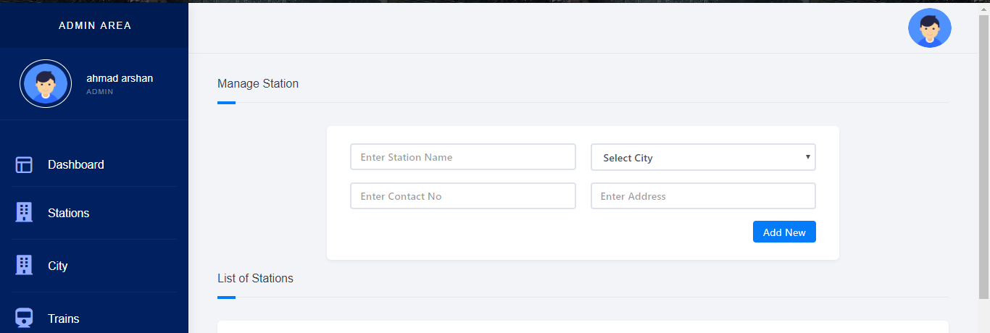
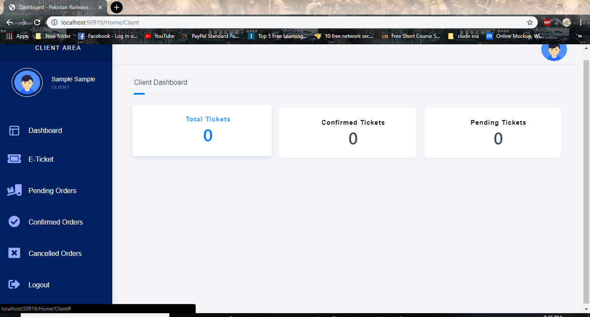

Reference and Bibliography

Reference and Bibliography

- doc/46041122/Research-report-on-Pakistan-Railway

- https://www.pakrail.gov.pk/

- https://www.tutorialspoint.com/

- https://www.tutorialspoint.com/asp.net/index.htm

