THE SUPERIOR COLLEGE LAHORE


Faculty of Computer Science & IT
Final Year Project
PROJECT REPORT
Online job Portal
Project ID:001
Project Team
Student name | Student ID | Program | Contact Number | Email
M Shahzad | MITW-F18-032 | MIT | 0333-8437087 | Mitw-f18-032@superior.edu.pk
Shazia Aslam | MCSW-F18-002 | MCS | 0307-4289172 | Mcsw-f18-002@superior.edu.pk
Maryam Arif | MCSW-F18-016 | MCS | 0317-4049882 | Mcsw-f18-016@superior.edu.pk
Kiran Rasheed | MCSW-F18-029 | MCS | 0312-4675225 | Mcsw-f18-029@superior.edu.pk

Mr Fayaz Ahmad
(Lecturer)

Project Report
ONLINE JOB PORTAL

Change Record
Author(s) | Version | Date | Notes | Supervisor’s Signature
 | 1.0 |  | <Original Draft>
 |  |  | <Changes Based on Feedback from Supervisor>
 |  |  | <Changes Based on Feedback From Faculty>
 |  |  | <Added Project Plan>
 |  |  | <Changes Based on Feedback from Supervisor>

APPROVAL
Project Supervisor
Comments: ___________________________________________________________________
_____________________________________________________________________________
Name:______________________________
Date:_______________________________ | Signature:__________________________

Project Manager
Comments: ___________________________________________________________________
_____________________________________________________________________________
Date:_______________________________ | Signature:__________________________

Head of the Department
Comments: ___________________________________________________________________
_____________________________________________________________________________
Date:_______________________________ | Signature:__________________________

Dedication

The work is dedicated to our Team and Teachers. All members of our group worked as team to achieve best of our Project. Every member put their effort to so I really appreciate their effort and time management that helped me to complete this document. Also, our supervisor who helped us with time to time to give complete shape of our project and guide us to overcome project weakness and better understand our project to develop real time product and its documentation.

Acknowledgements

Alhamdulillah, all praises to Allah Almighty, the foremost Merciful and therefore the most Gracious, for the strengths and His blessings in finishing this Project. Working on this project was so a difficult task that demanded large efforts. However, we tend to feel proud to specific our deepest sense of feeling and appreciation to our supervisor Mr. Fayaz Ahmad for his kind facilitate, advice, galvanized steering, unlimited support, Sympathetic angle and sincere personal involvement throughout the event of project.

Executive Summary
We are going to create a website by name of Online job Portal that will act as a platform to give the more facilities to the jobseeker people. It will give an easy and efficient access to the user to search customized or specific jobs according their skills and qualifications. This Job world is not limited to job search only but it is also provides the facilities to prepare interviews for a specific job etc. The diverse feature of this job world system would be that it will help the people to search job according to their needs. This system is to be used by employment to improve efficiency in employment sector and it will provide jobs catalog and information to user and help them decide on which jobs to apply.
To develop website for online jobs with various functional and non-functional part of design namely the main objective of over project is.
- Search job
- Apply job
- Interview & Preparation

Table of Contents
Dedication iv
Acknowledgements v
Executive Summary vi
Table of Contents vii
List of Figures .
List of Tables .
Chapter 1 1
Introduction 1
1.1. Background 2
1.2. Motivations and Challenges 2
1.3. Goals and Objectives 2
1.4. Literature Review/Existing Solutions 2
1.5. Gap Analysis 2
1.6. Proposed Solution 2
1.7. Project Plan 3
1.7.1. Work Breakdown Structure 3
1.7.2. Roles & Responsibility Matrix 3
1.7.3. Gantt Chart 3
1.8. Report Outline 3
Chapter 2 4
Software Requirement Specifications 4
2.1. Introduction 5
2.1.1. Purpose 5
2.1.2. Document Conventions 5
2.1.3. Intended Audience and Reading Suggestions 5
2.1.4. Product Scope 5
2.1.5. References 6
2.2. Overall Description 6
2.2.1. Product Perspective 6
2.2.2. Product Functions 6
2.2.3. User Classes and Characteristics 6
2.2.4. Operating Environment 7
2.2.5. Design and Implementation Constraints 7
2.2.6. User Documentation 7
2.2.7. Assumptions and Dependencies 7
2.3. External Interface Requirements 8
2.3.1. User Interfaces 8
2.3.2. Hardware Interfaces 8
2.3.3. Software Interfaces 8
2.3.4. Communications Interfaces 9
2.4. System Features 9
2.4.1. System Feature 1 9
2.4.1.1. Description and Priority 9
2.4.1.2. Stimulus/Response Sequences 9
2.4.1.3. Functional Requirements 9
2.4.2. System Feature 2 10
2.4.2.1. Description and Priority 10
2.4.2.2. Stimulus/Response Sequences 10
2.4.2.3. Functional Requirements 10
2.4.3. System Feature 3 (and so on) 11
2.5. Other Nonfunctional Requirements 11
2.5.1. Performance Requirements 11
2.5.2. Safety Requirements 11
2.5.3. Security Requirements 12
2.5.4. Software Quality Attributes 12
2.5.5. Business Rules 12
2.6. Other Requirements 12
Chapter 3 13
Use Case Analysis 13
3.1. Use Case Model 14
3.2. Use Case Descriptions 14
Chapter 4 15
System Design 15
4.1. Architecture Diagram 16
4.2. Domain Model 16
4.3. Entity Relationship Diagram with data dictionary 16
4.4. Class Diagram 17
4.5. Sequence / Collaboration Diagram 17
4.6. Operation contracts 17
4.7. Activity Diagram 18
4.8. State Transition Diagram 18
4.9. Component Diagram 18
4.10. Deployment Diagram 19
4.11. Data Flow diagram [only if structured approach is used - Level 0 and 1] 19
Chapter 5 20
Implementation 20
5.1. Important Flow Control/Pseudo codes 21
5.2. Components, Libraries, Web Services and stubs 21
5.3. Deployment Environment 21
5.4. Tools and Techniques 22
5.5. Best Practices / Coding Standards 22
5.6. Version Control 22
Chapter 6 23
Testing and Evaluation 23
6.1. Use Case Testing 24
6.2. Equivalence partitioning 24
6.3. Boundary value analysis 24
6.4. Data flow testing 24
6.5. Unit testing 25
6.6. Integration testing 25
6.7. Performance testing 25
6.8. Stress Testing 25
Chapter 7 26
Summary, Conclusion and Future Enhancements 26
7.1. Project Summary 27
7.2. Achievements and Improvements 27
7.3. Critical Review 27
7.4. Lessons Learnt 27
7.5. Future Enhancements/Recommendations 28
Appendices 29
Appendix A: User Manual 30
Appendix B: Administrator Manual 31
Appendix C: Information / Promotional Material 32
Reference and Bibliography 35
Index 37

List of Figures

1.1 Caption of first figure of first chapter 6
1.2 Caption of second figure of first chapter 7
2.1 Caption of first figure of second chapter 14
2.2 Caption of second figure of second chapter 22
2.3 Caption of third figure of second chapter 26
5.1 Caption of first figure of fifth chapter 49
5.2 Caption of second figure of fifth chapter 49

List of Tables

1.1 label of first table of first chapter 6
1.2 label of second table of first chapter 7
2.1 label of first table of second chapter 14
2.2 label of second table of second chapter 22
2.3 label of third table of second chapter 26
5.1 label of first table of fifth chapter 49
5.2 label of second table of fifth chapter 49

Chapter 1

Introduction

Chapter 1: Introduction
We are going to create a website by name of Online job portal that will act as a platform to give the more facilities to the job seeker people. It will give an easy and efficient access to the user to search customized or specific jobs according their skills and qualifications. This Job world is not limited to job search only but it is also provides the facilities to. The diverse feature of this job world system would be that it will help the people to search job according to their needs. This system is to be used by employment to improve efficiency in employment sector and it will provide jobs catalog and information to user and help them decide on which jobs to apply

Background
The idea came from those person who visit on the different job portals and companies that either they have vacancies according to their capabilities and then found the problem is that when they had to visit many websites and companies or this is time taking process for them.
.Now in our project the user can search job categories according to their own capabilities. They can find jobs in different organization.

Motivations and Challenges
As we know that mostly job portals basic functionalities. We are going to develop the online job portal system with extra functionalities to make it easy for the jobseeker. Different companies post jobs and the admin manages this jobs and jobseeker can apply according to their apply jobs.

Goals and Objectives
Goal:
Achieve User satisfaction.
Achieve the User loyalty.
Provide security to our users.
To make sure concurrency control is good.
Make our website for customer’s solution.
Objectives:
The main objective to creating this online job word is to give all the possible facilities to the jobseeker at a one platform. Our main modules are
- Select Job categories
- Get job info
- Job description
- Send Cv

Literature Review/Existing Solutions
We have seen the problem of jobseeker people and collecting knowledge about their related requirements. So, we decide to make online platform for that kind of people that will provides data of all companies that are offering jobs in all Pakistan. There are multiple websites running which provide solution a little bit similar to our like rozee.pk, Nokri.com etc. Our web portal is different and providing the platform of saving time and many other.

Gap Analysis
There are few other websites which offering the job We have seen the problem of jobseeker people and collecting knowledge about their related requirements. So, we decide to make online platform for that kind of people that will provides data of all companies that are offering jobs in all Pakistan. There are multiple websites running which provide solution a little bit similar to ours like rozee.pk, Nokri.com etc. Our web portal is different and providing the platform of saving time and many other.

Proposed Solution
We are going to develop an application that will overcome the above problems. It can customize as per requirements and needs of any specific user who may require some possible customization features. The user will have maximum rights and full access to the system. In this portal the user can search job categories according to their own capabilities. They can find jobs in different organization. This will make the employment process easier. This portal will be a solution to many who were in need of their dream jobs because they will search for it online and be able to apply online too. Many facilities will be provides on a single platform.

Project Plan
Our plan started with first gathering information about the public we are planning target so that we would know what the difficulties for the jobseekers are. After this our design team will start working on making its prototype keeping in view that it should be as user friendly as possible. Once we are done with design prototype, we’ll start working in parallel for design integration and creating database.
The project will be managed to divide into modules a modules to clearly understand how we take next step with the specified time. First we use the gather the requirement and then do all the phases of Software making like after requirement we analyze them and make design of our gathered requirements and divide the modules to our members then do implementation and later we do integration of the modules and last we do test our web portal and then make it available for our customers.
We follow the agile methodology in our project and work on each of single iteration within the time specified. We are using this methodology for Improvement in our project and can adopt change easily in each of single iteration.

Work Breakdown Structure
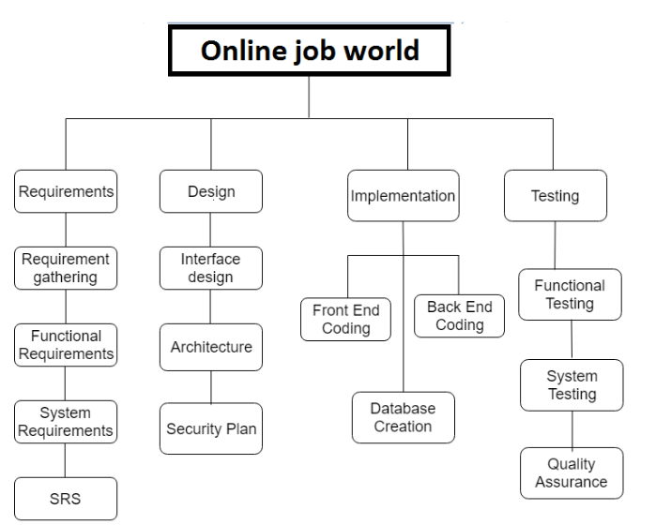

Roles & Responsibility Matrix
The purpose of roles & responsibility matrix is to identify who will do what
WBS # | WBS  Deliverable | Activity # | Activity to Complete the  Deliverable | Duration(#of  Days) | Responsible Team Member(s) & Role(s)
1 | 1.1 Initial level | 1.1.1 | Interview, survey & research | 7 | Team
 |  | 1.1.2 | Analysis research & find  Figures | 4 | Team
 |  | 1.1.3 | Deliverable: Submit initial  Report | 2 | Team
 |  | 1.1.4 | ProjectSigned/Approved | 2 | Team
 | 1.2 Planning | 1.2.1 | Define Scope Statement | 5 | Team
 |  | 1.2.2 | Determine Project Team &  Responsibilities | 2 | Team,
 |  | 1.2.3 | Develop Project Plan | 5 | Team
 |  | 1.2.4 | Submit Project Plan | 4 | Team
 |  | 1.2.5 | Project Plan Approval |  | Team
 | 1.3 Execution | 1.3.1 | Gather Requirements | 10 | Team
 |  | 1.3.2 | Verify & Validate  Requirements | 3 | Team
 |  | 1.3.3 | System Design | 20 | Team
 |  | 1.3.5 | Testing Phase Test cases Test plans | 14 | Team
 |  |  | Implementation |  | Team
 | 1.4 Close | 1.4.1 | Update Records |  | Team
 |  | 1.4.2 | Effectiveness of change |  | Team

Gantt Chart
Gant Chat shows the execution of project with the respect of passage of time step by step.
3Sep |  | 10Sep | 17Sep | 23Sep | 15Sep | 11Nov | 09Dec | 09Jan | Jan | Feb
Orientation Seminar Project Registration
Initial ProposalSubmission Project ProposalDefense
Final Project Proposal Report Submission(FYP-1) Internal Evaluation(FYP-1) Report Submission(FYP-2) Internal Evaluation(FYP-2) Submit CompleteProject

Chapter 2

Software Requirement Specifications

Chapter 2: Software Requirement Specifications

Introduction
We are going to create a website by name of Online job Portal that will act as a platform to give the more facilities to the job seeker people. It will give an easy and efficient access to the user to search customized or specific jobs according their skills and qualifications. This Job world is not limited to job search only but it is also provides the facilities.

Purpose
We are going to develop an application that will overcome the above problems. It can customize as per requirements and needs of any specific user who may require some possible customization features. The user will have maximum rights and full access to the system. In this portal the user can search job categories according to their own capabilities. They can find jobs in different organization. This will make the employment process easier. This portal will be a solution to many who were in need of their dream jobs because they will search for it online and be able to apply online too. Many facilities will be provides on a single platform.

Document Conventions

Document contains headings and paragraphs.

First Heading: is bold, Font is Calibri and Size is 16.

Second Heading: is bold, Font is Calibri and Size is 14.

Paragraph: Font is Calibri, Size is 12 and line spacing is 1.5.

DB: Database

ERD: Entity Relationship Diagram

SRS: Software Requirement Specification

API’s: Application programming interface

Intended Audience and Reading Suggestions
In first section purpose of the document described where every reader can understand the purpose of the document. In second section we described the product scope where stakeholders can get the idea of the system. In overall description stakeholders can clear whole idea of the systems. Developers can understand the requirements of the system. Designers can understand the design requirements in the user interface requirement sections. Tester can prepare test cases for testing the features of the system. Customers can verify their functional requirements.

Product Scope
The online job world is world best opportunities for jobseekers people
The online job world that provide jobseekers with different jobs information like
- Online applying for jobs
- Search for jobs
The people can easily access job opportunities.

References
No reference is taken. Our user and companies of job world will be referred to our website for great purpose

Overall Description

Product Perspective
Our website is the first website which introduces online applies for jobs according a specific job. Different types of websites are creating on this type of module but their functions are limited service but not having any single website like our website like online job world.

Product Functions
Our main functions are,
- Select Job categories
- Get job info
- Job description
- Send Cv
- Apply online

Operating Environment
Our Web-Portal is compatible for all Window and Mobile versions.

Design and Implementation Constraints

XAMPP
SQL
PHP STORM
LOGIN
REGISTRATION

User Documentation
We can also provide help page in which those who cannot understand what they should do after open the web portal. We give a page that was written of a help and customer can understand if he have some knowledge.

Assumptions and Dependencies
Modulus are directly connected with one to another if any module are missing in SRS then it is must be affected on our web portal. If client and worker information are not stored in then our database then our web cannot perform well. In future we used this SRS and modules for any other same like that having same vision and scope of the project

External Interface Requirements

User Interfaces

User Interface is an extremely important consideration for any project that requires human-machine interaction. However, this project doesn’t require human machine interaction and therefore the product runs solely in the background without any user input. The user interface is simple and easy to use. It has different characteristics like flexibility, reliability, safety and secure

Hardware Interfaces
ALL window and Linux versions and also compatible on Mac devices.

Software Interfaces
While the online job world may work with various browsers, we recommend using one of the following for the best experience: Microsoft Internet Explorer (IE) v11 or later, Firefox v45 or later and Google Chrome v58 or later. In other browsers, performance and graphical consistency may suffer.

Communications Interfaces
Login alerts will transfer to User after confirmation using SMTP Gmail protocol. HTTPS protocol will be used by our web network communication system for communication between user and admin. HTTPS standard will be used. AES encryption algorithms will be used for encrypting user data. Internet Data rate will be according to the customer internet data rate.

System Features
The main features of our website is..
  - Registration
  - Login
  - Post job
  - Search job
  - Apply for job
  - Select candidates

System Feature 1

Functional Requirements

REQ-SF1-1: user can registered
REQ-SF1-2: company can login
REQ-SF1-3: companies can post jobs
REQ-SF1-4: user can search job
REQ-SF1-5: user can apply for job
REQ-SF1-6: companies can select candidates

Other Nonfunctional Requirements

Performance Requirements
The performance requirements concern the speed of operation of a system. System user should have sound knowledge of SQL Server for retrieving required information in less time Criteria of performance:
• Response time (how quickly the system reacts to a user input)
• Throughput (how much the system can accomplish within a specified amount of time)
• Availability (is the system available for service when requested by end-users)

Safety Requirements
The authorization should be accurate, because of the use of the username and password for dealer identification. If there is extensive damage to a wide portion of the database due to catastrophic failure, such as a disk crash, the recovery method restores a past copy of the database that was backed up to archival storage (typically tape) and reconstructs a more current state by reapplying or redoing the operations of committed transactions from the backed up log, up to the time of failure

Security Requirements
School data should securely move in the system. Data should be encrypted when it transfers on network layer. User Accounts information should be secret when they Login and upload any data. Every kind of data should be secret and cannot reveal because in case of reveal data legal acts can charge against School by law. System location should be accurate. In case of wrong access school can face serious problems where school cans loss data. We need database for storing our website data. So, for security reasons we must choose database partners carefully

Software Quality Attributes
Availability:
Every time system should entertain users when system users wants.
Correctness:
System should perform all tasks accurately. System should provide accurate and up to date information to the user and company admin.
Flexibility:
System should be flexible if in future user wants any change or extend the system then system should allow the developers to extend the system.
Maintainability:
System should be maintainable mean if we want to maintain any functionality then system must allow changing it or redesigning the functionalities.
Portability:
System should be portable. System must be workable on every operating system, on any hardware configuration and in any kind of environment.
Reliability:
System should be reliable. System will work continues and in critical conditions. System should not fail when user increased or request increased.
Reusability:
System feature should be reusable, if same feature needs in future for any other project, then system should be reuse.
Robustness:
Every system crash, but crashes should be occurring in handsome way. So, our system should be produced danger alerts before crashes or in not working conditions.
Usability:
All system features should be usable and user friendly. System feature should execute efficiently and effectively. System UI should be user understandable and guide the user to perform the user related tasks

Business Rules
Admin: Admin can manage the job posts
Companies: companies can post jobs and select candidates
User: user can search jobs apply jobs

Other Requirements
Work should be done according to all standard methods and rules. No industry rule should violate.

Chapter 3

Use Case Analysis

Chapter 3: System Analysis
In this chapter we are discussing about the understanding for analysis of functions and their interaction with others functions of this project using use case of our projects.

Use Case Model
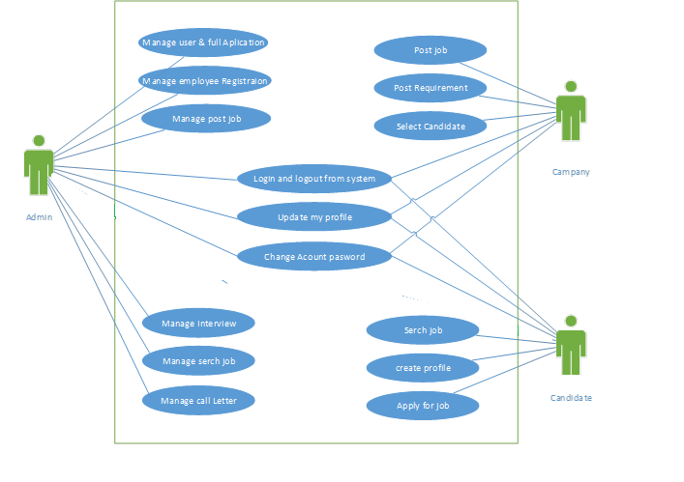

Chapter 4

System Design

Chapter 4: System Design
Architecture Diagram, Domain model, Entity relationship diagram, Class diagram, Sequence diagram, Operation contracts, Data flow diagram, Activity Diagram, Deployment Diagram, Component Diagram and State transition diagram

Architecture Diagram
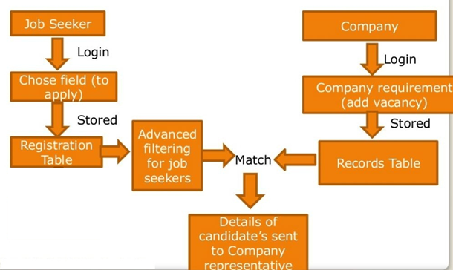

Domain Model
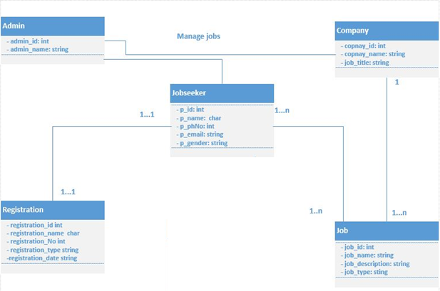

Entity Relationship Diagram with data dictionary
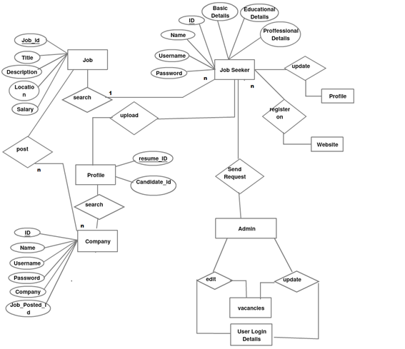

Class Diagram
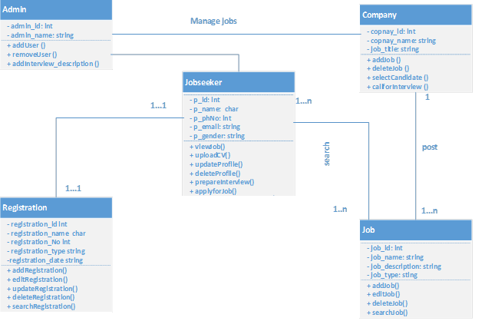

Sequence / Collaboration Diagram
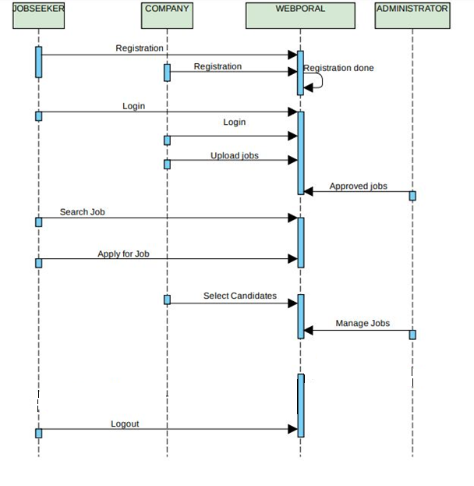

Operation contracts
Operation:- Register();
Cross Reference
Use Case:-Registration
Scenario:-Registration
Pre-Condition:-
None
Post-Condition:-
user.name=name;
user.email=email;
user.password=password;

Operation: - login ();
Cross Reference
Use Case:-login
Scenario:-login
Pre-Condition:-
Have register on website
Post-Condition:-
user.email=email;
user.password=password;

Operation:-post job ();
Cross Reference
Use Case:-post a job
Scenario:-post a job
Pre-Condition:-
Registration, Login on website
Post-Condition:-
Post requirement;
Select candidates;
user.password=password;

Operation:-Search job;
Cross Reference
Use Case:-Search job for apply
Scenario:-Search job for apply
Pre-Condition:-
have register on website
Post-Condition:-
Create Profile;
Apply for job;

Operation:-Prepare Interview;
Cross Reference
Use Case:-Prepare job related Interview
Scenario:-Prepare job related Interview
Pre-Condition:-
Select job, Apply job
Post-Condition:-
Logout;

Activity Diagram
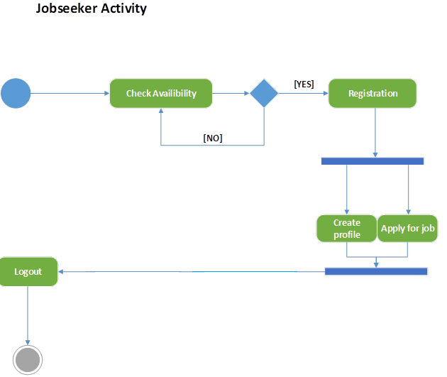
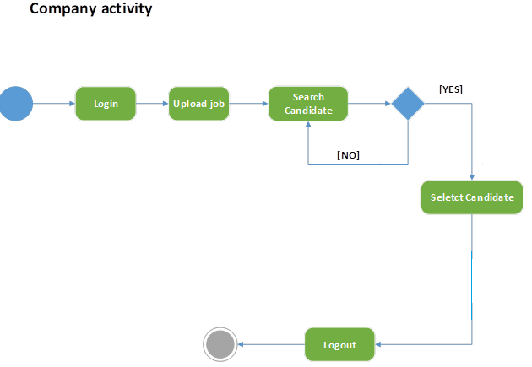

State Transition Diagram
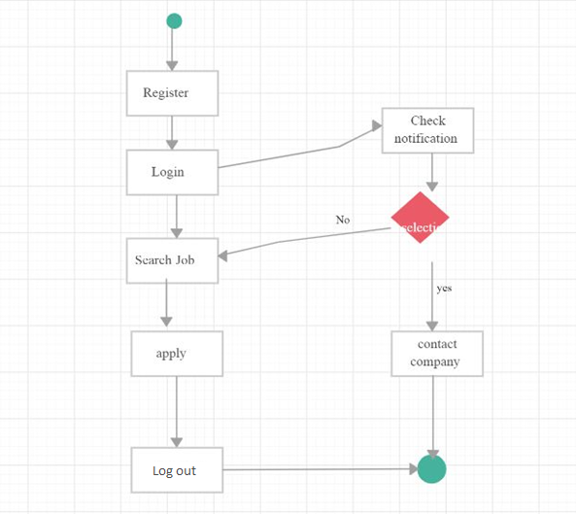

Component Diagram
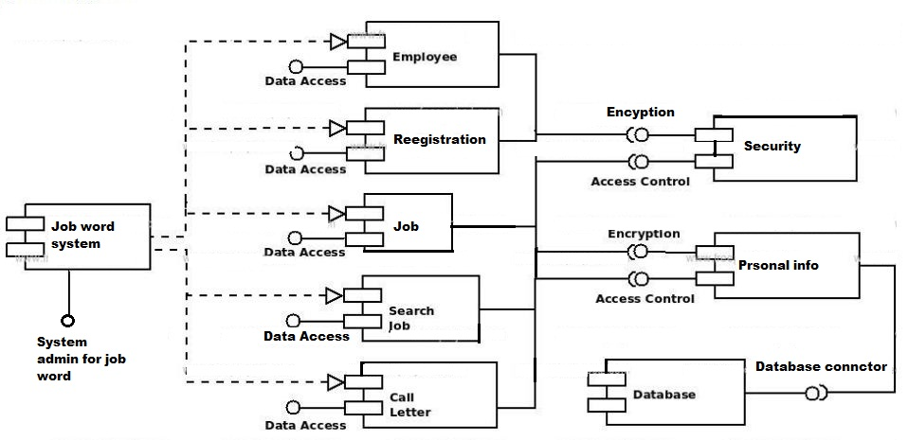

Deployment Diagram
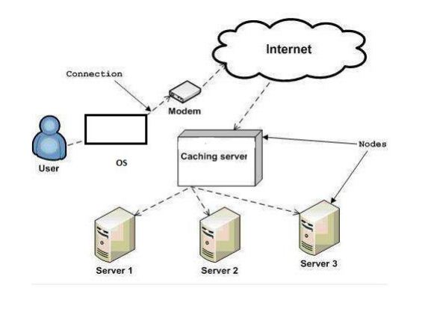

Data Flow diagram [only if structured approach is used - Level 0 and 1]
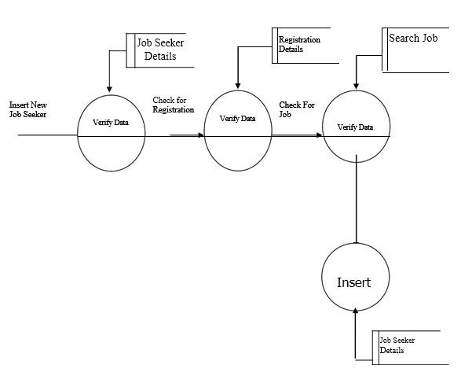

Chapter 5

Implementation

Chapter 5: Implementation
Implementation in this chapter we are going to give complete information about Development tools and tell about the basic in which our Website run. And how many tools and techniques for implemented the application

Important Flow Control/Pseudo codes
Flow control basically used for understanding the flow of the program. Our web what actually done we are understand by seen through flow diagram. Pseudo codes are just like English statements we are understand by reading English statements. Flow diagram and pseudo code is very important for user that easily learning and understand about the working of our website.

Components, Libraries, Web Services and stubs

1. Libraries: Google Speech Libraries, .NET Framework Libraries.
2. Web Services: SOAP and Rest web services will be used to communication between the technologies.
3. Components: Fee Payment alerts, Login Alerts, Notification Alerts

Deployment Environment
Operating environment or Deployment Environment for the Online “ONLINE JOB WORLD” is as listed below.
Distributed database
Client/server system
Operating system: Windows
Database: MS-SQL
Platform: Java/PHP/HTML/JAVASCRIPT/J-Query

Tools and Techniques
The following software/tools were used to develop the product
• Database: XAMPP.
• Application: php
• Tool: MS Visio, MS Word, Crystal Report 2012
• Libraries: Gantt chart, Project Management.

Best Practices / Coding Standards
• Consistent Naming Scheme.
• Dry Principle
• Avoid Deep Nesting
• Limit Line length
• Files and Folder Organizations
• Capitalize SQL Special Words.
• Object Oriented Approach.
• Code Refactoring

Version Control
We will use PHP version control system where we can handle our project with speed and efficiency. We can easily manage and share our code with other team members by using PHP.

Chapter 6

Testing and Evaluation

Chapter 6:
6.1 Testing

Generally, it has been specified thought for testing that:

“Testing is the critical element of any software quality assurance and represents the ultimate review of specification, design and code generation.”

Software testing has a dual function; it is used to establish the presence of defects in program and it is used to help judge whether or not the program is usable in practice. Thus software testing is used for validation and verification, which ensure that software conforms to its specification and meets the need of the software customer.

Developer resorted Alpha testing, which usually comes in after the basic design of the program has been completed. The project scientist will look over the program and give suggestions and ideas to improve or to correct the design. They also report and give after a program has been created.

Testability:-
Software Testability is simply how easily a computer program can be tasted. The check list that follows provides a set of characteristics that lead to testable software.
- Operability
- Observables
- Controllability
- Decomposability
- Simplicity
- Stability
- Understandability

Following are the attributes of the Good Test

- A good test has a high probability of finding an error.
- A good test is not redundant.
- A good test should be “Best of Breed”.
- A good test would be neither too simple nor too complex.

6.2 Compartmentalization:-

In this step we divide the project into number of manageable activities and task like

- Selection Module
- System Admin data module
- Dept. Admin data module
- Store and assign rendered module
- Employee data module
- Task creation data module
- Task allocation and reply data module
- Insert category and pwd Authority module
- Testing Module
- Documentation Module

Interdependency:-
Interdependencies of each compartmentalized activity were then found out. Some tasks must occur in sequence while there are many tasks, which can occur in parallel.
Software Inspection:-
Analyze and check system representations such as the requirements document, design, diagrams and the program source code. They may be applied at all the stages of process.

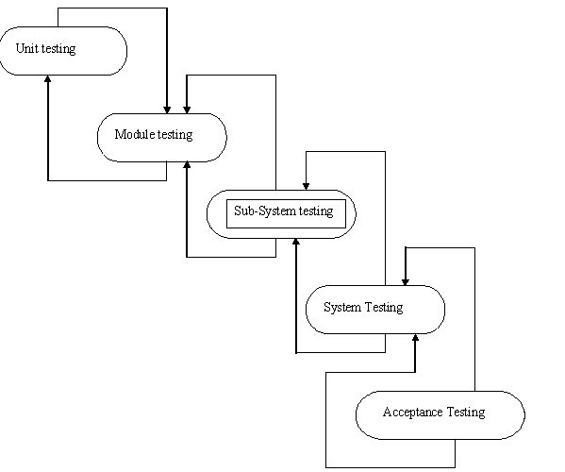
Figure of Testing Process

6.3 Test Plan:-
THE TESTING PROCESS

Developer tests the software process activity such as design, implementation and the requirement engineering. Because, design errors are very costly to repair when the system has been started to operate. Therefore, it is quite obvious to repair them at early stage of the system. So, analysis is the most important process of any project.

REQUIREMENTS TRACTABILITY
As most interested portion is whether the system is meeting its requirements or not, for that testing should be planned so that all requirements are individually tested. Developer checked the output of certain combinations of input, which gives desirable results, or not. Strictly stick to our requirements specifications, give you the path to get desirable results from the system.

TESTED ITEMS
Our tested items are like:
- Data fetching from the database
- Data insertion, updating and deleting in the database
- Form access to particular login

TESTING SCHEDULE
Developer has tested each procedure back to back so that errors and omissions can be found as earliest as possible. Once the system has been developed by fully developer tested it on other machines, which differs in configuration.

TESTING METHODS

Software testing involves executing an implementation of the software which tests data and examining the outputs of the software and its operational behavior to check that it is performing as required.

6.3 STATISTICAL TESTING

Statistical testing is used to test the program’s performance and reliability and to check how it works under operational conditions. Tests are designed to reflect the actual user inputs and their frequency.

The stages involved in the static analysis for this system are follows:

- Control Flow Analysis
  - Unreachable code
  - Unconditional branches into loops

- Data Use analysis
- Variable used before initialization
- Variables declared but never used
- Variables assigned twice but never used between assignments
- Possible array bound violations
- Declared variables
- Interface Analysis
- Parameter type mismatches
- Parameter number mismatches
- Non-usage of the results of function
- Uncalled functions and procedures

- Storage Management Faults
  - Data not stored in proper tables
  - Data cannot be fetched from proper table

DEFECT TESTING
Defect testing is intended to find inconsistencies between a program and its specifications. These inconsistencies are usually due to the program faults or defects.

6.4 UNIT TESTING:-
The Developer carries out unit testing in order to check if the particular module or unit of code is working fine. The unit testing comes at the very basic level as it is carried out as and when the unit of the code is developed or a particular functionality is built.

In this application we test one most important module as task allocation which is as follows:
LOOP TESTING:
Tester has tested the some condition in a code of application. So they test the looping in source code of application for finding miss route or any error or wrong direction of flow in code.

6.5 BLACK-BOX TESTING

In black box testing or functional testing, the developer is concerned about the output of the module and software, i.e. whether the software gives proper output as per the requirements or not. In another words, these testing aims to test a program behavior against specification without making any reference to the internal structure of the program or the algorithms used. Therefore, the source code is not needed, and so even purchased modules can be tested. The program just gets a certain input and its functionality is examined by observing the output.

This can be done in the following way:

- Input Interface
- Processing
- Output Interface

The tested program gets certain inputs. Then the program does its job and generates a certain output, which is collected by a second interface. This result is then compared to the excepted output, which has been determined before the test.

6.6 WHITEBOX TESTING:
It is also called ‘GLASS BOX’ or ‘STRUCTURAL’ testing. Tester has access to the system design.
- Simple Loops
- Nested Loops
- Concatenated Loops
- Unstructured Loops
- Continuous Loops
They can:
- Examine the design document
- View source code
- Individual path examine
- Logical path examine one time
- Logical decision on their true and false

The intention in white-box testing is to ensure that all possible feasible flow of control path through a sub-program is traversed while the software is under tested. This is not the same as saying that all statements in the sub-program will be executed as it is possible for all statements to be executed but for not all of the possible paths to be traversed. However, the conversed is true; whether all the possible paths through a sub-program are traversed then all statements in sub-programs will necessarily be executed.

When considering the number of possible paths through a sub-program two other factors need to be remembered. The first is that some of the possible paths through a sub-program turnout upon investigation to be non- feasible paths. The second consideration is that the number of possible paths to a sub-program indicated by a flow-graph analysis will indicate the minimum number of paths to ensure complete coverage. This may be less than the total number of paths which are possible when combinations of paths are allowed.

White-box testing is used as an important primary testing approach. Here, code is inspected to see what it does. Tests are designed to exercise the code. Code is tested using code scripts driver etc. which are employee to directly interfaced with and drive the code.
The tester can analyze the code and used the knowledge about the structure of a component to derive the test data.

Advantages of White box testing:-
- As the knowledge of internal coding structure is prerequisite, it becomes very easy to find out which type of input / data can help in testing the application effectively.
- The other advantage of white box testing is that it helps in optimizing the code.
- It helps in removing the extra lines of code, which can bring in hidden defects.

6.7 STRUCTURE TESTING:

Developer has done his path testing to exercise every independent execution path through a component or program. If every independent path is executed then all statements in the components must have been executed at least once. The structure of our program is also cheeked.

6.8 INTEGRATION TESTING:-

After our individual modules Developer tested out Developer go to the integrated to create a complete system. This integration process involves building the system for problems that arise from component interactions.

Developer has applied top-down strategy to validate high-level components of a system before design and implementations have been completed. Because, our development process started with high-level components and Developer worked down the component hierarchy.
PERFORMANCE TESTING:-

Performance testing is designed to test the runtime performance of the system within the context of the system. These tests Developer performed as module level as developer as system level. Individual modules developers tested for required performance.

6.9 CONDITION TESTING:-
Condition testing is a test case design method that exercises the logical conditions contained in a program module. If the condition is incorrect, then as least one part of the condition is incorrect. It may include:

- Boolean variable error
- String index out of Bound error
- Null pointer Assignment
- Input Output Connection Exceptions
- Arithmetic expression error
- Parsing ( conversion) errors
- Image unloaded errors

INTERFACE TESTING:-
Interface testing is integral part of integration testing. Therefore, developer checked for the following.
- Interface misuse
- Interface misunderstanding

Developer examined the code to be tested and explicitly list each call to an external component. In the system, standards tests for various modules have been performed, which are follows.

- All the menu functions and sub menu functions have been checked.
- Validations for all inputs are done.
- All required fields are not left blank.
6.10 OBJECT TESTING:-

Object testing is to test object as individual components, which are often larger than single function. Here following activities have taken place.

- Testing the individual operations associated with object.
- Testing individual object classes.
- Testing cluster of objects.
- Testing object oriented systems.

Now we will discuss how testing and debugging is done of this application. Our application can be divided into parts like;
- To make queries to database and retrieve information from it.
- Reduce some memory requirements for the database.
- Maintain database so that unauthorized access cannot affect.

Test Cases

Test Object | Inputs | Desired Outputs | Actual Outputs
File upload page of web application. | Zip file including Shape Files and its supporting database files. | Upload Successfully. | Upload Successfully.
Reading data from Text File and placing on the map at proper places. | Text File containing comma separated values. | Read and Placed Successfully. | Read and Placed Successfully.
Viewing Description of particular hotspot. | Text File containing comma separated values. | Viewed Successfully. | Viewed Successfully.

Chapter 7

Summary, Conclusion and Future Enhancements

Chapter 7:
Summary, Conclusion & Future Enhancements

Project Summary
In this report, we have focused on the automated system, which replaces the manual exam system.

In making of this application, we have learnt that handling files and maps is becoming easy.

Using this application, a user gets different information and a cost effective solution by visiting unknown place efficiently with all the necessary information regarding to various hotspots the user visits.

Also this application satisfies collaboration objective i.e. “I make it and you use it; u make it and I use it” which is the actual motive of this application.

Achievements and Improvements
Basically, we have tried to introduce the evaluation method of student performance. Here, the questions are appeared according to the previous answer of that student. We have implemented it in our report and it works successfully in our system. In this system, an educational institute can make their examination procedure automated.

Critical Review
With the spread of internet, online job portals have become important forums for job matching by employers and employees. Online job portals often collect large number of data in the form of job vacancies and resumes that can serve as a valuable source of information about the characteristics of labor market demand. Research using such data is limited but growing. Many methodological issues however remain open with respect to the representativeness of data and generalizability of findings. This paper focuses on methodological aspects of the usage of online job vacancy data and voluntary web-based surveys for the analysis of micro-level labor market dynamics. We highlight advantages and possible set-backs of online-gathered data and suggest strategies how selected methodological issues could be overcome. We argue that limited scope exists for representativeness adjustments of online job vacancies, but uniqueness and richness of this data can nevertheless be exploited to inform policies in various fields. We present a case of EURES online job vacancies and summarize aspects which make it a unique suitable source for comparative micro-level analyses of European labor markets.

Lessons Learnt
Software process is the way in which we produce the software. Apart from hiring smart, knowledgeable engineers and buying the latest development tools, effective software development process is also needed, so that engineers can systematically use the best technical and managerial practices to successfully complete their projects.

Future Enhancements/Recommendations
In future if we get a chance to work on the same project then we like to implement Improvement for advertisement.
We also like to make our site more secure.

Appendices

Appendix A: User Manual
[Paragraph Text 12 pt., Calibri, 1.5 Lines Spacing, Justified]
[Between 4 to 8 lines describe what this appendix all about is]

Appendix A: Appendix Title
[Appendix Heading 1]: [20 pt. Calibri, Bold, Left aligned]

Text in 12-Point Size, Times New Roman, 1.5 Line Spacing.

  - First Level heading [16 pt. Calibri, Bold, Left aligned]
[Paragraph Text 12 pt. Calibri, 1.5 Lines Spacing, Justified]

    - Second level heading [14 pt. Calibri, Bold, Left aligned]
[Paragraph Text 12 pt. Calibri, 1.5 Lines Spacing, Justified]

      - Third level heading [12 pt. Calibri, Bold, Left aligned]
[Paragraph Text 12 pt. Calibri, 1.5 Lines Spacing, Justified]

Appendix B: Administrator Manual
[Paragraph Text 12 pt. Calibri, 1.5 Line Spacing, Justified]
[Between 4 to 8 lines describe what this appendix all about is]

  - First Level heading [16 pt. Calibri, Bold, Left aligned]
[Paragraph Text 12 pt. Calibri, 1.5 Lines Spacing, Justified]

    - Second level heading [14 pt. Calibri, Bold, Left aligned]
[Paragraph Text 12 pt. Calibri, 1.5 Lines Spacing, Justified]

      - Third level heading [12 pt. Calibri, Bold, Left aligned]
[Paragraph Text 12 pt. Calibri, 1.5 Lines Spacing, Justified]

Appendix C: Information / Promotional Material
[Paragraph Text 12 pt. Calibri, 1.5 Lines Spacing, Justified]
[Between 4 to 8 lines describe what this appendix all about is]

  - Broacher

  - Flyer

  - Standee

  - Banner

  - First Level heading [16 pt. Calibri, Bold, Left aligned]
[Paragraph Text 12 pt. Calibri, 1.5 Lines Spacing, Justified]

    - Second level heading [14 pt. Calibri, Bold, Left aligned]
[Paragraph Text 12 pt. Calibri, 1.5 Lines Spacing, Justified]

      - Third level heading [12 pt. Calibri, Bold, Left aligned]
[Paragraph Text 12 pt. Calibri, 1.5 Lines Spacing, Justified]

Appendix [no.]: Appendix Title
[Paragraph Text 12 pt. Calibri, 1.5 Lines Spacing, Justified]
[Between 4 to 8 lines describe what this chapter all about is]

  - First Level heading [16 pt. Calibri, Bold, Left aligned]
[Paragraph Text 12 pt., Calibri, 1.5 Lines Spacing, Justified]

    - Second level heading [14 pt., Calibri, Bold, Left aligned]
[Paragraph Text 12 pt., Calibri, 1.5 Lines Spacing, Justified]

      - Third level heading [12 pt., Calibri, Bold, Left aligned]
[Paragraph Text 12 pt., Calibri, 1.5 Lines Spacing, Justified]

Reference and Bibliography

Reference and Bibliography

References Books

- C# 2.0 Complete Reference
- ProfessionalASP.NET 2.0
- ASP.NET Complete Reference
- System Analysis And Design

Internet Sources:

- Naukari.com
- Monster.com
- Rozee.pk

Index

Index

[A]

[B]

[C]

