SUPERIOR UNIVERSITY LAHORE


Faculty of Computer Science & IT

Final Year Project
PROJECT REPORT

[Brain Tumor Detection, Classification & Awareness Web Portal]

Project ID: [CS_019]

Project Team
Student Name | Student ID | Program | Contact Number | Email Address
Hamza Ashfaq | BCSM-F14-075 | BSCS | 0305-9518030 | Mian24142@gmail.com
Muhammad Arslan | BCSM-F14-107 | BSCS | 0300-5394928 | Axnjunaid@gmail.com
Kamran Manzoor | BCSM-F14-114 | BSCS | 0304-4858979 | Kamranawan70@gmail.com

[Amna Khan]
(Assistant Professor)
Project Report
[MRI Brain Tumor Detection]

Change Record
Author(s) | Version | Date | Notes | Supervisor’s Signature
 | 1.0 |  | <Original Draft>
 |  |  | <Changes Based on Feedback from Supervisor>
 |  |  | <Changes Based on Feedback From Faculty>
 |  |  | <Added Project Plan>
 |  |  | <Changes Based on Feedback from Supervisor>

APPROVAL
Project Supervisor
Comments: ___________________________________________________________________
_____________________________________________________________________________
Name:______________________________
Date:_______________________________ | Signature:__________________________

Project Manager
Comments: ___________________________________________________________________
_____________________________________________________________________________
Date:_______________________________ | Signature:__________________________

Head of the Department
Comments: ___________________________________________________________________
_____________________________________________________________________________
Date:_______________________________ | Signature:__________________________

Dedication
We are dedicate our works to those people who suffer this problem and count days of life, also decade this work to medical sciences and for those persons who shows their attentions in research project of medical sciences.

Acknowledgements

We would like to express our special thanks of gratitude to or teacher as well as our university management who gave us the golden opportunity to do this wonderful project, which also helped us in doing a lot of Research and we came to know about so many new things we are really thankful to them.

Executive Summary
As we know in Pakistan we have not a lot work in medical imaging, so our team decide to work in this field because of we are required this kind of software, apps and web based solution in Pakistan. Developing a desktop or web based solution app which will be able to identify the tumor .It will be able to identify the size, type and location of the tumor .The app will also detect any other kind of abnormalities of brain that causes other problems .To build this app the tool we are using matlab or support of other languages like c# and the technique is image processing.
So the first module of project is identification of tumor in this module our app read the data base of input images and then with compare with the ideal database of images for analysis. This module based on supervised learning and work on our inputs.
Next module is classification of tumor in which we are again compare the tumor with different type of tumor database, this module identify the type of tumor and at the end display the details about tumor and generate the reports.

Table of Contents
Acknowledgements iv
Executive Summary v
Table of Contents vi
List of Figures ix
List of Tables ix
Chapter 1 3
Introduction 3
1.1. Background 4
1.2. Motivations and Challenges 4
1.3. Goals and Objectives 5
1.4. Literature Review/Existing Solutions 5
1.5. Gap Analysis 5
1.6. Proposed Solution 6
1.7. Project Plan 6
1.7.1. Work Breakdown Structure 7
1.7.2. Roles & Responsibility Matrix 1
1.7.3. Gantt chart 3
1.8. Report Outline 3
Chapter 2 5
Software Requirement Specifications 5
2.1. Introduction 6
2.1.1. Purpose 6
2.1.2. Document Conventions 6
2.1.3. Intended Audience and Reading Suggestions 6
2.1.4. Product Scope 6
2.1.5. References 7
2.2. Overall Description 7
2.2.1. Product Perspective 7
2.2.2. Product Functions 7
2.2.3. User Classes and Characteristics 8
2.2.4. Operating Environment 9
2.2.5. Design and Implementation Constraints 9
2.2.6. User Documentation 9
2.2.7. Assumptions and Dependencies 9
2.3. External Interface Requirements 9
2.3.1. User Interfaces 9
2.3.2. Hardware Interfaces 9
2.3.3. Software Interfaces 10
2.3.4. Communications Interfaces 10
2.4. System Features 10
2.4.1. System Feature 1 10
2.4.1.1. Description and Priority 10
2.4.1.2. Stimulus/Response Sequences 10
2.4.1.3. Functional Requirements 11
2.4.2. System Feature 2 11
2.4.2.1. Description and Priority 11
2.4.2.2. Stimulus/Response Sequences 11
2.4.2.3. Functional Requirements 12
2.4.3. System Feature 3 (and so on) 12
2.4.3.1. Description and Priority 12
2.4.3.2. Stimulus/Response Sequences 13
2.4.3.3. Functional Requirements 13
2.4.4. System Feature 4 13
2.4.4.1. Description and Priority 13
2.4.4.2. Stimulus/Response Sequences 13
1.1.1.1. Functional Requirements 14
8.1. Other Nonfunctional Requirements 14
8.1.1. Performance Requirements 14
8.1.2. Safety Requirements 15
8.1.3. Security Requirements 15
8.1.4. Software Quality Attributes 15
8.1.5. Business Rules 15
Chapter 3 16
Use Case Analysis 16
3.1. Use Case Model 18
3.2. Use Case Descriptions 18
Use Case: 1 Log In 19
Use Case: 2 Sign up 19
Use Case: 3 Detection 20
Use Case: 4 Segmentation 20
Use Case: 5 Extract Features 20
Use Case: 6 Classification 21
Chapter 4 22
System Design 22
4.1. Architecture Diagram 23
4.2. Domain Model 24
4.3. Entity Relationship Diagram with data dictionary 25
4.4. Class Diagram 26
4.5. Sequence / Collaboration Diagram 26
4.6. Operation contracts 27
4.7. Activity Diagram 28
4.8. State Transition Diagram 29
4.9. Component Diagram 30
4.10. Deployment Diagram 30
4.11. Data Flow diagram [only if structured approach is used - Level 0 and 1] 31
Chapter 5 32
Implementation 32
5.1. Important Flow Control/Pseudo codes 33
5.1. Components, Libraries, Web Services and stubs 42
5.2. Deployment Environment 43
5.3. Tools and Techniques 43
5.4. Best Practices / Coding Standards 43
5.5. Version Control 43
Chapter 6 45
Testing and Evaluation 45
6.1. Use Case Testing 46
6.1.1 Sign up 46
Table 11 Sign Up 47
6.1.2 Log In 47
Table 12 Log In 47
6.1.3 Tumor Detection 47
Table 13 Detection 47
6.1.4 Feature Extraction 47
Table 14 Feature Extraction 48
6.1.5 Classification 48
Table 15 Classification 48
6.2. Equivalence partitioning 48
6.3. Boundary value analysis 48
6.4. Data flow testing 50
6.5. Unit testing 50
Table 16 Unit Testing 1
6.6. Integration testing 1
Table 17 Integration Testing 1
6.7. Performance testing 1
6.8. Stress Testing 2
Chapter 7 3
Summary, Conclusion and Future Enhancements 3
7.1. Project Summary 4
7.2. Achievements and Improvements 4
7.3. Critical Review 4
7.4. Lessons Learnt 5
7.5. Future Enhancements/Recommendations 5
Appendices 7
Appendix A: Information / Promotional Material 8
Reference and Bibliography 11

List of Figures
Figure 1 Gantt Chart 3
Figure 2 system Feature 3 Response Sequence 13
Figure 3 system Feature 4 Response Sequence 14
Figure 4 Full Dress Use Case Diagram 18
Figure 5 Architecture Diagram 23
Figure 6 Domain Model 24
Figure 7 Entity Relationship Diagram 25
Figure 8 Class Diagram 26
Figure 9 Sequence Diagram 26
Figure 10 Operation Contracts 27
Figure 11 Activity Diagram 28
Figure 12 state Transition Diagram 29
Figure 13 Data Flow Diagram 31
Figure 14 Data Flow Testing Diagram 50
Figure 15 Stress Testing Diagram 2

List of Tables
Table 1 Roles and Responsibility 1 3
Table 2.3.2 Use Case 2 9
Table 3.3.3 Use Case 2 10
Table 4 Use Case 1 19
Table 5 Use Case 2 20
Table 6 Use Case 3 20
Table 7 Use Case 4 20
Table 8 Use Case 5 21
Table 9 Use Case 6 21
Table 10 Use Case testing 46
Table 11 Sign Up 47
Table 12 Log In 47
Table 13 Detection 47
Table 14 Feature Extraction 48
Table 15 Classification 48
Table 16 Unit Testing 1
Table 17 Integration Testing 1

Chapter 1

Introduction

Chapter 1: Introduction
We are developing a desktop app which is based on MRI scan 0f brain .It will take the images or a MRI scan video of brain and will analyze the images to identify the tumor. It will compare all the images of brain with database to identify the size, type and location of the tumor. It can also identify any kind of brain abnormalities that causes other problems. So the desktop app have the database of images includes the all set we need for comparison and identification purpose. This kind of app improve the analysis and also maintain the time slot of doctors.
So this chapter is all about the initial terms of project like introductory things or which kind of technique we followed and structures we are implement in our project or basic work flow of project.

Background
Brain tumor is basically abnormal growth of cells because of some reason like affected proteins of cells. The least aggressive type of a brain tumor is often called a benign brain tumor. They originate from cells within or surrounding the brain, do not contain cancer cells, grow slowly, and typically have clear borders that do not spread into other tissue. Although there are some genetic conditions and environmental factors which may contribute to the development of brain cancer. Glioblastoma multiform (GBM) is the most common and deadliest of malignant primary brain tumors in adults and is one of a group of tumors referred to as gliomas. They are statistically more frequent in children and older adults

Motivations and Challenges
The world we are seen is a big motivation to do something for the people who suffer this kind of dieses, the most deadly conditions when you are not do something for the people who suffer because of we have not proper medication of these kind of dieses like cancer. But we can develop the software who detect dieses on early stages on the basic of percepts and data sets, but the most challenging thing is to set the trend of proper patient medical history, record and datasets of patient. Another thing implement the hardware for this purpose starting from the small level like clinic because it’s the first approach of patient.

Goals and Objectives
Our motive to engage the medical solution who are much more efficient more than manual detection system or solutions in the form of computational power as we are all know the computational power increases day by day. Our objective to provide software or web based solution in medical for the dieses whose detection is difficult in early stages with manual systems like cancer.

Literature Review/Existing Solutions
The only established risk factor is ionizing radiation, and a higher incidence is observed with increasing age and in men. There is no conclusive link between an increased risk of brain cancer and exposure to cell phones, other types of electromagnetic fields, head injuries, foods that contain N-nitrous compounds, aspartame, occupational risk factors, pesticides or seasonal birth. Interestingly, the risk of glioma is slightly reduced in people with asthma, eczema and hay fever, which perhaps reflects increased immune surveillance of the brain.
The solution geranyl use is a manual approach and time taking and depend on expert level. The segmentation, detection, and extraction of infected tumor area from magnetic resonance images are a primary concern but a tedious and time taking task performed by radiologists or clinical experts, and their accuracy depends on their experience only. That’s why in this filed expertise level is much important and role of risk involves very high.

Gap Analysis
There is huge gap between identification technique still used in brain tumor detection and technology now day involves in medical sciences, to reduce this gap or fill this gap we used advanced and mush more efficient systems in medical sciences which are artificial intelligence based or based on new technique involves in it.

Proposed Solution
So we proposed the solution in the way of an algorithm based image processing and data mine, this algorithm mostly remove the manual analysis of MRI scans of brain. The solution based on image processing techniques MRI scans (solution in any form). It will help doctors to identify the tumor within minutes. It will also help to identify the type of tumor. We will simply input the MRI based images of brain, the algorithm will take images and will analyze the images after applying the techniques of image processing it will deliver results. The results will show the defective area .After that it will compare that images with its database, by comparing if it will find any similar image then it will show both of images and will also identify the type of tumor. On the current situation the algorithm will also suggest for surgery if needed.
- Take images of MRI based
- Apply enhancement technique
- Apply pattern of noise removal
- Apply segmentation
- Feature extraction
- Results
Supervised learning

Project Plan
- WBS
- Gant Chart

Work Breakdown Structure

- Initiation
  - Prepare project plan
  - Budget management
  - Assign tasks
  - Review project
  - Collection of Datasets
- Gather requirement
  - requirement analysis
  - functional and non-functional requirements
  - division plan
  - Requirement document
  - Design Model
  - Assign Tasks
- Extract features
  - Upload images
  - Enhancement
  - Noise remove
  - Segmentation
  - Reconstruction
  - analyze contributed value
  - assign weights
  - algorithm and modification
  - Analyze algorithm
- Analyze web portal
4.1 ERD
4.2 Data Bases
4.3 Integrate code with web
4.4 Implement Web
4.5 Create Test
4.6 Apply Unit Test
4.7 supervised learning
- Prepare user manual
5.1 services
5.2 Meeting sign off
5.3 Deployment services

Roles & Responsibility Matrix
WBS # | WBS Deliverable | Activity # | Activity to Complete the Deliverable | Duration  (# of Days) | Responsible Team Member(s) & Role(s)
1 | initiation | 1 |  | 2 days | Arsaln,Kamran, Hamza
2 | Prepare project plan | 1.1 |  | 2 days | Arsaln,Kamran, Hamza
3 | Budget management | 1.2 |  | 2 days | Arsaln,Kamran, Hamza
4 | Assign Task | 1.3 |  | 2 days | Arsaln,Kamran, Hamza
5 | Review project | 1.4 | 4 | 4 days | Arsaln,Kamran, Hamza
6 | Collection of Datasets | 1.5 | 5 | 16 days | Arsaln,Kamran, Hamza
7 | Gather Requirement | 2 | 5 | 11 days | Arsaln,Kamran, Hamza
8 | requirement Analysis | 2.1 | 7 | 8 days | Arsaln,Kamran, Hamza
9 | Functional and non-functional requirements | 2.2 | 8 | 6 days | Arsaln,Kamran, Hamza
10 | Division plan | 2.3 | 9 | 2 days | Arsaln,Kamran, Hamza
11 | Requirement document | 2.4 | 9 | 3 days | Arsaln,Kamran, Hamza
12 | Design Model | 2.5 | 7 | 6 days | Arsaln,Kamran, Hamza
13 | Assign Task | 2.6 | 12 | 6 days | Arsaln,Kamran, Hamza
14 | Extract Features | 3 | 6,8 | 10 days | Arsaln,Kamran, Hamza
15 | Upload images | 3.1 | 14 | 3 days | Arsaln,Kamran, Hamza
16 | Enhancement | 3.2 | 15 | 6 days | Arsaln,Kamran, Hamza
17 | Noise remove | 3.3 | 16 | 6 days | Arsaln,Kamran, Hamza
18 | Segmentation | 3.4 | 17 | 10 days | Arsaln,Kamran, Hamza
19 | Reconstruction | 3.5 | 18 | 3 days | Arsaln,Kamran, Hamza
20 | Analyze contributed value | 3.6 | 19 | 4 days | Arsaln,Kamran, Hamza
21 | assign weights | 3.7 | 20 | 10 days | Arsaln,Kamran, Hamza
22 | algorithm and modification | 3.8 | 20 | 11 days | Arsaln,Kamran, Hamza
23 | Analyze algorithm | 3.9 | 12 | 6 days | Arsaln,Kamran, Hamza
24 | WEB solution | 4 | 23 | 7 days | Arsaln,Kamran, Hamza
25 | Erd | 4.1 | 24 | 7 days | Arsaln,Kamran, Hamza
26 | Database | 4.2 | 25 | 5 days | Arsaln,Kamran, Hamza
27 | Integrate code with web | 4.3 | 26 | 15 days | Arsaln,Kamran, Hamza
28 | Implement web | 4.4 | 27 | 12 days | Arsaln,Kamran, Hamza
29 | Create test | 4.5 | 28 | 10 days | Arsaln,Kamran, Hamza
30 | User Manual | 4.6 | 29 | 6 days | Arsaln,Kamran, Hamza
31 | Apply unit test | 4.7 | 30 | 6 days | Arsaln,Kamran, Hamza
32 | Apply supervised learning | 4.8 | 31 | 6 days | Arsaln,Kamran, Hamza
33 | User manual | 5 | 32 | 4 days | Arsaln,Kamran, Hamza
34 | Services | 5.1 | 33 | 5 days | Arsaln,Kamran, Hamza
35 | Meeting sign uff | 5.2 | 34 | 6 days | Arsaln,Kamran, Hamza
36 | Deployment services | 5.3 | 35 | 7 days | Arsaln,Kamran, Hamza

Table 1 Roles and Responsibility 1

Gantt chart
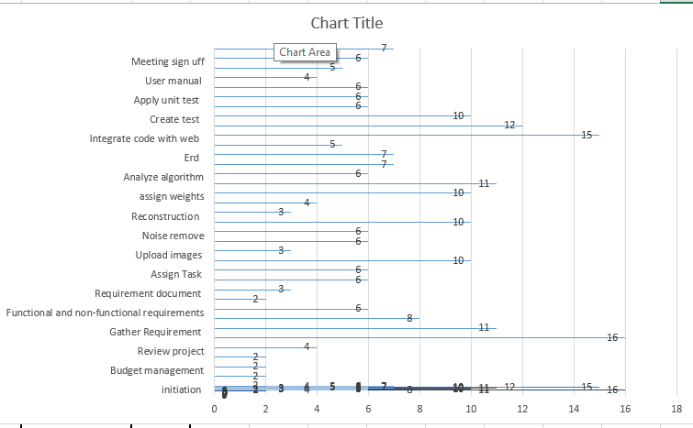

Figure 1 Gantt Chart

Report Outline
Done the intro of project basic planning of projects and parameters. Proposed solution of project or summery of project WBS and detail of it.

Chapter 2

Software Requirement Specifications

Chapter 2: Software Requirement Specifications

Introduction

Purpose
In this portion we define the all technical and basic foundation of the project, includes the basic structure and requirements. We define the product function, nonfunctional requirements, environment of software and interfaces of communication etc.
In SRS document we define the proper functionality and goals of our product. Also define working of product and proper key lines of project with the help of outlines. Define the terms and conditions of project audience and guidelines.

Document Conventions

Intended Audience and Reading Suggestions
Intended audience of our report are patient of brain tumor because of we are working on a algorithm based on MRI brain scans. With some modification our algorithm also works for the other type of tumors. We suggest reading this report for doctor and medical students because of these people help us to improve the system and make it more efficient. Also student of Research also study this material.

Product Scope
The main purpose of solution is detect the brain tumor and classify it on early stages. And the system perform supervised learning, reduces the time slot of MRI brain scan and find the abnormality with in time. System goals is to make a supervised learning environment who helps us to make the system more efficient.

References
[1] Mohammed Sabbih Hamoud Al-Tamimi, Ghazali Sulong. Tumor Brain Detection through MRI Images: A Review of Literature || Journal of Theoretical And Applied Information Technology 20th April 2014. Vol. 62 No. 2 || E-Mail: 1m_Altamimi75@Yahoo.Com, 2ghazali@Utmspace.Edu.My
[2] Jay Patel And Kaushal Doshi - A Study Of Segmentation Methods For Detection Of Tumor In Brain Mri || Issn 22311297, Volume 4, Number 3 (2014), Pp. 279-284 [3] Rohini Paul Joseph, C. Senthil Singh, M.Manikandan - Brain Tumor Mri Image Segmentation And Detection In Image Processing
[4] Mohamed N. Ahmed, Sameh M. Yamany, Nevin Mohamed, Aly A. Farag, Thomas Moriarty- A Modified Fuzzy C-Means Algorithm For Bias Field Estimation And Segmentation Of Mri Data.
[5] Yongyue Zhang, Michael Brady, And Stephen Smith - Segmentation Of Brain Mr Images Through A Hidden Markov Random Field Model And The ExpectationMaximization Algorithm || IEEE Transactions On Medical Imaging, Vol. 20, No. 1, January 2001.
[6] K.R.Yasodha, Dr. V.Thiagarasu - Automatic Segmentation of Brain Tumor from MRI Images- A Review.

Overall Description

Product Perspective
So the product is MRI brain scan tumor detection and when we discus about the origin of this technique, in previous we are followed manual analysis system of brain MRI but we are move towards an automated system on the base of image processing, we define more in next point.

Product Functions
- First take the images and apply the preprocess technique on it.
- Apply enhancement technique like contrast stretching to make image better and remove noise in the images if it have any.
- Detect the Tumor if it exist or not.
- Apply Segmentation and add the same images in one segment.
- Getting the Region of interest or feature extraction where tumor can exist.
- Classification of the Tumor and generate reports.

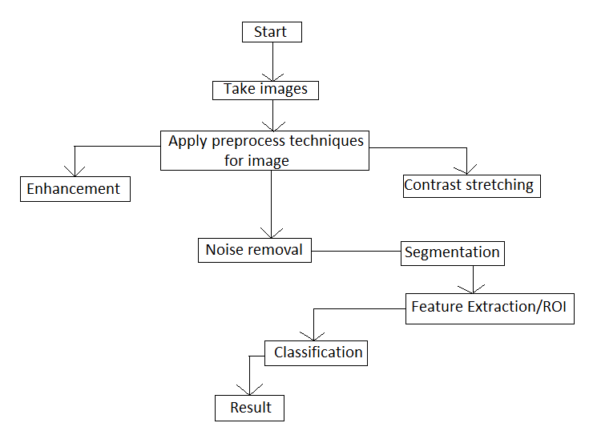

User Classes and Characteristics
- Super Admin:- The one admin who have all the access like removing adding new members and all other function
- Admin: Can’t Remove or Add members but can add new data change data and delete data.
- Sub-Admin: Those who can only add the new data but cannot delete it.
- End User:- The User who can only see the data.

Operating Environment
The Software will operate on Brain tumor Hospital computers. Where it use on the patient to detect the tumor if it exist or not. The minimum requirement for the hardware is Corei3 4GB RAM 1GB graphic card. This app is mostly run on system.

Design and Implementation Constraints
When we are think about constraints in our project first constraint is working in the environment of medical field but on the other hand making a user friendly design for user to understand and use the software or web.

User Documentation
We make a user manual for guidance, its include how to work in this environment of software or in web. Also move towers online services or proper guideline on video tutorials. Also make an online portal for help and health care.

Assumptions and Dependencies
We are depends on MRI brain scan hardware because of we get the MRI scan images from this hardware. That’s why we depend on it because of all algorithm work on MRI images. We are not made any kind of assumptions because of we are working on realistic data.

External Interface Requirements

User Interfaces
The User interface in this software is just that the user take the image of brain and put it in the software and then click the button on go the reaming thing software do and at the end user can see the result on the screen

Hardware Interfaces
The system has been designed to perform under following specification on the machine.
Hardware | Minimum Requirements
Computer | Intel or compatible core i3 or higher
Memory(RAM) | At least 4GB preferably higher
Hard disk space | Minimum 18 GB
Table 2.3.2 Use Case 2

Software Interfaces
Software interface of our project is with a web solution or with a desktop app, if we are implement this algorithm with a web portal, we design it in .net. We convert the matlab code into this technology or convert into a library and implement it. If we implement it in a desktop app then make GUI for this and implement the matlab algorithm.

Software | Minimum Requirements
Operating System | Windows 8, 8.1 or above
Internet information service | Version 7.5 or higher
Mat lab | Version 2013 or above
Microsoft.net Framework | Version 4.6.1 or higher
Table 3.3.3 Use Case 2

Communications Interfaces
We make a communication interface in the form of a web portal. Web portal have the portion of communication media between same kinds of users. Doctors have proper accounts on portal side for best way of communication.

System Features

System Feature 1
Detection and identification of tumor.

Description and Priority
We take MRI images of Brain and apply preprocessing technique like enhancement and then apply noise removal to clear the image and detect the tumor either its exit or not. The priority of this feature is very high and also came in 1st priority. We can rate this feature priority is 9.

Stimulus/Response Sequences
The user Take image and send to this software to detect tumor. the software take images apply all technique.
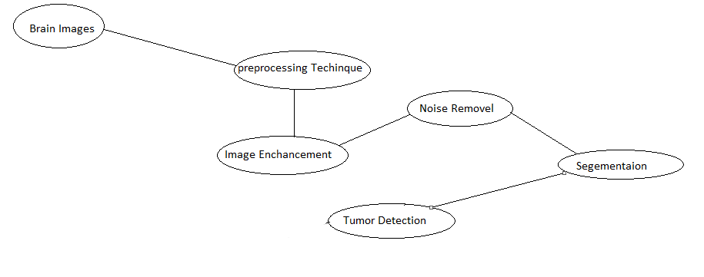

Functional Requirements
The image we give to software should be of the brain else he produce wrong result. Second the image should be in proper condition to be used.
- REQ-SF1-1: First take the images and apply the preprocess technique on it.
- REQ-SF1-2: Apply enhancement technique like contrast stretching to make image better and remove noise in the images if it have any.
- REQ-SF1-3: Detect the Tumor if it exist or not .

System Feature 2
Features Extraction/Region OF Interest

Description and Priority
The feature detection means its extract the area where the brain tumor exist means the region of interest in the brain.it show us the area of tumor so we can focus on that point. Its priority is also very high it came after the tumor detection. You can say its priority is also 9.

Stimulus/Response Sequences
The user Take image and send to this software to detect tumor the software take images apply all technique detect tumor and get the region of interest.
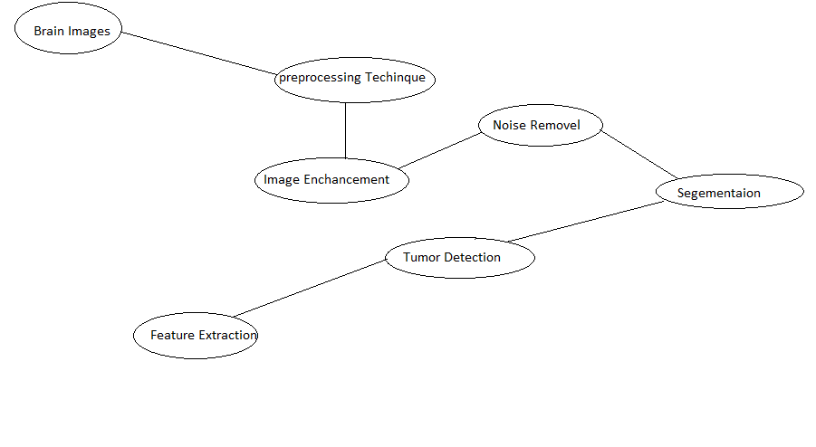

Functional Requirements
- REQ-SF1-1: First take the images and apply the preprocess technique on it.
- REQ-SF1-2: Apply enhancement technique like contrast stretching to make image better and remove noise in the images if it have any.
- REQ-SF1-3: Detect the Tumor if it exist or not .
- REQ-SF2-4: Apply Segmentation and add the same images in one segment.
- REQ-SF2-5: Getting the Region of interest or feature extraction where tumor can exist.

System Feature 3 (and so on)
Classification of Tumor

Description and Priority
The Action is performed on this after feature extraction is cancer classification in this feature we detect what kind of cancer is it.
Its priority is very high and came after getting the region of interest it’s priority is 9.

Stimulus/Response Sequences
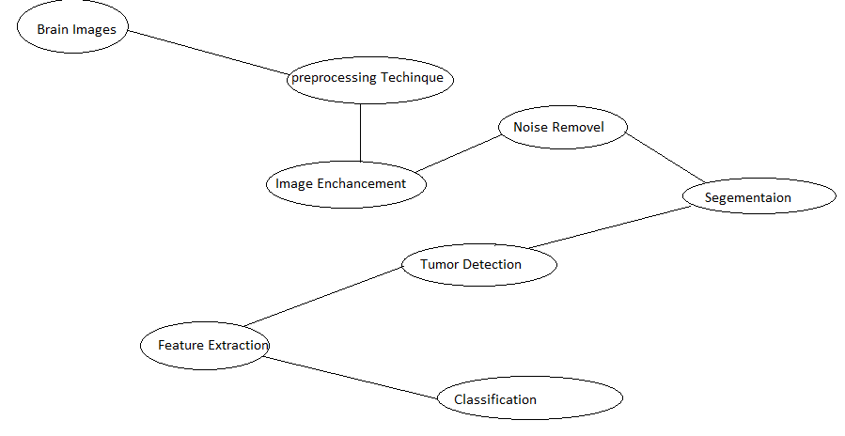
Figure 2 system Feature 3 Response Sequence

Functional Requirements
REQ-SF1-1: First take the images and apply the preprocess technique on it.
REQ-SF1-2: Apply enhancement technique like contrast stretching to make image better and remove noise in the images if it have any.
REQ-SF1-3: Detect the Tumor if it exist or not .
REQ-SF2-4: Apply Segmentation and add the same images in one segment.
REQ-SF2-5: Getting the Region of interest or feature extraction where tumor can exist.
REQ-SF2-6: After getting the region of interest we identify the type of tumor.

System Feature 4
Generate the report.

Description and Priority
After the classification generate the report of patient.
The priority of this feature is medium and it’s 9.

Stimulus/Response Sequences

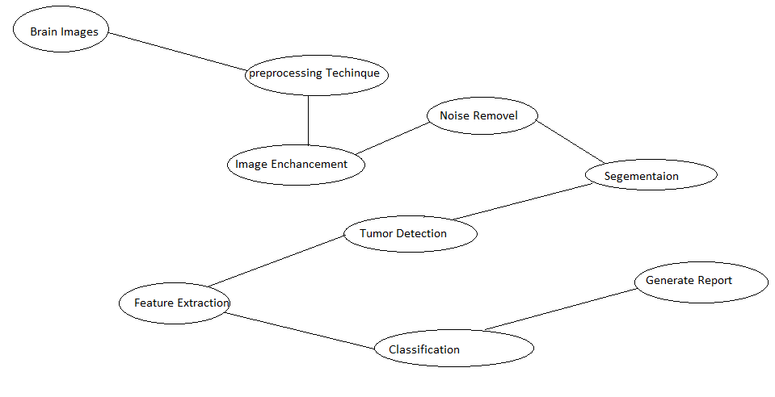
Figure 3 system Feature 4 Response Sequence

Functional Requirements
- REQ-SF1-1: First take the images and apply the preprocess technique on it.
- REQ-SF1-2: Apply enhancement technique like contrast stretching to make image better and remove noise in the images if it have any.
- REQ-SF1-3: Detect the Tumor if it exist or not .
- REQ-SF2-4: Apply Segmentation and add the same images in one segment.
- REQ-SF2-5: Getting the Region of interest or feature extraction where tumor can exist.
- REQ-SF2-6: After getting the region of interest we identify the type of tumor.
- REQ-SF2-7: Generate the report.

Other Nonfunctional Requirements

Performance Requirements
Speed requirements: Response time less than 10 seconds for any transition. The inventory database must be updated in real time.
Capacity requirements: The maximum of simultaneous users at peak use times about 200. Capacity requirements: The system will store data on about 50,000 customers for a total less than 2 Month of data.

Safety Requirements
Encryption is the process of modifying a message so that it becomes incomprehensible to anybody who does not know the key or decryption method. We distinguish two main types of encryption: symmetric encryption, and its variant, hashing, and asymmetric encryption. The implementation of the latter is based on digital certificates.

Security Requirements
Security is ability to protect the information system from disruption and data loss, whether caused by an intentional act. The requirements of security are as follows.
Access control: Customers can access all of data.
Encryption and authentication: Authentication will be needed for user access.
Virus control: The files will be checked when it is uploading to the web.

Software Quality Attributes
Reliability: Highly reliable software has been necessary for applications that are safety critical, such as medical device. The application will be reliable and results will be satisfying.
Usability: Traditional software applications have users, but web sites have customers.
Most web software applications have a broad customer base. Customers expect to be able to use web sites without training. Thus, the software must flow according to the users' expectations, offer only needed information, and when needed, and provide navigation controls that are clear and obvious.

Business Rules
The software is mostly used in Hospital by Lab attend and used carefully because some slide error can turn nothing into something big. The software does not handle by any person who is not associated with the system and does not know how the system work.

Chapter 3

Use Case Analysis

Chapter 3: System Analysis
This system is all about use case of system and role we assign and categorize the user of solution. We describe the all terms about the use case model and use case diagram of every role.at the end we make a proper dressed use case model of our project.

Use Case Model
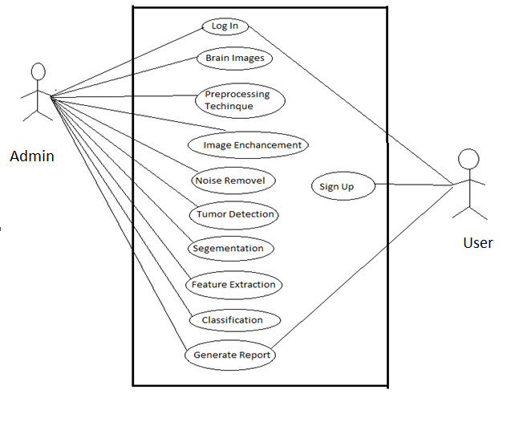
Figure 4 Full Dress Use Case Diagram

Use Case Descriptions
In this section it’s simulate that if we login in the system these condition and scenarios must be matched.

Use Case: 1 Log In
First Use case is Log In where admin and Customer Log in by using username and password. If the Username and Password are correct the user and admin can get access to his roles or operation they can perform

User Case Name | Log In
Scope | To get access to the System
Primary Actor | Admin, Customer
Precondition | User name and password
Post condition | The user can log in
Main Success Scenario | The user log in with the user name and password which is given to him if its correct the user can log in
Extension | If the user name or password is incorrect log in fail.
Frequency of Occurrence | Yes

Table 4 Use Case 1

Use Case: 2 Sign up
In Second user case it’s only for client the client can Sign up by filling the require fields that is given by the system.
User Case Name | Sign Up
Scope | To Register in the system
Primary Actor | Customer
Precondition | All required input fields
Post condition | The user can sign Up
Main Success Scenario | The user Sign up by filling all required input fields to egister in system
Extension | If Any required filed is empty user cannot register.
Frequency of Occurrence | No

Table 5 Use Case 2

Use Case: 3 Detection
User Case Name | Detection
Scope | To detect the tumor
Primary Actor | Admin
Precondition | MRI Images of brain
Post condition | The admin can detect tumor
Main Success Scenario | By putting the brain images we can detect tumor
Extension | Tumor Does not exist
Frequency of Occurrence | No

Table 6 Use Case 3

Use Case: 4 Segmentation

User Case Name | Segmentation
Scope | Divide the image into segments
Primary Actor | Admin
Precondition | MRI Images of brain
Post condition | Image divided into segments
Main Scenario | It take an image divide into segments and put same value image in a single segment
Extension
Frequency of occurrence | No
Table 7 Use Case 4

Use Case: 5 Extract Features
User Case Name | Extract feature
Scope | Find the region of interest
Primary Actor
Precondition | Input images must be RIO image
Post condition | System display the values in command window
Main Success Scenario | From RIO images it take the region of image which we require and show that region on command window
Extension | If image have no any region of interest it fail to detect the ROI in a image.
Frequency of Occurrence | No
Table 8 Use Case 5

Use Case: 6 Classification

User Case Name | Classification
Scope | Detect the type of tumor
Primary Actor
Precondition | Images with tumor detection
Post condition | System display the tumor type in command window
Main Success Scenario | It check the tumor type if it exist in database than show the tumor type.
Extension | Image have a tumor that does not exist in database
Frequency of Occurrence | No
Table 9 Use Case 6

Chapter 4

System Design

Chapter 4: System Design
This chapter is all about structure of our project and all kind of architecture we followed in this SRS report. It’s include all kind of models kike domain model, ERD of project and include operation content.

Architecture Diagram
Architecture Diagram of algorithm of MRI brain scan tumor detection.
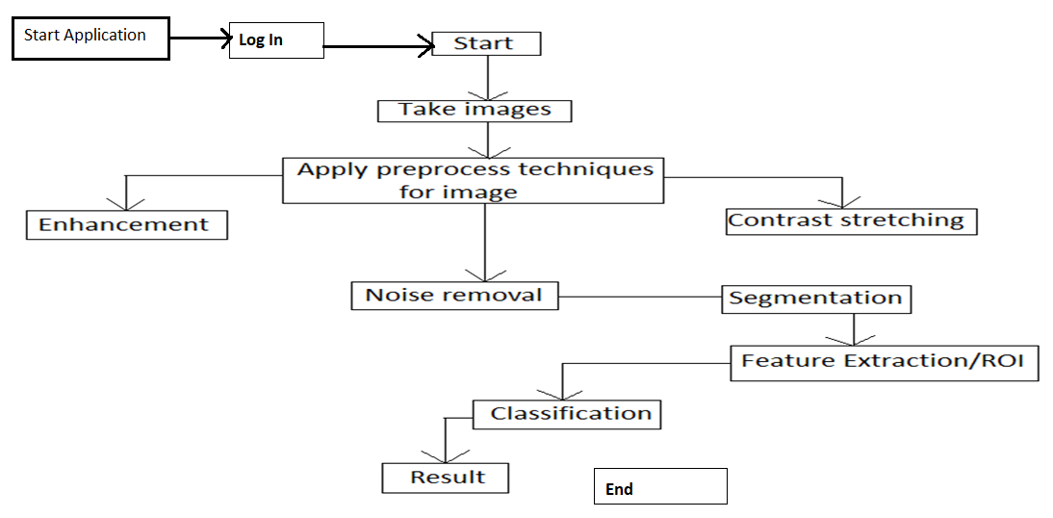
Figure 5 Architecture Diagram

Domain Model
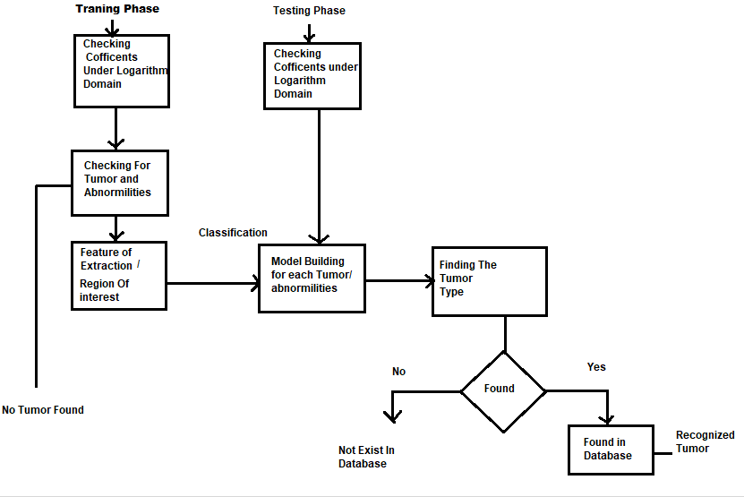
Figure 6 Domain Model

Entity Relationship Diagram with data dictionary
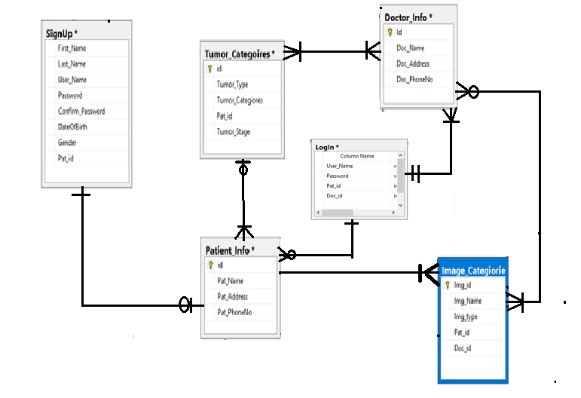
Figure 7 Entity Relationship Diagram

Class Diagram
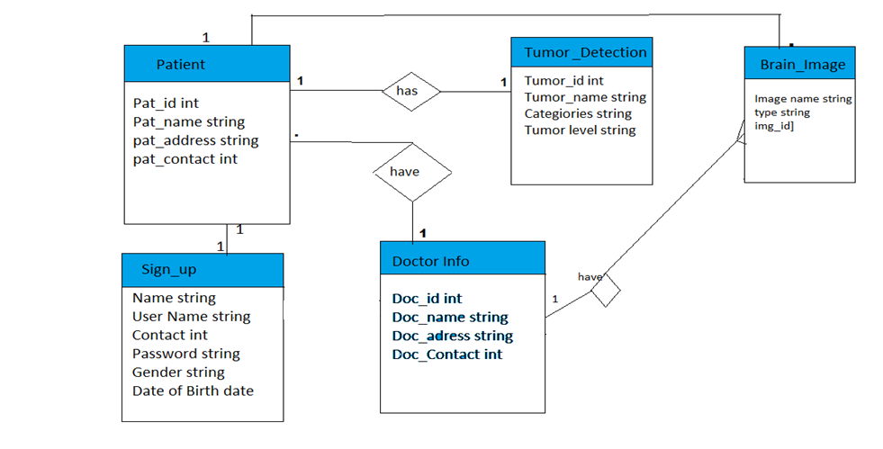
Figure 8 Class Diagram

Sequence / Collaboration Diagram
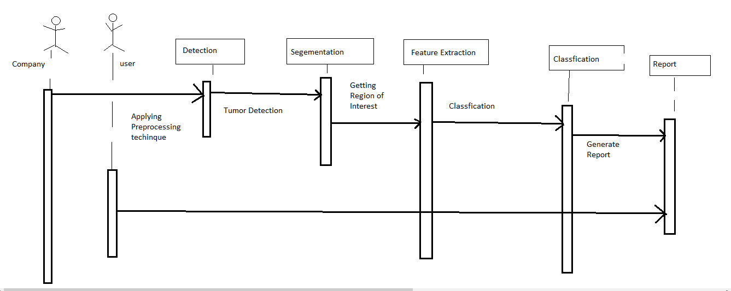
Figure 9 Sequence Diagram

Operation contracts
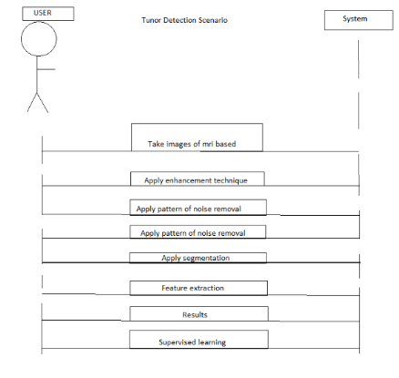
Figure 10 Operation Contracts

Activity Diagram
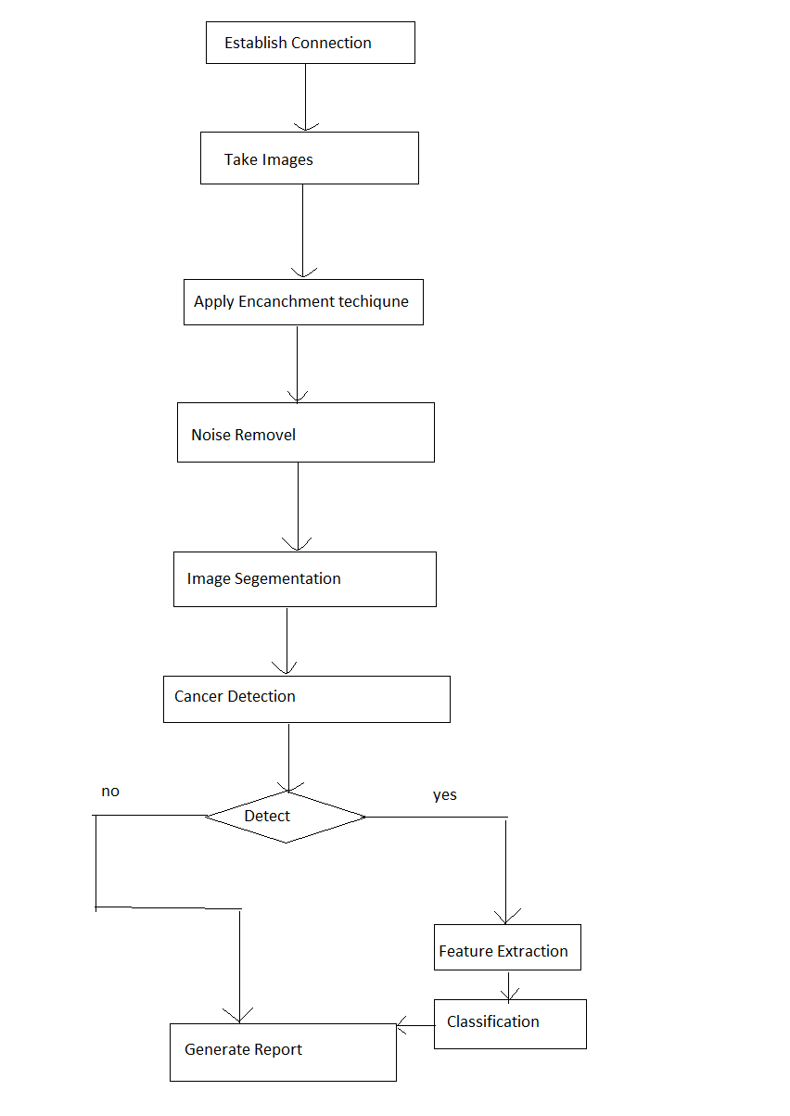
Figure 11 Activity Diagram

State Transition Diagram
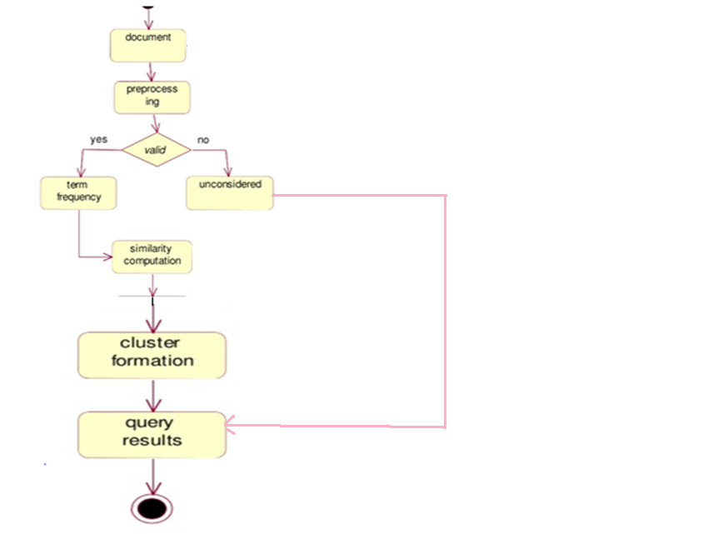

Figure 12 state Transition Diagram

Component Diagram
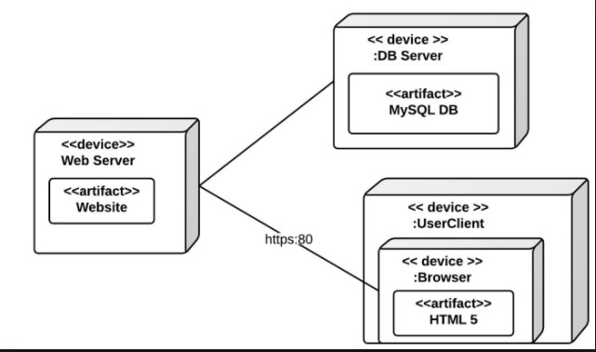

Deployment Diagram

Data Flow diagram [only if structured approach is used - Level 0 and 1]
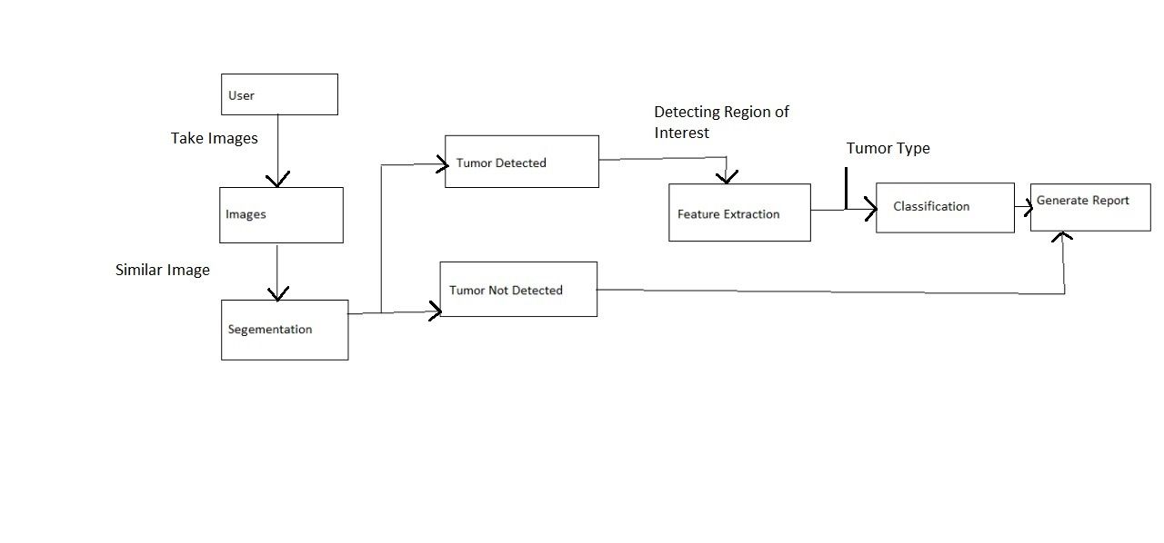
Figure 13 Data Flow Diagram

Chapter 5

Implementation

Chapter 5: Implementation
This portion contain all method we are following in project of implementation phase. We describe the flow control all components and the built in function we are use in it. Which kind of tools we are using and what kind of techniques we are followed in it. Basically this chapter include the whole implementation models we are followed in our project.

Important Flow Control/Pseudo codes
We will simply input the MRI based images of brain, the algorithm will take images and will analyze the images after applying the techniques of image processing it will deliver results. The results will show the defective area .After that it will compare that images with its database, by comparing if it will find any similar image then it will show both of images and will also identify the type of tumor. On the current situation the algorithm will also suggest for surgery if needed.
- Take images of mri based
- Apply enhancement technique
- Apply pattern of noise removal
- Apply segmentation
- Feature extraction
- Results
- Supervised learning
Pseudo Code:-
- function varargout = BrainMRI_GUI(varargin)
- gui_Singleton = 1;
- gui_State = struct('gui_Name', mfilename, ...
    - 'gui_Singleton', gui_Singleton, ...
    - 'gui_OpeningFcn', @BrainMRI_GUI_OpeningFcn, ...
    - 'gui_OutputFcn', @BrainMRI_GUI_OutputFcn, ...
    - 'gui_LayoutFcn', [] , ...
    - 'gui_Callback', []);
- if nargin && ischar(varargin{1})
- gui_State.gui_Callback = str2func(varargin{1});
- end
- if nargout
- [varargout{1:nargout}] = gui_mainfcn(gui_State, varargin{:});
- else
- gui_mainfcn(gui_State, varargin{:});
- end
- handles.output = hObject;
- ss = ones(200,200);
- axes(handles.axes1);
- imshow(ss);
- axes(handles.axes2);
- imshow(ss);
- guidata(hObject, handles);
- function varargout = BrainMRI_GUI_OutputFcn(hObject, eventdata, handles)
- varargout{1} = handles.output;
- function pushbutton1_Callback(hObject, eventdata, handles)
- [FileName,PathName] = uigetfile('*.jpg;*.png;*.bmp','Pick an MRI Image');
- if isequal(FileName,0)||isequal(PathName,0)
- warndlg('User Press Cancel');
- else
- P = imread([PathName,FileName]);
- P = imresize(P,[200,200]);
- axes(handles.axes1)
- imshow(P);title('Brain MRI Image');
- handles.ImgData = P;
- guidata(hObject,handles);
- end
- function pushbutton2_Callback(hObject, eventdata, handles)
- if isfield(handles,'ImgData')
- I = handles.ImgData;
- gray = rgb2gray(I);
- level = graythresh(I);
- img = im2bw(I,.6);
- img = bwareaopen(img,80);
- img2 = im2bw(I);
- axes(handles.axes2)
- imshow(img);title('Segmented Image');
- handles.ImgData2 = img2;
- guidata(hObject,handles);
- signal1 = img2(:,:);
- [cA1,cH1,cV1,cD1] = dwt2(signal1,'db4');
- [cA2,cH2,cV2,cD2] = dwt2(cA1,'db4');
- [cA3,cH3,cV3,cD3] = dwt2(cA2,'db4');
- DWT_feat = [cA3,cH3,cV3,cD3];
- G = pca(DWT_feat);
- whos DWT_feat
- whos G
- g = graycomatrix(G);
- stats = graycoprops(g,'Contrast Correlation Energy Homogeneity');
- Contrast = stats.Contrast;
- Correlation = stats.Correlation;
- Energy = stats.Energy;
- Homogeneity = stats.Homogeneity;
- Mean = mean2(G);
- Standard_Deviation = std2(G);
- Entropy = entropy(G);
- RMS = mean2(rms(G));
- Variance = mean2(var(double(G)));
- a = sum(double(G(:)));
- Smoothness = 1-(1/(1+a));
- Kurtosis = kurtosis(double(G(:)));
- Skewness = skewness(double(G(:)));
- m = size(G,1);
- n = size(G,2);
- in_diff = 0;
- for i = 1:m
- for j = 1:n
  - temp = G(i,j)./(1+(i-j).^2);
  - in_diff = in_diff+temp;
- end
- end
- IDM = double(in_diff);
- feat = [Contrast,Correlation,Energy,Homogeneity, Mean, Standard_Deviation, Entropy, RMS, Variance, Smoothness, Kurtosis, Skewness, IDM];
- load Trainset.mat
- xdata = meas;
- group = label;
- svmStruct1 = svmtrain(xdata,group,'kernel_function', 'linear');
- species = svmclassify(svmStruct1,feat,'showplot',false);
- if strcmpi(species,'MALIGNANT')
- helpdlg(' Malignant Tumor ');
- disp(' Malignant Tumor ');
- else
- helpdlg(' Benign Tumor ');
- disp(' Benign Tumor ');
- end
- set(handles.edit4,'string',species);
- set(handles.edit5,'string',Mean);
- set(handles.edit6,'string',Standard_Deviation);
- set(handles.edit7,'string',Entropy);
- set(handles.edit8,'string',RMS);
- set(handles.edit9,'string',Variance);
- set(handles.edit10,'string',Smoothness);
- set(handles.edit11,'string',Kurtosis);
- set(handles.edit12,'string',Skewness);
- set(handles.edit13,'string',IDM);
- set(handles.edit14,'string',Contrast);
- set(handles.edit15,'string',Correlation);
- set(handles.edit16,'string',Energy);
- set(handles.edit17,'string',Homogeneity);
- end
- function pushbutton3_Callback(hObject, eventdata, handles)
- load Trainset.mat
- Accuracy_Percent= zeros(200,1);
- itr = 80;
- hWaitBar = waitbar(0,'Evaluating Maximum Accuracy with 100 iterations');
- for i = 1:itr
- data = meas;
- groups = ismember(label,'MALIGNANT');
- [train,test] = crossvalind('HoldOut',groups);
- cp = classperf(groups);
- svmStruct_RBF = svmtrain(data(train,:),groups(train),'boxconstraint',Inf,'showplot',false,'kernel_function','rbf');
- classes2 = svmclassify(svmStruct_RBF,data(test,:),'showplot',false);
- classperf(cp,classes2,test);
- Accuracy_Percent(i) = cp.CorrectRate.*100;
- sprintf('Accuracy of RBF Kernel is: %g%%',Accuracy_Percent(i))
- waitbar(i/itr);
- end
- delete(hWaitBar);
- Max_Accuracy = max(Accuracy_Percent);
- sprintf('Accuracy of RBF kernel is: %g%%',Max_Accuracy)
- set(handles.edit1,'string',Max_Accuracy);
- guidata(hObject,handles);
- function pushbutton4_Callback(hObject, eventdata, handles)
- load Trainset.mat
- Accuracy_Percent= zeros(200,1);
- itr = 100;
- hWaitBar = waitbar(0,'Evaluating Maximum Accuracy with 100 iterations');
- for i = 1:itr
- data = meas;
- groups = ismember(label,'MALIGNANT');
- [train,test] = crossvalind('HoldOut',groups);
- cp = classperf(groups);
- svmStruct = svmtrain(data(train,:),groups(train),'showplot',false,'kernel_function','linear');
- classes = svmclassify(svmStruct,data(test,:),'showplot',false);
- classperf(cp,classes,test);
- Accuracy_Percent(i) = cp.CorrectRate.*100;
- sprintf('Accuracy of Linear Kernel is: %g%%',Accuracy_Percent(i))
- waitbar(i/itr);
- end
- delete(hWaitBar);
- Max_Accuracy = max(Accuracy_Percent);
- sprintf('Accuracy of Linear kernel is: %g%%',Max_Accuracy)
- set(handles.edit2,'string',Max_Accuracy);
- function pushbutton5_Callback(hObject, eventdata, handles)
- load Trainset.mat
- Accuracy_Percent= zeros(200,1);
- itr = 100;
- hWaitBar = waitbar(0,'Evaluating Maximum Accuracy with 100 iterations');
- for i = 1:itr
- data = meas;
- groups = ismember(label,'BENIGN ');
- groups = ismember(label,'MALIGNANT');
- [train,test] = crossvalind('HoldOut',groups);
- cp = classperf(groups);
- svmStruct_Poly = svmtrain(data(train,:),groups(train),'Polyorder',2,'Kernel_Function','polynomial');
- classes3 = svmclassify(svmStruct_Poly,data(test,:),'showplot',false);
- classperf(cp,classes3,test);
- Accuracy_Percent(i) = cp.CorrectRate.*100;
- sprintf('Accuracy of Polynomial Kernel is: %g%%',Accuracy_Percent(i))
- waitbar(i/itr);
- end
- delete(hWaitBar);
- Max_Accuracy = max(Accuracy_Percent);
- sprintf('Accuracy of Polynomial kernel is: %g%%',Max_Accuracy)
- set(handles.edit3,'string',Max_Accuracy);
- function edit1_Callback(hObject, eventdata, handles)
- function edit1_CreateFcn(hObject, eventdata, handles)
- if ispc && isequal(get(hObject,'BackgroundColor'), get(0,'defaultUicontrolBackgroundColor'))
- set(hObject,'BackgroundColor','white');
- end
- function edit2_Callback(hObject, eventdata, handles)
- function edit2_CreateFcn(hObject, eventdata, handles)
- if ispc && isequal(get(hObject,'BackgroundColor'), get(0,'defaultUicontrolBackgroundColor'))
- set(hObject,'BackgroundColor','white');
- end
- function edit3_Callback(hObject, eventdata, handles)
- function edit3_CreateFcn(hObject, eventdata, handles)
- if ispc && isequal(get(hObject,'BackgroundColor'), get(0,'defaultUicontrolBackgroundColor'))
- set(hObject,'BackgroundColor','white');
- end
- function pushbutton4_CreateFcn(hObject, eventdata, handles)
- function edit4_Callback(hObject, eventdata, handles)
- function edit4_CreateFcn(hObject, eventdata, handles)
- if ispc && isequal(get(hObject,'BackgroundColor'), get(0,'defaultUicontrolBackgroundColor'))
- set(hObject,'BackgroundColor','white');
- end
- function edit5_Callback(hObject, eventdata, handles)
- function edit5_CreateFcn(hObject, eventdata, handles)
- if ispc && isequal(get(hObject,'BackgroundColor'), get(0,'defaultUicontrolBackgroundColor'))
- set(hObject,'BackgroundColor','white');
- end
- function edit6_Callback(hObject, eventdata, handles)
- function edit6_CreateFcn(hObject, eventdata, handles)
- if ispc && isequal(get(hObject,'BackgroundColor'), get(0,'defaultUicontrolBackgroundColor'))
- set(hObject,'BackgroundColor','white');
- end
- function edit7_Callback(hObject, eventdata, handles)
- function edit7_CreateFcn(hObject, eventdata, handles)
- if ispc && isequal(get(hObject,'BackgroundColor'), get(0,'defaultUicontrolBackgroundColor'))
- set(hObject,'BackgroundColor','white');
- end
- function edit8_Callback(hObject, eventdata, handles)
- function edit8_CreateFcn(hObject, eventdata, handles)
- if ispc && isequal(get(hObject,'BackgroundColor'), get(0,'defaultUicontrolBackgroundColor'))
- set(hObject,'BackgroundColor','white');
- end
- function edit9_Callback(hObject, eventdata, handles)
- function edit9_CreateFcn(hObject, eventdata, handles)
- if ispc && isequal(get(hObject,'BackgroundColor'), get(0,'defaultUicontrolBackgroundColor'))
- set(hObject,'BackgroundColor','white');
- end
- function edit10_Callback(hObject, eventdata, handles)
- function edit10_CreateFcn(hObject, eventdata, handles)
- if ispc && isequal(get(hObject,'BackgroundColor'), get(0,'defaultUicontrolBackgroundColor'))
- set(hObject,'BackgroundColor','white');
- end
- function edit11_Callback(hObject, eventdata, handles)
- function edit11_CreateFcn(hObject, eventdata, handles)
- if ispc && isequal(get(hObject,'BackgroundColor'), get(0,'defaultUicontrolBackgroundColor'))
- set(hObject,'BackgroundColor','white');
- end
- function edit12_Callback(hObject, eventdata, handles)
- function edit12_CreateFcn(hObject, eventdata, handles)
- if ispc && isequal(get(hObject,'BackgroundColor'), get(0,'defaultUicontrolBackgroundColor'))
- set(hObject,'BackgroundColor','white');
- end
- function edit13_Callback(hObject, eventdata, handles)
- function edit13_CreateFcn(hObject, eventdata, handles)
- if ispc && isequal(get(hObject,'BackgroundColor'), get(0,'defaultUicontrolBackgroundColor'))
- set(hObject,'BackgroundColor','white');
- end
- function edit14_Callback(hObject, eventdata, handles)
- function edit14_CreateFcn(hObject, eventdata, handles)
- if ispc && isequal(get(hObject,'BackgroundColor'), get(0,'defaultUicontrolBackgroundColor'))
- set(hObject,'BackgroundColor','white');
- end
- function edit15_Callback(hObject, eventdata, handles)
- function edit15_CreateFcn(hObject, eventdata, handles)
- if ispc && isequal(get(hObject,'BackgroundColor'), get(0,'defaultUicontrolBackgroundColor'))
- set(hObject,'BackgroundColor','white');
- end
- function edit16_Callback(hObject, eventdata, handles)
- function edit16_CreateFcn(hObject, eventdata, handles)
- if ispc && isequal(get(hObject,'BackgroundColor'), get(0,'defaultUicontrolBackgroundColor'))
- set(hObject,'BackgroundColor','white');
- end
- function edit17_Callback(hObject, eventdata, handles)
- function edit17_CreateFcn(hObject, eventdata, handles)
- if ispc && isequal(get(hObject,'BackgroundColor'), get(0,'defaultUicontrolBackgroundColor'))
- set(hObject,'BackgroundColor','white');
- end
- function pushbutton6_Callback(hObject, eventdata, handles)
- load Trainset.mat
- Accuracy_Percent= zeros(200,1);
- itr = 100;
- hWaitBar = waitbar(0,'Evaluating Maximum Accuracy with 100 iterations');
- for i = 1:itr
- data = meas;
- groups = ismember(label,'BENIGN ');
- groups = ismember(label,'MALIGNANT');
- [train,test] = crossvalind('HoldOut',groups);
- cp = classperf(groups);
- svmStruct4 = svmtrain(data(train,:),groups(train),'showplot',false,'kernel_function','quadratic');
- classes4 = svmclassify(svmStruct4,data(test,:),'showplot',false);
- classperf(cp,classes4,test);
- Accuracy_Percent(i) = cp.CorrectRate.*100;
- sprintf('Accuracy of Quadratic Kernel is: %g%%',Accuracy_Percent(i))
- waitbar(i/itr);
- end
- delete(hWaitBar);
- Max_Accuracy = max(Accuracy_Percent);
- sprintf('Accuracy of Quadratic kernel is: %g%%',Max_Accuracy)
- set(handles.edit19,'string',Max_Accuracy);
- function edit19_Callback(hObject, eventdata, handles)
- function edit19_CreateFcn(hObject, eventdata, handles)
- if ispc && isequal(get(hObject,'BackgroundColor'), get(0,'defaultUicontrolBackgroundColor'))
- set(hObject,'BackgroundColor','white');
- end

Components, Libraries, Web Services and stubs
Now initially we are using the libraries of matlab and built a function of matlab and methods of image processing like Otsu method or water thresh techniques. In web services we are use visual studio for this purpose. We create web services using c# classes.

Deployment Environment
We are deployed this project in windows environment Microsoft but it’s also work for other environments because of we give the solution in a web and its support other environments also.

Tools and Techniques
In tools we are using matlab sql server and visual studio for implementation and development purpose and techniques we are using of image processing. For example in our algorithm we are using function of Matlab Lake thresh functions, Otsu methods or many more. And for data manipulation we are using sql server.

Best Practices / Coding Standards
- Defined Life Cycle and Milestones
- Stable Requirements and Scope
- Defined Organization, Systems, and Roles
- Quality Assurance
- Planned Commitments
- Scope and mission
Coding practices:-
- Commenting & Documentation
- Consistent Indentation
- Avoid Obvious Comments
- Code Grouping
- Consistent Naming Scheme
- DRY Principle
- Avoid Deep Nesting

Version Control
Version control software is keeps track of every modification to the code in a special kind of database. If a mistake is made, developers can turn back the clock and compare earlier version of the code to help fix the mistake while minimizing disruption to all team members.
- Data integrity is paramount. In a version control tool, nothing can be considered to be more important than guarding the safety of the data.
- Performance is critical. Software developers have about as much patience as a German shepherd sitting in front of a pot roast.
- Space matters too. We're going to be storing lots of data, much of which is being kept almost entirely for the purpose of archiving history. We'd prefer to keep this archive as compact as possible.

Chapter 6

Testing and Evaluation

Chapter 6: Testing and Evaluation
This chapter includes some test cases for the software to check if the software is working properly in various situations. In this whole chapter we check each aspect of software according to its performance and appearance.

Use Case Testing
In Use case testing from taking images segmentation, feature extraction and detecting brain tumor is working fine. Now just classification and Generate report is remaining.
SR # | Name | Working
1 | Taking Brain Images | Yes
2 | Image Enchantment | Yes
3 | Noise Removal | Yes
4 | Tumor Detection | Yes
5 | Segmentation | Yes
6 | Feature Extraction | Yes
7 | Classification/Type | Yes
8 | Log In | Yes
9 | Sign Up | Yes
10 | Generate Report | No
Table 10 Use Case testing

6.1.1 Sign up
Main Success Scenario | Step | Description
A= Actor | 1 | A:Fill Form: Username, password, city
S=system | 2 | S:For user name field : abc@gamil.com  For password field: 112233,a1c2d2,avxxdd,U1aaAA, For city: Lahore Karachi
 | 3 | Allow account access
Extension |  | Null

Table 11 Sign Up

6.1.2 Log In
Main Success Scenario | Step | Description
A= Actor | 1 | A: Enter email and password
S=system | 2 | S:For valid Email and Password
 | 3 | Allow account access
Extension | 2 | S: invalid password or Email  Show message for reentering password or email

Table 12 Log In

6.1.3 Tumor Detection
Main Success Scenario | Step | Description
A= Actor | 1 | A: Upload images
S=system | 2 | S:Detecting tumor or abnormalities
 | 3 | Show tumor in Image
Extension | 2 | S: Tumor does not exist

Table 13 Detection

6.1.4 Feature Extraction
Main Success Scenario | Step | Description
A= Actor | 1 | A: Upload images
S=system | 2 | S:Getting region of Interest
 | 3 | Getting region of interest
Extension |  | Null

Table 14 Feature Extraction

6.1.5 Classification
Main Success Scenario | Step | Description
A= Actor | 1 | A: Tumor images
S=system | 2 | S: Show the Tumor type.
 | 3 | Show the tumor type
Extension | 2 | S:type does not exist in tumor

Table 15 Classification

Equivalence partitioning
In equivalence portioning exist on three things that our software can do.
- First we load the image and check is exist or not.
- Sometime software detect some abnormalities that is not tumor but just some kind of brain damage or abnormal cells growth at certain points finding the difference between them
- And third thing is to detect tumor which part on its brain exist and extract that point of tumor.
Detection But Not Tumor | Tumor Detection | Tumor Not Exist
Find Abnormalities | Tumor Detected | Tumor Does not Exist

Boundary value analysis

User allowed at once to sign up on 1 mail address, repetition not allowed.
Input images allowed at once is 1 acceptable. 2 or above images not acceptable.

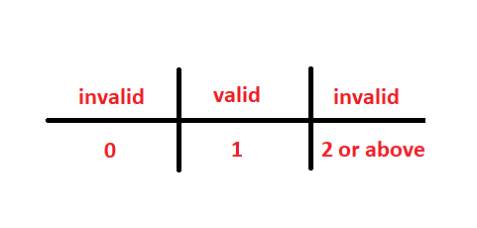
- Include password patterns in signup.
- Null password not allowed.
- Null user not allowed.
- Null phone number not allowed.
- Name letter less than 3 not allowed.

Data flow testing
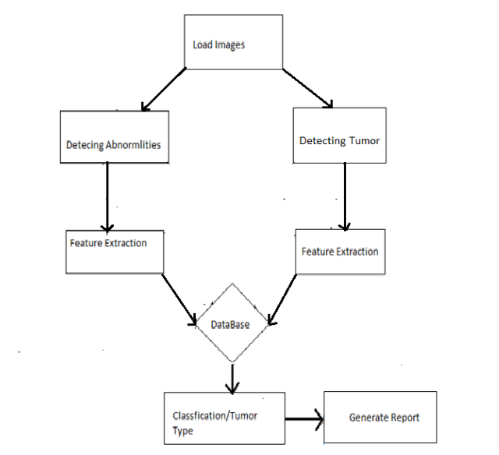
Figure 14 Data Flow Testing Diagram

Unit testing
The testing of unit testing is good the software has no issue with running and doing task in particular way but in unit testing performing the task before its first is completed create problem of slowing down and hanging.

Test Case No | Test Item | Input Specification | Output specification | Pass  /Fail | Description
1 | Log In | Email, password | Error message/ welcome Message | Pass | To verify Log in and user authentication
2 | Sign Up | Id, password, Email  Contact, address | Validation Error/ Successful Sign Up | Pass | To Register A new User
3 | Upload Images | MRI Based Brain Images | Validation Error/ Successful Upload | Pass | To load the image of brain in system
4 | Segmentation | MRI Based Brain Images | Error/ Successful Segmentation | Pass | Divide the image into Segment
5 | Feature of Extraction | Segmented Image | Error/ Successful Extraction | Pass | Getting  Feature Of Extraction
6 | Classification | Extracted Images | Not Detected/ Detected | Pass | Finding The Type of tumor

Table 16 Unit Testing

Integration testing
Test case id | Test case objective | Test case description | Expected Result
1 | Check the signup module | Enter user info | Save data and send mail on user mail id
2 | Check the login module | End valid user or password | Login user and generate list of rights
3 | Check upload image | Click button and give path | Upload image in project
4 | Check preprocessing | Click on preprocessing | Preprocessed the images
5 | Check for feature extraction | Clink on button | Extract the all values
6 | Check for classifier | Clink on button | Classify the tumor

Table 17 Integration Testing

Performance testing
Speed requirements: Response time is less than 20 seconds for transition. The inventory database also updated in real time.
Task Name | Minimum Time | Maximum Time
Load Images | 0.1Sec | 05 Sec
Segmentation | 1 Sec | 10 Sec
Feature Of extraction | 1 Sec | 10 Sec
Classification | 1 Sec | 10 Sec
Linear Accuracy | 1 Sec | 15 Sec
RBF Accuracy | 1 Sec | 15 Sec
Polygonal Accuracy | 1 Sec | 15 Sec
Quadratic Accuracy | 1 Sec | 15 Sec

Stress Testing
- In this testing we test the strength of software by pushing to its limits so that we can came to know about how much this software goes far. In our software we run series of task/test in the Matlab to check the stability of software and conclude that how much our system bear the burden and work effectively on different devices. Right now we only have the platform of three devices and its working effectively on these platforms.

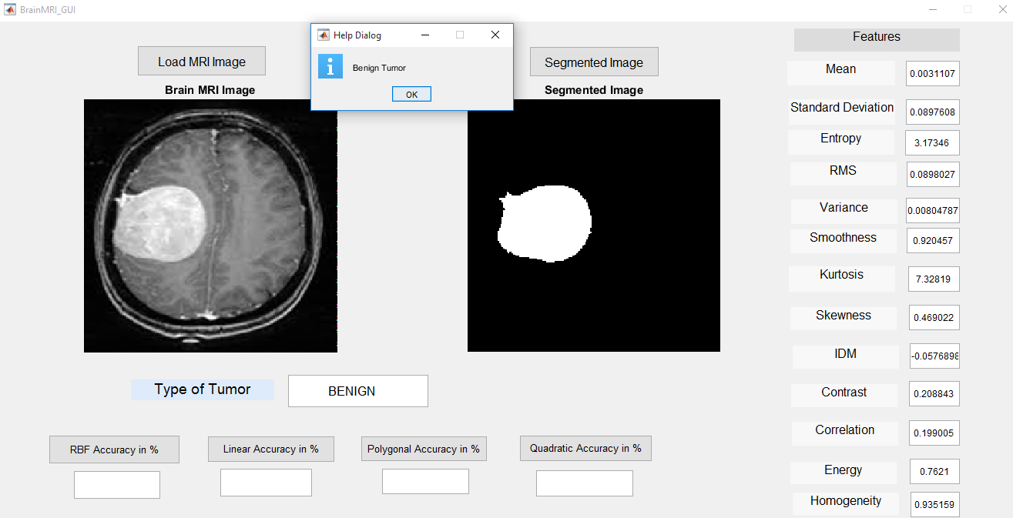
Figure 15 Stress Testing Diagram

In Above image after performing all stress task.

Chapter 7

Summary, Conclusion and Future Enhancements

Chapter 7: Summary, Conclusion & Future Enhancements

Project Summary
As we know in Pakistan we have not a lot work in medical imaging, so our team decide to work in this field because we are required this kind of software and apps in Pakistan. We are Developing a desktop app which will be able to identify the tumor .It will be able to identify the size ,type and location of the tumor .The app will also detect any other kind of abnormalities of brain that causes other problems .To build this app the tool we are using java and the technique is image processing.
The first module of project is identification of tumor in this module the app reads the database of input images and then compare it with the ideal database of images for analysis. This module based on supervised learning and work on our inputs.
Next module is classification of tumor in which we are again compare the tumor with different type of tumor having record in database, this module identify the type of tumor by comparing the input images with the database and at the end display the details about tumor and generate the reports.

Achievements and Improvements
Our motive to engage the medical solution which is much more efficient more than manual detection system or solutions in the form of computational power as we are all know the computational power increases day by day. Our objective to provide a software or web based solution in medical for the dieses which detection is difficult in early stages with manual systems like cancer. The targets we achieved that are:
Noise removal, feature extractions, segmentation, tumor detection.

Critical Review
In this study, we have studied different techniques for classification. The well-known models studied in this paper include neural networks, support vector machine, Decision Tree models, ID3 algorithm, and association rules. SVM and ANN give best results for brain tumor detection. Majority of the researchers preferred MR images, and CT scanned images are rarely used by the researchers.

Lessons Learnt
We absorb very much from this project. This project sharpens our skills in image processing, designing tools and many management concepts as well as how to deal with a problem and how to stick for finding the solution of any problem. As well as technical skills this project also enhance our personal development skills such as team working, dedication. We learnt various types of techniques in image processing. This project is a stepping stone for us in the beginning we don’t even know that if we accomplished it or not but due to our hardworking and research we do it and it’s an achievement for us that motivates us to do better and more.

Future Enhancements/Recommendations
To develop nanoscale devices that may lead to detection in early stages of tumor while simultaneously delivering anti-cancer agents to the tumor.
The system will be enhanced in future .Some more features will be added, the system will be trained to work on large no of data set.

Appendices

Appendix A: Information / Promotional Material
[Paragraph Text 12 pt, Calibri, 1.5 Line Spacing, Justified]
[Between 4 to 8 lines describe what is this appendix all about]

  - Broacher


  - Flyer
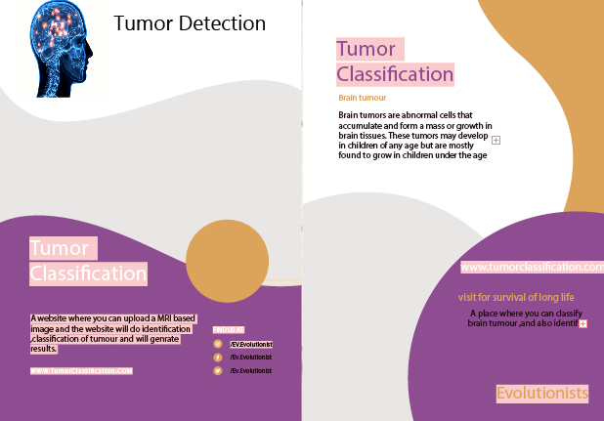

  - Standee
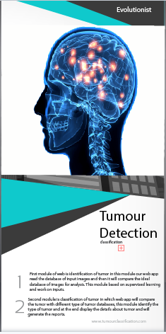
  - Banner


Reference and Bibliography

Reference and Bibliography

[1] Mohammed Sabbih Hamoud Al-Tamimi, Ghazali Sulong. Tumor Brain Detection through MRI Images: A Review of Literature || Journal of Theoretical And Applied Information Technology 20th April 2014. Vol. 62 No. 2 || E-Mail: 1m_Altamimi75@Yahoo.Com, 2ghazali@Utmspace.Edu.My
[2] Jay Patel And Kaushal Doshi - A Study Of Segmentation Methods For Detection Of Tumor In Brain Mri || Issn 22311297, Volume 4, Number 3 (2014), Pp. 279-284 [3] Rohini Paul Joseph, C. Senthil Singh, M.Manikandan - Brain Tumor Mri Image Segmentation And Detection In Image Processing
[4] Mohamed N. Ahmed, Sameh M. Yamany, Nevin Mohamed, Aly A. Farag, Thomas Moriarty- A Modified Fuzzy C-Means Algorithm For Bias Field Estimation And Segmentation Of Mri Data.
[5] Yongyue Zhang, Michael Brady, And Stephen Smith - Segmentation Of Brain Mr Images Through A Hidden Markov Random Field Model And The ExpectationMaximization Algorithm || IEEE Transactions On Medical Imaging, Vol. 20, No. 1, January 2001.
[6] K.R.Yasodha, Dr. V.Thiagarasu - Automatic Segmentation of Brain Tumor from MRI Images- A Review.

